Table of Contents

B1.2 · Unit 5 · Four Per Cent
English Animated · Weighing It Up · Hospital Regional, Valdivia Student's Book pages 94–115 · 22 pp · ~11 hours

Part 0 · The Big Picture ◆ A · THE WORLD
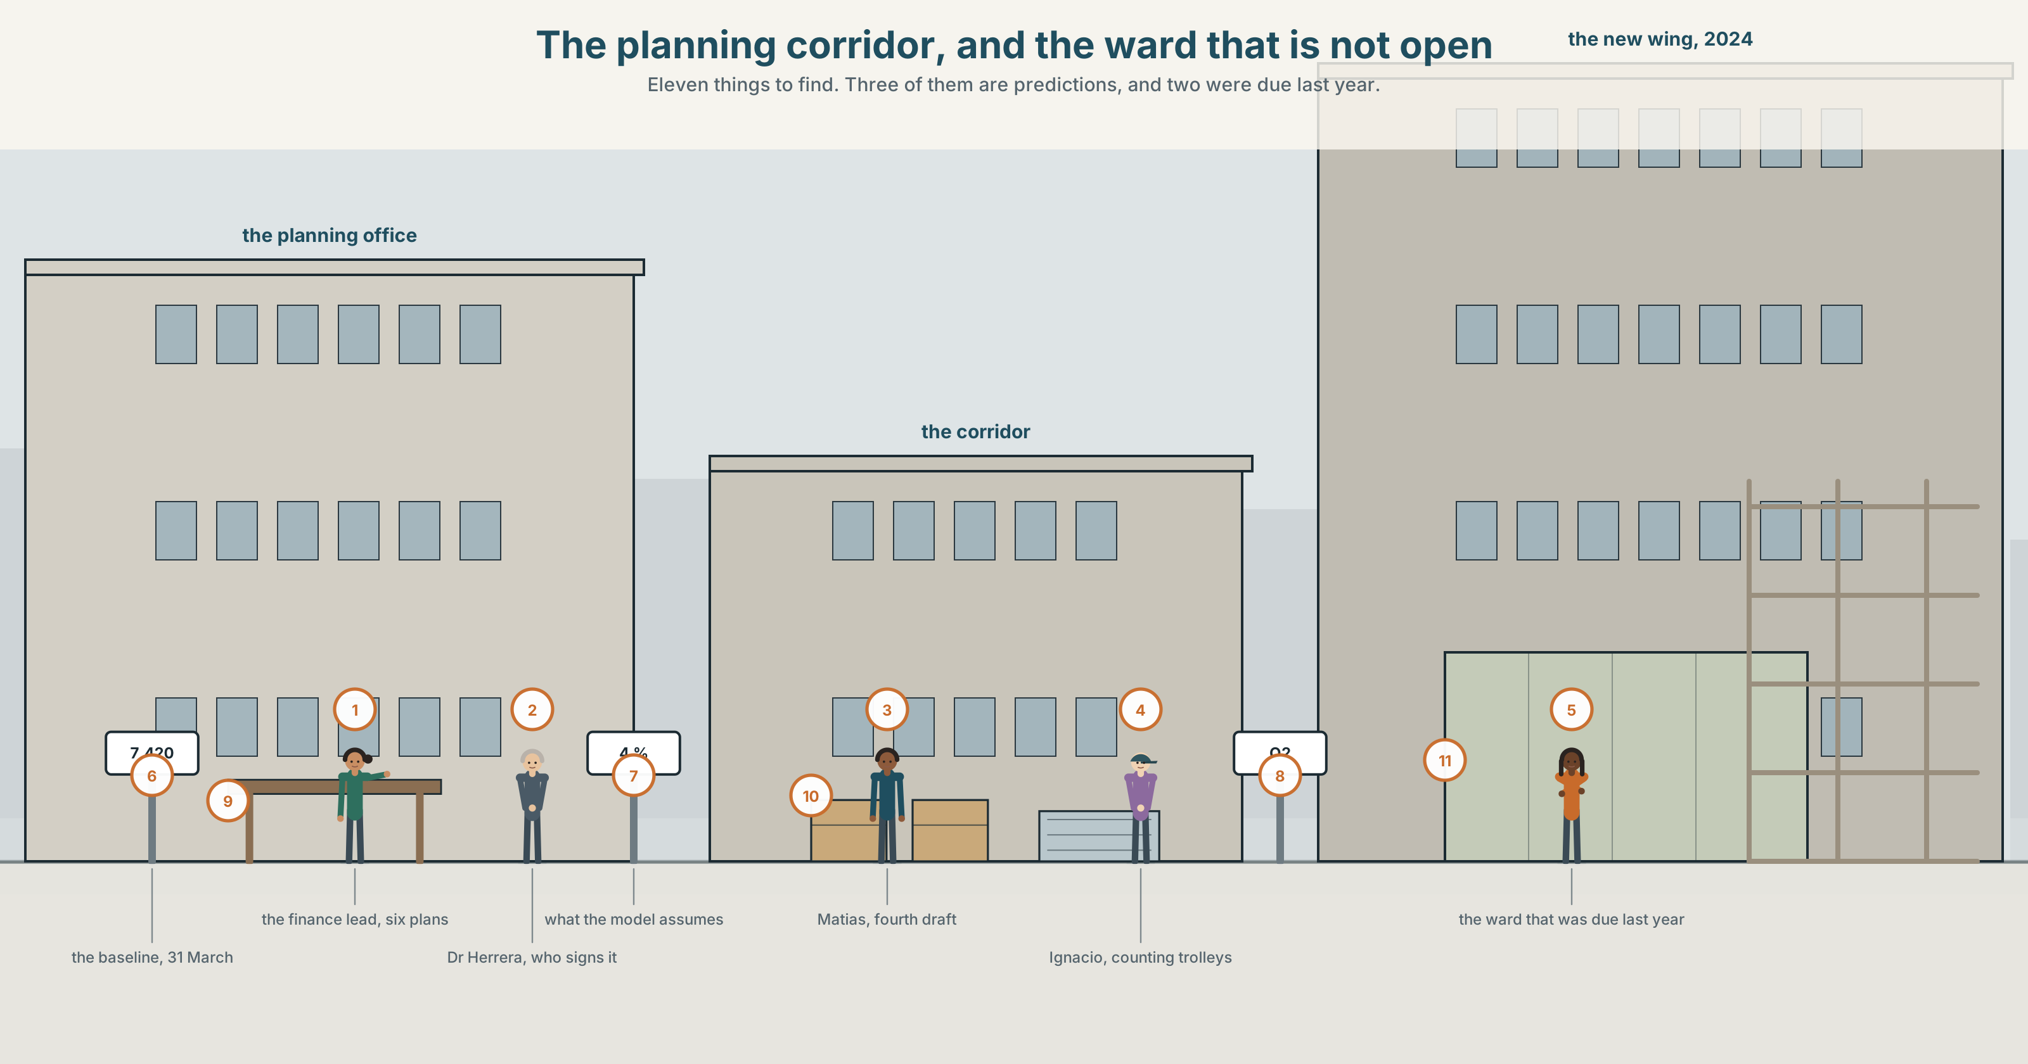{width=6.6in}
The planning corridor, and the ward that is not open — Eleven things to find. Three of them are predictions, and two were due last year.

What will have changed by then?
By the end of this unit you can present a three-year projection and state its assumptions out loud.
◆ A · THE WORLD | A model that has been wrong in the same direction twice
◆ B · THE SYSTEM | the future perfect and the future continuous · by, by the time · 23 words for projection and capacity · 22 words for placing things ahead · long chains of weak forms
◆ C · THE PERFORMANCE | A three-year projection with its assumptions said out loud

0A · Find it
Find eleven things in this picture. Three of them are predictions.
a capacity board · a waiting-list number on a whiteboard · a three-year plan on a screen · a trolley count · a staffing rota for next month · a corridor with beds in it · a building site hoarding · a sign for a ward that is not open yet · a printer · a calendar · a chart taped over an older chart

0B · Guess it
Two things in this picture were planned for last year and have not happened. Which, and what is the evidence?

0C · Say it ⏺
Record forty-five seconds. Where will you be, and what will you have finished, three years from today? Say one assumption your answer depends on. You will record it again at the end of this unit.

Part 1 · Vocabulary Lab 1 ◆ B · THE SYSTEM
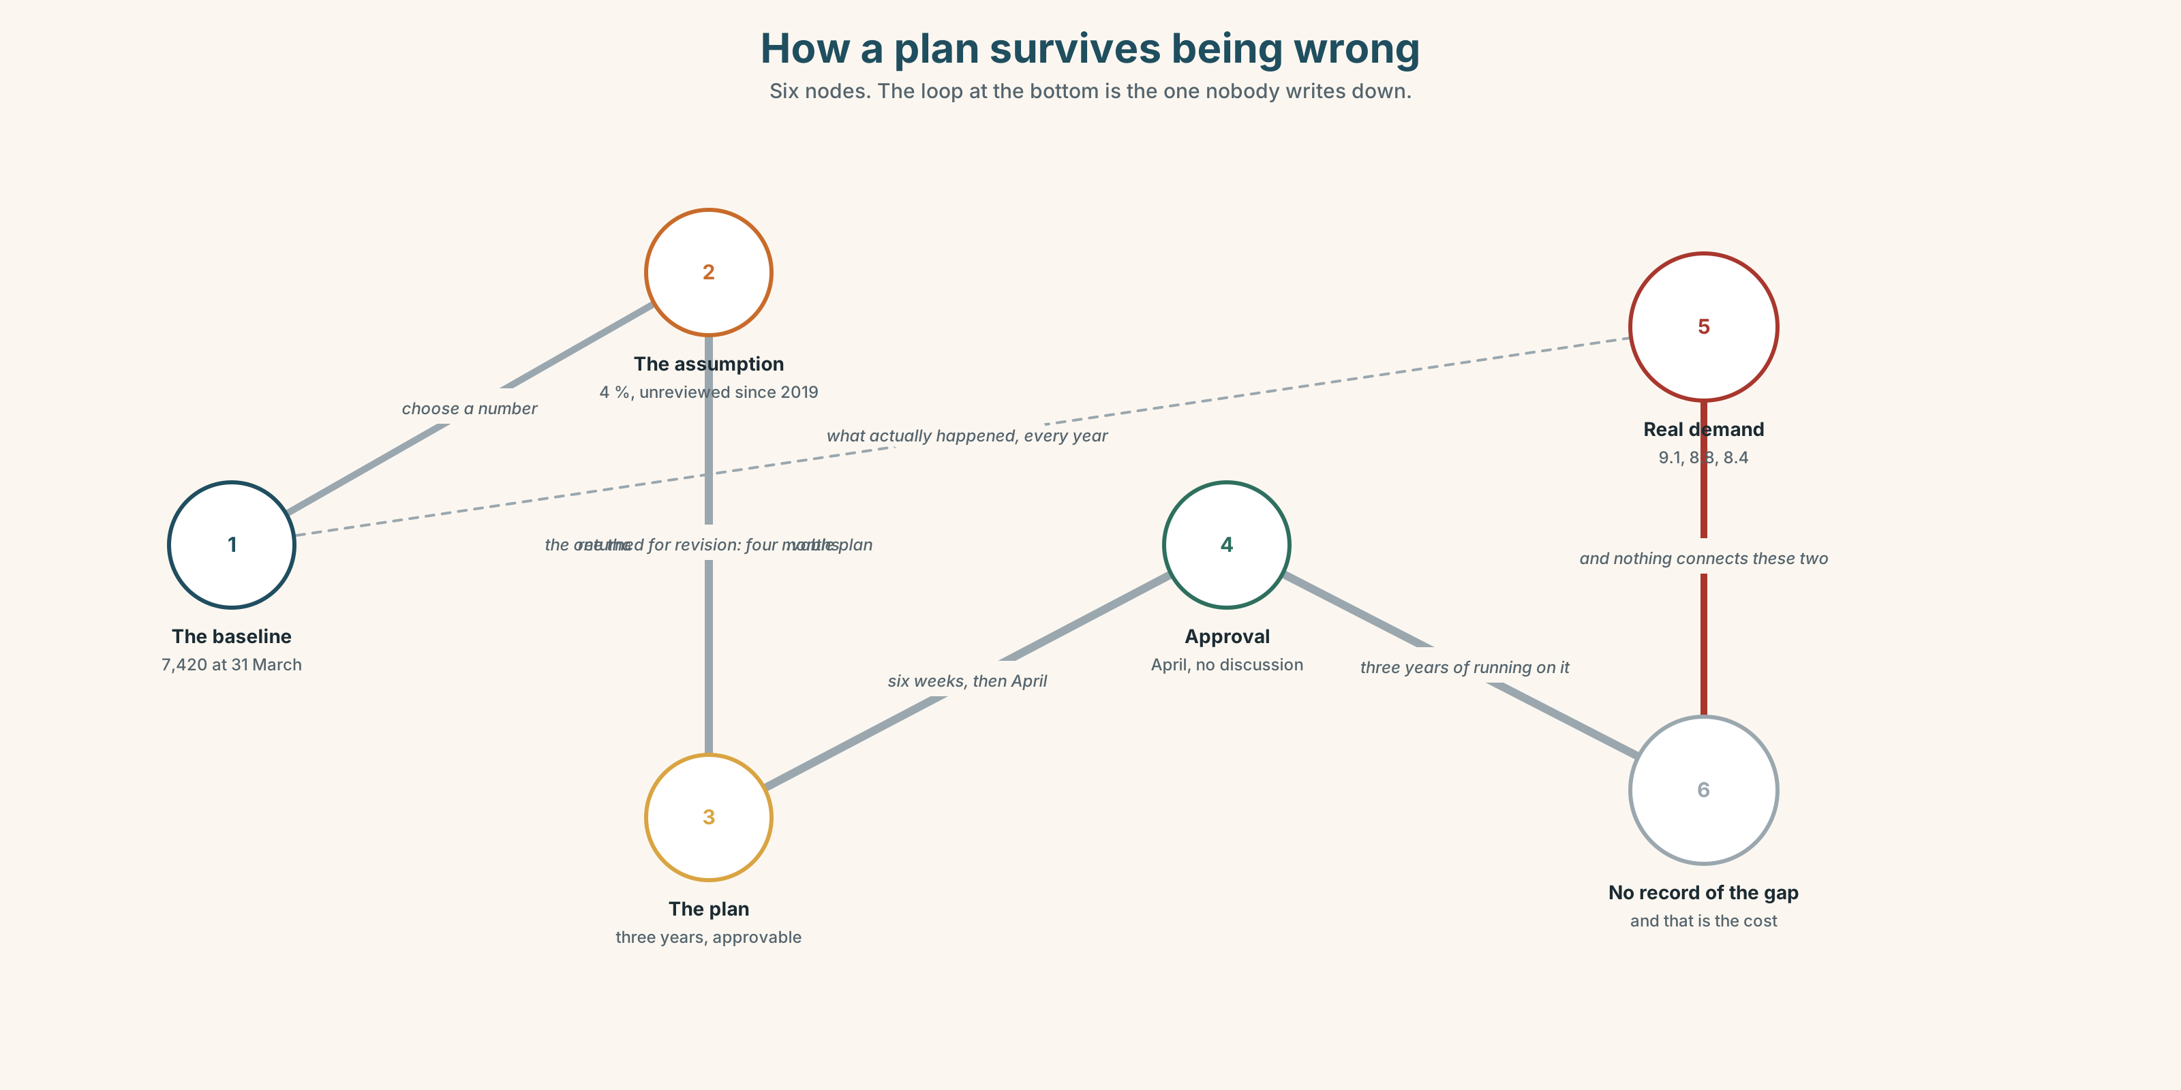{width=6.6in}
How a plan survives being wrong — Six nodes. The loop at the bottom is the one nobody writes down.

1A · Meet — the words of a plan
Match each word to one place on the map.
projection · forecast · target · deadline · milestone · assumption · baseline · capacity · demand · shortfall

1B · Sort — a number, a date, or a belief?
Three columns.
target · assumption · baseline · deadline · variance · milestone · demand · throughput · forecast
One of them is a belief that everybody treats as a number. Which, and what does that cost?

1C · Meet — three words that describe the same gap
variance · shortfall · demand
Variance is the difference between plan and reality. Shortfall is the same difference with a tone attached. Demand is the thing that caused it. Which of the three would you put in a title?

1D · Collocation Lab
Complete each one with one word.
- On current ______ , the waiting list reaches eleven thousand by March.
- All things being ______ , the new ward opens in the second quarter.
- That four per cent is a working ______ and has been since 2019.
- Best ______ , the building finishes in April. Worst ______ , it finishes in November.
- The model will run out of ______ some time in the third year.
- They have had to scale ______ the original plan twice and scale ______ the budget once.

1E · The fixed expressions
f That is the number we are planning on. f It has never been four per cent.
Two sentences from the same meeting. One of them ends the discussion and one of them starts it.
Which, and what is the sentence between them?

1F · Own it
Think of a plan you are inside — at work, at home, in your studies. Tell a partner four sentences: what it assumes, what has actually happened, how big the gap is, and who would have to say so.

Part 2 · Listening ◆ A · THE WORLD
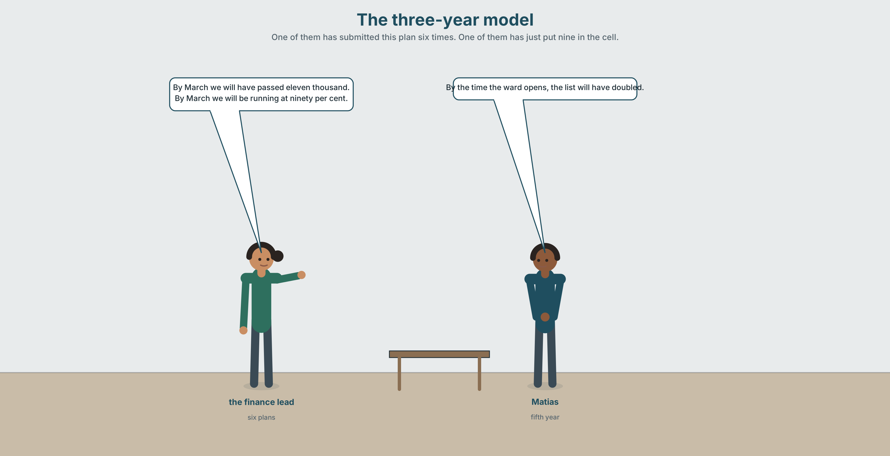{width=6.6in}
The three-year model — One of them has submitted this plan six times. One of them has just put nine in the cell.

2A · The three-year model 🔊 Track 5.1
Before you listen. The hospital's model assumes demand will rise four per cent a year. It has risen nine per cent for two years running. Guess: why has nobody changed it?
Listen once. One question. What happens to the plan if you put nine per cent in?
Listen again. Complete the table.
 | What they say | What they assume | What happens if the assumption is wrong
the finance lead
Dr Herrera
Matías
Listen again. Choose the best answer.
- At four per cent the list reaches 8,000 / 11,000 / 16,000 by year three.
- At nine per cent it reaches 8,000 / 11,000 / 16,000.
- A plan built on nine per cent would be approved / refused / returned for revision.
- The assumption was last reviewed in 2019 / 2022 / never.
Noticing. Four sentences from the recording.
- By March we will have passed eleven thousand.
- By March we will be running at ninety per cent.
- By the time the ward opens, the list will have doubled.
- This time next year we will have had three years of nine per cent.
Two of these describe a completed thing. Two describe something still running. Which are which?

2B · Decoding clinic 🔊 Track 5.2
Thirty seconds of the finance lead. Four jobs.
- How many times does she say will have?
- In we will have been, how many of the four words are stressed?
- Catch the two percentages and the year.
- She hedges one number and not the other. Which, and why that one?
Transcripts, page 154.

Part 3 · Grammar Lab 1 ◆ B · THE SYSTEM

Finished by then, or still going then

3A · Notice
Look at the four sentences in Part 2.
- In sentence 1, is the passing of eleven thousand finished by March or happening in March?
- In sentence 2, what is the state of affairs in March?
- Sentence 3 has two future points. Which is the deadline and which is the event?
- Sentence 4 uses will have had. How is that different from will have?
- Try "By March we will pass eleven thousand." Is it wrong? What does it lose?

3B · See
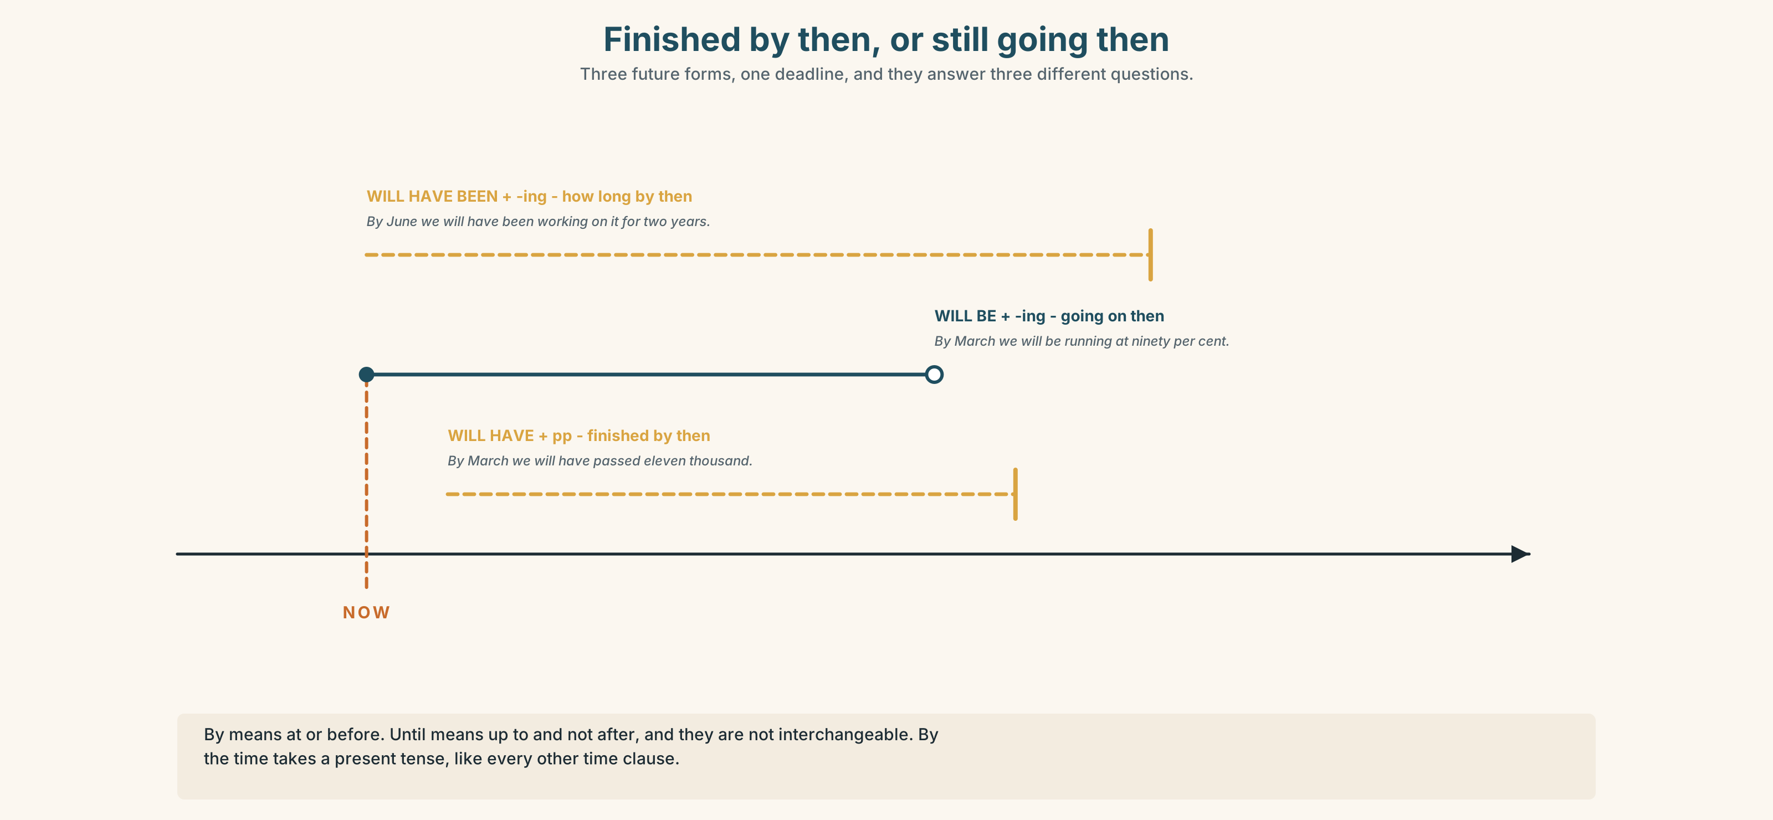{width=6.6in}
Finished by then, or still going then — Three future forms, one deadline, and they answer three different questions.

3C · Know
 | Shape | Use it for
future continuous | will be + -ing | what will be going on at a future point
future perfect | will have + past participle | what will be finished by a future point
future perfect continuous | will have been + -ing | how long something will have been going by then
The deadline word is by. by March, by the end of the year, by then. By means at or before. Until means up to and not after, and they are not interchangeable. ✓ We'll have finished by March. ✗ We'll have finished until March.
by the time takes a present tense, like all time clauses. ✓ By the time the ward opens, the list will have doubled. ✗ By the time the ward will open…
The future perfect is the tense of plans and audits. It is how you describe a state of the world at a date, which is exactly what a projection is.
Watch out. State verbs still resist the continuous. ✓ By then we will know. ✗ By then we will be knowing.

3D · Use — controlled
By March the list (1) __________ (pass) eleven thousand. By the end of the year the department (2) __________ (run) at over ninety per cent capacity, which it (3) __________ (do) continuously for about eighteen months by that point. By the time the new ward (4) __________ (open), the list (5) __________ (double). This time next year we (6) __________ (have) three consecutive years of nine per cent growth, and the model (7) __________ (still / assume) four. By 2029, on current trends, we (8) __________ (run out) of corridor.

3E · Use — guided
Choose the right future form, and say why the others fail.
- At six o'clock tomorrow I ______ (sit) in a meeting about this.
- By six o'clock tomorrow I ______ (finish) the paper.
- By the time you read this, I ______ (leave).
- In June we ______ (work) on this model for two years.
- By 2027 the department ______ (know) whether the assumption was right.

3F · Use — open
In pairs. Describe the same future point — this time in three years — four times: once with will, once with will be doing, once with will have done, once with will have been doing. Then say which was hardest and why.

3G · Error autopsy
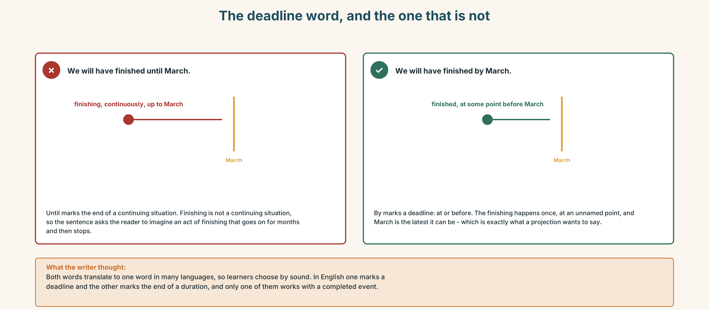{width=6.6in}
The deadline word, and the one that is not — The deadline word, and the one that is not
Read both versions. Then say what the first one commits the writer to that the second does not.

3H · Check — eight items
- By March we ______ (pass) eleven thousand.
- By March we ______ (run) at ninety per cent.
- By the time the ward ______ (open), the list ______ (double).
- In June we ______ (work) on it for two years.
- By then we ______ (know) the answer.
- We ______ (finish) ______ March. (deadline)
- At four tomorrow I ______ (present) this to the board.
- By 2029 we ______ (run out) of corridor.
0–4 → Workbook pp. 28–31. 5–6 → Part 6. 7–8 → page 107.

Part 4 · Speaking ◆ C · THE PERFORMANCE

4A · Fluency starter — three years
Your teacher names a date three years out. Each learner says one sentence beginning "By then I will have…" and one beginning "By then I will be…". Nobody may use the same verb twice.

4B · The functional core — presenting a projection
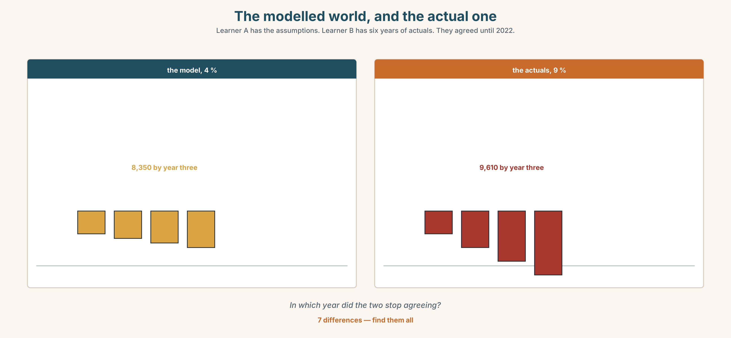{width=6.6in}
The modelled world, and the actual one — Learner A has the assumptions. Learner B has six years of actuals. They agreed until 2022.
Language Bank
the projection | By March we'll have… · On current trends…
the assumption, out loud | This assumes… · That number is a working assumption.
the sensitivity | If it's nine rather than four, then… · Best case… worst case…
the honest ending | It has never been four per cent. · I am planning on a number I do not believe.
Information gap. Learner A has the model's assumptions. Learner B has the last six years of actual figures. Find the year in which the two stopped agreeing.

4C · The performance — three minutes ⏺
Present a three-year projection. Three minutes. You must include:
the baseline · the projection at your central assumption · the assumption, said out loud · what happens at a different assumption · the point at which the plan breaks
Record it.

4D · Observer
One person listens for one thing: was every number attached to the assumption that produced it?

4E · Three criteria
☐ Did I use the future perfect and the future continuous for different jobs? ☐ Did I say the assumption out loud, in a sentence of its own? ☐ Did I give a second number for a different assumption?

Part 5 · Reading ◆ A · THE WORLD

5A · Predict
An opinion column. The title is "A plan that is refused is not a failure. A plan that is approved and wrong is." What do you expect the argument to be? Two sentences.

5B · Read — two minutes

A plan that is refused is not a failure. A plan that is approved and wrong is
Every public body I have worked in has had the same quiet arrangement, and nobody has ever written it down because writing it down would end it.
A department produces a three-year plan. The plan contains an assumption about demand. The assumption is chosen not because anybody believes it but because it is the number that produces a plan which can be approved. If you put the real number in, the plan asks for money that does not exist, and a plan that asks for money that does not exist is returned for revision, which costs four months.
So the department puts in four per cent. Demand rises nine. In year two somebody notices, and what they notice is not that the assumption was wrong — everybody knew the assumption was wrong — but that the department has now been running on an approved plan for two years and has no document anywhere that says what it actually needs.
That is the real cost, and it is not financial. It is that at the end of three years there will be no record of the gap. There will be a plan that was met, a service that is failing, and no piece of paper connecting the two.
I am not arguing that departments should submit plans that will be refused. I am arguing that they should submit the four per cent plan and a one-page annex saying what the nine per cent world looks like, and that they should do this every year whether anybody reads it or not, because in four years somebody will ask when this started and somebody ought to be able to answer.

5C · Comprehension — eight questions
- What is the "quiet arrangement" the writer describes?
- Why is the assumption chosen, according to the writer?
- What happens to a plan that asks for money that does not exist, and what does that cost?
- What does somebody notice in year two, and what do they not notice?
- What does the writer say the real cost is?
- What are the three things that will exist at the end of three years?
- What is the writer's actual proposal?
- Why does the writer say it should be done "whether anybody reads it or not"?

5D · Vocabulary in context
Guess from the text. Then check.
a quiet arrangement · returned for revision · running on an approved plan · an annex · connecting the two

5E · The counter-text
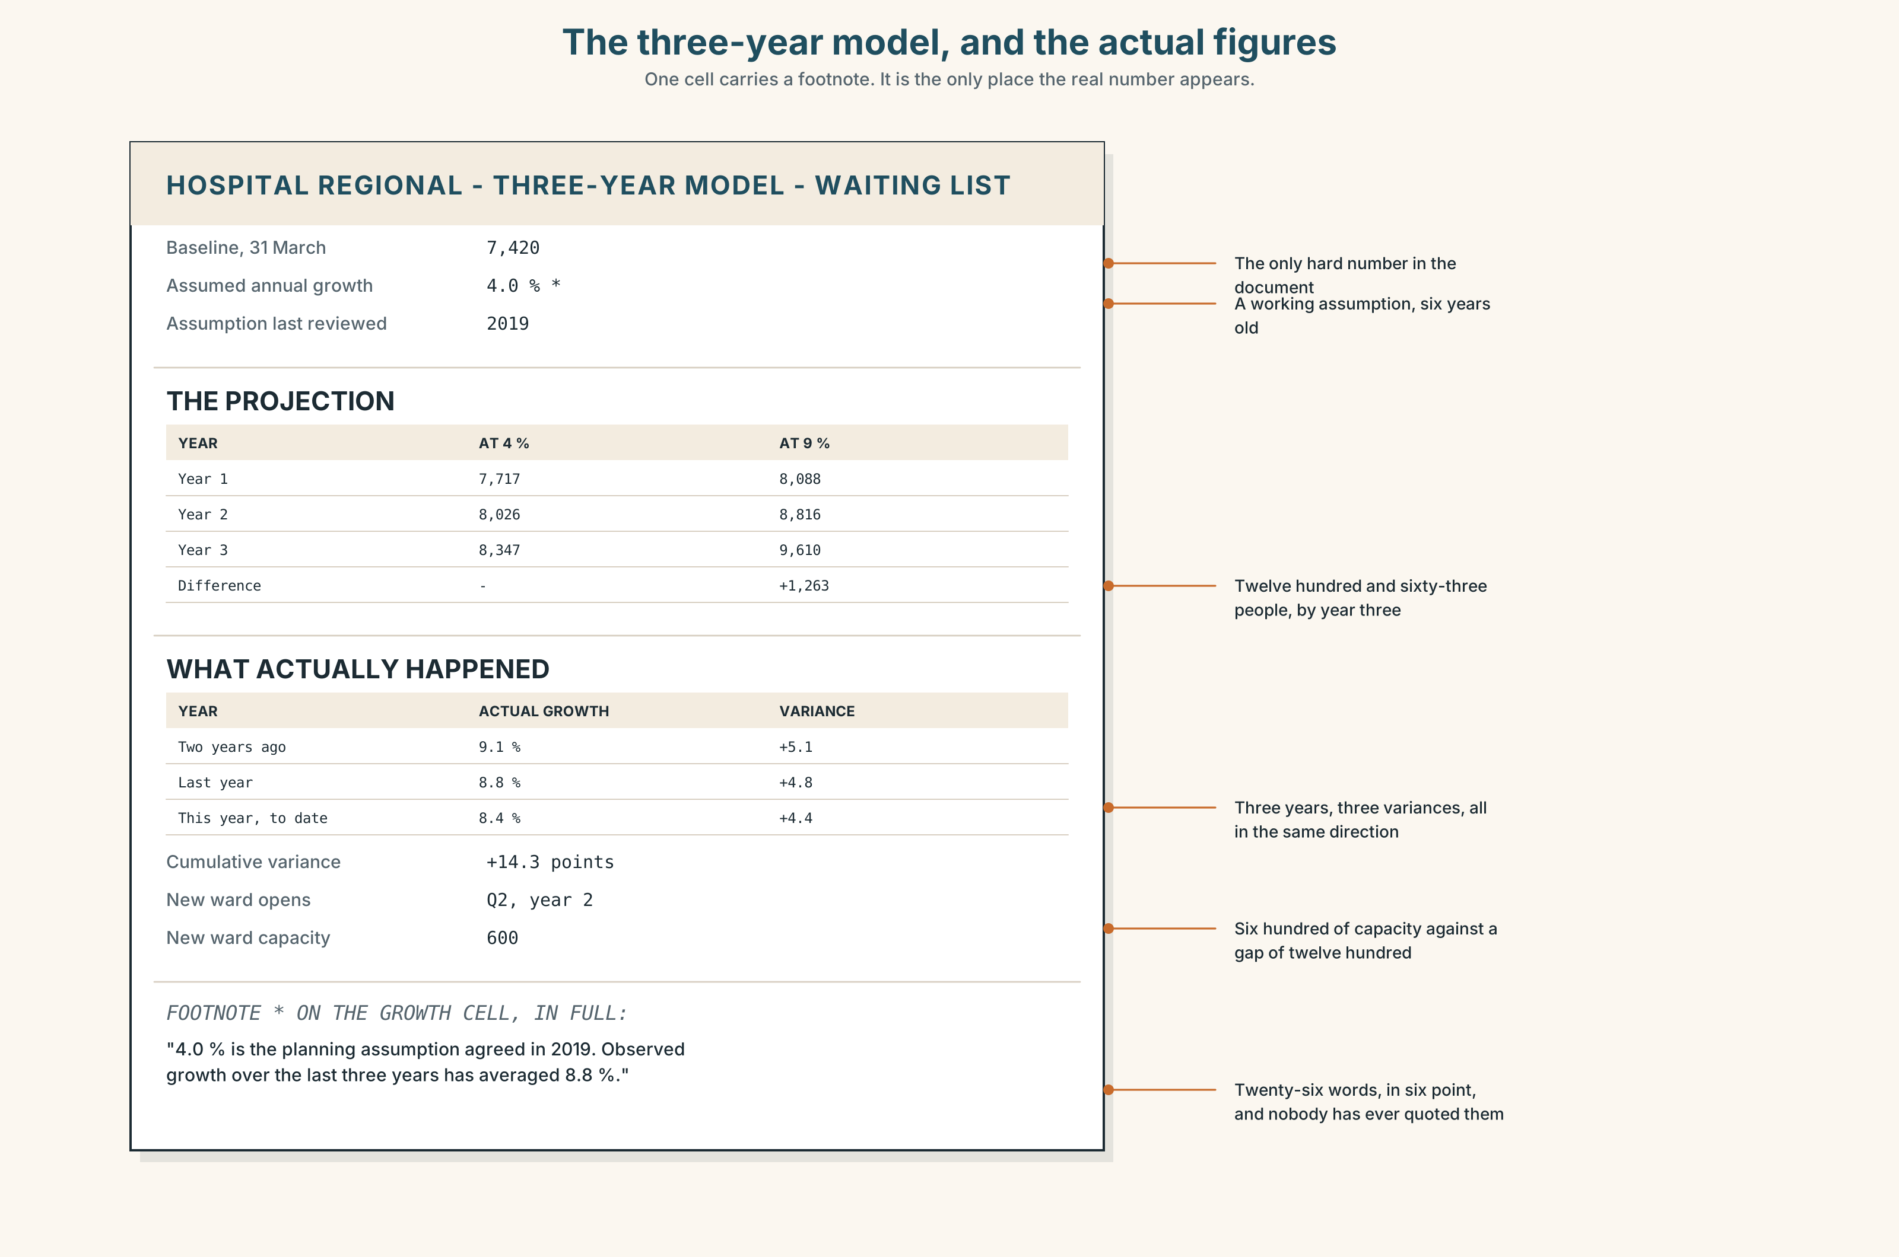{width=6.6in}
The three-year model, and the actual figures — One cell carries a footnote. It is the only place the real number appears.
Read the three-year model and the actual figures beside it, and answer.
- What is the baseline, and what growth rate does the model assume?
- What are the actual rates for the last three years, and what is the cumulative variance?
- What does the model project for year three, and what does nine per cent project?
- When was the assumption last reviewed, and by whom?
- One cell has a footnote. Which, and what does it say?

5F · Two texts
The column says a department ends up with no document saying what it needs. The model has a cell with a footnote giving the real figure.
Put those two facts together. Does the footnote count? Three sentences.

Part 6 · Vocabulary Lab 2 ◆ B · THE SYSTEM

Putting things ahead of you

6A · Sort — a point, a period, or a direction?
Three columns.
by · shortly · imminently · eventually · ultimately · thereafter · meanwhile · progressively · cumulatively · annually · henceforth

6B · Chunk completion
- By ______ the list will have passed eleven thousand.
- Within the ______ the new ward will be open or it will be cancelled.
- Over the ______ , demand has risen twenty-nine per cent.
- Year ______ year , the model has been out by five points.
- At this ______ , we will run out of corridor in 2029.
- They have failed to see ______ a single one of the four milestones.

6C · Three that look like timing and are not
ultimately · eventually · henceforth
Ultimately is about the end state, not the timing. Eventually is about the timing and refuses to give one. Henceforth is about a rule starting, and is nearly always too formal.
Rewrite each sentence with a date in it, and say what is gained.
- Ultimately the ward will open.
- The list will eventually come down.
- Henceforth the assumption will be reviewed annually.

6D · The fixed expression
f This time next year we will have…
Complete it three times: once for something certain, once for something planned, once for something you do not believe.

6E · Contrast Clinic
Eight items. Future simple, continuous, perfect or perfect continuous.
- At four tomorrow I ______ (present) this.
- By four tomorrow I ______ (present) this.
- By June we ______ (work) on it for two years.
- By the time it opens, the list ______ (double).
- By then we ______ (know). (a state)
- Next March we ______ (run) at ninety per cent. (a state of affairs)
- By next March we ______ (reach) ninety per cent. (an event completed)
- By 2029 we ______ (run out) of corridor.

Part 7 · Pronunciation & Fluency Lab ◆ B · THE SYSTEM

Four weak forms in a row
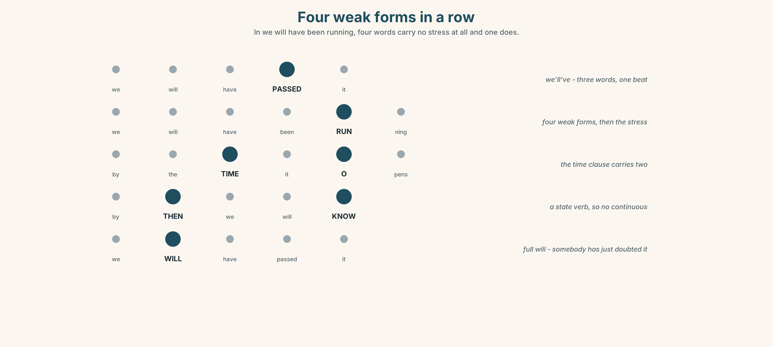{width=6.6in}
Four weak forms in a row — In we will have been running, four words carry no stress at all and one does.

7A · Hear 🔊 Track 5.3
we will have passed → /wiːləvˈpɑːst/ we will have been running → /wiːləvbɪnˈrʌnɪŋ/ by the time it opens → /baɪðəˈtaɪmɪtˈəʊpənz/
In we will have been running, four words carry no stress at all and one does.

7B · Say
Say each one. Then say the whole sentence three times, faster:
By the time the ward opens, we will have been running at ninety per cent for two years.

7C · Make it mean something
Say these two:
We WILL have passed it. (somebody has just doubted it) We'll've passed it. (and this is just the projection)
Which one belongs in a board paper?

7D · Fluency 30 ⏺
Thirty seconds: three things you will have finished and three you will still be doing, in three years. Three times, faster.

Part 8 · Writing ◆ C · THE PERFORMANCE

A three-year projection · 160 words
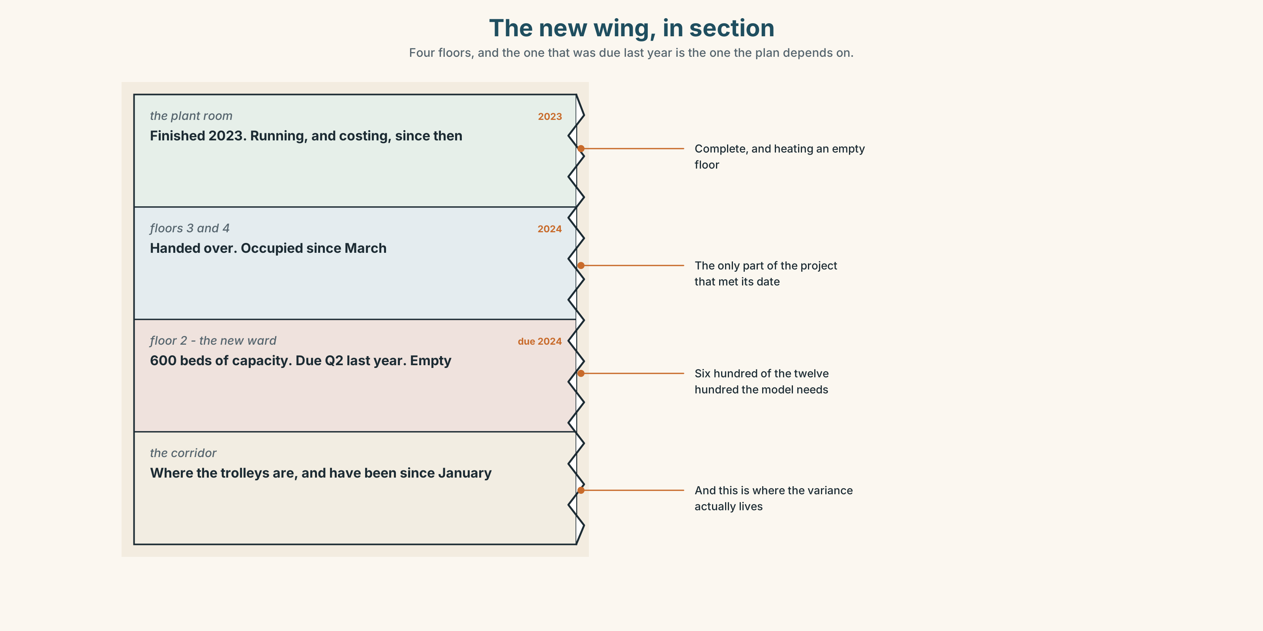{width=6.6in}
The new wing, in section — Four floors, and the one that was due last year is the one the plan depends on.

8A · Read the model
The baseline is 7,420 on the list at 31 March. The model assumes four per cent annual growth, which gives 8,350 by year three. [the baseline, the assumption and the result, in that order and in one breath]
That four per cent is a working assumption and has not been reviewed since 2019. Actual growth has been 9.1 and 8.8 per cent in the last two years. At nine per cent the year-three figure is 9,610. [the assumption named as an assumption, then the actual figures, then the second number]
By the time the new ward opens in Q2 of year two, the list will have passed nine thousand on the real figures and 8,000 on the modelled ones. The ward adds capacity for 600. [the point at which the two worlds separate, and the thing that was supposed to fix it]
I am presenting the four per cent plan because that is the number we are planning on. I would like the nine per cent annex minuted. [what the writer is doing, and what they are asking for, separately]
Questions about the writer's choices:
- The assumption is named in its own sentence. Why not in a footnote?
- The last paragraph separates what the writer is submitting from what they are asking for. Why does that distinction matter?
- There is no adjective anywhere in this piece. Is that a style choice or an argument?

8B · The anti-model
The department faces significant challenges in the coming period. Demand is expected to continue to grow and capacity will need to be reviewed. We remain committed to meeting our targets and will continue to monitor the situation closely.
Correct English, and not one number. Name three numbers it should contain, and say what monitor the situation closely is standing in for.

8C · Plan
baseline → central assumption, named as an assumption → the result → the actual figures → the second result → the point where the two separate → what you are asking for

8D · Write — 160 words

8E · Peer review — three criteria
☐ Is the assumption in a sentence of its own? ☐ Are there two projections, from two assumptions? ☐ Is there a named date at which the two worlds separate?

8F · Write it again · 8G · Publish
On the wall, with the model and the actual figures from Part 5E beside it.

Part 9 · The File ◆ A · THE WORLD + C · THE PERFORMANCE

STUDY FILE · Feedback and Revision
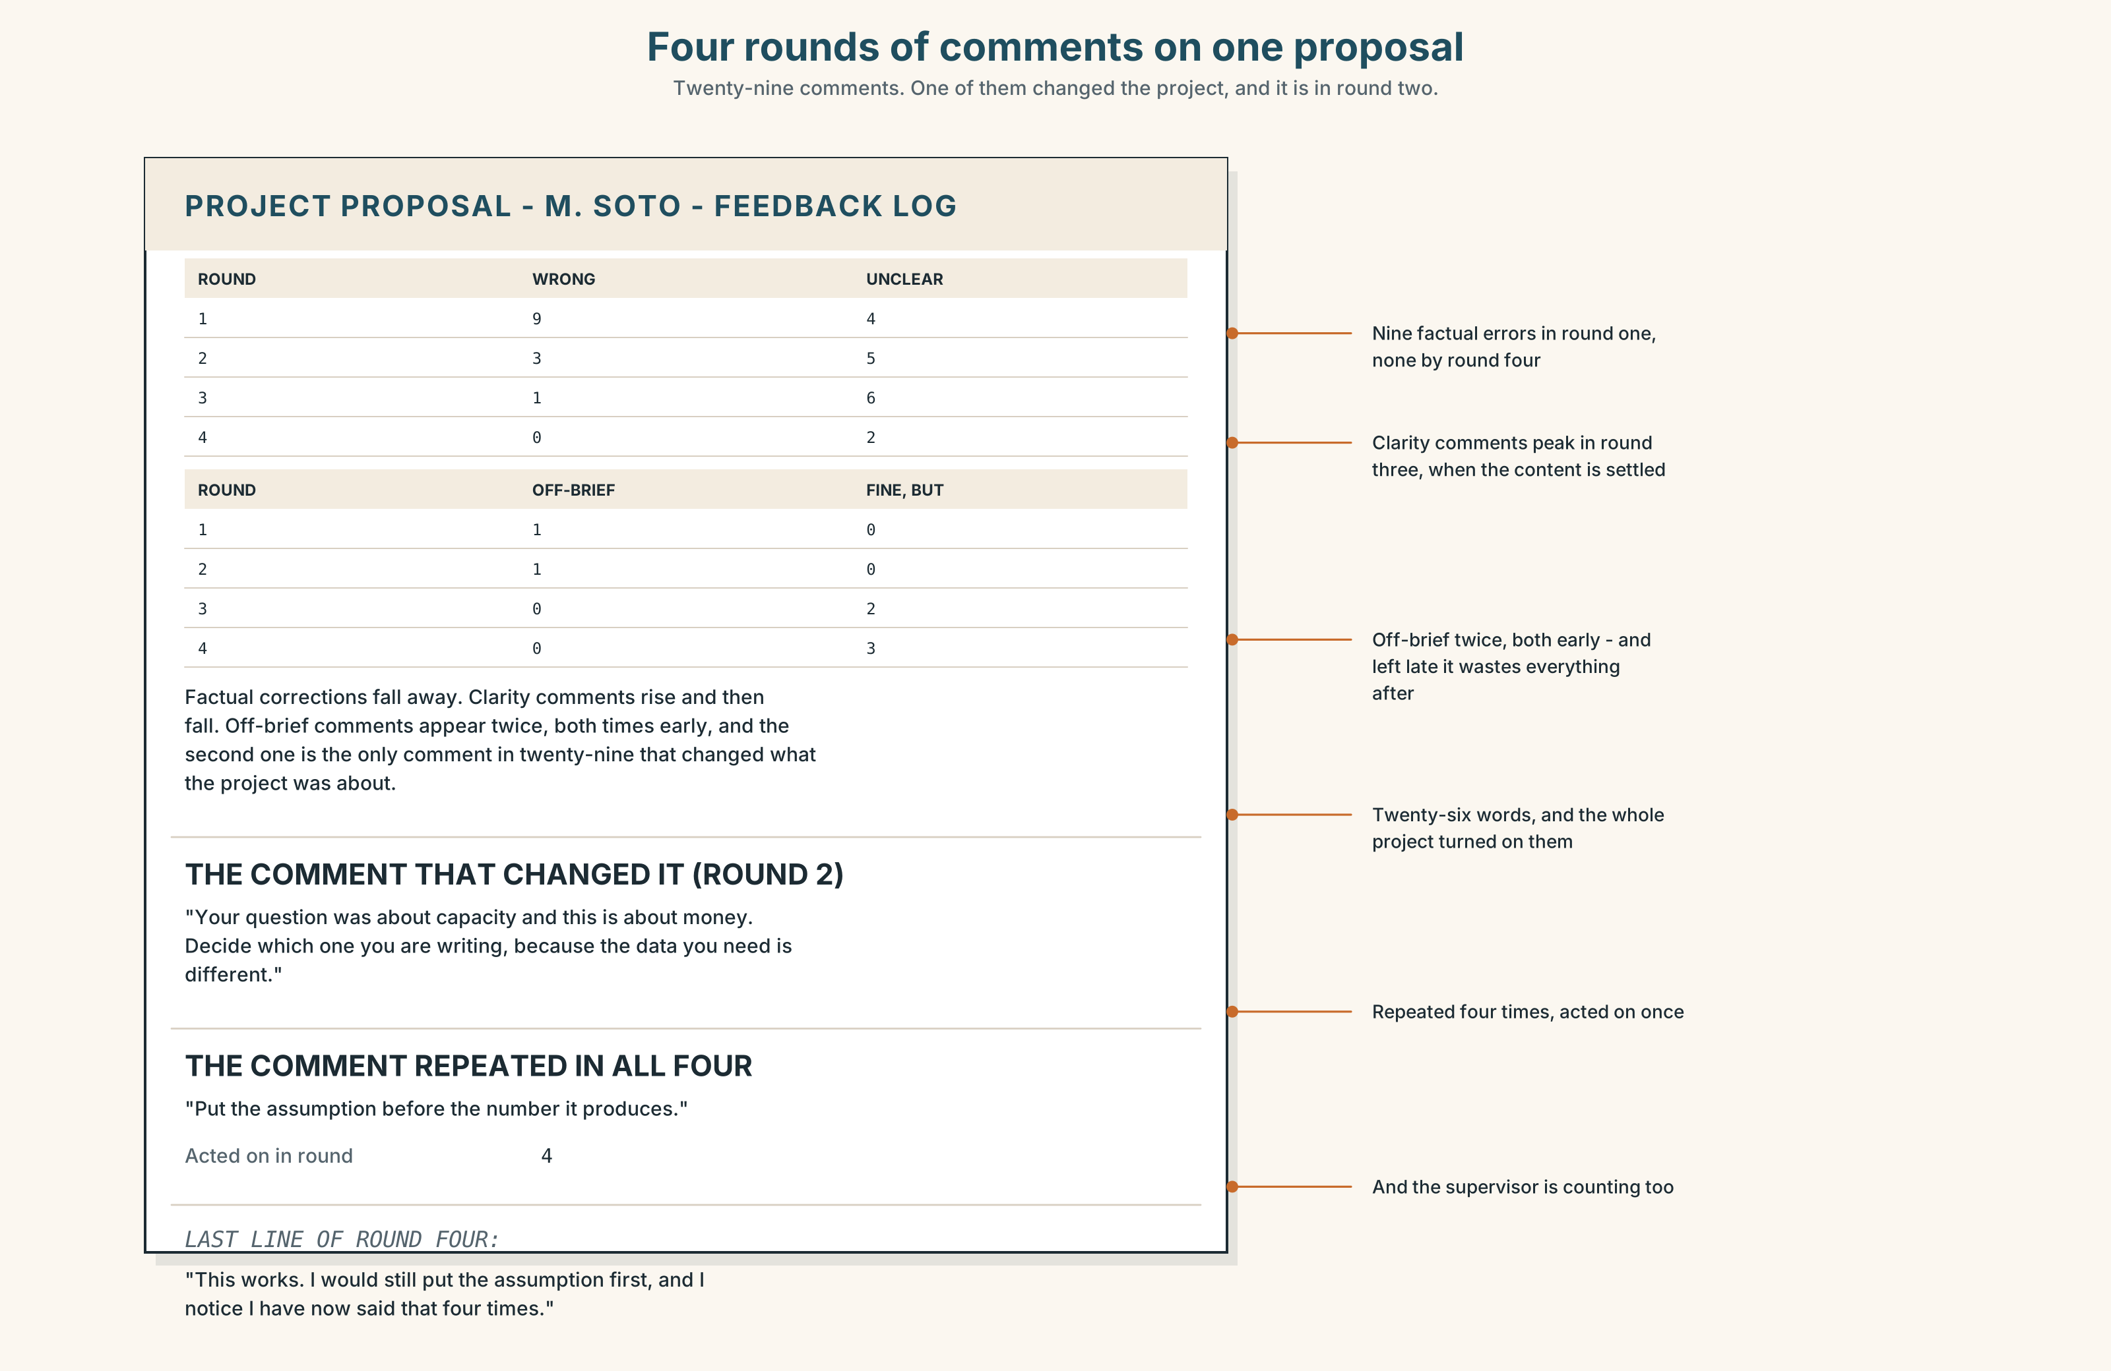{width=6.6in}
Four rounds of comments on one proposal — Twenty-nine comments. One of them changed the project, and it is in round two.

9A · Four rounds of comments 🔊 Track 5.4
Matías's project proposal has been through four drafts. Listen to his supervisor's feedback on each.
- What kind of comment dominates round one, and what kind dominates round four?
- Which round contains the comment that actually changed the project?
- One comment is repeated in all four rounds. Which, and what does that tell you?

9B · Four kinds of comment
this is wrong · this is unclear · this is not what you set out to do · this is fine and here is what I would do instead
Match each to one phrase.
"The 2019 figure is 7,420, not 7,240." · "I cannot tell whether this sentence is your claim or theirs." · "Your question was about capacity and this is about money." · "This works. I would still put the assumption first."

9C · The comment you should act on last
Which of the four kinds is it safe to leave until the final draft, and why? And which one, if you leave it, makes all the other work worthless?

9D · Your turn
In pairs. Twelve minutes. Swap the 160 words you wrote in Part 8. Give one comment of each of the four kinds, in writing. Then revise, and say which comment you acted on first.

9E · Transfer
Find one piece of feedback you have received and not acted on. Write down which of the four kinds it was, and why you left it.

Part 10 · Mediation & Interaction ◆ C · THE PERFORMANCE
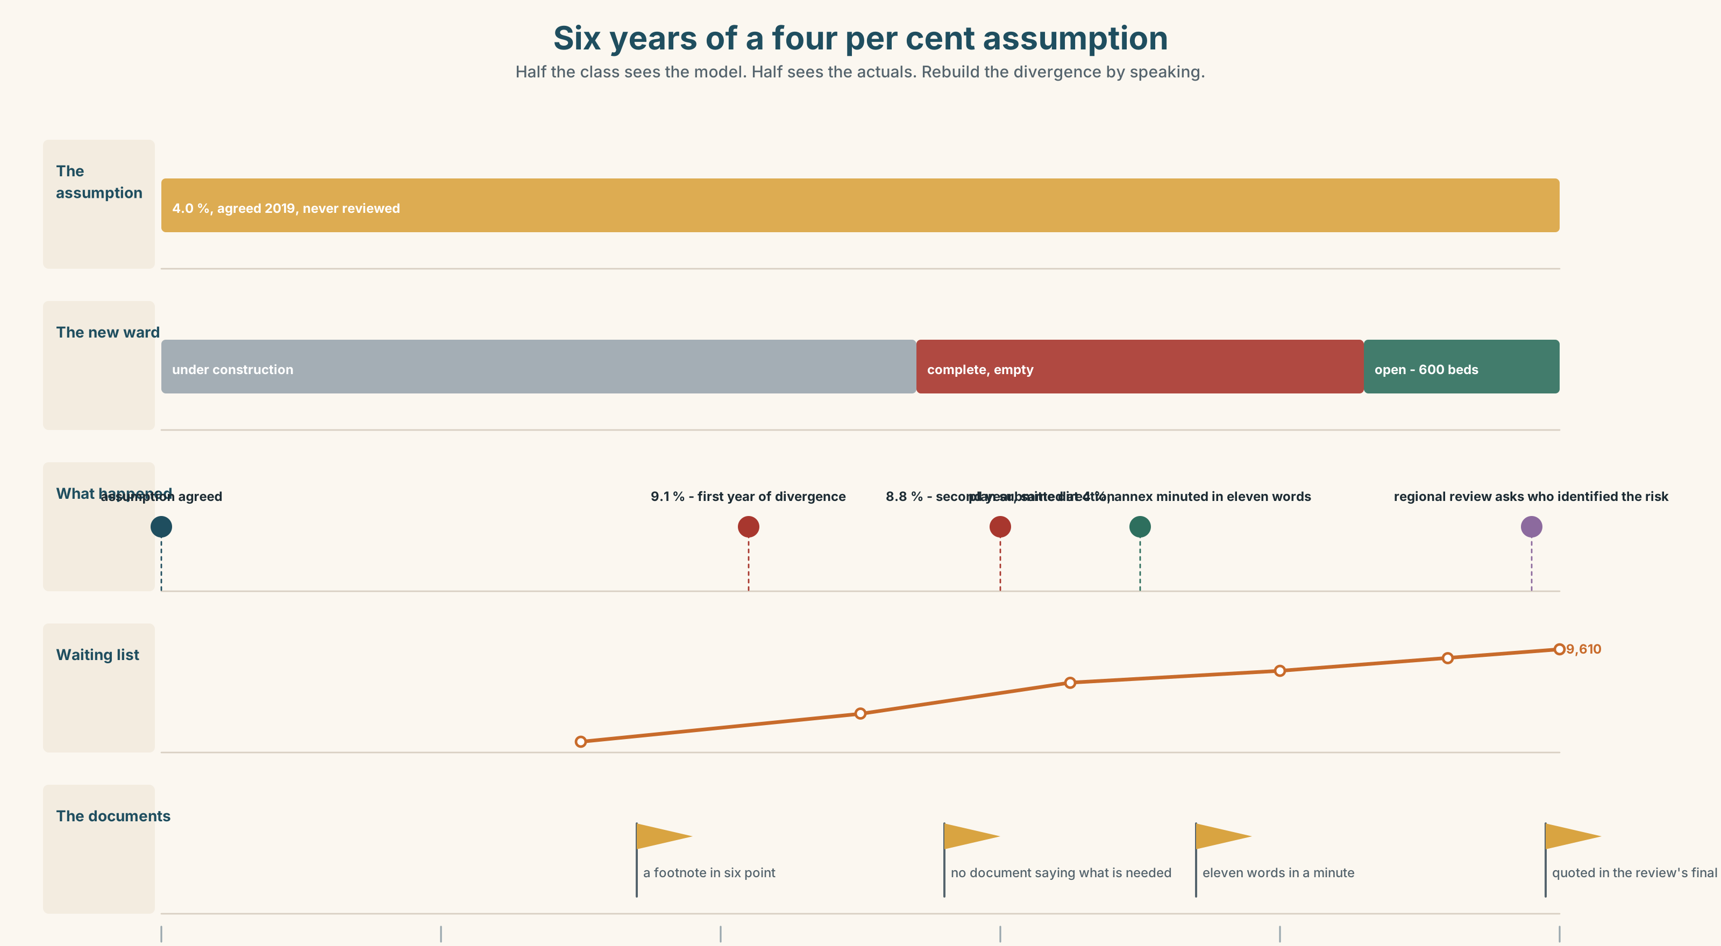{width=6.6in}
Six years of a four per cent assumption — Half the class sees the model. Half sees the actuals. Rebuild the divergence by speaking.

10A · Relay
Half the class sees the model. Half sees six years of actual figures. Rebuild the whole divergence by speaking. Twelve minutes.

10B · Simplify
Explain the three-year model from Part 5E to a ward manager who has to staff for it. Five sentences only.
Plan: what it assumes → what that means for your ward → what the real figure would mean → when the two separate → what you should plan for

10C · Compress
The column in Part 5 into forty words, keeping the proposal.

10D · Online
Write one message to the finance lead: you will submit the four per cent plan, you want the nine per cent annex minuted, and you are naming the date you need an answer by.

10E · Your language
How does your language say by the time the ward opens? Does the time clause take a future form or a present one? Say it in both languages and compare.

Part 11 · The Decision ◆ C · THE PERFORMANCE

Plan honestly, or plan approvably
The three-year plan is due in six weeks. The model assumes four per cent. Demand has risen nine per cent for two years.
- Submit at four per cent. It will be approved. The department will be running on a plan that nobody in it believes, for the third year.
- Submit at nine per cent. It will be returned for revision, which costs four months, and the department will spend those four months on the current plan anyway.
- Submit at four with a nine per cent annex. It will be approved and the annex will probably not be read, and it will exist.

11A · The evidence
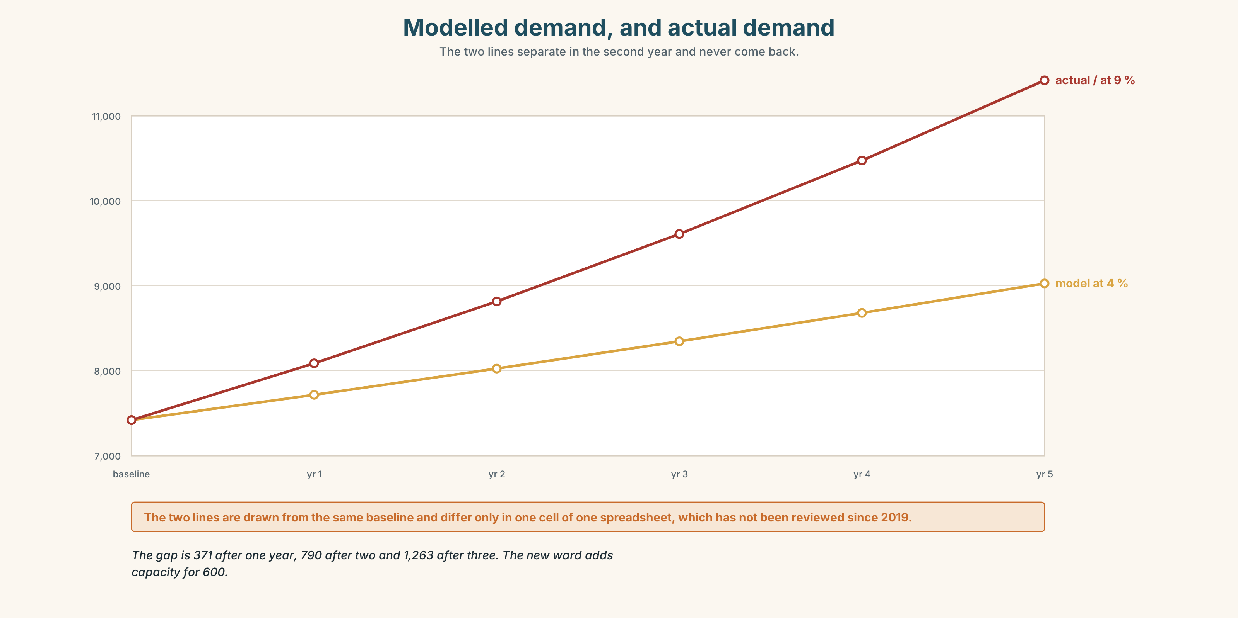{width=6.6in}
Modelled demand, and actual demand — The two lines separate in the second year and never come back.
- The model and the actuals from Part 5E — and the footnote on the growth cell.
- The chart — modelled and actual demand, and the point at which they separate.
- The voice. The finance lead, thirty seconds: "I have submitted the four per cent plan for six years. I have never believed it and I have never been criticised for it. If I submit nine I will be told to revise it, and when I resubmit at four, which I will, the only thing that will have changed is that it will be August."

11B · Talk about it
In fours. Everybody speaks twice. Use the frame.
By year three we will have ______ , which assumes ______ . If instead ______ , then ______ .
Words you can use: projection · forecast · target · assumption · baseline · variance · capacity · demand · shortfall · on current trends · best case · worst case

11C · Decide
Write three sentences. Choose, say why, and name what it costs.
I think they should ______________________ , because ______________________ . What this costs is ______________________ .

11D · Model decision
Submit at four with the annex, and ask for the annex to be minuted rather than attached. An attachment can be lost and a minute cannot. The column is right that the real damage is the absence of a record, and the cheapest possible record is one sentence in the minutes of a meeting that is going to happen anyway. It costs nothing, it will change nothing this year, and in four years it will be the only evidence that anybody knew.

11E · The Reveal
What happened. The plan went in at four per cent with a one-page annex. The finance lead asked for the annex to be minuted and it was, in eleven words.
The plan was approved in April. Demand in that year rose 8.4 per cent. The annex was not discussed at any meeting.
In the third year the regional office began a review of why four hospitals had missed the same target. One of its first requests was for any documentation showing that departments had identified the risk in advance. Three hospitals had nothing. This one had eleven words in a minute, and the review's final report quotes them.
Nobody read the annex. The eleven words in the minute did the whole job, three years later.
Was it the right decision? Say why — and say what the other three hospitals should do now.

Part 12 · Landing ◆ all three lines

12A · Recycle — twelve items
- By March we ______ (pass) eleven thousand.
- By March we ______ (run) at ninety per cent.
- By the time the ward ______ (open), the list ______ (double).
- In June we ______ (work) on it for two years.
- On current ______ , the list reaches eleven thousand.
- That four per cent is a working ______ .
- They have had to scale ______ the plan twice.
- At this ______ we run out of corridor in 2029.
- (Unit 4) There ______ (must / be) two of them. (past)
- (Unit 3) If we ______ (advertise) in March, we ______ (have) somebody now.
- (A2.2 U9) ______ of it can be carried over. (zero, uncountable)
- (A2.1 U5) We'll start as soon as it ______ (arrive).

12B · Consolidate
One hundred and sixty words. A three-year projection for anything you know. Baseline, assumption in its own sentence, two projections, and the date at which they separate.

12C · Can-do, with evidence
I can… | My evidence | Sure?
say what will be finished and what will still be running at a future date | Part 3H score | ◯ ◑ ●
present a three-year projection in three minutes | Part 4C recording | ◯ ◑ ●
write 160 words in which every number has an assumption | Part 8 draft 2 | ◯ ◑ ●
give and act on four kinds of feedback | Part 9D pair work | ◯ ◑ ●

12D · Replay ⏺
Find your forty-five seconds from Part 0C. Listen. Record it again. Two sentences: what is different, and whether your assumption has got more or less honest.

12E · Glossary — forty-five items, as a map
THE PLAN · projection · forecast · target · deadline · milestone · baseline · a working assumption THE NUMBERS · assumption · variance · capacity · demand · throughput · shortfall THE SCENARIOS · on current trends · all things being equal · best case · worst case · run out of road WHAT YOU DO TO A PLAN · scale up · scale back · bring in · push back · set out · see through THE DEADLINE · by · by the time · by then · within the year · no later than · annually AHEAD · eventually · ultimately · shortly · imminently · meanwhile · henceforth · thereafter · progressively · cumulatively · over the period · year on year · at this rate WHAT PEOPLE SAY · that is the number we are planning on · it has never been four per cent · this time next year we will have

12F · Next
Unit 6 · Who does this to you?

