Table of Contents

B1.2 · Unit 6 · Four Hours on the Phone
English Animated · Weighing It Up · Hospital Regional, Valdivia Student's Book pages 116–137 · 22 pp · ~11 hours

Part 0 · The Big Picture ◆ A · THE WORLD
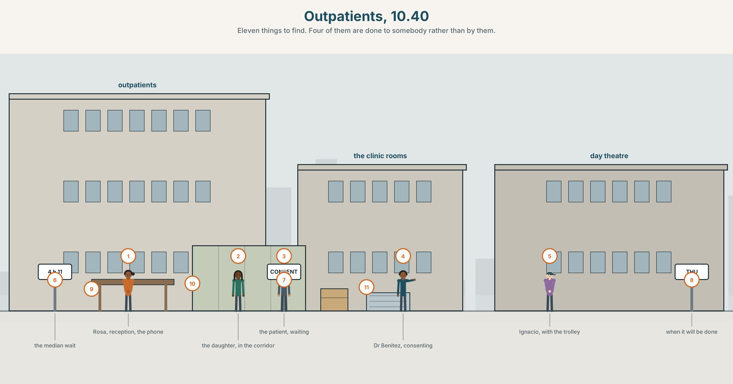{width=6.6in}
Outpatients, 10.40 — Eleven things to find. Four of them are done to somebody rather than by them.

Who does this to you?
By the end of this unit you can explain a procedure entirely from the patient's side. One hundred and sixty words.
◆ A · THE WORLD | A building in which things are done to people by people they never meet
◆ B · THE SYSTEM | modal and perfect passives · have something done · 23 words for care and services · 22 verbs of causing and permitting · where the stress goes in have it done
◆ C · THE PERFORMANCE | A hundred and sixty words with the patient as the subject

0A · Find it
Find eleven things in this picture. Four of them are things done to somebody rather than by them.
a referral letter · a consent form · a wristband · a trolley being pushed · a name on a list · a curtain being drawn · a phone on hold · an interpreter poster · a discharge summary · a bell push · a chair for a relative

0B · Guess it
Two people in this picture are making decisions and three are having decisions made about them. Which, and what in the drawing tells you?

0C · Say it ⏺
Record forty-five seconds. Describe something that was done to you — medical, official, anything. Who did it, and did you know their name? You will record it again at the end of this unit.

Part 1 · Vocabulary Lab 1 ◆ B · THE SYSTEM
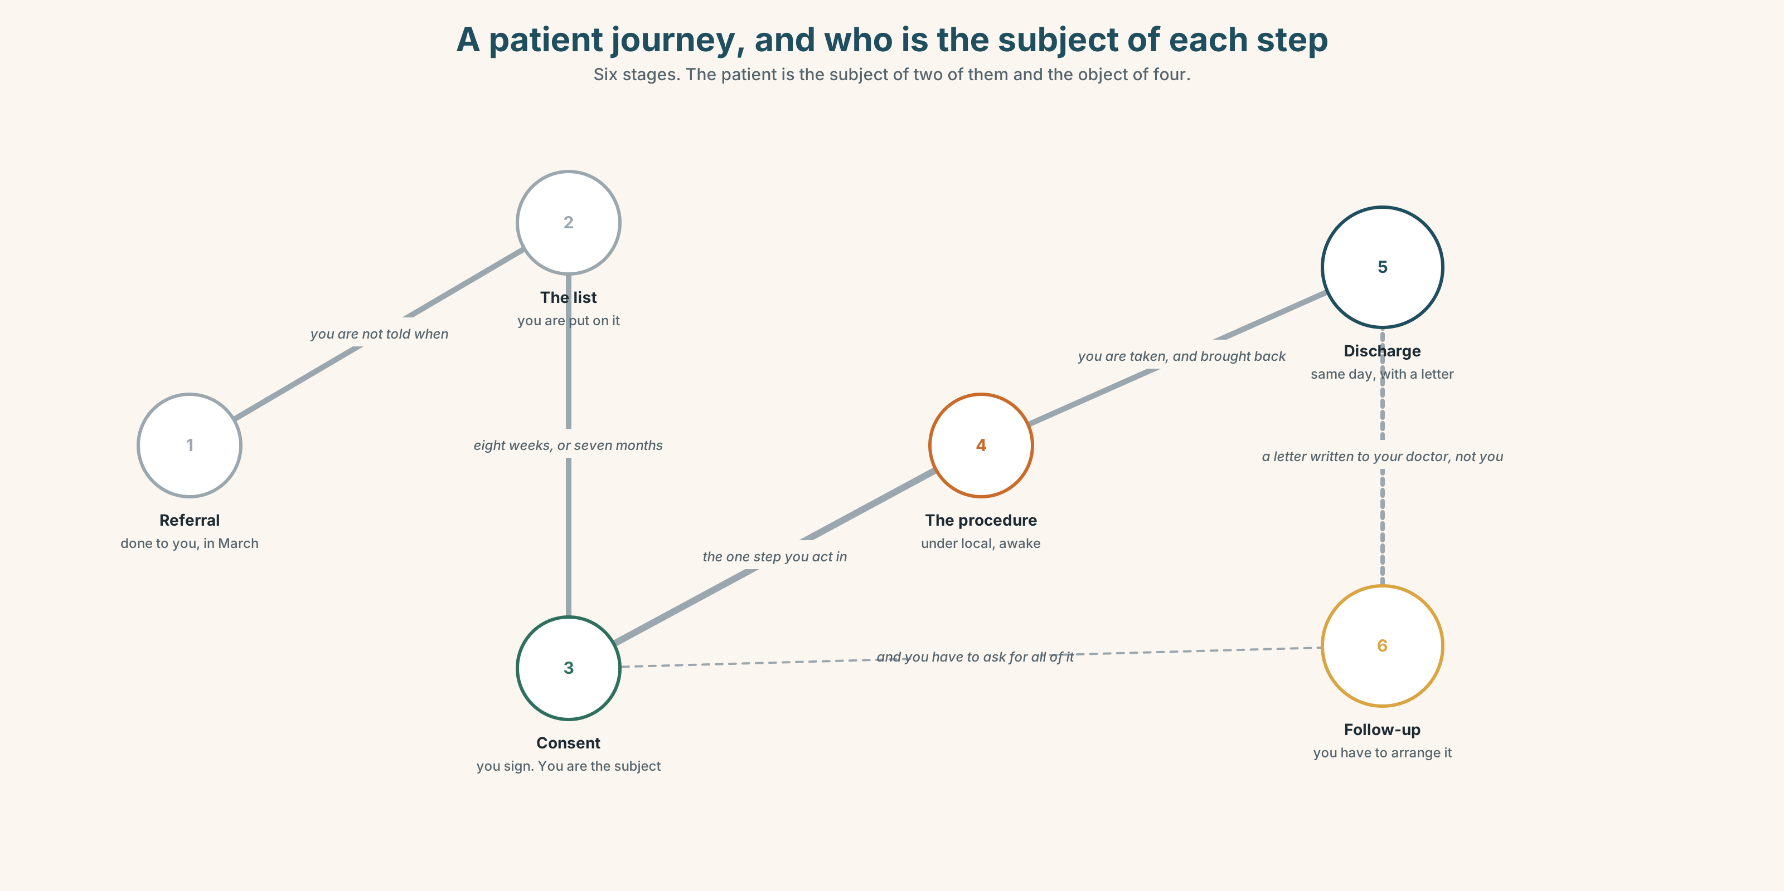{width=6.6in}
A patient journey, and who is the subject of each step — Six stages. The patient is the subject of two of them and the object of four.

1A · Meet — the words of a patient journey
Match each word to one place on the map.
referral · admission · consultation · procedure · ward · theatre · sedation · discharge · follow-up · consent

1B · Sort — a place, an event, or a document?
Three columns.
ward · referral · consent · theatre · admission · discharge · procedure · follow-up · consultation
Two of them are an event and a document with the same name. Which, and how can you tell which is meant?

1C · Meet — two people who are not staff
interpreter · carer
Both of them are essential and neither is employed. Which of the two is on the rota, and which is in the corridor?

1D · Collocation Lab
Complete each one with one word.
- She was referred ______ rheumatology in March and has not been seen.
- He will be ______ by a consultant, not a registrar — that is what the letter says.
- It is done under ______ , so you are awake and you feel the pressure and not the pain.
- You cannot be put ______ a list without a referral, and you cannot get a referral without being on a list.
- Written ______ is required for anything that breaks the skin.
- The operation has been brought ______ to Thursday and nobody has told the family.

1E · The fixed expressions
f Nobody explained any of it. f They did it while I was asleep.
Two sentences from the same complaint file. Neither of them is an accusation of harm.
What are they actually complaining about? Write the policy sentence that would answer each.

1F · Own it
Think of a service you have used — medical, legal, official. Tell a partner four sentences from the position of the person it was done to: what happened, who did it, what you were asked, and what you were told.

Part 2 · Listening ◆ A · THE WORLD
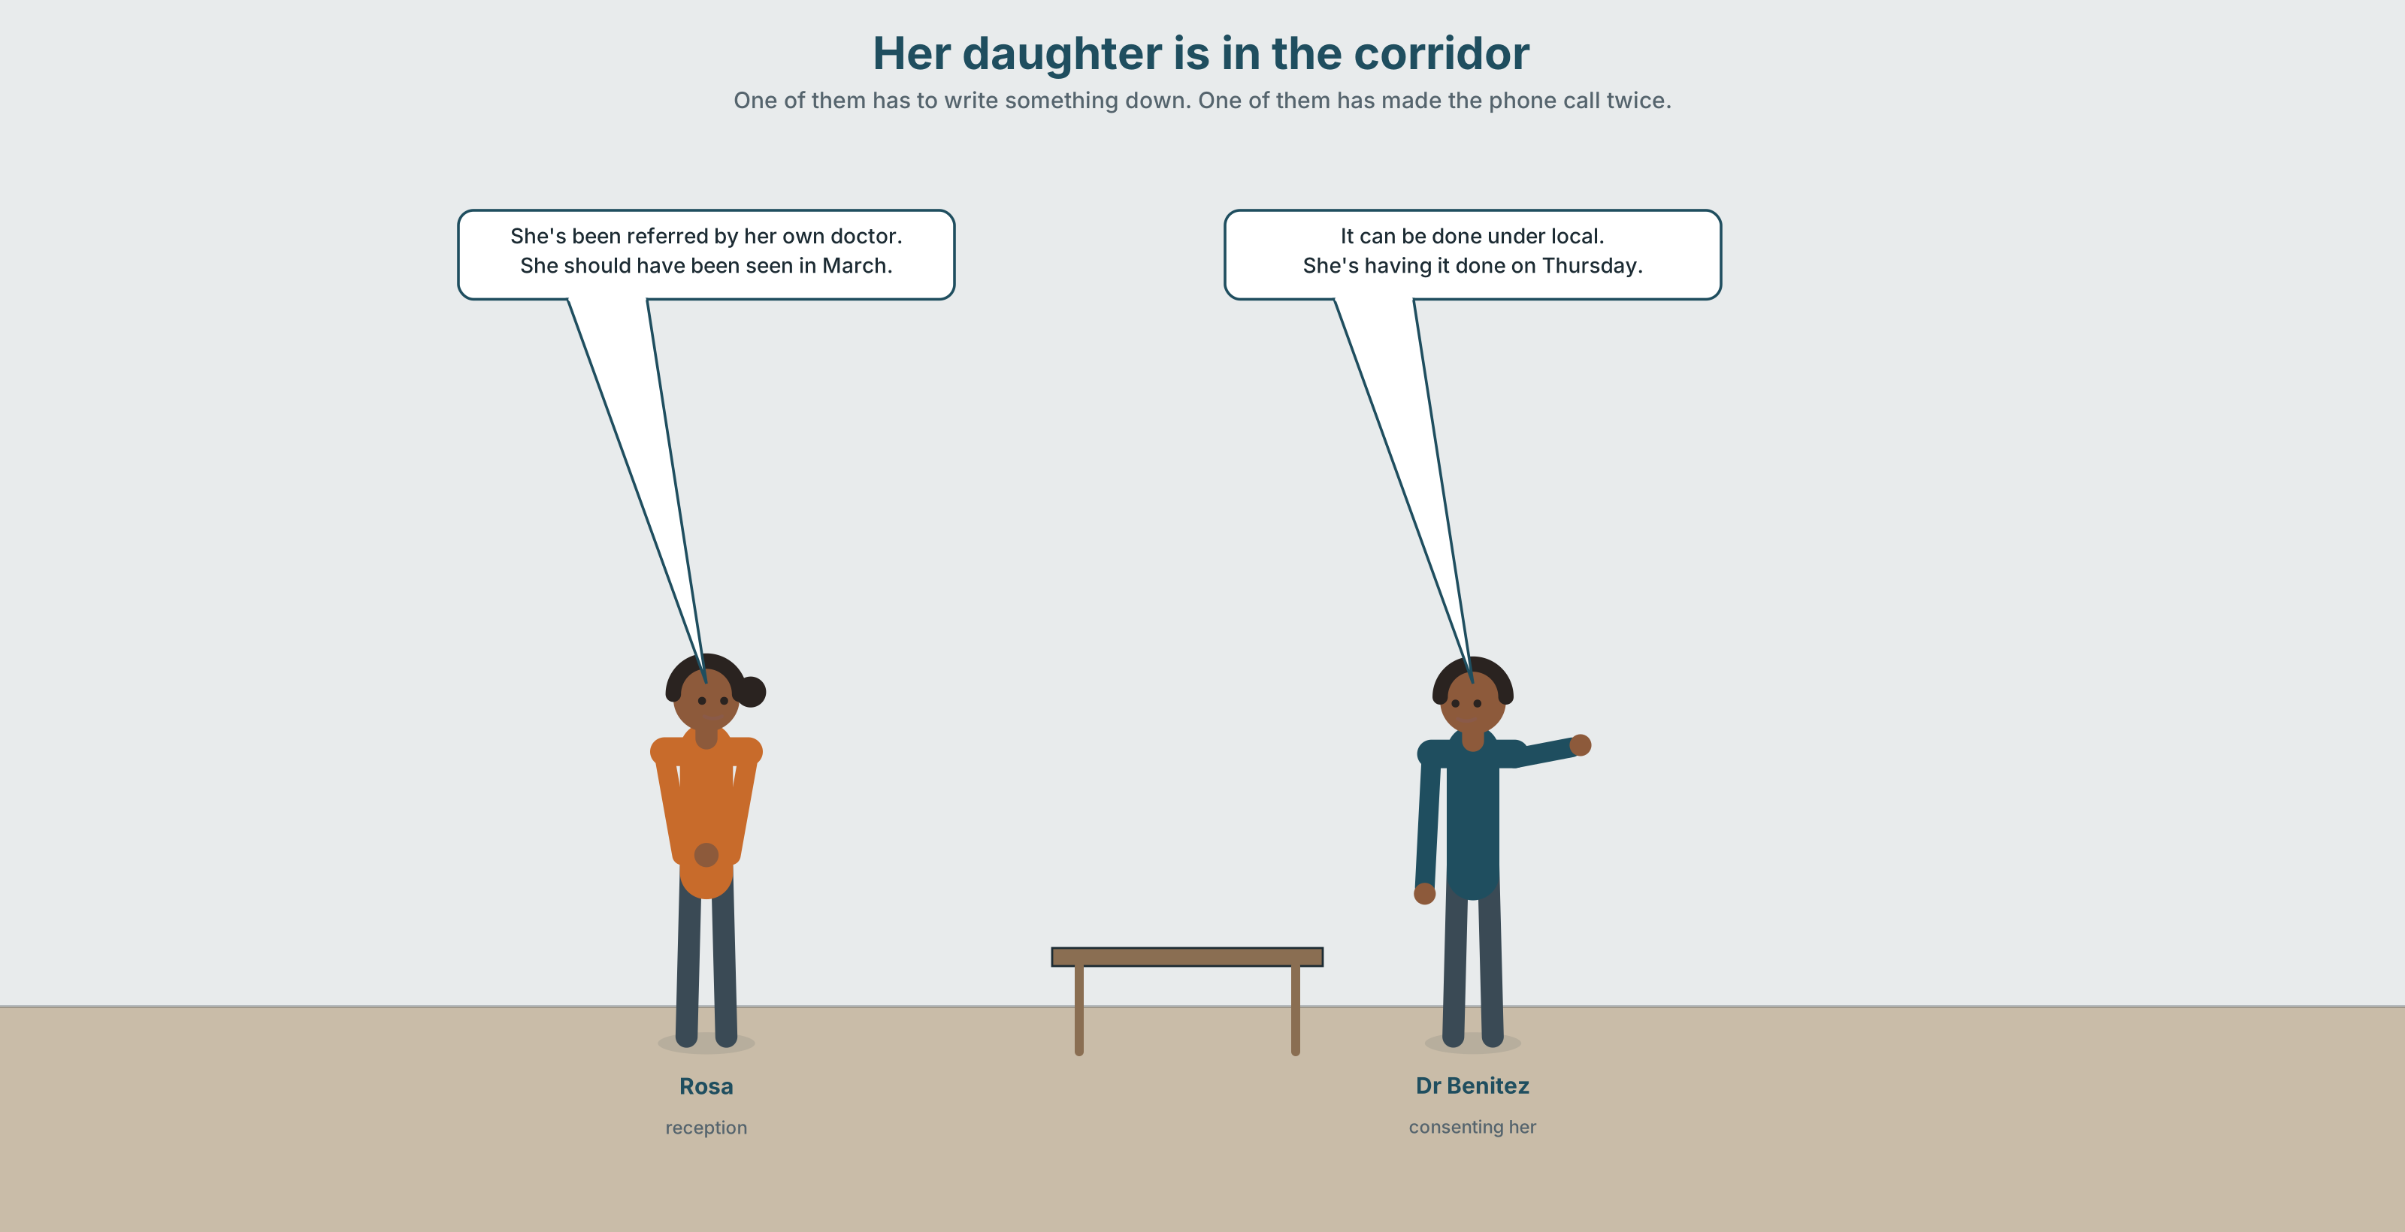{width=6.6in}
Her daughter is in the corridor — One of them has to write something down. One of them has made the phone call twice.

2A · Her daughter is in the corridor 🔊 Track 6.1
Before you listen. A patient wants her daughter to interpret. Policy says the telephone interpreting service must be used. Guess: how long is the queue?
Listen once. One question. What is the patient being consented for?
Listen again. Complete the table.
 | What they want | What the policy says | What they are worried about
the patient
Dr Benítez
Rosa
Listen again. Choose the best answer.
- The telephone service queue is about forty minutes / two hours / four hours.
- The daughter is sixteen / twenty-four / forty-one.
- The policy exists mainly to protect the hospital / the patient / the family.
- The procedure is urgent / today, not urgent / next week.
Noticing. Four sentences from the recording.
- She's been referred by her own doctor.
- It can be done under local.
- She should have been seen in March.
- She's having it done on Thursday.
Three of these are passives. One is a causative. Which, and what is the difference?

2B · Decoding clinic 🔊 Track 6.2
Thirty seconds of Rosa. Four jobs.
- How many passive forms can you count?
- In she's having it done, which word carries the stress?
- Catch the two times she gives.
- She uses one phrase that avoids naming who decided. Which?
Transcripts, page 155.

Part 3 · Grammar Lab 1 ◆ B · THE SYSTEM

Things done to you, and things you arrange

3A · Notice
Look at the four sentences in Part 2.
- In sentence 1, who did the referring? Is it named?
- Sentence 2 is a modal passive. What is the full shape?
- Sentence 3 is a perfect passive with should. What is it criticising?
- In sentence 4, who is doing the procedure? And who is the subject of the sentence?
- Try "She's doing it on Thursday." How does that change who she is?

3B · See
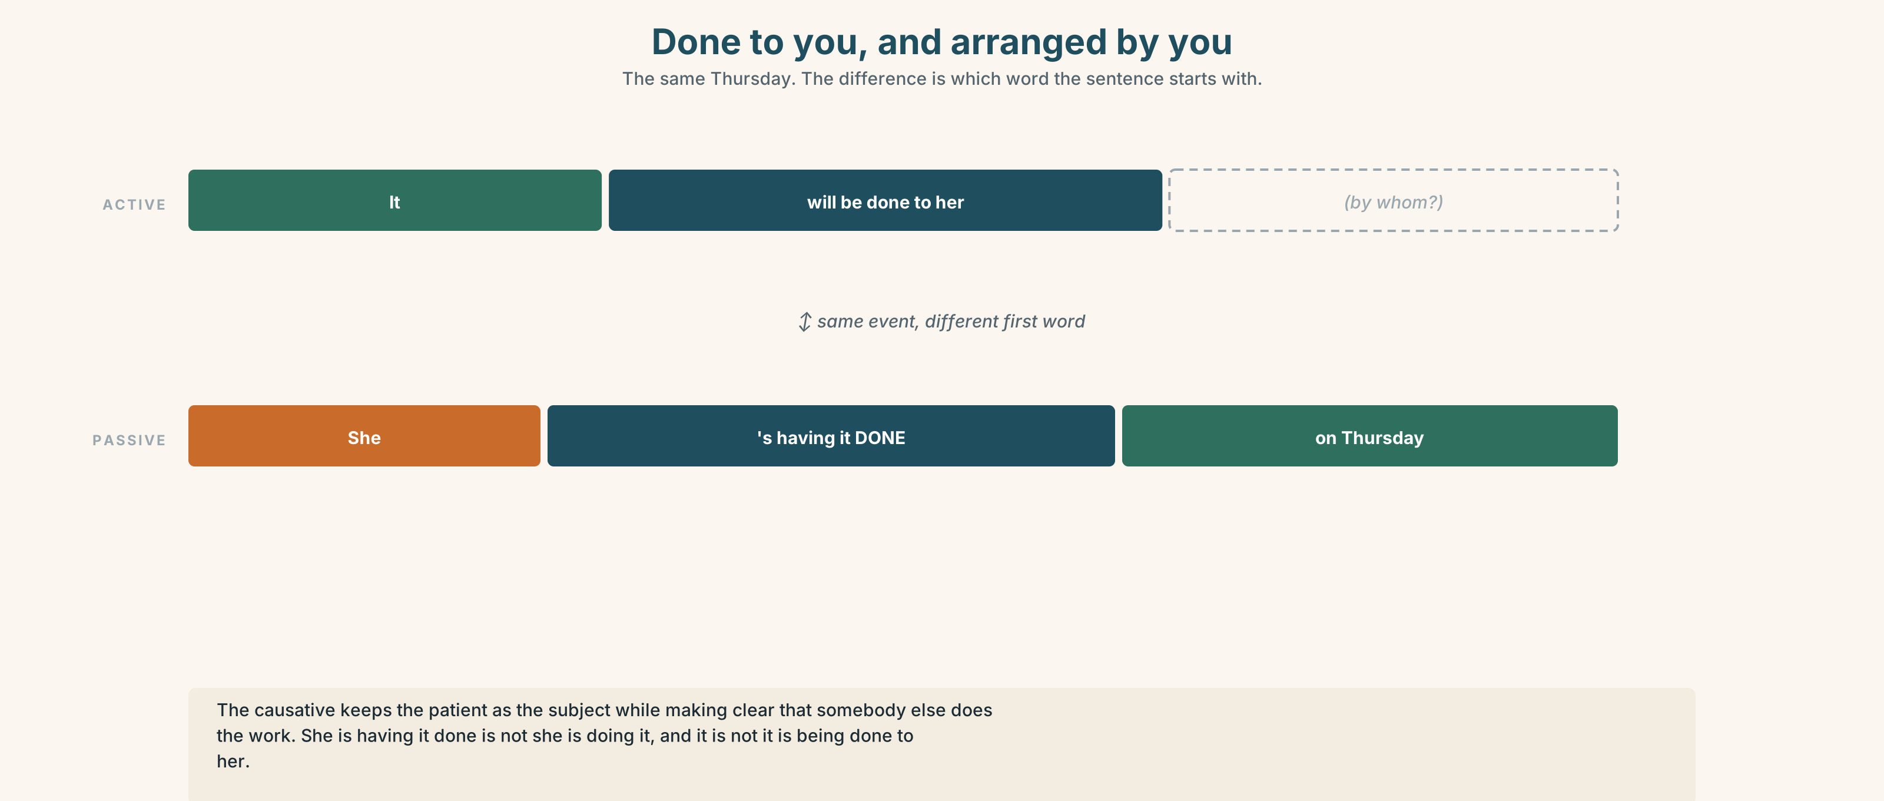{width=6.6in}
Done to you, and arranged by you — The same Thursday. The difference is which word the sentence starts with.

3C · Know
 | Shape | Example
modal passive | modal + be + pp | It can be done under local.
perfect passive | have + been + pp | She has been referred.
modal perfect passive | modal + have been + pp | She should have been seen in March.
causative: have | have + object + pp | She*'s having it done** on Thursday.*
causative: get | get + object + pp | I got my notes sent to the clinic.
The causative keeps the patient as the subject while making it clear that somebody else is doing the work. She is having it done is not the same as she is doing it, and it is not the same as it is being done to her: it says she arranged it, or that it is happening to her as part of her plan.
get is the informal causative and carries a faint sense of effort or arrangement: I got it sorted. Have is neutral.
The verbs that take an object and a to-infinitive: cause, allow, permit, require, oblige, entitle, get. The verbs that take an object and a bare infinitive: make, let. ✓ They made her wait. ✓ They required her to wait. ✗ They made her to wait.
In the passive, make takes to again. ✓ She was made to wait.

3D · Use — controlled
The patient (1) __________ (refer) by her own doctor in March. She (2) __________ (should / see) within eight weeks and was not. The procedure (3) __________ (can / do) under local, so she will be awake. She (4) __________ (have) it done on Thursday. Her daughter (5) __________ (not / allow) to interpret, because the policy (6) __________ (require) a registered interpreter, and she (7) __________ (make) to wait four hours for the telephone service on two previous occasions. Nothing (8) __________ (explain) to her in a language she speaks.

3E · Use — guided
Rewrite each one. Keep the patient as the subject.
- A consultant will see her. (passive)
- Somebody should have told her in March. (modal perfect passive)
- The hospital is arranging her transport. (causative)
- The policy does not permit her daughter to interpret. (passive, patient as subject)
- They forced her to wait four hours. (passive)

3F · Use — open
In pairs. Describe a service you have used twice: once with the institution as the subject, once with yourself. Three minutes each. Then say which version you would send as a complaint, and which as a thank-you.

3G · Error autopsy
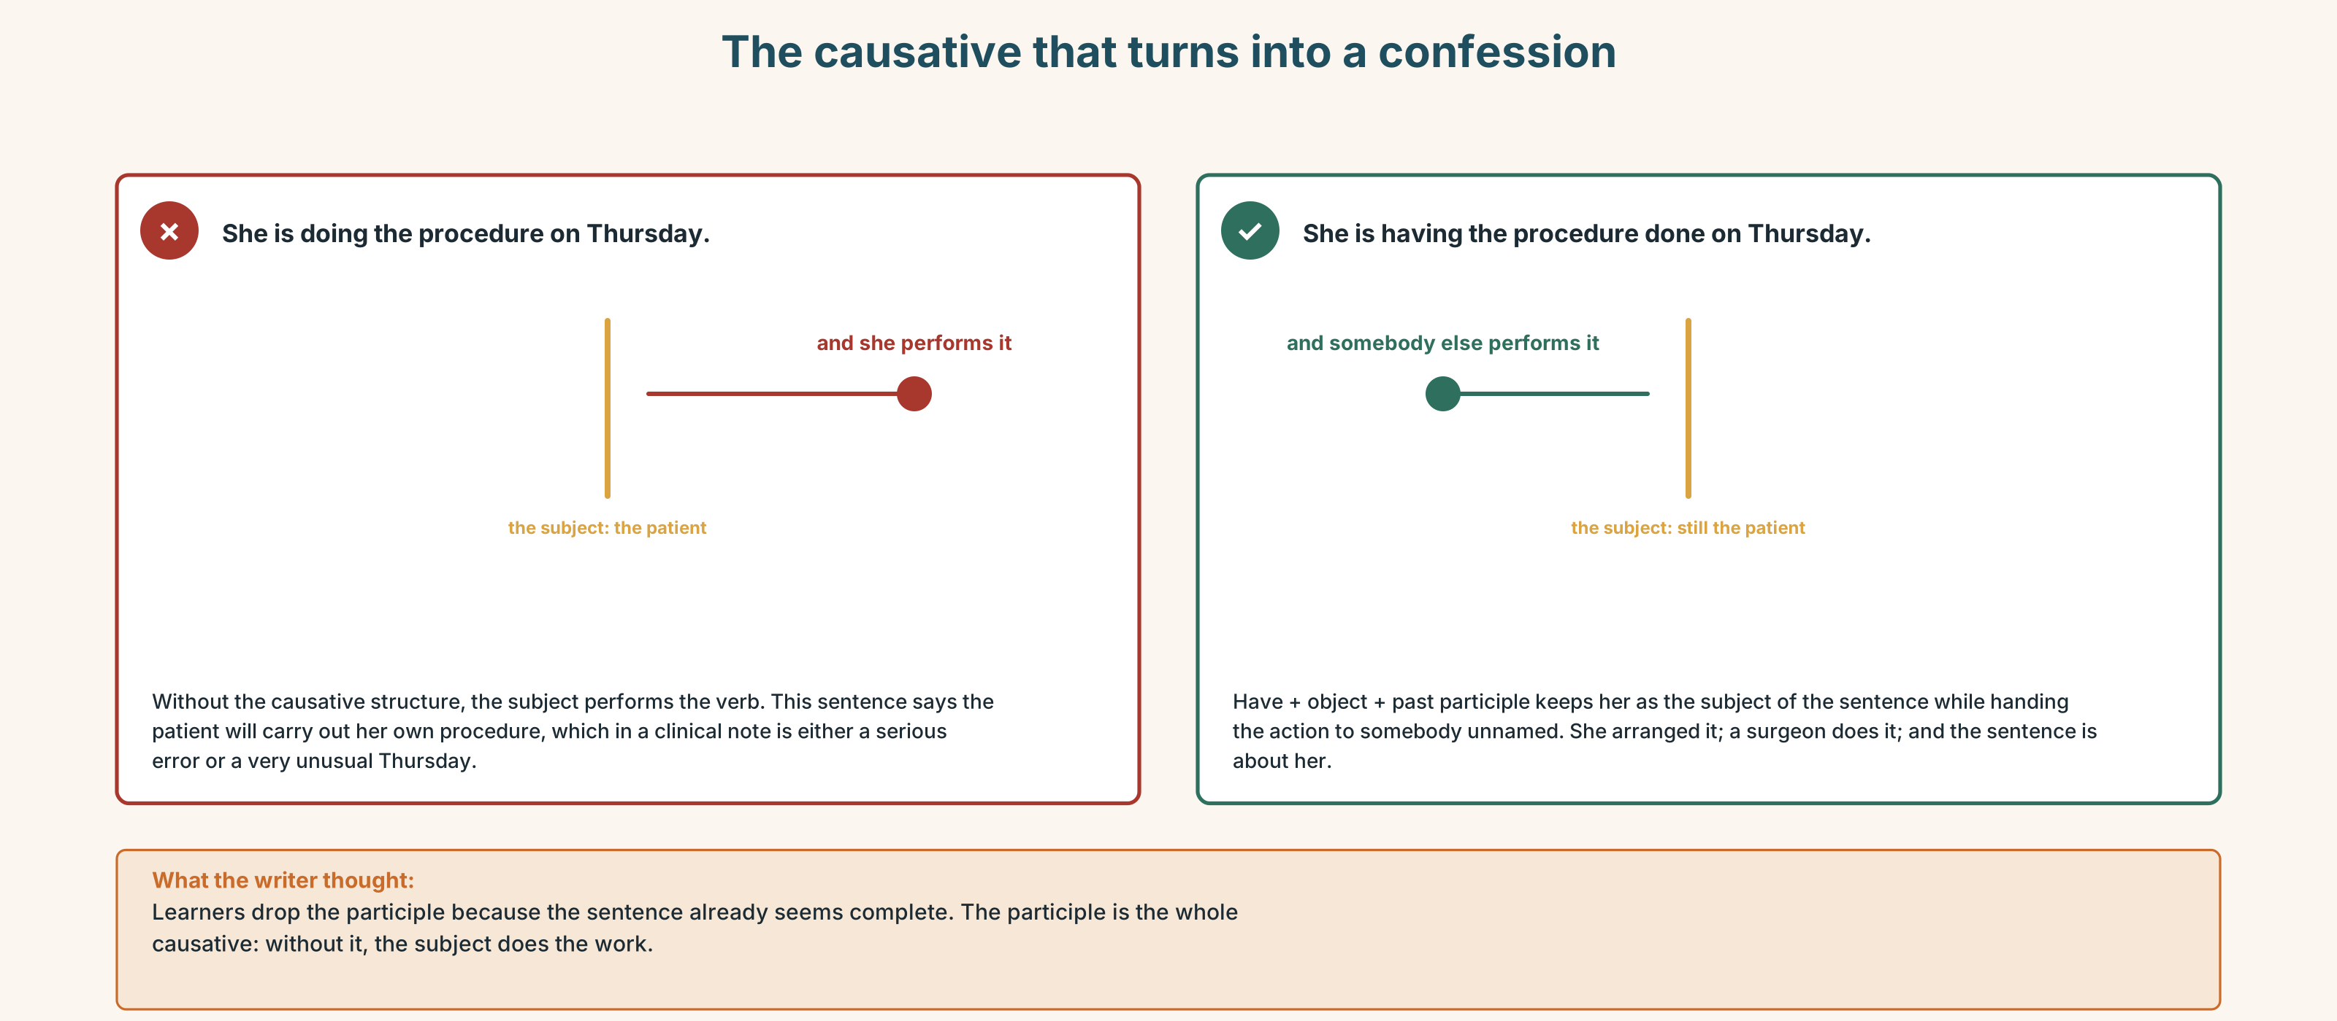{width=6.6in}
The causative that turns into a confession — The causative that turns into a confession
Read both versions. Then say what the first one accidentally says about the patient.

3H · Check — eight items
- She ______ (refer) by her own doctor.
- She ______ (should / see) in March.
- It ______ (can / do) under local.
- She ______ (have) it done on Thursday.
- Her daughter ______ (not / allow) to interpret.
- She ______ (make) to wait four hours.
- The policy ______ (require) a registered interpreter.
- I ______ my notes ______ (send) to the clinic. (causative, informal)
0–4 → Workbook pp. 34–37. 5–6 → Part 6. 7–8 → page 129.

Part 4 · Speaking ◆ C · THE PERFORMANCE

4A · Fluency starter — two subjects
Your teacher names an everyday service. Each learner describes it twice in thirty seconds: once with the institution as the subject, once with the customer. Four services. Four rounds.

4B · The functional core — the patient's side
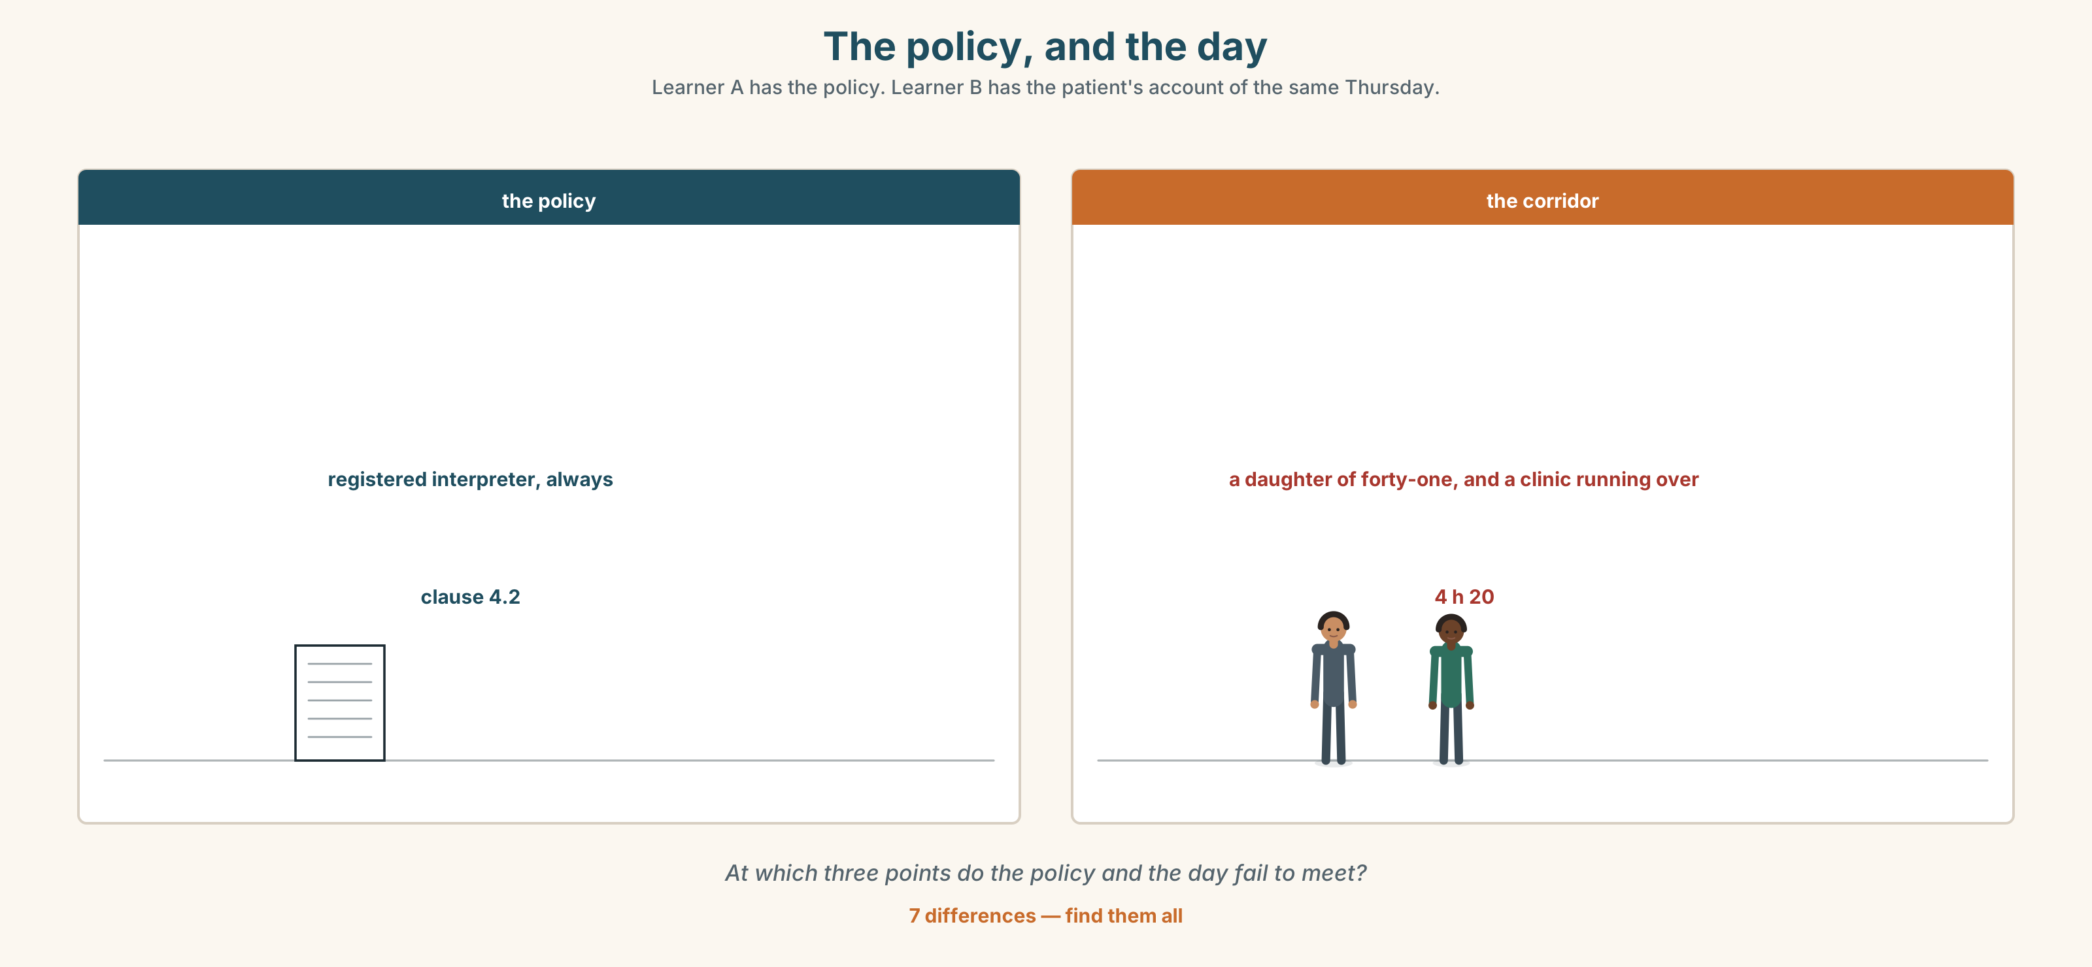{width=6.6in}
The policy, and the day — Learner A has the policy. Learner B has the patient's account of the same Thursday.
Language Bank
what happens to you | You'll be taken to… · You'll be seen by… · It'll be done under…
what you arrange | You can have it done… · Get your notes sent…
what you are entitled to | You're entitled to… · You're not required to…
the honest gap | Nobody will tell you… · You will have to ask.
Information gap. Learner A has the policy. Learner B has the patient's account of the same day. Find the three points at which the policy and the day do not meet.

4C · The performance — two minutes ⏺
Explain a procedure entirely from the patient's side. Two minutes. You must include:
what will be done to you · who will do it, named by role · what you have to arrange yourself · one thing nobody will tell you
Record it.

4D · Observer
One person listens for one thing: was the patient the subject of every sentence?

4E · Three criteria
☐ Did I use a modal passive and a causative? ☐ Is the patient the subject throughout? ☐ Did I name one thing the patient has to ask for?

Part 5 · Reading ◆ A · THE WORLD

5A · Predict
A feature article. The title is "The four-hour queue exists to protect her, and she has never used it." What do you expect the argument to be? Two sentences.

5B · Read — two minutes and a quarter

The four-hour queue exists to protect her, and she has never used it
The policy is correct. I want to establish that before anything else, because the piece that writes itself here is the one about heartless bureaucracy, and that piece would be wrong.
Family members should not interpret in clinical settings. The reasons are not procedural. A daughter will soften a prognosis. A son will omit a question about alcohol. A sixteen-year-old will be asked to say the word terminal to her own mother, and will be in a room for the rest of her life afterwards. Every hospital that has studied this has found the same thing, and the policy that follows from it is the right policy.
The telephone interpreting service that the policy requires has a median wait of four hours and eleven minutes.
So here is what actually happens, and it happens in every hospital I have visited in three countries. The clinician makes a judgement. For anything serious, they wait, and the four hours are real and the clinic runs over and other patients are seen late and the policy works. For anything routine — a consent for a minor procedure, a discharge explanation, a follow-up date — they use the daughter, and they do not write down that they used the daughter, because writing it down is a breach.
The policy therefore achieves two things. It protects patients in serious conversations, which is what it was for. And it produces a permanent, undocumented, unmeasurable practice in routine ones, which is the opposite of what a policy is for.
The queue is not a bureaucratic failure attached to a good policy. The queue is the policy, in the sense that a rule that cannot be followed is a rule about what gets written down.

5C · Comprehension — eight questions
- What does the writer establish first, and why?
- What three reasons does the writer give for the policy?
- What is the median wait for the telephone service?
- What do clinicians do for serious conversations, and what does that cost?
- What do they do for routine ones, and why is it not recorded?
- What are the two things the writer says the policy achieves?
- What does the writer mean by "the queue is the policy"?
- Why does the writer say the obvious article would be wrong?

5D · Vocabulary in context
Guess from the text. Then check.
the piece that writes itself · soften a prognosis · a median wait · the clinic runs over · a breach

5E · The counter-text
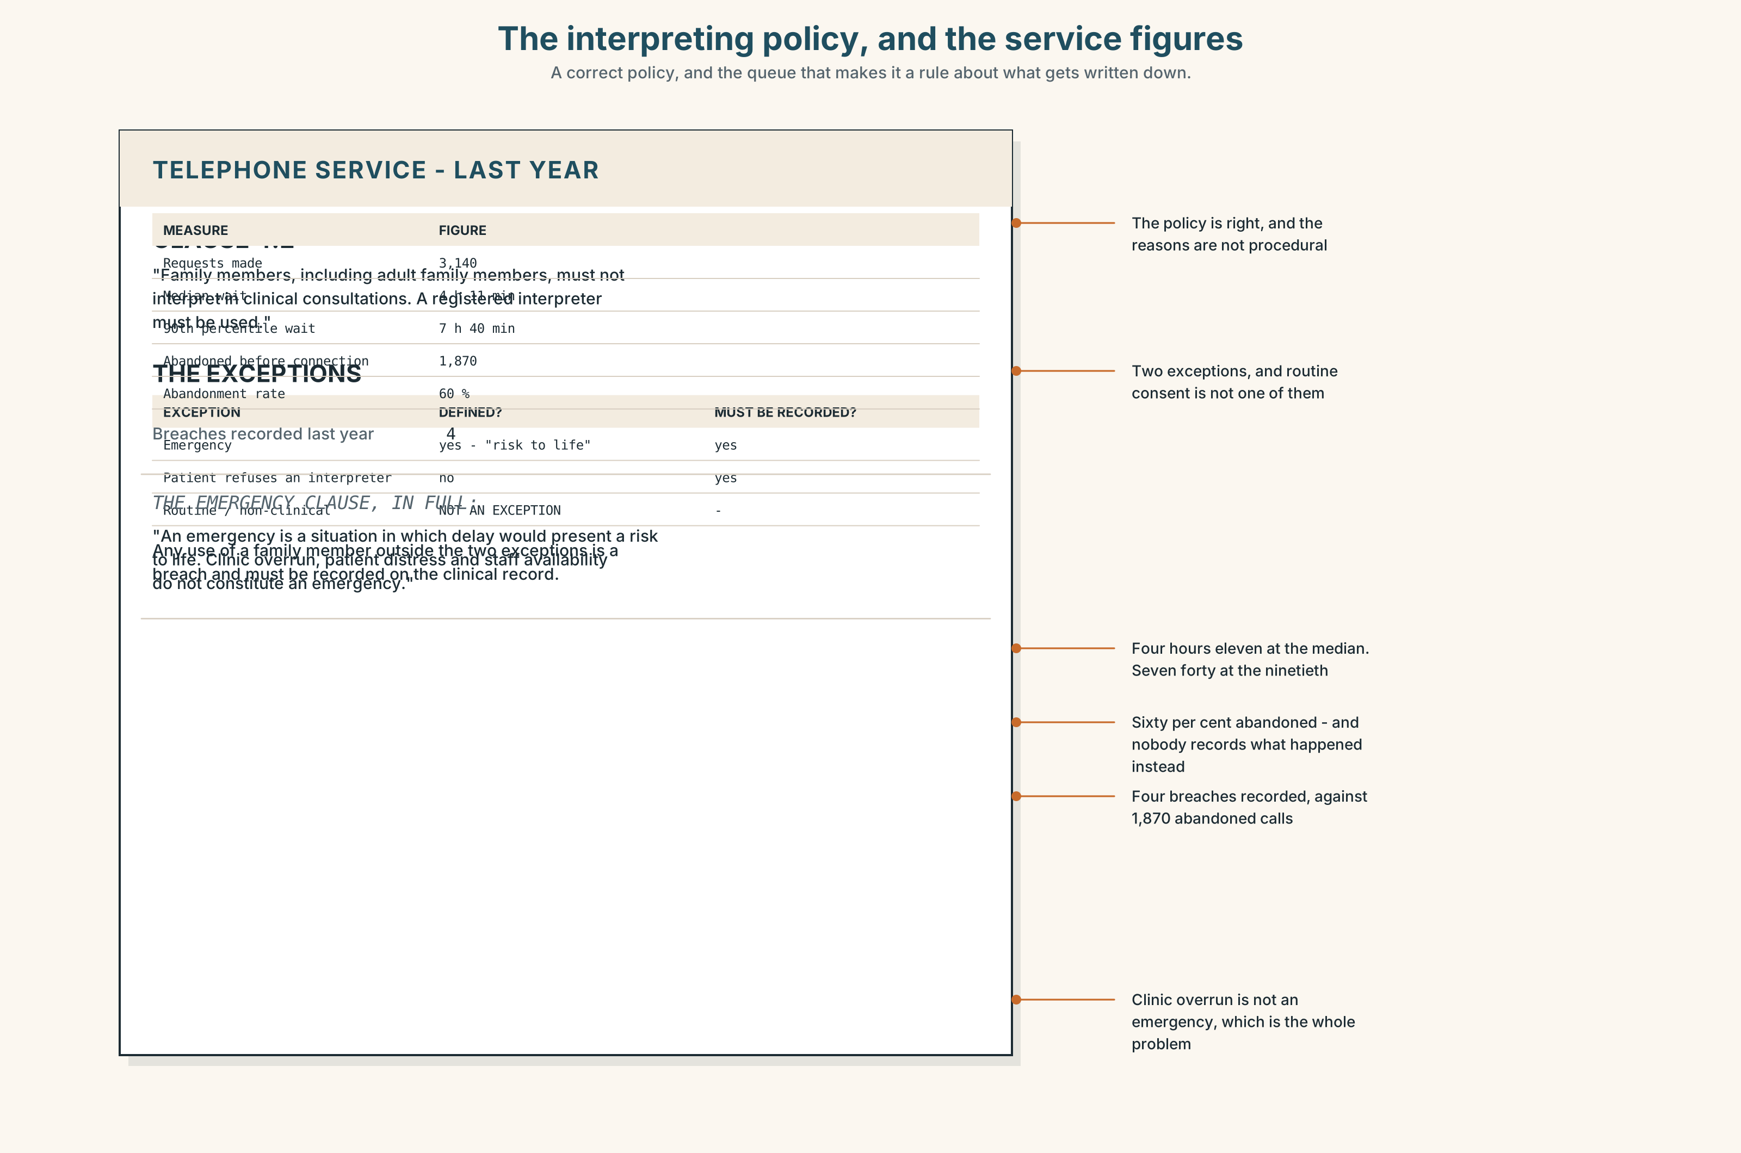{width=6.6in}
The interpreting policy, and the service figures — A correct policy, and the queue that makes it a rule about what gets written down.
Read the interpreting policy and the service's own figures, and answer.
- What does the policy forbid, and what two exceptions does it list?
- What is the median wait, and what is the ninetieth-percentile wait?
- How many requests were made last year, and how many were abandoned?
- What does the policy say must be recorded when a family member is used?
- One clause defines an emergency. What does it say, and what does it not cover?

5F · Two texts
The feature says routine use of family members is undocumented. The policy requires every such use to be recorded on the clinical record.
Put those two facts together. What does the abandonment figure actually measure? Three sentences.

Part 6 · Vocabulary Lab 2 ◆ B · THE SYSTEM

Who made whom do what

6A · Sort — bare infinitive, to-infinitive, or past participle?
Three columns.
make · let · allow · require · oblige · entitle · cause · get · have · permit
Two of them change column when they go into the passive. Which?

6B · Chunk completion
- She had it ______ on Thursday.
- He got the notes ______ to the clinic himself.
- She was made ______ wait four hours.
- You are not ______ to pay for this.
- The request was made on ______ of the patient by her daughter.
- Rosa saw ______ the transport when nobody else would.

6C · Three that look like permission and are not
entitle · oblige · require
Entitle gives a right. Oblige and require impose a duty, and oblige has a flavour of moral pressure that require does not.
Which fits each sentence, and what changes with the others?
- You are ______ to an interpreter at every appointment.
- The clinician is ______ to record the use of a family member.
- Nobody is ______ to explain why they did not.

6D · The fixed expression
f I had it taken out.
Say it twice: as somebody describing a decision they made, and as somebody describing something that happened to them. The words do not change. What does?

6E · Contrast Clinic
Eight items. Passive, modal passive, perfect passive or causative.
- Her doctor referred her.
- Somebody should have seen her in March.
- They can do it under local.
- She is arranging for somebody to do it on Thursday.
- The policy does not permit her daughter to interpret.
- They forced her to wait.
- Nobody explained it to her.
- I arranged for my notes to be sent. (informal)

Part 7 · Pronunciation & Fluency Lab ◆ B · THE SYSTEM

The word that moves the stress
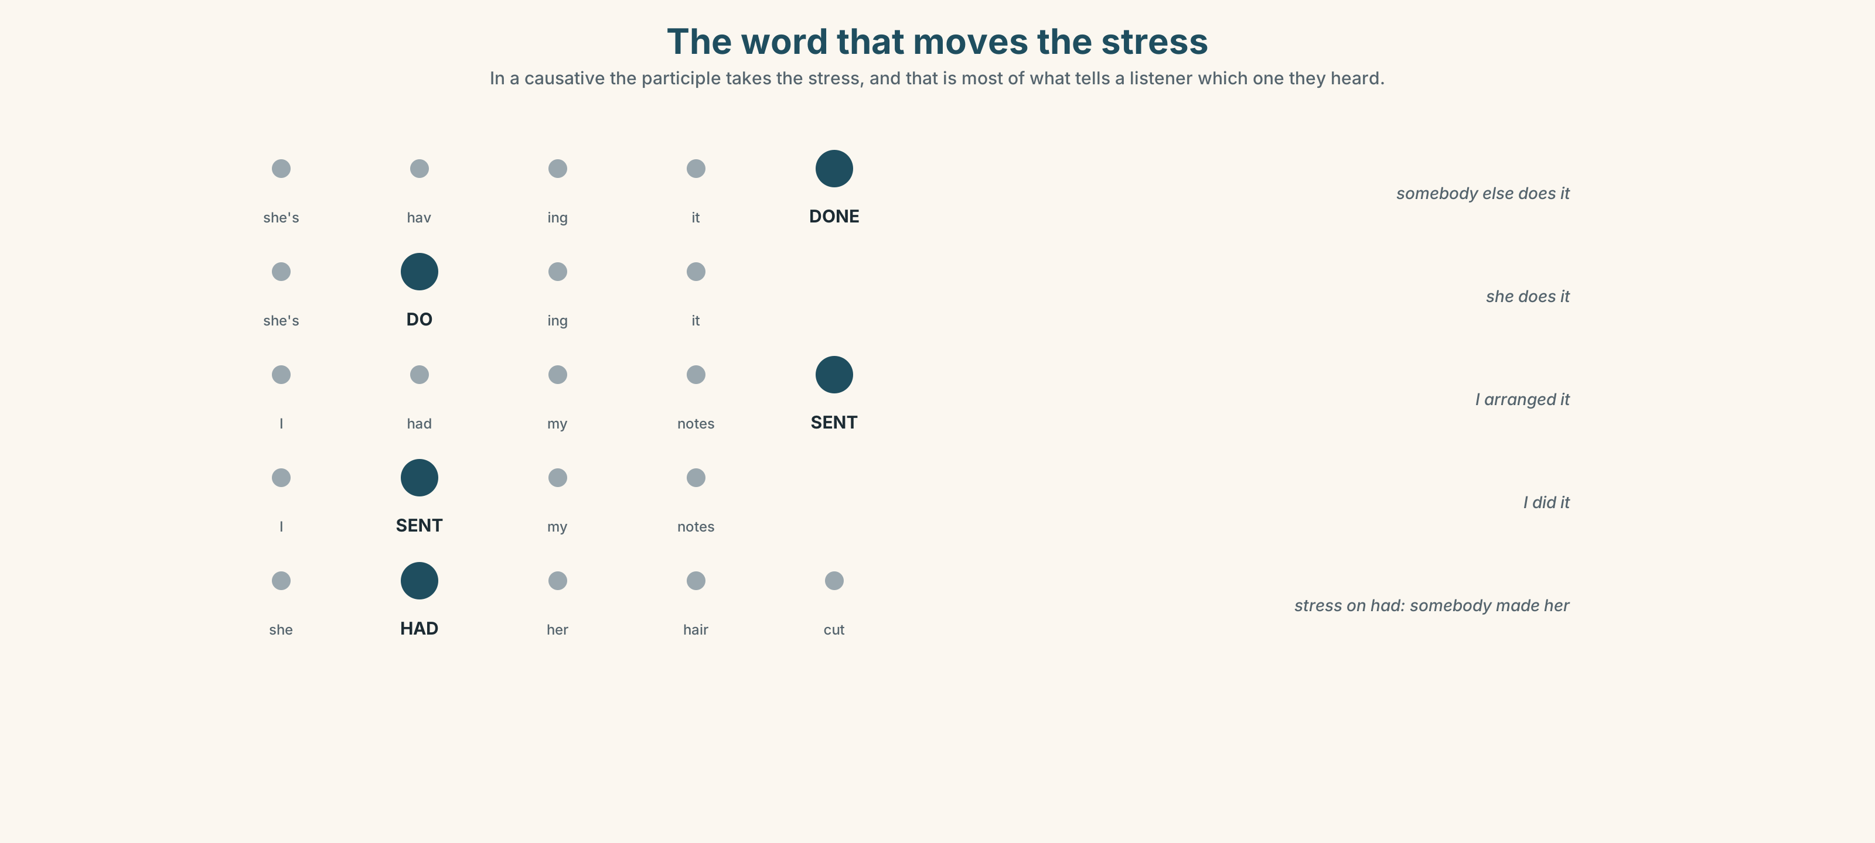{width=6.6in}
The word that moves the stress — In a causative the participle takes the stress, and that is most of what tells a listener which one they heard.

7A · Hear 🔊 Track 6.3
She's having it DONE. — somebody else does it She's DOing it. — she does it I had my notes SENT. — I arranged it I SENT my notes. — I did it
The participle takes the stress in a causative, and that is most of what tells a listener which one they are hearing.

7B · Say
Say all four. Then say the sentence three times, faster:
She's having it done on Thursday and she's having the notes sent on Monday.

7C · Make it mean something
Say these two:
She had her hair cut. (a hairdresser) She had her hair cut. (said with stress on HAD — somebody made her)
English uses the same words for an arrangement and a misfortune. Which one is which, here?

7D · Fluency 30 ⏺
Thirty seconds: three things you have had done and three things you did. Three times, faster, with the stress in the right place.

Part 8 · Writing ◆ C · THE PERFORMANCE

A procedure, from the patient's side · 160 words
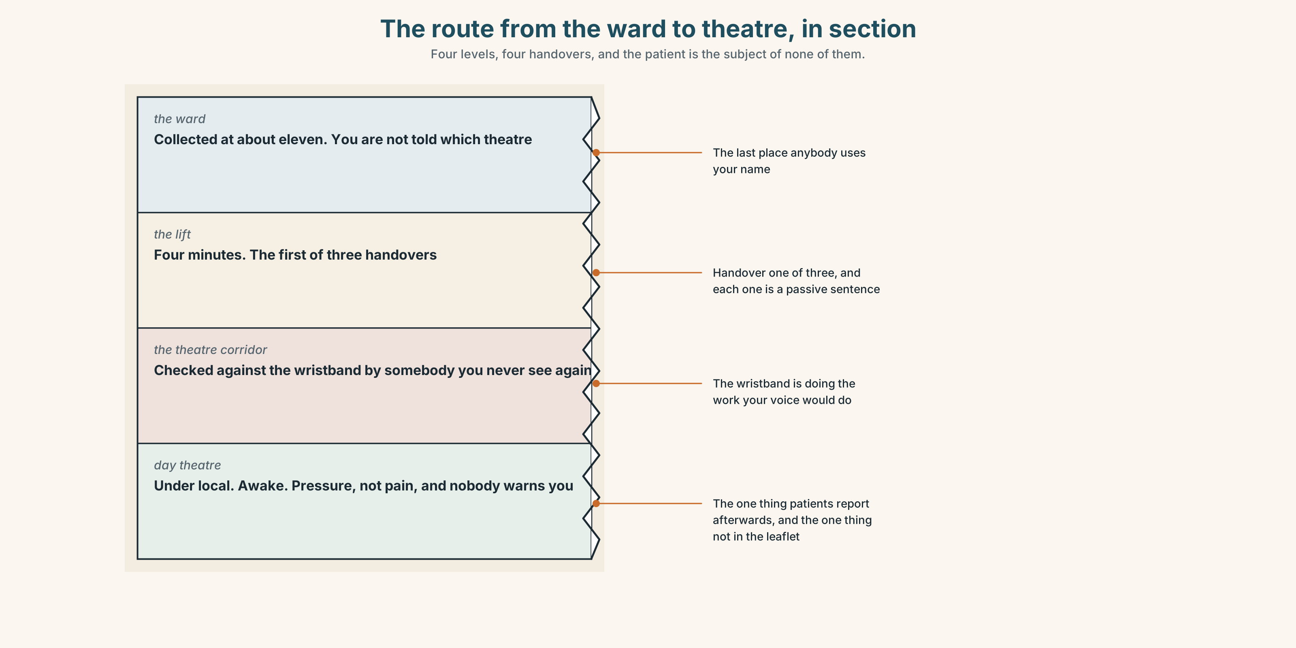{width=6.6in}
The route from the ward to theatre, in section — Four levels, four handovers, and the patient is the subject of none of them.

8A · Read the model
You will be collected from the ward at about eleven, by a porter, on a trolley, and you will not be told which of the three theatres you are going to. [everything in the passive, the patient as subject, and one thing stated as a known absence]
It is done under local, which means you will be awake and you will feel pressure and not pain, and nobody will warn you about the pressure. [what the words actually mean, in the patient's body]
You can have a relative with you until the door and not past it. You will have to ask for this. [one entitlement and one causative, and the entitlement comes with a condition]
You will be sent home the same day with a letter you cannot read, because it is written to your own doctor. Ask for the second paragraph to be explained before you leave. [the discharge, and one piece of advice that could only come from somebody who has watched this]
Questions about the writer's choices:
- Every sentence has you as the subject. What does that do that a procedure leaflet does not?
- Three sentences say what you will not be told. Is that hostile to the hospital?
- The last sentence is an instruction to the reader. Why end there?

8B · The anti-model
The procedure is performed under local anaesthetic and takes approximately twenty minutes. Patients are usually discharged the same day. A discharge summary will be sent to your GP. Please contact the department if you have any questions.
Correct English, and the patient appears twice as an object and never as a person. Rewrite the first sentence with the patient as the subject, and name one thing the leaflet does not say.

8C · Plan
what will be done to you, and by whom → what the technical words mean in your body → one thing you have to arrange or ask for → what happens afterwards, and the one question to ask

8D · Write — 160 words

8E · Peer review — three criteria
☐ Is the patient the subject of every sentence? ☐ Is there one causative and one modal passive? ☐ Is there one thing the reader is told to ask for?

8F · Write it again · 8G · Publish
On the wall, with the policy from Part 5E beside it.

Part 9 · The File ◆ A · THE WORLD + C · THE PERFORMANCE

CULTURE FILE · The Misunderstanding
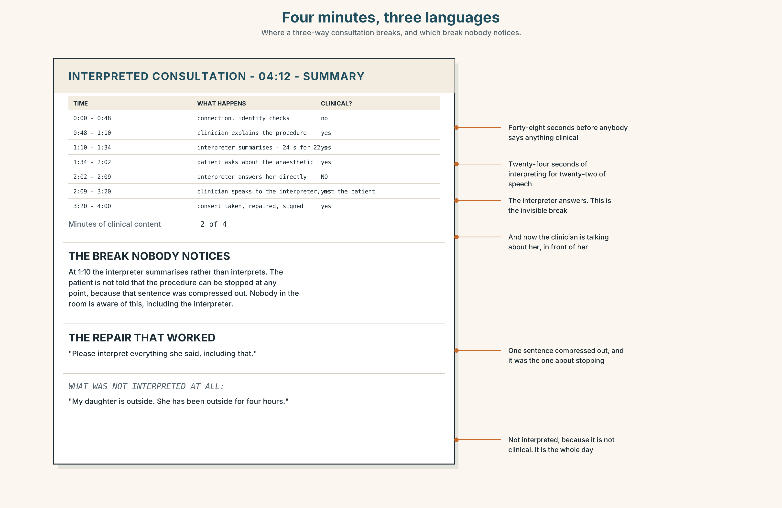{width=6.6in}
Four minutes, three languages — Where a three-way consultation breaks, and which break nobody notices.

9A · Four minutes, three languages 🔊 Track 6.4
A consultation with a telephone interpreter, a clinician and a patient. Listen to all of it.
- How many of the four minutes are spent on the actual clinical content?
- Where does the first misunderstanding happen, and who repairs it?
- One thing the patient says is not interpreted at all. What, and why might that be?

9B · Where a three-way conversation breaks
the clinician speaks to the interpreter instead of the patient · the interpreter summarises rather than interprets · the patient answers the interpreter rather than the clinician · a technical word has no equivalent and is left in English
Which of the four happens in the recording? And which of the four is the hardest to notice?

9C · The repairs
Match each to its job.
"I'm going to speak to you, and she will say it in your language." · "Please interpret everything she said, including that." · "Can you tell me what word you used for that?" · "I'll say that again more simply."
setting up the triangle · asking for completeness · checking a term · repairing your own English

9D · Your turn
In threes. Twelve minutes. One clinician, one patient, one interpreter — and the "interpreter" may only use words of two syllables or fewer. The clinician must use all four repair moves at least once.

9E · Transfer
Find one three-way conversation this week — any language, any setting. Write down who spoke to whom, and whether anybody was talked about in their presence.

Part 10 · Mediation & Interaction ◆ C · THE PERFORMANCE
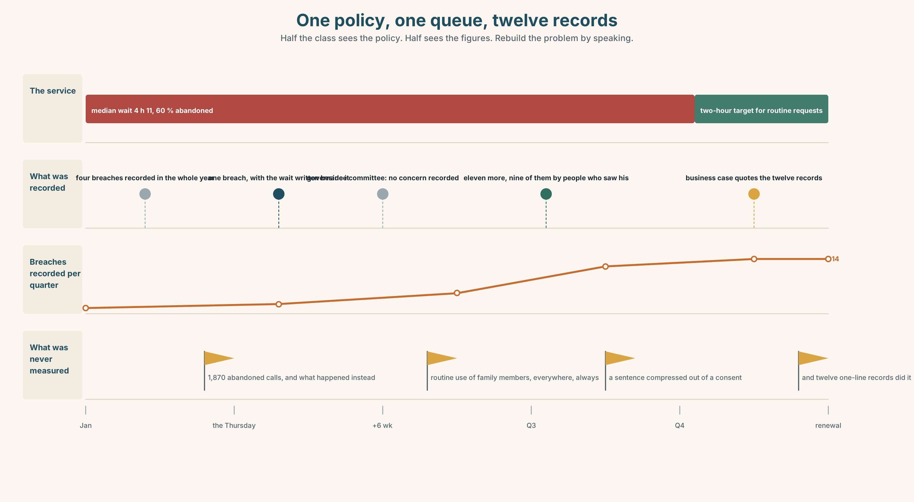{width=6.6in}
One policy, one queue, twelve records — Half the class sees the policy. Half sees the figures. Rebuild the problem by speaking.

10A · Relay
Half the class sees the policy. Half sees the service's figures. Rebuild the whole problem by speaking. Twelve minutes.

10B · Simplify
Explain the interpreting policy from Part 5E to a patient's daughter in the corridor. Five sentences only, and not one of them may blame her.
Plan: what the rule is → why it exists → what it means for today → what she can do → what she is entitled to ask for

10C · Compress
The feature in Part 5 into forty words, keeping the last paragraph's point.

10D · Online
Write one message to the interpreting service: you have the median wait, you have the abandonment rate, and you are asking for one specific thing for routine consultations.

10E · Your language
Does your language have a causative like have something done? Say I had my hair cut and I cut my hair in both languages. Which one needs more words?

Part 11 · The Decision ◆ C · THE PERFORMANCE

The daughter in the corridor
A patient is being consented for a minor procedure. Her daughter, who is forty-one, is in the corridor. The policy requires a registered interpreter. The telephone service has a median wait of four hours and eleven minutes.
- Follow the policy. Wait. The clinic runs over by four hours, eleven other patients are seen late, and three of them will not be seen today.
- Use the daughter and record it. The policy permits this in an emergency only, so recording it is recording a breach, which goes to the governance committee and names the clinician.
- Use the daughter and do not record it. What happens in practice, everywhere, and the reason nobody knows how often.

11A · The evidence
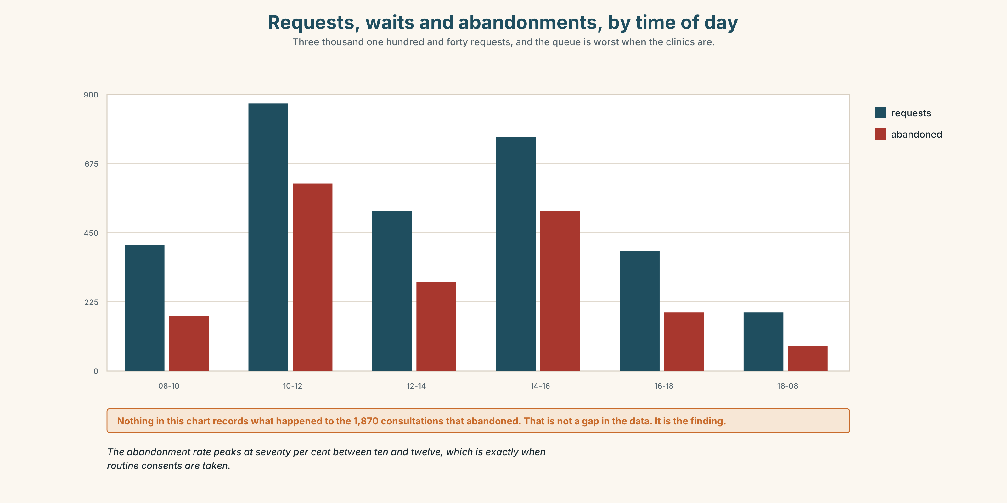{width=6.6in}
Requests, waits and abandonments, by time of day — Three thousand one hundred and forty requests, and the queue is worst when the clinics are.
- The policy and the service figures from Part 5E — and the emergency clause.
- The chart — requests, waits and abandonments, by time of day.
- The voice. The patient, through her daughter, thirty seconds: "I would like my daughter to do it. I am aware that she will make it sound better than it is. I have thought about that and I would still like my daughter to do it, and nobody has asked me this before, which is the part I mind."

11B · Talk about it
In fours. Everybody speaks twice. Use the frame.
If the policy is followed, ______ . If it is not, ______ . What is not recorded is ______ .
Words you can use: consent · procedure · interpreter · carer · be allowed to · be required to · on behalf of · written consent · nobody explained any of it

11C · Decide
Write three sentences. Choose, say why, and name what it costs.
I think the clinician should ______________________ , because ______________________ . What this costs is ______________________ .

11D · Model decision
Use the daughter, record it as a breach, and write one line saying why. The third option is the one everybody takes and it is the only one that guarantees nothing will ever change, because an unmeasured practice cannot be argued about. A breach that appears eleven times in a quarter, each with a four-hour wait beside it, is the only document that will ever get the service funded properly. It costs the clinician something. That is what it is for.

11E · The Reveal
What happened. Dr Benítez recorded it as a breach, with one line: telephone service wait 4 h 20 min, routine consent, patient's explicit request, daughter aged 41.
The governance committee reviewed it in six weeks and recorded no concern. Over the following quarter, eleven more breaches were recorded with similar lines, nine of them by people who had seen his.
The service's contract was renegotiated in the following year with a two-hour target for routine requests. The business case quotes the twelve breach records, which are the only documentation of the problem that has ever existed in this hospital.
He took the cost. Nine people copied him. And twelve one-line records did what four years of complaints had not.
Was it the right decision? Say why — and say what should happen to the policy now.

Part 12 · Landing ◆ all three lines

12A · Recycle — twelve items
- She ______ (refer) by her own doctor.
- She ______ (should / see) in March.
- It ______ (can / do) under local.
- She ______ (have) it done on Thursday.
- She ______ (make) to wait four hours.
- Written ______ is required for anything that breaks the skin.
- The operation has been brought ______ to Thursday.
- Rosa saw ______ the transport herself.
- (Unit 5) By March we ______ (pass) eleven thousand.
- (Unit 4) There ______ (must / be) two of them. (past)
- (A2.1 U7) The garlic ______ (grow) in China.
- (A2.2 U4) She ______ me that she had checked it. (said / told)

12B · Consolidate
One hundred and sixty words. A procedure or a service, entirely from the position of the person it is done to. One modal passive, one causative, one entitlement, one thing nobody will tell them.

12C · Can-do, with evidence
I can… | My evidence | Sure?
use passives and causatives to keep one person as the subject | Part 3H score | ◯ ◑ ●
explain a procedure from the patient's side in two minutes | Part 4C recording | ◯ ◑ ●
write 160 words in which the reader is the subject | Part 8 draft 2 | ◯ ◑ ●
run a three-way conversation through an interpreter | Part 9D role play | ◯ ◑ ●

12D · Replay ⏺
Find your forty-five seconds from Part 0C. Listen. Record it again. Two sentences: what is different, and whether you now know who did it.

12E · Glossary — forty-five items, as a map
THE JOURNEY · referral · be referred to · admission · consultation · be seen by · ward · theatre · procedure · discharge · follow-up THE PAPERWORK · consent · written consent · be put on a list · sign off · hand over THE PEOPLE · interpreter · carer · on behalf of · at the request of THE PROCEDURE · sedation · under local · have something done · have it done · get it done · I had it taken out WHO DECIDES · cause · arrange · get · make · let · allow · permit · require · ensure · oblige · entitle WHAT YOU MAY AND MUST · be made to · be allowed to · be required to · take over · see to WHAT GOES WRONG · bring forward · hold back · nobody explained any of it · they did it while I was asleep

12F · Next
Unit 7 · Did you stop to think, or stop thinking?

