Unit 1: Introduction to the Computer and the IT Department
English for Cybersecurity Personnel · Level: Upper A2 (the course moves to Low B1 from Unit 6) · Tracks: [OP] Warm-Up + Parts 1–6 · [PR] Parts 7–10
Warm Up
[OP] Operator track · in-class starter
Warm-up: Computer Words and Meanings
Match the computer words with their meanings. One meaning is not needed. Write the letter.
Column A
1. | Computer | ____
2. | Password | ____
3. | Screen | ____
4. | Help desk | ____
5. | File | ____
Column B
a) | a secret word that opens your account
b) | the keyboard you type on
c) | the machine you use to do your work
d) | the part you look at when you work
e) | the team you call when your computer has a problem
f) | a document you save and open again
Warm-up: In the IT Department
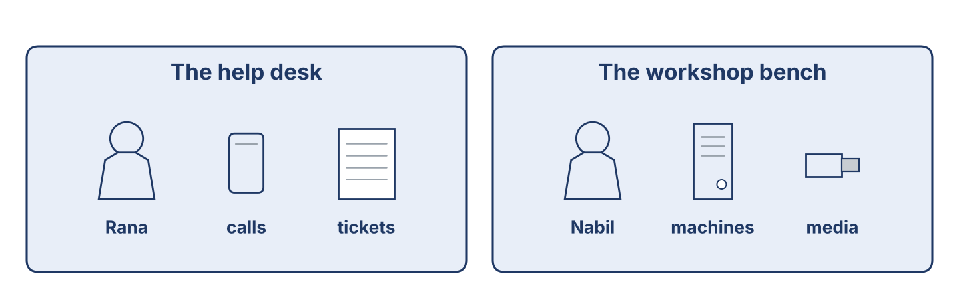
Figure 1.1 · The help desk and the workshop bench at Cham Systems.
Complete the sentences using the words in the word bank.
Word bank: password | help desk | file | screen
1. You type your ____________________ to open your account.
2. Rana works at the ____________________ .
3. Nabil saves the report as a ____________________ .
4. The ____________________ shows your work.
Warm-up: Reading About the IT Department
Read the text and choose the correct answer.
An IT and security department looks after the computers in a company. The user calls the help desk when there is a problem. The help-desk officer writes a ticket. Then a technician checks the machine at the bench. Safe, careful work is very important. A tidy desk and a locked screen keep information safe.
1. Who writes the ticket?
○ A) The user
○ B) The help-desk officer
○ C) The technician
○ D) The manager
2. Why is a locked screen good?
○ A) It keeps information safe
○ B) It is expensive
○ C) It is slow
○ D) It is new
Part 1 · Vocabulary and Terminology
[OP] Operator track · pre-class input
Part 1: Computer and Security Terms
Match the words with their meanings. One meaning is not needed. (0. is done for you.)
0. Help desk → the team you call when your computer has a problem.
Column A
1. | Server | ____
2. | Account | ____
3. | Password | ____
4. | Backup | ____
5. | Update | ____
6. | Ticket | ____
7. | Screen lock | ____
Column B
a) | a copy of your files, kept in a safe place
b) | a new version that fixes problems in a program
c) | a record of a problem and the work done on it
d) | the name the computer knows you by
e) | a big computer that keeps files for many people
f) | a secret word that opens your account
g) | a cable that joins two machines
h) | the step that hides your screen when you leave your desk
Gloss: server = a big computer that keeps files for many people · account = the name the computer knows you by
Gloss: backup = a copy of your files, kept in a safe place · ticket = a record of a problem and the work done on it
Part 1: Pronunciation
🔊 Audio Track 1.1
Listen and practise these words. Say each word aloud and stress the loud syllable (CAPITALS).
computer — com-PU-ter
password — PASS-word
security — se-CU-ri-ty
account — ac-COUNT
backup — BACK-up
update — UP-date
Part 1: People and Places in the Department
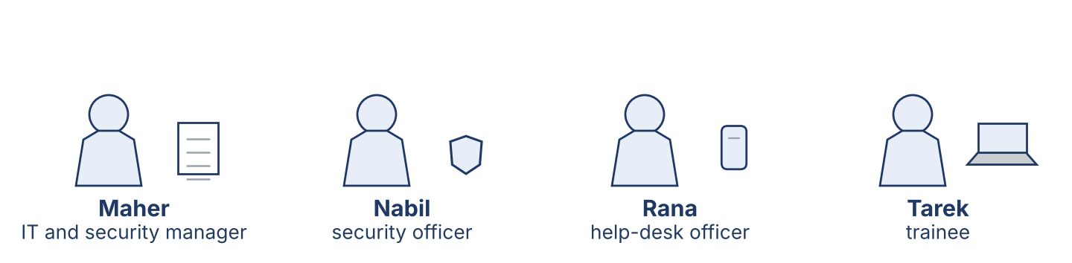
Figure 1.2 · The people in an IT and security department.
Complete the table. Write where each person works and what they do. (0. is done.)
Person | Where | What they do
Help-desk officer | help desk | Answers calls and writes tickets
Security officer
Manager
Trainee

Part 1: Parts of a Computer
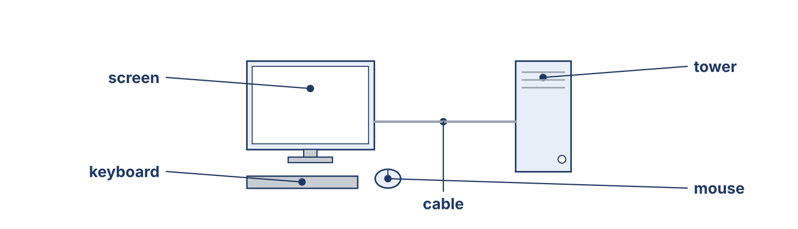
Figure 1.3 · The parts of a computer: screen, keyboard, mouse, tower and cable.
Match the parts of a computer with their descriptions. One description is not needed. Write the letter.
Column A
1. | Screen | ____
2. | Keyboard | ____
3. | Mouse | ____
4. | Tower | ____
5. | Cable | ____
Column B
a) | the box that holds the main parts of the computer
b) | the part you look at when you work
c) | you move it with your hand to point and click
d) | the printer that puts your work on paper
e) | you type on it
f) | it joins the screen to the tower
Part 1: Computers and Security — Multiple Choice
Read and choose the correct answer.
1. What does a backup do?
○ A) It makes the computer faster
○ B) It keeps a copy of your files
○ C) It opens your account
○ D) It cleans the screen
2. Where does a help-desk officer work?
○ A) The workshop bench
○ B) The store
○ C) The help desk
○ D) At home
3. What is a ticket?
○ A) A record of a problem and the work done on it
○ B) A type of cable
○ C) A password
○ D) A printer
Part 1: Vocabulary Fill-in
Complete the sentences with the correct word.
Word bank: server | update | account | ticket
1. Each person has one ____________________ with their own name.
2. The files for the whole office are kept on the ____________________ .
3. Rana writes a ____________________ for every call.
4. An ____________________ fixes problems in a program.
Part 1: Write About Computers (short)
Write two or three sentences about your computer or the IT department. Use three words from this unit.
Model — read this first:
I work at Cham Systems. I use a computer every day. First, I open my account with my password, and then I read the new tickets. Right now, I am writing a short report for my manager. When I leave my desk, I lock the screen.
Part 2 · Grammar — Present Simple vs Present Continuous
[OP] Operator track · pre-class input
Part 2: Notice
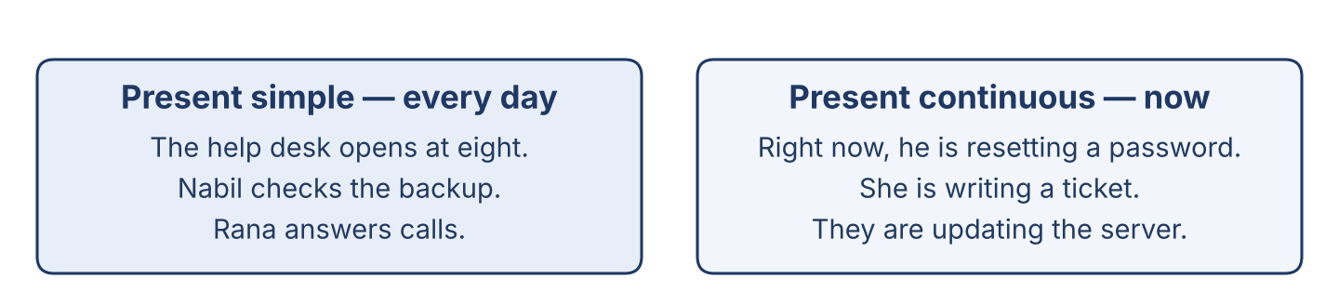
Figure 1.4 · Present simple (every day) and present continuous (now).
Read these lines from the help desk. Underline the verbs. Which are routines, and which are happening now?
Nabil checks the backup. He usually starts at eight. Right now, he is resetting a password for a user. The help desk opens every morning. Today it is answering many calls, because the office is busy.
Part 2: Grammar Focus Box
 | Form | Use | Example
Present simple | I/you check; he checks | routines, facts | The help desk opens every day.
Present continuous | am/is/are + -ing | now, this week | Nabil is resetting a password now.
Remember: every day, usually → present simple. now, this week, at the moment → present continuous.
Watch out! ✗ He check the backup. → ✓ He checks the backup. (add -s for he/she/it). ✗ I resetting now. → ✓ I am resetting now.
Part 2: Controlled Practice
Complete with the present simple or present continuous. (0. is done.)
0. Nabil usually works in the morning. (work)
1. Rana ____________________ (answer) the telephone every day.
2. Look! He ____________________ (change) the password right now.
3. The office ____________________ (open) at eight o’clock.
4. Today, Lina ____________________ (check) the list of accounts.
Part 2: Simple or Continuous?
Choose the correct form.
1. Right now, Tarek ____________________ (watches / is watching) Nabil.
2. Rana usually ____________________ (starts / is starting) at eight.
3. Listen! The server ____________________ (makes / is making) a strange noise.
4. The department ____________________ (checks / is checking) the backups every week.
Part 2: Correct the Sentence
Each sentence has one grammar mistake. Write the correct sentence.
1. The office keep the files on one server. __________________________________
2. Look! Nabil reset the password now. __________________________________
3. She check the backup every morning. __________________________________
4. We are update the program now. __________________________________
Part 2: Freer Practice
Write two sentences about your work or study: one routine (present simple) and one about now (present continuous).
Part 2: Grammar Review
Choose the correct sentence.
1. Which sentence is correct (now)?
○ A) Nabil reset the password.
○ B) Nabil is resetting the password.
○ C) Nabil resetting the password.
○ D) Nabil are resetting the password.
2. Which sentence is correct (routine)?
○ A) The department checks the backups.
○ B) The department checking the backups.
○ C) The department check the backups.
○ D) The department to check the backups.
→ You will see the present simple and present continuous again in the Part 5 reading. Watch for them.
Part 3 · Listening

Part 3: A Security Officer Talks About His Work
🔊 Audio Track 1.2
Before you listen: what does a security officer do first — read the ticket, or open the machine?
Nabil: Hello, my name is Nabil. I am a security officer at Cham Systems. I look after the computers and the accounts. First, I read the new tickets. Then I go to the user’s desk. Right now, I am helping Mr Aboud. He cannot open his account. I work with Rana at the help desk and with Tarek, our new trainee. I like my work, because every day is different.
While you listen: write True, False, or Not Given. (0. is done.)
0. Nabil is a security officer. — True
1. Nabil works in a bank. ____
2. Nabil is helping Mr Aboud right now. ____
3. Nabil works alone. ____
Useful phrases: I look after… · First, I… · Right now, I am…
Part 3: At the Help Desk
🔊 Audio Track 1.3
Before you listen: what does a help-desk officer ask a user first?
Rana: Good morning, Cham Systems help desk. How can I help you?
Mr Aboud: My computer does not open my account.
Rana: Of course. What message do you see?
Mr Aboud: It says the password is wrong, and I am sure it is right.
Rana: I’ll write a ticket. Can you stay at your desk for ten minutes?
Mr Aboud: Yes. When will it be ready?
Rana: This morning. We’ll call you.
While you listen: answer the questions. (0. is done.)
0. Where does Mr Aboud call? — The Cham Systems help desk.
1. What is the problem with his computer?
2. What message does he see?
3. When will it be ready?
Useful phrases: How can I help you? · What message do you see? · We’ll call you.
Part 3: A Day at Cham Systems
🔊 Audio Track 1.4
Before you listen: who works in an IT and security department? Write two jobs.
Maher: Good morning, everyone. Today we are busy. Nabil is helping Mr Aboud with his account. Tarek, you are new here, so you are watching and learning today. Lina is checking the backup from last night. Rana is answering the calls at the help desk. I am reading the new tickets. Please ask me if you are not sure about anything.
While you listen: match each person with what they are doing now. One action is not needed. (0. is done.)
0. Maher → reading the new tickets.
Column A
1. | Nabil | ____
2. | Tarek | ____
3. | Lina | ____
4. | Rana | ____
Column B
a) | answering the calls at the help desk
b) | watching and learning
c) | cleaning the keyboards
d) | helping a user with his account
e) | checking the backup from last night
Part 4 · Speaking
Part 4: Discussing Computers and Work
Work with a partner. Ask and answer these questions.
What computer does your family or your office have?
Do you like working with computers? Why?
What jobs are there in an IT and security department?
Useful language: We have a… · I like… because… · A security officer… · A help-desk officer…
Part 4: Help Desk Role Play
Work in pairs. Read the model, then use the cards.
Model exchange:
A: Good morning, help desk. How can I help you?
B: My computer does not open my account.
A: Of course. What message do you see?
B: It says the password is wrong.
A: I’ll write a ticket. Can you stay at your desk for ten minutes?
Useful language: How can I help you? · What message do you see? · I’ll write a ticket. · When will it be ready?
Card A — Help-desk officer (Rana): greet the user · ask what they need and what message they see · write a ticket · say when it will be ready.
Card B — User (Mr Aboud): greet · say your account does not open · say the message · ask when it will be ready.
Your turn: run the dialogue, then swap roles.
Stretch [PR]: the user needs the account back very quickly, but three people are waiting before him — offer a fair time politely.
Part 4: Mini-Presentation
Prepare a short talk (about one minute). Describe your job, or a computer you know: what it is, its main parts, and what you do with it every day.
Part 5 · Reading

Part 5: What Is an IT and Security Department?
Before you read: what three areas do you think an IT and security department has?
Gloss: help desk = the place users call when something does not work · ticket = a record of a problem and the work done on it · backup = a copy of your files, kept in a safe place
An IT and security department looks after the computers of a company. It has three main areas: the help desk, the workshop bench, and the store. A user calls the help desk, and the help-desk officer writes a ticket. A technician then checks the machine at the bench. The store keeps spare machines, disks and licences. The department also keeps the accounts: it opens an account for every new worker and closes it when a worker leaves. Every night it makes a backup of the files. A good department is tidy, careful and honest. It explains the problem in simple words, and it tells the user the truth about the time the work will take.
Answer the multiple-choice questions. (0. is done.)
0. What does an IT and security department do? — it looks after the computers of a company.
1. What does the help-desk officer write?
○ A) A letter
○ B) A ticket
○ C) A book
○ D) A bill
2. Where does a technician check a machine?
○ A) At the store
○ B) At the user’s home
○ C) At the workshop bench
○ D) At the bank
3. What is a good IT and security department?
○ A) Tidy, careful and honest
○ B) Dark and untidy
○ C) Slow
○ D) Closed
Part 5: Vocabulary in Context
Match each word from the text with its meaning. One meaning is not needed. Write the letter.
Column A
1. | help desk | ____
2. | ticket | ____
3. | store | ____
4. | backup | ____
Column B
a) | the place that keeps spare machines, disks and licences
b) | a record of a problem and the work done on it
c) | a cable for a printer
d) | the place users call when something does not work
e) | a copy of your files, kept in a safe place
Part 5: Computers in Syria
Before you read: why do offices in Syria keep computers for many years?
Gloss: licence = the paper that gives you the right to use a program · power cut = a time when the electricity stops
In Syria, offices keep computers for many years. New machines are expensive and hard to import, so people look after the ones they have. Dust, heat and power cuts are hard on a computer, so the IT department cleans the machines and plans its work around the hours when the electricity is on. Many programs are old, because a new licence is difficult to buy from Damascus. An old machine can still do good work if somebody cares for it: a clean fan, a safe password and a backup every night are worth more than a new computer with none of them.
Write True or False. (0. is done.)
0. Offices in Syria keep computers for many years. — True
1. New machines are cheap and easy to import in Syria. ____
2. Dust, heat and power cuts are hard on a computer. ____
3. An old machine can still do good work with good care. ____
Part 6 · Writing
[OP] Operator track · in-class / homework
Part 6: Describe Your Job or Your Computer (50–70 words)
Write about your job, or a computer you know. Use one present-simple and one present-continuous sentence.
Model — read this first:
I am a help-desk officer at Cham Systems. Every day, I answer the telephone and write tickets for the users. First, I ask what the problem is. Then I write the ticket and send it to a technician. Right now, I am helping a user who cannot open his account. I like my job, because I help people every day.
Plan (fill in, then write): I am a ___. Every day, I ___. First, I ___. Then I ___. Right now, I am ___.
Word bank: I answer / check / write… | every day… | First… Then… | Right now, I am …-ing | I like my job because…
Check before you finish: ☐ one present-simple + one present-continuous sentence? ☐ computer or security words used? ☐ 50–70 words?
Part 6: Why Good Computer Care Matters (50–70 words)
Write why good care of the computers is important. Give reasons.
Model — read this first:
Good care of the computers is important because the whole office stops when they do not work. A clean machine lasts longer, so the company spends less money. A backup every night means we never lose the files. A safe password keeps our information private. Careful work also keeps the users happy, because they trust us with their work.
Word bank: … is important because… | safe | lasts longer | saves money | keeps the users happy
Check before you finish: ☐ a clear opinion? ☐ two or three reasons? ☐ 50–70 words?
Part 6: A Note to the Security Officer (50–70 words)
Write a short note from Rana (help desk) to Nabil (security officer) about a user’s problem.
Model — read this first:
Dear Nabil, Here is ticket 104 from Mr Aboud in the accounts office. His account does not open, and the screen says the password is wrong. He is sure the password is right, so please check the account first. He is at his desk this morning and he needs the computer before twelve. Thank you. Rana.
Plan (fill in, then write): Dear ___, Here is ___. It needs ___. The user says ___, so please ___. Thank you. ___
Check before you finish: ☐ greeting and close? ☐ a clear request? ☐ 50–70 words?
Part 6: Reflection — A Computer I Know (40–60 words)
Write about a computer in your family or one you use at work.
Model — read this first:
We have one computer at home. It is old, and my brother uses it for his studies. It has a screen, a keyboard and a small tower under the desk. Every evening, he writes his work on it. Right now, he is reading a long report for his teacher. We keep it clean and we never share the password.
Check before you finish: ☐ the computer described? ☐ present simple + continuous? ☐ 40–60 words?
Part 7 · Management File — Welcoming a New Trainee
[PR] Practitioner track (optional for beginners) · IT and security manager
7A: Phrase Bank
Match what a manager says with its purpose. One purpose is not needed. Write the letter.
Column A
1. | “Welcome to the team.” | ____
2. | “Let me show you the help desk.” | ____
3. | “Never share your password, not even with me.” | ____
4. | “Ask me if you are not sure.” | ____
Column B
a) | giving a security rule
b) | offering help and support
c) | greeting a new worker
d) | talking about the price
e) | showing someone the department
7B: Manager Dialogue
🔊 Audio Track 1.5
Before you read: what does a manager say to a new trainee on the first day?
Maher: Good morning, Tarek. Welcome to Cham Systems. Nabil: Nice to meet you. Have you worked in an IT department before? Tarek: No, this is my first week. I studied computers at the institute. Maher: Good. This week you are watching and learning. Nabil will show you the help desk and the bench. Nabil: One rule first: never share your password, and never leave your screen open when you go. Tarek: I understand. Maher: And if you are not sure about something, ask. Nobody here is angry about a question.
Answer the questions. (0. is done.)
0. Where does Tarek start work? — At Cham Systems.
1. What is Tarek doing this week?
2. What security rule does Nabil give?
3. What should Tarek do if he is not sure?
7C: Controlled Practice — First-Day Checklist
Put a manager’s first-day steps in order. Number them 1–5. (0. is done.)
0. Say welcome to the new worker. — 1
____ Show the new worker the help desk and the bench.
____ Give the security rules.
____ Introduce the team.
____ Give the first small task.
7D: Role-Play — Briefing the Trainee
In pairs. One is the security officer (Nabil); one is the trainee (Tarek). Use the model and cards.
Model exchange: Nabil: Welcome, Tarek. First, never share your password. — Tarek: OK, Ustaz. — Nabil: Second, lock your screen when you leave the desk. — Tarek: And if I am not sure? — Nabil: Then you ask. Today you are watching me.
Card A — Security officer (Nabil): welcome · give three security rules · say what to do today. Card B — Trainee (Tarek): greet · ask one question about the rules · ask what to do first.
Stretch [PR]: the trainee wants to work on a manager’s computer alone in his first week — say no, and explain why, politely.
7E: Supervisory Writing (50–80 words)
You are Maher. Write a short welcome note to Tarek with his plan for the first week.
Model — read this first:
Dear Tarek, Welcome to Cham Systems. This week you are with Nabil at the help desk, so you can see how we answer a user and write a ticket. On Thursday you will watch a backup. One rule from your first day: never share your password, and lock your screen when you leave your desk. Ask any question you have — that is how we all learned. Maher.
Check before you finish: ☐ a warm welcome? ☐ a clear first-week plan? ☐ one security rule? ☐ 50–80 words?
Part 8 · Global Case Study — A Small Office Gets a Help Desk
[PR] Practitioner track · pre-read / in-class discuss
Before you read: how can a small office with no IT staff start to look after its computers?
Gloss: record = to write something down and keep it · honest = telling the truth and doing fair work · reputation = what people say about your work
In a small town, a company called Sadek Trading had eleven computers and nobody to look after them. When a machine stopped, the staff called a friend, and often nobody could say what had been done to it. Then the owner asked one worker, Sami, to spend two days a week on the computers. Sami did one simple thing first: he wrote down every call in a notebook — the date, the machine, the problem, and the work he did. After three months, the notebook showed him that the same two machines caused half the calls. He repaired them properly, and the calls went down. The staff started to trust him, because he always told them honestly how long a job would take. Today the company has a real help desk with three people, and it still keeps a record of every call.
Answer the questions. (0. is done.)
0. How many computers did the company have? — Eleven.
1. What was the problem before Sami started?
2. What simple thing did Sami do first?
3. Why did the staff start to trust him?
Part 8: Vocabulary in Context
Match each word with its meaning. One meaning is not needed. Write the letter.
Column A
1. | help desk | ____
2. | record | ____
3. | honest | ____
4. | repair | ____
Column B
a) | telling the truth and doing fair work
b) | to write something down and keep it
c) | the place that answers users and keeps their calls
d) | a new computer
e) | to fix something that is broken
Part 8: Discussion
Talk with a partner. Use the frames.
Discussion frames: “This is similar to Syria because…” · “This is different from Syria because…” · “I think the first step should be…” · “In a small office, the most useful record is…”
Part 9 · Local Case Study — Syria in Focus: The First Account List
[PR] Practitioner track · pre-read / in-class decide
Before you read: why is it a problem when several people in an office use the same computer account?
Lina is a young officer in a company in Homs with twenty-two staff. When she started, there were four accounts for twenty-two people. Everybody knew all four passwords, and the passwords were written on a card under the keyboard. Nobody was doing anything wrong: the office had grown slowly, and sharing had always been the quick way to work. But when a file was deleted one Thursday, nobody could say who had deleted it, and the argument lasted a week. Lina asked her manager for two quiet afternoons. She wrote a list of every person and what each one needed to open, and then she made one account for each name. It took longer than she expected, because two people had left the company a year before and still had working accounts. Now every file shows who opened it, and the card under the keyboard is gone.
Answer the questions. (0. is done.)
0. How many staff are there? — Twenty-two.
1. How many accounts were there when Lina started?
2. What happened on the Thursday?
3. What did Lina find when she wrote her list?
Part 9: Decision Task
Lina has two more quiet afternoons this month. Should she (a) write a short rule for new staff, (b) set a date when every password must be changed, or (c) teach the staff how to lock a screen? Choose one and give reasons.
Answer frame: “I think Lina should ___ because ___. Also, ___. This is better than ___ because ___.”
Model — read this first:
I think Lina should write a short rule for new staff, because the office is growing and every new person will start in the right way. Also, a rule on paper does not need her to be in the room. This is better than teaching the screen lock first, because she would have to teach it again for every new worker.
Phrase bank: I think… should… · because… · Also,… · This is better than… · In my opinion…
Part 10 · Review and Can-Do
[OP + PR] · homework / self-study
Part 10: Spiral Review
Complete the review. (0. is done.)
0. The team you call when your computer has a problem is the help desk.
Word bank: ticket | backup | account | present continuous | present simple
1. The record of a problem and the work done on it is a ____________________ .
2. A copy of your files, kept in a safe place, is a ____________________ .
3. The name the computer knows you by is your ____________________ .
4. “Nabil is resetting a password now” uses the ____________________ tense.
5. “The help desk opens every day” uses the ____________________ tense.
Part 10: Can-Do
Can-Do checklist
☐ I can name the main parts of a computer and the people in an IT and security department.
☐ I can use the present simple for routines and the present continuous for now.
☐ I can understand a short talk between a user, a help-desk officer and a technician.
☐ I can describe my job or a computer in 50–70 words.
☐ I can welcome and brief a new worker (Practitioner).
Part 10: Glossary
Unit 1 glossary (10 words)
server · account · password · backup · update · ticket · screen lock · help desk · licence · user

Unit 2: Inside the System — Machines, Accounts and Data
English for Cybersecurity Personnel · Level: Upper A2 (the course moves to Low B1 from Unit 6) · Tracks: [OP] Warm-Up + Parts 1–6 · [PR] Parts 7–10
Warm Up
[OP] Operator track · in-class starter
Warm-up: Machines, Accounts and Data
Match the words with their meanings. One meaning is not needed. Write the letter.
Column A
1. | Machine | ____
2. | Account | ____
3. | File | ____
4. | Disk | ____
5. | Licence | ____
Column B
a) | the paper that gives you the right to use a program
b) | a computer that one person works on
c) | the part that keeps your files when the power is off
d) | the cable that joins the machine to the wall
e) | the name the computer knows you by
f) | a document you save and open again
Warm-up: Checking the System
Complete the sentences using the words in the word bank.
Word bank: account | licence | disk | backup
1. Every worker has one ____________________ with their own name.
2. The office keeps a ____________________ of the files every night.
3. There is a new ____________________ for the accounts program.
4. The old ____________________ is full, so we cannot save anything.
Warm-up: Reading About the System
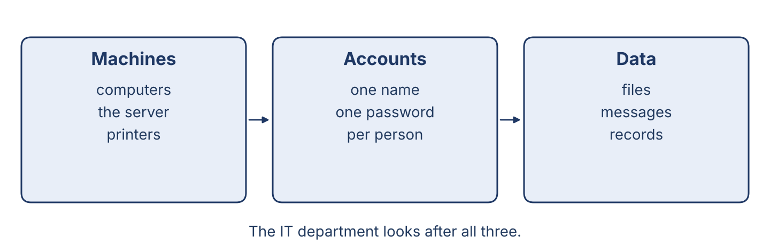
Figure 2.1 · Inside the system: machines, accounts and data.
Read the text and choose the correct answer.
An office system has three parts. There are the machines: the computers, the server and the printers. There are the accounts: one name for every person who works here. And there is the data: the files, the messages and the records. The IT department looks after all three. If there isn’t a backup of the data, a broken disk means the work is gone.
1. What does the IT department look after?
○ A) Only the machines
○ B) Only the accounts
○ C) The machines, the accounts and the data
○ D) Only the printers
2. What can happen if there isn’t a backup?
○ A) The work is gone when a disk breaks
○ B) The computer goes faster
○ C) Nothing happens
○ D) The printer stops
Part 1 · Vocabulary and Terminology
[OP] Operator track · pre-class input
Part 1: System and Data Terms
Match the parts with their meanings. One meaning is not needed. (0. is done for you.)
0. Server → the big computer that keeps files for many people.
Column A
1. | Disk | ____
2. | Memory | ____
3. | Network | ____
4. | Folder | ____
5. | Record | ____
6. | Licence | ____
7. | Printer | ____
Column B
a) | the cables and equipment that join the machines together
b) | a place on a disk where you keep files together
c) | the machine that puts your work on paper
d) | the part that keeps your files when the power is off
e) | one line of information kept about one thing or one person
f) | the paper that gives you the right to use a program
g) | a chair for the help desk
h) | the part the machine uses to work while it is on
Gloss: memory = the part the machine uses to work while it is on · record = one line of information kept about one thing or one person
Part 1: Pronunciation
🔊 Audio Track 2.1
Listen and practise these words. Say each word aloud and stress the loud syllable (CAPITALS).
machine — ma-CHINE
memory — MEM-o-ry
network — NET-work
folder — FOL-der
licence — LI-cence
printer — PRIN-ter
Part 1: Data Table

Figure 2.2 · The kinds of data an office keeps.
Complete the table. Write what each kind of data is and where it is kept. (0. is done.)
Data | What it is | Where it is kept
Files | the documents people write | in folders on the server
Messages
Records
Backups
0. Files — the documents people write — in folders on the server.
Part 1: Types of Data
Match each kind of data with what it is. One meaning is not needed. Write the letter.
Column A
1. | File | ____
2. | Message | ____
3. | Record | ____
4. | Backup | ____
5. | Licence | ____
Column B
a) | one line of information about one thing or one person
b) | a document a person writes and saves
c) | a copy of the data, kept in a safe place
d) | a cable for the printer
e) | something one person sends to another
f) | the paper that gives the right to use a program
Part 1: Machines and Data — Multiple Choice
Read and choose the correct answer.
1. What does the memory do?
○ A) It keeps files when the power is off
○ B) It helps the machine work while it is on
○ C) It prints the work
○ D) It cleans the screen
2. What do you use a folder for?
○ A) To start the machine
○ B) To open an account
○ C) To clean the disk
○ D) To keep files together
3. What does a backup do?
○ A) It makes the machine faster
○ B) It keeps a copy of the data in a safe place
○ C) It joins the machines together
○ D) It prints a record
Part 1: Vocabulary Fill-in
Complete the sentences with the correct word.
Word bank: disk | network | folder | licence
1. Save the report in the ____________________ for this month.
2. The ____________________ joins all the machines in the office.
3. The ____________________ is full, so we must clean it.
4. We cannot use the program without a ____________________ .
Part 1: Write About the System (short)
Write two or three sentences about the machines or the data in your office. Use three words from this unit.
Model — read this first:
In our office there are fourteen machines and one server. Every person has an account with their own name, and the files are kept in folders on the server. There isn’t much space left on the old disk, so we are asking for a new one. The backup runs every night at nine o’clock.
Part 2 · Grammar — There is / There are + some / any / much / many
[OP] Operator track · pre-class input
Part 2: Notice
Read these lines from the office. Underline there is / there are. When do we use some, any, much and many?
There is a server in the small room. There are two printers on this floor. There isn’t much space left on the disk. There aren’t many licences for the new program. Is there any coffee? And are there any spare keyboards in the store?
Part 2: Grammar Focus Box
 | Form | Use | Example
There is / There isn’t | + singular or uncountable | one thing, or a quantity | There is a server in the room.
There are / There aren’t | + plural | more than one thing | There are two printers here.
Remember: some → + sentences. any → questions and – sentences. much → uncountable. many → countable.
Watch out! ✗ There are much data. → ✓ There is much data (data is uncountable here). ✗ There is three disks. → ✓ There are three disks.
Part 2: Controlled Practice
Complete with is or are. (0. is done.)
0. There is a server in the small room.
1. There ____________________ two printers on this floor.
2. There ____________________ some space left on the new disk.
3. There ____________________ four machines in the store.
4. There ____________________ a problem with the network.
Part 2: Some, Any, Much or Many?
Choose the correct word.
1. Is there ____________________ space on the disk? (any / some)
2. There aren’t ____________________ spare keyboards. (much / many)
3. There isn’t ____________________ time before the power cut. (much / many)
4. We have ____________________ new licences. (some / any)
Part 2: Correct the Sentence
Each sentence has one grammar mistake. Write the correct sentence.
1. There is two servers in the room.
2. How much machines are there?
3. There are much data on this disk.
4. Is there some space left?
Part 2: Freer Practice
Write two sentences about your office or your desk: one with there is and one with there are.
Part 2: Grammar Review
Choose the correct sentence.
1. Which sentence is correct?
○ A) There are three printers.
○ B) There is three printers.
○ C) There be three printers.
○ D) There am three printers.
2. Which sentence is correct?
○ A) There is many accounts.
○ B) There are many accounts.
○ C) There are much accounts.
○ D) There is much accounts.
→ Harvest: you will see there is / there are and some / any / much / many again in the Part 5 reading.
Part 3 · Listening
[OP] Operator track · pre-class input · scripts printed inline
Part 3: Checking the Machines
🔊 Audio Track 2.2
Before you listen: which thing does a security officer check first on a machine?
Nabil: Right, let’s check this machine. First, I look at the disk. There is some space left, but there isn’t much — only four gigabytes. Then I check the memory: there are eight gigabytes, and that is enough for this work. Next, the licences. There is a licence for the office program, but there isn’t one for the new reader, so I will write that down. Last, I look for the backup. There are two backups from this week, and that is good.
While you listen: write True, False, or Not Given. (0. is done.)
0. Nabil is checking a machine. — True
1. There is a lot of space on the disk. ____
2. There is a licence for the new reader. ____
3. The machine is five years old. ____
Useful phrases: First, I look at… · There is / isn’t much… · There are two…
Part 3: At the Store
🔊 Audio Track 2.3
Before you listen: what does an IT department keep in its store?
Nabil: Tarek, are there any spare keyboards in the store? Tarek: Let me check. Yes, there are three. Nabil: Good. And how many disks are there? Tarek: There aren’t any new ones. There is one old disk, but it is full. Nabil: Then we must order some. How much space do we need? Tarek: For the backup, about two terabytes. Nabil: Write it down, please, and I will give the list to Maher.
While you listen: answer the questions. (0. is done.)
0. What is Tarek checking? — The store.
1. How many spare keyboards are there?
2. Are there any new disks?
3. What must Tarek write down?
Useful phrases: Are there any…? · How much…? · There aren’t any…
Part 3: The Morning Check
🔊 Audio Track 2.4
Before you listen: why does a manager check the system before the day starts?
Maher: Good morning. Before we start, let’s check the system. There are twenty-two accounts, and two of them belong to people who have left, so Nabil will close them. There is a backup from last night — Lina, please open it and see that the files are really there. Tarek, there aren’t any spare keyboards on your list; please count them again in the store. And everyone, there isn’t much space on the old server, so save your work in your own folder.
While you listen: match each person with what they do. One action is not needed. (0. is done.)
0. Maher → leads the morning check.
Column A
1. | Nabil | ____
2. | Tarek | ____
3. | Lina | ____
4. | Everyone | ____
Column B
a) | opens the backup and checks the files
b) | counts the spare keyboards again
c) | buys a new printer
d) | closes the accounts of people who have left
e) | saves their work in their own folder
Part 4 · Speaking
[OP] Operator track · in-class output
Part 4: Discussing Machines and Data
Work with a partner. Ask and answer these questions.
What machines are there in your office? Name three.
What can happen if there isn’t a backup of the data?
How often should an office count what is in its store?
Useful language: An office needs… · There is / are… · If there isn’t enough… · We should…
Part 4: Find the Difference
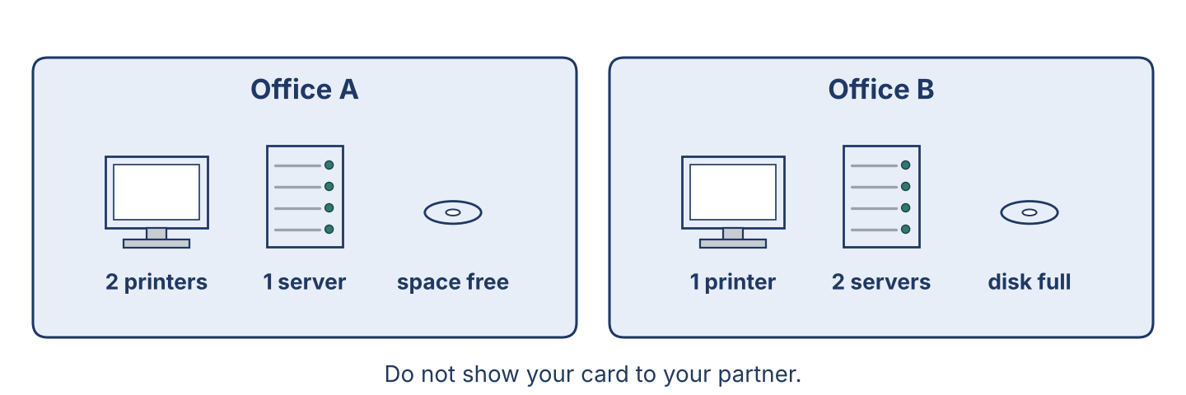
Figure 2.3 · Two offices, two sets of machines.
Work in pairs. Student A looks at Office A; Student B looks at Office B. Ask and answer to find four differences. Do not show your card.
Card A — Office A: there are two printers · there is one server · there aren’t any spare machines · there is a lot of space on the disk.
Card B — Office B: there is one printer · there are two servers · there are three spare machines · there isn’t much space on the disk.
Useful questions: Is there any…? · How much…? · How many…? · In my office there is…
Part 4: Reporting Role Play
Work in pairs. Read the model, then use the cards.
Model exchange: Nabil: There isn’t much space on the server, and there aren’t any spare disks. — Maher: How many do we need? — Nabil: Two, I think. There are twenty-two accounts now, and the backup is growing every week.
Card A — Security officer: report on the machines and the data (use some / any / much / many). Card B — Manager: ask how much and how many, then decide what to order first.
Stretch [PR]: a licence you need cannot be paid for from Damascus — explain the problem to your manager and ask for a decision, politely.
Part 4: Mini-Presentation
Prepare a short talk (about one minute). Say what machines and data there are in your office, and what there isn’t enough of.
Part 5 · Reading
[OP] Operator track · pre-class input
Part 5: The System and Its Data
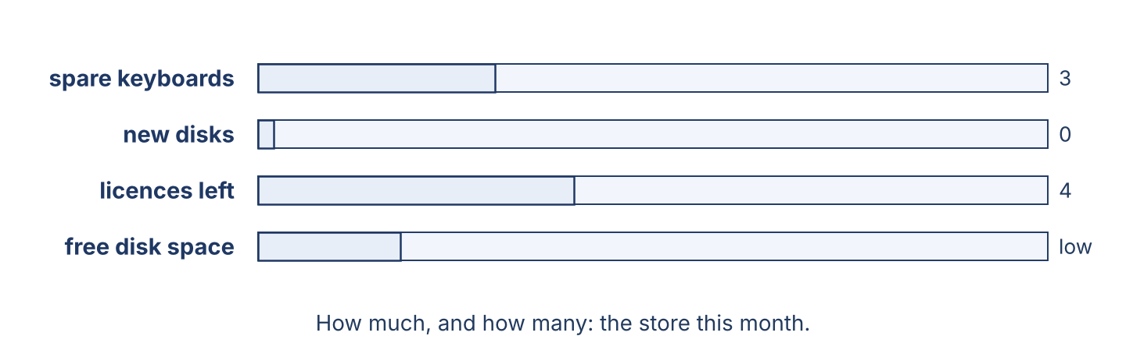
Figure 2.4 · What the store holds this month.
Before you read: which part of the system do you think is the most important to protect?
Gloss: level = how much of something there is · top up = to add more of something · spare = an extra one, kept ready
A system has many parts, and it needs several things to work well. There are the machines, and there is the data that lives on them. The disk keeps the files when the power is off, and the memory helps the machine work while it is on. There is a network that joins everything together, and there are licences that give the office the right to use its programs. The most important part, though, is the one you cannot see on a shelf: the backup. A machine can be replaced in a week, but ten years of records cannot. So a careful officer checks the levels every month — how much space there is on the disk, how many spare machines there are in the store, and how many licences are still good. If there isn’t much space left, the backup will stop, and nobody will notice until the day they need it.
Answer the multiple-choice questions. (0. is done.)
0. What keeps the files when the power is off? — the disk.
1. What does the memory do?
○ A) It keeps the files when the power is off
○ B) It joins the machines together
○ C) It helps the machine work while it is on
○ D) It prints the records
2. Why is the backup the most important part?
○ A) Because it is expensive
○ B) Because a machine can be replaced but old records cannot
○ C) Because it is new
○ D) Because it is fast
3. Why is checking the levels important?
○ A) It is slow and hard
○ B) It makes the machine faster
○ C) It is dangerous
○ D) A full disk stops the backup, and nobody notices
Part 5: Vocabulary in Context
Match each word from the text with its meaning. One meaning is not needed. Write the letter.
Column A
1. | disk | ____
2. | memory | ____
3. | network | ____
4. | spare | ____
Column B
a) | an extra one, kept ready
b) | it keeps the files when the power is off
c) | a tool for opening a machine
d) | the cables and equipment that join the machines
e) | it helps the machine work while it is on
Part 5: Machines and Licences in Syria
Before you read: are new machines and licences always easy to buy where you work?
Gloss: import = to bring from another country · genuine licence = a licence bought from the company that made the program
In Syria, machines and licences are not always easy to buy. New computers are expensive and hard to import, so many offices work with machines that are eight or ten years old. A genuine licence often cannot be paid for from Damascus at all, so an office buys it through a reseller in another country, and waits. Because of this, there are offices with twenty machines and only four licences, and the staff share what there is. A careful manager writes down how many licences there are and when each one ends, so that the office is never surprised. It costs nothing to keep that list, and it saves an argument later.
Write True or False. (0. is done.)
0. New machines are easy to import in Syria. — False
1. A genuine licence can be hard to pay for from Damascus. ____
2. Some offices have more machines than licences. ____
3. Keeping a list of licences is expensive. ____
Part 6 · Writing
[OP] Operator track · in-class / homework
Part 6: What Is in Your System? (50–70 words)
Describe the machines and the data in an office you know. Use there is and there are, with some, any, much and many.
Model — read this first:
In our office there is one server and there are fourteen machines. There are twenty-two accounts, one for every person. There is a backup every night, and there are two copies of it. There isn’t much space left on the old disk, and there aren’t any spare machines in the store. We need some new disks this month.
Plan (fill in, then write): In our office, there is ___. There are ___. There isn’t much ___. There aren’t many ___.
Word bank: there is / there are… | some / any / much / many… | machine | account | disk | backup | licence
Check before you finish: ☐ there is + there are used? ☐ some / any / much / many used? ☐ 50–70 words?
Part 6: Why Backups Matter (50–70 words)
Write why a backup of the data is important. Give reasons.
Model — read this first:
A backup is important because a disk can stop working on any day, with no warning. If there isn’t a copy, the work of many years is gone in a minute. A backup also helps when somebody deletes a file by mistake, which happens in every office. It costs little, and it saves the company from a loss it cannot repair.
Word bank: … is important because… | if there isn’t a copy… | the work is gone | it costs little | it saves…
Check before you finish: ☐ a clear opinion? ☐ two or three reasons? ☐ 50–70 words?
Part 6: A Stock Note (50–70 words)
Write a short note from Nabil (security officer) to Maher (manager) about what the department needs.
Model — read this first:
Dear Maher, I checked the store this morning. There are three spare keyboards, but there aren’t any new disks, and there is only one old disk, which is full. There isn’t much space left on the server either. Please can we order two disks of two terabytes this month? The backup will stop without them. Thank you. Nabil.
Plan (fill in, then write): Dear ___, I checked ___. There is / isn’t ___. There are / aren’t ___. Please can we order ___? Thank you. ___
Check before you finish: ☐ there is/are + some/any/much/many? ☐ a clear request? ☐ 50–70 words?
Part 6: Reflection — A Data Problem (40–60 words)
Write about a time a computer lost some work, or a disk became full.
Model — read this first:
Last year the disk in my brother’s computer stopped working. There wasn’t a backup, and three years of his study notes were gone. He went to two shops, but there wasn’t any way to read the disk. Now he keeps a copy on another disk every week, and he says it is the cheapest thing he has ever bought.
Check before you finish: ☐ the problem described? ☐ there is/are used? ☐ 40–60 words?
Part 7 · Management File — Checking the Stock of Machines and Licences
[PR] Practitioner track (optional for beginners) · IT and security manager
7A: Phrase Bank
Match what a manager says with its purpose. One purpose is not needed. Write the letter.
Column A
1. | “How much space do we have?” | ____
2. | “How many licences are left?” | ____
3. | “Please order some new disks.” | ____
4. | “Without a backup we lose everything.” | ____
Column B
a) | asking about quantity (countable)
b) | explaining why it matters
c) | asking about quantity (uncountable)
d) | talking about the weather
e) | giving an instruction to buy
7B: Manager Dialogue
🔊 Audio Track 2.5
Before you read: what does a manager ask about when checking the stock?
Maher: Nabil, let’s check the stock before the new staff arrive. Nabil: Right. How much space do we have on the server? Maher: That is my question for you. Nabil: About two hundred gigabytes. There isn’t much, and the backup grows every week. Maher: And how many licences are left for the office program? Nabil: Four. There are twenty-two people, so we are sharing. Maher: Then order two disks and ask the reseller about six more licences. Write it down, and I will sign it today.
Answer the questions. (0. is done.)
0. When do they check the stock? — Before the new staff arrive.
1. How much space is there on the server?
2. How many licences are left?
3. What must Nabil order?
7C: Controlled Practice — Completing the Order
Complete with much, many, some, or any.
Word bank: much | many | some | any
1. There isn’t ____________________ space on the server.
2. There aren’t ____________________ licences left.
3. Please order ____________________ new disks.
4. Is there ____________________ room in the store?
7D: Role-Play — The Stock Check
In pairs. One is the manager (Maher); one is the security officer (Nabil). Use the model and the cards.
Model exchange: Maher: How much space do we have? — Nabil: There is about two hundred gigabytes, but there isn’t much free. — Maher: And how many licences? — Nabil: Four, for twenty-two people.
Card A — Manager (Maher): ask how much / how many of three things · decide what to order first. Card B — Security officer (Nabil): answer with some / any / much / many · say what will stop working without it.
Stretch [PR]: money is tight this month — decide whether to buy disks or licences first, and say why to the staff who will keep sharing.
7E: Supervisory Writing (50–80 words)
You are Maher. Write a short order for the supplier. Say what you need and how much or how many.
Model — read this first:
Dear Sir, Please send us the following for Cham Systems, Damascus: two disks of two terabytes, six licences for the office program, and three spare keyboards. We have only four licences for twenty-two staff, so the licences are the most urgent part of this order. Please tell us the price and when you can deliver. Thank you. Maher Khoury, IT and Security Manager.
Check before you finish: ☐ clear quantities (how much / how many)? ☐ what is most urgent? ☐ 50–80 words?
Part 8 · Global Case Study — The Office That Never Lost a Record
[PR] Practitioner track · pre-read / in-class discuss
Before you read: what is the problem if an office keeps its only copy of the records in one place?
Gloss: stock = the things a business keeps ready to use · order = to ask a supplier to send more · restore = to bring the files back from a backup
A medium-sized company kept all of its records on one server in the basement. There was a backup, but nobody had ever opened it. One winter a pipe broke, and the water reached the machines. The company lost the server in one night. When the manager opened the backup, he found that it had stopped working eleven months before: the disk had been full, and the message had gone to an address nobody read. The company rebuilt what it could from paper and from the staff’s own copies, and it took five months. After that, the manager made two rules. First, there must be two backups, and one of them must be in another building. Second, somebody must restore one file from the backup every month and sign a sheet to say it worked. Ten years later the company has never lost a record again, and the sheet is still signed every month.
Answer the questions. (0. is done.)
0. Where were all the records kept? — On one server in the basement.
1. What did the manager find when he opened the backup?
2. How long did the company take to rebuild its records?
3. What two rules did the manager make?
Part 8: Vocabulary in Context
Match each word with its meaning. One meaning is not needed. Write the letter.
Column A
1. | backup | ____
2. | restore | ____
3. | record | ____
4. | rule | ____
Column B
a) | to bring the files back from a copy
b) | a copy of the data, kept in a safe place
c) | something everybody in the office must do
d) | a new computer
e) | one line of information kept about one thing
Part 8: Discussion
Talk with a partner. Use the frames.
Discussion frames: “This is similar to Syria because…” · “This is different from Syria because…” · “The first rule I would make is…” · “A backup nobody tests is…”
Part 9 · Local Case Study — Syria in Focus: Genuine Licence or Cheaper Copy?
[PR] Practitioner track · pre-read / in-class decide
Before you read: when an office needs a program, what two choices does it often have?
A trading company in Aleppo needed an accounts program for six machines. Rana, who looked after the computers, asked for prices. A genuine licence cost a great deal and had to be bought through a reseller in Beirut, with a wait of three weeks. A copy from the market cost almost nothing and could be installed the same afternoon. The owner wanted the cheap copy. Rana explained what he was really buying: the cheap copy came with no updates, so any fault in it would stay for ever; it could not be registered with the Ministry if the company was ever asked; and the shop that sold it would not answer the telephone in six months. In the end they bought two genuine licences for the two machines that held the accounts, and used the free reader on the other four. It was not the cheapest answer, and it was not the most expensive one.
Answer the questions. (0. is done.)
0. How many machines needed the program? — Six.
1. What were the two choices?
2. What three problems did Rana explain?
3. What did the company decide in the end?
Part 9: Decision Task
A manager wants the cheapest copy for every machine in the office, including the one that holds the staff records. Should the officer (a) agree, (b) refuse for every machine, or (c) ask for genuine licences only where the important data is? Choose one and give reasons.
Answer frame: “I think the officer should ___ because ___. For the important machines, ___. This is better than ___ because ___.”
Model — read this first:
I think the officer should ask for genuine licences only where the important data is, because the office cannot pay for everything at once. For the machines that hold the staff records, a licence with updates is worth the money. This is better than refusing for every machine, because the manager would say no to the whole plan, and then nothing would be protected.
Phrase bank: I think… should… · because… · for important data… · This is better than… · In my opinion…
Part 10 · Review and Can-Do
[OP + PR] · homework / self-study
Part 10: Spiral Review
Complete the review. (0. is done.)
0. The big computer that keeps files for many people is the server.
Word bank: disk | backup | are | is | many
1. The part that keeps your files when the power is off is the ____________________ .
2. A copy of the data, kept in a safe place, is a ____________________ .
3. “There ____________________ two printers on this floor.”
4. “There ____________________ some space left on the disk.”
5. much is for uncountable nouns; ____________________ is for countable nouns.
Part 10: Can-Do
Can-Do checklist
☐ I can name the main machines, accounts and kinds of data in an office system.
☐ I can use there is / there are with some, any, much and many.
☐ I can understand a stock check between a manager and a security officer.
☐ I can write a short order or stock note (Practitioner).
☐ I can say what an office has and how much or how many.
Part 10: Glossary
Unit 2 glossary (10 words)
disk · memory · network · folder · record · licence · printer · backup · restore · spare

Unit 3: Safe Working at the Desk — Passwords and Protection
English for Cybersecurity Personnel · Level: Upper A2 (the course moves to Low B1 from Unit 6) · Tracks: [OP] Warm-Up + Parts 1–6 · [PR] Parts 7–10
Warm Up
[OP] Operator track · in-class starter
Warm-up: Protections and Their Uses
Match the protections with their uses. One use is not needed. Write the letter.
Column A
1. | Password | ____
2. | Screen lock | ____
3. | Antivirus | ____
4. | Backup | ____
5. | Update | ____
Column B
a) | it hides your work when you leave your desk
b) | you use it to check the oil level
c) | it keeps a copy of your files in a safe place
d) | a secret word that opens your account
e) | it fixes faults in a program
f) | it watches for bad files on your machine
Warm-up: At Your Desk
Complete the sentences using the words in the word bank.
Word bank: password | screen | backup | tidy
1. Choose a long ____________________ that nobody can guess.
2. Lock your ____________________ before you leave the desk.
3. Check that the ____________________ ran last night.
4. Keep your desk ____________________ , with no notes under the keyboard.
Warm-up: Reading About Safe Working
Read the text and choose the correct answer.
Safe working is the most important rule at a desk. First, choose a long password, and never write it on paper. Then lock your screen every time you stand up, even for a minute. Next, keep your desk tidy: no notes, no open files, no visitors behind you. Finally, if something looks strange on your machine, stop and tell the help desk. Never try to repair it yourself.
1. What must you do first?
○ A) Nothing
○ B) Open your messages
○ C) Choose a long password
○ D) Call the manager
2. When something looks strange on your machine, what must you do?
○ A) Repair it yourself
○ B) Turn the machine off and say nothing
○ C) Stop and tell the help desk
○ D) Ask a visitor
Part 1 · Vocabulary and Terminology
[OP] Operator track · pre-class input
Part 1: Protection and Safe-Working Terms
Match the words with their meanings. One meaning is not needed. (0. is done for you.)
0. Screen lock → the step that hides your work when you leave your desk.
Column A
1. | Antivirus | ____
2. | Update | ____
3. | Passphrase | ____
4. | Clear desk | ____
5. | Visitor | ____
6. | Shoulder surfing | ____
7. | Report | ____
Column B
a) | a long password made of several words
b) | a new version that fixes faults in a program
c) | a rule that leaves no papers or notes on the desk at night
d) | a spanner for the server
e) | somebody from outside who must be met and signed in
f) | it watches for bad files on your machine
g) | to tell the help desk what you have seen
h) | when somebody reads your screen over your shoulder
Gloss: passphrase = a long password made of several words · shoulder surfing = when somebody reads your screen over your shoulder
Part 1: Pronunciation
🔊 Audio Track 3.1
Listen and practise these words. Say each word aloud and stress the loud syllable (CAPITALS).
antivirus — AN-ti-vi-rus
passphrase — PASS-phrase
visitor — VI-si-tor
protect — pro-TECT
safety — SAFE-ty
report — re-PORT
Part 1: The Protections Table
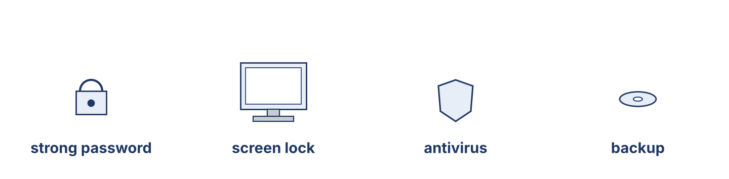
Figure 3.1 · The four protections every desk needs.
Complete the table. Write what each protection does and when to use it. (0. is done.)
Protection | Protects | When to use it
Screen lock | your open work | (example) every time you stand up
Strong password
Antivirus
Backup
0. Screen lock — your open work — every time you stand up.
Part 1: Everyday Protections
Match each protection with what it does. One meaning is not needed. Write the letter.
Column A
1. | Strong password | ____
2. | Screen lock | ____
3. | Antivirus | ____
4. | Clear desk | ____
5. | Backup | ____
Column B
a) | it watches for bad files on your machine
b) | it stops somebody opening your account
c) | it puts out a fire
d) | it keeps a copy of your files in a safe place
e) | it hides your work when you leave
f) | it leaves nothing on the desk for a visitor to read
Part 1: Protection and Safe Working — Multiple Choice
Read and choose the correct answer.
1. What does a passphrase do?
○ A) It cleans the disk
○ B) It makes a password long and hard to guess
○ C) It prints the records
○ D) It cools the machine
2. What is a clear desk for?
○ A) Leaving nothing for a visitor to read
○ B) Turning screws
○ C) Checking the backup
○ D) Storing cables
3. What does shoulder surfing mean?
○ A) Somebody takes your chair
○ B) Somebody cleans your screen
○ C) Somebody carries your machine
○ D) Somebody reads your screen from behind you
Part 1: Vocabulary Fill-in
Complete the sentences with the correct word.
Word bank: antivirus | update | visitor | report
1. Run the ____________________ so the program has no known faults.
2. The ____________________ found a bad file and stopped it.
3. Always meet a ____________________ at the door and sign them in.
4. If you see something strange, ____________________ it to the help desk.
Part 1: Write About Protections (short)
Write two or three sentences about the protections you use at your desk. Use three words from this unit.
Model — read this first:
At my desk I use a long passphrase of four words, and I never write it down. I lock my screen every time I stand up, even to take a cup of tea. The antivirus runs by itself, and the backup runs at night. If I see something strange, I report it to the help desk at once.
Part 2 · Grammar — Imperatives and Sequencers
[OP] Operator track · pre-class input
Part 2: Notice
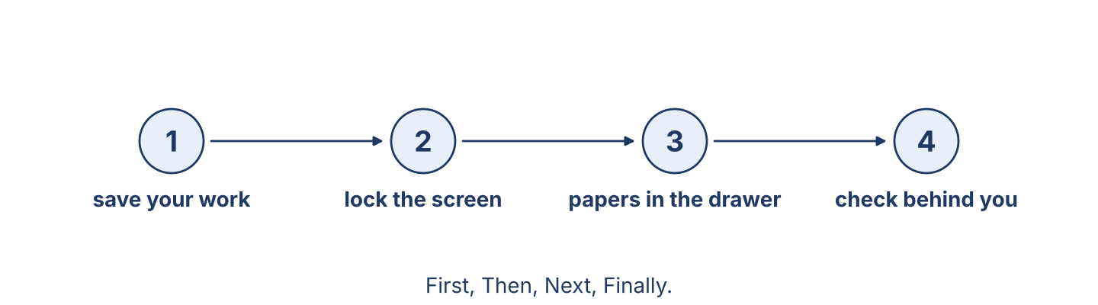
Figure 3.2 · Leaving your desk safely, step by step.
Read these rules from the office. Underline the verbs. Which words show the order of the steps?
First, save your work. Then lock your screen. Next, put your papers in the drawer. Finally, check that nobody is waiting behind you. Never leave your account open. Don’t write your password on paper. If you are not sure, ask the help desk.
Part 2: Grammar Focus Box
 | Form | Use | Example
Imperative | base verb (no subject) | an order, a rule, an instruction | Lock your screen.
Negative imperative | Don’t / Never + verb | a rule about what not to do | Never share your password.
Remember: Negative imperative = Don’t / Never + verb. Use sequencers to show the order: First, Then, Next, Finally.
Watch out! ✗ You lock your screen. (as a rule) → ✓ Lock your screen. ✗ Not share your password. → ✓ Don’t share your password.
Part 2: Controlled Practice
Write the instruction as an imperative. (0. is done.)
0. (lock) your screen. → Lock your screen.
1. (not / write) your password on paper.
2. (save) your work first.
3. (not / open) a file from a message you did not expect.
4. (report) a strange message to the help desk.
Part 2: Put the Steps in Order

Figure 3.3 · Opening an account for a new worker.
Number these steps to open an account for a new worker. Use the safe order.
0. Ask the manager to confirm the new worker’s name and job. — 1
____ Give the account only the folders this job needs.
____ Set a first password and ask the worker to change it.
____ Write the new account on the account list.
Part 2: Correct the Sentence
Each sentence has one grammar mistake. Write the correct sentence.
1. You lock your screen when you leave.
2. Not open a file from a strange message.
3. First open the account, then ask the manager.
4. Please to report the problem.
Part 2: Freer Practice
Write three desk rules for your office. Use imperatives (and one negative imperative).
Part 2: Grammar Review
Choose the correct answer.
1. Which is a correct instruction?
○ A) Lock your screen.
○ B) You locking your screen.
○ C) To lock your screen.
○ D) Your screen lock.
2. Which order is safe and correct?
○ A) First open the account, then ask the manager.
○ B) First ask the manager, then open the account.
○ C) Open the account and tell nobody.
○ D) Never ask the manager.
→ Harvest: you will see imperatives and sequencers again in the Part 5 reading.
Part 3 · Listening
[OP] Operator track · pre-class input · scripts printed inline
Part 3: A Security Briefing
🔊 Audio Track 3.2
Before you listen: what does a security officer say before new staff start work?
Nabil: Listen, everyone, before we start. First, always lock your screen when you stand up — every time, even for one minute. Second, never share your password, not with me and not with your manager. Third, don’t open a file from a message you did not expect; send it to the help desk and we will look at it. Fourth, keep your desk clear at night: no papers, no notes. And if you are ever not sure, stop and ask. Nobody here is angry about a question.
While you listen: write True, False, or Not Given. (0. is done.)
0. Nabil is giving a security briefing. — True
1. You can share your password with your manager. ____
2. You must lock your screen every time you stand up. ____
3. The briefing happens every Monday. ____
Useful phrases: First, always… · Never… · If you are not sure…
Part 3: Where Is the Rule?
🔊 Audio Track 3.3
Before you listen: where does an office keep its written rules?
Tarek: Ustaz, where is the password rule written? Nabil: It’s on the board by the help desk, and in the folder called Rules on the server. Tarek: And what do I do first with a new machine? Nabil: First, change the first password. Then lock the screen and check it works. Tarek: And before I give the machine to the user? Nabil: Before that, run the update and check the antivirus is on. Never give out a machine without those two.
While you listen: answer the questions. (0. is done.)
0. What is Tarek looking for? — The written rules.
1. Where are the rules kept?
2. What must Tarek do first with a new machine?
3. What must he do before giving the machine to the user?
Useful phrases: Where is…? · It’s on the board / in the folder… · First… Then… Before that…
Part 3: The Office Rules
🔊 Audio Track 3.4
Before you listen: how many desk rules do you think an office needs?
Maher: Welcome to Cham Systems. We have five simple rules, and everybody follows them, including me. Rule one: use a long passphrase and never share it. Rule two: lock your screen every time you stand up. Rule three: don’t open a file you did not expect — send it to the help desk. Rule four: keep your desk clear at night. Rule five: if you are not sure, stop and ask. That is all. Five rules, and we have had no trouble in three years.
While you listen: match each rule with what it says. One is not needed. (0. is done.)
0. Rule 1 → use a long passphrase and never share it.
Column A
1. | Rule 2 | ____
2. | Rule 3 | ____
3. | Rule 4 | ____
4. | Rule 5 | ____
Column B
a) | if you are not sure, stop and ask
b) | lock your screen every time you stand up
c) | buy a new machine every year
d) | keep your desk clear at night
e) | don’t open a file you did not expect
Part 4 · Speaking
[OP] Operator track · in-class output
Part 4: Discussing Safe Working
Work with a partner. Ask and answer these questions.
What protections do you use at your desk?
Why is a clear desk a safer desk?
What are three important desk rules?
Useful language: I use… · Always… · Never… · First… Then… Finally…
Part 4: Find the Difference
Work in pairs. Student A looks at Desk A; Student B looks at Desk B. Ask and answer to find four differences. Do not show your card.
Card A — Desk A: the screen is locked · the desk is clear · there is no password on paper · the drawer is closed.
Card B — Desk B: the screen is open · there are papers on the desk · there is a note under the keyboard · the drawer is open.
Useful questions: Is the screen locked? · Is there a note…? · At my desk, the…
Part 4: Safety Instructions Role Play
Work in pairs. Read the model, then use the cards.
Model exchange: Nabil: First, lock your screen when you stand up. — Tarek: Every time? — Nabil: Every time. Then keep your desk clear at night. And never write your password on paper.
Card A — Security officer: give the desk rules in order (use First, Then, Next, Finally). Card B — New worker: ask one question about each rule, and ask what to do if you are not sure.
Stretch [PR]: the new worker is in a hurry and wants to skip the screen lock — insist, and say why in one short sentence.
Part 4: Mini-Presentation
Prepare a short talk (about one minute). Explain the desk rules of your office, in order, to somebody on their first day.
Part 5 · Reading
[OP] Operator track · pre-class input
Part 5: Safe Working at the Desk
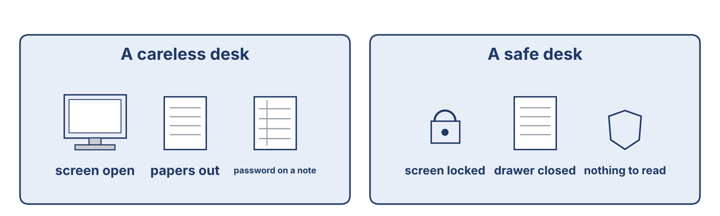
Figure 3.4 · A careless desk and a safe desk.
Before you read: what is the most important desk rule in an office?
Gloss: lock = to close your screen so nobody else can use it · passphrase = a long password made of several words · report = to tell the help desk what you have seen
An office can be a careless place, but good rules keep the work safe. The most important rule is the simplest: lock your screen every time you stand up. A machine left open for two minutes is enough. Next, choose a passphrase of four words instead of a short password, and never write it on paper or share it with anybody — not with a colleague, and not with the manager. Keep your desk clear at night, so that a cleaner or a visitor finds nothing to read. Before you open a file, look at who sent it: if you did not expect it, send it to the help desk first. And when something looks wrong, report it at once. The worst thing a worker can do is stay quiet, because a problem reported in the first hour is small, and the same problem reported in a week is not.
Answer the multiple-choice questions. (0. is done.)
0. What is the most important rule? — lock your screen every time you stand up.
1. Why must you keep your desk clear at night?
○ A) To look nice
○ B) To save money
○ C) So that a cleaner or a visitor finds nothing to read
○ D) Because it is the law
2. What must you do before you open a file?
○ A) Call the manager
○ B) Look at who sent it
○ C) Print it
○ D) Copy it to a disk
3. Why must a problem be reported at once?
○ A) Because a problem reported in the first hour is small
○ B) Because it is polite
○ C) Because the manager likes messages
○ D) Because the machine is new
Part 5: Vocabulary in Context
Match each word from the text with its meaning. One meaning is not needed. Write the letter.
Column A
1. | passphrase | ____
2. | lock | ____
3. | clear desk | ____
4. | report | ____
Column B
a) | to close your screen so nobody else can use it
b) | the rule that leaves nothing on the desk at night
c) | a tool for opening a machine
d) | to tell the help desk what you have seen
e) | a long password made of several words
Part 5: A Family Business in Syria
Before you read: how can a small office make its work safer without spending money?
Gloss: rule board = a board on the wall where the rules are written · habit = something you do the same way every time
In a small street in Damascus, the Khalil family has run a trading office for thirty years. For most of that time there were four machines and one password that everybody knew. Then the eldest son, Samir, came back from two years at a bank in Beirut, where he had learned how a careful office works. He did not change everything at once. In the first month he gave every person their own account and put the rules on a board by the door: five lines, in Arabic and English. In the second month he taught everybody the screen lock, and he locked his own screen in front of them every time he stood up, until it became a habit. In the third month he started the backup. None of it cost money. Samir says the hardest part was not the machines; it was asking his own uncle to stop using his son’s account.
Write True or False. (0. is done.)
0. The Khalil family office is new. — False
1. Samir learned how a careful office works at a bank in Beirut. ____
2. He changed everything in one day. ____
3. The changes cost the office a lot of money. ____
Part 6 · Writing
[OP] Operator track · in-class / homework
Part 6: Desk Rules for the Office (50–70 words)
Write five desk rules for an office. Use imperatives and sequencers.
Model — read this first:
First, choose a passphrase of four words and never write it down. Then lock your screen every time you stand up, even for a minute. Next, don’t open a file from a message you did not expect; send it to the help desk. After that, keep your desk clear at night. Finally, if you are not sure about anything, stop and ask.
Plan (fill in, then write): First, always… Then… Next… After that… Finally…
Word bank: First, Then, Next, Finally | Always… / Never… | Don’t… | lock | report | share
Check before you finish: ☐ imperatives used? ☐ sequencers used? ☐ 50–70 words?
Part 6: Why Safe Working Matters (50–70 words)
Write why safe working is important in an office. Give reasons.
Model — read this first:
Safe working is important because one open screen can cost the company everything it keeps. A shared password means nobody can say who did what, so an honest worker cannot be cleared. A reported problem is small in the first hour and large in a week. The rules take ten seconds each, and they protect the work of the whole office.
Word bank: … is important because… | one open screen… | nobody can say who… | it takes ten seconds | it protects…
Check before you finish: ☐ a clear opinion? ☐ two or three reasons? ☐ 50–70 words?
Part 6: A Desk Notice (40–60 words)
Write a short notice to put on the office wall. Use clear imperatives.
Model — read this first:
BEFORE YOU LEAVE YOUR DESK. Save your work. Lock your screen — every time. Put your papers in the drawer. Take nothing home on a USB stick without asking. If you see something strange on your machine, tell the help desk today, not tomorrow. Thank you. The IT and Security Department.
Check before you finish: ☐ clear imperatives? ☐ easy to read on a wall? ☐ 40–60 words?
Part 6: Reflection — A Time Care Mattered (40–60 words)
Write about a time when care with a password or a file was important, at work or at home.
Model — read this first:
Last winter my cousin opened a file in a message that looked like a delivery note. The machine became slow and strange, and he turned it off. He told the office the same morning, and they cleaned it in one afternoon. If he had said nothing for a week, the whole office would have lost its files.
Check before you finish: ☐ a clear story? ☐ imperatives or past tense used well? ☐ 40–60 words?
Part 7 · Management File — The Desk Induction
[PR] Practitioner track (optional for beginners) · IT and security manager
7A: Phrase Bank
Match what a manager says with its purpose. One purpose is not needed. Write the letter.
Column A
1. | “Always lock your screen.” | ____
2. | “Let me show you where the rules are.” | ____
3. | “Never share your password with anybody.” | ____
4. | “Ask me if you are not sure.” | ____
Column B
a) | showing someone around
b) | giving a strong warning
c) | giving a simple rule
d) | asking about the price
e) | offering help and support
7B: Manager Dialogue
🔊 Audio Track 3.5
Before you read: what does a manager show a new worker on their first day at a desk?
Nabil: Tarek, today is your desk induction. First, this is your account, with your own name on it. Tarek: And the password? Nabil: You set it now, in front of me, and I do not want to know it. Make it four words long. Then lock the screen and check it opens again. Tarek: What do I do after I use a machine at somebody else’s desk? Nabil: Sign out. Always. And never leave a file open on their screen. Tarek: And if I see something strange? Nabil: Stop and tell me. Never try to repair it yourself.
Answer the questions. (0. is done.)
0. What is Tarek’s induction about? — Safe working at his desk.
1. Who sets the password, and who may know it?
2. What must he do after using a machine at another desk?
3. What must he never do?
7C: Controlled Practice — Induction Steps
Put a manager’s induction steps in order. Number them 1–5. (0. is done.)
0. Give the new worker their own account. — 1
____ Show the rule board by the door.
____ Explain how to lock the screen.
____ Show where to report a strange message.
____ Say “ask me if you are not sure.”
7D: Role-Play — Inducting a New Worker
In pairs. One is the security officer (Nabil); one is the new worker (Tarek). Use the model and the cards.
Model exchange: Nabil: First, set your own password — I must not know it. — Tarek: How long? — Nabil: Four words. Then lock your screen, and check it opens again.
Card A — Security officer (Nabil): give the induction in order (account, password, screen lock, reporting). Card B — New worker (Tarek): ask one question at each step, and ask what to do if you are not sure.
Stretch [PR]: the new worker says the last office shared one password and nothing ever happened — answer without criticising the last office.
7E: Supervisory Writing (50–80 words)
You are Maher. Write the office’s desk rules as a short numbered notice for the wall.
Model — read this first:
CHAM SYSTEMS — DESK RULES. 1. Use a passphrase of four words. Never write it down. 2. Lock your screen every time you stand up. 3. Do not open a file you did not expect; send it to the help desk. 4. Keep your desk clear at night. 5. If you are not sure, stop and ask. These five rules apply to everybody, including the manager. Maher Khoury.
Check before you finish: ☐ clear numbered rules? ☐ imperatives used? ☐ 50–80 words?
Part 8 · Global Case Study — The Office with No Shared Passwords
[PR] Practitioner track · pre-read / in-class discuss
Before you read: how can an office stop a problem before it starts?
Gloss: incident = something that goes wrong and must be recorded · rule = an instruction that everybody follows · audit = a careful check of how things are really done
A large company once had too many small incidents. A file was deleted and nobody knew who had deleted it. A payment was changed and three people had used the same account that morning. The new manager did not buy anything. She did two things. First, she put the rules on the wall in every room, in five short lines that a tired person could read. Second, she walked through one department every morning before the staff arrived and wrote down what she saw: an open screen, a password on a card, a drawer left unlocked. She did not name anybody; she wrote numbers, and she put the numbers on the same wall each week. In the first month there were nineteen open screens. By the sixth month there were none. She says good security is not a machine you buy; it is a habit you build, and the only way to build it is to count it.
Answer the questions. (0. is done.)
0. What problem did the company have? — Too many small incidents.
1. What did the manager put on the wall?
2. What did she do every morning?
3. What did she say good security is?
Part 8: Vocabulary in Context
Match each word with its meaning. One meaning is not needed. Write the letter.
Column A
1. | rule | ____
2. | incident | ____
3. | habit | ____
4. | audit | ____
Column B
a) | something that goes wrong and must be recorded
b) | an instruction that everybody follows
c) | a careful check of how things are really done
d) | a new machine
e) | something you do the same way every time
Part 8: Discussion
Talk with a partner. Use the frames.
Discussion frames: “This is similar to my office because…” · “This is different because…” · “The rule I would put on the wall first is…” · “Counting works because…”
Part 9 · Local Case Study — Syria in Focus: Raising a Small Office to Bank Standard
[PR] Practitioner track · pre-read / in-class decide
Before you read: what does a small office need before a bank will work with it?
Maher once visited a small company in Damascus that wanted to do work for a bank. The bank had sent a list of what it required, and the owner thought he needed to buy expensive equipment. Maher read the list and told him that most of it cost nothing. The bank wanted three things first: one account for each person, with no sharing; a written rule that staff follow, kept where anybody can see it; and a record of who may open which files, reviewed twice a year. The owner did all three in six weeks, with no new machines. The bank then asked for two more things that did cost money: a second backup kept in another building, and a proper lock on the server room door. After six months the bank signed the contract. The owner told Maher that the part he had expected to be hardest — the equipment — had been the easy part.
Answer the questions. (0. is done.)
0. What did the small office want to do? — Work for a bank.
1. What did the owner think he needed first?
2. What three things did the bank want that cost nothing?
3. What happened after six months?
Part 9: Decision Task
An office owner has a little money to improve his security. Should he first (a) buy a lock for the server room, (b) give every person their own account, or (c) write the rules on a board? Choose one and give reasons.
Answer frame: “I think the owner should first ___ because ___. Safety is ___. After that, he can ___.”
Model — read this first:
I think the owner should first give every person their own account, because without that nobody can say who did what, and no rule can be checked. Safety is knowing who opened a file. After that, he can write the rules on a board, which costs nothing, and buy the lock when the money is there.
Phrase bank: I think… should first… · because… · Safety is… · After that… · In my opinion…
Part 10 · Review and Can-Do
[OP + PR] · homework / self-study
Part 10: Spiral Review
Complete the review. (0. is done.)
0. You use a passphrase to open your account safely.
Word bank: screen lock | antivirus | Lock | finally | backup
1. The step that hides your work when you leave your desk is the ____________________ .
2. The program that watches for bad files on your machine is the ____________________ .
3. “ ____________________ your screen.” (an instruction)
4. To show the last step, we use the word ____________________ .
5. A copy of the files, kept in a safe place, is a ____________________ .
Part 10: Can-Do
Can-Do checklist
☐ I can name the main protections and safe-working terms for a desk.
☐ I can give instructions and rules using imperatives and sequencers.
☐ I can understand a security briefing and a desk induction.
☐ I can write clear desk rules for an office.
☐ I can induct and brief a new worker (Practitioner).
Part 10: Glossary
Unit 3 glossary (10 words)
passphrase · screen lock · antivirus · update · clear desk · visitor · shoulder surfing · report · incident · habit

