3.1 Purpose and structure of the income statement
Chapter 3 · section 3.1

Fill every gap. Each word list holds one word more than there are gaps.
Chapter 3, section by section
Each stage leads to the next.
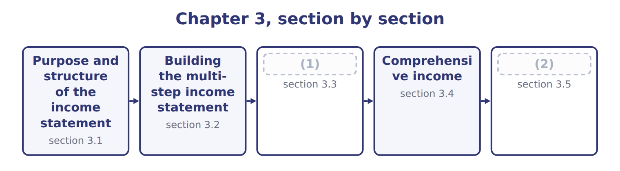
word list
reclassification adjustment · Unusual items and discontinued operations · Limitations and links to the other statements

Summary 1 gaps 3–13
The income statement reports a (3) revenues, expenses, gains and losses for a period, (4) a year. The (5) is net income, which (6) retained earnings. Where the (7) sheet is a (8) , the income statement is a film of the whole year. (9) use it to judge how (10) the company is and to predict its future earnings and cash flows. (11) use it to see whether the company earns enough to pay (12) . Managers use it to compare results with budgets and with (13) . U.S. GAAP does not require one layout. A multi-step income statement shows subtotals: gross profit, operating income and income before income taxes. A single-step income statement adds all revenues and gains, deducts all expenses and losses, and reaches net income in one step. SEC registrants such as Orontes follow the SEC's list of captions, which gives a multi-step layout.
word list
competitors · balance · increases · company's · multi-step income statement · profitable · usually · interest · result · Investors · Lenders · photograph

Orontes Foods Inc. — statement of income and comprehensive income, 2025
Orontes Foods Inc., year ended December 31, 2025 | 2025
Net sales | 42,000,000
Cost of goods sold | (27,300,000)
Gross profit | 14,700,000
Operating expenses
Selling, general and administrative | (7,237,000)
Credit loss expense | (63,000)
Research and development | (500,000)
Impairment losses | (2,724,000)
Total operating expenses | (10,524,000)
Operating income | 4,176,000
Other income and (expense)
Interest expense | (390,000)
Interest and dividend income | 3,800
Unrealized gains on securities | 4,000
Equity-method income | 177,000
Gain on sale of equipment | 3,000
Loss on sale of receivables | (15,000)
Total other income and (expense) | (217,200)
Income before income taxes | 3,958,800
Income tax expense | (989,700)
Net income | 2,969,100
Earnings per share, basic and diluted | $0.37
Weighted-average shares outstanding | 8,099,726
Other comprehensive income
Unrealized loss on available-for-sale debt securities, net of tax of 375 | (1,125)
Comprehensive income | 2,967,975

The English this section uses, and its Arabic
Each term sits against what it means.
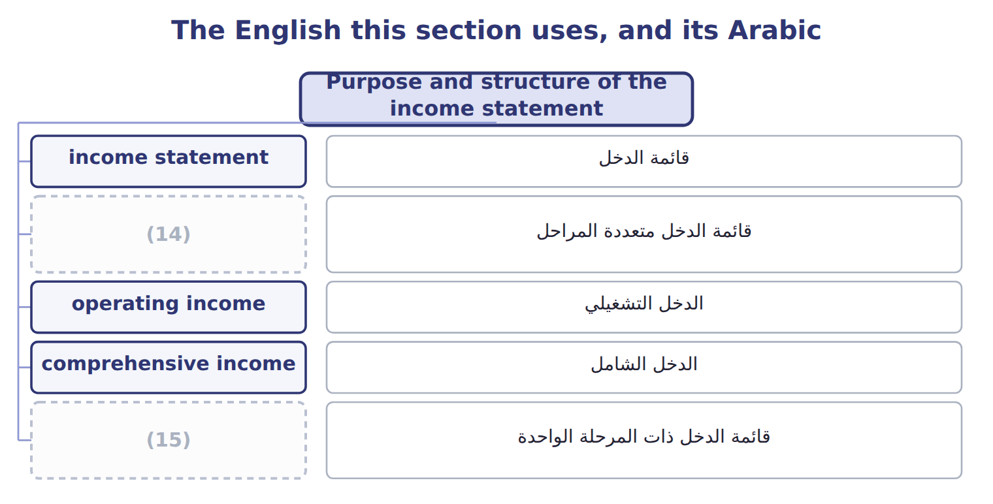
word list
comprehensive income · single-step income statement · multi-step income statement

The English this sheet uses, and its Arabic
English (exam term) | Arabic
multi-step income statement | قائمة الدخل متعددة المراحل
single-step income statement | قائمة الدخل ذات المرحلة الواحدة

Answer key · 3.1 Purpose and structure of the income statement

1 Unusual items and discontinued operations | 9 Investors
2 Limitations and links to the other statements | 10 profitable
3 company's | 11 Lenders
4 usually | 12 interest
5 result | 13 competitors
6 increases | 14 multi-step income statement
7 balance | 15 single-step income statement
8 photograph

the summaries in full
Summary 1 The income statement reports a company's revenues, expenses, gains and losses for a period, usually a year. The result is net income, which increases retained earnings. Where the balance sheet is a photograph, the income statement is a film of the whole year. Investors use it to judge how profitable the company is and to predict its future earnings and cash flows. Lenders use it to see whether the company earns enough to pay interest. Managers use it to compare results with budgets and with competitors. U.S. GAAP does not require one layout. A multi-step income statement shows subtotals: gross profit, operating income and income before income taxes. A single-step income statement adds all revenues and gains, deducts all expenses and losses, and reaches net income in one step. SEC registrants such as Orontes follow the SEC's list of captions, which gives a multi-step layout.

3.2 Building the multi-step income statement
Chapter 3 · section 3.2

Fill every gap. Each word list holds one word more than there are gaps.
Summary 1 gaps 1–6
Gross profit is net sales minus cost of goods sold. It shows how much the company earns on what it sells before its other costs. Orontes's gross profit is $14,700,000, which is 35% of net sales. Operating income is gross profit minus operating expenses: selling, general and (1) expenses, research and development, credit losses and impairments. Interest and income tax are never operating expenses. Orontes's operating income is $4,176,000. Other income and expense (2) operating income. It contains interest, (3) income and gains and losses. A gain or loss comes from a peripheral or incidental (4) , and it is shown net. For example, Orontes sold an old oven and (5) a gain of $3,000: the proceeds minus the carrying amount, not the full proceeds. Income tax expense is then (6) from income before income taxes.
word list
investment · deducted · administrative · transaction · function of expense · reported · follows

Summary 2 gaps 7–9
Public companies also show earnings per share (EPS) on the face of the (7) . Orontes's basic EPS is $0.37: net income divided by the (8) number of shares outstanding. Part 2 of the CMA exam (9) EPS in depth.
word list
other income and expense · analyzes · statement · weighted-average

Worked example: Orontes's subtotals

Summary 3 gaps 10–12
Gross (10) : $42,000,000 − $27,300,000 = $14,700,000. Operating income: $14,700,000 − $10,524,000 of operating (11) = $4,176,000. Income (12) income taxes: $4,176,000 − net other expense of $217,200 = $3,958,800. Net income: $3,958,800 − income tax of $989,700 = $2,969,100.
word list
profit · other income and expense · expenses · before

Barada's 2025 income statement

Where the line is drawn

Summary 4 gaps 13–14
Interest (13) is below operating income, never inside it. A gain on selling (14) is other income, not revenue. Gross profit uses cost of goods sold only; wages and depreciation outside production are operating expenses.
word list
expense · earnings per share (EPS) · equipment

Barada Wholesale — multi-step income statement, 2025 (complete the blanks)
Barada Wholesale, year ended December 31, 2025 ( | 2025
Sales revenue | 3,100
Cost of goods sold | (1,860)
Gross profit | 1,240
Wages expense | (520)
Depreciation expense | (300)
Operating income | ________
Interest expense | (90)
Net income | ________
Gross profit as a percentage of sales | ________

The English this section uses, and its Arabic
Each term sits against what it means.
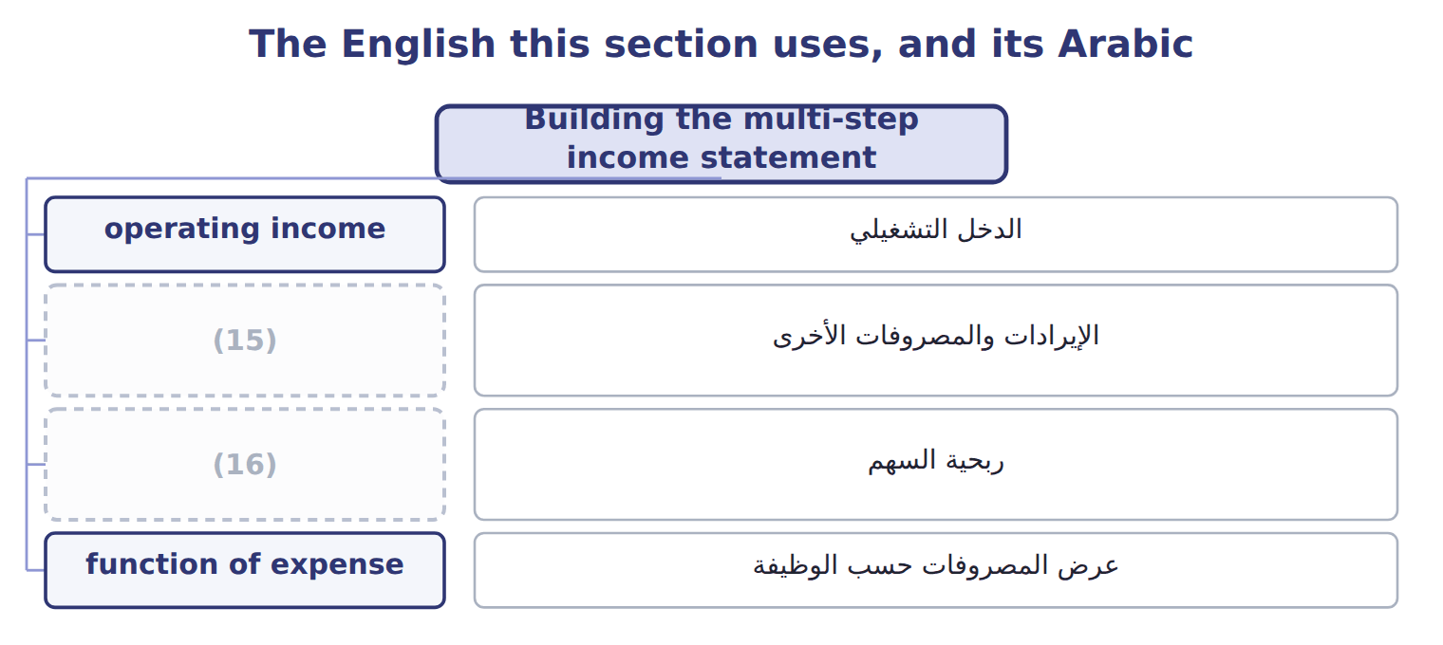
word list
single-step income statement · other income and expense · earnings per share (EPS)

The English this sheet uses, and its Arabic
English (exam term) | Arabic
operating income | الدخل التشغيلي
other income and expense | الإيرادات والمصروفات الأخرى
earnings per share (EPS) | ربحية السهم
function of expense | عرض المصروفات حسب الوظيفة

Answer key · 3.2 Building the multi-step income statement

1 administrative | 9 analyzes
2 follows | 10 profit
3 investment | 11 expenses
4 transaction | 12 before
5 reported | 13 expense
6 deducted | 14 equipment
7 statement | 15 other income and expense
8 weighted-average | 16 earnings per share (EPS)

the summaries in full
Summary 1 Gross profit is net sales minus cost of goods sold. It shows how much the company earns on what it sells before its other costs. Orontes's gross profit is $14,700,000, which is 35% of net sales. Operating income is gross profit minus operating expenses: selling, general and administrative expenses, research and development, credit losses and impairments. Interest and income tax are never operating expenses. Orontes's operating income is $4,176,000. Other income and expense follows operating income. It contains interest, investment income and gains and losses. A gain or loss comes from a peripheral or incidental transaction, and it is shown net. For example, Orontes sold an old oven and reported a gain of $3,000: the proceeds minus the carrying amount, not the full proceeds. Income tax expense is then deducted from income before income taxes.
Summary 2 Public companies also show earnings per share (EPS) on the face of the statement. Orontes's basic EPS is $0.37: net income divided by the weighted-average number of shares outstanding. Part 2 of the CMA exam analyzes EPS in depth.
Summary 3 Gross profit: $42,000,000 − $27,300,000 = $14,700,000. Operating income: $14,700,000 − $10,524,000 of operating expenses = $4,176,000. Income before income taxes: $4,176,000 − net other expense of $217,200 = $3,958,800. Net income: $3,958,800 − income tax of $989,700 = $2,969,100.
Summary 4 Interest expense is below operating income, never inside it. A gain on selling equipment is other income, not revenue. Gross profit uses cost of goods sold only; wages and depreciation outside production are operating expenses.

3.3 Unusual items and discontinued operations
Chapter 3 · section 3.3

Fill every gap. Each word list holds one word more than there are gaps.
Summary 1 gaps 1–10
Some items need special (1) because they may not (2) again. U.S. GAAP no longer has (3) items; the FASB (4) them in 2015. An unusual or (5) item, such as a large fire loss, is shown as a (6) line within continuing operations, before tax. A discontinued operation is a (7) of an entity that the company has sold, has (8) as held for sale, or has abandoned. The disposal must also be a (9) shift with a major (10) on the company. Examples are leaving a major line of business or a major geographic area. Closing one store or stopping one small product does not qualify. The results of a discontinued operation, including any gain or loss on disposal, appear below income from continuing operations, net of their own tax. This is called intraperiod tax allocation.
word list
extraordinary · happen · discontinued operation · effect · removed · infrequent · attention · separate · strategic · component · classified

Suppose: Orontes sells its frozen-foods business in 2026 — discontinued operations
Suppose: Orontes, 2026 (whole USD) | Before tax | Tax benefit | Net of tax
(11) | (420,000) | 105,000 | (315,000)
Loss on disposal of the business | (180,000) | 45,000 | (135,000)
(12) | (600,000) | 150,000 | (450,000)

word list
Loss on disposal of the business · Loss from discontinued operations · Loss from operations of the frozen-foods business

Extraordinary nostalgia

Summary 2 gaps 13–17
Older textbooks show earthquakes and (13) as extraordinary items, net of tax, below continuing operations. On today's exam, such an item is unusual or (14) : a separate pre-tax line in continuing operations. Only (15) operations are shown net of tax below continuing operations. IFRS 5 uses a similar idea: a separate major line of business or (16) area. IFRS also prohibits extraordinary items, so the two (17) now give very similar results in this area.
word list
expropriations · infrequent · frameworks · geographic · discontinued · intraperiod tax allocation

The English this section uses, and its Arabic
Each term sits against what it means.
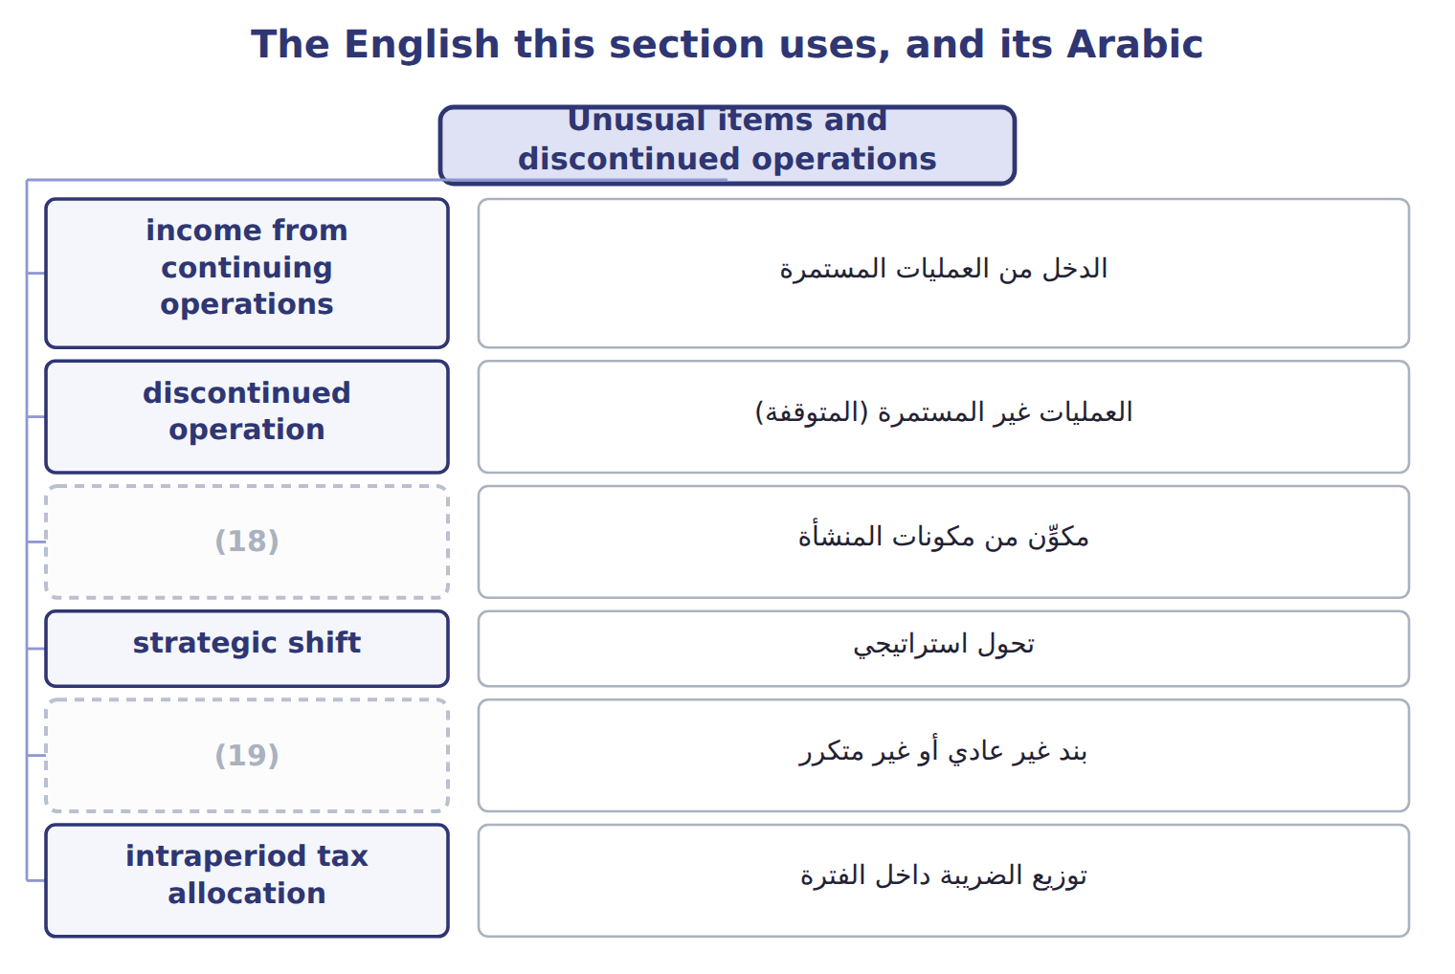
word list
component of an entity · reclassification adjustment · unusual or infrequent item

The English this sheet uses, and its Arabic
English (exam term) | Arabic
income from continuing operations | الدخل من العمليات المستمرة
discontinued operation | العمليات غير المستمرة (المتوقفة)
component of an entity | مكوِّن من مكونات المنشأة
strategic shift | تحول استراتيجي
unusual or infrequent item | بند غير عادي أو غير متكرر
intraperiod tax allocation | توزيع الضريبة داخل الفترة

Answer key · 3.3 Unusual items and discontinued operations

1 attention | 11 Loss from operations of the frozen-foods business
2 happen | 12 Loss from discontinued operations
3 extraordinary | 13 expropriations
4 removed | 14 infrequent
5 infrequent | 15 discontinued
6 separate | 16 geographic
7 component | 17 frameworks
8 classified | 18 component of an entity
9 strategic | 19 unusual or infrequent item
10 effect

the summaries in full
Summary 1 Some items need special attention because they may not happen again. U.S. GAAP no longer has extraordinary items; the FASB removed them in 2015. An unusual or infrequent item, such as a large fire loss, is shown as a separate line within continuing operations, before tax. A discontinued operation is a component of an entity that the company has sold, has classified as held for sale, or has abandoned. The disposal must also be a strategic shift with a major effect on the company. Examples are leaving a major line of business or a major geographic area. Closing one store or stopping one small product does not qualify. The results of a discontinued operation, including any gain or loss on disposal, appear below income from continuing operations, net of their own tax. This is called intraperiod tax allocation.
Summary 2 Older textbooks show earthquakes and expropriations as extraordinary items, net of tax, below continuing operations. On today's exam, such an item is unusual or infrequent: a separate pre-tax line in continuing operations. Only discontinued operations are shown net of tax below continuing operations. IFRS 5 uses a similar idea: a separate major line of business or geographic area. IFRS also prohibits extraordinary items, so the two frameworks now give very similar results in this area.

3.4 Comprehensive income
Chapter 3 · section 3.4

Fill every gap. Each word list holds one word more than there are gaps.
Summary 1 gaps 1–6
Some changes in value do not go (1) net income. U.S. GAAP sends them to other comprehensive income (OCI) until they are (2) . Comprehensive income is net income plus OCI for the (3) . Orontes's (4) debt securities lost $1,500 in fair value in 2025. After tax, the loss in OCI is $1,125, so comprehensive income is $2,969,100 − $1,125 = $2,967,975. Companies show this in one continuous statement, as Orontes does, or in two (5) statements. (6) OCI only in the statement of changes in equity is not allowed.
word list
available-for-sale · consecutive · comprehensive income · period · through · Showing · realized

Main OCI items: U.S. GAAP and IFRS
The two sides differ only where the rows say.
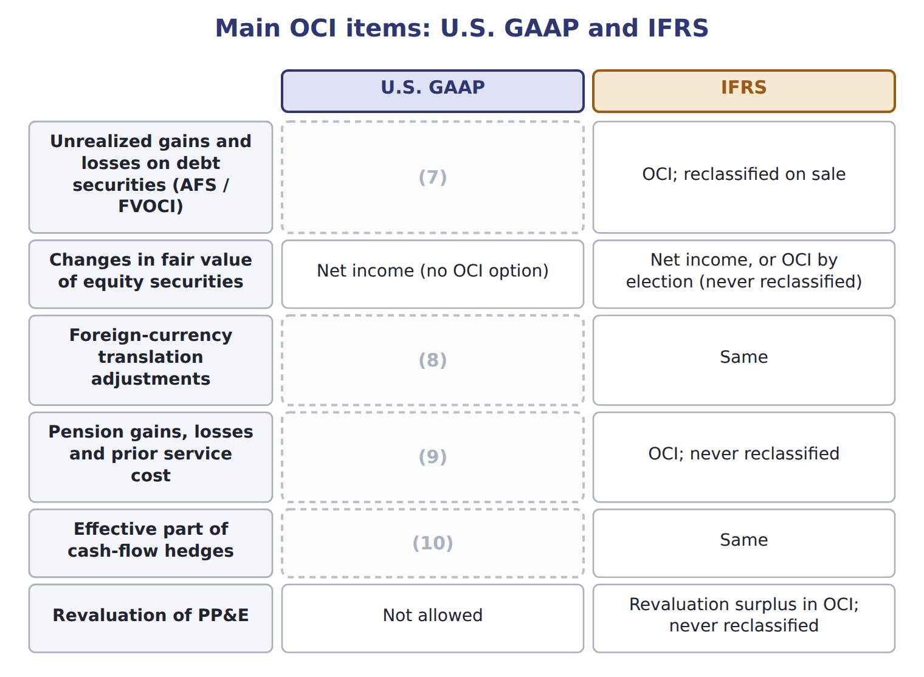
word list
OCI; reclassified when the hedged item affects income · earnings per share (EPS) · OCI; reclassified when the foreign operation is sold · OCI; amortized into net income later · OCI; reclassified to net income on sale

Summary 2 gaps 11–13
Under IFRS, a revaluation surplus on PP&E, fair value changes on equity (11) elected to OCI, and pension (12) stay in OCI forever. U.S. GAAP does not allow PP&E revaluation, and it (13) its OCI items to net income later.
word list
comprehensive income · reclassifies · investments · remeasurements

Comprehensive income traps

Summary 3 gaps 14–15
Comprehensive income adds this year's OCI, not the AOCI (14) . (15) gains on equity securities go to net income, not OCI. Use OCI after tax, unless the question shows the tax on a separate line.
word list
comprehensive income · balance · Unrealized

The English this section uses, and its Arabic
Each term sits against what it means.
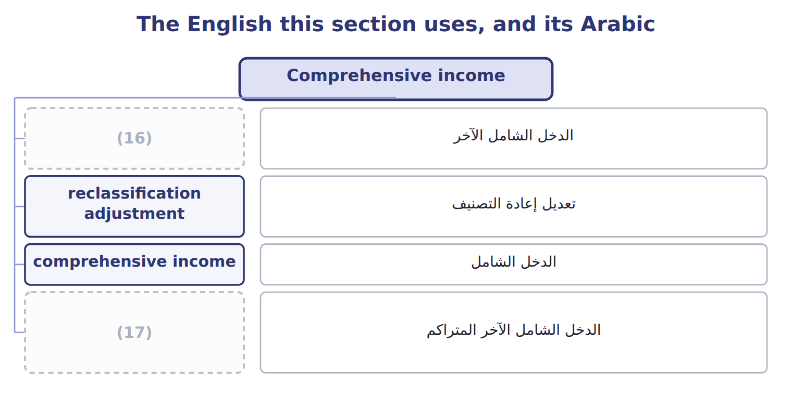
word list
strategic shift · other comprehensive income (OCI) · accumulated other comprehensive income (AOCI)

The English this sheet uses, and its Arabic
English (exam term) | Arabic
other comprehensive income (OCI) | الدخل الشامل الآخر
reclassification adjustment | تعديل إعادة التصنيف
comprehensive income | الدخل الشامل
accumulated other comprehensive income (AOCI) | الدخل الشامل الآخر المتراكم

Answer key · 3.4 Comprehensive income

1 through | 10 OCI; reclassified when the hedged item affects income
2 realized | 11 investments
3 period | 12 remeasurements
4 available-for-sale | 13 reclassifies
5 consecutive | 14 balance
6 Showing | 15 Unrealized
7 OCI; reclassified to net income on sale | 16 other comprehensive income (OCI)
8 OCI; reclassified when the foreign operation is sold | 17 accumulated other comprehensive income (AOCI)
9 OCI; amortized into net income later

the summaries in full
Summary 1 Some changes in value do not go through net income. U.S. GAAP sends them to other comprehensive income (OCI) until they are realized. Comprehensive income is net income plus OCI for the period. Orontes's available-for-sale debt securities lost $1,500 in fair value in 2025. After tax, the loss in OCI is $1,125, so comprehensive income is $2,969,100 − $1,125 = $2,967,975. Companies show this in one continuous statement, as Orontes does, or in two consecutive statements. Showing OCI only in the statement of changes in equity is not allowed.
Summary 2 Under IFRS, a revaluation surplus on PP&E, fair value changes on equity investments elected to OCI, and pension remeasurements stay in OCI forever. U.S. GAAP does not allow PP&E revaluation, and it reclassifies its OCI items to net income later.
Summary 3 Comprehensive income adds this year's OCI, not the AOCI balance. Unrealized gains on equity securities go to net income, not OCI. Use OCI after tax, unless the question shows the tax on a separate line.

3.5 Limitations and links to the other statements
Chapter 3 · section 3.5

Fill every gap. Each word list holds one word more than there are gaps.
Summary 1 gaps 1–12
Net income depends on many estimates: useful lives, credit losses, (1) tests and warranty costs. Different companies also choose different methods, such as FIFO or LIFO for (2) . Two similar companies can (3) report different profits from the same activity. The income statement also (4) things out. An increase in the value of (5) land, or of a brand it built itself, is not reported. Managers can influence results by timing sales or (6) costs, such as research or advertising, near the year-end. Net income then moves to the statement of changes in equity, where it (7) retained earnings. In the statement of cash flows, the (8) method starts from net income. ASU 2024-03 (DISE) requires public companies to break down some expense captions in the notes, such as employee pay and (9) . The face of the statement does not (10) . IFRS 18 replaces IAS 1 and adds required (11) , including operating profit. Both apply from 2027 and are not (12) before about January 2028.
word list
Orontes's · increases · unusual or infrequent item · inventory · depreciation · testable · discretionary · impairment · indirect · leaves · subtotals · therefore · change

Résultat and إيرادات

Summary 2 gaps 13–14
French résultat means profit, not result in general, and résultat (13) is not a U.S. category. Arabic إيرادات can mean revenue or income; in U.S. GAAP, revenue comes from main (14) , and income is what remains after expenses.
word list
exceptionnel · activities · unusual or infrequent item

Résultat and إيرادات
Item / memo (USD 000) | Amount / details
Net sales | 3,400
Cost of goods sold | 2,040
Wages expense | 560
Depreciation expense | 300
Fire loss (uninsured inventory) | 70
Lawsuit settlement | 50
Interest expense | 80
Gain on sale of equipment | 20
M1 | In August 2026 Barada sold its catering-supply division to focus only on wholesale food. The division was one of Barada's two lines of busin
M2 | In 2026 the division had an operating loss of 60 before tax. Barada lost 40 before tax on the sale.
M3 | The fire loss is the uninsured inventory destroyed on February 10, 2026. Fires are unusual for Barada.
M4 | The income tax rate is 25% on all items. Barada has no other comprehensive income.

Item — Answer
Item | Answer
Operating income | (15)
Net income | (16)
Gross profit percentage | 1,240 ÷ 3,100 = 40%

word list
420 − 90 = 330, the same as in Chapter 1 · 1,240 ÷ 3,100 = 40% · 1,240 − 520 − 300 = 420

Item — Category
Every item belongs to exactly one group.
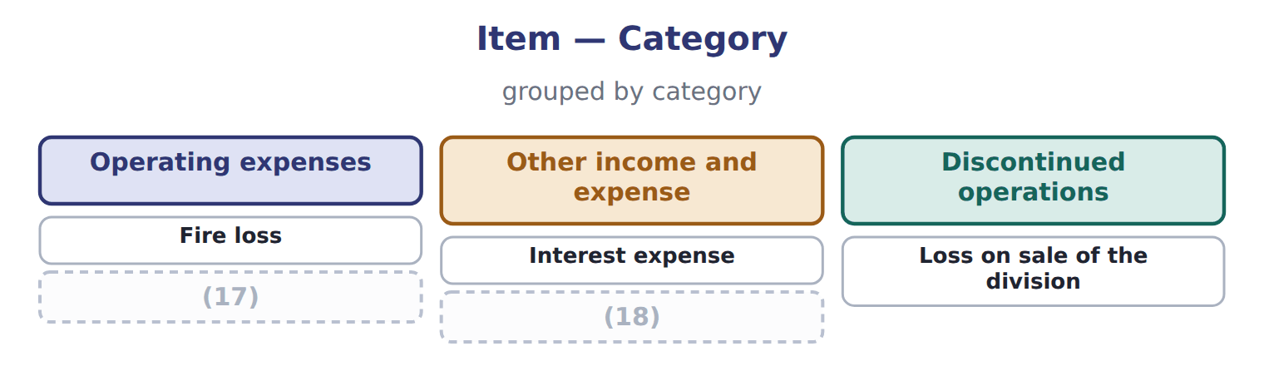
word list
Lawsuit settlement · Gain on sale of equipment · unusual or infrequent item

Answer key · 3.5 Limitations and links to the other statements

1 impairment | 10 change
2 inventory | 11 subtotals
3 therefore | 12 testable
4 leaves | 13 exceptionnel
5 Orontes's | 14 activities
6 discretionary | 15 1,240 − 520 − 300 = 420
7 increases | 16 420 − 90 = 330, the same as in Chapter 1
8 indirect | 17 Lawsuit settlement
9 depreciation | 18 Gain on sale of equipment

the summaries in full
Summary 1 Net income depends on many estimates: useful lives, credit losses, impairment tests and warranty costs. Different companies also choose different methods, such as FIFO or LIFO for inventory. Two similar companies can therefore report different profits from the same activity. The income statement also leaves things out. An increase in the value of Orontes's land, or of a brand it built itself, is not reported. Managers can influence results by timing sales or discretionary costs, such as research or advertising, near the year-end. Net income then moves to the statement of changes in equity, where it increases retained earnings. In the statement of cash flows, the indirect method starts from net income. ASU 2024-03 (DISE) requires public companies to break down some expense captions in the notes, such as employee pay and depreciation. The face of the statement does not change. IFRS 18 replaces IAS 1 and adds required subtotals, including operating profit. Both apply from 2027 and are not testable before about January 2028.
Summary 2 French résultat means profit, not result in general, and résultat exceptionnel is not a U.S. category. Arabic إيرادات can mean revenue or income; in U.S. GAAP, revenue comes from main activities, and income is what remains after expenses.

