5.1 Purpose and structure of the statement of cash flows
Chapter 5 · section 5.1

Fill every gap. Each word list holds one word more than there are gaps.
Chapter 5, section by section
Each stage leads to the next.
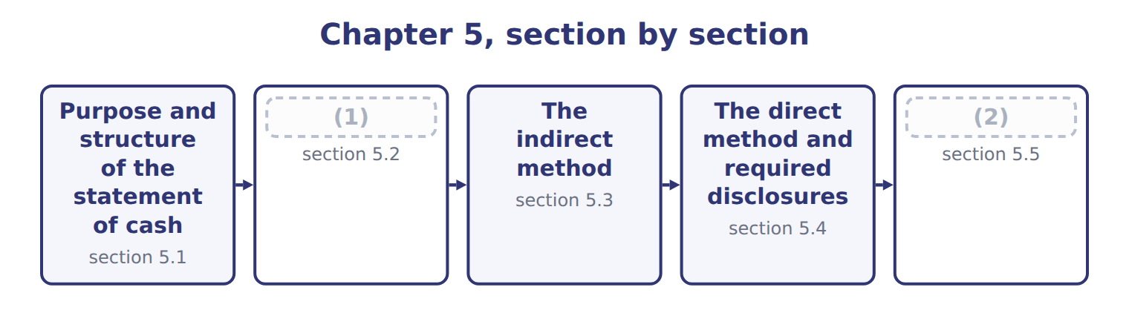
word list
direct method · Classifying cash flows · Limitations and links between the four stateme

Summary 1 gaps 3–8
The statement of cash flows reports a (3) cash receipts and cash payments for a period. Users need it (4) profit is not cash. It helps them judge whether the company can produce cash, pay its debts and (5) , and fund its growth without new financing. The statement explains the change in cash, cash equivalents and (6) cash together. Cash equivalents are short-term, highly liquid (7) with an original maturity to the holder of three months or less. Moving money between these (8) is not a cash flow.
word list
investments · company's · restricted · cash equivalents · dividends · categories · because

Orontes Foods Inc. — statement of cash flows (indirect method), 2025
Orontes Foods Inc., year ended December 31, 2025 | 2025
Cash flows from operating activities
Net income | 2,969,100
Adjustments to reconcile net income to net cash from operating activities:
Depreciation | 2,100,000
Impairment losses | 2,724,000
Equity-method income | (177,000)
Dividends from equity-method investees | 70,000
Gain on sale of equipment | (3,000)
Unrealized gains on securities | (4,000)
Deferred income taxes | 100,000
Increase in accounts receivable, net | (384,000)
Increase in inventory | (150,000)
Increase in prepaid expenses | (24,000)
Increase in accounts payable | 150,000
Increase in accrued liabilities | 50,000
Increase in income taxes payable | 50,000
Increase in contract liabilities | 60,000
Net cash provided by operating activities | 7,531,100
Cash flows from investing activities
Purchases of property, plant and equipment | (3,000,000)
Proceeds from sale of equipment | 21,000
Investment in Jordan Glass Co. | (1,200,000)
Net cash used in investing activities | (4,179,000)
Cash flows from financing activities
Issuance of common stock | 1,500,000
Proceeds from bank note | 800,000
Repayment of long-term debt | (400,000)
Dividends paid | (50,000)
Net cash provided by financing activities | 1,850,000
Net increase in cash | 5,202,100
Cash, January 1, 2025 | 2,100,000
Cash, December 31, 2025 | 7,302,100
Supplemental disclosures
Interest paid | 390,000
Income taxes paid | 839,700
Noncash investing and financing activities | none

The English this section uses, and its Arabic
Each term sits against what it means.
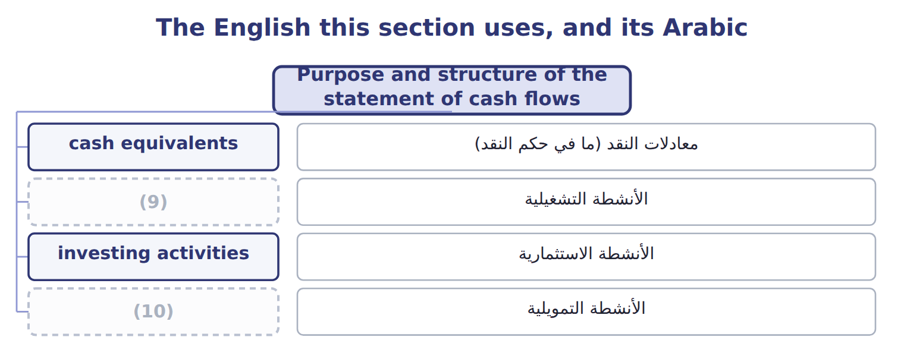
word list
financing activities · statement of cash flows · operating activities

The English this sheet uses, and its Arabic
English (exam term) | Arabic
cash equivalents | معادلات النقد (ما في حكم النقد)
operating activities | الأنشطة التشغيلية
investing activities | الأنشطة الاستثمارية
financing activities | الأنشطة التمويلية

Answer key · 5.1 Purpose and structure of the statement of cash flows

1 Classifying cash flows | 6 restricted
2 Limitations and links between the four stateme | 7 investments
3 company's | 8 categories
4 because | 9 operating activities
5 dividends | 10 financing activities

the summaries in full
Summary 1 The statement of cash flows reports a company's cash receipts and cash payments for a period. Users need it because profit is not cash. It helps them judge whether the company can produce cash, pay its debts and dividends, and fund its growth without new financing. The statement explains the change in cash, cash equivalents and restricted cash together. Cash equivalents are short-term, highly liquid investments with an original maturity to the holder of three months or less. Moving money between these categories is not a cash flow.

5.2 Classifying cash flows
Chapter 5 · section 5.2

Fill every gap. Each word list holds one word more than there are gaps.
Summary 1 gaps 1–7
Operating activities are the main revenue activities: cash from (1) and cash paid to (2) and employees. (3) that is not investing or financing is also operating. Investing activities involve (4) assets and other companies' (5) : Orontes paid $3,000,000 for equipment and $1,200,000 for its Jordan Glass shares. Financing activities are with owners and (6) . They include issuing and buying back shares, (7) and repaying principal, and paying dividends. Orontes received $1,500,000 from its share issue and $800,000 from the bank note, repaid $400,000 of debt and paid $50,000 of dividends.
word list
Anything · borrowing · securities · long-term · suppliers · lenders · customers · financing activities

Classifying interest, dividends and taxes: U.S. GAAP and IFRS
Every item belongs to exactly one group.
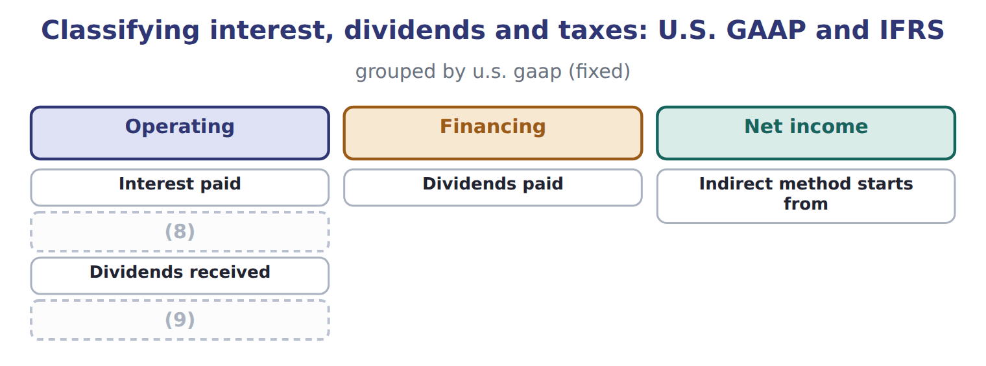
word list
Income taxes paid · financing activities · Interest received

Summary 2 gaps 10–15
Some investing and financing (10) involve no cash at all, such as buying land by (11) shares or a note. These noncash investing and financing (12) are not shown in the body of the (13) . They are disclosed (14) . Under IAS 7 today, interest paid can be operating or financing, and interest and (15) received can be operating or investing. The amendments that come with IFRS 18 remove some choices from 2027, but they are not testable before about January 2028.
word list
dividends · statement · transactions · direct method · activities · issuing · separately

Which activity?

Which activity? (complete the blanks)
Every item belongs to exactly one group.
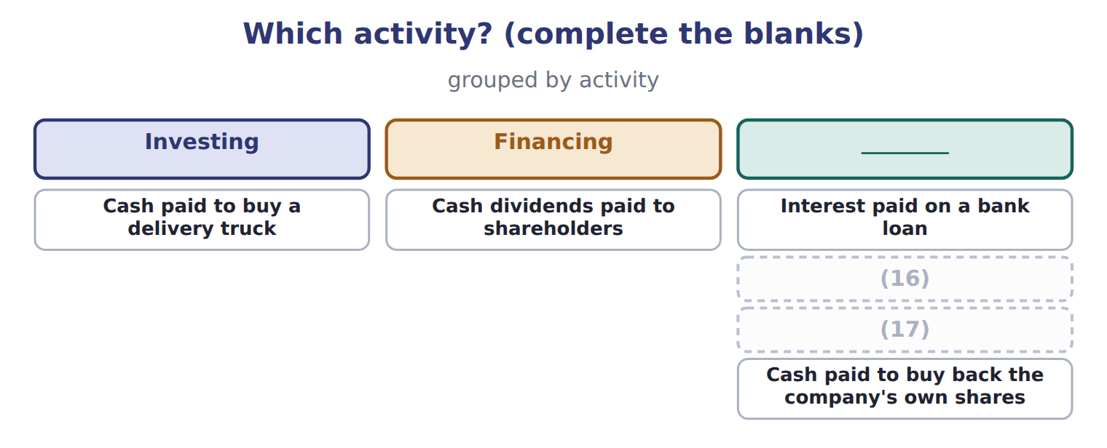
word list
Cash received from selling Jordan Glass shares · Land acquired by issuing a long-term note (no cash) · cash equivalents

Classification traps

Summary 3 gaps 18–19
Interest paid is operating, not financing, under U.S. GAAP. Dividends paid are financing; dividends (18) are operating. A note issued for land is not a cash flow: (19) it.
word list
received · disclose · investing activities

The English this section uses, and its Arabic
Each term sits against what it means.
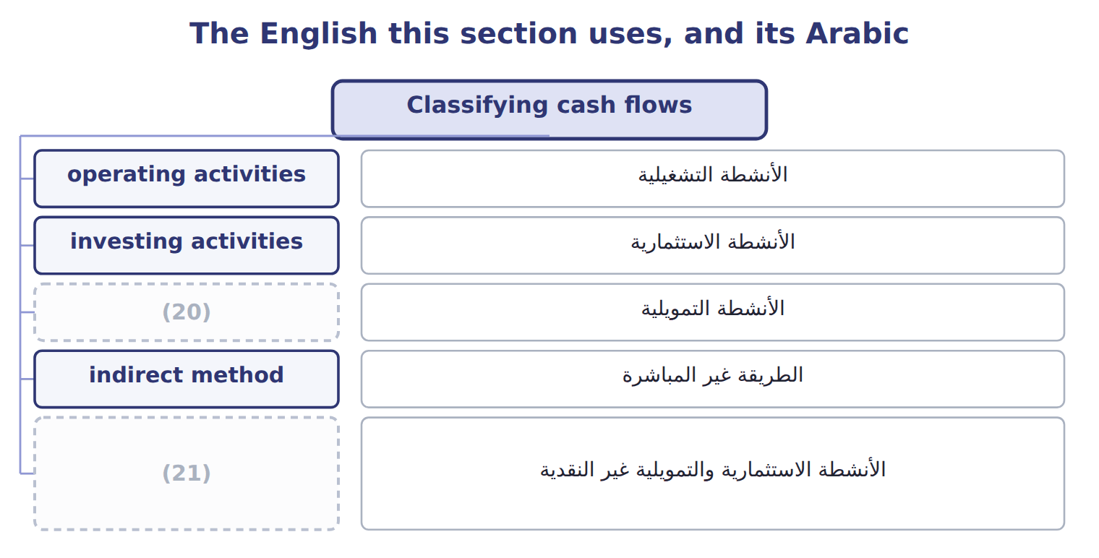
word list
cash equivalents · noncash investing and financing activities · financing activities

The English this sheet uses, and its Arabic
English (exam term) | Arabic
noncash investing and financing activities | الأنشطة الاستثمارية والتمويلية غير النقدية

Answer key · 5.2 Classifying cash flows

1 customers | 12 activities
2 suppliers | 13 statement
3 Anything | 14 separately
4 long-term | 15 dividends
5 securities | 16 Cash received from selling Jordan Glass shares
6 lenders | 17 Land acquired by issuing a long-term note (no cash)
7 borrowing | 18 received
8 Interest received | 19 disclose
9 Income taxes paid | 20 financing activities
10 transactions | 21 noncash investing and financing activities
11 issuing

the summaries in full
Summary 1 Operating activities are the main revenue activities: cash from customers and cash paid to suppliers and employees. Anything that is not investing or financing is also operating. Investing activities involve long-term assets and other companies' securities: Orontes paid $3,000,000 for equipment and $1,200,000 for its Jordan Glass shares. Financing activities are with owners and lenders. They include issuing and buying back shares, borrowing and repaying principal, and paying dividends. Orontes received $1,500,000 from its share issue and $800,000 from the bank note, repaid $400,000 of debt and paid $50,000 of dividends.
Summary 2 Some investing and financing transactions involve no cash at all, such as buying land by issuing shares or a note. These noncash investing and financing activities are not shown in the body of the statement. They are disclosed separately. Under IAS 7 today, interest paid can be operating or financing, and interest and dividends received can be operating or investing. The amendments that come with IFRS 18 remove some choices from 2027, but they are not testable before about January 2028.
Summary 3 Interest paid is operating, not financing, under U.S. GAAP. Dividends paid are financing; dividends received are operating. A note issued for land is not a cash flow: disclose it.

5.3 The indirect method
Chapter 5 · section 5.3

Fill every gap. Each word list holds one word more than there are gaps.
Summary 1 gaps 1–5
Most U.S. companies use the indirect method for operating (1) . It starts with net income and removes (2) that is not an operating cash flow. First, add back noncash expenses and losses, such as (3) , impairments and an increase in deferred tax liabilities. Second, remove gains and losses on investing and (4) items; the cash from those sales belongs in investing. Also subtract (5) income, which is not cash, and add the dividends received from the investee.
word list
everything · equity-method · indirect method · depreciation · activities · financing

Worked example: Orontes's operating cash flow

Summary 2 gaps 6–8
Start with net income: $2,969,100. Add (6) , impairments and deferred taxes, which used no cash: $4,924,000. Subtract (7) income of $177,000, add dividends from investees of $70,000, and subtract the oven gain of $3,000 and unrealized gains of $4,000. (8) changes reduce cash by a net $248,000.
word list
depreciation · Working-capital · equity-method · indirect method

Indirect-method traps

Summary 3 gaps 9–11
Start from net income, never from operating income. (9) payable and notes payable are financing items. Do not (10) their changes in working capital. Show the full proceeds of a sale in (11) , and remove the gain from operating.
word list
include · investing · Dividends · indirect method

The English this sheet uses, and its Arabic
English (exam term) | Arabic
indirect method | الطريقة غير المباشرة

Answer key · 5.3 The indirect method

1 activities | 7 equity-method
2 everything | 8 Working-capital
3 depreciation | 9 Dividends
4 financing | 10 include
5 equity-method | 11 investing
6 depreciation

the summaries in full
Summary 1 Most U.S. companies use the indirect method for operating activities. It starts with net income and removes everything that is not an operating cash flow. First, add back noncash expenses and losses, such as depreciation, impairments and an increase in deferred tax liabilities. Second, remove gains and losses on investing and financing items; the cash from those sales belongs in investing. Also subtract equity-method income, which is not cash, and add the dividends received from the investee.
Summary 2 Start with net income: $2,969,100. Add depreciation, impairments and deferred taxes, which used no cash: $4,924,000. Subtract equity-method income of $177,000, add dividends from investees of $70,000, and subtract the oven gain of $3,000 and unrealized gains of $4,000. Working-capital changes reduce cash by a net $248,000.
Summary 3 Start from net income, never from operating income. Dividends payable and notes payable are financing items. Do not include their changes in working capital. Show the full proceeds of a sale in investing, and remove the gain from operating.

5.4 The direct method and required disclosures
Chapter 5 · section 5.4

Fill every gap. Each word list holds one word more than there are gaps.
Summary 1 gaps 1–3
The direct method shows the main classes of operating receipts and payments, such as cash from (1) and cash paid to suppliers. The FASB (2) it, but few companies use it. A company that uses it must still show the (3) of net income to operating cash flow.
word list
direct method · customers · reconciliation · encourages

Orontes Foods Inc. — operating activities by the direct method, 2025
Orontes, 2025, direct method (whole USD) | 2025
Cash received from customers | 41,598,000
(4) | (32,911,000)
(5) | 73,800
Interest paid | (390,000)
(6) | (839,700)
Net cash provided by operating activities | 7,531,100

word list
Cash paid to suppliers and employees · Net cash provided by operating activities · Income taxes paid · Interest and dividends received

Summary 2 gaps 7–9
A company using the (7) method must disclose interest paid and income taxes paid. (8) paid $390,000 of interest and $839,700 of income taxes. Taxes paid are the current tax expense of $889,700 less the $50,000 (9) in taxes payable.
word list
direct method · indirect · increase · Orontes

The English this sheet uses, and its Arabic
English (exam term) | Arabic
direct method | الطريقة المباشرة

Answer key · 5.4 The direct method and required disclosures

1 customers | 6 Income taxes paid
2 encourages | 7 indirect
3 reconciliation | 8 Orontes
4 Cash paid to suppliers and employees | 9 increase
5 Interest and dividends received

the summaries in full
Summary 1 The direct method shows the main classes of operating receipts and payments, such as cash from customers and cash paid to suppliers. The FASB encourages it, but few companies use it. A company that uses it must still show the reconciliation of net income to operating cash flow.
Summary 2 A company using the indirect method must disclose interest paid and income taxes paid. Orontes paid $390,000 of interest and $839,700 of income taxes. Taxes paid are the current tax expense of $889,700 less the $50,000 increase in taxes payable.

5.5 Limitations and links between the four statements
Chapter 5 · section 5.5

Fill every gap. Each word list holds one word more than there are gaps.
Summary 1 gaps 1–10
Cash flows are harder to (1) than profits, but not (2) . A company can raise operating cash near year-end by delaying payments to (3) or by selling (4) . The (5) also shows only one year, and it is not a (6) of profit. (7) noncash deals, such as buying a (8) with a mortgage, appear only in the notes. Some (9) are also arbitrary: (10) paid is operating under U.S. GAAP but may be financing under IFRS, which makes companies harder to compare. Finally, one year of cash flows can mislead. A company that stops investing will show strong cash flow for a while, even if its future is weak. The links also help you find amounts that are not given. Orontes declared dividends of $450,000, but dividends payable rose by $400,000, so dividends paid were only $50,000. That is the amount in the financing section.
word list
interest · Finally · manage · Important · suppliers · impossible · classifications · statement · measure · building · receivables

Summary 2 gaps 11–13
In August 2026 the FASB proposed new (11) about the parts of cash equivalents and about some digital assets. It is only a proposal; the (12) of cash equivalents does not change. ASU 2023-09 already requires income taxes paid by (13) ; know this at awareness level.
word list
disclosures · financing activities · jurisdiction · definition

Tableau de financement

Summary 3 gaps 14–15
French tableau de (14) is an older funds statement based on working capital, not a statement of cash flows. The IFRS term is tableau des flux de trésorerie. Arabic قائمة التدفقات النقدية is the (15) term for this statement.
word list
financement · correct · investing activities

Tableau de financement
Barada Wholesale (USD 000) | Amount, or balance at Dec 31, 2025 | Balance at Dec 31, 2026
Income statement items, 2026
Net income | 165
Depreciation expense | 300
Gain on sale of equipment | 20
Loss on sale of the catering-supply division | 40
Balances
Accounts receivable, net | 280 | 310
Inventory | 420 | 390
Prepaid rent | 24 | 26
Accounts payable | 380 | 410
Income taxes payable | 0 | 30
Cash | 1,050 | ?
Other 2026 cash information
Proceeds from sale of equipment | 70
Proceeds from sale of the division | 150
Purchases of equipment | 200
Note installment repaid (Chapter 2, M1) | 300
Dividend paid (declared in 2025) | 50
Treasury stock bought (Chapter 4, E1) | 480
Treasury stock reissued (E2 and E3) | 200
Cash dividend declared December 15, 2026, payable January 2027 | 121

Item — Answer
Item | Answer
Interest paid on a bank loan | Operating (U.S. GAAP gives no choice).
Selling Jordan Glass shares | (16)
Land for a long-term note | Noncash investing and financing activity: disclosed, not in the body.
Buying back own shares | (17)

word list
Financing: a transaction with owners. · Operating (U.S. GAAP gives no choice). · Investing: another company's securities.

Cash flow — Category
Every item belongs to exactly one group.
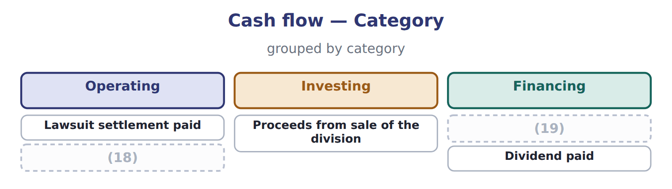
word list
Treasury stock bought · Interest paid · operating activities

Answer key · 5.5 Limitations and links between the four statements

1 manage | 11 disclosures
2 impossible | 12 definition
3 suppliers | 13 jurisdiction
4 receivables | 14 financement
5 statement | 15 correct
6 measure | 16 Investing: another company's securities.
7 Important | 17 Financing: a transaction with owners.
8 building | 18 Interest paid
9 classifications | 19 Treasury stock bought
10 interest

the summaries in full
Summary 1 Cash flows are harder to manage than profits, but not impossible. A company can raise operating cash near year-end by delaying payments to suppliers or by selling receivables. The statement also shows only one year, and it is not a measure of profit. Important noncash deals, such as buying a building with a mortgage, appear only in the notes. Some classifications are also arbitrary: interest paid is operating under U.S. GAAP but may be financing under IFRS, which makes companies harder to compare. Finally, one year of cash flows can mislead. A company that stops investing will show strong cash flow for a while, even if its future is weak. The links also help you find amounts that are not given. Orontes declared dividends of $450,000, but dividends payable rose by $400,000, so dividends paid were only $50,000. That is the amount in the financing section.
Summary 2 In August 2026 the FASB proposed new disclosures about the parts of cash equivalents and about some digital assets. It is only a proposal; the definition of cash equivalents does not change. ASU 2023-09 already requires income taxes paid by jurisdiction; know this at awareness level.
Summary 3 French tableau de financement is an older funds statement based on working capital, not a statement of cash flows. The IFRS term is tableau des flux de trésorerie. Arabic قائمة التدفقات النقدية is the correct term for this statement.

