14.1 What is a lease?
Chapter 14 · section 14.1

Fill every gap. Each word list holds one word more than there are gaps.
Chapter 14, section by section
Each stage leads to the next.
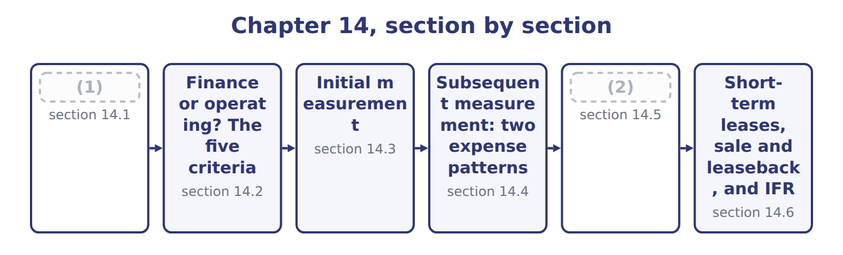
word list
What is a lease? · sale and leaseback · Presentation

Summary 1 gaps 3–9
A lease is a (3) that gives the right to control the use of an identified asset for a period of time in (4) for payment. The lessee uses the asset; the (5) provides it. The asset must be identified, and the (6) must not have a real right to swap it for (7) . The lessee (8) the asset if it gets almost all of its (9) benefits and decides how it is used. The lease term is the period the lessee cannot cancel, plus any renewal periods it is reasonably certain to use.
word list
lease · lessor · exchange · contract · supplier · another · controls · economic

The English this section uses, and its Arabic
Each term sits against what it means.
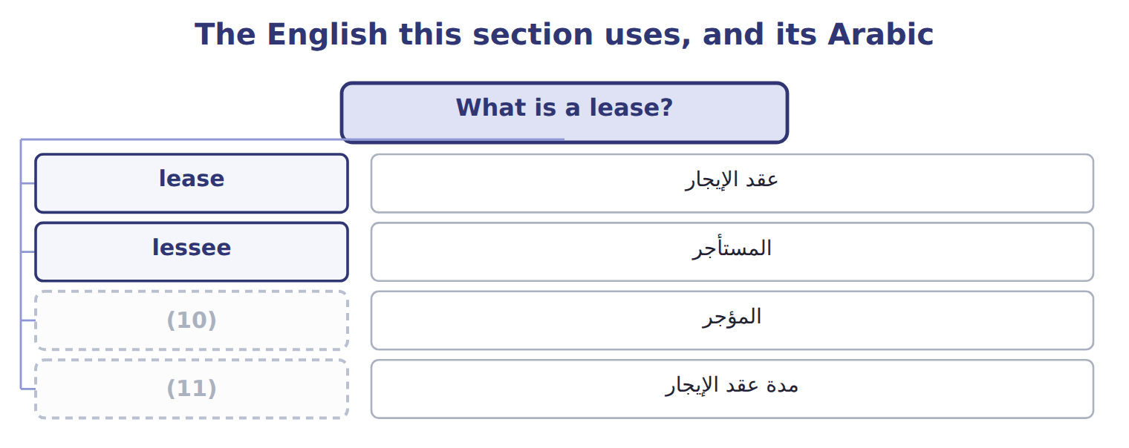
word list
lessor · operating lease · lease term

The English this sheet uses, and its Arabic
English (exam term) | Arabic
lease | عقد الإيجار
lessee | المستأجر
lessor | المؤجر
lease term | مدة عقد الإيجار

Answer key · 14.1 What is a lease?

1 What is a lease? | 7 another
2 Presentation | 8 controls
3 contract | 9 economic
4 exchange | 10 lessor
5 lessor | 11 lease term
6 supplier

the summaries in full
Summary 1 A lease is a contract that gives the right to control the use of an identified asset for a period of time in exchange for payment. The lessee uses the asset; the lessor provides it. The asset must be identified, and the supplier must not have a real right to swap it for another. The lessee controls the asset if it gets almost all of its economic benefits and decides how it is used. The lease term is the period the lessee cannot cancel, plus any renewal periods it is reasonably certain to use.

14.2 Finance or operating? The five criteria
Chapter 14 · section 14.2

Fill every gap. Each word list holds one word more than there are gaps.
Suppose: classifying Orontes's two leases, January 1, 2026
Criterion | Warehouse (5 years, 100,000 a year) | Olive press (4 years, 250,000 a year)
1. Ownership transfers | No | No
2. Purchase option reasonably certain | No | No
3. Major part of economic life | (1) | Yes: 4 of 5 years (80%)
4. PV ≥ substantially all of fair value | No: 421,236 of 1,500,000 (28%) | (2)
5. Specialized asset | No: any company could use it | (3)
Classification | (4) | Finance lease

word list
Operating lease · No: 5 of 30 years (17%) · Not needed · Yes: 4 of 5 years (80%) · Yes: built for Orontes

Crédit-bail is not a class

Summary 1 gaps 5–7
French crédit-bail and (5) عقد تأجير تمويلي are legal forms of contract. Under ASC 842, the class depends only on the five (6) . A crédit-bail contract can be an (7) lease, and an ordinary rental can be a finance lease.
word list
Arabic · finance lease · criteria · operating

The English this section uses, and its Arabic
Each term sits against what it means.
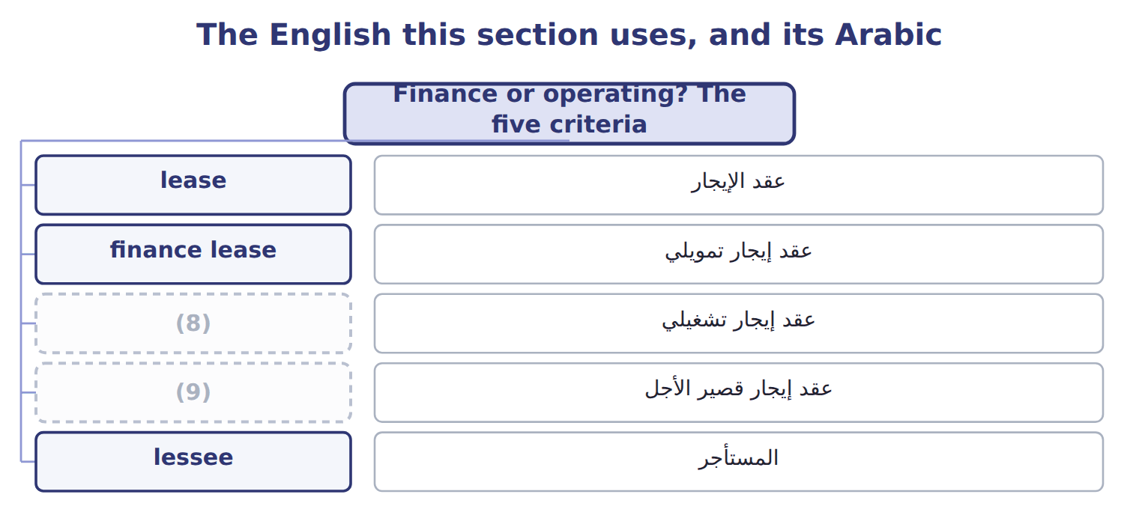
word list
finance lease · short-term lease · operating lease

The English this sheet uses, and its Arabic
English (exam term) | Arabic
finance lease | عقد إيجار تمويلي
operating lease | عقد إيجار تشغيلي

Answer key · 14.2 Finance or operating? The five criteria

1 No: 5 of 30 years (17%) | 6 criteria
2 Not needed | 7 operating
3 Yes: built for Orontes | 8 operating lease
4 Operating lease | 9 short-term lease
5 Arabic

the summaries in full
Summary 1 French crédit-bail and Arabic عقد تأجير تمويلي are legal forms of contract. Under ASC 842, the class depends only on the five criteria. A crédit-bail contract can be an operating lease, and an ordinary rental can be a finance lease.

14.3 Initial measurement
Chapter 14 · section 14.3

Fill every gap. Each word list holds one word more than there are gaps.
Summary 1 gaps 1–8
For both types, the lessee (1) a lease liability and a right-of-use asset at the start. The liability is the (2) value of the lease payments not yet paid. The discount rate is the rate implicit in the lease if the lessee can find it; (3) it is the lessee's (4) borrowing rate. Lease payments include fixed payments, payments that depend on an index such as CPI, a purchase price the lessee is (5) certain to pay, and amounts it expects to pay under a residual value (6) . The right-of-use asset starts at the liability, plus any (7) payments and initial direct costs, minus (8) received.
word list
incremental · otherwise · guarantee · incentives · records · lease liability · reasonably · present · prepaid

Suppose: initial measurement of Orontes's leases
Suppose: January 1, 2026 (whole USD) | Warehouse | Olive press
Annual payment (end of each year) | 100,000 | 250,000
Number of payments | 5 | 4
Discount rate (incremental borrowing rate) | 6% | 6%
Undiscounted payments | 500,000 | 1,000,000
Lease liability = present value of payments | 421,236 | 866,276
Right-of-use asset (no prepayments, costs or incentives) | 421,236 | 866,276

The English this section uses, and its Arabic
Each term sits against what it means.
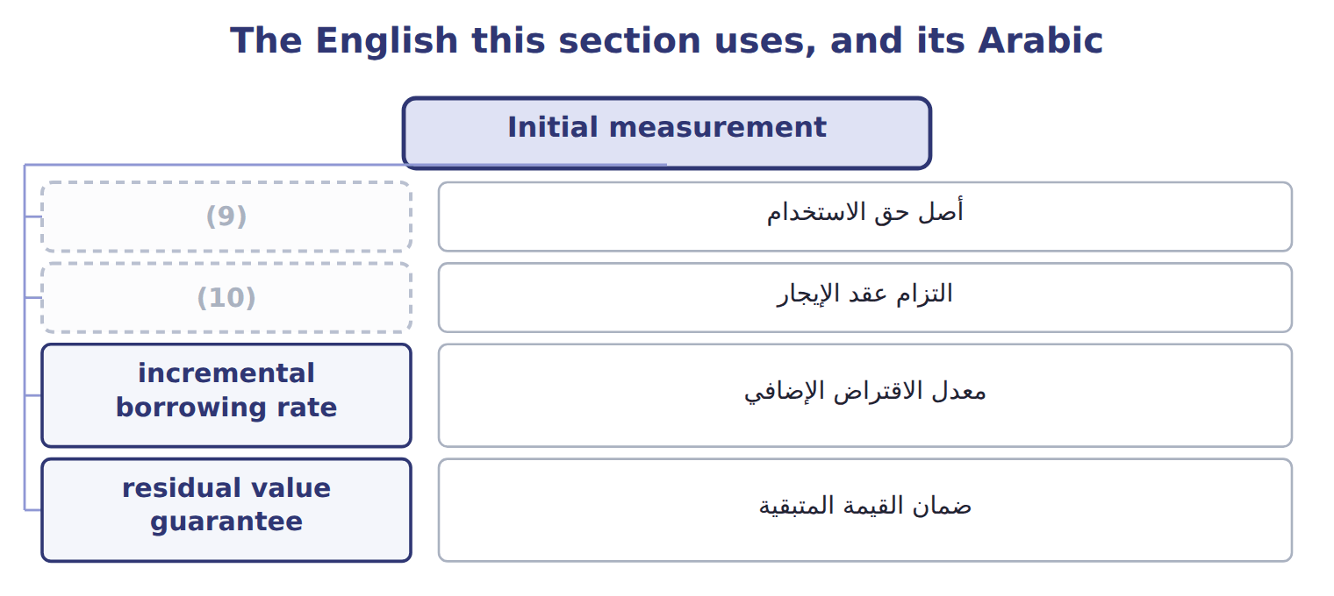
word list
operating lease · lease liability · right-of-use asset

The English this sheet uses, and its Arabic
English (exam term) | Arabic
right-of-use asset | أصل حق الاستخدام
lease liability | التزام عقد الإيجار
incremental borrowing rate | معدل الاقتراض الإضافي
residual value guarantee | ضمان القيمة المتبقية

Answer key · 14.3 Initial measurement

1 records | 6 guarantee
2 present | 7 prepaid
3 otherwise | 8 incentives
4 incremental | 9 right-of-use asset
5 reasonably | 10 lease liability

the summaries in full
Summary 1 For both types, the lessee records a lease liability and a right-of-use asset at the start. The liability is the present value of the lease payments not yet paid. The discount rate is the rate implicit in the lease if the lessee can find it; otherwise it is the lessee's incremental borrowing rate. Lease payments include fixed payments, payments that depend on an index such as CPI, a purchase price the lessee is reasonably certain to pay, and amounts it expects to pay under a residual value guarantee. The right-of-use asset starts at the liability, plus any prepaid payments and initial direct costs, minus incentives received.

14.4 Subsequent measurement: two expense patterns
Chapter 14 · section 14.4

Fill every gap. Each word list holds one word more than there are gaps.
Worked example: the olive-press finance lease in 2026

Summary 1 gaps 1–3
Interest: 6% × $866,276 = $51,977. (1) of $250,000: the liability falls to $668,253. Amortization: $866,276 ÷ 4 years = $216,569, so the ROU asset is $649,707. For an operating lease, the (2) records one lease cost, normally the same each year. The liability still grows by interest and falls by payments. The amortization of the (3) asset is simply the difference between the lease cost and the interest, so the asset and the liability stay equal when there are no prepayments or incentives.
word list
incremental borrowing rate · Payment · right-of-use · lessee

Complete the warehouse schedule

Measurement traps

Summary 2 gaps 4–6
The liability is a present value, not the total of the (4) . Each payment covers interest first; do not deduct the whole payment from the (5) liability. Operating (6) : one straight-line cost; do not show interest and amortization separately.
word list
residual value guarantee · lease · payments · opening

The English this section uses, and its Arabic
Each term sits against what it means.
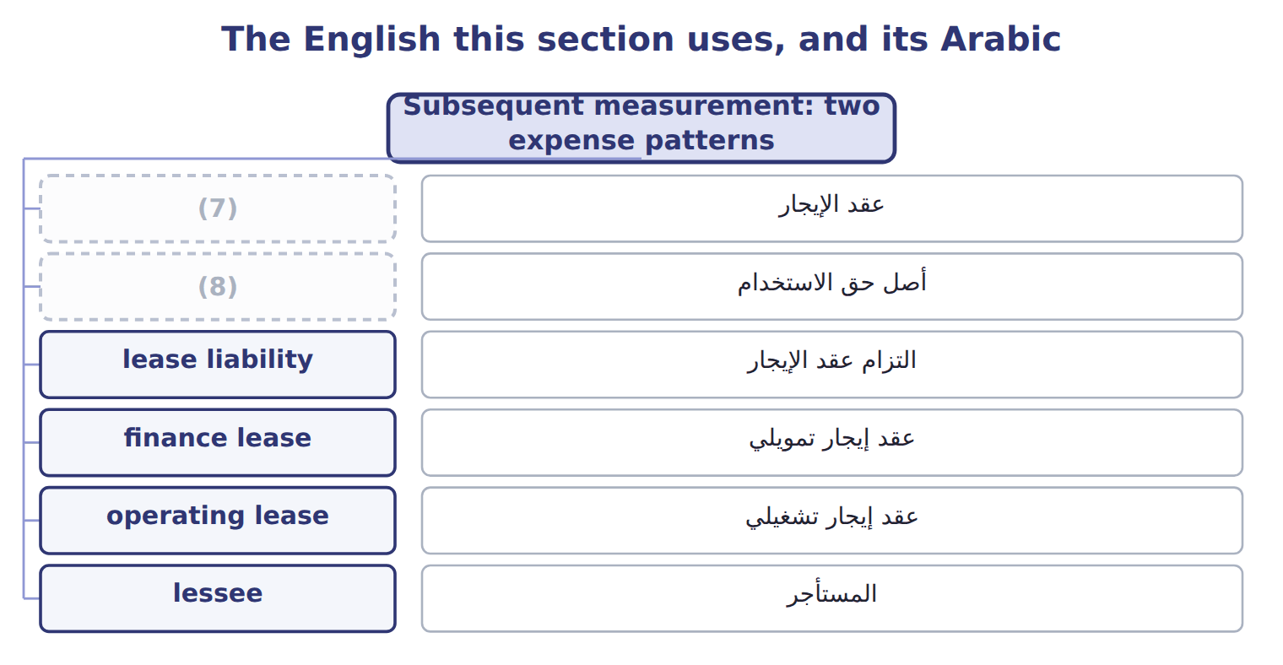
word list
lessee · right-of-use asset · lease

Answer key · 14.4 Subsequent measurement: two expense patterns

1 Payment | 5 opening
2 lessee | 6 lease
3 right-of-use | 7 lease
4 payments | 8 right-of-use asset

the summaries in full
Summary 1 Interest: 6% × $866,276 = $51,977. Payment of $250,000: the liability falls to $668,253. Amortization: $866,276 ÷ 4 years = $216,569, so the ROU asset is $649,707. For an operating lease, the lessee records one lease cost, normally the same each year. The liability still grows by interest and falls by payments. The amortization of the right-of-use asset is simply the difference between the lease cost and the interest, so the asset and the liability stay equal when there are no prepayments or incentives.
Summary 2 The liability is a present value, not the total of the payments. Each payment covers interest first; do not deduct the whole payment from the opening liability. Operating lease: one straight-line cost; do not show interest and amortization separately.

14.5 Presentation
Chapter 14 · section 14.5

Fill every gap. Each word list holds one word more than there are gaps.
Summary 1 gaps 1–7
On the balance sheet, the (1) assets and lease (2) of finance leases are shown separately from those of operating leases, or disclosed with the line items that contain them. Each (3) is split into a current part, the principal due within a year, and a (4) part. On the income statement, a finance lease shows interest expense and (5) separately; an operating lease shows one lease cost in operating (6) . In the statement of cash flows, finance-lease principal is financing; its interest and all (7) payments are operating. New leases are a noncash investing and financing activity, disclosed separately.
word list
expenses · operating-lease · amortization · finance lease · noncurrent · liabilities · liability · right-of-use

Presentation of finance and operating leases, with Orontes at December 31, 2026
Item | Finance lease (olive press) | Operating lease (warehouse)
Balance sheet | ROU asset and lease liability, shown separately from operating leases (or disclosed) | ROU asset and lease liability, shown separately from finance leases (or disclosed)
Income statement | (8) | One lease cost in operating expenses
Cash flow: principal | Financing | Operating
Cash flow: interest | Operating | (9)
Orontes at December 31, 2026 | Liability 668,253: current 209,905, noncurrent 458,348; ROU asset 649,707 | (10)

word list
Liability 346,510; ROU asset 346,510 · Financing · Interest expense and amortization, shown separately · Operating (part of the single payment)

Cash flow traps

Summary 2 gaps 11–12
Operating-lease payments are operating cash flows, even though a (11) is on the balance sheet. (12) interest is operating under U.S. GAAP, not financing.
word list
Finance-lease · liability · finance lease

The English this section uses, and its Arabic
Each term sits against what it means.
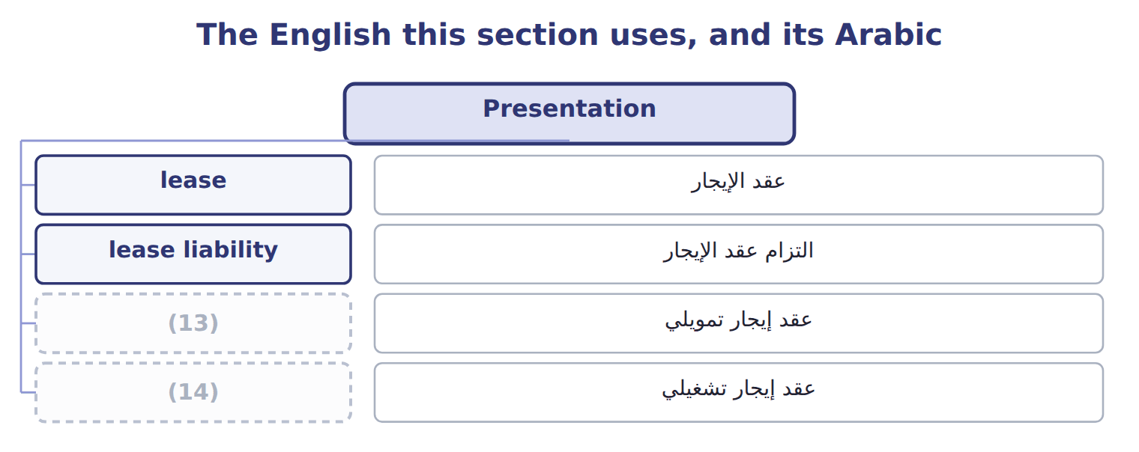
word list
lessor · finance lease · operating lease

Answer key · 14.5 Presentation

1 right-of-use | 8 Interest expense and amortization, shown separately
2 liabilities | 9 Operating (part of the single payment)
3 liability | 10 Liability 346,510; ROU asset 346,510
4 noncurrent | 11 liability
5 amortization | 12 Finance-lease
6 expenses | 13 finance lease
7 operating-lease | 14 operating lease

the summaries in full
Summary 1 On the balance sheet, the right-of-use assets and lease liabilities of finance leases are shown separately from those of operating leases, or disclosed with the line items that contain them. Each liability is split into a current part, the principal due within a year, and a noncurrent part. On the income statement, a finance lease shows interest expense and amortization separately; an operating lease shows one lease cost in operating expenses. In the statement of cash flows, finance-lease principal is financing; its interest and all operating-lease payments are operating. New leases are a noncash investing and financing activity, disclosed separately.
Summary 2 Operating-lease payments are operating cash flows, even though a liability is on the balance sheet. Finance-lease interest is operating under U.S. GAAP, not financing.

14.6 Short-term leases, sale and leaseback, and IFRS 16
Chapter 14 · section 14.6

Fill every gap. Each word list holds one word more than there are gaps.
Summary 1 gaps 1–8
A (1) lease lasts 12 months or less and has no purchase option that the lessee is (2) certain to use. A lessee may choose, by class of asset, to keep such leases off the (3) sheet and expense the payments (4) . U.S. GAAP has no (5) for low-value (6) . In a sale and leaseback, a company sells an asset and leases it back. It is a sale only if (7) passes to the buyer under the (8) rules. If the leaseback is a finance lease, or the seller can buy the asset back, there is no sale: the cash received is a loan.
word list
control · assets · reasonably · balance · exemption · short-term · straight-line · sale and leaseback · revenue

Leases: U.S. GAAP (ASC 842) and IFRS 16
The two sides differ only where the rows say.
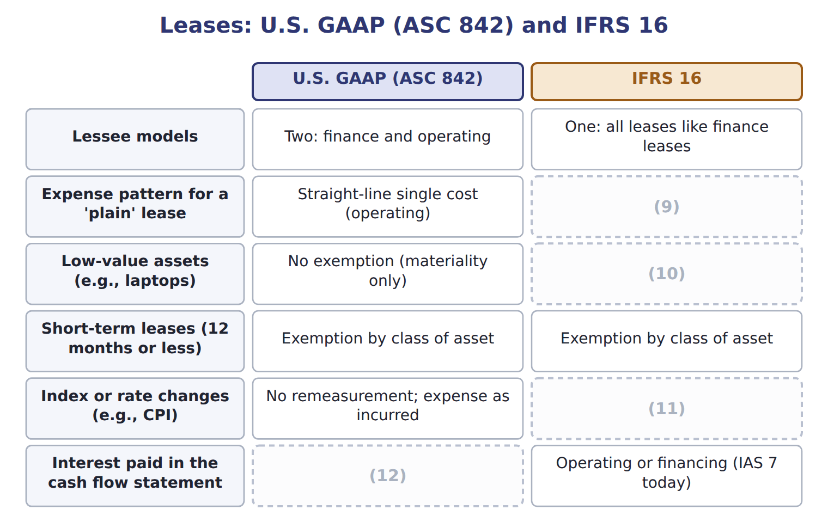
word list
Depreciation plus interest: higher early · residual value guarantee · Operating · Exemption allowed · Remeasure the liability

Summary 2 gaps 13–14
ASU 2023-01, on leases between companies under common control, is testable now at (13) level. ASU 2025-12 changes a (14) disclosure only; it is not testable before about January 2028.
word list
sale and leaseback · awareness · lessor

Barada Wholesale, leases signed in 2028 (whole U — Details
Barada Wholesale, leases signed in 2028 (whole U | Details
L1 Delivery trucks | 3-year lease from January 1, 2028; 30,000 at the end of each year; economic life 8 years; fair value 150,000; no ownership transfer, no purc
L2 Forklift | 5-year lease with an option to buy the forklift for $1 at the end; Barada is reasonably certain to use it.
L3 Storage room | 10-month lease; no purchase option. Barada applies the short-term exemption.
L4 Laptops | 3-year lease of office laptops; standard terms; no transfer or option.
M1 | Barada's incremental borrowing rate is 8%. The rate implicit in the leases is not known. Barada is not a public business entity but does not
M2 | Present value of an annuity of $1 for 3 years at 8%: 2.5771.

Item — Answer
Each stage leads to the next.
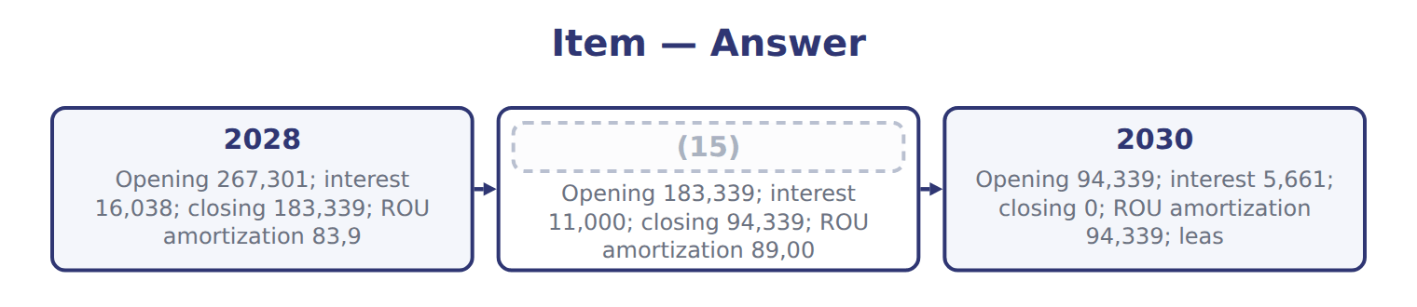
word list
2029 · finance lease

Lease — Category
Every item belongs to exactly one group.
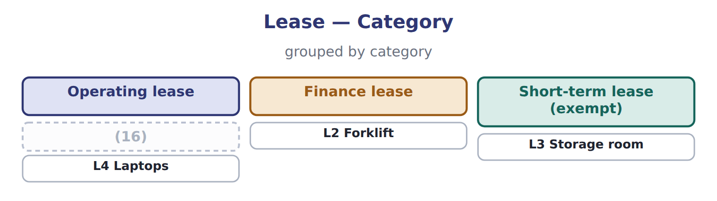
word list
L1 Delivery trucks · right-of-use asset

The English this section uses, and its Arabic
Each term sits against what it means.
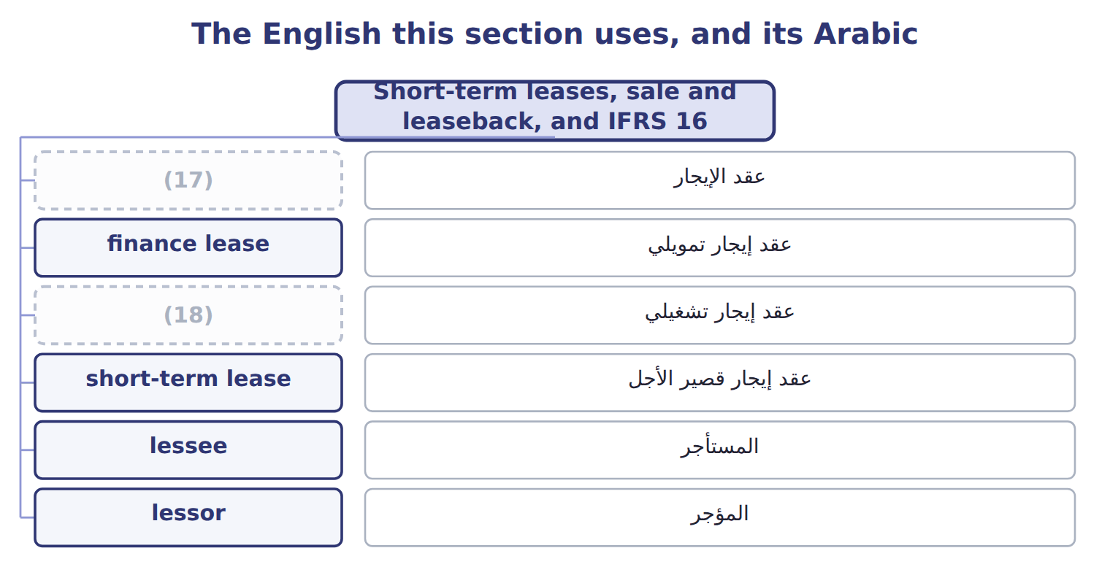
word list
incremental borrowing rate · lease · operating lease

The English this sheet uses, and its Arabic
English (exam term) | Arabic
short-term lease | عقد إيجار قصير الأجل
sale and leaseback | البيع وإعادة الاستئجار

Answer key · 14.6 Short-term leases, sale and leaseback, and IFRS 16

1 short-term | 10 Exemption allowed
2 reasonably | 11 Remeasure the liability
3 balance | 12 Operating
4 straight-line | 13 awareness
5 exemption | 14 lessor
6 assets | 15 2029
7 control | 16 L1 Delivery trucks
8 revenue | 17 lease
9 Depreciation plus interest: higher early | 18 operating lease

the summaries in full
Summary 1 A short-term lease lasts 12 months or less and has no purchase option that the lessee is reasonably certain to use. A lessee may choose, by class of asset, to keep such leases off the balance sheet and expense the payments straight-line. U.S. GAAP has no exemption for low-value assets. In a sale and leaseback, a company sells an asset and leases it back. It is a sale only if control passes to the buyer under the revenue rules. If the leaseback is a finance lease, or the seller can buy the asset back, there is no sale: the cash received is a loan.
Summary 2 ASU 2023-01, on leases between companies under common control, is testable now at awareness level. ASU 2025-12 changes a lessor disclosure only; it is not testable before about January 2028.

