1.1 What risk is
Chapter 1 · section 1.1

Fill every gap. Each word list holds one word more than there are gaps.
Chapter 1, section by section
Each stage leads to the next.
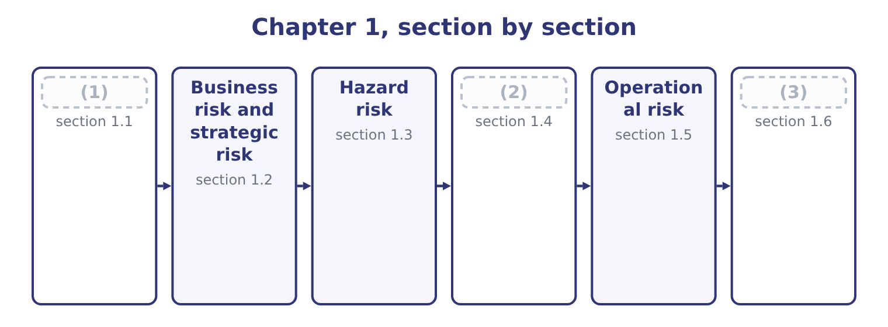
word list
What risk is · Legal, compliance and political risk · exchange controls · Financial risk

Summary 1 gaps 4–15
Risk is the possibility that an (4) differs from what was (5) . Two (6) follow from that definition and both are (7) . Risk runs in both (8) . The possibility that sales exceed the (9) is as much a (10) as the possibility that they fall short, and a definition that admits only the downside misses half of what risk management is for: which has no meaning unless risk can be (11) . In (12) speech risk means danger; in this syllabus it means (13) , and the examiners use the wider sense. Risk is not the same as uncertainty. In the classical distinction, a risk is a possibility whose outcomes and (14) can be described — a machine that fails on average once in two hundred days — while uncertainty describes a situation where the outcomes (15) are not known in advance.
word list
deviation · examined · things · expected · themselves · variability · favourable · forecast · directions · ordinary · definition · outcome · probabilities

Summary 2 gaps 16–27
The distinction matters because the tools of, and a situation that has none is managed by judgment, redundancy and (16) rather than by (17) . Two more terms (18) here before the classification. An exposure is what (19) to be lost: the (20) at stake, not the chance of losing it. Orontes's exposure to a Syrian pound (21) is the value of its (22) receivables; its exposure to a fire at the Hama plant is the plant plus the profit the plant would have earned while it was rebuilt. An event is the thing that (23) . Risk management works on (24) , and: a risk nobody has named is a risk nobody is (25) . The classification that (26) is not a natural fact. It is a working device, and a single event can sit in more than one family — a fire caused by a badly maintained roaster is a hazard risk and an (27) risk at once. The reason to classify at all is that the families differ in who owns them, how they are measured and what can be done about them.
word list
stands · managing · pound-denominated · devaluation · events · amount · flexibility · belong · happens · arithmetic · follows · operational · describes

The English this section uses, and its Arabic
Each term sits against what it means.
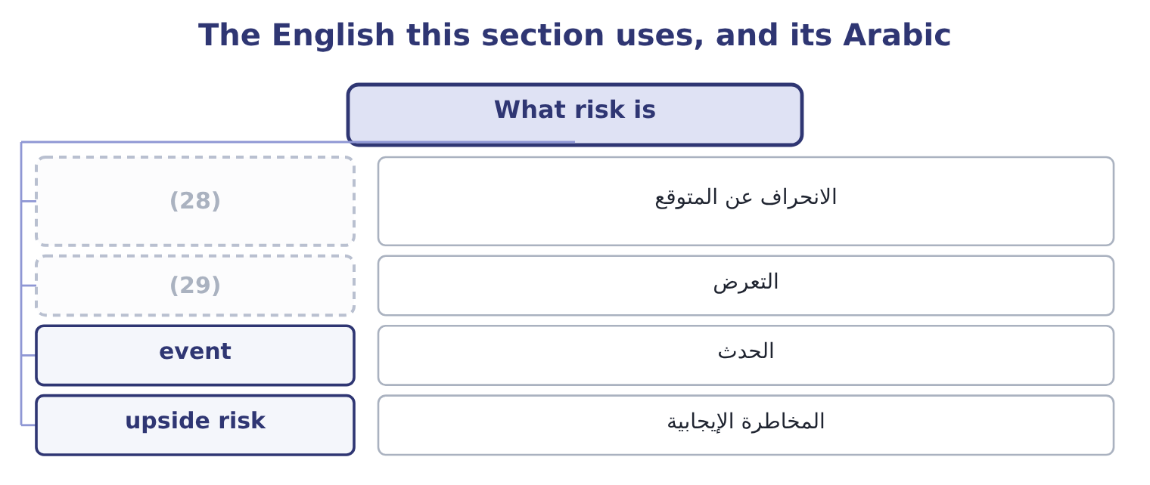
word list
exposure · deviation from expectation · upside risk

The English this sheet uses, and its Arabic
English (exam term) | Arabic
deviation from expectation | الانحراف عن المتوقع
exposure | التعرض
event | الحدث
upside risk | المخاطرة الإيجابية

Answer key · 1.1 What risk is

1 What risk is | 16 flexibility
2 Financial risk | 17 arithmetic
3 Legal, compliance and political risk | 18 belong
4 outcome | 19 stands
5 expected | 20 amount
6 things | 21 devaluation
7 examined | 22 pound-denominated
8 directions | 23 happens
9 forecast | 24 events
10 deviation | 25 managing
11 favourable | 26 follows
12 ordinary | 27 operational
13 variability | 28 deviation from expectation
14 probabilities | 29 exposure
15 themselves

the summaries in full
Summary 1 Risk is the possibility that an outcome differs from what was expected. Two things follow from that definition and both are examined. Risk runs in both directions. The possibility that sales exceed the forecast is as much a deviation as the possibility that they fall short, and a definition that admits only the downside misses half of what risk management is for: which has no meaning unless risk can be favourable. In ordinary speech risk means danger; in this syllabus it means variability, and the examiners use the wider sense. Risk is not the same as uncertainty. In the classical distinction, a risk is a possibility whose outcomes and probabilities can be described — a machine that fails on average once in two hundred days — while uncertainty describes a situation where the outcomes themselves are not known in advance.
Summary 2 The distinction matters because the tools of, and a situation that has none is managed by judgment, redundancy and flexibility rather than by arithmetic. Two more terms belong here before the classification. An exposure is what stands to be lost: the amount at stake, not the chance of losing it. Orontes's exposure to a Syrian pound devaluation is the value of its pound-denominated receivables; its exposure to a fire at the Hama plant is the plant plus the profit the plant would have earned while it was rebuilt. An event is the thing that happens. Risk management works on events, and: a risk nobody has named is a risk nobody is managing. The classification that follows is not a natural fact. It is a working device, and a single event can sit in more than one family — a fire caused by a badly maintained roaster is a hazard risk and an operational risk at once. The reason to classify at all is that the families differ in who owns them, how they are measured and what can be done about them.

1.2 Business risk and strategic risk
Chapter 1 · section 1.2

Fill every gap. Each word list holds one word more than there are gaps.
Summary 1 gaps 1–12
Business risk is the (1) of a company's operating (2) arising from the business it is: (3) , prices, input costs, competition, technology and the cost structure that turns all of those into (4) . It is the risk the company (5) in order to take, and it is measured before any (6) effect. Book 3 measured Orontes's. The company's operating (7) is 4.02, so a 10 per cent fall in sales becomes a 4.02 × 10 = 40.2 per cent fall in operating income — on operating income of $4,176,000, a loss of 4,176,000 × 0.402 = 1,678,752. The (8) of safety of 24.86 per cent says how far sales can fall before operating income (9) zero. Those two (10) are Orontes's business risk, stated in the (11) Book 3 taught, and they are a direct (12) of a cost structure in which $12,624,000 of the costs do not move with volume.
word list
profit · exists · demand · consequence · increase · leverage · language · variability · figures · results · financing · margin · reaches

Summary 2 gaps 13–24
Four (13) of business risk are worth naming, (14) an exam answer that names them is a better answer than one that defines the term. How much the volume moves, which for a food producer follows (15) incomes and, in Orontes's case, the sesame harvest and the (16) calendar. Sesame is a (17) , and Book 2's. (18) the company can pass an input cost (19) on, which Book 3's. The (20) of costs that do not vary, which magnifies (21) above. Strategic risk is (22) in kind. It is the risk that the company's chosen direction is wrong, or becomes wrong — that the market it serves (23) , that a competitor changes the terms of competition, that a technology makes its assets obsolete, that an (24) of the kind Book 3's, that its reputation is lost.
word list
changes · drivers · Whether · different · household · disappears · festival · acquisition · increase · everything · proportion · commodity · because

Summary 3 gaps 25–34
Three features (25) strategic risk and all three are (26) . It is owned by the board, not by a risk (27) . Nobody below the (28) can decide that the company's (29) is wrong. It is slow and large. Business risk shows up in a (30) ; strategic risk shows up over years, and by the time it is (31) in the numbers the window to respond has usually closed. And it is the (32) least amenable to (33) . There is no probability distribution for "tahini is displaced by a product nobody has invented yet", which is exactly the (34) of section 1.1, and the response is strategic flexibility — the real options of Book 3's.
word list
measurement · family · becomes · distinguish · strategy · directors · uncertainty · examined · quarter · visible · function

The English this section uses, and its Arabic
Each term sits against what it means.
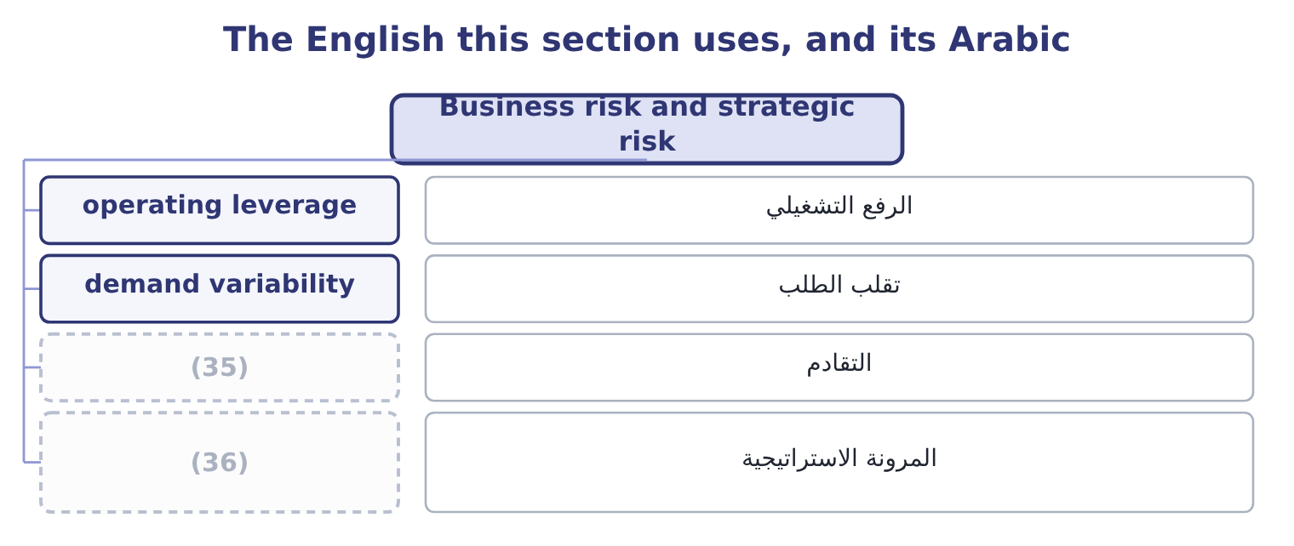
word list
strategic flexibility · المرونة الاستراتيجية · obsolescence

The English this sheet uses, and its Arabic
English (exam term) | Arabic
operating leverage | الرفع التشغيلي
demand variability | تقلب الطلب
obsolescence | التقادم
strategic flexibility | المرونة الاستراتيجية

Answer key · 1.2 Business risk and strategic risk

1 variability | 19 increase
2 results | 20 proportion
3 demand | 21 everything
4 profit | 22 different
5 exists | 23 disappears
6 financing | 24 acquisition
7 leverage | 25 distinguish
8 margin | 26 examined
9 reaches | 27 function
10 figures | 28 directors
11 language | 29 strategy
12 consequence | 30 quarter
13 drivers | 31 visible
14 because | 32 family
15 household | 33 measurement
16 festival | 34 uncertainty
17 commodity | 35 obsolescence
18 Whether | 36 strategic flexibility

the summaries in full
Summary 1 Business risk is the variability of a company's operating results arising from the business it is: demand, prices, input costs, competition, technology and the cost structure that turns all of those into profit. It is the risk the company exists in order to take, and it is measured before any financing effect. Book 3 measured Orontes's. The company's operating leverage is 4.02, so a 10 per cent fall in sales becomes a 4.02 × 10 = 40.2 per cent fall in operating income — on operating income of $4,176,000, a loss of 4,176,000 × 0.402 = 1,678,752. The margin of safety of 24.86 per cent says how far sales can fall before operating income reaches zero. Those two figures are Orontes's business risk, stated in the language Book 3 taught, and they are a direct consequence of a cost structure in which $12,624,000 of the costs do not move with volume.
Summary 2 Four drivers of business risk are worth naming, because an exam answer that names them is a better answer than one that defines the term. How much the volume moves, which for a food producer follows household incomes and, in Orontes's case, the sesame harvest and the festival calendar. Sesame is a commodity, and Book 2's. Whether the company can pass an input cost increase on, which Book 3's. The proportion of costs that do not vary, which magnifies everything above. Strategic risk is different in kind. It is the risk that the company's chosen direction is wrong, or becomes wrong — that the market it serves disappears, that a competitor changes the terms of competition, that a technology makes its assets obsolete, that an acquisition of the kind Book 3's, that its reputation is lost.
Summary 3 Three features distinguish strategic risk and all three are examined. It is owned by the board, not by a risk function. Nobody below the directors can decide that the company's strategy is wrong. It is slow and large. Business risk shows up in a quarter; strategic risk shows up over years, and by the time it is visible in the numbers the window to respond has usually closed. And it is the family least amenable to measurement. There is no probability distribution for "tahini is displaced by a product nobody has invented yet", which is exactly the uncertainty of section 1.1, and the response is strategic flexibility — the real options of Book 3's.

1.3 Hazard risk
Chapter 1 · section 1.3

Fill every gap. Each word list holds one word more than there are gaps.
Summary 1 gaps 1–12
Hazard risk — also called pure risk — is the risk of loss from a physical event: fire, flood, storm, (1) , explosion, theft, accident, product (2) , the death or injury of a key person. Its (3) feature is that it has no (4) . A fire can destroy a plant and cannot improve one, which is why the term pure risk is used and why hazard risk is the family where insurance is the natural response: an (5) risk is one that is (6) , measurable, and part of a large enough pool of similar exposures for an insurer to price it. Two kinds of loss (7) a hazard event and the exam (8) both. Direct loss: the asset itself — the (9) , the plant, the stock. Consequential loss: the profit that would have been earned while the asset was out of use, (10) with the extra cost of (11) around it. This is usually the larger figure and the one companies (12) .
word list
insurable · upside · accidental · underinsure · defining · follow · together · earthquake · building · working · sixty-day · expects · contamination

Summary 2 gaps 13–24
The (13) hall and its (14) would have to be (15) , and the stock in it (16) . Orontes earns a contribution of 3,500,000 × 4.80 = 16,800,000 a year, which is 16,800,000 ÷ 365 = 46,027 a day. At that rate a (17) stoppage costs 46,027 × 60 = 2,761,620 of contribution. (18) whole operating income is $4,176,000, so a (19) stoppage removes about two thirds of a year's operating profit without (20) a single asset on the insurance schedule. The (21) assumes nothing is recovered — no (22) caught up afterwards, no stock on hand to sell, no customer who waits. Each of those softens the figure and none of them is free: the right use of the number is to show that the consequential loss is of the same order as the direct one, which is the argument for business (23) cover and for the (24) planning.
word list
sixty-day · replaced · rebuilt · roasting · interruption · continuity · two-month · calculation · Orontes's · equipment · insurance · production · touching

The English this section uses, and its Arabic
Each term sits against what it means.
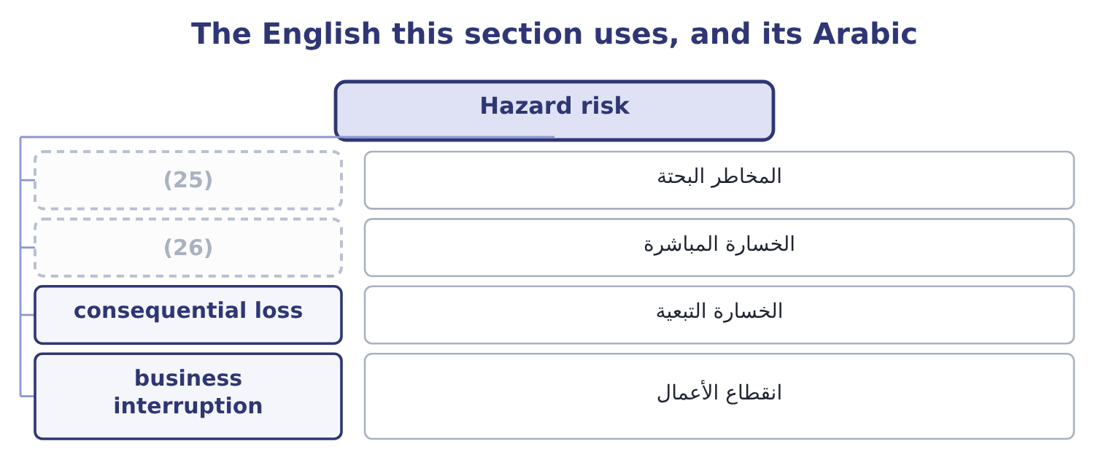
word list
direct loss · المخاطر البحتة · pure risk

The English this sheet uses, and its Arabic
English (exam term) | Arabic
pure risk | المخاطر البحتة
direct loss | الخسارة المباشرة
consequential loss | الخسارة التبعية
business interruption | انقطاع الأعمال

Answer key · 1.3 Hazard risk

1 earthquake | 14 equipment
2 contamination | 15 rebuilt
3 defining | 16 replaced
4 upside | 17 sixty-day
5 insurable | 18 Orontes's
6 accidental | 19 two-month
7 follow | 20 touching
8 expects | 21 calculation
9 building | 22 production
10 together | 23 interruption
11 working | 24 continuity
12 underinsure | 25 pure risk
13 roasting | 26 direct loss

the summaries in full
Summary 1 Hazard risk — also called pure risk — is the risk of loss from a physical event: fire, flood, storm, earthquake, explosion, theft, accident, product contamination, the death or injury of a key person. Its defining feature is that it has no upside. A fire can destroy a plant and cannot improve one, which is why the term pure risk is used and why hazard risk is the family where insurance is the natural response: an insurable risk is one that is accidental, measurable, and part of a large enough pool of similar exposures for an insurer to price it. Two kinds of loss follow a hazard event and the exam expects both. Direct loss: the asset itself — the building, the plant, the stock. Consequential loss: the profit that would have been earned while the asset was out of use, together with the extra cost of working around it. This is usually the larger figure and the one companies underinsure.
Summary 2 The roasting hall and its equipment would have to be rebuilt, and the stock in it replaced. Orontes earns a contribution of 3,500,000 × 4.80 = 16,800,000 a year, which is 16,800,000 ÷ 365 = 46,027 a day. At that rate a sixty-day stoppage costs 46,027 × 60 = 2,761,620 of contribution. Orontes's whole operating income is $4,176,000, so a two-month stoppage removes about two thirds of a year's operating profit without touching a single asset on the insurance schedule. The calculation assumes nothing is recovered — no production caught up afterwards, no stock on hand to sell, no customer who waits. Each of those softens the figure and none of them is free: the right use of the number is to show that the consequential loss is of the same order as the direct one, which is the argument for business interruption cover and for the continuity planning.

1.4 Financial risk
Chapter 1 · section 1.4

Fill every gap. Each word list holds one word more than there are gaps.
Summary 1 gaps 1–12
Financial risk is the risk arising from a (1) financing and from its financial position rather than from its trading: the risk that it cannot meet its (2) , and the risk that financial prices move against it. Four kinds, and the exam names them. (3) risk: that a customer or (4) does not pay. Orontes (5) $4,144,000 of (6) , and Book 1's. (7) risk: that cash is not (8) when it is needed, even though the company is solvent on paper. This is the risk that kills otherwise healthy companies, and Book 1's (9) chapters are its (10) . (11) risk: that a price moves — an interest rate, an exchange rate, a (12) price, a share price. Leverage or default risk: that the fixed claims of debt cannot be met out of a variable operating income.
word list
carries · Credit · working-capital · counterparty · measurement · Market · Liquidity · arising · company's · available · obligations · commodity · receivables

Summary 2 gaps 13–23
Orontes's (13) are 31,672,600 − 20,392,975 = 11,279,625 and its interest is $390,000 a year against operating income of $4,348,800, an interest cover of 4,348,800 ÷ 390,000 = 11.15 times, which is (14) . The point the (15) press is the (16) between business risk and financial risk. Business risk is given by the (17) and the cost structure; financial risk is (18) , by the capital structure (19) of Book 2's. A company in a (20) business that also borrows heavily has multiplied two (21) together, and the combined leverage of Book 3 is the arithmetic of that (22) . Orontes's operating leverage of 4.02 is high; its interest cover of 11.15 times says it has not (23) the problem with debt, and that is a deliberate choice rather than an accident.
word list
Orontes's · volatile · industry · examiners · comfortable · multiplication · decision · variabilities · chosen · relationship · liabilities · compounded

The English this section uses, and its Arabic
Each term sits against what it means.
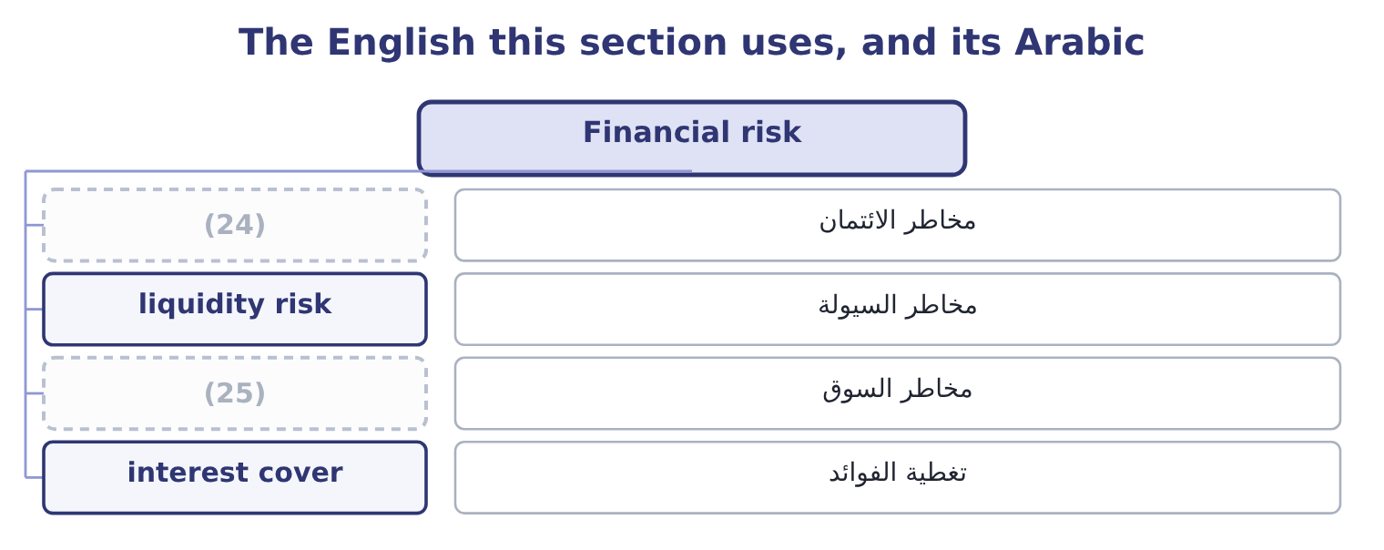
word list
financial risk · credit risk · market risk

The English this sheet uses, and its Arabic
English (exam term) | Arabic
credit risk | مخاطر الائتمان
liquidity risk | مخاطر السيولة
market risk | مخاطر السوق
interest cover | تغطية الفوائد

Answer key · 1.4 Financial risk

1 company's | 14 comfortable
2 obligations | 15 examiners
3 Credit | 16 relationship
4 counterparty | 17 industry
5 carries | 18 chosen
6 receivables | 19 decision
7 Liquidity | 20 volatile
8 available | 21 variabilities
9 working-capital | 22 multiplication
10 measurement | 23 compounded
11 Market | 24 credit risk
12 commodity | 25 market risk
13 liabilities

the summaries in full
Summary 1 Financial risk is the risk arising from a company's financing and from its financial position rather than from its trading: the risk that it cannot meet its obligations, and the risk that financial prices move against it. Four kinds, and the exam names them. Credit risk: that a customer or counterparty does not pay. Orontes carries $4,144,000 of receivables, and Book 1's. Liquidity risk: that cash is not available when it is needed, even though the company is solvent on paper. This is the risk that kills otherwise healthy companies, and Book 1's working-capital chapters are its measurement. Market risk: that a price moves — an interest rate, an exchange rate, a commodity price, a share price. Leverage or default risk: that the fixed claims of debt cannot be met out of a variable operating income.
Summary 2 Orontes's liabilities are 31,672,600 − 20,392,975 = 11,279,625 and its interest is $390,000 a year against operating income of $4,348,800, an interest cover of 4,348,800 ÷ 390,000 = 11.15 times, which is comfortable. The point the examiners press is the relationship between business risk and financial risk. Business risk is given by the industry and the cost structure; financial risk is chosen, by the capital structure decision of Book 2's. A company in a volatile business that also borrows heavily has multiplied two variabilities together, and the combined leverage of Book 3 is the arithmetic of that multiplication. Orontes's operating leverage of 4.02 is high; its interest cover of 11.15 times says it has not compounded the problem with debt, and that is a deliberate choice rather than an accident.

1.5 Operational risk
Chapter 1 · section 1.5

Fill every gap. Each word list holds one word more than there are gaps.
Summary 1 gaps 1–12
Operational risk is the risk of loss from inadequate or failed internal processes, people and (1) , or from external (2) . That definition, which comes from banking (3) and is now used (4) , repays reading twice, because it is built from four sources and the exam tests them separately. A control that does not work, a (5) nobody performs, a procedure that two departments interpret differently, a handover where (6) is lost. The recall of a (7) batch is a process failure before it is (8) else. Error, (9) , inadequate training, turnover that takes knowledge with it, and (10) wrongdoing — internal fraud. An outage, a failed (11) , a spreadsheet with a wrong formula in it, a data loss, a cyber (12) . The spreadsheet is not a joke: errors in uncontrolled spreadsheets are among the most frequently reported operational losses in surveys of finance functions.
word list
systems · deliberate · anything · intrusion · reconciliation · implementation · events · inexperience · regulation · everywhere · regulatory · mislabelled · responsibility

Summary 2 gaps 13–24
Suppliers failing, utilities (13) , transport blocked, a pandemic, a (14) change applied at short notice. The event is external; the risk is operational because the loss comes through the (15) own ability to keep (16) . Four (17) distinguish the family, and an exam answer that gives them is (18) the outcome rather than reciting the definition. It is present in every (19) , so it cannot be assigned to one (20) . (21) who runs a process owns some of it. Its loss (22) is lopsided: very many small losses and a few (23) ones. It is rarely taken (24) . A company takes business risk because it expects a return for it. Nobody is paid for operational risk, which makes reducing it the usual response and means the test of a control is the cost-benefit analysis. And it is under-reported. A credit loss appears in the accounts as a bad debt; an operational loss appears as a slightly worse margin, an unexplained variance, a write-off, a cost of poor quality — which is why.
word list
supplier · activity · interrupted · company's · regulatory · distribution · answering · department · characteristics · Everybody · deliberately · enormous · running

Worked example: one operational event at Orontes

Summary 3 gaps 25–36
A supplier delivers sesame with an (25) change in origin, and 40,000 jars are produced before the (26) is checked. The jars must be recalled from three distributors. Processes first — the (27) check did not match the certificate to the delivery; people second — the control was performed by one person without review; external third — the supplier's own (28) was wrong. The (29) forgone on the recalled jars is 40,000 × 4.80 = 192,000, with the recall's own costs, the (30) , the destroyed stock and the distributors' goodwill on top. The direct (31) loss is modest (32) $42,000,000 of sales. The (33) that matters is the one not in the arithmetic: a regulator that now looks at every (34) , and three distributors who will ask what else is not being checked. Note where the event would have appeared in the accounts if nobody had (35) it: in cost of goods sold, as a write-off, invisible by the time the figures were (36) . That is what under-reporting means in practice, and it is why operational risk needs a register of its own.
word list
paperwork · consequence · inexperience · consignment · goods-inwards · against · consolidated · financial · documentation · classified · undeclared · investigation · contribution

The English this section uses, and its Arabic
Each term sits against what it means.
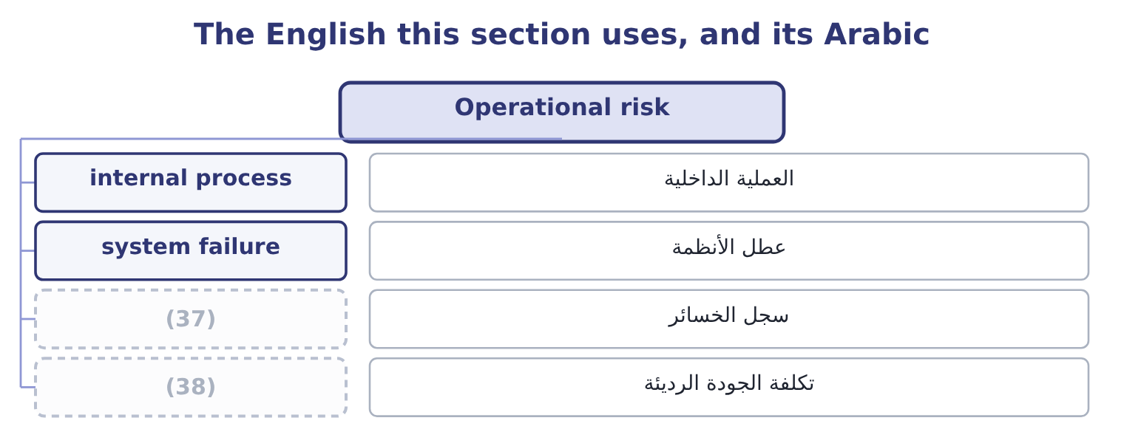
word list
loss database · cost of poor quality · demand variability

The English this sheet uses, and its Arabic
English (exam term) | Arabic
internal process | العملية الداخلية
system failure | عطل الأنظمة
loss database | سجل الخسائر
cost of poor quality | تكلفة الجودة الرديئة

Answer key · 1.5 Operational risk

1 systems | 20 department
2 events | 21 Everybody
3 regulation | 22 distribution
4 everywhere | 23 enormous
5 reconciliation | 24 deliberately
6 responsibility | 25 undeclared
7 mislabelled | 26 paperwork
8 anything | 27 goods-inwards
9 inexperience | 28 documentation
10 deliberate | 29 contribution
11 implementation | 30 investigation
12 intrusion | 31 financial
13 interrupted | 32 against
14 regulatory | 33 consequence
15 company's | 34 consignment
16 running | 35 classified
17 characteristics | 36 consolidated
18 answering | 37 loss database
19 activity | 38 cost of poor quality

the summaries in full
Summary 1 Operational risk is the risk of loss from inadequate or failed internal processes, people and systems, or from external events. That definition, which comes from banking regulation and is now used everywhere, repays reading twice, because it is built from four sources and the exam tests them separately. A control that does not work, a reconciliation nobody performs, a procedure that two departments interpret differently, a handover where responsibility is lost. The recall of a mislabelled batch is a process failure before it is anything else. Error, inexperience, inadequate training, turnover that takes knowledge with it, and deliberate wrongdoing — internal fraud. An outage, a failed implementation, a spreadsheet with a wrong formula in it, a data loss, a cyber intrusion. The spreadsheet is not a joke: errors in uncontrolled spreadsheets are among the most frequently reported operational losses in surveys of finance functions.
Summary 2 Suppliers failing, utilities interrupted, transport blocked, a pandemic, a regulatory change applied at short notice. The event is external; the risk is operational because the loss comes through the company's own ability to keep running. Four characteristics distinguish the family, and an exam answer that gives them is answering the outcome rather than reciting the definition. It is present in every activity, so it cannot be assigned to one department. Everybody who runs a process owns some of it. Its loss distribution is lopsided: very many small losses and a few enormous ones. It is rarely taken deliberately. A company takes business risk because it expects a return for it. Nobody is paid for operational risk, which makes reducing it the usual response and means the test of a control is the cost-benefit analysis. And it is under-reported. A credit loss appears in the accounts as a bad debt; an operational loss appears as a slightly worse margin, an unexplained variance, a write-off, a cost of poor quality — which is why.
Summary 3 A supplier delivers sesame with an undeclared change in origin, and 40,000 jars are produced before the paperwork is checked. The jars must be recalled from three distributors. Processes first — the goods-inwards check did not match the certificate to the delivery; people second — the control was performed by one person without review; external third — the supplier's own documentation was wrong. The contribution forgone on the recalled jars is 40,000 × 4.80 = 192,000, with the recall's own costs, the investigation, the destroyed stock and the distributors' goodwill on top. The direct financial loss is modest against $42,000,000 of sales. The consequence that matters is the one not in the arithmetic: a regulator that now looks at every consignment, and three distributors who will ask what else is not being checked. Note where the event would have appeared in the accounts if nobody had classified it: in cost of goods sold, as a write-off, invisible by the time the figures were consolidated. That is what under-reporting means in practice, and it is why operational risk needs a register of its own.

1.6 Legal, compliance and political risk
Chapter 1 · section 1.6

Fill every gap. Each word list holds one word more than there are gaps.
Summary 1 gaps 1–12
Three risks arrive from (1) the company's (2) and the outcome asks for each to be (3) . Legal risk is the risk of loss from legal proceedings or from legal defects: a contract that does not say what the company thought it said, a claim from a customer, an employee or a supplier, a dispute over (4) property, a (5) for a defective product, a judgment in a (6) the company did not expect to be sued. Its (7) feature is that the loss is (8) by a third party — a court or an (9) — on a timetable the company does not set, which is why legal risk is so poorly suited to point estimates and so well suited to a range. Compliance risk is the risk of loss from failing to observe laws, (10) , licence conditions, (11) or the company's own (12) rules.
word list
internal · determined · liabilities · liability · outside · standards · intellectual · distinguishing · regulations · jurisdiction · control · defined · arbitrator

Summary 2 gaps 13–24
The loss comes as a fine, a suspended licence, a required (13) , a prohibition on selling, and (14) as the cost of the (15) itself. For a food (16) , compliance is labelling, hygiene, (17) , weights and measures, export (18) and employment law. Two features (19) it from legal risk: the standard is written down in advance, so the risk can be assessed by (20) practice against the rule; and it is largely (21) , because compliance is a process the company runs. Political risk is the risk of loss from political action or instability in a country where the company operates or sells: (22) , a change in tax law, (23) controls that trap cash in a country, import or export (24) , sanctions, civil disorder, war, and the slower risk of a government that changes the rules of an industry. Its features are that it is largely uninsurable through ordinary markets — though specialist political risk insurance exists — that it is correlated across every exposure in one country at once, and that the usual responses are structural: limiting what is held in one country, financing locally so that a loss of assets is matched by a loss of liabilities, joint ventures with local partners, and the contract terms.
word list
certification · exchange · distinguish · traceability · controllable · remediation · restrictions · expropriation · specialist · producer · investigation · comparing · increasingly

The families of risk
Family | Arises from | Measured by | Usual response
Business | (25) | Operating leverage; margin of safety | Accept and manage; flexibility
Strategic | A wrong or outdated direction | Judgment; scenarios | (26)
Hazard | Physical events | Loss frequency and severity | (27)
Financial | Financing, counterparties, prices | (28) | Hedging; limits; liquidity buffers
Operational | Processes, people, systems, externals | Loss data; maximum possible loss | (29)
Legal | Proceedings and legal defects | (30) | Contract discipline; provisions; insurance
Compliance | Breach of rules written in advance | Gap against the rule | (31)
Political | (32) | Country exposure | Limit, localise, insure, structure

word list
Demand, prices, costs, cost structure · Board attention; real options · Controls; redundancy; training · Insurance; prevention; continuity plans · Cover ratios; value at risk · Process, monitoring, training · A range, not a point · Government action and instability · Loss frequency and severity

Name the risk

Name the family each belongs to.
Your turn: which family? (complete the blanks)
Event | Family
A fire stops the roasting hall for sixty days | ________
A new labelling regulation is applied at six weeks' notice | ________
The Syrian pound falls 20 per cent against the euro | ________
A goods-inwards check is not performed and a batch is recalled | ________
Household incomes fall and jar volumes drop 10 per cent | ________
A competitor launches a tahini with a two-year shelf life | ________

"Risk", "hazard" and "exposure"

Summary 3 gaps 33–42
English uses risk for the possibility, hazard for the thing that could cause harm and exposure for what (33) to be lost, and (34) writing keeps the three apart: a wet floor is a hazard, the possibility of (35) falling is a risk, and the exposure is the claim that would follow. Ordinary (36) uses all three for all three, which is why exam (37) blur them. Note also that English risk is both noun and verb and that the verb (38) blame — "they risked it" — which is one reason people avoid the word in (39) and write issue or (40) instead. A risk (41) that contains no risks is a (42) , not a style.
word list
somebody · challenge · register · symptom · answers · carries · stands · timetable · professional · reports · speech

"Risk", "hazard" and "exposure"
Event | Family
A fire stops the roasting hall for sixty days | Hazard risk, with a consequential loss larger than the direct one.
A new labelling regulation at six weeks' notice | Compliance risk, and an operational one in the execution.
The Syrian pound falls 20 per cent against the euro | (43)
A goods-inwards check is not performed | Operational risk, in the process source.
Household incomes fall and volumes drop 10 per cent | Business risk, magnified by operating leverage.
A competitor launches a longer-life product | (44)
What it tells you | Six events, six families, six different owners and six different responses — which is the only reason the (45) is worth making.

word list
classification · Financial risk, specifically market risk. · Strategic risk, owned by the board. · Contract discipline; provisions; insurance

The English this section uses, and its Arabic
Each term sits against what it means.
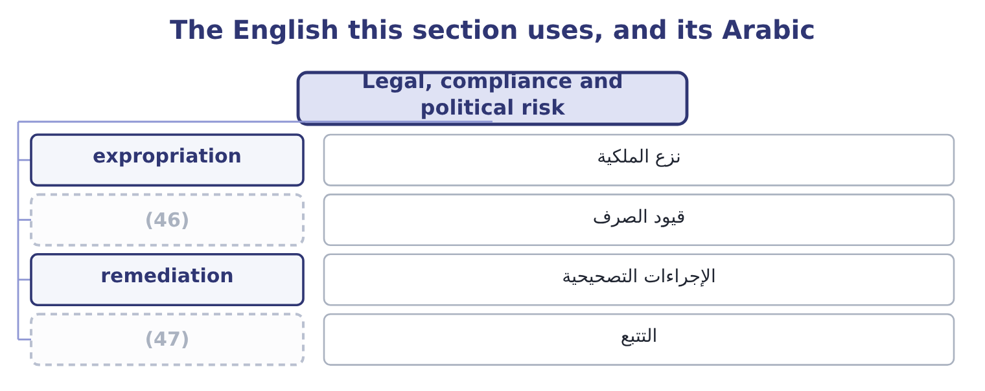
word list
traceability · exchange controls · political risk

The English this sheet uses, and its Arabic
English (exam term) | Arabic
expropriation | نزع الملكية
exchange controls | قيود الصرف
remediation | الإجراءات التصحيحية
traceability | التتبع

Answer key · 1.6 Legal, compliance and political risk

1 outside | 25 Demand, prices, costs, cost structure
2 control | 26 Board attention; real options
3 defined | 27 Insurance; prevention; continuity plans
4 intellectual | 28 Cover ratios; value at risk
5 liability | 29 Controls; redundancy; training
6 jurisdiction | 30 A range, not a point
7 distinguishing | 31 Process, monitoring, training
8 determined | 32 Government action and instability
9 arbitrator | 33 stands
10 regulations | 34 professional
11 standards | 35 somebody
12 internal | 36 speech
13 remediation | 37 answers
14 increasingly | 38 carries
15 investigation | 39 reports
16 producer | 40 challenge
17 traceability | 41 register
18 certification | 42 symptom
19 distinguish | 43 Financial risk, specifically market risk.
20 comparing | 44 Strategic risk, owned by the board.
21 controllable | 45 classification
22 expropriation | 46 exchange controls
23 exchange | 47 traceability
24 restrictions

the summaries in full
Summary 1 Three risks arrive from outside the company's control and the outcome asks for each to be defined. Legal risk is the risk of loss from legal proceedings or from legal defects: a contract that does not say what the company thought it said, a claim from a customer, an employee or a supplier, a dispute over intellectual property, a liability for a defective product, a judgment in a jurisdiction the company did not expect to be sued. Its distinguishing feature is that the loss is determined by a third party — a court or an arbitrator — on a timetable the company does not set, which is why legal risk is so poorly suited to point estimates and so well suited to a range. Compliance risk is the risk of loss from failing to observe laws, regulations, licence conditions, standards or the company's own internal rules.
Summary 2 The loss comes as a fine, a suspended licence, a required remediation, a prohibition on selling, and increasingly as the cost of the investigation itself. For a food producer, compliance is labelling, hygiene, traceability, weights and measures, export certification and employment law. Two features distinguish it from legal risk: the standard is written down in advance, so the risk can be assessed by comparing practice against the rule; and it is largely controllable, because compliance is a process the company runs. Political risk is the risk of loss from political action or instability in a country where the company operates or sells: expropriation, a change in tax law, exchange controls that trap cash in a country, import or export restrictions, sanctions, civil disorder, war, and the slower risk of a government that changes the rules of an industry. Its features are that it is largely uninsurable through ordinary markets — though specialist political risk insurance exists — that it is correlated across every exposure in one country at once, and that the usual responses are structural: limiting what is held in one country, financing locally so that a loss of assets is matched by a loss of liabilities, joint ventures with local partners, and the contract terms.
Summary 3 English uses risk for the possibility, hazard for the thing that could cause harm and exposure for what stands to be lost, and professional writing keeps the three apart: a wet floor is a hazard, the possibility of somebody falling is a risk, and the exposure is the claim that would follow. Ordinary speech uses all three for all three, which is why exam answers blur them. Note also that English risk is both noun and verb and that the verb carries blame — "they risked it" — which is one reason people avoid the word in reports and write issue or challenge instead. A risk register that contains no risks is a symptom, not a style.

