2.1 Volatility
Chapter 2 · section 2.1

Fill every gap. Each word list holds one word more than there are gaps.
Chapter 2, section by section
Each stage leads to the next.
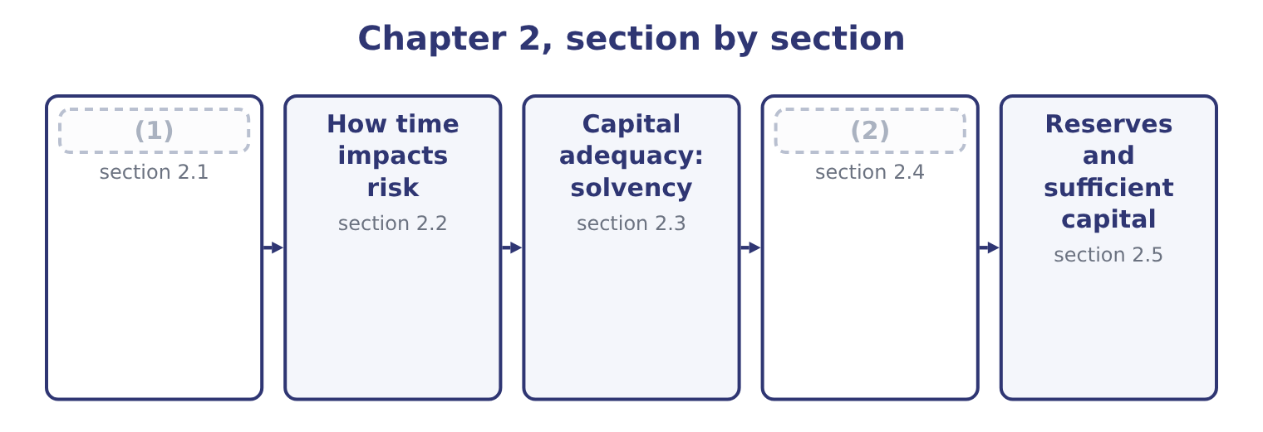
word list
Volatility · solvency · Capital adequacy: liquidity

Summary 1 gaps 3–14
Volatility is the (3) to which a (4) moves about its average. It is the first of the two (5) that make a risk large, and it is what people mean when they say that one business is (6) than another even when both earn the same on average. Three (7) of volatility (8) for the exam. It is about dispersion, not (9) . A series that is sometimes far above its average and sometimes far below it is (10) ; one that rises (11) is not, however fast it rises. It is measured from (12) and used for the future. A volatility estimated from five calm years will (13) the risk of the sixth, and a crisis is precisely the moment when past volatility stops (14) future volatility. And it is not the same as risk.
word list
direction · things · extent · matter · riskier · quantity · arithmetic · steadily · predicting · history · properties · volatile · understate

Summary 2 gaps 15–26
Volatility is a (15) of movement; risk is the (16) of that movement for the company. A business whose sales move (17) per cent either way but whose costs move with them has high volatility and (18) risk, which is the whole lesson of Book 3's cost (19) . The standard (20) are the ones Book 2 used. The standard deviation (21) dispersion in the units of the thing being measured — (22) of operating income, cents of share price. The (23) is its square and is used in the arithmetic rather than in (24) . The coefficient of variation divides the standard deviation by the mean, giving a (25) measure that allows a large business and a small one to be compared, and the range or the worst observed outcome gives a crude but intuitive (26) .
word list
states · consequence · structure · reports · variance · modest · dollars · alternative · reserves · measures · twenty · measurement · relative

Summary 3 gaps 27–38
Orontes's operating income over five years was 3,600,000, 4,900,000, 3,100,000, 4,600,000 and 4,176,000. The five add to 20,376,000, so the mean is 20,376,000 ÷ 5 = 4,075,200. Taking each year's (27) from the mean, squaring, (28) over four degrees of (29) and taking the root gives a standard deviation of 731,900. The coefficient of variation is 731,900 ÷ 4,075,200 = 17.96 per cent, which is the figure to (30) with another company or another (31) . Read the two figures as a (32) : Orontes earns about 4,075,200 of operating income in a (33) year and that figure moves by about 731,900 either way in an ordinary year. Then note what the arithmetic cannot know — the five years (34) no fire, no (35) and no recall, so the measured volatility (36) ordinary trading and says (37) at all about the (38) .
word list
compare · observed · division · tail · describes · sentence · contain · averaging · typical · devaluation · difference · freedom · nothing

The English this section uses, and its Arabic
Each term sits against what it means.
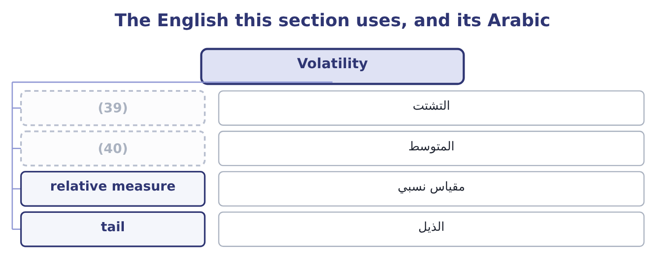
word list
المتوسط · mean · dispersion

The English this sheet uses, and its Arabic
English (exam term) | Arabic
dispersion | التشتت
mean | المتوسط
relative measure | مقياس نسبي
tail | الذيل

Answer key · 2.1 Volatility

1 Volatility | 21 states
2 Capital adequacy: liquidity | 22 dollars
3 extent | 23 variance
4 quantity | 24 reports
5 things | 25 relative
6 riskier | 26 alternative
7 properties | 27 difference
8 matter | 28 averaging
9 direction | 29 freedom
10 volatile | 30 compare
11 steadily | 31 division
12 history | 32 sentence
13 understate | 33 typical
14 predicting | 34 contain
15 measurement | 35 devaluation
16 consequence | 36 describes
17 twenty | 37 nothing
18 modest | 38 tail
19 structure | 39 dispersion
20 measures | 40 mean

the summaries in full
Summary 1 Volatility is the extent to which a quantity moves about its average. It is the first of the two things that make a risk large, and it is what people mean when they say that one business is riskier than another even when both earn the same on average. Three properties of volatility matter for the exam. It is about dispersion, not direction. A series that is sometimes far above its average and sometimes far below it is volatile; one that rises steadily is not, however fast it rises. It is measured from history and used for the future. A volatility estimated from five calm years will understate the risk of the sixth, and a crisis is precisely the moment when past volatility stops predicting future volatility. And it is not the same as risk.
Summary 2 Volatility is a measurement of movement; risk is the consequence of that movement for the company. A business whose sales move twenty per cent either way but whose costs move with them has high volatility and modest risk, which is the whole lesson of Book 3's cost structure. The standard measures are the ones Book 2 used. The standard deviation states dispersion in the units of the thing being measured — dollars of operating income, cents of share price. The variance is its square and is used in the arithmetic rather than in reports. The coefficient of variation divides the standard deviation by the mean, giving a relative measure that allows a large business and a small one to be compared, and the range or the worst observed outcome gives a crude but intuitive alternative.
Summary 3 Orontes's operating income over five years was 3,600,000, 4,900,000, 3,100,000, 4,600,000 and 4,176,000. The five add to 20,376,000, so the mean is 20,376,000 ÷ 5 = 4,075,200. Taking each year's difference from the mean, squaring, averaging over four degrees of freedom and taking the root gives a standard deviation of 731,900. The coefficient of variation is 731,900 ÷ 4,075,200 = 17.96 per cent, which is the figure to compare with another company or another division. Read the two figures as a sentence: Orontes earns about 4,075,200 of operating income in a typical year and that figure moves by about 731,900 either way in an ordinary year. Then note what the arithmetic cannot know — the five years contain no fire, no devaluation and no recall, so the measured volatility describes ordinary trading and says nothing at all about the tail.

2.2 How time impacts risk
Chapter 2 · section 2.2

Fill every gap. Each word list holds one word more than there are gaps.
Summary 1 gaps 1–12
Time is the second thing that makes a risk large, and it works in three (1) ways that the outcome expects to be (2) . The longer the horizon, the wider the (3) . A (4) that moves (5) drifts further from its starting point the longer it is allowed to move. Where the movements in (6) periods are independent, the standard deviation grows with the square root of time: four years of exposure (7) twice the one-year dispersion, not four times. The longer the horizon, the more (8) a rare event (9) . An event with a 5 per cent chance in any one year has a 1 − 0.5987 = 0.4013 chance of (10) at least once in ten, because 0.95 (11) by itself ten times is 0.5987. (12) about the event has changed; only the window has. And the longer the horizon, the less anybody knows.
word list
happening · carries · distribution · likely · distinct · randomly · Nothing · multiplied · successive · quantity · payment · becomes · distinguished

Summary 2 gaps 13–21
Beyond a few years the estimates (13) become unreliable, which is the (14) of, and it is why Book 3 put a terminal value on (15) after year five rather than pretending to forecast year eleven. Risk (16) must state their horizon. And exposure can be managed by (17) time as well as by (18) movement. A (19) payment term reduces credit exposure without (20) any customer's (21) ; a hedge that matures in three months leaves the fourth month exposed; holding stock for sixty days rather than ninety reduces the price risk in it by a third of the period.
word list
shortening · uncertainty · everything · changing · themselves · shorter · measures · creditworthiness · reducing · successive

Worked example: scaling volatility with time

Summary 3 gaps 22–33
Orontes's (22) income has a standard deviation of 731,900 over a year. Where the years are independent, the four-year dispersion is the one-year figure times the square root of four, which is 731,900 × 2 = 1,463,800. Going the other way, the (23) figure is the annual one (24) by the square root of four, which is 731,900 ÷ 2 = 365,950. All of this holds only where the periods are independent. Orontes's sales are (25) and its sesame price is persistent, so the real four-year dispersion is wider than the rule (26) in some respects and (27) in others. The (28) rule is a convention, not a law, and the (29) test whether you know what it (30) . Where movements are (31) correlated from period to period — a trend, a persistent price, a (32) that decays slowly — the rule understates the (33) risk.
word list
seasonal · operating · reputation · long-horizon · movement · square-root · assumes · suggests · examiners · positively · divided · narrower · quarterly

The English this section uses, and its Arabic
Each term sits against what it means.
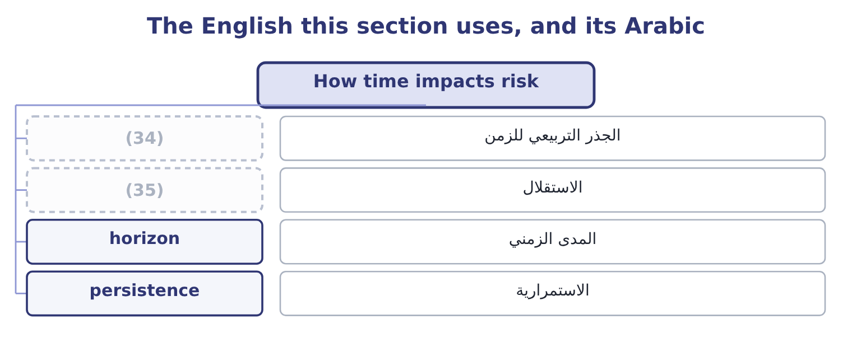
word list
persistence · independence · square root of time

The English this sheet uses, and its Arabic
English (exam term) | Arabic
square root of time | الجذر التربيعي للزمن
independence | الاستقلال
horizon | المدى الزمني
persistence | الاستمرارية

Answer key · 2.2 How time impacts risk

1 distinct | 19 shorter
2 distinguished | 20 changing
3 distribution | 21 creditworthiness
4 quantity | 22 operating
5 randomly | 23 quarterly
6 successive | 24 divided
7 carries | 25 seasonal
8 likely | 26 suggests
9 becomes | 27 narrower
10 happening | 28 square-root
11 multiplied | 29 examiners
12 Nothing | 30 assumes
13 themselves | 31 positively
14 uncertainty | 32 reputation
15 everything | 33 long-horizon
16 measures | 34 square root of time
17 shortening | 35 independence
18 reducing

the summaries in full
Summary 1 Time is the second thing that makes a risk large, and it works in three distinct ways that the outcome expects to be distinguished. The longer the horizon, the wider the distribution. A quantity that moves randomly drifts further from its starting point the longer it is allowed to move. Where the movements in successive periods are independent, the standard deviation grows with the square root of time: four years of exposure carries twice the one-year dispersion, not four times. The longer the horizon, the more likely a rare event becomes. An event with a 5 per cent chance in any one year has a 1 − 0.5987 = 0.4013 chance of happening at least once in ten, because 0.95 multiplied by itself ten times is 0.5987. Nothing about the event has changed; only the window has. And the longer the horizon, the less anybody knows.
Summary 2 Beyond a few years the estimates themselves become unreliable, which is the uncertainty of, and it is why Book 3 put a terminal value on everything after year five rather than pretending to forecast year eleven. Risk measures must state their horizon. And exposure can be managed by shortening time as well as by reducing movement. A shorter payment term reduces credit exposure without changing any customer's creditworthiness; a hedge that matures in three months leaves the fourth month exposed; holding stock for sixty days rather than ninety reduces the price risk in it by a third of the period.
Summary 3 Orontes's operating income has a standard deviation of 731,900 over a year. Where the years are independent, the four-year dispersion is the one-year figure times the square root of four, which is 731,900 × 2 = 1,463,800. Going the other way, the quarterly figure is the annual one divided by the square root of four, which is 731,900 ÷ 2 = 365,950. All of this holds only where the periods are independent. Orontes's sales are seasonal and its sesame price is persistent, so the real four-year dispersion is wider than the rule suggests in some respects and narrower in others. The square-root rule is a convention, not a law, and the examiners test whether you know what it assumes. Where movements are positively correlated from period to period — a trend, a persistent price, a reputation that decays slowly — the rule understates the long-horizon risk.

2.3 Capital adequacy: solvency
Chapter 2 · section 2.3

Fill every gap. Each word list holds one word more than there are gaps.
Summary 1 gaps 1–12
Capital (1) is the condition of having enough capital, of the right kinds and in the right places, to absorb the losses a (2) might suffer and still continue. The term comes from banking and insurance, where (3) impose it, but the concept applies to every company and the outcome asks for its four elements: solvency, (4) , reserves and sufficient capital. Solvency is the first: that assets exceed (5) , so that the company could meet its (6) if everything were realised. It is a (7) condition and it is (8) by the equity cushion. (9) equity is $20,392,975 (10) total assets of $31,672,600, so equity funds 20,392,975 ÷ 31,672,600 = 64.39 per cent of the assets. Read as a risk (11) , that says asset values could fall by nearly two thirds before the creditors were (12) — which is a different and more useful reading of the same ratio Book 1 computed as a measure of gearing.
word list
regulators · balance-sheet · obligations · impairment · liquidity · adequacy · statement · against · business · liabilities · Orontes's · measured · threatened

Summary 2 gaps 13–19
Three (13) belong with the solvency test and all three appear in (14) . It depends on the (15) of the assets. Book 1's,724,000, and an (16) is the discovery that the solvency cushion was (17) than the balance sheet said. It is a point in time. A company solvent at the year end can be (18) in March, and the test that matters is solvency after the loss, not before it. And solvency is not (19) . A company can be solvent and still fail.
word list
cautions · questions · smaller · measurement · buffer · impairment · insolvent · survival

The English this section uses, and its Arabic
Each term sits against what it means.
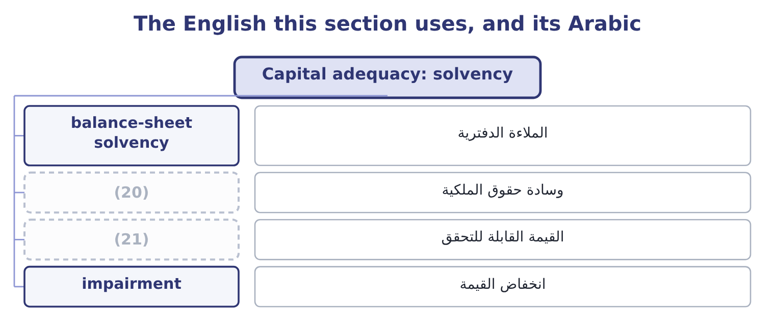
word list
الملاءة الدفترية · equity cushion · realisable value

The English this sheet uses, and its Arabic
English (exam term) | Arabic
balance-sheet solvency | الملاءة الدفترية
equity cushion | وسادة حقوق الملكية
realisable value | القيمة القابلة للتحقق
impairment | انخفاض القيمة

Answer key · 2.3 Capital adequacy: solvency

1 adequacy | 12 threatened
2 business | 13 cautions
3 regulators | 14 questions
4 liquidity | 15 measurement
5 liabilities | 16 impairment
6 obligations | 17 smaller
7 balance-sheet | 18 insolvent
8 measured | 19 survival
9 Orontes's | 20 equity cushion
10 against | 21 realisable value
11 statement

the summaries in full
Summary 1 Capital adequacy is the condition of having enough capital, of the right kinds and in the right places, to absorb the losses a business might suffer and still continue. The term comes from banking and insurance, where regulators impose it, but the concept applies to every company and the outcome asks for its four elements: solvency, liquidity, reserves and sufficient capital. Solvency is the first: that assets exceed liabilities, so that the company could meet its obligations if everything were realised. It is a balance-sheet condition and it is measured by the equity cushion. Orontes's equity is $20,392,975 against total assets of $31,672,600, so equity funds 20,392,975 ÷ 31,672,600 = 64.39 per cent of the assets. Read as a risk statement, that says asset values could fall by nearly two thirds before the creditors were threatened — which is a different and more useful reading of the same ratio Book 1 computed as a measure of gearing.
Summary 2 Three cautions belong with the solvency test and all three appear in questions. It depends on the measurement of the assets. Book 1's,724,000, and an impairment is the discovery that the solvency cushion was smaller than the balance sheet said. It is a point in time. A company solvent at the year end can be insolvent in March, and the test that matters is solvency after the loss, not before it. And solvency is not survival. A company can be solvent and still fail.

2.4 Capital adequacy: liquidity
Chapter 2 · section 2.4

Fill every gap. Each word list holds one word more than there are gaps.
Summary 1 gaps 1–12
Liquidity is the ability to meet (1) as they fall due, in cash, at the moment they fall due. It is a flow condition rather than a (2) one, and it is the element that actually kills companies: the great majority of corporate failures are liquidity failures in (3) that were solvent on paper. The (4) is worth stating in one line, because the exam tests it (5) . (6) asks whether there is (7) . Liquidity asks whether it is (8) in time and in the right form. (9) position is (10) . It holds $7,302,100 of cash and $4,144,000 of receivables, which (11) are 7,302,100 + 4,144,000 = 11,446,100 of (12) against payables of $2,050,000 — a cover of 11,446,100 ÷ 2,050,000 = 5.58 times. Book 1 read that as a sign of cash sitting idle; read as a risk statement it is a buffer, and the tension between those two readings is a real one.
word list
strong · Solvency · balance-sheet · directly · everybody · Orontes's · near-cash · obligations · enough · businesses · available · distinction · together

Summary 2 gaps 13–24
Four sources of liquidity exist and a company (13) know the size and (14) of each. Cash and (15) , which are certain and earn (16) . Undrawn committed facilities, which are nearly certain — subject to the covenants of Book 2's, which are exactly the (17) most likely to be breached in the (18) where the facility is needed. Assets that can be sold or (19) , which are reliable in calm markets and least reliable in the moment they are called on, because (20) else is selling the same things. And the (21) cycle itself: receivables that will be (22) and stock that will be sold, whose timing is the subject of Book 1's. That (23) is the lesson. Liquidity sources behave worst at exactly the moment they are needed, which is why a liquidity buffer is held in cash and committed facilities and not in the hope of selling (24) .
word list
collected · should · everybody · something · financed · deposits · ordering · selling · conditions · circumstances · reliability · operating · little

The English this section uses, and its Arabic
Each term sits against what it means.
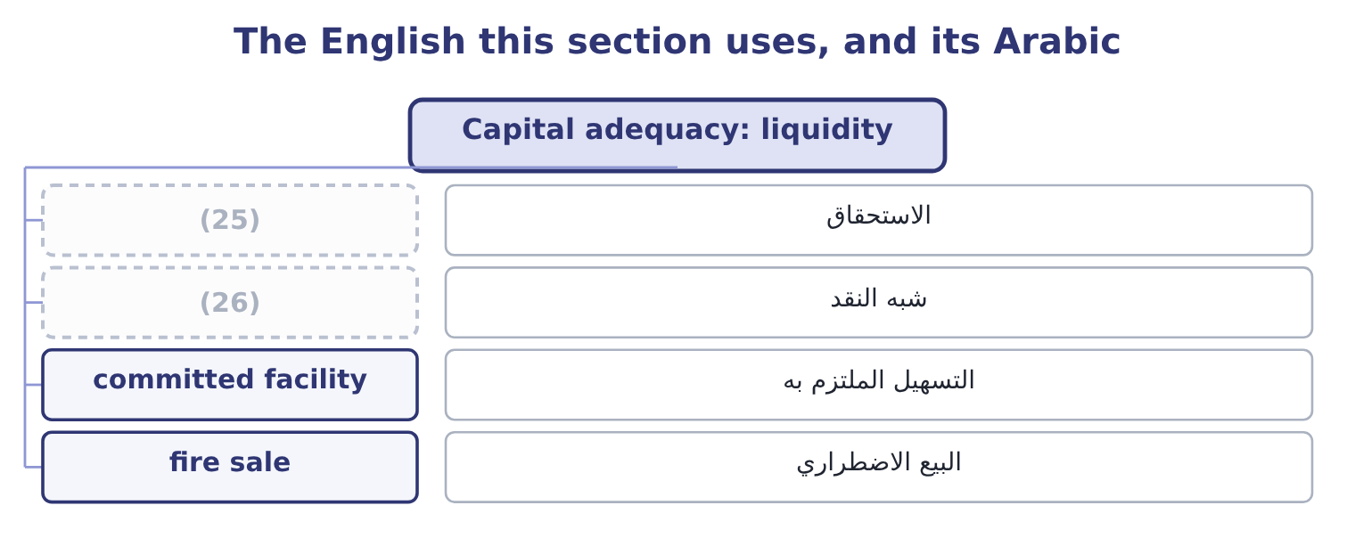
word list
horizon · near-cash · falling due

The English this sheet uses, and its Arabic
English (exam term) | Arabic
falling due | الاستحقاق
near-cash | شبه النقد
committed facility | التسهيل الملتزم به
fire sale | البيع الاضطراري

Answer key · 2.4 Capital adequacy: liquidity

1 obligations | 14 reliability
2 balance-sheet | 15 deposits
3 businesses | 16 little
4 distinction | 17 conditions
5 directly | 18 circumstances
6 Solvency | 19 financed
7 enough | 20 everybody
8 available | 21 operating
9 Orontes's | 22 collected
10 strong | 23 ordering
11 together | 24 something
12 near-cash | 25 falling due
13 should | 26 near-cash

the summaries in full
Summary 1 Liquidity is the ability to meet obligations as they fall due, in cash, at the moment they fall due. It is a flow condition rather than a balance-sheet one, and it is the element that actually kills companies: the great majority of corporate failures are liquidity failures in businesses that were solvent on paper. The distinction is worth stating in one line, because the exam tests it directly. Solvency asks whether there is enough. Liquidity asks whether it is available in time and in the right form. Orontes's position is strong. It holds $7,302,100 of cash and $4,144,000 of receivables, which together are 7,302,100 + 4,144,000 = 11,446,100 of near-cash against payables of $2,050,000 — a cover of 11,446,100 ÷ 2,050,000 = 5.58 times. Book 1 read that as a sign of cash sitting idle; read as a risk statement it is a buffer, and the tension between those two readings is a real one.
Summary 2 Four sources of liquidity exist and a company should know the size and reliability of each. Cash and deposits, which are certain and earn little. Undrawn committed facilities, which are nearly certain — subject to the covenants of Book 2's, which are exactly the conditions most likely to be breached in the circumstances where the facility is needed. Assets that can be sold or financed, which are reliable in calm markets and least reliable in the moment they are called on, because everybody else is selling the same things. And the operating cycle itself: receivables that will be collected and stock that will be sold, whose timing is the subject of Book 1's. That ordering is the lesson. Liquidity sources behave worst at exactly the moment they are needed, which is why a liquidity buffer is held in cash and committed facilities and not in the hope of selling something.

2.5 Reserves and sufficient capital
Chapter 2 · section 2.5

Fill every gap. Each word list holds one word more than there are gaps.
Summary 1 gaps 1–12
The last two elements of capital adequacy are the ones (1) most often confuse, because the word reserve is used in two (2) senses. A reserve in the accounting sense is a component of equity — retained earnings, a (3) reserve, a (4) reserve. It is a label on the (5) side of the balance sheet (6) where the equity came from, and it is not money. A company with large retained earnings and no cash cannot pay anything out of its reserves, which is one of the most persistent (7) in business (8) . A reserve in the risk sense is an amount set aside against an (9) future loss: an insurer's claims reserve, a bank's loan-loss provision, a (10) warranty provision, a company's allowance for doubtful receivables. This reserve is a (11) that a loss is expected, and that is the key: reserves cover expected (12) .
word list
losses · different · misunderstandings · recognition · revaluation · manufacturer's · right-hand · identified · describing · conversation · expenditure · translation · candidates

Summary 2 gaps 13–23
Sufficient capital is the (13) that covers what reserves do not. Capital absorbs unexpected loss — the amount by which an actual loss (14) what was expected and (15) . How much capital is sufficient (16) on four things, and an answer that names them is a (17) answer. The volatility and the (18) of sections 2.1 and 2.2 — how far (19) might move, over how long. The risk (20) : how much chance of (21) the owners are willing to run. The claims that must be met (22) happens: interest, (23) , committed capital expenditure, the fixed costs of Book 3. And any external requirement: regulatory capital for a financial institution, covenant minimums for a borrower, a credit rating the company wants to keep.
word list
failure · repayments · horizon · sixty-day · complete · results · appetite · element · whatever · depends · reserved · exceeds

Worked example: does Orontes hold enough?

Summary 3 gaps 24–35
A plausible bad year. Sales fall 10 per cent, which at an operating (24) of 4.02 removes 4,176,000 × 0.402 = 1,678,752 of operating income, (25) 4,176,000 − 1,678,752 = 2,497,248. A (26) stoppage of the kind,761,620 of (27) , and since 2,761,620 − 2,497,248 = 264,372, the year ends 264,372 below zero. Can it be (28) ? The interest of $390,000 must still be paid, and the cash balance of $7,302,100 covers both that and the loss many times over. The (29) is therefore not this year's loss but the (30) : capital expenditure to replace the (31) hall, on top of a year with no cash (32) , is what would consume the (33) . That is what a capital adequacy (34) looks like for a company that is not a bank: not a formula, but a plausible (35) of bad things, costed, set against the cash and the facilities actually available, with the fixed claims that do not stop.
word list
constraint · leverage · roasting · leaving · generation · absorbed · sixty-day · contribution · buffer · rebuilding · assessment · combination · elements

Volatility, time and adequacy

Your turn: measuring and surviving (complete the blanks)
Item | Data | Answer
Coefficient of variation | (36) | ________
Four-year volatility | (37) | ________
Probability of a 5 per cent event in ten years | 0.95 to the tenth power is 0.5987 | ________
Equity as a share of assets | (38) | ________
Cash and receivables against payables | 7,302,100 and 4,144,000 against 2,050,000 | ________
What covers expected loss, and what covers unexpected loss |  | ________

word list
One-year 731,900; periods independent · Equity 20,392,975; assets 31,672,600 · Standard deviation 731,900; mean 4,075,200 · square root of time

"Reserve", "provision" and "capital"

Summary 4 gaps 39–47
Few words cause more (39) in English than reserve. In accounting a reserve is part of equity and (40) where money came; in (41) and banking a reserve is an amount set aside against a loss; in ordinary speech a reserve is (42) held back for later, which is closer to the second. Provision is the (43) accounting term for a (44) of uncertain timing or amount, and in English (45) provision is the correct word where a loss is expected, with reserve kept for equity. Where a (46) uses the word, read which of the two it means before (47) .
word list
conversation · question · liability · describes · narrower · confusion · insurance · something · answering · practice

"Reserve", "provision" and "capital"
Item | Answer
Coefficient of variation | 17.96 per cent: 731,900 ÷ 4,075,200 = 17.96 per cent.
Four-year volatility | 1,463,800: 731,900 × 2 = 1,463,800, the square root of four being two.
Probability over ten years | (48) : 1 − 0.5987 = 0.4013.
Equity as a share of assets | 64.39 per cent: 20,392,975 ÷ 31,672,600 = 64.39 per cent.
Cash and receivables against payables | (49) : 11,446,100 ÷ 2,050,000 = 5.58.
What covers each kind of loss | Reserves cover expected loss; capital absorbs unexpected loss.
What it tells you | The first five are measurements and the sixth is the principle they serve: measure the movement, measure the time, and then ask whether what

word list
relative measure · About 40 per cent · 5.58 times

The English this section uses, and its Arabic
Each term sits against what it means.
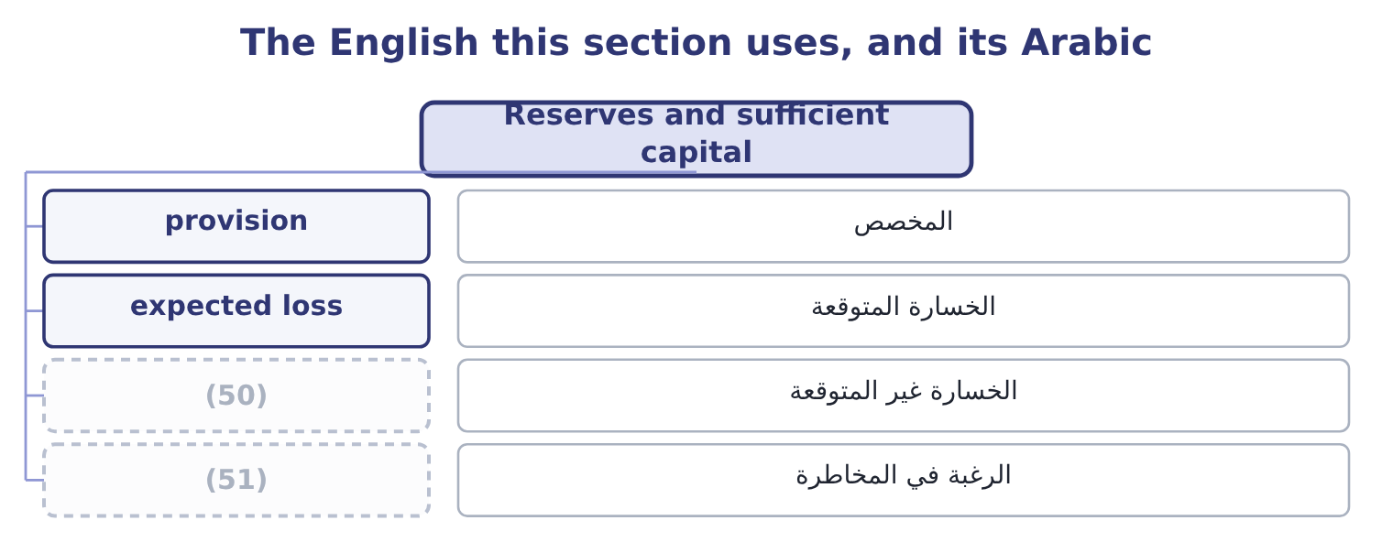
word list
unexpected loss · standard deviation · risk appetite

The English this sheet uses, and its Arabic
English (exam term) | Arabic
provision | المخصص
expected loss | الخسارة المتوقعة
unexpected loss | الخسارة غير المتوقعة
risk appetite | الرغبة في المخاطرة

Answer key · 2.5 Reserves and sufficient capital

1 candidates | 27 contribution
2 different | 28 absorbed
3 revaluation | 29 constraint
4 translation | 30 rebuilding
5 right-hand | 31 roasting
6 describing | 32 generation
7 misunderstandings | 33 buffer
8 conversation | 34 assessment
9 identified | 35 combination
10 manufacturer's | 36 Standard deviation 731,900; mean 4,075,200
11 recognition | 37 One-year 731,900; periods independent
12 losses | 38 Equity 20,392,975; assets 31,672,600
13 element | 39 confusion
14 exceeds | 40 describes
15 reserved | 41 insurance
16 depends | 42 something
17 complete | 43 narrower
18 horizon | 44 liability
19 results | 45 practice
20 appetite | 46 question
21 failure | 47 answering
22 whatever | 48 About 40 per cent
23 repayments | 49 5.58 times
24 leverage | 50 unexpected loss
25 leaving | 51 risk appetite
26 sixty-day

the summaries in full
Summary 1 The last two elements of capital adequacy are the ones candidates most often confuse, because the word reserve is used in two different senses. A reserve in the accounting sense is a component of equity — retained earnings, a revaluation reserve, a translation reserve. It is a label on the right-hand side of the balance sheet describing where the equity came from, and it is not money. A company with large retained earnings and no cash cannot pay anything out of its reserves, which is one of the most persistent misunderstandings in business conversation. A reserve in the risk sense is an amount set aside against an identified future loss: an insurer's claims reserve, a bank's loan-loss provision, a manufacturer's warranty provision, a company's allowance for doubtful receivables. This reserve is a recognition that a loss is expected, and that is the key: reserves cover expected losses.
Summary 2 Sufficient capital is the element that covers what reserves do not. Capital absorbs unexpected loss — the amount by which an actual loss exceeds what was expected and reserved. How much capital is sufficient depends on four things, and an answer that names them is a complete answer. The volatility and the horizon of sections 2.1 and 2.2 — how far results might move, over how long. The risk appetite: how much chance of failure the owners are willing to run. The claims that must be met whatever happens: interest, repayments, committed capital expenditure, the fixed costs of Book 3. And any external requirement: regulatory capital for a financial institution, covenant minimums for a borrower, a credit rating the company wants to keep.
Summary 3 A plausible bad year. Sales fall 10 per cent, which at an operating leverage of 4.02 removes 4,176,000 × 0.402 = 1,678,752 of operating income, leaving 4,176,000 − 1,678,752 = 2,497,248. A sixty-day stoppage of the kind,761,620 of contribution, and since 2,761,620 − 2,497,248 = 264,372, the year ends 264,372 below zero. Can it be absorbed? The interest of $390,000 must still be paid, and the cash balance of $7,302,100 covers both that and the loss many times over. The constraint is therefore not this year's loss but the rebuilding: capital expenditure to replace the roasting hall, on top of a year with no cash generation, is what would consume the buffer. That is what a capital adequacy assessment looks like for a company that is not a bank: not a formula, but a plausible combination of bad things, costed, set against the cash and the facilities actually available, with the fixed claims that do not stop.
Summary 4 Few words cause more confusion in English than reserve. In accounting a reserve is part of equity and describes where money came; in insurance and banking a reserve is an amount set aside against a loss; in ordinary speech a reserve is something held back for later, which is closer to the second. Provision is the narrower accounting term for a liability of uncertain timing or amount, and in English practice provision is the correct word where a loss is expected, with reserve kept for equity. Where a question uses the word, read which of the two it means before answering.

