3.1 Where probabilities come from
Chapter 3 · section 3.1

Fill every gap. Each word list holds one word more than there are gaps.
Chapter 3, section by section
Each stage leads to the next.
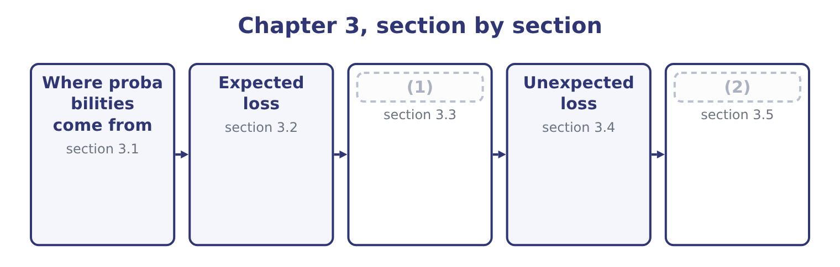
word list
Where probabilities come from · A register of risks, and the portfolio effect · Maximum possible loss

Summary 1 gaps 3–14
A probability is a number (3) zero and one (4) how likely an event is. Risk work uses three (5) for them and the exam expects the distinction, because the three differ (6) in how much they can be trusted. Where an event has happened many times under similar (7) — machine failures, delivery delays, customer defaults, claims on a class of insurance — the (8) of occasions on which it occurred is an estimate of its probability. This is the (9) source and it requires volume: a company with four hundred (10) can estimate the probability that a supplier fails; a company with one cannot. (11) , from people who know. Where data do not exist, the people closest to the process estimate the likelihood, usually on a scale — remote, (12) , possible, likely, almost certain — anchored to numbers so that the words mean the same thing to (13) . This is where most corporate risk (14) actually lives.
word list
describing · suppliers · sources · conditions · strongest · computed · Judgment · everybody · enormously · unlikely · proportion · assessment · between

Summary 2 gaps 15–26
A model, from a (15) . Where the event depends on things that can (16) be modelled — an exchange rate, an interest rate, a commodity price — a (17) can be fitted and probabilities read off it. This is the (18) source and the most dangerous, because the apparent precision of a computed probability is inherited from (19) nobody tests. Four rules of use (20) , and they are the (21) part. Probabilities of mutually (22) outcomes sum to one. A (23) table whose probabilities add to 0.9 is (24) , and the missing tenth is usually the outcome nobody wanted to write down. (25) must be argued, not (26) . The probability that two things both happen is the product of their probabilities only where neither affects the other, and in a company almost nothing is independent: a bad year for volumes is also a bad year for collections, because the same economy causes both.
word list
assumed · incomplete · follow · between · exclusive · severity · Independence · distribution · strongest-looking · structure · examinable · assumptions · themselves

Summary 3 gaps 27–32
Probabilities are (27) on the controls that exist now. The likelihood of a loss from an unchecked delivery is not the likelihood after the check is (28) , which is the (29) distinction. And a probability (30) for a frequent event does not (31) to a rare one. Estimating a one-in-two-hundred-year event from twenty years of data is (32) , not measurement, and section 3.5 is about exactly that problem.
word list
estimated · outcome · transfer · conditional · reinstated · inherent-and-residual · extrapolation

The English this section uses, and its Arabic
Each term sits against what it means.
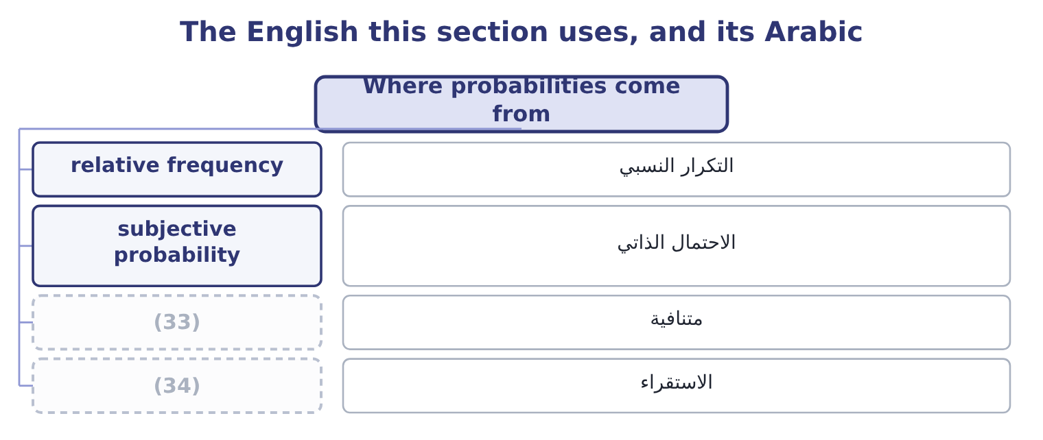
word list
severity distribution · extrapolation · mutually exclusive

The English this sheet uses, and its Arabic
English (exam term) | Arabic
relative frequency | التكرار النسبي
subjective probability | الاحتمال الذاتي
mutually exclusive | متنافية
extrapolation | الاستقراء

Answer key · 3.1 Where probabilities come from

1 A register of risks, and the portfolio effect | 18 strongest-looking
2 Maximum possible loss | 19 assumptions
3 between | 20 follow
4 describing | 21 examinable
5 sources | 22 exclusive
6 enormously | 23 severity
7 conditions | 24 incomplete
8 proportion | 25 Independence
9 strongest | 26 assumed
10 suppliers | 27 conditional
11 Judgment | 28 reinstated
12 unlikely | 29 inherent-and-residual
13 everybody | 30 estimated
14 assessment | 31 transfer
15 structure | 32 extrapolation
16 themselves | 33 mutually exclusive
17 distribution | 34 extrapolation

the summaries in full
Summary 1 A probability is a number between zero and one describing how likely an event is. Risk work uses three sources for them and the exam expects the distinction, because the three differ enormously in how much they can be trusted. Where an event has happened many times under similar conditions — machine failures, delivery delays, customer defaults, claims on a class of insurance — the proportion of occasions on which it occurred is an estimate of its probability. This is the strongest source and it requires volume: a company with four hundred suppliers can estimate the probability that a supplier fails; a company with one cannot. Judgment, from people who know. Where data do not exist, the people closest to the process estimate the likelihood, usually on a scale — remote, unlikely, possible, likely, almost certain — anchored to numbers so that the words mean the same thing to everybody. This is where most corporate risk assessment actually lives.
Summary 2 A model, from a structure. Where the event depends on things that can themselves be modelled — an exchange rate, an interest rate, a commodity price — a distribution can be fitted and probabilities read off it. This is the strongest-looking source and the most dangerous, because the apparent precision of a computed probability is inherited from assumptions nobody tests. Four rules of use follow, and they are the examinable part. Probabilities of mutually exclusive outcomes sum to one. A severity table whose probabilities add to 0.9 is incomplete, and the missing tenth is usually the outcome nobody wanted to write down. Independence must be argued, not assumed. The probability that two things both happen is the product of their probabilities only where neither affects the other, and in a company almost nothing is independent: a bad year for volumes is also a bad year for collections, because the same economy causes both.
Summary 3 Probabilities are conditional on the controls that exist now. The likelihood of a loss from an unchecked delivery is not the likelihood after the check is reinstated, which is the inherent-and-residual distinction. And a probability estimated for a frequent event does not transfer to a rare one. Estimating a one-in-two-hundred-year event from twenty years of data is extrapolation, not measurement, and section 3.5 is about exactly that problem.

3.2 Expected loss
Chapter 3 · section 3.2

Fill every gap. Each word list holds one word more than there are gaps.
Summary 1 gaps 1–6
Expected loss is probability (1) by severity. It is the average loss per period over many (2) , and it is the figure that belongs in a budget, in a price and in a (3) . Where a risk has a (4) severity, the calculation is one (5) . Where it has a range of possible (6) , the expected loss is the sum of probability times severity across every outcome, including the outcome in which nothing happens.
word list
provision · severities · multiplied · single · costing · multiplication · periods

Worked example: the expected cost of a roaster failure

Summary 2 gaps 7–18
Orontes's (7) put the year's roaster (8) into four cases: no (9) failure, with probability 0.60; a short stop costing 150,000, with probability 0.25; a serious failure costing 800,000, with probability 0.10; and a destroyed roaster costing 3,000,000, with probability 0.05. The short stop contributes 0.25 × 150,000 = 37,500; the serious failure 0.10 × 800,000 = 80,000; the destroyed roaster 0.05 × 3,000,000 = 150,000; and the (10) case contributes nothing. (11) 37,500 + 80,000 + 150,000 = 267,500. The expected loss from roaster failure is 267,500 a year. Note what that figure is not. It is not what will (12) : in 60 per cent of years the loss is zero, and the expected loss of 267,500 is an outcome that (13) occur at all. It is the amount to put in the budget, the amount a fair (14) would charge before (15) , and the amount (16) which the cost of a preventive (17) contract should be (18) .
word list
against · certainty · maintenance · happen · insurer · cannot · performance · Together · compared · significant · engineers · no-failure · expenses

Summary 3 gaps 19–30
Anybody who reads it as a (19) of this year's loss has (20) it. Three uses and one warning. An expected credit loss belongs in the margin, which is why a (21) with a weaker (22) should be charged more or given shorter terms. The expected loss is what, and an (23) for doubtful (24) is an expected loss calculation whether or not anybody calls it one. A (25) costing 100,000 a year that (26) a 267,500 expected loss saves 267,500 ÷ 2 = 133,750, so it pays — which is. The warning is that the expected loss is an average and (27) hide shape. Two risks with the same expected loss of 267,500 — one that loses 267,500 every year with (28) , and one that loses nothing for nineteen years and 5,350,000 in the (29) — are entirely different problems, and the second may end the company. (30) 3.4 and 3.5 exist because of that sentence.
word list
certainty · customer · forecast · averages · control · covenant · Sections · twentieth · receivables · misunderstood · halves · because · allowance

The English this section uses, and its Arabic
Each term sits against what it means.
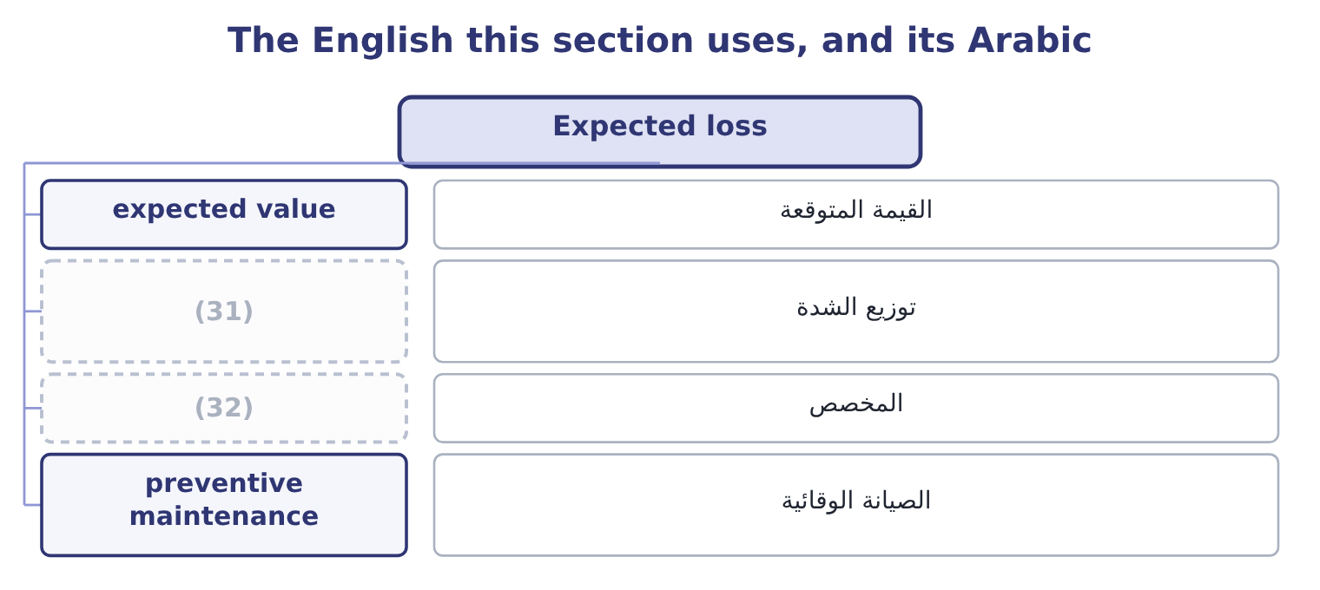
word list
unexpected loss · severity distribution · provision

The English this sheet uses, and its Arabic
English (exam term) | Arabic
expected value | القيمة المتوقعة
severity distribution | توزيع الشدة
provision | المخصص
preventive maintenance | الصيانة الوقائية

Answer key · 3.2 Expected loss

1 multiplied | 17 maintenance
2 periods | 18 compared
3 provision | 19 forecast
4 single | 20 misunderstood
5 multiplication | 21 customer
6 severities | 22 covenant
7 engineers | 23 allowance
8 performance | 24 receivables
9 significant | 25 control
10 no-failure | 26 halves
11 Together | 27 averages
12 happen | 28 certainty
13 cannot | 29 twentieth
14 insurer | 30 Sections
15 expenses | 31 severity distribution
16 against | 32 provision

the summaries in full
Summary 1 Expected loss is probability multiplied by severity. It is the average loss per period over many periods, and it is the figure that belongs in a budget, in a price and in a provision. Where a risk has a single severity, the calculation is one multiplication. Where it has a range of possible severities, the expected loss is the sum of probability times severity across every outcome, including the outcome in which nothing happens.
Summary 2 Orontes's engineers put the year's roaster performance into four cases: no significant failure, with probability 0.60; a short stop costing 150,000, with probability 0.25; a serious failure costing 800,000, with probability 0.10; and a destroyed roaster costing 3,000,000, with probability 0.05. The short stop contributes 0.25 × 150,000 = 37,500; the serious failure 0.10 × 800,000 = 80,000; the destroyed roaster 0.05 × 3,000,000 = 150,000; and the no-failure case contributes nothing. Together 37,500 + 80,000 + 150,000 = 267,500. The expected loss from roaster failure is 267,500 a year. Note what that figure is not. It is not what will happen: in 60 per cent of years the loss is zero, and the expected loss of 267,500 is an outcome that cannot occur at all. It is the amount to put in the budget, the amount a fair insurer would charge before expenses, and the amount against which the cost of a preventive maintenance contract should be compared.
Summary 3 Anybody who reads it as a forecast of this year's loss has misunderstood it. Three uses and one warning. An expected credit loss belongs in the margin, which is why a customer with a weaker covenant should be charged more or given shorter terms. The expected loss is what, and an allowance for doubtful receivables is an expected loss calculation whether or not anybody calls it one. A control costing 100,000 a year that halves a 267,500 expected loss saves 267,500 ÷ 2 = 133,750, so it pays — which is. The warning is that the expected loss is an average and averages hide shape. Two risks with the same expected loss of 267,500 — one that loses 267,500 every year with certainty, and one that loses nothing for nineteen years and 5,350,000 in the twentieth — are entirely different problems, and the second may end the company. Sections 3.4 and 3.5 exist because of that sentence.

3.3 A register of risks, and the portfolio effect
Chapter 3 · section 3.3

Fill every gap. Each word list holds one word more than there are gaps.
Summary 1 gaps 1–3
A company does not face one risk. It faces a list, and the expected losses on that list add — which is one of the few (1) in risk work where (2) addition is correct, because (3) add whether or not the risks are independent.
word list
places · expectations · simple · average

Orontes's expected loss, five risks
The bars are drawn to scale.
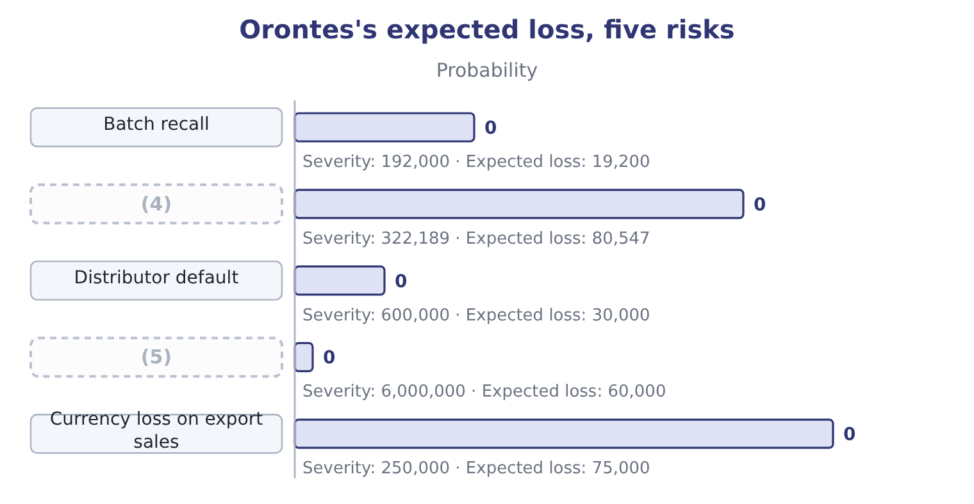
word list
Currency loss on export sales · Fire, sixty days and rebuilding · Roaster stoppage, seven days

Summary 2 gaps 6–17
The arithmetic is four (6) and an addition: 19,200 + 80,547 + 30,000 = 129,747 for the first three, and 129,747 + 60,000 + 75,000 = 264,747 with the last two. Against (7) income of $4,176,000 that is about six per cent, which is a (8) statement of what risk costs Orontes in a typical year. Three (9) of the table repay (10) , and all three are examined. The ranking by expected loss is not the ranking by (11) . The roaster (12) has the largest expected loss and would not (13) the company; the fire has the smallest but one and could. Expected loss ranks risks by what they cost on (14) , not by what they could do, which is why. Expected losses add; (15) do not. The total expected loss is 264,747 whether the risks move (16) or not, but the chance of a very bad year depends (17) on whether they do.
word list
entirely · attention · dispersions · readings · reasonable · multiplications · operating · usually · threaten · average · stoppage · danger · together

Summary 3 gaps 18–23
If the (18) loss, the default and the recall all follow from the same economic shock, the (19) is far riskier than five independent risks of the same sizes. And the total is only as good as the (20) . Every (21) in this table is for a risk (22) wrote down. The loss that ends a company is (23) one that was not on the list, which is why.
word list
number · expected · register · portfolio · somebody · usually · currency

The English this section uses, and its Arabic
Each term sits against what it means.
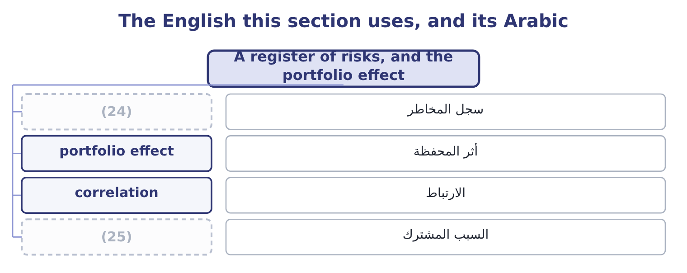
word list
risk register · expected value · common cause

The English this sheet uses, and its Arabic
English (exam term) | Arabic
risk register | سجل المخاطر
portfolio effect | أثر المحفظة
correlation | الارتباط
common cause | السبب المشترك

Answer key · 3.3 A register of risks, and the portfolio effect

1 places | 14 average
2 simple | 15 dispersions
3 expectations | 16 together
4 Roaster stoppage, seven days | 17 entirely
5 Fire, sixty days and rebuilding | 18 currency
6 multiplications | 19 portfolio
7 operating | 20 register
8 reasonable | 21 number
9 readings | 22 somebody
10 attention | 23 usually
11 danger | 24 risk register
12 stoppage | 25 common cause
13 threaten

the summaries in full
Summary 1 A company does not face one risk. It faces a list, and the expected losses on that list add — which is one of the few places in risk work where simple addition is correct, because expectations add whether or not the risks are independent.
Summary 2 The arithmetic is four multiplications and an addition: 19,200 + 80,547 + 30,000 = 129,747 for the first three, and 129,747 + 60,000 + 75,000 = 264,747 with the last two. Against operating income of $4,176,000 that is about six per cent, which is a reasonable statement of what risk costs Orontes in a typical year. Three readings of the table repay attention, and all three are examined. The ranking by expected loss is not the ranking by danger. The roaster stoppage has the largest expected loss and would not threaten the company; the fire has the smallest but one and could. Expected loss ranks risks by what they cost on average, not by what they could do, which is why. Expected losses add; dispersions do not. The total expected loss is 264,747 whether the risks move together or not, but the chance of a very bad year depends entirely on whether they do.
Summary 3 If the currency loss, the default and the recall all follow from the same economic shock, the portfolio is far riskier than five independent risks of the same sizes. And the total is only as good as the register. Every number in this table is for a risk somebody wrote down. The loss that ends a company is usually one that was not on the list, which is why.

3.4 Unexpected loss
Chapter 3 · section 3.4

Fill every gap. Each word list holds one word more than there are gaps.
Summary 1 gaps 1–8
Unexpected loss is the (1) by which an actual loss (2) the expected loss. It is the dispersion of the loss distribution rather than its average, and it is. It is (3) in two ways and both appear in (4) . As a (5) dispersion: the standard (6) of the loss, which is the usual (7) where a distribution has been fitted. As the (8) from the expected loss to a chosen percentile: the loss that will not be exceeded in, say, 95 or 99 per cent of years, less the expected loss.
word list
amount · statistical · definition · deviation · distance · questions · awkwardness · exceeds · stated

Worked example: the roaster's unexpected loss

Summary 2 gaps 9–20
From section 3.2: no loss at 0.60, so 60 per cent of years cost (9) ; adding the short stop takes the cumulative (10) to 0.60 + 0.25 = 0.85; adding the (11) failure takes it to 0.85 + 0.10 = 0.95; the (12) roaster takes it to one. Find the 95th percentile. The loss not exceeded in 95 per cent of years is 800,000. (13) the expected loss. The unexpected loss at that confidence level is 800,000 − 267,500 = 532,500. Read the two (14) . In an average year the roaster costs 267,500. In a bad year — one year in (15) — it costs 800,000, which is 532,500 more than the budget (16) for. Those two (17) are what a risk (18) should say, and the second is the one that (19) how much capital or how large a (20) is needed.
word list
Subtract · report · provides · probability · sentences · together · serious · nothing · destroyed · deviation · twenty · facility · determines

Summary 3 gaps 21–32
Note also the (21) at the boundary: the 95th percentile of this distribution lands exactly on an outcome, so a slightly (22) confidence level — 96 per cent — jumps straight to 3,000,000. Discrete (23) behave like that, and an answer that quotes a percentile from a (24) table should say which row it fell on. Two (25) of unexpected loss (26) . It depends on the confidence level chosen, which is a (27) about risk (28) and not a fact about the risk. A 99 per cent standard (29) more capital than a 95 per cent one for the same (30) . And (31) expected losses, unexpected losses do not add. Two risks that are not perfectly correlated produce a combined unexpected loss smaller than the sum of the two — the (32) Book 2's, operating here on losses. That is the single strongest argument for assessing risk at the enterprise level rather than one department at a time, which is.
word list
diversification · business · four-row · unlike · properties · judgment · appetite · extrapolation · matter · awkwardness · requires · different · distributions

The English this section uses, and its Arabic
Each term sits against what it means.
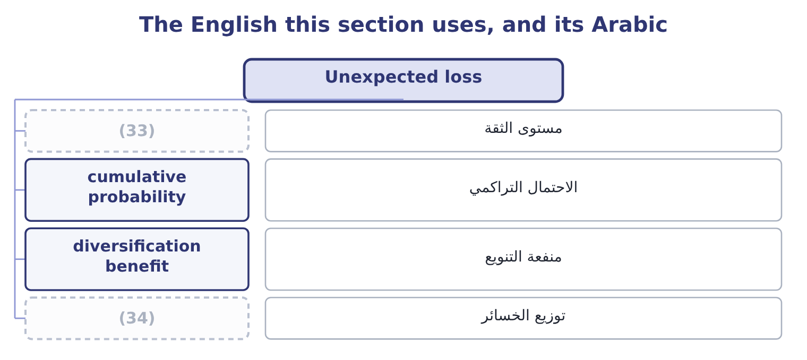
word list
unexpected loss · confidence level · loss distribution

The English this sheet uses, and its Arabic
English (exam term) | Arabic
confidence level | مستوى الثقة
cumulative probability | الاحتمال التراكمي
diversification benefit | منفعة التنويع
loss distribution | توزيع الخسائر

Answer key · 3.4 Unexpected loss

1 amount | 18 report
2 exceeds | 19 determines
3 stated | 20 facility
4 questions | 21 awkwardness
5 statistical | 22 different
6 deviation | 23 distributions
7 definition | 24 four-row
8 distance | 25 properties
9 nothing | 26 matter
10 probability | 27 judgment
11 serious | 28 appetite
12 destroyed | 29 requires
13 Subtract | 30 business
14 together | 31 unlike
15 twenty | 32 diversification
16 provides | 33 confidence level
17 sentences | 34 loss distribution

the summaries in full
Summary 1 Unexpected loss is the amount by which an actual loss exceeds the expected loss. It is the dispersion of the loss distribution rather than its average, and it is. It is stated in two ways and both appear in questions. As a statistical dispersion: the standard deviation of the loss, which is the usual definition where a distribution has been fitted. As the distance from the expected loss to a chosen percentile: the loss that will not be exceeded in, say, 95 or 99 per cent of years, less the expected loss.
Summary 2 From section 3.2: no loss at 0.60, so 60 per cent of years cost nothing; adding the short stop takes the cumulative probability to 0.60 + 0.25 = 0.85; adding the serious failure takes it to 0.85 + 0.10 = 0.95; the destroyed roaster takes it to one. Find the 95th percentile. The loss not exceeded in 95 per cent of years is 800,000. Subtract the expected loss. The unexpected loss at that confidence level is 800,000 − 267,500 = 532,500. Read the two together. In an average year the roaster costs 267,500. In a bad year — one year in twenty — it costs 800,000, which is 532,500 more than the budget provides for. Those two sentences are what a risk report should say, and the second is the one that determines how much capital or how large a facility is needed.
Summary 3 Note also the awkwardness at the boundary: the 95th percentile of this distribution lands exactly on an outcome, so a slightly different confidence level — 96 per cent — jumps straight to 3,000,000. Discrete distributions behave like that, and an answer that quotes a percentile from a four-row table should say which row it fell on. Two properties of unexpected loss matter. It depends on the confidence level chosen, which is a judgment about risk appetite and not a fact about the risk. A 99 per cent standard requires more capital than a 95 per cent one for the same business. And unlike expected losses, unexpected losses do not add. Two risks that are not perfectly correlated produce a combined unexpected loss smaller than the sum of the two — the diversification Book 2's, operating here on losses. That is the single strongest argument for assessing risk at the enterprise level rather than one department at a time, which is.

3.5 Maximum possible loss
Chapter 3 · section 3.5

Fill every gap. Each word list holds one word more than there are gaps.
Summary 1 gaps 1–12
The maximum possible loss is the (1) loss that could occur if everything that could go wrong did — no partial (2) , no working (3) , no mitigating (4) . It is also met as the extreme or (5) loss, and in insurance practice two related terms are used: the maximum possible loss, which assumes the worst (6) outcome, and the maximum probable loss, which assumes the worst outcome that is (7) likely, with fire doors holding and the alarm working. Three (8) define its role. It is not (9) . The expected loss of Orontes's fire risk is 60,000 a year; the maximum possible loss is the plant, the stock, the business interrupted and any liability to third (10) — a figure of a (11) different order, and the one that decides the insurance limit. It answers the (12) question.
word list
catastrophic · realistically · insuring · recovery · probability-weighted · survival · conceivable · largest · things · circumstance · completely · control · parties

Summary 2 gaps 13–22
The (13) of the figure is to ask whether the company would (14) to exist, and the answer (15) whether the risk may be retained at all. A loss (16) than the company's capital cannot be retained however (17) it is, which is the rule (18) . And it is the figure most often wrong, (19) it is never (20) . Nobody has data on an event that has not happened, so the maximum possible loss is built from (21) rather than from (22) : what is physically there, what could burn, what claims could follow, what the business would lose while it was gone, and what else fails at the same time.
word list
behind · governs · continue · frequency · structure · company's · observed · purpose · larger · unlikely · because

Worked example: three figures for one risk

Summary 3 gaps 23–34
Fire at the Hama plant: probability 0.01 against a (23) of 6,000,000, so the expected loss is 0.01 × 6,000,000 = 60,000 a year. In the one year in a (24) where the fire happens, the loss exceeds the (25) by 6,000,000 − 60,000 = 5,940,000. The maximum possible loss. Assume the fire spreads: the roasting hall, the (26) store, a year of interrupted (27) rather than sixty days, and a product liability claim. Orontes's (28) put it at 14,000,000. The (29) each figure (30) . The 60,000 goes in the budget. The 5,940,000 tests whether the cash and (31) . The 14,000,000 sets the insurance limit, and since it exceeds the company's cash and most of its (32) , the risk cannot be retained. One risk, three numbers, three different uses — and the mistake the (33) look for is using one of them for (34) job. Budgeting the maximum possible loss would make the company look unprofitable; insuring the expected loss would leave it uninsured for everything that matters; and holding capital against the maximum possible loss of every risk at once would require more capital than any business has.
word list
production · drives · hundred · equity · another's · assessors · facilities · examiners · severity · adjoining · decision · recovery · expectation

Three losses from one table

Your turn: expected, unexpected and maximum (complete the blanks)
Item | Data | Answer
Do the probabilities sum to one? | 0.70 (35) ; 0.20 of 100,000; 0.08 of 500,000; 0.02 of 2,000,000 | ________
Expected loss |  | ________
Loss not exceeded in 98 per cent of years |  | ________
Unexpected loss at that level |  | ________
Maximum possible loss on this table |  | ________
Which figure decides whether the risk may be retained |  | ________

word list
percentile · nothing

"Expected"

Summary 4 gaps 36–38
In (36) English what you expect is what you think will happen; in (37) the expected value is a weighted average that (38) cannot happen at all — Orontes's expected roaster loss of 267,500 is not among the four outcomes.
word list
ordinary · statistics · frequently · business

"Expected"
Item | Answer
Do the probabilities sum to one? | (39)
Expected loss | 100,000: 0.20 × 100,000 = 20,000, plus 0.08 × 500,000 = 40,000, plus 0.02 × 2,000,000 = 40,000.
Loss not exceeded in 98 per cent of years | 500,000, since the (40) reaches 0.98 at that outcome.
Unexpected loss at that level | 400,000: 500,000 − 100,000 = 400,000.
Maximum possible loss on this table | (41)
Which figure decides retention | The maximum possible loss, compared with the company's capacity to absorb it.
What it tells you | One table, three figures, three decisions: what to budget, what to hold capital against, and whether the risk may be kept at all.

word list
2,000,000, the worst outcome listed. · unexpected loss · Yes: 0.70 + 0.20 + 0.08 + 0.02 = 1.00. · cumulative probability

The English this section uses, and its Arabic
Each term sits against what it means.
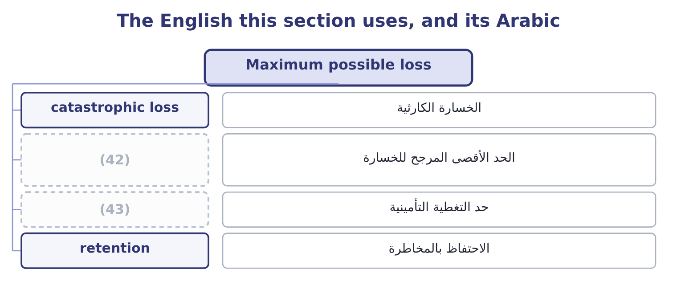
word list
maximum probable loss · insurance limit · حد التغطية التأمينية

The English this sheet uses, and its Arabic
English (exam term) | Arabic
catastrophic loss | الخسارة الكارثية
maximum probable loss | الحد الأقصى المرجح للخسارة
insurance limit | حد التغطية التأمينية
retention | الاحتفاظ بالمخاطرة

Answer key · 3.5 Maximum possible loss

1 largest | 23 severity
2 recovery | 24 hundred
3 control | 25 expectation
4 circumstance | 26 adjoining
5 catastrophic | 27 production
6 conceivable | 28 assessors
7 realistically | 29 decision
8 things | 30 drives
9 probability-weighted | 31 facilities
10 parties | 32 equity
11 completely | 33 examiners
12 survival | 34 another's
13 purpose | 35 nothing
14 continue | 36 ordinary
15 governs | 37 statistics
16 larger | 38 frequently
17 unlikely | 39 Yes: 0.70 + 0.20 + 0.08 + 0.02 = 1.00.
18 behind | 40 cumulative probability
19 because | 41 2,000,000, the worst outcome listed.
20 observed | 42 maximum probable loss
21 structure | 43 insurance limit
22 frequency

the summaries in full
Summary 1 The maximum possible loss is the largest loss that could occur if everything that could go wrong did — no partial recovery, no working control, no mitigating circumstance. It is also met as the extreme or catastrophic loss, and in insurance practice two related terms are used: the maximum possible loss, which assumes the worst conceivable outcome, and the maximum probable loss, which assumes the worst outcome that is realistically likely, with fire doors holding and the alarm working. Three things define its role. It is not probability-weighted. The expected loss of Orontes's fire risk is 60,000 a year; the maximum possible loss is the plant, the stock, the business interrupted and any liability to third parties — a figure of a completely different order, and the one that decides the insurance limit. It answers the survival question.
Summary 2 The purpose of the figure is to ask whether the company would continue to exist, and the answer governs whether the risk may be retained at all. A loss larger than the company's capital cannot be retained however unlikely it is, which is the rule behind. And it is the figure most often wrong, because it is never observed. Nobody has data on an event that has not happened, so the maximum possible loss is built from structure rather than from frequency: what is physically there, what could burn, what claims could follow, what the business would lose while it was gone, and what else fails at the same time.
Summary 3 Fire at the Hama plant: probability 0.01 against a severity of 6,000,000, so the expected loss is 0.01 × 6,000,000 = 60,000 a year. In the one year in a hundred where the fire happens, the loss exceeds the expectation by 6,000,000 − 60,000 = 5,940,000. The maximum possible loss. Assume the fire spreads: the roasting hall, the adjoining store, a year of interrupted production rather than sixty days, and a product liability claim. Orontes's assessors put it at 14,000,000. The decision each figure drives. The 60,000 goes in the budget. The 5,940,000 tests whether the cash and facilities. The 14,000,000 sets the insurance limit, and since it exceeds the company's cash and most of its equity, the risk cannot be retained. One risk, three numbers, three different uses — and the mistake the examiners look for is using one of them for another's job. Budgeting the maximum possible loss would make the company look unprofitable; insuring the expected loss would leave it uninsured for everything that matters; and holding capital against the maximum possible loss of every risk at once would require more capital than any business has.
Summary 4 In ordinary English what you expect is what you think will happen; in statistics the expected value is a weighted average that frequently cannot happen at all — Orontes's expected roaster loss of 267,500 is not among the four outcomes.

