4.1 Inherent risk
Chapter 4 · section 4.1

Fill every gap. Each word list holds one word more than there are gaps.
Chapter 4, section by section
Each stage leads to the next.
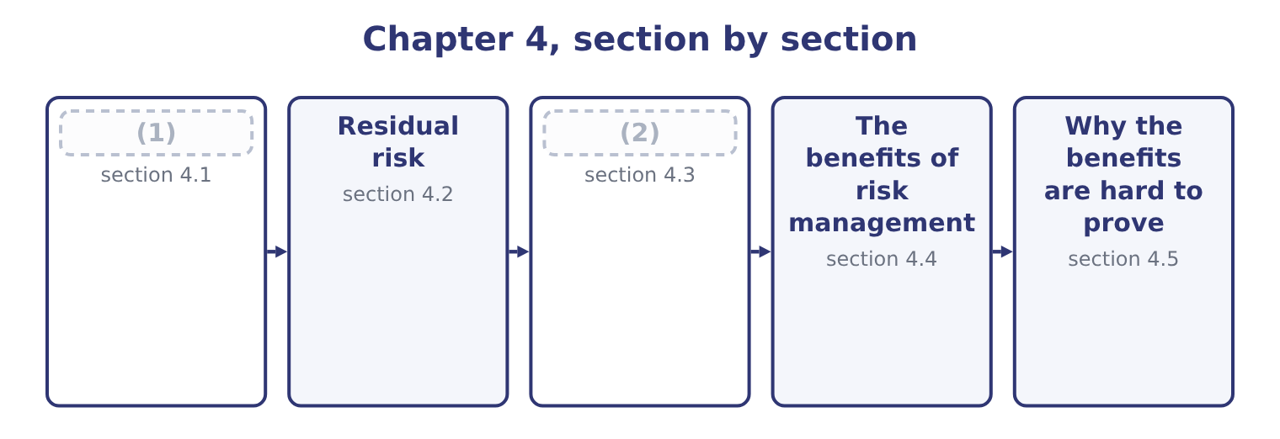
word list
section 4.1 · Reading the two together · Inherent risk

Summary 1 gaps 3–14
Inherent risk is the risk in an activity before any management action — the (3) that exists because of what the business does, measured as though no control, no (4) and no procedure were in place. It is a (5) artificial figure, and that is the first thing to (6) about it. Orontes's inherent food-safety risk is the risk of selling (7) tahini with no testing, no supplier approval, no (8) and no hygiene regime — a situation that has never existed and never will. The figure is (9) , not observed. Why (10) something artificial? Three (11) , and the exam asks for them. It shows what the controls are (12) . A residual risk of near zero can mean the activity is harmless or that an (13) control structure is holding back something enormous, and only the inherent figure (14) the two.
word list
constructed · exposure · contaminated · compute · oversight · understand · reasons · deliberately · elaborate · traceability · insurance · carrying · distinguishes

Summary 2 gaps 15–26
The (15) is what would happen if the controls stopped working — which is exactly what happens in a crisis, a system (16) or a year of heavy staff turnover. It ranks (17) for attention. Two (18) with the same residual risk are not equally important; the one with the higher inherent risk deserves more (19) , more testing and more attention from internal audit, because it has further to fall. And it (20) the circular comfort of (21) only what is left. A company that measures nothing but residual risk (22) that its risks are small because its controls work, which is a (23) it has assumed rather than tested. Two practical (24) go with it, and a good answer (25) them. Inherent risk is hard to (26) , because nobody has observed the world without the controls.
word list
processes · difference · concludes · prevents · measure · without · migration · assessing · difficulties · activities · conclusion · mentions · oversight

Summary 3 gaps 27–33
The (27) is a judgment anchored on industry events, on (28) , and on what happened in the places where the control (29) failed. And "no controls" has to be (30) . Does inherent mean no controls at all, or no controls beyond those (31) by law, or the controls a prudent company would have anyway? (32) varies; the exam's (33) is the strict one — before any management action — and an answer should say which basis it is using.
word list
required · Practice · estimate · understand · near-misses · genuinely · position · defined

The English this section uses, and its Arabic
Each term sits against what it means.
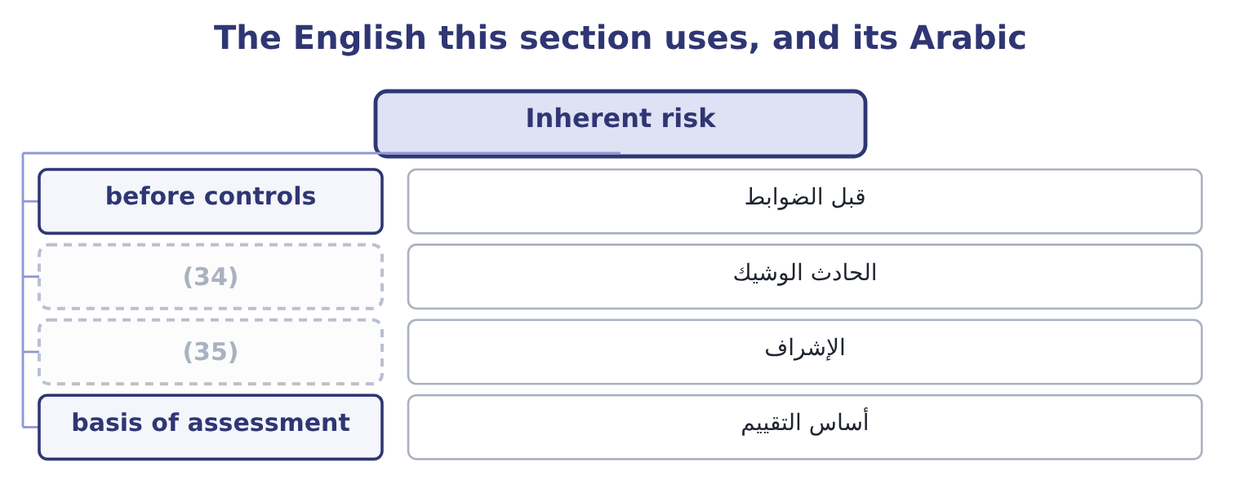
word list
near miss · oversight · re-examination

The English this sheet uses, and its Arabic
English (exam term) | Arabic
before controls | قبل الضوابط
near miss | الحادث الوشيك
oversight | الإشراف
basis of assessment | أساس التقييم

Answer key · 4.1 Inherent risk

1 Inherent risk | 19 oversight
2 Reading the two together | 20 prevents
3 exposure | 21 assessing
4 insurance | 22 concludes
5 deliberately | 23 conclusion
6 understand | 24 difficulties
7 contaminated | 25 mentions
8 traceability | 26 measure
9 constructed | 27 estimate
10 compute | 28 near-misses
11 reasons | 29 genuinely
12 carrying | 30 defined
13 elaborate | 31 required
14 distinguishes | 32 Practice
15 difference | 33 position
16 migration | 34 near miss
17 activities | 35 oversight
18 processes

the summaries in full
Summary 1 Inherent risk is the risk in an activity before any management action — the exposure that exists because of what the business does, measured as though no control, no insurance and no procedure were in place. It is a deliberately artificial figure, and that is the first thing to understand about it. Orontes's inherent food-safety risk is the risk of selling contaminated tahini with no testing, no supplier approval, no traceability and no hygiene regime — a situation that has never existed and never will. The figure is constructed, not observed. Why compute something artificial? Three reasons, and the exam asks for them. It shows what the controls are carrying. A residual risk of near zero can mean the activity is harmless or that an elaborate control structure is holding back something enormous, and only the inherent figure distinguishes the two.
Summary 2 The difference is what would happen if the controls stopped working — which is exactly what happens in a crisis, a system migration or a year of heavy staff turnover. It ranks activities for attention. Two processes with the same residual risk are not equally important; the one with the higher inherent risk deserves more oversight, more testing and more attention from internal audit, because it has further to fall. And it prevents the circular comfort of assessing only what is left. A company that measures nothing but residual risk concludes that its risks are small because its controls work, which is a conclusion it has assumed rather than tested. Two practical difficulties go with it, and a good answer mentions them. Inherent risk is hard to measure, because nobody has observed the world without the controls.
Summary 3 The estimate is a judgment anchored on industry events, on near-misses, and on what happened in the places where the control genuinely failed. And "no controls" has to be defined. Does inherent mean no controls at all, or no controls beyond those required by law, or the controls a prudent company would have anyway? Practice varies; the exam's position is the strict one — before any management action — and an answer should say which basis it is using.

4.2 Residual risk
Chapter 4 · section 4.2

Fill every gap. Each word list holds one word more than there are gaps.
Summary 1 gaps 1–12
Residual risk is what (1) after the controls and other (2) have done their work. It is the risk the company is (3) running, and it is the figure that should be compared with risk appetite and (4) to a board. Between the two sits (5) : the controls that reduce the (6) , the controls that reduce the severity, the insurance that transfers the loss, the contract that shares it, and the decision not to do the activity at all. With no maintenance regime, no condition (7) , no critical spares and no trained operators, (8) engineers put the expected loss from roaster failure at 620,000 a year. Residual as (9) stand. The present regime — (10) servicing, two trained operators, a set of spares — (11) it to the 267,500. What the controls (12) . The reduction is 620,000 − 267,500 = 352,500 a year, and the regime costs 95,000, so it returns 352,500 − 95,000 = 257,500 of net benefit.
word list
things · engineers · reported · actually · scheduled · brings · responses · Orontes's · everything · remains · deliver · monitoring · probability

Summary 2 gaps 13–24
With the maintenance contract of,500, which would be the (13) residual risk. Note the shape of the (14) . The (15) controls are (16) good value: they remove more than half the risk for 95,000. The (17) contract removes 267,500 − 84,500 = 183,000 more for $180,000, which is (18) worth it on expected loss alone. Three (19) belong with residual risk. Residual risk is not zero risk, and it is not meant to be. (20) a risk to nothing is almost always (21) — by stopping the activity — and almost never worth it. Residual risk is compared with risk appetite. Where residual risk exceeds appetite, (22) must change: more control, transfer, or a decision to accept a larger exposure (23) and say so. And residual risk (24) the controls work. A control that exists on paper, is performed inconsistently, or is performed by the same person who performs the activity it checks, does not reduce risk by the amount claimed for it — which is why control effectiveness must be tested rather than asserted, and why.
word list
distinctions · proposed · barely · something · servicing · Reducing · existing · extremely · possible · target · deliberately · numbers · assumes

The English this section uses, and its Arabic
Each term sits against what it means.
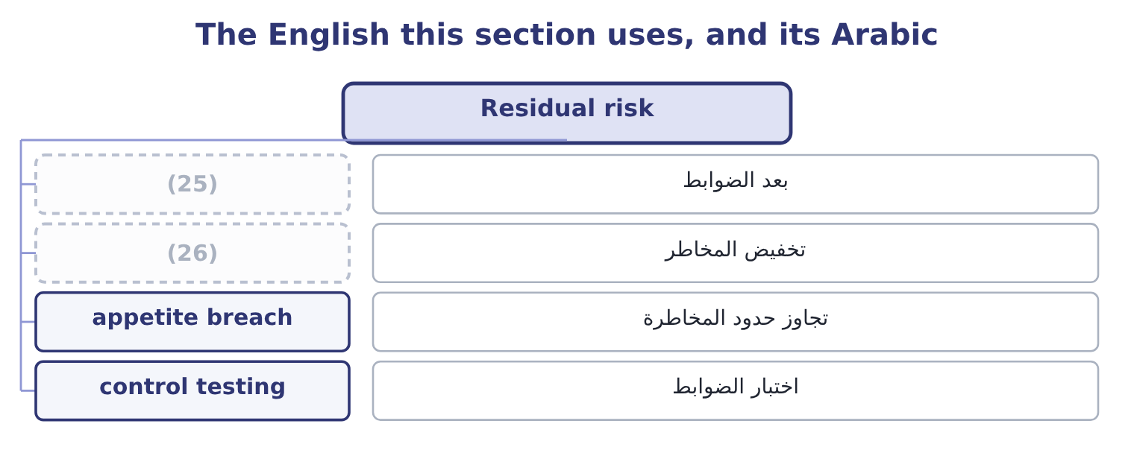
word list
second-order benefit · risk reduction · after controls

The English this sheet uses, and its Arabic
English (exam term) | Arabic
after controls | بعد الضوابط
risk reduction | تخفيض المخاطر
appetite breach | تجاوز حدود المخاطرة
control testing | اختبار الضوابط

Answer key · 4.2 Residual risk

1 remains | 14 numbers
2 responses | 15 existing
3 actually | 16 extremely
4 reported | 17 proposed
5 everything | 18 barely
6 probability | 19 distinctions
7 monitoring | 20 Reducing
8 Orontes's | 21 possible
9 things | 22 something
10 scheduled | 23 deliberately
11 brings | 24 assumes
12 deliver | 25 after controls
13 target | 26 risk reduction

the summaries in full
Summary 1 Residual risk is what remains after the controls and other responses have done their work. It is the risk the company is actually running, and it is the figure that should be compared with risk appetite and reported to a board. Between the two sits everything: the controls that reduce the probability, the controls that reduce the severity, the insurance that transfers the loss, the contract that shares it, and the decision not to do the activity at all. With no maintenance regime, no condition monitoring, no critical spares and no trained operators, Orontes's engineers put the expected loss from roaster failure at 620,000 a year. Residual as things stand. The present regime — scheduled servicing, two trained operators, a set of spares — brings it to the 267,500. What the controls deliver. The reduction is 620,000 − 267,500 = 352,500 a year, and the regime costs 95,000, so it returns 352,500 − 95,000 = 257,500 of net benefit.
Summary 2 With the maintenance contract of,500, which would be the target residual risk. Note the shape of the numbers. The existing controls are extremely good value: they remove more than half the risk for 95,000. The proposed contract removes 267,500 − 84,500 = 183,000 more for $180,000, which is barely worth it on expected loss alone. Three distinctions belong with residual risk. Residual risk is not zero risk, and it is not meant to be. Reducing a risk to nothing is almost always possible — by stopping the activity — and almost never worth it. Residual risk is compared with risk appetite. Where residual risk exceeds appetite, something must change: more control, transfer, or a decision to accept a larger exposure deliberately and say so. And residual risk assumes the controls work. A control that exists on paper, is performed inconsistently, or is performed by the same person who performs the activity it checks, does not reduce risk by the amount claimed for it — which is why control effectiveness must be tested rather than asserted, and why.

4.3 Reading the two together
Chapter 4 · section 4.3

Fill every gap. Each word list holds one word more than there are gaps.
Summary 1 gaps 1–2
The pair of figures is more (1) than either alone, and the exam rewards an answer that reads them (2) .
word list
rewards · together · informative

What the pair of figures tells you
Every item belongs to exactly one group.
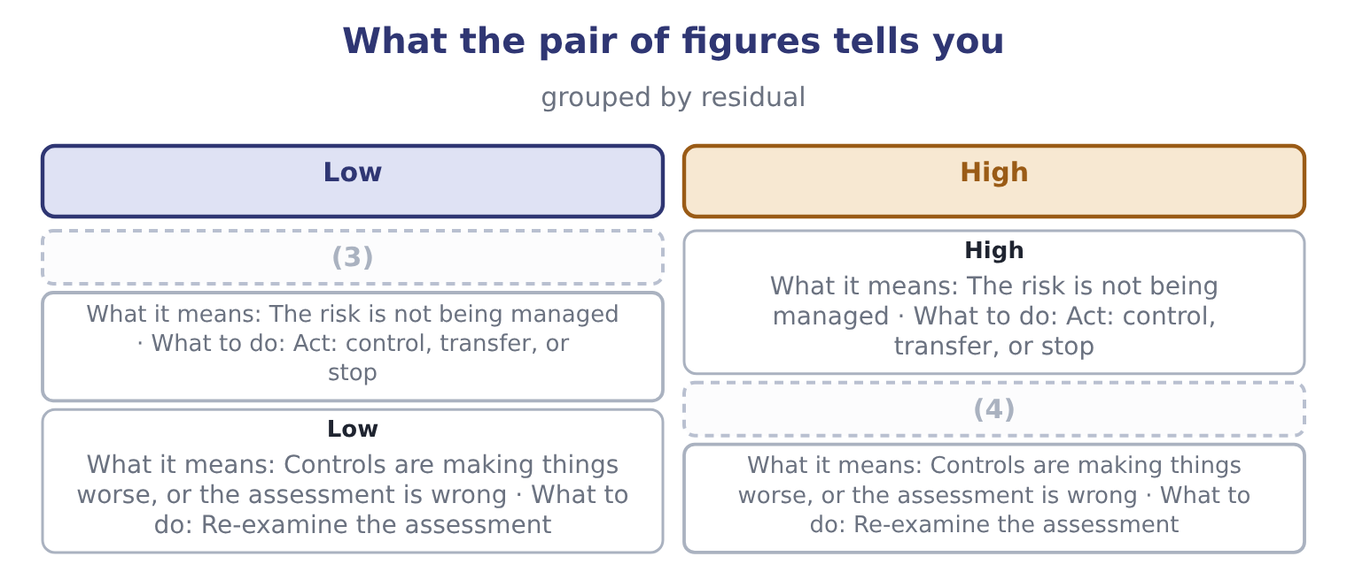
word list
High · assurance · Low

Summary 2 gaps 5–16
The fourth row deserves a sentence, because (5) assume it is (6) . It is not: a (7) can create risk. A new system introduced to reduce error introduces (8) risk; an approval step introduces delay; a (9) of duties that nobody has staffed creates a process that stops. More often, though, the fourth row means the (10) is wrong — usually because the inherent figure was (11) as though the controls were partly in place. Three (12) uses of the pair. (13) audit should spend its time where the gap between inherent and residual is largest, because that is where the company is most (14) on controls it has not recently tested. A board that is shown only residual risk sees a company with small risks. A board shown both sees a company whose small risks are small because of specific (15) that specific people do, which is a different and more (16) picture.
word list
further · segregation · candidates · implementation · assessment · inherent · actionable · dependent · estimated · things · Internal · impossible · control

The English this section uses, and its Arabic
Each term sits against what it means.
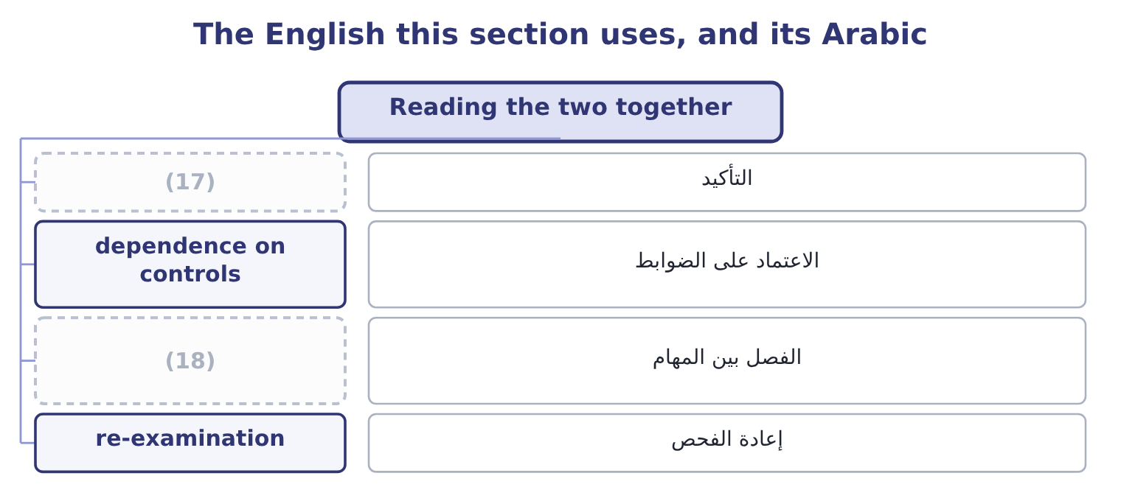
word list
near-miss reporting · segregation of duties · assurance

The English this sheet uses, and its Arabic
English (exam term) | Arabic
assurance | التأكيد
dependence on controls | الاعتماد على الضوابط
segregation of duties | الفصل بين المهام
re-examination | إعادة الفحص

Answer key · 4.3 Reading the two together

1 informative | 10 assessment
2 together | 11 estimated
3 High | 12 further
4 Low | 13 Internal
5 candidates | 14 dependent
6 impossible | 15 things
7 control | 16 actionable
8 implementation | 17 assurance
9 segregation | 18 segregation of duties

the summaries in full
Summary 1 The pair of figures is more informative than either alone, and the exam rewards an answer that reads them together.
Summary 2 The fourth row deserves a sentence, because candidates assume it is impossible. It is not: a control can create risk. A new system introduced to reduce error introduces implementation risk; an approval step introduces delay; a segregation of duties that nobody has staffed creates a process that stops. More often, though, the fourth row means the assessment is wrong — usually because the inherent figure was estimated as though the controls were partly in place. Three further uses of the pair. Internal audit should spend its time where the gap between inherent and residual is largest, because that is where the company is most dependent on controls it has not recently tested. A board that is shown only residual risk sees a company with small risks. A board shown both sees a company whose small risks are small because of specific things that specific people do, which is a different and more actionable picture.

4.4 The benefits of risk management
Chapter 4 · section 4.4

Fill every gap. Each word list holds one word more than there are gaps.
Summary 1 gaps 1–12
The outcome asks for the (1) to be identified and (2) , and an answer that lists them in order of how hard they are to prove is a better answer than one that (3) them. Fewer and smaller (4) . The direct benefit, and the (5) one: the reduction from inherent to residual risk, which for (6) roaster alone was 352,500 a year against a cost of 95,000. That matters for its own sake — plans hold, (7) are not breached, the (8) of Book 2's. A lower cost of capital. Lenders price default risk and equity investors price (9) , so a company that (10) manages risk borrows more cheaply, keeps a better rating, and faces a smaller equity risk premium. The effect is small per unit and large in total: Orontes (11) equity of $20,392,975 and debt of 390,000 ÷ 0.06 = 6,500,000, which is 20,392,975 + 6,500,000 = 26,892,975 of capital, so twenty basis points off its 9.04 per cent cost of capital is worth 26,892,975 × 0.002 = 53,786 a year, every year, for nothing but (12) .
word list
benefits · credibility · measurable · explained · Orontes's · volatility · demonstrably · dividend · losses · corporate · recites · employs · covenants

Summary 2 gaps 13–24
The (13) to take more risk where it pays. This is the benefit most often (14) and the one that matters most to a board. A company that knows its exposures, and knows it can absorb them, can take the (15) risks it is paid for — the new market, the new product, the (16) of Book 3's. Risk management is not for (17) risk; it is for taking the right risks (18) . (19) of reputation and of the (20) to operate. A recall, a safety failure, a fraud, a (21) : each damages (22) that took years to build and is not on the balance sheet. Book 1's,724,000 written off in an (23) . Every project in Book 3 was (24) with an estimate; risk management supplies the range around the estimate and the question of what happens if it is wrong.
word list
deliberate · licence · assurance · afternoon · Protection · acquisition · something · ability · appraised · knowingly · reducing · omitted · sanction

Summary 3 gaps 25–33
Fewer (25) , which is the benefit boards (26) ask for. A loss that was identified, (27) and accepted is a managed outcome; the same loss arriving (28) is a governance failure, and the (29) is entirely in whether anybody wrote it down first. Codes of corporate governance in most (30) require the board to state that it has reviewed the (31) of risk management, which makes some of this work (32) regardless of its economics. And lower insurance costs, since insurers price the quality of a company's risk management directly, through premiums, (33) and the terms they are willing to offer.
word list
jurisdictions · deductibles · effectiveness · unannounced · quantified · actually · surprises · difference · obligatory · whether

The English this section uses, and its Arabic
Each term sits against what it means.
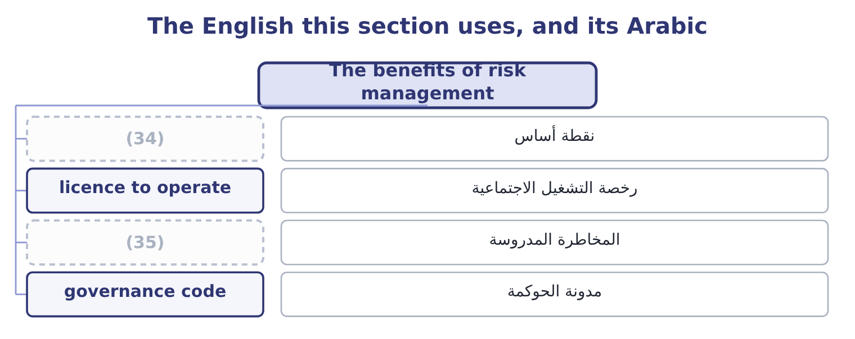
word list
inherent risk · informed risk-taking · basis point

The English this sheet uses, and its Arabic
English (exam term) | Arabic
basis point | نقطة أساس
licence to operate | رخصة التشغيل الاجتماعية
informed risk-taking | المخاطرة المدروسة
governance code | مدونة الحوكمة

Answer key · 4.4 The benefits of risk management

1 benefits | 19 Protection
2 explained | 20 licence
3 recites | 21 sanction
4 losses | 22 something
5 measurable | 23 afternoon
6 Orontes's | 24 appraised
7 covenants | 25 surprises
8 dividend | 26 actually
9 volatility | 27 quantified
10 demonstrably | 28 unannounced
11 employs | 29 difference
12 credibility | 30 jurisdictions
13 ability | 31 effectiveness
14 omitted | 32 obligatory
15 deliberate | 33 deductibles
16 acquisition | 34 basis point
17 reducing | 35 informed risk-taking
18 knowingly

the summaries in full
Summary 1 The outcome asks for the benefits to be identified and explained, and an answer that lists them in order of how hard they are to prove is a better answer than one that recites them. Fewer and smaller losses. The direct benefit, and the measurable one: the reduction from inherent to residual risk, which for Orontes's roaster alone was 352,500 a year against a cost of 95,000. That matters for its own sake — plans hold, covenants are not breached, the dividend of Book 2's. A lower cost of capital. Lenders price default risk and equity investors price volatility, so a company that demonstrably manages risk borrows more cheaply, keeps a better rating, and faces a smaller equity risk premium. The effect is small per unit and large in total: Orontes employs equity of $20,392,975 and debt of 390,000 ÷ 0.06 = 6,500,000, which is 20,392,975 + 6,500,000 = 26,892,975 of capital, so twenty basis points off its 9.04 per cent cost of capital is worth 26,892,975 × 0.002 = 53,786 a year, every year, for nothing but credibility.
Summary 2 The ability to take more risk where it pays. This is the benefit most often omitted and the one that matters most to a board. A company that knows its exposures, and knows it can absorb them, can take the deliberate risks it is paid for — the new market, the new product, the acquisition of Book 3's. Risk management is not for reducing risk; it is for taking the right risks knowingly. Protection of reputation and of the licence to operate. A recall, a safety failure, a fraud, a sanction: each damages something that took years to build and is not on the balance sheet. Book 1's,724,000 written off in an afternoon. Every project in Book 3 was appraised with an estimate; risk management supplies the range around the estimate and the question of what happens if it is wrong.
Summary 3 Fewer surprises, which is the benefit boards actually ask for. A loss that was identified, quantified and accepted is a managed outcome; the same loss arriving unannounced is a governance failure, and the difference is entirely in whether anybody wrote it down first. Codes of corporate governance in most jurisdictions require the board to state that it has reviewed the effectiveness of risk management, which makes some of this work obligatory regardless of its economics. And lower insurance costs, since insurers price the quality of a company's risk management directly, through premiums, deductibles and the terms they are willing to offer.

4.5 Why the benefits are hard to prove
Chapter 4 · section 4.5

Fill every gap. Each word list holds one word more than there are gaps.
Summary 1 gaps 1–12
Risk management has a (1) problem that every (2) should be able to state, because exam questions on the benefits often turn into questions about this. Its (3) are invisible. The fire that did not happen leaves no trace, and a function whose entire output is the (4) of events cannot point to (5) . The losses it failed to (6) , by contrast, are (7) visible. Its costs are immediate and certain, while its benefits are deferred and (8) — the same asymmetry that makes Book 3's (9) projects hard to defend against a payback rule. And the counterfactual is (10) . Nobody can show what the loss would have been without the control, which is why the (11) estimate of section 4.1 matters so much: it is the only (12) statement of the counterfactual, and it is a judgment.
word list
anything · probabilistic · available · prevent · measurement · candidate · inherent-risk · absence · extremely · successes · long-lived · unobservable · because

Summary 2 gaps 13–22
Four ways of showing the value anyway, and an answer that offers them is (13) the harder (14) . Track (15) and the events that controls (16) . A control that stopped forty incorrect (17) this year has a visible output, and the loss (18) . (19) inherent and residual (20) , as section 4.3 argued, so that the gap is the stated output of the function. Use the (21) arithmetic of, so that decisions are (22) in money at the time they are taken rather than defended afterwards. And measure the second-order benefits where they can be observed: insurance premiums and terms, the credit rating, covenant headroom, the volatility of earnings over time, the number of surprises reported to the board.
word list
performs · near-misses · together · documented · answering · question · cost-benefit · deliveries · Report · database · caught

Worked example: what risk management is worth at Orontes

Summary 3 gaps 23–34
Loss reduction on the (23) . The five risks of,747 of residual (24) loss. The inherent figure for the same five is (25) at 940,000, so the controls (26) 940,000 − 264,747 = 675,253 a year. What the controls cost. (27) , testing, approvals, the quality function and insurance premiums come to 410,000 a year. Net on the (28) benefit alone. Add the cost of capital. Twenty basis points on 26,892,975 of capital is 53,786, (29) 265,253 + 53,786 = 319,039. Against (30) income of $4,176,000 that is nearly eight per cent, which is a defensible answer to a director who asks what the risk function is for. Two honest (31) go with it. The inherent estimate of 940,000 is a judgment and the whole (32) rests on it. And the twenty basis points cannot be observed directly; it is (33) from what lenders and insurers say they price. State both, and the number is (34) ; omit them, and it is advocacy.
word list
remove · giving · expected · direct · inferred · operating · Maintenance · payback · register · credible · estimated · qualifications · calculation

Before, after, and what it is worth

Your turn: inherent and residual (complete the blanks)
Item | Data | Answer
Risk measured before any management action |  | ________
Risk measured after the controls |  | ________
Reduction delivered by the roaster regime | Inherent 620,000; residual 267,500 | ________
Net benefit of that regime | (35) | ________
What residual risk should be compared with |  | ________
Why the benefits of risk management are hard to prove |  | ________

word list
dependence on controls · Controls cost 95,000

"Inherent" and "residual"

Summary 4 gaps 36–46
Both words are Latin and both are (36) , which is unusual in risk (37) . Inherent means (38) in — a property of the thing itself, not of what (39) has done about it — and that is exactly right: inherent risk belongs to the (40) . Residual means left over, and it (41) the correct (42) that something has been taken away. The trap is (43) , in the word control, which in English (44) means a procedure that reduces risk, while in (45) English it means power over something. A manager who says "we have that under control" is making the ordinary-language claim; a control in the technical sense is a specific, (46) , testable act, and if nobody can name who performs it and when, it is not one.
word list
accounting · precise · anybody · activity · carries · vocabulary · insurers · ordinary · implication · sticking · elsewhere · performable

"Inherent" and "residual"
Item | Answer
Risk before any management action | Inherent risk.
Risk after the controls | Residual risk.
Reduction delivered by the regime | (47)
Net benefit of that regime | (48)
What residual risk is compared with | Risk appetite, and where it exceeds appetite something must change.
Why benefits are hard to prove | Prevented events leave no trace, costs are certain while benefits are not, and the counterfactual cannot be observed.
What it tells you | Two (49) and one subtraction produce the only defensible statement of what risk management is worth — and the subtraction depends en

word list
measurements · residual risk · 257,500: 352,500 − 95,000 = 257,500. · 352,500: 620,000 − 267,500 = 352,500.

The English this section uses, and its Arabic
Each term sits against what it means.
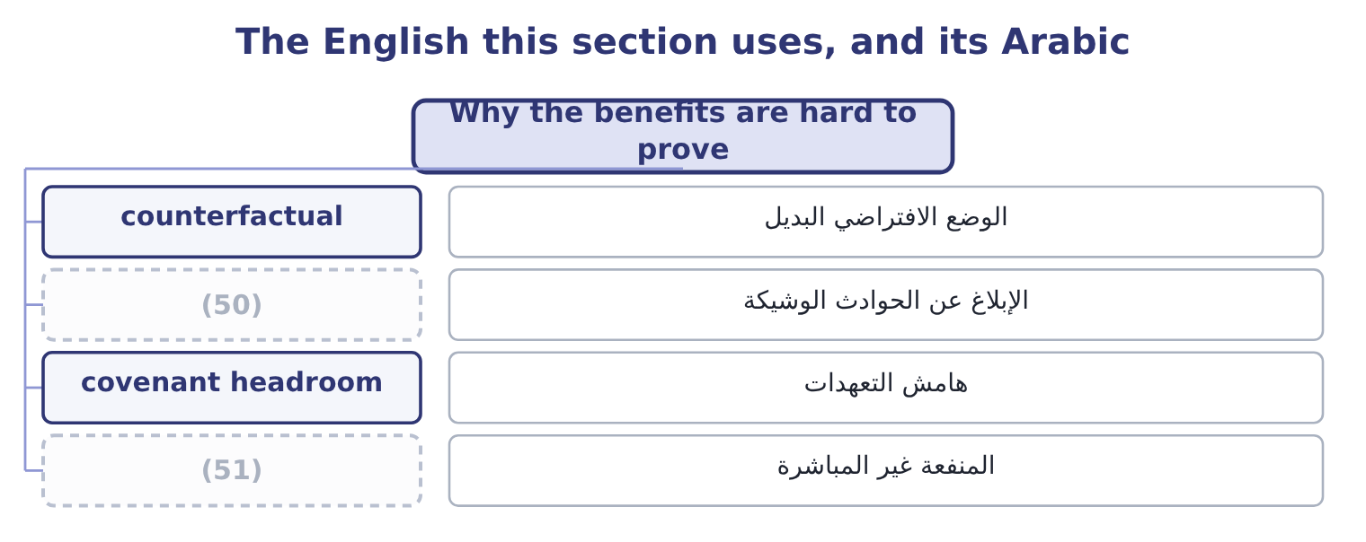
word list
second-order benefit · before controls · near-miss reporting

The English this sheet uses, and its Arabic
English (exam term) | Arabic
counterfactual | الوضع الافتراضي البديل
near-miss reporting | الإبلاغ عن الحوادث الوشيكة
covenant headroom | هامش التعهدات
second-order benefit | المنفعة غير المباشرة

Answer key · 4.5 Why the benefits are hard to prove

1 measurement | 27 Maintenance
2 candidate | 28 direct
3 successes | 29 giving
4 absence | 30 operating
5 anything | 31 qualifications
6 prevent | 32 calculation
7 extremely | 33 inferred
8 probabilistic | 34 credible
9 long-lived | 35 Controls cost 95,000
10 unobservable | 36 precise
11 inherent-risk | 37 vocabulary
12 available | 38 sticking
13 answering | 39 anybody
14 question | 40 activity
15 near-misses | 41 carries
16 caught | 42 implication
17 deliveries | 43 elsewhere
18 database | 44 accounting
19 Report | 45 ordinary
20 together | 46 performable
21 cost-benefit | 47 352,500: 620,000 − 267,500 = 352,500.
22 documented | 48 257,500: 352,500 − 95,000 = 257,500.
23 register | 49 measurements
24 expected | 50 near-miss reporting
25 estimated | 51 second-order benefit
26 remove

the summaries in full
Summary 1 Risk management has a measurement problem that every candidate should be able to state, because exam questions on the benefits often turn into questions about this. Its successes are invisible. The fire that did not happen leaves no trace, and a function whose entire output is the absence of events cannot point to anything. The losses it failed to prevent, by contrast, are extremely visible. Its costs are immediate and certain, while its benefits are deferred and probabilistic — the same asymmetry that makes Book 3's long-lived projects hard to defend against a payback rule. And the counterfactual is unobservable. Nobody can show what the loss would have been without the control, which is why the inherent-risk estimate of section 4.1 matters so much: it is the only available statement of the counterfactual, and it is a judgment.
Summary 2 Four ways of showing the value anyway, and an answer that offers them is answering the harder question. Track near-misses and the events that controls caught. A control that stopped forty incorrect deliveries this year has a visible output, and the loss database. Report inherent and residual together, as section 4.3 argued, so that the gap is the stated output of the function. Use the cost-benefit arithmetic of, so that decisions are documented in money at the time they are taken rather than defended afterwards. And measure the second-order benefits where they can be observed: insurance premiums and terms, the credit rating, covenant headroom, the volatility of earnings over time, the number of surprises reported to the board.
Summary 3 Loss reduction on the register. The five risks of,747 of residual expected loss. The inherent figure for the same five is estimated at 940,000, so the controls remove 940,000 − 264,747 = 675,253 a year. What the controls cost. Maintenance, testing, approvals, the quality function and insurance premiums come to 410,000 a year. Net on the direct benefit alone. Add the cost of capital. Twenty basis points on 26,892,975 of capital is 53,786, giving 265,253 + 53,786 = 319,039. Against operating income of $4,176,000 that is nearly eight per cent, which is a defensible answer to a director who asks what the risk function is for. Two honest qualifications go with it. The inherent estimate of 940,000 is a judgment and the whole calculation rests on it. And the twenty basis points cannot be observed directly; it is inferred from what lenders and insurers say they price. State both, and the number is credible; omit them, and it is advocacy.
Summary 4 Both words are Latin and both are precise, which is unusual in risk vocabulary. Inherent means sticking in — a property of the thing itself, not of what anybody has done about it — and that is exactly right: inherent risk belongs to the activity. Residual means left over, and it carries the correct implication that something has been taken away. The trap is elsewhere, in the word control, which in English accounting means a procedure that reduces risk, while in ordinary English it means power over something. A manager who says "we have that under control" is making the ordinary-language claim; a control in the technical sense is a specific, performable, testable act, and if nobody can name who performs it and when, it is not one.

