5.1 The five responses
Chapter 5 · section 5.1

Fill every gap. Each word list holds one word more than there are gaps.
Chapter 5, section by section
Each stage leads to the next.
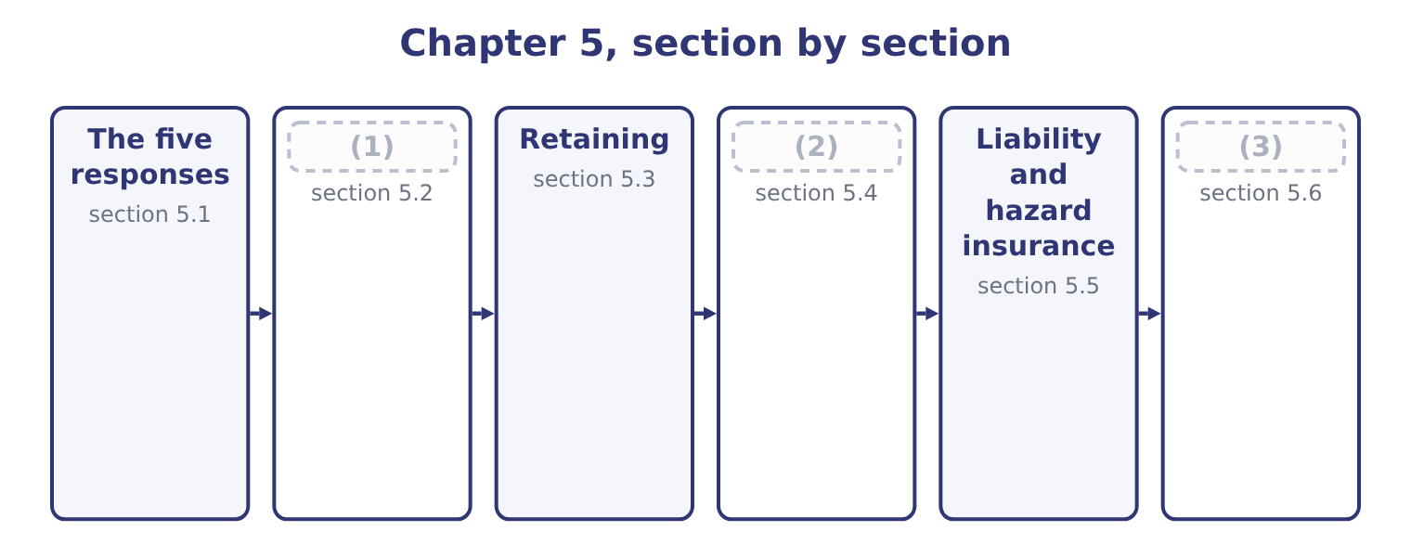
word list
Transferring · Avoiding and reducing · Exploiting, and choosing · The five responses

Summary 1 gaps 4–15
The (4) , with the test each must pass. Do not (5) the activity, or stop (6) it: decline the customer, withdraw from the market, do not make the product. It is the only response that removes the risk (7) , and it also removes the return, which is why it is (8) only where the risk cannot be brought within appetite by any other means, or where the activity was never going to earn its cost of capital anyway. Reduce, also called (9) . Act on the (10) , the severity, or both: (11) , training, testing, duplicate equipment, segregation of duties, fire doors, a second supplier. Most risk (12) is this, and the test is the (13) comparison. Transfer, also called share. Arrange for another party to carry some or all of the (14) , for a price: insurance, a contractual (15) , a hedge, outsourcing, a joint venture, a guarantee.
word list
appropriate · probability · undertake · segregation · indemnity · responses · maintenance · undertaking · management · cost-benefit · mitigate · consequences · entirely

Summary 2 gaps 16–27
The risk does not (16) ; it is moved, and the test is (17) the other party can carry it and will still be there when it matters. Retain, also called accept or (18) . Carry the risk deliberately. This is the correct response for small, frequent, (19) losses and for risks the company is paid to take, and the key word is deliberately: a retained risk is one (20) has decided to keep, written down, and budgeted for. A risk nobody (21) is not retained; it is (22) . Take more of the risk, because the company has an (23) in bearing it or because the upside is worth the (24) . A company with a strong balance sheet can offer credit terms a weaker (25) cannot; a company with deep (26) of a market can take positions in it that others would not. This is the response that follows from, and the response most often absent from a (27) answer.
word list
competitor · tolerate · missed · cheaply · noticed · disappear · advantage · knowledge · exposure · predictable · whether · candidate's · somebody

Summary 3 gaps 28–32
Two (28) are so common they (29) names. Reduce then retain is the ordinary pattern for (30) risk: control what can be (31) cheaply, budget for what remains. Retain to a limit then transfer is the ordinary pattern for hazard risk: carry the first slice through a (32) and insure the tail, which section 5.3 computes.
word list
operational · deductible · tolerate · deserve · combinations · controlled

The English this section uses, and its Arabic
Each term sits against what it means.
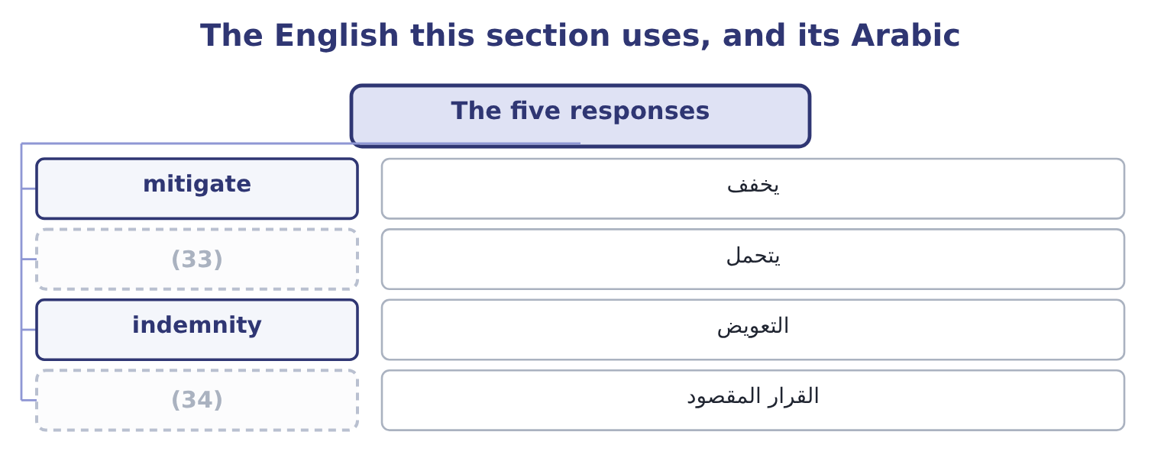
word list
deliberate decision · over-control · tolerate

The English this sheet uses, and its Arabic
English (exam term) | Arabic
mitigate | يخفف
tolerate | يتحمل
indemnity | التعويض
deliberate decision | القرار المقصود

Answer key · 5.1 The five responses

1 Avoiding and reducing | 18 tolerate
2 Transferring | 19 predictable
3 Exploiting, and choosing | 20 somebody
4 responses | 21 noticed
5 undertake | 22 missed
6 undertaking | 23 advantage
7 entirely | 24 exposure
8 appropriate | 25 competitor
9 mitigate | 26 knowledge
10 probability | 27 candidate's
11 maintenance | 28 combinations
12 management | 29 deserve
13 cost-benefit | 30 operational
14 consequences | 31 controlled
15 indemnity | 32 deductible
16 disappear | 33 tolerate
17 whether | 34 deliberate decision

the summaries in full
Summary 1 The responses, with the test each must pass. Do not undertake the activity, or stop undertaking it: decline the customer, withdraw from the market, do not make the product. It is the only response that removes the risk entirely, and it also removes the return, which is why it is appropriate only where the risk cannot be brought within appetite by any other means, or where the activity was never going to earn its cost of capital anyway. Reduce, also called mitigate. Act on the probability, the severity, or both: maintenance, training, testing, duplicate equipment, segregation of duties, fire doors, a second supplier. Most risk management is this, and the test is the cost-benefit comparison. Transfer, also called share. Arrange for another party to carry some or all of the consequences, for a price: insurance, a contractual indemnity, a hedge, outsourcing, a joint venture, a guarantee.
Summary 2 The risk does not disappear; it is moved, and the test is whether the other party can carry it and will still be there when it matters. Retain, also called accept or tolerate. Carry the risk deliberately. This is the correct response for small, frequent, predictable losses and for risks the company is paid to take, and the key word is deliberately: a retained risk is one somebody has decided to keep, written down, and budgeted for. A risk nobody noticed is not retained; it is missed. Take more of the risk, because the company has an advantage in bearing it or because the upside is worth the exposure. A company with a strong balance sheet can offer credit terms a weaker competitor cannot; a company with deep knowledge of a market can take positions in it that others would not. This is the response that follows from, and the response most often absent from a candidate's answer.
Summary 3 Two combinations are so common they deserve names. Reduce then retain is the ordinary pattern for operational risk: control what can be controlled cheaply, budget for what remains. Retain to a limit then transfer is the ordinary pattern for hazard risk: carry the first slice through a deductible and insure the tail, which section 5.3 computes.

5.2 Avoiding and reducing
Chapter 5 · section 5.2

Fill every gap. Each word list holds one word more than there are gaps.
Summary 1 gaps 1–12
Avoidance is the (1) response and the most (2) , because it forgoes the return along with the risk. Orontes could avoid its currency exposure entirely by refusing to sell to its Gulf (3) , whose business (4) 820,000 a year. The currency risk on that trade has an expected loss of 75,000. Avoiding a 75,000 expected loss by giving up 820,000 of (5) is an obviously bad trade, and stating it that way is the whole analysis: avoidance is correct only where the exposure, not the (6) , is what cannot be borne — a risk whose maximum possible loss exceeds what the company could survive. Three (7) cases for avoidance, and an exam answer (8) have them. Where the maximum possible loss is (9) and cannot be (10) . Where the (11) does not earn its cost of (12) once the risk is priced — which is Book 3's analysis with the risk premium of its.
word list
expectation · capital · contributes · transferred · legitimate · contribution · expensive · unsurvivable · supplier · distributor · activity · strongest · should

Summary 2 gaps 13–24
Where the risk is one the company has no (13) to manage: a market it does not understand, a technology it cannot maintain, a (14) whose rules it cannot follow. Reduction acts on probability, on severity, or on both, and a complete answer (15) the three. Probability reduction: preventive (16) , supplier approval, training, access controls, driver testing, the (17) check. Severity reduction: fire doors and (18) , a second site, backups, limits on the size of any single exposure, the contract that caps a (19) . A second (20) does not make the first one less likely to fail; it makes the failure cost almost (21) , and a standby supplier does the same for a supply failure. Two (22) govern how much reduction to buy. Every further (23) costs more and (24) less, and the stopping point is where the marginal cost exceeds the marginal benefit, which is Book 3's. Controls create their own risks. A new system, a new approval step, a new party in the process: each adds operational risk of its own, and a control whose own failure rate is high can be worse than the exposure it addresses.
word list
increment · sprinklers · competence · survive · distinguishes · liability · roaster · goods-inwards · nothing · jurisdiction · principles · delivers · maintenance

The English this section uses, and its Arabic
Each term sits against what it means.
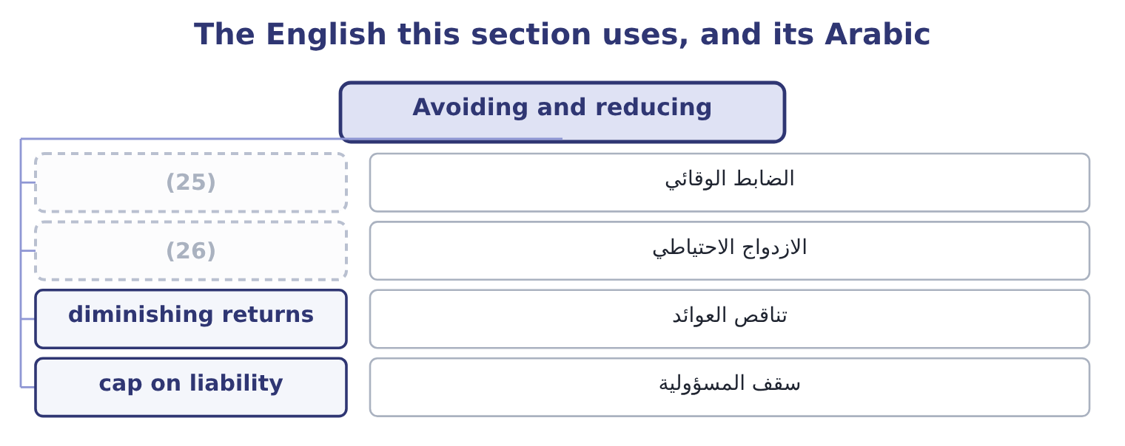
word list
سقف المسؤولية · redundancy · preventive control

The English this sheet uses, and its Arabic
English (exam term) | Arabic
preventive control | الضابط الوقائي
redundancy | الازدواج الاحتياطي
diminishing returns | تناقص العوائد
cap on liability | سقف المسؤولية

Answer key · 5.2 Avoiding and reducing

1 strongest | 14 jurisdiction
2 expensive | 15 distinguishes
3 distributor | 16 maintenance
4 contributes | 17 goods-inwards
5 contribution | 18 sprinklers
6 expectation | 19 liability
7 legitimate | 20 roaster
8 should | 21 nothing
9 unsurvivable | 22 principles
10 transferred | 23 increment
11 activity | 24 delivers
12 capital | 25 preventive control
13 competence | 26 redundancy

the summaries in full
Summary 1 Avoidance is the strongest response and the most expensive, because it forgoes the return along with the risk. Orontes could avoid its currency exposure entirely by refusing to sell to its Gulf distributor, whose business contributes 820,000 a year. The currency risk on that trade has an expected loss of 75,000. Avoiding a 75,000 expected loss by giving up 820,000 of contribution is an obviously bad trade, and stating it that way is the whole analysis: avoidance is correct only where the exposure, not the expectation, is what cannot be borne — a risk whose maximum possible loss exceeds what the company could survive. Three legitimate cases for avoidance, and an exam answer should have them. Where the maximum possible loss is unsurvivable and cannot be transferred. Where the activity does not earn its cost of capital once the risk is priced — which is Book 3's analysis with the risk premium of its.
Summary 2 Where the risk is one the company has no competence to manage: a market it does not understand, a technology it cannot maintain, a jurisdiction whose rules it cannot follow. Reduction acts on probability, on severity, or on both, and a complete answer distinguishes the three. Probability reduction: preventive maintenance, supplier approval, training, access controls, driver testing, the goods-inwards check. Severity reduction: fire doors and sprinklers, a second site, backups, limits on the size of any single exposure, the contract that caps a liability. A second roaster does not make the first one less likely to fail; it makes the failure cost almost nothing, and a standby supplier does the same for a supply failure. Two principles govern how much reduction to buy. Every further increment costs more and delivers less, and the stopping point is where the marginal cost exceeds the marginal benefit, which is Book 3's. Controls create their own risks. A new system, a new approval step, a new party in the process: each adds operational risk of its own, and a control whose own failure rate is high can be worse than the exposure it addresses.

5.3 Retaining
Chapter 5 · section 5.3

Fill every gap. Each word list holds one word more than there are gaps.
Summary 1 gaps 1–12
Retention is the (1) for risks that are small (2) to the company, frequent enough to be predictable, and cheaper to carry than to transfer. Three forms appear in (3) . (4) retention: the loss is (5) in the results when it happens. (6) for small, frequent losses — breakages, minor (7) , the ordinary bad debts covered by the allowance. Funded retention, or (8) : an amount is set aside, formally or (9) , against the expected loss, so that the charge is smoothed instead of lumpy. A large group may do this through a (10) insurer, which is its own insurance company; the exam needs the term, not the (11) . (12) retention through a deductible: the company carries the first slice of every loss and the insurer carries the rest. This is the most common arrangement in practice, because the first slice is where the small, predictable, expensive-to-administer losses live, and because carrying it reduces the premium by more than the expected cost of the losses retained.
word list
Partial · captive · relative · mechanics · Appropriate · informally · Unfunded · self-insurance · questions · absorbed · response · write-offs · capital

Worked example: full cover, or a deductible?

Summary 2 gaps 13–19
The roaster (13) : nothing at 0.60, 150,000 at 0.25, 800,000 at 0.10, 3,000,000 at 0.05, for an expected loss of 267,500. The insurer (14) a premium of $400,000. That is 400,000 − 267,500 = 132,500 more than the expected loss, a loading of 132,500 ÷ 267,500 = 49.53 per cent, which pays for the (15) expenses, capital and (16) . The premium falls to $180,000. Orontes now carries the 150,000 (17) in full, contributing 0.25 × 150,000 = 37,500, and the first 250,000 of each larger loss, contributing 0.10 × 250,000 = 25,000 and 0.05 × 250,000 = 12,500. Retained expected loss is 37,500 + 25,000 + 12,500 = 75,000. (18) the total cost. With the deductible the expected (19) cost is 180,000 + 75,000 = 255,000, against 400,000 for full cover — a saving of 400,000 − 255,000 = 145,000 a year.
word list
distribution · Compare · outcome · quotes · profit · annual · insurer's · relative

Summary 3 gaps 20–31
The deductible is better, and the reason is (20) rather than (21) : the insurer (22) its loading on every dollar of cover, and the first 250,000 is the part Orontes can predict and absorb without (23) . The test for how large a deductible should be is not where the saving is largest but how large a loss the company can take in a single year without (24) anything — which is, not an (25) . Two (26) with retention. Retained risk must be funded, not merely (27) . A decision to retain that is not (28) in a budget, a (29) or a cash buffer is a decision to be surprised. Ten retained risks of 75,000 each have a combined expected cost of 750,000 and a much larger bad-year cost, and the (30) retention across the company is a figure somebody should know, not a (31) of ten separate decisions.
word list
Partial · optimisation · by-product · provision · reflected · disrupting · charges · accepted · difficulty · arithmetical · structural · cautions · aggregate

The English this section uses, and its Arabic
Each term sits against what it means.
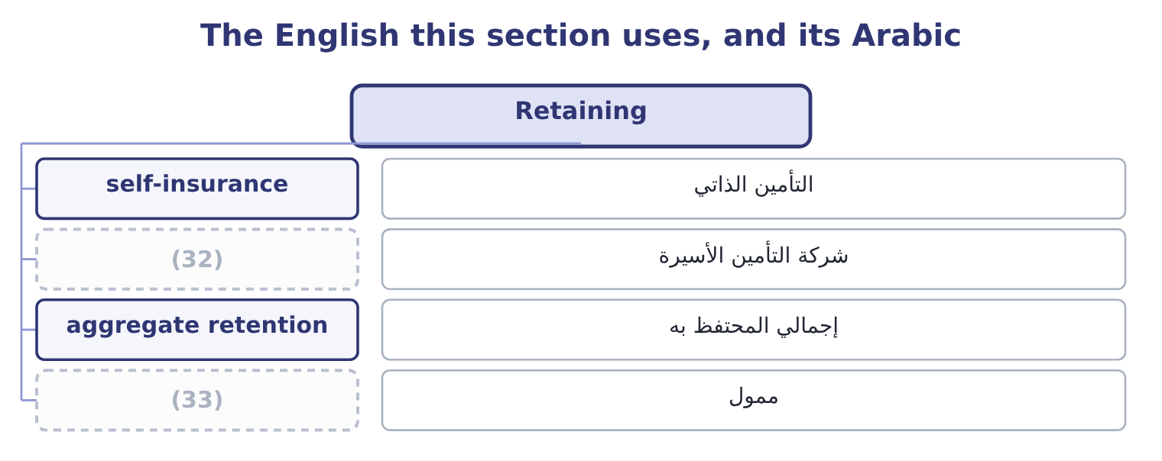
word list
mitigate · funded · captive insurer

The English this sheet uses, and its Arabic
English (exam term) | Arabic
self-insurance | التأمين الذاتي
captive insurer | شركة التأمين الأسيرة
aggregate retention | إجمالي المحتفظ به
funded | ممول

Answer key · 5.3 Retaining

1 response | 18 Compare
2 relative | 19 annual
3 questions | 20 structural
4 Unfunded | 21 arithmetical
5 absorbed | 22 charges
6 Appropriate | 23 difficulty
7 write-offs | 24 disrupting
8 self-insurance | 25 optimisation
9 informally | 26 cautions
10 captive | 27 accepted
11 mechanics | 28 reflected
12 Partial | 29 provision
13 distribution | 30 aggregate
14 quotes | 31 by-product
15 insurer's | 32 captive insurer
16 profit | 33 funded
17 outcome

the summaries in full
Summary 1 Retention is the response for risks that are small relative to the company, frequent enough to be predictable, and cheaper to carry than to transfer. Three forms appear in questions. Unfunded retention: the loss is absorbed in the results when it happens. Appropriate for small, frequent losses — breakages, minor write-offs, the ordinary bad debts covered by the allowance. Funded retention, or self-insurance: an amount is set aside, formally or informally, against the expected loss, so that the charge is smoothed instead of lumpy. A large group may do this through a captive insurer, which is its own insurance company; the exam needs the term, not the mechanics. Partial retention through a deductible: the company carries the first slice of every loss and the insurer carries the rest. This is the most common arrangement in practice, because the first slice is where the small, predictable, expensive-to-administer losses live, and because carrying it reduces the premium by more than the expected cost of the losses retained.
Summary 2 The roaster distribution: nothing at 0.60, 150,000 at 0.25, 800,000 at 0.10, 3,000,000 at 0.05, for an expected loss of 267,500. The insurer quotes a premium of $400,000. That is 400,000 − 267,500 = 132,500 more than the expected loss, a loading of 132,500 ÷ 267,500 = 49.53 per cent, which pays for the insurer's expenses, capital and profit. The premium falls to $180,000. Orontes now carries the 150,000 outcome in full, contributing 0.25 × 150,000 = 37,500, and the first 250,000 of each larger loss, contributing 0.10 × 250,000 = 25,000 and 0.05 × 250,000 = 12,500. Retained expected loss is 37,500 + 25,000 + 12,500 = 75,000. Compare the total cost. With the deductible the expected annual cost is 180,000 + 75,000 = 255,000, against 400,000 for full cover — a saving of 400,000 − 255,000 = 145,000 a year.
Summary 3 The deductible is better, and the reason is structural rather than arithmetical: the insurer charges its loading on every dollar of cover, and the first 250,000 is the part Orontes can predict and absorb without difficulty. The test for how large a deductible should be is not where the saving is largest but how large a loss the company can take in a single year without disrupting anything — which is, not an optimisation. Two cautions with retention. Retained risk must be funded, not merely accepted. A decision to retain that is not reflected in a budget, a provision or a cash buffer is a decision to be surprised. Ten retained risks of 75,000 each have a combined expected cost of 750,000 and a much larger bad-year cost, and the aggregate retention across the company is a figure somebody should know, not a by-product of ten separate decisions.

5.4 Transferring
Chapter 5 · section 5.4

Fill every gap. Each word list holds one word more than there are gaps.
Summary 1 gaps 1–12
Risk transfer is an arrangement under which another party bears some or all of the financial (1) of a risk, in return for a payment or another (2) . The outcome names two (3) and both repay (4) . The company pays a premium and the (5) pays the loss, (6) the limits and exclusions of the policy. The premium exceeds the expected loss by the loading of section 5.3, and the company pays that loading (7) because it converts an (8) large loss into a certain small cost — which is. This one puzzles (9) , and the logic is worth (10) . A company (11) partly by debt has transferred part of its (12) risk to lenders: they accept a fixed return and, in exchange, bear the risk that the company cannot pay, which in the limit means they absorb losses the shareholders' limited liability protects the shareholders.
word list
regulatory · within · willingly · candidates · consequences · insurer · financed · business · uncertain · attention · consideration · stating · examples

Summary 2 gaps 13–24
Book 2's, as the lenders' (13) return. Note the exam's point: risk transfer is not only (14) , and the financing structure of a company is itself a (15) arrangement. Other transfers appear in (16) . Contractual transfer: an (17) , a warranty from a supplier, a liability cap, a (18) clause, a penalty for late delivery. These are the cheapest transfers (19) and the most neglected, because they cost nothing but (20) . (21) : a forward, a (22) , an option or a swap, which transfers a price risk to a counterparty, as Book 2's. Outsourcing: giving an activity to a (23) who carries its operational risk — (24) to the warning below. Joint ventures and partnerships: sharing an exposure with somebody who shares the return. Securitisation and other capital market transfers, where a risk is packaged and sold to investors.
word list
Hedging · future · indemnity · hold-harmless · available · subject · specialist · Policies · insurance · required · risk-sharing · questions · negotiation

Summary 3 gaps 25–36
Four tests every transfer must pass, and they are the (25) part. Can the counterparty actually pay? A transfer to a party that fails when the risk (26) is not a transfer; it is an (27) credit risk. This is why (28) ' financial strength matters and why (29) with one counterparty is itself an exposure. What exactly has been transferred? (30) have limits, exclusions, (31) and conditions. A transfer that (32) the direct loss and not the (33) loss. What cannot be transferred at all? (34) , regulatory responsibility and legal (35) generally stay with the company. Outsourcing a process transfers its cost and some of its operational risk; it does not transfer the (36) to the regulator or the customer, and a candidate who writes that outsourcing eliminates a risk has made the standard error. And does the transfer create new risk? Every transfer introduces a counterparty, a contract and a dependency, which are themselves exposures.
word list
consequential · crystallises · additional · concentration · deductibles · accountability · Reputation · examined · covers · Policies · transfers · obligation · insurers

The English this section uses, and its Arabic
Each term sits against what it means.
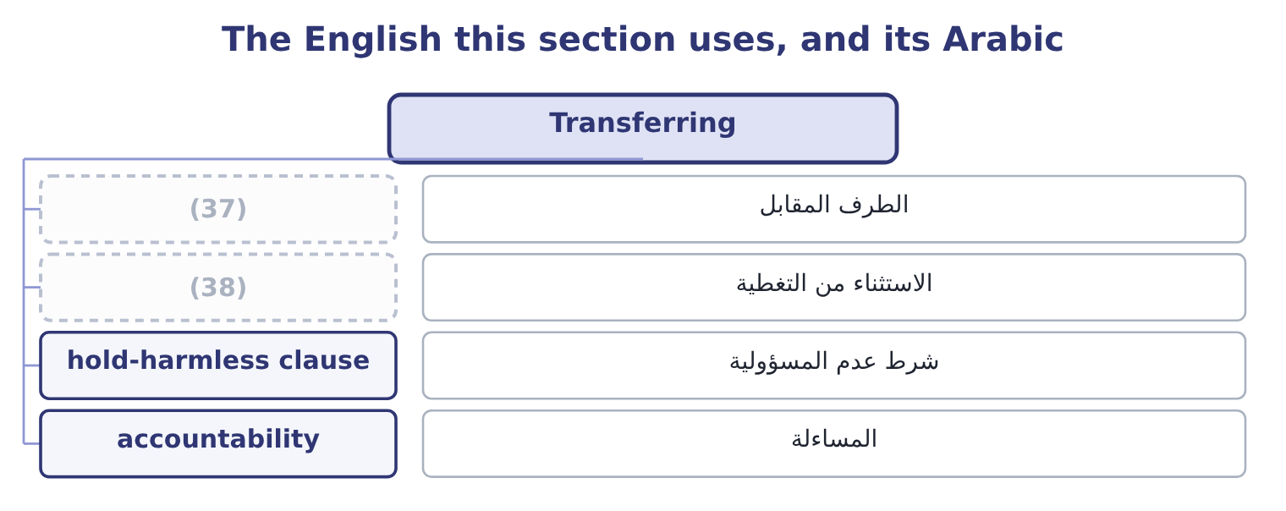
word list
redundancy · counterparty · exclusion

The English this sheet uses, and its Arabic
English (exam term) | Arabic
counterparty | الطرف المقابل
exclusion | الاستثناء من التغطية
hold-harmless clause | شرط عدم المسؤولية
accountability | المساءلة

Answer key · 5.4 Transferring

1 consequences | 20 negotiation
2 consideration | 21 Hedging
3 examples | 22 future
4 attention | 23 specialist
5 insurer | 24 subject
6 within | 25 examined
7 willingly | 26 crystallises
8 uncertain | 27 additional
9 candidates | 28 insurers
10 stating | 29 concentration
11 financed | 30 Policies
12 business | 31 deductibles
13 required | 32 covers
14 insurance | 33 consequential
15 risk-sharing | 34 Reputation
16 questions | 35 accountability
17 indemnity | 36 obligation
18 hold-harmless | 37 counterparty
19 available | 38 exclusion

the summaries in full
Summary 1 Risk transfer is an arrangement under which another party bears some or all of the financial consequences of a risk, in return for a payment or another consideration. The outcome names two examples and both repay attention. The company pays a premium and the insurer pays the loss, within the limits and exclusions of the policy. The premium exceeds the expected loss by the loading of section 5.3, and the company pays that loading willingly because it converts an uncertain large loss into a certain small cost — which is. This one puzzles candidates, and the logic is worth stating. A company financed partly by debt has transferred part of its business risk to lenders: they accept a fixed return and, in exchange, bear the risk that the company cannot pay, which in the limit means they absorb losses the shareholders' limited liability protects the shareholders.
Summary 2 Book 2's, as the lenders' required return. Note the exam's point: risk transfer is not only insurance, and the financing structure of a company is itself a risk-sharing arrangement. Other transfers appear in questions. Contractual transfer: an indemnity, a warranty from a supplier, a liability cap, a hold-harmless clause, a penalty for late delivery. These are the cheapest transfers available and the most neglected, because they cost nothing but negotiation. Hedging: a forward, a future, an option or a swap, which transfers a price risk to a counterparty, as Book 2's. Outsourcing: giving an activity to a specialist who carries its operational risk — subject to the warning below. Joint ventures and partnerships: sharing an exposure with somebody who shares the return. Securitisation and other capital market transfers, where a risk is packaged and sold to investors.
Summary 3 Four tests every transfer must pass, and they are the examined part. Can the counterparty actually pay? A transfer to a party that fails when the risk crystallises is not a transfer; it is an additional credit risk. This is why insurers' financial strength matters and why concentration with one counterparty is itself an exposure. What exactly has been transferred? Policies have limits, exclusions, deductibles and conditions. A transfer that covers the direct loss and not the consequential loss. What cannot be transferred at all? Reputation, regulatory responsibility and legal accountability generally stay with the company. Outsourcing a process transfers its cost and some of its operational risk; it does not transfer the obligation to the regulator or the customer, and a candidate who writes that outsourcing eliminates a risk has made the standard error. And does the transfer create new risk? Every transfer introduces a counterparty, a contract and a dependency, which are themselves exposures.

5.5 Liability and hazard insurance
Chapter 5 · section 5.5

Fill every gap. Each word list holds one word more than there are gaps.
Summary 1 gaps 1–12
The (1) asks for a general (2) of insurance as a transfer (3) , not for the detail of policy (4) . Five (5) are enough. It pools a large number of similar exposures so that the insurer, which (6) predict any one loss, can predict the total (7) . That is the law of large (8) , and it is why an insurer can charge each company a premium close to its (9) loss plus a loading and still be (10) of its own result. What makes a risk insurable. The exam uses six conditions: the loss must be accidental rather than within the insured's control; it must be measurable in money and (11) as to time and place; there must be a large number of similar, independent exposures; the loss must not be (12) to the insurer, which is why flood and war are often excluded or reinsured; the premium must be economically feasible, which rules out risks that are near-certain; and the insured must have an insurable interest — must actually stand to lose.
word list
closely · outcome · identifiable · things · mechanism · numbers · understanding · catastrophic · confident · exclusions · wordings · cannot · expected

Summary 2 gaps 13–24
The main (13) a company buys. Property and hazard cover: the (14) , plant and stock against fire, flood, storm, (15) and theft — the direct loss. Business (16) cover: the profit lost and the extra cost of (17) while the asset is out of use —, and the cover companies most often buy too little. Liability insurance: the (18) legal liability to (19) . Public liability for injury or damage to third parties; product liability for harm caused by what the company sells, which for a food producer is the material one; employers' liability for injury to employees; professional (20) for advice; and directors' and officers' liability for claims against the board (21) . Other covers: goods in (22) , credit insurance on (23) , political risk insurance, key person cover, cyber. The (24) features that decide what a policy is worth.
word list
others · buildings · indemnity · classes · interruption · company's · political · working · personally · explosion · structural · receivables · transit

Summary 3 gaps 25–34
The limit, which is the most the insurer will pay and which should be set against; the (25) of section 5.3; the (26) , which is where most disputes live; the conditions, breach of which can void cover — a (27) system required to be maintained, a (28) required within a period; and the basis of settlement, (29) cost or market value. Two moral hazards the (30) . Insurance can reduce the (31) to prevent losses, which is why insurers use deductibles, (32) and conditions; and a company that is insured may (33) in continuity planning, which protects (34) insurance does not pay for — the customer who went elsewhere while the plant was rebuilt.
word list
deductible · exclusions · notification · replacement · sprinkler · insurer · something · incentive · under-invest · examiners · co-insurance

The English this section uses, and its Arabic
Each term sits against what it means.
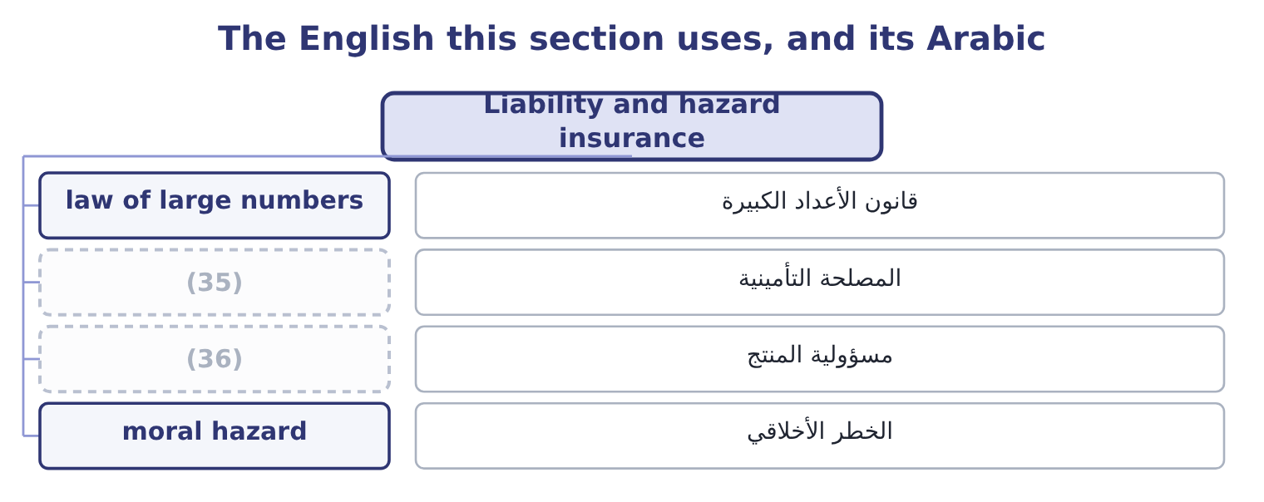
word list
الخطر الأخلاقي · insurable interest · product liability

The English this sheet uses, and its Arabic
English (exam term) | Arabic
law of large numbers | قانون الأعداد الكبيرة
insurable interest | المصلحة التأمينية
product liability | مسؤولية المنتج
moral hazard | الخطر الأخلاقي

Answer key · 5.5 Liability and hazard insurance

1 outcome | 19 others
2 understanding | 20 indemnity
3 mechanism | 21 personally
4 wordings | 22 transit
5 things | 23 receivables
6 cannot | 24 structural
7 closely | 25 deductible
8 numbers | 26 exclusions
9 expected | 27 sprinkler
10 confident | 28 notification
11 identifiable | 29 replacement
12 catastrophic | 30 examiners
13 classes | 31 incentive
14 buildings | 32 co-insurance
15 explosion | 33 under-invest
16 interruption | 34 something
17 working | 35 insurable interest
18 company's | 36 product liability

the summaries in full
Summary 1 The outcome asks for a general understanding of insurance as a transfer mechanism, not for the detail of policy wordings. Five things are enough. It pools a large number of similar exposures so that the insurer, which cannot predict any one loss, can predict the total closely. That is the law of large numbers, and it is why an insurer can charge each company a premium close to its expected loss plus a loading and still be confident of its own result. What makes a risk insurable. The exam uses six conditions: the loss must be accidental rather than within the insured's control; it must be measurable in money and identifiable as to time and place; there must be a large number of similar, independent exposures; the loss must not be catastrophic to the insurer, which is why flood and war are often excluded or reinsured; the premium must be economically feasible, which rules out risks that are near-certain; and the insured must have an insurable interest — must actually stand to lose.
Summary 2 The main classes a company buys. Property and hazard cover: the buildings, plant and stock against fire, flood, storm, explosion and theft — the direct loss. Business interruption cover: the profit lost and the extra cost of working while the asset is out of use —, and the cover companies most often buy too little. Liability insurance: the company's legal liability to others. Public liability for injury or damage to third parties; product liability for harm caused by what the company sells, which for a food producer is the material one; employers' liability for injury to employees; professional indemnity for advice; and directors' and officers' liability for claims against the board personally. Other covers: goods in transit, credit insurance on receivables, political risk insurance, key person cover, cyber. The structural features that decide what a policy is worth.
Summary 3 The limit, which is the most the insurer will pay and which should be set against; the deductible of section 5.3; the exclusions, which is where most disputes live; the conditions, breach of which can void cover — a sprinkler system required to be maintained, a notification required within a period; and the basis of settlement, replacement cost or market value. Two moral hazards the examiners. Insurance can reduce the incentive to prevent losses, which is why insurers use deductibles, co-insurance and conditions; and a company that is insured may under-invest in continuity planning, which protects something insurance does not pay for — the customer who went elsewhere while the plant was rebuilt.

5.6 Exploiting, and choosing
Chapter 5 · section 5.6

Fill every gap. Each word list holds one word more than there are gaps.
Summary 1 gaps 1–12
Exploitation is the response for a risk the company is better placed to bear than others are, and the examiners include it precisely because (1) forget that risk (2) can increase an exposure on purpose. (3) more of a risk the company is paid for. Orontes's strong cash (4) lets it offer sixty-day terms where a (5) competitor must ask for thirty, which wins volume. The (6) risk rises deliberately, and the contribution rises with it. (7) a response that (8) . A control bought when the company was smaller, an (9) limit set for a risk that has shrunk, an approval (10) nobody has revisited: each is a cost without a matching benefit, and releasing it is as much a risk decision as adding one. (11) an upside the risk (12) . A currency movement that hurts imports helps exports; a competitor's supply failure is an opportunity for a company with spare capacity; a new regulation that is expensive to meet is a barrier to smaller entrants.
word list
over-controls · Taking · position · whatever · threshold · insurance · weaker · credit · management · Changing · candidates · Pursuing · creates

The five responses
Response | What it does | Right when | Watch for
Avoid | (13) | The exposure cannot be survived or transferred | Forgone contribution
Reduce | Lowers probability, severity or both | The control costs less than it saves | (14)
Transfer | Moves consequences to another party | The other party can carry it and will be there | (15)
Retain | Keeps the consequences deliberately | Losses are small, frequent and predictable | (16)
Exploit | (17) | The company has an advantage in bearing it | The advantage must be real

word list
Diminishing returns; new risks · Must be funded; aggregates across the company · Removes the risk and the return · Offering sixty-day terms to win volume · Limits, exclusions, counterparty failure · Takes more of the exposure

Summary 2 gaps 18–25
Choosing among them (18) a pattern that is worth (19) as a sequence. Start with the maximum (20) loss. If it cannot be survived, the risk must be transferred or avoided, (21) the probability. Then ask whether reduction is cheap. The early (22) of, and they (23) both the premium and the retention. Then compare transfer with retention on the (24) exposure, using the (25) arithmetic of section 5.3 — premium plus retained expected loss — rather than the premium alone. Then retain the rest deliberately, write it down, and fund it.
word list
remaining · controls · whatever · follows · learning · shrink · creates · total-cost · possible

Match the response

Your turn: which response? (complete the blanks)
Situation | Response
A 250,000 deductible with the rest insured | ________
Declining to trade in a country whose rules cannot be followed | ________
Installing sprinklers in the roasting hall | ________
Offering sixty-day terms to win volume, funded by the cash balance | ________
Budgeting 75,000 a year for small write-offs | ________
A supplier contract that caps Orontes's liability for a recall | ________

"Transfer", "share" and "deductible"

Summary 3 gaps 26–36
Transfer is the word most likely to mislead a board, because in English it (26) the risk has gone (27) else and is no longer the (28) problem. Risk is not transferred in the way an asset is; what moves is the financial (29) , and only to the (30) the contract says. Several (31) now prefer share for (32) that reason, and it is the better word: it keeps the company in the (33) . Deductible is an (34) trap of its own: in British (35) it is the excess, in (36) the retention, and all three mean the slice the insured carries. When a question gives a figure, check whether it is deducted from every loss or only applies once in a year, because the arithmetic of section 5.3 changes completely.
word list
company's · somewhere · picture · consequence · English-language · over-control · suggests · practice · reinsurance · frameworks · extent · exactly

"Transfer", "share" and "deductible"
Situation | Response
A 250,000 deductible with the rest insured | Partial retention with transfer above it.
Declining to trade where the rules cannot be followed | Avoidance.
Installing sprinklers | (37)
Offering sixty-day terms to win volume | Exploitation.
Budgeting 75,000 for small write-offs | (38)
A supplier contract capping liability | (39)
What it tells you | Four of the six are things a company does every day without calling them risk responses — which is the point: the (40) names decis

word list
Transfer, by contract. · Reduction, acting on severity. · Retention, funded. · classification · Exploitation.

The English this section uses, and its Arabic
Each term sits against what it means.
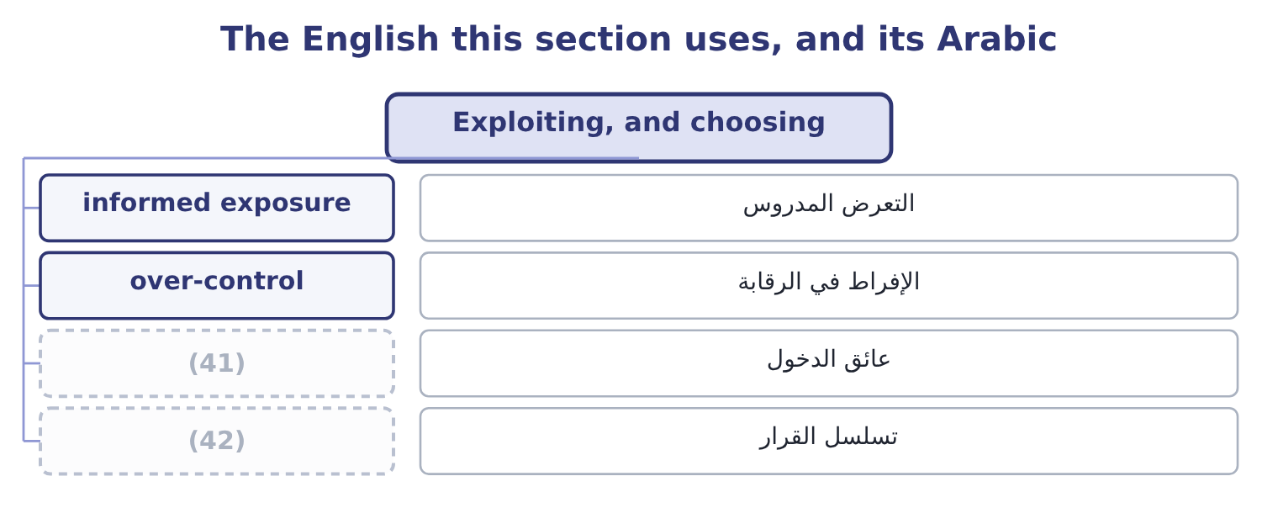
word list
barrier to entry · sequence of decision · الإفراط في الرقابة

The English this sheet uses, and its Arabic
English (exam term) | Arabic
informed exposure | التعرض المدروس
over-control | الإفراط في الرقابة
barrier to entry | عائق الدخول
sequence of decision | تسلسل القرار

Answer key · 5.6 Exploiting, and choosing

1 candidates | 22 controls
2 management | 23 shrink
3 Taking | 24 remaining
4 position | 25 total-cost
5 weaker | 26 suggests
6 credit | 27 somewhere
7 Changing | 28 company's
8 over-controls | 29 consequence
9 insurance | 30 extent
10 threshold | 31 frameworks
11 Pursuing | 32 exactly
12 creates | 33 picture
13 Removes the risk and the return | 34 English-language
14 Diminishing returns; new risks | 35 practice
15 Limits, exclusions, counterparty failure | 36 reinsurance
16 Must be funded; aggregates across the company | 37 Reduction, acting on severity.
17 Takes more of the exposure | 38 Retention, funded.
18 follows | 39 Transfer, by contract.
19 learning | 40 classification
20 possible | 41 barrier to entry
21 whatever | 42 sequence of decision

the summaries in full
Summary 1 Exploitation is the response for a risk the company is better placed to bear than others are, and the examiners include it precisely because candidates forget that risk management can increase an exposure on purpose. Taking more of a risk the company is paid for. Orontes's strong cash position lets it offer sixty-day terms where a weaker competitor must ask for thirty, which wins volume. The credit risk rises deliberately, and the contribution rises with it. Changing a response that over-controls. A control bought when the company was smaller, an insurance limit set for a risk that has shrunk, an approval threshold nobody has revisited: each is a cost without a matching benefit, and releasing it is as much a risk decision as adding one. Pursuing an upside the risk creates. A currency movement that hurts imports helps exports; a competitor's supply failure is an opportunity for a company with spare capacity; a new regulation that is expensive to meet is a barrier to smaller entrants.
Summary 2 Choosing among them follows a pattern that is worth learning as a sequence. Start with the maximum possible loss. If it cannot be survived, the risk must be transferred or avoided, whatever the probability. Then ask whether reduction is cheap. The early controls of, and they shrink both the premium and the retention. Then compare transfer with retention on the remaining exposure, using the total-cost arithmetic of section 5.3 — premium plus retained expected loss — rather than the premium alone. Then retain the rest deliberately, write it down, and fund it.
Summary 3 Transfer is the word most likely to mislead a board, because in English it suggests the risk has gone somewhere else and is no longer the company's problem. Risk is not transferred in the way an asset is; what moves is the financial consequence, and only to the extent the contract says. Several frameworks now prefer share for exactly that reason, and it is the better word: it keeps the company in the picture. Deductible is an English-language trap of its own: in British practice it is the excess, in reinsurance the retention, and all three mean the slice the insured carries. When a question gives a figure, check whether it is deducted from every loss or only applies once in a year, because the arithmetic of section 5.3 changes completely.

