6.1 The steps of the process
Chapter 6 · section 6.1

Fill every gap. Each word list holds one word more than there are gaps.
Chapter 6, section by section
Each stage leads to the next.
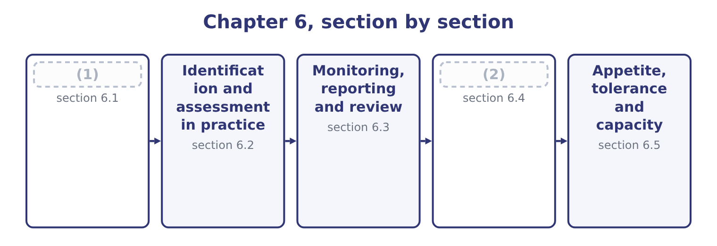
word list
Monitoring, reporting and review · The steps of the process · Attitude toward risk

Summary 1 gaps 3–14
Frameworks name the steps (3) , and the examiners accept any (4) version provided the logic is right. Five steps cover it, with a sixth that runs (5) all of them. Establish the (6) and the objectives. What the business is (7) to achieve, in what (8) , with what appetite. Risk is defined (9) to an objective — the risk that something will not happen — so a process that starts by listing risks rather than objectives (10) a list of worries instead of a list of threats to something specific. What could happen that would (11) those objectives, from any. (12) and impact, inherent and residual, with the expected loss, (13) loss and maximum possible loss. Choose from, with the (14) test of, and assign each response to a named owner with a date. Confirm that the responses are in place and working, that the assessments are still right, and that no new risk has arrived.
word list
context · sensible · relative · produces · alongside · trying · affect · cost-benefit · environment · unexpected · differently · advises · Likelihood

Summary 2 gaps 15–26
Risks (15) faster than (16) do. And throughout: (17) and consult. Risk (18) has to move up to the board, down to the people who run the (19) , and sideways between functions that each see part of an exposure. The step is listed (20) in most frameworks because it is the one most often missing — a register that lives in a file nobody reads is a (21) process with no effect. Three (22) of the process as a whole are (23) . It is (24) , not linear. (25) feeds back into (26) ; a response changes the assessment; a changed objective changes everything. It is owned by management, not by a risk function. The risk manager designs and runs the process and advises on it; the manager who owns the business process owns the risk, and the board owns the appetite. And it operates at every level. The same five steps apply to a factory process, to a project, to a division and to the enterprise, which is the connection.
word list
registers · identification · properties · information · iterative · Monitoring · specific · examined · separately · completed · change · processes · communicate

The English this section uses, and its Arabic
Each term sits against what it means.
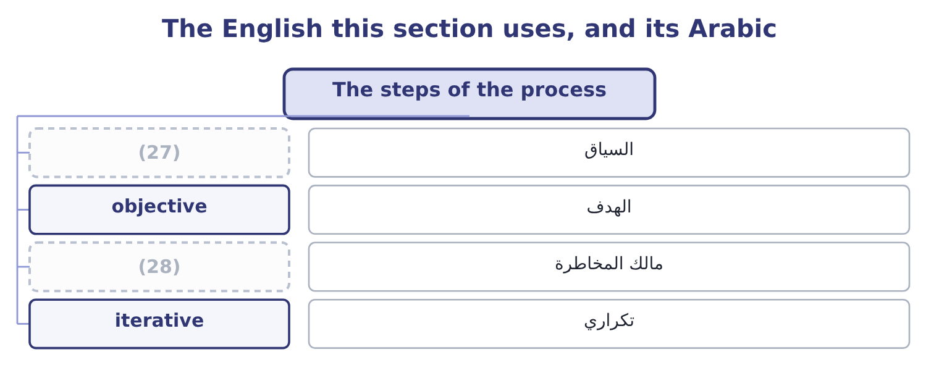
word list
risk owner · appetite statement · context

The English this sheet uses, and its Arabic
English (exam term) | Arabic
context | السياق
objective | الهدف
risk owner | مالك المخاطرة
iterative | تكراري

Answer key · 6.1 The steps of the process

1 The steps of the process | 15 change
2 Attitude toward risk | 16 registers
3 differently | 17 communicate
4 sensible | 18 information
5 alongside | 19 processes
6 context | 20 separately
7 trying | 21 completed
8 environment | 22 properties
9 relative | 23 examined
10 produces | 24 iterative
11 affect | 25 Monitoring
12 Likelihood | 26 identification
13 unexpected | 27 context
14 cost-benefit | 28 risk owner

the summaries in full
Summary 1 Frameworks name the steps differently, and the examiners accept any sensible version provided the logic is right. Five steps cover it, with a sixth that runs alongside all of them. Establish the context and the objectives. What the business is trying to achieve, in what environment, with what appetite. Risk is defined relative to an objective — the risk that something will not happen — so a process that starts by listing risks rather than objectives produces a list of worries instead of a list of threats to something specific. What could happen that would affect those objectives, from any. Likelihood and impact, inherent and residual, with the expected loss, unexpected loss and maximum possible loss. Choose from, with the cost-benefit test of, and assign each response to a named owner with a date. Confirm that the responses are in place and working, that the assessments are still right, and that no new risk has arrived.
Summary 2 Risks change faster than registers do. And throughout: communicate and consult. Risk information has to move up to the board, down to the people who run the processes, and sideways between functions that each see part of an exposure. The step is listed separately in most frameworks because it is the one most often missing — a register that lives in a file nobody reads is a completed process with no effect. Three properties of the process as a whole are examined. It is iterative, not linear. Monitoring feeds back into identification; a response changes the assessment; a changed objective changes everything. It is owned by management, not by a risk function. The risk manager designs and runs the process and advises on it; the manager who owns the business process owns the risk, and the board owns the appetite. And it operates at every level. The same five steps apply to a factory process, to a project, to a division and to the enterprise, which is the connection.

6.2 Identification and assessment in practice
Chapter 6 · section 6.2

Fill every gap. Each word list holds one word more than there are gaps.
Summary 1 gaps 1–12
Two of the steps (1) more than a (2) , because most of the work and most of the failure is in them. (3) fails in characteristic ways, and naming them is (4) . It stops at the (5) . People list the risks they have already (6) , which are by (7) the ones already managed. It stops at the boundary of a (8) . Nobody owns the risk that falls between sales and (9) , which is usually where it is. It (10) risks with their causes and their (11) . A register that mixes all three (12) and obscures where a response would act. And it omits the risks nobody wants to write down: the risk that the strategy is wrong, the risk from a dominant personality, the risk that a figure management is attached to is unachievable. Assessment has its own failure modes.
word list
familiar · experienced · sentence · Identification · conflates · single-source · effects · double-counts · deserve · definition · production · examinable · department

Summary 2 gaps 13–24
Scales that are not anchored. An anchored scale (13) high as, say, more than 500,000 or more than a 20 per cent chance in a year, so that two (14) produce the same answer. Assessing with the (15) half in place, which (16) a figure that is neither inherent nor residual. Assessing likelihood and impact without a time horizon. And (17) the assessment as the output. The output is the response; the assessment (18) to choose it. Supply the Gulf (19) on contract terms for the next (20) months. A (21) supplier of hulled sesame fails to (22) for six weeks in the harvest gap. Likelihood 0.25 in a year on the current single-source (23) ; impact a stoppage costing 46,027 a day, so about 1,933,134 over six weeks; expected loss (24) 0.25 × 1,933,134 = 483,284.
word list
objective · defines · assessors · single · therefore · controls · arrangement · exists · deliver · treating · distributor · produces · twelve

Summary 3 gaps 25–31
The response and the owner. (25) a second supplier and hold four weeks of (26) stock. Owner: the (27) manager. Date: (28) the next harvest. Residual likelihood after the response: 0.05. Every element the step list requires is present: an (29) , an event distinct from its cause and its effect, a (30) likelihood and impact over a stated horizon, a response, a named owner and a date. A register line without those is a note, and a register of notes is what most companies (31) have.
word list
before · objective · buffer · actually · quantified · Qualify · current · procurement

The English this section uses, and its Arabic
Each term sits against what it means.
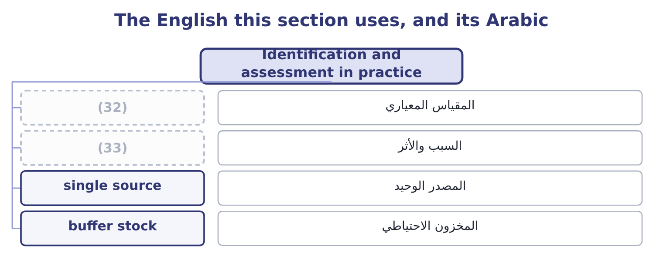
word list
anchored scale · cause and effect · buffer stock

The English this sheet uses, and its Arabic
English (exam term) | Arabic
anchored scale | المقياس المعياري
cause and effect | السبب والأثر
single source | المصدر الوحيد
buffer stock | المخزون الاحتياطي

Answer key · 6.2 Identification and assessment in practice

1 deserve | 18 exists
2 sentence | 19 distributor
3 Identification | 20 twelve
4 examinable | 21 single
5 familiar | 22 deliver
6 experienced | 23 arrangement
7 definition | 24 therefore
8 department | 25 Qualify
9 production | 26 buffer
10 conflates | 27 procurement
11 effects | 28 before
12 double-counts | 29 objective
13 defines | 30 quantified
14 assessors | 31 actually
15 controls | 32 anchored scale
16 produces | 33 cause and effect
17 treating

the summaries in full
Summary 1 Two of the steps deserve more than a sentence, because most of the work and most of the failure is in them. Identification fails in characteristic ways, and naming them is examinable. It stops at the familiar. People list the risks they have already experienced, which are by definition the ones already managed. It stops at the boundary of a department. Nobody owns the risk that falls between sales and production, which is usually where it is. It conflates risks with their causes and their effects. A register that mixes all three double-counts and obscures where a response would act. And it omits the risks nobody wants to write down: the risk that the strategy is wrong, the risk from a dominant personality, the risk that a figure management is attached to is unachievable. Assessment has its own failure modes.
Summary 2 Scales that are not anchored. An anchored scale defines high as, say, more than 500,000 or more than a 20 per cent chance in a year, so that two assessors produce the same answer. Assessing with the controls half in place, which produces a figure that is neither inherent nor residual. Assessing likelihood and impact without a time horizon. And treating the assessment as the output. The output is the response; the assessment exists to choose it. Supply the Gulf distributor on contract terms for the next twelve months. A single supplier of hulled sesame fails to deliver for six weeks in the harvest gap. Likelihood 0.25 in a year on the current single-source arrangement; impact a stoppage costing 46,027 a day, so about 1,933,134 over six weeks; expected loss therefore 0.25 × 1,933,134 = 483,284.
Summary 3 The response and the owner. Qualify a second supplier and hold four weeks of buffer stock. Owner: the procurement manager. Date: before the next harvest. Residual likelihood after the response: 0.05. Every element the step list requires is present: an objective, an event distinct from its cause and its effect, a quantified likelihood and impact over a stated horizon, a response, a named owner and a date. A register line without those is a note, and a register of notes is what most companies actually have.

6.3 Monitoring, reporting and review
Chapter 6 · section 6.3

Fill every gap. Each word list holds one word more than there are gaps.
Summary 1 gaps 1–12
The last step is the one that turns a (1) into a process, and the exam asks what it (2) . (3) that responses are in place. An (4) action with an owner and a date is not a control until (5) has checked it exists. Testing that (6) work. Key risk indicators are measures that move before a loss does — supplier delivery performance, staff turnover, overdue (7) , the age of (8) , complaint volumes, near-misses. They are the (9) half of the process, and they differ from key performance indicators in (10) forward at a risk rather than backward at a result. To the board, (11) , in a form that shows the (12) risks, their assessment, the responses, the owners and what has changed. What has changed is the part boards read. Reviewing the process itself. Whether the register is current, whether the appetite still fits the strategy, whether any loss occurred that the process should have caught — which is Book 3's postaudit applied to risk. A route by which a risk discovered at any level reaches the people who can act, without depending on the goodwill of everybody in between.
word list
reconciliations · receivables · Confirming · significant · periodically · pointing · project · somebody · process · controls · consists · agreed · early-warning

The English this section uses, and its Arabic
Each term sits against what it means.
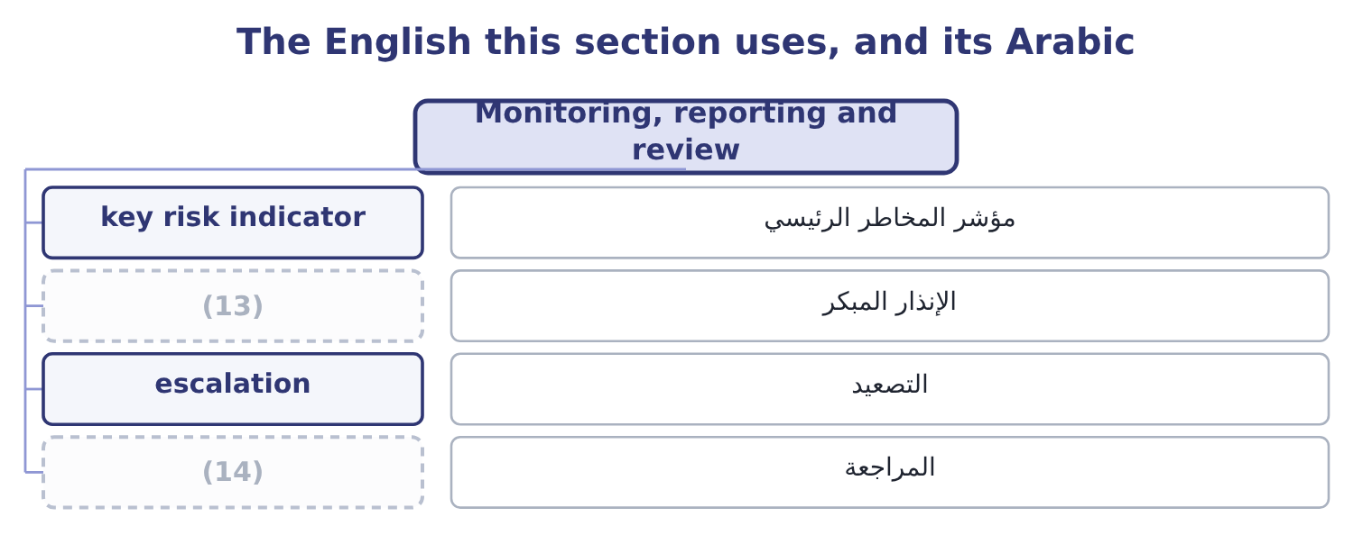
word list
early warning · review · zero tolerance

The English this sheet uses, and its Arabic
English (exam term) | Arabic
key risk indicator | مؤشر المخاطر الرئيسي
early warning | الإنذار المبكر
escalation | التصعيد
review | المراجعة

Answer key · 6.3 Monitoring, reporting and review

1 project | 8 receivables
2 consists | 9 early-warning
3 Confirming | 10 pointing
4 agreed | 11 periodically
5 somebody | 12 significant
6 controls | 13 early warning
7 reconciliations | 14 review

the summaries in full
Summary 1 The last step is the one that turns a project into a process, and the exam asks what it consists. Confirming that responses are in place. An agreed action with an owner and a date is not a control until somebody has checked it exists. Testing that controls work. Key risk indicators are measures that move before a loss does — supplier delivery performance, staff turnover, overdue reconciliations, the age of receivables, complaint volumes, near-misses. They are the early-warning half of the process, and they differ from key performance indicators in pointing forward at a risk rather than backward at a result. To the board, periodically, in a form that shows the significant risks, their assessment, the responses, the owners and what has changed. What has changed is the part boards read. Reviewing the process itself. Whether the register is current, whether the appetite still fits the strategy, whether any loss occurred that the process should have caught — which is Book 3's postaudit applied to risk. A route by which a risk discovered at any level reaches the people who can act, without depending on the goodwill of everybody in between.

6.4 Attitude toward risk
Chapter 6 · section 6.4

Fill every gap. Each word list holds one word more than there are gaps.
Summary 1 gaps 1–12
The (1) outcome asks how attitude to risk (2) its management, and the (3) begins with three (4) positions. A decision-maker who prefers a certain outcome to a gamble of the same expected value, and who requires (5) for bearing variability. Most companies and most (6) are risk averse over (7) that matter to them, and the entire cost of capital of Book 2 is built on the assumption. A decision-maker indifferent between a certain amount and a gamble with the same expected value, who (8) decides by expected value alone. This is the assumption behind, which is why those (9) need the risk (10) of Book 3's. A decision-maker who prefers the gamble — who will pay for variability. It appears in companies more often than theory (11) : in a division with nothing left to lose, in a manager whose bonus pays only above a (12) , and in anybody who has already lost money and is trying to recover it.
word list
suggests · calculations · individuals · second · threshold · answer · amounts · therefore · classical · affects · compensation · indifferent · adjustments

Worked example: what attitude costs, in money

Summary 2 gaps 13–24
A new (13) contract offers a 50 per cent chance of (14) 2,000,000 of contribution and a 50 per cent chance of losing 1,000,000. The favourable branch (15) 0.5 × 2,000,000 = 1,000,000, the (16) 0.5 × 1,000,000 = 500,000, so the expected value is 1,000,000 − 500,000 = 500,000 positive. A (17) company takes it. The expected value is positive, which is the whole of the test. A (18) company may not. If (19) board would be indifferent between this gamble and a certain 200,000, then its certainty (20) is 200,000 and the risk premium it demands is 500,000 − 200,000 = 300,000. Any (21) of the contract that locks in less than 200,000 of certain contribution will be (22) , even though its expected value is 500,000. That (23) — 300,000 — is what risk aversion costs, and it is not a (24) . It is the price of avoiding a 50 per cent chance of losing a million, and whether it is too high depends on whether losing a million would matter, which is the capacity question of section 6.5.
word list
contributes · refused · adding · mistake · risk-neutral · number · version · decides · unfavourable · equivalent · risk-averse · Orontes's · export

Summary 3 gaps 25–33
Risk aversion that reflects real consequences is rational; risk aversion that reflects a (25) fear of being blamed is a (26) problem. Four ways attitude (27) the management of risk, and these are the (28) consequences. It sets the (29) chosen. An averse organisation insures, (30) and avoids; a neutral one retains more and (31) expected costs; a seeking one exploits. Faced with, three attitudes produce three different (32) from the same (33) . Book 3's risk premium is attitude expressed as a discount rate, and a higher premium rejects projects a less averse company would accept. It differs across the organisation, which is the problem.
word list
compares · responses · refused · controls · examinable · arithmetic · changes · deductibles · governance · manager's

Summary 4 gaps 34–45
A company can be averse about (34) , neutral about credit and seeking about new (35) , and that is (36) only if somebody has said so. Where it is not said, attitude is set by whoever is (37) , and it varies with their incentives — which is why the appetite (38) of the next section (39) . And it is (40) by incentives and by (41) . A bonus that pays above a target makes a manager (42) just below it; a loss already (43) makes people take worse risks to recover it; and the same decision (44) as a possible gain or a possible loss produces different answers from the same person. Those are findings about human behaviour, and the exam expects them to be (45) as a reason for written limits rather than individual judgment.
word list
products · framing · recognised · whoever · coherent · presented · deciding · incurred · shaped · statement · risk-seeking · safety · exists

The English this section uses, and its Arabic
Each term sits against what it means.
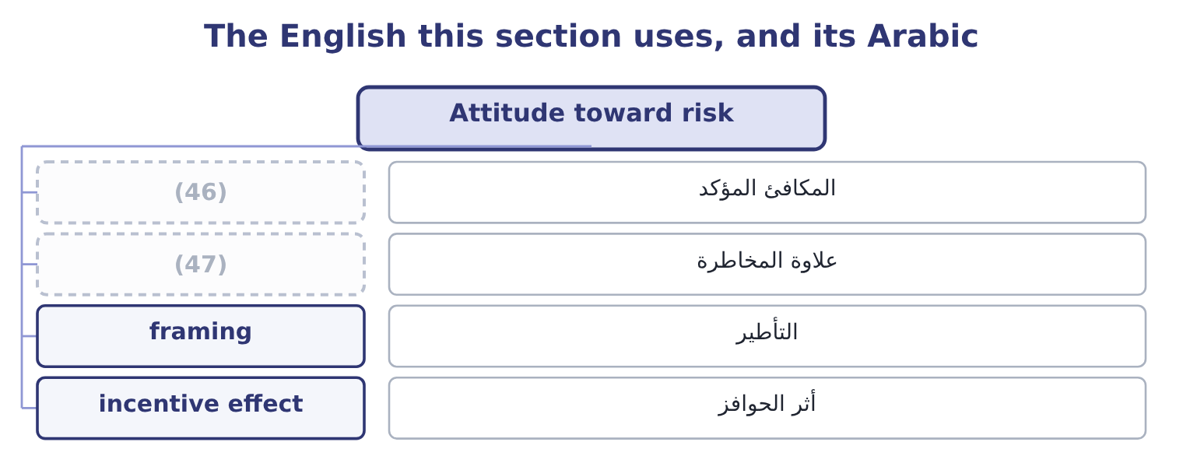
word list
incentive effect · certainty equivalent · risk premium

The English this sheet uses, and its Arabic
English (exam term) | Arabic
certainty equivalent | المكافئ المؤكد
risk premium | علاوة المخاطرة
framing | التأطير
incentive effect | أثر الحوافز

Answer key · 6.4 Attitude toward risk

1 second | 25 manager's
2 affects | 26 governance
3 answer | 27 changes
4 classical | 28 examinable
5 compensation | 29 responses
6 individuals | 30 controls
7 amounts | 31 compares
8 therefore | 32 deductibles
9 calculations | 33 arithmetic
10 adjustments | 34 safety
11 suggests | 35 products
12 threshold | 36 coherent
13 export | 37 deciding
14 adding | 38 statement
15 contributes | 39 exists
16 unfavourable | 40 shaped
17 risk-neutral | 41 framing
18 risk-averse | 42 risk-seeking
19 Orontes's | 43 incurred
20 equivalent | 44 presented
21 version | 45 recognised
22 refused | 46 certainty equivalent
23 number | 47 risk premium
24 mistake

the summaries in full
Summary 1 The second outcome asks how attitude to risk affects its management, and the answer begins with three classical positions. A decision-maker who prefers a certain outcome to a gamble of the same expected value, and who requires compensation for bearing variability. Most companies and most individuals are risk averse over amounts that matter to them, and the entire cost of capital of Book 2 is built on the assumption. A decision-maker indifferent between a certain amount and a gamble with the same expected value, who therefore decides by expected value alone. This is the assumption behind, which is why those calculations need the risk adjustments of Book 3's. A decision-maker who prefers the gamble — who will pay for variability. It appears in companies more often than theory suggests: in a division with nothing left to lose, in a manager whose bonus pays only above a threshold, and in anybody who has already lost money and is trying to recover it.
Summary 2 A new export contract offers a 50 per cent chance of adding 2,000,000 of contribution and a 50 per cent chance of losing 1,000,000. The favourable branch contributes 0.5 × 2,000,000 = 1,000,000, the unfavourable 0.5 × 1,000,000 = 500,000, so the expected value is 1,000,000 − 500,000 = 500,000 positive. A risk-neutral company takes it. The expected value is positive, which is the whole of the test. A risk-averse company may not. If Orontes's board would be indifferent between this gamble and a certain 200,000, then its certainty equivalent is 200,000 and the risk premium it demands is 500,000 − 200,000 = 300,000. Any version of the contract that locks in less than 200,000 of certain contribution will be refused, even though its expected value is 500,000. That number — 300,000 — is what risk aversion costs, and it is not a mistake. It is the price of avoiding a 50 per cent chance of losing a million, and whether it is too high depends on whether losing a million would matter, which is the capacity question of section 6.5.
Summary 3 Risk aversion that reflects real consequences is rational; risk aversion that reflects a manager's fear of being blamed is a governance problem. Four ways attitude changes the management of risk, and these are the examinable consequences. It sets the responses chosen. An averse organisation insures, controls and avoids; a neutral one retains more and compares expected costs; a seeking one exploits. Faced with, three attitudes produce three different deductibles from the same arithmetic. Book 3's risk premium is attitude expressed as a discount rate, and a higher premium rejects projects a less averse company would accept. It differs across the organisation, which is the problem.
Summary 4 A company can be averse about safety, neutral about credit and seeking about new products, and that is coherent only if somebody has said so. Where it is not said, attitude is set by whoever is deciding, and it varies with their incentives — which is why the appetite statement of the next section exists. And it is shaped by incentives and by framing. A bonus that pays above a target makes a manager risk-seeking just below it; a loss already incurred makes people take worse risks to recover it; and the same decision presented as a possible gain or a possible loss produces different answers from the same person. Those are findings about human behaviour, and the exam expects them to be recognised as a reason for written limits rather than individual judgment.

6.5 Appetite, tolerance and capacity
Chapter 6 · section 6.5

Fill every gap. Each word list holds one word more than there are gaps.
Summary 1 gaps 1–12
Attitude becomes (1) when it is (2) down, and three terms do that work. The exam (3) them and candidates (4) confuse them. Risk capacity is the (5) risk the company could bear — a fact about its balance sheet, its cash and its (6) , not a preference. (7) lending covenant (8) interest cover of four times, which on interest of $390,000 means operating income must stay above 390,000 × 4 = 1,560,000. Against the (9) $4,348,800 that is a headroom of 4,348,800 − 1,560,000 = 2,788,800: the company can lose that much of its operating income (10) the covenant binds, and that figure is part of its capacity. Risk appetite is the amount and kind of risk the company (11) to take in (12) of its objectives. It is a decision of the board, it is necessarily less than capacity, and it is expressed by category: which risks the company seeks, which it accepts, and which it will not take at any price.
word list
requires · manageable · Orontes's · pursuit · routinely · distinguishes · obligations · maximum · written · chooses · before · metaphor · present

Summary 2 gaps 13–23
Risk tolerance is the (13) variation around a (14) objective — the limit in practice. A usable appetite (15) has four features, and an answer that gives them is a (16) answer. It is expressed in (17) the business (18) uses. It (19) by category. A single appetite for all risks is useless: nobody has the same appetite for a (20) risk and a (21) risk. It names the (22) categories (23) . Bribery, safety, deliberate misstatement, breach of sanctions: these are the categories where the answer is no regardless of the return, and Book 4's second half is about why. And it connects to limits that bind somebody's decision. An appetite that does not change what anybody may do is a paragraph, not a control.
word list
zero-tolerance · measures · already · food-safety · statement · specific · differentiates · explicitly · acceptable · medicine · currency · complete

Capacity, appetite and tolerance
Every item belongs to exactly one group.
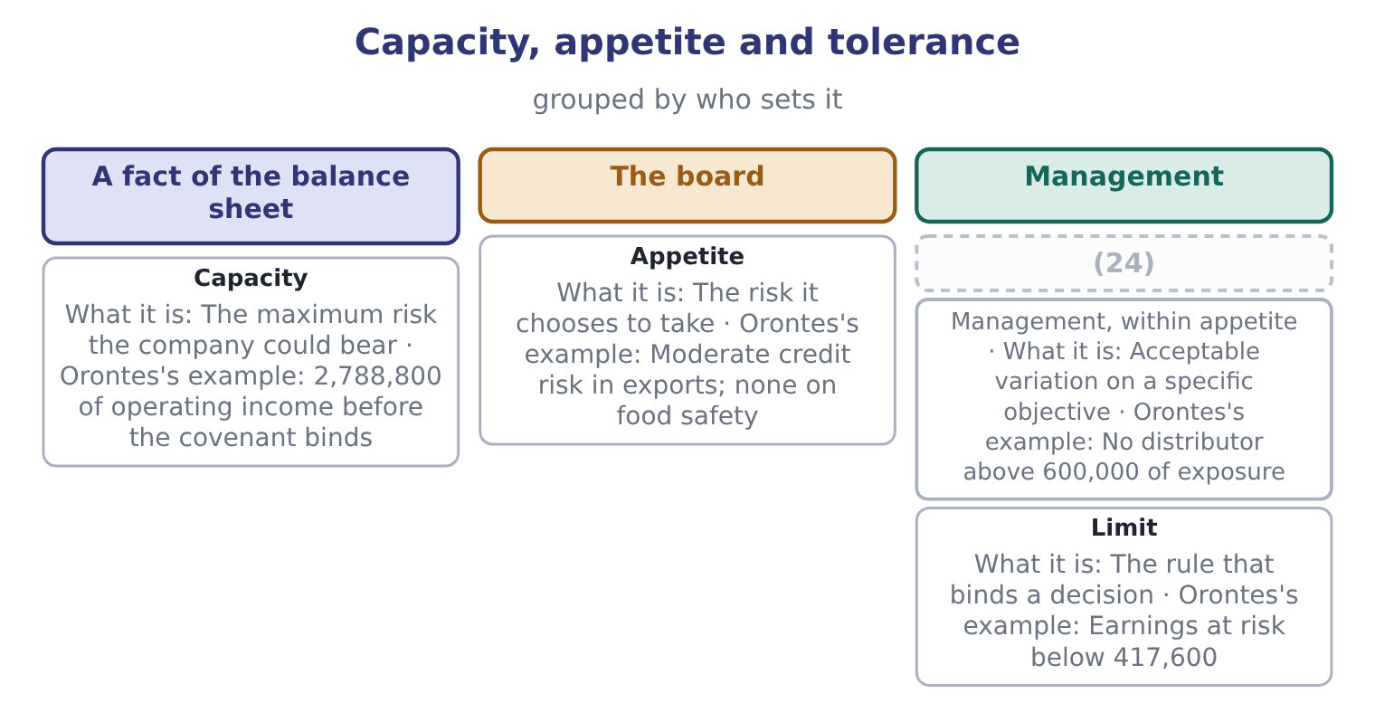
word list
Tolerance · framing

Process and appetite

Your turn: running the process (complete the blanks)
Item | Data | Answer
The step the process should begin with |  | ________
Expected loss on a supplier failure | (25) | ________
Risk premium demanded | (26) | ________
Operating income floor under a four-times cover covenant | Interest 390,000 | ________
Headroom against that floor | Operating income 4,348,800 | ________
Earnings at risk limit at 10 per cent of operating income | (27) | ________

word list
Operating income 4,176,000 · Likelihood 0.25; impact 1,933,134 · risk management process · Expected value 500,000; certainty equivalent 200,000

"Appetite", "tolerance" and "capacity"

Summary 3 gaps 28–38
English risk appetite is a metaphor from eating, and like most (28) it leaks: appetite (29) a quantity somebody wants, when what is meant is a (30) policy about which risks to take and how much. Tolerance comes from medicine and (31) , where a tolerance is the (32) deviation from a (33) , and that image is exactly right — a tolerance is a band around a target. Capacity is from physics, a (34) volume, and is (35) apt: it is what the company could hold, not what it wants to. The error to avoid in any language is using appetite where you mean capacity, which turns a preference into a (36) and lets a board believe it has decided (37) when it has only (38) its balance sheet.
word list
described · equally · something · suggests · specification · container's · engineering · considered · permitted · deviation · metaphors · constraint

"Appetite", "tolerance" and "capacity"
Item | Answer
The first step | Establish the objectives and the context; risk is defined relative to an objective.
Expected loss on a supplier failure | 483,284: 0.25 × 1,933,134 = 483,284.
Risk premium demanded | (39)
Operating income floor | (40)
Headroom against the floor | (41)
Earnings at risk limit | 417,600: 4,176,000 × 0.10 = 417,600.
What it tells you | The first answer is the process and the other five are the appetite — and the appetite only becomes usable at the point where it turns into

word list
The risk it chooses to take · 300,000: 500,000 − 200,000 = 300,000. · 1,560,000: 390,000 × 4 = 1,560,000. · 2,788,800: 4,348,800 − 1,560,000 = 2,788,800.

The English this section uses, and its Arabic
Each term sits against what it means.
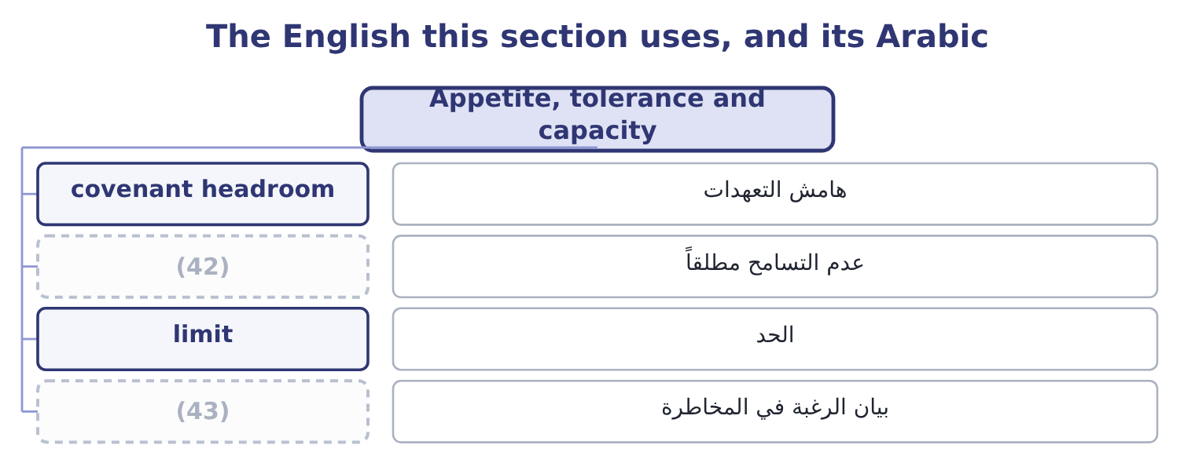
word list
appetite statement · zero tolerance · risk premium

The English this sheet uses, and its Arabic
English (exam term) | Arabic
covenant headroom | هامش التعهدات
zero tolerance | عدم التسامح مطلقاً
limit | الحد
appetite statement | بيان الرغبة في المخاطرة

Answer key · 6.5 Appetite, tolerance and capacity

1 manageable | 23 explicitly
2 written | 24 Tolerance
3 distinguishes | 25 Likelihood 0.25; impact 1,933,134
4 routinely | 26 Expected value 500,000; certainty equivalent 200,000
5 maximum | 27 Operating income 4,176,000
6 obligations | 28 metaphors
7 Orontes's | 29 suggests
8 requires | 30 considered
9 present | 31 engineering
10 before | 32 permitted
11 chooses | 33 specification
12 pursuit | 34 container's
13 acceptable | 35 equally
14 specific | 36 constraint
15 statement | 37 something
16 complete | 38 described
17 measures | 39 300,000: 500,000 − 200,000 = 300,000.
18 already | 40 1,560,000: 390,000 × 4 = 1,560,000.
19 differentiates | 41 2,788,800: 4,348,800 − 1,560,000 = 2,788,800.
20 food-safety | 42 zero tolerance
21 currency | 43 appetite statement
22 zero-tolerance

the summaries in full
Summary 1 Attitude becomes manageable when it is written down, and three terms do that work. The exam distinguishes them and candidates routinely confuse them. Risk capacity is the maximum risk the company could bear — a fact about its balance sheet, its cash and its obligations, not a preference. Orontes's lending covenant requires interest cover of four times, which on interest of $390,000 means operating income must stay above 390,000 × 4 = 1,560,000. Against the present $4,348,800 that is a headroom of 4,348,800 − 1,560,000 = 2,788,800: the company can lose that much of its operating income before the covenant binds, and that figure is part of its capacity. Risk appetite is the amount and kind of risk the company chooses to take in pursuit of its objectives. It is a decision of the board, it is necessarily less than capacity, and it is expressed by category: which risks the company seeks, which it accepts, and which it will not take at any price.
Summary 2 Risk tolerance is the acceptable variation around a specific objective — the limit in practice. A usable appetite statement has four features, and an answer that gives them is a complete answer. It is expressed in measures the business already uses. It differentiates by category. A single appetite for all risks is useless: nobody has the same appetite for a food-safety risk and a currency risk. It names the zero-tolerance categories explicitly. Bribery, safety, deliberate misstatement, breach of sanctions: these are the categories where the answer is no regardless of the return, and Book 4's second half is about why. And it connects to limits that bind somebody's decision. An appetite that does not change what anybody may do is a paragraph, not a control.
Summary 3 English risk appetite is a metaphor from eating, and like most metaphors it leaks: appetite suggests a quantity somebody wants, when what is meant is a considered policy about which risks to take and how much. Tolerance comes from medicine and engineering, where a tolerance is the permitted deviation from a specification, and that image is exactly right — a tolerance is a band around a target. Capacity is from physics, a container's volume, and is equally apt: it is what the company could hold, not what it wants to. The error to avoid in any language is using appetite where you mean capacity, which turns a preference into a constraint and lets a board believe it has decided something when it has only described its balance sheet.

