7.1 Managing operational risk
Chapter 7 · section 7.1

Fill every gap. Each word list holds one word more than there are gaps.
Chapter 7, section by section
Each stage leads to the next.
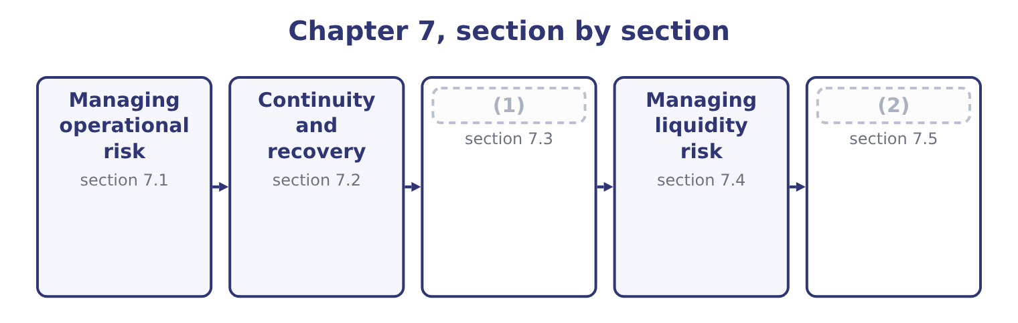
word list
Managing credit risk · Managing market risk · segregation of duties

Summary 1 gaps 3–14
Operational risk is (3) almost entirely by (4) , because, nobody is paid a return for bearing it. The (5) fall into six groups and an answer that uses the groups is (6) than one that lists twenty controls. Controls, in their two kinds. A preventive control stops the event — an (7) before a payment, a check before a (8) is accepted, an access right that does not exist. A (9) control finds it (10) — a reconciliation, an exception report, a stock count, a review of unusual items. Both are needed: prevention is better and never complete, and (11) limits the (12) of what prevention missed. (13) of duties, so that no one person both performs and checks a transaction; authorisation limits that rise with seniority; mandatory leave, during which somebody else does the job and anything being concealed surfaces; rotation of duties; dual (14) on payments. These are the controls that address deliberate as well as accidental loss.
word list
Segregation · clearer · delivery · duration · afterwards · signatures · approval · succession · reduction · methods · detection · managed · detective

Summary 2 gaps 15–26
A (15) procedure performed the same way every time produces fewer errors than judgment (16) afresh; a system that will not accept an invalid entry prevents what a reminder cannot. The caution: (17) converts many small human errors into few large (18) ones, so an automated control needs its own testing. (19) checks, training, (20) , competence assessment, succession planning for key roles, and attention to workload and turnover, which are among the best leading indicators of operational failure. A second supplier, a standby machine, backups kept (21) else, spare capacity, (22) staff. These do not reduce the (23) of an event; they reduce what it costs, which section 7.2 (24) . A loss database that records events and (25) , root cause analysis of (26) ones, key risk indicators of the kind, and the postaudit discipline of asking, after every loss, which control should have caught it and why it did not.
word list
supervision · somewhere · near-misses · systematic · significant · address · automation · cross-trained · develops · probability · Recruitment · exercised · documented

Worked example: designing the control for one process

Summary 3 gaps 27–38
Orontes pays about four hundred supplier (27) a month. The risks are paying an invoice that is not owed, paying it twice, paying the wrong (28) , and paying a (29) supplier invented by an employee. (30) matching of purchase order, goods received note and invoice, performed by the system; a supplier master file that only two named people may change, with changes reviewed by a third; payment authorisation limits by value; and bank details verified by (31) to a number held on file, never to a number on the invoice. A monthly report of (32) invoice numbers and amounts; a (33) review of new suppliers created, matched against the employee address file; a supplier statement reconciliation. The person who (34) a supplier may not approve a payment to it, and the person who (35) may not release it at the bank. Four risks, ten controls, and the (36) ones are the automated preventive checks that run on every transaction. The structural control costs nothing but (37) , and it is the one most often absent in a small finance team — which is precisely why the (38) fraud.
word list
amount · fake-supplier · approves · fraudulent · organisation · Three-way · quarterly · telephone · exception · duplicate · costly · invoices · creates

The English this section uses, and its Arabic
Each term sits against what it means.
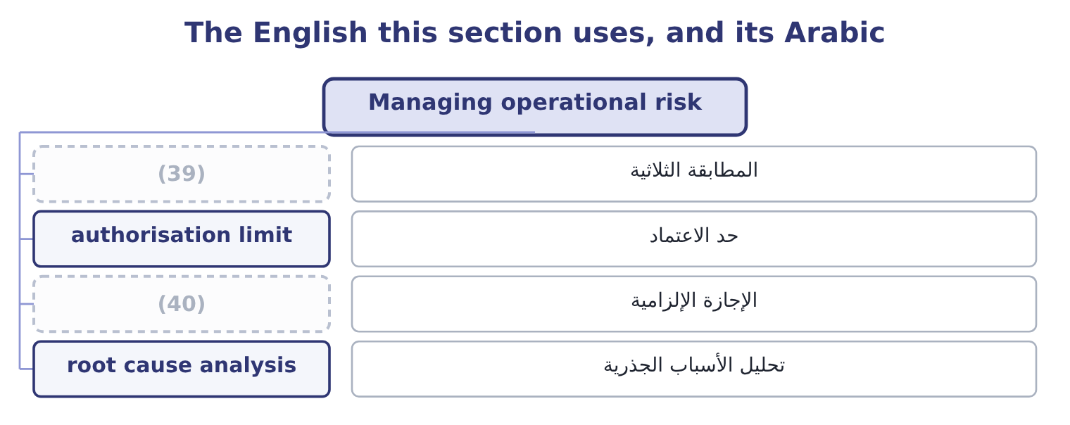
word list
authorisation limit · mandatory leave · three-way match

The English this sheet uses, and its Arabic
English (exam term) | Arabic
three-way match | المطابقة الثلاثية
authorisation limit | حد الاعتماد
mandatory leave | الإجازة الإلزامية
root cause analysis | تحليل الأسباب الجذرية

Answer key · 7.1 Managing operational risk

1 Managing credit risk | 21 somewhere
2 Managing market risk | 22 cross-trained
3 managed | 23 probability
4 reduction | 24 develops
5 methods | 25 near-misses
6 clearer | 26 significant
7 approval | 27 invoices
8 delivery | 28 amount
9 detective | 29 fraudulent
10 afterwards | 30 Three-way
11 detection | 31 telephone
12 duration | 32 duplicate
13 Segregation | 33 quarterly
14 signatures | 34 creates
15 documented | 35 approves
16 exercised | 36 costly
17 automation | 37 organisation
18 systematic | 38 fake-supplier
19 Recruitment | 39 three-way match
20 supervision | 40 mandatory leave

the summaries in full
Summary 1 Operational risk is managed almost entirely by reduction, because, nobody is paid a return for bearing it. The methods fall into six groups and an answer that uses the groups is clearer than one that lists twenty controls. Controls, in their two kinds. A preventive control stops the event — an approval before a payment, a check before a delivery is accepted, an access right that does not exist. A detective control finds it afterwards — a reconciliation, an exception report, a stock count, a review of unusual items. Both are needed: prevention is better and never complete, and detection limits the duration of what prevention missed. Segregation of duties, so that no one person both performs and checks a transaction; authorisation limits that rise with seniority; mandatory leave, during which somebody else does the job and anything being concealed surfaces; rotation of duties; dual signatures on payments. These are the controls that address deliberate as well as accidental loss.
Summary 2 A documented procedure performed the same way every time produces fewer errors than judgment exercised afresh; a system that will not accept an invalid entry prevents what a reminder cannot. The caution: automation converts many small human errors into few large systematic ones, so an automated control needs its own testing. Recruitment checks, training, supervision, competence assessment, succession planning for key roles, and attention to workload and turnover, which are among the best leading indicators of operational failure. A second supplier, a standby machine, backups kept somewhere else, spare capacity, cross-trained staff. These do not reduce the probability of an event; they reduce what it costs, which section 7.2 develops. A loss database that records events and near-misses, root cause analysis of significant ones, key risk indicators of the kind, and the postaudit discipline of asking, after every loss, which control should have caught it and why it did not.
Summary 3 Orontes pays about four hundred supplier invoices a month. The risks are paying an invoice that is not owed, paying it twice, paying the wrong amount, and paying a fraudulent supplier invented by an employee. Three-way matching of purchase order, goods received note and invoice, performed by the system; a supplier master file that only two named people may change, with changes reviewed by a third; payment authorisation limits by value; and bank details verified by telephone to a number held on file, never to a number on the invoice. A monthly report of duplicate invoice numbers and amounts; a quarterly review of new suppliers created, matched against the employee address file; a supplier statement reconciliation. The person who creates a supplier may not approve a payment to it, and the person who approves may not release it at the bank. Four risks, ten controls, and the costly ones are the automated preventive checks that run on every transaction. The structural control costs nothing but organisation, and it is the one most often absent in a small finance team — which is precisely why the fake-supplier fraud.

7.2 Continuity and recovery
Chapter 7 · section 7.2

Fill every gap. Each word list holds one word more than there are gaps.
Summary 1 gaps 1–12
Some (1) events cannot be prevented, and for those the (2) method is planning what happens next. The exam (3) two related (4) . A business continuity plan sets out how the business keeps operating during a (5) : which activities are critical, in what order they are restored, where people work, how (6) are told, who decides. Its unit of analysis is the business process. A (7) recovery plan is the technical subset: how systems and data are restored, from what (8) , at what site, within what time. Its unit of analysis is the system. Four (9) travel with them. A business (10) analysis, which asks what each process is worth per hour or per day of (11) . The recovery time objective: how (12) a process must be back. It is a business decision, not a technical one, and it drives the cost of everything else.
word list
disruption · disaster · things · backups · management · impact · alternative · quickly · customers · distinguishes · interruption · concepts · operational

Summary 2 gaps 13–24
The recovery point objective: how much data the company can (13) to lose, which (14) backup frequency. And the critical dependency list: the (15) , utilities, systems, (16) and people without which a process cannot run. Most continuity plans fail at this point, because the dependency that stops the business is usually one nobody mapped — a single (17) , a single shipping agent, a licence held in one (18) name. Three rules make a plan real rather than (19) . An untested plan is a document, and testing finds the (20) : the contact list that is out of date, the backup that cannot be restored, the (21) site with no power for the equipment. It must be (22) when the event happens. A plan stored only on the system that is down is a (23) and complete (24) . And it must name people and decisions, not intentions.
word list
suppliers · afford · failure · objective · approver · omissions · premises · determines · accessible · decorative · person's · familiar · alternative

The English this section uses, and its Arabic
Each term sits against what it means.
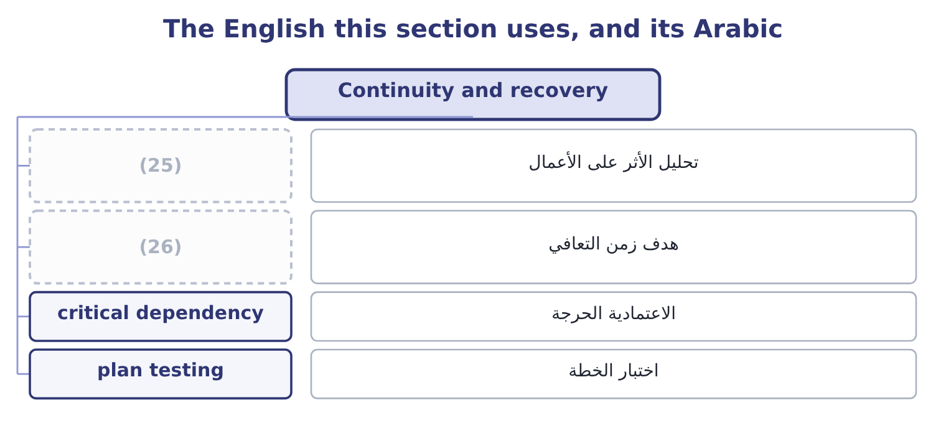
word list
dealing and settlement · business impact analysis · recovery time objective

The English this sheet uses, and its Arabic
English (exam term) | Arabic
business impact analysis | تحليل الأثر على الأعمال
recovery time objective | هدف زمن التعافي
critical dependency | الاعتمادية الحرجة
plan testing | اختبار الخطة

Answer key · 7.2 Continuity and recovery

1 operational | 14 determines
2 management | 15 suppliers
3 distinguishes | 16 premises
4 things | 17 approver
5 disruption | 18 person's
6 customers | 19 decorative
7 disaster | 20 omissions
8 backups | 21 alternative
9 concepts | 22 accessible
10 impact | 23 familiar
11 interruption | 24 failure
12 quickly | 25 business impact analysis
13 afford | 26 recovery time objective

the summaries in full
Summary 1 Some operational events cannot be prevented, and for those the management method is planning what happens next. The exam distinguishes two related things. A business continuity plan sets out how the business keeps operating during a disruption: which activities are critical, in what order they are restored, where people work, how customers are told, who decides. Its unit of analysis is the business process. A disaster recovery plan is the technical subset: how systems and data are restored, from what backups, at what site, within what time. Its unit of analysis is the system. Four concepts travel with them. A business impact analysis, which asks what each process is worth per hour or per day of interruption. The recovery time objective: how quickly a process must be back. It is a business decision, not a technical one, and it drives the cost of everything else.
Summary 2 The recovery point objective: how much data the company can afford to lose, which determines backup frequency. And the critical dependency list: the suppliers, utilities, systems, premises and people without which a process cannot run. Most continuity plans fail at this point, because the dependency that stops the business is usually one nobody mapped — a single approver, a single shipping agent, a licence held in one person's name. Three rules make a plan real rather than decorative. An untested plan is a document, and testing finds the omissions: the contact list that is out of date, the backup that cannot be restored, the alternative site with no power for the equipment. It must be accessible when the event happens. A plan stored only on the system that is down is a familiar and complete failure. And it must name people and decisions, not intentions.

7.3 Managing credit risk
Chapter 7 · section 7.3

Fill every gap. Each word list holds one word more than there are gaps.
Summary 1 gaps 1–12
Financial risk (1) begins with the money owed to the company. The methods form a sequence that matches the life of a (2) . Before the sale: (3) . Financial statements, credit agency reports, trade references, the length and history of the (4) , and the country the customer sits. The (5) is a credit limit and terms, not a yes or no. At the sale: (6) . Terms of payment, deposits or (7) in advance, retention of title until payment, a letter of credit or a bank guarantee for export sales —. During the life: (8) . Ageing of the balance, (9) against the limit, the pattern of payments rather than only the total, and alerts on deterioration elsewhere in the market. After the due date: collection. A defined escalation with dates, from a reminder through to suspension of supply and legal action, applied (10) , because customers learn quickly which suppliers mean what they say. And across the whole: (11) measures. Concentration limits so that no single customer can cause an unacceptable loss, credit insurance, factoring, and (12) across customers, sectors and countries.
word list
part-payment · monitoring · consistently · management · diversification · portfolio · assessment · output · candidates · receivable · utilisation · structure · relationship

Worked example: pricing a distributor's credit

Summary 2 gaps 13–24
Orontes's limit for a single distributor is 600,000. The credit agency puts the distributor's probability of default at 2 per cent in a year, and Orontes (13) to recover 30 per cent of any balance, so the loss given default is 70 per cent. The expected loss is 600,000 × 0.02 = 12,000 of (14) exposure, of which 12,000 × 0.70 = 8,400 would be lost. The distributor's trade earns a contribution of 240,000 a year. An expected credit loss of 8,400 against 240,000 of contribution is a cost of doing (15) , not a reason to (16) . What would (17) the answer is concentration — a balance that could not be (18) if it went — or a deterioration that (19) the default probability. (20) that the right (21) here is not to reduce the credit risk but to price it and watch it. This is: Orontes's cash (22) lets it offer terms a weaker (23) cannot, and the 8,400 is what that (24) costs.
word list
advantage · raises · sectors · response · business · change · expects · Observe · absorbed · defaulted · position · competitor · refuse

Summary 3 gaps 25–30
One (25) method belongs here because (26) forget it. (27) terms reduces exposure without (28) anybody. Orontes's (29) stand at $4,144,000, which on sales of $42,000,000 is 36 days; since sales run at 42,000,000 ÷ 365 = 115,068 a day, (30) six days from the collection period would release 115,068 × 6 = 690,408 of cash and reduce the amount at risk by the same figure.
word list
cutting · receivables · refusing · against · candidates · Shortening · further

The English this section uses, and its Arabic
Each term sits against what it means.
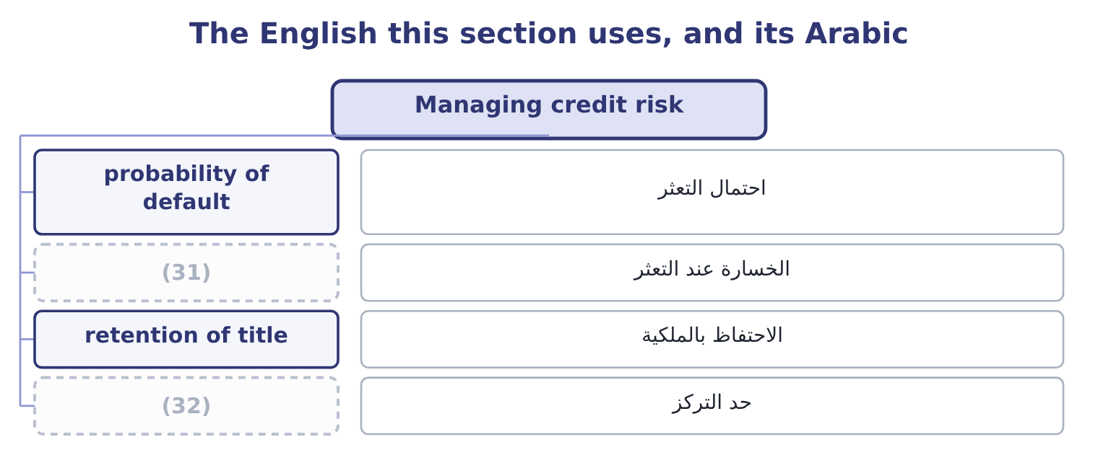
word list
الخسارة عند التعثر · concentration limit · loss given default

The English this sheet uses, and its Arabic
English (exam term) | Arabic
probability of default | احتمال التعثر
loss given default | الخسارة عند التعثر
retention of title | الاحتفاظ بالملكية
concentration limit | حد التركز

Answer key · 7.3 Managing credit risk

1 management | 17 change
2 receivable | 18 absorbed
3 assessment | 19 raises
4 relationship | 20 Observe
5 output | 21 response
6 structure | 22 position
7 part-payment | 23 competitor
8 monitoring | 24 advantage
9 utilisation | 25 further
10 consistently | 26 candidates
11 portfolio | 27 Shortening
12 diversification | 28 refusing
13 expects | 29 receivables
14 defaulted | 30 cutting
15 business | 31 loss given default
16 refuse | 32 concentration limit

the summaries in full
Summary 1 Financial risk management begins with the money owed to the company. The methods form a sequence that matches the life of a receivable. Before the sale: assessment. Financial statements, credit agency reports, trade references, the length and history of the relationship, and the country the customer sits. The output is a credit limit and terms, not a yes or no. At the sale: structure. Terms of payment, deposits or part-payment in advance, retention of title until payment, a letter of credit or a bank guarantee for export sales —. During the life: monitoring. Ageing of the balance, utilisation against the limit, the pattern of payments rather than only the total, and alerts on deterioration elsewhere in the market. After the due date: collection. A defined escalation with dates, from a reminder through to suspension of supply and legal action, applied consistently, because customers learn quickly which suppliers mean what they say. And across the whole: portfolio measures. Concentration limits so that no single customer can cause an unacceptable loss, credit insurance, factoring, and diversification across customers, sectors and countries.
Summary 2 Orontes's limit for a single distributor is 600,000. The credit agency puts the distributor's probability of default at 2 per cent in a year, and Orontes expects to recover 30 per cent of any balance, so the loss given default is 70 per cent. The expected loss is 600,000 × 0.02 = 12,000 of defaulted exposure, of which 12,000 × 0.70 = 8,400 would be lost. The distributor's trade earns a contribution of 240,000 a year. An expected credit loss of 8,400 against 240,000 of contribution is a cost of doing business, not a reason to refuse. What would change the answer is concentration — a balance that could not be absorbed if it went — or a deterioration that raises the default probability. Observe that the right response here is not to reduce the credit risk but to price it and watch it. This is: Orontes's cash position lets it offer terms a weaker competitor cannot, and the 8,400 is what that advantage costs.
Summary 3 One further method belongs here because candidates forget it. Shortening terms reduces exposure without refusing anybody. Orontes's receivables stand at $4,144,000, which on sales of $42,000,000 is 36 days; since sales run at 42,000,000 ÷ 365 = 115,068 a day, cutting six days from the collection period would release 115,068 × 6 = 690,408 of cash and reduce the amount at risk by the same figure.

7.4 Managing liquidity risk
Chapter 7 · section 7.4

Fill every gap. Each word list holds one word more than there are gaps.
Summary 1 gaps 1–12
The (1) methods are four. A rolling cash (2) — thirteen weeks in detail, twelve months in outline — built from receipts and payments rather than from profit, with the (3) of Book 3's. A company that cannot say what its cash will be in eight weeks is not (4) liquidity; it is (5) it. Cash and committed facilities sized against (6) , not chosen round. A (7) basis is the fixed cost base: Orontes's fixed costs of $12,624,000 are 12,624,000 ÷ 12 = 1,052,000 a month, so three months of fixed costs with no receipts at all is 1,052,000 × 3 = 3,156,000 — which the $7,302,100 cash (8) covers twice over, and which gives the board a reason for the number rather than a habit. Matching the maturity of funding to the life of the assets it supports, so that long assets are not financed by money that can be withdrawn; staggering maturities so that nothing large falls due at once; keeping covenant (9) ,348,800 − 1,560,000 = 2,788,800 of operating income; and holding facilities that are committed rather than (10) . (11) in Book 1's: (12) faster, paying no earlier than agreed, holding less stock. These are the cheapest liquidity sources a company has, and the 690,408 released by six days of collection in section 7.3 is larger than most facilities a company of Orontes's size would negotiate.
word list
balance · collecting · something · sensitivity · managing · uncommitted · watching · headroom · management · defensible · holding · Everything · forecast

The English this section uses, and its Arabic
Each term sits against what it means.
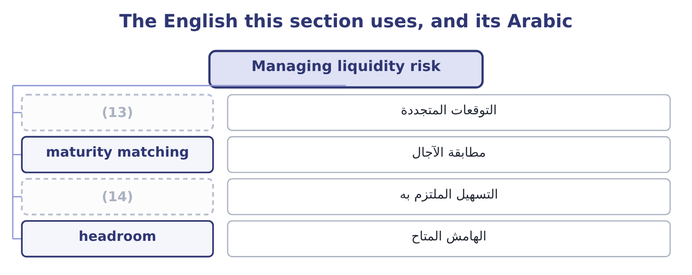
word list
الهامش المتاح · committed facility · rolling forecast

The English this sheet uses, and its Arabic
English (exam term) | Arabic
rolling forecast | التوقعات المتجددة
maturity matching | مطابقة الآجال
committed facility | التسهيل الملتزم به
headroom | الهامش المتاح

Answer key · 7.4 Managing liquidity risk

1 management | 8 balance
2 forecast | 9 headroom
3 sensitivity | 10 uncommitted
4 managing | 11 Everything
5 watching | 12 collecting
6 something | 13 rolling forecast
7 defensible | 14 committed facility

the summaries in full
Summary 1 The management methods are four. A rolling cash forecast — thirteen weeks in detail, twelve months in outline — built from receipts and payments rather than from profit, with the sensitivity of Book 3's. A company that cannot say what its cash will be in eight weeks is not managing liquidity; it is watching it. Cash and committed facilities sized against something, not chosen round. A defensible basis is the fixed cost base: Orontes's fixed costs of $12,624,000 are 12,624,000 ÷ 12 = 1,052,000 a month, so three months of fixed costs with no receipts at all is 1,052,000 × 3 = 3,156,000 — which the $7,302,100 cash balance covers twice over, and which gives the board a reason for the number rather than a habit. Matching the maturity of funding to the life of the assets it supports, so that long assets are not financed by money that can be withdrawn; staggering maturities so that nothing large falls due at once; keeping covenant headroom,348,800 − 1,560,000 = 2,788,800 of operating income; and holding facilities that are committed rather than uncommitted. Everything in Book 1's: collecting faster, paying no earlier than agreed, holding less stock. These are the cheapest liquidity sources a company has, and the 690,408 released by six days of collection in section 7.3 is larger than most facilities a company of Orontes's size would negotiate.

7.5 Managing market risk
Chapter 7 · section 7.5

Fill every gap. Each word list holds one word more than there are gaps.
Summary 1 gaps 1–12
Market risk is managed in four ways, and an answer that gives them in this order gives them in the order of cost. Natural hedging, which costs nothing. Arrange the (1) so that exposures offset: buy (2) in the currency sales are made in, (3) in the currency of the (4) , match a floating-rate asset with a floating-rate (5) , source from the (6) sales are made to. Orontes's export sales in euros are partly matched by its purchases of (7) and packaging in euros, and the exposure that needs (8) is only the (9) . Pricing in the (10) own currency, (11) clauses that share a price movement above a (12) , the ability to switch sourcing between regions, and the shorter exposure periods of section 7.2 — invoice promptly, collect promptly, and the exposure window shrinks.
word list
borrow · inputs · Natural · company's · contractual · assets · equipment · liability · threshold · difference · managing · region · business

Summary 2 gaps 13–23
Forwards, (13) , options and swaps, which Book 2's. The (14) points are that a hedge removes the favourable movement along with the (15) one; that a hedge has a cost, (16) for an option and (17) in the forward rate; and that a hedge is only a hedge if it matches the exposure in amount and in timing, since a (18) is a position. A policy that says what (19) of exposure is hedged, over what horizon, with what instruments and with which (20) ; a prohibition on taking positions for gain; (21) of dealing from settlement and from recording; and regular reporting of positions and their value. More (22) treasury disasters come from the absence of this (23) than from any market movement.
word list
futures · corporate · implicit · paragraph · explicit · position · mismatch · counterparties · unfavourable · essential · separation · proportion

Worked example: two exposures at Orontes

Summary 3 gaps 24–35
Orontes's debt is $6,500,000 at 6 per cent. A (24) rise in rates on floating debt costs 6,500,000 × 0.01 = 65,000 a year, which against operating income of $4,348,800 is (25) — so the right response is to do nothing and say why. (26) euro receipts for the next (27) months are 2,000,000. The natural hedge first. Euro purchases of packaging and (28) run to 400,000 over the same period, so the net exposure is 2,000,000 − 400,000 = 1,600,000 and the policy (29) to. Forward sales of euros (30) the expected receipt dates, for 1,600,000 × 0.75 = 1,200,000, leaving a quarter (31) against the risk that a shipment slips. Two exposures, two (32) answers, and both (33) in writing. The interest rate exposure is left open because it is small relative to the company — a (34) reached by (35) rather than by assuming — and the currency exposure is hedged after the natural offset is taken first, which is the order that costs least. An exam answer that hedges everything with instruments has done the expensive thing first.
word list
unhedged · matching · conclusion · different · immaterial · twelve · measuring · Contracted · one-point · Arrange · applies · defensible · spares

Operational and financial methods

Your turn: which method? (complete the blanks)
Situation | Method
The person who creates a supplier may not approve its payment | ________
A monthly report of duplicate invoice amounts | ________
Buying packaging in the currency exports are sold in | ________
Thirteen weeks of receipts and payments, updated weekly | ________
A list of the suppliers and systems without which a process stops | ________
A limit of 600,000 on any one distributor's balance | ________

"Control", "hedge" and "exposure"

Summary 4 gaps 36–47
Control was (36) ; here note the pair (37) and detective, which in English are (38) describing when the control acts rather than how strong it is — a detective control is not a weak one, it is a later one. Hedge comes from the (39) that marks a (40) and limits movement, and the metaphor is exact: a hedge does not improve the position, it narrows the range of outcomes in both (41) . (42) who write that a hedge (43) against loss have given half the (44) , and the other half — that it gives up the gain — is what makes hedging a policy decision rather than an obvious good. And exposure, is the word to use when you mean the amount at stake: an exposure is hedged, a risk is managed, and a loss is (45) , and keeping the three verbs with their (46) nouns makes a report much (47) to read.
word list
boundary · discussed · incurred · Candidates · protects · preventive · adjectives · definition · quarter · directions · proper · hedgerow · easier

"Control", "hedge" and "exposure"
Situation | Method
Creator of a supplier may not approve its payment | (48)
Monthly report of duplicate invoice amounts | A detective control.
Buying packaging in the export currency | A natural hedge.
Thirteen weeks of receipts and payments | A rolling cash forecast.
A list of suppliers and systems a process needs | (49)
A 600,000 limit on one distributor | (50)
What it tells you | Six methods, and only one of them involves buying anything. Most risk management is (51) , information and discipline rather than exp

word list
A critical dependency list, within continuity planning. · Method · organisation · Segregation of duties, a structural control. · A concentration limit, within credit risk management.

The English this section uses, and its Arabic
Each term sits against what it means.
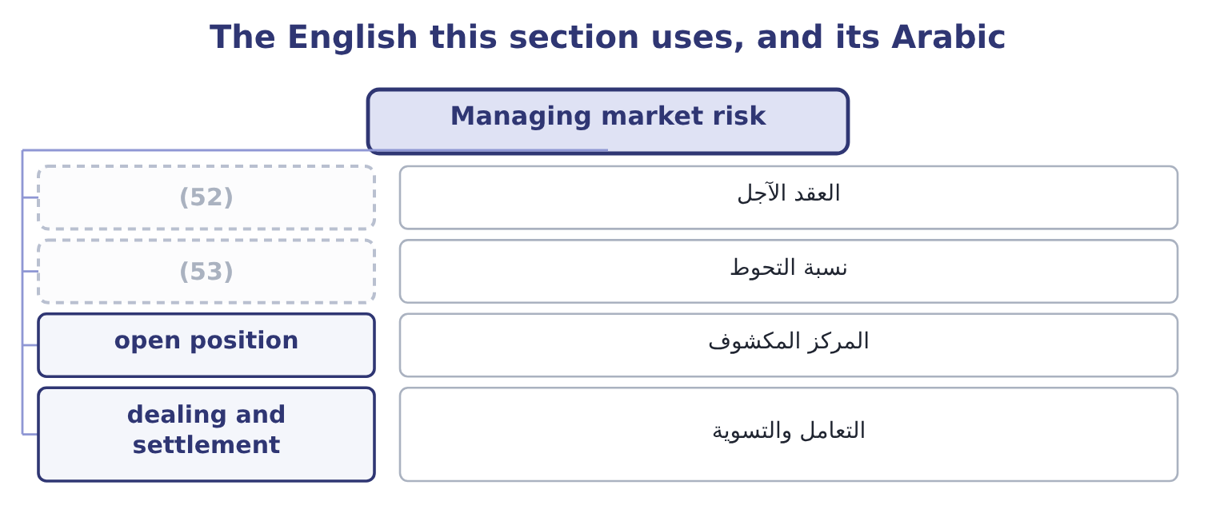
word list
detective control · hedge ratio · forward contract

The English this sheet uses, and its Arabic
English (exam term) | Arabic
forward contract | العقد الآجل
hedge ratio | نسبة التحوط
open position | المركز المكشوف
dealing and settlement | التعامل والتسوية

Answer key · 7.5 Managing market risk

1 business | 28 spares
2 inputs | 29 applies
3 borrow | 30 matching
4 assets | 31 unhedged
5 liability | 32 different
6 region | 33 defensible
7 equipment | 34 conclusion
8 managing | 35 measuring
9 difference | 36 discussed
10 company's | 37 preventive
11 contractual | 38 adjectives
12 threshold | 39 hedgerow
13 futures | 40 boundary
14 essential | 41 directions
15 unfavourable | 42 Candidates
16 explicit | 43 protects
17 implicit | 44 definition
18 mismatch | 45 incurred
19 proportion | 46 proper
20 counterparties | 47 easier
21 separation | 48 Segregation of duties, a structural control.
22 corporate | 49 A critical dependency list, within continuity planning.
23 paragraph | 50 A concentration limit, within credit risk management.
24 one-point | 51 organisation
25 immaterial | 52 forward contract
26 Contracted | 53 hedge ratio
27 twelve

the summaries in full
Summary 1 Market risk is managed in four ways, and an answer that gives them in this order gives them in the order of cost. Natural hedging, which costs nothing. Arrange the business so that exposures offset: buy inputs in the currency sales are made in, borrow in the currency of the assets, match a floating-rate asset with a floating-rate liability, source from the region sales are made to. Orontes's export sales in euros are partly matched by its purchases of equipment and packaging in euros, and the exposure that needs managing is only the difference. Pricing in the company's own currency, contractual clauses that share a price movement above a threshold, the ability to switch sourcing between regions, and the shorter exposure periods of section 7.2 — invoice promptly, collect promptly, and the exposure window shrinks.
Summary 2 Forwards, futures, options and swaps, which Book 2's. The essential points are that a hedge removes the favourable movement along with the unfavourable one; that a hedge has a cost, explicit for an option and implicit in the forward rate; and that a hedge is only a hedge if it matches the exposure in amount and in timing, since a mismatch is a position. A policy that says what proportion of exposure is hedged, over what horizon, with what instruments and with which counterparties; a prohibition on taking positions for gain; separation of dealing from settlement and from recording; and regular reporting of positions and their value. More corporate treasury disasters come from the absence of this paragraph than from any market movement.
Summary 3 Orontes's debt is $6,500,000 at 6 per cent. A one-point rise in rates on floating debt costs 6,500,000 × 0.01 = 65,000 a year, which against operating income of $4,348,800 is immaterial — so the right response is to do nothing and say why. Contracted euro receipts for the next twelve months are 2,000,000. The natural hedge first. Euro purchases of packaging and spares run to 400,000 over the same period, so the net exposure is 2,000,000 − 400,000 = 1,600,000 and the policy applies to. Forward sales of euros matching the expected receipt dates, for 1,600,000 × 0.75 = 1,200,000, leaving a quarter unhedged against the risk that a shipment slips. Two exposures, two different answers, and both defensible in writing. The interest rate exposure is left open because it is small relative to the company — a conclusion reached by measuring rather than by assuming — and the currency exposure is hedged after the natural offset is taken first, which is the order that costs least. An exam answer that hedges everything with instruments has done the expensive thing first.
Summary 4 Control was discussed; here note the pair preventive and detective, which in English are adjectives describing when the control acts rather than how strong it is — a detective control is not a weak one, it is a later one. Hedge comes from the hedgerow that marks a boundary and limits movement, and the metaphor is exact: a hedge does not improve the position, it narrows the range of outcomes in both directions. Candidates who write that a hedge protects against loss have given half the definition, and the other half — that it gives up the gain — is what makes hedging a policy decision rather than an obvious good. And exposure, is the word to use when you mean the amount at stake: an exposure is hedged, a risk is managed, and a loss is incurred, and keeping the three verbs with their proper nouns makes a report much easier to read.

