8.1 Finding the risks
Chapter 8 · section 8.1

Fill every gap. Each word list holds one word more than there are gaps.
Chapter 8, section by section
Each stage leads to the next.
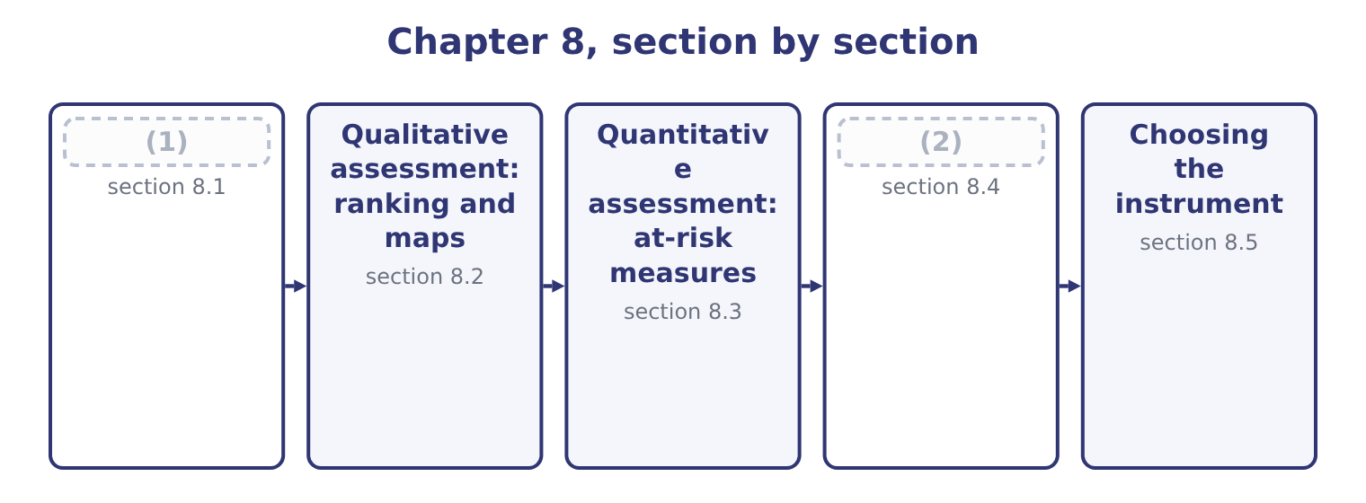
word list
Value at risk · Finding the risks · reconciliation of methods

Summary 1 gaps 3–14
Event (3) is the step that (4) the quality of everything after it, and the outcome asks for techniques with examples. Workshops and (5) interviews. A (6) session with the people who run a process, (7) through what could go wrong and what has nearly gone wrong. The most (8) single technique, and the one whose quality (9) most on whether people feel able to speak —. (10) and risk taxonomies. A standard list of risk categories, such, worked through (11) so that nothing is missed by (12) . Cheap, and (13) to what is on the list. (14) a process from end to end and asking at each step what could fail. This is the technique that finds the risks between departments, because a process map crosses boundaries that an organisation chart does not. Loss and incident data.
word list
systematically · facilitated · Walking · limited · Checklists · identification · productive · identify · depends · structured · determines · inattention · working

Summary 2 gaps 15–26
The company's own history, (15) included, and published data from the industry. The strongest evidence available and necessarily (16) . Event (17) and industry benchmarks. Lists of events that have happened to comparable companies, including events this company has not (18) . Leading (19) and exception reports. Rising staff turnover, lengthening delivery times, growing overdue (20) : things that identify a risk before it is an event. Scenario analysis and what-if (21) . (22) asking what would have to be true for a serious loss to occur, which finds combinations rather than single events. Root cause analysis of events that have occurred, which (23) surfaces three or four risks that nobody had listed. Three (24) improve the output of any of them. Identify at the level of the event, not of the cause or the (25) . One event, with its causes listed and its (26) costed, is worth more than three register lines describing the same thing.
word list
serious · reconciliations · effect · near-misses · Deliberately · typically · questioning · indicators · experienced · principles · inventories · consequences · backward-looking

Summary 3 gaps 27–31
An event (27) that contains only bad (28) will never produce. And (29) what people are (30) to write. The risk from a dominant chief executive, the risk that a target is unachievable, the risk that a (31) supplier relationship is too comfortable: these do not appear in a workshop unless somebody is asked for them directly and nothing happens to them afterwards.
word list
include · inventory · long-standing · reluctant · outcomes · likelihood

The English this section uses, and its Arabic
Each term sits against what it means.
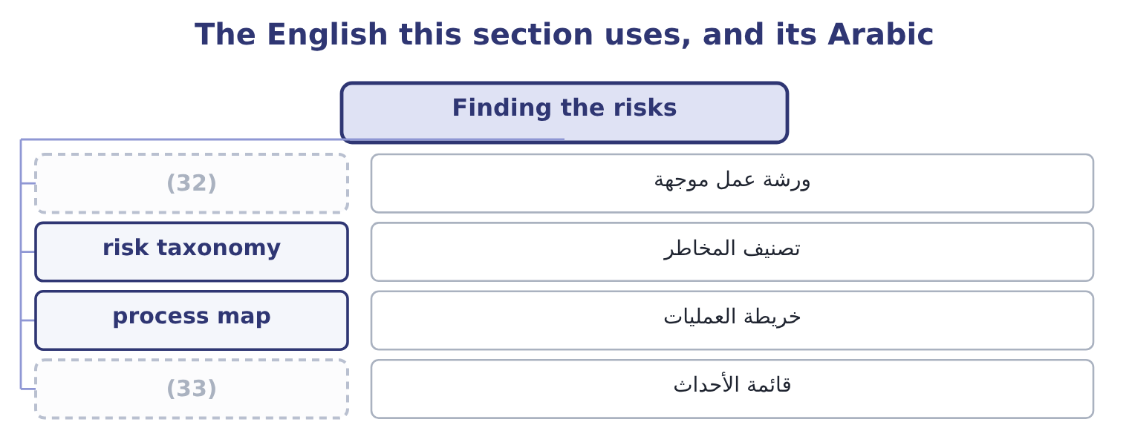
word list
event inventory · risk taxonomy · facilitated workshop

The English this sheet uses, and its Arabic
English (exam term) | Arabic
facilitated workshop | ورشة عمل موجهة
risk taxonomy | تصنيف المخاطر
process map | خريطة العمليات
event inventory | قائمة الأحداث

Answer key · 8.1 Finding the risks

1 Finding the risks | 18 experienced
2 Value at risk | 19 indicators
3 identification | 20 reconciliations
4 determines | 21 questioning
5 structured | 22 Deliberately
6 facilitated | 23 typically
7 working | 24 principles
8 productive | 25 effect
9 depends | 26 consequences
10 Checklists | 27 inventory
11 systematically | 28 outcomes
12 inattention | 29 include
13 limited | 30 reluctant
14 Walking | 31 long-standing
15 near-misses | 32 facilitated workshop
16 backward-looking | 33 event inventory
17 inventories

the summaries in full
Summary 1 Event identification is the step that determines the quality of everything after it, and the outcome asks for techniques with examples. Workshops and structured interviews. A facilitated session with the people who run a process, working through what could go wrong and what has nearly gone wrong. The most productive single technique, and the one whose quality depends most on whether people feel able to speak —. Checklists and risk taxonomies. A standard list of risk categories, such, worked through systematically so that nothing is missed by inattention. Cheap, and limited to what is on the list. Walking a process from end to end and asking at each step what could fail. This is the technique that finds the risks between departments, because a process map crosses boundaries that an organisation chart does not. Loss and incident data.
Summary 2 The company's own history, near-misses included, and published data from the industry. The strongest evidence available and necessarily backward-looking. Event inventories and industry benchmarks. Lists of events that have happened to comparable companies, including events this company has not experienced. Leading indicators and exception reports. Rising staff turnover, lengthening delivery times, growing overdue reconciliations: things that identify a risk before it is an event. Scenario analysis and what-if questioning. Deliberately asking what would have to be true for a serious loss to occur, which finds combinations rather than single events. Root cause analysis of events that have occurred, which typically surfaces three or four risks that nobody had listed. Three principles improve the output of any of them. Identify at the level of the event, not of the cause or the effect. One event, with its causes listed and its consequences costed, is worth more than three register lines describing the same thing.
Summary 3 An event inventory that contains only bad outcomes will never produce. And include what people are reluctant to write. The risk from a dominant chief executive, the risk that a target is unachievable, the risk that a long-standing supplier relationship is too comfortable: these do not appear in a workshop unless somebody is asked for them directly and nothing happens to them afterwards.

8.2 Qualitative assessment: ranking and maps
Chapter 8 · section 8.2

Fill every gap. Each word list holds one word more than there are gaps.
Summary 1 gaps 1–12
Qualitative (1) scores each risk on two dimensions — likelihood and impact — using anchored scales, and then (2) the result. An anchored scale (3) each level in terms (4) can check. Risk ranking (5) or combines the two scores to order the (6) . A supply failure (7) as likelihood 4 and impact 4 scores 4 × 4 = 16; a plant fire at likelihood 1 and impact 5 scores 1 × 5 = 5. Ranking is simple, (8) instantly and has three (9) the exam expects to be named. The (10) of two ordinal scales is not a (11) . A score of 16 is not twice as bad as a score of 8, because the levels are categories and not quantities, and multiplying them (12) a precision that is not there. It compresses the tail.
word list
different · multiplies · number · somebody · manufactures · communicates · product · register · assessed · assessment · weaknesses · defines · displays

Summary 2 gaps 13–24
The fire scores 5 and could end the company; the supply failure scores 16 and could not. This is, which is not the ranking by (13) . And it hides disagreement. A (14) agreed score (15) the fact that two (16) put the likelihood at 2 and 4, and the disagreement is usually more (17) than the average. A risk map, or heat map, plots the same two dimensions on a grid, with likelihood on one axis and impact on the other, and each risk (18) as a point. Its (19) are visual and real: it shows the whole (20) at once, it makes the (21) corner obvious, and it supports the (22) by which different zones require different responses — the top right treated, the bottom left accepted, the top left (rare but severe) (23) , and the bottom right (frequent but small) reduced or absorbed into normal (24) .
word list
top-right · single · operations · informative · assessors · portfolio · conceals · danger · transferred · convention · placed · advantages · disagreement

Summary 3 gaps 25–30
Three (25) are worth knowing. Plot (26) and residual (27) for each risk, with an arrow between them, so that the map shows what the controls are doing —. Plot the target position as well, so that the gap between residual and target (28) the action list. And show (29) , the speed with which a risk would develop: a (30) collapse and a slow regulatory change may occupy the same square and need entirely different responses.
word list
positions · becomes · portfolio · reputational · velocity · refinements · inherent

The English this section uses, and its Arabic
Each term sits against what it means.
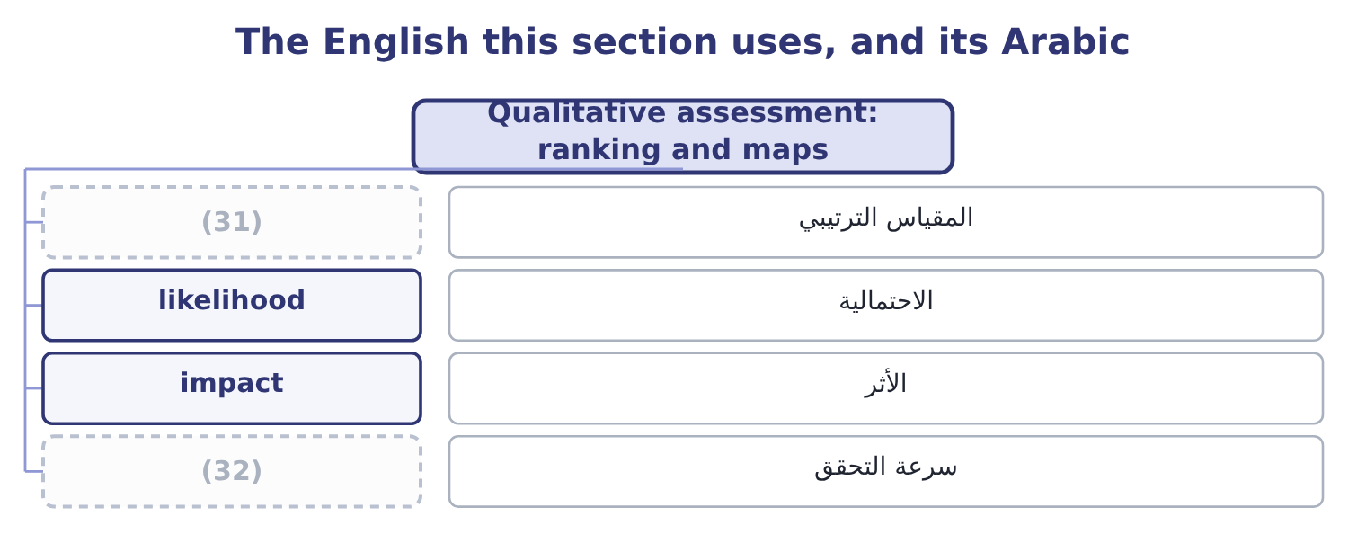
word list
stress testing · ordinal scale · velocity

The English this sheet uses, and its Arabic
English (exam term) | Arabic
ordinal scale | المقياس الترتيبي
likelihood | الاحتمالية
impact | الأثر
velocity | سرعة التحقق

Answer key · 8.2 Qualitative assessment: ranking and maps

1 assessment | 17 informative
2 displays | 18 placed
3 defines | 19 advantages
4 somebody | 20 portfolio
5 multiplies | 21 top-right
6 register | 22 convention
7 assessed | 23 transferred
8 communicates | 24 operations
9 weaknesses | 25 refinements
10 product | 26 inherent
11 number | 27 positions
12 manufactures | 28 becomes
13 danger | 29 velocity
14 single | 30 reputational
15 conceals | 31 ordinal scale
16 assessors | 32 velocity

the summaries in full
Summary 1 Qualitative assessment scores each risk on two dimensions — likelihood and impact — using anchored scales, and then displays the result. An anchored scale defines each level in terms somebody can check. Risk ranking multiplies or combines the two scores to order the register. A supply failure assessed as likelihood 4 and impact 4 scores 4 × 4 = 16; a plant fire at likelihood 1 and impact 5 scores 1 × 5 = 5. Ranking is simple, communicates instantly and has three weaknesses the exam expects to be named. The product of two ordinal scales is not a number. A score of 16 is not twice as bad as a score of 8, because the levels are categories and not quantities, and multiplying them manufactures a precision that is not there. It compresses the tail.
Summary 2 The fire scores 5 and could end the company; the supply failure scores 16 and could not. This is, which is not the ranking by danger. And it hides disagreement. A single agreed score conceals the fact that two assessors put the likelihood at 2 and 4, and the disagreement is usually more informative than the average. A risk map, or heat map, plots the same two dimensions on a grid, with likelihood on one axis and impact on the other, and each risk placed as a point. Its advantages are visual and real: it shows the whole portfolio at once, it makes the top-right corner obvious, and it supports the convention by which different zones require different responses — the top right treated, the bottom left accepted, the top left (rare but severe) transferred, and the bottom right (frequent but small) reduced or absorbed into normal operations.
Summary 3 Three refinements are worth knowing. Plot inherent and residual positions for each risk, with an arrow between them, so that the map shows what the controls are doing —. Plot the target position as well, so that the gap between residual and target becomes the action list. And show velocity, the speed with which a risk would develop: a reputational collapse and a slow regulatory change may occupy the same square and need entirely different responses.

8.3 Quantitative assessment: at-risk measures
Chapter 8 · section 8.3

Fill every gap. Each word list holds one word more than there are gaps.
Summary 1 gaps 1–12
Where the (1) supports a distribution, the (2) can be stated in money. The outcome names four (3) and they share one (4) : take the distribution of an outcome, (5) a confidence level, and state how far below the expectation the outcome could fall. An earnings distribution is the whole picture: the range of operating income or net income the company might produce, with (6) attached, usually built by simulation from distributions of the (7) drivers — volume, price, input cost, exchange rate. (8) below is a (9) of it. Earnings at risk is the (10) by which earnings could fall below expectation at a chosen confidence level over a chosen (11) . For Orontes, if operating income is expected at $4,176,000 and the (12) fifth percentile is 2,900,000, earnings at risk at 95 per cent for a year is 4,176,000 − 2,900,000 = 1,276,000.
word list
simulation's · evidence · Everything · structure · choose · measures · summary · probabilities · underlying · assessment · period · amount · precisely

Summary 2 gaps 13–24
Read that (13) ,600 and the company is (14) its stated appetite, which is (15) the use of the measure. Cash flow at risk is the same (16) applied to cash flow rather than earnings, and for most (17) companies it is the more useful of the two, because cash is what pays interest, capital (18) and dividends. Orontes's expected operating cash flow is 4,176,000 + 2,100,000 = 6,276,000 with (19) added back; if the fifth percentile is 4,500,000, cash flow at risk is 6,276,000 − 4,500,000 = 1,776,000, and the (20) is whether the (21) and buffers. An (22) distribution (23) the earnings distribution per share, which is the form in which equity (24) and analysts think. Orontes's net income of $2,969,100 across 8,100,000 shares is 2,969,100 ÷ 8,100,000 = 0.3666 a share; in the adverse case where net income falls to 2,000,000 it is 2,000,000 ÷ 8,100,000 = 0.2469.
word list
question · non-financial · depreciation · earnings-per-share · outside · precisely · facilities · restates · calculation · expenditure · investors · against · supports

Summary 3 gaps 25–36
The distribution matters because the market reacts to earnings per share relative to (25) , so the probability of (26) short of a published (27) figure is itself a risk — one Book 2's. Four (28) apply to all of them, and an exam answer that gives them is (29) the outcome rather than defining the terms. They are only as good as the input distributions, which are (30) . They assume correlations that are usually (31) , and correlations are (32) what matters in a bad year. They (33) a chosen percentile and say (34) about what lies beyond it, which is. And they are easiest to compute for the risks that are easiest to model — prices and rates — which can shift (35) away from the (36) and strategic risks that are harder to quantify and more likely to be fatal.
word list
assumptions · exactly · attention · expectations · answering · guessed · nothing · cautions · guidance · operational · facilities · describe · falling

The English this section uses, and its Arabic
Each term sits against what it means.
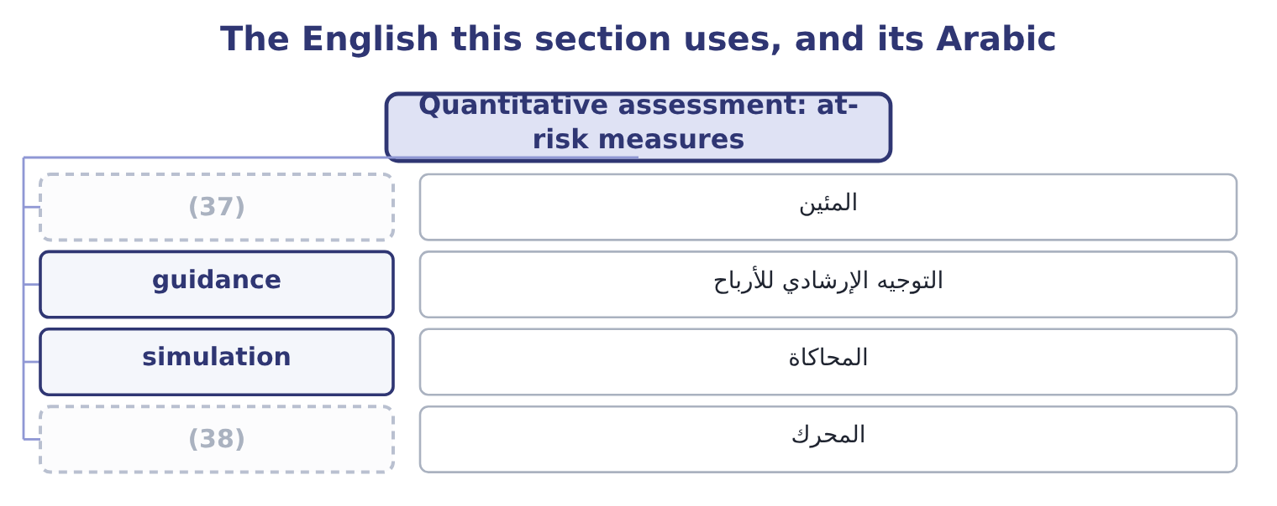
word list
percentile · المحاكاة · driver

The English this sheet uses, and its Arabic
English (exam term) | Arabic
percentile | المئين
guidance | التوجيه الإرشادي للأرباح
simulation | المحاكاة
driver | المحرك

Answer key · 8.3 Quantitative assessment: at-risk measures

1 evidence | 20 question
2 assessment | 21 facilities
3 measures | 22 earnings-per-share
4 structure | 23 restates
5 choose | 24 investors
6 probabilities | 25 expectations
7 underlying | 26 falling
8 Everything | 27 guidance
9 summary | 28 cautions
10 amount | 29 answering
11 period | 30 assumptions
12 simulation's | 31 guessed
13 against | 32 exactly
14 outside | 33 describe
15 precisely | 34 nothing
16 calculation | 35 attention
17 non-financial | 36 operational
18 expenditure | 37 percentile
19 depreciation | 38 driver

the summaries in full
Summary 1 Where the evidence supports a distribution, the assessment can be stated in money. The outcome names four measures and they share one structure: take the distribution of an outcome, choose a confidence level, and state how far below the expectation the outcome could fall. An earnings distribution is the whole picture: the range of operating income or net income the company might produce, with probabilities attached, usually built by simulation from distributions of the underlying drivers — volume, price, input cost, exchange rate. Everything below is a summary of it. Earnings at risk is the amount by which earnings could fall below expectation at a chosen confidence level over a chosen period. For Orontes, if operating income is expected at $4,176,000 and the simulation's fifth percentile is 2,900,000, earnings at risk at 95 per cent for a year is 4,176,000 − 2,900,000 = 1,276,000.
Summary 2 Read that against,600 and the company is outside its stated appetite, which is precisely the use of the measure. Cash flow at risk is the same calculation applied to cash flow rather than earnings, and for most non-financial companies it is the more useful of the two, because cash is what pays interest, capital expenditure and dividends. Orontes's expected operating cash flow is 4,176,000 + 2,100,000 = 6,276,000 with depreciation added back; if the fifth percentile is 4,500,000, cash flow at risk is 6,276,000 − 4,500,000 = 1,776,000, and the question is whether the facilities and buffers. An earnings-per-share distribution restates the earnings distribution per share, which is the form in which equity investors and analysts think. Orontes's net income of $2,969,100 across 8,100,000 shares is 2,969,100 ÷ 8,100,000 = 0.3666 a share; in the adverse case where net income falls to 2,000,000 it is 2,000,000 ÷ 8,100,000 = 0.2469.
Summary 3 The distribution matters because the market reacts to earnings per share relative to expectations, so the probability of falling short of a published guidance figure is itself a risk — one Book 2's. Four cautions apply to all of them, and an exam answer that gives them is answering the outcome rather than defining the terms. They are only as good as the input distributions, which are assumptions. They assume correlations that are usually guessed, and correlations are exactly what matters in a bad year. They describe a chosen percentile and say nothing about what lies beyond it, which is. And they are easiest to compute for the risks that are easiest to model — prices and rates — which can shift attention away from the operational and strategic risks that are harder to quantify and more likely to be fatal.

8.4 Value at risk
Chapter 8 · section 8.4

Fill every gap. Each word list holds one word more than there are gaps.
Summary 1 gaps 1–12
Value at risk states the (1) loss on a position or a (2) over a given period at a given confidence level. It is the measure that made (3) risk management famous, it is required knowledge for this exam, and the syllabus does not require its calculation — which is a relief, because the calculation is the least (4) thing about it. Its (5) has three parts and all three must be quoted (6) . A value at risk of 15,792 means nothing; a one-day value at risk of 15,792 at 95 per cent confidence means that on 95 days out of 100 the loss on this position will be less than 15,792. Three methods of (7) it appear in (8) . The (9) or parametric method assumes the returns follow a known distribution, usually the normal, and computes the figure from the (10) volatility. It is quick and it (11) the tail, because real (12) returns have more extreme movements than the normal distribution allows.
word list
maximum · comforting · portfolio · quantitative · understates · position's · together · financial · computing · definition · questions · interesting · variance-covariance

Summary 2 gaps 13–16
Historical simulation (13) the actual movements of the last few hundred days to today's position and reads the (14) off the result. It needs no (15) assumption and assumes the past period is (16) . Monte Carlo simulation generates movements from assumed distributions, as Book 3's, and is the most flexible and most demanding.
word list
representative · required · distributional · percentile · applies

Worked example: value at risk on a currency position

Summary 3 gaps 17–28
Orontes's (17) euro exposure from,600,000. The euro has moved about 0.6 per cent a day against the (18) reporting currency, so one standard (19) of daily movement is 1,600,000 × 0.006 = 9,600. For 95 per cent on a normal distribution the (20) is 1.645, giving 9,600 × 1.645 = 15,792. Using, the ten-day figure is 15,792 × 3.162 = 49,934. State it in words: on 95 (21) days out of 100, the one-day loss on this position should be below 15,792, and over a ten-day (22) period below 49,934. Then state what it does not say, which is the whole of the exam's (23) in this topic. Four (24) , and they are (25) more often than the method. It says nothing about the size of the loss when the (26) is exceeded. A 95 per cent figure is (27) about the worst five days in a hundred, which are the days that (28) .
word list
matter · examined · interest · silent · unhedged · trading · periods · multiplier · settlement · deviation · company's · threshold · limitations

Summary 4 gaps 29–37
The measure called expected (29) exists to answer that question and is (30) preferred. It (31) on the historical period chosen. A calm period produces a (32) figure, and volatility (33) : calm periods precede violent ones. It assumes positions can be held or closed within the (34) , which fails in (35) the markets where it matters. And it (36) false comfort. A single number, computed daily, produces an impression of control that is not warranted — which is why it should always be accompanied by stress testing, where positions are revalued under specified extreme scenarios chosen for their (37) rather than their probability.
word list
clusters · plausibility · shortfall · increasingly · portfolio · exactly · comforting · depends · horizon · invites

The English this section uses, and its Arabic
Each term sits against what it means.
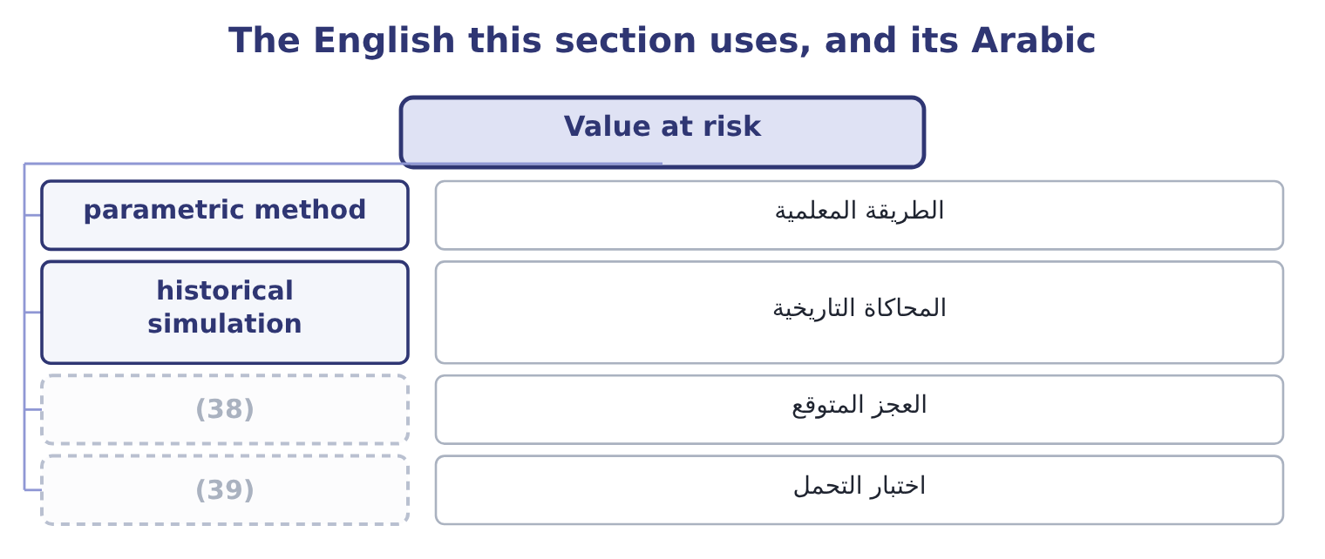
word list
stress testing · expected shortfall · historical simulation

The English this sheet uses, and its Arabic
English (exam term) | Arabic
parametric method | الطريقة المعلمية
historical simulation | المحاكاة التاريخية
expected shortfall | العجز المتوقع
stress testing | اختبار التحمل

Answer key · 8.4 Value at risk

1 maximum | 21 trading
2 portfolio | 22 settlement
3 quantitative | 23 interest
4 interesting | 24 limitations
5 definition | 25 examined
6 together | 26 threshold
7 computing | 27 silent
8 questions | 28 matter
9 variance-covariance | 29 shortfall
10 position's | 30 increasingly
11 understates | 31 depends
12 financial | 32 comforting
13 applies | 33 clusters
14 percentile | 34 horizon
15 distributional | 35 exactly
16 representative | 36 invites
17 unhedged | 37 plausibility
18 company's | 38 expected shortfall
19 deviation | 39 stress testing
20 multiplier

the summaries in full
Summary 1 Value at risk states the maximum loss on a position or a portfolio over a given period at a given confidence level. It is the measure that made quantitative risk management famous, it is required knowledge for this exam, and the syllabus does not require its calculation — which is a relief, because the calculation is the least interesting thing about it. Its definition has three parts and all three must be quoted together. A value at risk of 15,792 means nothing; a one-day value at risk of 15,792 at 95 per cent confidence means that on 95 days out of 100 the loss on this position will be less than 15,792. Three methods of computing it appear in questions. The variance-covariance or parametric method assumes the returns follow a known distribution, usually the normal, and computes the figure from the position's volatility. It is quick and it understates the tail, because real financial returns have more extreme movements than the normal distribution allows.
Summary 2 Historical simulation applies the actual movements of the last few hundred days to today's position and reads the percentile off the result. It needs no distributional assumption and assumes the past period is representative. Monte Carlo simulation generates movements from assumed distributions, as Book 3's, and is the most flexible and most demanding.
Summary 3 Orontes's unhedged euro exposure from,600,000. The euro has moved about 0.6 per cent a day against the company's reporting currency, so one standard deviation of daily movement is 1,600,000 × 0.006 = 9,600. For 95 per cent on a normal distribution the multiplier is 1.645, giving 9,600 × 1.645 = 15,792. Using, the ten-day figure is 15,792 × 3.162 = 49,934. State it in words: on 95 trading days out of 100, the one-day loss on this position should be below 15,792, and over a ten-day settlement period below 49,934. Then state what it does not say, which is the whole of the exam's interest in this topic. Four limitations, and they are examined more often than the method. It says nothing about the size of the loss when the threshold is exceeded. A 95 per cent figure is silent about the worst five days in a hundred, which are the days that matter.
Summary 4 The measure called expected shortfall exists to answer that question and is increasingly preferred. It depends on the historical period chosen. A calm period produces a comforting figure, and volatility clusters: calm periods precede violent ones. It assumes positions can be held or closed within the horizon, which fails in exactly the markets where it matters. And it invites false comfort. A single number, computed daily, produces an impression of control that is not warranted — which is why it should always be accompanied by stress testing, where positions are revalued under specified extreme scenarios chosen for their plausibility rather than their probability.

8.5 Choosing the instrument
Chapter 8 · section 8.5

Fill every gap. Each word list holds one word more than there are gaps.
Summary 1 gaps 1–12
The last (1) is which tool to use, and the answer follows from the evidence (2) and the decision to be made. Use qualitative tools where (3) cannot be estimated from data: strategic risks, (4) risks, most operational risks, anything novel. A ranked register and a map, with anchored scales and honest (5) recorded, are the right (6) and should not apologise for being judgments. Use quantitative tools where a (7) can be supported: market prices, rates, credit portfolios with many names, (8) operational processes with loss histories. Here an at-risk measure (9) a risk into a figure that can be (10) with appetite and with capital. Use both where possible, and (11) them. A risk that the map puts in the top-right corner but that no quantitative measure can find is a warning about the (12) , not about the map. And whichever is used, apply three disciplines.
word list
available · distribution · question · journalism · high-volume · reconcile · disagreement · converts · measurement · reputational · compared · instruments · probabilities

Summary 2 gaps 13–17
State the (13) and the confidence level. State the (14) that drive the answer, and test the one that drives it most, which is Book 3's (15) analysis. And keep the register honest about what is not (16) . The most dangerous line in any assessment is a risk quantified at a (17) number because a number was required.
word list
analysis · sensitivity · assumptions · measurable · comfortable · horizon

Choosing and computing

Your turn: assessment tools (complete the blanks)
Item | Data | Answer
Ranking score | (18) | 16: 4 × 4 = 16.
Earnings at risk | Expected 4,176,000; fifth percentile 2,900,000 | (19)
Expected operating cash flow | (20) | 6,276,000: 4,176,000 + 2,100,000 = 6,276,000.
Earnings per share | Net income 2,969,100; shares 8,100,000 | 0.3666: 2,969,100 ÷ 8,100,000 = 0.3666.
One-standard-deviation daily move | Position 1,600,000; volatility 0.6 per cent | (21)
What value at risk does not tell you |  | How large the loss is on the days the (22) is exceeded.

word list
Operating income 4,176,000; depreciation 2,100,000 · Likelihood 4, impact 4 · Net income 2,969,100; shares 8,100,000 · 1,276,000: 4,176,000 − 2,900,000 = 1,276,000. · threshold · 9,600: 1,600,000 × 0.006 = 9,600.

"At risk", "map" and "heat"

Summary 3 gaps 23–34
The (23) at risk in earnings at risk, cash flow at risk and value at risk is a (24) technical idiom and it misleads (25) , because it (26) as though the whole amount is in danger. It is not: the figure is the possible (27) at a confidence level, not the amount (28) . (29) "earnings at risk of 1,276,000" where the reader (30) "earnings of 4,176,000, of which 1,276,000 could be lost in a bad year" invites exactly the wrong reading, and the cure is to write the (31) out. Heat map is (32) rather than (33) — the colours carry no (34) the position on the grid does not — and risk map or risk matrix is the better term in a report, because a reader who sees red may believe something has been measured when it has only been coloured.
word list
phrase · sounds · exposed · journalism · shortfall · compressed · terminology · beginners · probabilities · information · Writing · expects · sentence

The English this section uses, and its Arabic
Each term sits against what it means.
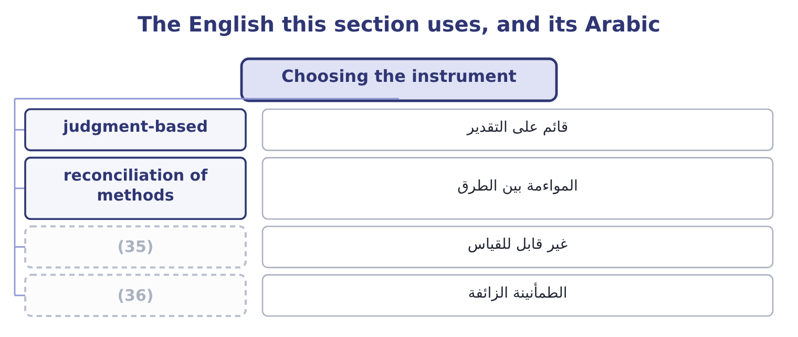
word list
event identification · spurious comfort · unmeasurable

The English this sheet uses, and its Arabic
English (exam term) | Arabic
judgment-based | قائم على التقدير
reconciliation of methods | المواءمة بين الطرق
unmeasurable | غير قابل للقياس
spurious comfort | الطمأنينة الزائفة

Answer key · 8.5 Choosing the instrument

1 question | 19 1,276,000: 4,176,000 − 2,900,000 = 1,276,000.
2 available | 20 Operating income 4,176,000; depreciation 2,100,000
3 probabilities | 21 9,600: 1,600,000 × 0.006 = 9,600.
4 reputational | 22 threshold
5 disagreement | 23 phrase
6 instruments | 24 compressed
7 distribution | 25 beginners
8 high-volume | 26 sounds
9 converts | 27 shortfall
10 compared | 28 exposed
11 reconcile | 29 Writing
12 measurement | 30 expects
13 horizon | 31 sentence
14 assumptions | 32 journalism
15 sensitivity | 33 terminology
16 measurable | 34 information
17 comfortable | 35 unmeasurable
18 Likelihood 4, impact 4 | 36 spurious comfort

the summaries in full
Summary 1 The last question is which tool to use, and the answer follows from the evidence available and the decision to be made. Use qualitative tools where probabilities cannot be estimated from data: strategic risks, reputational risks, most operational risks, anything novel. A ranked register and a map, with anchored scales and honest disagreement recorded, are the right instruments and should not apologise for being judgments. Use quantitative tools where a distribution can be supported: market prices, rates, credit portfolios with many names, high-volume operational processes with loss histories. Here an at-risk measure converts a risk into a figure that can be compared with appetite and with capital. Use both where possible, and reconcile them. A risk that the map puts in the top-right corner but that no quantitative measure can find is a warning about the measurement, not about the map. And whichever is used, apply three disciplines.
Summary 2 State the horizon and the confidence level. State the assumptions that drive the answer, and test the one that drives it most, which is Book 3's sensitivity analysis. And keep the register honest about what is not measurable. The most dangerous line in any assessment is a risk quantified at a comfortable number because a number was required.
Summary 3 The phrase at risk in earnings at risk, cash flow at risk and value at risk is a compressed technical idiom and it misleads beginners, because it sounds as though the whole amount is in danger. It is not: the figure is the possible shortfall at a confidence level, not the amount exposed. Writing "earnings at risk of 1,276,000" where the reader expects "earnings of 4,176,000, of which 1,276,000 could be lost in a bad year" invites exactly the wrong reading, and the cure is to write the sentence out. Heat map is journalism rather than terminology — the colours carry no information the position on the grid does not — and risk map or risk matrix is the better term in a report, because a reader who sees red may believe something has been measured when it has only been coloured.

