9.1 What enterprise risk management is
Chapter 9 · section 9.1

Fill every gap. Each word list holds one word more than there are gaps.
Chapter 9, section by section
Each stage leads to the next.
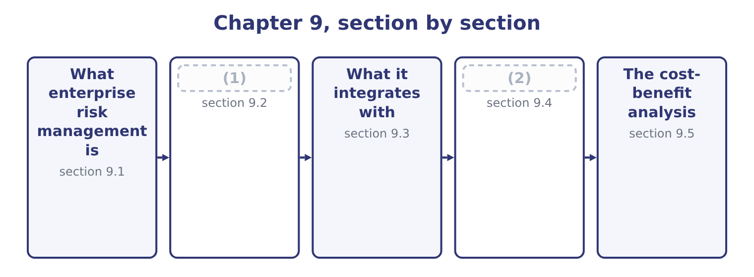
word list
Evaluating a scenario and recommending · What it integrates with · The COSO framework

Summary 1 gaps 3–14
Enterprise risk management is the process, directed by the board and applied across the whole organisation, of (3) and managing the risks to its strategy and objectives (4) an appetite the board has set, so as to (5) reasonable assurance that the objectives will be (6) . Four elements of that (7) carry the examinable (8) . Across the whole organisation. Risk is (9) in every unit and function and then (10) , rather than managed separately in each. The failure it corrects has a name — the (11) — in which each department manages its own exposures (12) and nobody sees the combination. Directed by the board. The appetite is set at the top, the (13) risks are reported there, and the process is owned by management rather than (14) to a technical function. Applied to strategy and objectives.
word list
aggregated · silo · within · identifying · competently · risk-taking · definition · delegated · considered · achieved · significant · weight · provide

Summary 2 gaps 15–26
Enterprise risk management is about what could stop the company (15) what it has set out to do, (16) the risk that the strategy itself is wrong, which no (17) process can raise. Reasonable assurance, not (18) . No system (19) all loss; the (20) is a sensible balance of cost and benefit, which section 9.5 (21) . The objectives of an enterprise programme, which the exam asks for, are to align (22) with appetite and strategy; to improve the quality of risk responses by choosing among them (23) ; to reduce surprises and losses; to identify and manage risks that cross units; to seize (24) , which is; and to deploy capital more effectively, because a company that knows its aggregate exposure knows how much capital it needs. The (25) follow from those objectives and were set out; three are (26) to the enterprise view.
word list
opportunities · risk-taking · departmental · specific · certainty · computes · benefits · prevents · achieving · standard · including · exposure · consistently

Summary 3 gaps 27–38
Because unexpected losses do not add, the enterprise exposure is (27) than the sum of the parts. Where (28) four areas report unexpected losses (29) 1,900,000 and the enterprise figure is 1,400,000, the 1,900,000 − 1,400,000 = 500,000 of difference is a (30) benefit that no division can see from where it stands — and a company that manages risk only in silos will buy 500,000 more (31) than it needs. One appetite, one set of scales, one method of (32) responses means that the next dollar of risk (33) goes where it does most good, instead of to (34) manager argued hardest. And visible risk (35) . The (36) that cause serious losses — a currency movement, a customer failure and a supply (37) with one economic cause — are (38) to each department and obvious from the centre.
word list
whichever · combinations · interactions · spending · Orontes's · computes · invisible · totalling · comparing · smaller · protection · diversification · interruption

The English this section uses, and its Arabic
Each term sits against what it means.
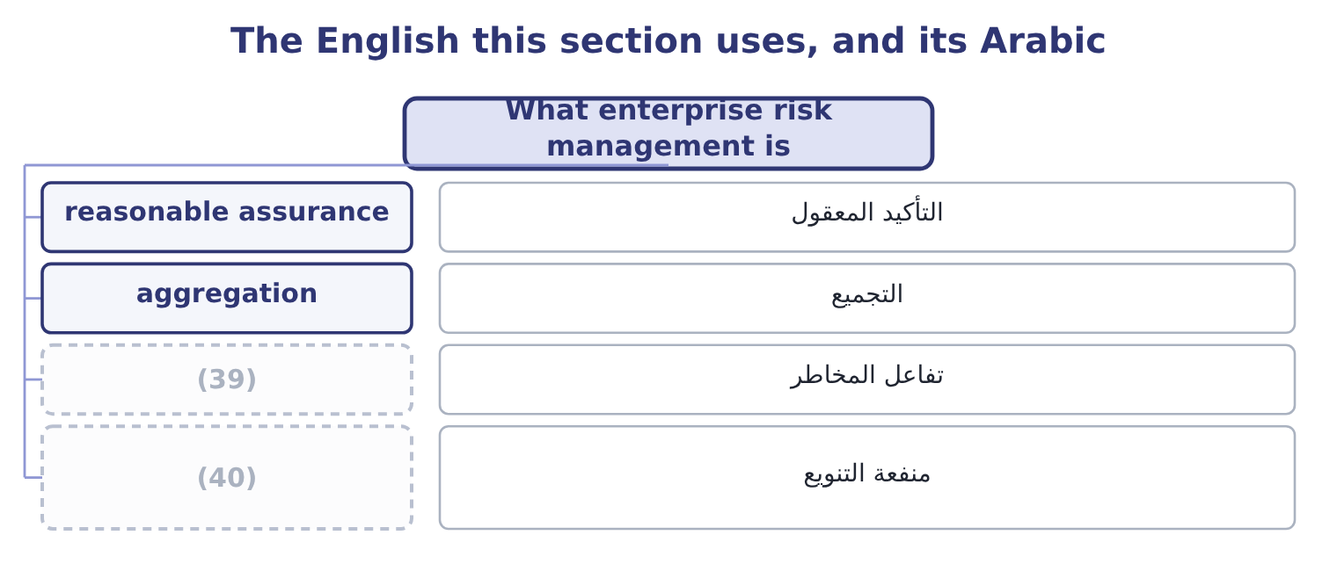
word list
diversification benefit · incentive design · risk interaction

The English this sheet uses, and its Arabic
English (exam term) | Arabic
reasonable assurance | التأكيد المعقول
aggregation | التجميع
risk interaction | تفاعل المخاطر
diversification benefit | منفعة التنويع

Answer key · 9.1 What enterprise risk management is

1 The COSO framework | 21 computes
2 Evaluating a scenario and recommending | 22 risk-taking
3 identifying | 23 consistently
4 within | 24 opportunities
5 provide | 25 benefits
6 achieved | 26 specific
7 definition | 27 smaller
8 weight | 28 Orontes's
9 considered | 29 totalling
10 aggregated | 30 diversification
11 silo | 31 protection
12 competently | 32 comparing
13 significant | 33 spending
14 delegated | 34 whichever
15 achieving | 35 interactions
16 including | 36 combinations
17 departmental | 37 interruption
18 certainty | 38 invisible
19 prevents | 39 risk interaction
20 standard | 40 diversification benefit

the summaries in full
Summary 1 Enterprise risk management is the process, directed by the board and applied across the whole organisation, of identifying and managing the risks to its strategy and objectives within an appetite the board has set, so as to provide reasonable assurance that the objectives will be achieved. Four elements of that definition carry the examinable weight. Across the whole organisation. Risk is considered in every unit and function and then aggregated, rather than managed separately in each. The failure it corrects has a name — the silo — in which each department manages its own exposures competently and nobody sees the combination. Directed by the board. The appetite is set at the top, the significant risks are reported there, and the process is owned by management rather than delegated to a technical function. Applied to strategy and objectives.
Summary 2 Enterprise risk management is about what could stop the company achieving what it has set out to do, including the risk that the strategy itself is wrong, which no departmental process can raise. Reasonable assurance, not certainty. No system prevents all loss; the standard is a sensible balance of cost and benefit, which section 9.5 computes. The objectives of an enterprise programme, which the exam asks for, are to align risk-taking with appetite and strategy; to improve the quality of risk responses by choosing among them consistently; to reduce surprises and losses; to identify and manage risks that cross units; to seize opportunities, which is; and to deploy capital more effectively, because a company that knows its aggregate exposure knows how much capital it needs. The benefits follow from those objectives and were set out; three are specific to the enterprise view.
Summary 3 Because unexpected losses do not add, the enterprise exposure is smaller than the sum of the parts. Where Orontes's four areas report unexpected losses totalling 1,900,000 and the enterprise figure is 1,400,000, the 1,900,000 − 1,400,000 = 500,000 of difference is a diversification benefit that no division can see from where it stands — and a company that manages risk only in silos will buy 500,000 more protection than it needs. One appetite, one set of scales, one method of comparing responses means that the next dollar of risk spending goes where it does most good, instead of to whichever manager argued hardest. And visible risk interactions. The combinations that cause serious losses — a currency movement, a customer failure and a supply interruption with one economic cause — are invisible to each department and obvious from the centre.

9.2 The COSO framework
Chapter 9 · section 9.2

Fill every gap. Each word list holds one word more than there are gaps.
Summary 1 gaps 1–12
The Committee of Sponsoring (1) of the Treadway Commission publishes two documents the exam refers to: the Internal Control — Integrated Framework, which underlies, and Enterprise Risk Management — (2) with Strategy and Performance, the 2017 revision of the 2004 enterprise framework. (3) meet both versions, and it is worth (4) each. The 2004 framework presented a cube: eight components against four (5) of objective — strategic, (6) , reporting and compliance — across the units of the entity. The eight components were the internal (7) , objective setting, event (8) , risk assessment, risk response, control activities, information and communication, and monitoring. The structure is (9) the process of, and (10) still use the eight component names. The 2017 framework is the current one and is organised quite differently, as five (11) components (12) twenty principles, with risk presented as part of strategy and performance rather than as a separate exercise.
word list
operations · Organizations · questions · containing · Candidates · environment · identification · because · knowing · categories · Integrating · recognisably · interrelated

Summary 2 gaps 13–24
The board's oversight of risk, the operating structure, the desired culture, the (13) to core values, and the (14) and retention of capable people. Analysing the business context, defining risk appetite, evaluating (15) strategies, and (16) business objectives. The central insight of the 2017 revision lives here: the greatest risk is not a risk to the strategy but the (17) that the strategy itself is misaligned with the mission, or that the company has chosen a strategy whose (18) it has not understood. (19) risk, assessing severity, (20) risks, implementing responses, and developing a portfolio view —. Assessing (21) change, reviewing risk and performance, and pursuing (22) in enterprise risk management —. Information, communication and reporting. (23) information systems, (24) risk information, and reporting on risk, culture and performance. Three themes of the revision are examinable.
word list
substantial · implications · possibility · retention · improvement · Leveraging · alternative · commitment · Identifying · formulating · communicating · prioritising · attraction

Summary 3 gaps 25–28
Risk is integrated with performance, not (25) to it. The same (26) that reviews results reviews the risks to them. Culture is treated as a component in its own right, because frameworks do not fail (27) ; they fail where people do not use them. And risk appetite connects strategy to (28) , which is why.
word list
execution · parallel · meeting · improvement · technically

The English this section uses, and its Arabic
Each term sits against what it means.
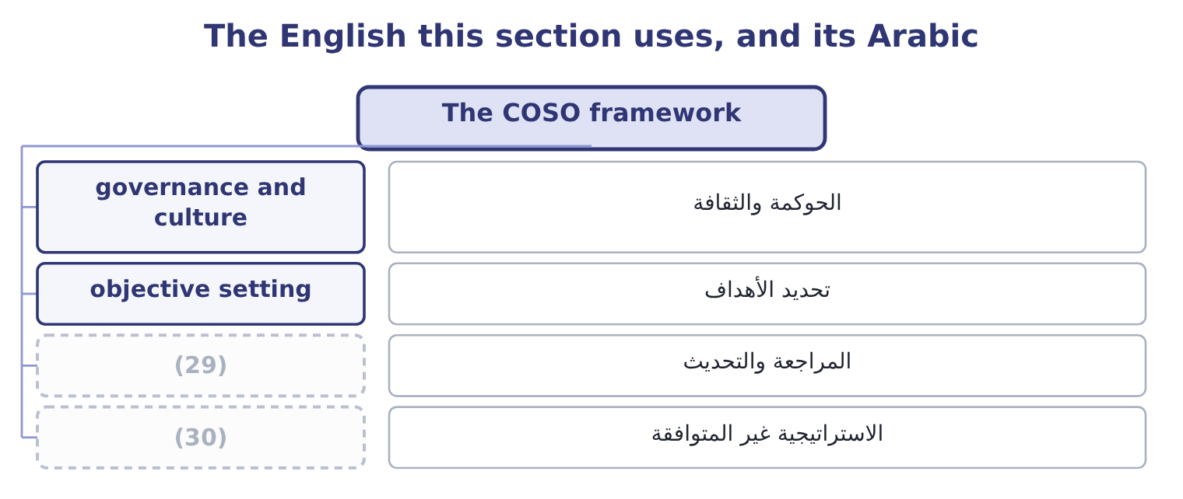
word list
review and revision · misaligned strategy · diversification benefit

The English this sheet uses, and its Arabic
English (exam term) | Arabic
governance and culture | الحوكمة والثقافة
objective setting | تحديد الأهداف
review and revision | المراجعة والتحديث
misaligned strategy | الاستراتيجية غير المتوافقة

Answer key · 9.2 The COSO framework

1 Organizations | 16 formulating
2 Integrating | 17 possibility
3 Candidates | 18 implications
4 knowing | 19 Identifying
5 categories | 20 prioritising
6 operations | 21 substantial
7 environment | 22 improvement
8 identification | 23 Leveraging
9 recognisably | 24 communicating
10 questions | 25 parallel
11 interrelated | 26 meeting
12 containing | 27 technically
13 commitment | 28 execution
14 attraction | 29 review and revision
15 alternative | 30 misaligned strategy

the summaries in full
Summary 1 The Committee of Sponsoring Organizations of the Treadway Commission publishes two documents the exam refers to: the Internal Control — Integrated Framework, which underlies, and Enterprise Risk Management — Integrating with Strategy and Performance, the 2017 revision of the 2004 enterprise framework. Candidates meet both versions, and it is worth knowing each. The 2004 framework presented a cube: eight components against four categories of objective — strategic, operations, reporting and compliance — across the units of the entity. The eight components were the internal environment, objective setting, event identification, risk assessment, risk response, control activities, information and communication, and monitoring. The structure is recognisably the process of, and questions still use the eight component names. The 2017 framework is the current one and is organised quite differently, as five interrelated components containing twenty principles, with risk presented as part of strategy and performance rather than as a separate exercise.
Summary 2 The board's oversight of risk, the operating structure, the desired culture, the commitment to core values, and the attraction and retention of capable people. Analysing the business context, defining risk appetite, evaluating alternative strategies, and formulating business objectives. The central insight of the 2017 revision lives here: the greatest risk is not a risk to the strategy but the possibility that the strategy itself is misaligned with the mission, or that the company has chosen a strategy whose implications it has not understood. Identifying risk, assessing severity, prioritising risks, implementing responses, and developing a portfolio view —. Assessing substantial change, reviewing risk and performance, and pursuing improvement in enterprise risk management —. Information, communication and reporting. Leveraging information systems, communicating risk information, and reporting on risk, culture and performance. Three themes of the revision are examinable.
Summary 3 Risk is integrated with performance, not parallel to it. The same meeting that reviews results reviews the risks to them. Culture is treated as a component in its own right, because frameworks do not fail technically; they fail where people do not use them. And risk appetite connects strategy to execution, which is why.

9.3 What it integrates with
Chapter 9 · section 9.3

Fill every gap. Each word list holds one word more than there are gaps.
Summary 1 gaps 1–12
The outcome asks how enterprise risk (1) integrate with five other things, and each (2) has a specific content. The board sets the appetite, (3) the process, and (4) itself that it works; the audit committee or a separate risk committee does the detailed review; management owns the risks; internal audit provides independent assurance that the process operates. That division is often (5) as the three lines: the business owns and manages risk, risk and (6) functions set the framework and challenge, and internal audit provides independent assurance. The (7) of, the at-risk figures, the loss databases, and (8) the models that predict failures from operating data. Analytics serve the process; they are not the process, and a company with (9) analytics and no appetite (10) has measured things nobody can act on. The (11) of section 9.1: risks combined across units with (12) taken into account, compared with capital and appetite, and resources allocated across them as Book 3's.
word list
satisfies · connection · correlations · practices · statement · summarised · outcome · increasingly · aggregation · compliance · excellent · measurement · oversees

Summary 2 gaps 13–20
Risk belongs in the same (13) as results, which means three practical things: targets set with the risk of missing them understood; variances (14) for what they reveal about exposure as well as about (15) ; and incentives designed so that they do not pay for risk-taking the company has not agreed to. Controls are the (16) layer for the reduction (17) . Enterprise risk management (18) which risks matter and how far they should be (19) ; internal control (20) the reduction; and the control framework reports whether the controls work.
word list
decides · conversation · investigated · targets · execution · reduced · performance · response · delivers

The English this section uses, and its Arabic
Each term sits against what it means.
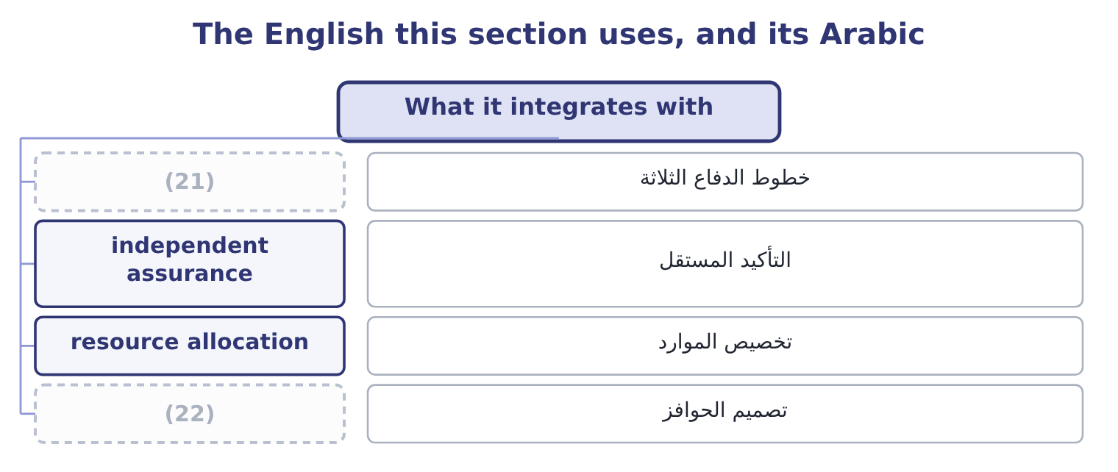
word list
three lines · internal control · incentive design

The English this sheet uses, and its Arabic
English (exam term) | Arabic
three lines | خطوط الدفاع الثلاثة
independent assurance | التأكيد المستقل
resource allocation | تخصيص الموارد
incentive design | تصميم الحوافز

Answer key · 9.3 What it integrates with

1 practices | 12 correlations
2 connection | 13 conversation
3 oversees | 14 investigated
4 satisfies | 15 performance
5 summarised | 16 execution
6 compliance | 17 response
7 measurement | 18 decides
8 increasingly | 19 reduced
9 excellent | 20 delivers
10 statement | 21 three lines
11 aggregation | 22 incentive design

the summaries in full
Summary 1 The outcome asks how enterprise risk practices integrate with five other things, and each connection has a specific content. The board sets the appetite, oversees the process, and satisfies itself that it works; the audit committee or a separate risk committee does the detailed review; management owns the risks; internal audit provides independent assurance that the process operates. That division is often summarised as the three lines: the business owns and manages risk, risk and compliance functions set the framework and challenge, and internal audit provides independent assurance. The measurement of, the at-risk figures, the loss databases, and increasingly the models that predict failures from operating data. Analytics serve the process; they are not the process, and a company with excellent analytics and no appetite statement has measured things nobody can act on. The aggregation of section 9.1: risks combined across units with correlations taken into account, compared with capital and appetite, and resources allocated across them as Book 3's.
Summary 2 Risk belongs in the same conversation as results, which means three practical things: targets set with the risk of missing them understood; variances investigated for what they reveal about exposure as well as about performance; and incentives designed so that they do not pay for risk-taking the company has not agreed to. Controls are the execution layer for the reduction response. Enterprise risk management decides which risks matter and how far they should be reduced; internal control delivers the reduction; and the control framework reports whether the controls work.

9.4 Evaluating a scenario and recommending
Chapter 9 · section 9.4

Fill every gap. Each word list holds one word more than there are gaps.
Summary 1 gaps 1–12
The outcome asks for (1) to be evaluated and mitigation (2) , which is the practical skill the essay section of the exam tests. A (3) in five steps (4) an answer that earns the marks. (5) the scenario (6) , including what else is true. A scenario is not one variable (7) ; it is a coherent (8) . Trace the (9) through the (10) . Volume, price, contribution, operating income, cash, covenant headroom, in that order, because the (11) that matters is not what profit falls to but whether (12) breaks. Identify the breaking points. Which covenant, which facility, which customer commitment, which regulatory threshold fails first. Choose responses from, with the cost-benefit test of section 9.5, and say what each does to the breaking points rather than to the average. Recommend, with an owner, a cost, a date and a trigger — the observable condition that would cause the response to be activated, which converts a plan into a decision somebody can take.
word list
situation · precisely · question · method · consequences · Describe · moving · recommended · anything · response · produces · scenarios · figures

Worked example: a scenario and its mitigation

Summary 2 gaps 13–24
A poor harvest (13) hulled sesame prices by 25 per cent for a year and (14) single supplier cannot (15) for six weeks. The supply interruption costs 46,027 a day of contribution, so six weeks is about 1,933,134. The price (16) , on variable costs that are (17) sesame, would remove a (18) large part of the 16,800,000 annual contribution unless prices can be raised, which Book 3's. Operating income of $4,348,800 (19) a covenant floor of 1,560,000 gives 2,788,800 of headroom, and the supply interruption alone (20) two thirds of it. (21) with the price effect the covenant is the first thing to break, not the cash (22) . Responses and their cost. Qualify a second supplier (cost 60,000 a year); hold four weeks of buffer stock (cost 180,000 of (23) ); contract forward for part of the crop as Book 2's: the forward premium and the loss of any price fall); and open a (24) with the lender about the covenant before it is needed rather than after.
word list
against · raises · Orontes's · carrying · supplier · conversation · mostly · further · increase · balance · consumes · Combined · deliver

Summary 3 gaps 25–33
The (25) , with triggers. Qualify the second supplier now. Build buffer stock when the harvest (26) first falls below the (27) average, not when the delivery fails. Hedge half the (28) volume at the point the forward price is below (29) . And (30) the covenant at the (31) . Note what the last step adds. Without triggers, a scenario analysis is an (32) document; with them, it is a set of decisions that have already been taken and only need to be activated, which is the (33) between a company that responds in a week and one that responds in a quarter.
word list
recommendation · expected · half-year · budget · interesting · difference · five-year · outcome · forecast · review

The English this section uses, and its Arabic
Each term sits against what it means.
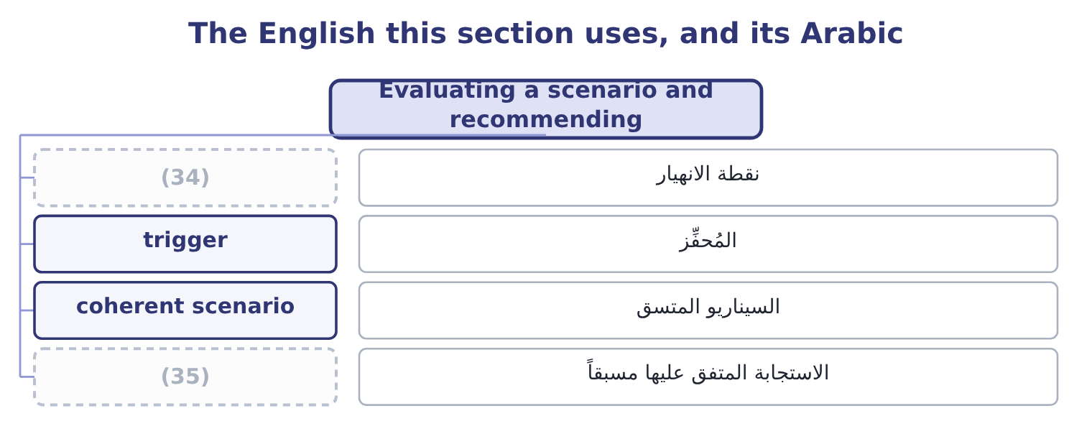
word list
breaking point · pre-agreed response · corporate governance

The English this sheet uses, and its Arabic
English (exam term) | Arabic
breaking point | نقطة الانهيار
trigger | المُحفِّز
coherent scenario | السيناريو المتسق
pre-agreed response | الاستجابة المتفق عليها مسبقاً

Answer key · 9.4 Evaluating a scenario and recommending

1 scenarios | 19 against
2 recommended | 20 consumes
3 method | 21 Combined
4 produces | 22 balance
5 Describe | 23 carrying
6 precisely | 24 conversation
7 moving | 25 recommendation
8 situation | 26 forecast
9 consequences | 27 five-year
10 figures | 28 expected
11 question | 29 budget
12 anything | 30 review
13 raises | 31 half-year
14 Orontes's | 32 interesting
15 deliver | 33 difference
16 increase | 34 breaking point
17 mostly | 35 pre-agreed response
18 further

the summaries in full
Summary 1 The outcome asks for scenarios to be evaluated and mitigation recommended, which is the practical skill the essay section of the exam tests. A method in five steps produces an answer that earns the marks. Describe the scenario precisely, including what else is true. A scenario is not one variable moving; it is a coherent situation. Trace the consequences through the figures. Volume, price, contribution, operating income, cash, covenant headroom, in that order, because the question that matters is not what profit falls to but whether anything breaks. Identify the breaking points. Which covenant, which facility, which customer commitment, which regulatory threshold fails first. Choose responses from, with the cost-benefit test of section 9.5, and say what each does to the breaking points rather than to the average. Recommend, with an owner, a cost, a date and a trigger — the observable condition that would cause the response to be activated, which converts a plan into a decision somebody can take.
Summary 2 A poor harvest raises hulled sesame prices by 25 per cent for a year and Orontes's single supplier cannot deliver for six weeks. The supply interruption costs 46,027 a day of contribution, so six weeks is about 1,933,134. The price increase, on variable costs that are mostly sesame, would remove a further large part of the 16,800,000 annual contribution unless prices can be raised, which Book 3's. Operating income of $4,348,800 against a covenant floor of 1,560,000 gives 2,788,800 of headroom, and the supply interruption alone consumes two thirds of it. Combined with the price effect the covenant is the first thing to break, not the cash balance. Responses and their cost. Qualify a second supplier (cost 60,000 a year); hold four weeks of buffer stock (cost 180,000 of carrying); contract forward for part of the crop as Book 2's: the forward premium and the loss of any price fall); and open a conversation with the lender about the covenant before it is needed rather than after.
Summary 3 The recommendation, with triggers. Qualify the second supplier now. Build buffer stock when the harvest forecast first falls below the five-year average, not when the delivery fails. Hedge half the expected volume at the point the forward price is below budget. And review the covenant at the half-year. Note what the last step adds. Without triggers, a scenario analysis is an interesting document; with them, it is a set of decisions that have already been taken and only need to be activated, which is the difference between a company that responds in a week and one that responds in a quarter.

9.5 The cost-benefit analysis
Chapter 9 · section 9.5

Fill every gap. Each word list holds one word more than there are gaps.
Summary 1 gaps 1–12
Every risk response (1) for money with every other use of money, and the (2) that decides is a cost-benefit analysis. The (3) asks you to (4) one, which means knowing what goes on each side. The costs, and (5) usually stop too early. The direct cost of the response: the premium, the contract, the (6) , the salaries of the people (7) a control. The (8) cost: systems, (9) , project time. The (10) friction: the delay an (11) adds, the sales lost to a tighter credit policy, the capital tied up in buffer stock. And the new risks the response (12) . The reduction in expected loss, which is the measurable core: inherent expected loss less residual. The reduction in unexpected loss, which is worth more than it looks because it reduces the capital or facilities the company must hold. Second-order effects: lower premiums, better terms from lenders, fewer disruptions to customers, and the cost-of-capital effect. And any operational benefit that comes with the control, since many risk responses also improve the process — a second supplier is also a negotiating position.
word list
approval · competes · residual · candidates · prepare · operating · performing · creates · equipment · outcome · training · instrument · implementation

Worked example: the second supplier

Summary 2 gaps 13–22
Qualifying a second supplier and (13) buffer stock reduces the likelihood to 0.05, so the expected loss becomes 0.05 × 1,933,134 = 96,657. The benefit and the cost. The reduction is 483,284 − 96,657 = 386,627 a year, against costs of 240,000 — 60,000 of qualification and (14) and 180,000 of carrying the stock — so the net benefit is 386,627 − 240,000 = 146,627 a year and the benefit-to-cost ratio is 386,627 ÷ 240,000 = 1.61. Over the life of the (15) . Treating it as a (16) commitment and (17) at the 9 per cent of Book 3, the annual net benefit is worth 146,627 × 3.8897 = 570,335, against a (18) qualification and trial cost of 150,000, (19) 570,335 − 150,000 = 420,335 of value (20) . Three (21) make this a (22) analysis rather than an arithmetic exercise.
word list
decision · giving · one-off · oversight · things · cost-benefit · created · discounting · holding · five-year · complete

Summary 3 gaps 23–34
The benefit on unexpected loss is not in the figures: (23) the likelihood from 0.25 to 0.05 (24) most of the chance of the event that would consume the (25) headroom, and that is worth more to the board than the 146,627. The buffer stock has an operational cost (26) its carrying charge, since stock ages and this is a food (27) . And the whole (28) rests on two judgments — the 0.25 and the 0.05 — so the honest (29) states them as such and shows what the answer becomes if the reduction is half as effective. Four (30) for any cost-benefit analysis in risk work. Use cash flows and (31) amounts, exactly as Book 3's, and ignore (32) costs. Include the (33) that cannot be quantified, as a stated list beside the arithmetic, rather than (34) them and allowing the quantified ones to decide alone.
word list
calculation · removes · presentation · covenant · reducing · disruptions · incremental · omitting · allocated · benefits · principles · beyond · product

Summary 4 gaps 35–37
Test the judgments that drive the answer. And state the limit of the analysis. A control whose benefit is the avoidance of a (35) loss cannot be justified by (36) arithmetic, because the expected value of a rare event is small; the (37) is the survival test of, and the cost-benefit analysis has nothing to say about it.
word list
expected-value · catastrophic · justification · function

The enterprise view

Your turn: enterprise risk management (complete the blanks)
Item | Data | Answer
Expected loss before the response | (38) | ________
Expected loss after it | Likelihood 0.05 | ________
Annual benefit |  | ________
Net annual benefit | (39) | ________
Benefit-to-cost ratio |  | ________
Diversification benefit of the portfolio view | Divisions 1,900,000; enterprise 1,400,000 | ________

word list
Cost 240,000 · Likelihood 0.25; impact 1,933,134 · Diversification benefit

"Enterprise", "framework" and "integrated"

Summary 5 gaps 40–51
Enterprise in enterprise risk management means the whole entity, every unit and (40) , and it is doing real work: the word was chosen to contrast with the (41) risk management it (42) . (43) also uses enterprise for a venture and for (44) , and neither is meant here. Framework is a word to use (45) : a framework is a structure for (46) work, not the work, and a company that says it has adopted a framework has said nothing about whether it (47) risk. (48) , in the COSO titles, is the (49) claim in either document — it means the (50) are part of how the business is run rather than an exercise performed beside it — and it is the claim most companies fail. When an exam question asks whether a company's risk management is effective, the answer turns on (51) and culture rather than on whether a framework has been adopted.
word list
carefully · integration · initiative · strongest · discounting · manages · English · replaced · Integrated · departmental · organising · function · practices

"Enterprise", "framework" and "integrated"
Item | Answer
Expected loss before the response | 483,284: 0.25 × 1,933,134 = 483,284.
Expected loss after it | 96,657: 0.05 × 1,933,134 = 96,657.
Annual benefit | (52)
Net annual benefit | (53)
Benefit-to-cost ratio | 1.61: 386,627 ÷ 240,000 = 1.61.
Diversification benefit | (54)
What it tells you | Five of the six are the cost-benefit case for one control; the sixth is the reason the case has to be made at the top, where the portfolio i

word list
Diversification benefit of the portfolio view · 500,000: 1,900,000 − 1,400,000 = 500,000. · 386,627: 483,284 − 96,657 = 386,627. · 146,627: 386,627 − 240,000 = 146,627.

The English this section uses, and its Arabic
Each term sits against what it means.
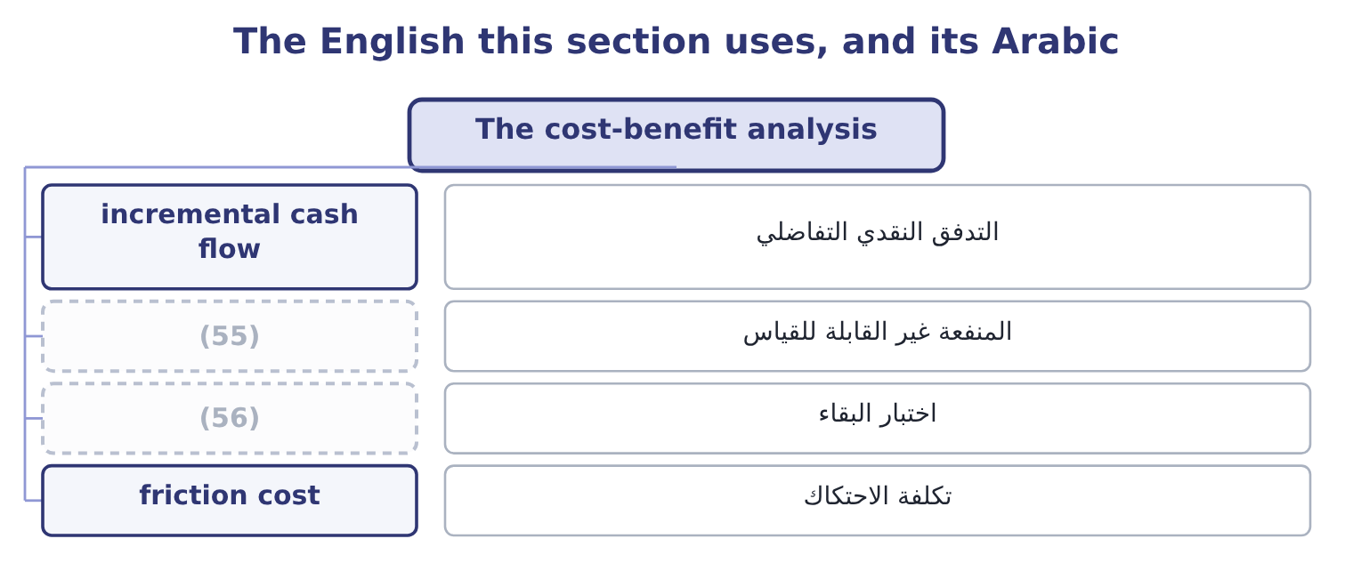
word list
unquantified benefit · survival test · portfolio view

The English this sheet uses, and its Arabic
English (exam term) | Arabic
incremental cash flow | التدفق النقدي التفاضلي
unquantified benefit | المنفعة غير القابلة للقياس
survival test | اختبار البقاء
friction cost | تكلفة الاحتكاك

Answer key · 9.5 The cost-benefit analysis

1 competes | 29 presentation
2 instrument | 30 principles
3 outcome | 31 incremental
4 prepare | 32 allocated
5 candidates | 33 benefits
6 equipment | 34 omitting
7 performing | 35 catastrophic
8 implementation | 36 expected-value
9 training | 37 justification
10 operating | 38 Likelihood 0.25; impact 1,933,134
11 approval | 39 Cost 240,000
12 creates | 40 function
13 holding | 41 departmental
14 oversight | 42 replaced
15 decision | 43 English
16 five-year | 44 initiative
17 discounting | 45 carefully
18 one-off | 46 organising
19 giving | 47 manages
20 created | 48 Integrated
21 things | 49 strongest
22 complete | 50 practices
23 reducing | 51 integration
24 removes | 52 386,627: 483,284 − 96,657 = 386,627.
25 covenant | 53 146,627: 386,627 − 240,000 = 146,627.
26 beyond | 54 500,000: 1,900,000 − 1,400,000 = 500,000.
27 product | 55 unquantified benefit
28 calculation | 56 survival test

the summaries in full
Summary 1 Every risk response competes for money with every other use of money, and the instrument that decides is a cost-benefit analysis. The outcome asks you to prepare one, which means knowing what goes on each side. The costs, and candidates usually stop too early. The direct cost of the response: the premium, the contract, the equipment, the salaries of the people performing a control. The implementation cost: systems, training, project time. The operating friction: the delay an approval adds, the sales lost to a tighter credit policy, the capital tied up in buffer stock. And the new risks the response creates. The reduction in expected loss, which is the measurable core: inherent expected loss less residual. The reduction in unexpected loss, which is worth more than it looks because it reduces the capital or facilities the company must hold. Second-order effects: lower premiums, better terms from lenders, fewer disruptions to customers, and the cost-of-capital effect. And any operational benefit that comes with the control, since many risk responses also improve the process — a second supplier is also a negotiating position.
Summary 2 Qualifying a second supplier and holding buffer stock reduces the likelihood to 0.05, so the expected loss becomes 0.05 × 1,933,134 = 96,657. The benefit and the cost. The reduction is 483,284 − 96,657 = 386,627 a year, against costs of 240,000 — 60,000 of qualification and oversight and 180,000 of carrying the stock — so the net benefit is 386,627 − 240,000 = 146,627 a year and the benefit-to-cost ratio is 386,627 ÷ 240,000 = 1.61. Over the life of the decision. Treating it as a five-year commitment and discounting at the 9 per cent of Book 3, the annual net benefit is worth 146,627 × 3.8897 = 570,335, against a one-off qualification and trial cost of 150,000, giving 570,335 − 150,000 = 420,335 of value created. Three things make this a complete analysis rather than an arithmetic exercise.
Summary 3 The benefit on unexpected loss is not in the figures: reducing the likelihood from 0.25 to 0.05 removes most of the chance of the event that would consume the covenant headroom, and that is worth more to the board than the 146,627. The buffer stock has an operational cost beyond its carrying charge, since stock ages and this is a food product. And the whole calculation rests on two judgments — the 0.25 and the 0.05 — so the honest presentation states them as such and shows what the answer becomes if the reduction is half as effective. Four principles for any cost-benefit analysis in risk work. Use cash flows and incremental amounts, exactly as Book 3's, and ignore allocated costs. Include the benefits that cannot be quantified, as a stated list beside the arithmetic, rather than omitting them and allowing the quantified ones to decide alone.
Summary 4 Test the judgments that drive the answer. And state the limit of the analysis. A control whose benefit is the avoidance of a catastrophic loss cannot be justified by expected-value arithmetic, because the expected value of a rare event is small; the justification is the survival test of, and the cost-benefit analysis has nothing to say about it.
Summary 5 Enterprise in enterprise risk management means the whole entity, every unit and function, and it is doing real work: the word was chosen to contrast with the departmental risk management it replaced. English also uses enterprise for a venture and for initiative, and neither is meant here. Framework is a word to use carefully: a framework is a structure for organising work, not the work, and a company that says it has adopted a framework has said nothing about whether it manages risk. Integrated, in the COSO titles, is the strongest claim in either document — it means the practices are part of how the business is run rather than an exercise performed beside it — and it is the claim most companies fail. When an exam question asks whether a company's risk management is effective, the answer turns on integration and culture rather than on whether a framework has been adopted.

