10.1 Rates, and the prices of goods
Chapter 10 · section 10.1

Fill every gap. Each word list holds one word more than there are gaps.
Chapter 10, section by section
Each stage leads to the next.
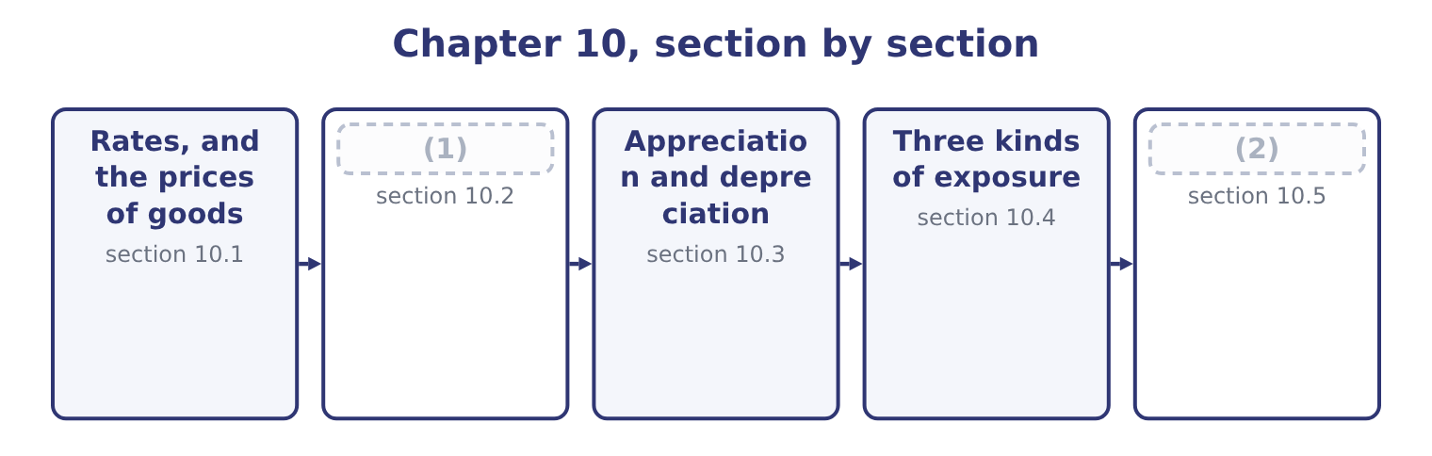
word list
The profit or loss on a cross-border transacti · Three kinds of exposure · What moves a rate

Summary 1 gaps 3–14
An (3) rate is the price of one currency in another, and like any price it can be (4) either way round. For a company (5) in dollars, a direct quote states how many dollars one unit of the foreign currency costs — $1.0800 to the euro — and an (6) quote states how many euros a (7) buys, which is 1 ÷ 1.0800 = 0.9259. Both describe the same rate, and (8) them is the single commonest (9) error in this topic. Read the quote before (10) anything. The first outcome asks how foreign currency affects the prices of goods and services, and the (11) runs in both (12) . What the (13) product costs a foreign buyer. Orontes's jar sells at $12.00. At 1.0800 dollars to the euro, a (14) buyer pays 12.00 ÷ 1.0800 = 11.11 euros.
word list
quoted · reversing · European · arithmetic · company's · dollar · reporting · directions · equipment · computing · mechanism · indirect · exchange

Summary 2 gaps 15–26
If the rate moves to 1.1500 — the euro (15) more dollars — the same jar costs 12.00 ÷ 1.1500 = 10.43 euros. Orontes has not (16) its price and its product has become 6 per cent (17) in Europe. What a foreign input costs the company. A spare part (18) at 50 euros costs 50 × 1.0800 = 54.00 before the move and 50 × 1.1500 = 57.50 after it. Orontes's costs have risen without any (19) raising a price. Three (20) follow and they are the (21) substance. A weaker home currency helps exporters and hurts (22) , and a stronger one does the (23) . Orontes, which exports tahini and imports (24) , is affected both ways and the net (25) depends on the balance of the two. (26) changes even where the company does not trade at all.
word list
position · equipment · cheaper · consequences · buying · examinable · reverse · changed · priced · Competitiveness · supplier · importers · appreciation

Summary 3 gaps 27–34
A domestic producer (27) with imports is helped by a weaker home currency, because the imports become dearer; it has a currency exposure without a single foreign (28) , which is the (29) exposure of section 10.4. And prices do not adjust fully or (30) . Exporters often hold foreign prices steady and absorb the movement in their (31) , to protect market share — pricing to market — which (32) a price effect into a profit effect. Orontes's (33) whether to pass the euro movement on is (34) Book 3's, asked in another currency.
word list
transaction · margins · economic · exactly · converts · changes · immediately · decision · competing

The English this section uses, and its Arabic
Each term sits against what it means.
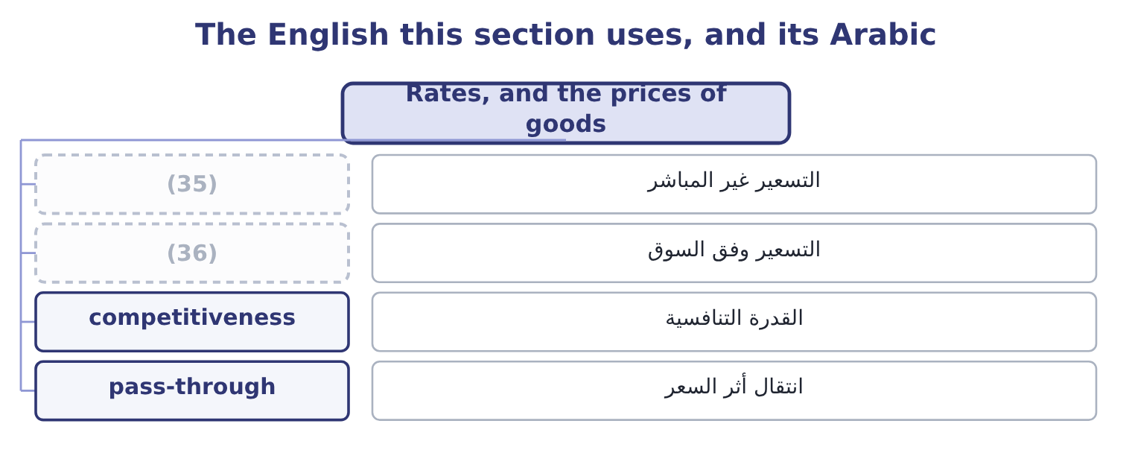
word list
economic exposure · pricing to market · indirect quote

The English this sheet uses, and its Arabic
English (exam term) | Arabic
indirect quote | التسعير غير المباشر
pricing to market | التسعير وفق السوق
competitiveness | القدرة التنافسية
pass-through | انتقال أثر السعر

Answer key · 10.1 Rates, and the prices of goods

1 What moves a rate | 19 supplier
2 The profit or loss on a cross-border transacti | 20 consequences
3 exchange | 21 examinable
4 quoted | 22 importers
5 reporting | 23 reverse
6 indirect | 24 equipment
7 dollar | 25 position
8 reversing | 26 Competitiveness
9 arithmetic | 27 competing
10 computing | 28 transaction
11 mechanism | 29 economic
12 directions | 30 immediately
13 company's | 31 margins
14 European | 32 converts
15 buying | 33 decision
16 changed | 34 exactly
17 cheaper | 35 indirect quote
18 priced | 36 pricing to market

the summaries in full
Summary 1 An exchange rate is the price of one currency in another, and like any price it can be quoted either way round. For a company reporting in dollars, a direct quote states how many dollars one unit of the foreign currency costs — $1.0800 to the euro — and an indirect quote states how many euros a dollar buys, which is 1 ÷ 1.0800 = 0.9259. Both describe the same rate, and reversing them is the single commonest arithmetic error in this topic. Read the quote before computing anything. The first outcome asks how foreign currency affects the prices of goods and services, and the mechanism runs in both directions. What the company's product costs a foreign buyer. Orontes's jar sells at $12.00. At 1.0800 dollars to the euro, a European buyer pays 12.00 ÷ 1.0800 = 11.11 euros.
Summary 2 If the rate moves to 1.1500 — the euro buying more dollars — the same jar costs 12.00 ÷ 1.1500 = 10.43 euros. Orontes has not changed its price and its product has become 6 per cent cheaper in Europe. What a foreign input costs the company. A spare part priced at 50 euros costs 50 × 1.0800 = 54.00 before the move and 50 × 1.1500 = 57.50 after it. Orontes's costs have risen without any supplier raising a price. Three consequences follow and they are the examinable substance. A weaker home currency helps exporters and hurts importers, and a stronger one does the reverse. Orontes, which exports tahini and imports equipment, is affected both ways and the net position depends on the balance of the two. Competitiveness changes even where the company does not trade at all.
Summary 3 A domestic producer competing with imports is helped by a weaker home currency, because the imports become dearer; it has a currency exposure without a single foreign transaction, which is the economic exposure of section 10.4. And prices do not adjust fully or immediately. Exporters often hold foreign prices steady and absorb the movement in their margins, to protect market share — pricing to market — which converts a price effect into a profit effect. Orontes's decision whether to pass the euro movement on is exactly Book 3's, asked in another currency.

10.2 What moves a rate
Chapter 10 · section 10.2

Fill every gap. Each word list holds one word more than there are gaps.
Summary 1 gaps 1–12
The (1) asks for the variables that affect exchange rates, and seven cover the (2) . Learn them with their direction, because a (3) usually asks which way the rate moves. A country whose prices rise faster than its trading (4) ' sees its currency weaken, because its goods become (5) until the rate corrects. This is purchasing power parity, which says that the expected (6) in the rate equals the (7) in inflation rates. Where home inflation is 8 per cent and the other (8) is 3 per cent, the home currency is expected to weaken by about 1.08 ÷ 1.03 = 1.0485, which is 4.85 per cent. Purchasing power parity holds poorly over months and (9) well over years, which is exactly the opposite of what a (10) needs. Higher interest rates attract capital and strengthen a currency in the short run, while the forward market prices the opposite: interest rate parity says the currency with the higher interest rate trades at a forward discount, so that no (11) profit exists from (12) in one currency and lending in the other.
word list
borrowing · reasonably · question · treasurer · syllabus · risk-free · uncompetitive · country's · difference · change · partners · purpose · outcome

Summary 2 gaps 13–24
At a spot of 1.0800, a (13) rate of 6 per cent and a euro rate of 3 per cent, the forward rate is 1.06 ÷ 1.03 = 1.0291 times the spot, which is 1.0800 × 1.0291 = 1.1114. The balance of (14) . A (15) trade deficit means more of the home currency is being sold to buy (16) goods than is being bought, which weakens it, subject to capital flows running the other way. (17) growth and relative (18) . A growing economy (19) investment and (20) its currency, though growth also pulls in imports, which works the other way. (21) and central bank (22) . (23) in the market, capital (24) , and above all monetary policy. A central bank raising rates to control inflation is acting on the rate whether or not that is its purpose.
word list
attracts · dominates · controls · performance · dollar · payments · persistent · Economic · Government · foreign · strengthens · action · Intervention

Summary 3 gaps 25–36
Political (25) and country risk. The political risk of, (26) . Instability, conflict, a (27) election or an (28) legal system all drive capital out and weaken a currency. Rates move on what the market expects rather than on what has happened, which is why an (29) moves a rate and the event it (30) often does not. (31) flows dwarf trade flows in the major currencies, so a rate can move a long way from anything a (32) model would predict, and stay there. Two (33) belong with the list, and strong (34) include them. The variables (35) and often conflict. Higher interest rates strengthen a currency; the inflation they are being used to fight weakens it. Which (36) depends on what the market believes about the future, not on either variable alone. And exchange rate forecasting is unreliable over the horizons companies care about. That is not a reason to ignore the variables, which explain the direction of pressure; it is a reason to manage exposure with the instruments.
word list
cautions · priced · dominates · stability · unpredictable · interact · inflation · trade-based · announces · announcement · Speculative · disputed · answers

The English this section uses, and its Arabic
Each term sits against what it means.
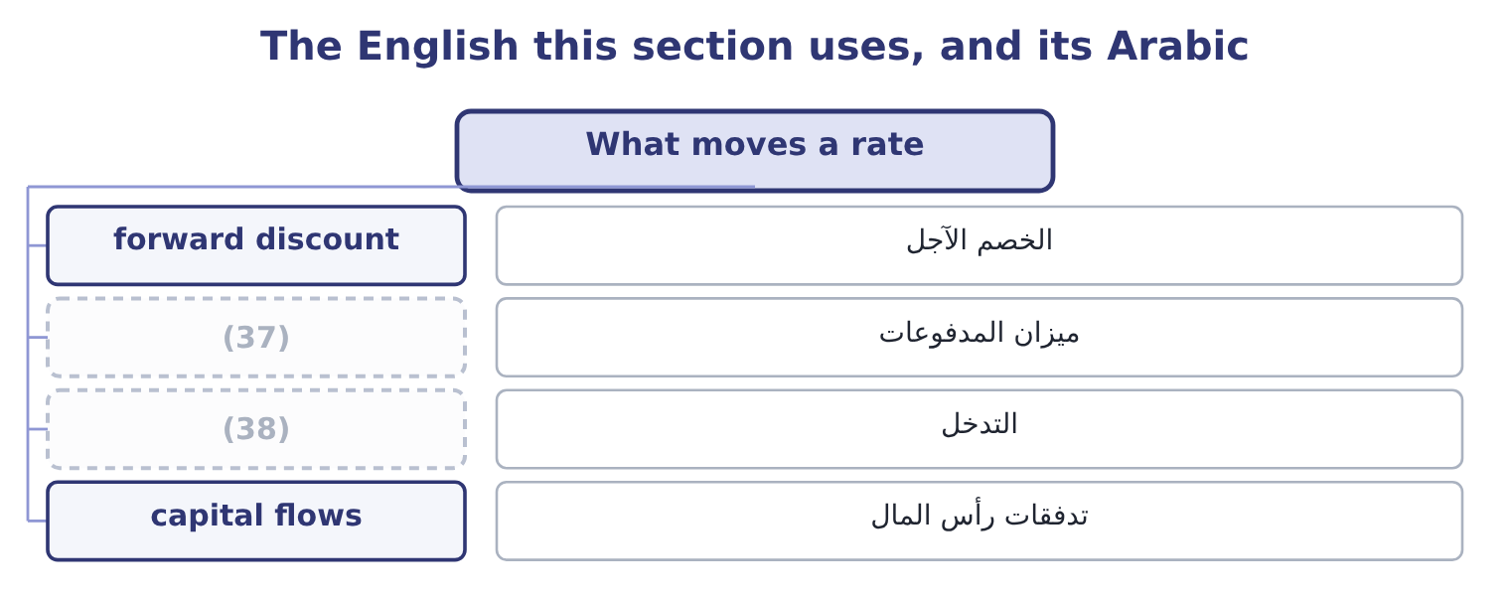
word list
intervention · balance of payments · spot rate

The English this sheet uses, and its Arabic
English (exam term) | Arabic
forward discount | الخصم الآجل
balance of payments | ميزان المدفوعات
intervention | التدخل
capital flows | تدفقات رأس المال

Answer key · 10.2 What moves a rate

1 outcome | 20 strengthens
2 syllabus | 21 Government
3 question | 22 action
4 partners | 23 Intervention
5 uncompetitive | 24 controls
6 change | 25 stability
7 difference | 26 priced
8 country's | 27 disputed
9 reasonably | 28 unpredictable
10 treasurer | 29 announcement
11 risk-free | 30 announces
12 borrowing | 31 Speculative
13 dollar | 32 trade-based
14 payments | 33 cautions
15 persistent | 34 answers
16 foreign | 35 interact
17 Economic | 36 dominates
18 performance | 37 balance of payments
19 attracts | 38 intervention

the summaries in full
Summary 1 The outcome asks for the variables that affect exchange rates, and seven cover the syllabus. Learn them with their direction, because a question usually asks which way the rate moves. A country whose prices rise faster than its trading partners' sees its currency weaken, because its goods become uncompetitive until the rate corrects. This is purchasing power parity, which says that the expected change in the rate equals the difference in inflation rates. Where home inflation is 8 per cent and the other country's is 3 per cent, the home currency is expected to weaken by about 1.08 ÷ 1.03 = 1.0485, which is 4.85 per cent. Purchasing power parity holds poorly over months and reasonably well over years, which is exactly the opposite of what a treasurer needs. Higher interest rates attract capital and strengthen a currency in the short run, while the forward market prices the opposite: interest rate parity says the currency with the higher interest rate trades at a forward discount, so that no risk-free profit exists from borrowing in one currency and lending in the other.
Summary 2 At a spot of 1.0800, a dollar rate of 6 per cent and a euro rate of 3 per cent, the forward rate is 1.06 ÷ 1.03 = 1.0291 times the spot, which is 1.0800 × 1.0291 = 1.1114. The balance of payments. A persistent trade deficit means more of the home currency is being sold to buy foreign goods than is being bought, which weakens it, subject to capital flows running the other way. Economic growth and relative performance. A growing economy attracts investment and strengthens its currency, though growth also pulls in imports, which works the other way. Government and central bank action. Intervention in the market, capital controls, and above all monetary policy. A central bank raising rates to control inflation is acting on the rate whether or not that is its purpose.
Summary 3 Political stability and country risk. The political risk of, priced. Instability, conflict, a disputed election or an unpredictable legal system all drive capital out and weaken a currency. Rates move on what the market expects rather than on what has happened, which is why an announcement moves a rate and the event it announces often does not. Speculative flows dwarf trade flows in the major currencies, so a rate can move a long way from anything a trade-based model would predict, and stay there. Two cautions belong with the list, and strong answers include them. The variables interact and often conflict. Higher interest rates strengthen a currency; the inflation they are being used to fight weakens it. Which dominates depends on what the market believes about the future, not on either variable alone. And exchange rate forecasting is unreliable over the horizons companies care about. That is not a reason to ignore the variables, which explain the direction of pressure; it is a reason to manage exposure with the instruments.

10.3 Appreciation and depreciation
Chapter 10 · section 10.3

Fill every gap. Each word list holds one word more than there are gaps.
Summary 1 gaps 1–5
The third outcome asks for a calculation and for a (1) , and the calculation has one trap in it. A currency (2) when it buys more of another currency and (3) when it buys less. The percentage change is computed on the currency being (4) , which means the same movement produces two different (5) depending on which side you stand.
word list
appreciates · judgment · percentages · described · movement · depreciates

Worked example: one movement, two percentages

Summary 2 gaps 6–16
The rate goes from 1.0800 dollars to the euro at the start of the year to 1.1500 at the end. From the (6) side. The euro now buys more dollars, so it has (7) , by 1.1500 − 1.0800 = 0.0700 on a base of 1.0800, which is 0.0700 ÷ 1.0800 = 6.48 per cent. From the (8) side. (9) the rate in euros per dollar: it was 1 ÷ 1.0800 = 0.9259 and is now 1 ÷ 1.1500 = 0.8696. The dollar now buys fewer euros, so it has (10) , by 0.9259 − 0.8696 = 0.0563 on a base of 0.9259, which is 0.0563 ÷ 0.9259 = 6.08 per cent. A 6.48 per cent (11) of one currency is a 6.08 per cent (12) of the other, (13) the base changes. The two are never equal (14) for very small (15) , and a question that gives one and asks for the other is testing (16) this.
word list
depreciated · movements · precisely · dollar's · appreciated · depreciation · except · because · appreciation · euro's · Restate · pass-through

Summary 3 gaps 17–28
State the (17) in words before computing anything: "the euro buys more dollars than it did, so the euro is stronger and the dollar is weaker." (18) lose marks by computing a correct percentage and attaching it to the wrong currency. (19) the impact is the second half of the outcome, and it runs through three (20) . Orontes's export sales are (21) in euros, so a stronger euro means more dollars per sale. Its European (22) cost more. On (23) , a company that sells more (24) than it buys gains from a weaker home currency. What it does to (25) . Orontes's jar fell from 11.11 to 10.43 euros without a price change, which is an (26) to take share or to raise the euro price and keep the gain — a decision, not an automatic (27) . And whether the movement is temporary or (28) .
word list
abroad · balance · consequence · opportunity · sensible · competitiveness · Candidates · direction · questions · purchases · structural · Evaluating · invoiced

Summary 4 gaps 29–32
A movement that (29) within the year affects (30) in flight and nothing else. A movement that (31) changes where it is sensible to produce, source and sell, which is the economic exposure of the next section and a matter for the board rather than the (32) .
word list
reverses · persists · treasurer · movements · transactions

The English this section uses, and its Arabic
Each term sits against what it means.
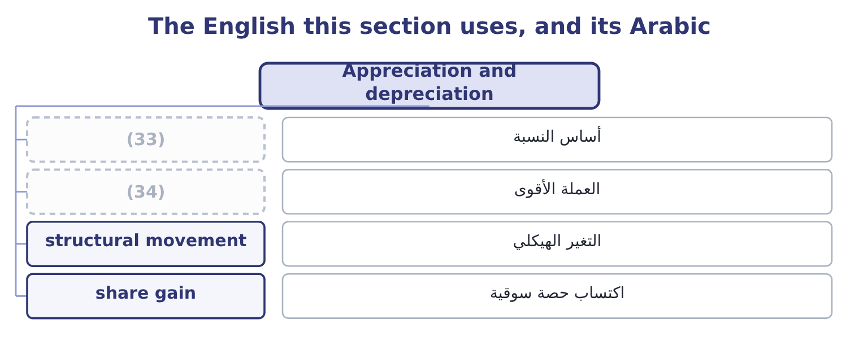
word list
structural response · base of a percentage · stronger currency

The English this sheet uses, and its Arabic
English (exam term) | Arabic
base of a percentage | أساس النسبة
stronger currency | العملة الأقوى
structural movement | التغير الهيكلي
share gain | اكتساب حصة سوقية

Answer key · 10.3 Appreciation and depreciation

1 judgment | 18 Candidates
2 appreciates | 19 Evaluating
3 depreciates | 20 questions
4 described | 21 invoiced
5 percentages | 22 purchases
6 euro's | 23 balance
7 appreciated | 24 abroad
8 dollar's | 25 competitiveness
9 Restate | 26 opportunity
10 depreciated | 27 consequence
11 appreciation | 28 structural
12 depreciation | 29 reverses
13 because | 30 transactions
14 except | 31 persists
15 movements | 32 treasurer
16 precisely | 33 base of a percentage
17 direction | 34 stronger currency

the summaries in full
Summary 1 The third outcome asks for a calculation and for a judgment, and the calculation has one trap in it. A currency appreciates when it buys more of another currency and depreciates when it buys less. The percentage change is computed on the currency being described, which means the same movement produces two different percentages depending on which side you stand.
Summary 2 The rate goes from 1.0800 dollars to the euro at the start of the year to 1.1500 at the end. From the euro's side. The euro now buys more dollars, so it has appreciated, by 1.1500 − 1.0800 = 0.0700 on a base of 1.0800, which is 0.0700 ÷ 1.0800 = 6.48 per cent. From the dollar's side. Restate the rate in euros per dollar: it was 1 ÷ 1.0800 = 0.9259 and is now 1 ÷ 1.1500 = 0.8696. The dollar now buys fewer euros, so it has depreciated, by 0.9259 − 0.8696 = 0.0563 on a base of 0.9259, which is 0.0563 ÷ 0.9259 = 6.08 per cent. A 6.48 per cent appreciation of one currency is a 6.08 per cent depreciation of the other, because the base changes. The two are never equal except for very small movements, and a question that gives one and asks for the other is testing precisely this.
Summary 3 State the direction in words before computing anything: "the euro buys more dollars than it did, so the euro is stronger and the dollar is weaker." Candidates lose marks by computing a correct percentage and attaching it to the wrong currency. Evaluating the impact is the second half of the outcome, and it runs through three questions. Orontes's export sales are invoiced in euros, so a stronger euro means more dollars per sale. Its European purchases cost more. On balance, a company that sells more abroad than it buys gains from a weaker home currency. What it does to competitiveness. Orontes's jar fell from 11.11 to 10.43 euros without a price change, which is an opportunity to take share or to raise the euro price and keep the gain — a decision, not an automatic consequence. And whether the movement is temporary or structural.
Summary 4 A movement that reverses within the year affects transactions in flight and nothing else. A movement that persists changes where it is sensible to produce, source and sell, which is the economic exposure of the next section and a matter for the board rather than the treasurer.

10.4 Three kinds of exposure
Chapter 10 · section 10.4

Fill every gap. Each word list holds one word more than there are gaps.
Summary 1 gaps 1–12
Before computing the profit or loss on a transaction, it is worth (1) three exposures, because they are (2) differently, managed differently and confused (3) . The risk that the (4) value of a committed foreign-currency cash flow changes between the (5) and the settlement: an invoice issued, an order placed, a loan to be repaid. It is specific, dated, (6) , and it is what the (7) . Section 10.5 (8) it. Translation exposure, also called accounting exposure. The risk that the reported value of foreign assets, (9) and results changes when they are (10) into the reporting currency for the financial statements. It affects the balance sheet and the reported figures without any cash moving, which is why companies (11) about how far it should be hedged: hedging an accounting number with a real cash (12) converts a book entry into a cash gain or loss.
word list
instrument · home-currency · disagree · constantly · commitment · computes · measurable · measured · liabilities · separating · hedges · flexible · translated

Summary 2 gaps 13–20
Economic exposure, also called (13) exposure. The risk that the present value of the (14) future cash flows changes because of a rate movement — (15) the cash flows of a business that has no foreign (16) at all. It is the (17) of the three, the hardest to measure, and the one that cannot be hedged with a forward (18) , because it has no date and no amount. It is managed (19) : where production is located, where inputs are bought, what currency prices are set in, how (20) sourcing is.
word list
structurally · including · transactions · largest · company's · contract · managed · operating · flexible

Three exposures
Exposure | What is at risk | Horizon | Managed by
Transaction | Committed foreign-currency cash flows | (21) | Forwards, options, matching
Translation | Reported amounts on consolidation | Reporting date | (22)
Economic | (23) | Years | Location, sourcing, pricing, flexibility

word list
Matching assets with local borrowing · Present value of future cash flows · committed cash flow · Days to months

The English this section uses, and its Arabic
Each term sits against what it means.
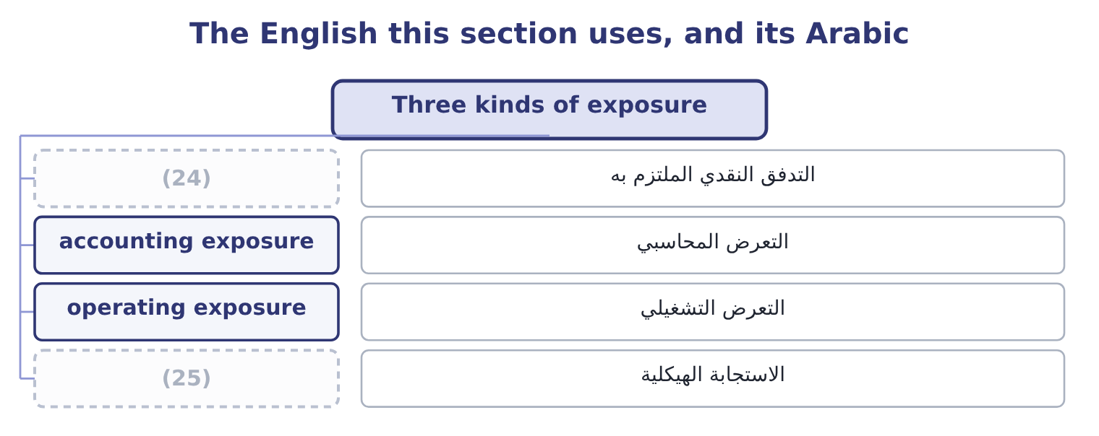
word list
committed cash flow · structural response · interest rate parity

The English this sheet uses, and its Arabic
English (exam term) | Arabic
committed cash flow | التدفق النقدي الملتزم به
accounting exposure | التعرض المحاسبي
operating exposure | التعرض التشغيلي
structural response | الاستجابة الهيكلية

Answer key · 10.4 Three kinds of exposure

1 separating | 14 company's
2 measured | 15 including
3 constantly | 16 transactions
4 home-currency | 17 largest
5 commitment | 18 contract
6 measurable | 19 structurally
7 hedges | 20 flexible
8 computes | 21 Days to months
9 liabilities | 22 Matching assets with local borrowing
10 translated | 23 Present value of future cash flows
11 disagree | 24 committed cash flow
12 instrument | 25 structural response
13 operating

the summaries in full
Summary 1 Before computing the profit or loss on a transaction, it is worth separating three exposures, because they are measured differently, managed differently and confused constantly. The risk that the home-currency value of a committed foreign-currency cash flow changes between the commitment and the settlement: an invoice issued, an order placed, a loan to be repaid. It is specific, dated, measurable, and it is what the hedges. Section 10.5 computes it. Translation exposure, also called accounting exposure. The risk that the reported value of foreign assets, liabilities and results changes when they are translated into the reporting currency for the financial statements. It affects the balance sheet and the reported figures without any cash moving, which is why companies disagree about how far it should be hedged: hedging an accounting number with a real cash instrument converts a book entry into a cash gain or loss.
Summary 2 Economic exposure, also called operating exposure. The risk that the present value of the company's future cash flows changes because of a rate movement — including the cash flows of a business that has no foreign transactions at all. It is the largest of the three, the hardest to measure, and the one that cannot be hedged with a forward contract, because it has no date and no amount. It is managed structurally: where production is located, where inputs are bought, what currency prices are set in, how flexible sourcing is.

10.5 The profit or loss on a cross-border transaction
Chapter 10 · section 10.5

Fill every gap. Each word list holds one word more than there are gaps.
Summary 1 gaps 1–7
The (1) outcome asks for a calculation and for its (2) . The calculation is a (3) and the discipline is in (4) the dates right. A foreign-currency (5) is recorded at the rate on the day it is (6) into. It is settled at the rate on the day the money moves. The (7) , applied to the foreign-currency amount, is the exchange gain or loss, and it goes to the income statement in the period it arises.
word list
transaction · fourth · evaluation · getting · difference · entered · operating · subtraction

Worked example: Orontes's year in euros

Summary 2 gaps 8–19
On 1 March Orontes (8) its European (9) 2,000,000 euros, payable in (10) days. The spot rate is 1.0800, so the sale is recorded at 2,000,000 × 1.0800 = 2,160,000. On 30 May the euro has strengthened to 1.1500, so the (11) is worth 2,000,000 × 1.1500 = 2,300,000 and the exchange gain is 2,300,000 − 2,160,000 = 140,000. On the same dates Orontes owes 400,000 euros for packaging, recorded at 400,000 × 1.0800 = 432,000 and settled at 400,000 × 1.1500 = 460,000, (12) a loss of 460,000 − 432,000 = 28,000. The year's (13) position produces 140,000 − 28,000 = 112,000 of net exchange gain. Two things to (14) . The gain and the loss arise on the same movement in opposite (15) , which is the (16) hedge: only the net 1,600,000 of exposure was ever at risk. And the 112,000 is a (17) , not a performance: it arose because the euro moved (18) , and the same position would have produced a loss of (19) size had it moved the other way.
word list
giving · ninety · distributor · invoices · favourably · receipt · windfall · natural · directions · similar · notice · cross-border · currency

Summary 3 gaps 20–28
Reporting it as a (20) result would be exactly the kind of (21) problem Book 1's. (22) the impact, which the outcome also asks for, means (23) four things. How large it is relative to the (24) . On (25) income of $4,176,000, a 112,000 swing is under 3 per cent — material but not (26) . The same movement on a company with half the (27) and twice the exports would be (28) . Whether it is symmetrical. It is: the position that produced 112,000 of gain would have produced a comparable loss, and a board told only about favourable years is being misled.
word list
earnings-quality · business · decisive · direction · threatening · trading · operating · margin · Evaluating · saying

Summary 4 gaps 29–34
What it says about the exposure. A gain on an (29) position is not a success; it is (30) that the company was carrying an (31) exposure and was lucky. And whether it changes any (32) . A (33) movement changes the competitiveness of exporting and may change where Orontes buys its packaging, which is economic exposure and belongs in a strategy (34) rather than a treasury report.
word list
evidence · discussion · decision · unhedged · produced · unmanaged · persistent

Rates and results

Your turn: currency arithmetic (complete the blanks)
Item | Data | Answer
Euro appreciation | From 1.0800 to 1.1500 dollars per euro | ________
Dollar depreciation on the same move | Inverse rates 0.9259 and 0.8696 | ________
A 12.00 jar in euros, after the move | (35) | ________
Gain on a 2,000,000 euro receivable | (36) | ________
Loss on a 400,000 euro payable | (37) | ________
Forward rate implied by interest parity | Spot 1.0800; dollar 6 per cent, euro 3 per cent | ________

word list
Invoiced at 1.0800, settled at 1.1500 · exchange gain · Rate 1.1500 · Same two rates

"Strong", "weak", "up" and "down"

Summary 5 gaps 38–46
No (38) in finance causes more (39) than this one, because the words are relative and the (40) depends on which currency you are standing. Strong and weak are safer, because they (41) to a named currency — "the euro strengthened" (42) be misread — and (43) writing uses them for exactly that reason. (44) also carries a value (45) in the pair: strong sounds good and weak sounds bad, which is wrong for an exporter, and (46) in every language make the same mistake. In an exam answer, name the currency and say strengthened or weakened, then give the percentage and the base.
word list
professional · vocabulary · opposite · judgment · attach · newspapers · confusion · English · direction · cannot

"Strong", "weak", "up" and "down"
Item | Answer
Euro appreciation | 6.48 per cent: 0.0700 ÷ 1.0800 = 6.48 per cent.
Dollar depreciation | (47)
A 12.00 jar in euros after the move | 10.43 euros: 12.00 ÷ 1.1500 = 10.43.
Gain on the receivable | (48)
Loss on the payable | 28,000: 460,000 − 432,000 = 28,000.
Forward rate by interest parity | (49)
What it tells you | The first three are about competitiveness and the last three about cash — and the exam asks for both, because a movement that helps the inco

word list
140,000: 2,300,000 − 2,160,000 = 140,000. · 1.1114: 1.0800 × 1.0291 = 1.1114. · 6.08 per cent: 0.0563 ÷ 0.9259 = 6.08 per cent. · 10.43 euros: 12.00 ÷ 1.1500 = 10.43.

The English this section uses, and its Arabic
Each term sits against what it means.
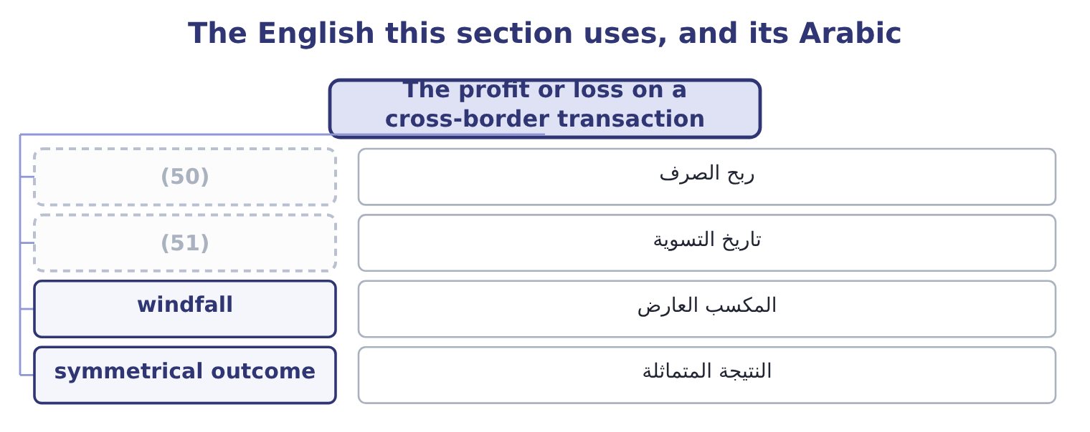
word list
settlement date · exchange gain · accounting exposure

The English this sheet uses, and its Arabic
English (exam term) | Arabic
exchange gain | ربح الصرف
settlement date | تاريخ التسوية
windfall | المكسب العارض
symmetrical outcome | النتيجة المتماثلة

Answer key · 10.5 The profit or loss on a cross-border transaction

1 fourth | 27 margin
2 evaluation | 28 decisive
3 subtraction | 29 unhedged
4 getting | 30 evidence
5 transaction | 31 unmanaged
6 entered | 32 decision
7 difference | 33 persistent
8 invoices | 34 discussion
9 distributor | 35 Rate 1.1500
10 ninety | 36 Invoiced at 1.0800, settled at 1.1500
11 receipt | 37 Same two rates
12 giving | 38 vocabulary
13 cross-border | 39 confusion
14 notice | 40 direction
15 directions | 41 attach
16 natural | 42 cannot
17 windfall | 43 professional
18 favourably | 44 English
19 similar | 45 judgment
20 trading | 46 newspapers
21 earnings-quality | 47 6.08 per cent: 0.0563 ÷ 0.9259 = 6.08 per cent.
22 Evaluating | 48 140,000: 2,300,000 − 2,160,000 = 140,000.
23 saying | 49 1.1114: 1.0800 × 1.0291 = 1.1114.
24 business | 50 exchange gain
25 operating | 51 settlement date
26 threatening

the summaries in full
Summary 1 The fourth outcome asks for a calculation and for its evaluation. The calculation is a subtraction and the discipline is in getting the dates right. A foreign-currency transaction is recorded at the rate on the day it is entered into. It is settled at the rate on the day the money moves. The difference, applied to the foreign-currency amount, is the exchange gain or loss, and it goes to the income statement in the period it arises.
Summary 2 On 1 March Orontes invoices its European distributor 2,000,000 euros, payable in ninety days. The spot rate is 1.0800, so the sale is recorded at 2,000,000 × 1.0800 = 2,160,000. On 30 May the euro has strengthened to 1.1500, so the receipt is worth 2,000,000 × 1.1500 = 2,300,000 and the exchange gain is 2,300,000 − 2,160,000 = 140,000. On the same dates Orontes owes 400,000 euros for packaging, recorded at 400,000 × 1.0800 = 432,000 and settled at 400,000 × 1.1500 = 460,000, giving a loss of 460,000 − 432,000 = 28,000. The year's cross-border position produces 140,000 − 28,000 = 112,000 of net exchange gain. Two things to notice. The gain and the loss arise on the same movement in opposite directions, which is the natural hedge: only the net 1,600,000 of exposure was ever at risk. And the 112,000 is a windfall, not a performance: it arose because the euro moved favourably, and the same position would have produced a loss of similar size had it moved the other way.
Summary 3 Reporting it as a trading result would be exactly the kind of earnings-quality problem Book 1's. Evaluating the impact, which the outcome also asks for, means saying four things. How large it is relative to the business. On operating income of $4,176,000, a 112,000 swing is under 3 per cent — material but not threatening. The same movement on a company with half the margin and twice the exports would be decisive. Whether it is symmetrical. It is: the position that produced 112,000 of gain would have produced a comparable loss, and a board told only about favourable years is being misled.
Summary 4 What it says about the exposure. A gain on an unhedged position is not a success; it is evidence that the company was carrying an unmanaged exposure and was lucky. And whether it changes any decision. A persistent movement changes the competitiveness of exporting and may change where Orontes buys its packaging, which is economic exposure and belongs in a strategy discussion rather than a treasury report.
Summary 5 No vocabulary in finance causes more confusion than this one, because the words are relative and the direction depends on which currency you are standing. Strong and weak are safer, because they attach to a named currency — "the euro strengthened" cannot be misread — and professional writing uses them for exactly that reason. English also carries a value judgment in the pair: strong sounds good and weak sounds bad, which is wrong for an exporter, and newspapers in every language make the same mistake. In an exam answer, name the currency and say strengthened or weakened, then give the percentage and the base.

