11.1 Forwards and futures
Chapter 11 · section 11.1

Fill every gap. Each word list holds one word more than there are gaps.
Chapter 11, section by section
Each stage leads to the next.
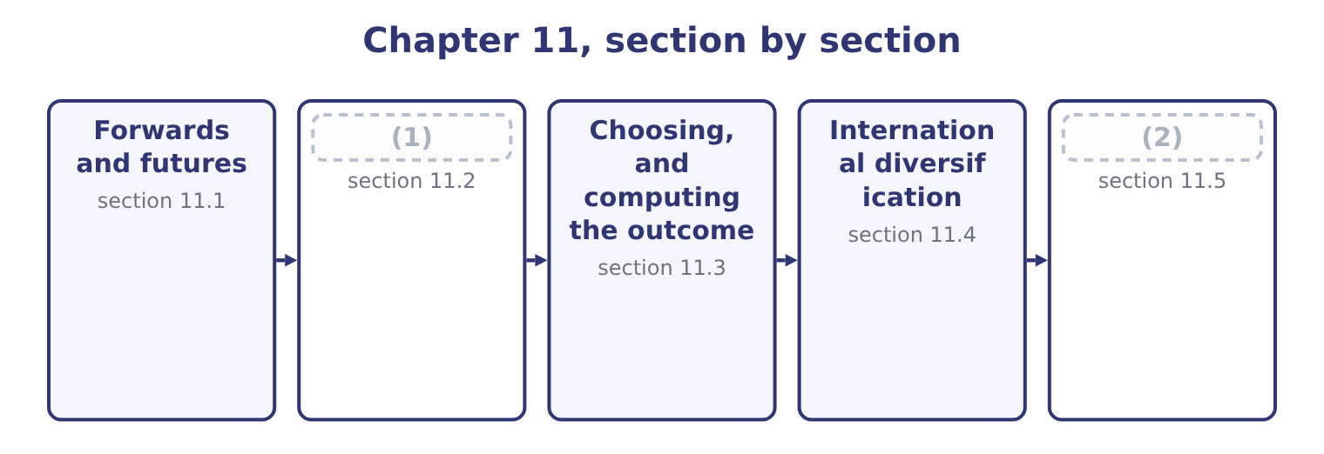
word list
bill of lading · Options and swaps · Financing the trade

Summary 1 gaps 3–14
A forward contract is an (3) with a bank to exchange a fixed amount of one currency for (4) , at a fixed rate, on a fixed date. It is the instrument companies use most, because it matches an exposure exactly in amount and date and because it costs (5) to enter. The forward rate is not a (6) . It is set by interest rate (7) : the rate that removes any (8) gain from borrowing in one currency and (9) in the other. Over (10) days, with dollar interest at 6 per cent and euro interest at 3 per cent, a spot of 1.0800 gives a forward of about 1.0880, and a company that (11) at that rate has not (12) anything. Its (13) , stated as the exam wants them: it is a private contract between the company and its bank; it is tailored in amount and date; it carries no up-front payment; it obliges both parties, so the favourable movement is given up along with the (14) ; and it carries counterparty risk, since the bank must perform.
word list
lending · contracts · payment · forecast · nothing · predicted · unfavourable · risk-free · agreement · features · parity · another · ninety

Summary 2 gaps 15–26
A currency future is the (15) version. The (16) are the examinable part. It is (17) in amount and in (18) date, so it rarely matches an exposure exactly, and the mismatch — basis risk — remains. It is traded on an exchange with a (19) house as counterparty, which removes the credit risk of (20) with one bank. It requires margin: an initial deposit and daily (21) margin as the position is marked to market, so a hedge that is winning or losing (22) cash flows before the exposure settles. That is a liquidity (23) of a risk management decision, and it has (24) companies whose hedges were correct and whose margin calls were not funded. And a position can be (25) at any time by taking the (26) contract, which a forward cannot. For a company of Orontes's size, hedging specific commercial exposures, the forward is almost always the right instrument. Futures belong where the amounts are large, the maturities standard, the counterparty risk material, or where positions must be adjusted frequently.
word list
generates · exchange-traded · opposite · consequence · dealing · counterpurchase · standardised · variation · closed · clearing · embarrassed · maturity · differences

The English this section uses, and its Arabic
Each term sits against what it means.
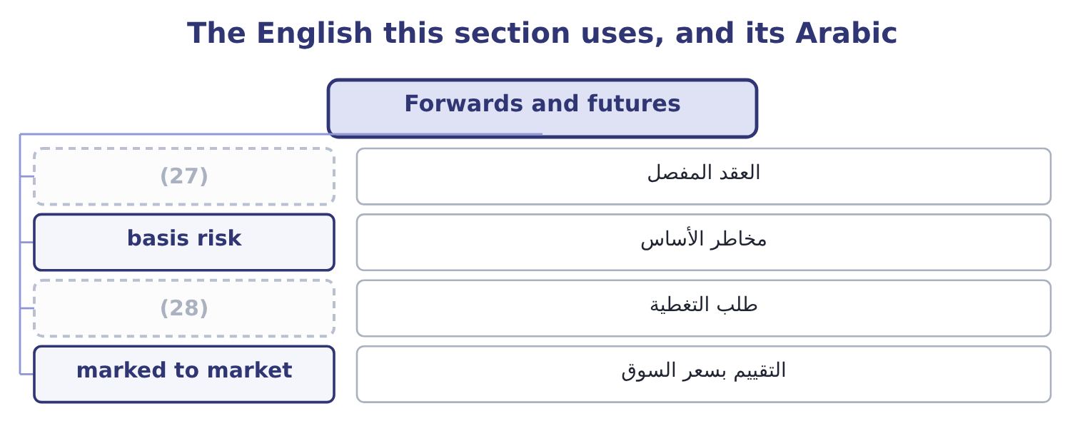
word list
tailored contract · margin call · currency option

The English this sheet uses, and its Arabic
English (exam term) | Arabic
tailored contract | العقد المفصل
basis risk | مخاطر الأساس
margin call | طلب التغطية
marked to market | التقييم بسعر السوق

Answer key · 11.1 Forwards and futures

1 Options and swaps | 15 exchange-traded
2 Financing the trade | 16 differences
3 agreement | 17 standardised
4 another | 18 maturity
5 nothing | 19 clearing
6 forecast | 20 dealing
7 parity | 21 variation
8 risk-free | 22 generates
9 lending | 23 consequence
10 ninety | 24 embarrassed
11 contracts | 25 closed
12 predicted | 26 opposite
13 features | 27 tailored contract
14 unfavourable | 28 margin call

the summaries in full
Summary 1 A forward contract is an agreement with a bank to exchange a fixed amount of one currency for another, at a fixed rate, on a fixed date. It is the instrument companies use most, because it matches an exposure exactly in amount and date and because it costs nothing to enter. The forward rate is not a forecast. It is set by interest rate parity: the rate that removes any risk-free gain from borrowing in one currency and lending in the other. Over ninety days, with dollar interest at 6 per cent and euro interest at 3 per cent, a spot of 1.0800 gives a forward of about 1.0880, and a company that contracts at that rate has not predicted anything. Its features, stated as the exam wants them: it is a private contract between the company and its bank; it is tailored in amount and date; it carries no up-front payment; it obliges both parties, so the favourable movement is given up along with the unfavourable; and it carries counterparty risk, since the bank must perform.
Summary 2 A currency future is the exchange-traded version. The differences are the examinable part. It is standardised in amount and in maturity date, so it rarely matches an exposure exactly, and the mismatch — basis risk — remains. It is traded on an exchange with a clearing house as counterparty, which removes the credit risk of dealing with one bank. It requires margin: an initial deposit and daily variation margin as the position is marked to market, so a hedge that is winning or losing generates cash flows before the exposure settles. That is a liquidity consequence of a risk management decision, and it has embarrassed companies whose hedges were correct and whose margin calls were not funded. And a position can be closed at any time by taking the opposite contract, which a forward cannot. For a company of Orontes's size, hedging specific commercial exposures, the forward is almost always the right instrument. Futures belong where the amounts are large, the maturities standard, the counterparty risk material, or where positions must be adjusted frequently.

11.2 Options and swaps
Chapter 11 · section 11.2

Fill every gap. Each word list holds one word more than there are gaps.
Summary 1 gaps 1–12
A currency option gives the (1) the right, but not the obligation, to exchange currency at a stated rate on or (2) a stated date, in (3) for a premium paid at the outset. An exporter (4) foreign currency buys a put option on that currency; an (5) who will need it buys a call. The (6) is the whole point and it is what the premium buys. If the rate moves (7) the option is exercised and the company has a (8) ; if it moves favourably the option is abandoned and the company keeps the gain, less the premium. (9) a forward, an option costs money and (10) the upside; a forward is free and does not. Three cases where an option is the right (11) , and the exam looks for them. Where the exposure is (12) .
word list
holder · instrument · unfavourably · uncertain · Against · return · dollars · importer · floor · expecting · before · asymmetry · preserves

Summary 2 gaps 13–24
A tender for a (13) that may not be won (14) a currency exposure only if the tender (15) . A forward would leave the company with an (16) position if it lost; an option (17) lapses. Where the company has a view it is (18) to bet on. And where the (19) must be capped for a (20) , a budget or a board. A currency swap is an (21) to exchange principal and interest (22) in one currency for principal and interest in another, usually over several years. Its typical use is not the hedging of a single (23) but the matching of a long-term funding stream to a long-term revenue stream: a company with euro (24) that has borrowed in dollars swaps the dollar obligation into euros, so that its debt service arises in the currency its income arrives.
word list
unwilling · payments · covenant · contract · revenues · floor · transaction · creates · downside · simply · agreement · unwanted · succeeds

Summary 3 gaps 25–30
Three (25) the exam uses. A swap hedges a series of flows rather than one, so it suits (26) and funding (27) . It is driven partly by (28) advantage in (29) : each party borrows where it is best known and swaps into the currency it wants, and both can be better off. And it carries (30) risk over its whole life, which is longer than a forward's.
word list
borrowing · comparative · exposures · counterparty · translation · points · floor

The English this section uses, and its Arabic
Each term sits against what it means.
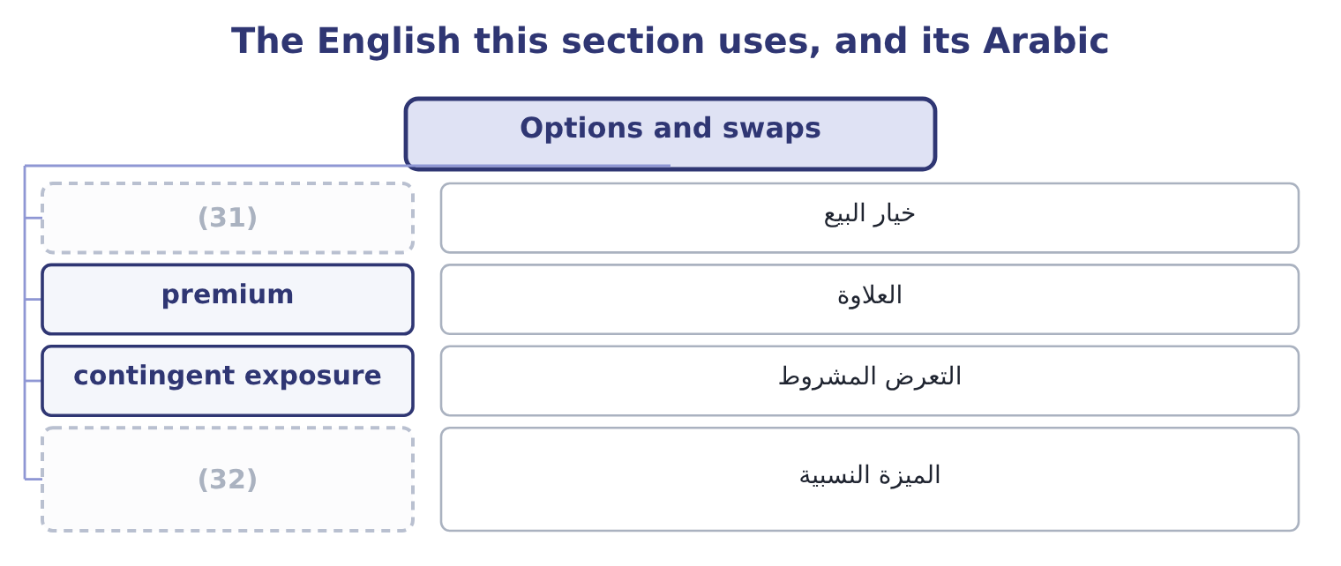
word list
imperfect correlation · put option · comparative advantage

The English this sheet uses, and its Arabic
English (exam term) | Arabic
put option | خيار البيع
premium | العلاوة
contingent exposure | التعرض المشروط
comparative advantage | الميزة النسبية

Answer key · 11.2 Options and swaps

1 holder | 17 simply
2 before | 18 unwilling
3 return | 19 downside
4 expecting | 20 covenant
5 importer | 21 agreement
6 asymmetry | 22 payments
7 unfavourably | 23 transaction
8 floor | 24 revenues
9 Against | 25 points
10 preserves | 26 translation
11 instrument | 27 exposures
12 uncertain | 28 comparative
13 contract | 29 borrowing
14 creates | 30 counterparty
15 succeeds | 31 put option
16 unwanted | 32 comparative advantage

the summaries in full
Summary 1 A currency option gives the holder the right, but not the obligation, to exchange currency at a stated rate on or before a stated date, in return for a premium paid at the outset. An exporter expecting foreign currency buys a put option on that currency; an importer who will need it buys a call. The asymmetry is the whole point and it is what the premium buys. If the rate moves unfavourably the option is exercised and the company has a floor; if it moves favourably the option is abandoned and the company keeps the gain, less the premium. Against a forward, an option costs money and preserves the upside; a forward is free and does not. Three cases where an option is the right instrument, and the exam looks for them. Where the exposure is uncertain.
Summary 2 A tender for a contract that may not be won creates a currency exposure only if the tender succeeds. A forward would leave the company with an unwanted position if it lost; an option simply lapses. Where the company has a view it is unwilling to bet on. And where the downside must be capped for a covenant, a budget or a board. A currency swap is an agreement to exchange principal and interest payments in one currency for principal and interest in another, usually over several years. Its typical use is not the hedging of a single transaction but the matching of a long-term funding stream to a long-term revenue stream: a company with euro revenues that has borrowed in dollars swaps the dollar obligation into euros, so that its debt service arises in the currency its income arrives.
Summary 3 Three points the exam uses. A swap hedges a series of flows rather than one, so it suits translation and funding exposures. It is driven partly by comparative advantage in borrowing: each party borrows where it is best known and swaps into the currency it wants, and both can be better off. And it carries counterparty risk over its whole life, which is longer than a forward's.

11.3 Choosing, and computing the outcome
Chapter 11 · section 11.3

Fill every gap. Each word list holds one word more than there are gaps.
Summary 1 gaps 1–12
The (1) outcome asks for a recommendation with the net profit or loss of the (2) method computed, which is the (3) most likely to appear in an exam. Orontes will (4) 2,000,000 euros in ninety days. The spot rate is 1.0800, the (5) forward is 1.0880, (6) interest is 6 per cent a year and euro interest 3 per cent, and a put option on euros at a strike of 1.0800 costs 0.0150 a euro. The result (7) on the rate in ninety days. At 1.1500 the receipt is 2,000,000 × 1.1500 = 2,300,000; at 1.0200 it is 2,000,000 × 1.0200 = 2,040,000. The range is 260,000 wide and (8) is known in (9) . (10) to sell 2,000,000 euros at 1.0880 for 2,000,000 × 1.0880 = 2,176,000, certain, (11) the rate does. Borrow euros today against the (12) , convert at spot and hold dollars.
word list
position · recommended · advance · dollar · second · receivable · nothing · calculation · ninety-day · whatever · receive · Contract · depends

Summary 2 gaps 13–23
The amount to borrow is 2,000,000 ÷ 1.0075 = 1,985,112, since ninety days of euro interest at 3 per cent a year is a (13) of 3 per cent. (14) gives 1,985,112 × 1.0800 = 2,143,921, and (15) that in dollars at 6 per cent for ninety days gives 2,143,921 × 1.015 = 2,176,080. Pay a premium of 2,000,000 × 0.0150 = 30,000 now. If the rate falls to 1.0200, (16) at 1.0800 for 2,000,000 × 1.0800 = 2,160,000, so the net is 2,160,000 − 30,000 = 2,130,000. If it rises to 1.1500, let the option lapse and sell at spot for 2,300,000, so the net is 2,300,000 − 30,000 = 2,270,000. Two results are worth (17) . The forward and the money (18) hedge give 2,176,000 and 2,176,080 — the same answer, which is interest rate parity (19) exactly; any material (20) between them would be an (21) . And the option is never the best outcome and never the worst: it costs 30,000 to convert the whole range into a (22) with the upside (23) .
word list
working · natural · holding · market · intact · exercise · difference · floor · Converting · quarter · noticing · arbitrage

The same exposure, four treatments
The bars are drawn to scale.
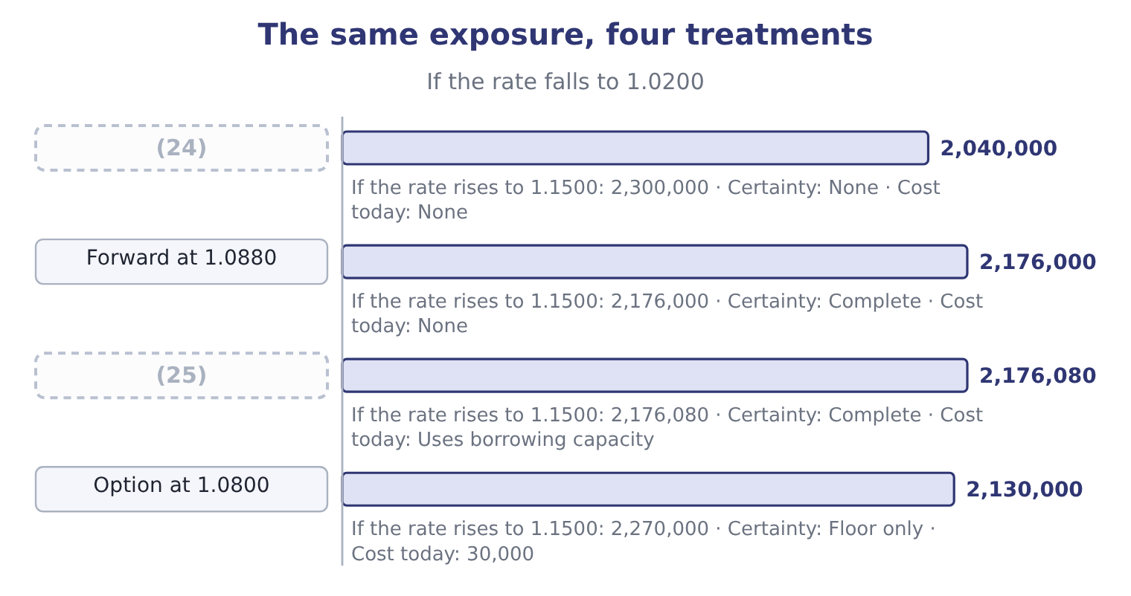
word list
margin call · Money market hedge · Do nothing

Summary 3 gaps 26–37
The recommendation, which the outcome (26) , follows from four (27) rather than from the table. Is the exposure certain? If the sale is (28) and the customer is good, the forward is (29) . If it is (30) , use an option. What does the policy say?, which (31) most of the question before any (32) . Has the natural hedge been taken first? (33) 400,000 of euro costs reduce the exposure needing an (34) to 1,600,000, and hedging the gross amount would create a position. And what can the company afford to be wrong about? If 260,000 of (35) would breach a covenant or a budget (36) , certainty is worth paying for; if it would not, the premium may not be. On that basis the recommendation for Orontes is a forward for 75 per cent of the net 1,600,000 exposure, dated to the (37) receipt, with the balance left open against the risk that the shipment slips — which is the answer.
word list
contingent · balance · commitment · arithmetic · appropriate · settles · requires · contracted · Orontes's · expected · questions · variation · instrument

The English this section uses, and its Arabic
Each term sits against what it means.
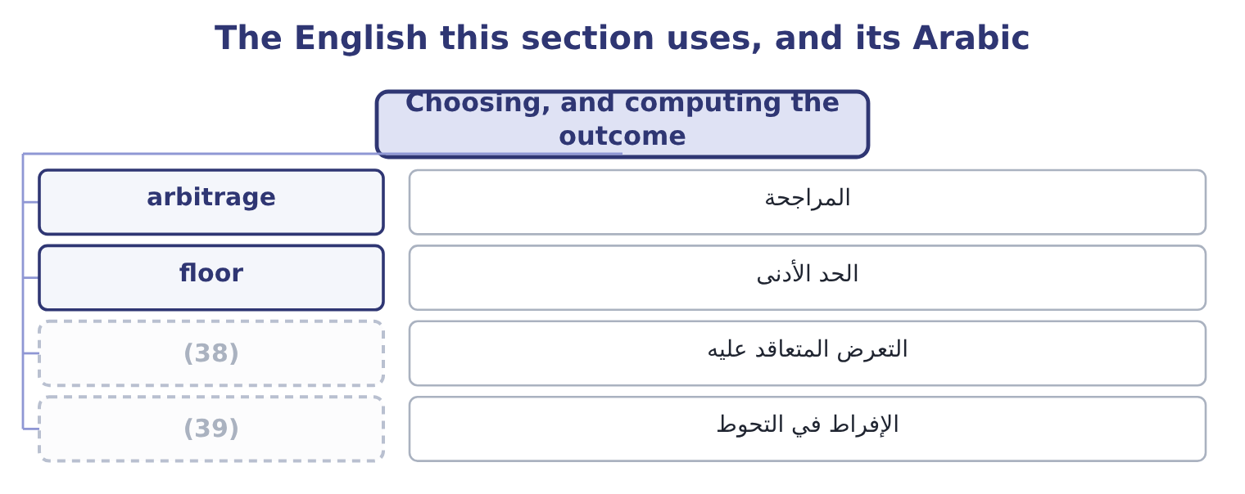
word list
contracted exposure · over-hedging · without recourse

The English this sheet uses, and its Arabic
English (exam term) | Arabic
arbitrage | المراجحة
floor | الحد الأدنى
contracted exposure | التعرض المتعاقد عليه
over-hedging | الإفراط في التحوط

Answer key · 11.3 Choosing, and computing the outcome

1 second | 21 arbitrage
2 recommended | 22 floor
3 calculation | 23 intact
4 receive | 24 Do nothing
5 ninety-day | 25 Money market hedge
6 dollar | 26 requires
7 depends | 27 questions
8 nothing | 28 contracted
9 advance | 29 appropriate
10 Contract | 30 contingent
11 whatever | 31 settles
12 receivable | 32 arithmetic
13 quarter | 33 Orontes's
14 Converting | 34 instrument
15 holding | 35 variation
16 exercise | 36 commitment
17 noticing | 37 expected
18 market | 38 contracted exposure
19 working | 39 over-hedging
20 difference

the summaries in full
Summary 1 The second outcome asks for a recommendation with the net profit or loss of the recommended method computed, which is the calculation most likely to appear in an exam. Orontes will receive 2,000,000 euros in ninety days. The spot rate is 1.0800, the ninety-day forward is 1.0880, dollar interest is 6 per cent a year and euro interest 3 per cent, and a put option on euros at a strike of 1.0800 costs 0.0150 a euro. The result depends on the rate in ninety days. At 1.1500 the receipt is 2,000,000 × 1.1500 = 2,300,000; at 1.0200 it is 2,000,000 × 1.0200 = 2,040,000. The range is 260,000 wide and nothing is known in advance. Contract to sell 2,000,000 euros at 1.0880 for 2,000,000 × 1.0880 = 2,176,000, certain, whatever the rate does. Borrow euros today against the receivable, convert at spot and hold dollars.
Summary 2 The amount to borrow is 2,000,000 ÷ 1.0075 = 1,985,112, since ninety days of euro interest at 3 per cent a year is a quarter of 3 per cent. Converting gives 1,985,112 × 1.0800 = 2,143,921, and holding that in dollars at 6 per cent for ninety days gives 2,143,921 × 1.015 = 2,176,080. Pay a premium of 2,000,000 × 0.0150 = 30,000 now. If the rate falls to 1.0200, exercise at 1.0800 for 2,000,000 × 1.0800 = 2,160,000, so the net is 2,160,000 − 30,000 = 2,130,000. If it rises to 1.1500, let the option lapse and sell at spot for 2,300,000, so the net is 2,300,000 − 30,000 = 2,270,000. Two results are worth noticing. The forward and the money market hedge give 2,176,000 and 2,176,080 — the same answer, which is interest rate parity working exactly; any material difference between them would be an arbitrage. And the option is never the best outcome and never the worst: it costs 30,000 to convert the whole range into a floor with the upside intact.
Summary 3 The recommendation, which the outcome requires, follows from four questions rather than from the table. Is the exposure certain? If the sale is contracted and the customer is good, the forward is appropriate. If it is contingent, use an option. What does the policy say?, which settles most of the question before any arithmetic. Has the natural hedge been taken first? Orontes's 400,000 of euro costs reduce the exposure needing an instrument to 1,600,000, and hedging the gross amount would create a position. And what can the company afford to be wrong about? If 260,000 of variation would breach a covenant or a budget commitment, certainty is worth paying for; if it would not, the premium may not be. On that basis the recommendation for Orontes is a forward for 75 per cent of the net 1,600,000 exposure, dated to the expected receipt, with the balance left open against the risk that the shipment slips — which is the answer.

11.4 International diversification
Chapter 11 · section 11.4

Fill every gap. Each word list holds one word more than there are gaps.
Summary 1 gaps 1–12
The third outcome asks for the benefits of international diversification, which means (1) and operating abroad rather than merely selling abroad. Six benefits, with their (2) . Lower (3) of results. (4) do not move together, so profits from several countries are less variable in total than profits from one. This is Book 2's, and it works for the same reason: imperfect (5) . Markets that are growing faster than the home market, and (6) the company's products suit. Lower input costs and (7) to inputs. (8) or sourcing where labour, materials or energy are cheaper, or where the raw material grows. Natural hedging of (9) . A company with euro costs as well as euro revenues has reduced its exposure (10) . Reduced political and regulatory (11) . A single adverse decision affects one country's (12) rather than the whole business, which is.
word list
Producing · concentration · currency · access · qualifications · populations · correlation · variability · Economies · investing · adverse · operations · structurally

Summary 2 gaps 13–24
Learning and (13) position. Exposure to (14) customers, different competitors and other regulatory standards improves the business at home, and presence in a (15) market is itself a deterrent. (16) that, four costs the exam (17) as the other half of a good answer. New risks: political, legal, cultural, and the (18) risk of running something far away. (19) rise in a crisis, so the diversification is smallest in the years it is most wanted — the same (20) . (21) attention is finite, and a foreign operation (22) more of it per dollar than a domestic one. And (23) can diversify (24) for themselves, more cheaply, by buying foreign shares. That is Book 3's, and it applies here with the same force: the case for international investment must rest on something the company can do — a product, a brand, a process, a cost position — and not on diversification alone.
word list
observation · Against · cheaply · demanding · internationally · consumes · expects · Correlations · shareholders · competitive · competitor's · Management · operational

The English this section uses, and its Arabic
Each term sits against what it means.
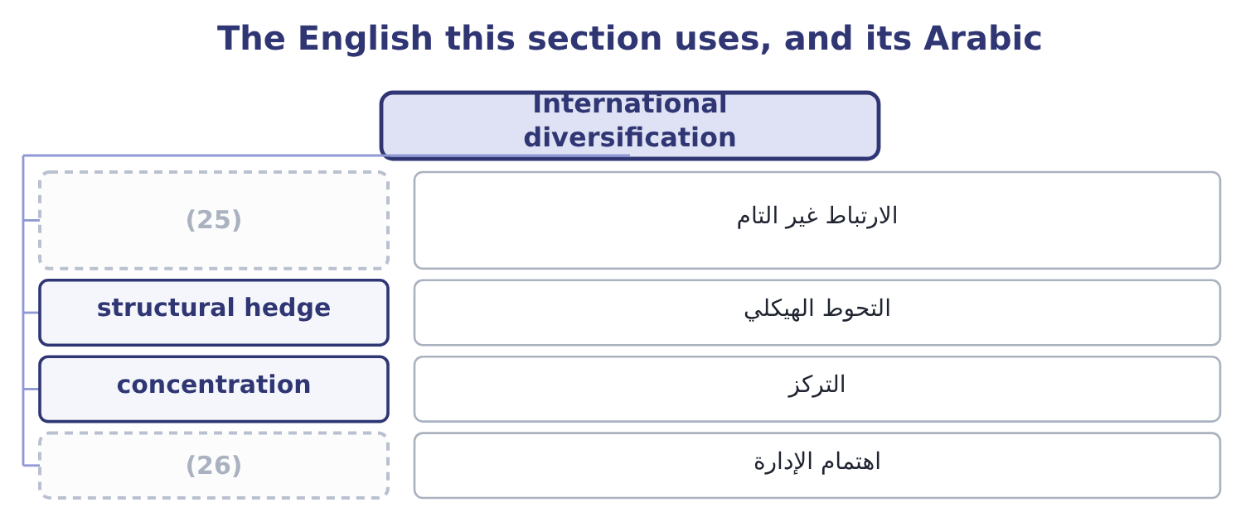
word list
comparative advantage · management attention · imperfect correlation

The English this sheet uses, and its Arabic
English (exam term) | Arabic
imperfect correlation | الارتباط غير التام
structural hedge | التحوط الهيكلي
concentration | التركز
management attention | اهتمام الإدارة

Answer key · 11.4 International diversification

1 investing | 14 demanding
2 qualifications | 15 competitor's
3 variability | 16 Against
4 Economies | 17 expects
5 correlation | 18 operational
6 populations | 19 Correlations
7 access | 20 observation
8 Producing | 21 Management
9 currency | 22 consumes
10 structurally | 23 shareholders
11 concentration | 24 internationally
12 operations | 25 imperfect correlation
13 competitive | 26 management attention

the summaries in full
Summary 1 The third outcome asks for the benefits of international diversification, which means investing and operating abroad rather than merely selling abroad. Six benefits, with their qualifications. Lower variability of results. Economies do not move together, so profits from several countries are less variable in total than profits from one. This is Book 2's, and it works for the same reason: imperfect correlation. Markets that are growing faster than the home market, and populations the company's products suit. Lower input costs and access to inputs. Producing or sourcing where labour, materials or energy are cheaper, or where the raw material grows. Natural hedging of currency. A company with euro costs as well as euro revenues has reduced its exposure structurally. Reduced political and regulatory concentration. A single adverse decision affects one country's operations rather than the whole business, which is.
Summary 2 Learning and competitive position. Exposure to demanding customers, different competitors and other regulatory standards improves the business at home, and presence in a competitor's market is itself a deterrent. Against that, four costs the exam expects as the other half of a good answer. New risks: political, legal, cultural, and the operational risk of running something far away. Correlations rise in a crisis, so the diversification is smallest in the years it is most wanted — the same observation. Management attention is finite, and a foreign operation consumes more of it per dollar than a domestic one. And shareholders can diversify internationally for themselves, more cheaply, by buying foreign shares. That is Book 3's, and it applies here with the same force: the case for international investment must rest on something the company can do — a product, a brand, a process, a cost position — and not on diversification alone.

11.5 Financing the trade
Chapter 11 · section 11.5

Fill every gap. Each word list holds one word more than there are gaps.
Summary 1 gaps 1–12
Cross-border sales create two (1) at once: the exporter wants payment and the importer wants the goods, and (2) will go first. The (3) of trade finance exist to break that (4) , and the outcome names five. A letter of credit is an undertaking by the importer's bank to pay the exporter on (5) of specified documents — typically the bill of lading, the invoice and a (6) of inspection or origin. It (7) a bank's credit for the buyer's, which is its whole (8) : the exporter no longer has to assess a customer in another country. It is (9) , meaning the bank pays against conforming documents and not against the goods, so a (10) in the paperwork can delay payment even where the shipment is perfect. A (11) letter of credit adds the (12) own bank's undertaking, removing the risk of the issuing bank or its country.
word list
instruments · certificate · documentary · discrepancy · confirmed · neither · presentation · exporter's · deadlock · purpose · problems · substitutes · opposite

Summary 2 gaps 13–24
A banker's acceptance is a time draft drawn on a bank which the bank accepts, so that the bank becomes (13) liable to pay it at (14) . Because a bank's acceptance is a (15) instrument, it can be sold at a discount in the money (16) , which means the exporter can have the cash immediately while the importer still has time to pay. It (17) trade credit into a (18) security. Cross-border factoring is the sale of (19) receivables to a factor, (20) through a chain of (21) factors with one in the importer's country, who (22) and collects locally. It (23) cash immediately, transfers the collection work, and where it is without recourse it transfers the credit risk as well. Its cost is the fee and the discount, and that cost must be (24) with the alternative uses of the money.
word list
primarily · market · converts · provides · correspondent · tradeable · analysis · compared · high-quality · maturity · usually · assesses · foreign

Summary 3 gaps 25–36
Forfaiting is the (25) , without recourse, of medium-term receivables from an exporter — typically notes or drafts, often (26) by a bank in the importer's country, over terms of one to seven years. It suits capital goods sold to buyers in difficult markets: the exporter is paid at once and keeps none of the credit, country or currency risk, and pays a (27) discount for. Countertrade is payment in goods rather than money, in various forms: barter, where goods are (28) directly; counterpurchase, where the exporter agrees to buy (29) goods from the (30) country; and offset, where part of the value must be sourced or produced in the buyer's country. It appears where currency is scarce or (31) , where the buyer is a (32) , and in large defence and (33) contracts. Its costs are real — the exporter must (34) of goods it did not want, often at a discount — and should be valued (35) rather than (36) as free.
word list
substantial · purchase · importing · without · treated · controlled · explicitly · government · unrelated · exchanged · infrastructure · dispose · guaranteed

Worked example: what factoring costs

Summary 4 gaps 37–45
Orontes's 2,000,000 euro receivable, due in ninety days. A factor (37) 2 per cent of face value as a fee, plus interest at 7 per cent a year on the (38) for the ninety days. The fee is 2,000,000 × 0.02 = 40,000 and the interest 2,000,000 × 0.07 × 0.25 = 35,000, so the total is 40,000 + 35,000 = 75,000. That is 75,000 ÷ 2,000,000 = 3.75 per cent for ninety days, which (39) to roughly 3.75 × 4 = 15.0 per cent. (40) per cent against a cost of capital of 9.04 per cent looks (41) , and may still be worth it: the (42) is not with the cost of capital but with what the alternative costs. If the arrangement is without recourse it also removes the credit risk, and it removes the collection (43) in a country where Orontes has no (44) . An exam answer that stops at "15 per cent is more than the cost of capital, so reject" has not (45) the analysis.
word list
Fifteen · offers · annualises · finance · presence · comparison · advance · expensive · effort · finished

Trade finance instruments
Instrument | What it does | Who it protects | Typical use
Letter of credit | A bank pays against conforming documents | The exporter, against the buyer | (46)
Banker's acceptance | (47) | Both, with early cash | Short-term goods trade
Cross-border factoring | Receivables sold to a factor who collects locally | (48) | Continuing export sales
Forfaiting | Medium-term receivables bought without recourse | (49) | Capital goods, long terms
Countertrade | Payment in goods rather than money | The importer short of currency | (50)

word list
First dealings; difficult markets · 2,130,000: 2,160,000 − 30,000 = 2,130,000. · A bank accepts a time draft, which can be discounted · The exporter, completely · Currency controls; state buyers · The exporter, with cash and often credit cover

Instruments and arithmetic

Your turn: hedging and financing (complete the blanks)
Item | Data | Answer
Proceeds under a forward | (51) | ________
Option premium | (52) | ________
Net proceeds if the option is exercised | Strike 1.0800, premium as above | ________
Instrument for an exposure that exists only if a tender is won |  | ________
Instrument substituting a bank's credit for the buyer's |  | ________
Annualised cost of factoring | Fee 40,000 plus interest 35,000 on 2,000,000 for 90 days | ________

word list
2,000,000 euros at 1.0880 · Both, with early cash · 2,000,000 euros at 0.0150

"Hedge", "cover" and "without recourse"

Summary 5 gaps 53–64
Two (53) terms matter here. Cover is used in British practice as a (54) for hedge — "we have covered the exposure" — and in (55) for what a policy pays; in a cross-border (56) it may mean either, so a report should use hedged for (57) and insured for policies. Without recourse is the phrase that (58) the money in trade finance: it means the buyer of the receivable (59) come back to the exporter if the customer does not pay, so the credit risk has (60) moved. With recourse means the opposite, and the (61) in price between the two is the price of the credit risk. When a question (62) a factoring or forfaiting arrangement, the first thing to (63) is which of the two it is, because (64) about the risk analysis follows from it.
word list
cannot · further · insurance · document · positions · establish · carries · difference · usually · describes · everything · genuinely · near-synonym

"Hedge", "cover" and "without recourse"
Item | Answer
Proceeds under a forward | 2,176,000: 2,000,000 × 1.0880 = 2,176,000.
Option premium | (65)
Net proceeds if exercised | (66)
Instrument for a tender-contingent exposure | An option, which lapses if the tender is lost.
Instrument substituting a bank's credit | (67)
Annualised cost of factoring | (68) : 3.75 per cent for ninety days.
What it tells you | Three calculations and three choices — and in every case the arithmetic narrows the options while the decision turns on whether the exposure

word list
A letter of credit. · 30,000: 2,000,000 × 0.0150 = 30,000. · 2,130,000: 2,160,000 − 30,000 = 2,130,000. · About 15.0 per cent · 2,176,000: 2,000,000 × 1.0880 = 2,176,000.

The English this section uses, and its Arabic
Each term sits against what it means.
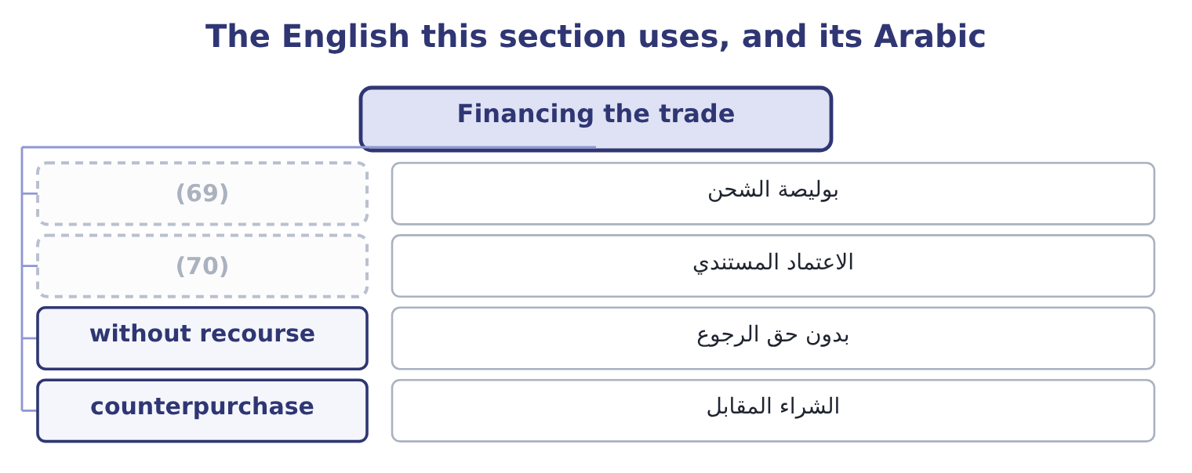
word list
comparative advantage · documentary credit · bill of lading

The English this sheet uses, and its Arabic
English (exam term) | Arabic
bill of lading | بوليصة الشحن
documentary credit | الاعتماد المستندي
without recourse | بدون حق الرجوع
counterpurchase | الشراء المقابل

Answer key · 11.5 Financing the trade

1 problems | 36 treated
2 neither | 37 offers
3 instruments | 38 advance
4 deadlock | 39 annualises
5 presentation | 40 Fifteen
6 certificate | 41 expensive
7 substitutes | 42 comparison
8 purpose | 43 effort
9 documentary | 44 presence
10 discrepancy | 45 finished
11 confirmed | 46 First dealings; difficult markets
12 exporter's | 47 A bank accepts a time draft, which can be discounted
13 primarily | 48 The exporter, with cash and often credit cover
14 maturity | 49 The exporter, completely
15 high-quality | 50 Currency controls; state buyers
16 market | 51 2,000,000 euros at 1.0880
17 converts | 52 2,000,000 euros at 0.0150
18 tradeable | 53 further
19 foreign | 54 near-synonym
20 usually | 55 insurance
21 correspondent | 56 document
22 assesses | 57 positions
23 provides | 58 carries
24 compared | 59 cannot
25 purchase | 60 genuinely
26 guaranteed | 61 difference
27 substantial | 62 describes
28 exchanged | 63 establish
29 unrelated | 64 everything
30 importing | 65 30,000: 2,000,000 × 0.0150 = 30,000.
31 controlled | 66 2,130,000: 2,160,000 − 30,000 = 2,130,000.
32 government | 67 A letter of credit.
33 infrastructure | 68 About 15.0 per cent
34 dispose | 69 bill of lading
35 explicitly | 70 documentary credit

the summaries in full
Summary 1 Cross-border sales create two problems at once: the exporter wants payment and the importer wants the goods, and neither will go first. The instruments of trade finance exist to break that deadlock, and the outcome names five. A letter of credit is an undertaking by the importer's bank to pay the exporter on presentation of specified documents — typically the bill of lading, the invoice and a certificate of inspection or origin. It substitutes a bank's credit for the buyer's, which is its whole purpose: the exporter no longer has to assess a customer in another country. It is documentary, meaning the bank pays against conforming documents and not against the goods, so a discrepancy in the paperwork can delay payment even where the shipment is perfect. A confirmed letter of credit adds the exporter's own bank's undertaking, removing the risk of the issuing bank or its country.
Summary 2 A banker's acceptance is a time draft drawn on a bank which the bank accepts, so that the bank becomes primarily liable to pay it at maturity. Because a bank's acceptance is a high-quality instrument, it can be sold at a discount in the money market, which means the exporter can have the cash immediately while the importer still has time to pay. It converts trade credit into a tradeable security. Cross-border factoring is the sale of foreign receivables to a factor, usually through a chain of correspondent factors with one in the importer's country, who assesses and collects locally. It provides cash immediately, transfers the collection work, and where it is without recourse it transfers the credit risk as well. Its cost is the fee and the discount, and that cost must be compared with the alternative uses of the money.
Summary 3 Forfaiting is the purchase, without recourse, of medium-term receivables from an exporter — typically notes or drafts, often guaranteed by a bank in the importer's country, over terms of one to seven years. It suits capital goods sold to buyers in difficult markets: the exporter is paid at once and keeps none of the credit, country or currency risk, and pays a substantial discount for. Countertrade is payment in goods rather than money, in various forms: barter, where goods are exchanged directly; counterpurchase, where the exporter agrees to buy unrelated goods from the importing country; and offset, where part of the value must be sourced or produced in the buyer's country. It appears where currency is scarce or controlled, where the buyer is a government, and in large defence and infrastructure contracts. Its costs are real — the exporter must dispose of goods it did not want, often at a discount — and should be valued explicitly rather than treated as free.
Summary 4 Orontes's 2,000,000 euro receivable, due in ninety days. A factor offers 2 per cent of face value as a fee, plus interest at 7 per cent a year on the advance for the ninety days. The fee is 2,000,000 × 0.02 = 40,000 and the interest 2,000,000 × 0.07 × 0.25 = 35,000, so the total is 40,000 + 35,000 = 75,000. That is 75,000 ÷ 2,000,000 = 3.75 per cent for ninety days, which annualises to roughly 3.75 × 4 = 15.0 per cent. Fifteen per cent against a cost of capital of 9.04 per cent looks expensive, and may still be worth it: the comparison is not with the cost of capital but with what the alternative costs. If the arrangement is without recourse it also removes the credit risk, and it removes the collection effort in a country where Orontes has no presence. An exam answer that stops at "15 per cent is more than the cost of capital, so reject" has not finished the analysis.
Summary 5 Two further terms matter here. Cover is used in British practice as a near-synonym for hedge — "we have covered the exposure" — and in insurance for what a policy pays; in a cross-border document it may mean either, so a report should use hedged for positions and insured for policies. Without recourse is the phrase that carries the money in trade finance: it means the buyer of the receivable cannot come back to the exporter if the customer does not pay, so the credit risk has genuinely moved. With recourse means the opposite, and the difference in price between the two is the price of the credit risk. When a question describes a factoring or forfaiting arrangement, the first thing to establish is which of the two it is, because everything about the risk analysis follows from it.

