12.1 What business ethics is
Chapter 12 · section 12.1

Fill every gap. Each word list holds one word more than there are gaps.
Chapter 12, section by section
Each stage leads to the next.
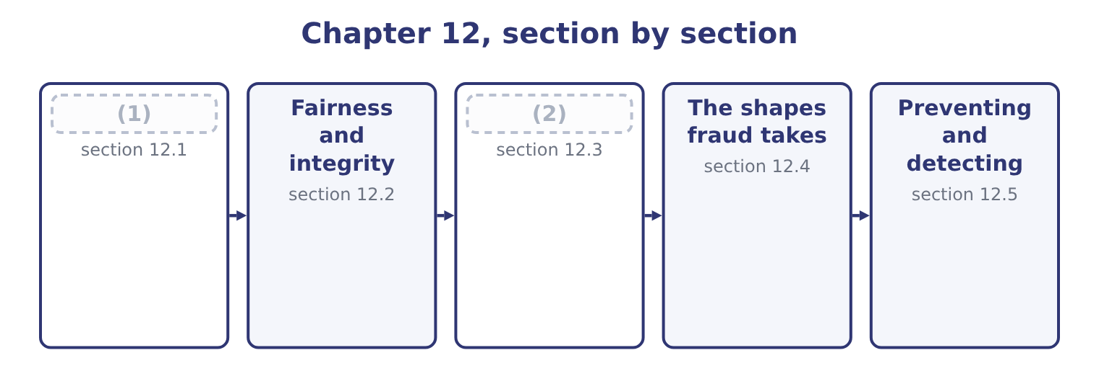
word list
Due diligence and fiduciary responsibility · The shapes fraud takes · What business ethics is

Summary 1 gaps 3–14
Business ethics is the (3) of moral principles and standards of conduct to the decisions and behaviour of (4) and the people in them. It asks what ought to be done, where law asks what must be done and (5) asks what pays. Four points of (6) carry the weight in this (7) . It concerns conduct, not (8) . Ethics is about what is done, not about how (9) feels, and an ethical company is one whose decisions are (10) defensible, not one whose values statement is well written. It is not the same as (11) , and: much that is legal is (12) , and the gap between the two is where most professional dilemmas live. It (13) to the organisation and to the (14) separately. A company has obligations, and so does each professional inside it, and the Statement of Ethical Professional Practice. And it concerns everybody affected by a decision, not only its shareholders.
word list
unethical · individual · anybody · sentiment · organisations · consistently · obligations · applies · economics · definition · application · syllabus · legality

Summary 2 gaps 15–26
Customers, (15) , suppliers, lenders, (16) and regulators all have interests, and ethical reasoning means weighing them rather than assuming one of them always wins. Three (17) to deciding appear in exam (18) and are worth having. Which action (19) the best overall outcome for everybody affected. Its strength is (20) ; its weakness is that it permits harm to a few for the benefit of many and that (21) are forecast rather than known. Some things are owed (22) of outcome: tell the truth, keep (23) , respect the rights of others. Its strength is that it does not (24) ; its weakness is that duties (25) . What a person of (26) would do, and what the decision makes of the person who takes it. Its strength is that it describes how people actually decide; its weakness is that it gives little guidance in a genuinely new situation. A practical answer uses all three as tests rather than choosing between them, and adds a fourth that is more useful than any of them in an exam: would this decision survive publication? If an action could not be explained to the people affected, or would be indefensible on the front page of a newspaper, that is strong evidence about it.
word list
integrity · agreements · answers · conflict · practicality · consequences · legality · approaches · produces · communities · employees · regardless · negotiate

The English this section uses, and its Arabic
Each term sits against what it means.
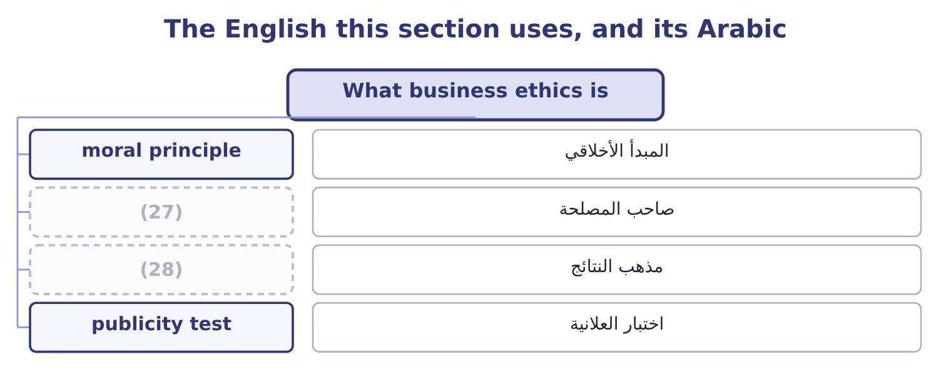
word list
consequentialism · stakeholder · irregularity

The English this sheet uses, and its Arabic
English (exam term) | Arabic
moral principle | المبدأ الأخلاقي
stakeholder | صاحب المصلحة
consequentialism | مذهب النتائج
publicity test | اختبار العلانية

Answer key · 12.1 What business ethics is

1 What business ethics is | 15 employees
2 Due diligence and fiduciary responsibility | 16 communities
3 application | 17 approaches
4 organisations | 18 answers
5 economics | 19 produces
6 definition | 20 practicality
7 syllabus | 21 consequences
8 sentiment | 22 regardless
9 anybody | 23 agreements
10 consistently | 24 negotiate
11 legality | 25 conflict
12 unethical | 26 integrity
13 applies | 27 stakeholder
14 individual | 28 consequentialism

the summaries in full
Summary 1 Business ethics is the application of moral principles and standards of conduct to the decisions and behaviour of organisations and the people in them. It asks what ought to be done, where law asks what must be done and economics asks what pays. Four points of definition carry the weight in this syllabus. It concerns conduct, not sentiment. Ethics is about what is done, not about how anybody feels, and an ethical company is one whose decisions are consistently defensible, not one whose values statement is well written. It is not the same as legality, and: much that is legal is unethical, and the gap between the two is where most professional dilemmas live. It applies to the organisation and to the individual separately. A company has obligations, and so does each professional inside it, and the Statement of Ethical Professional Practice. And it concerns everybody affected by a decision, not only its shareholders.
Summary 2 Customers, employees, suppliers, lenders, communities and regulators all have interests, and ethical reasoning means weighing them rather than assuming one of them always wins. Three approaches to deciding appear in exam answers and are worth having. Which action produces the best overall outcome for everybody affected. Its strength is practicality; its weakness is that it permits harm to a few for the benefit of many and that consequences are forecast rather than known. Some things are owed regardless of outcome: tell the truth, keep agreements, respect the rights of others. Its strength is that it does not negotiate; its weakness is that duties conflict. What a person of integrity would do, and what the decision makes of the person who takes it. Its strength is that it describes how people actually decide; its weakness is that it gives little guidance in a genuinely new situation. A practical answer uses all three as tests rather than choosing between them, and adds a fourth that is more useful than any of them in an exam: would this decision survive publication? If an action could not be explained to the people affected, or would be indefensible on the front page of a newspaper, that is strong evidence about it.

12.2 Fairness and integrity
Chapter 12 · section 12.2

Fill every gap. Each word list holds one word more than there are gaps.
Summary 1 gaps 1–12
The outcome names four (1) and asks what each means and how it affects (2) . Two of them are about the (3) of a decision and two about the care taken over it. Fairness is treating like cases alike, and treating people (4) to standards they could accept if they knew them. It has three (5) the exam uses. Fairness of outcome: whether the (6) of benefit and (7) is defensible. A supplier (8) on payment terms because it cannot afford to argue is being treated (9) in outcome, whatever the contract allows. Fairness of process: whether the decision was made by a method that treats everybody consistently, with the same (10) and the same (11) to be heard. A tender awarded on (12) that were changed after bids were received is unfair in process even if the winner was the best bidder.
word list
decisions · distribution · fairness · criteria · dimensions · character · burden · concepts · opportunity · information · squeezed · unfairly · according

Summary 2 gaps 13–24
Fairness of (13) : whether people are dealt with (14) and with respect — told the truth, told in time, not misled by omission. In (15) fairness bites hardest where a company has power: over a small supplier, over a (16) who cannot evaluate what is being sold, over an employee who cannot easily leave. The test is not whether the other party agreed; it is whether they agreed on terms they (17) and could have (18) . Integrity is wholeness — acting on the same (19) consistently, whether or not anybody is watching, and whether or not it is (20) . For a (21) accountant it has four practical (22) . (23) in what is reported, (24) what is omitted. A technically true figure presented so as to mislead is a breach of integrity, and Book 1's. Avoiding conflicts of interest, and disclosing those that cannot be avoided.
word list
understood · Honesty · principles · including · customer · Integrity's · practice · refused · honestly · components · treatment · convenient · management

Summary 3 gaps 25–36
The (25) is the problem, not the (26) it might lead to, and the (27) arises before anything has gone wrong. Refusing to do (28) what may not be done directly — which covers the request to leave (29) out, to delay a (30) , to book an entry somebody else will reverse. And (31) between what is said and what is done, which is the (32) other people actually observe and the one on which a finance function's (33) rests. (34) practical difficulty is that it is tested in small (35) long before it is tested in large ones. Nobody is asked to commit a fraud on their first day; they are asked to accept an expense claim they know is wrong, to describe a (36) in a way that is technically defensible, to leave a sentence out of a paper.
word list
component · consistency · something · conflict · indirectly · sentence · provision · matters · obligation · recognition · wrongdoing · credibility · Integrity's

The English this section uses, and its Arabic
Each term sits against what it means.
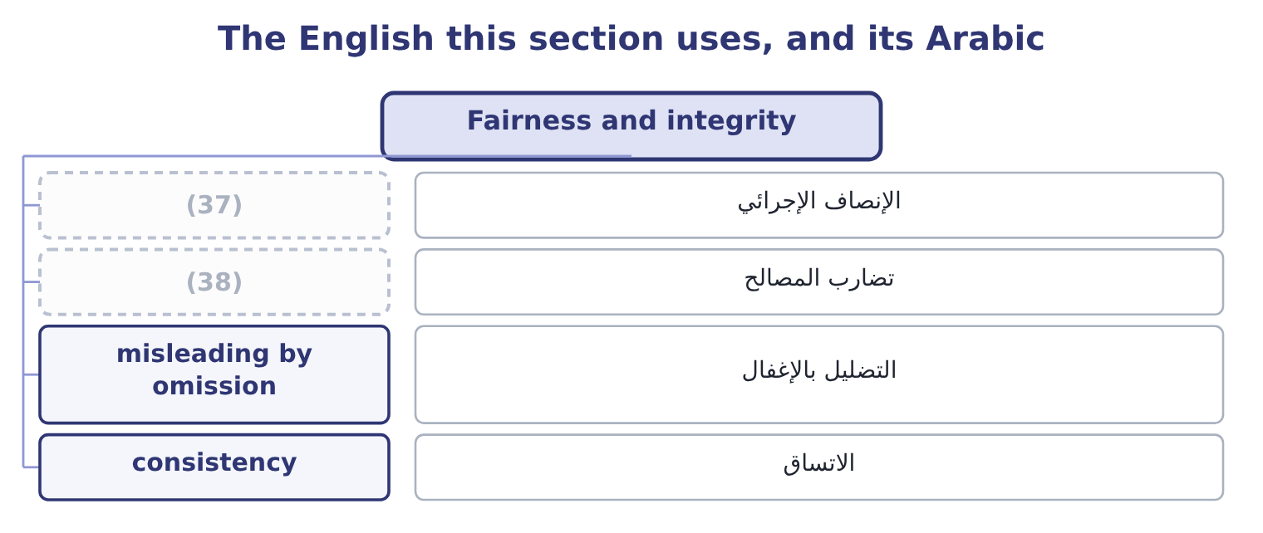
word list
conflict of interest · control environment · procedural fairness

The English this sheet uses, and its Arabic
English (exam term) | Arabic
procedural fairness | الإنصاف الإجرائي
conflict of interest | تضارب المصالح
misleading by omission | التضليل بالإغفال
consistency | الاتساق

Answer key · 12.2 Fairness and integrity

1 concepts | 20 convenient
2 decisions | 21 management
3 character | 22 components
4 according | 23 Honesty
5 dimensions | 24 including
6 distribution | 25 conflict
7 burden | 26 wrongdoing
8 squeezed | 27 obligation
9 unfairly | 28 indirectly
10 information | 29 something
11 opportunity | 30 recognition
12 criteria | 31 consistency
13 treatment | 32 component
14 honestly | 33 credibility
15 practice | 34 Integrity's
16 customer | 35 matters
17 understood | 36 provision
18 refused | 37 procedural fairness
19 principles | 38 conflict of interest

the summaries in full
Summary 1 The outcome names four concepts and asks what each means and how it affects decisions. Two of them are about the character of a decision and two about the care taken over it. Fairness is treating like cases alike, and treating people according to standards they could accept if they knew them. It has three dimensions the exam uses. Fairness of outcome: whether the distribution of benefit and burden is defensible. A supplier squeezed on payment terms because it cannot afford to argue is being treated unfairly in outcome, whatever the contract allows. Fairness of process: whether the decision was made by a method that treats everybody consistently, with the same information and the same opportunity to be heard. A tender awarded on criteria that were changed after bids were received is unfair in process even if the winner was the best bidder.
Summary 2 Fairness of treatment: whether people are dealt with honestly and with respect — told the truth, told in time, not misled by omission. In practice fairness bites hardest where a company has power: over a small supplier, over a customer who cannot evaluate what is being sold, over an employee who cannot easily leave. The test is not whether the other party agreed; it is whether they agreed on terms they understood and could have refused. Integrity is wholeness — acting on the same principles consistently, whether or not anybody is watching, and whether or not it is convenient. For a management accountant it has four practical components. Honesty in what is reported, including what is omitted. A technically true figure presented so as to mislead is a breach of integrity, and Book 1's. Avoiding conflicts of interest, and disclosing those that cannot be avoided.
Summary 3 The conflict is the problem, not the wrongdoing it might lead to, and the obligation arises before anything has gone wrong. Refusing to do indirectly what may not be done directly — which covers the request to leave something out, to delay a recognition, to book an entry somebody else will reverse. And consistency between what is said and what is done, which is the component other people actually observe and the one on which a finance function's credibility rests. Integrity's practical difficulty is that it is tested in small matters long before it is tested in large ones. Nobody is asked to commit a fraud on their first day; they are asked to accept an expense claim they know is wrong, to describe a provision in a way that is technically defensible, to leave a sentence out of a paper.

12.3 Due diligence and fiduciary responsibility
Chapter 12 · section 12.3

Fill every gap. Each word list holds one word more than there are gaps.
Summary 1 gaps 1–12
Due diligence is the care a reasonable and (1) person would take before acting — the obligation to find out, rather than to assume, before committing the (2) or signing (3) . It has a general sense and a specific one, and the exam uses both. In its general sense, due diligence is the standard of care in any professional act: checking the figures before certifying them, (4) a contract before (5) it, verifying a (6) before relying on it, reading the file before giving the advice. Its breach is (7) rather than (8) , which is why it is the obligation (9) most often fail without noticing. In its specific sense it is the (10) of a target before an (11) — the work Book 3's: financial due diligence on the numbers, legal on the contracts and liabilities, commercial on the market and customers, operational on the assets and processes, and (12) ethical due diligence on conduct, sanctions and bribery exposure.
word list
investigation · professionals · whether · recommending · negligence · organisation · dishonesty · increasingly · understanding · acquisition · something · competent · counterparty

Summary 2 gaps 13–24
Three ethical (13) of due diligence are (14) . It is owed even where the answer is (15) . Due diligence (16) to confirm a decision already taken is not due diligence; it is (17) . Its scope must match the (18) . Reasonable care on a 10,000 contract is not reasonable care on a 10,000,000 one. And a professional who cannot (19) it must say so, rather than signing with an unspoken (20) . Fiduciary (21) is the duty owed by someone who acts for another and is trusted with their (22) or their property. Directors owe it to the company; trustees to (23) ; agents to (24) ; and a finance professional with authority over funds or information is in a fiduciary position whether or not the word appears anywhere in their contract. Its content is specific and worth learning as a list.
word list
dimensions · examinable · complete · figures · reservation · documentation · responsibility · beneficiaries · stakes · performed · interests · principals · unwelcome

Summary 3 gaps 25–36
The duty of loyalty: to act in the (25) interest and not one's own, which is why (26) , taking a corporate opportunity for oneself, and undisclosed benefits from suppliers are breaches of a different order from ordinary misconduct. The duty of care: to act with the (27) and diligence of section 12.3's first half. The duty of good faith: to act (28) and for the purpose for which the authority was given. The duty of (29) : not to use or (30) information obtained in the role for any other purpose —. And the duty to account: to be able to show what was done with what was entrusted, which is the ethical (31) of the entire (32) of accounting. A fiduciary duty is stricter than an ordinary commercial obligation in one specific way the exam likes: the fiduciary must avoid even the (33) of a conflict, and good (34) are not a defence. It is no answer that the (35) was fair, or that the company did not lose; what is (36) to is acting for oneself in a matter where one was acting for another.
word list
transaction · confidentiality · objected · competence · accounting · disclose · beneficiary's · intentions · self-dealing · honestly · possibility · foundation · discipline

The English this section uses, and its Arabic
Each term sits against what it means.
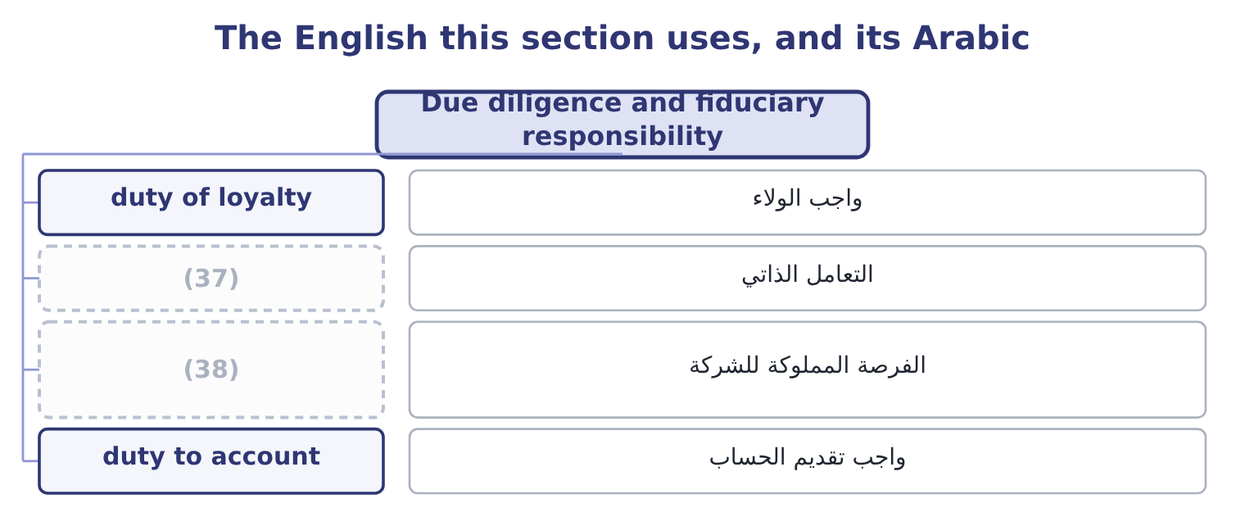
word list
corporate opportunity · fairness · self-dealing

The English this sheet uses, and its Arabic
English (exam term) | Arabic
duty of loyalty | واجب الولاء
self-dealing | التعامل الذاتي
corporate opportunity | الفرصة المملوكة للشركة
duty to account | واجب تقديم الحساب

Answer key · 12.3 Due diligence and fiduciary responsibility

1 competent | 20 reservation
2 organisation | 21 responsibility
3 something | 22 interests
4 understanding | 23 beneficiaries
5 recommending | 24 principals
6 counterparty | 25 beneficiary's
7 negligence | 26 self-dealing
8 dishonesty | 27 competence
9 professionals | 28 honestly
10 investigation | 29 confidentiality
11 acquisition | 30 disclose
12 increasingly | 31 foundation
13 dimensions | 32 discipline
14 examinable | 33 possibility
15 unwelcome | 34 intentions
16 performed | 35 transaction
17 documentation | 36 objected
18 stakes | 37 self-dealing
19 complete | 38 corporate opportunity

the summaries in full
Summary 1 Due diligence is the care a reasonable and competent person would take before acting — the obligation to find out, rather than to assume, before committing the organisation or signing something. It has a general sense and a specific one, and the exam uses both. In its general sense, due diligence is the standard of care in any professional act: checking the figures before certifying them, understanding a contract before recommending it, verifying a counterparty before relying on it, reading the file before giving the advice. Its breach is negligence rather than dishonesty, which is why it is the obligation professionals most often fail without noticing. In its specific sense it is the investigation of a target before an acquisition — the work Book 3's: financial due diligence on the numbers, legal on the contracts and liabilities, commercial on the market and customers, operational on the assets and processes, and increasingly ethical due diligence on conduct, sanctions and bribery exposure.
Summary 2 Three ethical dimensions of due diligence are examinable. It is owed even where the answer is unwelcome. Due diligence performed to confirm a decision already taken is not due diligence; it is documentation. Its scope must match the stakes. Reasonable care on a 10,000 contract is not reasonable care on a 10,000,000 one. And a professional who cannot complete it must say so, rather than signing with an unspoken reservation. Fiduciary responsibility is the duty owed by someone who acts for another and is trusted with their interests or their property. Directors owe it to the company; trustees to beneficiaries; agents to principals; and a finance professional with authority over funds or information is in a fiduciary position whether or not the word appears anywhere in their contract. Its content is specific and worth learning as a list.
Summary 3 The duty of loyalty: to act in the beneficiary's interest and not one's own, which is why self-dealing, taking a corporate opportunity for oneself, and undisclosed benefits from suppliers are breaches of a different order from ordinary misconduct. The duty of care: to act with the competence and diligence of section 12.3's first half. The duty of good faith: to act honestly and for the purpose for which the authority was given. The duty of confidentiality: not to use or disclose information obtained in the role for any other purpose —. And the duty to account: to be able to show what was done with what was entrusted, which is the ethical foundation of the entire discipline of accounting. A fiduciary duty is stricter than an ordinary commercial obligation in one specific way the exam likes: the fiduciary must avoid even the possibility of a conflict, and good intentions are not a defence. It is no answer that the transaction was fair, or that the company did not lose; what is objected to is acting for oneself in a matter where one was acting for another.

12.4 The shapes fraud takes
Chapter 12 · section 12.4

Fill every gap. Each word list holds one word more than there are gaps.
Summary 1 gaps 1–12
Fraud is (1) for gain. The outcome asks for the types of business fraud, and the standard (2) has three branches, of which the (3) list is the detail. Asset (4) is the theft or misuse of the (5) assets. It is by far the most common branch — the great majority of (6) frauds — and usually the smallest in (7) value, though not in total. Its forms include the (8) . (9) , where cash is taken before it is recorded, which leaves no accounting trace at all and is therefore the hardest to detect; larceny, where recorded cash is taken afterwards, which does leave a trace; and fraudulent (10) , where the company is made to pay out money improperly. Inventory and other asset theft. Product taken from the (11) or in transit; raw material written off as waste and sold; equipment removed; misuse of assets rather than outright theft, such as using company vehicles or (12) for private business.
word list
individual · deception · warehouse · classification · syllabus's · occupational · misappropriation · facilities · organisation's · requires · disbursements · Skimming · following

Summary 2 gaps 13–24
For a food producer, shrinkage is a (13) cost: 1.5 per cent of Orontes's $2,450,000 of stock is 2,450,000 × 0.015 = 36,750 a year, and (14) theft from spoilage and from (15) is itself a control problem. Ghost employees kept on the payroll by whoever controls both the records and the payments; falsified hours or overtime; inflated (16) ; and expense (17) fraud, which is the most (18) and most tolerated of all — fictitious expenses, overstated amounts, personal costs claimed as business, and the same receipt claimed twice. An employee (19) a supplier that exists only in the master file, with bank details they control, and (20) invoices to it for (21) nobody can verify. The sums are rarely dramatic (22) : eighteen invoices (23) 14,500 is 18 × 14,500 = 261,000, spread across two years and buried in (24) fees.
word list
standard · averaging · professional · commissions · miscounting · distinguishing · reimbursement · widespread · approves · creates · services · individually · continuing

Summary 3 gaps 25–36
Lapping, in which a receipt from one customer is used to cover a balance previously stolen from another, and the gap is rolled forward (25) ; writing off a live balance as (26) after taking the payment; issuing false credit notes; and diverting payments to an account the employee controls. (27) statement fraud is the deliberate (28) of reported results. It is the least common branch and by far the most (29) , because the amounts are the amounts of the (30) rather than of a cash drawer. Its forms are the ones Book 1's: revenue recognised too early or invented outright; expenses deferred, (31) or simply not recorded; (32) and commitments concealed; assets overstated through inventory, receivables or avoided impairments; reserves released to smooth a result; and disclosures omitted. Its motive is almost never personal (33) directly; it is a target, a covenant, a share price, a bonus or a reputation, which is what makes it so easy to (34) . (35) is the third branch: bribery, kickbacks, (36) conflicts of interest, bid rigging and extortion.
word list
uncollectible · enrichment · indefinitely · undisclosed · expensive · misstatement · liabilities · capitalised · rationalise · Financial · accounts · smallest · Corruption

Worked example: what a fraud costs

Summary 4 gaps 37–48
The fictitious supplier above has taken 261,000 over two years. What it takes to (37) it. Orontes's net (38) is 2,969,100 ÷ 42,000,000 = 7.07 per cent, so (39) 261,000 of lost profit (40) 261,000 ÷ 0.0707 = 3,691,655 of additional sales. (41) , legal fees, (42) time, the auditors' additional work, the controls that must now be built, and the effect on the people who were not involved. The (43) taken is rarely the material figure. What matters is what the fraud reveals about the control (44) and what else may have happened under the same (45) . The (46) in step 2 is the (47) to use with a board that regards a fraud as small. A (48) of a million is three and a half million of sales, and the sales are hard.
word list
falsified · replace · conditions · arithmetic · sentence · amount · margin · requires · environment · quarter · recovering · Investigation · management

The English this section uses, and its Arabic
Each term sits against what it means.
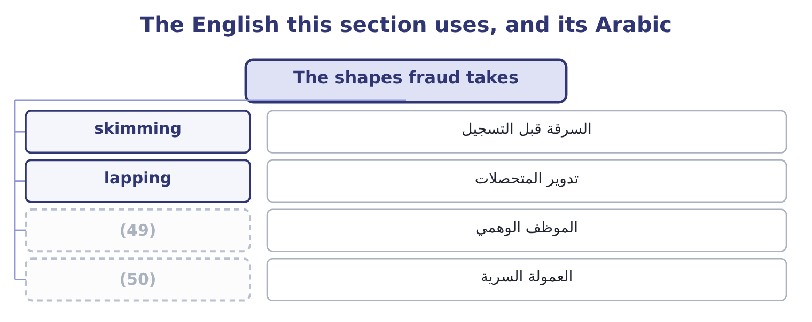
word list
moral principle · ghost employee · kickback

The English this sheet uses, and its Arabic
English (exam term) | Arabic
skimming | السرقة قبل التسجيل
lapping | تدوير المتحصلات
ghost employee | الموظف الوهمي
kickback | العمولة السرية

Answer key · 12.4 The shapes fraud takes

1 deception | 26 uncollectible
2 classification | 27 Financial
3 syllabus's | 28 misstatement
4 misappropriation | 29 expensive
5 organisation's | 30 accounts
6 occupational | 31 capitalised
7 individual | 32 liabilities
8 following | 33 enrichment
9 Skimming | 34 rationalise
10 disbursements | 35 Corruption
11 warehouse | 36 undisclosed
12 facilities | 37 replace
13 continuing | 38 margin
14 distinguishing | 39 recovering
15 miscounting | 40 requires
16 commissions | 41 Investigation
17 reimbursement | 42 management
18 widespread | 43 amount
19 creates | 44 environment
20 approves | 45 conditions
21 services | 46 arithmetic
22 individually | 47 sentence
23 averaging | 48 quarter
24 professional | 49 ghost employee
25 indefinitely | 50 kickback

the summaries in full
Summary 1 Fraud is deception for gain. The outcome asks for the types of business fraud, and the standard classification has three branches, of which the syllabus's list is the detail. Asset misappropriation is the theft or misuse of the organisation's assets. It is by far the most common branch — the great majority of occupational frauds — and usually the smallest in individual value, though not in total. Its forms include the following. Skimming, where cash is taken before it is recorded, which leaves no accounting trace at all and is therefore the hardest to detect; larceny, where recorded cash is taken afterwards, which does leave a trace; and fraudulent disbursements, where the company is made to pay out money improperly. Inventory and other asset theft. Product taken from the warehouse or in transit; raw material written off as waste and sold; equipment removed; misuse of assets rather than outright theft, such as using company vehicles or facilities for private business.
Summary 2 For a food producer, shrinkage is a continuing cost: 1.5 per cent of Orontes's $2,450,000 of stock is 2,450,000 × 0.015 = 36,750 a year, and distinguishing theft from spoilage and from miscounting is itself a control problem. Ghost employees kept on the payroll by whoever controls both the records and the payments; falsified hours or overtime; inflated commissions; and expense reimbursement fraud, which is the most widespread and most tolerated of all — fictitious expenses, overstated amounts, personal costs claimed as business, and the same receipt claimed twice. An employee creates a supplier that exists only in the master file, with bank details they control, and approves invoices to it for services nobody can verify. The sums are rarely dramatic individually: eighteen invoices averaging 14,500 is 18 × 14,500 = 261,000, spread across two years and buried in professional fees.
Summary 3 Lapping, in which a receipt from one customer is used to cover a balance previously stolen from another, and the gap is rolled forward indefinitely; writing off a live balance as uncollectible after taking the payment; issuing false credit notes; and diverting payments to an account the employee controls. Financial statement fraud is the deliberate misstatement of reported results. It is the least common branch and by far the most expensive, because the amounts are the amounts of the accounts rather than of a cash drawer. Its forms are the ones Book 1's: revenue recognised too early or invented outright; expenses deferred, capitalised or simply not recorded; liabilities and commitments concealed; assets overstated through inventory, receivables or avoided impairments; reserves released to smooth a result; and disclosures omitted. Its motive is almost never personal enrichment directly; it is a target, a covenant, a share price, a bonus or a reputation, which is what makes it so easy to rationalise. Corruption is the third branch: bribery, kickbacks, undisclosed conflicts of interest, bid rigging and extortion.
Summary 4 The fictitious supplier above has taken 261,000 over two years. What it takes to replace it. Orontes's net margin is 2,969,100 ÷ 42,000,000 = 7.07 per cent, so recovering 261,000 of lost profit requires 261,000 ÷ 0.0707 = 3,691,655 of additional sales. Investigation, legal fees, management time, the auditors' additional work, the controls that must now be built, and the effect on the people who were not involved. The amount taken is rarely the material figure. What matters is what the fraud reveals about the control environment and what else may have happened under the same conditions. The arithmetic in step 2 is the sentence to use with a board that regards a fraud as small. A quarter of a million is three and a half million of sales, and the sales are hard.

12.5 Preventing and detecting
Chapter 12 · section 12.5

Fill every gap. Each word list holds one word more than there are gaps.
Summary 1 gaps 1–2
The control (1) were set out; what (2) here is how they map onto the frauds and what ethics adds to them.
word list
belongs · methods · carries

Frauds and the controls that address them
Fraud | How it works | Principal control | What it depends on
Skimming | (3) | Independent recording at the point of receipt | Two people, or a machine
Inventory theft | Stock removed or written off | Counts, reconciliation of waste, access control | (4)
Payroll fraud | Ghost employees, false hours | (5) of payroll records from payments; review of the payroll | Somebody checking a list they did not make
Fictitious supplier | A supplier that exists only in the file | Master file access, bank (6) , new supplier review | Restricted access being enforced
Receivable fraud | Lapping, false credit notes, write-offs | Statement reconciliation, authorisation of write-offs, mandatory leave | (7)
Statement fraud | (8) | Review by somebody competent and independent; audit committee access | Tone at the top, and a route to raise concerns

word list
Rotation and independent confirmation · Entries, estimates and omissions · Separation · verification · Counts done by people who do not hold the stock · skimming · Cash taken before recording

Summary 2 gaps 9–20
The last column is the ethics column. Every control in the fifth column depends on (9) in the sixth, and what the sixth column (10) is people being willing and able to do their job honestly. A (11) of duties that everybody agrees to work around is not a control; a review (12) by somebody who will not question the chief executive is not a review; and a supplier approval process in which no approval has ever been refused is a procedure, not a control. Three ethical (13) to the control (14) . A code of conduct that says (15) what is and is not acceptable, so that (16) has to guess. A route to raise a concern that does not (17) going through the person the concern is about, which is. And a (18) willingness to act on what is found, at every level. A fraud by a junior employee that ends in (19) , and a similar act by a senior one that ends in a quiet (20) , teach everybody the same lesson about which rules apply to whom — and that lesson does more damage than the original act.
word list
dismissal · carries · segregation · contains · something · specifically · resignation · require · nobody · framework · demonstrated · additions · performed

Concepts and frauds

Your turn: naming it correctly (complete the blanks)
Item | Answer
Treating like cases alike, on standards people could accept | ________
Acting on the same principles whether or not anybody is watching | ________
The care a reasonable and competent person takes before acting | ________
The duty owed by one who acts for another and is trusted with their interests | ________
Using a later customer's receipt to cover an earlier balance already stolen | ________
Sales needed to replace 261,000 of loss at a 7.07 per cent net margin | ________

"Integrity", "fraud" and "irregularity"

Summary 3 gaps 21–32
Integrity in (21) carries two senses that are really one: moral (22) , and structural (23) — the integrity of a dam. Both mean nothing (24) and nothing (25) , which is the right image for the (26) sense. Fraud is a legal term as well as an ethical one, and that matters in a report: writing that an employee committed fraud is an (27) of a crime, which is why investigators write (28) , discrepancy or (29) difference until a conclusion is reached, and why a management accountant should do the same. The caution is not evasion: it is the difference between (30) what is known and (31) what has not been (32) . Write what you observed, say what it is consistent with, and let the conclusion follow the investigation rather than precede it.
word list
English · allegation · unexplained · hollow · uprightness · missing · professional · somebody · asserting · irregularity · describing · established · wholeness

"Integrity", "fraud" and "irregularity"
Item | Answer
Treating like cases alike on acceptable standards | (33)
Acting on the same principles whether or not observed | (34)
The care a reasonable, competent person takes | (35)
The duty of one who acts for another | Fiduciary responsibility.
Using a later receipt to cover an earlier theft | (36)
Sales needed to replace 261,000 at 7.07 per cent | 3,691,655: 261,000 ÷ 0.0707 = 3,691,655.
What it tells you | Four concepts and two frauds — and the four concepts are what the controls against the two frauds ultimately rest on.

word list
Fairness. · Integrity. · business ethics · Lapping, a receivable fraud. · Due diligence.

The English this section uses, and its Arabic
Each term sits against what it means.
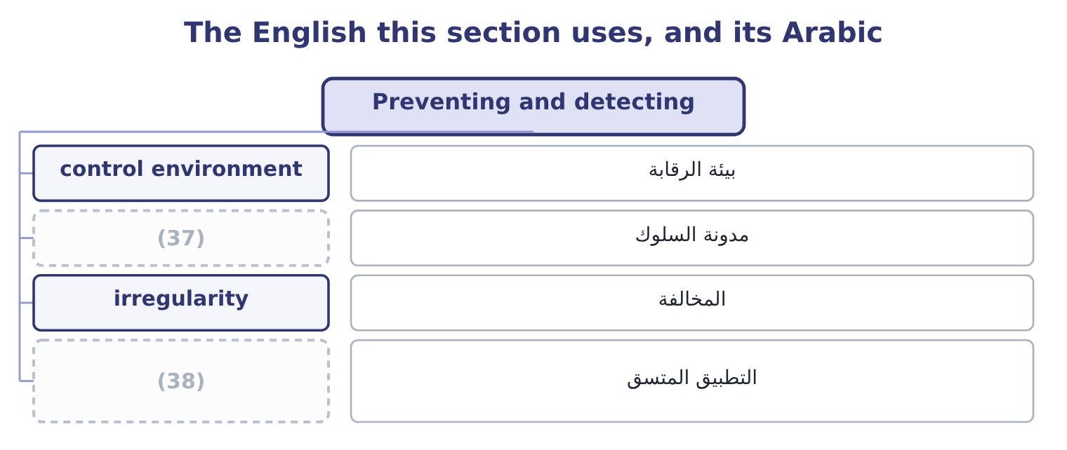
word list
consistent enforcement · code of conduct · مدونة السلوك

The English this sheet uses, and its Arabic
English (exam term) | Arabic
control environment | بيئة الرقابة
code of conduct | مدونة السلوك
irregularity | المخالفة
consistent enforcement | التطبيق المتسق

Answer key · 12.5 Preventing and detecting

1 methods | 20 resignation
2 belongs | 21 English
3 Cash taken before recording | 22 uprightness
4 Counts done by people who do not hold the stock | 23 wholeness
5 Separation | 24 missing
6 verification | 25 hollow
7 Rotation and independent confirmation | 26 professional
8 Entries, estimates and omissions | 27 allegation
9 something | 28 irregularity
10 contains | 29 unexplained
11 segregation | 30 describing
12 performed | 31 asserting
13 additions | 32 established
14 framework | 33 Fairness.
15 specifically | 34 Integrity.
16 nobody | 35 Due diligence.
17 require | 36 Lapping, a receivable fraud.
18 demonstrated | 37 code of conduct
19 dismissal | 38 consistent enforcement

the summaries in full
Summary 1 The control methods were set out; what belongs here is how they map onto the frauds and what ethics adds to them.
Summary 2 The last column is the ethics column. Every control in the fifth column depends on something in the sixth, and what the sixth column contains is people being willing and able to do their job honestly. A segregation of duties that everybody agrees to work around is not a control; a review performed by somebody who will not question the chief executive is not a review; and a supplier approval process in which no approval has ever been refused is a procedure, not a control. Three ethical additions to the control framework. A code of conduct that says specifically what is and is not acceptable, so that nobody has to guess. A route to raise a concern that does not require going through the person the concern is about, which is. And a demonstrated willingness to act on what is found, at every level. A fraud by a junior employee that ends in dismissal, and a similar act by a senior one that ends in a quiet resignation, teach everybody the same lesson about which rules apply to whom — and that lesson does more damage than the original act.
Summary 3 Integrity in English carries two senses that are really one: moral uprightness, and structural wholeness — the integrity of a dam. Both mean nothing missing and nothing hollow, which is the right image for the professional sense. Fraud is a legal term as well as an ethical one, and that matters in a report: writing that an employee committed fraud is an allegation of a crime, which is why investigators write irregularity, discrepancy or unexplained difference until a conclusion is reached, and why a management accountant should do the same. The caution is not evasion: it is the difference between describing what is known and asserting what has not been established. Write what you observed, say what it is consistent with, and let the conclusion follow the investigation rather than precede it.

