13.1 The four principles
Chapter 13 · section 13.1

Fill every gap. Each word list holds one word more than there are gaps.
Chapter 13, section by section
Each stage leads to the next.
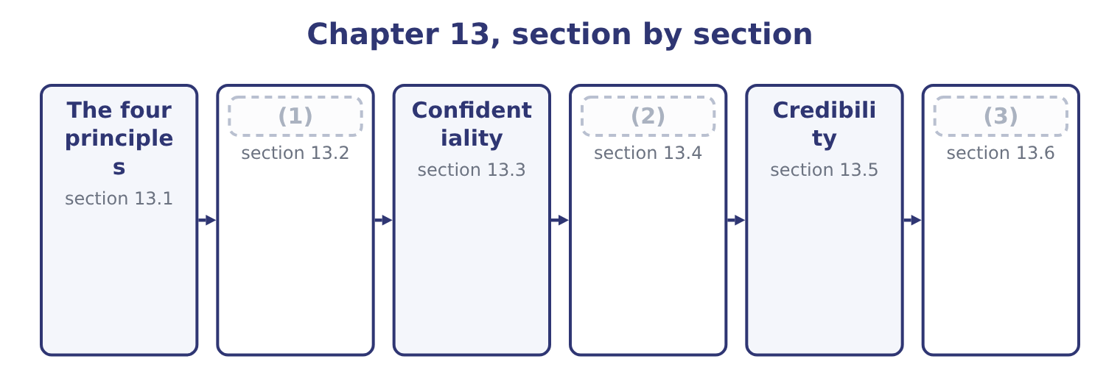
word list
section 13.6 · Competence · Integrity · Applying the Statement to a situation

Summary 1 gaps 4–15
The Statement opens with four (4) ethical principles, which express the values members are (5) to hold. They are not rules to be complied with one at a time; they are the basis on which the standards rest, and the Statement says that members shall act in (6) with these principles and shall encourage others within their (7) to do the same. Not (8) : in what is said, in what is (9) , and in what is left out. Treating people and interests (10) , with the three (11) of, process and treatment. (12) and judging on the evidence, free from bias and from the (13) of personal interest or of pressure from others. It is the principle that (14) a professional opinion from a (15) one. Accepting accountability for one's actions and for one's professional obligations, including the obligation to act when something is wrong rather than to observe it.
word list
obligation · accordance · convenient · dimensions · even-handedly · overarching · written · influence · expected · distinguishes · Reporting · organisations · deceiving

Summary 2 gaps 16–21
Two (16) about the principles are worth (17) for an exam. They apply to the individual, personally and (18) , regardless of the employer's (19) . The Statement is a (20) made by the member, and no instruction from an employer (21) it. And they are the reason the standards exist, which matters when a situation is not covered neatly by any standard. Where the rules run out, the principles decide.
word list
releases · points · continuously · commitment · having · credibility · instructions

The English this section uses, and its Arabic
Each term sits against what it means.
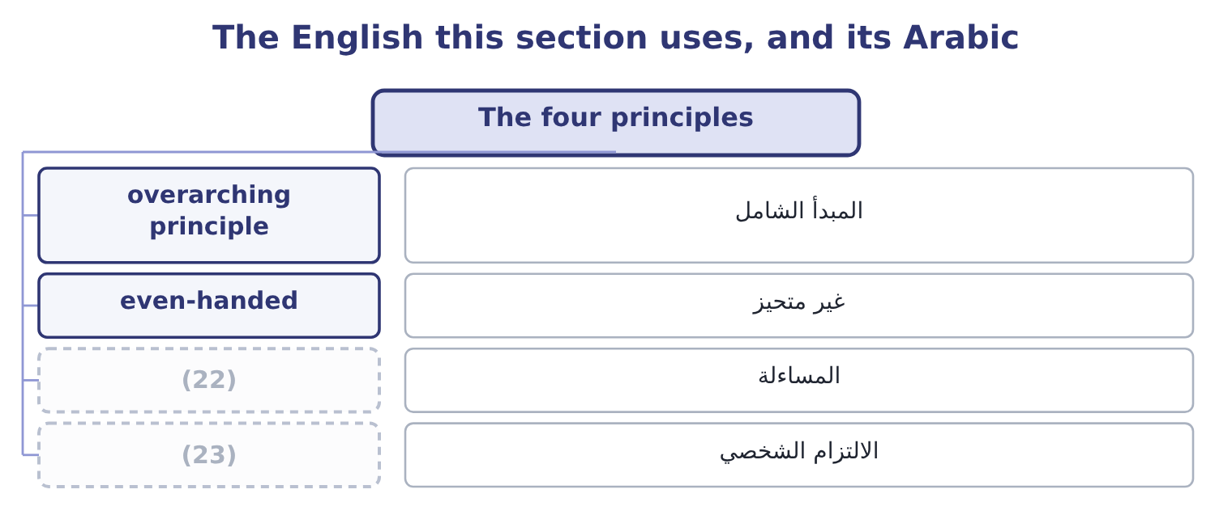
word list
completeness · personal commitment · accountability

The English this sheet uses, and its Arabic
English (exam term) | Arabic
overarching principle | المبدأ الشامل
even-handed | غير متحيز
accountability | المساءلة
personal commitment | الالتزام الشخصي

Answer key · 13.1 The four principles

1 Competence | 13 influence
2 Integrity | 14 distinguishes
3 Applying the Statement to a situation | 15 convenient
4 overarching | 16 points
5 expected | 17 having
6 accordance | 18 continuously
7 organisations | 19 instructions
8 deceiving | 20 commitment
9 written | 21 releases
10 even-handedly | 22 accountability
11 dimensions | 23 personal commitment
12 Reporting

the summaries in full
Summary 1 The Statement opens with four overarching ethical principles, which express the values members are expected to hold. They are not rules to be complied with one at a time; they are the basis on which the standards rest, and the Statement says that members shall act in accordance with these principles and shall encourage others within their organisations to do the same. Not deceiving: in what is said, in what is written, and in what is left out. Treating people and interests even-handedly, with the three dimensions of, process and treatment. Reporting and judging on the evidence, free from bias and from the influence of personal interest or of pressure from others. It is the principle that distinguishes a professional opinion from a convenient one. Accepting accountability for one's actions and for one's professional obligations, including the obligation to act when something is wrong rather than to observe it.
Summary 2 Two points about the principles are worth having for an exam. They apply to the individual, personally and continuously, regardless of the employer's instructions. The Statement is a commitment made by the member, and no instruction from an employer releases it. And they are the reason the standards exist, which matters when a situation is not covered neatly by any standard. Where the rules run out, the principles decide.

13.2 Competence
Chapter 13 · section 13.2

Fill every gap. Each word list holds one word more than there are gaps.
Summary 1 gaps 1–12
Its obligations are four and each has teeth. Maintain an (1) level of professional leadership and expertise by (2) developing knowledge and skills. Competence is not a state (3) once; the obligation is (4) , and it extends to leadership as well as technique. Perform professional duties in (5) with relevant laws, (6) and technical standards. This is the obligation that makes a breach of (7) standards an (8) matter and not only a technical one. (9) decision support information and (10) that are accurate, clear, concise and timely. All four (11) are obligations: an accurate analysis (12) after the decision, or an accurate one nobody can follow, has not met the standard. Recognise and help manage risk. Identifying an exposure and saying nothing is a breach of competence. Three situations in which competence is the standard engaged.
word list
adjectives · Provide · accounting · continuing · continually · accurate · delivered · reached · regulations · recommendations · accordance · ethical · appropriate

Summary 2 gaps 13–18
Accepting an (13) beyond one's expertise (14) saying so. The obligation is not to know (15) ; it is to be honest about the limit and to get help, which also engages (16) fourth clause. Working from a model, a (17) or an assumption the professional has not (18) . And failing to keep up: applying a superseded standard, missing a change in the law, using a technique that has been replaced.
word list
understood · Credibility's · spreadsheet · obligation · everything · without · assignment

The English this section uses, and its Arabic
Each term sits against what it means.
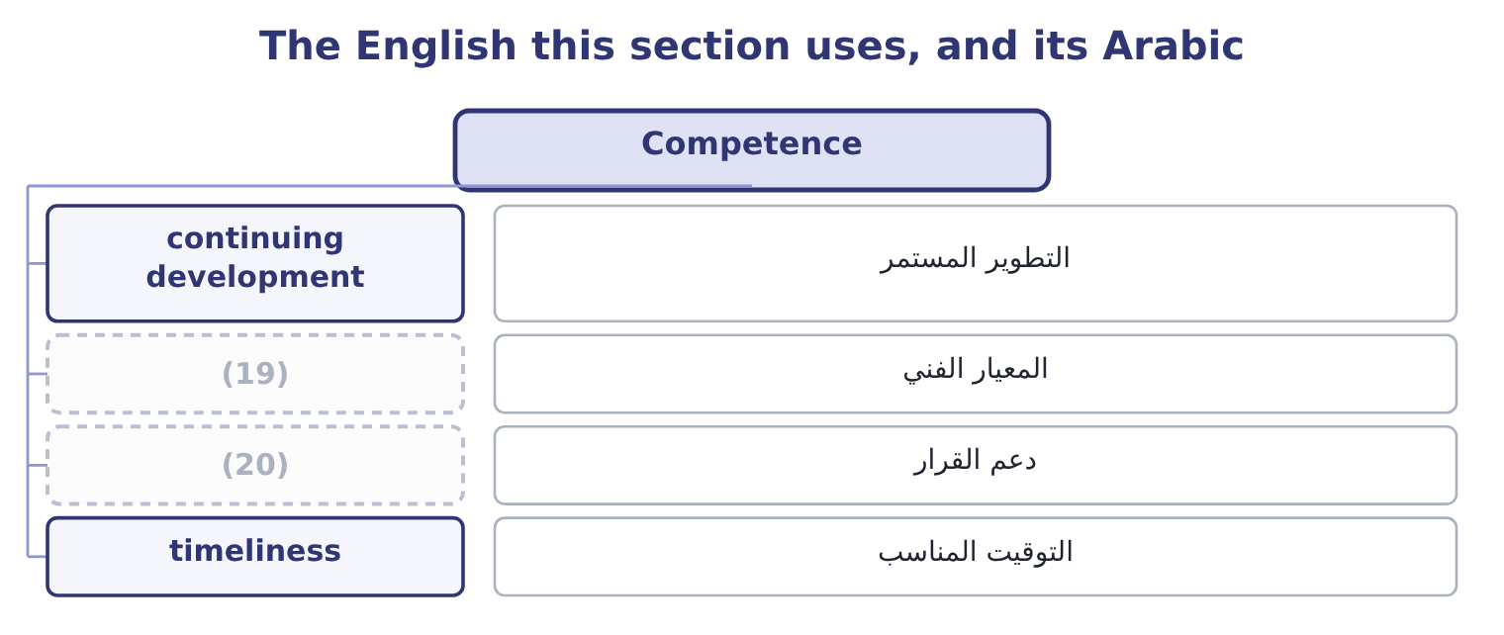
word list
specific obligation · decision support · technical standard

The English this sheet uses, and its Arabic
English (exam term) | Arabic
continuing development | التطوير المستمر
technical standard | المعيار الفني
decision support | دعم القرار
timeliness | التوقيت المناسب

Answer key · 13.2 Competence

1 appropriate | 11 adjectives
2 continually | 12 delivered
3 reached | 13 assignment
4 continuing | 14 without
5 accordance | 15 everything
6 regulations | 16 Credibility's
7 accounting | 17 spreadsheet
8 ethical | 18 understood
9 Provide | 19 technical standard
10 recommendations | 20 decision support

the summaries in full
Summary 1 Its obligations are four and each has teeth. Maintain an appropriate level of professional leadership and expertise by continually developing knowledge and skills. Competence is not a state reached once; the obligation is continuing, and it extends to leadership as well as technique. Perform professional duties in accordance with relevant laws, regulations and technical standards. This is the obligation that makes a breach of accounting standards an ethical matter and not only a technical one. Provide decision support information and recommendations that are accurate, clear, concise and timely. All four adjectives are obligations: an accurate analysis delivered after the decision, or an accurate one nobody can follow, has not met the standard. Recognise and help manage risk. Identifying an exposure and saying nothing is a breach of competence. Three situations in which competence is the standard engaged.
Summary 2 Accepting an assignment beyond one's expertise without saying so. The obligation is not to know everything; it is to be honest about the limit and to get help, which also engages Credibility's fourth clause. Working from a model, a spreadsheet or an assumption the professional has not understood. And failing to keep up: applying a superseded standard, missing a change in the law, using a technique that has been replaced.

13.3 Confidentiality
Chapter 13 · section 13.3

Fill every gap. Each word list holds one word more than there are gaps.
Summary 1 gaps 1–12
The second standard, and the one with the (1) edges and the hardest (2) . Its (3) are three. Keep information confidential except when disclosure is authorised or legally required. The exception is narrow and (4) : authorised, or legally required. A belief that disclosure would be (5) is not an exception, and neither is a request from (6) who ought to know. Inform all relevant parties (7) the appropriate use of confidential information, and monitor to ensure (8) . The obligation extends to (9) and to anyone to whom information is passed: a (10) who hands confidential information to a team without saying what may be done with it has not met the standard. Refrain from using confidential information for (11) or illegal (12) . Note that the prohibition is on use, not only on disclosure. Trading on inside information, buying a property the company is about to need, or taking a customer list to a new employer are breaches whether or not anything is ever told to anybody.
word list
somebody · clearest · subordinates · precise · regarding · unethical · professional · compliance · beneficial · exceptions · reservation · advantage · obligations

Summary 2 gaps 13–20
Four points the (13) test. Confidentiality survives the (14) . (15) the company does not (16) the obligation. Confidentiality is not a reason to conceal (17) from those (18) to know within the organisation. (19) a concern up the internal chain, or to the audit (20) , is not a breach. Where disclosure outside the organisation is contemplated, the Statement's position is that this is not appropriate except where legally prescribed, and legal advice should be obtained. And confidentiality covers more than financial data: plans, personnel matters, customer information, security arrangements, and the fact of an investigation.
word list
entitled · property · wrongdoing · Reporting · Leaving · employment · release · committee · examiners

The English this section uses, and its Arabic
Each term sits against what it means.
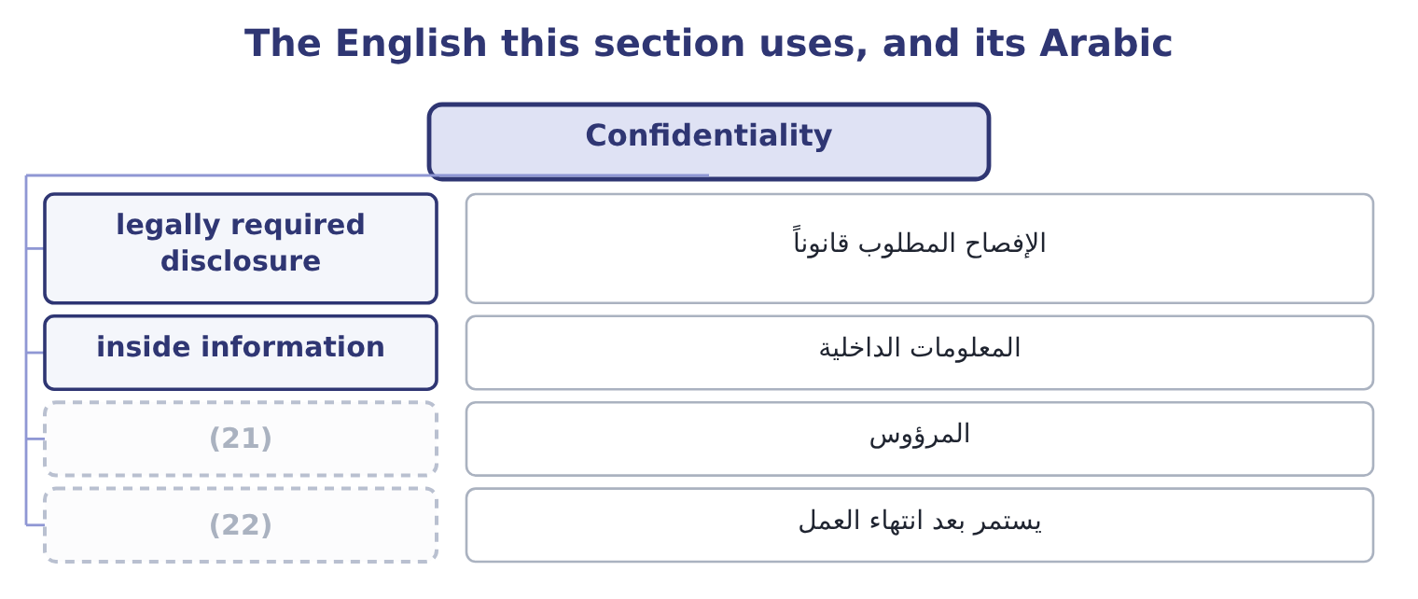
word list
survives employment · confidentiality · subordinate

The English this sheet uses, and its Arabic
English (exam term) | Arabic
legally required disclosure | الإفصاح المطلوب قانوناً
inside information | المعلومات الداخلية
subordinate | المرؤوس
survives employment | يستمر بعد انتهاء العمل

Answer key · 13.3 Confidentiality

1 clearest | 12 advantage
2 exceptions | 13 examiners
3 obligations | 14 employment
4 precise | 15 Leaving
5 beneficial | 16 release
6 somebody | 17 wrongdoing
7 regarding | 18 entitled
8 compliance | 19 Reporting
9 subordinates | 20 committee
10 professional | 21 subordinate
11 unethical | 22 survives employment

the summaries in full
Summary 1 The second standard, and the one with the clearest edges and the hardest exceptions. Its obligations are three. Keep information confidential except when disclosure is authorised or legally required. The exception is narrow and precise: authorised, or legally required. A belief that disclosure would be beneficial is not an exception, and neither is a request from somebody who ought to know. Inform all relevant parties regarding the appropriate use of confidential information, and monitor to ensure compliance. The obligation extends to subordinates and to anyone to whom information is passed: a professional who hands confidential information to a team without saying what may be done with it has not met the standard. Refrain from using confidential information for unethical or illegal advantage. Note that the prohibition is on use, not only on disclosure. Trading on inside information, buying a property the company is about to need, or taking a customer list to a new employer are breaches whether or not anything is ever told to anybody.
Summary 2 Four points the examiners test. Confidentiality survives the employment. Leaving the company does not release the obligation. Confidentiality is not a reason to conceal wrongdoing from those entitled to know within the organisation. Reporting a concern up the internal chain, or to the audit committee, is not a breach. Where disclosure outside the organisation is contemplated, the Statement's position is that this is not appropriate except where legally prescribed, and legal advice should be obtained. And confidentiality covers more than financial data: plans, personnel matters, customer information, security arrangements, and the fact of an investigation.

13.4 Integrity
Chapter 13 · section 13.4

Fill every gap. Each word list holds one word more than there are gaps.
Summary 1 gaps 1–12
Mitigate actual conflicts of interest, (1) regularly with business (2) to avoid apparent conflicts, and advise all parties of any potential conflicts. Three (3) — actual, apparent and potential — and three (4) duties. An apparent conflict matters even where no actual conflict exists, because the (5) damages the (6) others place on the professional's judgment. Refrain from conduct that would (7) carrying out duties (8) . This covers accepting gifts, (9) or favours that could influence or appear to influence a decision, and anything that creates an obligation to somebody whose interests may diverge from the (10) . Abstain from (11) in or supporting any activity that might (12) the profession. The word supporting is important: assisting, enabling or remaining silent about such an activity falls within it. Contribute to a positive ethical culture and place integrity of the profession above personal interests. This is the forward-looking obligation — not merely avoiding wrong, but helping to build the culture.
word list
hospitality · engaging · categories · damages · ethically · reliance · different · communicate · discredit · appearance · associates · employer's · prejudice

Summary 2 gaps 13–20
Two (13) candidates are (14) to make. Integrity concerns the professional's own conduct and interests; Credibility concerns what is (15) to others. A conflict of interest engages Integrity; an incomplete report engages Credibility; and a report made incomplete in order to (16) an interest engages both. And a (17) value is not the only test. A modest gift from a supplier in a (18) tender is a problem where a larger one from a (19) customer with nothing pending may not be. What matters is (20) it could influence, or appear to influence, a decision.
word list
distinctions · whether · gift's · communicated · because · long-standing · expected · protect · competitive

The English this section uses, and its Arabic
Each term sits against what it means.
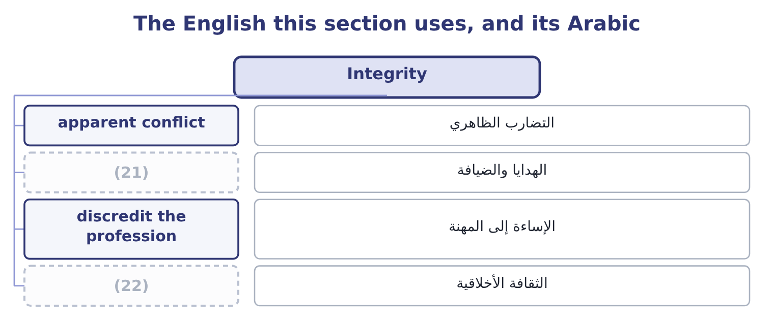
word list
discredit the profession · ethical culture · gift and hospitality

The English this sheet uses, and its Arabic
English (exam term) | Arabic
apparent conflict | التضارب الظاهري
gift and hospitality | الهدايا والضيافة
discredit the profession | الإساءة إلى المهنة
ethical culture | الثقافة الأخلاقية

Answer key · 13.4 Integrity

1 communicate | 12 discredit
2 associates | 13 distinctions
3 categories | 14 expected
4 different | 15 communicated
5 appearance | 16 protect
6 reliance | 17 gift's
7 prejudice | 18 competitive
8 ethically | 19 long-standing
9 hospitality | 20 whether
10 employer's | 21 gift and hospitality
11 engaging | 22 ethical culture

the summaries in full
Summary 1 Mitigate actual conflicts of interest, communicate regularly with business associates to avoid apparent conflicts, and advise all parties of any potential conflicts. Three categories — actual, apparent and potential — and three different duties. An apparent conflict matters even where no actual conflict exists, because the appearance damages the reliance others place on the professional's judgment. Refrain from conduct that would prejudice carrying out duties ethically. This covers accepting gifts, hospitality or favours that could influence or appear to influence a decision, and anything that creates an obligation to somebody whose interests may diverge from the employer's. Abstain from engaging in or supporting any activity that might discredit the profession. The word supporting is important: assisting, enabling or remaining silent about such an activity falls within it. Contribute to a positive ethical culture and place integrity of the profession above personal interests. This is the forward-looking obligation — not merely avoiding wrong, but helping to build the culture.
Summary 2 Two distinctions candidates are expected to make. Integrity concerns the professional's own conduct and interests; Credibility concerns what is communicated to others. A conflict of interest engages Integrity; an incomplete report engages Credibility; and a report made incomplete in order to protect an interest engages both. And a gift's value is not the only test. A modest gift from a supplier in a competitive tender is a problem where a larger one from a long-standing customer with nothing pending may not be. What matters is whether it could influence, or appear to influence, a decision.

13.5 Credibility
Chapter 13 · section 13.5

Fill every gap. Each word list holds one word more than there are gaps.
Summary 1 gaps 1–12
The fourth (1) , and the one most often engaged in exam situations, because it governs what is (2) . Its (3) are four. Communicate information fairly and (4) . Fairly covers (5) as well as content: a chart with a truncated axis, a (6) against a revised budget, a result shown before an unfavourable adjustment. Disclose all relevant information that could reasonably be expected to influence an intended user's (7) of reports, analyses or (8) . This is the (9) obligation, and it is the one that makes (10) a breach. The test is what the user would need, not what the preparer was asked for. Disclose delays or (11) in information, (12) , processing or internal controls, in conformance with organisation policy or applicable law. A professional who knows a control has failed and says nothing has breached this clause, whether or not a loss followed.
word list
timeliness · understanding · completeness · omission · deficiencies · recommendations · reported · internal · obligations · objectively · standard · comparison · presentation

Summary 2 gaps 13–22
Communicate professional (13) or other constraints that would preclude (14) judgment or successful performance of an activity. If you cannot do it (15) — for lack of time, information, (16) or access — say so, to somebody who can act on it. Three situations that engage (17) . A forecast prepared on assumptions the preparer believes to be (18) , presented without that (19) . A (20) analysis that explains the (21) items and attributes the unfavourable ones to timing without evidence. And an analysis prepared for a decision in which a known weakness — an estimate with a wide range, a figure that could not be verified, a control that was not (22) — is not stated.
word list
limitations · expertise · unachievable · variance · Credibility · favourable · reservation · responsible · operating · properly · conformance

The English this section uses, and its Arabic
Each term sits against what it means.
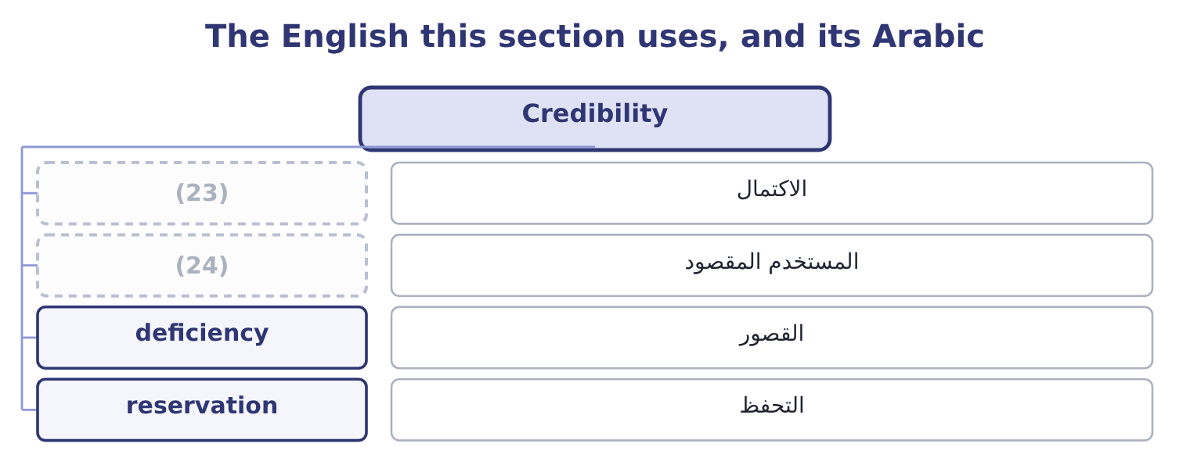
word list
التحفظ · intended user · completeness

The English this sheet uses, and its Arabic
English (exam term) | Arabic
completeness | الاكتمال
intended user | المستخدم المقصود
deficiency | القصور
reservation | التحفظ

Answer key · 13.5 Credibility

1 standard | 13 limitations
2 reported | 14 responsible
3 obligations | 15 properly
4 objectively | 16 expertise
5 presentation | 17 Credibility
6 comparison | 18 unachievable
7 understanding | 19 reservation
8 recommendations | 20 variance
9 completeness | 21 favourable
10 omission | 22 operating
11 deficiencies | 23 completeness
12 timeliness | 24 intended user

the summaries in full
Summary 1 The fourth standard, and the one most often engaged in exam situations, because it governs what is reported. Its obligations are four. Communicate information fairly and objectively. Fairly covers presentation as well as content: a chart with a truncated axis, a comparison against a revised budget, a result shown before an unfavourable adjustment. Disclose all relevant information that could reasonably be expected to influence an intended user's understanding of reports, analyses or recommendations. This is the completeness obligation, and it is the one that makes omission a breach. The test is what the user would need, not what the preparer was asked for. Disclose delays or deficiencies in information, timeliness, processing or internal controls, in conformance with organisation policy or applicable law. A professional who knows a control has failed and says nothing has breached this clause, whether or not a loss followed.
Summary 2 Communicate professional limitations or other constraints that would preclude responsible judgment or successful performance of an activity. If you cannot do it properly — for lack of time, information, expertise or access — say so, to somebody who can act on it. Three situations that engage Credibility. A forecast prepared on assumptions the preparer believes to be unachievable, presented without that reservation. A variance analysis that explains the favourable items and attributes the unfavourable ones to timing without evidence. And an analysis prepared for a decision in which a known weakness — an estimate with a wide range, a figure that could not be verified, a control that was not operating — is not stated.

13.6 Applying the Statement to a situation
Chapter 13 · section 13.6

Fill every gap. Each word list holds one word more than there are gaps.
Summary 1 gaps 1–10
The third outcome asks which standards may have been (1) and why they apply, which is a specific skill with a (2) . Four steps produce a (3) answer. State the facts that matter, (4) what is known from what is (5) . An exam situation (6) facts, and an answer that adds facts of its own loses marks. (7) each standard engaged, by name, and say which specific obligation (8) it. (9) why the obligation applies to these facts. This is the step that carries the marks and the one (10) skip. Note where a standard is engaged but not necessarily breached, which is often the honest answer at the point the facts are known.
word list
complete · assumed · required · candidates · Explain · within · separating · method · Identify · violated · contains

Worked example: four facts and the standards they engage

Summary 2 gaps 11–22
Orontes's controller is asked by the chief executive to delay (11) an inventory write-down of 180,000 until after the year end, because the covenant (12) at the year end requires interest cover above four times and the (13) is thin. The controller's (14) supplies the inventory in (15) . The controller (16) the request to nobody, (17) the accounts as asked, and does not refer to the write-down in the board pack. Credibility, on two (18) . (19) fairly and objectively is breached by accounts that omit a write-down known to be required; and the obligation to disclose all information that could (20) influence a user's understanding is breached by the board pack, since the covenant position depends on it. Integrity, on the conflict. The supplier (21) is an actual conflict of interest, and the obligation is to mitigate it and to advise all (22) .
word list
parties · expectation · obligations · brother-in-law · mentions · question · relationship · tested · margin · reasonably · prepares · Communicating · recognising

Summary 3 gaps 23–31
Not (23) it is a breach whether or not it (24) anything. Competence, and then the principles. Competence requires duties to be (25) in accordance with technical standards, and (26) a required write-down does not. (27) all three, the principles of honesty and objectivity are engaged (28) . Note what the answer does not say. It does not say the chief executive is (29) , because the facts given do not (30) intent. It does not say a fraud has been (31) , for. And it does not stop at naming the standards: each is tied to a specific obligation and to a specific fact, which is what the outcome asks for.
word list
committed · directly · influenced · establish · objectivity · performed · deferring · mentioning · Underneath · dishonest

The Statement at a glance
Element | Content | Engaged when
Principles | (32) | Always; and where no standard fits exactly
Competence | Develop expertise; follow laws and technical standards; accurate, clear, concise, timely information; recognise and help manage risk | Work beyond expertise; standards breached; late or unclear analysis; risk (33)
Confidentiality | Keep it; inform and monitor those who receive it; do not use it for advantage | Disclosure without authority; use for private gain; careless handling
Integrity | Mitigate actual, apparent and potential conflicts; avoid prejudicial conduct; do not support discrediting activity; build ethical culture | (34)
Credibility | Communicate fairly and objectively; disclose all influencing information; report delays and control deficiencies; state limitations | Omissions; misleading (35) ; unreported control failures

word list
Honesty, fairness, objectivity, responsibility · Standard · presentation · unreported · Conflicts; gifts; silence about misconduct

Which standard?

Your turn: naming the standard (complete the blanks)
Situation | Standard
Omitting a known write-down from a board pack | ________
Buying shares on information not yet public | ________
Accepting an assignment beyond one's expertise without saying so | ________
Failing to disclose that a supplier is a relative | ________
Not reporting that a reconciliation control has stopped operating | ________
Applying a superseded accounting standard through inattention | ________

"Shall", "should" and "may"

Summary 4 gaps 36–45
Professional codes are written in a (36) of obligation, and the words are not (37) . Shall and must state a (38) : the member has no (39) . Should states a strong (40) that may yield to (41) , and a member who departs from a should is expected to be able to say why. May grants (42) or describes an (43) . (44) codes use all three (45) , and a candidate reading a standard quickly will often turn a shall into a should in their memory, which changes the answer. The practical habit worth forming is this: when a situation asks whether something was permitted, find the verb in the obligation and read it exactly. Most ethics questions are decided by a verb.
word list
requirement · vocabulary · permission · expectation · circumstances · discretion · mentions · interchangeable · English · deliberately · option

"Shall", "should" and "may"
Situation | Standard
Omitting a known write-down from a board pack | Credibility: disclose all information influencing understanding.
Buying shares on information not yet public | Confidentiality: no use for unethical or illegal advantage.
Accepting work beyond one's expertise silently | Competence, with Credibility's duty to state limitations.
Not disclosing that a supplier is a relative | (46)
Not reporting a failed reconciliation control | (47)
Applying a superseded standard through inattention | Competence: perform duties in accordance with technical standards.
What it tells you | Six situations, four standards, and in two of them more than one standard applies — which is why an answer names each one with the obligatio

word list
Conflicts; gifts; silence about misconduct · Integrity: mitigate and disclose conflicts. · Credibility: report deficiencies in internal controls.

The English this section uses, and its Arabic
Each term sits against what it means.
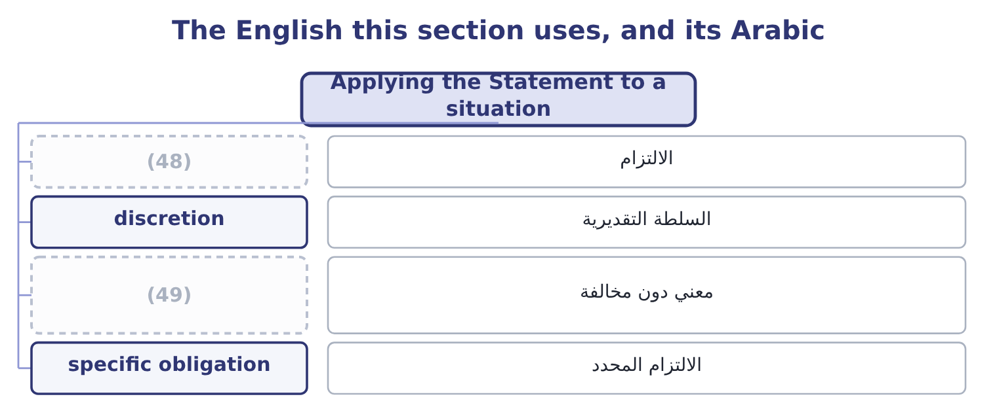
word list
obligation · engaged but not breached · الالتزام المحدد

The English this sheet uses, and its Arabic
English (exam term) | Arabic
obligation | الالتزام
discretion | السلطة التقديرية
engaged but not breached | معني دون مخالفة
specific obligation | الالتزام المحدد

Answer key · 13.6 Applying the Statement to a situation

1 violated | 26 deferring
2 method | 27 Underneath
3 complete | 28 directly
4 separating | 29 dishonest
5 assumed | 30 establish
6 contains | 31 committed
7 Identify | 32 Honesty, fairness, objectivity, responsibility
8 within | 33 unreported
9 Explain | 34 Conflicts; gifts; silence about misconduct
10 candidates | 35 presentation
11 recognising | 36 vocabulary
12 tested | 37 interchangeable
13 margin | 38 requirement
14 brother-in-law | 39 discretion
15 question | 40 expectation
16 mentions | 41 circumstances
17 prepares | 42 permission
18 obligations | 43 option
19 Communicating | 44 English
20 reasonably | 45 deliberately
21 relationship | 46 Integrity: mitigate and disclose conflicts.
22 parties | 47 Credibility: report deficiencies in internal controls.
23 mentioning | 48 obligation
24 influenced | 49 engaged but not breached
25 performed

the summaries in full
Summary 1 The third outcome asks which standards may have been violated and why they apply, which is a specific skill with a method. Four steps produce a complete answer. State the facts that matter, separating what is known from what is assumed. An exam situation contains facts, and an answer that adds facts of its own loses marks. Identify each standard engaged, by name, and say which specific obligation within it. Explain why the obligation applies to these facts. This is the step that carries the marks and the one candidates skip. Note where a standard is engaged but not necessarily breached, which is often the honest answer at the point the facts are known.
Summary 2 Orontes's controller is asked by the chief executive to delay recognising an inventory write-down of 180,000 until after the year end, because the covenant tested at the year end requires interest cover above four times and the margin is thin. The controller's brother-in-law supplies the inventory in question. The controller mentions the request to nobody, prepares the accounts as asked, and does not refer to the write-down in the board pack. Credibility, on two obligations. Communicating fairly and objectively is breached by accounts that omit a write-down known to be required; and the obligation to disclose all information that could reasonably influence a user's understanding is breached by the board pack, since the covenant position depends on it. Integrity, on the conflict. The supplier relationship is an actual conflict of interest, and the obligation is to mitigate it and to advise all parties.
Summary 3 Not mentioning it is a breach whether or not it influenced anything. Competence, and then the principles. Competence requires duties to be performed in accordance with technical standards, and deferring a required write-down does not. Underneath all three, the principles of honesty and objectivity are engaged directly. Note what the answer does not say. It does not say the chief executive is dishonest, because the facts given do not establish intent. It does not say a fraud has been committed, for. And it does not stop at naming the standards: each is tied to a specific obligation and to a specific fact, which is what the outcome asks for.
Summary 4 Professional codes are written in a vocabulary of obligation, and the words are not interchangeable. Shall and must state a requirement: the member has no discretion. Should states a strong expectation that may yield to circumstances, and a member who departs from a should is expected to be able to say why. May grants permission or describes an option. English codes use all three deliberately, and a candidate reading a standard quickly will often turn a shall into a should in their memory, which changes the answer. The practical habit worth forming is this: when a situation asks whether something was permitted, find the verb in the obligation and read it exactly. Most ethics questions are decided by a verb.

