14.1 What a dilemma is
Chapter 14 · section 14.1

Fill every gap. Each word list holds one word more than there are gaps.
Chapter 14, section by section
Each stage leads to the next.
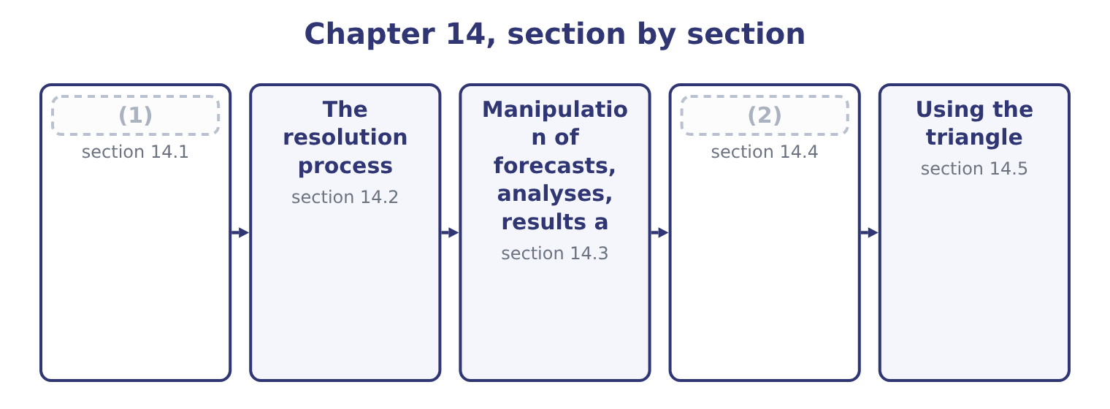
word list
What a dilemma is · obligation in play · The fraud triangle

Summary 1 gaps 3–14
An ethical dilemma is a situation in which the (3) faces a choice between courses of action where at least one obligation cannot be met, or where meeting an obligation carries a personal or (4) cost. Three things it is not, and (5) them saves a great deal of (6) writing in an exam. It is not a disagreement about (7) . A (8) of view about the right estimate for a provision, honestly held on both sides, is a technical disagreement, and the resolution is evidence and (9) . It becomes ethical when one party insists on an answer they know the evidence does not support, or when the disagreement is resolved by (10) rather than by (11) . It is not a hard decision with an (12) outcome. Closing a plant is painful and may be (13) proper; the ethical (14) are how the decision is made, who is told what and when, and whether the people affected are treated fairly. And it is not resolved by the fact that something is legal, customary in the industry, or approved by somebody senior.
word list
entirely · authority · difference · organisational · questions · discussion · confused · Honesty · professional · judgment · argument · distinguishing · unpleasant

Summary 2 gaps 15–20
Two (15) define the real thing. An obligation is in play. Honesty about a number, (16) in a report, the duty to (17) a conflict, the duty to report a control failure: one of the specific (18) . And there is a cost to meeting it. This is what makes it a dilemma rather than an (19) matter, and it is why the resolution process exists: an obligation that costs (20) needs no process.
word list
nothing · administrative · disclose · features · completeness · obligations · meeting

The English this section uses, and its Arabic
Each term sits against what it means.
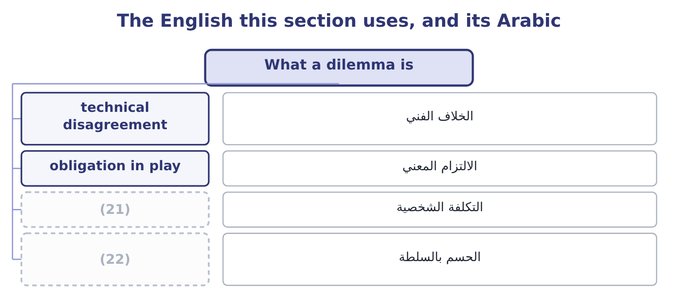
word list
personal cost · budget slack · resolution by authority

The English this sheet uses, and its Arabic
English (exam term) | Arabic
technical disagreement | الخلاف الفني
obligation in play | الالتزام المعني
personal cost | التكلفة الشخصية
resolution by authority | الحسم بالسلطة

Answer key · 14.1 What a dilemma is

1 What a dilemma is | 12 unpleasant
2 The fraud triangle | 13 entirely
3 professional | 14 questions
4 organisational | 15 features
5 distinguishing | 16 completeness
6 confused | 17 disclose
7 judgment | 18 obligations
8 difference | 19 administrative
9 discussion | 20 nothing
10 authority | 21 personal cost
11 argument | 22 resolution by authority

the summaries in full
Summary 1 An ethical dilemma is a situation in which the professional faces a choice between courses of action where at least one obligation cannot be met, or where meeting an obligation carries a personal or organisational cost. Three things it is not, and distinguishing them saves a great deal of confused writing in an exam. It is not a disagreement about judgment. A difference of view about the right estimate for a provision, honestly held on both sides, is a technical disagreement, and the resolution is evidence and discussion. It becomes ethical when one party insists on an answer they know the evidence does not support, or when the disagreement is resolved by authority rather than by argument. It is not a hard decision with an unpleasant outcome. Closing a plant is painful and may be entirely proper; the ethical questions are how the decision is made, who is told what and when, and whether the people affected are treated fairly. And it is not resolved by the fact that something is legal, customary in the industry, or approved by somebody senior.
Summary 2 Two features define the real thing. An obligation is in play. Honesty about a number, completeness in a report, the duty to disclose a conflict, the duty to report a control failure: one of the specific obligations. And there is a cost to meeting it. This is what makes it a dilemma rather than an administrative matter, and it is why the resolution process exists: an obligation that costs nothing needs no process.

14.2 The resolution process
Chapter 14 · section 14.2

Fill every gap. Each word list holds one word more than there are gaps.
Summary 1 gaps 1–12
The Statement sets out what a (1) should do when faced with an ethical issue, and the exam expects the (2) . It is a ladder, (3) one rung at a time. Start with the (4) own policy. Many employers have an (5) policy for (6) ethical conflicts, and where one exists it should be followed first. (7) the issue with the immediate supervisor, (8) the supervisor is involved in it. Many (9) are resolved here, because they arose from (10) , misunderstanding or haste rather than from intent. Where the supervisor is involved, or where the (11) is not resolved, take it to the next level of (12) , and continue upward. The Statement contemplates escalation to the audit committee, the board or another appropriate governing body, and contact with levels above the immediate supervisor should normally be initiated only with the supervisor's knowledge, assuming the supervisor is not implicated.
word list
internal · organisation's · sequence · situations · management · resolving · matter · pressure · member · established · climbed · Discuss · unless

Summary 2 gaps 13–24
Clarify the issues with an (13) adviser. The IMA offers an ethics helpline for (14) discussion of how the Statement applies, and the point of the step is to test your own reading of the situation against (15) who has no (16) in the outcome. Consult your own (17) about your legal obligations and (18) . This is a separate step and a real one, because the legal position — on (19) , on employment, on protection for reporting — differs by (20) and is not something a professional should guess at. Five practical (21) belong with the ladder, and an answer that (22) them is better than one that recites the steps. Dates, requests, what was said, what was (23) , what was decided. A note written at the time is evidence; a (24) written later is not.
word list
includes · provided · confidential · disciplines · objective · interest · helpline · rights · somebody · disclosure · jurisdiction · attorney · recollection

Summary 3 gaps 25–36
Raise the (25) rather than the (26) . (27) a workable (28) . Most requests have a (29) underlying problem — a covenant, a target, a customer — and a professional who offers a proper way to address it is far more (30) than one who only refuses. Separate what you must not do from what you would (31) not to do. You may not sign something false; you may dislike a (32) that is defensible. Spending (33) on the second leaves none for the first. And do not go (34) the organisation except where legally (35) . The (36) position is explicit. Resignation is the last resort, not the first, and it is not in itself a resolution: it removes the professional from the situation and leaves the situation. Where it becomes necessary — because the conduct continues and every internal route is exhausted — the obligations of confidentiality survive it.
word list
persuasive · alternative · defensible · Statement's · presentation · prescribed · outside · accusation · Propose · obligation · credibility · legitimate · prefer

The English this section uses, and its Arabic
Each term sits against what it means.
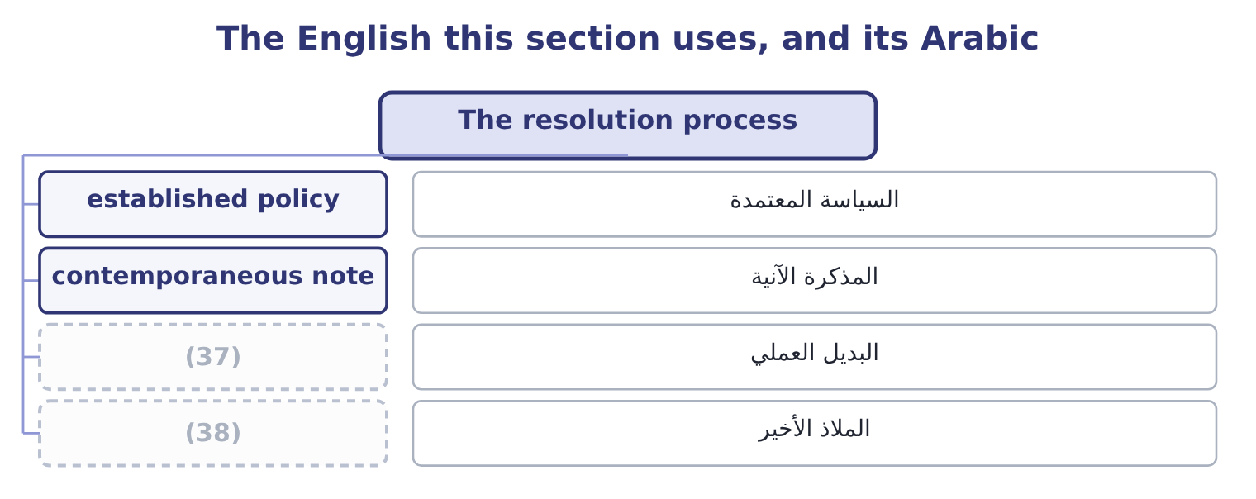
word list
technical disagreement · last resort · workable alternative

The English this sheet uses, and its Arabic
English (exam term) | Arabic
established policy | السياسة المعتمدة
contemporaneous note | المذكرة الآنية
workable alternative | البديل العملي
last resort | الملاذ الأخير

Answer key · 14.2 The resolution process

1 member | 20 jurisdiction
2 sequence | 21 disciplines
3 climbed | 22 includes
4 organisation's | 23 provided
5 established | 24 recollection
6 resolving | 25 obligation
7 Discuss | 26 accusation
8 unless | 27 Propose
9 situations | 28 alternative
10 pressure | 29 legitimate
11 matter | 30 persuasive
12 management | 31 prefer
13 objective | 32 presentation
14 confidential | 33 credibility
15 somebody | 34 outside
16 interest | 35 prescribed
17 attorney | 36 Statement's
18 rights | 37 workable alternative
19 disclosure | 38 last resort

the summaries in full
Summary 1 The Statement sets out what a member should do when faced with an ethical issue, and the exam expects the sequence. It is a ladder, climbed one rung at a time. Start with the organisation's own policy. Many employers have an established policy for resolving ethical conflicts, and where one exists it should be followed first. Discuss the issue with the immediate supervisor, unless the supervisor is involved in it. Many situations are resolved here, because they arose from pressure, misunderstanding or haste rather than from intent. Where the supervisor is involved, or where the matter is not resolved, take it to the next level of management, and continue upward. The Statement contemplates escalation to the audit committee, the board or another appropriate governing body, and contact with levels above the immediate supervisor should normally be initiated only with the supervisor's knowledge, assuming the supervisor is not implicated.
Summary 2 Clarify the issues with an objective adviser. The IMA offers an ethics helpline for confidential discussion of how the Statement applies, and the point of the step is to test your own reading of the situation against somebody who has no interest in the outcome. Consult your own attorney about your legal obligations and rights. This is a separate step and a real one, because the legal position — on disclosure, on employment, on protection for reporting — differs by jurisdiction and is not something a professional should guess at. Five practical disciplines belong with the ladder, and an answer that includes them is better than one that recites the steps. Dates, requests, what was said, what was provided, what was decided. A note written at the time is evidence; a recollection written later is not.
Summary 3 Raise the obligation rather than the accusation. Propose a workable alternative. Most requests have a legitimate underlying problem — a covenant, a target, a customer — and a professional who offers a proper way to address it is far more persuasive than one who only refuses. Separate what you must not do from what you would prefer not to do. You may not sign something false; you may dislike a presentation that is defensible. Spending credibility on the second leaves none for the first. And do not go outside the organisation except where legally prescribed. The Statement's position is explicit. Resignation is the last resort, not the first, and it is not in itself a resolution: it removes the professional from the situation and leaves the situation. Where it becomes necessary — because the conduct continues and every internal route is exhausted — the obligations of confidentiality survive it.

14.3 Manipulation of forecasts, analyses, results and budgets
Chapter 14 · section 14.3

Fill every gap. Each word list holds one word more than there are gaps.
Summary 1 gaps 1–12
The (1) outcome names the family of issues a management (2) meets most often and asks for (3) to be proposed. The forms are worth (4) , because recognising one is half the answer. Recognising revenue early — (5) goods before they are wanted, which is channel stuffing; holding a period open past its end; deferring or (6) costs that should be expensed; releasing a provision because a result is short; delaying a (7) . The (8) is usually small relative to the company and decisive relative to the target: releasing a provision from 240,000 to 90,000 adds 240,000 − 90,000 = 150,000 to profit, which is 150,000 ÷ 4,176,000 = 3.59 per cent of (9) operating income — (10) to an auditor and quite enough to turn a miss into a hit. Presenting a forecast the (11) believes to be unachievable because it is what the board wants to hear; or the reverse, (12) in slack so that the target can be beaten.
word list
arithmetic · shipping · naming · capitalising · commercial · building · preparer · resolutions · second · immaterial · Orontes's · accountant · write-down

Summary 2 gaps 13–24
A manager who adds 8 per cent to a 3,000,000 cost budget has created 3,000,000 × 0.08 = 240,000 of (13) slack, and the company will plan on it, price on it and (14) capital on it. Choosing the discount rate, the base period, the comparator or the scenario that produces the wanted answer; omitting the (15) that would undermine the (16) ; presenting one option with its risks and the preferred one without. Book 3's capital budgeting is (17) exposed, since every (18) rests on assumptions somebody chose. The truncated axis, the (19) against a revised target, the favourable variance explained and the (20) one attributed to timing, the one-off gain in operating income and the one-off cost below it. Proposing a (21) , which the outcome requires, (22) a pattern. (23) the legitimate problem (24) the request.
word list
follows · Identify · resolution · Choosing · invisible · unfavourable · allocate · comparison · behind · sensitivity · particularly · appraisal · recommendation

Summary 3 gaps 25–35
Channel stuffing is usually a revenue shortfall; budget slack is usually a fear of being held to a forecast made under (25) ; a released provision is usually a covenant. (26) the real problem is what makes the refusal (27) . State the obligation and its (28) precisely, without (29) : what the standard requires, what the disclosure would have to say, and what happens if the treatment is later reversed. Offer the legitimate (30) . For a covenant: talk to the (31) early. For a revenue shortfall: (32) it with the reasons and the (33) plan. For an unachievable forecast: present it as a range with the assumptions stated, which (34) Credibility and is also better management (35) . Escalate if the request stands, by the ladder of section 14.2.
word list
report · information · satisfies · management · Addressing · constructive · uncertainty · accusation · consequence · recovery · alternatives · lender

Worked example: the quarter that was 150,000 short

Summary 4 gaps 36–47
At a 40 per cent contribution margin the early (36) brings 250,000 × 0.40 = 100,000 of contribution into this quarter and takes it out of the next. Is it a breach? It (37) on facts, not on the request. If the customers have (38) the goods and accept (39) , early despatch is a (40) decision and the revenue is properly (41) . If the goods are shipped without agreement, on (42) , or with a side (43) that they may be sent back, it is not revenue at all and the accounts would be misstated. (44) which it is, in (45) , from the customers' own orders. Where the orders are genuine, do it and disclose the (46) in the commentary, because Credibility requires the board to know that the quarter was helped by 100,000 of next (47) contribution.
word list
delivery · shipment · sale-or-return · commercial · writing · quarter's · pull-forward · depends · understanding · Establish · recognised · customers · ordered

Summary 5 gaps 48–52
Where they are not, refuse the (48) treatment, say why, and escalate if it is (49) . Notice that the (50) answer is not "refuse". It is "find out, then treat it (51) and say what was done". A (52) who refuses everything that looks awkward loses the standing needed to refuse the thing that matters.
word list
correctly · ethical · constructive · pressed · professional · accounting

The English this section uses, and its Arabic
Each term sits against what it means.
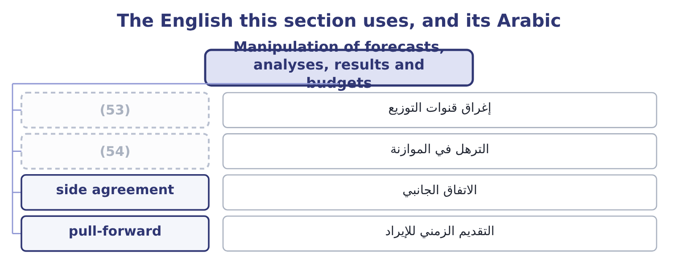
word list
established policy · budget slack · channel stuffing

The English this sheet uses, and its Arabic
English (exam term) | Arabic
channel stuffing | إغراق قنوات التوزيع
budget slack | الترهل في الموازنة
side agreement | الاتفاق الجانبي
pull-forward | التقديم الزمني للإيراد

Answer key · 14.3 Manipulation of forecasts, analyses, results and budgets

1 second | 28 consequence
2 accountant | 29 accusation
3 resolutions | 30 alternatives
4 naming | 31 lender
5 shipping | 32 report
6 capitalising | 33 recovery
7 write-down | 34 satisfies
8 arithmetic | 35 information
9 Orontes's | 36 shipment
10 immaterial | 37 depends
11 preparer | 38 ordered
12 building | 39 delivery
13 invisible | 40 commercial
14 allocate | 41 recognised
15 sensitivity | 42 sale-or-return
16 recommendation | 43 understanding
17 particularly | 44 Establish
18 appraisal | 45 writing
19 comparison | 46 pull-forward
20 unfavourable | 47 quarter's
21 resolution | 48 accounting
22 follows | 49 pressed
23 Identify | 50 ethical
24 behind | 51 correctly
25 uncertainty | 52 professional
26 Addressing | 53 channel stuffing
27 constructive | 54 budget slack

the summaries in full
Summary 1 The second outcome names the family of issues a management accountant meets most often and asks for resolutions to be proposed. The forms are worth naming, because recognising one is half the answer. Recognising revenue early — shipping goods before they are wanted, which is channel stuffing; holding a period open past its end; deferring or capitalising costs that should be expensed; releasing a provision because a result is short; delaying a write-down. The arithmetic is usually small relative to the company and decisive relative to the target: releasing a provision from 240,000 to 90,000 adds 240,000 − 90,000 = 150,000 to profit, which is 150,000 ÷ 4,176,000 = 3.59 per cent of Orontes's operating income — immaterial to an auditor and quite enough to turn a miss into a hit. Presenting a forecast the preparer believes to be unachievable because it is what the board wants to hear; or the reverse, building in slack so that the target can be beaten.
Summary 2 A manager who adds 8 per cent to a 3,000,000 cost budget has created 3,000,000 × 0.08 = 240,000 of invisible slack, and the company will plan on it, price on it and allocate capital on it. Choosing the discount rate, the base period, the comparator or the scenario that produces the wanted answer; omitting the sensitivity that would undermine the recommendation; presenting one option with its risks and the preferred one without. Book 3's capital budgeting is particularly exposed, since every appraisal rests on assumptions somebody chose. The truncated axis, the comparison against a revised target, the favourable variance explained and the unfavourable one attributed to timing, the one-off gain in operating income and the one-off cost below it. Proposing a resolution, which the outcome requires, follows a pattern. Identify the legitimate problem behind the request.
Summary 3 Channel stuffing is usually a revenue shortfall; budget slack is usually a fear of being held to a forecast made under uncertainty; a released provision is usually a covenant. Addressing the real problem is what makes the refusal constructive. State the obligation and its consequence precisely, without accusation: what the standard requires, what the disclosure would have to say, and what happens if the treatment is later reversed. Offer the legitimate alternatives. For a covenant: talk to the lender early. For a revenue shortfall: report it with the reasons and the recovery plan. For an unachievable forecast: present it as a range with the assumptions stated, which satisfies Credibility and is also better management information. Escalate if the request stands, by the ladder of section 14.2.
Summary 4 At a 40 per cent contribution margin the early shipment brings 250,000 × 0.40 = 100,000 of contribution into this quarter and takes it out of the next. Is it a breach? It depends on facts, not on the request. If the customers have ordered the goods and accept delivery, early despatch is a commercial decision and the revenue is properly recognised. If the goods are shipped without agreement, on sale-or-return, or with a side understanding that they may be sent back, it is not revenue at all and the accounts would be misstated. Establish which it is, in writing, from the customers' own orders. Where the orders are genuine, do it and disclose the pull-forward in the commentary, because Credibility requires the board to know that the quarter was helped by 100,000 of next quarter's contribution.
Summary 5 Where they are not, refuse the accounting treatment, say why, and escalate if it is pressed. Notice that the ethical answer is not "refuse". It is "find out, then treat it correctly and say what was done". A professional who refuses everything that looks awkward loses the standing needed to refuse the thing that matters.

14.4 The fraud triangle
Chapter 14 · section 14.4

Fill every gap. Each word list holds one word more than there are gaps.
Summary 1 gaps 1–12
The third (1) asks for the three (2) , and the model is the most useful (3) idea in this half of the book. It holds that fraud requires three (4) together, and that (5) any one of them prevents it. Pressure, also called (6) or motivation. A (7) to commit the act. It may be personal — debt, medical costs, gambling, (8) , a lifestyle that cannot be sustained on the salary, a family (9) — or organisational: a target, a bonus threshold, a covenant, a share price, a plant whose closure depends on the numbers, a fear of losing a job. Note that financial statement fraud is almost always organisational pressure and asset (10) almost always personal, which is why the two have (11) warning signs. A way to do it and a (12) that it will not be found.
word list
misappropriation · components · addiction · single · expectation · removing · belief · reason · incentive · together · outcome · different · conditions

Summary 2 gaps 13–24
Opportunity is created by weak controls, by the absence of (13) , by access that nobody reviews, by (14) that nobody checks, and above all by a person who can both perform and conceal. Of the three sides, this is the one the (15) controls directly, which is why. A way of reconciling the act with one's own (16) , because the great majority of (17) fraud is committed by people who do not think of themselves as criminals. The standard forms are worth knowing, because they appear in (18) and in exam cases: "I am only (19) it"; "they owe me, after what I have done for them"; "everybody does it"; "the company can afford it"; "I had no choice"; "it is only until the quarter turns"; "it is not really stealing, nobody is hurt". Two extensions appear in the (20) and are worth a line. Some writers add (21) — the person must have the position, the knowledge and the nerve to carry it out — making a fraud diamond; and in financial statement fraud, arrogance or (22) is often added, describing a senior person who believes the rules do not apply to them. The (23) model is what the exam asks for; the extensions are useful in an answer that has (24) given it.
word list
capability · borrowing · organisation · interviews · occupational · three-sided · already · literature · entitlement · authority · segregation · self-image · knowing

The English this section uses, and its Arabic
Each term sits against what it means.
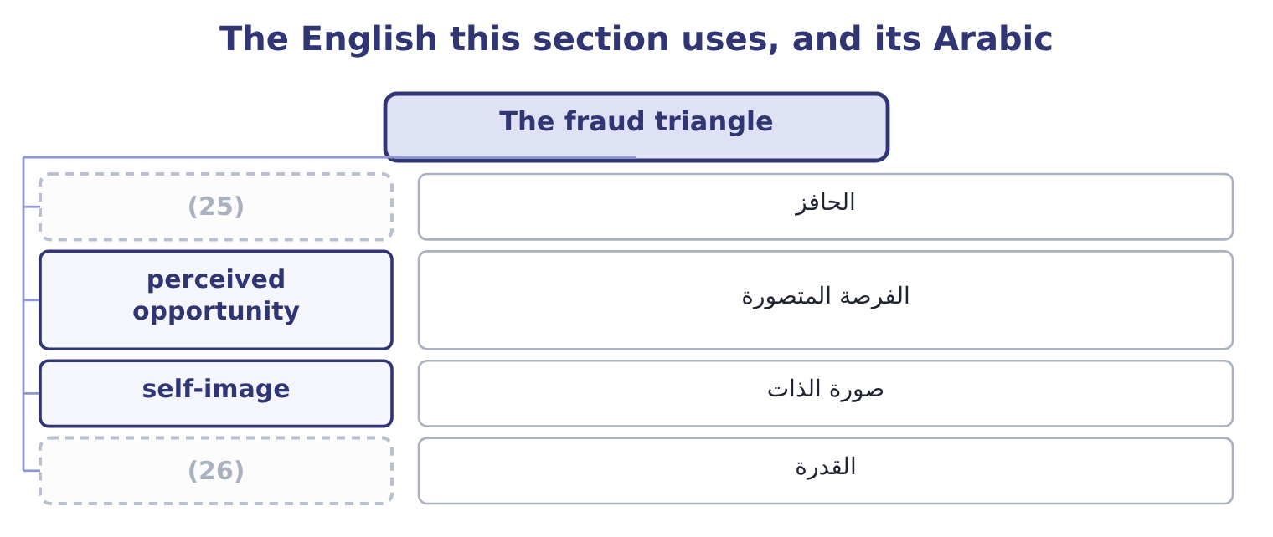
word list
override · capability · incentive

The English this sheet uses, and its Arabic
English (exam term) | Arabic
incentive | الحافز
perceived opportunity | الفرصة المتصورة
self-image | صورة الذات
capability | القدرة

Answer key · 14.4 The fraud triangle

1 outcome | 14 authority
2 components | 15 organisation
3 single | 16 self-image
4 conditions | 17 occupational
5 removing | 18 interviews
6 incentive | 19 borrowing
7 reason | 20 literature
8 addiction | 21 capability
9 expectation | 22 entitlement
10 misappropriation | 23 three-sided
11 different | 24 already
12 belief | 25 incentive
13 segregation | 26 capability

the summaries in full
Summary 1 The third outcome asks for the three components, and the model is the most useful single idea in this half of the book. It holds that fraud requires three conditions together, and that removing any one of them prevents it. Pressure, also called incentive or motivation. A reason to commit the act. It may be personal — debt, medical costs, gambling, addiction, a lifestyle that cannot be sustained on the salary, a family expectation — or organisational: a target, a bonus threshold, a covenant, a share price, a plant whose closure depends on the numbers, a fear of losing a job. Note that financial statement fraud is almost always organisational pressure and asset misappropriation almost always personal, which is why the two have different warning signs. A way to do it and a belief that it will not be found.
Summary 2 Opportunity is created by weak controls, by the absence of segregation, by access that nobody reviews, by authority that nobody checks, and above all by a person who can both perform and conceal. Of the three sides, this is the one the organisation controls directly, which is why. A way of reconciling the act with one's own self-image, because the great majority of occupational fraud is committed by people who do not think of themselves as criminals. The standard forms are worth knowing, because they appear in interviews and in exam cases: "I am only borrowing it"; "they owe me, after what I have done for them"; "everybody does it"; "the company can afford it"; "I had no choice"; "it is only until the quarter turns"; "it is not really stealing, nobody is hurt". Two extensions appear in the literature and are worth a line. Some writers add capability — the person must have the position, the knowledge and the nerve to carry it out — making a fraud diamond; and in financial statement fraud, arrogance or entitlement is often added, describing a senior person who believes the rules do not apply to them. The three-sided model is what the exam asks for; the extensions are useful in an answer that has already given it.

14.5 Using the triangle
Chapter 14 · section 14.5

Fill every gap. Each word list holds one word more than there are gaps.
Summary 1 gaps 1–12
The fourth (1) asks how a professional uses the model to (2) and manage the risk of fraud, and the answer is one (3) for each side. Reduce opportunity, which is the (4) half. (5) : segregation of duties, (6) limits, reconciliations performed by people who do not hold the asset, (7) master file access, mandatory leave and rotation, audit trails that cannot be altered, and review of the exceptions rather than only of the totals. Add to those the specific (8) tests that find the frauds of, payments just below approval thresholds, new (9) , credit notes, write-offs, manual journals posted near a period end and reversed after it. Reduce pressure where it is created by the organisation. This is the part management controls and rarely (10) . Targets that cannot be met honestly, bonus structures with cliff edges, a culture in which missing a number is (11) , and a sales commission paid on orders rather than on cash collected: each of these (12) pressure, and a company that creates the motive and then relies on controls to stop the act has made its own problem.
word list
authorisation · suppliers · examines · practical · detective · unsurvivable · identify · changes · restricted · action · Everything · outcome · manufactures

Summary 2 gaps 13–20
Attack rationalisation, which sounds the (13) and is not. A code of (14) that is specific about the acts in question, training that uses real situations rather than (15) , visible and consistent enforcement at every level, a route to raise a (16) , and leaders who talk about the awkward cases: all of these make the stories harder to tell oneself. The (17) enemy of rationalisation is (18) — the senior person who is treated exactly as a junior one would be. For (19) fraud risk, the model becomes a (20) .
word list
slogans · diagnostic · concern · conduct · consistency · particular · whether · identifying · softest

The triangle as a diagnostic
Side | The question to ask | What to look for | What to do
Pressure | Who in this process is under pressure, and from what? | Targets missed, cliff-edge bonuses, personal difficulty, (21) lifestyle | Change the incentive; support the person; increase oversight
Opportunity | Who could do it and conceal it? | One person performing and recording; unreviewed access; overrides | (22)
Rationalisation | What story would make it acceptable here? | (23) | Specific code, real training, consistent enforcement
All three | Where do all three coincide? | (24) | Treat as a high risk; test it

word list
incentive · unexplained · Segregate, restrict, review exceptions · A single process with pressure, access and a grievance · "Everybody does it"; grievance; inconsistent discipline

Summary 3 gaps 25–36
Four (25) signs are worth knowing for the exam, because situations are (26) around them. (27) : an employee who never takes leave, who resists control changes, who insists on handling one relationship (28) , whose lifestyle exceeds their income, or who has an (29) close relationship with a supplier or customer. Process: reconciliations that are late or performed by the wrong person, a rising volume of manual journals, (30) overrides, missing (31) , and customer or supplier (32) that stop reaching the people who should hear them. (33) : margins that move without explanation, (34) entries, payments just below thresholds, credit notes concentrated after period ends, and write-offs concentrated in one (35) accounts. And structural: a dominant individual, a finance function too small for segregation, a (36) person in a sensitive role with no cover, and an audit committee that meets rarely.
word list
complaints · unusually · person's · handling · warning · Numerical · round-number · personally · written · repeated · documentation · long-tenured · Behavioural

Summary 4 gaps 37–41
The (37) own position is the last point and the most personal. The triangle (38) to you. Pressure will come from a target or a superior; opportunity exists because you prepare the numbers; and rationalisation is (39) in the words "it is only a (40) " or "the quarter will correct it". Knowing the model is some (41) against being inside it.
word list
presentation · available · knowing · applies · protection · professional's

Dilemmas and the triangle

Your turn: resolving and diagnosing (complete the blanks)
Item | Data | Answer
First step when an ethical issue arises |  | ________
Where to take it when the supervisor is involved |  | ________
Contribution moved by shipping 250,000 early | Contribution margin 40 per cent | ________
Slack created by an 8 per cent addition | (42) | ________
The three sides of the fraud triangle |  | ________
The side the organisation controls most directly |  | ________

word list
Cost budget 3,000,000 · obligation in play

"Aggressive", "conservative" and "manage"

Summary 5 gaps 43–54
Three (43) words do most of the work of disguising (44) , and a management (45) should recognise all of them. Aggressive (46) sounds energetic and (47) minded; it means (48) at or beyond the edge of what the standards allow. (49) sounds prudent and careful; applied to a (50) taken in a good year to be (51) in a bad one, it means building a reserve to manage earnings, which is not prudence. And manage, in earnings management, is the most (52) of the three, because managing is what managers are supposed to do: the phrase makes the (53) shaping of a reported result sound like (54) . The habit worth forming is to replace the adjective with the act: not "we are being aggressive on revenue" but "we are recognising revenue before the customer has agreed to take the goods" — and then see whether the sentence still sounds acceptable.
word list
deliberate · released · accounting · effective · English · accountant · Conservative · treatments · journals · manipulation · provision · competence · commercially

"Aggressive", "conservative" and "manage"
Item | Answer
First step | Follow the organisation's (55) for resolving ethical conflicts.
Where the supervisor is involved | The next level of management, and upward to the audit committee or board.
Contribution moved | (56)
Slack created | 240,000: 3,000,000 × 0.08 = 240,000.
The three sides | Pressure, opportunity and rationalisation.
The side most directly controlled | Opportunity, through segregation, access and review.
What it tells you | Two questions about the process and two about the (57) , with the triangle underneath both — because the process exists for the moment

word list
arithmetic · earnings management · 100,000: 250,000 × 0.40 = 100,000. · established policy

The English this section uses, and its Arabic
Each term sits against what it means.
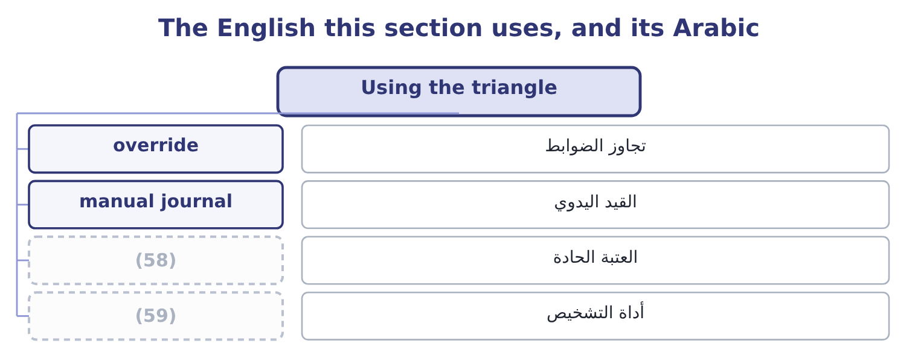
word list
pressure · cliff edge · diagnostic

The English this sheet uses, and its Arabic
English (exam term) | Arabic
override | تجاوز الضوابط
manual journal | القيد اليدوي
cliff edge | العتبة الحادة
diagnostic | أداة التشخيص

Answer key · 14.5 Using the triangle

1 outcome | 31 documentation
2 identify | 32 complaints
3 action | 33 Numerical
4 practical | 34 round-number
5 Everything | 35 person's
6 authorisation | 36 long-tenured
7 restricted | 37 professional's
8 detective | 38 applies
9 suppliers | 39 available
10 examines | 40 presentation
11 unsurvivable | 41 protection
12 manufactures | 42 Cost budget 3,000,000
13 softest | 43 English
14 conduct | 44 manipulation
15 slogans | 45 accountant
16 concern | 46 accounting
17 particular | 47 commercially
18 consistency | 48 treatments
19 identifying | 49 Conservative
20 diagnostic | 50 provision
21 unexplained | 51 released
22 Segregate, restrict, review exceptions | 52 effective
23 "Everybody does it"; grievance; inconsistent discipline | 53 deliberate
24 A single process with pressure, access and a grievance | 54 competence
25 warning | 55 established policy
26 written | 56 100,000: 250,000 × 0.40 = 100,000.
27 Behavioural | 57 arithmetic
28 personally | 58 cliff edge
29 unusually | 59 diagnostic
30 repeated

the summaries in full
Summary 1 The fourth outcome asks how a professional uses the model to identify and manage the risk of fraud, and the answer is one action for each side. Reduce opportunity, which is the practical half. Everything: segregation of duties, authorisation limits, reconciliations performed by people who do not hold the asset, restricted master file access, mandatory leave and rotation, audit trails that cannot be altered, and review of the exceptions rather than only of the totals. Add to those the specific detective tests that find the frauds of, payments just below approval thresholds, new suppliers, credit notes, write-offs, manual journals posted near a period end and reversed after it. Reduce pressure where it is created by the organisation. This is the part management controls and rarely examines. Targets that cannot be met honestly, bonus structures with cliff edges, a culture in which missing a number is unsurvivable, and a sales commission paid on orders rather than on cash collected: each of these manufactures pressure, and a company that creates the motive and then relies on controls to stop the act has made its own problem.
Summary 2 Attack rationalisation, which sounds the softest and is not. A code of conduct that is specific about the acts in question, training that uses real situations rather than slogans, visible and consistent enforcement at every level, a route to raise a concern, and leaders who talk about the awkward cases: all of these make the stories harder to tell oneself. The particular enemy of rationalisation is consistency — the senior person who is treated exactly as a junior one would be. For identifying fraud risk, the model becomes a diagnostic.
Summary 3 Four warning signs are worth knowing for the exam, because situations are written around them. Behavioural: an employee who never takes leave, who resists control changes, who insists on handling one relationship personally, whose lifestyle exceeds their income, or who has an unusually close relationship with a supplier or customer. Process: reconciliations that are late or performed by the wrong person, a rising volume of manual journals, repeated overrides, missing documentation, and customer or supplier complaints that stop reaching the people who should hear them. Numerical: margins that move without explanation, round-number entries, payments just below thresholds, credit notes concentrated after period ends, and write-offs concentrated in one person's accounts. And structural: a dominant individual, a finance function too small for segregation, a long-tenured person in a sensitive role with no cover, and an audit committee that meets rarely.
Summary 4 The professional's own position is the last point and the most personal. The triangle applies to you. Pressure will come from a target or a superior; opportunity exists because you prepare the numbers; and rationalisation is available in the words "it is only a presentation" or "the quarter will correct it". Knowing the model is some protection against being inside it.
Summary 5 Three English words do most of the work of disguising manipulation, and a management accountant should recognise all of them. Aggressive accounting sounds energetic and commercially minded; it means treatments at or beyond the edge of what the standards allow. Conservative sounds prudent and careful; applied to a provision taken in a good year to be released in a bad one, it means building a reserve to manage earnings, which is not prudence. And manage, in earnings management, is the most effective of the three, because managing is what managers are supposed to do: the phrase makes the deliberate shaping of a reported result sound like competence. The habit worth forming is to replace the adjective with the act: not "we are being aggressive on revenue" but "we are recognising revenue before the customer has agreed to take the goods" — and then see whether the sentence still sounds acceptable.

