15.1 Applying values across borders
Chapter 15 · section 15.1

Fill every gap. Each word list holds one word more than there are gaps.
Chapter 15, section by section
Each stage leads to the next.
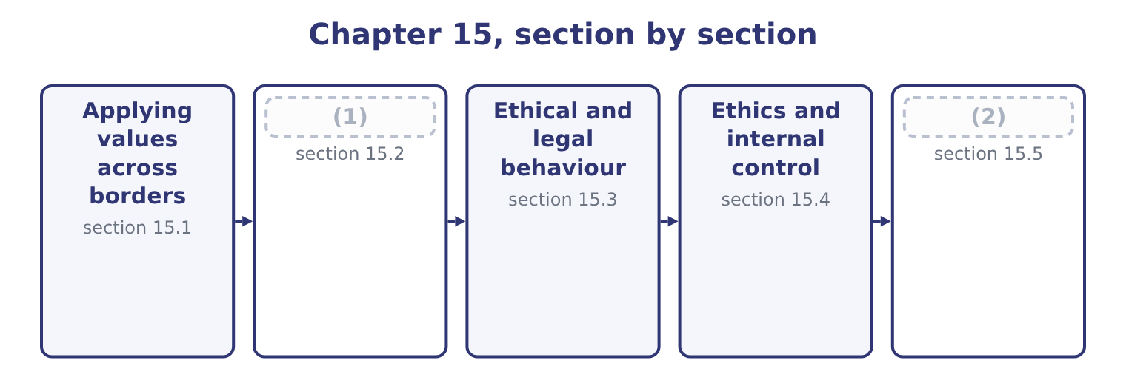
word list
Ethics and internal control · Designing for both · Three positions, and the workable one

Summary 1 gaps 3–14
The outcome asks for the issues an (3) faces in applying its values and ethical standards (4) , and there are seven worth naming. Different laws, and (5) ones. Employment protections, environmental limits, data rules, disclosure (6) and competition law differ, and (7) a company is required by one country's law to do what another's forbids. Data (8) and sanctions produce the (9) cases. Different (10) around gifts, (11) and payments. In some markets a payment to an (12) to do what they are already obliged to do — clear a shipment, issue a licence — is routine and (13) . It is a (14) payment, it is a criminal offence under the laws, and the company that refuses it bears a real cost: a consignment held five days costs Orontes 46,027 × 5 = 230,135 of contribution, against a payment of 2,000 which is 2,000 ÷ 450,000 = 0.44 per cent of the shipment's value.
word list
expected · transfer · facilitation · sharpest · customs · occasionally · organisation · conflicting · exactly · official · requirements · hospitality · internationally

Summary 2 gaps 15–26
The (15) is exactly why the rule has to be absolute: anything less than a (16) becomes a calculation, and the calculation always favours paying. Different (17) and safety standards. Working hours, minimum ages, union rights, (18) and safety (19) . A company may be (20) lawful locally and far below what it would accept at home, and the question is which standard applies to its own (21) and to its suppliers'. Different environmental standards, with the same (22) . Conduct in the (23) chain and among partners. A company is judged by what is done in its name — by its distributors, agents, (24) partners and suppliers — and it (25) has less control over them than over its own staff. Agents in (26) are the standard route by which bribery enters a company that has prohibited it.
word list
particular · entirely · usually · operations · equipment · prohibition · joint-venture · arithmetic · general · structure · accommodation · labour · supply

Summary 3 gaps 27–34
The reach of (27) law. (28) statutes, sanctions and some tax and disclosure rules apply to conduct (29) , so "it is legal there" is not even a legal (30) , let alone an ethical one. And the practical problems of applying a code at a distance: (31) that must carry meaning and not only words, local managers who have to interpret general (32) in situations the code never (33) , training delivered in a language and a format that work locally, monitoring that is genuine rather than a (34) , and a reporting route a local employee will actually use.
word list
translation · defence · principles · abroad · environmental · Anti-bribery · questionnaire · home-country · contemplated

The English this section uses, and its Arabic
Each term sits against what it means.
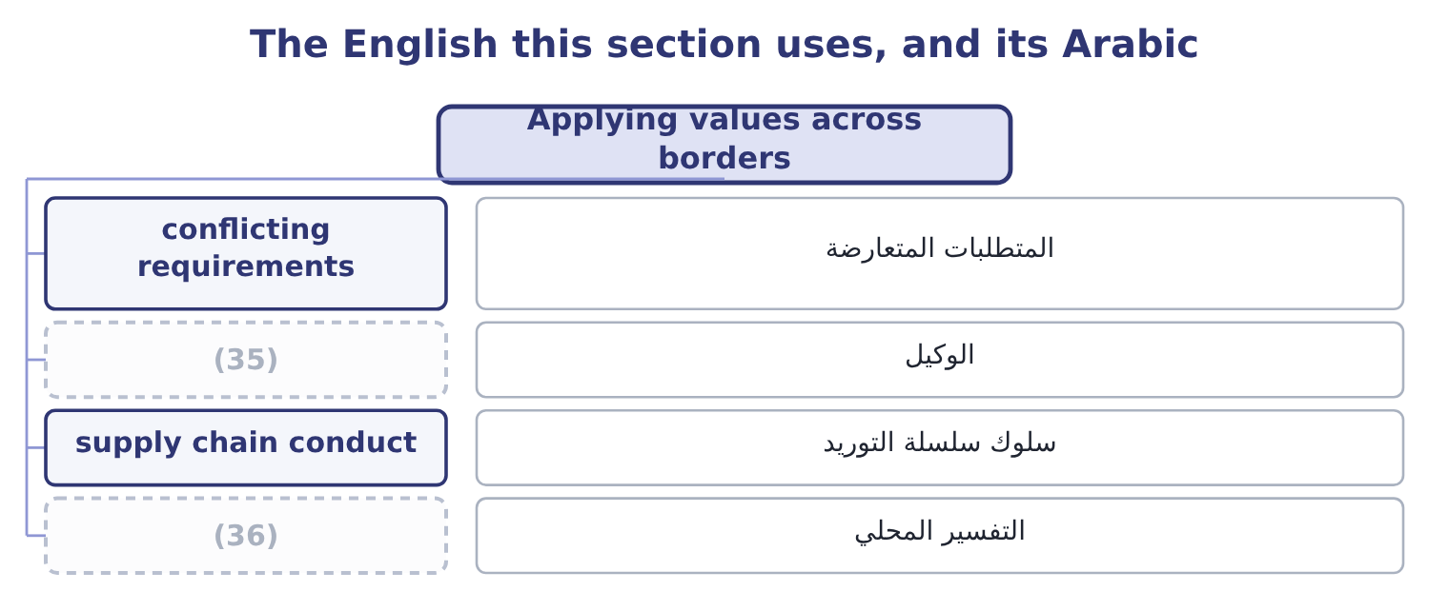
word list
local interpretation · agent · local practice

The English this sheet uses, and its Arabic
English (exam term) | Arabic
conflicting requirements | المتطلبات المتعارضة
agent | الوكيل
supply chain conduct | سلوك سلسلة التوريد
local interpretation | التفسير المحلي

Answer key · 15.1 Applying values across borders

1 Three positions, and the workable one | 19 equipment
2 Designing for both | 20 entirely
3 organisation | 21 operations
4 internationally | 22 structure
5 conflicting | 23 supply
6 requirements | 24 joint-venture
7 occasionally | 25 usually
8 transfer | 26 particular
9 sharpest | 27 home-country
10 customs | 28 Anti-bribery
11 hospitality | 29 abroad
12 official | 30 defence
13 expected | 31 translation
14 facilitation | 32 principles
15 arithmetic | 33 contemplated
16 prohibition | 34 questionnaire
17 labour | 35 agent
18 accommodation | 36 local interpretation

the summaries in full
Summary 1 The outcome asks for the issues an organisation faces in applying its values and ethical standards internationally, and there are seven worth naming. Different laws, and conflicting ones. Employment protections, environmental limits, data rules, disclosure requirements and competition law differ, and occasionally a company is required by one country's law to do what another's forbids. Data transfer and sanctions produce the sharpest cases. Different customs around gifts, hospitality and payments. In some markets a payment to an official to do what they are already obliged to do — clear a shipment, issue a licence — is routine and expected. It is a facilitation payment, it is a criminal offence under the laws, and the company that refuses it bears a real cost: a consignment held five days costs Orontes 46,027 × 5 = 230,135 of contribution, against a payment of 2,000 which is 2,000 ÷ 450,000 = 0.44 per cent of the shipment's value.
Summary 2 The arithmetic is exactly why the rule has to be absolute: anything less than a prohibition becomes a calculation, and the calculation always favours paying. Different labour and safety standards. Working hours, minimum ages, union rights, accommodation and safety equipment. A company may be entirely lawful locally and far below what it would accept at home, and the question is which standard applies to its own operations and to its suppliers'. Different environmental standards, with the same structure. Conduct in the supply chain and among partners. A company is judged by what is done in its name — by its distributors, agents, joint-venture partners and suppliers — and it usually has less control over them than over its own staff. Agents in particular are the standard route by which bribery enters a company that has prohibited it.
Summary 3 The reach of home-country law. Anti-bribery statutes, sanctions and some tax and disclosure rules apply to conduct abroad, so "it is legal there" is not even a legal defence, let alone an ethical one. And the practical problems of applying a code at a distance: translation that must carry meaning and not only words, local managers who have to interpret general principles in situations the code never contemplated, training delivered in a language and a format that work locally, monitoring that is genuine rather than a questionnaire, and a reporting route a local employee will actually use.

15.2 Three positions, and the workable one
Chapter 15 · section 15.2

Fill every gap. Each word list holds one word more than there are gaps.
Summary 1 gaps 1–12
Two extreme (1) are available and both fail, which is why the exam wants the middle one (2) . (3) holds that the company's home standards apply (4) without variation. Its strength is (5) : nobody has to (6) anything, and the rule is the same in every office. Its weaknesses are that it can be arrogant — not every local practice is worse, merely different — that it may be (7) or even unlawful locally, and that it leaves no room for the genuine (8) in custom that have nothing to do with right and wrong. (9) holds that the right standard is (10) is accepted locally — "when in Rome". Its strength is respect for local practice and the (11) that outsiders (12) less than they think. Its weakness is fatal: it provides no ground on which to refuse anything, since every practice is accepted somewhere, and it hands the standard to whoever benefits from the worst local custom.
word list
differences · Relativism · customary · Absolutism · positions · clarity · whatever · everywhere · described · understand · interpret · recognition · impractical

Summary 2 gaps 13–24
The workable position (13) between core values and local practice. Core values do not vary. Honesty, safety, no bribery, no forced or child labour, no deliberate misstatement, no (14) of the kinds the company has named: these apply in every country and in every operation, and they are the (15) categories. Local practice (16) , and should. Negotiating style, the role of relationships and (17) , how directly (18) is expressed, hospitality norms, hierarchy, working patterns, how decisions are made and recorded. A company that treats these as (19) matters mistakes (20) for wrongdoing. The hard cases live in between, and the exam uses them: a gift that is customary and (21) ; a hiring practice that favours family and is universal locally; a supplier whose working (22) are lawful and poor; a payment that is demanded rather than offered. Would we do it at home, and if not, what (23) is different? Sometimes the answer is a real difference in (24) and sometimes it is only that nobody would. And is it being required of us, or offered to us? Extortion and opportunity are different cases, and a payment demanded under threat of harm is treated differently in most anti-bribery regimes from one offered to win business — though the company should still report and record it.
word list
substantial · zero-tolerance · circumstance · intermediaries · exactly · ethical · unfamiliarity · conditions · disagreement · varies · discrimination · distinguishes · arrogant

The English this section uses, and its Arabic
Each term sits against what it means.
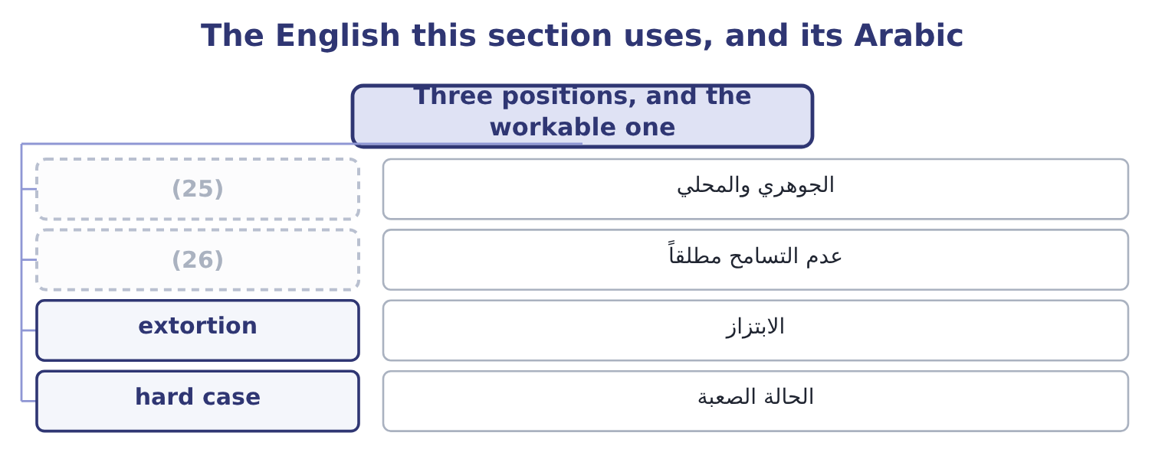
word list
zero tolerance · core and local · anything of value

The English this sheet uses, and its Arabic
English (exam term) | Arabic
core and local | الجوهري والمحلي
zero tolerance | عدم التسامح مطلقاً
extortion | الابتزاز
hard case | الحالة الصعبة

Answer key · 15.2 Three positions, and the workable one

1 positions | 14 discrimination
2 described | 15 zero-tolerance
3 Absolutism | 16 varies
4 everywhere | 17 intermediaries
5 clarity | 18 disagreement
6 interpret | 19 ethical
7 impractical | 20 unfamiliarity
8 differences | 21 substantial
9 Relativism | 22 conditions
10 whatever | 23 exactly
11 recognition | 24 circumstance
12 understand | 25 core and local
13 distinguishes | 26 zero tolerance

the summaries in full
Summary 1 Two extreme positions are available and both fail, which is why the exam wants the middle one described. Absolutism holds that the company's home standards apply everywhere without variation. Its strength is clarity: nobody has to interpret anything, and the rule is the same in every office. Its weaknesses are that it can be arrogant — not every local practice is worse, merely different — that it may be impractical or even unlawful locally, and that it leaves no room for the genuine differences in custom that have nothing to do with right and wrong. Relativism holds that the right standard is whatever is accepted locally — "when in Rome". Its strength is respect for local practice and the recognition that outsiders understand less than they think. Its weakness is fatal: it provides no ground on which to refuse anything, since every practice is accepted somewhere, and it hands the standard to whoever benefits from the worst local custom.
Summary 2 The workable position distinguishes between core values and local practice. Core values do not vary. Honesty, safety, no bribery, no forced or child labour, no deliberate misstatement, no discrimination of the kinds the company has named: these apply in every country and in every operation, and they are the zero-tolerance categories. Local practice varies, and should. Negotiating style, the role of relationships and intermediaries, how directly disagreement is expressed, hospitality norms, hierarchy, working patterns, how decisions are made and recorded. A company that treats these as ethical matters mistakes unfamiliarity for wrongdoing. The hard cases live in between, and the exam uses them: a gift that is customary and substantial; a hiring practice that favours family and is universal locally; a supplier whose working conditions are lawful and poor; a payment that is demanded rather than offered. Would we do it at home, and if not, what exactly is different? Sometimes the answer is a real difference in circumstance and sometimes it is only that nobody would. And is it being required of us, or offered to us? Extortion and opportunity are different cases, and a payment demanded under threat of harm is treated differently in most anti-bribery regimes from one offered to win business — though the company should still report and record it.

15.3 Ethical and legal behaviour
Chapter 15 · section 15.3

Fill every gap. Each word list holds one word more than there are gaps.
Summary 1 gaps 1–12
The (1) asks for the (2) , and four of them matter. Law is a floor; ethics is a standard. (3) the law forbids is unethical in the ordinary case, but a great deal that is lawful is not ethical: a contract term enforced against a party who did not understand it, a redundancy handled lawfully and brutally, a marketing claim technically true and designed to mislead, a tax structure that is legal and (4) in public. Legal (5) is the minimum, not the (6) . Law is enforced (7) ; ethics is enforced internally and (8) . The sanction for (9) is a court; the sanction for unethical conduct is (10) , professional membership, trust and the loss of people who will not work for the company. Law is (11) , codified and (12) . It names acts, in writing, after a problem has been recognised. Ethics applies to situations no rule has contemplated — new technologies, new markets, new products — and it operates before the law catches up. And law varies by jurisdiction; core ethical values are held to be the same everywhere, which is section 15.2's point.
word list
backward-looking · reputation · differences · specific · professionally · externally · structure · indefensible · outcome · compliance · illegality · objective · Everything

Legal and ethical
Case | Example | What to do
Legal and ethical | (13) | Proceed
Legal but unethical | A technically true marketing claim designed to mislead | (14)
Illegal but widely tolerated locally | (15) | Refuse; and report the demand
Illegal and unethical | (16) | Refuse; report; investigate

word list
Refuse; the law is not the standard · Bribery to win a contract · Refuse; report; investigate · A facilitation payment · Ordinary trading on agreed terms

Summary 2 gaps 17–26
Two (17) points the (18) use. A legal (19) can conflict with an ethical (20) . A local law requiring disclosure of (21) a professional holds in (22) , or forbidding the employment of a group the company's values require it to treat equally, puts the two in direct conflict. The (23) is legal advice, escalation and, where the conflict is (24) , a decision about whether to operate there at all. And "it is not illegal" is the most (25) warning phrase in (26) . It is almost never offered about a decision that is comfortable, and a professional who hears it should ask what the speaker thinks the ethical objection is, since they have evidently thought of one.
word list
obligation · business · further · confidence · requirement · irreducible · reliable · mislead · resolution · information · examiners

The English this section uses, and its Arabic
Each term sits against what it means.
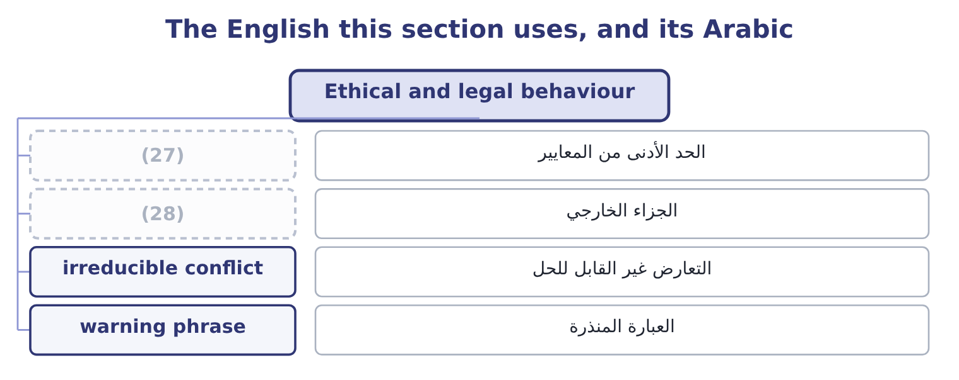
word list
external sanction · management override · minimum standard

The English this sheet uses, and its Arabic
English (exam term) | Arabic
minimum standard | الحد الأدنى من المعايير
external sanction | الجزاء الخارجي
irreducible conflict | التعارض غير القابل للحل
warning phrase | العبارة المنذرة

Answer key · 15.3 Ethical and legal behaviour

1 outcome | 15 A facilitation payment
2 differences | 16 Bribery to win a contract
3 Everything | 17 further
4 indefensible | 18 examiners
5 compliance | 19 requirement
6 objective | 20 obligation
7 externally | 21 information
8 professionally | 22 confidence
9 illegality | 23 resolution
10 reputation | 24 irreducible
11 specific | 25 reliable
12 backward-looking | 26 business
13 Ordinary trading on agreed terms | 27 minimum standard
14 Refuse; the law is not the standard | 28 external sanction

the summaries in full
Summary 1 The outcome asks for the differences, and four of them matter. Law is a floor; ethics is a standard. Everything the law forbids is unethical in the ordinary case, but a great deal that is lawful is not ethical: a contract term enforced against a party who did not understand it, a redundancy handled lawfully and brutally, a marketing claim technically true and designed to mislead, a tax structure that is legal and indefensible in public. Legal compliance is the minimum, not the objective. Law is enforced externally; ethics is enforced internally and professionally. The sanction for illegality is a court; the sanction for unethical conduct is reputation, professional membership, trust and the loss of people who will not work for the company. Law is specific, codified and backward-looking. It names acts, in writing, after a problem has been recognised. Ethics applies to situations no rule has contemplated — new technologies, new markets, new products — and it operates before the law catches up. And law varies by jurisdiction; core ethical values are held to be the same everywhere, which is section 15.2's point.
Summary 2 Two further points the examiners use. A legal requirement can conflict with an ethical obligation. A local law requiring disclosure of information a professional holds in confidence, or forbidding the employment of a group the company's values require it to treat equally, puts the two in direct conflict. The resolution is legal advice, escalation and, where the conflict is irreducible, a decision about whether to operate there at all. And "it is not illegal" is the most reliable warning phrase in business. It is almost never offered about a decision that is comfortable, and a professional who hears it should ask what the speaker thinks the ethical objection is, since they have evidently thought of one.

15.4 Ethics and internal control
Chapter 15 · section 15.4

Fill every gap. Each word list holds one word more than there are gaps.
Summary 1 gaps 1–12
The third (1) asks for the relationship (2) ethics and internal control, and it runs in both (3) . Ethics is the (4) of internal control. COSO's internal control framework puts the control (5) first among its five (6) and makes a commitment to integrity and ethical values its first principle, for a reason: every control is performed by somebody, and a control performed by somebody willing to subvert it is not a control. Controls can be (7) . (8) override is the most common way serious control failures occur and the hardest to prevent, because the person (9) has the authority to do so. No amount of control design addresses it; what addresses it is a culture in which an override is (10) and a route by which the question reaches somebody (11) . Controls can be circumvented by (12) .
word list
overriding · environment · Management · components · collusion · foundation · directions · override · questioned · between · outcome · independent · overridden

Summary 2 gaps 13–24
Segregation of duties works because two people must agree, and it fails when they do. The defence is ethical and (13) as much as (14) . And controls that are not (15) in are not performed. A (16) signed without being done, an approval given without being considered, a supplier review completed from memory: these are the ordinary way a control framework hollows out, and nothing in the (17) reveals it. Internal control supports ethical (18) . The relationship runs back the other way too, and this half is as (19) . Controls remove (20) , which is one side of, and they remove it from honest people as well as (21) ones. Segregation of duties protects the person who handles cash from (22) as much as it protects the cash. Controls make the (23) concrete. A code that says "we do not accept (24) gifts" is interpreted; a control that requires every gift above a value to be recorded in a register that somebody reviews is not.
word list
examinable · dishonest · procedural · standard · reconciliation · behaviour · cultural · overriding · believed · documentation · inappropriate · suspicion · opportunity

Summary 3 gaps 25–33
Controls (25) the record on which (26) depends —. And controls (27) the pressure on (28) courage. A (29) who can point to a rule, a (30) or a required approval is in a far stronger position than one who must refuse on personal judgment alone, and that is one of the most practical arguments for having written policies at all. The two together produce the (31) the exam wants: neither ethics nor control is (32) alone. Controls without ethics are a structure people work around; ethics without controls is a good intention with no record, no (33) and no protection for the person who has to say no.
word list
threshold · reduce · sufficient · conclusion · integrity · professional · individual · consistency · create · accountability

The English this section uses, and its Arabic
Each term sits against what it means.
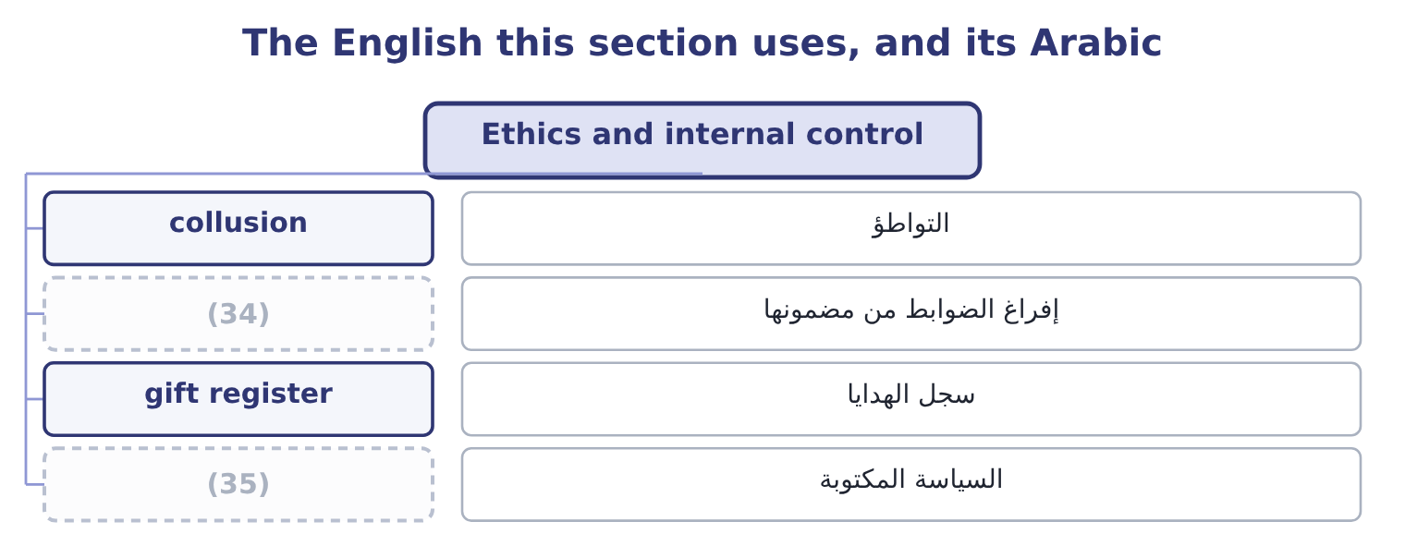
word list
warning phrase · written policy · hollowing out

The English this sheet uses, and its Arabic
English (exam term) | Arabic
collusion | التواطؤ
hollowing out | إفراغ الضوابط من مضمونها
gift register | سجل الهدايا
written policy | السياسة المكتوبة

Answer key · 15.4 Ethics and internal control

1 outcome | 19 examinable
2 between | 20 opportunity
3 directions | 21 dishonest
4 foundation | 22 suspicion
5 environment | 23 standard
6 components | 24 inappropriate
7 overridden | 25 create
8 Management | 26 accountability
9 overriding | 27 reduce
10 questioned | 28 individual
11 independent | 29 professional
12 collusion | 30 threshold
13 cultural | 31 conclusion
14 procedural | 32 sufficient
15 believed | 33 consistency
16 reconciliation | 34 hollowing out
17 documentation | 35 written policy
18 behaviour

the summaries in full
Summary 1 The third outcome asks for the relationship between ethics and internal control, and it runs in both directions. Ethics is the foundation of internal control. COSO's internal control framework puts the control environment first among its five components and makes a commitment to integrity and ethical values its first principle, for a reason: every control is performed by somebody, and a control performed by somebody willing to subvert it is not a control. Controls can be overridden. Management override is the most common way serious control failures occur and the hardest to prevent, because the person overriding has the authority to do so. No amount of control design addresses it; what addresses it is a culture in which an override is questioned and a route by which the question reaches somebody independent. Controls can be circumvented by collusion.
Summary 2 Segregation of duties works because two people must agree, and it fails when they do. The defence is ethical and cultural as much as procedural. And controls that are not believed in are not performed. A reconciliation signed without being done, an approval given without being considered, a supplier review completed from memory: these are the ordinary way a control framework hollows out, and nothing in the documentation reveals it. Internal control supports ethical behaviour. The relationship runs back the other way too, and this half is as examinable. Controls remove opportunity, which is one side of, and they remove it from honest people as well as dishonest ones. Segregation of duties protects the person who handles cash from suspicion as much as it protects the cash. Controls make the standard concrete. A code that says "we do not accept inappropriate gifts" is interpreted; a control that requires every gift above a value to be recorded in a register that somebody reviews is not.
Summary 3 Controls create the record on which accountability depends —. And controls reduce the pressure on individual courage. A professional who can point to a rule, a threshold or a required approval is in a far stronger position than one who must refuse on personal judgment alone, and that is one of the most practical arguments for having written policies at all. The two together produce the conclusion the exam wants: neither ethics nor control is sufficient alone. Controls without ethics are a structure people work around; ethics without controls is a good intention with no record, no consistency and no protection for the person who has to say no.

15.5 Designing for both
Chapter 15 · section 15.5

Fill every gap. Each word list holds one word more than there are gaps.
Summary 1 gaps 1–12
What a company actually does with all of this falls into five (1) measures, and an exam answer that offers them is answering the outcome rather than (2) it. A code of conduct that is (3) where it matters. For the (4) case specifically, the code should name the zero-tolerance (5) explicitly, state that it applies to agents and partners, and say what to do when local law and the code conflict. Controls designed with the local (6) in mind. A (7) of duties that assumes six people in a finance function cannot be applied in an office of three, and (8) otherwise produces a documented control nobody performs. The answer is a different control — review by the (9) office, a payment approval held (10) , a rotation — not a fiction. Due diligence on third parties, (11) to the risk, with (12) rights to audit and to terminate.
word list
pretending · describing · categories · practical · international · centrally · regional · segregation · proportionate · authority · situation · specific · contractual

Summary 2 gaps 13–21
The agent is the (13) , and the contract is where it is (14) . A reporting route that works locally: in the local language, available to people who do not have company email, free of the (15) that a concern will reach the person it concerns, and with a (16) history of being used without (17) . And training in (18) rather than rules. The useful training is the one that works through the shipment held at the port, the gift at the new year, the customer who asks for an (19) with a different date — (20) those are the forms in which the (21) arrives.
word list
consequence · expectation · managed · exposure · demonstrated · otherwise · situations · problem · because · invoice

Worked example: the shipment at the port

Summary 3 gaps 22–33
A consignment of 450,000 is held at a port, and the official (22) indicates that it will be cleared (23) on payment of 2,000 in cash, which is customary. The cost of (24) . Every day the consignment is held costs Orontes about 46,027 of contribution, so a five-day delay is 46,027 × 5 = 230,135 — more than a (25) times the payment, which is (26) only 2,000 ÷ 450,000 = 0.44 per cent of the (27) value. Why the arithmetic is (28) . The payment is a bribe under the laws of, which reach Orontes wherever it operates; it is a zero-tolerance category under the appetite (29) ; and the moment it is made once, the company has (30) that it pays, and the price and the (31) will both rise. Refuse, clearly and (32) , and say that the company is not (33) to make such payments.
word list
actually · statement · politely · established · itself · refusing · frequency · permitted · responsible · shipment's · hundred · irrelevant · promptly

Summary 4 gaps 34–43
Escalate within the port (34) and to the company's local (35) . (36) the customer, who may have (37) . Record the (38) in writing and report it through the company's own (39) . Expect the delay and plan for it, which is a supply chain (40) : buffer stock, earlier shipment, a different port, or a freight agent with a (41) record. Note the shape of the answer. The refusal is the easy half; the (42) half is that somebody must bear the 230,135 and must not be (43) for it. A company whose local manager is measured on delivery performance and told to refuse facilitation payments has created exactly the pressure of, and it will get what it has designed for.
word list
standing · authority · counsel · practical · difficult · demonstrable · Involve · decision · demand · channel · penalised

Borders, law and control

Your turn: values and controls (complete the blanks)
Item | Data | Answer
A payment to an official to do what they already must do | Customary locally; 2,000 on a 450,000 shipment | ________
The position that local acceptance determines the standard | (44) | ________
What distinguishes core values from local practice | (45) | ________
The relationship between law and ethics | Much that is lawful is not ethical | ________
Cost of a five-day delay in contribution | 46,027 a day | ________
What makes controls fail despite good design | (46) | ________

word list
"When in Rome" · core value · Bribery against negotiating style · Three mechanisms

"When in Rome", "grease" and "gift"

Summary 5 gaps 47–56
Three English (47) do a great deal of quiet work in this area. Grease payment is the (48) term for a facilitation payment, and the (49) is doing the arguing: grease makes (50) run smoothly and sounds harmless, which is the opposite of what the laws. And gift is the most elastic word of all, covering a calendar, a dinner, a holiday and a payment; English practice in codes of conduct is (51) to abandon the word and specify — anything of value, including (52) , travel, services and offers of (53) to relatives. When writing or (54) a code, look for the (55) ; where a code says only " (56) gifts", nobody has yet decided anything.
word list
hospitality · machinery · specifics · expressions · informal · reading · shipment · employment · metaphor · therefore · inappropriate

"When in Rome", "grease" and "gift"
Item | Answer
A payment for a duty already owed | A facilitation payment, prohibited under anti-bribery laws.
The position that local acceptance sets the standard | (57)
Core values against local practice | Core values do not vary; local practice may, where no core value is engaged.
Law and ethics | Law is a floor; ethics is the standard, and much that is lawful is unethical.
Cost of a five-day delay | (58)
Why well-designed controls fail | Override, collusion, and controls performed without belief.
What it tells you | Five of the six are about judgment and one is arithmetic — and the arithmetic exists to show exactly why the judgment has to be made in adva

word list
230,135: 46,027 × 5 = 230,135. · management override · Cultural relativism.

The English this section uses, and its Arabic
Each term sits against what it means.
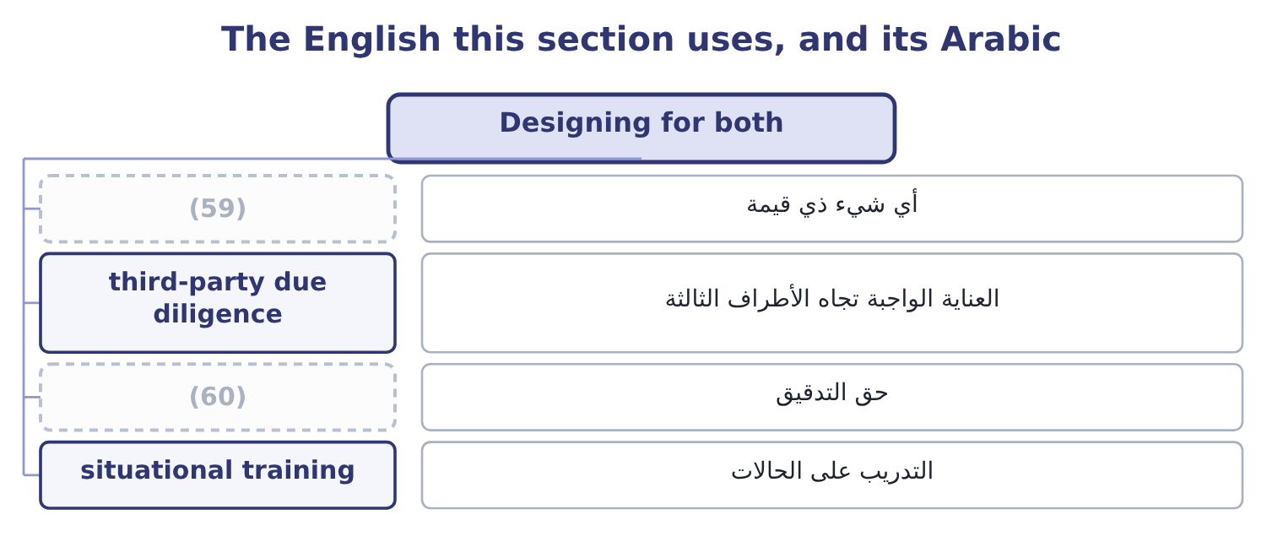
word list
supply chain conduct · right to audit · anything of value

The English this sheet uses, and its Arabic
English (exam term) | Arabic
anything of value | أي شيء ذي قيمة
third-party due diligence | العناية الواجبة تجاه الأطراف الثالثة
right to audit | حق التدقيق
situational training | التدريب على الحالات

Answer key · 15.5 Designing for both

1 practical | 31 frequency
2 describing | 32 politely
3 specific | 33 permitted
4 international | 34 authority
5 categories | 35 counsel
6 situation | 36 Involve
7 segregation | 37 standing
8 pretending | 38 demand
9 regional | 39 channel
10 centrally | 40 decision
11 proportionate | 41 demonstrable
12 contractual | 42 difficult
13 exposure | 43 penalised
14 managed | 44 "When in Rome"
15 expectation | 45 Bribery against negotiating style
16 demonstrated | 46 Three mechanisms
17 consequence | 47 expressions
18 situations | 48 informal
19 invoice | 49 metaphor
20 because | 50 machinery
21 problem | 51 therefore
22 responsible | 52 hospitality
23 promptly | 53 employment
24 refusing | 54 reading
25 hundred | 55 specifics
26 itself | 56 inappropriate
27 shipment's | 57 Cultural relativism.
28 irrelevant | 58 230,135: 46,027 × 5 = 230,135.
29 statement | 59 anything of value
30 established | 60 right to audit

the summaries in full
Summary 1 What a company actually does with all of this falls into five practical measures, and an exam answer that offers them is answering the outcome rather than describing it. A code of conduct that is specific where it matters. For the international case specifically, the code should name the zero-tolerance categories explicitly, state that it applies to agents and partners, and say what to do when local law and the code conflict. Controls designed with the local situation in mind. A segregation of duties that assumes six people in a finance function cannot be applied in an office of three, and pretending otherwise produces a documented control nobody performs. The answer is a different control — review by the regional office, a payment approval held centrally, a rotation — not a fiction. Due diligence on third parties, proportionate to the risk, with contractual rights to audit and to terminate.
Summary 2 The agent is the exposure, and the contract is where it is managed. A reporting route that works locally: in the local language, available to people who do not have company email, free of the expectation that a concern will reach the person it concerns, and with a demonstrated history of being used without consequence. And training in situations rather than rules. The useful training is the one that works through the shipment held at the port, the gift at the new year, the customer who asks for an invoice with a different date — because those are the forms in which the problem arrives.
Summary 3 A consignment of 450,000 is held at a port, and the official responsible indicates that it will be cleared promptly on payment of 2,000 in cash, which is customary. The cost of refusing. Every day the consignment is held costs Orontes about 46,027 of contribution, so a five-day delay is 46,027 × 5 = 230,135 — more than a hundred times the payment, which is itself only 2,000 ÷ 450,000 = 0.44 per cent of the shipment's value. Why the arithmetic is irrelevant. The payment is a bribe under the laws of, which reach Orontes wherever it operates; it is a zero-tolerance category under the appetite statement; and the moment it is made once, the company has established that it pays, and the price and the frequency will both rise. Refuse, clearly and politely, and say that the company is not permitted to make such payments.
Summary 4 Escalate within the port authority and to the company's local counsel. Involve the customer, who may have standing. Record the demand in writing and report it through the company's own channel. Expect the delay and plan for it, which is a supply chain decision: buffer stock, earlier shipment, a different port, or a freight agent with a demonstrable record. Note the shape of the answer. The refusal is the easy half; the difficult half is that somebody must bear the 230,135 and must not be penalised for it. A company whose local manager is measured on delivery performance and told to refuse facilitation payments has created exactly the pressure of, and it will get what it has designed for.
Summary 5 Three English expressions do a great deal of quiet work in this area. Grease payment is the informal term for a facilitation payment, and the metaphor is doing the arguing: grease makes machinery run smoothly and sounds harmless, which is the opposite of what the laws. And gift is the most elastic word of all, covering a calendar, a dinner, a holiday and a payment; English practice in codes of conduct is therefore to abandon the word and specify — anything of value, including hospitality, travel, services and offers of employment to relatives. When writing or reading a code, look for the specifics; where a code says only "inappropriate gifts", nobody has yet decided anything.

