16.1 What corporate culture is
Chapter 16 · section 16.1

Fill every gap. Each word list holds one word more than there are gaps.
Chapter 16, section by section
Each stage leads to the next.
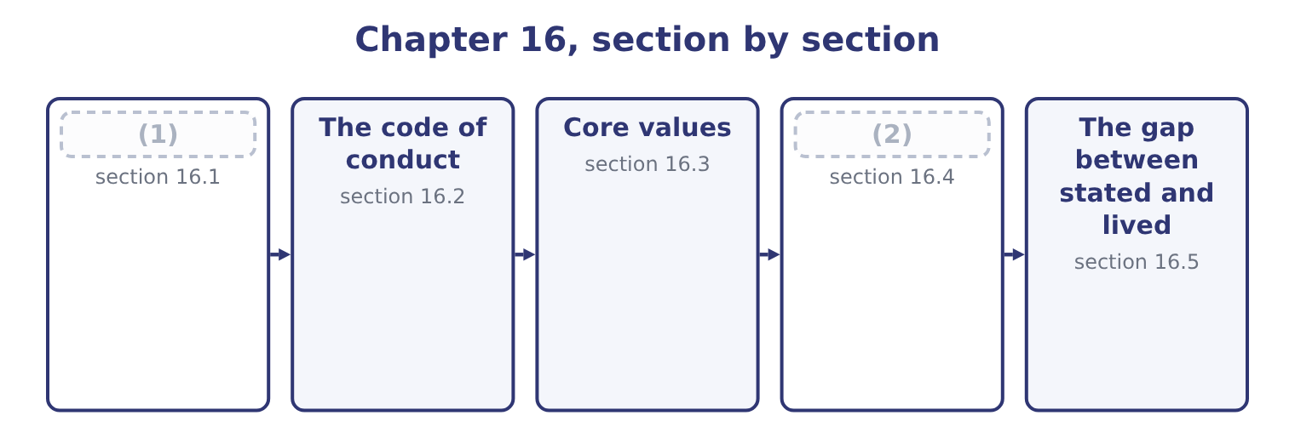
word list
What corporate culture is · What ethical values are worth · The code of conduct

Summary 1 gaps 3–14
Corporate culture is the set of shared assumptions, values and (3) that determine how people in an organisation behave — (4) when no rule covers the situation and nobody is watching. Four features of the (5) are examinable. It is about what is shared. An (6) conscience is not culture; culture is what people believe about each (7) behaviour and about what the organisation expects. Its strongest (8) is the phrase "that is how things are done here", which no (9) produces. It (10) where rules do not. A rule tells you what to do in a situation somebody (11) . Culture decides (12) else, which is most of what (13) . It is learned, chiefly by (14) . New employees learn the culture from what they see rewarded, tolerated and punished in their first weeks, not from the induction pack.
word list
norms · everything · expression · document · observation · other's · happens · individual's · because · definition · particularly · operates · anticipated

Summary 2 gaps 15–26
A single visible (15) teaches more than a year of (16) . And it (17) whether or not anybody (18) it. Every organisation has a culture; the only question is whether it is the one the board (19) it has. Three levels are worth (20) , because an exam question that asks why a company with good values (21) badly is asking about the gap between them. (22) : what can be seen — the office, the (23) , the language, the documents, the code on the wall. (24) values: what the company says it believes, in its (25) and its code. (26) assumptions: what people actually believe about how the organisation works — whether bad news is welcome, whether the rules apply to everybody, whether a refusal will be supported. This level determines behaviour and it is invisible in documentation.
word list
exists · punished · hierarchy · Espoused · Underlying · distinguishing · Artefacts · behaves · designed · training · inconsistency · thinks · statements

Summary 3 gaps 27–33
How culture shapes ethical (27) , which is the first outcome's second half, runs through four (28) . It (29) what is normal, and most people do what is normal. The strongest predictor of whether somebody will do something (30) is whether they believe others around them do it. It determines what can be said. A culture in which raising a problem is treated as (31) produces silence, and silence is where every large failure begins. It sets the cost of (32) . And it supplies or removes (33) .
word list
examinable · refusing · mechanisms · questionable · decisions · disloyalty · rationalisations · defines

The English this section uses, and its Arabic
Each term sits against what it means.
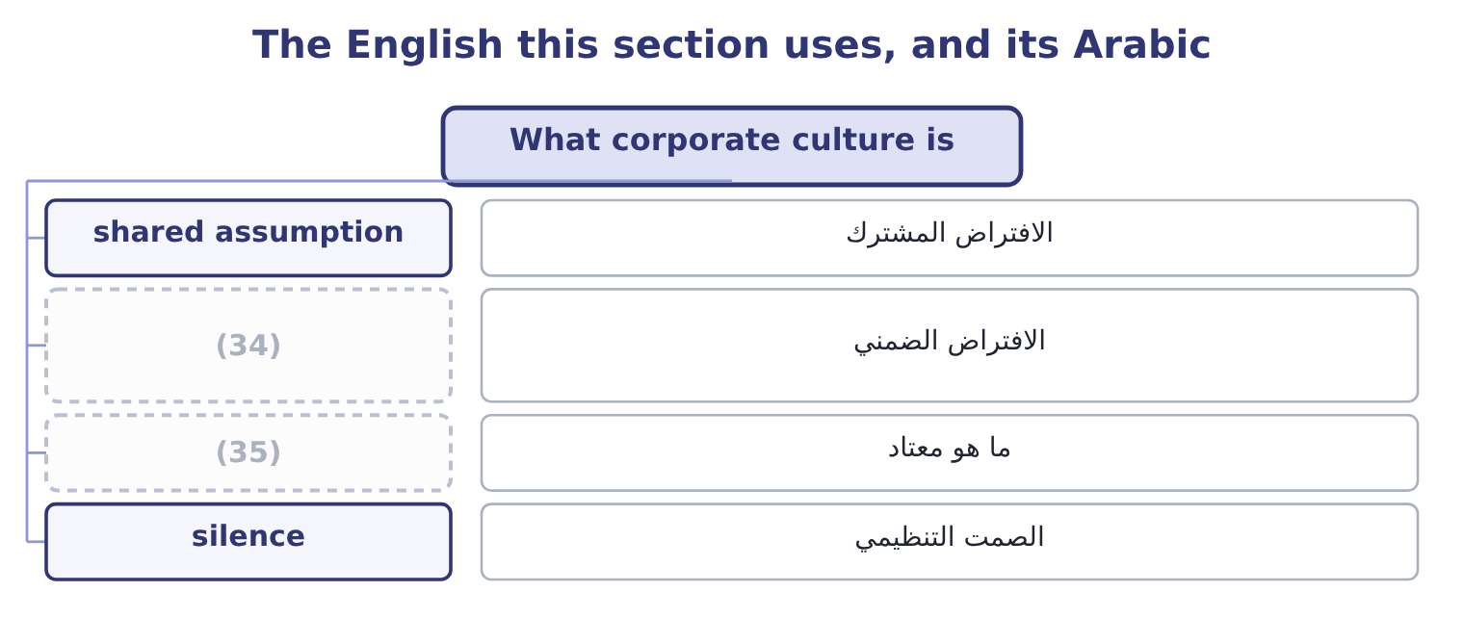
word list
cost of control · underlying assumption · what is normal

The English this sheet uses, and its Arabic
English (exam term) | Arabic
shared assumption | الافتراض المشترك
underlying assumption | الافتراض الضمني
what is normal | ما هو معتاد
silence | الصمت التنظيمي

Answer key · 16.1 What corporate culture is

1 What corporate culture is | 19 thinks
2 What ethical values are worth | 20 distinguishing
3 norms | 21 behaves
4 particularly | 22 Artefacts
5 definition | 23 hierarchy
6 individual's | 24 Espoused
7 other's | 25 statements
8 expression | 26 Underlying
9 document | 27 decisions
10 operates | 28 mechanisms
11 anticipated | 29 defines
12 everything | 30 questionable
13 happens | 31 disloyalty
14 observation | 32 refusing
15 inconsistency | 33 rationalisations
16 training | 34 underlying assumption
17 exists | 35 what is normal
18 designed

the summaries in full
Summary 1 Corporate culture is the set of shared assumptions, values and norms that determine how people in an organisation behave — particularly when no rule covers the situation and nobody is watching. Four features of the definition are examinable. It is about what is shared. An individual's conscience is not culture; culture is what people believe about each other's behaviour and about what the organisation expects. Its strongest expression is the phrase "that is how things are done here", which no document produces. It operates where rules do not. A rule tells you what to do in a situation somebody anticipated. Culture decides everything else, which is most of what happens. It is learned, chiefly by observation. New employees learn the culture from what they see rewarded, tolerated and punished in their first weeks, not from the induction pack.
Summary 2 A single visible inconsistency teaches more than a year of training. And it exists whether or not anybody designed it. Every organisation has a culture; the only question is whether it is the one the board thinks it has. Three levels are worth distinguishing, because an exam question that asks why a company with good values behaves badly is asking about the gap between them. Artefacts: what can be seen — the office, the hierarchy, the language, the documents, the code on the wall. Espoused values: what the company says it believes, in its statements and its code. Underlying assumptions: what people actually believe about how the organisation works — whether bad news is welcome, whether the rules apply to everybody, whether a refusal will be supported. This level determines behaviour and it is invisible in documentation.
Summary 3 How culture shapes ethical decisions, which is the first outcome's second half, runs through four mechanisms. It defines what is normal, and most people do what is normal. The strongest predictor of whether somebody will do something questionable is whether they believe others around them do it. It determines what can be said. A culture in which raising a problem is treated as disloyalty produces silence, and silence is where every large failure begins. It sets the cost of refusing. And it supplies or removes rationalisations.

16.2 The code of conduct
Chapter 16 · section 16.2

Fill every gap. Each word list holds one word more than there are gaps.
Summary 1 gaps 1–12
A code of conduct is the written (1) of the standards of behaviour an (2) expects of its people. The (3) asks why it matters and how it contributes to culture, and both have specific (4) . Why it matters, in six (5) . It makes the standard (6) , so that nobody has to guess and nobody can claim they did not know. It (7) the hard cases in advance, when nobody is under (8) . A gift (9) decided in January is a rule; the same question decided in December, with a contract pending, is a (10) . It supports the (11) . It tells outsiders what to expect — customers, suppliers, agents and regulators — and it becomes a contractual standard when it is (12) into agreements. It is the basis for consistent enforcement. And it is increasingly expected by law, by listing rules and by customers' own procurement requirements, so its absence is itself a finding.
word list
outcome · explicit · answers · individual · settles · threshold · organisation · pressure · incorporated · protection · negotiation · points · statement

Summary 2 gaps 13–24
What makes a code (13) , which is the half (14) omit. It is specific where (15) matters. It covers the situations people actually meet: gifts and (16) , conflicts of interest, outside employment, use of company assets and information, accuracy of records and reports, safety, (17) and harassment, dealings with officials, competition and customer dealings, and the use of personal data. It says what to do when (18) is unclear or wrong — whom to ask, whom to tell, and what (19) exists. A code with standards and no route is half a code. It (20) to everybody, with the senior people named first rather than (21) , and it says so. It is short enough to be read and written in language the people bound by it use, (22) properly for every country, and (23) to people who do not sit at a desk. It is reinforced by training in situations, by annual (24) , and by visible enforcement. And it is reviewed when the business changes — a new market, a new channel, a new technology — because a code that does not mention the thing everybody is doing is already out of date.
word list
protection · hospitality · something · applies · acknowledgement · discrimination · exempted · translated · records · effective · specificity · available · candidates

Summary 3 gaps 25–30
How it contributes to culture is then (25) : it converts espoused values into specific (26) , it removes ambiguity that (27) feeds on, and — provided it is enforced — it demonstrates that the espoused values and the underlying assumptions are the same thing. Where it is not enforced, it does the (28) , and a code that is visibly ignored is worse than none, because it teaches that the company's (29) are not to be taken (30) .
word list
rationalisation · seriously · individual · statements · opposite · expectations · straightforward

The English this section uses, and its Arabic
Each term sits against what it means.
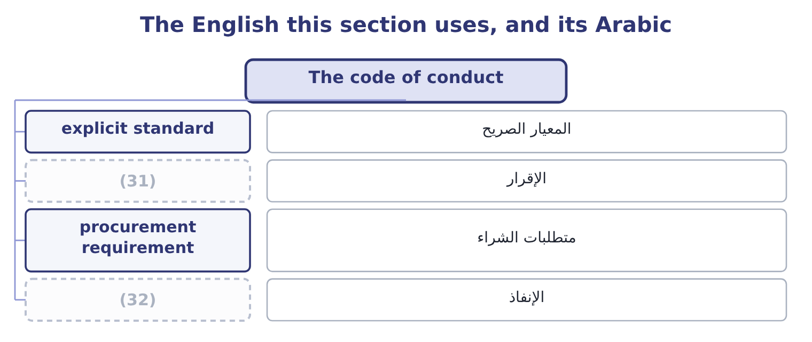
word list
self-reporting · acknowledgement · enforcement

The English this sheet uses, and its Arabic
English (exam term) | Arabic
explicit standard | المعيار الصريح
acknowledgement | الإقرار
procurement requirement | متطلبات الشراء
enforcement | الإنفاذ

Answer key · 16.2 The code of conduct

1 statement | 17 discrimination
2 organisation | 18 something
3 outcome | 19 protection
4 answers | 20 applies
5 points | 21 exempted
6 explicit | 22 translated
7 settles | 23 available
8 pressure | 24 acknowledgement
9 threshold | 25 straightforward
10 negotiation | 26 expectations
11 individual | 27 rationalisation
12 incorporated | 28 opposite
13 effective | 29 statements
14 candidates | 30 seriously
15 specificity | 31 acknowledgement
16 hospitality | 32 enforcement

the summaries in full
Summary 1 A code of conduct is the written statement of the standards of behaviour an organisation expects of its people. The outcome asks why it matters and how it contributes to culture, and both have specific answers. Why it matters, in six points. It makes the standard explicit, so that nobody has to guess and nobody can claim they did not know. It settles the hard cases in advance, when nobody is under pressure. A gift threshold decided in January is a rule; the same question decided in December, with a contract pending, is a negotiation. It supports the individual. It tells outsiders what to expect — customers, suppliers, agents and regulators — and it becomes a contractual standard when it is incorporated into agreements. It is the basis for consistent enforcement. And it is increasingly expected by law, by listing rules and by customers' own procurement requirements, so its absence is itself a finding.
Summary 2 What makes a code effective, which is the half candidates omit. It is specific where specificity matters. It covers the situations people actually meet: gifts and hospitality, conflicts of interest, outside employment, use of company assets and information, accuracy of records and reports, safety, discrimination and harassment, dealings with officials, competition and customer dealings, and the use of personal data. It says what to do when something is unclear or wrong — whom to ask, whom to tell, and what protection exists. A code with standards and no route is half a code. It applies to everybody, with the senior people named first rather than exempted, and it says so. It is short enough to be read and written in language the people bound by it use, translated properly for every country, and available to people who do not sit at a desk. It is reinforced by training in situations, by annual acknowledgement, and by visible enforcement. And it is reviewed when the business changes — a new market, a new channel, a new technology — because a code that does not mention the thing everybody is doing is already out of date.
Summary 3 How it contributes to culture is then straightforward: it converts espoused values into specific expectations, it removes ambiguity that rationalisation feeds on, and — provided it is enforced — it demonstrates that the espoused values and the underlying assumptions are the same thing. Where it is not enforced, it does the opposite, and a code that is visibly ignored is worse than none, because it teaches that the company's statements are not to be taken seriously.

16.3 Core values
Chapter 16 · section 16.3

Fill every gap. Each word list holds one word more than there are gaps.
Summary 1 gaps 1–12
Core values are the small number of (1) an organisation treats as (2) — the ones that do not change with the (3) , the market or the year, and that the code and the culture are both supposed to express. Four tests (4) a core value from a (5) , and an exam answer that gives them is (6) the outcome. Would we hold it even if it cost us money? A value that is (7) the first time it is (8) was never core, and the only evidence that a value is real is a decision that was made (9) because of it. Is it specific to us, or would any company say it? "Integrity" appears in almost every (10) values statement, (11) those of companies that have (12) in fraud. A value that nobody would deny is not distinguishing anything.
word list
evidence · collapsed · non-negotiable · abandoned · corporate · expensive · including · strategy · answering · differently · slogan · commitments · distinguish

Summary 2 gaps 13–24
Does it decide anything? A usable value resolves a real (13) : between speed and safety, between a sale and a (14) , between a cost and a supplier's working conditions. And is it few enough to be (15) ? Three to five values are usable; (16) are a list nobody can recall, which means they cannot be applied at the moment of decision. How core values promote ethical (17) , which is the (18) second half, works through four channels. They give a (19) , not just a rule. A code says what to do; a value says why, which is what allows somebody to extend it to a (20) the code did not (21) . They are a decision filter under (22) . At the point where, a value that has been stated, (23) and visibly applied is (24) as a reference; one that has not is not. They are the basis of consistency, across countries. And they attract and retain the people who share them, which over time changes who the organisation consists of — the slowest and most powerful mechanism of all.
word list
situation · remembered · attract · pressure · trade-off · behaviour · disclosure · repeated · outcome's · reason · anticipate · twelve · available

Summary 3 gaps 25–29
Orontes's are an (25) worth having in mind: we do not sell what we would not eat; we tell the (26) before they find out; we pay (27) on the day we agreed; and nobody is asked to do something they would have to hide. Each of those (28) something, each is (29) of costing money, and none of them is "integrity".
word list
customer · capable · illustration · decides · repeated · suppliers

The English this section uses, and its Arabic
Each term sits against what it means.
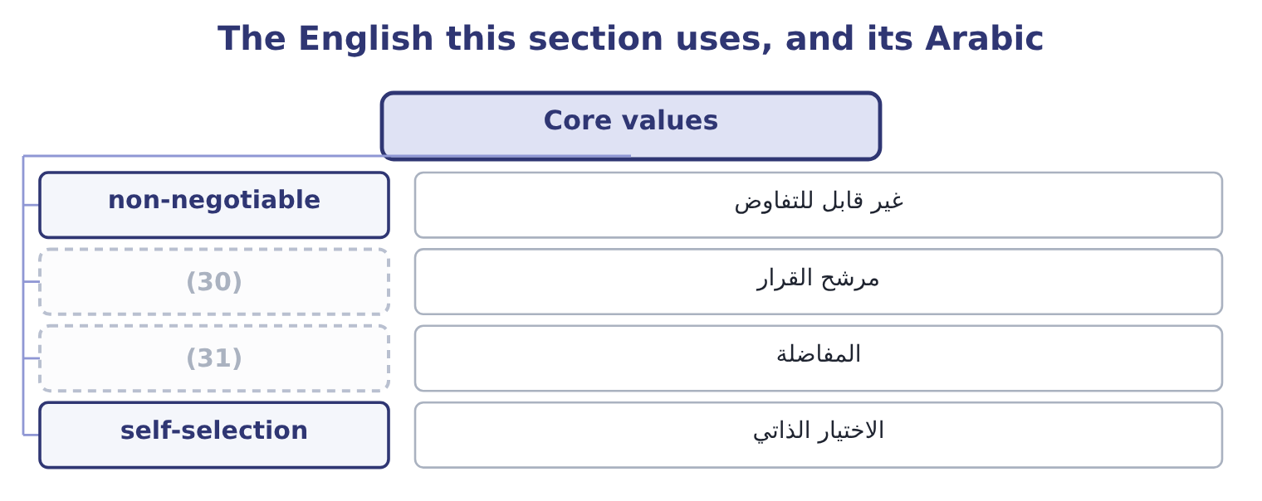
word list
decision filter · silence · trade-off

The English this sheet uses, and its Arabic
English (exam term) | Arabic
non-negotiable | غير قابل للتفاوض
decision filter | مرشح القرار
trade-off | المفاضلة
self-selection | الاختيار الذاتي

Answer key · 16.3 Core values

1 commitments | 17 behaviour
2 non-negotiable | 18 outcome's
3 strategy | 19 reason
4 distinguish | 20 situation
5 slogan | 21 anticipate
6 answering | 22 pressure
7 abandoned | 23 repeated
8 expensive | 24 available
9 differently | 25 illustration
10 corporate | 26 customer
11 including | 27 suppliers
12 collapsed | 28 decides
13 trade-off | 29 capable
14 disclosure | 30 decision filter
15 remembered | 31 trade-off
16 twelve

the summaries in full
Summary 1 Core values are the small number of commitments an organisation treats as non-negotiable — the ones that do not change with the strategy, the market or the year, and that the code and the culture are both supposed to express. Four tests distinguish a core value from a slogan, and an exam answer that gives them is answering the outcome. Would we hold it even if it cost us money? A value that is abandoned the first time it is expensive was never core, and the only evidence that a value is real is a decision that was made differently because of it. Is it specific to us, or would any company say it? "Integrity" appears in almost every corporate values statement, including those of companies that have collapsed in fraud. A value that nobody would deny is not distinguishing anything.
Summary 2 Does it decide anything? A usable value resolves a real trade-off: between speed and safety, between a sale and a disclosure, between a cost and a supplier's working conditions. And is it few enough to be remembered? Three to five values are usable; twelve are a list nobody can recall, which means they cannot be applied at the moment of decision. How core values promote ethical behaviour, which is the outcome's second half, works through four channels. They give a reason, not just a rule. A code says what to do; a value says why, which is what allows somebody to extend it to a situation the code did not anticipate. They are a decision filter under pressure. At the point where, a value that has been stated, repeated and visibly applied is available as a reference; one that has not is not. They are the basis of consistency, across countries. And they attract and retain the people who share them, which over time changes who the organisation consists of — the slowest and most powerful mechanism of all.
Summary 3 Orontes's are an illustration worth having in mind: we do not sell what we would not eat; we tell the customer before they find out; we pay suppliers on the day we agreed; and nobody is asked to do something they would have to hide. Each of those decides something, each is capable of costing money, and none of them is "integrity".

16.4 What ethical values are worth
Chapter 16 · section 16.4

Fill every gap. Each word list holds one word more than there are gaps.
Summary 1 gaps 1–12
The fourth outcome asks for the ways ethical values benefit an organisation, and a good answer runs from the measurable to the (1) rather than (2) with reputation. Lower losses from (3) . Fraud, safety failures, (4) penalties and (5) all fall where conduct standards are real. Lower cost of control. This is the benefit boards find most (6) . A company whose people will not do certain things needs fewer controls to prevent them doing those things, and controls are (7) in money and in friction — approvals, delays, (8) effort. Ethics and control are (9) at the margin as well as (10) . Better retention and recruitment. People leave (11) that ask them to do things they (12) , and the good ones leave first because they can. If Orontes's turnover across 400 employees falls from 18 to 12 per cent, that is 400 × 0.06 = 24 fewer departures, and at a replacement cost of 9,000 each in recruitment, training and lost productivity, 24 × 9,000 = 216,000 a year.
word list
organisations · litigation · duplicated · expensive · misconduct · complements · regulatory · substitutes · beginning · strategic · dislike · surprising · certain

Summary 2 gaps 13–24
Higher (13) and better (14) . In an organisation where bad news is safe to deliver, (15) finds out about (16) early, which is worth more than any control:. Customer and (17) trust, which shows up as retention, as (18) to deal on better terms, and as access to customers whose own (19) standards require it. Lower cost of (20) and better access to it. Regulators and prosecutors in most (21) take compliance programmes, (22) and cooperation into account, and the difference between a penalty for a company with a credible programme and one without is frequently larger than the cost of the programme. And the avoidance of (23) reputational loss, which is last in the list because it is the least measurable and not the least (24) : reputation takes years to build, is lost in days, and is the asset that does not appear on the balance sheet Book 1 analysed.
word list
important · supplier · catastrophic · willingness · engagement · management · capital · jurisdictions · procurement · information · problems · self-reporting · analysed

Summary 3 gaps 25–34
Two honest (25) belong with the list, and strong (26) include them. Most of these benefits are (27) and long-dated, while the costs of ethical (28) are immediate and certain — the 230,135 delay of, the order not taken, the customer not kept. That (29) is exactly, and it is why these (30) must be made on values rather than on a (31) case. And the causation is not one-way: (32) companies can afford better conduct, so some of the observed (33) between ethics and (34) runs backwards. The honest claim is not that ethics pays, but that it costs less than most boards think and that the failures cost very much more.
word list
profitable · business · relationship · asymmetry · decisions · self-selection · answers · performance · probabilistic · qualifications · behaviour

The English this section uses, and its Arabic
Each term sits against what it means.
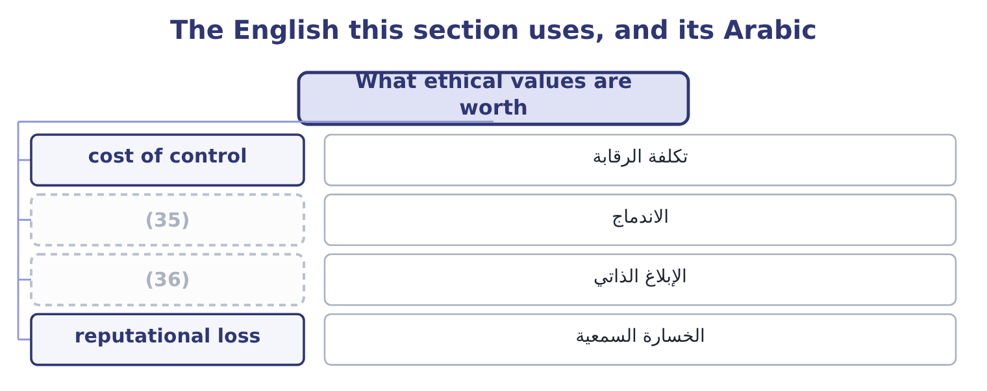
word list
self-reporting · non-negotiable · engagement

The English this sheet uses, and its Arabic
English (exam term) | Arabic
cost of control | تكلفة الرقابة
engagement | الاندماج
self-reporting | الإبلاغ الذاتي
reputational loss | الخسارة السمعية

Answer key · 16.4 What ethical values are worth

1 strategic | 19 procurement
2 beginning | 20 capital
3 misconduct | 21 jurisdictions
4 regulatory | 22 self-reporting
5 litigation | 23 catastrophic
6 surprising | 24 important
7 expensive | 25 qualifications
8 duplicated | 26 answers
9 substitutes | 27 probabilistic
10 complements | 28 behaviour
11 organisations | 29 asymmetry
12 dislike | 30 decisions
13 engagement | 31 business
14 information | 32 profitable
15 management | 33 relationship
16 problems | 34 performance
17 supplier | 35 engagement
18 willingness | 36 self-reporting

the summaries in full
Summary 1 The fourth outcome asks for the ways ethical values benefit an organisation, and a good answer runs from the measurable to the strategic rather than beginning with reputation. Lower losses from misconduct. Fraud, safety failures, regulatory penalties and litigation all fall where conduct standards are real. Lower cost of control. This is the benefit boards find most surprising. A company whose people will not do certain things needs fewer controls to prevent them doing those things, and controls are expensive in money and in friction — approvals, delays, duplicated effort. Ethics and control are substitutes at the margin as well as complements. Better retention and recruitment. People leave organisations that ask them to do things they dislike, and the good ones leave first because they can. If Orontes's turnover across 400 employees falls from 18 to 12 per cent, that is 400 × 0.06 = 24 fewer departures, and at a replacement cost of 9,000 each in recruitment, training and lost productivity, 24 × 9,000 = 216,000 a year.
Summary 2 Higher engagement and better information. In an organisation where bad news is safe to deliver, management finds out about problems early, which is worth more than any control:. Customer and supplier trust, which shows up as retention, as willingness to deal on better terms, and as access to customers whose own procurement standards require it. Lower cost of capital and better access to it. Regulators and prosecutors in most jurisdictions take compliance programmes, self-reporting and cooperation into account, and the difference between a penalty for a company with a credible programme and one without is frequently larger than the cost of the programme. And the avoidance of catastrophic reputational loss, which is last in the list because it is the least measurable and not the least important: reputation takes years to build, is lost in days, and is the asset that does not appear on the balance sheet Book 1 analysed.
Summary 3 Two honest qualifications belong with the list, and strong answers include them. Most of these benefits are probabilistic and long-dated, while the costs of ethical behaviour are immediate and certain — the 230,135 delay of, the order not taken, the customer not kept. That asymmetry is exactly, and it is why these decisions must be made on values rather than on a business case. And the causation is not one-way: profitable companies can afford better conduct, so some of the observed relationship between ethics and performance runs backwards. The honest claim is not that ethics pays, but that it costs less than most boards think and that the failures cost very much more.

16.5 The gap between stated and lived
Chapter 16 · section 16.5

Fill every gap. Each word list holds one word more than there are gaps.
Summary 1 gaps 1–12
Six signs of a gap, each of which can (1) in an exam (2) . The code is (3) and nobody can name three things in it. Values are (4) and no decision can be (5) that was made differently because of them. Discipline is inconsistent between levels or between high and low (6) . Bad news (7) slowly, arrives late, and arrives first from (8) . The people who raise concerns leave, and are described (9) as not having been a good fit. And (10) is measured by completion rates — training completed, (11) signed — rather than by anything about behaviour. (12) the gap is the work of, and three measures belong here. Decide the hard cases visibly. A culture is created by decisions, and the decisions that create it are the ones where the value cost something. Those decisions should be explained, not merely taken: the order declined, the supplier changed, the result reported as it was.
word list
identified · comprehensive · Closing · appear · reaches · outside · compliance · displayed · afterwards · acknowledgements · situation · performers · travels

Summary 2 gaps 13–19
Make the code real at the point of decision. A gift (13) that is reviewed, a conflict (14) that is checked, a tender (15) that has actually (16) somebody. And (17) what matters. Not training completion but: how many concerns were raised, and what happened to them; what (18) of employees say they could raise one; how quickly bad news reaches management; how (19) discipline was applied; and how many decisions were taken that cost money for a stated reason.
word list
consistently · proportion · unreported · measure · declaration · process · register · disqualified

Worked example: reading a culture from the evidence

Summary 3 gaps 20–31
Orontes's code is (20) pages, its values are six, and acknowledgement is at 100 per cent. In the last two years: one employee raised a concern, about car parking; a senior manager's expense (21) ended in a resignation with no (22) , while a warehouse employee was (23) for taking stock worth 400; the inventory (24) stopped for two months and nobody reported it; and the quarterly result has met the forecast to within 1 per cent eleven times running. What the evidence says. One concern in two years from four (25) people is not an absence of (26) ; it is an absence of reporting. The two (27) outcomes teach the whole company which rules apply to whom. The (28) control failure shows that reporting a (29) is not expected behaviour. And eleven (30) within 1 per cent is a statistical (31) that suggests results are being managed.
word list
hundred · quarters · twenty-four · deficiency · announcement · reconciliation · problems · proportion · disciplinary · irregularities · unreported · improbability · dismissed

Summary 4 gaps 32–37
The espoused values and the underlying assumptions are different, and the acknowledgement rate of 100 per cent measures (32) at all. Note that none of the evidence in step 2 is an ethics (33) on its own. Each has an innocent (34) and together they describe a culture. That is how this is (35) in practice and how exam situations are built: no (36) fact, and a (37) .
word list
pattern · assessed · finding · explanation · completion · nothing · single

Culture, code and values

Your turn: what makes it real (complete the blanks)
Item | Data | Answer
What culture governs that rules do not | (38) | ________
The level of culture that actually determines behaviour | Three levels: artefacts, espoused values, and one more | ________
What makes a code provision usable | Compare "act with integrity" with a gift threshold | ________
The only evidence that a value is core | (39) | ________
Fewer departures from a six-point fall in turnover | 400 employees | ________
What that is worth at 9,000 each | (40) | ________

word list
The situations no rule anticipated · Values cost money or they are slogans · Enough specificity to decide an actual case. · Replacement cost per departure 9,000

"Values", "culture" and "tone"

Summary 5 gaps 41–52
Three words that are used (41) and mean different things. Values are what an organisation (42) to; culture is what it does; tone, is what its (43) signal. A company can have good values, a poor culture and an inconsistent tone all at once, and an answer that uses the three as (44) cannot describe the (45) . (46) has a further trap in the word value itself, which in finance means worth and in ethics means commitment — and a (47) such as "our values create value" is doing something slightly (48) , because it suggests the commitment is held for the worth it (49) , which is the (50) of what makes it a commitment. The (51) test in any (52) is the one from section 16.3: name the decision that went the other way because of the value, and if there is none, the word is doing no work.
word list
sentence · English · produces · commits · dishonest · leaders · synonyms · cleanest · reconciliation · loosely · problem · language · opposite

"Values", "culture" and "tone"
Item | Answer
What culture governs | (53)
The level that determines behaviour | Underlying assumptions — what people believe about how the organisation really works.
What makes a code provision usable | Enough specificity to decide an actual case.
The only evidence that a value is core | A decision that went differently, and cost something, because of it.
Fewer departures | 24: 400 × 0.06 = 24.
What that is worth | (54)
What it tells you | Four judgments and one calculation — and the calculation is the smallest of the benefits, which is why the judgments cannot be made on the s

word list
Enough specificity to decide an actual case. · 216,000: 24 × 9,000 = 216,000. · Behaviour where no rule applies and nobody is watching.

The English this section uses, and its Arabic
Each term sits against what it means.
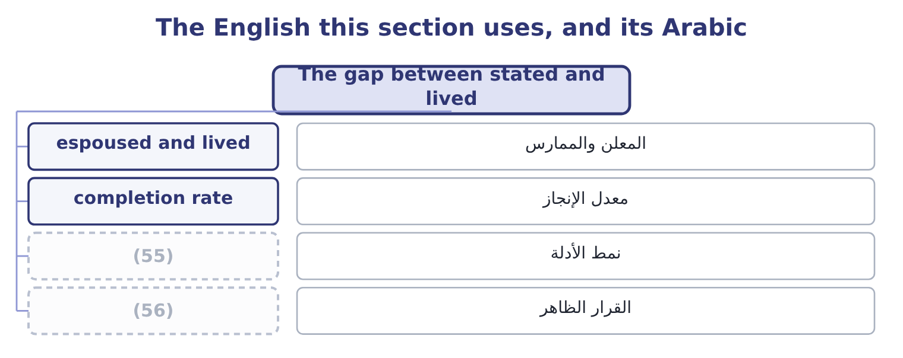
word list
pattern of evidence · espoused value · visible decision

The English this sheet uses, and its Arabic
English (exam term) | Arabic
espoused and lived | المعلن والممارس
completion rate | معدل الإنجاز
pattern of evidence | نمط الأدلة
visible decision | القرار الظاهر

Answer key · 16.5 The gap between stated and lived

1 appear | 29 deficiency
2 situation | 30 quarters
3 comprehensive | 31 improbability
4 displayed | 32 nothing
5 identified | 33 finding
6 performers | 34 explanation
7 travels | 35 assessed
8 outside | 36 single
9 afterwards | 37 pattern
10 compliance | 38 The situations no rule anticipated
11 acknowledgements | 39 Values cost money or they are slogans
12 Closing | 40 Replacement cost per departure 9,000
13 register | 41 loosely
14 declaration | 42 commits
15 process | 43 leaders
16 disqualified | 44 synonyms
17 measure | 45 problem
18 proportion | 46 English
19 consistently | 47 sentence
20 twenty-four | 48 dishonest
21 irregularities | 49 produces
22 announcement | 50 opposite
23 dismissed | 51 cleanest
24 reconciliation | 52 language
25 hundred | 53 Behaviour where no rule applies and nobody is watching.
26 problems | 54 216,000: 24 × 9,000 = 216,000.
27 disciplinary | 55 pattern of evidence
28 unreported | 56 visible decision

the summaries in full
Summary 1 Six signs of a gap, each of which can appear in an exam situation. The code is comprehensive and nobody can name three things in it. Values are displayed and no decision can be identified that was made differently because of them. Discipline is inconsistent between levels or between high and low performers. Bad news travels slowly, arrives late, and arrives first from outside. The people who raise concerns leave, and are described afterwards as not having been a good fit. And compliance is measured by completion rates — training completed, acknowledgements signed — rather than by anything about behaviour. Closing the gap is the work of, and three measures belong here. Decide the hard cases visibly. A culture is created by decisions, and the decisions that create it are the ones where the value cost something. Those decisions should be explained, not merely taken: the order declined, the supplier changed, the result reported as it was.
Summary 2 Make the code real at the point of decision. A gift register that is reviewed, a conflict declaration that is checked, a tender process that has actually disqualified somebody. And measure what matters. Not training completion but: how many concerns were raised, and what happened to them; what proportion of employees say they could raise one; how quickly bad news reaches management; how consistently discipline was applied; and how many decisions were taken that cost money for a stated reason.
Summary 3 Orontes's code is twenty-four pages, its values are six, and acknowledgement is at 100 per cent. In the last two years: one employee raised a concern, about car parking; a senior manager's expense irregularities ended in a resignation with no announcement, while a warehouse employee was dismissed for taking stock worth 400; the inventory reconciliation stopped for two months and nobody reported it; and the quarterly result has met the forecast to within 1 per cent eleven times running. What the evidence says. One concern in two years from four hundred people is not an absence of problems; it is an absence of reporting. The two disciplinary outcomes teach the whole company which rules apply to whom. The unreported control failure shows that reporting a deficiency is not expected behaviour. And eleven quarters within 1 per cent is a statistical improbability that suggests results are being managed.
Summary 4 The espoused values and the underlying assumptions are different, and the acknowledgement rate of 100 per cent measures nothing at all. Note that none of the evidence in step 2 is an ethics finding on its own. Each has an innocent explanation and together they describe a culture. That is how this is assessed in practice and how exam situations are built: no single fact, and a pattern.
Summary 5 Three words that are used loosely and mean different things. Values are what an organisation commits to; culture is what it does; tone, is what its leaders signal. A company can have good values, a poor culture and an inconsistent tone all at once, and an answer that uses the three as synonyms cannot describe the problem. English has a further trap in the word value itself, which in finance means worth and in ethics means commitment — and a sentence such as "our values create value" is doing something slightly dishonest, because it suggests the commitment is held for the worth it produces, which is the opposite of what makes it a commitment. The cleanest test in any language is the one from section 16.3: name the decision that went the other way because of the value, and if there is none, the word is doing no work.

