17.1 Tone at the top
Chapter 17 · section 17.1

Fill every gap. Each word list holds one word more than there are gaps.
Chapter 17, section by section
Each stage leads to the next.
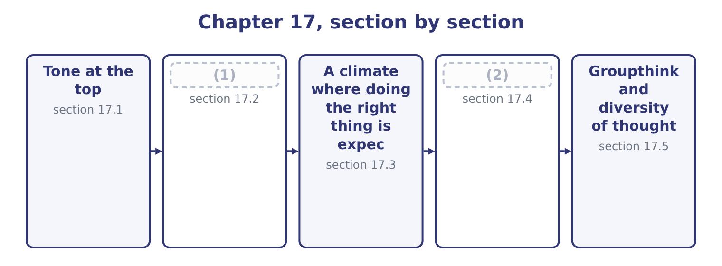
word list
second-chance meeting · Ethical leadership and its traits · Training

Summary 1 gaps 3–14
Tone at the top is the ethical (3) that senior management and the board send through what they say, what they do and what they (4) . The outcome calls it (5) by example, which is the mechanism: people take their standard from what they observe at the top of the (6) , not from what they are told. Four reasons it is (7) , and an answer that gives them is (8) the outcome rather than quoting the phrase. It sets the (9) point for what is (10) . It is the only (11) against management (12) . It (13) whether bad news (14) . A chief executive who reacts badly to problems will be told fewer of them. And it is read from small things. Expenses, punctuality, how a junior employee is spoken to, whether the leader takes the parking space, what happens to the person who disagrees in a meeting.
word list
concealment · travels · tolerate · determines · leadership · override · defence · signal · reference · organisation · decisive · answering · normal

Summary 2 gaps 15–26
Employees are extremely good at reading these signals and extremely quick to (15) formal statements that (16) with them. Three (17) of tone are worth naming, because (18) are written around them. The (19) leader, whose statements are correct and whose (20) are not. This is the most (21) case: the gap itself becomes the lesson, and people conclude that the statements are a (22) . The absent leader, who says (23) about conduct at all, (24) every manager to infer a standard. Silence is not neutral; it is read as (25) , and in a company under pressure it is read as (26) . And the leader who sets targets that cannot be met honestly and then speaks about integrity. That is, delivered with a disclaimer, and it produces precisely the conduct it warns against.
word list
situations · damaging · nothing · decisions · failures · inconsistent · permission · performance · indifference · discount · conflict · override · leaving

The English this section uses, and its Arabic
Each term sits against what it means.
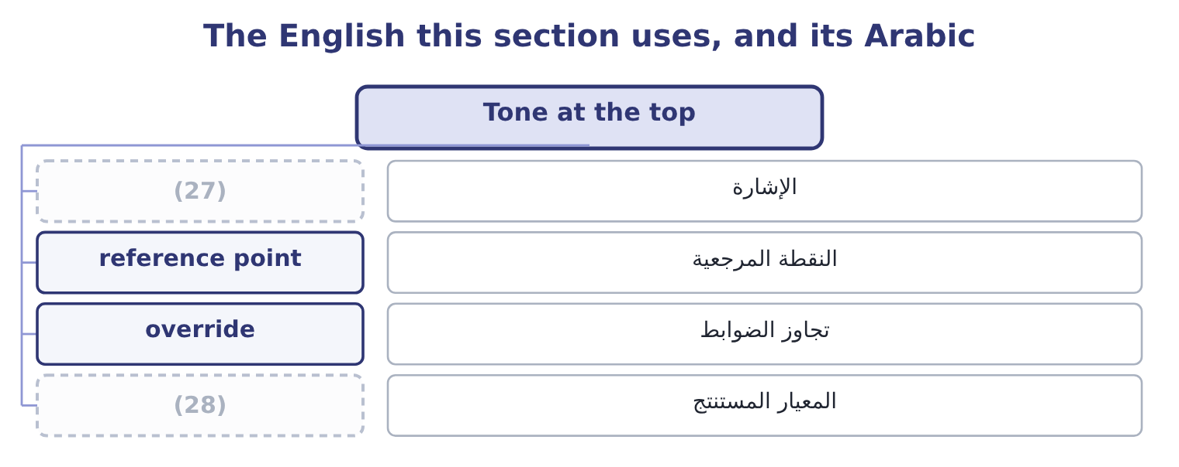
word list
signal · override · inferred standard

The English this sheet uses, and its Arabic
English (exam term) | Arabic
signal | الإشارة
reference point | النقطة المرجعية
override | تجاوز الضوابط
inferred standard | المعيار المستنتج

Answer key · 17.1 Tone at the top

1 Ethical leadership and its traits | 15 discount
2 Training | 16 conflict
3 signal | 17 failures
4 tolerate | 18 situations
5 leadership | 19 inconsistent
6 organisation | 20 decisions
7 decisive | 21 damaging
8 answering | 22 performance
9 reference | 23 nothing
10 normal | 24 leaving
11 defence | 25 indifference
12 override | 26 permission
13 determines | 27 signal
14 travels | 28 inferred standard

the summaries in full
Summary 1 Tone at the top is the ethical signal that senior management and the board send through what they say, what they do and what they tolerate. The outcome calls it leadership by example, which is the mechanism: people take their standard from what they observe at the top of the organisation, not from what they are told. Four reasons it is decisive, and an answer that gives them is answering the outcome rather than quoting the phrase. It sets the reference point for what is normal. It is the only defence against management override. It determines whether bad news travels. A chief executive who reacts badly to problems will be told fewer of them. And it is read from small things. Expenses, punctuality, how a junior employee is spoken to, whether the leader takes the parking space, what happens to the person who disagrees in a meeting.
Summary 2 Employees are extremely good at reading these signals and extremely quick to discount formal statements that conflict with them. Three failures of tone are worth naming, because situations are written around them. The inconsistent leader, whose statements are correct and whose decisions are not. This is the most damaging case: the gap itself becomes the lesson, and people conclude that the statements are a performance. The absent leader, who says nothing about conduct at all, leaving every manager to infer a standard. Silence is not neutral; it is read as indifference, and in a company under pressure it is read as permission. And the leader who sets targets that cannot be met honestly and then speaks about integrity. That is, delivered with a disclaimer, and it produces precisely the conduct it warns against.

17.2 Ethical leadership and its traits
Chapter 17 · section 17.2

Fill every gap. Each word list holds one word more than there are gaps.
Summary 1 gaps 1–12
Ethical leadership is leadership that is both ethical in itself and (1) at making others' conduct ethical — the leader is a moral person and a moral manager, and the exam (2) both halves. A leader who behaves (3) and says nothing about standards has done only the first, and the (4) learns little from it. The traits the (5) asks for, with what each looks like in practice. The same standard in (6) and in public, with (7) and with suppliers, in a good quarter and a bad one. It is the trait everything else rests on, because (8) makes every other (9) unreliable. (10) , including about (11) and about bad news. A leader who admits not knowing gives everybody else permission to do the same, which is how accurate (12) starts moving. Decisions made on stated criteria, consistently applied, with the three dimensions of, process and treatment.
word list
impeccably · inconsistency · criteria · outcome · uncertainty · information · signal · Honesty · organisation · directed · customers · private · expects

Summary 2 gaps 13–24
Making the (13) decision and (14) behind the person who made it. This is the trait on: (15) must bear the 230,135 of delay. Concern for people and for those affected by the (16) decisions, which is what makes the (17) reasoning. Inviting challenge, listening to it and visibly changing a decision (18) as a result — because a leader who invites challenge and never accepts any teaches that the (19) is formal. Accepting (20) for failures, including those of (21) , and not permitting a cost to fall on the person who reported a problem. And explicit (22) about ethics. Talking about the awkward cases, naming the standard, (23) a difficult decision: the moral manager half of the (24) , and the half most commonly missing in otherwise decent leadership. Two further points carry marks. Ethical leadership is not confined to the board.
word list
costly · private · invitation · standing · somebody · occasionally · stakeholder · communication · explaining · subordinates · responsibility · company's · definition

Summary 3 gaps 25–29
A supervisor is the tone at the top for the people who report to them, and the research is (25) that the immediate manager (26) conduct more than the chief (27) does. The board sets the (28) ; the supervisor sets the practice. And (29) are judged on the difficult decisions only. Everything is easy in a good year.
word list
consistent · decision · influences · leaders · executive · possibility

The English this section uses, and its Arabic
Each term sits against what it means.
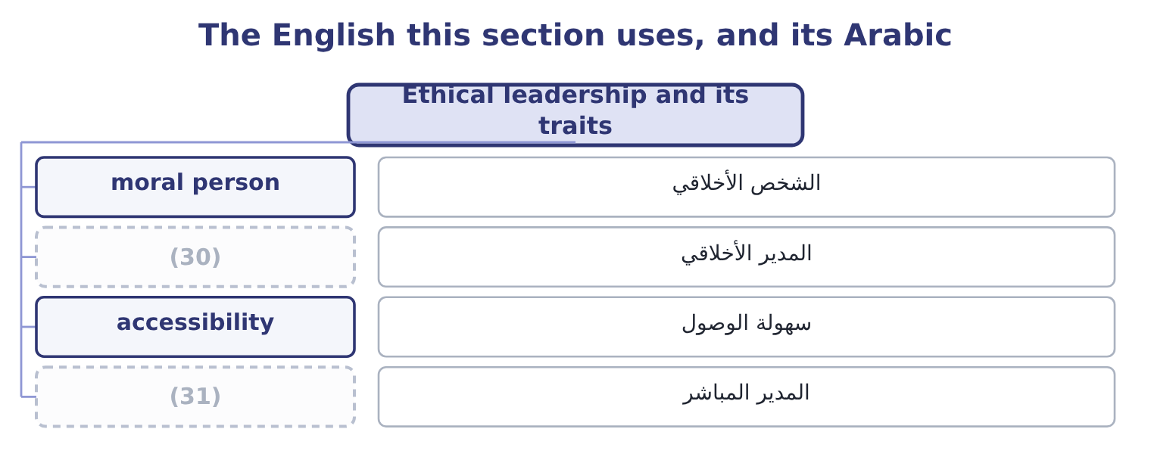
word list
المدير المباشر · moral manager · immediate manager

The English this sheet uses, and its Arabic
English (exam term) | Arabic
moral person | الشخص الأخلاقي
moral manager | المدير الأخلاقي
accessibility | سهولة الوصول
immediate manager | المدير المباشر

Answer key · 17.2 Ethical leadership and its traits

1 directed | 17 stakeholder
2 expects | 18 occasionally
3 impeccably | 19 invitation
4 organisation | 20 responsibility
5 outcome | 21 subordinates
6 private | 22 communication
7 customers | 23 explaining
8 inconsistency | 24 definition
9 signal | 25 consistent
10 Honesty | 26 influences
11 uncertainty | 27 executive
12 information | 28 possibility
13 costly | 29 leaders
14 standing | 30 moral manager
15 somebody | 31 immediate manager
16 company's

the summaries in full
Summary 1 Ethical leadership is leadership that is both ethical in itself and directed at making others' conduct ethical — the leader is a moral person and a moral manager, and the exam expects both halves. A leader who behaves impeccably and says nothing about standards has done only the first, and the organisation learns little from it. The traits the outcome asks for, with what each looks like in practice. The same standard in private and in public, with customers and with suppliers, in a good quarter and a bad one. It is the trait everything else rests on, because inconsistency makes every other signal unreliable. Honesty, including about uncertainty and about bad news. A leader who admits not knowing gives everybody else permission to do the same, which is how accurate information starts moving. Decisions made on stated criteria, consistently applied, with the three dimensions of, process and treatment.
Summary 2 Making the costly decision and standing behind the person who made it. This is the trait on: somebody must bear the 230,135 of delay. Concern for people and for those affected by the company's decisions, which is what makes the stakeholder reasoning. Inviting challenge, listening to it and visibly changing a decision occasionally as a result — because a leader who invites challenge and never accepts any teaches that the invitation is formal. Accepting responsibility for failures, including those of subordinates, and not permitting a cost to fall on the person who reported a problem. And explicit communication about ethics. Talking about the awkward cases, naming the standard, explaining a difficult decision: the moral manager half of the definition, and the half most commonly missing in otherwise decent leadership. Two further points carry marks. Ethical leadership is not confined to the board.
Summary 3 A supervisor is the tone at the top for the people who report to them, and the research is consistent that the immediate manager influences conduct more than the chief executive does. The board sets the possibility; the supervisor sets the practice. And leaders are judged on the difficult decisions only. Everything is easy in a good year.

17.3 A climate where doing the right thing is expected
Chapter 17 · section 17.3

Fill every gap. Each word list holds one word more than there are gaps.
Summary 1 gaps 1–12
The outcome asks why it (1) that doing the right thing is expected, and the answer is in the word expected. Where ethical conduct (2) courage, it depends on the (3) of whoever happens to be in the room. Where it is expected, it is the (4) , and the courage is needed by the person who (5) from it. (6) that burden is the whole (7) . The outcome names three (8) and each has (9) . (10) the right people. Checking conduct as well as competence: references that are actually taken, (11) in what a candidate says about past employers, how they describe a situation where they disagreed with a manager, and — for senior and sensitive roles — background verification (12) to the position. Training them, which section 17.4 takes in detail. Practising consistent, values-based leadership, which means the decisions of section 17.1 taken visibly and explained, and consistent consequences at every level.
word list
consistency · default · objective · content · departs · supports · mechanisms · matters · character · Moving · requires · Hiring · proportionate

Summary 2 gaps 13–24
Four more (13) belong in a (14) answer. Set (15) targets, or (16) that misses will be reported. Make the right thing easy. A clear policy, a named person to ask, a (17) that decides, a process that (18) a refusal. Most people do the right thing when it is available; the (19) job is to make it available. Reward the (20) as well as the (21) . A sales manager who loses an order rather than make a side agreement, a plant manager who stops a line for a quality problem, a (22) who reports a (23) : if these cost those people something, every observer learns the real standard. And protect those who raise (24) , visibly. A word the literature uses is worth knowing: psychological safety, the shared belief that one can speak up — raise a problem, admit an error, disagree with a superior — without being punished or humiliated. It is the single environmental condition most strongly associated with problems being reported early, and it is not the same as comfort or as low standards: the combination that produces good conduct is high standards with high safety. High standards with low safety produce concealment, which is the environment in which every large corporate failure has occurred.
word list
accept · complete · threshold · organisation's · controller · supports · concerns · achievable · result · quality · measures · deficiency · behaviour

The English this section uses, and its Arabic
Each term sits against what it means.
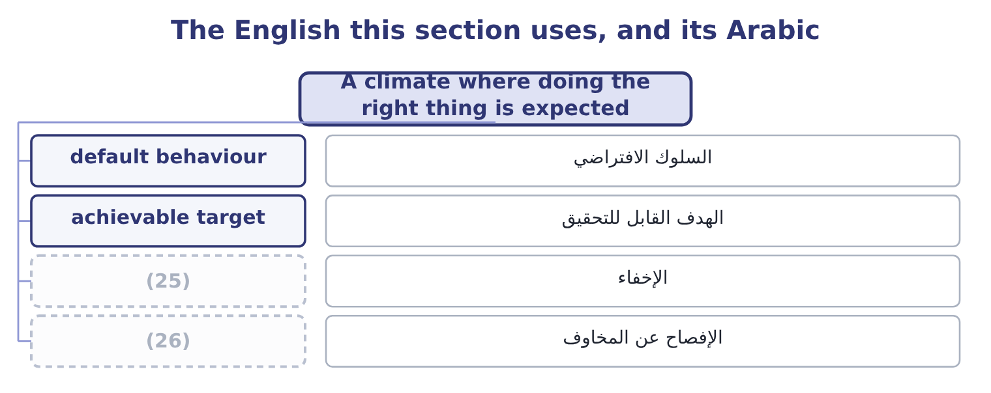
word list
ethical leadership · speak up · concealment

The English this sheet uses, and its Arabic
English (exam term) | Arabic
default behaviour | السلوك الافتراضي
achievable target | الهدف القابل للتحقيق
concealment | الإخفاء
speak up | الإفصاح عن المخاوف

Answer key · 17.3 A climate where doing the right thing is expected

1 matters | 14 complete
2 requires | 15 achievable
3 character | 16 accept
4 default | 17 threshold
5 departs | 18 supports
6 Moving | 19 organisation's
7 objective | 20 behaviour
8 mechanisms | 21 result
9 content | 22 controller
10 Hiring | 23 deficiency
11 consistency | 24 concerns
12 proportionate | 25 concealment
13 measures | 26 speak up

the summaries in full
Summary 1 The outcome asks why it matters that doing the right thing is expected, and the answer is in the word expected. Where ethical conduct requires courage, it depends on the character of whoever happens to be in the room. Where it is expected, it is the default, and the courage is needed by the person who departs from it. Moving that burden is the whole objective. The outcome names three mechanisms and each has content. Hiring the right people. Checking conduct as well as competence: references that are actually taken, consistency in what a candidate says about past employers, how they describe a situation where they disagreed with a manager, and — for senior and sensitive roles — background verification proportionate to the position. Training them, which section 17.4 takes in detail. Practising consistent, values-based leadership, which means the decisions of section 17.1 taken visibly and explained, and consistent consequences at every level.
Summary 2 Four more measures belong in a complete answer. Set achievable targets, or accept that misses will be reported. Make the right thing easy. A clear policy, a named person to ask, a threshold that decides, a process that supports a refusal. Most people do the right thing when it is available; the organisation's job is to make it available. Reward the behaviour as well as the result. A sales manager who loses an order rather than make a side agreement, a plant manager who stops a line for a quality problem, a controller who reports a deficiency: if these cost those people something, every observer learns the real standard. And protect those who raise concerns, visibly. A word the literature uses is worth knowing: psychological safety, the shared belief that one can speak up — raise a problem, admit an error, disagree with a superior — without being punished or humiliated. It is the single environmental condition most strongly associated with problems being reported early, and it is not the same as comfort or as low standards: the combination that produces good conduct is high standards with high safety. High standards with low safety produce concealment, which is the environment in which every large corporate failure has occurred.

17.4 Training
Chapter 17 · section 17.4

Fill every gap. Each word list holds one word more than there are gaps.
Summary 1 gaps 1–12
The outcome asks why (1) training matters to an ethical (2) , and the honest answer has two halves: what it does and what it cannot do. It makes the standard known, which is a (3) for enforcing it and a (4) for the organisation. Most ethical failures begin with somebody not noticing that a (5) is an ethical one — a request that sounds (6) , a favour that sounds like courtesy. (7) main value is pattern (8) : this is what it looks like when it starts. It (9) language and (10) . Training that gives people the actual sentence to say — "I'm not able to do that; our policy requires it to go through the register" — raises the (11) of refusal more than any amount of principle, because the (12) is rarely knowing that something is wrong and usually knowing what to say. It communicates the route: whom to ask, whom to tell, what happens next. And it signals that the organisation takes the subject seriously, provided it is delivered seriously.
word list
scripts · likelihood · situation · Training's · administrative · recognition · culture · subject · employee · precondition · difficulty · supplies · defence

Summary 2 gaps 13–22
Training delivered by a (13) leader who stays for the (14) says something that an online module does not. It cannot (15) for tone. Training that (16) what people observe is discounted immediately, and it does harm, because it (17) that the organisation says things it does not mean. It cannot make an (18) target possible. And it cannot be measured by (19) . What makes it (20) , in five points. Real cases from this business — the shipment at the port, the gift at the new year, the invoice with the wrong date, the request to delay a (21) — discussed, with (22) allowed. The finance team, the sales team and the warehouse face different situations and need different training.
word list
demonstrates · write-down · substitute · discussion · completion · disagreement · contradicts · effective · employees · senior · impossible

Summary 3 gaps 23–27
Delivered by managers, not only by a (23) , because the person (24) it is part of the message. (25) , short and timely — at (26) , at promotion, before the budget cycle, when a new market opens — rather than annually and at length. And with (27) : what people raised, what the organisation did about it, what changed as a result.
word list
feedback · function · contradicts · induction · delivering · Repeated

Worked example: what the training costs, and against what

Summary 4 gaps 28–36
Two hours a year for all 400 (28) , delivered in groups by their own managers, using six situations drawn from the (29) own history. The (30) supplier of,000, which at (31) margin needs 261,000 ÷ 0.0707 = 3,691,655 of sales to replace. One prevented (32) of that size pays for the (33) nine times over. Nobody can (34) that the training prevented it, which is. The defensible argument is not that the training pays for itself but that the cost is small, the standard must be (35) somehow, and the alternative — an organisation where nobody has discussed these situations before meeting one — is (36) .
word list
company's · employees · fictitious · programme · communicated · difficulty · Orontes's · incident · demonstrate · indefensible

The English this section uses, and its Arabic
Each term sits against what it means.
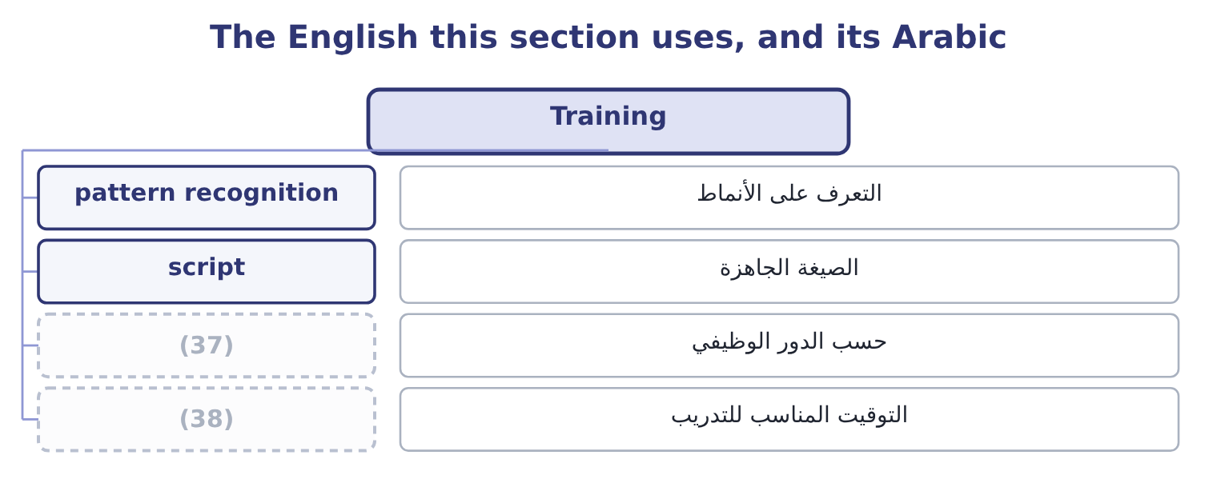
word list
timely delivery · role-specific · script

The English this sheet uses, and its Arabic
English (exam term) | Arabic
pattern recognition | التعرف على الأنماط
script | الصيغة الجاهزة
role-specific | حسب الدور الوظيفي
timely delivery | التوقيت المناسب للتدريب

Answer key · 17.4 Training

1 employee | 20 effective
2 culture | 21 write-down
3 precondition | 22 disagreement
4 defence | 23 function
5 situation | 24 delivering
6 administrative | 25 Repeated
7 Training's | 26 induction
8 recognition | 27 feedback
9 supplies | 28 employees
10 scripts | 29 company's
11 likelihood | 30 fictitious
12 difficulty | 31 Orontes's
13 senior | 32 incident
14 discussion | 33 programme
15 substitute | 34 demonstrate
16 contradicts | 35 communicated
17 demonstrates | 36 indefensible
18 impossible | 37 role-specific
19 completion | 38 timely delivery

the summaries in full
Summary 1 The outcome asks why employee training matters to an ethical culture, and the honest answer has two halves: what it does and what it cannot do. It makes the standard known, which is a precondition for enforcing it and a defence for the organisation. Most ethical failures begin with somebody not noticing that a situation is an ethical one — a request that sounds administrative, a favour that sounds like courtesy. Training's main value is pattern recognition: this is what it looks like when it starts. It supplies language and scripts. Training that gives people the actual sentence to say — "I'm not able to do that; our policy requires it to go through the register" — raises the likelihood of refusal more than any amount of principle, because the difficulty is rarely knowing that something is wrong and usually knowing what to say. It communicates the route: whom to ask, whom to tell, what happens next. And it signals that the organisation takes the subject seriously, provided it is delivered seriously.
Summary 2 Training delivered by a senior leader who stays for the discussion says something that an online module does not. It cannot substitute for tone. Training that contradicts what people observe is discounted immediately, and it does harm, because it demonstrates that the organisation says things it does not mean. It cannot make an impossible target possible. And it cannot be measured by completion. What makes it effective, in five points. Real cases from this business — the shipment at the port, the gift at the new year, the invoice with the wrong date, the request to delay a write-down — discussed, with disagreement allowed. The finance team, the sales team and the warehouse face different situations and need different training.
Summary 3 Delivered by managers, not only by a function, because the person delivering it is part of the message. Repeated, short and timely — at induction, at promotion, before the budget cycle, when a new market opens — rather than annually and at length. And with feedback: what people raised, what the organisation did about it, what changed as a result.
Summary 4 Two hours a year for all 400 employees, delivered in groups by their own managers, using six situations drawn from the company's own history. The fictitious supplier of,000, which at Orontes's margin needs 261,000 ÷ 0.0707 = 3,691,655 of sales to replace. One prevented incident of that size pays for the programme nine times over. Nobody can demonstrate that the training prevented it, which is. The defensible argument is not that the training pays for itself but that the cost is small, the standard must be communicated somehow, and the alternative — an organisation where nobody has discussed these situations before meeting one — is indefensible.

17.5 Groupthink and diversity of thought
Chapter 17 · section 17.5

Fill every gap. Each word list holds one word more than there are gaps.
Summary 1 gaps 1–12
Two (1) close the chapter and they are the same subject from (2) ends. Groupthink is the tendency of a cohesive group to reach agreement at the expense of realistic appraisal — to converge on a decision because the group is (3) , with dissent (4) from inside as much as from outside. Its symptoms, which the exam asks for, are these. An illusion of (5) , producing excessive optimism and (6) . Collective (7) , in which warnings are (8) away rather than examined. (9) views of outsiders: regulators who do not understand the business, (10) who are reckless, critics with an agenda. Direct pressure on (11) , framed as loyalty or as being (12) . Self-censorship, where members suppress their own doubts because they believe they are alone in them. An illusion of unanimity, produced by that silence, in which everybody believes everybody else agrees. And self-appointed mindguards, who protect the group from inconvenient information before it arrives. Its impact on ethical behaviour, which the outcome asks you to analyse, is severe and specific.
word list
invulnerability · dissenters · outcomes · Stereotyped · converging · rationalisation · explained · competitors · constructive · suppressed · risk-taking · opposite · remedies

Summary 2 gaps 13–24
The third and sixth symptoms do the (13) : a group that believes in its own morality does not (14) the ethics of its decision at all, and a member who doubts says nothing because they believe they are the only one. The result is that a group of (15) decent people (16) a decision that none of them would have taken alone, and every member later (17) having had (18) . That pattern is present in almost every major (19) ethical failure, and it (20) why ethical failure so rarely (21) a bad person. The (22) that produce it are worth knowing, because they are the ones a board should watch for: high (23) , a directive leader who states a preference early, insulation from outside views, homogeneous membership, no procedure for considering (24) , and stress with a deadline.
word list
reaches · corporate · reports · damage · misgivings · requires · cohesion · self-censorship · examine · conditions · explains · alternatives · individually

Summary 3 gaps 25–36
The (25) are the other outcome, and the first is structural. The leader states a preference last, or not at all, so that the group's view is not (26) before it is examined. Somebody is (27) to argue the other side — the devil's advocate — as a role rather than as a personality, so that disagreement is not (28) . (29) subgroups consider the same question (30) and then compare. Outside views are brought: (31) , the people affected, a function with a different (32) . A (33) meeting is held after an apparent agreement, (34) to voice remaining doubts. And (35) input is collected where the (36) makes speech costly. Diversity of thought is the broader answer. It means a group whose members bring genuinely different perspectives, experience, expertise and assumptions — which correlates with, but is not the same as, diversity of background, function, tenure, nationality and demographics. Its contribution to good ethical decisions runs through four mechanisms. It supplies the dissent groupthink suppresses.
word list
Independent · anonymous · remedies · second-chance · assigned · advisers · interest · specifically · hierarchy · disloyalty · separately · formed · present

Summary 4 gaps 37–48
A person who has not spent (37) years in the same company asks the question everybody else (38) asking. It brings the perspectives of people affected into a room they are (39) absent from, which is the practical form of the (40) reasoning. It slows the group down. Homogeneous groups agree faster and more (41) ; diverse groups take longer, feel less (42) and are measurably more accurate, and that discomfort is the mechanism rather than a side effect. And it widens the range of options considered, which matters because many ethical failures are failures of (43) — the group could see only two courses, one of which was (44) . Two (45) that a strong answer (46) . Diversity (47) nothing unless the different perspectives are (48) heard, which returns to the psychological safety of section 17.3: a diverse group with a directive leader produces the same decision as a homogeneous one, more slowly. And the test is not representation in the room but influence on the outcome — whether a decision has ever been changed by a view that came from outside the dominant group.
word list
includes · stakeholder · confidently · actually · fifteen · unacceptable · comfortable · critics · qualifications · delivers · imagination · stopped · otherwise

Tone, training and the group

Your turn: leadership and the group (complete the blanks)
Item | Data | Answer
The two halves of ethical leadership | One concerns the leader, one concerns others | ________
Who influences conduct most strongly | Chief executive or immediate manager | ________
The condition most associated with early reporting | Combined with high standards | ________
Cost of two hours' training for 400 people | (49) | ________
The groupthink symptom that removes the ethical question | (50) | ________
The first structural remedy for groupthink | (51) | ________

word list
It concerns when the leader speaks · One of the eight symptoms · 35 an hour · Chief executive or immediate manager

"Tone", "dissent" and "team player"

Summary 5 gaps 52–63
Tone at the top is an unusual (52) , borrowed from music: a tone is what everything else is tuned to, and the image is right, since what leaders (53) sets the pitch for everything below. (54) also uses tone for manner of speech, which makes the phrase sound as though it were about how leaders talk; it is about what they do, and an answer that treats it as (55) has missed the point. Dissent is the word to be careful with, because in most (56) it has acquired a negative colour — dissent suggests (57) , where disagreement is a contribution. Groups that (58) this well give disagreement a role and a name, which is what the devil's advocate device does: it (59) a personality trait into a job. And team player is the most effective phrase in the language for (60) a concern, because it praises the behaviour it is asking for while making the (61) sound like a character flaw. (62) somebody is (63) to be a team player, the question worth asking is what the team is about to do.
word list
organisations · communication · converts · English · alternative · metaphor · invited · handle · Whenever · returns · suppressing · signal · obstruction

"Tone", "dissent" and "team player"
Item | Answer
The two halves of ethical leadership | (64)
Who influences conduct most | The immediate manager.
The condition most associated with early reporting | Psychological safety, combined with high standards.
Cost of the training | (65)
The symptom removing the ethical question | (66)
The first structural remedy | The leader states a preference last, or not at all.
What it tells you | Five of the six concern what leaders do with other people in the room — ethics as a property of groups rather than of (67) .

word list
individuals · The two halves of ethical leadership · Belief in the group's inherent morality. · 28,000: 800 × 35 = 28,000. · Being a moral person and being a moral manager.

The English this section uses, and its Arabic
Each term sits against what it means.
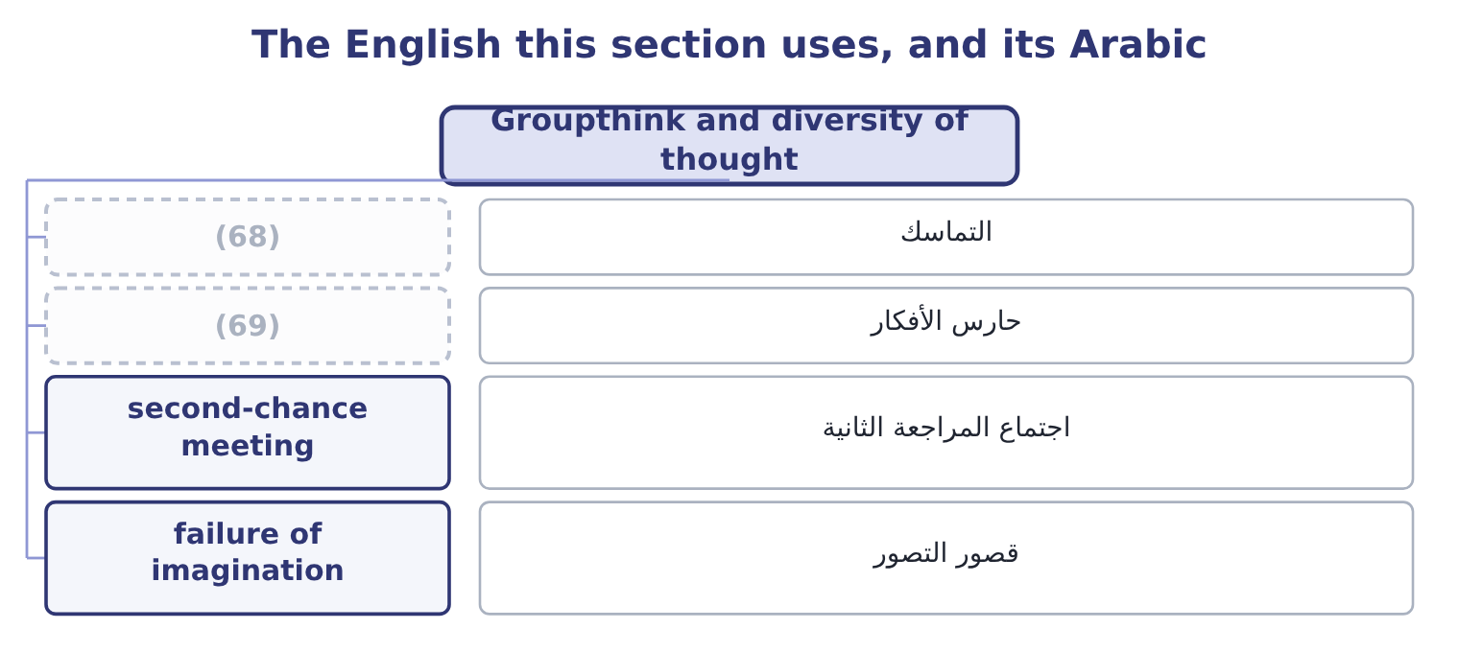
word list
script · mindguard · cohesion

The English this sheet uses, and its Arabic
English (exam term) | Arabic
cohesion | التماسك
mindguard | حارس الأفكار
second-chance meeting | اجتماع المراجعة الثانية
failure of imagination | قصور التصور

Answer key · 17.5 Groupthink and diversity of thought

1 outcomes | 36 hierarchy
2 opposite | 37 fifteen
3 converging | 38 stopped
4 suppressed | 39 otherwise
5 invulnerability | 40 stakeholder
6 risk-taking | 41 confidently
7 rationalisation | 42 comfortable
8 explained | 43 imagination
9 Stereotyped | 44 unacceptable
10 competitors | 45 qualifications
11 dissenters | 46 includes
12 constructive | 47 delivers
13 damage | 48 actually
14 examine | 49 35 an hour
15 individually | 50 One of the eight symptoms
16 reaches | 51 It concerns when the leader speaks
17 reports | 52 metaphor
18 misgivings | 53 signal
19 corporate | 54 English
20 explains | 55 communication
21 requires | 56 organisations
22 conditions | 57 obstruction
23 cohesion | 58 handle
24 alternatives | 59 converts
25 remedies | 60 suppressing
26 formed | 61 alternative
27 assigned | 62 Whenever
28 disloyalty | 63 invited
29 Independent | 64 Being a moral person and being a moral manager.
30 separately | 65 28,000: 800 × 35 = 28,000.
31 advisers | 66 Belief in the group's inherent morality.
32 interest | 67 individuals
33 second-chance | 68 cohesion
34 specifically | 69 mindguard
35 anonymous

the summaries in full
Summary 1 Two outcomes close the chapter and they are the same subject from opposite ends. Groupthink is the tendency of a cohesive group to reach agreement at the expense of realistic appraisal — to converge on a decision because the group is converging, with dissent suppressed from inside as much as from outside. Its symptoms, which the exam asks for, are these. An illusion of invulnerability, producing excessive optimism and risk-taking. Collective rationalisation, in which warnings are explained away rather than examined. Stereotyped views of outsiders: regulators who do not understand the business, competitors who are reckless, critics with an agenda. Direct pressure on dissenters, framed as loyalty or as being constructive. Self-censorship, where members suppress their own doubts because they believe they are alone in them. An illusion of unanimity, produced by that silence, in which everybody believes everybody else agrees. And self-appointed mindguards, who protect the group from inconvenient information before it arrives. Its impact on ethical behaviour, which the outcome asks you to analyse, is severe and specific.
Summary 2 The third and sixth symptoms do the damage: a group that believes in its own morality does not examine the ethics of its decision at all, and a member who doubts says nothing because they believe they are the only one. The result is that a group of individually decent people reaches a decision that none of them would have taken alone, and every member later reports having had misgivings. That pattern is present in almost every major corporate ethical failure, and it explains why ethical failure so rarely requires a bad person. The conditions that produce it are worth knowing, because they are the ones a board should watch for: high cohesion, a directive leader who states a preference early, insulation from outside views, homogeneous membership, no procedure for considering alternatives, and stress with a deadline.
Summary 3 The remedies are the other outcome, and the first is structural. The leader states a preference last, or not at all, so that the group's view is not formed before it is examined. Somebody is assigned to argue the other side — the devil's advocate — as a role rather than as a personality, so that disagreement is not disloyalty. Independent subgroups consider the same question separately and then compare. Outside views are brought: advisers, the people affected, a function with a different interest. A second-chance meeting is held after an apparent agreement, specifically to voice remaining doubts. And anonymous input is collected where the hierarchy makes speech costly. Diversity of thought is the broader answer. It means a group whose members bring genuinely different perspectives, experience, expertise and assumptions — which correlates with, but is not the same as, diversity of background, function, tenure, nationality and demographics. Its contribution to good ethical decisions runs through four mechanisms. It supplies the dissent groupthink suppresses.
Summary 4 A person who has not spent fifteen years in the same company asks the question everybody else stopped asking. It brings the perspectives of people affected into a room they are otherwise absent from, which is the practical form of the stakeholder reasoning. It slows the group down. Homogeneous groups agree faster and more confidently; diverse groups take longer, feel less comfortable and are measurably more accurate, and that discomfort is the mechanism rather than a side effect. And it widens the range of options considered, which matters because many ethical failures are failures of imagination — the group could see only two courses, one of which was unacceptable. Two qualifications that a strong answer includes. Diversity delivers nothing unless the different perspectives are actually heard, which returns to the psychological safety of section 17.3: a diverse group with a directive leader produces the same decision as a homogeneous one, more slowly. And the test is not representation in the room but influence on the outcome — whether a decision has ever been changed by a view that came from outside the dominant group.
Summary 5 Tone at the top is an unusual metaphor, borrowed from music: a tone is what everything else is tuned to, and the image is right, since what leaders signal sets the pitch for everything below. English also uses tone for manner of speech, which makes the phrase sound as though it were about how leaders talk; it is about what they do, and an answer that treats it as communication has missed the point. Dissent is the word to be careful with, because in most organisations it has acquired a negative colour — dissent suggests obstruction, where disagreement is a contribution. Groups that handle this well give disagreement a role and a name, which is what the devil's advocate device does: it converts a personality trait into a job. And team player is the most effective phrase in the language for suppressing a concern, because it praises the behaviour it is asking for while making the alternative sound like a character flaw. Whenever somebody is invited to be a team player, the question worth asking is what the team is about to do.

