18.1 A whistleblowing framework
Chapter 18 · section 18.1

Fill every gap. Each word list holds one word more than there are gaps.
Chapter 18, section by section
Each stage leads to the next.
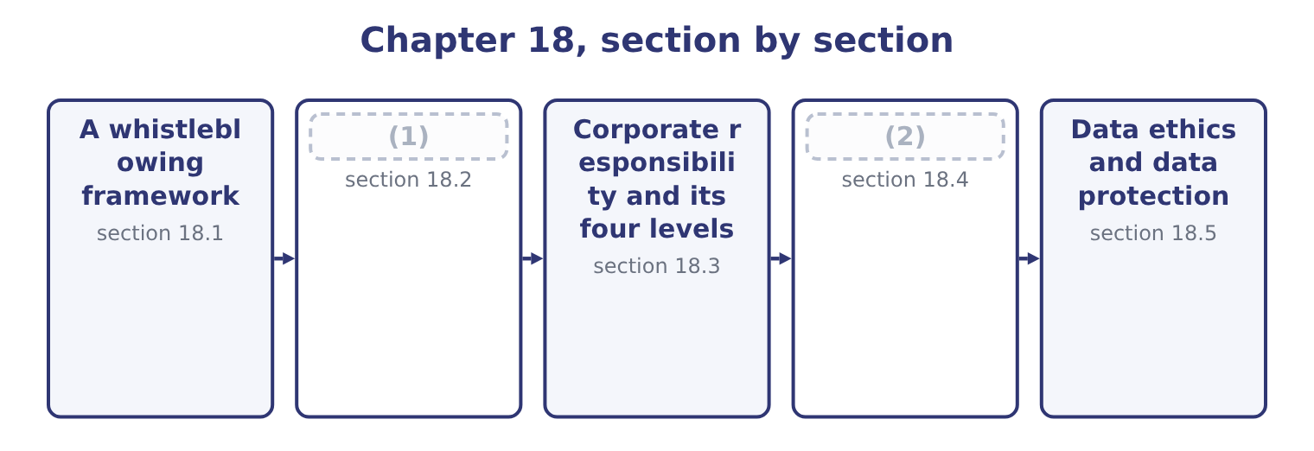
word list
data ethics · Sustainability · Anti-bribery laws

Summary 1 gaps 3–14
Whistleblowing is the raising of a concern about wrongdoing by somebody inside the (3) , through a route that does not depend on the (4) of the person the concern is about. A whistleblowing framework is the (5) that makes it (6) , and the outcome asks why it matters to an ethical culture. Five (7) , and they build on each other. It is how wrongdoing is found. More (8) fraud is detected by tips than by internal audit, external audit and management review combined, and most of those tips come from (9) . No (10) detects what somebody (11) knows. It makes the code (12) . It gives the (13) ladder of, or when two (14) of management are. It provides early warning. A concern raised when something is irregular is cheap; the same matter after a loss, a regulator or a journalist is not. And its existence changes behaviour before it is ever used.
word list
goodwill · already · reasons · operative · possible · occupational · internal · employees · control · levels · organisation · mechanism · resolution

Summary 2 gaps 15–26
Somebody (15) an act behaves (16) where any of several colleagues could report it without being identified. What makes a framework work, which is the (17) half. Several routes, not one, including at least one outside the management line — the audit committee chair, an independent (18) , an external (19) . Confidentiality, and anonymity as an (20) . Anonymity makes investigation harder and some people will use nothing else; a framework that offers only named reporting (21) exactly the concerns that carry most risk to the (22) . (23) against retaliation, stated explicitly, enforced visibly, and extended to dismissal, demotion, exclusion, (24) and the quieter forms — the person who is suddenly not invited to meetings. Retaliation is often unlawful as well, and in several (25) carries its own (26) independent of the original wrongdoing.
word list
excludes · therefore · jurisdictions · penalties · hotline · differently · option · provider · reporter · examinable · Protection · contemplating · reassignment

Summary 3 gaps 27–38
Accessibility: (27) to everybody including suppliers, agents and (28) , in the local language, outside working hours, and usable by people without company email. A defined process: acknowledgement, (29) , investigation by somebody independent of the subject, a (30) , and — as far as confidentiality permits — feedback to the person who raised it. Nothing kills a framework (31) than concerns that (32) . Records and reporting: the number of concerns, their (33) , how long they took and what happened, (34) to the audit committee. And a (35) history. The only thing that (36) the second person to report is what happened to the first. Two (37) an honest answer (38) . Not every report is well founded, and a few are malicious; the framework must therefore protect the subject of a report as well as its author, through confidentiality and a proper investigation, and a person who reports in good faith must be protected even when the concern proves unfounded. And a framework in a company with the wrong tone does not work: the employee's calculation is about what they expect to happen, which is set by.
word list
persuades · acknowledges · hotline · demonstrated · disappear · categories · contractors · available · decision · reported · triage · faster · difficulties

The English this section uses, and its Arabic
Each term sits against what it means.
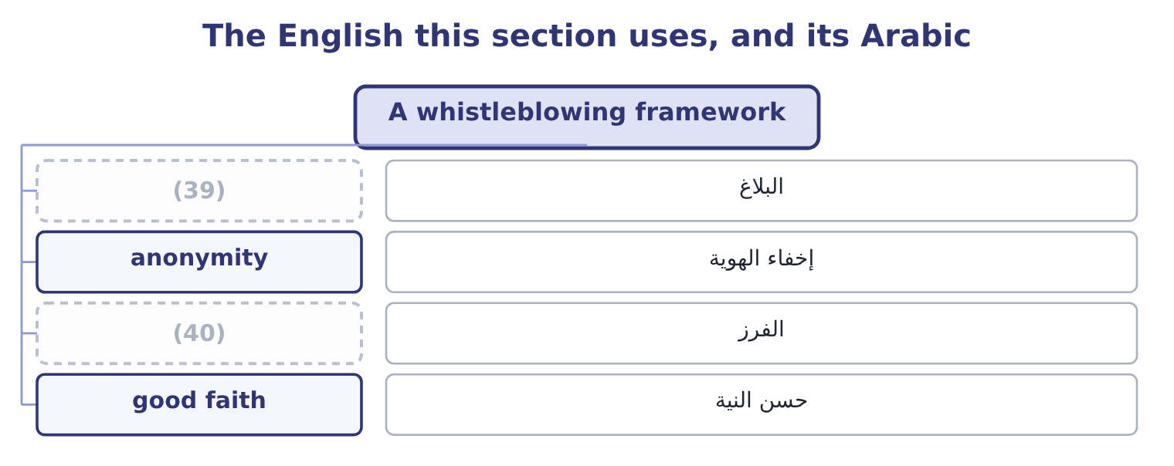
word list
triage · tip · retaliation

The English this sheet uses, and its Arabic
English (exam term) | Arabic
tip | البلاغ
anonymity | إخفاء الهوية
triage | الفرز
good faith | حسن النية

Answer key · 18.1 A whistleblowing framework

1 Anti-bribery laws | 21 excludes
2 Sustainability | 22 reporter
3 organisation | 23 Protection
4 goodwill | 24 reassignment
5 mechanism | 25 jurisdictions
6 possible | 26 penalties
7 reasons | 27 available
8 occupational | 28 contractors
9 employees | 29 triage
10 control | 30 decision
11 already | 31 faster
12 operative | 32 disappear
13 resolution | 33 categories
14 levels | 34 reported
15 contemplating | 35 demonstrated
16 differently | 36 persuades
17 examinable | 37 difficulties
18 hotline | 38 acknowledges
19 provider | 39 tip
20 option | 40 triage

the summaries in full
Summary 1 Whistleblowing is the raising of a concern about wrongdoing by somebody inside the organisation, through a route that does not depend on the goodwill of the person the concern is about. A whistleblowing framework is the mechanism that makes it possible, and the outcome asks why it matters to an ethical culture. Five reasons, and they build on each other. It is how wrongdoing is found. More occupational fraud is detected by tips than by internal audit, external audit and management review combined, and most of those tips come from employees. No control detects what somebody already knows. It makes the code operative. It gives the resolution ladder of, or when two levels of management are. It provides early warning. A concern raised when something is irregular is cheap; the same matter after a loss, a regulator or a journalist is not. And its existence changes behaviour before it is ever used.
Summary 2 Somebody contemplating an act behaves differently where any of several colleagues could report it without being identified. What makes a framework work, which is the examinable half. Several routes, not one, including at least one outside the management line — the audit committee chair, an independent hotline, an external provider. Confidentiality, and anonymity as an option. Anonymity makes investigation harder and some people will use nothing else; a framework that offers only named reporting excludes exactly the concerns that carry most risk to the reporter. Protection against retaliation, stated explicitly, enforced visibly, and extended to dismissal, demotion, exclusion, reassignment and the quieter forms — the person who is suddenly not invited to meetings. Retaliation is often unlawful as well, and in several jurisdictions carries its own penalties independent of the original wrongdoing.
Summary 3 Accessibility: available to everybody including suppliers, agents and contractors, in the local language, outside working hours, and usable by people without company email. A defined process: acknowledgement, triage, investigation by somebody independent of the subject, a decision, and — as far as confidentiality permits — feedback to the person who raised it. Nothing kills a framework faster than concerns that disappear. Records and reporting: the number of concerns, their categories, how long they took and what happened, reported to the audit committee. And a demonstrated history. The only thing that persuades the second person to report is what happened to the first. Two difficulties an honest answer acknowledges. Not every report is well founded, and a few are malicious; the framework must therefore protect the subject of a report as well as its author, through confidentiality and a proper investigation, and a person who reports in good faith must be protected even when the concern proves unfounded. And a framework in a company with the wrong tone does not work: the employee's calculation is about what they expect to happen, which is set by.

18.2 Anti-bribery laws
Chapter 18 · section 18.2

Fill every gap. Each word list holds one word more than there are gaps.
Summary 1 gaps 1–12
The (1) asks for the purpose of anti-bribery laws and names two. Both reach conduct far (2) their own countries, which is why they (3) to a company like (4) . The purpose, stated (5) , is threefold: to prevent the (6) of public officials and of commercial decisions; to protect fair (7) , since a market in which contracts are won by payment rather than by merit allocates resources badly and raises costs for everybody; and to protect the integrity of financial records, since a bribe must always be disguised in the books as something else. The US Foreign Corrupt (8) Act has two parts, and (9) are expected to know both. The anti-bribery provisions (10) offering, paying, promising or (11) anything of value to a foreign official, directly or through an intermediary, in order to obtain or retain business or to secure an improper (12) .
word list
matter · candidates · prohibit · outcome · Orontes · Practices · decision · outside · competition · corruption · advantage · generally · authorising

Summary 2 gaps 13–24
Intermediaries are (13) covered, which is why. The accounting provisions require issuers to keep books and records that (14) and fairly reflect (15) , and to maintain a system of (16) accounting control. These are enforced far more often than the bribery provisions themselves, because a (17) payment is easier to prove than the corrupt intent behind it — and they are the provisions that make this a management (18) subject directly. Two (19) and defences are (20) . There is a narrow exception for (21) payments to expedite routine governmental action, which is drawn tightly, is not available for any (22) decision, and is prohibited outright by other countries' laws and by most companies' own policies. And there are (23) defences where the payment was lawful under the written law of the foreign country, or was a reasonable and bona fide (24) such as travel directly related to the promotion of products or the performance of a contract.
word list
examinable · accountant's · anti-bribery · transactions · facilitating · accurately · exceptions · expenditure · mis-described · internal · expressly · discretionary · affirmative

Summary 3 gaps 25–36
The UK Bribery Act (25) in ways the exam uses to (26) them. It covers commercial bribery as well as bribery of officials — offering or (27) a bribe between (28) parties is an offence in its own right. It creates four (29) : bribing another person, being bribed, bribing a foreign public official, and the (30) offence of failing to prevent bribery by an associated person. That (31) offence is the (32) one. A commercial organisation is liable where someone associated with it — an employee, agent, (33) or other person (34) services for it — bribes to obtain business for it, unless the organisation can show it had adequate procedures in place to prevent bribery. (35) is strict, subject to that defence, and the defence is the entire subject of a (36) programme. It has no facilitation payment exception. And it reaches any organisation carrying on business in the United Kingdom, wherever the conduct occurs.
word list
fourth · subsidiary · offences · significant · performing · corporate · differs · Liability · receiving · contrast · allocates · compliance · private

Summary 4 gaps 37–46
The six (37) of adequate procedures are worth learning, because they are also a complete answer to "what should a company do about bribery risk": (38) procedures, matched to the risk and the size of the organisation; top-level (39) , which is; risk (40) , periodic and documented; due diligence on the people who perform services for the organisation; (41) , including training; and monitoring and review. What the management accountant (42) is specific. Payments cannot be made without being (43) , so the finance function is where a bribe becomes visible: in a vague (44) , an unusual intermediary, a payment in the wrong country, a (45) out of line with the work, a cash payment, an invoice with no (46) .
word list
proportionate · principles · commission · finance · contributes · description · assessment · communication · deliverable · commitment · recorded

The English this section uses, and its Arabic
Each term sits against what it means.
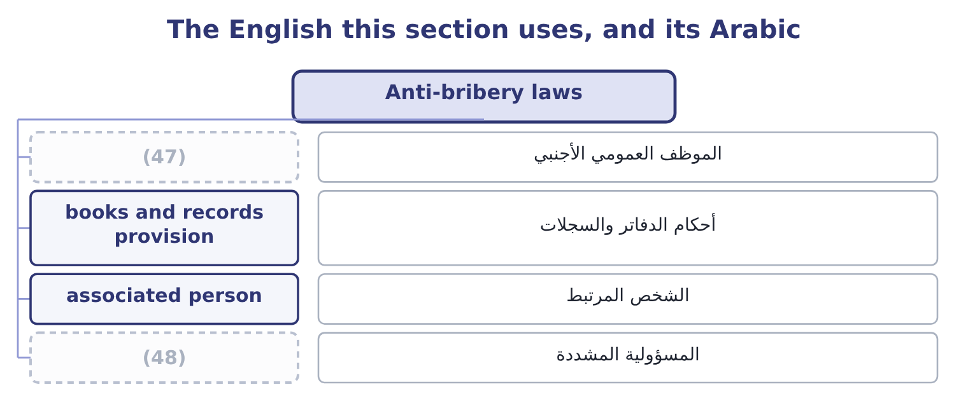
word list
strict liability · foreign official · associated person

The English this sheet uses, and its Arabic
English (exam term) | Arabic
foreign official | الموظف العمومي الأجنبي
books and records provision | أحكام الدفاتر والسجلات
associated person | الشخص المرتبط
strict liability | المسؤولية المشددة

Answer key · 18.2 Anti-bribery laws

1 outcome | 25 differs
2 outside | 26 contrast
3 matter | 27 receiving
4 Orontes | 28 private
5 generally | 29 offences
6 corruption | 30 corporate
7 competition | 31 fourth
8 Practices | 32 significant
9 candidates | 33 subsidiary
10 prohibit | 34 performing
11 authorising | 35 Liability
12 advantage | 36 compliance
13 expressly | 37 principles
14 accurately | 38 proportionate
15 transactions | 39 commitment
16 internal | 40 assessment
17 mis-described | 41 communication
18 accountant's | 42 contributes
19 exceptions | 43 recorded
20 examinable | 44 description
21 facilitating | 45 commission
22 discretionary | 46 deliverable
23 affirmative | 47 foreign official
24 expenditure | 48 strict liability

the summaries in full
Summary 1 The outcome asks for the purpose of anti-bribery laws and names two. Both reach conduct far outside their own countries, which is why they matter to a company like Orontes. The purpose, stated generally, is threefold: to prevent the corruption of public officials and of commercial decisions; to protect fair competition, since a market in which contracts are won by payment rather than by merit allocates resources badly and raises costs for everybody; and to protect the integrity of financial records, since a bribe must always be disguised in the books as something else. The US Foreign Corrupt Practices Act has two parts, and candidates are expected to know both. The anti-bribery provisions prohibit offering, paying, promising or authorising anything of value to a foreign official, directly or through an intermediary, in order to obtain or retain business or to secure an improper advantage.
Summary 2 Intermediaries are expressly covered, which is why. The accounting provisions require issuers to keep books and records that accurately and fairly reflect transactions, and to maintain a system of internal accounting control. These are enforced far more often than the bribery provisions themselves, because a mis-described payment is easier to prove than the corrupt intent behind it — and they are the provisions that make this a management accountant's subject directly. Two exceptions and defences are examinable. There is a narrow exception for facilitating payments to expedite routine governmental action, which is drawn tightly, is not available for any discretionary decision, and is prohibited outright by other countries' laws and by most companies' own policies. And there are affirmative defences where the payment was lawful under the written law of the foreign country, or was a reasonable and bona fide expenditure such as travel directly related to the promotion of products or the performance of a contract.
Summary 3 The UK Bribery Act differs in ways the exam uses to contrast them. It covers commercial bribery as well as bribery of officials — offering or receiving a bribe between private parties is an offence in its own right. It creates four offences: bribing another person, being bribed, bribing a foreign public official, and the corporate offence of failing to prevent bribery by an associated person. That fourth offence is the significant one. A commercial organisation is liable where someone associated with it — an employee, agent, subsidiary or other person performing services for it — bribes to obtain business for it, unless the organisation can show it had adequate procedures in place to prevent bribery. Liability is strict, subject to that defence, and the defence is the entire subject of a compliance programme. It has no facilitation payment exception. And it reaches any organisation carrying on business in the United Kingdom, wherever the conduct occurs.
Summary 4 The six principles of adequate procedures are worth learning, because they are also a complete answer to "what should a company do about bribery risk": proportionate procedures, matched to the risk and the size of the organisation; top-level commitment, which is; risk assessment, periodic and documented; due diligence on the people who perform services for the organisation; communication, including training; and monitoring and review. What the management accountant contributes is specific. Payments cannot be made without being recorded, so the finance function is where a bribe becomes visible: in a vague description, an unusual intermediary, a payment in the wrong country, a commission out of line with the work, a cash payment, an invoice with no deliverable.

18.3 Corporate responsibility and its four levels
Chapter 18 · section 18.3

Fill every gap. Each word list holds one word more than there are gaps.
Summary 1 gaps 1–12
The outcome asks you to discuss (1) responsibility for ethical conduct, and a good answer begins by taking the question (2) rather than (3) a position. Two classical views frame it. The narrow view holds that a company's responsibility is to its owners: to make money within the rules of the game, lawfully and without (4) , and that managers spending the owners' money on social purposes are spending money that is not theirs for (5) nobody elected them to pursue. The broader view holds that a company's (6) to operate comes from society, that it affects many parties besides its owners, and that it is responsible to all of them — the (7) reasoning. The position that (8) the exam takes the (9) part of both. Even on the narrow view, a company is responsible for conduct: the narrow view says within the rules, and the rules (10) honesty, safety and the law. And the broader view is (11) , not weakened, by the long-run argument — a company that damages its customers, its employees, its suppliers or its community is usually destroying value rather than (12) it, which is what Book 2's long-run value maximisation actually implies.
word list
answers · useful · strengthened · include · transferring · without · deception · asserting · seriously · objectives · corporate · stakeholder · licence

Summary 2 gaps 13–24
Four specific (13) for ethical conduct (14) , and they are what the outcome is asking for. For its own conduct, by the people it (15) , which is the (16) . For conduct in its name, by agents, (17) and partners, which section 18.2 makes a legal (18) and not only an ethical one. For conduct in its (19) chain, to the extent of its (20) . This is the most (21) of the four: a company cannot audit every tier, and the standard applied is that it should know its material risks, use its (22) where it has any, and not arrange its affairs so as to avoid knowing. And for the effects of its products and (23) on people who never agreed to them: the (24) who cannot evaluate what they are buying, the community affected by the plant, the person whose data the company holds.
word list
influence · contested · operations · leverage · customer · spending · subject · employs · follow · distributors · responsibilities · supply · liability

Summary 3 gaps 25–36
The four levels of social responsibility, which the outcome asks to be (25) , are the classical pyramid and provide the (26) for an answer. (27) responsibility: to be (28) . It is the (29) , because a company that does not cover its costs can meet none of the other (30) , and Book 1's whole analysis is about whether it does. Legal responsibility: to obey the law — the floor. Ethical responsibility: to do what is right, fair and (31) beyond what the law (32) , which is the gap. (33) responsibility: to contribute resources to the community — donations, (34) , support for education and the arts. It is (35) , and the order matters: (36) does not compensate for failures at the levels below it, and a company that underpays its suppliers and funds a scholarship has not balanced anything.
word list
obligations · expected · Philanthropic · philanthropy · profitable · structure · defined · whistleblowing · Economic · discretionary · requires · foundation · volunteering

The English this section uses, and its Arabic
Each term sits against what it means.
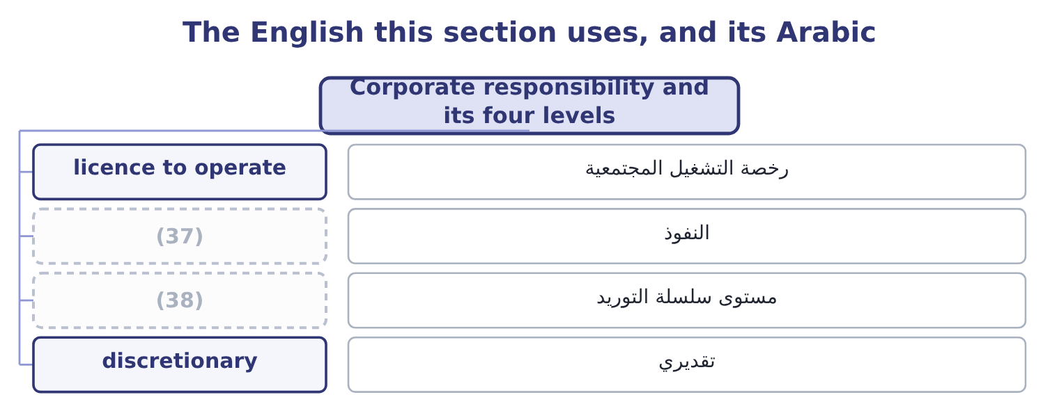
word list
leverage · lawful basis · supply chain tier

The English this sheet uses, and its Arabic
English (exam term) | Arabic
licence to operate | رخصة التشغيل المجتمعية
leverage | النفوذ
supply chain tier | مستوى سلسلة التوريد
discretionary | تقديري

Answer key · 18.3 Corporate responsibility and its four levels

1 corporate | 20 influence
2 seriously | 21 contested
3 asserting | 22 leverage
4 deception | 23 operations
5 objectives | 24 customer
6 licence | 25 defined
7 stakeholder | 26 structure
8 answers | 27 Economic
9 useful | 28 profitable
10 include | 29 foundation
11 strengthened | 30 obligations
12 transferring | 31 expected
13 responsibilities | 32 requires
14 follow | 33 Philanthropic
15 employs | 34 volunteering
16 subject | 35 discretionary
17 distributors | 36 philanthropy
18 liability | 37 leverage
19 supply | 38 supply chain tier

the summaries in full
Summary 1 The outcome asks you to discuss corporate responsibility for ethical conduct, and a good answer begins by taking the question seriously rather than asserting a position. Two classical views frame it. The narrow view holds that a company's responsibility is to its owners: to make money within the rules of the game, lawfully and without deception, and that managers spending the owners' money on social purposes are spending money that is not theirs for objectives nobody elected them to pursue. The broader view holds that a company's licence to operate comes from society, that it affects many parties besides its owners, and that it is responsible to all of them — the stakeholder reasoning. The position that answers the exam takes the useful part of both. Even on the narrow view, a company is responsible for conduct: the narrow view says within the rules, and the rules include honesty, safety and the law. And the broader view is strengthened, not weakened, by the long-run argument — a company that damages its customers, its employees, its suppliers or its community is usually destroying value rather than transferring it, which is what Book 2's long-run value maximisation actually implies.
Summary 2 Four specific responsibilities for ethical conduct follow, and they are what the outcome is asking for. For its own conduct, by the people it employs, which is the subject. For conduct in its name, by agents, distributors and partners, which section 18.2 makes a legal liability and not only an ethical one. For conduct in its supply chain, to the extent of its influence. This is the most contested of the four: a company cannot audit every tier, and the standard applied is that it should know its material risks, use its leverage where it has any, and not arrange its affairs so as to avoid knowing. And for the effects of its products and operations on people who never agreed to them: the customer who cannot evaluate what they are buying, the community affected by the plant, the person whose data the company holds.
Summary 3 The four levels of social responsibility, which the outcome asks to be defined, are the classical pyramid and provide the structure for an answer. Economic responsibility: to be profitable. It is the foundation, because a company that does not cover its costs can meet none of the other obligations, and Book 1's whole analysis is about whether it does. Legal responsibility: to obey the law — the floor. Ethical responsibility: to do what is right, fair and expected beyond what the law requires, which is the gap. Philanthropic responsibility: to contribute resources to the community — donations, volunteering, support for education and the arts. It is discretionary, and the order matters: philanthropy does not compensate for failures at the levels below it, and a company that underpays its suppliers and funds a scholarship has not balanced anything.

18.4 Sustainability
Chapter 18 · section 18.4

Fill every gap. Each word list holds one word more than there are gaps.
Summary 1 gaps 1–12
Two outcomes meet here: the major issues of sustainability and social (1) , and the three (2) spheres. The three spheres — (3) the three pillars, or people, planet and profit — are the (4) to use. The (5) sphere: whether the activity is (6) viable over the long run, for the company and for those who depend on it. An (7) activity is not (8) in any sense, which is why this sphere comes first and why sustainability and the economics of Books 1 to 3 are not opposed. The environmental sphere: whether the activity can continue without (9) or damaging the natural systems it depends on — emissions, energy, water, waste, land, (10) , materials. The social sphere: the effects on people — employees, (11) , customers and supply chain workers — covering safety, labour conditions, human rights, (12) and community impact.
word list
development · Resources · economic · communities · financially · depleting · sometimes · unprofitable · conceptual · structure · responsibility · biodiversity · sustainable

Summary 2 gaps 13–24
The point of the (13) framing is that sustainability is where they overlap. An initiative that is good (14) and loses money (15) will stop; one that is profitable and damages a community will be stopped; and the useful work is in finding the overlap, which is also where a management accountant is most useful, because the overlap is identified with numbers. The major issues the (16) asks about, (17) . Climate and emissions: (18) gas emissions from a company's own (19) , from the energy it buys, and from its value chain — the last of which is usually the largest and the hardest to measure. (20) risk, as regulation and markets change, and physical risk, as weather (21) do; for a food company, the physical risk is direct, since Orontes's sesame comes from fields. (22) : energy, water, raw materials and the waste (23) . These have the useful property of (24) in the accounts: Orontes's energy cost is 42,000,000 × 0.03 = 1,260,000 a year, and a 15 per cent reduction is 1,260,000 × 0.15 = 189,000 of saving as well as an emissions reduction — which is the overlap of the three spheres in one line.
word list
indefinitely · appearing · grouped · operations · three-sphere · environmentally · outcome · Resources · materials · Transition · patterns · greenhouse · produced

Summary 3 gaps 25–32
Process waste of 1.5 per cent of cost of goods sold is 27,300,000 × 0.015 = 409,500, and waste is both an environmental issue and the cost of poor (25) of Book 1. People: safety, pay and conditions, (26) and child labour in the supply chain, (27) and inclusion, community effects. Products: (28) and safety for a food company, (29) and its disposal, honest (30) , and what the product does to the people who use it. (31) and reporting: how sustainability is governed, what is (32) , to what standard, and whether it is assured.
word list
nutrition · quality · forced · marketing · disclosed · materials · Governance · packaging · diversity

Summary 4 gaps 33–44
Reporting frameworks have converged considerably — the (33) Sustainability Standards Board's standards building on earlier frameworks, with climate disclosure modelled on the task force (34) — and the direction is toward disclosure that is comparable, assured and located in the financial report rather than beside it. Two issues that produce exam (35) . Materiality, and its two (36) . Financial materiality asks which sustainability matters (37) the company's own cash flows and value — climate risk to the sesame crop, for example. Impact materiality asks which of the company's effects on the world are (38) regardless of whether they (39) on it. Some frameworks require only the first and some require both, and an (40) should say which sense it is using. And (41) : claims that overstate performance, that are (42) , that count something the company would have done anyway, or that offset rather than reduce. It matters ethically because it is simply dishonesty about a technical subject, and it matters (43) because regulators in several (44) now treat it as a misleading commercial practice.
word list
recommendations · jurisdictions · unmeasurable · answer · frameworks · questions · affect · International · rebound · practically · significant · senses · greenwashing

The English this section uses, and its Arabic
Each term sits against what it means.
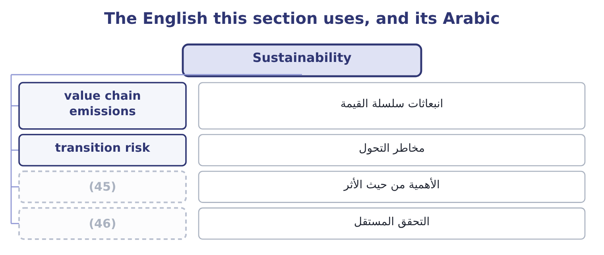
word list
discretionary · assurance · impact materiality

The English this sheet uses, and its Arabic
English (exam term) | Arabic
value chain emissions | انبعاثات سلسلة القيمة
transition risk | مخاطر التحول
impact materiality | الأهمية من حيث الأثر
assurance | التحقق المستقل

Answer key · 18.4 Sustainability

1 responsibility | 24 appearing
2 conceptual | 25 quality
3 sometimes | 26 forced
4 structure | 27 diversity
5 economic | 28 nutrition
6 financially | 29 packaging
7 unprofitable | 30 marketing
8 sustainable | 31 Governance
9 depleting | 32 disclosed
10 biodiversity | 33 International
11 communities | 34 recommendations
12 development | 35 questions
13 three-sphere | 36 senses
14 environmentally | 37 affect
15 indefinitely | 38 significant
16 outcome | 39 rebound
17 grouped | 40 answer
18 greenhouse | 41 greenwashing
19 operations | 42 unmeasurable
20 Transition | 43 practically
21 patterns | 44 jurisdictions
22 Resources | 45 impact materiality
23 produced | 46 assurance

the summaries in full
Summary 1 Two outcomes meet here: the major issues of sustainability and social responsibility, and the three conceptual spheres. The three spheres — sometimes the three pillars, or people, planet and profit — are the structure to use. The economic sphere: whether the activity is financially viable over the long run, for the company and for those who depend on it. An unprofitable activity is not sustainable in any sense, which is why this sphere comes first and why sustainability and the economics of Books 1 to 3 are not opposed. The environmental sphere: whether the activity can continue without depleting or damaging the natural systems it depends on — emissions, energy, water, waste, land, biodiversity, materials. The social sphere: the effects on people — employees, communities, customers and supply chain workers — covering safety, labour conditions, human rights, development and community impact.
Summary 2 The point of the three-sphere framing is that sustainability is where they overlap. An initiative that is good environmentally and loses money indefinitely will stop; one that is profitable and damages a community will be stopped; and the useful work is in finding the overlap, which is also where a management accountant is most useful, because the overlap is identified with numbers. The major issues the outcome asks about, grouped. Climate and emissions: greenhouse gas emissions from a company's own operations, from the energy it buys, and from its value chain — the last of which is usually the largest and the hardest to measure. Transition risk, as regulation and markets change, and physical risk, as weather patterns do; for a food company, the physical risk is direct, since Orontes's sesame comes from fields. Resources: energy, water, raw materials and the waste produced. These have the useful property of appearing in the accounts: Orontes's energy cost is 42,000,000 × 0.03 = 1,260,000 a year, and a 15 per cent reduction is 1,260,000 × 0.15 = 189,000 of saving as well as an emissions reduction — which is the overlap of the three spheres in one line.
Summary 3 Process waste of 1.5 per cent of cost of goods sold is 27,300,000 × 0.015 = 409,500, and waste is both an environmental issue and the cost of poor quality of Book 1. People: safety, pay and conditions, forced and child labour in the supply chain, diversity and inclusion, community effects. Products: nutrition and safety for a food company, packaging and its disposal, honest marketing, and what the product does to the people who use it. Governance and reporting: how sustainability is governed, what is disclosed, to what standard, and whether it is assured.
Summary 4 Reporting frameworks have converged considerably — the International Sustainability Standards Board's standards building on earlier frameworks, with climate disclosure modelled on the task force recommendations — and the direction is toward disclosure that is comparable, assured and located in the financial report rather than beside it. Two issues that produce exam questions. Materiality, and its two senses. Financial materiality asks which sustainability matters affect the company's own cash flows and value — climate risk to the sesame crop, for example. Impact materiality asks which of the company's effects on the world are significant regardless of whether they rebound on it. Some frameworks require only the first and some require both, and an answer should say which sense it is using. And greenwashing: claims that overstate performance, that are unmeasurable, that count something the company would have done anyway, or that offset rather than reduce. It matters ethically because it is simply dishonesty about a technical subject, and it matters practically because regulators in several jurisdictions now treat it as a misleading commercial practice.

18.5 Data ethics and data protection
Chapter 18 · section 18.5

Fill every gap. Each word list holds one word more than there are gaps.
Summary 1 gaps 1–12
The last two outcomes concern the (1) of the obligations and the one (2) fastest. Data ethics is the (3) of ethical principles to the (4) , use, sharing and retention of data — particularly data about people, and particularly where decisions about people are made from it, including by models the company cannot fully explain. The outcome names five principles. Data and the models built on it should not (5) outcomes that (6) people on grounds that are irrelevant or (7) . The practical problem is that a model trained on (8) data reproduces the patterns in that data, including the ones nobody would defend: a credit model, a (9) screen or a pricing algorithm can (10) accurately and (11) without any (12) to do so, and without anybody being able to point to the line that does it.
word list
pricing · indefensibly · instruction · newest · application · produce · discriminate · collection · disadvantage · unacceptable · historical · changing · recruitment

Summary 2 gaps 13–24
Fairness is (13) a property to be (14) for in outcomes, not an (15) to be declared. People should retain (16) over information about them: what is collected, for what purpose, who sees it, and how long it is kept. The ethical standard goes beyond consent, because consent obtained through a document nobody reads, as a (17) of a service with no (18) , is not meaningful agreement — which is. People should be able to know what data is held, how it is used, and when a decision about them has been made or (19) by a model. Where a model's workings cannot be (20) , the company should be able to explain the decision anyway — what factors mattered, and how the decision can be (21) . Whose data it is, and what rights (22) . The legal answer varies and the ethical one is more (23) : data about a person is not simply an asset of whoever collected it, and the rights that come with it — to access, to correct, to (24) , to have it deleted — belong to the person.
word list
obtained · withdraw · assisted · settled · questioned · alternative · control · therefore · tested · condition · explained · follow · intention

Summary 3 gaps 25–36
Somebody is (25) for how data and models are used, for their outcomes, and for (26) things right. A model is not a party and cannot be responsible; the company is, and the obligation is not (27) by the fact that an outcome was produced (28) . Four practical issues a (29) accountant meets directly. Data collected for one purpose used for (30) — the most common failure and the (31) to avoid, by asking whether the person would recognise this use as the one they agreed to. Retention: data kept because (32) is cheap, long after any purpose, which raises both the ethical exposure and the loss if it is (33) . Security, which is the (34) risk of, and where the duty to those whose data it is survives any (35) . And the use of models in decisions about people — credit limits, prices, (36) — where the five principles apply together and where somebody must be able to answer a question about an individual case.
word list
easiest · operational · employment · outsourcing · automatically · discharged · another · putting · management · storage · answerable · breached · collection

Summary 4 gaps 37–48
Governmental data (37) regulation, which is the final outcome, exists for a purpose the exam asks you to state: to protect individuals' rights in (38) to information about them, by placing obligations on the organisations that hold it. The common features across (39) are worth knowing as a set, since the (40) varies and the pattern does not. A lawful basis is (41) for processing personal data, of which consent is only one; others include contract, legal obligation and a (42) interest that does not override the person's rights. Purpose limitation and data (43) : collect for a (44) purpose, collect no more than is needed, and do not repurpose without a basis. (45) , and retention no longer than (46) . Security (47) to the risk, with (48) of breaches to the regulator and, where the risk is high, to the people affected, within short deadlines.
word list
protection · specified · relation · minimisation · notification · necessary · required · legitimate · regulation · jurisdictions · detail · appropriate · Accuracy

Summary 5 gaps 49–57
Rights for individuals: to be informed, to access their data, to have it (49) or deleted, to object to certain processing, to (50) , and in several regimes a right not to be subject to a decision made solely by automated processing where it has (51) effects. Accountability and records: the (52) must be able to (53) compliance, which usually means documented (54) , policies and a responsible person. (55) on transferring data across borders, which bear directly on a company (56) in several (57) . And substantial penalties, in several regimes calculated as a percentage of worldwide turnover, which places the subject firmly on the risk register.
word list
interrupting · organisation · assessments · corrected · demonstrate · Restrictions · significant · countries · operating · portability

Worked example: the distributor's customer list

Summary 6 gaps 58–69
Orontes's (58) manager proposes to buy a list of 40,000 consumer names and (59) from a distributor, for a direct campaign offering samples. The (60) to ask first. The ethical test, (61) of the legal one. Would these people recognise this use as something they agreed to? If the answer is no, the campaign fails the fairness and transparency principles (62) the contract with the distributor says, and: the (63) is a floor. Require written evidence of the lawful basis and of what people were told; contract for it with (64) and an indemnity; limit the data taken to what the campaign needs and delete it (65) ; provide a clear opt-out in the first contact; and record the assessment. If the distributor cannot evidence the basis, (66) the list, because the exposure is a penalty (67) against turnover and a public failure in Orontes's own name. The pattern is the same as the agent: a third party offering something valuable whose (68) the company has not verified, where the liability and the (69) remain the company's own.
word list
lawfulness · whatever · warranties · independent · measured · provenance · substantial · decline · addresses · afterwards · reputation · marketing · questions

The outward obligations

Your turn: the last obligations (complete the blanks)
Item | Data | Answer
How most occupational fraud is detected | More than audit and review combined | ________
The corporate offence under the UK Bribery Act, and its defence | (70) | ________
The four levels of social responsibility | (71) | ________
The three spheres of sustainability | Sustainability lives where they overlap | ________
Saving from a 15 per cent cut in energy cost | Energy 1,260,000 | ________
The five principles of data ethics | (72) | ________

word list
In ascending order · Named in the learning outcome · Liability is strict, subject to one defence · The four levels of responsibility

"Whistleblower", "stakeholder" and "sustainable"

Summary 7 gaps 73–84
Three words that carry (73) inside them. (74) is an unfortunate English coinage: it suggests an outsider (75) a game, and in many organisations it has acquired the sense of informer, which is why codes (76) use speak up or raise a concern instead — the act is ordinary and the vocabulary should be too. (77) was coined as a deliberate play on (78) , and the play is the argument: it asserts that others hold a stake too. And sustainable has been used so (79) that it now means little on its own — a sustainable (80) , a sustainable margin, a sustainable pace. In a report, replace it with what is meant: (81) reduced by a stated amount against a stated baseline, or water use per tonne, or a margin that does not depend on deferring (82) . The general word is where (83) lives; the (84) one cannot be greenwashed.
word list
interrupting · limitation · Whistleblower · shareholder · greenwashing · widely · maintenance · emissions · Stakeholder · specific · arguments · product · increasingly

"Whistleblower", "stakeholder" and "sustainable"
Item | Answer
How most fraud is detected | Tips, chiefly from (85) — more than audit and review combined.
The UK corporate offence and its defence | Failing to prevent bribery by an associated person; the defence is adequate procedures.
The four levels of responsibility | (86)
The three spheres of sustainability | Economic, environmental and social.
Saving from a 15 per cent energy cut | (87)
The five principles of data ethics | Fairness, privacy, transparency, ownership and accountability.
What it tells you | Five lists and one calculation — and the calculation is there to show that the sustainability sphere where the three overlap is found with f

word list
The three spheres of sustainability · Economic, legal, ethical and philanthropic. · 189,000: 1,260,000 × 0.15 = 189,000. · employees

The English this section uses, and its Arabic
Each term sits against what it means.
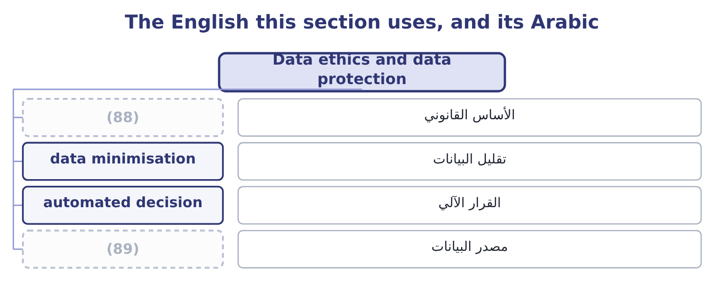
word list
assurance · provenance · lawful basis

The English this sheet uses, and its Arabic
English (exam term) | Arabic
lawful basis | الأساس القانوني
data minimisation | تقليل البيانات
automated decision | القرار الآلي
provenance | مصدر البيانات

Answer key · 18.5 Data ethics and data protection

1 newest | 46 necessary
2 changing | 47 appropriate
3 application | 48 notification
4 collection | 49 corrected
5 produce | 50 portability
6 disadvantage | 51 significant
7 unacceptable | 52 organisation
8 historical | 53 demonstrate
9 recruitment | 54 assessments
10 discriminate | 55 Restrictions
11 indefensibly | 56 operating
12 instruction | 57 countries
13 therefore | 58 marketing
14 tested | 59 addresses
15 intention | 60 questions
16 control | 61 independent
17 condition | 62 whatever
18 alternative | 63 lawfulness
19 assisted | 64 warranties
20 explained | 65 afterwards
21 questioned | 66 decline
22 follow | 67 measured
23 settled | 68 provenance
24 withdraw | 69 reputation
25 answerable | 70 Liability is strict, subject to one defence
26 putting | 71 In ascending order
27 discharged | 72 Named in the learning outcome
28 automatically | 73 arguments
29 management | 74 Whistleblower
30 another | 75 interrupting
31 easiest | 76 increasingly
32 storage | 77 Stakeholder
33 breached | 78 shareholder
34 operational | 79 widely
35 outsourcing | 80 product
36 employment | 81 emissions
37 protection | 82 maintenance
38 relation | 83 greenwashing
39 jurisdictions | 84 specific
40 detail | 85 employees
41 required | 86 Economic, legal, ethical and philanthropic.
42 legitimate | 87 189,000: 1,260,000 × 0.15 = 189,000.
43 minimisation | 88 lawful basis
44 specified | 89 provenance
45 Accuracy

the summaries in full
Summary 1 The last two outcomes concern the newest of the obligations and the one changing fastest. Data ethics is the application of ethical principles to the collection, use, sharing and retention of data — particularly data about people, and particularly where decisions about people are made from it, including by models the company cannot fully explain. The outcome names five principles. Data and the models built on it should not produce outcomes that disadvantage people on grounds that are irrelevant or unacceptable. The practical problem is that a model trained on historical data reproduces the patterns in that data, including the ones nobody would defend: a credit model, a recruitment screen or a pricing algorithm can discriminate accurately and indefensibly without any instruction to do so, and without anybody being able to point to the line that does it.
Summary 2 Fairness is therefore a property to be tested for in outcomes, not an intention to be declared. People should retain control over information about them: what is collected, for what purpose, who sees it, and how long it is kept. The ethical standard goes beyond consent, because consent obtained through a document nobody reads, as a condition of a service with no alternative, is not meaningful agreement — which is. People should be able to know what data is held, how it is used, and when a decision about them has been made or assisted by a model. Where a model's workings cannot be explained, the company should be able to explain the decision anyway — what factors mattered, and how the decision can be questioned. Whose data it is, and what rights follow. The legal answer varies and the ethical one is more settled: data about a person is not simply an asset of whoever collected it, and the rights that come with it — to access, to correct, to withdraw, to have it deleted — belong to the person.
Summary 3 Somebody is answerable for how data and models are used, for their outcomes, and for putting things right. A model is not a party and cannot be responsible; the company is, and the obligation is not discharged by the fact that an outcome was produced automatically. Four practical issues a management accountant meets directly. Data collected for one purpose used for another — the most common failure and the easiest to avoid, by asking whether the person would recognise this use as the one they agreed to. Retention: data kept because storage is cheap, long after any purpose, which raises both the ethical exposure and the loss if it is breached. Security, which is the operational risk of, and where the duty to those whose data it is survives any outsourcing. And the use of models in decisions about people — credit limits, prices, employment — where the five principles apply together and where somebody must be able to answer a question about an individual case.
Summary 4 Governmental data protection regulation, which is the final outcome, exists for a purpose the exam asks you to state: to protect individuals' rights in relation to information about them, by placing obligations on the organisations that hold it. The common features across jurisdictions are worth knowing as a set, since the detail varies and the pattern does not. A lawful basis is required for processing personal data, of which consent is only one; others include contract, legal obligation and a legitimate interest that does not override the person's rights. Purpose limitation and data minimisation: collect for a specified purpose, collect no more than is needed, and do not repurpose without a basis. Accuracy, and retention no longer than necessary. Security appropriate to the risk, with notification of breaches to the regulator and, where the risk is high, to the people affected, within short deadlines.
Summary 5 Rights for individuals: to be informed, to access their data, to have it corrected or deleted, to object to certain processing, to portability, and in several regimes a right not to be subject to a decision made solely by automated processing where it has significant effects. Accountability and records: the organisation must be able to demonstrate compliance, which usually means documented assessments, policies and a responsible person. Restrictions on transferring data across borders, which bear directly on a company operating in several countries. And substantial penalties, in several regimes calculated as a percentage of worldwide turnover, which places the subject firmly on the risk register.
Summary 6 Orontes's marketing manager proposes to buy a list of 40,000 consumer names and addresses from a distributor, for a direct campaign offering samples. The questions to ask first. The ethical test, independent of the legal one. Would these people recognise this use as something they agreed to? If the answer is no, the campaign fails the fairness and transparency principles whatever the contract with the distributor says, and: the lawfulness is a floor. Require written evidence of the lawful basis and of what people were told; contract for it with warranties and an indemnity; limit the data taken to what the campaign needs and delete it afterwards; provide a clear opt-out in the first contact; and record the assessment. If the distributor cannot evidence the basis, decline the list, because the exposure is a penalty measured against turnover and a public failure in Orontes's own name. The pattern is the same as the agent: a third party offering something valuable whose provenance the company has not verified, where the liability and the reputation remain the company's own.
Summary 7 Three words that carry arguments inside them. Whistleblower is an unfortunate English coinage: it suggests an outsider interrupting a game, and in many organisations it has acquired the sense of informer, which is why codes increasingly use speak up or raise a concern instead — the act is ordinary and the vocabulary should be too. Stakeholder was coined as a deliberate play on shareholder, and the play is the argument: it asserts that others hold a stake too. And sustainable has been used so widely that it now means little on its own — a sustainable product, a sustainable margin, a sustainable pace. In a report, replace it with what is meant: emissions reduced by a stated amount against a stated baseline, or water use per tonne, or a margin that does not depend on deferring maintenance. The general word is where greenwashing lives; the specific one cannot be greenwashed.

