1.1 What risk is
Chapter 1 · section 1.1

Fill every gap. Each word list holds one word more than there are gaps.
Chapter 1, section by section
Each stage leads to the next.
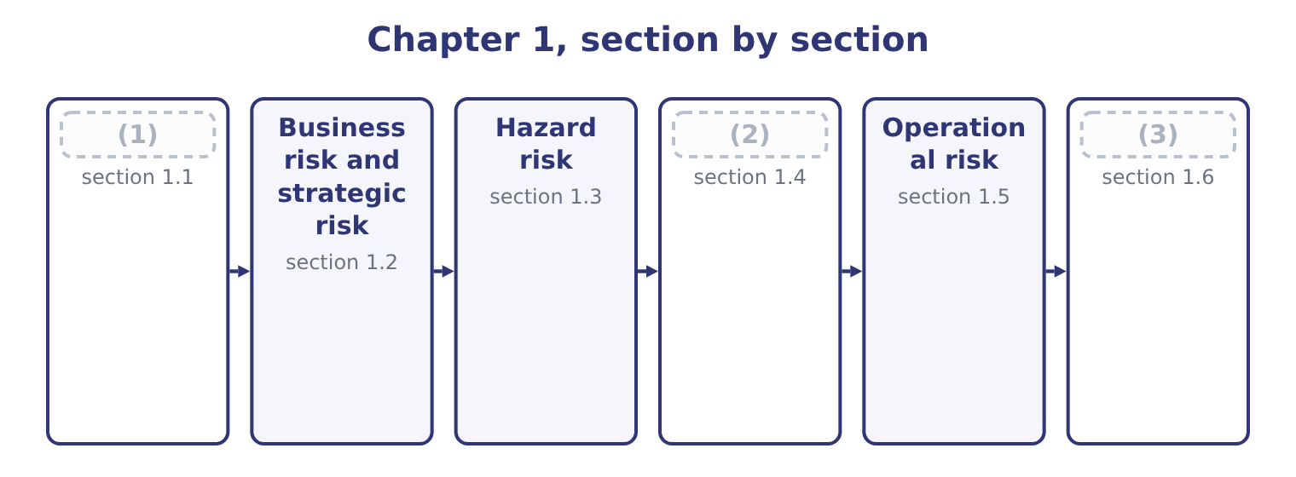
word list
What risk is · Legal, compliance and political risk · exchange controls · Financial risk

Summary 1 gaps 4–15
Risk is the possibility that an (4) differs from what was (5) . Two (6) follow from that definition and both are (7) . Risk runs in both (8) . The possibility that sales exceed the (9) is as much a (10) as the possibility that they fall short, and a definition that admits only the downside misses half of what risk management is for: which has no meaning unless risk can be (11) . In (12) speech risk means danger; in this syllabus it means (13) , and the examiners use the wider sense. Risk is not the same as uncertainty. In the classical distinction, a risk is a possibility whose outcomes and (14) can be described — a machine that fails on average once in two hundred days — while uncertainty describes a situation where the outcomes (15) are not known in advance.
word list
deviation · examined · things · expected · themselves · variability · favourable · forecast · directions · ordinary · definition · outcome · probabilities

Summary 2 gaps 16–27
The distinction matters because the tools of, and a situation that has none is managed by judgment, redundancy and (16) rather than by (17) . Two more terms (18) here before the classification. An exposure is what (19) to be lost: the (20) at stake, not the chance of losing it. Orontes's exposure to a Syrian pound (21) is the value of its (22) receivables; its exposure to a fire at the Hama plant is the plant plus the profit the plant would have earned while it was rebuilt. An event is the thing that (23) . Risk management works on (24) , and: a risk nobody has named is a risk nobody is (25) . The classification that (26) is not a natural fact. It is a working device, and a single event can sit in more than one family — a fire caused by a badly maintained roaster is a hazard risk and an (27) risk at once. The reason to classify at all is that the families differ in who owns them, how they are measured and what can be done about them.
word list
stands · managing · pound-denominated · devaluation · events · amount · flexibility · belong · happens · arithmetic · follows · operational · describes

The English this section uses, and its Arabic
Each term sits against what it means.
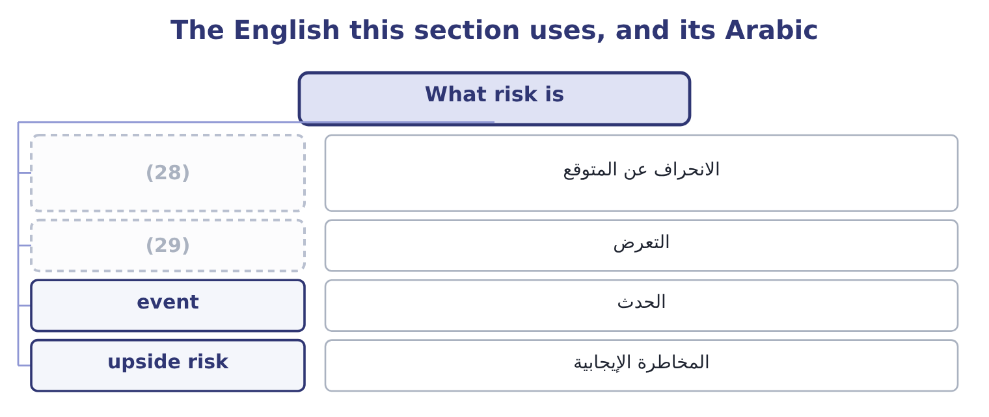
word list
exposure · deviation from expectation · upside risk

The English this sheet uses, and its Arabic
English (exam term) | Arabic
deviation from expectation | الانحراف عن المتوقع
exposure | التعرض
event | الحدث
upside risk | المخاطرة الإيجابية

Answer key · 1.1 What risk is

1 What risk is | 16 flexibility
2 Financial risk | 17 arithmetic
3 Legal, compliance and political risk | 18 belong
4 outcome | 19 stands
5 expected | 20 amount
6 things | 21 devaluation
7 examined | 22 pound-denominated
8 directions | 23 happens
9 forecast | 24 events
10 deviation | 25 managing
11 favourable | 26 follows
12 ordinary | 27 operational
13 variability | 28 deviation from expectation
14 probabilities | 29 exposure
15 themselves

the summaries in full
Summary 1 Risk is the possibility that an outcome differs from what was expected. Two things follow from that definition and both are examined. Risk runs in both directions. The possibility that sales exceed the forecast is as much a deviation as the possibility that they fall short, and a definition that admits only the downside misses half of what risk management is for: which has no meaning unless risk can be favourable. In ordinary speech risk means danger; in this syllabus it means variability, and the examiners use the wider sense. Risk is not the same as uncertainty. In the classical distinction, a risk is a possibility whose outcomes and probabilities can be described — a machine that fails on average once in two hundred days — while uncertainty describes a situation where the outcomes themselves are not known in advance.
Summary 2 The distinction matters because the tools of, and a situation that has none is managed by judgment, redundancy and flexibility rather than by arithmetic. Two more terms belong here before the classification. An exposure is what stands to be lost: the amount at stake, not the chance of losing it. Orontes's exposure to a Syrian pound devaluation is the value of its pound-denominated receivables; its exposure to a fire at the Hama plant is the plant plus the profit the plant would have earned while it was rebuilt. An event is the thing that happens. Risk management works on events, and: a risk nobody has named is a risk nobody is managing. The classification that follows is not a natural fact. It is a working device, and a single event can sit in more than one family — a fire caused by a badly maintained roaster is a hazard risk and an operational risk at once. The reason to classify at all is that the families differ in who owns them, how they are measured and what can be done about them.

1.2 Business risk and strategic risk
Chapter 1 · section 1.2

Fill every gap. Each word list holds one word more than there are gaps.
Summary 1 gaps 1–12
Business risk is the (1) of a company's operating (2) arising from the business it is: (3) , prices, input costs, competition, technology and the cost structure that turns all of those into (4) . It is the risk the company (5) in order to take, and it is measured before any (6) effect. Book 3 measured Orontes's. The company's operating (7) is 4.02, so a 10 per cent fall in sales becomes a 4.02 × 10 = 40.2 per cent fall in operating income — on operating income of $4,176,000, a loss of 4,176,000 × 0.402 = 1,678,752. The (8) of safety of 24.86 per cent says how far sales can fall before operating income (9) zero. Those two (10) are Orontes's business risk, stated in the (11) Book 3 taught, and they are a direct (12) of a cost structure in which $12,624,000 of the costs do not move with volume.
word list
profit · exists · demand · consequence · increase · leverage · language · variability · figures · results · financing · margin · reaches

Summary 2 gaps 13–24
Four (13) of business risk are worth naming, (14) an exam answer that names them is a better answer than one that defines the term. How much the volume moves, which for a food producer follows (15) incomes and, in Orontes's case, the sesame harvest and the (16) calendar. Sesame is a (17) , and Book 2's. (18) the company can pass an input cost (19) on, which Book 3's. The (20) of costs that do not vary, which magnifies (21) above. Strategic risk is (22) in kind. It is the risk that the company's chosen direction is wrong, or becomes wrong — that the market it serves (23) , that a competitor changes the terms of competition, that a technology makes its assets obsolete, that an (24) of the kind Book 3's, that its reputation is lost.
word list
changes · drivers · Whether · different · household · disappears · festival · acquisition · increase · everything · proportion · commodity · because

Summary 3 gaps 25–34
Three features (25) strategic risk and all three are (26) . It is owned by the board, not by a risk (27) . Nobody below the (28) can decide that the company's (29) is wrong. It is slow and large. Business risk shows up in a (30) ; strategic risk shows up over years, and by the time it is (31) in the numbers the window to respond has usually closed. And it is the (32) least amenable to (33) . There is no probability distribution for "tahini is displaced by a product nobody has invented yet", which is exactly the (34) of section 1.1, and the response is strategic flexibility — the real options of Book 3's.
word list
measurement · family · becomes · distinguish · strategy · directors · uncertainty · examined · quarter · visible · function

The English this section uses, and its Arabic
Each term sits against what it means.
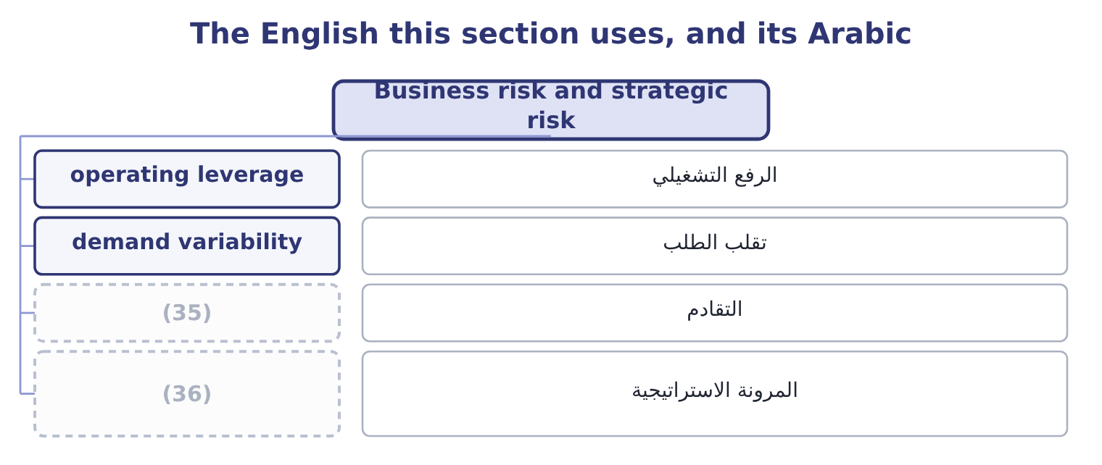
word list
strategic flexibility · المرونة الاستراتيجية · obsolescence

The English this sheet uses, and its Arabic
English (exam term) | Arabic
operating leverage | الرفع التشغيلي
demand variability | تقلب الطلب
obsolescence | التقادم
strategic flexibility | المرونة الاستراتيجية

Answer key · 1.2 Business risk and strategic risk

1 variability | 19 increase
2 results | 20 proportion
3 demand | 21 everything
4 profit | 22 different
5 exists | 23 disappears
6 financing | 24 acquisition
7 leverage | 25 distinguish
8 margin | 26 examined
9 reaches | 27 function
10 figures | 28 directors
11 language | 29 strategy
12 consequence | 30 quarter
13 drivers | 31 visible
14 because | 32 family
15 household | 33 measurement
16 festival | 34 uncertainty
17 commodity | 35 obsolescence
18 Whether | 36 strategic flexibility

the summaries in full
Summary 1 Business risk is the variability of a company's operating results arising from the business it is: demand, prices, input costs, competition, technology and the cost structure that turns all of those into profit. It is the risk the company exists in order to take, and it is measured before any financing effect. Book 3 measured Orontes's. The company's operating leverage is 4.02, so a 10 per cent fall in sales becomes a 4.02 × 10 = 40.2 per cent fall in operating income — on operating income of $4,176,000, a loss of 4,176,000 × 0.402 = 1,678,752. The margin of safety of 24.86 per cent says how far sales can fall before operating income reaches zero. Those two figures are Orontes's business risk, stated in the language Book 3 taught, and they are a direct consequence of a cost structure in which $12,624,000 of the costs do not move with volume.
Summary 2 Four drivers of business risk are worth naming, because an exam answer that names them is a better answer than one that defines the term. How much the volume moves, which for a food producer follows household incomes and, in Orontes's case, the sesame harvest and the festival calendar. Sesame is a commodity, and Book 2's. Whether the company can pass an input cost increase on, which Book 3's. The proportion of costs that do not vary, which magnifies everything above. Strategic risk is different in kind. It is the risk that the company's chosen direction is wrong, or becomes wrong — that the market it serves disappears, that a competitor changes the terms of competition, that a technology makes its assets obsolete, that an acquisition of the kind Book 3's, that its reputation is lost.
Summary 3 Three features distinguish strategic risk and all three are examined. It is owned by the board, not by a risk function. Nobody below the directors can decide that the company's strategy is wrong. It is slow and large. Business risk shows up in a quarter; strategic risk shows up over years, and by the time it is visible in the numbers the window to respond has usually closed. And it is the family least amenable to measurement. There is no probability distribution for "tahini is displaced by a product nobody has invented yet", which is exactly the uncertainty of section 1.1, and the response is strategic flexibility — the real options of Book 3's.

1.3 Hazard risk
Chapter 1 · section 1.3

Fill every gap. Each word list holds one word more than there are gaps.
Summary 1 gaps 1–12
Hazard risk — also called pure risk — is the risk of loss from a physical event: fire, flood, storm, (1) , explosion, theft, accident, product (2) , the death or injury of a key person. Its (3) feature is that it has no (4) . A fire can destroy a plant and cannot improve one, which is why the term pure risk is used and why hazard risk is the family where insurance is the natural response: an (5) risk is one that is (6) , measurable, and part of a large enough pool of similar exposures for an insurer to price it. Two kinds of loss (7) a hazard event and the exam (8) both. Direct loss: the asset itself — the (9) , the plant, the stock. Consequential loss: the profit that would have been earned while the asset was out of use, (10) with the extra cost of (11) around it. This is usually the larger figure and the one companies (12) .
word list
insurable · upside · accidental · underinsure · defining · follow · together · earthquake · building · working · sixty-day · expects · contamination

Summary 2 gaps 13–24
The (13) hall and its (14) would have to be (15) , and the stock in it (16) . Orontes earns a contribution of 3,500,000 × 4.80 = 16,800,000 a year, which is 16,800,000 ÷ 365 = 46,027 a day. At that rate a (17) stoppage costs 46,027 × 60 = 2,761,620 of contribution. (18) whole operating income is $4,176,000, so a (19) stoppage removes about two thirds of a year's operating profit without (20) a single asset on the insurance schedule. The (21) assumes nothing is recovered — no (22) caught up afterwards, no stock on hand to sell, no customer who waits. Each of those softens the figure and none of them is free: the right use of the number is to show that the consequential loss is of the same order as the direct one, which is the argument for business (23) cover and for the (24) planning.
word list
sixty-day · replaced · rebuilt · roasting · interruption · continuity · two-month · calculation · Orontes's · equipment · insurance · production · touching

The English this section uses, and its Arabic
Each term sits against what it means.
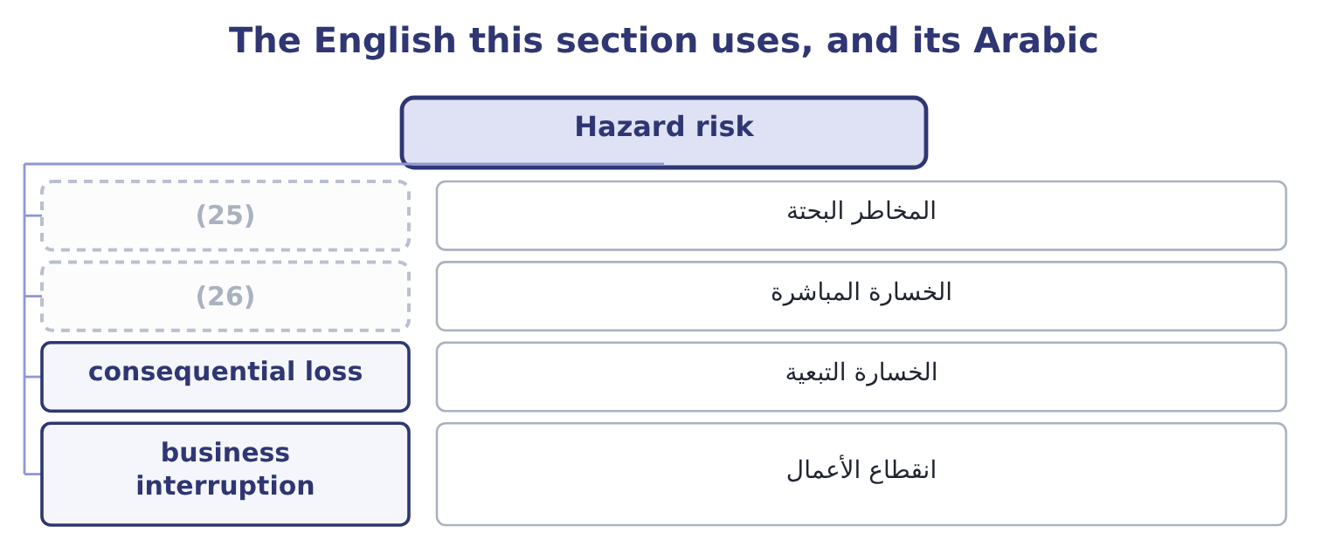
word list
direct loss · المخاطر البحتة · pure risk

The English this sheet uses, and its Arabic
English (exam term) | Arabic
pure risk | المخاطر البحتة
direct loss | الخسارة المباشرة
consequential loss | الخسارة التبعية
business interruption | انقطاع الأعمال

Answer key · 1.3 Hazard risk

1 earthquake | 14 equipment
2 contamination | 15 rebuilt
3 defining | 16 replaced
4 upside | 17 sixty-day
5 insurable | 18 Orontes's
6 accidental | 19 two-month
7 follow | 20 touching
8 expects | 21 calculation
9 building | 22 production
10 together | 23 interruption
11 working | 24 continuity
12 underinsure | 25 pure risk
13 roasting | 26 direct loss

the summaries in full
Summary 1 Hazard risk — also called pure risk — is the risk of loss from a physical event: fire, flood, storm, earthquake, explosion, theft, accident, product contamination, the death or injury of a key person. Its defining feature is that it has no upside. A fire can destroy a plant and cannot improve one, which is why the term pure risk is used and why hazard risk is the family where insurance is the natural response: an insurable risk is one that is accidental, measurable, and part of a large enough pool of similar exposures for an insurer to price it. Two kinds of loss follow a hazard event and the exam expects both. Direct loss: the asset itself — the building, the plant, the stock. Consequential loss: the profit that would have been earned while the asset was out of use, together with the extra cost of working around it. This is usually the larger figure and the one companies underinsure.
Summary 2 The roasting hall and its equipment would have to be rebuilt, and the stock in it replaced. Orontes earns a contribution of 3,500,000 × 4.80 = 16,800,000 a year, which is 16,800,000 ÷ 365 = 46,027 a day. At that rate a sixty-day stoppage costs 46,027 × 60 = 2,761,620 of contribution. Orontes's whole operating income is $4,176,000, so a two-month stoppage removes about two thirds of a year's operating profit without touching a single asset on the insurance schedule. The calculation assumes nothing is recovered — no production caught up afterwards, no stock on hand to sell, no customer who waits. Each of those softens the figure and none of them is free: the right use of the number is to show that the consequential loss is of the same order as the direct one, which is the argument for business interruption cover and for the continuity planning.

1.4 Financial risk
Chapter 1 · section 1.4

Fill every gap. Each word list holds one word more than there are gaps.
Summary 1 gaps 1–12
Financial risk is the risk arising from a (1) financing and from its financial position rather than from its trading: the risk that it cannot meet its (2) , and the risk that financial prices move against it. Four kinds, and the exam names them. (3) risk: that a customer or (4) does not pay. Orontes (5) $4,144,000 of (6) , and Book 1's. (7) risk: that cash is not (8) when it is needed, even though the company is solvent on paper. This is the risk that kills otherwise healthy companies, and Book 1's (9) chapters are its (10) . (11) risk: that a price moves — an interest rate, an exchange rate, a (12) price, a share price. Leverage or default risk: that the fixed claims of debt cannot be met out of a variable operating income.
word list
carries · Credit · working-capital · counterparty · measurement · Market · Liquidity · arising · company's · available · obligations · commodity · receivables

Summary 2 gaps 13–23
Orontes's (13) are 31,672,600 − 20,392,975 = 11,279,625 and its interest is $390,000 a year against operating income of $4,348,800, an interest cover of 4,348,800 ÷ 390,000 = 11.15 times, which is (14) . The point the (15) press is the (16) between business risk and financial risk. Business risk is given by the (17) and the cost structure; financial risk is (18) , by the capital structure (19) of Book 2's. A company in a (20) business that also borrows heavily has multiplied two (21) together, and the combined leverage of Book 3 is the arithmetic of that (22) . Orontes's operating leverage of 4.02 is high; its interest cover of 11.15 times says it has not (23) the problem with debt, and that is a deliberate choice rather than an accident.
word list
Orontes's · volatile · industry · examiners · comfortable · multiplication · decision · variabilities · chosen · relationship · liabilities · compounded

The English this section uses, and its Arabic
Each term sits against what it means.
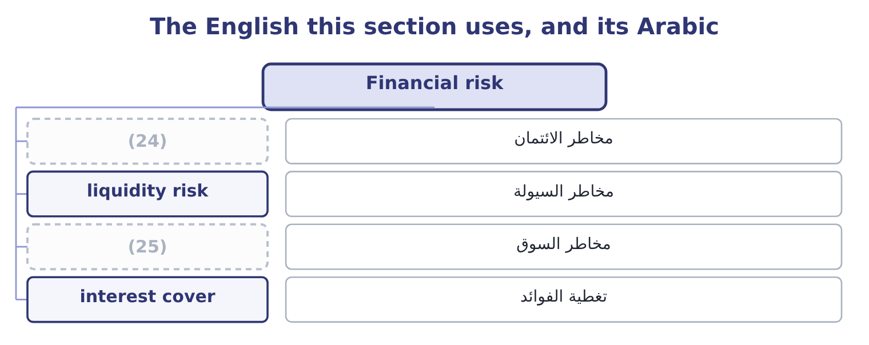
word list
financial risk · credit risk · market risk

The English this sheet uses, and its Arabic
English (exam term) | Arabic
credit risk | مخاطر الائتمان
liquidity risk | مخاطر السيولة
market risk | مخاطر السوق
interest cover | تغطية الفوائد

Answer key · 1.4 Financial risk

1 company's | 14 comfortable
2 obligations | 15 examiners
3 Credit | 16 relationship
4 counterparty | 17 industry
5 carries | 18 chosen
6 receivables | 19 decision
7 Liquidity | 20 volatile
8 available | 21 variabilities
9 working-capital | 22 multiplication
10 measurement | 23 compounded
11 Market | 24 credit risk
12 commodity | 25 market risk
13 liabilities

the summaries in full
Summary 1 Financial risk is the risk arising from a company's financing and from its financial position rather than from its trading: the risk that it cannot meet its obligations, and the risk that financial prices move against it. Four kinds, and the exam names them. Credit risk: that a customer or counterparty does not pay. Orontes carries $4,144,000 of receivables, and Book 1's. Liquidity risk: that cash is not available when it is needed, even though the company is solvent on paper. This is the risk that kills otherwise healthy companies, and Book 1's working-capital chapters are its measurement. Market risk: that a price moves — an interest rate, an exchange rate, a commodity price, a share price. Leverage or default risk: that the fixed claims of debt cannot be met out of a variable operating income.
Summary 2 Orontes's liabilities are 31,672,600 − 20,392,975 = 11,279,625 and its interest is $390,000 a year against operating income of $4,348,800, an interest cover of 4,348,800 ÷ 390,000 = 11.15 times, which is comfortable. The point the examiners press is the relationship between business risk and financial risk. Business risk is given by the industry and the cost structure; financial risk is chosen, by the capital structure decision of Book 2's. A company in a volatile business that also borrows heavily has multiplied two variabilities together, and the combined leverage of Book 3 is the arithmetic of that multiplication. Orontes's operating leverage of 4.02 is high; its interest cover of 11.15 times says it has not compounded the problem with debt, and that is a deliberate choice rather than an accident.

1.5 Operational risk
Chapter 1 · section 1.5

Fill every gap. Each word list holds one word more than there are gaps.
Summary 1 gaps 1–12
Operational risk is the risk of loss from inadequate or failed internal processes, people and (1) , or from external (2) . That definition, which comes from banking (3) and is now used (4) , repays reading twice, because it is built from four sources and the exam tests them separately. A control that does not work, a (5) nobody performs, a procedure that two departments interpret differently, a handover where (6) is lost. The recall of a (7) batch is a process failure before it is (8) else. Error, (9) , inadequate training, turnover that takes knowledge with it, and (10) wrongdoing — internal fraud. An outage, a failed (11) , a spreadsheet with a wrong formula in it, a data loss, a cyber (12) . The spreadsheet is not a joke: errors in uncontrolled spreadsheets are among the most frequently reported operational losses in surveys of finance functions.
word list
systems · deliberate · anything · intrusion · reconciliation · implementation · events · inexperience · regulation · everywhere · regulatory · mislabelled · responsibility

Summary 2 gaps 13–24
Suppliers failing, utilities (13) , transport blocked, a pandemic, a (14) change applied at short notice. The event is external; the risk is operational because the loss comes through the (15) own ability to keep (16) . Four (17) distinguish the family, and an exam answer that gives them is (18) the outcome rather than reciting the definition. It is present in every (19) , so it cannot be assigned to one (20) . (21) who runs a process owns some of it. Its loss (22) is lopsided: very many small losses and a few (23) ones. It is rarely taken (24) . A company takes business risk because it expects a return for it. Nobody is paid for operational risk, which makes reducing it the usual response and means the test of a control is the cost-benefit analysis. And it is under-reported. A credit loss appears in the accounts as a bad debt; an operational loss appears as a slightly worse margin, an unexplained variance, a write-off, a cost of poor quality — which is why.
word list
supplier · activity · interrupted · company's · regulatory · distribution · answering · department · characteristics · Everybody · deliberately · enormous · running

Worked example: one operational event at Orontes

Summary 3 gaps 25–36
A supplier delivers sesame with an (25) change in origin, and 40,000 jars are produced before the (26) is checked. The jars must be recalled from three distributors. Processes first — the (27) check did not match the certificate to the delivery; people second — the control was performed by one person without review; external third — the supplier's own (28) was wrong. The (29) forgone on the recalled jars is 40,000 × 4.80 = 192,000, with the recall's own costs, the (30) , the destroyed stock and the distributors' goodwill on top. The direct (31) loss is modest (32) $42,000,000 of sales. The (33) that matters is the one not in the arithmetic: a regulator that now looks at every (34) , and three distributors who will ask what else is not being checked. Note where the event would have appeared in the accounts if nobody had (35) it: in cost of goods sold, as a write-off, invisible by the time the figures were (36) . That is what under-reporting means in practice, and it is why operational risk needs a register of its own.
word list
paperwork · consequence · inexperience · consignment · goods-inwards · against · consolidated · financial · documentation · classified · undeclared · investigation · contribution

The English this section uses, and its Arabic
Each term sits against what it means.
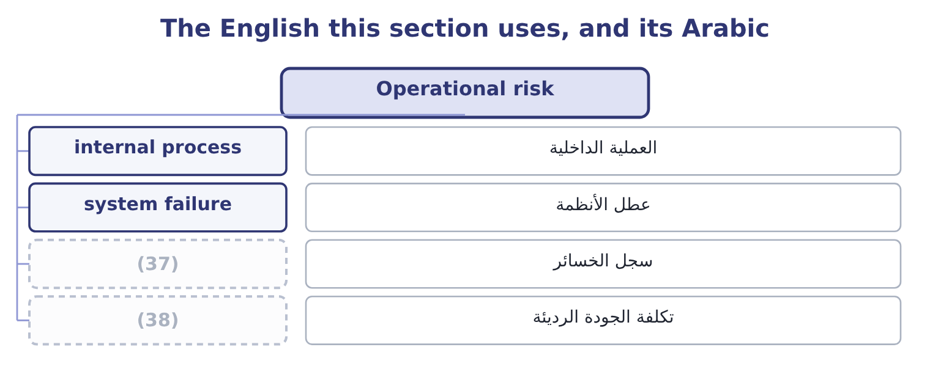
word list
loss database · cost of poor quality · demand variability

The English this sheet uses, and its Arabic
English (exam term) | Arabic
internal process | العملية الداخلية
system failure | عطل الأنظمة
loss database | سجل الخسائر
cost of poor quality | تكلفة الجودة الرديئة

Answer key · 1.5 Operational risk

1 systems | 20 department
2 events | 21 Everybody
3 regulation | 22 distribution
4 everywhere | 23 enormous
5 reconciliation | 24 deliberately
6 responsibility | 25 undeclared
7 mislabelled | 26 paperwork
8 anything | 27 goods-inwards
9 inexperience | 28 documentation
10 deliberate | 29 contribution
11 implementation | 30 investigation
12 intrusion | 31 financial
13 interrupted | 32 against
14 regulatory | 33 consequence
15 company's | 34 consignment
16 running | 35 classified
17 characteristics | 36 consolidated
18 answering | 37 loss database
19 activity | 38 cost of poor quality

the summaries in full
Summary 1 Operational risk is the risk of loss from inadequate or failed internal processes, people and systems, or from external events. That definition, which comes from banking regulation and is now used everywhere, repays reading twice, because it is built from four sources and the exam tests them separately. A control that does not work, a reconciliation nobody performs, a procedure that two departments interpret differently, a handover where responsibility is lost. The recall of a mislabelled batch is a process failure before it is anything else. Error, inexperience, inadequate training, turnover that takes knowledge with it, and deliberate wrongdoing — internal fraud. An outage, a failed implementation, a spreadsheet with a wrong formula in it, a data loss, a cyber intrusion. The spreadsheet is not a joke: errors in uncontrolled spreadsheets are among the most frequently reported operational losses in surveys of finance functions.
Summary 2 Suppliers failing, utilities interrupted, transport blocked, a pandemic, a regulatory change applied at short notice. The event is external; the risk is operational because the loss comes through the company's own ability to keep running. Four characteristics distinguish the family, and an exam answer that gives them is answering the outcome rather than reciting the definition. It is present in every activity, so it cannot be assigned to one department. Everybody who runs a process owns some of it. Its loss distribution is lopsided: very many small losses and a few enormous ones. It is rarely taken deliberately. A company takes business risk because it expects a return for it. Nobody is paid for operational risk, which makes reducing it the usual response and means the test of a control is the cost-benefit analysis. And it is under-reported. A credit loss appears in the accounts as a bad debt; an operational loss appears as a slightly worse margin, an unexplained variance, a write-off, a cost of poor quality — which is why.
Summary 3 A supplier delivers sesame with an undeclared change in origin, and 40,000 jars are produced before the paperwork is checked. The jars must be recalled from three distributors. Processes first — the goods-inwards check did not match the certificate to the delivery; people second — the control was performed by one person without review; external third — the supplier's own documentation was wrong. The contribution forgone on the recalled jars is 40,000 × 4.80 = 192,000, with the recall's own costs, the investigation, the destroyed stock and the distributors' goodwill on top. The direct financial loss is modest against $42,000,000 of sales. The consequence that matters is the one not in the arithmetic: a regulator that now looks at every consignment, and three distributors who will ask what else is not being checked. Note where the event would have appeared in the accounts if nobody had classified it: in cost of goods sold, as a write-off, invisible by the time the figures were consolidated. That is what under-reporting means in practice, and it is why operational risk needs a register of its own.

1.6 Legal, compliance and political risk
Chapter 1 · section 1.6

Fill every gap. Each word list holds one word more than there are gaps.
Summary 1 gaps 1–12
Three risks arrive from (1) the company's (2) and the outcome asks for each to be (3) . Legal risk is the risk of loss from legal proceedings or from legal defects: a contract that does not say what the company thought it said, a claim from a customer, an employee or a supplier, a dispute over (4) property, a (5) for a defective product, a judgment in a (6) the company did not expect to be sued. Its (7) feature is that the loss is (8) by a third party — a court or an (9) — on a timetable the company does not set, which is why legal risk is so poorly suited to point estimates and so well suited to a range. Compliance risk is the risk of loss from failing to observe laws, (10) , licence conditions, (11) or the company's own (12) rules.
word list
internal · determined · liabilities · liability · outside · standards · intellectual · distinguishing · regulations · jurisdiction · control · defined · arbitrator

Summary 2 gaps 13–24
The loss comes as a fine, a suspended licence, a required (13) , a prohibition on selling, and (14) as the cost of the (15) itself. For a food (16) , compliance is labelling, hygiene, (17) , weights and measures, export (18) and employment law. Two features (19) it from legal risk: the standard is written down in advance, so the risk can be assessed by (20) practice against the rule; and it is largely (21) , because compliance is a process the company runs. Political risk is the risk of loss from political action or instability in a country where the company operates or sells: (22) , a change in tax law, (23) controls that trap cash in a country, import or export (24) , sanctions, civil disorder, war, and the slower risk of a government that changes the rules of an industry. Its features are that it is largely uninsurable through ordinary markets — though specialist political risk insurance exists — that it is correlated across every exposure in one country at once, and that the usual responses are structural: limiting what is held in one country, financing locally so that a loss of assets is matched by a loss of liabilities, joint ventures with local partners, and the contract terms.
word list
certification · exchange · distinguish · traceability · controllable · remediation · restrictions · expropriation · specialist · producer · investigation · comparing · increasingly

The families of risk
Family | Arises from | Measured by | Usual response
Business | (25) | Operating leverage; margin of safety | Accept and manage; flexibility
Strategic | A wrong or outdated direction | Judgment; scenarios | (26)
Hazard | Physical events | Loss frequency and severity | (27)
Financial | Financing, counterparties, prices | (28) | Hedging; limits; liquidity buffers
Operational | Processes, people, systems, externals | Loss data; maximum possible loss | (29)
Legal | Proceedings and legal defects | (30) | Contract discipline; provisions; insurance
Compliance | Breach of rules written in advance | Gap against the rule | (31)
Political | (32) | Country exposure | Limit, localise, insure, structure

word list
Demand, prices, costs, cost structure · Board attention; real options · Controls; redundancy; training · Insurance; prevention; continuity plans · Cover ratios; value at risk · Process, monitoring, training · A range, not a point · Government action and instability · Loss frequency and severity

Name the risk

Name the family each belongs to.
Your turn: which family? (complete the blanks)
Event | Family
A fire stops the roasting hall for sixty days | ________
A new labelling regulation is applied at six weeks' notice | ________
The Syrian pound falls 20 per cent against the euro | ________
A goods-inwards check is not performed and a batch is recalled | ________
Household incomes fall and jar volumes drop 10 per cent | ________
A competitor launches a tahini with a two-year shelf life | ________

"Risk", "hazard" and "exposure"

Summary 3 gaps 33–42
English uses risk for the possibility, hazard for the thing that could cause harm and exposure for what (33) to be lost, and (34) writing keeps the three apart: a wet floor is a hazard, the possibility of (35) falling is a risk, and the exposure is the claim that would follow. Ordinary (36) uses all three for all three, which is why exam (37) blur them. Note also that English risk is both noun and verb and that the verb (38) blame — "they risked it" — which is one reason people avoid the word in (39) and write issue or (40) instead. A risk (41) that contains no risks is a (42) , not a style.
word list
somebody · challenge · register · symptom · answers · carries · stands · timetable · professional · reports · speech

"Risk", "hazard" and "exposure"
Event | Family
A fire stops the roasting hall for sixty days | Hazard risk, with a consequential loss larger than the direct one.
A new labelling regulation at six weeks' notice | Compliance risk, and an operational one in the execution.
The Syrian pound falls 20 per cent against the euro | (43)
A goods-inwards check is not performed | Operational risk, in the process source.
Household incomes fall and volumes drop 10 per cent | Business risk, magnified by operating leverage.
A competitor launches a longer-life product | (44)
What it tells you | Six events, six families, six different owners and six different responses — which is the only reason the (45) is worth making.

word list
classification · Financial risk, specifically market risk. · Strategic risk, owned by the board. · Contract discipline; provisions; insurance

The English this section uses, and its Arabic
Each term sits against what it means.
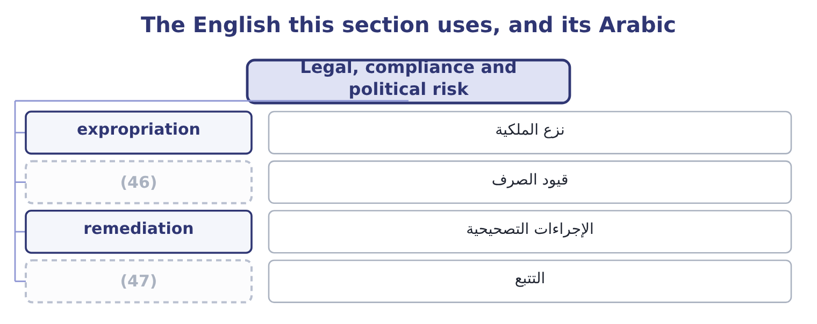
word list
traceability · exchange controls · political risk

The English this sheet uses, and its Arabic
English (exam term) | Arabic
expropriation | نزع الملكية
exchange controls | قيود الصرف
remediation | الإجراءات التصحيحية
traceability | التتبع

Answer key · 1.6 Legal, compliance and political risk

1 outside | 25 Demand, prices, costs, cost structure
2 control | 26 Board attention; real options
3 defined | 27 Insurance; prevention; continuity plans
4 intellectual | 28 Cover ratios; value at risk
5 liability | 29 Controls; redundancy; training
6 jurisdiction | 30 A range, not a point
7 distinguishing | 31 Process, monitoring, training
8 determined | 32 Government action and instability
9 arbitrator | 33 stands
10 regulations | 34 professional
11 standards | 35 somebody
12 internal | 36 speech
13 remediation | 37 answers
14 increasingly | 38 carries
15 investigation | 39 reports
16 producer | 40 challenge
17 traceability | 41 register
18 certification | 42 symptom
19 distinguish | 43 Financial risk, specifically market risk.
20 comparing | 44 Strategic risk, owned by the board.
21 controllable | 45 classification
22 expropriation | 46 exchange controls
23 exchange | 47 traceability
24 restrictions

the summaries in full
Summary 1 Three risks arrive from outside the company's control and the outcome asks for each to be defined. Legal risk is the risk of loss from legal proceedings or from legal defects: a contract that does not say what the company thought it said, a claim from a customer, an employee or a supplier, a dispute over intellectual property, a liability for a defective product, a judgment in a jurisdiction the company did not expect to be sued. Its distinguishing feature is that the loss is determined by a third party — a court or an arbitrator — on a timetable the company does not set, which is why legal risk is so poorly suited to point estimates and so well suited to a range. Compliance risk is the risk of loss from failing to observe laws, regulations, licence conditions, standards or the company's own internal rules.
Summary 2 The loss comes as a fine, a suspended licence, a required remediation, a prohibition on selling, and increasingly as the cost of the investigation itself. For a food producer, compliance is labelling, hygiene, traceability, weights and measures, export certification and employment law. Two features distinguish it from legal risk: the standard is written down in advance, so the risk can be assessed by comparing practice against the rule; and it is largely controllable, because compliance is a process the company runs. Political risk is the risk of loss from political action or instability in a country where the company operates or sells: expropriation, a change in tax law, exchange controls that trap cash in a country, import or export restrictions, sanctions, civil disorder, war, and the slower risk of a government that changes the rules of an industry. Its features are that it is largely uninsurable through ordinary markets — though specialist political risk insurance exists — that it is correlated across every exposure in one country at once, and that the usual responses are structural: limiting what is held in one country, financing locally so that a loss of assets is matched by a loss of liabilities, joint ventures with local partners, and the contract terms.
Summary 3 English uses risk for the possibility, hazard for the thing that could cause harm and exposure for what stands to be lost, and professional writing keeps the three apart: a wet floor is a hazard, the possibility of somebody falling is a risk, and the exposure is the claim that would follow. Ordinary speech uses all three for all three, which is why exam answers blur them. Note also that English risk is both noun and verb and that the verb carries blame — "they risked it" — which is one reason people avoid the word in reports and write issue or challenge instead. A risk register that contains no risks is a symptom, not a style.

2.1 Volatility
Chapter 2 · section 2.1

Fill every gap. Each word list holds one word more than there are gaps.
Chapter 2, section by section
Each stage leads to the next.
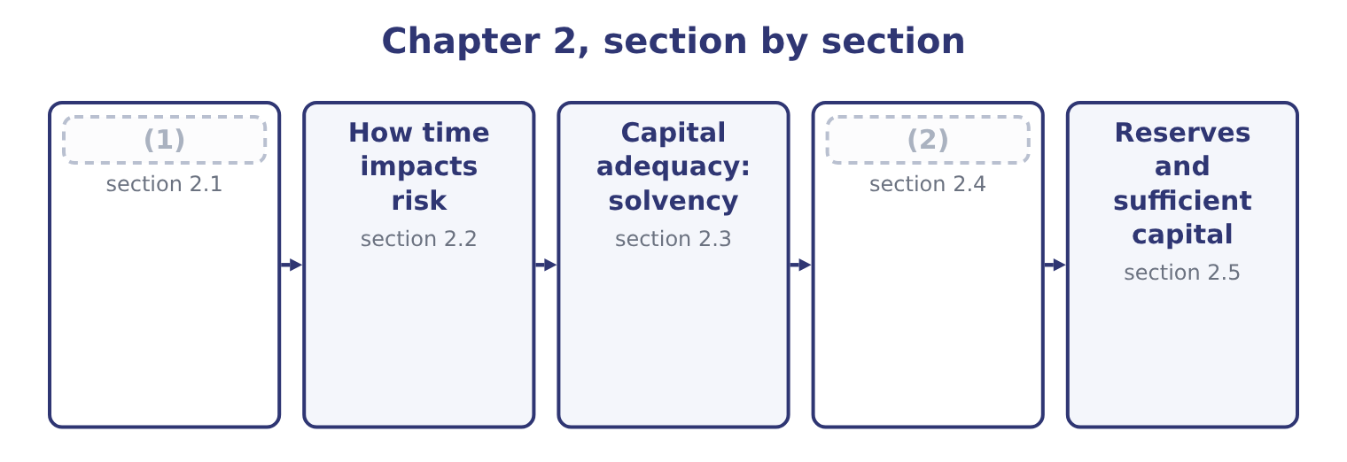
word list
Volatility · solvency · Capital adequacy: liquidity

Summary 1 gaps 3–14
Volatility is the (3) to which a (4) moves about its average. It is the first of the two (5) that make a risk large, and it is what people mean when they say that one business is (6) than another even when both earn the same on average. Three (7) of volatility (8) for the exam. It is about dispersion, not (9) . A series that is sometimes far above its average and sometimes far below it is (10) ; one that rises (11) is not, however fast it rises. It is measured from (12) and used for the future. A volatility estimated from five calm years will (13) the risk of the sixth, and a crisis is precisely the moment when past volatility stops (14) future volatility. And it is not the same as risk.
word list
direction · things · extent · matter · riskier · quantity · arithmetic · steadily · predicting · history · properties · volatile · understate

Summary 2 gaps 15–26
Volatility is a (15) of movement; risk is the (16) of that movement for the company. A business whose sales move (17) per cent either way but whose costs move with them has high volatility and (18) risk, which is the whole lesson of Book 3's cost (19) . The standard (20) are the ones Book 2 used. The standard deviation (21) dispersion in the units of the thing being measured — (22) of operating income, cents of share price. The (23) is its square and is used in the arithmetic rather than in (24) . The coefficient of variation divides the standard deviation by the mean, giving a (25) measure that allows a large business and a small one to be compared, and the range or the worst observed outcome gives a crude but intuitive (26) .
word list
states · consequence · structure · reports · variance · modest · dollars · alternative · reserves · measures · twenty · measurement · relative

Summary 3 gaps 27–38
Orontes's operating income over five years was 3,600,000, 4,900,000, 3,100,000, 4,600,000 and 4,176,000. The five add to 20,376,000, so the mean is 20,376,000 ÷ 5 = 4,075,200. Taking each year's (27) from the mean, squaring, (28) over four degrees of (29) and taking the root gives a standard deviation of 731,900. The coefficient of variation is 731,900 ÷ 4,075,200 = 17.96 per cent, which is the figure to (30) with another company or another (31) . Read the two figures as a (32) : Orontes earns about 4,075,200 of operating income in a (33) year and that figure moves by about 731,900 either way in an ordinary year. Then note what the arithmetic cannot know — the five years (34) no fire, no (35) and no recall, so the measured volatility (36) ordinary trading and says (37) at all about the (38) .
word list
compare · observed · division · tail · describes · sentence · contain · averaging · typical · devaluation · difference · freedom · nothing

The English this section uses, and its Arabic
Each term sits against what it means.
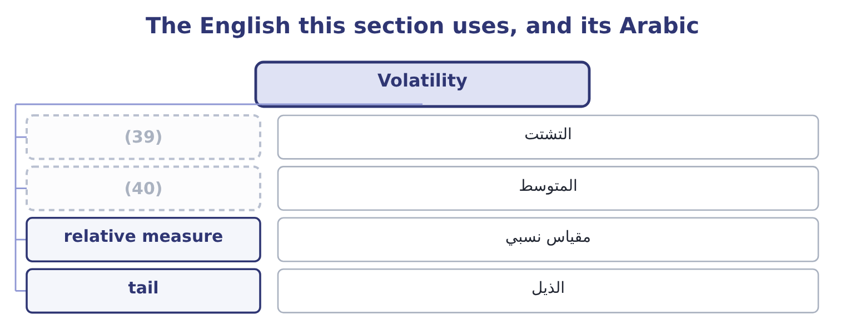
word list
المتوسط · mean · dispersion

The English this sheet uses, and its Arabic
English (exam term) | Arabic
dispersion | التشتت
mean | المتوسط
relative measure | مقياس نسبي
tail | الذيل

Answer key · 2.1 Volatility

1 Volatility | 21 states
2 Capital adequacy: liquidity | 22 dollars
3 extent | 23 variance
4 quantity | 24 reports
5 things | 25 relative
6 riskier | 26 alternative
7 properties | 27 difference
8 matter | 28 averaging
9 direction | 29 freedom
10 volatile | 30 compare
11 steadily | 31 division
12 history | 32 sentence
13 understate | 33 typical
14 predicting | 34 contain
15 measurement | 35 devaluation
16 consequence | 36 describes
17 twenty | 37 nothing
18 modest | 38 tail
19 structure | 39 dispersion
20 measures | 40 mean

the summaries in full
Summary 1 Volatility is the extent to which a quantity moves about its average. It is the first of the two things that make a risk large, and it is what people mean when they say that one business is riskier than another even when both earn the same on average. Three properties of volatility matter for the exam. It is about dispersion, not direction. A series that is sometimes far above its average and sometimes far below it is volatile; one that rises steadily is not, however fast it rises. It is measured from history and used for the future. A volatility estimated from five calm years will understate the risk of the sixth, and a crisis is precisely the moment when past volatility stops predicting future volatility. And it is not the same as risk.
Summary 2 Volatility is a measurement of movement; risk is the consequence of that movement for the company. A business whose sales move twenty per cent either way but whose costs move with them has high volatility and modest risk, which is the whole lesson of Book 3's cost structure. The standard measures are the ones Book 2 used. The standard deviation states dispersion in the units of the thing being measured — dollars of operating income, cents of share price. The variance is its square and is used in the arithmetic rather than in reports. The coefficient of variation divides the standard deviation by the mean, giving a relative measure that allows a large business and a small one to be compared, and the range or the worst observed outcome gives a crude but intuitive alternative.
Summary 3 Orontes's operating income over five years was 3,600,000, 4,900,000, 3,100,000, 4,600,000 and 4,176,000. The five add to 20,376,000, so the mean is 20,376,000 ÷ 5 = 4,075,200. Taking each year's difference from the mean, squaring, averaging over four degrees of freedom and taking the root gives a standard deviation of 731,900. The coefficient of variation is 731,900 ÷ 4,075,200 = 17.96 per cent, which is the figure to compare with another company or another division. Read the two figures as a sentence: Orontes earns about 4,075,200 of operating income in a typical year and that figure moves by about 731,900 either way in an ordinary year. Then note what the arithmetic cannot know — the five years contain no fire, no devaluation and no recall, so the measured volatility describes ordinary trading and says nothing at all about the tail.

2.2 How time impacts risk
Chapter 2 · section 2.2

Fill every gap. Each word list holds one word more than there are gaps.
Summary 1 gaps 1–12
Time is the second thing that makes a risk large, and it works in three (1) ways that the outcome expects to be (2) . The longer the horizon, the wider the (3) . A (4) that moves (5) drifts further from its starting point the longer it is allowed to move. Where the movements in (6) periods are independent, the standard deviation grows with the square root of time: four years of exposure (7) twice the one-year dispersion, not four times. The longer the horizon, the more (8) a rare event (9) . An event with a 5 per cent chance in any one year has a 1 − 0.5987 = 0.4013 chance of (10) at least once in ten, because 0.95 (11) by itself ten times is 0.5987. (12) about the event has changed; only the window has. And the longer the horizon, the less anybody knows.
word list
happening · carries · distribution · likely · distinct · randomly · Nothing · multiplied · successive · quantity · payment · becomes · distinguished

Summary 2 gaps 13–21
Beyond a few years the estimates (13) become unreliable, which is the (14) of, and it is why Book 3 put a terminal value on (15) after year five rather than pretending to forecast year eleven. Risk (16) must state their horizon. And exposure can be managed by (17) time as well as by (18) movement. A (19) payment term reduces credit exposure without (20) any customer's (21) ; a hedge that matures in three months leaves the fourth month exposed; holding stock for sixty days rather than ninety reduces the price risk in it by a third of the period.
word list
shortening · uncertainty · everything · changing · themselves · shorter · measures · creditworthiness · reducing · successive

Worked example: scaling volatility with time

Summary 3 gaps 22–33
Orontes's (22) income has a standard deviation of 731,900 over a year. Where the years are independent, the four-year dispersion is the one-year figure times the square root of four, which is 731,900 × 2 = 1,463,800. Going the other way, the (23) figure is the annual one (24) by the square root of four, which is 731,900 ÷ 2 = 365,950. All of this holds only where the periods are independent. Orontes's sales are (25) and its sesame price is persistent, so the real four-year dispersion is wider than the rule (26) in some respects and (27) in others. The (28) rule is a convention, not a law, and the (29) test whether you know what it (30) . Where movements are (31) correlated from period to period — a trend, a persistent price, a (32) that decays slowly — the rule understates the (33) risk.
word list
seasonal · operating · reputation · long-horizon · movement · square-root · assumes · suggests · examiners · positively · divided · narrower · quarterly

The English this section uses, and its Arabic
Each term sits against what it means.
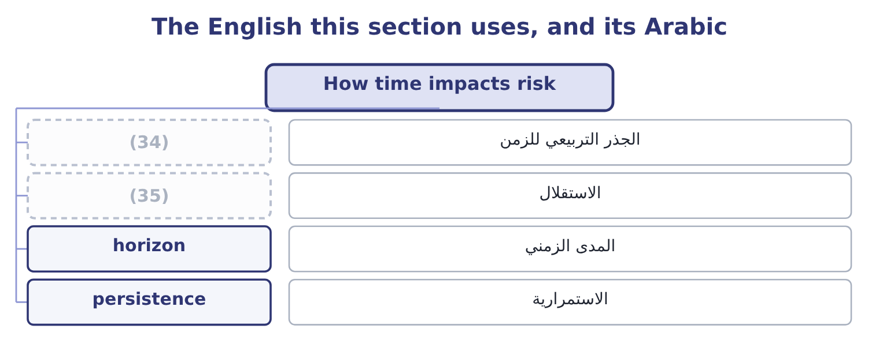
word list
persistence · independence · square root of time

The English this sheet uses, and its Arabic
English (exam term) | Arabic
square root of time | الجذر التربيعي للزمن
independence | الاستقلال
horizon | المدى الزمني
persistence | الاستمرارية

Answer key · 2.2 How time impacts risk

1 distinct | 19 shorter
2 distinguished | 20 changing
3 distribution | 21 creditworthiness
4 quantity | 22 operating
5 randomly | 23 quarterly
6 successive | 24 divided
7 carries | 25 seasonal
8 likely | 26 suggests
9 becomes | 27 narrower
10 happening | 28 square-root
11 multiplied | 29 examiners
12 Nothing | 30 assumes
13 themselves | 31 positively
14 uncertainty | 32 reputation
15 everything | 33 long-horizon
16 measures | 34 square root of time
17 shortening | 35 independence
18 reducing

the summaries in full
Summary 1 Time is the second thing that makes a risk large, and it works in three distinct ways that the outcome expects to be distinguished. The longer the horizon, the wider the distribution. A quantity that moves randomly drifts further from its starting point the longer it is allowed to move. Where the movements in successive periods are independent, the standard deviation grows with the square root of time: four years of exposure carries twice the one-year dispersion, not four times. The longer the horizon, the more likely a rare event becomes. An event with a 5 per cent chance in any one year has a 1 − 0.5987 = 0.4013 chance of happening at least once in ten, because 0.95 multiplied by itself ten times is 0.5987. Nothing about the event has changed; only the window has. And the longer the horizon, the less anybody knows.
Summary 2 Beyond a few years the estimates themselves become unreliable, which is the uncertainty of, and it is why Book 3 put a terminal value on everything after year five rather than pretending to forecast year eleven. Risk measures must state their horizon. And exposure can be managed by shortening time as well as by reducing movement. A shorter payment term reduces credit exposure without changing any customer's creditworthiness; a hedge that matures in three months leaves the fourth month exposed; holding stock for sixty days rather than ninety reduces the price risk in it by a third of the period.
Summary 3 Orontes's operating income has a standard deviation of 731,900 over a year. Where the years are independent, the four-year dispersion is the one-year figure times the square root of four, which is 731,900 × 2 = 1,463,800. Going the other way, the quarterly figure is the annual one divided by the square root of four, which is 731,900 ÷ 2 = 365,950. All of this holds only where the periods are independent. Orontes's sales are seasonal and its sesame price is persistent, so the real four-year dispersion is wider than the rule suggests in some respects and narrower in others. The square-root rule is a convention, not a law, and the examiners test whether you know what it assumes. Where movements are positively correlated from period to period — a trend, a persistent price, a reputation that decays slowly — the rule understates the long-horizon risk.

2.3 Capital adequacy: solvency
Chapter 2 · section 2.3

Fill every gap. Each word list holds one word more than there are gaps.
Summary 1 gaps 1–12
Capital (1) is the condition of having enough capital, of the right kinds and in the right places, to absorb the losses a (2) might suffer and still continue. The term comes from banking and insurance, where (3) impose it, but the concept applies to every company and the outcome asks for its four elements: solvency, (4) , reserves and sufficient capital. Solvency is the first: that assets exceed (5) , so that the company could meet its (6) if everything were realised. It is a (7) condition and it is (8) by the equity cushion. (9) equity is $20,392,975 (10) total assets of $31,672,600, so equity funds 20,392,975 ÷ 31,672,600 = 64.39 per cent of the assets. Read as a risk (11) , that says asset values could fall by nearly two thirds before the creditors were (12) — which is a different and more useful reading of the same ratio Book 1 computed as a measure of gearing.
word list
regulators · balance-sheet · obligations · impairment · liquidity · adequacy · statement · against · business · liabilities · Orontes's · measured · threatened

Summary 2 gaps 13–19
Three (13) belong with the solvency test and all three appear in (14) . It depends on the (15) of the assets. Book 1's,724,000, and an (16) is the discovery that the solvency cushion was (17) than the balance sheet said. It is a point in time. A company solvent at the year end can be (18) in March, and the test that matters is solvency after the loss, not before it. And solvency is not (19) . A company can be solvent and still fail.
word list
cautions · questions · smaller · measurement · buffer · impairment · insolvent · survival

The English this section uses, and its Arabic
Each term sits against what it means.
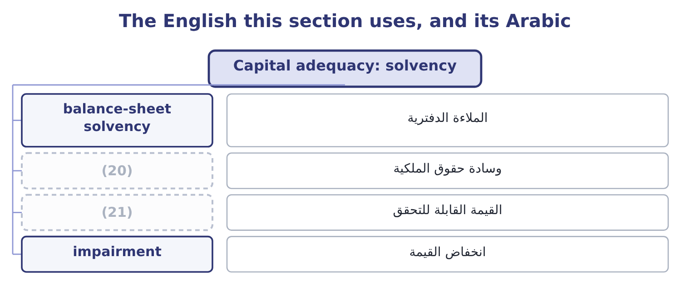
word list
الملاءة الدفترية · equity cushion · realisable value

The English this sheet uses, and its Arabic
English (exam term) | Arabic
balance-sheet solvency | الملاءة الدفترية
equity cushion | وسادة حقوق الملكية
realisable value | القيمة القابلة للتحقق
impairment | انخفاض القيمة

Answer key · 2.3 Capital adequacy: solvency

1 adequacy | 12 threatened
2 business | 13 cautions
3 regulators | 14 questions
4 liquidity | 15 measurement
5 liabilities | 16 impairment
6 obligations | 17 smaller
7 balance-sheet | 18 insolvent
8 measured | 19 survival
9 Orontes's | 20 equity cushion
10 against | 21 realisable value
11 statement

the summaries in full
Summary 1 Capital adequacy is the condition of having enough capital, of the right kinds and in the right places, to absorb the losses a business might suffer and still continue. The term comes from banking and insurance, where regulators impose it, but the concept applies to every company and the outcome asks for its four elements: solvency, liquidity, reserves and sufficient capital. Solvency is the first: that assets exceed liabilities, so that the company could meet its obligations if everything were realised. It is a balance-sheet condition and it is measured by the equity cushion. Orontes's equity is $20,392,975 against total assets of $31,672,600, so equity funds 20,392,975 ÷ 31,672,600 = 64.39 per cent of the assets. Read as a risk statement, that says asset values could fall by nearly two thirds before the creditors were threatened — which is a different and more useful reading of the same ratio Book 1 computed as a measure of gearing.
Summary 2 Three cautions belong with the solvency test and all three appear in questions. It depends on the measurement of the assets. Book 1's,724,000, and an impairment is the discovery that the solvency cushion was smaller than the balance sheet said. It is a point in time. A company solvent at the year end can be insolvent in March, and the test that matters is solvency after the loss, not before it. And solvency is not survival. A company can be solvent and still fail.

2.4 Capital adequacy: liquidity
Chapter 2 · section 2.4

Fill every gap. Each word list holds one word more than there are gaps.
Summary 1 gaps 1–12
Liquidity is the ability to meet (1) as they fall due, in cash, at the moment they fall due. It is a flow condition rather than a (2) one, and it is the element that actually kills companies: the great majority of corporate failures are liquidity failures in (3) that were solvent on paper. The (4) is worth stating in one line, because the exam tests it (5) . (6) asks whether there is (7) . Liquidity asks whether it is (8) in time and in the right form. (9) position is (10) . It holds $7,302,100 of cash and $4,144,000 of receivables, which (11) are 7,302,100 + 4,144,000 = 11,446,100 of (12) against payables of $2,050,000 — a cover of 11,446,100 ÷ 2,050,000 = 5.58 times. Book 1 read that as a sign of cash sitting idle; read as a risk statement it is a buffer, and the tension between those two readings is a real one.
word list
strong · Solvency · balance-sheet · directly · everybody · Orontes's · near-cash · obligations · enough · businesses · available · distinction · together

Summary 2 gaps 13–24
Four sources of liquidity exist and a company (13) know the size and (14) of each. Cash and (15) , which are certain and earn (16) . Undrawn committed facilities, which are nearly certain — subject to the covenants of Book 2's, which are exactly the (17) most likely to be breached in the (18) where the facility is needed. Assets that can be sold or (19) , which are reliable in calm markets and least reliable in the moment they are called on, because (20) else is selling the same things. And the (21) cycle itself: receivables that will be (22) and stock that will be sold, whose timing is the subject of Book 1's. That (23) is the lesson. Liquidity sources behave worst at exactly the moment they are needed, which is why a liquidity buffer is held in cash and committed facilities and not in the hope of selling (24) .
word list
collected · should · everybody · something · financed · deposits · ordering · selling · conditions · circumstances · reliability · operating · little

The English this section uses, and its Arabic
Each term sits against what it means.
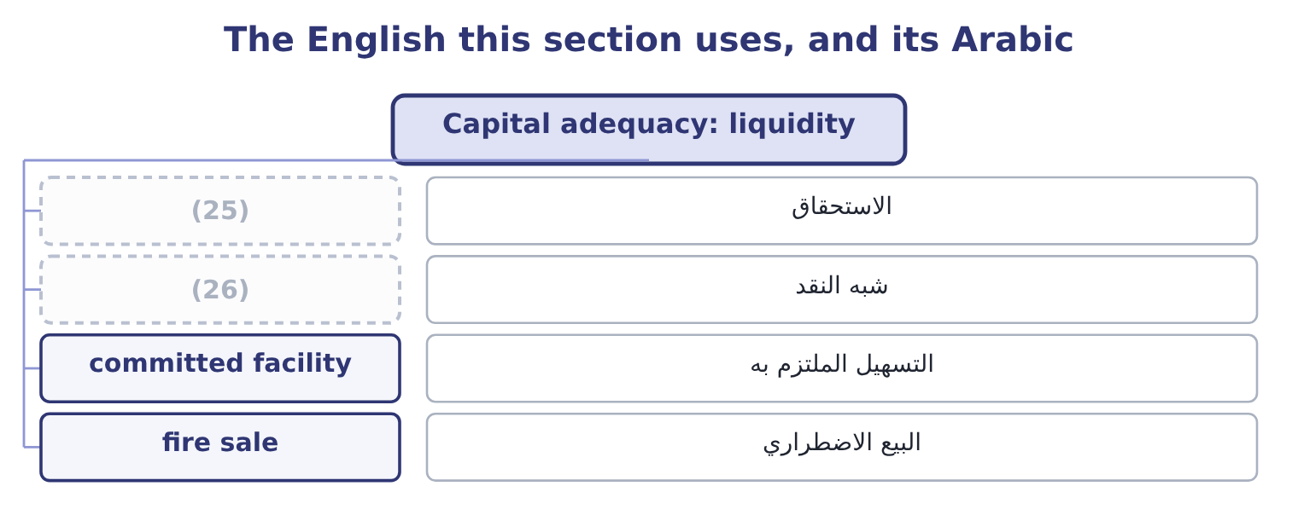
word list
horizon · near-cash · falling due

The English this sheet uses, and its Arabic
English (exam term) | Arabic
falling due | الاستحقاق
near-cash | شبه النقد
committed facility | التسهيل الملتزم به
fire sale | البيع الاضطراري

Answer key · 2.4 Capital adequacy: liquidity

1 obligations | 14 reliability
2 balance-sheet | 15 deposits
3 businesses | 16 little
4 distinction | 17 conditions
5 directly | 18 circumstances
6 Solvency | 19 financed
7 enough | 20 everybody
8 available | 21 operating
9 Orontes's | 22 collected
10 strong | 23 ordering
11 together | 24 something
12 near-cash | 25 falling due
13 should | 26 near-cash

the summaries in full
Summary 1 Liquidity is the ability to meet obligations as they fall due, in cash, at the moment they fall due. It is a flow condition rather than a balance-sheet one, and it is the element that actually kills companies: the great majority of corporate failures are liquidity failures in businesses that were solvent on paper. The distinction is worth stating in one line, because the exam tests it directly. Solvency asks whether there is enough. Liquidity asks whether it is available in time and in the right form. Orontes's position is strong. It holds $7,302,100 of cash and $4,144,000 of receivables, which together are 7,302,100 + 4,144,000 = 11,446,100 of near-cash against payables of $2,050,000 — a cover of 11,446,100 ÷ 2,050,000 = 5.58 times. Book 1 read that as a sign of cash sitting idle; read as a risk statement it is a buffer, and the tension between those two readings is a real one.
Summary 2 Four sources of liquidity exist and a company should know the size and reliability of each. Cash and deposits, which are certain and earn little. Undrawn committed facilities, which are nearly certain — subject to the covenants of Book 2's, which are exactly the conditions most likely to be breached in the circumstances where the facility is needed. Assets that can be sold or financed, which are reliable in calm markets and least reliable in the moment they are called on, because everybody else is selling the same things. And the operating cycle itself: receivables that will be collected and stock that will be sold, whose timing is the subject of Book 1's. That ordering is the lesson. Liquidity sources behave worst at exactly the moment they are needed, which is why a liquidity buffer is held in cash and committed facilities and not in the hope of selling something.

2.5 Reserves and sufficient capital
Chapter 2 · section 2.5

Fill every gap. Each word list holds one word more than there are gaps.
Summary 1 gaps 1–12
The last two elements of capital adequacy are the ones (1) most often confuse, because the word reserve is used in two (2) senses. A reserve in the accounting sense is a component of equity — retained earnings, a (3) reserve, a (4) reserve. It is a label on the (5) side of the balance sheet (6) where the equity came from, and it is not money. A company with large retained earnings and no cash cannot pay anything out of its reserves, which is one of the most persistent (7) in business (8) . A reserve in the risk sense is an amount set aside against an (9) future loss: an insurer's claims reserve, a bank's loan-loss provision, a (10) warranty provision, a company's allowance for doubtful receivables. This reserve is a (11) that a loss is expected, and that is the key: reserves cover expected (12) .
word list
losses · different · misunderstandings · recognition · revaluation · manufacturer's · right-hand · identified · describing · conversation · expenditure · translation · candidates

Summary 2 gaps 13–23
Sufficient capital is the (13) that covers what reserves do not. Capital absorbs unexpected loss — the amount by which an actual loss (14) what was expected and (15) . How much capital is sufficient (16) on four things, and an answer that names them is a (17) answer. The volatility and the (18) of sections 2.1 and 2.2 — how far (19) might move, over how long. The risk (20) : how much chance of (21) the owners are willing to run. The claims that must be met (22) happens: interest, (23) , committed capital expenditure, the fixed costs of Book 3. And any external requirement: regulatory capital for a financial institution, covenant minimums for a borrower, a credit rating the company wants to keep.
word list
failure · repayments · horizon · sixty-day · complete · results · appetite · element · whatever · depends · reserved · exceeds

Worked example: does Orontes hold enough?

Summary 3 gaps 24–35
A plausible bad year. Sales fall 10 per cent, which at an operating (24) of 4.02 removes 4,176,000 × 0.402 = 1,678,752 of operating income, (25) 4,176,000 − 1,678,752 = 2,497,248. A (26) stoppage of the kind,761,620 of (27) , and since 2,761,620 − 2,497,248 = 264,372, the year ends 264,372 below zero. Can it be (28) ? The interest of $390,000 must still be paid, and the cash balance of $7,302,100 covers both that and the loss many times over. The (29) is therefore not this year's loss but the (30) : capital expenditure to replace the (31) hall, on top of a year with no cash (32) , is what would consume the (33) . That is what a capital adequacy (34) looks like for a company that is not a bank: not a formula, but a plausible (35) of bad things, costed, set against the cash and the facilities actually available, with the fixed claims that do not stop.
word list
constraint · leverage · roasting · leaving · generation · absorbed · sixty-day · contribution · buffer · rebuilding · assessment · combination · elements

Volatility, time and adequacy

Your turn: measuring and surviving (complete the blanks)
Item | Data | Answer
Coefficient of variation | (36) | ________
Four-year volatility | (37) | ________
Probability of a 5 per cent event in ten years | 0.95 to the tenth power is 0.5987 | ________
Equity as a share of assets | (38) | ________
Cash and receivables against payables | 7,302,100 and 4,144,000 against 2,050,000 | ________
What covers expected loss, and what covers unexpected loss |  | ________

word list
One-year 731,900; periods independent · Equity 20,392,975; assets 31,672,600 · Standard deviation 731,900; mean 4,075,200 · square root of time

"Reserve", "provision" and "capital"

Summary 4 gaps 39–47
Few words cause more (39) in English than reserve. In accounting a reserve is part of equity and (40) where money came; in (41) and banking a reserve is an amount set aside against a loss; in ordinary speech a reserve is (42) held back for later, which is closer to the second. Provision is the (43) accounting term for a (44) of uncertain timing or amount, and in English (45) provision is the correct word where a loss is expected, with reserve kept for equity. Where a (46) uses the word, read which of the two it means before (47) .
word list
conversation · question · liability · describes · narrower · confusion · insurance · something · answering · practice

"Reserve", "provision" and "capital"
Item | Answer
Coefficient of variation | 17.96 per cent: 731,900 ÷ 4,075,200 = 17.96 per cent.
Four-year volatility | 1,463,800: 731,900 × 2 = 1,463,800, the square root of four being two.
Probability over ten years | (48) : 1 − 0.5987 = 0.4013.
Equity as a share of assets | 64.39 per cent: 20,392,975 ÷ 31,672,600 = 64.39 per cent.
Cash and receivables against payables | (49) : 11,446,100 ÷ 2,050,000 = 5.58.
What covers each kind of loss | Reserves cover expected loss; capital absorbs unexpected loss.
What it tells you | The first five are measurements and the sixth is the principle they serve: measure the movement, measure the time, and then ask whether what

word list
relative measure · About 40 per cent · 5.58 times

The English this section uses, and its Arabic
Each term sits against what it means.
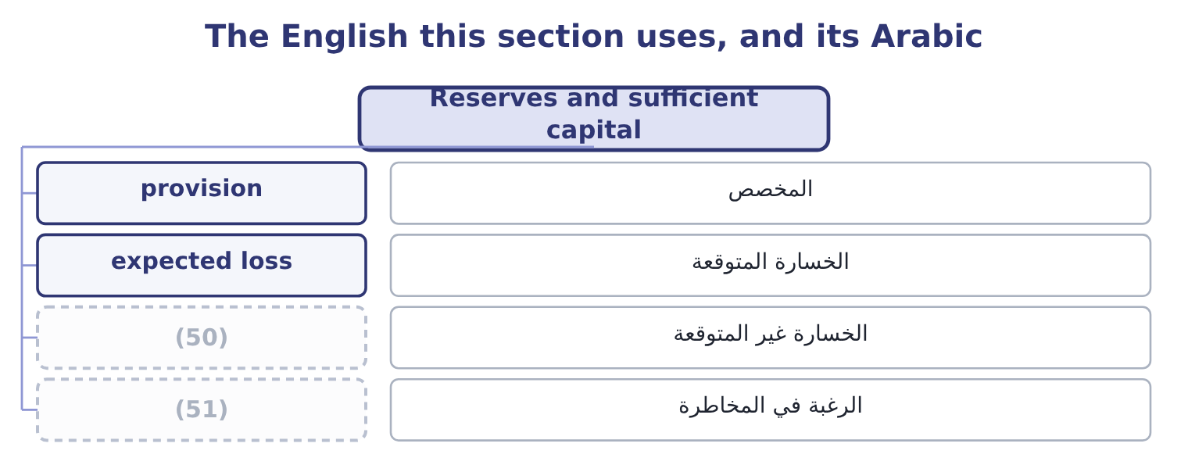
word list
unexpected loss · standard deviation · risk appetite

The English this sheet uses, and its Arabic
English (exam term) | Arabic
provision | المخصص
expected loss | الخسارة المتوقعة
unexpected loss | الخسارة غير المتوقعة
risk appetite | الرغبة في المخاطرة

Answer key · 2.5 Reserves and sufficient capital

1 candidates | 27 contribution
2 different | 28 absorbed
3 revaluation | 29 constraint
4 translation | 30 rebuilding
5 right-hand | 31 roasting
6 describing | 32 generation
7 misunderstandings | 33 buffer
8 conversation | 34 assessment
9 identified | 35 combination
10 manufacturer's | 36 Standard deviation 731,900; mean 4,075,200
11 recognition | 37 One-year 731,900; periods independent
12 losses | 38 Equity 20,392,975; assets 31,672,600
13 element | 39 confusion
14 exceeds | 40 describes
15 reserved | 41 insurance
16 depends | 42 something
17 complete | 43 narrower
18 horizon | 44 liability
19 results | 45 practice
20 appetite | 46 question
21 failure | 47 answering
22 whatever | 48 About 40 per cent
23 repayments | 49 5.58 times
24 leverage | 50 unexpected loss
25 leaving | 51 risk appetite
26 sixty-day

the summaries in full
Summary 1 The last two elements of capital adequacy are the ones candidates most often confuse, because the word reserve is used in two different senses. A reserve in the accounting sense is a component of equity — retained earnings, a revaluation reserve, a translation reserve. It is a label on the right-hand side of the balance sheet describing where the equity came from, and it is not money. A company with large retained earnings and no cash cannot pay anything out of its reserves, which is one of the most persistent misunderstandings in business conversation. A reserve in the risk sense is an amount set aside against an identified future loss: an insurer's claims reserve, a bank's loan-loss provision, a manufacturer's warranty provision, a company's allowance for doubtful receivables. This reserve is a recognition that a loss is expected, and that is the key: reserves cover expected losses.
Summary 2 Sufficient capital is the element that covers what reserves do not. Capital absorbs unexpected loss — the amount by which an actual loss exceeds what was expected and reserved. How much capital is sufficient depends on four things, and an answer that names them is a complete answer. The volatility and the horizon of sections 2.1 and 2.2 — how far results might move, over how long. The risk appetite: how much chance of failure the owners are willing to run. The claims that must be met whatever happens: interest, repayments, committed capital expenditure, the fixed costs of Book 3. And any external requirement: regulatory capital for a financial institution, covenant minimums for a borrower, a credit rating the company wants to keep.
Summary 3 A plausible bad year. Sales fall 10 per cent, which at an operating leverage of 4.02 removes 4,176,000 × 0.402 = 1,678,752 of operating income, leaving 4,176,000 − 1,678,752 = 2,497,248. A sixty-day stoppage of the kind,761,620 of contribution, and since 2,761,620 − 2,497,248 = 264,372, the year ends 264,372 below zero. Can it be absorbed? The interest of $390,000 must still be paid, and the cash balance of $7,302,100 covers both that and the loss many times over. The constraint is therefore not this year's loss but the rebuilding: capital expenditure to replace the roasting hall, on top of a year with no cash generation, is what would consume the buffer. That is what a capital adequacy assessment looks like for a company that is not a bank: not a formula, but a plausible combination of bad things, costed, set against the cash and the facilities actually available, with the fixed claims that do not stop.
Summary 4 Few words cause more confusion in English than reserve. In accounting a reserve is part of equity and describes where money came; in insurance and banking a reserve is an amount set aside against a loss; in ordinary speech a reserve is something held back for later, which is closer to the second. Provision is the narrower accounting term for a liability of uncertain timing or amount, and in English practice provision is the correct word where a loss is expected, with reserve kept for equity. Where a question uses the word, read which of the two it means before answering.

3.1 Where probabilities come from
Chapter 3 · section 3.1

Fill every gap. Each word list holds one word more than there are gaps.
Chapter 3, section by section
Each stage leads to the next.
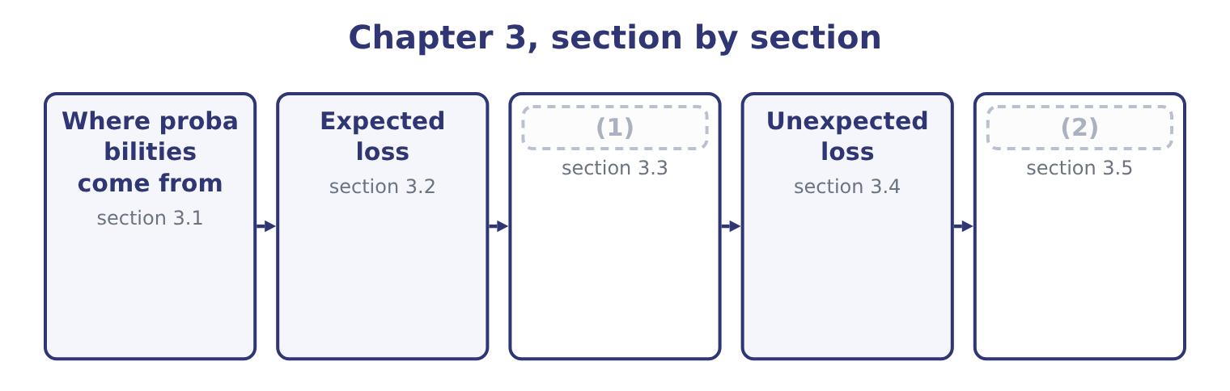
word list
Where probabilities come from · A register of risks, and the portfolio effect · Maximum possible loss

Summary 1 gaps 3–14
A probability is a number (3) zero and one (4) how likely an event is. Risk work uses three (5) for them and the exam expects the distinction, because the three differ (6) in how much they can be trusted. Where an event has happened many times under similar (7) — machine failures, delivery delays, customer defaults, claims on a class of insurance — the (8) of occasions on which it occurred is an estimate of its probability. This is the (9) source and it requires volume: a company with four hundred (10) can estimate the probability that a supplier fails; a company with one cannot. (11) , from people who know. Where data do not exist, the people closest to the process estimate the likelihood, usually on a scale — remote, (12) , possible, likely, almost certain — anchored to numbers so that the words mean the same thing to (13) . This is where most corporate risk (14) actually lives.
word list
describing · suppliers · sources · conditions · strongest · computed · Judgment · everybody · enormously · unlikely · proportion · assessment · between

Summary 2 gaps 15–26
A model, from a (15) . Where the event depends on things that can (16) be modelled — an exchange rate, an interest rate, a commodity price — a (17) can be fitted and probabilities read off it. This is the (18) source and the most dangerous, because the apparent precision of a computed probability is inherited from (19) nobody tests. Four rules of use (20) , and they are the (21) part. Probabilities of mutually (22) outcomes sum to one. A (23) table whose probabilities add to 0.9 is (24) , and the missing tenth is usually the outcome nobody wanted to write down. (25) must be argued, not (26) . The probability that two things both happen is the product of their probabilities only where neither affects the other, and in a company almost nothing is independent: a bad year for volumes is also a bad year for collections, because the same economy causes both.
word list
assumed · incomplete · follow · between · exclusive · severity · Independence · distribution · strongest-looking · structure · examinable · assumptions · themselves

Summary 3 gaps 27–32
Probabilities are (27) on the controls that exist now. The likelihood of a loss from an unchecked delivery is not the likelihood after the check is (28) , which is the (29) distinction. And a probability (30) for a frequent event does not (31) to a rare one. Estimating a one-in-two-hundred-year event from twenty years of data is (32) , not measurement, and section 3.5 is about exactly that problem.
word list
estimated · outcome · transfer · conditional · reinstated · inherent-and-residual · extrapolation

The English this section uses, and its Arabic
Each term sits against what it means.
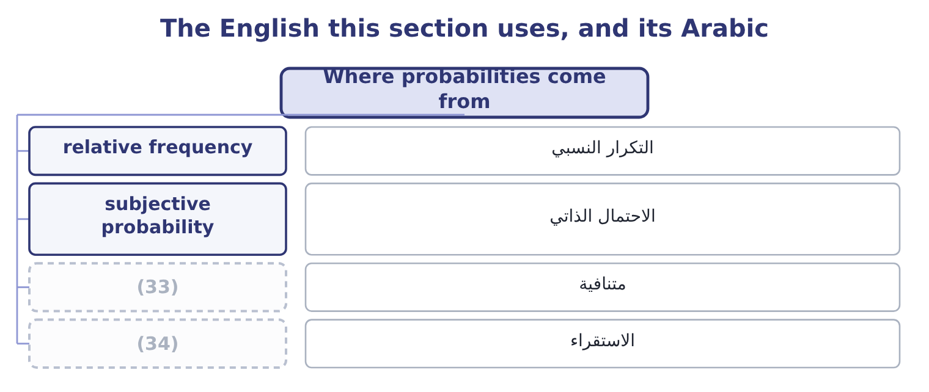
word list
severity distribution · extrapolation · mutually exclusive

The English this sheet uses, and its Arabic
English (exam term) | Arabic
relative frequency | التكرار النسبي
subjective probability | الاحتمال الذاتي
mutually exclusive | متنافية
extrapolation | الاستقراء

Answer key · 3.1 Where probabilities come from

1 A register of risks, and the portfolio effect | 18 strongest-looking
2 Maximum possible loss | 19 assumptions
3 between | 20 follow
4 describing | 21 examinable
5 sources | 22 exclusive
6 enormously | 23 severity
7 conditions | 24 incomplete
8 proportion | 25 Independence
9 strongest | 26 assumed
10 suppliers | 27 conditional
11 Judgment | 28 reinstated
12 unlikely | 29 inherent-and-residual
13 everybody | 30 estimated
14 assessment | 31 transfer
15 structure | 32 extrapolation
16 themselves | 33 mutually exclusive
17 distribution | 34 extrapolation

the summaries in full
Summary 1 A probability is a number between zero and one describing how likely an event is. Risk work uses three sources for them and the exam expects the distinction, because the three differ enormously in how much they can be trusted. Where an event has happened many times under similar conditions — machine failures, delivery delays, customer defaults, claims on a class of insurance — the proportion of occasions on which it occurred is an estimate of its probability. This is the strongest source and it requires volume: a company with four hundred suppliers can estimate the probability that a supplier fails; a company with one cannot. Judgment, from people who know. Where data do not exist, the people closest to the process estimate the likelihood, usually on a scale — remote, unlikely, possible, likely, almost certain — anchored to numbers so that the words mean the same thing to everybody. This is where most corporate risk assessment actually lives.
Summary 2 A model, from a structure. Where the event depends on things that can themselves be modelled — an exchange rate, an interest rate, a commodity price — a distribution can be fitted and probabilities read off it. This is the strongest-looking source and the most dangerous, because the apparent precision of a computed probability is inherited from assumptions nobody tests. Four rules of use follow, and they are the examinable part. Probabilities of mutually exclusive outcomes sum to one. A severity table whose probabilities add to 0.9 is incomplete, and the missing tenth is usually the outcome nobody wanted to write down. Independence must be argued, not assumed. The probability that two things both happen is the product of their probabilities only where neither affects the other, and in a company almost nothing is independent: a bad year for volumes is also a bad year for collections, because the same economy causes both.
Summary 3 Probabilities are conditional on the controls that exist now. The likelihood of a loss from an unchecked delivery is not the likelihood after the check is reinstated, which is the inherent-and-residual distinction. And a probability estimated for a frequent event does not transfer to a rare one. Estimating a one-in-two-hundred-year event from twenty years of data is extrapolation, not measurement, and section 3.5 is about exactly that problem.

3.2 Expected loss
Chapter 3 · section 3.2

Fill every gap. Each word list holds one word more than there are gaps.
Summary 1 gaps 1–6
Expected loss is probability (1) by severity. It is the average loss per period over many (2) , and it is the figure that belongs in a budget, in a price and in a (3) . Where a risk has a (4) severity, the calculation is one (5) . Where it has a range of possible (6) , the expected loss is the sum of probability times severity across every outcome, including the outcome in which nothing happens.
word list
provision · severities · multiplied · single · costing · multiplication · periods

Worked example: the expected cost of a roaster failure

Summary 2 gaps 7–18
Orontes's (7) put the year's roaster (8) into four cases: no (9) failure, with probability 0.60; a short stop costing 150,000, with probability 0.25; a serious failure costing 800,000, with probability 0.10; and a destroyed roaster costing 3,000,000, with probability 0.05. The short stop contributes 0.25 × 150,000 = 37,500; the serious failure 0.10 × 800,000 = 80,000; the destroyed roaster 0.05 × 3,000,000 = 150,000; and the (10) case contributes nothing. (11) 37,500 + 80,000 + 150,000 = 267,500. The expected loss from roaster failure is 267,500 a year. Note what that figure is not. It is not what will (12) : in 60 per cent of years the loss is zero, and the expected loss of 267,500 is an outcome that (13) occur at all. It is the amount to put in the budget, the amount a fair (14) would charge before (15) , and the amount (16) which the cost of a preventive (17) contract should be (18) .
word list
against · certainty · maintenance · happen · insurer · cannot · performance · Together · compared · significant · engineers · no-failure · expenses

Summary 3 gaps 19–30
Anybody who reads it as a (19) of this year's loss has (20) it. Three uses and one warning. An expected credit loss belongs in the margin, which is why a (21) with a weaker (22) should be charged more or given shorter terms. The expected loss is what, and an (23) for doubtful (24) is an expected loss calculation whether or not anybody calls it one. A (25) costing 100,000 a year that (26) a 267,500 expected loss saves 267,500 ÷ 2 = 133,750, so it pays — which is. The warning is that the expected loss is an average and (27) hide shape. Two risks with the same expected loss of 267,500 — one that loses 267,500 every year with (28) , and one that loses nothing for nineteen years and 5,350,000 in the (29) — are entirely different problems, and the second may end the company. (30) 3.4 and 3.5 exist because of that sentence.
word list
certainty · customer · forecast · averages · control · covenant · Sections · twentieth · receivables · misunderstood · halves · because · allowance

The English this section uses, and its Arabic
Each term sits against what it means.
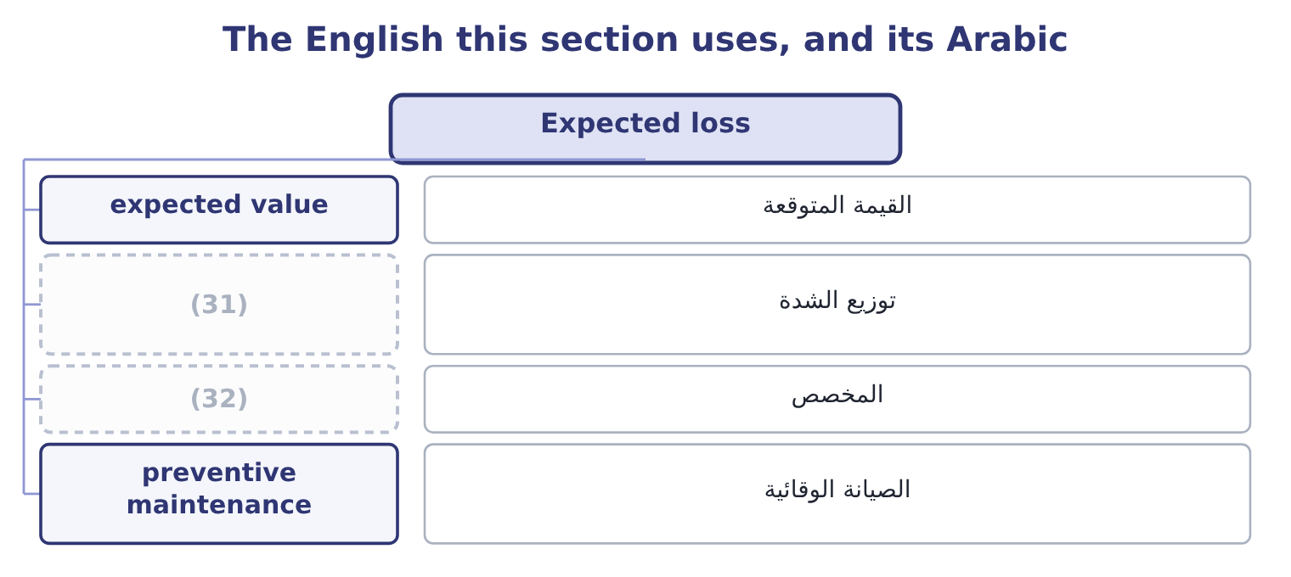
word list
unexpected loss · severity distribution · provision

The English this sheet uses, and its Arabic
English (exam term) | Arabic
expected value | القيمة المتوقعة
severity distribution | توزيع الشدة
provision | المخصص
preventive maintenance | الصيانة الوقائية

Answer key · 3.2 Expected loss

1 multiplied | 17 maintenance
2 periods | 18 compared
3 provision | 19 forecast
4 single | 20 misunderstood
5 multiplication | 21 customer
6 severities | 22 covenant
7 engineers | 23 allowance
8 performance | 24 receivables
9 significant | 25 control
10 no-failure | 26 halves
11 Together | 27 averages
12 happen | 28 certainty
13 cannot | 29 twentieth
14 insurer | 30 Sections
15 expenses | 31 severity distribution
16 against | 32 provision

the summaries in full
Summary 1 Expected loss is probability multiplied by severity. It is the average loss per period over many periods, and it is the figure that belongs in a budget, in a price and in a provision. Where a risk has a single severity, the calculation is one multiplication. Where it has a range of possible severities, the expected loss is the sum of probability times severity across every outcome, including the outcome in which nothing happens.
Summary 2 Orontes's engineers put the year's roaster performance into four cases: no significant failure, with probability 0.60; a short stop costing 150,000, with probability 0.25; a serious failure costing 800,000, with probability 0.10; and a destroyed roaster costing 3,000,000, with probability 0.05. The short stop contributes 0.25 × 150,000 = 37,500; the serious failure 0.10 × 800,000 = 80,000; the destroyed roaster 0.05 × 3,000,000 = 150,000; and the no-failure case contributes nothing. Together 37,500 + 80,000 + 150,000 = 267,500. The expected loss from roaster failure is 267,500 a year. Note what that figure is not. It is not what will happen: in 60 per cent of years the loss is zero, and the expected loss of 267,500 is an outcome that cannot occur at all. It is the amount to put in the budget, the amount a fair insurer would charge before expenses, and the amount against which the cost of a preventive maintenance contract should be compared.
Summary 3 Anybody who reads it as a forecast of this year's loss has misunderstood it. Three uses and one warning. An expected credit loss belongs in the margin, which is why a customer with a weaker covenant should be charged more or given shorter terms. The expected loss is what, and an allowance for doubtful receivables is an expected loss calculation whether or not anybody calls it one. A control costing 100,000 a year that halves a 267,500 expected loss saves 267,500 ÷ 2 = 133,750, so it pays — which is. The warning is that the expected loss is an average and averages hide shape. Two risks with the same expected loss of 267,500 — one that loses 267,500 every year with certainty, and one that loses nothing for nineteen years and 5,350,000 in the twentieth — are entirely different problems, and the second may end the company. Sections 3.4 and 3.5 exist because of that sentence.

3.3 A register of risks, and the portfolio effect
Chapter 3 · section 3.3

Fill every gap. Each word list holds one word more than there are gaps.
Summary 1 gaps 1–3
A company does not face one risk. It faces a list, and the expected losses on that list add — which is one of the few (1) in risk work where (2) addition is correct, because (3) add whether or not the risks are independent.
word list
places · expectations · simple · average

Orontes's expected loss, five risks
The bars are drawn to scale.
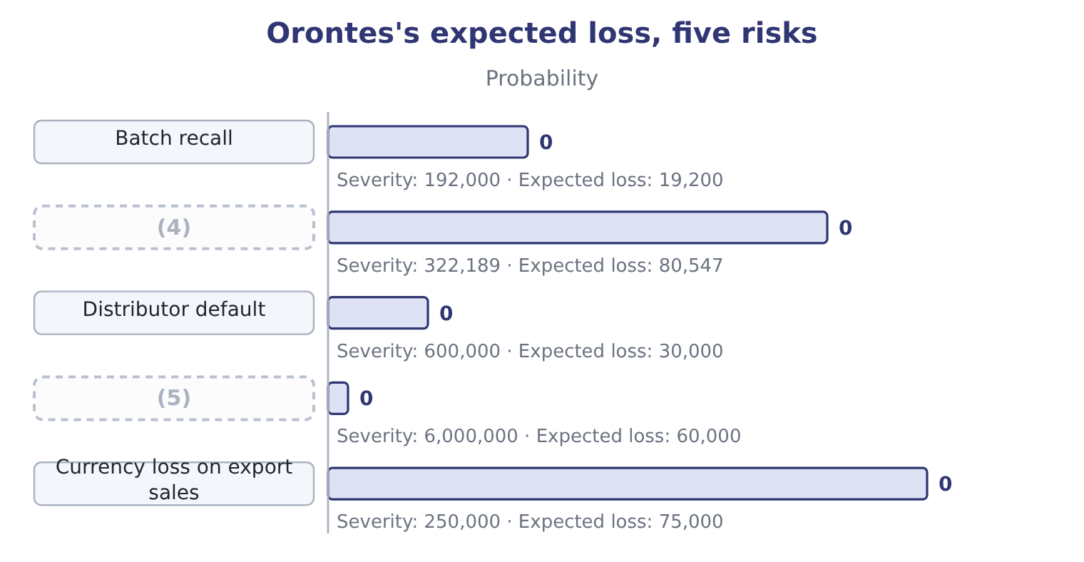
word list
Currency loss on export sales · Fire, sixty days and rebuilding · Roaster stoppage, seven days

Summary 2 gaps 6–17
The arithmetic is four (6) and an addition: 19,200 + 80,547 + 30,000 = 129,747 for the first three, and 129,747 + 60,000 + 75,000 = 264,747 with the last two. Against (7) income of $4,176,000 that is about six per cent, which is a (8) statement of what risk costs Orontes in a typical year. Three (9) of the table repay (10) , and all three are examined. The ranking by expected loss is not the ranking by (11) . The roaster (12) has the largest expected loss and would not (13) the company; the fire has the smallest but one and could. Expected loss ranks risks by what they cost on (14) , not by what they could do, which is why. Expected losses add; (15) do not. The total expected loss is 264,747 whether the risks move (16) or not, but the chance of a very bad year depends (17) on whether they do.
word list
entirely · attention · dispersions · readings · reasonable · multiplications · operating · usually · threaten · average · stoppage · danger · together

Summary 3 gaps 18–23
If the (18) loss, the default and the recall all follow from the same economic shock, the (19) is far riskier than five independent risks of the same sizes. And the total is only as good as the (20) . Every (21) in this table is for a risk (22) wrote down. The loss that ends a company is (23) one that was not on the list, which is why.
word list
number · expected · register · portfolio · somebody · usually · currency

The English this section uses, and its Arabic
Each term sits against what it means.
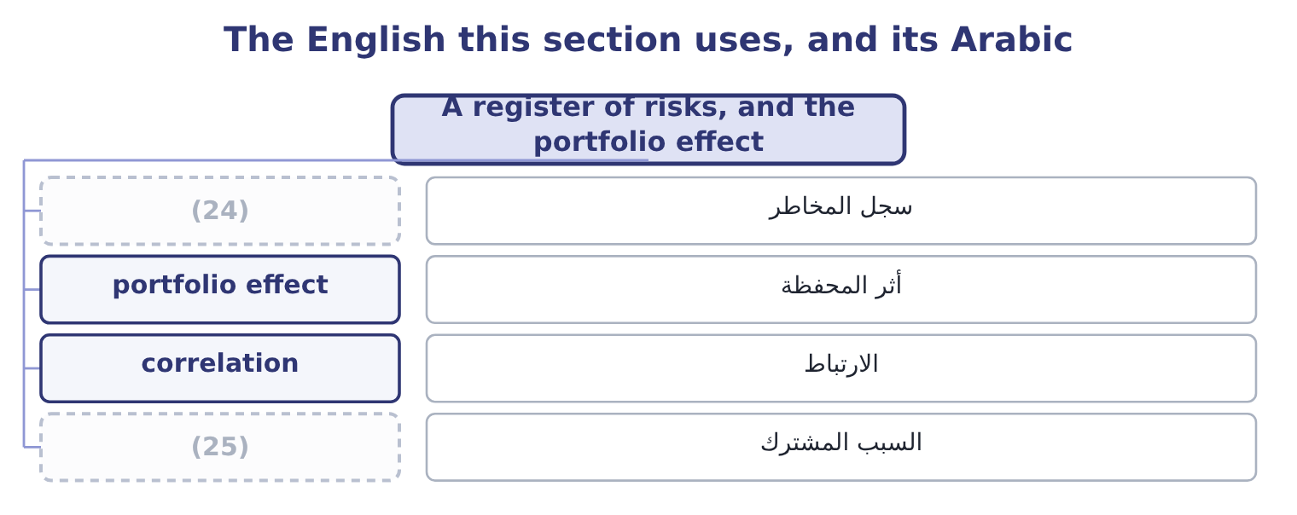
word list
risk register · expected value · common cause

The English this sheet uses, and its Arabic
English (exam term) | Arabic
risk register | سجل المخاطر
portfolio effect | أثر المحفظة
correlation | الارتباط
common cause | السبب المشترك

Answer key · 3.3 A register of risks, and the portfolio effect

1 places | 14 average
2 simple | 15 dispersions
3 expectations | 16 together
4 Roaster stoppage, seven days | 17 entirely
5 Fire, sixty days and rebuilding | 18 currency
6 multiplications | 19 portfolio
7 operating | 20 register
8 reasonable | 21 number
9 readings | 22 somebody
10 attention | 23 usually
11 danger | 24 risk register
12 stoppage | 25 common cause
13 threaten

the summaries in full
Summary 1 A company does not face one risk. It faces a list, and the expected losses on that list add — which is one of the few places in risk work where simple addition is correct, because expectations add whether or not the risks are independent.
Summary 2 The arithmetic is four multiplications and an addition: 19,200 + 80,547 + 30,000 = 129,747 for the first three, and 129,747 + 60,000 + 75,000 = 264,747 with the last two. Against operating income of $4,176,000 that is about six per cent, which is a reasonable statement of what risk costs Orontes in a typical year. Three readings of the table repay attention, and all three are examined. The ranking by expected loss is not the ranking by danger. The roaster stoppage has the largest expected loss and would not threaten the company; the fire has the smallest but one and could. Expected loss ranks risks by what they cost on average, not by what they could do, which is why. Expected losses add; dispersions do not. The total expected loss is 264,747 whether the risks move together or not, but the chance of a very bad year depends entirely on whether they do.
Summary 3 If the currency loss, the default and the recall all follow from the same economic shock, the portfolio is far riskier than five independent risks of the same sizes. And the total is only as good as the register. Every number in this table is for a risk somebody wrote down. The loss that ends a company is usually one that was not on the list, which is why.

3.4 Unexpected loss
Chapter 3 · section 3.4

Fill every gap. Each word list holds one word more than there are gaps.
Summary 1 gaps 1–8
Unexpected loss is the (1) by which an actual loss (2) the expected loss. It is the dispersion of the loss distribution rather than its average, and it is. It is (3) in two ways and both appear in (4) . As a (5) dispersion: the standard (6) of the loss, which is the usual (7) where a distribution has been fitted. As the (8) from the expected loss to a chosen percentile: the loss that will not be exceeded in, say, 95 or 99 per cent of years, less the expected loss.
word list
amount · statistical · definition · deviation · distance · questions · awkwardness · exceeds · stated

Worked example: the roaster's unexpected loss

Summary 2 gaps 9–20
From section 3.2: no loss at 0.60, so 60 per cent of years cost (9) ; adding the short stop takes the cumulative (10) to 0.60 + 0.25 = 0.85; adding the (11) failure takes it to 0.85 + 0.10 = 0.95; the (12) roaster takes it to one. Find the 95th percentile. The loss not exceeded in 95 per cent of years is 800,000. (13) the expected loss. The unexpected loss at that confidence level is 800,000 − 267,500 = 532,500. Read the two (14) . In an average year the roaster costs 267,500. In a bad year — one year in (15) — it costs 800,000, which is 532,500 more than the budget (16) for. Those two (17) are what a risk (18) should say, and the second is the one that (19) how much capital or how large a (20) is needed.
word list
Subtract · report · provides · probability · sentences · together · serious · nothing · destroyed · deviation · twenty · facility · determines

Summary 3 gaps 21–32
Note also the (21) at the boundary: the 95th percentile of this distribution lands exactly on an outcome, so a slightly (22) confidence level — 96 per cent — jumps straight to 3,000,000. Discrete (23) behave like that, and an answer that quotes a percentile from a (24) table should say which row it fell on. Two (25) of unexpected loss (26) . It depends on the confidence level chosen, which is a (27) about risk (28) and not a fact about the risk. A 99 per cent standard (29) more capital than a 95 per cent one for the same (30) . And (31) expected losses, unexpected losses do not add. Two risks that are not perfectly correlated produce a combined unexpected loss smaller than the sum of the two — the (32) Book 2's, operating here on losses. That is the single strongest argument for assessing risk at the enterprise level rather than one department at a time, which is.
word list
diversification · business · four-row · unlike · properties · judgment · appetite · extrapolation · matter · awkwardness · requires · different · distributions

The English this section uses, and its Arabic
Each term sits against what it means.
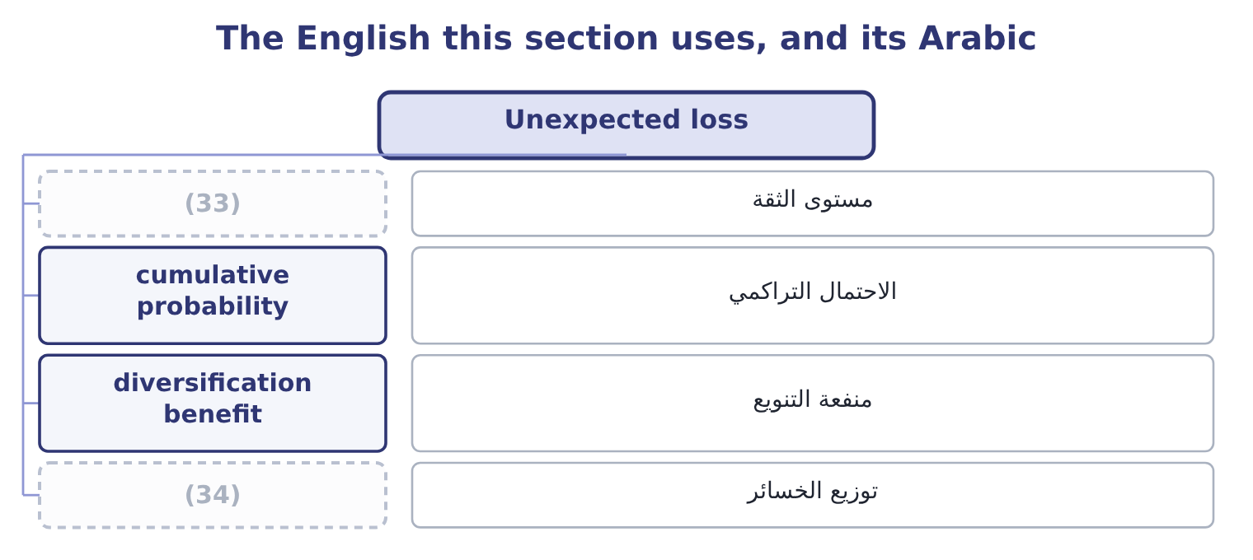
word list
unexpected loss · confidence level · loss distribution

The English this sheet uses, and its Arabic
English (exam term) | Arabic
confidence level | مستوى الثقة
cumulative probability | الاحتمال التراكمي
diversification benefit | منفعة التنويع
loss distribution | توزيع الخسائر

Answer key · 3.4 Unexpected loss

1 amount | 18 report
2 exceeds | 19 determines
3 stated | 20 facility
4 questions | 21 awkwardness
5 statistical | 22 different
6 deviation | 23 distributions
7 definition | 24 four-row
8 distance | 25 properties
9 nothing | 26 matter
10 probability | 27 judgment
11 serious | 28 appetite
12 destroyed | 29 requires
13 Subtract | 30 business
14 together | 31 unlike
15 twenty | 32 diversification
16 provides | 33 confidence level
17 sentences | 34 loss distribution

the summaries in full
Summary 1 Unexpected loss is the amount by which an actual loss exceeds the expected loss. It is the dispersion of the loss distribution rather than its average, and it is. It is stated in two ways and both appear in questions. As a statistical dispersion: the standard deviation of the loss, which is the usual definition where a distribution has been fitted. As the distance from the expected loss to a chosen percentile: the loss that will not be exceeded in, say, 95 or 99 per cent of years, less the expected loss.
Summary 2 From section 3.2: no loss at 0.60, so 60 per cent of years cost nothing; adding the short stop takes the cumulative probability to 0.60 + 0.25 = 0.85; adding the serious failure takes it to 0.85 + 0.10 = 0.95; the destroyed roaster takes it to one. Find the 95th percentile. The loss not exceeded in 95 per cent of years is 800,000. Subtract the expected loss. The unexpected loss at that confidence level is 800,000 − 267,500 = 532,500. Read the two together. In an average year the roaster costs 267,500. In a bad year — one year in twenty — it costs 800,000, which is 532,500 more than the budget provides for. Those two sentences are what a risk report should say, and the second is the one that determines how much capital or how large a facility is needed.
Summary 3 Note also the awkwardness at the boundary: the 95th percentile of this distribution lands exactly on an outcome, so a slightly different confidence level — 96 per cent — jumps straight to 3,000,000. Discrete distributions behave like that, and an answer that quotes a percentile from a four-row table should say which row it fell on. Two properties of unexpected loss matter. It depends on the confidence level chosen, which is a judgment about risk appetite and not a fact about the risk. A 99 per cent standard requires more capital than a 95 per cent one for the same business. And unlike expected losses, unexpected losses do not add. Two risks that are not perfectly correlated produce a combined unexpected loss smaller than the sum of the two — the diversification Book 2's, operating here on losses. That is the single strongest argument for assessing risk at the enterprise level rather than one department at a time, which is.

3.5 Maximum possible loss
Chapter 3 · section 3.5

Fill every gap. Each word list holds one word more than there are gaps.
Summary 1 gaps 1–12
The maximum possible loss is the (1) loss that could occur if everything that could go wrong did — no partial (2) , no working (3) , no mitigating (4) . It is also met as the extreme or (5) loss, and in insurance practice two related terms are used: the maximum possible loss, which assumes the worst (6) outcome, and the maximum probable loss, which assumes the worst outcome that is (7) likely, with fire doors holding and the alarm working. Three (8) define its role. It is not (9) . The expected loss of Orontes's fire risk is 60,000 a year; the maximum possible loss is the plant, the stock, the business interrupted and any liability to third (10) — a figure of a (11) different order, and the one that decides the insurance limit. It answers the (12) question.
word list
catastrophic · realistically · insuring · recovery · probability-weighted · survival · conceivable · largest · things · circumstance · completely · control · parties

Summary 2 gaps 13–22
The (13) of the figure is to ask whether the company would (14) to exist, and the answer (15) whether the risk may be retained at all. A loss (16) than the company's capital cannot be retained however (17) it is, which is the rule (18) . And it is the figure most often wrong, (19) it is never (20) . Nobody has data on an event that has not happened, so the maximum possible loss is built from (21) rather than from (22) : what is physically there, what could burn, what claims could follow, what the business would lose while it was gone, and what else fails at the same time.
word list
behind · governs · continue · frequency · structure · company's · observed · purpose · larger · unlikely · because

Worked example: three figures for one risk

Summary 3 gaps 23–34
Fire at the Hama plant: probability 0.01 against a (23) of 6,000,000, so the expected loss is 0.01 × 6,000,000 = 60,000 a year. In the one year in a (24) where the fire happens, the loss exceeds the (25) by 6,000,000 − 60,000 = 5,940,000. The maximum possible loss. Assume the fire spreads: the roasting hall, the (26) store, a year of interrupted (27) rather than sixty days, and a product liability claim. Orontes's (28) put it at 14,000,000. The (29) each figure (30) . The 60,000 goes in the budget. The 5,940,000 tests whether the cash and (31) . The 14,000,000 sets the insurance limit, and since it exceeds the company's cash and most of its (32) , the risk cannot be retained. One risk, three numbers, three different uses — and the mistake the (33) look for is using one of them for (34) job. Budgeting the maximum possible loss would make the company look unprofitable; insuring the expected loss would leave it uninsured for everything that matters; and holding capital against the maximum possible loss of every risk at once would require more capital than any business has.
word list
production · drives · hundred · equity · another's · assessors · facilities · examiners · severity · adjoining · decision · recovery · expectation

Three losses from one table

Your turn: expected, unexpected and maximum (complete the blanks)
Item | Data | Answer
Do the probabilities sum to one? | 0.70 (35) ; 0.20 of 100,000; 0.08 of 500,000; 0.02 of 2,000,000 | ________
Expected loss |  | ________
Loss not exceeded in 98 per cent of years |  | ________
Unexpected loss at that level |  | ________
Maximum possible loss on this table |  | ________
Which figure decides whether the risk may be retained |  | ________

word list
percentile · nothing

"Expected"

Summary 4 gaps 36–38
In (36) English what you expect is what you think will happen; in (37) the expected value is a weighted average that (38) cannot happen at all — Orontes's expected roaster loss of 267,500 is not among the four outcomes.
word list
ordinary · statistics · frequently · business

"Expected"
Item | Answer
Do the probabilities sum to one? | (39)
Expected loss | 100,000: 0.20 × 100,000 = 20,000, plus 0.08 × 500,000 = 40,000, plus 0.02 × 2,000,000 = 40,000.
Loss not exceeded in 98 per cent of years | 500,000, since the (40) reaches 0.98 at that outcome.
Unexpected loss at that level | 400,000: 500,000 − 100,000 = 400,000.
Maximum possible loss on this table | (41)
Which figure decides retention | The maximum possible loss, compared with the company's capacity to absorb it.
What it tells you | One table, three figures, three decisions: what to budget, what to hold capital against, and whether the risk may be kept at all.

word list
2,000,000, the worst outcome listed. · unexpected loss · Yes: 0.70 + 0.20 + 0.08 + 0.02 = 1.00. · cumulative probability

The English this section uses, and its Arabic
Each term sits against what it means.
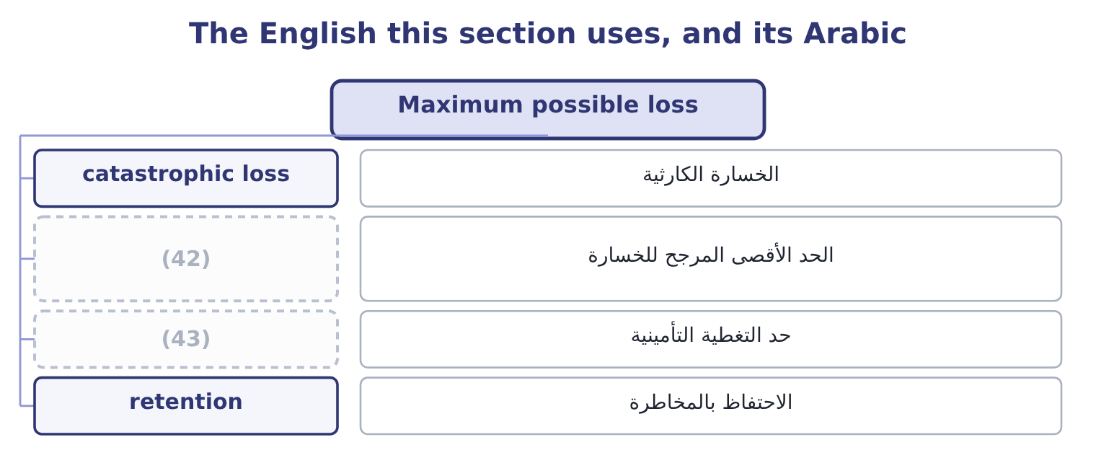
word list
maximum probable loss · insurance limit · حد التغطية التأمينية

The English this sheet uses, and its Arabic
English (exam term) | Arabic
catastrophic loss | الخسارة الكارثية
maximum probable loss | الحد الأقصى المرجح للخسارة
insurance limit | حد التغطية التأمينية
retention | الاحتفاظ بالمخاطرة

Answer key · 3.5 Maximum possible loss

1 largest | 23 severity
2 recovery | 24 hundred
3 control | 25 expectation
4 circumstance | 26 adjoining
5 catastrophic | 27 production
6 conceivable | 28 assessors
7 realistically | 29 decision
8 things | 30 drives
9 probability-weighted | 31 facilities
10 parties | 32 equity
11 completely | 33 examiners
12 survival | 34 another's
13 purpose | 35 nothing
14 continue | 36 ordinary
15 governs | 37 statistics
16 larger | 38 frequently
17 unlikely | 39 Yes: 0.70 + 0.20 + 0.08 + 0.02 = 1.00.
18 behind | 40 cumulative probability
19 because | 41 2,000,000, the worst outcome listed.
20 observed | 42 maximum probable loss
21 structure | 43 insurance limit
22 frequency

the summaries in full
Summary 1 The maximum possible loss is the largest loss that could occur if everything that could go wrong did — no partial recovery, no working control, no mitigating circumstance. It is also met as the extreme or catastrophic loss, and in insurance practice two related terms are used: the maximum possible loss, which assumes the worst conceivable outcome, and the maximum probable loss, which assumes the worst outcome that is realistically likely, with fire doors holding and the alarm working. Three things define its role. It is not probability-weighted. The expected loss of Orontes's fire risk is 60,000 a year; the maximum possible loss is the plant, the stock, the business interrupted and any liability to third parties — a figure of a completely different order, and the one that decides the insurance limit. It answers the survival question.
Summary 2 The purpose of the figure is to ask whether the company would continue to exist, and the answer governs whether the risk may be retained at all. A loss larger than the company's capital cannot be retained however unlikely it is, which is the rule behind. And it is the figure most often wrong, because it is never observed. Nobody has data on an event that has not happened, so the maximum possible loss is built from structure rather than from frequency: what is physically there, what could burn, what claims could follow, what the business would lose while it was gone, and what else fails at the same time.
Summary 3 Fire at the Hama plant: probability 0.01 against a severity of 6,000,000, so the expected loss is 0.01 × 6,000,000 = 60,000 a year. In the one year in a hundred where the fire happens, the loss exceeds the expectation by 6,000,000 − 60,000 = 5,940,000. The maximum possible loss. Assume the fire spreads: the roasting hall, the adjoining store, a year of interrupted production rather than sixty days, and a product liability claim. Orontes's assessors put it at 14,000,000. The decision each figure drives. The 60,000 goes in the budget. The 5,940,000 tests whether the cash and facilities. The 14,000,000 sets the insurance limit, and since it exceeds the company's cash and most of its equity, the risk cannot be retained. One risk, three numbers, three different uses — and the mistake the examiners look for is using one of them for another's job. Budgeting the maximum possible loss would make the company look unprofitable; insuring the expected loss would leave it uninsured for everything that matters; and holding capital against the maximum possible loss of every risk at once would require more capital than any business has.
Summary 4 In ordinary English what you expect is what you think will happen; in statistics the expected value is a weighted average that frequently cannot happen at all — Orontes's expected roaster loss of 267,500 is not among the four outcomes.

4.1 Inherent risk
Chapter 4 · section 4.1

Fill every gap. Each word list holds one word more than there are gaps.
Chapter 4, section by section
Each stage leads to the next.
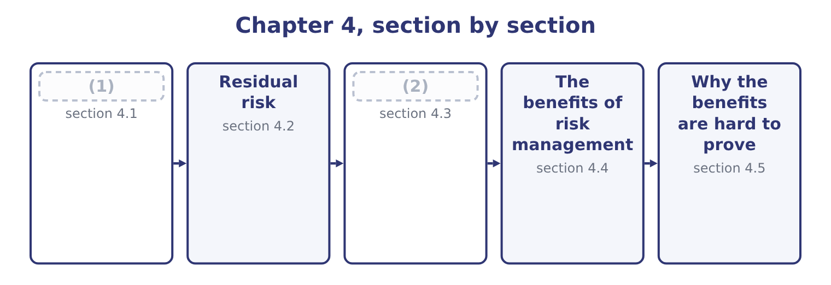
word list
section 4.1 · Reading the two together · Inherent risk

Summary 1 gaps 3–14
Inherent risk is the risk in an activity before any management action — the (3) that exists because of what the business does, measured as though no control, no (4) and no procedure were in place. It is a (5) artificial figure, and that is the first thing to (6) about it. Orontes's inherent food-safety risk is the risk of selling (7) tahini with no testing, no supplier approval, no (8) and no hygiene regime — a situation that has never existed and never will. The figure is (9) , not observed. Why (10) something artificial? Three (11) , and the exam asks for them. It shows what the controls are (12) . A residual risk of near zero can mean the activity is harmless or that an (13) control structure is holding back something enormous, and only the inherent figure (14) the two.
word list
constructed · exposure · contaminated · compute · oversight · understand · reasons · deliberately · elaborate · traceability · insurance · carrying · distinguishes

Summary 2 gaps 15–26
The (15) is what would happen if the controls stopped working — which is exactly what happens in a crisis, a system (16) or a year of heavy staff turnover. It ranks (17) for attention. Two (18) with the same residual risk are not equally important; the one with the higher inherent risk deserves more (19) , more testing and more attention from internal audit, because it has further to fall. And it (20) the circular comfort of (21) only what is left. A company that measures nothing but residual risk (22) that its risks are small because its controls work, which is a (23) it has assumed rather than tested. Two practical (24) go with it, and a good answer (25) them. Inherent risk is hard to (26) , because nobody has observed the world without the controls.
word list
processes · difference · concludes · prevents · measure · without · migration · assessing · difficulties · activities · conclusion · mentions · oversight

Summary 3 gaps 27–33
The (27) is a judgment anchored on industry events, on (28) , and on what happened in the places where the control (29) failed. And "no controls" has to be (30) . Does inherent mean no controls at all, or no controls beyond those (31) by law, or the controls a prudent company would have anyway? (32) varies; the exam's (33) is the strict one — before any management action — and an answer should say which basis it is using.
word list
required · Practice · estimate · understand · near-misses · genuinely · position · defined

The English this section uses, and its Arabic
Each term sits against what it means.
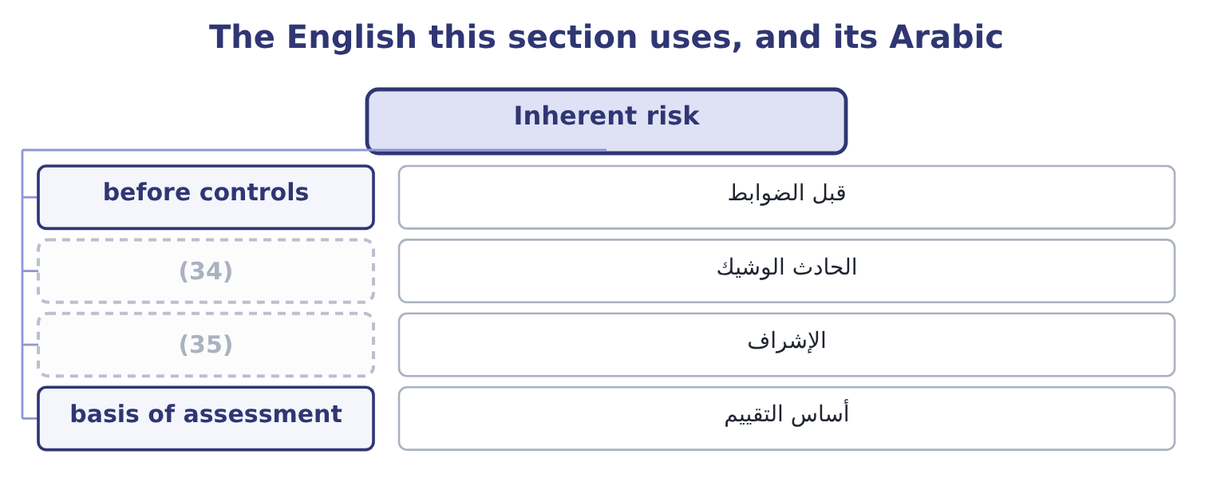
word list
near miss · oversight · re-examination

The English this sheet uses, and its Arabic
English (exam term) | Arabic
before controls | قبل الضوابط
near miss | الحادث الوشيك
oversight | الإشراف
basis of assessment | أساس التقييم

Answer key · 4.1 Inherent risk

1 Inherent risk | 19 oversight
2 Reading the two together | 20 prevents
3 exposure | 21 assessing
4 insurance | 22 concludes
5 deliberately | 23 conclusion
6 understand | 24 difficulties
7 contaminated | 25 mentions
8 traceability | 26 measure
9 constructed | 27 estimate
10 compute | 28 near-misses
11 reasons | 29 genuinely
12 carrying | 30 defined
13 elaborate | 31 required
14 distinguishes | 32 Practice
15 difference | 33 position
16 migration | 34 near miss
17 activities | 35 oversight
18 processes

the summaries in full
Summary 1 Inherent risk is the risk in an activity before any management action — the exposure that exists because of what the business does, measured as though no control, no insurance and no procedure were in place. It is a deliberately artificial figure, and that is the first thing to understand about it. Orontes's inherent food-safety risk is the risk of selling contaminated tahini with no testing, no supplier approval, no traceability and no hygiene regime — a situation that has never existed and never will. The figure is constructed, not observed. Why compute something artificial? Three reasons, and the exam asks for them. It shows what the controls are carrying. A residual risk of near zero can mean the activity is harmless or that an elaborate control structure is holding back something enormous, and only the inherent figure distinguishes the two.
Summary 2 The difference is what would happen if the controls stopped working — which is exactly what happens in a crisis, a system migration or a year of heavy staff turnover. It ranks activities for attention. Two processes with the same residual risk are not equally important; the one with the higher inherent risk deserves more oversight, more testing and more attention from internal audit, because it has further to fall. And it prevents the circular comfort of assessing only what is left. A company that measures nothing but residual risk concludes that its risks are small because its controls work, which is a conclusion it has assumed rather than tested. Two practical difficulties go with it, and a good answer mentions them. Inherent risk is hard to measure, because nobody has observed the world without the controls.
Summary 3 The estimate is a judgment anchored on industry events, on near-misses, and on what happened in the places where the control genuinely failed. And "no controls" has to be defined. Does inherent mean no controls at all, or no controls beyond those required by law, or the controls a prudent company would have anyway? Practice varies; the exam's position is the strict one — before any management action — and an answer should say which basis it is using.

4.2 Residual risk
Chapter 4 · section 4.2

Fill every gap. Each word list holds one word more than there are gaps.
Summary 1 gaps 1–12
Residual risk is what (1) after the controls and other (2) have done their work. It is the risk the company is (3) running, and it is the figure that should be compared with risk appetite and (4) to a board. Between the two sits (5) : the controls that reduce the (6) , the controls that reduce the severity, the insurance that transfers the loss, the contract that shares it, and the decision not to do the activity at all. With no maintenance regime, no condition (7) , no critical spares and no trained operators, (8) engineers put the expected loss from roaster failure at 620,000 a year. Residual as (9) stand. The present regime — (10) servicing, two trained operators, a set of spares — (11) it to the 267,500. What the controls (12) . The reduction is 620,000 − 267,500 = 352,500 a year, and the regime costs 95,000, so it returns 352,500 − 95,000 = 257,500 of net benefit.
word list
things · engineers · reported · actually · scheduled · brings · responses · Orontes's · everything · remains · deliver · monitoring · probability

Summary 2 gaps 13–24
With the maintenance contract of,500, which would be the (13) residual risk. Note the shape of the (14) . The (15) controls are (16) good value: they remove more than half the risk for 95,000. The (17) contract removes 267,500 − 84,500 = 183,000 more for $180,000, which is (18) worth it on expected loss alone. Three (19) belong with residual risk. Residual risk is not zero risk, and it is not meant to be. (20) a risk to nothing is almost always (21) — by stopping the activity — and almost never worth it. Residual risk is compared with risk appetite. Where residual risk exceeds appetite, (22) must change: more control, transfer, or a decision to accept a larger exposure (23) and say so. And residual risk (24) the controls work. A control that exists on paper, is performed inconsistently, or is performed by the same person who performs the activity it checks, does not reduce risk by the amount claimed for it — which is why control effectiveness must be tested rather than asserted, and why.
word list
distinctions · proposed · barely · something · servicing · Reducing · existing · extremely · possible · target · deliberately · numbers · assumes

The English this section uses, and its Arabic
Each term sits against what it means.
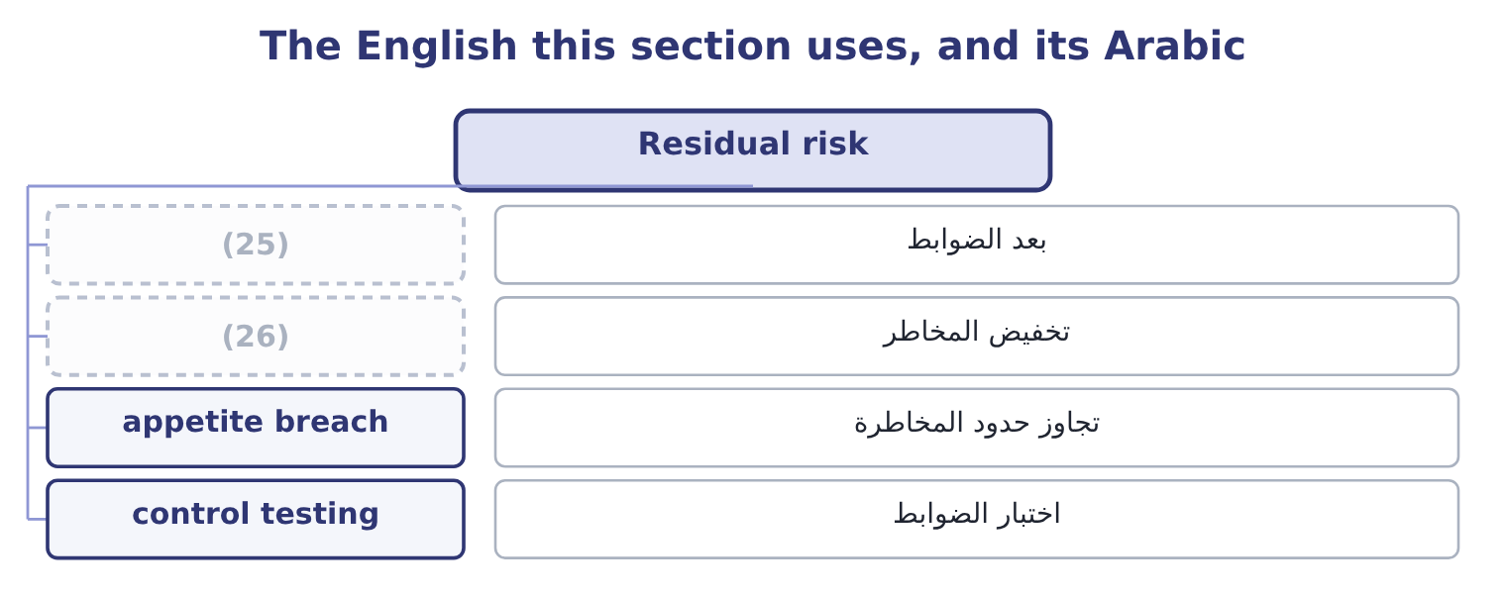
word list
second-order benefit · risk reduction · after controls

The English this sheet uses, and its Arabic
English (exam term) | Arabic
after controls | بعد الضوابط
risk reduction | تخفيض المخاطر
appetite breach | تجاوز حدود المخاطرة
control testing | اختبار الضوابط

Answer key · 4.2 Residual risk

1 remains | 14 numbers
2 responses | 15 existing
3 actually | 16 extremely
4 reported | 17 proposed
5 everything | 18 barely
6 probability | 19 distinctions
7 monitoring | 20 Reducing
8 Orontes's | 21 possible
9 things | 22 something
10 scheduled | 23 deliberately
11 brings | 24 assumes
12 deliver | 25 after controls
13 target | 26 risk reduction

the summaries in full
Summary 1 Residual risk is what remains after the controls and other responses have done their work. It is the risk the company is actually running, and it is the figure that should be compared with risk appetite and reported to a board. Between the two sits everything: the controls that reduce the probability, the controls that reduce the severity, the insurance that transfers the loss, the contract that shares it, and the decision not to do the activity at all. With no maintenance regime, no condition monitoring, no critical spares and no trained operators, Orontes's engineers put the expected loss from roaster failure at 620,000 a year. Residual as things stand. The present regime — scheduled servicing, two trained operators, a set of spares — brings it to the 267,500. What the controls deliver. The reduction is 620,000 − 267,500 = 352,500 a year, and the regime costs 95,000, so it returns 352,500 − 95,000 = 257,500 of net benefit.
Summary 2 With the maintenance contract of,500, which would be the target residual risk. Note the shape of the numbers. The existing controls are extremely good value: they remove more than half the risk for 95,000. The proposed contract removes 267,500 − 84,500 = 183,000 more for $180,000, which is barely worth it on expected loss alone. Three distinctions belong with residual risk. Residual risk is not zero risk, and it is not meant to be. Reducing a risk to nothing is almost always possible — by stopping the activity — and almost never worth it. Residual risk is compared with risk appetite. Where residual risk exceeds appetite, something must change: more control, transfer, or a decision to accept a larger exposure deliberately and say so. And residual risk assumes the controls work. A control that exists on paper, is performed inconsistently, or is performed by the same person who performs the activity it checks, does not reduce risk by the amount claimed for it — which is why control effectiveness must be tested rather than asserted, and why.

4.3 Reading the two together
Chapter 4 · section 4.3

Fill every gap. Each word list holds one word more than there are gaps.
Summary 1 gaps 1–2
The pair of figures is more (1) than either alone, and the exam rewards an answer that reads them (2) .
word list
rewards · together · informative

What the pair of figures tells you
Every item belongs to exactly one group.
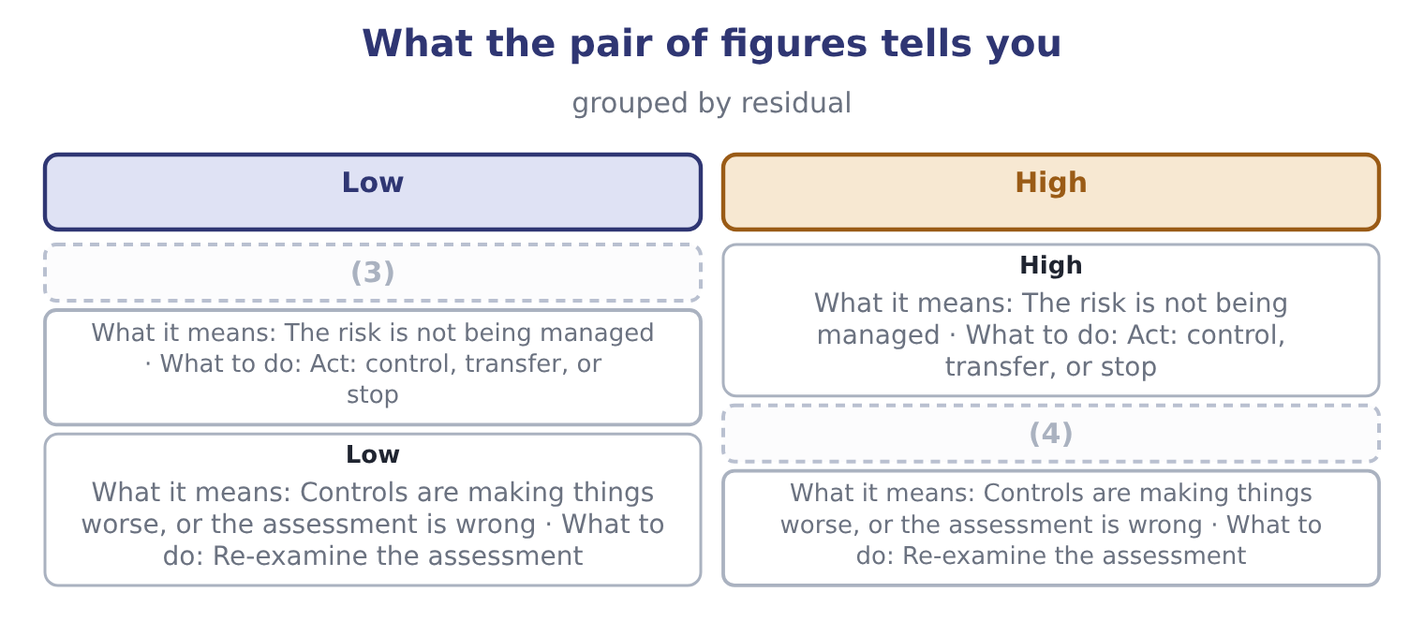
word list
High · assurance · Low

Summary 2 gaps 5–16
The fourth row deserves a sentence, because (5) assume it is (6) . It is not: a (7) can create risk. A new system introduced to reduce error introduces (8) risk; an approval step introduces delay; a (9) of duties that nobody has staffed creates a process that stops. More often, though, the fourth row means the (10) is wrong — usually because the inherent figure was (11) as though the controls were partly in place. Three (12) uses of the pair. (13) audit should spend its time where the gap between inherent and residual is largest, because that is where the company is most (14) on controls it has not recently tested. A board that is shown only residual risk sees a company with small risks. A board shown both sees a company whose small risks are small because of specific (15) that specific people do, which is a different and more (16) picture.
word list
further · segregation · candidates · implementation · assessment · inherent · actionable · dependent · estimated · things · Internal · impossible · control

The English this section uses, and its Arabic
Each term sits against what it means.
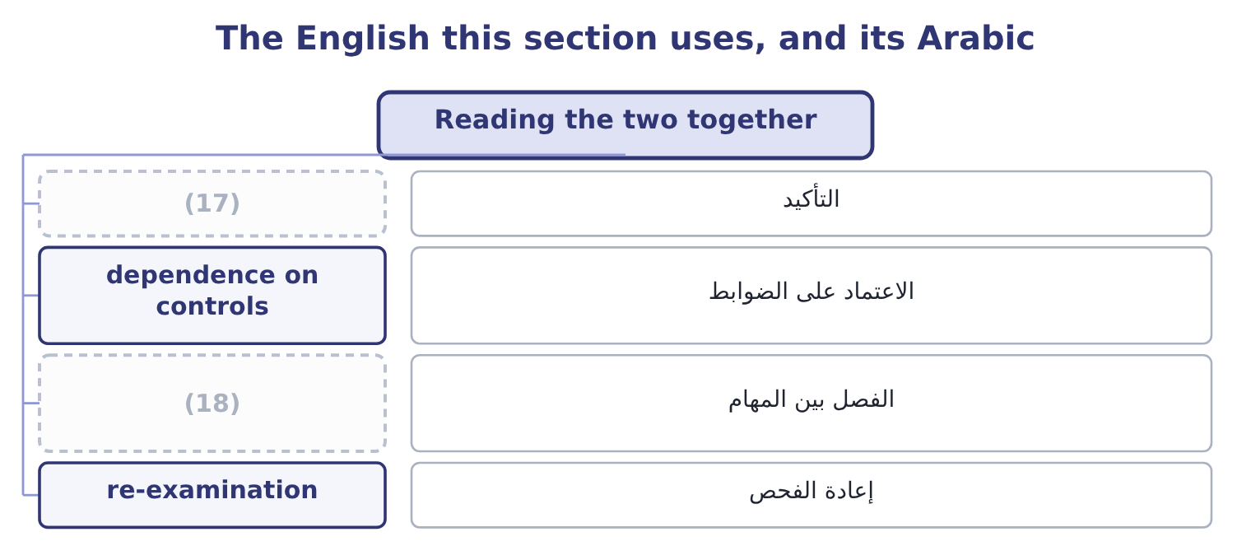
word list
near-miss reporting · segregation of duties · assurance

The English this sheet uses, and its Arabic
English (exam term) | Arabic
assurance | التأكيد
dependence on controls | الاعتماد على الضوابط
segregation of duties | الفصل بين المهام
re-examination | إعادة الفحص

Answer key · 4.3 Reading the two together

1 informative | 10 assessment
2 together | 11 estimated
3 High | 12 further
4 Low | 13 Internal
5 candidates | 14 dependent
6 impossible | 15 things
7 control | 16 actionable
8 implementation | 17 assurance
9 segregation | 18 segregation of duties

the summaries in full
Summary 1 The pair of figures is more informative than either alone, and the exam rewards an answer that reads them together.
Summary 2 The fourth row deserves a sentence, because candidates assume it is impossible. It is not: a control can create risk. A new system introduced to reduce error introduces implementation risk; an approval step introduces delay; a segregation of duties that nobody has staffed creates a process that stops. More often, though, the fourth row means the assessment is wrong — usually because the inherent figure was estimated as though the controls were partly in place. Three further uses of the pair. Internal audit should spend its time where the gap between inherent and residual is largest, because that is where the company is most dependent on controls it has not recently tested. A board that is shown only residual risk sees a company with small risks. A board shown both sees a company whose small risks are small because of specific things that specific people do, which is a different and more actionable picture.

4.4 The benefits of risk management
Chapter 4 · section 4.4

Fill every gap. Each word list holds one word more than there are gaps.
Summary 1 gaps 1–12
The outcome asks for the (1) to be identified and (2) , and an answer that lists them in order of how hard they are to prove is a better answer than one that (3) them. Fewer and smaller (4) . The direct benefit, and the (5) one: the reduction from inherent to residual risk, which for (6) roaster alone was 352,500 a year against a cost of 95,000. That matters for its own sake — plans hold, (7) are not breached, the (8) of Book 2's. A lower cost of capital. Lenders price default risk and equity investors price (9) , so a company that (10) manages risk borrows more cheaply, keeps a better rating, and faces a smaller equity risk premium. The effect is small per unit and large in total: Orontes (11) equity of $20,392,975 and debt of 390,000 ÷ 0.06 = 6,500,000, which is 20,392,975 + 6,500,000 = 26,892,975 of capital, so twenty basis points off its 9.04 per cent cost of capital is worth 26,892,975 × 0.002 = 53,786 a year, every year, for nothing but (12) .
word list
benefits · credibility · measurable · explained · Orontes's · volatility · demonstrably · dividend · losses · corporate · recites · employs · covenants

Summary 2 gaps 13–24
The (13) to take more risk where it pays. This is the benefit most often (14) and the one that matters most to a board. A company that knows its exposures, and knows it can absorb them, can take the (15) risks it is paid for — the new market, the new product, the (16) of Book 3's. Risk management is not for (17) risk; it is for taking the right risks (18) . (19) of reputation and of the (20) to operate. A recall, a safety failure, a fraud, a (21) : each damages (22) that took years to build and is not on the balance sheet. Book 1's,724,000 written off in an (23) . Every project in Book 3 was (24) with an estimate; risk management supplies the range around the estimate and the question of what happens if it is wrong.
word list
deliberate · licence · assurance · afternoon · Protection · acquisition · something · ability · appraised · knowingly · reducing · omitted · sanction

Summary 3 gaps 25–33
Fewer (25) , which is the benefit boards (26) ask for. A loss that was identified, (27) and accepted is a managed outcome; the same loss arriving (28) is a governance failure, and the (29) is entirely in whether anybody wrote it down first. Codes of corporate governance in most (30) require the board to state that it has reviewed the (31) of risk management, which makes some of this work (32) regardless of its economics. And lower insurance costs, since insurers price the quality of a company's risk management directly, through premiums, (33) and the terms they are willing to offer.
word list
jurisdictions · deductibles · effectiveness · unannounced · quantified · actually · surprises · difference · obligatory · whether

The English this section uses, and its Arabic
Each term sits against what it means.
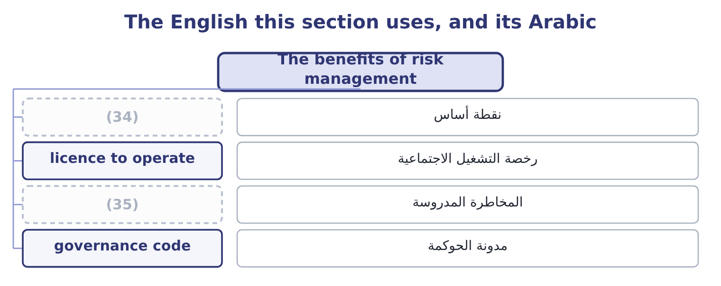
word list
inherent risk · informed risk-taking · basis point

The English this sheet uses, and its Arabic
English (exam term) | Arabic
basis point | نقطة أساس
licence to operate | رخصة التشغيل الاجتماعية
informed risk-taking | المخاطرة المدروسة
governance code | مدونة الحوكمة

Answer key · 4.4 The benefits of risk management

1 benefits | 19 Protection
2 explained | 20 licence
3 recites | 21 sanction
4 losses | 22 something
5 measurable | 23 afternoon
6 Orontes's | 24 appraised
7 covenants | 25 surprises
8 dividend | 26 actually
9 volatility | 27 quantified
10 demonstrably | 28 unannounced
11 employs | 29 difference
12 credibility | 30 jurisdictions
13 ability | 31 effectiveness
14 omitted | 32 obligatory
15 deliberate | 33 deductibles
16 acquisition | 34 basis point
17 reducing | 35 informed risk-taking
18 knowingly

the summaries in full
Summary 1 The outcome asks for the benefits to be identified and explained, and an answer that lists them in order of how hard they are to prove is a better answer than one that recites them. Fewer and smaller losses. The direct benefit, and the measurable one: the reduction from inherent to residual risk, which for Orontes's roaster alone was 352,500 a year against a cost of 95,000. That matters for its own sake — plans hold, covenants are not breached, the dividend of Book 2's. A lower cost of capital. Lenders price default risk and equity investors price volatility, so a company that demonstrably manages risk borrows more cheaply, keeps a better rating, and faces a smaller equity risk premium. The effect is small per unit and large in total: Orontes employs equity of $20,392,975 and debt of 390,000 ÷ 0.06 = 6,500,000, which is 20,392,975 + 6,500,000 = 26,892,975 of capital, so twenty basis points off its 9.04 per cent cost of capital is worth 26,892,975 × 0.002 = 53,786 a year, every year, for nothing but credibility.
Summary 2 The ability to take more risk where it pays. This is the benefit most often omitted and the one that matters most to a board. A company that knows its exposures, and knows it can absorb them, can take the deliberate risks it is paid for — the new market, the new product, the acquisition of Book 3's. Risk management is not for reducing risk; it is for taking the right risks knowingly. Protection of reputation and of the licence to operate. A recall, a safety failure, a fraud, a sanction: each damages something that took years to build and is not on the balance sheet. Book 1's,724,000 written off in an afternoon. Every project in Book 3 was appraised with an estimate; risk management supplies the range around the estimate and the question of what happens if it is wrong.
Summary 3 Fewer surprises, which is the benefit boards actually ask for. A loss that was identified, quantified and accepted is a managed outcome; the same loss arriving unannounced is a governance failure, and the difference is entirely in whether anybody wrote it down first. Codes of corporate governance in most jurisdictions require the board to state that it has reviewed the effectiveness of risk management, which makes some of this work obligatory regardless of its economics. And lower insurance costs, since insurers price the quality of a company's risk management directly, through premiums, deductibles and the terms they are willing to offer.

4.5 Why the benefits are hard to prove
Chapter 4 · section 4.5

Fill every gap. Each word list holds one word more than there are gaps.
Summary 1 gaps 1–12
Risk management has a (1) problem that every (2) should be able to state, because exam questions on the benefits often turn into questions about this. Its (3) are invisible. The fire that did not happen leaves no trace, and a function whose entire output is the (4) of events cannot point to (5) . The losses it failed to (6) , by contrast, are (7) visible. Its costs are immediate and certain, while its benefits are deferred and (8) — the same asymmetry that makes Book 3's (9) projects hard to defend against a payback rule. And the counterfactual is (10) . Nobody can show what the loss would have been without the control, which is why the (11) estimate of section 4.1 matters so much: it is the only (12) statement of the counterfactual, and it is a judgment.
word list
anything · probabilistic · available · prevent · measurement · candidate · inherent-risk · absence · extremely · successes · long-lived · unobservable · because

Summary 2 gaps 13–22
Four ways of showing the value anyway, and an answer that offers them is (13) the harder (14) . Track (15) and the events that controls (16) . A control that stopped forty incorrect (17) this year has a visible output, and the loss (18) . (19) inherent and residual (20) , as section 4.3 argued, so that the gap is the stated output of the function. Use the (21) arithmetic of, so that decisions are (22) in money at the time they are taken rather than defended afterwards. And measure the second-order benefits where they can be observed: insurance premiums and terms, the credit rating, covenant headroom, the volatility of earnings over time, the number of surprises reported to the board.
word list
performs · near-misses · together · documented · answering · question · cost-benefit · deliveries · Report · database · caught

Worked example: what risk management is worth at Orontes

Summary 3 gaps 23–34
Loss reduction on the (23) . The five risks of,747 of residual (24) loss. The inherent figure for the same five is (25) at 940,000, so the controls (26) 940,000 − 264,747 = 675,253 a year. What the controls cost. (27) , testing, approvals, the quality function and insurance premiums come to 410,000 a year. Net on the (28) benefit alone. Add the cost of capital. Twenty basis points on 26,892,975 of capital is 53,786, (29) 265,253 + 53,786 = 319,039. Against (30) income of $4,176,000 that is nearly eight per cent, which is a defensible answer to a director who asks what the risk function is for. Two honest (31) go with it. The inherent estimate of 940,000 is a judgment and the whole (32) rests on it. And the twenty basis points cannot be observed directly; it is (33) from what lenders and insurers say they price. State both, and the number is (34) ; omit them, and it is advocacy.
word list
remove · giving · expected · direct · inferred · operating · Maintenance · payback · register · credible · estimated · qualifications · calculation

Before, after, and what it is worth

Your turn: inherent and residual (complete the blanks)
Item | Data | Answer
Risk measured before any management action |  | ________
Risk measured after the controls |  | ________
Reduction delivered by the roaster regime | Inherent 620,000; residual 267,500 | ________
Net benefit of that regime | (35) | ________
What residual risk should be compared with |  | ________
Why the benefits of risk management are hard to prove |  | ________

word list
dependence on controls · Controls cost 95,000

"Inherent" and "residual"

Summary 4 gaps 36–46
Both words are Latin and both are (36) , which is unusual in risk (37) . Inherent means (38) in — a property of the thing itself, not of what (39) has done about it — and that is exactly right: inherent risk belongs to the (40) . Residual means left over, and it (41) the correct (42) that something has been taken away. The trap is (43) , in the word control, which in English (44) means a procedure that reduces risk, while in (45) English it means power over something. A manager who says "we have that under control" is making the ordinary-language claim; a control in the technical sense is a specific, (46) , testable act, and if nobody can name who performs it and when, it is not one.
word list
accounting · precise · anybody · activity · carries · vocabulary · insurers · ordinary · implication · sticking · elsewhere · performable

"Inherent" and "residual"
Item | Answer
Risk before any management action | Inherent risk.
Risk after the controls | Residual risk.
Reduction delivered by the regime | (47)
Net benefit of that regime | (48)
What residual risk is compared with | Risk appetite, and where it exceeds appetite something must change.
Why benefits are hard to prove | Prevented events leave no trace, costs are certain while benefits are not, and the counterfactual cannot be observed.
What it tells you | Two (49) and one subtraction produce the only defensible statement of what risk management is worth — and the subtraction depends en

word list
measurements · residual risk · 257,500: 352,500 − 95,000 = 257,500. · 352,500: 620,000 − 267,500 = 352,500.

The English this section uses, and its Arabic
Each term sits against what it means.
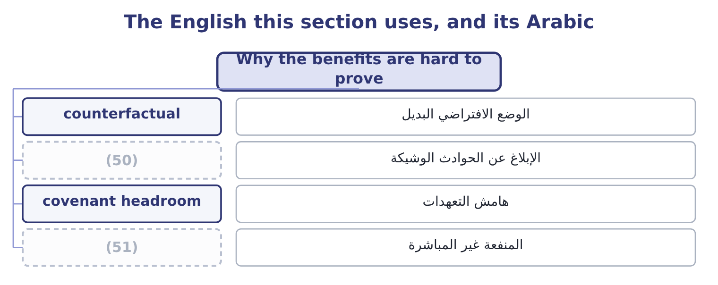
word list
second-order benefit · before controls · near-miss reporting

The English this sheet uses, and its Arabic
English (exam term) | Arabic
counterfactual | الوضع الافتراضي البديل
near-miss reporting | الإبلاغ عن الحوادث الوشيكة
covenant headroom | هامش التعهدات
second-order benefit | المنفعة غير المباشرة

Answer key · 4.5 Why the benefits are hard to prove

1 measurement | 27 Maintenance
2 candidate | 28 direct
3 successes | 29 giving
4 absence | 30 operating
5 anything | 31 qualifications
6 prevent | 32 calculation
7 extremely | 33 inferred
8 probabilistic | 34 credible
9 long-lived | 35 Controls cost 95,000
10 unobservable | 36 precise
11 inherent-risk | 37 vocabulary
12 available | 38 sticking
13 answering | 39 anybody
14 question | 40 activity
15 near-misses | 41 carries
16 caught | 42 implication
17 deliveries | 43 elsewhere
18 database | 44 accounting
19 Report | 45 ordinary
20 together | 46 performable
21 cost-benefit | 47 352,500: 620,000 − 267,500 = 352,500.
22 documented | 48 257,500: 352,500 − 95,000 = 257,500.
23 register | 49 measurements
24 expected | 50 near-miss reporting
25 estimated | 51 second-order benefit
26 remove

the summaries in full
Summary 1 Risk management has a measurement problem that every candidate should be able to state, because exam questions on the benefits often turn into questions about this. Its successes are invisible. The fire that did not happen leaves no trace, and a function whose entire output is the absence of events cannot point to anything. The losses it failed to prevent, by contrast, are extremely visible. Its costs are immediate and certain, while its benefits are deferred and probabilistic — the same asymmetry that makes Book 3's long-lived projects hard to defend against a payback rule. And the counterfactual is unobservable. Nobody can show what the loss would have been without the control, which is why the inherent-risk estimate of section 4.1 matters so much: it is the only available statement of the counterfactual, and it is a judgment.
Summary 2 Four ways of showing the value anyway, and an answer that offers them is answering the harder question. Track near-misses and the events that controls caught. A control that stopped forty incorrect deliveries this year has a visible output, and the loss database. Report inherent and residual together, as section 4.3 argued, so that the gap is the stated output of the function. Use the cost-benefit arithmetic of, so that decisions are documented in money at the time they are taken rather than defended afterwards. And measure the second-order benefits where they can be observed: insurance premiums and terms, the credit rating, covenant headroom, the volatility of earnings over time, the number of surprises reported to the board.
Summary 3 Loss reduction on the register. The five risks of,747 of residual expected loss. The inherent figure for the same five is estimated at 940,000, so the controls remove 940,000 − 264,747 = 675,253 a year. What the controls cost. Maintenance, testing, approvals, the quality function and insurance premiums come to 410,000 a year. Net on the direct benefit alone. Add the cost of capital. Twenty basis points on 26,892,975 of capital is 53,786, giving 265,253 + 53,786 = 319,039. Against operating income of $4,176,000 that is nearly eight per cent, which is a defensible answer to a director who asks what the risk function is for. Two honest qualifications go with it. The inherent estimate of 940,000 is a judgment and the whole calculation rests on it. And the twenty basis points cannot be observed directly; it is inferred from what lenders and insurers say they price. State both, and the number is credible; omit them, and it is advocacy.
Summary 4 Both words are Latin and both are precise, which is unusual in risk vocabulary. Inherent means sticking in — a property of the thing itself, not of what anybody has done about it — and that is exactly right: inherent risk belongs to the activity. Residual means left over, and it carries the correct implication that something has been taken away. The trap is elsewhere, in the word control, which in English accounting means a procedure that reduces risk, while in ordinary English it means power over something. A manager who says "we have that under control" is making the ordinary-language claim; a control in the technical sense is a specific, performable, testable act, and if nobody can name who performs it and when, it is not one.

5.1 The five responses
Chapter 5 · section 5.1

Fill every gap. Each word list holds one word more than there are gaps.
Chapter 5, section by section
Each stage leads to the next.
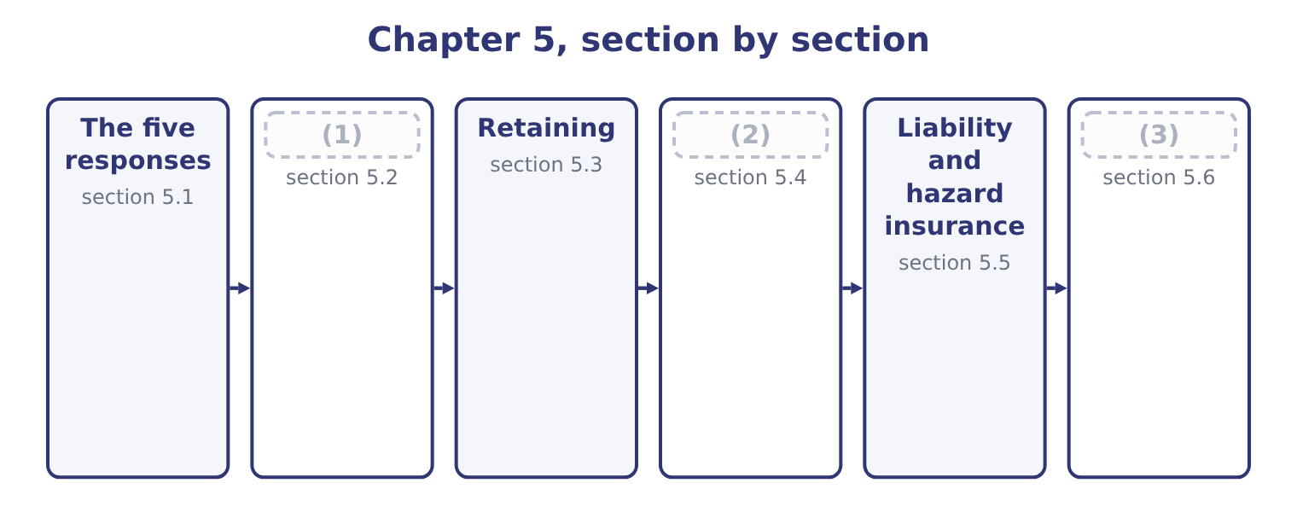
word list
Transferring · Avoiding and reducing · Exploiting, and choosing · The five responses

Summary 1 gaps 4–15
The (4) , with the test each must pass. Do not (5) the activity, or stop (6) it: decline the customer, withdraw from the market, do not make the product. It is the only response that removes the risk (7) , and it also removes the return, which is why it is (8) only where the risk cannot be brought within appetite by any other means, or where the activity was never going to earn its cost of capital anyway. Reduce, also called (9) . Act on the (10) , the severity, or both: (11) , training, testing, duplicate equipment, segregation of duties, fire doors, a second supplier. Most risk (12) is this, and the test is the (13) comparison. Transfer, also called share. Arrange for another party to carry some or all of the (14) , for a price: insurance, a contractual (15) , a hedge, outsourcing, a joint venture, a guarantee.
word list
appropriate · probability · undertake · segregation · indemnity · responses · maintenance · undertaking · management · cost-benefit · mitigate · consequences · entirely

Summary 2 gaps 16–27
The risk does not (16) ; it is moved, and the test is (17) the other party can carry it and will still be there when it matters. Retain, also called accept or (18) . Carry the risk deliberately. This is the correct response for small, frequent, (19) losses and for risks the company is paid to take, and the key word is deliberately: a retained risk is one (20) has decided to keep, written down, and budgeted for. A risk nobody (21) is not retained; it is (22) . Take more of the risk, because the company has an (23) in bearing it or because the upside is worth the (24) . A company with a strong balance sheet can offer credit terms a weaker (25) cannot; a company with deep (26) of a market can take positions in it that others would not. This is the response that follows from, and the response most often absent from a (27) answer.
word list
competitor · tolerate · missed · cheaply · noticed · disappear · advantage · knowledge · exposure · predictable · whether · candidate's · somebody

Summary 3 gaps 28–32
Two (28) are so common they (29) names. Reduce then retain is the ordinary pattern for (30) risk: control what can be (31) cheaply, budget for what remains. Retain to a limit then transfer is the ordinary pattern for hazard risk: carry the first slice through a (32) and insure the tail, which section 5.3 computes.
word list
operational · deductible · tolerate · deserve · combinations · controlled

The English this section uses, and its Arabic
Each term sits against what it means.
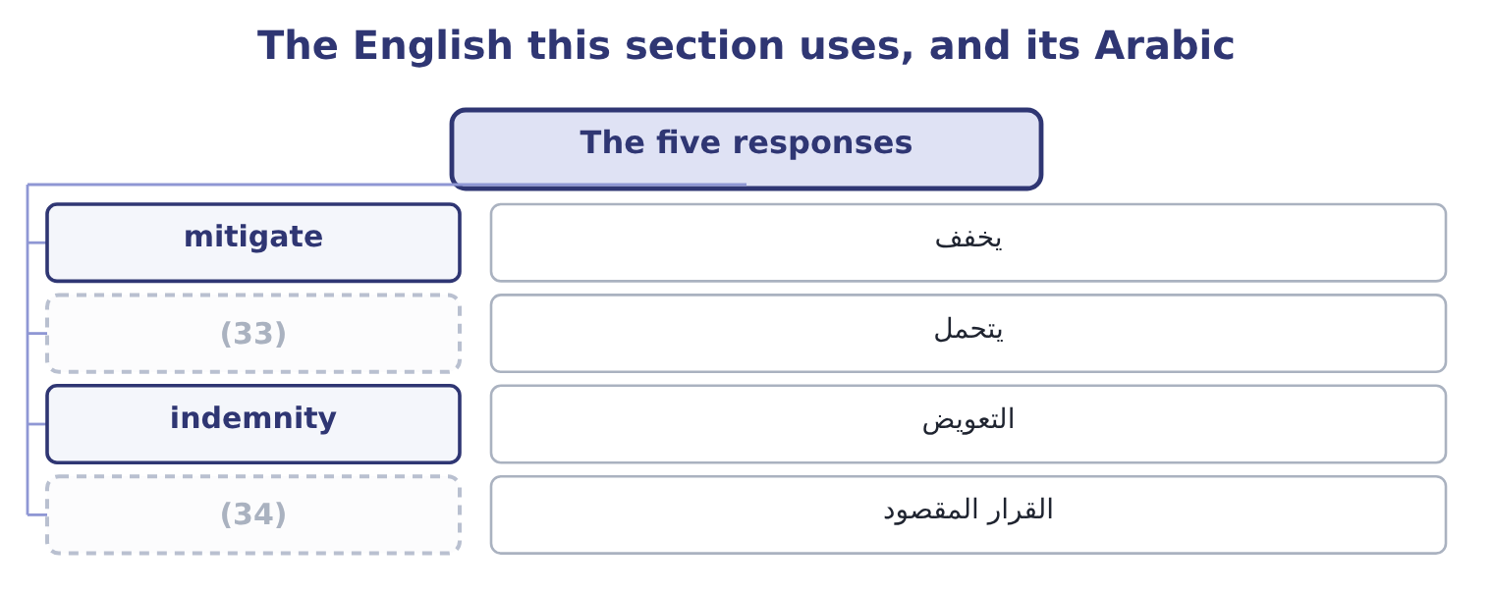
word list
deliberate decision · over-control · tolerate

The English this sheet uses, and its Arabic
English (exam term) | Arabic
mitigate | يخفف
tolerate | يتحمل
indemnity | التعويض
deliberate decision | القرار المقصود

Answer key · 5.1 The five responses

1 Avoiding and reducing | 18 tolerate
2 Transferring | 19 predictable
3 Exploiting, and choosing | 20 somebody
4 responses | 21 noticed
5 undertake | 22 missed
6 undertaking | 23 advantage
7 entirely | 24 exposure
8 appropriate | 25 competitor
9 mitigate | 26 knowledge
10 probability | 27 candidate's
11 maintenance | 28 combinations
12 management | 29 deserve
13 cost-benefit | 30 operational
14 consequences | 31 controlled
15 indemnity | 32 deductible
16 disappear | 33 tolerate
17 whether | 34 deliberate decision

the summaries in full
Summary 1 The responses, with the test each must pass. Do not undertake the activity, or stop undertaking it: decline the customer, withdraw from the market, do not make the product. It is the only response that removes the risk entirely, and it also removes the return, which is why it is appropriate only where the risk cannot be brought within appetite by any other means, or where the activity was never going to earn its cost of capital anyway. Reduce, also called mitigate. Act on the probability, the severity, or both: maintenance, training, testing, duplicate equipment, segregation of duties, fire doors, a second supplier. Most risk management is this, and the test is the cost-benefit comparison. Transfer, also called share. Arrange for another party to carry some or all of the consequences, for a price: insurance, a contractual indemnity, a hedge, outsourcing, a joint venture, a guarantee.
Summary 2 The risk does not disappear; it is moved, and the test is whether the other party can carry it and will still be there when it matters. Retain, also called accept or tolerate. Carry the risk deliberately. This is the correct response for small, frequent, predictable losses and for risks the company is paid to take, and the key word is deliberately: a retained risk is one somebody has decided to keep, written down, and budgeted for. A risk nobody noticed is not retained; it is missed. Take more of the risk, because the company has an advantage in bearing it or because the upside is worth the exposure. A company with a strong balance sheet can offer credit terms a weaker competitor cannot; a company with deep knowledge of a market can take positions in it that others would not. This is the response that follows from, and the response most often absent from a candidate's answer.
Summary 3 Two combinations are so common they deserve names. Reduce then retain is the ordinary pattern for operational risk: control what can be controlled cheaply, budget for what remains. Retain to a limit then transfer is the ordinary pattern for hazard risk: carry the first slice through a deductible and insure the tail, which section 5.3 computes.

5.2 Avoiding and reducing
Chapter 5 · section 5.2

Fill every gap. Each word list holds one word more than there are gaps.
Summary 1 gaps 1–12
Avoidance is the (1) response and the most (2) , because it forgoes the return along with the risk. Orontes could avoid its currency exposure entirely by refusing to sell to its Gulf (3) , whose business (4) 820,000 a year. The currency risk on that trade has an expected loss of 75,000. Avoiding a 75,000 expected loss by giving up 820,000 of (5) is an obviously bad trade, and stating it that way is the whole analysis: avoidance is correct only where the exposure, not the (6) , is what cannot be borne — a risk whose maximum possible loss exceeds what the company could survive. Three (7) cases for avoidance, and an exam answer (8) have them. Where the maximum possible loss is (9) and cannot be (10) . Where the (11) does not earn its cost of (12) once the risk is priced — which is Book 3's analysis with the risk premium of its.
word list
expectation · capital · contributes · transferred · legitimate · contribution · expensive · unsurvivable · supplier · distributor · activity · strongest · should

Summary 2 gaps 13–24
Where the risk is one the company has no (13) to manage: a market it does not understand, a technology it cannot maintain, a (14) whose rules it cannot follow. Reduction acts on probability, on severity, or on both, and a complete answer (15) the three. Probability reduction: preventive (16) , supplier approval, training, access controls, driver testing, the (17) check. Severity reduction: fire doors and (18) , a second site, backups, limits on the size of any single exposure, the contract that caps a (19) . A second (20) does not make the first one less likely to fail; it makes the failure cost almost (21) , and a standby supplier does the same for a supply failure. Two (22) govern how much reduction to buy. Every further (23) costs more and (24) less, and the stopping point is where the marginal cost exceeds the marginal benefit, which is Book 3's. Controls create their own risks. A new system, a new approval step, a new party in the process: each adds operational risk of its own, and a control whose own failure rate is high can be worse than the exposure it addresses.
word list
increment · sprinklers · competence · survive · distinguishes · liability · roaster · goods-inwards · nothing · jurisdiction · principles · delivers · maintenance

The English this section uses, and its Arabic
Each term sits against what it means.
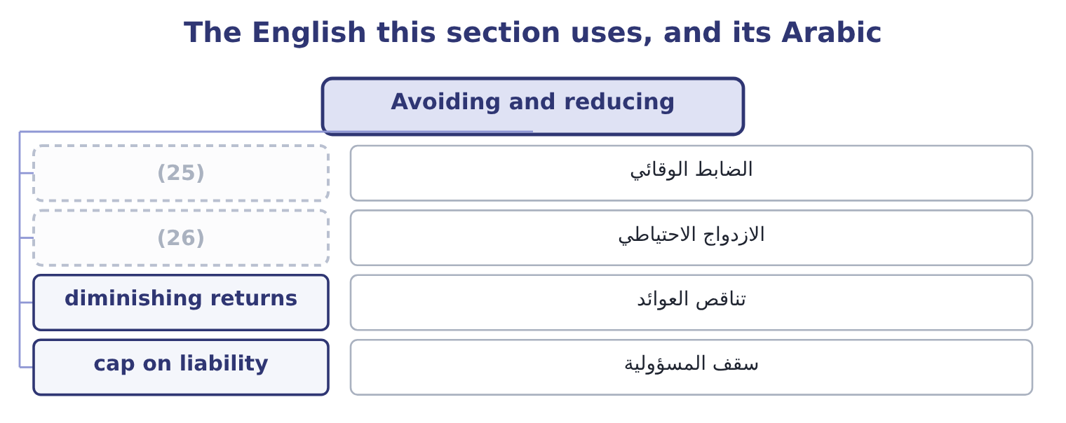
word list
سقف المسؤولية · redundancy · preventive control

The English this sheet uses, and its Arabic
English (exam term) | Arabic
preventive control | الضابط الوقائي
redundancy | الازدواج الاحتياطي
diminishing returns | تناقص العوائد
cap on liability | سقف المسؤولية

Answer key · 5.2 Avoiding and reducing

1 strongest | 14 jurisdiction
2 expensive | 15 distinguishes
3 distributor | 16 maintenance
4 contributes | 17 goods-inwards
5 contribution | 18 sprinklers
6 expectation | 19 liability
7 legitimate | 20 roaster
8 should | 21 nothing
9 unsurvivable | 22 principles
10 transferred | 23 increment
11 activity | 24 delivers
12 capital | 25 preventive control
13 competence | 26 redundancy

the summaries in full
Summary 1 Avoidance is the strongest response and the most expensive, because it forgoes the return along with the risk. Orontes could avoid its currency exposure entirely by refusing to sell to its Gulf distributor, whose business contributes 820,000 a year. The currency risk on that trade has an expected loss of 75,000. Avoiding a 75,000 expected loss by giving up 820,000 of contribution is an obviously bad trade, and stating it that way is the whole analysis: avoidance is correct only where the exposure, not the expectation, is what cannot be borne — a risk whose maximum possible loss exceeds what the company could survive. Three legitimate cases for avoidance, and an exam answer should have them. Where the maximum possible loss is unsurvivable and cannot be transferred. Where the activity does not earn its cost of capital once the risk is priced — which is Book 3's analysis with the risk premium of its.
Summary 2 Where the risk is one the company has no competence to manage: a market it does not understand, a technology it cannot maintain, a jurisdiction whose rules it cannot follow. Reduction acts on probability, on severity, or on both, and a complete answer distinguishes the three. Probability reduction: preventive maintenance, supplier approval, training, access controls, driver testing, the goods-inwards check. Severity reduction: fire doors and sprinklers, a second site, backups, limits on the size of any single exposure, the contract that caps a liability. A second roaster does not make the first one less likely to fail; it makes the failure cost almost nothing, and a standby supplier does the same for a supply failure. Two principles govern how much reduction to buy. Every further increment costs more and delivers less, and the stopping point is where the marginal cost exceeds the marginal benefit, which is Book 3's. Controls create their own risks. A new system, a new approval step, a new party in the process: each adds operational risk of its own, and a control whose own failure rate is high can be worse than the exposure it addresses.

5.3 Retaining
Chapter 5 · section 5.3

Fill every gap. Each word list holds one word more than there are gaps.
Summary 1 gaps 1–12
Retention is the (1) for risks that are small (2) to the company, frequent enough to be predictable, and cheaper to carry than to transfer. Three forms appear in (3) . (4) retention: the loss is (5) in the results when it happens. (6) for small, frequent losses — breakages, minor (7) , the ordinary bad debts covered by the allowance. Funded retention, or (8) : an amount is set aside, formally or (9) , against the expected loss, so that the charge is smoothed instead of lumpy. A large group may do this through a (10) insurer, which is its own insurance company; the exam needs the term, not the (11) . (12) retention through a deductible: the company carries the first slice of every loss and the insurer carries the rest. This is the most common arrangement in practice, because the first slice is where the small, predictable, expensive-to-administer losses live, and because carrying it reduces the premium by more than the expected cost of the losses retained.
word list
Partial · captive · relative · mechanics · Appropriate · informally · Unfunded · self-insurance · questions · absorbed · response · write-offs · capital

Worked example: full cover, or a deductible?

Summary 2 gaps 13–19
The roaster (13) : nothing at 0.60, 150,000 at 0.25, 800,000 at 0.10, 3,000,000 at 0.05, for an expected loss of 267,500. The insurer (14) a premium of $400,000. That is 400,000 − 267,500 = 132,500 more than the expected loss, a loading of 132,500 ÷ 267,500 = 49.53 per cent, which pays for the (15) expenses, capital and (16) . The premium falls to $180,000. Orontes now carries the 150,000 (17) in full, contributing 0.25 × 150,000 = 37,500, and the first 250,000 of each larger loss, contributing 0.10 × 250,000 = 25,000 and 0.05 × 250,000 = 12,500. Retained expected loss is 37,500 + 25,000 + 12,500 = 75,000. (18) the total cost. With the deductible the expected (19) cost is 180,000 + 75,000 = 255,000, against 400,000 for full cover — a saving of 400,000 − 255,000 = 145,000 a year.
word list
distribution · Compare · outcome · quotes · profit · annual · insurer's · relative

Summary 3 gaps 20–31
The deductible is better, and the reason is (20) rather than (21) : the insurer (22) its loading on every dollar of cover, and the first 250,000 is the part Orontes can predict and absorb without (23) . The test for how large a deductible should be is not where the saving is largest but how large a loss the company can take in a single year without (24) anything — which is, not an (25) . Two (26) with retention. Retained risk must be funded, not merely (27) . A decision to retain that is not (28) in a budget, a (29) or a cash buffer is a decision to be surprised. Ten retained risks of 75,000 each have a combined expected cost of 750,000 and a much larger bad-year cost, and the (30) retention across the company is a figure somebody should know, not a (31) of ten separate decisions.
word list
Partial · optimisation · by-product · provision · reflected · disrupting · charges · accepted · difficulty · arithmetical · structural · cautions · aggregate

The English this section uses, and its Arabic
Each term sits against what it means.
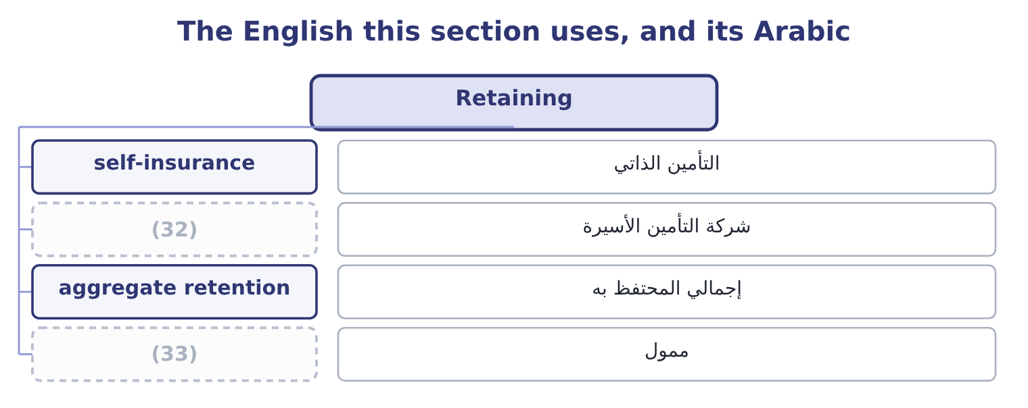
word list
mitigate · funded · captive insurer

The English this sheet uses, and its Arabic
English (exam term) | Arabic
self-insurance | التأمين الذاتي
captive insurer | شركة التأمين الأسيرة
aggregate retention | إجمالي المحتفظ به
funded | ممول

Answer key · 5.3 Retaining

1 response | 18 Compare
2 relative | 19 annual
3 questions | 20 structural
4 Unfunded | 21 arithmetical
5 absorbed | 22 charges
6 Appropriate | 23 difficulty
7 write-offs | 24 disrupting
8 self-insurance | 25 optimisation
9 informally | 26 cautions
10 captive | 27 accepted
11 mechanics | 28 reflected
12 Partial | 29 provision
13 distribution | 30 aggregate
14 quotes | 31 by-product
15 insurer's | 32 captive insurer
16 profit | 33 funded
17 outcome

the summaries in full
Summary 1 Retention is the response for risks that are small relative to the company, frequent enough to be predictable, and cheaper to carry than to transfer. Three forms appear in questions. Unfunded retention: the loss is absorbed in the results when it happens. Appropriate for small, frequent losses — breakages, minor write-offs, the ordinary bad debts covered by the allowance. Funded retention, or self-insurance: an amount is set aside, formally or informally, against the expected loss, so that the charge is smoothed instead of lumpy. A large group may do this through a captive insurer, which is its own insurance company; the exam needs the term, not the mechanics. Partial retention through a deductible: the company carries the first slice of every loss and the insurer carries the rest. This is the most common arrangement in practice, because the first slice is where the small, predictable, expensive-to-administer losses live, and because carrying it reduces the premium by more than the expected cost of the losses retained.
Summary 2 The roaster distribution: nothing at 0.60, 150,000 at 0.25, 800,000 at 0.10, 3,000,000 at 0.05, for an expected loss of 267,500. The insurer quotes a premium of $400,000. That is 400,000 − 267,500 = 132,500 more than the expected loss, a loading of 132,500 ÷ 267,500 = 49.53 per cent, which pays for the insurer's expenses, capital and profit. The premium falls to $180,000. Orontes now carries the 150,000 outcome in full, contributing 0.25 × 150,000 = 37,500, and the first 250,000 of each larger loss, contributing 0.10 × 250,000 = 25,000 and 0.05 × 250,000 = 12,500. Retained expected loss is 37,500 + 25,000 + 12,500 = 75,000. Compare the total cost. With the deductible the expected annual cost is 180,000 + 75,000 = 255,000, against 400,000 for full cover — a saving of 400,000 − 255,000 = 145,000 a year.
Summary 3 The deductible is better, and the reason is structural rather than arithmetical: the insurer charges its loading on every dollar of cover, and the first 250,000 is the part Orontes can predict and absorb without difficulty. The test for how large a deductible should be is not where the saving is largest but how large a loss the company can take in a single year without disrupting anything — which is, not an optimisation. Two cautions with retention. Retained risk must be funded, not merely accepted. A decision to retain that is not reflected in a budget, a provision or a cash buffer is a decision to be surprised. Ten retained risks of 75,000 each have a combined expected cost of 750,000 and a much larger bad-year cost, and the aggregate retention across the company is a figure somebody should know, not a by-product of ten separate decisions.

5.4 Transferring
Chapter 5 · section 5.4

Fill every gap. Each word list holds one word more than there are gaps.
Summary 1 gaps 1–12
Risk transfer is an arrangement under which another party bears some or all of the financial (1) of a risk, in return for a payment or another (2) . The outcome names two (3) and both repay (4) . The company pays a premium and the (5) pays the loss, (6) the limits and exclusions of the policy. The premium exceeds the expected loss by the loading of section 5.3, and the company pays that loading (7) because it converts an (8) large loss into a certain small cost — which is. This one puzzles (9) , and the logic is worth (10) . A company (11) partly by debt has transferred part of its (12) risk to lenders: they accept a fixed return and, in exchange, bear the risk that the company cannot pay, which in the limit means they absorb losses the shareholders' limited liability protects the shareholders.
word list
regulatory · within · willingly · candidates · consequences · insurer · financed · business · uncertain · attention · consideration · stating · examples

Summary 2 gaps 13–24
Book 2's, as the lenders' (13) return. Note the exam's point: risk transfer is not only (14) , and the financing structure of a company is itself a (15) arrangement. Other transfers appear in (16) . Contractual transfer: an (17) , a warranty from a supplier, a liability cap, a (18) clause, a penalty for late delivery. These are the cheapest transfers (19) and the most neglected, because they cost nothing but (20) . (21) : a forward, a (22) , an option or a swap, which transfers a price risk to a counterparty, as Book 2's. Outsourcing: giving an activity to a (23) who carries its operational risk — (24) to the warning below. Joint ventures and partnerships: sharing an exposure with somebody who shares the return. Securitisation and other capital market transfers, where a risk is packaged and sold to investors.
word list
Hedging · future · indemnity · hold-harmless · available · subject · specialist · Policies · insurance · required · risk-sharing · questions · negotiation

Summary 3 gaps 25–36
Four tests every transfer must pass, and they are the (25) part. Can the counterparty actually pay? A transfer to a party that fails when the risk (26) is not a transfer; it is an (27) credit risk. This is why (28) ' financial strength matters and why (29) with one counterparty is itself an exposure. What exactly has been transferred? (30) have limits, exclusions, (31) and conditions. A transfer that (32) the direct loss and not the (33) loss. What cannot be transferred at all? (34) , regulatory responsibility and legal (35) generally stay with the company. Outsourcing a process transfers its cost and some of its operational risk; it does not transfer the (36) to the regulator or the customer, and a candidate who writes that outsourcing eliminates a risk has made the standard error. And does the transfer create new risk? Every transfer introduces a counterparty, a contract and a dependency, which are themselves exposures.
word list
consequential · crystallises · additional · concentration · deductibles · accountability · Reputation · examined · covers · Policies · transfers · obligation · insurers

The English this section uses, and its Arabic
Each term sits against what it means.
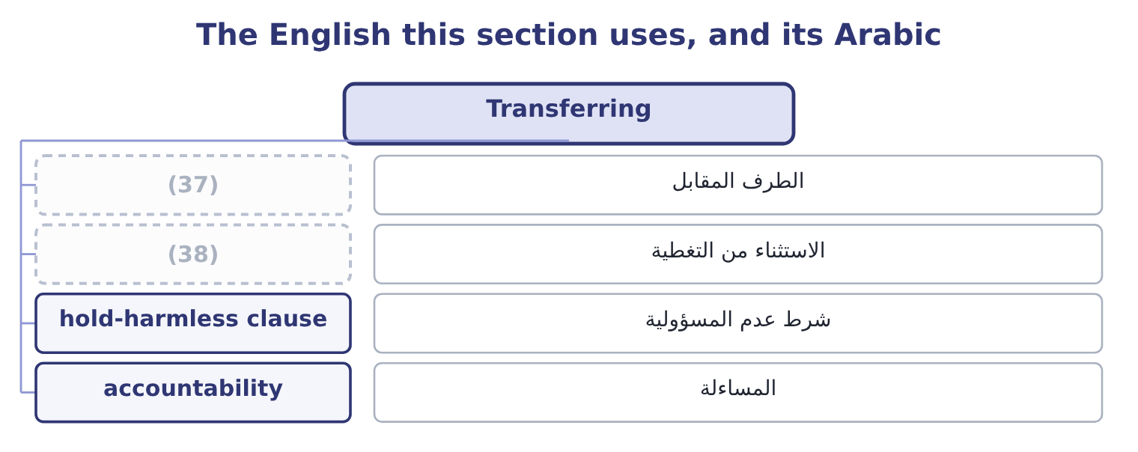
word list
redundancy · counterparty · exclusion

The English this sheet uses, and its Arabic
English (exam term) | Arabic
counterparty | الطرف المقابل
exclusion | الاستثناء من التغطية
hold-harmless clause | شرط عدم المسؤولية
accountability | المساءلة

Answer key · 5.4 Transferring

1 consequences | 20 negotiation
2 consideration | 21 Hedging
3 examples | 22 future
4 attention | 23 specialist
5 insurer | 24 subject
6 within | 25 examined
7 willingly | 26 crystallises
8 uncertain | 27 additional
9 candidates | 28 insurers
10 stating | 29 concentration
11 financed | 30 Policies
12 business | 31 deductibles
13 required | 32 covers
14 insurance | 33 consequential
15 risk-sharing | 34 Reputation
16 questions | 35 accountability
17 indemnity | 36 obligation
18 hold-harmless | 37 counterparty
19 available | 38 exclusion

the summaries in full
Summary 1 Risk transfer is an arrangement under which another party bears some or all of the financial consequences of a risk, in return for a payment or another consideration. The outcome names two examples and both repay attention. The company pays a premium and the insurer pays the loss, within the limits and exclusions of the policy. The premium exceeds the expected loss by the loading of section 5.3, and the company pays that loading willingly because it converts an uncertain large loss into a certain small cost — which is. This one puzzles candidates, and the logic is worth stating. A company financed partly by debt has transferred part of its business risk to lenders: they accept a fixed return and, in exchange, bear the risk that the company cannot pay, which in the limit means they absorb losses the shareholders' limited liability protects the shareholders.
Summary 2 Book 2's, as the lenders' required return. Note the exam's point: risk transfer is not only insurance, and the financing structure of a company is itself a risk-sharing arrangement. Other transfers appear in questions. Contractual transfer: an indemnity, a warranty from a supplier, a liability cap, a hold-harmless clause, a penalty for late delivery. These are the cheapest transfers available and the most neglected, because they cost nothing but negotiation. Hedging: a forward, a future, an option or a swap, which transfers a price risk to a counterparty, as Book 2's. Outsourcing: giving an activity to a specialist who carries its operational risk — subject to the warning below. Joint ventures and partnerships: sharing an exposure with somebody who shares the return. Securitisation and other capital market transfers, where a risk is packaged and sold to investors.
Summary 3 Four tests every transfer must pass, and they are the examined part. Can the counterparty actually pay? A transfer to a party that fails when the risk crystallises is not a transfer; it is an additional credit risk. This is why insurers' financial strength matters and why concentration with one counterparty is itself an exposure. What exactly has been transferred? Policies have limits, exclusions, deductibles and conditions. A transfer that covers the direct loss and not the consequential loss. What cannot be transferred at all? Reputation, regulatory responsibility and legal accountability generally stay with the company. Outsourcing a process transfers its cost and some of its operational risk; it does not transfer the obligation to the regulator or the customer, and a candidate who writes that outsourcing eliminates a risk has made the standard error. And does the transfer create new risk? Every transfer introduces a counterparty, a contract and a dependency, which are themselves exposures.

5.5 Liability and hazard insurance
Chapter 5 · section 5.5

Fill every gap. Each word list holds one word more than there are gaps.
Summary 1 gaps 1–12
The (1) asks for a general (2) of insurance as a transfer (3) , not for the detail of policy (4) . Five (5) are enough. It pools a large number of similar exposures so that the insurer, which (6) predict any one loss, can predict the total (7) . That is the law of large (8) , and it is why an insurer can charge each company a premium close to its (9) loss plus a loading and still be (10) of its own result. What makes a risk insurable. The exam uses six conditions: the loss must be accidental rather than within the insured's control; it must be measurable in money and (11) as to time and place; there must be a large number of similar, independent exposures; the loss must not be (12) to the insurer, which is why flood and war are often excluded or reinsured; the premium must be economically feasible, which rules out risks that are near-certain; and the insured must have an insurable interest — must actually stand to lose.
word list
closely · outcome · identifiable · things · mechanism · numbers · understanding · catastrophic · confident · exclusions · wordings · cannot · expected

Summary 2 gaps 13–24
The main (13) a company buys. Property and hazard cover: the (14) , plant and stock against fire, flood, storm, (15) and theft — the direct loss. Business (16) cover: the profit lost and the extra cost of (17) while the asset is out of use —, and the cover companies most often buy too little. Liability insurance: the (18) legal liability to (19) . Public liability for injury or damage to third parties; product liability for harm caused by what the company sells, which for a food producer is the material one; employers' liability for injury to employees; professional (20) for advice; and directors' and officers' liability for claims against the board (21) . Other covers: goods in (22) , credit insurance on (23) , political risk insurance, key person cover, cyber. The (24) features that decide what a policy is worth.
word list
others · buildings · indemnity · classes · interruption · company's · political · working · personally · explosion · structural · receivables · transit

Summary 3 gaps 25–34
The limit, which is the most the insurer will pay and which should be set against; the (25) of section 5.3; the (26) , which is where most disputes live; the conditions, breach of which can void cover — a (27) system required to be maintained, a (28) required within a period; and the basis of settlement, (29) cost or market value. Two moral hazards the (30) . Insurance can reduce the (31) to prevent losses, which is why insurers use deductibles, (32) and conditions; and a company that is insured may (33) in continuity planning, which protects (34) insurance does not pay for — the customer who went elsewhere while the plant was rebuilt.
word list
deductible · exclusions · notification · replacement · sprinkler · insurer · something · incentive · under-invest · examiners · co-insurance

The English this section uses, and its Arabic
Each term sits against what it means.
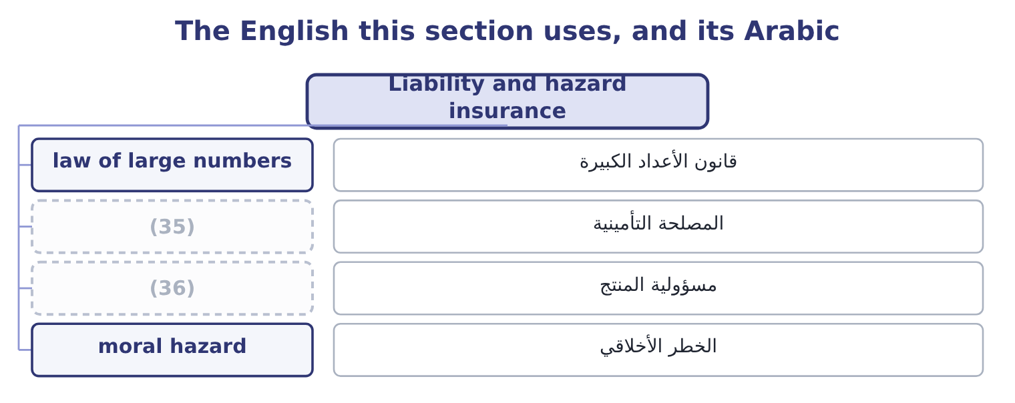
word list
الخطر الأخلاقي · insurable interest · product liability

The English this sheet uses, and its Arabic
English (exam term) | Arabic
law of large numbers | قانون الأعداد الكبيرة
insurable interest | المصلحة التأمينية
product liability | مسؤولية المنتج
moral hazard | الخطر الأخلاقي

Answer key · 5.5 Liability and hazard insurance

1 outcome | 19 others
2 understanding | 20 indemnity
3 mechanism | 21 personally
4 wordings | 22 transit
5 things | 23 receivables
6 cannot | 24 structural
7 closely | 25 deductible
8 numbers | 26 exclusions
9 expected | 27 sprinkler
10 confident | 28 notification
11 identifiable | 29 replacement
12 catastrophic | 30 examiners
13 classes | 31 incentive
14 buildings | 32 co-insurance
15 explosion | 33 under-invest
16 interruption | 34 something
17 working | 35 insurable interest
18 company's | 36 product liability

the summaries in full
Summary 1 The outcome asks for a general understanding of insurance as a transfer mechanism, not for the detail of policy wordings. Five things are enough. It pools a large number of similar exposures so that the insurer, which cannot predict any one loss, can predict the total closely. That is the law of large numbers, and it is why an insurer can charge each company a premium close to its expected loss plus a loading and still be confident of its own result. What makes a risk insurable. The exam uses six conditions: the loss must be accidental rather than within the insured's control; it must be measurable in money and identifiable as to time and place; there must be a large number of similar, independent exposures; the loss must not be catastrophic to the insurer, which is why flood and war are often excluded or reinsured; the premium must be economically feasible, which rules out risks that are near-certain; and the insured must have an insurable interest — must actually stand to lose.
Summary 2 The main classes a company buys. Property and hazard cover: the buildings, plant and stock against fire, flood, storm, explosion and theft — the direct loss. Business interruption cover: the profit lost and the extra cost of working while the asset is out of use —, and the cover companies most often buy too little. Liability insurance: the company's legal liability to others. Public liability for injury or damage to third parties; product liability for harm caused by what the company sells, which for a food producer is the material one; employers' liability for injury to employees; professional indemnity for advice; and directors' and officers' liability for claims against the board personally. Other covers: goods in transit, credit insurance on receivables, political risk insurance, key person cover, cyber. The structural features that decide what a policy is worth.
Summary 3 The limit, which is the most the insurer will pay and which should be set against; the deductible of section 5.3; the exclusions, which is where most disputes live; the conditions, breach of which can void cover — a sprinkler system required to be maintained, a notification required within a period; and the basis of settlement, replacement cost or market value. Two moral hazards the examiners. Insurance can reduce the incentive to prevent losses, which is why insurers use deductibles, co-insurance and conditions; and a company that is insured may under-invest in continuity planning, which protects something insurance does not pay for — the customer who went elsewhere while the plant was rebuilt.

5.6 Exploiting, and choosing
Chapter 5 · section 5.6

Fill every gap. Each word list holds one word more than there are gaps.
Summary 1 gaps 1–12
Exploitation is the response for a risk the company is better placed to bear than others are, and the examiners include it precisely because (1) forget that risk (2) can increase an exposure on purpose. (3) more of a risk the company is paid for. Orontes's strong cash (4) lets it offer sixty-day terms where a (5) competitor must ask for thirty, which wins volume. The (6) risk rises deliberately, and the contribution rises with it. (7) a response that (8) . A control bought when the company was smaller, an (9) limit set for a risk that has shrunk, an approval (10) nobody has revisited: each is a cost without a matching benefit, and releasing it is as much a risk decision as adding one. (11) an upside the risk (12) . A currency movement that hurts imports helps exports; a competitor's supply failure is an opportunity for a company with spare capacity; a new regulation that is expensive to meet is a barrier to smaller entrants.
word list
over-controls · Taking · position · whatever · threshold · insurance · weaker · credit · management · Changing · candidates · Pursuing · creates

The five responses
Response | What it does | Right when | Watch for
Avoid | (13) | The exposure cannot be survived or transferred | Forgone contribution
Reduce | Lowers probability, severity or both | The control costs less than it saves | (14)
Transfer | Moves consequences to another party | The other party can carry it and will be there | (15)
Retain | Keeps the consequences deliberately | Losses are small, frequent and predictable | (16)
Exploit | (17) | The company has an advantage in bearing it | The advantage must be real

word list
Diminishing returns; new risks · Must be funded; aggregates across the company · Removes the risk and the return · Offering sixty-day terms to win volume · Limits, exclusions, counterparty failure · Takes more of the exposure

Summary 2 gaps 18–25
Choosing among them (18) a pattern that is worth (19) as a sequence. Start with the maximum (20) loss. If it cannot be survived, the risk must be transferred or avoided, (21) the probability. Then ask whether reduction is cheap. The early (22) of, and they (23) both the premium and the retention. Then compare transfer with retention on the (24) exposure, using the (25) arithmetic of section 5.3 — premium plus retained expected loss — rather than the premium alone. Then retain the rest deliberately, write it down, and fund it.
word list
remaining · controls · whatever · follows · learning · shrink · creates · total-cost · possible

Match the response

Your turn: which response? (complete the blanks)
Situation | Response
A 250,000 deductible with the rest insured | ________
Declining to trade in a country whose rules cannot be followed | ________
Installing sprinklers in the roasting hall | ________
Offering sixty-day terms to win volume, funded by the cash balance | ________
Budgeting 75,000 a year for small write-offs | ________
A supplier contract that caps Orontes's liability for a recall | ________

"Transfer", "share" and "deductible"

Summary 3 gaps 26–36
Transfer is the word most likely to mislead a board, because in English it (26) the risk has gone (27) else and is no longer the (28) problem. Risk is not transferred in the way an asset is; what moves is the financial (29) , and only to the (30) the contract says. Several (31) now prefer share for (32) that reason, and it is the better word: it keeps the company in the (33) . Deductible is an (34) trap of its own: in British (35) it is the excess, in (36) the retention, and all three mean the slice the insured carries. When a question gives a figure, check whether it is deducted from every loss or only applies once in a year, because the arithmetic of section 5.3 changes completely.
word list
company's · somewhere · picture · consequence · English-language · over-control · suggests · practice · reinsurance · frameworks · extent · exactly

"Transfer", "share" and "deductible"
Situation | Response
A 250,000 deductible with the rest insured | Partial retention with transfer above it.
Declining to trade where the rules cannot be followed | Avoidance.
Installing sprinklers | (37)
Offering sixty-day terms to win volume | Exploitation.
Budgeting 75,000 for small write-offs | (38)
A supplier contract capping liability | (39)
What it tells you | Four of the six are things a company does every day without calling them risk responses — which is the point: the (40) names decis

word list
Transfer, by contract. · Reduction, acting on severity. · Retention, funded. · classification · Exploitation.

The English this section uses, and its Arabic
Each term sits against what it means.
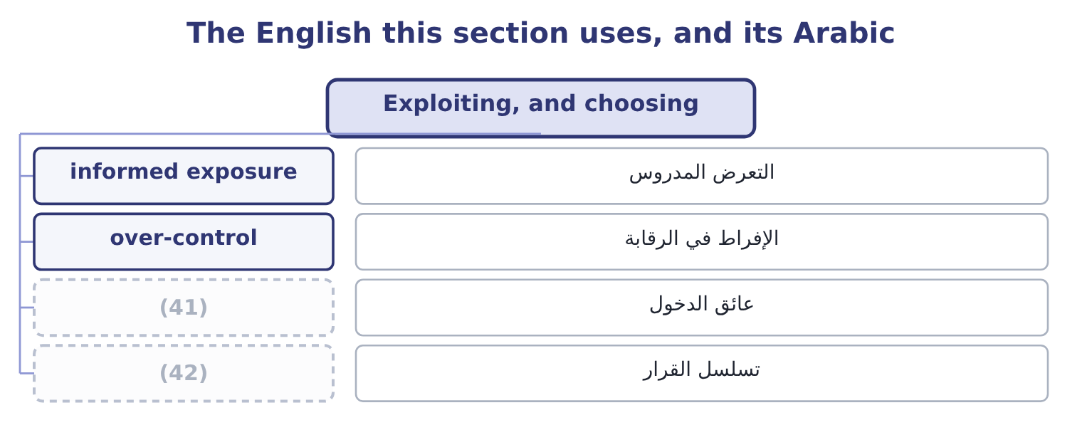
word list
barrier to entry · sequence of decision · الإفراط في الرقابة

The English this sheet uses, and its Arabic
English (exam term) | Arabic
informed exposure | التعرض المدروس
over-control | الإفراط في الرقابة
barrier to entry | عائق الدخول
sequence of decision | تسلسل القرار

Answer key · 5.6 Exploiting, and choosing

1 candidates | 22 controls
2 management | 23 shrink
3 Taking | 24 remaining
4 position | 25 total-cost
5 weaker | 26 suggests
6 credit | 27 somewhere
7 Changing | 28 company's
8 over-controls | 29 consequence
9 insurance | 30 extent
10 threshold | 31 frameworks
11 Pursuing | 32 exactly
12 creates | 33 picture
13 Removes the risk and the return | 34 English-language
14 Diminishing returns; new risks | 35 practice
15 Limits, exclusions, counterparty failure | 36 reinsurance
16 Must be funded; aggregates across the company | 37 Reduction, acting on severity.
17 Takes more of the exposure | 38 Retention, funded.
18 follows | 39 Transfer, by contract.
19 learning | 40 classification
20 possible | 41 barrier to entry
21 whatever | 42 sequence of decision

the summaries in full
Summary 1 Exploitation is the response for a risk the company is better placed to bear than others are, and the examiners include it precisely because candidates forget that risk management can increase an exposure on purpose. Taking more of a risk the company is paid for. Orontes's strong cash position lets it offer sixty-day terms where a weaker competitor must ask for thirty, which wins volume. The credit risk rises deliberately, and the contribution rises with it. Changing a response that over-controls. A control bought when the company was smaller, an insurance limit set for a risk that has shrunk, an approval threshold nobody has revisited: each is a cost without a matching benefit, and releasing it is as much a risk decision as adding one. Pursuing an upside the risk creates. A currency movement that hurts imports helps exports; a competitor's supply failure is an opportunity for a company with spare capacity; a new regulation that is expensive to meet is a barrier to smaller entrants.
Summary 2 Choosing among them follows a pattern that is worth learning as a sequence. Start with the maximum possible loss. If it cannot be survived, the risk must be transferred or avoided, whatever the probability. Then ask whether reduction is cheap. The early controls of, and they shrink both the premium and the retention. Then compare transfer with retention on the remaining exposure, using the total-cost arithmetic of section 5.3 — premium plus retained expected loss — rather than the premium alone. Then retain the rest deliberately, write it down, and fund it.
Summary 3 Transfer is the word most likely to mislead a board, because in English it suggests the risk has gone somewhere else and is no longer the company's problem. Risk is not transferred in the way an asset is; what moves is the financial consequence, and only to the extent the contract says. Several frameworks now prefer share for exactly that reason, and it is the better word: it keeps the company in the picture. Deductible is an English-language trap of its own: in British practice it is the excess, in reinsurance the retention, and all three mean the slice the insured carries. When a question gives a figure, check whether it is deducted from every loss or only applies once in a year, because the arithmetic of section 5.3 changes completely.

6.1 The steps of the process
Chapter 6 · section 6.1

Fill every gap. Each word list holds one word more than there are gaps.
Chapter 6, section by section
Each stage leads to the next.
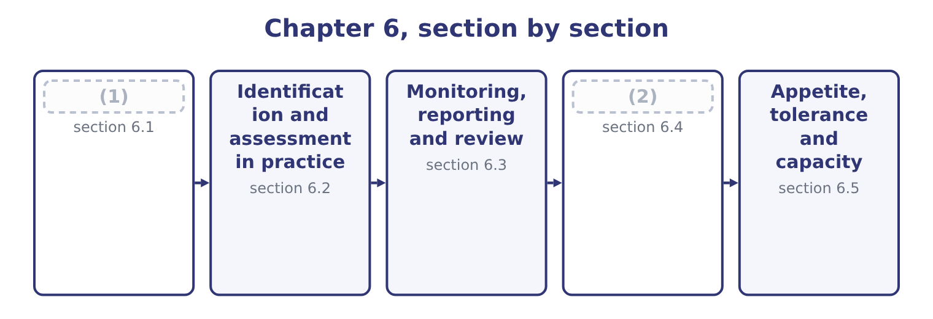
word list
Monitoring, reporting and review · The steps of the process · Attitude toward risk

Summary 1 gaps 3–14
Frameworks name the steps (3) , and the examiners accept any (4) version provided the logic is right. Five steps cover it, with a sixth that runs (5) all of them. Establish the (6) and the objectives. What the business is (7) to achieve, in what (8) , with what appetite. Risk is defined (9) to an objective — the risk that something will not happen — so a process that starts by listing risks rather than objectives (10) a list of worries instead of a list of threats to something specific. What could happen that would (11) those objectives, from any. (12) and impact, inherent and residual, with the expected loss, (13) loss and maximum possible loss. Choose from, with the (14) test of, and assign each response to a named owner with a date. Confirm that the responses are in place and working, that the assessments are still right, and that no new risk has arrived.
word list
context · sensible · relative · produces · alongside · trying · affect · cost-benefit · environment · unexpected · differently · advises · Likelihood

Summary 2 gaps 15–26
Risks (15) faster than (16) do. And throughout: (17) and consult. Risk (18) has to move up to the board, down to the people who run the (19) , and sideways between functions that each see part of an exposure. The step is listed (20) in most frameworks because it is the one most often missing — a register that lives in a file nobody reads is a (21) process with no effect. Three (22) of the process as a whole are (23) . It is (24) , not linear. (25) feeds back into (26) ; a response changes the assessment; a changed objective changes everything. It is owned by management, not by a risk function. The risk manager designs and runs the process and advises on it; the manager who owns the business process owns the risk, and the board owns the appetite. And it operates at every level. The same five steps apply to a factory process, to a project, to a division and to the enterprise, which is the connection.
word list
registers · identification · properties · information · iterative · Monitoring · specific · examined · separately · completed · change · processes · communicate

The English this section uses, and its Arabic
Each term sits against what it means.
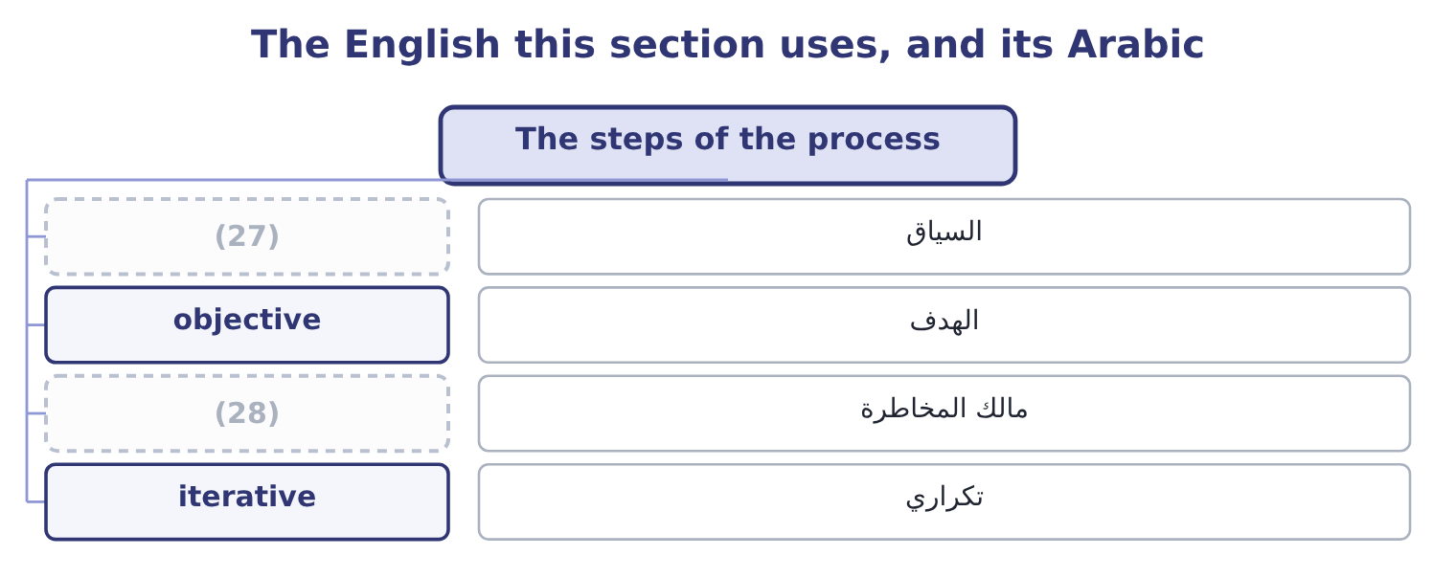
word list
risk owner · appetite statement · context

The English this sheet uses, and its Arabic
English (exam term) | Arabic
context | السياق
objective | الهدف
risk owner | مالك المخاطرة
iterative | تكراري

Answer key · 6.1 The steps of the process

1 The steps of the process | 15 change
2 Attitude toward risk | 16 registers
3 differently | 17 communicate
4 sensible | 18 information
5 alongside | 19 processes
6 context | 20 separately
7 trying | 21 completed
8 environment | 22 properties
9 relative | 23 examined
10 produces | 24 iterative
11 affect | 25 Monitoring
12 Likelihood | 26 identification
13 unexpected | 27 context
14 cost-benefit | 28 risk owner

the summaries in full
Summary 1 Frameworks name the steps differently, and the examiners accept any sensible version provided the logic is right. Five steps cover it, with a sixth that runs alongside all of them. Establish the context and the objectives. What the business is trying to achieve, in what environment, with what appetite. Risk is defined relative to an objective — the risk that something will not happen — so a process that starts by listing risks rather than objectives produces a list of worries instead of a list of threats to something specific. What could happen that would affect those objectives, from any. Likelihood and impact, inherent and residual, with the expected loss, unexpected loss and maximum possible loss. Choose from, with the cost-benefit test of, and assign each response to a named owner with a date. Confirm that the responses are in place and working, that the assessments are still right, and that no new risk has arrived.
Summary 2 Risks change faster than registers do. And throughout: communicate and consult. Risk information has to move up to the board, down to the people who run the processes, and sideways between functions that each see part of an exposure. The step is listed separately in most frameworks because it is the one most often missing — a register that lives in a file nobody reads is a completed process with no effect. Three properties of the process as a whole are examined. It is iterative, not linear. Monitoring feeds back into identification; a response changes the assessment; a changed objective changes everything. It is owned by management, not by a risk function. The risk manager designs and runs the process and advises on it; the manager who owns the business process owns the risk, and the board owns the appetite. And it operates at every level. The same five steps apply to a factory process, to a project, to a division and to the enterprise, which is the connection.

6.2 Identification and assessment in practice
Chapter 6 · section 6.2

Fill every gap. Each word list holds one word more than there are gaps.
Summary 1 gaps 1–12
Two of the steps (1) more than a (2) , because most of the work and most of the failure is in them. (3) fails in characteristic ways, and naming them is (4) . It stops at the (5) . People list the risks they have already (6) , which are by (7) the ones already managed. It stops at the boundary of a (8) . Nobody owns the risk that falls between sales and (9) , which is usually where it is. It (10) risks with their causes and their (11) . A register that mixes all three (12) and obscures where a response would act. And it omits the risks nobody wants to write down: the risk that the strategy is wrong, the risk from a dominant personality, the risk that a figure management is attached to is unachievable. Assessment has its own failure modes.
word list
familiar · experienced · sentence · Identification · conflates · single-source · effects · double-counts · deserve · definition · production · examinable · department

Summary 2 gaps 13–24
Scales that are not anchored. An anchored scale (13) high as, say, more than 500,000 or more than a 20 per cent chance in a year, so that two (14) produce the same answer. Assessing with the (15) half in place, which (16) a figure that is neither inherent nor residual. Assessing likelihood and impact without a time horizon. And (17) the assessment as the output. The output is the response; the assessment (18) to choose it. Supply the Gulf (19) on contract terms for the next (20) months. A (21) supplier of hulled sesame fails to (22) for six weeks in the harvest gap. Likelihood 0.25 in a year on the current single-source (23) ; impact a stoppage costing 46,027 a day, so about 1,933,134 over six weeks; expected loss (24) 0.25 × 1,933,134 = 483,284.
word list
objective · defines · assessors · single · therefore · controls · arrangement · exists · deliver · treating · distributor · produces · twelve

Summary 3 gaps 25–31
The response and the owner. (25) a second supplier and hold four weeks of (26) stock. Owner: the (27) manager. Date: (28) the next harvest. Residual likelihood after the response: 0.05. Every element the step list requires is present: an (29) , an event distinct from its cause and its effect, a (30) likelihood and impact over a stated horizon, a response, a named owner and a date. A register line without those is a note, and a register of notes is what most companies (31) have.
word list
before · objective · buffer · actually · quantified · Qualify · current · procurement

The English this section uses, and its Arabic
Each term sits against what it means.
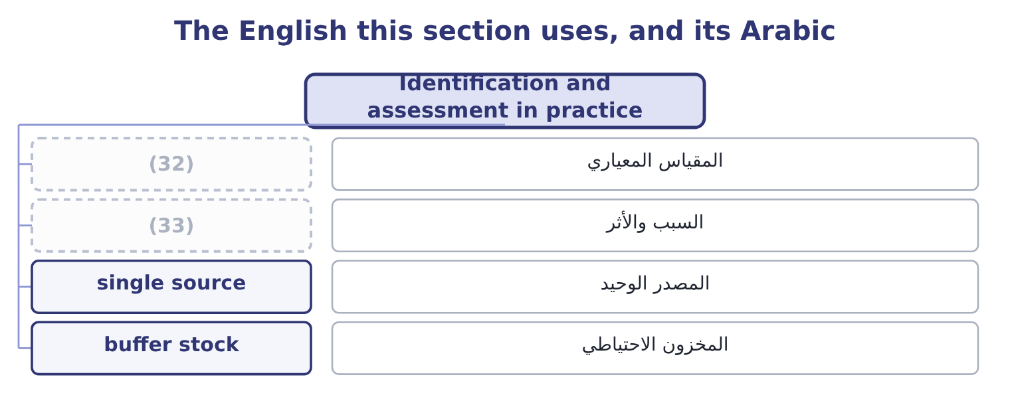
word list
anchored scale · cause and effect · buffer stock

The English this sheet uses, and its Arabic
English (exam term) | Arabic
anchored scale | المقياس المعياري
cause and effect | السبب والأثر
single source | المصدر الوحيد
buffer stock | المخزون الاحتياطي

Answer key · 6.2 Identification and assessment in practice

1 deserve | 18 exists
2 sentence | 19 distributor
3 Identification | 20 twelve
4 examinable | 21 single
5 familiar | 22 deliver
6 experienced | 23 arrangement
7 definition | 24 therefore
8 department | 25 Qualify
9 production | 26 buffer
10 conflates | 27 procurement
11 effects | 28 before
12 double-counts | 29 objective
13 defines | 30 quantified
14 assessors | 31 actually
15 controls | 32 anchored scale
16 produces | 33 cause and effect
17 treating

the summaries in full
Summary 1 Two of the steps deserve more than a sentence, because most of the work and most of the failure is in them. Identification fails in characteristic ways, and naming them is examinable. It stops at the familiar. People list the risks they have already experienced, which are by definition the ones already managed. It stops at the boundary of a department. Nobody owns the risk that falls between sales and production, which is usually where it is. It conflates risks with their causes and their effects. A register that mixes all three double-counts and obscures where a response would act. And it omits the risks nobody wants to write down: the risk that the strategy is wrong, the risk from a dominant personality, the risk that a figure management is attached to is unachievable. Assessment has its own failure modes.
Summary 2 Scales that are not anchored. An anchored scale defines high as, say, more than 500,000 or more than a 20 per cent chance in a year, so that two assessors produce the same answer. Assessing with the controls half in place, which produces a figure that is neither inherent nor residual. Assessing likelihood and impact without a time horizon. And treating the assessment as the output. The output is the response; the assessment exists to choose it. Supply the Gulf distributor on contract terms for the next twelve months. A single supplier of hulled sesame fails to deliver for six weeks in the harvest gap. Likelihood 0.25 in a year on the current single-source arrangement; impact a stoppage costing 46,027 a day, so about 1,933,134 over six weeks; expected loss therefore 0.25 × 1,933,134 = 483,284.
Summary 3 The response and the owner. Qualify a second supplier and hold four weeks of buffer stock. Owner: the procurement manager. Date: before the next harvest. Residual likelihood after the response: 0.05. Every element the step list requires is present: an objective, an event distinct from its cause and its effect, a quantified likelihood and impact over a stated horizon, a response, a named owner and a date. A register line without those is a note, and a register of notes is what most companies actually have.

6.3 Monitoring, reporting and review
Chapter 6 · section 6.3

Fill every gap. Each word list holds one word more than there are gaps.
Summary 1 gaps 1–12
The last step is the one that turns a (1) into a process, and the exam asks what it (2) . (3) that responses are in place. An (4) action with an owner and a date is not a control until (5) has checked it exists. Testing that (6) work. Key risk indicators are measures that move before a loss does — supplier delivery performance, staff turnover, overdue (7) , the age of (8) , complaint volumes, near-misses. They are the (9) half of the process, and they differ from key performance indicators in (10) forward at a risk rather than backward at a result. To the board, (11) , in a form that shows the (12) risks, their assessment, the responses, the owners and what has changed. What has changed is the part boards read. Reviewing the process itself. Whether the register is current, whether the appetite still fits the strategy, whether any loss occurred that the process should have caught — which is Book 3's postaudit applied to risk. A route by which a risk discovered at any level reaches the people who can act, without depending on the goodwill of everybody in between.
word list
reconciliations · receivables · Confirming · significant · periodically · pointing · project · somebody · process · controls · consists · agreed · early-warning

The English this section uses, and its Arabic
Each term sits against what it means.
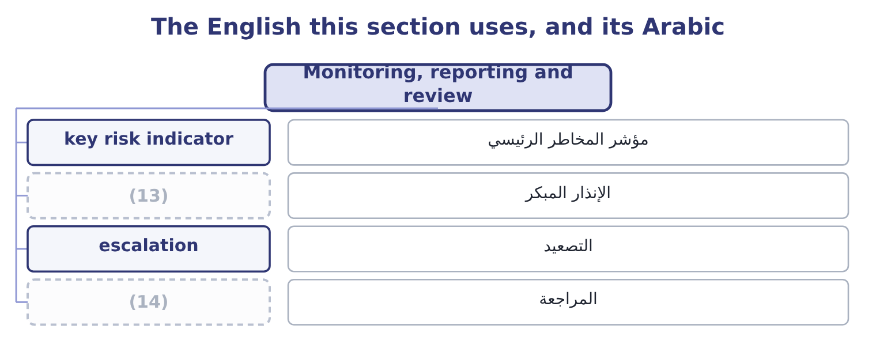
word list
early warning · review · zero tolerance

The English this sheet uses, and its Arabic
English (exam term) | Arabic
key risk indicator | مؤشر المخاطر الرئيسي
early warning | الإنذار المبكر
escalation | التصعيد
review | المراجعة

Answer key · 6.3 Monitoring, reporting and review

1 project | 8 receivables
2 consists | 9 early-warning
3 Confirming | 10 pointing
4 agreed | 11 periodically
5 somebody | 12 significant
6 controls | 13 early warning
7 reconciliations | 14 review

the summaries in full
Summary 1 The last step is the one that turns a project into a process, and the exam asks what it consists. Confirming that responses are in place. An agreed action with an owner and a date is not a control until somebody has checked it exists. Testing that controls work. Key risk indicators are measures that move before a loss does — supplier delivery performance, staff turnover, overdue reconciliations, the age of receivables, complaint volumes, near-misses. They are the early-warning half of the process, and they differ from key performance indicators in pointing forward at a risk rather than backward at a result. To the board, periodically, in a form that shows the significant risks, their assessment, the responses, the owners and what has changed. What has changed is the part boards read. Reviewing the process itself. Whether the register is current, whether the appetite still fits the strategy, whether any loss occurred that the process should have caught — which is Book 3's postaudit applied to risk. A route by which a risk discovered at any level reaches the people who can act, without depending on the goodwill of everybody in between.

6.4 Attitude toward risk
Chapter 6 · section 6.4

Fill every gap. Each word list holds one word more than there are gaps.
Summary 1 gaps 1–12
The (1) outcome asks how attitude to risk (2) its management, and the (3) begins with three (4) positions. A decision-maker who prefers a certain outcome to a gamble of the same expected value, and who requires (5) for bearing variability. Most companies and most (6) are risk averse over (7) that matter to them, and the entire cost of capital of Book 2 is built on the assumption. A decision-maker indifferent between a certain amount and a gamble with the same expected value, who (8) decides by expected value alone. This is the assumption behind, which is why those (9) need the risk (10) of Book 3's. A decision-maker who prefers the gamble — who will pay for variability. It appears in companies more often than theory (11) : in a division with nothing left to lose, in a manager whose bonus pays only above a (12) , and in anybody who has already lost money and is trying to recover it.
word list
suggests · calculations · individuals · second · threshold · answer · amounts · therefore · classical · affects · compensation · indifferent · adjustments

Worked example: what attitude costs, in money

Summary 2 gaps 13–24
A new (13) contract offers a 50 per cent chance of (14) 2,000,000 of contribution and a 50 per cent chance of losing 1,000,000. The favourable branch (15) 0.5 × 2,000,000 = 1,000,000, the (16) 0.5 × 1,000,000 = 500,000, so the expected value is 1,000,000 − 500,000 = 500,000 positive. A (17) company takes it. The expected value is positive, which is the whole of the test. A (18) company may not. If (19) board would be indifferent between this gamble and a certain 200,000, then its certainty (20) is 200,000 and the risk premium it demands is 500,000 − 200,000 = 300,000. Any (21) of the contract that locks in less than 200,000 of certain contribution will be (22) , even though its expected value is 500,000. That (23) — 300,000 — is what risk aversion costs, and it is not a (24) . It is the price of avoiding a 50 per cent chance of losing a million, and whether it is too high depends on whether losing a million would matter, which is the capacity question of section 6.5.
word list
contributes · refused · adding · mistake · risk-neutral · number · version · decides · unfavourable · equivalent · risk-averse · Orontes's · export

Summary 3 gaps 25–33
Risk aversion that reflects real consequences is rational; risk aversion that reflects a (25) fear of being blamed is a (26) problem. Four ways attitude (27) the management of risk, and these are the (28) consequences. It sets the (29) chosen. An averse organisation insures, (30) and avoids; a neutral one retains more and (31) expected costs; a seeking one exploits. Faced with, three attitudes produce three different (32) from the same (33) . Book 3's risk premium is attitude expressed as a discount rate, and a higher premium rejects projects a less averse company would accept. It differs across the organisation, which is the problem.
word list
compares · responses · refused · controls · examinable · arithmetic · changes · deductibles · governance · manager's

Summary 4 gaps 34–45
A company can be averse about (34) , neutral about credit and seeking about new (35) , and that is (36) only if somebody has said so. Where it is not said, attitude is set by whoever is (37) , and it varies with their incentives — which is why the appetite (38) of the next section (39) . And it is (40) by incentives and by (41) . A bonus that pays above a target makes a manager (42) just below it; a loss already (43) makes people take worse risks to recover it; and the same decision (44) as a possible gain or a possible loss produces different answers from the same person. Those are findings about human behaviour, and the exam expects them to be (45) as a reason for written limits rather than individual judgment.
word list
products · framing · recognised · whoever · coherent · presented · deciding · incurred · shaped · statement · risk-seeking · safety · exists

The English this section uses, and its Arabic
Each term sits against what it means.
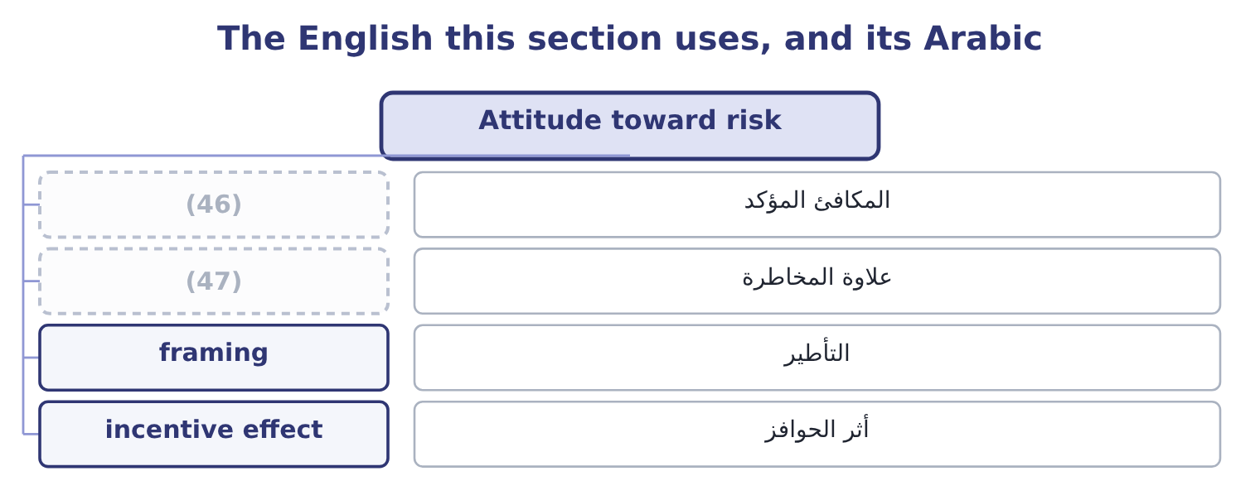
word list
incentive effect · certainty equivalent · risk premium

The English this sheet uses, and its Arabic
English (exam term) | Arabic
certainty equivalent | المكافئ المؤكد
risk premium | علاوة المخاطرة
framing | التأطير
incentive effect | أثر الحوافز

Answer key · 6.4 Attitude toward risk

1 second | 25 manager's
2 affects | 26 governance
3 answer | 27 changes
4 classical | 28 examinable
5 compensation | 29 responses
6 individuals | 30 controls
7 amounts | 31 compares
8 therefore | 32 deductibles
9 calculations | 33 arithmetic
10 adjustments | 34 safety
11 suggests | 35 products
12 threshold | 36 coherent
13 export | 37 deciding
14 adding | 38 statement
15 contributes | 39 exists
16 unfavourable | 40 shaped
17 risk-neutral | 41 framing
18 risk-averse | 42 risk-seeking
19 Orontes's | 43 incurred
20 equivalent | 44 presented
21 version | 45 recognised
22 refused | 46 certainty equivalent
23 number | 47 risk premium
24 mistake

the summaries in full
Summary 1 The second outcome asks how attitude to risk affects its management, and the answer begins with three classical positions. A decision-maker who prefers a certain outcome to a gamble of the same expected value, and who requires compensation for bearing variability. Most companies and most individuals are risk averse over amounts that matter to them, and the entire cost of capital of Book 2 is built on the assumption. A decision-maker indifferent between a certain amount and a gamble with the same expected value, who therefore decides by expected value alone. This is the assumption behind, which is why those calculations need the risk adjustments of Book 3's. A decision-maker who prefers the gamble — who will pay for variability. It appears in companies more often than theory suggests: in a division with nothing left to lose, in a manager whose bonus pays only above a threshold, and in anybody who has already lost money and is trying to recover it.
Summary 2 A new export contract offers a 50 per cent chance of adding 2,000,000 of contribution and a 50 per cent chance of losing 1,000,000. The favourable branch contributes 0.5 × 2,000,000 = 1,000,000, the unfavourable 0.5 × 1,000,000 = 500,000, so the expected value is 1,000,000 − 500,000 = 500,000 positive. A risk-neutral company takes it. The expected value is positive, which is the whole of the test. A risk-averse company may not. If Orontes's board would be indifferent between this gamble and a certain 200,000, then its certainty equivalent is 200,000 and the risk premium it demands is 500,000 − 200,000 = 300,000. Any version of the contract that locks in less than 200,000 of certain contribution will be refused, even though its expected value is 500,000. That number — 300,000 — is what risk aversion costs, and it is not a mistake. It is the price of avoiding a 50 per cent chance of losing a million, and whether it is too high depends on whether losing a million would matter, which is the capacity question of section 6.5.
Summary 3 Risk aversion that reflects real consequences is rational; risk aversion that reflects a manager's fear of being blamed is a governance problem. Four ways attitude changes the management of risk, and these are the examinable consequences. It sets the responses chosen. An averse organisation insures, controls and avoids; a neutral one retains more and compares expected costs; a seeking one exploits. Faced with, three attitudes produce three different deductibles from the same arithmetic. Book 3's risk premium is attitude expressed as a discount rate, and a higher premium rejects projects a less averse company would accept. It differs across the organisation, which is the problem.
Summary 4 A company can be averse about safety, neutral about credit and seeking about new products, and that is coherent only if somebody has said so. Where it is not said, attitude is set by whoever is deciding, and it varies with their incentives — which is why the appetite statement of the next section exists. And it is shaped by incentives and by framing. A bonus that pays above a target makes a manager risk-seeking just below it; a loss already incurred makes people take worse risks to recover it; and the same decision presented as a possible gain or a possible loss produces different answers from the same person. Those are findings about human behaviour, and the exam expects them to be recognised as a reason for written limits rather than individual judgment.

6.5 Appetite, tolerance and capacity
Chapter 6 · section 6.5

Fill every gap. Each word list holds one word more than there are gaps.
Summary 1 gaps 1–12
Attitude becomes (1) when it is (2) down, and three terms do that work. The exam (3) them and candidates (4) confuse them. Risk capacity is the (5) risk the company could bear — a fact about its balance sheet, its cash and its (6) , not a preference. (7) lending covenant (8) interest cover of four times, which on interest of $390,000 means operating income must stay above 390,000 × 4 = 1,560,000. Against the (9) $4,348,800 that is a headroom of 4,348,800 − 1,560,000 = 2,788,800: the company can lose that much of its operating income (10) the covenant binds, and that figure is part of its capacity. Risk appetite is the amount and kind of risk the company (11) to take in (12) of its objectives. It is a decision of the board, it is necessarily less than capacity, and it is expressed by category: which risks the company seeks, which it accepts, and which it will not take at any price.
word list
requires · manageable · Orontes's · pursuit · routinely · distinguishes · obligations · maximum · written · chooses · before · metaphor · present

Summary 2 gaps 13–23
Risk tolerance is the (13) variation around a (14) objective — the limit in practice. A usable appetite (15) has four features, and an answer that gives them is a (16) answer. It is expressed in (17) the business (18) uses. It (19) by category. A single appetite for all risks is useless: nobody has the same appetite for a (20) risk and a (21) risk. It names the (22) categories (23) . Bribery, safety, deliberate misstatement, breach of sanctions: these are the categories where the answer is no regardless of the return, and Book 4's second half is about why. And it connects to limits that bind somebody's decision. An appetite that does not change what anybody may do is a paragraph, not a control.
word list
zero-tolerance · measures · already · food-safety · statement · specific · differentiates · explicitly · acceptable · medicine · currency · complete

Capacity, appetite and tolerance
Every item belongs to exactly one group.
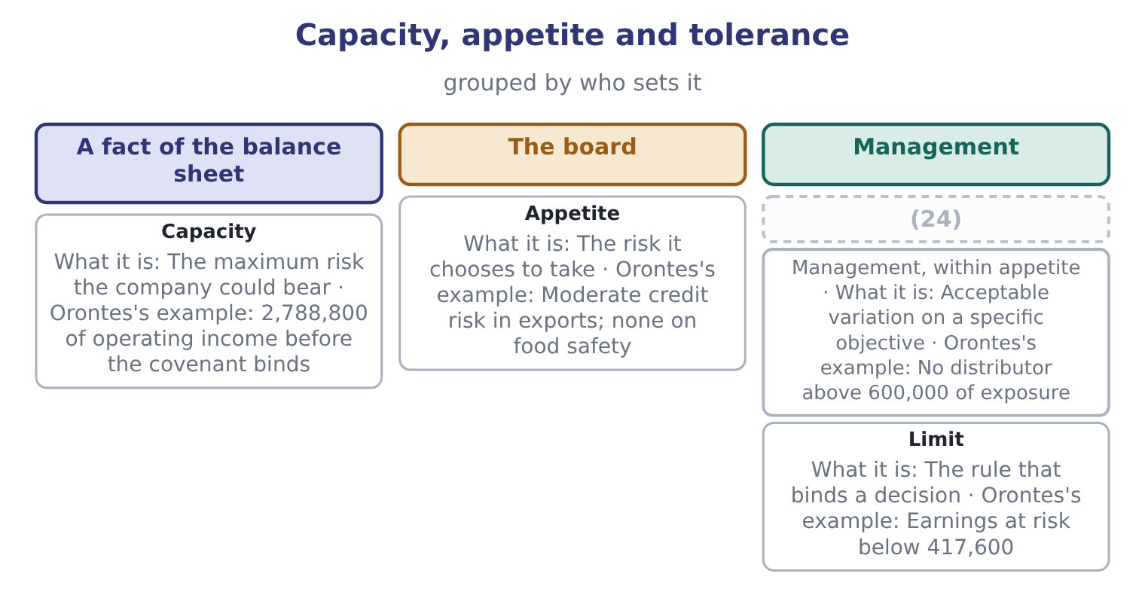
word list
Tolerance · framing

Process and appetite

Your turn: running the process (complete the blanks)
Item | Data | Answer
The step the process should begin with |  | ________
Expected loss on a supplier failure | (25) | ________
Risk premium demanded | (26) | ________
Operating income floor under a four-times cover covenant | Interest 390,000 | ________
Headroom against that floor | Operating income 4,348,800 | ________
Earnings at risk limit at 10 per cent of operating income | (27) | ________

word list
Operating income 4,176,000 · Likelihood 0.25; impact 1,933,134 · risk management process · Expected value 500,000; certainty equivalent 200,000

"Appetite", "tolerance" and "capacity"

Summary 3 gaps 28–38
English risk appetite is a metaphor from eating, and like most (28) it leaks: appetite (29) a quantity somebody wants, when what is meant is a (30) policy about which risks to take and how much. Tolerance comes from medicine and (31) , where a tolerance is the (32) deviation from a (33) , and that image is exactly right — a tolerance is a band around a target. Capacity is from physics, a (34) volume, and is (35) apt: it is what the company could hold, not what it wants to. The error to avoid in any language is using appetite where you mean capacity, which turns a preference into a (36) and lets a board believe it has decided (37) when it has only (38) its balance sheet.
word list
described · equally · something · suggests · specification · container's · engineering · considered · permitted · deviation · metaphors · constraint

"Appetite", "tolerance" and "capacity"
Item | Answer
The first step | Establish the objectives and the context; risk is defined relative to an objective.
Expected loss on a supplier failure | 483,284: 0.25 × 1,933,134 = 483,284.
Risk premium demanded | (39)
Operating income floor | (40)
Headroom against the floor | (41)
Earnings at risk limit | 417,600: 4,176,000 × 0.10 = 417,600.
What it tells you | The first answer is the process and the other five are the appetite — and the appetite only becomes usable at the point where it turns into

word list
The risk it chooses to take · 300,000: 500,000 − 200,000 = 300,000. · 1,560,000: 390,000 × 4 = 1,560,000. · 2,788,800: 4,348,800 − 1,560,000 = 2,788,800.

The English this section uses, and its Arabic
Each term sits against what it means.
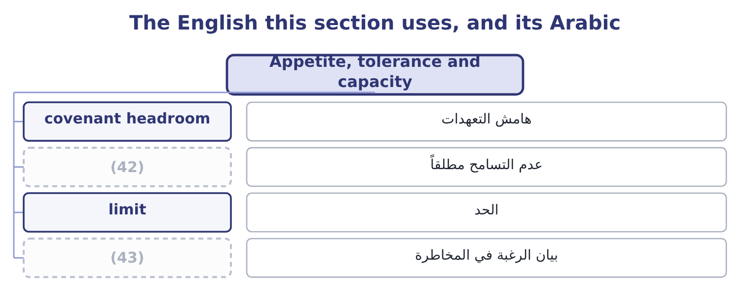
word list
appetite statement · zero tolerance · risk premium

The English this sheet uses, and its Arabic
English (exam term) | Arabic
covenant headroom | هامش التعهدات
zero tolerance | عدم التسامح مطلقاً
limit | الحد
appetite statement | بيان الرغبة في المخاطرة

Answer key · 6.5 Appetite, tolerance and capacity

1 manageable | 23 explicitly
2 written | 24 Tolerance
3 distinguishes | 25 Likelihood 0.25; impact 1,933,134
4 routinely | 26 Expected value 500,000; certainty equivalent 200,000
5 maximum | 27 Operating income 4,176,000
6 obligations | 28 metaphors
7 Orontes's | 29 suggests
8 requires | 30 considered
9 present | 31 engineering
10 before | 32 permitted
11 chooses | 33 specification
12 pursuit | 34 container's
13 acceptable | 35 equally
14 specific | 36 constraint
15 statement | 37 something
16 complete | 38 described
17 measures | 39 300,000: 500,000 − 200,000 = 300,000.
18 already | 40 1,560,000: 390,000 × 4 = 1,560,000.
19 differentiates | 41 2,788,800: 4,348,800 − 1,560,000 = 2,788,800.
20 food-safety | 42 zero tolerance
21 currency | 43 appetite statement
22 zero-tolerance

the summaries in full
Summary 1 Attitude becomes manageable when it is written down, and three terms do that work. The exam distinguishes them and candidates routinely confuse them. Risk capacity is the maximum risk the company could bear — a fact about its balance sheet, its cash and its obligations, not a preference. Orontes's lending covenant requires interest cover of four times, which on interest of $390,000 means operating income must stay above 390,000 × 4 = 1,560,000. Against the present $4,348,800 that is a headroom of 4,348,800 − 1,560,000 = 2,788,800: the company can lose that much of its operating income before the covenant binds, and that figure is part of its capacity. Risk appetite is the amount and kind of risk the company chooses to take in pursuit of its objectives. It is a decision of the board, it is necessarily less than capacity, and it is expressed by category: which risks the company seeks, which it accepts, and which it will not take at any price.
Summary 2 Risk tolerance is the acceptable variation around a specific objective — the limit in practice. A usable appetite statement has four features, and an answer that gives them is a complete answer. It is expressed in measures the business already uses. It differentiates by category. A single appetite for all risks is useless: nobody has the same appetite for a food-safety risk and a currency risk. It names the zero-tolerance categories explicitly. Bribery, safety, deliberate misstatement, breach of sanctions: these are the categories where the answer is no regardless of the return, and Book 4's second half is about why. And it connects to limits that bind somebody's decision. An appetite that does not change what anybody may do is a paragraph, not a control.
Summary 3 English risk appetite is a metaphor from eating, and like most metaphors it leaks: appetite suggests a quantity somebody wants, when what is meant is a considered policy about which risks to take and how much. Tolerance comes from medicine and engineering, where a tolerance is the permitted deviation from a specification, and that image is exactly right — a tolerance is a band around a target. Capacity is from physics, a container's volume, and is equally apt: it is what the company could hold, not what it wants to. The error to avoid in any language is using appetite where you mean capacity, which turns a preference into a constraint and lets a board believe it has decided something when it has only described its balance sheet.

7.1 Managing operational risk
Chapter 7 · section 7.1

Fill every gap. Each word list holds one word more than there are gaps.
Chapter 7, section by section
Each stage leads to the next.
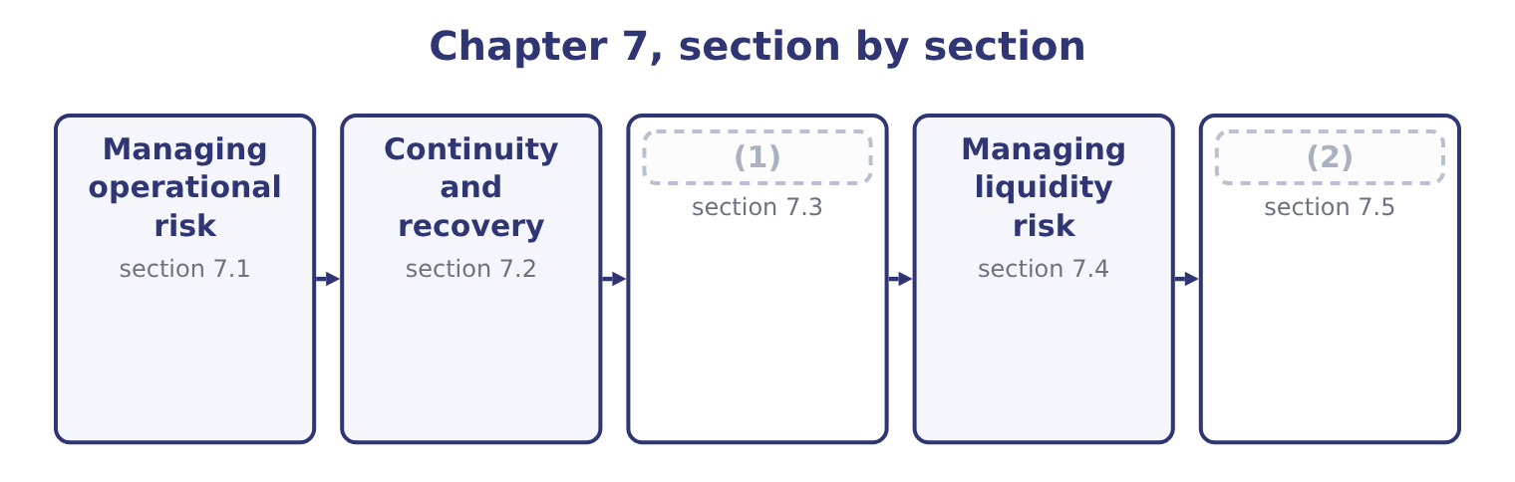
word list
Managing credit risk · Managing market risk · segregation of duties

Summary 1 gaps 3–14
Operational risk is (3) almost entirely by (4) , because, nobody is paid a return for bearing it. The (5) fall into six groups and an answer that uses the groups is (6) than one that lists twenty controls. Controls, in their two kinds. A preventive control stops the event — an (7) before a payment, a check before a (8) is accepted, an access right that does not exist. A (9) control finds it (10) — a reconciliation, an exception report, a stock count, a review of unusual items. Both are needed: prevention is better and never complete, and (11) limits the (12) of what prevention missed. (13) of duties, so that no one person both performs and checks a transaction; authorisation limits that rise with seniority; mandatory leave, during which somebody else does the job and anything being concealed surfaces; rotation of duties; dual (14) on payments. These are the controls that address deliberate as well as accidental loss.
word list
Segregation · clearer · delivery · duration · afterwards · signatures · approval · succession · reduction · methods · detection · managed · detective

Summary 2 gaps 15–26
A (15) procedure performed the same way every time produces fewer errors than judgment (16) afresh; a system that will not accept an invalid entry prevents what a reminder cannot. The caution: (17) converts many small human errors into few large (18) ones, so an automated control needs its own testing. (19) checks, training, (20) , competence assessment, succession planning for key roles, and attention to workload and turnover, which are among the best leading indicators of operational failure. A second supplier, a standby machine, backups kept (21) else, spare capacity, (22) staff. These do not reduce the (23) of an event; they reduce what it costs, which section 7.2 (24) . A loss database that records events and (25) , root cause analysis of (26) ones, key risk indicators of the kind, and the postaudit discipline of asking, after every loss, which control should have caught it and why it did not.
word list
supervision · somewhere · near-misses · systematic · significant · address · automation · cross-trained · develops · probability · Recruitment · exercised · documented

Worked example: designing the control for one process

Summary 3 gaps 27–38
Orontes pays about four hundred supplier (27) a month. The risks are paying an invoice that is not owed, paying it twice, paying the wrong (28) , and paying a (29) supplier invented by an employee. (30) matching of purchase order, goods received note and invoice, performed by the system; a supplier master file that only two named people may change, with changes reviewed by a third; payment authorisation limits by value; and bank details verified by (31) to a number held on file, never to a number on the invoice. A monthly report of (32) invoice numbers and amounts; a (33) review of new suppliers created, matched against the employee address file; a supplier statement reconciliation. The person who (34) a supplier may not approve a payment to it, and the person who (35) may not release it at the bank. Four risks, ten controls, and the (36) ones are the automated preventive checks that run on every transaction. The structural control costs nothing but (37) , and it is the one most often absent in a small finance team — which is precisely why the (38) fraud.
word list
amount · fake-supplier · approves · fraudulent · organisation · Three-way · quarterly · telephone · exception · duplicate · costly · invoices · creates

The English this section uses, and its Arabic
Each term sits against what it means.
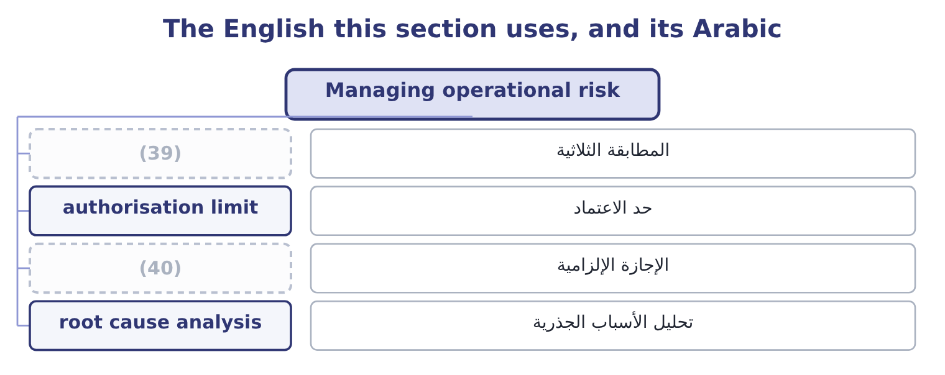
word list
authorisation limit · mandatory leave · three-way match

The English this sheet uses, and its Arabic
English (exam term) | Arabic
three-way match | المطابقة الثلاثية
authorisation limit | حد الاعتماد
mandatory leave | الإجازة الإلزامية
root cause analysis | تحليل الأسباب الجذرية

Answer key · 7.1 Managing operational risk

1 Managing credit risk | 21 somewhere
2 Managing market risk | 22 cross-trained
3 managed | 23 probability
4 reduction | 24 develops
5 methods | 25 near-misses
6 clearer | 26 significant
7 approval | 27 invoices
8 delivery | 28 amount
9 detective | 29 fraudulent
10 afterwards | 30 Three-way
11 detection | 31 telephone
12 duration | 32 duplicate
13 Segregation | 33 quarterly
14 signatures | 34 creates
15 documented | 35 approves
16 exercised | 36 costly
17 automation | 37 organisation
18 systematic | 38 fake-supplier
19 Recruitment | 39 three-way match
20 supervision | 40 mandatory leave

the summaries in full
Summary 1 Operational risk is managed almost entirely by reduction, because, nobody is paid a return for bearing it. The methods fall into six groups and an answer that uses the groups is clearer than one that lists twenty controls. Controls, in their two kinds. A preventive control stops the event — an approval before a payment, a check before a delivery is accepted, an access right that does not exist. A detective control finds it afterwards — a reconciliation, an exception report, a stock count, a review of unusual items. Both are needed: prevention is better and never complete, and detection limits the duration of what prevention missed. Segregation of duties, so that no one person both performs and checks a transaction; authorisation limits that rise with seniority; mandatory leave, during which somebody else does the job and anything being concealed surfaces; rotation of duties; dual signatures on payments. These are the controls that address deliberate as well as accidental loss.
Summary 2 A documented procedure performed the same way every time produces fewer errors than judgment exercised afresh; a system that will not accept an invalid entry prevents what a reminder cannot. The caution: automation converts many small human errors into few large systematic ones, so an automated control needs its own testing. Recruitment checks, training, supervision, competence assessment, succession planning for key roles, and attention to workload and turnover, which are among the best leading indicators of operational failure. A second supplier, a standby machine, backups kept somewhere else, spare capacity, cross-trained staff. These do not reduce the probability of an event; they reduce what it costs, which section 7.2 develops. A loss database that records events and near-misses, root cause analysis of significant ones, key risk indicators of the kind, and the postaudit discipline of asking, after every loss, which control should have caught it and why it did not.
Summary 3 Orontes pays about four hundred supplier invoices a month. The risks are paying an invoice that is not owed, paying it twice, paying the wrong amount, and paying a fraudulent supplier invented by an employee. Three-way matching of purchase order, goods received note and invoice, performed by the system; a supplier master file that only two named people may change, with changes reviewed by a third; payment authorisation limits by value; and bank details verified by telephone to a number held on file, never to a number on the invoice. A monthly report of duplicate invoice numbers and amounts; a quarterly review of new suppliers created, matched against the employee address file; a supplier statement reconciliation. The person who creates a supplier may not approve a payment to it, and the person who approves may not release it at the bank. Four risks, ten controls, and the costly ones are the automated preventive checks that run on every transaction. The structural control costs nothing but organisation, and it is the one most often absent in a small finance team — which is precisely why the fake-supplier fraud.

7.2 Continuity and recovery
Chapter 7 · section 7.2

Fill every gap. Each word list holds one word more than there are gaps.
Summary 1 gaps 1–12
Some (1) events cannot be prevented, and for those the (2) method is planning what happens next. The exam (3) two related (4) . A business continuity plan sets out how the business keeps operating during a (5) : which activities are critical, in what order they are restored, where people work, how (6) are told, who decides. Its unit of analysis is the business process. A (7) recovery plan is the technical subset: how systems and data are restored, from what (8) , at what site, within what time. Its unit of analysis is the system. Four (9) travel with them. A business (10) analysis, which asks what each process is worth per hour or per day of (11) . The recovery time objective: how (12) a process must be back. It is a business decision, not a technical one, and it drives the cost of everything else.
word list
disruption · disaster · things · backups · management · impact · alternative · quickly · customers · distinguishes · interruption · concepts · operational

Summary 2 gaps 13–24
The recovery point objective: how much data the company can (13) to lose, which (14) backup frequency. And the critical dependency list: the (15) , utilities, systems, (16) and people without which a process cannot run. Most continuity plans fail at this point, because the dependency that stops the business is usually one nobody mapped — a single (17) , a single shipping agent, a licence held in one (18) name. Three rules make a plan real rather than (19) . An untested plan is a document, and testing finds the (20) : the contact list that is out of date, the backup that cannot be restored, the (21) site with no power for the equipment. It must be (22) when the event happens. A plan stored only on the system that is down is a (23) and complete (24) . And it must name people and decisions, not intentions.
word list
suppliers · afford · failure · objective · approver · omissions · premises · determines · accessible · decorative · person's · familiar · alternative

The English this section uses, and its Arabic
Each term sits against what it means.
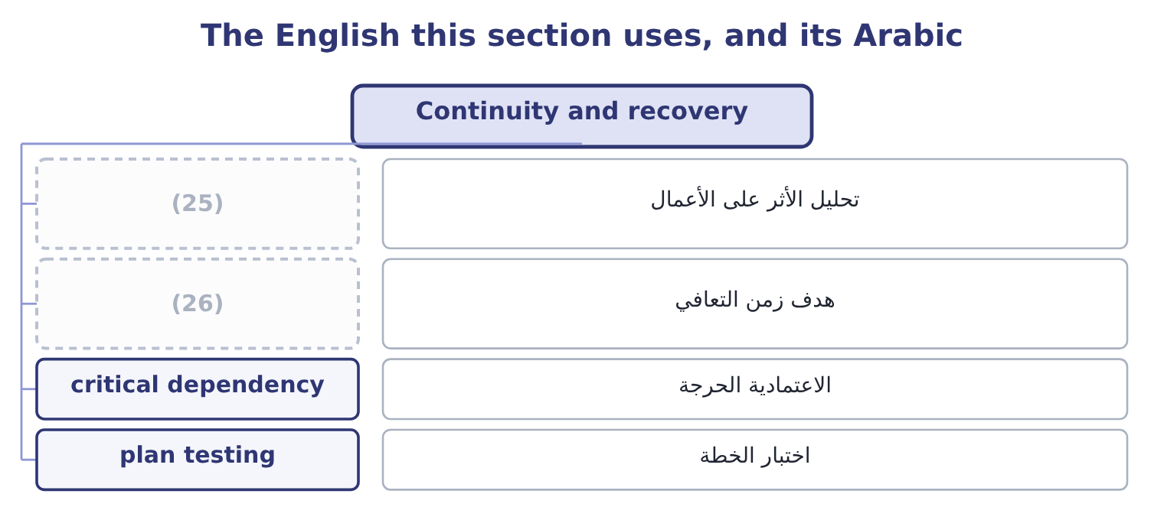
word list
dealing and settlement · business impact analysis · recovery time objective

The English this sheet uses, and its Arabic
English (exam term) | Arabic
business impact analysis | تحليل الأثر على الأعمال
recovery time objective | هدف زمن التعافي
critical dependency | الاعتمادية الحرجة
plan testing | اختبار الخطة

Answer key · 7.2 Continuity and recovery

1 operational | 14 determines
2 management | 15 suppliers
3 distinguishes | 16 premises
4 things | 17 approver
5 disruption | 18 person's
6 customers | 19 decorative
7 disaster | 20 omissions
8 backups | 21 alternative
9 concepts | 22 accessible
10 impact | 23 familiar
11 interruption | 24 failure
12 quickly | 25 business impact analysis
13 afford | 26 recovery time objective

the summaries in full
Summary 1 Some operational events cannot be prevented, and for those the management method is planning what happens next. The exam distinguishes two related things. A business continuity plan sets out how the business keeps operating during a disruption: which activities are critical, in what order they are restored, where people work, how customers are told, who decides. Its unit of analysis is the business process. A disaster recovery plan is the technical subset: how systems and data are restored, from what backups, at what site, within what time. Its unit of analysis is the system. Four concepts travel with them. A business impact analysis, which asks what each process is worth per hour or per day of interruption. The recovery time objective: how quickly a process must be back. It is a business decision, not a technical one, and it drives the cost of everything else.
Summary 2 The recovery point objective: how much data the company can afford to lose, which determines backup frequency. And the critical dependency list: the suppliers, utilities, systems, premises and people without which a process cannot run. Most continuity plans fail at this point, because the dependency that stops the business is usually one nobody mapped — a single approver, a single shipping agent, a licence held in one person's name. Three rules make a plan real rather than decorative. An untested plan is a document, and testing finds the omissions: the contact list that is out of date, the backup that cannot be restored, the alternative site with no power for the equipment. It must be accessible when the event happens. A plan stored only on the system that is down is a familiar and complete failure. And it must name people and decisions, not intentions.

7.3 Managing credit risk
Chapter 7 · section 7.3

Fill every gap. Each word list holds one word more than there are gaps.
Summary 1 gaps 1–12
Financial risk (1) begins with the money owed to the company. The methods form a sequence that matches the life of a (2) . Before the sale: (3) . Financial statements, credit agency reports, trade references, the length and history of the (4) , and the country the customer sits. The (5) is a credit limit and terms, not a yes or no. At the sale: (6) . Terms of payment, deposits or (7) in advance, retention of title until payment, a letter of credit or a bank guarantee for export sales —. During the life: (8) . Ageing of the balance, (9) against the limit, the pattern of payments rather than only the total, and alerts on deterioration elsewhere in the market. After the due date: collection. A defined escalation with dates, from a reminder through to suspension of supply and legal action, applied (10) , because customers learn quickly which suppliers mean what they say. And across the whole: (11) measures. Concentration limits so that no single customer can cause an unacceptable loss, credit insurance, factoring, and (12) across customers, sectors and countries.
word list
part-payment · monitoring · consistently · management · diversification · portfolio · assessment · output · candidates · receivable · utilisation · structure · relationship

Worked example: pricing a distributor's credit

Summary 2 gaps 13–24
Orontes's limit for a single distributor is 600,000. The credit agency puts the distributor's probability of default at 2 per cent in a year, and Orontes (13) to recover 30 per cent of any balance, so the loss given default is 70 per cent. The expected loss is 600,000 × 0.02 = 12,000 of (14) exposure, of which 12,000 × 0.70 = 8,400 would be lost. The distributor's trade earns a contribution of 240,000 a year. An expected credit loss of 8,400 against 240,000 of contribution is a cost of doing (15) , not a reason to (16) . What would (17) the answer is concentration — a balance that could not be (18) if it went — or a deterioration that (19) the default probability. (20) that the right (21) here is not to reduce the credit risk but to price it and watch it. This is: Orontes's cash (22) lets it offer terms a weaker (23) cannot, and the 8,400 is what that (24) costs.
word list
advantage · raises · sectors · response · business · change · expects · Observe · absorbed · defaulted · position · competitor · refuse

Summary 3 gaps 25–30
One (25) method belongs here because (26) forget it. (27) terms reduces exposure without (28) anybody. Orontes's (29) stand at $4,144,000, which on sales of $42,000,000 is 36 days; since sales run at 42,000,000 ÷ 365 = 115,068 a day, (30) six days from the collection period would release 115,068 × 6 = 690,408 of cash and reduce the amount at risk by the same figure.
word list
cutting · receivables · refusing · against · candidates · Shortening · further

The English this section uses, and its Arabic
Each term sits against what it means.
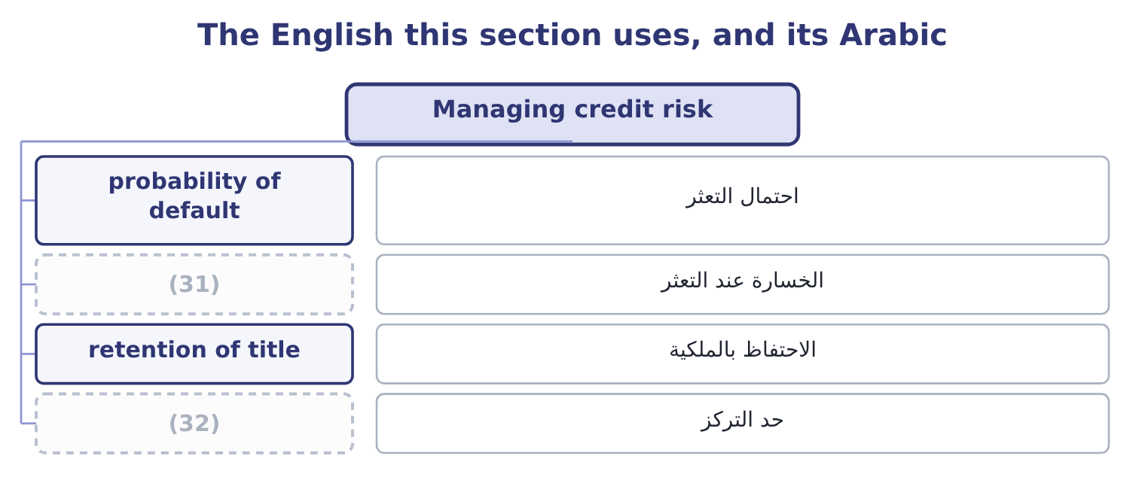
word list
الخسارة عند التعثر · concentration limit · loss given default

The English this sheet uses, and its Arabic
English (exam term) | Arabic
probability of default | احتمال التعثر
loss given default | الخسارة عند التعثر
retention of title | الاحتفاظ بالملكية
concentration limit | حد التركز

Answer key · 7.3 Managing credit risk

1 management | 17 change
2 receivable | 18 absorbed
3 assessment | 19 raises
4 relationship | 20 Observe
5 output | 21 response
6 structure | 22 position
7 part-payment | 23 competitor
8 monitoring | 24 advantage
9 utilisation | 25 further
10 consistently | 26 candidates
11 portfolio | 27 Shortening
12 diversification | 28 refusing
13 expects | 29 receivables
14 defaulted | 30 cutting
15 business | 31 loss given default
16 refuse | 32 concentration limit

the summaries in full
Summary 1 Financial risk management begins with the money owed to the company. The methods form a sequence that matches the life of a receivable. Before the sale: assessment. Financial statements, credit agency reports, trade references, the length and history of the relationship, and the country the customer sits. The output is a credit limit and terms, not a yes or no. At the sale: structure. Terms of payment, deposits or part-payment in advance, retention of title until payment, a letter of credit or a bank guarantee for export sales —. During the life: monitoring. Ageing of the balance, utilisation against the limit, the pattern of payments rather than only the total, and alerts on deterioration elsewhere in the market. After the due date: collection. A defined escalation with dates, from a reminder through to suspension of supply and legal action, applied consistently, because customers learn quickly which suppliers mean what they say. And across the whole: portfolio measures. Concentration limits so that no single customer can cause an unacceptable loss, credit insurance, factoring, and diversification across customers, sectors and countries.
Summary 2 Orontes's limit for a single distributor is 600,000. The credit agency puts the distributor's probability of default at 2 per cent in a year, and Orontes expects to recover 30 per cent of any balance, so the loss given default is 70 per cent. The expected loss is 600,000 × 0.02 = 12,000 of defaulted exposure, of which 12,000 × 0.70 = 8,400 would be lost. The distributor's trade earns a contribution of 240,000 a year. An expected credit loss of 8,400 against 240,000 of contribution is a cost of doing business, not a reason to refuse. What would change the answer is concentration — a balance that could not be absorbed if it went — or a deterioration that raises the default probability. Observe that the right response here is not to reduce the credit risk but to price it and watch it. This is: Orontes's cash position lets it offer terms a weaker competitor cannot, and the 8,400 is what that advantage costs.
Summary 3 One further method belongs here because candidates forget it. Shortening terms reduces exposure without refusing anybody. Orontes's receivables stand at $4,144,000, which on sales of $42,000,000 is 36 days; since sales run at 42,000,000 ÷ 365 = 115,068 a day, cutting six days from the collection period would release 115,068 × 6 = 690,408 of cash and reduce the amount at risk by the same figure.

7.4 Managing liquidity risk
Chapter 7 · section 7.4

Fill every gap. Each word list holds one word more than there are gaps.
Summary 1 gaps 1–12
The (1) methods are four. A rolling cash (2) — thirteen weeks in detail, twelve months in outline — built from receipts and payments rather than from profit, with the (3) of Book 3's. A company that cannot say what its cash will be in eight weeks is not (4) liquidity; it is (5) it. Cash and committed facilities sized against (6) , not chosen round. A (7) basis is the fixed cost base: Orontes's fixed costs of $12,624,000 are 12,624,000 ÷ 12 = 1,052,000 a month, so three months of fixed costs with no receipts at all is 1,052,000 × 3 = 3,156,000 — which the $7,302,100 cash (8) covers twice over, and which gives the board a reason for the number rather than a habit. Matching the maturity of funding to the life of the assets it supports, so that long assets are not financed by money that can be withdrawn; staggering maturities so that nothing large falls due at once; keeping covenant (9) ,348,800 − 1,560,000 = 2,788,800 of operating income; and holding facilities that are committed rather than (10) . (11) in Book 1's: (12) faster, paying no earlier than agreed, holding less stock. These are the cheapest liquidity sources a company has, and the 690,408 released by six days of collection in section 7.3 is larger than most facilities a company of Orontes's size would negotiate.
word list
balance · collecting · something · sensitivity · managing · uncommitted · watching · headroom · management · defensible · holding · Everything · forecast

The English this section uses, and its Arabic
Each term sits against what it means.
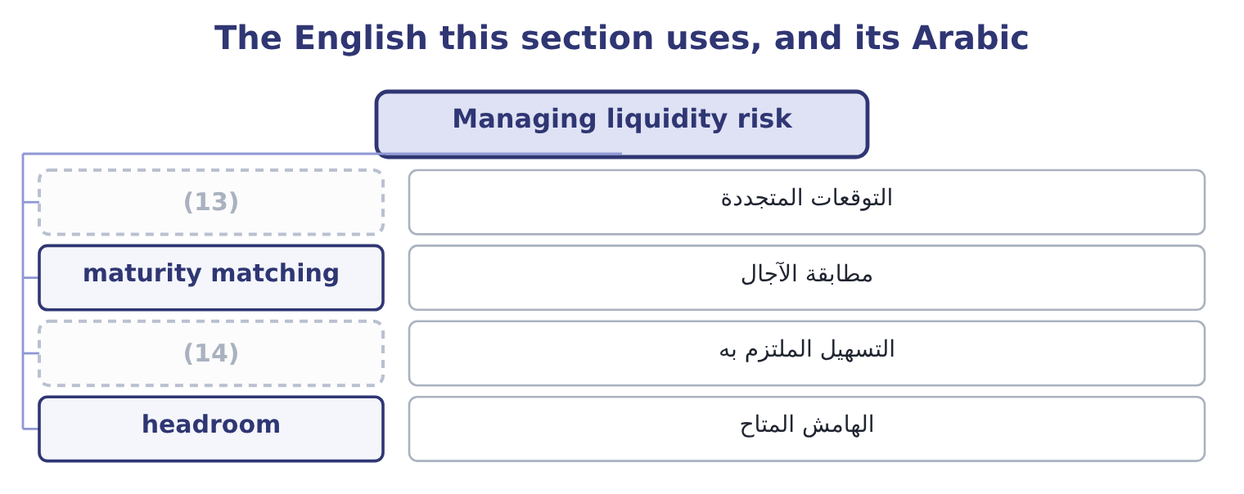
word list
الهامش المتاح · committed facility · rolling forecast

The English this sheet uses, and its Arabic
English (exam term) | Arabic
rolling forecast | التوقعات المتجددة
maturity matching | مطابقة الآجال
committed facility | التسهيل الملتزم به
headroom | الهامش المتاح

Answer key · 7.4 Managing liquidity risk

1 management | 8 balance
2 forecast | 9 headroom
3 sensitivity | 10 uncommitted
4 managing | 11 Everything
5 watching | 12 collecting
6 something | 13 rolling forecast
7 defensible | 14 committed facility

the summaries in full
Summary 1 The management methods are four. A rolling cash forecast — thirteen weeks in detail, twelve months in outline — built from receipts and payments rather than from profit, with the sensitivity of Book 3's. A company that cannot say what its cash will be in eight weeks is not managing liquidity; it is watching it. Cash and committed facilities sized against something, not chosen round. A defensible basis is the fixed cost base: Orontes's fixed costs of $12,624,000 are 12,624,000 ÷ 12 = 1,052,000 a month, so three months of fixed costs with no receipts at all is 1,052,000 × 3 = 3,156,000 — which the $7,302,100 cash balance covers twice over, and which gives the board a reason for the number rather than a habit. Matching the maturity of funding to the life of the assets it supports, so that long assets are not financed by money that can be withdrawn; staggering maturities so that nothing large falls due at once; keeping covenant headroom,348,800 − 1,560,000 = 2,788,800 of operating income; and holding facilities that are committed rather than uncommitted. Everything in Book 1's: collecting faster, paying no earlier than agreed, holding less stock. These are the cheapest liquidity sources a company has, and the 690,408 released by six days of collection in section 7.3 is larger than most facilities a company of Orontes's size would negotiate.

7.5 Managing market risk
Chapter 7 · section 7.5

Fill every gap. Each word list holds one word more than there are gaps.
Summary 1 gaps 1–12
Market risk is managed in four ways, and an answer that gives them in this order gives them in the order of cost. Natural hedging, which costs nothing. Arrange the (1) so that exposures offset: buy (2) in the currency sales are made in, (3) in the currency of the (4) , match a floating-rate asset with a floating-rate (5) , source from the (6) sales are made to. Orontes's export sales in euros are partly matched by its purchases of (7) and packaging in euros, and the exposure that needs (8) is only the (9) . Pricing in the (10) own currency, (11) clauses that share a price movement above a (12) , the ability to switch sourcing between regions, and the shorter exposure periods of section 7.2 — invoice promptly, collect promptly, and the exposure window shrinks.
word list
borrow · inputs · Natural · company's · contractual · assets · equipment · liability · threshold · difference · managing · region · business

Summary 2 gaps 13–23
Forwards, (13) , options and swaps, which Book 2's. The (14) points are that a hedge removes the favourable movement along with the (15) one; that a hedge has a cost, (16) for an option and (17) in the forward rate; and that a hedge is only a hedge if it matches the exposure in amount and in timing, since a (18) is a position. A policy that says what (19) of exposure is hedged, over what horizon, with what instruments and with which (20) ; a prohibition on taking positions for gain; (21) of dealing from settlement and from recording; and regular reporting of positions and their value. More (22) treasury disasters come from the absence of this (23) than from any market movement.
word list
futures · corporate · implicit · paragraph · explicit · position · mismatch · counterparties · unfavourable · essential · separation · proportion

Worked example: two exposures at Orontes

Summary 3 gaps 24–35
Orontes's debt is $6,500,000 at 6 per cent. A (24) rise in rates on floating debt costs 6,500,000 × 0.01 = 65,000 a year, which against operating income of $4,348,800 is (25) — so the right response is to do nothing and say why. (26) euro receipts for the next (27) months are 2,000,000. The natural hedge first. Euro purchases of packaging and (28) run to 400,000 over the same period, so the net exposure is 2,000,000 − 400,000 = 1,600,000 and the policy (29) to. Forward sales of euros (30) the expected receipt dates, for 1,600,000 × 0.75 = 1,200,000, leaving a quarter (31) against the risk that a shipment slips. Two exposures, two (32) answers, and both (33) in writing. The interest rate exposure is left open because it is small relative to the company — a (34) reached by (35) rather than by assuming — and the currency exposure is hedged after the natural offset is taken first, which is the order that costs least. An exam answer that hedges everything with instruments has done the expensive thing first.
word list
unhedged · matching · conclusion · different · immaterial · twelve · measuring · Contracted · one-point · Arrange · applies · defensible · spares

Operational and financial methods

Your turn: which method? (complete the blanks)
Situation | Method
The person who creates a supplier may not approve its payment | ________
A monthly report of duplicate invoice amounts | ________
Buying packaging in the currency exports are sold in | ________
Thirteen weeks of receipts and payments, updated weekly | ________
A list of the suppliers and systems without which a process stops | ________
A limit of 600,000 on any one distributor's balance | ________

"Control", "hedge" and "exposure"

Summary 4 gaps 36–47
Control was (36) ; here note the pair (37) and detective, which in English are (38) describing when the control acts rather than how strong it is — a detective control is not a weak one, it is a later one. Hedge comes from the (39) that marks a (40) and limits movement, and the metaphor is exact: a hedge does not improve the position, it narrows the range of outcomes in both (41) . (42) who write that a hedge (43) against loss have given half the (44) , and the other half — that it gives up the gain — is what makes hedging a policy decision rather than an obvious good. And exposure, is the word to use when you mean the amount at stake: an exposure is hedged, a risk is managed, and a loss is (45) , and keeping the three verbs with their (46) nouns makes a report much (47) to read.
word list
boundary · discussed · incurred · Candidates · protects · preventive · adjectives · definition · quarter · directions · proper · hedgerow · easier

"Control", "hedge" and "exposure"
Situation | Method
Creator of a supplier may not approve its payment | (48)
Monthly report of duplicate invoice amounts | A detective control.
Buying packaging in the export currency | A natural hedge.
Thirteen weeks of receipts and payments | A rolling cash forecast.
A list of suppliers and systems a process needs | (49)
A 600,000 limit on one distributor | (50)
What it tells you | Six methods, and only one of them involves buying anything. Most risk management is (51) , information and discipline rather than exp

word list
A critical dependency list, within continuity planning. · Method · organisation · Segregation of duties, a structural control. · A concentration limit, within credit risk management.

The English this section uses, and its Arabic
Each term sits against what it means.
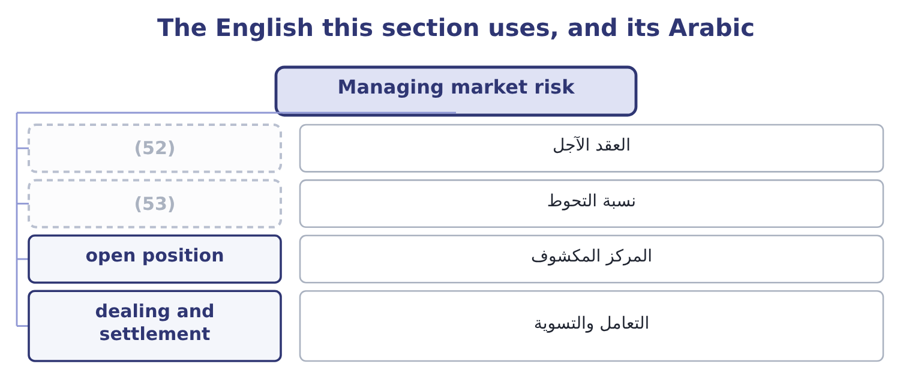
word list
detective control · hedge ratio · forward contract

The English this sheet uses, and its Arabic
English (exam term) | Arabic
forward contract | العقد الآجل
hedge ratio | نسبة التحوط
open position | المركز المكشوف
dealing and settlement | التعامل والتسوية

Answer key · 7.5 Managing market risk

1 business | 28 spares
2 inputs | 29 applies
3 borrow | 30 matching
4 assets | 31 unhedged
5 liability | 32 different
6 region | 33 defensible
7 equipment | 34 conclusion
8 managing | 35 measuring
9 difference | 36 discussed
10 company's | 37 preventive
11 contractual | 38 adjectives
12 threshold | 39 hedgerow
13 futures | 40 boundary
14 essential | 41 directions
15 unfavourable | 42 Candidates
16 explicit | 43 protects
17 implicit | 44 definition
18 mismatch | 45 incurred
19 proportion | 46 proper
20 counterparties | 47 easier
21 separation | 48 Segregation of duties, a structural control.
22 corporate | 49 A critical dependency list, within continuity planning.
23 paragraph | 50 A concentration limit, within credit risk management.
24 one-point | 51 organisation
25 immaterial | 52 forward contract
26 Contracted | 53 hedge ratio
27 twelve

the summaries in full
Summary 1 Market risk is managed in four ways, and an answer that gives them in this order gives them in the order of cost. Natural hedging, which costs nothing. Arrange the business so that exposures offset: buy inputs in the currency sales are made in, borrow in the currency of the assets, match a floating-rate asset with a floating-rate liability, source from the region sales are made to. Orontes's export sales in euros are partly matched by its purchases of equipment and packaging in euros, and the exposure that needs managing is only the difference. Pricing in the company's own currency, contractual clauses that share a price movement above a threshold, the ability to switch sourcing between regions, and the shorter exposure periods of section 7.2 — invoice promptly, collect promptly, and the exposure window shrinks.
Summary 2 Forwards, futures, options and swaps, which Book 2's. The essential points are that a hedge removes the favourable movement along with the unfavourable one; that a hedge has a cost, explicit for an option and implicit in the forward rate; and that a hedge is only a hedge if it matches the exposure in amount and in timing, since a mismatch is a position. A policy that says what proportion of exposure is hedged, over what horizon, with what instruments and with which counterparties; a prohibition on taking positions for gain; separation of dealing from settlement and from recording; and regular reporting of positions and their value. More corporate treasury disasters come from the absence of this paragraph than from any market movement.
Summary 3 Orontes's debt is $6,500,000 at 6 per cent. A one-point rise in rates on floating debt costs 6,500,000 × 0.01 = 65,000 a year, which against operating income of $4,348,800 is immaterial — so the right response is to do nothing and say why. Contracted euro receipts for the next twelve months are 2,000,000. The natural hedge first. Euro purchases of packaging and spares run to 400,000 over the same period, so the net exposure is 2,000,000 − 400,000 = 1,600,000 and the policy applies to. Forward sales of euros matching the expected receipt dates, for 1,600,000 × 0.75 = 1,200,000, leaving a quarter unhedged against the risk that a shipment slips. Two exposures, two different answers, and both defensible in writing. The interest rate exposure is left open because it is small relative to the company — a conclusion reached by measuring rather than by assuming — and the currency exposure is hedged after the natural offset is taken first, which is the order that costs least. An exam answer that hedges everything with instruments has done the expensive thing first.
Summary 4 Control was discussed; here note the pair preventive and detective, which in English are adjectives describing when the control acts rather than how strong it is — a detective control is not a weak one, it is a later one. Hedge comes from the hedgerow that marks a boundary and limits movement, and the metaphor is exact: a hedge does not improve the position, it narrows the range of outcomes in both directions. Candidates who write that a hedge protects against loss have given half the definition, and the other half — that it gives up the gain — is what makes hedging a policy decision rather than an obvious good. And exposure, is the word to use when you mean the amount at stake: an exposure is hedged, a risk is managed, and a loss is incurred, and keeping the three verbs with their proper nouns makes a report much easier to read.

8.1 Finding the risks
Chapter 8 · section 8.1

Fill every gap. Each word list holds one word more than there are gaps.
Chapter 8, section by section
Each stage leads to the next.
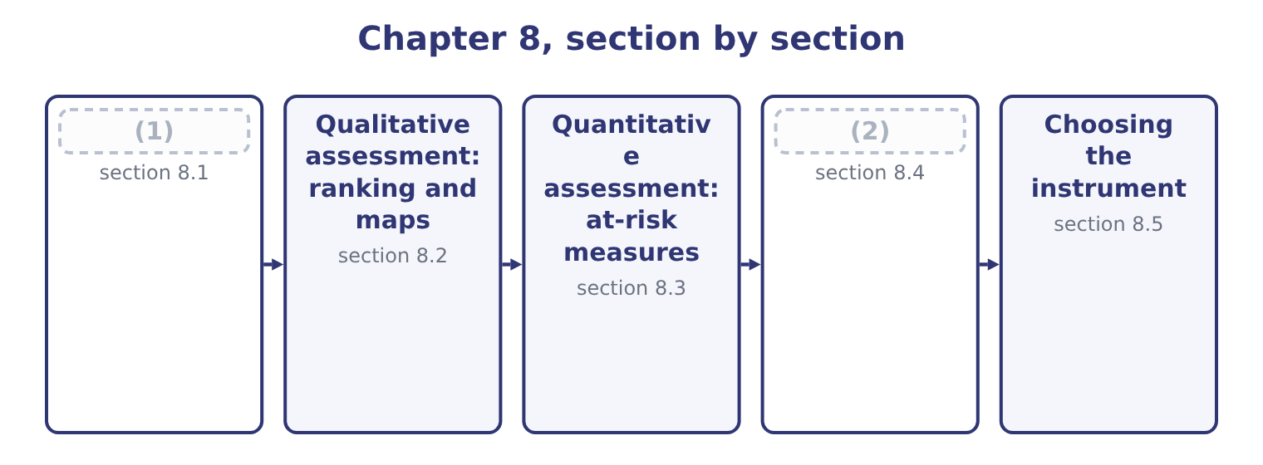
word list
Value at risk · Finding the risks · reconciliation of methods

Summary 1 gaps 3–14
Event (3) is the step that (4) the quality of everything after it, and the outcome asks for techniques with examples. Workshops and (5) interviews. A (6) session with the people who run a process, (7) through what could go wrong and what has nearly gone wrong. The most (8) single technique, and the one whose quality (9) most on whether people feel able to speak —. (10) and risk taxonomies. A standard list of risk categories, such, worked through (11) so that nothing is missed by (12) . Cheap, and (13) to what is on the list. (14) a process from end to end and asking at each step what could fail. This is the technique that finds the risks between departments, because a process map crosses boundaries that an organisation chart does not. Loss and incident data.
word list
systematically · facilitated · Walking · limited · Checklists · identification · productive · identify · depends · structured · determines · inattention · working

Summary 2 gaps 15–26
The company's own history, (15) included, and published data from the industry. The strongest evidence available and necessarily (16) . Event (17) and industry benchmarks. Lists of events that have happened to comparable companies, including events this company has not (18) . Leading (19) and exception reports. Rising staff turnover, lengthening delivery times, growing overdue (20) : things that identify a risk before it is an event. Scenario analysis and what-if (21) . (22) asking what would have to be true for a serious loss to occur, which finds combinations rather than single events. Root cause analysis of events that have occurred, which (23) surfaces three or four risks that nobody had listed. Three (24) improve the output of any of them. Identify at the level of the event, not of the cause or the (25) . One event, with its causes listed and its (26) costed, is worth more than three register lines describing the same thing.
word list
serious · reconciliations · effect · near-misses · Deliberately · typically · questioning · indicators · experienced · principles · inventories · consequences · backward-looking

Summary 3 gaps 27–31
An event (27) that contains only bad (28) will never produce. And (29) what people are (30) to write. The risk from a dominant chief executive, the risk that a target is unachievable, the risk that a (31) supplier relationship is too comfortable: these do not appear in a workshop unless somebody is asked for them directly and nothing happens to them afterwards.
word list
include · inventory · long-standing · reluctant · outcomes · likelihood

The English this section uses, and its Arabic
Each term sits against what it means.
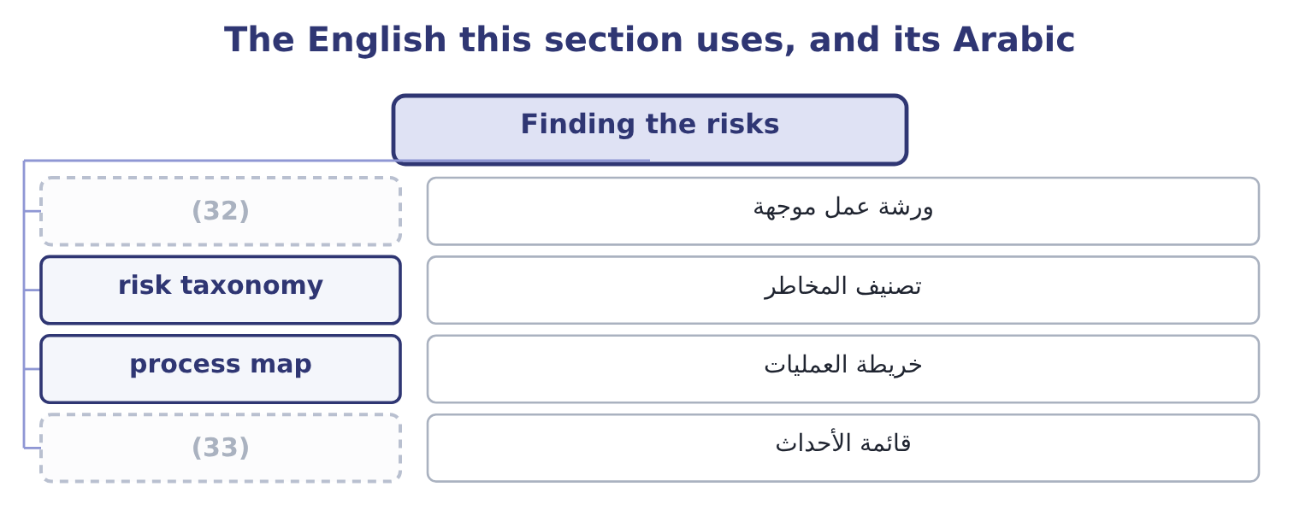
word list
event inventory · risk taxonomy · facilitated workshop

The English this sheet uses, and its Arabic
English (exam term) | Arabic
facilitated workshop | ورشة عمل موجهة
risk taxonomy | تصنيف المخاطر
process map | خريطة العمليات
event inventory | قائمة الأحداث

Answer key · 8.1 Finding the risks

1 Finding the risks | 18 experienced
2 Value at risk | 19 indicators
3 identification | 20 reconciliations
4 determines | 21 questioning
5 structured | 22 Deliberately
6 facilitated | 23 typically
7 working | 24 principles
8 productive | 25 effect
9 depends | 26 consequences
10 Checklists | 27 inventory
11 systematically | 28 outcomes
12 inattention | 29 include
13 limited | 30 reluctant
14 Walking | 31 long-standing
15 near-misses | 32 facilitated workshop
16 backward-looking | 33 event inventory
17 inventories

the summaries in full
Summary 1 Event identification is the step that determines the quality of everything after it, and the outcome asks for techniques with examples. Workshops and structured interviews. A facilitated session with the people who run a process, working through what could go wrong and what has nearly gone wrong. The most productive single technique, and the one whose quality depends most on whether people feel able to speak —. Checklists and risk taxonomies. A standard list of risk categories, such, worked through systematically so that nothing is missed by inattention. Cheap, and limited to what is on the list. Walking a process from end to end and asking at each step what could fail. This is the technique that finds the risks between departments, because a process map crosses boundaries that an organisation chart does not. Loss and incident data.
Summary 2 The company's own history, near-misses included, and published data from the industry. The strongest evidence available and necessarily backward-looking. Event inventories and industry benchmarks. Lists of events that have happened to comparable companies, including events this company has not experienced. Leading indicators and exception reports. Rising staff turnover, lengthening delivery times, growing overdue reconciliations: things that identify a risk before it is an event. Scenario analysis and what-if questioning. Deliberately asking what would have to be true for a serious loss to occur, which finds combinations rather than single events. Root cause analysis of events that have occurred, which typically surfaces three or four risks that nobody had listed. Three principles improve the output of any of them. Identify at the level of the event, not of the cause or the effect. One event, with its causes listed and its consequences costed, is worth more than three register lines describing the same thing.
Summary 3 An event inventory that contains only bad outcomes will never produce. And include what people are reluctant to write. The risk from a dominant chief executive, the risk that a target is unachievable, the risk that a long-standing supplier relationship is too comfortable: these do not appear in a workshop unless somebody is asked for them directly and nothing happens to them afterwards.

8.2 Qualitative assessment: ranking and maps
Chapter 8 · section 8.2

Fill every gap. Each word list holds one word more than there are gaps.
Summary 1 gaps 1–12
Qualitative (1) scores each risk on two dimensions — likelihood and impact — using anchored scales, and then (2) the result. An anchored scale (3) each level in terms (4) can check. Risk ranking (5) or combines the two scores to order the (6) . A supply failure (7) as likelihood 4 and impact 4 scores 4 × 4 = 16; a plant fire at likelihood 1 and impact 5 scores 1 × 5 = 5. Ranking is simple, (8) instantly and has three (9) the exam expects to be named. The (10) of two ordinal scales is not a (11) . A score of 16 is not twice as bad as a score of 8, because the levels are categories and not quantities, and multiplying them (12) a precision that is not there. It compresses the tail.
word list
different · multiplies · number · somebody · manufactures · communicates · product · register · assessed · assessment · weaknesses · defines · displays

Summary 2 gaps 13–24
The fire scores 5 and could end the company; the supply failure scores 16 and could not. This is, which is not the ranking by (13) . And it hides disagreement. A (14) agreed score (15) the fact that two (16) put the likelihood at 2 and 4, and the disagreement is usually more (17) than the average. A risk map, or heat map, plots the same two dimensions on a grid, with likelihood on one axis and impact on the other, and each risk (18) as a point. Its (19) are visual and real: it shows the whole (20) at once, it makes the (21) corner obvious, and it supports the (22) by which different zones require different responses — the top right treated, the bottom left accepted, the top left (rare but severe) (23) , and the bottom right (frequent but small) reduced or absorbed into normal (24) .
word list
top-right · single · operations · informative · assessors · portfolio · conceals · danger · transferred · convention · placed · advantages · disagreement

Summary 3 gaps 25–30
Three (25) are worth knowing. Plot (26) and residual (27) for each risk, with an arrow between them, so that the map shows what the controls are doing —. Plot the target position as well, so that the gap between residual and target (28) the action list. And show (29) , the speed with which a risk would develop: a (30) collapse and a slow regulatory change may occupy the same square and need entirely different responses.
word list
positions · becomes · portfolio · reputational · velocity · refinements · inherent

The English this section uses, and its Arabic
Each term sits against what it means.
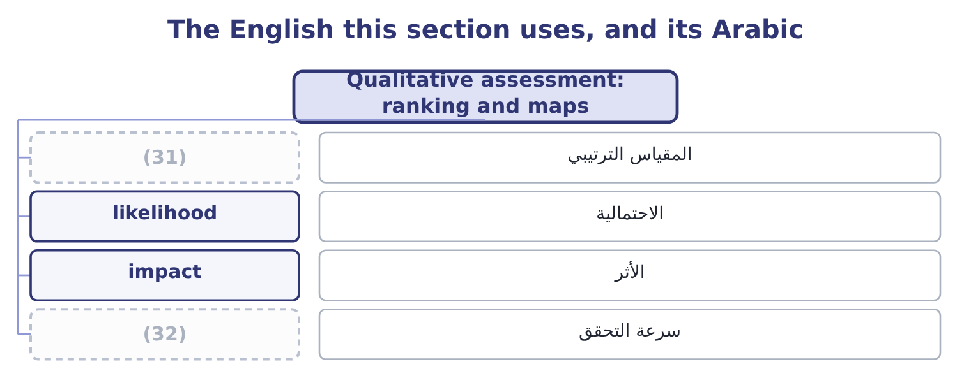
word list
stress testing · ordinal scale · velocity

The English this sheet uses, and its Arabic
English (exam term) | Arabic
ordinal scale | المقياس الترتيبي
likelihood | الاحتمالية
impact | الأثر
velocity | سرعة التحقق

Answer key · 8.2 Qualitative assessment: ranking and maps

1 assessment | 17 informative
2 displays | 18 placed
3 defines | 19 advantages
4 somebody | 20 portfolio
5 multiplies | 21 top-right
6 register | 22 convention
7 assessed | 23 transferred
8 communicates | 24 operations
9 weaknesses | 25 refinements
10 product | 26 inherent
11 number | 27 positions
12 manufactures | 28 becomes
13 danger | 29 velocity
14 single | 30 reputational
15 conceals | 31 ordinal scale
16 assessors | 32 velocity

the summaries in full
Summary 1 Qualitative assessment scores each risk on two dimensions — likelihood and impact — using anchored scales, and then displays the result. An anchored scale defines each level in terms somebody can check. Risk ranking multiplies or combines the two scores to order the register. A supply failure assessed as likelihood 4 and impact 4 scores 4 × 4 = 16; a plant fire at likelihood 1 and impact 5 scores 1 × 5 = 5. Ranking is simple, communicates instantly and has three weaknesses the exam expects to be named. The product of two ordinal scales is not a number. A score of 16 is not twice as bad as a score of 8, because the levels are categories and not quantities, and multiplying them manufactures a precision that is not there. It compresses the tail.
Summary 2 The fire scores 5 and could end the company; the supply failure scores 16 and could not. This is, which is not the ranking by danger. And it hides disagreement. A single agreed score conceals the fact that two assessors put the likelihood at 2 and 4, and the disagreement is usually more informative than the average. A risk map, or heat map, plots the same two dimensions on a grid, with likelihood on one axis and impact on the other, and each risk placed as a point. Its advantages are visual and real: it shows the whole portfolio at once, it makes the top-right corner obvious, and it supports the convention by which different zones require different responses — the top right treated, the bottom left accepted, the top left (rare but severe) transferred, and the bottom right (frequent but small) reduced or absorbed into normal operations.
Summary 3 Three refinements are worth knowing. Plot inherent and residual positions for each risk, with an arrow between them, so that the map shows what the controls are doing —. Plot the target position as well, so that the gap between residual and target becomes the action list. And show velocity, the speed with which a risk would develop: a reputational collapse and a slow regulatory change may occupy the same square and need entirely different responses.

8.3 Quantitative assessment: at-risk measures
Chapter 8 · section 8.3

Fill every gap. Each word list holds one word more than there are gaps.
Summary 1 gaps 1–12
Where the (1) supports a distribution, the (2) can be stated in money. The outcome names four (3) and they share one (4) : take the distribution of an outcome, (5) a confidence level, and state how far below the expectation the outcome could fall. An earnings distribution is the whole picture: the range of operating income or net income the company might produce, with (6) attached, usually built by simulation from distributions of the (7) drivers — volume, price, input cost, exchange rate. (8) below is a (9) of it. Earnings at risk is the (10) by which earnings could fall below expectation at a chosen confidence level over a chosen (11) . For Orontes, if operating income is expected at $4,176,000 and the (12) fifth percentile is 2,900,000, earnings at risk at 95 per cent for a year is 4,176,000 − 2,900,000 = 1,276,000.
word list
simulation's · evidence · Everything · structure · choose · measures · summary · probabilities · underlying · assessment · period · amount · precisely

Summary 2 gaps 13–24
Read that (13) ,600 and the company is (14) its stated appetite, which is (15) the use of the measure. Cash flow at risk is the same (16) applied to cash flow rather than earnings, and for most (17) companies it is the more useful of the two, because cash is what pays interest, capital (18) and dividends. Orontes's expected operating cash flow is 4,176,000 + 2,100,000 = 6,276,000 with (19) added back; if the fifth percentile is 4,500,000, cash flow at risk is 6,276,000 − 4,500,000 = 1,776,000, and the (20) is whether the (21) and buffers. An (22) distribution (23) the earnings distribution per share, which is the form in which equity (24) and analysts think. Orontes's net income of $2,969,100 across 8,100,000 shares is 2,969,100 ÷ 8,100,000 = 0.3666 a share; in the adverse case where net income falls to 2,000,000 it is 2,000,000 ÷ 8,100,000 = 0.2469.
word list
question · non-financial · depreciation · earnings-per-share · outside · precisely · facilities · restates · calculation · expenditure · investors · against · supports

Summary 3 gaps 25–36
The distribution matters because the market reacts to earnings per share relative to (25) , so the probability of (26) short of a published (27) figure is itself a risk — one Book 2's. Four (28) apply to all of them, and an exam answer that gives them is (29) the outcome rather than defining the terms. They are only as good as the input distributions, which are (30) . They assume correlations that are usually (31) , and correlations are (32) what matters in a bad year. They (33) a chosen percentile and say (34) about what lies beyond it, which is. And they are easiest to compute for the risks that are easiest to model — prices and rates — which can shift (35) away from the (36) and strategic risks that are harder to quantify and more likely to be fatal.
word list
assumptions · exactly · attention · expectations · answering · guessed · nothing · cautions · guidance · operational · facilities · describe · falling

The English this section uses, and its Arabic
Each term sits against what it means.
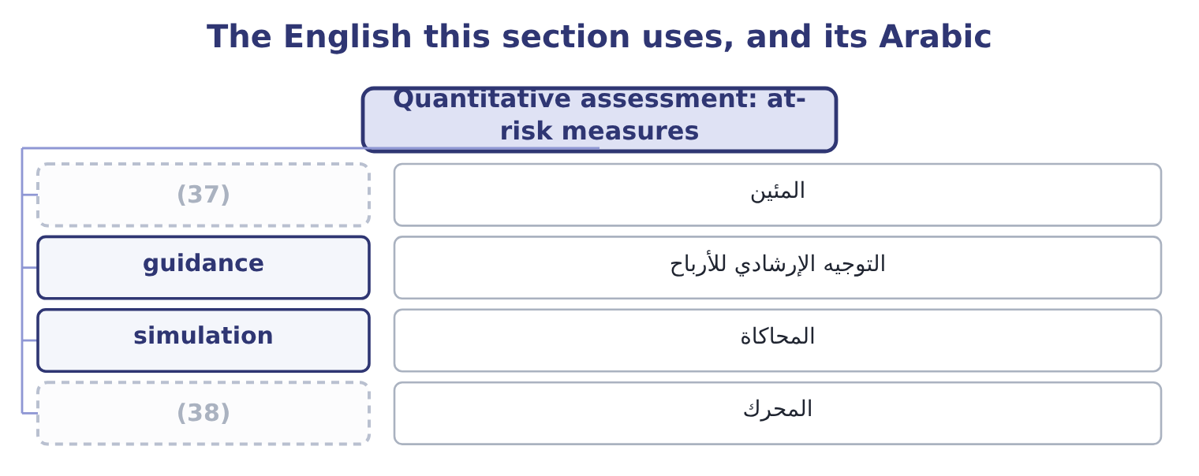
word list
percentile · المحاكاة · driver

The English this sheet uses, and its Arabic
English (exam term) | Arabic
percentile | المئين
guidance | التوجيه الإرشادي للأرباح
simulation | المحاكاة
driver | المحرك

Answer key · 8.3 Quantitative assessment: at-risk measures

1 evidence | 20 question
2 assessment | 21 facilities
3 measures | 22 earnings-per-share
4 structure | 23 restates
5 choose | 24 investors
6 probabilities | 25 expectations
7 underlying | 26 falling
8 Everything | 27 guidance
9 summary | 28 cautions
10 amount | 29 answering
11 period | 30 assumptions
12 simulation's | 31 guessed
13 against | 32 exactly
14 outside | 33 describe
15 precisely | 34 nothing
16 calculation | 35 attention
17 non-financial | 36 operational
18 expenditure | 37 percentile
19 depreciation | 38 driver

the summaries in full
Summary 1 Where the evidence supports a distribution, the assessment can be stated in money. The outcome names four measures and they share one structure: take the distribution of an outcome, choose a confidence level, and state how far below the expectation the outcome could fall. An earnings distribution is the whole picture: the range of operating income or net income the company might produce, with probabilities attached, usually built by simulation from distributions of the underlying drivers — volume, price, input cost, exchange rate. Everything below is a summary of it. Earnings at risk is the amount by which earnings could fall below expectation at a chosen confidence level over a chosen period. For Orontes, if operating income is expected at $4,176,000 and the simulation's fifth percentile is 2,900,000, earnings at risk at 95 per cent for a year is 4,176,000 − 2,900,000 = 1,276,000.
Summary 2 Read that against,600 and the company is outside its stated appetite, which is precisely the use of the measure. Cash flow at risk is the same calculation applied to cash flow rather than earnings, and for most non-financial companies it is the more useful of the two, because cash is what pays interest, capital expenditure and dividends. Orontes's expected operating cash flow is 4,176,000 + 2,100,000 = 6,276,000 with depreciation added back; if the fifth percentile is 4,500,000, cash flow at risk is 6,276,000 − 4,500,000 = 1,776,000, and the question is whether the facilities and buffers. An earnings-per-share distribution restates the earnings distribution per share, which is the form in which equity investors and analysts think. Orontes's net income of $2,969,100 across 8,100,000 shares is 2,969,100 ÷ 8,100,000 = 0.3666 a share; in the adverse case where net income falls to 2,000,000 it is 2,000,000 ÷ 8,100,000 = 0.2469.
Summary 3 The distribution matters because the market reacts to earnings per share relative to expectations, so the probability of falling short of a published guidance figure is itself a risk — one Book 2's. Four cautions apply to all of them, and an exam answer that gives them is answering the outcome rather than defining the terms. They are only as good as the input distributions, which are assumptions. They assume correlations that are usually guessed, and correlations are exactly what matters in a bad year. They describe a chosen percentile and say nothing about what lies beyond it, which is. And they are easiest to compute for the risks that are easiest to model — prices and rates — which can shift attention away from the operational and strategic risks that are harder to quantify and more likely to be fatal.

8.4 Value at risk
Chapter 8 · section 8.4

Fill every gap. Each word list holds one word more than there are gaps.
Summary 1 gaps 1–12
Value at risk states the (1) loss on a position or a (2) over a given period at a given confidence level. It is the measure that made (3) risk management famous, it is required knowledge for this exam, and the syllabus does not require its calculation — which is a relief, because the calculation is the least (4) thing about it. Its (5) has three parts and all three must be quoted (6) . A value at risk of 15,792 means nothing; a one-day value at risk of 15,792 at 95 per cent confidence means that on 95 days out of 100 the loss on this position will be less than 15,792. Three methods of (7) it appear in (8) . The (9) or parametric method assumes the returns follow a known distribution, usually the normal, and computes the figure from the (10) volatility. It is quick and it (11) the tail, because real (12) returns have more extreme movements than the normal distribution allows.
word list
maximum · comforting · portfolio · quantitative · understates · position's · together · financial · computing · definition · questions · interesting · variance-covariance

Summary 2 gaps 13–16
Historical simulation (13) the actual movements of the last few hundred days to today's position and reads the (14) off the result. It needs no (15) assumption and assumes the past period is (16) . Monte Carlo simulation generates movements from assumed distributions, as Book 3's, and is the most flexible and most demanding.
word list
representative · required · distributional · percentile · applies

Worked example: value at risk on a currency position

Summary 3 gaps 17–28
Orontes's (17) euro exposure from,600,000. The euro has moved about 0.6 per cent a day against the (18) reporting currency, so one standard (19) of daily movement is 1,600,000 × 0.006 = 9,600. For 95 per cent on a normal distribution the (20) is 1.645, giving 9,600 × 1.645 = 15,792. Using, the ten-day figure is 15,792 × 3.162 = 49,934. State it in words: on 95 (21) days out of 100, the one-day loss on this position should be below 15,792, and over a ten-day (22) period below 49,934. Then state what it does not say, which is the whole of the exam's (23) in this topic. Four (24) , and they are (25) more often than the method. It says nothing about the size of the loss when the (26) is exceeded. A 95 per cent figure is (27) about the worst five days in a hundred, which are the days that (28) .
word list
matter · examined · interest · silent · unhedged · trading · periods · multiplier · settlement · deviation · company's · threshold · limitations

Summary 4 gaps 29–37
The measure called expected (29) exists to answer that question and is (30) preferred. It (31) on the historical period chosen. A calm period produces a (32) figure, and volatility (33) : calm periods precede violent ones. It assumes positions can be held or closed within the (34) , which fails in (35) the markets where it matters. And it (36) false comfort. A single number, computed daily, produces an impression of control that is not warranted — which is why it should always be accompanied by stress testing, where positions are revalued under specified extreme scenarios chosen for their (37) rather than their probability.
word list
clusters · plausibility · shortfall · increasingly · portfolio · exactly · comforting · depends · horizon · invites

The English this section uses, and its Arabic
Each term sits against what it means.
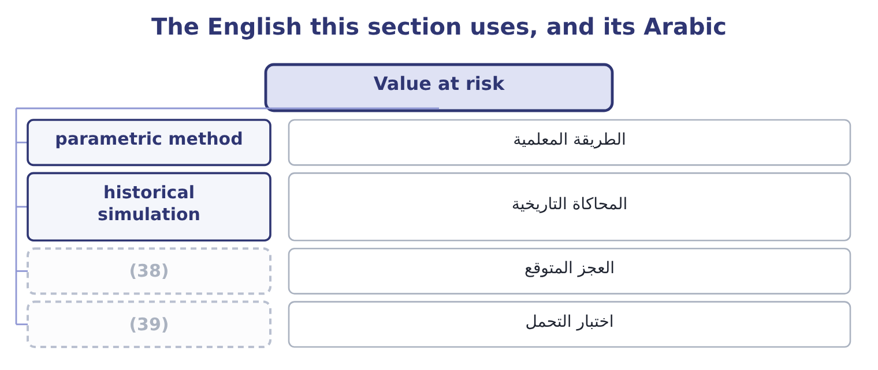
word list
stress testing · expected shortfall · historical simulation

The English this sheet uses, and its Arabic
English (exam term) | Arabic
parametric method | الطريقة المعلمية
historical simulation | المحاكاة التاريخية
expected shortfall | العجز المتوقع
stress testing | اختبار التحمل

Answer key · 8.4 Value at risk

1 maximum | 21 trading
2 portfolio | 22 settlement
3 quantitative | 23 interest
4 interesting | 24 limitations
5 definition | 25 examined
6 together | 26 threshold
7 computing | 27 silent
8 questions | 28 matter
9 variance-covariance | 29 shortfall
10 position's | 30 increasingly
11 understates | 31 depends
12 financial | 32 comforting
13 applies | 33 clusters
14 percentile | 34 horizon
15 distributional | 35 exactly
16 representative | 36 invites
17 unhedged | 37 plausibility
18 company's | 38 expected shortfall
19 deviation | 39 stress testing
20 multiplier

the summaries in full
Summary 1 Value at risk states the maximum loss on a position or a portfolio over a given period at a given confidence level. It is the measure that made quantitative risk management famous, it is required knowledge for this exam, and the syllabus does not require its calculation — which is a relief, because the calculation is the least interesting thing about it. Its definition has three parts and all three must be quoted together. A value at risk of 15,792 means nothing; a one-day value at risk of 15,792 at 95 per cent confidence means that on 95 days out of 100 the loss on this position will be less than 15,792. Three methods of computing it appear in questions. The variance-covariance or parametric method assumes the returns follow a known distribution, usually the normal, and computes the figure from the position's volatility. It is quick and it understates the tail, because real financial returns have more extreme movements than the normal distribution allows.
Summary 2 Historical simulation applies the actual movements of the last few hundred days to today's position and reads the percentile off the result. It needs no distributional assumption and assumes the past period is representative. Monte Carlo simulation generates movements from assumed distributions, as Book 3's, and is the most flexible and most demanding.
Summary 3 Orontes's unhedged euro exposure from,600,000. The euro has moved about 0.6 per cent a day against the company's reporting currency, so one standard deviation of daily movement is 1,600,000 × 0.006 = 9,600. For 95 per cent on a normal distribution the multiplier is 1.645, giving 9,600 × 1.645 = 15,792. Using, the ten-day figure is 15,792 × 3.162 = 49,934. State it in words: on 95 trading days out of 100, the one-day loss on this position should be below 15,792, and over a ten-day settlement period below 49,934. Then state what it does not say, which is the whole of the exam's interest in this topic. Four limitations, and they are examined more often than the method. It says nothing about the size of the loss when the threshold is exceeded. A 95 per cent figure is silent about the worst five days in a hundred, which are the days that matter.
Summary 4 The measure called expected shortfall exists to answer that question and is increasingly preferred. It depends on the historical period chosen. A calm period produces a comforting figure, and volatility clusters: calm periods precede violent ones. It assumes positions can be held or closed within the horizon, which fails in exactly the markets where it matters. And it invites false comfort. A single number, computed daily, produces an impression of control that is not warranted — which is why it should always be accompanied by stress testing, where positions are revalued under specified extreme scenarios chosen for their plausibility rather than their probability.

8.5 Choosing the instrument
Chapter 8 · section 8.5

Fill every gap. Each word list holds one word more than there are gaps.
Summary 1 gaps 1–12
The last (1) is which tool to use, and the answer follows from the evidence (2) and the decision to be made. Use qualitative tools where (3) cannot be estimated from data: strategic risks, (4) risks, most operational risks, anything novel. A ranked register and a map, with anchored scales and honest (5) recorded, are the right (6) and should not apologise for being judgments. Use quantitative tools where a (7) can be supported: market prices, rates, credit portfolios with many names, (8) operational processes with loss histories. Here an at-risk measure (9) a risk into a figure that can be (10) with appetite and with capital. Use both where possible, and (11) them. A risk that the map puts in the top-right corner but that no quantitative measure can find is a warning about the (12) , not about the map. And whichever is used, apply three disciplines.
word list
available · distribution · question · journalism · high-volume · reconcile · disagreement · converts · measurement · reputational · compared · instruments · probabilities

Summary 2 gaps 13–17
State the (13) and the confidence level. State the (14) that drive the answer, and test the one that drives it most, which is Book 3's (15) analysis. And keep the register honest about what is not (16) . The most dangerous line in any assessment is a risk quantified at a (17) number because a number was required.
word list
analysis · sensitivity · assumptions · measurable · comfortable · horizon

Choosing and computing

Your turn: assessment tools (complete the blanks)
Item | Data | Answer
Ranking score | (18) | 16: 4 × 4 = 16.
Earnings at risk | Expected 4,176,000; fifth percentile 2,900,000 | (19)
Expected operating cash flow | (20) | 6,276,000: 4,176,000 + 2,100,000 = 6,276,000.
Earnings per share | Net income 2,969,100; shares 8,100,000 | 0.3666: 2,969,100 ÷ 8,100,000 = 0.3666.
One-standard-deviation daily move | Position 1,600,000; volatility 0.6 per cent | (21)
What value at risk does not tell you |  | How large the loss is on the days the (22) is exceeded.

word list
Operating income 4,176,000; depreciation 2,100,000 · Likelihood 4, impact 4 · Net income 2,969,100; shares 8,100,000 · 1,276,000: 4,176,000 − 2,900,000 = 1,276,000. · threshold · 9,600: 1,600,000 × 0.006 = 9,600.

"At risk", "map" and "heat"

Summary 3 gaps 23–34
The (23) at risk in earnings at risk, cash flow at risk and value at risk is a (24) technical idiom and it misleads (25) , because it (26) as though the whole amount is in danger. It is not: the figure is the possible (27) at a confidence level, not the amount (28) . (29) "earnings at risk of 1,276,000" where the reader (30) "earnings of 4,176,000, of which 1,276,000 could be lost in a bad year" invites exactly the wrong reading, and the cure is to write the (31) out. Heat map is (32) rather than (33) — the colours carry no (34) the position on the grid does not — and risk map or risk matrix is the better term in a report, because a reader who sees red may believe something has been measured when it has only been coloured.
word list
phrase · sounds · exposed · journalism · shortfall · compressed · terminology · beginners · probabilities · information · Writing · expects · sentence

The English this section uses, and its Arabic
Each term sits against what it means.
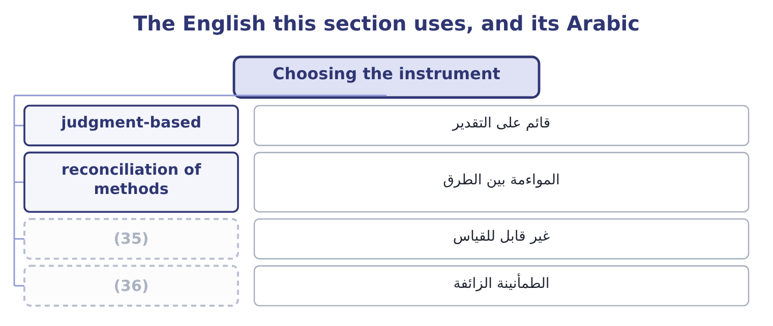
word list
event identification · spurious comfort · unmeasurable

The English this sheet uses, and its Arabic
English (exam term) | Arabic
judgment-based | قائم على التقدير
reconciliation of methods | المواءمة بين الطرق
unmeasurable | غير قابل للقياس
spurious comfort | الطمأنينة الزائفة

Answer key · 8.5 Choosing the instrument

1 question | 19 1,276,000: 4,176,000 − 2,900,000 = 1,276,000.
2 available | 20 Operating income 4,176,000; depreciation 2,100,000
3 probabilities | 21 9,600: 1,600,000 × 0.006 = 9,600.
4 reputational | 22 threshold
5 disagreement | 23 phrase
6 instruments | 24 compressed
7 distribution | 25 beginners
8 high-volume | 26 sounds
9 converts | 27 shortfall
10 compared | 28 exposed
11 reconcile | 29 Writing
12 measurement | 30 expects
13 horizon | 31 sentence
14 assumptions | 32 journalism
15 sensitivity | 33 terminology
16 measurable | 34 information
17 comfortable | 35 unmeasurable
18 Likelihood 4, impact 4 | 36 spurious comfort

the summaries in full
Summary 1 The last question is which tool to use, and the answer follows from the evidence available and the decision to be made. Use qualitative tools where probabilities cannot be estimated from data: strategic risks, reputational risks, most operational risks, anything novel. A ranked register and a map, with anchored scales and honest disagreement recorded, are the right instruments and should not apologise for being judgments. Use quantitative tools where a distribution can be supported: market prices, rates, credit portfolios with many names, high-volume operational processes with loss histories. Here an at-risk measure converts a risk into a figure that can be compared with appetite and with capital. Use both where possible, and reconcile them. A risk that the map puts in the top-right corner but that no quantitative measure can find is a warning about the measurement, not about the map. And whichever is used, apply three disciplines.
Summary 2 State the horizon and the confidence level. State the assumptions that drive the answer, and test the one that drives it most, which is Book 3's sensitivity analysis. And keep the register honest about what is not measurable. The most dangerous line in any assessment is a risk quantified at a comfortable number because a number was required.
Summary 3 The phrase at risk in earnings at risk, cash flow at risk and value at risk is a compressed technical idiom and it misleads beginners, because it sounds as though the whole amount is in danger. It is not: the figure is the possible shortfall at a confidence level, not the amount exposed. Writing "earnings at risk of 1,276,000" where the reader expects "earnings of 4,176,000, of which 1,276,000 could be lost in a bad year" invites exactly the wrong reading, and the cure is to write the sentence out. Heat map is journalism rather than terminology — the colours carry no information the position on the grid does not — and risk map or risk matrix is the better term in a report, because a reader who sees red may believe something has been measured when it has only been coloured.

9.1 What enterprise risk management is
Chapter 9 · section 9.1

Fill every gap. Each word list holds one word more than there are gaps.
Chapter 9, section by section
Each stage leads to the next.
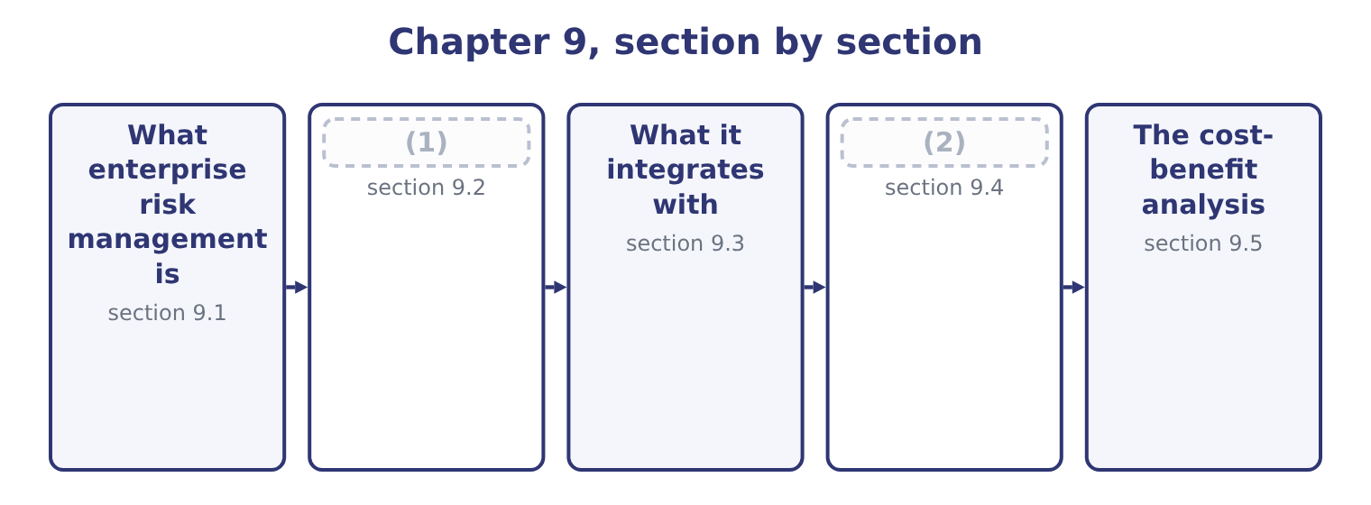
word list
Evaluating a scenario and recommending · What it integrates with · The COSO framework

Summary 1 gaps 3–14
Enterprise risk management is the process, directed by the board and applied across the whole organisation, of (3) and managing the risks to its strategy and objectives (4) an appetite the board has set, so as to (5) reasonable assurance that the objectives will be (6) . Four elements of that (7) carry the examinable (8) . Across the whole organisation. Risk is (9) in every unit and function and then (10) , rather than managed separately in each. The failure it corrects has a name — the (11) — in which each department manages its own exposures (12) and nobody sees the combination. Directed by the board. The appetite is set at the top, the (13) risks are reported there, and the process is owned by management rather than (14) to a technical function. Applied to strategy and objectives.
word list
aggregated · silo · within · identifying · competently · risk-taking · definition · delegated · considered · achieved · significant · weight · provide

Summary 2 gaps 15–26
Enterprise risk management is about what could stop the company (15) what it has set out to do, (16) the risk that the strategy itself is wrong, which no (17) process can raise. Reasonable assurance, not (18) . No system (19) all loss; the (20) is a sensible balance of cost and benefit, which section 9.5 (21) . The objectives of an enterprise programme, which the exam asks for, are to align (22) with appetite and strategy; to improve the quality of risk responses by choosing among them (23) ; to reduce surprises and losses; to identify and manage risks that cross units; to seize (24) , which is; and to deploy capital more effectively, because a company that knows its aggregate exposure knows how much capital it needs. The (25) follow from those objectives and were set out; three are (26) to the enterprise view.
word list
opportunities · risk-taking · departmental · specific · certainty · computes · benefits · prevents · achieving · standard · including · exposure · consistently

Summary 3 gaps 27–38
Because unexpected losses do not add, the enterprise exposure is (27) than the sum of the parts. Where (28) four areas report unexpected losses (29) 1,900,000 and the enterprise figure is 1,400,000, the 1,900,000 − 1,400,000 = 500,000 of difference is a (30) benefit that no division can see from where it stands — and a company that manages risk only in silos will buy 500,000 more (31) than it needs. One appetite, one set of scales, one method of (32) responses means that the next dollar of risk (33) goes where it does most good, instead of to (34) manager argued hardest. And visible risk (35) . The (36) that cause serious losses — a currency movement, a customer failure and a supply (37) with one economic cause — are (38) to each department and obvious from the centre.
word list
whichever · combinations · interactions · spending · Orontes's · computes · invisible · totalling · comparing · smaller · protection · diversification · interruption

The English this section uses, and its Arabic
Each term sits against what it means.
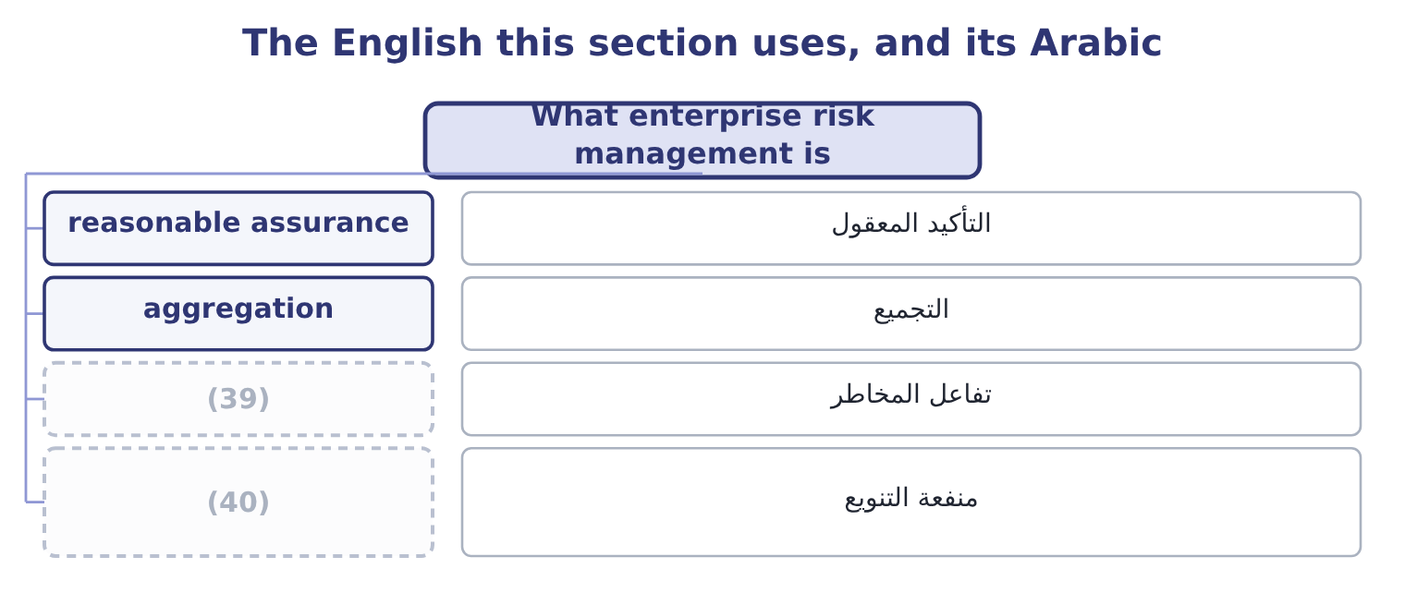
word list
diversification benefit · incentive design · risk interaction

The English this sheet uses, and its Arabic
English (exam term) | Arabic
reasonable assurance | التأكيد المعقول
aggregation | التجميع
risk interaction | تفاعل المخاطر
diversification benefit | منفعة التنويع

Answer key · 9.1 What enterprise risk management is

1 The COSO framework | 21 computes
2 Evaluating a scenario and recommending | 22 risk-taking
3 identifying | 23 consistently
4 within | 24 opportunities
5 provide | 25 benefits
6 achieved | 26 specific
7 definition | 27 smaller
8 weight | 28 Orontes's
9 considered | 29 totalling
10 aggregated | 30 diversification
11 silo | 31 protection
12 competently | 32 comparing
13 significant | 33 spending
14 delegated | 34 whichever
15 achieving | 35 interactions
16 including | 36 combinations
17 departmental | 37 interruption
18 certainty | 38 invisible
19 prevents | 39 risk interaction
20 standard | 40 diversification benefit

the summaries in full
Summary 1 Enterprise risk management is the process, directed by the board and applied across the whole organisation, of identifying and managing the risks to its strategy and objectives within an appetite the board has set, so as to provide reasonable assurance that the objectives will be achieved. Four elements of that definition carry the examinable weight. Across the whole organisation. Risk is considered in every unit and function and then aggregated, rather than managed separately in each. The failure it corrects has a name — the silo — in which each department manages its own exposures competently and nobody sees the combination. Directed by the board. The appetite is set at the top, the significant risks are reported there, and the process is owned by management rather than delegated to a technical function. Applied to strategy and objectives.
Summary 2 Enterprise risk management is about what could stop the company achieving what it has set out to do, including the risk that the strategy itself is wrong, which no departmental process can raise. Reasonable assurance, not certainty. No system prevents all loss; the standard is a sensible balance of cost and benefit, which section 9.5 computes. The objectives of an enterprise programme, which the exam asks for, are to align risk-taking with appetite and strategy; to improve the quality of risk responses by choosing among them consistently; to reduce surprises and losses; to identify and manage risks that cross units; to seize opportunities, which is; and to deploy capital more effectively, because a company that knows its aggregate exposure knows how much capital it needs. The benefits follow from those objectives and were set out; three are specific to the enterprise view.
Summary 3 Because unexpected losses do not add, the enterprise exposure is smaller than the sum of the parts. Where Orontes's four areas report unexpected losses totalling 1,900,000 and the enterprise figure is 1,400,000, the 1,900,000 − 1,400,000 = 500,000 of difference is a diversification benefit that no division can see from where it stands — and a company that manages risk only in silos will buy 500,000 more protection than it needs. One appetite, one set of scales, one method of comparing responses means that the next dollar of risk spending goes where it does most good, instead of to whichever manager argued hardest. And visible risk interactions. The combinations that cause serious losses — a currency movement, a customer failure and a supply interruption with one economic cause — are invisible to each department and obvious from the centre.

9.2 The COSO framework
Chapter 9 · section 9.2

Fill every gap. Each word list holds one word more than there are gaps.
Summary 1 gaps 1–12
The Committee of Sponsoring (1) of the Treadway Commission publishes two documents the exam refers to: the Internal Control — Integrated Framework, which underlies, and Enterprise Risk Management — (2) with Strategy and Performance, the 2017 revision of the 2004 enterprise framework. (3) meet both versions, and it is worth (4) each. The 2004 framework presented a cube: eight components against four (5) of objective — strategic, (6) , reporting and compliance — across the units of the entity. The eight components were the internal (7) , objective setting, event (8) , risk assessment, risk response, control activities, information and communication, and monitoring. The structure is (9) the process of, and (10) still use the eight component names. The 2017 framework is the current one and is organised quite differently, as five (11) components (12) twenty principles, with risk presented as part of strategy and performance rather than as a separate exercise.
word list
operations · Organizations · questions · containing · Candidates · environment · identification · because · knowing · categories · Integrating · recognisably · interrelated

Summary 2 gaps 13–24
The board's oversight of risk, the operating structure, the desired culture, the (13) to core values, and the (14) and retention of capable people. Analysing the business context, defining risk appetite, evaluating (15) strategies, and (16) business objectives. The central insight of the 2017 revision lives here: the greatest risk is not a risk to the strategy but the (17) that the strategy itself is misaligned with the mission, or that the company has chosen a strategy whose (18) it has not understood. (19) risk, assessing severity, (20) risks, implementing responses, and developing a portfolio view —. Assessing (21) change, reviewing risk and performance, and pursuing (22) in enterprise risk management —. Information, communication and reporting. (23) information systems, (24) risk information, and reporting on risk, culture and performance. Three themes of the revision are examinable.
word list
substantial · implications · possibility · retention · improvement · Leveraging · alternative · commitment · Identifying · formulating · communicating · prioritising · attraction

Summary 3 gaps 25–28
Risk is integrated with performance, not (25) to it. The same (26) that reviews results reviews the risks to them. Culture is treated as a component in its own right, because frameworks do not fail (27) ; they fail where people do not use them. And risk appetite connects strategy to (28) , which is why.
word list
execution · parallel · meeting · improvement · technically

The English this section uses, and its Arabic
Each term sits against what it means.
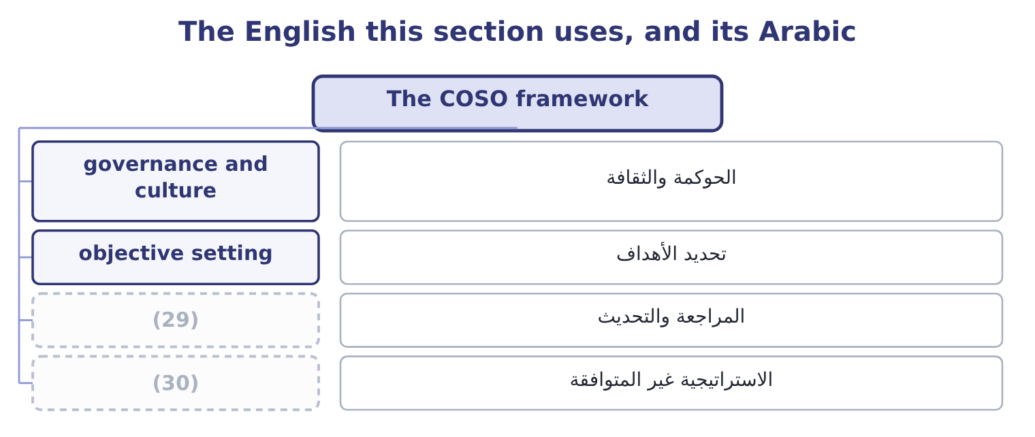
word list
review and revision · misaligned strategy · diversification benefit

The English this sheet uses, and its Arabic
English (exam term) | Arabic
governance and culture | الحوكمة والثقافة
objective setting | تحديد الأهداف
review and revision | المراجعة والتحديث
misaligned strategy | الاستراتيجية غير المتوافقة

Answer key · 9.2 The COSO framework

1 Organizations | 16 formulating
2 Integrating | 17 possibility
3 Candidates | 18 implications
4 knowing | 19 Identifying
5 categories | 20 prioritising
6 operations | 21 substantial
7 environment | 22 improvement
8 identification | 23 Leveraging
9 recognisably | 24 communicating
10 questions | 25 parallel
11 interrelated | 26 meeting
12 containing | 27 technically
13 commitment | 28 execution
14 attraction | 29 review and revision
15 alternative | 30 misaligned strategy

the summaries in full
Summary 1 The Committee of Sponsoring Organizations of the Treadway Commission publishes two documents the exam refers to: the Internal Control — Integrated Framework, which underlies, and Enterprise Risk Management — Integrating with Strategy and Performance, the 2017 revision of the 2004 enterprise framework. Candidates meet both versions, and it is worth knowing each. The 2004 framework presented a cube: eight components against four categories of objective — strategic, operations, reporting and compliance — across the units of the entity. The eight components were the internal environment, objective setting, event identification, risk assessment, risk response, control activities, information and communication, and monitoring. The structure is recognisably the process of, and questions still use the eight component names. The 2017 framework is the current one and is organised quite differently, as five interrelated components containing twenty principles, with risk presented as part of strategy and performance rather than as a separate exercise.
Summary 2 The board's oversight of risk, the operating structure, the desired culture, the commitment to core values, and the attraction and retention of capable people. Analysing the business context, defining risk appetite, evaluating alternative strategies, and formulating business objectives. The central insight of the 2017 revision lives here: the greatest risk is not a risk to the strategy but the possibility that the strategy itself is misaligned with the mission, or that the company has chosen a strategy whose implications it has not understood. Identifying risk, assessing severity, prioritising risks, implementing responses, and developing a portfolio view —. Assessing substantial change, reviewing risk and performance, and pursuing improvement in enterprise risk management —. Information, communication and reporting. Leveraging information systems, communicating risk information, and reporting on risk, culture and performance. Three themes of the revision are examinable.
Summary 3 Risk is integrated with performance, not parallel to it. The same meeting that reviews results reviews the risks to them. Culture is treated as a component in its own right, because frameworks do not fail technically; they fail where people do not use them. And risk appetite connects strategy to execution, which is why.

9.3 What it integrates with
Chapter 9 · section 9.3

Fill every gap. Each word list holds one word more than there are gaps.
Summary 1 gaps 1–12
The outcome asks how enterprise risk (1) integrate with five other things, and each (2) has a specific content. The board sets the appetite, (3) the process, and (4) itself that it works; the audit committee or a separate risk committee does the detailed review; management owns the risks; internal audit provides independent assurance that the process operates. That division is often (5) as the three lines: the business owns and manages risk, risk and (6) functions set the framework and challenge, and internal audit provides independent assurance. The (7) of, the at-risk figures, the loss databases, and (8) the models that predict failures from operating data. Analytics serve the process; they are not the process, and a company with (9) analytics and no appetite (10) has measured things nobody can act on. The (11) of section 9.1: risks combined across units with (12) taken into account, compared with capital and appetite, and resources allocated across them as Book 3's.
word list
satisfies · connection · correlations · practices · statement · summarised · outcome · increasingly · aggregation · compliance · excellent · measurement · oversees

Summary 2 gaps 13–20
Risk belongs in the same (13) as results, which means three practical things: targets set with the risk of missing them understood; variances (14) for what they reveal about exposure as well as about (15) ; and incentives designed so that they do not pay for risk-taking the company has not agreed to. Controls are the (16) layer for the reduction (17) . Enterprise risk management (18) which risks matter and how far they should be (19) ; internal control (20) the reduction; and the control framework reports whether the controls work.
word list
decides · conversation · investigated · targets · execution · reduced · performance · response · delivers

The English this section uses, and its Arabic
Each term sits against what it means.
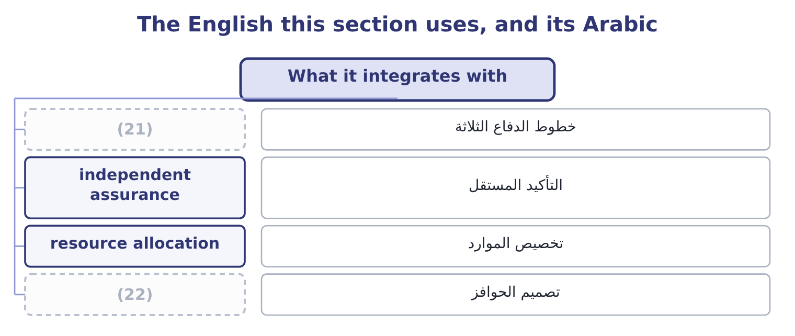
word list
three lines · internal control · incentive design

The English this sheet uses, and its Arabic
English (exam term) | Arabic
three lines | خطوط الدفاع الثلاثة
independent assurance | التأكيد المستقل
resource allocation | تخصيص الموارد
incentive design | تصميم الحوافز

Answer key · 9.3 What it integrates with

1 practices | 12 correlations
2 connection | 13 conversation
3 oversees | 14 investigated
4 satisfies | 15 performance
5 summarised | 16 execution
6 compliance | 17 response
7 measurement | 18 decides
8 increasingly | 19 reduced
9 excellent | 20 delivers
10 statement | 21 three lines
11 aggregation | 22 incentive design

the summaries in full
Summary 1 The outcome asks how enterprise risk practices integrate with five other things, and each connection has a specific content. The board sets the appetite, oversees the process, and satisfies itself that it works; the audit committee or a separate risk committee does the detailed review; management owns the risks; internal audit provides independent assurance that the process operates. That division is often summarised as the three lines: the business owns and manages risk, risk and compliance functions set the framework and challenge, and internal audit provides independent assurance. The measurement of, the at-risk figures, the loss databases, and increasingly the models that predict failures from operating data. Analytics serve the process; they are not the process, and a company with excellent analytics and no appetite statement has measured things nobody can act on. The aggregation of section 9.1: risks combined across units with correlations taken into account, compared with capital and appetite, and resources allocated across them as Book 3's.
Summary 2 Risk belongs in the same conversation as results, which means three practical things: targets set with the risk of missing them understood; variances investigated for what they reveal about exposure as well as about performance; and incentives designed so that they do not pay for risk-taking the company has not agreed to. Controls are the execution layer for the reduction response. Enterprise risk management decides which risks matter and how far they should be reduced; internal control delivers the reduction; and the control framework reports whether the controls work.

9.4 Evaluating a scenario and recommending
Chapter 9 · section 9.4

Fill every gap. Each word list holds one word more than there are gaps.
Summary 1 gaps 1–12
The outcome asks for (1) to be evaluated and mitigation (2) , which is the practical skill the essay section of the exam tests. A (3) in five steps (4) an answer that earns the marks. (5) the scenario (6) , including what else is true. A scenario is not one variable (7) ; it is a coherent (8) . Trace the (9) through the (10) . Volume, price, contribution, operating income, cash, covenant headroom, in that order, because the (11) that matters is not what profit falls to but whether (12) breaks. Identify the breaking points. Which covenant, which facility, which customer commitment, which regulatory threshold fails first. Choose responses from, with the cost-benefit test of section 9.5, and say what each does to the breaking points rather than to the average. Recommend, with an owner, a cost, a date and a trigger — the observable condition that would cause the response to be activated, which converts a plan into a decision somebody can take.
word list
situation · precisely · question · method · consequences · Describe · moving · recommended · anything · response · produces · scenarios · figures

Worked example: a scenario and its mitigation

Summary 2 gaps 13–24
A poor harvest (13) hulled sesame prices by 25 per cent for a year and (14) single supplier cannot (15) for six weeks. The supply interruption costs 46,027 a day of contribution, so six weeks is about 1,933,134. The price (16) , on variable costs that are (17) sesame, would remove a (18) large part of the 16,800,000 annual contribution unless prices can be raised, which Book 3's. Operating income of $4,348,800 (19) a covenant floor of 1,560,000 gives 2,788,800 of headroom, and the supply interruption alone (20) two thirds of it. (21) with the price effect the covenant is the first thing to break, not the cash (22) . Responses and their cost. Qualify a second supplier (cost 60,000 a year); hold four weeks of buffer stock (cost 180,000 of (23) ); contract forward for part of the crop as Book 2's: the forward premium and the loss of any price fall); and open a (24) with the lender about the covenant before it is needed rather than after.
word list
against · raises · Orontes's · carrying · supplier · conversation · mostly · further · increase · balance · consumes · Combined · deliver

Summary 3 gaps 25–33
The (25) , with triggers. Qualify the second supplier now. Build buffer stock when the harvest (26) first falls below the (27) average, not when the delivery fails. Hedge half the (28) volume at the point the forward price is below (29) . And (30) the covenant at the (31) . Note what the last step adds. Without triggers, a scenario analysis is an (32) document; with them, it is a set of decisions that have already been taken and only need to be activated, which is the (33) between a company that responds in a week and one that responds in a quarter.
word list
recommendation · expected · half-year · budget · interesting · difference · five-year · outcome · forecast · review

The English this section uses, and its Arabic
Each term sits against what it means.
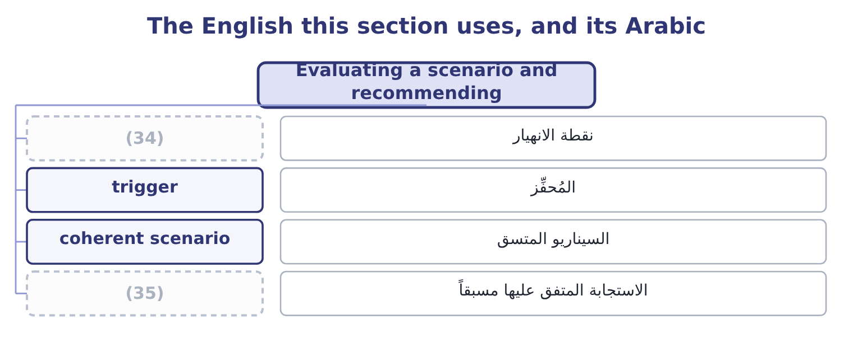
word list
breaking point · pre-agreed response · corporate governance

The English this sheet uses, and its Arabic
English (exam term) | Arabic
breaking point | نقطة الانهيار
trigger | المُحفِّز
coherent scenario | السيناريو المتسق
pre-agreed response | الاستجابة المتفق عليها مسبقاً

Answer key · 9.4 Evaluating a scenario and recommending

1 scenarios | 19 against
2 recommended | 20 consumes
3 method | 21 Combined
4 produces | 22 balance
5 Describe | 23 carrying
6 precisely | 24 conversation
7 moving | 25 recommendation
8 situation | 26 forecast
9 consequences | 27 five-year
10 figures | 28 expected
11 question | 29 budget
12 anything | 30 review
13 raises | 31 half-year
14 Orontes's | 32 interesting
15 deliver | 33 difference
16 increase | 34 breaking point
17 mostly | 35 pre-agreed response
18 further

the summaries in full
Summary 1 The outcome asks for scenarios to be evaluated and mitigation recommended, which is the practical skill the essay section of the exam tests. A method in five steps produces an answer that earns the marks. Describe the scenario precisely, including what else is true. A scenario is not one variable moving; it is a coherent situation. Trace the consequences through the figures. Volume, price, contribution, operating income, cash, covenant headroom, in that order, because the question that matters is not what profit falls to but whether anything breaks. Identify the breaking points. Which covenant, which facility, which customer commitment, which regulatory threshold fails first. Choose responses from, with the cost-benefit test of section 9.5, and say what each does to the breaking points rather than to the average. Recommend, with an owner, a cost, a date and a trigger — the observable condition that would cause the response to be activated, which converts a plan into a decision somebody can take.
Summary 2 A poor harvest raises hulled sesame prices by 25 per cent for a year and Orontes's single supplier cannot deliver for six weeks. The supply interruption costs 46,027 a day of contribution, so six weeks is about 1,933,134. The price increase, on variable costs that are mostly sesame, would remove a further large part of the 16,800,000 annual contribution unless prices can be raised, which Book 3's. Operating income of $4,348,800 against a covenant floor of 1,560,000 gives 2,788,800 of headroom, and the supply interruption alone consumes two thirds of it. Combined with the price effect the covenant is the first thing to break, not the cash balance. Responses and their cost. Qualify a second supplier (cost 60,000 a year); hold four weeks of buffer stock (cost 180,000 of carrying); contract forward for part of the crop as Book 2's: the forward premium and the loss of any price fall); and open a conversation with the lender about the covenant before it is needed rather than after.
Summary 3 The recommendation, with triggers. Qualify the second supplier now. Build buffer stock when the harvest forecast first falls below the five-year average, not when the delivery fails. Hedge half the expected volume at the point the forward price is below budget. And review the covenant at the half-year. Note what the last step adds. Without triggers, a scenario analysis is an interesting document; with them, it is a set of decisions that have already been taken and only need to be activated, which is the difference between a company that responds in a week and one that responds in a quarter.

9.5 The cost-benefit analysis
Chapter 9 · section 9.5

Fill every gap. Each word list holds one word more than there are gaps.
Summary 1 gaps 1–12
Every risk response (1) for money with every other use of money, and the (2) that decides is a cost-benefit analysis. The (3) asks you to (4) one, which means knowing what goes on each side. The costs, and (5) usually stop too early. The direct cost of the response: the premium, the contract, the (6) , the salaries of the people (7) a control. The (8) cost: systems, (9) , project time. The (10) friction: the delay an (11) adds, the sales lost to a tighter credit policy, the capital tied up in buffer stock. And the new risks the response (12) . The reduction in expected loss, which is the measurable core: inherent expected loss less residual. The reduction in unexpected loss, which is worth more than it looks because it reduces the capital or facilities the company must hold. Second-order effects: lower premiums, better terms from lenders, fewer disruptions to customers, and the cost-of-capital effect. And any operational benefit that comes with the control, since many risk responses also improve the process — a second supplier is also a negotiating position.
word list
approval · competes · residual · candidates · prepare · operating · performing · creates · equipment · outcome · training · instrument · implementation

Worked example: the second supplier

Summary 2 gaps 13–22
Qualifying a second supplier and (13) buffer stock reduces the likelihood to 0.05, so the expected loss becomes 0.05 × 1,933,134 = 96,657. The benefit and the cost. The reduction is 483,284 − 96,657 = 386,627 a year, against costs of 240,000 — 60,000 of qualification and (14) and 180,000 of carrying the stock — so the net benefit is 386,627 − 240,000 = 146,627 a year and the benefit-to-cost ratio is 386,627 ÷ 240,000 = 1.61. Over the life of the (15) . Treating it as a (16) commitment and (17) at the 9 per cent of Book 3, the annual net benefit is worth 146,627 × 3.8897 = 570,335, against a (18) qualification and trial cost of 150,000, (19) 570,335 − 150,000 = 420,335 of value (20) . Three (21) make this a (22) analysis rather than an arithmetic exercise.
word list
decision · giving · one-off · oversight · things · cost-benefit · created · discounting · holding · five-year · complete

Summary 3 gaps 23–34
The benefit on unexpected loss is not in the figures: (23) the likelihood from 0.25 to 0.05 (24) most of the chance of the event that would consume the (25) headroom, and that is worth more to the board than the 146,627. The buffer stock has an operational cost (26) its carrying charge, since stock ages and this is a food (27) . And the whole (28) rests on two judgments — the 0.25 and the 0.05 — so the honest (29) states them as such and shows what the answer becomes if the reduction is half as effective. Four (30) for any cost-benefit analysis in risk work. Use cash flows and (31) amounts, exactly as Book 3's, and ignore (32) costs. Include the (33) that cannot be quantified, as a stated list beside the arithmetic, rather than (34) them and allowing the quantified ones to decide alone.
word list
calculation · removes · presentation · covenant · reducing · disruptions · incremental · omitting · allocated · benefits · principles · beyond · product

Summary 4 gaps 35–37
Test the judgments that drive the answer. And state the limit of the analysis. A control whose benefit is the avoidance of a (35) loss cannot be justified by (36) arithmetic, because the expected value of a rare event is small; the (37) is the survival test of, and the cost-benefit analysis has nothing to say about it.
word list
expected-value · catastrophic · justification · function

The enterprise view

Your turn: enterprise risk management (complete the blanks)
Item | Data | Answer
Expected loss before the response | (38) | ________
Expected loss after it | Likelihood 0.05 | ________
Annual benefit |  | ________
Net annual benefit | (39) | ________
Benefit-to-cost ratio |  | ________
Diversification benefit of the portfolio view | Divisions 1,900,000; enterprise 1,400,000 | ________

word list
Cost 240,000 · Likelihood 0.25; impact 1,933,134 · Diversification benefit

"Enterprise", "framework" and "integrated"

Summary 5 gaps 40–51
Enterprise in enterprise risk management means the whole entity, every unit and (40) , and it is doing real work: the word was chosen to contrast with the (41) risk management it (42) . (43) also uses enterprise for a venture and for (44) , and neither is meant here. Framework is a word to use (45) : a framework is a structure for (46) work, not the work, and a company that says it has adopted a framework has said nothing about whether it (47) risk. (48) , in the COSO titles, is the (49) claim in either document — it means the (50) are part of how the business is run rather than an exercise performed beside it — and it is the claim most companies fail. When an exam question asks whether a company's risk management is effective, the answer turns on (51) and culture rather than on whether a framework has been adopted.
word list
carefully · integration · initiative · strongest · discounting · manages · English · replaced · Integrated · departmental · organising · function · practices

"Enterprise", "framework" and "integrated"
Item | Answer
Expected loss before the response | 483,284: 0.25 × 1,933,134 = 483,284.
Expected loss after it | 96,657: 0.05 × 1,933,134 = 96,657.
Annual benefit | (52)
Net annual benefit | (53)
Benefit-to-cost ratio | 1.61: 386,627 ÷ 240,000 = 1.61.
Diversification benefit | (54)
What it tells you | Five of the six are the cost-benefit case for one control; the sixth is the reason the case has to be made at the top, where the portfolio i

word list
Diversification benefit of the portfolio view · 500,000: 1,900,000 − 1,400,000 = 500,000. · 386,627: 483,284 − 96,657 = 386,627. · 146,627: 386,627 − 240,000 = 146,627.

The English this section uses, and its Arabic
Each term sits against what it means.
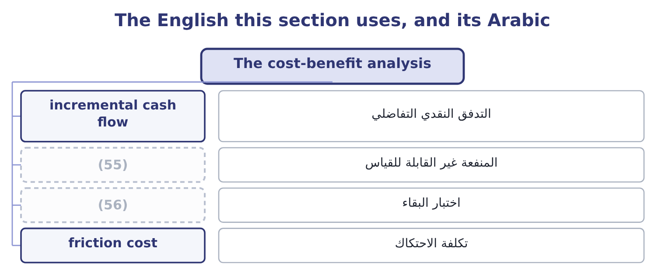
word list
unquantified benefit · survival test · portfolio view

The English this sheet uses, and its Arabic
English (exam term) | Arabic
incremental cash flow | التدفق النقدي التفاضلي
unquantified benefit | المنفعة غير القابلة للقياس
survival test | اختبار البقاء
friction cost | تكلفة الاحتكاك

Answer key · 9.5 The cost-benefit analysis

1 competes | 29 presentation
2 instrument | 30 principles
3 outcome | 31 incremental
4 prepare | 32 allocated
5 candidates | 33 benefits
6 equipment | 34 omitting
7 performing | 35 catastrophic
8 implementation | 36 expected-value
9 training | 37 justification
10 operating | 38 Likelihood 0.25; impact 1,933,134
11 approval | 39 Cost 240,000
12 creates | 40 function
13 holding | 41 departmental
14 oversight | 42 replaced
15 decision | 43 English
16 five-year | 44 initiative
17 discounting | 45 carefully
18 one-off | 46 organising
19 giving | 47 manages
20 created | 48 Integrated
21 things | 49 strongest
22 complete | 50 practices
23 reducing | 51 integration
24 removes | 52 386,627: 483,284 − 96,657 = 386,627.
25 covenant | 53 146,627: 386,627 − 240,000 = 146,627.
26 beyond | 54 500,000: 1,900,000 − 1,400,000 = 500,000.
27 product | 55 unquantified benefit
28 calculation | 56 survival test

the summaries in full
Summary 1 Every risk response competes for money with every other use of money, and the instrument that decides is a cost-benefit analysis. The outcome asks you to prepare one, which means knowing what goes on each side. The costs, and candidates usually stop too early. The direct cost of the response: the premium, the contract, the equipment, the salaries of the people performing a control. The implementation cost: systems, training, project time. The operating friction: the delay an approval adds, the sales lost to a tighter credit policy, the capital tied up in buffer stock. And the new risks the response creates. The reduction in expected loss, which is the measurable core: inherent expected loss less residual. The reduction in unexpected loss, which is worth more than it looks because it reduces the capital or facilities the company must hold. Second-order effects: lower premiums, better terms from lenders, fewer disruptions to customers, and the cost-of-capital effect. And any operational benefit that comes with the control, since many risk responses also improve the process — a second supplier is also a negotiating position.
Summary 2 Qualifying a second supplier and holding buffer stock reduces the likelihood to 0.05, so the expected loss becomes 0.05 × 1,933,134 = 96,657. The benefit and the cost. The reduction is 483,284 − 96,657 = 386,627 a year, against costs of 240,000 — 60,000 of qualification and oversight and 180,000 of carrying the stock — so the net benefit is 386,627 − 240,000 = 146,627 a year and the benefit-to-cost ratio is 386,627 ÷ 240,000 = 1.61. Over the life of the decision. Treating it as a five-year commitment and discounting at the 9 per cent of Book 3, the annual net benefit is worth 146,627 × 3.8897 = 570,335, against a one-off qualification and trial cost of 150,000, giving 570,335 − 150,000 = 420,335 of value created. Three things make this a complete analysis rather than an arithmetic exercise.
Summary 3 The benefit on unexpected loss is not in the figures: reducing the likelihood from 0.25 to 0.05 removes most of the chance of the event that would consume the covenant headroom, and that is worth more to the board than the 146,627. The buffer stock has an operational cost beyond its carrying charge, since stock ages and this is a food product. And the whole calculation rests on two judgments — the 0.25 and the 0.05 — so the honest presentation states them as such and shows what the answer becomes if the reduction is half as effective. Four principles for any cost-benefit analysis in risk work. Use cash flows and incremental amounts, exactly as Book 3's, and ignore allocated costs. Include the benefits that cannot be quantified, as a stated list beside the arithmetic, rather than omitting them and allowing the quantified ones to decide alone.
Summary 4 Test the judgments that drive the answer. And state the limit of the analysis. A control whose benefit is the avoidance of a catastrophic loss cannot be justified by expected-value arithmetic, because the expected value of a rare event is small; the justification is the survival test of, and the cost-benefit analysis has nothing to say about it.
Summary 5 Enterprise in enterprise risk management means the whole entity, every unit and function, and it is doing real work: the word was chosen to contrast with the departmental risk management it replaced. English also uses enterprise for a venture and for initiative, and neither is meant here. Framework is a word to use carefully: a framework is a structure for organising work, not the work, and a company that says it has adopted a framework has said nothing about whether it manages risk. Integrated, in the COSO titles, is the strongest claim in either document — it means the practices are part of how the business is run rather than an exercise performed beside it — and it is the claim most companies fail. When an exam question asks whether a company's risk management is effective, the answer turns on integration and culture rather than on whether a framework has been adopted.

10.1 Rates, and the prices of goods
Chapter 10 · section 10.1

Fill every gap. Each word list holds one word more than there are gaps.
Chapter 10, section by section
Each stage leads to the next.
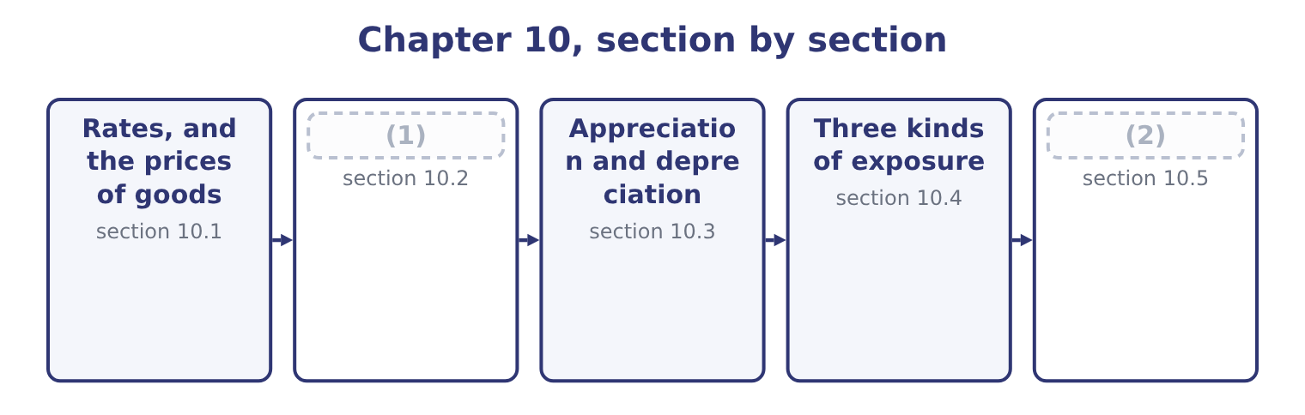
word list
The profit or loss on a cross-border transacti · Three kinds of exposure · What moves a rate

Summary 1 gaps 3–14
An (3) rate is the price of one currency in another, and like any price it can be (4) either way round. For a company (5) in dollars, a direct quote states how many dollars one unit of the foreign currency costs — $1.0800 to the euro — and an (6) quote states how many euros a (7) buys, which is 1 ÷ 1.0800 = 0.9259. Both describe the same rate, and (8) them is the single commonest (9) error in this topic. Read the quote before (10) anything. The first outcome asks how foreign currency affects the prices of goods and services, and the (11) runs in both (12) . What the (13) product costs a foreign buyer. Orontes's jar sells at $12.00. At 1.0800 dollars to the euro, a (14) buyer pays 12.00 ÷ 1.0800 = 11.11 euros.
word list
quoted · reversing · European · arithmetic · company's · dollar · reporting · directions · equipment · computing · mechanism · indirect · exchange

Summary 2 gaps 15–26
If the rate moves to 1.1500 — the euro (15) more dollars — the same jar costs 12.00 ÷ 1.1500 = 10.43 euros. Orontes has not (16) its price and its product has become 6 per cent (17) in Europe. What a foreign input costs the company. A spare part (18) at 50 euros costs 50 × 1.0800 = 54.00 before the move and 50 × 1.1500 = 57.50 after it. Orontes's costs have risen without any (19) raising a price. Three (20) follow and they are the (21) substance. A weaker home currency helps exporters and hurts (22) , and a stronger one does the (23) . Orontes, which exports tahini and imports (24) , is affected both ways and the net (25) depends on the balance of the two. (26) changes even where the company does not trade at all.
word list
position · equipment · cheaper · consequences · buying · examinable · reverse · changed · priced · Competitiveness · supplier · importers · appreciation

Summary 3 gaps 27–34
A domestic producer (27) with imports is helped by a weaker home currency, because the imports become dearer; it has a currency exposure without a single foreign (28) , which is the (29) exposure of section 10.4. And prices do not adjust fully or (30) . Exporters often hold foreign prices steady and absorb the movement in their (31) , to protect market share — pricing to market — which (32) a price effect into a profit effect. Orontes's (33) whether to pass the euro movement on is (34) Book 3's, asked in another currency.
word list
transaction · margins · economic · exactly · converts · changes · immediately · decision · competing

The English this section uses, and its Arabic
Each term sits against what it means.
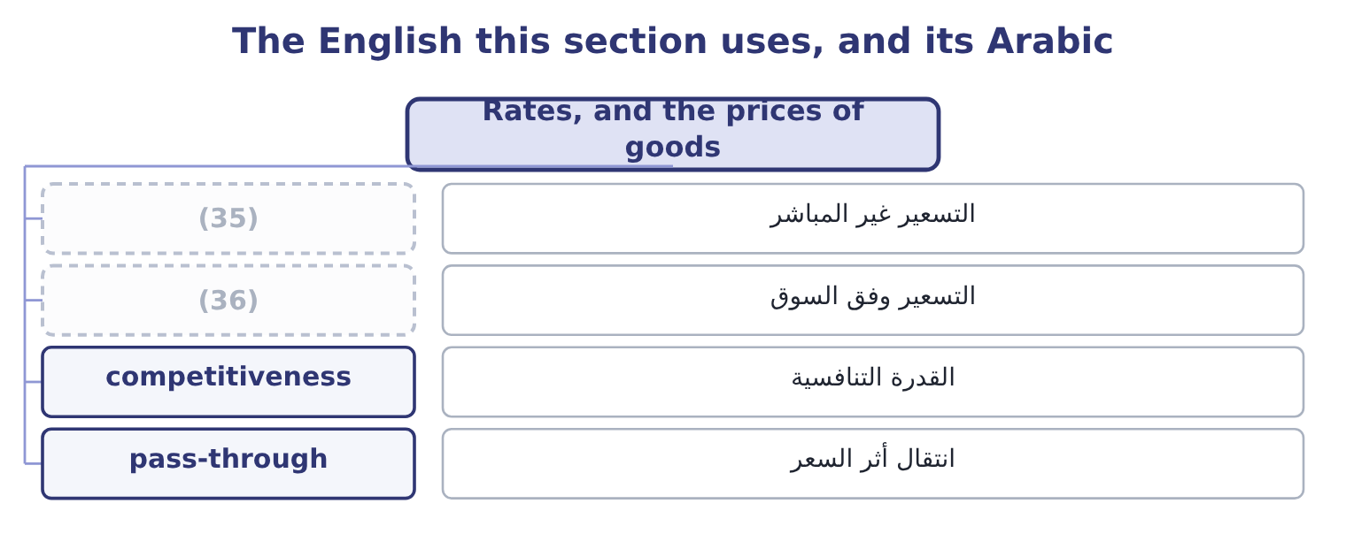
word list
economic exposure · pricing to market · indirect quote

The English this sheet uses, and its Arabic
English (exam term) | Arabic
indirect quote | التسعير غير المباشر
pricing to market | التسعير وفق السوق
competitiveness | القدرة التنافسية
pass-through | انتقال أثر السعر

Answer key · 10.1 Rates, and the prices of goods

1 What moves a rate | 19 supplier
2 The profit or loss on a cross-border transacti | 20 consequences
3 exchange | 21 examinable
4 quoted | 22 importers
5 reporting | 23 reverse
6 indirect | 24 equipment
7 dollar | 25 position
8 reversing | 26 Competitiveness
9 arithmetic | 27 competing
10 computing | 28 transaction
11 mechanism | 29 economic
12 directions | 30 immediately
13 company's | 31 margins
14 European | 32 converts
15 buying | 33 decision
16 changed | 34 exactly
17 cheaper | 35 indirect quote
18 priced | 36 pricing to market

the summaries in full
Summary 1 An exchange rate is the price of one currency in another, and like any price it can be quoted either way round. For a company reporting in dollars, a direct quote states how many dollars one unit of the foreign currency costs — $1.0800 to the euro — and an indirect quote states how many euros a dollar buys, which is 1 ÷ 1.0800 = 0.9259. Both describe the same rate, and reversing them is the single commonest arithmetic error in this topic. Read the quote before computing anything. The first outcome asks how foreign currency affects the prices of goods and services, and the mechanism runs in both directions. What the company's product costs a foreign buyer. Orontes's jar sells at $12.00. At 1.0800 dollars to the euro, a European buyer pays 12.00 ÷ 1.0800 = 11.11 euros.
Summary 2 If the rate moves to 1.1500 — the euro buying more dollars — the same jar costs 12.00 ÷ 1.1500 = 10.43 euros. Orontes has not changed its price and its product has become 6 per cent cheaper in Europe. What a foreign input costs the company. A spare part priced at 50 euros costs 50 × 1.0800 = 54.00 before the move and 50 × 1.1500 = 57.50 after it. Orontes's costs have risen without any supplier raising a price. Three consequences follow and they are the examinable substance. A weaker home currency helps exporters and hurts importers, and a stronger one does the reverse. Orontes, which exports tahini and imports equipment, is affected both ways and the net position depends on the balance of the two. Competitiveness changes even where the company does not trade at all.
Summary 3 A domestic producer competing with imports is helped by a weaker home currency, because the imports become dearer; it has a currency exposure without a single foreign transaction, which is the economic exposure of section 10.4. And prices do not adjust fully or immediately. Exporters often hold foreign prices steady and absorb the movement in their margins, to protect market share — pricing to market — which converts a price effect into a profit effect. Orontes's decision whether to pass the euro movement on is exactly Book 3's, asked in another currency.

10.2 What moves a rate
Chapter 10 · section 10.2

Fill every gap. Each word list holds one word more than there are gaps.
Summary 1 gaps 1–12
The (1) asks for the variables that affect exchange rates, and seven cover the (2) . Learn them with their direction, because a (3) usually asks which way the rate moves. A country whose prices rise faster than its trading (4) ' sees its currency weaken, because its goods become (5) until the rate corrects. This is purchasing power parity, which says that the expected (6) in the rate equals the (7) in inflation rates. Where home inflation is 8 per cent and the other (8) is 3 per cent, the home currency is expected to weaken by about 1.08 ÷ 1.03 = 1.0485, which is 4.85 per cent. Purchasing power parity holds poorly over months and (9) well over years, which is exactly the opposite of what a (10) needs. Higher interest rates attract capital and strengthen a currency in the short run, while the forward market prices the opposite: interest rate parity says the currency with the higher interest rate trades at a forward discount, so that no (11) profit exists from (12) in one currency and lending in the other.
word list
borrowing · reasonably · question · treasurer · syllabus · risk-free · uncompetitive · country's · difference · change · partners · purpose · outcome

Summary 2 gaps 13–24
At a spot of 1.0800, a (13) rate of 6 per cent and a euro rate of 3 per cent, the forward rate is 1.06 ÷ 1.03 = 1.0291 times the spot, which is 1.0800 × 1.0291 = 1.1114. The balance of (14) . A (15) trade deficit means more of the home currency is being sold to buy (16) goods than is being bought, which weakens it, subject to capital flows running the other way. (17) growth and relative (18) . A growing economy (19) investment and (20) its currency, though growth also pulls in imports, which works the other way. (21) and central bank (22) . (23) in the market, capital (24) , and above all monetary policy. A central bank raising rates to control inflation is acting on the rate whether or not that is its purpose.
word list
attracts · dominates · controls · performance · dollar · payments · persistent · Economic · Government · foreign · strengthens · action · Intervention

Summary 3 gaps 25–36
Political (25) and country risk. The political risk of, (26) . Instability, conflict, a (27) election or an (28) legal system all drive capital out and weaken a currency. Rates move on what the market expects rather than on what has happened, which is why an (29) moves a rate and the event it (30) often does not. (31) flows dwarf trade flows in the major currencies, so a rate can move a long way from anything a (32) model would predict, and stay there. Two (33) belong with the list, and strong (34) include them. The variables (35) and often conflict. Higher interest rates strengthen a currency; the inflation they are being used to fight weakens it. Which (36) depends on what the market believes about the future, not on either variable alone. And exchange rate forecasting is unreliable over the horizons companies care about. That is not a reason to ignore the variables, which explain the direction of pressure; it is a reason to manage exposure with the instruments.
word list
cautions · priced · dominates · stability · unpredictable · interact · inflation · trade-based · announces · announcement · Speculative · disputed · answers

The English this section uses, and its Arabic
Each term sits against what it means.
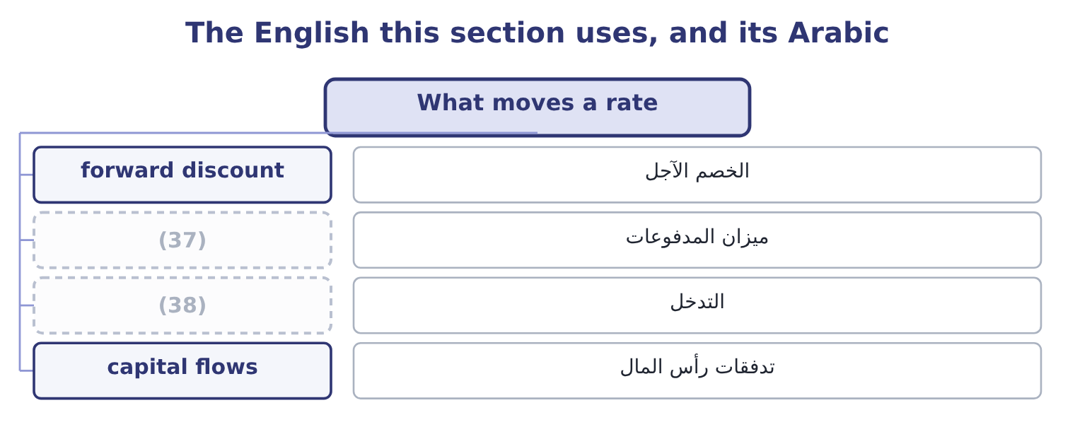
word list
intervention · balance of payments · spot rate

The English this sheet uses, and its Arabic
English (exam term) | Arabic
forward discount | الخصم الآجل
balance of payments | ميزان المدفوعات
intervention | التدخل
capital flows | تدفقات رأس المال

Answer key · 10.2 What moves a rate

1 outcome | 20 strengthens
2 syllabus | 21 Government
3 question | 22 action
4 partners | 23 Intervention
5 uncompetitive | 24 controls
6 change | 25 stability
7 difference | 26 priced
8 country's | 27 disputed
9 reasonably | 28 unpredictable
10 treasurer | 29 announcement
11 risk-free | 30 announces
12 borrowing | 31 Speculative
13 dollar | 32 trade-based
14 payments | 33 cautions
15 persistent | 34 answers
16 foreign | 35 interact
17 Economic | 36 dominates
18 performance | 37 balance of payments
19 attracts | 38 intervention

the summaries in full
Summary 1 The outcome asks for the variables that affect exchange rates, and seven cover the syllabus. Learn them with their direction, because a question usually asks which way the rate moves. A country whose prices rise faster than its trading partners' sees its currency weaken, because its goods become uncompetitive until the rate corrects. This is purchasing power parity, which says that the expected change in the rate equals the difference in inflation rates. Where home inflation is 8 per cent and the other country's is 3 per cent, the home currency is expected to weaken by about 1.08 ÷ 1.03 = 1.0485, which is 4.85 per cent. Purchasing power parity holds poorly over months and reasonably well over years, which is exactly the opposite of what a treasurer needs. Higher interest rates attract capital and strengthen a currency in the short run, while the forward market prices the opposite: interest rate parity says the currency with the higher interest rate trades at a forward discount, so that no risk-free profit exists from borrowing in one currency and lending in the other.
Summary 2 At a spot of 1.0800, a dollar rate of 6 per cent and a euro rate of 3 per cent, the forward rate is 1.06 ÷ 1.03 = 1.0291 times the spot, which is 1.0800 × 1.0291 = 1.1114. The balance of payments. A persistent trade deficit means more of the home currency is being sold to buy foreign goods than is being bought, which weakens it, subject to capital flows running the other way. Economic growth and relative performance. A growing economy attracts investment and strengthens its currency, though growth also pulls in imports, which works the other way. Government and central bank action. Intervention in the market, capital controls, and above all monetary policy. A central bank raising rates to control inflation is acting on the rate whether or not that is its purpose.
Summary 3 Political stability and country risk. The political risk of, priced. Instability, conflict, a disputed election or an unpredictable legal system all drive capital out and weaken a currency. Rates move on what the market expects rather than on what has happened, which is why an announcement moves a rate and the event it announces often does not. Speculative flows dwarf trade flows in the major currencies, so a rate can move a long way from anything a trade-based model would predict, and stay there. Two cautions belong with the list, and strong answers include them. The variables interact and often conflict. Higher interest rates strengthen a currency; the inflation they are being used to fight weakens it. Which dominates depends on what the market believes about the future, not on either variable alone. And exchange rate forecasting is unreliable over the horizons companies care about. That is not a reason to ignore the variables, which explain the direction of pressure; it is a reason to manage exposure with the instruments.

10.3 Appreciation and depreciation
Chapter 10 · section 10.3

Fill every gap. Each word list holds one word more than there are gaps.
Summary 1 gaps 1–5
The third outcome asks for a calculation and for a (1) , and the calculation has one trap in it. A currency (2) when it buys more of another currency and (3) when it buys less. The percentage change is computed on the currency being (4) , which means the same movement produces two different (5) depending on which side you stand.
word list
appreciates · judgment · percentages · described · movement · depreciates

Worked example: one movement, two percentages

Summary 2 gaps 6–16
The rate goes from 1.0800 dollars to the euro at the start of the year to 1.1500 at the end. From the (6) side. The euro now buys more dollars, so it has (7) , by 1.1500 − 1.0800 = 0.0700 on a base of 1.0800, which is 0.0700 ÷ 1.0800 = 6.48 per cent. From the (8) side. (9) the rate in euros per dollar: it was 1 ÷ 1.0800 = 0.9259 and is now 1 ÷ 1.1500 = 0.8696. The dollar now buys fewer euros, so it has (10) , by 0.9259 − 0.8696 = 0.0563 on a base of 0.9259, which is 0.0563 ÷ 0.9259 = 6.08 per cent. A 6.48 per cent (11) of one currency is a 6.08 per cent (12) of the other, (13) the base changes. The two are never equal (14) for very small (15) , and a question that gives one and asks for the other is testing (16) this.
word list
depreciated · movements · precisely · dollar's · appreciated · depreciation · except · because · appreciation · euro's · Restate · pass-through

Summary 3 gaps 17–28
State the (17) in words before computing anything: "the euro buys more dollars than it did, so the euro is stronger and the dollar is weaker." (18) lose marks by computing a correct percentage and attaching it to the wrong currency. (19) the impact is the second half of the outcome, and it runs through three (20) . Orontes's export sales are (21) in euros, so a stronger euro means more dollars per sale. Its European (22) cost more. On (23) , a company that sells more (24) than it buys gains from a weaker home currency. What it does to (25) . Orontes's jar fell from 11.11 to 10.43 euros without a price change, which is an (26) to take share or to raise the euro price and keep the gain — a decision, not an automatic (27) . And whether the movement is temporary or (28) .
word list
abroad · balance · consequence · opportunity · sensible · competitiveness · Candidates · direction · questions · purchases · structural · Evaluating · invoiced

Summary 4 gaps 29–32
A movement that (29) within the year affects (30) in flight and nothing else. A movement that (31) changes where it is sensible to produce, source and sell, which is the economic exposure of the next section and a matter for the board rather than the (32) .
word list
reverses · persists · treasurer · movements · transactions

The English this section uses, and its Arabic
Each term sits against what it means.
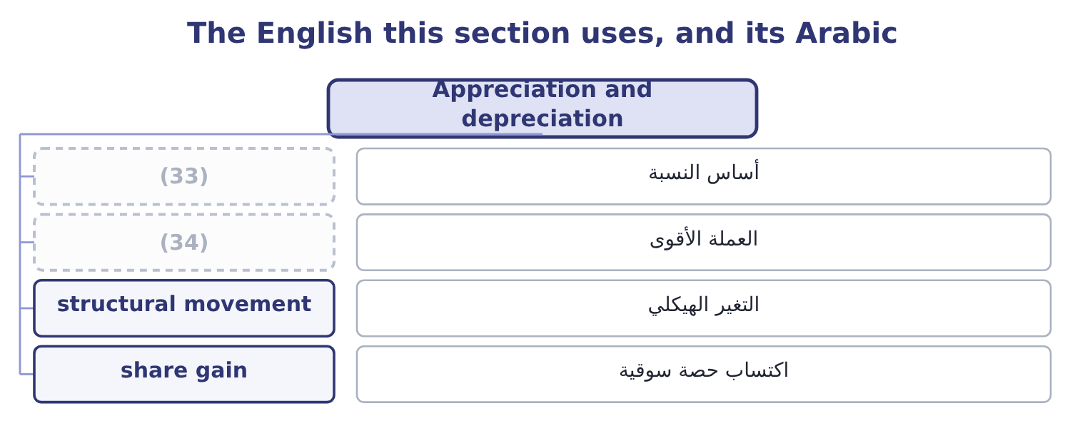
word list
structural response · base of a percentage · stronger currency

The English this sheet uses, and its Arabic
English (exam term) | Arabic
base of a percentage | أساس النسبة
stronger currency | العملة الأقوى
structural movement | التغير الهيكلي
share gain | اكتساب حصة سوقية

Answer key · 10.3 Appreciation and depreciation

1 judgment | 18 Candidates
2 appreciates | 19 Evaluating
3 depreciates | 20 questions
4 described | 21 invoiced
5 percentages | 22 purchases
6 euro's | 23 balance
7 appreciated | 24 abroad
8 dollar's | 25 competitiveness
9 Restate | 26 opportunity
10 depreciated | 27 consequence
11 appreciation | 28 structural
12 depreciation | 29 reverses
13 because | 30 transactions
14 except | 31 persists
15 movements | 32 treasurer
16 precisely | 33 base of a percentage
17 direction | 34 stronger currency

the summaries in full
Summary 1 The third outcome asks for a calculation and for a judgment, and the calculation has one trap in it. A currency appreciates when it buys more of another currency and depreciates when it buys less. The percentage change is computed on the currency being described, which means the same movement produces two different percentages depending on which side you stand.
Summary 2 The rate goes from 1.0800 dollars to the euro at the start of the year to 1.1500 at the end. From the euro's side. The euro now buys more dollars, so it has appreciated, by 1.1500 − 1.0800 = 0.0700 on a base of 1.0800, which is 0.0700 ÷ 1.0800 = 6.48 per cent. From the dollar's side. Restate the rate in euros per dollar: it was 1 ÷ 1.0800 = 0.9259 and is now 1 ÷ 1.1500 = 0.8696. The dollar now buys fewer euros, so it has depreciated, by 0.9259 − 0.8696 = 0.0563 on a base of 0.9259, which is 0.0563 ÷ 0.9259 = 6.08 per cent. A 6.48 per cent appreciation of one currency is a 6.08 per cent depreciation of the other, because the base changes. The two are never equal except for very small movements, and a question that gives one and asks for the other is testing precisely this.
Summary 3 State the direction in words before computing anything: "the euro buys more dollars than it did, so the euro is stronger and the dollar is weaker." Candidates lose marks by computing a correct percentage and attaching it to the wrong currency. Evaluating the impact is the second half of the outcome, and it runs through three questions. Orontes's export sales are invoiced in euros, so a stronger euro means more dollars per sale. Its European purchases cost more. On balance, a company that sells more abroad than it buys gains from a weaker home currency. What it does to competitiveness. Orontes's jar fell from 11.11 to 10.43 euros without a price change, which is an opportunity to take share or to raise the euro price and keep the gain — a decision, not an automatic consequence. And whether the movement is temporary or structural.
Summary 4 A movement that reverses within the year affects transactions in flight and nothing else. A movement that persists changes where it is sensible to produce, source and sell, which is the economic exposure of the next section and a matter for the board rather than the treasurer.

10.4 Three kinds of exposure
Chapter 10 · section 10.4

Fill every gap. Each word list holds one word more than there are gaps.
Summary 1 gaps 1–12
Before computing the profit or loss on a transaction, it is worth (1) three exposures, because they are (2) differently, managed differently and confused (3) . The risk that the (4) value of a committed foreign-currency cash flow changes between the (5) and the settlement: an invoice issued, an order placed, a loan to be repaid. It is specific, dated, (6) , and it is what the (7) . Section 10.5 (8) it. Translation exposure, also called accounting exposure. The risk that the reported value of foreign assets, (9) and results changes when they are (10) into the reporting currency for the financial statements. It affects the balance sheet and the reported figures without any cash moving, which is why companies (11) about how far it should be hedged: hedging an accounting number with a real cash (12) converts a book entry into a cash gain or loss.
word list
instrument · home-currency · disagree · constantly · commitment · computes · measurable · measured · liabilities · separating · hedges · flexible · translated

Summary 2 gaps 13–20
Economic exposure, also called (13) exposure. The risk that the present value of the (14) future cash flows changes because of a rate movement — (15) the cash flows of a business that has no foreign (16) at all. It is the (17) of the three, the hardest to measure, and the one that cannot be hedged with a forward (18) , because it has no date and no amount. It is managed (19) : where production is located, where inputs are bought, what currency prices are set in, how (20) sourcing is.
word list
structurally · including · transactions · largest · company's · contract · managed · operating · flexible

Three exposures
Exposure | What is at risk | Horizon | Managed by
Transaction | Committed foreign-currency cash flows | (21) | Forwards, options, matching
Translation | Reported amounts on consolidation | Reporting date | (22)
Economic | (23) | Years | Location, sourcing, pricing, flexibility

word list
Matching assets with local borrowing · Present value of future cash flows · committed cash flow · Days to months

The English this section uses, and its Arabic
Each term sits against what it means.
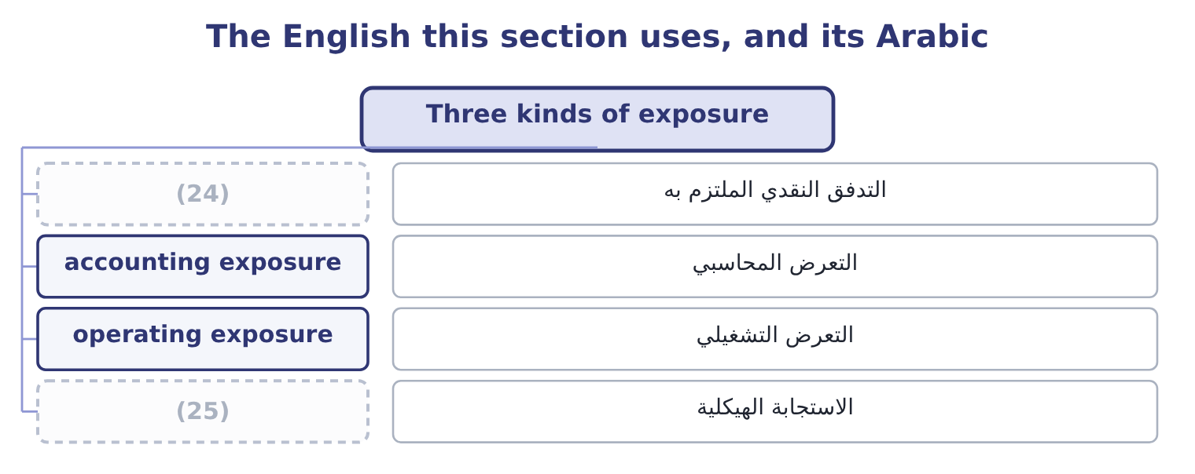
word list
committed cash flow · structural response · interest rate parity

The English this sheet uses, and its Arabic
English (exam term) | Arabic
committed cash flow | التدفق النقدي الملتزم به
accounting exposure | التعرض المحاسبي
operating exposure | التعرض التشغيلي
structural response | الاستجابة الهيكلية

Answer key · 10.4 Three kinds of exposure

1 separating | 14 company's
2 measured | 15 including
3 constantly | 16 transactions
4 home-currency | 17 largest
5 commitment | 18 contract
6 measurable | 19 structurally
7 hedges | 20 flexible
8 computes | 21 Days to months
9 liabilities | 22 Matching assets with local borrowing
10 translated | 23 Present value of future cash flows
11 disagree | 24 committed cash flow
12 instrument | 25 structural response
13 operating

the summaries in full
Summary 1 Before computing the profit or loss on a transaction, it is worth separating three exposures, because they are measured differently, managed differently and confused constantly. The risk that the home-currency value of a committed foreign-currency cash flow changes between the commitment and the settlement: an invoice issued, an order placed, a loan to be repaid. It is specific, dated, measurable, and it is what the hedges. Section 10.5 computes it. Translation exposure, also called accounting exposure. The risk that the reported value of foreign assets, liabilities and results changes when they are translated into the reporting currency for the financial statements. It affects the balance sheet and the reported figures without any cash moving, which is why companies disagree about how far it should be hedged: hedging an accounting number with a real cash instrument converts a book entry into a cash gain or loss.
Summary 2 Economic exposure, also called operating exposure. The risk that the present value of the company's future cash flows changes because of a rate movement — including the cash flows of a business that has no foreign transactions at all. It is the largest of the three, the hardest to measure, and the one that cannot be hedged with a forward contract, because it has no date and no amount. It is managed structurally: where production is located, where inputs are bought, what currency prices are set in, how flexible sourcing is.

10.5 The profit or loss on a cross-border transaction
Chapter 10 · section 10.5

Fill every gap. Each word list holds one word more than there are gaps.
Summary 1 gaps 1–7
The (1) outcome asks for a calculation and for its (2) . The calculation is a (3) and the discipline is in (4) the dates right. A foreign-currency (5) is recorded at the rate on the day it is (6) into. It is settled at the rate on the day the money moves. The (7) , applied to the foreign-currency amount, is the exchange gain or loss, and it goes to the income statement in the period it arises.
word list
transaction · fourth · evaluation · getting · difference · entered · operating · subtraction

Worked example: Orontes's year in euros

Summary 2 gaps 8–19
On 1 March Orontes (8) its European (9) 2,000,000 euros, payable in (10) days. The spot rate is 1.0800, so the sale is recorded at 2,000,000 × 1.0800 = 2,160,000. On 30 May the euro has strengthened to 1.1500, so the (11) is worth 2,000,000 × 1.1500 = 2,300,000 and the exchange gain is 2,300,000 − 2,160,000 = 140,000. On the same dates Orontes owes 400,000 euros for packaging, recorded at 400,000 × 1.0800 = 432,000 and settled at 400,000 × 1.1500 = 460,000, (12) a loss of 460,000 − 432,000 = 28,000. The year's (13) position produces 140,000 − 28,000 = 112,000 of net exchange gain. Two things to (14) . The gain and the loss arise on the same movement in opposite (15) , which is the (16) hedge: only the net 1,600,000 of exposure was ever at risk. And the 112,000 is a (17) , not a performance: it arose because the euro moved (18) , and the same position would have produced a loss of (19) size had it moved the other way.
word list
giving · ninety · distributor · invoices · favourably · receipt · windfall · natural · directions · similar · notice · cross-border · currency

Summary 3 gaps 20–28
Reporting it as a (20) result would be exactly the kind of (21) problem Book 1's. (22) the impact, which the outcome also asks for, means (23) four things. How large it is relative to the (24) . On (25) income of $4,176,000, a 112,000 swing is under 3 per cent — material but not (26) . The same movement on a company with half the (27) and twice the exports would be (28) . Whether it is symmetrical. It is: the position that produced 112,000 of gain would have produced a comparable loss, and a board told only about favourable years is being misled.
word list
earnings-quality · business · decisive · direction · threatening · trading · operating · margin · Evaluating · saying

Summary 4 gaps 29–34
What it says about the exposure. A gain on an (29) position is not a success; it is (30) that the company was carrying an (31) exposure and was lucky. And whether it changes any (32) . A (33) movement changes the competitiveness of exporting and may change where Orontes buys its packaging, which is economic exposure and belongs in a strategy (34) rather than a treasury report.
word list
evidence · discussion · decision · unhedged · produced · unmanaged · persistent

Rates and results

Your turn: currency arithmetic (complete the blanks)
Item | Data | Answer
Euro appreciation | From 1.0800 to 1.1500 dollars per euro | ________
Dollar depreciation on the same move | Inverse rates 0.9259 and 0.8696 | ________
A 12.00 jar in euros, after the move | (35) | ________
Gain on a 2,000,000 euro receivable | (36) | ________
Loss on a 400,000 euro payable | (37) | ________
Forward rate implied by interest parity | Spot 1.0800; dollar 6 per cent, euro 3 per cent | ________

word list
Invoiced at 1.0800, settled at 1.1500 · exchange gain · Rate 1.1500 · Same two rates

"Strong", "weak", "up" and "down"

Summary 5 gaps 38–46
No (38) in finance causes more (39) than this one, because the words are relative and the (40) depends on which currency you are standing. Strong and weak are safer, because they (41) to a named currency — "the euro strengthened" (42) be misread — and (43) writing uses them for exactly that reason. (44) also carries a value (45) in the pair: strong sounds good and weak sounds bad, which is wrong for an exporter, and (46) in every language make the same mistake. In an exam answer, name the currency and say strengthened or weakened, then give the percentage and the base.
word list
professional · vocabulary · opposite · judgment · attach · newspapers · confusion · English · direction · cannot

"Strong", "weak", "up" and "down"
Item | Answer
Euro appreciation | 6.48 per cent: 0.0700 ÷ 1.0800 = 6.48 per cent.
Dollar depreciation | (47)
A 12.00 jar in euros after the move | 10.43 euros: 12.00 ÷ 1.1500 = 10.43.
Gain on the receivable | (48)
Loss on the payable | 28,000: 460,000 − 432,000 = 28,000.
Forward rate by interest parity | (49)
What it tells you | The first three are about competitiveness and the last three about cash — and the exam asks for both, because a movement that helps the inco

word list
140,000: 2,300,000 − 2,160,000 = 140,000. · 1.1114: 1.0800 × 1.0291 = 1.1114. · 6.08 per cent: 0.0563 ÷ 0.9259 = 6.08 per cent. · 10.43 euros: 12.00 ÷ 1.1500 = 10.43.

The English this section uses, and its Arabic
Each term sits against what it means.
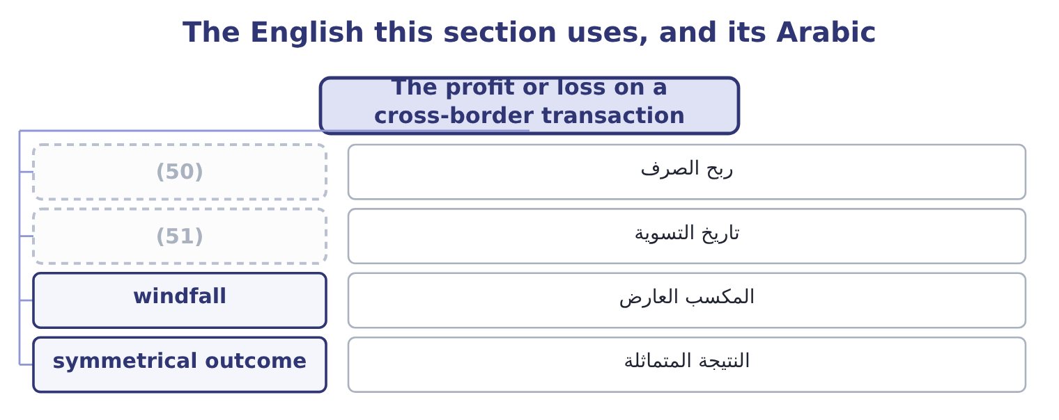
word list
settlement date · exchange gain · accounting exposure

The English this sheet uses, and its Arabic
English (exam term) | Arabic
exchange gain | ربح الصرف
settlement date | تاريخ التسوية
windfall | المكسب العارض
symmetrical outcome | النتيجة المتماثلة

Answer key · 10.5 The profit or loss on a cross-border transaction

1 fourth | 27 margin
2 evaluation | 28 decisive
3 subtraction | 29 unhedged
4 getting | 30 evidence
5 transaction | 31 unmanaged
6 entered | 32 decision
7 difference | 33 persistent
8 invoices | 34 discussion
9 distributor | 35 Rate 1.1500
10 ninety | 36 Invoiced at 1.0800, settled at 1.1500
11 receipt | 37 Same two rates
12 giving | 38 vocabulary
13 cross-border | 39 confusion
14 notice | 40 direction
15 directions | 41 attach
16 natural | 42 cannot
17 windfall | 43 professional
18 favourably | 44 English
19 similar | 45 judgment
20 trading | 46 newspapers
21 earnings-quality | 47 6.08 per cent: 0.0563 ÷ 0.9259 = 6.08 per cent.
22 Evaluating | 48 140,000: 2,300,000 − 2,160,000 = 140,000.
23 saying | 49 1.1114: 1.0800 × 1.0291 = 1.1114.
24 business | 50 exchange gain
25 operating | 51 settlement date
26 threatening

the summaries in full
Summary 1 The fourth outcome asks for a calculation and for its evaluation. The calculation is a subtraction and the discipline is in getting the dates right. A foreign-currency transaction is recorded at the rate on the day it is entered into. It is settled at the rate on the day the money moves. The difference, applied to the foreign-currency amount, is the exchange gain or loss, and it goes to the income statement in the period it arises.
Summary 2 On 1 March Orontes invoices its European distributor 2,000,000 euros, payable in ninety days. The spot rate is 1.0800, so the sale is recorded at 2,000,000 × 1.0800 = 2,160,000. On 30 May the euro has strengthened to 1.1500, so the receipt is worth 2,000,000 × 1.1500 = 2,300,000 and the exchange gain is 2,300,000 − 2,160,000 = 140,000. On the same dates Orontes owes 400,000 euros for packaging, recorded at 400,000 × 1.0800 = 432,000 and settled at 400,000 × 1.1500 = 460,000, giving a loss of 460,000 − 432,000 = 28,000. The year's cross-border position produces 140,000 − 28,000 = 112,000 of net exchange gain. Two things to notice. The gain and the loss arise on the same movement in opposite directions, which is the natural hedge: only the net 1,600,000 of exposure was ever at risk. And the 112,000 is a windfall, not a performance: it arose because the euro moved favourably, and the same position would have produced a loss of similar size had it moved the other way.
Summary 3 Reporting it as a trading result would be exactly the kind of earnings-quality problem Book 1's. Evaluating the impact, which the outcome also asks for, means saying four things. How large it is relative to the business. On operating income of $4,176,000, a 112,000 swing is under 3 per cent — material but not threatening. The same movement on a company with half the margin and twice the exports would be decisive. Whether it is symmetrical. It is: the position that produced 112,000 of gain would have produced a comparable loss, and a board told only about favourable years is being misled.
Summary 4 What it says about the exposure. A gain on an unhedged position is not a success; it is evidence that the company was carrying an unmanaged exposure and was lucky. And whether it changes any decision. A persistent movement changes the competitiveness of exporting and may change where Orontes buys its packaging, which is economic exposure and belongs in a strategy discussion rather than a treasury report.
Summary 5 No vocabulary in finance causes more confusion than this one, because the words are relative and the direction depends on which currency you are standing. Strong and weak are safer, because they attach to a named currency — "the euro strengthened" cannot be misread — and professional writing uses them for exactly that reason. English also carries a value judgment in the pair: strong sounds good and weak sounds bad, which is wrong for an exporter, and newspapers in every language make the same mistake. In an exam answer, name the currency and say strengthened or weakened, then give the percentage and the base.

11.1 Forwards and futures
Chapter 11 · section 11.1

Fill every gap. Each word list holds one word more than there are gaps.
Chapter 11, section by section
Each stage leads to the next.
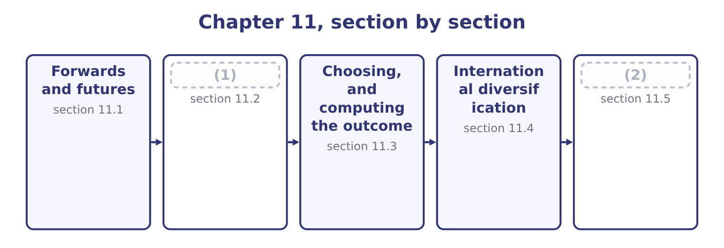
word list
bill of lading · Options and swaps · Financing the trade

Summary 1 gaps 3–14
A forward contract is an (3) with a bank to exchange a fixed amount of one currency for (4) , at a fixed rate, on a fixed date. It is the instrument companies use most, because it matches an exposure exactly in amount and date and because it costs (5) to enter. The forward rate is not a (6) . It is set by interest rate (7) : the rate that removes any (8) gain from borrowing in one currency and (9) in the other. Over (10) days, with dollar interest at 6 per cent and euro interest at 3 per cent, a spot of 1.0800 gives a forward of about 1.0880, and a company that (11) at that rate has not (12) anything. Its (13) , stated as the exam wants them: it is a private contract between the company and its bank; it is tailored in amount and date; it carries no up-front payment; it obliges both parties, so the favourable movement is given up along with the (14) ; and it carries counterparty risk, since the bank must perform.
word list
lending · contracts · payment · forecast · nothing · predicted · unfavourable · risk-free · agreement · features · parity · another · ninety

Summary 2 gaps 15–26
A currency future is the (15) version. The (16) are the examinable part. It is (17) in amount and in (18) date, so it rarely matches an exposure exactly, and the mismatch — basis risk — remains. It is traded on an exchange with a (19) house as counterparty, which removes the credit risk of (20) with one bank. It requires margin: an initial deposit and daily (21) margin as the position is marked to market, so a hedge that is winning or losing (22) cash flows before the exposure settles. That is a liquidity (23) of a risk management decision, and it has (24) companies whose hedges were correct and whose margin calls were not funded. And a position can be (25) at any time by taking the (26) contract, which a forward cannot. For a company of Orontes's size, hedging specific commercial exposures, the forward is almost always the right instrument. Futures belong where the amounts are large, the maturities standard, the counterparty risk material, or where positions must be adjusted frequently.
word list
generates · exchange-traded · opposite · consequence · dealing · counterpurchase · standardised · variation · closed · clearing · embarrassed · maturity · differences

The English this section uses, and its Arabic
Each term sits against what it means.
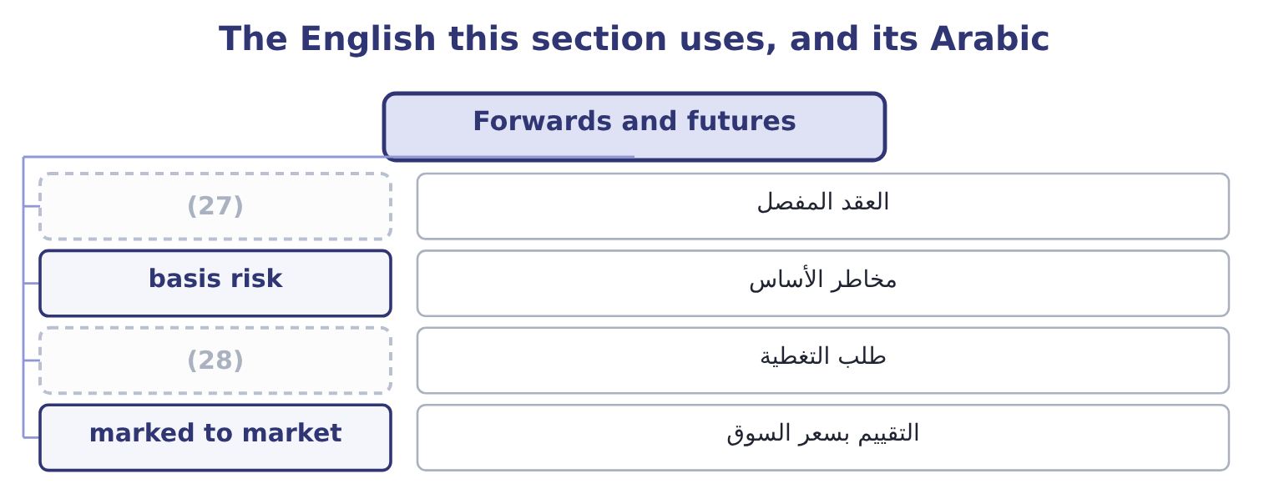
word list
tailored contract · margin call · currency option

The English this sheet uses, and its Arabic
English (exam term) | Arabic
tailored contract | العقد المفصل
basis risk | مخاطر الأساس
margin call | طلب التغطية
marked to market | التقييم بسعر السوق

Answer key · 11.1 Forwards and futures

1 Options and swaps | 15 exchange-traded
2 Financing the trade | 16 differences
3 agreement | 17 standardised
4 another | 18 maturity
5 nothing | 19 clearing
6 forecast | 20 dealing
7 parity | 21 variation
8 risk-free | 22 generates
9 lending | 23 consequence
10 ninety | 24 embarrassed
11 contracts | 25 closed
12 predicted | 26 opposite
13 features | 27 tailored contract
14 unfavourable | 28 margin call

the summaries in full
Summary 1 A forward contract is an agreement with a bank to exchange a fixed amount of one currency for another, at a fixed rate, on a fixed date. It is the instrument companies use most, because it matches an exposure exactly in amount and date and because it costs nothing to enter. The forward rate is not a forecast. It is set by interest rate parity: the rate that removes any risk-free gain from borrowing in one currency and lending in the other. Over ninety days, with dollar interest at 6 per cent and euro interest at 3 per cent, a spot of 1.0800 gives a forward of about 1.0880, and a company that contracts at that rate has not predicted anything. Its features, stated as the exam wants them: it is a private contract between the company and its bank; it is tailored in amount and date; it carries no up-front payment; it obliges both parties, so the favourable movement is given up along with the unfavourable; and it carries counterparty risk, since the bank must perform.
Summary 2 A currency future is the exchange-traded version. The differences are the examinable part. It is standardised in amount and in maturity date, so it rarely matches an exposure exactly, and the mismatch — basis risk — remains. It is traded on an exchange with a clearing house as counterparty, which removes the credit risk of dealing with one bank. It requires margin: an initial deposit and daily variation margin as the position is marked to market, so a hedge that is winning or losing generates cash flows before the exposure settles. That is a liquidity consequence of a risk management decision, and it has embarrassed companies whose hedges were correct and whose margin calls were not funded. And a position can be closed at any time by taking the opposite contract, which a forward cannot. For a company of Orontes's size, hedging specific commercial exposures, the forward is almost always the right instrument. Futures belong where the amounts are large, the maturities standard, the counterparty risk material, or where positions must be adjusted frequently.

11.2 Options and swaps
Chapter 11 · section 11.2

Fill every gap. Each word list holds one word more than there are gaps.
Summary 1 gaps 1–12
A currency option gives the (1) the right, but not the obligation, to exchange currency at a stated rate on or (2) a stated date, in (3) for a premium paid at the outset. An exporter (4) foreign currency buys a put option on that currency; an (5) who will need it buys a call. The (6) is the whole point and it is what the premium buys. If the rate moves (7) the option is exercised and the company has a (8) ; if it moves favourably the option is abandoned and the company keeps the gain, less the premium. (9) a forward, an option costs money and (10) the upside; a forward is free and does not. Three cases where an option is the right (11) , and the exam looks for them. Where the exposure is (12) .
word list
holder · instrument · unfavourably · uncertain · Against · return · dollars · importer · floor · expecting · before · asymmetry · preserves

Summary 2 gaps 13–24
A tender for a (13) that may not be won (14) a currency exposure only if the tender (15) . A forward would leave the company with an (16) position if it lost; an option (17) lapses. Where the company has a view it is (18) to bet on. And where the (19) must be capped for a (20) , a budget or a board. A currency swap is an (21) to exchange principal and interest (22) in one currency for principal and interest in another, usually over several years. Its typical use is not the hedging of a single (23) but the matching of a long-term funding stream to a long-term revenue stream: a company with euro (24) that has borrowed in dollars swaps the dollar obligation into euros, so that its debt service arises in the currency its income arrives.
word list
unwilling · payments · covenant · contract · revenues · floor · transaction · creates · downside · simply · agreement · unwanted · succeeds

Summary 3 gaps 25–30
Three (25) the exam uses. A swap hedges a series of flows rather than one, so it suits (26) and funding (27) . It is driven partly by (28) advantage in (29) : each party borrows where it is best known and swaps into the currency it wants, and both can be better off. And it carries (30) risk over its whole life, which is longer than a forward's.
word list
borrowing · comparative · exposures · counterparty · translation · points · floor

The English this section uses, and its Arabic
Each term sits against what it means.
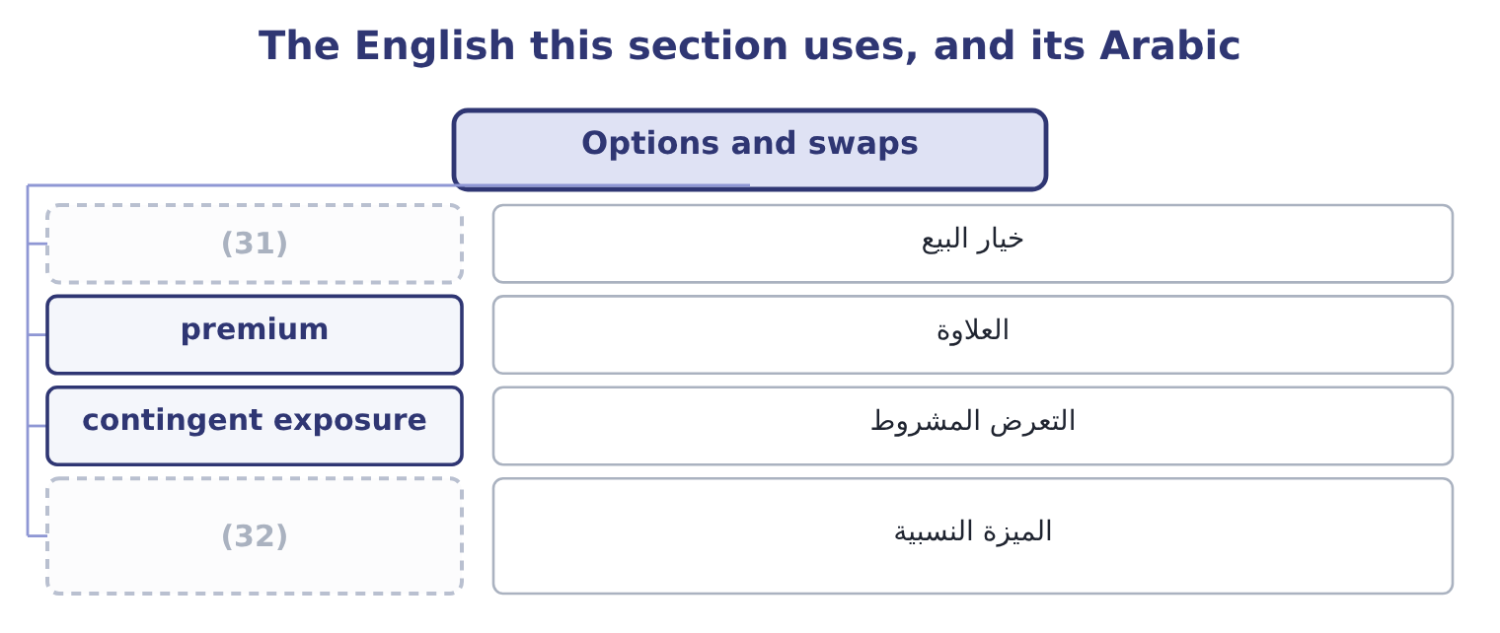
word list
imperfect correlation · put option · comparative advantage

The English this sheet uses, and its Arabic
English (exam term) | Arabic
put option | خيار البيع
premium | العلاوة
contingent exposure | التعرض المشروط
comparative advantage | الميزة النسبية

Answer key · 11.2 Options and swaps

1 holder | 17 simply
2 before | 18 unwilling
3 return | 19 downside
4 expecting | 20 covenant
5 importer | 21 agreement
6 asymmetry | 22 payments
7 unfavourably | 23 transaction
8 floor | 24 revenues
9 Against | 25 points
10 preserves | 26 translation
11 instrument | 27 exposures
12 uncertain | 28 comparative
13 contract | 29 borrowing
14 creates | 30 counterparty
15 succeeds | 31 put option
16 unwanted | 32 comparative advantage

the summaries in full
Summary 1 A currency option gives the holder the right, but not the obligation, to exchange currency at a stated rate on or before a stated date, in return for a premium paid at the outset. An exporter expecting foreign currency buys a put option on that currency; an importer who will need it buys a call. The asymmetry is the whole point and it is what the premium buys. If the rate moves unfavourably the option is exercised and the company has a floor; if it moves favourably the option is abandoned and the company keeps the gain, less the premium. Against a forward, an option costs money and preserves the upside; a forward is free and does not. Three cases where an option is the right instrument, and the exam looks for them. Where the exposure is uncertain.
Summary 2 A tender for a contract that may not be won creates a currency exposure only if the tender succeeds. A forward would leave the company with an unwanted position if it lost; an option simply lapses. Where the company has a view it is unwilling to bet on. And where the downside must be capped for a covenant, a budget or a board. A currency swap is an agreement to exchange principal and interest payments in one currency for principal and interest in another, usually over several years. Its typical use is not the hedging of a single transaction but the matching of a long-term funding stream to a long-term revenue stream: a company with euro revenues that has borrowed in dollars swaps the dollar obligation into euros, so that its debt service arises in the currency its income arrives.
Summary 3 Three points the exam uses. A swap hedges a series of flows rather than one, so it suits translation and funding exposures. It is driven partly by comparative advantage in borrowing: each party borrows where it is best known and swaps into the currency it wants, and both can be better off. And it carries counterparty risk over its whole life, which is longer than a forward's.

11.3 Choosing, and computing the outcome
Chapter 11 · section 11.3

Fill every gap. Each word list holds one word more than there are gaps.
Summary 1 gaps 1–12
The (1) outcome asks for a recommendation with the net profit or loss of the (2) method computed, which is the (3) most likely to appear in an exam. Orontes will (4) 2,000,000 euros in ninety days. The spot rate is 1.0800, the (5) forward is 1.0880, (6) interest is 6 per cent a year and euro interest 3 per cent, and a put option on euros at a strike of 1.0800 costs 0.0150 a euro. The result (7) on the rate in ninety days. At 1.1500 the receipt is 2,000,000 × 1.1500 = 2,300,000; at 1.0200 it is 2,000,000 × 1.0200 = 2,040,000. The range is 260,000 wide and (8) is known in (9) . (10) to sell 2,000,000 euros at 1.0880 for 2,000,000 × 1.0880 = 2,176,000, certain, (11) the rate does. Borrow euros today against the (12) , convert at spot and hold dollars.
word list
position · recommended · advance · dollar · second · receivable · nothing · calculation · ninety-day · whatever · receive · Contract · depends

Summary 2 gaps 13–23
The amount to borrow is 2,000,000 ÷ 1.0075 = 1,985,112, since ninety days of euro interest at 3 per cent a year is a (13) of 3 per cent. (14) gives 1,985,112 × 1.0800 = 2,143,921, and (15) that in dollars at 6 per cent for ninety days gives 2,143,921 × 1.015 = 2,176,080. Pay a premium of 2,000,000 × 0.0150 = 30,000 now. If the rate falls to 1.0200, (16) at 1.0800 for 2,000,000 × 1.0800 = 2,160,000, so the net is 2,160,000 − 30,000 = 2,130,000. If it rises to 1.1500, let the option lapse and sell at spot for 2,300,000, so the net is 2,300,000 − 30,000 = 2,270,000. Two results are worth (17) . The forward and the money (18) hedge give 2,176,000 and 2,176,080 — the same answer, which is interest rate parity (19) exactly; any material (20) between them would be an (21) . And the option is never the best outcome and never the worst: it costs 30,000 to convert the whole range into a (22) with the upside (23) .
word list
working · natural · holding · market · intact · exercise · difference · floor · Converting · quarter · noticing · arbitrage

The same exposure, four treatments
The bars are drawn to scale.
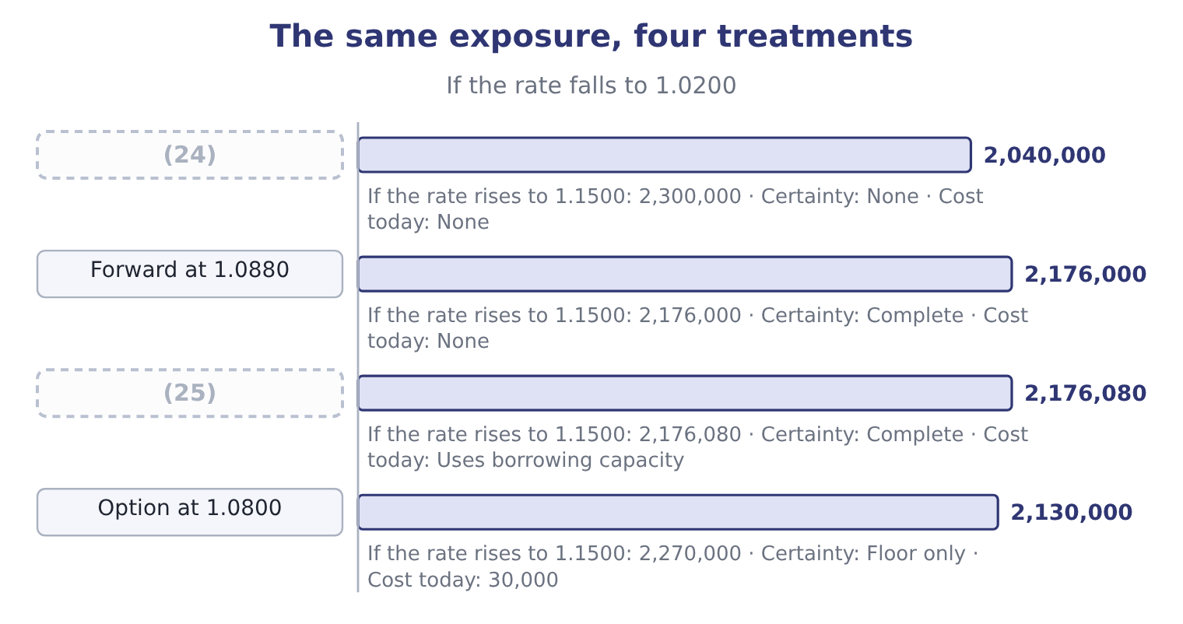
word list
margin call · Money market hedge · Do nothing

Summary 3 gaps 26–37
The recommendation, which the outcome (26) , follows from four (27) rather than from the table. Is the exposure certain? If the sale is (28) and the customer is good, the forward is (29) . If it is (30) , use an option. What does the policy say?, which (31) most of the question before any (32) . Has the natural hedge been taken first? (33) 400,000 of euro costs reduce the exposure needing an (34) to 1,600,000, and hedging the gross amount would create a position. And what can the company afford to be wrong about? If 260,000 of (35) would breach a covenant or a budget (36) , certainty is worth paying for; if it would not, the premium may not be. On that basis the recommendation for Orontes is a forward for 75 per cent of the net 1,600,000 exposure, dated to the (37) receipt, with the balance left open against the risk that the shipment slips — which is the answer.
word list
contingent · balance · commitment · arithmetic · appropriate · settles · requires · contracted · Orontes's · expected · questions · variation · instrument

The English this section uses, and its Arabic
Each term sits against what it means.
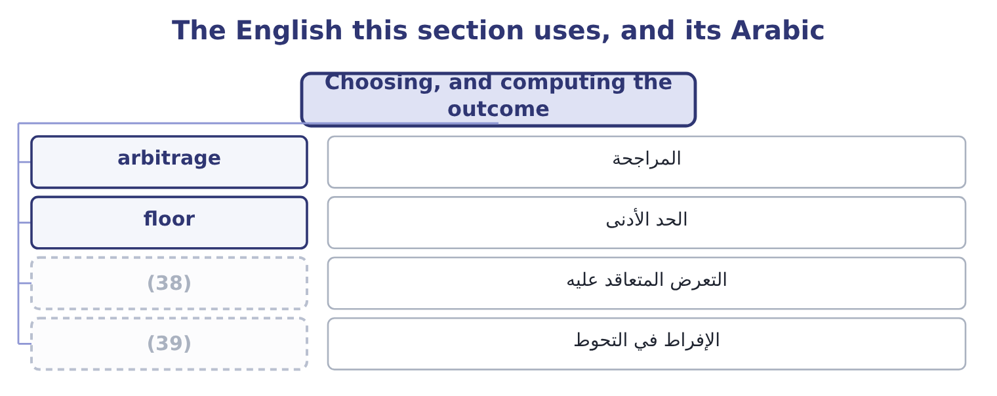
word list
contracted exposure · over-hedging · without recourse

The English this sheet uses, and its Arabic
English (exam term) | Arabic
arbitrage | المراجحة
floor | الحد الأدنى
contracted exposure | التعرض المتعاقد عليه
over-hedging | الإفراط في التحوط

Answer key · 11.3 Choosing, and computing the outcome

1 second | 21 arbitrage
2 recommended | 22 floor
3 calculation | 23 intact
4 receive | 24 Do nothing
5 ninety-day | 25 Money market hedge
6 dollar | 26 requires
7 depends | 27 questions
8 nothing | 28 contracted
9 advance | 29 appropriate
10 Contract | 30 contingent
11 whatever | 31 settles
12 receivable | 32 arithmetic
13 quarter | 33 Orontes's
14 Converting | 34 instrument
15 holding | 35 variation
16 exercise | 36 commitment
17 noticing | 37 expected
18 market | 38 contracted exposure
19 working | 39 over-hedging
20 difference

the summaries in full
Summary 1 The second outcome asks for a recommendation with the net profit or loss of the recommended method computed, which is the calculation most likely to appear in an exam. Orontes will receive 2,000,000 euros in ninety days. The spot rate is 1.0800, the ninety-day forward is 1.0880, dollar interest is 6 per cent a year and euro interest 3 per cent, and a put option on euros at a strike of 1.0800 costs 0.0150 a euro. The result depends on the rate in ninety days. At 1.1500 the receipt is 2,000,000 × 1.1500 = 2,300,000; at 1.0200 it is 2,000,000 × 1.0200 = 2,040,000. The range is 260,000 wide and nothing is known in advance. Contract to sell 2,000,000 euros at 1.0880 for 2,000,000 × 1.0880 = 2,176,000, certain, whatever the rate does. Borrow euros today against the receivable, convert at spot and hold dollars.
Summary 2 The amount to borrow is 2,000,000 ÷ 1.0075 = 1,985,112, since ninety days of euro interest at 3 per cent a year is a quarter of 3 per cent. Converting gives 1,985,112 × 1.0800 = 2,143,921, and holding that in dollars at 6 per cent for ninety days gives 2,143,921 × 1.015 = 2,176,080. Pay a premium of 2,000,000 × 0.0150 = 30,000 now. If the rate falls to 1.0200, exercise at 1.0800 for 2,000,000 × 1.0800 = 2,160,000, so the net is 2,160,000 − 30,000 = 2,130,000. If it rises to 1.1500, let the option lapse and sell at spot for 2,300,000, so the net is 2,300,000 − 30,000 = 2,270,000. Two results are worth noticing. The forward and the money market hedge give 2,176,000 and 2,176,080 — the same answer, which is interest rate parity working exactly; any material difference between them would be an arbitrage. And the option is never the best outcome and never the worst: it costs 30,000 to convert the whole range into a floor with the upside intact.
Summary 3 The recommendation, which the outcome requires, follows from four questions rather than from the table. Is the exposure certain? If the sale is contracted and the customer is good, the forward is appropriate. If it is contingent, use an option. What does the policy say?, which settles most of the question before any arithmetic. Has the natural hedge been taken first? Orontes's 400,000 of euro costs reduce the exposure needing an instrument to 1,600,000, and hedging the gross amount would create a position. And what can the company afford to be wrong about? If 260,000 of variation would breach a covenant or a budget commitment, certainty is worth paying for; if it would not, the premium may not be. On that basis the recommendation for Orontes is a forward for 75 per cent of the net 1,600,000 exposure, dated to the expected receipt, with the balance left open against the risk that the shipment slips — which is the answer.

11.4 International diversification
Chapter 11 · section 11.4

Fill every gap. Each word list holds one word more than there are gaps.
Summary 1 gaps 1–12
The third outcome asks for the benefits of international diversification, which means (1) and operating abroad rather than merely selling abroad. Six benefits, with their (2) . Lower (3) of results. (4) do not move together, so profits from several countries are less variable in total than profits from one. This is Book 2's, and it works for the same reason: imperfect (5) . Markets that are growing faster than the home market, and (6) the company's products suit. Lower input costs and (7) to inputs. (8) or sourcing where labour, materials or energy are cheaper, or where the raw material grows. Natural hedging of (9) . A company with euro costs as well as euro revenues has reduced its exposure (10) . Reduced political and regulatory (11) . A single adverse decision affects one country's (12) rather than the whole business, which is.
word list
Producing · concentration · currency · access · qualifications · populations · correlation · variability · Economies · investing · adverse · operations · structurally

Summary 2 gaps 13–24
Learning and (13) position. Exposure to (14) customers, different competitors and other regulatory standards improves the business at home, and presence in a (15) market is itself a deterrent. (16) that, four costs the exam (17) as the other half of a good answer. New risks: political, legal, cultural, and the (18) risk of running something far away. (19) rise in a crisis, so the diversification is smallest in the years it is most wanted — the same (20) . (21) attention is finite, and a foreign operation (22) more of it per dollar than a domestic one. And (23) can diversify (24) for themselves, more cheaply, by buying foreign shares. That is Book 3's, and it applies here with the same force: the case for international investment must rest on something the company can do — a product, a brand, a process, a cost position — and not on diversification alone.
word list
observation · Against · cheaply · demanding · internationally · consumes · expects · Correlations · shareholders · competitive · competitor's · Management · operational

The English this section uses, and its Arabic
Each term sits against what it means.
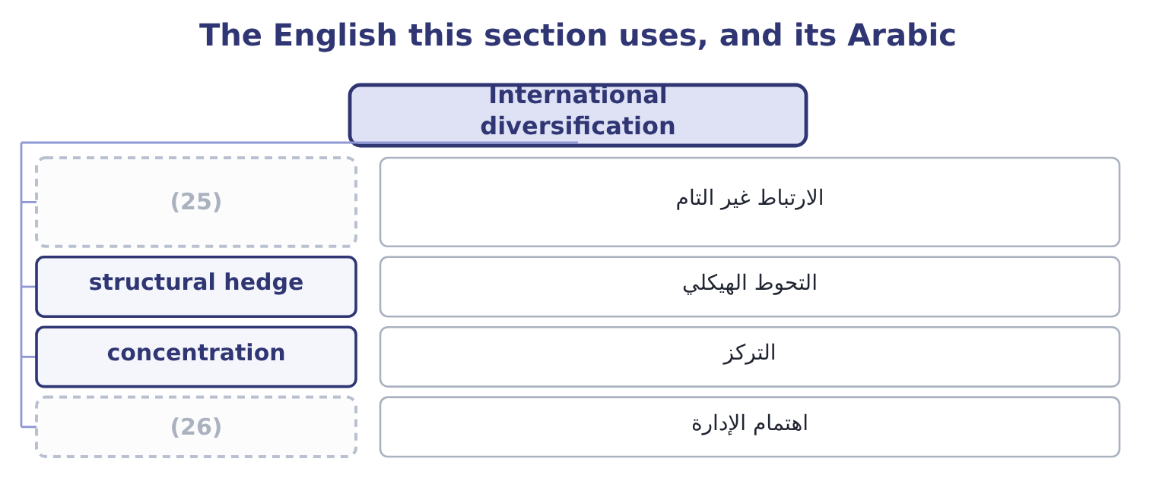
word list
comparative advantage · management attention · imperfect correlation

The English this sheet uses, and its Arabic
English (exam term) | Arabic
imperfect correlation | الارتباط غير التام
structural hedge | التحوط الهيكلي
concentration | التركز
management attention | اهتمام الإدارة

Answer key · 11.4 International diversification

1 investing | 14 demanding
2 qualifications | 15 competitor's
3 variability | 16 Against
4 Economies | 17 expects
5 correlation | 18 operational
6 populations | 19 Correlations
7 access | 20 observation
8 Producing | 21 Management
9 currency | 22 consumes
10 structurally | 23 shareholders
11 concentration | 24 internationally
12 operations | 25 imperfect correlation
13 competitive | 26 management attention

the summaries in full
Summary 1 The third outcome asks for the benefits of international diversification, which means investing and operating abroad rather than merely selling abroad. Six benefits, with their qualifications. Lower variability of results. Economies do not move together, so profits from several countries are less variable in total than profits from one. This is Book 2's, and it works for the same reason: imperfect correlation. Markets that are growing faster than the home market, and populations the company's products suit. Lower input costs and access to inputs. Producing or sourcing where labour, materials or energy are cheaper, or where the raw material grows. Natural hedging of currency. A company with euro costs as well as euro revenues has reduced its exposure structurally. Reduced political and regulatory concentration. A single adverse decision affects one country's operations rather than the whole business, which is.
Summary 2 Learning and competitive position. Exposure to demanding customers, different competitors and other regulatory standards improves the business at home, and presence in a competitor's market is itself a deterrent. Against that, four costs the exam expects as the other half of a good answer. New risks: political, legal, cultural, and the operational risk of running something far away. Correlations rise in a crisis, so the diversification is smallest in the years it is most wanted — the same observation. Management attention is finite, and a foreign operation consumes more of it per dollar than a domestic one. And shareholders can diversify internationally for themselves, more cheaply, by buying foreign shares. That is Book 3's, and it applies here with the same force: the case for international investment must rest on something the company can do — a product, a brand, a process, a cost position — and not on diversification alone.

11.5 Financing the trade
Chapter 11 · section 11.5

Fill every gap. Each word list holds one word more than there are gaps.
Summary 1 gaps 1–12
Cross-border sales create two (1) at once: the exporter wants payment and the importer wants the goods, and (2) will go first. The (3) of trade finance exist to break that (4) , and the outcome names five. A letter of credit is an undertaking by the importer's bank to pay the exporter on (5) of specified documents — typically the bill of lading, the invoice and a (6) of inspection or origin. It (7) a bank's credit for the buyer's, which is its whole (8) : the exporter no longer has to assess a customer in another country. It is (9) , meaning the bank pays against conforming documents and not against the goods, so a (10) in the paperwork can delay payment even where the shipment is perfect. A (11) letter of credit adds the (12) own bank's undertaking, removing the risk of the issuing bank or its country.
word list
instruments · certificate · documentary · discrepancy · confirmed · neither · presentation · exporter's · deadlock · purpose · problems · substitutes · opposite

Summary 2 gaps 13–24
A banker's acceptance is a time draft drawn on a bank which the bank accepts, so that the bank becomes (13) liable to pay it at (14) . Because a bank's acceptance is a (15) instrument, it can be sold at a discount in the money (16) , which means the exporter can have the cash immediately while the importer still has time to pay. It (17) trade credit into a (18) security. Cross-border factoring is the sale of (19) receivables to a factor, (20) through a chain of (21) factors with one in the importer's country, who (22) and collects locally. It (23) cash immediately, transfers the collection work, and where it is without recourse it transfers the credit risk as well. Its cost is the fee and the discount, and that cost must be (24) with the alternative uses of the money.
word list
primarily · market · converts · provides · correspondent · tradeable · analysis · compared · high-quality · maturity · usually · assesses · foreign

Summary 3 gaps 25–36
Forfaiting is the (25) , without recourse, of medium-term receivables from an exporter — typically notes or drafts, often (26) by a bank in the importer's country, over terms of one to seven years. It suits capital goods sold to buyers in difficult markets: the exporter is paid at once and keeps none of the credit, country or currency risk, and pays a (27) discount for. Countertrade is payment in goods rather than money, in various forms: barter, where goods are (28) directly; counterpurchase, where the exporter agrees to buy (29) goods from the (30) country; and offset, where part of the value must be sourced or produced in the buyer's country. It appears where currency is scarce or (31) , where the buyer is a (32) , and in large defence and (33) contracts. Its costs are real — the exporter must (34) of goods it did not want, often at a discount — and should be valued (35) rather than (36) as free.
word list
substantial · purchase · importing · without · treated · controlled · explicitly · government · unrelated · exchanged · infrastructure · dispose · guaranteed

Worked example: what factoring costs

Summary 4 gaps 37–45
Orontes's 2,000,000 euro receivable, due in ninety days. A factor (37) 2 per cent of face value as a fee, plus interest at 7 per cent a year on the (38) for the ninety days. The fee is 2,000,000 × 0.02 = 40,000 and the interest 2,000,000 × 0.07 × 0.25 = 35,000, so the total is 40,000 + 35,000 = 75,000. That is 75,000 ÷ 2,000,000 = 3.75 per cent for ninety days, which (39) to roughly 3.75 × 4 = 15.0 per cent. (40) per cent against a cost of capital of 9.04 per cent looks (41) , and may still be worth it: the (42) is not with the cost of capital but with what the alternative costs. If the arrangement is without recourse it also removes the credit risk, and it removes the collection (43) in a country where Orontes has no (44) . An exam answer that stops at "15 per cent is more than the cost of capital, so reject" has not (45) the analysis.
word list
Fifteen · offers · annualises · finance · presence · comparison · advance · expensive · effort · finished

Trade finance instruments
Instrument | What it does | Who it protects | Typical use
Letter of credit | A bank pays against conforming documents | The exporter, against the buyer | (46)
Banker's acceptance | (47) | Both, with early cash | Short-term goods trade
Cross-border factoring | Receivables sold to a factor who collects locally | (48) | Continuing export sales
Forfaiting | Medium-term receivables bought without recourse | (49) | Capital goods, long terms
Countertrade | Payment in goods rather than money | The importer short of currency | (50)

word list
First dealings; difficult markets · 2,130,000: 2,160,000 − 30,000 = 2,130,000. · A bank accepts a time draft, which can be discounted · The exporter, completely · Currency controls; state buyers · The exporter, with cash and often credit cover

Instruments and arithmetic

Your turn: hedging and financing (complete the blanks)
Item | Data | Answer
Proceeds under a forward | (51) | ________
Option premium | (52) | ________
Net proceeds if the option is exercised | Strike 1.0800, premium as above | ________
Instrument for an exposure that exists only if a tender is won |  | ________
Instrument substituting a bank's credit for the buyer's |  | ________
Annualised cost of factoring | Fee 40,000 plus interest 35,000 on 2,000,000 for 90 days | ________

word list
2,000,000 euros at 1.0880 · Both, with early cash · 2,000,000 euros at 0.0150

"Hedge", "cover" and "without recourse"

Summary 5 gaps 53–64
Two (53) terms matter here. Cover is used in British practice as a (54) for hedge — "we have covered the exposure" — and in (55) for what a policy pays; in a cross-border (56) it may mean either, so a report should use hedged for (57) and insured for policies. Without recourse is the phrase that (58) the money in trade finance: it means the buyer of the receivable (59) come back to the exporter if the customer does not pay, so the credit risk has (60) moved. With recourse means the opposite, and the (61) in price between the two is the price of the credit risk. When a question (62) a factoring or forfaiting arrangement, the first thing to (63) is which of the two it is, because (64) about the risk analysis follows from it.
word list
cannot · further · insurance · document · positions · establish · carries · difference · usually · describes · everything · genuinely · near-synonym

"Hedge", "cover" and "without recourse"
Item | Answer
Proceeds under a forward | 2,176,000: 2,000,000 × 1.0880 = 2,176,000.
Option premium | (65)
Net proceeds if exercised | (66)
Instrument for a tender-contingent exposure | An option, which lapses if the tender is lost.
Instrument substituting a bank's credit | (67)
Annualised cost of factoring | (68) : 3.75 per cent for ninety days.
What it tells you | Three calculations and three choices — and in every case the arithmetic narrows the options while the decision turns on whether the exposure

word list
A letter of credit. · 30,000: 2,000,000 × 0.0150 = 30,000. · 2,130,000: 2,160,000 − 30,000 = 2,130,000. · About 15.0 per cent · 2,176,000: 2,000,000 × 1.0880 = 2,176,000.

The English this section uses, and its Arabic
Each term sits against what it means.
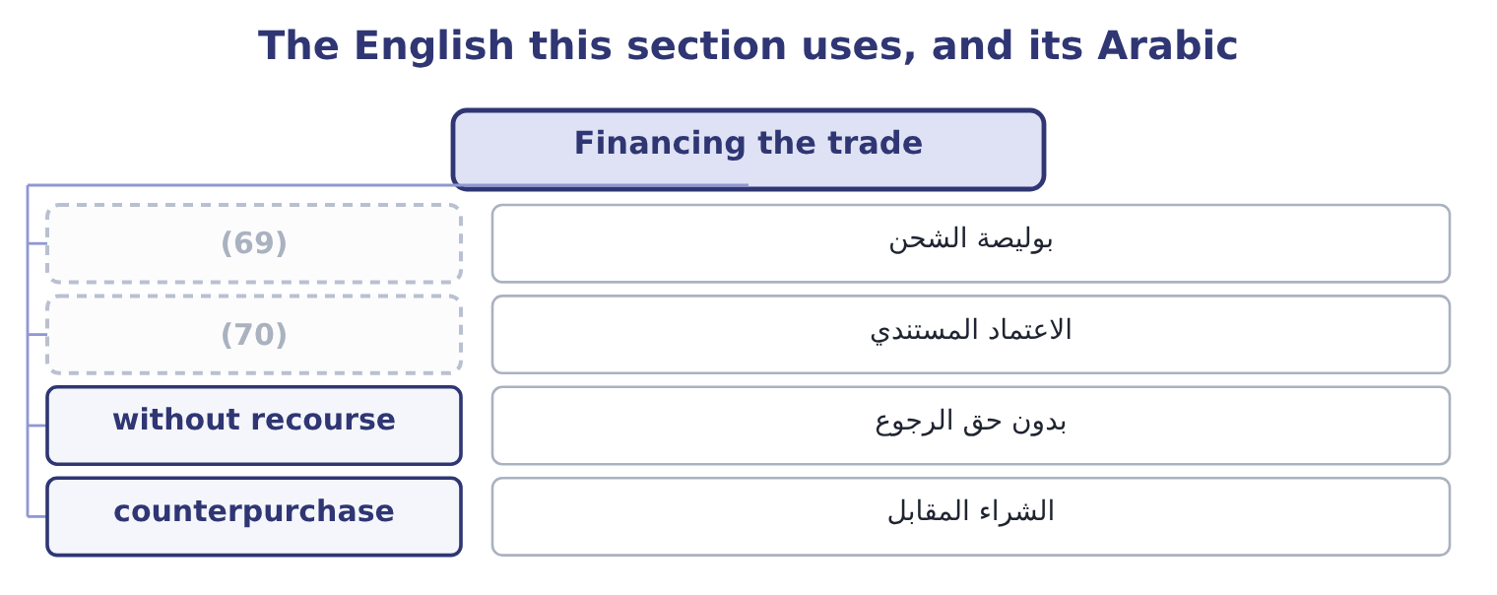
word list
comparative advantage · documentary credit · bill of lading

The English this sheet uses, and its Arabic
English (exam term) | Arabic
bill of lading | بوليصة الشحن
documentary credit | الاعتماد المستندي
without recourse | بدون حق الرجوع
counterpurchase | الشراء المقابل

Answer key · 11.5 Financing the trade

1 problems | 36 treated
2 neither | 37 offers
3 instruments | 38 advance
4 deadlock | 39 annualises
5 presentation | 40 Fifteen
6 certificate | 41 expensive
7 substitutes | 42 comparison
8 purpose | 43 effort
9 documentary | 44 presence
10 discrepancy | 45 finished
11 confirmed | 46 First dealings; difficult markets
12 exporter's | 47 A bank accepts a time draft, which can be discounted
13 primarily | 48 The exporter, with cash and often credit cover
14 maturity | 49 The exporter, completely
15 high-quality | 50 Currency controls; state buyers
16 market | 51 2,000,000 euros at 1.0880
17 converts | 52 2,000,000 euros at 0.0150
18 tradeable | 53 further
19 foreign | 54 near-synonym
20 usually | 55 insurance
21 correspondent | 56 document
22 assesses | 57 positions
23 provides | 58 carries
24 compared | 59 cannot
25 purchase | 60 genuinely
26 guaranteed | 61 difference
27 substantial | 62 describes
28 exchanged | 63 establish
29 unrelated | 64 everything
30 importing | 65 30,000: 2,000,000 × 0.0150 = 30,000.
31 controlled | 66 2,130,000: 2,160,000 − 30,000 = 2,130,000.
32 government | 67 A letter of credit.
33 infrastructure | 68 About 15.0 per cent
34 dispose | 69 bill of lading
35 explicitly | 70 documentary credit

the summaries in full
Summary 1 Cross-border sales create two problems at once: the exporter wants payment and the importer wants the goods, and neither will go first. The instruments of trade finance exist to break that deadlock, and the outcome names five. A letter of credit is an undertaking by the importer's bank to pay the exporter on presentation of specified documents — typically the bill of lading, the invoice and a certificate of inspection or origin. It substitutes a bank's credit for the buyer's, which is its whole purpose: the exporter no longer has to assess a customer in another country. It is documentary, meaning the bank pays against conforming documents and not against the goods, so a discrepancy in the paperwork can delay payment even where the shipment is perfect. A confirmed letter of credit adds the exporter's own bank's undertaking, removing the risk of the issuing bank or its country.
Summary 2 A banker's acceptance is a time draft drawn on a bank which the bank accepts, so that the bank becomes primarily liable to pay it at maturity. Because a bank's acceptance is a high-quality instrument, it can be sold at a discount in the money market, which means the exporter can have the cash immediately while the importer still has time to pay. It converts trade credit into a tradeable security. Cross-border factoring is the sale of foreign receivables to a factor, usually through a chain of correspondent factors with one in the importer's country, who assesses and collects locally. It provides cash immediately, transfers the collection work, and where it is without recourse it transfers the credit risk as well. Its cost is the fee and the discount, and that cost must be compared with the alternative uses of the money.
Summary 3 Forfaiting is the purchase, without recourse, of medium-term receivables from an exporter — typically notes or drafts, often guaranteed by a bank in the importer's country, over terms of one to seven years. It suits capital goods sold to buyers in difficult markets: the exporter is paid at once and keeps none of the credit, country or currency risk, and pays a substantial discount for. Countertrade is payment in goods rather than money, in various forms: barter, where goods are exchanged directly; counterpurchase, where the exporter agrees to buy unrelated goods from the importing country; and offset, where part of the value must be sourced or produced in the buyer's country. It appears where currency is scarce or controlled, where the buyer is a government, and in large defence and infrastructure contracts. Its costs are real — the exporter must dispose of goods it did not want, often at a discount — and should be valued explicitly rather than treated as free.
Summary 4 Orontes's 2,000,000 euro receivable, due in ninety days. A factor offers 2 per cent of face value as a fee, plus interest at 7 per cent a year on the advance for the ninety days. The fee is 2,000,000 × 0.02 = 40,000 and the interest 2,000,000 × 0.07 × 0.25 = 35,000, so the total is 40,000 + 35,000 = 75,000. That is 75,000 ÷ 2,000,000 = 3.75 per cent for ninety days, which annualises to roughly 3.75 × 4 = 15.0 per cent. Fifteen per cent against a cost of capital of 9.04 per cent looks expensive, and may still be worth it: the comparison is not with the cost of capital but with what the alternative costs. If the arrangement is without recourse it also removes the credit risk, and it removes the collection effort in a country where Orontes has no presence. An exam answer that stops at "15 per cent is more than the cost of capital, so reject" has not finished the analysis.
Summary 5 Two further terms matter here. Cover is used in British practice as a near-synonym for hedge — "we have covered the exposure" — and in insurance for what a policy pays; in a cross-border document it may mean either, so a report should use hedged for positions and insured for policies. Without recourse is the phrase that carries the money in trade finance: it means the buyer of the receivable cannot come back to the exporter if the customer does not pay, so the credit risk has genuinely moved. With recourse means the opposite, and the difference in price between the two is the price of the credit risk. When a question describes a factoring or forfaiting arrangement, the first thing to establish is which of the two it is, because everything about the risk analysis follows from it.

12.1 What business ethics is
Chapter 12 · section 12.1

Fill every gap. Each word list holds one word more than there are gaps.
Chapter 12, section by section
Each stage leads to the next.
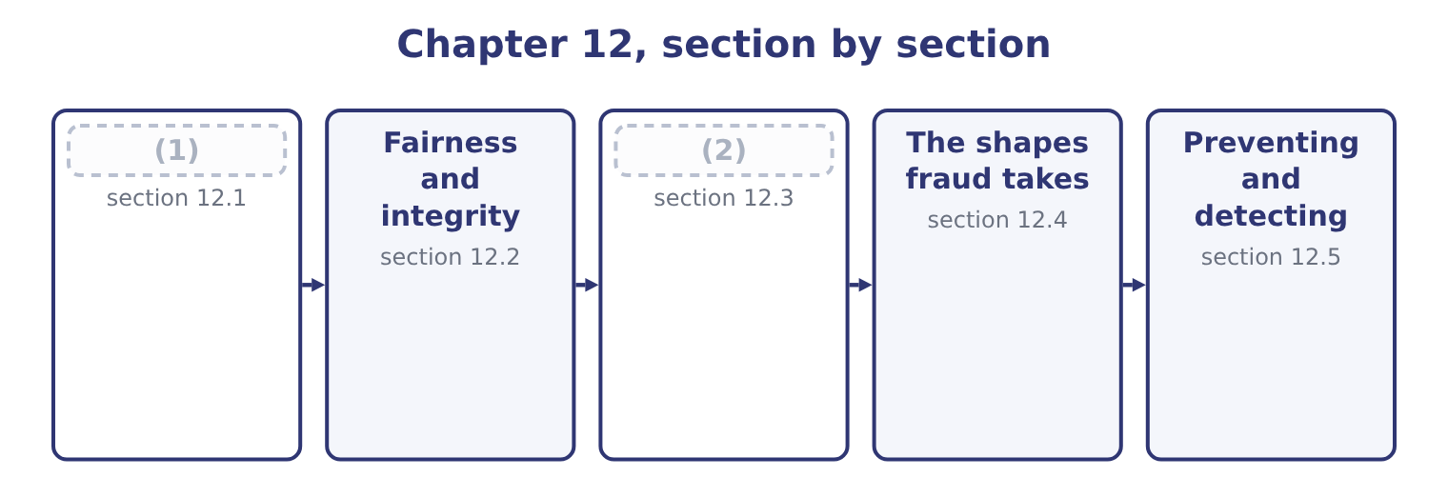
word list
Due diligence and fiduciary responsibility · The shapes fraud takes · What business ethics is

Summary 1 gaps 3–14
Business ethics is the (3) of moral principles and standards of conduct to the decisions and behaviour of (4) and the people in them. It asks what ought to be done, where law asks what must be done and (5) asks what pays. Four points of (6) carry the weight in this (7) . It concerns conduct, not (8) . Ethics is about what is done, not about how (9) feels, and an ethical company is one whose decisions are (10) defensible, not one whose values statement is well written. It is not the same as (11) , and: much that is legal is (12) , and the gap between the two is where most professional dilemmas live. It (13) to the organisation and to the (14) separately. A company has obligations, and so does each professional inside it, and the Statement of Ethical Professional Practice. And it concerns everybody affected by a decision, not only its shareholders.
word list
unethical · individual · anybody · sentiment · organisations · consistently · obligations · applies · economics · definition · application · syllabus · legality

Summary 2 gaps 15–26
Customers, (15) , suppliers, lenders, (16) and regulators all have interests, and ethical reasoning means weighing them rather than assuming one of them always wins. Three (17) to deciding appear in exam (18) and are worth having. Which action (19) the best overall outcome for everybody affected. Its strength is (20) ; its weakness is that it permits harm to a few for the benefit of many and that (21) are forecast rather than known. Some things are owed (22) of outcome: tell the truth, keep (23) , respect the rights of others. Its strength is that it does not (24) ; its weakness is that duties (25) . What a person of (26) would do, and what the decision makes of the person who takes it. Its strength is that it describes how people actually decide; its weakness is that it gives little guidance in a genuinely new situation. A practical answer uses all three as tests rather than choosing between them, and adds a fourth that is more useful than any of them in an exam: would this decision survive publication? If an action could not be explained to the people affected, or would be indefensible on the front page of a newspaper, that is strong evidence about it.
word list
integrity · agreements · answers · conflict · practicality · consequences · legality · approaches · produces · communities · employees · regardless · negotiate

The English this section uses, and its Arabic
Each term sits against what it means.
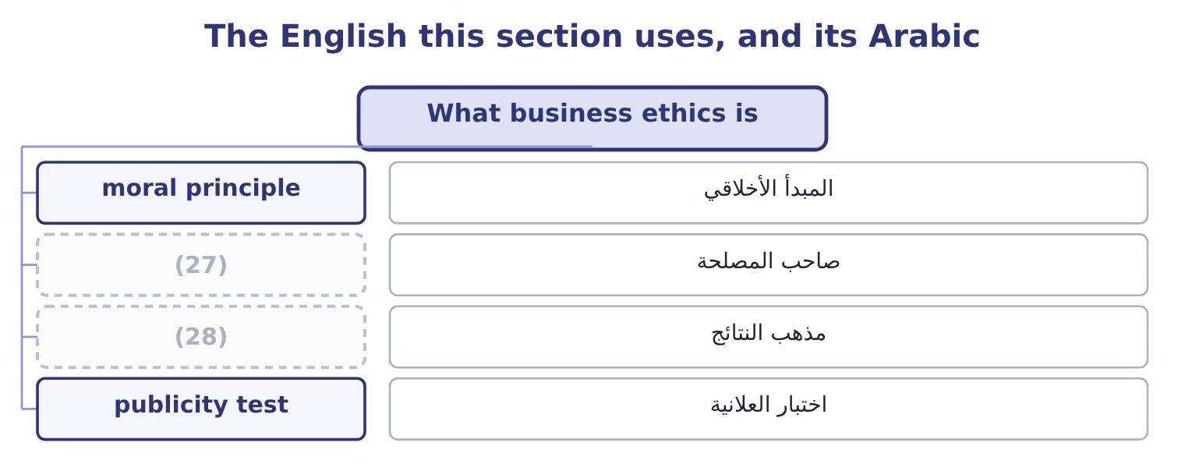
word list
consequentialism · stakeholder · irregularity

The English this sheet uses, and its Arabic
English (exam term) | Arabic
moral principle | المبدأ الأخلاقي
stakeholder | صاحب المصلحة
consequentialism | مذهب النتائج
publicity test | اختبار العلانية

Answer key · 12.1 What business ethics is

1 What business ethics is | 15 employees
2 Due diligence and fiduciary responsibility | 16 communities
3 application | 17 approaches
4 organisations | 18 answers
5 economics | 19 produces
6 definition | 20 practicality
7 syllabus | 21 consequences
8 sentiment | 22 regardless
9 anybody | 23 agreements
10 consistently | 24 negotiate
11 legality | 25 conflict
12 unethical | 26 integrity
13 applies | 27 stakeholder
14 individual | 28 consequentialism

the summaries in full
Summary 1 Business ethics is the application of moral principles and standards of conduct to the decisions and behaviour of organisations and the people in them. It asks what ought to be done, where law asks what must be done and economics asks what pays. Four points of definition carry the weight in this syllabus. It concerns conduct, not sentiment. Ethics is about what is done, not about how anybody feels, and an ethical company is one whose decisions are consistently defensible, not one whose values statement is well written. It is not the same as legality, and: much that is legal is unethical, and the gap between the two is where most professional dilemmas live. It applies to the organisation and to the individual separately. A company has obligations, and so does each professional inside it, and the Statement of Ethical Professional Practice. And it concerns everybody affected by a decision, not only its shareholders.
Summary 2 Customers, employees, suppliers, lenders, communities and regulators all have interests, and ethical reasoning means weighing them rather than assuming one of them always wins. Three approaches to deciding appear in exam answers and are worth having. Which action produces the best overall outcome for everybody affected. Its strength is practicality; its weakness is that it permits harm to a few for the benefit of many and that consequences are forecast rather than known. Some things are owed regardless of outcome: tell the truth, keep agreements, respect the rights of others. Its strength is that it does not negotiate; its weakness is that duties conflict. What a person of integrity would do, and what the decision makes of the person who takes it. Its strength is that it describes how people actually decide; its weakness is that it gives little guidance in a genuinely new situation. A practical answer uses all three as tests rather than choosing between them, and adds a fourth that is more useful than any of them in an exam: would this decision survive publication? If an action could not be explained to the people affected, or would be indefensible on the front page of a newspaper, that is strong evidence about it.

12.2 Fairness and integrity
Chapter 12 · section 12.2

Fill every gap. Each word list holds one word more than there are gaps.
Summary 1 gaps 1–12
The outcome names four (1) and asks what each means and how it affects (2) . Two of them are about the (3) of a decision and two about the care taken over it. Fairness is treating like cases alike, and treating people (4) to standards they could accept if they knew them. It has three (5) the exam uses. Fairness of outcome: whether the (6) of benefit and (7) is defensible. A supplier (8) on payment terms because it cannot afford to argue is being treated (9) in outcome, whatever the contract allows. Fairness of process: whether the decision was made by a method that treats everybody consistently, with the same (10) and the same (11) to be heard. A tender awarded on (12) that were changed after bids were received is unfair in process even if the winner was the best bidder.
word list
decisions · distribution · fairness · criteria · dimensions · character · burden · concepts · opportunity · information · squeezed · unfairly · according

Summary 2 gaps 13–24
Fairness of (13) : whether people are dealt with (14) and with respect — told the truth, told in time, not misled by omission. In (15) fairness bites hardest where a company has power: over a small supplier, over a (16) who cannot evaluate what is being sold, over an employee who cannot easily leave. The test is not whether the other party agreed; it is whether they agreed on terms they (17) and could have (18) . Integrity is wholeness — acting on the same (19) consistently, whether or not anybody is watching, and whether or not it is (20) . For a (21) accountant it has four practical (22) . (23) in what is reported, (24) what is omitted. A technically true figure presented so as to mislead is a breach of integrity, and Book 1's. Avoiding conflicts of interest, and disclosing those that cannot be avoided.
word list
understood · Honesty · principles · including · customer · Integrity's · practice · refused · honestly · components · treatment · convenient · management

Summary 3 gaps 25–36
The (25) is the problem, not the (26) it might lead to, and the (27) arises before anything has gone wrong. Refusing to do (28) what may not be done directly — which covers the request to leave (29) out, to delay a (30) , to book an entry somebody else will reverse. And (31) between what is said and what is done, which is the (32) other people actually observe and the one on which a finance function's (33) rests. (34) practical difficulty is that it is tested in small (35) long before it is tested in large ones. Nobody is asked to commit a fraud on their first day; they are asked to accept an expense claim they know is wrong, to describe a (36) in a way that is technically defensible, to leave a sentence out of a paper.
word list
component · consistency · something · conflict · indirectly · sentence · provision · matters · obligation · recognition · wrongdoing · credibility · Integrity's

The English this section uses, and its Arabic
Each term sits against what it means.
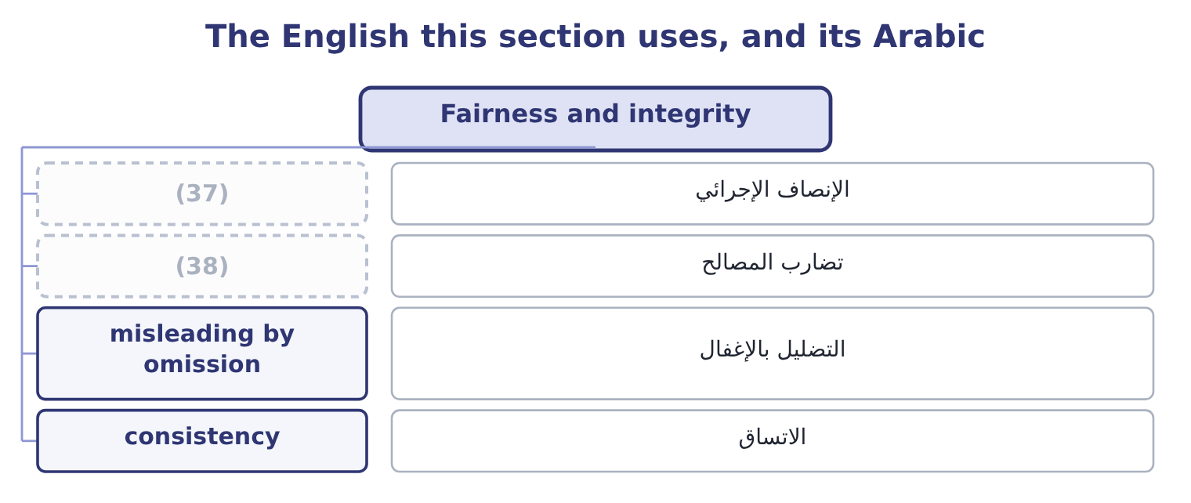
word list
conflict of interest · control environment · procedural fairness

The English this sheet uses, and its Arabic
English (exam term) | Arabic
procedural fairness | الإنصاف الإجرائي
conflict of interest | تضارب المصالح
misleading by omission | التضليل بالإغفال
consistency | الاتساق

Answer key · 12.2 Fairness and integrity

1 concepts | 20 convenient
2 decisions | 21 management
3 character | 22 components
4 according | 23 Honesty
5 dimensions | 24 including
6 distribution | 25 conflict
7 burden | 26 wrongdoing
8 squeezed | 27 obligation
9 unfairly | 28 indirectly
10 information | 29 something
11 opportunity | 30 recognition
12 criteria | 31 consistency
13 treatment | 32 component
14 honestly | 33 credibility
15 practice | 34 Integrity's
16 customer | 35 matters
17 understood | 36 provision
18 refused | 37 procedural fairness
19 principles | 38 conflict of interest

the summaries in full
Summary 1 The outcome names four concepts and asks what each means and how it affects decisions. Two of them are about the character of a decision and two about the care taken over it. Fairness is treating like cases alike, and treating people according to standards they could accept if they knew them. It has three dimensions the exam uses. Fairness of outcome: whether the distribution of benefit and burden is defensible. A supplier squeezed on payment terms because it cannot afford to argue is being treated unfairly in outcome, whatever the contract allows. Fairness of process: whether the decision was made by a method that treats everybody consistently, with the same information and the same opportunity to be heard. A tender awarded on criteria that were changed after bids were received is unfair in process even if the winner was the best bidder.
Summary 2 Fairness of treatment: whether people are dealt with honestly and with respect — told the truth, told in time, not misled by omission. In practice fairness bites hardest where a company has power: over a small supplier, over a customer who cannot evaluate what is being sold, over an employee who cannot easily leave. The test is not whether the other party agreed; it is whether they agreed on terms they understood and could have refused. Integrity is wholeness — acting on the same principles consistently, whether or not anybody is watching, and whether or not it is convenient. For a management accountant it has four practical components. Honesty in what is reported, including what is omitted. A technically true figure presented so as to mislead is a breach of integrity, and Book 1's. Avoiding conflicts of interest, and disclosing those that cannot be avoided.
Summary 3 The conflict is the problem, not the wrongdoing it might lead to, and the obligation arises before anything has gone wrong. Refusing to do indirectly what may not be done directly — which covers the request to leave something out, to delay a recognition, to book an entry somebody else will reverse. And consistency between what is said and what is done, which is the component other people actually observe and the one on which a finance function's credibility rests. Integrity's practical difficulty is that it is tested in small matters long before it is tested in large ones. Nobody is asked to commit a fraud on their first day; they are asked to accept an expense claim they know is wrong, to describe a provision in a way that is technically defensible, to leave a sentence out of a paper.

12.3 Due diligence and fiduciary responsibility
Chapter 12 · section 12.3

Fill every gap. Each word list holds one word more than there are gaps.
Summary 1 gaps 1–12
Due diligence is the care a reasonable and (1) person would take before acting — the obligation to find out, rather than to assume, before committing the (2) or signing (3) . It has a general sense and a specific one, and the exam uses both. In its general sense, due diligence is the standard of care in any professional act: checking the figures before certifying them, (4) a contract before (5) it, verifying a (6) before relying on it, reading the file before giving the advice. Its breach is (7) rather than (8) , which is why it is the obligation (9) most often fail without noticing. In its specific sense it is the (10) of a target before an (11) — the work Book 3's: financial due diligence on the numbers, legal on the contracts and liabilities, commercial on the market and customers, operational on the assets and processes, and (12) ethical due diligence on conduct, sanctions and bribery exposure.
word list
investigation · professionals · whether · recommending · negligence · organisation · dishonesty · increasingly · understanding · acquisition · something · competent · counterparty

Summary 2 gaps 13–24
Three ethical (13) of due diligence are (14) . It is owed even where the answer is (15) . Due diligence (16) to confirm a decision already taken is not due diligence; it is (17) . Its scope must match the (18) . Reasonable care on a 10,000 contract is not reasonable care on a 10,000,000 one. And a professional who cannot (19) it must say so, rather than signing with an unspoken (20) . Fiduciary (21) is the duty owed by someone who acts for another and is trusted with their (22) or their property. Directors owe it to the company; trustees to (23) ; agents to (24) ; and a finance professional with authority over funds or information is in a fiduciary position whether or not the word appears anywhere in their contract. Its content is specific and worth learning as a list.
word list
dimensions · examinable · complete · figures · reservation · documentation · responsibility · beneficiaries · stakes · performed · interests · principals · unwelcome

Summary 3 gaps 25–36
The duty of loyalty: to act in the (25) interest and not one's own, which is why (26) , taking a corporate opportunity for oneself, and undisclosed benefits from suppliers are breaches of a different order from ordinary misconduct. The duty of care: to act with the (27) and diligence of section 12.3's first half. The duty of good faith: to act (28) and for the purpose for which the authority was given. The duty of (29) : not to use or (30) information obtained in the role for any other purpose —. And the duty to account: to be able to show what was done with what was entrusted, which is the ethical (31) of the entire (32) of accounting. A fiduciary duty is stricter than an ordinary commercial obligation in one specific way the exam likes: the fiduciary must avoid even the (33) of a conflict, and good (34) are not a defence. It is no answer that the (35) was fair, or that the company did not lose; what is (36) to is acting for oneself in a matter where one was acting for another.
word list
transaction · confidentiality · objected · competence · accounting · disclose · beneficiary's · intentions · self-dealing · honestly · possibility · foundation · discipline

The English this section uses, and its Arabic
Each term sits against what it means.
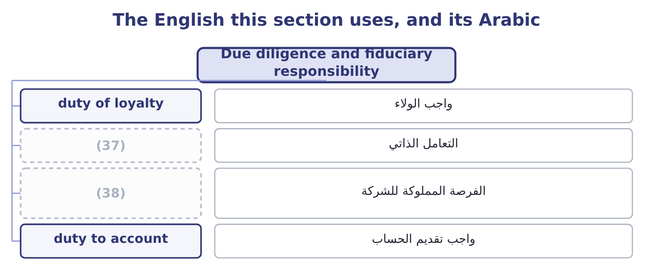
word list
corporate opportunity · fairness · self-dealing

The English this sheet uses, and its Arabic
English (exam term) | Arabic
duty of loyalty | واجب الولاء
self-dealing | التعامل الذاتي
corporate opportunity | الفرصة المملوكة للشركة
duty to account | واجب تقديم الحساب

Answer key · 12.3 Due diligence and fiduciary responsibility

1 competent | 20 reservation
2 organisation | 21 responsibility
3 something | 22 interests
4 understanding | 23 beneficiaries
5 recommending | 24 principals
6 counterparty | 25 beneficiary's
7 negligence | 26 self-dealing
8 dishonesty | 27 competence
9 professionals | 28 honestly
10 investigation | 29 confidentiality
11 acquisition | 30 disclose
12 increasingly | 31 foundation
13 dimensions | 32 discipline
14 examinable | 33 possibility
15 unwelcome | 34 intentions
16 performed | 35 transaction
17 documentation | 36 objected
18 stakes | 37 self-dealing
19 complete | 38 corporate opportunity

the summaries in full
Summary 1 Due diligence is the care a reasonable and competent person would take before acting — the obligation to find out, rather than to assume, before committing the organisation or signing something. It has a general sense and a specific one, and the exam uses both. In its general sense, due diligence is the standard of care in any professional act: checking the figures before certifying them, understanding a contract before recommending it, verifying a counterparty before relying on it, reading the file before giving the advice. Its breach is negligence rather than dishonesty, which is why it is the obligation professionals most often fail without noticing. In its specific sense it is the investigation of a target before an acquisition — the work Book 3's: financial due diligence on the numbers, legal on the contracts and liabilities, commercial on the market and customers, operational on the assets and processes, and increasingly ethical due diligence on conduct, sanctions and bribery exposure.
Summary 2 Three ethical dimensions of due diligence are examinable. It is owed even where the answer is unwelcome. Due diligence performed to confirm a decision already taken is not due diligence; it is documentation. Its scope must match the stakes. Reasonable care on a 10,000 contract is not reasonable care on a 10,000,000 one. And a professional who cannot complete it must say so, rather than signing with an unspoken reservation. Fiduciary responsibility is the duty owed by someone who acts for another and is trusted with their interests or their property. Directors owe it to the company; trustees to beneficiaries; agents to principals; and a finance professional with authority over funds or information is in a fiduciary position whether or not the word appears anywhere in their contract. Its content is specific and worth learning as a list.
Summary 3 The duty of loyalty: to act in the beneficiary's interest and not one's own, which is why self-dealing, taking a corporate opportunity for oneself, and undisclosed benefits from suppliers are breaches of a different order from ordinary misconduct. The duty of care: to act with the competence and diligence of section 12.3's first half. The duty of good faith: to act honestly and for the purpose for which the authority was given. The duty of confidentiality: not to use or disclose information obtained in the role for any other purpose —. And the duty to account: to be able to show what was done with what was entrusted, which is the ethical foundation of the entire discipline of accounting. A fiduciary duty is stricter than an ordinary commercial obligation in one specific way the exam likes: the fiduciary must avoid even the possibility of a conflict, and good intentions are not a defence. It is no answer that the transaction was fair, or that the company did not lose; what is objected to is acting for oneself in a matter where one was acting for another.

12.4 The shapes fraud takes
Chapter 12 · section 12.4

Fill every gap. Each word list holds one word more than there are gaps.
Summary 1 gaps 1–12
Fraud is (1) for gain. The outcome asks for the types of business fraud, and the standard (2) has three branches, of which the (3) list is the detail. Asset (4) is the theft or misuse of the (5) assets. It is by far the most common branch — the great majority of (6) frauds — and usually the smallest in (7) value, though not in total. Its forms include the (8) . (9) , where cash is taken before it is recorded, which leaves no accounting trace at all and is therefore the hardest to detect; larceny, where recorded cash is taken afterwards, which does leave a trace; and fraudulent (10) , where the company is made to pay out money improperly. Inventory and other asset theft. Product taken from the (11) or in transit; raw material written off as waste and sold; equipment removed; misuse of assets rather than outright theft, such as using company vehicles or (12) for private business.
word list
individual · deception · warehouse · classification · syllabus's · occupational · misappropriation · facilities · organisation's · requires · disbursements · Skimming · following

Summary 2 gaps 13–24
For a food producer, shrinkage is a (13) cost: 1.5 per cent of Orontes's $2,450,000 of stock is 2,450,000 × 0.015 = 36,750 a year, and (14) theft from spoilage and from (15) is itself a control problem. Ghost employees kept on the payroll by whoever controls both the records and the payments; falsified hours or overtime; inflated (16) ; and expense (17) fraud, which is the most (18) and most tolerated of all — fictitious expenses, overstated amounts, personal costs claimed as business, and the same receipt claimed twice. An employee (19) a supplier that exists only in the master file, with bank details they control, and (20) invoices to it for (21) nobody can verify. The sums are rarely dramatic (22) : eighteen invoices (23) 14,500 is 18 × 14,500 = 261,000, spread across two years and buried in (24) fees.
word list
standard · averaging · professional · commissions · miscounting · distinguishing · reimbursement · widespread · approves · creates · services · individually · continuing

Summary 3 gaps 25–36
Lapping, in which a receipt from one customer is used to cover a balance previously stolen from another, and the gap is rolled forward (25) ; writing off a live balance as (26) after taking the payment; issuing false credit notes; and diverting payments to an account the employee controls. (27) statement fraud is the deliberate (28) of reported results. It is the least common branch and by far the most (29) , because the amounts are the amounts of the (30) rather than of a cash drawer. Its forms are the ones Book 1's: revenue recognised too early or invented outright; expenses deferred, (31) or simply not recorded; (32) and commitments concealed; assets overstated through inventory, receivables or avoided impairments; reserves released to smooth a result; and disclosures omitted. Its motive is almost never personal (33) directly; it is a target, a covenant, a share price, a bonus or a reputation, which is what makes it so easy to (34) . (35) is the third branch: bribery, kickbacks, (36) conflicts of interest, bid rigging and extortion.
word list
uncollectible · enrichment · indefinitely · undisclosed · expensive · misstatement · liabilities · capitalised · rationalise · Financial · accounts · smallest · Corruption

Worked example: what a fraud costs

Summary 4 gaps 37–48
The fictitious supplier above has taken 261,000 over two years. What it takes to (37) it. Orontes's net (38) is 2,969,100 ÷ 42,000,000 = 7.07 per cent, so (39) 261,000 of lost profit (40) 261,000 ÷ 0.0707 = 3,691,655 of additional sales. (41) , legal fees, (42) time, the auditors' additional work, the controls that must now be built, and the effect on the people who were not involved. The (43) taken is rarely the material figure. What matters is what the fraud reveals about the control (44) and what else may have happened under the same (45) . The (46) in step 2 is the (47) to use with a board that regards a fraud as small. A (48) of a million is three and a half million of sales, and the sales are hard.
word list
falsified · replace · conditions · arithmetic · sentence · amount · margin · requires · environment · quarter · recovering · Investigation · management

The English this section uses, and its Arabic
Each term sits against what it means.
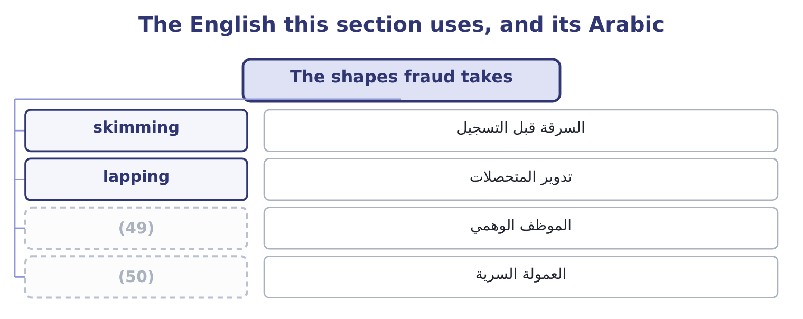
word list
moral principle · ghost employee · kickback

The English this sheet uses, and its Arabic
English (exam term) | Arabic
skimming | السرقة قبل التسجيل
lapping | تدوير المتحصلات
ghost employee | الموظف الوهمي
kickback | العمولة السرية

Answer key · 12.4 The shapes fraud takes

1 deception | 26 uncollectible
2 classification | 27 Financial
3 syllabus's | 28 misstatement
4 misappropriation | 29 expensive
5 organisation's | 30 accounts
6 occupational | 31 capitalised
7 individual | 32 liabilities
8 following | 33 enrichment
9 Skimming | 34 rationalise
10 disbursements | 35 Corruption
11 warehouse | 36 undisclosed
12 facilities | 37 replace
13 continuing | 38 margin
14 distinguishing | 39 recovering
15 miscounting | 40 requires
16 commissions | 41 Investigation
17 reimbursement | 42 management
18 widespread | 43 amount
19 creates | 44 environment
20 approves | 45 conditions
21 services | 46 arithmetic
22 individually | 47 sentence
23 averaging | 48 quarter
24 professional | 49 ghost employee
25 indefinitely | 50 kickback

the summaries in full
Summary 1 Fraud is deception for gain. The outcome asks for the types of business fraud, and the standard classification has three branches, of which the syllabus's list is the detail. Asset misappropriation is the theft or misuse of the organisation's assets. It is by far the most common branch — the great majority of occupational frauds — and usually the smallest in individual value, though not in total. Its forms include the following. Skimming, where cash is taken before it is recorded, which leaves no accounting trace at all and is therefore the hardest to detect; larceny, where recorded cash is taken afterwards, which does leave a trace; and fraudulent disbursements, where the company is made to pay out money improperly. Inventory and other asset theft. Product taken from the warehouse or in transit; raw material written off as waste and sold; equipment removed; misuse of assets rather than outright theft, such as using company vehicles or facilities for private business.
Summary 2 For a food producer, shrinkage is a continuing cost: 1.5 per cent of Orontes's $2,450,000 of stock is 2,450,000 × 0.015 = 36,750 a year, and distinguishing theft from spoilage and from miscounting is itself a control problem. Ghost employees kept on the payroll by whoever controls both the records and the payments; falsified hours or overtime; inflated commissions; and expense reimbursement fraud, which is the most widespread and most tolerated of all — fictitious expenses, overstated amounts, personal costs claimed as business, and the same receipt claimed twice. An employee creates a supplier that exists only in the master file, with bank details they control, and approves invoices to it for services nobody can verify. The sums are rarely dramatic individually: eighteen invoices averaging 14,500 is 18 × 14,500 = 261,000, spread across two years and buried in professional fees.
Summary 3 Lapping, in which a receipt from one customer is used to cover a balance previously stolen from another, and the gap is rolled forward indefinitely; writing off a live balance as uncollectible after taking the payment; issuing false credit notes; and diverting payments to an account the employee controls. Financial statement fraud is the deliberate misstatement of reported results. It is the least common branch and by far the most expensive, because the amounts are the amounts of the accounts rather than of a cash drawer. Its forms are the ones Book 1's: revenue recognised too early or invented outright; expenses deferred, capitalised or simply not recorded; liabilities and commitments concealed; assets overstated through inventory, receivables or avoided impairments; reserves released to smooth a result; and disclosures omitted. Its motive is almost never personal enrichment directly; it is a target, a covenant, a share price, a bonus or a reputation, which is what makes it so easy to rationalise. Corruption is the third branch: bribery, kickbacks, undisclosed conflicts of interest, bid rigging and extortion.
Summary 4 The fictitious supplier above has taken 261,000 over two years. What it takes to replace it. Orontes's net margin is 2,969,100 ÷ 42,000,000 = 7.07 per cent, so recovering 261,000 of lost profit requires 261,000 ÷ 0.0707 = 3,691,655 of additional sales. Investigation, legal fees, management time, the auditors' additional work, the controls that must now be built, and the effect on the people who were not involved. The amount taken is rarely the material figure. What matters is what the fraud reveals about the control environment and what else may have happened under the same conditions. The arithmetic in step 2 is the sentence to use with a board that regards a fraud as small. A quarter of a million is three and a half million of sales, and the sales are hard.

12.5 Preventing and detecting
Chapter 12 · section 12.5

Fill every gap. Each word list holds one word more than there are gaps.
Summary 1 gaps 1–2
The control (1) were set out; what (2) here is how they map onto the frauds and what ethics adds to them.
word list
belongs · methods · carries

Frauds and the controls that address them
Fraud | How it works | Principal control | What it depends on
Skimming | (3) | Independent recording at the point of receipt | Two people, or a machine
Inventory theft | Stock removed or written off | Counts, reconciliation of waste, access control | (4)
Payroll fraud | Ghost employees, false hours | (5) of payroll records from payments; review of the payroll | Somebody checking a list they did not make
Fictitious supplier | A supplier that exists only in the file | Master file access, bank (6) , new supplier review | Restricted access being enforced
Receivable fraud | Lapping, false credit notes, write-offs | Statement reconciliation, authorisation of write-offs, mandatory leave | (7)
Statement fraud | (8) | Review by somebody competent and independent; audit committee access | Tone at the top, and a route to raise concerns

word list
Rotation and independent confirmation · Entries, estimates and omissions · Separation · verification · Counts done by people who do not hold the stock · skimming · Cash taken before recording

Summary 2 gaps 9–20
The last column is the ethics column. Every control in the fifth column depends on (9) in the sixth, and what the sixth column (10) is people being willing and able to do their job honestly. A (11) of duties that everybody agrees to work around is not a control; a review (12) by somebody who will not question the chief executive is not a review; and a supplier approval process in which no approval has ever been refused is a procedure, not a control. Three ethical (13) to the control (14) . A code of conduct that says (15) what is and is not acceptable, so that (16) has to guess. A route to raise a concern that does not (17) going through the person the concern is about, which is. And a (18) willingness to act on what is found, at every level. A fraud by a junior employee that ends in (19) , and a similar act by a senior one that ends in a quiet (20) , teach everybody the same lesson about which rules apply to whom — and that lesson does more damage than the original act.
word list
dismissal · carries · segregation · contains · something · specifically · resignation · require · nobody · framework · demonstrated · additions · performed

Concepts and frauds

Your turn: naming it correctly (complete the blanks)
Item | Answer
Treating like cases alike, on standards people could accept | ________
Acting on the same principles whether or not anybody is watching | ________
The care a reasonable and competent person takes before acting | ________
The duty owed by one who acts for another and is trusted with their interests | ________
Using a later customer's receipt to cover an earlier balance already stolen | ________
Sales needed to replace 261,000 of loss at a 7.07 per cent net margin | ________

"Integrity", "fraud" and "irregularity"

Summary 3 gaps 21–32
Integrity in (21) carries two senses that are really one: moral (22) , and structural (23) — the integrity of a dam. Both mean nothing (24) and nothing (25) , which is the right image for the (26) sense. Fraud is a legal term as well as an ethical one, and that matters in a report: writing that an employee committed fraud is an (27) of a crime, which is why investigators write (28) , discrepancy or (29) difference until a conclusion is reached, and why a management accountant should do the same. The caution is not evasion: it is the difference between (30) what is known and (31) what has not been (32) . Write what you observed, say what it is consistent with, and let the conclusion follow the investigation rather than precede it.
word list
English · allegation · unexplained · hollow · uprightness · missing · professional · somebody · asserting · irregularity · describing · established · wholeness

"Integrity", "fraud" and "irregularity"
Item | Answer
Treating like cases alike on acceptable standards | (33)
Acting on the same principles whether or not observed | (34)
The care a reasonable, competent person takes | (35)
The duty of one who acts for another | Fiduciary responsibility.
Using a later receipt to cover an earlier theft | (36)
Sales needed to replace 261,000 at 7.07 per cent | 3,691,655: 261,000 ÷ 0.0707 = 3,691,655.
What it tells you | Four concepts and two frauds — and the four concepts are what the controls against the two frauds ultimately rest on.

word list
Fairness. · Integrity. · business ethics · Lapping, a receivable fraud. · Due diligence.

The English this section uses, and its Arabic
Each term sits against what it means.
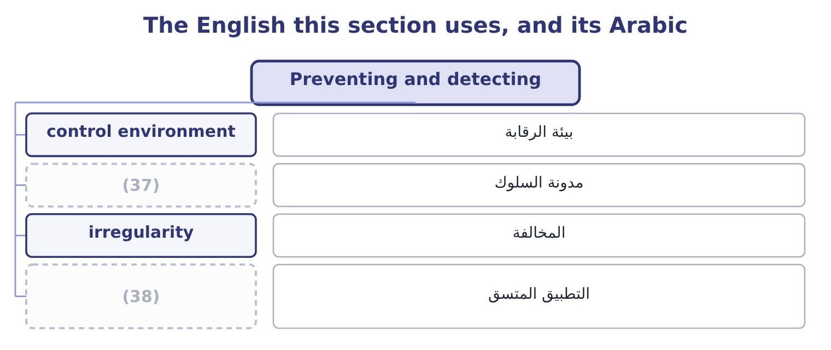
word list
consistent enforcement · code of conduct · مدونة السلوك

The English this sheet uses, and its Arabic
English (exam term) | Arabic
control environment | بيئة الرقابة
code of conduct | مدونة السلوك
irregularity | المخالفة
consistent enforcement | التطبيق المتسق

Answer key · 12.5 Preventing and detecting

1 methods | 20 resignation
2 belongs | 21 English
3 Cash taken before recording | 22 uprightness
4 Counts done by people who do not hold the stock | 23 wholeness
5 Separation | 24 missing
6 verification | 25 hollow
7 Rotation and independent confirmation | 26 professional
8 Entries, estimates and omissions | 27 allegation
9 something | 28 irregularity
10 contains | 29 unexplained
11 segregation | 30 describing
12 performed | 31 asserting
13 additions | 32 established
14 framework | 33 Fairness.
15 specifically | 34 Integrity.
16 nobody | 35 Due diligence.
17 require | 36 Lapping, a receivable fraud.
18 demonstrated | 37 code of conduct
19 dismissal | 38 consistent enforcement

the summaries in full
Summary 1 The control methods were set out; what belongs here is how they map onto the frauds and what ethics adds to them.
Summary 2 The last column is the ethics column. Every control in the fifth column depends on something in the sixth, and what the sixth column contains is people being willing and able to do their job honestly. A segregation of duties that everybody agrees to work around is not a control; a review performed by somebody who will not question the chief executive is not a review; and a supplier approval process in which no approval has ever been refused is a procedure, not a control. Three ethical additions to the control framework. A code of conduct that says specifically what is and is not acceptable, so that nobody has to guess. A route to raise a concern that does not require going through the person the concern is about, which is. And a demonstrated willingness to act on what is found, at every level. A fraud by a junior employee that ends in dismissal, and a similar act by a senior one that ends in a quiet resignation, teach everybody the same lesson about which rules apply to whom — and that lesson does more damage than the original act.
Summary 3 Integrity in English carries two senses that are really one: moral uprightness, and structural wholeness — the integrity of a dam. Both mean nothing missing and nothing hollow, which is the right image for the professional sense. Fraud is a legal term as well as an ethical one, and that matters in a report: writing that an employee committed fraud is an allegation of a crime, which is why investigators write irregularity, discrepancy or unexplained difference until a conclusion is reached, and why a management accountant should do the same. The caution is not evasion: it is the difference between describing what is known and asserting what has not been established. Write what you observed, say what it is consistent with, and let the conclusion follow the investigation rather than precede it.

13.1 The four principles
Chapter 13 · section 13.1

Fill every gap. Each word list holds one word more than there are gaps.
Chapter 13, section by section
Each stage leads to the next.
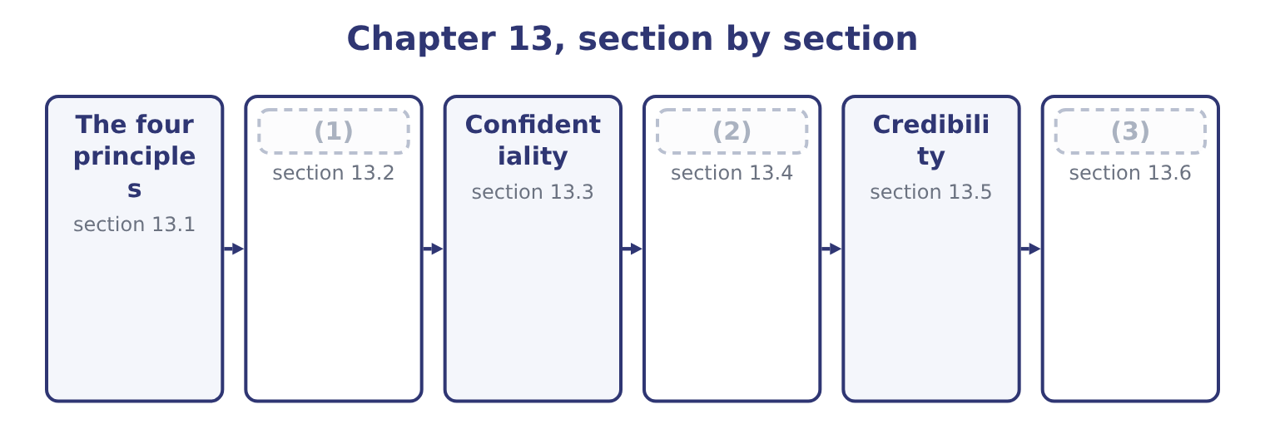
word list
section 13.6 · Competence · Integrity · Applying the Statement to a situation

Summary 1 gaps 4–15
The Statement opens with four (4) ethical principles, which express the values members are (5) to hold. They are not rules to be complied with one at a time; they are the basis on which the standards rest, and the Statement says that members shall act in (6) with these principles and shall encourage others within their (7) to do the same. Not (8) : in what is said, in what is (9) , and in what is left out. Treating people and interests (10) , with the three (11) of, process and treatment. (12) and judging on the evidence, free from bias and from the (13) of personal interest or of pressure from others. It is the principle that (14) a professional opinion from a (15) one. Accepting accountability for one's actions and for one's professional obligations, including the obligation to act when something is wrong rather than to observe it.
word list
obligation · accordance · convenient · dimensions · even-handedly · overarching · written · influence · expected · distinguishes · Reporting · organisations · deceiving

Summary 2 gaps 16–21
Two (16) about the principles are worth (17) for an exam. They apply to the individual, personally and (18) , regardless of the employer's (19) . The Statement is a (20) made by the member, and no instruction from an employer (21) it. And they are the reason the standards exist, which matters when a situation is not covered neatly by any standard. Where the rules run out, the principles decide.
word list
releases · points · continuously · commitment · having · credibility · instructions

The English this section uses, and its Arabic
Each term sits against what it means.
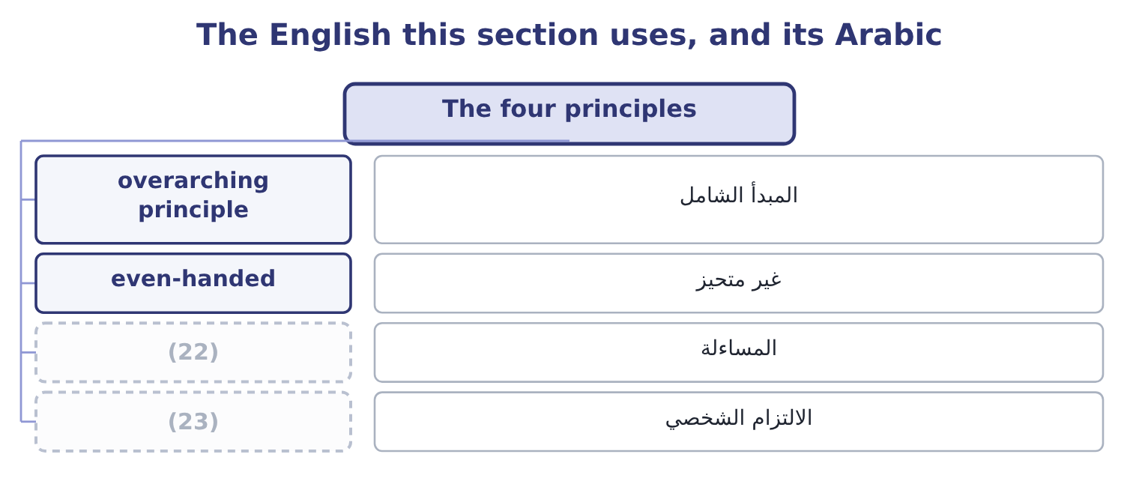
word list
completeness · personal commitment · accountability

The English this sheet uses, and its Arabic
English (exam term) | Arabic
overarching principle | المبدأ الشامل
even-handed | غير متحيز
accountability | المساءلة
personal commitment | الالتزام الشخصي

Answer key · 13.1 The four principles

1 Competence | 13 influence
2 Integrity | 14 distinguishes
3 Applying the Statement to a situation | 15 convenient
4 overarching | 16 points
5 expected | 17 having
6 accordance | 18 continuously
7 organisations | 19 instructions
8 deceiving | 20 commitment
9 written | 21 releases
10 even-handedly | 22 accountability
11 dimensions | 23 personal commitment
12 Reporting

the summaries in full
Summary 1 The Statement opens with four overarching ethical principles, which express the values members are expected to hold. They are not rules to be complied with one at a time; they are the basis on which the standards rest, and the Statement says that members shall act in accordance with these principles and shall encourage others within their organisations to do the same. Not deceiving: in what is said, in what is written, and in what is left out. Treating people and interests even-handedly, with the three dimensions of, process and treatment. Reporting and judging on the evidence, free from bias and from the influence of personal interest or of pressure from others. It is the principle that distinguishes a professional opinion from a convenient one. Accepting accountability for one's actions and for one's professional obligations, including the obligation to act when something is wrong rather than to observe it.
Summary 2 Two points about the principles are worth having for an exam. They apply to the individual, personally and continuously, regardless of the employer's instructions. The Statement is a commitment made by the member, and no instruction from an employer releases it. And they are the reason the standards exist, which matters when a situation is not covered neatly by any standard. Where the rules run out, the principles decide.

13.2 Competence
Chapter 13 · section 13.2

Fill every gap. Each word list holds one word more than there are gaps.
Summary 1 gaps 1–12
Its obligations are four and each has teeth. Maintain an (1) level of professional leadership and expertise by (2) developing knowledge and skills. Competence is not a state (3) once; the obligation is (4) , and it extends to leadership as well as technique. Perform professional duties in (5) with relevant laws, (6) and technical standards. This is the obligation that makes a breach of (7) standards an (8) matter and not only a technical one. (9) decision support information and (10) that are accurate, clear, concise and timely. All four (11) are obligations: an accurate analysis (12) after the decision, or an accurate one nobody can follow, has not met the standard. Recognise and help manage risk. Identifying an exposure and saying nothing is a breach of competence. Three situations in which competence is the standard engaged.
word list
adjectives · Provide · accounting · continuing · continually · accurate · delivered · reached · regulations · recommendations · accordance · ethical · appropriate

Summary 2 gaps 13–18
Accepting an (13) beyond one's expertise (14) saying so. The obligation is not to know (15) ; it is to be honest about the limit and to get help, which also engages (16) fourth clause. Working from a model, a (17) or an assumption the professional has not (18) . And failing to keep up: applying a superseded standard, missing a change in the law, using a technique that has been replaced.
word list
understood · Credibility's · spreadsheet · obligation · everything · without · assignment

The English this section uses, and its Arabic
Each term sits against what it means.
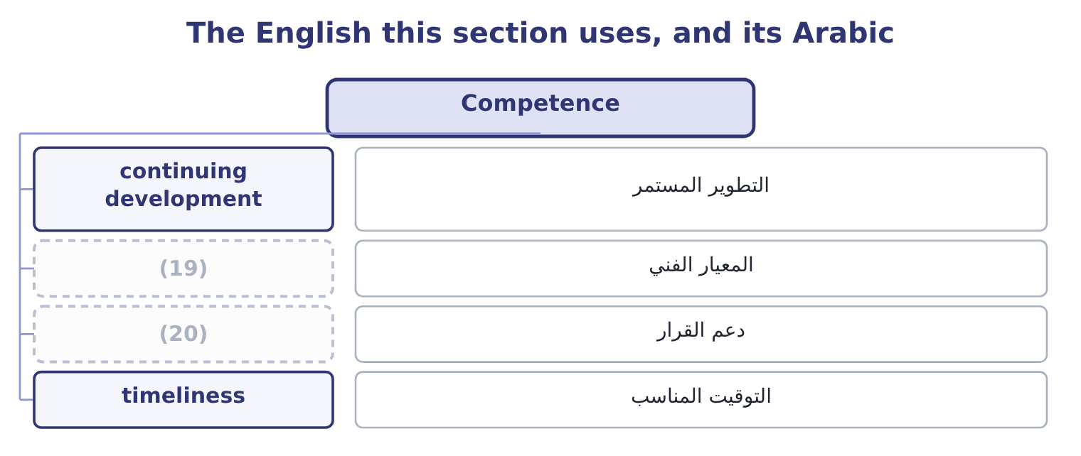
word list
specific obligation · decision support · technical standard

The English this sheet uses, and its Arabic
English (exam term) | Arabic
continuing development | التطوير المستمر
technical standard | المعيار الفني
decision support | دعم القرار
timeliness | التوقيت المناسب

Answer key · 13.2 Competence

1 appropriate | 11 adjectives
2 continually | 12 delivered
3 reached | 13 assignment
4 continuing | 14 without
5 accordance | 15 everything
6 regulations | 16 Credibility's
7 accounting | 17 spreadsheet
8 ethical | 18 understood
9 Provide | 19 technical standard
10 recommendations | 20 decision support

the summaries in full
Summary 1 Its obligations are four and each has teeth. Maintain an appropriate level of professional leadership and expertise by continually developing knowledge and skills. Competence is not a state reached once; the obligation is continuing, and it extends to leadership as well as technique. Perform professional duties in accordance with relevant laws, regulations and technical standards. This is the obligation that makes a breach of accounting standards an ethical matter and not only a technical one. Provide decision support information and recommendations that are accurate, clear, concise and timely. All four adjectives are obligations: an accurate analysis delivered after the decision, or an accurate one nobody can follow, has not met the standard. Recognise and help manage risk. Identifying an exposure and saying nothing is a breach of competence. Three situations in which competence is the standard engaged.
Summary 2 Accepting an assignment beyond one's expertise without saying so. The obligation is not to know everything; it is to be honest about the limit and to get help, which also engages Credibility's fourth clause. Working from a model, a spreadsheet or an assumption the professional has not understood. And failing to keep up: applying a superseded standard, missing a change in the law, using a technique that has been replaced.

13.3 Confidentiality
Chapter 13 · section 13.3

Fill every gap. Each word list holds one word more than there are gaps.
Summary 1 gaps 1–12
The second standard, and the one with the (1) edges and the hardest (2) . Its (3) are three. Keep information confidential except when disclosure is authorised or legally required. The exception is narrow and (4) : authorised, or legally required. A belief that disclosure would be (5) is not an exception, and neither is a request from (6) who ought to know. Inform all relevant parties (7) the appropriate use of confidential information, and monitor to ensure (8) . The obligation extends to (9) and to anyone to whom information is passed: a (10) who hands confidential information to a team without saying what may be done with it has not met the standard. Refrain from using confidential information for (11) or illegal (12) . Note that the prohibition is on use, not only on disclosure. Trading on inside information, buying a property the company is about to need, or taking a customer list to a new employer are breaches whether or not anything is ever told to anybody.
word list
somebody · clearest · subordinates · precise · regarding · unethical · professional · compliance · beneficial · exceptions · reservation · advantage · obligations

Summary 2 gaps 13–20
Four points the (13) test. Confidentiality survives the (14) . (15) the company does not (16) the obligation. Confidentiality is not a reason to conceal (17) from those (18) to know within the organisation. (19) a concern up the internal chain, or to the audit (20) , is not a breach. Where disclosure outside the organisation is contemplated, the Statement's position is that this is not appropriate except where legally prescribed, and legal advice should be obtained. And confidentiality covers more than financial data: plans, personnel matters, customer information, security arrangements, and the fact of an investigation.
word list
entitled · property · wrongdoing · Reporting · Leaving · employment · release · committee · examiners

The English this section uses, and its Arabic
Each term sits against what it means.
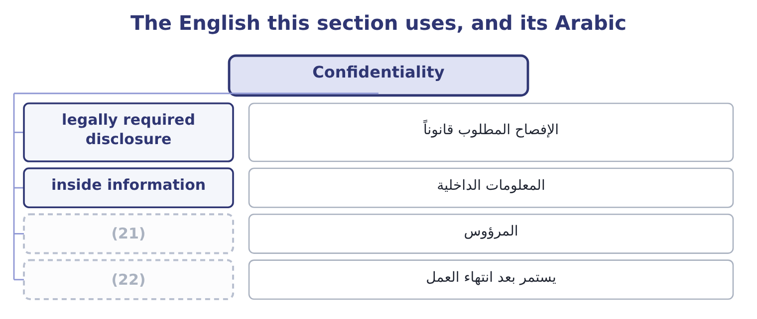
word list
survives employment · confidentiality · subordinate

The English this sheet uses, and its Arabic
English (exam term) | Arabic
legally required disclosure | الإفصاح المطلوب قانوناً
inside information | المعلومات الداخلية
subordinate | المرؤوس
survives employment | يستمر بعد انتهاء العمل

Answer key · 13.3 Confidentiality

1 clearest | 12 advantage
2 exceptions | 13 examiners
3 obligations | 14 employment
4 precise | 15 Leaving
5 beneficial | 16 release
6 somebody | 17 wrongdoing
7 regarding | 18 entitled
8 compliance | 19 Reporting
9 subordinates | 20 committee
10 professional | 21 subordinate
11 unethical | 22 survives employment

the summaries in full
Summary 1 The second standard, and the one with the clearest edges and the hardest exceptions. Its obligations are three. Keep information confidential except when disclosure is authorised or legally required. The exception is narrow and precise: authorised, or legally required. A belief that disclosure would be beneficial is not an exception, and neither is a request from somebody who ought to know. Inform all relevant parties regarding the appropriate use of confidential information, and monitor to ensure compliance. The obligation extends to subordinates and to anyone to whom information is passed: a professional who hands confidential information to a team without saying what may be done with it has not met the standard. Refrain from using confidential information for unethical or illegal advantage. Note that the prohibition is on use, not only on disclosure. Trading on inside information, buying a property the company is about to need, or taking a customer list to a new employer are breaches whether or not anything is ever told to anybody.
Summary 2 Four points the examiners test. Confidentiality survives the employment. Leaving the company does not release the obligation. Confidentiality is not a reason to conceal wrongdoing from those entitled to know within the organisation. Reporting a concern up the internal chain, or to the audit committee, is not a breach. Where disclosure outside the organisation is contemplated, the Statement's position is that this is not appropriate except where legally prescribed, and legal advice should be obtained. And confidentiality covers more than financial data: plans, personnel matters, customer information, security arrangements, and the fact of an investigation.

13.4 Integrity
Chapter 13 · section 13.4

Fill every gap. Each word list holds one word more than there are gaps.
Summary 1 gaps 1–12
Mitigate actual conflicts of interest, (1) regularly with business (2) to avoid apparent conflicts, and advise all parties of any potential conflicts. Three (3) — actual, apparent and potential — and three (4) duties. An apparent conflict matters even where no actual conflict exists, because the (5) damages the (6) others place on the professional's judgment. Refrain from conduct that would (7) carrying out duties (8) . This covers accepting gifts, (9) or favours that could influence or appear to influence a decision, and anything that creates an obligation to somebody whose interests may diverge from the (10) . Abstain from (11) in or supporting any activity that might (12) the profession. The word supporting is important: assisting, enabling or remaining silent about such an activity falls within it. Contribute to a positive ethical culture and place integrity of the profession above personal interests. This is the forward-looking obligation — not merely avoiding wrong, but helping to build the culture.
word list
hospitality · engaging · categories · damages · ethically · reliance · different · communicate · discredit · appearance · associates · employer's · prejudice

Summary 2 gaps 13–20
Two (13) candidates are (14) to make. Integrity concerns the professional's own conduct and interests; Credibility concerns what is (15) to others. A conflict of interest engages Integrity; an incomplete report engages Credibility; and a report made incomplete in order to (16) an interest engages both. And a (17) value is not the only test. A modest gift from a supplier in a (18) tender is a problem where a larger one from a (19) customer with nothing pending may not be. What matters is (20) it could influence, or appear to influence, a decision.
word list
distinctions · whether · gift's · communicated · because · long-standing · expected · protect · competitive

The English this section uses, and its Arabic
Each term sits against what it means.
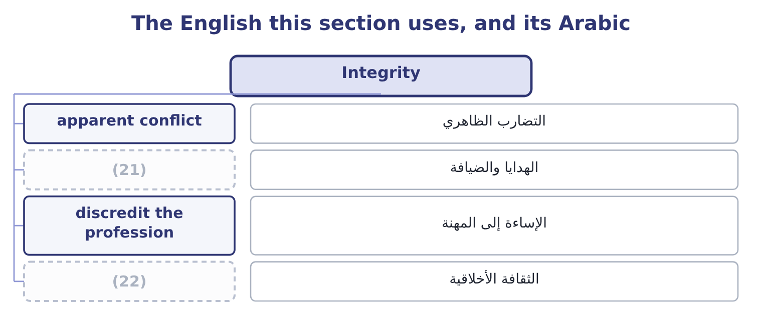
word list
discredit the profession · ethical culture · gift and hospitality

The English this sheet uses, and its Arabic
English (exam term) | Arabic
apparent conflict | التضارب الظاهري
gift and hospitality | الهدايا والضيافة
discredit the profession | الإساءة إلى المهنة
ethical culture | الثقافة الأخلاقية

Answer key · 13.4 Integrity

1 communicate | 12 discredit
2 associates | 13 distinctions
3 categories | 14 expected
4 different | 15 communicated
5 appearance | 16 protect
6 reliance | 17 gift's
7 prejudice | 18 competitive
8 ethically | 19 long-standing
9 hospitality | 20 whether
10 employer's | 21 gift and hospitality
11 engaging | 22 ethical culture

the summaries in full
Summary 1 Mitigate actual conflicts of interest, communicate regularly with business associates to avoid apparent conflicts, and advise all parties of any potential conflicts. Three categories — actual, apparent and potential — and three different duties. An apparent conflict matters even where no actual conflict exists, because the appearance damages the reliance others place on the professional's judgment. Refrain from conduct that would prejudice carrying out duties ethically. This covers accepting gifts, hospitality or favours that could influence or appear to influence a decision, and anything that creates an obligation to somebody whose interests may diverge from the employer's. Abstain from engaging in or supporting any activity that might discredit the profession. The word supporting is important: assisting, enabling or remaining silent about such an activity falls within it. Contribute to a positive ethical culture and place integrity of the profession above personal interests. This is the forward-looking obligation — not merely avoiding wrong, but helping to build the culture.
Summary 2 Two distinctions candidates are expected to make. Integrity concerns the professional's own conduct and interests; Credibility concerns what is communicated to others. A conflict of interest engages Integrity; an incomplete report engages Credibility; and a report made incomplete in order to protect an interest engages both. And a gift's value is not the only test. A modest gift from a supplier in a competitive tender is a problem where a larger one from a long-standing customer with nothing pending may not be. What matters is whether it could influence, or appear to influence, a decision.

13.5 Credibility
Chapter 13 · section 13.5

Fill every gap. Each word list holds one word more than there are gaps.
Summary 1 gaps 1–12
The fourth (1) , and the one most often engaged in exam situations, because it governs what is (2) . Its (3) are four. Communicate information fairly and (4) . Fairly covers (5) as well as content: a chart with a truncated axis, a (6) against a revised budget, a result shown before an unfavourable adjustment. Disclose all relevant information that could reasonably be expected to influence an intended user's (7) of reports, analyses or (8) . This is the (9) obligation, and it is the one that makes (10) a breach. The test is what the user would need, not what the preparer was asked for. Disclose delays or (11) in information, (12) , processing or internal controls, in conformance with organisation policy or applicable law. A professional who knows a control has failed and says nothing has breached this clause, whether or not a loss followed.
word list
timeliness · understanding · completeness · omission · deficiencies · recommendations · reported · internal · obligations · objectively · standard · comparison · presentation

Summary 2 gaps 13–22
Communicate professional (13) or other constraints that would preclude (14) judgment or successful performance of an activity. If you cannot do it (15) — for lack of time, information, (16) or access — say so, to somebody who can act on it. Three situations that engage (17) . A forecast prepared on assumptions the preparer believes to be (18) , presented without that (19) . A (20) analysis that explains the (21) items and attributes the unfavourable ones to timing without evidence. And an analysis prepared for a decision in which a known weakness — an estimate with a wide range, a figure that could not be verified, a control that was not (22) — is not stated.
word list
limitations · expertise · unachievable · variance · Credibility · favourable · reservation · responsible · operating · properly · conformance

The English this section uses, and its Arabic
Each term sits against what it means.
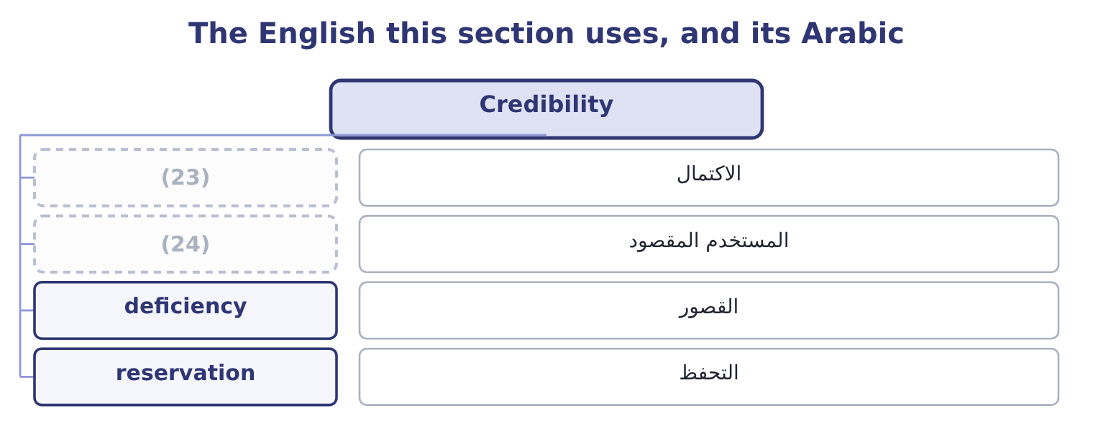
word list
التحفظ · intended user · completeness

The English this sheet uses, and its Arabic
English (exam term) | Arabic
completeness | الاكتمال
intended user | المستخدم المقصود
deficiency | القصور
reservation | التحفظ

Answer key · 13.5 Credibility

1 standard | 13 limitations
2 reported | 14 responsible
3 obligations | 15 properly
4 objectively | 16 expertise
5 presentation | 17 Credibility
6 comparison | 18 unachievable
7 understanding | 19 reservation
8 recommendations | 20 variance
9 completeness | 21 favourable
10 omission | 22 operating
11 deficiencies | 23 completeness
12 timeliness | 24 intended user

the summaries in full
Summary 1 The fourth standard, and the one most often engaged in exam situations, because it governs what is reported. Its obligations are four. Communicate information fairly and objectively. Fairly covers presentation as well as content: a chart with a truncated axis, a comparison against a revised budget, a result shown before an unfavourable adjustment. Disclose all relevant information that could reasonably be expected to influence an intended user's understanding of reports, analyses or recommendations. This is the completeness obligation, and it is the one that makes omission a breach. The test is what the user would need, not what the preparer was asked for. Disclose delays or deficiencies in information, timeliness, processing or internal controls, in conformance with organisation policy or applicable law. A professional who knows a control has failed and says nothing has breached this clause, whether or not a loss followed.
Summary 2 Communicate professional limitations or other constraints that would preclude responsible judgment or successful performance of an activity. If you cannot do it properly — for lack of time, information, expertise or access — say so, to somebody who can act on it. Three situations that engage Credibility. A forecast prepared on assumptions the preparer believes to be unachievable, presented without that reservation. A variance analysis that explains the favourable items and attributes the unfavourable ones to timing without evidence. And an analysis prepared for a decision in which a known weakness — an estimate with a wide range, a figure that could not be verified, a control that was not operating — is not stated.

13.6 Applying the Statement to a situation
Chapter 13 · section 13.6

Fill every gap. Each word list holds one word more than there are gaps.
Summary 1 gaps 1–10
The third outcome asks which standards may have been (1) and why they apply, which is a specific skill with a (2) . Four steps produce a (3) answer. State the facts that matter, (4) what is known from what is (5) . An exam situation (6) facts, and an answer that adds facts of its own loses marks. (7) each standard engaged, by name, and say which specific obligation (8) it. (9) why the obligation applies to these facts. This is the step that carries the marks and the one (10) skip. Note where a standard is engaged but not necessarily breached, which is often the honest answer at the point the facts are known.
word list
complete · assumed · required · candidates · Explain · within · separating · method · Identify · violated · contains

Worked example: four facts and the standards they engage

Summary 2 gaps 11–22
Orontes's controller is asked by the chief executive to delay (11) an inventory write-down of 180,000 until after the year end, because the covenant (12) at the year end requires interest cover above four times and the (13) is thin. The controller's (14) supplies the inventory in (15) . The controller (16) the request to nobody, (17) the accounts as asked, and does not refer to the write-down in the board pack. Credibility, on two (18) . (19) fairly and objectively is breached by accounts that omit a write-down known to be required; and the obligation to disclose all information that could (20) influence a user's understanding is breached by the board pack, since the covenant position depends on it. Integrity, on the conflict. The supplier (21) is an actual conflict of interest, and the obligation is to mitigate it and to advise all (22) .
word list
parties · expectation · obligations · brother-in-law · mentions · question · relationship · tested · margin · reasonably · prepares · Communicating · recognising

Summary 3 gaps 23–31
Not (23) it is a breach whether or not it (24) anything. Competence, and then the principles. Competence requires duties to be (25) in accordance with technical standards, and (26) a required write-down does not. (27) all three, the principles of honesty and objectivity are engaged (28) . Note what the answer does not say. It does not say the chief executive is (29) , because the facts given do not (30) intent. It does not say a fraud has been (31) , for. And it does not stop at naming the standards: each is tied to a specific obligation and to a specific fact, which is what the outcome asks for.
word list
committed · directly · influenced · establish · objectivity · performed · deferring · mentioning · Underneath · dishonest

The Statement at a glance
Element | Content | Engaged when
Principles | (32) | Always; and where no standard fits exactly
Competence | Develop expertise; follow laws and technical standards; accurate, clear, concise, timely information; recognise and help manage risk | Work beyond expertise; standards breached; late or unclear analysis; risk (33)
Confidentiality | Keep it; inform and monitor those who receive it; do not use it for advantage | Disclosure without authority; use for private gain; careless handling
Integrity | Mitigate actual, apparent and potential conflicts; avoid prejudicial conduct; do not support discrediting activity; build ethical culture | (34)
Credibility | Communicate fairly and objectively; disclose all influencing information; report delays and control deficiencies; state limitations | Omissions; misleading (35) ; unreported control failures

word list
Honesty, fairness, objectivity, responsibility · Standard · presentation · unreported · Conflicts; gifts; silence about misconduct

Which standard?

Your turn: naming the standard (complete the blanks)
Situation | Standard
Omitting a known write-down from a board pack | ________
Buying shares on information not yet public | ________
Accepting an assignment beyond one's expertise without saying so | ________
Failing to disclose that a supplier is a relative | ________
Not reporting that a reconciliation control has stopped operating | ________
Applying a superseded accounting standard through inattention | ________

"Shall", "should" and "may"

Summary 4 gaps 36–45
Professional codes are written in a (36) of obligation, and the words are not (37) . Shall and must state a (38) : the member has no (39) . Should states a strong (40) that may yield to (41) , and a member who departs from a should is expected to be able to say why. May grants (42) or describes an (43) . (44) codes use all three (45) , and a candidate reading a standard quickly will often turn a shall into a should in their memory, which changes the answer. The practical habit worth forming is this: when a situation asks whether something was permitted, find the verb in the obligation and read it exactly. Most ethics questions are decided by a verb.
word list
requirement · vocabulary · permission · expectation · circumstances · discretion · mentions · interchangeable · English · deliberately · option

"Shall", "should" and "may"
Situation | Standard
Omitting a known write-down from a board pack | Credibility: disclose all information influencing understanding.
Buying shares on information not yet public | Confidentiality: no use for unethical or illegal advantage.
Accepting work beyond one's expertise silently | Competence, with Credibility's duty to state limitations.
Not disclosing that a supplier is a relative | (46)
Not reporting a failed reconciliation control | (47)
Applying a superseded standard through inattention | Competence: perform duties in accordance with technical standards.
What it tells you | Six situations, four standards, and in two of them more than one standard applies — which is why an answer names each one with the obligatio

word list
Conflicts; gifts; silence about misconduct · Integrity: mitigate and disclose conflicts. · Credibility: report deficiencies in internal controls.

The English this section uses, and its Arabic
Each term sits against what it means.
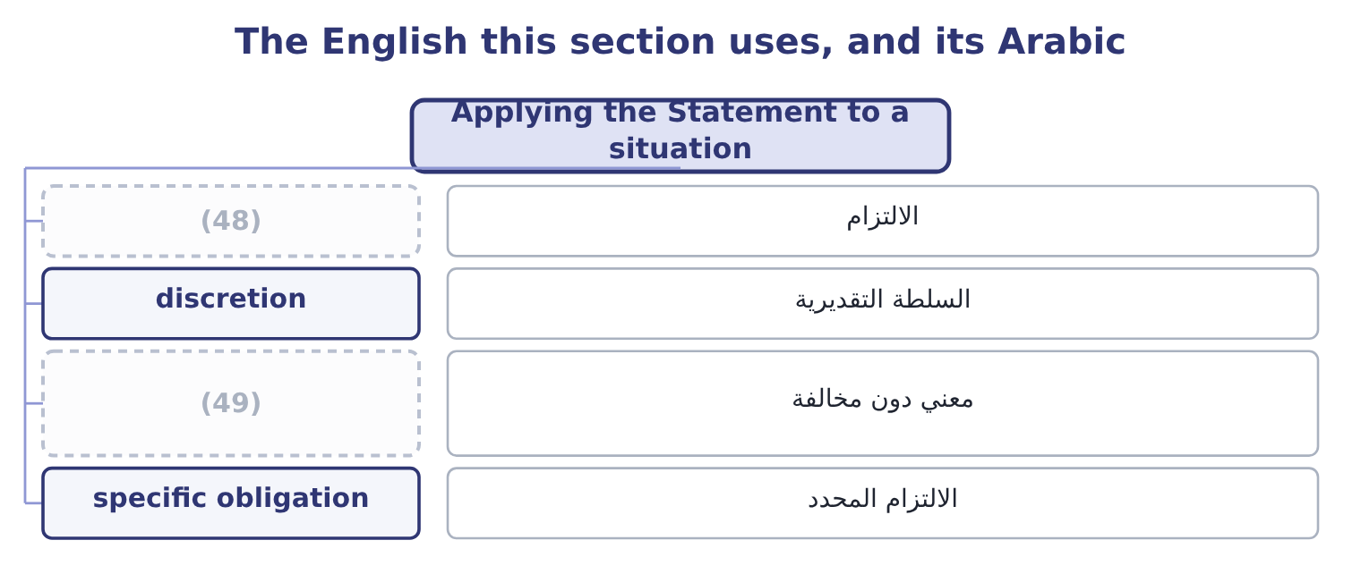
word list
obligation · engaged but not breached · الالتزام المحدد

The English this sheet uses, and its Arabic
English (exam term) | Arabic
obligation | الالتزام
discretion | السلطة التقديرية
engaged but not breached | معني دون مخالفة
specific obligation | الالتزام المحدد

Answer key · 13.6 Applying the Statement to a situation

1 violated | 26 deferring
2 method | 27 Underneath
3 complete | 28 directly
4 separating | 29 dishonest
5 assumed | 30 establish
6 contains | 31 committed
7 Identify | 32 Honesty, fairness, objectivity, responsibility
8 within | 33 unreported
9 Explain | 34 Conflicts; gifts; silence about misconduct
10 candidates | 35 presentation
11 recognising | 36 vocabulary
12 tested | 37 interchangeable
13 margin | 38 requirement
14 brother-in-law | 39 discretion
15 question | 40 expectation
16 mentions | 41 circumstances
17 prepares | 42 permission
18 obligations | 43 option
19 Communicating | 44 English
20 reasonably | 45 deliberately
21 relationship | 46 Integrity: mitigate and disclose conflicts.
22 parties | 47 Credibility: report deficiencies in internal controls.
23 mentioning | 48 obligation
24 influenced | 49 engaged but not breached
25 performed

the summaries in full
Summary 1 The third outcome asks which standards may have been violated and why they apply, which is a specific skill with a method. Four steps produce a complete answer. State the facts that matter, separating what is known from what is assumed. An exam situation contains facts, and an answer that adds facts of its own loses marks. Identify each standard engaged, by name, and say which specific obligation within it. Explain why the obligation applies to these facts. This is the step that carries the marks and the one candidates skip. Note where a standard is engaged but not necessarily breached, which is often the honest answer at the point the facts are known.
Summary 2 Orontes's controller is asked by the chief executive to delay recognising an inventory write-down of 180,000 until after the year end, because the covenant tested at the year end requires interest cover above four times and the margin is thin. The controller's brother-in-law supplies the inventory in question. The controller mentions the request to nobody, prepares the accounts as asked, and does not refer to the write-down in the board pack. Credibility, on two obligations. Communicating fairly and objectively is breached by accounts that omit a write-down known to be required; and the obligation to disclose all information that could reasonably influence a user's understanding is breached by the board pack, since the covenant position depends on it. Integrity, on the conflict. The supplier relationship is an actual conflict of interest, and the obligation is to mitigate it and to advise all parties.
Summary 3 Not mentioning it is a breach whether or not it influenced anything. Competence, and then the principles. Competence requires duties to be performed in accordance with technical standards, and deferring a required write-down does not. Underneath all three, the principles of honesty and objectivity are engaged directly. Note what the answer does not say. It does not say the chief executive is dishonest, because the facts given do not establish intent. It does not say a fraud has been committed, for. And it does not stop at naming the standards: each is tied to a specific obligation and to a specific fact, which is what the outcome asks for.
Summary 4 Professional codes are written in a vocabulary of obligation, and the words are not interchangeable. Shall and must state a requirement: the member has no discretion. Should states a strong expectation that may yield to circumstances, and a member who departs from a should is expected to be able to say why. May grants permission or describes an option. English codes use all three deliberately, and a candidate reading a standard quickly will often turn a shall into a should in their memory, which changes the answer. The practical habit worth forming is this: when a situation asks whether something was permitted, find the verb in the obligation and read it exactly. Most ethics questions are decided by a verb.

14.1 What a dilemma is
Chapter 14 · section 14.1

Fill every gap. Each word list holds one word more than there are gaps.
Chapter 14, section by section
Each stage leads to the next.
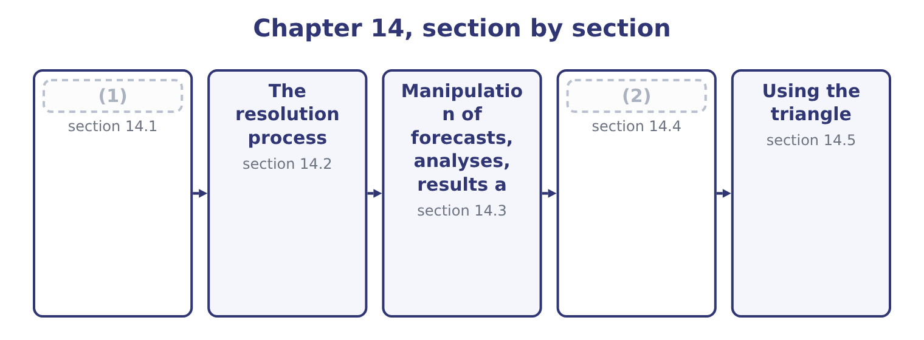
word list
What a dilemma is · obligation in play · The fraud triangle

Summary 1 gaps 3–14
An ethical dilemma is a situation in which the (3) faces a choice between courses of action where at least one obligation cannot be met, or where meeting an obligation carries a personal or (4) cost. Three things it is not, and (5) them saves a great deal of (6) writing in an exam. It is not a disagreement about (7) . A (8) of view about the right estimate for a provision, honestly held on both sides, is a technical disagreement, and the resolution is evidence and (9) . It becomes ethical when one party insists on an answer they know the evidence does not support, or when the disagreement is resolved by (10) rather than by (11) . It is not a hard decision with an (12) outcome. Closing a plant is painful and may be (13) proper; the ethical (14) are how the decision is made, who is told what and when, and whether the people affected are treated fairly. And it is not resolved by the fact that something is legal, customary in the industry, or approved by somebody senior.
word list
entirely · authority · difference · organisational · questions · discussion · confused · Honesty · professional · judgment · argument · distinguishing · unpleasant

Summary 2 gaps 15–20
Two (15) define the real thing. An obligation is in play. Honesty about a number, (16) in a report, the duty to (17) a conflict, the duty to report a control failure: one of the specific (18) . And there is a cost to meeting it. This is what makes it a dilemma rather than an (19) matter, and it is why the resolution process exists: an obligation that costs (20) needs no process.
word list
nothing · administrative · disclose · features · completeness · obligations · meeting

The English this section uses, and its Arabic
Each term sits against what it means.
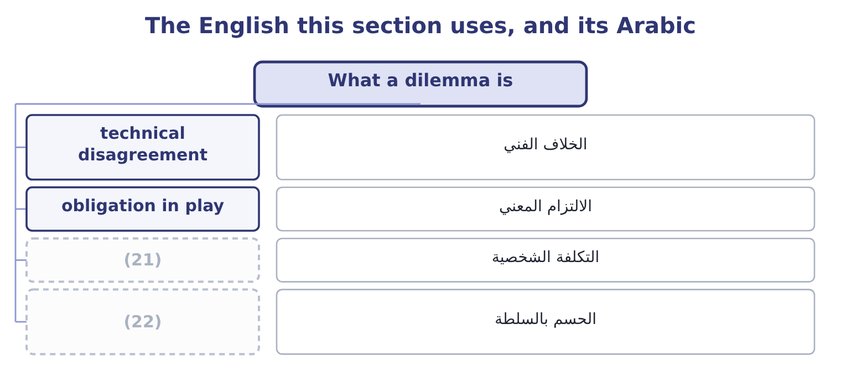
word list
personal cost · budget slack · resolution by authority

The English this sheet uses, and its Arabic
English (exam term) | Arabic
technical disagreement | الخلاف الفني
obligation in play | الالتزام المعني
personal cost | التكلفة الشخصية
resolution by authority | الحسم بالسلطة

Answer key · 14.1 What a dilemma is

1 What a dilemma is | 12 unpleasant
2 The fraud triangle | 13 entirely
3 professional | 14 questions
4 organisational | 15 features
5 distinguishing | 16 completeness
6 confused | 17 disclose
7 judgment | 18 obligations
8 difference | 19 administrative
9 discussion | 20 nothing
10 authority | 21 personal cost
11 argument | 22 resolution by authority

the summaries in full
Summary 1 An ethical dilemma is a situation in which the professional faces a choice between courses of action where at least one obligation cannot be met, or where meeting an obligation carries a personal or organisational cost. Three things it is not, and distinguishing them saves a great deal of confused writing in an exam. It is not a disagreement about judgment. A difference of view about the right estimate for a provision, honestly held on both sides, is a technical disagreement, and the resolution is evidence and discussion. It becomes ethical when one party insists on an answer they know the evidence does not support, or when the disagreement is resolved by authority rather than by argument. It is not a hard decision with an unpleasant outcome. Closing a plant is painful and may be entirely proper; the ethical questions are how the decision is made, who is told what and when, and whether the people affected are treated fairly. And it is not resolved by the fact that something is legal, customary in the industry, or approved by somebody senior.
Summary 2 Two features define the real thing. An obligation is in play. Honesty about a number, completeness in a report, the duty to disclose a conflict, the duty to report a control failure: one of the specific obligations. And there is a cost to meeting it. This is what makes it a dilemma rather than an administrative matter, and it is why the resolution process exists: an obligation that costs nothing needs no process.

14.2 The resolution process
Chapter 14 · section 14.2

Fill every gap. Each word list holds one word more than there are gaps.
Summary 1 gaps 1–12
The Statement sets out what a (1) should do when faced with an ethical issue, and the exam expects the (2) . It is a ladder, (3) one rung at a time. Start with the (4) own policy. Many employers have an (5) policy for (6) ethical conflicts, and where one exists it should be followed first. (7) the issue with the immediate supervisor, (8) the supervisor is involved in it. Many (9) are resolved here, because they arose from (10) , misunderstanding or haste rather than from intent. Where the supervisor is involved, or where the (11) is not resolved, take it to the next level of (12) , and continue upward. The Statement contemplates escalation to the audit committee, the board or another appropriate governing body, and contact with levels above the immediate supervisor should normally be initiated only with the supervisor's knowledge, assuming the supervisor is not implicated.
word list
internal · organisation's · sequence · situations · management · resolving · matter · pressure · member · established · climbed · Discuss · unless

Summary 2 gaps 13–24
Clarify the issues with an (13) adviser. The IMA offers an ethics helpline for (14) discussion of how the Statement applies, and the point of the step is to test your own reading of the situation against (15) who has no (16) in the outcome. Consult your own (17) about your legal obligations and (18) . This is a separate step and a real one, because the legal position — on (19) , on employment, on protection for reporting — differs by (20) and is not something a professional should guess at. Five practical (21) belong with the ladder, and an answer that (22) them is better than one that recites the steps. Dates, requests, what was said, what was (23) , what was decided. A note written at the time is evidence; a (24) written later is not.
word list
includes · provided · confidential · disciplines · objective · interest · helpline · rights · somebody · disclosure · jurisdiction · attorney · recollection

Summary 3 gaps 25–36
Raise the (25) rather than the (26) . (27) a workable (28) . Most requests have a (29) underlying problem — a covenant, a target, a customer — and a professional who offers a proper way to address it is far more (30) than one who only refuses. Separate what you must not do from what you would (31) not to do. You may not sign something false; you may dislike a (32) that is defensible. Spending (33) on the second leaves none for the first. And do not go (34) the organisation except where legally (35) . The (36) position is explicit. Resignation is the last resort, not the first, and it is not in itself a resolution: it removes the professional from the situation and leaves the situation. Where it becomes necessary — because the conduct continues and every internal route is exhausted — the obligations of confidentiality survive it.
word list
persuasive · alternative · defensible · Statement's · presentation · prescribed · outside · accusation · Propose · obligation · credibility · legitimate · prefer

The English this section uses, and its Arabic
Each term sits against what it means.
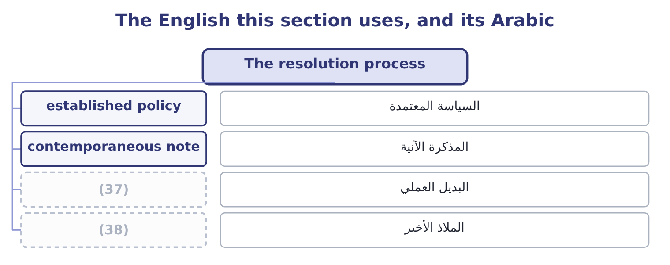
word list
technical disagreement · last resort · workable alternative

The English this sheet uses, and its Arabic
English (exam term) | Arabic
established policy | السياسة المعتمدة
contemporaneous note | المذكرة الآنية
workable alternative | البديل العملي
last resort | الملاذ الأخير

Answer key · 14.2 The resolution process

1 member | 20 jurisdiction
2 sequence | 21 disciplines
3 climbed | 22 includes
4 organisation's | 23 provided
5 established | 24 recollection
6 resolving | 25 obligation
7 Discuss | 26 accusation
8 unless | 27 Propose
9 situations | 28 alternative
10 pressure | 29 legitimate
11 matter | 30 persuasive
12 management | 31 prefer
13 objective | 32 presentation
14 confidential | 33 credibility
15 somebody | 34 outside
16 interest | 35 prescribed
17 attorney | 36 Statement's
18 rights | 37 workable alternative
19 disclosure | 38 last resort

the summaries in full
Summary 1 The Statement sets out what a member should do when faced with an ethical issue, and the exam expects the sequence. It is a ladder, climbed one rung at a time. Start with the organisation's own policy. Many employers have an established policy for resolving ethical conflicts, and where one exists it should be followed first. Discuss the issue with the immediate supervisor, unless the supervisor is involved in it. Many situations are resolved here, because they arose from pressure, misunderstanding or haste rather than from intent. Where the supervisor is involved, or where the matter is not resolved, take it to the next level of management, and continue upward. The Statement contemplates escalation to the audit committee, the board or another appropriate governing body, and contact with levels above the immediate supervisor should normally be initiated only with the supervisor's knowledge, assuming the supervisor is not implicated.
Summary 2 Clarify the issues with an objective adviser. The IMA offers an ethics helpline for confidential discussion of how the Statement applies, and the point of the step is to test your own reading of the situation against somebody who has no interest in the outcome. Consult your own attorney about your legal obligations and rights. This is a separate step and a real one, because the legal position — on disclosure, on employment, on protection for reporting — differs by jurisdiction and is not something a professional should guess at. Five practical disciplines belong with the ladder, and an answer that includes them is better than one that recites the steps. Dates, requests, what was said, what was provided, what was decided. A note written at the time is evidence; a recollection written later is not.
Summary 3 Raise the obligation rather than the accusation. Propose a workable alternative. Most requests have a legitimate underlying problem — a covenant, a target, a customer — and a professional who offers a proper way to address it is far more persuasive than one who only refuses. Separate what you must not do from what you would prefer not to do. You may not sign something false; you may dislike a presentation that is defensible. Spending credibility on the second leaves none for the first. And do not go outside the organisation except where legally prescribed. The Statement's position is explicit. Resignation is the last resort, not the first, and it is not in itself a resolution: it removes the professional from the situation and leaves the situation. Where it becomes necessary — because the conduct continues and every internal route is exhausted — the obligations of confidentiality survive it.

14.3 Manipulation of forecasts, analyses, results and budgets
Chapter 14 · section 14.3

Fill every gap. Each word list holds one word more than there are gaps.
Summary 1 gaps 1–12
The (1) outcome names the family of issues a management (2) meets most often and asks for (3) to be proposed. The forms are worth (4) , because recognising one is half the answer. Recognising revenue early — (5) goods before they are wanted, which is channel stuffing; holding a period open past its end; deferring or (6) costs that should be expensed; releasing a provision because a result is short; delaying a (7) . The (8) is usually small relative to the company and decisive relative to the target: releasing a provision from 240,000 to 90,000 adds 240,000 − 90,000 = 150,000 to profit, which is 150,000 ÷ 4,176,000 = 3.59 per cent of (9) operating income — (10) to an auditor and quite enough to turn a miss into a hit. Presenting a forecast the (11) believes to be unachievable because it is what the board wants to hear; or the reverse, (12) in slack so that the target can be beaten.
word list
arithmetic · shipping · naming · capitalising · commercial · building · preparer · resolutions · second · immaterial · Orontes's · accountant · write-down

Summary 2 gaps 13–24
A manager who adds 8 per cent to a 3,000,000 cost budget has created 3,000,000 × 0.08 = 240,000 of (13) slack, and the company will plan on it, price on it and (14) capital on it. Choosing the discount rate, the base period, the comparator or the scenario that produces the wanted answer; omitting the (15) that would undermine the (16) ; presenting one option with its risks and the preferred one without. Book 3's capital budgeting is (17) exposed, since every (18) rests on assumptions somebody chose. The truncated axis, the (19) against a revised target, the favourable variance explained and the (20) one attributed to timing, the one-off gain in operating income and the one-off cost below it. Proposing a (21) , which the outcome requires, (22) a pattern. (23) the legitimate problem (24) the request.
word list
follows · Identify · resolution · Choosing · invisible · unfavourable · allocate · comparison · behind · sensitivity · particularly · appraisal · recommendation

Summary 3 gaps 25–35
Channel stuffing is usually a revenue shortfall; budget slack is usually a fear of being held to a forecast made under (25) ; a released provision is usually a covenant. (26) the real problem is what makes the refusal (27) . State the obligation and its (28) precisely, without (29) : what the standard requires, what the disclosure would have to say, and what happens if the treatment is later reversed. Offer the legitimate (30) . For a covenant: talk to the (31) early. For a revenue shortfall: (32) it with the reasons and the (33) plan. For an unachievable forecast: present it as a range with the assumptions stated, which (34) Credibility and is also better management (35) . Escalate if the request stands, by the ladder of section 14.2.
word list
report · information · satisfies · management · Addressing · constructive · uncertainty · accusation · consequence · recovery · alternatives · lender

Worked example: the quarter that was 150,000 short

Summary 4 gaps 36–47
At a 40 per cent contribution margin the early (36) brings 250,000 × 0.40 = 100,000 of contribution into this quarter and takes it out of the next. Is it a breach? It (37) on facts, not on the request. If the customers have (38) the goods and accept (39) , early despatch is a (40) decision and the revenue is properly (41) . If the goods are shipped without agreement, on (42) , or with a side (43) that they may be sent back, it is not revenue at all and the accounts would be misstated. (44) which it is, in (45) , from the customers' own orders. Where the orders are genuine, do it and disclose the (46) in the commentary, because Credibility requires the board to know that the quarter was helped by 100,000 of next (47) contribution.
word list
delivery · shipment · sale-or-return · commercial · writing · quarter's · pull-forward · depends · understanding · Establish · recognised · customers · ordered

Summary 5 gaps 48–52
Where they are not, refuse the (48) treatment, say why, and escalate if it is (49) . Notice that the (50) answer is not "refuse". It is "find out, then treat it (51) and say what was done". A (52) who refuses everything that looks awkward loses the standing needed to refuse the thing that matters.
word list
correctly · ethical · constructive · pressed · professional · accounting

The English this section uses, and its Arabic
Each term sits against what it means.
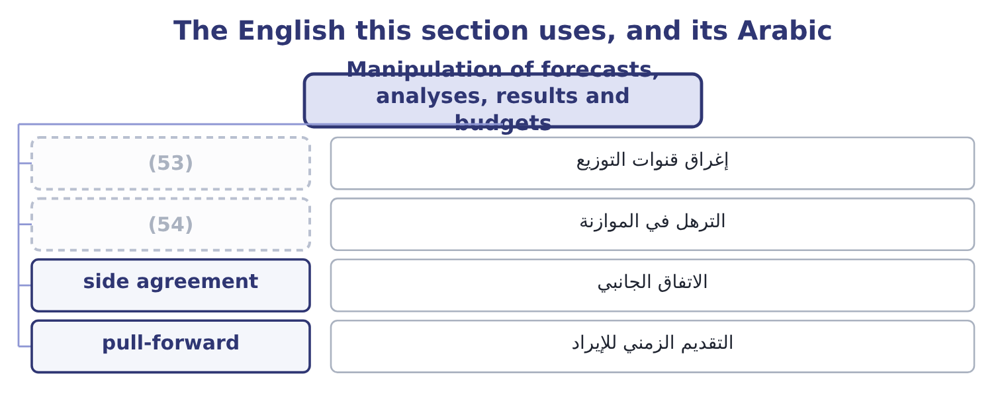
word list
established policy · budget slack · channel stuffing

The English this sheet uses, and its Arabic
English (exam term) | Arabic
channel stuffing | إغراق قنوات التوزيع
budget slack | الترهل في الموازنة
side agreement | الاتفاق الجانبي
pull-forward | التقديم الزمني للإيراد

Answer key · 14.3 Manipulation of forecasts, analyses, results and budgets

1 second | 28 consequence
2 accountant | 29 accusation
3 resolutions | 30 alternatives
4 naming | 31 lender
5 shipping | 32 report
6 capitalising | 33 recovery
7 write-down | 34 satisfies
8 arithmetic | 35 information
9 Orontes's | 36 shipment
10 immaterial | 37 depends
11 preparer | 38 ordered
12 building | 39 delivery
13 invisible | 40 commercial
14 allocate | 41 recognised
15 sensitivity | 42 sale-or-return
16 recommendation | 43 understanding
17 particularly | 44 Establish
18 appraisal | 45 writing
19 comparison | 46 pull-forward
20 unfavourable | 47 quarter's
21 resolution | 48 accounting
22 follows | 49 pressed
23 Identify | 50 ethical
24 behind | 51 correctly
25 uncertainty | 52 professional
26 Addressing | 53 channel stuffing
27 constructive | 54 budget slack

the summaries in full
Summary 1 The second outcome names the family of issues a management accountant meets most often and asks for resolutions to be proposed. The forms are worth naming, because recognising one is half the answer. Recognising revenue early — shipping goods before they are wanted, which is channel stuffing; holding a period open past its end; deferring or capitalising costs that should be expensed; releasing a provision because a result is short; delaying a write-down. The arithmetic is usually small relative to the company and decisive relative to the target: releasing a provision from 240,000 to 90,000 adds 240,000 − 90,000 = 150,000 to profit, which is 150,000 ÷ 4,176,000 = 3.59 per cent of Orontes's operating income — immaterial to an auditor and quite enough to turn a miss into a hit. Presenting a forecast the preparer believes to be unachievable because it is what the board wants to hear; or the reverse, building in slack so that the target can be beaten.
Summary 2 A manager who adds 8 per cent to a 3,000,000 cost budget has created 3,000,000 × 0.08 = 240,000 of invisible slack, and the company will plan on it, price on it and allocate capital on it. Choosing the discount rate, the base period, the comparator or the scenario that produces the wanted answer; omitting the sensitivity that would undermine the recommendation; presenting one option with its risks and the preferred one without. Book 3's capital budgeting is particularly exposed, since every appraisal rests on assumptions somebody chose. The truncated axis, the comparison against a revised target, the favourable variance explained and the unfavourable one attributed to timing, the one-off gain in operating income and the one-off cost below it. Proposing a resolution, which the outcome requires, follows a pattern. Identify the legitimate problem behind the request.
Summary 3 Channel stuffing is usually a revenue shortfall; budget slack is usually a fear of being held to a forecast made under uncertainty; a released provision is usually a covenant. Addressing the real problem is what makes the refusal constructive. State the obligation and its consequence precisely, without accusation: what the standard requires, what the disclosure would have to say, and what happens if the treatment is later reversed. Offer the legitimate alternatives. For a covenant: talk to the lender early. For a revenue shortfall: report it with the reasons and the recovery plan. For an unachievable forecast: present it as a range with the assumptions stated, which satisfies Credibility and is also better management information. Escalate if the request stands, by the ladder of section 14.2.
Summary 4 At a 40 per cent contribution margin the early shipment brings 250,000 × 0.40 = 100,000 of contribution into this quarter and takes it out of the next. Is it a breach? It depends on facts, not on the request. If the customers have ordered the goods and accept delivery, early despatch is a commercial decision and the revenue is properly recognised. If the goods are shipped without agreement, on sale-or-return, or with a side understanding that they may be sent back, it is not revenue at all and the accounts would be misstated. Establish which it is, in writing, from the customers' own orders. Where the orders are genuine, do it and disclose the pull-forward in the commentary, because Credibility requires the board to know that the quarter was helped by 100,000 of next quarter's contribution.
Summary 5 Where they are not, refuse the accounting treatment, say why, and escalate if it is pressed. Notice that the ethical answer is not "refuse". It is "find out, then treat it correctly and say what was done". A professional who refuses everything that looks awkward loses the standing needed to refuse the thing that matters.

14.4 The fraud triangle
Chapter 14 · section 14.4

Fill every gap. Each word list holds one word more than there are gaps.
Summary 1 gaps 1–12
The third (1) asks for the three (2) , and the model is the most useful (3) idea in this half of the book. It holds that fraud requires three (4) together, and that (5) any one of them prevents it. Pressure, also called (6) or motivation. A (7) to commit the act. It may be personal — debt, medical costs, gambling, (8) , a lifestyle that cannot be sustained on the salary, a family (9) — or organisational: a target, a bonus threshold, a covenant, a share price, a plant whose closure depends on the numbers, a fear of losing a job. Note that financial statement fraud is almost always organisational pressure and asset (10) almost always personal, which is why the two have (11) warning signs. A way to do it and a (12) that it will not be found.
word list
misappropriation · components · addiction · single · expectation · removing · belief · reason · incentive · together · outcome · different · conditions

Summary 2 gaps 13–24
Opportunity is created by weak controls, by the absence of (13) , by access that nobody reviews, by (14) that nobody checks, and above all by a person who can both perform and conceal. Of the three sides, this is the one the (15) controls directly, which is why. A way of reconciling the act with one's own (16) , because the great majority of (17) fraud is committed by people who do not think of themselves as criminals. The standard forms are worth knowing, because they appear in (18) and in exam cases: "I am only (19) it"; "they owe me, after what I have done for them"; "everybody does it"; "the company can afford it"; "I had no choice"; "it is only until the quarter turns"; "it is not really stealing, nobody is hurt". Two extensions appear in the (20) and are worth a line. Some writers add (21) — the person must have the position, the knowledge and the nerve to carry it out — making a fraud diamond; and in financial statement fraud, arrogance or (22) is often added, describing a senior person who believes the rules do not apply to them. The (23) model is what the exam asks for; the extensions are useful in an answer that has (24) given it.
word list
capability · borrowing · organisation · interviews · occupational · three-sided · already · literature · entitlement · authority · segregation · self-image · knowing

The English this section uses, and its Arabic
Each term sits against what it means.
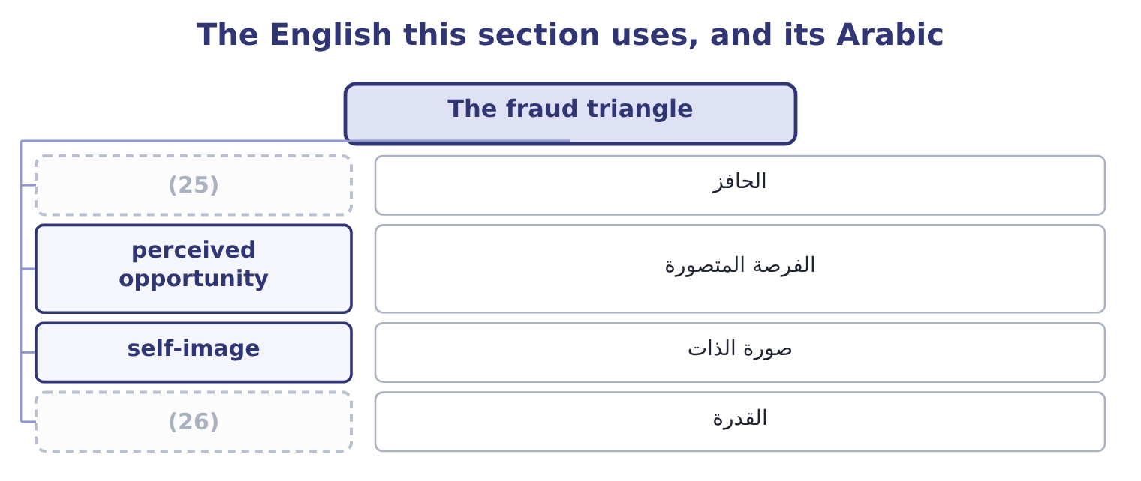
word list
override · capability · incentive

The English this sheet uses, and its Arabic
English (exam term) | Arabic
incentive | الحافز
perceived opportunity | الفرصة المتصورة
self-image | صورة الذات
capability | القدرة

Answer key · 14.4 The fraud triangle

1 outcome | 14 authority
2 components | 15 organisation
3 single | 16 self-image
4 conditions | 17 occupational
5 removing | 18 interviews
6 incentive | 19 borrowing
7 reason | 20 literature
8 addiction | 21 capability
9 expectation | 22 entitlement
10 misappropriation | 23 three-sided
11 different | 24 already
12 belief | 25 incentive
13 segregation | 26 capability

the summaries in full
Summary 1 The third outcome asks for the three components, and the model is the most useful single idea in this half of the book. It holds that fraud requires three conditions together, and that removing any one of them prevents it. Pressure, also called incentive or motivation. A reason to commit the act. It may be personal — debt, medical costs, gambling, addiction, a lifestyle that cannot be sustained on the salary, a family expectation — or organisational: a target, a bonus threshold, a covenant, a share price, a plant whose closure depends on the numbers, a fear of losing a job. Note that financial statement fraud is almost always organisational pressure and asset misappropriation almost always personal, which is why the two have different warning signs. A way to do it and a belief that it will not be found.
Summary 2 Opportunity is created by weak controls, by the absence of segregation, by access that nobody reviews, by authority that nobody checks, and above all by a person who can both perform and conceal. Of the three sides, this is the one the organisation controls directly, which is why. A way of reconciling the act with one's own self-image, because the great majority of occupational fraud is committed by people who do not think of themselves as criminals. The standard forms are worth knowing, because they appear in interviews and in exam cases: "I am only borrowing it"; "they owe me, after what I have done for them"; "everybody does it"; "the company can afford it"; "I had no choice"; "it is only until the quarter turns"; "it is not really stealing, nobody is hurt". Two extensions appear in the literature and are worth a line. Some writers add capability — the person must have the position, the knowledge and the nerve to carry it out — making a fraud diamond; and in financial statement fraud, arrogance or entitlement is often added, describing a senior person who believes the rules do not apply to them. The three-sided model is what the exam asks for; the extensions are useful in an answer that has already given it.

14.5 Using the triangle
Chapter 14 · section 14.5

Fill every gap. Each word list holds one word more than there are gaps.
Summary 1 gaps 1–12
The fourth (1) asks how a professional uses the model to (2) and manage the risk of fraud, and the answer is one (3) for each side. Reduce opportunity, which is the (4) half. (5) : segregation of duties, (6) limits, reconciliations performed by people who do not hold the asset, (7) master file access, mandatory leave and rotation, audit trails that cannot be altered, and review of the exceptions rather than only of the totals. Add to those the specific (8) tests that find the frauds of, payments just below approval thresholds, new (9) , credit notes, write-offs, manual journals posted near a period end and reversed after it. Reduce pressure where it is created by the organisation. This is the part management controls and rarely (10) . Targets that cannot be met honestly, bonus structures with cliff edges, a culture in which missing a number is (11) , and a sales commission paid on orders rather than on cash collected: each of these (12) pressure, and a company that creates the motive and then relies on controls to stop the act has made its own problem.
word list
authorisation · suppliers · examines · practical · detective · unsurvivable · identify · changes · restricted · action · Everything · outcome · manufactures

Summary 2 gaps 13–20
Attack rationalisation, which sounds the (13) and is not. A code of (14) that is specific about the acts in question, training that uses real situations rather than (15) , visible and consistent enforcement at every level, a route to raise a (16) , and leaders who talk about the awkward cases: all of these make the stories harder to tell oneself. The (17) enemy of rationalisation is (18) — the senior person who is treated exactly as a junior one would be. For (19) fraud risk, the model becomes a (20) .
word list
slogans · diagnostic · concern · conduct · consistency · particular · whether · identifying · softest

The triangle as a diagnostic
Side | The question to ask | What to look for | What to do
Pressure | Who in this process is under pressure, and from what? | Targets missed, cliff-edge bonuses, personal difficulty, (21) lifestyle | Change the incentive; support the person; increase oversight
Opportunity | Who could do it and conceal it? | One person performing and recording; unreviewed access; overrides | (22)
Rationalisation | What story would make it acceptable here? | (23) | Specific code, real training, consistent enforcement
All three | Where do all three coincide? | (24) | Treat as a high risk; test it

word list
incentive · unexplained · Segregate, restrict, review exceptions · A single process with pressure, access and a grievance · "Everybody does it"; grievance; inconsistent discipline

Summary 3 gaps 25–36
Four (25) signs are worth knowing for the exam, because situations are (26) around them. (27) : an employee who never takes leave, who resists control changes, who insists on handling one relationship (28) , whose lifestyle exceeds their income, or who has an (29) close relationship with a supplier or customer. Process: reconciliations that are late or performed by the wrong person, a rising volume of manual journals, (30) overrides, missing (31) , and customer or supplier (32) that stop reaching the people who should hear them. (33) : margins that move without explanation, (34) entries, payments just below thresholds, credit notes concentrated after period ends, and write-offs concentrated in one (35) accounts. And structural: a dominant individual, a finance function too small for segregation, a (36) person in a sensitive role with no cover, and an audit committee that meets rarely.
word list
complaints · unusually · person's · handling · warning · Numerical · round-number · personally · written · repeated · documentation · long-tenured · Behavioural

Summary 4 gaps 37–41
The (37) own position is the last point and the most personal. The triangle (38) to you. Pressure will come from a target or a superior; opportunity exists because you prepare the numbers; and rationalisation is (39) in the words "it is only a (40) " or "the quarter will correct it". Knowing the model is some (41) against being inside it.
word list
presentation · available · knowing · applies · protection · professional's

Dilemmas and the triangle

Your turn: resolving and diagnosing (complete the blanks)
Item | Data | Answer
First step when an ethical issue arises |  | ________
Where to take it when the supervisor is involved |  | ________
Contribution moved by shipping 250,000 early | Contribution margin 40 per cent | ________
Slack created by an 8 per cent addition | (42) | ________
The three sides of the fraud triangle |  | ________
The side the organisation controls most directly |  | ________

word list
Cost budget 3,000,000 · obligation in play

"Aggressive", "conservative" and "manage"

Summary 5 gaps 43–54
Three (43) words do most of the work of disguising (44) , and a management (45) should recognise all of them. Aggressive (46) sounds energetic and (47) minded; it means (48) at or beyond the edge of what the standards allow. (49) sounds prudent and careful; applied to a (50) taken in a good year to be (51) in a bad one, it means building a reserve to manage earnings, which is not prudence. And manage, in earnings management, is the most (52) of the three, because managing is what managers are supposed to do: the phrase makes the (53) shaping of a reported result sound like (54) . The habit worth forming is to replace the adjective with the act: not "we are being aggressive on revenue" but "we are recognising revenue before the customer has agreed to take the goods" — and then see whether the sentence still sounds acceptable.
word list
deliberate · released · accounting · effective · English · accountant · Conservative · treatments · journals · manipulation · provision · competence · commercially

"Aggressive", "conservative" and "manage"
Item | Answer
First step | Follow the organisation's (55) for resolving ethical conflicts.
Where the supervisor is involved | The next level of management, and upward to the audit committee or board.
Contribution moved | (56)
Slack created | 240,000: 3,000,000 × 0.08 = 240,000.
The three sides | Pressure, opportunity and rationalisation.
The side most directly controlled | Opportunity, through segregation, access and review.
What it tells you | Two questions about the process and two about the (57) , with the triangle underneath both — because the process exists for the moment

word list
arithmetic · earnings management · 100,000: 250,000 × 0.40 = 100,000. · established policy

The English this section uses, and its Arabic
Each term sits against what it means.
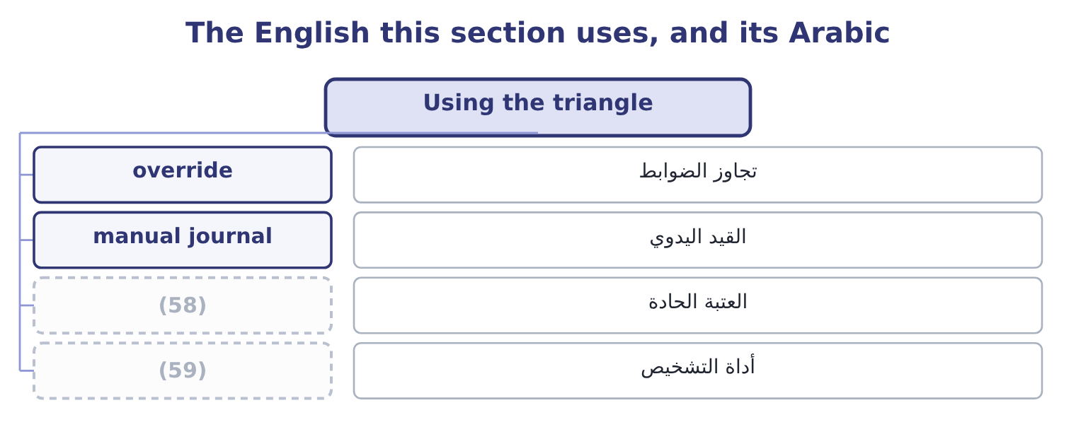
word list
pressure · cliff edge · diagnostic

The English this sheet uses, and its Arabic
English (exam term) | Arabic
override | تجاوز الضوابط
manual journal | القيد اليدوي
cliff edge | العتبة الحادة
diagnostic | أداة التشخيص

Answer key · 14.5 Using the triangle

1 outcome | 31 documentation
2 identify | 32 complaints
3 action | 33 Numerical
4 practical | 34 round-number
5 Everything | 35 person's
6 authorisation | 36 long-tenured
7 restricted | 37 professional's
8 detective | 38 applies
9 suppliers | 39 available
10 examines | 40 presentation
11 unsurvivable | 41 protection
12 manufactures | 42 Cost budget 3,000,000
13 softest | 43 English
14 conduct | 44 manipulation
15 slogans | 45 accountant
16 concern | 46 accounting
17 particular | 47 commercially
18 consistency | 48 treatments
19 identifying | 49 Conservative
20 diagnostic | 50 provision
21 unexplained | 51 released
22 Segregate, restrict, review exceptions | 52 effective
23 "Everybody does it"; grievance; inconsistent discipline | 53 deliberate
24 A single process with pressure, access and a grievance | 54 competence
25 warning | 55 established policy
26 written | 56 100,000: 250,000 × 0.40 = 100,000.
27 Behavioural | 57 arithmetic
28 personally | 58 cliff edge
29 unusually | 59 diagnostic
30 repeated

the summaries in full
Summary 1 The fourth outcome asks how a professional uses the model to identify and manage the risk of fraud, and the answer is one action for each side. Reduce opportunity, which is the practical half. Everything: segregation of duties, authorisation limits, reconciliations performed by people who do not hold the asset, restricted master file access, mandatory leave and rotation, audit trails that cannot be altered, and review of the exceptions rather than only of the totals. Add to those the specific detective tests that find the frauds of, payments just below approval thresholds, new suppliers, credit notes, write-offs, manual journals posted near a period end and reversed after it. Reduce pressure where it is created by the organisation. This is the part management controls and rarely examines. Targets that cannot be met honestly, bonus structures with cliff edges, a culture in which missing a number is unsurvivable, and a sales commission paid on orders rather than on cash collected: each of these manufactures pressure, and a company that creates the motive and then relies on controls to stop the act has made its own problem.
Summary 2 Attack rationalisation, which sounds the softest and is not. A code of conduct that is specific about the acts in question, training that uses real situations rather than slogans, visible and consistent enforcement at every level, a route to raise a concern, and leaders who talk about the awkward cases: all of these make the stories harder to tell oneself. The particular enemy of rationalisation is consistency — the senior person who is treated exactly as a junior one would be. For identifying fraud risk, the model becomes a diagnostic.
Summary 3 Four warning signs are worth knowing for the exam, because situations are written around them. Behavioural: an employee who never takes leave, who resists control changes, who insists on handling one relationship personally, whose lifestyle exceeds their income, or who has an unusually close relationship with a supplier or customer. Process: reconciliations that are late or performed by the wrong person, a rising volume of manual journals, repeated overrides, missing documentation, and customer or supplier complaints that stop reaching the people who should hear them. Numerical: margins that move without explanation, round-number entries, payments just below thresholds, credit notes concentrated after period ends, and write-offs concentrated in one person's accounts. And structural: a dominant individual, a finance function too small for segregation, a long-tenured person in a sensitive role with no cover, and an audit committee that meets rarely.
Summary 4 The professional's own position is the last point and the most personal. The triangle applies to you. Pressure will come from a target or a superior; opportunity exists because you prepare the numbers; and rationalisation is available in the words "it is only a presentation" or "the quarter will correct it". Knowing the model is some protection against being inside it.
Summary 5 Three English words do most of the work of disguising manipulation, and a management accountant should recognise all of them. Aggressive accounting sounds energetic and commercially minded; it means treatments at or beyond the edge of what the standards allow. Conservative sounds prudent and careful; applied to a provision taken in a good year to be released in a bad one, it means building a reserve to manage earnings, which is not prudence. And manage, in earnings management, is the most effective of the three, because managing is what managers are supposed to do: the phrase makes the deliberate shaping of a reported result sound like competence. The habit worth forming is to replace the adjective with the act: not "we are being aggressive on revenue" but "we are recognising revenue before the customer has agreed to take the goods" — and then see whether the sentence still sounds acceptable.

15.1 Applying values across borders
Chapter 15 · section 15.1

Fill every gap. Each word list holds one word more than there are gaps.
Chapter 15, section by section
Each stage leads to the next.
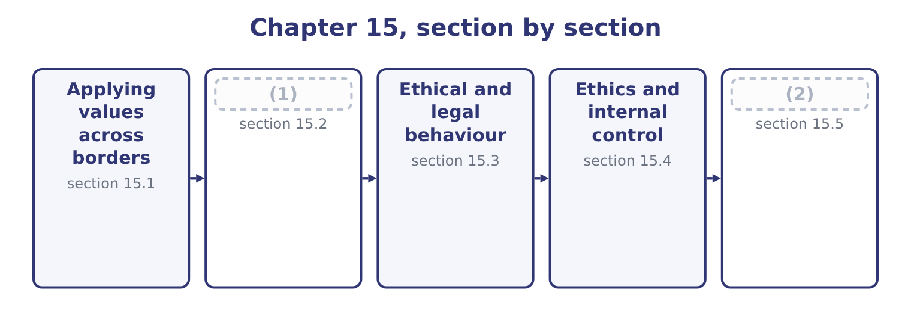
word list
Ethics and internal control · Designing for both · Three positions, and the workable one

Summary 1 gaps 3–14
The outcome asks for the issues an (3) faces in applying its values and ethical standards (4) , and there are seven worth naming. Different laws, and (5) ones. Employment protections, environmental limits, data rules, disclosure (6) and competition law differ, and (7) a company is required by one country's law to do what another's forbids. Data (8) and sanctions produce the (9) cases. Different (10) around gifts, (11) and payments. In some markets a payment to an (12) to do what they are already obliged to do — clear a shipment, issue a licence — is routine and (13) . It is a (14) payment, it is a criminal offence under the laws, and the company that refuses it bears a real cost: a consignment held five days costs Orontes 46,027 × 5 = 230,135 of contribution, against a payment of 2,000 which is 2,000 ÷ 450,000 = 0.44 per cent of the shipment's value.
word list
expected · transfer · facilitation · sharpest · customs · occasionally · organisation · conflicting · exactly · official · requirements · hospitality · internationally

Summary 2 gaps 15–26
The (15) is exactly why the rule has to be absolute: anything less than a (16) becomes a calculation, and the calculation always favours paying. Different (17) and safety standards. Working hours, minimum ages, union rights, (18) and safety (19) . A company may be (20) lawful locally and far below what it would accept at home, and the question is which standard applies to its own (21) and to its suppliers'. Different environmental standards, with the same (22) . Conduct in the (23) chain and among partners. A company is judged by what is done in its name — by its distributors, agents, (24) partners and suppliers — and it (25) has less control over them than over its own staff. Agents in (26) are the standard route by which bribery enters a company that has prohibited it.
word list
particular · entirely · usually · operations · equipment · prohibition · joint-venture · arithmetic · general · structure · accommodation · labour · supply

Summary 3 gaps 27–34
The reach of (27) law. (28) statutes, sanctions and some tax and disclosure rules apply to conduct (29) , so "it is legal there" is not even a legal (30) , let alone an ethical one. And the practical problems of applying a code at a distance: (31) that must carry meaning and not only words, local managers who have to interpret general (32) in situations the code never (33) , training delivered in a language and a format that work locally, monitoring that is genuine rather than a (34) , and a reporting route a local employee will actually use.
word list
translation · defence · principles · abroad · environmental · Anti-bribery · questionnaire · home-country · contemplated

The English this section uses, and its Arabic
Each term sits against what it means.
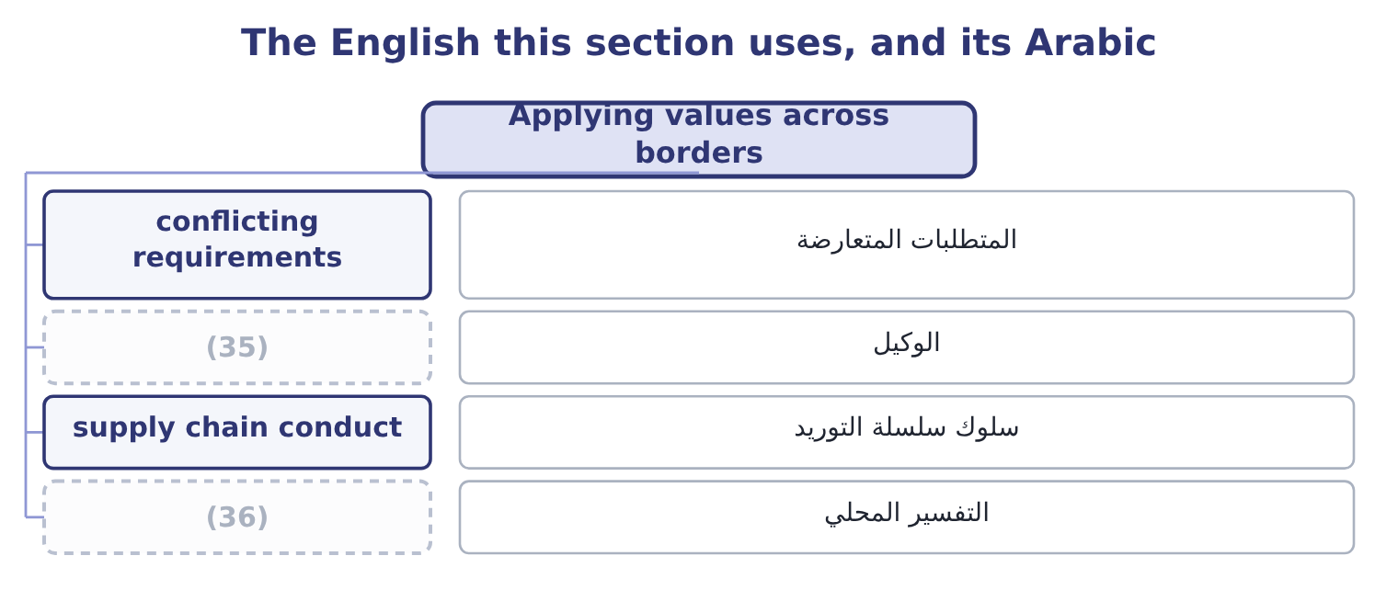
word list
local interpretation · agent · local practice

The English this sheet uses, and its Arabic
English (exam term) | Arabic
conflicting requirements | المتطلبات المتعارضة
agent | الوكيل
supply chain conduct | سلوك سلسلة التوريد
local interpretation | التفسير المحلي

Answer key · 15.1 Applying values across borders

1 Three positions, and the workable one | 19 equipment
2 Designing for both | 20 entirely
3 organisation | 21 operations
4 internationally | 22 structure
5 conflicting | 23 supply
6 requirements | 24 joint-venture
7 occasionally | 25 usually
8 transfer | 26 particular
9 sharpest | 27 home-country
10 customs | 28 Anti-bribery
11 hospitality | 29 abroad
12 official | 30 defence
13 expected | 31 translation
14 facilitation | 32 principles
15 arithmetic | 33 contemplated
16 prohibition | 34 questionnaire
17 labour | 35 agent
18 accommodation | 36 local interpretation

the summaries in full
Summary 1 The outcome asks for the issues an organisation faces in applying its values and ethical standards internationally, and there are seven worth naming. Different laws, and conflicting ones. Employment protections, environmental limits, data rules, disclosure requirements and competition law differ, and occasionally a company is required by one country's law to do what another's forbids. Data transfer and sanctions produce the sharpest cases. Different customs around gifts, hospitality and payments. In some markets a payment to an official to do what they are already obliged to do — clear a shipment, issue a licence — is routine and expected. It is a facilitation payment, it is a criminal offence under the laws, and the company that refuses it bears a real cost: a consignment held five days costs Orontes 46,027 × 5 = 230,135 of contribution, against a payment of 2,000 which is 2,000 ÷ 450,000 = 0.44 per cent of the shipment's value.
Summary 2 The arithmetic is exactly why the rule has to be absolute: anything less than a prohibition becomes a calculation, and the calculation always favours paying. Different labour and safety standards. Working hours, minimum ages, union rights, accommodation and safety equipment. A company may be entirely lawful locally and far below what it would accept at home, and the question is which standard applies to its own operations and to its suppliers'. Different environmental standards, with the same structure. Conduct in the supply chain and among partners. A company is judged by what is done in its name — by its distributors, agents, joint-venture partners and suppliers — and it usually has less control over them than over its own staff. Agents in particular are the standard route by which bribery enters a company that has prohibited it.
Summary 3 The reach of home-country law. Anti-bribery statutes, sanctions and some tax and disclosure rules apply to conduct abroad, so "it is legal there" is not even a legal defence, let alone an ethical one. And the practical problems of applying a code at a distance: translation that must carry meaning and not only words, local managers who have to interpret general principles in situations the code never contemplated, training delivered in a language and a format that work locally, monitoring that is genuine rather than a questionnaire, and a reporting route a local employee will actually use.

15.2 Three positions, and the workable one
Chapter 15 · section 15.2

Fill every gap. Each word list holds one word more than there are gaps.
Summary 1 gaps 1–12
Two extreme (1) are available and both fail, which is why the exam wants the middle one (2) . (3) holds that the company's home standards apply (4) without variation. Its strength is (5) : nobody has to (6) anything, and the rule is the same in every office. Its weaknesses are that it can be arrogant — not every local practice is worse, merely different — that it may be (7) or even unlawful locally, and that it leaves no room for the genuine (8) in custom that have nothing to do with right and wrong. (9) holds that the right standard is (10) is accepted locally — "when in Rome". Its strength is respect for local practice and the (11) that outsiders (12) less than they think. Its weakness is fatal: it provides no ground on which to refuse anything, since every practice is accepted somewhere, and it hands the standard to whoever benefits from the worst local custom.
word list
differences · Relativism · customary · Absolutism · positions · clarity · whatever · everywhere · described · understand · interpret · recognition · impractical

Summary 2 gaps 13–24
The workable position (13) between core values and local practice. Core values do not vary. Honesty, safety, no bribery, no forced or child labour, no deliberate misstatement, no (14) of the kinds the company has named: these apply in every country and in every operation, and they are the (15) categories. Local practice (16) , and should. Negotiating style, the role of relationships and (17) , how directly (18) is expressed, hospitality norms, hierarchy, working patterns, how decisions are made and recorded. A company that treats these as (19) matters mistakes (20) for wrongdoing. The hard cases live in between, and the exam uses them: a gift that is customary and (21) ; a hiring practice that favours family and is universal locally; a supplier whose working (22) are lawful and poor; a payment that is demanded rather than offered. Would we do it at home, and if not, what (23) is different? Sometimes the answer is a real difference in (24) and sometimes it is only that nobody would. And is it being required of us, or offered to us? Extortion and opportunity are different cases, and a payment demanded under threat of harm is treated differently in most anti-bribery regimes from one offered to win business — though the company should still report and record it.
word list
substantial · zero-tolerance · circumstance · intermediaries · exactly · ethical · unfamiliarity · conditions · disagreement · varies · discrimination · distinguishes · arrogant

The English this section uses, and its Arabic
Each term sits against what it means.
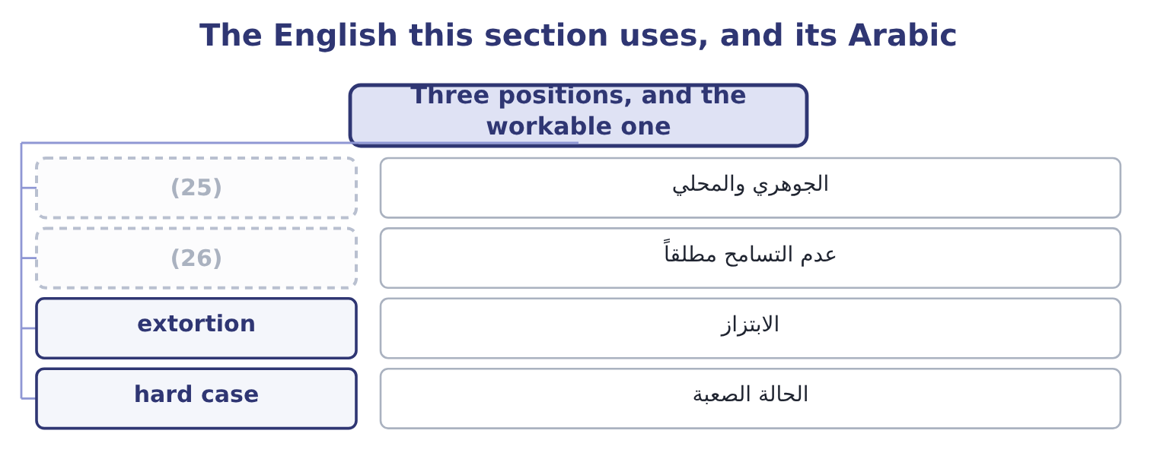
word list
zero tolerance · core and local · anything of value

The English this sheet uses, and its Arabic
English (exam term) | Arabic
core and local | الجوهري والمحلي
zero tolerance | عدم التسامح مطلقاً
extortion | الابتزاز
hard case | الحالة الصعبة

Answer key · 15.2 Three positions, and the workable one

1 positions | 14 discrimination
2 described | 15 zero-tolerance
3 Absolutism | 16 varies
4 everywhere | 17 intermediaries
5 clarity | 18 disagreement
6 interpret | 19 ethical
7 impractical | 20 unfamiliarity
8 differences | 21 substantial
9 Relativism | 22 conditions
10 whatever | 23 exactly
11 recognition | 24 circumstance
12 understand | 25 core and local
13 distinguishes | 26 zero tolerance

the summaries in full
Summary 1 Two extreme positions are available and both fail, which is why the exam wants the middle one described. Absolutism holds that the company's home standards apply everywhere without variation. Its strength is clarity: nobody has to interpret anything, and the rule is the same in every office. Its weaknesses are that it can be arrogant — not every local practice is worse, merely different — that it may be impractical or even unlawful locally, and that it leaves no room for the genuine differences in custom that have nothing to do with right and wrong. Relativism holds that the right standard is whatever is accepted locally — "when in Rome". Its strength is respect for local practice and the recognition that outsiders understand less than they think. Its weakness is fatal: it provides no ground on which to refuse anything, since every practice is accepted somewhere, and it hands the standard to whoever benefits from the worst local custom.
Summary 2 The workable position distinguishes between core values and local practice. Core values do not vary. Honesty, safety, no bribery, no forced or child labour, no deliberate misstatement, no discrimination of the kinds the company has named: these apply in every country and in every operation, and they are the zero-tolerance categories. Local practice varies, and should. Negotiating style, the role of relationships and intermediaries, how directly disagreement is expressed, hospitality norms, hierarchy, working patterns, how decisions are made and recorded. A company that treats these as ethical matters mistakes unfamiliarity for wrongdoing. The hard cases live in between, and the exam uses them: a gift that is customary and substantial; a hiring practice that favours family and is universal locally; a supplier whose working conditions are lawful and poor; a payment that is demanded rather than offered. Would we do it at home, and if not, what exactly is different? Sometimes the answer is a real difference in circumstance and sometimes it is only that nobody would. And is it being required of us, or offered to us? Extortion and opportunity are different cases, and a payment demanded under threat of harm is treated differently in most anti-bribery regimes from one offered to win business — though the company should still report and record it.

15.3 Ethical and legal behaviour
Chapter 15 · section 15.3

Fill every gap. Each word list holds one word more than there are gaps.
Summary 1 gaps 1–12
The (1) asks for the (2) , and four of them matter. Law is a floor; ethics is a standard. (3) the law forbids is unethical in the ordinary case, but a great deal that is lawful is not ethical: a contract term enforced against a party who did not understand it, a redundancy handled lawfully and brutally, a marketing claim technically true and designed to mislead, a tax structure that is legal and (4) in public. Legal (5) is the minimum, not the (6) . Law is enforced (7) ; ethics is enforced internally and (8) . The sanction for (9) is a court; the sanction for unethical conduct is (10) , professional membership, trust and the loss of people who will not work for the company. Law is (11) , codified and (12) . It names acts, in writing, after a problem has been recognised. Ethics applies to situations no rule has contemplated — new technologies, new markets, new products — and it operates before the law catches up. And law varies by jurisdiction; core ethical values are held to be the same everywhere, which is section 15.2's point.
word list
backward-looking · reputation · differences · specific · professionally · externally · structure · indefensible · outcome · compliance · illegality · objective · Everything

Legal and ethical
Case | Example | What to do
Legal and ethical | (13) | Proceed
Legal but unethical | A technically true marketing claim designed to mislead | (14)
Illegal but widely tolerated locally | (15) | Refuse; and report the demand
Illegal and unethical | (16) | Refuse; report; investigate

word list
Refuse; the law is not the standard · Bribery to win a contract · Refuse; report; investigate · A facilitation payment · Ordinary trading on agreed terms

Summary 2 gaps 17–26
Two (17) points the (18) use. A legal (19) can conflict with an ethical (20) . A local law requiring disclosure of (21) a professional holds in (22) , or forbidding the employment of a group the company's values require it to treat equally, puts the two in direct conflict. The (23) is legal advice, escalation and, where the conflict is (24) , a decision about whether to operate there at all. And "it is not illegal" is the most (25) warning phrase in (26) . It is almost never offered about a decision that is comfortable, and a professional who hears it should ask what the speaker thinks the ethical objection is, since they have evidently thought of one.
word list
obligation · business · further · confidence · requirement · irreducible · reliable · mislead · resolution · information · examiners

The English this section uses, and its Arabic
Each term sits against what it means.
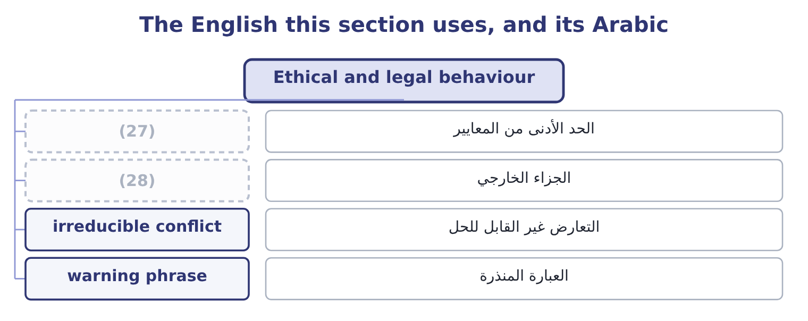
word list
external sanction · management override · minimum standard

The English this sheet uses, and its Arabic
English (exam term) | Arabic
minimum standard | الحد الأدنى من المعايير
external sanction | الجزاء الخارجي
irreducible conflict | التعارض غير القابل للحل
warning phrase | العبارة المنذرة

Answer key · 15.3 Ethical and legal behaviour

1 outcome | 15 A facilitation payment
2 differences | 16 Bribery to win a contract
3 Everything | 17 further
4 indefensible | 18 examiners
5 compliance | 19 requirement
6 objective | 20 obligation
7 externally | 21 information
8 professionally | 22 confidence
9 illegality | 23 resolution
10 reputation | 24 irreducible
11 specific | 25 reliable
12 backward-looking | 26 business
13 Ordinary trading on agreed terms | 27 minimum standard
14 Refuse; the law is not the standard | 28 external sanction

the summaries in full
Summary 1 The outcome asks for the differences, and four of them matter. Law is a floor; ethics is a standard. Everything the law forbids is unethical in the ordinary case, but a great deal that is lawful is not ethical: a contract term enforced against a party who did not understand it, a redundancy handled lawfully and brutally, a marketing claim technically true and designed to mislead, a tax structure that is legal and indefensible in public. Legal compliance is the minimum, not the objective. Law is enforced externally; ethics is enforced internally and professionally. The sanction for illegality is a court; the sanction for unethical conduct is reputation, professional membership, trust and the loss of people who will not work for the company. Law is specific, codified and backward-looking. It names acts, in writing, after a problem has been recognised. Ethics applies to situations no rule has contemplated — new technologies, new markets, new products — and it operates before the law catches up. And law varies by jurisdiction; core ethical values are held to be the same everywhere, which is section 15.2's point.
Summary 2 Two further points the examiners use. A legal requirement can conflict with an ethical obligation. A local law requiring disclosure of information a professional holds in confidence, or forbidding the employment of a group the company's values require it to treat equally, puts the two in direct conflict. The resolution is legal advice, escalation and, where the conflict is irreducible, a decision about whether to operate there at all. And "it is not illegal" is the most reliable warning phrase in business. It is almost never offered about a decision that is comfortable, and a professional who hears it should ask what the speaker thinks the ethical objection is, since they have evidently thought of one.

15.4 Ethics and internal control
Chapter 15 · section 15.4

Fill every gap. Each word list holds one word more than there are gaps.
Summary 1 gaps 1–12
The third (1) asks for the relationship (2) ethics and internal control, and it runs in both (3) . Ethics is the (4) of internal control. COSO's internal control framework puts the control (5) first among its five (6) and makes a commitment to integrity and ethical values its first principle, for a reason: every control is performed by somebody, and a control performed by somebody willing to subvert it is not a control. Controls can be (7) . (8) override is the most common way serious control failures occur and the hardest to prevent, because the person (9) has the authority to do so. No amount of control design addresses it; what addresses it is a culture in which an override is (10) and a route by which the question reaches somebody (11) . Controls can be circumvented by (12) .
word list
overriding · environment · Management · components · collusion · foundation · directions · override · questioned · between · outcome · independent · overridden

Summary 2 gaps 13–24
Segregation of duties works because two people must agree, and it fails when they do. The defence is ethical and (13) as much as (14) . And controls that are not (15) in are not performed. A (16) signed without being done, an approval given without being considered, a supplier review completed from memory: these are the ordinary way a control framework hollows out, and nothing in the (17) reveals it. Internal control supports ethical (18) . The relationship runs back the other way too, and this half is as (19) . Controls remove (20) , which is one side of, and they remove it from honest people as well as (21) ones. Segregation of duties protects the person who handles cash from (22) as much as it protects the cash. Controls make the (23) concrete. A code that says "we do not accept (24) gifts" is interpreted; a control that requires every gift above a value to be recorded in a register that somebody reviews is not.
word list
examinable · dishonest · procedural · standard · reconciliation · behaviour · cultural · overriding · believed · documentation · inappropriate · suspicion · opportunity

Summary 3 gaps 25–33
Controls (25) the record on which (26) depends —. And controls (27) the pressure on (28) courage. A (29) who can point to a rule, a (30) or a required approval is in a far stronger position than one who must refuse on personal judgment alone, and that is one of the most practical arguments for having written policies at all. The two together produce the (31) the exam wants: neither ethics nor control is (32) alone. Controls without ethics are a structure people work around; ethics without controls is a good intention with no record, no (33) and no protection for the person who has to say no.
word list
threshold · reduce · sufficient · conclusion · integrity · professional · individual · consistency · create · accountability

The English this section uses, and its Arabic
Each term sits against what it means.
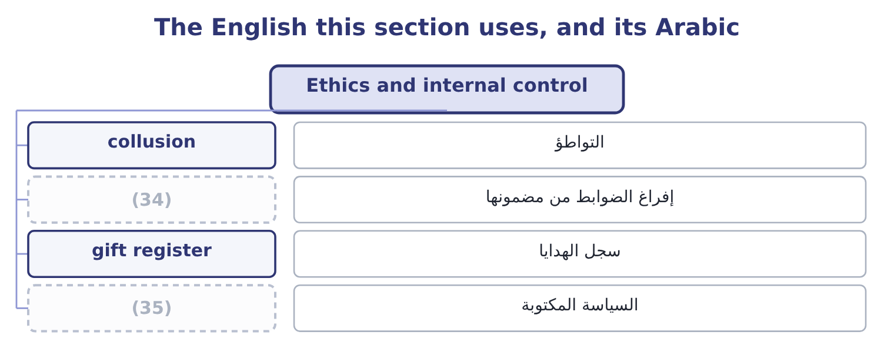
word list
warning phrase · written policy · hollowing out

The English this sheet uses, and its Arabic
English (exam term) | Arabic
collusion | التواطؤ
hollowing out | إفراغ الضوابط من مضمونها
gift register | سجل الهدايا
written policy | السياسة المكتوبة

Answer key · 15.4 Ethics and internal control

1 outcome | 19 examinable
2 between | 20 opportunity
3 directions | 21 dishonest
4 foundation | 22 suspicion
5 environment | 23 standard
6 components | 24 inappropriate
7 overridden | 25 create
8 Management | 26 accountability
9 overriding | 27 reduce
10 questioned | 28 individual
11 independent | 29 professional
12 collusion | 30 threshold
13 cultural | 31 conclusion
14 procedural | 32 sufficient
15 believed | 33 consistency
16 reconciliation | 34 hollowing out
17 documentation | 35 written policy
18 behaviour

the summaries in full
Summary 1 The third outcome asks for the relationship between ethics and internal control, and it runs in both directions. Ethics is the foundation of internal control. COSO's internal control framework puts the control environment first among its five components and makes a commitment to integrity and ethical values its first principle, for a reason: every control is performed by somebody, and a control performed by somebody willing to subvert it is not a control. Controls can be overridden. Management override is the most common way serious control failures occur and the hardest to prevent, because the person overriding has the authority to do so. No amount of control design addresses it; what addresses it is a culture in which an override is questioned and a route by which the question reaches somebody independent. Controls can be circumvented by collusion.
Summary 2 Segregation of duties works because two people must agree, and it fails when they do. The defence is ethical and cultural as much as procedural. And controls that are not believed in are not performed. A reconciliation signed without being done, an approval given without being considered, a supplier review completed from memory: these are the ordinary way a control framework hollows out, and nothing in the documentation reveals it. Internal control supports ethical behaviour. The relationship runs back the other way too, and this half is as examinable. Controls remove opportunity, which is one side of, and they remove it from honest people as well as dishonest ones. Segregation of duties protects the person who handles cash from suspicion as much as it protects the cash. Controls make the standard concrete. A code that says "we do not accept inappropriate gifts" is interpreted; a control that requires every gift above a value to be recorded in a register that somebody reviews is not.
Summary 3 Controls create the record on which accountability depends —. And controls reduce the pressure on individual courage. A professional who can point to a rule, a threshold or a required approval is in a far stronger position than one who must refuse on personal judgment alone, and that is one of the most practical arguments for having written policies at all. The two together produce the conclusion the exam wants: neither ethics nor control is sufficient alone. Controls without ethics are a structure people work around; ethics without controls is a good intention with no record, no consistency and no protection for the person who has to say no.

15.5 Designing for both
Chapter 15 · section 15.5

Fill every gap. Each word list holds one word more than there are gaps.
Summary 1 gaps 1–12
What a company actually does with all of this falls into five (1) measures, and an exam answer that offers them is answering the outcome rather than (2) it. A code of conduct that is (3) where it matters. For the (4) case specifically, the code should name the zero-tolerance (5) explicitly, state that it applies to agents and partners, and say what to do when local law and the code conflict. Controls designed with the local (6) in mind. A (7) of duties that assumes six people in a finance function cannot be applied in an office of three, and (8) otherwise produces a documented control nobody performs. The answer is a different control — review by the (9) office, a payment approval held (10) , a rotation — not a fiction. Due diligence on third parties, (11) to the risk, with (12) rights to audit and to terminate.
word list
pretending · describing · categories · practical · international · centrally · regional · segregation · proportionate · authority · situation · specific · contractual

Summary 2 gaps 13–21
The agent is the (13) , and the contract is where it is (14) . A reporting route that works locally: in the local language, available to people who do not have company email, free of the (15) that a concern will reach the person it concerns, and with a (16) history of being used without (17) . And training in (18) rather than rules. The useful training is the one that works through the shipment held at the port, the gift at the new year, the customer who asks for an (19) with a different date — (20) those are the forms in which the (21) arrives.
word list
consequence · expectation · managed · exposure · demonstrated · otherwise · situations · problem · because · invoice

Worked example: the shipment at the port

Summary 3 gaps 22–33
A consignment of 450,000 is held at a port, and the official (22) indicates that it will be cleared (23) on payment of 2,000 in cash, which is customary. The cost of (24) . Every day the consignment is held costs Orontes about 46,027 of contribution, so a five-day delay is 46,027 × 5 = 230,135 — more than a (25) times the payment, which is (26) only 2,000 ÷ 450,000 = 0.44 per cent of the (27) value. Why the arithmetic is (28) . The payment is a bribe under the laws of, which reach Orontes wherever it operates; it is a zero-tolerance category under the appetite (29) ; and the moment it is made once, the company has (30) that it pays, and the price and the (31) will both rise. Refuse, clearly and (32) , and say that the company is not (33) to make such payments.
word list
actually · statement · politely · established · itself · refusing · frequency · permitted · responsible · shipment's · hundred · irrelevant · promptly

Summary 4 gaps 34–43
Escalate within the port (34) and to the company's local (35) . (36) the customer, who may have (37) . Record the (38) in writing and report it through the company's own (39) . Expect the delay and plan for it, which is a supply chain (40) : buffer stock, earlier shipment, a different port, or a freight agent with a (41) record. Note the shape of the answer. The refusal is the easy half; the (42) half is that somebody must bear the 230,135 and must not be (43) for it. A company whose local manager is measured on delivery performance and told to refuse facilitation payments has created exactly the pressure of, and it will get what it has designed for.
word list
standing · authority · counsel · practical · difficult · demonstrable · Involve · decision · demand · channel · penalised

Borders, law and control

Your turn: values and controls (complete the blanks)
Item | Data | Answer
A payment to an official to do what they already must do | Customary locally; 2,000 on a 450,000 shipment | ________
The position that local acceptance determines the standard | (44) | ________
What distinguishes core values from local practice | (45) | ________
The relationship between law and ethics | Much that is lawful is not ethical | ________
Cost of a five-day delay in contribution | 46,027 a day | ________
What makes controls fail despite good design | (46) | ________

word list
"When in Rome" · core value · Bribery against negotiating style · Three mechanisms

"When in Rome", "grease" and "gift"

Summary 5 gaps 47–56
Three English (47) do a great deal of quiet work in this area. Grease payment is the (48) term for a facilitation payment, and the (49) is doing the arguing: grease makes (50) run smoothly and sounds harmless, which is the opposite of what the laws. And gift is the most elastic word of all, covering a calendar, a dinner, a holiday and a payment; English practice in codes of conduct is (51) to abandon the word and specify — anything of value, including (52) , travel, services and offers of (53) to relatives. When writing or (54) a code, look for the (55) ; where a code says only " (56) gifts", nobody has yet decided anything.
word list
hospitality · machinery · specifics · expressions · informal · reading · shipment · employment · metaphor · therefore · inappropriate

"When in Rome", "grease" and "gift"
Item | Answer
A payment for a duty already owed | A facilitation payment, prohibited under anti-bribery laws.
The position that local acceptance sets the standard | (57)
Core values against local practice | Core values do not vary; local practice may, where no core value is engaged.
Law and ethics | Law is a floor; ethics is the standard, and much that is lawful is unethical.
Cost of a five-day delay | (58)
Why well-designed controls fail | Override, collusion, and controls performed without belief.
What it tells you | Five of the six are about judgment and one is arithmetic — and the arithmetic exists to show exactly why the judgment has to be made in adva

word list
230,135: 46,027 × 5 = 230,135. · management override · Cultural relativism.

The English this section uses, and its Arabic
Each term sits against what it means.
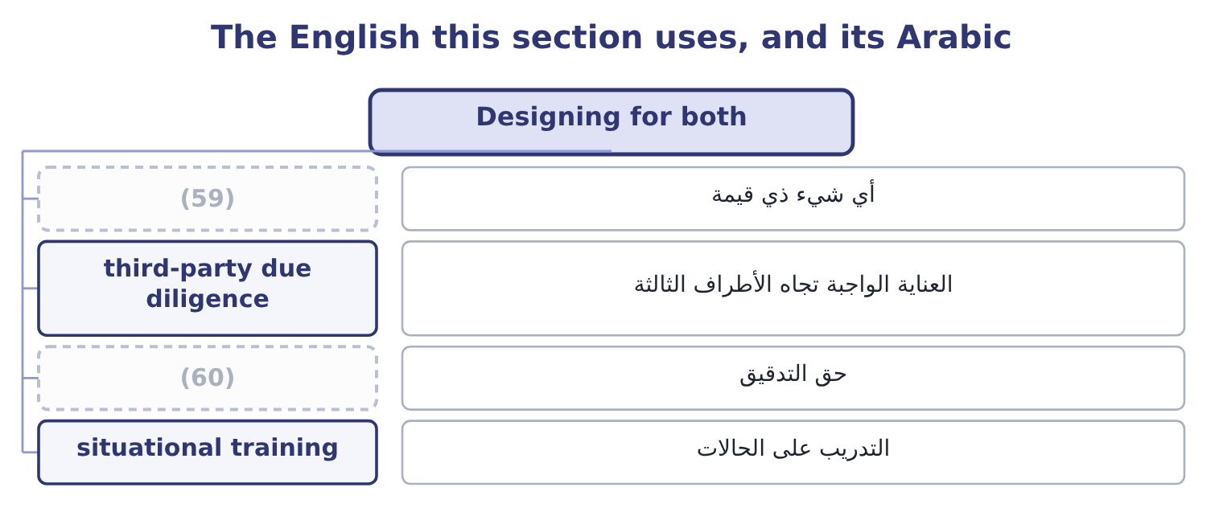
word list
supply chain conduct · right to audit · anything of value

The English this sheet uses, and its Arabic
English (exam term) | Arabic
anything of value | أي شيء ذي قيمة
third-party due diligence | العناية الواجبة تجاه الأطراف الثالثة
right to audit | حق التدقيق
situational training | التدريب على الحالات

Answer key · 15.5 Designing for both

1 practical | 31 frequency
2 describing | 32 politely
3 specific | 33 permitted
4 international | 34 authority
5 categories | 35 counsel
6 situation | 36 Involve
7 segregation | 37 standing
8 pretending | 38 demand
9 regional | 39 channel
10 centrally | 40 decision
11 proportionate | 41 demonstrable
12 contractual | 42 difficult
13 exposure | 43 penalised
14 managed | 44 "When in Rome"
15 expectation | 45 Bribery against negotiating style
16 demonstrated | 46 Three mechanisms
17 consequence | 47 expressions
18 situations | 48 informal
19 invoice | 49 metaphor
20 because | 50 machinery
21 problem | 51 therefore
22 responsible | 52 hospitality
23 promptly | 53 employment
24 refusing | 54 reading
25 hundred | 55 specifics
26 itself | 56 inappropriate
27 shipment's | 57 Cultural relativism.
28 irrelevant | 58 230,135: 46,027 × 5 = 230,135.
29 statement | 59 anything of value
30 established | 60 right to audit

the summaries in full
Summary 1 What a company actually does with all of this falls into five practical measures, and an exam answer that offers them is answering the outcome rather than describing it. A code of conduct that is specific where it matters. For the international case specifically, the code should name the zero-tolerance categories explicitly, state that it applies to agents and partners, and say what to do when local law and the code conflict. Controls designed with the local situation in mind. A segregation of duties that assumes six people in a finance function cannot be applied in an office of three, and pretending otherwise produces a documented control nobody performs. The answer is a different control — review by the regional office, a payment approval held centrally, a rotation — not a fiction. Due diligence on third parties, proportionate to the risk, with contractual rights to audit and to terminate.
Summary 2 The agent is the exposure, and the contract is where it is managed. A reporting route that works locally: in the local language, available to people who do not have company email, free of the expectation that a concern will reach the person it concerns, and with a demonstrated history of being used without consequence. And training in situations rather than rules. The useful training is the one that works through the shipment held at the port, the gift at the new year, the customer who asks for an invoice with a different date — because those are the forms in which the problem arrives.
Summary 3 A consignment of 450,000 is held at a port, and the official responsible indicates that it will be cleared promptly on payment of 2,000 in cash, which is customary. The cost of refusing. Every day the consignment is held costs Orontes about 46,027 of contribution, so a five-day delay is 46,027 × 5 = 230,135 — more than a hundred times the payment, which is itself only 2,000 ÷ 450,000 = 0.44 per cent of the shipment's value. Why the arithmetic is irrelevant. The payment is a bribe under the laws of, which reach Orontes wherever it operates; it is a zero-tolerance category under the appetite statement; and the moment it is made once, the company has established that it pays, and the price and the frequency will both rise. Refuse, clearly and politely, and say that the company is not permitted to make such payments.
Summary 4 Escalate within the port authority and to the company's local counsel. Involve the customer, who may have standing. Record the demand in writing and report it through the company's own channel. Expect the delay and plan for it, which is a supply chain decision: buffer stock, earlier shipment, a different port, or a freight agent with a demonstrable record. Note the shape of the answer. The refusal is the easy half; the difficult half is that somebody must bear the 230,135 and must not be penalised for it. A company whose local manager is measured on delivery performance and told to refuse facilitation payments has created exactly the pressure of, and it will get what it has designed for.
Summary 5 Three English expressions do a great deal of quiet work in this area. Grease payment is the informal term for a facilitation payment, and the metaphor is doing the arguing: grease makes machinery run smoothly and sounds harmless, which is the opposite of what the laws. And gift is the most elastic word of all, covering a calendar, a dinner, a holiday and a payment; English practice in codes of conduct is therefore to abandon the word and specify — anything of value, including hospitality, travel, services and offers of employment to relatives. When writing or reading a code, look for the specifics; where a code says only "inappropriate gifts", nobody has yet decided anything.

16.1 What corporate culture is
Chapter 16 · section 16.1

Fill every gap. Each word list holds one word more than there are gaps.
Chapter 16, section by section
Each stage leads to the next.
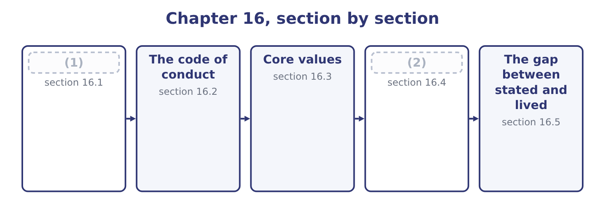
word list
What corporate culture is · What ethical values are worth · The code of conduct

Summary 1 gaps 3–14
Corporate culture is the set of shared assumptions, values and (3) that determine how people in an organisation behave — (4) when no rule covers the situation and nobody is watching. Four features of the (5) are examinable. It is about what is shared. An (6) conscience is not culture; culture is what people believe about each (7) behaviour and about what the organisation expects. Its strongest (8) is the phrase "that is how things are done here", which no (9) produces. It (10) where rules do not. A rule tells you what to do in a situation somebody (11) . Culture decides (12) else, which is most of what (13) . It is learned, chiefly by (14) . New employees learn the culture from what they see rewarded, tolerated and punished in their first weeks, not from the induction pack.
word list
norms · everything · expression · document · observation · other's · happens · individual's · because · definition · particularly · operates · anticipated

Summary 2 gaps 15–26
A single visible (15) teaches more than a year of (16) . And it (17) whether or not anybody (18) it. Every organisation has a culture; the only question is whether it is the one the board (19) it has. Three levels are worth (20) , because an exam question that asks why a company with good values (21) badly is asking about the gap between them. (22) : what can be seen — the office, the (23) , the language, the documents, the code on the wall. (24) values: what the company says it believes, in its (25) and its code. (26) assumptions: what people actually believe about how the organisation works — whether bad news is welcome, whether the rules apply to everybody, whether a refusal will be supported. This level determines behaviour and it is invisible in documentation.
word list
exists · punished · hierarchy · Espoused · Underlying · distinguishing · Artefacts · behaves · designed · training · inconsistency · thinks · statements

Summary 3 gaps 27–33
How culture shapes ethical (27) , which is the first outcome's second half, runs through four (28) . It (29) what is normal, and most people do what is normal. The strongest predictor of whether somebody will do something (30) is whether they believe others around them do it. It determines what can be said. A culture in which raising a problem is treated as (31) produces silence, and silence is where every large failure begins. It sets the cost of (32) . And it supplies or removes (33) .
word list
examinable · refusing · mechanisms · questionable · decisions · disloyalty · rationalisations · defines

The English this section uses, and its Arabic
Each term sits against what it means.
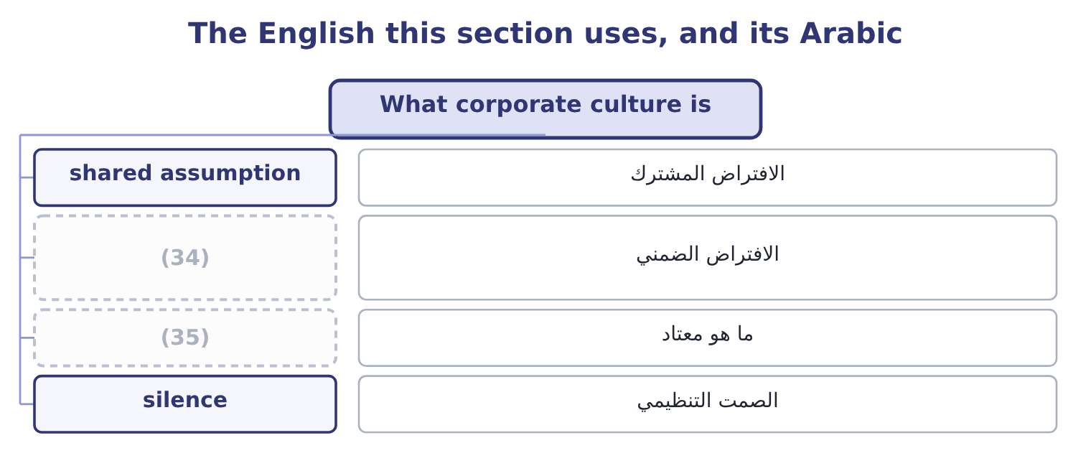
word list
cost of control · underlying assumption · what is normal

The English this sheet uses, and its Arabic
English (exam term) | Arabic
shared assumption | الافتراض المشترك
underlying assumption | الافتراض الضمني
what is normal | ما هو معتاد
silence | الصمت التنظيمي

Answer key · 16.1 What corporate culture is

1 What corporate culture is | 19 thinks
2 What ethical values are worth | 20 distinguishing
3 norms | 21 behaves
4 particularly | 22 Artefacts
5 definition | 23 hierarchy
6 individual's | 24 Espoused
7 other's | 25 statements
8 expression | 26 Underlying
9 document | 27 decisions
10 operates | 28 mechanisms
11 anticipated | 29 defines
12 everything | 30 questionable
13 happens | 31 disloyalty
14 observation | 32 refusing
15 inconsistency | 33 rationalisations
16 training | 34 underlying assumption
17 exists | 35 what is normal
18 designed

the summaries in full
Summary 1 Corporate culture is the set of shared assumptions, values and norms that determine how people in an organisation behave — particularly when no rule covers the situation and nobody is watching. Four features of the definition are examinable. It is about what is shared. An individual's conscience is not culture; culture is what people believe about each other's behaviour and about what the organisation expects. Its strongest expression is the phrase "that is how things are done here", which no document produces. It operates where rules do not. A rule tells you what to do in a situation somebody anticipated. Culture decides everything else, which is most of what happens. It is learned, chiefly by observation. New employees learn the culture from what they see rewarded, tolerated and punished in their first weeks, not from the induction pack.
Summary 2 A single visible inconsistency teaches more than a year of training. And it exists whether or not anybody designed it. Every organisation has a culture; the only question is whether it is the one the board thinks it has. Three levels are worth distinguishing, because an exam question that asks why a company with good values behaves badly is asking about the gap between them. Artefacts: what can be seen — the office, the hierarchy, the language, the documents, the code on the wall. Espoused values: what the company says it believes, in its statements and its code. Underlying assumptions: what people actually believe about how the organisation works — whether bad news is welcome, whether the rules apply to everybody, whether a refusal will be supported. This level determines behaviour and it is invisible in documentation.
Summary 3 How culture shapes ethical decisions, which is the first outcome's second half, runs through four mechanisms. It defines what is normal, and most people do what is normal. The strongest predictor of whether somebody will do something questionable is whether they believe others around them do it. It determines what can be said. A culture in which raising a problem is treated as disloyalty produces silence, and silence is where every large failure begins. It sets the cost of refusing. And it supplies or removes rationalisations.

16.2 The code of conduct
Chapter 16 · section 16.2

Fill every gap. Each word list holds one word more than there are gaps.
Summary 1 gaps 1–12
A code of conduct is the written (1) of the standards of behaviour an (2) expects of its people. The (3) asks why it matters and how it contributes to culture, and both have specific (4) . Why it matters, in six (5) . It makes the standard (6) , so that nobody has to guess and nobody can claim they did not know. It (7) the hard cases in advance, when nobody is under (8) . A gift (9) decided in January is a rule; the same question decided in December, with a contract pending, is a (10) . It supports the (11) . It tells outsiders what to expect — customers, suppliers, agents and regulators — and it becomes a contractual standard when it is (12) into agreements. It is the basis for consistent enforcement. And it is increasingly expected by law, by listing rules and by customers' own procurement requirements, so its absence is itself a finding.
word list
outcome · explicit · answers · individual · settles · threshold · organisation · pressure · incorporated · protection · negotiation · points · statement

Summary 2 gaps 13–24
What makes a code (13) , which is the half (14) omit. It is specific where (15) matters. It covers the situations people actually meet: gifts and (16) , conflicts of interest, outside employment, use of company assets and information, accuracy of records and reports, safety, (17) and harassment, dealings with officials, competition and customer dealings, and the use of personal data. It says what to do when (18) is unclear or wrong — whom to ask, whom to tell, and what (19) exists. A code with standards and no route is half a code. It (20) to everybody, with the senior people named first rather than (21) , and it says so. It is short enough to be read and written in language the people bound by it use, (22) properly for every country, and (23) to people who do not sit at a desk. It is reinforced by training in situations, by annual (24) , and by visible enforcement. And it is reviewed when the business changes — a new market, a new channel, a new technology — because a code that does not mention the thing everybody is doing is already out of date.
word list
protection · hospitality · something · applies · acknowledgement · discrimination · exempted · translated · records · effective · specificity · available · candidates

Summary 3 gaps 25–30
How it contributes to culture is then (25) : it converts espoused values into specific (26) , it removes ambiguity that (27) feeds on, and — provided it is enforced — it demonstrates that the espoused values and the underlying assumptions are the same thing. Where it is not enforced, it does the (28) , and a code that is visibly ignored is worse than none, because it teaches that the company's (29) are not to be taken (30) .
word list
rationalisation · seriously · individual · statements · opposite · expectations · straightforward

The English this section uses, and its Arabic
Each term sits against what it means.
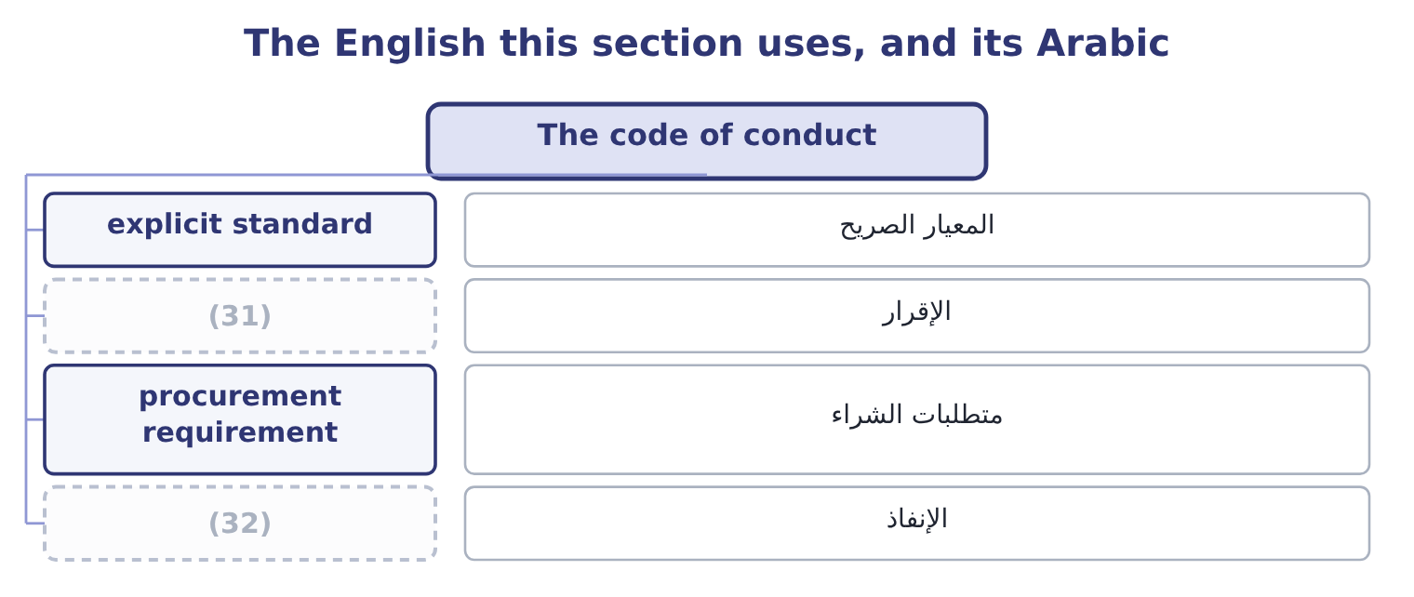
word list
self-reporting · acknowledgement · enforcement

The English this sheet uses, and its Arabic
English (exam term) | Arabic
explicit standard | المعيار الصريح
acknowledgement | الإقرار
procurement requirement | متطلبات الشراء
enforcement | الإنفاذ

Answer key · 16.2 The code of conduct

1 statement | 17 discrimination
2 organisation | 18 something
3 outcome | 19 protection
4 answers | 20 applies
5 points | 21 exempted
6 explicit | 22 translated
7 settles | 23 available
8 pressure | 24 acknowledgement
9 threshold | 25 straightforward
10 negotiation | 26 expectations
11 individual | 27 rationalisation
12 incorporated | 28 opposite
13 effective | 29 statements
14 candidates | 30 seriously
15 specificity | 31 acknowledgement
16 hospitality | 32 enforcement

the summaries in full
Summary 1 A code of conduct is the written statement of the standards of behaviour an organisation expects of its people. The outcome asks why it matters and how it contributes to culture, and both have specific answers. Why it matters, in six points. It makes the standard explicit, so that nobody has to guess and nobody can claim they did not know. It settles the hard cases in advance, when nobody is under pressure. A gift threshold decided in January is a rule; the same question decided in December, with a contract pending, is a negotiation. It supports the individual. It tells outsiders what to expect — customers, suppliers, agents and regulators — and it becomes a contractual standard when it is incorporated into agreements. It is the basis for consistent enforcement. And it is increasingly expected by law, by listing rules and by customers' own procurement requirements, so its absence is itself a finding.
Summary 2 What makes a code effective, which is the half candidates omit. It is specific where specificity matters. It covers the situations people actually meet: gifts and hospitality, conflicts of interest, outside employment, use of company assets and information, accuracy of records and reports, safety, discrimination and harassment, dealings with officials, competition and customer dealings, and the use of personal data. It says what to do when something is unclear or wrong — whom to ask, whom to tell, and what protection exists. A code with standards and no route is half a code. It applies to everybody, with the senior people named first rather than exempted, and it says so. It is short enough to be read and written in language the people bound by it use, translated properly for every country, and available to people who do not sit at a desk. It is reinforced by training in situations, by annual acknowledgement, and by visible enforcement. And it is reviewed when the business changes — a new market, a new channel, a new technology — because a code that does not mention the thing everybody is doing is already out of date.
Summary 3 How it contributes to culture is then straightforward: it converts espoused values into specific expectations, it removes ambiguity that rationalisation feeds on, and — provided it is enforced — it demonstrates that the espoused values and the underlying assumptions are the same thing. Where it is not enforced, it does the opposite, and a code that is visibly ignored is worse than none, because it teaches that the company's statements are not to be taken seriously.

16.3 Core values
Chapter 16 · section 16.3

Fill every gap. Each word list holds one word more than there are gaps.
Summary 1 gaps 1–12
Core values are the small number of (1) an organisation treats as (2) — the ones that do not change with the (3) , the market or the year, and that the code and the culture are both supposed to express. Four tests (4) a core value from a (5) , and an exam answer that gives them is (6) the outcome. Would we hold it even if it cost us money? A value that is (7) the first time it is (8) was never core, and the only evidence that a value is real is a decision that was made (9) because of it. Is it specific to us, or would any company say it? "Integrity" appears in almost every (10) values statement, (11) those of companies that have (12) in fraud. A value that nobody would deny is not distinguishing anything.
word list
evidence · collapsed · non-negotiable · abandoned · corporate · expensive · including · strategy · answering · differently · slogan · commitments · distinguish

Summary 2 gaps 13–24
Does it decide anything? A usable value resolves a real (13) : between speed and safety, between a sale and a (14) , between a cost and a supplier's working conditions. And is it few enough to be (15) ? Three to five values are usable; (16) are a list nobody can recall, which means they cannot be applied at the moment of decision. How core values promote ethical (17) , which is the (18) second half, works through four channels. They give a (19) , not just a rule. A code says what to do; a value says why, which is what allows somebody to extend it to a (20) the code did not (21) . They are a decision filter under (22) . At the point where, a value that has been stated, (23) and visibly applied is (24) as a reference; one that has not is not. They are the basis of consistency, across countries. And they attract and retain the people who share them, which over time changes who the organisation consists of — the slowest and most powerful mechanism of all.
word list
situation · remembered · attract · pressure · trade-off · behaviour · disclosure · repeated · outcome's · reason · anticipate · twelve · available

Summary 3 gaps 25–29
Orontes's are an (25) worth having in mind: we do not sell what we would not eat; we tell the (26) before they find out; we pay (27) on the day we agreed; and nobody is asked to do something they would have to hide. Each of those (28) something, each is (29) of costing money, and none of them is "integrity".
word list
customer · capable · illustration · decides · repeated · suppliers

The English this section uses, and its Arabic
Each term sits against what it means.
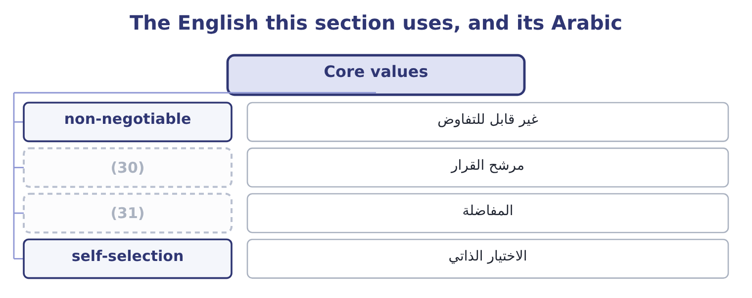
word list
decision filter · silence · trade-off

The English this sheet uses, and its Arabic
English (exam term) | Arabic
non-negotiable | غير قابل للتفاوض
decision filter | مرشح القرار
trade-off | المفاضلة
self-selection | الاختيار الذاتي

Answer key · 16.3 Core values

1 commitments | 17 behaviour
2 non-negotiable | 18 outcome's
3 strategy | 19 reason
4 distinguish | 20 situation
5 slogan | 21 anticipate
6 answering | 22 pressure
7 abandoned | 23 repeated
8 expensive | 24 available
9 differently | 25 illustration
10 corporate | 26 customer
11 including | 27 suppliers
12 collapsed | 28 decides
13 trade-off | 29 capable
14 disclosure | 30 decision filter
15 remembered | 31 trade-off
16 twelve

the summaries in full
Summary 1 Core values are the small number of commitments an organisation treats as non-negotiable — the ones that do not change with the strategy, the market or the year, and that the code and the culture are both supposed to express. Four tests distinguish a core value from a slogan, and an exam answer that gives them is answering the outcome. Would we hold it even if it cost us money? A value that is abandoned the first time it is expensive was never core, and the only evidence that a value is real is a decision that was made differently because of it. Is it specific to us, or would any company say it? "Integrity" appears in almost every corporate values statement, including those of companies that have collapsed in fraud. A value that nobody would deny is not distinguishing anything.
Summary 2 Does it decide anything? A usable value resolves a real trade-off: between speed and safety, between a sale and a disclosure, between a cost and a supplier's working conditions. And is it few enough to be remembered? Three to five values are usable; twelve are a list nobody can recall, which means they cannot be applied at the moment of decision. How core values promote ethical behaviour, which is the outcome's second half, works through four channels. They give a reason, not just a rule. A code says what to do; a value says why, which is what allows somebody to extend it to a situation the code did not anticipate. They are a decision filter under pressure. At the point where, a value that has been stated, repeated and visibly applied is available as a reference; one that has not is not. They are the basis of consistency, across countries. And they attract and retain the people who share them, which over time changes who the organisation consists of — the slowest and most powerful mechanism of all.
Summary 3 Orontes's are an illustration worth having in mind: we do not sell what we would not eat; we tell the customer before they find out; we pay suppliers on the day we agreed; and nobody is asked to do something they would have to hide. Each of those decides something, each is capable of costing money, and none of them is "integrity".

16.4 What ethical values are worth
Chapter 16 · section 16.4

Fill every gap. Each word list holds one word more than there are gaps.
Summary 1 gaps 1–12
The fourth outcome asks for the ways ethical values benefit an organisation, and a good answer runs from the measurable to the (1) rather than (2) with reputation. Lower losses from (3) . Fraud, safety failures, (4) penalties and (5) all fall where conduct standards are real. Lower cost of control. This is the benefit boards find most (6) . A company whose people will not do certain things needs fewer controls to prevent them doing those things, and controls are (7) in money and in friction — approvals, delays, (8) effort. Ethics and control are (9) at the margin as well as (10) . Better retention and recruitment. People leave (11) that ask them to do things they (12) , and the good ones leave first because they can. If Orontes's turnover across 400 employees falls from 18 to 12 per cent, that is 400 × 0.06 = 24 fewer departures, and at a replacement cost of 9,000 each in recruitment, training and lost productivity, 24 × 9,000 = 216,000 a year.
word list
organisations · litigation · duplicated · expensive · misconduct · complements · regulatory · substitutes · beginning · strategic · dislike · surprising · certain

Summary 2 gaps 13–24
Higher (13) and better (14) . In an organisation where bad news is safe to deliver, (15) finds out about (16) early, which is worth more than any control:. Customer and (17) trust, which shows up as retention, as (18) to deal on better terms, and as access to customers whose own (19) standards require it. Lower cost of (20) and better access to it. Regulators and prosecutors in most (21) take compliance programmes, (22) and cooperation into account, and the difference between a penalty for a company with a credible programme and one without is frequently larger than the cost of the programme. And the avoidance of (23) reputational loss, which is last in the list because it is the least measurable and not the least (24) : reputation takes years to build, is lost in days, and is the asset that does not appear on the balance sheet Book 1 analysed.
word list
important · supplier · catastrophic · willingness · engagement · management · capital · jurisdictions · procurement · information · problems · self-reporting · analysed

Summary 3 gaps 25–34
Two honest (25) belong with the list, and strong (26) include them. Most of these benefits are (27) and long-dated, while the costs of ethical (28) are immediate and certain — the 230,135 delay of, the order not taken, the customer not kept. That (29) is exactly, and it is why these (30) must be made on values rather than on a (31) case. And the causation is not one-way: (32) companies can afford better conduct, so some of the observed (33) between ethics and (34) runs backwards. The honest claim is not that ethics pays, but that it costs less than most boards think and that the failures cost very much more.
word list
profitable · business · relationship · asymmetry · decisions · self-selection · answers · performance · probabilistic · qualifications · behaviour

The English this section uses, and its Arabic
Each term sits against what it means.
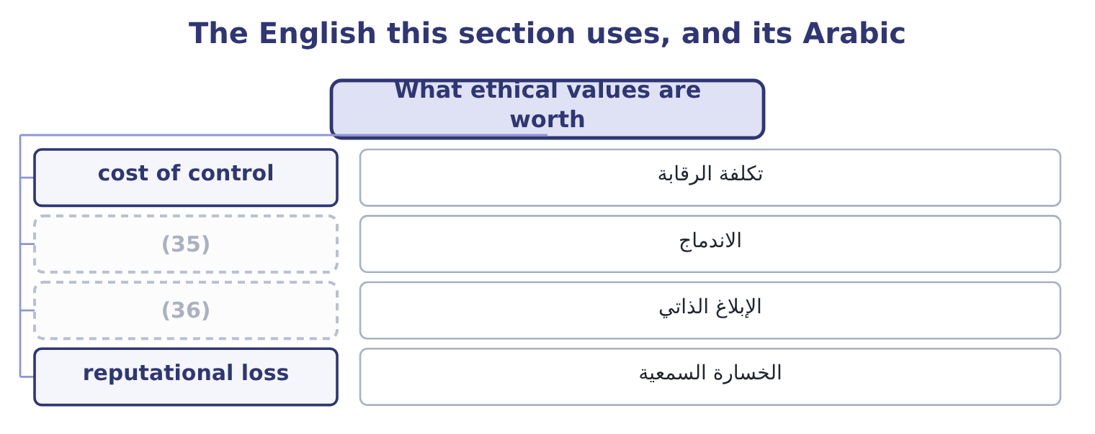
word list
self-reporting · non-negotiable · engagement

The English this sheet uses, and its Arabic
English (exam term) | Arabic
cost of control | تكلفة الرقابة
engagement | الاندماج
self-reporting | الإبلاغ الذاتي
reputational loss | الخسارة السمعية

Answer key · 16.4 What ethical values are worth

1 strategic | 19 procurement
2 beginning | 20 capital
3 misconduct | 21 jurisdictions
4 regulatory | 22 self-reporting
5 litigation | 23 catastrophic
6 surprising | 24 important
7 expensive | 25 qualifications
8 duplicated | 26 answers
9 substitutes | 27 probabilistic
10 complements | 28 behaviour
11 organisations | 29 asymmetry
12 dislike | 30 decisions
13 engagement | 31 business
14 information | 32 profitable
15 management | 33 relationship
16 problems | 34 performance
17 supplier | 35 engagement
18 willingness | 36 self-reporting

the summaries in full
Summary 1 The fourth outcome asks for the ways ethical values benefit an organisation, and a good answer runs from the measurable to the strategic rather than beginning with reputation. Lower losses from misconduct. Fraud, safety failures, regulatory penalties and litigation all fall where conduct standards are real. Lower cost of control. This is the benefit boards find most surprising. A company whose people will not do certain things needs fewer controls to prevent them doing those things, and controls are expensive in money and in friction — approvals, delays, duplicated effort. Ethics and control are substitutes at the margin as well as complements. Better retention and recruitment. People leave organisations that ask them to do things they dislike, and the good ones leave first because they can. If Orontes's turnover across 400 employees falls from 18 to 12 per cent, that is 400 × 0.06 = 24 fewer departures, and at a replacement cost of 9,000 each in recruitment, training and lost productivity, 24 × 9,000 = 216,000 a year.
Summary 2 Higher engagement and better information. In an organisation where bad news is safe to deliver, management finds out about problems early, which is worth more than any control:. Customer and supplier trust, which shows up as retention, as willingness to deal on better terms, and as access to customers whose own procurement standards require it. Lower cost of capital and better access to it. Regulators and prosecutors in most jurisdictions take compliance programmes, self-reporting and cooperation into account, and the difference between a penalty for a company with a credible programme and one without is frequently larger than the cost of the programme. And the avoidance of catastrophic reputational loss, which is last in the list because it is the least measurable and not the least important: reputation takes years to build, is lost in days, and is the asset that does not appear on the balance sheet Book 1 analysed.
Summary 3 Two honest qualifications belong with the list, and strong answers include them. Most of these benefits are probabilistic and long-dated, while the costs of ethical behaviour are immediate and certain — the 230,135 delay of, the order not taken, the customer not kept. That asymmetry is exactly, and it is why these decisions must be made on values rather than on a business case. And the causation is not one-way: profitable companies can afford better conduct, so some of the observed relationship between ethics and performance runs backwards. The honest claim is not that ethics pays, but that it costs less than most boards think and that the failures cost very much more.

16.5 The gap between stated and lived
Chapter 16 · section 16.5

Fill every gap. Each word list holds one word more than there are gaps.
Summary 1 gaps 1–12
Six signs of a gap, each of which can (1) in an exam (2) . The code is (3) and nobody can name three things in it. Values are (4) and no decision can be (5) that was made differently because of them. Discipline is inconsistent between levels or between high and low (6) . Bad news (7) slowly, arrives late, and arrives first from (8) . The people who raise concerns leave, and are described (9) as not having been a good fit. And (10) is measured by completion rates — training completed, (11) signed — rather than by anything about behaviour. (12) the gap is the work of, and three measures belong here. Decide the hard cases visibly. A culture is created by decisions, and the decisions that create it are the ones where the value cost something. Those decisions should be explained, not merely taken: the order declined, the supplier changed, the result reported as it was.
word list
identified · comprehensive · Closing · appear · reaches · outside · compliance · displayed · afterwards · acknowledgements · situation · performers · travels

Summary 2 gaps 13–19
Make the code real at the point of decision. A gift (13) that is reviewed, a conflict (14) that is checked, a tender (15) that has actually (16) somebody. And (17) what matters. Not training completion but: how many concerns were raised, and what happened to them; what (18) of employees say they could raise one; how quickly bad news reaches management; how (19) discipline was applied; and how many decisions were taken that cost money for a stated reason.
word list
consistently · proportion · unreported · measure · declaration · process · register · disqualified

Worked example: reading a culture from the evidence

Summary 3 gaps 20–31
Orontes's code is (20) pages, its values are six, and acknowledgement is at 100 per cent. In the last two years: one employee raised a concern, about car parking; a senior manager's expense (21) ended in a resignation with no (22) , while a warehouse employee was (23) for taking stock worth 400; the inventory (24) stopped for two months and nobody reported it; and the quarterly result has met the forecast to within 1 per cent eleven times running. What the evidence says. One concern in two years from four (25) people is not an absence of (26) ; it is an absence of reporting. The two (27) outcomes teach the whole company which rules apply to whom. The (28) control failure shows that reporting a (29) is not expected behaviour. And eleven (30) within 1 per cent is a statistical (31) that suggests results are being managed.
word list
hundred · quarters · twenty-four · deficiency · announcement · reconciliation · problems · proportion · disciplinary · irregularities · unreported · improbability · dismissed

Summary 4 gaps 32–37
The espoused values and the underlying assumptions are different, and the acknowledgement rate of 100 per cent measures (32) at all. Note that none of the evidence in step 2 is an ethics (33) on its own. Each has an innocent (34) and together they describe a culture. That is how this is (35) in practice and how exam situations are built: no (36) fact, and a (37) .
word list
pattern · assessed · finding · explanation · completion · nothing · single

Culture, code and values

Your turn: what makes it real (complete the blanks)
Item | Data | Answer
What culture governs that rules do not | (38) | ________
The level of culture that actually determines behaviour | Three levels: artefacts, espoused values, and one more | ________
What makes a code provision usable | Compare "act with integrity" with a gift threshold | ________
The only evidence that a value is core | (39) | ________
Fewer departures from a six-point fall in turnover | 400 employees | ________
What that is worth at 9,000 each | (40) | ________

word list
The situations no rule anticipated · Values cost money or they are slogans · Enough specificity to decide an actual case. · Replacement cost per departure 9,000

"Values", "culture" and "tone"

Summary 5 gaps 41–52
Three words that are used (41) and mean different things. Values are what an organisation (42) to; culture is what it does; tone, is what its (43) signal. A company can have good values, a poor culture and an inconsistent tone all at once, and an answer that uses the three as (44) cannot describe the (45) . (46) has a further trap in the word value itself, which in finance means worth and in ethics means commitment — and a (47) such as "our values create value" is doing something slightly (48) , because it suggests the commitment is held for the worth it (49) , which is the (50) of what makes it a commitment. The (51) test in any (52) is the one from section 16.3: name the decision that went the other way because of the value, and if there is none, the word is doing no work.
word list
sentence · English · produces · commits · dishonest · leaders · synonyms · cleanest · reconciliation · loosely · problem · language · opposite

"Values", "culture" and "tone"
Item | Answer
What culture governs | (53)
The level that determines behaviour | Underlying assumptions — what people believe about how the organisation really works.
What makes a code provision usable | Enough specificity to decide an actual case.
The only evidence that a value is core | A decision that went differently, and cost something, because of it.
Fewer departures | 24: 400 × 0.06 = 24.
What that is worth | (54)
What it tells you | Four judgments and one calculation — and the calculation is the smallest of the benefits, which is why the judgments cannot be made on the s

word list
Enough specificity to decide an actual case. · 216,000: 24 × 9,000 = 216,000. · Behaviour where no rule applies and nobody is watching.

The English this section uses, and its Arabic
Each term sits against what it means.
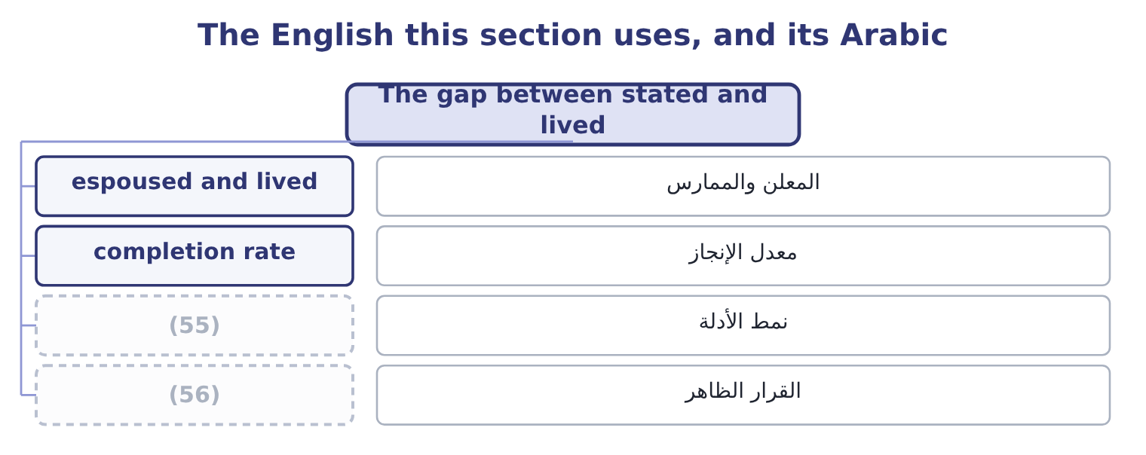
word list
pattern of evidence · espoused value · visible decision

The English this sheet uses, and its Arabic
English (exam term) | Arabic
espoused and lived | المعلن والممارس
completion rate | معدل الإنجاز
pattern of evidence | نمط الأدلة
visible decision | القرار الظاهر

Answer key · 16.5 The gap between stated and lived

1 appear | 29 deficiency
2 situation | 30 quarters
3 comprehensive | 31 improbability
4 displayed | 32 nothing
5 identified | 33 finding
6 performers | 34 explanation
7 travels | 35 assessed
8 outside | 36 single
9 afterwards | 37 pattern
10 compliance | 38 The situations no rule anticipated
11 acknowledgements | 39 Values cost money or they are slogans
12 Closing | 40 Replacement cost per departure 9,000
13 register | 41 loosely
14 declaration | 42 commits
15 process | 43 leaders
16 disqualified | 44 synonyms
17 measure | 45 problem
18 proportion | 46 English
19 consistently | 47 sentence
20 twenty-four | 48 dishonest
21 irregularities | 49 produces
22 announcement | 50 opposite
23 dismissed | 51 cleanest
24 reconciliation | 52 language
25 hundred | 53 Behaviour where no rule applies and nobody is watching.
26 problems | 54 216,000: 24 × 9,000 = 216,000.
27 disciplinary | 55 pattern of evidence
28 unreported | 56 visible decision

the summaries in full
Summary 1 Six signs of a gap, each of which can appear in an exam situation. The code is comprehensive and nobody can name three things in it. Values are displayed and no decision can be identified that was made differently because of them. Discipline is inconsistent between levels or between high and low performers. Bad news travels slowly, arrives late, and arrives first from outside. The people who raise concerns leave, and are described afterwards as not having been a good fit. And compliance is measured by completion rates — training completed, acknowledgements signed — rather than by anything about behaviour. Closing the gap is the work of, and three measures belong here. Decide the hard cases visibly. A culture is created by decisions, and the decisions that create it are the ones where the value cost something. Those decisions should be explained, not merely taken: the order declined, the supplier changed, the result reported as it was.
Summary 2 Make the code real at the point of decision. A gift register that is reviewed, a conflict declaration that is checked, a tender process that has actually disqualified somebody. And measure what matters. Not training completion but: how many concerns were raised, and what happened to them; what proportion of employees say they could raise one; how quickly bad news reaches management; how consistently discipline was applied; and how many decisions were taken that cost money for a stated reason.
Summary 3 Orontes's code is twenty-four pages, its values are six, and acknowledgement is at 100 per cent. In the last two years: one employee raised a concern, about car parking; a senior manager's expense irregularities ended in a resignation with no announcement, while a warehouse employee was dismissed for taking stock worth 400; the inventory reconciliation stopped for two months and nobody reported it; and the quarterly result has met the forecast to within 1 per cent eleven times running. What the evidence says. One concern in two years from four hundred people is not an absence of problems; it is an absence of reporting. The two disciplinary outcomes teach the whole company which rules apply to whom. The unreported control failure shows that reporting a deficiency is not expected behaviour. And eleven quarters within 1 per cent is a statistical improbability that suggests results are being managed.
Summary 4 The espoused values and the underlying assumptions are different, and the acknowledgement rate of 100 per cent measures nothing at all. Note that none of the evidence in step 2 is an ethics finding on its own. Each has an innocent explanation and together they describe a culture. That is how this is assessed in practice and how exam situations are built: no single fact, and a pattern.
Summary 5 Three words that are used loosely and mean different things. Values are what an organisation commits to; culture is what it does; tone, is what its leaders signal. A company can have good values, a poor culture and an inconsistent tone all at once, and an answer that uses the three as synonyms cannot describe the problem. English has a further trap in the word value itself, which in finance means worth and in ethics means commitment — and a sentence such as "our values create value" is doing something slightly dishonest, because it suggests the commitment is held for the worth it produces, which is the opposite of what makes it a commitment. The cleanest test in any language is the one from section 16.3: name the decision that went the other way because of the value, and if there is none, the word is doing no work.

17.1 Tone at the top
Chapter 17 · section 17.1

Fill every gap. Each word list holds one word more than there are gaps.
Chapter 17, section by section
Each stage leads to the next.
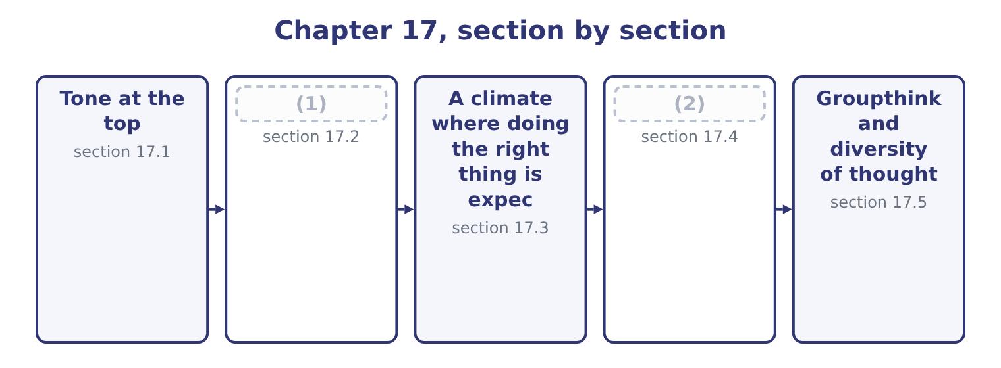
word list
second-chance meeting · Ethical leadership and its traits · Training

Summary 1 gaps 3–14
Tone at the top is the ethical (3) that senior management and the board send through what they say, what they do and what they (4) . The outcome calls it (5) by example, which is the mechanism: people take their standard from what they observe at the top of the (6) , not from what they are told. Four reasons it is (7) , and an answer that gives them is (8) the outcome rather than quoting the phrase. It sets the (9) point for what is (10) . It is the only (11) against management (12) . It (13) whether bad news (14) . A chief executive who reacts badly to problems will be told fewer of them. And it is read from small things. Expenses, punctuality, how a junior employee is spoken to, whether the leader takes the parking space, what happens to the person who disagrees in a meeting.
word list
concealment · travels · tolerate · determines · leadership · override · defence · signal · reference · organisation · decisive · answering · normal

Summary 2 gaps 15–26
Employees are extremely good at reading these signals and extremely quick to (15) formal statements that (16) with them. Three (17) of tone are worth naming, because (18) are written around them. The (19) leader, whose statements are correct and whose (20) are not. This is the most (21) case: the gap itself becomes the lesson, and people conclude that the statements are a (22) . The absent leader, who says (23) about conduct at all, (24) every manager to infer a standard. Silence is not neutral; it is read as (25) , and in a company under pressure it is read as (26) . And the leader who sets targets that cannot be met honestly and then speaks about integrity. That is, delivered with a disclaimer, and it produces precisely the conduct it warns against.
word list
situations · damaging · nothing · decisions · failures · inconsistent · permission · performance · indifference · discount · conflict · override · leaving

The English this section uses, and its Arabic
Each term sits against what it means.
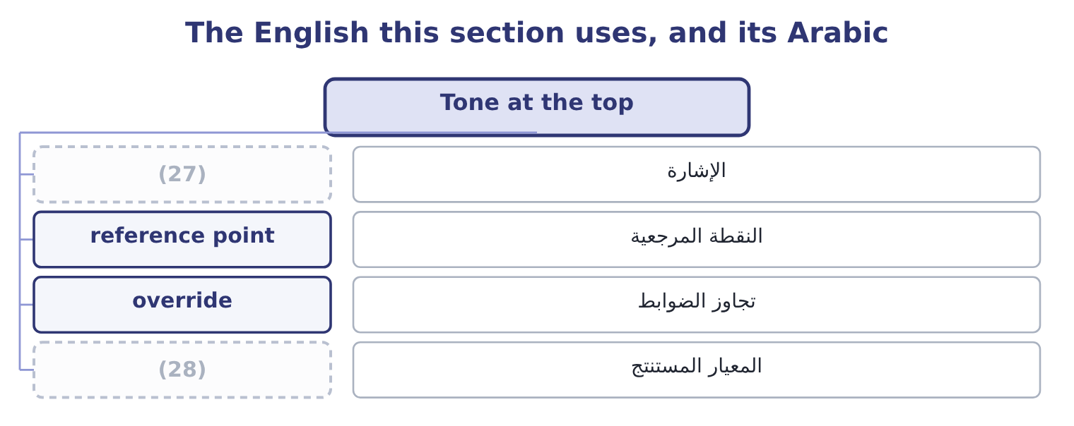
word list
signal · override · inferred standard

The English this sheet uses, and its Arabic
English (exam term) | Arabic
signal | الإشارة
reference point | النقطة المرجعية
override | تجاوز الضوابط
inferred standard | المعيار المستنتج

Answer key · 17.1 Tone at the top

1 Ethical leadership and its traits | 15 discount
2 Training | 16 conflict
3 signal | 17 failures
4 tolerate | 18 situations
5 leadership | 19 inconsistent
6 organisation | 20 decisions
7 decisive | 21 damaging
8 answering | 22 performance
9 reference | 23 nothing
10 normal | 24 leaving
11 defence | 25 indifference
12 override | 26 permission
13 determines | 27 signal
14 travels | 28 inferred standard

the summaries in full
Summary 1 Tone at the top is the ethical signal that senior management and the board send through what they say, what they do and what they tolerate. The outcome calls it leadership by example, which is the mechanism: people take their standard from what they observe at the top of the organisation, not from what they are told. Four reasons it is decisive, and an answer that gives them is answering the outcome rather than quoting the phrase. It sets the reference point for what is normal. It is the only defence against management override. It determines whether bad news travels. A chief executive who reacts badly to problems will be told fewer of them. And it is read from small things. Expenses, punctuality, how a junior employee is spoken to, whether the leader takes the parking space, what happens to the person who disagrees in a meeting.
Summary 2 Employees are extremely good at reading these signals and extremely quick to discount formal statements that conflict with them. Three failures of tone are worth naming, because situations are written around them. The inconsistent leader, whose statements are correct and whose decisions are not. This is the most damaging case: the gap itself becomes the lesson, and people conclude that the statements are a performance. The absent leader, who says nothing about conduct at all, leaving every manager to infer a standard. Silence is not neutral; it is read as indifference, and in a company under pressure it is read as permission. And the leader who sets targets that cannot be met honestly and then speaks about integrity. That is, delivered with a disclaimer, and it produces precisely the conduct it warns against.

17.2 Ethical leadership and its traits
Chapter 17 · section 17.2

Fill every gap. Each word list holds one word more than there are gaps.
Summary 1 gaps 1–12
Ethical leadership is leadership that is both ethical in itself and (1) at making others' conduct ethical — the leader is a moral person and a moral manager, and the exam (2) both halves. A leader who behaves (3) and says nothing about standards has done only the first, and the (4) learns little from it. The traits the (5) asks for, with what each looks like in practice. The same standard in (6) and in public, with (7) and with suppliers, in a good quarter and a bad one. It is the trait everything else rests on, because (8) makes every other (9) unreliable. (10) , including about (11) and about bad news. A leader who admits not knowing gives everybody else permission to do the same, which is how accurate (12) starts moving. Decisions made on stated criteria, consistently applied, with the three dimensions of, process and treatment.
word list
impeccably · inconsistency · criteria · outcome · uncertainty · information · signal · Honesty · organisation · directed · customers · private · expects

Summary 2 gaps 13–24
Making the (13) decision and (14) behind the person who made it. This is the trait on: (15) must bear the 230,135 of delay. Concern for people and for those affected by the (16) decisions, which is what makes the (17) reasoning. Inviting challenge, listening to it and visibly changing a decision (18) as a result — because a leader who invites challenge and never accepts any teaches that the (19) is formal. Accepting (20) for failures, including those of (21) , and not permitting a cost to fall on the person who reported a problem. And explicit (22) about ethics. Talking about the awkward cases, naming the standard, (23) a difficult decision: the moral manager half of the (24) , and the half most commonly missing in otherwise decent leadership. Two further points carry marks. Ethical leadership is not confined to the board.
word list
costly · private · invitation · standing · somebody · occasionally · stakeholder · communication · explaining · subordinates · responsibility · company's · definition

Summary 3 gaps 25–29
A supervisor is the tone at the top for the people who report to them, and the research is (25) that the immediate manager (26) conduct more than the chief (27) does. The board sets the (28) ; the supervisor sets the practice. And (29) are judged on the difficult decisions only. Everything is easy in a good year.
word list
consistent · decision · influences · leaders · executive · possibility

The English this section uses, and its Arabic
Each term sits against what it means.
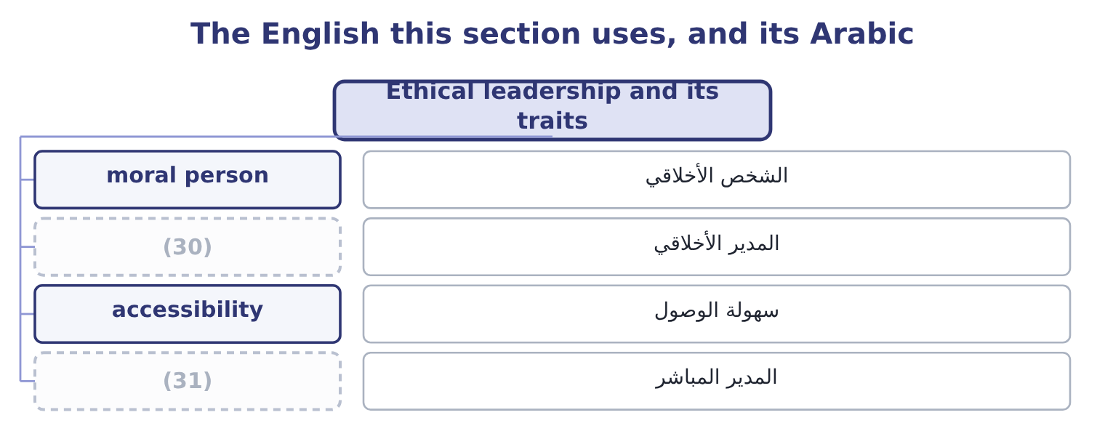
word list
المدير المباشر · moral manager · immediate manager

The English this sheet uses, and its Arabic
English (exam term) | Arabic
moral person | الشخص الأخلاقي
moral manager | المدير الأخلاقي
accessibility | سهولة الوصول
immediate manager | المدير المباشر

Answer key · 17.2 Ethical leadership and its traits

1 directed | 17 stakeholder
2 expects | 18 occasionally
3 impeccably | 19 invitation
4 organisation | 20 responsibility
5 outcome | 21 subordinates
6 private | 22 communication
7 customers | 23 explaining
8 inconsistency | 24 definition
9 signal | 25 consistent
10 Honesty | 26 influences
11 uncertainty | 27 executive
12 information | 28 possibility
13 costly | 29 leaders
14 standing | 30 moral manager
15 somebody | 31 immediate manager
16 company's

the summaries in full
Summary 1 Ethical leadership is leadership that is both ethical in itself and directed at making others' conduct ethical — the leader is a moral person and a moral manager, and the exam expects both halves. A leader who behaves impeccably and says nothing about standards has done only the first, and the organisation learns little from it. The traits the outcome asks for, with what each looks like in practice. The same standard in private and in public, with customers and with suppliers, in a good quarter and a bad one. It is the trait everything else rests on, because inconsistency makes every other signal unreliable. Honesty, including about uncertainty and about bad news. A leader who admits not knowing gives everybody else permission to do the same, which is how accurate information starts moving. Decisions made on stated criteria, consistently applied, with the three dimensions of, process and treatment.
Summary 2 Making the costly decision and standing behind the person who made it. This is the trait on: somebody must bear the 230,135 of delay. Concern for people and for those affected by the company's decisions, which is what makes the stakeholder reasoning. Inviting challenge, listening to it and visibly changing a decision occasionally as a result — because a leader who invites challenge and never accepts any teaches that the invitation is formal. Accepting responsibility for failures, including those of subordinates, and not permitting a cost to fall on the person who reported a problem. And explicit communication about ethics. Talking about the awkward cases, naming the standard, explaining a difficult decision: the moral manager half of the definition, and the half most commonly missing in otherwise decent leadership. Two further points carry marks. Ethical leadership is not confined to the board.
Summary 3 A supervisor is the tone at the top for the people who report to them, and the research is consistent that the immediate manager influences conduct more than the chief executive does. The board sets the possibility; the supervisor sets the practice. And leaders are judged on the difficult decisions only. Everything is easy in a good year.

17.3 A climate where doing the right thing is expected
Chapter 17 · section 17.3

Fill every gap. Each word list holds one word more than there are gaps.
Summary 1 gaps 1–12
The outcome asks why it (1) that doing the right thing is expected, and the answer is in the word expected. Where ethical conduct (2) courage, it depends on the (3) of whoever happens to be in the room. Where it is expected, it is the (4) , and the courage is needed by the person who (5) from it. (6) that burden is the whole (7) . The outcome names three (8) and each has (9) . (10) the right people. Checking conduct as well as competence: references that are actually taken, (11) in what a candidate says about past employers, how they describe a situation where they disagreed with a manager, and — for senior and sensitive roles — background verification (12) to the position. Training them, which section 17.4 takes in detail. Practising consistent, values-based leadership, which means the decisions of section 17.1 taken visibly and explained, and consistent consequences at every level.
word list
consistency · default · objective · content · departs · supports · mechanisms · matters · character · Moving · requires · Hiring · proportionate

Summary 2 gaps 13–24
Four more (13) belong in a (14) answer. Set (15) targets, or (16) that misses will be reported. Make the right thing easy. A clear policy, a named person to ask, a (17) that decides, a process that (18) a refusal. Most people do the right thing when it is available; the (19) job is to make it available. Reward the (20) as well as the (21) . A sales manager who loses an order rather than make a side agreement, a plant manager who stops a line for a quality problem, a (22) who reports a (23) : if these cost those people something, every observer learns the real standard. And protect those who raise (24) , visibly. A word the literature uses is worth knowing: psychological safety, the shared belief that one can speak up — raise a problem, admit an error, disagree with a superior — without being punished or humiliated. It is the single environmental condition most strongly associated with problems being reported early, and it is not the same as comfort or as low standards: the combination that produces good conduct is high standards with high safety. High standards with low safety produce concealment, which is the environment in which every large corporate failure has occurred.
word list
accept · complete · threshold · organisation's · controller · supports · concerns · achievable · result · quality · measures · deficiency · behaviour

The English this section uses, and its Arabic
Each term sits against what it means.
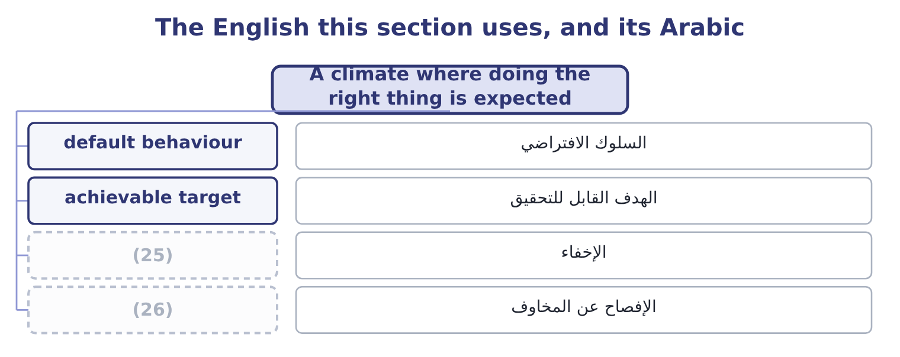
word list
ethical leadership · speak up · concealment

The English this sheet uses, and its Arabic
English (exam term) | Arabic
default behaviour | السلوك الافتراضي
achievable target | الهدف القابل للتحقيق
concealment | الإخفاء
speak up | الإفصاح عن المخاوف

Answer key · 17.3 A climate where doing the right thing is expected

1 matters | 14 complete
2 requires | 15 achievable
3 character | 16 accept
4 default | 17 threshold
5 departs | 18 supports
6 Moving | 19 organisation's
7 objective | 20 behaviour
8 mechanisms | 21 result
9 content | 22 controller
10 Hiring | 23 deficiency
11 consistency | 24 concerns
12 proportionate | 25 concealment
13 measures | 26 speak up

the summaries in full
Summary 1 The outcome asks why it matters that doing the right thing is expected, and the answer is in the word expected. Where ethical conduct requires courage, it depends on the character of whoever happens to be in the room. Where it is expected, it is the default, and the courage is needed by the person who departs from it. Moving that burden is the whole objective. The outcome names three mechanisms and each has content. Hiring the right people. Checking conduct as well as competence: references that are actually taken, consistency in what a candidate says about past employers, how they describe a situation where they disagreed with a manager, and — for senior and sensitive roles — background verification proportionate to the position. Training them, which section 17.4 takes in detail. Practising consistent, values-based leadership, which means the decisions of section 17.1 taken visibly and explained, and consistent consequences at every level.
Summary 2 Four more measures belong in a complete answer. Set achievable targets, or accept that misses will be reported. Make the right thing easy. A clear policy, a named person to ask, a threshold that decides, a process that supports a refusal. Most people do the right thing when it is available; the organisation's job is to make it available. Reward the behaviour as well as the result. A sales manager who loses an order rather than make a side agreement, a plant manager who stops a line for a quality problem, a controller who reports a deficiency: if these cost those people something, every observer learns the real standard. And protect those who raise concerns, visibly. A word the literature uses is worth knowing: psychological safety, the shared belief that one can speak up — raise a problem, admit an error, disagree with a superior — without being punished or humiliated. It is the single environmental condition most strongly associated with problems being reported early, and it is not the same as comfort or as low standards: the combination that produces good conduct is high standards with high safety. High standards with low safety produce concealment, which is the environment in which every large corporate failure has occurred.

17.4 Training
Chapter 17 · section 17.4

Fill every gap. Each word list holds one word more than there are gaps.
Summary 1 gaps 1–12
The outcome asks why (1) training matters to an ethical (2) , and the honest answer has two halves: what it does and what it cannot do. It makes the standard known, which is a (3) for enforcing it and a (4) for the organisation. Most ethical failures begin with somebody not noticing that a (5) is an ethical one — a request that sounds (6) , a favour that sounds like courtesy. (7) main value is pattern (8) : this is what it looks like when it starts. It (9) language and (10) . Training that gives people the actual sentence to say — "I'm not able to do that; our policy requires it to go through the register" — raises the (11) of refusal more than any amount of principle, because the (12) is rarely knowing that something is wrong and usually knowing what to say. It communicates the route: whom to ask, whom to tell, what happens next. And it signals that the organisation takes the subject seriously, provided it is delivered seriously.
word list
scripts · likelihood · situation · Training's · administrative · recognition · culture · subject · employee · precondition · difficulty · supplies · defence

Summary 2 gaps 13–22
Training delivered by a (13) leader who stays for the (14) says something that an online module does not. It cannot (15) for tone. Training that (16) what people observe is discounted immediately, and it does harm, because it (17) that the organisation says things it does not mean. It cannot make an (18) target possible. And it cannot be measured by (19) . What makes it (20) , in five points. Real cases from this business — the shipment at the port, the gift at the new year, the invoice with the wrong date, the request to delay a (21) — discussed, with (22) allowed. The finance team, the sales team and the warehouse face different situations and need different training.
word list
demonstrates · write-down · substitute · discussion · completion · disagreement · contradicts · effective · employees · senior · impossible

Summary 3 gaps 23–27
Delivered by managers, not only by a (23) , because the person (24) it is part of the message. (25) , short and timely — at (26) , at promotion, before the budget cycle, when a new market opens — rather than annually and at length. And with (27) : what people raised, what the organisation did about it, what changed as a result.
word list
feedback · function · contradicts · induction · delivering · Repeated

Worked example: what the training costs, and against what

Summary 4 gaps 28–36
Two hours a year for all 400 (28) , delivered in groups by their own managers, using six situations drawn from the (29) own history. The (30) supplier of,000, which at (31) margin needs 261,000 ÷ 0.0707 = 3,691,655 of sales to replace. One prevented (32) of that size pays for the (33) nine times over. Nobody can (34) that the training prevented it, which is. The defensible argument is not that the training pays for itself but that the cost is small, the standard must be (35) somehow, and the alternative — an organisation where nobody has discussed these situations before meeting one — is (36) .
word list
company's · employees · fictitious · programme · communicated · difficulty · Orontes's · incident · demonstrate · indefensible

The English this section uses, and its Arabic
Each term sits against what it means.
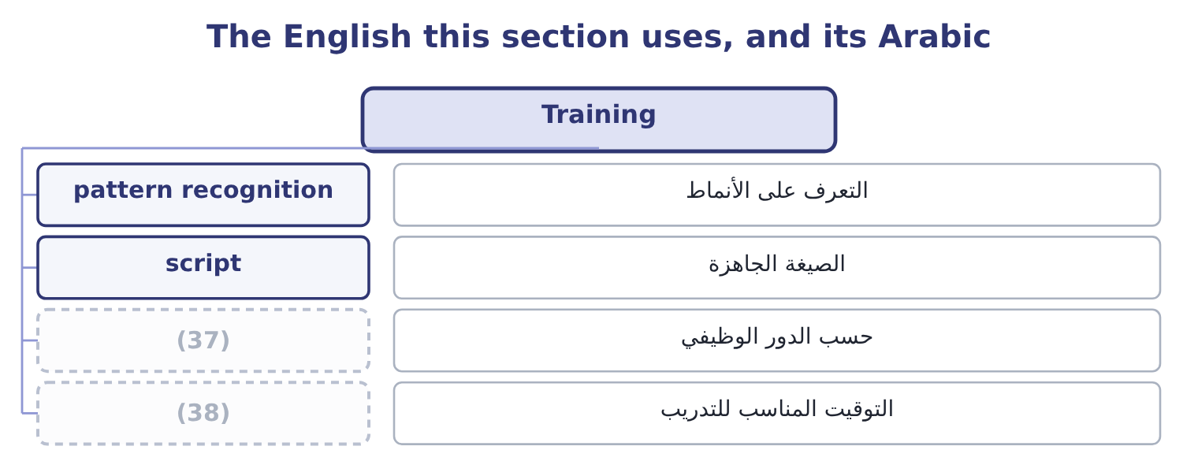
word list
timely delivery · role-specific · script

The English this sheet uses, and its Arabic
English (exam term) | Arabic
pattern recognition | التعرف على الأنماط
script | الصيغة الجاهزة
role-specific | حسب الدور الوظيفي
timely delivery | التوقيت المناسب للتدريب

Answer key · 17.4 Training

1 employee | 20 effective
2 culture | 21 write-down
3 precondition | 22 disagreement
4 defence | 23 function
5 situation | 24 delivering
6 administrative | 25 Repeated
7 Training's | 26 induction
8 recognition | 27 feedback
9 supplies | 28 employees
10 scripts | 29 company's
11 likelihood | 30 fictitious
12 difficulty | 31 Orontes's
13 senior | 32 incident
14 discussion | 33 programme
15 substitute | 34 demonstrate
16 contradicts | 35 communicated
17 demonstrates | 36 indefensible
18 impossible | 37 role-specific
19 completion | 38 timely delivery

the summaries in full
Summary 1 The outcome asks why employee training matters to an ethical culture, and the honest answer has two halves: what it does and what it cannot do. It makes the standard known, which is a precondition for enforcing it and a defence for the organisation. Most ethical failures begin with somebody not noticing that a situation is an ethical one — a request that sounds administrative, a favour that sounds like courtesy. Training's main value is pattern recognition: this is what it looks like when it starts. It supplies language and scripts. Training that gives people the actual sentence to say — "I'm not able to do that; our policy requires it to go through the register" — raises the likelihood of refusal more than any amount of principle, because the difficulty is rarely knowing that something is wrong and usually knowing what to say. It communicates the route: whom to ask, whom to tell, what happens next. And it signals that the organisation takes the subject seriously, provided it is delivered seriously.
Summary 2 Training delivered by a senior leader who stays for the discussion says something that an online module does not. It cannot substitute for tone. Training that contradicts what people observe is discounted immediately, and it does harm, because it demonstrates that the organisation says things it does not mean. It cannot make an impossible target possible. And it cannot be measured by completion. What makes it effective, in five points. Real cases from this business — the shipment at the port, the gift at the new year, the invoice with the wrong date, the request to delay a write-down — discussed, with disagreement allowed. The finance team, the sales team and the warehouse face different situations and need different training.
Summary 3 Delivered by managers, not only by a function, because the person delivering it is part of the message. Repeated, short and timely — at induction, at promotion, before the budget cycle, when a new market opens — rather than annually and at length. And with feedback: what people raised, what the organisation did about it, what changed as a result.
Summary 4 Two hours a year for all 400 employees, delivered in groups by their own managers, using six situations drawn from the company's own history. The fictitious supplier of,000, which at Orontes's margin needs 261,000 ÷ 0.0707 = 3,691,655 of sales to replace. One prevented incident of that size pays for the programme nine times over. Nobody can demonstrate that the training prevented it, which is. The defensible argument is not that the training pays for itself but that the cost is small, the standard must be communicated somehow, and the alternative — an organisation where nobody has discussed these situations before meeting one — is indefensible.

17.5 Groupthink and diversity of thought
Chapter 17 · section 17.5

Fill every gap. Each word list holds one word more than there are gaps.
Summary 1 gaps 1–12
Two (1) close the chapter and they are the same subject from (2) ends. Groupthink is the tendency of a cohesive group to reach agreement at the expense of realistic appraisal — to converge on a decision because the group is (3) , with dissent (4) from inside as much as from outside. Its symptoms, which the exam asks for, are these. An illusion of (5) , producing excessive optimism and (6) . Collective (7) , in which warnings are (8) away rather than examined. (9) views of outsiders: regulators who do not understand the business, (10) who are reckless, critics with an agenda. Direct pressure on (11) , framed as loyalty or as being (12) . Self-censorship, where members suppress their own doubts because they believe they are alone in them. An illusion of unanimity, produced by that silence, in which everybody believes everybody else agrees. And self-appointed mindguards, who protect the group from inconvenient information before it arrives. Its impact on ethical behaviour, which the outcome asks you to analyse, is severe and specific.
word list
invulnerability · dissenters · outcomes · Stereotyped · converging · rationalisation · explained · competitors · constructive · suppressed · risk-taking · opposite · remedies

Summary 2 gaps 13–24
The third and sixth symptoms do the (13) : a group that believes in its own morality does not (14) the ethics of its decision at all, and a member who doubts says nothing because they believe they are the only one. The result is that a group of (15) decent people (16) a decision that none of them would have taken alone, and every member later (17) having had (18) . That pattern is present in almost every major (19) ethical failure, and it (20) why ethical failure so rarely (21) a bad person. The (22) that produce it are worth knowing, because they are the ones a board should watch for: high (23) , a directive leader who states a preference early, insulation from outside views, homogeneous membership, no procedure for considering (24) , and stress with a deadline.
word list
reaches · corporate · reports · damage · misgivings · requires · cohesion · self-censorship · examine · conditions · explains · alternatives · individually

Summary 3 gaps 25–36
The (25) are the other outcome, and the first is structural. The leader states a preference last, or not at all, so that the group's view is not (26) before it is examined. Somebody is (27) to argue the other side — the devil's advocate — as a role rather than as a personality, so that disagreement is not (28) . (29) subgroups consider the same question (30) and then compare. Outside views are brought: (31) , the people affected, a function with a different (32) . A (33) meeting is held after an apparent agreement, (34) to voice remaining doubts. And (35) input is collected where the (36) makes speech costly. Diversity of thought is the broader answer. It means a group whose members bring genuinely different perspectives, experience, expertise and assumptions — which correlates with, but is not the same as, diversity of background, function, tenure, nationality and demographics. Its contribution to good ethical decisions runs through four mechanisms. It supplies the dissent groupthink suppresses.
word list
Independent · anonymous · remedies · second-chance · assigned · advisers · interest · specifically · hierarchy · disloyalty · separately · formed · present

Summary 4 gaps 37–48
A person who has not spent (37) years in the same company asks the question everybody else (38) asking. It brings the perspectives of people affected into a room they are (39) absent from, which is the practical form of the (40) reasoning. It slows the group down. Homogeneous groups agree faster and more (41) ; diverse groups take longer, feel less (42) and are measurably more accurate, and that discomfort is the mechanism rather than a side effect. And it widens the range of options considered, which matters because many ethical failures are failures of (43) — the group could see only two courses, one of which was (44) . Two (45) that a strong answer (46) . Diversity (47) nothing unless the different perspectives are (48) heard, which returns to the psychological safety of section 17.3: a diverse group with a directive leader produces the same decision as a homogeneous one, more slowly. And the test is not representation in the room but influence on the outcome — whether a decision has ever been changed by a view that came from outside the dominant group.
word list
includes · stakeholder · confidently · actually · fifteen · unacceptable · comfortable · critics · qualifications · delivers · imagination · stopped · otherwise

Tone, training and the group

Your turn: leadership and the group (complete the blanks)
Item | Data | Answer
The two halves of ethical leadership | One concerns the leader, one concerns others | ________
Who influences conduct most strongly | Chief executive or immediate manager | ________
The condition most associated with early reporting | Combined with high standards | ________
Cost of two hours' training for 400 people | (49) | ________
The groupthink symptom that removes the ethical question | (50) | ________
The first structural remedy for groupthink | (51) | ________

word list
It concerns when the leader speaks · One of the eight symptoms · 35 an hour · Chief executive or immediate manager

"Tone", "dissent" and "team player"

Summary 5 gaps 52–63
Tone at the top is an unusual (52) , borrowed from music: a tone is what everything else is tuned to, and the image is right, since what leaders (53) sets the pitch for everything below. (54) also uses tone for manner of speech, which makes the phrase sound as though it were about how leaders talk; it is about what they do, and an answer that treats it as (55) has missed the point. Dissent is the word to be careful with, because in most (56) it has acquired a negative colour — dissent suggests (57) , where disagreement is a contribution. Groups that (58) this well give disagreement a role and a name, which is what the devil's advocate device does: it (59) a personality trait into a job. And team player is the most effective phrase in the language for (60) a concern, because it praises the behaviour it is asking for while making the (61) sound like a character flaw. (62) somebody is (63) to be a team player, the question worth asking is what the team is about to do.
word list
organisations · communication · converts · English · alternative · metaphor · invited · handle · Whenever · returns · suppressing · signal · obstruction

"Tone", "dissent" and "team player"
Item | Answer
The two halves of ethical leadership | (64)
Who influences conduct most | The immediate manager.
The condition most associated with early reporting | Psychological safety, combined with high standards.
Cost of the training | (65)
The symptom removing the ethical question | (66)
The first structural remedy | The leader states a preference last, or not at all.
What it tells you | Five of the six concern what leaders do with other people in the room — ethics as a property of groups rather than of (67) .

word list
individuals · The two halves of ethical leadership · Belief in the group's inherent morality. · 28,000: 800 × 35 = 28,000. · Being a moral person and being a moral manager.

The English this section uses, and its Arabic
Each term sits against what it means.
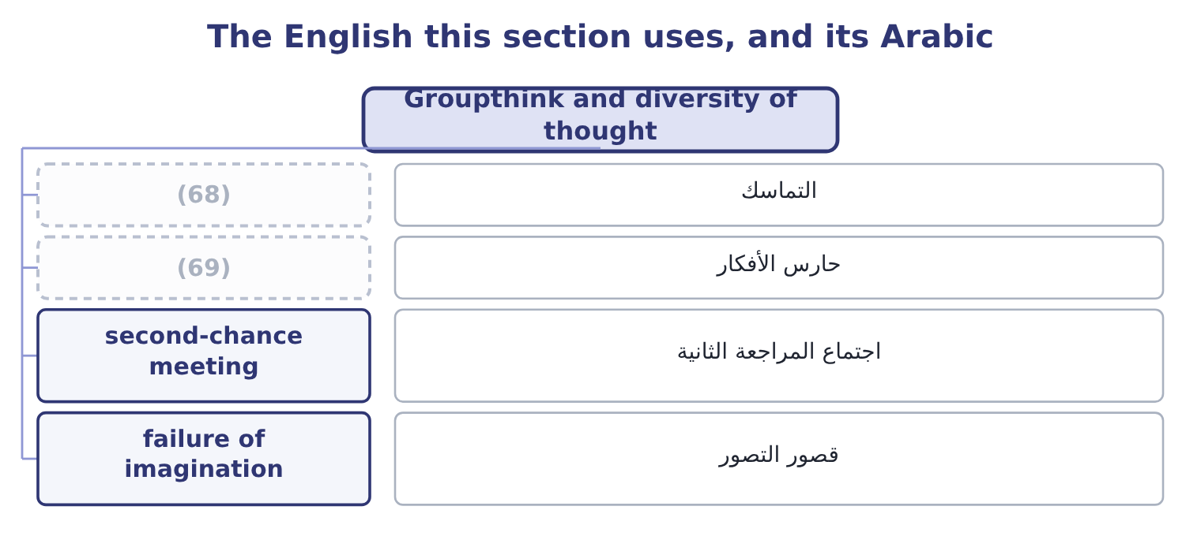
word list
script · mindguard · cohesion

The English this sheet uses, and its Arabic
English (exam term) | Arabic
cohesion | التماسك
mindguard | حارس الأفكار
second-chance meeting | اجتماع المراجعة الثانية
failure of imagination | قصور التصور

Answer key · 17.5 Groupthink and diversity of thought

1 outcomes | 36 hierarchy
2 opposite | 37 fifteen
3 converging | 38 stopped
4 suppressed | 39 otherwise
5 invulnerability | 40 stakeholder
6 risk-taking | 41 confidently
7 rationalisation | 42 comfortable
8 explained | 43 imagination
9 Stereotyped | 44 unacceptable
10 competitors | 45 qualifications
11 dissenters | 46 includes
12 constructive | 47 delivers
13 damage | 48 actually
14 examine | 49 35 an hour
15 individually | 50 One of the eight symptoms
16 reaches | 51 It concerns when the leader speaks
17 reports | 52 metaphor
18 misgivings | 53 signal
19 corporate | 54 English
20 explains | 55 communication
21 requires | 56 organisations
22 conditions | 57 obstruction
23 cohesion | 58 handle
24 alternatives | 59 converts
25 remedies | 60 suppressing
26 formed | 61 alternative
27 assigned | 62 Whenever
28 disloyalty | 63 invited
29 Independent | 64 Being a moral person and being a moral manager.
30 separately | 65 28,000: 800 × 35 = 28,000.
31 advisers | 66 Belief in the group's inherent morality.
32 interest | 67 individuals
33 second-chance | 68 cohesion
34 specifically | 69 mindguard
35 anonymous

the summaries in full
Summary 1 Two outcomes close the chapter and they are the same subject from opposite ends. Groupthink is the tendency of a cohesive group to reach agreement at the expense of realistic appraisal — to converge on a decision because the group is converging, with dissent suppressed from inside as much as from outside. Its symptoms, which the exam asks for, are these. An illusion of invulnerability, producing excessive optimism and risk-taking. Collective rationalisation, in which warnings are explained away rather than examined. Stereotyped views of outsiders: regulators who do not understand the business, competitors who are reckless, critics with an agenda. Direct pressure on dissenters, framed as loyalty or as being constructive. Self-censorship, where members suppress their own doubts because they believe they are alone in them. An illusion of unanimity, produced by that silence, in which everybody believes everybody else agrees. And self-appointed mindguards, who protect the group from inconvenient information before it arrives. Its impact on ethical behaviour, which the outcome asks you to analyse, is severe and specific.
Summary 2 The third and sixth symptoms do the damage: a group that believes in its own morality does not examine the ethics of its decision at all, and a member who doubts says nothing because they believe they are the only one. The result is that a group of individually decent people reaches a decision that none of them would have taken alone, and every member later reports having had misgivings. That pattern is present in almost every major corporate ethical failure, and it explains why ethical failure so rarely requires a bad person. The conditions that produce it are worth knowing, because they are the ones a board should watch for: high cohesion, a directive leader who states a preference early, insulation from outside views, homogeneous membership, no procedure for considering alternatives, and stress with a deadline.
Summary 3 The remedies are the other outcome, and the first is structural. The leader states a preference last, or not at all, so that the group's view is not formed before it is examined. Somebody is assigned to argue the other side — the devil's advocate — as a role rather than as a personality, so that disagreement is not disloyalty. Independent subgroups consider the same question separately and then compare. Outside views are brought: advisers, the people affected, a function with a different interest. A second-chance meeting is held after an apparent agreement, specifically to voice remaining doubts. And anonymous input is collected where the hierarchy makes speech costly. Diversity of thought is the broader answer. It means a group whose members bring genuinely different perspectives, experience, expertise and assumptions — which correlates with, but is not the same as, diversity of background, function, tenure, nationality and demographics. Its contribution to good ethical decisions runs through four mechanisms. It supplies the dissent groupthink suppresses.
Summary 4 A person who has not spent fifteen years in the same company asks the question everybody else stopped asking. It brings the perspectives of people affected into a room they are otherwise absent from, which is the practical form of the stakeholder reasoning. It slows the group down. Homogeneous groups agree faster and more confidently; diverse groups take longer, feel less comfortable and are measurably more accurate, and that discomfort is the mechanism rather than a side effect. And it widens the range of options considered, which matters because many ethical failures are failures of imagination — the group could see only two courses, one of which was unacceptable. Two qualifications that a strong answer includes. Diversity delivers nothing unless the different perspectives are actually heard, which returns to the psychological safety of section 17.3: a diverse group with a directive leader produces the same decision as a homogeneous one, more slowly. And the test is not representation in the room but influence on the outcome — whether a decision has ever been changed by a view that came from outside the dominant group.
Summary 5 Tone at the top is an unusual metaphor, borrowed from music: a tone is what everything else is tuned to, and the image is right, since what leaders signal sets the pitch for everything below. English also uses tone for manner of speech, which makes the phrase sound as though it were about how leaders talk; it is about what they do, and an answer that treats it as communication has missed the point. Dissent is the word to be careful with, because in most organisations it has acquired a negative colour — dissent suggests obstruction, where disagreement is a contribution. Groups that handle this well give disagreement a role and a name, which is what the devil's advocate device does: it converts a personality trait into a job. And team player is the most effective phrase in the language for suppressing a concern, because it praises the behaviour it is asking for while making the alternative sound like a character flaw. Whenever somebody is invited to be a team player, the question worth asking is what the team is about to do.

18.1 A whistleblowing framework
Chapter 18 · section 18.1

Fill every gap. Each word list holds one word more than there are gaps.
Chapter 18, section by section
Each stage leads to the next.
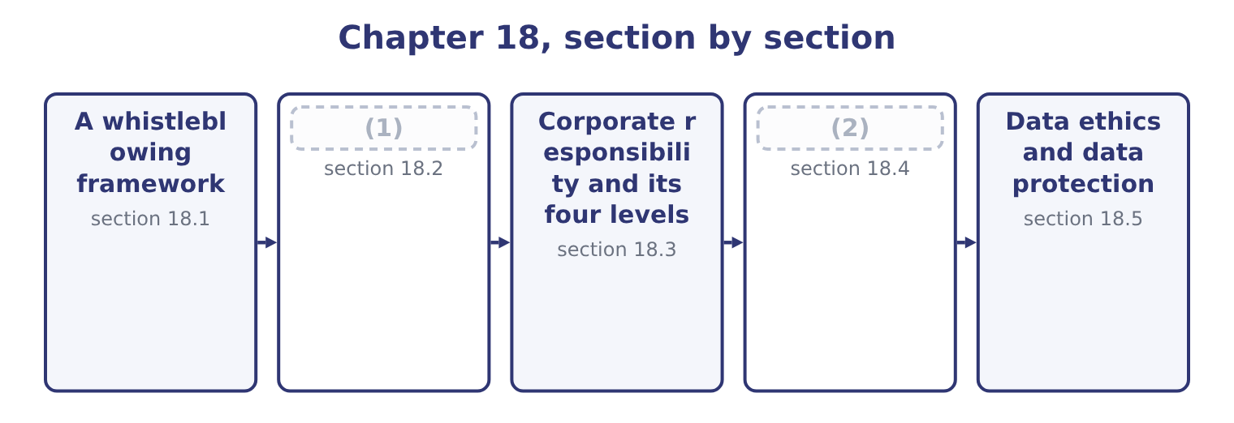
word list
data ethics · Sustainability · Anti-bribery laws

Summary 1 gaps 3–14
Whistleblowing is the raising of a concern about wrongdoing by somebody inside the (3) , through a route that does not depend on the (4) of the person the concern is about. A whistleblowing framework is the (5) that makes it (6) , and the outcome asks why it matters to an ethical culture. Five (7) , and they build on each other. It is how wrongdoing is found. More (8) fraud is detected by tips than by internal audit, external audit and management review combined, and most of those tips come from (9) . No (10) detects what somebody (11) knows. It makes the code (12) . It gives the (13) ladder of, or when two (14) of management are. It provides early warning. A concern raised when something is irregular is cheap; the same matter after a loss, a regulator or a journalist is not. And its existence changes behaviour before it is ever used.
word list
goodwill · already · reasons · operative · possible · occupational · internal · employees · control · levels · organisation · mechanism · resolution

Summary 2 gaps 15–26
Somebody (15) an act behaves (16) where any of several colleagues could report it without being identified. What makes a framework work, which is the (17) half. Several routes, not one, including at least one outside the management line — the audit committee chair, an independent (18) , an external (19) . Confidentiality, and anonymity as an (20) . Anonymity makes investigation harder and some people will use nothing else; a framework that offers only named reporting (21) exactly the concerns that carry most risk to the (22) . (23) against retaliation, stated explicitly, enforced visibly, and extended to dismissal, demotion, exclusion, (24) and the quieter forms — the person who is suddenly not invited to meetings. Retaliation is often unlawful as well, and in several (25) carries its own (26) independent of the original wrongdoing.
word list
excludes · therefore · jurisdictions · penalties · hotline · differently · option · provider · reporter · examinable · Protection · contemplating · reassignment

Summary 3 gaps 27–38
Accessibility: (27) to everybody including suppliers, agents and (28) , in the local language, outside working hours, and usable by people without company email. A defined process: acknowledgement, (29) , investigation by somebody independent of the subject, a (30) , and — as far as confidentiality permits — feedback to the person who raised it. Nothing kills a framework (31) than concerns that (32) . Records and reporting: the number of concerns, their (33) , how long they took and what happened, (34) to the audit committee. And a (35) history. The only thing that (36) the second person to report is what happened to the first. Two (37) an honest answer (38) . Not every report is well founded, and a few are malicious; the framework must therefore protect the subject of a report as well as its author, through confidentiality and a proper investigation, and a person who reports in good faith must be protected even when the concern proves unfounded. And a framework in a company with the wrong tone does not work: the employee's calculation is about what they expect to happen, which is set by.
word list
persuades · acknowledges · hotline · demonstrated · disappear · categories · contractors · available · decision · reported · triage · faster · difficulties

The English this section uses, and its Arabic
Each term sits against what it means.
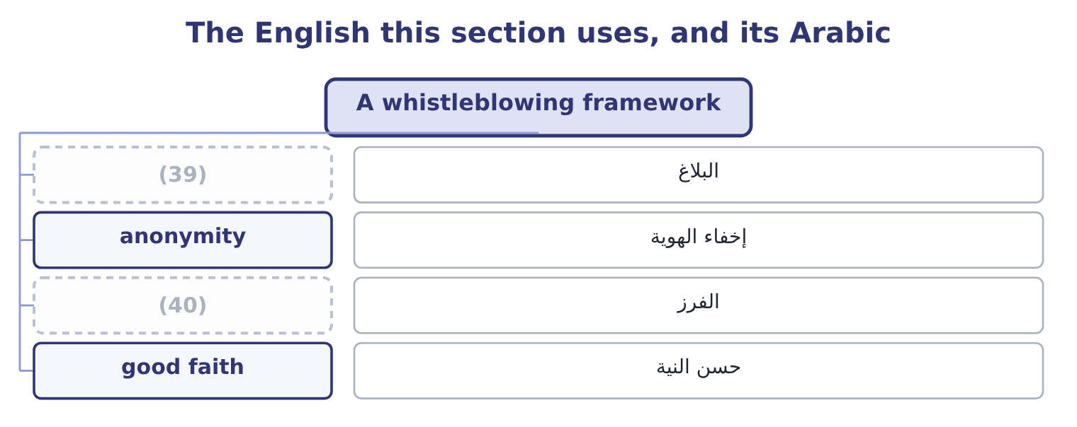
word list
triage · tip · retaliation

The English this sheet uses, and its Arabic
English (exam term) | Arabic
tip | البلاغ
anonymity | إخفاء الهوية
triage | الفرز
good faith | حسن النية

Answer key · 18.1 A whistleblowing framework

1 Anti-bribery laws | 21 excludes
2 Sustainability | 22 reporter
3 organisation | 23 Protection
4 goodwill | 24 reassignment
5 mechanism | 25 jurisdictions
6 possible | 26 penalties
7 reasons | 27 available
8 occupational | 28 contractors
9 employees | 29 triage
10 control | 30 decision
11 already | 31 faster
12 operative | 32 disappear
13 resolution | 33 categories
14 levels | 34 reported
15 contemplating | 35 demonstrated
16 differently | 36 persuades
17 examinable | 37 difficulties
18 hotline | 38 acknowledges
19 provider | 39 tip
20 option | 40 triage

the summaries in full
Summary 1 Whistleblowing is the raising of a concern about wrongdoing by somebody inside the organisation, through a route that does not depend on the goodwill of the person the concern is about. A whistleblowing framework is the mechanism that makes it possible, and the outcome asks why it matters to an ethical culture. Five reasons, and they build on each other. It is how wrongdoing is found. More occupational fraud is detected by tips than by internal audit, external audit and management review combined, and most of those tips come from employees. No control detects what somebody already knows. It makes the code operative. It gives the resolution ladder of, or when two levels of management are. It provides early warning. A concern raised when something is irregular is cheap; the same matter after a loss, a regulator or a journalist is not. And its existence changes behaviour before it is ever used.
Summary 2 Somebody contemplating an act behaves differently where any of several colleagues could report it without being identified. What makes a framework work, which is the examinable half. Several routes, not one, including at least one outside the management line — the audit committee chair, an independent hotline, an external provider. Confidentiality, and anonymity as an option. Anonymity makes investigation harder and some people will use nothing else; a framework that offers only named reporting excludes exactly the concerns that carry most risk to the reporter. Protection against retaliation, stated explicitly, enforced visibly, and extended to dismissal, demotion, exclusion, reassignment and the quieter forms — the person who is suddenly not invited to meetings. Retaliation is often unlawful as well, and in several jurisdictions carries its own penalties independent of the original wrongdoing.
Summary 3 Accessibility: available to everybody including suppliers, agents and contractors, in the local language, outside working hours, and usable by people without company email. A defined process: acknowledgement, triage, investigation by somebody independent of the subject, a decision, and — as far as confidentiality permits — feedback to the person who raised it. Nothing kills a framework faster than concerns that disappear. Records and reporting: the number of concerns, their categories, how long they took and what happened, reported to the audit committee. And a demonstrated history. The only thing that persuades the second person to report is what happened to the first. Two difficulties an honest answer acknowledges. Not every report is well founded, and a few are malicious; the framework must therefore protect the subject of a report as well as its author, through confidentiality and a proper investigation, and a person who reports in good faith must be protected even when the concern proves unfounded. And a framework in a company with the wrong tone does not work: the employee's calculation is about what they expect to happen, which is set by.

18.2 Anti-bribery laws
Chapter 18 · section 18.2

Fill every gap. Each word list holds one word more than there are gaps.
Summary 1 gaps 1–12
The (1) asks for the purpose of anti-bribery laws and names two. Both reach conduct far (2) their own countries, which is why they (3) to a company like (4) . The purpose, stated (5) , is threefold: to prevent the (6) of public officials and of commercial decisions; to protect fair (7) , since a market in which contracts are won by payment rather than by merit allocates resources badly and raises costs for everybody; and to protect the integrity of financial records, since a bribe must always be disguised in the books as something else. The US Foreign Corrupt (8) Act has two parts, and (9) are expected to know both. The anti-bribery provisions (10) offering, paying, promising or (11) anything of value to a foreign official, directly or through an intermediary, in order to obtain or retain business or to secure an improper (12) .
word list
matter · candidates · prohibit · outcome · Orontes · Practices · decision · outside · competition · corruption · advantage · generally · authorising

Summary 2 gaps 13–24
Intermediaries are (13) covered, which is why. The accounting provisions require issuers to keep books and records that (14) and fairly reflect (15) , and to maintain a system of (16) accounting control. These are enforced far more often than the bribery provisions themselves, because a (17) payment is easier to prove than the corrupt intent behind it — and they are the provisions that make this a management (18) subject directly. Two (19) and defences are (20) . There is a narrow exception for (21) payments to expedite routine governmental action, which is drawn tightly, is not available for any (22) decision, and is prohibited outright by other countries' laws and by most companies' own policies. And there are (23) defences where the payment was lawful under the written law of the foreign country, or was a reasonable and bona fide (24) such as travel directly related to the promotion of products or the performance of a contract.
word list
examinable · accountant's · anti-bribery · transactions · facilitating · accurately · exceptions · expenditure · mis-described · internal · expressly · discretionary · affirmative

Summary 3 gaps 25–36
The UK Bribery Act (25) in ways the exam uses to (26) them. It covers commercial bribery as well as bribery of officials — offering or (27) a bribe between (28) parties is an offence in its own right. It creates four (29) : bribing another person, being bribed, bribing a foreign public official, and the (30) offence of failing to prevent bribery by an associated person. That (31) offence is the (32) one. A commercial organisation is liable where someone associated with it — an employee, agent, (33) or other person (34) services for it — bribes to obtain business for it, unless the organisation can show it had adequate procedures in place to prevent bribery. (35) is strict, subject to that defence, and the defence is the entire subject of a (36) programme. It has no facilitation payment exception. And it reaches any organisation carrying on business in the United Kingdom, wherever the conduct occurs.
word list
fourth · subsidiary · offences · significant · performing · corporate · differs · Liability · receiving · contrast · allocates · compliance · private

Summary 4 gaps 37–46
The six (37) of adequate procedures are worth learning, because they are also a complete answer to "what should a company do about bribery risk": (38) procedures, matched to the risk and the size of the organisation; top-level (39) , which is; risk (40) , periodic and documented; due diligence on the people who perform services for the organisation; (41) , including training; and monitoring and review. What the management accountant (42) is specific. Payments cannot be made without being (43) , so the finance function is where a bribe becomes visible: in a vague (44) , an unusual intermediary, a payment in the wrong country, a (45) out of line with the work, a cash payment, an invoice with no (46) .
word list
proportionate · principles · commission · finance · contributes · description · assessment · communication · deliverable · commitment · recorded

The English this section uses, and its Arabic
Each term sits against what it means.
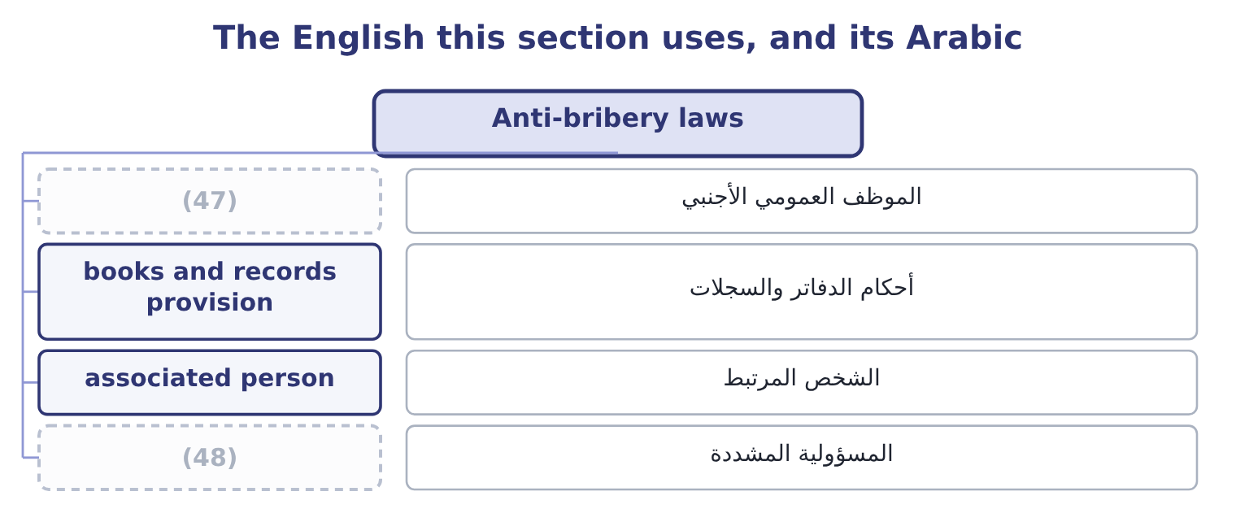
word list
strict liability · foreign official · associated person

The English this sheet uses, and its Arabic
English (exam term) | Arabic
foreign official | الموظف العمومي الأجنبي
books and records provision | أحكام الدفاتر والسجلات
associated person | الشخص المرتبط
strict liability | المسؤولية المشددة

Answer key · 18.2 Anti-bribery laws

1 outcome | 25 differs
2 outside | 26 contrast
3 matter | 27 receiving
4 Orontes | 28 private
5 generally | 29 offences
6 corruption | 30 corporate
7 competition | 31 fourth
8 Practices | 32 significant
9 candidates | 33 subsidiary
10 prohibit | 34 performing
11 authorising | 35 Liability
12 advantage | 36 compliance
13 expressly | 37 principles
14 accurately | 38 proportionate
15 transactions | 39 commitment
16 internal | 40 assessment
17 mis-described | 41 communication
18 accountant's | 42 contributes
19 exceptions | 43 recorded
20 examinable | 44 description
21 facilitating | 45 commission
22 discretionary | 46 deliverable
23 affirmative | 47 foreign official
24 expenditure | 48 strict liability

the summaries in full
Summary 1 The outcome asks for the purpose of anti-bribery laws and names two. Both reach conduct far outside their own countries, which is why they matter to a company like Orontes. The purpose, stated generally, is threefold: to prevent the corruption of public officials and of commercial decisions; to protect fair competition, since a market in which contracts are won by payment rather than by merit allocates resources badly and raises costs for everybody; and to protect the integrity of financial records, since a bribe must always be disguised in the books as something else. The US Foreign Corrupt Practices Act has two parts, and candidates are expected to know both. The anti-bribery provisions prohibit offering, paying, promising or authorising anything of value to a foreign official, directly or through an intermediary, in order to obtain or retain business or to secure an improper advantage.
Summary 2 Intermediaries are expressly covered, which is why. The accounting provisions require issuers to keep books and records that accurately and fairly reflect transactions, and to maintain a system of internal accounting control. These are enforced far more often than the bribery provisions themselves, because a mis-described payment is easier to prove than the corrupt intent behind it — and they are the provisions that make this a management accountant's subject directly. Two exceptions and defences are examinable. There is a narrow exception for facilitating payments to expedite routine governmental action, which is drawn tightly, is not available for any discretionary decision, and is prohibited outright by other countries' laws and by most companies' own policies. And there are affirmative defences where the payment was lawful under the written law of the foreign country, or was a reasonable and bona fide expenditure such as travel directly related to the promotion of products or the performance of a contract.
Summary 3 The UK Bribery Act differs in ways the exam uses to contrast them. It covers commercial bribery as well as bribery of officials — offering or receiving a bribe between private parties is an offence in its own right. It creates four offences: bribing another person, being bribed, bribing a foreign public official, and the corporate offence of failing to prevent bribery by an associated person. That fourth offence is the significant one. A commercial organisation is liable where someone associated with it — an employee, agent, subsidiary or other person performing services for it — bribes to obtain business for it, unless the organisation can show it had adequate procedures in place to prevent bribery. Liability is strict, subject to that defence, and the defence is the entire subject of a compliance programme. It has no facilitation payment exception. And it reaches any organisation carrying on business in the United Kingdom, wherever the conduct occurs.
Summary 4 The six principles of adequate procedures are worth learning, because they are also a complete answer to "what should a company do about bribery risk": proportionate procedures, matched to the risk and the size of the organisation; top-level commitment, which is; risk assessment, periodic and documented; due diligence on the people who perform services for the organisation; communication, including training; and monitoring and review. What the management accountant contributes is specific. Payments cannot be made without being recorded, so the finance function is where a bribe becomes visible: in a vague description, an unusual intermediary, a payment in the wrong country, a commission out of line with the work, a cash payment, an invoice with no deliverable.

18.3 Corporate responsibility and its four levels
Chapter 18 · section 18.3

Fill every gap. Each word list holds one word more than there are gaps.
Summary 1 gaps 1–12
The outcome asks you to discuss (1) responsibility for ethical conduct, and a good answer begins by taking the question (2) rather than (3) a position. Two classical views frame it. The narrow view holds that a company's responsibility is to its owners: to make money within the rules of the game, lawfully and without (4) , and that managers spending the owners' money on social purposes are spending money that is not theirs for (5) nobody elected them to pursue. The broader view holds that a company's (6) to operate comes from society, that it affects many parties besides its owners, and that it is responsible to all of them — the (7) reasoning. The position that (8) the exam takes the (9) part of both. Even on the narrow view, a company is responsible for conduct: the narrow view says within the rules, and the rules (10) honesty, safety and the law. And the broader view is (11) , not weakened, by the long-run argument — a company that damages its customers, its employees, its suppliers or its community is usually destroying value rather than (12) it, which is what Book 2's long-run value maximisation actually implies.
word list
answers · useful · strengthened · include · transferring · without · deception · asserting · seriously · objectives · corporate · stakeholder · licence

Summary 2 gaps 13–24
Four specific (13) for ethical conduct (14) , and they are what the outcome is asking for. For its own conduct, by the people it (15) , which is the (16) . For conduct in its name, by agents, (17) and partners, which section 18.2 makes a legal (18) and not only an ethical one. For conduct in its (19) chain, to the extent of its (20) . This is the most (21) of the four: a company cannot audit every tier, and the standard applied is that it should know its material risks, use its (22) where it has any, and not arrange its affairs so as to avoid knowing. And for the effects of its products and (23) on people who never agreed to them: the (24) who cannot evaluate what they are buying, the community affected by the plant, the person whose data the company holds.
word list
influence · contested · operations · leverage · customer · spending · subject · employs · follow · distributors · responsibilities · supply · liability

Summary 3 gaps 25–36
The four levels of social responsibility, which the outcome asks to be (25) , are the classical pyramid and provide the (26) for an answer. (27) responsibility: to be (28) . It is the (29) , because a company that does not cover its costs can meet none of the other (30) , and Book 1's whole analysis is about whether it does. Legal responsibility: to obey the law — the floor. Ethical responsibility: to do what is right, fair and (31) beyond what the law (32) , which is the gap. (33) responsibility: to contribute resources to the community — donations, (34) , support for education and the arts. It is (35) , and the order matters: (36) does not compensate for failures at the levels below it, and a company that underpays its suppliers and funds a scholarship has not balanced anything.
word list
obligations · expected · Philanthropic · philanthropy · profitable · structure · defined · whistleblowing · Economic · discretionary · requires · foundation · volunteering

The English this section uses, and its Arabic
Each term sits against what it means.
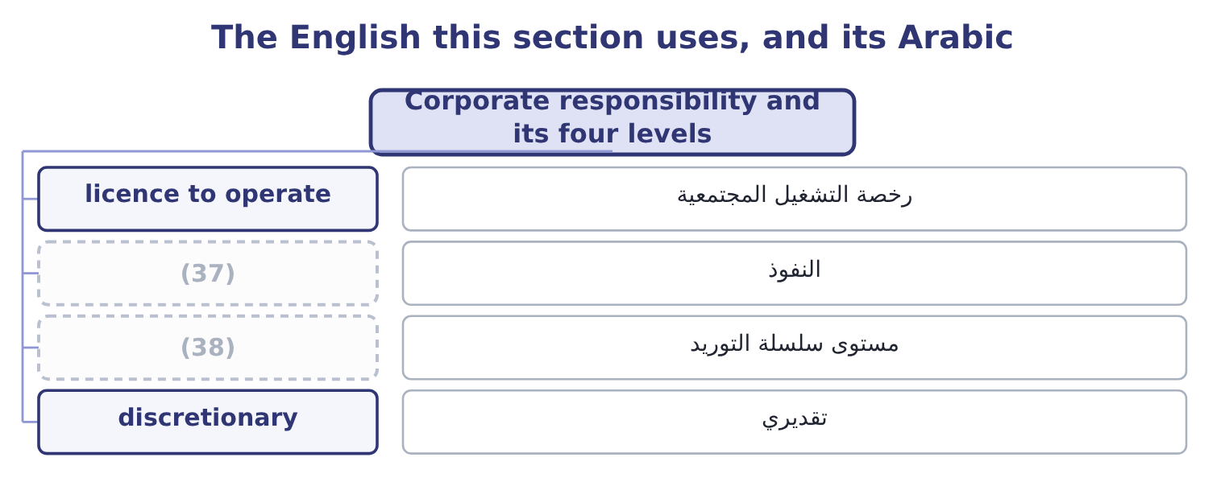
word list
leverage · lawful basis · supply chain tier

The English this sheet uses, and its Arabic
English (exam term) | Arabic
licence to operate | رخصة التشغيل المجتمعية
leverage | النفوذ
supply chain tier | مستوى سلسلة التوريد
discretionary | تقديري

Answer key · 18.3 Corporate responsibility and its four levels

1 corporate | 20 influence
2 seriously | 21 contested
3 asserting | 22 leverage
4 deception | 23 operations
5 objectives | 24 customer
6 licence | 25 defined
7 stakeholder | 26 structure
8 answers | 27 Economic
9 useful | 28 profitable
10 include | 29 foundation
11 strengthened | 30 obligations
12 transferring | 31 expected
13 responsibilities | 32 requires
14 follow | 33 Philanthropic
15 employs | 34 volunteering
16 subject | 35 discretionary
17 distributors | 36 philanthropy
18 liability | 37 leverage
19 supply | 38 supply chain tier

the summaries in full
Summary 1 The outcome asks you to discuss corporate responsibility for ethical conduct, and a good answer begins by taking the question seriously rather than asserting a position. Two classical views frame it. The narrow view holds that a company's responsibility is to its owners: to make money within the rules of the game, lawfully and without deception, and that managers spending the owners' money on social purposes are spending money that is not theirs for objectives nobody elected them to pursue. The broader view holds that a company's licence to operate comes from society, that it affects many parties besides its owners, and that it is responsible to all of them — the stakeholder reasoning. The position that answers the exam takes the useful part of both. Even on the narrow view, a company is responsible for conduct: the narrow view says within the rules, and the rules include honesty, safety and the law. And the broader view is strengthened, not weakened, by the long-run argument — a company that damages its customers, its employees, its suppliers or its community is usually destroying value rather than transferring it, which is what Book 2's long-run value maximisation actually implies.
Summary 2 Four specific responsibilities for ethical conduct follow, and they are what the outcome is asking for. For its own conduct, by the people it employs, which is the subject. For conduct in its name, by agents, distributors and partners, which section 18.2 makes a legal liability and not only an ethical one. For conduct in its supply chain, to the extent of its influence. This is the most contested of the four: a company cannot audit every tier, and the standard applied is that it should know its material risks, use its leverage where it has any, and not arrange its affairs so as to avoid knowing. And for the effects of its products and operations on people who never agreed to them: the customer who cannot evaluate what they are buying, the community affected by the plant, the person whose data the company holds.
Summary 3 The four levels of social responsibility, which the outcome asks to be defined, are the classical pyramid and provide the structure for an answer. Economic responsibility: to be profitable. It is the foundation, because a company that does not cover its costs can meet none of the other obligations, and Book 1's whole analysis is about whether it does. Legal responsibility: to obey the law — the floor. Ethical responsibility: to do what is right, fair and expected beyond what the law requires, which is the gap. Philanthropic responsibility: to contribute resources to the community — donations, volunteering, support for education and the arts. It is discretionary, and the order matters: philanthropy does not compensate for failures at the levels below it, and a company that underpays its suppliers and funds a scholarship has not balanced anything.

18.4 Sustainability
Chapter 18 · section 18.4

Fill every gap. Each word list holds one word more than there are gaps.
Summary 1 gaps 1–12
Two outcomes meet here: the major issues of sustainability and social (1) , and the three (2) spheres. The three spheres — (3) the three pillars, or people, planet and profit — are the (4) to use. The (5) sphere: whether the activity is (6) viable over the long run, for the company and for those who depend on it. An (7) activity is not (8) in any sense, which is why this sphere comes first and why sustainability and the economics of Books 1 to 3 are not opposed. The environmental sphere: whether the activity can continue without (9) or damaging the natural systems it depends on — emissions, energy, water, waste, land, (10) , materials. The social sphere: the effects on people — employees, (11) , customers and supply chain workers — covering safety, labour conditions, human rights, (12) and community impact.
word list
development · Resources · economic · communities · financially · depleting · sometimes · unprofitable · conceptual · structure · responsibility · biodiversity · sustainable

Summary 2 gaps 13–24
The point of the (13) framing is that sustainability is where they overlap. An initiative that is good (14) and loses money (15) will stop; one that is profitable and damages a community will be stopped; and the useful work is in finding the overlap, which is also where a management accountant is most useful, because the overlap is identified with numbers. The major issues the (16) asks about, (17) . Climate and emissions: (18) gas emissions from a company's own (19) , from the energy it buys, and from its value chain — the last of which is usually the largest and the hardest to measure. (20) risk, as regulation and markets change, and physical risk, as weather (21) do; for a food company, the physical risk is direct, since Orontes's sesame comes from fields. (22) : energy, water, raw materials and the waste (23) . These have the useful property of (24) in the accounts: Orontes's energy cost is 42,000,000 × 0.03 = 1,260,000 a year, and a 15 per cent reduction is 1,260,000 × 0.15 = 189,000 of saving as well as an emissions reduction — which is the overlap of the three spheres in one line.
word list
indefinitely · appearing · grouped · operations · three-sphere · environmentally · outcome · Resources · materials · Transition · patterns · greenhouse · produced

Summary 3 gaps 25–32
Process waste of 1.5 per cent of cost of goods sold is 27,300,000 × 0.015 = 409,500, and waste is both an environmental issue and the cost of poor (25) of Book 1. People: safety, pay and conditions, (26) and child labour in the supply chain, (27) and inclusion, community effects. Products: (28) and safety for a food company, (29) and its disposal, honest (30) , and what the product does to the people who use it. (31) and reporting: how sustainability is governed, what is (32) , to what standard, and whether it is assured.
word list
nutrition · quality · forced · marketing · disclosed · materials · Governance · packaging · diversity

Summary 4 gaps 33–44
Reporting frameworks have converged considerably — the (33) Sustainability Standards Board's standards building on earlier frameworks, with climate disclosure modelled on the task force (34) — and the direction is toward disclosure that is comparable, assured and located in the financial report rather than beside it. Two issues that produce exam (35) . Materiality, and its two (36) . Financial materiality asks which sustainability matters (37) the company's own cash flows and value — climate risk to the sesame crop, for example. Impact materiality asks which of the company's effects on the world are (38) regardless of whether they (39) on it. Some frameworks require only the first and some require both, and an (40) should say which sense it is using. And (41) : claims that overstate performance, that are (42) , that count something the company would have done anyway, or that offset rather than reduce. It matters ethically because it is simply dishonesty about a technical subject, and it matters (43) because regulators in several (44) now treat it as a misleading commercial practice.
word list
recommendations · jurisdictions · unmeasurable · answer · frameworks · questions · affect · International · rebound · practically · significant · senses · greenwashing

The English this section uses, and its Arabic
Each term sits against what it means.
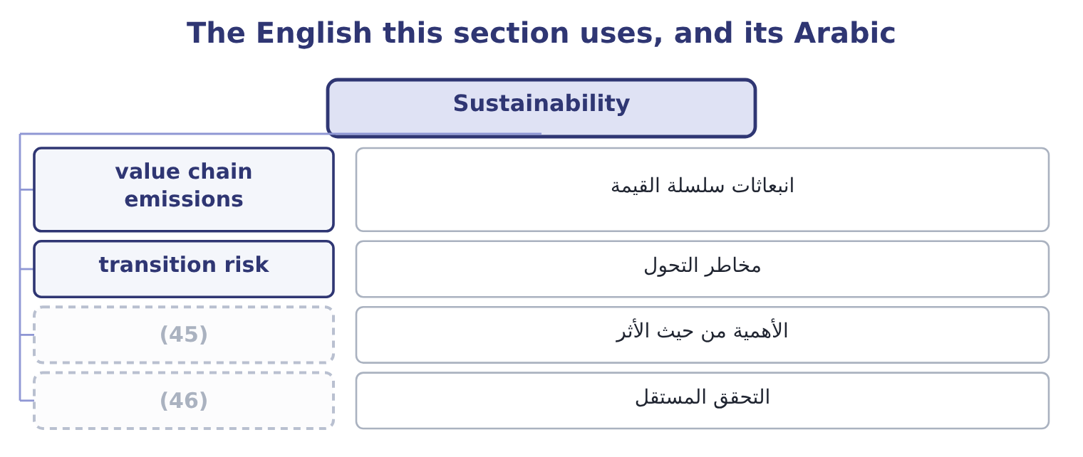
word list
discretionary · assurance · impact materiality

The English this sheet uses, and its Arabic
English (exam term) | Arabic
value chain emissions | انبعاثات سلسلة القيمة
transition risk | مخاطر التحول
impact materiality | الأهمية من حيث الأثر
assurance | التحقق المستقل

Answer key · 18.4 Sustainability

1 responsibility | 24 appearing
2 conceptual | 25 quality
3 sometimes | 26 forced
4 structure | 27 diversity
5 economic | 28 nutrition
6 financially | 29 packaging
7 unprofitable | 30 marketing
8 sustainable | 31 Governance
9 depleting | 32 disclosed
10 biodiversity | 33 International
11 communities | 34 recommendations
12 development | 35 questions
13 three-sphere | 36 senses
14 environmentally | 37 affect
15 indefinitely | 38 significant
16 outcome | 39 rebound
17 grouped | 40 answer
18 greenhouse | 41 greenwashing
19 operations | 42 unmeasurable
20 Transition | 43 practically
21 patterns | 44 jurisdictions
22 Resources | 45 impact materiality
23 produced | 46 assurance

the summaries in full
Summary 1 Two outcomes meet here: the major issues of sustainability and social responsibility, and the three conceptual spheres. The three spheres — sometimes the three pillars, or people, planet and profit — are the structure to use. The economic sphere: whether the activity is financially viable over the long run, for the company and for those who depend on it. An unprofitable activity is not sustainable in any sense, which is why this sphere comes first and why sustainability and the economics of Books 1 to 3 are not opposed. The environmental sphere: whether the activity can continue without depleting or damaging the natural systems it depends on — emissions, energy, water, waste, land, biodiversity, materials. The social sphere: the effects on people — employees, communities, customers and supply chain workers — covering safety, labour conditions, human rights, development and community impact.
Summary 2 The point of the three-sphere framing is that sustainability is where they overlap. An initiative that is good environmentally and loses money indefinitely will stop; one that is profitable and damages a community will be stopped; and the useful work is in finding the overlap, which is also where a management accountant is most useful, because the overlap is identified with numbers. The major issues the outcome asks about, grouped. Climate and emissions: greenhouse gas emissions from a company's own operations, from the energy it buys, and from its value chain — the last of which is usually the largest and the hardest to measure. Transition risk, as regulation and markets change, and physical risk, as weather patterns do; for a food company, the physical risk is direct, since Orontes's sesame comes from fields. Resources: energy, water, raw materials and the waste produced. These have the useful property of appearing in the accounts: Orontes's energy cost is 42,000,000 × 0.03 = 1,260,000 a year, and a 15 per cent reduction is 1,260,000 × 0.15 = 189,000 of saving as well as an emissions reduction — which is the overlap of the three spheres in one line.
Summary 3 Process waste of 1.5 per cent of cost of goods sold is 27,300,000 × 0.015 = 409,500, and waste is both an environmental issue and the cost of poor quality of Book 1. People: safety, pay and conditions, forced and child labour in the supply chain, diversity and inclusion, community effects. Products: nutrition and safety for a food company, packaging and its disposal, honest marketing, and what the product does to the people who use it. Governance and reporting: how sustainability is governed, what is disclosed, to what standard, and whether it is assured.
Summary 4 Reporting frameworks have converged considerably — the International Sustainability Standards Board's standards building on earlier frameworks, with climate disclosure modelled on the task force recommendations — and the direction is toward disclosure that is comparable, assured and located in the financial report rather than beside it. Two issues that produce exam questions. Materiality, and its two senses. Financial materiality asks which sustainability matters affect the company's own cash flows and value — climate risk to the sesame crop, for example. Impact materiality asks which of the company's effects on the world are significant regardless of whether they rebound on it. Some frameworks require only the first and some require both, and an answer should say which sense it is using. And greenwashing: claims that overstate performance, that are unmeasurable, that count something the company would have done anyway, or that offset rather than reduce. It matters ethically because it is simply dishonesty about a technical subject, and it matters practically because regulators in several jurisdictions now treat it as a misleading commercial practice.

18.5 Data ethics and data protection
Chapter 18 · section 18.5

Fill every gap. Each word list holds one word more than there are gaps.
Summary 1 gaps 1–12
The last two outcomes concern the (1) of the obligations and the one (2) fastest. Data ethics is the (3) of ethical principles to the (4) , use, sharing and retention of data — particularly data about people, and particularly where decisions about people are made from it, including by models the company cannot fully explain. The outcome names five principles. Data and the models built on it should not (5) outcomes that (6) people on grounds that are irrelevant or (7) . The practical problem is that a model trained on (8) data reproduces the patterns in that data, including the ones nobody would defend: a credit model, a (9) screen or a pricing algorithm can (10) accurately and (11) without any (12) to do so, and without anybody being able to point to the line that does it.
word list
pricing · indefensibly · instruction · newest · application · produce · discriminate · collection · disadvantage · unacceptable · historical · changing · recruitment

Summary 2 gaps 13–24
Fairness is (13) a property to be (14) for in outcomes, not an (15) to be declared. People should retain (16) over information about them: what is collected, for what purpose, who sees it, and how long it is kept. The ethical standard goes beyond consent, because consent obtained through a document nobody reads, as a (17) of a service with no (18) , is not meaningful agreement — which is. People should be able to know what data is held, how it is used, and when a decision about them has been made or (19) by a model. Where a model's workings cannot be (20) , the company should be able to explain the decision anyway — what factors mattered, and how the decision can be (21) . Whose data it is, and what rights (22) . The legal answer varies and the ethical one is more (23) : data about a person is not simply an asset of whoever collected it, and the rights that come with it — to access, to correct, to (24) , to have it deleted — belong to the person.
word list
obtained · withdraw · assisted · settled · questioned · alternative · control · therefore · tested · condition · explained · follow · intention

Summary 3 gaps 25–36
Somebody is (25) for how data and models are used, for their outcomes, and for (26) things right. A model is not a party and cannot be responsible; the company is, and the obligation is not (27) by the fact that an outcome was produced (28) . Four practical issues a (29) accountant meets directly. Data collected for one purpose used for (30) — the most common failure and the (31) to avoid, by asking whether the person would recognise this use as the one they agreed to. Retention: data kept because (32) is cheap, long after any purpose, which raises both the ethical exposure and the loss if it is (33) . Security, which is the (34) risk of, and where the duty to those whose data it is survives any (35) . And the use of models in decisions about people — credit limits, prices, (36) — where the five principles apply together and where somebody must be able to answer a question about an individual case.
word list
easiest · operational · employment · outsourcing · automatically · discharged · another · putting · management · storage · answerable · breached · collection

Summary 4 gaps 37–48
Governmental data (37) regulation, which is the final outcome, exists for a purpose the exam asks you to state: to protect individuals' rights in (38) to information about them, by placing obligations on the organisations that hold it. The common features across (39) are worth knowing as a set, since the (40) varies and the pattern does not. A lawful basis is (41) for processing personal data, of which consent is only one; others include contract, legal obligation and a (42) interest that does not override the person's rights. Purpose limitation and data (43) : collect for a (44) purpose, collect no more than is needed, and do not repurpose without a basis. (45) , and retention no longer than (46) . Security (47) to the risk, with (48) of breaches to the regulator and, where the risk is high, to the people affected, within short deadlines.
word list
protection · specified · relation · minimisation · notification · necessary · required · legitimate · regulation · jurisdictions · detail · appropriate · Accuracy

Summary 5 gaps 49–57
Rights for individuals: to be informed, to access their data, to have it (49) or deleted, to object to certain processing, to (50) , and in several regimes a right not to be subject to a decision made solely by automated processing where it has (51) effects. Accountability and records: the (52) must be able to (53) compliance, which usually means documented (54) , policies and a responsible person. (55) on transferring data across borders, which bear directly on a company (56) in several (57) . And substantial penalties, in several regimes calculated as a percentage of worldwide turnover, which places the subject firmly on the risk register.
word list
interrupting · organisation · assessments · corrected · demonstrate · Restrictions · significant · countries · operating · portability

Worked example: the distributor's customer list

Summary 6 gaps 58–69
Orontes's (58) manager proposes to buy a list of 40,000 consumer names and (59) from a distributor, for a direct campaign offering samples. The (60) to ask first. The ethical test, (61) of the legal one. Would these people recognise this use as something they agreed to? If the answer is no, the campaign fails the fairness and transparency principles (62) the contract with the distributor says, and: the (63) is a floor. Require written evidence of the lawful basis and of what people were told; contract for it with (64) and an indemnity; limit the data taken to what the campaign needs and delete it (65) ; provide a clear opt-out in the first contact; and record the assessment. If the distributor cannot evidence the basis, (66) the list, because the exposure is a penalty (67) against turnover and a public failure in Orontes's own name. The pattern is the same as the agent: a third party offering something valuable whose (68) the company has not verified, where the liability and the (69) remain the company's own.
word list
lawfulness · whatever · warranties · independent · measured · provenance · substantial · decline · addresses · afterwards · reputation · marketing · questions

The outward obligations

Your turn: the last obligations (complete the blanks)
Item | Data | Answer
How most occupational fraud is detected | More than audit and review combined | ________
The corporate offence under the UK Bribery Act, and its defence | (70) | ________
The four levels of social responsibility | (71) | ________
The three spheres of sustainability | Sustainability lives where they overlap | ________
Saving from a 15 per cent cut in energy cost | Energy 1,260,000 | ________
The five principles of data ethics | (72) | ________

word list
In ascending order · Named in the learning outcome · Liability is strict, subject to one defence · The four levels of responsibility

"Whistleblower", "stakeholder" and "sustainable"

Summary 7 gaps 73–84
Three words that carry (73) inside them. (74) is an unfortunate English coinage: it suggests an outsider (75) a game, and in many organisations it has acquired the sense of informer, which is why codes (76) use speak up or raise a concern instead — the act is ordinary and the vocabulary should be too. (77) was coined as a deliberate play on (78) , and the play is the argument: it asserts that others hold a stake too. And sustainable has been used so (79) that it now means little on its own — a sustainable (80) , a sustainable margin, a sustainable pace. In a report, replace it with what is meant: (81) reduced by a stated amount against a stated baseline, or water use per tonne, or a margin that does not depend on deferring (82) . The general word is where (83) lives; the (84) one cannot be greenwashed.
word list
interrupting · limitation · Whistleblower · shareholder · greenwashing · widely · maintenance · emissions · Stakeholder · specific · arguments · product · increasingly

"Whistleblower", "stakeholder" and "sustainable"
Item | Answer
How most fraud is detected | Tips, chiefly from (85) — more than audit and review combined.
The UK corporate offence and its defence | Failing to prevent bribery by an associated person; the defence is adequate procedures.
The four levels of responsibility | (86)
The three spheres of sustainability | Economic, environmental and social.
Saving from a 15 per cent energy cut | (87)
The five principles of data ethics | Fairness, privacy, transparency, ownership and accountability.
What it tells you | Five lists and one calculation — and the calculation is there to show that the sustainability sphere where the three overlap is found with f

word list
The three spheres of sustainability · Economic, legal, ethical and philanthropic. · 189,000: 1,260,000 × 0.15 = 189,000. · employees

The English this section uses, and its Arabic
Each term sits against what it means.
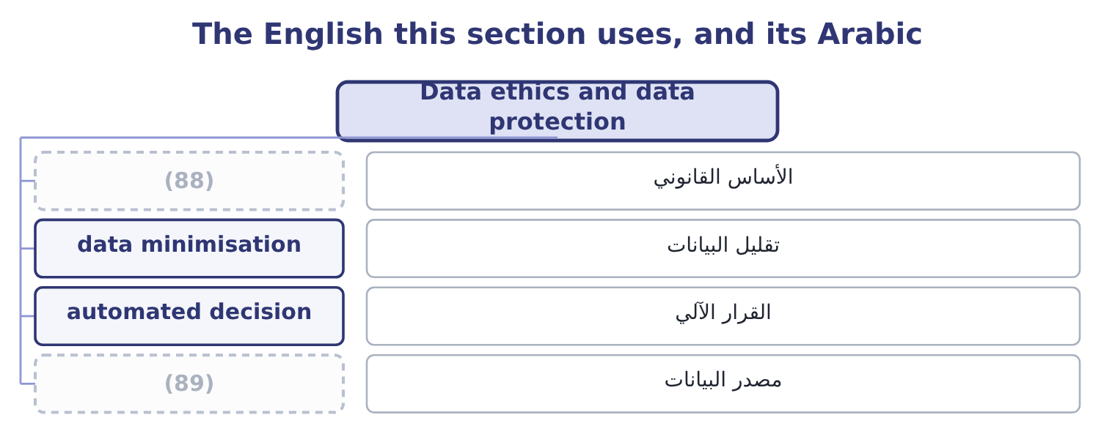
word list
assurance · provenance · lawful basis

The English this sheet uses, and its Arabic
English (exam term) | Arabic
lawful basis | الأساس القانوني
data minimisation | تقليل البيانات
automated decision | القرار الآلي
provenance | مصدر البيانات

Answer key · 18.5 Data ethics and data protection

1 newest | 46 necessary
2 changing | 47 appropriate
3 application | 48 notification
4 collection | 49 corrected
5 produce | 50 portability
6 disadvantage | 51 significant
7 unacceptable | 52 organisation
8 historical | 53 demonstrate
9 recruitment | 54 assessments
10 discriminate | 55 Restrictions
11 indefensibly | 56 operating
12 instruction | 57 countries
13 therefore | 58 marketing
14 tested | 59 addresses
15 intention | 60 questions
16 control | 61 independent
17 condition | 62 whatever
18 alternative | 63 lawfulness
19 assisted | 64 warranties
20 explained | 65 afterwards
21 questioned | 66 decline
22 follow | 67 measured
23 settled | 68 provenance
24 withdraw | 69 reputation
25 answerable | 70 Liability is strict, subject to one defence
26 putting | 71 In ascending order
27 discharged | 72 Named in the learning outcome
28 automatically | 73 arguments
29 management | 74 Whistleblower
30 another | 75 interrupting
31 easiest | 76 increasingly
32 storage | 77 Stakeholder
33 breached | 78 shareholder
34 operational | 79 widely
35 outsourcing | 80 product
36 employment | 81 emissions
37 protection | 82 maintenance
38 relation | 83 greenwashing
39 jurisdictions | 84 specific
40 detail | 85 employees
41 required | 86 Economic, legal, ethical and philanthropic.
42 legitimate | 87 189,000: 1,260,000 × 0.15 = 189,000.
43 minimisation | 88 lawful basis
44 specified | 89 provenance
45 Accuracy

the summaries in full
Summary 1 The last two outcomes concern the newest of the obligations and the one changing fastest. Data ethics is the application of ethical principles to the collection, use, sharing and retention of data — particularly data about people, and particularly where decisions about people are made from it, including by models the company cannot fully explain. The outcome names five principles. Data and the models built on it should not produce outcomes that disadvantage people on grounds that are irrelevant or unacceptable. The practical problem is that a model trained on historical data reproduces the patterns in that data, including the ones nobody would defend: a credit model, a recruitment screen or a pricing algorithm can discriminate accurately and indefensibly without any instruction to do so, and without anybody being able to point to the line that does it.
Summary 2 Fairness is therefore a property to be tested for in outcomes, not an intention to be declared. People should retain control over information about them: what is collected, for what purpose, who sees it, and how long it is kept. The ethical standard goes beyond consent, because consent obtained through a document nobody reads, as a condition of a service with no alternative, is not meaningful agreement — which is. People should be able to know what data is held, how it is used, and when a decision about them has been made or assisted by a model. Where a model's workings cannot be explained, the company should be able to explain the decision anyway — what factors mattered, and how the decision can be questioned. Whose data it is, and what rights follow. The legal answer varies and the ethical one is more settled: data about a person is not simply an asset of whoever collected it, and the rights that come with it — to access, to correct, to withdraw, to have it deleted — belong to the person.
Summary 3 Somebody is answerable for how data and models are used, for their outcomes, and for putting things right. A model is not a party and cannot be responsible; the company is, and the obligation is not discharged by the fact that an outcome was produced automatically. Four practical issues a management accountant meets directly. Data collected for one purpose used for another — the most common failure and the easiest to avoid, by asking whether the person would recognise this use as the one they agreed to. Retention: data kept because storage is cheap, long after any purpose, which raises both the ethical exposure and the loss if it is breached. Security, which is the operational risk of, and where the duty to those whose data it is survives any outsourcing. And the use of models in decisions about people — credit limits, prices, employment — where the five principles apply together and where somebody must be able to answer a question about an individual case.
Summary 4 Governmental data protection regulation, which is the final outcome, exists for a purpose the exam asks you to state: to protect individuals' rights in relation to information about them, by placing obligations on the organisations that hold it. The common features across jurisdictions are worth knowing as a set, since the detail varies and the pattern does not. A lawful basis is required for processing personal data, of which consent is only one; others include contract, legal obligation and a legitimate interest that does not override the person's rights. Purpose limitation and data minimisation: collect for a specified purpose, collect no more than is needed, and do not repurpose without a basis. Accuracy, and retention no longer than necessary. Security appropriate to the risk, with notification of breaches to the regulator and, where the risk is high, to the people affected, within short deadlines.
Summary 5 Rights for individuals: to be informed, to access their data, to have it corrected or deleted, to object to certain processing, to portability, and in several regimes a right not to be subject to a decision made solely by automated processing where it has significant effects. Accountability and records: the organisation must be able to demonstrate compliance, which usually means documented assessments, policies and a responsible person. Restrictions on transferring data across borders, which bear directly on a company operating in several countries. And substantial penalties, in several regimes calculated as a percentage of worldwide turnover, which places the subject firmly on the risk register.
Summary 6 Orontes's marketing manager proposes to buy a list of 40,000 consumer names and addresses from a distributor, for a direct campaign offering samples. The questions to ask first. The ethical test, independent of the legal one. Would these people recognise this use as something they agreed to? If the answer is no, the campaign fails the fairness and transparency principles whatever the contract with the distributor says, and: the lawfulness is a floor. Require written evidence of the lawful basis and of what people were told; contract for it with warranties and an indemnity; limit the data taken to what the campaign needs and delete it afterwards; provide a clear opt-out in the first contact; and record the assessment. If the distributor cannot evidence the basis, decline the list, because the exposure is a penalty measured against turnover and a public failure in Orontes's own name. The pattern is the same as the agent: a third party offering something valuable whose provenance the company has not verified, where the liability and the reputation remain the company's own.
Summary 7 Three words that carry arguments inside them. Whistleblower is an unfortunate English coinage: it suggests an outsider interrupting a game, and in many organisations it has acquired the sense of informer, which is why codes increasingly use speak up or raise a concern instead — the act is ordinary and the vocabulary should be too. Stakeholder was coined as a deliberate play on shareholder, and the play is the argument: it asserts that others hold a stake too. And sustainable has been used so widely that it now means little on its own — a sustainable product, a sustainable margin, a sustainable pace. In a report, replace it with what is meant: emissions reduced by a stated amount against a stated baseline, or water use per tonne, or a margin that does not depend on deferring maintenance. The general word is where greenwashing lives; the specific one cannot be greenwashed.

