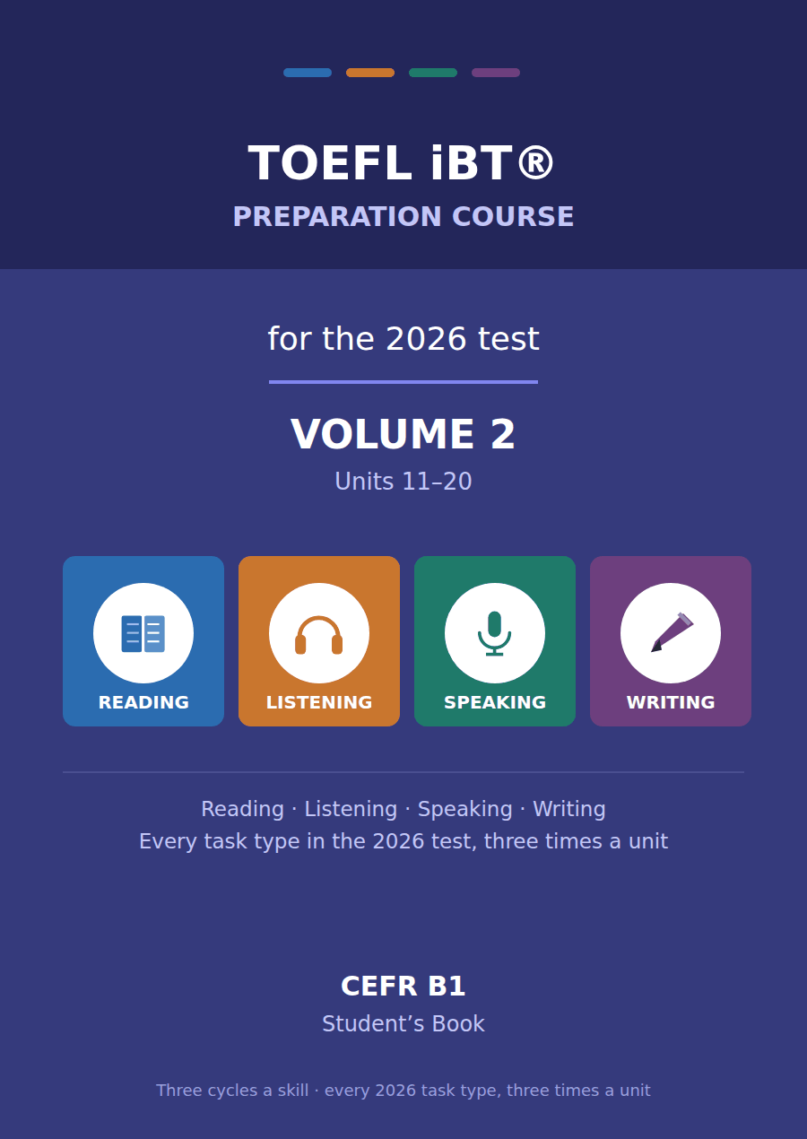

TOEFL iBT® Preparation Course 2026
Volume 2 · Units 11–20 · CEFR B1
Student’s Book with Practice Test 2

This course prepares B1 learners for the TOEFL iBT® test as it has been since 21 January 2026. Every task name, item count and timing in this book follows the official ETS practice test for that form.
Twenty units, ten in each volume. Each unit takes one topic from the test — American History, Astronomy, Public Health — and runs it through all four skills, three times, on three different sub-topics.

Series TOEFL iBT® Preparation Course 2026
Level CEFR B1 (targeting a steady 3.0–4.0 band)
Components Student’s Book · Audio · Interview video
This volume Units 11–20, Practice Test 2, answer key, audio scripts, glossary

TOEFL and TOEFL iBT are registered trademarks of ETS. This publication is not endorsed by or affiliated with ETS. Format details are taken from ETS’s own published practice material for the January 2026 form.

Map of the book Volume 2
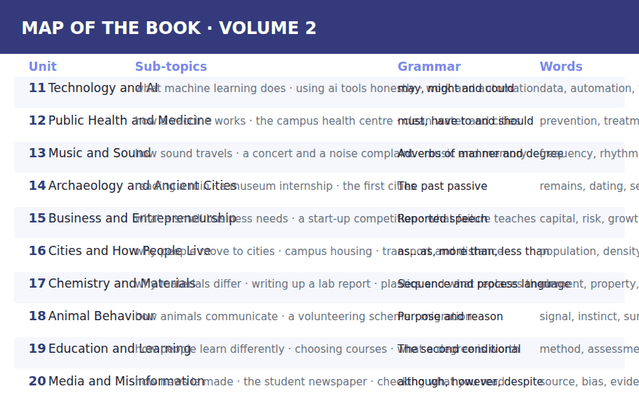

How to use this book Three cycles, four skills
Every unit is sixteen pages and every unit is built the same way, so once you have worked through Unit 11 you know where everything is.
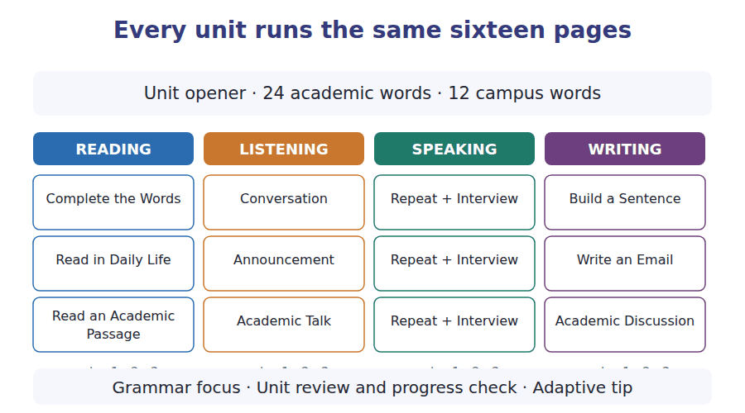
What a cycle is
A cycle is one sub-topic taken through one skill. Cycle 1 of Reading, Listening, Speaking and Writing all deal with sub-topic A; cycle 2 with sub-topic B; cycle 3 with sub-topic C. That is why the email you write in Writing cycle 2 answers the announcement you heard in Listening cycle 2.
Teach, guide, test
Inside every cycle the order is the same. A skill box tells you what to do. A guided exercise does it with help. An exam exercise does it the way the test will.

The 2026 test at a glance What you are preparing for
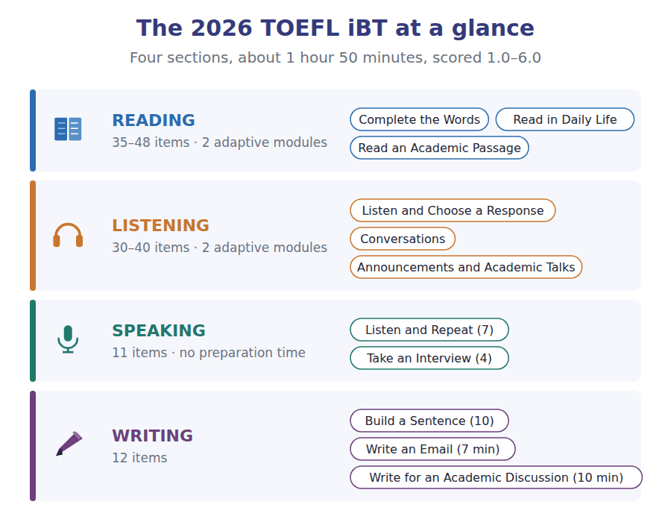
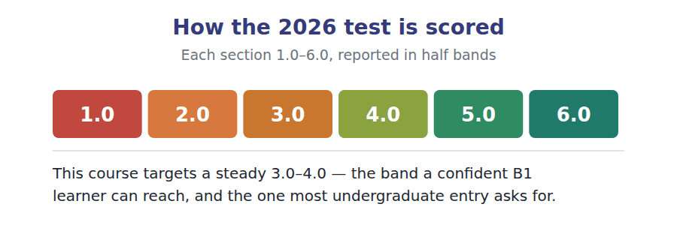

What an adaptive test does to you Modules, and why you cannot go back
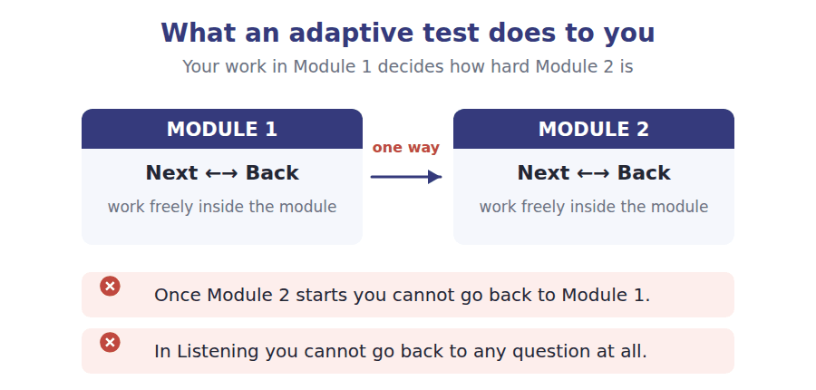
Reading and Listening are adaptive. Each is split into two modules, and how you do in Module 1 decides how hard Module 2 is. Two rules follow, and they are not the same rule.
- In Reading you can move Next and Back freely inside a module. Only the jump to Module 2 is one-way.
- In Listening you cannot go back to a previous question at all. The audio plays once.
- The early questions in a module carry the most weight, because they place you. Never rush them to buy time later.
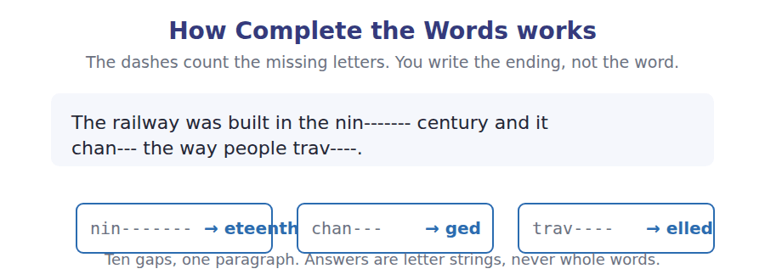

Study planner Twelve weeks, two units a week
When | What | Focus
Week 1 | Unit 11 · Technology and AI | Vocabulary, Reading, Listening
Week 2 | Unit 12 · Public Health and Medicine | Speaking, Writing, grammar, review
Week 3 | Unit 13 · Music and Sound | Vocabulary, Reading, Listening
Week 4 | Unit 14 · Archaeology and Ancient Cities | Speaking, Writing, grammar, review
Week 5 | Unit 15 · Business and Entrepreneurship | Vocabulary, Reading, Listening
Week 6 | Unit 16 · Cities and How People Live | Speaking, Writing, grammar, review
Week 7 | Unit 17 · Chemistry and Materials | Vocabulary, Reading, Listening
Week 8 | Unit 18 · Animal Behaviour | Speaking, Writing, grammar, review
Week 9 | Unit 19 · Education and Learning | Vocabulary, Reading, Listening
Week 10 | Unit 20 · Media and Misinformation | Speaking, Writing, grammar, review
Week 11 | Review units 11–20 | Glossary and grammar reference
Week 12 | Practice Test 2 | Sit it in one sitting, then mark it

Unit 11 · Technology and AI
TOEFL iBT® Preparation Course 2026 · Volume 2
CEFR B1 · Grammar: may, might and could · Word field: data, automation, trust

By the end of this unit I can…
- complete word endings in a text about how a system learns
- read a coursework rule and a post about it and find what applies to me
- follow an academic passage that distinguishes two things people confuse
- understand two students disagreeing about what is allowed
- give a careful, hedged opinion out loud without preparing
- write an email asking whether something is permitted, and a post that draws a line

Volume 2 opens where Volume 1 left you. The vocabulary of Units 1–10 is assumed from here on and comes back unglossed in the texts.

Vocabulary 1 · Academic 24 words from the Academic Word List
These twenty-four words come back through the whole unit, and again in the review. Cover the right-hand column and test yourself.
data facts and figures collected for study | rely to depend on
automate to make a machine do a job instead of a person | enhance to improve the quality of something
compute to calculate using a computer | facilitate to make something easier
technology machines and methods based on science | implement to put a plan into action
technique a particular way of doing something | incorporate to include as part of something
intelligent able to learn and understand | capacity the amount something can hold or do
logic reasoning that follows clear rules | parameter a limit or setting that controls a system
simulate to imitate something real | protocol an agreed set of rules for doing something
input what is put into a system | manipulate to control or change something skilfully
code instructions written for a computer | inevitable certain to happen
channel a way of sending information | ethic a principle about right and wrong
secure safe from harm or interference | explicit stated clearly and openly

Exercise A Work in pairs. Ask and answer.
1. Which technology do you rely on most? What would you do without it?
2. Name one task you would happily automate and one you would not.
3. What data about you do you think your phone collects?
4. Is it inevitable that machines will do your future job? Why or why not?
Vocabulary 2 · Campus and everyday 12 words for the daily-life tasks
The exam does not only test academic English. Notices, emails, conversations and announcements use the everyday words below.
laptop a portable computer | plagiarism using someone else’s work as your own
password a secret word that lets you in | citation a reference to a source you used
log in to enter a system with your details | declaration form a form in which you state what you did
software programs that run on a computer | tutor a teacher responsible for a small group
update a newer version of a program | submission portal the website where you hand work in
coursework work done during a course and marked | back-up a second copy kept in case of loss

Words you will meet again: process | significant | evaluate | estimate | predict | identify | structure | component


SKILL · Technical texts still use ordinary endings
- Do not be put off by the subject. The endings are the same ones: -ing, -ed, -ion, -ive.
- A gap after is or are is usually a participle, exactly as in Unit 3.
- Count the dashes before choosing between -ion and -ation.
- Read the sentence back. Technical prose repeats its key nouns constantly.

Exercise A Guided practice. Five words are not complete. Write the missing letters.
A machine does not learn the way a person does. It is sh--- millions of examples, and it adjusts itself until its answ--- match them. Nobody writes a rule for what a cat looks l---. The system finds a patt--- that works and cannot explain it eit---.

The first one is done for you: 1 sh--- → own (shown)
Exercise B Exam practice. One paragraph, ten gaps — the real task.
The word learning is doing a lot of work in machine learning, and it is worth asking what is actually happ-----. A traditional program follows rules that somebody wrote. A learning system is given examples instead, and it adjusts thousands of internal numbers until its outputs match them closely en----. Nobody decides what those numbers me--. This is why such a system can be extremely accu---- and completely unable to explain its---. It is also why it fails in ways that look st-----. Change a few pixels in a photograph and the system may conf--- a bus with an ostrich, because its patt--- was never the pattern a person wo--- have used. The useful rule is simple: these systems are confident everywhere and reliable only where their examples actually we--.

Check your answers in the key at the back of the book.


SKILL · Find the category you are in
- Rules documents divide the world into cases. Decide which case the question describes.
- Allowed, allowed with a declaration, and not allowed are three different categories.
- An example in a rule is usually what the question asks about.
- In a post, the writer’s opinion and the rule itself are different things.

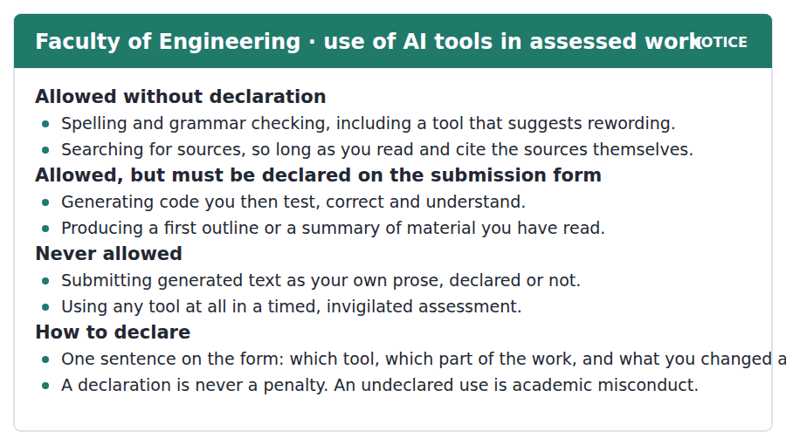
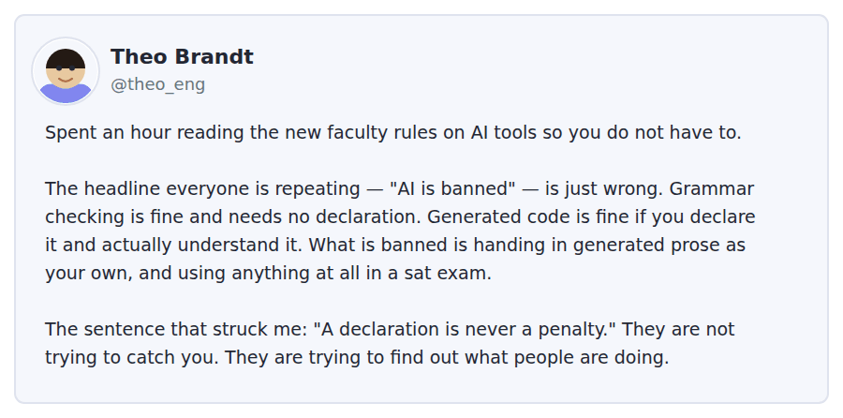
Exercise A Guided practice. The answer is on the page — find it.
1. Which use needs no declaration?
(A) Checking spelling and grammar
(B) Generating code
(C) Producing an outline
(D) Summarising a reading
2. What must a student do after generating code?
(A) Nothing
(B) Delete it before submitting
(C) Ask a tutor first
(D) Declare it and understand it
3. What is never allowed?
(A) Searching for sources
(B) Declaring a tool
(C) Submitting generated text as your own prose
(D) Rewording a sentence
4. What must a declaration contain?
(A) The name of the tutor
(B) Which tool, which part, and what you changed
(C) A copy of the output
(D) The time you spent
Exercise B Exam practice.
5. What is the main purpose of Theo’s post?
(A) To complain about the rules
(B) To correct what people are saying about them
(C) To ask for advice
(D) To advertise a tool
6. According to Theo, what is the rule about grammar checking?
(A) It is banned
(B) It must be declared
(C) It is allowed with no declaration
(D) It depends on the module
7. Which sentence did Theo find most significant?
(A) "AI is banned"
(B) "Using any tool at all in a timed assessment"
(C) "Searching for sources"
(D) "A declaration is never a penalty"
8. What does Theo think the faculty is trying to do?
(A) Find out what people are doing
(B) Catch students out
(C) Reduce marking
(D) Ban new software
9. A student uses a tool to summarise three articles for an essay. They should
(A) declare it on the submission form
(B) do nothing
(C) not use it at all
(D) ask the tutor for permission
10. What can be inferred about the invigilated assessment rule?
(A) It applies only to engineering
(B) It is the strictest of the rules
(C) It will be reviewed next year
(D) It allows grammar tools


SKILL · Separate two questions the public confuses
- A passage of this type names a confusion in its first paragraph. That is the main idea.
- The case study in paragraph 2 exists to prove one half of the distinction.
- The last paragraph usually converts the finding into a better question. Note the new question.
- Examples given at the end are tested for what they illustrate, not for themselves.

Which Jobs Automation Changes, and Which It Replaces
Public argument about automation nearly always runs together two different things: whether a job disappears, and whether a job changes. They have very different histories. Automation has eliminated remarkably few occupations outright. It has rewritten the content of almost all of them.
The clearest case is the cash machine. Economists expected it to end the career of the bank clerk, and for a decade the number of clerks per branch did fall. But cheaper branches meant more branches, and the clerks who remained spent their time selling and advising rather than counting notes. The number of bank employees in the United States was higher thirty years after the cash machine than before it. The job had not gone. It had been emptied of one task and filled with another.
What this suggests is that the useful question is not which jobs will be automated but which tasks. A job is a bundle of tasks, and automation takes the ones that are routine, well-defined and repeated, whatever the status of the job they sit in. That is why the effect falls so unevenly: a radiologist and a warehouse picker may lose the same proportion of their working day, while a plumber loses almost none, because almost nothing a plumber does in an afternoon is the same as what they did in the morning.
[280 words]

Exercise A Guided practice.
1. What is the passage mainly about?
(A) Why bank clerks lost their jobs
(B) Why plumbers are safe
(C) How cash machines work
(D) The difference between jobs disappearing and jobs changing
2. According to paragraph 1, what has automation mostly done?
(A) Eliminated occupations
(B) Reduced wages
(C) Changed the content of occupations
(D) Created new industries
3. What happened to the number of bank employees?
(A) It fell steadily
(B) It stayed exactly the same
(C) It is not known
(D) It was higher thirty years later
4. Why does the author mention the cash machine?
(A) To give the clearest case of a job changing rather than vanishing
(B) To explain how banking works
(C) To show that economists are usually wrong
(D) To compare two countries
Exercise B Exam practice.
5. What does the author say the useful question is?
(A) Which jobs will be automated
(B) Which tasks will be automated
(C) How many jobs will go
(D) Which industries will grow
6. Which kind of task does automation take?
(A) Difficult and skilled
(B) Physical rather than mental
(C) Routine, well-defined and repeated
(D) Badly paid
7. Why is a plumber barely affected?
(A) The work is physical
(B) The work is well paid
(C) There are too few plumbers
(D) Almost nothing repeats within a day
8. All of the following are stated in the passage EXCEPT:
(A) Skilled jobs are always safer
(B) Few occupations have disappeared
(C) A job is a bundle of tasks
(D) The effect falls unevenly
9. The word "emptied" in paragraph 2 is closest in meaning to
(A) abolished
(B) expanded
(C) cleared out
(D) divided
10. What can be inferred about the economists mentioned in paragraph 2?
(A) They predicted the outcome correctly
(B) They asked which job rather than which task
(C) They had no data
(D) They worked for banks
11. Which best states the main idea of paragraph 3?
(A) Radiologists are at risk
(B) Routine work is badly paid
(C) Automation will slow down
(D) Automation affects tasks, so its effects are uneven


Exercise A Listen and choose a response. You hear one line. Choose the best reply.
1. Man: Have you declared the tool you used?
(A) It’s on the submission form.
(B) Not yet — do I have to?
(C) Last Tuesday.
(D) Yes, it’s very good.
2. Woman: Is it banned completely?
(A) In an exam, yes. Otherwise no.
(B) On the faculty page.
(C) Three categories.
(D) Yes, I read it.
3. Man: Where do I put the declaration?
(A) One sentence is enough.
(B) Before the deadline.
(C) On the submission form.
(D) Yes, you must.
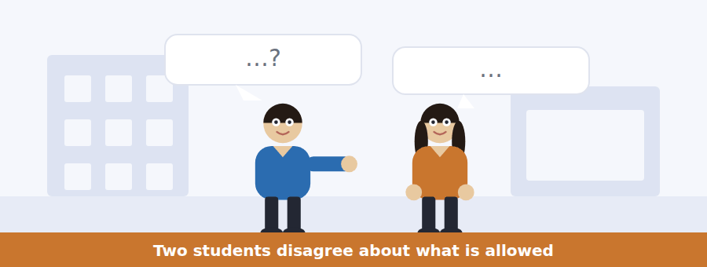
SKILL · Separate what someone believes from what the rule says
- One speaker is usually wrong about a rule. The correction is a question.
- Listen for I thought… and actually — they bracket the error.
- An agreement at the end may be only partial. Note what is still disputed.
- The audio plays once, so write the rule down as you hear it.

Exercise B Listen and answer. The audio plays once.
4. What is the man’s mistake?
(A) He used a tool in an exam
(B) He believed generated code was banned
(C) He submitted late
(D) He copied another student
5. What does the woman say the rule actually is?
(A) Code tools are allowed if declared and understood
(B) Code tools are banned
(C) Code tools need a tutor’s permission
(D) Code tools are allowed in exams
6. What must a declaration contain?
(A) A copy of the output
(B) The tutor’s signature
(C) The tool, the part and what you changed
(D) The time taken
7. According to the woman, what counts as misconduct?
(A) Using a tool at all
(B) Declaring a tool
(C) Rewriting generated code
(D) Using one and not saying so
8. Why can the man not simply add a declaration now?
(A) He has lost the form
(B) His tutor is away
(C) The deadline has moved
(D) The submission portal has closed
9. What does the woman advise?
(A) Email the tutor tonight
(B) Say nothing and hope
(C) Wait until Monday
(D) Resubmit the work
Audio script: see the back of the book. Do not read it before you listen.


Exercise A Listen and choose a response. You hear one line. Choose the best reply.
1. Woman: Do I declare a spellchecker?
(A) On the submission form.
(B) It’s in the second category.
(C) No — that one needs no declaration.
(D) Yes, everything.
2. Man: What if I am not sure?
(A) It is never a penalty.
(B) Declare it anyway.
(C) In the exam hall.
(D) Three categories.
3. Woman: Does this apply to exams too?
(A) No tools at all in an exam.
(B) It applies to coursework.
(C) From this term.
(D) Yes, declare it.
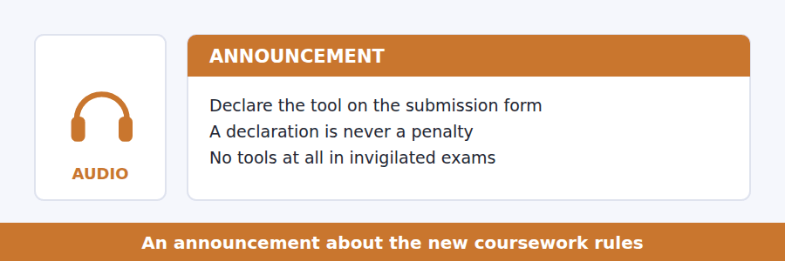
SKILL · Catch the exception to the exception
- Rules announcements often qualify twice: allowed, unless, except when.
- Note the final condition — it is usually what is tested.
- A phrase repeated word for word is being emphasised for you.
- The closing sentence usually tells you what to do if you are unsure.

Exercise B Listen and answer. The audio plays once.
4. What is the main purpose of the announcement?
(A) To ban AI tools
(B) To change an exam date
(C) To introduce new software
(D) To explain three categories of use
5. Why does the speaker mention social media?
(A) To recommend a page
(B) Because the version circulating there is wrong
(C) To ask students to share the rules
(D) To explain how the rules were written
6. What must accompany a declared use?
(A) A tutor’s signature
(B) A copy of the output
(C) One sentence naming tool, part and changes
(D) A citation
7. Which rule has no exception at all?
(A) Declaring an outline
(B) Citing sources you have read
(C) Using any tool in an invigilated assessment
(D) Using a spellchecker
8. What should a student do if unsure which category applies?
(A) Ask another student
(B) Declare it
(C) Avoid the tool
(D) Submit and explain later
Audio script: see the back of the book. Do not read it before you listen.


Exercise A Listen and choose a response. You hear one line. Choose the best reply.
1. Woman: Did she say the model explains itself?
(A) No — the opposite.
(B) On the board.
(C) Thousands of numbers.
(D) Yes, she did.
2. Man: What is it trained on?
(A) Very accurately.
(B) Last year.
(C) Yes, it is.
(D) Examples.
3. Woman: Could you explain the ostrich example?
(A) It changed a few pixels.
(B) Of course — which part confused you?
(C) In the third slide.
(D) Yes, I could.
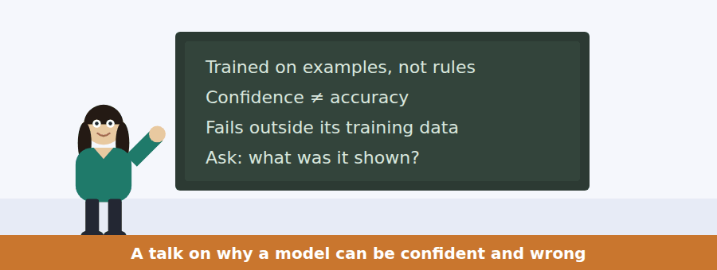
SKILL · Follow a warning, not a description
- Some talks exist to warn you. The warning is the main idea; the mechanism is the support.
- Listen for the word that signals the turn: but, the trouble is, here is the problem.
- A single striking example is almost always tested.
- The final instruction tells you what the speaker wants you to do with the talk.

Exercise B Listen and answer. The audio plays once.
4. What is the main idea of the talk?
(A) Learning systems are usually inaccurate
(B) Adversarial images should be banned
(C) A system’s confidence is not the same as its accuracy
(D) Programming by rules is better
5. How does a learning system differ from a traditional program?
(A) It is faster
(B) It uses less data
(C) It can explain its answers
(D) It is shown examples instead of given rules
6. What does a confidence figure actually measure?
(A) How typical the input looked
(B) How accurate the answer is
(C) How much data was used
(D) How long the system took
7. When do confidence and accuracy come apart?
(A) Inside the training range
(B) Only in images
(C) Only with new systems
(D) Outside the training range
8. Why does the speaker mention the bus and the ostrich?
(A) To show a mechanical failure
(B) To demonstrate confident and wrong
(C) To explain how photographs are stored
(D) To compare two systems
9. What question does the speaker want students to ask?
(A) How accurate is it?
(B) Who built it?
(C) What was it shown?
(D) How fast is it?
Audio script: see the back of the book. Do not read it before you listen.


Part 1 · Listen and Repeat
You hear a sentence and repeat it once. There is no preparation time, and the sentences get longer. Focus: weak forms in modal verbs
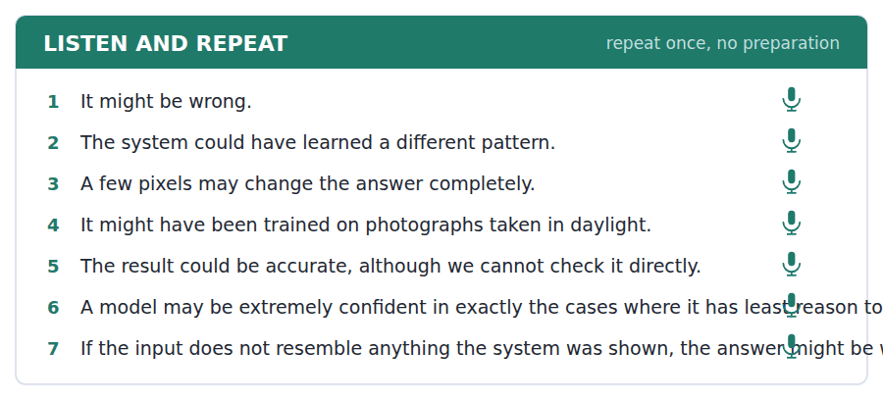
SKILL · Reduce the modal, not the verb
- might have sounds like /maɪtəv/. Could have sounds like /kʊdəv/.
- Never say of. It is have, however it sounds.
- Keep the main verb clear and let the modal shrink.
- Finish the sentence even if a word escapes you.

Part 2 · Take an Interview
An interviewer asks you four questions on one theme: tools you use. Answer each one fully. There is no preparation time.
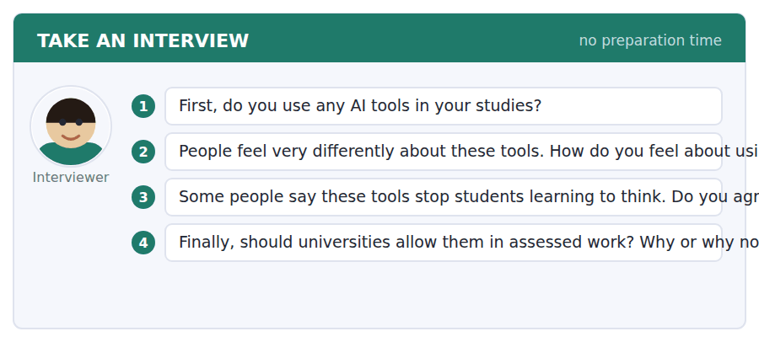
A good answer sounds like this
Question 2 — Slightly guilty, which I think is unreasonable. I use one to check my grammar and nobody would call a dictionary cheating.
Question 3 — It might, if you let it write for you. Used to check whether your own argument holds, it could do the opposite.
I can… | Not yet | Yes
I reduced the modal and kept the verb clear | □ | □
I said have, never of | □ | □
I gave a reason after every opinion | □ | □


Part 1 · Listen and Repeat
You hear a sentence and repeat it once. There is no preparation time, and the sentences get longer. Focus: hedged opinion
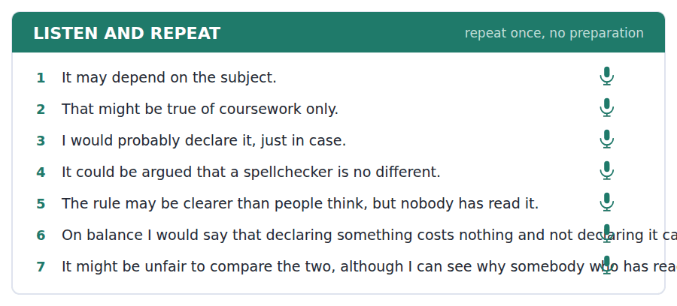
SKILL · Say how sure you are
- It may be…, it might depend on…, I would probably say…
- Hedging is not weakness. It is accuracy, and the test rewards it.
- Still commit at the end: on balance, I think…
- One hedge, one position, one reason.

Part 2 · Take an Interview
An interviewer asks you four questions on one theme: rules about honesty in study. Answer each one fully. There is no preparation time.
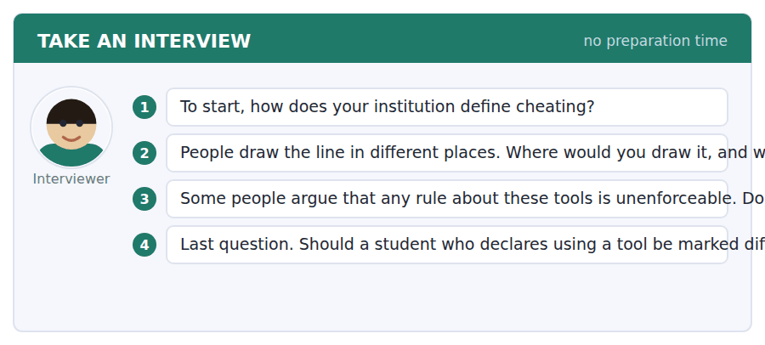
A good answer sounds like this
Question 2 — I would draw it at whether the thinking is mine. If a tool corrects my sentence, the thought was still mine; if it supplies the thought, it is not.
Question 4 — No, and I think that is the whole point of saying a declaration is never a penalty. The moment it costs marks, nobody declares anything.
I can… | Not yet | Yes
I used at least two hedging expressions | □ | □
I still committed to a position | □ | □
I gave one clear reason | □ | □


Part 1 · Listen and Repeat
You hear a sentence and repeat it once. There is no preparation time, and the sentences get longer. Focus: academic register
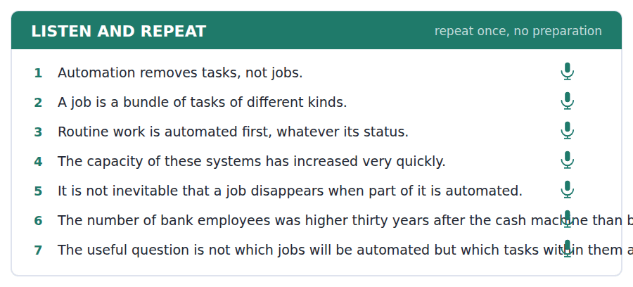
SKILL · Make a distinction and hold it
- Use the unit’s words: automate, capacity, inevitable, explicit, implement.
- Name the two things you are separating, then keep the labels.
- Not X but Y is the strongest sentence shape here.
- Mark yourself against the three statements below.

Part 2 · Take an Interview
An interviewer asks you four questions on one theme: work and machines. Answer each one fully. There is no preparation time.
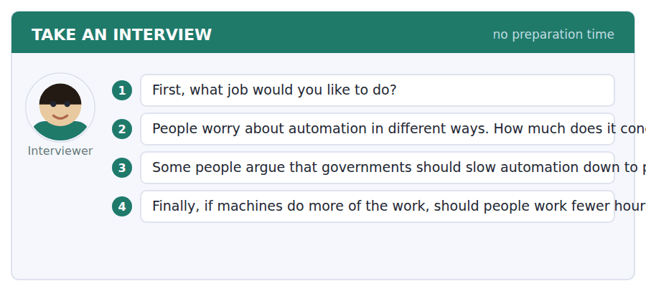
A good answer sounds like this
Question 3 — I disagree, mostly. Slowing it down protects the task, not the person, and the task was going to go either way.
Question 4 — In principle yes, and the history is on that side: the working week has fallen with every previous wave and nobody now argues we should put it back.
I can… | Not yet | Yes
I used at least three academic words from this unit | □ | □
I made a distinction and kept it clear | □ | □
My last answer had an opinion, a reason and an example | □ | □


You see a sentence, then a set of words in boxes. Put the words in order to make one grammatical sentence. Almost every item in the real test makes a question or a question inside another sentence.
SKILL · Modals inside questions
- A modal behaves like any auxiliary: Might it be wrong? Could you tell me…?
- In an embedded question the modal stays after the subject: whether it might be wrong.
- Never two modals together. Might can is impossible.
- Use every tile exactly once.

Exercise A Guided practice. The first three are worked through.
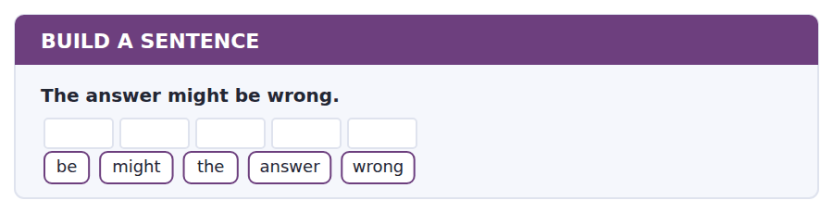
1. Might the answer be wrong?
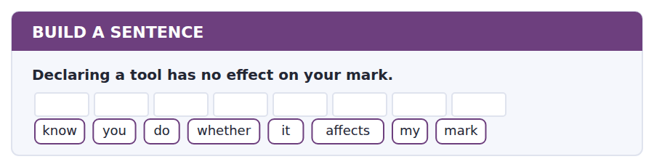
2. Do you know whether it affects my mark?
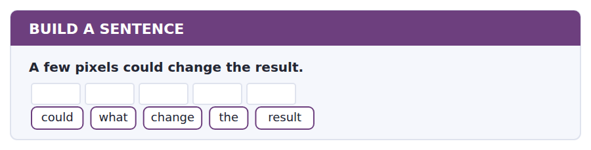
3. What could change the result?
Exercise B Exam practice. Write the sentence.
4. Generated code may be used if it is declared.
tell / can / you / me / whether / code / may / be / used
__________________________________________________________
5. The portal closed an hour ago.
did / when / the / portal / close
__________________________________________________________
6. No tools at all are allowed in an exam.
tools / which / are / allowed / in / an / exam
__________________________________________________________
7. The system might have been trained on daylight photographs.
know / do / you / what / it / was / trained / on
__________________________________________________________
8. The student who declared the tool was not penalised.
the / student / who / declared / the / tool / was / not / penalised
__________________________________________________________
9. A declaration is one sentence on the form.
long / how / should / the / declaration / be
__________________________________________________________
10. The model reported an ostrich with high confidence.
know / do / you / why / it / reported / an / ostrich
__________________________________________________________


You read a short situation and write an email. You have 7 minutes. The three bullet points are the mark scheme: answer all three.
You used a code-generating tool for part of a laboratory report, rewrote most of what it produced, and submitted the work without declaring it, because you believed such tools were banned. You have now learned that they are allowed if declared. The submission portal has closed.
Write an email to your tutor, Dr Carrington.
- Say exactly what you used and for which part.
- Explain why you did not declare it.
- Ask what you should do now.
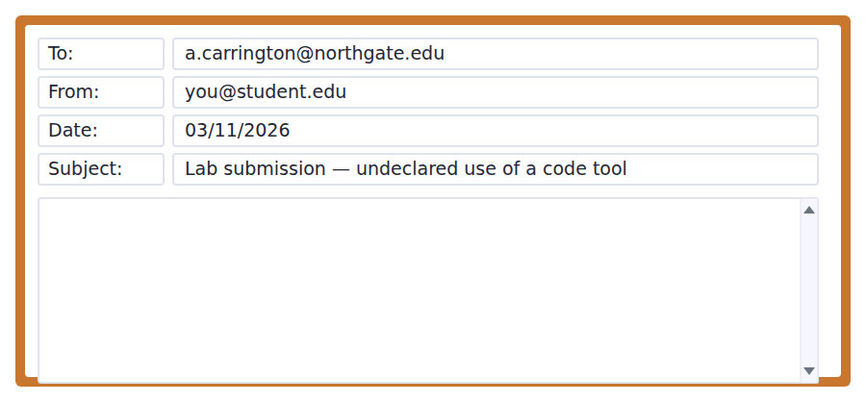
SKILL · Say the awkward thing first
- An email that buries the admission reads as an excuse. Put it in sentence one.
- Be precise about the scope: which part, how much, what you changed.
- Explain without defending. One sentence of reason is enough.
- Seven minutes. 110–140 words.

Model email
Dear Dr Carrington,
I am writing because I used a code-generating tool for part of my laboratory report and did not declare it on the submission form. I want to correct that before it is marked.
Specifically, I used it for the data-plotting section, roughly a third of the code. Most of what it produced did not run, so I rewrote it and I can explain every line. The analysis and the discussion are entirely my own.
I did not declare it because I believed such tools were banned outright. I have now read the faculty notice properly and I understand that this use is permitted if declared.
The portal closed last night, so I cannot add the declaration myself. Please could you tell me what you would like me to do?
I am sorry for the trouble.
Rami Haddad
Why it works
- The admission is the first sentence, which is what makes the rest credible.
- The scope is exact: which section, roughly a third, rewritten, and what is untouched.
- The reason is one sentence and is not offered as an excuse.
- The question is practical and leaves the decision with the person who has to make it.
Now write your own. 7 minutes.
__________________________________________________________
__________________________________________________________
__________________________________________________________
__________________________________________________________
__________________________________________________________
__________________________________________________________
__________________________________________________________
__________________________________________________________


A professor asks a question and two students answer. You add your own post. You have 10 minutes and an effective answer is at least 100 words.
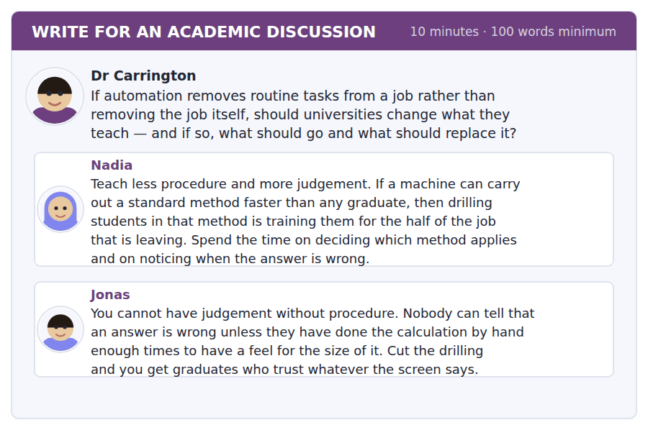
SKILL · Find where both are right
- Two reasonable positions usually disagree about order or quantity, not about direction.
- Say what the real disagreement is before you take a side.
- Use something from the unit — here, the lecture’s point about confidence.
- At least 100 words in ten minutes.

Sentence starters
- Jonas and Nadia disagree about sequence rather than about content:…
- The lecture gives Jonas a stronger argument than he makes:…
- What matters is how much procedure, not whether:…
- I would therefore keep… and cut…
Model post
Jonas and Nadia are not really disagreeing about what to teach. They are disagreeing about how much and in what order.
The lecture actually gives Jonas a stronger argument than he makes. A learning system reports its confidence, and that figure is not accuracy — it is how typical the input looked. The only person who can catch that is somebody who has an independent sense of what the answer should be, and you do not acquire that by being told about it. You acquire it by doing enough examples by hand to be surprised when one comes out wrong.
But Nadia is right that this does not require years of drilling. It requires enough. So I would keep the first-year calculations and cut the third-year ones, and spend the time saved on cases where the standard method quietly does not apply.
[158 words]
Now write your own. 10 minutes, at least 100 words.
__________________________________________________________
__________________________________________________________
__________________________________________________________
__________________________________________________________
__________________________________________________________
__________________________________________________________
__________________________________________________________
__________________________________________________________
__________________________________________________________
__________________________________________________________

Grammar focus may, might and could
Form | Example
may / might + infinitive (possibility) | The answer might be wrong.
could + infinitive (possibility) | A few pixels could change the result.
may + infinitive (permission) | Generated code may be used if declared.
might have + past participle | It might have been trained on daylight photographs.
Negative | It may not be accurate outside that range.
Question | Might the answer be wrong?
Never two modals | It might can work. ✗

May and might are almost interchangeable for possibility. Might is very slightly less certain, and is the safer choice in academic writing.
Could means possible, not permitted. You could use it says it is possible; you may use it says it is allowed. The test does distinguish these.
For a past possibility use might have or could have plus the past participle. Write have, never of, however it sounds when spoken.
Watch out! Could not have a different meaning from may not. It may not be accurate = perhaps it is not. It could not be accurate = it is impossible that it is.
Exercise 1 Complete with may, might, could or a negative form.
1. The system __________ be wrong, although it reports high confidence.
2. You __________ use a spellchecker without declaring it.
3. A few pixels __________ change the answer completely.
4. It __________ (not) be accurate outside its training range.
5. The model __________ have been trained on photographs taken in daylight.
6. __________ the answer be wrong?
Exercise 2 Rewrite with a modal, keeping the meaning.
1. Perhaps the data is incomplete. →
2. It is possible that it was trained on old examples. →
3. It is permitted to use a grammar checker. →
4. It is impossible that the figure is accurate. →
Exercise 3 Correct the mistake in each sentence.
1. It might can be wrong.
2. The system might of learned a different pattern.
3. You could use a tool in the exam — the rules allow it.
How this is tested in Build a Sentence
Build a Sentence uses modals inside embedded questions: Do you know whether it might be wrong? Keep the modal after the subject once the question is embedded.

Unit review and progress check Unit 11
Exercise A Vocabulary. Write the word.
1. to make a machine do a job instead of a person
2. a particular way of doing something
3. to imitate something real
4. to depend on
5. to make something easier
6. to put a plan into action
7. the amount something can hold or do
8. an agreed set of rules for doing something
9. certain to happen
10. stated clearly and openly
11. using someone else’s work as your own
12. a form in which you state what you did
Exercise B Grammar. Complete the sentence.
1. The system __________ be wrong, although it is confident.
2. You __________ use a spellchecker without declaring it.
3. A few pixels __________ change the answer completely.
4. It __________ (not) be accurate outside its training range.
5. The model __________ (have / train) on daylight photographs.
6. __________ the answer be wrong?
7. It is impossible that the figure is accurate. → It __________ be accurate.
8. Do you know whether it __________ (might / be) wrong?
Exercise C One timed mini-section. 6 minutes.
1. According to the passage on page 26, automation mostly
(A) changes what an occupation involves
(B) eliminates occupations
(C) reduces wages
(D) creates new industries
2. In the talk, a confidence figure measures
(A) how accurate the answer is
(B) how typical the input looked
(C) how much data was used
(D) how long the system took
3. Which sentence is correct?
(A) It might can be wrong.
(B) The system might of learned it.
(C) You could use a tool in the exam.
(D) It might have been trained on old examples.
4. A student who is unsure whether to declare a tool should
(A) declare it
(B) not use it
(C) ask another student
(D) submit and explain later
5. In Volume 2 the vocabulary of Units 1–10 is
(A) retaught from the beginning
(B) listed again in the glossary only
(C) assumed and recycled unglossed
(D) not used
6. In an adaptive Listening module you can
(A) return to any question
(B) not return at all
(C) return within the module
(D) return only in Module 1
Can you do these now?
I can… | Not yet | Yes
complete word endings in a text about how a system learns | □ | □
read a coursework rule and a post about it and find what applies to me | □ | □
follow an academic passage that distinguishes two things people confuse | □ | □
understand two students disagreeing about what is allowed | □ | □
give a careful, hedged opinion out loud without preparing | □ | □
write an email asking whether something is permitted, and a post that draws a line | □ | □

ADAPTIVE TIP Volume 2 opens at the level Volume 1 left you, which is also what the real test does between Module 1 and Module 2. Do not expect the second half of anything to feel easier — if it does, something has gone wrong in the first half.

Unit 12 · Public Health and Medicine
TOEFL iBT® Preparation Course 2026 · Volume 2
CEFR B1 · Grammar: must, have to and should · Word field: prevention, treatment, access
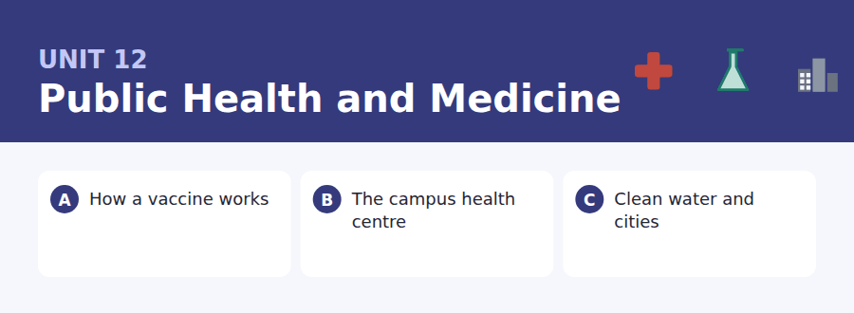
By the end of this unit I can…
- complete word endings in a text about how the body is protected
- read a clinic notice and a booking email and find the rule that applies to me
- follow a passage that explains why one intervention worked more than another
- understand someone sorting out a booking that has gone wrong
- give and ask for advice out loud without preparing
- write an email rearranging an appointment, and a post about priorities

Health texts are full of obligation: you must, you should, you do not have to. This unit sorts the three out, because they are not the same and the test knows it.

Vocabulary 1 · Academic 24 words from the Academic Word List
These twenty-four words come back through the whole unit, and again in the review. Cover the right-hand column and test yourself.
access the chance or right to use something | obtain to get something
medical connected with medicine and illness | restore to bring something back to how it was
inhibit to slow something down or prevent it | intervene to act in order to change what is happening
ensure to make certain that something happens | infrastructure the basic systems a place needs, such as water and roads
survive to continue to live | incidence how often something happens in a population
injure to hurt a part of the body | capable able to do something
welfare the health and comfort of people | adequate enough for the purpose
aid help, especially to people in need | annual happening once a year
assist to help | guideline official advice about how to do something
benefit an advantage or good effect | comprehensive including everything needed
require to need, or to demand officially | voluntary done by choice, not because you must
administrate to manage or organise something officially | promote to encourage something to grow or happen

Exercise A Work in pairs. Ask and answer.
1. What medical care can students obtain free where you live?
2. Name one thing a university could do to promote student wellbeing.
3. Is the infrastructure where you live adequate? What is missing?
4. Should a flu jab be voluntary or required for health workers? Why?
Vocabulary 2 · Campus and everyday 12 words for the daily-life tasks
The exam does not only test academic English. Notices, emails, conversations and announcements use the everyday words below.
health centre a place on campus where you see a nurse or doctor | flu jab an injection that protects against influenza
appointment an arranged time to see someone | sick note a letter saying you were too ill to work
receptionist the person who greets you and books appointments | pharmacy a shop where medicines are given out
prescription a written order for medicine | emergency a sudden situation needing immediate action
waiting room the room where you wait to be seen | consultation a meeting with a doctor or expert
registration putting your name officially on a list | walk-in a service you can use without an appointment

Words you will meet again: process | significant | require | impact | restrict | inhibit | policy | regulate


SKILL · Medical nouns have predictable endings
- -ion, -ity, -ism and -ance are the commonest noun endings in this field.
- A gap after the or a finishes a noun; a gap after is or are finishes a participle.
- Count the dashes before choosing between -tion and -ation.
- Say the sentence back; this kind of prose repeats its key nouns.

Exercise A Guided practice. Five words are not complete. Write the missing letters.
A vaccine does not fight an illness. It teaches the body to recog---- one. The immune system is sh--- a harmless piece of the virus, it builds the right defe----, and it keeps the recipe. If the real virus arri--- years later, the response is already r----.

The first one is done for you: 1 recog---- → nise (recognise)
Exercise B Exam practice. One paragraph, ten gaps — the real task.
The immune system has a memory, and a vaccine is a way of writing in it without the illness. The body is shown something harm---- that looks like part of the virus. It respo--- as though it were under attack, produces the right antibo----, and then, crucially, keeps a record. Years later, if the real infec---- arrives, the response begins in hours rather than in days, and the difference between hours and days is often the difference between a mild illness and a serious o--. There is a second eff---, which is less obvious and more import---. If enough people in a population are protec---, the virus cannot find a chain of hosts and stops circul-----. That protects the people who cannot be vaccinated at a--: newborns, and those whose immune systems are already weak.

Check your answers in the key at the back of the book.


SKILL · Match the service to the situation
- A health notice lists several services. Decide which one the question describes.
- Registered and not registered are usually different cases. Note which.
- A walk-in service and an appointment service have different rules. Both are tested.
- An email confirming a booking will contain a time, a place and something to bring.

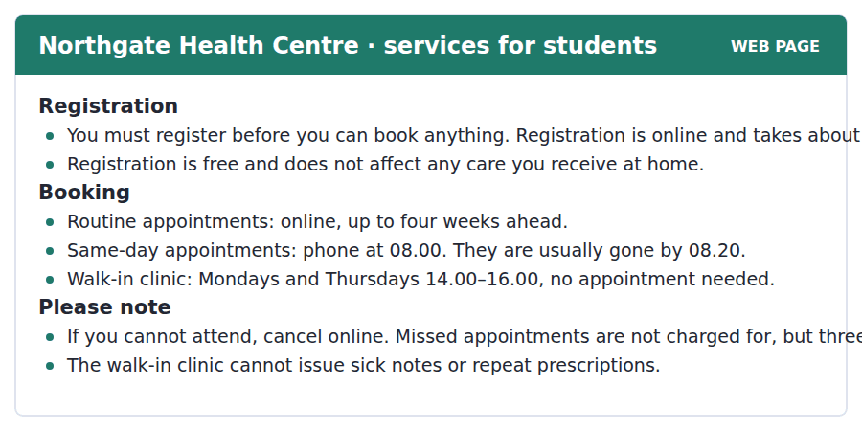
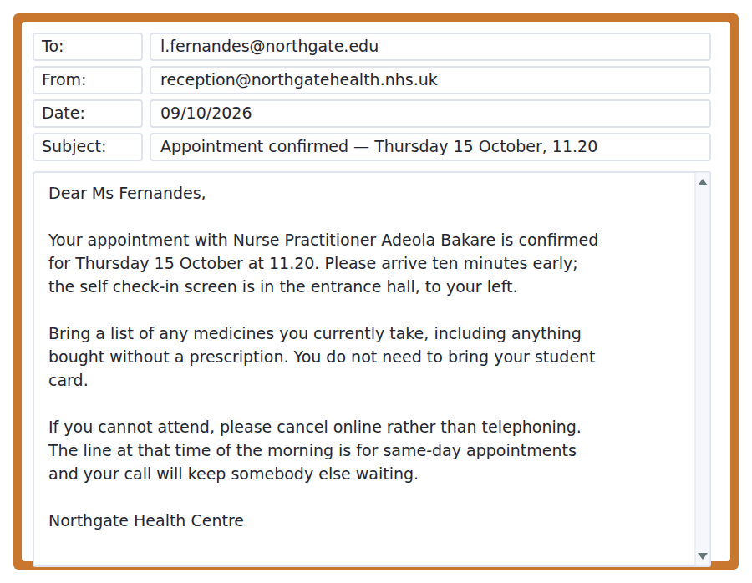
Exercise A Guided practice. The answer is on the page — find it.
1. What must a student do before booking?
(A) Pay a fee
(B) Visit the walk-in clinic
(C) Register online
(D) Bring a student card
2. When is the walk-in clinic open?
(A) Mondays and Thursdays afternoons
(B) Every weekday
(C) Mondays only
(D) At eight in the morning
3. How far ahead can a routine appointment be booked?
(A) One week
(B) Four weeks
(C) Two weeks
(D) Three months
4. What can the walk-in clinic NOT do?
(A) See a student without an appointment
(B) Open in the afternoon
(C) Treat a minor injury
(D) Issue a sick note
Exercise B Exam practice.
5. What should Ms Fernandes bring?
(A) Her student card
(B) A prescription
(C) A sick note
(D) A list of her medicines
6. Why should she cancel online rather than by phone?
(A) The phone line is for same-day appointments
(B) The line is closed
(C) Online cancellation is faster
(D) The receptionist is busy
7. What happens after three missed appointments in a year?
(A) A charge is made
(B) Routine booking goes by phone only
(C) Registration is cancelled
(D) The walk-in clinic must be used
8. Why should she arrive ten minutes early?
(A) The clinic may be busy
(B) To register
(C) To use the self check-in screen
(D) To collect a prescription
9. A student wanting an appointment on the same day should
(A) phone at eight in the morning
(B) book online
(C) go to the walk-in clinic
(D) email reception
10. What can be inferred about registration?
(A) It costs money
(B) It is the main barrier to using the service
(C) It replaces care at home
(D) It must be renewed each year


SKILL · Watch for the argument hidden in the dates
- When a passage gives a date, it is usually testing a common explanation against it.
- The phrase the dates do not fit is a signal: an accepted idea is about to be corrected.
- A result given as fell by figures no drug has matched is a comparison, and comparisons are tested.
- The final paragraph usually generalises. The generalisation is the main idea.

Clean Water and Why Cities Got Healthier
In 1850 a child born in a large European city was less likely to reach the age of five than a child born in the countryside. By 1920 that had reversed. The usual explanation is medicine, and medicine deserves some of the credit, but the dates do not fit. Most of the improvement happened before antibiotics, before most vaccines, and in several cases before anybody accepted that microbes caused disease at all.
What changed first was water. Cities built reservoirs, filtration beds and separate systems for sewage, at enormous cost and usually against fierce opposition from ratepayers. The results were visible within a decade. In the cities that built them, deaths from waterborne disease fell by figures that no drug has ever matched, and deaths from diseases that have nothing to do with water fell as well — probably because a child who is not repeatedly ill grows better and survives other illnesses.
The lesson has outlived its century. Public health interventions that change the environment people live in tend to work regardless of whether anybody cooperates, while interventions that require each person to act have to be sold, repeatedly, to everyone. Clean water protects a household that has never heard of a microbe. That is not an argument against medicine. It is an argument about where the first money should go in a city that has very little.
[280 words]

Exercise A Guided practice.
1. What is the passage mainly about?
(A) How reservoirs are built
(B) The history of antibiotics
(C) Why people opposed higher rates
(D) Why urban child mortality fell, and what deserves the credit
2. What was true of city children in 1850?
(A) They lived longer than rural children
(B) They had better medical care
(C) They were less likely to reach five than rural children
(D) They were vaccinated
3. Why does the author say the dates do not fit?
(A) The records are unreliable
(B) Cities kept no statistics
(C) Doctors disagreed
(D) Most improvement came before the medicine
4. What did cities build?
(A) Hospitals and clinics
(B) Schools
(C) Reservoirs, filtration beds and sewers
(D) Wider streets
Exercise B Exam practice.
5. What happened to deaths from diseases unrelated to water?
(A) They rose
(B) They also fell
(C) They stayed the same
(D) They were not recorded
6. Who opposed the building projects?
(A) Ratepayers
(B) Doctors
(C) Engineers
(D) The national government
7. According to paragraph 3, what kind of intervention works without cooperation?
(A) One that requires individual action
(B) One that uses new drugs
(C) One that is voluntary
(D) One that changes the environment
8. All of the following are stated in the passage EXCEPT:
(A) Antibiotics were the main cause
(B) Medicine deserves some credit
(C) Water came first
(D) The improvement was visible within a decade
9. What does the author mean by "Clean water protects a household that has never heard of a microbe"?
(A) People were ignorant in 1850
(B) Education is unnecessary
(C) The benefit does not depend on understanding or consent
(D) Microbes were discovered late
10. What is the author’s conclusion about spending?
(A) Medicine should be funded first
(B) Environmental measures should come first where money is short
(C) Both cost the same
(D) Cities should not build infrastructure
11. Which best states the main idea of paragraph 2?
(A) Sewers are expensive
(B) Ratepayers were short-sighted
(C) Water infrastructure produced the fall in deaths
(D) Filtration was invented in the 1850s


Exercise A Listen and choose a response. You hear one line. Choose the best reply.
1. Woman: Have you registered yet?
(A) It takes ten minutes.
(B) Last week, online.
(C) At the health centre.
(D) Yes, it’s free.
2. Man: When is the walk-in clinic?
(A) No appointment needed.
(B) At the health centre.
(C) Yes, there is one.
(D) Monday and Thursday afternoons.
3. Woman: Should I bring my student card?
(A) No — just a list of your medicines.
(B) It’s in my bag.
(C) At eleven twenty.
(D) Yes, it’s free.
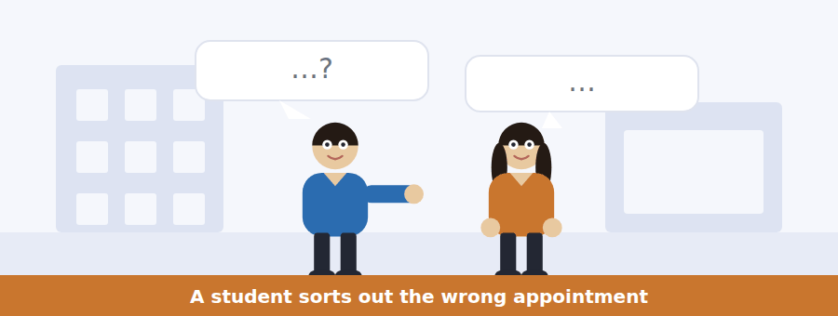
SKILL · Track a booking through the conversation
- Dates, times and names change during a booking conversation. Note the latest version.
- Listen for the mistake and who made it.
- An alternative offered and refused is often a question.
- The final arrangement comes in the last two lines.

Exercise B Listen and answer. The audio plays once.
4. What is the man’s problem when he arrives?
(A) He has no appointment
(B) He is not registered
(C) His email gives a different day
(D) He has forgotten his card
5. What caused the confusion?
(A) He misread the email
(B) The clinic changed the date
(C) The system was offline
(D) Two students have similar names
6. Whose appointment is today?
(A) Mr Ferreira’s
(B) Ms Fernandes’s
(C) Both
(D) Neither
7. What does the receptionist say about the list of medicines?
(A) It is not needed
(B) It is standard for everyone
(C) It applies only to Ms Fernandes
(D) It should have been sent in advance
8. Why must the man wait?
(A) He must register first
(B) The waiting room is full
(C) The nurse is running late
(D) His notes are missing
9. What does the receptionist advise him to do later?
(A) Cancel and rebook
(B) Phone at eight in the morning
(C) Use the walk-in clinic
(D) Check his date of birth on the portal
Audio script: see the back of the book. Do not read it before you listen.


Exercise A Listen and choose a response. You hear one line. Choose the best reply.
1. Man: Do I have to pay?
(A) If you are not in a listed group, yes.
(B) On Tuesday and Wednesday.
(C) At the health centre.
(D) Yes, it’s free.
2. Woman: Do I need an appointment?
(A) It takes five minutes.
(B) No — just turn up.
(C) In the sports hall.
(D) Yes, it’s free.
3. Man: What if I am registered somewhere else?
(A) It is free for students.
(B) On Wednesday afternoon.
(C) Yes, you are.
(D) Then you must register here first.
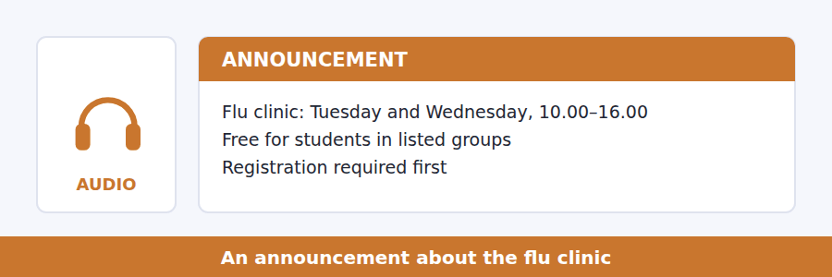
SKILL · Hear who a rule applies to
- Health announcements usually name groups. Note which group each rule covers.
- Free, free for some, and chargeable are three different categories.
- Listen for the one that catches people out — the speaker usually signals it.
- The last instruction is nearly always a question.

Exercise B Listen and answer. The audio plays once.
4. Who may have the vaccination free?
(A) All students
(B) Only students with asthma
(C) Students in listed groups
(D) Only students on placement
5. What does the speaker say catches people out every year?
(A) The registration requirement
(B) The cost
(C) The location
(D) The opening hours
6. What can an unregistered student do?
(A) Nothing until next year
(B) Register online and come straight down
(C) Pay extra on the day
(D) Book an appointment instead
7. How long should a student allow in total?
(A) Five minutes
(B) Ten minutes
(C) Twenty minutes
(D) An hour
8. Why must students sit down for fifteen minutes?
(A) The form takes that long
(B) The hall is crowded
(C) A second dose is given
(D) It is a precaution and is standard
Audio script: see the back of the book. Do not read it before you listen.


Exercise A Listen and choose a response. You hear one line. Choose the best reply.
1. Woman: Did he say per person or per population?
(A) It is on the board.
(B) Per population, for prevention.
(C) About ten pounds.
(D) Yes, he did.
2. Man: Why does nobody notice prevention working?
(A) Because the illness never happens.
(B) It costs less.
(C) In the second half.
(D) Yes, that is true.
3. Woman: Can you send me the figures?
(A) They were on the slide.
(B) About four to one.
(C) Yes — I will put them on the page tonight.
(D) No, I did not write them down.
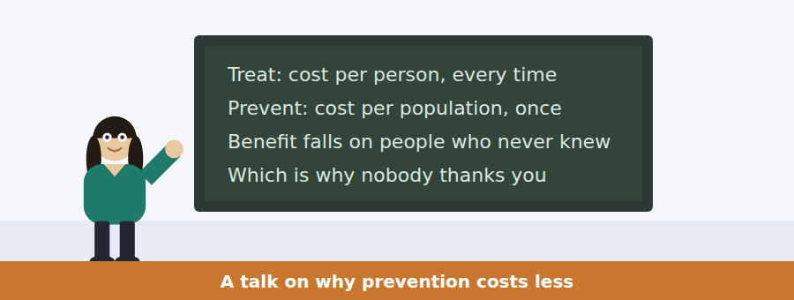
SKILL · Follow a cost comparison
- A talk comparing two approaches will cost them differently. Note the unit of each cost.
- A paradox stated by the speaker (nobody thanks you) is always tested.
- Numbers given once in a talk like this carry the argument.
- The last sentence usually says what the speaker wants you to remember.

Exercise B Listen and answer. The audio plays once.
4. What is the main idea of the talk?
(A) Treatment should be reduced
(B) Prevention is cheaper but politically weak because its benefit is invisible
(C) Vaccination is the cheapest intervention
(D) Budget meetings are badly run
5. How is treatment costed?
(A) Per population, once
(B) Per hospital, annually
(C) It cannot be costed
(D) Per person, every time
6. Why does the cost per protected person fall as coverage rises?
(A) The virus cannot find a chain of hosts
(B) Vaccines get cheaper
(C) Fewer people need treatment
(D) Governments subsidise it
7. Why does prevention lose budget arguments?
(A) It costs more overall
(B) Its benefit falls on people who never knew they were at risk
(C) It takes longer to work
(D) It is harder to administer
8. What does the speaker say about a programme cut for not demonstrating impact?
(A) Of course it could not demonstrate impact
(B) The evaluation was wrong
(C) It should be restarted
(D) It was too expensive
9. Why does the speaker mention nineteenth-century water infrastructure?
(A) To criticise modern spending
(B) To explain how filtration works
(C) To show a one-off cost that worked for 150 years
(D) To compare two cities
Audio script: see the back of the book. Do not read it before you listen.


Part 1 · Listen and Repeat
You hear a sentence and repeat it once. There is no preparation time, and the sentences get longer. Focus: stress in obligation
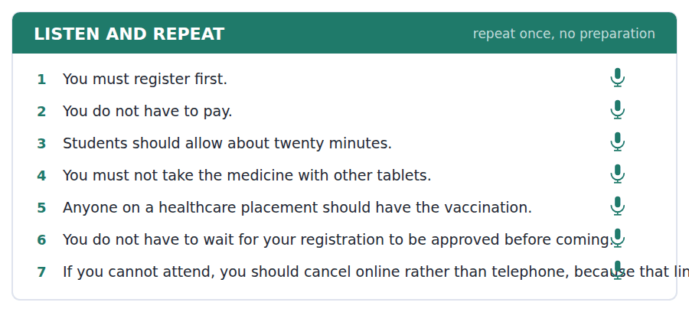
SKILL · Stress the modal when it carries the news
- You MUST register is different from you must REGISTER. Choose.
- Have to is reduced in speech: /hæftə/. Must is not reduced.
- Do not have to and must not mean opposite things. Say them clearly.
- Finish the sentence, even if you choose the wrong stress.

Part 2 · Take an Interview
An interviewer asks you four questions on one theme: how you look after your health. Answer each one fully. There is no preparation time.
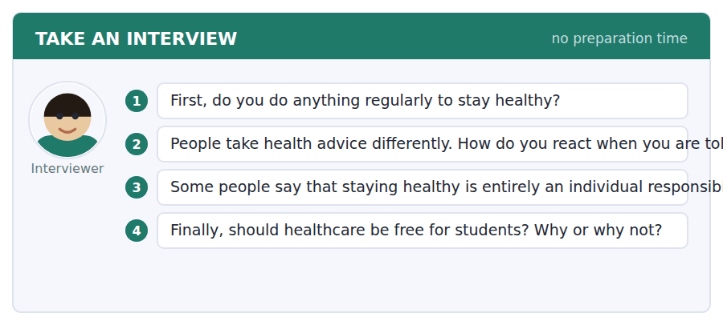
A good answer sounds like this
Question 2 — Badly, if I am honest. I know the advice is right and I still resent being told, which is probably why nobody changes anything.
Question 3 — I disagree. Whether I can walk somewhere safely or buy fresh food near my home is not a decision I make.
I can… | Not yet | Yes
I distinguished must not from do not have to | □ | □
I reduced have to naturally | □ | □
I gave a reason after every opinion | □ | □


Part 1 · Listen and Repeat
You hear a sentence and repeat it once. There is no preparation time, and the sentences get longer. Focus: giving and asking for advice
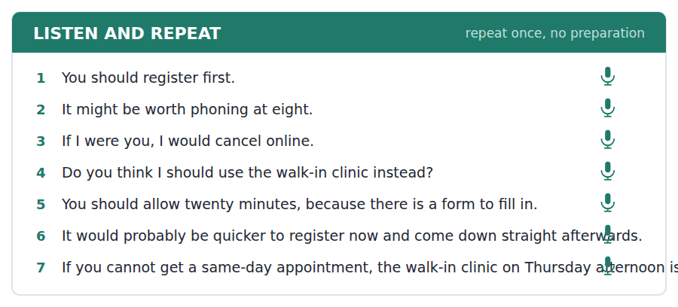
SKILL · Advise, do not instruct
- You should… / It might be worth… / If I were you I would…
- Give the reason with the advice. Advice without a reason is ignored.
- Asking for advice: what would you do? / do you think I should…?
- One piece of advice, one reason, one check that it helps.

Part 2 · Take an Interview
An interviewer asks you four questions on one theme: health services where you live. Answer each one fully. There is no preparation time.
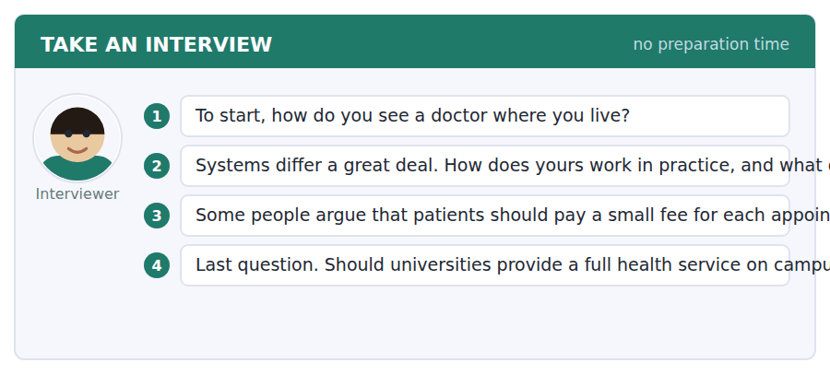
A good answer sounds like this
Question 3 — I disagree, although I understand the problem. A fee stops the people with least money rather than the people who miss appointments.
Question 4 — On campus, at least for simple things. A student who has to travel an hour to be seen will simply not go.
I can… | Not yet | Yes
I gave a reason with every piece of advice | □ | □
I used at least two advice structures | □ | □
I asked for advice in a natural way | □ | □


Part 1 · Listen and Repeat
You hear a sentence and repeat it once. There is no preparation time, and the sentences get longer. Focus: academic register
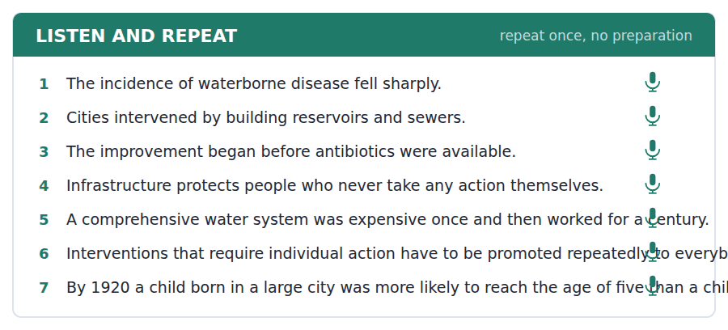
SKILL · Argue from a date or a number
- Use the unit’s words: incidence, infrastructure, intervene, adequate, comprehensive.
- Give the figure or the date first, then the conclusion you draw.
- Separate what the evidence shows from what you would do about it.
- Mark yourself against the three statements below.

Part 2 · Take an Interview
An interviewer asks you four questions on one theme: public health and money. Answer each one fully. There is no preparation time.
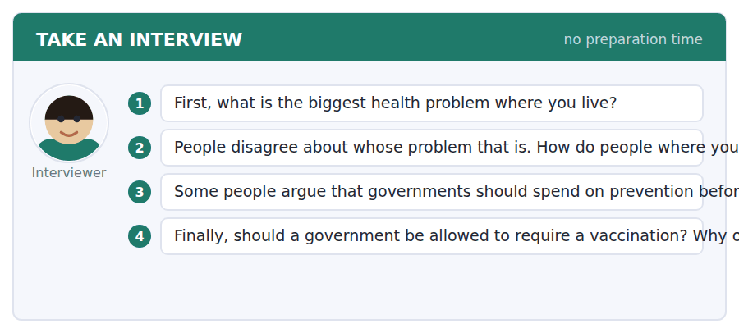
A good answer sounds like this
Question 3 — The evidence is strongly on that side. The incidence of waterborne disease fell by more than any drug has achieved, and it fell before the drugs existed.
Question 4 — For health workers, I think yes, because the risk they carry falls on other people. For everybody else I would persuade rather than require.
I can… | Not yet | Yes
I used at least three academic words from this unit | □ | □
I gave a figure or a date before my conclusion | □ | □
I separated evidence from opinion | □ | □


You see a sentence, then a set of words in boxes. Put the words in order to make one grammatical sentence. Almost every item in the real test makes a question or a question inside another sentence.
SKILL · Obligation inside questions
- Do I have to…? and Must I…? are both direct questions. Should I…? asks for advice.
- An embedded obligation question keeps statement order: whether I should…
- Never do must. Must is its own auxiliary.
- Use every tile exactly once.

Exercise A Guided practice. The first three are worked through.
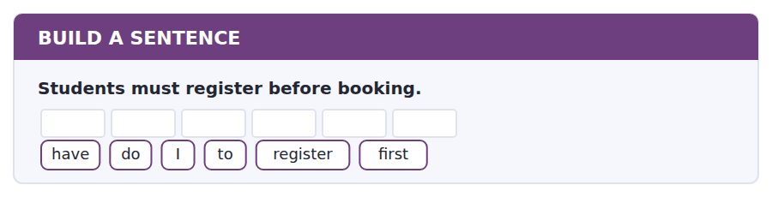
1. Do I have to register first?
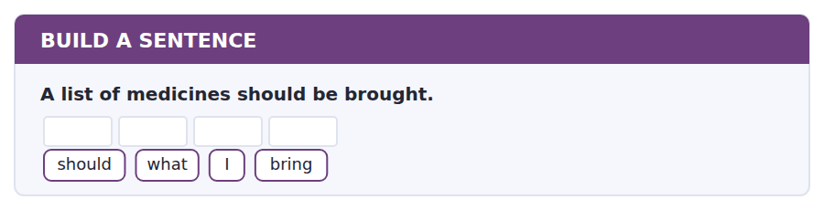
2. What should I bring?
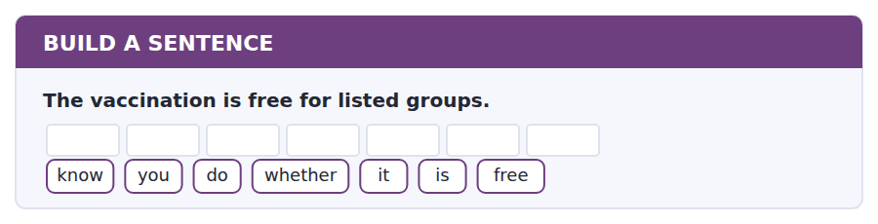
3. Do you know whether it is free?
Exercise B Exam practice. Write the sentence.
4. Cancellation should be done online.
tell / can / you / me / whether / I / should / cancel / online
__________________________________________________________
5. The clinic runs on Tuesday and Wednesday.
days / which / does / the / clinic / run
__________________________________________________________
6. Students do not have to wait for approval.
have / do / I / to / wait / for / approval
__________________________________________________________
7. Twenty minutes should be allowed in total.
long / how / should / I / allow
__________________________________________________________
8. The nurse who saw me last time has left.
the / nurse / who / saw / me / last / time / has / left
__________________________________________________________
9. The walk-in clinic cannot issue sick notes.
know / do / you / where / I / can / get / a / sick / note
__________________________________________________________
10. Same-day appointments go by eight twenty.
time / what / should / I / phone
__________________________________________________________


You read a short situation and write an email. You have 7 minutes. The three bullet points are the mark scheme: answer all three.
You have an appointment at the campus health centre on Thursday 15 October at 11.20. Your department has just scheduled a compulsory assessment at eleven that morning. You have already missed one appointment this year, and the notice says three in a year means routine booking goes by phone only.
Write an email to the health centre.
- Explain why you cannot attend.
- Ask for a different appointment, giving your availability.
- Show that you know how cancellation should be done.
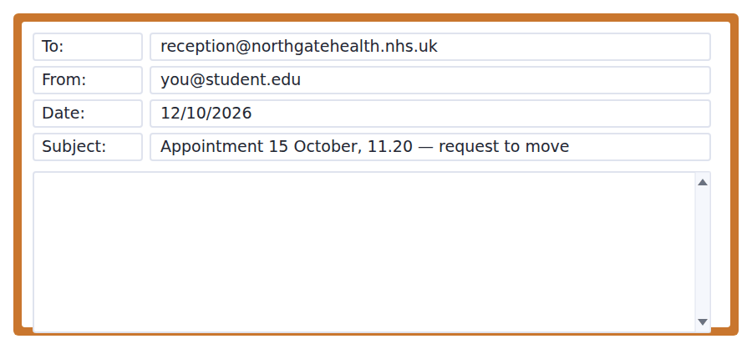
SKILL · Cancel in the way they asked
- The notice tells you how to cancel. Doing it their way is half the email.
- Give availability as a range, not as a single alternative.
- Mention what you already know, so the reply does not repeat it.
- Seven minutes. 110–140 words.

Model email
Dear Reception,
I have an appointment with Nurse Practitioner Bakare on Thursday 15 October at 11.20. My department has just scheduled a compulsory assessment at eleven that morning, so I cannot attend.
I have cancelled the appointment online, as the email asked, rather than telephoning. I am writing because I would like to rebook rather than simply disappear from the list.
I am free all day on Monday and Tuesday of that week, and after two o’clock on any other day. Anything in the next three weeks would be fine.
I know that three missed appointments in a year changes how I can book, which is why I have cancelled rather than failed to arrive. Please could you confirm that the cancellation has been recorded as a cancellation?
Thank you,
Luísa Fernandes
Why it works
- The cancellation has already been done, and done the way the clinic asked, before anything is requested.
- Availability is a range, which means one reply can settle it.
- The writer shows they have read the rule about three missed appointments, and uses it to explain their care rather than to argue.
- The closing question is small, specific and answerable in one line.
Now write your own. 7 minutes.
__________________________________________________________
__________________________________________________________
__________________________________________________________
__________________________________________________________
__________________________________________________________
__________________________________________________________
__________________________________________________________
__________________________________________________________


A professor asks a question and two students answer. You add your own post. You have 10 minutes and an effective answer is at least 100 words.
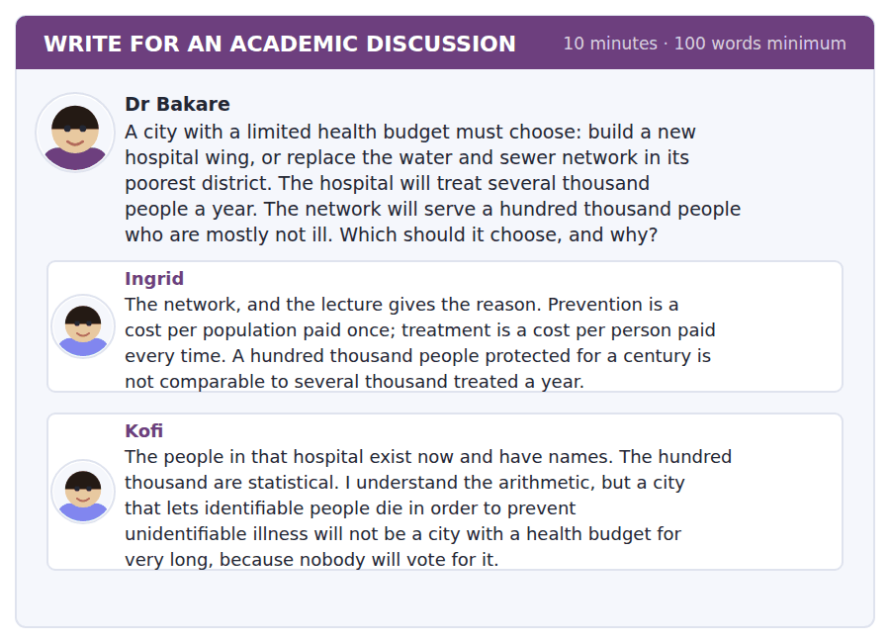
SKILL · Answer the political objection, not just the economic one
- Kofi is not disputing the arithmetic. He is disputing what will survive a budget meeting.
- An answer that only repeats the arithmetic has not met him.
- Use the lecture’s point about where the benefit lands.
- At least 100 words in ten minutes.

Sentence starters
- Ingrid has the arithmetic and Kofi has the politics, and…
- The lecture anticipated Kofi’s objection exactly:…
- What would change the calculation is…
- I would choose…, but only if…
Model post
Ingrid has the arithmetic and Kofi has the politics, and the lecture anticipated both.
The economics is not in doubt. Prevention is paid once and keeps working, and the nineteenth-century water systems ran for a century and a half without anybody paying again. But the lecturer also told us why this argument keeps losing: the benefit lands on people who never become ill and never know they were at risk. You cannot photograph an epidemic that did not happen. Kofi is describing exactly that problem, and repeating the arithmetic at him does not solve it.
So I would build the network, and I would spend a small part of the budget on making its effect visible — publishing the district’s illness figures every year, before and after. If the only weakness of prevention is that nobody can see it working, then the fix is to make it visible, not to stop doing it.
[172 words]
Now write your own. 10 minutes, at least 100 words.
__________________________________________________________
__________________________________________________________
__________________________________________________________
__________________________________________________________
__________________________________________________________
__________________________________________________________
__________________________________________________________
__________________________________________________________
__________________________________________________________
__________________________________________________________

Grammar focus must, have to and should
Form | Example
must (the speaker’s own rule) | You must register before you book.
have to (an outside rule) | Students have to register online.
should (advice) | You should allow twenty minutes.
must not (forbidden) | You must not use a tool in the exam.
do not have to (not necessary) | You do not have to bring your card.
Question: must / do I have to | Do I have to register first?
had to (past of both) | I had to register last week.

Must not and do not have to are opposites, not variants. Must not means it is forbidden. Do not have to means it is optional. This is the single most testable point in the unit.
Must has no past, no future and no infinitive, so have to covers those: I had to, I will have to, I want to have to is impossible but I want to be able to is fine.
Should is weaker than must and is used for advice, recommendation and expectation: it should arrive tomorrow.
Watch out! Never write *you don’t must*. The negative of must as an obligation is do not have to; the negative of must as a prohibition is must not.
Exercise 1 Complete with must, must not, have to, do not have to or should.
1. You __________ register before you can book anything.
2. You __________ bring your student card — it is not needed.
3. You __________ use any tool at all in an invigilated exam.
4. You __________ allow twenty minutes, to be safe.
5. Students __________ cancel online rather than by phone.
6. I __________ (past) register again when I moved.
Exercise 2 Say whether each sentence means forbidden or not necessary.
1. You must not take it with other tablets.
2. You do not have to wait for approval.
3. You must not photograph the display.
4. You do not have to pay if you are in a listed group.
Exercise 3 Correct the mistake in each sentence.
1. You don’t must bring your card.
2. I must register again last year.
3. You mustn’t to pay.
How this is tested in Build a Sentence
Build a Sentence tests this as Do I have to…? and Can you tell me whether I should…? Note that must almost never appears in these items, because have to is what people actually say.

Unit review and progress check Unit 12
Exercise A Vocabulary. Write the word.
1. the chance or right to use something
2. to make certain that something happens
3. to act in order to change what is happening
4. how often something happens in a population
5. the basic systems a place needs
6. enough for the purpose
7. including everything needed
8. done by choice, not because you must
9. to encourage something to grow or happen
10. to bring something back to how it was
11. a service you can use without an appointment
12. a letter saying you were too ill to work
Exercise B Grammar. Complete the sentence.
1. You __________ register before you can book.
2. You __________ bring your card — it is not needed.
3. You __________ use any tool in an invigilated exam.
4. You __________ allow twenty minutes, to be safe.
5. Students __________ cancel online rather than by phone.
6. I __________ (must, past) register again when I moved.
7. Do I __________ wait for approval?
8. Can you tell me whether I __________ cancel online?
Exercise C One timed mini-section. 6 minutes.
1. According to the passage on page 42, most of the fall in urban child deaths came
(A) from antibiotics
(B) from better hospitals
(C) from rural migration
(D) before the main medical advances
2. In the talk, prevention loses budget arguments because
(A) it costs more
(B) it takes longer
(C) it is harder to administer
(D) its benefit falls on people who never knew they were at risk
3. Which sentence is correct?
(A) You don’t must bring your card.
(B) I must register again last year.
(C) You do not have to bring your card.
(D) You mustn’t to pay.
4. An unregistered student at the flu clinic should
(A) register online and come straight down
(B) come back next year
(C) pay extra
(D) book an appointment
5. "You must not" and "you do not have to" mean
(A) the same thing
(B) opposite things
(C) nearly the same thing
(D) the same in questions only
6. In Speaking, the interview questions
(A) are all the same difficulty
(B) can be answered in any order
(C) may be skipped
(D) get harder in a fixed order
Can you do these now?
I can… | Not yet | Yes
complete word endings in a text about how the body is protected | □ | □
read a clinic notice and a booking email and find the rule that applies to me | □ | □
follow a passage that explains why one intervention worked more than another | □ | □
understand someone sorting out a booking that has gone wrong | □ | □
give and ask for advice out loud without preparing | □ | □
write an email rearranging an appointment, and a post about priorities | □ | □

ADAPTIVE TIP In Write an Email the three bullet points are the mark scheme. Give each one its own short paragraph. A rater looking for three things in seven minutes should be able to find all three without reading twice.

Unit 13 · Music and Sound
TOEFL iBT® Preparation Course 2026 · Volume 2
CEFR B1 · Grammar: Adverbs of manner and degree · Word field: frequency, rhythm, emotion
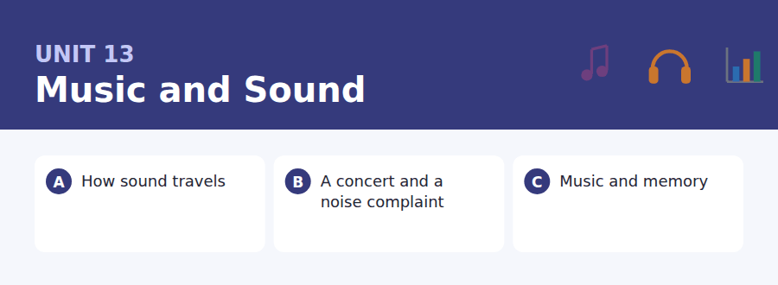
By the end of this unit I can…
- complete word endings in a text about sound and hearing
- read a concert listing and a residents’ notice and find the rule
- follow a passage that explains why one kind of memory is unusually strong
- understand a difficult conversation between neighbours
- describe how something is done, out loud, without preparing
- write a polite complaint, and a post that resists an easy explanation

This unit is about how things are done — loudly, gradually, almost completely. Adverbs are the grammar of that, and they are worth more marks than their size suggests.

Vocabulary 1 · Academic 24 words from the Academic Word List
These twenty-four words come back through the whole unit, and again in the review. Cover the right-hand column and test yourself.
mode a way in which something is done or happens | tense stretched tight; nervous
range the limits between which something varies | relax to become less tense
series a number of similar things in order | dramatic sudden and noticeable
constant not changing | portion a part of a whole
alter to change | overall taking everything into account
modify to change something slightly | correspond to match or be equivalent to
discrete separate and distinct | differentiate to see or show a difference
notion an idea or belief | coincide to happen at the same time
positive good, or certain | physical connected with the body or with matter
negate to make something have no effect | item a single thing in a list or group
emphasis special importance given to something | technical connected with the practical details of a subject
stress force or pressure; also extra force on a syllable | instance a particular example

Exercise A Work in pairs. Ask and answer.
1. What range of music do you listen to? Has it altered in the last few years?
2. Describe an instance when music changed your mood dramatically.
3. Does your taste in music correspond to your friends’, or differ from it?
4. Which sound relaxes you most, and which makes you tense?
Vocabulary 2 · Campus and everyday 12 words for the daily-life tasks
The exam does not only test academic English. Notices, emails, conversations and announcements use the everyday words below.
concert a performance of music | noise complaint a formal objection about sound
rehearsal a practice before a performance | neighbour a person living next to you
venue the place where an event happens | quiet hours times when noise is not allowed
ticket a paper or code that lets you in | soundcheck a test of equipment before a performance
headphones speakers worn over the ears | band a group of musicians
speaker a device that produces sound | encore an extra piece played after the end

Words you will meet again: perceive | vary | significant | intense | distinct | retain | component | impact


SKILL · Science and everyday words mix here
- This field uses both technical nouns (-ency, -ation) and plain verbs (-ed, -ing).
- Count the dashes before choosing between -ion and -ation.
- A gap in a comparative or superlative is short: -er is two, -est is three.
- Read the sentence back with your ending in place.

Exercise A Guided practice. Five words are not complete. Write the missing letters.
Sound is movement. A string vib-----, it pushes the air beside it, and that push travels outwards as a wave. The faster the vibration, the hig--- the note sounds. A wave that is big--- is not higher; it is simply lou---, because loudness and pitch are two differ--- things.

The first one is done for you: 1 vib----- → rates (vibrates)
Exercise B Exam practice. One paragraph, ten gaps — the real task.
People use high and loud as though they were the same, and they are not rela---. Pitch depends on how often a string vibr---- each second: faster vibration, higher note, and nothing to do with how hard you pl--- it. Loudness depends on how f-- the air moves, which is the size of the wave rather than its sp---. You can play the same note very qui---- or very loudly, and you can play a quiet note that is extremely h---. A second confusion is worth clearing up at the same t---. Sound needs something to travel thro---: air, water, steel, anything with particles to push. In a vacuum there is noth--- to push, so there is no sound at all, which is why films set in space are quietly lying to you.

Check your answers in the key at the back of the book.


SKILL · Rules about time are tested precisely
- Quiet hours, curfews and deadlines carry exact times. Note them to the minute.
- A rule with an exception for one night is always worth a question.
- A complaints procedure has steps. Expect to be asked which step comes first.
- Two documents about the same rule may differ; the newer one wins.

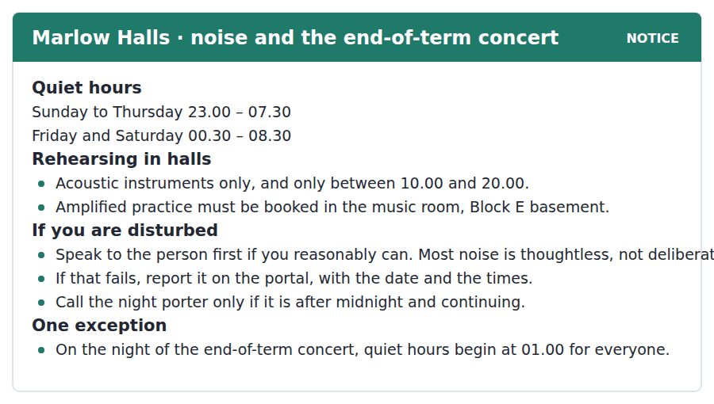
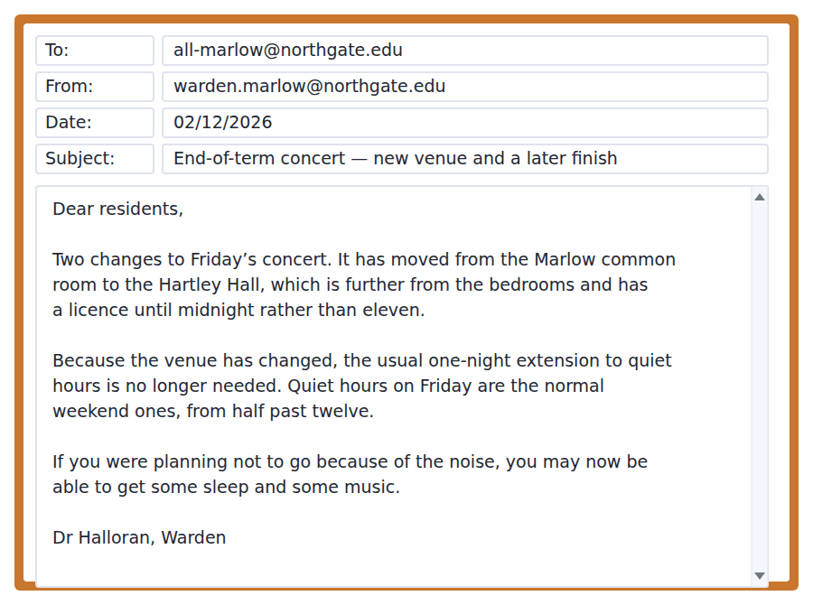
Exercise A Guided practice. The answer is on the page — find it.
1. When do quiet hours begin on a Tuesday?
(A) 22.00
(B) 00.30
(C) 23.00
(D) 08.30
2. When may acoustic instruments be played in halls?
(A) Any time
(B) 10.00–20.00
(C) 08.30–23.00
(D) Only at weekends
3. Where must amplified practice take place?
(A) In the Block E music room
(B) In a bedroom
(C) In the common room
(D) In Hartley Hall
4. What should a disturbed resident do first?
(A) Report it on the portal
(B) Call the night porter
(C) Email the warden
(D) Speak to the person if they reasonably can
Exercise B Exam practice.
5. What has changed about the concert?
(A) The date
(B) The performers
(C) The ticket price
(D) The venue and the finishing time
6. Why is the one-night extension no longer needed?
(A) The new venue is further from the bedrooms
(B) Fewer people are coming
(C) The concert finishes earlier
(D) Quiet hours have been abolished
7. When do quiet hours begin on the Friday of the concert?
(A) 23.00
(B) 01.00
(C) 00.30
(D) They do not apply
8. What does the warden suggest residents may now get?
(A) A refund
(B) Both sleep and music
(C) A later start on Saturday
(D) A different room
9. A resident disturbed at 00.45 by continuing noise should
(A) wait until morning
(B) call the night porter
(C) report it on the portal only
(D) speak to the warden
10. What can be inferred about the old venue?
(A) It was closer to the bedrooms
(B) It was larger
(C) It had no licence
(D) It was cheaper


SKILL · Watch the author replace one explanation with another
- A passage that says the usual explanation is not quite right will give a better one. Find it.
- Technical terms defined in passing (encoding, retrieval) are usually tested.
- A named effect, such as the reminiscence bump, will be asked about.
- The author’s own summary is usually the last sentence.

Why a Tune Brings Back a Memory
Almost everyone has had the experience: a few seconds of a song and a whole afternoon from twenty years ago arrives, complete with the weather. It feels magical, and the usual explanation — that music is somehow stored differently — is not quite right. What is unusual is not the storage. It is the retrieval.
Memories are easiest to recover when the conditions at recall resemble the conditions at encoding. A song is an unusually good match, because it is identical every time. The weather, your mood, the room and your own voice all change between one year and the next; a recording does not. Four bars of it reproduce a fragment of the original moment exactly, and the rest of the moment comes with it.
Two further facts make the effect stronger than it looks. The first is that the memories recovered this way cluster heavily in adolescence and early adulthood, the period psychologists call the reminiscence bump, when a great deal is happening for the first time and is therefore encoded in detail. The second is that music of that period is usually heard repeatedly, in company, and attached to events that mattered. So the apparent magic has a dull explanation: it is not that music reaches memory by a special route. It is that a recording is the only part of your past that can be played back without having changed.
[280 words]

Exercise A Guided practice.
1. What is the passage mainly about?
(A) Why music is stored differently from other memories
(B) How adolescence affects memory
(C) How recordings are made
(D) Why music is unusually good at bringing memories back
2. According to paragraph 1, what is NOT unusual about musical memory?
(A) The retrieval
(B) The detail
(C) The storage
(D) The emotion
3. When are memories easiest to recover?
(A) When conditions at recall resemble those at encoding
(B) When they are recent
(C) When they are emotional
(D) When they are repeated often
4. Why is a song an unusually good match?
(A) It is emotional
(B) It is identical every time
(C) It is short
(D) It is heard in company
Exercise B Exam practice.
5. What is the reminiscence bump?
(A) A sudden loud passage in music
(B) A failure of memory in old age
(C) A technique for remembering
(D) A cluster of memories from adolescence and early adulthood
6. Why is that period encoded in detail?
(A) People are younger and healthier
(B) Music was better then
(C) A great deal is happening for the first time
(D) There is more free time
7. All of the following are given as reasons the effect is strong EXCEPT:
(A) A recording does not change
(B) Music of that period is heard repeatedly
(C) Music is attached to events that mattered
(D) Music is processed in a separate part of the brain
8. The word "encoding" in paragraph 2 refers to
(A) the moment it is recalled
(B) the moment a memory is formed
(C) the way music is recorded
(D) the way a brain stores sound
9. What does the author call the explanation?
(A) Dull
(B) Magical
(C) Controversial
(D) Incomplete
10. What can be inferred about photographs?
(A) They work better than music
(B) They are not used in memory research
(C) They are also unchanged, but reproduce less of the moment
(D) They cause the reminiscence bump
11. Which best states the main idea of paragraph 3?
(A) Music is best in adolescence
(B) Memory declines with age
(C) Recordings should be preserved
(D) Two ordinary facts explain most of the apparent magic


Exercise A Listen and choose a response. You hear one line. Choose the best reply.
1. Woman: Sorry — have you got a minute?
(A) Of course. Is something wrong?
(B) About eleven o’clock.
(C) It’s in Block E.
(D) Yes, it was loud.
2. Man: Was it keeping you awake?
(A) Until about one.
(B) In the music room.
(C) It was, a bit.
(D) No, I play the bass.
3. Woman: I did not realise anyone could hear it.
(A) At half past twelve.
(B) The walls are quite thin.
(C) Yes, I can hear it.
(D) It was a rehearsal.
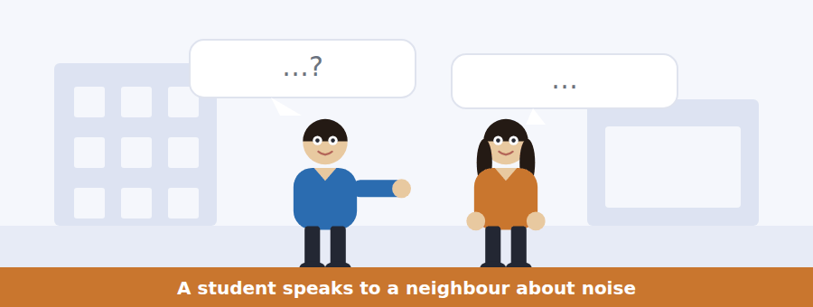
SKILL · Hear the tone as well as the facts
- A difficult conversation has a tone question as well as detail questions.
- Listen for softening: I am sure you did not realise, it is only that…
- What each speaker offers to do is the usual last question.
- Note any time or number mentioned — they are rarely decorative.

Exercise B Listen and answer. The audio plays once.
4. Why has the woman come to the man’s room?
(A) To ask him about noise at night
(B) To invite him to a concert
(C) To borrow equipment
(D) To complain to the warden
5. Why did the man not realise he was disturbing anyone?
(A) He was out
(B) He plays quietly
(C) He was wearing headphones
(D) He practises in the music room
6. What does the woman explain about bass?
(A) It is louder than other instruments
(B) It cannot be played with headphones
(C) It is worse at night
(D) It travels through the floor rather than the air
7. Why did the woman not call the night porter?
(A) It was before midnight
(B) She preferred to ask him directly
(C) She did not know the number
(D) The porter was unavailable
8. What does the man first offer to do?
(A) Stop playing
(B) Move the amplifier onto something soft
(C) Book the music room
(D) Practise during the day
9. What does the woman make clear at the end?
(A) She will report him
(B) She also plays an instrument
(C) She is moving out
(D) She does not want to stop him practising
Audio script: see the back of the book. Do not read it before you listen.


Exercise A Listen and choose a response. You hear one line. Choose the best reply.
1. Man: Where is the concert now?
(A) At midnight.
(B) Because of the noise.
(C) In Hartley Hall.
(D) Yes, it moved.
2. Woman: Is it later than last year?
(A) Until midnight, so yes.
(B) In the common room.
(C) Because of the licence.
(D) No, it is Friday.
3. Man: Do quiet hours change that night?
(A) At half past twelve.
(B) In Hartley Hall.
(C) Yes, until one.
(D) No — the normal weekend time applies.
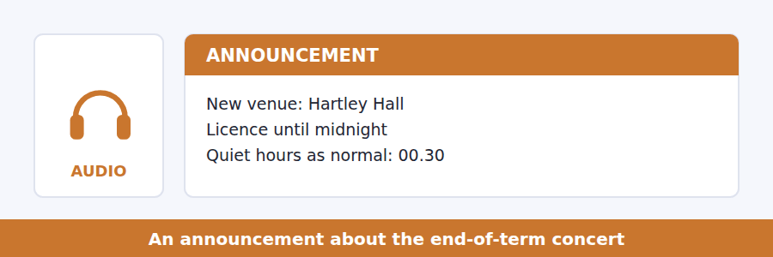
SKILL · Catch a cancelled exception
- Announcements sometimes remove a special rule. That removal is testable.
- Note the reason — it usually explains a second detail as well.
- A time stated twice is certain to be asked about.
- What stays the same matters as much as what changes.

Exercise B Listen and answer. The audio plays once.
4. Why has the concert moved?
(A) More tickets were sold
(B) The common room is directly below bedrooms
(C) The common room was double-booked
(D) Hartley Hall is cheaper
5. How much longer is the concert than planned?
(A) Half an hour
(B) Two hours
(C) An hour
(D) It is shorter
6. What has been cancelled?
(A) The one-night extension to quiet hours
(B) The concert
(C) The ticket sale
(D) The soundcheck
7. When do quiet hours start on Friday?
(A) 23.00
(B) 01.00
(C) They do not
(D) 00.30
8. What has not changed?
(A) The price and where tickets are sold
(B) The venue
(C) The finishing time
(D) The quiet-hours extension
Audio script: see the back of the book. Do not read it before you listen.


Exercise A Listen and choose a response. You hear one line. Choose the best reply.
1. Woman: Which one is pitch?
(A) The size of the wave.
(B) On the board.
(C) Frequency.
(D) Yes, it is.
2. Man: What happens if you double the frequency?
(A) It gets louder.
(B) You go up an octave.
(C) About four hundred.
(D) Yes, it does.
3. Woman: Did she give the number for A?
(A) It is a frequency.
(B) Yes, twice.
(C) In the second half.
(D) Four hundred and forty.
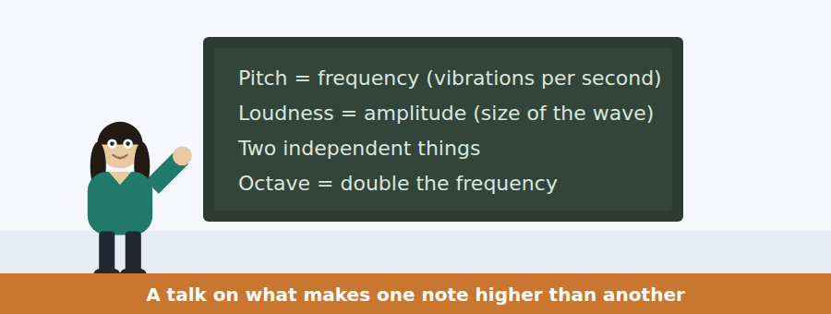
SKILL · Keep two variables apart
- A talk that separates two things people confuse will test whether you kept them separate.
- Note which word goes with which quantity.
- A worked number (double, half, four times) is almost always tested.
- The last example usually carries the main idea.

Exercise B Listen and answer. The audio plays once.
4. What is the main idea of the talk?
(A) Students find acoustics difficult
(B) Pitch and loudness are independent, and the octave is universal
(C) Concert A is 440 hertz
(D) Music varies between cultures
5. What is pitch?
(A) How many times per second it vibrates
(B) How far the string moves
(C) How loud the note is
(D) How long the note lasts
6. What happens if you double the frequency?
(A) The note is twice as high
(B) The note is twice as loud
(C) You get the same note an octave higher
(D) Nothing audible changes
7. Why does the speaker mention 220?
(A) It is the lowest audible note
(B) It is the loudness of concert A
(C) It is an error in the textbook
(D) It shows halving gives the same note too
8. What does the speaker say about the octave across cultures?
(A) It is a European convention
(B) Only some systems use it
(C) Every musical system treats it the same way
(D) It was invented in the nineteenth century
9. What does the speaker conclude from that?
(A) Musical training is unnecessary
(B) The octave is something about ears rather than culture
(C) Western music is more advanced
(D) The explanation is well understood
Audio script: see the back of the book. Do not read it before you listen.


Part 1 · Listen and Repeat
You hear a sentence and repeat it once. There is no preparation time, and the sentences get longer. Focus: stress in adverbs
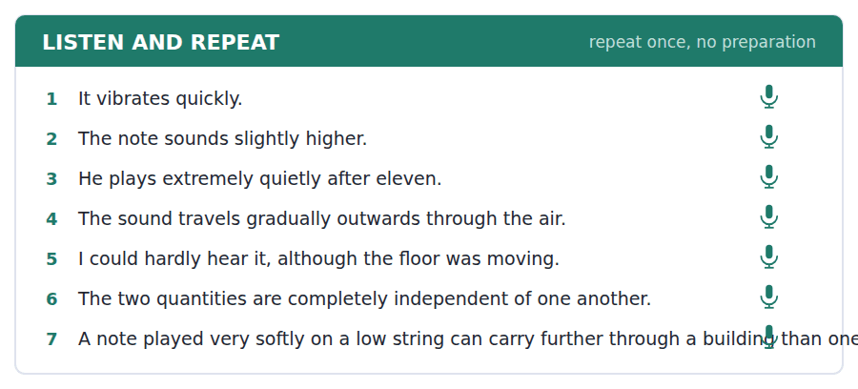
SKILL · Put the stress where the meaning is
- In extremely quietly the stress is on quiet, not on extreme.
- Adverbs of degree (almost, hardly, completely) usually take less stress than the word they modify.
- Hardly and nearly change the meaning completely. Say them clearly.
- Finish the sentence even if the stress goes wrong.

Part 2 · Take an Interview
An interviewer asks you four questions on one theme: music you listen to. Answer each one fully. There is no preparation time.
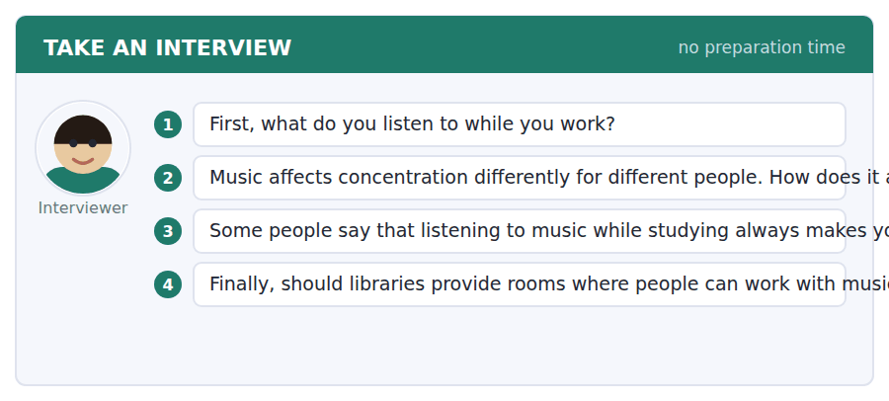
A good answer sounds like this
Question 2 — Instrumental music helps and anything with words destroys it, which I assume is because the words compete with the reading.
Question 3 — Not always, no. It probably depends on the task — I can file and listen, and I cannot read and listen.
I can… | Not yet | Yes
I stressed the word that carried the meaning | □ | □
I said hardly and nearly clearly | □ | □
I gave a reason after every opinion | □ | □


Part 1 · Listen and Repeat
You hear a sentence and repeat it once. There is no preparation time, and the sentences get longer. Focus: complaining politely
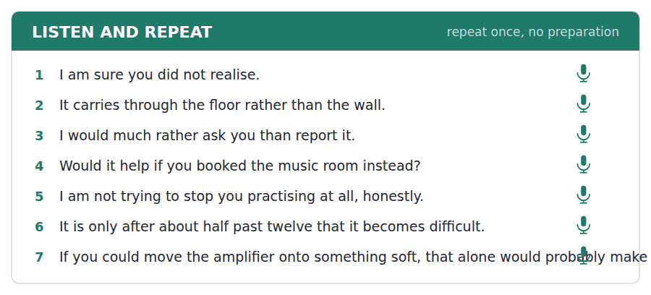
SKILL · Complain about the effect, not the person
- I am finding it hard to sleep beats You are too loud.
- Assume good faith out loud: I am sure you did not realise.
- Propose a solution. A complaint with a solution is a request.
- End by making it easy to agree.

Part 2 · Take an Interview
An interviewer asks you four questions on one theme: living with other people. Answer each one fully. There is no preparation time.
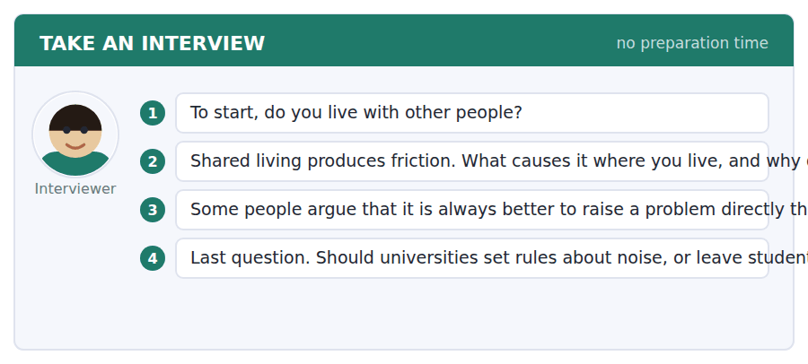
A good answer sounds like this
Question 2 — Washing up, every time. I think it is because it is the one thing everybody notices and nobody has agreed about.
Question 3 — Usually, yes, but not always. If somebody has already been asked twice, reporting it is not a failure of nerve.
I can… | Not yet | Yes
I described the effect rather than blaming | □ | □
I proposed at least one solution | □ | □
I stayed polite without being vague | □ | □


Part 1 · Listen and Repeat
You hear a sentence and repeat it once. There is no preparation time, and the sentences get longer. Focus: academic register
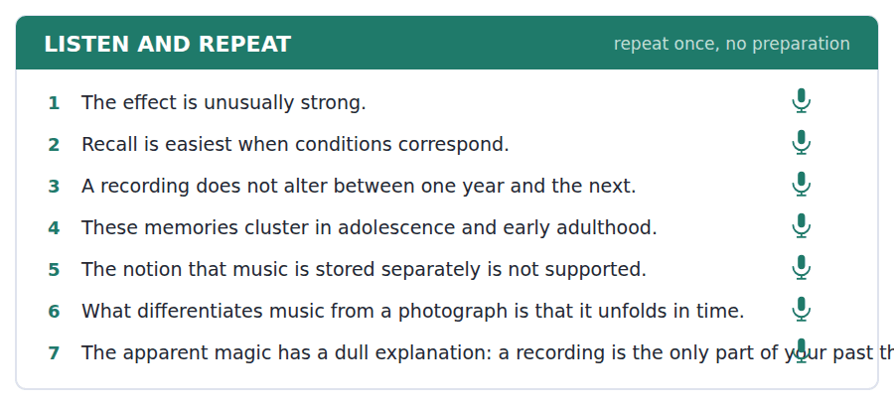
SKILL · Report a mechanism, not a feeling
- Use the unit’s words: correspond, coincide, differentiate, instance, notion.
- Say what the research shows before you say what you think.
- Replace it is amazing with the effect is unusually strong because…
- Mark yourself against the three statements below.

Part 2 · Take an Interview
An interviewer asks you four questions on one theme: memory and the past. Answer each one fully. There is no preparation time.
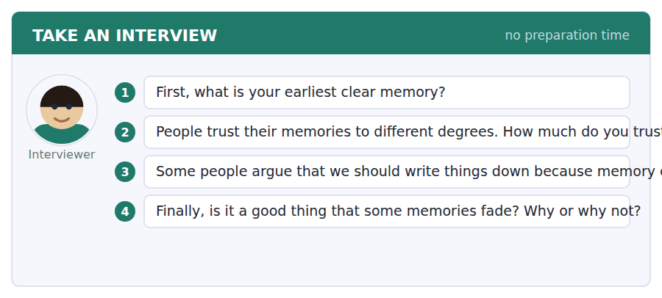
A good answer sounds like this
Question 2 — Less than I used to. We read a study last term showing that one word in a question can change what people remember seeing.
Question 4 — Probably, yes. A memory that stayed as sharp as the day it formed would make it very difficult to stop being angry about anything.
I can… | Not yet | Yes
I used at least three academic words from this unit | □ | □
I reported the mechanism before my opinion | □ | □
I avoided it is amazing in favour of a reason | □ | □


You see a sentence, then a set of words in boxes. Put the words in order to make one grammatical sentence. Almost every item in the real test makes a question or a question inside another sentence.
SKILL · Degree questions
- How well, how often, how loudly, how quickly — these open most items here.
- The adverb goes next to how, not at the end: How loudly does it play?
- In an embedded question the order stays a statement: do you know how often it happens.
- Use every tile exactly once.

Exercise A Guided practice. The first three are worked through.
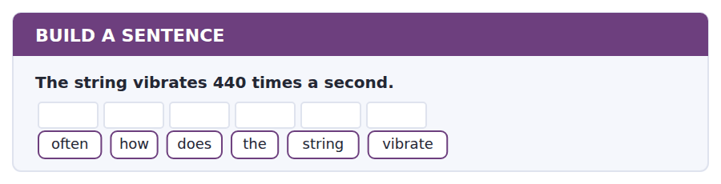
1. How often does the string vibrate?
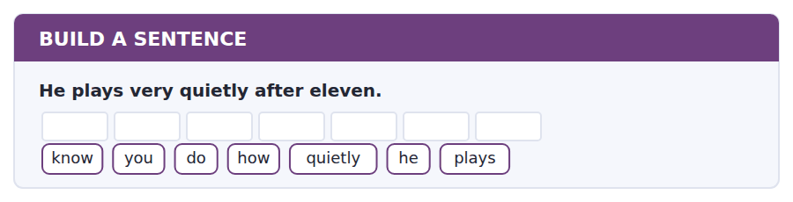
2. Do you know how quietly he plays?
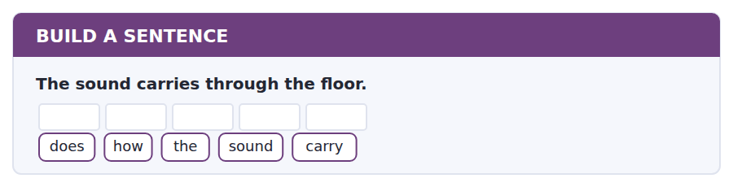
3. How does the sound carry?
Exercise B Exam practice. Write the sentence.
4. The concert now finishes at midnight.
time / what / does / the / concert / finish
__________________________________________________________
5. Quiet hours begin at half past twelve on Friday.
tell / can / you / me / when / quiet / hours / begin
__________________________________________________________
6. The music room can be booked until eleven.
late / how / can / I / book / it
__________________________________________________________
7. Doubling the frequency gives the same note an octave higher.
know / do / you / what / happens / if / you / double / it
__________________________________________________________
8. The student who complained lives directly below.
the / student / who / complained / lives / directly / below
__________________________________________________________
9. Tickets cost four pounds from the porters’ lodge.
much / how / do / tickets / cost
__________________________________________________________
10. These memories come mostly from adolescence.
know / do / you / why / they / come / from / adolescence
__________________________________________________________


You read a short situation and write an email. You have 7 minutes. The three bullet points are the mark scheme: answer all three.
You have twice spoken politely to the student in the room above about bass practice after midnight. He has been apologetic both times and it has continued. The notice says to report it on the portal, but you also think there is a practical cause: the Block E music room is only bookable until eight in the evening.
Write an email to the warden.
- Say what has happened and what you have already done.
- Report the specific times.
- Suggest the change you think would solve it.
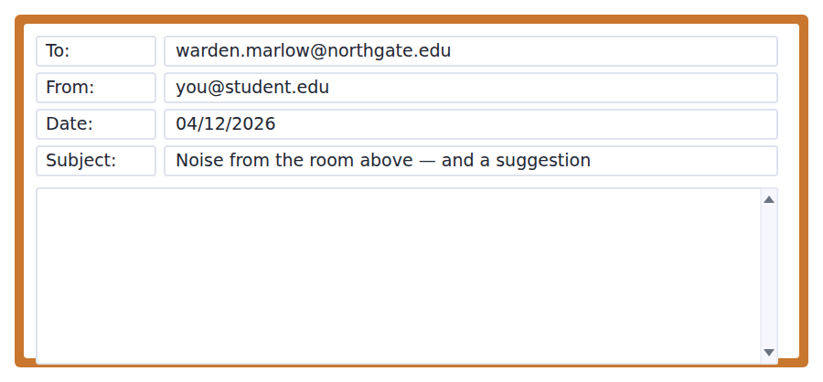
SKILL · Report facts, propose a fix
- Dates and times make a complaint actionable. Without them it is a mood.
- Say what you tried first. It shows you followed the procedure.
- Propose a change to the system, not a punishment for the person.
- Seven minutes. 110–140 words.

Model email
Dear Dr Halloran,
I am in room 212 and I am writing about bass practice in the room above, 312. I have spoken to the student twice, on 20 and 27 November. He was apologetic on both occasions and I do not think he is being deliberate — bass carries through the floor and he cannot hear it himself through headphones.
It has happened again since: Tuesday 2 December until about 01.30, and Wednesday 3 December until about 00.50.
Rather than a warning, could the music room in Block E be bookable later than eight in the evening? He has told me he practises late because that is when he is free, and at the moment the only room that would solve the problem is closed by then.
Thank you,
Mina Petrova, room 212
Why it works
- Both earlier conversations are dated, which proves the procedure was followed.
- The writer explicitly removes malice from the account, which makes the rest credible.
- The two incidents are given with dates and approximate end times — exactly what the notice asks for.
- The suggestion is a change to the timetable rather than a punishment, which is what makes it likely to be acted on.
Now write your own. 7 minutes.
__________________________________________________________
__________________________________________________________
__________________________________________________________
__________________________________________________________
__________________________________________________________
__________________________________________________________
__________________________________________________________
__________________________________________________________


A professor asks a question and two students answer. You add your own post. You have 10 minutes and an effective answer is at least 100 words.
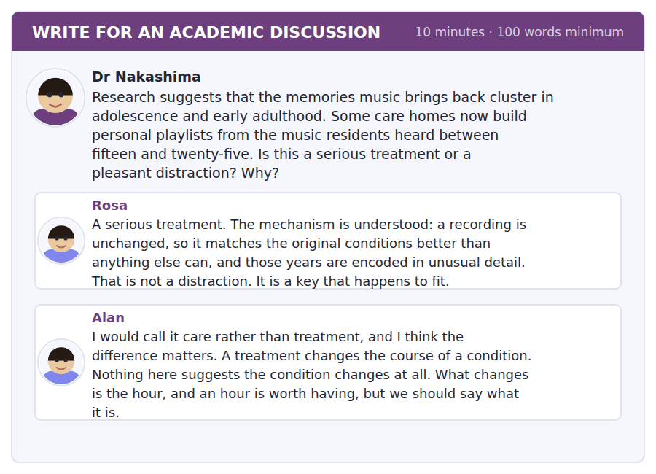
SKILL · Argue about a definition when that is the real question
- This disagreement is about what counts as a treatment, not about the evidence.
- Say so, then say which definition is the useful one here, and why.
- Use the mechanism from the passage to decide it.
- At least 100 words in ten minutes.

Sentence starters
- Rosa and Alan agree about the evidence and disagree about the word:…
- Alan’s distinction is real, but it may be the wrong one here, because…
- If a treatment has to change the course of a condition, then…
- What I would want to know is…
Model post
Rosa and Alan agree about every fact and disagree about one word, which is worth noticing before anybody argues further.
Alan’s distinction is real. A treatment changes the course of a condition, and nothing in the research suggests that playing a 1968 record slows anything down. But I am not sure that is the right test in this case. The passage explains the mechanism precisely: a recording is the only part of the past that can be played back unchanged, and those years are encoded in unusual detail. The key fits, as Rosa says.
What I would want to know is whether the hour has effects outside the hour — whether a resident who has been listening eats better, sleeps better or speaks more that evening. If it does, Alan’s line has been crossed on his own definition. If it does not, he is right, and it is still worth doing.
[164 words]
Now write your own. 10 minutes, at least 100 words.
__________________________________________________________
__________________________________________________________
__________________________________________________________
__________________________________________________________
__________________________________________________________
__________________________________________________________
__________________________________________________________
__________________________________________________________
__________________________________________________________
__________________________________________________________

Grammar focus Adverbs of manner and degree
Form | Example
adjective + -ly | quiet → quietly; dramatic → dramatically
Irregular | good → well; fast → fast; hard → hard
Position: after the verb or object | He plays the bass quietly.
Degree before an adjective or adverb | extremely quiet; almost completely
hard / hardly are different words | He works hard. He hardly works.
Comparative adverb | more quietly; faster; better
How + adverb question | How quietly does he play?

Manner adverbs say how something is done. Degree adverbs say how much, and go in front of the word they modify: almost silent, extremely quietly.
Hardly is not the adverb of hard. Hard means with effort; hardly means almost not at all. The test does use this pair.
Do not put an adverb between a verb and its object. Not *he plays quietly the bass*.
Watch out! Good is an adjective and well is its adverb. He plays good is wrong; he plays well is right. The exception is feel good, which is about state rather than manner.
Exercise 1 Make the adverb and put it in the right place.
1. He plays the bass. (quiet) →
2. She explained it. (clear) →
3. The note sounds higher. (slight) →
4. They arrived. (late) →
5. He works. (hard) →
6. She sings. (good) →
Exercise 2 Choose hard or hardly.
1. I could __________ hear it, although the floor was moving.
2. She works very __________ and still has time to rehearse.
3. There was __________ anybody at the soundcheck.
4. The question was __________ to answer.
Exercise 3 Correct the mistake in each sentence.
1. He plays quietly the bass.
2. She sings very good.
3. The two things are complete independent.
How this is tested in Build a Sentence
Build a Sentence asks these as degree questions: How loudly does it play? How often does it happen? The adverb stays beside how and never moves to the end.

Unit review and progress check Unit 13
Exercise A Vocabulary. Write the word.
1. not changing
2. to change something slightly
3. separate and distinct
4. an idea or belief
5. to make something have no effect
6. sudden and noticeable
7. to match or be equivalent to
8. to happen at the same time
9. to see or show a difference
10. a particular example
11. times when noise is not allowed
12. a test of equipment before a performance
Exercise B Grammar. Complete the sentence.
1. He plays the bass __________ (quiet).
2. I could __________ hear it, although the floor moved.
3. She sings very __________ (good).
4. The note sounds __________ (slight) higher.
5. The two things are __________ (complete) independent.
6. She works very __________ and still finds time.
7. They arrived __________ (late) for the soundcheck.
8. __________ (how / loud) does it play at night?
Exercise C One timed mini-section. 6 minutes.
1. According to the passage on page 58, what is unusual about musical memory is
(A) how it is retrieved
(B) how it is stored
(C) how long it lasts
(D) how emotional it is
2. In the talk, doubling the frequency gives
(A) the same note an octave higher
(B) a note twice as high
(C) a note twice as loud
(D) no audible change
3. Which sentence is correct?
(A) He plays quietly the bass.
(B) She sings very good.
(C) The two things are complete independent.
(D) I could hardly hear it.
4. A resident disturbed at 00.45 by continuing noise should
(A) wait until morning
(B) report it on the portal only
(C) call the night porter
(D) speak to the warden first
5. In Complete the Words, a gap of two dashes after an adjective stem is most likely
(A) -ly
(B) -er
(C) -est
(D) -ing
6. In Reading, an inference question asks for
(A) a fact stated in the text
(B) something the text supports but does not state
(C) the meaning of a word
(D) the main idea
Can you do these now?
I can… | Not yet | Yes
complete word endings in a text about sound and hearing | □ | □
read a concert listing and a residents’ notice and find the rule | □ | □
follow a passage that explains why one kind of memory is unusually strong | □ | □
understand a difficult conversation between neighbours | □ | □
describe how something is done, out loud, without preparing | □ | □
write a polite complaint, and a post that resists an easy explanation | □ | □

ADAPTIVE TIP In Listen and Repeat, say the whole sentence or say nothing. Half a sentence, however accurate, scores lower than a complete one delivered slowly — the task is testing whether you can hold a whole utterance, not whether you can pronounce its first four words.

Unit 14 · Archaeology and Ancient Cities
TOEFL iBT® Preparation Course 2026 · Volume 2
CEFR B1 · Grammar: The past passive · Word field: remains, dating, settlement
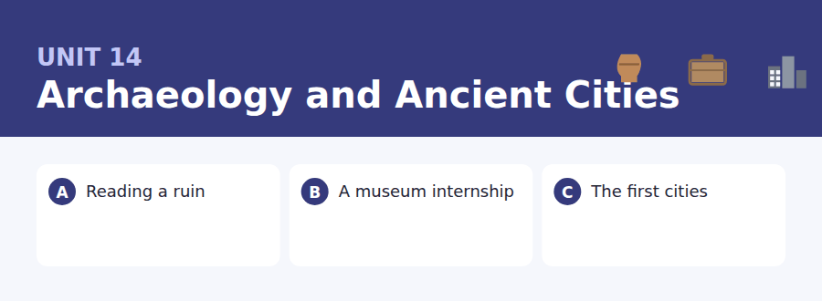
By the end of this unit I can…
- complete word endings in a text about what buildings leave behind
- read an internship advertisement and a reference request and find what is needed
- follow a passage that explains why something appeared where it did
- understand two students preparing for an interview
- describe a past process out loud without preparing
- write an email about a deadline I may miss, and a post about competing claims

Archaeology is written almost entirely in the past passive: it was built, it was abandoned, it was found. Unit 3 taught the present; this unit does the past.

Vocabulary 1 · Academic 24 words from the Academic Word List
These twenty-four words come back through the whole unit, and again in the review. Cover the right-hand column and test yourself.
empirical based on observation rather than theory | thesis a long piece of research writing; a central claim
preliminary coming before the main part | manual done with the hands rather than by machine
intermediate in the middle between two stages | bulk the largest part of something
successor a person or thing that comes after another | estate a large area of land with one owner
maintain to keep in good condition | civil connected with ordinary citizens
occupy to live in or use a place | military connected with armed forces
abandon to leave a place for ever | constitute to make up or form
cease to stop | dominate to be the strongest or most noticeable
encounter to meet or find unexpectedly | diminish to become smaller or less
indicate to show or point to | integrity the state of being whole and undamaged
deduce to work something out from evidence | chart to record or map something
presume to think something is probably true | inspect to look at carefully

Exercise A Work in pairs. Ask and answer.
1. Is there a building near you that was abandoned and then reused? What happened?
2. What would a future archaeologist deduce from the contents of your bag?
3. Which period of your country’s past is best maintained, and which has been lost?
4. What do you presume about a town when you see its oldest street?
Vocabulary 2 · Campus and everyday 12 words for the daily-life tasks
The exam does not only test academic English. Notices, emails, conversations and announcements use the everyday words below.
internship a period of work experience, often unpaid | supervisor the person responsible for your work
placement a period of work arranged as part of a course | logbook a record of what was done each day
site visit a trip to see a place being studied | hard hat a helmet worn on a work site
trowel a small hand tool for digging carefully | spoil heap the pile of removed earth beside a trench
finds tray a tray for objects recovered from a dig | rota a list showing who works when
dig an archaeological excavation | context sheet a form recording where an object was found

Words you will meet again: structure | construct | region | significant | evident | period | establish | migrate


SKILL · Past passive endings are everywhere
- Was and were are followed by a past participle. Most gaps after them are -ed or -en.
- Irregular participles are short: built, found, left, taken. Few dashes.
- Noun endings common here: -ment, -ation, -ure.
- Count the dashes before choosing.

Exercise A Guided practice. Five words are not complete. Write the missing letters.
A ruined wall is a document. You can see where it was buil-, where it was repai---, and where somebody later knocked a doorway thro---. Each change was made for a reas--, and the reasons were almost always practi---, not beautiful.

The first one is done for you: 1 buil- → t (built)
Exercise B Exam practice. One paragraph, ten gaps — the real task.
Archaeologists do not dig to find objects. They dig to find relation-----: what was lying on top of what. A floor that was la-- over a layer of ash tells you the building bur--- and was then reused, and it tells you so without a single written word. The same wall may have been exte---- twice, cut thro--- for a drain, and finally robb-- of its stone for a later house. Each of those events is record-- in the order the material was left. This is why an object taken out of the ground without its context is nearly worth----: a coin tells you a great deal when it is fo--- under a floor and almost nothing when it arrives in a box. The information was never in the coin. It was in the earth aro--- it.

Check your answers in the key at the back of the book.


SKILL · Find the requirement, then the deadline
- Job and internship notices pair a requirement with a date. Both are tested.
- What is provided and what you must supply are different lists.
- A request for a reference has its own deadline, usually earlier.
- If one date changes, check what else moves with it.

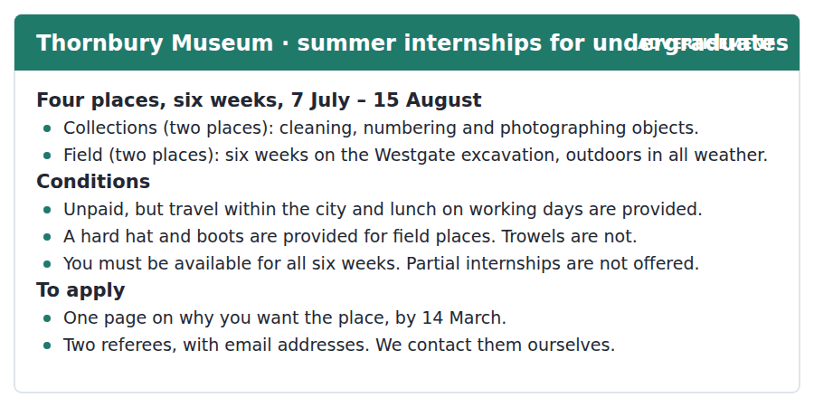
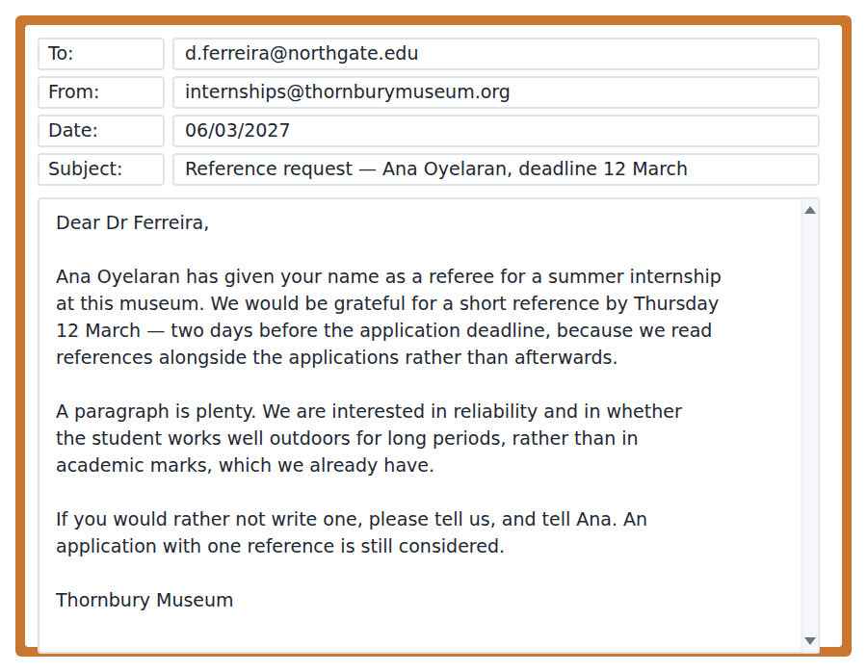
Exercise A Guided practice. The answer is on the page — find it.
1. How long does the internship last?
(A) Four weeks
(B) Eight weeks
(C) Six weeks
(D) The whole summer
2. What is provided for field places?
(A) A trowel
(B) Accommodation
(C) A daily wage
(D) A hard hat and boots
3. What is NOT provided?
(A) Pay
(B) Lunch on working days
(C) Travel within the city
(D) A hard hat
4. Can a student take only part of the internship?
(A) Yes, by arrangement
(B) No
(C) Yes, for field places only
(D) Only in August
Exercise B Exam practice.
5. Why is the reference deadline earlier than the application deadline?
(A) References take longer to write
(B) References are read alongside the applications
(C) The museum closes on 14 March
(D) Applications are read first
6. What does the museum want the reference to cover?
(A) Academic marks
(B) Previous museum experience
(C) Language ability
(D) Reliability and working outdoors
7. How long should the reference be?
(A) One page
(B) Two pages
(C) A paragraph
(D) As long as possible
8. What should a referee do if they would rather not write?
(A) Tell the museum and the student
(B) Say nothing
(C) Tell the museum only
(D) Write a short negative reference
9. What happens to an application with only one reference?
(A) It is still considered
(B) It is rejected
(C) It is delayed
(D) It goes to a later round
10. What can be inferred about the field places?
(A) They are more popular than collections places
(B) They require physical stamina
(C) They are paid
(D) They are open to postgraduates


SKILL · Follow a correction of the obvious answer
- When a passage calls an explanation true but incomplete, it will supply the missing part.
- The second paragraph usually carries the real claim. Mark its first sentence.
- Evidence in the third paragraph will be tested against the claim.
- A sentence beginning Writing was not invented to… is a main idea in disguise.

Why the First Cities Appeared Where They Did
The first cities were built in a handful of river valleys within a few centuries of one another, and the obvious explanation is farming: once a field produced more food than the family that worked it needed, some people could do something else. That is true but incomplete. Farming began several thousand years before the first city, and in many places it never produced one at all.
What the successful valleys had in common was not fertility but unpredictability. The Nile and the Tigris flood, and a flood does two things. It renews the soil, which is the part everyone remembers, and it destroys the boundaries between one field and the next, which is the part that matters here. Every year the land had to be measured out again, and measuring land for several thousand households requires records, arbitration and somebody with the authority to decide. The institutions came first, and the city grew around them.
The evidence is in what was written. The earliest tablets from these cities are not poems or laws or histories. They are receipts: quantities of barley, numbers of sheep, names of people who owed something to somebody. Writing was not invented to preserve ideas. It was invented to keep track of who had what, and the first cities are best understood as the places where keeping track became too complicated to do in anybody’s head.
[280 words]

Exercise A Guided practice.
1. What is the passage mainly about?
(A) How farming began
(B) How writing developed
(C) Why floods are dangerous
(D) Why cities appeared in certain river valleys
2. Why is the farming explanation described as incomplete?
(A) Farming is more recent than cities
(B) Fields were too small
(C) Farming often produced no city at all
(D) The evidence is missing
3. What did the successful valleys have in common?
(A) The richest soil
(B) The warmest climate
(C) The largest rivers
(D) Unpredictable flooding
4. What does a flood destroy, according to the passage?
(A) The crops
(B) The houses
(C) The boundaries between fields
(D) The records
Exercise B Exam practice.
5. Why does re-measuring the land require institutions?
(A) Several thousand households need records and arbitration
(B) It is physically hard
(C) The rivers change course
(D) Farmers cannot count
6. What were the earliest tablets?
(A) Poems
(B) Receipts
(C) Laws
(D) Histories
7. All of the following are stated in the passage EXCEPT:
(A) Floods renew the soil
(B) The institutions came before the city
(C) The first cities had the largest populations
(D) Writing began as record-keeping
8. The word "arbitration" in paragraph 2 is closest in meaning to
(A) measuring land
(B) settling disagreements
(C) collecting taxes
(D) writing records
9. What can be inferred about writing?
(A) It was invented for literature
(B) It began in one valley only
(C) It replaced spoken agreement
(D) It followed a practical need
10. What does the author mean by "too complicated to do in anybody’s head"?
(A) Record-keeping had outgrown memory
(B) Cities were confusing places
(C) Farming required arithmetic
(D) Floods were unpredictable
11. Which best states the main idea of paragraph 2?
(A) Floods made the soil rich
(B) The Nile is longer than the Tigris
(C) The need to redraw boundaries created institutions, and cities grew round them
(D) Farming needs water


Exercise A Listen and choose a response. You hear one line. Choose the best reply.
1. Man: Have you applied for the internship?
(A) Four places.
(B) At the museum.
(C) Yes, six weeks.
(D) I sent it last night.
2. Woman: Is it paid?
(A) For six weeks.
(B) No, but lunch and travel are.
(C) At the Westgate site.
(D) Yes, quite well.
3. Man: Who did you put as referees?
(A) Dr Ferreira and my tutor.
(B) Two of them.
(C) By the twelfth.
(D) Yes, I did.
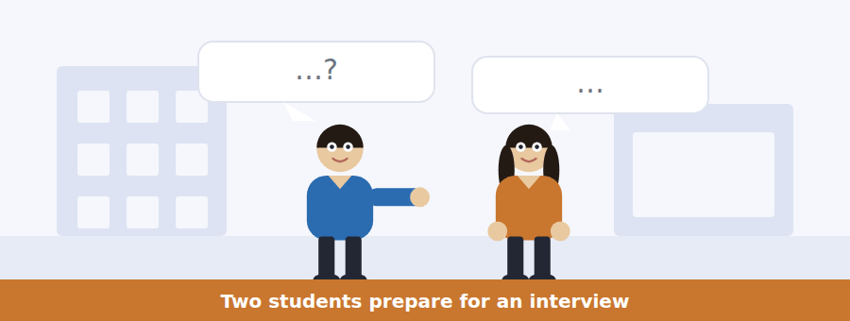
SKILL · Note the advice and who gives it
- When one speaker coaches another, the advice is the content of most questions.
- Listen for the thing they get wrong and the correction.
- A fact about the organisation mentioned in passing is usually tested.
- The last exchange says what each will do.

Exercise B Listen and answer. The audio plays once.
4. What is the woman worried about?
(A) Whether she will be offered a place
(B) Whether the internship is paid
(C) How to get to the site
(D) What she will be asked at interview
5. What does the man predict they will ask about?
(A) Her academic marks
(B) Her referees
(C) Working outdoors
(D) Museum experience
6. Why does the museum care about this?
(A) People leave halfway through and training takes two weeks
(B) The work is dangerous
(C) The site closes in bad weather
(D) There are only four places
7. What kind of answer does the man recommend?
(A) A short yes
(B) A specific example with details
(C) An academic answer
(D) A question back
8. Why does the man tell her to mention the number eleven?
(A) It is the number of places
(B) It makes the example concrete
(C) It is how long the internship lasts
(D) It was her mark
9. What does the man advise about the why-this-museum question?
(A) Praise the collection
(B) Mention her tutor
(C) Name one object she actually wants to see
(D) Ask about the rota
Audio script: see the back of the book. Do not read it before you listen.


Exercise A Listen and choose a response. You hear one line. Choose the best reply.
1. Woman: When do applications close?
(A) Four places.
(B) At the museum.
(C) Yes, they do.
(D) The fourteenth of March.
2. Man: Has the date changed?
(A) It is two weeks earlier.
(B) On the fourteenth.
(C) Two referees.
(D) Yes, six weeks.
3. Woman: Can I do four weeks instead of six?
(A) No — it is all six or none.
(B) It runs from July.
(C) Four places are available.
(D) Yes, if you ask.
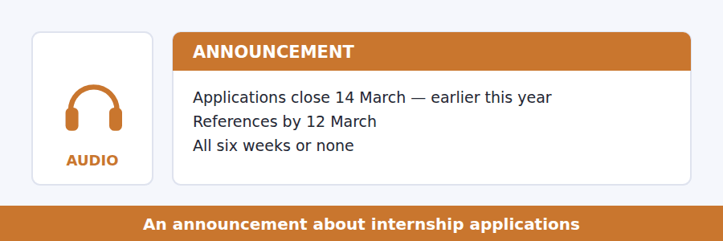
SKILL · Hear a deadline that has moved
- When a date is described as earlier than last year, both dates may be tested.
- A requirement that has not changed is as testable as one that has.
- Listen for the reason a rule exists — it is usually given once.
- The final instruction is the usual last question.

Exercise B Listen and answer. The audio plays once.
4. What has changed since last year?
(A) The number of places
(B) The dates of the internship
(C) References are no longer needed
(D) The deadline is two weeks earlier
5. How are references collected?
(A) Students collect letters
(B) Referees post them
(C) The museum contacts the referees
(D) Tutors upload them
6. Why must referees be asked this week?
(A) They are busy
(B) The reference deadline is before the application deadline
(C) The museum reads them last
(D) There are only four places
7. Why are partial internships refused?
(A) There are too many applicants
(B) Training takes a fortnight
(C) The site closes in August
(D) Insurance does not cover it
8. What does the speaker say about last year’s applications?
(A) There were sixty
(B) There were four
(C) There were twelve
(D) The number is not known
Audio script: see the back of the book. Do not read it before you listen.


Exercise A Listen and choose a response. You hear one line. Choose the best reply.
1. Woman: Which layer do you dig first?
(A) With a trowel.
(B) On a context sheet.
(C) The top one.
(D) Yes, carefully.
2. Man: Why record everything?
(A) On the context sheet.
(B) Every layer.
(C) Yes, you must.
(D) Because digging destroys it.
3. Woman: Can you put a layer back?
(A) With a trowel.
(B) In reverse order.
(C) No — that is the whole point.
(D) Yes, afterwards.
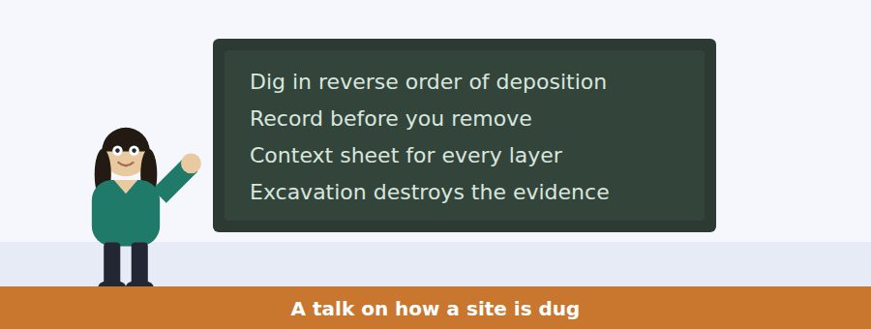
SKILL · Follow a method that cannot be undone
- A talk about an irreversible process will stress recording. Expect questions on it.
- Listen for the order: what is done before what.
- A striking statement (we destroy it) is always tested.
- The final instruction is the main idea.

Exercise B Listen and answer. The audio plays once.
4. What is the main idea of the talk?
(A) Archaeology is tedious at first
(B) Excavation destroys evidence, so recording is everything
(C) Westgate is an important site
(D) Chemistry is more reliable than archaeology
5. Why can an excavation not be repeated?
(A) The layer no longer exists
(B) It is too expensive
(C) Sites are protected by law
(D) The team changes each year
6. In what order are layers removed?
(A) Oldest first
(B) Largest first
(C) Whichever is most interesting
(D) Reverse order of deposition
7. What must be done before anything is removed?
(A) It must be recorded
(B) It must be cleaned
(C) It must be photographed only
(D) A supervisor must approve it
8. Why does the speaker mention a sherd under a wall?
(A) To show that pottery is valuable
(B) To explain how walls are built
(C) To show that position, not the object, carries the information
(D) To warn about breakages
9. What is the rule the speaker gives?
(A) Dig slowly
(B) Record anything you are unsure about
(C) Photograph everything twice
(D) Ask a supervisor first
Audio script: see the back of the book. Do not read it before you listen.


Part 1 · Listen and Repeat
You hear a sentence and repeat it once. There is no preparation time, and the sentences get longer. Focus: past passive forms
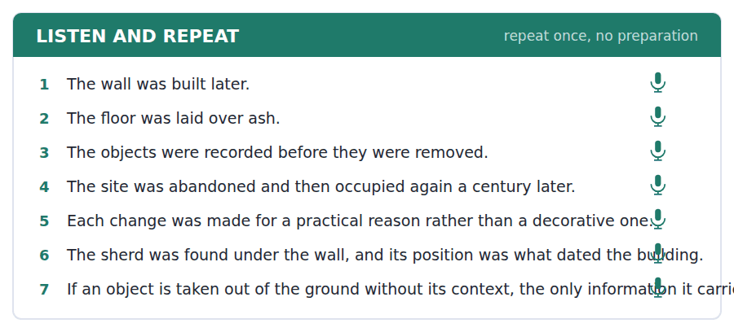
SKILL · Keep was and were clear
- The auxiliary carries the tense and the number. Do not swallow it.
- Irregular participles matter: built, found, left, taken, known.
- Say by only when the agent is news.
- Finish the sentence even if the participle comes out wrong.

Part 2 · Take an Interview
An interviewer asks you four questions on one theme: old places you know. Answer each one fully. There is no preparation time.
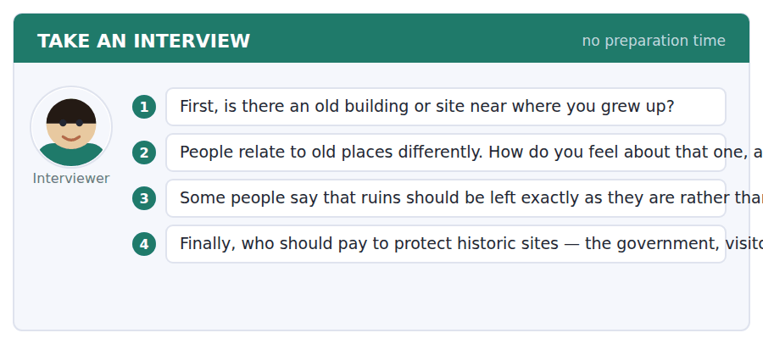
A good answer sounds like this
Question 2 — I walked past it every day for years without looking at it, which I now think is the normal relationship people have with the past near them.
Question 3 — Mostly I agree. Once you rebuild a ruin you have made a guess, and in fifty years nobody will remember which parts were the guess.
I can… | Not yet | Yes
I kept was and were audible | □ | □
I used the right irregular participles | □ | □
I gave a reason after every opinion | □ | □


Part 1 · Listen and Repeat
You hear a sentence and repeat it once. There is no preparation time, and the sentences get longer. Focus: describing experience
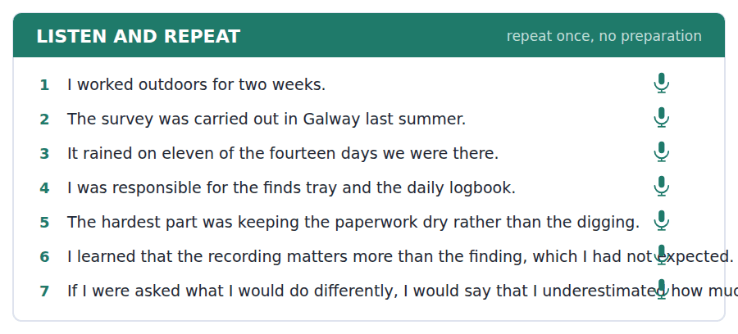
SKILL · Be specific, then be brief
- Where, how long, what was difficult. Three facts beat three adjectives.
- Numbers make an example believable: two weeks, eleven days of rain.
- Say what you learned from it in one clause, not three.
- Stop when you have answered. A long answer is not a better one.

Part 2 · Take an Interview
An interviewer asks you four questions on one theme: work experience. Answer each one fully. There is no preparation time.
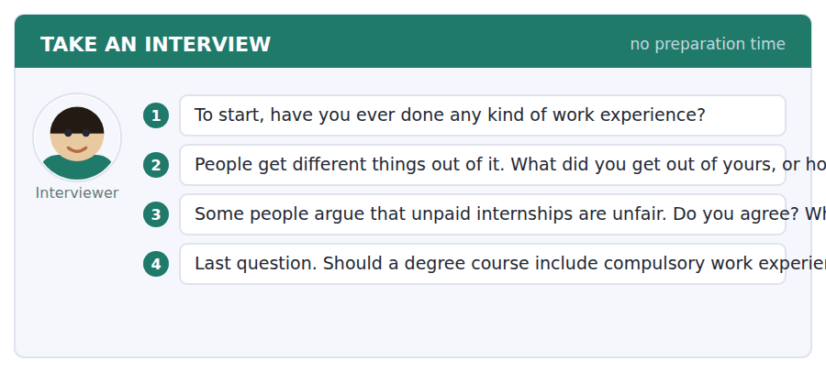
A good answer sounds like this
Question 3 — I agree, and the reason is simple: an unpaid place is only available to somebody who can afford six weeks without earning.
Question 4 — Yes, if the university arranges and pays for it. Compulsory and unarranged is the worst combination.
I can… | Not yet | Yes
I gave where, how long and what was difficult | □ | □
I used at least one number | □ | □
I stopped when I had answered | □ | □


Part 1 · Listen and Repeat
You hear a sentence and repeat it once. There is no preparation time, and the sentences get longer. Focus: academic register
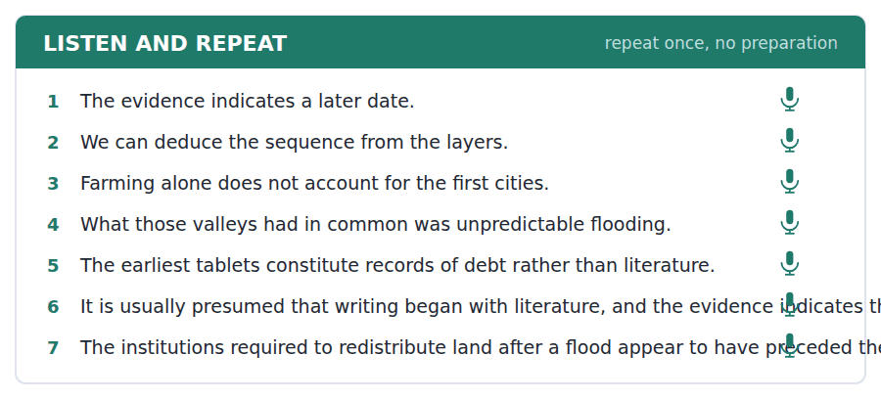
SKILL · Correct an explanation politely
- Use the unit’s words: indicate, deduce, presume, constitute, diminish.
- The usual explanation is… but that does not account for…
- Then give the better one with its evidence.
- Mark yourself against the three statements below.

Part 2 · Take an Interview
An interviewer asks you four questions on one theme: the past and how it is explained. Answer each one fully. There is no preparation time.
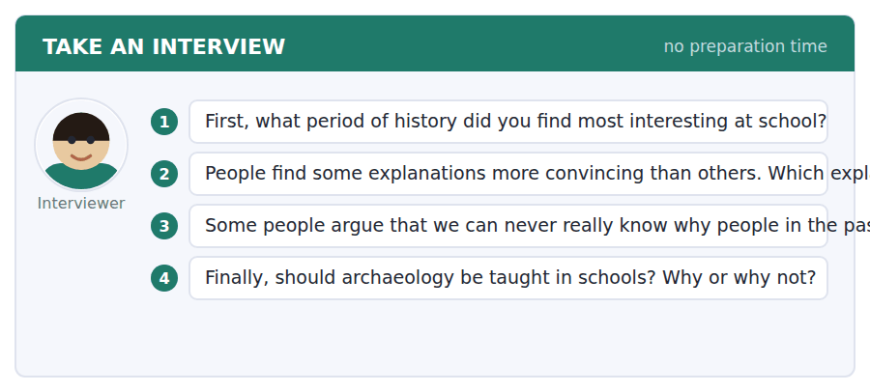
A good answer sounds like this
Question 2 — Any explanation that makes people in the past simpler than people now. It usually indicates that the evidence is thin.
Question 3 — Partly. We cannot know what anybody intended, but we can often deduce what they did, and the second is more useful than people assume.
I can… | Not yet | Yes
I used at least three academic words from this unit | □ | □
I corrected an explanation before offering another | □ | □
My last answer had an opinion, a reason and an example | □ | □


You see a sentence, then a set of words in boxes. Put the words in order to make one grammatical sentence. Almost every item in the real test makes a question or a question inside another sentence.
SKILL · Past passive questions
- When was it built? — the question word, then was, then the subject.
- Who was it built by? puts by at the end in speech.
- An embedded version keeps statement order: do you know when it was built.
- Use every tile exactly once.

Exercise A Guided practice. The first three are worked through.
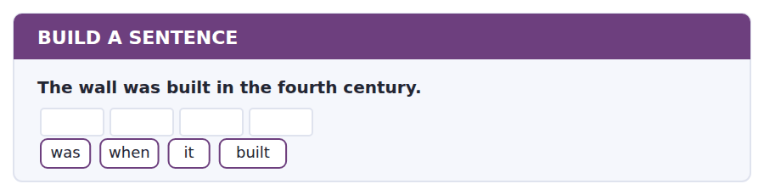
1. When was it built?
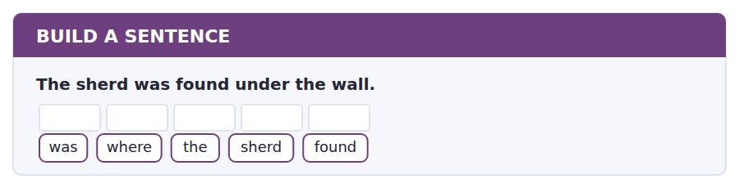
2. Where was the sherd found?
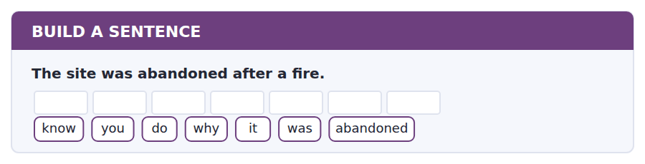
3. Do you know why it was abandoned?
Exercise B Exam practice. Write the sentence.
4. References are contacted by the museum itself.
tell / can / you / me / whether / references / are / contacted
__________________________________________________________
5. The deadline was moved two weeks earlier.
much / how / was / the / deadline / moved
__________________________________________________________
6. Four places were offered last year.
places / how / many / were / offered
__________________________________________________________
7. The layer was recorded before it was removed.
know / do / you / when / it / was / recorded
__________________________________________________________
8. The tablets that were found first were receipts.
the / tablets / that / were / found / first / were / receipts
__________________________________________________________
9. Training a field intern takes a fortnight.
long / how / does / the / training / take
__________________________________________________________
10. Lunch and travel are provided but the place is unpaid.
know / do / you / whether / lunch / is / provided
__________________________________________________________


You read a short situation and write an email. You have 7 minutes. The three bullet points are the mark scheme: answer all three.
You have applied for a field internship. One of your two referees is away at a conference until 13 March and has told you he cannot write before then. The reference deadline is 12 March and the application deadline is 14 March. Your other referee has already replied.
Write an email to the museum.
- Explain the situation and give the dates.
- Ask what you should do.
- Say what you have already arranged.
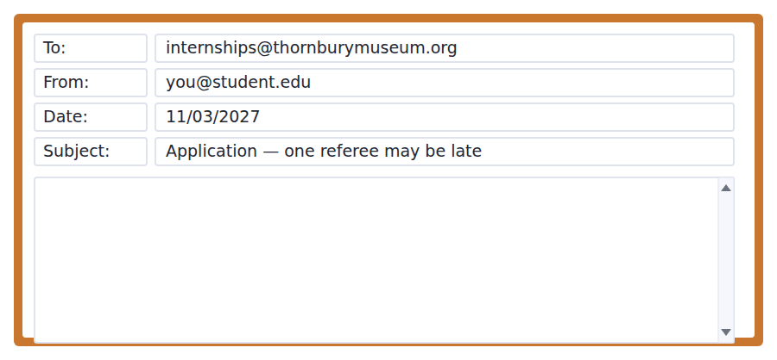
SKILL · Raise a problem before it becomes one
- An email sent before a deadline reads as organised; the same email after reads as an excuse.
- Give every date in full so nothing has to be looked up.
- Offer an alternative in case the answer is no.
- Seven minutes. 110–140 words.

Model email
Dear Internships Office,
I have applied for a field place this summer and I am writing about my references, before the deadline rather than after it.
One of my referees, Dr Ferreira, has already replied to you. The second, Professor Aduba, is at a conference until Friday 13 March and has told me he cannot write before he returns. That is one day after your reference deadline of 12 March, although still before the application deadline of 14 March.
Could you tell me whether a reference arriving on the thirteenth would still be read? If it would not, I am happy for my application to be considered with Dr Ferreira’s reference alone, which I understand is permitted.
Thank you for your help.
Ana Oyelaran
Why it works
- Before the deadline rather than after it is the sentence that sets the tone of the whole email.
- All three dates are given in full, so the reader never has to check anything.
- The fallback uses a rule from the museum’s own email, which shows it was read.
- The question is answerable with one word, which is what makes it likely to be answered quickly.
Now write your own. 7 minutes.
__________________________________________________________
__________________________________________________________
__________________________________________________________
__________________________________________________________
__________________________________________________________
__________________________________________________________
__________________________________________________________
__________________________________________________________


A professor asks a question and two students answer. You add your own post. You have 10 minutes and an effective answer is at least 100 words.
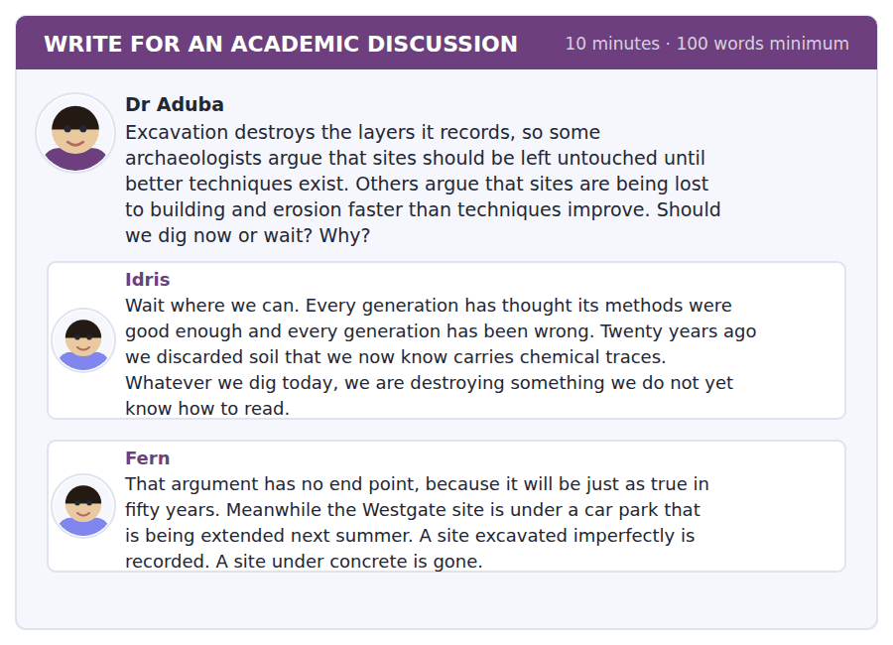
SKILL · Notice when an argument has no stopping rule
- An argument that will always be true is not an argument for waiting; it is an argument for never.
- Say so, then say what would make waiting right in a particular case.
- Use the lecture’s point that excavation cannot be repeated.
- At least 100 words in ten minutes.

Sentence starters
- Idris is right about the methods and wrong about what follows:…
- Fern’s point about the car park is not a detail — it is the whole question:…
- What decides it is whether the site is under threat:…
- So I would dig where… and wait where…
Model post
Idris is right about the methods and I do not think the conclusion follows. His argument will be exactly as true in fifty years, which means it is not an argument for waiting. It is an argument for never digging anything, and nobody holds that.
Fern has found the distinction that actually decides it. The lecture made the point that excavation cannot be repeated, and that is precisely why a threatened site is a different case from a safe one. A site under a car park extension is going to be destroyed either way; the only question is whether it is destroyed with a context sheet or with a digger.
So I would dig where the site is under threat and wait where it is not, and I would spend the argument about methods on the second group, where it can actually change something.
[161 words]
Now write your own. 10 minutes, at least 100 words.
__________________________________________________________
__________________________________________________________
__________________________________________________________
__________________________________________________________
__________________________________________________________
__________________________________________________________
__________________________________________________________
__________________________________________________________
__________________________________________________________
__________________________________________________________

Grammar focus The past passive
Form | Example
was / were + past participle | The wall was built later.
Negative | The layer was not recorded.
Question | When was it built?
With by (only if it matters) | The site was excavated by students.
Past continuous passive | The trench was being recorded all morning.
Modal passive, past | It should have been recorded.
In an embedded question | Do you know when it was built?

Use the past passive when the action matters more than the actor, which in archaeology is almost always. The wall was rebuilt tells you what happened; who rebuilt it is usually unknown anyway.
The participle is the third form of the verb: build → built, find → found, take → taken, leave → left. Regular verbs simply take -ed.
Was being + participle describes something in progress in the past: the trench was being recorded when it rained.
Watch out! Do not use the past simple of the main verb after was. It is was found, never *was find*, and was taken, never *was took*.
Exercise 1 Rewrite in the past passive.
1. Someone built the wall in the fourth century. → The wall __________.
2. They found the sherd under the floor. → The sherd __________.
3. Nobody recorded the layer. → The layer __________.
4. Students excavated the trench. → The trench __________ by students.
5. They abandoned the site after a fire. → The site __________ after a fire.
6. They were recording the trench all morning. → The trench __________ all morning.
Exercise 2 Write a past passive question for each answer.
1. __________________? — In the fourth century.
2. __________________? — Under the floor.
3. __________________? — By students from Northgate.
4. __________________? — Because of a fire.
Exercise 3 Correct the mistake in each sentence.
1. The sherd was find under the wall.
2. The layer was not record before it was removed.
3. When the wall was built?
How this is tested in Build a Sentence
Build a Sentence uses the past passive in both shapes: When was it built? and Do you know when it was built? The inversion disappears as soon as the question is embedded.

Unit review and progress check Unit 14
Exercise A Vocabulary. Write the word.
1. based on observation rather than theory
2. coming before the main part
3. to leave a place for ever
4. to stop
5. to work something out from evidence
6. to think something is probably true
7. the largest part of something
8. to make up or form
9. to become smaller or less
10. the state of being whole and undamaged
11. a form recording where an object was found
12. the pile of removed earth beside a trench
Exercise B Grammar. Complete the sentence.
1. The wall __________ (build) in the fourth century.
2. The sherd __________ (find) under the floor.
3. The layer __________ (not / record) before removal.
4. The trench __________ (excavate) by students.
5. When __________ the site __________ (abandon)?
6. The trench __________ (record) all morning when it rained.
7. It __________ (should / record) at the time.
8. Do you know when it __________ (build)?
Exercise C One timed mini-section. 6 minutes.
1. According to the passage on page 74, the first cities appeared because
(A) farming produced surplus food
(B) rivers made travel easy
(C) writing had been invented
(D) floods destroyed field boundaries and institutions were needed
2. In the talk, the most important reason for recording is that
(A) supervisors require it
(B) objects are fragile
(C) museums need paperwork
(D) excavation cannot be repeated
3. Which sentence is correct?
(A) The sherd was find under the wall.
(B) When the wall was built?
(C) The layer was not recorded.
(D) The trench was excavate by students.
4. A student who can do only four of the six weeks should
(A) apply and explain
(B) apply next year
(C) apply for collections instead
(D) ask for a shorter placement
5. In Complete the Words, a gap after "was" is most likely
(A) a past participle ending
(B) a noun ending
(C) an adverb ending
(D) a plural ending
6. In Reading, a question asking what a word refers to is testing
(A) vocabulary
(B) the main idea
(C) reference back to an earlier noun
(D) the author’s purpose
Can you do these now?
I can… | Not yet | Yes
complete word endings in a text about what buildings leave behind | □ | □
read an internship advertisement and a reference request and find what is needed | □ | □
follow a passage that explains why something appeared where it did | □ | □
understand two students preparing for an interview | □ | □
describe a past process out loud without preparing | □ | □
write an email about a deadline I may miss, and a post about competing claims | □ | □

ADAPTIVE TIP An EXCEPT question wants the one option the passage does not support. Tick off the three it does and the answer is whatever is left — do not read the options looking for something that sounds wrong, because three of them will sound right and that is the point.

Unit 15 · Business and Entrepreneurship
TOEFL iBT® Preparation Course 2026 · Volume 2
CEFR B1 · Grammar: Reported speech · reported and indirect questions · Word field: capital, risk, growth
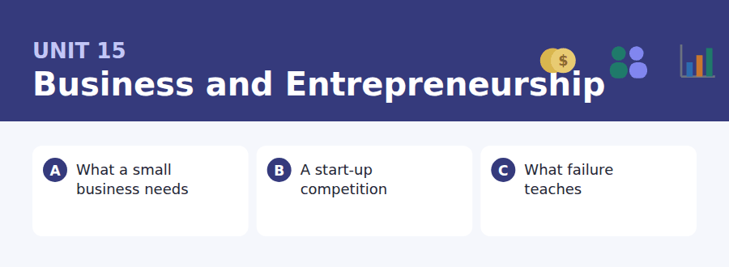
By the end of this unit I can…
- complete word endings in a text about starting something
- read a competition page and a confirmation email for the conditions
- follow a passage that explains why a common belief is only half true
- understand two people rehearsing and disagreeing about numbers
- report what somebody else said, out loud, without preparing
- write an email asking to change a slot, and a post that separates two claims

The third anchor unit. Unit 1 taught direct questions and Unit 6 embedded ones; this unit does the reported form, which is the third shape Build a Sentence uses.

Vocabulary 1 · Academic 24 words from the Academic Word List
These twenty-four words come back through the whole unit, and again in the review. Cover the right-hand column and test yourself.
corporate connected with a large company | project a planned piece of work
commission to order work to be done; a payment for selling | partner a person who shares a business with you
consent permission, or to give permission | mediate to help two sides reach agreement
undertake to agree to do something | guarantee a firm promise that something will happen
strategy a plan for achieving something over time | initiate to start something
target a result you aim at | commence to begin
pursue to follow or try to achieve | debate a formal discussion of opposing views
attain to reach or achieve | challenge something difficult that tests you
achieve to succeed in doing something | conflict a serious disagreement
acquire to get or buy | compile to put together from several sources
prospect the possibility of something happening | team a group working together
potential possible in the future | panel a group of people who judge or discuss

Exercise A Work in pairs. Ask and answer.
1. What challenge would you face if you started a business tomorrow?
2. Name a company you admire. What strategy do you think it is pursuing?
3. Would you prefer a guaranteed small income or a potential large one? Why?
4. Who would you choose as a business partner, and what would they bring?
Vocabulary 2 · Campus and everyday 12 words for the daily-life tasks
The exam does not only test academic English. Notices, emails, conversations and announcements use the everyday words below.
pitch a short talk persuading someone to back an idea | stall a small open stand at an event
start-up a new and small company | customer a person who buys something
competition an event where entrants are judged | profit money left after costs are paid
slide one screen of a presentation | loan money borrowed that must be repaid
judge a person who decides a result | business plan a written description of how a business will work
prize something given to a winner | networking meeting people who may be useful professionally

Words you will meet again: economy | invest | revenue | margin | incentive | significant | estimate | evaluate


SKILL · Business texts repeat a small set of endings
- -ment, -ity, -ance and -ers cover most of the nouns in this field.
- A gap after a number or a quantity word is almost always plural.
- Count the dashes before choosing between -ment and -ation.
- Read it back; this writing repeats its key words deliberately.

Exercise A Guided practice. Five words are not complete. Write the missing letters.
Most people think a new business needs an idea. It needs an idea l---, and then it needs three duller things: enough money to survive the first year, at least one person who will actually b--, and a way of being paid that does not depend on anybody’s good--- will. Businesses rarely f--- because the idea was w----.

The first one is done for you: 1 l--- → ast (last)
Exercise B Exam practice. One paragraph, ten gaps — the real task.
Ask a hundred people why small businesses f---, and most will say the idea was bad. The record says someth--- duller. The commonest cause is running out of cash while still profit----, which sounds impossible and happens const----- . You sell something in March, you p-- your supplier in April, and your customer pays you in June. On paper you made a profit. In May you cannot pay the rent. The second commonest cause is gro---- too quickly: every new customer costs money before they bring any in, so a business that doubles its orders can double its way into fail---. Neither of these is a failure of imagin-----. Both are failures of ti----, and timing is the part that nobody finds interest--- until it is happening to them.

Check your answers in the key at the back of the book.


SKILL · Judge the conditions, not the prize
- Competition pages advertise the prize and bury the conditions. The conditions are tested.
- Eligibility, deadlines and what happens to your idea are the three usual questions.
- A confirmation email adds a time, a place and a length.
- If a rule has an exception, note who it applies to.

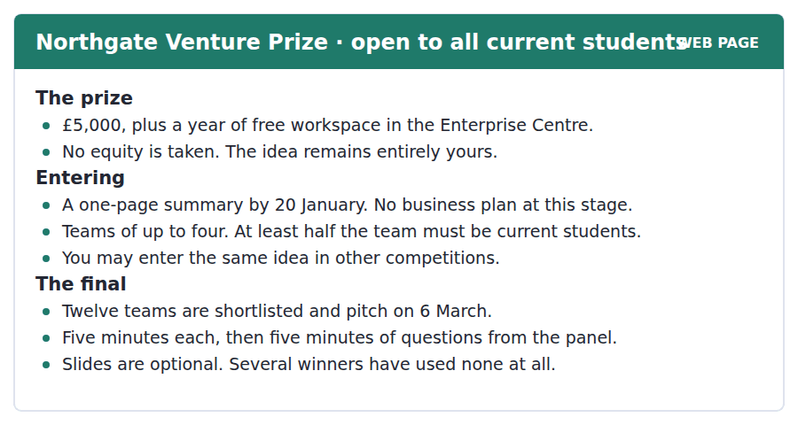
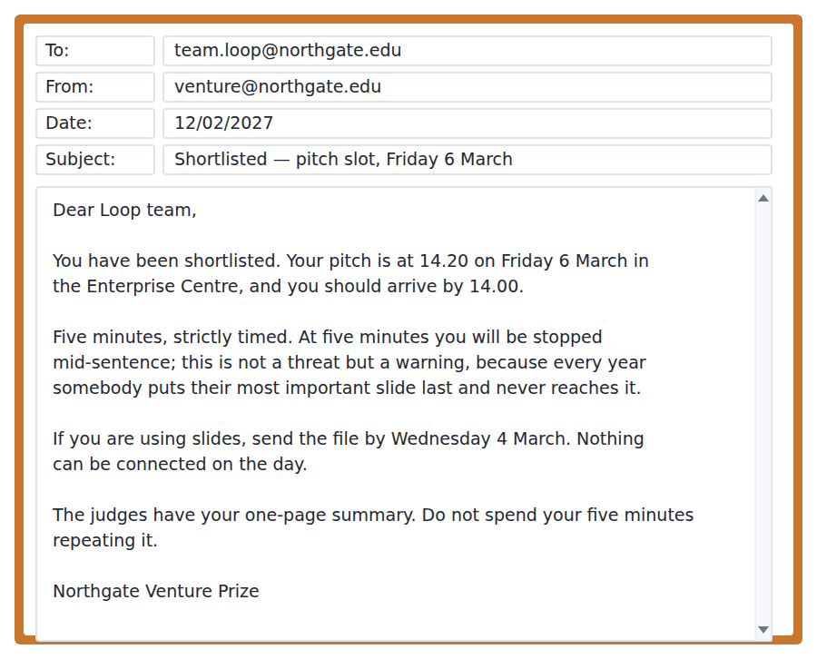
Exercise A Guided practice. The answer is on the page — find it.
1. What is the prize?
(A) £5,000 only
(B) A year of workspace only
(C) £5,000 and a year of workspace
(D) A business loan
2. What does the competition take in return?
(A) Nothing — the idea remains yours
(B) A share of the company
(C) The first year’s profit
(D) The right to publish the plan
3. What must be submitted by 20 January?
(A) A full business plan
(B) Slides
(C) A team list
(D) A one-page summary
4. How large may a team be?
(A) Two
(B) Four
(C) Three
(D) There is no limit
Exercise B Exam practice.
5. How long is each pitch?
(A) Three minutes
(B) Ten minutes
(C) Five minutes
(D) Five minutes plus slides
6. Why does the email warn about the time limit?
(A) Teams put their key slide last and never reach it
(B) The room is booked
(C) The judges leave at three
(D) Other teams are waiting
7. When must slides be sent?
(A) On the day
(B) Wednesday 4 March
(C) Friday 6 March
(D) 20 January
8. What does the email tell the team not to do?
(A) Use slides
(B) Arrive early
(C) Answer questions
(D) Repeat the one-page summary
9. What can be inferred about slides?
(A) They are required
(B) They must be sent on the day
(C) They count towards the five minutes
(D) They are not necessary to win
10. A team of four with one current student would be
(A) ineligible
(B) eligible
(C) eligible with permission
(D) placed in a separate category


SKILL · Test a slogan against evidence
- A passage that quotes a popular saying will usually qualify it. Find the qualification.
- Watch for narrower, smaller than people assume, in part — they mark the real claim.
- When a passage divides a category into two kinds, the division is tested.
- The last sentence usually rewrites the slogan correctly.

What a Failed Business Actually Teaches
It is now almost compulsory to say that failure is valuable. Founders describe failed companies as an education, and investors say they prefer a founder who has failed once. There is something in this, but it is repeated so widely and so uncritically that it is worth asking what the evidence shows.
It shows something narrower than the slogan. Founders whose first company failed do better the second time than first-time founders, but by a smaller margin than people assume, and much of the difference disappears when you account for the fact that people who start a second company are not a random sample of those who started a first. More interesting is which failures help. Failing because the market did not want the product appears to teach a great deal. Failing because the founders ran out of cash, or fell out with each other, teaches far less, and those two causes together account for most failures.
There is a plausible explanation. A market failure produces information: you now know something specific about what customers will not buy, and that knowledge transfers. Running out of cash produces no information at all, only a memory of fear, and fear is a poor teacher because it changes behaviour without explaining why. The useful version of the slogan is therefore much less comfortable than the usual one. Failure teaches you something if, and only if, it tells you something you did not already know.
[280 words]

Exercise A Guided practice.
1. What is the passage mainly about?
(A) Why most businesses fail
(B) How investors choose founders
(C) Whether failure really teaches, and when
(D) Why founders fall out
2. According to paragraph 2, founders who failed once do
(A) worse the second time
(B) better, but by a smaller margin than assumed
(C) exactly the same
(D) better only with investment
3. Why does the author mention that second-time founders are not a random sample?
(A) To praise them
(B) To explain part of the measured advantage
(C) To criticise the research
(D) To describe how surveys work
4. Which kind of failure teaches most?
(A) Running out of cash
(B) Falling out with partners
(C) Growing too fast
(D) The market not wanting the product
Exercise B Exam practice.
5. What do the two least instructive causes have in common?
(A) Together they account for most failures
(B) They are rare
(C) They happen late
(D) They involve investors
6. Why does a market failure teach?
(A) It is more dramatic
(B) It happens more slowly
(C) It produces transferable information
(D) It attracts investors
7. What does running out of cash produce, according to the author?
(A) A useful warning
(B) A better strategy
(C) A smaller company
(D) No information, only fear
8. All of the following are stated about the slogan EXCEPT:
(A) It is repeated widely
(B) It is entirely false
(C) There is something in it
(D) It is uncritical in its usual form
9. The word "transfers" in paragraph 3 is closest in meaning to
(A) disappears
(B) is written down
(C) moves to another situation
(D) is sold
10. What is the author’s rewritten version of the slogan?
(A) Failure teaches only if it tells you something new
(B) Failure always teaches
(C) Failure teaches investors
(D) Failure should be avoided
11. Which best states the main idea of paragraph 3?
(A) Cash problems are common
(B) Customers are unpredictable
(C) Investors prefer experienced founders
(D) Fear is a poor teacher because it carries no information


Exercise A Listen and choose a response. You hear one line. Choose the best reply.
1. Man: How long have we got?
(A) Five minutes.
(B) At twenty past two.
(C) Twelve teams.
(D) Yes, quite long.
2. Woman: Are slides compulsory?
(A) By Wednesday.
(B) In the Enterprise Centre.
(C) No — several winners used none.
(D) Yes, send the file.
3. Man: Shall I take the first two minutes?
(A) It is five minutes.
(B) Yes, and I will do the numbers.
(C) In the final.
(D) No, they are optional.
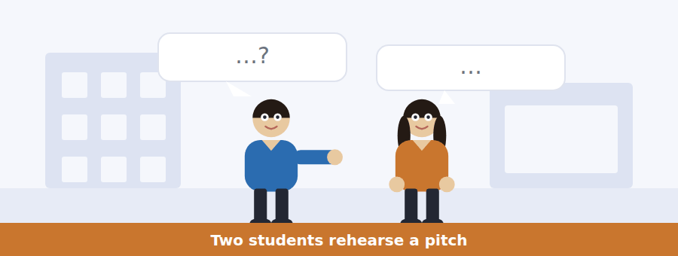
SKILL · Track a disagreement about a number
- When two speakers argue about a figure, both figures will be tested.
- Listen for where each number came from — that is usually the real question.
- A concession in the middle often marks the turning point.
- What they decide to change is the last question.

Exercise B Listen and answer. The audio plays once.
4. What are the speakers doing?
(A) Writing a business plan
(B) Rehearsing a pitch
(C) Choosing a team
(D) Preparing slides
5. Why does the woman object to forty thousand?
(A) It counts people the product cannot serve
(B) It is too small
(C) It is out of date
(D) The panel already knows it
6. What does the woman say the panel always asks first?
(A) How much money is needed
(B) Who is on the team
(C) Where the number came from
(D) How long it will take
7. What number does she recommend?
(A) Forty thousand
(B) Four thousand
(C) None at all
(D) Eleven thousand
8. What does the man object to about the smaller number?
(A) It is harder to remember
(B) It is not accurate
(C) It makes the market look small
(D) The panel will not believe it
9. What does the woman mean by "a big number and a shrug"?
(A) A large market with no evidence behind it
(B) A confident presentation
(C) A team that disagrees
(D) A pitch without slides
Audio script: see the back of the book. Do not read it before you listen.


Exercise A Listen and choose a response. You hear one line. Choose the best reply.
1. Woman: What time should we arrive?
(A) Twenty past two.
(B) Twenty minutes before your slot.
(C) In the Enterprise Centre.
(D) Yes, early.
2. Man: Can we connect a laptop on the day?
(A) By Wednesday.
(B) Slides are optional.
(C) Yes, if it works.
(D) No — nothing can be connected.
3. Woman: Do the questions count in the five minutes?
(A) Five minutes each.
(B) The panel asks them.
(C) No, they are separate.
(D) Yes, strictly.
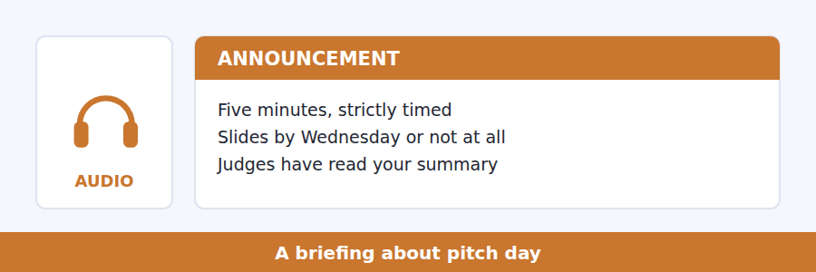
SKILL · Note what is strict and what is optional
- Briefings mix firm rules with advice. Only the rules are tested as rules.
- Listen for strictly, must, cannot — and for optional, if you wish.
- A common mistake described by the speaker is a guaranteed question.
- The final instruction usually answers what should I do.

Exercise B Listen and answer. The audio plays once.
4. How long do teams have in total with the panel?
(A) Five minutes
(B) Fifteen minutes
(C) Twenty minutes
(D) Ten minutes
5. Why is the timing strict?
(A) Teams leave their key point until the end
(B) There are twelve teams
(C) The room is booked until four
(D) The judges have other work
6. What does the speaker advise for the first forty seconds?
(A) Introduce the team
(B) Say what you are building and who will pay
(C) Show the slides
(D) Thank the panel
7. What is the rule about slides?
(A) They are compulsory
(B) They may be brought on a memory stick
(C) They count in the five minutes
(D) They must arrive by Wednesday if used
8. Why should teams arrive twenty minutes early?
(A) To set up slides
(B) To meet the judges
(C) The schedule may run early
(D) The building is hard to find
Audio script: see the back of the book. Do not read it before you listen.


Exercise A Listen and choose a response. You hear one line. Choose the best reply.
1. Man: Did he say profitable or solvent?
(A) Both — they are different.
(B) On the board.
(C) In May.
(D) Yes, he did.
2. Woman: What does solvent mean?
(A) Making a profit.
(B) Able to pay what you owe now.
(C) In the third month.
(D) Yes, exactly.
3. Man: Can a profitable business fail?
(A) In June.
(B) It made a profit.
(C) No, never.
(D) Yes — that is the whole point.

SKILL · Follow a counter-intuitive claim
- A talk that opens with something that sounds impossible will explain it immediately.
- A worked example with dates is the usual explanation. Follow the months.
- Listen for the second cause — talks of this kind usually have exactly two.
- The last sentence states what the speaker wants remembered.

Exercise B Listen and answer. The audio plays once.
4. What is the main idea of the talk?
(A) Most businesses have bad ideas
(B) Profit and cash are different, and timing is what closes companies
(C) Growth should be avoided
(D) Suppliers should be paid late
5. Why does the speaker use months?
(A) To show cash leaving before it arrives
(B) To show how long a business lasts
(C) To explain the tax year
(D) To compare two companies
6. In the example, when does the company get paid?
(A) March
(B) April
(C) June
(D) May
7. Why does growth make the problem worse?
(A) Customers pay later
(B) Every new customer costs money before bringing any in
(C) Staff must be paid more
(D) Suppliers raise prices
8. What advice does the speaker call unambitious but life-saving?
(A) Refuse large orders
(B) Pay suppliers late
(C) Grow only as fast as you can finance
(D) Keep prices high
9. What does the speaker say both causes have in common?
(A) They are failures of imagination
(B) They are caused by customers
(C) They happen in the first year
(D) They are failures of timing
Audio script: see the back of the book. Do not read it before you listen.


Part 1 · Listen and Repeat
You hear a sentence and repeat it once. There is no preparation time, and the sentences get longer. Focus: reporting verbs
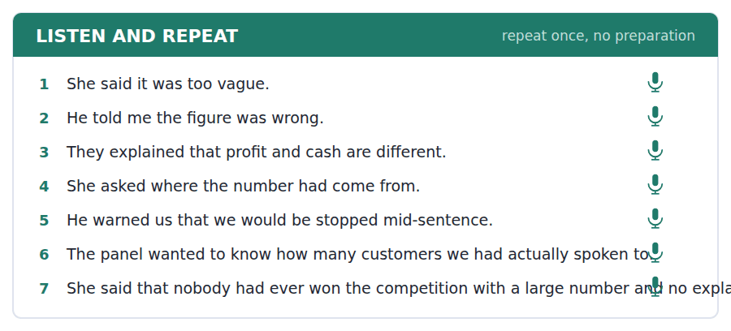
SKILL · Choose the verb that carries the meaning
- She said, she told me, she asked, she explained, she warned — each one means something different.
- Tell needs an object: he told me. Say does not: he said that.
- Keep the stress on the content, not on the reporting verb.
- Finish the sentence even if the backshift goes wrong.

Part 2 · Take an Interview
An interviewer asks you four questions on one theme: a business you admire. Answer each one fully. There is no preparation time.
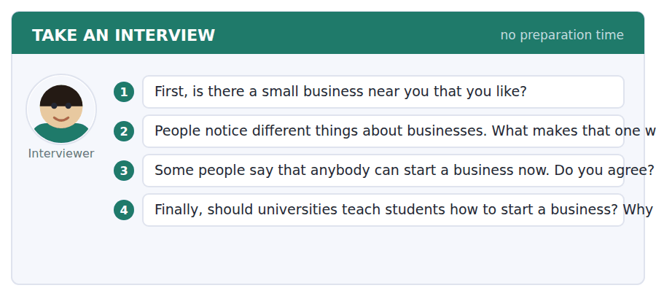
A good answer sounds like this
Question 2 — It is a bakery, and what makes it work is that the owner remembers what everybody orders. That is not a strategy you can copy easily.
Question 3 — Anybody can start one. Far fewer people can survive a year without income, which is a different claim and the one that matters.
I can… | Not yet | Yes
I chose reporting verbs that carried the meaning | □ | □
I used told with an object and said without one | □ | □
I gave a reason after every opinion | □ | □


Part 1 · Listen and Repeat
You hear a sentence and repeat it once. There is no preparation time, and the sentences get longer. Focus: relaying what was said
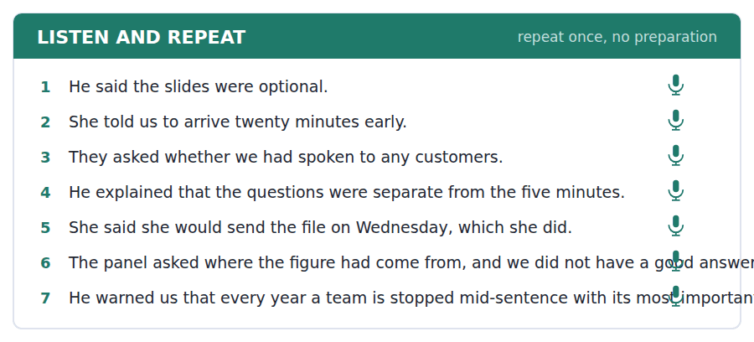
SKILL · Report accurately, then react
- First say what was said, then what you think of it. Do not mix them.
- Backshift one step: is → was, will → would, has → had.
- Keep the present if it is still true: she said profit and cash are different.
- One report, one reaction, one reason.

Part 2 · Take an Interview
An interviewer asks you four questions on one theme: presenting and being judged. Answer each one fully. There is no preparation time.
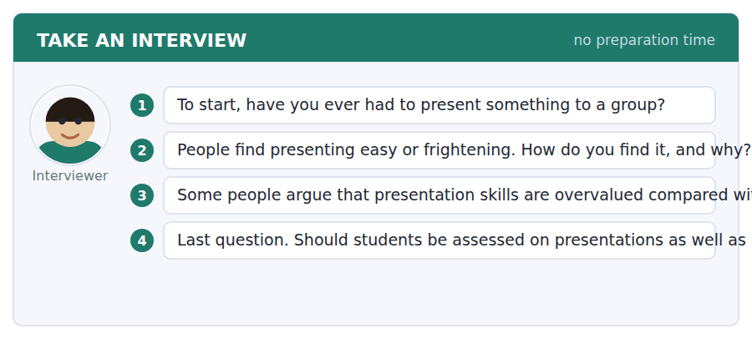
A good answer sounds like this
Question 2 — Frightening for the first minute and then fine, which several people have told me is normal and I did not believe until it happened.
Question 3 — Partly. A good idea presented badly still loses, which is unfair, and is also what happens in every meeting anybody will ever attend.
I can… | Not yet | Yes
I backshifted correctly | □ | □
I separated what was said from what I thought | □ | □
I kept the present where the fact is still true | □ | □


Part 1 · Listen and Repeat
You hear a sentence and repeat it once. There is no preparation time, and the sentences get longer. Focus: academic register
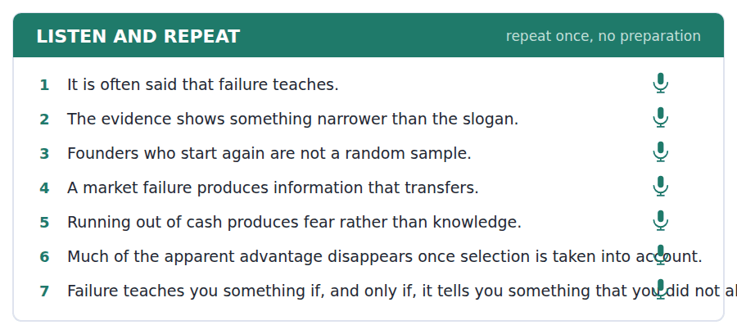
SKILL · Qualify a popular claim
- Use the unit’s words: attain, prospect, potential, initiate, compile.
- It is often said that… The evidence shows something narrower:…
- Give the condition under which the claim is true.
- Mark yourself against the three statements below.

Part 2 · Take an Interview
An interviewer asks you four questions on one theme: risk and failure. Answer each one fully. There is no preparation time.
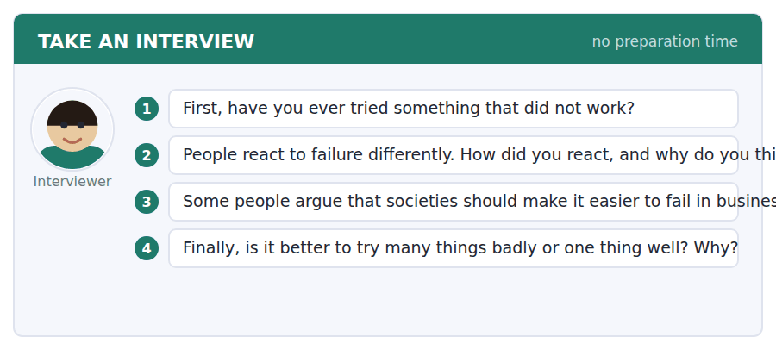
A good answer sounds like this
Question 3 — I agree, with a condition. Making failure cheap helps only if people learn something from it, and the evidence suggests that depends on why it failed.
Question 4 — One thing well, probably, although the people who say that have usually tried several things first.
I can… | Not yet | Yes
I used at least three academic words from this unit | □ | □
I qualified a popular claim rather than repeating it | □ | □
I gave the condition under which it holds | □ | □


You see a sentence, then a set of words in boxes. Put the words in order to make one grammatical sentence. Almost every item in the real test makes a question or a question inside another sentence.
SKILL · The third shape: reported questions
- She asked where I lived — no auxiliary, no question mark, statement order.
- He wanted to know whether we had spoken to customers — the same rule.
- Backshift one step: do → did, is → was, will → would, can → could.
- Use every tile exactly once.

Exercise A Guided practice. The first three are worked through.
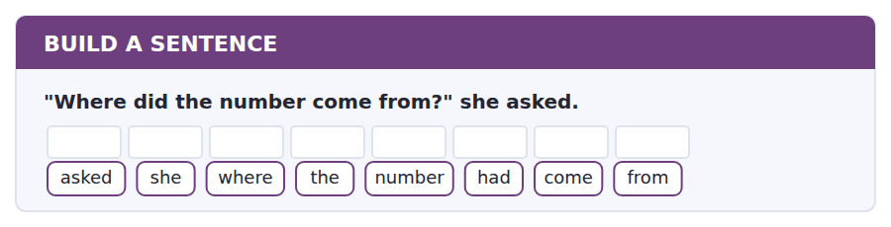
1. She asked where the number had come from.
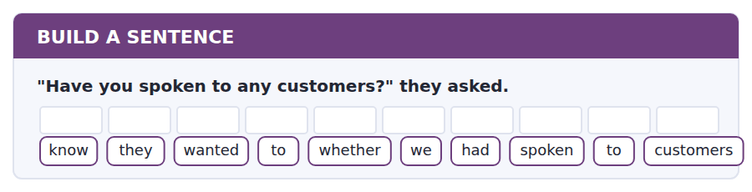
2. They wanted to know whether we had spoken to customers.
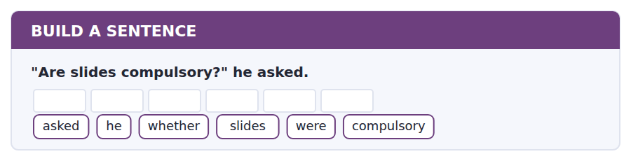
3. He asked whether slides were compulsory.
Exercise B Exam practice. Write the sentence.
4. "When does the pitch start?" she asked.
asked / she / when / the / pitch / started
__________________________________________________________
5. "Can I send the file on Thursday?" he asked.
asked / he / whether / he / could / send / it / on / Thursday
__________________________________________________________
6. "How many students are there?" the panel asked.
know / the / panel / wanted / to / how / many / students / there / were
__________________________________________________________
7. The judges have read the summary already.
know / do / you / whether / they / have / read / it
__________________________________________________________
8. The team that arrived late lost two minutes.
the / team / that / arrived / late / lost / two / minutes
__________________________________________________________
9. "Will you take equity?" we asked.
asked / we / whether / they / would / take / equity
__________________________________________________________
10. Most businesses close while still profitable.
know / do / you / why / profitable / businesses / close
__________________________________________________________


You read a short situation and write an email. You have 7 minutes. The three bullet points are the mark scheme: answer all three.
Your team has been shortlisted and given a pitch slot at 14.20 on Friday 6 March. One of your four team members, who presents the financial section, has a compulsory laboratory assessment from 13.00 to 15.30 that day. The other three are free all day.
Write an email to the organisers.
- Explain the clash precisely.
- Ask whether the slot can be moved, and say when you are free.
- Say what you will do if it cannot.
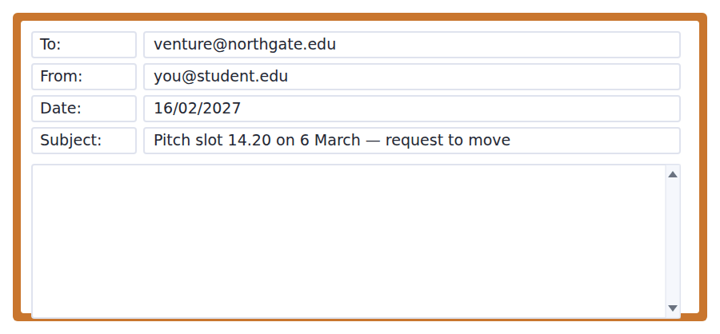
SKILL · Ask for the smallest change that solves it
- A request for a whole new day is harder to grant than a request for a different hour.
- Give your availability as a window, not a single time.
- Say what happens if the answer is no, so the reply can be short.
- Seven minutes. 110–140 words.

Model email
Dear Venture Prize team,
Thank you for shortlisting Loop. Our slot is 14.20 on Friday 6 March, and we have one clash. Priya Raman, who presents our financial section, has a compulsory laboratory assessment from 13.00 to 15.30 that day. The other three of us are free all day.
Would it be possible to move us to a slot before one o’clock or after four? We are available at any point in either window, and we would rather take an early morning slot than a different day.
If the schedule cannot be changed, we will pitch with three people and I will take the financial section myself. Priya has written it and I can answer on it, so we would rather do that than withdraw.
Thank you,
Tom Whelan, Loop
Why it works
- The clash is given with the person, the reason and the exact times, so nothing has to be asked.
- The request is for a different hour, not a different day, and offers two windows.
- We would rather take an early morning slot shows flexibility in a way the organiser can use.
- The fallback means the organiser can reply no without creating a second problem.
Now write your own. 7 minutes.
__________________________________________________________
__________________________________________________________
__________________________________________________________
__________________________________________________________
__________________________________________________________
__________________________________________________________
__________________________________________________________
__________________________________________________________


A professor asks a question and two students answer. You add your own post. You have 10 minutes and an effective answer is at least 100 words.
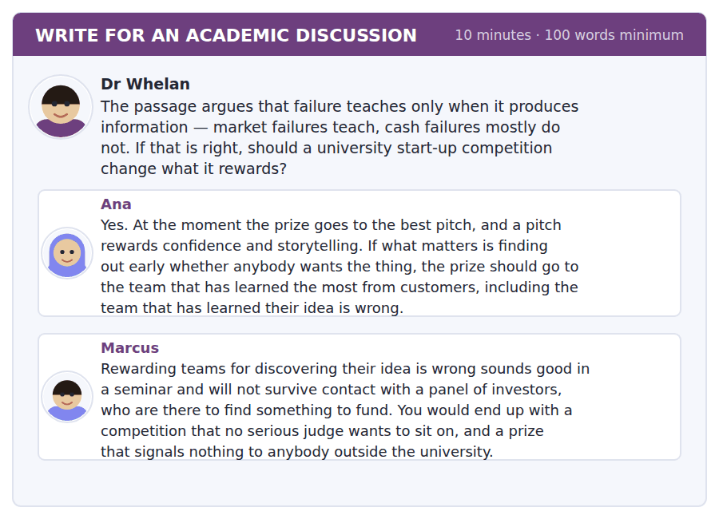
SKILL · Weigh an ideal against what will actually happen
- Ana argues from the evidence; Marcus argues from institutions. Both are legitimate.
- A good post says which constraint is binding and why.
- Propose something that survives both objections if you can.
- At least 100 words in ten minutes.

Sentence starters
- Ana has the evidence and Marcus has the institution, and…
- Marcus is right that a prize has to signal something, which means…
- The change that would survive both objections is…
- What I would not do is…
Model post
Ana has the evidence and Marcus has the institution, and a competition has to live inside both.
The passage does support Ana. A market failure produces knowledge that transfers; a cash failure produces fear that does not. If the point of a student competition is learning rather than investment, rewarding evidence about customers is exactly right. But Marcus is also right that a prize is a signal, and a prize that nobody outside the university recognises is worth less to the winners than it looks.
The change that survives both objections is smaller than Ana’s. Keep one prize for the best venture, which is what the judges are there for, and add a second, smaller one for the team that has tested its assumption most seriously — awarded on evidence, and open to teams whose answer was no. That costs the panel nothing and changes what every entrant does in January.
[168 words]
Now write your own. 10 minutes, at least 100 words.
__________________________________________________________
__________________________________________________________
__________________________________________________________
__________________________________________________________
__________________________________________________________
__________________________________________________________
__________________________________________________________
__________________________________________________________
__________________________________________________________
__________________________________________________________

Grammar focus Reported speech · reported and indirect questions
Direct | Reported
"It is too vague." | She said (that) it was too vague.
"I will send it." | He said he would send it.
"Have you spoken to customers?" | They asked whether we had spoken to customers.
"Where did it come from?" | She asked where it had come from.
"Arrive early." | He told us to arrive early.
say vs tell | She said that… / She told me that…
Still true? No backshift needed | She said profit and cash are different.

Backshift one step: is → was, does → did, has → had, will → would, can → could. A past simple can stay as it is or become a past perfect.
A reported question has no auxiliary, no inversion and no question mark. She asked where it was, never *she asked where was it*.
Tell takes a person: he told me. Say does not: he said that. This is tested constantly and is the easiest mark in the unit to lose.
If the reported fact is still true, backshift is optional: she said that profit and cash are different is perfectly correct.
Watch out! Never write *she asked where did it come from*. Once the question is reported, the word order is that of a statement.
Exercise 1 Report each sentence.
1. "The slides are optional." → He said __________.
2. "I will send the file." → She said __________.
3. "Where did the number come from?" → She asked __________.
4. "Have you spoken to customers?" → They asked __________.
5. "Arrive twenty minutes early." → He told us __________.
6. "Can I send it on Thursday?" → He asked __________.
Exercise 2 Choose say or tell in the right form.
1. She __________ that the figure was wrong.
2. He __________ me that the slides were optional.
3. They __________ us to arrive early.
4. Nobody __________ anything about adapters.
Exercise 3 Correct the mistake in each sentence.
1. She asked where did it come from.
2. He said me that it was optional.
3. They asked whether had we spoken to customers.
How this is tested in Build a Sentence
This is the third anchor. The official practice test contains She wanted to know where she could buy a copy — a reported question ending in a full stop, with no inversion anywhere. If you can build that sentence, you can build every item of this type.

Unit review and progress check Unit 15
Exercise A Vocabulary. Write the word.
1. a plan for achieving something over time
2. to reach or achieve
3. the possibility of something happening
4. to help two sides reach agreement
5. a firm promise that something will happen
6. to start something
7. to put together from several sources
8. a group of people who judge or discuss
9. permission, or to give permission
10. to agree to do something
11. money borrowed that must be repaid
12. a short talk persuading someone to back an idea
Exercise B Grammar. Complete the sentence.
1. "The slides are optional." → He said they __________ optional.
2. "I will send it." → She said she __________ send it.
3. "Where did it come from?" → She asked where it __________ come from.
4. "Have you spoken to them?" → They asked __________ we had spoken to them.
5. He __________ (say / tell) me that it was optional.
6. She __________ (say / tell) that the figure was wrong.
7. "Arrive early." → He told us __________ early.
8. "Can I send it Thursday?" → He asked whether he __________ send it Thursday.
Exercise C One timed mini-section. 6 minutes.
1. According to the passage on page 90, which failures teach most?
(A) the market not wanting the product
(B) running out of cash
(C) falling out with partners
(D) growing too fast
2. In the talk, a profitable business can close because
(A) its idea was bad
(B) cash leaves before it arrives
(C) it grew too slowly
(D) its customers disappeared
3. Which sentence is correct?
(A) She asked where did it come from.
(B) He said me it was optional.
(C) They asked whether had we spoken.
(D) They asked whether we had spoken to customers.
4. A team wanting to use slides must send the file
(A) by the Wednesday before
(B) on the day
(C) with the entry in January
(D) on a memory stick
5. In Build a Sentence, a reported question ends with
(A) a question mark
(B) either
(C) a full stop
(D) no punctuation
6. The three shapes Build a Sentence uses are
(A) present, past and future
(B) statement, question, command
(C) active, passive, reported
(D) direct question, embedded question, relative clause
Can you do these now?
I can… | Not yet | Yes
complete word endings in a text about starting something | □ | □
read a competition page and a confirmation email for the conditions | □ | □
follow a passage that explains why a common belief is only half true | □ | □
understand two people rehearsing and disagreeing about numbers | □ | □
report what somebody else said, out loud, without preparing | □ | □
write an email asking to change a slot, and a post that separates two claims | □ | □

ADAPTIVE TIP In Write for an Academic Discussion, name one classmate’s point before you add your own. A post that engages with the thread scores above one that could have been written without reading it, and naming somebody is the cheapest way to show you did.

Unit 16 · Cities and How People Live
TOEFL iBT® Preparation Course 2026 · Volume 2
CEFR B1 · Grammar: as…as, more than, less than · Word field: population, density, movement
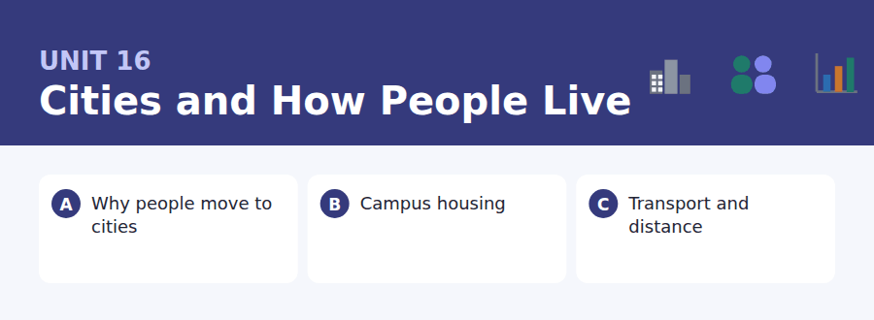
By the end of this unit I can…
- complete word endings in a text about why people move
- read a housing page and an email about a room change and find the condition
- follow a passage that explains how a city spreads
- understand two people weighing two places to live
- compare two options out loud and commit to one
- write an email requesting a change, and a post that reframes a question

Everything in this unit is a comparison between two places, so the grammar is the grammar of equality and difference. Unit 2 did the comparative; this unit does the rest of it.

Vocabulary 1 · Academic 24 words from the Academic Word List
These twenty-four words come back through the whole unit, and again in the review. Cover the right-hand column and test yourself.
domestic inside one country; or of the home | regime a system of rules or government
area a part of a place or surface | equip to supply what is needed
transit the movement of people or goods through a place | option a choice
vehicle a machine for carrying people or goods | select to choose
via by way of | seek to look for or try to obtain
accommodate to provide room for | pose to present a problem or question
displace to force out of a place | circumstance a fact or condition affecting a situation
subsidy money paid to reduce the cost of something | trend a general direction of change
grant money given for a purpose; to give formally | scenario a possible sequence of events
levy a charge collected by an authority | forthcoming about to happen
legal allowed or required by law | temporary lasting only a short time
legislate to make laws | overseas in or to another country across the sea

Exercise A Work in pairs. Ask and answer.
1. Would you rather live in the centre and pay more, or further out and commute? Why?
2. What trend have you noticed in the area where you grew up?
3. What does your university do to accommodate students who arrive late?
4. Name one circumstance that would make you move city tomorrow.
Vocabulary 2 · Campus and everyday 12 words for the daily-life tasks
The exam does not only test academic English. Notices, emails, conversations and announcements use the everyday words below.
halls of residence university buildings where students live | commute the regular journey between home and study or work
flat share a flat rented by several people together | viewing an arranged visit to look at a property
rent money paid regularly for a place to live | utilities services such as gas, water and electricity
deposit money held as security and returned later | housemate someone you share a house with
landlord the owner who rents a property to you | waiting list a list of people waiting for something
bus pass a ticket allowing many bus journeys | inventory a list of what is in a property and its condition

Words you will meet again: region | estimate | proportion | impact | significant | transport | migrate | route


SKILL · Comparative endings are short
- -er is two dashes, -est is three, -ier is three. Count before you write.
- Nouns of movement and quantity: -ation, -ment, -ity.
- A gap after a number is a plural; a gap after the is a noun.
- Read the sentence back with your ending in place.

Exercise A Guided practice. Five words are not complete. Write the missing letters.
More than half the world now lives in cities, and the proport--- is still rising. People do not move because cities are pleas---. They move because a city off--- more different kinds of work within reach of one bus journey than a village can offer in a life----. Choice, not comfort, is what pu--- people in.

The first one is done for you: 1 proport--- → ion (proportion)
Exercise B Exam practice. One paragraph, ten gaps — the real task.
Ask somebody why they moved to a city and they will usually say work. That is true, and it is less inform----- than it sounds, because there was work in the village too. What a city offers is not work but opt----: hundreds of employers within an hour, so that losing one job does not mean losing your home. Economists call this a thick labour mar---, and it explains something the comfort explanation cannot. People move to cities that are expen----, crowded and noi--, and they stay. They are not buying pleas---. They are buying the ability to change their mind. The same logic works in reverse, which is why a city that loses its vari--- of employers empties even when the rents f---. One large factory closing can do more dam--- to a town than ten small businesses closing, because the ten were the thing that made the town surviv----.

Check your answers in the key at the back of the book.


SKILL · Find the deadline attached to the right group
- Housing documents have different rules for different years and groups.
- Note who each deadline applies to before you answer.
- Money terms (deposit, rent, utilities) are nearly always tested.
- An email about a change usually names a condition for granting it.

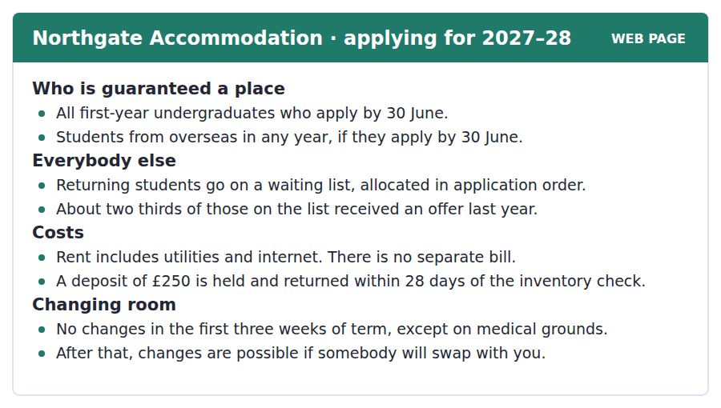
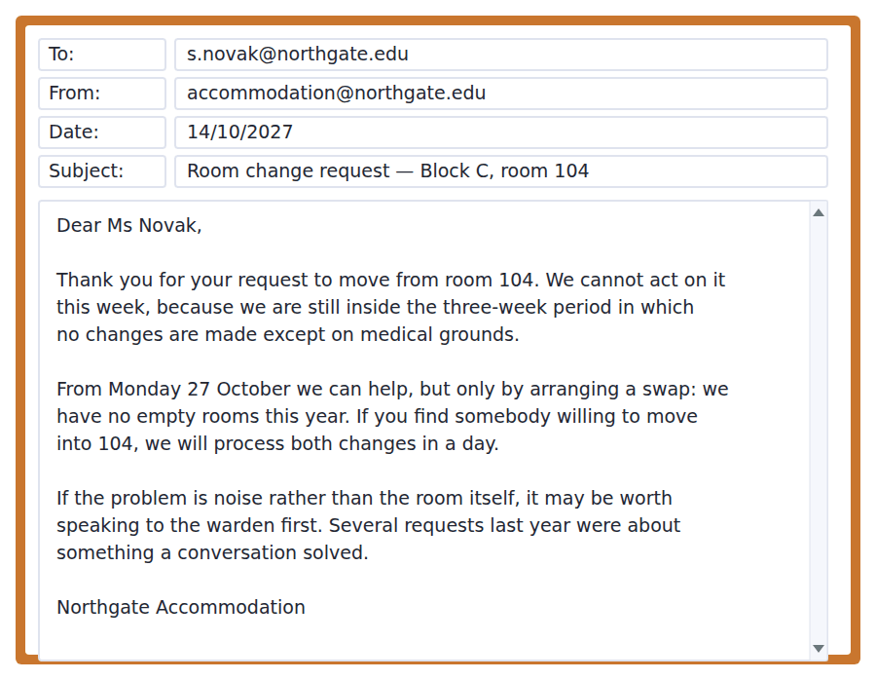
Exercise A Guided practice. The answer is on the page — find it.
1. Who is guaranteed a place?
(A) All students
(B) Returning students
(C) First-years and overseas students who apply by 30 June
(D) Anyone on the waiting list
2. What does the rent include?
(A) Nothing extra
(B) Utilities and internet
(C) Utilities only
(D) Internet only
3. How much is the deposit?
(A) £100
(B) £500
(C) There is none
(D) £250
4. When can a room normally be changed?
(A) After the first three weeks
(B) At any time
(C) Never
(D) Only in the first three weeks
Exercise B Exam practice.
5. Why can the office not act this week?
(A) It is within the three-week period
(B) There are no staff
(C) The request was late
(D) A medical note is needed
6. How will a change be arranged after 27 October?
(A) By allocating an empty room
(B) By a waiting list
(C) By the warden
(D) By a swap with another student
7. How quickly will a swap be processed?
(A) Within a week
(B) Within a day
(C) Within 28 days
(D) At the end of term
8. What does the office suggest if the problem is noise?
(A) Apply for a different block
(B) Wait until next term
(C) Speak to the warden first
(D) Record the noise
9. What proportion of waiting-list students got an offer last year?
(A) About a third
(B) About a half
(C) All of them
(D) About two thirds
10. What can be inferred about accommodation this year?
(A) It is cheaper than last year
(B) It is full
(C) Overseas students are prioritised after June
(D) Deposits have risen


SKILL · Follow one constant through three examples
- When a passage names a constant, every example will illustrate it. Track the constant.
- A named effect (Marchetti’s constant, induced demand) is always tested.
- The consequence paragraph usually contains the inference questions.
- If a figure is repeated, it is the one the passage is built on.

How Transport Decides the Shape of a City
People have travelled about the same amount of time to work for as long as anybody has measured it: roughly half an hour each way, in medieval towns, in Victorian cities and in modern ones. The figure is remarkably stable across centuries and countries, and it is usually called Marchetti’s constant. What changes is not the time but the speed, and therefore the distance.
That single fact explains the shape of almost every city. A walking city cannot be more than about five kilometres across, because nobody will live further than half an hour from work — and medieval cities are almost exactly that size, wherever you find them. Trams and trains stretched the half hour to fifteen kilometres, and cities grew outwards along the lines, producing the star shape still visible in older European suburbs. The car stretched it again, in every direction at once, which is why cities built after 1950 are round and low rather than star-shaped and dense.
The uncomfortable consequence is that road building rarely reduces travel time for long. A faster road does not persuade people to spend less time travelling; it persuades them to live further away, until the half hour is used up again. Transport planners call this induced demand, and it is why the lanes added to a congested road are often full within a few years. The constant is the time, and the city rearranges itself around whatever speed it is given.
[280 words]

Exercise A Guided practice.
1. What is the passage mainly about?
(A) Why roads become congested
(B) The history of trams
(C) How travel time shapes the size of cities
(D) Why medieval cities were small
2. What has stayed the same across centuries?
(A) The time spent travelling
(B) The distance travelled
(C) The cost of travel
(D) The size of cities
3. Why can a walking city not be large?
(A) Streets were narrow
(B) Walls limited its size
(C) Food could not be transported
(D) Nobody will live more than half an hour from work
4. What shape did trams and trains produce?
(A) Star-shaped
(B) Round and low
(C) Square
(D) Long and thin
Exercise B Exam practice.
5. Why are cities built after 1950 round rather than star-shaped?
(A) Planners preferred it
(B) Land was cheaper
(C) The car stretched the half hour in every direction
(D) Trams were removed
6. What is induced demand?
(A) More people buying cars
(B) New capacity being used up by people travelling further
(C) Congestion at peak times
(D) Demand for public transport
7. All of the following are stated in the passage EXCEPT:
(A) The half hour is stable across countries
(B) Medieval cities were about five kilometres across
(C) Road building always increases total travel time
(D) Trains extended the range to fifteen kilometres
8. The word "stable" in paragraph 1 is closest in meaning to
(A) reliable
(B) unchanging
(C) increasing
(D) measured
9. What can be inferred about adding lanes to a congested road?
(A) It will probably fill up again
(B) It solves congestion permanently
(C) It reduces the size of the city
(D) It has no effect at all
10. What does the author mean by "the city rearranges itself"?
(A) Buildings are moved
(B) Planners redesign the roads
(C) Transport routes are rebuilt
(D) People change where they live in response to speed
11. Which best states the main idea of paragraph 2?
(A) Cities have grown steadily
(B) Trams were better than cars
(C) The speed of transport sets the size of a city
(D) Suburbs are older than centres


Exercise A Listen and choose a response. You hear one line. Choose the best reply.
1. Man: Are you staying in halls next year?
(A) I am still deciding.
(B) About two thirds.
(C) In Block C.
(D) Yes, the rent includes utilities.
2. Woman: How much is the flat?
(A) Twenty minutes on the bus.
(B) Three of us.
(C) Yes, quite cheap.
(D) Four hundred and ten a month.
3. Man: Does that include bills?
(A) Four hundred and ten.
(B) No — bills are on top.
(C) In the city centre.
(D) Yes, it is cheaper.
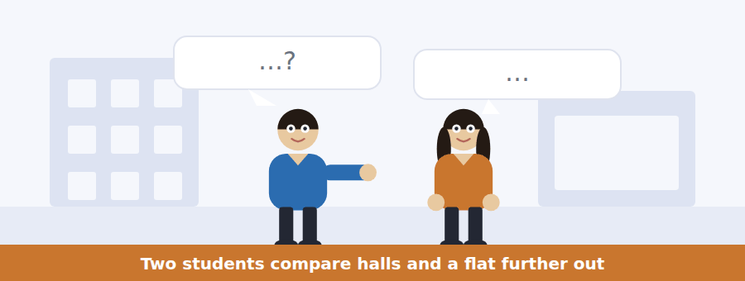
SKILL · Weigh two options as you listen
- Each option will have a cost and an advantage. Note all four.
- A figure mentioned once is usually the one being compared.
- Listen for the thing neither of them had thought of — it often decides it.
- The decision is in the last two lines.

Exercise B Listen and answer. The audio plays once.
4. What are the speakers comparing?
(A) Two flats
(B) Halls and a flat
(C) Two bus routes
(D) Two summer jobs
5. Why is the flat not really cheaper?
(A) The rent rises in winter
(B) The deposit is higher
(C) It is further from the shops
(D) Bills and a bus pass are extra
6. How far out is the flat?
(A) Twenty-five minutes
(B) Fifteen minutes
(C) Twenty minutes
(D) Forty minutes
7. How long is the halls contract?
(A) Forty-five weeks
(B) Fifty weeks
(C) Forty weeks
(D) Fifty-two weeks
8. Why does the length of contract matter to the woman?
(A) It is cheaper per week
(B) She wants to travel
(C) Her family lives nearby
(D) She needs to stay in the city for a summer job
9. What does the woman mean by "the money is a wash"?
(A) The costs come out about the same
(B) The flat is cheaper
(C) The bills are unpredictable
(D) She cannot afford either
Audio script: see the back of the book. Do not read it before you listen.


Exercise A Listen and choose a response. You hear one line. Choose the best reply.
1. Woman: What is the deadline?
(A) For first years.
(B) The thirtieth of June.
(C) On the waiting list.
(D) Yes, there is one.
2. Man: Am I guaranteed a place?
(A) Two thirds got one.
(B) By the thirtieth.
(C) Only if you are a first year or from overseas.
(D) Yes, everybody is.
3. Woman: Is the deposit refundable?
(A) It is two hundred and fifty.
(B) At the inventory check.
(C) Yes, within 28 days.
(D) No, it is rent.
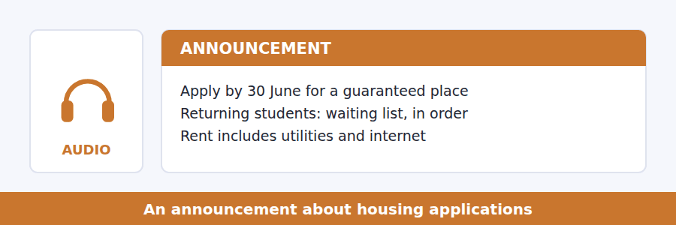
SKILL · Hear which group a deadline binds
- A deadline may guarantee a place for one group and mean nothing for another.
- Note the order of allocation — first come, by year, or by need.
- A figure from last year is given to help you judge your chances, and is tested.
- The final instruction is usually a question.

Exercise B Listen and answer. The audio plays once.
4. Who is guaranteed a place?
(A) First-years and overseas students who apply by 30 June
(B) All students who apply by 30 June
(C) Only first-years
(D) Returning students in application order
5. How is the waiting list ordered?
(A) By need
(B) By year of study
(C) By distance from home
(D) By application order
6. What happened to a third of the list last year?
(A) They were offered a room
(B) They received no offer
(C) They withdrew
(D) They were given private flats
7. What did most of those students have in common?
(A) They applied in August
(B) They were first years
(C) They were from overseas
(D) They wanted a particular block
8. Why does the speaker mention sixty to ninety pounds?
(A) It is the deposit
(B) It is the monthly rent rise
(C) It is what to add to a private flat before comparing
(D) It is the bus pass
Audio script: see the back of the book. Do not read it before you listen.


Exercise A Listen and choose a response. You hear one line. Choose the best reply.
1. Woman: Did she say density raises or lowers costs?
(A) On the board.
(B) Both — different costs.
(C) About half an hour.
(D) Yes, she did.
2. Man: What is Marchetti’s constant?
(A) A transport planner.
(B) In the reading.
(C) Yes, it is.
(D) Half an hour each way.
3. Woman: Could you repeat the figure for infrastructure?
(A) Of course — about forty per cent lower.
(B) It is on the board.
(C) Per person.
(D) Yes, I can.
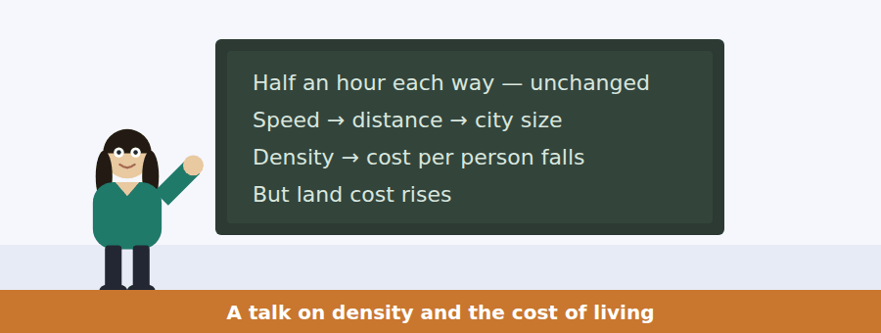
SKILL · Hold two opposite effects together
- A talk that gives one effect and then its opposite is testing whether you kept both.
- Note which effect wins, and under what condition.
- A number given for each side is almost certainly tested.
- The final sentence usually says what the speaker thinks follows.

Exercise B Listen and answer. The audio plays once.
4. What is the main idea of the talk?
(A) Density is always better
(B) Cities should be less dense
(C) Density cuts infrastructure costs and raises land costs, and who gains depends on ownership
(D) Transport speed is the only factor
5. Why is infrastructure cheaper in a dense area?
(A) Materials are cheaper
(B) There is less road
(C) Labour costs less
(D) Each metre of pipe serves more households
6. By about how much are costs per household lower?
(A) Ten per cent
(B) Forty per cent
(C) Twenty-five per cent
(D) Sixty per cent
7. Why does density raise land prices?
(A) Buildings are taller
(B) Everybody wants to be inside the half hour
(C) Construction is harder
(D) Taxes are higher
8. What decides which effect a household feels?
(A) Whether it owns land
(B) Its income
(C) How far it travels
(D) Whether it has a car
9. What does the speaker say about the two effects?
(A) Both are shared equally
(B) Both benefit landowners
(C) The saving is shared and the land price is captured
(D) Neither can be measured
Audio script: see the back of the book. Do not read it before you listen.


Part 1 · Listen and Repeat
You hear a sentence and repeat it once. There is no preparation time, and the sentences get longer. Focus: linking in comparatives
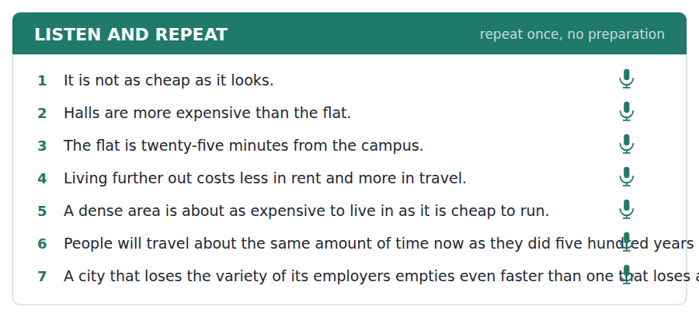
SKILL · Join the comparison smoothly
- as expensive as runs together: /əzɪksˈpensɪvəz/.
- Than is weak: /ðən/, not /ðæn/.
- Keep the two things being compared clearly separated by the structure.
- Finish the comparison — an unfinished than is the commonest slip.

Part 2 · Take an Interview
An interviewer asks you four questions on one theme: where you live now. Answer each one fully. There is no preparation time.
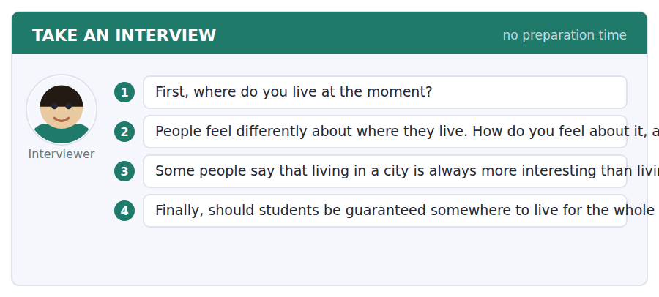
A good answer sounds like this
Question 2 — Mixed. It is convenient and it is noisy, and I notice the convenience in the morning and the noise at night.
Question 3 — Not always. A city offers more options, which is not quite the same as being more interesting — you still have to take them.
I can… | Not yet | Yes
I linked as…as smoothly | □ | □
I finished every comparison I started | □ | □
I gave a reason after every opinion | □ | □


Part 1 · Listen and Repeat
You hear a sentence and repeat it once. There is no preparation time, and the sentences get longer. Focus: weighing and deciding
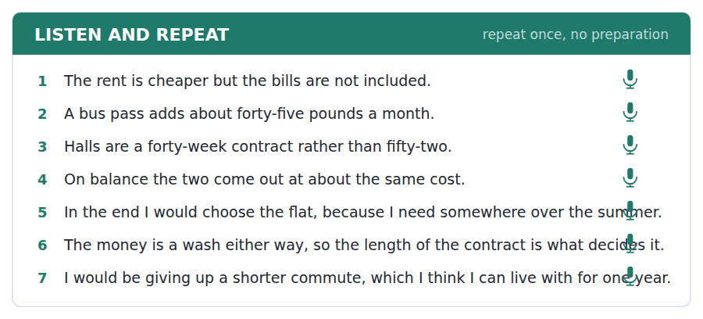
SKILL · Compare, then commit
- Give both sides with figures, then choose and say why.
- On balance… / In the end I would… are the phrases that close a comparison.
- One deciding factor is enough. Do not list four.
- Say what you are giving up — it makes the choice sound real.

Part 2 · Take an Interview
An interviewer asks you four questions on one theme: choices about where to live. Answer each one fully. There is no preparation time.
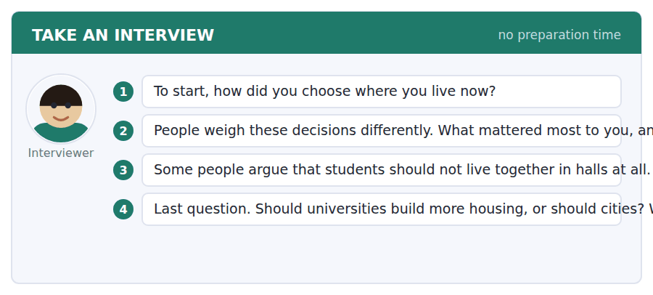
A good answer sounds like this
Question 2 — Cost, mostly, and then I realised I had not counted the travel, which changed the answer completely.
Question 4 — Universities, because they create the demand. A city that has to house ten thousand extra people every September did not choose that.
I can… | Not yet | Yes
I gave both sides before choosing | □ | □
I committed to one with a reason | □ | □
I said what I was giving up | □ | □


Part 1 · Listen and Repeat
You hear a sentence and repeat it once. There is no preparation time, and the sentences get longer. Focus: academic register
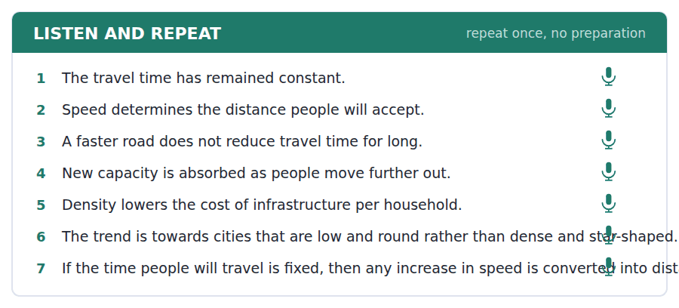
SKILL · State a constant and its consequences
- Use the unit’s words: transit, accommodate, displace, trend, scenario.
- Name the constant, then trace what changes around it.
- Say what follows rather than what you feel.
- Mark yourself against the three statements below.

Part 2 · Take an Interview
An interviewer asks you four questions on one theme: transport and cities. Answer each one fully. There is no preparation time.
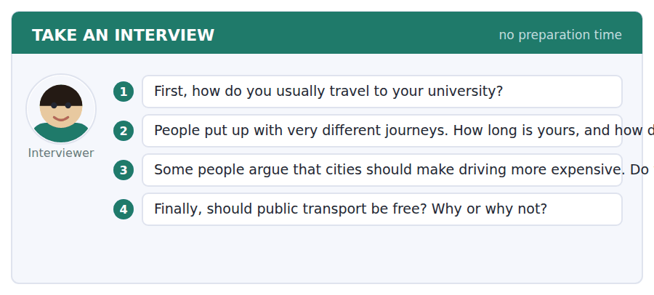
A good answer sounds like this
Question 3 — The evidence from induced demand supports it. If you widen a road the new space is absorbed within a few years, so pricing is the only thing that changes behaviour durably.
Question 4 — Free is probably the wrong target. Frequent matters more than free — a free bus every forty minutes does not change anybody’s scenario.
I can… | Not yet | Yes
I used at least three academic words from this unit | □ | □
I named a constant and traced its consequences | □ | □
My last answer had an opinion, a reason and an example | □ | □


You see a sentence, then a set of words in boxes. Put the words in order to make one grammatical sentence. Almost every item in the real test makes a question or a question inside another sentence.
SKILL · Comparison questions
- Which is cheaper? Is it as far as…? How much more does…?
- As…as needs both halves. One as is always wrong.
- An embedded comparison keeps statement order: do you know which is cheaper.
- Use every tile exactly once.

Exercise A Guided practice. The first three are worked through.
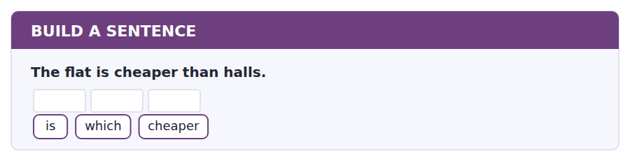
1. Which is cheaper?
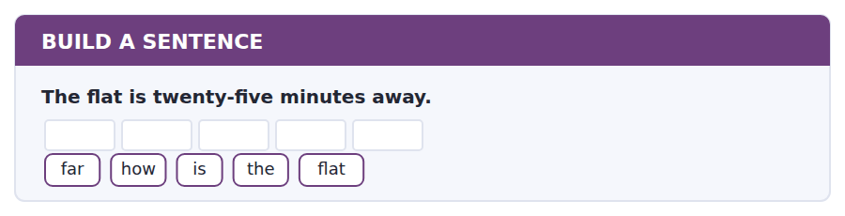
2. How far is the flat?
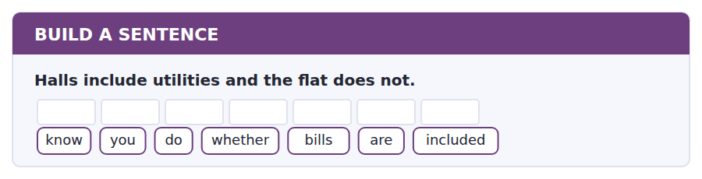
3. Do you know whether bills are included?
Exercise B Exam practice. Write the sentence.
4. Halls cost eighty pounds a month more.
more / how / much / do / halls / cost
__________________________________________________________
5. The deadline for a guaranteed place is 30 June.
tell / can / you / me / when / the / deadline / is
__________________________________________________________
6. Two thirds of the waiting list received an offer.
many / how / received / an / offer
__________________________________________________________
7. The halls contract runs for forty weeks.
know / do / you / how / long / the / contract / runs
__________________________________________________________
8. The student who applied in August was not offered a room.
the / student / who / applied / in / August / was / not / offered / a / room
__________________________________________________________
9. The bus takes as long as walking at rush hour.
is / the / bus / as / quick / as / walking
__________________________________________________________
10. People have always travelled about half an hour each way.
know / do / you / why / the / time / has / not / changed
__________________________________________________________


You read a short situation and write an email. You have 7 minutes. The three bullet points are the mark scheme: answer all three.
You asked to move out of room 104 and were told that no changes are made in the first three weeks, and that after 27 October a change is only possible as a swap. You have now found a student in Block A who is willing to move into 104, and you have spoken to the warden about the noise as suggested.
Write an email to the accommodation office.
- Say that you have found somebody to swap with, and name them.
- Say what you did about the warden’s suggestion.
- Ask what happens next.
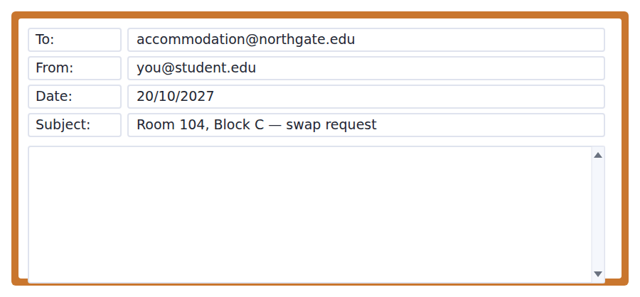
SKILL · Do what you were asked, then say so
- The office gave you two instructions. Answering both in order makes the reply easy.
- Name the other student and their room — nothing can be processed without it.
- One question at the end, answerable in a line.
- Seven minutes. 110–140 words.

Model email
Dear Accommodation Office,
Thank you for your reply about room 104. I have found somebody willing to swap: Daniel Osei, currently in A212, who is happy to move into 104. He has emailed you separately to confirm.
I also spoke to the warden, as you suggested. The noise is from the extractor fan in the kitchen next door rather than from any person, and maintenance have said it cannot be quietened without replacing the unit, which is not scheduled until the summer. So a conversation has not solved it, although I am glad I tried.
Both of us are free to move on any day from Monday 27 October onwards. Could you tell me what we need to do next — is there a form, or do you simply arrange it?
Thank you,
Sofia Novak
Why it works
- The swap partner is named with their room number, which is the one fact the office cannot act without.
- The warden suggestion is answered honestly, including the result, which makes the request stronger rather than weaker.
- Availability is given as a range, so one reply can settle it.
- The closing question offers two possibilities, which makes it quick to answer.
Now write your own. 7 minutes.
__________________________________________________________
__________________________________________________________
__________________________________________________________
__________________________________________________________
__________________________________________________________
__________________________________________________________
__________________________________________________________
__________________________________________________________


A professor asks a question and two students answer. You add your own post. You have 10 minutes and an effective answer is at least 100 words.
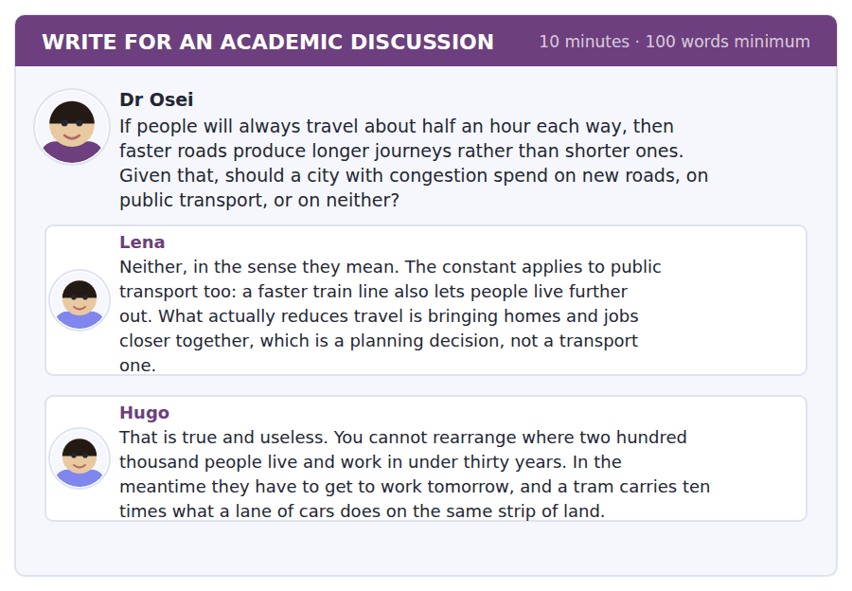
SKILL · Separate the right answer from the available one
- Lena is arguing about what works; Hugo about what can be done in time.
- A good post says what each is true of, and over what period.
- Use the constant from the passage to decide.
- At least 100 words in ten minutes.

Sentence starters
- Lena is right about the mechanism and Hugo is right about the timescale:…
- The constant applies to both, which means…
- Over ten years I would…; over fifty I would…
- What neither post mentions is…
Model post
Lena is right about the mechanism and Hugo is right about the timescale, and the question does not say which one it is asking about.
The constant does apply to public transport, as Lena says: a faster line converts into distance exactly as a faster road does. So neither road nor tram reduces travel time for long, and in that sense she is correct that the real variable is how far apart homes and jobs are. But Hugo’s objection is not a quibble. Land use changes over decades and congestion is a problem this year.
What neither post mentions is that the two interact. A tram line does not only move people; it decides where the next ten thousand homes get built, because developers follow it. So I would spend on public transport, and I would treat the route as a planning decision rather than a transport one — which is Lena’s point, delivered by Hugo’s instrument.
[168 words]
Now write your own. 10 minutes, at least 100 words.
__________________________________________________________
__________________________________________________________
__________________________________________________________
__________________________________________________________
__________________________________________________________
__________________________________________________________
__________________________________________________________
__________________________________________________________
__________________________________________________________
__________________________________________________________

Grammar focus as…as, more than, less than
Form | Example
as + adjective + as (equal) | The bus is as quick as walking.
not as + adjective + as | It is not as cheap as it looks.
more / less + adjective + than | Halls are more expensive than the flat.
more / fewer + noun + than | more options, fewer rooms
twice / half / three times as…as | A tram carries ten times as many people.
the same as | The cost is the same as last year.
different from | The flat is different from the halls.

As…as needs both halves. Writing *as cheap than* or leaving out the second as is the commonest error in this structure.
Multiples go in front of the first as: twice as expensive as, ten times as many as.
Use different from in writing. Different than is American and different to is informal British; from is safe everywhere.
Watch out! The same takes as, not than or from. It is the same as last year, never *the same than last year*.
Exercise 1 Complete the comparison.
1. The bus is __________ quick __________ walking at rush hour.
2. Halls are more expensive __________ the flat.
3. It is not __________ cheap __________ it looks.
4. A tram carries ten times __________ many people __________ a lane of cars.
5. The rent is the same __________ last year.
6. The flat is quite different __________ the halls.
Exercise 2 Rewrite using as…as.
1. The flat is cheaper than halls. → Halls are not __________.
2. The bus and the walk take the same time. → The bus is __________.
3. My room is smaller than yours. → My room is not __________.
4. The bills are higher in winter than in summer. → The bills in summer are not __________.
Exercise 3 Correct the mistake in each sentence.
1. It is not as cheap than it looks.
2. The rent is the same than last year.
3. A tram carries ten times more people as a lane of cars.
How this is tested in Build a Sentence
Build a Sentence asks comparisons as questions: Which is cheaper? Is the bus as quick as walking? Build the structure first and the word order follows.

Unit review and progress check Unit 16
Exercise A Vocabulary. Write the word.
1. to provide room for
2. to force out of a place
3. money paid to reduce the cost of something
4. a charge collected by an authority
5. to make laws
6. a general direction of change
7. a possible sequence of events
8. about to happen
9. lasting only a short time
10. to present a problem or question
11. the regular journey between home and study
12. a list of what is in a property and its condition
Exercise B Grammar. Complete the sentence.
1. The bus is __________ quick __________ walking.
2. Halls are more expensive __________ the flat.
3. It is not __________ cheap __________ it looks.
4. A tram carries ten times __________ many people.
5. The rent is the same __________ last year.
6. The flat is quite different __________ the halls.
7. There are __________ (few) rooms than applicants.
8. My room is not __________ (large) as yours.
Exercise C One timed mini-section. 6 minutes.
1. According to the passage on page 106, what has stayed constant?
(A) the distance travelled
(B) the cost of travel
(C) the size of cities
(D) the time spent travelling
2. In the talk, density lowers the cost of
(A) land
(B) rent
(C) transport fares
(D) infrastructure per household
3. Which sentence is correct?
(A) It is not as cheap than it looks.
(B) The rent is the same than last year.
(C) A tram carries ten times as many people as a lane of cars.
(D) My room is not as large than yours.
4. A returning home student who applies in August will
(A) be guaranteed a place
(B) go on a waiting list near the bottom
(C) be given priority
(D) pay a higher rent
5. When comparing halls with a private flat, you should add to the flat
(A) utilities and internet
(B) the deposit
(C) the inventory
(D) the waiting list
6. In Reading, a question about what a word refers to is answered by
(A) the dictionary meaning
(B) the main idea
(C) the following sentence
(D) the noun phrase earlier in the passage
Can you do these now?
I can… | Not yet | Yes
complete word endings in a text about why people move | □ | □
read a housing page and an email about a room change and find the condition | □ | □
follow a passage that explains how a city spreads | □ | □
understand two people weighing two places to live | □ | □
compare two options out loud and commit to one | □ | □
write an email requesting a change, and a post that reframes a question | □ | □

ADAPTIVE TIP In Take an Interview the reward is for a reason, not for length. Say what you think, then because, then stop. A thirty-second answer with a clear reason beats a ninety-second answer that circles the question without ever landing on one.

Unit 17 · Chemistry and Materials
TOEFL iBT® Preparation Course 2026 · Volume 2
CEFR B1 · Grammar: Sequence and process language · Word field: element, property, reaction
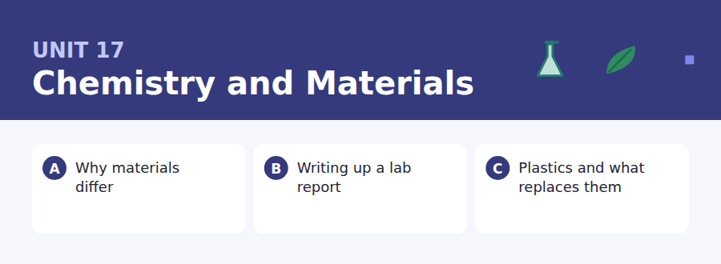
By the end of this unit I can…
- complete word endings in a text about why materials behave as they do
- read a report template and a feedback email and find what must change
- follow a passage that explains why a replacement is harder than it looks
- understand two students working out why two results differ
- describe a procedure out loud, in order, without preparing
- write an email asking for an extension, and a post that costs a proposal

Process writing has its own grammar: first, once, until, by which point. This unit teaches the connectors that hold a method together.

Vocabulary 1 · Academic 24 words from the Academic Word List
These twenty-four words come back through the whole unit, and again in the review. Cover the right-hand column and test yourself.
substitute to use one thing in place of another | journal an academic magazine; a record kept over time
attribute a quality or feature of something | label a piece of information attached to something
flexible able to bend without breaking | define to say exactly what something means
dispose to get rid of something | apparent clear or obvious; seeming to be true
refine to improve by small changes; to purify | minimal as small as possible
amend to change something slightly to improve it | exclude to leave out
proceed to continue, or to go on to the next step | complement to go well with; to complete
conduct to carry out; to allow heat or electricity through | ultimate final, or greatest
analyse to examine in detail | sole only
demonstrate to show clearly | finite having limits; not endless
valid based on good reasoning; officially acceptable | exploit to use fully, sometimes unfairly
error a mistake | append to add at the end

Exercise A Work in pairs. Ask and answer.
1. Name a material you use every day. What attribute makes it suitable?
2. What could realistically be substituted for plastic in one thing you own?
3. Describe an experiment you have done. What was the main source of error?
4. Is any resource you depend on finite? What happens when it runs out?
Vocabulary 2 · Campus and everyday 12 words for the daily-life tasks
The exam does not only test academic English. Notices, emails, conversations and announcements use the everyday words below.
lab report a written account of an experiment | resubmission handing work in again after corrections
results what an experiment produced | draft an early version of a piece of writing
graph a drawing showing how numbers relate | marking the process of assessing work
beaker a glass container used in a laboratory | feedback comments telling you how to improve
scales an instrument for weighing | spillage liquid that has been accidentally dropped
extension extra time granted for a deadline | fume cupboard an enclosed space that removes dangerous gases

Words you will meet again: structure | component | process | convert | stable | generate | react | significant


SKILL · Chemistry uses long nouns and short verbs
- Nouns here are often -ion, -ity, -ure, -ance. Verbs are often -ed or -s.
- A gap after the is a noun; after is or are, a participle.
- Count the dashes: -ity is three, -ion is three, -ation is five.
- Read the sentence back; the subject usually names the property.

Exercise A Guided practice. Five words are not complete. Write the missing letters.
Two objects can be made of the same atoms and behave completely differ-----. Carbon is the famous case: the same element gives you graphite, which is so so-- you can write with it, and diamond, which is the hard--- natural substance there is. Nothing about the atoms has chan---. Only the arrang----- has.

The first one is done for you: 1 differ----- → ently (differently)
Exercise B Exam practice. One paragraph, ten gaps — the real task.
Why does one material bend and anot--- shatter? Not because of what it is made of, usually, but because of how the pieces are j-----. In a metal the atoms sit in layers that can sl--- over one another, so a force makes the metal change sh--- rather than break. In glass the atoms are locked in a rigid network with no layers to sl---, so a force goes on building until something gives, and then the whole thing fa--- at once. This is also why a tiny scratch mat---- so much in glass and so little in steel: in glass the crack has nowhere to spr--- its energy, and it trav--- straight through. Engineers exploit this const----- deliberately. Safety glass is made by putting the surface under compression, so that a crack has to fight the material before it can even begin.

Check your answers in the key at the back of the book.


SKILL · Read the template and the feedback together
- A template says what is required; feedback says what was missing. Both are tested.
- Note the word count and whether it includes anything.
- A resubmission usually carries a condition about the mark.
- Deadlines for different parts may differ. Check each one.

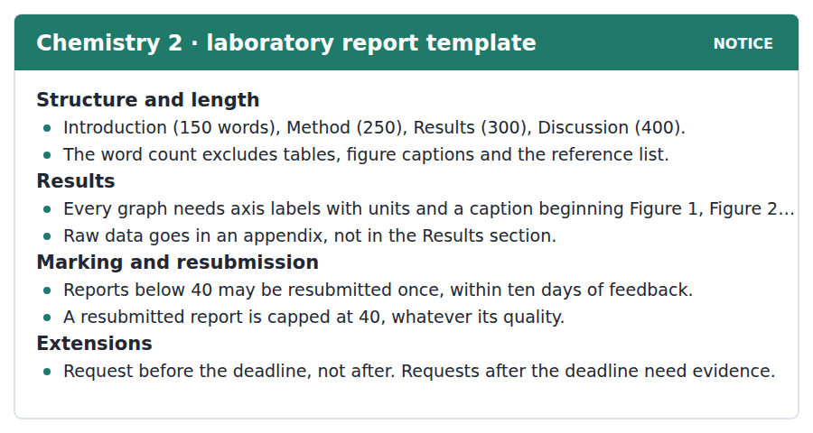
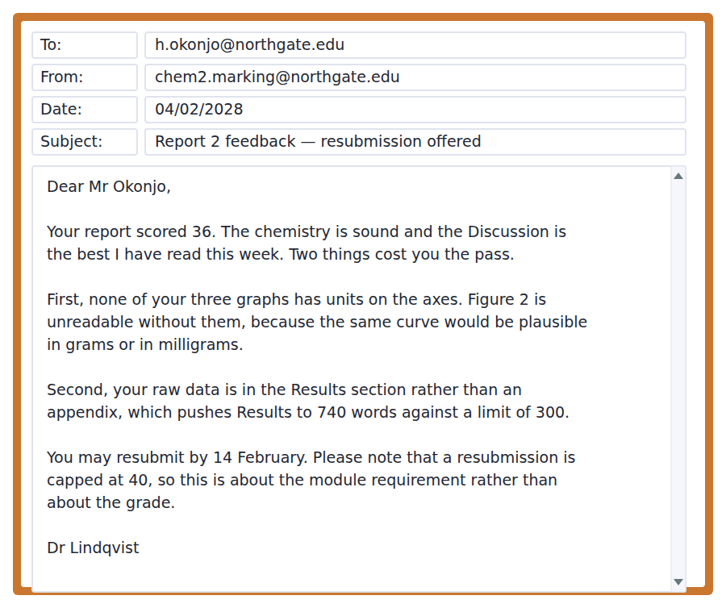
Exercise A Guided practice. The answer is on the page — find it.
1. How long should the Discussion be?
(A) 150 words
(B) 250 words
(C) 300 words
(D) 400 words
2. What does the word count exclude?
(A) The introduction
(B) Tables, captions and references
(C) The discussion only
(D) Nothing
3. Where should raw data go?
(A) In an appendix
(B) In the Results
(C) In the Discussion
(D) In a caption
4. What must every graph have?
(A) A title only
(B) A grid
(C) Axis labels with units and a caption
(D) Colour
Exercise B Exam practice.
5. What did Mr Okonjo score?
(A) 30
(B) 36
(C) 40
(D) 44
6. What is the first problem with the report?
(A) The Discussion is too short
(B) The references are missing
(C) The graphs have no units on the axes
(D) The method is unclear
7. Why is Figure 2 unreadable without units?
(A) The same curve would be plausible in grams or milligrams
(B) The curve is too small
(C) The caption is missing
(D) It is in the wrong section
8. Why is the Results section too long?
(A) There are too many graphs
(B) The captions are counted
(C) The discussion has been repeated
(D) Raw data has been included in it
9. What is the highest mark a resubmission can get?
(A) 36
(B) 50
(C) 40
(D) There is no cap
10. What can be inferred about the resubmission?
(A) It will improve his grade considerably
(B) It is about passing the module rather than the mark
(C) It is optional and pointless
(D) It must be a new experiment


SKILL · Follow a comparison across a whole life cycle
- A passage that compares materials will move the comparison from one stage to another. Follow it.
- Each substitute is given one advantage and one cost. Note both.
- The conclusion often rejects the framing of the question. Mark it.
- A closing reference to another subject is usually a main-idea signal.

Plastics and Why Replacing Them Is Hard
Plastic is unpopular and extremely good at its job, and the second fact is why the first one is so difficult to act on. A material that is light, cheap, waterproof, mouldable into any shape and chemically inert is not easily replaced by anything, and most of the proposed substitutes trade one of those properties for another.
Consider packaging for food. Glass is recyclable indefinitely and weighs about ten times as much, so the carbon saved in disposal is spent again in transport. Paper is renewable and permeable, so it needs a coating, and most coatings are plastic. Compostable bioplastics solve the disposal problem only where industrial composting exists, and where it does not they behave like ordinary plastic with a reassuring label. None of this means the substitutes are useless. It means that a comparison has to include the whole life of the material, and that a substitution which looks obviously right at the point of purchase may not be.
The most reliable saving turns out not to be substitution at all, but using less. A thinner film, a smaller cap, a container designed to be refilled, an item shipped without an outer box: none of these makes a good photograph, and together they account for more material saved than any of the replacements currently available. The uncomfortable conclusion is that the most effective action is also the least visible, which is a pattern anybody who has studied public health will recognise.
[280 words]

Exercise A Guided practice.
1. What is the passage mainly about?
(A) Why plastic is bad for the environment
(B) How bioplastics are made
(C) Why glass is recyclable
(D) Why replacing plastic is harder than it looks
2. Why is plastic difficult to replace?
(A) It combines several useful properties at once
(B) It is cheap to make
(C) It is widely available
(D) Factories are built for it
3. What is the problem with glass?
(A) It cannot be recycled
(B) It weighs about ten times as much
(C) It is not waterproof
(D) It is expensive to make
4. Why does paper packaging need a coating?
(A) It is not strong enough
(B) It is not renewable
(C) It cannot be printed on
(D) It lets liquid through
Exercise B Exam practice.
5. When do compostable bioplastics solve the disposal problem?
(A) Only where industrial composting exists
(B) Always
(C) Only in landfill
(D) Only for food packaging
6. What does the author say a comparison must include?
(A) The price
(B) The opinion of consumers
(C) The whole life of the material
(D) The recycling rate
7. What does the author identify as the most reliable saving?
(A) Glass
(B) Bioplastics
(C) Using less material
(D) Recycling more
8. All of the following are given as examples of using less EXCEPT:
(A) a thinner film
(B) a smaller cap
(C) a refillable container
(D) a compostable bag
9. What does the author mean by "none of these makes a good photograph"?
(A) They are invisible as achievements
(B) They are too small to see
(C) They are not yet available
(D) They are difficult to measure
10. Which subject does the author say shows the same pattern?
(A) Economics
(B) Public health
(C) Engineering
(D) Archaeology
11. Which best states the main idea of paragraph 2?
(A) Glass should be preferred
(B) Bioplastics are dishonest
(C) Every substitute trades one advantage for another
(D) Food packaging is the biggest problem


Exercise A Listen and choose a response. You hear one line. Choose the best reply.
1. Man: Did you get the same result?
(A) Not even close, actually.
(B) About twice as high.
(C) In the fume cupboard.
(D) Yes, three graphs.
2. Woman: What temperature did you use?
(A) For twenty minutes.
(B) In a beaker.
(C) Yes, the same one.
(D) Sixty degrees.
3. Man: Shall we run it again?
(A) It took an hour.
(B) There is no time before Friday.
(C) Twice as high.
(D) Yes, sixty degrees.
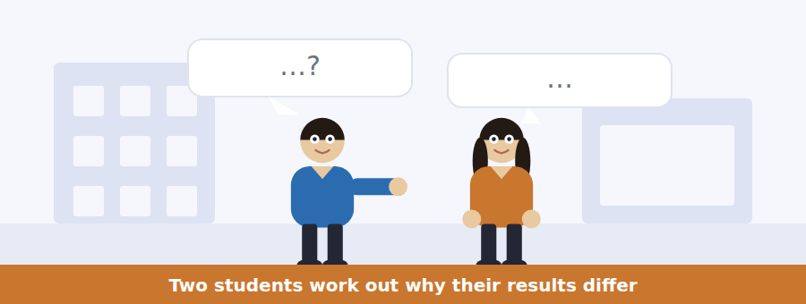
SKILL · Follow a diagnosis
- When two people compare results, they are eliminating causes. Track which are ruled out.
- The cause they settle on is the answer to the main question.
- A number repeated is a number tested.
- What they decide to do about it is the last question.

Exercise B Listen and answer. The audio plays once.
4. What is the difference between the two yields?
(A) A few per cent
(B) They are the same
(C) One is exactly half the other
(D) One is twice as accurate
5. What do they rule out first?
(A) The solvent
(B) The weighing
(C) The time
(D) Temperature and starting mass
6. Why does the wet product not explain the difference?
(A) It would make his yield higher, not lower
(B) It was dried afterwards
(C) The filter was clean
(D) The difference is too large
7. What was the actual cause?
(A) The wrong temperature
(B) Half the volume of solvent
(C) A broken beaker
(D) A weighing error
8. What does the man mean by "it is a measurement of something else"?
(A) He measured a different procedure accurately
(B) His result is useless
(C) The equipment was faulty
(D) He must repeat the experiment
9. What does the woman advise him to do?
(A) Repeat the experiment
(B) Use her results
(C) Ask for an extension
(D) Explain the cause in the Discussion
Audio script: see the back of the book. Do not read it before you listen.


Exercise A Listen and choose a response. You hear one line. Choose the best reply.
1. Woman: When is it due?
(A) Ten days.
(B) In the lab.
(C) Friday at four.
(D) Yes, it has moved.
2. Man: Can I ask for an extension now?
(A) It is capped at forty.
(B) Yes — before the deadline is the easy case.
(C) On Friday afternoon.
(D) No, you cannot resubmit.
3. Woman: What if I ask afterwards?
(A) Then you need evidence.
(B) By Friday at four.
(C) It is a ten-day window.
(D) Yes, you can.
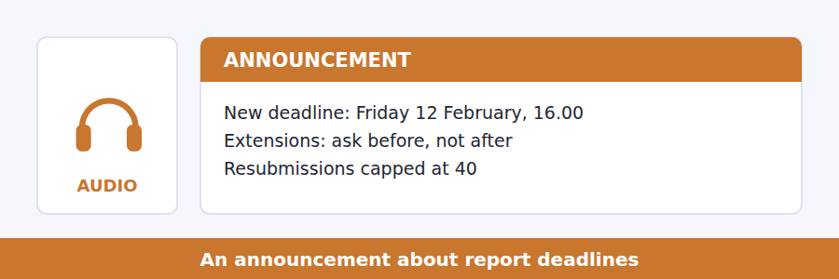
SKILL · Note the rule about asking
- Deadline announcements usually distinguish before and after. Both cases are tested.
- Evidence requirements are a frequent question.
- A cap or a limit is almost always asked about.
- The reason a rule exists is given once, briefly.

Exercise B Listen and answer. The audio plays once.
4. Why has the deadline moved?
(A) Too many students asked
(B) The spectrometer was out of service
(C) The marking is late
(D) A holiday falls that week
5. Do students need to ask for the new date?
(A) Yes, by email
(B) Yes, with evidence
(C) No, it applies to everybody
(D) Only if they are late
6. What happens if a student asks for an extension before the deadline?
(A) It is refused
(B) Evidence is required
(C) It is capped at forty
(D) It is usually granted without detailed explanation
7. Why is evidence needed for a late request?
(A) The department requires it
(B) It prevents resubmission
(C) It is unfair to those who handed in on time
(D) The marking has started
8. Why does the resubmission cap exist?
(A) To save marking time
(B) So resubmission is about meeting the requirement
(C) To discourage late work
(D) Because the module is compulsory
Audio script: see the back of the book. Do not read it before you listen.


Exercise A Listen and choose a response. You hear one line. Choose the best reply.
1. Woman: Does breaking bonds release energy?
(A) On the board.
(B) About half.
(C) Yes, it does.
(D) No — it takes energy in.
2. Man: What does exothermic mean?
(A) Energy out overall.
(B) It is on the second line.
(C) Very fast.
(D) Yes, exactly.
3. Woman: Is rate the same as energy?
(A) They are different questions.
(B) About twice as fast.
(C) In the third stage.
(D) Yes, the same.
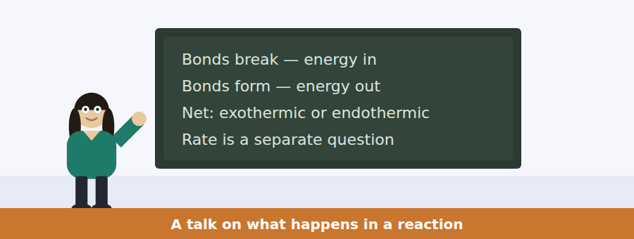
SKILL · Separate two questions about the same event
- A talk may distinguish how much and how fast. Keep them apart.
- A chemical example given twice is being used to make both points.
- Listen for which one students confuse — that is the question.
- The last sentence usually names what the next lecture does.

Exercise B Listen and answer. The audio plays once.
4. What is the main idea of the talk?
(A) All reactions release energy
(B) Petrol is dangerous
(C) How much energy and how fast are separate questions
(D) Catalysts change the energy released
5. What happens when a bond breaks?
(A) Energy is released
(B) Nothing changes
(C) The reaction stops
(D) Energy is taken in
6. What makes a reaction exothermic?
(A) It happens quickly
(B) New bonds release more than old bonds consumed
(C) A spark is supplied
(D) It involves oxygen
7. Why does petrol in a jar not react?
(A) It is not exothermic
(B) Air is not present
(C) Nothing has supplied the energy to start it
(D) The jar is sealed
8. What does a spark supply?
(A) The energy of the reaction
(B) Oxygen
(C) A catalyst
(D) The energy needed to start it
9. What will the next lecture be about?
(A) Energy diagrams
(B) Catalysts
(C) Exothermic reactions
(D) Measuring heat
Audio script: see the back of the book. Do not read it before you listen.


Part 1 · Listen and Repeat
You hear a sentence and repeat it once. There is no preparation time, and the sentences get longer. Focus: sequencing adverbs
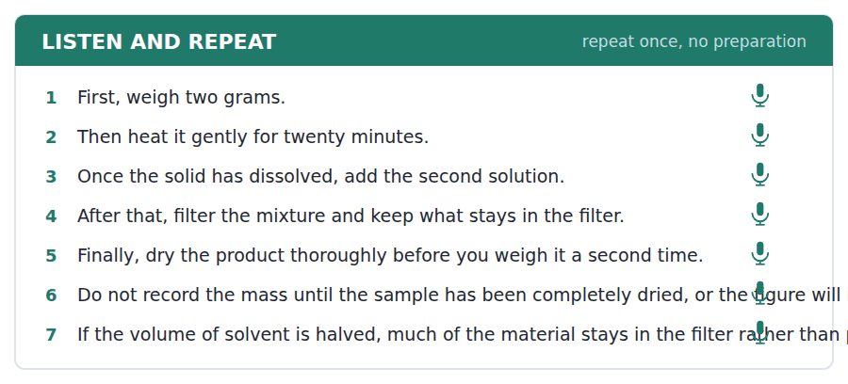
SKILL · Mark the steps out loud
- First, then, next, after that, finally — a short pause after each.
- Once and until introduce a clause: once it dissolves, until it is clear.
- Do not use and for every step. It flattens the sequence.
- Finish the sequence you start. A method stopped halfway scores badly.

Part 2 · Take an Interview
An interviewer asks you four questions on one theme: something you know how to make or do. Answer each one fully. There is no preparation time.
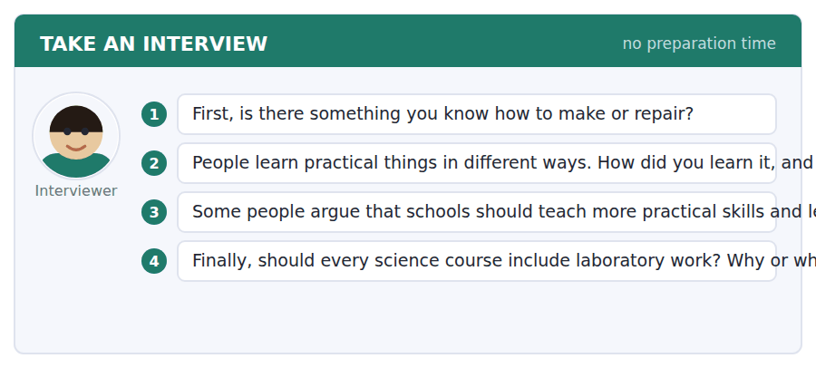
A good answer sounds like this
Question 2 — By watching, then doing it badly, then doing it again. Nobody explained anything and I am not sure explaining would have helped.
Question 4 — Yes, and the reason is not the skill. It is that you cannot understand what an error bar means until you have produced one.
I can… | Not yet | Yes
I marked each step with a sequencing word | □ | □
I did not join every step with and | □ | □
I finished the whole sequence | □ | □


Part 1 · Listen and Repeat
You hear a sentence and repeat it once. There is no preparation time, and the sentences get longer. Focus: explaining what went wrong
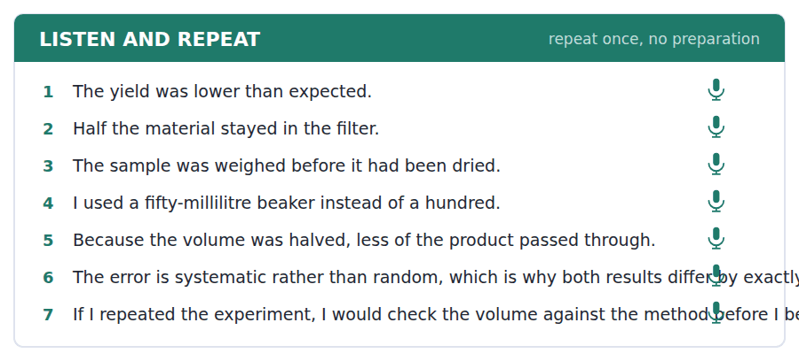
SKILL · Explain the cause, not the feeling
- My result was low because I used half the solvent — cause, then effect.
- Avoid I made a mistake. Say what the mistake caused.
- Use the passive where the actor does not matter: the sample was not dried.
- One cause, one consequence, one correction.

Part 2 · Take an Interview
An interviewer asks you four questions on one theme: mistakes and what you learned. Answer each one fully. There is no preparation time.
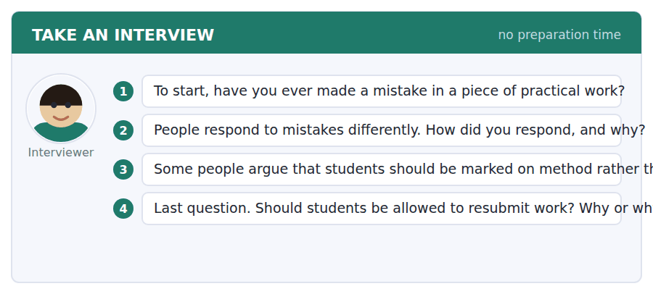
A good answer sounds like this
Question 3 — I agree, because the result depends partly on the equipment and the method is entirely the student’s.
Question 4 — Yes, but capped, as ours is. Otherwise the first submission becomes a free draft and the deadline means nothing.
I can… | Not yet | Yes
I gave the cause before the consequence | □ | □
I avoided simply saying I made a mistake | □ | □
I said what I would do differently | □ | □


Part 1 · Listen and Repeat
You hear a sentence and repeat it once. There is no preparation time, and the sentences get longer. Focus: academic register
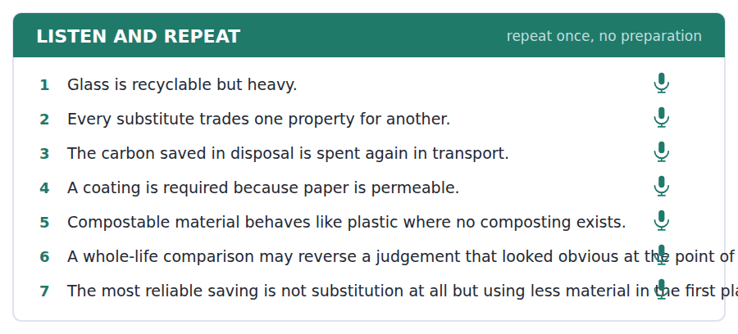
SKILL · Cost a proposal properly
- Use the unit’s words: substitute, dispose, finite, exploit, complement.
- For each option give the gain and the cost, then the net.
- Say at which stage the saving or the cost occurs.
- Mark yourself against the three statements below.

Part 2 · Take an Interview
An interviewer asks you four questions on one theme: waste and what you buy. Answer each one fully. There is no preparation time.
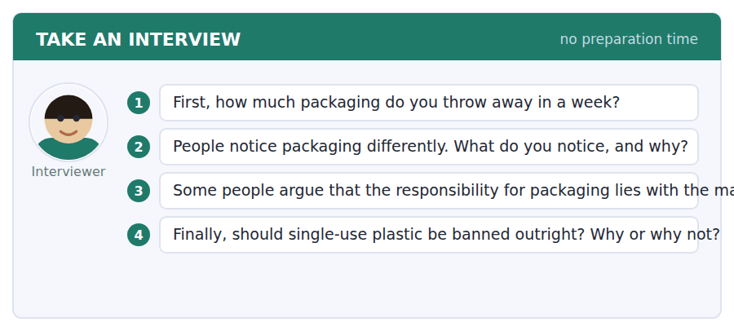
A good answer sounds like this
Question 3 — I agree. A shopper cannot select packaging that is not on the shelf, so the decision has already been made before they arrive.
Question 4 — Not outright, because some substitutes are worse once you count transport. I would ban it where a lighter alternative exists.
I can… | Not yet | Yes
I used at least three academic words from this unit | □ | □
I gave a gain and a cost for each option | □ | □
I said at which stage each occurred | □ | □


You see a sentence, then a set of words in boxes. Put the words in order to make one grammatical sentence. Almost every item in the real test makes a question or a question inside another sentence.
SKILL · Process questions
- What happens next? How is it made? What do I do when…?
- A passive process question keeps is or are in front of the subject.
- An embedded version keeps statement order: can you tell me how it is made.
- Use every tile exactly once.

Exercise A Guided practice. The first three are worked through.
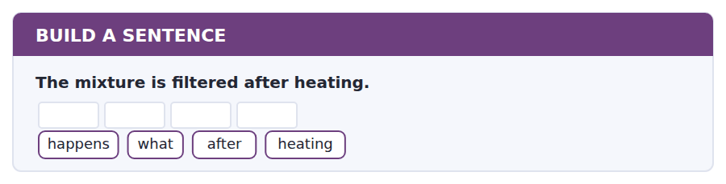
1. What happens after heating?
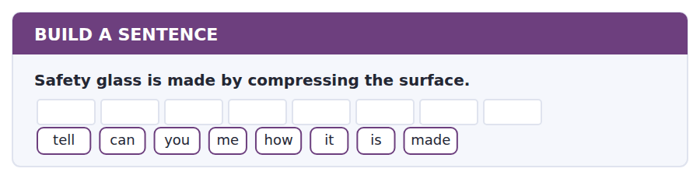
2. Can you tell me how it is made?
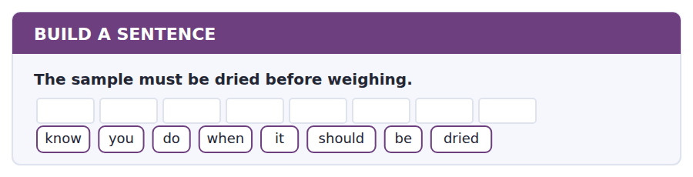
3. Do you know when it should be dried?
Exercise B Exam practice. Write the sentence.
4. The deadline has moved to Friday at four.
has / when / the / deadline / moved / to
__________________________________________________________
5. A resubmission is capped at forty.
tell / can / you / me / whether / it / is / capped
__________________________________________________________
6. Raw data belongs in an appendix.
know / do / you / where / raw / data / goes
__________________________________________________________
7. Breaking a bond takes energy in.
happens / what / when / a / bond / breaks
__________________________________________________________
8. The student who used the smaller beaker got half the yield.
the / student / who / used / the / smaller / beaker / got / half / the / yield
__________________________________________________________
9. Extensions must be requested before the deadline.
should / when / I / request / an / extension
__________________________________________________________
10. Petrol does not ignite without a spark.
know / do / you / why / it / does / not / ignite
__________________________________________________________


You read a short situation and write an email. You have 7 minutes. The three bullet points are the mark scheme: answer all three.
Report 3 is due on Friday 12 February at four. You have the data but your laboratory partner, who holds the spectrometer output for the second half, is ill and has not been able to send it. You are asking before the deadline, which the announcement said is the easy case.
Write an email to Dr Lindqvist.
- Say what you have and what you are waiting for.
- Ask for a specific amount of extra time.
- Say what you will do if the data does not arrive at all.
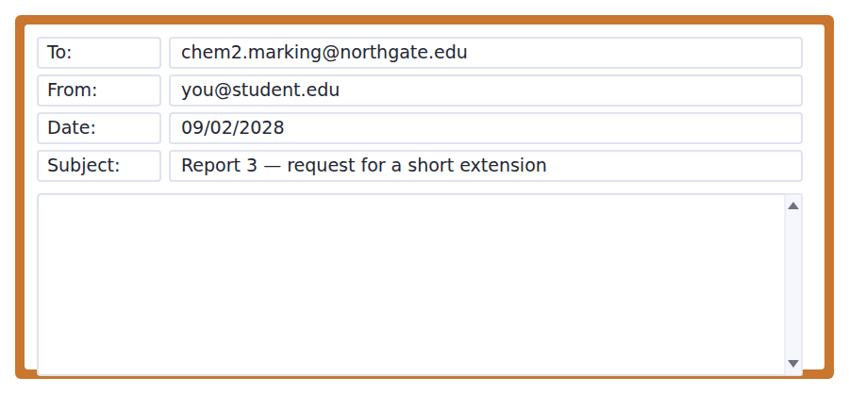
SKILL · Ask for a number of days, not for more time
- A vague request is harder to grant than a specific one.
- Show what is already finished. It proves the request is not about starting late.
- Say what happens in the worst case, so no second email is needed.
- Seven minutes. 110–140 words.

Model email
Dear Dr Lindqvist,
I am writing before Friday’s deadline rather than after it, as you asked.
My introduction, method and the first half of the results are written. What I am waiting for is the spectrometer output for runs four to six, which is on my lab partner’s account. She has been ill since Thursday and has not been able to send it.
Could I have until Tuesday 16 February? Four days would be enough to finish the Results and rewrite the Discussion properly, rather than writing round the missing data.
If the file does not arrive by Monday, I will submit on Tuesday using only the first three runs and say so explicitly in the Method, rather than asking for a second extension.
Thank you,
Hassan Okonjo
Why it works
- The first line uses the lecturer’s own distinction, which immediately places the request in the easy category.
- What is finished is listed before what is missing, so the request is clearly not about having started late.
- The ask is a date and a number of days, not more time.
- The worst case is stated, which means the reply can be a single word.
Now write your own. 7 minutes.
__________________________________________________________
__________________________________________________________
__________________________________________________________
__________________________________________________________
__________________________________________________________
__________________________________________________________
__________________________________________________________
__________________________________________________________


A professor asks a question and two students answer. You add your own post. You have 10 minutes and an effective answer is at least 100 words.
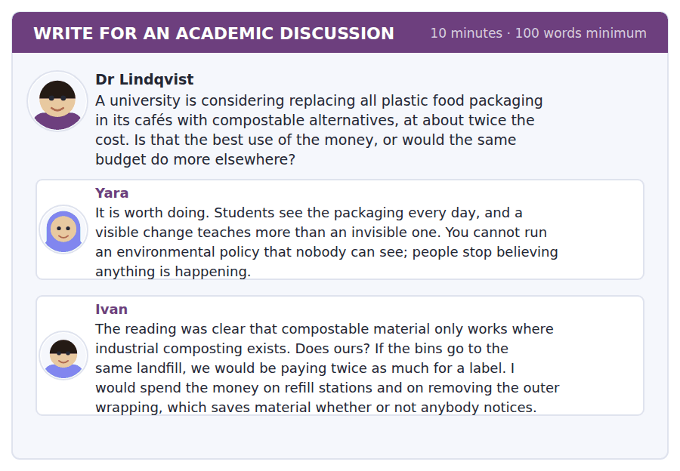
SKILL · Check the condition before the conclusion
- The reading made one substitute conditional. Ask whether the condition holds.
- If it does not, the argument is settled before the values debate begins.
- Then deal with the part that survives — here, Yara’s point about visibility.
- At least 100 words in ten minutes.

Sentence starters
- Ivan has asked the question that settles this:…
- The reading made compostables conditional on…
- Yara’s point about visibility survives even if…
- So I would…, and I would also…
Model post
Ivan has asked the question that settles this, and it should be answered before anybody argues about values.
The reading was explicit: compostable packaging solves the disposal problem only where industrial composting exists, and where it does not it behaves like ordinary plastic with a reassuring label. So the first thing to establish is whether this city has that facility. If it does not, we would be doubling the cost for no material saving at all, and Yara’s visible change would be visible and false, which is worse than invisible and true.
But her point survives in another form. The reading also said the most effective saving is the least visible, and that this is why it loses arguments. So I would spend the money on refill stations, as Ivan suggests, and spend a very small part of it on a sign saying how much material the stations have saved this term.
[176 words]
Now write your own. 10 minutes, at least 100 words.
__________________________________________________________
__________________________________________________________
__________________________________________________________
__________________________________________________________
__________________________________________________________
__________________________________________________________
__________________________________________________________
__________________________________________________________
__________________________________________________________
__________________________________________________________

Grammar focus Sequence and process language
Form | Example
first, then, next, after that, finally | First weigh it, then heat it.
once + clause | Once the solid has dissolved, add the acid.
until + clause | Heat until the liquid is clear.
before / after + -ing | Dry it before weighing it.
Passive for a method | The mixture is filtered and the solid is kept.
Imperative for instructions | Do not record the mass until it is dry.
by which point / at this stage | By which point the reaction is complete.

Once and after both mean the earlier action is complete. Once is slightly more formal and very common in written methods.
Until marks the end point of an action, not its start: heat until it is clear, never *heat since it is clear*.
A written method uses the passive and the past; a spoken instruction uses the imperative and the present. Do not mix them in one paragraph.
Watch out! Do not write *after to dry it*. After and before take -ing or a clause: after drying it, or after it has been dried.
Exercise 1 Join the steps with the word in brackets.
1. The solid dissolves. Add the acid. (once) →
2. Heat the mixture. The liquid is clear. (until) →
3. Dry the sample. Weigh it. (before) →
4. Filter the mixture. Keep the solid. (after) →
5. Weigh two grams. Heat it gently. (then) →
6. The reaction is complete. The colour stops changing. (by which point) →
Exercise 2 Rewrite the instruction as a written method, in the passive.
1. Weigh two grams of the solid. →
2. Heat the mixture for twenty minutes. →
3. Filter the product and dry it. →
4. Record the mass. →
Exercise 3 Correct the mistake in each sentence.
1. After to dry the sample, weigh it.
2. Heat it since the liquid is clear.
3. Once the solid will dissolve, add the acid.
How this is tested in Build a Sentence
Build a Sentence uses process language in questions: What happens after heating? Can you tell me how it is made? The connector stays where it belongs and the question word goes to the front.

Unit review and progress check Unit 17
Exercise A Vocabulary. Write the word.
1. to use one thing in place of another
2. a quality or feature of something
3. to get rid of something
4. to improve by small changes
5. to show clearly
6. based on good reasoning
7. clear or obvious; seeming to be true
8. as small as possible
9. having limits; not endless
10. to add at the end
11. extra time granted for a deadline
12. an enclosed space that removes dangerous gases
Exercise B Grammar. Complete the sentence.
1. __________ the solid dissolves, add the acid.
2. Heat the mixture __________ the liquid is clear.
3. Dry the sample before __________ (weigh) it.
4. __________ (after) filtering, keep the solid.
5. The mixture __________ (heat) for twenty minutes.
6. Weigh two grams, __________ heat it gently.
7. The colour stops changing, __________ which point it is complete.
8. Do not record the mass __________ it is dry.
Exercise C One timed mini-section. 6 minutes.
1. According to the passage on page 122, the most reliable saving comes from
(A) using less material
(B) glass
(C) bioplastics
(D) recycling
2. In the talk, a spark supplies
(A) the energy needed to start it
(B) the energy of the reaction
(C) oxygen
(D) a catalyst
3. Which sentence is correct?
(A) After to dry the sample, weigh it.
(B) Heat it since the liquid is clear.
(C) Once the solid will dissolve, add the acid.
(D) Once the solid dissolves, add the acid.
4. A student who asks for an extension after the deadline must
(A) pay a fee
(B) resubmit
(C) provide evidence
(D) accept a cap of forty
5. A resubmitted report is capped at
(A) 36
(B) 40
(C) 50
(D) there is no cap
6. In Writing, the email task is worth
(A) seven minutes
(B) ten minutes
(C) fifteen minutes
(D) twenty minutes
Can you do these now?
I can… | Not yet | Yes
complete word endings in a text about why materials behave as they do | □ | □
read a report template and a feedback email and find what must change | □ | □
follow a passage that explains why a replacement is harder than it looks | □ | □
understand two students working out why two results differ | □ | □
describe a procedure out loud, in order, without preparing | □ | □
write an email asking for an extension, and a post that costs a proposal | □ | □

ADAPTIVE TIP In Complete the Words the dashes count the missing letters exactly. Count them before you write, because -ed and -ing are two and three, and -ion and -ity are both three. A right word with the wrong number of letters is a wrong answer.

Unit 18 · Animal Behaviour
TOEFL iBT® Preparation Course 2026 · Volume 2
CEFR B1 · Grammar: Purpose and reason · Word field: signal, instinct, survival
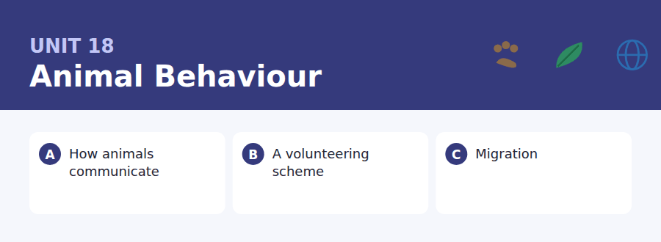
By the end of this unit I can…
- complete word endings in a text about how animals signal
- read a volunteering notice and a post and find what I would have to commit to
- follow a passage that explains how something is known rather than what is known
- understand two people arranging shifts around their timetables
- explain why I do something, out loud, without preparing
- write an email asking to swap a commitment, and a post about competing goods

Biology asks why constantly, and English has two different answers: a reason that looks backwards and a purpose that looks forwards. This unit separates them.

Vocabulary 1 · Academic 24 words from the Academic Word List
These twenty-four words come back through the whole unit, and again in the review. Cover the right-hand column and test yourself.
denote to be a sign of; to mean | aspect one part or feature of something
conform to behave according to a rule or pattern | approach a way of dealing with something
adjust to change slightly to fit a situation | involve to include as a necessary part
communicate to pass information to others | specific particular and exact
category a group of similar things | principle a basic rule or belief
discriminate to tell the difference between | primary main or first
subordinate lower in rank | research careful study to discover facts
cooperate to work together | investigate to examine in order to find out the truth
passive not acting; accepting what happens | couple two of something; to join together
neutral not favouring either side | mature fully grown or developed
crucial extremely important | anticipate to expect and prepare for
occur to happen | attach to fasten or connect

Exercise A Work in pairs. Ask and answer.
1. What animals occur naturally where you live? Which are you most likely to see?
2. Describe one specific behaviour you have noticed in an animal. What do you think it denotes?
3. Do people in your country cooperate to protect wildlife? In what way?
4. What is the primary threat to wildlife in your region?
Vocabulary 2 · Campus and everyday 12 words for the daily-life tasks
The exam does not only test academic English. Notices, emails, conversations and announcements use the everyday words below.
wildlife animals and plants living in natural conditions | badge a small sign worn to identify you
reserve an area protected for wildlife | hide a small shelter for watching animals unseen
binoculars an instrument for seeing distant things | ranger a person who looks after a park or reserve
nest box a wooden box put up for birds to nest in | sightings log a record of animals seen and when
feeding giving food to animals | enclosure a fenced area where animals are kept
training session a meeting at which you are taught a task | lead a strap for controlling a dog

Words you will meet again: transmit | signal | adapt | vary | significant | survive | evident | identify


SKILL · Biology mixes long nouns with simple verbs
- -ation, -ism, -ity are the long endings; -s, -ed, -ing the short ones.
- A gap after a plural subject is often a verb with no -s at all.
- Count the dashes before you choose between -ion and -ation.
- Read it back; biology writing repeats its key nouns deliberately.

Exercise A Guided practice. Five words are not complete. Write the missing letters.
An animal signal is not a word. A bird’s alarm call does not mean hawk; it means something clos-- to danger above. The difference matt---, because a word can be used to li- and most signals cannot. A signal that can be fak-- cheaply stops being believed, and then it stops being us--.

The first one is done for you: 1 clos--- → er (closer)
Exercise B Exam practice. One paragraph, ten gaps — the real task.
Why should an animal tell the truth? A signal is only worth attending to if it is reli----, and the obvious strategy for any individual is to exagg-----. Biologists have spent decades on this problem and the answer is that honest signals are usually expen----. A stag’s roar is produced by a structure that only a large animal can main----, so a small stag cannot simply roar louder. The cost is what makes the signal belie-----. Where a signal is ch--- to produce, cheating spreads, and the signal stops carrying inform-----: this is why so many displays involve something physically demand---, from the weight of a tail to the length of a s---. The principle has a name, the handicap principle, and it predicts something odd but correct: the mo-- useless a display looks, the more trustworthy it probably is.

Check your answers in the key at the back of the book.


SKILL · Find the commitment inside the invitation
- A volunteering notice sells the experience and buries the commitment. Find the commitment.
- Training, minimum hours and cancellation rules are the usual questions.
- A post by a volunteer gives the experience; the notice gives the rules.
- Dates in a post may be more recent than the notice.

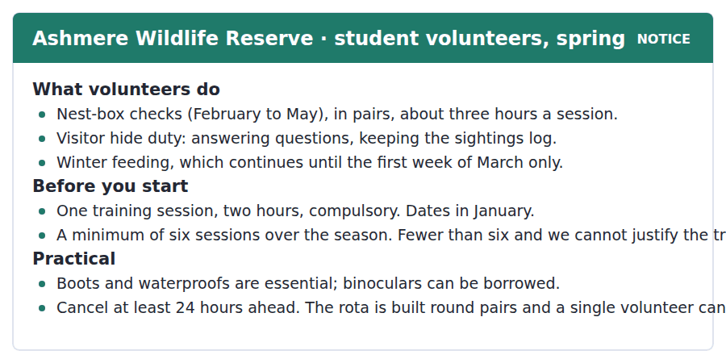
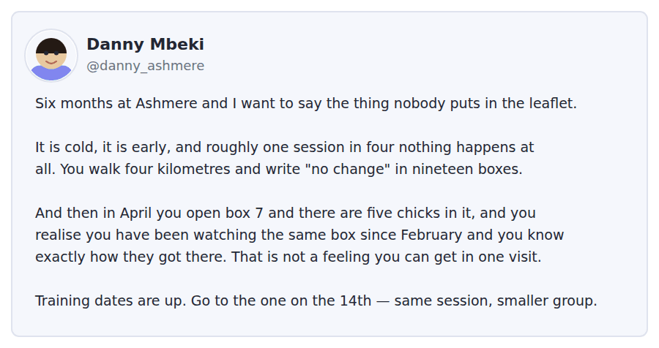
Exercise A Guided practice. The answer is on the page — find it.
1. How long is a nest-box session?
(A) Two hours
(B) About three hours
(C) Four hours
(D) A whole day
2. Which activity stops in early March?
(A) Nest-box checks
(B) Hide duty
(C) Winter feeding
(D) Training
3. What is compulsory before starting?
(A) Six sessions
(B) Owning binoculars
(C) A medical check
(D) A training session
4. What is the minimum commitment?
(A) Six sessions
(B) Three sessions
(C) Four sessions
(D) Ten sessions
Exercise B Exam practice.
5. What is Danny’s main point?
(A) The reserve needs more volunteers
(B) The training is too long
(C) The work is more rewarding than it looks at first
(D) The leaflet is inaccurate
6. How often does nothing happen, according to Danny?
(A) Every session
(B) About one session in four
(C) Only in February
(D) Almost never
7. Why does Danny mention box 7?
(A) It is the largest box
(B) To explain the sightings log
(C) To warn about disturbing chicks
(D) To show what continuity gives you
8. What does Danny recommend?
(A) The training session on the 14th
(B) Bringing your own binoculars
(C) Starting in April
(D) Doing hide duty first
9. Why must a cancellation be made 24 hours ahead?
(A) A nest-box round cannot be done alone
(B) The log must be updated
(C) The reserve closes early
(D) Training is arranged weekly
10. What can be inferred about the equipment?
(A) Everything is provided
(B) Binoculars must be bought
(C) Nothing is needed in spring
(D) Volunteers must buy boots and waterproofs


SKILL · Follow how something is known
- Some passages are about method rather than fact. Note how each claim was established.
- An experiment described in detail will be tested.
- A technical term introduced with its definition is always asked about.
- The final sentence usually explains why the system is as it is.

How Birds Know When and Where to Go
A young cuckoo has never met its parents, never seen the route and never travelled anywhere. In its first autumn it flies from northern Europe to central Africa, alone, and arrives. Whatever it is using, it is not experience, and working out what it is has taken a century of experiments that are mostly ingenious and occasionally cruel.
The timing turns out to be the easy part. Birds respond to day length, which is the one environmental signal that is identical every year and cannot be disturbed by weather. Keep a bird under artificial light that shortens at the wrong time of year and it becomes restless at the wrong time of year, in a cage, facing the direction it would have flown. That restlessness, called by its German name Zugunruhe, is how a great deal of migration research is done without anybody leaving the laboratory.
Direction is harder, because birds use at least three systems and switch between them. They take a compass bearing from the sun, correcting for the time of day; they read the pattern of stars around the pole, which they learn as nestlings by watching the sky rotate; and they sense the Earth’s magnetic field, apparently through a chemical reaction in the eye that is sensitive to it. A bird deprived of one system uses another. This redundancy is probably the point: a navigation method that fails on a cloudy night would not have survived a single generation.
[280 words]

Exercise A Guided practice.
1. What is the passage mainly about?
(A) Why cuckoos migrate alone
(B) The effect of weather on migration
(C) How birds navigate and how that was discovered
(D) How birds learn from their parents
2. What does the young cuckoo NOT have?
(A) A route
(B) Experience
(C) A destination
(D) A compass sense
3. Why do birds use day length for timing?
(A) It is easy to measure
(B) It changes fastest in spring
(C) It is visible at night
(D) It is identical every year and unaffected by weather
4. What is Zugunruhe?
(A) A migration route
(B) Restlessness at migration time
(C) A magnetic sense
(D) A type of cage
Exercise B Exam practice.
5. Why is Zugunruhe useful to researchers?
(A) It can be measured without leaving the laboratory
(B) It only occurs in cuckoos
(C) It shows how far a bird will fly
(D) It can be switched off
6. How do birds learn the star pattern?
(A) From their parents
(B) By instinct alone
(C) By watching the sky rotate as nestlings
(D) From the magnetic field
7. What correction does the sun compass require?
(A) For cloud
(B) For latitude
(C) For the season
(D) For the time of day
8. All of the following are navigation systems mentioned EXCEPT:
(A) landmarks on the ground
(B) the sun
(C) the stars
(D) the magnetic field
9. What does the author suggest is the point of having three systems?
(A) Birds are inefficient
(B) Different species use different ones
(C) A single system would fail on a cloudy night
(D) It makes research easier
10. The word "redundancy" in paragraph 3 is closest in meaning to
(A) being unnecessary
(B) having more than one system for the same job
(C) losing a system
(D) repeating a journey
11. Which best states the main idea of paragraph 2?
(A) Birds dislike artificial light
(B) Timing matters more than direction
(C) Day length is an unusually reliable signal, and it can be manipulated in a laboratory
(D) German researchers led the field


Exercise A Listen and choose a response. You hear one line. Choose the best reply.
1. Man: Have you done the training yet?
(A) Two hours.
(B) On the fourteenth.
(C) Six sessions.
(D) Yes, in January.
2. Woman: How many sessions do we have to do?
(A) At least six.
(B) About three hours.
(C) In pairs.
(D) Yes, quite a lot.
3. Man: Can we do them together?
(A) Four kilometres.
(B) They are in pairs anyway.
(C) On the fourteenth.
(D) Yes, three hours.
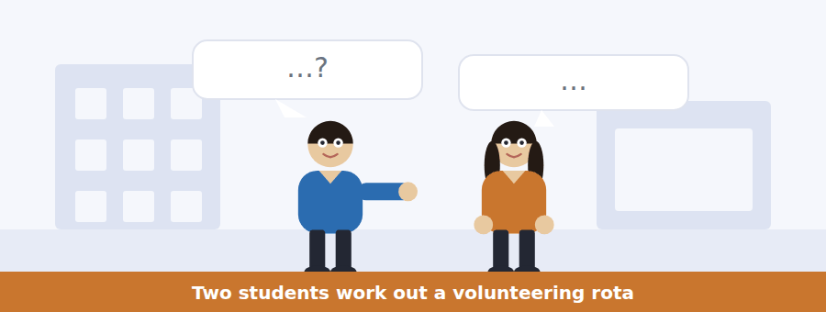
SKILL · Follow a schedule being built
- Days, times and numbers of sessions are all testable. Note each.
- An obstacle is usually raised and then solved. Note both.
- A fact about the scheme mentioned in passing is often a question.
- The agreed plan is in the last two lines.

Exercise B Listen and answer. The audio plays once.
4. Why are nest-box rounds early?
(A) The reserve is quieter
(B) Volunteers prefer mornings
(C) The light is better
(D) They must be done before the reserve opens
5. When does the woman have lectures?
(A) Monday and Wednesday
(B) Tuesday and Thursday
(C) Every morning
(D) At the weekend
6. What are the hours of hide duty?
(A) 11.00–15.00
(B) 07.00–10.00
(C) 09.00–12.00
(D) 14.00–17.00
7. What is the problem with the January training?
(A) It is full
(B) It lasts a whole day
(C) Two of the three dates are on a Tuesday
(D) It is at seven in the morning
8. Which training date do they choose?
(A) The fourteenth
(B) The seventh
(C) The twenty-first
(D) They have not decided
9. Why does doing the rounds together help?
(A) It is faster
(B) They share transport
(C) Only pairs are trained
(D) Rounds are in pairs, so it solves the cancellation problem
Audio script: see the back of the book. Do not read it before you listen.


Exercise A Listen and choose a response. You hear one line. Choose the best reply.
1. Woman: Is the training compulsory now?
(A) Three dates.
(B) Two hours.
(C) Yes, from this year.
(D) On the fourteenth.
2. Man: What happens if I only do four sessions?
(A) Six is the minimum.
(B) We would rather you did not start.
(C) In pairs.
(D) Yes, four is fine.
3. Woman: Which date is at the weekend?
(A) In January.
(B) Two hours.
(C) Yes, one of them.
(D) The fourteenth.
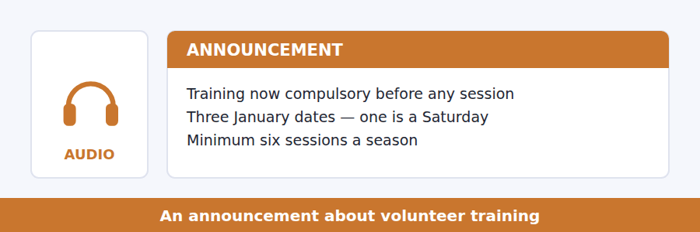
SKILL · Hear what has become compulsory
- A rule that used to be optional is prime question material.
- Note the reason, which is usually given once and briefly.
- A minimum is tested, and so is what happens if you fall short.
- The last instruction tells you what to do now.

Exercise B Listen and answer. The audio plays once.
4. What has changed this year?
(A) Training is now compulsory
(B) The number of sessions
(C) The season is longer
(D) Rounds are done alone
5. Why was the rule changed?
(A) Too few volunteers came
(B) Nest boxes in use were moved
(C) The reserve expanded
(D) Insurance required it
6. Which training date suits a student with morning lectures?
(A) The seventh
(B) The twenty-first
(C) The fourteenth
(D) None of them
7. What does the speaker ask students who cannot do six sessions to do?
(A) Do as many as they can
(B) Not take a training place
(C) Do hide duty only
(D) Start in March
8. Why does a late cancellation cost two people?
(A) Two volunteers are trained together
(B) The rota is published weekly
(C) Two sessions are lost
(D) A round cannot be done alone
Audio script: see the back of the book. Do not read it before you listen.


Exercise A Listen and choose a response. You hear one line. Choose the best reply.
1. Man: What is cross-fostering?
(A) Raising a young animal with a different species.
(B) In the second study.
(C) About two weeks.
(D) Yes, it is common.
2. Woman: Is birdsong learned or inherited?
(A) From the parents.
(B) In the spring.
(C) Both, apparently.
(D) Yes, it is.
3. Man: Could you repeat the sparrow example?
(A) It is on the board.
(B) About forty songs.
(C) Of course — the one raised in silence?
(D) Yes, I could.
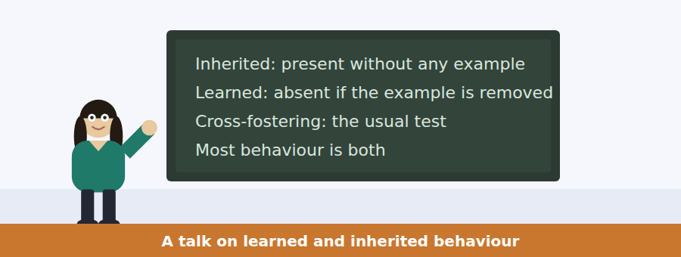
SKILL · Follow a test, not a definition
- When a talk names an experimental method, it will apply it to cases.
- Note what each case shows: inherited, learned, or both.
- A result that surprises the speaker is always tested.
- The last sentence usually says what the distinction is good for.

Exercise B Listen and answer. The audio plays once.
4. What is the main idea of the talk?
(A) Birdsong is inherited
(B) Learned and inherited are not alternatives but parts of the same behaviour
(C) Cross-fostering is unreliable
(D) Sparrows are unusual
5. What is cross-fostering?
(A) Recording an animal’s song
(B) Releasing an animal into the wild
(C) Breeding two species together
(D) Raising an animal with another species or in isolation
6. What does a sparrow raised in silence produce?
(A) A simplified, incorrect song
(B) No song at all
(C) The song of another species
(D) The correct song
7. What happens when it hears another species’ song?
(A) It ignores it and sings the bad version
(B) It copies it
(C) It stops singing
(D) It mixes the two
8. What is the third finding?
(A) The capacity is inherited
(B) What can be learned is limited in advance
(C) The detail is learned
(D) Females prefer complex songs
9. What question does the speaker say we should ask instead?
(A) Is it learned or inherited?
(B) How long does learning take?
(C) Which species learns fastest?
(D) Which part is which?
Audio script: see the back of the book. Do not read it before you listen.


Part 1 · Listen and Repeat
You hear a sentence and repeat it once. There is no preparation time, and the sentences get longer. Focus: purpose clauses
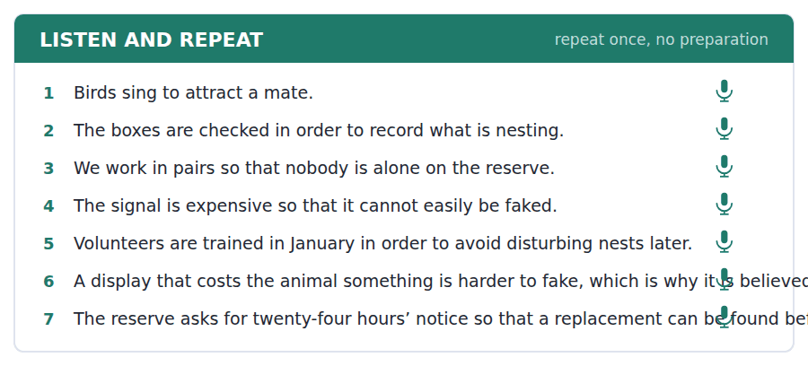
SKILL · Do not pause before to
- in order to and so that run on from the main clause. One breath.
- so that takes a subject and a verb: so that the chicks can feed.
- to + infinitive needs no subject: to attract a mate.
- Finish the clause. A purpose left hanging scores badly.

Part 2 · Take an Interview
An interviewer asks you four questions on one theme: animals where you live. Answer each one fully. There is no preparation time.
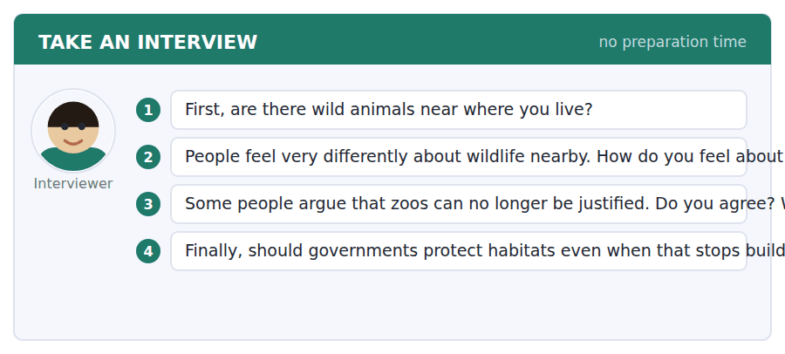
A good answer sounds like this
Question 2 — Mostly pleased, and slightly guilty, because the only reason there are foxes in my street is that we built over everywhere else.
Question 3 — Partly. A zoo that breeds species that cannot survive outside it is doing something a photograph cannot, and most zoos are not that zoo.
I can… | Not yet | Yes
I ran purpose clauses on without a pause | □ | □
I used so that with a subject and a verb | □ | □
I gave a reason after every opinion | □ | □


Part 1 · Listen and Repeat
You hear a sentence and repeat it once. There is no preparation time, and the sentences get longer. Focus: explaining why you do something
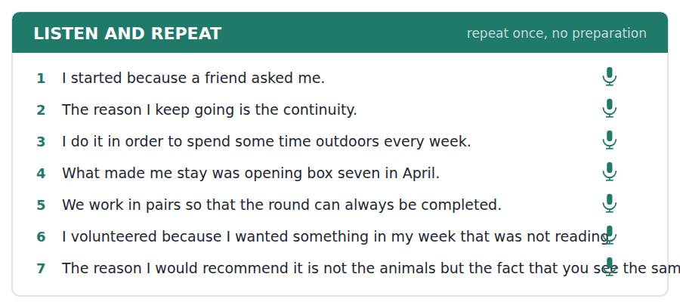
SKILL · Give the reason, not the description
- Because I wanted to… / The reason I do it is… / What made me start was…
- One reason, developed, beats three listed.
- A specific moment is more convincing than a general feeling.
- End on the reason, not on an apology for it.

Part 2 · Take an Interview
An interviewer asks you four questions on one theme: volunteering and giving time. Answer each one fully. There is no preparation time.
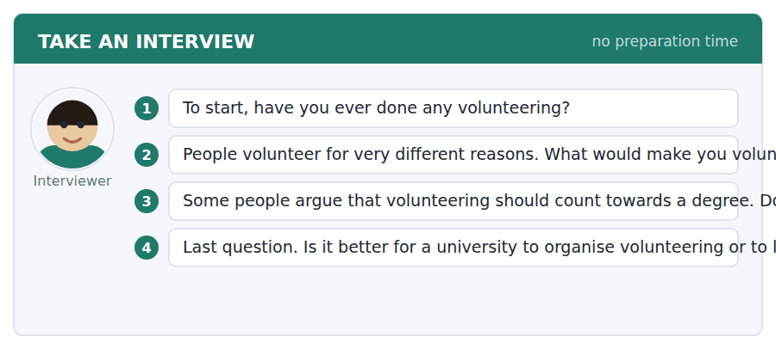
A good answer sounds like this
Question 2 — Something outdoors and regular, I think. The reason is that I would actually turn up, and a good intention that happens once is not worth much.
Question 3 — I am cautious about it. Once it counts, people do it for the credit, and the organisations end up training volunteers who leave in April.
I can… | Not yet | Yes
I gave one reason and developed it | □ | □
I used a specific moment rather than a general feeling | □ | □
I finished on the reason | □ | □


Part 1 · Listen and Repeat
You hear a sentence and repeat it once. There is no preparation time, and the sentences get longer. Focus: academic register
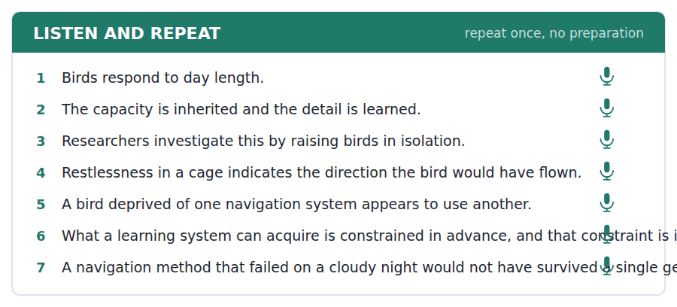
SKILL · Say how something is known
- Use the unit’s words: investigate, anticipate, occur, crucial, approach.
- Name the method, then the finding: when birds are raised in isolation,…
- Distinguish what is shown from what is inferred.
- Mark yourself against the three statements below.

Part 2 · Take an Interview
An interviewer asks you four questions on one theme: how we know things about nature. Answer each one fully. There is no preparation time.
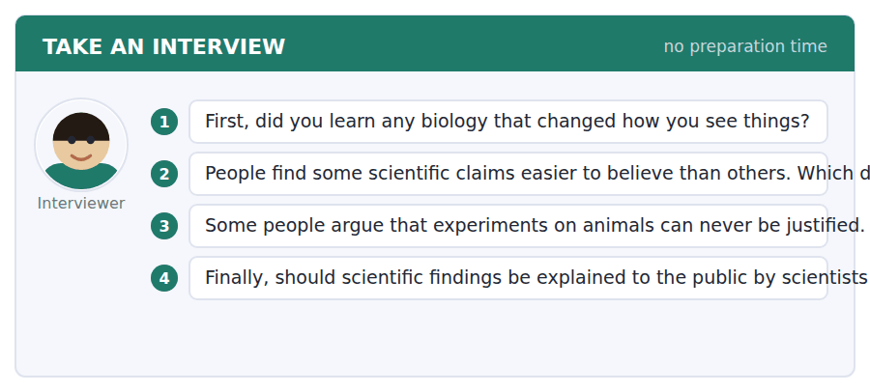
A good answer sounds like this
Question 3 — I think it depends on the experiment and on the alternative, which is an uncomfortable position but the only one I can defend.
Question 4 — By both, and separately. A scientist knows what was actually shown; a journalist knows what a reader will take away, and those are different skills.
I can… | Not yet | Yes
I used at least three academic words from this unit | □ | □
I named the method before the finding | □ | □
I distinguished shown from inferred | □ | □


You see a sentence, then a set of words in boxes. Put the words in order to make one grammatical sentence. Almost every item in the real test makes a question or a question inside another sentence.
SKILL · Purpose and reason questions
- Why do they…? asks for either. What is it for? asks for purpose only.
- An embedded version keeps statement order: do you know what it is for.
- So that needs a subject and a verb; to needs neither.
- Use every tile exactly once.

Exercise A Guided practice. The first three are worked through.
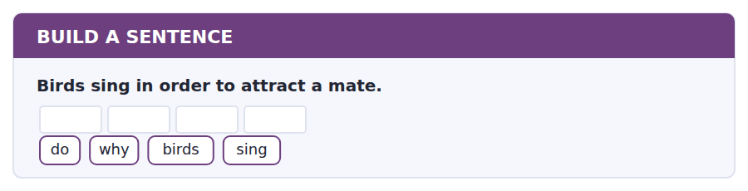
1. Why do birds sing?
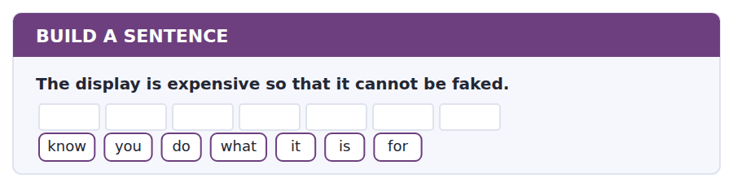
2. Do you know what it is for?
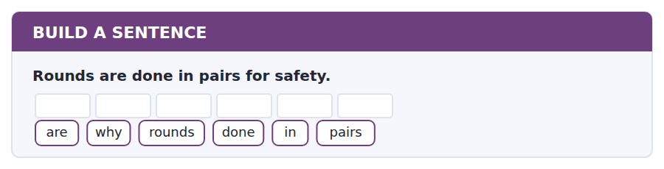
3. Why are rounds done in pairs?
Exercise B Exam practice. Write the sentence.
4. Training is compulsory because boxes were moved.
tell / can / you / me / why / training / is / compulsory
__________________________________________________________
5. The minimum is six sessions a season.
sessions / how / many / are / required
__________________________________________________________
6. Cancellations must be made 24 hours ahead.
notice / how / much / do / I / need / to / give
__________________________________________________________
7. Birds use day length because it is unaffected by weather.
know / do / you / why / they / use / day / length
__________________________________________________________
8. The volunteer who checked box 7 found five chicks.
the / volunteer / who / checked / box / 7 / found / five / chicks
__________________________________________________________
9. The fourteenth is the only Saturday date.
date / which / is / at / the / weekend
__________________________________________________________
10. A sparrow raised in silence sings an incorrect song.
know / do / you / what / happens / in / silence
__________________________________________________________


You read a short situation and write an email. You have 7 minutes. The three bullet points are the mark scheme: answer all three.
You are signed up for a nest-box round on Saturday 4 March at seven, in a pair with another volunteer. Your department has just scheduled a compulsory field trip that weekend. You know that rounds are done in pairs and that a late cancellation costs the reserve two people rather than one.
Write an email to the reserve.
- Explain the clash and give plenty of notice.
- Offer a solution rather than only a problem.
- Confirm your remaining commitment.
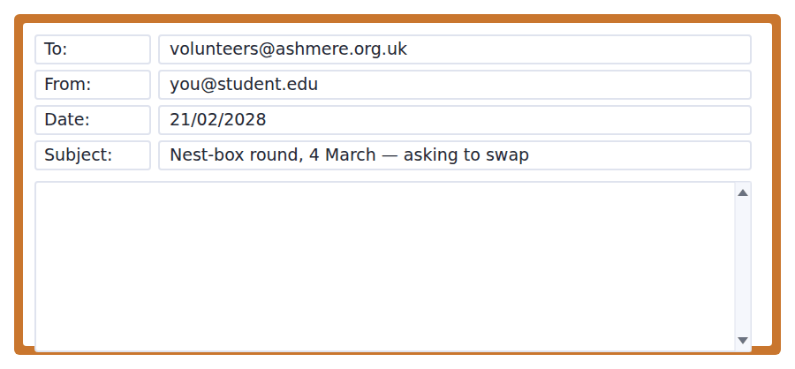
SKILL · Cancel in a way that does not cost anybody
- A cancellation that comes with a replacement is barely a cancellation.
- Show you understand the cost you are imposing.
- Confirm what you are still doing, so the record is clear.
- Seven minutes. 110–140 words.

Model email
Dear Ashmere volunteers team,
I am down for the nest-box round on Saturday 4 March at seven, paired with Priya Anand. My department has just scheduled a compulsory field trip that weekend, so I cannot come. I am telling you now rather than in March because I know a round cannot be done by one person.
I have already asked Daniel Mbeki, who has done the training and is free that morning, and he is willing to take my place with Priya if you are happy with that. He is copied in to this email.
This was going to be my third session. I am still down for 18 March and 1 April, and I will add two more dates in April to reach six.
Thank you,
Leyla Haddad
Why it works
- The notice is nearly two weeks, and the writer says why that matters in the reserve’s own terms.
- A named, trained replacement who is already willing turns a problem into an administrative note.
- Copying the replacement in removes one more email from the coordinator’s day.
- The last paragraph confirms the six-session commitment, which is the thing the scheme actually cares about.
Now write your own. 7 minutes.
__________________________________________________________
__________________________________________________________
__________________________________________________________
__________________________________________________________
__________________________________________________________
__________________________________________________________
__________________________________________________________
__________________________________________________________


A professor asks a question and two students answer. You add your own post. You have 10 minutes and an effective answer is at least 100 words.
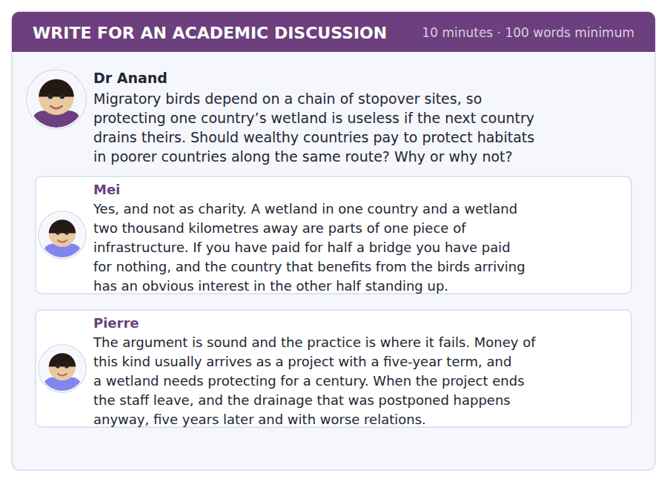
SKILL · Attack the implementation, not the principle
- Pierre agrees with the principle. His objection is about the shape of the funding.
- A good post answers the shape rather than restating the principle.
- Use the passage’s idea of redundancy if it helps.
- At least 100 words in ten minutes.

Sentence starters
- Mei has the principle and Pierre has the problem with the instrument:…
- The bridge image is right and it cuts both ways, because…
- What a five-year project cannot do is…
- So I would fund… rather than…
Model post
Mei has the principle and Pierre has the problem with the instrument, and the instrument is where this is actually decided.
The bridge image is right, and it cuts both ways. If half a bridge is worth nothing, then a bridge funded for five years is also worth nothing, because the river is still there in year six. Pierre is describing exactly that: the drainage is postponed rather than prevented, and the relationship is worse afterwards.
What a five-year project cannot do is create a reason for the other country to want the wetland in year thirty. So I would not fund projects at all. I would fund something that keeps paying — a share of the tourism, a long endowment managed locally, a treaty obligation with money attached — and I would accept that this is slower and much less photogenic than a five-year programme with a ribbon at the start.
[166 words]
Now write your own. 10 minutes, at least 100 words.
__________________________________________________________
__________________________________________________________
__________________________________________________________
__________________________________________________________
__________________________________________________________
__________________________________________________________
__________________________________________________________
__________________________________________________________
__________________________________________________________
__________________________________________________________

Grammar focus Purpose and reason
Form | Example
to + infinitive (purpose) | Birds sing to attract a mate.
in order to / so as to (formal) | Boxes are checked in order to record nesting.
so that + subject + verb | We work in pairs so that nobody is alone.
for + noun | The hide is used for watching birds.
for + -ing (the function of a thing) | A nest box is for nesting in.
because + clause (reason) | Training is compulsory because boxes were moved.
because of + noun | The round was cancelled because of the weather.

Purpose looks forward to an intended result; reason looks back to a cause. Why can ask for either, so the answer must choose.
Never use for + infinitive to express purpose. Not *for to attract a mate* and not *for attract a mate*.
Because takes a clause; because of takes a noun. Because of the weather, not *because the weather*.
Watch out! So that needs a subject: so that nobody is alone. So on its own means therefore and introduces a result, not a purpose: it rained, so we stopped.
Exercise 1 Complete with to, in order to, so that, for, because or because of.
1. Birds sing __________ attract a mate.
2. We work in pairs __________ nobody is alone.
3. The hide is used __________ watching birds.
4. The round was cancelled __________ the weather.
5. Training is compulsory __________ two boxes were moved.
6. Boxes are numbered __________ make the log easier to keep.
Exercise 2 Say whether each sentence gives a purpose or a reason.
1. The signal is expensive so that it cannot be faked.
2. The session was cancelled because of the snow.
3. Volunteers are trained in January to avoid disturbing nests.
4. He stopped volunteering because he moved away.
Exercise 3 Correct the mistake in each sentence.
1. Birds sing for to attract a mate.
2. We work in pairs so that is nobody alone.
3. The round was cancelled because the weather.
How this is tested in Build a Sentence
Build a Sentence asks these as why questions and as embedded ones: Why are rounds done in pairs? Do you know what it is for? The second keeps statement order after know.

Unit review and progress check Unit 18
Exercise A Vocabulary. Write the word.
1. to be a sign of; to mean
2. to behave according to a rule or pattern
3. to tell the difference between
4. lower in rank
5. to work together
6. extremely important
7. to examine in order to find the truth
8. to expect and prepare for
9. fully grown or developed
10. one part or feature of something
11. a record of animals seen and when
12. a small shelter for watching animals unseen
Exercise B Grammar. Complete the sentence.
1. Birds sing __________ attract a mate.
2. We work in pairs __________ nobody is alone.
3. The hide is used __________ watching birds.
4. The round was cancelled __________ the weather.
5. Training is compulsory __________ two boxes were moved.
6. Boxes are numbered __________ (order) make the log easier.
7. The signal is costly __________ it cannot be faked.
8. He stopped volunteering __________ he moved away.
Exercise C One timed mini-section. 6 minutes.
1. According to the passage on page 138, birds use day length because
(A) it is easy to measure
(B) it changes fastest in spring
(C) it is the same every year and unaffected by weather
(D) it can be seen at night
2. In the talk, a sparrow raised in silence
(A) produces no song
(B) copies another species
(C) learns from a recording
(D) produces an incorrect song
3. Which sentence is correct?
(A) Birds sing for to attract a mate.
(B) The round was cancelled because the weather.
(C) We work in pairs so that nobody is alone.
(D) Boxes are numbered for make the log easier.
4. A volunteer who cancels late costs the reserve
(A) one session
(B) two people
(C) one person
(D) nothing
5. In Listening, an announcement usually exists because
(A) something has changed
(B) a routine event is happening
(C) a deadline has passed
(D) a new term has started
6. A "why does the speaker mention" question asks for
(A) the fact itself
(B) a definition
(C) a number
(D) the purpose of the example
Can you do these now?
I can… | Not yet | Yes
complete word endings in a text about how animals signal | □ | □
read a volunteering notice and a post and find what I would have to commit to | □ | □
follow a passage that explains how something is known rather than what is known | □ | □
understand two people arranging shifts around their timetables | □ | □
explain why I do something, out loud, without preparing | □ | □
write an email asking to swap a commitment, and a post about competing goods | □ | □

ADAPTIVE TIP A "why does the speaker mention X" question is not asking about X. It is asking what job X is doing in the argument — introducing a concept, giving evidence, raising an objection. Answer the job, not the fact.

Unit 19 · Education and Learning
TOEFL iBT® Preparation Course 2026 · Volume 2
CEFR B1 · Grammar: The second conditional · Word field: method, assessment, outcome
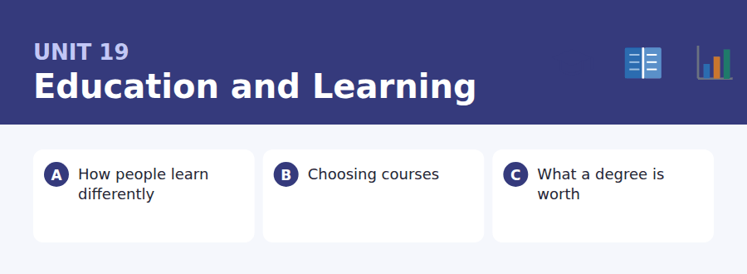
By the end of this unit I can…
- complete word endings in a text about how people learn
- read a course page and an email about a clash and find what I must do
- follow a passage that questions a figure everybody quotes
- understand two students choosing between two options
- talk about a situation that is not real, out loud, without preparing
- write an email asking to change a module, and a post that distinguishes two claims

This unit is about what would happen if things were otherwise, which is exactly what the second conditional is for — and what the last two interview questions in the test usually ask.

Vocabulary 1 · Academic 24 words from the Academic Word List
These twenty-four words come back through the whole unit, and again in the review. Cover the right-hand column and test yourself.
method a way of doing something | register to put your name on an official list
criteria the standards used to judge something | submit to hand in formally
assess to judge the quality or value of something | revise to study again; to change a text
grade a mark showing quality of work | publication something published; the act of publishing
outcome the result of something | principal main or most important
objective an aim; or not influenced by feelings | relevant connected with what is being discussed
goal something you are trying to achieve | minor small or less important
schedule a plan of when things happen | final last; or an examination at the end
lecture a formal talk to a class | section one part of something larger
instruct to teach, or to tell someone what to do | topic a subject being studied or discussed
academy a place of study or training | justify to give a good reason for
qualitative based on qualities rather than numbers | acknowledge to admit or recognise

Exercise A Work in pairs. Ask and answer.
1. What criteria would you use to choose an optional module?
2. Describe one method of studying that works for you and one that does not.
3. What was the principal outcome of your last year of study?
4. How would you justify studying your subject to somebody who thinks it is useless?
Vocabulary 2 · Campus and everyday 12 words for the daily-life tasks
The exam does not only test academic English. Notices, emails, conversations and announcements use the everyday words below.
module one unit of a degree course | resit a second attempt at an examination
tutorial a teaching session for one or two students | transcript an official record of your results
reading week a week in term with no classes, kept for reading | open day a day when a university shows itself to visitors
enrolment the act of joining a course officially | prospectus a booklet describing courses
seminar a small class for discussion | adviser a member of staff who guides your choices
essay a piece of written academic work | workload the amount of work you have to do

Words you will meet again: evaluate | perceive | concentrate | significant | estimate | retain | insight | rational


SKILL · Education writing has a small set of endings
- -ion, -ment, -ance and -ive cover most of the nouns and adjectives here.
- A gap after a plural subject may be a verb with no ending at all.
- Count the dashes before choosing between -ion and -ation.
- Read the sentence back; the subject usually names the claim.

Exercise A Guided practice. Five words are not complete. Write the missing letters.
Almost every teacher has been told that students have learning sty---: that some are visual and others prefer to li----. It is a comfort---- idea and the evidence for it is remarkably th--. When researchers test it prope---, matching the teaching to the stated preference makes no measurable difference at all.

The first one is done for you: 1 sty--- → les (styles)
Exercise B Exam practice. One paragraph, ten gaps — the real task.
The learning styles idea is one of the most popular beliefs in education and one of the least suppor---. The claim is specific and therefore testable: if a student says they learn visu----, teaching them visually should produce better results than teaching them in words. Dozens of studies have run exactly that compar----, and the matching makes no significant differ----. Students do have prefer-----, strongly held ones, and those preferences simply do not predict which method works b---. What does predict it is the material. Teaching geography with maps helps every---- , not only the visual learners, because the content is spa----. The practical conclusion is almost the opposite of the popular o--. Do not match the method to the student. Match it to the sub----.

Check your answers in the key at the back of the book.


SKILL · Find the rule that constrains your choice
- Course documents list options and then constrain them. Find the constraint.
- Prerequisites, caps and deadlines are the three usual questions.
- An email about a clash usually names what can and cannot be changed.
- Note which rule has an exception and who grants it.

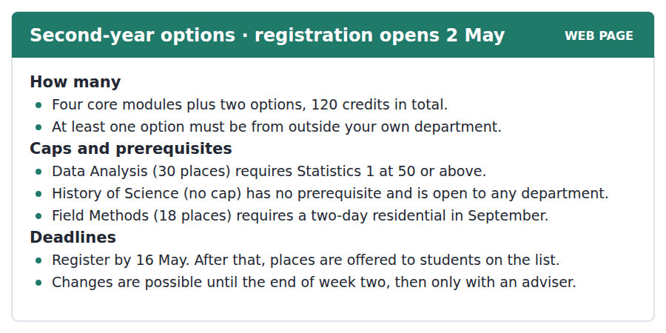
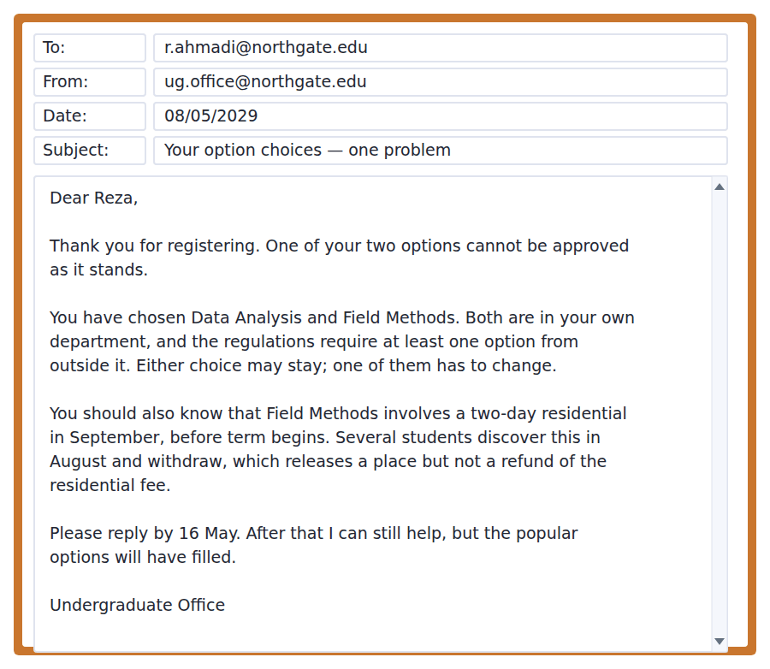
Exercise A Guided practice. The answer is on the page — find it.
1. How many options must a student take?
(A) Two
(B) One
(C) Four
(D) Six
2. Which module has no prerequisite?
(A) Data Analysis
(B) History of Science
(C) Field Methods
(D) Statistics 1
3. What does Data Analysis require?
(A) A residential
(B) Permission from an adviser
(C) Nothing
(D) Statistics 1 at 50 or above
4. Until when can choices be changed freely?
(A) 16 May
(B) The end of week one
(C) The end of week two
(D) The end of term
Exercise B Exam practice.
5. Why can Reza’s choices not be approved?
(A) He has chosen too many
(B) Both options are in his own department
(C) He has no prerequisite
(D) He registered late
6. What does the office say about which one must change?
(A) Data Analysis must go
(B) Field Methods must go
(C) Either may stay
(D) Both must change
7. What do several students discover in August?
(A) That there is a residential before term
(B) That the module is full
(C) That the fee has risen
(D) That the prerequisite has changed
8. What is NOT refunded when a student withdraws?
(A) The module fee
(B) The registration fee
(C) Nothing is refunded
(D) The residential fee
9. What happens after 16 May?
(A) Help is still available but popular options will have filled
(B) No changes are possible
(C) The office cannot help
(D) A fee is charged
10. What can be inferred about History of Science?
(A) It is unpopular
(B) It requires Statistics 1
(C) It has a residential
(D) It would solve Reza’s problem


SKILL · Question a statistic without rejecting it
- A passage of this kind accepts the figure and attacks the use made of it.
- Two reasons are usually given for why an average misleads. Mark both.
- The final paragraph states what would be useful instead. That is tested.
- Watch for none of this is an argument against — it marks the author’s real position.

What a Degree Is Actually Worth
The figure everybody quotes is the graduate premium: the amount more that graduates earn over a working life. It is large, it is real, and it is almost always presented in a way that invites a mistake. The premium is an average across everyone who graduated, and averages conceal more here than in almost any other statistic in education.
Two things drive the concealment. The first is subject. The gap between the best-paid and worst-paid degree subjects is wider than the gap between graduates and non-graduates as a whole, which means the headline figure describes almost nobody. The second is selection. People who go to university differ from people who do not in ways that affect earnings regardless of the degree — school results, family income, the region they grew up in. Studies that control for these find a premium that is smaller, though still clearly positive, and very uneven.
None of this is an argument against higher education. It is an argument against a particular use of one number. A seventeen-year-old deciding what to do is not choosing between the average graduate and the average non-graduate; they are choosing between one specific course at one specific institution and whatever else they would have done. The average tells them nothing about that choice, and the figures that would tell them something — outcomes by subject and institution — exist, are published, and are read by almost nobody.
[280 words]

Exercise A Guided practice.
1. What is the passage mainly about?
(A) Why university is not worth it
(B) How to choose a degree subject
(C) Why the graduate premium is misleading as it is usually presented
(D) Why some subjects pay more
2. What is the graduate premium?
(A) The cost of a degree
(B) The extra earnings of graduates over a working life
(C) The number of graduates
(D) The difference between subjects
3. What is the first reason the average misleads?
(A) Selection
(B) Region
(C) Subject
(D) Age
4. What does "selection" mean here?
(A) People who go to university differing in ways that affect earnings anyway
(B) Choosing a subject
(C) Universities choosing students
(D) Employers choosing graduates
Exercise B Exam practice.
5. What happens to the premium when studies control for selection?
(A) It disappears
(B) It is smaller but still positive
(C) It becomes negative
(D) It grows
6. Why does the author say the headline figure "describes almost nobody"?
(A) The sample is small
(B) It is out of date
(C) It excludes part-time students
(D) The subject gap is wider than the graduate gap
7. All of the following are given as selection factors EXCEPT:
(A) school results
(B) family income
(C) the region they grew up in
(D) the choice of institution
8. What is the author’s position on higher education?
(A) It is worth it but the average is misused
(B) It is not worth the cost
(C) Only some subjects are worthwhile
(D) The research is unreliable
9. What figures does the author say would actually help?
(A) The national average
(B) The cost of tuition
(C) Outcomes by subject and institution
(D) Employment rates by region
10. What can be inferred about the seventeen-year-old?
(A) They should not go to university
(B) The average is the wrong number for their decision
(C) They will earn less than the average
(D) They should choose by institution alone
11. Which best states the main idea of paragraph 2?
(A) Some subjects pay better than others
(B) Family income determines earnings
(C) Subject and selection both make the average misleading
(D) Studies disagree about the premium


Exercise A Listen and choose a response. You hear one line. Choose the best reply.
1. Man: Have you registered yet?
(A) Not yet — I cannot decide.
(B) By the sixteenth.
(C) Two options.
(D) Yes, thirty places.
2. Woman: How many places are there?
(A) By the sixteenth.
(B) In the second year.
(C) Yes, there is a cap.
(D) Thirty.
3. Man: Do I need Statistics 1 for that?
(A) It has thirty places.
(B) At fifty or above.
(C) By the sixteenth.
(D) Yes, it is popular.
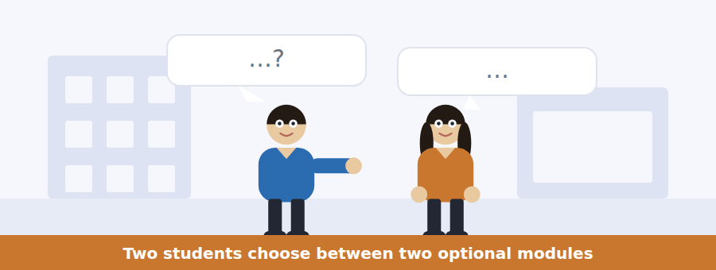
SKILL · Follow the constraint, not the preference
- When a choice is constrained by rules, the rules decide and the preferences are noise.
- Note the prerequisite, the cap and the deadline as they appear.
- Listen for the piece of information that changes the decision.
- The last two lines contain the choice.

Exercise B Listen and answer. The audio plays once.
4. Why can the man not take Data Analysis?
(A) It is full
(B) It is outside his department
(C) He registered late
(D) His Statistics 1 mark is below the requirement
5. Why does the woman think an appeal would fail?
(A) Appeals are not allowed
(B) Thirty places and about ninety applicants
(C) The deadline has passed
(D) He has already registered
6. What other problem does History of Science solve?
(A) It provides the required outside option
(B) It has no cap
(C) It has no examination
(D) It is taught on Fridays
7. What would have happened if he had scored fifty?
(A) He would have taken both
(B) He would have appealed
(C) He would have had to drop something else anyway
(D) He would have needed an adviser
8. What does the man mean by "saved me an email"?
(A) He no longer has to appeal
(B) He no longer has to fix the department rule
(C) He can register online
(D) He does not need an adviser
9. What does the woman still recommend?
(A) Appealing anyway
(B) Changing department
(C) Registering late
(D) Taking the statistics resit
Audio script: see the back of the book. Do not read it before you listen.


Exercise A Listen and choose a response. You hear one line. Choose the best reply.
1. Woman: When does registration close?
(A) On the second.
(B) Two options.
(C) The sixteenth of May.
(D) Yes, it is open.
2. Man: Does Field Methods have a cap?
(A) Eighteen places.
(B) In September.
(C) Two days.
(D) Yes, it is popular.
3. Woman: What is the commonest mistake?
(A) Registering late.
(B) Eighteen places.
(C) Choosing both options inside your own department.
(D) Yes, people do.
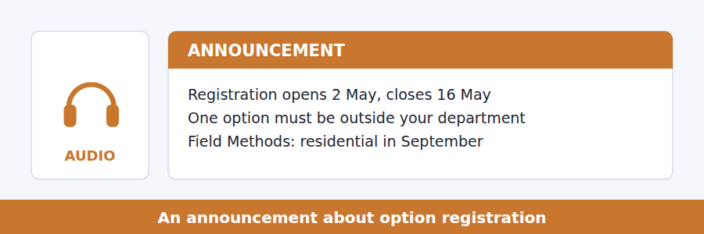
SKILL · Note the rule people forget
- A briefing usually names the mistake most students make. That is a question.
- Caps and prerequisites are tested separately.
- A hidden cost or commitment is nearly always asked about.
- The closing instruction is the usual last question.

Exercise B Listen and answer. The audio plays once.
4. What catches about a third of students every year?
(A) Choosing both options inside their own department
(B) Registering late
(C) Missing a prerequisite
(D) Forgetting the residential
5. Why is the Statistics prerequisite not waived?
(A) The module is full
(B) The module genuinely assumes it
(C) The regulations forbid it
(D) It is a departmental rule
6. What is not refunded if a student withdraws in August?
(A) The module fee
(B) The registration fee
(C) Everything is refunded
(D) The residential fee
7. Why is History of Science the easiest outside option?
(A) It is the most interesting
(B) It is taught online
(C) It has no cap and no prerequisite
(D) It has no examination
8. When do changes start to need an adviser?
(A) After 16 May
(B) After week two
(C) After week one
(D) After the first term
Audio script: see the back of the book. Do not read it before you listen.


Exercise A Listen and choose a response. You hear one line. Choose the best reply.
1. Man: Which group did better?
(A) The one that tested itself.
(B) About fifty per cent.
(C) A week later.
(D) Yes, they did.
2. Woman: Did they know they were doing better?
(A) A week later.
(B) Two groups.
(C) Yes, they were told.
(D) No — they thought the opposite.
3. Man: So should I stop rereading?
(A) It feels productive.
(B) Two groups, same material.
(C) Yes — cover the page instead.
(D) No, it was the same.
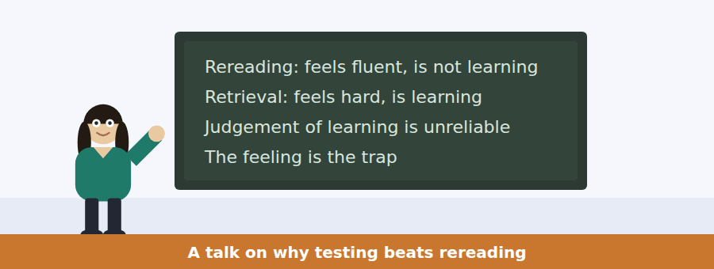
SKILL · Follow a finding that contradicts the feeling
- A talk of this kind separates what works from what feels like it works.
- The experimental numbers are always tested.
- Listen for and here is the problem — it marks the twist.
- The last instruction says what to do with the finding.

Exercise B Listen and answer. The audio plays once.
4. What is the main idea of the talk?
(A) Rereading is a waste of time
(B) The method that feels worse is the one that works, and students cannot feel the difference
(C) Students should study for longer
(D) Memory declines after a week
5. What did group two do?
(A) Read once and recalled three times
(B) Reread four times
(C) Studied for longer
(D) Worked in pairs
6. What happened immediately after the study session?
(A) Group two did better
(B) Both groups scored the same
(C) Neither group was tested
(D) Group one did slightly better and felt more confident
7. By how much did group two score higher a week later?
(A) Ten per cent
(B) Twenty-five per cent
(C) Twice as much
(D) Fifty per cent
8. What does the speaker call the problem?
(A) The experiment is hard to repeat
(B) Group two still believed they had learned less
(C) The material was too easy
(D) Students do not revise enough
9. What is the speaker’s practical advice?
(A) Reread more slowly
(B) Study in groups
(C) Be suspicious of a method that feels comfortable
(D) Revise earlier
Audio script: see the back of the book. Do not read it before you listen.


Part 1 · Listen and Repeat
You hear a sentence and repeat it once. There is no preparation time, and the sentences get longer. Focus: would contractions
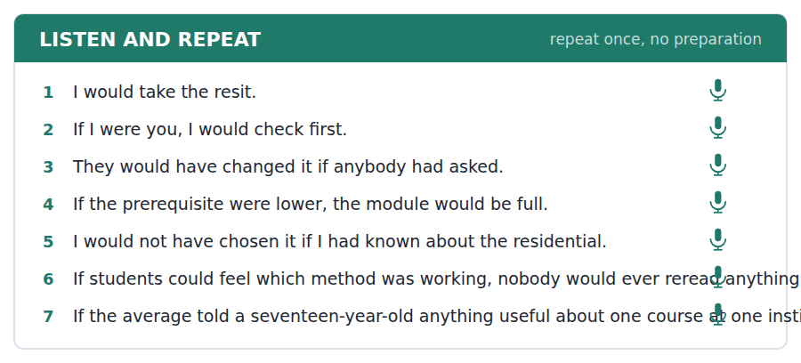
SKILL · Contract would, keep the verb
- I’d, he’d, they’d — the vowel almost disappears and the d joins the verb.
- Would have is /wʊdəv/. Never would of.
- If I were is the correct form after if, although was is common in speech.
- Finish the conditional. An unfinished if is the commonest slip.

Part 2 · Take an Interview
An interviewer asks you four questions on one theme: a subject you chose. Answer each one fully. There is no preparation time.
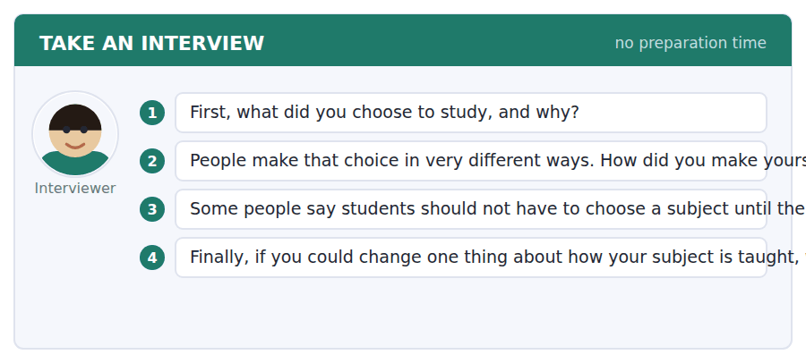
A good answer sounds like this
Question 2 — Badly, if I am honest. I chose it because I was good at it at school, which turned out to be a different thing from enjoying it.
Question 4 — I would have one seminar a week where we read something nobody is examined on, because that is where the actual thinking happens.
I can… | Not yet | Yes
I contracted would naturally | □ | □
I said would have, never would of | □ | □
I finished every conditional | □ | □


Part 1 · Listen and Repeat
You hear a sentence and repeat it once. There is no preparation time, and the sentences get longer. Focus: hypothetical advice
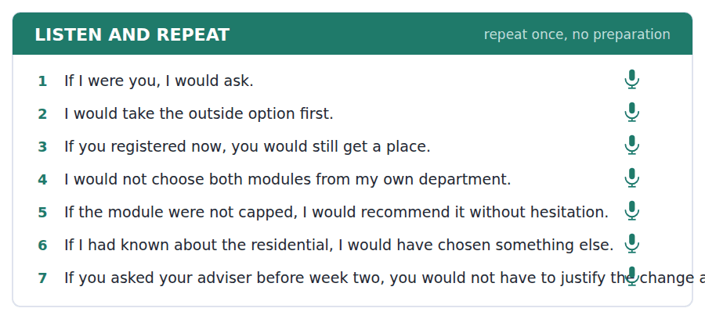
SKILL · Advise with the second conditional
- If I were you, I would… is the standard form and the test likes it.
- Say what you would do and why, not what they should do.
- Keep the tenses: if + past, would + infinitive.
- One piece of advice, one reason, one alternative.

Part 2 · Take an Interview
An interviewer asks you four questions on one theme: choices and advice. Answer each one fully. There is no preparation time.
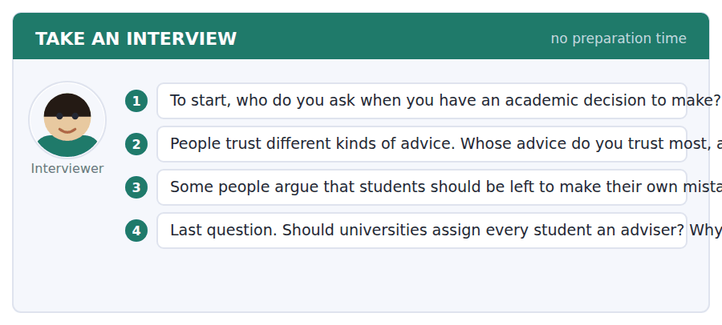
A good answer sounds like this
Question 2 — Somebody a year ahead of me, usually, because they remember the thing and they have no stake in my choosing it.
Question 3 — Up to a point. A mistake you can recover from is useful; a mistake that costs you a year is just a cost.
I can… | Not yet | Yes
I used if + past, would + infinitive correctly | □ | □
I said what I would do rather than what they should do | □ | □
I gave one reason with the advice | □ | □


Part 1 · Listen and Repeat
You hear a sentence and repeat it once. There is no preparation time, and the sentences get longer. Focus: academic register
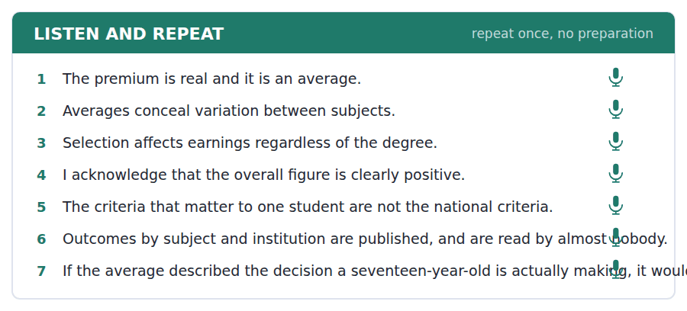
SKILL · Handle a statistic carefully
- Use the unit’s words: criteria, assess, outcome, justify, acknowledge.
- Acknowledge what the figure shows before you say what it hides.
- Name the group an average actually describes.
- Mark yourself against the three statements below.

Part 2 · Take an Interview
An interviewer asks you four questions on one theme: the value of study. Answer each one fully. There is no preparation time.
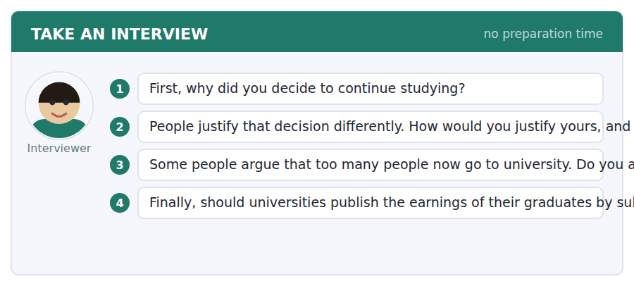
A good answer sounds like this
Question 3 — I acknowledge the figures are uneven by subject, but too many is a claim about who should not have gone, and nobody making it ever names them.
Question 4 — Yes, by subject and institution, because that is the only version of the number that describes the choice an applicant is actually making.
I can… | Not yet | Yes
I used at least three academic words from this unit | □ | □
I acknowledged the figure before qualifying it | □ | □
I named the group the average describes | □ | □


You see a sentence, then a set of words in boxes. Put the words in order to make one grammatical sentence. Almost every item in the real test makes a question or a question inside another sentence.
SKILL · Hypothetical questions
- What would you do if…? — would before the subject, past tense after if.
- If I were is the form the test expects after if with the verb to be.
- An embedded version keeps statement order: do you know what you would do.
- Use every tile exactly once.

Exercise A Guided practice. The first three are worked through.
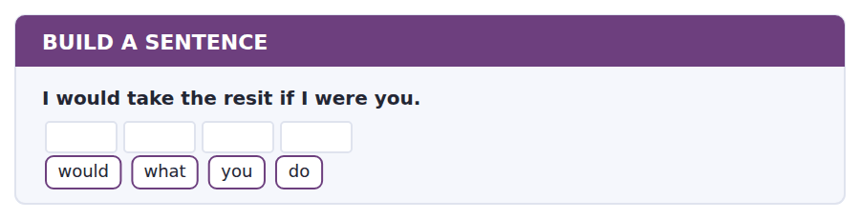
1. What would you do?
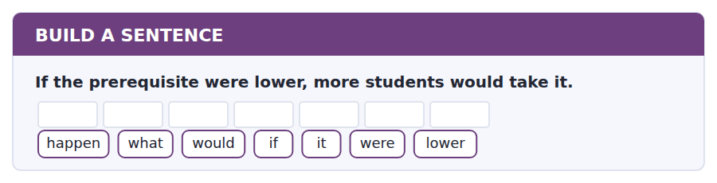
2. What would happen if it were lower?
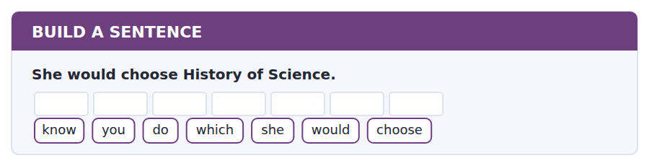
3. Do you know which she would choose?
Exercise B Exam practice. Write the sentence.
4. The module requires fifty in Statistics 1.
tell / can / you / me / what / the / prerequisite / is
__________________________________________________________
5. Data Analysis has thirty places.
places / how / many / are / there
__________________________________________________________
6. If he had known, he would have chosen differently.
have / what / would / he / chosen
__________________________________________________________
7. Changes need an adviser after week two.
know / do / you / when / I / need / an / adviser
__________________________________________________________
8. The student who missed the residential lost the fee.
the / student / who / missed / the / residential / lost / the / fee
__________________________________________________________
9. One option must come from outside the department.
tell / can / you / me / whether / both / can / be / internal
__________________________________________________________
10. Group two scored fifty per cent higher a week later.
know / do / you / why / they / scored / higher
__________________________________________________________


You read a short situation and write an email. You have 7 minutes. The three bullet points are the mark scheme: answer all three.
The undergraduate office has told you that both your options are in your own department and one must change. You want to keep Data Analysis. You also now know that Field Methods has a two-day residential in September that you cannot attend, and that History of Science has no cap and no prerequisite.
Write an email to the undergraduate office.
- Say which option you are dropping and which you are keeping.
- Say what you want instead, and why it meets the rule.
- Ask for confirmation.
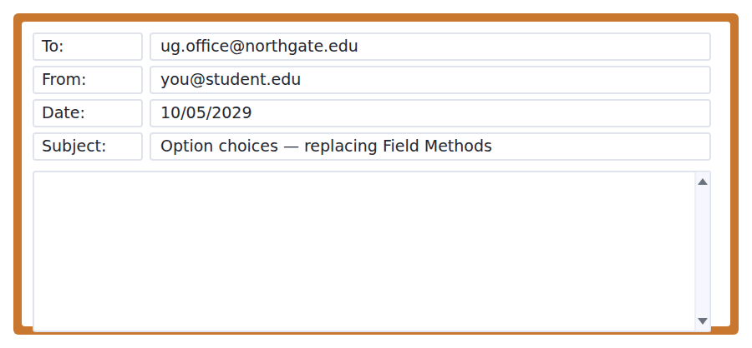
SKILL · Make the decision, do not ask for one
- The office told you what to fix. Fix it and ask them to confirm.
- Name all three modules so nothing has to be looked up.
- Show that your replacement satisfies the rule you broke.
- Seven minutes. 110–140 words.

Model email
Dear Undergraduate Office,
Thank you for your email about my option choices. I am dropping Field Methods and keeping Data Analysis.
In place of Field Methods I would like to take History of Science, which is outside my department and therefore satisfies the requirement that at least one option comes from elsewhere. I understand it has no cap and no prerequisite, so I hope this is straightforward.
I should add that I would not have been able to attend the September residential in any case, as I am abroad until the twenty-eighth. So this change solves two problems rather than one.
Could you confirm that my two options are now Data Analysis and History of Science? I am writing before the sixteenth so that nothing has to be rushed.
Thank you,
Reza Ahmadi
Why it works
- The decision is made in the first short paragraph, so the reader knows what to do before reading the reasons.
- The replacement is justified against the exact rule that was broken, which removes the need for a check.
- The residential point is added as supporting information rather than as the main reason, which keeps the email short.
- The confirmation request names both final modules, so a reply can be one line.
Now write your own. 7 minutes.
__________________________________________________________
__________________________________________________________
__________________________________________________________
__________________________________________________________
__________________________________________________________
__________________________________________________________
__________________________________________________________
__________________________________________________________


A professor asks a question and two students answer. You add your own post. You have 10 minutes and an effective answer is at least 100 words.
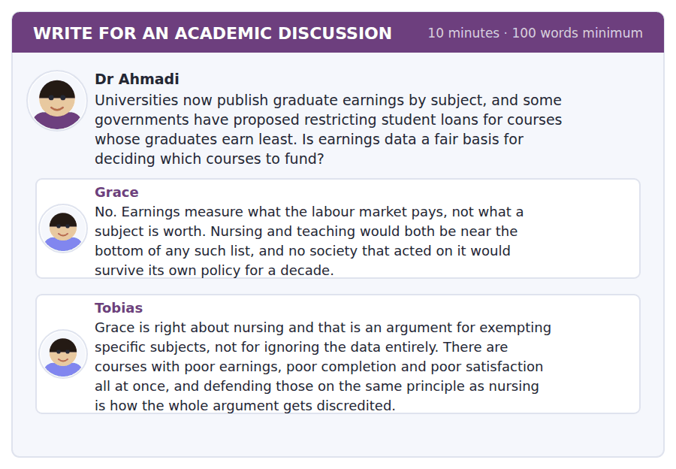
SKILL · Distinguish the strong case from the weak one
- Grace defends everything; Tobias separates two kinds of course. That separation is the move.
- Use the passage: the average conceals subject variation.
- Say what you would actually fund and on what criteria.
- At least 100 words in ten minutes.

Sentence starters
- Grace’s example is the strongest one available, which is a warning:…
- Tobias is right that one exemption is not the same as…
- The passage suggests a third measure:…
- I would fund on… rather than on…
Model post
Grace has chosen the strongest example available, and that is itself a warning. Nursing wins the argument, and a rule written for nursing will be used to defend courses that could not win it alone.
Tobias is right to separate the two cases. But the passage points to something neither of them says. The graduate premium is an average that conceals enormous variation by subject and by institution, and the same is true of the earnings data being proposed: it is an average of people who differ from each other before they arrive. Using it to close a course punishes an institution for its intake.
So I would not fund on earnings. I would fund on what a course adds — the difference between what its graduates earn and what students with the same prior results earned elsewhere. That is harder to compute, it is already computed in several countries, and it is the only version of the number that measures the course rather than the student.
[179 words]
Now write your own. 10 minutes, at least 100 words.
__________________________________________________________
__________________________________________________________
__________________________________________________________
__________________________________________________________
__________________________________________________________
__________________________________________________________
__________________________________________________________
__________________________________________________________
__________________________________________________________
__________________________________________________________

Grammar focus The second conditional
Form | Example
If + past simple, would + infinitive | If I had time, I would take it.
If I were (not was) in formal use | If I were you, I would ask.
Result first (no comma) | I would ask if I were you.
could / might instead of would | If he asked, they might agree.
Question | What would you do if you failed?
Third conditional (past, unreal) | If I had known, I would have chosen differently.
Mixed | If I had taken it, I would be qualified now.

The second conditional is about an unreal or unlikely present or future. The past tense after if does not refer to past time; it marks unreality.
Use were for all persons after if in formal writing: if I were, if he were. Was is common in speech and is marked down in formal registers.
The third conditional moves the whole thing into the past: if + past perfect, would have + past participle. Use it for things that did not happen.
Watch out! Never put would in the if-half. It is If I had time, not *If I would have time*. The same rule as the first conditional, one tense further back.
Exercise 1 Put the verbs in the right form.
1. If I __________ (be) you, I __________ (ask) the office.
2. If the prerequisite __________ (be) lower, more students __________ (take) it.
3. What __________ you __________ (do) if you __________ (fail)?
4. If he __________ (know) about the residential, he __________ (not choose) it.
5. If they __________ (publish) the data by subject, applicants __________ (use) it.
6. If I __________ (have) a free afternoon, I __________ (go) to the open day.
Exercise 2 Rewrite as a second or third conditional.
1. I do not have time, so I am not taking it. →
2. He did not know, so he chose it. →
3. The module is capped, so she cannot join. →
4. They did not publish the data, so nobody used it. →
Exercise 3 Correct the mistake in each sentence.
1. If I would have time, I would take it.
2. If I was you, I would ask.
3. If he knew about it, he would not have chosen it.
How this is tested in Build a Sentence
Build a Sentence asks this as What would you do if…? and as an embedded question: Do you know what you would do? The modal stays in the result half, never in the if-half.

Unit review and progress check Unit 19
Exercise A Vocabulary. Write the word.
1. the standards used to judge something
2. the result of something
3. an aim; or not influenced by feelings
4. based on qualities rather than numbers
5. to hand in formally
6. main or most important
7. connected with what is being discussed
8. to give a good reason for
9. to admit or recognise
10. to put your name on an official list
11. a second attempt at an examination
12. an official record of your results
Exercise B Grammar. Complete the sentence.
1. If I __________ (be) you, I would ask.
2. If the prerequisite were lower, more students __________ (take) it.
3. What __________ you do if you failed?
4. If he __________ (know), he would not have chosen it.
5. If they published the data, applicants __________ (use) it.
6. If I had time, I __________ (go) to the open day.
7. If the module were not capped, she __________ (can) join.
8. If I __________ (take) it last year, I would be qualified now.
Exercise C One timed mini-section. 6 minutes.
1. According to the passage on page 154, the graduate premium is misleading because
(A) it is an average across very different subjects and students
(B) it is too small
(C) it is out of date
(D) it excludes part-time study
2. In the talk, students who tested themselves
(A) felt more confident
(B) studied for longer
(C) preferred the method
(D) scored about fifty per cent higher a week later
3. Which sentence is correct?
(A) If I would have time, I would take it.
(B) If I was you, I would ask.
(C) If I were you, I would ask.
(D) If he knew, he would not have chosen it.
4. A student whose two options are both in their own department must
(A) change one of them
(B) pay a fee
(C) see an adviser
(D) take a third option
5. A revision method that feels comfortable is
(A) probably effective
(B) probably not teaching you much
(C) the one most students avoid
(D) only useful for languages
6. In Speaking, the fourth interview question is usually
(A) an opinion about policy
(B) a fact about you
(C) a reaction
(D) a repetition
Can you do these now?
I can… | Not yet | Yes
complete word endings in a text about how people learn | □ | □
read a course page and an email about a clash and find what I must do | □ | □
follow a passage that questions a figure everybody quotes | □ | □
understand two students choosing between two options | □ | □
talk about a situation that is not real, out loud, without preparing | □ | □
write an email asking to change a module, and a post that distinguishes two claims | □ | □

ADAPTIVE TIP Budget the Writing section backwards. The discussion post is worth the most and comes last, so finish Build a Sentence quickly and do not spend an extra two minutes polishing the email — those two minutes are worth far more at the end.

Unit 20 · Media and Misinformation
TOEFL iBT® Preparation Course 2026 · Volume 2
CEFR B1 · Grammar: although, however, despite · Word field: source, bias, evidence
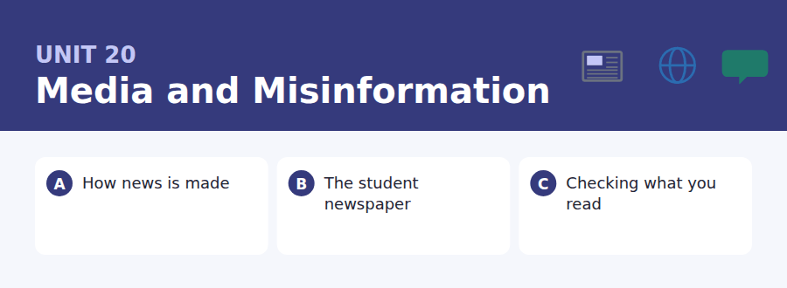
By the end of this unit I can…
- complete word endings in a text about how news is produced
- read a call for writers and a correction notice and find what applies to me
- follow a passage that explains why a false story spreads
- understand two people disagreeing about whether to publish
- concede a point out loud and then argue past it
- write an email offering to contribute, and a post that holds two things at once

The last unit. The grammar is concession, which is the structure every good discussion post in this course has used — and Build a Sentence here mixes every frame from the whole twenty units.

Vocabulary 1 · Academic 24 words from the Academic Word List
These twenty-four words come back through the whole unit, and again in the review. Cover the right-hand column and test yourself.
source where information comes from | remove to take away
bias an unfair preference for one side | suspend to stop something temporarily
cite to quote or refer to a source | impose to force something on somebody
media the main means of mass communication | framework a basic structure of ideas or rules
issue an important subject being discussed | ideology a set of political or social beliefs
controversy a long public disagreement | philosophy a system of ideas about life and knowledge
contrary opposite | obvious easy to see or understand
deny to say something is not true | straightforward simple and clear
convince to make somebody believe something | whereas while in contrast
assure to tell somebody confidently that something is true | nevertheless in spite of that
prohibit to forbid officially | furthermore in addition
reject to refuse to accept | thereby by that means

Exercise A Work in pairs. Ask and answer.
1. Where do you get your news? What bias would you expect that source to have?
2. Describe a controversy you have followed. What convinced you one way or the other?
3. Have you ever seen a correction published? What was it for?
4. Would you cite a social media post in an essay? Why or why not?
Vocabulary 2 · Campus and everyday 12 words for the daily-life tasks
The exam does not only test academic English. Notices, emails, conversations and announcements use the everyday words below.
newspaper a printed or online publication of news | fact-check to verify claims before publishing
editor the person who decides what is published | press pass a card allowing a journalist access
headline the title of a news story | column a regular opinion piece by one writer
article a piece of writing in a newspaper | byline the line giving the writer’s name
photo credit the name of the person who took a photograph | layout the way text and images are arranged on a page
correction a published statement that something was wrong | print run the number of copies printed at one time

Words you will meet again: evident | interpret | assume | evaluate | significant | distort | investigate | imply


SKILL · The last Complete the Words of the course
- Everything you have practised is here: -ed, -ing, -ion, -ly, -est, plurals.
- Count the dashes first, every time. That alone prevents most errors.
- Read the whole sentence before the gap. The grammar names the ending.
- Never write a whole word. You are completing one.

Exercise A Guided practice. Five words are not complete. Write the missing letters.
A news story does not begin when something happ---. It begins when somebody dec---- that it is news, and that decision is made by a small number of people under consider---- time pressure. Two events of equal importance can end up on page one and on page fourt---, and the differ---- is often simply what else happened that day.

The first one is done for you: 1 happ--- → ens (happens)
Exercise B Exam practice. One paragraph, ten gaps — the real task.
Ask people what makes something news and they will describe import----. Ask a news editor and you will get a list that is more honest and less comfort----: is it new, is it near, is it about somebody recogni-----, can it be told in ninety seconds, and is there a pic----? None of these is importance. They are the properties of a story that can be produ--- today, which is a different thing. This is not a conspi----. It is the predictable result of a deadline and a fixed number of pa---. The consequence is a sys------- bias that nobody intends: slow changes get too little attention and sudden ones get too much, whatever their actual scale. A famine that develops over two years is harder to cover than a crash that takes two seconds, even though the first ki--- far more people. Nothing in that sentence is anybody’s fa---.

Check your answers in the key at the back of the book.


SKILL · Separate the invitation from the rules
- A call for writers describes the opportunity and then constrains it.
- Deadlines, word limits and verification rules are the usual questions.
- A corrections notice tells you what went wrong and what changed because of it.
- Note what is required for every submission, not just for some.

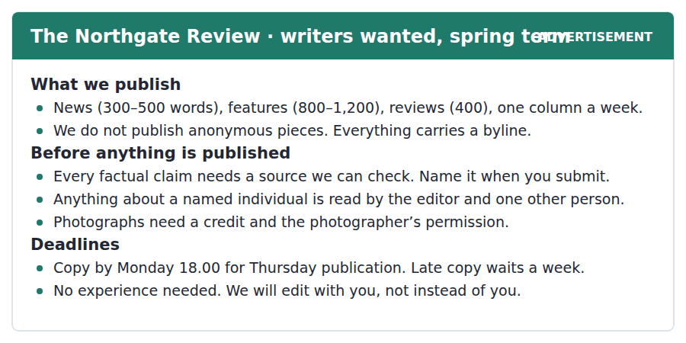
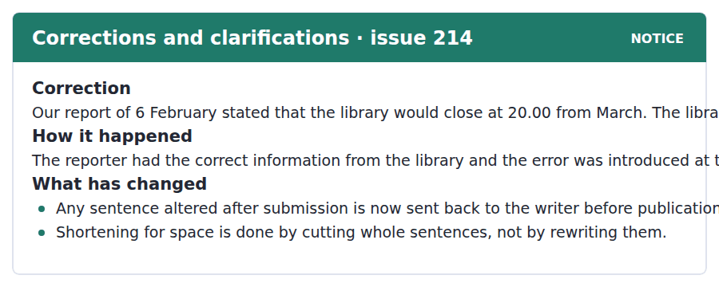
Exercise A Guided practice. The answer is on the page — find it.
1. How long is a news piece?
(A) 400 words
(B) 800–1,200 words
(C) 300–500 words
(D) One column
2. What does the paper never publish?
(A) Reviews
(B) Photographs
(C) Columns
(D) Anonymous pieces
3. What does every factual claim need?
(A) A source the paper can check
(B) A photograph
(C) An editor’s approval
(D) A second writer
4. When must copy be submitted?
(A) Thursday at six
(B) Monday at six
(C) Friday
(D) Any day
Exercise B Exam practice.
5. What was wrong in the report of 6 February?
(A) The date of the change
(B) The name of the library
(C) The closing time and when it applies
(D) The reporter’s byline
6. Where was the error introduced?
(A) By the library
(B) By the reporter
(C) By the printer
(D) At the editing stage
7. What is the first change the paper has made?
(A) Shorter news pieces
(B) Altered sentences go back to the writer
(C) Two editors read everything
(D) No vacation reporting
8. How will pieces now be shortened?
(A) By cutting whole sentences
(B) By rewriting sentences
(C) By reducing the print run
(D) By removing photographs
9. What does a piece about a named individual require?
(A) A photograph
(B) A longer word count
(C) Two readers before publication
(D) The individual’s approval
10. What can be inferred about the paper’s attitude to new writers?
(A) It prefers experienced ones
(B) It pays them
(C) It publishes them anonymously
(D) It is willing to train them


SKILL · Follow a finding into its consequence
- A research passage that ends in a practical conclusion is testing whether you followed the chain.
- Watch for the explanation the researchers favoured — it marks a claim that is argued, not proved.
- An emotional or behavioural pattern given as support is always tested.
- The last sentence usually distinguishes two purposes. Note both.

Why a False Story Travels Faster Than a Correction
A large study of rumours on social media found that false stories reached more people, reached them faster, and spread further through the network than true ones. The effect was not small, and it was not caused by automated accounts: it held when those were removed. Human beings were doing the spreading.
The explanation the researchers favoured was novelty. A false story is not constrained by what happened, so it can be more surprising than a true one, and surprise is what makes people pass something on. The emotional pattern supported this: replies to false stories showed more surprise and disgust, while replies to true ones showed more sadness and trust. Nobody in the study appeared to be lying. They were forwarding what struck them.
The structural problem follows. A correction is, by definition, less surprising than the story it corrects, and it arrives later, at an audience that has already moved on. It also carries a cost the original did not: reading it requires admitting that you believed something false, which is why corrections are shared most by people who never believed the story in the first place. The practical conclusion is uncomfortable for anybody who writes them. A correction cannot undo a false story. It can only make the record right, which is worth doing for a different reason entirely.
[280 words]

Exercise A Guided practice.
1. What is the passage mainly about?
(A) Why automated accounts spread rumours
(B) Why false stories spread further and what that means for corrections
(C) How social media networks are built
(D) Why people lie online
2. What was NOT the cause of the effect?
(A) Automated accounts
(B) Novelty
(C) Surprise
(D) Human sharing
3. What explanation did the researchers favour?
(A) Novelty
(B) Dishonesty
(C) Network size
(D) Political bias
4. What emotions appeared in replies to false stories?
(A) Sadness and trust
(B) Anger and fear
(C) Amusement and doubt
(D) Surprise and disgust
Exercise B Exam practice.
5. Why is a correction less surprising than the story it corrects?
(A) It is shorter
(B) It is constrained by what actually happened
(C) It is published later
(D) It has no headline
6. What cost does reading a correction carry?
(A) It takes time
(B) It is usually behind a paywall
(C) It requires admitting you believed something false
(D) It is written badly
7. Who shares corrections most?
(A) People who believed the story
(B) People who never believed it
(C) Journalists
(D) Automated accounts
8. All of the following are stated in the study EXCEPT:
(A) They were mostly spread by automated accounts
(B) False stories reached more people
(C) They spread faster
(D) They spread further through the network
9. What does the author say a correction cannot do?
(A) Reach the original audience
(B) Be written quickly
(C) Be verified
(D) Undo a false story
10. What is the "different reason entirely"?
(A) To attract readers
(B) To protect the newspaper
(C) To correct the record rather than to change minds
(D) To satisfy the editor
11. Which best states the main idea of paragraph 2?
(A) People lie frequently online
(B) Emotions cannot be measured
(C) Novelty, not dishonesty, explains the spread
(D) Disgust spreads faster than sadness


Exercise A Listen and choose a response. You hear one line. Choose the best reply.
1. Woman: Have you got a second source?
(A) By Monday at six.
(B) Three hundred words.
(C) Yes, it is checked.
(D) Only one so far.
2. Man: Can we run it anonymously?
(A) No — everything carries a byline.
(B) It is a news piece.
(C) On Thursday.
(D) Yes, if it is short.
3. Woman: What if we are wrong?
(A) Five hundred words.
(B) Then we print a correction.
(C) By Monday.
(D) Yes, we might be.
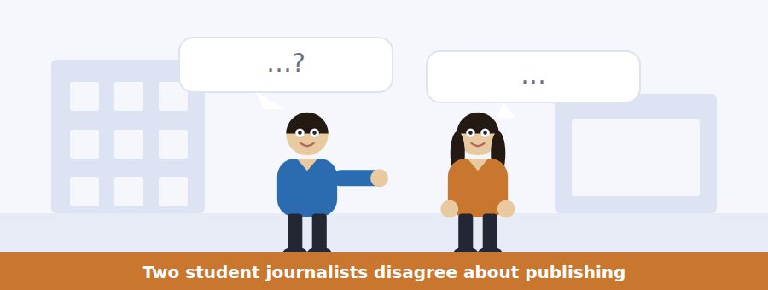
SKILL · Hold both positions in mind
- The last listening of the course: both speakers have a real argument.
- Note what each one concedes. Concessions are tested as often as claims.
- The resolution may be a compromise rather than a winner.
- The final two lines carry the decision.

Exercise B Listen and answer. The audio plays once.
4. What is the disagreement about?
(A) Whether the story is interesting
(B) Who should write it
(C) Whether there is enough sourcing to publish
(D) How long it should be
5. Why does the woman question the source?
(A) She was not at the meeting
(B) She has an interest in the outcome
(C) She has been wrong before
(D) She asked to remain anonymous
6. What is the man’s argument for publishing now?
(A) The deadline is Monday
(B) The editor has approved it
(C) The story will expire
(D) Another paper may publish first
7. What does the woman concede?
(A) That her position is comfortable
(B) That the source is unreliable
(C) That the story is unimportant
(D) That the Gazette is better
8. Why does the woman mention issue 214?
(A) To blame the editor
(B) To explain the word limit
(C) To praise the reporter
(D) To show how long a correction takes to resolve
9. What do they agree to do?
(A) Wait for the second source
(B) Publish everything on Thursday
(C) Publish only what is verified and hold the rest
(D) Let the Gazette run it
Audio script: see the back of the book. Do not read it before you listen.


Exercise A Listen and choose a response. You hear one line. Choose the best reply.
1. Man: When is copy due?
(A) Thursday.
(B) Monday at six.
(C) Three hundred words.
(D) Yes, every week.
2. Woman: Do I need a source for everything?
(A) For every factual claim.
(B) On Thursday.
(C) Five hundred words.
(D) Yes, a byline.
3. Man: What if the editor changes my sentence?
(A) By Monday at six.
(B) It comes back to you first.
(C) Whole sentences only.
(D) Yes, they might.
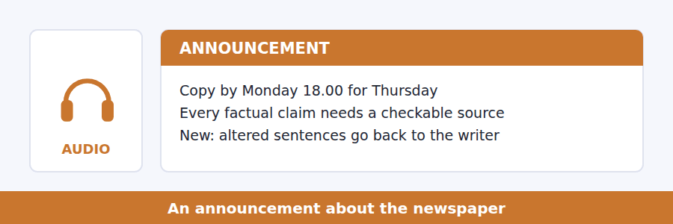
SKILL · The last announcement: expect everything
- Deadlines, rules, a change, a reason and a closing instruction.
- A change introduced because of a past mistake is always tested.
- Note what is now required that was not before.
- The final sentence usually tells you what to do if you want to join in.

Exercise B Listen and answer. The audio plays once.
4. What happens to copy submitted after Monday at six?
(A) It is published anyway
(B) It is shortened
(C) It loses its byline
(D) It waits a week
5. When must a source be named?
(A) When somebody asks
(B) Before Thursday
(C) When you submit
(D) Only for named individuals
6. Why is a piece about an individual read twice?
(A) Two people are harder to fool than one
(B) The writer may be inexperienced
(C) The editor is often away
(D) It is a legal requirement
7. Where did the issue 214 error come from?
(A) The library
(B) The shortening of a sentence at editing
(C) The reporter
(D) The printer
8. What is now done when a piece is too long?
(A) Sentences are rewritten
(B) The piece is held a week
(C) Whole sentences are cut
(D) The writer rewrites it
Audio script: see the back of the book. Do not read it before you listen.


Exercise A Listen and choose a response. You hear one line. Choose the best reply.
1. Man: Was it caused by bots?
(A) About six times faster.
(B) On social media.
(C) Yes, mostly.
(D) No — it held without them.
2. Woman: Why do people share false stories?
(A) Because they are surprising.
(B) About seventy thousand.
(C) In the study.
(D) Yes, they do.
3. Man: Does a correction work?
(A) By Thursday.
(B) It makes the record right.
(C) Six times faster.
(D) Yes, completely.
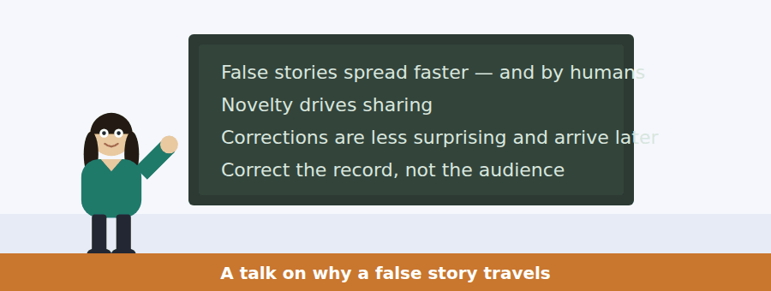
SKILL · The last talk: a finding, a mechanism and a conclusion
- Expect all three, in that order, and expect the conclusion to be uncomfortable.
- A figure given once carries the argument.
- The speaker may reject an explanation before offering one. Note which is rejected.
- The last sentence is what the whole course has been building towards.

Exercise B Listen and answer. The audio plays once.
4. What is the main idea of the talk?
(A) Social media should be regulated
(B) Automated accounts cause misinformation
(C) False stories spread further for reasons that make corrections ineffective at changing minds
(D) People lie more than they admit
5. What did the researchers rule out?
(A) Automated accounts
(B) Novelty
(C) Emotion
(D) Network size
6. What explanation do the authors favour?
(A) Dishonesty
(B) Political bias
(C) Network structure
(D) Novelty
7. What emotions surrounded true stories?
(A) Surprise and disgust
(B) Sadness and trust
(C) Anger and fear
(D) Amusement and doubt
8. Why does reading a correction cost something?
(A) It takes time
(B) It is usually long
(C) It is hard to find
(D) You must accept you believed something untrue
9. What does the speaker say a correction is for?
(A) Making the record right
(B) Changing the minds of everybody who read the original
(C) Protecting the publication
(D) Attracting new readers
Audio script: see the back of the book. Do not read it before you listen.


Part 1 · Listen and Repeat
You hear a sentence and repeat it once. There is no preparation time, and the sentences get longer. Focus: contrast linkers
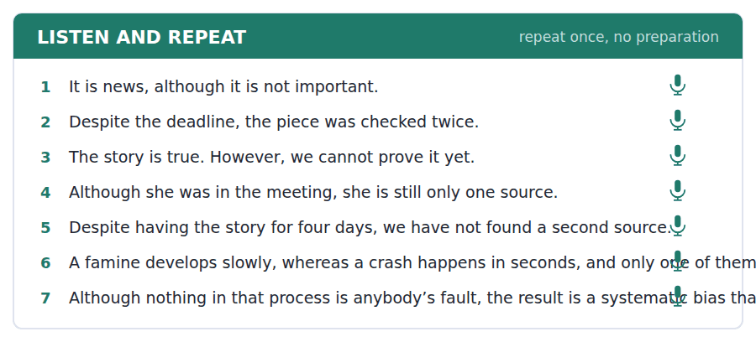
SKILL · Mark the turn with your voice
- A slight rise before although and however tells the listener a turn is coming.
- Despite is followed by a noun or -ing, never by a clause.
- Do not pause after however in the middle of a sentence.
- Finish the contrast. An abandoned although is the commonest slip.

Part 2 · Take an Interview
An interviewer asks you four questions on one theme: where you get your news. Answer each one fully. There is no preparation time.
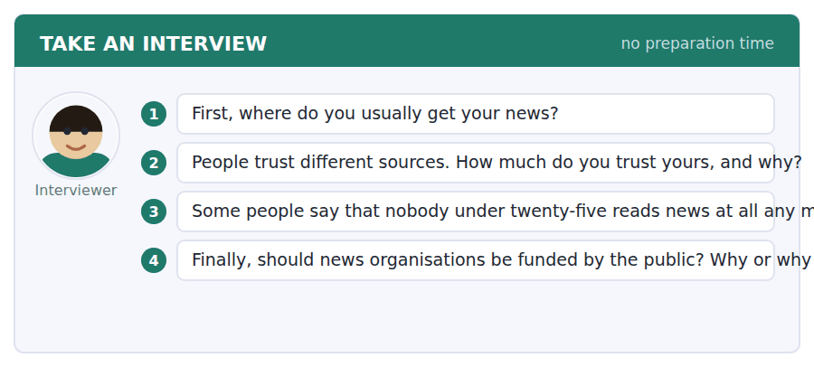
A good answer sounds like this
Question 2 — Not very much, although I keep reading it, which is probably the strangest part of the arrangement.
Question 3 — I disagree. They read a great deal of news; they do not read newspapers, and people keep treating those as the same claim.
I can… | Not yet | Yes
I marked the contrast with my voice | □ | □
I used despite with a noun or -ing | □ | □
I finished every contrast I started | □ | □


Part 1 · Listen and Repeat
You hear a sentence and repeat it once. There is no preparation time, and the sentences get longer. Focus: conceding before arguing
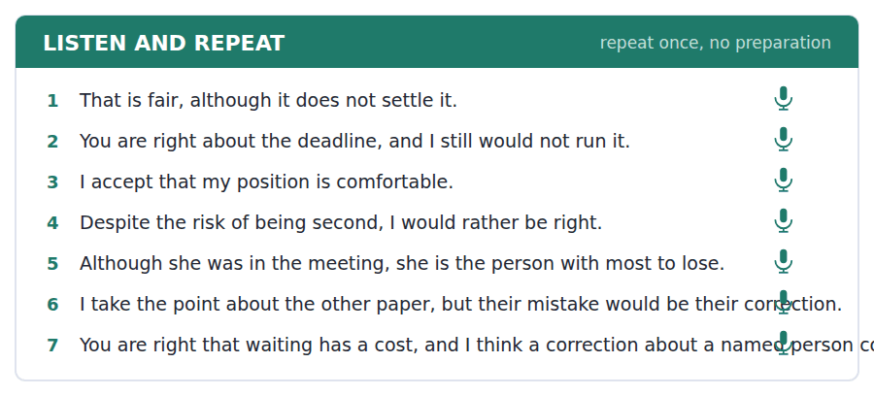
SKILL · Give ground, then take it back
- I accept that… but… / That is fair, although… / You are right, and yet…
- Concede something real. Conceding nothing sounds evasive.
- The argument after the concession must be stronger than the concession.
- One concession, one counter-argument, one reason.

Part 2 · Take an Interview
An interviewer asks you four questions on one theme: disagreement and how you handle it. Answer each one fully. There is no preparation time.
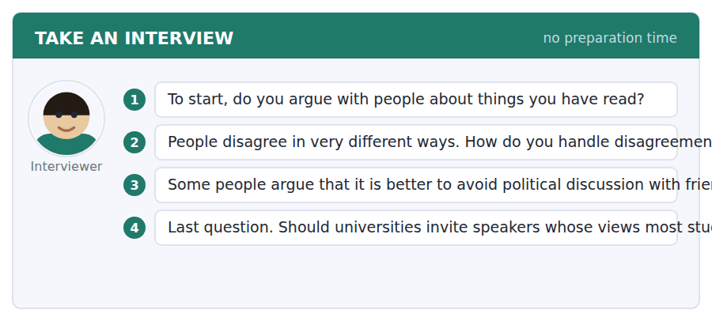
A good answer sounds like this
Question 2 — I concede too early, usually. It keeps the peace and it means I rarely find out whether I was right.
Question 4 — Yes, although not any speaker and not without a format. A lecture with no questions is not a discussion; it is a platform.
I can… | Not yet | Yes
I conceded something real before arguing | □ | □
My counter-argument was stronger than the concession | □ | □
I gave one clear reason | □ | □


Part 1 · Listen and Repeat
You hear a sentence and repeat it once. There is no preparation time, and the sentences get longer. Focus: academic register
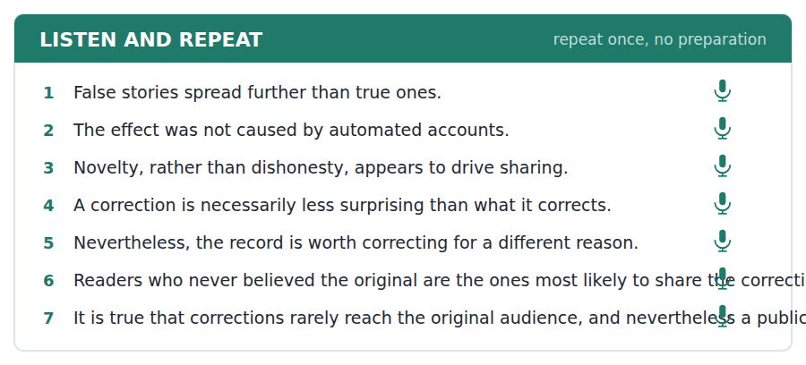
SKILL · The last speaking page of the course
- Use the unit’s words: source, bias, cite, controversy, nevertheless.
- Report the finding, name the mechanism, state the consequence.
- Hold two things at once: it is true that… and nevertheless…
- Mark yourself against the three statements below.

Part 2 · Take an Interview
An interviewer asks you four questions on one theme: information and who you believe. Answer each one fully. There is no preparation time.
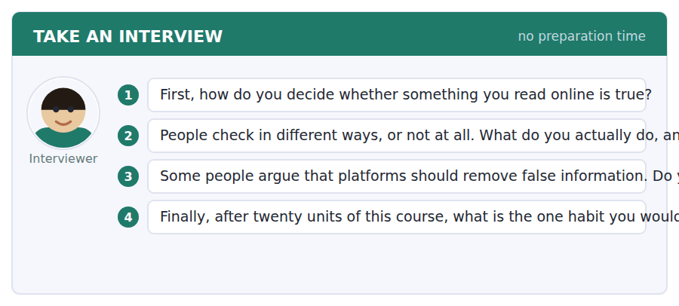
A good answer sounds like this
Question 3 — It is true that removal stops the spread, and nevertheless somebody has to decide what is false, and that decision is itself a source of bias.
Question 4 — Checking who is telling me something before I decide whether I believe it. Everything else in this course follows from that one question.
I can… | Not yet | Yes
I used at least three academic words from this unit | □ | □
I held two things at once with nevertheless | □ | □
My last answer had an opinion, a reason and an example | □ | □


You see a sentence, then a set of words in boxes. Put the words in order to make one grammatical sentence. Almost every item in the real test makes a question or a question inside another sentence.
SKILL · The pre-test audit
- These ten items use every frame the course has taught: direct questions, embedded, reported, relative clauses.
- Identify the frame before you order the tiles. The frame decides the order.
- If a tile says whether, if, who or that, the frame is already decided for you.
- Use every tile exactly once. This is the last practice before the test.

Exercise A Guided practice. The first three are worked through.
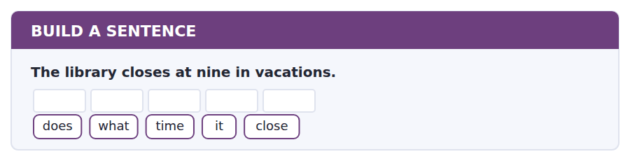
1. What time does it close?
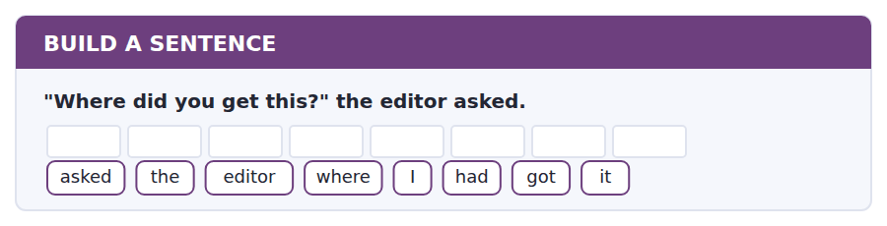
2. The editor asked where I had got it.
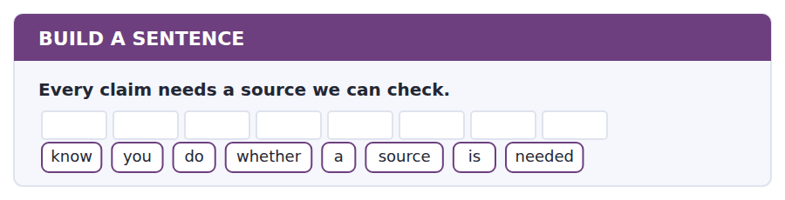
3. Do you know whether a source is needed?
Exercise B Exam practice. Write the sentence.
4. Copy is due on Monday at six.
tell / can / you / me / when / copy / is / due
__________________________________________________________
5. The reporter who wrote it was not at fault.
the / reporter / who / wrote / it / was / not / at / fault
__________________________________________________________
6. False stories spread faster than true ones.
spread / which / stories / faster
__________________________________________________________
7. "Will you run it on Thursday?" she asked.
asked / she / whether / we / would / run / it
__________________________________________________________
8. The error appeared when a sentence was shortened.
know / do / you / how / the / error / appeared
__________________________________________________________
9. Anonymous pieces are never published.
are / why / anonymous / pieces / rejected
__________________________________________________________
10. A correction makes the record right.
tell / can / you / me / what / a / correction / achieves
__________________________________________________________


You read a short situation and write an email. You have 7 minutes. The three bullet points are the mark scheme: answer all three.
You want to write for the student newspaper. You have no journalism experience but you have a specific story: the library’s vacation opening times have changed twice this year and nobody has reported why. You are not sure what counts as a checkable source.
Write an email to the editor.
- Offer to write and say what you want to write about.
- Be honest about your experience.
- Ask the question you need answered before you start.
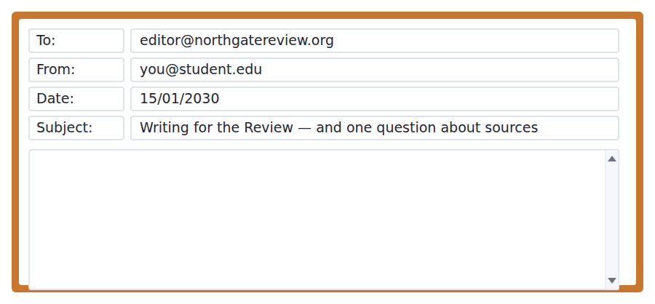
SKILL · Offer a story, not availability
- I would like to write is weak. I would like to write about X is a proposal.
- Say what you already know and what you would have to find out.
- Ask one question, and make it specific enough to answer in a line.
- Seven minutes. 110–140 words. This is the last email practice before the test.

Model email
Dear Editor,
I would like to write for the Review. I have a specific story in mind: the library’s vacation opening times have changed twice since October, and as far as I can find nobody has reported why. I think it is a news piece rather than a feature, so around four hundred words.
I should say that I have never written for a newspaper. I read the note saying that no experience is needed and that the first piece is edited with the writer, which is the reason I am writing at all.
One question before I start. Would an email from the library office count as a checkable source, or do you need something published? I would rather ask now than submit something you cannot use.
I will come to the Tuesday meeting.
Hana Ozdemir
Why it works
- The story comes before the offer, which turns an availability email into a proposal.
- The length is proposed, with a reason, so the editor can agree or correct it in one word.
- The inexperience is stated and immediately tied to the paper’s own policy, which turns a weakness into evidence that the notice was read.
- The question is specific, offers two alternatives, and explains why asking now saves work later.
Now write your own. 7 minutes.
__________________________________________________________
__________________________________________________________
__________________________________________________________
__________________________________________________________
__________________________________________________________
__________________________________________________________
__________________________________________________________
__________________________________________________________


A professor asks a question and two students answer. You add your own post. You have 10 minutes and an effective answer is at least 100 words.
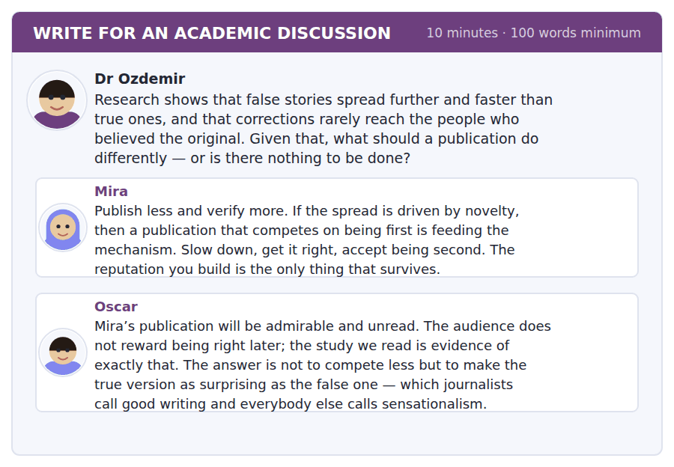
SKILL · The last discussion of the course
- Everything is here: name a classmate, take the strong version, make a distinction, use the evidence.
- Both posts are good. Say what each gets right before you go past them.
- Finish with something you would actually do.
- At least 100 words in ten minutes.

Sentence starters
- Mira is right about the mechanism and Oscar is right about the audience:…
- The study supports Oscar more than he realises, because…
- What neither post separates is… and…
- So I would…, and I would stop…
Model post
Mira is right about the mechanism and Oscar is right about the audience, and the study supports Oscar slightly more than he realises.
The finding was that novelty drives sharing and that corrections arrive later, less surprising, and carrying a cost to the reader. Mira’s answer accepts all of that and then asks a publication to behave as though it were not true. That is a position with integrity and no readers.
But Oscar’s answer blurs two things. Making a true story vivid is not the same as making it surprising, and only the second one competes with falsehood. A true story can be told well without being stretched, and the moment it is stretched it is carrying the same defect as the story it was meant to replace.
So I would write true stories as well as anybody writes false ones, and I would stop treating corrections as damage control. Publish them as their own small stories, with the reason the error happened, as the Review did after issue 214. That is surprising, it is true, and it is the only version of a correction anybody reads.
[197 words]
Now write your own. 10 minutes, at least 100 words.
__________________________________________________________
__________________________________________________________
__________________________________________________________
__________________________________________________________
__________________________________________________________
__________________________________________________________
__________________________________________________________
__________________________________________________________
__________________________________________________________
__________________________________________________________

Grammar focus although, however, despite
Form | Example
although / though + clause | Although she was there, she is one source.
even though (stronger) | Even though we had it first, we waited.
However, + sentence | The story is true. However, we cannot prove it.
despite / in spite of + noun | Despite the deadline, it was checked.
despite / in spite of + -ing | Despite having it for four days…
despite the fact that + clause | Despite the fact that she was there…
whereas (direct contrast) | A famine is slow, whereas a crash is instant.

Although joins two clauses inside one sentence. However joins two sentences and takes a comma after it. They are not interchangeable.
Despite and in spite of are prepositions, so they take a noun or an -ing form, never a clause. If you need a clause, use despite the fact that, or just use although.
Whereas marks a direct contrast between two balanced facts, not a concession. A famine is slow, whereas a crash is instant — neither is surprising given the other.
Watch out! Never write *despite she was there* or *although of the deadline*. Despite takes a noun; although takes a clause. This is the single commonest error in B1 discussion writing.
Exercise 1 Complete with although, however, despite or whereas.
1. __________ she was in the meeting, she is only one source.
2. The story may be true. __________, we cannot prove it yet.
3. __________ the deadline, the piece was checked twice.
4. A famine develops slowly, __________ a crash happens in seconds.
5. __________ having the story for four days, we have no second source.
6. We waited, __________ the other paper did not.
Exercise 2 Rewrite using the word in brackets.
1. She was in the meeting but she is one source. (although) →
2. We had it for four days but we did not run it. (despite) →
3. The story is good. We cannot prove it. (however) →
4. False stories spread fast. True ones do not. (whereas) →
Exercise 3 Correct the mistake in each sentence.
1. Despite she was in the meeting, she is one source.
2. Although of the deadline, we checked it twice.
3. The story is true, however we cannot prove it.
How this is tested in Build a Sentence
The last Build a Sentence page mixes every frame in the course. Concession rarely appears in the task itself, but it appears in every good discussion post you will write in the test, which is where the marks for this unit actually land.

Unit review and progress check Unit 20
Exercise A Vocabulary. Write the word.
1. where information comes from
2. an unfair preference for one side
3. to quote or refer to a source
4. a long public disagreement
5. to say something is not true
6. to refuse to accept
7. to stop something temporarily
8. a basic structure of ideas or rules
9. simple and clear
10. in spite of that
11. a published statement that something was wrong
12. to verify claims before publishing
Exercise B Grammar. Complete the sentence.
1. __________ she was in the meeting, she is one source.
2. The story may be true. __________, we cannot prove it.
3. __________ the deadline, the piece was checked twice.
4. A famine is slow, __________ a crash is instant.
5. __________ (despite) having it for four days, we waited.
6. __________ (although / despite) the risk, we published.
7. We waited; __________, the other paper did not.
8. __________ the fact that she was there, she is one source.
Exercise C One timed mini-section. 6 minutes.
1. According to the passage on page 170, false stories spread further because
(A) automated accounts share them
(B) they are shorter
(C) they are more surprising
(D) they are published first
2. In the talk, a correction is published in order to
(A) change the minds of everybody who read the original
(B) make the record right
(C) attract readers
(D) protect the publication
3. Which sentence is correct?
(A) Despite she was there, she is one source.
(B) Although of the deadline, we checked it.
(C) The story is true, however we cannot prove it.
(D) Despite the deadline, we checked it twice.
4. A piece about a named individual at the Review is read by
(A) the writer only
(B) the editor only
(C) the editor and one other person
(D) the whole team
5. Across the whole course, Build a Sentence has used
(A) three frames
(B) one frame
(C) two frames
(D) five frames
6. Before Practice Test 2 you should revisit
(A) the adaptive tips from every unit
(B) the glossary only
(C) Unit 1 only
(D) nothing
Can you do these now?
I can… | Not yet | Yes
complete word endings in a text about how news is produced | □ | □
read a call for writers and a correction notice and find what applies to me | □ | □
follow a passage that explains why a false story spreads | □ | □
understand two people disagreeing about whether to publish | □ | □
concede a point out loud and then argue past it | □ | □
write an email offering to contribute, and a post that holds two things at once | □ | □

ADAPTIVE TIP The whole-course tip list is reprinted before Practice Test 2. Read it in one sitting: twenty short paragraphs about how the test behaves, which is the part most candidates meet for the first time on the day. **Volume 2 ends here.**

Practice Test 2
The full 2026 shape: 97 items, in the order the real test asks them
Reading 40 · Listening 34 · Writing 12 · Speaking 11
Sit this in one sitting. Do not look anything up. Mark it with the key at the back, then read the explanations — they matter more than the score.

Reading Section, Module 1 In an actual test the clock shows you how long you have
You can use Next and Back to move between questions inside this module.
Fill in the missing letters in the paragraph. (Questions 1–10)
Before the 1950s an archaeologist could say that one layer of a site was old-- than another, but not how old either of them was. Dating depended on objects whose age was already kn---: a coin with an emperor on it, a pot of a style that had been traced elsew----. A site with no such object was almost sil---. Then came radiocarbon dating, which measures the carbon left in anything that was once ali--. Suddenly a handful of charcoal from a fire was as useful as a coin, and whole peri--- had to be rewritten. Some dates moved by centu----. The method is not per----: it needs organic material, it has a margin of er---, and it stops working beyond about fifty thousand years. But it changed the ques----- archaeologists were able to ask.

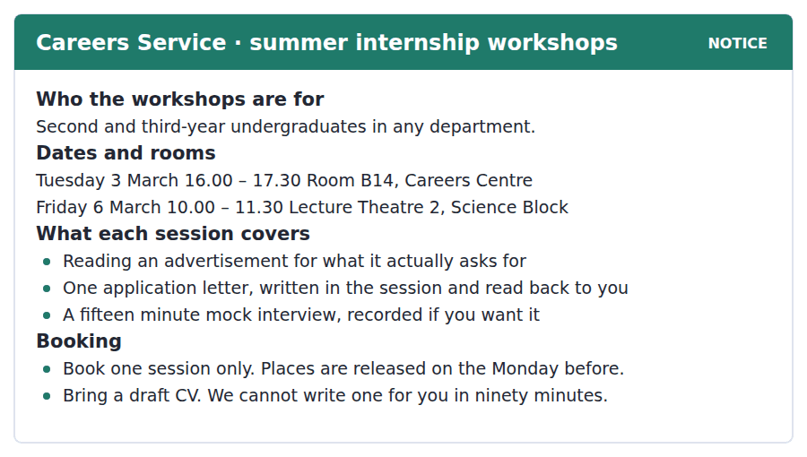
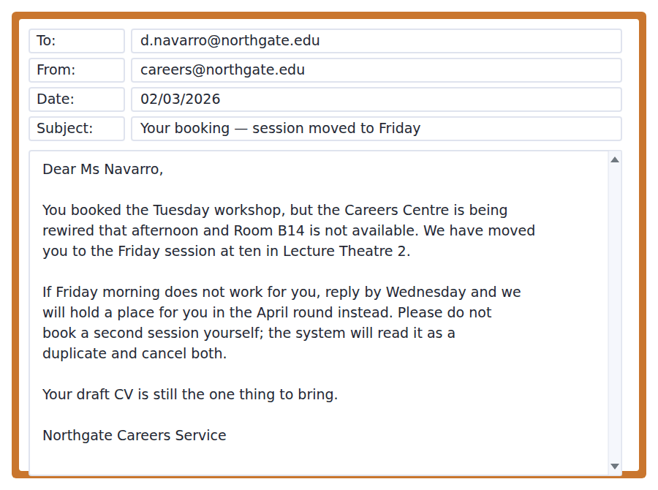
11. Who may attend the workshops?
(A) Students in any department in years two and three
(B) First-year students only
(C) Science students only
(D) Postgraduates
12. What are students asked to bring?
(A) A recording device
(B) A letter of application
(C) A job advertisement
(D) A draft CV
13. Why has Ms Navarro’s session been changed?
(A) She booked twice
(B) The workshop is full
(C) The room is unavailable because of building work
(D) The Tuesday session was cancelled for everyone
14. What should Ms Navarro do if Friday does not suit her?
(A) Book another session online
(B) Reply by Wednesday
(C) Attend the April round without replying
(D) Contact Room B14
15. Why is she told not to book a second session?
(A) Places have run out
(B) It would be read as a duplicate and cancel both
(C) Only staff can book
(D) The system closes on Monday
The Loudness War
A recording has a fixed ceiling. Whatever the music, the loudest moment cannot go past the maximum the format allows, so the only way to make a track sound louder is to raise the quiet parts towards that ceiling. Engineers do this with compression, and for about thirty years they did it harder every decade.
The reason was competition rather than taste. A track that sounded louder than the one before it on the radio seemed to listeners to be better produced, and nobody wanted to be the quiet record in a playlist. By the late 1990s some albums were mastered so close to the ceiling that the difference between the softest and the loudest passage had almost disappeared. A famous example from 2008 was released in two versions, and many buyers preferred the quieter one that came with a video game.
What ended the practice was not an argument about music. Streaming services began to normalise volume automatically, turning every track down to the same perceived level before it was played. A heavily compressed track no longer sounds louder than anything else; it simply sounds flat, because the loud moments it gave away cannot be returned. The incentive reversed overnight, and dynamic range has been recovering ever since. The lesson is a general one about competition: a race that everybody can enter is a race that nobody wins.
[272 words]

16. What is the passage mainly about?
(A) How compression works in a recording studio
(B) Why listeners prefer loud music
(C) How streaming services choose what to play
(D) Why recordings became louder and then stopped
17. According to the passage, why can a track not simply be made louder?
(A) Listeners would object
(B) Compression is expensive
(C) The format has a fixed maximum
(D) Radio stations limit it
18. The word "ceiling" in the passage is closest in meaning to
(A) upper limit
(B) recording studio
(C) average level
(D) starting point
19. Why does the author mention the album released in two versions?
(A) To show that compression improves sound
(B) To explain how video games use music
(C) To give an example of how far the practice had gone
(D) To compare two recording formats
20. Why does normalisation remove the incentive to compress?
(A) A compressed track is turned down to the same level as any other
(B) Streaming services reject compressed tracks
(C) Compression is now done automatically
(D) Listeners can set their own volume

Reading Section, Module 2 In an actual test the clock shows you how long you have
You cannot return to Module 1 once Module 2 has begun.
You can use Next and Back to move between questions inside this module.
Fill in the missing letters in the paragraph. (Questions 1–10)
A city can be measured by how far its people have to tra--- to do ordinary things. Planners call the comfortable version the fifteen minute city: a place where a school, a shop, a doctor and a park are all within a short w--- or cycle. The idea is not n--: it describes most European towns before the car. What is new is having to design it back in deli--------. Twentieth century planning separated functions on pur----, putting housing in one zone, work in anot---, and shopping in a third, and then conn------ them with roads. That worked while driving was ch--- and the roads were empty. It works bad-- now. Bringing the functions back together is slow, because it means changing rules that were written to keep them ap---.

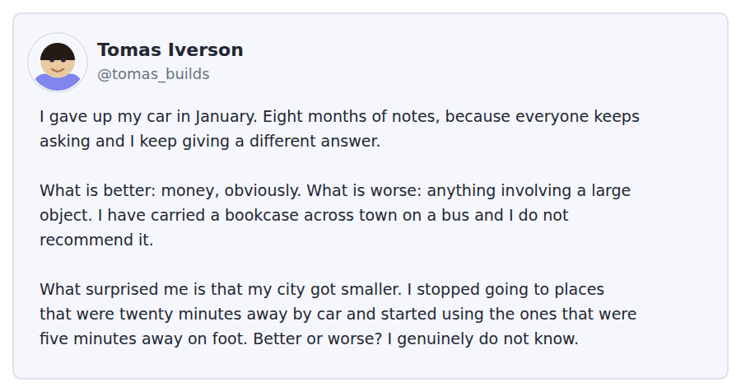
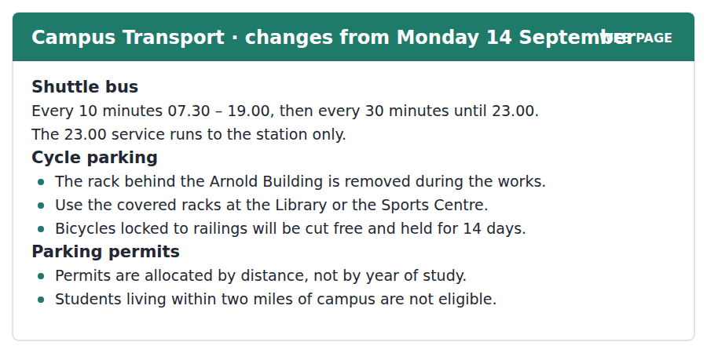
11. What is the main purpose of Tomas’s post?
(A) To persuade readers to give up driving
(B) To report what changed after he stopped driving
(C) To complain about public transport
(D) To sell a bookcase
12. What does Tomas say is worse without a car?
(A) The cost
(B) The time it takes
(C) Travelling at night
(D) Journeys involving something large
13. What surprised Tomas?
(A) How much money he saved
(B) That buses were faster
(C) That he used places closer to home
(D) That he missed driving
14. How often does the shuttle bus run at 8 p.m.?
(A) Every 30 minutes
(B) Every 10 minutes
(C) Every 15 minutes
(D) It does not run
15. Who cannot get a parking permit?
(A) First-year students
(B) Students living within two miles of campus
(C) Students who cycle
(D) Students using the shuttle
Why Animals Play
Play is expensive. A young animal that chases, wrestles or leaps is burning energy it could store, making noise a predator can hear, and risking injury for no immediate return. Behaviour that costly does not usually survive, which is why biologists treat play as a problem to be explained rather than an obvious pleasure.
The oldest explanation is practice. A kitten stalking a leaf is rehearsing a hunt, and a young deer running in circles is training the muscles it will need to escape. The difficulty is that animals deprived of play often hunt and run perfectly well as adults. What they do badly is something else: they handle surprises poorly, and they fail at the social parts of their lives. A rat raised without play can fight, but it cannot tell when a fight has stopped being a game.
The current view is therefore closer to flexibility than to skill. Play puts an animal into situations it does not control, on purpose and at low cost, and what it learns is how to recover. This also explains the pattern across species. Play is common in animals with long childhoods and complicated social lives, and rare in animals that must function almost immediately after birth. An animal with no time to be bad at things does not play, and an animal that will need to improvise does.
[268 words]

16. Which of the following best states a main idea of the passage?
(A) Play teaches animals the physical skills they will need as adults
(B) Play is a form of pleasure that has no biological purpose
(C) Play is found in all young animals
(D) Play is a way of learning to deal with situations an animal does not control
17. Why does the author call play "expensive"?
(A) It requires adult supervision
(B) It takes time away from feeding
(C) It is only possible in large groups
(D) It uses energy and carries risk for no immediate return
18. What problem is identified with the practice explanation?
(A) Young animals do not play enough to practise
(B) Practice cannot be measured
(C) Animals deprived of play still hunt and run well
(D) Adults also play
19. What is said about a rat raised without play?
(A) It cannot fight
(B) It cannot tell when a fight is no longer a game
(C) It avoids other rats
(D) It is physically weak
20. What can be inferred about an animal that must function immediately after birth?
(A) It is unlikely to play
(B) It plays more than other animals
(C) It learns to play as an adult
(D) It plays only with its parents

Listening Section, Module 1 You will not be able to return to previous questions
Choose the best response.
1. Man: Where did you put the lab notebook?
(A) About two hours.
(B) I wrote it up yesterday.
(C) On the shelf above your desk.
(D) Yes, I have it.
2. Woman: Haven’t you handed in the assignment yet?
(A) It was a long assignment.
(B) Yes, it was due last week.
(C) I don’t have that class.
(D) No, I’m finishing the last section tonight.
3. Woman: The printer in the lab is out of paper again.
(A) I’ll get some from the store cupboard.
(B) It prints in colour.
(C) About thirty pages.
(D) Yes, I printed it.
4. Man: Could you tell me how the referencing system works?
(A) It’s on the third floor.
(B) There’s a guide on the library site I can send you.
(C) Yes, I referenced it.
(D) I didn’t read that one.
5. Man: I’m afraid the data from Tuesday is unusable.
(A) Tuesday is fine for me.
(B) That’s a shame — can we run it again?
(C) No, I don’t mind.
(D) It was very useful.
6. Woman: Who is supervising your project?
(A) Next semester.
(B) In the biology department.
(C) Dr Haddad, in the biology department.
(D) It’s about animal behaviour.
7. Woman: So the seminar has been moved to Thursday?
(A) Yes, I attended it.
(B) Yes, Thursday is a busy day.
(C) Yes, it lasted two hours.
(D) Yes, and to a bigger room.
8. Man: If you want, I can look over your draft.
(A) That would really help — are you free Friday?
(B) I looked over it twice.
(C) You’ve asked a lot of questions.
(D) No, the draft is long.
Listen to a conversation.

9. What is the man’s problem?
(A) He is not interested in the topic
(B) He has not been invited
(C) He has a class until 4.30
(D) He does not know where the talk is
10. What does the woman offer to do?
(A) Record the talk
(B) Ask a question on his behalf
(C) Change the time of the talk
(D) Lend him her notes
Listen to a conversation.
11. Why is the man concerned?
(A) Only eleven students have enrolled
(B) The module has too many students
(C) The module has been cancelled
(D) He cannot find a room
12. What explanation does the woman suggest?
(A) The module is too difficult
(B) Students are not interested in the subject
(C) It was advertised too late
(D) It clashes with a compulsory course
Listen to an announcement.
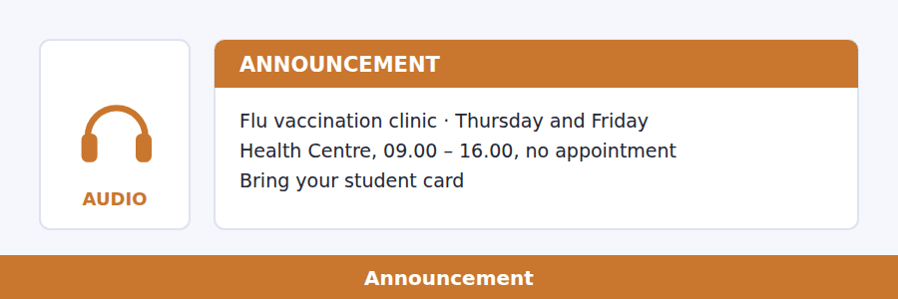
13. What is the announcement mainly about?
(A) A change to Health Centre opening hours
(B) A flu outbreak on campus
(C) A vaccination clinic
(D) A new charge for health services
14. What does the speaker advise students who have recently had flu to do?
(A) Speak to a nurse before queueing
(B) Come on Friday instead
(C) Make an appointment
(D) Avoid the clinic entirely
Listen to a talk.
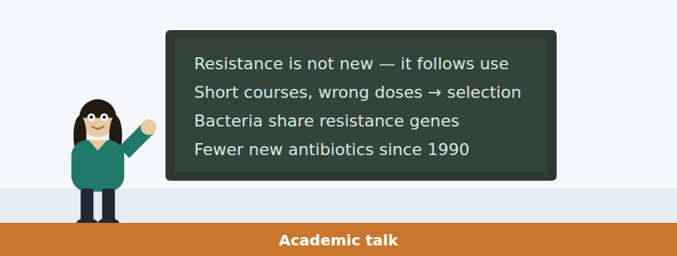
15. What is the main point of the talk?
(A) Penicillin is no longer effective
(B) Hospitals use antibiotics incorrectly
(C) New antibiotics are easy to develop
(D) Resistance is an expected result of antibiotic use
16. Why does the speaker mention the 1940s?
(A) To praise the discovery of penicillin
(B) To show that resistance appeared almost immediately
(C) To compare two kinds of bacteria
(D) To explain how antibiotics are made
17. What does the speaker say about stopping a course of treatment early?
(A) It has no effect on resistance
(B) It leaves the strongest bacteria with less competition
(C) It kills all the bacteria more slowly
(D) It is recommended in some cases
18. Why are few new antibiotics being developed?
(A) A drug meant to be used rarely is hard to sell
(B) The science is no longer understood
(C) Bacteria change too quickly to study
(D) Hospitals will not buy them

Listening Section, Module 2 You will not be able to return to previous questions
Choose the best response.
1. Woman: What time does the recording studio close?
(A) It’s in the music building.
(B) Yes, it’s open today.
(C) I booked it last week.
(D) At nine, but the last booking is eight.
2. Man: How many sources do we need for the essay?
(A) It’s due on Monday.
(B) I found it in the library.
(C) Six, and at least two from journals.
(D) No, I haven’t started.
3. Man: I’ve finished the slides for our presentation.
(A) The presentation is on Friday.
(B) Yes, I like presentations.
(C) That was quick — can you send them over?
(D) About fifteen minutes.
4. Woman: Would you rather present first or last?
(A) For about ten minutes.
(B) Last, if that’s allowed.
(C) Yes, I would.
(D) In the main lecture theatre.
5. Woman: I can’t find the reading list anywhere.
(A) It moved to the new course page — I’ll send the link.
(B) It’s quite a long list.
(C) Yes, I read it.
(D) There were four readings.
6. Man: Do you know whether the museum is free for students?
(A) It’s open until six.
(B) The museum is near the station.
(C) Yes, I went last year.
(D) I think so, with a student card.
7. Man: Dr Okoye said she wants to see us both on Thursday.
(A) Thursday afternoon is fine.
(B) I haven’t met her.
(C) Did she say what about?
(D) She teaches archaeology.
8. Woman: The survey results are completely different from last year’s.
(A) How many people answered this time?
(B) Yes, it was a long survey.
(C) I filled it in.
(D) Last year was better.
Listen to a conversation.
9. What has changed?
(A) The topic of the project
(B) The size of the group
(C) The survey questions
(D) The deadline has moved earlier
10. Why does the woman reject using only the survey data?
(A) The data is unreliable
(B) The interviews were meant to explain the survey
(C) There is not enough of it
(D) The survey is not finished
Listen to an announcement.
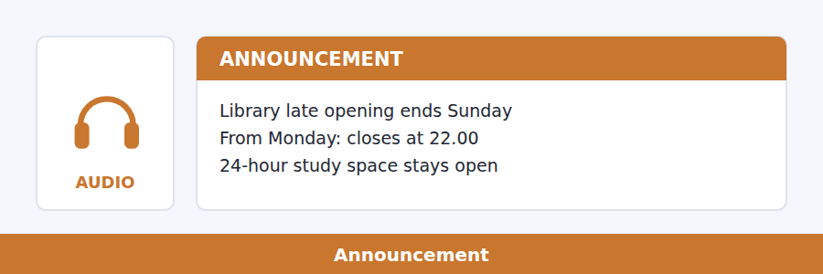
11. What is the main purpose of the notice?
(A) To explain the end of 24-hour opening
(B) To announce longer opening hours
(C) To advertise the study space
(D) To announce a new return machine
12. Why does the speaker mention the drop box?
(A) It is being moved
(B) It is for staff only
(C) It will be checked immediately
(D) It is the only way to return books after ten
Listen to a talk.
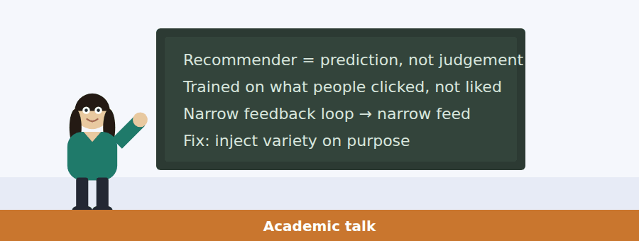
13. What is the main topic of the talk?
(A) How to build a recommendation system
(B) Why people click on misleading headlines
(C) What recommendation systems actually predict, and the problems that follow
(D) How companies measure customer satisfaction
14. What does the speaker say about the training data?
(A) It is usually too small
(B) It records behaviour that is easy to measure, not enjoyment
(C) It is collected from surveys
(D) It is deleted after use
15. Why does the speaker mention an angry headline?
(A) To criticise journalism
(B) To explain how headlines are written
(C) To give an example of poor prediction
(D) To show that the system cannot tell a valued article from a provoking one
16. Why is interrupting the loop described as a management decision?
(A) It requires new technology
(B) Engineers do not understand it
(C) It costs clicks in the short term
(D) It is illegal in some countries

Writing Section 12 questions, three types of task
Build a Sentence. Move the words to make grammatical sentences.
1. I hear the department is hiring a new lecturer.
do / you / the interviews / know / are / when
__________________________________________________________
2. The archaeology field trip is in June.
how / tell / can / me / it / you / long / lasts
__________________________________________________________
3. I have applied for the summer internship.
heard / whether / have / you / shortlisted / you / been
__________________________________________________________
4. My brother is studying in Berlin this year.
is / what / he / there / studying
__________________________________________________________
5. What did the supervisor say about your draft?
she / rewrite / asked / I / whether / could / the conclusion
__________________________________________________________
6. The concert on Saturday has sold out.
any / wonder / whether / I / will be / returns / there
__________________________________________________________
7. I would like to use the recording studio.
do / book / it / how / you
__________________________________________________________
8. Somebody called about the laboratory induction.
they / it / told / me / postponed / had been
__________________________________________________________
9. I read a very good article about city planning.
the one / was / that / it / you recommended
__________________________________________________________
10. Our presentation is first on Friday morning.
you / nervous / are / about / going first
__________________________________________________________
Write an Email. You have 7 minutes.
You booked a recording studio on campus for a group project and travelled in to use it. When you arrived, the room was locked and a sign said the booking system had been reset. Your group lost the afternoon.
Write an email to the bookings office.
- Explain which booking you had made and when.
- Describe what happened when you arrived.
- Ask what will be done about the lost session.
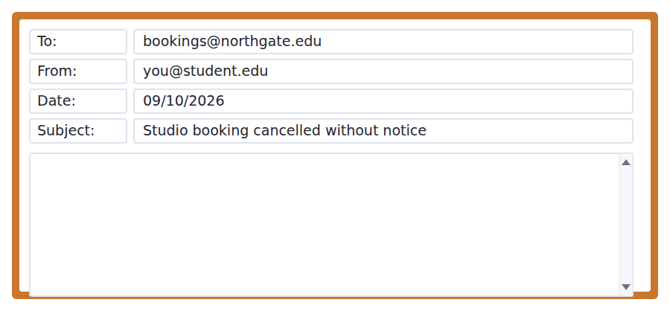
__________________________________________________________
__________________________________________________________
__________________________________________________________
__________________________________________________________
__________________________________________________________
__________________________________________________________
__________________________________________________________
__________________________________________________________
Write for an Academic Discussion. You have 10 minutes.
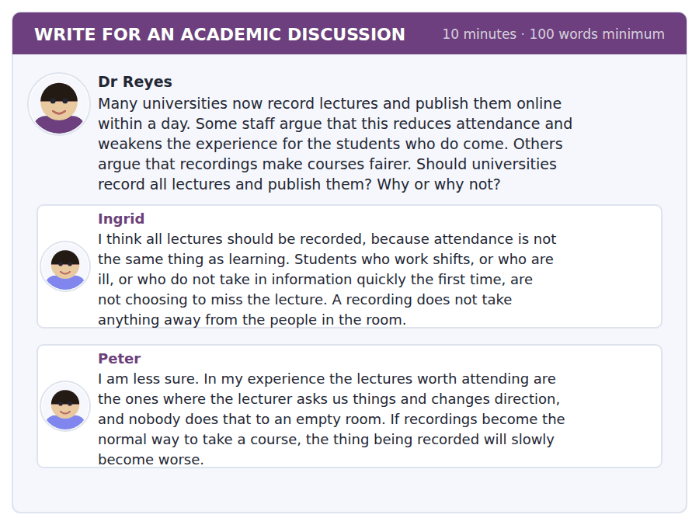
An effective response will contain at least 100 words.
__________________________________________________________
__________________________________________________________
__________________________________________________________
__________________________________________________________
__________________________________________________________
__________________________________________________________
__________________________________________________________
__________________________________________________________
__________________________________________________________
__________________________________________________________

Speaking Section 11 questions, two types of task · no preparation time
Listen and Repeat. Repeat only once.
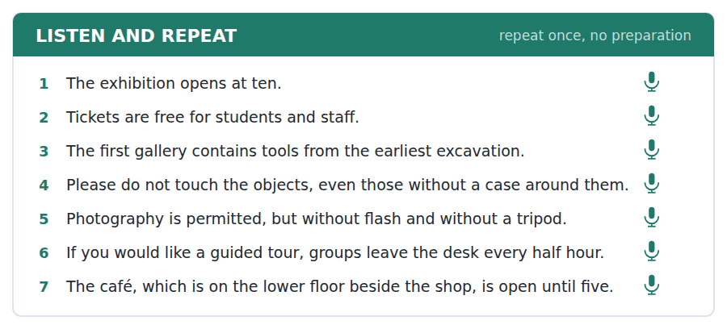
Take an Interview. Answer the questions and say as much as you can.
a research study about how people learn
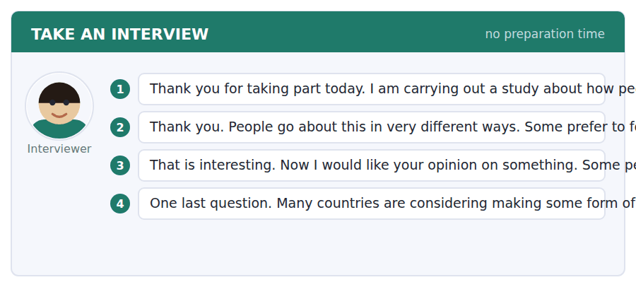

Answer key
Volume 2 · Units 11–20 and Practice Test 2
Every wrong option is explained, because a letter on its own teaches nothing.

Unit 11 · Technology and AI
Reading 1 · Complete the Words
1 ening | 3 an | 5 elf | 7 use | 9 uld
2 ough | 4 rate | 6 range | 8 ern | 10 re

Reading 2 · Read in Daily Life
1 (A) It sits under Allowed without declaration, together with searching for sources.
2 (D) Code you then test, correct and understand, declared on the submission form.
3 (C) Listed under Never allowed, and the notice adds declared or not.
4 (B) One sentence on the form with exactly those three things.
5 (B) He opens by saying the headline everyone is repeating is just wrong.
6 (C) He summarises the first category of the notice correctly.
7 (D) He quotes it and then explains what he thinks it shows.
8 (A) They are not trying to catch you — they are trying to find out what people are doing.
9 (A) Producing a summary of material you have read sits in the declare category.
10 (B) Every other rule has a declared exception; this one says any tool at all, with no exception.
Reading 3 · Academic Passage
1 (D) The confusion is named in the first paragraph and the rest of the passage unpicks it.
2 (C) Remarkably few occupations eliminated; almost all rewritten.
3 (D) Cheaper branches meant more branches, and the total was higher.
4 (A) It is introduced as the clearest case of the distinction made in paragraph 1.
5 (B) Not which jobs but which tasks — stated at the start of paragraph 3.
6 (C) And the author adds whatever the status of the job they sit in.
7 (D) Almost nothing a plumber does in an afternoon is the same as what they did in the morning.
8 (A) The radiologist example is given precisely to contradict that.
9 (C) One task was removed and another put in its place, which is emptying and refilling.
10 (B) They expected the occupation to end, which is exactly the error paragraph 3 diagnoses.
11 (D) The task framing comes first and the uneven effect follows from it.
Listening 1 · Conversation
1 (B) A yes/no question about an action; the reply answers and asks a useful follow-up.
2 (A) A yes/no question that needs a qualified answer, which only one option gives.
3 (C) Where wants a place, even on a document.
4 (B) He says it’s banned, so no, and the woman corrects him.
5 (A) She states both conditions in the same sentence.
6 (C) One sentence on the form: which tool, which part, what you changed.
7 (D) And she points out that this is what the man has done.
8 (D) The portal closed an hour ago.
9 (A) Tonight, not Monday — she stresses the timing and gives the reason.
Listening 2 · Announcement
1 (C) A do-I question about one specific tool; only one option answers for that tool.
2 (B) A what-if question wants an instruction.
3 (A) A does-it-apply question needs the exam rule itself.
4 (D) Three categories, not one — and the speaker takes them in order.
5 (B) That is given as the reason for going through them.
6 (C) The declaration is one sentence with exactly those three elements.
7 (C) The speaker says there is no exception to that one, not even a spellchecker.
8 (B) Nobody has ever been penalised for over-declaring.
Listening 3 · Academic Talk
1 (A) A did-she-say question checks a claim, and the reply corrects it.
2 (D) What is it trained on wants the training material.
3 (B) A request for explanation is answered by agreeing and narrowing it.
4 (C) The whole talk builds to the distinction and the question that follows from it.
5 (D) Stated at the start, and the inability to explain follows from it.
6 (A) The speaker corrects the common reading explicitly.
7 (D) Inside that range the two usually agree; outside it they come apart completely.
8 (B) Ninety-nine per cent confidence on a completely wrong answer, with nothing mechanically broken.
9 (C) The talk opens and closes on that question.
Writing 1 · Build a Sentence
1 Might the answer be wrong?
2 Do you know whether it affects my mark?
3 What could change the result?
4 Can you tell me whether code may be used?
5 When did the portal close?
6 Which tools are allowed in an exam?
7 Do you know what it was trained on?
8 The student who declared the tool was not penalised.
9 How long should the declaration be?
10 Do you know why it reported an ostrich?
Grammar focus
Exercise 1 might · may · could · may not · might · Might
Exercise 2 The data might be incomplete. · It could have been trained on old examples. · You may use a grammar checker. · The figure could not be accurate.
Exercise 3 It might be wrong. · The system might have learned a different pattern. · You may not use a tool in the exam — the rules forbid it.
Unit review
A Vocabulary 1 automate · 2 technique · 3 simulate · 4 rely · 5 facilitate · 6 implement · 7 capacity · 8 protocol · 9 inevitable · 10 explicit · 11 plagiarism · 12 declaration form
B Grammar 1 might · 2 may · 3 could · 4 may not · 5 might have been trained · 6 Might · 7 could not · 8 might be
C Mini-section 1 A · 2 B · 3 D · 4 A · 5 C · 6 B

Unit 12 · Public Health and Medicine
Reading 1 · Complete the Words
1 less | 3 dies | 5 ne | 7 ant | 9 ating
2 nds | 4 tion | 6 ect | 8 ted | 10 ll

Reading 2 · Read in Daily Life
1 (C) You must register before you can book anything, and it is online.
2 (A) Mondays and Thursdays, 14.00–16.00, with no appointment needed.
3 (B) Up to four weeks ahead, online.
4 (D) It cannot issue sick notes or repeat prescriptions.
5 (D) Including anything bought without a prescription — and the card is specifically ruled out.
6 (A) Her call would keep somebody else waiting, because that line is for same-day booking.
7 (B) Missed appointments are not charged for, but three in a year changes how you book.
8 (C) The email gives the screen and its location in the same sentence.
9 (A) Same-day appointments: phone at 08.00, and they are usually gone by 08.20.
10 (B) Everything else depends on it, and the notice answers the two commonest worries — cost and care at home — in the same breath.
Reading 3 · Academic Passage
1 (D) The usual explanation is tested against dates and replaced in paragraph 2.
2 (C) The first sentence states it, and the second says it had reversed by 1920.
3 (D) Before antibiotics, before most vaccines, and sometimes before germ theory.
4 (C) Listed together in the first sentence of paragraph 2.
5 (B) And the author offers a reason: a child who is not repeatedly ill survives other illnesses.
6 (A) At enormous cost and usually against fierce opposition from ratepayers.
7 (D) The contrast with interventions that have to be sold repeatedly makes it explicit.
8 (A) The passage argues the opposite, from the dates.
9 (C) It is the clearest statement of the paragraph’s distinction.
10 (B) The last sentence says it is an argument about where the first money should go.
11 (C) The whole paragraph links the building to the measured result.
Listening 1 · Conversation
1 (B) A yes/no question about an action; the answer gives when and how.
2 (D) When wants days or times.
3 (A) A should-I question wants advice, and this one corrects the assumption.
4 (C) The email says Thursday and today is Wednesday.
5 (D) Fernandes and Ferreira, put on the same slot.
6 (A) Yours was Wednesday — today — at eleven twenty.
7 (B) That part is standard, yes.
8 (C) She is running about ten minutes behind.
9 (D) That is usually what causes this — she gives the reason as she gives the advice.
Listening 2 · Announcement
1 (A) A do-I-have-to question about cost; the only answer that states the condition.
2 (B) A do-I-need question wants a yes or no.
3 (D) A what-if question wants the consequence for that case.
4 (C) Four groups are named, and everybody else pays eleven pounds.
5 (A) Registered here, not at home — she stresses the distinction.
6 (B) You do not have to wait for anything to be approved.
7 (C) A short form plus fifteen minutes sitting down afterwards.
8 (D) The speaker says it is standard and not a sign that anything is wrong.
Listening 3 · Academic Talk
1 (B) The question offers two units and the answer picks the right one.
2 (A) A why question wants the reason, and only one option gives one.
3 (C) A request is answered by agreeing and saying when.
4 (B) The first half argues the economics and the second half explains why it loses anyway.
5 (D) And prevention is a cost per population, often paid once.
6 (A) Even unvaccinated people stop catching it, so each dose protects more than one person.
7 (B) You cannot photograph an epidemic that did not happen.
8 (A) Not demonstrating anything is what success looks like.
9 (C) No course of treatment has ever done that — the comparison is the point.
Writing 1 · Build a Sentence
1 Do I have to register first?
2 What should I bring?
3 Do you know whether it is free?
4 Can you tell me whether I should cancel online?
5 Which days does the clinic run?
6 Do I have to wait for approval?
7 How long should I allow?
8 The nurse who saw me last time has left.
9 Do you know where I can get a sick note?
10 What time should I phone?
Grammar focus
Exercise 1 must · do not have to · must not · should · have to · had to
Exercise 2 forbidden · not necessary · forbidden · not necessary
Exercise 3 You do not have to bring your card. · I had to register again last year. · You do not have to pay.
Unit review
A Vocabulary 1 access · 2 ensure · 3 intervene · 4 incidence · 5 infrastructure · 6 adequate · 7 comprehensive · 8 voluntary · 9 promote · 10 restore · 11 walk-in · 12 sick note
B Grammar 1 must · 2 do not have to · 3 must not · 4 should · 5 have to · 6 had to · 7 have to · 8 should
C Mini-section 1 D · 2 D · 3 C · 4 A · 5 B · 6 D

Unit 13 · Music and Sound
Reading 1 · Complete the Words
1 ted | 3 uck | 5 eed | 7 igh | 9 ugh
2 ates | 4 ar | 6 etly | 8 ime | 10 ing

Reading 2 · Read in Daily Life
1 (C) Sunday to Thursday, 23.00–07.30; the later time is the weekend rule.
2 (B) Acoustic instruments only, and only between those hours.
3 (A) Amplified practice must be booked in the music room, Block E basement.
4 (D) Most noise is thoughtless, not deliberate — the notice gives the reason for the order.
5 (D) Moved to Hartley Hall, with a licence until midnight rather than eleven.
6 (A) Because the venue has changed, so the noise no longer reaches the rooms.
7 (C) The normal weekend rule applies, which the notice gives as 00.30.
8 (B) The last line makes exactly that point to people who had decided not to go.
9 (B) After midnight and continuing is the stated condition for calling the porter.
10 (A) The new one is described as further from the bedrooms, which is why the extension was needed before.
Reading 3 · Academic Passage
1 (D) The author explicitly moves the explanation from storage to retrieval.
2 (C) What is unusual is not the storage. It is the retrieval.
3 (A) That is the general principle the whole explanation rests on.
4 (B) The weather, mood and room all change; the recording does not.
5 (D) The passage names and dates it in the same sentence.
6 (C) First-time events are encoded in more detail, which is the stated reason.
7 (D) That is precisely the explanation the author rejects at the start.
8 (B) It is contrasted with recall, so it means the laying down of the memory.
9 (A) The apparent magic has a dull explanation — the author’s own word.
10 (C) The argument turns on reproducing a fragment of the moment exactly; a photograph is unchanged but silent and still.
11 (D) The paragraph adds two facts and then draws exactly that conclusion.
Listening 1 · Conversation
1 (A) A request for a moment is answered by granting it.
2 (C) A yes/no question about effect, answered honestly and mildly.
3 (B) A statement of surprise is met with the explanation.
4 (A) She identifies herself as the neighbour below and names the bass.
5 (C) From in here it is almost silent, because the headphones remove what he would hear.
6 (D) The headphones take away the part you hear and leave the part I hear.
7 (B) I nearly rang the porter and then I thought I would rather just ask.
8 (B) The music room is the woman’s suggestion, which comes afterwards.
9 (D) I would just like to sleep on a Tuesday.
Listening 2 · Announcement
1 (C) Where wants a place.
2 (A) A comparison question answered with the fact that settles it.
3 (D) A do-they-change question wants a yes or no about the rule.
4 (B) Directly below forty bedrooms, against a hundred metres away.
5 (C) A licence until midnight rather than eleven.
6 (A) That is cancelled — and the speaker explains why it is no longer needed.
7 (D) The normal weekend time, half past twelve.
8 (A) Still four pounds and still from the porters’ lodge.
Listening 3 · Academic Talk
1 (C) The question asks which of two quantities, and the answer names it.
2 (B) A what-happens-if question wants the consequence.
3 (D) A did-she-give question is answered by giving the number.
4 (B) The talk separates the two quantities and then makes its claim about the octave.
5 (A) Pitch is frequency, defined in the second sentence.
6 (C) Eight hundred and eighty is also an A.
7 (D) Halve it and two hundred and twenty is an A as well.
8 (C) Every musical system anybody has ever built, anywhere in the world.
9 (B) It is something about ears — and she adds that nobody fully agrees why.
Writing 1 · Build a Sentence
1 How often does the string vibrate?
2 Do you know how quietly he plays?
3 How does the sound carry?
4 What time does the concert finish?
5 Can you tell me when quiet hours begin?
6 How late can I book it?
7 Do you know what happens if you double it?
8 The student who complained lives directly below.
9 How much do tickets cost?
10 Do you know why they come from adolescence?
Grammar focus
Exercise 1 He plays the bass quietly. · She explained it clearly. · The note sounds slightly higher. · They arrived late. · He works hard. · She sings well.
Exercise 2 hardly · hard · hardly · hard
Exercise 3 He plays the bass quietly. · She sings very well. · The two things are completely independent.
Unit review
A Vocabulary 1 constant · 2 modify · 3 discrete · 4 notion · 5 negate · 6 dramatic · 7 correspond · 8 coincide · 9 differentiate · 10 instance · 11 quiet hours · 12 soundcheck
B Grammar 1 quietly · 2 hardly · 3 well · 4 slightly · 5 completely · 6 hard · 7 late · 8 How loudly
C Mini-section 1 A · 2 A · 3 D · 4 C · 5 B · 6 B

Unit 14 · Archaeology and Ancient Cities
Reading 1 · Complete the Words
1 ships | 3 ned | 5 ugh | 7 ed | 9 und
2 id | 4 nded | 6 ed | 8 less | 10 und

Reading 2 · Read in Daily Life
1 (C) Six weeks, 7 July to 15 August.
2 (D) Trowels are specifically excluded in the same line.
3 (A) Unpaid, but travel and lunch are provided.
4 (B) You must be available for all six weeks. Partial internships are not offered.
5 (B) Rather than afterwards — the email gives the reason with because.
6 (D) And it says it already has the marks.
7 (C) A paragraph is plenty.
8 (A) Please tell us, and tell Ana.
9 (A) The last sentence says so directly.
10 (B) Six weeks outdoors in all weather, and the reference is asked specifically about working outdoors for long periods.
Reading 3 · Academic Passage
1 (D) The obvious answer is corrected in paragraph 2 and the evidence follows in paragraph 3.
2 (C) It began thousands of years earlier and in many places produced no city.
3 (D) Not fertility but unpredictability — stated at the start of paragraph 2.
4 (C) And the author says that is the part that matters here.
5 (A) Records, arbitration and somebody with the authority to decide.
6 (B) Quantities of barley, numbers of sheep, names of people who owed something.
7 (C) Population size is never mentioned.
8 (B) It appears in a list of what is needed when boundaries have to be redrawn between neighbours.
9 (D) Writing was not invented to preserve ideas; it was invented to keep track.
10 (A) That is why writing, and therefore the city, appeared.
11 (C) The institutions came first, and the city grew around them.
Listening 1 · Conversation
1 (D) A yes/no question about an action, answered with when.
2 (B) A yes/no question about pay, answered and usefully qualified.
3 (A) Who wants the people named.
4 (D) I have no idea what they will ask.
5 (C) Half the interview was about whether you understand six weeks outdoors.
6 (A) A replacement is useless because the training takes a fortnight.
7 (B) Where, how long, what the worst day was like.
8 (B) Say that. Exactly that, with the eleven — the detail is what makes it believable.
9 (C) Because it stops you giving the answer everybody gives.
Listening 2 · Announcement
1 (D) When wants a date, and the other options answer how many and where.
2 (A) A has-it-changed question is answered by the size of the change.
3 (A) A can-I question wants permission, and this one refuses with the rule.
4 (D) And the speaker asks students to correct it wherever they wrote it down.
5 (C) You give two names with email addresses and the museum contacts them itself.
6 (B) By the twelfth, two days before your own deadline.
7 (B) Somebody who leaves after four weeks has cost more than they contributed.
8 (A) Four places, and last year there were sixty applications.
Listening 3 · Academic Talk
1 (C) Which wants one of the layers.
2 (D) Why wants a reason, which only one of the four actually gives.
3 (C) A can-you question about possibility, answered and emphasised.
4 (B) The first idea governs everything else and the final rule follows from it.
5 (A) Every layer removed is removed permanently.
6 (D) The last thing to arrive is the first thing to go.
7 (A) A context sheet for every layer, a plan, levels and photographs.
8 (C) Its position, not the sherd, is what dates the wall.
9 (B) The paper costs nothing and the layer costs everything.
Writing 1 · Build a Sentence
1 When was it built?
2 Where was the sherd found?
3 Do you know why it was abandoned?
4 Can you tell me whether references are contacted?
5 How much was the deadline moved?
6 How many places were offered?
7 Do you know when it was recorded?
8 The tablets that were found first were receipts.
9 How long does the training take?
10 Do you know whether lunch is provided?
Grammar focus
Exercise 1 was built in the fourth century · was found under the floor · was not recorded · was excavated · was abandoned · was being recorded
Exercise 2 When was it built · Where was the sherd found · Who was the trench excavated by · Why was the site abandoned
Exercise 3 was found · was not recorded · When was the wall built?
Unit review
A Vocabulary 1 empirical · 2 preliminary · 3 abandon · 4 cease · 5 deduce · 6 presume · 7 bulk · 8 constitute · 9 diminish · 10 integrity · 11 context sheet · 12 spoil heap
B Grammar 1 was built · 2 was found · 3 was not recorded · 4 was excavated · 5 was / abandoned · 6 was being recorded · 7 should have been recorded · 8 was built
C Mini-section 1 D · 2 D · 3 C · 4 B · 5 A · 6 C

Unit 15 · Business and Entrepreneurship
Reading 1 · Complete the Words
1 ail | 3 able | 5 ay | 7 ure | 9 ming
2 ing | 4 antly | 6 wing | 8 ation | 10 ing

Reading 2 · Read in Daily Life
1 (C) Both parts are listed under The prize.
2 (A) No equity is taken — the notice says the idea remains entirely yours.
3 (D) And the notice adds no business plan at this stage.
4 (B) Teams of up to four, at least half of them current students.
5 (C) Five minutes each, then five minutes of questions — the questions are separate.
6 (A) This is not a threat but a warning, and the reason follows.
7 (B) Nothing can be connected on the day.
8 (D) The judges have it already.
9 (D) Slides are optional, and several winners have used none at all.
10 (A) At least half the team must be current students, so four needs two.
Reading 3 · Academic Passage
1 (C) The slogan is introduced, tested and rewritten.
2 (B) And much of that difference disappears under closer analysis.
3 (B) People who start again differ from those who do not, so some of the advantage is selection.
4 (D) It appears to teach a great deal; the other two teach far less.
5 (A) Which is what makes the finding uncomfortable.
6 (C) You now know something specific about what customers will not buy.
7 (D) And fear changes behaviour without explaining why.
8 (B) The author says there is something in this and then narrows it, rather than rejecting it.
9 (C) The knowledge is useful in the next company, which is what makes it valuable.
10 (A) If, and only if, it tells you something you did not already know.
11 (D) The information/fear contrast is the explanation the whole paragraph offers.
Listening 1 · Conversation
1 (A) How long wants a duration, not a time of day.
2 (C) A yes/no question about a requirement, answered and supported.
3 (B) A shall-I offer is accepted and divided up.
4 (B) The woman times him and stops him mid-sentence.
5 (A) It includes part-time and distance students, and the product needs people on campus.
6 (C) And she explains the consequence of a vague answer.
7 (D) Eleven thousand full-time undergraduates on this campus.
8 (C) And the woman answers that it makes it look real.
9 (A) The shrug is the vague answer to where the number came from.
Listening 2 · Announcement
1 (B) What time should we arrive wants the arrival rule, not the slot time.
2 (D) A can-we question about permission, refused with the rule.
3 (C) A do-they-count question about timing, answered directly.
4 (D) Five to pitch and five of questions, which are separate.
5 (A) The speaker says he wants to explain why rather than just assert it.
6 (B) And use the rest to support it.
7 (D) Nothing can be connected on the day, including your own adapter.
8 (C) The schedule runs early as often as it runs late.
Listening 3 · Academic Talk
1 (A) The question offers two terms and the answer distinguishes them.
2 (B) A what-does-it-mean question wants a definition.
3 (D) A can-it question about possibility, answered and emphasised.
4 (B) The opening claim and the closing sentence say the same thing.
5 (A) March, April, June for the money and May for the bills.
6 (C) Ninety days after the March order.
7 (B) So doubling orders doubles the hole that has to be funded.
8 (C) He names it as the advice that sounds most unambitious.
9 (D) The final sentence states it.
Writing 1 · Build a Sentence
1 She asked where the number had come from.
2 They wanted to know whether we had spoken to customers.
3 He asked whether slides were compulsory.
4 She asked when the pitch started.
5 He asked whether he could send it on Thursday.
6 The panel wanted to know how many students there were.
7 Do you know whether they have read it?
8 The team that arrived late lost two minutes.
9 We asked whether they would take equity.
10 Do you know why profitable businesses close?
Grammar focus
Exercise 1 the slides were optional · she would send the file · where the number had come from · whether we had spoken to customers · to arrive twenty minutes early · whether he could send it on Thursday
Exercise 2 said · told · told · said
Exercise 3 She asked where it had come from. · He told me that it was optional. · They asked whether we had spoken to customers.
Unit review
A Vocabulary 1 strategy · 2 attain · 3 prospect · 4 mediate · 5 guarantee · 6 initiate · 7 compile · 8 panel · 9 consent · 10 undertake · 11 loan · 12 pitch
B Grammar 1 were · 2 would · 3 had · 4 whether · 5 told · 6 said · 7 to arrive · 8 could
C Mini-section 1 A · 2 B · 3 D · 4 A · 5 C · 6 D

Unit 16 · Cities and How People Live
Reading 1 · Complete the Words
1 ative | 3 ket | 5 sy | 7 ety | 9 age
2 ions | 4 sive | 6 ure | 8 all | 10 able

Reading 2 · Read in Daily Life
1 (C) Both groups share the same deadline.
2 (B) And the notice adds that there is no separate bill.
3 (D) Held and returned within 28 days of the inventory check.
4 (A) No changes in the first three weeks except on medical grounds.
5 (A) Except on medical grounds, which does not apply here.
6 (D) We have no empty rooms this year.
7 (B) We will process both changes in a day.
8 (C) Several requests last year were about something a conversation solved.
9 (D) Stated under Everybody else.
10 (B) We have no empty rooms this year, and returning students are on a waiting list.
Reading 3 · Academic Passage
1 (C) One constant time, three speeds, three city shapes, and one consequence.
2 (A) Roughly half an hour each way, which is why it is called a constant.
3 (D) And the author notes that medieval cities are almost exactly that size.
4 (A) Cities grew outwards along the lines, which is still visible in older suburbs.
5 (C) In every direction at once, rather than along fixed lines.
6 (B) A faster road persuades people to live further away until the half hour is used up.
7 (C) The passage says it rarely reduces travel time for long, which is not the same claim.
8 (B) It is contrasted with what changes, which is the speed.
9 (A) Often full within a few years — the passage says so almost directly.
10 (D) The constant is the time, so when speed changes, location changes.
11 (C) Three speeds produce three sizes and shapes, which is the paragraph’s whole structure.
Listening 1 · Conversation
1 (A) A yes/no question about a plan, answered honestly.
2 (D) How much wants a price.
3 (B) A does-it-include question wants a yes or no about what is covered.
4 (B) She names both prices in the first line.
5 (D) Sixty to ninety for bills and forty-five for the bus pass wipe out the eighty.
6 (A) The man says twenty and the woman corrects him to twenty-five.
7 (C) Forty for halls against fifty-two for the flat.
8 (D) And she can leave her things there, which the forty-week contract does not allow.
9 (A) Which is why the contract length becomes the deciding factor.
Listening 2 · Announcement
1 (B) What is the deadline wants a date.
2 (C) An am-I question about status, answered with the condition.
3 (C) A yes/no question about the deposit, answered with the period.
4 (A) And the speaker stresses that it is a place, not a particular room.
5 (D) Not in order of need, so applying on the first day genuinely matters.
6 (B) Two thirds received an offer, which means a third did not.
7 (A) The speaker names it as the pattern.
8 (C) Because the halls figure already includes utilities and internet.
Listening 3 · Academic Talk
1 (B) The question offers two alternatives and the answer resolves it.
2 (D) A what-is question wants the definition.
3 (A) A request to repeat is answered by repeating the figure.
4 (C) The two opposite effects and the ownership point are the whole talk.
5 (D) Four flats in a dense street against one house in a suburb.
6 (B) The speaker gives the figure and notes that it varies.
7 (B) And there is only so much land there.
8 (A) The speaker says it depends almost entirely on that.
9 (C) That is the final sentence and the point of the talk.
Writing 1 · Build a Sentence
1 Which is cheaper?
2 How far is the flat?
3 Do you know whether bills are included?
4 How much more do halls cost?
5 Can you tell me when the deadline is?
6 How many received an offer?
7 Do you know how long the contract runs?
8 The student who applied in August was not offered a room.
9 Is the bus as quick as walking?
10 Do you know why the time has not changed?
Grammar focus
Exercise 1 as / as · than · as / as · as / as · as · from
Exercise 2 as cheap as the flat · as quick as the walk · as large as yours · as high as in winter
Exercise 3 as cheap as it looks · the same as last year · ten times as many people as a lane of cars
Unit review
A Vocabulary 1 accommodate · 2 displace · 3 subsidy · 4 levy · 5 legislate · 6 trend · 7 scenario · 8 forthcoming · 9 temporary · 10 pose · 11 commute · 12 inventory
B Grammar 1 as / as · 2 than · 3 as / as · 4 as · 5 as · 6 from · 7 fewer · 8 as large
C Mini-section 1 D · 2 D · 3 C · 4 B · 5 A · 6 D

Unit 17 · Chemistry and Materials
Reading 1 · Complete the Words
1 her | 3 ide | 5 ide | 7 ters | 9 els
2 oined | 4 ape | 6 ils | 8 ead | 10 raint

Reading 2 · Read in Daily Life
1 (D) The longest of the four sections, in the template.
2 (B) Listed in the second line of the template.
3 (A) Raw data goes in an appendix, not in the Results section.
4 (C) Both are required in the same line.
5 (B) Below 40, which is why a resubmission is offered.
6 (C) And the email explains why Figure 2 in particular is unreadable.
7 (A) Stated as the reason in the same sentence.
8 (D) 740 words against a limit of 300, because the raw data is there.
9 (C) Capped at 40, whatever its quality.
10 (B) The email says so almost directly, given the cap.
Reading 3 · Academic Passage
1 (D) The second sentence frames it and the whole passage works through why.
2 (A) Light, cheap, waterproof, mouldable and inert — and substitutes trade one for another.
3 (B) So the carbon saved in disposal is spent again in transport.
4 (D) Paper is renewable and permeable, so it needs a coating — usually plastic.
5 (A) And elsewhere they behave like ordinary plastic with a reassuring label.
6 (C) Which is why a substitution that looks right at purchase may not be.
7 (C) Not substitution at all, but using less.
8 (D) The compostable option belongs to substitution, which the author has just set aside.
9 (A) The most effective action is also the least visible.
10 (B) Anybody who has studied public health will recognise it — prevention is invisible when it works.
11 (C) Three substitutes, three trade-offs, one conclusion about whole-life comparison.
Listening 1 · Conversation
1 (A) A yes/no question about results, answered with a judgement.
2 (D) What temperature wants a figure in degrees.
3 (B) A shall-we suggestion is answered by whether it is possible.
4 (C) 62 and 31, which the woman immediately recognises as systematic.
5 (D) Two grams and sixty degrees for twenty minutes are the same for both.
6 (A) The woman points out that the error would run the wrong way.
7 (B) Fifty millilitres instead of a hundred, so half the material stayed behind.
8 (A) He did not do the method as written, so his number measures the method he did do.
9 (D) They give marks for knowing which experiment you actually did.
Listening 2 · Announcement
1 (C) When wants a date and time.
2 (B) A can-I question wants permission, and this gives it with the distinction.
3 (A) A what-if question wants the consequence for that case.
4 (B) For most of last week, which is why it applies to everybody.
5 (C) That applies to everybody; you do not need to ask.
6 (D) And the speaker explains that he would rather have a good report late.
7 (C) And this is not me being suspicious — the speaker says so explicitly.
8 (B) Not about improving a mark you are unhappy with.
Listening 3 · Academic Talk
1 (D) A does-it question about direction, corrected by the answer.
2 (A) A what-does-it-mean question wants the definition.
3 (A) An is-it-the-same question is answered by distinguishing them.
4 (C) The talk is built on the two questions and the confusion between them.
5 (D) Breaking a bond always costs energy and making one always releases it.
6 (B) The difference comes out as heat.
7 (C) The reaction gives out an enormous amount of energy and still does not begin.
8 (D) Not the energy of the reaction, which the reaction supplies itself.
9 (B) Catalysts, which are entirely a story about that hill.
Writing 1 · Build a Sentence
1 What happens after heating?
2 Can you tell me how it is made?
3 Do you know when it should be dried?
4 When has the deadline moved to?
5 Can you tell me whether it is capped?
6 Do you know where raw data goes?
7 What happens when a bond breaks?
8 The student who used the smaller beaker got half the yield.
9 When should I request an extension?
10 Do you know why it does not ignite?
Grammar focus
Exercise 1 Once the solid dissolves, add the acid. · Heat the mixture until the liquid is clear. · Dry the sample before weighing it. · After filtering the mixture, keep the solid. · Weigh two grams, then heat it gently. · The colour stops changing, by which point the reaction is complete.
Exercise 2 Two grams of the solid were weighed. · The mixture was heated for twenty minutes. · The product was filtered and dried. · The mass was recorded.
Exercise 3 After drying the sample, weigh it. · Heat it until the liquid is clear. · Once the solid dissolves, add the acid.
Unit review
A Vocabulary 1 substitute · 2 attribute · 3 dispose · 4 refine · 5 demonstrate · 6 valid · 7 apparent · 8 minimal · 9 finite · 10 append · 11 extension · 12 fume cupboard
B Grammar 1 Once · 2 until · 3 weighing · 4 After · 5 was heated · 6 then · 7 by · 8 until
C Mini-section 1 A · 2 A · 3 D · 4 C · 5 B · 6 A

Unit 18 · Animal Behaviour
Reading 1 · Complete the Words
1 able | 3 sive | 5 vable | 7 ation | 9 ong
2 erate | 4 tain | 6 eap | 8 ing | 10 re

Reading 2 · Read in Daily Life
1 (B) In pairs, about three hours a session, February to May.
2 (C) Winter feeding continues until the first week of March only.
3 (D) One training session, two hours, compulsory, with dates in January.
4 (A) Fewer than six and we cannot justify the training.
5 (C) He describes the dull part honestly and then says what makes it worth it.
6 (B) You walk four kilometres and write no change in nineteen boxes.
7 (D) That is not a feeling you can get in one visit.
8 (A) Same session, smaller group.
9 (A) The rota is built round pairs.
10 (D) Boots and waterproofs are essential, while binoculars can be borrowed — the contrast is the point.
Reading 3 · Academic Passage
1 (C) Timing and direction, each with the evidence that established it.
2 (B) Whatever it is using, it is not experience.
3 (D) The one environmental signal that cannot be disturbed by weather.
4 (B) The passage defines it in the sentence that names it.
5 (A) A great deal of migration research is done without anybody leaving the laboratory.
6 (C) Which is why it has to be learned rather than inherited.
7 (D) The sun moves, so a bearing from it is useless without a clock.
8 (A) Three systems are named and landmarks is not among them.
9 (C) A navigation method that fails on a cloudy night would not have survived a single generation.
10 (B) A bird deprived of one system uses another, which is what the word names.
11 (C) Both halves of the paragraph serve that claim.
Listening 1 · Conversation
1 (D) A yes/no question about an action, answered with when.
2 (A) How many wants a number of sessions.
3 (B) A can-we question about arrangement, answered with the rule that makes it easy.
4 (D) And the man adds the one-word reason first: birds.
5 (B) A nine o’clock on Tuesdays and Thursdays.
6 (A) The man gives it as the alternative to the seven o’clock start.
7 (C) Which clashes with her nine o’clock, so she takes the Saturday date.
8 (A) The fourteenth is a Saturday.
9 (D) Which solves the alone problem as well.
Listening 2 · Announcement
1 (C) A yes/no question about a rule, answered with the change.
2 (B) A what-happens-if question wants the consequence, and this one states it plainly.
3 (D) Which wants the specific date.
4 (A) It was optional last year.
5 (B) Two incidents, and the speaker explains why it is obvious only once told.
6 (C) The fourteenth is a Saturday and the other two are Tuesdays.
7 (B) Because somebody else will use it.
8 (D) The speaker ends on exactly that point.
Listening 3 · Academic Talk
1 (A) A what-is question wants the definition.
2 (C) A learned-or-inherited question is answered by choosing, or by refusing the choice.
3 (C) A request to repeat is answered by agreeing and identifying which.
4 (B) The talk ends by rejecting the either/or question outright.
5 (D) The speaker defines it as the standard method.
6 (A) Simplified, in the wrong order, and no female responds to it.
7 (A) Which is the finding the speaker calls interesting.
8 (B) And the speaker says that last one is the part people miss.
9 (D) The final sentence states it.
Writing 1 · Build a Sentence
1 Why do birds sing?
2 Do you know what it is for?
3 Why are rounds done in pairs?
4 Can you tell me why training is compulsory?
5 How many sessions are required?
6 How much notice do I need to give?
7 Do you know why they use day length?
8 The volunteer who checked box 7 found five chicks.
9 Which date is at the weekend?
10 Do you know what happens in silence?
Grammar focus
Exercise 1 to · so that · for · because of · because · to
Exercise 2 purpose · reason · purpose · reason
Exercise 3 Birds sing to attract a mate. · We work in pairs so that nobody is alone. · The round was cancelled because of the weather.
Unit review
A Vocabulary 1 denote · 2 conform · 3 discriminate · 4 subordinate · 5 cooperate · 6 crucial · 7 investigate · 8 anticipate · 9 mature · 10 aspect · 11 sightings log · 12 hide
B Grammar 1 to · 2 so that · 3 for · 4 because of · 5 because · 6 in order to · 7 so that · 8 because
C Mini-section 1 C · 2 D · 3 C · 4 B · 5 A · 6 D

Unit 19 · Education and Learning
Reading 1 · Complete the Words
1 ted | 3 ison | 5 ences | 7 body | 9 ne
2 ally | 4 ence | 6 est | 8 tial | 10 ject

Reading 2 · Read in Daily Life
1 (A) Four core modules plus two options.
2 (B) No cap and no prerequisite, open to any department.
3 (D) Listed with the cap of thirty places.
4 (C) Then only with an adviser.
5 (B) The regulations require at least one option from outside it.
6 (C) Either choice may stay; one of them has to change.
7 (A) And they withdraw, releasing a place but not getting a refund.
8 (D) Which releases a place but not a refund of the residential fee.
9 (A) The email says exactly that in its last paragraph.
10 (D) It is outside any one department, has no cap and no prerequisite, so it fits the rule he has broken.
Reading 3 · Academic Passage
1 (C) The figure is accepted and its use is criticised.
2 (B) Defined in the first sentence.
3 (C) The gap between subjects is wider than the gap between graduates and non-graduates.
4 (A) School results, family income and region are given as examples.
5 (B) Smaller, though still clearly positive, and very uneven.
6 (D) An average between two extremes describes neither.
7 (D) Institution appears in the last paragraph as a useful figure, not as a selection factor.
8 (A) None of this is an argument against higher education.
9 (C) And the author adds that they exist, are published, and are read by almost nobody.
10 (B) They are choosing one course at one institution, which the average says nothing about.
11 (C) Two things drive the concealment, and the paragraph takes each in turn.
Listening 1 · Conversation
1 (A) A yes/no question about an action, answered honestly.
2 (D) How many wants a number of places.
3 (B) A do-I-need question about a prerequisite, answered with the threshold.
4 (D) Forty-eight against a prerequisite of fifty.
5 (B) They are not going to waive a prerequisite for anybody.
6 (A) One option has to be from outside his department.
7 (C) The woman points this out, which is why the low mark changes nothing.
8 (B) The outside-option problem would have required him to write to the office.
9 (D) Her last line, after conceding everything else.
Listening 2 · Announcement
1 (C) When wants a date, and the second of May is the opening date.
2 (A) A does-it-have-a-cap question is answered with the number.
3 (C) A what-is question wants the mistake named.
4 (A) And the speaker explains exactly how it happens.
5 (B) We do not waive that, because the module genuinely assumes it.
6 (D) Please read that sentence twice — the speaker flags it deliberately.
7 (C) Which is why it satisfies the rule without any further obstacle.
8 (B) Changes are free until the end of week two.
Listening 3 · Academic Talk
1 (A) Which group wants the group named.
2 (D) A did-they-know question about awareness, answered with the twist.
3 (C) A should-I question wants advice, with the alternative.
4 (B) The finding plus the failure of self-judgement is the whole talk.
5 (A) Checking afterwards each time.
6 (D) Which is exactly why the method survives.
7 (D) About fifty per cent higher.
8 (B) And it is not the finding — he says so explicitly.
9 (C) Cover the page, write what you remember, check — and expect it to feel worse.
Writing 1 · Build a Sentence
1 What would you do?
2 What would happen if it were lower?
3 Do you know which she would choose?
4 Can you tell me what the prerequisite is?
5 How many places are there?
6 What would he have chosen?
7 Do you know when I need an adviser?
8 The student who missed the residential lost the fee.
9 Can you tell me whether both can be internal?
10 Do you know why they scored higher?
Grammar focus
Exercise 1 were / would ask · were / would take · would / do / failed · had known / would not have chosen · published / would use · had / would go
Exercise 2 If I had time, I would take it. · If he had known, he would not have chosen it. · If the module were not capped, she could join. · If they had published the data, somebody would have used it.
Exercise 3 If I had time, I would take it. · If I were you, I would ask. · If he had known about it, he would not have chosen it.
Unit review
A Vocabulary 1 criteria · 2 outcome · 3 objective · 4 qualitative · 5 submit · 6 principal · 7 relevant · 8 justify · 9 acknowledge · 10 register · 11 resit · 12 transcript
B Grammar 1 were · 2 would take · 3 would · 4 had known · 5 would use · 6 would go · 7 could · 8 had taken
C Mini-section 1 A · 2 D · 3 C · 4 A · 5 B · 6 A

Unit 20 · Media and Misinformation
Reading 1 · Complete the Words
1 ance | 3 sable | 5 ced | 7 ges | 9 lls
2 able | 4 ture | 6 racy | 8 tematic | 10 ult

Reading 2 · Read in Daily Life
1 (C) News is the shortest category listed.
2 (D) Everything carries a byline.
3 (A) Name it when you submit.
4 (B) For Thursday publication; late copy waits a week.
5 (C) Both details were wrong: 20.00 instead of 21.00, and all year instead of vacations.
6 (D) When the sentence was shortened — and the notice adds that the reporter is not at fault.
7 (B) Any sentence altered after submission is now sent back before publication.
8 (A) Which is precisely what would have prevented this error.
9 (C) Read by the editor and one other person.
10 (D) No experience needed, and we will edit with you, not instead of you.
Reading 3 · Academic Passage
1 (B) The finding, the explanation, and the consequence for corrections.
2 (A) It held when those were removed.
3 (A) A false story is not constrained by what happened, so it can be more surprising.
4 (D) And the opposite pattern appeared in replies to true ones.
5 (B) By definition — the original was free of that constraint, which is what made it surprising.
6 (C) Which is why corrections are shared by people who never believed the story.
7 (B) The passage states it as a consequence of the cost just described.
8 (A) The passage rules that out in the first paragraph.
9 (D) It can only make the record right.
10 (C) The final sentence separates the two purposes, and only one of them is achievable.
11 (C) Nobody in the study appeared to be lying — they were forwarding what struck them.
Listening 1 · Conversation
1 (D) A yes/no question about sourcing, answered with the current state.
2 (A) A can-we question about permission, refused with the rule.
3 (B) A what-if question wants the consequence.
4 (C) He has a good source; she says one source is not enough.
5 (B) That does not make her wrong. It makes her one source.
6 (D) If we wait, the Gazette runs it first.
7 (A) It is. I accept that — before she gives her counter-argument.
8 (D) Three weeks explaining themselves over a single changed sentence.
9 (C) That a meeting took place and a decision was made, leaving out who said what.
Listening 2 · Announcement
1 (B) When wants the deadline, not the publication day.
2 (A) A do-I-need question answered with the scope of the rule.
3 (B) A what-if question wants the new procedure.
4 (D) We do not hold the page.
5 (C) Not when somebody asks — the speaker makes the contrast explicitly.
6 (A) And she says it is not about trusting the writer.
7 (B) The error was not the reporter’s.
8 (C) Which is the change that would have prevented the error.
Listening 3 · Academic Talk
1 (D) A yes/no question about the cause, answered with the finding that rules it out.
2 (A) A why question wants the mechanism.
3 (B) A does-it-work question answered with what it does achieve.
4 (C) Finding, mechanism and the narrowed purpose of a correction.
5 (A) They removed them and the effect held.
6 (D) A false story is not constrained by what happened, so it can be stranger.
7 (B) The opposite pattern to false ones, which supports the novelty explanation.
8 (D) Which is the third reason corrections do not catch up.
9 (A) Those are different jobs, and only one of them is achievable.
Writing 1 · Build a Sentence
1 What time does it close?
2 The editor asked where I had got it.
3 Do you know whether a source is needed?
4 Can you tell me when copy is due?
5 The reporter who wrote it was not at fault.
6 Which stories spread faster?
7 She asked whether we would run it.
8 Do you know how the error appeared?
9 Why are anonymous pieces rejected?
10 Can you tell me what a correction achieves?
Grammar focus
Exercise 1 Although · However · Despite · whereas · Despite · whereas
Exercise 2 Although she was in the meeting, she is one source. · Despite having it for four days, we did not run it. · The story is good. However, we cannot prove it. · False stories spread fast, whereas true ones do not.
Exercise 3 Despite being in the meeting, she is one source. · Despite the deadline, we checked it twice. · The story is true. However, we cannot prove it.
Unit review
A Vocabulary 1 source · 2 bias · 3 cite · 4 controversy · 5 deny · 6 reject · 7 suspend · 8 framework · 9 straightforward · 10 nevertheless · 11 correction · 12 fact-check
B Grammar 1 Although · 2 However · 3 Despite · 4 whereas · 5 Despite · 6 Despite · 7 however · 8 Despite
C Mini-section 1 C · 2 B · 3 D · 4 C · 5 A · 6 A

Practice Test 2
Reading, Module 1
1 er | 5 ve | 9 ror | 13 C | 17 C
2 own | 6 ods | 10 tions | 14 B | 18 A
3 here | 7 ries | 11 A | 15 B | 19 C
4 ent | 8 fect | 12 D | 16 D | 20 A

11 (A) Second and third-year undergraduates in any department.
12 (D) Bring a draft CV — the notice says the service cannot write one for you.
13 (C) The Careers Centre is being rewired and Room B14 is not available.
14 (B) Reply by Wednesday and a place will be held in April.
15 (B) The system will read it as a duplicate and cancel both.
16 (D) The passage traces a thirty-year rise in loudness and the change that ended it.
17 (C) The loudest moment cannot go past the maximum the format allows.
18 (A) It is the maximum the format allows, so it is an upper limit.
19 (C) It is offered as a famous example of mastering taken to its extreme, with buyers preferring the quieter cut.
20 (A) Everything is brought to the same perceived level, so the loudness gained by compression no longer exists.
Reading, Module 2
1 vel | 5 pose | 9 ly | 13 C | 17 D
2 alk | 6 her | 10 art | 14 A | 18 C
3 ew | 7 ecting | 11 B | 15 B | 19 B
4 berately | 8 eap | 12 D | 16 D | 20 A

11 (B) He says he is giving eight months of notes because people keep asking.
12 (D) Anything involving a large object — he carried a bookcase on a bus.
13 (C) He stopped going to places twenty minutes away and used ones five minutes away.
14 (A) Every 30 minutes after 19.00, until 23.00.
15 (B) Permits go by distance, and those within two miles are not eligible.
16 (D) The third paragraph names flexibility, not skill, as the current view.
17 (D) The first paragraph lists energy, noise and risk of injury with no immediate return.
18 (C) They do those things perfectly well; what they do badly is social and unexpected situations.
19 (B) It can fight, but it cannot read the point at which a fight stops being a game.
20 (A) An animal with no time to be bad at things does not play.
Listening, Module 1
1 C | 5 B | 9 C | 13 C | 17 B
2 D | 6 C | 10 B | 14 A | 18 A
3 A | 7 D | 11 A | 15 D
4 B | 8 A | 12 D | 16 B

1 (C) Where wants a place; the others answer how long, what and yes/no.
2 (D) A negative question expects confirmation or a correction, with a reason.
3 (A) A complaint about a shortage invites an offer to fix it.
4 (B) How wants a method, and pointing to a guide supplies one.
5 (B) Bad news invites a response to the problem, not agreement.
6 (C) Who wants a person; a department alone does not answer it.
7 (D) A checking question about a change is answered by confirming and adding to it.
8 (A) An offer is accepted and then arranged.
9 (C) He says four is difficult because he has a lab until half past.
10 (B) Send me a question and I’ll ask it for you.
11 (A) Eleven have enrolled and fifteen are needed.
12 (D) It is timetabled against the statistics course, which everybody has to take.
13 (C) The whole notice is about the clinic and how to attend it.
14 (A) Speak to a nurse at the desk before joining the queue.
15 (D) The speaker says resistance is what happens whenever an antibiotic is used, and builds the talk on that.
16 (B) Resistant bacteria were reported within a few years, which shows it is not a modern accident.
17 (B) It kills the weakest and leaves the strongest alive and with less competition.
18 (A) The speaker gives that commercial reason explicitly.
Listening, Module 2
1 D | 5 A | 9 D | 13 C
2 C | 6 D | 10 B | 14 B
3 C | 7 C | 11 A | 15 D
4 B | 8 A | 12 D | 16 C

1 (D) What time wants a time, and the useful answer adds the booking limit.
2 (C) How many wants a number; the others answer when, where and yes/no.
3 (C) News that work is done invites a response to the work.
4 (B) A would-rather question offers two choices and needs one of them.
5 (A) Not being able to find something invites help finding it.
6 (D) An embedded whether question asks for a yes or no about the fact, with the condition that applies.
7 (C) Being told about a summons invites a question about its purpose.
8 (A) A surprising result invites a question that would explain it.
9 (D) The email moves the deadline forward a week.
10 (B) Without the interviews they just have numbers.
11 (A) Everything in the notice follows from 24-hour opening ending on Sunday.
12 (D) The return machine is inside, so after ten the external drop box is the option.
13 (C) The talk opens with the narrow thing these systems predict and derives the rest from it.
14 (B) Clicks, watch time and purchases are recorded; enjoyment and regret are not.
15 (D) To the system the two are indistinguishable, because both produce a click.
16 (C) The last sentence gives exactly that reason.
Writing · Build a Sentence
1 Do you know when the interviews are?
2 Can you tell me how long it lasts?
3 Have you heard whether you have been shortlisted?
4 What is he studying there?
5 She asked whether I could rewrite the conclusion.
6 I wonder whether there will be any returns.
7 How do you book it?
8 They told me it had been postponed.
9 It was the one that you recommended.
10 Are you nervous about going first?
The email, the discussion post and the whole Speaking section are rated, not marked. Use the band descriptors on the next page.

Audio scripts
Volume 2
Read these only after you have listened. At B1 a script is a reading text too, and teachers may use it as one.

Unit 11 · Technology and AI
Listening 1 · Conversation
Woman: You used that code generator for the lab, didn’t you?
Man: For about half of it. I rewrote most of what it gave me because it did not work.
Woman: Have you declared it?
Man: Declared it? It’s banned, so no, I just did not mention it.
Woman: It isn’t banned. That’s the thing everyone has got wrong. Generated code is allowed if you declare it and you understand it.
Man: Seriously?
Woman: One sentence on the form. Which tool, which part, what you changed.
Man: And nothing happens?
Woman: Nothing happens. The notice actually says a declaration is never a penalty. What is misconduct is using it and not saying so, which is exactly what you have just done.
Man: The portal closed an hour ago.
Woman: Then email your tutor tonight and say so. Tonight, not Monday. It is a very different conversation if you raise it first.
Listen and choose a response, items 1–3:
1. Man: Have you declared the tool you used?
2. Woman: Is it banned completely?
3. Man: Where do I put the declaration?
Listening 2 · Announcement
Man: The faculty has published its rules on AI tools and I want to go through them, because the version circulating on social media is wrong. There are three categories, not one. First, tools you may use with no declaration at all: spelling and grammar checking, including rewording suggestions, and searching for sources, provided you then read and cite the actual sources. Second, tools you may use but must declare: generating code that you then test and understand, and producing an outline or a summary of material you have read. The declaration is one sentence on the submission form — which tool, which part of the work, what you changed afterwards. I want to say this very clearly: a declaration is never a penalty. It has no effect on your mark. Third, what is never allowed: submitting generated prose as your own writing, whether you declare it or not, and using any tool at all in an invigilated assessment — and there is no exception to that one, not even a spellchecker. Finally, if you cannot tell which category you are in, declare it. Nobody has ever been penalised for over-declaring. Several people have been penalised for the opposite.
Listen and choose a response, items 1–3:
1. Woman: Do I declare a spellchecker?
2. Man: What if I am not sure?
3. Woman: Does this apply to exams too?
Listening 3 · Academic Talk
Professor: I want to give you one habit that will serve you for the rest of your career, and it is a question: what was this system shown? A learning system is not programmed with rules. It is shown examples and adjusts thousands of internal numbers until its answers match them. Nobody knows what any individual number means, including the people who built it. Now, here is the problem. The system produces a confidence figure with every answer, and students read that figure as accuracy. It is not accuracy. It is how typical the input looked compared with the training examples. Inside that range the two usually agree. Outside it they come apart completely, and the system is most confident precisely where it has least reason to be. The famous demonstration is adversarial images: change a handful of pixels in a photograph of a bus, invisible to you and me, and the system will report an ostrich with ninety-nine per cent confidence. Nothing has gone wrong mechanically. The pattern it learned was never the pattern we would have used. So when somebody shows you a system that is ninety-nine per cent accurate, do not ask how accurate. Ask what it was shown, and then ask whether the case in front of you looks anything like that.
Listen and choose a response, items 1–3:
1. Woman: Did she say the model explains itself?
2. Man: What is it trained on?
3. Woman: Could you explain the ostrich example?
Speaking · Listen and Repeat
Cycle 1: It might be wrong. | The system could have learned a different pattern. | A few pixels may change the answer completely. | It might have been trained on photographs taken in daylight. | The result could be accurate, although we cannot check it directly. | A model may be extremely confident in exactly the cases where it has least reason to be. | If the input does not resemble anything the system was shown, the answer might be wrong in a way that nobody will notice until much later.
Cycle 2: It may depend on the subject. | That might be true of coursework only. | I would probably declare it, just in case. | It could be argued that a spellchecker is no different. | The rule may be clearer than people think, but nobody has read it. | On balance I would say that declaring something costs nothing and not declaring it can cost a great deal. | It might be unfair to compare the two, although I can see why somebody who has read only the headline would do so.
Cycle 3: Automation removes tasks, not jobs. | A job is a bundle of tasks of different kinds. | Routine work is automated first, whatever its status. | The capacity of these systems has increased very quickly. | It is not inevitable that a job disappears when part of it is automated. | The number of bank employees was higher thirty years after the cash machine than before it. | The useful question is not which jobs will be automated but which tasks within them are routine enough to be.
Speaking · Take an Interview
Cycle 1 · tools you use
Interviewer 1: First, do you use any AI tools in your studies?
Interviewer 2: People feel very differently about these tools. How do you feel about using one, and why?
Interviewer 3: Some people say these tools stop students learning to think. Do you agree? Why or why not?
Interviewer 4: Finally, should universities allow them in assessed work? Why or why not?
Cycle 2 · rules about honesty in study
Interviewer 1: To start, how does your institution define cheating?
Interviewer 2: People draw the line in different places. Where would you draw it, and why?
Interviewer 3: Some people argue that any rule about these tools is unenforceable. Do you agree? Why or why not?
Interviewer 4: Last question. Should a student who declares using a tool be marked differently? Why or why not?
Cycle 3 · work and machines
Interviewer 1: First, what job would you like to do?
Interviewer 2: People worry about automation in different ways. How much does it concern you, and why?
Interviewer 3: Some people argue that governments should slow automation down to protect jobs. Do you agree? Why or why not?
Interviewer 4: Finally, if machines do more of the work, should people work fewer hours for the same pay? Why or why not?

Unit 12 · Public Health and Medicine
Listening 1 · Conversation
Man: Hello — I’ve got an appointment at eleven twenty, but the email says Thursday the fifteenth and today is Wednesday.
Woman: Let me look. Fernandes?
Man: No, Ferreira. Daniel Ferreira.
Woman: Ah. There are two of you and the system has put you both on the same slot. Yours was Wednesday — today — at eleven twenty. Hers is tomorrow.
Man: So I am in the right place.
Woman: You are, but the email you got was hers, which is why it says Thursday. I am sorry about that.
Man: It said to bring a list of my medicines. Does that still apply?
Woman: That part is standard, yes. Did you bring one?
Man: I did.
Woman: Then you are fine. Take a seat — she is running about ten minutes behind. And when you get home, check that your date of birth is right on the portal. That is usually what causes this.
Listen and choose a response, items 1–3:
1. Woman: Have you registered yet?
2. Man: When is the walk-in clinic?
3. Woman: Should I bring my student card?
Listening 2 · Announcement
Woman: The annual flu clinic runs next Tuesday and Wednesday, ten until four, in the sports hall, and you do not need an appointment — just come. Three things worth knowing. First, it is free if you are in one of the listed groups: anyone with asthma or diabetes, anyone pregnant, anyone living in catered halls, and anyone on a healthcare course who will be on placement this year. Everybody else can still have it, at eleven pounds. Second — and this is the one that catches people out every year — you must be registered with the campus health centre. Not registered with a practice at home. Registered here. If you are not, you can register online in about ten minutes and come straight down afterwards; you do not have to wait for anything to be approved. Third, you should allow about twenty minutes in total, because there is a short form and then fifteen minutes sitting down afterwards, which is standard and is not a sign that anything is wrong.
Listen and choose a response, items 1–3:
1. Man: Do I have to pay?
2. Woman: Do I need an appointment?
3. Man: What if I am registered somewhere else?
Listening 3 · Academic Talk
Professor: I want to explain why prevention is cheaper than treatment, and then why that argument keeps losing. The arithmetic is not complicated. Treatment is a cost per person, and you pay it every single time somebody becomes ill. Prevention is a cost per population, and in many cases you pay it once. Water infrastructure in a nineteenth-century city cost a fortune, and then it went on working for a hundred and fifty years without anybody paying again. No course of treatment has ever done that. Vaccination is the same shape: the cost per protected person falls as coverage rises, because at a certain point the virus cannot find a chain of hosts and even unvaccinated people stop catching it. So why does prevention lose the argument in almost every budget meeting? Because of where the benefit lands. If a hospital treats a child, there is a child, a family and a photograph. If clean water prevents that illness, there is nobody: the benefit falls on a person who never became ill and never knew they were at risk. You cannot photograph an epidemic that did not happen. Remember that when you read that a prevention programme has been cut because it could not demonstrate its impact. Of course it could not. Not demonstrating anything is what success looks like.
Listen and choose a response, items 1–3:
1. Woman: Did he say per person or per population?
2. Man: Why does nobody notice prevention working?
3. Woman: Can you send me the figures?
Speaking · Listen and Repeat
Cycle 1: You must register first. | You do not have to pay. | Students should allow about twenty minutes. | You must not take the medicine with other tablets. | Anyone on a healthcare placement should have the vaccination. | You do not have to wait for your registration to be approved before coming. | If you cannot attend, you should cancel online rather than telephone, because that line is needed for same-day appointments.
Cycle 2: You should register first. | It might be worth phoning at eight. | If I were you, I would cancel online. | Do you think I should use the walk-in clinic instead? | You should allow twenty minutes, because there is a form to fill in. | It would probably be quicker to register now and come down straight afterwards. | If you cannot get a same-day appointment, the walk-in clinic on Thursday afternoon is usually the fastest alternative.
Cycle 3: The incidence of waterborne disease fell sharply. | Cities intervened by building reservoirs and sewers. | The improvement began before antibiotics were available. | Infrastructure protects people who never take any action themselves. | A comprehensive water system was expensive once and then worked for a century. | Interventions that require individual action have to be promoted repeatedly to everybody. | By 1920 a child born in a large city was more likely to reach the age of five than a child born in the countryside, and most of that change happened before anybody accepted that microbes caused disease.
Speaking · Take an Interview
Cycle 1 · how you look after your health
Interviewer 1: First, do you do anything regularly to stay healthy?
Interviewer 2: People take health advice differently. How do you react when you are told to change a habit, and why?
Interviewer 3: Some people say that staying healthy is entirely an individual responsibility. Do you agree? Why or why not?
Interviewer 4: Finally, should healthcare be free for students? Why or why not?
Cycle 2 · health services where you live
Interviewer 1: To start, how do you see a doctor where you live?
Interviewer 2: Systems differ a great deal. How does yours work in practice, and what do you think of it?
Interviewer 3: Some people argue that patients should pay a small fee for each appointment to stop people missing them. Do you agree? Why or why not?
Interviewer 4: Last question. Should universities provide a full health service on campus, or leave it to the public system? Why?
Cycle 3 · public health and money
Interviewer 1: First, what is the biggest health problem where you live?
Interviewer 2: People disagree about whose problem that is. How do people where you live see it, and why?
Interviewer 3: Some people argue that governments should spend on prevention before they spend on hospitals. Do you agree? Why or why not?
Interviewer 4: Finally, should a government be allowed to require a vaccination? Why or why not?

Unit 13 · Music and Sound
Listening 1 · Conversation
Woman: Sorry to knock. I am in the room below — Mina.
Man: Oh. The bass.
Woman: The bass.
Man: I am so sorry. I genuinely did not know it carried. I had headphones on, so from in here it is almost silent.
Woman: That is the problem with bass — the headphones take away the part you hear and leave the part I hear. It is the floor rather than the air.
Man: How late was it?
Woman: Half past one, Tuesday. I nearly rang the porter and then I thought I would rather just ask.
Man: I would much rather you asked. What if I move the amp onto something soft?
Woman: That would help a little. Honestly, the music room in Block E would help a lot more, and you can book it.
Man: After eight at night?
Woman: Until eleven, I think. Worth checking. And I am not trying to stop you practising — I would just like to sleep on a Tuesday.
Man: Fair. I will book it tomorrow.
Listen and choose a response, items 1–3:
1. Woman: Sorry — have you got a minute?
2. Man: Was it keeping you awake?
3. Woman: I did not realise anyone could hear it.
Listening 2 · Announcement
Woman: Two things about Friday’s end-of-term concert. First, it has moved. It was going to be in the Marlow common room, which is directly below forty bedrooms, and it is now in Hartley Hall, which is a hundred metres away across the car park. Hartley also has a licence until midnight, where the common room had one until eleven, so the concert is an hour longer than planned. Second, and this follows from the first: we had arranged a one-night extension to quiet hours, pushing them back to one in the morning. That is cancelled. Because the noise is no longer underneath anybody, Friday’s quiet hours are simply the normal weekend ones, from half past twelve. So if you were planning to be away on Friday because you could not face it, you may want to reconsider — you can now go to the concert and still sleep in your own bed afterwards. Tickets are still four pounds and still from the porters’ lodge.
Listen and choose a response, items 1–3:
1. Man: Where is the concert now?
2. Woman: Is it later than last year?
3. Man: Do quiet hours change that night?
Listening 3 · Academic Talk
Professor: Two words, and students mix them up for a whole term, so let us be slow. Pitch is frequency: how many times per second the string goes back and forth. Concert A is four hundred and forty times a second. Loudness is amplitude: how far the string moves each time, which decides how far the air moves. They are completely independent. You can play a very high note very quietly and a very low note very loudly, and nothing about one tells you anything about the other. Now the interesting part. Double the frequency and you do not get a note that sounds twice as high. You get the same note, higher up — what we call an octave. Eight hundred and eighty is also an A. Halve it and two hundred and twenty is an A as well. Every musical system anybody has ever built, anywhere in the world, treats those as the same note, and nobody fully agrees on why. That is not a small fact. It means the octave is not a European convention. It is something about ears.
Listen and choose a response, items 1–3:
1. Woman: Which one is pitch?
2. Man: What happens if you double the frequency?
3. Woman: Did she give the number for A?
Speaking · Listen and Repeat
Cycle 1: It vibrates quickly. | The note sounds slightly higher. | He plays extremely quietly after eleven. | The sound travels gradually outwards through the air. | I could hardly hear it, although the floor was moving. | The two quantities are completely independent of one another. | A note played very softly on a low string can carry further through a building than one played loudly on a high one.
Cycle 2: I am sure you did not realise. | It carries through the floor rather than the wall. | I would much rather ask you than report it. | Would it help if you booked the music room instead? | I am not trying to stop you practising at all, honestly. | It is only after about half past twelve that it becomes difficult. | If you could move the amplifier onto something soft, that alone would probably make most of the difference.
Cycle 3: The effect is unusually strong. | Recall is easiest when conditions correspond. | A recording does not alter between one year and the next. | These memories cluster in adolescence and early adulthood. | The notion that music is stored separately is not supported. | What differentiates music from a photograph is that it unfolds in time. | The apparent magic has a dull explanation: a recording is the only part of your past that can be played back without having changed.
Speaking · Take an Interview
Cycle 1 · music you listen to
Interviewer 1: First, what do you listen to while you work?
Interviewer 2: Music affects concentration differently for different people. How does it affect yours, and why do you think that is?
Interviewer 3: Some people say that listening to music while studying always makes you work worse. Do you agree? Why or why not?
Interviewer 4: Finally, should libraries provide rooms where people can work with music playing? Why or why not?
Cycle 2 · living with other people
Interviewer 1: To start, do you live with other people?
Interviewer 2: Shared living produces friction. What causes it where you live, and why do you think that is?
Interviewer 3: Some people argue that it is always better to raise a problem directly than to report it. Do you agree? Why or why not?
Interviewer 4: Last question. Should universities set rules about noise, or leave students to sort it out? Why?
Cycle 3 · memory and the past
Interviewer 1: First, what is your earliest clear memory?
Interviewer 2: People trust their memories to different degrees. How much do you trust yours, and why?
Interviewer 3: Some people argue that we should write things down because memory cannot be relied on. Do you agree? Why or why not?
Interviewer 4: Finally, is it a good thing that some memories fade? Why or why not?

Unit 14 · Archaeology and Ancient Cities
Listening 1 · Conversation
Woman: They have asked me in on Thursday. I have no idea what they will ask.
Man: Did you apply for field or collections?
Woman: Field.
Man: Then they will ask about the weather. Seriously. My sister did it two years ago and she said half the interview was about whether you really understand what six weeks outdoors in March means.
Woman: It is July.
Man: It rains in July. The point is they lose people halfway through every year, and a replacement is useless because the training takes a fortnight.
Woman: So the answer is yes, I have worked outdoors.
Man: The answer is a specific example. Where, how long, what the worst day was like.
Woman: I did two weeks on a survey in Galway. It rained for eleven of them.
Man: Say that. Exactly that, with the eleven.
Woman: And if they ask why the museum?
Man: Have one thing from their collection that you actually want to see. Not because it impresses them — because it stops you giving the answer everybody gives.
Listen and choose a response, items 1–3:
1. Man: Have you applied for the internship?
2. Woman: Is it paid?
3. Man: Who did you put as referees?
Listening 2 · Announcement
Man: Thornbury Museum internships, and three things that catch people out. First, the deadline is the fourteenth of March, which is two weeks earlier than last year. Several of you have told me the old date, so please correct it wherever you have written it down. Second, references. You give two names with email addresses and the museum contacts them itself — you do not collect letters. But the museum wants those references by the twelfth, two days before your own deadline, because they read the two together. In practice that means asking your referees this week, not next. Third, and this is the one people argue with me about: you must be free for all six weeks, the seventh of July to the fifteenth of August. No partial internships. If you have a wedding in the middle of July, apply next year. They are not being difficult — training a field intern takes a fortnight, so somebody who leaves after four weeks has cost them more than they contributed. Four places, and last year there were sixty applications.
Listen and choose a response, items 1–3:
1. Woman: When do applications close?
2. Man: Has the date changed?
3. Woman: Can I do four weeks instead of six?
Listening 3 · Academic Talk
Professor: Before you go anywhere near the Westgate site, one idea, and it is the one that governs everything else. Excavation is destruction. Every layer you remove is removed permanently, and no one will ever be able to check your work by looking at the same layer again, because it will not be there. A chemist can repeat an experiment. We cannot. That single fact explains all the apparently excessive paperwork. You dig in reverse order of deposition — the last thing to arrive is the first thing to go — and before you remove anything you record it: a context sheet for every layer, a plan, levels, photographs. Students find this tedious for about three days and then something happens that converts them. Usually it is finding a sherd under a wall and realising that its position, not the sherd, is what dates the wall — and that if you had picked it up without writing down where it was, you would have thrown away the only piece of information in the trench. So the rule is simple. If you are not sure whether something matters, record it. The paper costs nothing and the layer costs everything.
Listen and choose a response, items 1–3:
1. Woman: Which layer do you dig first?
2. Man: Why record everything?
3. Woman: Can you put a layer back?
Speaking · Listen and Repeat
Cycle 1: The wall was built later. | The floor was laid over ash. | The objects were recorded before they were removed. | The site was abandoned and then occupied again a century later. | Each change was made for a practical reason rather than a decorative one. | The sherd was found under the wall, and its position was what dated the building. | If an object is taken out of the ground without its context, the only information it carried has already been destroyed.
Cycle 2: I worked outdoors for two weeks. | The survey was carried out in Galway last summer. | It rained on eleven of the fourteen days we were there. | I was responsible for the finds tray and the daily logbook. | The hardest part was keeping the paperwork dry rather than the digging. | I learned that the recording matters more than the finding, which I had not expected. | If I were asked what I would do differently, I would say that I underestimated how much of the day is spent writing rather than digging.
Cycle 3: The evidence indicates a later date. | We can deduce the sequence from the layers. | Farming alone does not account for the first cities. | What those valleys had in common was unpredictable flooding. | The earliest tablets constitute records of debt rather than literature. | It is usually presumed that writing began with literature, and the evidence indicates the opposite. | The institutions required to redistribute land after a flood appear to have preceded the cities that grew around them.
Speaking · Take an Interview
Cycle 1 · old places you know
Interviewer 1: First, is there an old building or site near where you grew up?
Interviewer 2: People relate to old places differently. How do you feel about that one, and why?
Interviewer 3: Some people say that ruins should be left exactly as they are rather than rebuilt. Do you agree? Why or why not?
Interviewer 4: Finally, who should pay to protect historic sites — the government, visitors, or nobody? Why?
Cycle 2 · work experience
Interviewer 1: To start, have you ever done any kind of work experience?
Interviewer 2: People get different things out of it. What did you get out of yours, or hope to get, and why?
Interviewer 3: Some people argue that unpaid internships are unfair. Do you agree? Why or why not?
Interviewer 4: Last question. Should a degree course include compulsory work experience? Why or why not?
Cycle 3 · the past and how it is explained
Interviewer 1: First, what period of history did you find most interesting at school?
Interviewer 2: People find some explanations more convincing than others. Which explanation of the past do you distrust, and why?
Interviewer 3: Some people argue that we can never really know why people in the past acted as they did. Do you agree? Why or why not?
Interviewer 4: Finally, should archaeology be taught in schools? Why or why not?

Unit 15 · Business and Entrepreneurship
Listening 1 · Conversation
Woman: Right. Five minutes. Go.
Man: We think there are about forty thousand students in this city who—
Woman: Stop. Where did forty thousand come from?
Man: It is roughly the number of students.
Woman: It is the number of students at all three institutions, including part time and distance. Our product needs somebody physically on a campus three days a week. That is not forty thousand.
Man: It is a reasonable estimate.
Woman: It is a reasonable estimate of a different thing. And the first question the panel asks is always where the number came from. If the answer is a bit vague, nothing you say afterwards is believed.
Man: So what do we say?
Woman: Say the smaller number and say how you got it. Eleven thousand full-time undergraduates on this campus. It is a quarter of the size and four times as convincing.
Man: That does make the market look small.
Woman: It makes it look real. Nobody has ever won this thing with a big number and a shrug.
Listen and choose a response, items 1–3:
1. Man: How long have we got?
2. Woman: Are slides compulsory?
3. Man: Shall I take the first two minutes?
Listening 2 · Announcement
Man: Pitch day, Friday the sixth. Twelve teams, each with five minutes, and then five minutes of questions from the panel, which are separate and not part of your five. The timing is strict and I want to explain why rather than just assert it. Every year at least one team is stopped mid-sentence with their most important point still coming, because they built the pitch like an essay, with the conclusion at the end. Do not do that. Say what you are building and who will pay for it in the first forty seconds, and use the rest to support it. Slides. They are optional, and several past winners used none. If you want them, the file must arrive by Wednesday the fourth — nothing can be connected on the day, no exceptions, including adapters you have brought yourself. Arrive twenty minutes before your slot, not five, because the schedule runs early as often as it runs late. And one last thing: the judges have read your one-page summary. Repeating it is the commonest way to waste the only five minutes you get.
Listen and choose a response, items 1–3:
1. Woman: What time should we arrive?
2. Man: Can we connect a laptop on the day?
3. Woman: Do the questions count in the five minutes?
Listening 3 · Academic Talk
Professor: Here is a sentence that sounds like nonsense and is not: most businesses that close were profitable when they closed. Profit and cash are different things, and the difference kills companies. Let me walk you through it with months. In March you win an order and buy materials. In April your supplier invoices you and you pay, because your supplier gives you thirty days. In June your customer pays you, because you gave them ninety. On the year’s accounts you made a healthy margin on that order. But in May you have to pay rent and wages with money you have not received yet, and if you cannot, the company stops — profitably. Now the second cause, which is the same thing wearing a disguise. Growth. Every new customer costs you money before they bring any in, so a company that doubles its orders doubles the hole it has to fund. That is why fast-growing small companies fail more often than slow ones, and why the advice that sounds most unambitious — grow only as fast as you can finance — is the advice that keeps companies alive. Neither of these is a failure of imagination. Both are failures of timing.
Listen and choose a response, items 1–3:
1. Man: Did he say profitable or solvent?
2. Woman: What does solvent mean?
3. Man: Can a profitable business fail?
Speaking · Listen and Repeat
Cycle 1: She said it was too vague. | He told me the figure was wrong. | They explained that profit and cash are different. | She asked where the number had come from. | He warned us that we would be stopped mid-sentence. | The panel wanted to know how many customers we had actually spoken to. | She said that nobody had ever won the competition with a large number and no explanation of where it came from.
Cycle 2: He said the slides were optional. | She told us to arrive twenty minutes early. | They asked whether we had spoken to any customers. | He explained that the questions were separate from the five minutes. | She said she would send the file on Wednesday, which she did. | The panel asked where the figure had come from, and we did not have a good answer. | He warned us that every year a team is stopped mid-sentence with its most important point still to come.
Cycle 3: It is often said that failure teaches. | The evidence shows something narrower than the slogan. | Founders who start again are not a random sample. | A market failure produces information that transfers. | Running out of cash produces fear rather than knowledge. | Much of the apparent advantage disappears once selection is taken into account. | Failure teaches you something if, and only if, it tells you something that you did not already know.
Speaking · Take an Interview
Cycle 1 · a business you admire
Interviewer 1: First, is there a small business near you that you like?
Interviewer 2: People notice different things about businesses. What makes that one work, and why do you think so?
Interviewer 3: Some people say that anybody can start a business now. Do you agree? Why or why not?
Interviewer 4: Finally, should universities teach students how to start a business? Why or why not?
Cycle 2 · presenting and being judged
Interviewer 1: To start, have you ever had to present something to a group?
Interviewer 2: People find presenting easy or frightening. How do you find it, and why?
Interviewer 3: Some people argue that presentation skills are overvalued compared with the quality of the work. Do you agree? Why or why not?
Interviewer 4: Last question. Should students be assessed on presentations as well as on written work? Why?
Cycle 3 · risk and failure
Interviewer 1: First, have you ever tried something that did not work?
Interviewer 2: People react to failure differently. How did you react, and why do you think that was?
Interviewer 3: Some people argue that societies should make it easier to fail in business. Do you agree? Why or why not?
Interviewer 4: Finally, is it better to try many things badly or one thing well? Why?

Unit 16 · Cities and How People Live
Listening 1 · Conversation
Woman: The flat is four hundred and ten a month. Halls are four hundred and ninety.
Man: So the flat is eighty cheaper.
Woman: That is what I thought until I looked at the halls contract. Halls include utilities and internet. The flat does not.
Man: How much are bills?
Woman: Between sixty and ninety a month each, apparently, depending on the winter.
Man: Then they are the same, more or less. And the flat is twenty minutes out.
Woman: Twenty-five. Which is a bus pass, another forty-five a month.
Man: So the flat is actually more expensive.
Woman: It is. But here is the thing nobody mentions. Halls are a forty-week contract and the flat is fifty-two.
Man: So you pay for the summer.
Woman: You pay for the summer, and you can leave your things there, and you can stay in the city if you get a summer job. Which I need.
Man: That is not a small thing.
Woman: No. I think it is the only thing, actually. The money is a wash either way.
Listen and choose a response, items 1–3:
1. Man: Are you staying in halls next year?
2. Woman: How much is the flat?
3. Man: Does that include bills?
Listening 2 · Announcement
Man: Housing applications for next year open on Monday and I want to be precise about who is guaranteed what, because every year somebody misunderstands this and it is expensive. If you are a first-year undergraduate, or a student from overseas in any year, and you apply by the thirtieth of June, you are guaranteed a place. Not a particular room, not a particular block, but a place. If you are a returning home student, you are not guaranteed anything. You go on a waiting list, and the list is in application order, not in order of need, so applying on the first day genuinely matters. Last year about two thirds of the people on that list ended up with an offer, which means a third did not, and the third who did not were mostly people who applied in August. One other thing. The rent figure includes utilities and internet, so when you compare it with a private flat, add sixty to ninety pounds a month to the flat before you decide which is cheaper. Several people have told me afterwards that they wished somebody had said that in May.
Listen and choose a response, items 1–3:
1. Woman: What is the deadline?
2. Man: Am I guaranteed a place?
3. Woman: Is the deposit refundable?
Listening 3 · Academic Talk
Professor: Last week we established that the time people will travel is fixed at about half an hour each way, and that the speed of transport therefore sets the size of a city. Today, what density does to the cost of living, and it does two opposite things, which is why the argument never ends. First, density makes infrastructure cheaper per person. A metre of water pipe, sewer or road serves four flats in a dense street and one house in a suburb. The figures vary, but costs per household in a dense area run around forty per cent below a low-density one. Second, and pulling the other way, density makes land more expensive, because everybody wants to be inside the half hour and there is only so much land there. So the dense city is cheaper to run and more expensive to live in, and which of those a household experiences depends almost entirely on whether it owns any of that land. That, rather than any argument about tower blocks, is why housing policy is so bitter. The infrastructure saving is shared by everybody. The land price is captured by whoever got there first.
Listen and choose a response, items 1–3:
1. Woman: Did she say density raises or lowers costs?
2. Man: What is Marchetti’s constant?
3. Woman: Could you repeat the figure for infrastructure?
Speaking · Listen and Repeat
Cycle 1: It is not as cheap as it looks. | Halls are more expensive than the flat. | The flat is twenty-five minutes from the campus. | Living further out costs less in rent and more in travel. | A dense area is about as expensive to live in as it is cheap to run. | People will travel about the same amount of time now as they did five hundred years ago. | A city that loses the variety of its employers empties even faster than one that loses a single large factory.
Cycle 2: The rent is cheaper but the bills are not included. | A bus pass adds about forty-five pounds a month. | Halls are a forty-week contract rather than fifty-two. | On balance the two come out at about the same cost. | In the end I would choose the flat, because I need somewhere over the summer. | The money is a wash either way, so the length of the contract is what decides it. | I would be giving up a shorter commute, which I think I can live with for one year.
Cycle 3: The travel time has remained constant. | Speed determines the distance people will accept. | A faster road does not reduce travel time for long. | New capacity is absorbed as people move further out. | Density lowers the cost of infrastructure per household. | The trend is towards cities that are low and round rather than dense and star-shaped. | If the time people will travel is fixed, then any increase in speed is converted into distance rather than into time saved.
Speaking · Take an Interview
Cycle 1 · where you live now
Interviewer 1: First, where do you live at the moment?
Interviewer 2: People feel differently about where they live. How do you feel about it, and why?
Interviewer 3: Some people say that living in a city is always more interesting than living in a small town. Do you agree? Why or why not?
Interviewer 4: Finally, should students be guaranteed somewhere to live for the whole of their degree? Why or why not?
Cycle 2 · choices about where to live
Interviewer 1: To start, how did you choose where you live now?
Interviewer 2: People weigh these decisions differently. What mattered most to you, and why?
Interviewer 3: Some people argue that students should not live together in halls at all. Do you agree? Why or why not?
Interviewer 4: Last question. Should universities build more housing, or should cities? Why?
Cycle 3 · transport and cities
Interviewer 1: First, how do you usually travel to your university?
Interviewer 2: People put up with very different journeys. How long is yours, and how do you feel about it?
Interviewer 3: Some people argue that cities should make driving more expensive. Do you agree? Why or why not?
Interviewer 4: Finally, should public transport be free? Why or why not?

Unit 17 · Chemistry and Materials
Listening 1 · Conversation
Woman: My yield is 62 per cent. Yours?
Man: 31.
Woman: Exactly half. That is not random error.
Man: No. Something systematic.
Woman: Same starting mass?
Man: Two grams.
Woman: Same. Same temperature?
Man: Sixty, for twenty minutes.
Woman: Same. Did you dry the product before weighing?
Man: I weighed it straight out of the filter.
Woman: Then it was wet, and wet product weighs more, not less. That would make yours higher than mine, not lower.
Man: Unless… I used the fifty-millilitre beaker. The method says a hundred.
Woman: There it is. Half the solvent, so half the material stayed in the filter rather than coming through.
Man: So my number is not wrong. It is a measurement of something else.
Woman: Write exactly that in the Discussion. They give marks for knowing which experiment you actually did.
Listen and choose a response, items 1–3:
1. Man: Did you get the same result?
2. Woman: What temperature did you use?
3. Man: Shall we run it again?
Listening 2 · Announcement
Man: Report 3 and the rules around it. The deadline has moved to Friday the twelfth at four, which is two days later than the handbook says, because the spectrometer was out of service for most of last week. That applies to everybody; you do not need to ask. Extensions beyond that. If you ask before the deadline, an extension is usually granted and you do not have to explain yourself in any detail — I would rather have a good report late than a rushed one on time. If you ask after the deadline, I need evidence, and that is not me being suspicious. It is because an extension granted after the fact is unfair to everybody who handed in at four having stayed up to do it. One more thing about resubmissions: if your report is below forty you may resubmit within ten days, and the resubmitted mark is capped at forty. People are sometimes upset by that cap. It exists so that resubmission is about meeting the requirement, not about improving a mark you are unhappy with.
Listen and choose a response, items 1–3:
1. Woman: When is it due?
2. Man: Can I ask for an extension now?
3. Woman: What if I ask afterwards?
Listening 3 · Academic Talk
Professor: Two questions about any reaction, and students answer the second one when they have been asked the first. Question one: how much energy? Breaking a bond always costs energy and making one always releases it, so whether a reaction gives out heat or takes it in depends entirely on which side is bigger. If forming the new bonds releases more than breaking the old ones consumed, the difference comes out as heat and we call it exothermic. Question two, and it is completely separate: how fast? A reaction can be strongly exothermic and take ten thousand years. Petrol and air sitting together in a jar is the standard example — the reaction gives out an enormous amount of energy and it does not happen, because nothing has supplied the energy needed to break the first bonds. That is what a spark does. Not supply the energy of the reaction, which the reaction supplies itself, but supply the much smaller amount needed to start it. So when somebody asks you why a reaction has not happened, do not look at the energy diagram’s two ends. Look at the hill between them. Next week: catalysts, which are entirely a story about that hill.
Listen and choose a response, items 1–3:
1. Woman: Does breaking bonds release energy?
2. Man: What does exothermic mean?
3. Woman: Is rate the same as energy?
Speaking · Listen and Repeat
Cycle 1: First, weigh two grams. | Then heat it gently for twenty minutes. | Once the solid has dissolved, add the second solution. | After that, filter the mixture and keep what stays in the filter. | Finally, dry the product thoroughly before you weigh it a second time. | Do not record the mass until the sample has been completely dried, or the figure will be too high. | If the volume of solvent is halved, much of the material stays in the filter rather than passing through it.
Cycle 2: The yield was lower than expected. | Half the material stayed in the filter. | The sample was weighed before it had been dried. | I used a fifty-millilitre beaker instead of a hundred. | Because the volume was halved, less of the product passed through. | The error is systematic rather than random, which is why both results differ by exactly a half. | If I repeated the experiment, I would check the volume against the method before I began rather than afterwards.
Cycle 3: Glass is recyclable but heavy. | Every substitute trades one property for another. | The carbon saved in disposal is spent again in transport. | A coating is required because paper is permeable. | Compostable material behaves like plastic where no composting exists. | A whole-life comparison may reverse a judgement that looked obvious at the point of purchase. | The most reliable saving is not substitution at all but using less material in the first place.
Speaking · Take an Interview
Cycle 1 · something you know how to make or do
Interviewer 1: First, is there something you know how to make or repair?
Interviewer 2: People learn practical things in different ways. How did you learn it, and why that way?
Interviewer 3: Some people argue that schools should teach more practical skills and less theory. Do you agree? Why or why not?
Interviewer 4: Finally, should every science course include laboratory work? Why or why not?
Cycle 2 · mistakes and what you learned
Interviewer 1: To start, have you ever made a mistake in a piece of practical work?
Interviewer 2: People respond to mistakes differently. How did you respond, and why?
Interviewer 3: Some people argue that students should be marked on method rather than on results. Do you agree? Why or why not?
Interviewer 4: Last question. Should students be allowed to resubmit work? Why or why not?
Cycle 3 · waste and what you buy
Interviewer 1: First, how much packaging do you throw away in a week?
Interviewer 2: People notice packaging differently. What do you notice, and why?
Interviewer 3: Some people argue that the responsibility for packaging lies with the manufacturer rather than the shopper. Do you agree? Why or why not?
Interviewer 4: Finally, should single-use plastic be banned outright? Why or why not?

Unit 18 · Animal Behaviour
Listening 1 · Conversation
Woman: Six sessions between February and May. That is not many.
Man: It is not many until you look at when they are. Nest-box rounds start at seven.
Woman: Seven in the morning?
Man: Birds. And they have to be done before the reserve opens, so it is seven to ten.
Woman: I have a nine o’clock on Tuesdays and Thursdays.
Man: So Monday, Wednesday or the weekend. That is still plenty for six over four months.
Woman: What about hide duty? That is not at seven.
Man: No, that is eleven to three, but it only counts if you have done the training, and the training in January is on a Tuesday.
Woman: Both of them?
Man: There are three dates. The fourteenth is a Saturday.
Woman: Then that one. And we do the rounds together, since they are in pairs anyway, which solves the alone problem as well.
Man: I will put us both down for the fourteenth tonight.
Listen and choose a response, items 1–3:
1. Man: Have you done the training yet?
2. Woman: How many sessions do we have to do?
3. Man: Can we do them together?
Listening 2 · Announcement
Woman: Three things about volunteering at Ashmere this spring. First, training is now compulsory before any session, including hide duty. It was optional last year and we had two incidents where volunteers moved nest boxes that were in use, which is the sort of thing that is obvious once somebody has told you and not before. Two hours, three dates in January: the seventh, the fourteenth and the twenty-first. The fourteenth is a Saturday and the other two are Tuesdays, so if you have morning lectures, take the Saturday. Second, the minimum is six sessions across the season, February to May. I know that sounds like a lot in May and it is one session a fortnight. If you cannot manage six, please do not take a training place, because somebody else will use it. Third, cancellations. Twenty-four hours, always. The rounds are done in pairs and a single volunteer cannot do one alone, so a late cancellation does not cost us one person. It costs us two.
Listen and choose a response, items 1–3:
1. Woman: Is the training compulsory now?
2. Man: What happens if I only do four sessions?
3. Woman: Which date is at the weekend?
Listening 3 · Academic Talk
Professor: How do you tell whether a behaviour is inherited or learned? The question sounds philosophical and it is actually experimental. The standard method is cross-fostering: you raise a young animal with parents of a different species, or in isolation, and you see what it does anyway. Take birdsong. A white-crowned sparrow raised in silence produces a song, which tells you something is inherited. But the song is wrong — simplified, in the wrong order, and no female responds to it. Raise the same bird with a recording of its own species and it produces the proper song. Raise it with a recording of a different species and, interestingly, it ignores it and produces the bad version again. So there are three findings in one experiment: the capacity is inherited, the detail is learned, and what can be learned is constrained in advance. That last one is the part people miss. A learning system is not a blank page. It is a system that is predisposed to learn certain things and almost unable to learn others, and that predisposition is itself inherited. Which is why asking whether a behaviour is learned or inherited is usually the wrong question. Ask which part is which.
Listen and choose a response, items 1–3:
1. Man: What is cross-fostering?
2. Woman: Is birdsong learned or inherited?
3. Man: Could you repeat the sparrow example?
Speaking · Listen and Repeat
Cycle 1: Birds sing to attract a mate. | The boxes are checked in order to record what is nesting. | We work in pairs so that nobody is alone on the reserve. | The signal is expensive so that it cannot easily be faked. | Volunteers are trained in January in order to avoid disturbing nests later. | A display that costs the animal something is harder to fake, which is why it is believed. | The reserve asks for twenty-four hours’ notice so that a replacement can be found before the round begins.
Cycle 2: I started because a friend asked me. | The reason I keep going is the continuity. | I do it in order to spend some time outdoors every week. | What made me stay was opening box seven in April. | We work in pairs so that the round can always be completed. | I volunteered because I wanted something in my week that was not reading. | The reason I would recommend it is not the animals but the fact that you see the same place change over four months.
Cycle 3: Birds respond to day length. | The capacity is inherited and the detail is learned. | Researchers investigate this by raising birds in isolation. | Restlessness in a cage indicates the direction the bird would have flown. | A bird deprived of one navigation system appears to use another. | What a learning system can acquire is constrained in advance, and that constraint is itself inherited. | A navigation method that failed on a cloudy night would not have survived a single generation, which is probably why there are three.
Speaking · Take an Interview
Cycle 1 · animals where you live
Interviewer 1: First, are there wild animals near where you live?
Interviewer 2: People feel very differently about wildlife nearby. How do you feel about it, and why?
Interviewer 3: Some people argue that zoos can no longer be justified. Do you agree? Why or why not?
Interviewer 4: Finally, should governments protect habitats even when that stops building? Why or why not?
Cycle 2 · volunteering and giving time
Interviewer 1: To start, have you ever done any volunteering?
Interviewer 2: People volunteer for very different reasons. What would make you volunteer, and why?
Interviewer 3: Some people argue that volunteering should count towards a degree. Do you agree? Why or why not?
Interviewer 4: Last question. Is it better for a university to organise volunteering or to leave it to students? Why?
Cycle 3 · how we know things about nature
Interviewer 1: First, did you learn any biology that changed how you see things?
Interviewer 2: People find some scientific claims easier to believe than others. Which do you find hardest, and why?
Interviewer 3: Some people argue that experiments on animals can never be justified. Do you agree? Why or why not?
Interviewer 4: Finally, should scientific findings be explained to the public by scientists or by journalists? Why?

Unit 19 · Education and Learning
Listening 1 · Conversation
Woman: Data Analysis or History of Science?
Man: Data Analysis, obviously. It is the useful one.
Woman: Did you get fifty in Statistics 1?
Man: Forty-eight.
Woman: Then it is not a choice. The prerequisite is fifty.
Man: Can I appeal?
Woman: You can ask, but there are thirty places and about ninety people want them, so they are not going to waive a prerequisite for anybody.
Man: History of Science it is, then. Reluctantly.
Woman: Why reluctantly? It also solves your other problem.
Man: Which other problem?
Woman: One option has to be from outside your department. Data Analysis is inside it. If you had got your fifty you would have had to drop something else anyway.
Man: So the forty-eight has actually saved me an email.
Woman: It has saved you an email. I would still take the statistics resit.
Listen and choose a response, items 1–3:
1. Man: Have you registered yet?
2. Woman: How many places are there?
3. Man: Do I need Statistics 1 for that?
Listening 2 · Announcement
Man: Option registration opens on the second of May and closes on the sixteenth. Four core modules and two options, and here is the thing that catches roughly a third of you every single year: at least one option must be from outside your own department. People choose the two modules that interest them most, both of which are naturally in their own subject, and then get an email in week one telling them to change. Check that before you submit, not afterwards. Caps and prerequisites. Data Analysis has thirty places and requires fifty in Statistics 1, and we do not waive that, because the module genuinely assumes it. Field Methods has eighteen places and a two-day residential in September, before term starts, which you pay for separately and which is not refunded if you withdraw in August. Please read that sentence twice. History of Science has no cap and no prerequisite, which is why it is the easiest way to satisfy the outside-department rule. Changes are free until the end of week two and after that you need your adviser.
Listen and choose a response, items 1–3:
1. Woman: When does registration close?
2. Man: Does Field Methods have a cap?
3. Woman: What is the commonest mistake?
Listening 3 · Academic Talk
Professor: I am going to describe an experiment that has been repeated so many times that it is no longer controversial, and which almost nobody acts on. Two groups of students, the same material, the same total time. Group one rereads the text four times. Group two reads it once and then tries to recall it from memory three times, checking afterwards. Immediately after, group one performs slightly better and reports feeling much more confident. A week later, group two scores about fifty per cent higher. Now here is the problem, and it is not the finding. It is that the students in group two still believed, at the end, that they had learned less. The feeling of fluency that comes from rereading is produced by familiarity, and familiarity is not knowledge. The struggle of trying to recall something is what actually strengthens the memory, and struggle feels like failure. So your own judgement of how well you have learned something is systematically wrong, in a known direction. The practical version: if a revision method feels comfortable, be suspicious of it. Cover the page. Write down what you can remember. Check. It will feel worse every single time, and it is the only part of this lecture I would like you to act on.
Listen and choose a response, items 1–3:
1. Man: Which group did better?
2. Woman: Did they know they were doing better?
3. Man: So should I stop rereading?
Speaking · Listen and Repeat
Cycle 1: I would take the resit. | If I were you, I would check first. | They would have changed it if anybody had asked. | If the prerequisite were lower, the module would be full. | I would not have chosen it if I had known about the residential. | If students could feel which method was working, nobody would ever reread anything. | If the average told a seventeen-year-old anything useful about one course at one institution, it would be worth quoting.
Cycle 2: If I were you, I would ask. | I would take the outside option first. | If you registered now, you would still get a place. | I would not choose both modules from my own department. | If the module were not capped, I would recommend it without hesitation. | If I had known about the residential, I would have chosen something else. | If you asked your adviser before week two, you would not have to justify the change at all.
Cycle 3: The premium is real and it is an average. | Averages conceal variation between subjects. | Selection affects earnings regardless of the degree. | I acknowledge that the overall figure is clearly positive. | The criteria that matter to one student are not the national criteria. | Outcomes by subject and institution are published, and are read by almost nobody. | If the average described the decision a seventeen-year-old is actually making, it would be worth quoting to them.
Speaking · Take an Interview
Cycle 1 · a subject you chose
Interviewer 1: First, what did you choose to study, and why?
Interviewer 2: People make that choice in very different ways. How did you make yours, and what would you do differently?
Interviewer 3: Some people say students should not have to choose a subject until their second year. Do you agree? Why or why not?
Interviewer 4: Finally, if you could change one thing about how your subject is taught, what would it be? Why?
Cycle 2 · choices and advice
Interviewer 1: To start, who do you ask when you have an academic decision to make?
Interviewer 2: People trust different kinds of advice. Whose advice do you trust most, and why?
Interviewer 3: Some people argue that students should be left to make their own mistakes. Do you agree? Why or why not?
Interviewer 4: Last question. Should universities assign every student an adviser? Why or why not?
Cycle 3 · the value of study
Interviewer 1: First, why did you decide to continue studying?
Interviewer 2: People justify that decision differently. How would you justify yours, and to whom?
Interviewer 3: Some people argue that too many people now go to university. Do you agree? Why or why not?
Interviewer 4: Finally, should universities publish the earnings of their graduates by subject? Why or why not?

Unit 20 · Media and Misinformation
Listening 1 · Conversation
Man: It is a good story and we have had it for four days.
Woman: We have one source.
Man: A very good source. She was in the meeting.
Woman: She was in the meeting and she is also the person who loses most if the decision stands. That does not make her wrong. It makes her one source.
Man: If we wait, the Gazette runs it first.
Woman: Possibly. Although if the Gazette runs it and it is wrong, that is their correction and not ours.
Man: That is a very comfortable position.
Woman: It is. I accept that. But look at what happened in issue 214 — one sentence changed at the editing stage and we spent three weeks explaining ourselves to the library.
Man: That was a time, not a fact.
Woman: And this would be a person. Which is worse.
Man: All right. What if we publish what we can actually stand up — that a meeting took place and a decision was made — and leave out who said what until we have the second source?
Woman: That I would run on Thursday.
Listen and choose a response, items 1–3:
1. Woman: Have you got a second source?
2. Man: Can we run it anonymously?
3. Woman: What if we are wrong?
Listening 2 · Announcement
Woman: The Review is looking for writers and I want to say what the job actually involves rather than what the poster says. Copy is due Monday at six for Thursday, and late copy genuinely waits a week; we do not hold the page. Every factual claim needs a source we can check, and you name it when you submit, not when somebody asks. If your piece is about a named individual, it is read by me and by one other person before it goes anywhere, and that is not about trusting you. It is about two people being harder to fool than one. Now, a change, and it comes out of issue 214. We printed a library closing time that was wrong, and the error was not the reporter’s — it appeared when somebody shortened a sentence at the editing stage. From now on, any sentence that is altered after submission goes back to the writer before publication, and shortening is done by cutting whole sentences rather than rewriting them. Finally: we take people with no experience, every term, and the first piece is always edited with the writer sitting there. Come to the meeting on Tuesday at five.
Listen and choose a response, items 1–3:
1. Man: When is copy due?
2. Woman: Do I need a source for everything?
3. Man: What if the editor changes my sentence?
Listening 3 · Academic Talk
Professor: We finish the term with a finding that should change how you read, and a conclusion that nobody enjoys. A study of around a hundred and twenty thousand rumour cascades found that false stories reached more people, reached them faster, and went further through the network than true ones — by a wide margin. The first thing everybody assumes is automated accounts. The researchers removed them and the effect held. It was people. Now, why? Not dishonesty: almost nobody in the study appeared to be knowingly lying. The explanation the authors favour is novelty. A true story has to match what happened. A false one does not, so it can be stranger, and strangeness is what gets forwarded. The replies supported that — surprise and disgust around false stories, sadness and trust around true ones. And here is the uncomfortable part. A correction is necessarily less surprising than what it corrects, it arrives later, and reading it costs you something: you have to accept that you believed something untrue. So corrections do not catch up. They are not useless, but their purpose is narrower than people think. You publish a correction to make the record right, not to change the minds of everybody who read the original. Those are different jobs, and only one of them is achievable.
Listen and choose a response, items 1–3:
1. Man: Was it caused by bots?
2. Woman: Why do people share false stories?
3. Man: Does a correction work?
Speaking · Listen and Repeat
Cycle 1: It is news, although it is not important. | Despite the deadline, the piece was checked twice. | The story is true. However, we cannot prove it yet. | Although she was in the meeting, she is still only one source. | Despite having the story for four days, we have not found a second source. | A famine develops slowly, whereas a crash happens in seconds, and only one of them is easy to report. | Although nothing in that process is anybody’s fault, the result is a systematic bias that nobody intended and everybody inherits.
Cycle 2: That is fair, although it does not settle it. | You are right about the deadline, and I still would not run it. | I accept that my position is comfortable. | Despite the risk of being second, I would rather be right. | Although she was in the meeting, she is the person with most to lose. | I take the point about the other paper, but their mistake would be their correction. | You are right that waiting has a cost, and I think a correction about a named person costs considerably more.
Cycle 3: False stories spread further than true ones. | The effect was not caused by automated accounts. | Novelty, rather than dishonesty, appears to drive sharing. | A correction is necessarily less surprising than what it corrects. | Nevertheless, the record is worth correcting for a different reason. | Readers who never believed the original are the ones most likely to share the correction. | It is true that corrections rarely reach the original audience, and nevertheless a publication that stops issuing them has given up something it cannot get back.
Speaking · Take an Interview
Cycle 1 · where you get your news
Interviewer 1: First, where do you usually get your news?
Interviewer 2: People trust different sources. How much do you trust yours, and why?
Interviewer 3: Some people say that nobody under twenty-five reads news at all any more. Do you agree? Why or why not?
Interviewer 4: Finally, should news organisations be funded by the public? Why or why not?
Cycle 2 · disagreement and how you handle it
Interviewer 1: To start, do you argue with people about things you have read?
Interviewer 2: People disagree in very different ways. How do you handle disagreement, and why that way?
Interviewer 3: Some people argue that it is better to avoid political discussion with friends. Do you agree? Why or why not?
Interviewer 4: Last question. Should universities invite speakers whose views most students reject? Why or why not?
Cycle 3 · information and who you believe
Interviewer 1: First, how do you decide whether something you read online is true?
Interviewer 2: People check in different ways, or not at all. What do you actually do, and why?
Interviewer 3: Some people argue that platforms should remove false information. Do you agree? Why or why not?
Interviewer 4: Finally, after twenty units of this course, what is the one habit you would keep? Why?

Practice Test 2
Listening, Module 1
1. Man: Where did you put the lab notebook?
2. Woman: Haven’t you handed in the assignment yet?
3. Woman: The printer in the lab is out of paper again.
4. Man: Could you tell me how the referencing system works?
5. Man: I’m afraid the data from Tuesday is unusable.
6. Woman: Who is supervising your project?
7. Woman: So the seminar has been moved to Thursday?
8. Man: If you want, I can look over your draft.
Conversation
Woman: Are you going to the department talk at four?
Man: I didn’t know there was one. What’s it on?
Woman: Antibiotic resistance. The speaker works on it in hospitals.
Man: Four is difficult. I’ve got a lab until half past.
Woman: They record them now. It goes up the next morning.
Man: That solves it, then. Although I’d rather be in the room — you can ask things.
Woman: Send me a question and I’ll ask it for you.
Man: Deal.
Conversation
Man: I’ve been looking at the enrolment numbers for the new module.
Woman: Lower than you hoped?
Man: Eleven. We need fifteen to run it.
Woman: It’s timetabled against the statistics course, which everybody has to take. That’s probably all it is.
Man: I hadn’t checked that. If it’s a clash rather than a lack of interest, that’s fixable.
Woman: Ask for a Wednesday slot before the timetable is published.
Announcement
Woman: A quick notice about health services. The Health Centre is running its flu vaccination clinic this Thursday and Friday, from nine until four on both days. You do not need an appointment; just come to the Health Centre and bring your student card. The vaccination is free for all registered students. I should say that the clinic is busiest at lunchtime, so if your timetable allows it, come in the morning. One more thing: if you have had flu in the last two weeks, speak to a nurse at the desk before joining the queue rather than waiting and being turned away at the end.
Academic talk
Man: When penicillin reached hospitals in the 1940s it looked like the end of bacterial disease. Resistant bacteria were reported within a few years. That is worth sitting with, because it tells you that resistance is not a modern accident. It is what happens whenever an antibiotic is used. In any large population of bacteria a few happen to survive the drug. Kill the rest and you have cleared the space for exactly those few. The practical question is therefore not how to prevent resistance, which we cannot, but how fast we let it spread. Two things make it faster. The first is incomplete treatment: a course stopped early, or a dose too low, kills the weakest bacteria and leaves the strongest alive and with less competition. The second is that bacteria do not only pass resistance to their offspring. They can hand the relevant genes sideways to unrelated bacteria, which means resistance acquired in one species can appear in another. Now, against all of that we would want a steady supply of new antibiotics, and here the news is poor. Almost nothing genuinely new has reached patients since 1990, largely because a drug that doctors are told to use as rarely as possible is a difficult thing to sell. I want to look next at what has been tried to fix that.
Listening, Module 2
1. Woman: What time does the recording studio close?
2. Man: How many sources do we need for the essay?
3. Man: I’ve finished the slides for our presentation.
4. Woman: Would you rather present first or last?
5. Woman: I can’t find the reading list anywhere.
6. Man: Do you know whether the museum is free for students?
7. Man: Dr Okoye said she wants to see us both on Thursday.
8. Woman: The survey results are completely different from last year’s.
Conversation
Woman: Did you get the email about the group project deadline?
Man: The one moving it forward a week?
Woman: Yes. Which is a problem, because we were going to interview people in week nine.
Man: Can we not use the survey data instead? We already have it.
Woman: We could, but the whole point of the interviews was to explain the survey. Without them we just have numbers.
Man: Then let’s ask for the original date and say why. That’s a reason, not an excuse.
Announcement
Man: This is a notice from the Library. The twenty-four hour opening we have run through the examination period ends this Sunday. From Monday the Library closes at ten in the evening, as it does in term time, and the last entry is half past nine. The twenty-four hour study space on the ground floor is not affected and remains open with your card. Please note that the book return machine is inside the main entrance, so after ten you will need to use the external drop box by the cycle racks. Items placed in the drop box are checked in the following morning, which matters if something is due that day.
Academic talk
Woman: A recommendation system does something narrower than most people assume. It does not decide what is good. It predicts what you are likely to click on, and it does that by looking at what people similar to you clicked on before. Those two things are not the same, and almost everything strange about these systems comes out of the gap between them. Consider what the training data actually contains. It records clicks, watch time and purchases, because those are easy to measure. It does not record whether you enjoyed the thing, whether you regretted the evening, or whether you learned anything. A headline that makes you angry enough to open it is, to the system, indistinguishable from an article you valued. Then there is the loop. The system shows you what it predicts you will click; you can only click on what you are shown; your clicks become tomorrow’s training data. A small early preference can narrow into a very small world, and the system will report that it is performing beautifully, because it is: it is predicting clicks with great accuracy. The engineering response is to interrupt the loop deliberately, by inserting items the model is uncertain about and seeing what happens. That costs clicks in the short term, which is why it is a management decision rather than a technical one.
Speaking
Listen and Repeat: The exhibition opens at ten. | Tickets are free for students and staff. | The first gallery contains tools from the earliest excavation. | Please do not touch the objects, even those without a case around them. | Photography is permitted, but without flash and without a tripod. | If you would like a guided tour, groups leave the desk every half hour. | The café, which is on the lower floor beside the shop, is open until five.
Interviewer 1: Thank you for taking part today. I am carrying out a study about how people learn outside formal education. To begin with, have you taught yourself anything in the last year or two — a language, an instrument, a practical skill?
Interviewer 2: Thank you. People go about this in very different ways. Some prefer to follow a course from beginning to end, and others prefer to start with a real task and fill in the gaps as they go. Which of those is closer to how you learn, and why do you think that suits you?
Interviewer 3: That is interesting. Now I would like your opinion on something. Some people argue that free material online has made teachers less necessary than they were, because anybody can now find an explanation of anything. Do you agree that teachers are less necessary than they used to be? Why or why not?
Interviewer 4: One last question. Many countries are considering making some form of education compulsory for adults, so that people return to study every few years as their work changes. Do you think governments should require adults to continue studying? Why or why not?

Glossary
Volume 2 · 360 words with B1 definitions
The number after each word is the unit where it is first taught.

A
abandon to leave a place for ever (14) | anticipate to expect and prepare for (18)
academy a place of study or training (19) | apparent clear or obvious; seeming to be true (17)
access the chance or right to use something (12) | append to add at the end (17)
accommodate to provide room for (16) | appointment an arranged time to see someone (12)
achieve to succeed in doing something (15) | approach a way of dealing with something (18)
acknowledge to admit or recognise (19) | area a part of a place or surface (16)
acquire to get or buy (15) | article a piece of writing in a newspaper (20)
adequate enough for the purpose (12) | aspect one part or feature of something (18)
adjust to change slightly to fit a situation (18) | assess to judge the quality or value of something (19)
administrate to manage or organise something officially (12) | assist to help (12)
adviser a member of staff who guides your choices (19) | assure to tell somebody confidently that something is true (20)
aid help, especially to people in need (12) | attach to fasten or connect (18)
alter to change (13) | attain to reach or achieve (15)
amend to change something slightly to improve it (17) | attribute a quality or feature of something (17)
analyse to examine in detail (17) | automate to make a machine do a job instead of a person (11)
annual happening once a year (12)

B
back-up a second copy kept in case of loss (11) | binoculars an instrument for seeing distant things (18)
badge a small sign worn to identify you (18) | bulk the largest part of something (14)
band a group of musicians (13) | bus pass a ticket allowing many bus journeys (16)
beaker a glass container used in a laboratory (17) | business plan a written description of how a business will work (15)
benefit an advantage or good effect (12) | byline the line giving the writer’s name (20)
bias an unfair preference for one side (20)

C
capable able to do something (12) | compute to calculate using a computer (11)
capacity the amount something can hold or do (11) | concert a performance of music (13)
category a group of similar things (18) | conduct to carry out; to allow heat or electricity through (17)
cease to stop (14) | conflict a serious disagreement (15)
challenge something difficult that tests you (15) | conform to behave according to a rule or pattern (18)
channel a way of sending information (11) | consent permission, or to give permission (15)
chart to record or map something (14) | constant not changing (13)
circumstance a fact or condition affecting a situation (16) | constitute to make up or form (14)
citation a reference to a source you used (11) | consultation a meeting with a doctor or expert (12)
cite to quote or refer to a source (20) | context sheet a form recording where an object was found (14)
civil connected with ordinary citizens (14) | contrary opposite (20)
code instructions written for a computer (11) | controversy a long public disagreement (20)
coincide to happen at the same time (13) | convince to make somebody believe something (20)
column a regular opinion piece by one writer (20) | cooperate to work together (18)
commence to begin (15) | corporate connected with a large company (15)
commission to order work to be done; a payment for selling (15) | correction a published statement that something was wrong (20)
communicate to pass information to others (18) | correspond to match or be equivalent to (13)
commute the regular journey between home and study or work (16) | couple two of something; to join together (18)
competition an event where entrants are judged (15) | coursework work done during a course and marked (11)
compile to put together from several sources (15) | criteria the standards used to judge something (19)
complement to go well with; to complete (17) | crucial extremely important (18)
comprehensive including everything needed (12) | customer a person who buys something (15)

D
data facts and figures collected for study (11) | dig an archaeological excavation (14)
debate a formal discussion of opposing views (15) | diminish to become smaller or less (14)
declaration form a form in which you state what you did (11) | discrete separate and distinct (13)
deduce to work something out from evidence (14) | discriminate to tell the difference between (18)
define to say exactly what something means (17) | displace to force out of a place (16)
demonstrate to show clearly (17) | dispose to get rid of something (17)
denote to be a sign of; to mean (18) | domestic inside one country; or of the home (16)
deny to say something is not true (20) | dominate to be the strongest or most noticeable (14)
deposit money held as security and returned later (16) | draft an early version of a piece of writing (17)
differentiate to see or show a difference (13) | dramatic sudden and noticeable (13)

E
editor the person who decides what is published (20) | equip to supply what is needed (16)
emergency a sudden situation needing immediate action (12) | error a mistake (17)
emphasis special importance given to something (13) | essay a piece of written academic work (19)
empirical based on observation rather than theory (14) | estate a large area of land with one owner (14)
enclosure a fenced area where animals are kept (18) | ethic a principle about right and wrong (11)
encore an extra piece played after the end (13) | exclude to leave out (17)
encounter to meet or find unexpectedly (14) | explicit stated clearly and openly (11)
enhance to improve the quality of something (11) | exploit to use fully, sometimes unfairly (17)
enrolment the act of joining a course officially (19) | extension extra time granted for a deadline (17)
ensure to make certain that something happens (12)

F
facilitate to make something easier (11) | flat share a flat rented by several people together (16)
fact-check to verify claims before publishing (20) | flexible able to bend without breaking (17)
feedback comments telling you how to improve (17) | flu jab an injection that protects against influenza (12)
feeding giving food to animals (18) | forthcoming about to happen (16)
final last; or an examination at the end (19) | framework a basic structure of ideas or rules (20)
finds tray a tray for objects recovered from a dig (14) | fume cupboard an enclosed space that removes dangerous gases (17)
finite having limits; not endless (17) | furthermore in addition (20)

G
goal something you are trying to achieve (19) | graph a drawing showing how numbers relate (17)
grade a mark showing quality of work (19) | guarantee a firm promise that something will happen (15)
grant money given for a purpose; to give formally (16) | guideline official advice about how to do something (12)

H
halls of residence university buildings where students live (16) | health centre a place on campus where you see a nurse or doctor (12)
hard hat a helmet worn on a work site (14) | hide a small shelter for watching animals unseen (18)
headline the title of a news story (20) | housemate someone you share a house with (16)
headphones speakers worn over the ears (13)

I
ideology a set of political or social beliefs (20) | instance a particular example (13)
implement to put a plan into action (11) | instruct to teach, or to tell someone what to do (19)
impose to force something on somebody (20) | integrity the state of being whole and undamaged (14)
incidence how often something happens in a population (12) | intelligent able to learn and understand (11)
incorporate to include as part of something (11) | intermediate in the middle between two stages (14)
indicate to show or point to (14) | internship a period of work experience, often unpaid (14)
inevitable certain to happen (11) | intervene to act in order to change what is happening (12)
infrastructure the basic systems a place needs, such as water and roads (12) | inventory a list of what is in a property and its condition (16)
inhibit to slow something down or prevent it (12) | investigate to examine in order to find out the truth (18)
initiate to start something (15) | involve to include as a necessary part (18)
injure to hurt a part of the body (12) | issue an important subject being discussed (20)
input what is put into a system (11) | item a single thing in a list or group (13)
inspect to look at carefully (14)

J
journal an academic magazine; a record kept over time (17) | justify to give a good reason for (19)
judge a person who decides a result (15)

L
lab report a written account of an experiment (17) | legal allowed or required by law (16)
label a piece of information attached to something (17) | legislate to make laws (16)
landlord the owner who rents a property to you (16) | levy a charge collected by an authority (16)
laptop a portable computer (11) | loan money borrowed that must be repaid (15)
layout the way text and images are arranged on a page (20) | log in to enter a system with your details (11)
lead a strap for controlling a dog (18) | logbook a record of what was done each day (14)
lecture a formal talk to a class (19) | logic reasoning that follows clear rules (11)

M
maintain to keep in good condition (14) | method a way of doing something (19)
manipulate to control or change something skilfully (11) | military connected with armed forces (14)
manual done with the hands rather than by machine (14) | minimal as small as possible (17)
marking the process of assessing work (17) | minor small or less important (19)
mature fully grown or developed (18) | mode a way in which something is done or happens (13)
media the main means of mass communication (20) | modify to change something slightly (13)
mediate to help two sides reach agreement (15) | module one unit of a degree course (19)
medical connected with medicine and illness (12)

N
negate to make something have no effect (13) | nevertheless in spite of that (20)
neighbour a person living next to you (13) | newspaper a printed or online publication of news (20)
nest box a wooden box put up for birds to nest in (18) | noise complaint a formal objection about sound (13)
networking meeting people who may be useful professionally (15) | notion an idea or belief (13)
neutral not favouring either side (18)

O
objective an aim; or not influenced by feelings (19) | open day a day when a university shows itself to visitors (19)
obtain to get something (12) | option a choice (16)
obvious easy to see or understand (20) | outcome the result of something (19)
occupy to live in or use a place (14) | overall taking everything into account (13)
occur to happen (18) | overseas in or to another country across the sea (16)

P
panel a group of people who judge or discuss (15) | press pass a card allowing a journalist access (20)
parameter a limit or setting that controls a system (11) | presume to think something is probably true (14)
partner a person who shares a business with you (15) | primary main or first (18)
passive not acting; accepting what happens (18) | principal main or most important (19)
password a secret word that lets you in (11) | principle a basic rule or belief (18)
pharmacy a shop where medicines are given out (12) | print run the number of copies printed at one time (20)
philosophy a system of ideas about life and knowledge (20) | prize something given to a winner (15)
photo credit the name of the person who took a photograph (20) | proceed to continue, or to go on to the next step (17)
physical connected with the body or with matter (13) | profit money left after costs are paid (15)
pitch a short talk persuading someone to back an idea (15) | prohibit to forbid officially (20)
placement a period of work arranged as part of a course (14) | project a planned piece of work (15)
plagiarism using someone else’s work as your own (11) | promote to encourage something to grow or happen (12)
portion a part of a whole (13) | prospect the possibility of something happening (15)
pose to present a problem or question (16) | prospectus a booklet describing courses (19)
positive good, or certain (13) | protocol an agreed set of rules for doing something (11)
potential possible in the future (15) | publication something published; the act of publishing (19)
preliminary coming before the main part (14) | pursue to follow or try to achieve (15)
prescription a written order for medicine (12)

Q
qualitative based on qualities rather than numbers (19) | quiet hours times when noise is not allowed (13)

R
range the limits between which something varies (13) | rely to depend on (11)
ranger a person who looks after a park or reserve (18) | remove to take away (20)
reading week a week in term with no classes, kept for reading (19) | rent money paid regularly for a place to live (16)
receptionist the person who greets you and books appointments (12) | require to need, or to demand officially (12)
refine to improve by small changes; to purify (17) | research careful study to discover facts (18)
regime a system of rules or government (16) | reserve an area protected for wildlife (18)
register to put your name on an official list (19) | resit a second attempt at an examination (19)
registration putting your name officially on a list (12) | restore to bring something back to how it was (12)
rehearsal a practice before a performance (13) | resubmission handing work in again after corrections (17)
reject to refuse to accept (20) | results what an experiment produced (17)
relax to become less tense (13) | revise to study again; to change a text (19)
relevant connected with what is being discussed (19) | rota a list showing who works when (14)

S
scales an instrument for weighing (17) | speaker a device that produces sound (13)
scenario a possible sequence of events (16) | specific particular and exact (18)
schedule a plan of when things happen (19) | spillage liquid that has been accidentally dropped (17)
section one part of something larger (19) | spoil heap the pile of removed earth beside a trench (14)
secure safe from harm or interference (11) | stall a small open stand at an event (15)
seek to look for or try to obtain (16) | start-up a new and small company (15)
select to choose (16) | straightforward simple and clear (20)
seminar a small class for discussion (19) | strategy a plan for achieving something over time (15)
series a number of similar things in order (13) | stress force or pressure; also extra force on a syllable (13)
sick note a letter saying you were too ill to work (12) | submission portal the website where you hand work in (11)
sightings log a record of animals seen and when (18) | submit to hand in formally (19)
simulate to imitate something real (11) | subordinate lower in rank (18)
site visit a trip to see a place being studied (14) | subsidy money paid to reduce the cost of something (16)
slide one screen of a presentation (15) | substitute to use one thing in place of another (17)
software programs that run on a computer (11) | successor a person or thing that comes after another (14)
sole only (17) | supervisor the person responsible for your work (14)
soundcheck a test of equipment before a performance (13) | survive to continue to live (12)
source where information comes from (20) | suspend to stop something temporarily (20)

T
target a result you aim at (15) | ticket a paper or code that lets you in (13)
team a group working together (15) | topic a subject being studied or discussed (19)
technical connected with the practical details of a subject (13) | training session a meeting at which you are taught a task (18)
technique a particular way of doing something (11) | transcript an official record of your results (19)
technology machines and methods based on science (11) | transit the movement of people or goods through a place (16)
temporary lasting only a short time (16) | trend a general direction of change (16)
tense stretched tight; nervous (13) | trowel a small hand tool for digging carefully (14)
thereby by that means (20) | tutor a teacher responsible for a small group (11)
thesis a long piece of research writing; a central claim (14) | tutorial a teaching session for one or two students (19)

U
ultimate final, or greatest (17) | update a newer version of a program (11)
undertake to agree to do something (15) | utilities services such as gas, water and electricity (16)

V
valid based on good reasoning; officially acceptable (17) | via by way of (16)
vehicle a machine for carrying people or goods (16) | viewing an arranged visit to look at a property (16)
venue the place where an event happens (13) | voluntary done by choice, not because you must (12)

W
waiting list a list of people waiting for something (16) | whereas while in contrast (20)
waiting room the room where you wait to be seen (12) | wildlife animals and plants living in natural conditions (18)
walk-in a service you can use without an appointment (12) | workload the amount of work you have to do (19)
welfare the health and comfort of people (12)

Grammar reference
Volume 2 · the ten points of this volume, on two pages
Unit 11 · may, might and could
Form | Example
may / might + infinitive (possibility) | The answer might be wrong.
could + infinitive (possibility) | A few pixels could change the result.
may + infinitive (permission) | Generated code may be used if declared.
might have + past participle | It might have been trained on daylight photographs.
Negative | It may not be accurate outside that range.
Question | Might the answer be wrong?
Never two modals | It might can work. ✗

Build a Sentence uses modals inside embedded questions: Do you know whether it might be wrong? Keep the modal after the subject once the question is embedded.
Unit 12 · must, have to and should
Form | Example
must (the speaker’s own rule) | You must register before you book.
have to (an outside rule) | Students have to register online.
should (advice) | You should allow twenty minutes.
must not (forbidden) | You must not use a tool in the exam.
do not have to (not necessary) | You do not have to bring your card.
Question: must / do I have to | Do I have to register first?
had to (past of both) | I had to register last week.

Build a Sentence tests this as Do I have to…? and Can you tell me whether I should…? Note that must almost never appears in these items, because have to is what people actually say.
Unit 13 · Adverbs of manner and degree
Form | Example
adjective + -ly | quiet → quietly; dramatic → dramatically
Irregular | good → well; fast → fast; hard → hard
Position: after the verb or object | He plays the bass quietly.
Degree before an adjective or adverb | extremely quiet; almost completely
hard / hardly are different words | He works hard. He hardly works.
Comparative adverb | more quietly; faster; better
How + adverb question | How quietly does he play?

Build a Sentence asks these as degree questions: How loudly does it play? How often does it happen? The adverb stays beside how and never moves to the end.
Unit 14 · The past passive
Form | Example
was / were + past participle | The wall was built later.
Negative | The layer was not recorded.
Question | When was it built?
With by (only if it matters) | The site was excavated by students.
Past continuous passive | The trench was being recorded all morning.
Modal passive, past | It should have been recorded.
In an embedded question | Do you know when it was built?

Build a Sentence uses the past passive in both shapes: When was it built? and Do you know when it was built? The inversion disappears as soon as the question is embedded.
Unit 15 · Reported speech · reported and indirect questions
Direct | Reported
"It is too vague." | She said (that) it was too vague.
"I will send it." | He said he would send it.
"Have you spoken to customers?" | They asked whether we had spoken to customers.
"Where did it come from?" | She asked where it had come from.
"Arrive early." | He told us to arrive early.
say vs tell | She said that… / She told me that…
Still true? No backshift needed | She said profit and cash are different.

This is the third anchor. The official practice test contains She wanted to know where she could buy a copy — a reported question ending in a full stop, with no inversion anywhere. If you can build that sentence, you can build every item of this type.
Unit 16 · as…as, more than, less than
Form | Example
as + adjective + as (equal) | The bus is as quick as walking.
not as + adjective + as | It is not as cheap as it looks.
more / less + adjective + than | Halls are more expensive than the flat.
more / fewer + noun + than | more options, fewer rooms
twice / half / three times as…as | A tram carries ten times as many people.
the same as | The cost is the same as last year.
different from | The flat is different from the halls.

Build a Sentence asks comparisons as questions: Which is cheaper? Is the bus as quick as walking? Build the structure first and the word order follows.
Unit 17 · Sequence and process language
Form | Example
first, then, next, after that, finally | First weigh it, then heat it.
once + clause | Once the solid has dissolved, add the acid.
until + clause | Heat until the liquid is clear.
before / after + -ing | Dry it before weighing it.
Passive for a method | The mixture is filtered and the solid is kept.
Imperative for instructions | Do not record the mass until it is dry.
by which point / at this stage | By which point the reaction is complete.

Build a Sentence uses process language in questions: What happens after heating? Can you tell me how it is made? The connector stays where it belongs and the question word goes to the front.
Unit 18 · Purpose and reason
Form | Example
to + infinitive (purpose) | Birds sing to attract a mate.
in order to / so as to (formal) | Boxes are checked in order to record nesting.
so that + subject + verb | We work in pairs so that nobody is alone.
for + noun | The hide is used for watching birds.
for + -ing (the function of a thing) | A nest box is for nesting in.
because + clause (reason) | Training is compulsory because boxes were moved.
because of + noun | The round was cancelled because of the weather.

Build a Sentence asks these as why questions and as embedded ones: Why are rounds done in pairs? Do you know what it is for? The second keeps statement order after know.
Unit 19 · The second conditional
Form | Example
If + past simple, would + infinitive | If I had time, I would take it.
If I were (not was) in formal use | If I were you, I would ask.
Result first (no comma) | I would ask if I were you.
could / might instead of would | If he asked, they might agree.
Question | What would you do if you failed?
Third conditional (past, unreal) | If I had known, I would have chosen differently.
Mixed | If I had taken it, I would be qualified now.

Build a Sentence asks this as What would you do if…? and as an embedded question: Do you know what you would do? The modal stays in the result half, never in the if-half.
Unit 20 · although, however, despite
Form | Example
although / though + clause | Although she was there, she is one source.
even though (stronger) | Even though we had it first, we waited.
However, + sentence | The story is true. However, we cannot prove it.
despite / in spite of + noun | Despite the deadline, it was checked.
despite / in spite of + -ing | Despite having it for four days…
despite the fact that + clause | Despite the fact that she was there…
whereas (direct contrast) | A famine is slow, whereas a crash is instant.

The last Build a Sentence page mixes every frame in the course. Concession rarely appears in the task itself, but it appears in every good discussion post you will write in the test, which is where the marks for this unit actually land.

Can-do record
Tick a statement when you can do it without help
Unit 11 · Technology and AI
I can… | Not yet | Yes
complete word endings in a text about how a system learns | □ | □
read a coursework rule and a post about it and find what applies to me | □ | □
follow an academic passage that distinguishes two things people confuse | □ | □
understand two students disagreeing about what is allowed | □ | □
give a careful, hedged opinion out loud without preparing | □ | □
write an email asking whether something is permitted, and a post that draws a line | □ | □

Unit 12 · Public Health and Medicine
I can… | Not yet | Yes
complete word endings in a text about how the body is protected | □ | □
read a clinic notice and a booking email and find the rule that applies to me | □ | □
follow a passage that explains why one intervention worked more than another | □ | □
understand someone sorting out a booking that has gone wrong | □ | □
give and ask for advice out loud without preparing | □ | □
write an email rearranging an appointment, and a post about priorities | □ | □

Unit 13 · Music and Sound
I can… | Not yet | Yes
complete word endings in a text about sound and hearing | □ | □
read a concert listing and a residents’ notice and find the rule | □ | □
follow a passage that explains why one kind of memory is unusually strong | □ | □
understand a difficult conversation between neighbours | □ | □
describe how something is done, out loud, without preparing | □ | □
write a polite complaint, and a post that resists an easy explanation | □ | □

Unit 14 · Archaeology and Ancient Cities
I can… | Not yet | Yes
complete word endings in a text about what buildings leave behind | □ | □
read an internship advertisement and a reference request and find what is needed | □ | □
follow a passage that explains why something appeared where it did | □ | □
understand two students preparing for an interview | □ | □
describe a past process out loud without preparing | □ | □
write an email about a deadline I may miss, and a post about competing claims | □ | □

Unit 15 · Business and Entrepreneurship
I can… | Not yet | Yes
complete word endings in a text about starting something | □ | □
read a competition page and a confirmation email for the conditions | □ | □
follow a passage that explains why a common belief is only half true | □ | □
understand two people rehearsing and disagreeing about numbers | □ | □
report what somebody else said, out loud, without preparing | □ | □
write an email asking to change a slot, and a post that separates two claims | □ | □

Unit 16 · Cities and How People Live
I can… | Not yet | Yes
complete word endings in a text about why people move | □ | □
read a housing page and an email about a room change and find the condition | □ | □
follow a passage that explains how a city spreads | □ | □
understand two people weighing two places to live | □ | □
compare two options out loud and commit to one | □ | □
write an email requesting a change, and a post that reframes a question | □ | □

Unit 17 · Chemistry and Materials
I can… | Not yet | Yes
complete word endings in a text about why materials behave as they do | □ | □
read a report template and a feedback email and find what must change | □ | □
follow a passage that explains why a replacement is harder than it looks | □ | □
understand two students working out why two results differ | □ | □
describe a procedure out loud, in order, without preparing | □ | □
write an email asking for an extension, and a post that costs a proposal | □ | □

Unit 18 · Animal Behaviour
I can… | Not yet | Yes
complete word endings in a text about how animals signal | □ | □
read a volunteering notice and a post and find what I would have to commit to | □ | □
follow a passage that explains how something is known rather than what is known | □ | □
understand two people arranging shifts around their timetables | □ | □
explain why I do something, out loud, without preparing | □ | □
write an email asking to swap a commitment, and a post about competing goods | □ | □

Unit 19 · Education and Learning
I can… | Not yet | Yes
complete word endings in a text about how people learn | □ | □
read a course page and an email about a clash and find what I must do | □ | □
follow a passage that questions a figure everybody quotes | □ | □
understand two students choosing between two options | □ | □
talk about a situation that is not real, out loud, without preparing | □ | □
write an email asking to change a module, and a post that distinguishes two claims | □ | □

Unit 20 · Media and Misinformation
I can… | Not yet | Yes
complete word endings in a text about how news is produced | □ | □
read a call for writers and a correction notice and find what applies to me | □ | □
follow a passage that explains why a false story spreads | □ | □
understand two people disagreeing about whether to publish | □ | □
concede a point out loud and then argue past it | □ | □
write an email offering to contribute, and a post that holds two things at once | □ | □

