Table of Contents

B2.2 · Unit 6 · Ninety-Four Posts and Thirty-Two Injuries
English Animated · Holding the Floor · a port and its logistics chain, Rotterdam Student's Book pages 116–137 · 22 pp · ~11 hours

Part 0 · The Big Picture ◆ A · THE WORLD
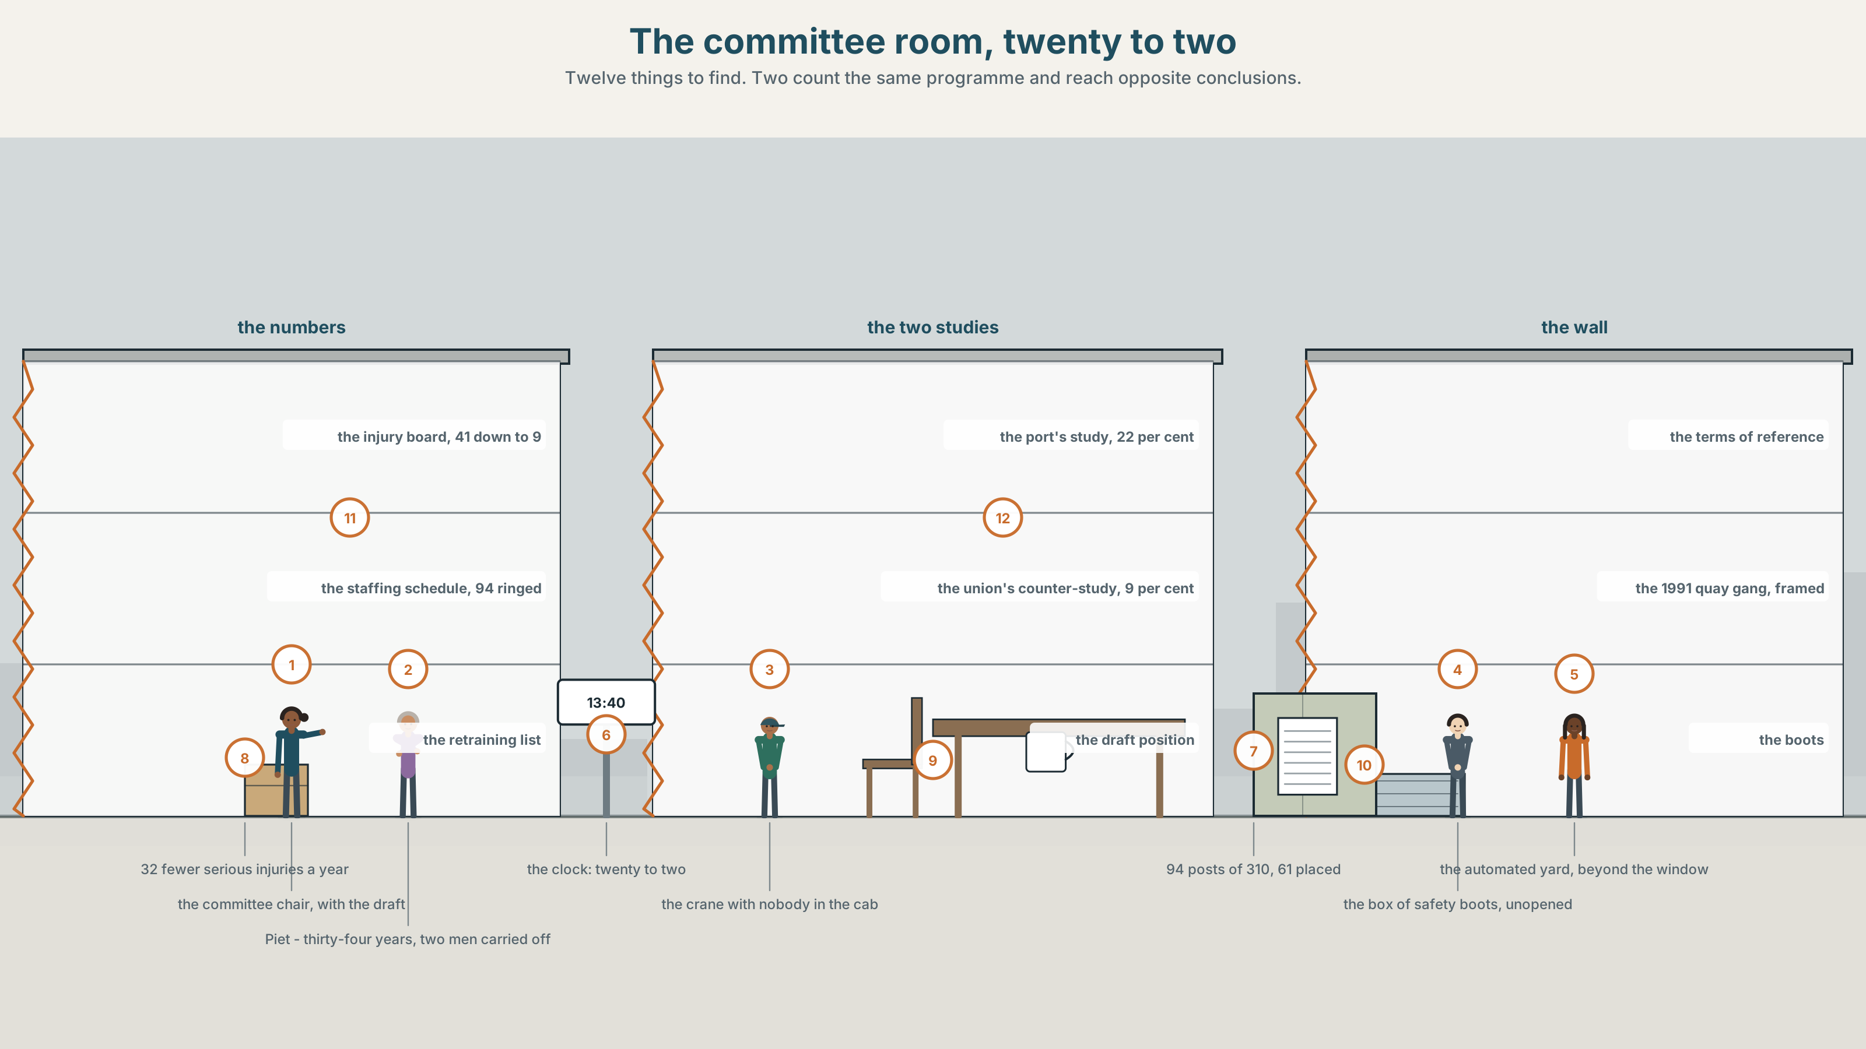{width=6.6in}
The committee room, twenty to two — Twelve things to find. Two count the same programme and reach opposite conclusions.

Can you agree and disagree at once?
By the end of this unit you can concede something real without abandoning your case, and hear when somebody else has. Two hundred words.
◆ A · THE WORLD | An automation programme that removes ninety-four jobs and thirty-two injuries a year
◆ B · THE SYSTEM | concessive structures: while, albeit, for all · 28 words for ethics and trade-offs · 22 concessive connectors and frames · the tune of a concession
◆ C · THE PERFORMANCE | Two hundred words that hold two true things at once

0A · Find it
Find twelve things in this picture. Two of them count the same programme and reach opposite conclusions.
the injury board, 41 down to 9 · the staffing schedule, 94 posts ringed · the retraining list, 61 names · the union's counter-study · the port's own study · the automated yard beyond the window · a crane with nobody in the cab · the ethics committee's terms of reference · a draft position, four lines · a photograph of the 1991 quay gang · a clock at 13.40 · a box of safety boots, unopened

0B · Guess it
One thing in this room is evidence in both studies and is read in opposite directions. Which, and what does each side say about it?

0C · Say it ⏺
Record sixty seconds. Describe a change that was good for most people and bad for some. Say both halves without letting either one win. You will record it again at the end of this unit.

Part 1 · Vocabulary Lab 1 ◆ B · THE SYSTEM
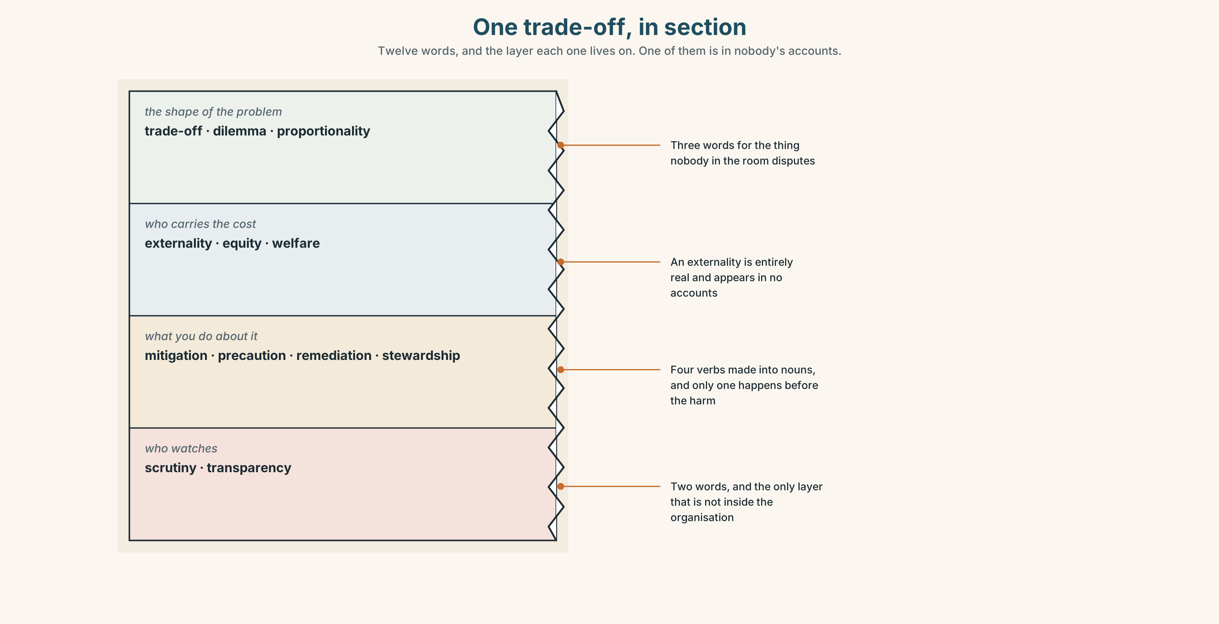{width=6.6in}
One trade-off, in section — Twelve words, and the layer each one lives on. One of them is in nobody's accounts.

1A · Meet — the words of a trade-off
Match each word to one layer of the cutaway.
trade-off · externality · stewardship · mitigation · proportionality · precaution · remediation · welfare · dilemma · scrutiny · transparency · equity

1B · Sort — the shape of the problem, who carries the cost, what you do, or who watches?
Four columns. One of the twelve is a cost that is entirely real and appears in nobody's accounts.
trade-off · externality · mitigation · scrutiny · dilemma · equity · precaution · transparency · proportionality · welfare · remediation · stewardship

1C · Meet — the five phrases an ethics committee lives on
a moral hazard | Somebody is protected from a risk and therefore takes more of it.
the lesser evil | A phrase that is true far less often than it is used.
a duty of care | An obligation that does not depend on anybody having agreed to it.
an unintended consequence | Unintended is a claim about the planner, not about the consequence.
the greater good | Always invoked by somebody who is not paying for it.

1D · Collocation Lab
Complete each one, and say which of the five names a person rather than a quantity.
on balance · a hard choice · due regard · a legitimate interest · the human cost
- ______ ______ , the committee supports the programme, and the two words are doing real work.
- The union has ______ ______ ______ in the ninety-four posts, whatever the safety figures say.
- The terms of reference require ______ ______ to the workforce, which is not the same as consent.
- ______ ______ ______ is thirty-three people the retraining scheme will not place.
- This is ______ ______ ______ , and calling it one is the minimum the committee owes.

1E · The phrasal verbs, and the three fixed expressions
weigh up · trade off · stand down
f there is no good answer · f both things are true · f that is the price
One of these fixed expressions can be used to end a discussion honestly and to end it dishonestly. Which, and what is the difference?

1F · Own it
Write one sentence about a change in your own life that was good overall and bad for somebody, with both halves in it.

Part 2 · Listening ◆ A · THE WORLD
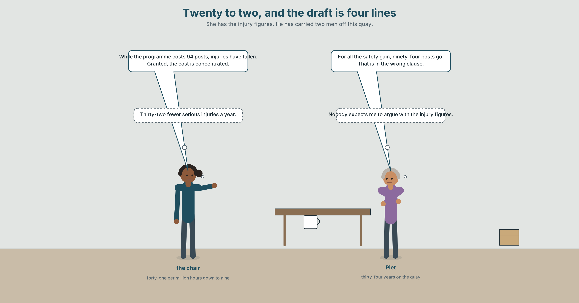{width=6.6in}
Twenty to two, and the draft is four lines — She has the injury figures. He has carried two men off this quay.

2A · Twenty to two 🔊 Track 6.1
Before you listen. Automation at the two new terminals has cut lost-time injuries from forty-one to nine per million hours. Ninety-four of three hundred and ten stevedore posts go. The retraining scheme will place sixty-one of them.
Listen once. What does each side concede, and what does each refuse to concede?
Listen again. Complete the table.
 | What they concede | What they hold | What they will not discuss
the committee
the union
the draft position
Listen again. True or false?
- Injuries fell from forty-one to nine. ☐ T ☐ F
- The scheme will place all ninety-four. ☐ T ☐ F
- The port's study claims a twenty-two per cent gain. ☐ T ☐ F
- The union's study covers the transition period. ☐ T ☐ F
Noticing. Six sentences from the recording.
- While the programme costs ninety-four posts, injuries have fallen by seventy-eight per cent.
- The programme costs ninety-four posts, albeit with a large safety gain.
- For all the safety gain, the programme costs ninety-four posts.
- The safety gain is real. Nonetheless, ninety-four posts go.
- Granted, the safety gain is real.
- The safety gain is real; conversely, the cost is concentrated on sixty people.
Six sentences, the same two facts. In each one, say which half the reader is left holding — and find the two that leave them holding the opposite halves.

2B · Decoding clinic 🔊 Track 6.2
Thirty seconds at speed. Three jobs.
- One speaker says granted twice. Mark the tune each time and say what changed.
- Where does the voice rise in the while clause, and what is that rise promising?
- Somebody says up to a point. What have they just accepted, and what have they not?

Part 3 · Grammar Lab 1 ◆ B · THE SYSTEM

Giving something away and keeping the sentence

3A · Notice
Look at the six sentences in Part 2 again.
- In sentence 1, which half is the reader left holding? Which clause is the main one?
- Sentence 3 begins with for all. What does it concede, and in how many words?
- Sentence 2 uses albeit. What can follow albeit, and what cannot?
- Sentences 4 and 5 split one move across two sentences. What is the advantage of splitting it?

3B · See
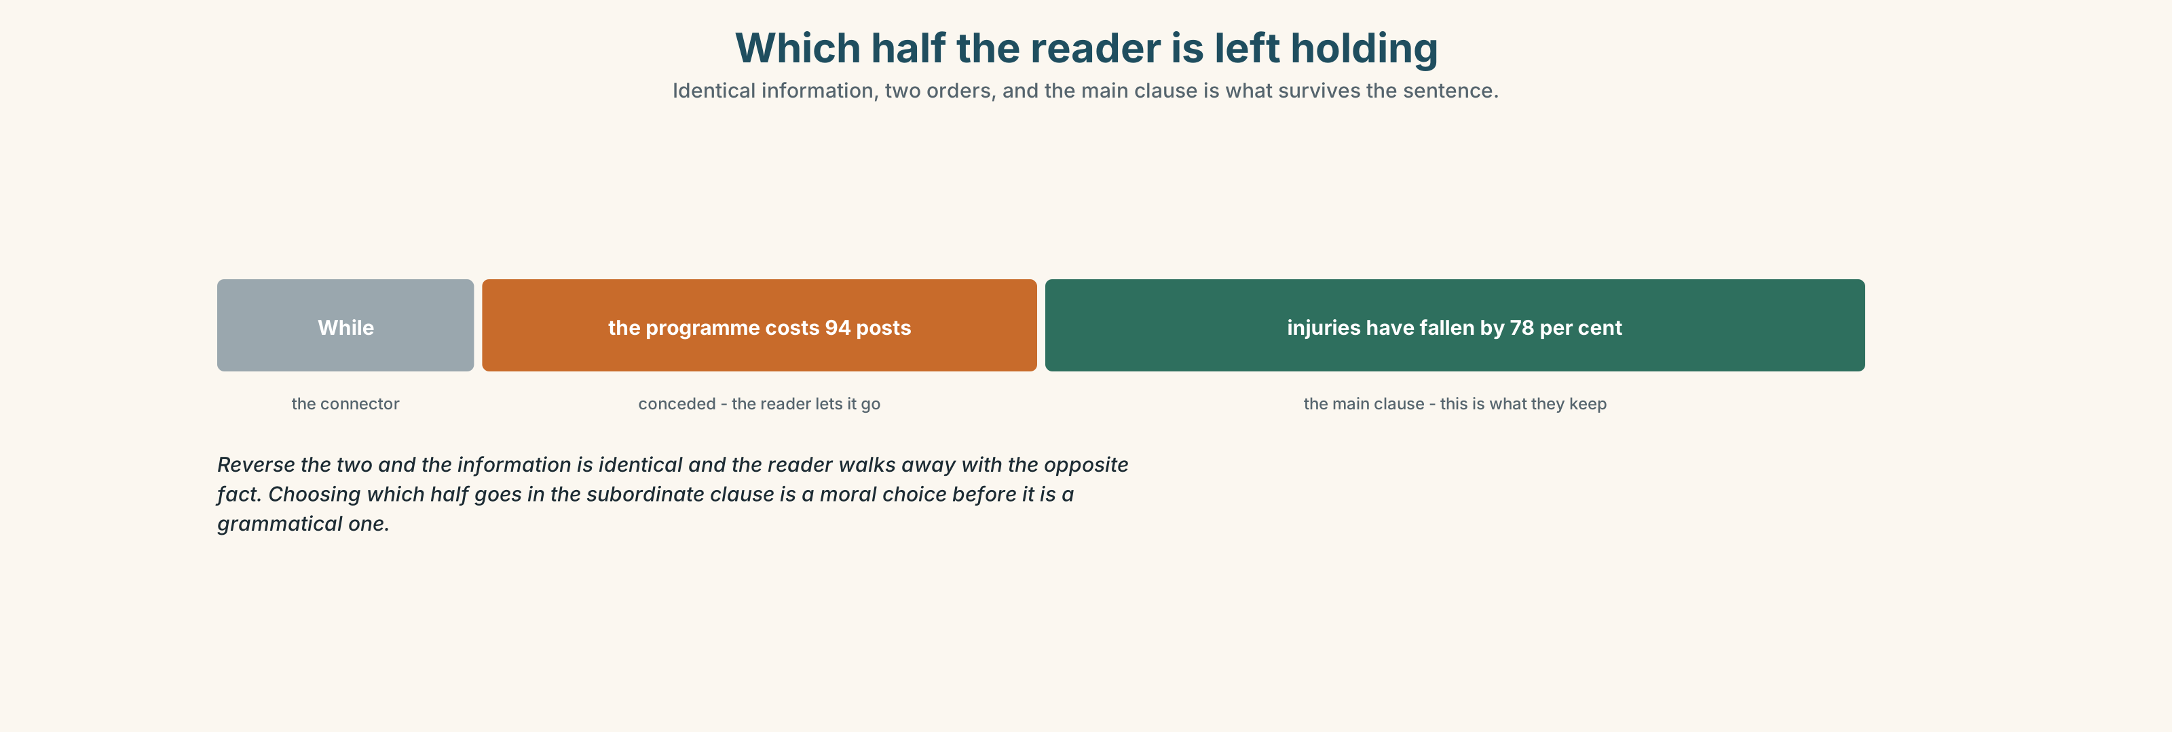{width=6.6in}
Which half the reader is left holding — Identical information, two orders, and the main clause is what survives the sentence.

3C · Know
while · whilst | a full clause; the main clause comes second and wins | While the cost is real, the case stands.
albeit | a phrase, not a clause; no subject, no finite verb | …the case stands, albeit at a cost.
for all | a noun phrase; concedes a quantity of something | For all the safety gain, ninety-four posts go.
granted · admittedly | a whole move in one word, usually sentence-initial | Granted, the gain is real.
nonetheless · even so | holds the position after the concession | Nonetheless, ninety-four posts go.
notwithstanding | formal; takes a noun phrase, before or after it | Notwithstanding the gain, the cost is real.
The reader keeps the main clause. While A, B and While B, A contain identical information and leave the reader holding opposite things. Choosing which fact goes in the subordinate clause is the whole of this unit, and it is a moral choice before it is a grammatical one.
Albeit takes no verb. …albeit at a cost, …albeit slowly, …albeit a small one. It cannot take a clause, and a learner who writes albeit it is expensive has been caught by the one irregularity in the set.
conceding in a phrase | to be fair · in fairness · that may be · there is something in
conceding and holding | at the same time · for all that · I accept that
limiting the concession | up to a point · I will grant you that · that does not follow
what people do in an argument | give way · back down · hold firm
Why it matters. A position that concedes nothing is not read as strong; it is read as uninformed. A position that concedes everything has no position. The sentence that does both is the hardest one in professional English and the most quoted when it works.

3D · Use — controlled
Complete with the connector the structure requires.
(1) ______ the safety gain is real, ninety-four posts go. (a full clause, first) The case stands, (2) ______ at a cost. (a phrase, no verb) (3) ______ ______ the safety gain, the cost falls on sixty people. (two words, a noun phrase) The gain is real. (4) ______ , the posts go. (one word, holding the position) (5) ______ , the figures are not in dispute. (one word, conceding, sentence-initial)

3E · Use — guided
Rewrite each one so that the reader is left holding the other half.
- While the programme costs ninety-four posts, injuries have fallen by seventy-eight per cent.
- The gain is real, albeit at a cost.
- For all the safety gain, the cost is concentrated.
- Granted, the figures are sound. Nonetheless, the scheme places only sixty-one.
- The retraining works for most people, though not for everybody.

3F · Use — open
In pairs. One of you states a position. The other concedes something real and then holds their own. Six rounds each, and nobody may concede the same thing twice.

3G · Error autopsy
✗ Albeit it is expensive, the case stands. ✗ While the gain is real, but the posts go. ✗ For all the programme costs ninety-four posts, injuries fell.
For each, name the rule and say what the writer was reaching for.

3H · Check — eight items
- ______ the gain is real, ninety-four posts go. (one word, a full clause)
- The case stands, ______ at a cost. (one word, a phrase)
- ______ ______ the safety gain, the cost is concentrated. (two words)
- The gain is real. ______ , the posts go. (one word)
- ______ , the figures are not in dispute. (one word, conceding)
- ✗ Albeit it is expensive, the case stands. → correct it.
- Rewrite item 1 so that the reader is left holding the safety gain.
- Write one sentence that concedes something real and still holds a position.

Part 4 · Speaking ◆ C · THE PERFORMANCE

4A · Fluency starter — concede and hold
One person states a position. The next concedes something real and holds the same position. The round ends when somebody concedes something that destroys the position — and the group says whether that was honest.

4B · The functional core — conceding strategically
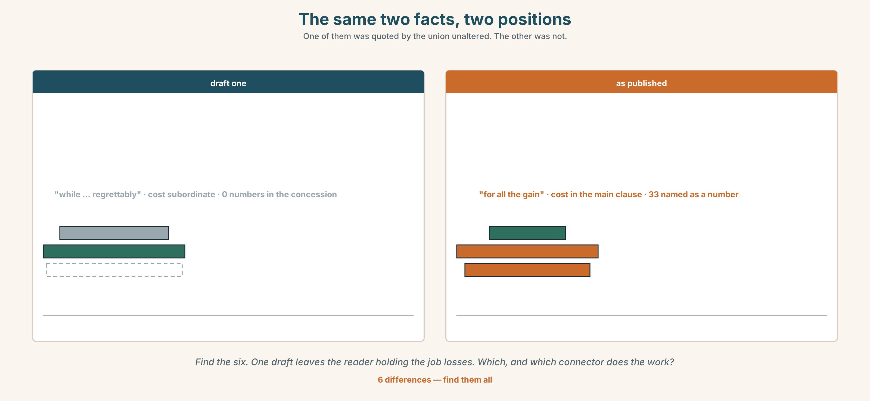{width=6.6in}
The same two facts, two positions — One of them was quoted by the union unaltered. The other was not.
Language Bank
conceding | granted · admittedly · to be fair · in fairness · I accept that
holding | nonetheless · even so · regardless · at the same time · for all that
limiting | up to a point · that may be · there is something in
turning it | conversely · while it is true · that does not follow
Information gap. Learner A has the port's study. Learner B has the union's. Agree on one sentence both sides would quote. Ten minutes.

4C · The performance — three minutes ⏺
Argue a position for three minutes. You must concede three real things, each one in a different structure, and your partner must judge whether any of the three cost you the argument.
Record it.

4D · Observer
One person writes down every concession and marks whether the speaker got the main clause back.

4E · Three criteria
☐ Was each concession something that actually costs me? ☐ Did the reader end each sentence holding what I wanted? ☐ Did I use three different structures, or but three times?

Part 5 · Reading ◆ A · THE WORLD

5A · Predict
The title is "Both things are true." Can one sentence carry a seventy-eight per cent fall in injuries and ninety-four redundancies without favouring one?

5B · Read — two minutes

Both things are true
Lost-time injuries at the two automated terminals have fallen from forty-one per million hours to nine. Across the port's whole labour force that is about thirty-two fewer serious injuries a year, and the people who are not injured are, on the whole, the same people whose jobs are going.
Ninety-four of three hundred and ten stevedore posts go. The retraining scheme places sixty-one. Thirty-three it does not place, and the scheme's own documents say so on page four.
The port's study reports a twenty-two per cent productivity gain. The union's study points out that the comparison excludes the eighteen months of transition, during which productivity fell by a third, and that including it reduces the gain to about nine per cent. Both studies are correct about what they measured.
The committee's draft position runs to four lines. Its first version began While the programme regrettably entails some reduction in headcount, the safety benefits are substantial. The union representative, a stevedore of thirty-four years, read it once and said that the first half of the sentence was in the wrong clause.
He was right, and nobody in the room could say why for about a minute.

5C · Comprehension — eight questions
- What has happened to lost-time injuries?
- How many posts go, and how many does the scheme place?
- Where does the scheme say it will not place thirty-three people?
- What does the port's study report, and what does the union's add?
- How long is the draft position?
- Why does the writer point out that the uninjured and the redundant are the same people?
- "Both studies are correct about what they measured." What is the writer conceding, and to whom?
- The stevedore's objection is grammatical and the writer calls it right. Explain what he meant.

5D · Vocabulary in context
Infer from the text, then check.
on the whole · entails some reduction in headcount · excludes the eighteen months of transition · correct about what they measured · in the wrong clause

5E · The counter-text
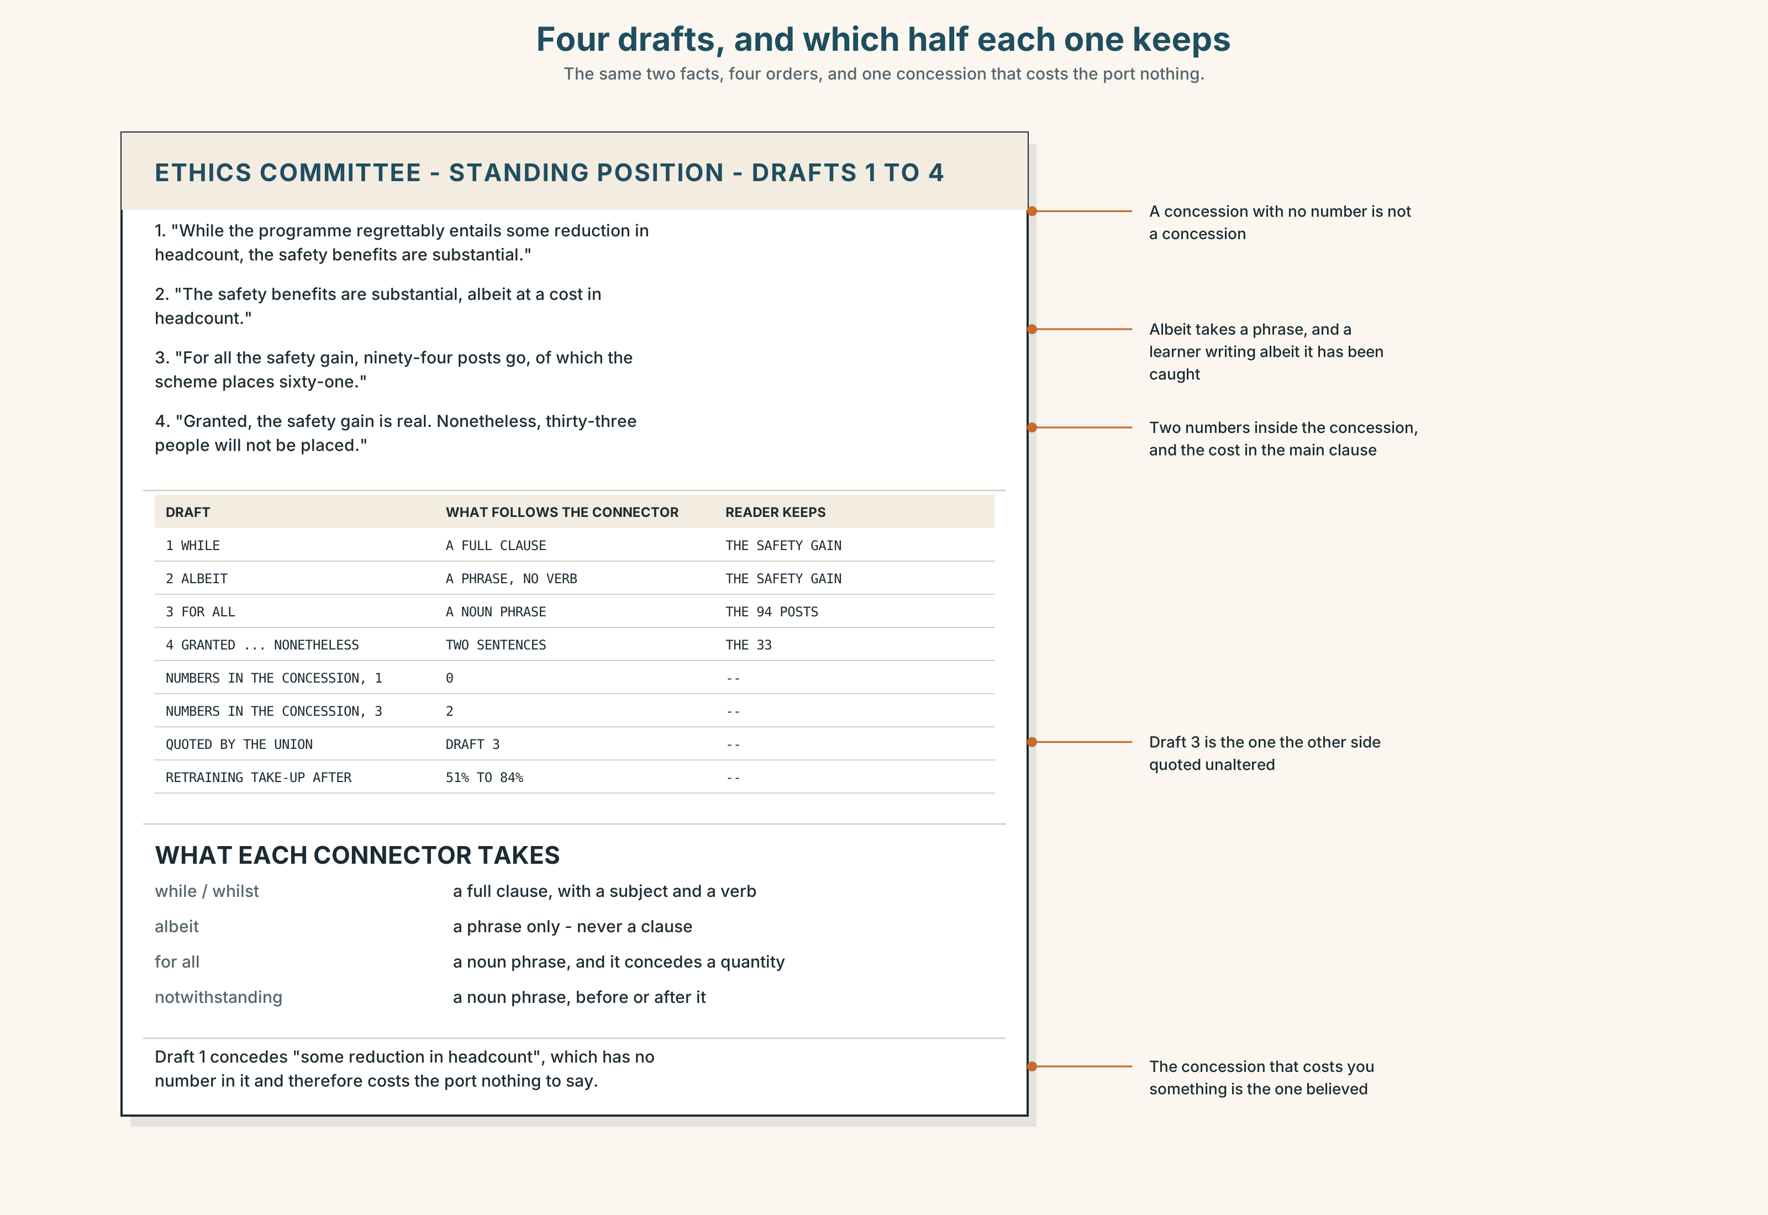{width=6.6in}
Four drafts, and which half each one keeps — The same two facts, four orders, and one concession that costs the port nothing.
Read the four drafts of the position and answer.
- In each draft, which fact is in the main clause?
- Find every concessive connector and say what kind of thing follows it: a clause, a phrase or a noun.
- One draft concedes something that costs the port nothing. Which, and how can you tell?
- Write a fifth draft that neither side could quote against the other.

5F · Two texts
The port's study says a twenty-two per cent productivity gain. The union's says about nine per cent, including transition.
Are these in conflict? Write two sentences, and use the word proportionality in one of them.

Part 6 · Vocabulary Lab 2 ◆ B · THE SYSTEM

Words that give something away

6A · Sort — conceding, holding anyway, or turning it round?
Three columns.
granted · nonetheless · conversely · admittedly · even so · whilst · regardless · albeit

6B · Chunk completion
- ______ ______ ______ , the cost falls on sixty people. (three words)
- ______ ______ ______ ______ that the figures are sound. (four words)
- ______ ______ ______ , the scheme places sixty-one of ninety-four. (three words)
- ______ ______ ______ , the committee supports it. (three words — holding both at once)
- ______ ______ ______ , but it is not the whole story. (three words)
- ______ ______ ______ ______ what he says. (four words — partial agreement)
- ______ ______ ______ ______ the programme is sound. (four words)
- I agree, ______ ______ ______ ______ . (four words — and no further)

6C · Three that are not interchangeable
albeit · although · notwithstanding
Say which one takes a clause, which one takes a phrase, and which one takes a noun — and which of the three can come after what it concedes.

6D · The phrasal verbs and the fixed expressions
give way · back down · hold firm
f up to a point · f I will grant you that · f that does not follow
One of these fixed expressions concedes a fact and refuses the conclusion drawn from it. Which, and why is that the most useful move in the set?

6E · Contrast Clinic
Eight items. Rewrite each one as the bracket asks.
- The programme costs ninety-four posts and injuries fell by 78 per cent. (while, leaving the reader holding the safety gain)
- The same pair of facts. (while, leaving the reader holding the job losses)
- The case stands and it is expensive. (albeit)
- There is a safety gain but the cost is concentrated. (for all)
- The figures are sound and the posts still go. (granted … nonetheless)
- The retraining works for most people. (a concession that names the exception)
- The union's study is right and so is the port's. (one sentence, both held)
- I accept your figure but not your conclusion. (a four-word fixed expression)

Part 7 · Pronunciation & Fluency Lab ◆ B · THE SYSTEM
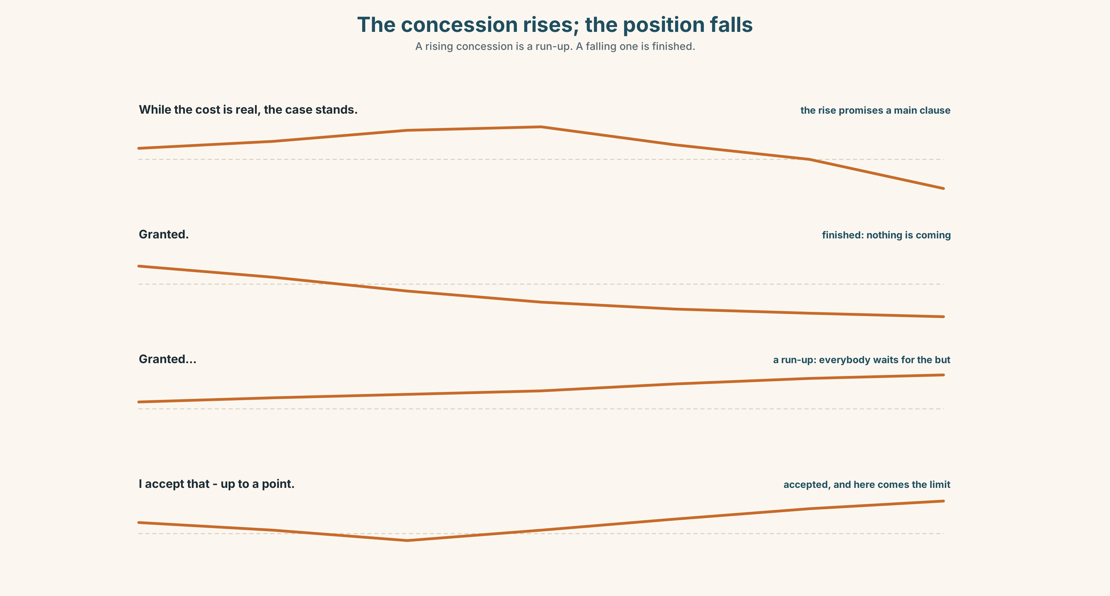{width=6.6in}
The concession rises; the position falls — A rising concession is a run-up. A falling one is finished.

A concession rises and the position falls

7A · Hear 🔊 Track 6.3
While the cost is real, ↗ the case stands. ↘ — the rise promises the main clause Granted. ↘ — a full stop: the concession is complete and nothing follows Granted… ↗ — and something is about to follow, and everybody waits for it

7B · Say
Say all three. Then say this:
Granted — and I do not say it lightly — the cost is real; nonetheless, the case stands. — one rise, one level stretch, one fall, and the fall is where the position is.

7C · Make it mean something
Say these two:
I accept that. ↘ — accepted, finished I accept that… ↗ — accepted, and here comes the limit
A concession said with a falling tune is a concession; said with a rising one it is a run-up. Everybody in the room can hear the difference, which is why a rising granted never has to be followed by but.

7D · Fluency 30 ⏺
Thirty seconds: three concessions, each with a rising tail, each followed by a position that falls. Three times, faster.

Part 8 · Writing ◆ C · THE PERFORMANCE

A position that holds two things · 200 words

8A · Read the model
Lost-time injuries at the automated terminals have fallen from forty-one per million hours to nine, which is about thirty-two fewer serious injuries a year. [the fact, unqualified, with its scope: nothing is conceded yet because nothing has been claimed]
Ninety-four posts go, of which the retraining scheme will place sixty-one; the remaining thirty-three are named in the scheme's own documents. [the cost, in the main clause, with the number the port would rather not print]
For all the safety gain, the two facts fall on the same people: those not injured next year are, in the main, those whose jobs end this year. [for all + noun phrase, and the main clause is the uncomfortable one]
The committee supports the programme, albeit with a recommendation that the scheme be extended to the thirty-three. [albeit + a phrase, and the position survives the concession because the concession has a number in it]
Questions about the writer's choices:
- The first two paragraphs concede nothing. Why not?
- Paragraph three puts the cost in the main clause. What would the reverse have read as?
- The last sentence concedes with albeit and a recommendation. What makes that concession credible rather than decorative?

8B · The anti-model
While the programme regrettably entails some reduction in headcount, the substantial safety benefits, which are considerable, clearly outweigh any short-term disruption, and the port remains fully committed to supporting all affected colleagues throughout this transition.
One sentence, thirty-six words, one concession with no number in it, and the cost in the subordinate clause. Rewrite it with the cost in a main clause and a number in every claim.

8C · Plan
the gain, with its scope → the cost, in a main clause, with its number → the concession in for all, and the uncomfortable fact in the main clause → the position, conceding with albeit and a commitment

8D · Write — 200 words

8E · Peer review — three criteria
☐ Does each concession cost you something a reader could name? ☐ Is the fact you want remembered in the main clause of its sentence? ☐ Did you use three different concessive structures, or one three times?

8F · Write it again · 8G · Publish
Rewrite after review. Publish both, and mark the main clause of every concessive sentence.

Part 9 · The File ◆ A · THE WORLD + C · THE PERFORMANCE
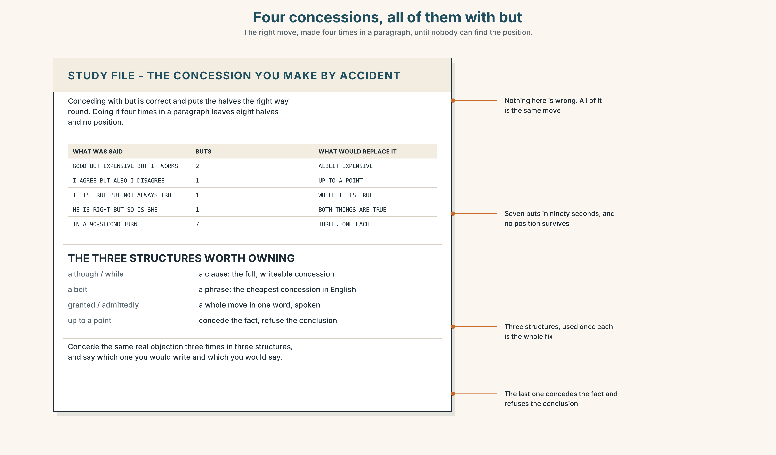{width=6.6in}
Four concessions, all of them with but — The right move, made four times in a paragraph, until nobody can find the position.

STUDY FILE · The concession you make by accident

9A · But, but, but 🔊 Track 6.4
Learners concede constantly and almost always with but, which puts the concession in the first half and the position in the second — the right way round — and then do it four times in a paragraph, so that the listener stops being able to tell which half is the position.
what you say | It is good but expensive, but it works, but not always
what the listener hears | four halves and no position
what is missing | one concession, in a different structure, used once
the fix | three structures, one each: although, albeit, granted

9B · One concession, three ways
Take one opinion you hold. Concede the same real objection three times, in three structures, and say which one you would write and which you would say.

9C · Role play — hold the position
In pairs. One of you states a position. The other raises an objection. The first must concede it and keep the position, in one sentence. Four rounds each.

9D · The thing you never concede
Everybody has one point they defend past the evidence. Name yours, and write the sentence that would concede it without giving up your position.

9E · Transfer — before next week
Write four sentences about something you believe, conceding something real in each. Bring them, and ask somebody which concession they thought was genuine.

Part 10 · Mediation & Interaction ◆ C · THE PERFORMANCE
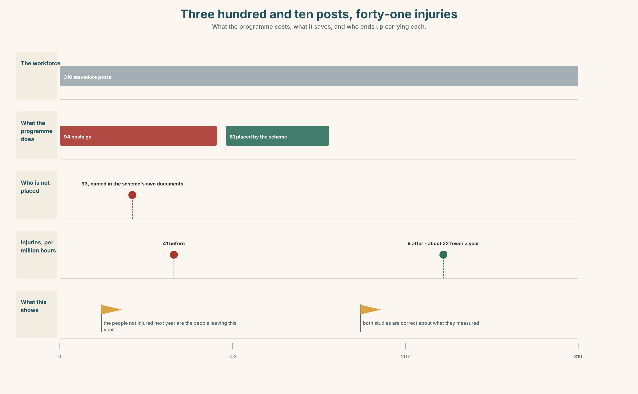{width=6.6in}
Three hundred and ten posts, forty-one injuries — What the programme costs, what it saves, and who ends up carrying each.

10A · Relay
Half the class has the injury figures. Half has the staffing schedule and the retraining list. Produce one sentence both halves accept, by speaking only. Ten minutes.

10B · Simplify — for one reader
One of the thirty-three writes: So is my job worth somebody else's back? Reply in four sentences. Do not use the phrase the greater good.

10C · Online
Write one message to the committee proposing that the thirty-three be named in the position. Three sentences, conceding the obvious objection in one of them.

10D · Your language
How does your language concede — with a connector, with a particle, or with word order? Translate all six sentences from Part 2. Which of the six come out identical?

Part 11 · The Decision ◆ C · THE PERFORMANCE

The standing position
Option one: state the safety case. Injuries have fallen by seventy-eight per cent, that is thirty-two people a year, and everything else is a transition cost.
Option two: state the job losses first and the safety case second, because the cost is certain and concentrated and the benefit is statistical and spread.
Option three: one concessive sentence carrying both, published as the standing position, with the numbers for each half printed beside it and the thirty-three named as a number.

11A · The evidence
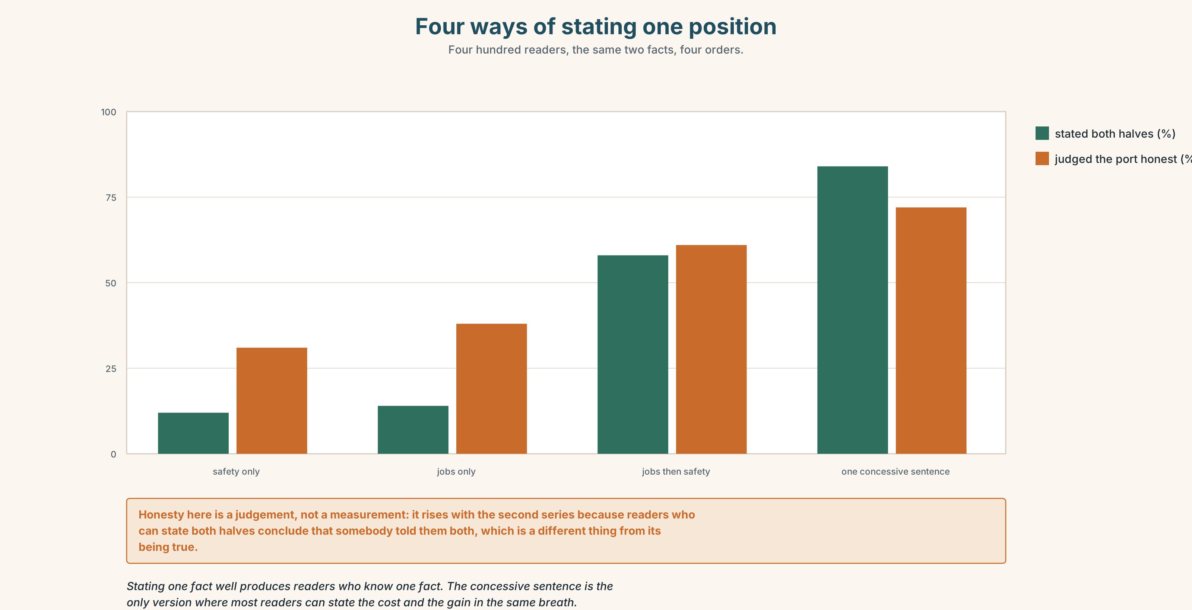{width=6.6in}
Four ways of stating one position — Four hundred readers, the same two facts, four orders.
🔊 Track 6.6. Piet de Wit, stevedore, thirty-four years, 30 seconds: "I have carried two men off this quay. I am not going to stand here and tell you the injury figures do not matter, and I notice nobody expects me to, which is its own kind of insult. What I want is the sentence written the other way round once — the cost in the main clause, the gain in the subordinate — so that I know somebody in that room has had to hold it that way for as long as it takes to type it."

11B · Talk about it
In threes. Use the frame, and concede once per turn in a different structure.
Granted, ______ . Nonetheless, ______ , albeit ______ .

11C · Decide
Write three sentences: the decision, the evidence, and the standing position itself.

11D · Model decision
Option three. Option one is true and will be read as a refusal to look; option two is true and will be read as a refusal to decide. The single sentence is harder to write and is the only version that survives being quoted by either side, because both halves are in it and neither is in a subordinate clause by default. Naming the thirty-three as a number is the part that costs the port something, which is what makes the rest of it believable.

11E · The Reveal
What happened. The committee published one sentence with the cost in the main clause and the gain in a for all phrase, and printed both sets of figures beside it. The union quoted it unaltered in its own newsletter, which had not happened in nine years of the programme.
Then something nobody predicted: take-up of the retraining scheme rose from fifty-one per cent to eighty-four. The scheme had not changed. What had changed was that the position named thirty-three people it would not place, and the sixty-one who could be placed now had a reason to believe the number applied to somebody else.
One question. You do not have to answer it out loud.
The port conceded something and gained something. What exactly did it concede?

Part 12 · Landing ◆ all three lines

12A · Recycle — fifteen items
- ______ the gain is real, ninety-four posts go. (one word, a clause)
- The case stands, ______ at a cost. (one word, a phrase)
- ______ ______ the safety gain, the cost is concentrated. (two words)
- The gain is real. ______ , the posts go. (one word)
- ______ , the figures are not in dispute. (one word)
- ______ , the cost falls on sixty people. (one word — turning it round)
- The committee supports it ______ . (one word — whatever is said)
- ______ ______ ______ ______ that the figures are sound. (four words)
- ______ ______ ______ , the committee supports it. (three words — both at once)
- ______ ______ ______ ______ what he says. (four words — partial agreement)
- I agree, ______ ______ ______ ______ . (four words — and no further)
- ______ ______ ______ ______ . (four words — conceding the fact, refusing the conclusion)
- Neither side will ______ ______ on the transition figures. (two words)
- The committee refused to ______ ______ on the naming. (two words)
- Somebody always has to ______ ______ ______ the two numbers. (three words)

12B · Consolidate — one task, everything in it
Write 150 words taking a position on something contested, conceding three real things in three different structures. Mark the main clause of each.

12C · Can-do, with evidence
☐ I can use while, albeit, for all and notwithstanding correctly. Evidence: 3H, 8D ☐ I can choose which fact goes in the main clause, and say why. Evidence: 6E, 5E ☐ I can concede something real and keep my position. Evidence: 4C, 9C ☐ I can hear and produce the rising concession. Evidence: 7C

12D · Replay ⏺
Record 0C again. Compare. Which half won the first time, and did you notice?

12E · Glossary — fifty items, as a map
THE SHAPE OF THE PROBLEM · trade-off · dilemma · proportionality WHO CARRIES THE COST · externality · equity · welfare WHAT YOU DO ABOUT IT · mitigation · precaution · remediation · stewardship WHO WATCHES · scrutiny · transparency THE FIVE PHRASES · a moral hazard · the lesser evil · a duty of care · an unintended consequence · the greater good WEIGHING IT · on balance · a hard choice · due regard · a legitimate interest · the human cost WHAT PEOPLE DO IN AN ARGUMENT · weigh up · trade off · stand down · give way · back down · hold firm IN THE ROOM · there is no good answer · both things are true · that is the price THE CONNECTORS · albeit · whilst · granted · admittedly · nonetheless · conversely · regardless · even so THE FRAMES · for all that · while it is true · to be fair · in fairness · at the same time · that may be · there is something in · I accept that LIMITING IT · up to a point · I will grant you that · that does not follow

12F · Next
Unit 7 · What goes first and what goes last?

