Table of Contents

B2.2 · Unit 7 · Twenty-Four Words at a Gate
English Animated · Holding the Floor · a port and its logistics chain, Rotterdam Student's Book pages 138–159 · 22 pp · ~11 hours

Part 0 · The Big Picture ◆ A · THE WORLD
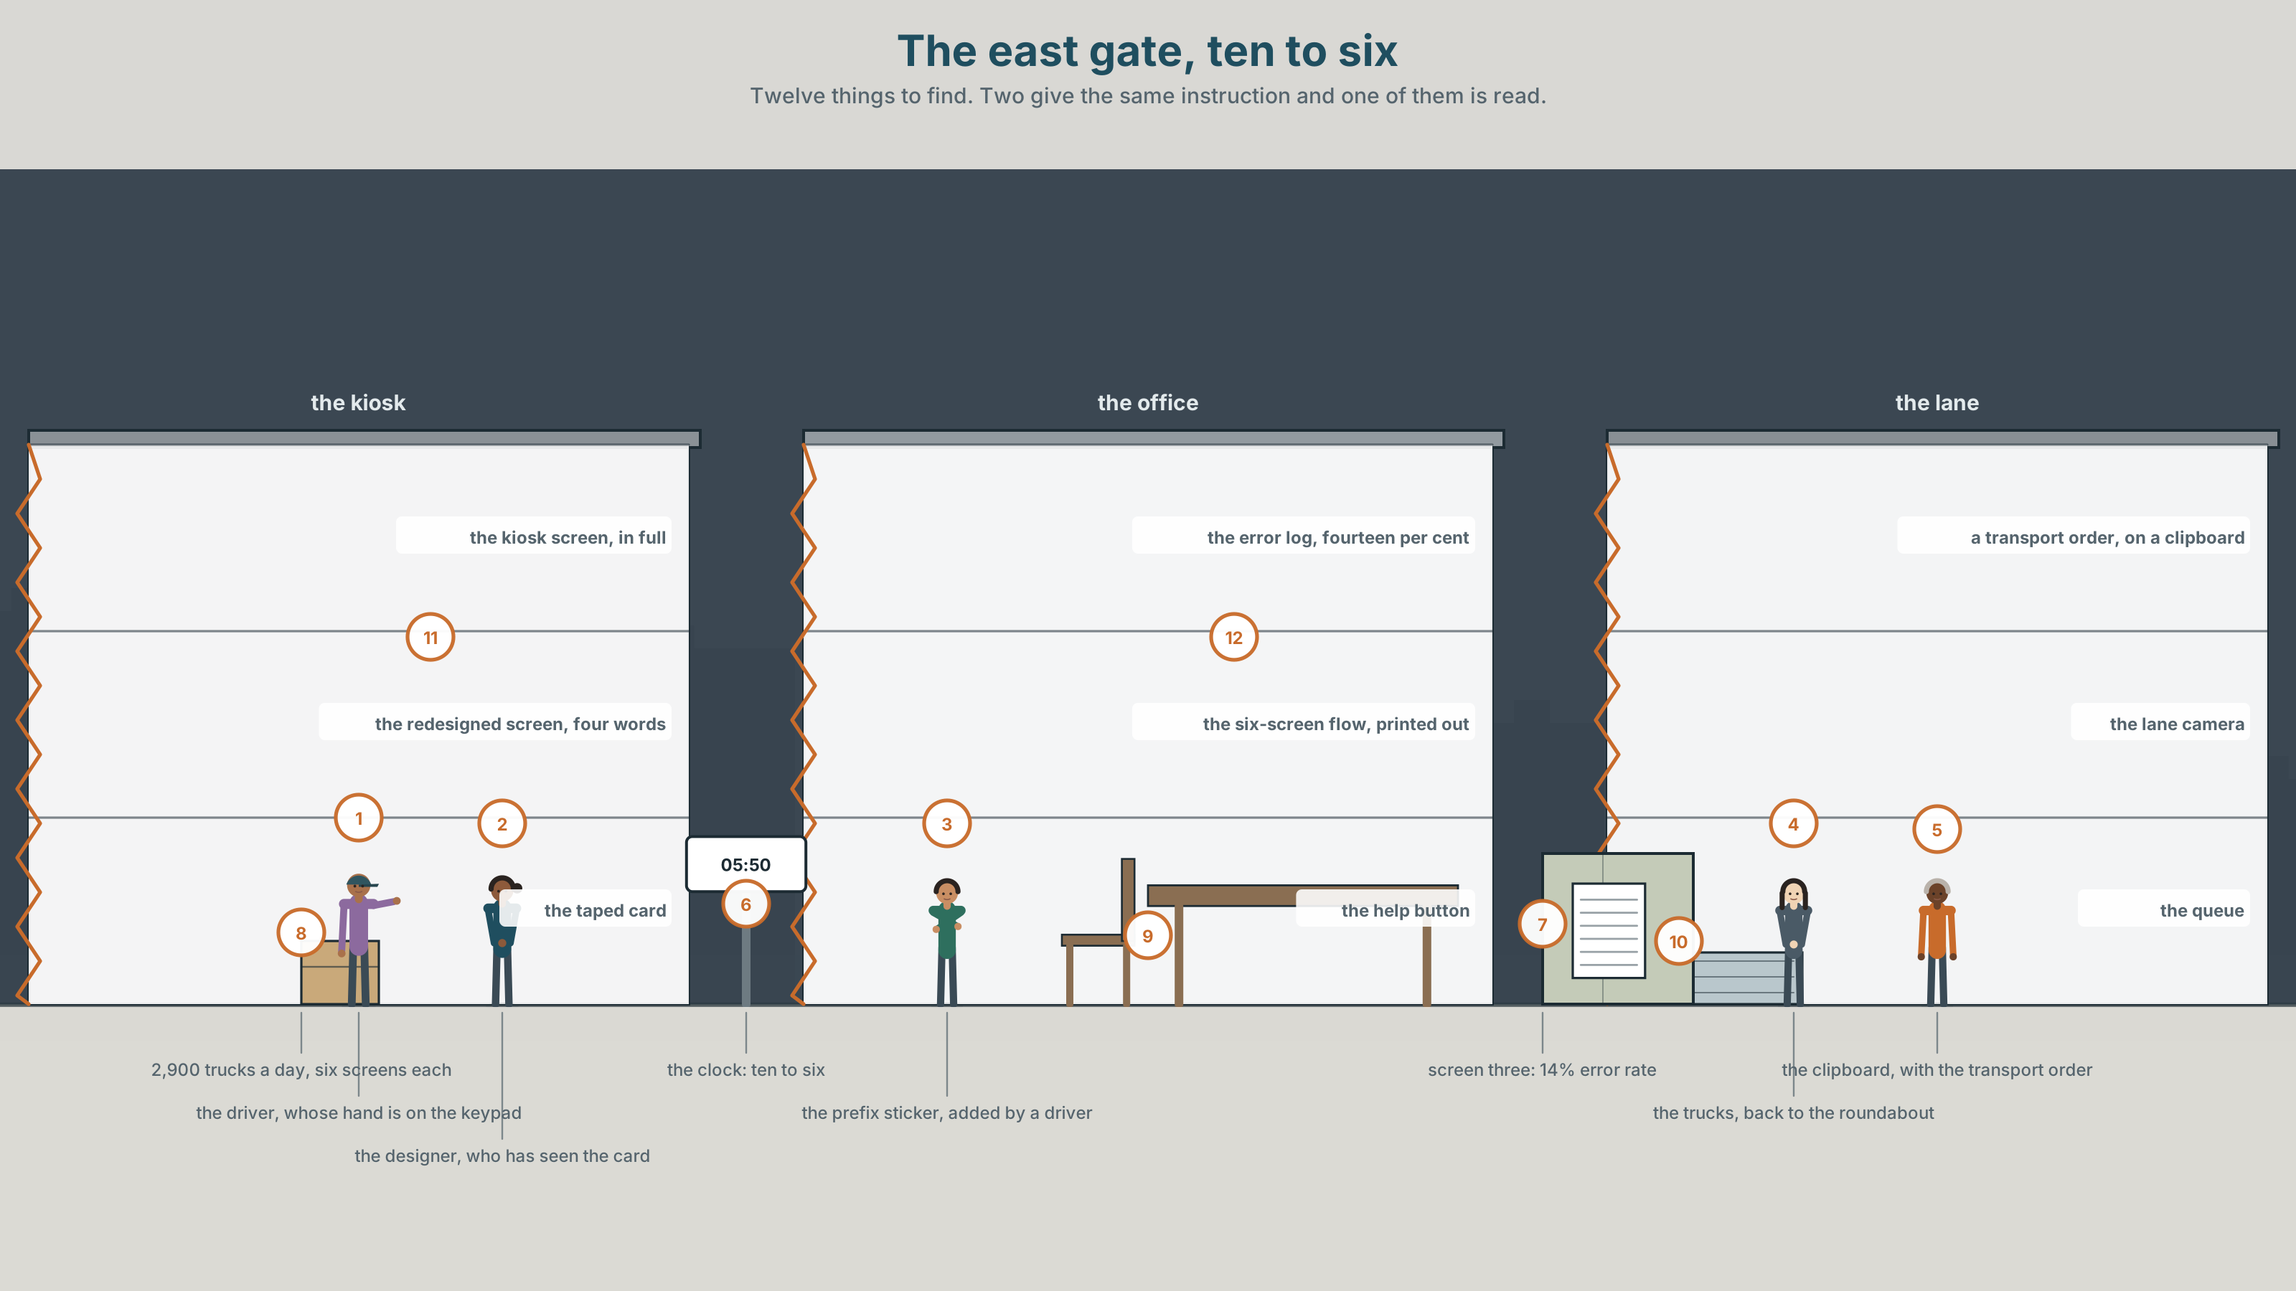{width=6.6in}
The east gate, ten to six — Twelve things to find. Two give the same instruction and one of them is read.

What goes first and what goes last?
By the end of this unit you can put the right thing at each end of a sentence, and say what each position costs. Two hundred words.
◆ A · THE WORLD | A gate kiosk, two thousand nine hundred trucks a day, and one instruction with a fourteen per cent error rate
◆ B · THE SYSTEM | fronting and end-weight · 28 words for interfaces and instructions · 22 thematic words and frames · end-focus
◆ C · THE PERFORMANCE | Two hundred words in which every sentence ends where you meant it to

0A · Find it
Find twelve things in this picture. Two of them give the same instruction and one of them is read.
the kiosk screen, instruction in full · the redesigned screen, four words · the error log, fourteen per cent · the queue of trucks, back to the roundabout · a transport order on a clipboard · a driver's hand on the keypad · the help button nobody presses · the prefix sticker added by a driver · the lane camera · a clock at 05.50 · a laminated card taped to the kiosk · the six-screen flow printed out

0B · Guess it
One thing in this picture was added by the people the kiosk is for, and it fixes the instruction better than the instruction does. Which, and what does that tell the designer?

0C · Say it ⏺
Record sixty seconds. Give instructions for something you do every day, to somebody who has never done it. You will record it again at the end of this unit.

Part 1 · Vocabulary Lab 1 ◆ B · THE SYSTEM
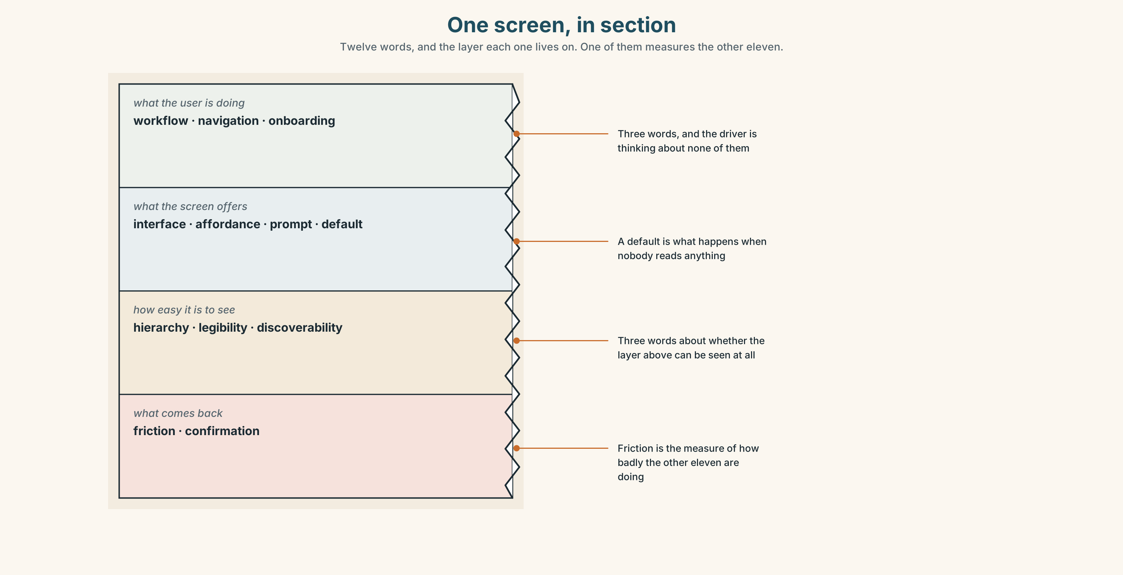{width=6.6in}
One screen, in section — Twelve words, and the layer each one lives on. One of them measures the other eleven.

1A · Meet — the words of an interface
Match each word to one layer of the cutaway.
interface · affordance · workflow · prompt · onboarding · friction · navigation · hierarchy · legibility · discoverability · default · confirmation

1B · Sort — what the user is doing, what the screen offers, or how easy it is to use?
Three columns. One of the twelve is a measure of how badly the other eleven are doing.
workflow · interface · hierarchy · navigation · affordance · legibility · onboarding · prompt · discoverability · default · friction · confirmation

1C · Meet — the five things on every screen
a default setting | What happens if the user does nothing, which is what most of them do.
the critical action | The one thing this screen exists for. Usually not the biggest element.
an error state | The screen a user sees most often and the one designed last.
a dead end | A screen with no way forward that does not say so.
the happy path | The route taken by a user who makes no mistakes, and by almost nobody.

1D · Collocation Lab
Complete each one, and say which of the five is the only one a driver ever reads twice.
step one of four · a confirmation screen · the primary button · a help string · the first run
- ______ ______ ______ ______ tells the user how long this is going to take.
- ______ ______ ______ is grey on grey and sits below the fold.
- ______ ______ ______ repeats the booking reference so that it can be checked.
- ______ ______ ______ runs to twenty-four words and is read by nobody.
- ______ ______ ______ is the only time a driver is paying attention, and it happens once.

1E · The phrasal verbs, and the three fixed expressions
walk through · click through · opt out
f where do I click · f what happens if I · f nothing told me that
One of these fixed expressions is the only honest measure of an interface. Which, and why can it only be heard and never designed for?

1F · Own it
Write one instruction you give people often, twice: once with the action first and once with the condition first.

Part 2 · Listening ◆ A · THE WORLD
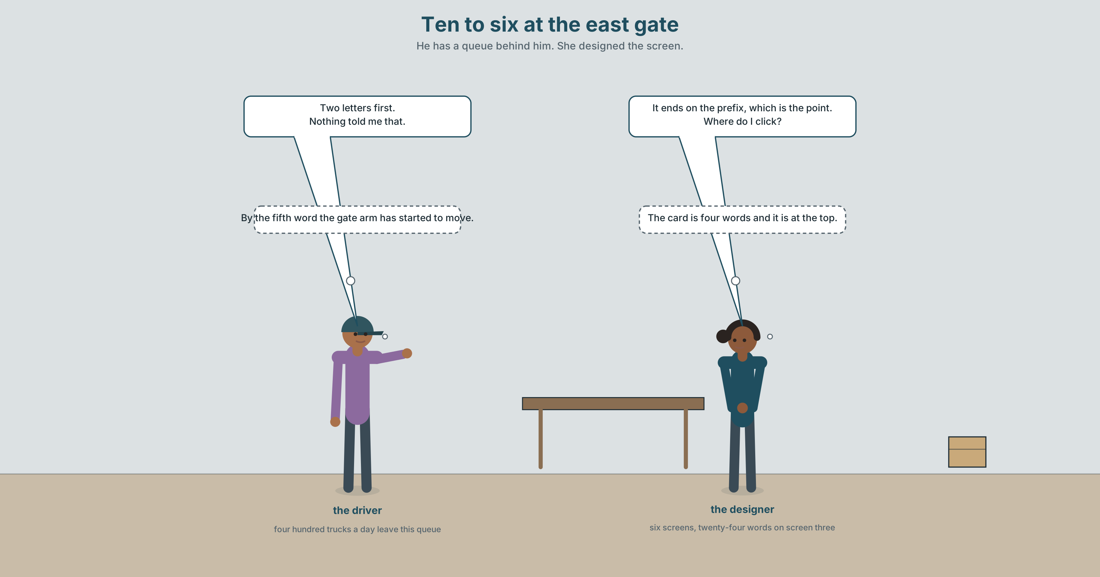{width=6.6in}
Ten to six at the east gate — He has a queue behind him. She designed the screen.

2A · Ten to six 🔊 Track 7.1
Before you listen. Two thousand nine hundred trucks arrive a day. The booking-reference screen has a fourteen per cent error rate. A driver has taped a card to the kiosk.
Listen once. What does the instruction say, and what do drivers actually do?
Listen again. Complete the table.
 | What the screen says | What the driver does | Where it goes wrong
screen 3
the error state
the taped card
Listen again. True or false?
- Two thousand nine hundred trucks arrive a day. ☐ T ☐ F
- The instruction is twenty-four words. ☐ T ☐ F
- The error rate is four per cent. ☐ T ☐ F
- A driver added the prefix sticker. ☐ T ☐ F
Noticing. Six versions of the same instruction.
- Please ensure that the booking reference, which can be found on your transport order, is entered in full including the prefix.
- Enter the booking reference in full, including the prefix.
- Including the prefix, enter the booking reference in full.
- The booking reference is what you enter here — in full, including the prefix.
- Enter your booking reference. It begins with two letters.
- What you must include is the two-letter prefix.
Six versions, one instruction. Say which word each version ends on, and which of the six a driver in a queue would get right.

2B · Decoding clinic 🔊 Track 7.2
Thirty seconds at speed. Three jobs.
- One speaker reads version 1 aloud. Mark where the voice falls, and count how many falls there are.
- Which word carries the last stress in version 5, and why does that matter?
- Somebody says nothing told me that. What had they just done?

Part 3 · Grammar Lab 1 ◆ B · THE SYSTEM

The first position and the last position do different jobs

3A · Notice
Look at the six versions in Part 2 again.
- Version 1 ends on prefix. Why is that the wrong word to end on, if the prefix is the problem?
- Version 3 fronts a phrase. What does fronting it promise, and does the sentence keep the promise?
- Version 5 is two sentences. What has the split bought?
- Version 6 is a pseudo-cleft. Where does it put the prefix, and what does that cost?

3B · See
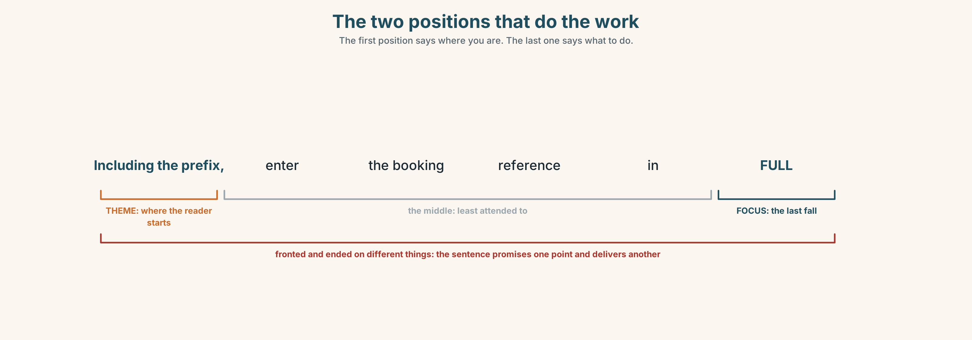{width=6.6in}
The two positions that do the work — The first position says where you are. The last one says what to do.

3C · Know
the first position (theme) | what the sentence is about; the reader's starting point | Including the prefix, …
the last position (focus) | the new information; where the voice falls | …including the prefix.
fronting | moving something to the front for contrast or linkage | The prefix you must include.
end-weight | long and heavy elements go last, short ones first | Enter, in full, the reference printed on your order.
extraposition | a heavy subject is moved to the end and it holds its place | It is essential to include the prefix.
the conflict | you cannot front a thing and also end on it | and most bad instructions try
English puts old information first and new information last. The first position tells the reader where they are; the last position tells them what to do with it. A sentence that puts the new fact first and a familiar one last has been read backwards, and the reader will have to do it twice.
End-weight is not a style rule. Enter the reference printed on your transport order in full is hard because a long noun phrase has been pushed into the middle. Move it to the end and the sentence works: Enter in full the reference printed on your transport order.
fronting for emphasis | more important is · what matters most is · central to this is
marking position in a list | first · foremost · last of all · chief among them · last but not least
adding weight at the end | worse still · no less important · and finally
what writers do with order | lead with · end on · put off
Why it matters. An instruction is read once, at speed, by somebody who is already doing something else. The last word of each sentence is the one that survives, which means the order of the words is the design.

3D · Use — controlled
Rewrite each one so that it ends on the word in brackets.
Enter the booking reference in full, including the prefix. (1) (prefix) You must include the two-letter prefix. (2) (prefix) The reference printed on your transport order must be entered in full. (3) (full) It is essential to include the prefix. (4) (prefix) Check the reference before you press confirm. (5) (confirm)

3E · Use — guided
Rewrite each one using end-weight, moving the heavy element to the end.
- The reference printed on your transport order must be entered in full.
- That the prefix is two letters is not obvious.
- Whether the driver has the order in the cab is the real question.
- A screen that nobody reads twice was designed last.
- To enter the reference without the prefix is the commonest error.

3F · Use — open
In pairs. One of you gives an instruction. The other says the last word back. If it is not the word that matters, the first speaker rewrites it. Six rounds each.

3G · Error autopsy
✗ Including the prefix, the reference must be entered in full including the prefix. ✗ That the prefix is two letters is not obvious to most drivers who are in a queue. ✗ Enter the reference printed on your transport order which begins with two letters in full.
For each, name the rule and say what the writer was reaching for.

3H · Check — eight items
- Rewrite Enter the reference in full, including the prefix so that it ends on prefix.
- Rewrite The reference printed on your order must be entered in full with end-weight.
- Rewrite That the prefix is two letters is not obvious with extraposition.
- ______ ______ ______ is the two-letter prefix. (three words — a fronted focus frame)
- ______ ______ , check the order in your cab. (two words — first in a list)
- ✗ Enter the reference printed on your transport order which begins with two letters in full. → correct it.
- Write one instruction of eight words or fewer that ends on its critical element.
- Write the same instruction fronted, and say what you lost.

Part 4 · Speaking ◆ C · THE PERFORMANCE

4A · Fluency starter — end on it
One person names a word. The next makes a sentence ending on that word. The third says whether the sentence sounds natural or forced — and if forced, says which position the word wanted.

4B · The functional core — ordering a sentence
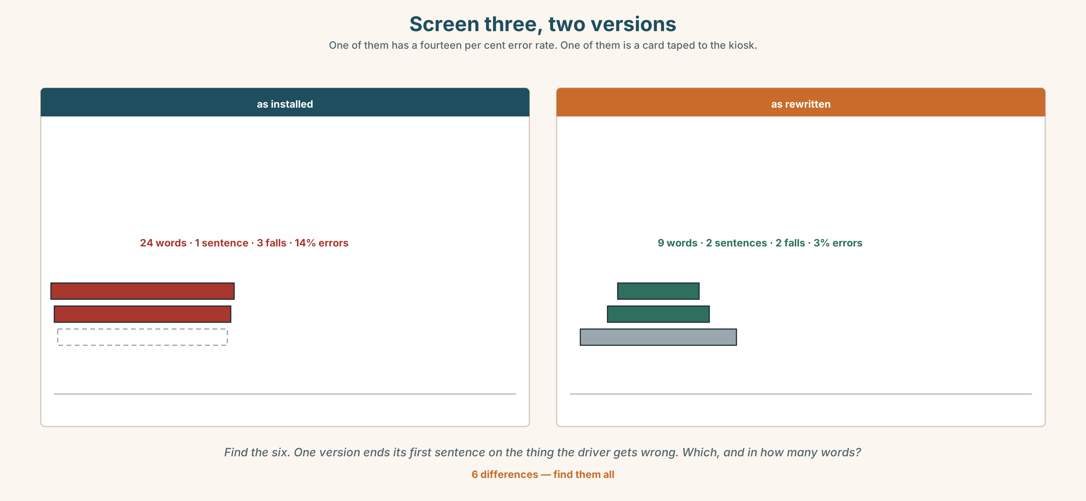{width=6.6in}
Screen three, two versions — One of them has a fourteen per cent error rate. One of them is a card taped to the kiosk.
Language Bank
fronting | more important is · what matters most is · central to this is · at the heart of it
ordering | first · foremost · last of all · chief among them
weighting the end | worse still · no less important · and finally
talking about order | lead with · end on · put off
Information gap. Learner A has the six kiosk screens. Learner B has the error log. Agree on one new instruction for screen three. Ten minutes.

4C · The performance — three minutes ⏺
Explain a procedure in three minutes. Every sentence must end on the word you want remembered, and your partner writes down the last word of each and reads the list back.
Record it.

4D · Observer
One person writes the last word of every sentence and marks whether it was the point.

4E · Three criteria
☐ Did each sentence end where I meant it to? ☐ Did I front anything, and did the sentence keep that promise? ☐ Was the heaviest element at the end of its sentence?

Part 5 · Reading ◆ A · THE WORLD

5A · Predict
The title is "The card somebody taped to the kiosk." If users fix an instruction themselves, what have they told you?

5B · Read — two minutes

The card somebody taped to the kiosk
Two thousand nine hundred trucks arrive at the east gate each day. Each driver passes through six kiosk screens. Screen three asks for the booking reference.
The instruction on screen three reads: Please ensure that the booking reference, which can be found on your transport order, is entered in full including the prefix. Twenty-four words. The error rate on that screen is fourteen per cent, which is about four hundred trucks a day entering a queue they will have to leave.
Every error is the same error. The prefix is two letters. Drivers enter the six digits and omit them.
The sentence ends on prefix, which is the one piece of information that matters, and that ought to be right. It is not, because by the time a driver reaches the end of a twenty-four word sentence in a queue at ten to six in the morning, they have already started typing.
At some point in the last year somebody taped a card to the kiosk. It says, in marker pen, 2 LETTERS FIRST. Four words, at the top, where the hand is.
The error rate at that kiosk is three per cent. It is the only one of the twelve gates where anybody has measured it, because it is the only one where anybody noticed.

5C · Comprehension — eight questions
- How many trucks arrive, and how many screens are there?
- How long is the instruction, and what is the error rate?
- How many trucks a day is that?
- What is the error, every time?
- What does the taped card say, and in how many words?
- The sentence ends on the right word and still fails. Why?
- Why does the writer mention the time of day?
- The last paragraph contains two facts about measurement. What is the writer saying about the other eleven gates?

5D · Vocabulary in context
Infer from the text, then check.
passes through six kiosk screens · a queue they will have to leave · ought to be right · where the hand is · the only one where anybody noticed

5E · The counter-text
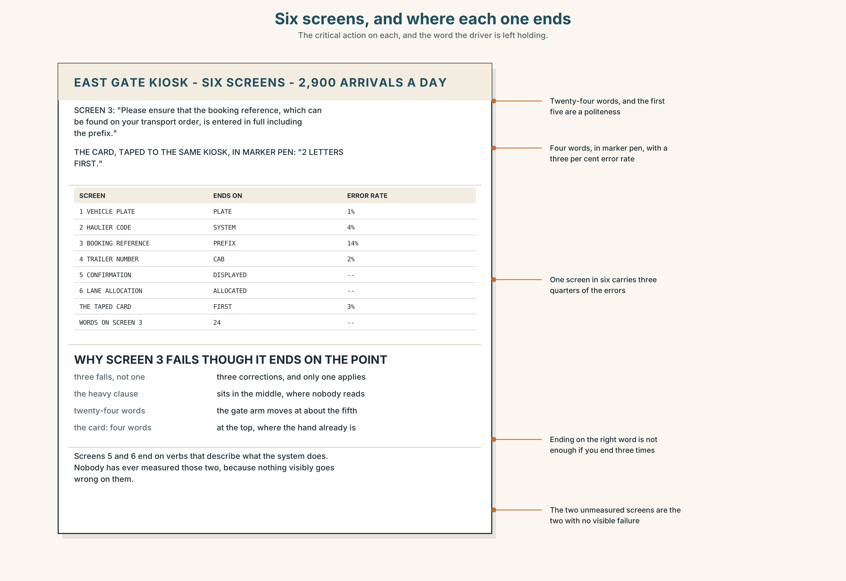{width=6.6in}
Six screens, and where each one ends — The critical action on each, and the word the driver is left holding.
Read the six screens and answer.
- What is the critical action on each screen, and where does it appear?
- Find every sentence that ends on something that is not the point.
- Screen five is a confirmation. What does it put in the last position, and should it?
- Rewrite screens three and five so that each ends on its critical element.

5F · Two texts
The kiosk says …is entered in full including the prefix. The card says 2 LETTERS FIRST.
Which is the instruction? Write two sentences, and use the word friction in one of them.

Part 6 · Vocabulary Lab 2 ◆ B · THE SYSTEM

Words that claim a position

6A · Sort — first, after that, or last and worse?
Three columns.
first · thus · last · foremost · thereupon · worse · henceforth · further

6B · Chunk completion
- ______ ______ ______ the order in your cab. (three words — the fronted focus)
- ______ ______ ______ ______ is the two-letter prefix. (four words)
- ______ ______ ______ ______ is the queue behind you. (four words)
- ______ ______ ______ ______ is the time it takes. (four words)
- ______ ______ ______ , check the trailer number. (three words — the end of a list)
- ______ ______ , the error state is unreadable. (two words — and it gets worse)
- ______ ______ ______ is the confirmation screen. (four words — equal weight)
- ______ ______ ______ are the four hundred trucks a day. (three words — out of a set)

6C · Three that are not interchangeable
first · foremost · first of all
Say which one orders a list, which one ranks importance, and which one announces that a list is starting.

6D · The phrasal verbs and the fixed expressions
lead with · end on · put off
f first things first · f last but not least · f and finally
Two of these fixed expressions make a promise about what is coming and one makes a claim about what has just been said. Which is which?

6E · Contrast Clinic
Eight items. Reorder each sentence as the bracket asks.
- Enter the reference in full, including the prefix. (end on the prefix)
- The reference printed on your transport order must be entered in full. (end-weight)
- That the prefix is two letters is not obvious. (extraposition)
- The prefix is the thing you must include. (a fronted focus frame)
- The queue behind you is the real cost. (front the cost)
- The confirmation screen is no less important than the entry screen. (end on the confirmation)
- Check the order in your cab before you start. (front the check)
- Four hundred trucks a day leave the queue. (end on the number)

Part 7 · Pronunciation & Fluency Lab ◆ B · THE SYSTEM
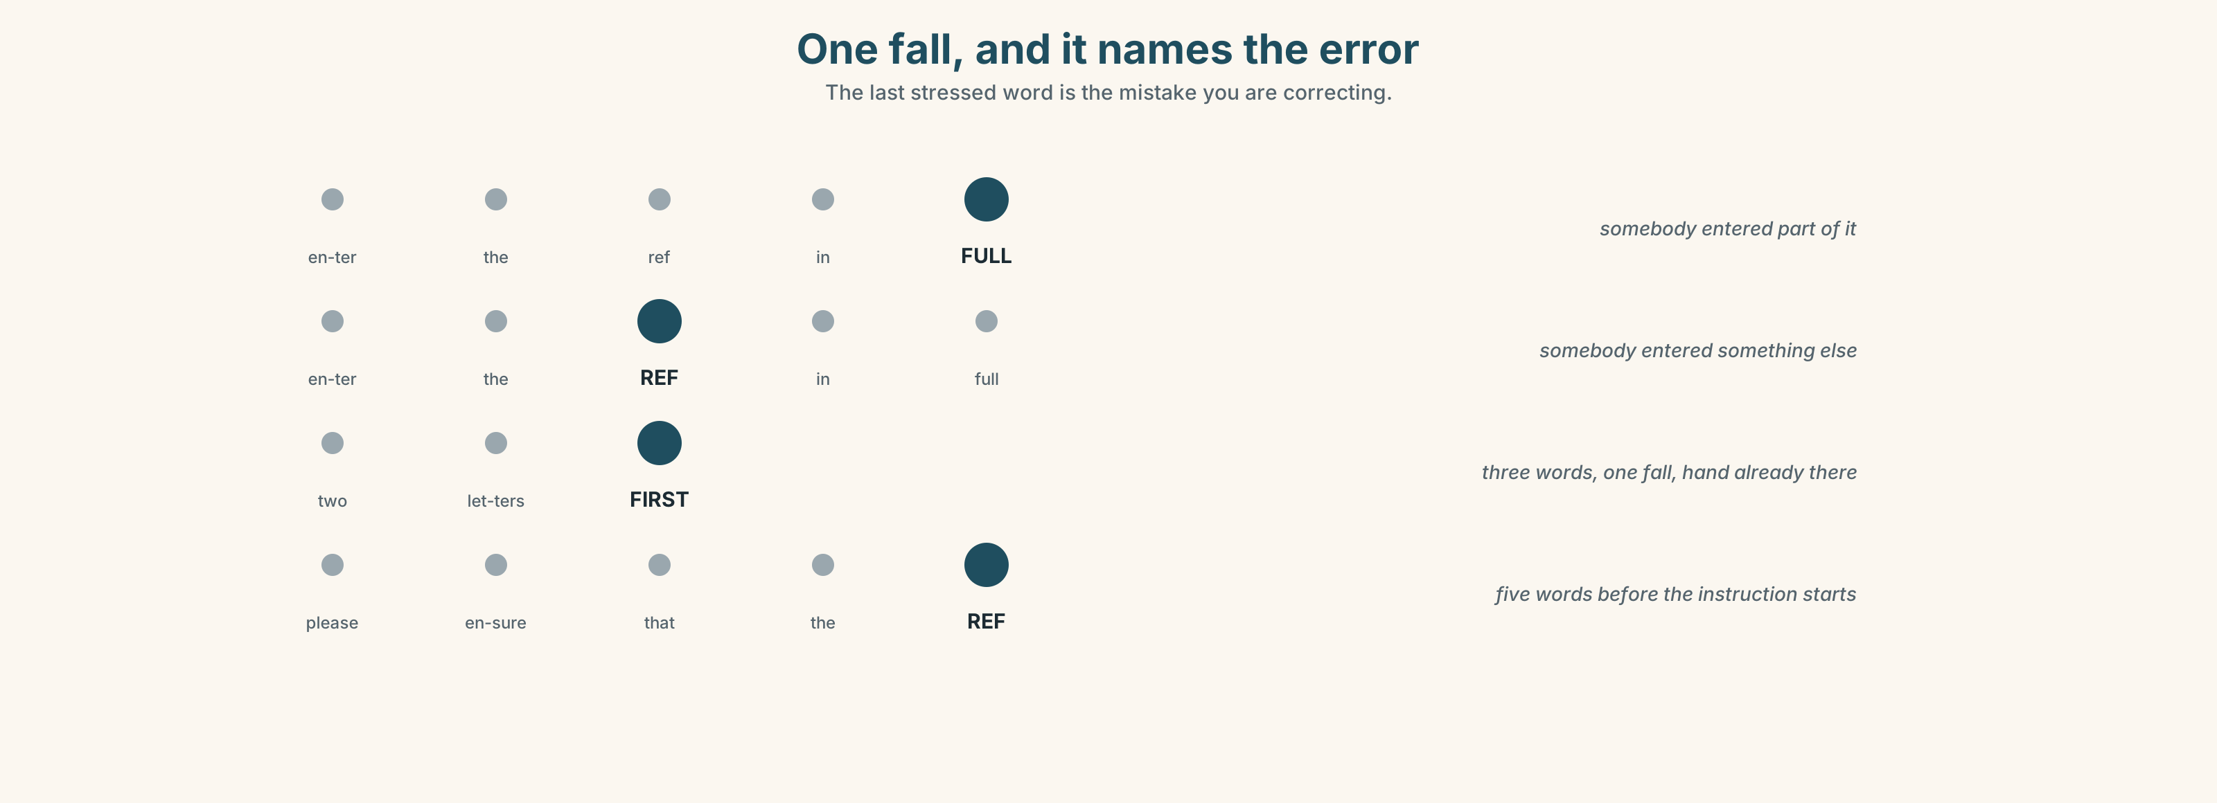{width=6.6in}
One fall, and it names the error — The last stressed word is the mistake you are correcting.

The last stressed word is the instruction

7A · Hear 🔊 Track 7.3
Enter the reference in full, including the PREfix. — one fall, at the end, on the point Please ensure that the booking REFerence, which can be found on your transport ORder, is entered in full including the PREfix. — three falls, and the first two are not instructions Two letters FIRST. — one fall, three words, and the hand is already there

7B · Say
Say all three. Then say this, with exactly one fall:
Enter your reference in full, with the two-letter prefix.

7C · Make it mean something
Say these two:
Enter the reference in FULL. — and somebody has been entering part of it Enter the REFerence in full. — and somebody has been entering something else
The last stressed word names the error you are correcting, which is why an instruction with three falls in it is three different corrections and a driver has to guess which one applies.

7D · Fluency 30 ⏺
Thirty seconds: four instructions, each with exactly one fall, each on a different word. Three times, faster.

Part 8 · Writing ◆ C · THE PERFORMANCE

An instruction set that ends in the right places · 200 words

8A · Read the model
Enter your booking reference. [four words, one fall, and the fall is on the thing being entered]
It begins with two letters. [extraposed and short: the new fact is alone at the end of a five-word sentence, where it cannot be missed]
More important than the digits is the prefix, which is the only part most drivers omit. [fronted comparison, and the heavy relative clause has been pushed to the end where it belongs]
Last of all, check the trailer number against the order in your cab; without it, the gate will not open. [a list marker at the front, the heaviest element last, and the consequence in the final position because that is the one drivers repeat to each other]
Questions about the writer's choices:
- The second sentence is five words long. What would putting it inside the first have cost?
- The third sentence fronts a comparison. What does the front position promise here?
- The last sentence ends on a consequence rather than an action. Why, in an instruction?

8B · The anti-model
Please ensure that all required fields, including the booking reference, which can be found on your transport order, and the trailer number, are completed in full before proceeding to the confirmation screen, which will then be displayed.
One sentence, thirty-six words, four heavy elements in the middle, and it ends on something that happens by itself. Rewrite it as four sentences, each ending on something the driver does.

8C · Plan
the action, four words → the new fact, alone at the end → the fronted comparison with its heavy clause last → the list marker, the heavy element, and the consequence

8D · Write — 200 words

8E · Peer review — three criteria
☐ Does each sentence end on the thing you want remembered? ☐ Is the heaviest element in each sentence at its end? ☐ Did anything get fronted that the sentence then failed to deliver?

8F · Write it again · 8G · Publish
Rewrite after review. Publish both, and list the last word of every sentence in each.

Part 9 · The File ◆ A · THE WORLD + C · THE PERFORMANCE
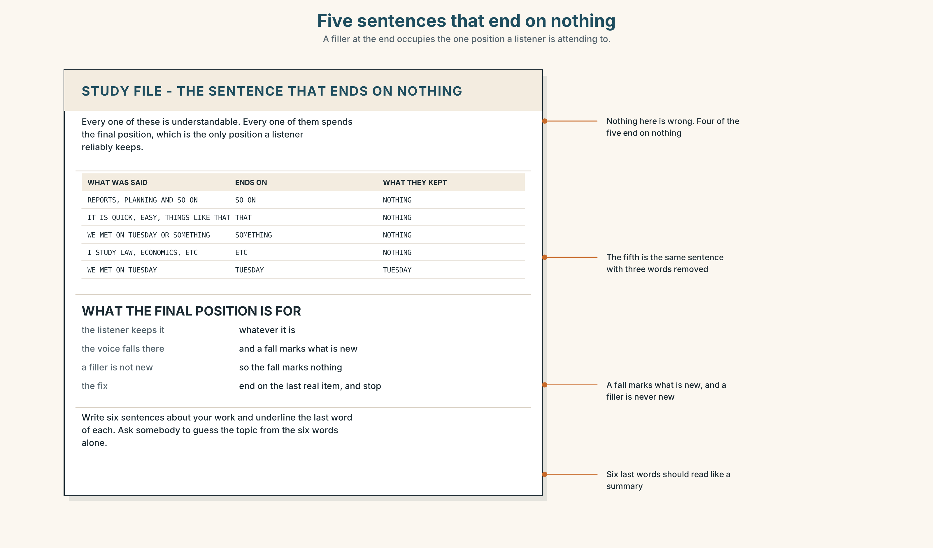{width=6.6in}
Five sentences that end on nothing — A filler at the end occupies the one position a listener is attending to.

STUDY FILE · The sentence that ends on nothing

9A · …and so on, and things like that 🔊 Track 9.4
Learners at this level end sentences on fillers: and so on, things like that, or something, etcetera. Each one is understandable and each one occupies the single position in an English sentence that a listener is actually attending to.
what you say | I work on reports, planning, meetings and so on
what the listener hears | a list that ends on nothing
what it costs | the one position a listener remembers
the fix | end on the last real item, and stop

9B · Cut the tails
Take three sentences you have said this week that ended on a filler. Remove the filler and say them again. Nothing is lost; something arrives.

9C · Role play — the last word
In pairs. One of you speaks for thirty seconds. The other writes down the last word of every sentence and reads the list back. Swap. The list should read like a summary.

9D · The filler you own
Everybody has one. Record two minutes and count. If more than one sentence in four ends on it, that is this week's work.

9E · Transfer — before next week
Write six sentences about your work, and underline the last word of each. Bring them, and ask somebody to guess the topic from the six underlined words alone.

Part 10 · Mediation & Interaction ◆ C · THE PERFORMANCE
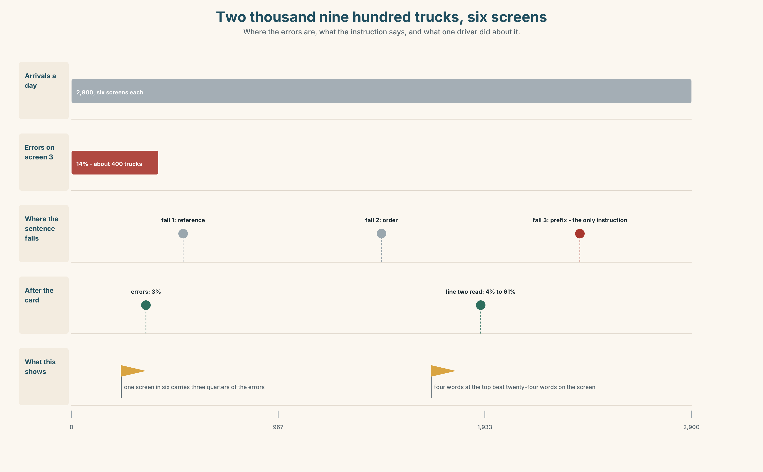{width=6.6in}
Two thousand nine hundred trucks, six screens — Where the errors are, what the instruction says, and what one driver did about it.

10A · Relay
Half the class has the six screens. Half has the error log and the taped card. Produce one instruction for screen three, by speaking only. Ten minutes.

10B · Simplify — for one reader
A driver writes: Why does it reject my number? Reply in four sentences, each ending on something the driver does.

10C · Online
Write one message to the designer about the taped card. Three sentences. Describe what the card does, not what the screen fails to do.

10D · Your language
Does your language put new information last, as English does? Translate all six versions from Part 2. Which ones end on a different word once translated?

Part 11 · The Decision ◆ C · THE PERFORMANCE

How the kiosk gives an instruction
Option one: keep the full sentence. It is complete, it is legally precise, and every field it mentions is a field the system requires.
Option two: one imperative per screen, the action first, everything else deleted.
Option three: the action first, the qualification at the end, and the single thing that varies — the prefix — in the final position of its own short sentence.

11A · The evidence
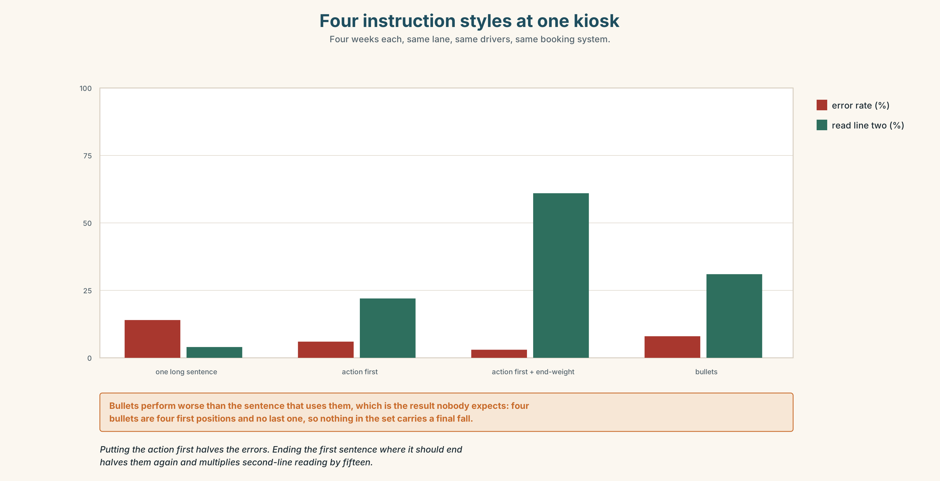{width=6.6in}
Four instruction styles at one kiosk — Four weeks each, same lane, same drivers, same booking system.
🔊 Track 7.6. The driver who taped the card, 30 seconds: "I did not design anything. I wrote down the thing I kept getting wrong, and I put it where my hand already was. Four words, because by the fifth word the gate arm has started to move and I have stopped reading. If somebody wants to pay me for that, they can send it to the yard and I will be asleep."

11B · Talk about it
In threes. Use the frame, and end every turn on the word that matters.
I would lead with ______ , and end on ______ , because the reader is ______ .

11C · Decide
Write three sentences: the decision, the evidence, and the new text of screen three.

11D · Model decision
Option three. Deleting everything is the right instinct and goes one step too far: the transport-order reference is genuinely needed and a driver who has not brought it needs to know that before they start typing. The split is what does the work — one short sentence whose last word is letters — and the full qualification can stay, provided it is in a second sentence where it cannot push the point out of the final position.

11E · The Reveal
What happened. The gate adopted the split instruction. The error rate on screen three fell from fourteen per cent to three — the same rate as the kiosk with the taped card.
Then something nobody predicted: drivers began reading the second line. Observed reading of line two rose from four per cent to sixty-one. Nothing on line two had changed. What had changed was that line one now ended, and a sentence that ends gives a reader somewhere to stop and therefore somewhere to start again.
One question. You do not have to answer it out loud.
The second line was always there. Why did ending the first one make it readable?

Part 12 · Landing ◆ all three lines

12A · Recycle — fifteen items
- Rewrite Enter the reference in full, including the prefix so that it ends on prefix.
- ______ ______ ______ ______ is the two-letter prefix. (four words)
- ______ ______ ______ ______ is the queue behind you. (four words)
- ______ ______ ______ ______ is the time it takes. (four words)
- ______ ______ ______ , check the trailer number. (three words)
- ______ ______ , the error state is unreadable. (two words)
- ______ ______ ______ is the confirmation screen. (four words)
- ______ ______ ______ are the four hundred trucks. (three words)
- ______ , check the order in your cab. (one word)
- ______ , the prefix. (one word — the thing that matters most)
- ______ ______ ______ . (three words — before anything else)
- ______ ______ ______ ______ . (four words — the end of a list, with a compliment)
- Somebody has to ______ ______ the critical action. (two words)
- Never ______ ______ a filler. (two words)
- Do not ______ ______ the hardest screen until last. (two words)

12B · Consolidate — one task, everything in it
Write 150 words of instructions, with one fronted element, one extraposed subject and one sentence using end-weight. Mark the last word of every sentence.

12C · Can-do, with evidence
☐ I can front an element and deliver on it. Evidence: 3H, 8D ☐ I can use end-weight and extraposition. Evidence: 6E, 8D ☐ I can write an instruction that ends on its critical element. Evidence: 10B, 5E ☐ I can place the final fall on the word I mean. Evidence: 7C

12D · Replay ⏺
Record 0C again. Compare. What did your sentences end on the first time?

12E · Glossary — fifty items, as a map
WHAT THE USER IS DOING · workflow · navigation · onboarding WHAT THE SCREEN OFFERS · interface · affordance · prompt · default · confirmation HOW EASY IT IS · hierarchy · legibility · discoverability · friction ON EVERY SCREEN · a default setting · the critical action · an error state · a dead end · the happy path THE PARTS OF IT · step one of four · a confirmation screen · the primary button · a help string · the first run WHAT USERS DO · walk through · click through · opt out · lead with · end on · put off IN THE QUEUE · where do I click · what happens if I · nothing told me that THE POSITION WORDS · thus · henceforth · thereupon · first · foremost · last · worse · further THE FRAMES · more important is · what matters most is · at the heart of it · central to this is · last of all · worse still · no less important · chief among them OPENING AND CLOSING · first things first · last but not least · and finally

12F · Next
Unit 8 · Whose words are those?

