Table of Contents

B2.2 · Unit 8 · One Word Changed
English Animated · Holding the Floor · a port and its logistics chain, Rotterdam Student's Book pages 160–181 · 22 pp · ~11 hours

Part 0 · The Big Picture ◆ A · THE WORLD
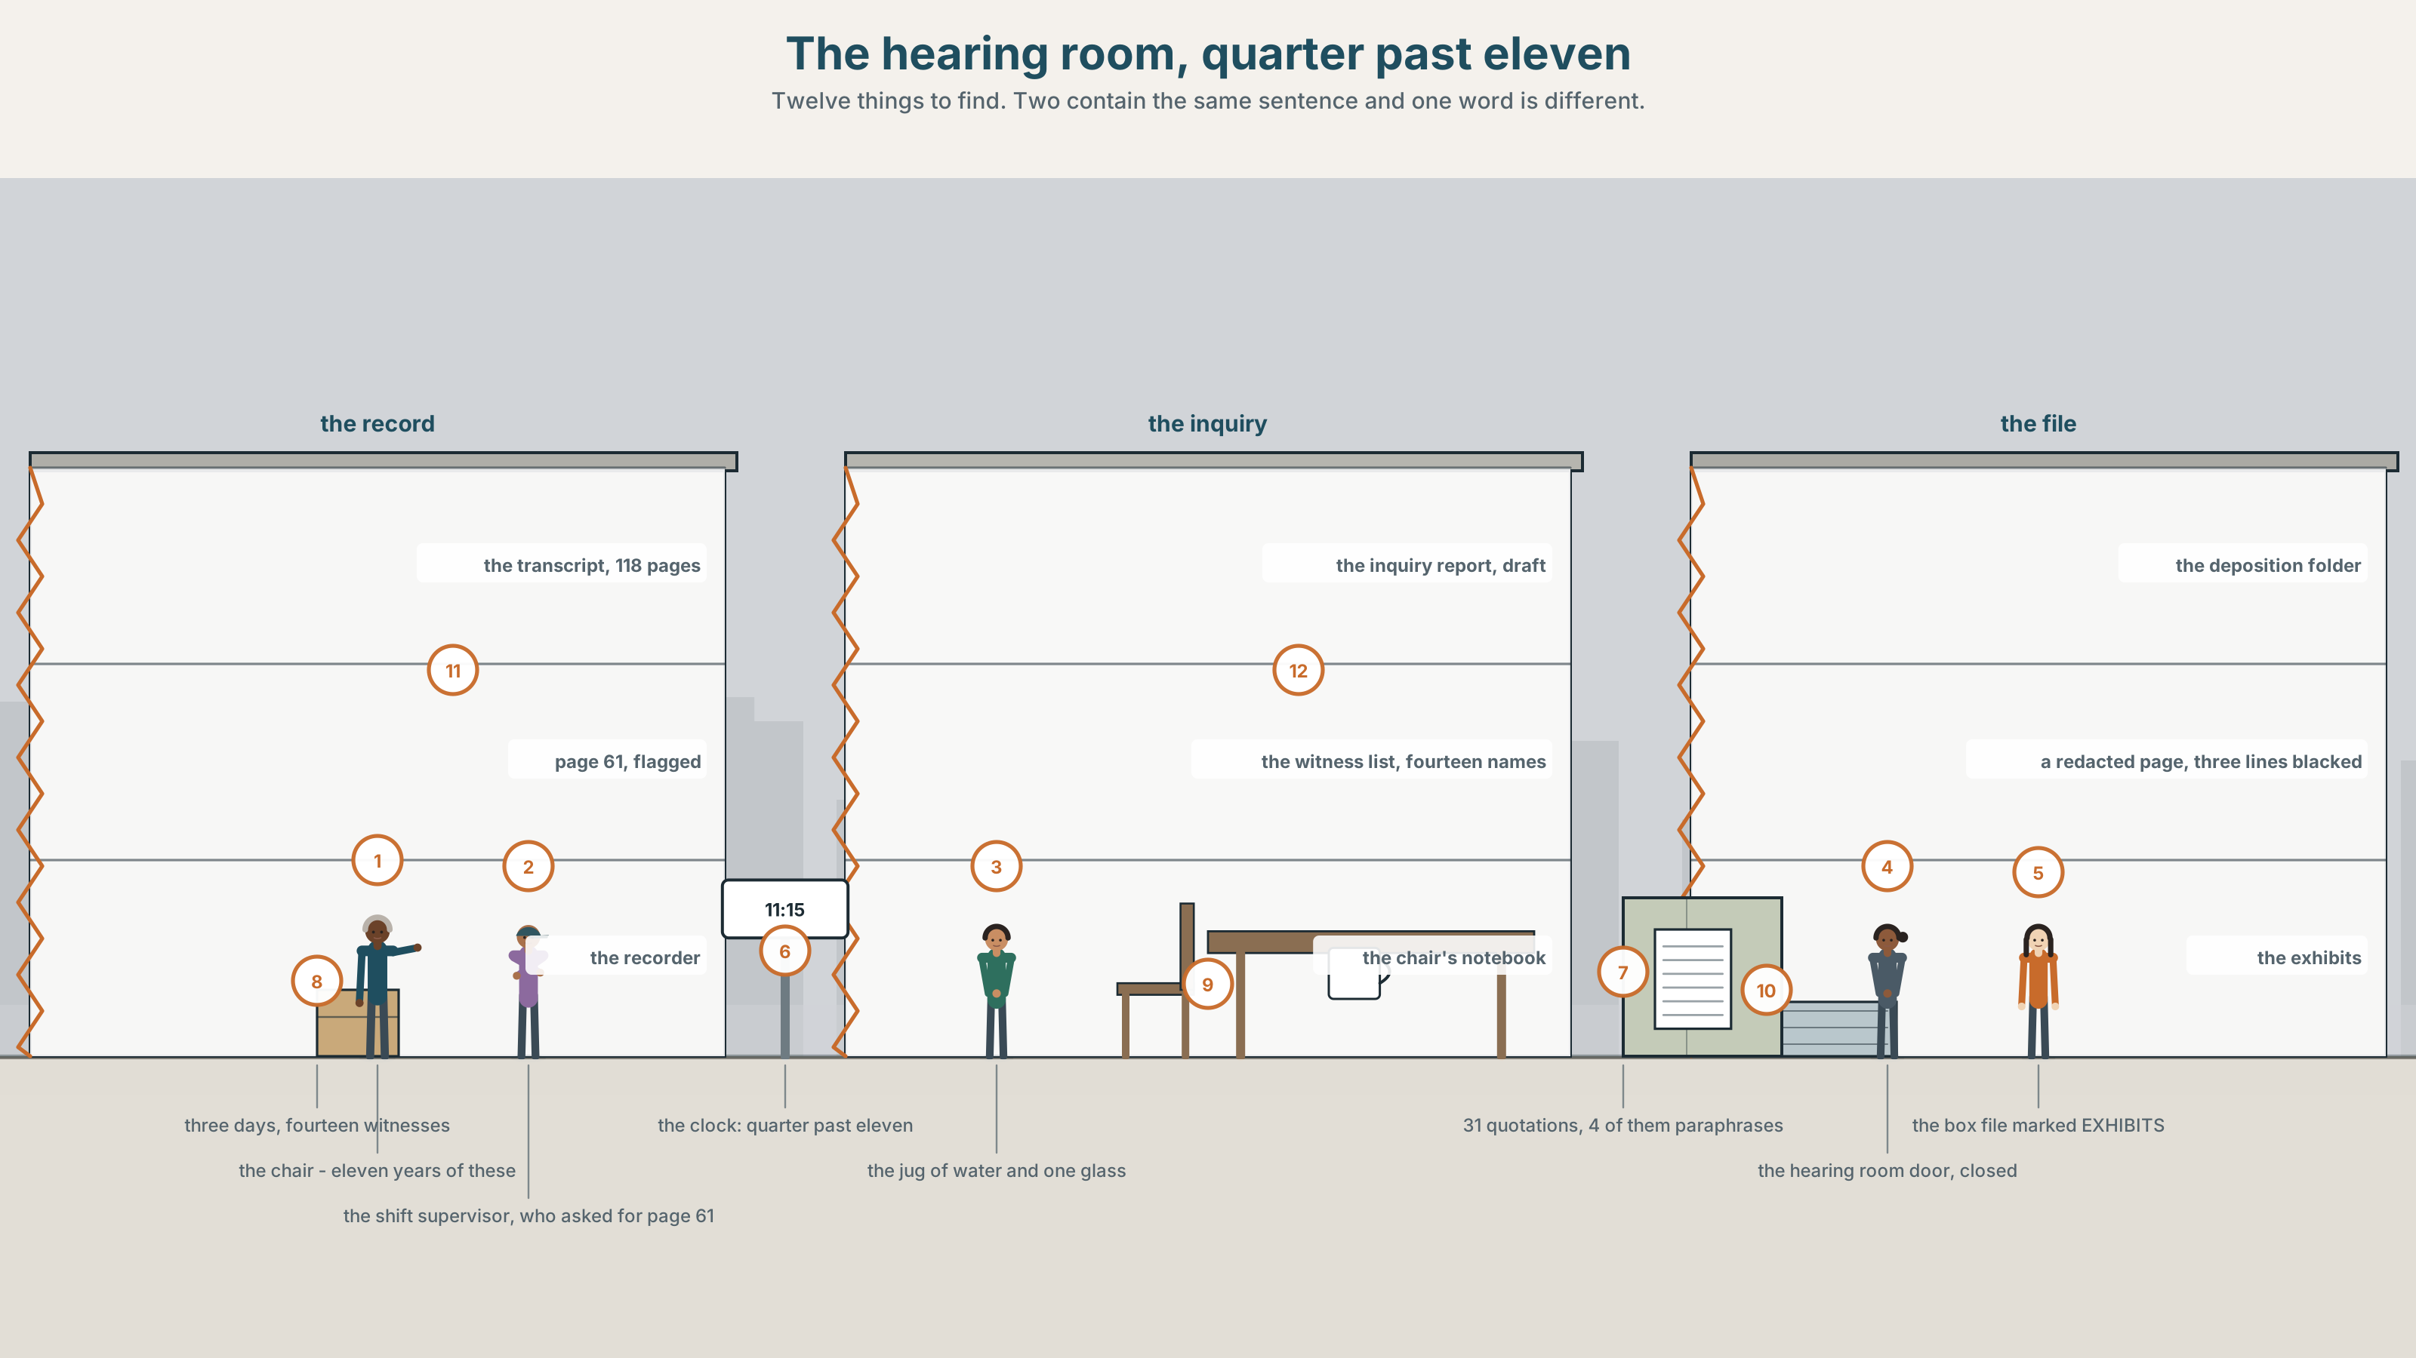{width=6.6in}
The hearing room, quarter past eleven — Twelve things to find. Two contain the same sentence and one word is different.

Whose words are those?
By the end of this unit you can report what somebody said at exactly the distance you intend, and show where the words came from. Two hundred words.
◆ A · THE WORLD | A hundred and eighteen pages of transcript, thirty-one quotations, and one word that was changed
◆ B · THE SYSTEM | reported speech for distancing and attribution · 28 words for testimony and quotation · 22 attribution verbs and frames · the tune of a quotation
◆ C · THE PERFORMANCE | Two hundred words in which every borrowed sentence is marked

0A · Find it
Find twelve things in this picture. Two of them contain the same sentence and one word is different.
the transcript, 118 pages · the inquiry report, draft · page 61, flagged · the recorder, still running · the witness list, fourteen names · the deposition folder · a redacted page, three lines blacked · the chair's notebook · a jug of water and one glass · a clock at 11.15 · the hearing room door, closed · a box file marked EXHIBITS

0B · Guess it
Two documents in this room say the witness knew something. Only one of them is what the witness said. Which, and what is the other one?

0C · Say it ⏺
Record sixty seconds. Report something somebody told you recently, three times: as if you believed it, as if you did not, and as if you had no view. You will record it again at the end of this unit.

Part 1 · Vocabulary Lab 1 ◆ B · THE SYSTEM
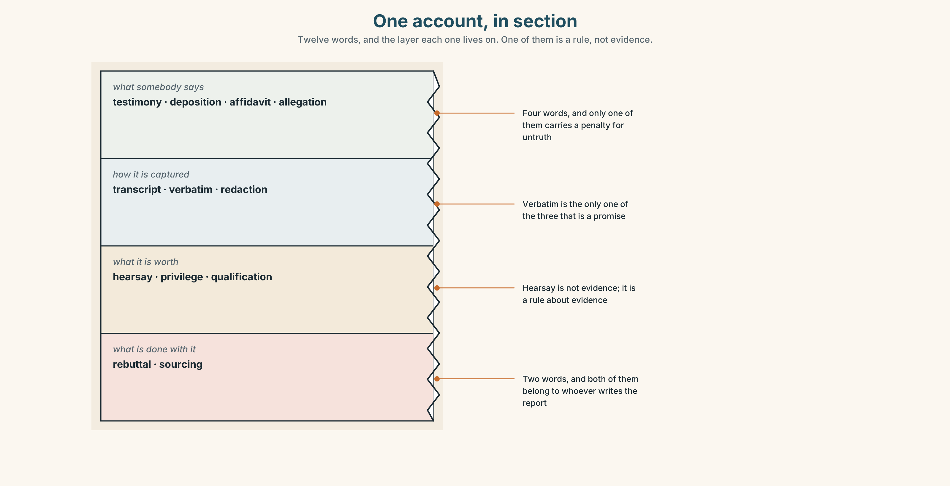{width=6.6in}
One account, in section — Twelve words, and the layer each one lives on. One of them is a rule, not evidence.

1A · Meet — the words of an account
Match each word to one layer of the cutaway.
deposition · testimony · affidavit · transcript · hearsay · verbatim · redaction · rebuttal · allegation · privilege · qualification · sourcing

1B · Sort — what somebody says, how it is captured, or what it is worth?
Three columns. One of the twelve is not a kind of evidence at all but a rule about which evidence you may not use.
testimony · transcript · hearsay · deposition · verbatim · privilege · affidavit · redaction · qualification · allegation · rebuttal · sourcing

1C · Meet — the five phrases a hearing turns on
a sworn statement | Written, signed, and carrying a penalty for being untrue.
in open court | Said where anybody could hear it, which changes what may be repeated.
a contemporaneous note | Written at the time, which is why it beats a better memory.
the exact words | What a transcript holds and a summary never does.
a form of words | An agreed sentence that both sides can live with and neither wrote.

1D · Collocation Lab
Complete each one, and say which of the five is the only one that can be checked by looking.
a direct quotation · an indirect quotation · as reported · the source of the claim · the quoted passage
- ______ ______ ______ is set in quotation marks and must match the transcript exactly.
- ______ ______ ______ reports the sense, changes the pronouns, and takes no quotation marks.
- ______ ______ , the supervisor knew. In his own words, he assumed.
- ______ ______ ______ ______ ______ is a witness who was not in the yard that morning.
- ______ ______ ______ runs to nine lines and corresponds to page sixty-one.

1E · The phrasal verbs, and the three fixed expressions
put to · go back on · stand by
f words to that effect · f she is alleged to have said · f that is a paraphrase
One of these fixed expressions admits in advance that the words are not the words. Which, and why is it safer than quotation marks?

1F · Own it
Write one sentence somebody said to you this week, once as a direct quotation and once as an indirect one, and mark everything that changed.

Part 2 · Listening ◆ A · THE WORLD
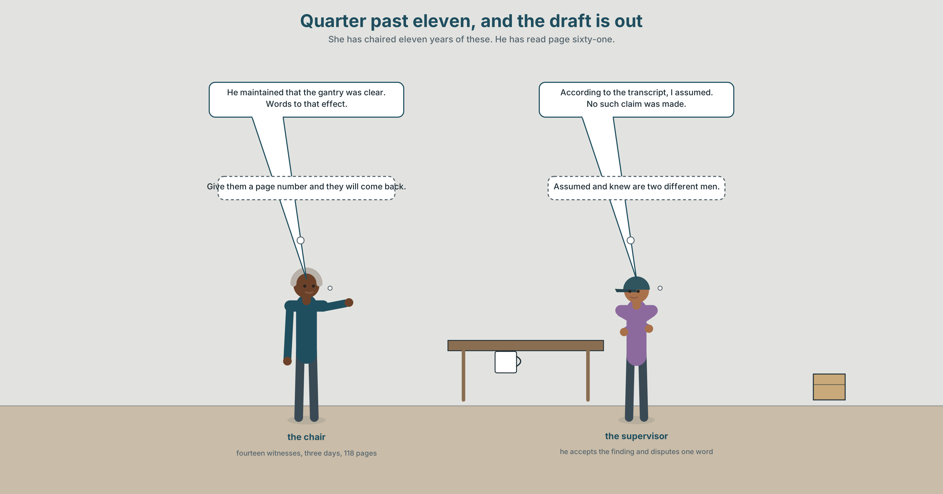{width=6.6in}
Quarter past eleven, and the draft is out — She has chaired eleven years of these. He has read page sixty-one.

2A · Quarter past eleven 🔊 Track 8.1
Before you listen. The inquiry heard fourteen witnesses over three days. The transcript runs to a hundred and eighteen pages. The draft report contains thirty-one quotations.
Listen once. What did the supervisor say, and what does the report say he said?
Listen again. Complete the table.
 | What the transcript says | What the report says | The difference
page 61
the finding
the rebuttal
Listen again. True or false?
- The transcript runs to a hundred and eighteen pages. ☐ T ☐ F
- The report contains thirty-one quotations. ☐ T ☐ F
- All thirty-one are verbatim. ☐ T ☐ F
- One word was changed on page sixty-one. ☐ T ☐ F
Noticing. Six reports of the same sentence.
- He said the gantry was clear.
- He claimed the gantry was clear.
- He maintained that the gantry was clear.
- He is said to have told the crew the gantry was clear.
- He stopped short of saying the gantry was clear.
- He would not be drawn on whether the gantry was clear.
Six verbs, one event. Rank them by how much the reporter is committing to, and say which two report the absence of a statement rather than a statement.

2B · Decoding clinic 🔊 Track 8.2
Thirty seconds at speed. Three jobs.
- One speaker reads a quotation aloud. Mark where the voice changes, and say how you knew.
- What happens to the speed inside the quoted part?
- Somebody says words to that effect. What has just been quoted, and what has not?

Part 3 · Grammar Lab 1 ◆ B · THE SYSTEM

Reporting at a distance you choose

3A · Notice
Look at the six reports in Part 2 again.
- In sentence 1, how much does the reporter commit to? In sentence 2, how much?
- Sentence 4 has two layers of reporting. Name both, and say who the second source is.
- Sentence 5 reports something that did not happen. What exactly is being asserted?
- Which of the six could be printed if the speaker denied all of it?

3B · See
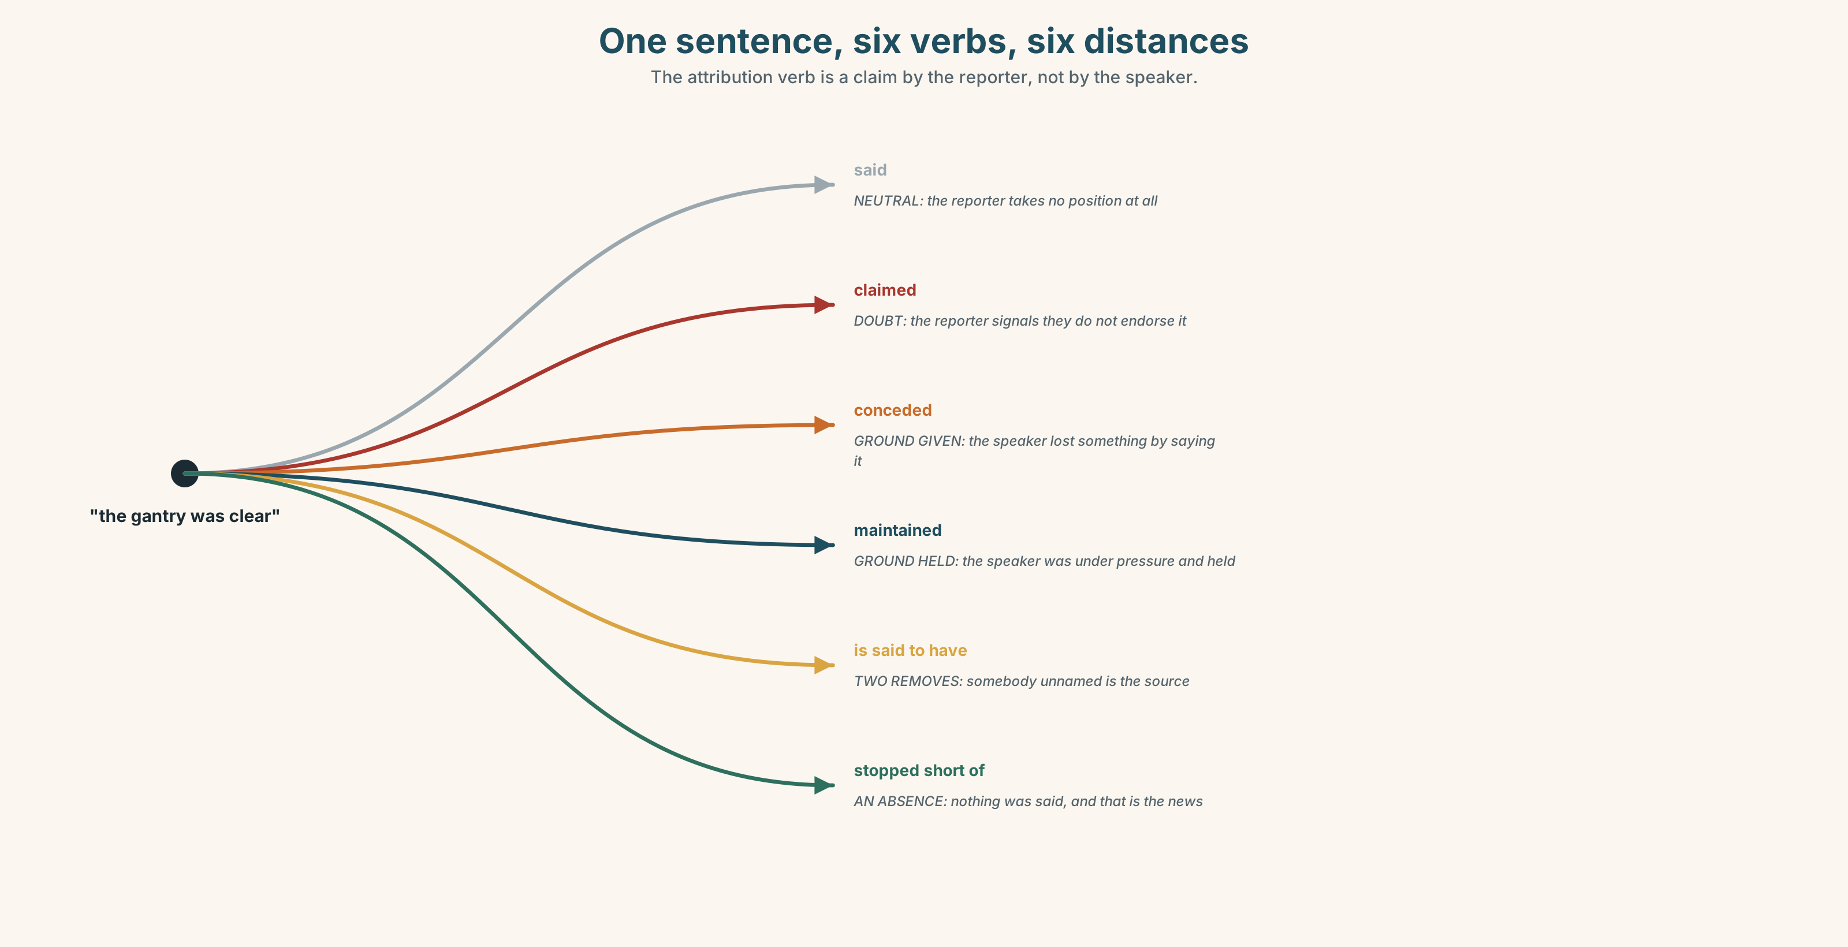{width=6.6in}
One sentence, six verbs, six distances — The attribution verb is a claim by the reporter, not by the speaker.

3C · Know
neutral reporting | said · told · stated | the reporter takes no position
casting doubt | claimed · alleged | the reporter signals they do not endorse it
giving ground | conceded · acknowledged · admitted | the speaker lost something by saying it
holding ground | maintained · insisted · asserted · denied | the speaker was under pressure and held
answering | countered · responded · replied | there was something to answer
reporting an absence | stopped short of · would not be drawn · declined to comment | nothing was said, and that is the news
Every attribution verb is a claim by the reporter, not by the speaker. He claimed and he said report the same words; the first adds the reporter's doubt and is actionable if the doubt is unfounded. Choosing the verb is choosing how much of somebody else's sentence you are prepared to carry.
The passive reporting frame removes the reporter entirely. He is said to have told the crew has no subject for said: somebody, unnamed, is the source, and the reporter has placed two layers between themselves and the claim. It is the most distancing construction available and the easiest to abuse.
the double-layer frames | is said to have · is understood to have · was quoted as saying
the absence frames | declined to comment · would not be drawn · could not confirm · stopped short of
the continuation frame | went on to say
the honesty markers | according to the transcript · in his own words · that is a paraphrase
Why it matters. The difference between what a person said and what a document says they said is one word, often, and it is the word on which an inquiry turns. Reporting at the right distance is not a style question; it is the difference between a quotation and an allegation.

3D · Use — controlled
Complete with the attribution verb the situation requires.
He (1) ______ that the gantry was clear. (he was under pressure and held his position) He (2) ______ that he had not checked. (he lost something by saying it) He (3) ______ the gantry was clear. (the reporter does not endorse it) He (4) ______ ______ ______ saying the gantry was clear. (three words — he nearly did) He (5) ______ ______ ______ ______ on whether he had checked. (four words — he refused)

3E · Use — guided
Rewrite each one at the distance in brackets.
- The gantry was clear. (reported neutrally)
- The gantry was clear. (reported with doubt)
- The gantry was clear. (reported at two removes, source unnamed)
- I did not check. (reported as a concession)
- I will not answer that. (reported as an absence)

3F · Use — open
In pairs. One of you makes a statement. The other reports it three times at three distances. The first speaker says which report they would object to, and why. Four rounds each.

3G · Error autopsy
✗ He is said to have been told the crew that the gantry was clear. ✗ He denied that he had not checked it, which he had not. ✗ "The gantry was clear," he claimed that.
For each, name the rule and say what the writer was reaching for.

3H · Check — eight items
- He ______ that the gantry was clear. (he held his position)
- He ______ that he had not checked. (he gave ground)
- He ______ the gantry was clear. (the reporter doubts it)
- He ______ ______ ______ saying it. (three words — he nearly did)
- He ______ ______ ______ ______ on the question. (four words — he refused)
- ✗ He is said to have been told the crew. → correct it.
- Rewrite He assumed it was clear as a report that says he knew — and say what you have done.
- Write one sentence reporting something at two removes, with no source named.

Part 4 · Speaking ◆ C · THE PERFORMANCE

4A · Fluency starter — three distances
One person says a sentence. Three others report it: neutrally, with doubt, and at two removes. The original speaker says which one they would sue over.

4B · The functional core — attributing and disowning
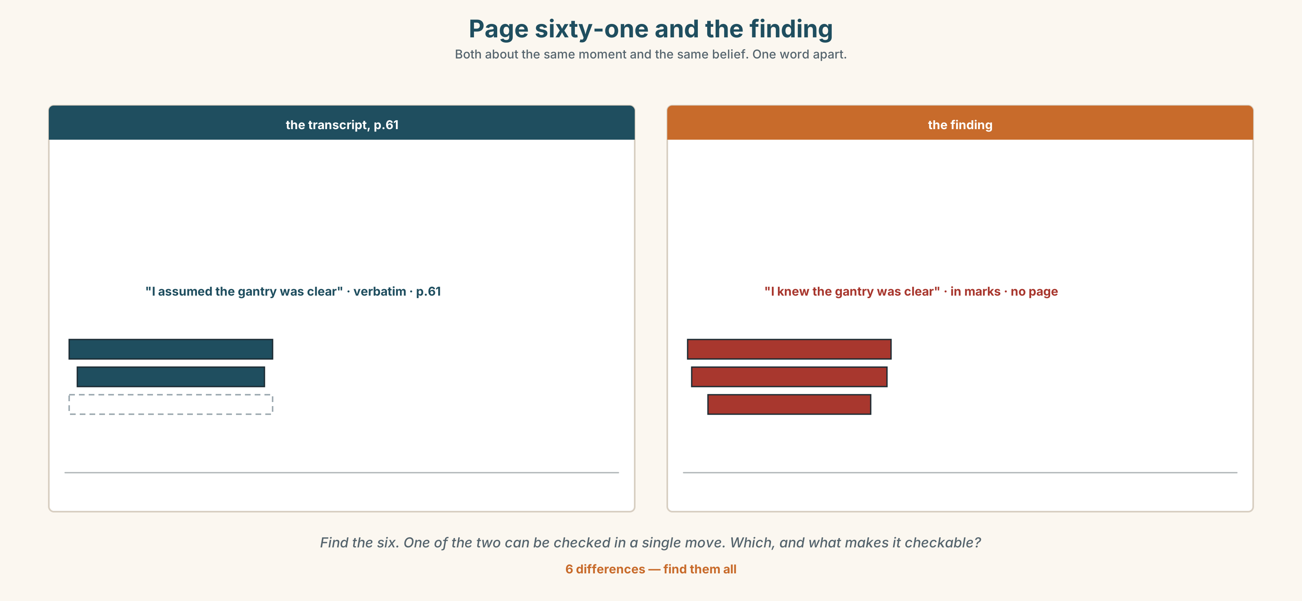{width=6.6in}
Page sixty-one and the finding — Both about the same moment and the same belief. One word apart.
Language Bank
neutral | said · told · went on to say
distanced | claimed · is said to have · is understood to have · was quoted as saying
conceding and holding | conceded · acknowledged · maintained · insisted · asserted · denied
absences | declined to comment · would not be drawn · could not confirm · stopped short of
Information gap. Learner A has page sixty-one of the transcript. Learner B has the report's finding. Find the word that changed, by speaking only. Ten minutes.

4C · The performance — three minutes ⏺
Report a meeting or a conversation in three minutes. Every borrowed sentence must be marked as direct, indirect or at two removes, and your partner must be able to say, for any three, how much you were committing to.
Record it.

4D · Observer
One person writes down every attribution verb and marks what it commits the speaker to.

4E · Three criteria
☐ Was every quotation either exact or clearly marked as not exact? ☐ Did each attribution verb report the speaker, or did it report me? ☐ Could my partner tell where each sentence came from?

Part 5 · Reading ◆ A · THE WORLD

5A · Predict
The title is "Assumed and knew." What is the difference, in an inquiry, between a witness who assumed something and one who knew it?

5B · Read — two minutes

Assumed and knew
The inquiry sat for three days and heard fourteen witnesses. The transcript runs to a hundred and eighteen pages. The draft report quotes thirty-one passages, each in quotation marks, each attributed.
Four of the thirty-one are not quotations. They are paraphrases, accurate in substance, set in quotation marks because the drafter understood the marks as a courtesy to the reader rather than as a claim about the words.
One of the four is on page sixty-one. The witness, a shift supervisor, said: I assumed the gantry was clear. The report quotes him as saying: I knew the gantry was clear.
Both sentences are about the same moment and the same belief. One of them describes a man who checked nothing and one describes a man who checked. The finding against him rests on the second.
The supervisor read the draft, did not recognise the sentence, and asked for the transcript page. He was sent it. He has not disputed the substance of the finding, which he accepts. He has disputed one word, which the inquiry has agreed to correct, and he has asked that the correction be recorded rather than made silently.
The inquiry has not yet decided whether to do that.

5C · Comprehension — eight questions
- How long did the inquiry sit, and how many witnesses did it hear?
- How many passages are quoted, and how many of those are not quotations?
- What did the witness say, and what does the report say he said?
- What does the finding rest on?
- What has the supervisor accepted, and what has he disputed?
- Why does the writer explain what the drafter thought quotation marks were for?
- "One describes a man who checked nothing and one describes a man who checked." Why does the writer spell that out rather than leave it?
- The last sentence is seven words and stands alone. What is still open, and why is it the harder question?

5D · Vocabulary in context
Infer from the text, then check.
accurate in substance · as a courtesy to the reader · rests on the second · did not recognise the sentence · recorded rather than made silently

5E · The counter-text
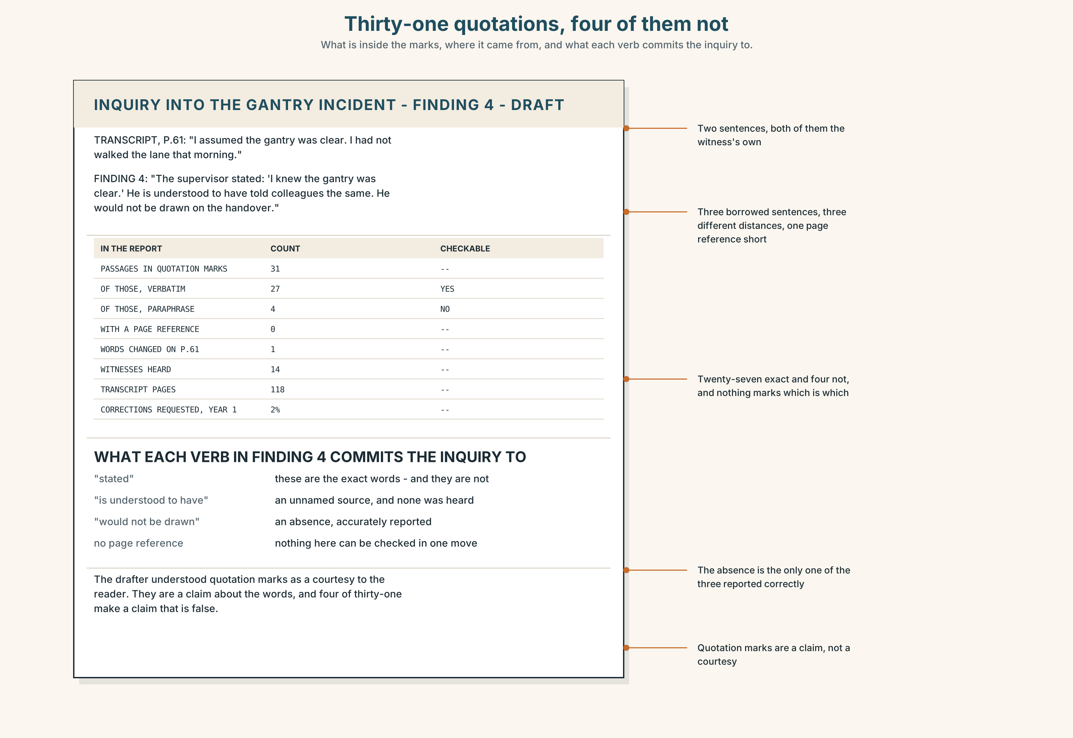{width=6.6in}
Thirty-one quotations, four of them not — What is inside the marks, where it came from, and what each verb commits the inquiry to.
Read page sixty-one and the report's finding, and answer.
- Which passages in the finding are verbatim, and which are not?
- Find every attribution verb in the finding and say what each commits the inquiry to.
- One sentence reports an absence. What was not said, and by whom?
- Rewrite the finding so that every borrowed sentence is marked for what it is.

5F · Two texts
The transcript says I assumed the gantry was clear. The report says "I knew the gantry was clear."
Is the report inaccurate? Write two sentences, and use the word verbatim in one of them.

Part 6 · Vocabulary Lab 2 ◆ B · THE SYSTEM

Verbs that report somebody and describe you

6A · Sort — the speaker gave ground, held ground, answered back, or is being doubted?
Four columns.
conceded · maintained · countered · claimed · acknowledged · insisted · denied · asserted

6B · Chunk completion
- He ______ ______ ______ told the crew. (three words — two removes, no source)
- He ______ ______ ______ ______ he had checked. (four words — two removes, formal)
- He ______ ______ ______ he had checked it himself. (three words — a continuation)
- He ______ ______ ______ on the question. (three words — he refused)
- He ______ ______ ______ ______ on whether he had checked. (four words — he refused, idiomatic)
- He ______ ______ ______ saying he had checked. (three words — he nearly said it)
- He ______ ______ ______ ______ that the gantry was clear. (four words — the inquiry's record)
- He ______ ______ ______ the time of the handover. (three words — he did not know)

6C · Three that are not interchangeable
claimed · maintained · acknowledged
Say which one tells you about the reporter, which one tells you the speaker was under pressure, and which one tells you the speaker lost something.

6D · The phrasal verbs and the fixed expressions
take back · rule on · hold to
f according to the transcript · f in his own words · f no such claim was made
One of these fixed expressions is a denial that is also a challenge. Which, and what is it inviting the other side to do?

6E · Contrast Clinic
Eight items. Rewrite each one at the distance the bracket asks for.
- The gantry was clear. (neutral report)
- The gantry was clear. (the reporter does not endorse it)
- The gantry was clear. (two removes, no source named)
- I did not check. (reported as a concession)
- I will not answer that. (reported as an absence, idiomatic)
- I assumed it was clear. (reported so that the inquiry's record is exact)
- He said one thing on Tuesday and another on Thursday. (report both without judging)
- He nearly said it and then did not. (three words)

Part 7 · Pronunciation & Fluency Lab ◆ B · THE SYSTEM
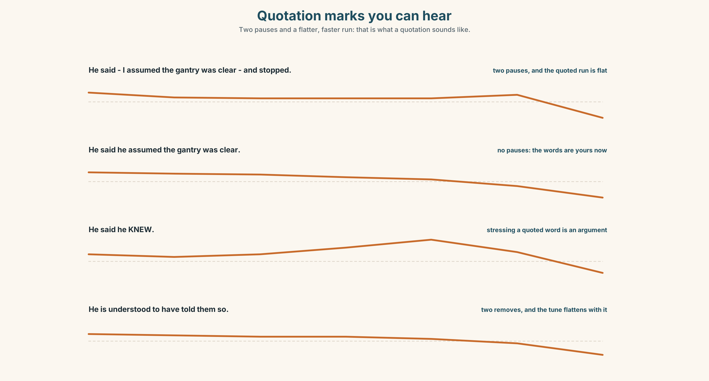{width=6.6in}
Quotation marks you can hear — Two pauses and a flatter, faster run: that is what a quotation sounds like.

Quotation marks you can hear

7A · Hear 🔊 Track 8.3
He said — ⏸ I assumed the gantry was clear ⏸ — and then stopped. the pauses are the quotation marks, and the quoted part is said faster and flatter He said he assumed the gantry was clear. — no pauses, no shift, and the words are now yours

7B · Say
Say both. Then say this, making the quotation audible without the word quote:
The report says he knew. The transcript says — I assumed.

7C · Make it mean something
Say these two:
He said he knew. — flat: a report, and you are not commenting He said he KNEW. — the stress on the quoted word: and the transcript says otherwise
Stressing a word inside a report is a comment on the word, not on the speaker, which is why a reporter who stresses a quoted verb has stopped reporting and started arguing.

7D · Fluency 30 ⏺
Thirty seconds: one sentence reported four times — flat, with audible quotation marks, with a stressed quoted word, and at two removes. Three times, faster.

Part 8 · Writing ◆ C · THE PERFORMANCE

A finding with its sources marked · 200 words

8A · Read the model
The supervisor said, at page 61 of the transcript, "I assumed the gantry was clear." [a direct quotation with a page reference: everything inside the marks can be checked in one move]
He acknowledged that he had not walked the lane that morning, and maintained that the handover had been completed. [two attribution verbs doing opposite jobs in one sentence: one records a loss, the other a position held under pressure]
He is understood to have told two colleagues the same thing before the hearing, although the inquiry has not taken evidence from either. [two removes, source unnamed, and the second clause states exactly what is missing]
Asked whether he had checked, he would not be drawn. The finding does not rest on that refusal. [an absence reported as an absence, followed immediately by a sentence saying what the inquiry is not doing with it]
Questions about the writer's choices:
- The page reference is inside the first sentence. Why not in a footnote?
- Acknowledged and maintained in one sentence. What would said twice have lost?
- The last sentence disclaims a use of the refusal. Why say that at all?

8B · The anti-model
The supervisor claimed he knew the gantry was clear, although it is understood he may have stopped short of checking, and sources indicate that he is said to have told colleagues words to that effect, which he denies.
One sentence, thirty-seven words, three distancing frames stacked, one quotation mark missing and no page reference anywhere. Rewrite it so that every borrowed claim has a source and a distance.

8C · Plan
the direct quotation with its page → two attribution verbs doing opposite jobs → the two-remove report, with its gap stated → the absence, and what you are not doing with it

8D · Write — 200 words

8E · Peer review — three criteria
☐ Is everything inside quotation marks checkable in one move? ☐ Does each attribution verb report the speaker rather than your opinion of them? ☐ Is every two-remove report accompanied by what is missing?

8F · Write it again · 8G · Publish
Rewrite after review. Publish both, and mark each borrowed sentence direct, indirect or at two removes.

Part 9 · The File ◆ A · THE WORLD + C · THE PERFORMANCE
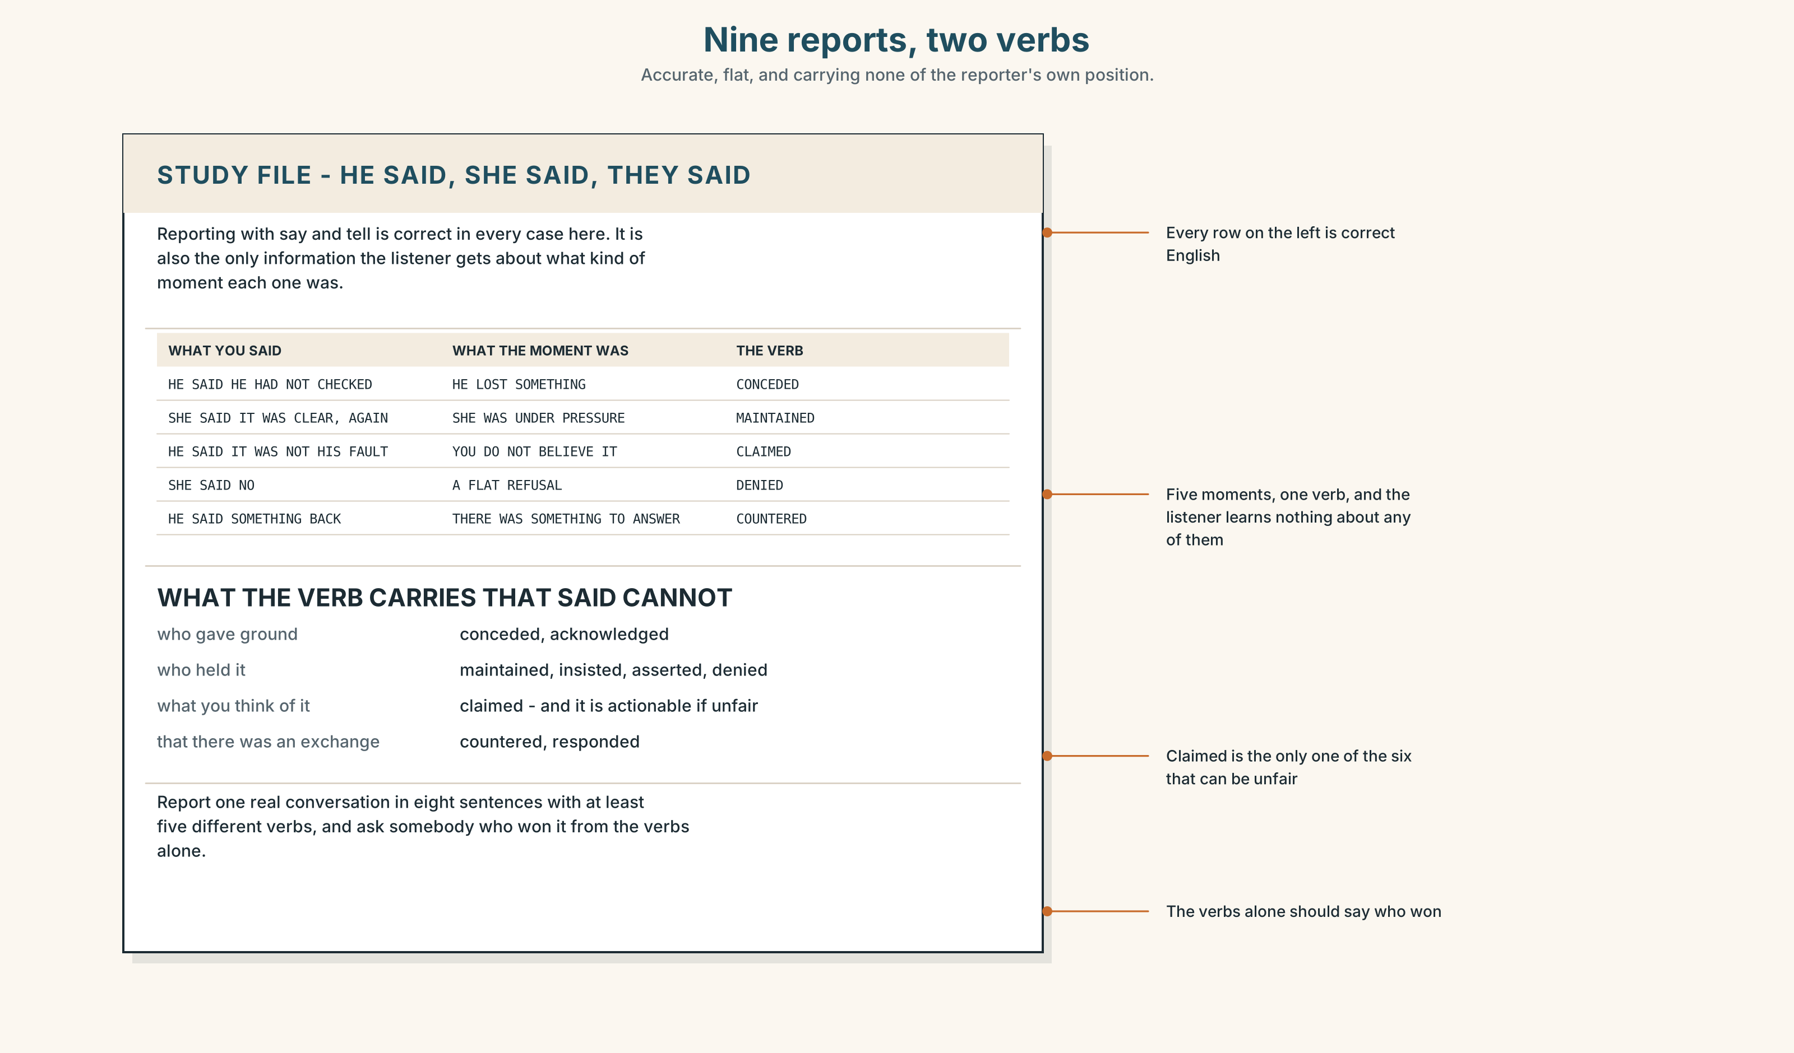{width=6.6in}
Nine reports, two verbs — Accurate, flat, and carrying none of the reporter's own position.

STUDY FILE · He said, she said, they said

9A · One verb for everything 🔊 Track 8.4
Learners report with say and tell and almost nothing else. The reports are accurate and flat: a listener can follow what happened and cannot tell who gave ground, who held, or what the speaker thought of any of it.
what you use | said and told, about nine times in ten
what is missing | the whole distance scale
what it costs | your own position, which the verb would have carried
the fix | six verbs: claimed · conceded · maintained · denied · countered · acknowledged

9B · Six verbs, six sentences
Take one conversation you remember. Report six moments from it with six different verbs, and say what each verb added that said would not have.

9C · Role play — which verb?
In pairs. One of you makes a statement. The other reports it with a verb and the first says whether the verb was fair. Six rounds each.

9D · The verb you avoid
Most learners never use conceded or countered although both are understood instantly. Use each four times this week, out loud.

9E · Transfer — before next week
Report one real conversation in eight sentences, using at least five different attribution verbs. Bring it, and ask somebody to say who won the conversation from the verbs alone.

Part 10 · Mediation & Interaction ◆ C · THE PERFORMANCE
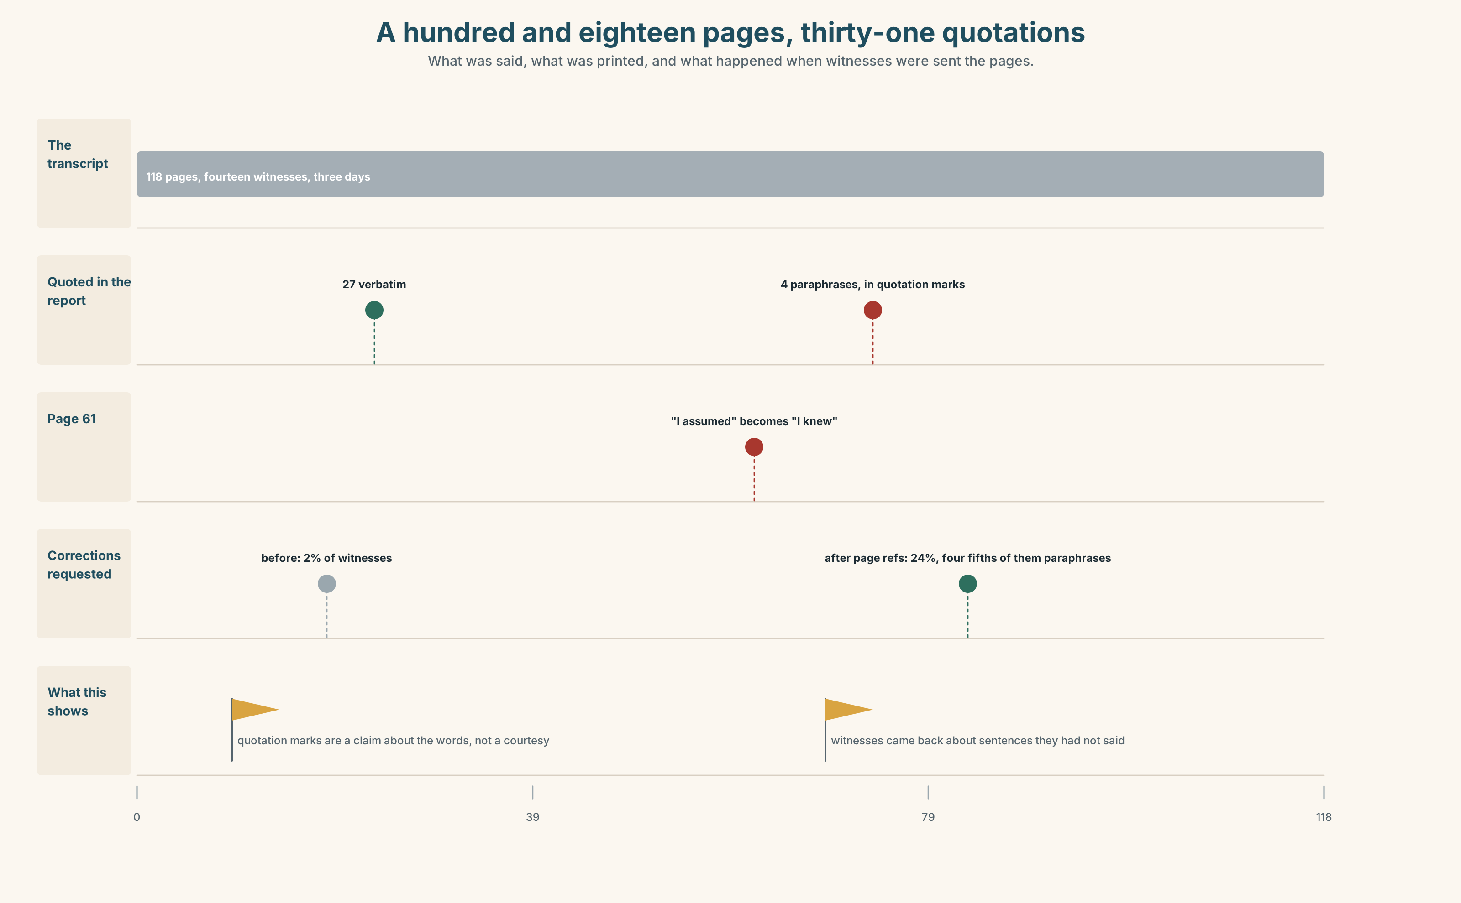{width=6.6in}
A hundred and eighteen pages, thirty-one quotations — What was said, what was printed, and what happened when witnesses were sent the pages.

10A · Relay
Half the class has the transcript pages. Half has the report's findings. Find all four paraphrases set in quotation marks, by speaking only. Ten minutes.

10B · Simplify — for one reader
The supervisor writes: Did I say that or not? Reply in four sentences, quoting exactly once and paraphrasing exactly once, each marked.

10C · Online
Write one message to the inquiry chair about recording the correction. Three sentences. Report the supervisor's position without adopting it.

10D · Your language
How does your language mark a quotation — with punctuation, with a particle, or with a verb form? Translate all six reports from Part 2. Which distinctions survive?

Part 11 · The Decision ◆ C · THE PERFORMANCE

How the port's inquiries quote
Option one: paraphrase freely. Quotation marks in an internal report are a readability device, and every drafter in the building has used them that way for twenty years.
Option two: verbatim only, with a transcript page reference for every passage in quotation marks, and no paraphrase inside marks ever.
Option three: option two, plus a marked style for deliberate paraphrase, so that a reader can see at a glance which sentences are the witness's and which are the inquiry's.

11A · The evidence
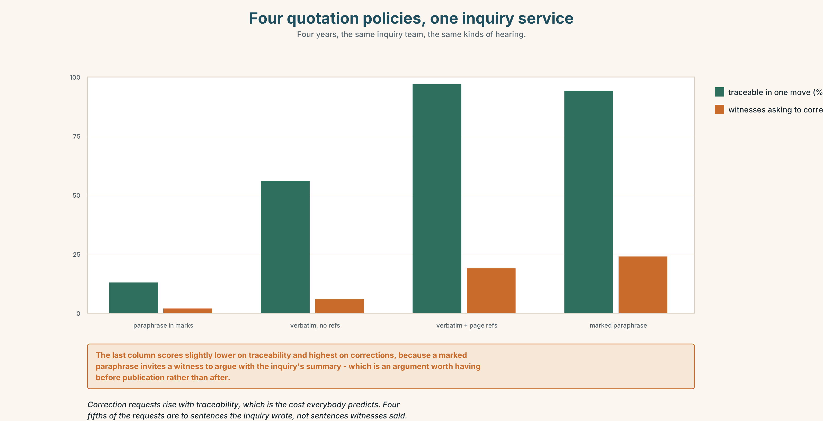{width=6.6in}
Four quotation policies, one inquiry service — Four years, the same inquiry team, the same kinds of hearing.
🔊 Track 8.6. The inquiry chair, 30 seconds: "My worry is the obvious one. Give witnesses a page number and they will come back, and fourteen witnesses coming back is three more days I do not have. I have been chairing these for eleven years and I will tell you what I have never once had: a witness who came back to correct a sentence they actually said."

11B · Talk about it
In threes. Use the frame, and attribute every claim you borrow.
I would ______ , because ______ . He said — in his own words — ______ .

11C · Decide
Write three sentences: the decision, the evidence, and the rule as you would write it into the inquiry's handbook.

11D · Model decision
Option three. The page reference does the whole of the work and the marked style costs nothing: a reader who can see which sentences are the inquiry's own stops attributing the inquiry's reasoning to the witness, which is the second failure in this report and nobody has mentioned it. The chair's objection is correct about the cost and wrong about the direction: witnesses who come back come back about sentences they did not say, and every one of those is an error the inquiry would otherwise publish.

11E · The Reveal
What happened. The port adopted the rule. Witnesses were sent their own transcript pages with the draft. Requests to correct rose from two per cent of witnesses to twenty-four.
Then something nobody predicted: of the corrections requested in the first year, four fifths were to sentences the inquiry had paraphrased, and almost none to sentences that had been quoted exactly. The chair's three extra days turned out to be three days of fixing the inquiry's own words, which the inquiry had been publishing under other people's names for eleven years.
One question. You do not have to answer it out loud.
The witnesses were correcting their own evidence. Whose words were they correcting?

Part 12 · Landing ◆ all three lines

12A · Recycle — fifteen items
- He ______ that the gantry was clear. (he held his position)
- He ______ that he had not checked. (he gave ground)
- He ______ the gantry was clear. (the reporter doubts it)
- He ______ ______ ______ saying it. (three words)
- He ______ ______ ______ ______ on the question. (four words)
- He ______ ______ ______ told the crew. (three words — two removes)
- He ______ ______ ______ ______ he had checked. (four words — two removes, formal)
- He ______ ______ ______ he had checked it himself. (three words)
- He ______ ______ ______ the time of the handover. (three words)
- ______ ______ ______ , he assumed. (three words)
- ______ ______ ______ ______ , he assumed. (four words)
- ______ ______ ______ ______ ______ . (five words — the denial that is a challenge)
- He will not ______ ______ what he said on Tuesday. (two words)
- The chair has to ______ ______ the objection. (two words)
- The witness will ______ ______ his original account. (two words)

12B · Consolidate — one task, everything in it
Write 150 words reporting a disagreement, with one direct quotation, two different attribution verbs and one two-remove report. Mark all four.

12C · Can-do, with evidence
☐ I can report at a distance I choose. Evidence: 3H, 8D ☐ I can select an attribution verb for what it commits me to. Evidence: 6C, 6E ☐ I can mark what is quoted and what is paraphrased. Evidence: 5E, 10B ☐ I can make quotation marks audible. Evidence: 7B

12D · Replay ⏺
Record 0C again. Compare. Which of your three versions was hardest the first time?

12E · Glossary — fifty items, as a map
WHAT SOMEBODY SAYS · testimony · deposition · affidavit · allegation HOW IT IS CAPTURED · transcript · verbatim · redaction WHAT IT IS WORTH · hearsay · privilege · qualification WHAT IS DONE WITH IT · rebuttal · sourcing THE FIVE PHRASES · a sworn statement · in open court · a contemporaneous note · the exact words · a form of words QUOTING IT · a direct quotation · an indirect quotation · as reported · the source of the claim · the quoted passage WHAT PEOPLE DO WITH WORDS · put to · go back on · stand by · take back · rule on · hold to IN THE HEARING · words to that effect · she is alleged to have said · that is a paraphrase THE ATTRIBUTION VERBS · claimed · conceded · maintained · asserted · insisted · denied · acknowledged · countered THE FRAMES · is said to have · went on to say · declined to comment · was quoted as saying · stopped short of · would not be drawn · is understood to have · could not confirm MARKING THE SOURCE · according to the transcript · in his own words · no such claim was made

12F · Next
Unit 9 · Why does distance sound polite?

