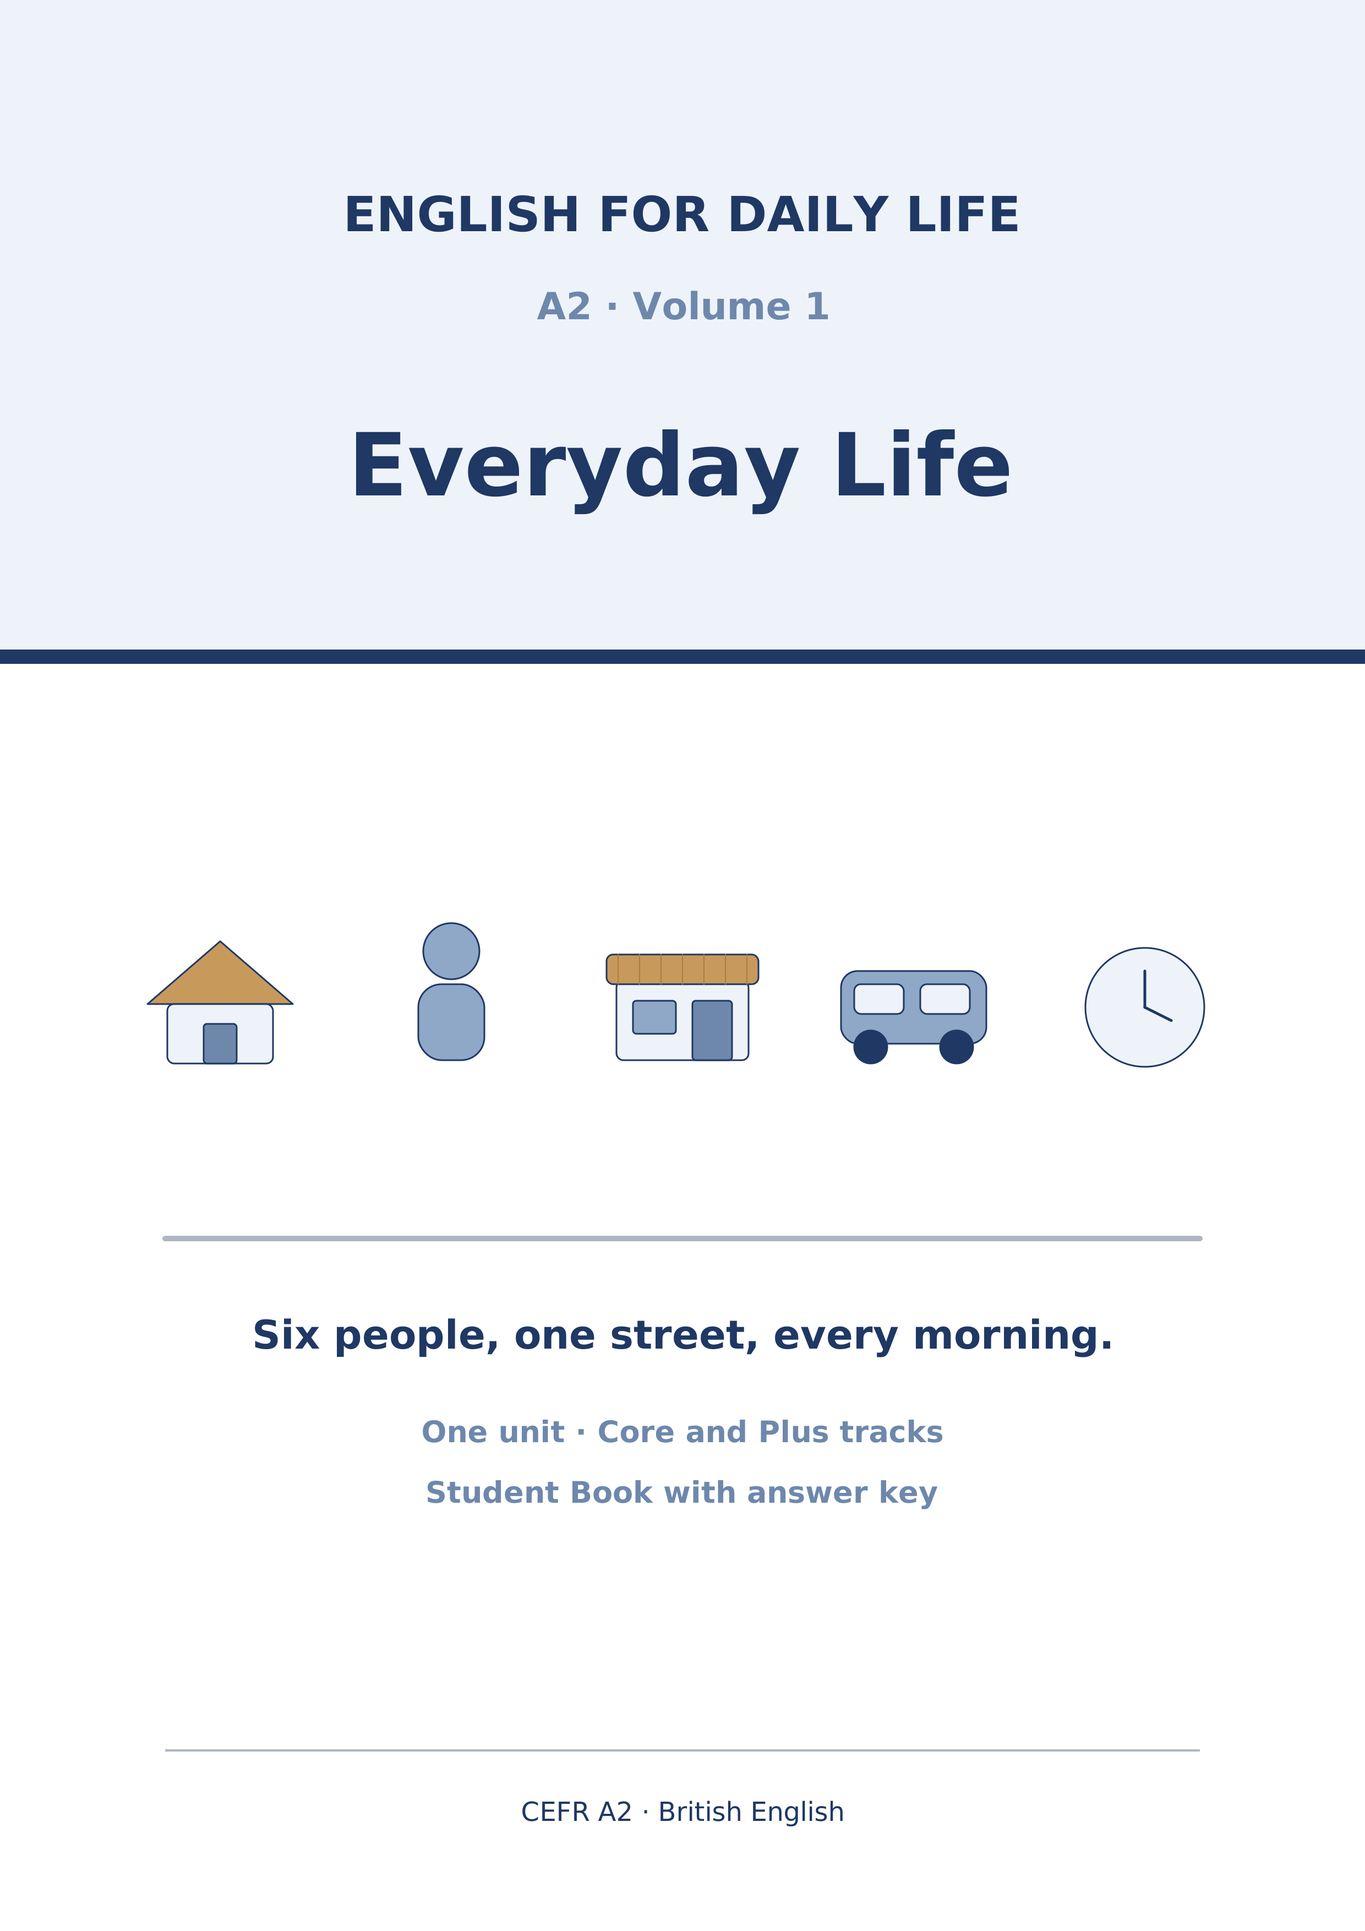
English for Daily Life
A2 · Volume 1 · Everyday Life
How to use this book
Every unit has the same ten parts in the same order, so after Unit 1 you always know where you are.
[CORE] is the Warm Up and Parts 1–6. Everybody does these.
[PLUS] is Parts 7–9. They are there when you are ready for them, and optional when you are not. Part 10 is for everybody.
Almost every exercise opens with item 0, already answered. It is the worked example: read it before you start.
Symbols
🔊 | an audio track; the script is printed on the page
☐ | something to tick when you have checked it
✗ → ✓ | a common mistake, then the correction
Stretch | a harder version of the task, for the Plus track
→ Harvest | the grammar you will meet again later in the unit
Map of the Book
Unit | Topic | Grammar | Glossary
1 | People and Routines | present simple | routine, shift, flatmate, neighbour…
Audio tracks
Track | Where | What
1.1 | Unit 1 · Part 1 Pronunciation | People and Routines
1.2 | Unit 1 · Part 3 (1) | People and Routines
1.3 | Unit 1 · Part 3 (2) | People and Routines
1.4 | Unit 1 · Part 3 (3) | People and Routines
1.5 | Unit 1 · Part 7B | People and Routines
Unit 1: People and Routines
English for Daily Life · Level: A2 · Tracks: [CORE] Warm-Up + Parts 1–6 · [PLUS] Parts 7–10
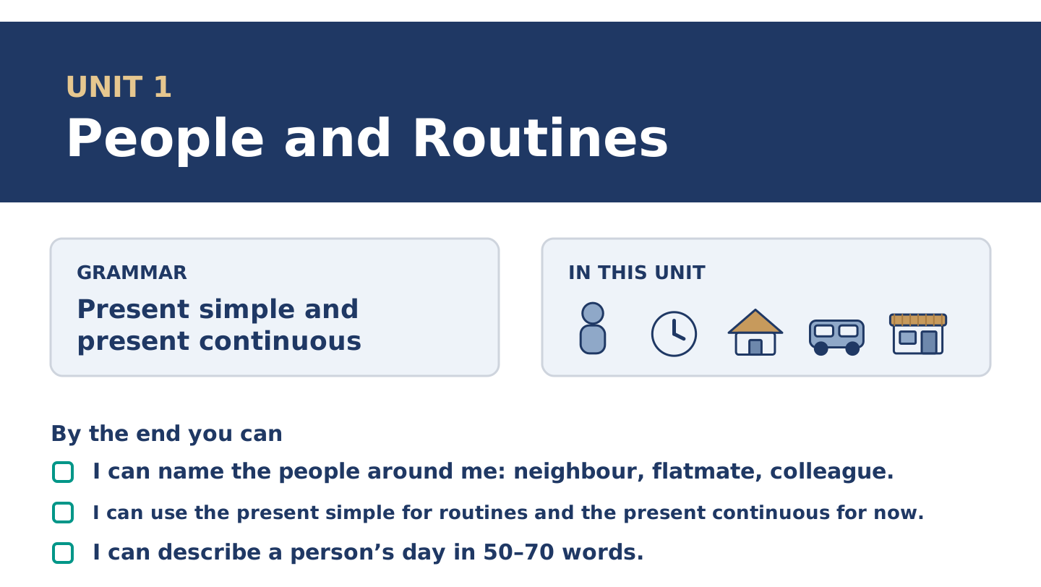
Figure 1.1 · Unit 1 at a glance: the grammar, the topic and what you will be able to do.
Warm Up
[CORE] Core track · in-class starter
Warm-up: People Words and Meanings
Match the words with their meanings. One meaning is not needed. Write the letter.
Column A
1. | Neighbour | ____
2. | Flatmate | ____
3. | Colleague | ____
4. | Routine | ____
5. | Shift | ____
Column B
a) | a person you work with
b) | the hours you work, for example eight at night to eight in the morning
c) | a person who lives near you
d) | a person who pays you every month
e) | the same things you do every day or every week
f) | a person who shares your home
Warm-up: Talking About People
Complete the sentences using the words in the word bank.
Word bank: busy | neighbour | routine | works
- Tomas ______________________ at the hospital, often at night.
- Maya has a simple morning ______________________ : coffee, radio, bus.
- Amina is our ______________________ ; her shop is downstairs.
- On Tuesdays Maya is very ______________________ , because she has a class.
Warm-up: A Street of Neighbours
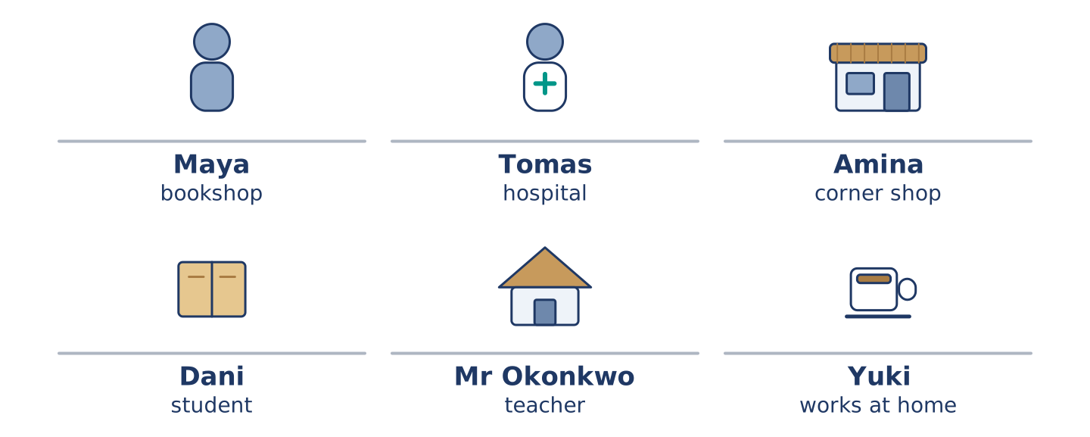
Figure 1.2 · 14 Alder Street at eight in the morning.
Read the text and choose the correct answer.
Six people live at 14 Alder Street. Maya works in a bookshop. Tomas is a nurse, and he often works at night. Amina has the corner shop downstairs. Dani is a student, and he lives on the second floor. Mr Okonkwo is seventy, and he is a retired teacher. Yuki is new here, and she works at home. Every morning the street is busy. Right now, Maya is waiting for the bus, Amina is opening her shop, and Dani is looking for his keys. Mr Okonkwo is at his window, as he is every morning. He knows the street better than anybody.
1. Where do these people live?
○ A) In a hospital
○ B) At 14 Alder Street
○ C) In a bookshop
○ D) In six different cities
2. What is Amina doing right now?
○ A) Opening her shop
○ B) Working at the hospital
○ C) Waiting for the bus
○ D) Sleeping
Part 1 · Vocabulary and Terminology
[CORE] Core track · pre-class input
Part 1: People and Routine Terms
Match the words with their meanings. One meaning is not needed. (0. is done for you.)
- Routine → the same things you do every day or every week.
Column A
1. | Shift | ____
2. | Commute | ____
3. | Appointment | ____
4. | Colleague | ____
5. | Flatmate | ____
6. | Break | ____
7. | Weekday | ____
Column B
a) | a short rest in the middle of work or study
b) | the journey between your home and your work or school
c) | a time you have arranged to see somebody, for example a doctor
d) | a person you work with
e) | Monday, Tuesday, Wednesday, Thursday or Friday
f) | a person who shares your home
g) | the hours you work, for example two in the afternoon to ten at night
h) | a day when nobody works
Gloss: commute = the journey between home and work · shift = the block of hours you work · appointment = an arranged time to see somebody
Part 1: Pronunciation
🔊 Audio Track 1.1
Listen and practise these words. Say each word aloud and stress the loud syllable (CAPITALS).
routine — rou-TINE
commute — com-MUTE
appointment — ap-POINT-ment
colleague — COL-league
usually — U-su-al-ly
neighbour — NEIGH-bour
Then listen again to the -s ending on he, she and it verbs. It has three sounds.
/s/ — he works · he starts · he gets up
/z/ — she lives · he opens · she reads
/ɪz/ — she finishes · he watches · she closes
Say each line twice. The sound depends on the letter before the -s, not on the spelling.
Part 1: Jobs, Places and Hours
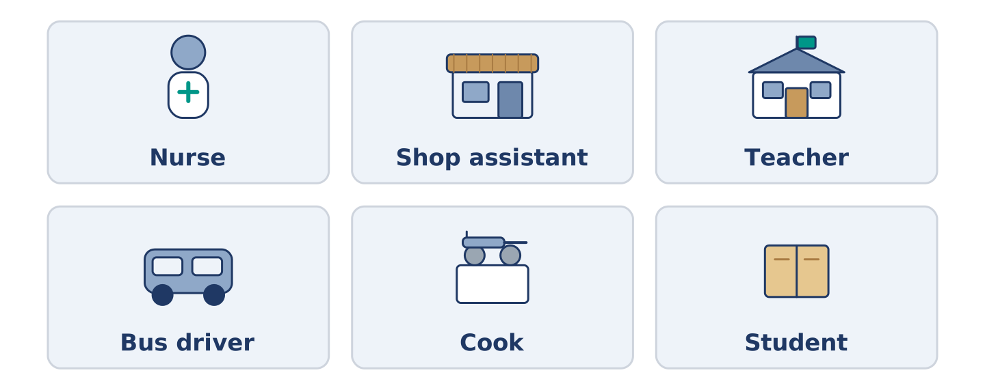
Figure 1.3 · Six jobs and the places people do them.
Complete the table. Write the place where each person works and when they usually work. (0. is done.)
Job | Place | Usual hours
Nurse | a hospital | (example)
Shop assistant
Teacher
Bus driver
- Nurse — a hospital — days, and sometimes nights.
Tomas is the nurse, so row 0 is his. For the other three, think about somebody you know. A bus driver often starts before the city is awake; a teacher works when the children are in school. There is more than one right answer, and you should be ready to say why you chose yours.
Part 1: Parts of a Day

Figure 1.4 · Parts of a day — write the correct word on each line.
Match the parts of a day with their descriptions. One description is not needed. Write the letter.
Column A
1. | Dawn | ____
2. | Midday | ____
3. | Afternoon | ____
4. | Evening | ____
5. | Midnight | ____
Column B
a) | twelve o’clock in the middle of the day
b) | the hours between midday and about six
c) | the first day of the working week
d) | the early time when the sun comes up
e) | twelve o’clock at night
f) | the end of the day, when people come home
Part 1: Daily Life — Multiple Choice
Read and choose the correct answer.
1. A person who lives near you is a…
○ A) colleague
○ B) neighbour
○ C) customer
○ D) flatmate
2. The journey from your home to your work is your…
○ A) break
○ B) shift
○ C) commute
○ D) routine
3. A time you have arranged to see the doctor is an…
○ A) appointment
○ B) weekday
○ C) colleague
○ D) routine
Part 1: Vocabulary Fill-in
Complete the sentences with the correct word.
Word bank: shift | commute | appointment | break
- Tomas works a night ______________ twice a week.
- Her ______________ takes twenty minutes by bus.
- At eleven o’clock they have a short ______________ .
- Mr Okonkwo has an ______________ at the clinic on Thursday.
Part 1: Write About Your Day (short)
Write two or three sentences about your own day. Use three words from this unit.
Model — read this first:
My commute takes half an hour on two buses. I usually have a break at eleven, and I eat with a colleague from my floor. At the moment I am starting work early, because the mornings are quiet.
Part 2 · Grammar — Present Simple vs Present Continuous
[CORE] Core track · pre-class input
Part 2: Notice
Read these lines from Alder Street. Underline the verbs. Which are routines, and which are happening now?
Maya works in a bookshop. She usually starts at nine. Right now, she is waiting for the bus. Tomas works at the hospital every week. This week, he is working nights. Dani studies at the college. He usually cooks on Tuesdays, but today he is eating at his mother’s. Mr Okonkwo reads every afternoon. At the moment he is reading about birds.
Five of these sentences are about a routine, and three are about now. The time words tell you which is which. Usually, every week and every afternoon point one way. Right now, this week, today and at the moment point the other.
Part 2: Grammar Focus Box
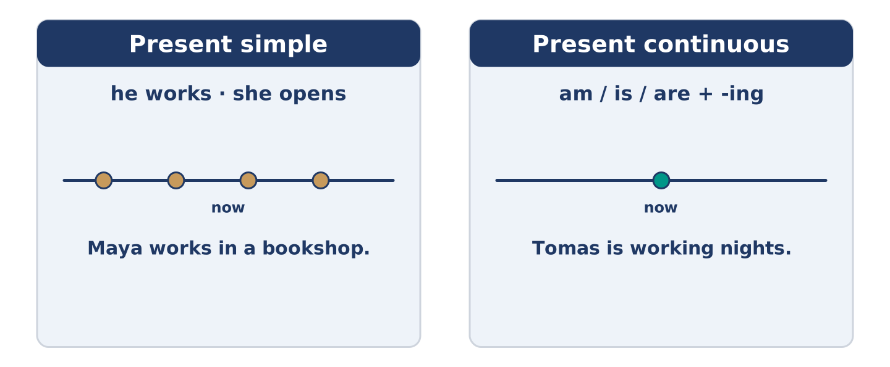
Figure 1.5 · Present simple and present continuous: again and again, or now.
 | Form | Use | Example
Present simple | I/you work; he works | routines, facts | Maya works in a bookshop.
Present continuous | am/is/are + -ing | now, this week | Tomas is working nights.
Remember: every day, usually, often → present simple. now, right now, at the moment, this week → present continuous.
Watch out! ✗ She work in a shop. → ✓ She works in a shop. (add -s for he/she/it). ✗ I waiting now. → ✓ I am waiting now. (don’t drop am/is/are).
Part 2: Controlled Practice
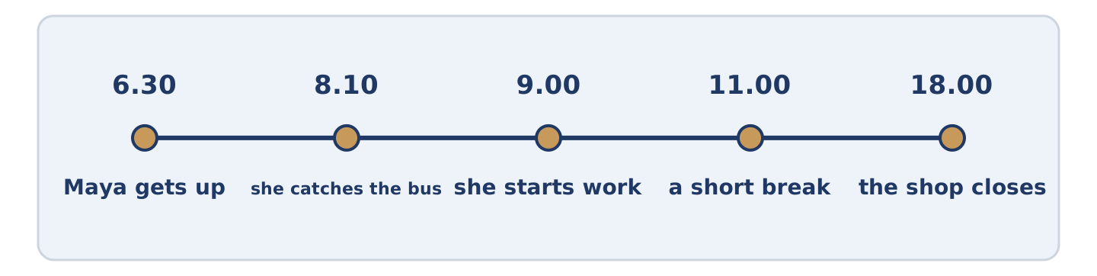
Figure 1.6 · One weekday on a line: the times this unit keeps coming back to.
Complete with the present simple or present continuous. (0. is done.)
- Maya usually starts work at nine. (start)
- Tomas ______________________ (work) at the hospital.
- Listen! Dani ______________________ (cook) in the kitchen.
- Amina ______________________ (open) the shop every morning at seven.
- This week, Yuki ______________________ (paint) her new flat.
Part 2: Simple or Continuous?
Choose the correct form. (0. is done.)
- Every morning, the bus leaves at ten past eight. (leaves / is leaving)
- Right now, Maya ______________________ (waits / is waiting) at the bus stop.
- Mr Okonkwo usually ______________________ (reads / is reading) in the afternoon.
- Look! Dani ______________________ (burns / is burning) the rice.
- Tomas ______________________ (works / is working) three nights every week.
Part 2: Correct the Sentence
Each sentence has one grammar mistake. Write the correct sentence.
- Amina open the shop at seven.
- Look! Maya wait for the bus.
- He work at the hospital every night.
- We are study English this week.
Part 2: Freer Practice
Write two sentences about yourself: one routine (present simple) and one about now (present continuous).
Part 2: Grammar Review
Choose the correct sentence.
1. Which sentence is correct (now)?
○ A) Dani cook the rice.
○ B) Dani is cooking the rice.
○ C) Dani cooking the rice.
○ D) Dani are cooking the rice.
2. Which sentence is correct (routine)?
○ A) Maya working in a bookshop.
○ B) Maya work in a bookshop.
○ C) Maya works in a bookshop.
○ D) Maya to work in a bookshop.
→ Harvest: you will see the present simple and present continuous again in the Part 5 reading. Watch for them.
Part 3 · Listening
[CORE] Core track · pre-class input · scripts printed inline
Part 3: A Nurse Talks About His Week
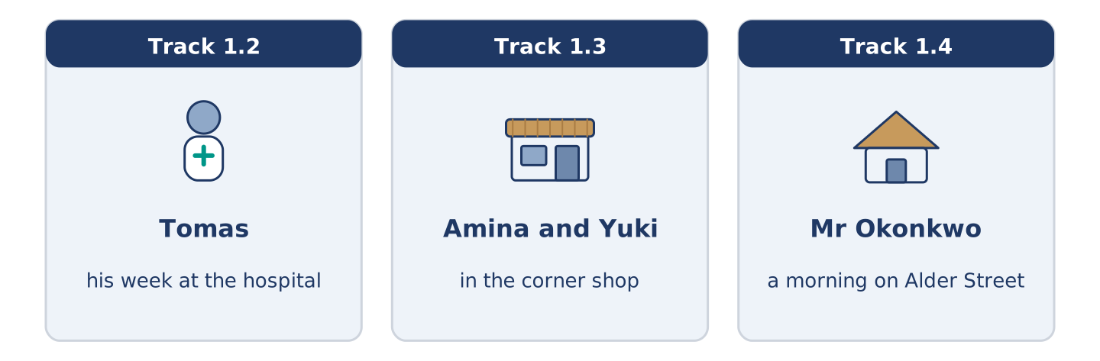
Figure 1.7 · The three listenings: who is speaking, and what about.
🔊 Audio Track 1.2
Before you listen: how many nights a week do you think a nurse works?
Tomas: Hello, I’m Tomas. I’m a nurse, and I live at 14 Alder Street with Maya. I work at the city hospital. Usually I work three days, but some weeks I work nights. This week I’m working nights, so I sleep in the morning and get up at four in the afternoon. It’s strange, but I like the quiet. Right now I’m drinking coffee and waiting for the bus.
While you listen: write True, False, or Not Given. (0. is done.)
- Tomas is a nurse. — True
- Tomas lives alone. ____
- This week Tomas is working nights. ____
- Tomas has worked at the hospital for ten years. ____
Useful phrases: I work… · Usually I… · This week I’m…
Part 3: In the Corner Shop
🔊 Audio Track 1.3
Before you listen: what do people buy in a small shop near their home?
Amina: Good morning, Yuki. You’re new here, aren’t you? Yuki: Yes, this is my first week. Amina: Welcome to Alder Street. What can I get you? Yuki: Some bread and milk, please. Do you open on Sundays? Amina: I open every day except Sunday. On Saturday I close at two. Yuki: Thank you. I’m working from home, so I’m here a lot. Amina: Then I’ll see you often.
While you listen: answer the questions. (0. is done.)
- Where is Yuki? — In the corner shop.
- Why is Yuki in the shop a lot?
- What does Yuki want to buy?
- Which day does Amina close?
Useful phrases: What can I get you? · Do you open on…? · I close at…
Part 3: A Morning on Alder Street
🔊 Audio Track 1.4
Before you listen: at eight in the morning, what are the people in your street doing?
Mr Okonkwo: It’s eight o’clock, and Alder Street is awake. Amina is opening her shop — she does that every morning at seven, but today she is late. Maya is running for the bus again. Tomas is coming home; he is finishing a night shift. Dani is carrying a very large bag of rice, and I am watching all of it from my window, as usual.
While you listen: match each person with what they are doing now. One action is not needed. (0. is done.)
- Mr Okonkwo → watching from his window.
Column A
1. | Amina | ____
2. | Maya | ____
3. | Tomas | ____
4. | Dani | ____
Column B
a) | running for the bus
b) | coming home from a night shift
c) | sleeping in the afternoon
d) | opening her shop
e) | carrying a bag of rice
Part 4 · Speaking
[CORE] Core track · in-class output
Part 4: Discussing Routines
Work with a partner. Ask and answer these questions.
- What time do you usually get up? Is it the same every day?
- What are you doing this week that is not normal for you?
- Who do you see every day — at home, at work, or in your street?
Useful language: I usually… · Every day I… · At the moment I’m… · This week I’m…
Part 4: Find the Difference (pairwork)
Student A and Student B each have a daily routine. Ask questions and find three differences.
Useful questions: What time do you get up? · Where do you work? · How do you travel? · What are you doing this week?
Student A — your routine: get up 6.30 · work in a bookshop · travel by bus · this week: evening class.
Student B — your routine: get up 6.30 · work in a hospital · travel by bike · this week: working nights.
Part 4: New Neighbour Role Play
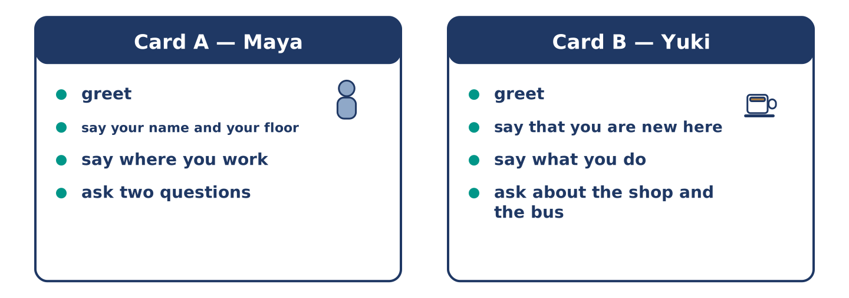
Figure 1.8 · Card A and Card B: what each of you has to say.
Work in pairs. Read the model, then use the cards.
Model exchange:
A: Hello — you’re new here, aren’t you? — B: Yes, this is my first week. — A: Welcome. I’m Maya, from the second floor. — B: I’m Yuki. Nice to meet you. — A: Do you work near here? — B: I work from home, actually. And you? — A: I work in the bookshop on the corner.
Useful language: You’re new here, aren’t you? · This is my first week · I’m… from… · Do you work near here? · Nice to meet you.
Card A — Neighbour (Maya): greet · say your name and your floor · say where you work · ask two questions about their routine.
Card B — New arrival (Yuki): greet · say that you are new here · say what you do · ask about the shop and the bus.
Your turn: run the dialogue, then swap roles.
Stretch [PLUS]: the new neighbour asks a question you cannot answer — say so politely and offer to find out.
Part 4: Mini-Presentation
Prepare a short talk (about one minute). Describe one person you see every day: who they are, what they usually do, and what they are doing at the moment.
Part 5 · Reading
[CORE] Core track · pre-class input
Part 5: What Is a Routine?
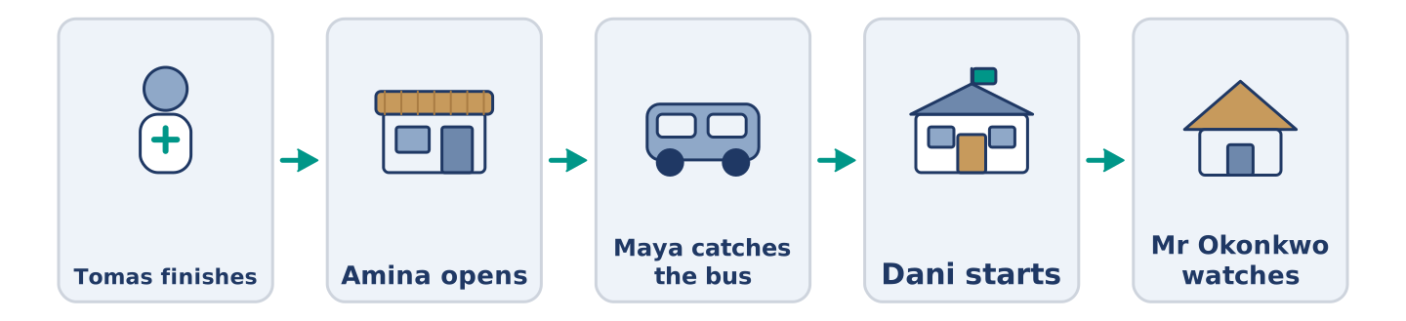
Figure 1.9 · One morning, six people, in order.
Before you read: what three things do you do every single morning?
Gloss: routine = the same things you do every day · commute = the journey between home and work · flexible = easy to change · habit = something you do without thinking
A routine is the set of things a person does again and again. Most people have a morning routine, a work routine, and a weekend routine. Maya gets up at half past six, makes coffee, and listens to the radio. Then she catches the bus. Her commute takes twenty minutes. At the bookshop she opens the till, checks the new books, and makes a list. This is the same almost every weekday. Right now, however, Maya is doing something different: she is studying for an exam, so on Tuesdays she is leaving work early. Routines are useful because they save thinking. A good routine is also flexible. When Tomas works nights, his whole routine changes, and he sleeps while the street is busy. Some people love a fixed routine; others find it boring. Most of us need a little of both: the same breakfast, and a different evening.
Answer the multiple-choice questions. (0. is done.)
- What is a routine? — the set of things a person does again and again.
1. What does Maya do after she makes coffee?
○ A) She catches the bus
○ B) She listens to the radio
○ C) She opens the till
○ D) She studies for an exam
2. Why is Maya leaving work early on Tuesdays?
○ A) Because the shop closes early
○ B) Because she is ill
○ C) Because she works nights
○ D) Because she is studying for an exam
3. Why are routines useful, according to the text?
○ A) They are always the same
○ B) They make people boring
○ C) They save thinking
○ D) They take twenty minutes
Part 5: Vocabulary in Context
Match each word from the text with its meaning. One meaning is not needed. Write the letter.
Column A
1. | commute | ____
2. | flexible | ____
3. | habit | ____
4. | weekday | ____
Column B
a) | easy to change
b) | Monday to Friday
c) | the journey between home and work
d) | something you do without thinking
e) | a short rest in the middle of the day
Part 5: Routines Around the World
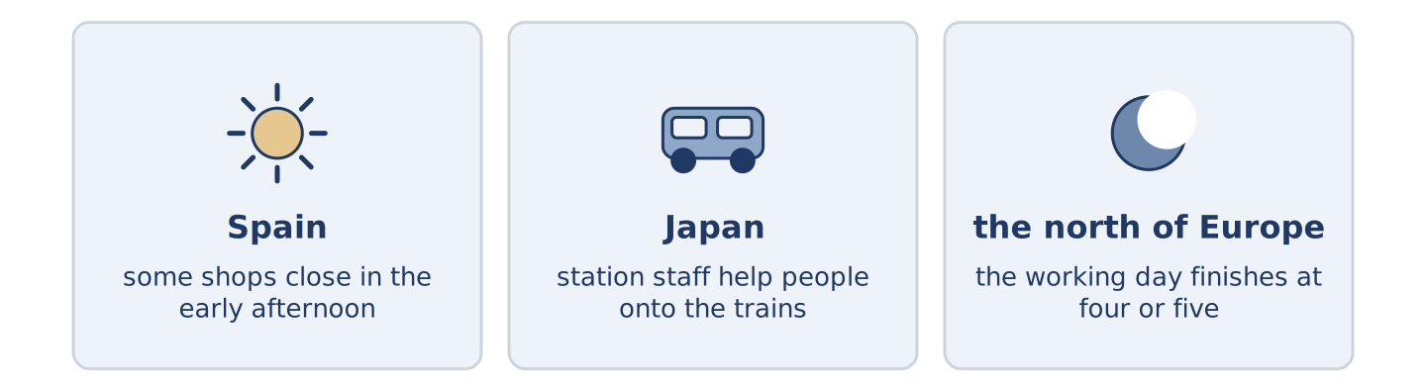
Figure 1.10 · The same day in three places.
Before you read: in your country, what time do people usually eat the evening meal?
Gloss: siesta = a short sleep in the early afternoon · rush hour = the time when many people travel to or from work
Routines are not the same everywhere. In some countries people eat the main meal at midday and rest after it; in others, nobody stops until the evening. In parts of Spain and Latin America, some shops still close for a siesta. In Japan, the morning rush hour is so busy that station staff help people onto the trains. In much of the north of Europe, the working day finishes at four or five, and the evening is long. The clock is the same everywhere. What people do with it is not.
Answer the questions. (0. is done.)
- Are routines the same everywhere? — No, they are not.
- What happens in some shops in Spain and Latin America?
- What do station staff do in Japan?
- In the text, what is the same everywhere?
Part 6 · Writing
[CORE] Core track · in-class / homework
Part 6: Describe a Person’s Day (50–70 words)
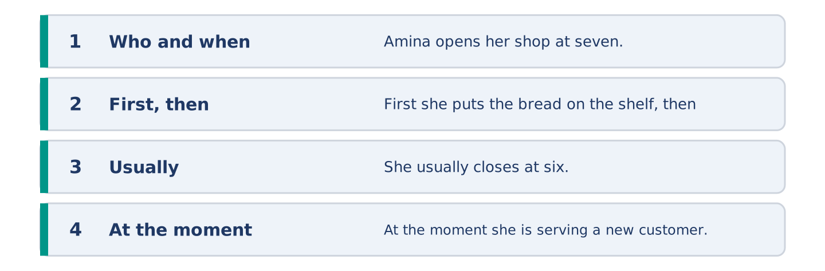
Figure 1.11 · The shape of the paragraph you are about to write.
Write about one person’s normal day. Use the present simple. Add one sentence about what they are doing at the moment.
Model — read this first:
Amina opens her shop at seven o’clock every morning. First she puts the bread on the shelf, then she makes tea. She knows almost everybody in the street, so she talks a lot. She closes at six, but on Saturday she closes at two. At the moment she is serving a new customer, because a woman called Yuki is moving in upstairs. (62 words)
Plan (fill in, then write): ___ gets up at ___. First ___, then ___. ___ usually ___. At the moment, ___ is ___.
Word bank: gets up | first | then | usually | every day | at the moment
Check before you finish: ☐ one present-simple and one present-continuous sentence? ☐ two time words? ☐ 50–70 words? ☐ capitals & full stops?
Part 6: Why Routines Matter (50–70 words)
Do you think a fixed routine is a good thing? Give your opinion and two or three reasons.
Model — read this first:
I think a routine is a good thing, but not a very strict one. A routine saves time, because you do not decide the same things every morning. It also helps you sleep well. However, a routine that never changes is boring, and you stop noticing things. In my opinion the best routine is the same before nine o’clock and free after six. (63 words)
Word bank: I think… because… | it saves time | it helps me… | however | boring | in my opinion
Check before you finish: ☐ a clear opinion? ☐ two or three reasons? ☐ 50–70 words?
Part 6: A Message to a New Neighbour (50–70 words)
Yuki has just moved into your building. Write her a short message: welcome her, tell her two useful things about the street, and offer help.
Model — read this first:
Dear Yuki, Welcome to 14 Alder Street. I live on the second floor with Tomas. Two useful things: Amina’s shop downstairs opens every day except Sunday, and the number 7 bus goes to the centre every ten minutes. The post comes before nine. If you need anything, knock on our door. See you soon. Maya (64 words)
Plan (fill in, then write): Dear ___, Welcome to ___. I live ___. Two useful things: ___ and ___. If you need ___, ___. ___
Check before you finish: ☐ greeting and close? ☐ two useful facts? ☐ an offer of help? ☐ 50–70 words?
Part 6: Reflection — My Perfect Weekday (40–60 words)
Describe your perfect weekday. What would you do, and at what times?
Model — read this first:
My perfect weekday starts late. I get up at eight, not at six, and I walk to work instead of taking the bus. I work until two, and then I stop. In the afternoon I read, and I cook something slowly. In the evening I see one friend — not three. (51 words)
Check before you finish: ☐ three or four times of day? ☐ what you do at each? ☐ 40–60 words?
Part 7 · Real-World File — Meeting Someone New
[PLUS] Plus track (optional) · stronger learners
7A: Phrase Bank
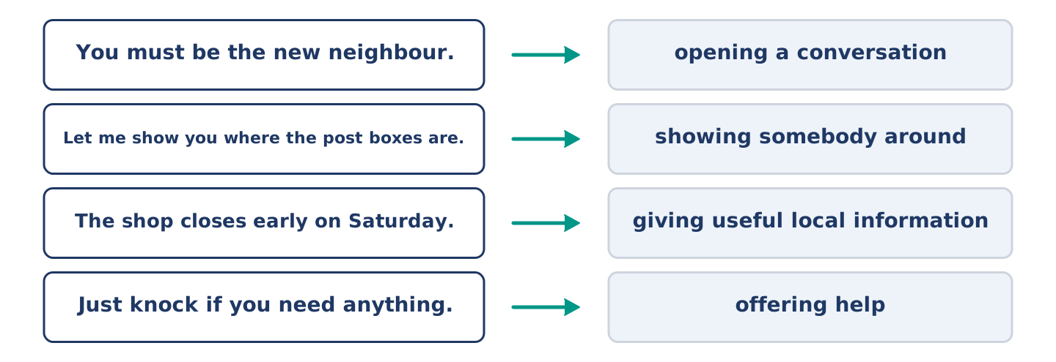
Figure 1.12 · What a neighbour says, and what each thing does.
Match what a person says with its purpose. One purpose is not needed. Write the letter.
Column A
1. | “You must be the new neighbour.” | ____
2. | “Let me show you where the post boxes are.” | ____
3. | “The shop closes early on Saturday.” | ____
4. | “Just knock if you need anything.” | ____
Column B
a) | giving useful local information
b) | offering help
c) | opening a conversation with somebody you have not met
d) | asking for money
e) | showing somebody around
7B: Neighbour Dialogue
🔊 Audio Track 1.5
Before you read: what is the first thing you say to somebody who has just moved in?
Maya: Hello — you must be the new neighbour. Yuki: Yes, I’m Yuki. I moved in on Saturday. Maya: I’m Maya, second floor. This is Tomas. Tomas: Hi. Sorry, I’m half asleep — I’m working nights this week. Yuki: Oh, don’t worry. Maya: Two things you need to know. The post comes before nine, and Amina’s shop is closed on Sundays. Yuki: That’s useful, thank you. Maya: And just knock if you need anything. We’re usually in after seven.
Answer the questions. (0. is done.)
- When did Yuki move in? — On Saturday.
- Why is Tomas tired?
- What two things does Maya tell Yuki?
- When are Maya and Tomas usually at home?
7C: Controlled Practice — Meeting Someone New
Put the steps in order. Number them 1–5. (0. is done.)
- Say hello and open the conversation. — 1
____ Give one or two useful local facts.
____ Say your name and where you live.
____ Offer help and say when you are usually in.
____ Ask one question about them.
7D: Role-Play — Welcoming a New Arrival
In pairs. One is the neighbour; one is the new arrival. Use the model and cards.
Model exchange: Maya: Hello — you must be the new neighbour. — Yuki: Yes, I moved in on Saturday. — Maya: I’m Maya, second floor. Do you know the area at all? — Yuki: Not really. Where do people shop? — Maya: Amina’s, downstairs — every day except Sunday. Just knock if you need anything.
Card A — Neighbour: open the conversation · say your name and floor · give two useful facts · offer help.
Card B — New arrival: say when you moved in · say what you do · ask two questions about the area · thank them.
Stretch [PLUS]: the new arrival asks about something noisy or awkward in the building — answer honestly but kindly.
7E: Writing — A Welcome Note (50–80 words)
You are Maya. Write a short welcome note to Yuki with three things she needs to know in her first week.
Model — read this first:
Dear Yuki, Welcome to number 14. Three things for your first week. The post comes before nine, and the box for recycling is the blue one by the door. Amina’s shop downstairs is open every day except Sunday, and she knows everything about this street. The hot water is slow in the morning — give it five minutes. We’re on the second floor if you need anything. Maya
Check before you finish: ☐ a warm welcome? ☐ three clear facts? ☐ an offer of help? ☐ 50–80 words?
Part 8 · Global Story — The Man Who Changed His Mornings
[PLUS] Plus track · pre-read / discuss
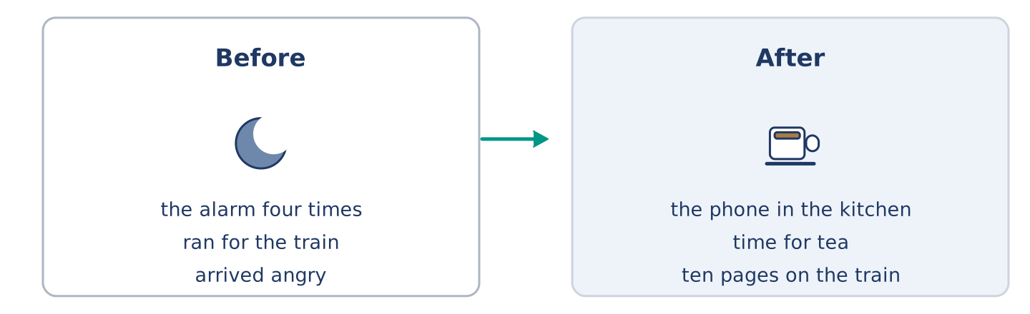
Figure 1.13 · Jun’s mornings before and after one small change.
Before you read: can a small change in the morning change a whole day?
Gloss: alarm = the clock sound that wakes you · swap = to change one thing for another · habit = something you do without thinking about it
In Seoul, a man called Jun worked in an office and hated his mornings. Every day he stopped the alarm four times, then ran for the train, and arrived angry. One winter he made one small change: he put his phone in the kitchen instead of beside his bed. Now, to stop the alarm, he had to stand up and walk. It was a very small thing, and it changed everything. He was awake five minutes earlier, so he had time for tea. With tea, he sat down. Sitting down, he read ten pages. After a year, he had thirty books behind him and he was not angry on the train. Now people ask him: “What is your secret?” He tells them: “I swapped one habit, not twenty.” His brother tried the same thing and hated it. Jun says that is also part of the answer: a routine has to be yours.
Answer the questions. (0. is done.)
- Where does Jun live? — In Seoul.
- What did Jun do every morning before the change?
- What was the one small change?
- What does Jun say about his brother?
Part 8: Vocabulary in Context
Match each word with its meaning. One meaning is not needed. Write the letter.
Column A
1. | alarm | ____
2. | swap | ____
3. | habit | ____
4. | secret | ____
Column B
a) | something you do without thinking about it
b) | the clock sound that wakes you
c) | something you do not tell other people
d) | to change one thing for another
e) | a short journey by train
Part 8: Discussion
Talk with a partner. Use the frames.
Discussion frames: “This is similar to where I live because…” · “This is different from where I live because…” · “I think the most important thing is… because…”
Part 9 · Close to Home — A New Arrival on Your Street
[PLUS] Plus track · pre-read / decide
Before you read: when somebody new moves into your building, who speaks to them first?
Yuki moved into the top flat at 14 Alder Street on a Saturday in March. She did not know anybody in the city. For the first four days she spoke to nobody except Amina in the shop, and only about bread. She worked from home, so she did not meet people at an office. In the evening she heard the building: doors, a television, somebody laughing on the stairs. She did not know any of the voices. After four days, Maya knocked on her door with a short note about the post and the bus. It took two minutes. Yuki says now that those two minutes were the difference between living in a building and living in a street. Three weeks later she knew four of the six people at number 14, and she had started leaving her door open when she cooked.
Answer the questions. (0. is done.)
- Which flat did Yuki move into? — The top flat at 14 Alder Street.
- Why did Yuki not meet people easily?
- What did Maya do after four days?
- What had changed three weeks later?
Part 9: Decision Task
A new person moves into your building next week. Should you (a) knock on the door with a note, (b) wait until you meet them on the stairs, or (c) put a message in the building’s group chat? Decide and explain. Use the frame.
Answer frame: “I think I should ___ because ___. Also, ___. This is better than ___ because ___.”
Model — read this first:
I think I should knock on the door with a short note, because a note is easy for a shy person to read later. Also, it takes two minutes and it does not ask them to talk straight away. This is better than waiting on the stairs, because you can wait for weeks and never meet somebody who works from home. (60 words)
Phrase bank: I think I should… · because… · Also,… · This is better than… · In my opinion…
Part 10 · Review and Can-Do
[CORE + PLUS] · homework / self-study
Part 10: Spiral Review
Complete the review. (0. is done.)
- The journey between your home and your work is your commute.
Word bank: routine | shift | flatmate | appointment | present continuous | present simple | neighbour | usually
- A person who shares your home is your ______________________ .
- A person who lives near you is your ______________________ .
- The same things you do every day are your ______________________ .
- Tomas works a night ______________________ twice a week.
- Maya has an ______________________ at the clinic on Thursday.
- “Maya works in a bookshop” uses the ______________________ tense.
- “Dani is cooking right now” uses the ______________________ tense.
- “She ______________________ gets up at half past six” — the word for a routine.
Part 10: Can-Do
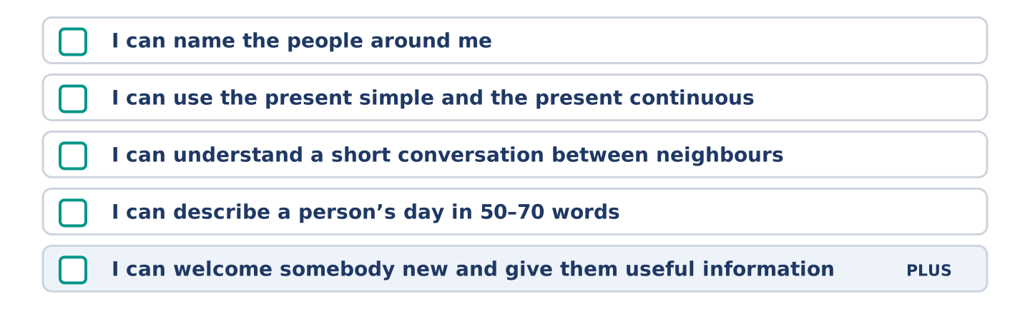
Figure 1.14 · What you can do at the end of this unit.
Can-Do checklist
☐ I can name the people around me: neighbour, flatmate, colleague.
☐ I can use the present simple for routines and the present continuous for now.
☐ I can understand a short conversation between neighbours.
☐ I can describe a person’s day in 50–70 words.
☐ I can welcome somebody new and give them useful information (Plus).
Part 10: Glossary
Unit 1 glossary (10 words)
routine · shift · flatmate · neighbour · colleague · commute · appointment · busy · usually · at the moment
Answer Key
The source this course is modelled on has no answer key at all. This one covers every closed item, and gives marking points and a sample answer for every open task.
Unit 1: People and Routines — Answer Key
English for Daily Life · Teacher’s section. The source book has no answer key; this is an addition. Open tasks carry a sample answer, not the only correct one.

Warm Up
Warm-up: People Words and Meanings
- c · 2. f · 3. a · 4. e · 5. b Not needed: d) a person who pays you every month
Warm-up: Talking About People
- works · 2. routine · 3. neighbour · 4. busy
Warm-up: A Street of Neighbours
- B) At 14 Alder Street · 2. A) Opening her shop

Part 1 · Vocabulary and Terminology
Part 1: People and Routine Terms
- g · 2. b · 3. c · 4. d · 5. f · 6. a · 7. e Not needed: h) a day when nobody works
Item 0 (Routine) is a standalone worked example, exactly as in the source: the word is not in Column A and its meaning is not in Column B, so it uses up no letter. Seven items, eight letters, one spare.
Part 1: Pronunciation (Track 1.1)
Stress as printed: rou-TINE · com-MUTE · ap-POINT-ment · COL-league · U-su-al-ly · NEIGH-bour
Note that routine and commute take the stress on the second syllable, while colleague, usually and neighbour take it on the first. Learners who stress ROU-tine are following their first language, not English.
The -s ending, three sounds: /s/ after /p t k f θ/ — works, starts, gets, waits, stops /z/ after a vowel or a voiced sound — lives, opens, reads, knows, goes /ɪz/ after /s z ʃ tʃ dʒ/ — finishes, closes, watches, washes, changes
Part 1: Jobs, Places and Hours
- Nurse — a hospital — days, and sometimes nights (given)
Accept any sensible pair. The expected answers:
Job | Place | Usual hours
Shop assistant | a shop | shop hours, often including Saturday
Teacher | a school | weekday mornings and afternoons
Bus driver | a bus (on the road) | early starts, in shifts
Part 1: Parts of a Day
- d · 2. a · 3. b · 4. f · 5. e Not needed: c) the first day of the working week
Part 1: Daily Life — Multiple Choice
- B) neighbour · 2. C) commute · 3. A) appointment
Part 1: Vocabulary Fill-in
- shift · 2. commute · 3. break · 4. appointment
Part 1: Write About Your Day (short)
Open. Two or three sentences, using three words from the unit. The unit prints a model; this is a second one.
Sample: I usually get up at seven, and my commute takes forty minutes. My flatmate works a late shift, so the flat is quiet in the morning. At the moment I am finishing a course, so I study on the bus.

Part 2 · Grammar — Present Simple vs Present Continuous
Part 2: Notice
Verbs, and which is which: works (routine) · starts (routine) · is waiting (now) · works (routine) · is working (now — this week) · studies (routine) · cooks (routine) · is eating (now) · reads (routine) · is reading (now)
Five routines, three sentences about now. The time words are the evidence; make learners point at them.
Part 2: Controlled Practice
- starts (given) · 1. works · 2. is cooking · 3. opens · 4. is painting
Part 2: Simple or Continuous?
- leaves (given) · 1. is waiting · 2. reads · 3. is burning · 4. works
Part 2: Correct the Sentence
- Amina opens the shop at seven. (third person -s)
- Look! Maya is waiting for the bus. (happening now)
- He works at the hospital every night. (third person -s)
- We are studying English this week. (-ing after are)
Part 2: Freer Practice
Open. One present simple and one present continuous, correctly formed.
Sample: I finish work at five every day. This week I am working from home.
Part 2: Grammar Review
- B) Dani is cooking the rice. · 2. C) Maya works in a bookshop.

Part 3 · Listening
Part 3: A Nurse Talks About His Week (Track 1.2)
- True (given)
- False — he lives with Maya at 14 Alder Street.
- True — “This week I’m working nights.”
- Not Given — he says where he works, never for how long.
Part 3: In the Corner Shop (Track 1.3)
- In the corner shop. (given)
- Because she works from home.
- Some bread and milk.
- Sunday. (She also closes early, at two, on Saturday.)
Part 3: A Morning on Alder Street (Track 1.4)
- Mr Okonkwo → watching from his window (given)
- d · 2. a · 3. b · 4. e Not needed: c) sleeping in the afternoon

Part 4 · Speaking
All four tasks are productive. Accept any answer that meets the brief; correct form, not content.
Part 4: Discussing Routines
Listen for present simple with usually / every day and present continuous with this week / at the moment. The second question is the one that forces the continuous.
Sample: I usually get up at half past six, but not at the weekend. This week I am travelling to another city for work, so I am getting up at five. I see my flatmate every day and the woman in the bakery every morning.
Part 4: Find the Difference (pairwork)
Marking points: ☐ questions in the present simple ☐ one question in the present continuous for this week ☐ exactly three differences reported.
Three differences: workplace (bookshop / hospital) · transport (bus / bike) · this week (evening class / working nights). The get-up time (6.30) is the same in both — learners who report four differences have guessed.
Sample exchange: A: What time do you get up? — B: At half past six. — A: Me too. Where do you work? — B: I work in a hospital. — A: I work in a bookshop. How do you travel? — B: By bike. — A: I take the bus. And what are you doing this week? — B: I’m working nights.
Part 4: New Neighbour Role Play
Marking points: ☐ both partners speak ☐ present simple for work and home ☐ at least one present continuous ☐ the exchange closes politely.
Card A must produce: a greeting, a name and floor, a workplace, two questions. Card B must produce: a greeting, a statement that they are new, a job, two questions.
Sample: A: Hello — you’re new here, aren’t you? — B: Yes, this is my first week. I’m Yuki. — A: I’m Maya, flat 2. I work in the bookshop on the corner. Do you work near here? — B: I work from home, actually. Is the shop downstairs open on Sundays? — A: No, that’s the one day Amina closes.
Stretch: accept I’m not sure, actually — I’ll ask Amina and let you know or similar. The marker is a polite admission plus an offer, not an invented answer.
Part 4: Mini-Presentation
Marking points: ☐ about one minute ☐ at least one present-simple routine sentence ☐ at least one present-continuous at the moment sentence ☐ the person is identified before anything is said about them.
Sample (51 words): I want to talk about Mr Okonkwo, my neighbour on the fourth floor. He is a retired teacher, and he is seventy. He reads his newspaper every afternoon by the window, and he watches the whole street. At the moment he is waiting for an appointment at the clinic on Thursday.

Part 5 · Reading
Part 5: What Is a Routine?
- the set of things a person does again and again (given)
- B) She listens to the radio
- D) Because she is studying for an exam
- C) They save thinking
Part 5: Vocabulary in Context
- c · 2. a · 3. d · 4. b Not needed: e) a short rest in the middle of the day
Part 5: Routines Around the World
- No, they are not. (given)
- They close for a siesta — a short sleep in the early afternoon.
- They help people onto the trains in the morning rush hour.
- The clock. What people do with it is not the same.

Part 6 · Writing
Each task already prints a model. These are the marking points and a second sample, so that the printed model is not the only answer a learner has seen.
Part 6: Describe a Person’s Day (50–70 words)
Marking points: ☐ at least one present simple routine sentence ☐ at least one present continuous at the moment sentence ☐ two time expressions ☐ 50–70 words ☐ capitals and full stops.
Sample (53 words): My brother gets up at five, because he drives a bus. First he makes tea, then he walks to the depot. He usually starts at six and finishes at two, so he is at home in the afternoon. At the moment he is doing a training course, so on Thursdays he finishes late.
Part 6: Why Routines Matter (50–70 words)
Marking points: ☐ a clear opinion in the first sentence ☐ two or three reasons, each with because or a linker ☐ 50–70 words.
Sample (56 words): I do not think a fixed routine is always good. It helps in the morning, because nobody wants to think before coffee. But a routine can make a week disappear, and you remember nothing. I prefer a routine for small things and no routine for the evening. That way the days are not all the same.
Part 6: A Message to a New Neighbour (50–70 words)
Marking points: ☐ greeting and close ☐ two useful facts about the place ☐ an offer of help ☐ 50–70 words.
Sample (53 words): Hi Yuki, Welcome to the building. I’m Dani, flat 3. Two things that help: the hot water is slow before eight, so wait a few minutes, and the number 7 bus stops right outside. Amina downstairs will change a note for you if you need coins for the machine. Knock any time. Dani
Part 6: Reflection — My Perfect Weekday (40–60 words)
Marking points: ☐ three or four times of day named ☐ an activity at each ☐ 40–60 words.
Sample (48 words): My perfect weekday is quiet. At seven I drink coffee and nobody talks to me. At nine I start work, and I finish at three. In the afternoon I swim. In the evening I cook something that takes an hour, and I do not look at my phone.

Part 7 · Real-World File — Meeting Someone New
7A: Phrase Bank
- c · 2. e · 3. a · 4. b Not needed: d) asking for money
7B: Neighbour Dialogue (Track 1.5)
- On Saturday. (given)
- Because he is working nights this week.
- The post comes before nine, and Amina’s shop is closed on Sundays.
- After seven.
7C: Controlled Practice — Meeting Someone New
- Say hello and open the conversation — 1 (given) Give one or two useful local facts — 4 Say your name and where you live — 2 Offer help and say when you are usually in — 5 Ask one question about them — 3
7D: Role-Play — Welcoming a New Arrival
Marking points: ☐ an opener that does not assume ☐ two facts a newcomer could not know ☐ an offer with a time attached ☐ the new arrival asks, not only answers.
Card A must produce: an opener, a name and floor, two local facts, an offer of help. Card B must produce: a move-in date, a job, two questions about the area, thanks.
Sample: A: You must be the new neighbour. — B: Yes, I moved in on Saturday. I’m Yuki. — A: I’m Maya, second floor. Two things: the post comes before nine, and Amina’s shop is closed on Sundays. — B: That’s useful. Is the hot water always slow? — A: In the morning, yes. Give it five minutes. Knock any time after seven.
Stretch: the honest-but-kind answer. Accept The flat above is noisy on Fridays, but they stop by eleven and they’re fine if you ask — a real fact plus something that makes it liveable. Do not accept Everything is perfect.
7E: Writing — A Welcome Note (50–80 words)
Marking points: ☐ a warm opening ☐ exactly three facts, clearly separated ☐ an offer of help ☐ 50–80 words.
Sample (59 words): Dear Yuki, Welcome to Alder Street. Three things for this week. First, the post: it comes before nine, so listen for the door. Second, the front door sticks — lift it a little and it opens. Third, Amina’s shop downstairs is closed on Sundays, so buy bread on Saturday. I’m on the second floor if you need anything. Maya

Part 8 · Global Story — The Woman Who Changed Her Mornings
- In Seoul. (given)
- He stopped the alarm four times, then ran for the train, and arrived angry.
- He put his phone in the kitchen instead of beside his bed, so he had to stand up to stop the alarm.
- His brother tried the same change and hated it. Jun says that is part of the answer: a routine has to be yours.
Part 8: Vocabulary in Context
- b · 2. d · 3. a · 4. c Not needed: e) a short journey by train
Part 8: Discussion
Marking points: ☐ at least one similar frame ☐ at least one different frame ☐ a reason after each ☐ the frames are used, not paraphrased.
Sample: This is similar to where I live because most people here also travel to work by train, and the mornings are very fast. This is different from where I live because nobody drinks tea before work — we all drink coffee standing up. I think the most important thing is the five minutes, because five minutes is small enough to keep.

Part 9 · Close to Home — A New Arrival on Your Street
- The top flat at 14 Alder Street. (given)
- She worked from home, so she did not meet people at an office, and she knew nobody in the city.
- She knocked on Yuki’s door with a short note about the post and the bus.
- She knew four of the six people at number 14, and she had started leaving her door open when she cooked.
Part 9: Decision Task
No option is wrong. The task is the reasoning, and the frame must be used.
Marking points: ☐ a choice stated in the first sentence ☐ a because reason ☐ a second point after Also ☐ a comparison with one rejected option ☐ 50–70 words.
Sample (57 words): I think I should put a message in the group chat, because then everybody knows at the same time and nobody is the one person who did nothing. Also, a message is easy to answer later. This is better than knocking on the door, because some people do not want a stranger at the door in their first week.
The three options, and the strongest case for each:
- (a) a note through the door — works for a shy person or somebody who works from home; it asks nothing of them immediately.
- (b) wait for the stairs — no pressure, nothing forced; but it can take weeks, and may never happen at all.
- (c) the group chat — reaches everybody at once and is easy; but a new person may not be in the chat yet, and a message to a group is not a welcome to a person.

Part 10 · Review and Can-Do
Part 10: Spiral Review
- commute (given)
- flatmate · 2. neighbour · 3. routine · 4. shift · 5. appointment
- present simple · 7. present continuous · 8. usually
Part 10: Can-Do
Self-assessment. No key. If a learner cannot tick line 2, send them back to Part 2; line 4, back to Part 6.
Part 10: Glossary
routine · shift · flatmate · neighbour · colleague · commute · appointment · busy · usually · at the moment

Counts for this unit, against the source’s own.
 | Source U1 | This unit
Words | 4,636 | 5,216
Sub-sections | 42 | 42
Figures | 4 | 4
Audio tracks | 5 | 5
Seeded 0. worked examples | 14 | 14
one meaning / purpose is not needed | 7 | 7
Model — read this first | 7 | 7 (all filled; the source’s are empty)
Before you read | 5 | 5
Check before you finish | 5 | 5
Word bank | 4 | 5
Gloss | 4 | 4
Before you listen | 3 | 3
Useful language / phrases / questions | 5 | 5
Model exchange | 2 | 2
Stretch | 2 | 2
Remember · Watch out! · Harvest · Answer frame · Phrase bank · Discussion frames | 1 each | 1 each
Glossary words | 10 | 10
Can-Do lines | 5 | 5
Writing tasks | 5 (50–70 ×3, 40–60 ×1, 50–80 ×1) | 5 (same)
Closed items: 61 — matching 29 · MCQ 10 · gap-fill 13 · True/False/Not Given 3 · short answer 10 — plus 4 ordering steps and 3 table cells. The 580-word excess over the source is the filled Models and this unit’s longer Part 1 table; it is inside the source’s own unit range once the Models are discounted.
