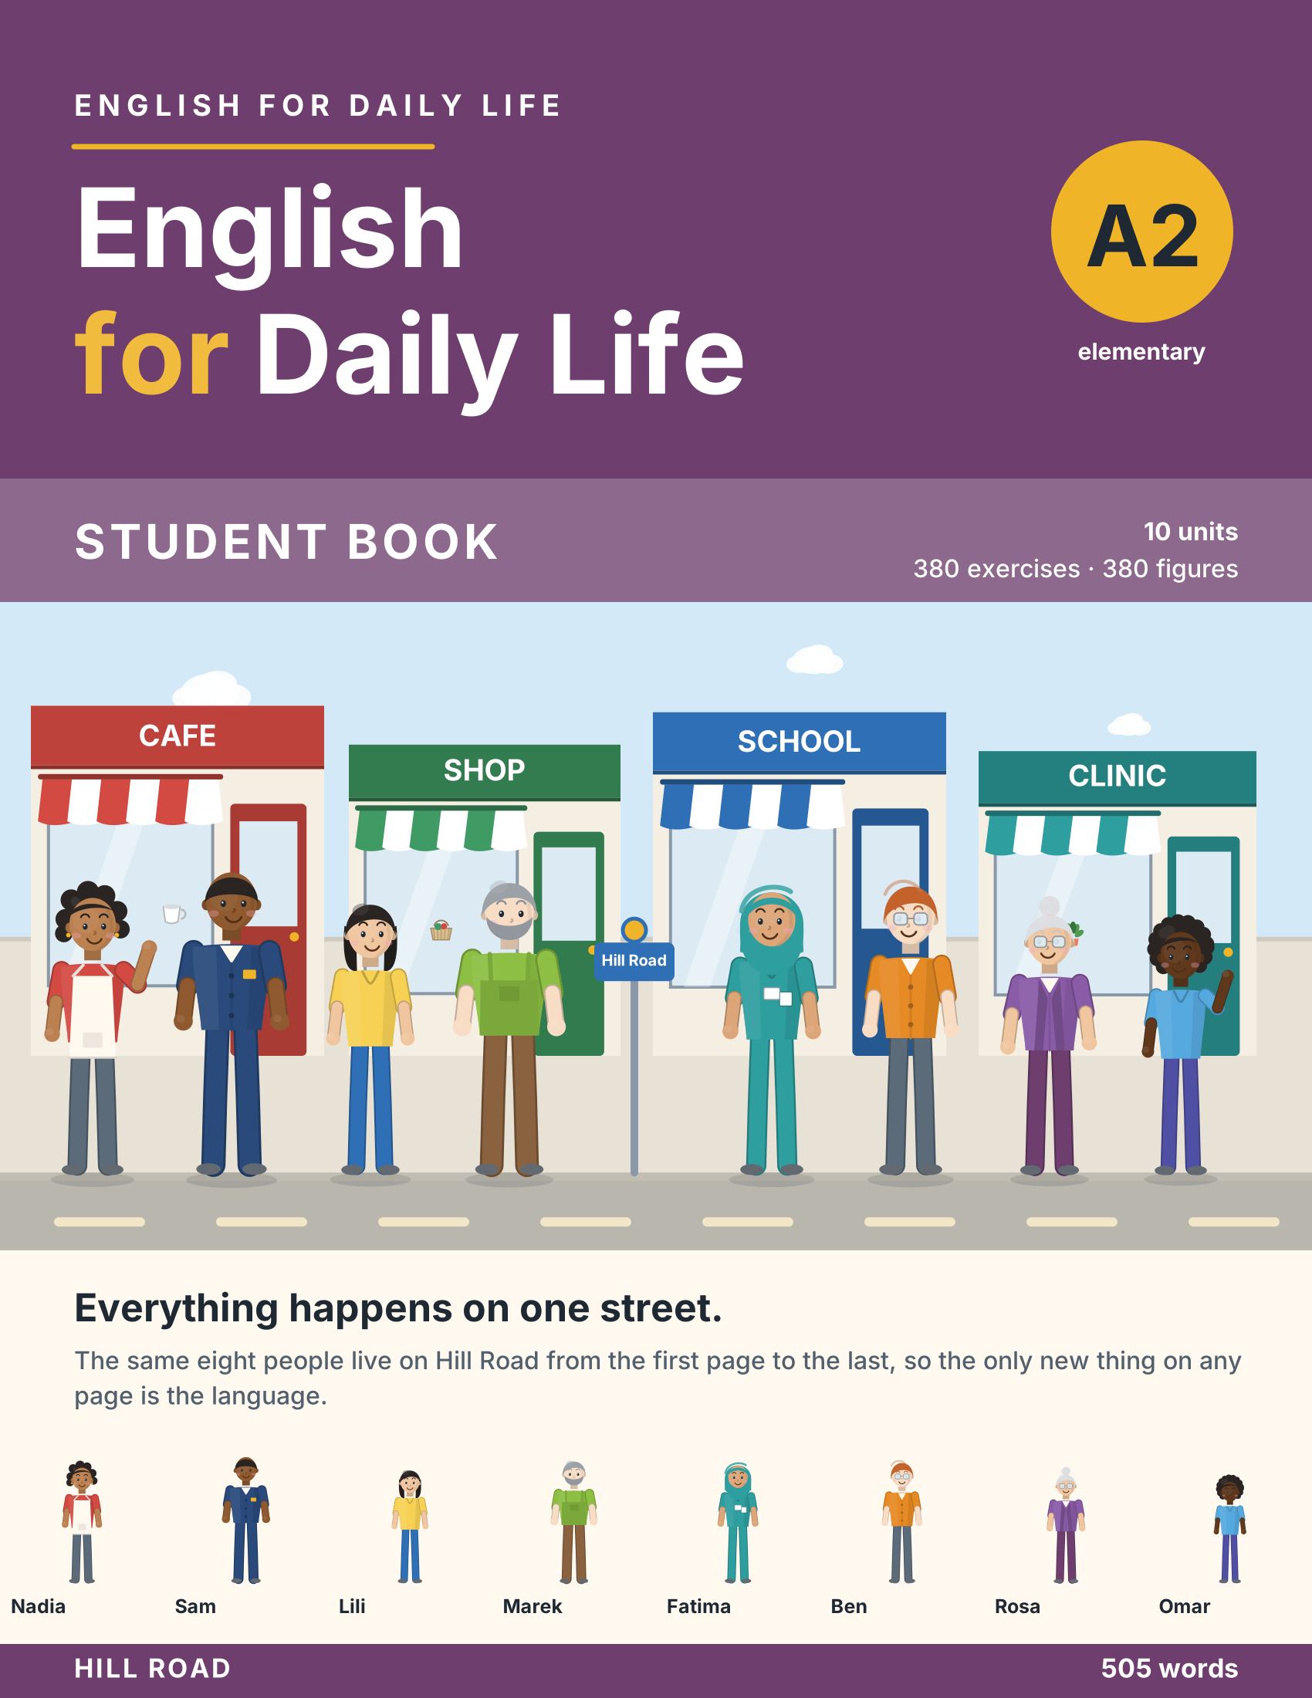

English for Daily Life

A2 — Student Book
10 units · 380 exercises · 220 figures
A beginner’s course. Everything happens on one street, Hill Road, and the same eight people live there, so the only new thing on any page is the language.
Unit | Title | Grammar
1 | Back on Hill Road | tense review: be, present simple, past simple, will
2 | Every Day and Right Now | present simple vs present continuous · state verbs
3 | A Place of My Own | have got · too and enough
4 | How Much, How Many | much, many, a lot of, a few, a little
5 | What Happened | past simple vs past continuous · when and while
6 | Getting There | prepositions of movement · have to, don’t have to
7 | Making Plans | will vs going to vs present continuous for arrangements
8 | At Work | must, mustn’t, should
9 | Feeling Better | should and shouldn’t for advice
10 | The Way I Am | adverbs of manner · frequency · not as … as
The people of Hill Road
Nadia cooks at the cafe. Sam drives bus 12. Lili is a student. Marek looks after the flats. Fatima is a nurse at the clinic and teaches the evening class. Ben works in the shop. Rosa is Marek’s mother. Omar is his son.

Unit 1: Back on Hill Road
In this unit you talk about last year, this year and next year.
Warm Up
W1 Look at Figure 1.1. Answer the questions.
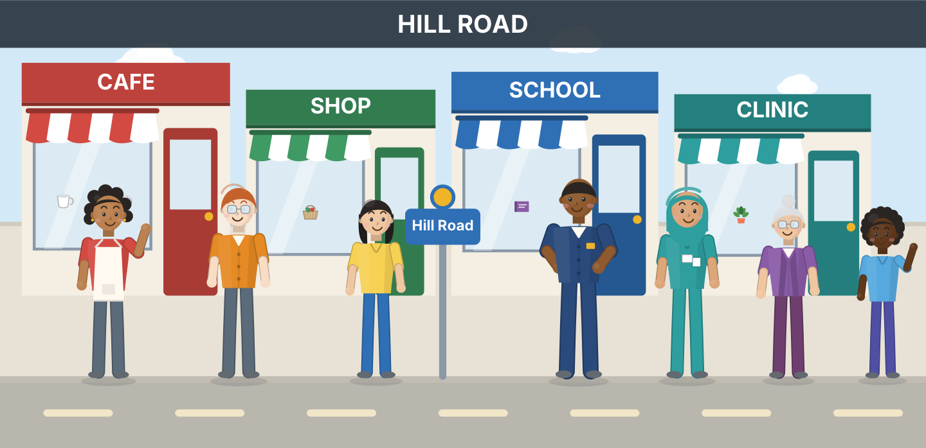
Figure 1.1 · Hill Road, a year later.
- How many people are on the street? — seven (example)
- Which four places can you see? — ______________
- Who is carrying a suitcase? — ______________
- Where does Nadia work? — ______________
W2 Look at Figure 1.2. Answer the questions.
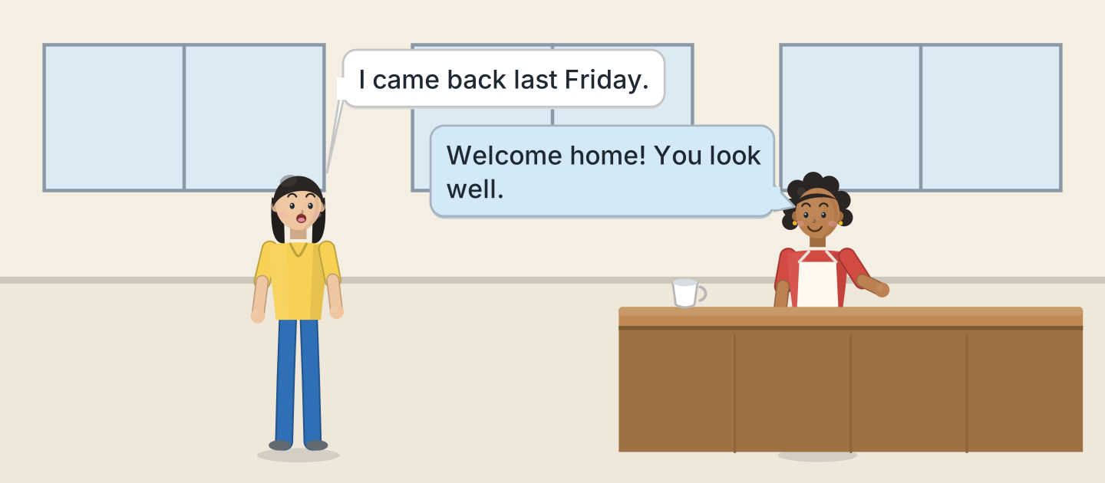
Figure 1.2 · Lili comes back.
- Where are Lili and Nadia? — in the cafe (example)
- When did Lili come back? — ______________
- What does Nadia say to her? — ______________
- Why is Lili carrying a bag? — ______________
W3 Look at Figure 1.3. Write the word.
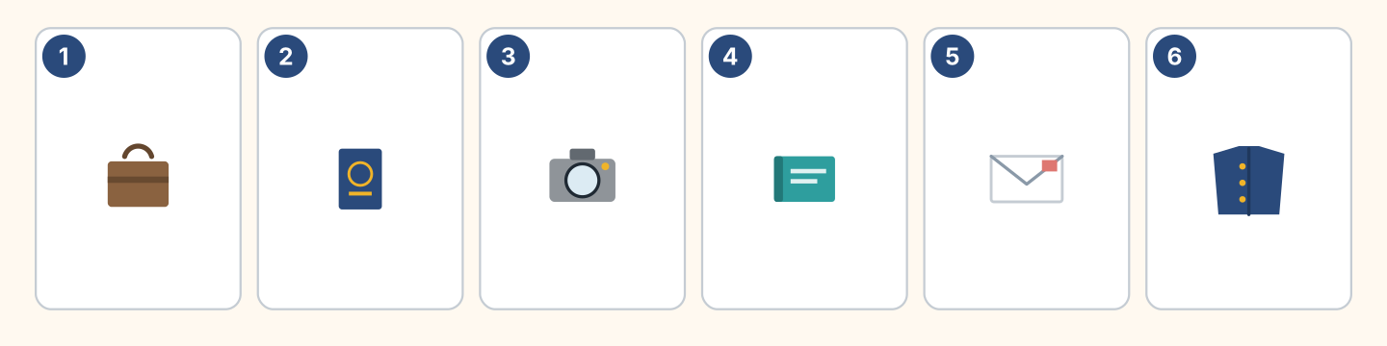
Figure 1.3 · Six things in a suitcase.
Words: camera · coat · book · envelope · passport · suitcase
- 1 — suitcase (example)
- 2 — ______________
- 3 — ______________
- 4 — ______________
- 5 — ______________
Part 1 · Words & Sounds
1A Look at Figure 1.4. Write last year, now or next year.
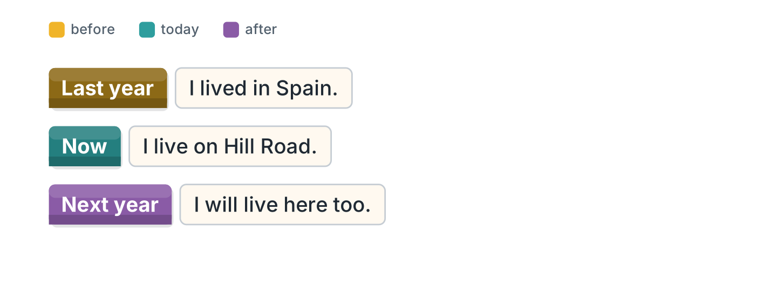
Figure 1.4 · The three times, in one line.
- I lived in Spain. — last year (example)
- I will live here too. — ______________
- I live on Hill Road. — ______________
- I worked in a hotel. — ______________
1B Look at Figure 1.5. Write the past form.
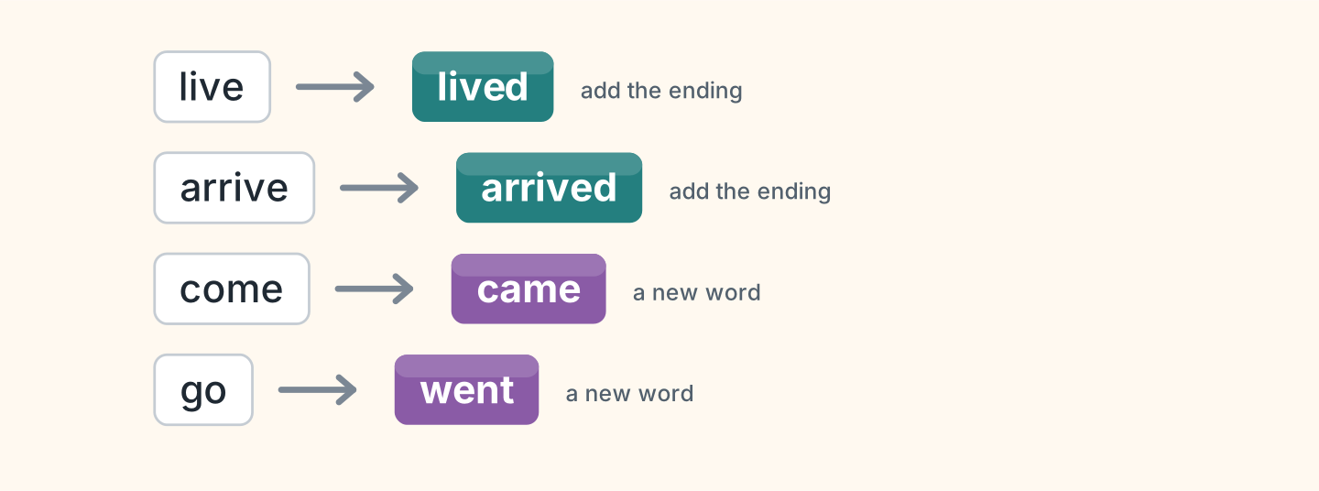
Figure 1.5 · Now and then, four verbs.
- live — lived (example)
- arrive — ______________
- come — ______________
- go — ______________
1C Look at Figure 1.6. Write what the person is carrying.
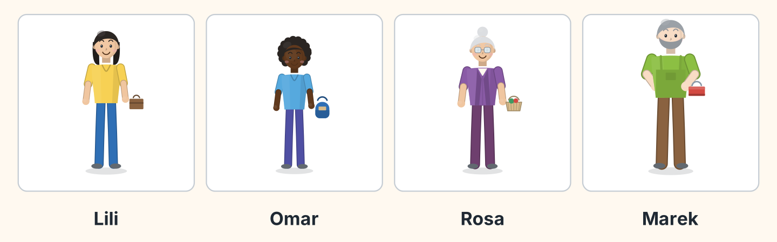
Figure 1.6 · Four neighbours and their news.
- Lili — a suitcase (example)
- Omar — ______________
- Rosa — ______________
- Marek — ______________
1D Say it. Look at Figure 1.7. Say the short forms.
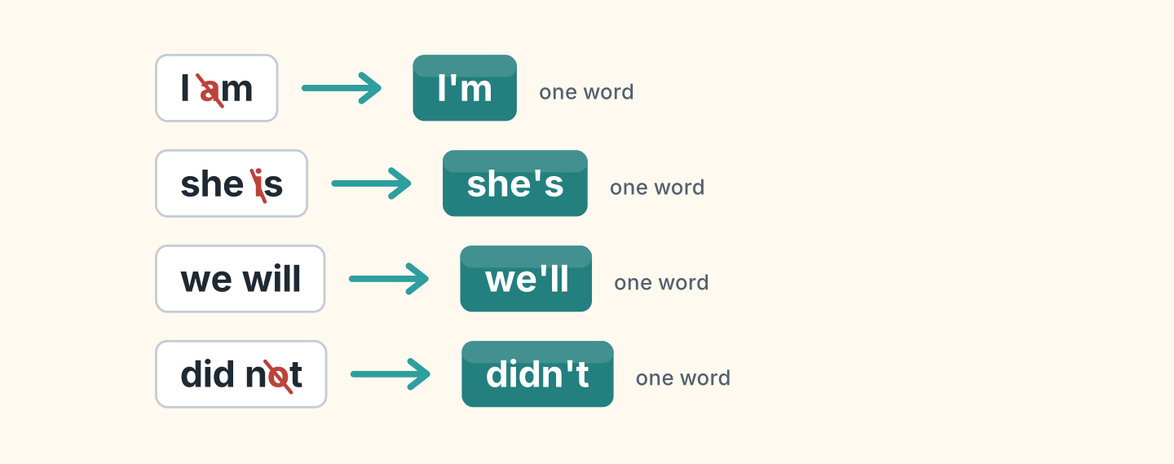
Figure 1.7 · The short forms we say.
- I am — I’m (example)
- she is
- we will
- did not
- I will not
1E Look at Figure 1.8. Answer the questions.
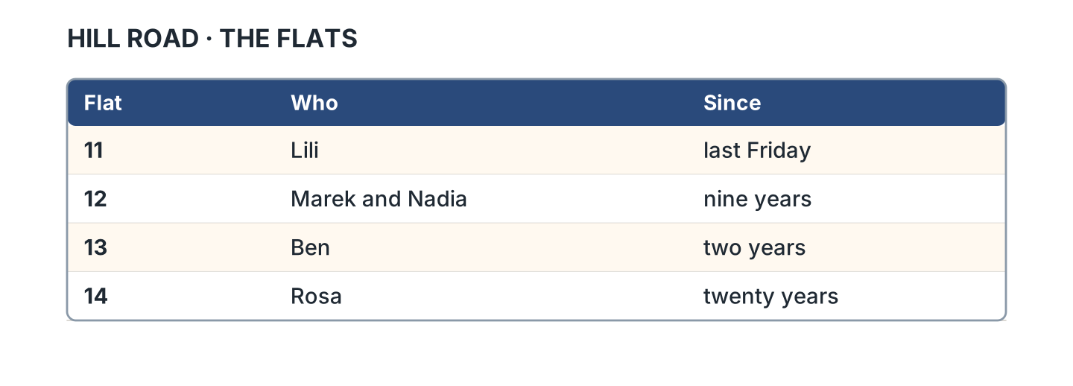
Figure 1.8 · Who lives where now.
- Who lives in flat 11? — Lili (example)
- Who lives in flat 13? — ______________
- How long has Rosa been in flat 14? — ______________
- Which flat has two people? — ______________
1F Look at Figure 1.9. Write the word for the meaning.
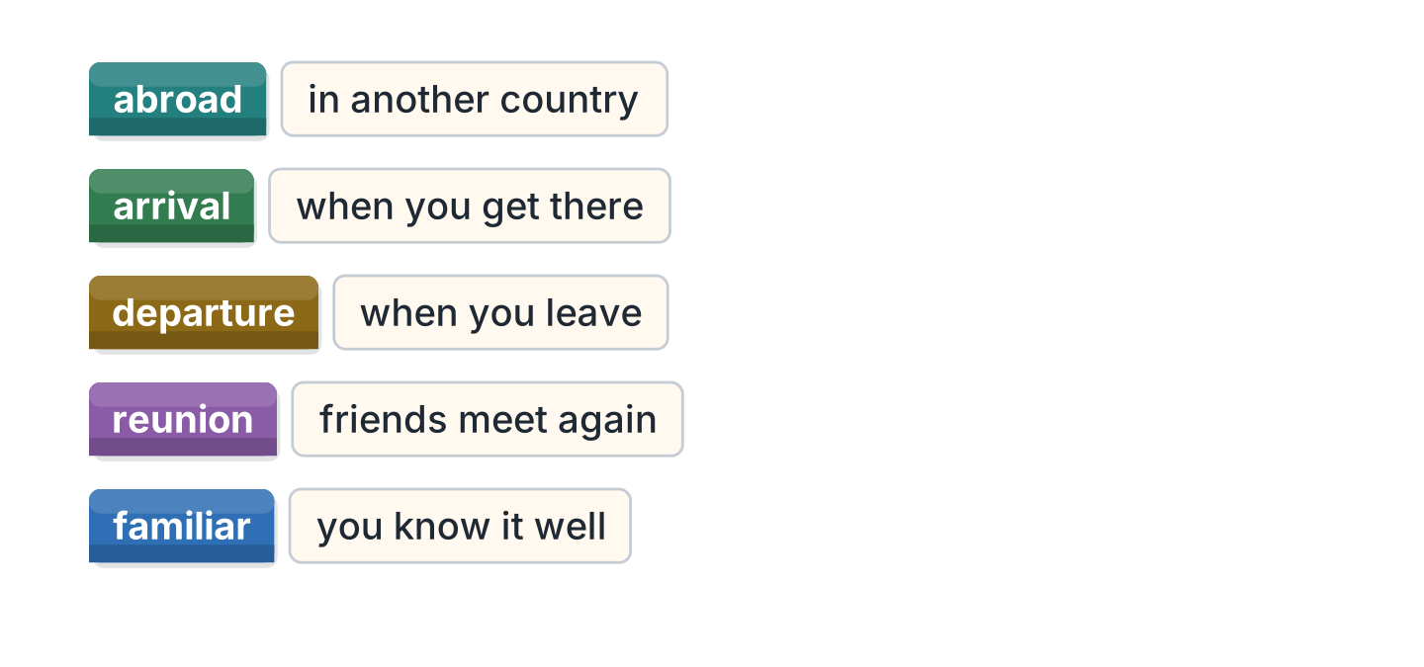
Figure 1.9 · Five words for coming back.
- in another country — abroad (example)
- when you get there — ______________
- when you leave — ______________
- friends meet again — ______________
- you know it well — ______________
Part 2 · Grammar
2A Look at Figure 1.10. Choose the correct verb.
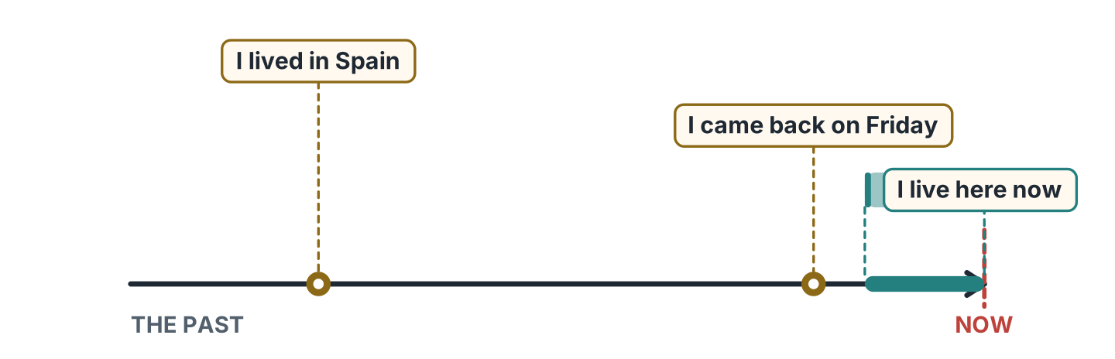
Figure 1.10 · One line for each time.
- Last year I (live / lived) in Spain. — lived (example)
- I (came / come) back on Friday.
- I (live / lived) on Hill Road now.
- Next year I (work / will work) at the school.
- Last June I (am / was) in Madrid.
2B Look at Figure 1.11. Put the words in order.
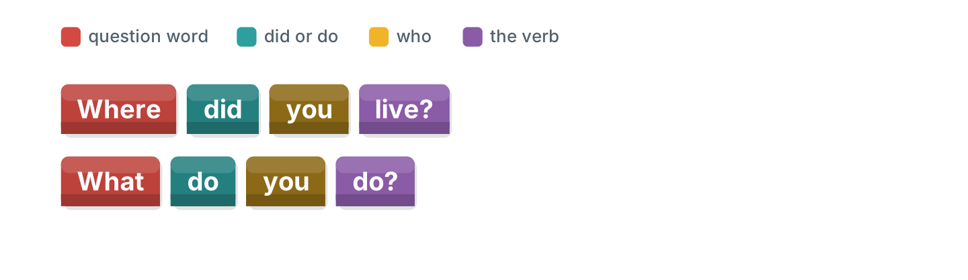
Figure 1.11 · Where the question word goes.
- (did / where / live / you) — Where did you live? (example)
- (do / what / you / do) — ______________
- (you / will / stay / where) — ______________
- (did / when / arrive / she) — ______________
2C Look at Figure 1.12. Write the answer.
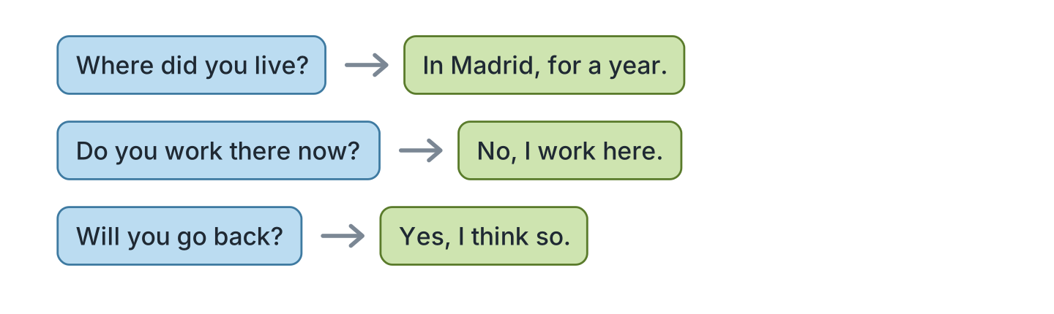
Figure 1.12 · Asking and answering.
- Where did you live? — In Madrid, for a year. (example)
- Do you work there now? ✗ — ______________
- Will you go back? ✓ — ______________
- How long were you away? (a year) — ______________
2D Look at Figure 1.13. Write the next year line.
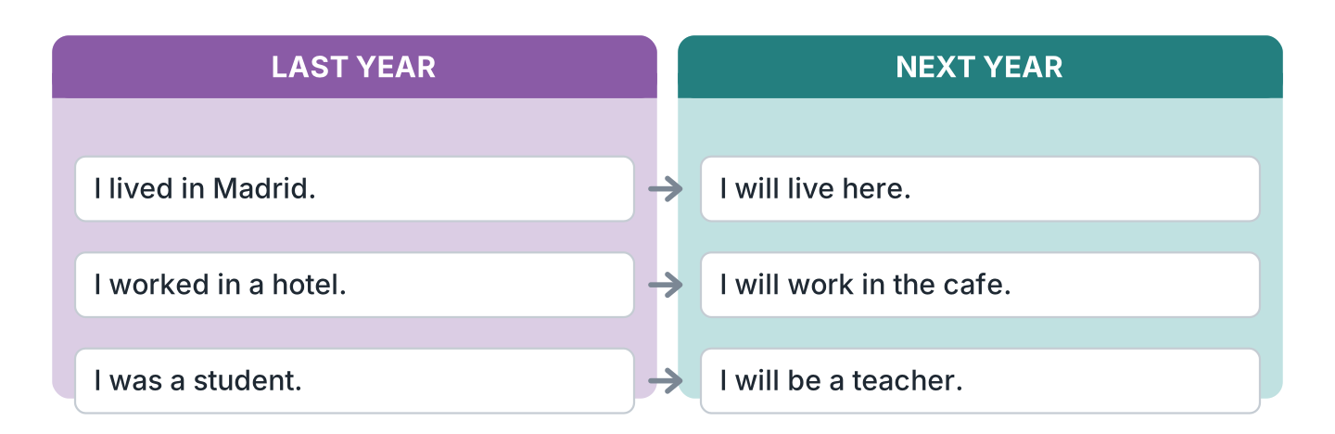
Figure 1.13 · Last year and next year.
- I lived in Madrid. — I will live here. (example)
- I worked in a hotel. — ______________
- I was a student. — ______________
- I studied every evening. — ______________
2E Look at Figure 1.14. Write yes or no.
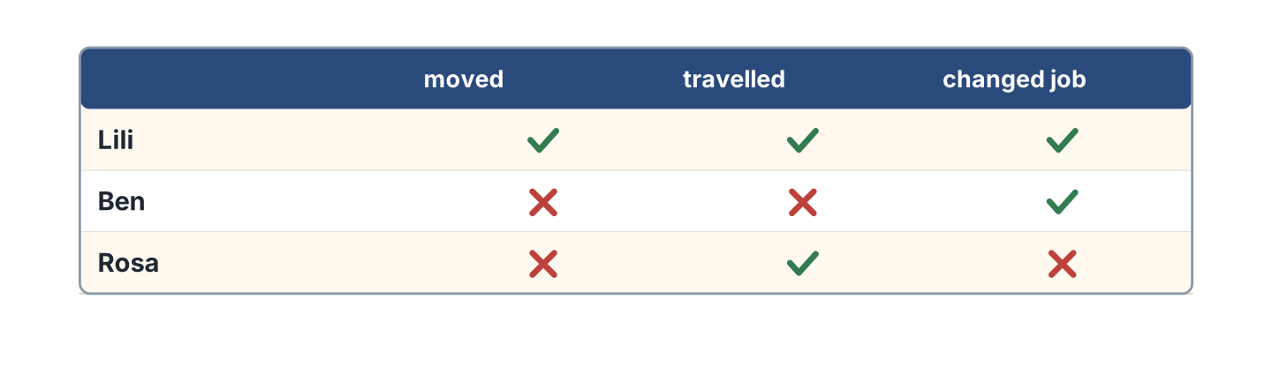
Figure 1.14 · Who did what last year.
- Lili moved last year. — yes (example)
- Ben travelled last year. — ______
- Rosa changed her job. — ______
- Lili changed her job. — ______
2F Look at Figure 1.15. Find the mistake and write it correctly.
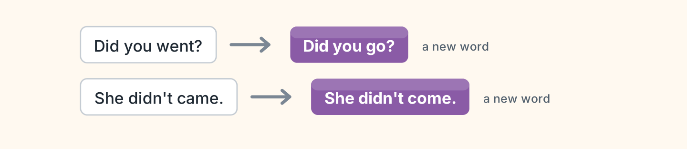
Figure 1.15 · After did, the verb goes back.
- Did you went to Spain? — Did you go (example)
- She didn’t came home. — ______________
- Where did you lived? — ______________
- He didn’t worked there. — ______________
Part 3 · Listening
3A Listen. Look at Figure 1.16. Write the number.
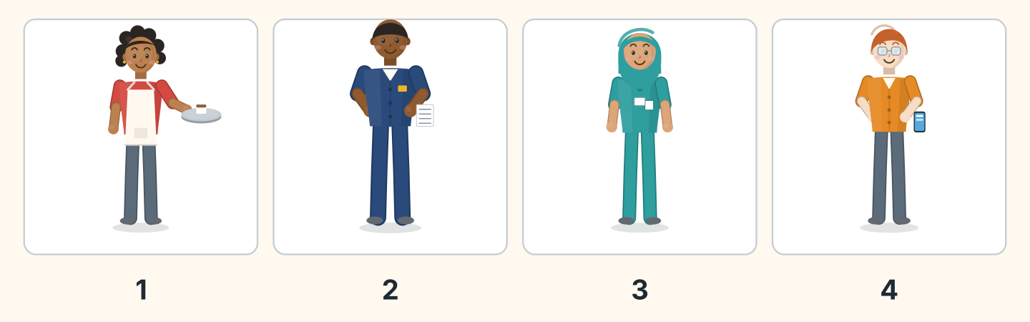
Figure 1.16 · Four voices on the street.
- Nadia — 1 (example)
- Sam — ______
- Fatima — ______
- Ben — ______
3B Listen. Look at Figure 1.17. Write the answer you hear.
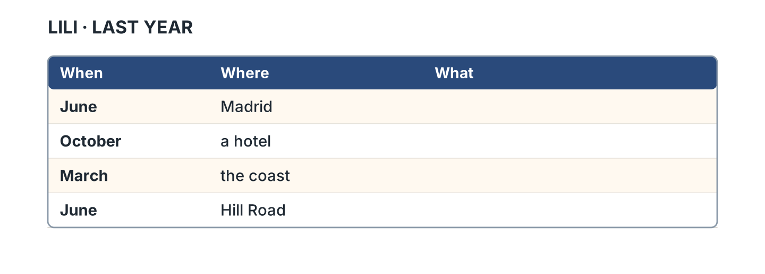
Figure 1.17 · What Lili did in Spain.
- What did she do in June? — she started a course (example)
- What did she do in October? — ______________
- What did she do in March? — ______________
- What did she do at the end? — ______________
3C Listen. Look at Figure 1.18. Answer the questions.
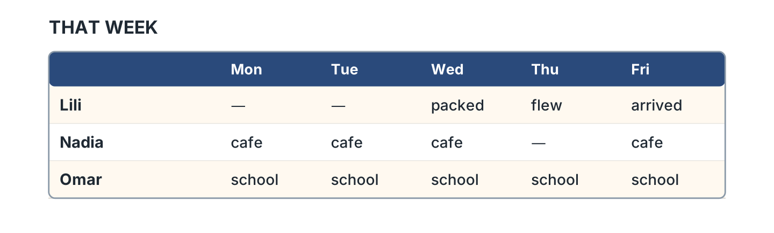
Figure 1.18 · The week she came back.
- What did Lili do on Wednesday? — she packed (example)
- What did Lili do on Thursday? — ______________
- Which day was Nadia not at the cafe? — ______________
- How many days was Omar at school? — ______________
3D Listen. Look at Figure 1.19. Write the number of the thing you hear.
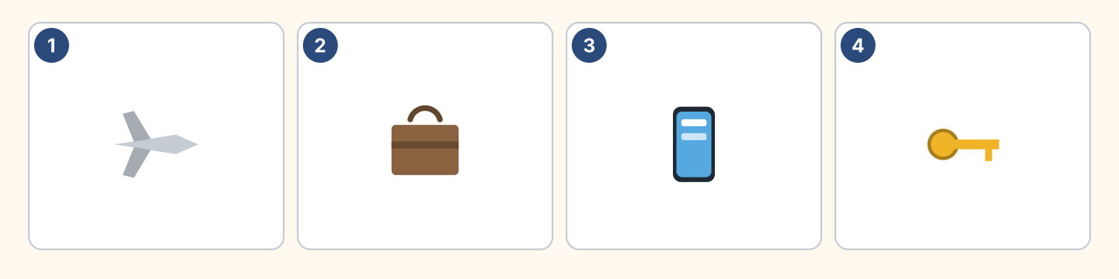
Figure 1.19 · Four words you will hear.
- a plane — 1 (example)
- a suitcase — ______
- a phone — ______
- a key — ______
Part 4 · Speaking
4A Look at Figure 1.20. Ask a friend about last year.
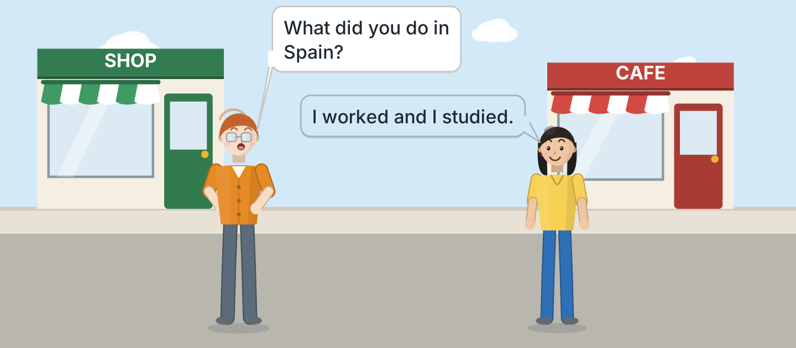
Figure 1.20 · Ben asks about the year.
- A: What did you do in Spain? B: I worked and I studied. (example)
- Ask where your friend went last year.
- Ask how long they stayed there.
- Say one thing you did last year.
4B Look at Figure 1.21. Ask and answer.
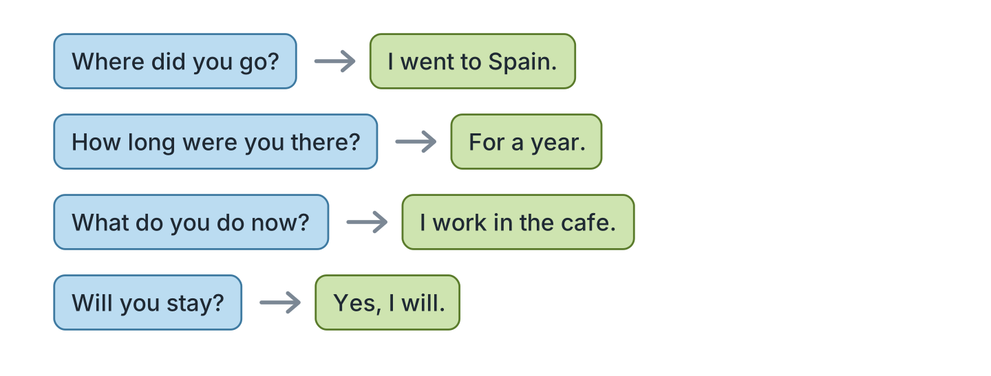
Figure 1.21 · Four questions to ask.
- A: Which country were you in? B: Spain, for a whole year. (example)
- A: How long were you there? B: ______________
- A: What do you do now? B: ______________
- A: Will you stay here? B: ______________
4C Look at Figure 1.22. Say what Lili did, in order.
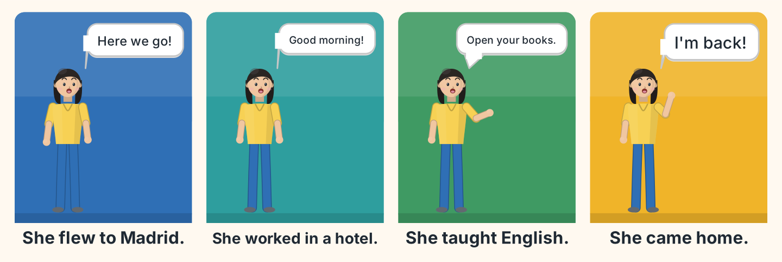
Figure 1.22 · A year in four pictures.
- First she flew to Madrid in June. (example)
- Say what she did after that.
- Say what she did in March.
- Say when she came home.
4D Look at Figure 1.23. Ask two of these neighbours about their work.
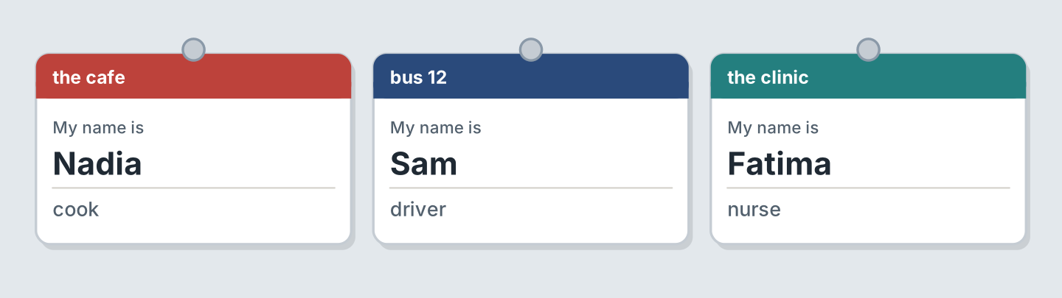
Figure 1.23 · Three neighbours to ask.
- A: Where do you work? B: At the cafe. I am the cook. (example)
- Ask Sam what he does.
- Ask Fatima where she works.
- Say what you do, and where.
Part 5 · Reading
5A Look at Figure 1.24. Answer the questions.
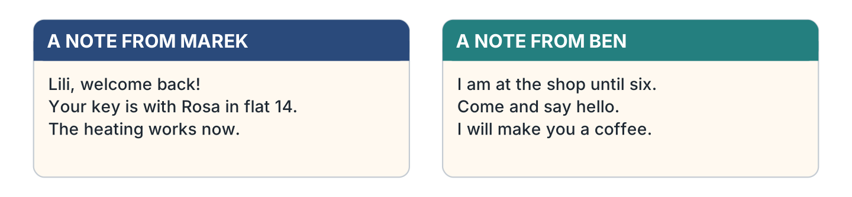
Figure 1.24 · Two notes on the door.
- Who wrote the first note? — Marek (example)
- Who has Lili’s key? — ______________
- What works now? — ______________
- When is Ben at the shop until? — ______________
5B Look at Figure 1.25. Answer the questions.
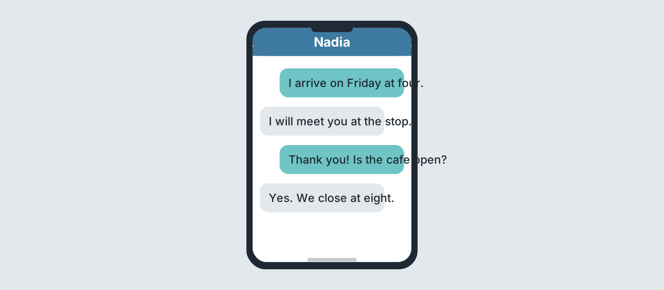
Figure 1.25 · A message about Friday.
- When does Lili arrive? — on Friday at four (example)
- Where will Nadia meet her? — ______________
- Is the cafe open on Friday? — ______________
- What time does the cafe close? — ______________
5C Look at Figure 1.26. Choose the correct answer.
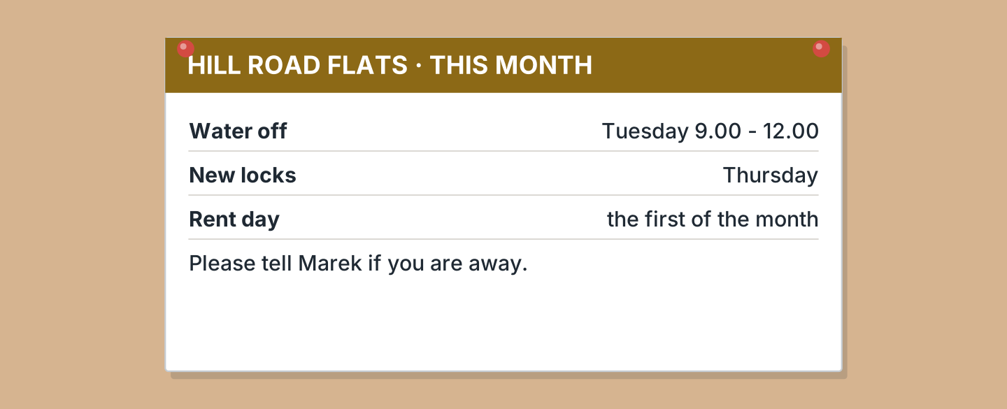
Figure 1.26 · A notice in the hall.
- Who should you tell if you go away? (a) Rosa (b) Marek (c) Ben — b (example)
- When is the water off? (a) Tuesday (b) Thursday (c) Friday
- What happens on Thursday? (a) rent day (b) water off (c) new locks
- When is rent day? (a) the first (b) the last (c) Tuesday
5D Look at Figure 1.27. Read and correct. Write the correct word.
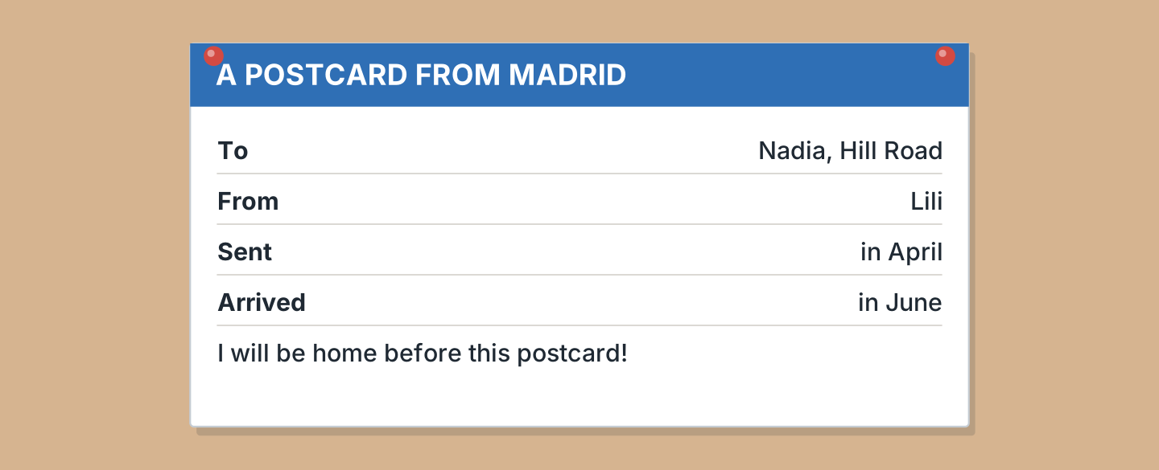
Figure 1.27 · A postcard that arrived late.
- The postcard is from Nadia. — Lili (example)
- The postcard was sent in June. — ______________
- The postcard arrived in April. — ______________
- Lili will be home after the postcard. — ______________
Part 6 · Writing
6A Look at Figure 1.28. Complete the form about you.
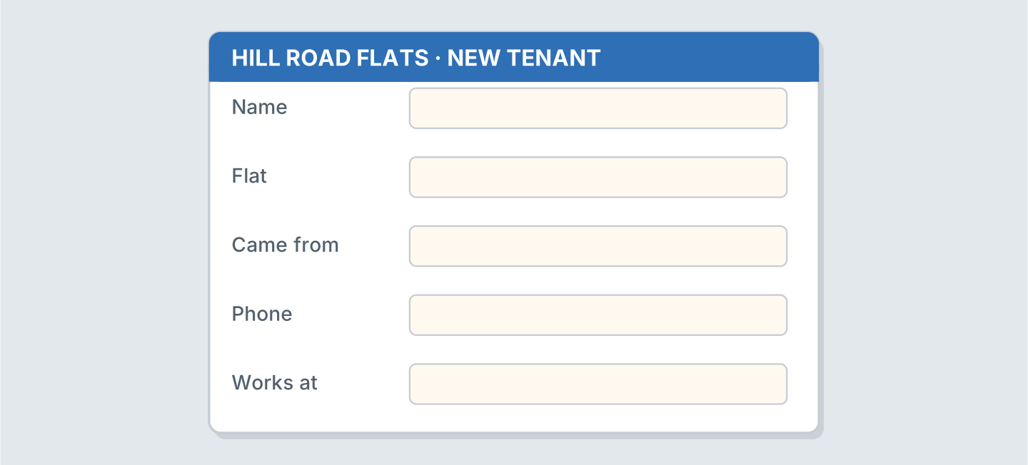
Figure 1.28 · A form for the flats.
- Name: Lili Chen (example)
- Name: ______________
- Came from: ______________
- Works at: ______________
6B Look at Figure 1.29. Write four lines about your year.
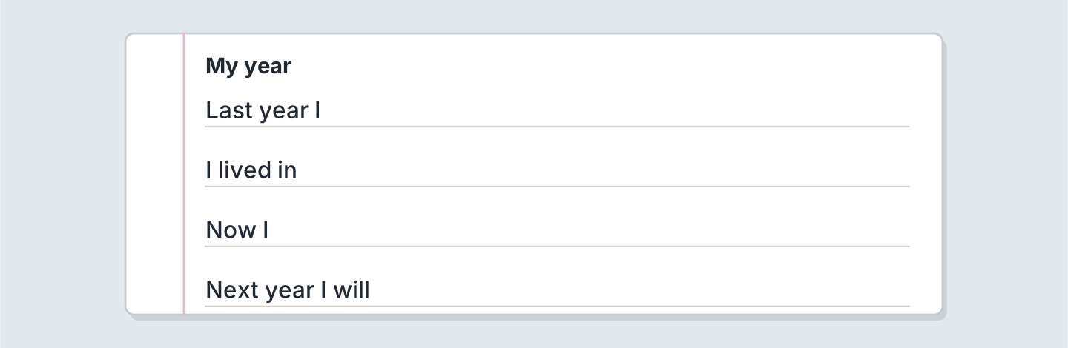
Figure 1.29 · Four lines about your year.
- Last year I worked in a shop. (example)
- Last year I ______________.
- I lived in ______________.
- Next year I will ______________.
6C Look at Figure 1.30. Write five lines about your year.
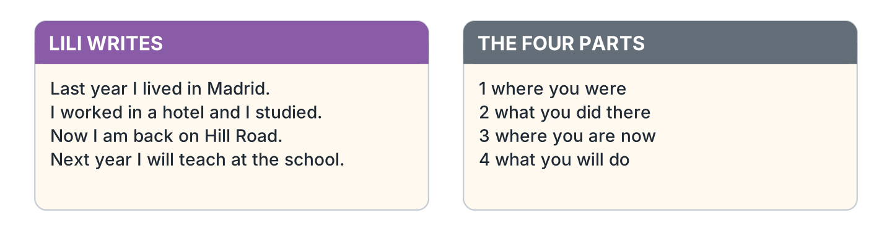
Figure 1.30 · A model to copy.
- Last year I lived in Madrid. I worked in a hotel. (example)
- Say where you were last year.
- Say what you did there.
- Say where you are now.
- Say what you will do next year.
Part 7 · Real-World File
7A Look at Figure 1.31. Answer the questions.
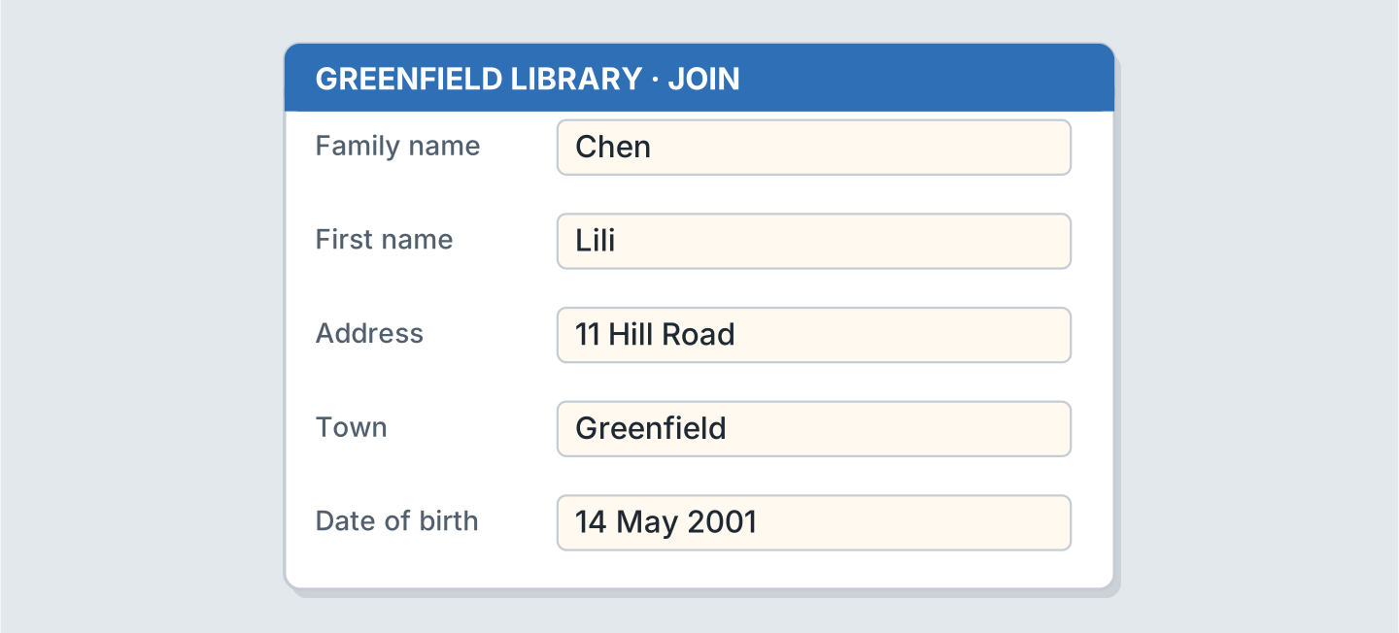
Figure 1.31 · A registration form.
- What is the family name? — Chen (example)
- What is the first name? — ______________
- What is the address? — ______________
- What is the date of birth? — ______________
7B Look at Figure 1.32. Answer the questions.
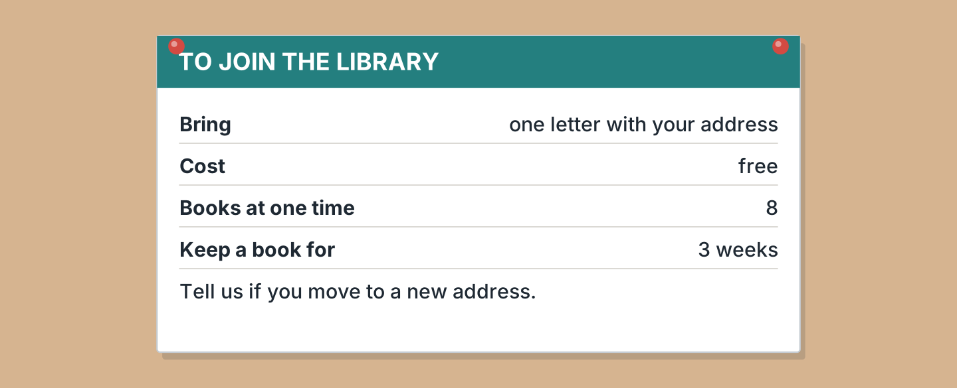
Figure 1.32 · What the library asks for.
- How much does it cost? — free (example)
- What do you take with you? — ______________
- How many books can you take? — ______________
- How long can you keep a book? — ______________
7C Look at Figure 1.33. Write about a place you joined.

Figure 1.33 · Three forms, three places.
- I joined the library last year. They asked for my address. (example)
- The place: ______________
- What they asked for: ______________
- What it cost: ______________
Part 8 · Review & Can-Do
8A Look at Figure 1.34. Write the word.
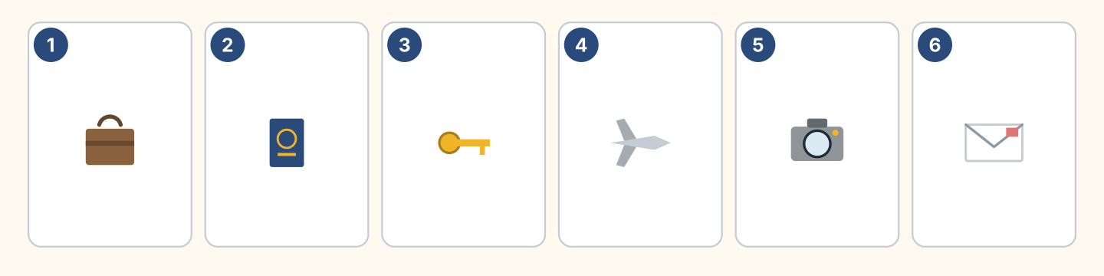
Figure 1.34 · Six things from this unit.
Words: camera · envelope · key · passport · plane · suitcase
- 1 — suitcase (example)
- 2 — ______________
- 3 — ______________
- 4 — ______________
- 5 — ______________
8B Look at Figure 1.35. Complete the conversation.
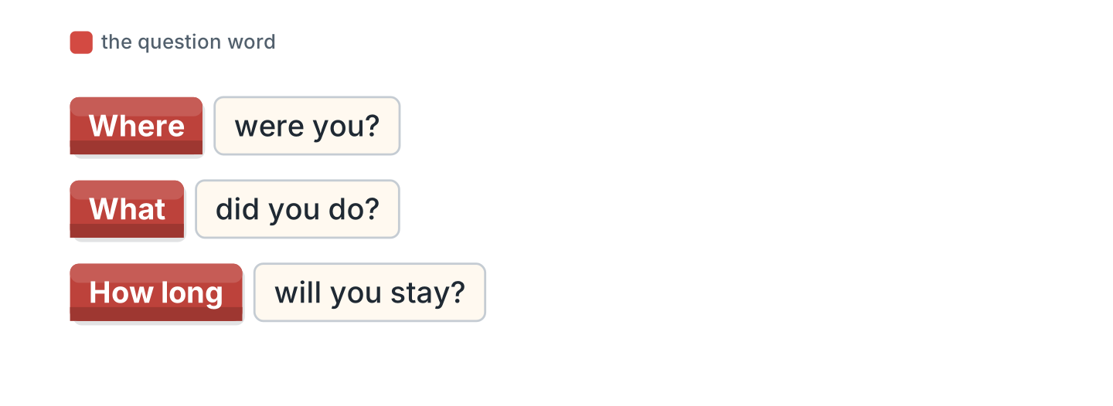
Figure 1.35 · The conversation, in blocks.
Words: How long · What · Where · worked
- A: Where were you last year? (Where) (example)
- A: ______ did you do there?
- B: I ______ in a hotel.
- A: ______ will you stay here?
8C Look at Figure 1.36. Write the past form.
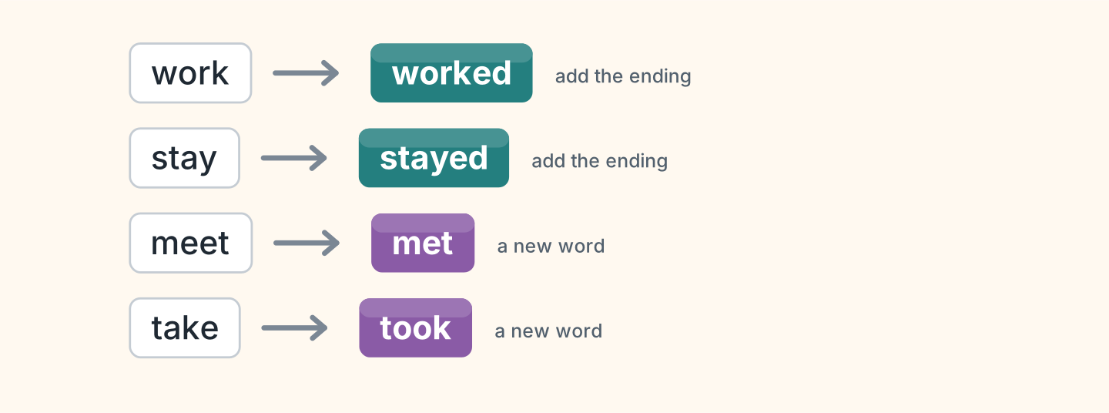
Figure 1.36 · Four more verbs to change.
- work — worked (example)
- stay — ______________
- meet — ______________
- take — ______________
8D Look at Figure 1.37. Match the person and the answer.
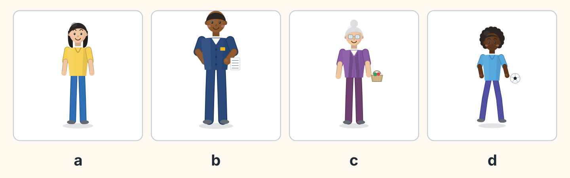
Figure 1.37 · Four people, four answers.
Person | What they say
1 Lili | a I came back last Friday.
2 Sam | b I drive bus 12 every day.
3 Rosa | c I went to the lake in July.
4 Omar | d I started a new school.
 | e I will fly to Madrid.
One option is not needed.
- 1 — a (example)
- 2 — ______
- 3 — ______
- 4 — ______
8E Look at Figure 1.38. Tick what you can do.
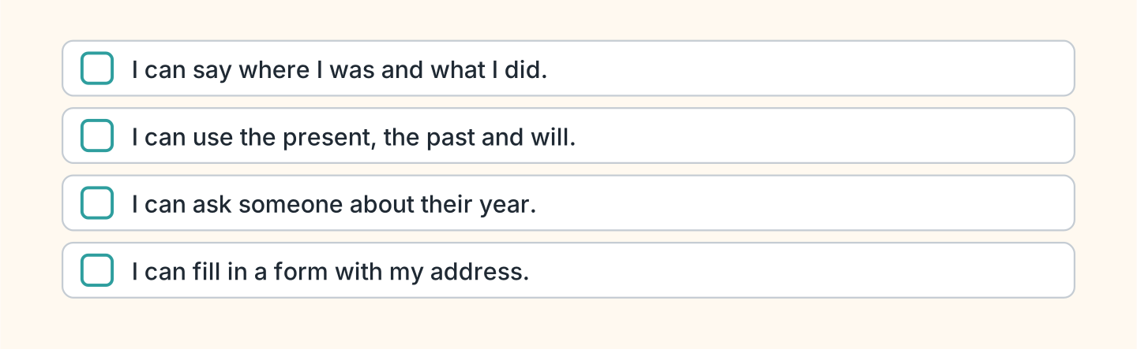
Figure 1.38 · What I can do.
- I can say where I was and what I did. — ✓ (example)
- I can use the present, the past and will. — ______
- I can ask someone about their year. — ______
- I can fill in a form with my address. — ______

Unit 2: Every Day and Right Now
In this unit you say what you do every day and what you are doing now.
Warm Up
W1 Look at Figure 2.1. Answer the questions.
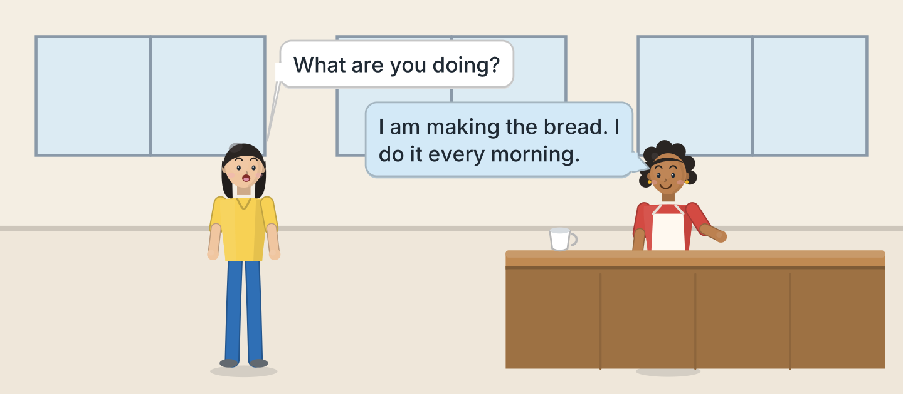
Figure 2.1 · Nadia talks about her week.
- What does Lili ask? — What are you doing? (example)
- What is Nadia making? — ______________
- How often does she make it? — ______________
- Where are they? — ______________
W2 Look at Figure 2.2. Answer the questions.
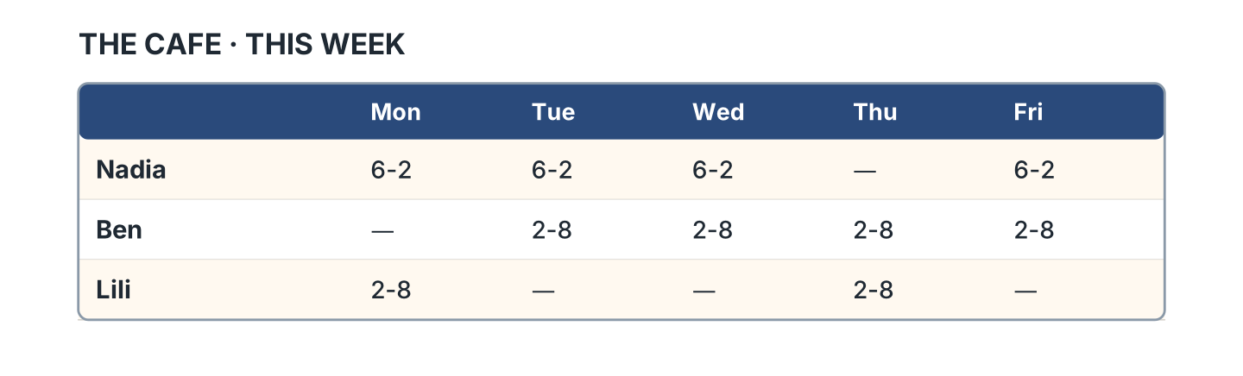
Figure 2.2 · The cafe rota this week.
- When does Nadia start on Monday? — at six (example)
- Which day is Nadia not working? — ______________
- How many days is Ben working? — ______________
- Who works on Thursday? — ______________
W3 Look at Figure 2.3. Write the word.
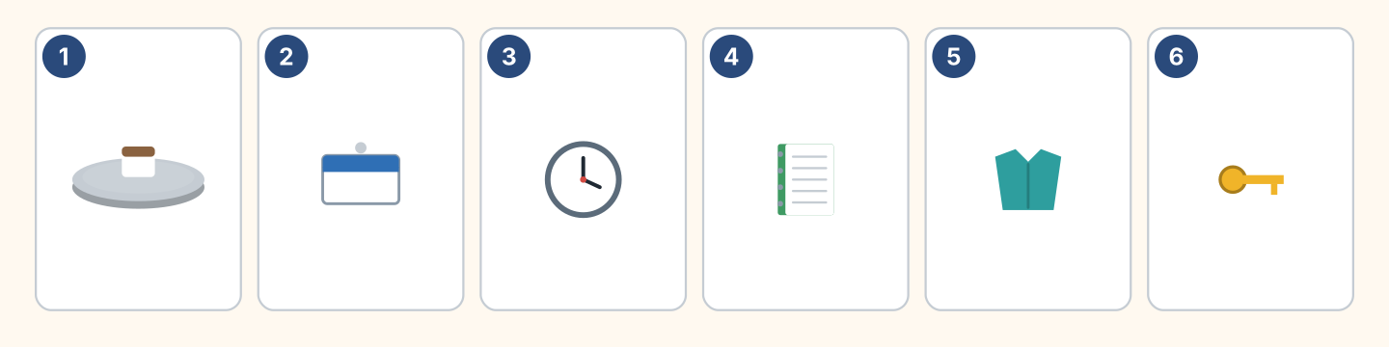
Figure 2.3 · Six things at work.
Words: badge · clock · key · notebook · shirt · tray
- 1 — tray (example)
- 2 — ______________
- 3 — ______________
- 4 — ______________
- 5 — ______________
Part 1 · Words & Sounds
1A Look at Figure 2.4. Write every day or right now.
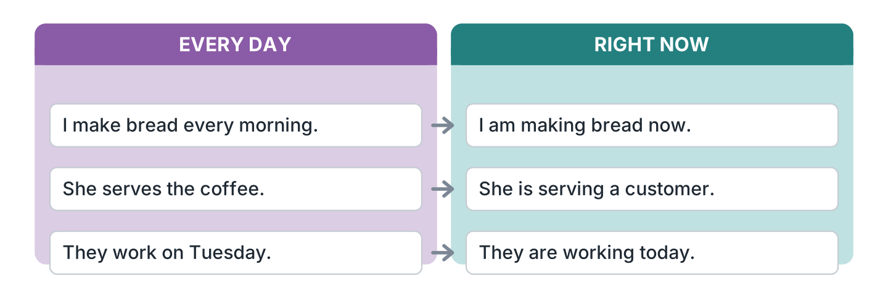
Figure 2.4 · Every day and right now.
- I make bread every morning. — every day (example)
- She is serving a customer. — ______________
- They work on Tuesday. — ______________
- I am making bread now. — ______________
1B Look at Figure 2.5. Write the ing form.
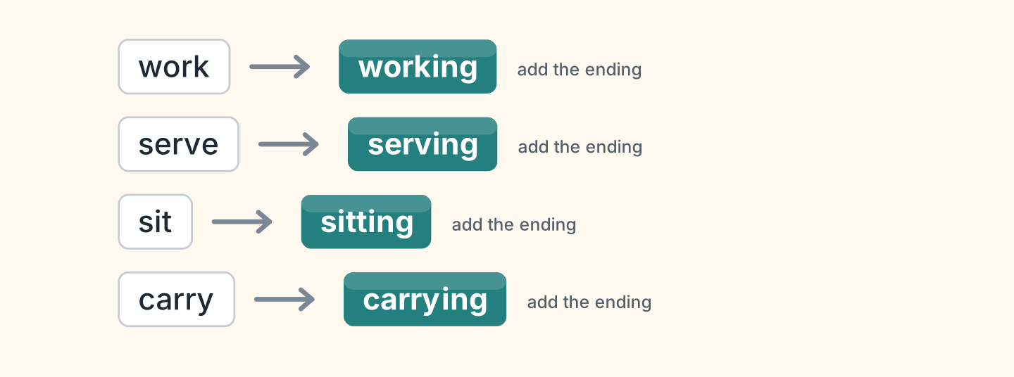
Figure 2.5 · Adding ing to the verb.
- work — working (example)
- serve — ______________
- sit — ______________
- carry — ______________
1C Look at Figure 2.6. Write what the person is holding.
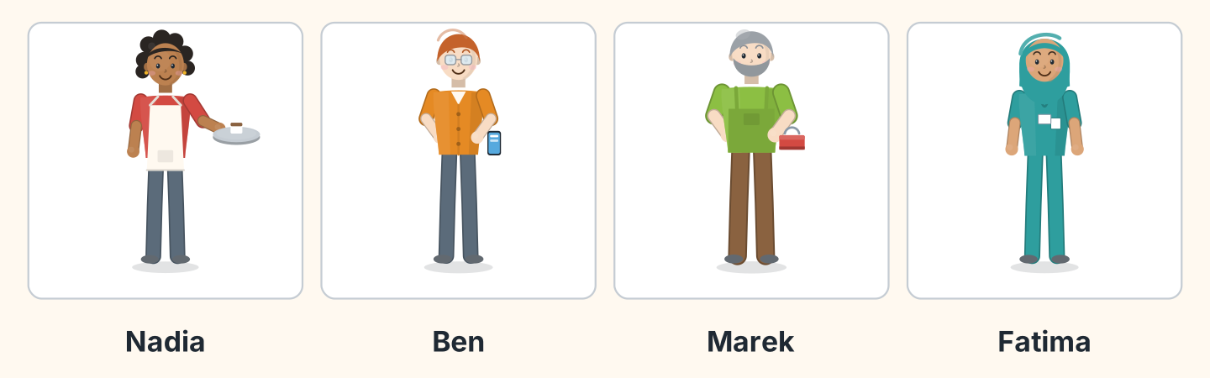
Figure 2.6 · Four people, four jobs now.
- Nadia — a tray (example)
- Ben — ______________
- Marek — ______________
- Fatima — ______________
1D Say it. Look at Figure 2.7. Say the short forms.
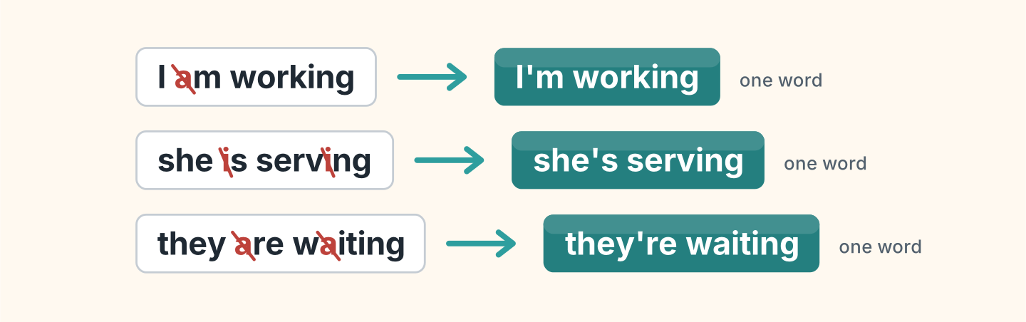
Figure 2.7 · The short forms with ing.
- I am working — I’m working (example)
- she is serving
- they are waiting
- he is cooking
- we are closing
1E Look at Figure 2.8. Answer the questions.
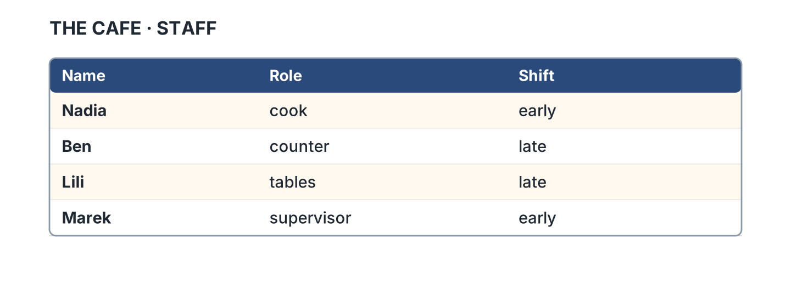
Figure 2.8 · The staff list.
- What is Nadia’s role? — cook (example)
- What is Marek’s role? — ______________
- Who works the late shift? — ______________
- Which role does Lili have? — ______________
1F Look at Figure 2.9. Write the word for the meaning.
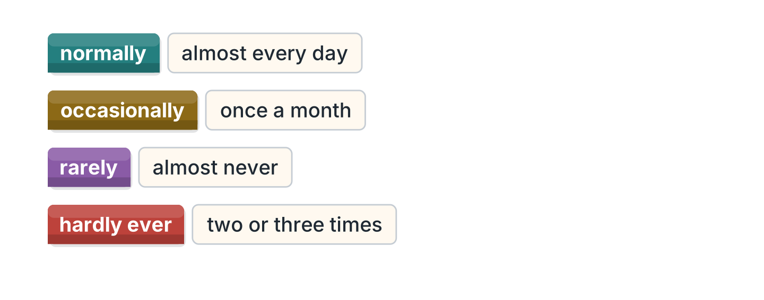
Figure 2.9 · How often we say it.
- almost every day — normally (example)
- once a month — ______________
- almost never — ______________
- two or three times — ______________
Part 2 · Grammar
2A Look at Figure 2.10. Write am, is or are.
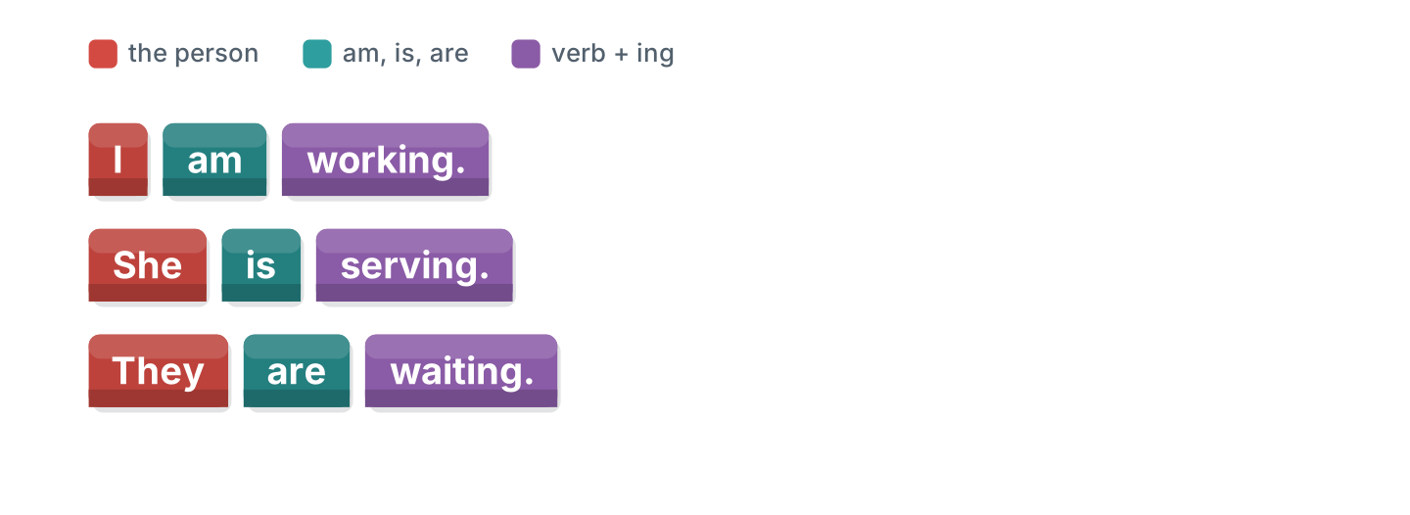
Figure 2.10 · Am, is, are, plus ing.
- I ______ working. — am (example)
- She ______ serving a customer.
- They ______ waiting outside.
- We ______ closing at eight.
- Marek ______ locking the door.
2B Look at Figure 2.11. Write the answer.
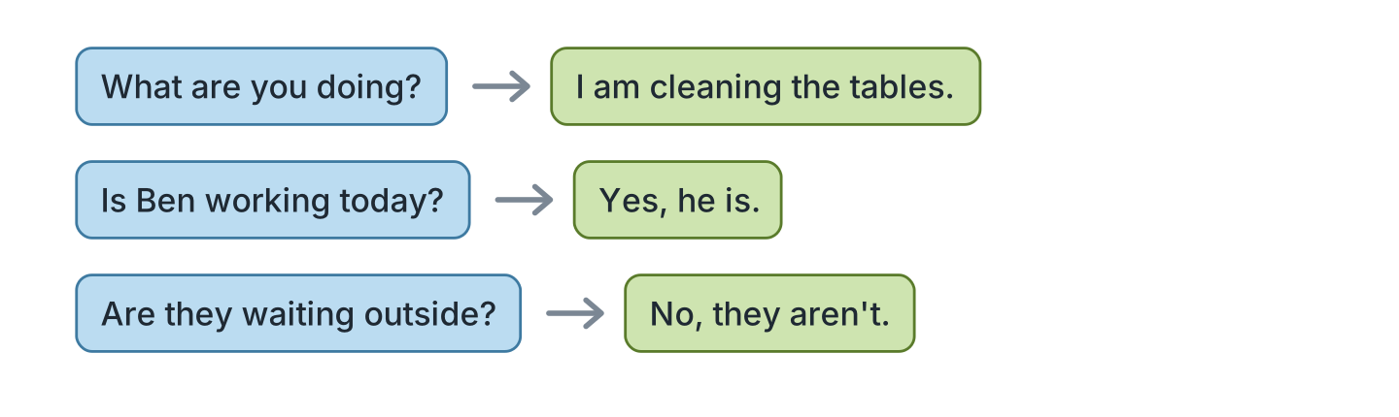
Figure 2.11 · Questions about now.
- What are you doing? — I am tidying the tables. (example)
- Is Ben working today? ✓ — ______________
- Are they waiting outside? ✗ — ______________
- What is Nadia doing? (cook) — ______________
2C Look at Figure 2.12. Write yes or no.
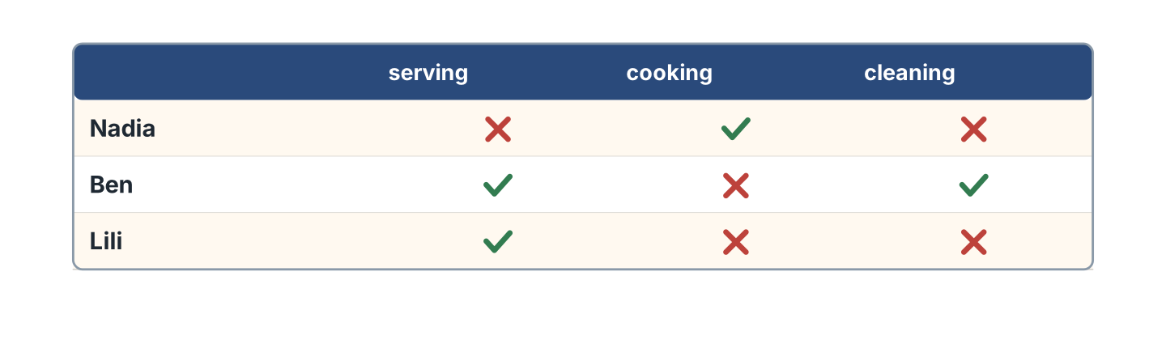
Figure 2.12 · Who is doing what now.
- Nadia is cooking. — yes (example)
- Ben is serving. — ______
- Lili is tidying. — ______
- Ben is tidying. — ______
2D Look at Figure 2.13. Write see or inside.
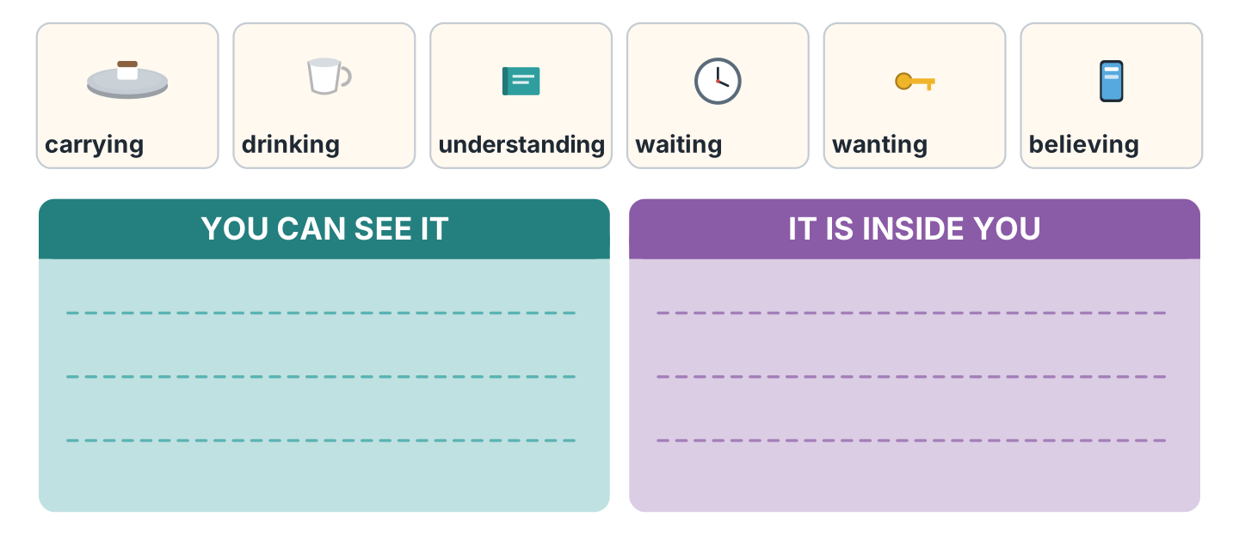
Figure 2.13 · Two kinds of verb.
- carrying — see (example)
- understanding — ______________
- drinking — ______________
- believing — ______________
- waiting — ______________
2E Look at Figure 2.14. Choose the correct verb.
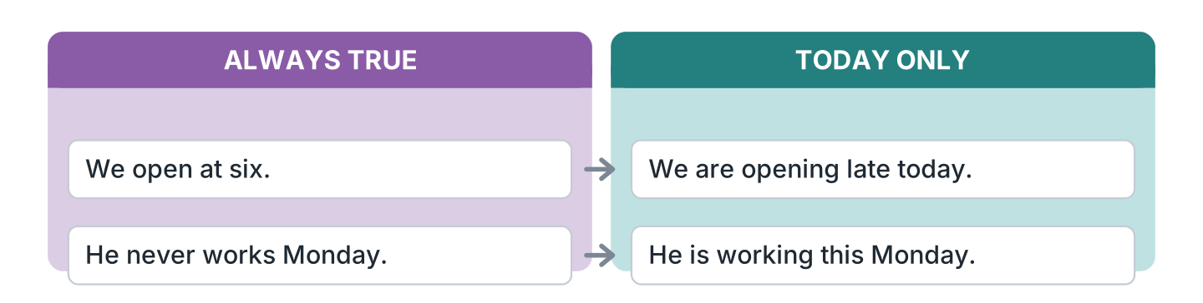
Figure 2.14 · Every day or at the moment.
- We (open / are opening) at six every day. — open (example)
- We (open / are opening) late today.
- He never (works / is working) on Monday.
- He (works / is working) this Monday.
- The cafe (closes / is closing) at eight.
2F Look at Figure 2.15. Find the mistake and write it correctly.
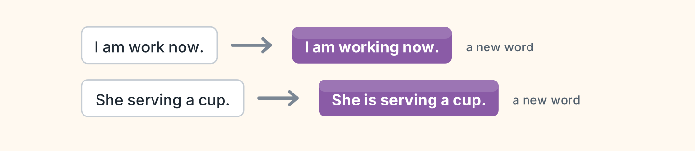
Figure 2.15 · Mistakes with the two tenses.
- I am work now. — I am working (example)
- She serving a cup. — ______________
- They is waiting outside. — ______________
- He work at the moment. — ______________
Part 3 · Listening
3A Listen. Look at Figure 2.16. Write the number.
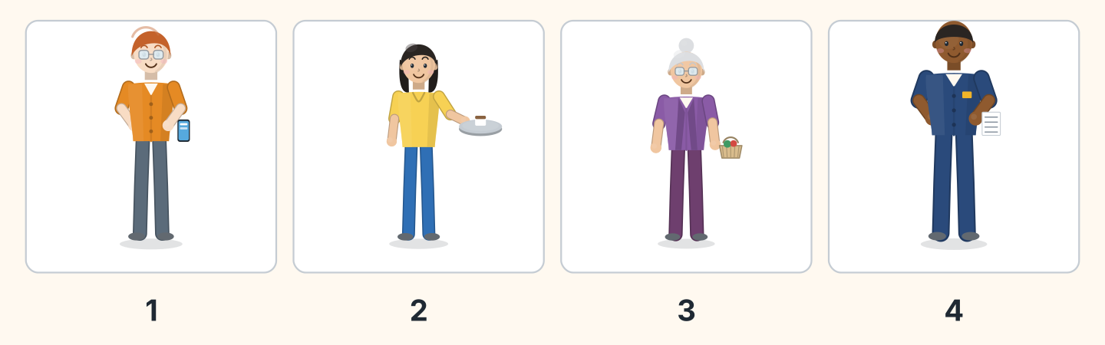
Figure 2.16 · Four voices at the cafe.
- Ben — 1 (example)
- Lili — ______
- Rosa — ______
- Sam — ______
3B Listen. Look at Figure 2.17. Write the answer you hear.
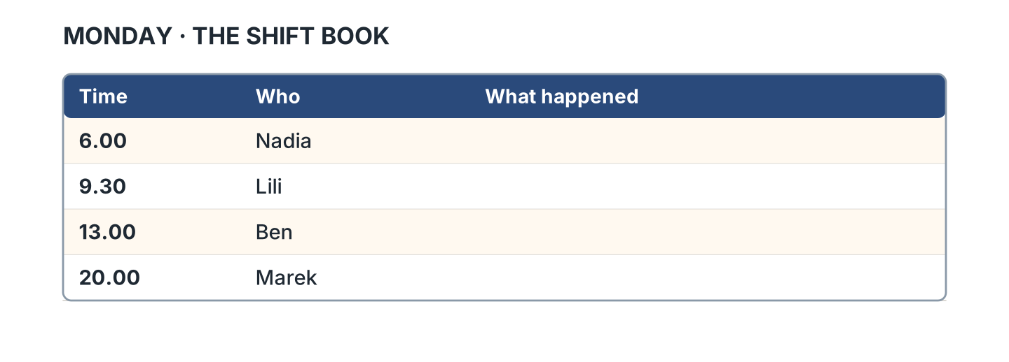
Figure 2.17 · What the supervisor wrote.
- Who started at six? — Nadia (example)
- What did Lili do at 9.30? — ______________
- What did Ben do at one? — ______________
- What did Marek do at eight? — ______________
3C Listen. Look at Figure 2.18. Answer the questions.
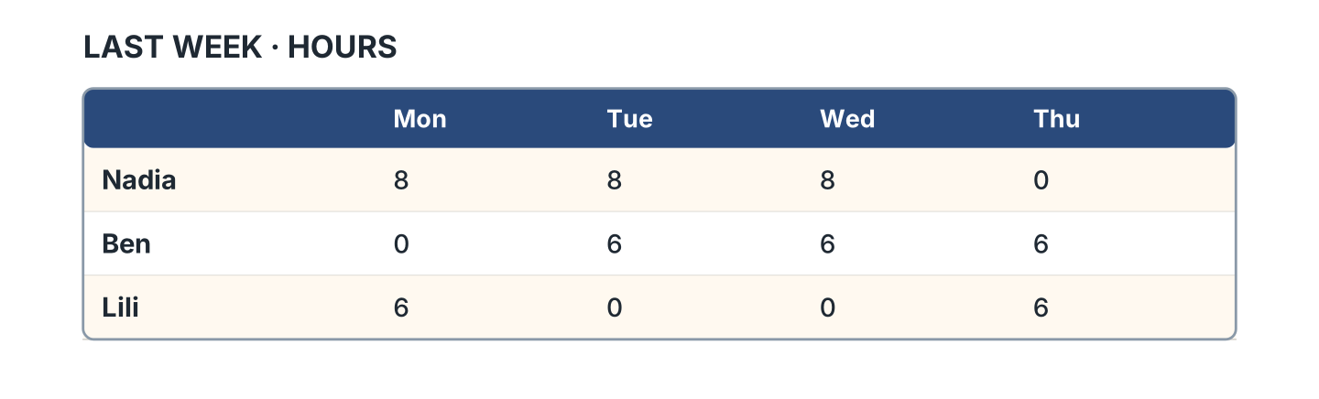
Figure 2.18 · The hours they worked.
- How many hours did Nadia work on Monday? — eight (example)
- Which day did Nadia not work? — ______________
- How many hours did Ben work on Tuesday? — ______________
- Who worked the shortest week? — ______________
3D Listen. Look at Figure 2.19. Write the number of the thing you hear.
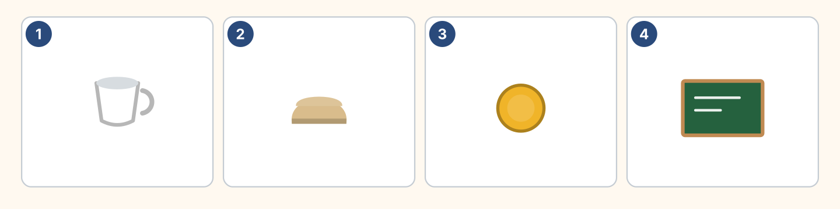
Figure 2.19 · Four more things to hear.
- a cup — 1 (example)
- bread — ______
- a coin — ______
- a board — ______
Part 4 · Speaking
4A Look at Figure 2.20. Ask a workmate what they are doing.
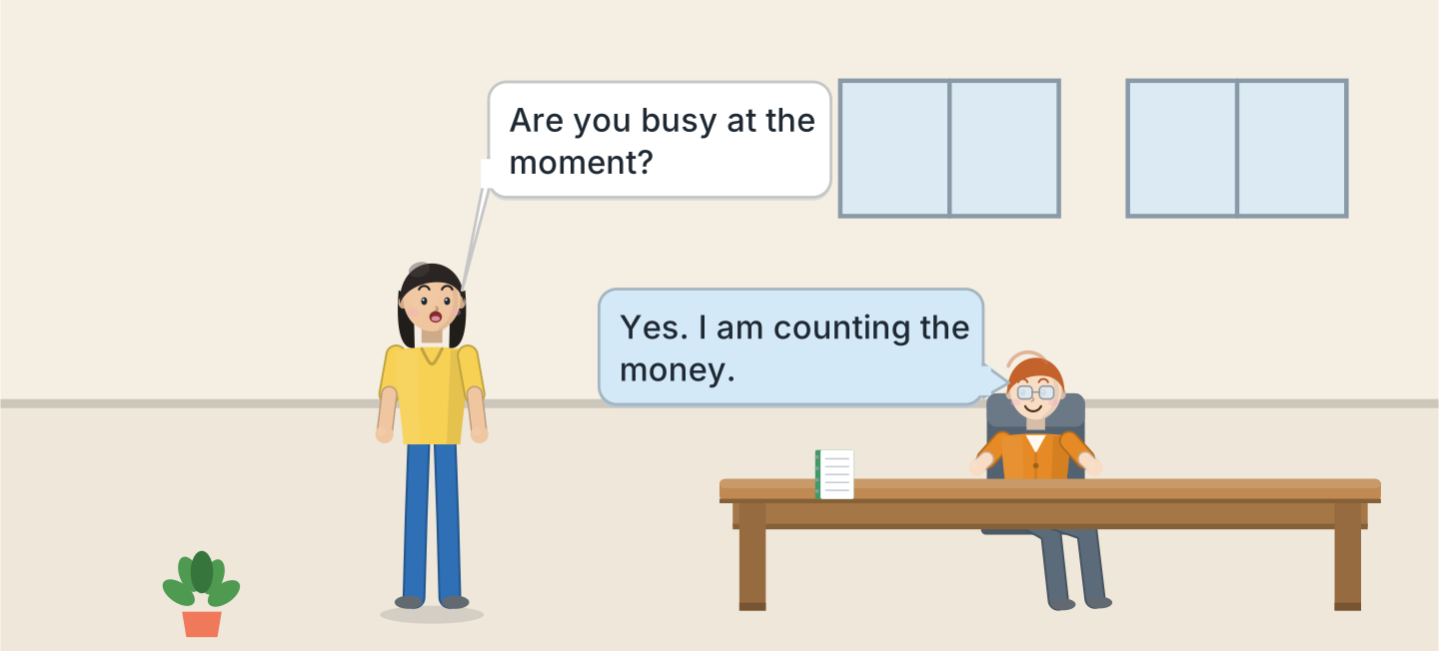
Figure 2.20 · Lili asks Ben about work.
- A: Are you busy at the moment? B: Yes. I am counting the money. (example)
- Ask what your colleague is doing right now.
- Ask what they normally do on Monday.
- Say one thing you decided to do recently.
4B Look at Figure 2.21. Ask and answer.
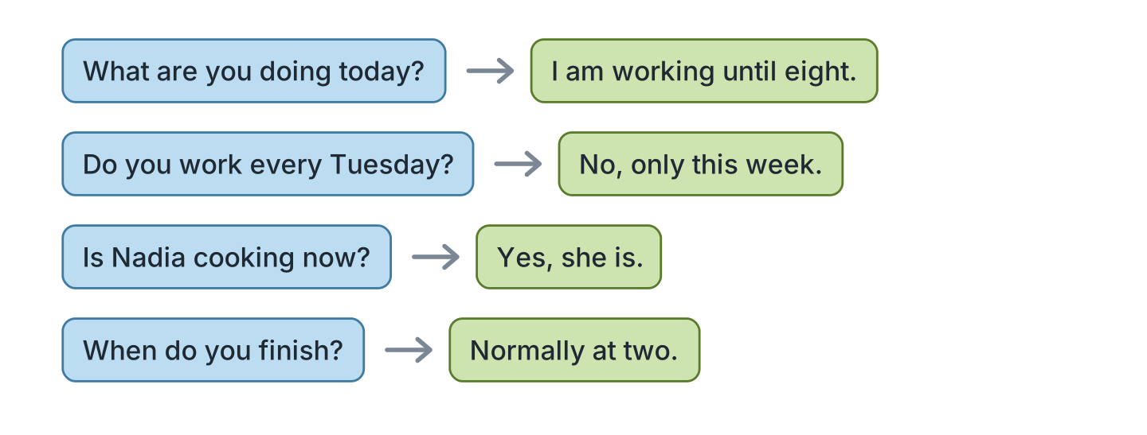
Figure 2.21 · Four questions about today.
- A: What are you doing today? B: I am working until eight. (example)
- A: Do you work every Tuesday? B: ______________
- A: Is Nadia cooking now? B: ______________
- A: When do you finish? B: ______________
4C Look at Figure 2.22. Say what happens in each picture.
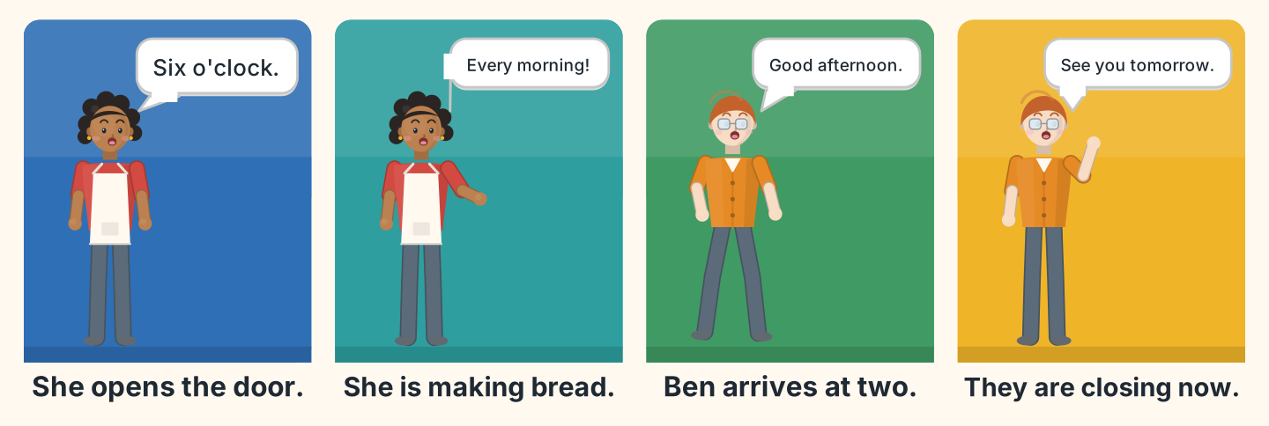
Figure 2.22 · A morning in four moments.
- First Nadia opens the door at six. (example)
- Say what Nadia is doing in the second picture.
- Say what time Ben arrives.
- Say what they are doing in picture four.
4D Look at Figure 2.23. Ask two of these people about their work.
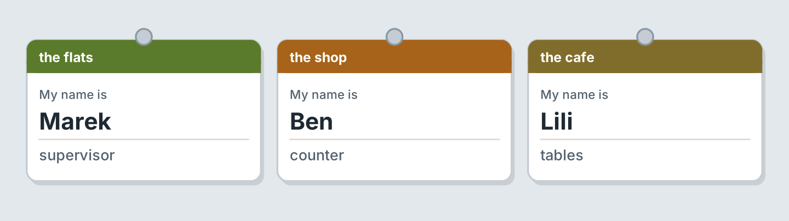
Figure 2.23 · Three workmates to ask.
- A: What do you do here? B: I look after the flats. (example)
- Ask Ben about his boss.
- Ask Lili what her job is.
- Say what you do, and explain why you prefer it.
Part 5 · Reading
5A Look at Figure 2.24. Answer the questions.
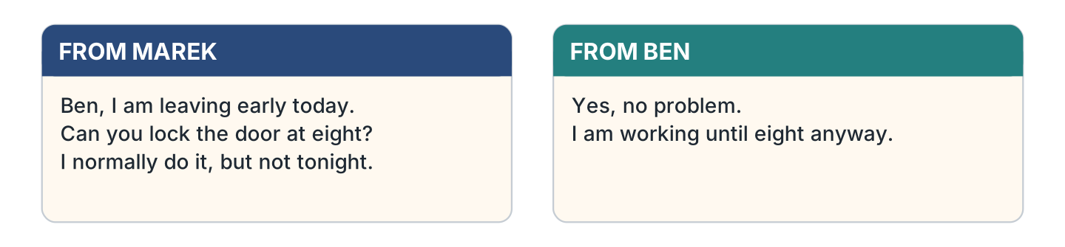
Figure 2.24 · Two notes about the shift.
- Who is leaving early? — Marek (example)
- What does Marek ask Ben to do? — ______________
- Who normally locks the door? — ______________
- Until what time is Ben working? — ______________
5B Look at Figure 2.25. Answer the questions.
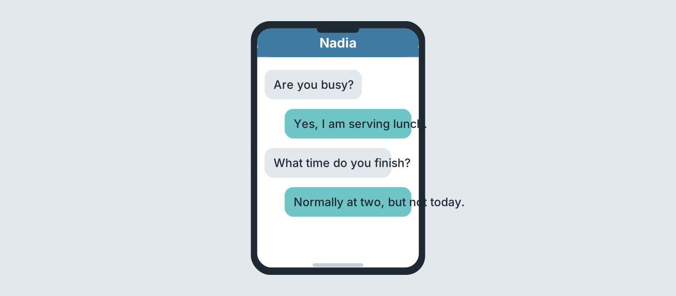
Figure 2.25 · Messages at lunchtime.
- What is Nadia doing? — she is serving lunch (example)
- What time does she normally finish? — ______________
- Is today a normal day? — ______________
- Who asks the first question? — ______________
5C Look at Figure 2.26. Choose the correct answer.
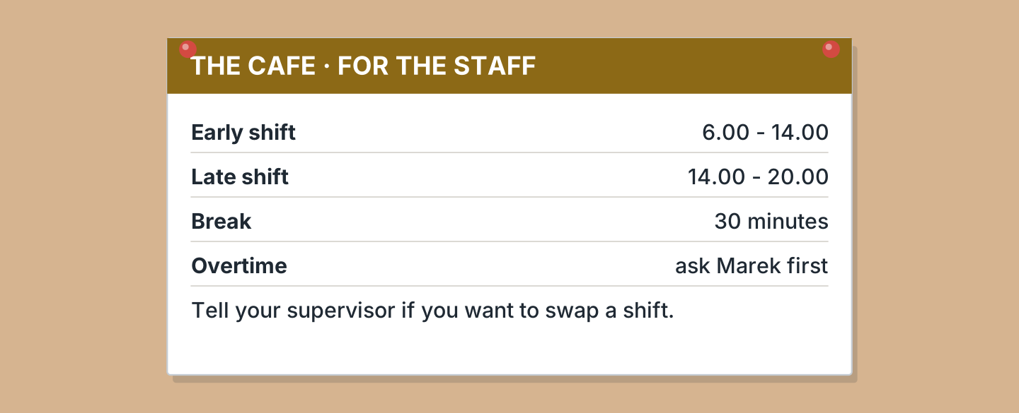
Figure 2.26 · A notice for the staff.
- When does the early shift start? (a) 6.00 (b) 14.00 (c) 20.00 — a (example)
- How long is the break? (a) 20 minutes (b) 30 minutes (c) one hour
- Who do you ask about overtime? (a) Ben (b) Nadia (c) Marek
- When does the late shift end? (a) 14.00 (b) 18.00 (c) 20.00
5D Look at Figure 2.27. Read and correct. Write the correct word.
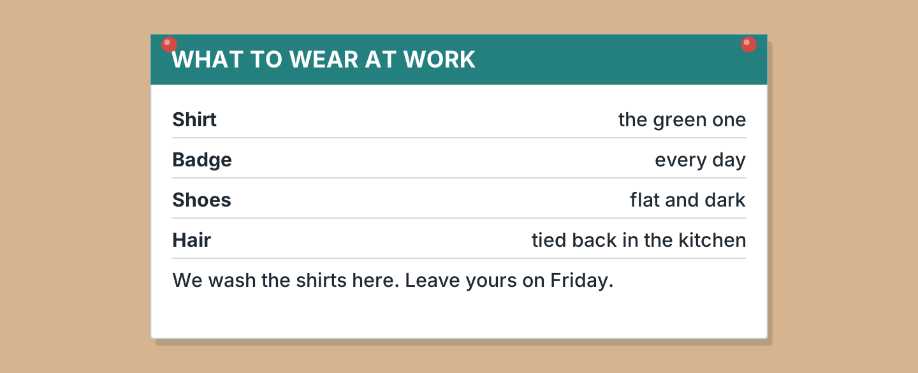
Figure 2.27 · The uniform rules.
- The shirt is blue. — green (example)
- You wear the badge on Friday. — ______________
- The shoes are red. — ______________
- You wash the shirts at home. — ______________
Part 6 · Writing
6A Look at Figure 2.28. Complete the form about you.
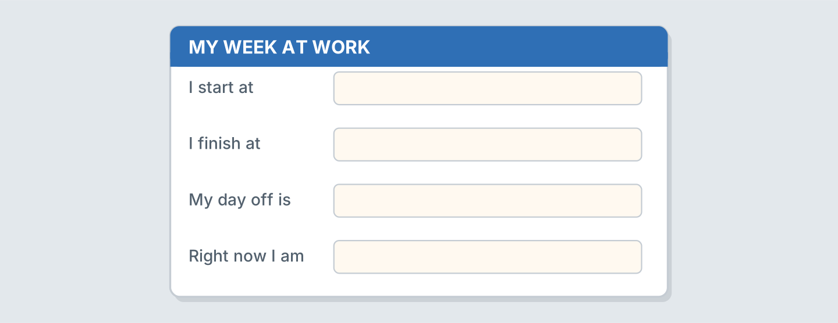
Figure 2.28 · A form about your hours.
- I start at: eight (example)
- I start at: ______________
- I finish at: ______________
- My day off is: ______________
6B Look at Figure 2.29. Write four lines about your day.
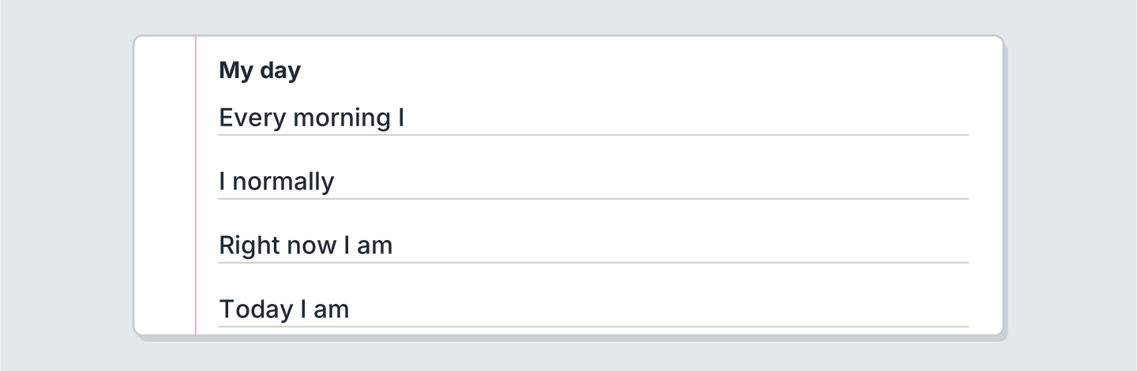
Figure 2.29 · Four lines about your day.
- Every morning I take the bus. (example)
- Lately, every morning I ______________.
- I normally greet ______________.
- Right now I am ______________.
6C Look at Figure 2.30. Write four lines about today.
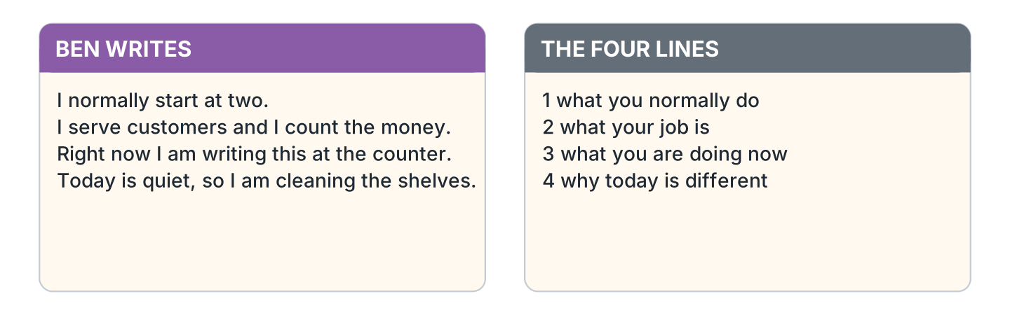
Figure 2.30 · A model day.
- I normally start at nine. Today I am starting at seven. (example)
- Say what you normally do, and mention one habit.
- Say what your job is, and who your colleague is.
- Say what you are doing now.
- Say why today seems strange, or quite normal.
Part 7 · Real-World File
7A Look at Figure 2.31. Answer the questions.
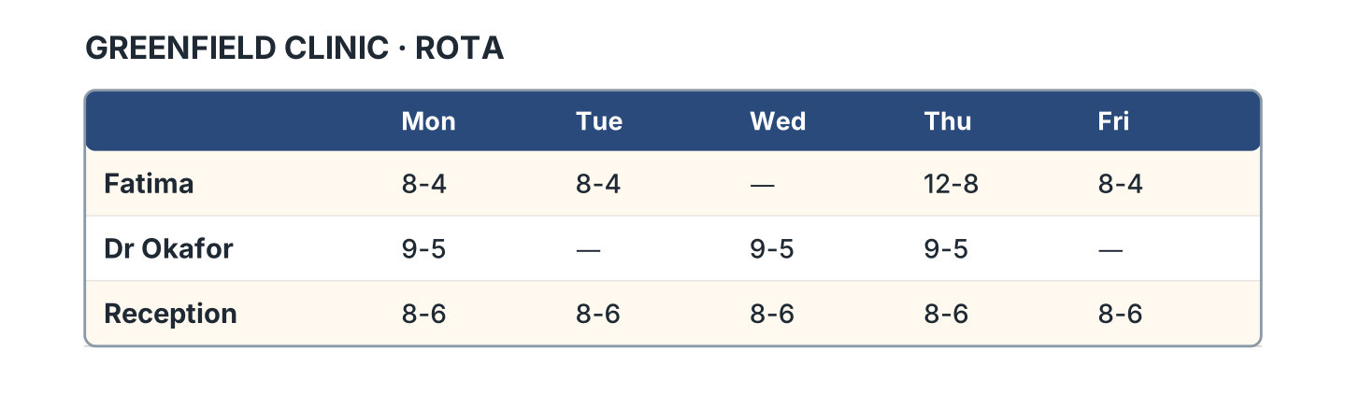
Figure 2.31 · A real work rota.
- When does Fatima start on Monday? — at eight (example)
- Which day is Fatima not working? — ______________
- What are Fatima’s hours on Thursday? — ______________
- Who works every day? — ______________
7B Look at Figure 2.32. Answer the questions.
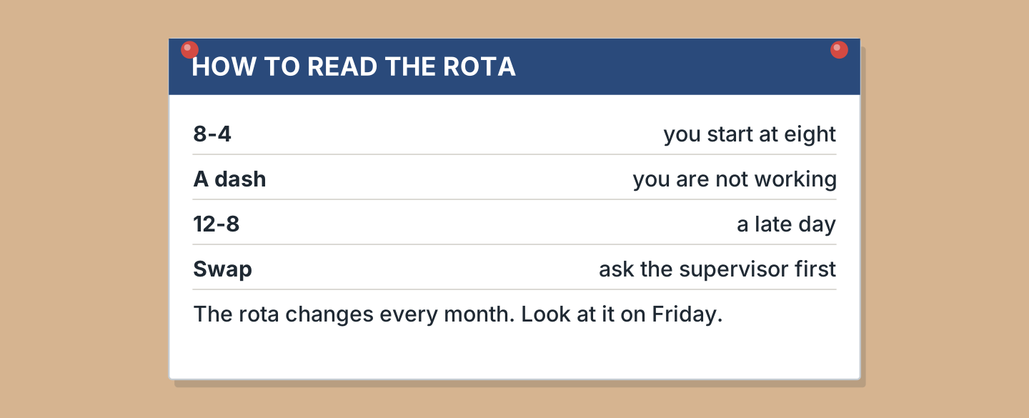
Figure 2.32 · What the rota means.
- What does 8-4 mean? — you start at eight (example)
- What does a dash mean? — ______________
- Who do you ask about a swap? — ______________
- How often does the rota change? — ______________
7C Look at Figure 2.33. Write about a place where you work or study.

Figure 2.33 · Three places people work.
- I work at the clinic. I normally start at eight. (example)
- The place, and who the boss is: ______________
- My hours: ______________
- What I still do every week: ______________
Part 8 · Review & Can-Do
8A Look at Figure 2.34. Write the word.
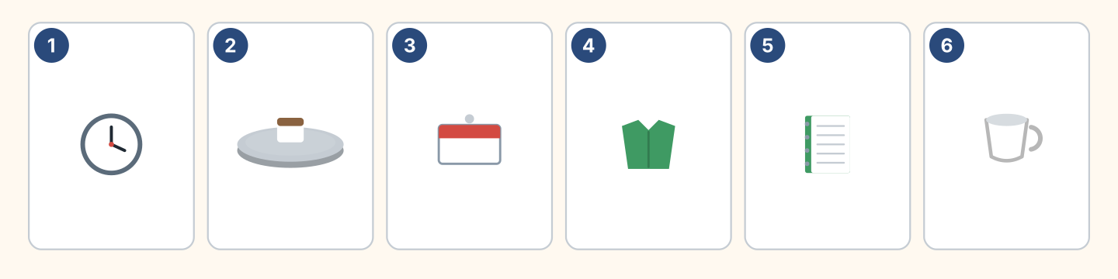
Figure 2.34 · Six things from this unit.
Words: badge · clock · cup · notebook · shirt · tray
- 1 — clock (example)
- 2 — ______________
- 3 — ______________
- 4 — ______________
- 5 — ______________
8B Look at Figure 2.35. Complete the sentences.
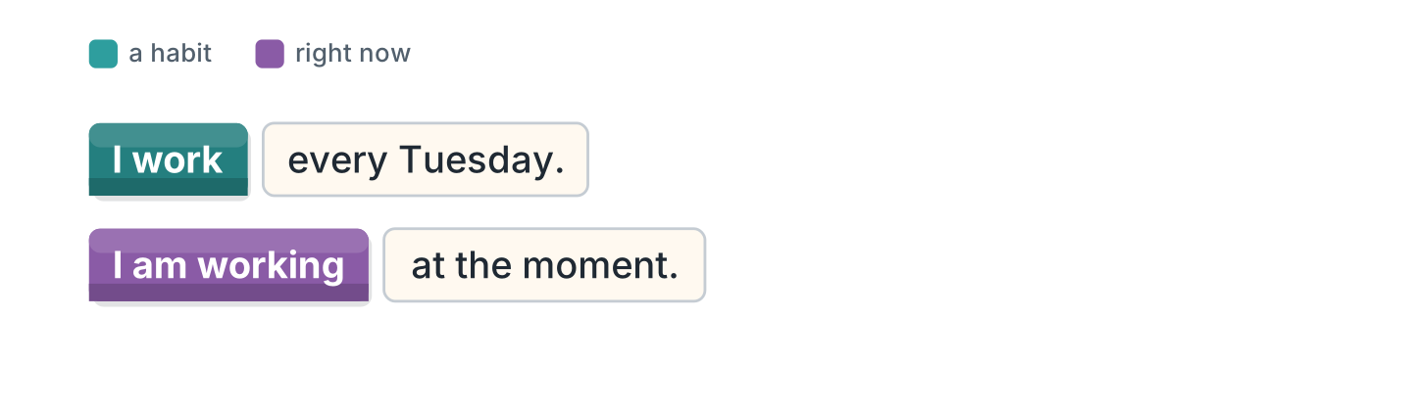
Figure 2.35 · The two tenses in blocks.
Words: am · every · moment · work
- I ______ on Tuesday. (work) (example)
- I work ______ Tuesday.
- I ______ working at the moment.
- I am working at the ______ .
8C Look at Figure 2.36. Write the ing form.
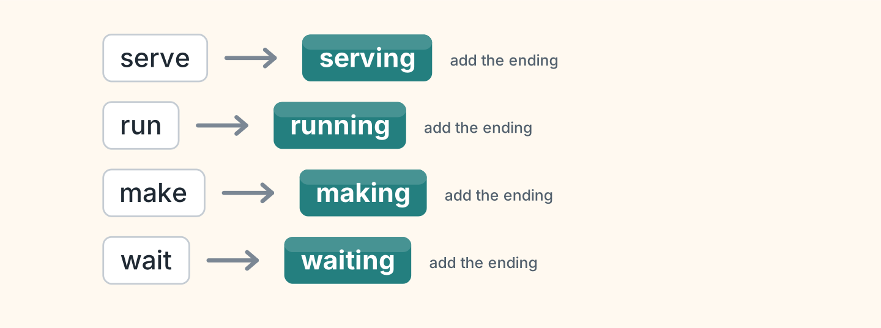
Figure 2.36 · Four verbs to change.
- serve — serving (example)
- run — ______________
- make — ______________
- wait — ______________
8D Look at Figure 2.37. Match the worker and the answer.
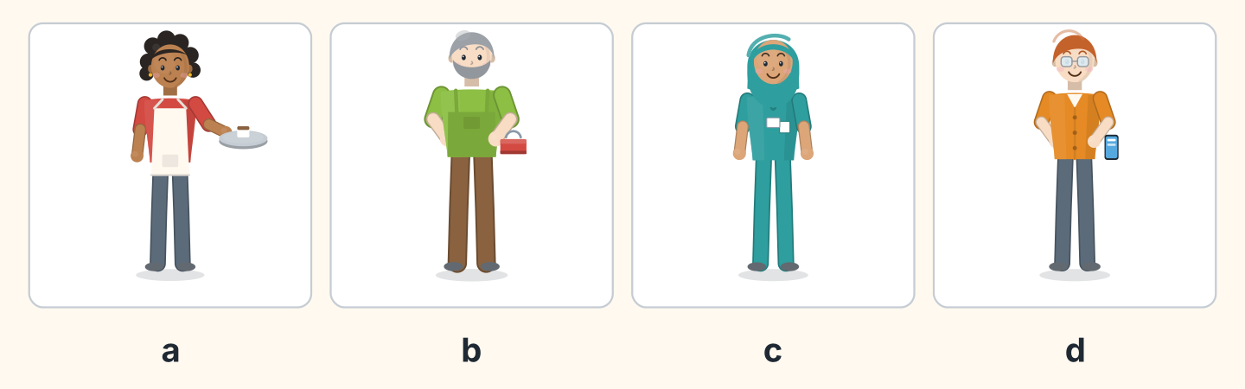
Figure 2.37 · Four workers, four answers.
Worker | What they say
1 Nadia | a I am making the bread now.
2 Marek | b I am painting a door today.
3 Fatima | c I see patients every morning.
4 Ben | d I am counting the money.
 | e I am driving the bus.
One option is not needed.
- 1 — a (example)
- 2 — ______
- 3 — ______
- 4 — ______
8E Look at Figure 2.38. Tick what you can do.
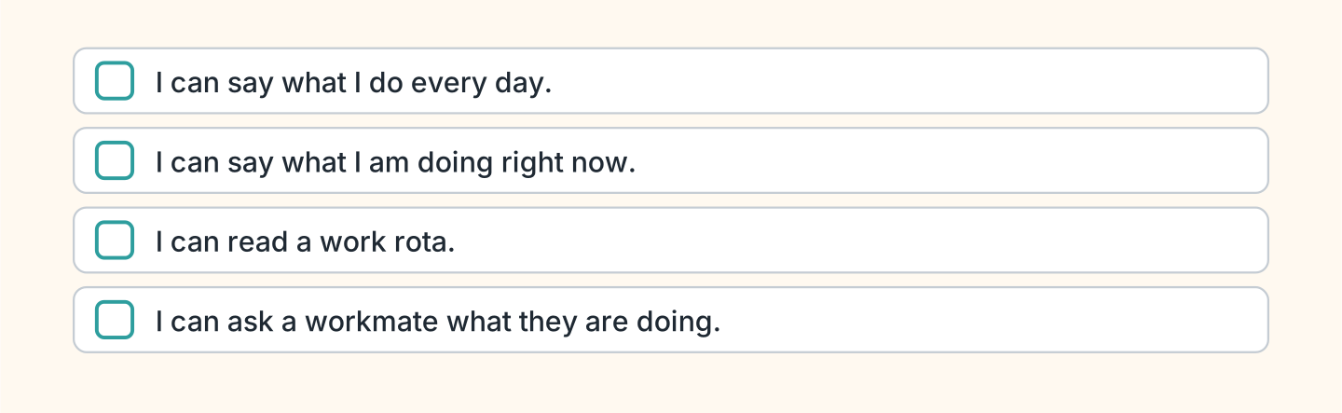
Figure 2.38 · What I can do.
- I can talk about my normal week. — ✓ (example)
- I can say what I am doing right now. — ______
- I can read a work rota. — ______
- I can ask a workmate what they are doing. — ______

Unit 3: A Place of My Own
In this unit you say what your home has got, and what is too small.
Warm Up
W1 Look at Figure 3.1. Answer the questions.
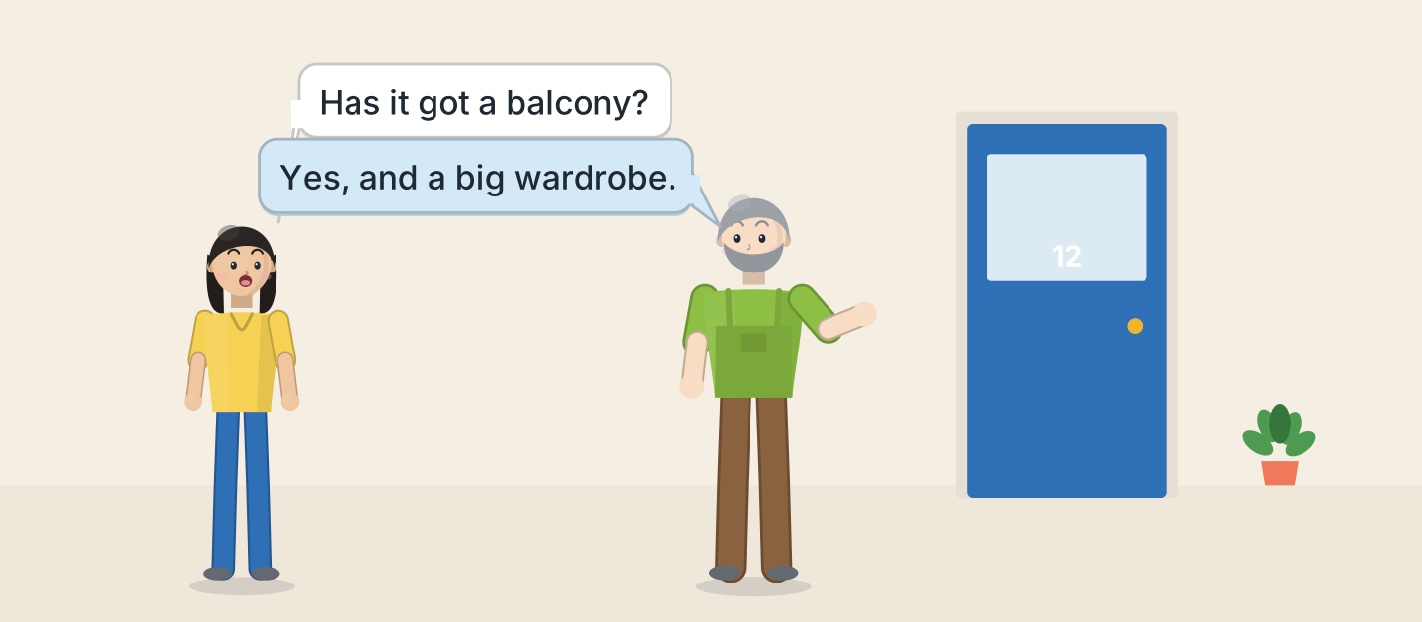
Figure 3.1 · Marek shows Lili the flat.
- Who is showing the flat? — Marek (example)
- What does Lili ask about? — ______________
- What has the flat got? — ______________
- Who is the landlord here? — ______________
W2 Look at Figure 3.2. Answer the questions.
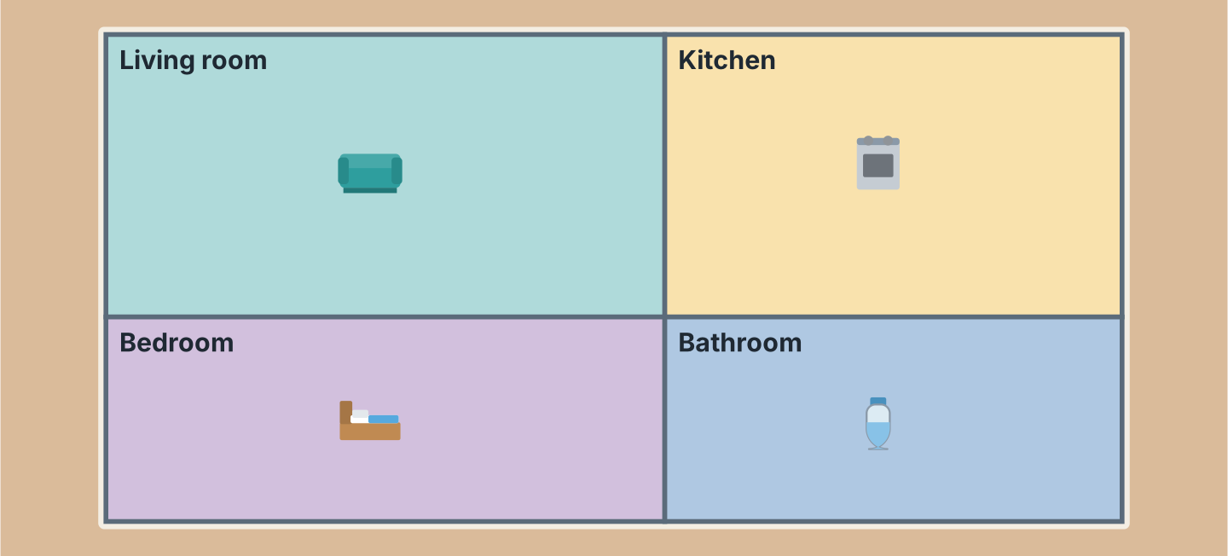
Figure 3.2 · The flat from above.
- How many rooms are there? — four (example)
- Which room has the cooker? — ______________
- Which room has the bed? — ______________
- Which room is next to the kitchen? — ______________
W3 Look at Figure 3.3. Write the word.
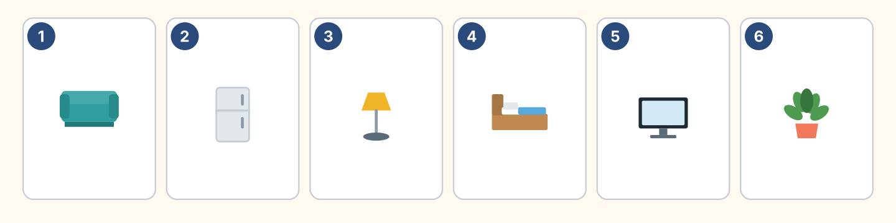
Figure 3.3 · Six things in a flat.
Words: bed · fridge · lamp · plant · sofa · tv
- 1 — sofa (example)
- 2 — ______________
- 3 — ______________
- 4 — ______________
- 5 — ______________
Part 1 · Words & Sounds
1A Look at Figure 3.4. Write have got or has got.
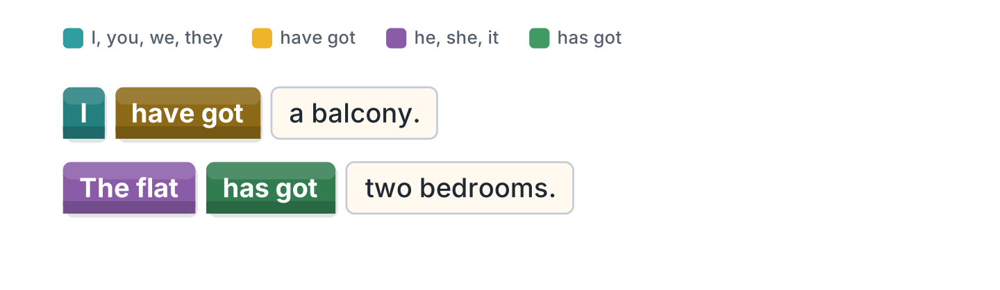
Figure 3.4 · Have got and has got.
- I ______ a balcony. — have got (example)
- The flat ______ two bedrooms.
- We ______ a new fridge.
- My neighbour ______ a garage.
1B Look at Figure 3.5. Write the short form.
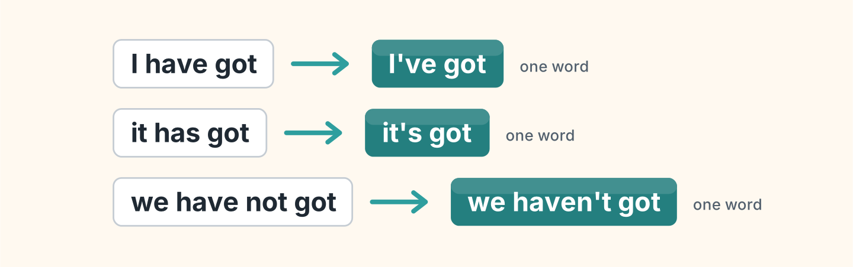
Figure 3.5 · The short forms of have got.
- I have got — I’ve got (example)
- it has got — ______________
- we have not got — ______________
- she has got — ______________
1C Look at Figure 3.6. Write what the person is carrying.
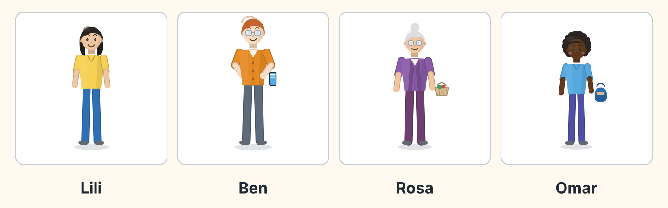
Figure 3.6 · Four tenants and their rooms.
- Lili — nothing (example)
- Ben — ______________
- Rosa — ______________
- Omar — ______________
1D Say it. Look at Figure 3.7. Say these words about a home.
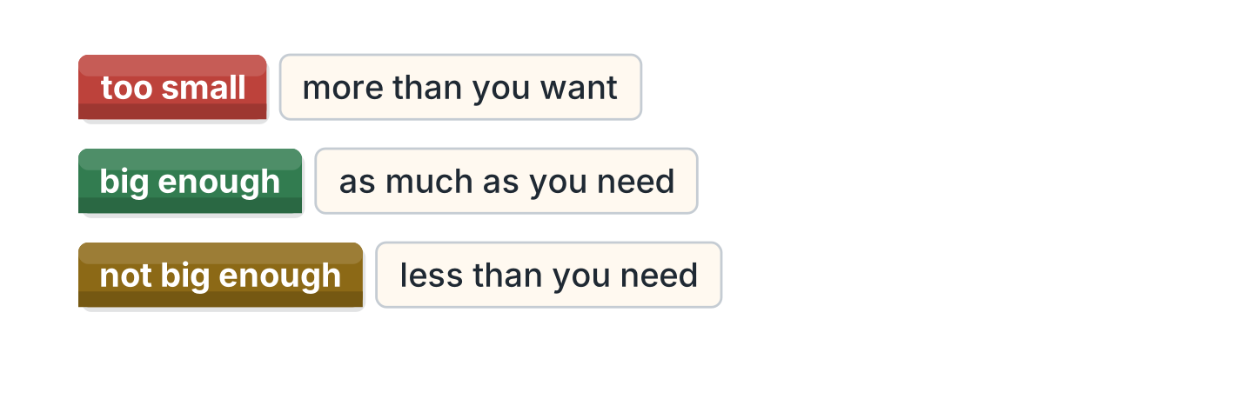
Figure 3.7 · Too and enough.
- too small (example)
- big enough
- not warm enough
- too expensive
- comfortable
1E Look at Figure 3.8. Answer the questions.
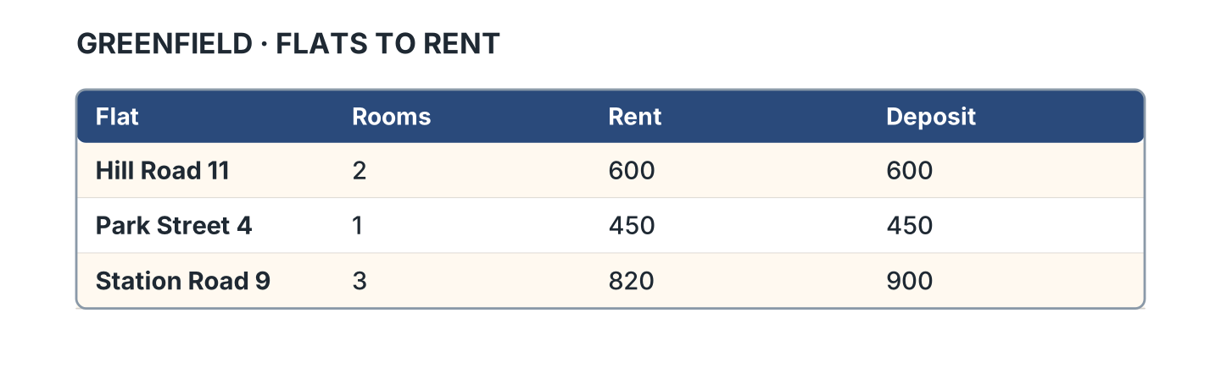
Figure 3.8 · Three flats to rent.
- How much is the rent on Hill Road? — 600 (example)
- Which flat has three rooms? — ______________
- How much is the deposit on Station Road? — ______________
- Which flat is the cheapest? — ______________
1F Look at Figure 3.9. Write the word for the meaning.
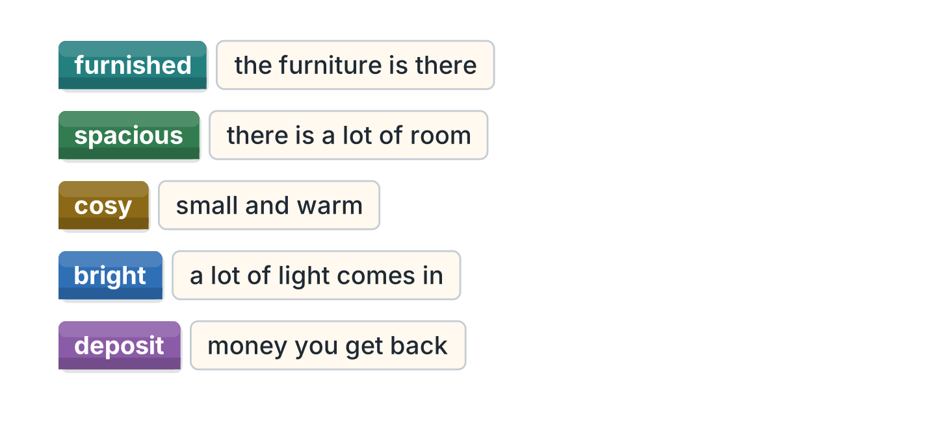
Figure 3.9 · Five words about a home.
- the furniture is there — furnished (example)
- there is a lot of room — ______________
- small and warm — ______________
- a lot of light comes in — ______________
- money you get back — ______________
Part 2 · Grammar
2A Look at Figure 3.10. Write the answer.
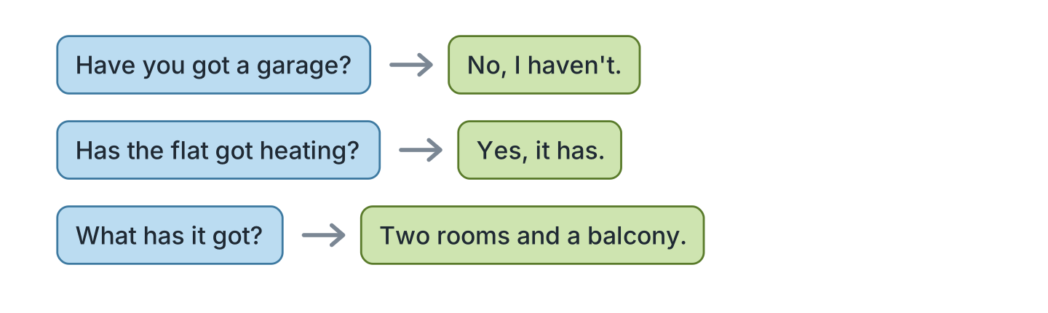
Figure 3.10 · Asking with have got.
- Have you got a garage? ✗ — No, I haven’t. (example)
- Has the flat got heating? ✓ — ______________
- Have they got a dishwasher? ✗ — ______________
- What has it got? (two rooms) — ______________
2B Look at Figure 3.11. Write yes or no.
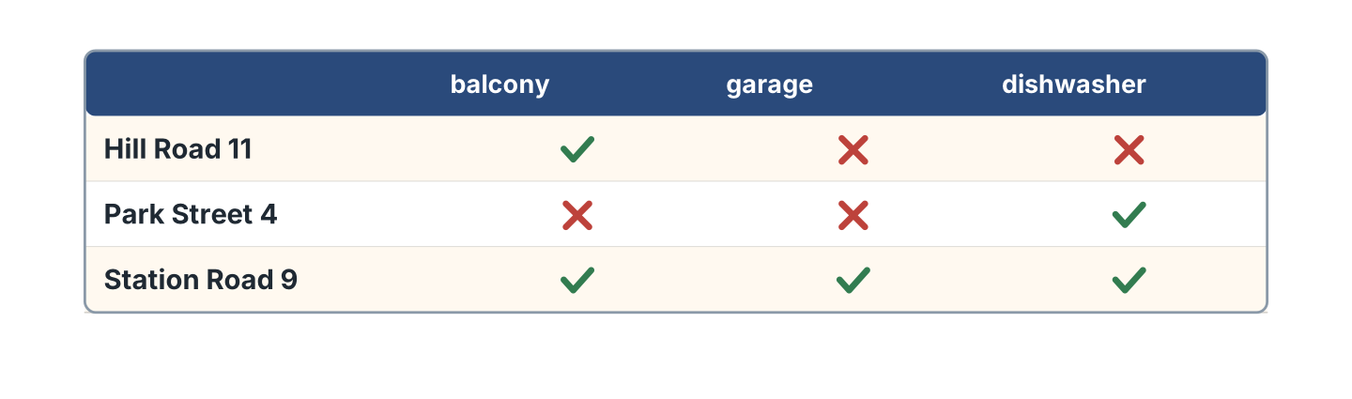
Figure 3.11 · What each flat has got.
- Flat 11 has got a balcony. — yes (example)
- Flat 4 has got a garage. — ______
- Flat 9 has got a dishwasher. — ______
- Flat 11 has got a dishwasher. — ______
2C Look at Figure 3.12. Answer the questions.
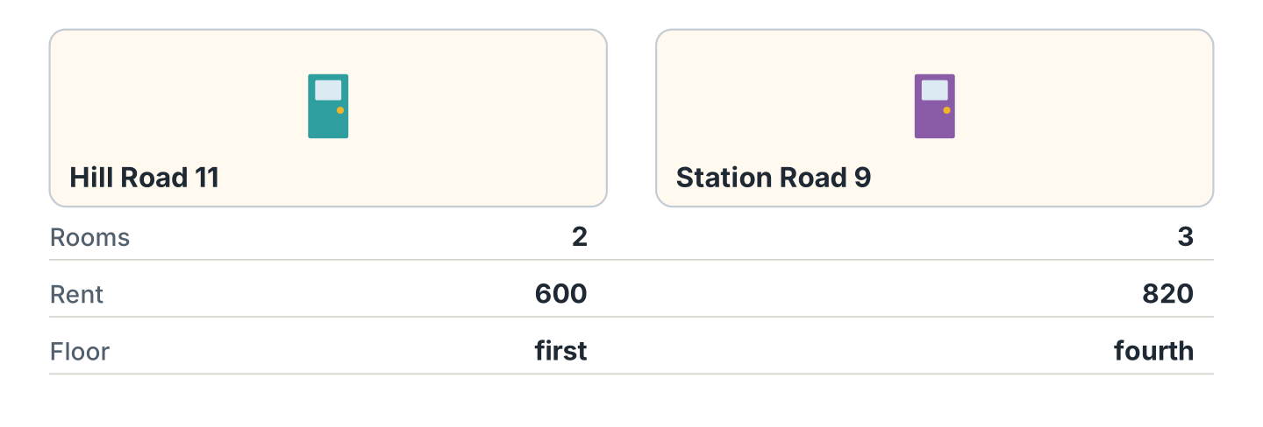
Figure 3.12 · Two flats side by side.
- How many rooms has Hill Road got? — two (example)
- How much is the rent on Station Road? — ______________
- Which flat is on the fourth floor? — ______________
- Which flat is cheaper? — ______________
2D Look at Figure 3.13. Write the other way.
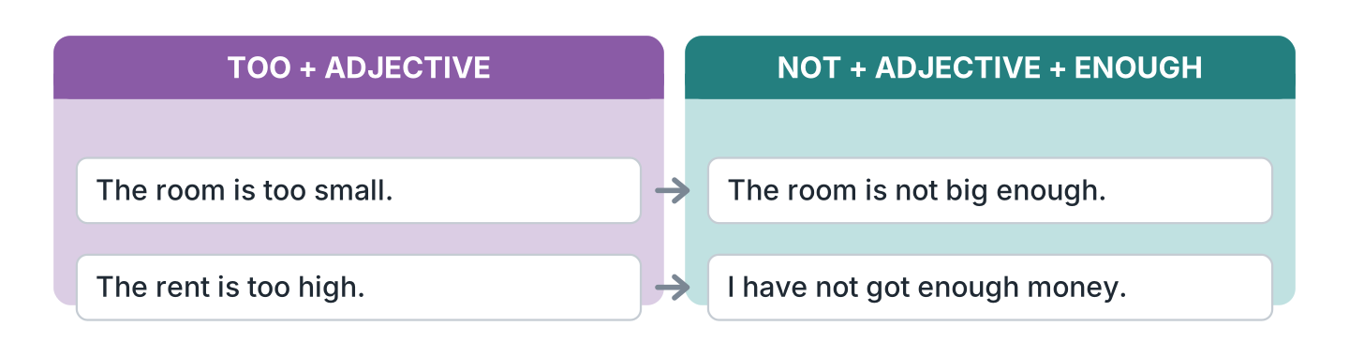
Figure 3.13 · Not big enough, or too small.
- The room is too small. — The room is not big enough. (example)
- The rent is too high. — ______________
- The kitchen is not warm enough. — ______________
- The flat is too dark. — ______________
2E Look at Figure 3.14. Write too much or right.
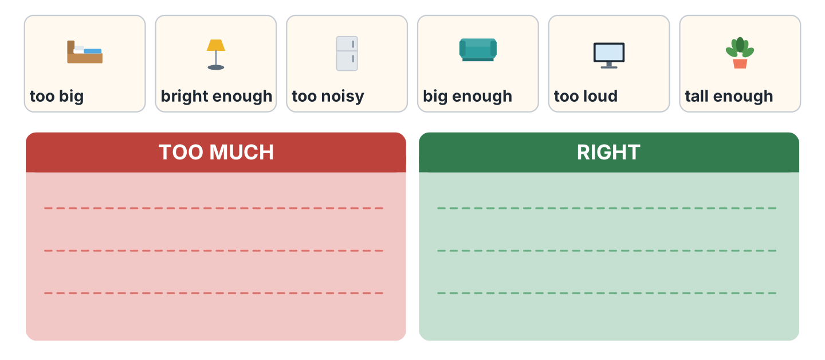
Figure 3.14 · Sorting too and enough.
- too big — too much (example)
- bright enough — ______________
- too noisy — ______________
- big enough — ______________
- too loud — ______________
2F Look at Figure 3.15. Find the mistake and write it correctly.
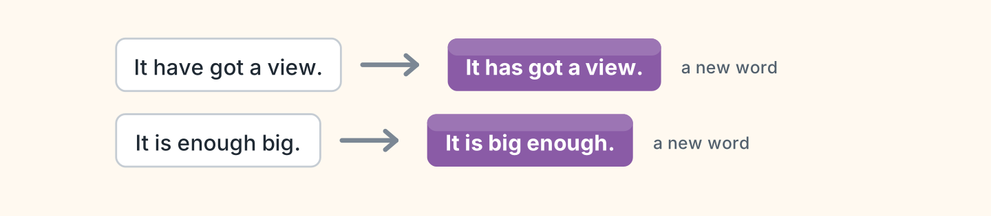
Figure 3.15 · Mistakes with got and enough.
- It have got a view. — It has got (example)
- It is enough big. — ______________
- They has got a garage. — ______________
- The room is not enough warm. — ______________
Part 3 · Listening
3A Listen. Look at Figure 3.16. Write the number.
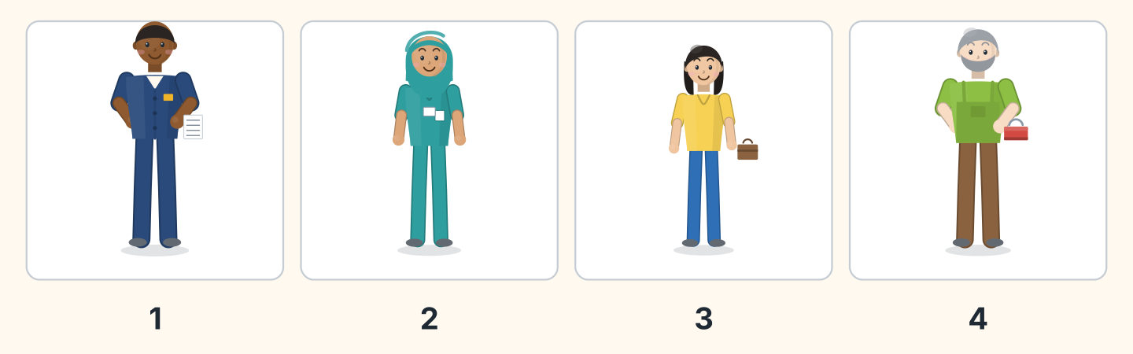
Figure 3.16 · Four people looking for a flat.
- Sam — 1 (example)
- Fatima — ______
- Lili — ______
- Marek — ______
3B Listen. Look at Figure 3.17. Write the answer you hear.
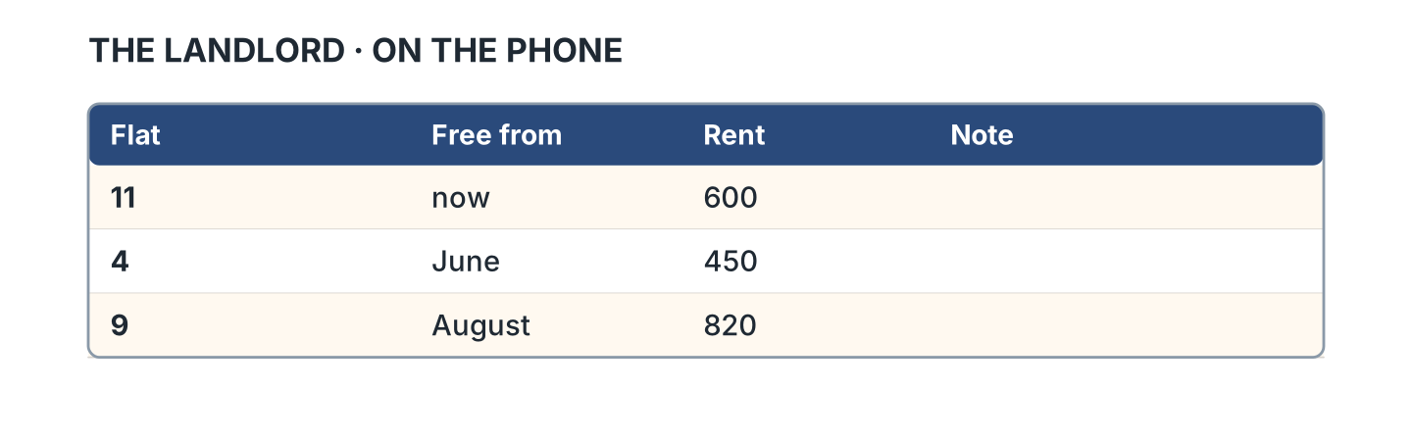
Figure 3.17 · What the landlord said.
- Which flat is free now? — flat 11 (example)
- What is flat 11 like? — ______________
- Which flat has no garage? — ______________
- Which flat is very bright? — ______________
3C Listen. Look at Figure 3.18. Answer the questions.
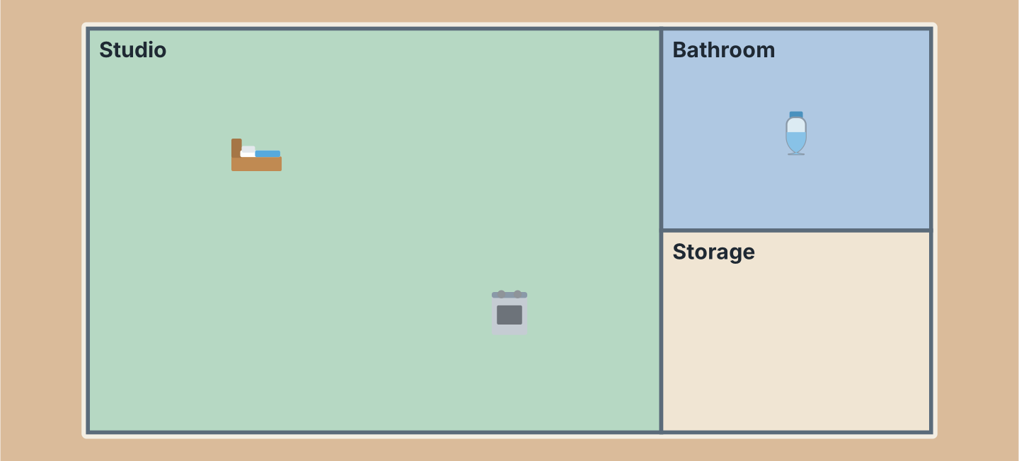
Figure 3.18 · A second flat from above.
- How many rooms has this flat got? — three (example)
- Where is the bed? — ______________
- What is next to the bathroom? — ______________
- Is there a separate bedroom? — ______________
3D Listen. Look at Figure 3.19. Write the number of the thing you hear.
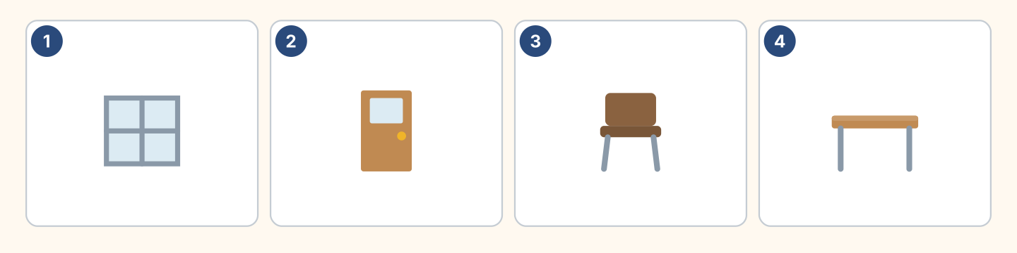
Figure 3.19 · Four more things to hear.
- a window — 1 (example)
- a door — ______
- a chair — ______
- a desk — ______
Part 4 · Speaking
4A Look at Figure 3.20. Ask about a flat.
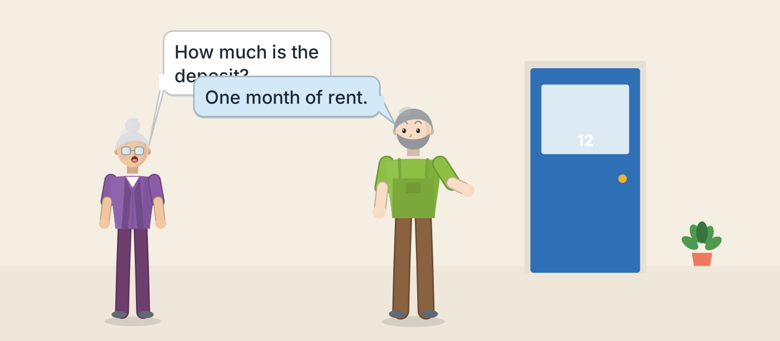
Figure 3.20 · Rosa asks about the rent.
- A: How much is the deposit? B: One month of rent. (example)
- Ask your colleague what the flat has got.
- Ask when it is free, and about the break in the week.
- Explain what your home has not got, and why.
4B Look at Figure 3.21. Ask and answer.
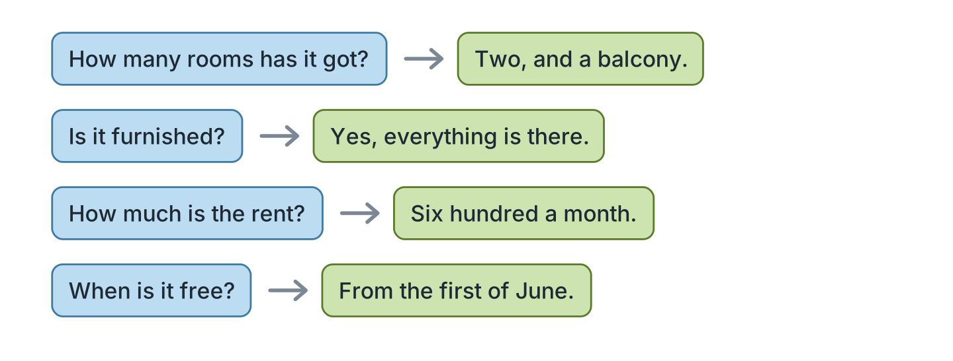
Figure 3.21 · Four questions about a flat.
- A: How many rooms has it got? B: Two, and a balcony. (example)
- A: Is it furnished? B: ______________
- A: How much is the rent? B: ______________
- A: When is it free? B: ______________
4C Look at Figure 3.22. Say what happens in each picture.
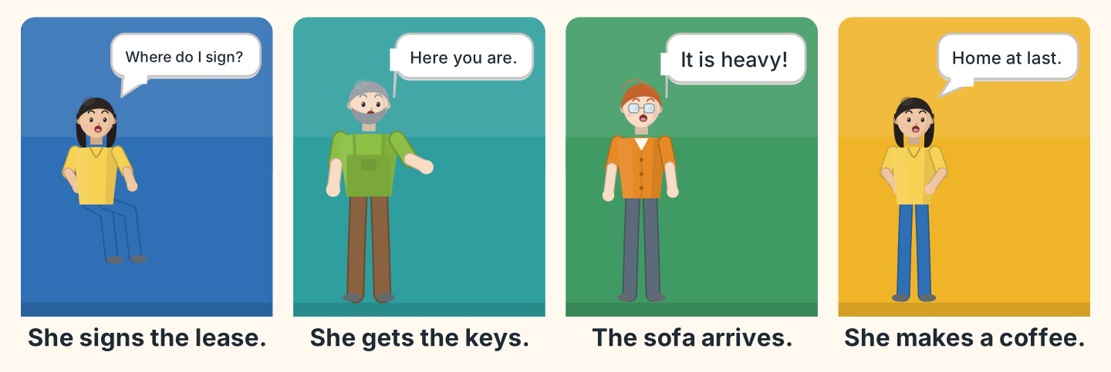
Figure 3.22 · Moving day in four moments.
- First Lili signs the lease. (example)
- Say what Marek, the caretaker, gives her.
- Say what Ben is carrying.
- Say what Lili does at the end, and why she is glad.
4D Look at Figure 3.23. Ask two of these people about their home.
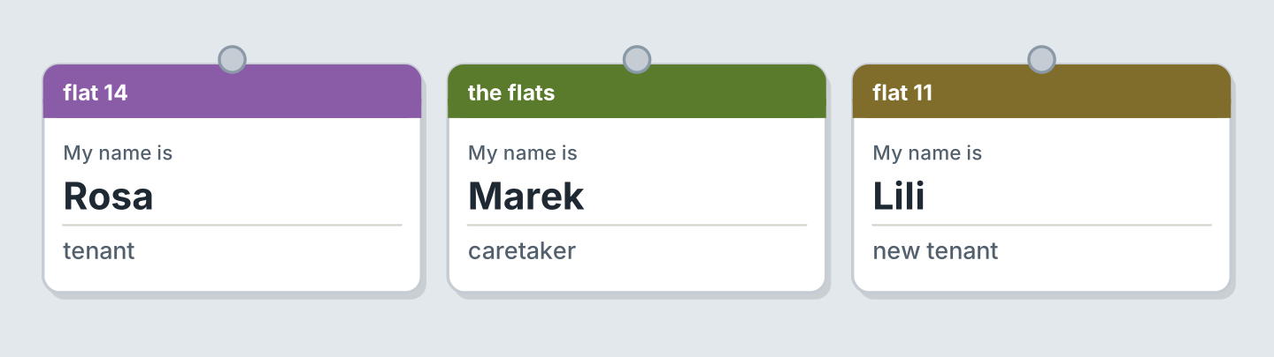
Figure 3.23 · Three people to ask about home.
- A: Has your flat got a balcony? B: Yes, a small one. (example)
- Ask Rosa if the neighbourhood changed recently.
- Ask the landlord about the heating.
- Say what you prefer about your neighbourhood.
Part 5 · Reading
5A Look at Figure 3.24. Answer the questions.
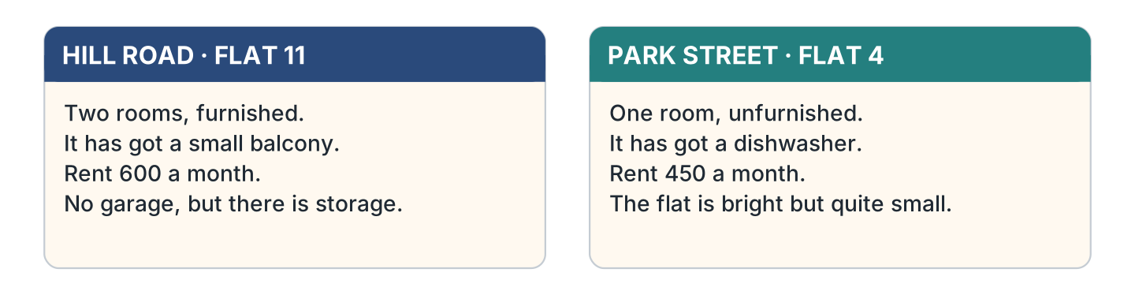
Figure 3.24 · Two flats in the paper.
- Which flat is furnished? — Hill Road 11 (example)
- Which flat has got a dishwasher? — ______________
- How much is Park Street? — ______________
- Which flat has got storage? — ______________
5B Look at Figure 3.25. Answer the questions.
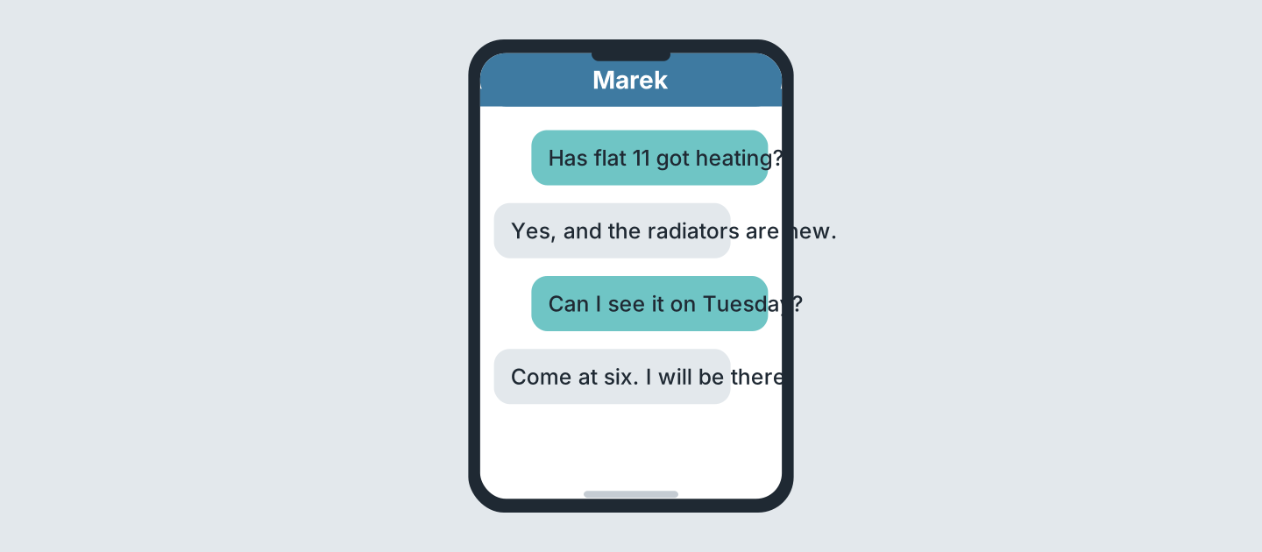
Figure 3.25 · Messages about a viewing.
- What does the first message ask about? — heating (example)
- What is new in the flat? — ______________
- When can she see the flat? — ______________
- What time will Marek be there? — ______________
5C Look at Figure 3.26. Choose the correct answer.
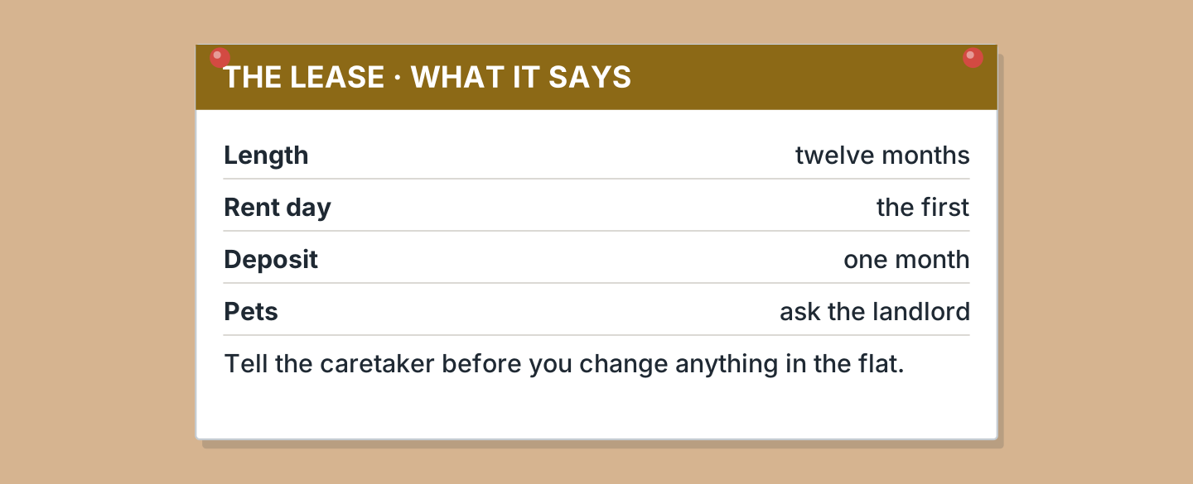
Figure 3.26 · The rules of the lease.
- How long is the lease? (a) six months (b) twelve months (c) two years — b (example)
- What do you tell the caretaker about? (a) a change (b) your job (c) your rent
- How much is the deposit? (a) two months (b) one month (c) nothing
- Who do you ask about pets? (a) the caretaker (b) the agent (c) the landlord
5D Look at Figure 3.27. Read and correct. Write the correct word.
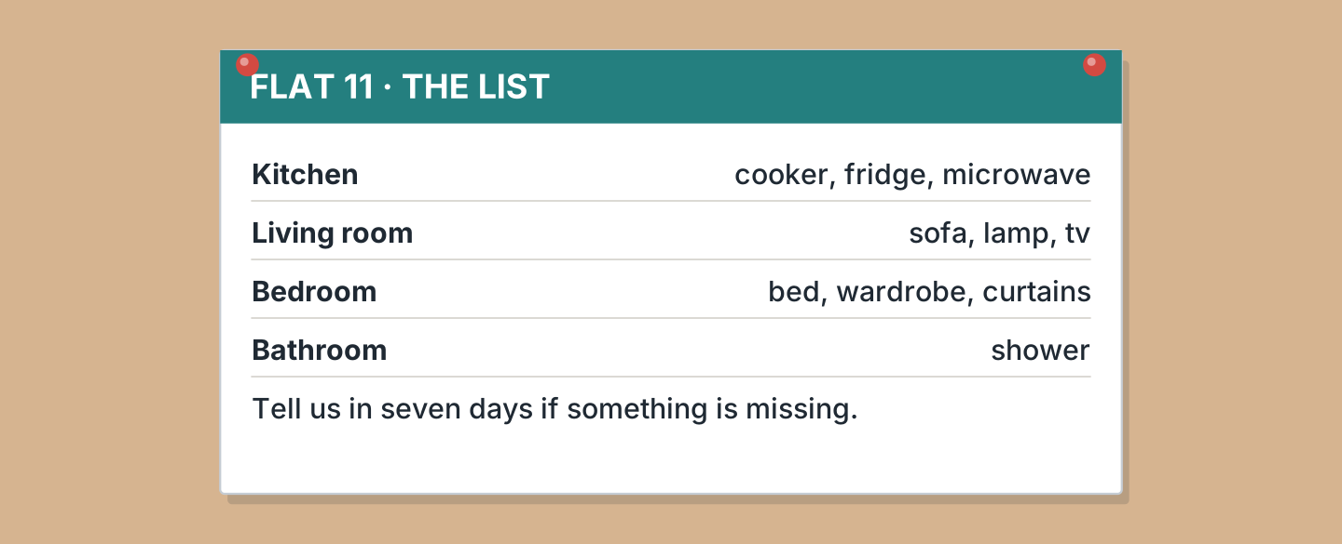
Figure 3.27 · What is in the flat.
- The sofa is in the bedroom. — living room (example)
- The wardrobe is in the kitchen. — ______________
- There is a microwave in the bathroom. — ______________
- You have fourteen days to tell them. — ______________
Part 6 · Writing
6A Look at Figure 3.28. Complete the form about you.
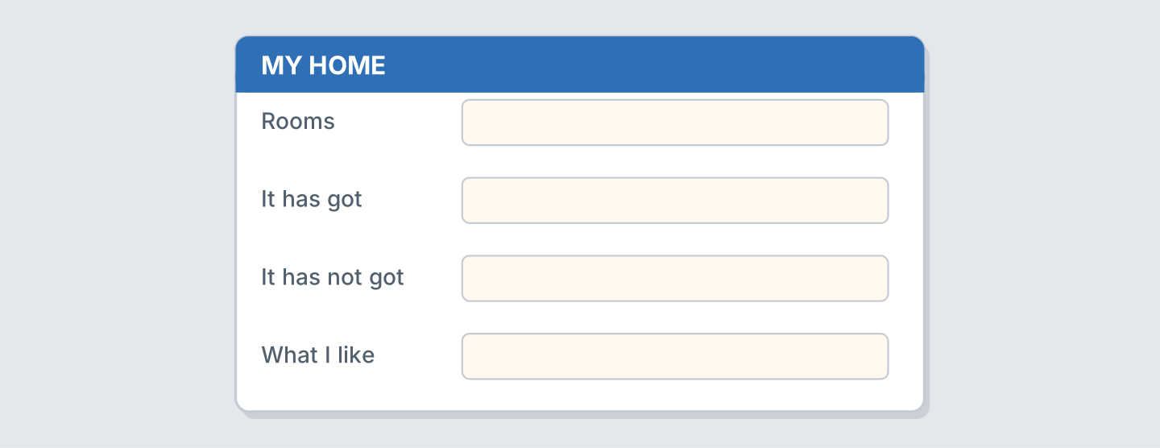
Figure 3.28 · A form about your home.
- Rooms: three (example)
- Rooms: ______________
- It has got, and I use it daily: ______________
- It has not got, and I hardly use it: ______________
6B Look at Figure 3.29. Write four lines about your home.
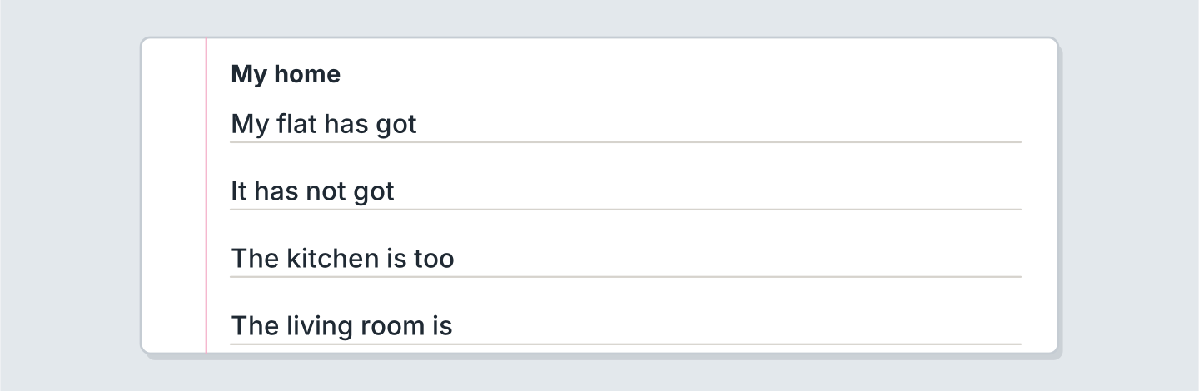
Figure 3.29 · Four lines about your home.
- My flat has got two bedrooms. (example)
- My flat, after a long shift, has got ______________.
- It has not got ______________, and that is a monthly task.
- My normal routine at home is ______________.
6C Look at Figure 3.30. Write an advert of four lines.
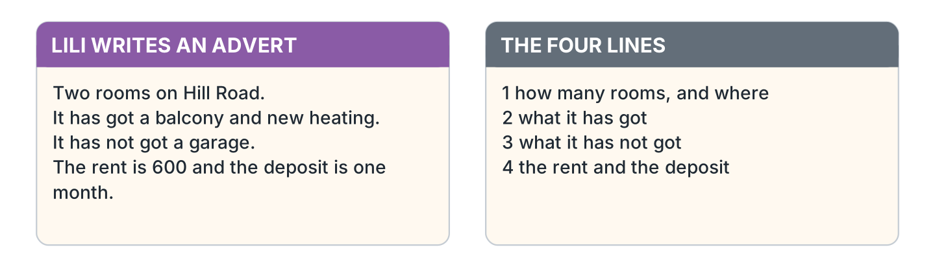
Figure 3.30 · A model advert.
- Two rooms on Hill Road, furnished. (example)
- Say how many rooms, and how near the place is to your work.
- Say what it has got, and what you normally use.
- Say what it has not got, and whether that is a problem every day.
- Say the rent, the deposit, and the hour you can see it.
Part 7 · Real-World File
7A Look at Figure 3.31. Answer the questions.
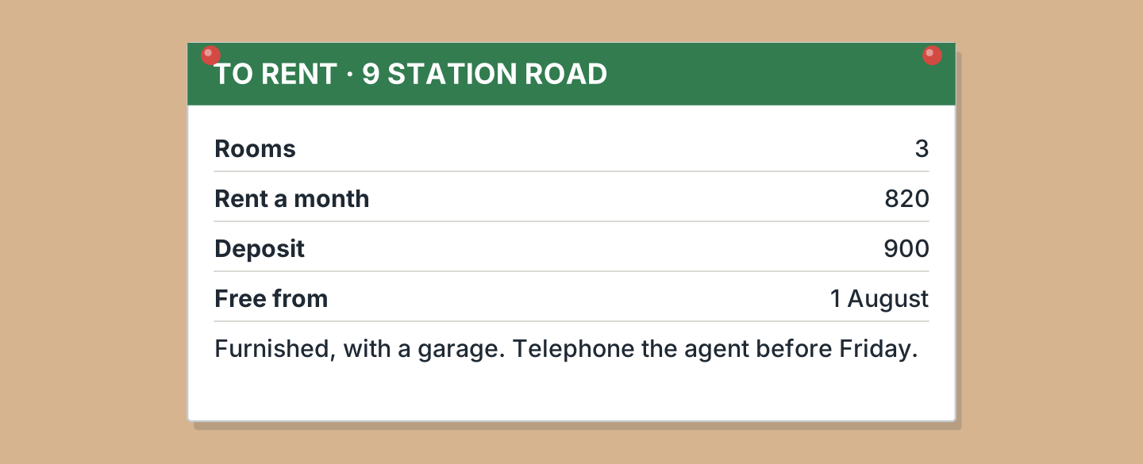
Figure 3.31 · A rental advert.
- How many rooms has it got? — three (example)
- How much is the rent? — ______________
- How much is the deposit? — ______________
- When can you move in? — ______________
7B Look at Figure 3.32. Answer the questions.
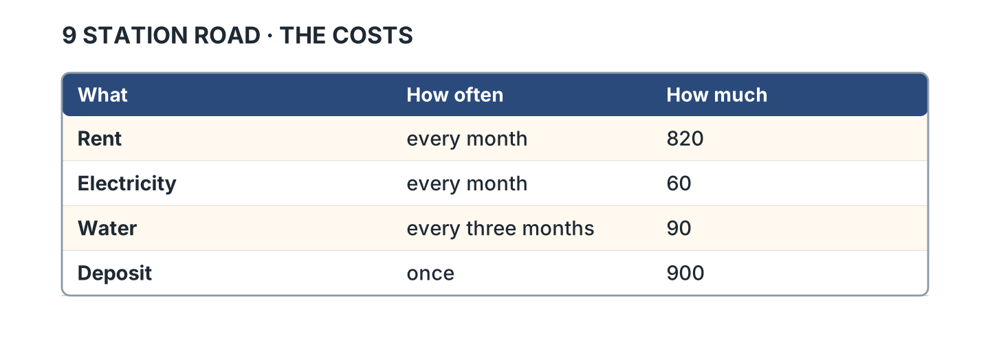
Figure 3.32 · What it costs in a year.
- How often do you pay the rent? — every month (example)
- How much is the electricity? — ______________
- How often do you pay for water? — ______________
- Which cost do you pay only once? — ______________
7C Look at Figure 3.33. Write about the home you want.
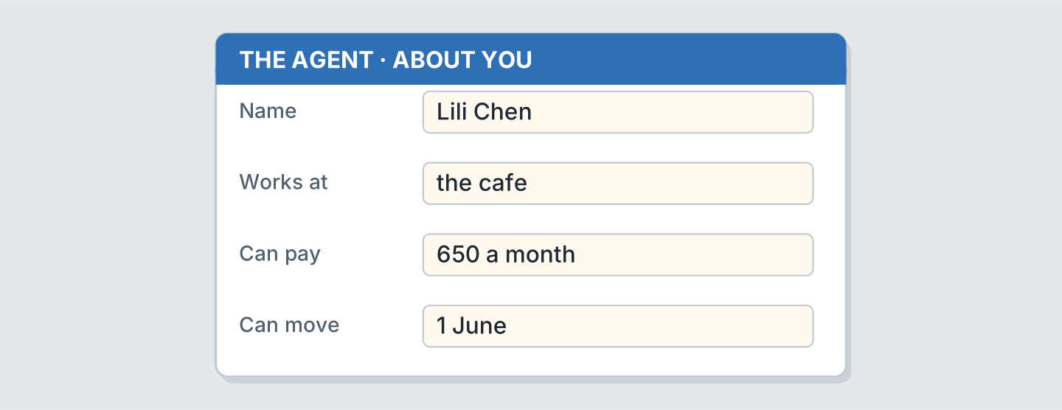
Figure 3.33 · A form for the agent.
- I can pay 500 a month. I can move in June. (example)
- Where I work, and my shift: ______________
- What I can pay every month: ______________
- When I can move, and my day off: ______________
Part 8 · Review & Can-Do
8A Look at Figure 3.34. Write the word.
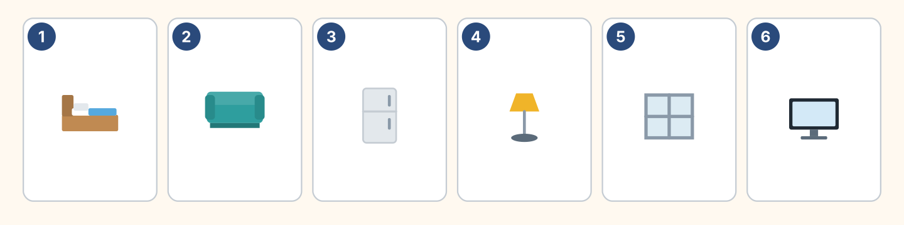
Figure 3.34 · Six things from this unit.
Words: bed · fridge · lamp · sofa · tv · window
- 1 — bed (example)
- 2 — ______________
- 3 — ______________
- 4 — ______________
- 5 — ______________
8B Look at Figure 3.35. Complete the sentences.
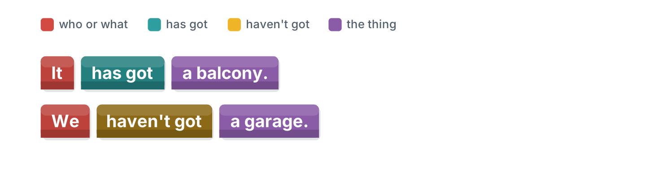
Figure 3.35 · Have got in blocks.
Words: got · has · haven’t · We
- It ______ got a balcony. (has) (example)
- It has ______ a balcony.
- ______ haven’t got a garage.
- We ______ got a garage.
8C Look at Figure 3.36. Write the short form.
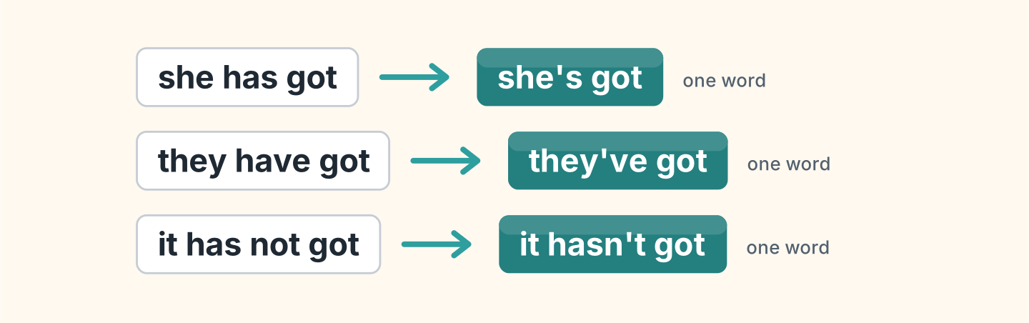
Figure 3.36 · Four short forms to write.
- she has got — she’s got (example)
- they have got — ______________
- it has not got — ______________
- I have got — ______________
8D Look at Figure 3.37. Match the person and the answer.
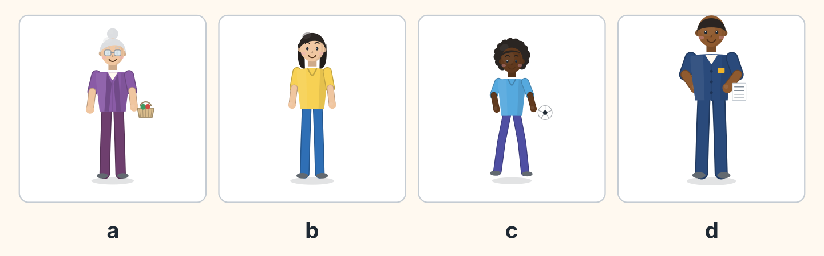
Figure 3.37 · Four homes, four answers.
Person | What they say
1 Rosa | a I have got the same flat for twenty years.
2 Lili | b My flat has got a balcony and new heating.
3 Omar | c Our garden is not big enough for football.
4 Sam | d My flat is too far from the bus stop.
 | e I have not got a flat at all.
One option is not needed.
- 1 — a (example)
- 2 — ______
- 3 — ______
- 4 — ______
8E Look at Figure 3.38. Tick what you can do.
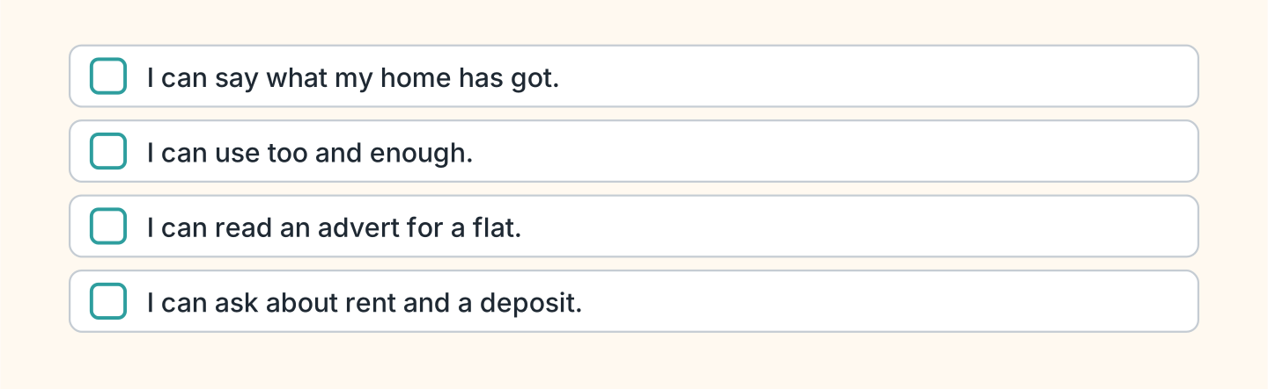
Figure 3.38 · What I can do.
- I can say what my home has got. — ✓ (example)
- I can use too and enough. — ______
- I can read an advert for a flat. — ______
- I can ask about rent and a deposit. — ______

Unit 4: How Much, How Many
In this unit you talk about money, and about how much of a thing there is.
Warm Up
W1 Look at Figure 4.1. Answer the questions.
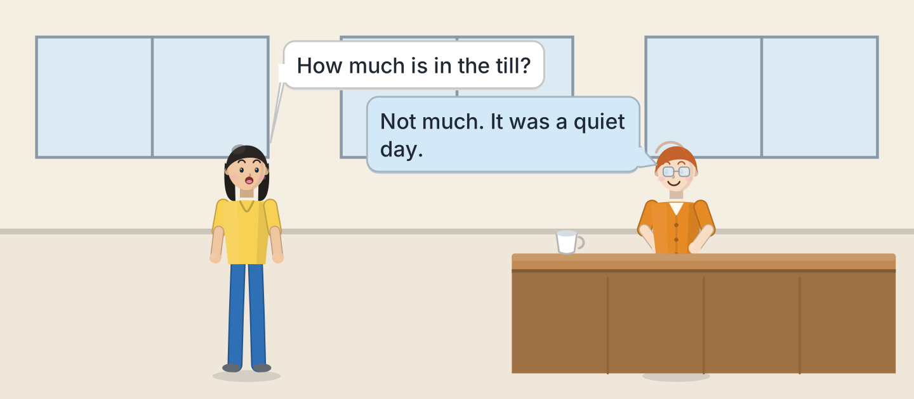
Figure 4.1 · Ben counts the money.
- What does Lili ask about? — the money in the till (example)
- How much is in the till? — ______________
- Why is there not much? — ______________
- Which room are they in? — ______________
W2 Look at Figure 4.2. Answer the questions.
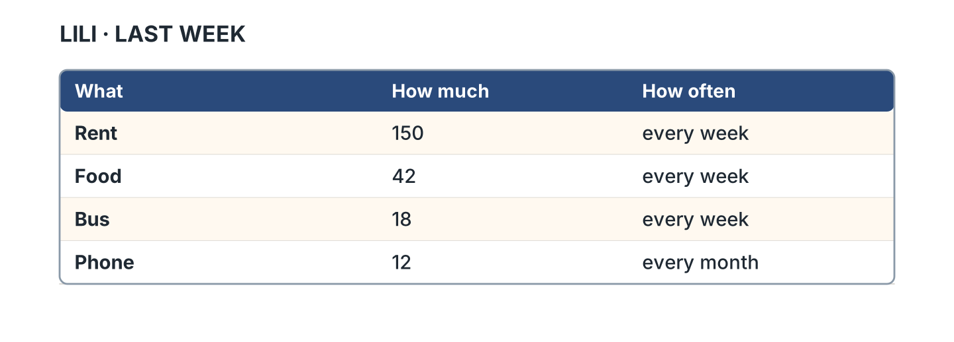
Figure 4.2 · A week of spending.
- How much is the rent? — 150 (example)
- What does Lili spend on food? — ______________
- Which cost is monthly? — ______________
- Which cost is the smallest? — ______________
W3 Look at Figure 4.3. Write the word.
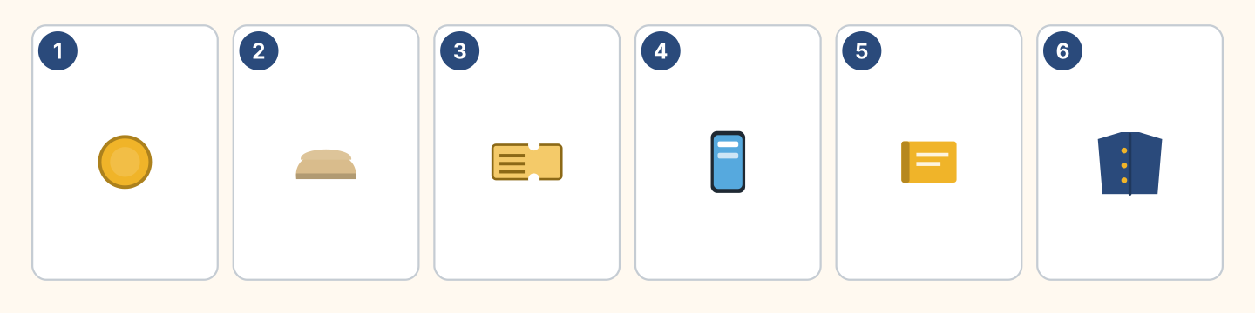
Figure 4.3 · Six things you pay for.
Words: book · bread · coat · coin · phone · ticket
- 1 — coin (example)
- 2 — ______________
- 3 — ______________
- 4 — ______________
- 5 — ______________
Part 1 · Words & Sounds
1A Look at Figure 4.4. Write much or many.
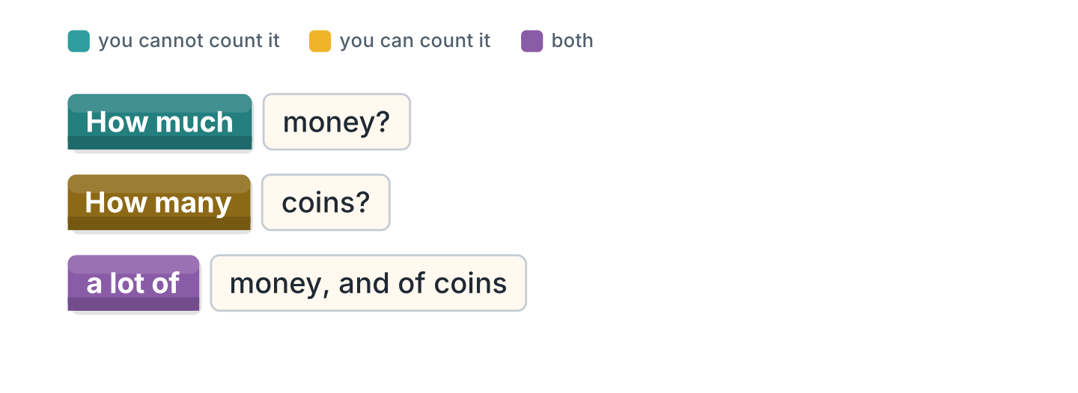
Figure 4.4 · Much, many and a lot of.
- How ______ money? — much (example)
- How ______ coins?
- How ______ time?
- How ______ tickets?
1B Look at Figure 4.5. Write a few or a little.
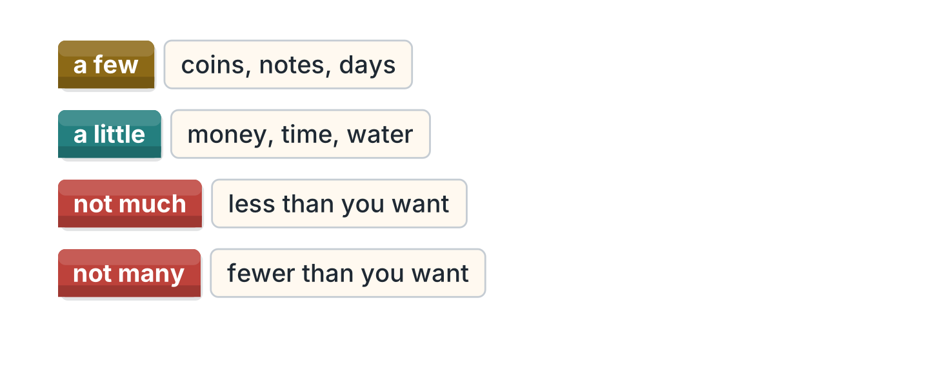
Figure 4.5 · A few and a little.
- ______ coins — a few (example)
- ______ money
- ______ days
- ______ water
1C Look at Figure 4.6. Answer the questions.
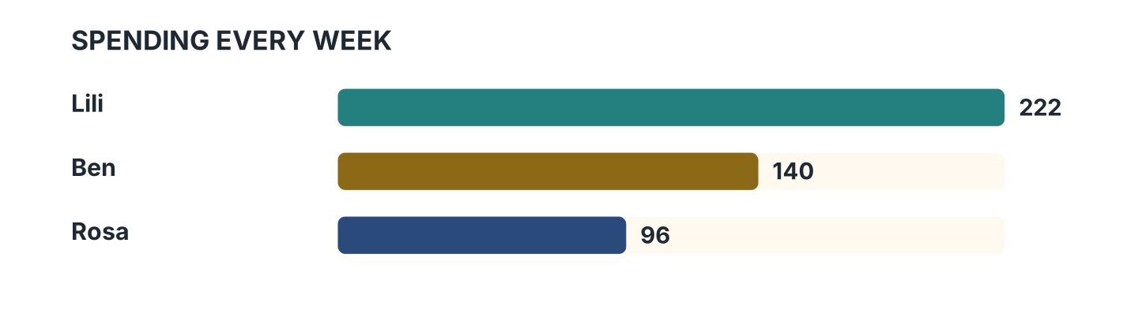
Figure 4.6 · How much each one spends.
- Who spends the most? — Lili (example)
- How much does Ben spend? — ______________
- Who spends the least? — ______________
- How much more does Lili spend than Rosa? — ______________
1D Say it. Look at Figure 4.7. Say these numbers.
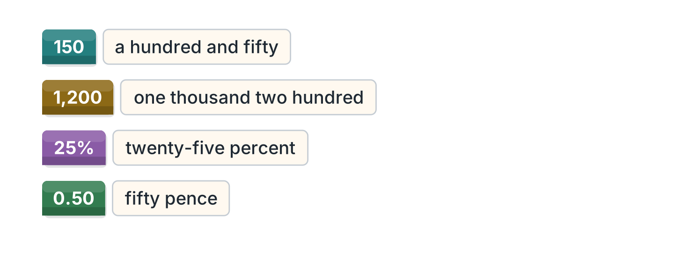
Figure 4.7 · Saying the long numbers.
- 150 — a hundred and fifty (example)
- 1,200
- 25%
- 0.50
- 1,476
1E Look at Figure 4.8. Answer the questions.
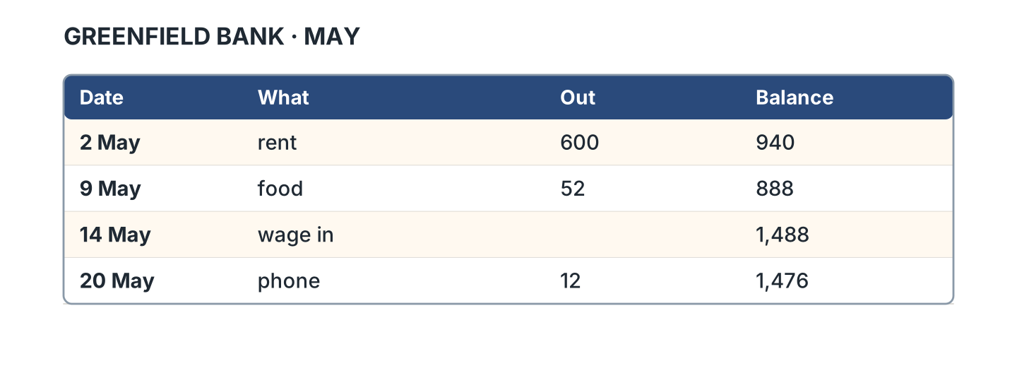
Figure 4.8 · A bank statement.
- How much was the rent? — 600 (example)
- What was the balance after the food? — ______________
- When did the wage arrive? — ______________
- How much was the phone? — ______________
1F Look at Figure 4.9. Write the word for the meaning.
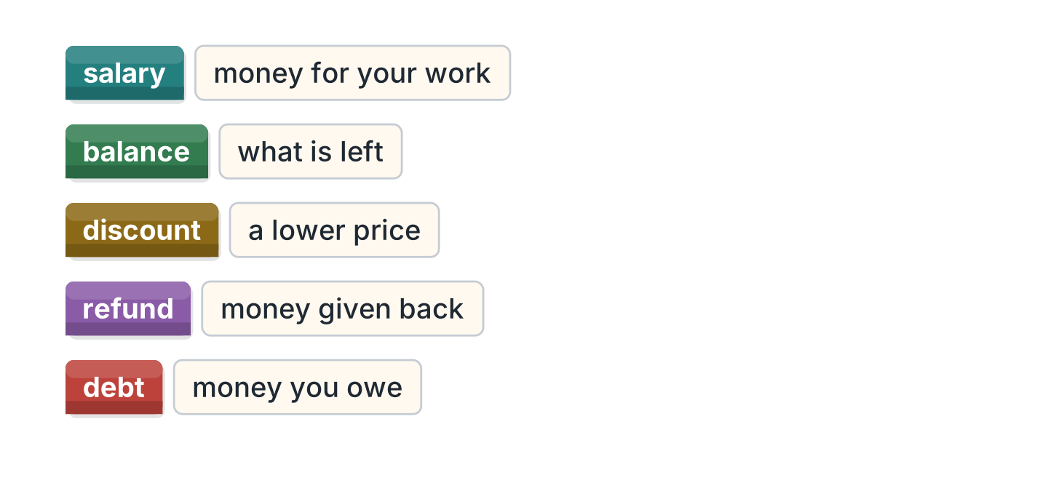
Figure 4.9 · Five money words.
- money for your work — salary (example)
- what is left — ______________
- a lower price — ______________
- money given back — ______________
- money you owe — ______________
Part 2 · Grammar
2A Look at Figure 4.10. Write countable or uncountable.
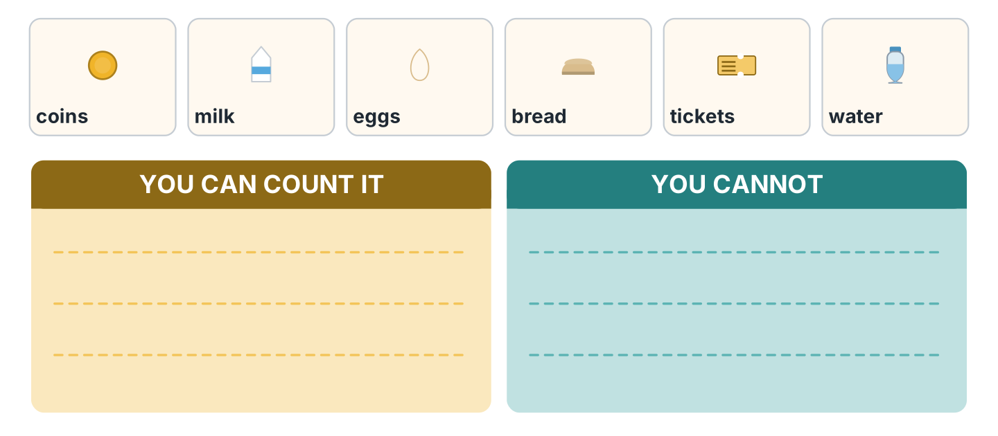
Figure 4.10 · Countable and uncountable.
- coins — countable (example)
- milk — ______________
- eggs — ______________
- bread — ______________
- tickets — ______________
2B Look at Figure 4.11. Write the answer.
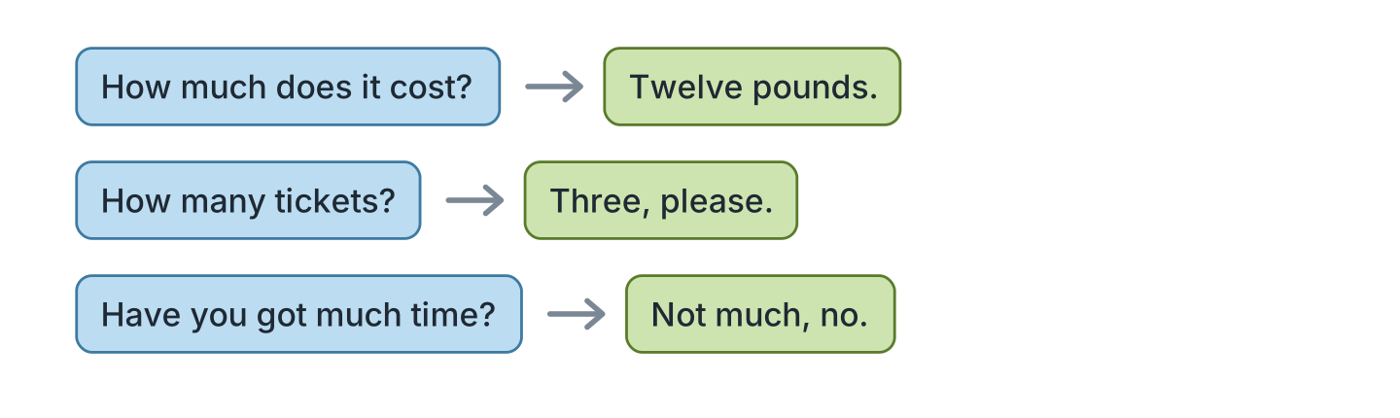
Figure 4.11 · How much and how many.
- How much does it cost? (twelve pounds) — Twelve pounds. (example)
- How many tickets? (three) — ______________
- Have you got much time? ✗ — ______________
- How much is the deposit? (one month) — ______________
2C Look at Figure 4.12. Answer the questions.
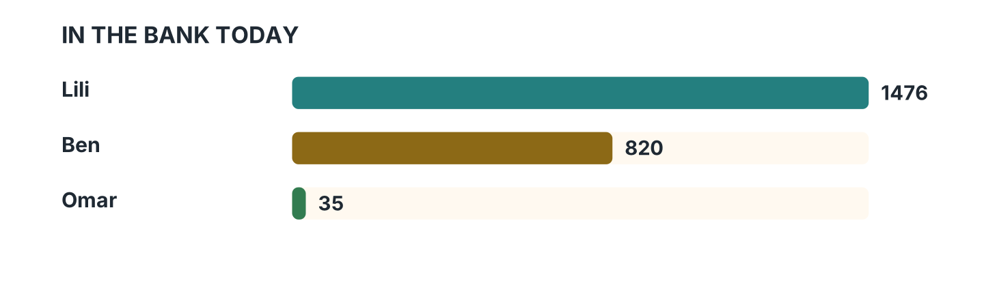
Figure 4.12 · Who has got how much.
- Who has got the most? — Lili (example)
- How much has Ben got? — ______________
- Who has got the least? — ______________
- Has Omar got a lot of money? — ______________
2D Look at Figure 4.13. Choose the correct words.
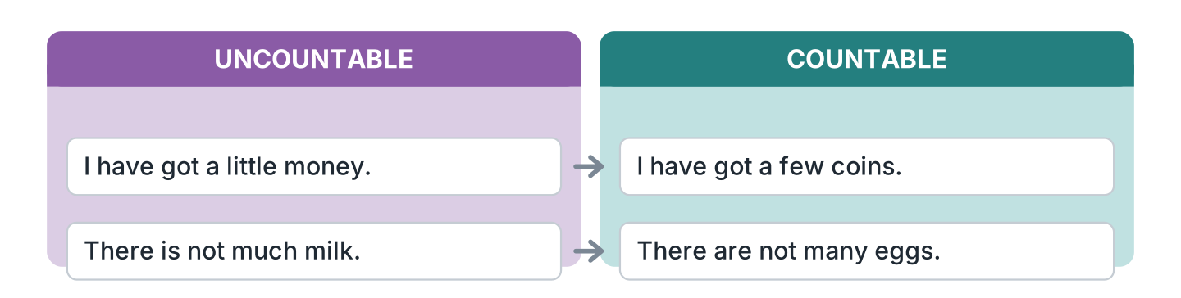
Figure 4.13 · A little and a few, again.
- I have got (a little / a few) money. — a little (example)
- I have got (a little / a few) coins.
- There is not (much / many) milk.
- There are not (much / many) eggs.
- We have not got (much / many) time.
2E Look at Figure 4.14. Answer the questions.
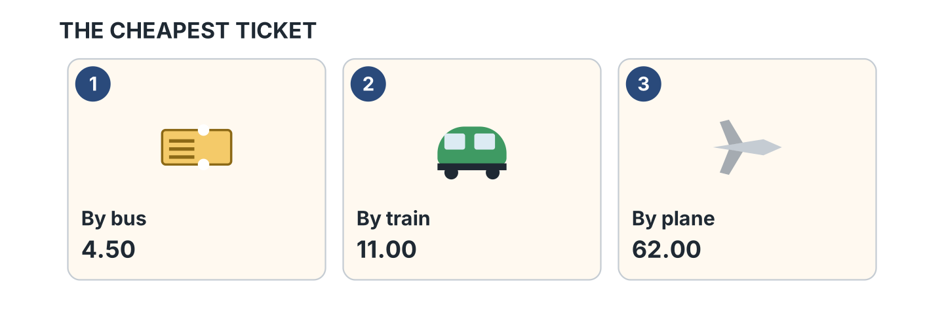
Figure 4.14 · Three prices to compare.
- How much is the bus? — 4.50 (example)
- How much is the train? — ______________
- Which way is the most expensive? — ______________
- How much more is the plane than the train? — ______________
2F Look at Figure 4.15. Find the mistake and write it correctly.
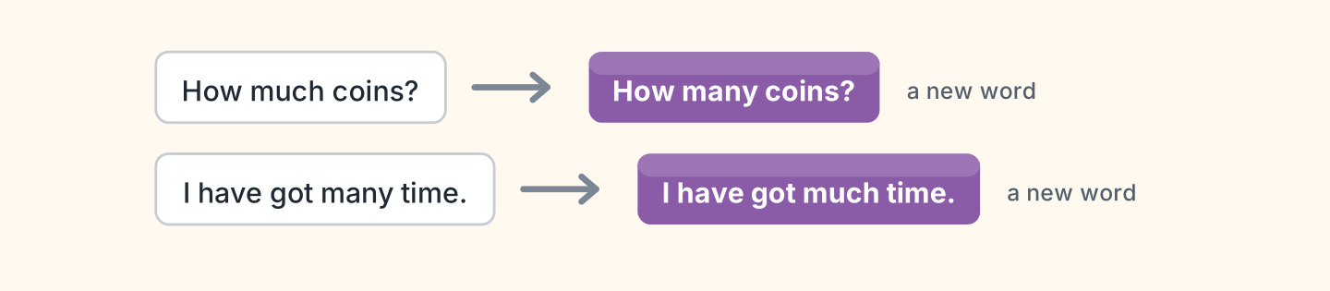
Figure 4.15 · Mistakes with much and many.
- How much coins? — How many coins? (example)
- I have got many time. — ______________
- There are not much eggs. — ______________
- How many bread? — ______________
Part 3 · Listening
3A Listen. Look at Figure 4.16. Write the number.
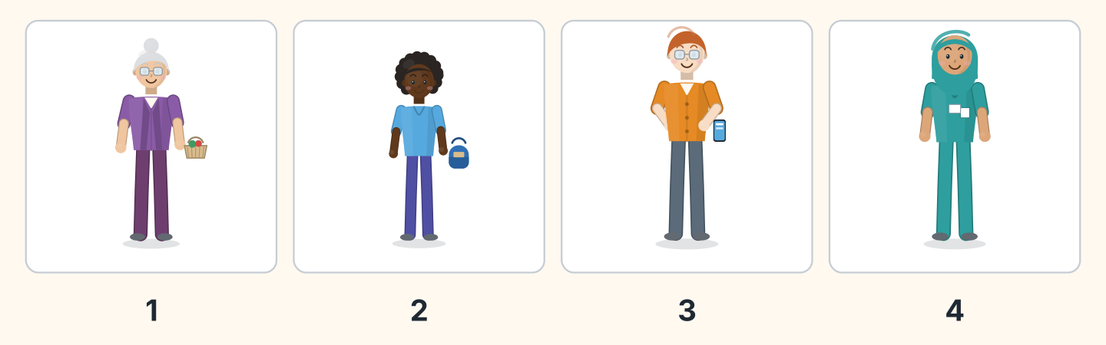
Figure 4.16 · Four people at the bank.
- Rosa — 1 (example)
- Omar — ______
- Ben — ______
- Fatima — ______
3B Listen. Look at Figure 4.17. Write the answer you hear.
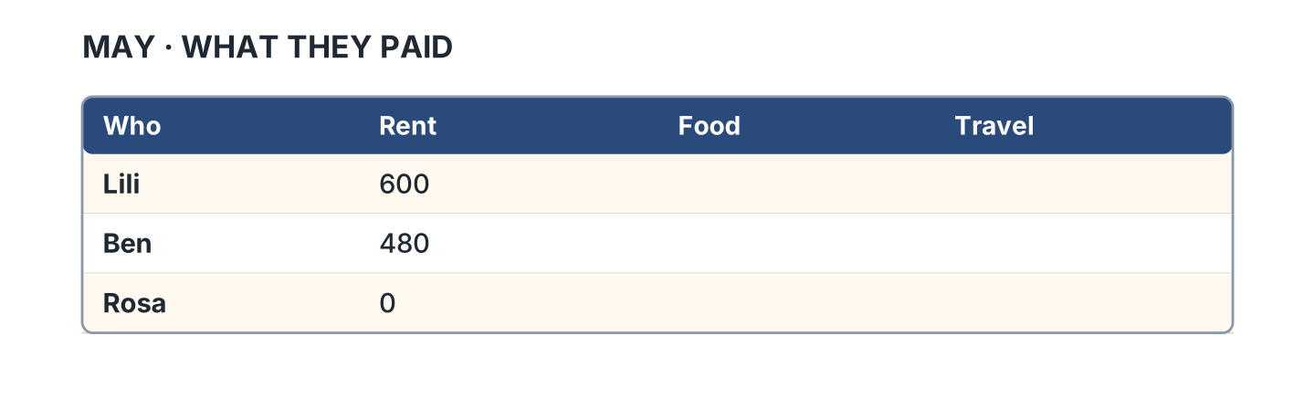
Figure 4.17 · What they paid in May.
- How much rent did Lili pay? — 600 (example)
- How much did Ben pay for food? — ______________
- How much did Rosa pay for food? — ______________
- How much did Lili pay for travel? — ______________
3C Listen. Look at Figure 4.18. Write the answer you hear.
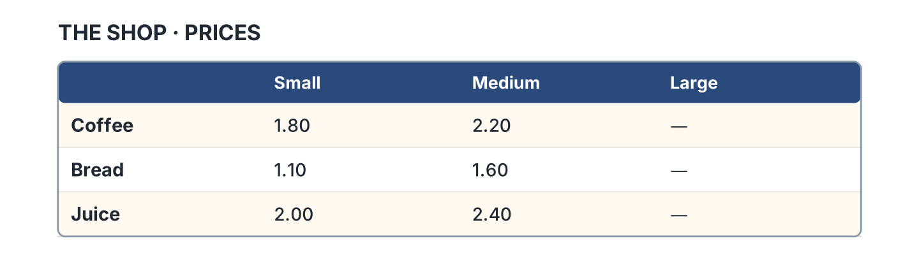
Figure 4.18 · The prices in the shop.
- How much is a small coffee? — 1.80 (example)
- How much is a large juice? — ______________
- Which size of bread is not there? — ______________
- How much is a large coffee? — ______________
3D Listen. Look at Figure 4.19. Write the number of the thing you hear.
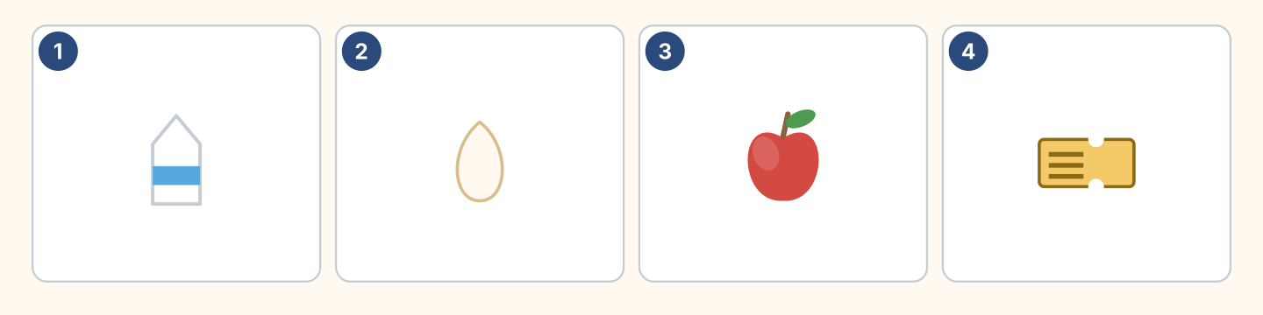
Figure 4.19 · Four more things to hear.
- milk — 1 (example)
- an egg — ______
- an apple — ______
- a ticket — ______
Part 4 · Speaking
4A Look at Figure 4.20. Ask about a bill.
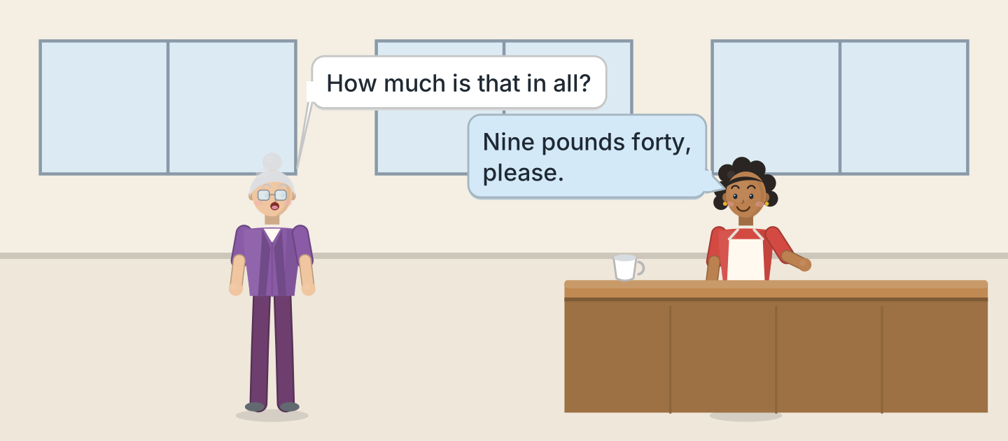
Figure 4.20 · Asking about the bill.
- A: How much is that in all? B: Nine pounds forty, please. (example)
- Ask how much a coffee costs, and whether that is enough.
- Ask about the deposit, and about a break in the rent.
- Say how much the heating and the electricity cost you.
4B Look at Figure 4.21. Ask and answer.
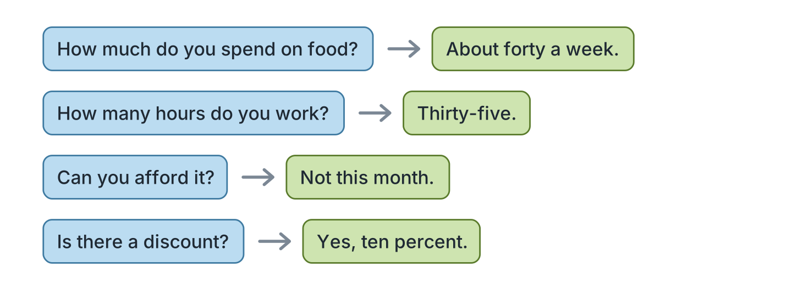
Figure 4.21 · Four questions about money.
- A: How much do you spend on food? B: About forty a week. (example)
- A: How many hours do you work? B: ______________
- A: Can you afford it? B: ______________
- A: Is there a discount? B: ______________
4C Look at Figure 4.22. Say what happens in each picture.
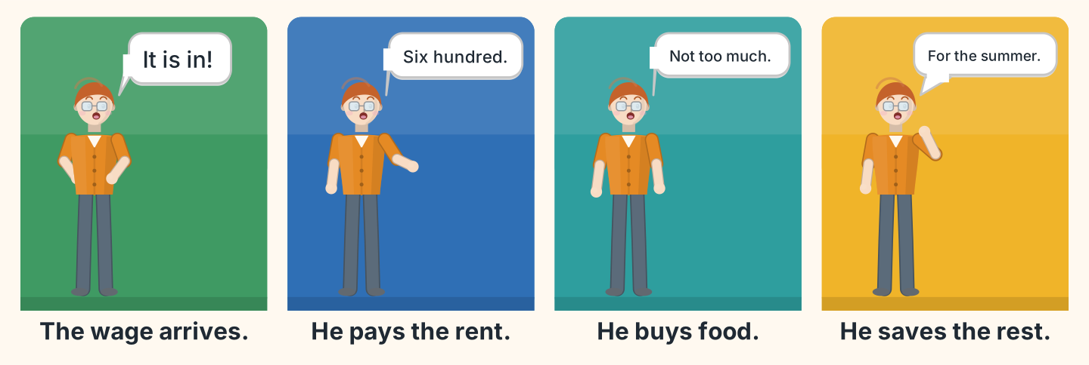
Figure 4.22 · Payday in four moments.
- First the wage arrives in the account. (example)
- Say what Ben pays first, and how much the rent is.
- Say what he buys after that.
- Say what he does with the money that is left.
4D Look at Figure 4.23. Ask two of these people about money.
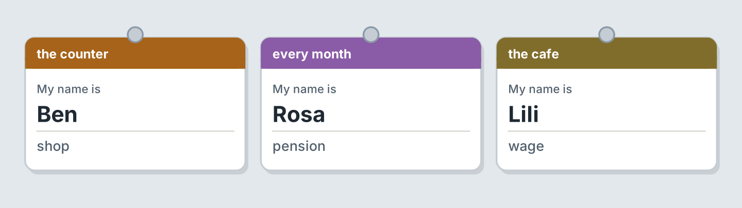
Figure 4.23 · Three people to ask about money.
- A: How often do you get paid? B: Every month, from the shop. (example)
- Ask Rosa about her pension, and about her lease.
- Ask Lili what the agent asked for, and what the contract says.
- Say what you decided to save for recently.
Part 5 · Reading
5A Look at Figure 4.24. Answer the questions.
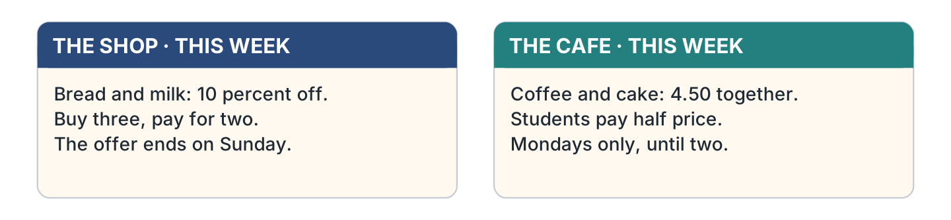
Figure 4.24 · Two offers in the window.
- How much off is the bread? — ten percent (example)
- When does the shop offer end? — ______________
- How much are a coffee and a cake together? — ______________
- Which day is the cafe offer? — ______________
5B Look at Figure 4.25. Answer the questions.
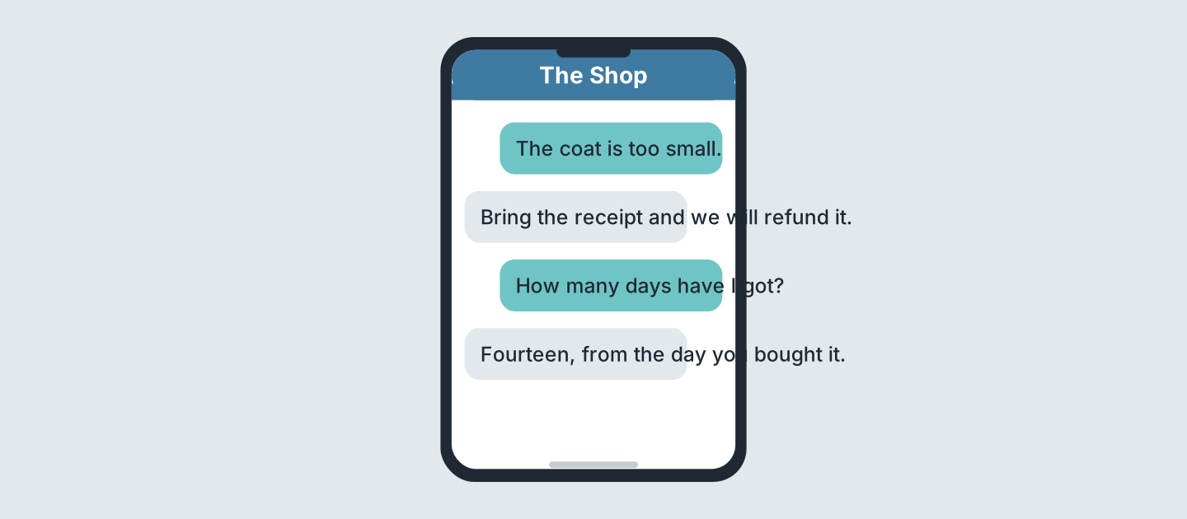
Figure 4.25 · Messages about a refund.
- What is wrong with the coat? — it is too small (example)
- What do you bring for a refund? — ______________
- How many days have you got? — ______________
- When do the days start? — ______________
5C Look at Figure 4.26. Choose the correct answer.
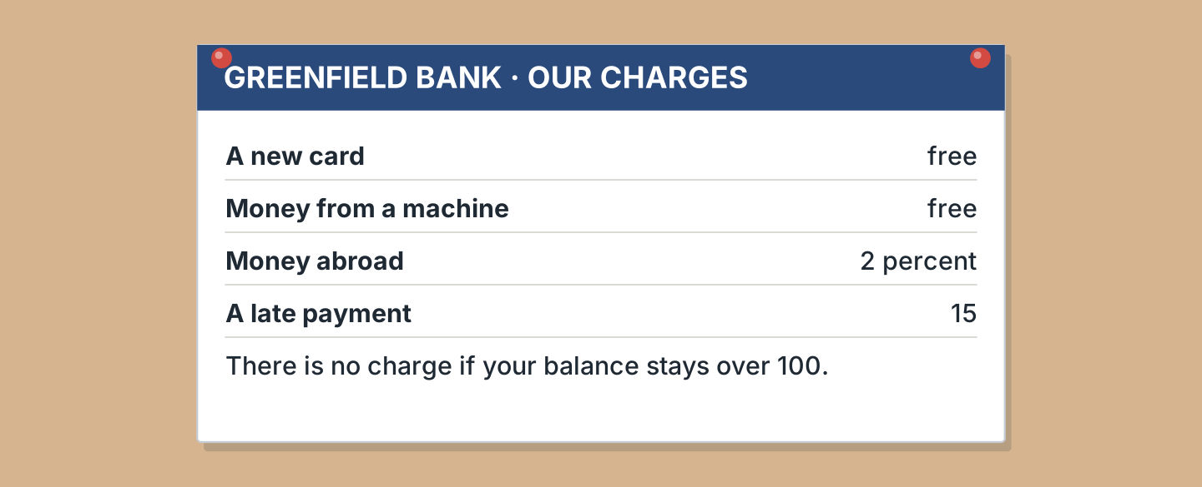
Figure 4.26 · What the bank charges.
- How much is a new card? (a) free (b) 2 percent (c) 15 — a (example)
- What costs 15? (a) a new card (b) a late payment (c) money abroad
- How much is money abroad? (a) free (b) 15 (c) 2 percent
- When is there no charge? (a) over 100 (b) under 100 (c) always
5D Look at Figure 4.27. Read and correct. Write the correct word.
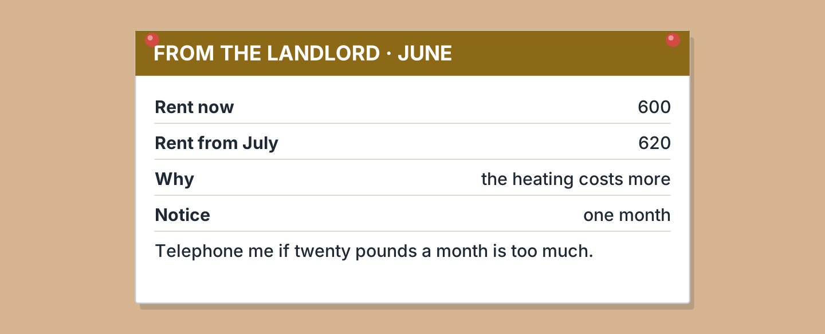
Figure 4.27 · A letter about the rent.
- The rent now is 620. — 600 (example)
- The rent goes up in June. — ______________
- The reason is the electricity. — ______________
- The notice is two months. — ______________
Part 6 · Writing
6A Look at Figure 4.28. Complete the form about you.
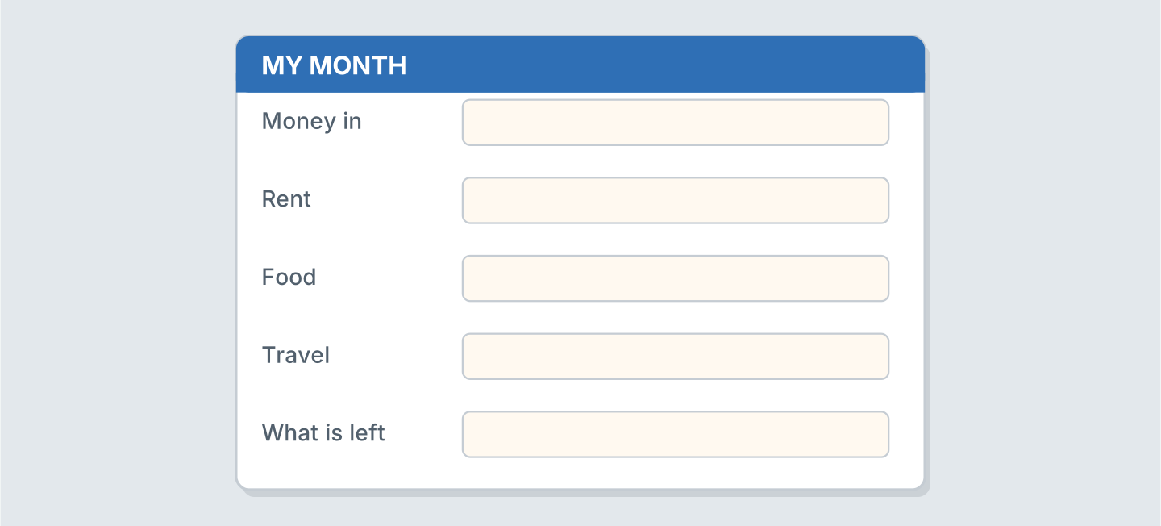
Figure 4.28 · A budget form.
- Money in: 1,400 (example)
- Money in: ______________
- Rent, and my weekly shift: ______________
- What is left after a month of overtime: ______________
6B Look at Figure 4.29. Write four lines about your money.
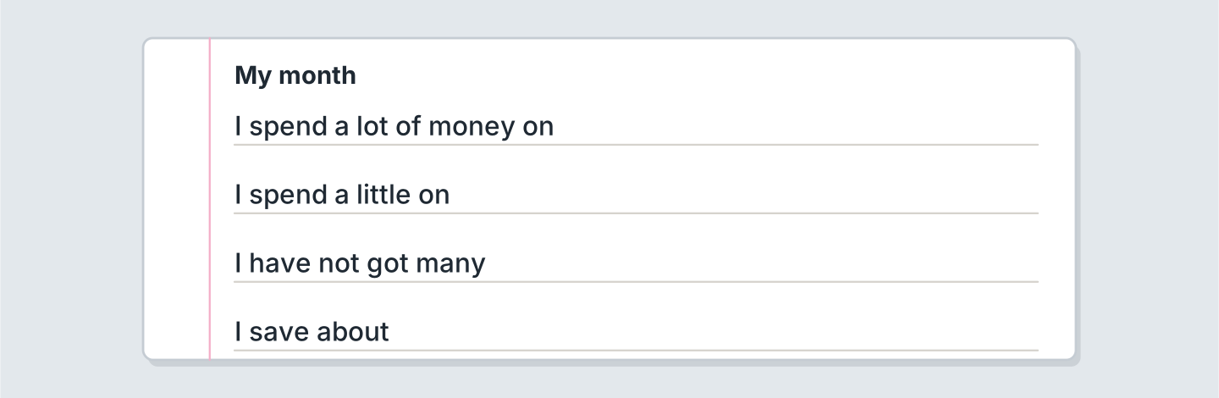
Figure 4.29 · Four lines about your money.
- I spend a lot of money on rent. (example)
- I spend a lot of money on ______________.
- I spend a little on ______________.
- After a long shift I save about ______________ every month.
6C Look at Figure 4.30. Write four lines about your month.
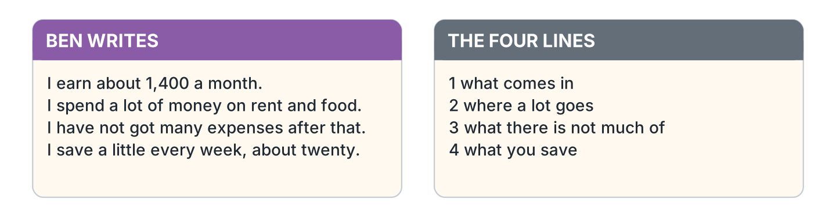
Figure 4.30 · A model budget.
- I earn about 1,400 a month from the cafe. (example)
- Say what comes in, and from which boss or job.
- Say where a lot of it goes: the rent, the light, the storage.
- Say what there is not much of, and what is not comfortable.
- Say what you save, and what you are saving for.
Part 7 · Real-World File
7A Look at Figure 4.31. Answer the questions.
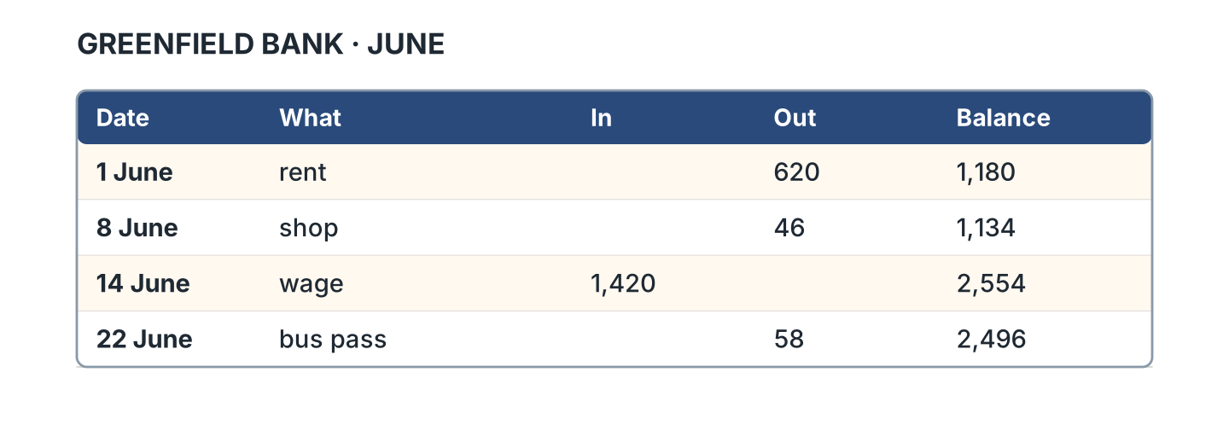
Figure 4.31 · A real bank statement.
- How much was the rent in June? — 620 (example)
- What was the balance after the shop? — ______________
- How much was the wage? — ______________
- What did she buy on 22 June? — ______________
7B Look at Figure 4.32. Answer the questions.
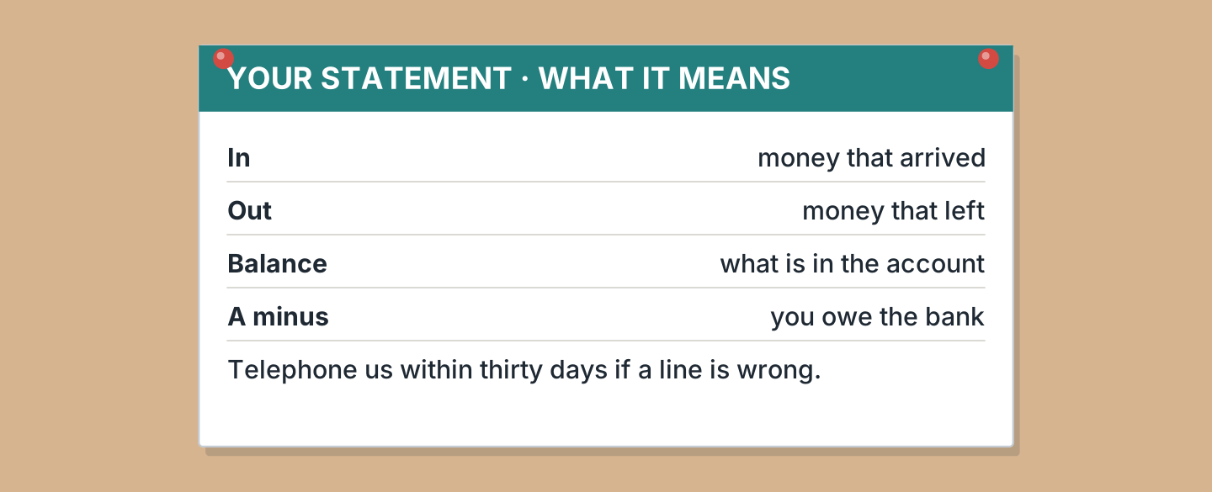
Figure 4.32 · How to read it.
- What does In mean? — money that arrived (example)
- What does Out mean? — ______________
- What does a minus mean? — ______________
- How many days have you got to telephone? — ______________
7C Look at Figure 4.33. Write about how you pay for things.
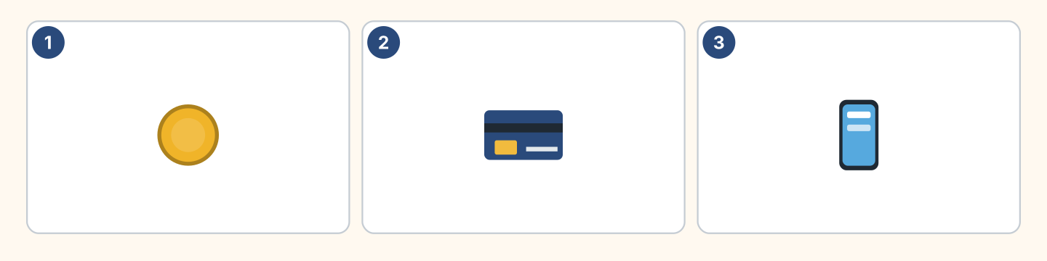
Figure 4.33 · Three ways to pay.
- I normally pay by card. I only use coins for the bus. (example)
- How I normally pay, almost every hour: ______________
- What I prefer, and why, in a bright shop: ______________
- One thing I only pay for once a year, like a garage: ______________
Part 8 · Review & Can-Do
8A Look at Figure 4.34. Write the word.
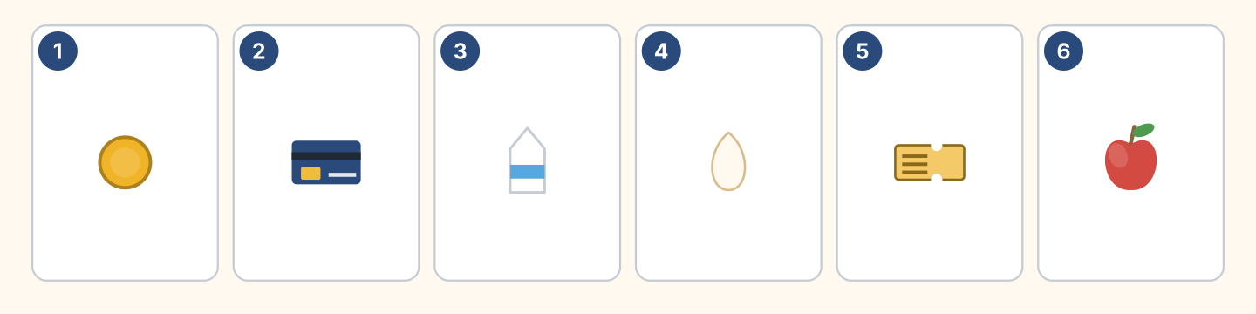
Figure 4.34 · Six things from this unit.
Words: apple · card · coin · egg · milk · ticket
- 1 — coin (example)
- 2 — ______________
- 3 — ______________
- 4 — ______________
- 5 — ______________
8B Look at Figure 4.35. Complete the questions.
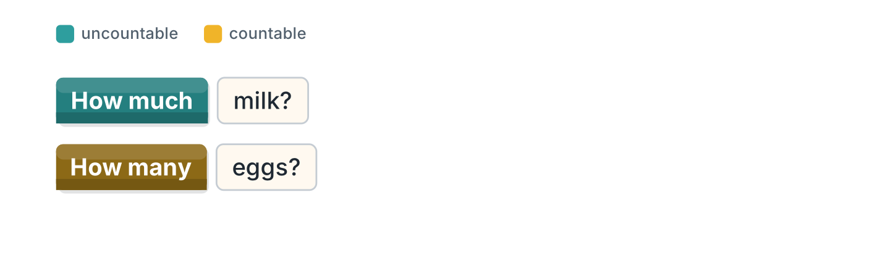
Figure 4.35 · Much or many, in blocks.
Words: eggs · many · milk · much
- How ______ milk? (much) (example)
- How much ______ ?
- How ______ eggs?
- How many ______ ?
8C Look at Figure 4.36. Answer the questions.
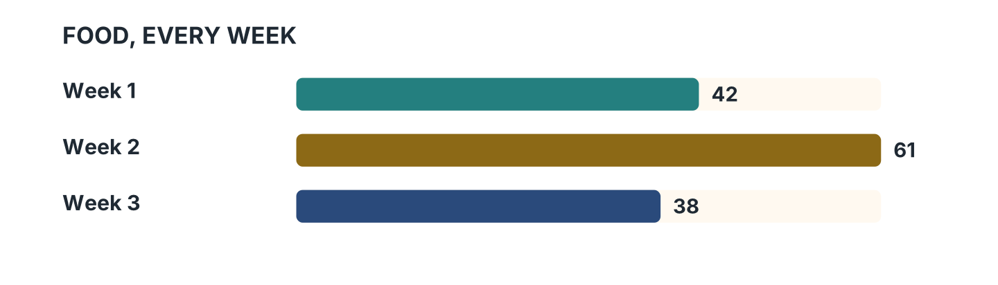
Figure 4.36 · Three weeks of spending.
- Which week was the most expensive? — week 2 (example)
- How much was week 1? — ______________
- Which week was the cheapest? — ______________
- How much was week 2? — ______________
8D Look at Figure 4.37. Match the person and the answer.
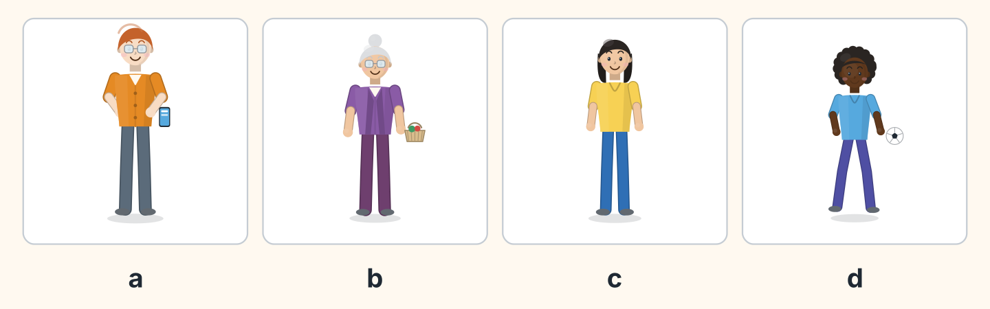
Figure 4.37 · Four answers about money.
Person | What they say
1 Ben | a I count the money in the till every night.
2 Rosa | b My pension arrives on the third of the month.
3 Lili | c My wage from the cafe is not very big.
4 Omar | d I have got a few coins and that is all.
 | e I pay the rent for all the flats.
One option is not needed.
- 1 — a (example)
- 2 — ______
- 3 — ______
- 4 — ______
8E Look at Figure 4.38. Tick what you can do.
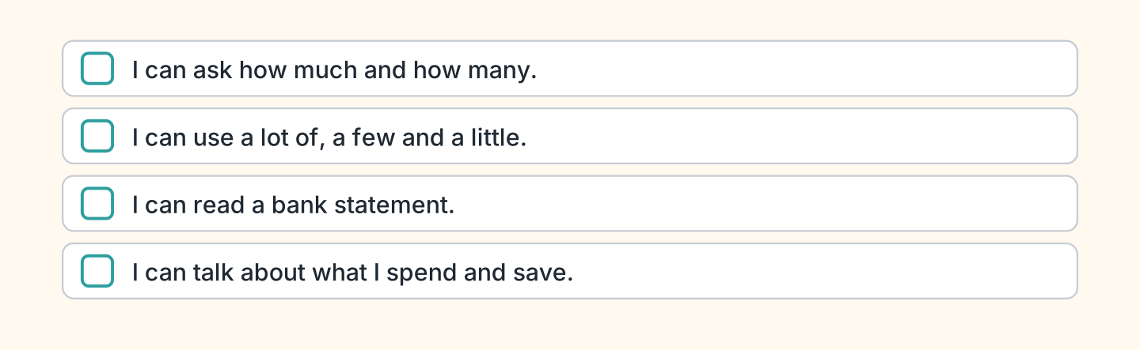
Figure 4.38 · What I can do.
- I can ask how much and how many. — ✓ (example)
- I can use a lot of, a few and a little. — ______
- I can read a bank statement. — ______
- I can talk about what I spend and save. — ______

Unit 5: What Happened
In this unit you say what you were doing when something happened.
Warm Up
W1 Look at Figure 5.1. Answer the questions.
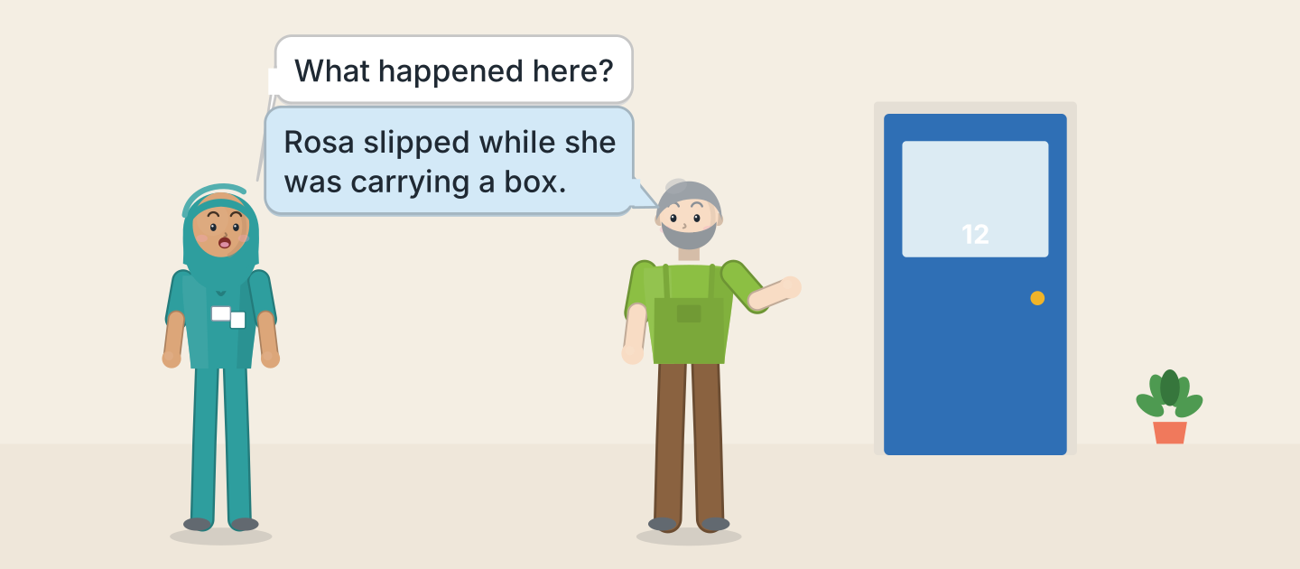
Figure 5.1 · Something happened on the stairs.
- Who asks the question? — Fatima (example)
- What was Rosa carrying? — ______________
- Where did it happen? — ______________
- Who tells Fatima about it? — ______________
W2 Look at Figure 5.2. Answer the questions.
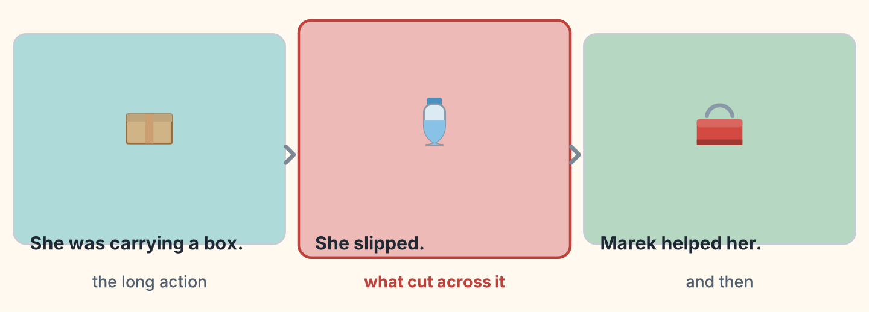
Figure 5.2 · One long action, one short.
- What was the long action? — carrying a box (example)
- What was the short action? — ______________
- What happened after that? — ______________
- Which picture is the accident? — ______________
W3 Look at Figure 5.3. Write the word.
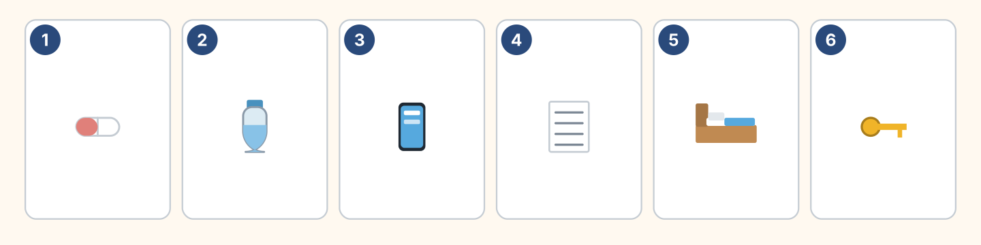
Figure 5.3 · Six things after an accident.
Words: bed · bottle · key · paper · phone · pill
- 1 — pill (example)
- 2 — ______________
- 3 — ______________
- 4 — ______________
- 5 — ______________
Part 1 · Words & Sounds
1A Look at Figure 5.4. Write was or were.
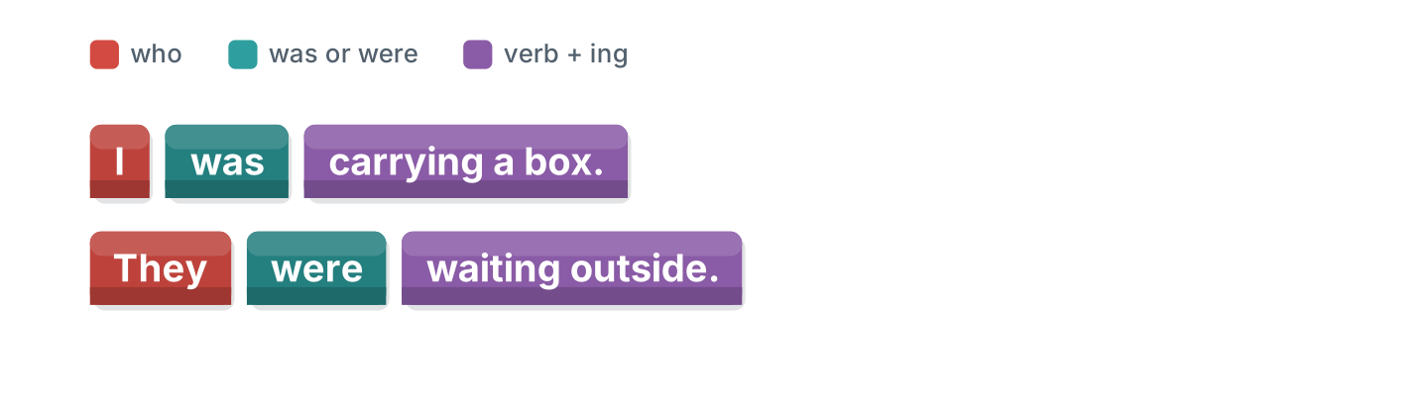
Figure 5.4 · Was and were, plus ing.
- I ______ carrying a box. — was (example)
- They ______ standing in the yard.
- She ______ going downstairs.
- We ______ closing the shop.
1B Look at Figure 5.5. Write when or while.
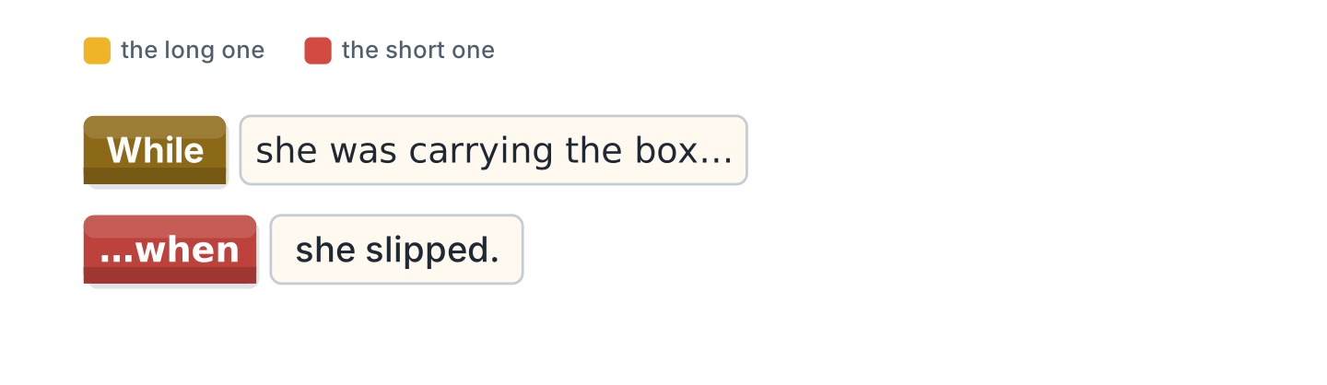
Figure 5.5 · When and while.
- ______ she was carrying the box, she slipped. — While (example)
- She was carrying the box ______ she slipped.
- ______ I was reading, the phone rang.
- I was reading ______ the phone rang.
1C Look at Figure 5.6. Write what the person is carrying.
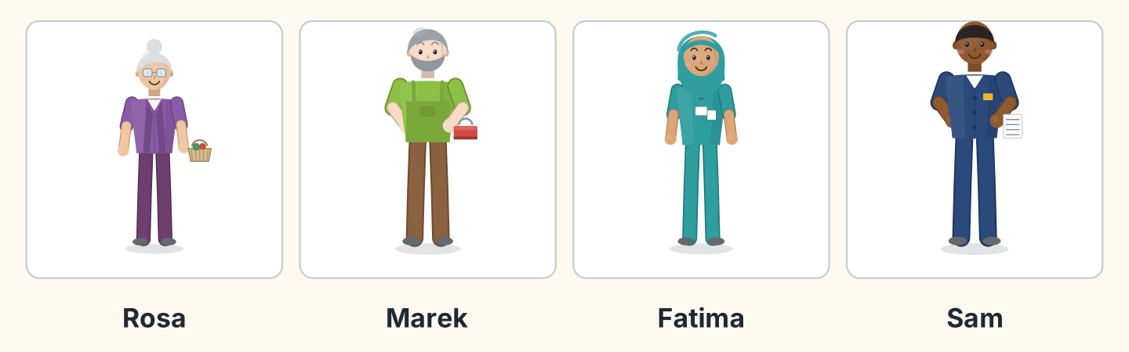
Figure 5.6 · Four people on that morning.
- Rosa — a basket (example)
- Marek — ______________
- Fatima — ______________
- Sam — ______________
1D Say it. Look at Figure 5.7. Say the short forms.
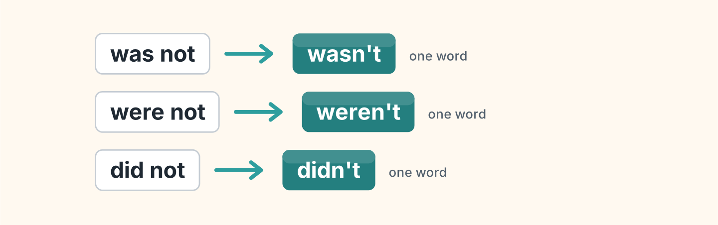
Figure 5.7 · The short forms in the past.
- was not — wasn’t (example)
- were not
- did not
- could not
- had not
1E Look at Figure 5.8. Answer the questions.
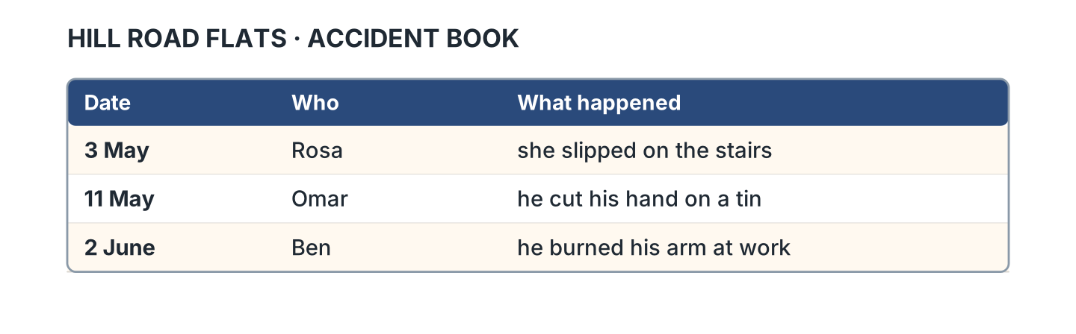
Figure 5.8 · The accident book.
- What happened to Rosa? — she slipped on the stairs (example)
- What happened to Omar? — ______________
- When did Ben burn his arm? — ______________
- How many accidents are in the book? — ______________
1F Look at Figure 5.9. Write the word for the meaning.
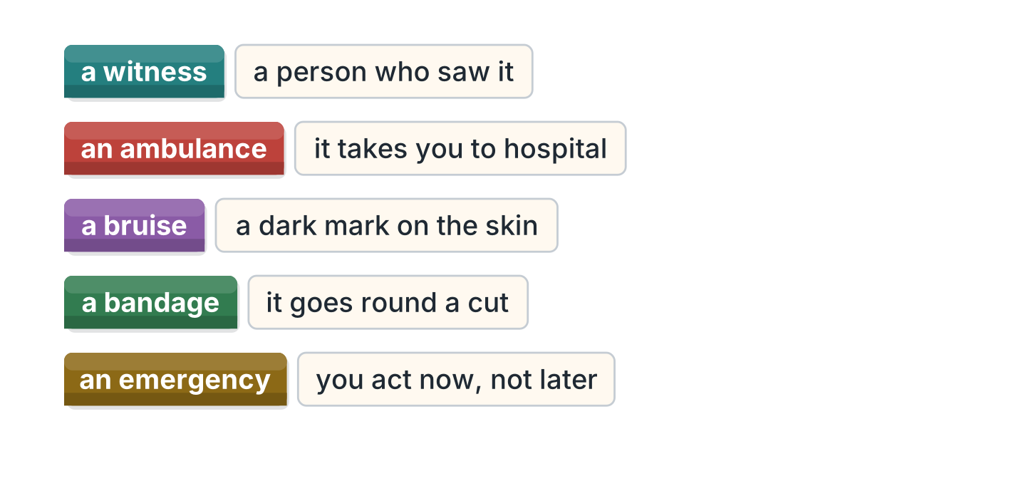
Figure 5.9 · Five words about an accident.
- a person who saw it — a witness (example)
- it takes you to hospital — ______________
- a dark mark on the skin — ______________
- it goes round a cut — ______________
- you act now, not later — ______________
Part 2 · Grammar
2A Look at Figure 5.10. Answer the questions.
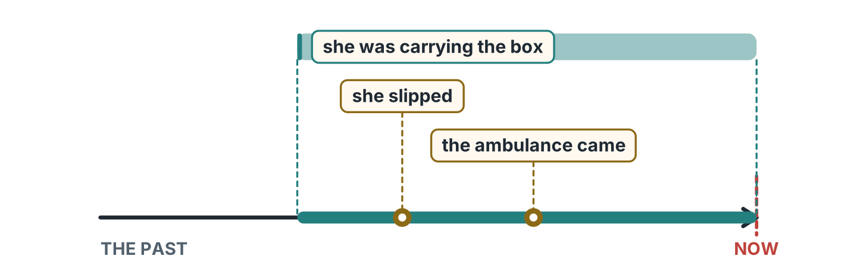
Figure 5.10 · The long one and the short one.
- What was the long action? — carrying the box (example)
- What was the first short action? — ______________
- What came last? — ______________
- Was she carrying the box when she slipped? — ______________
2B Look at Figure 5.11. Write the answer.
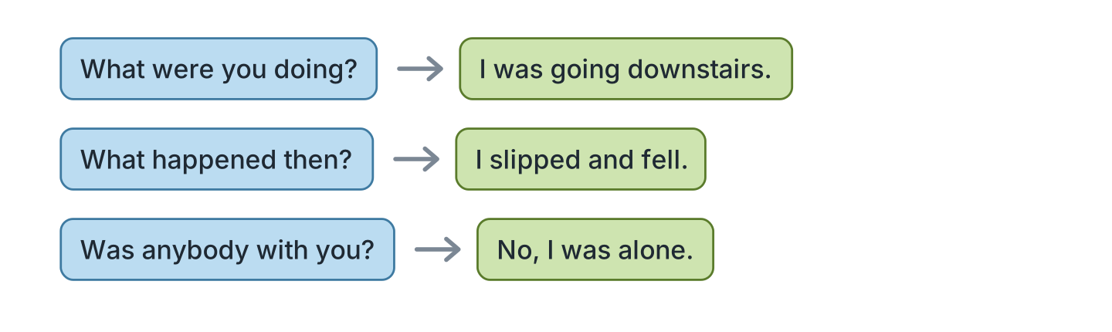
Figure 5.11 · Asking what happened.
- What were you doing? — I was going downstairs. (example)
- What happened then? (slip and fall) — ______________
- Was anybody with you? ✗ — ______________
- Were you carrying anything? ✓ — ______________
2C Look at Figure 5.12. Write yes or no.
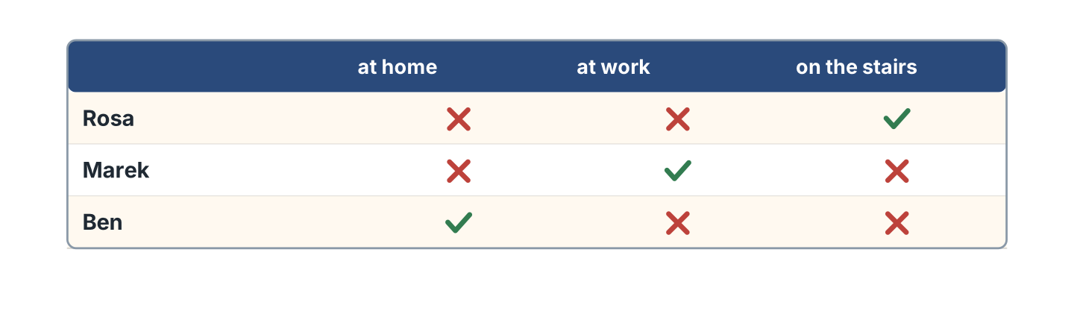
Figure 5.12 · Who was where at nine.
- Rosa was on the stairs. — yes (example)
- Marek was at home. — ______
- Ben was at work. — ______
- Marek was at work. — ______
2D Look at Figure 5.13. Choose the correct verb.
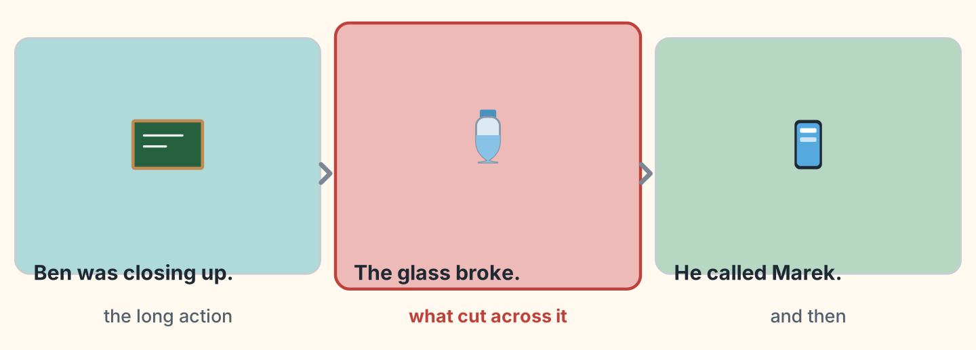
Figure 5.13 · Two cut across by one.
- Ben (was closing / closed) the shop. — was closing (example)
- The glass (was breaking / broke).
- He (was calling / called) Marek.
- While he (was closing / closed), the glass broke.
- When the glass (was breaking / broke), he called Marek.
2E Look at Figure 5.14. Write the sentence the other way.
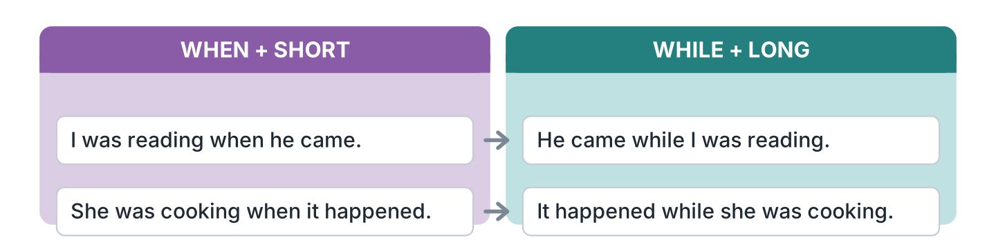
Figure 5.14 · Which verb takes the ing.
- I was reading when he came. — He came while I was reading. (example)
- She was cooking when it happened. — ______________
- He came while I was waiting. — ______________
- It rained while we were walking. — ______________
2F Look at Figure 5.15. Find the mistake and write it correctly.
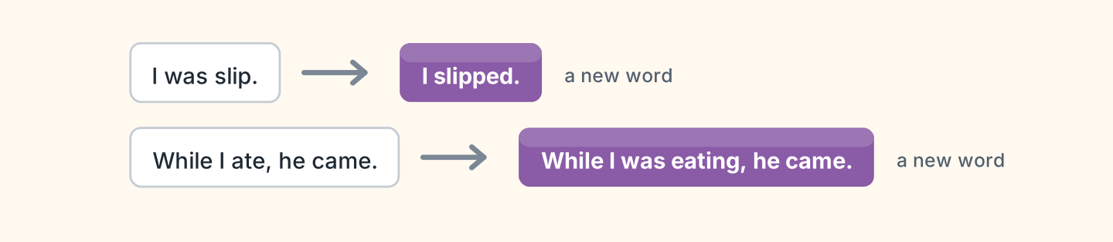
Figure 5.15 · Mistakes with the two pasts.
- I was slip. — I slipped (example)
- While I ate, he came. — ______________
- They was waiting outside. — ______________
- She slipped while she carried a box. — ______________
Part 3 · Listening
3A Listen. Look at Figure 5.16. Write the number.
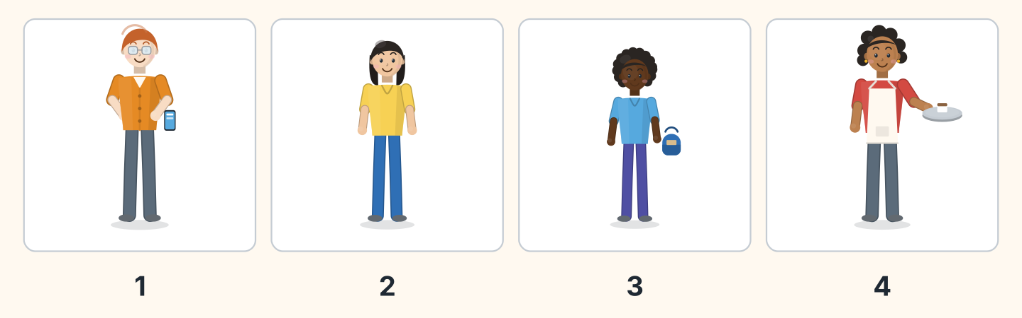
Figure 5.16 · Four witnesses.
- Ben — 1 (example)
- Lili — ______
- Omar — ______
- Nadia — ______
3B Listen. Look at Figure 5.17. Write the answer you hear.
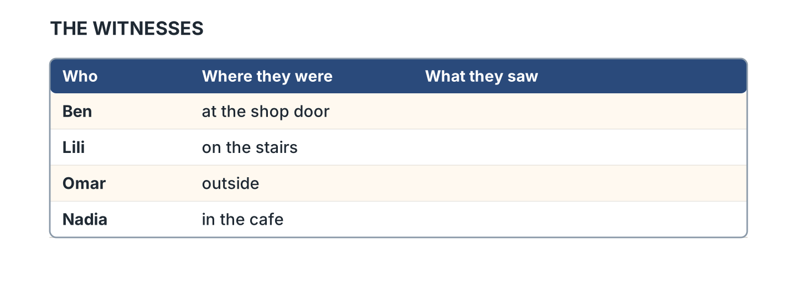
Figure 5.17 · What each witness said.
- Where was Ben? — at the shop door (example)
- What did Lili see? — ______________
- What did Omar see? — ______________
- Who saw nothing? — ______________
3C Listen. Look at Figure 5.18. Answer the questions.
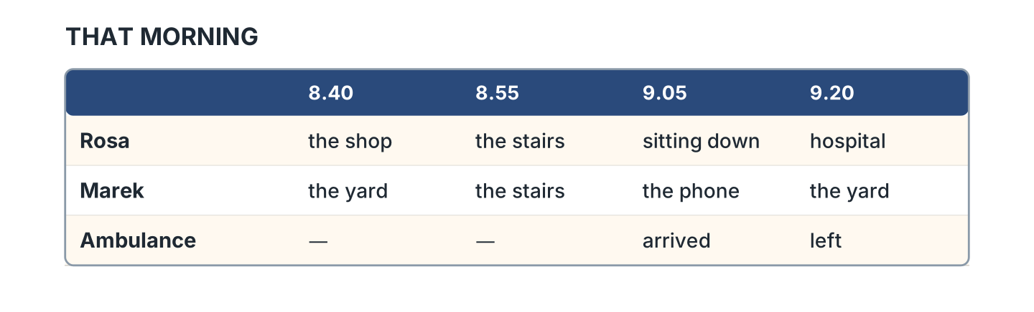
Figure 5.18 · The times that morning.
- Where was Rosa at 8.40? — the shop (example)
- Where was Rosa at 8.55? — ______________
- When did the ambulance arrive? — ______________
- Where was Marek at 9.05? — ______________
3D Listen. Look at Figure 5.19. Write the number of the thing you hear.
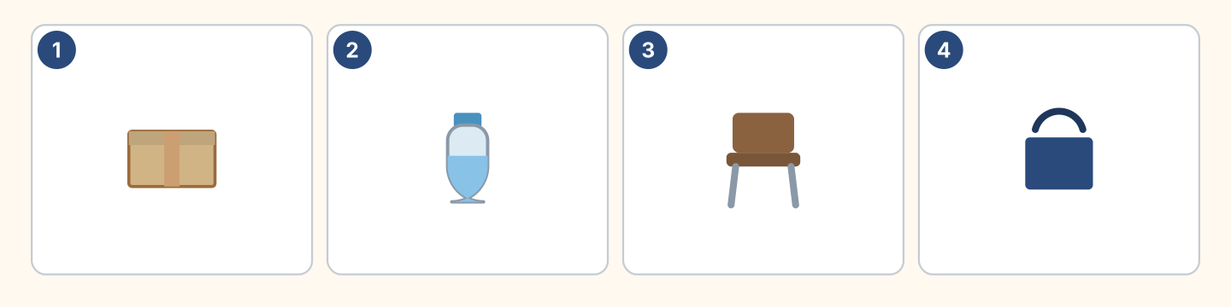
Figure 5.19 · Four more things to hear.
- a box — 1 (example)
- a bottle — ______
- a chair — ______
- a bag — ______
Part 4 · Speaking
4A Look at Figure 5.20. Tell a friend about something that happened.
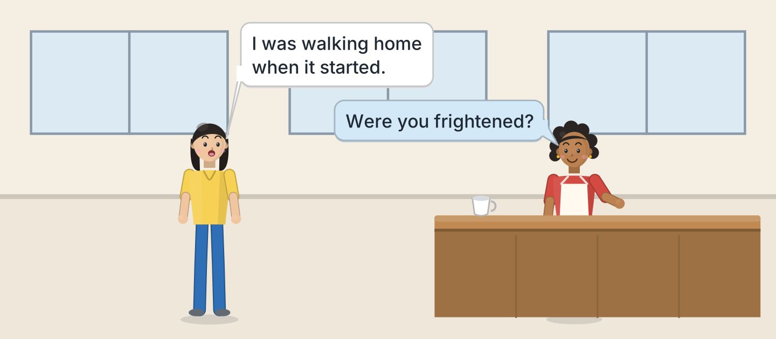
Figure 5.20 · Telling a friend what happened.
- A: I was walking home when it started. B: Were you frightened? (example)
- Say what you were doing, and how much money you had on you.
- Say what happened suddenly, and what the damage was worth.
- Say whether you were lucky, and what it cost to mend.
4B Look at Figure 5.21. Ask and answer.
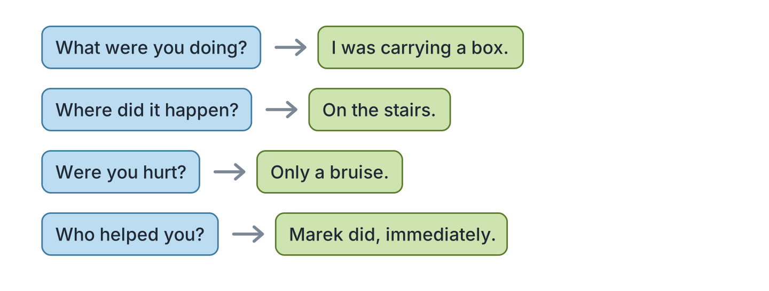
Figure 5.21 · Four questions about an accident.
- A: What were you doing? B: I was carrying a box. (example)
- A: Where did it happen? B: ______________
- A: Were you hurt? B: ______________
- A: Who helped you? B: ______________
4C Look at Figure 5.22. Say what happens in each picture.
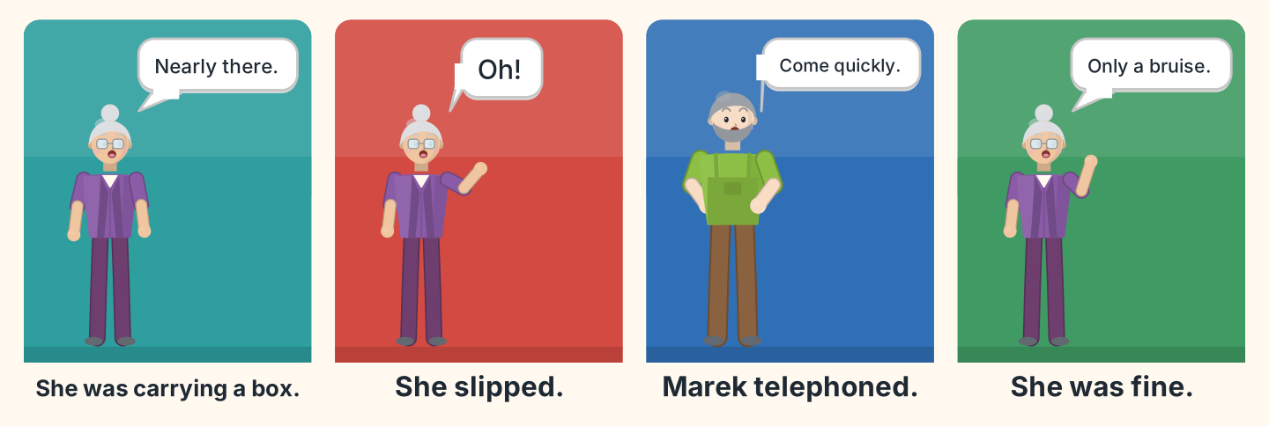
Figure 5.22 · The morning in four moments.
- First Rosa was carrying a box down the stairs. (example)
- Say what happened suddenly in the second picture.
- Say who telephoned, and what he said.
- Say how Rosa was at the end of the hour, and why she felt relieved.
4D Look at Figure 5.23. Ask two of these people what they saw.
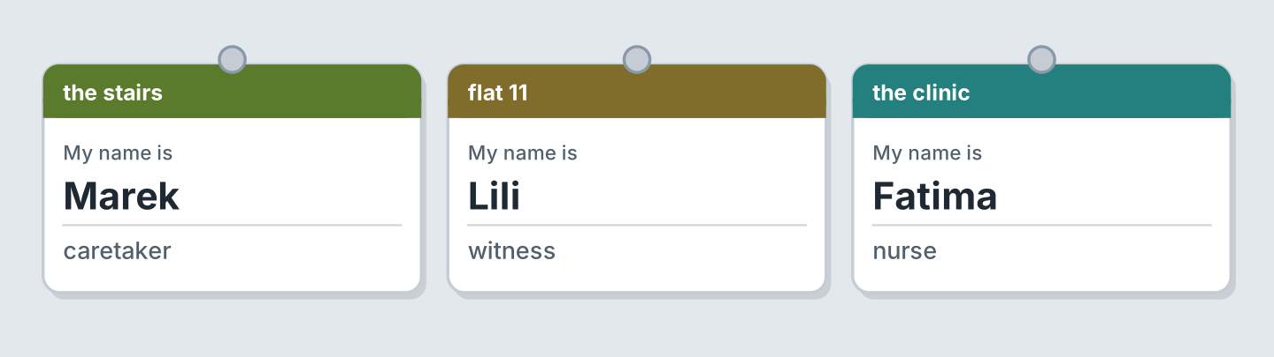
Figure 5.23 · Three people who were there.
- A: Where were you at nine? B: I was in the yard, quite near the stairs. (example)
- Ask Marek what he was doing when he heard the shout.
- Ask Lili what she saw, and what the charge to mend it was.
- Say what you were doing at nine, and whether you could afford the day off.
Part 5 · Reading
5A Look at Figure 5.24. Answer the questions.
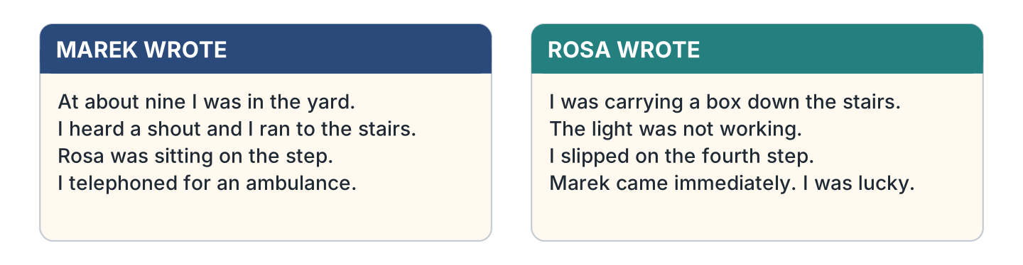
Figure 5.24 · Two reports of the same morning.
- Where was Marek at nine? — in the yard (example)
- What did Marek hear? — ______________
- Which step did Rosa slip on? — ______________
- What was not working? — ______________
5B Look at Figure 5.25. Answer the questions.
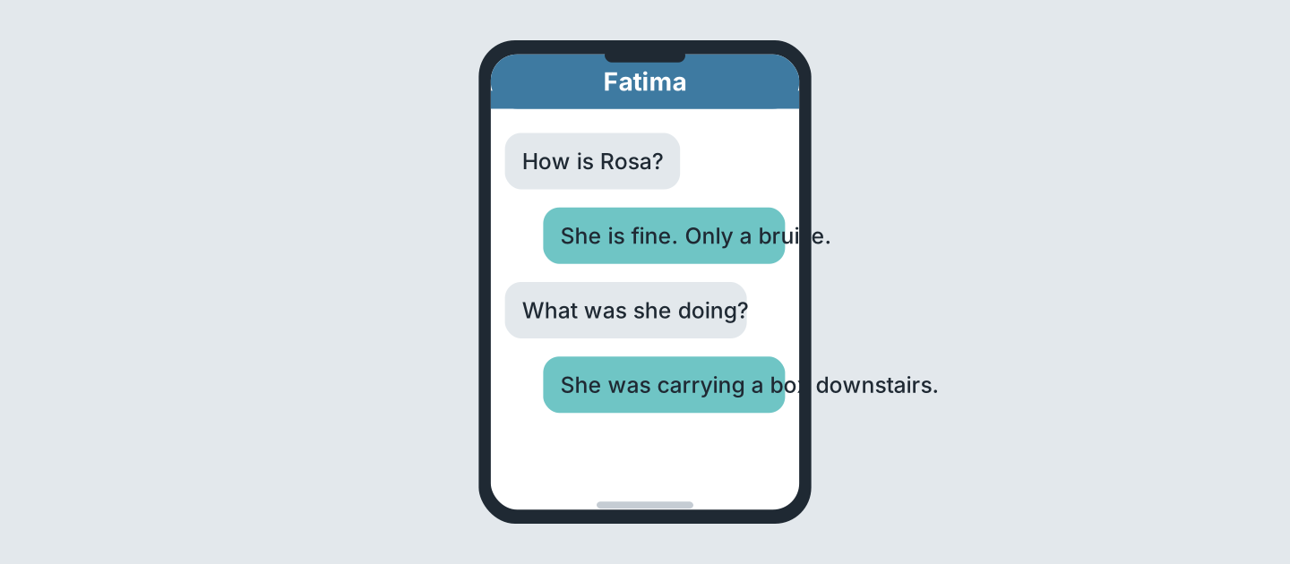
Figure 5.25 · Messages from the hospital.
- How is Rosa? — fine, only a bruise (example)
- What was Rosa doing? — ______________
- Who answers the questions? — ______________
- Where was she going? — ______________
5C Look at Figure 5.26. Choose the correct answer.
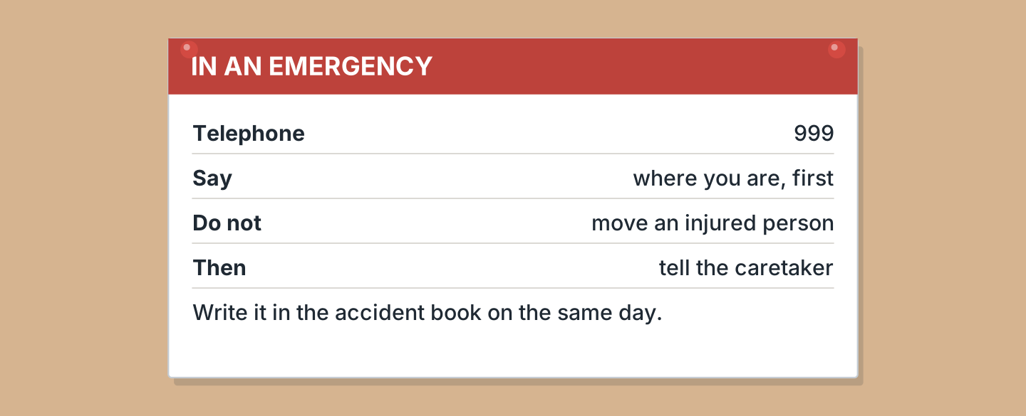
Figure 5.26 · What to do in an emergency.
- What number do you telephone? (a) 111 (b) 999 (c) 112 — b (example)
- What do you say first? (a) your name (b) the time (c) where you are
- What do you never do? (a) move the person (b) telephone (c) wait
- When do you write it down? (a) the same day (b) in a week (c) never
5D Look at Figure 5.27. Read and correct. Write the correct word.
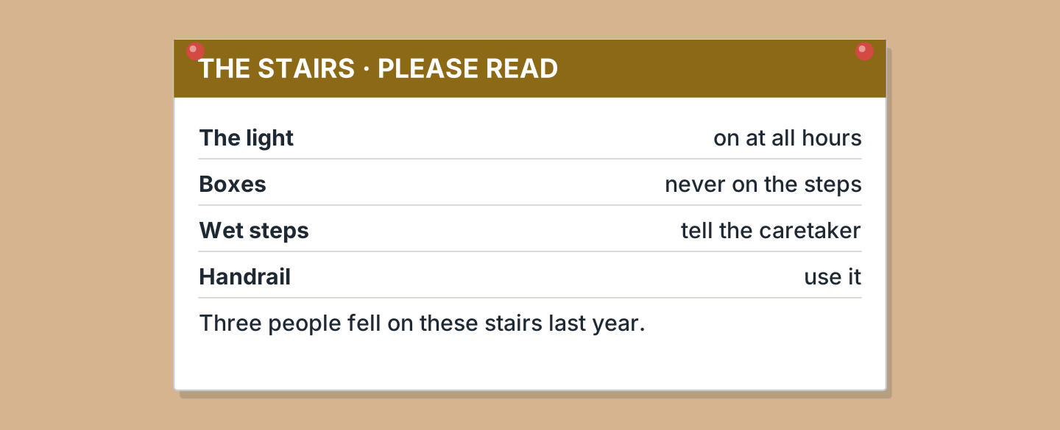
Figure 5.27 · A safety notice.
- Boxes can stay on the steps. — never (example)
- The light is on in the morning only. — ______________
- Two people fell last year. — ______________
- You tell the agent about wet steps. — ______________
Part 6 · Writing
6A Look at Figure 5.28. Complete the form about an accident.
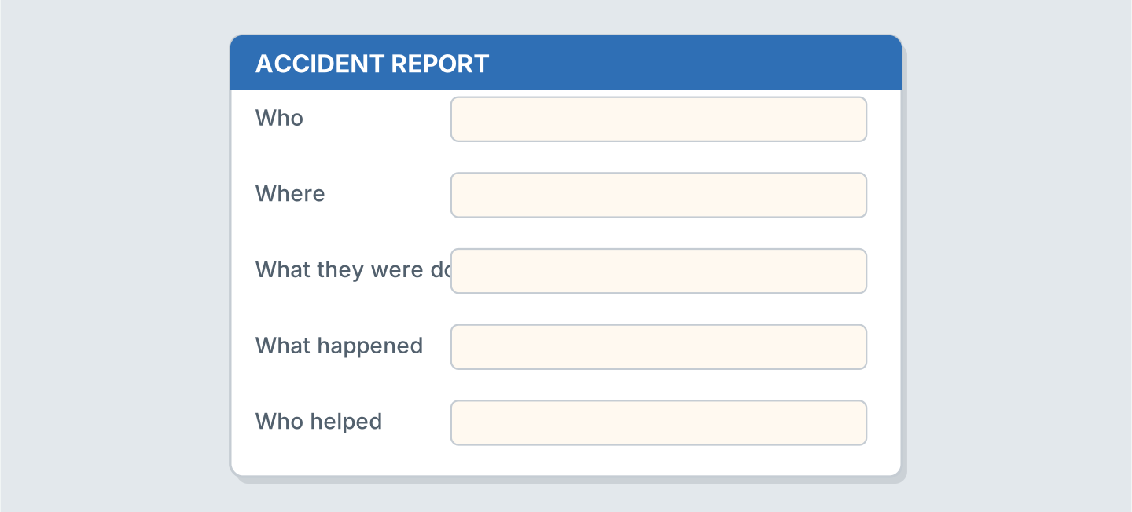
Figure 5.28 · An accident form.
- Who: Rosa (example)
- Where, and the value of the damage: ______________
- What they were doing, and who paid the fee: ______________
- What happened: ______________
6B Look at Figure 5.29. Write four lines about something that happened.
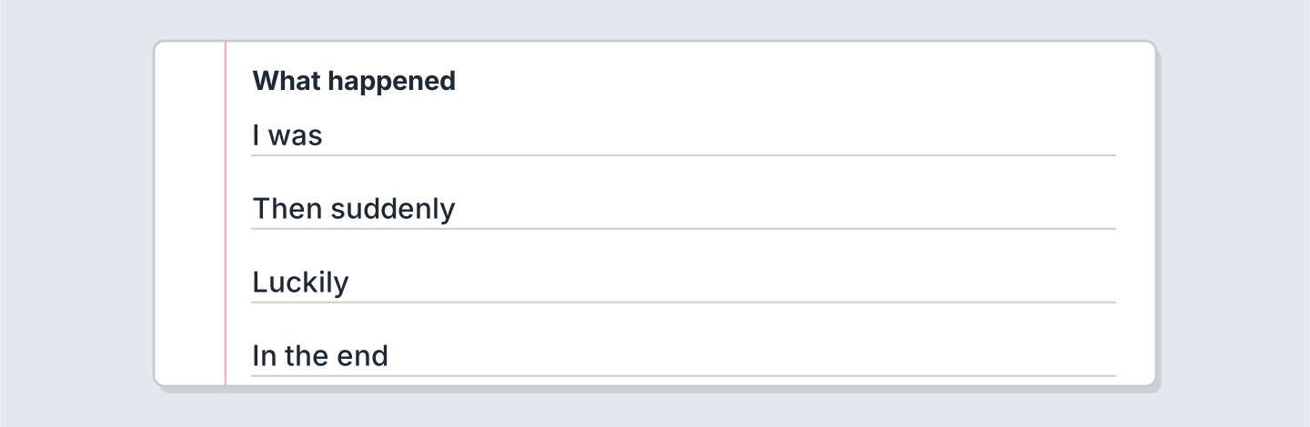
Figure 5.29 · Four lines about what happened.
- I was waiting for the bus. (example)
- I was ______________.
- Then suddenly ______________.
- Luckily the amount I had to spend was ______________.
6C Look at Figure 5.30. Write four lines about an accident you know.
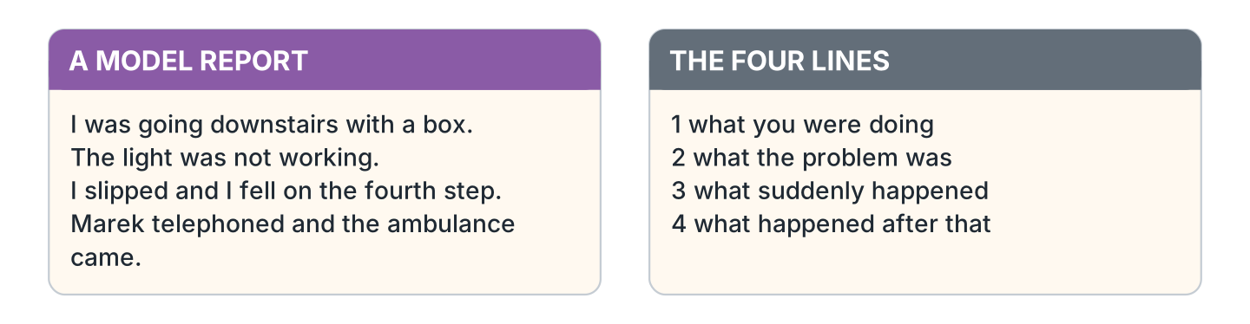
Figure 5.30 · A model report.
- I was going downstairs with a heavy box. (example)
- Say what you were doing, and whether the light was bright enough.
- Say what the problem was, and what it cost to mend.
- Say what suddenly happened.
- Say what happened after that, and who paid.
Part 7 · Real-World File
7A Look at Figure 5.31. Answer the questions.
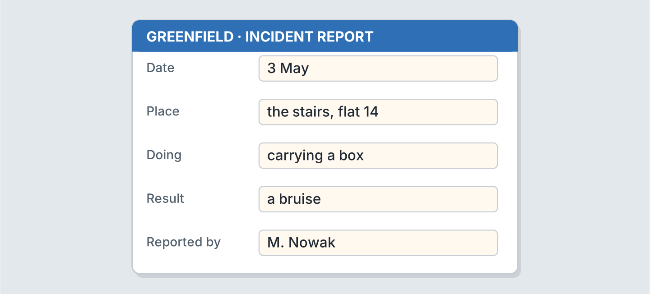
Figure 5.31 · A real incident report.
- What is the date? — 3 May (example)
- Where did it happen? — ______________
- What was the person doing? — ______________
- Who reported it? — ______________
7B Look at Figure 5.32. Answer the questions.
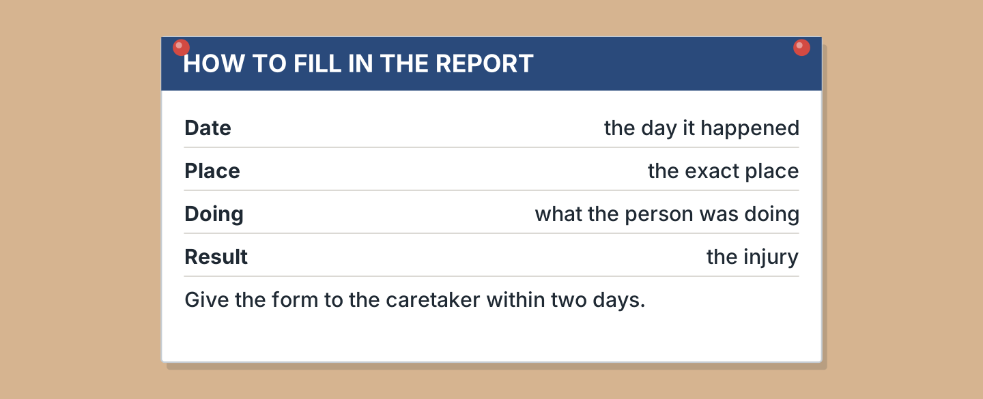
Figure 5.32 · What the form asks for.
- What date do you write? — the day it happened (example)
- What do you write under Place? — ______________
- What do you write under Result? — ______________
- How soon do you give the form in? — ______________
7C Look at Figure 5.33. Write about where you report a problem.
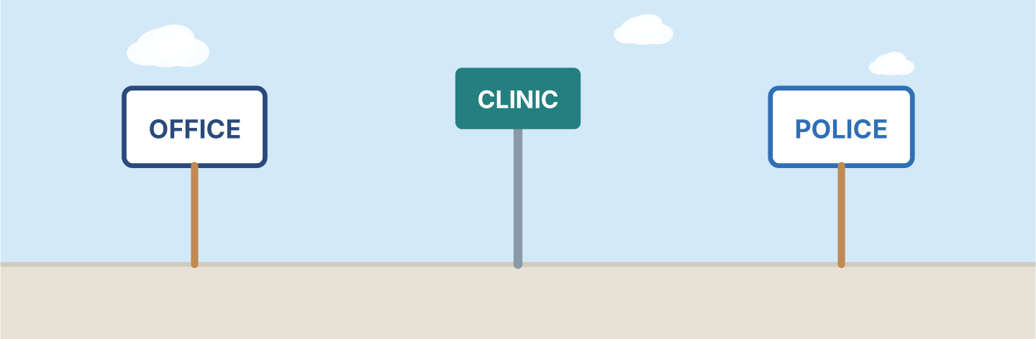
Figure 5.33 · Three places to report it.
- At work I tell my supervisor immediately, on the same shift. (example)
- Who I tell at work, my supervisor or a workmate: ______________
- Who I tell at home, and whether the deposit covers it: ______________
- What it normally costs to mend, and who refunds it: ______________
Part 8 · Review & Can-Do
8A Look at Figure 5.34. Write the word.
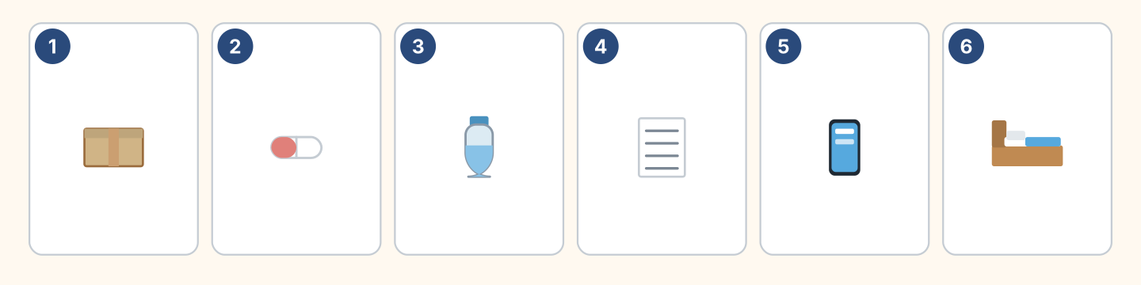
Figure 5.34 · Six things from this unit.
Words: bed · bottle · box · paper · phone · pill
- 1 — box (example)
- 2 — ______________
- 3 — ______________
- 4 — ______________
- 5 — ______________
8B Look at Figure 5.35. Complete the sentences.
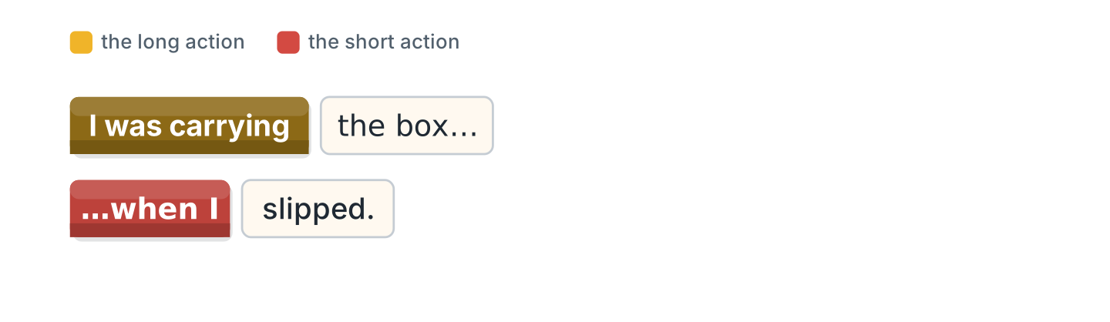
Figure 5.35 · The two pasts in blocks.
Words: carrying · slipped · was · when
- I ______ carrying the box. (was) (example)
- I was ______ the box.
- I was carrying the box ______ I slipped.
- I was carrying the box when I ______ .
8C Look at Figure 5.36. Write the past form.
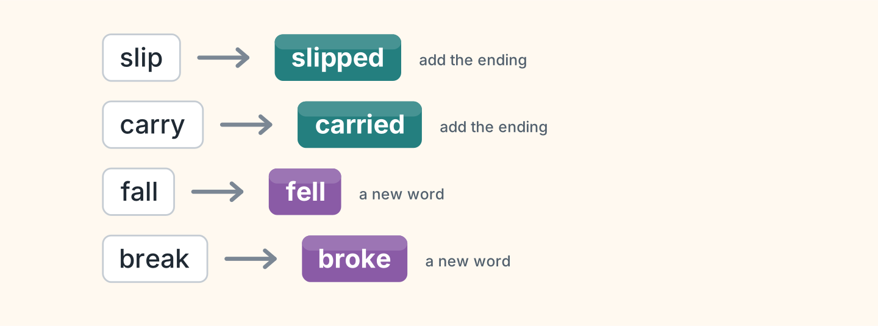
Figure 5.36 · Four verbs in the past.
- slip — slipped (example)
- carry — ______________
- fall — ______________
- break — ______________
8D Look at Figure 5.37. Match the person and the account.
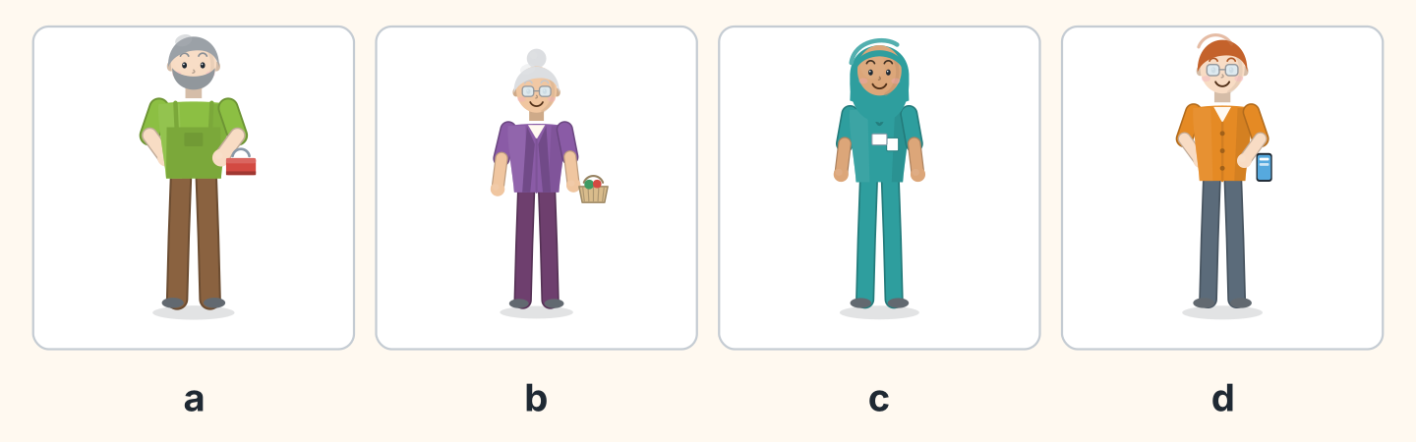
Figure 5.37 · Four people, four accounts.
Person | What they say
1 Marek | a I was in the yard when I heard a shout.
2 Rosa | b I was carrying a box when I slipped.
3 Fatima | c I was at the clinic when they telephoned.
4 Ben | d I was closing the shop when the glass broke.
 | e I was driving the bus at the time.
One option is not needed.
- 1 — a (example)
- 2 — ______
- 3 — ______
- 4 — ______
8E Look at Figure 5.38. Tick what you can do.
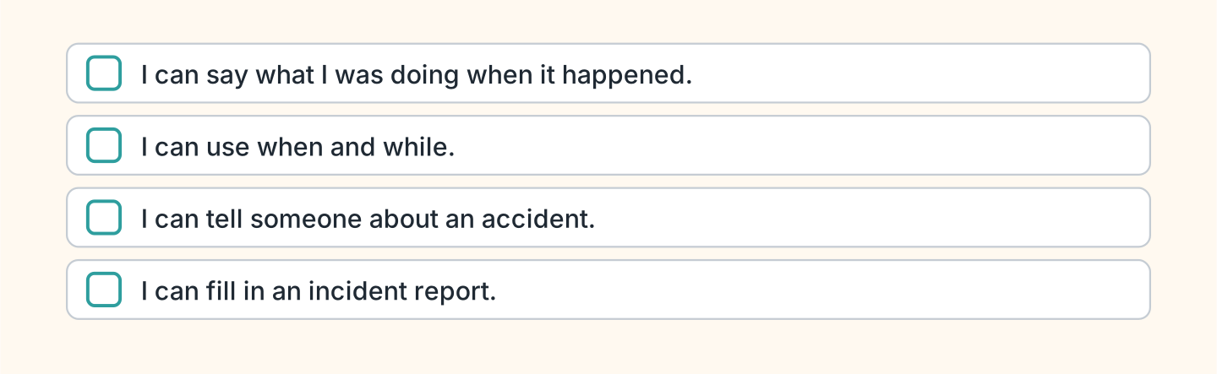
Figure 5.38 · What I can do.
- I can say what I was doing when it happened. — ✓ (example)
- I can use when and while. — ______
- I can tell someone about an accident. — ______
- I can fill in an incident report. — ______

Unit 6: Getting There
In this unit you say how you travel, and what you have to do.
Warm Up
W1 Look at Figure 6.1. Answer the questions.
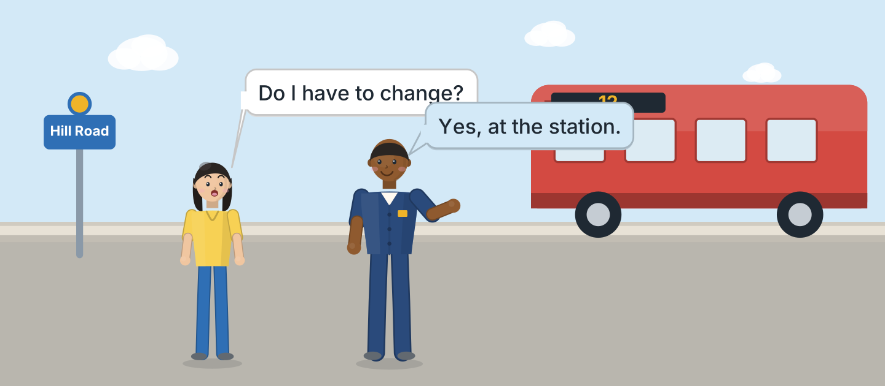
Figure 6.1 · Sam explains the route.
- What does Lili ask about? — changing buses (example)
- Where does she have to change? — ______________
- Who answers her? — ______________
- Where are they standing? — ______________
W2 Look at Figure 6.2. Answer the questions.
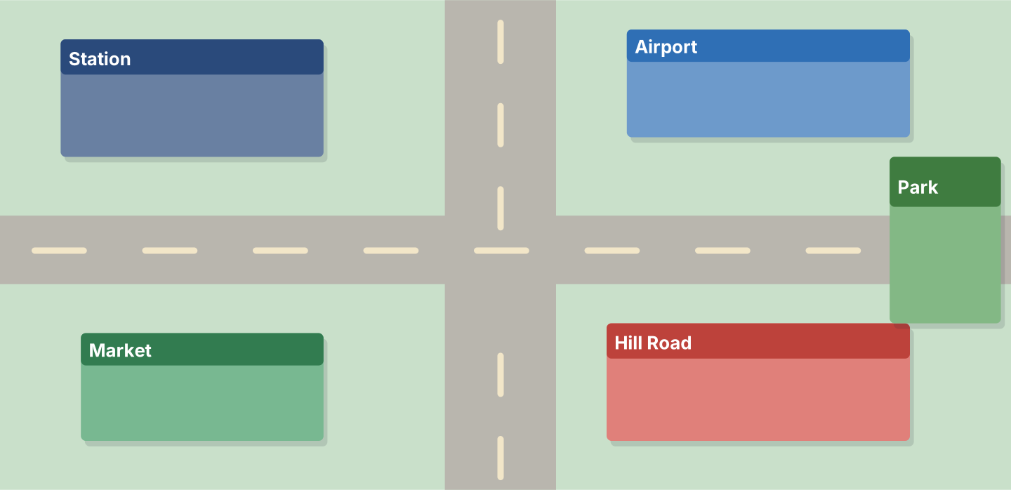
Figure 6.2 · The town and the routes.
- Which place is at the top left? — the Station (example)
- Which place is at the top right? — ______________
- Which place is at the bottom left? — ______________
- Which place is furthest right? — ______________
W3 Look at Figure 6.3. Write the word.
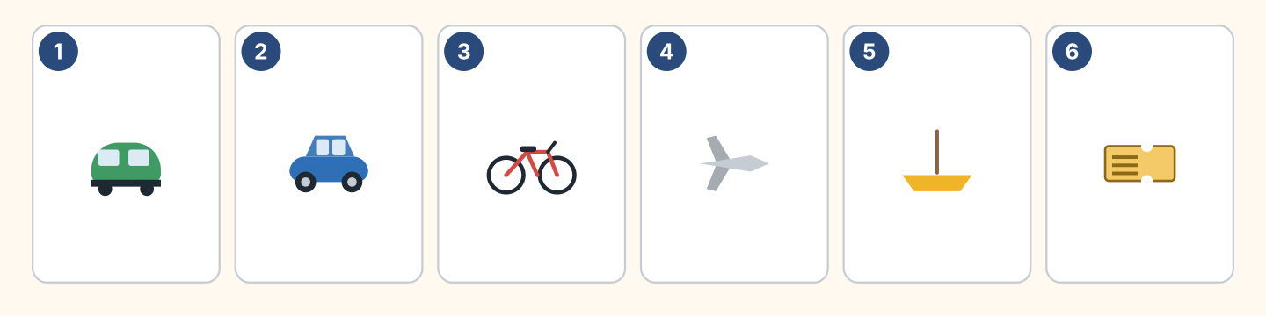
Figure 6.3 · Six ways to travel.
Words: bike · boat · car · plane · ticket · train
- 1 — train (example)
- 2 — ______________
- 3 — ______________
- 4 — ______________
- 5 — ______________
Part 1 · Words & Sounds
1A Look at Figure 6.4. Write the preposition.
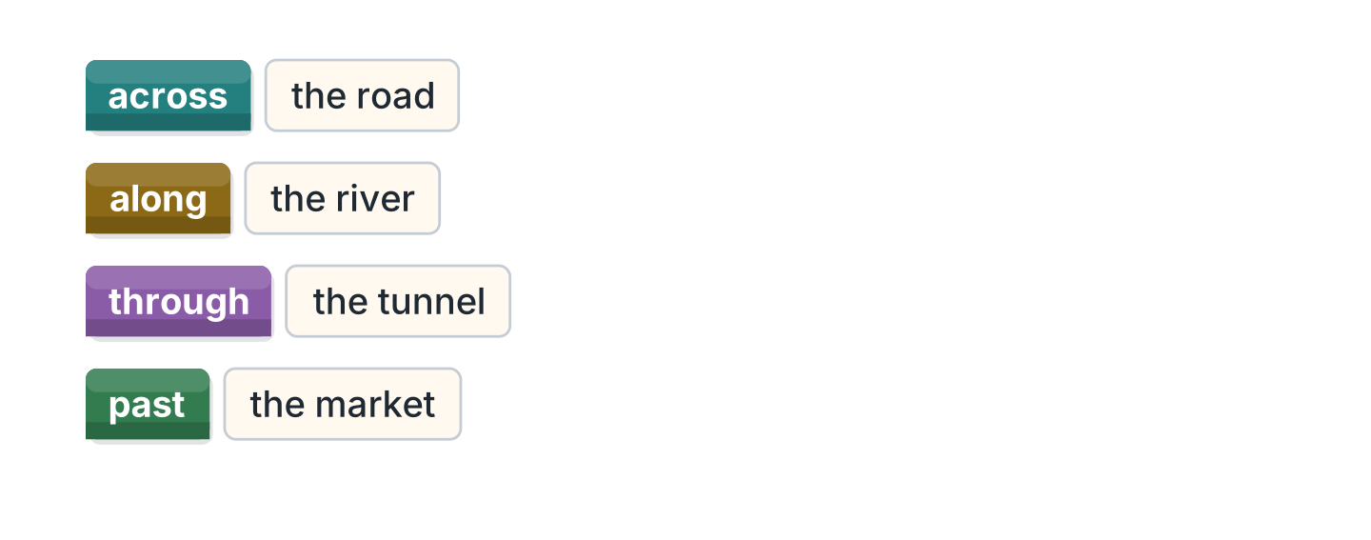
Figure 6.4 · Across, along, through, past.
- ______ the road — across (example)
- ______ the river
- ______ the tunnel
- ______ the market
1B Look at Figure 6.5. Write have to or do not have to.
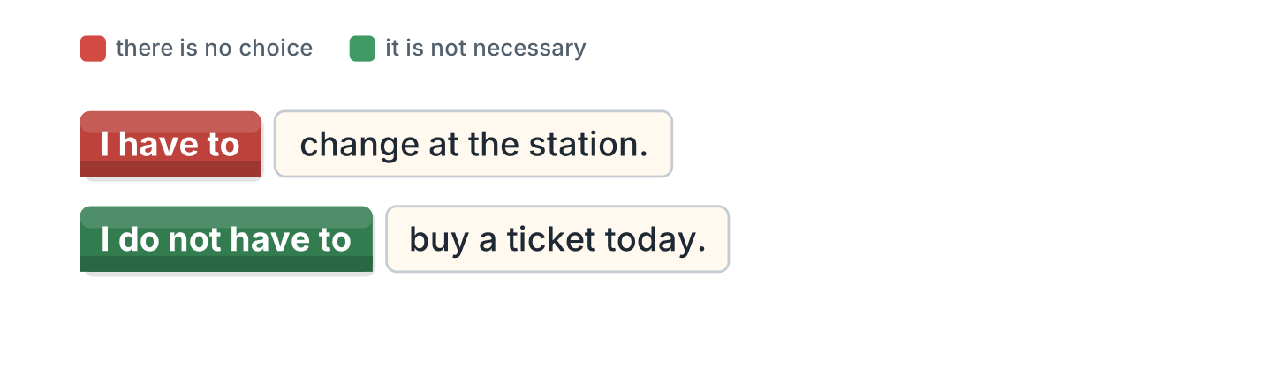
Figure 6.5 · Have to and do not have to.
- I ______ change at the station. — have to (example)
- I ______ buy a ticket today.
- Children ______ pay the fare.
- You ______ show a passport at the gate.
1C Look at Figure 6.6. Write what the person is carrying.
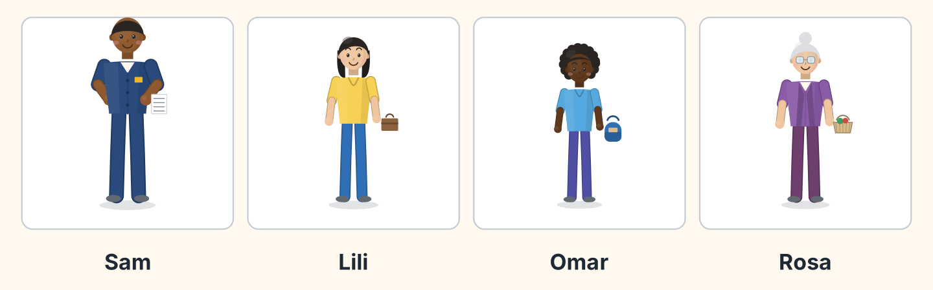
Figure 6.6 · Four travellers this morning.
- Sam — a timetable (example)
- Lili — ______________
- Omar — ______________
- Rosa — ______________
1D Say it. Look at Figure 6.7. Say these words together.
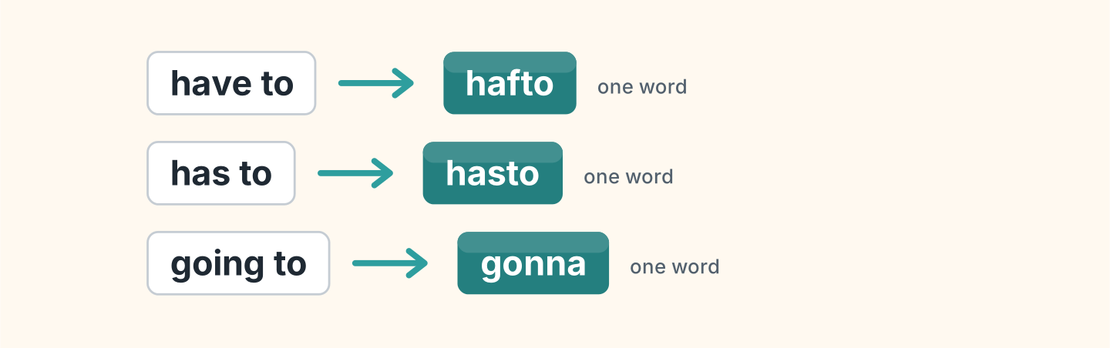
Figure 6.7 · Linking the words together.
- have to — hafto (example)
- has to
- going to
- want to
- have got to
1E Look at Figure 6.8. Answer the questions.
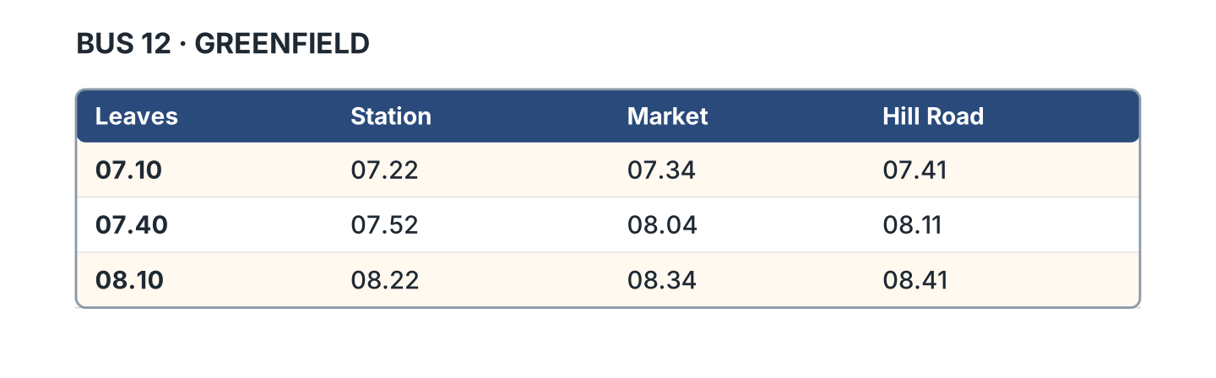
Figure 6.8 · The timetable at the stop.
- When does the first bus leave? — 07.10 (example)
- When does the 07.40 reach the market? — ______________
- How long is the journey to Hill Road? — ______________
- How often does the bus leave? — ______________
1F Look at Figure 6.9. Write the word for the meaning.
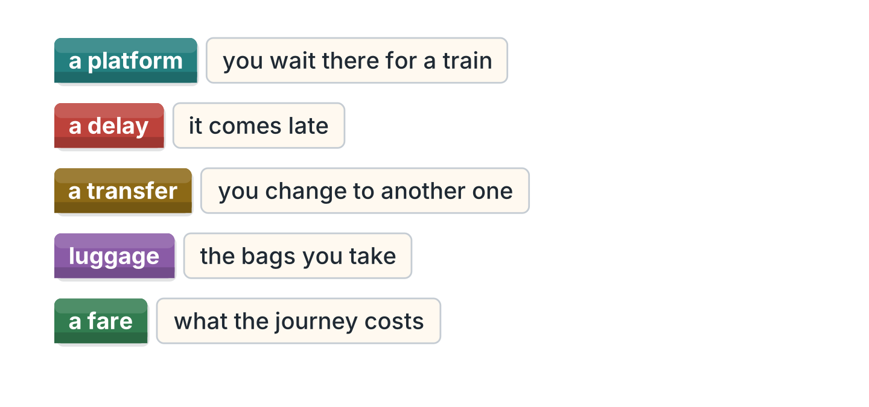
Figure 6.9 · Five words on a journey.
- you wait there for a train — a platform (example)
- it comes late — ______________
- you change to another one — ______________
- the bags you take — ______________
- what the journey costs — ______________
Part 2 · Grammar
2A Look at Figure 6.10. Write the answer.
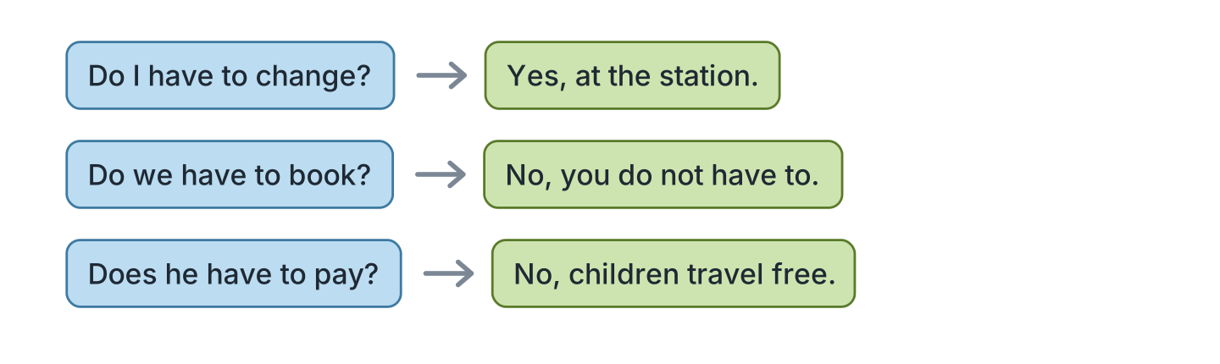
Figure 6.10 · Asking about the rules.
- Do I have to change? ✓ — Yes, at the station. (example)
- Do we have to book? ✗ — ______________
- Does he have to pay? ✗ — ______________
- Do I have to show a card? ✓ — ______________
2B Look at Figure 6.11. Write yes or no.
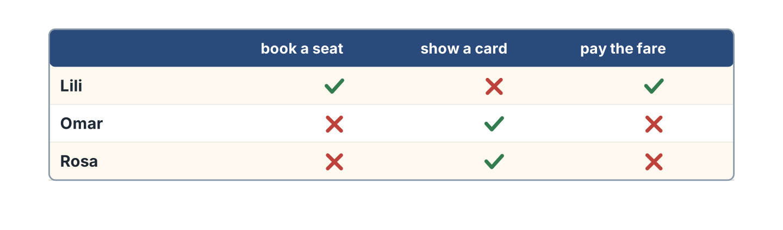
Figure 6.11 · Who has to do what.
- Lili has to book a seat. — yes (example)
- Omar has to pay the fare. — ______
- Rosa has to show a card. — ______
- Lili has to show a card. — ______
2C Look at Figure 6.12. Answer the questions.
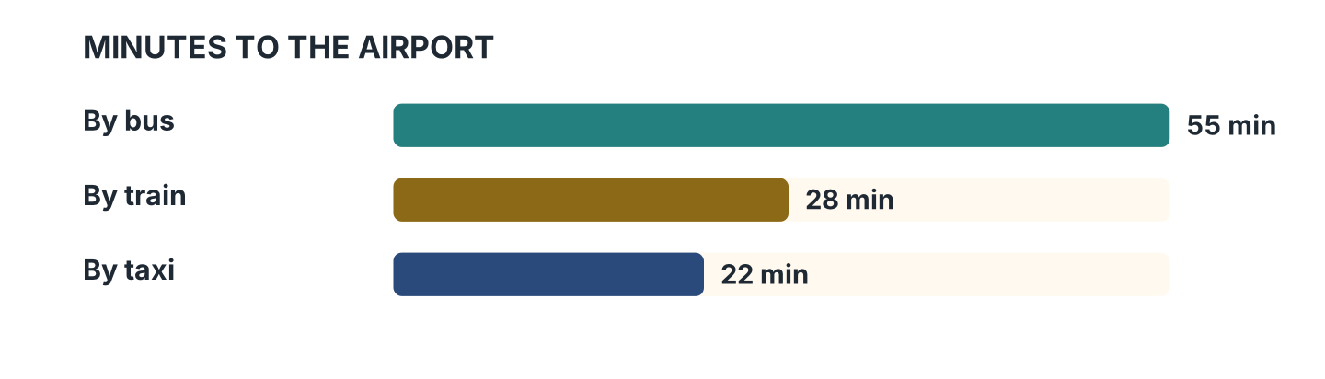
Figure 6.12 · Three ways to the airport.
- How long does the bus take? — 55 minutes (example)
- How long does the train take? — ______________
- Which way is the quickest? — ______________
- How much longer is the bus than the taxi? — ______________
2D Look at Figure 6.13. Write choice or not allowed.
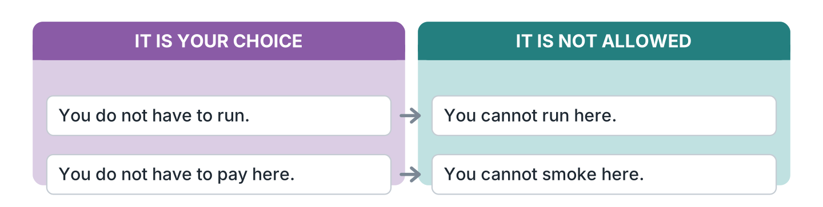
Figure 6.13 · Cannot and do not have to.
- You do not have to run. — choice (example)
- You cannot run here. — ______________
- You do not have to pay here. — ______________
- You cannot smoke here. — ______________
2E Look at Figure 6.14. Answer the questions.
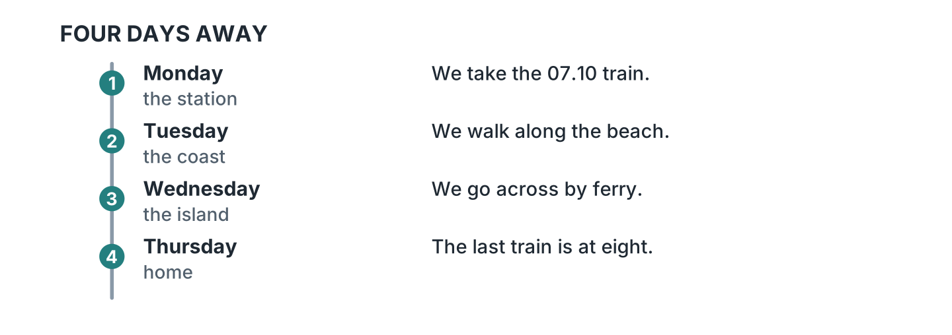
Figure 6.14 · A four-day trip.
- What do they do on Monday? — they take the 07.10 train (example)
- Where do they go on Tuesday? — ______________
- How do they reach the island? — ______________
- When is the last train home? — ______________
2F Look at Figure 6.15. Find the mistake and write it correctly.

Figure 6.15 · Mistakes with have to.
- I have to going. — I have to go (example)
- He have to pay. — ______________
- Do you has to change? — ______________
- She have to leave early. — ______________
Part 3 · Listening
3A Listen. Look at Figure 6.16. Write the number.
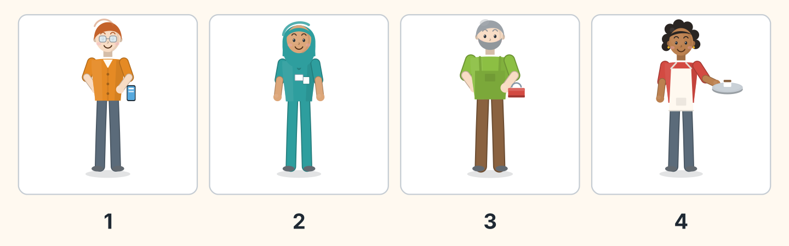
Figure 6.16 · Four passengers.
- Ben — 1 (example)
- Fatima — ______
- Marek — ______
- Nadia — ______
3B Listen. Look at Figure 6.17. Answer the questions.
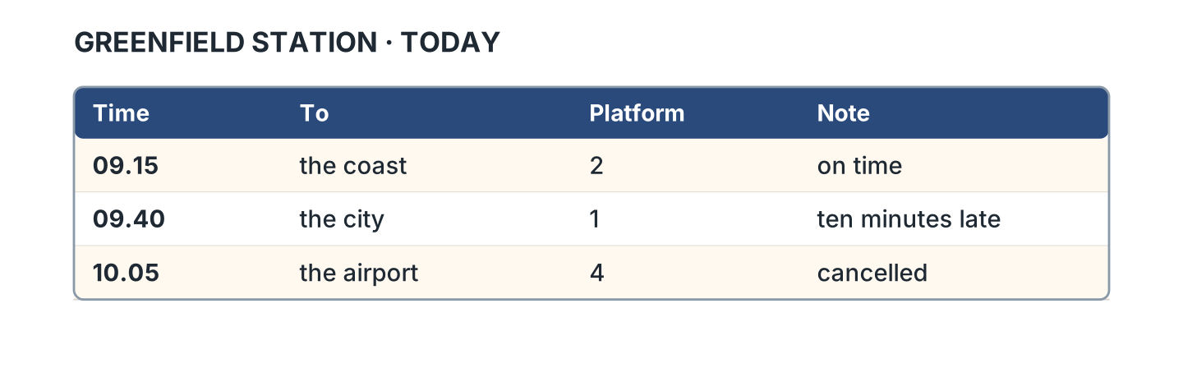
Figure 6.17 · What the announcement said.
- Which platform for the coast? — platform 2 (example)
- Which train is ten minutes late? — ______________
- Which train is cancelled? — ______________
- Which platform is the 09.40 on? — ______________
3C Listen. Look at Figure 6.18. Answer the questions.
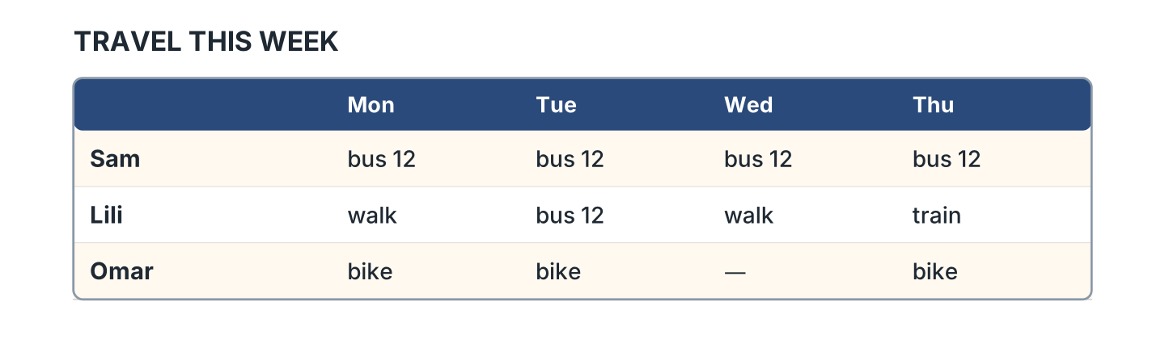
Figure 6.18 · The week of travel.
- How does Sam travel every day? — on bus 12 (example)
- How does Lili travel on Thursday? — ______________
- Which day does Omar not cycle? — ______________
- How many days does Lili walk? — ______________
3D Listen. Look at Figure 6.19. Write the number of the thing you hear.
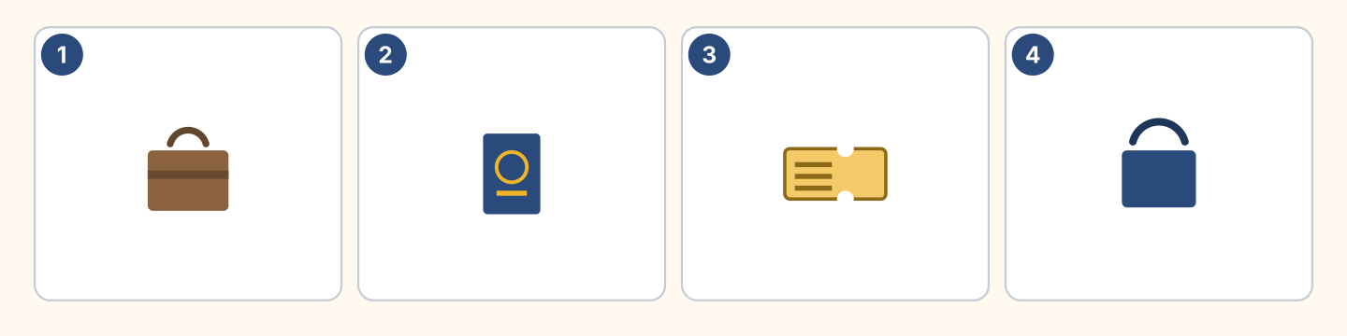
Figure 6.19 · Four more things to hear.
- a suitcase — 1 (example)
- a passport — ______
- a ticket — ______
- a bag — ______
Part 4 · Speaking
4A Look at Figure 6.20. Ask about a platform.
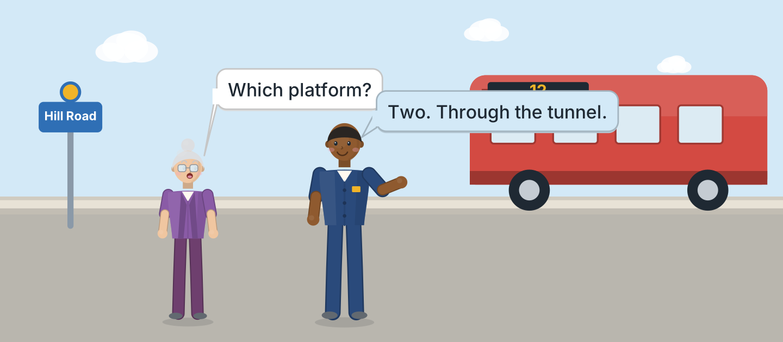
Figure 6.20 · Asking the way at the station.
- A: Which platform? B: Two. Through the tunnel. (example)
- Ask which platform the train leaves from, and whether it is safe at night.
- Ask whether you have to change, and whether you can afford a taxi.
- Say how you normally travel, and what you spend on it.
4B Look at Figure 6.21. Ask and answer.
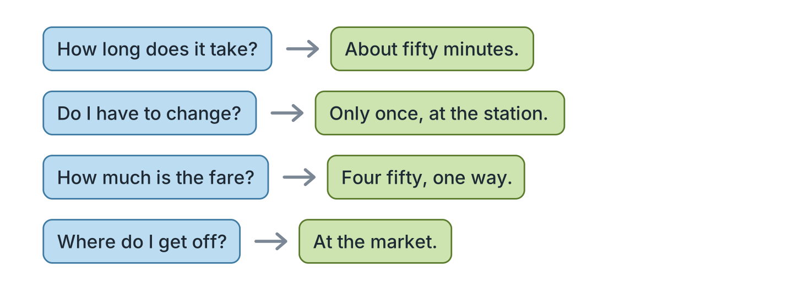
Figure 6.21 · Four questions on a journey.
- A: How long does it take? B: About fifty minutes. (example)
- A: Do I have to change? B: ______________
- A: How much is the fare? B: ______________
- A: Where do I get off? B: ______________
4C Look at Figure 6.22. Say what happens in each picture.
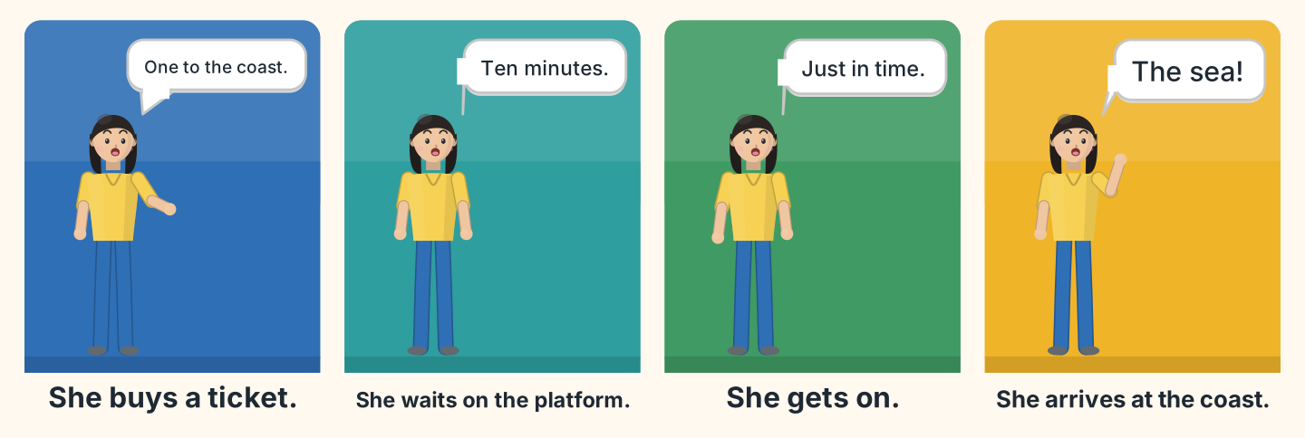
Figure 6.22 · A journey in four moments.
- First Lili buys a ticket to the coast. (example)
- Say where she waits, and whether there was a delay or an accident.
- Say what she does immediately when the train arrives.
- Say where she arrives, and why she was quite relieved.
4D Look at Figure 6.23. Ask two of these people about travel.
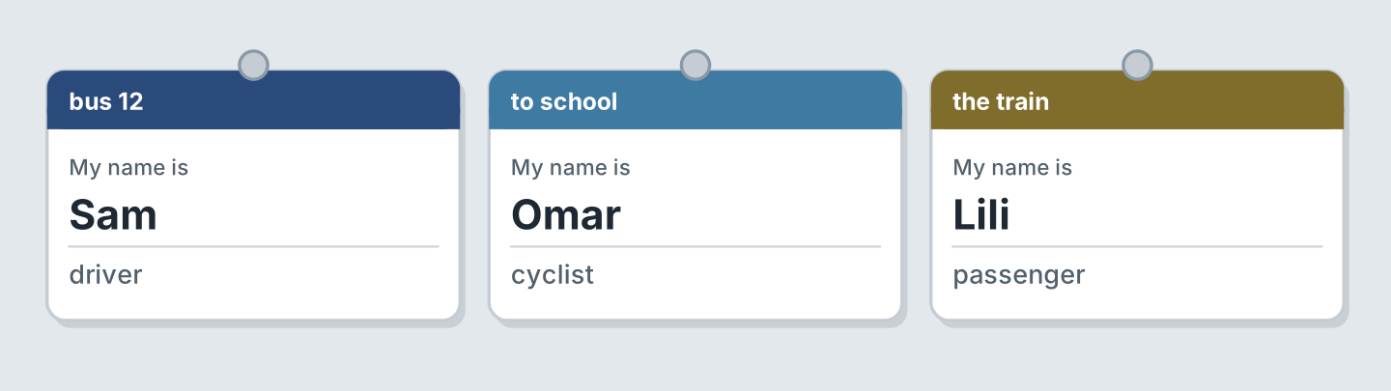
Figure 6.23 · Three people to ask about travel.
- A: How do you get to work? B: I drive the bus myself. (example)
- Ask Omar how far he cycles, and whether the road is dangerous.
- Ask Lili what the fare costs, and whether she gets a discount.
- Explain what you have to do before you leave, and what your boss says.
Part 5 · Reading
5A Look at Figure 6.24. Answer the questions.
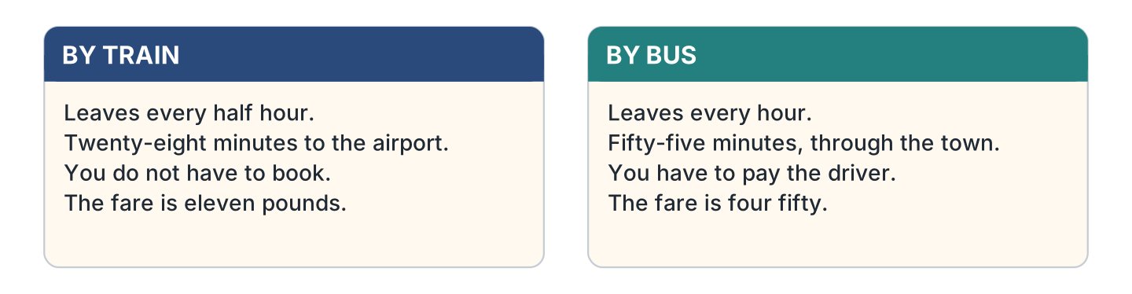
Figure 6.24 · Two ways to get there.
- How often does the train leave? — every half hour (example)
- How long does the bus take? — ______________
- Which one do you not have to book? — ______________
- How much is the bus fare? — ______________
5B Look at Figure 6.25. Answer the questions.
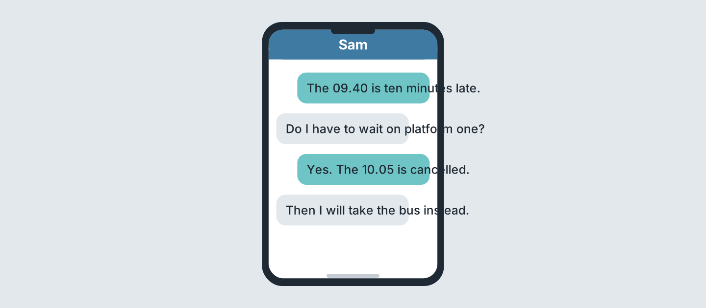
Figure 6.25 · Messages about a delay.
- How late is the 09.40? — ten minutes (example)
- Which train is cancelled? — ______________
- Which platform does she wait on? — ______________
- What will she take instead? — ______________
5C Look at Figure 6.26. Choose the correct answer.
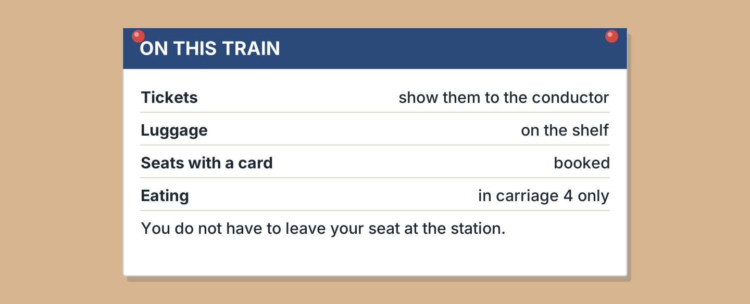
Figure 6.26 · The rules on the train.
- Who do you show your ticket to? (a) the driver (b) the conductor (c) nobody — b (example)
- Where does luggage go? (a) on the shelf (b) on a seat (c) by the door
- What does a card on a seat mean? (a) free (b) broken (c) booked
- Where can you eat? (a) carriage 2 (b) carriage 4 (c) anywhere
5D Look at Figure 6.27. Read and correct. Write the correct word.
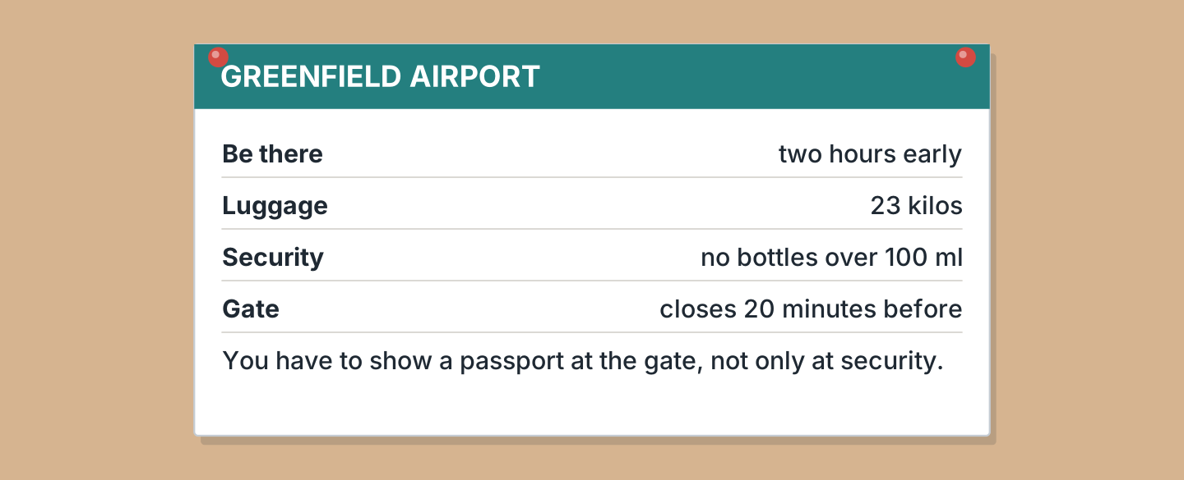
Figure 6.27 · At the airport.
- Be there one hour early. — two (example)
- Luggage is 32 kilos. — ______________
- The gate closes ten minutes before. — ______________
- You show a passport only at security. — ______________
Part 6 · Writing
6A Look at Figure 6.28. Complete the form about you.
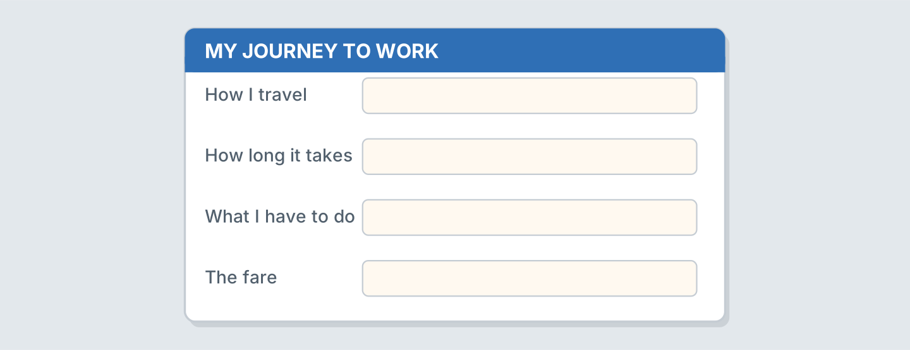
Figure 6.28 · A form for a journey.
- How I travel: by bus (example)
- How I travel, and whether the seat is comfortable: ______________
- How long it takes, and the amount I pay: ______________
- What I have to do, and what it costs to park: ______________
6B Look at Figure 6.29. Write four lines about your journey.
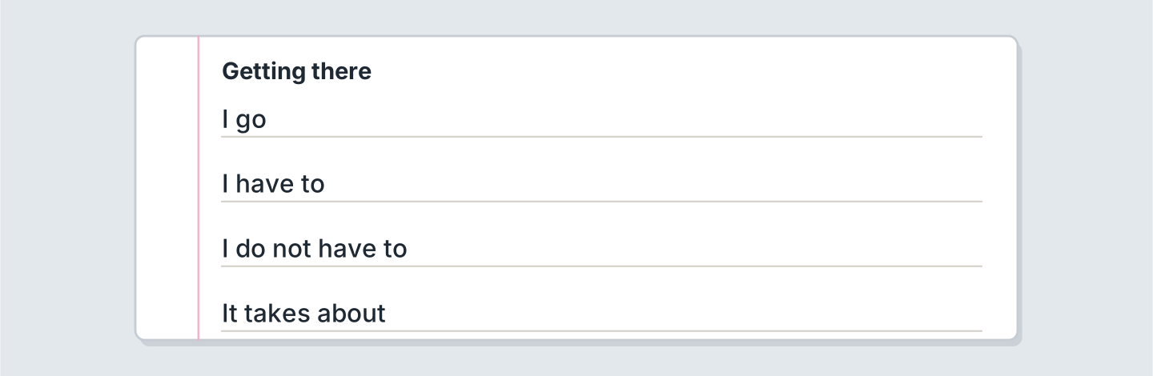
Figure 6.29 · Four lines about getting there.
- I go to work by train. (example)
- I go ______________.
- Because of my colleague I have to ______________.
- If there is no accident it takes about ______________.
6C Look at Figure 6.30. Write four lines of directions to your home.
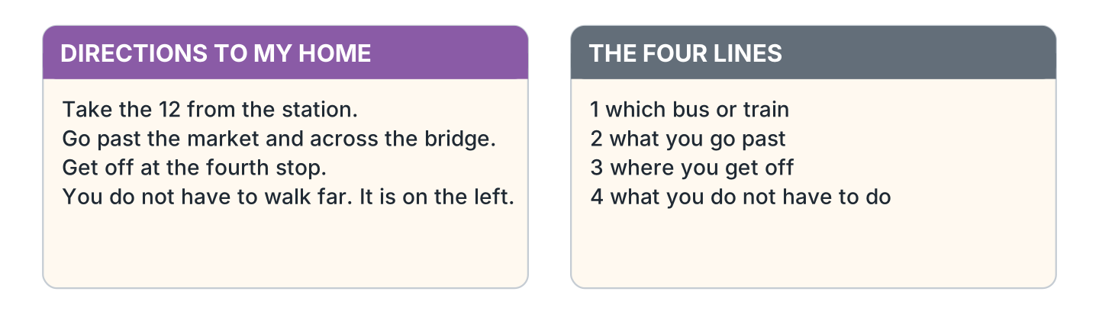
Figure 6.30 · A model set of directions.
- Take the 12 from the station and get off at the market. (example)
- Say which bus or train, and what the whole journey is worth.
- Say what you go past: a bright shop, a garage, a separate gate.
- Say where to get off, and what to do in an emergency.
- Say what the person does not have to do, and what to be careful about.
Part 7 · Real-World File
7A Look at Figure 6.31. Answer the questions.
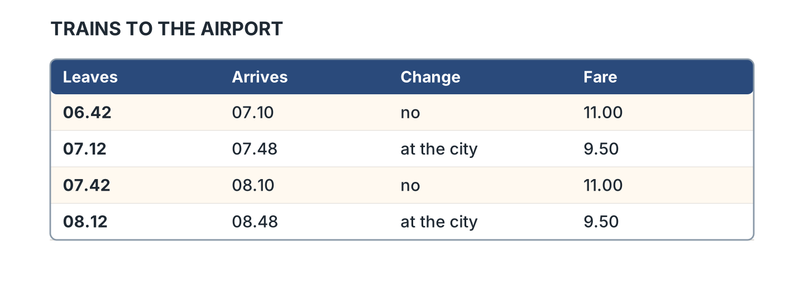
Figure 6.31 · A real timetable.
- When does the first train leave? — 06.42 (example)
- Which trains have no change? — ______________
- How much is the 07.12? — ______________
- How long does the 07.42 take? — ______________
7B Look at Figure 6.32. Answer the questions.
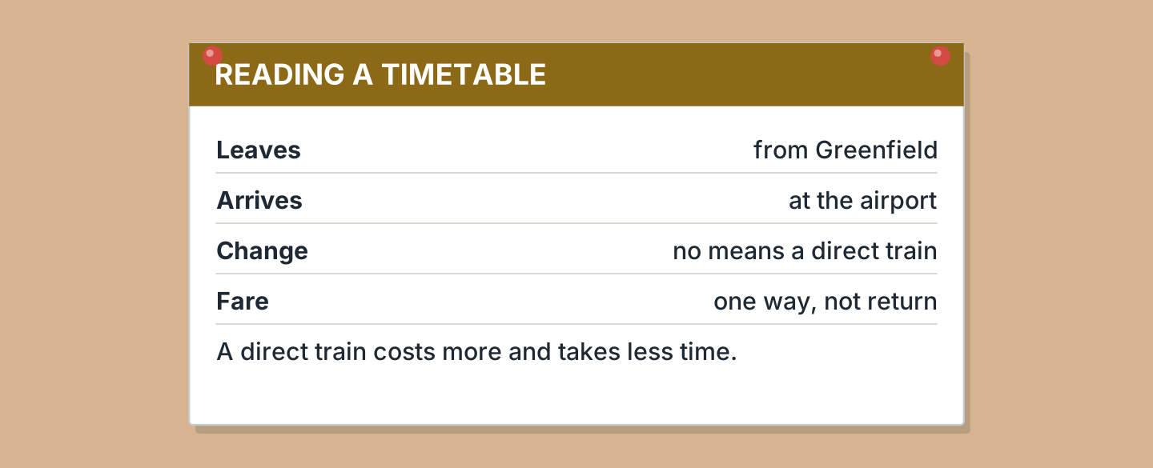
Figure 6.32 · How to read the timetable.
- What does Leaves mean? — from Greenfield (example)
- What does no under Change mean? — ______________
- Is the fare one way or return? — ______________
- Which train costs more, the direct one or the other? — ______________
7C Look at Figure 6.33. Write about a journey you make often.
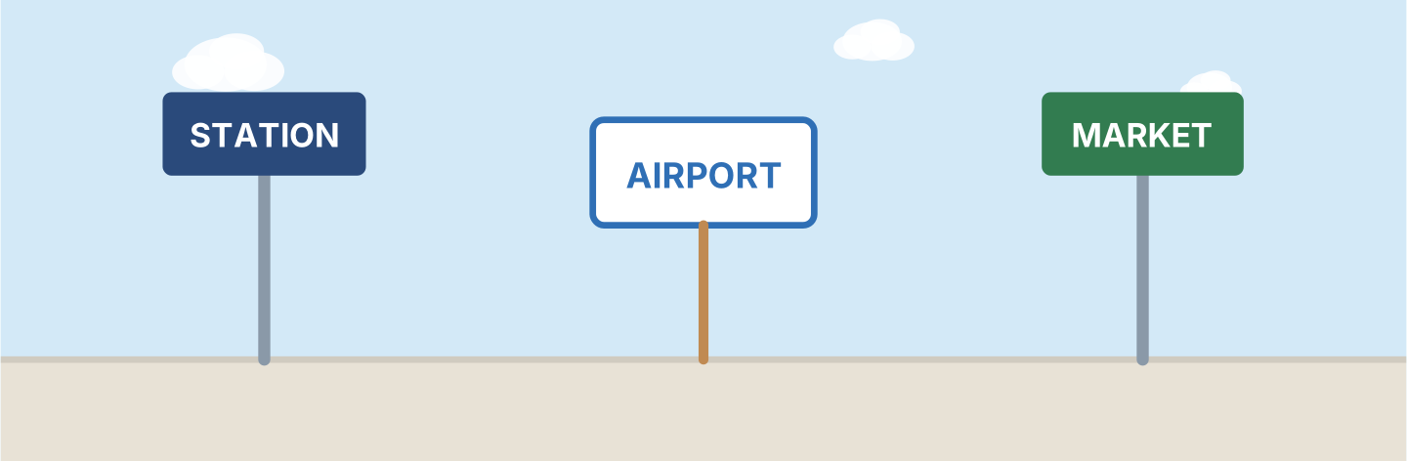
Figure 6.33 · Three signs on the way.
- I go to the market every Saturday. It takes twenty minutes. (example)
- Where I go, how often, and with which colleague: ______________
- What I have to do first, and who I explain it to: ______________
- What the journey costs, and whether I can save on it: ______________
Part 8 · Review & Can-Do
8A Look at Figure 6.34. Write the word.
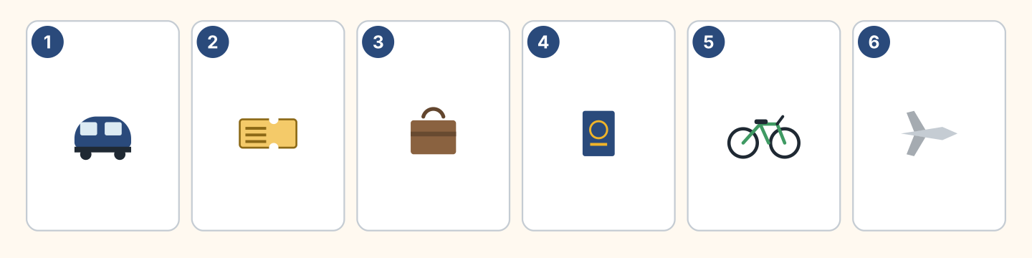
Figure 6.34 · Six things from this unit.
Words: bike · passport · plane · suitcase · ticket · train
- 1 — train (example)
- 2 — ______________
- 3 — ______________
- 4 — ______________
- 5 — ______________
8B Look at Figure 6.35. Complete the sentences.
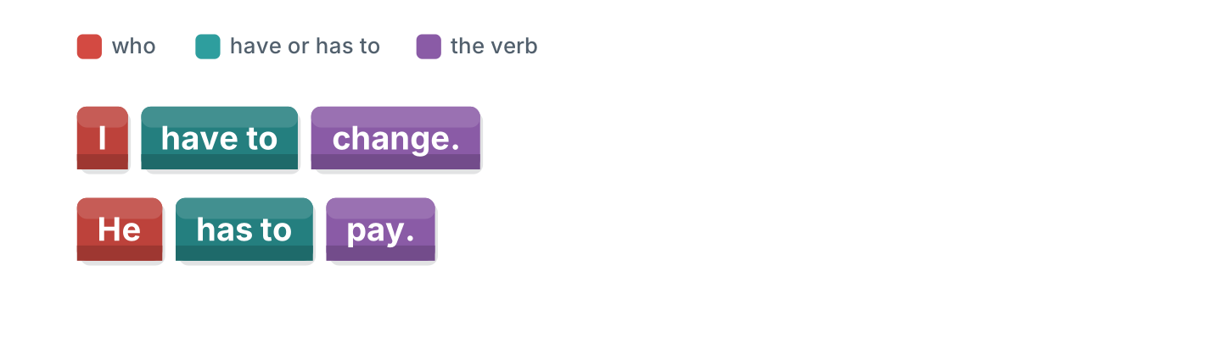
Figure 6.35 · Have to in blocks.
Words: change · has · have · He
- I ______ to change. (have) (example)
- I have to ______ .
- ______ has to pay.
- He ______ to pay.
8C Look at Figure 6.36. Answer the questions.
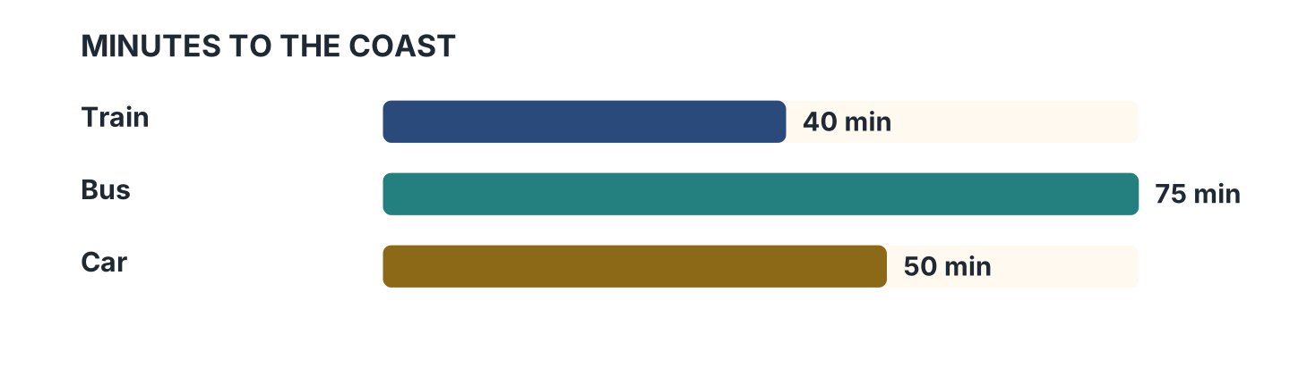
Figure 6.36 · Three journeys compared.
- How long does the train take? — 40 minutes (example)
- How long does the bus take? — ______________
- Which way is the slowest? — ______________
- How much quicker is the train than the car? — ______________
8D Look at Figure 6.37. Match the traveller and the answer.
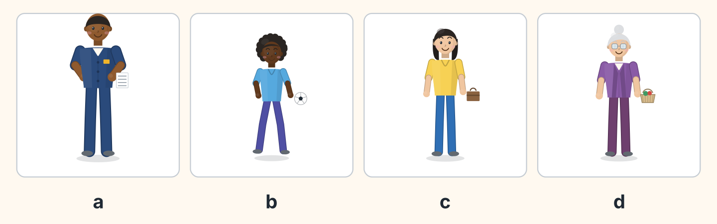
Figure 6.37 · Four travellers, four answers.
Traveller | What they say
1 Sam | a I drive the 12 from six in the morning.
2 Omar | b I cycle to school and it takes ten minutes.
3 Lili | c I have to change at the station every day.
4 Rosa | d I walk to the market with my basket.
 | e I fly to Madrid every June.
One option is not needed.
- 1 — a (example)
- 2 — ______
- 3 — ______
- 4 — ______
8E Look at Figure 6.38. Tick what you can do.
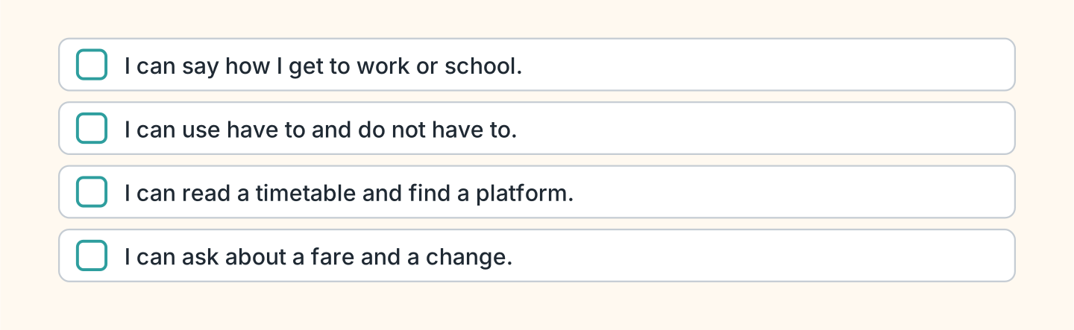
Figure 6.38 · What I can do.
- I can say how I get to work or school. — ✓ (example)
- I can use have to and do not have to. — ______
- I can read a timetable and find a platform. — ______
- I can ask about a fare and a change. — ______

Unit 7: Making Plans
In this unit you talk about arrangements, plans and sudden decisions.
Warm Up
W1 Look at Figure 7.1. Answer the questions.
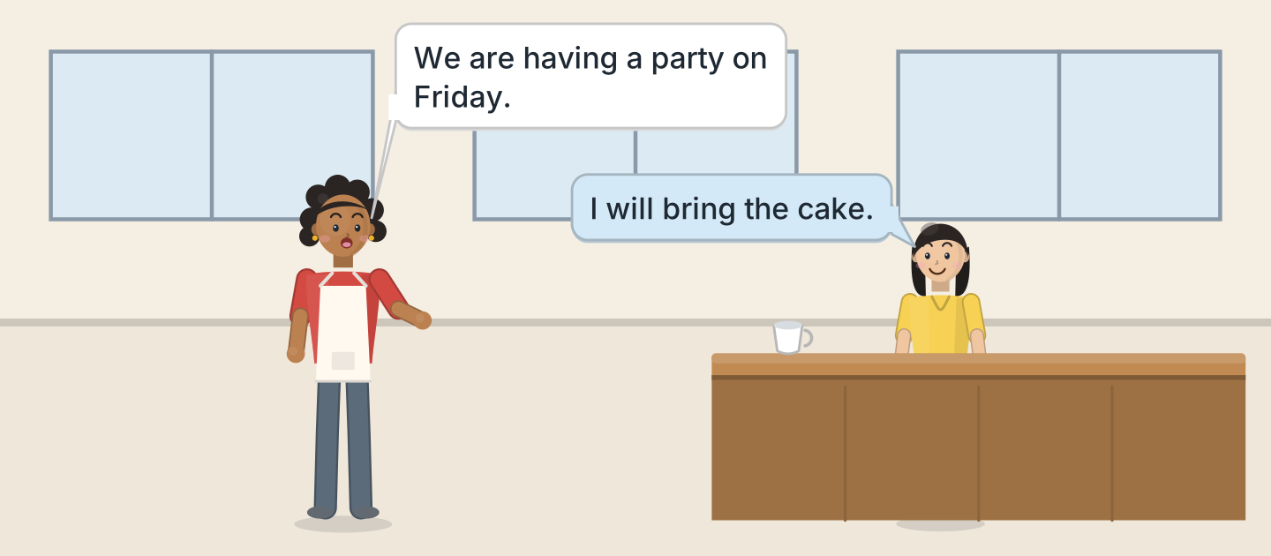
Figure 7.1 · Nadia plans the party.
- When is the party? — on Friday (example)
- What will Lili bring? — ______________
- Who is having the party? — ______________
- Where are they talking? — ______________
W2 Look at Figure 7.2. Answer the questions.
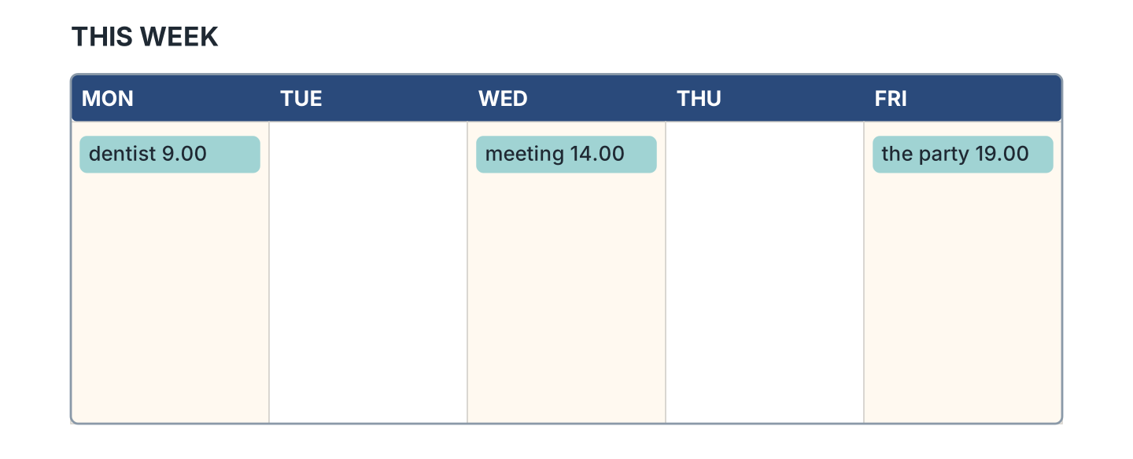
Figure 7.2 · The week ahead.
- What is on Monday? — the dentist at 9.00 (example)
- What is on Wednesday? — ______________
- What time is the party? — ______________
- Which days are free? — ______________
W3 Look at Figure 7.3. Write the word.
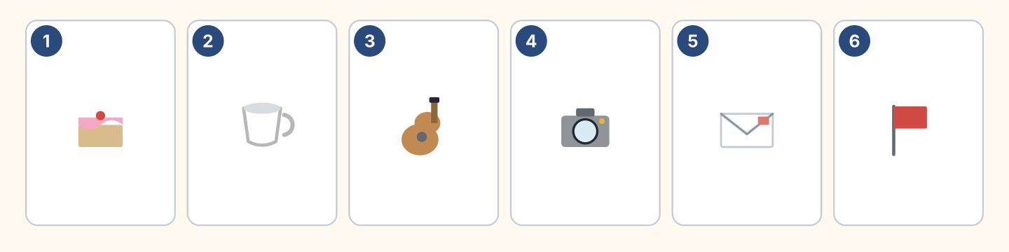
Figure 7.3 · Six things for a party.
Words: cake · camera · cup · envelope · flag · guitar
- 1 — cake (example)
- 2 — ______________
- 3 — ______________
- 4 — ______________
- 5 — ______________
Part 1 · Words & Sounds
1A Look at Figure 7.4. Write arranged, decided before or decided now.
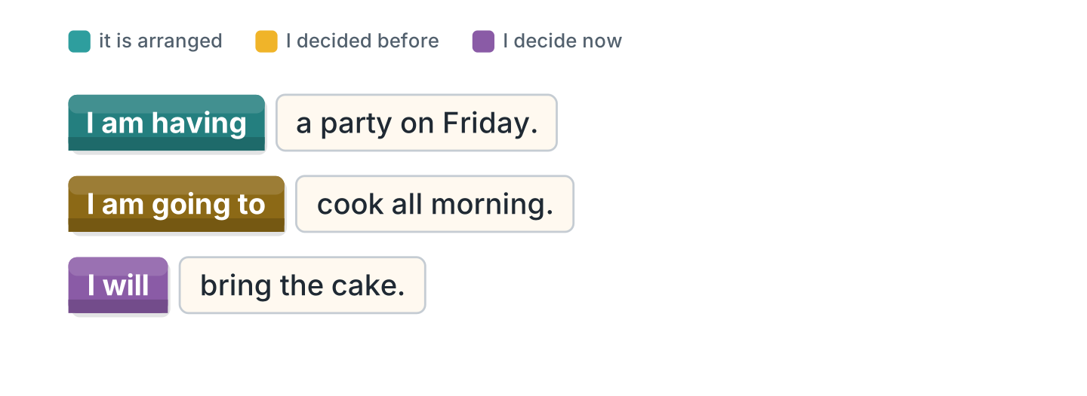
Figure 7.4 · Three ways to talk ahead.
- I am having a party on Friday. — arranged (example)
- I am going to cook all morning. — ______________
- I will bring the cake. — ______________
- We are flying on Monday. — ______________
1B Look at Figure 7.5. Write the short form.
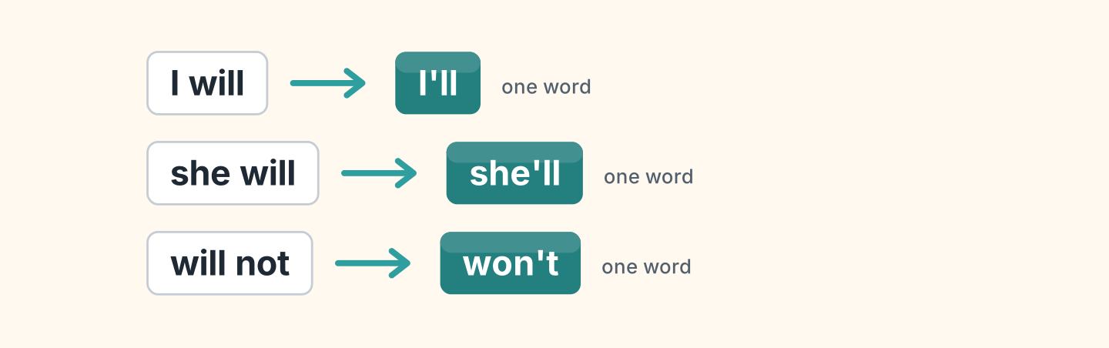
Figure 7.5 · The short form of will.
- I will — I’ll (example)
- she will — ______________
- will not — ______________
- we will — ______________
1C Look at Figure 7.6. Write what the person is carrying.
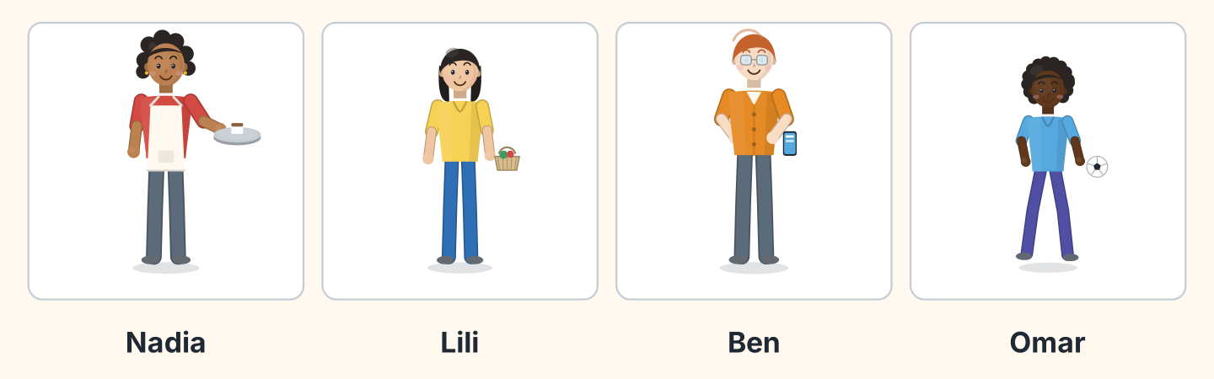
Figure 7.6 · Four people with plans.
- Nadia — a tray (example)
- Lili — ______________
- Ben — ______________
- Omar — ______________
1D Say it. Look at Figure 7.7. Say these quickly.
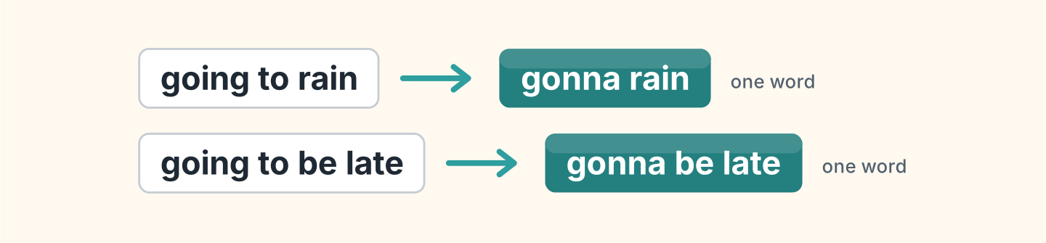
Figure 7.7 · Going to, said quickly.
- going to rain — gonna rain (example)
- going to be late
- going to help
- going to ask
- going to leave
1E Look at Figure 7.8. Answer the questions.
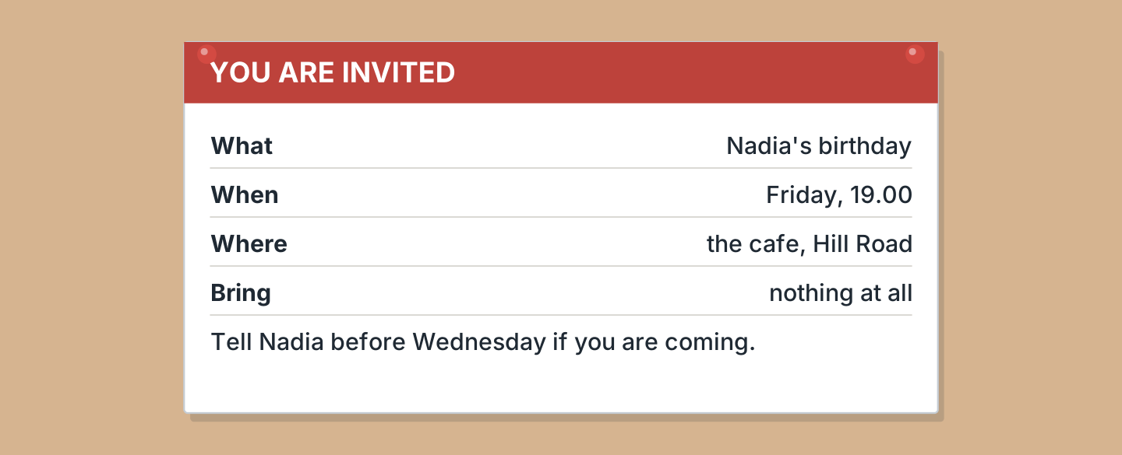
Figure 7.8 · The invitation.
- What is the party for? — Nadia’s birthday (example)
- What time does it start? — ______________
- Where is it? — ______________
- What do you have to bring? — ______________
1F Look at Figure 7.9. Write the word for the meaning.
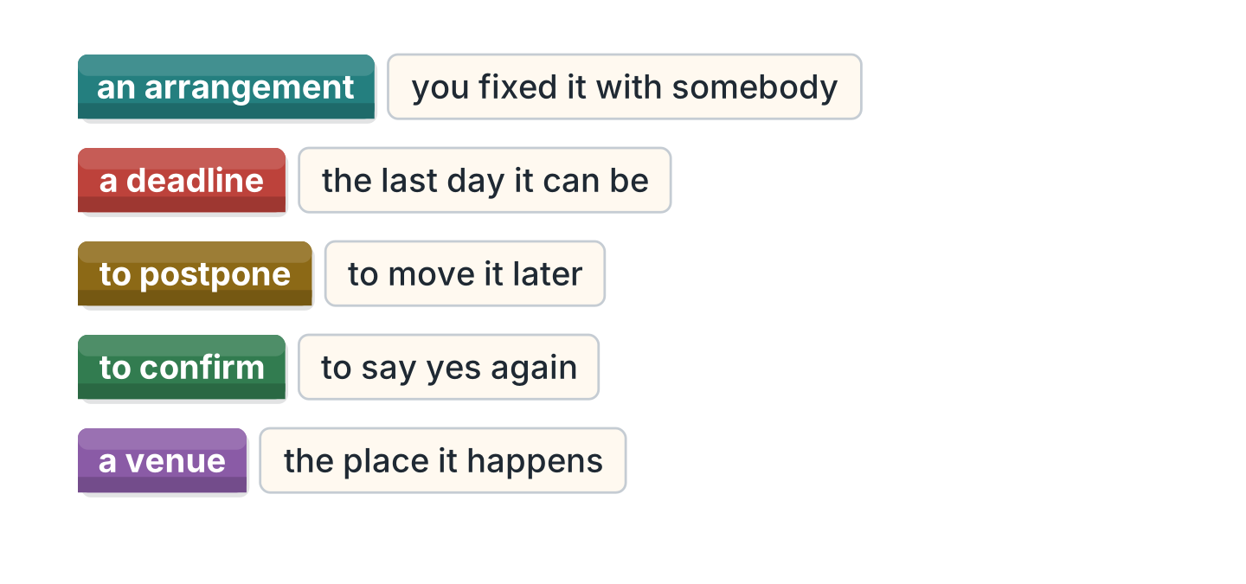
Figure 7.9 · Five words about plans.
- you fixed it with somebody — an arrangement (example)
- the last day it can be — ______________
- to move it later — ______________
- to say yes again — ______________
- the place it happens — ______________
Part 2 · Grammar
2A Look at Figure 7.10. Write already or just now.
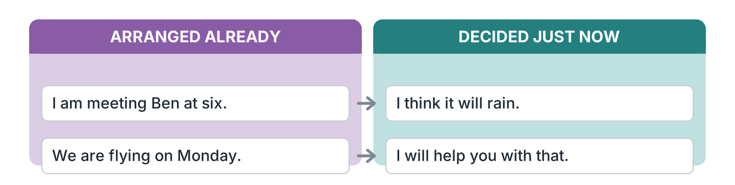
Figure 7.10 · Which future for which job.
- I am meeting Ben at six. — already (example)
- I think it will rain. — ______________
- We are flying on Monday. — ______________
- I will help you with that. — ______________
2B Look at Figure 7.11. Write the answer.
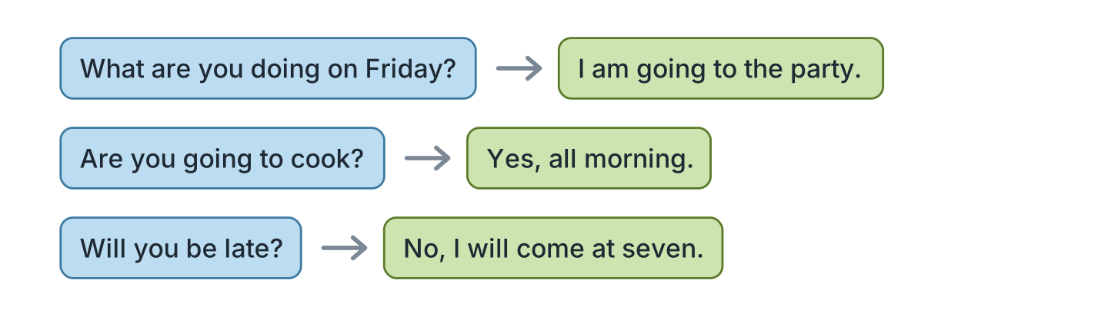
Figure 7.11 · Asking about plans.
- What are you doing on Friday? — I am going to the party. (example)
- Are you going to cook? ✓ — ______________
- Will you be late? ✗ — ______________
- What are you doing on Sunday? (the coast) — ______________
2C Look at Figure 7.12. Write yes or no.
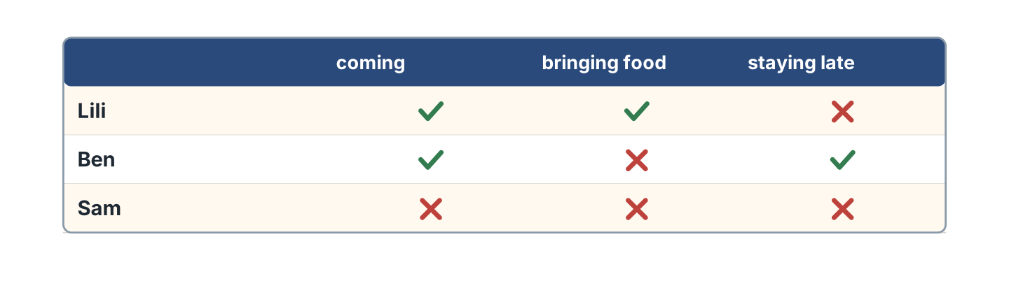
Figure 7.12 · Who is doing what on Friday.
- Lili is coming. — yes (example)
- Ben is bringing food. — ______
- Sam is coming. — ______
- Ben is staying late. — ______
2D Look at Figure 7.13. Choose the correct future.

Figure 7.13 · Going to and will.
- Look at the sky. It (is going to / will) rain. — is going to (example)
- The phone is ringing. I (am going to / will) answer it.
- She has got her ticket. She (is going to / will) fly on Monday.
- That bag is heavy. I (am going to / will) carry it for you.
- We booked the hall. We (are going to / will) have the party there.
2E Look at Figure 7.14. Answer the questions.
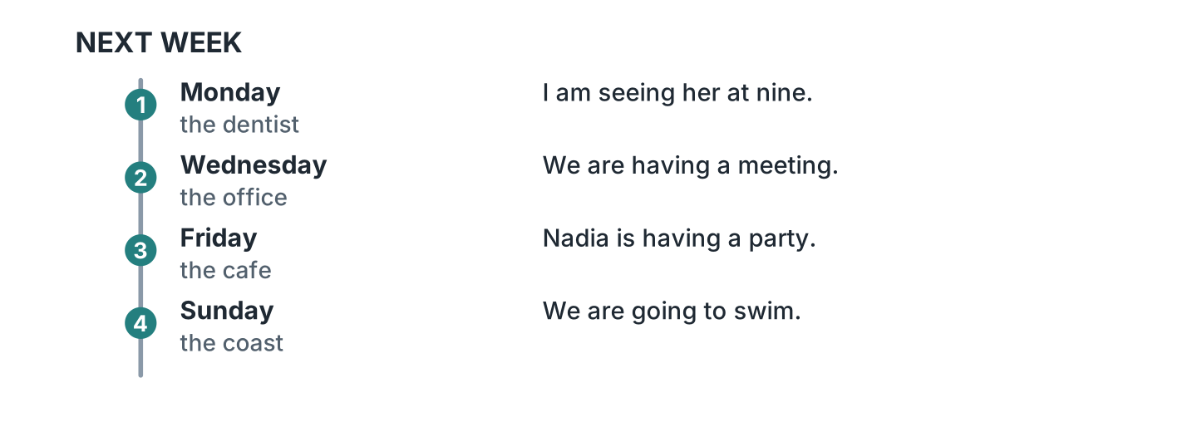
Figure 7.14 · Four days of arrangements.
- What is arranged for Monday? — the dentist at nine (example)
- What is happening on Wednesday? — ______________
- Where is the party? — ______________
- What are they going to do on Sunday? — ______________
2F Look at Figure 7.15. Find the mistake and write it correctly.
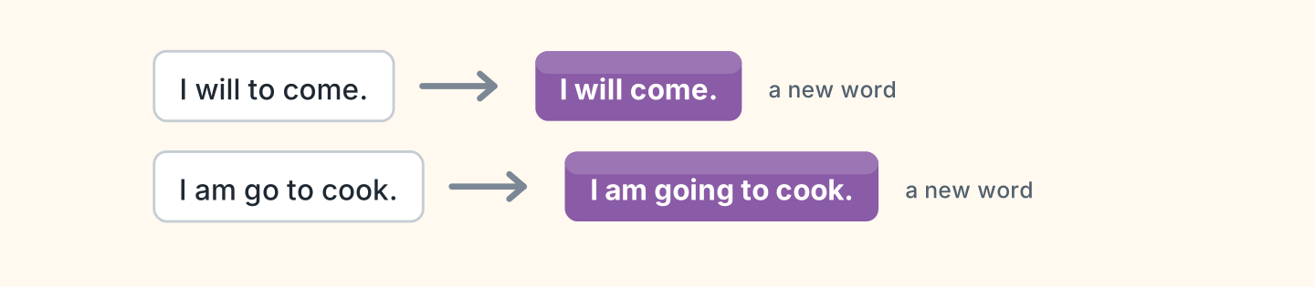
Figure 7.15 · Mistakes with the future.
- I will to come. — I will come (example)
- I am go to cook. — ______________
- She will comes early. — ______________
- We are go to fly on Monday. — ______________
Part 3 · Listening
3A Listen. Look at Figure 7.16. Write the number.
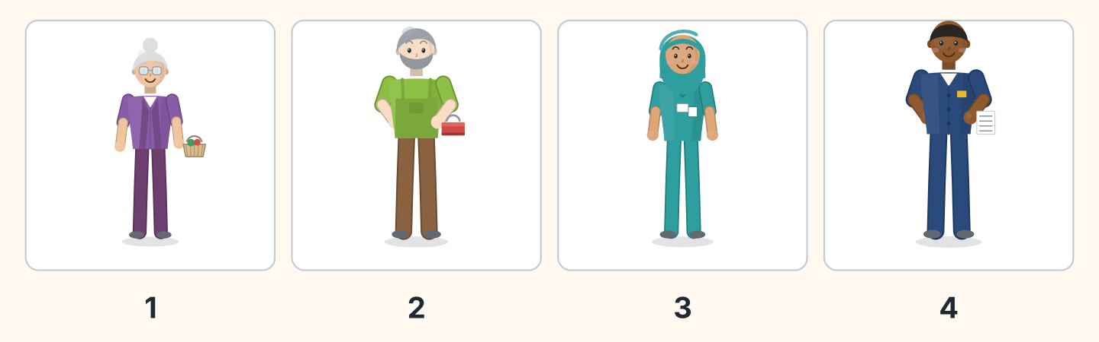
Figure 7.16 · Four replies to the invitation.
- Rosa — 1 (example)
- Marek — ______
- Fatima — ______
- Sam — ______
3B Listen. Look at Figure 7.17. Answer the questions.
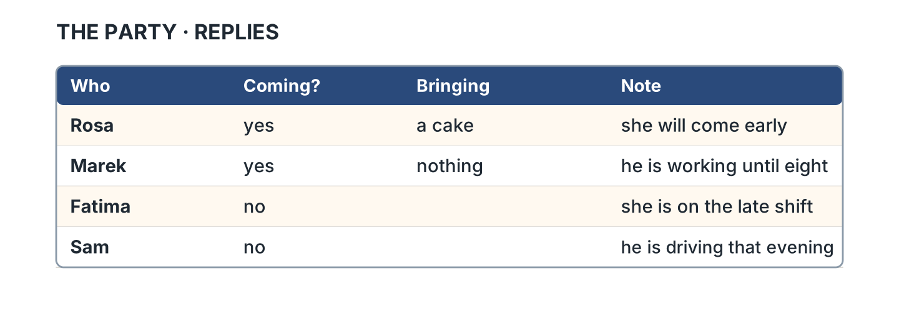
Figure 7.17 · Who said yes and no.
- Who is bringing a cake? — Rosa (example)
- Who is working until eight? — ______________
- Who is on the late shift? — ______________
- How many people said no? — ______________
3C Listen. Look at Figure 7.18. Write the answer you hear.
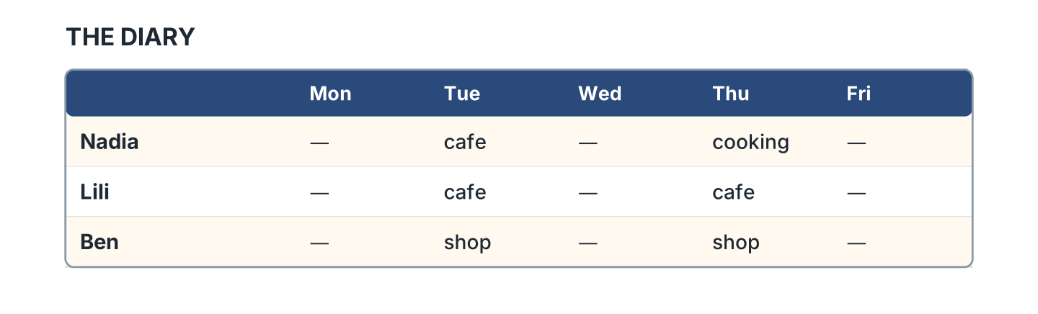
Figure 7.18 · The diary for the week.
- What is Nadia doing on Wednesday? — shopping (example)
- What is Lili doing on Monday? — ______________
- Where is Ben on Monday? — ______________
- What are all three doing on Friday? — ______________
3D Listen. Look at Figure 7.19. Write the number of the thing you hear.
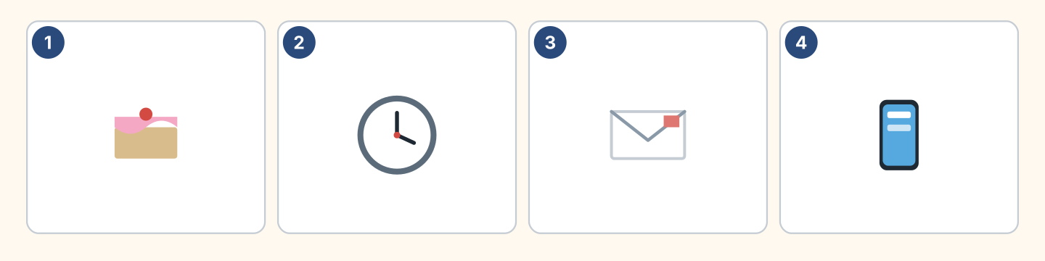
Figure 7.19 · Four more things to hear.
- a cake — 1 (example)
- a clock — ______
- an envelope — ______
- a phone — ______
Part 4 · Speaking
4A Look at Figure 7.20. Arrange a time with a colleague.
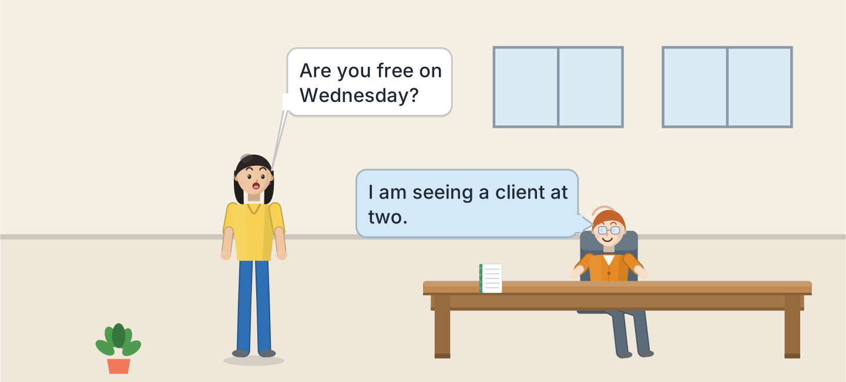
Figure 7.20 · Fixing a time at work.
- A: Are you free on Wednesday? B: I am seeing a client at two. (example)
- Ask whether your colleague is free, and why it is urgent.
- Suggest another day, and say whether you have to change buses.
- Say what you will confirm, and how long the journey takes.
4B Look at Figure 7.21. Ask and answer.
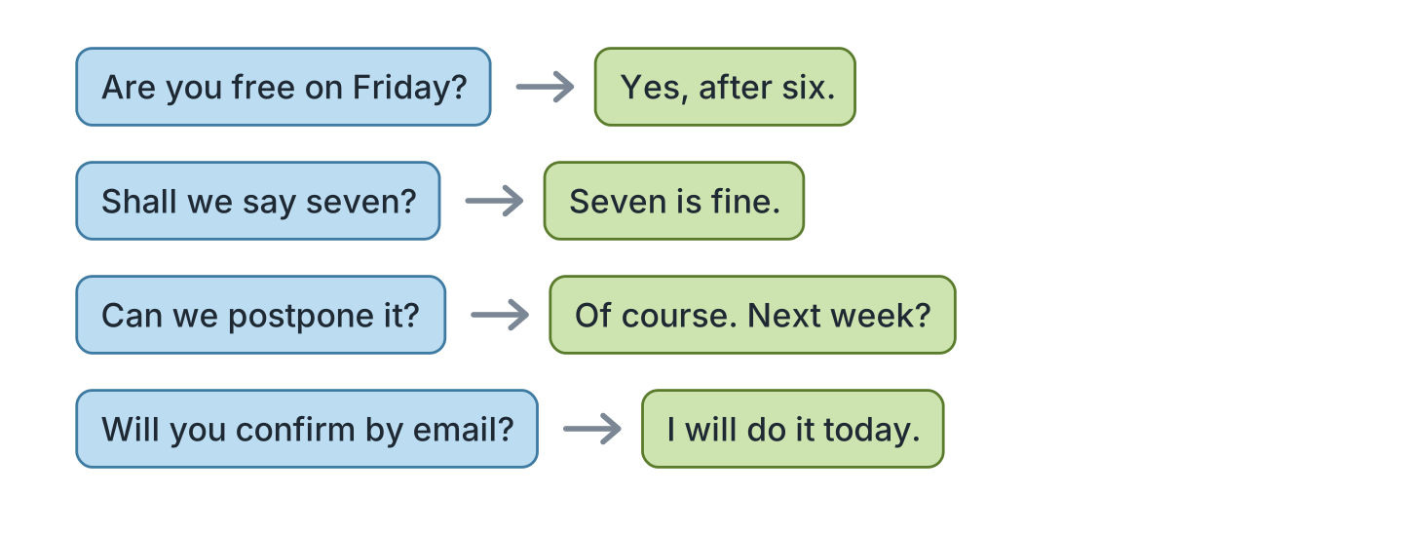
Figure 7.21 · Four ways to arrange a time.
- A: Are you free on Friday? B: Yes, after six. (example)
- A: Shall we say seven? B: ______________
- A: Can we postpone it? B: ______________
- A: Will you confirm by email? B: ______________
4C Look at Figure 7.22. Say what happens in each picture.
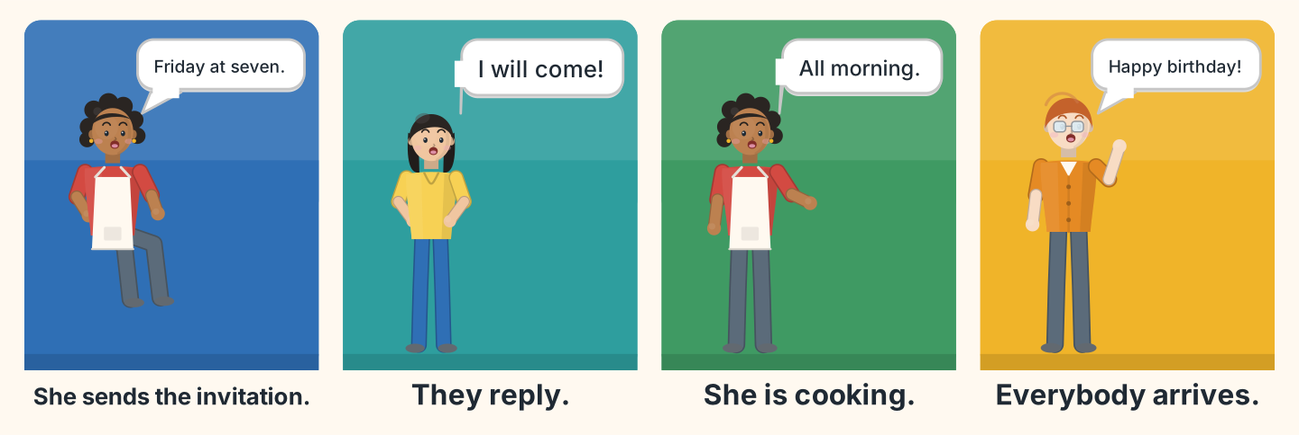
Figure 7.22 · The party in four moments.
- First Nadia sends the invitation to everybody. (example)
- Say who replies immediately, and who was careful about the date.
- Say what Nadia is going to do, and whether there is a delay.
- Say what happens at seven, and whether the traffic was slow.
4D Look at Figure 7.23. Invite two of these people.
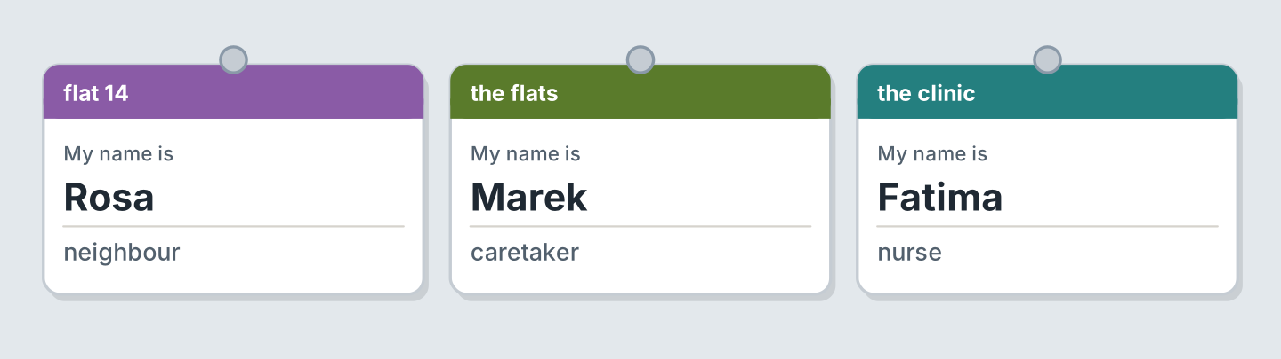
Figure 7.23 · Three people to invite.
- A: We are having a party on Friday. B: Thank you, I will come. (example)
- Invite Rosa, and say the stairs are safe now, after the accident.
- Invite Marek, and say which platform his train leaves from.
- Say one trip you are going to make, and the fare.
Part 5 · Reading
5A Look at Figure 7.24. Answer the questions.
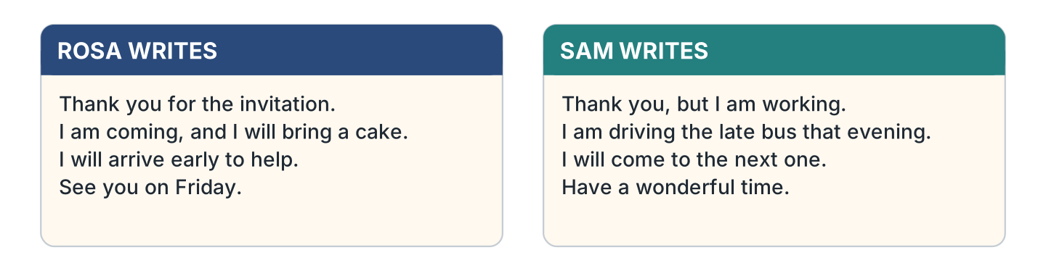
Figure 7.24 · Two replies to the same invitation.
- Who is bringing a cake? — Rosa (example)
- Why can Sam not come? — ______________
- When will Rosa arrive? — ______________
- What does Sam say about the next party? — ______________
5B Look at Figure 7.25. Answer the questions.
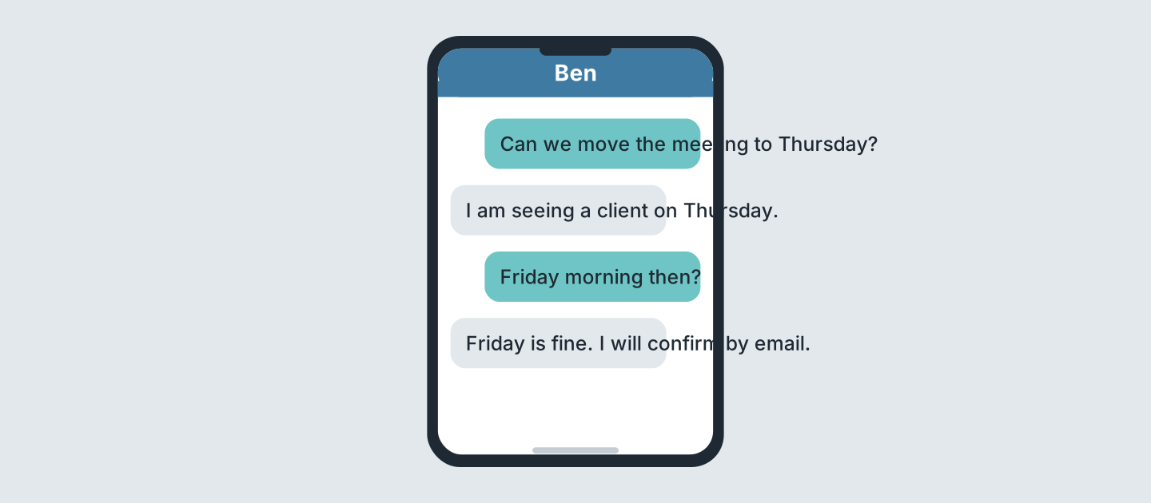
Figure 7.25 · Messages about a change.
- Which day does he ask for first? — Thursday (example)
- Why is Thursday not possible? — ______________
- Which day do they agree on? — ______________
- How will Ben confirm it? — ______________
5C Look at Figure 7.26. Choose the correct answer.
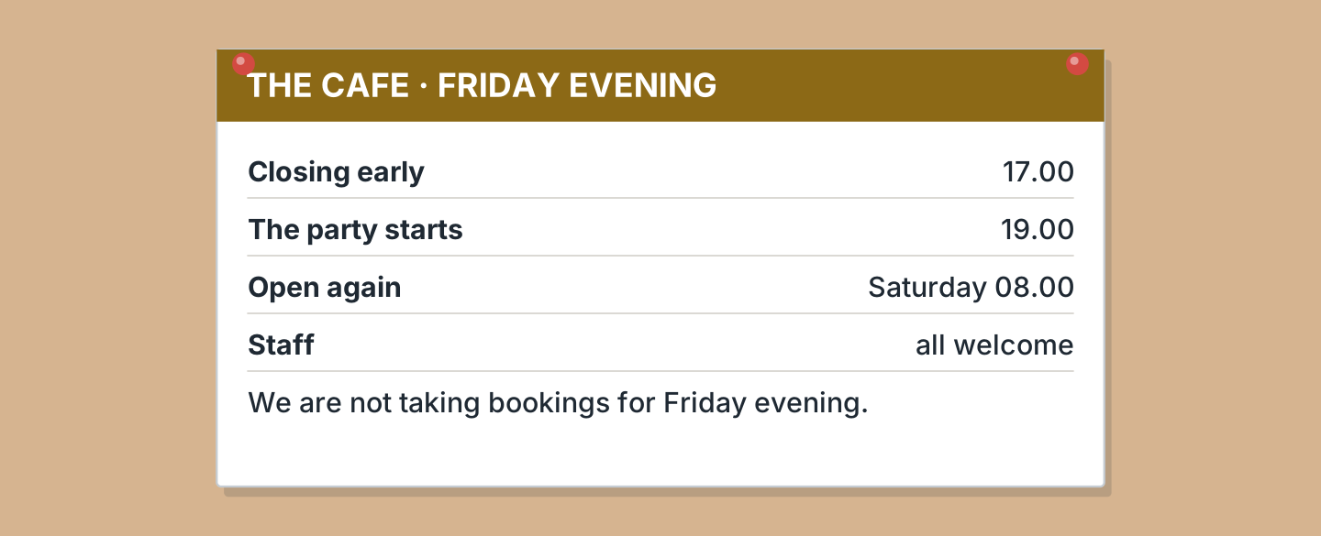
Figure 7.26 · A notice about the party.
- When does the cafe close on Friday? (a) 17.00 (b) 19.00 (c) 08.00 — a (example)
- When does the party start? (a) 17.00 (b) 19.00 (c) 20.00
- When does the cafe open again? (a) Friday (b) Saturday (c) Sunday
- Are they taking bookings? (a) yes (b) no (c) only for staff
5D Look at Figure 7.27. Read and correct. Write the correct word.
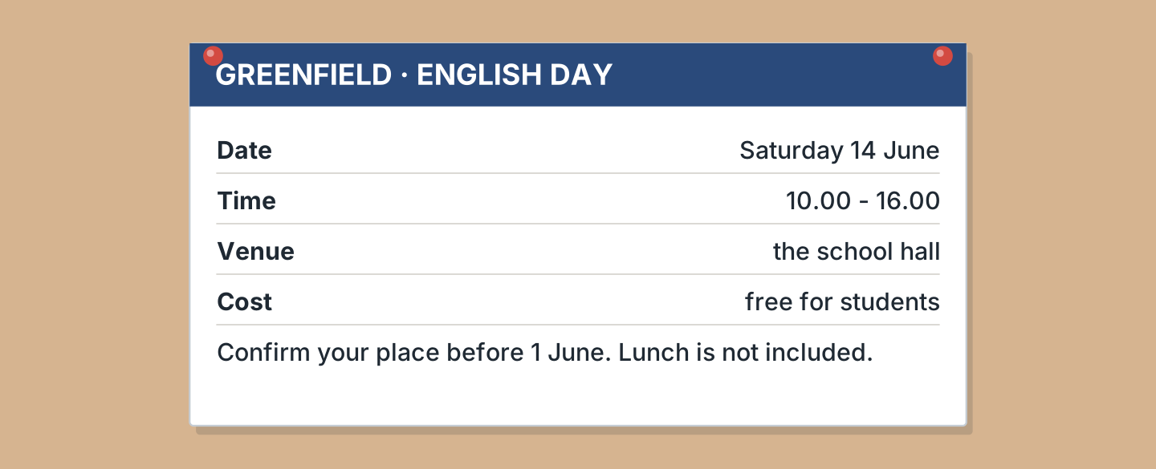
Figure 7.27 · A conference invitation.
- The day is Sunday. — Saturday (example)
- It finishes at five. — ______________
- It costs ten pounds for students. — ______________
- Lunch is included. — ______________
Part 6 · Writing
6A Look at Figure 7.28. Complete the form for your own invitation.
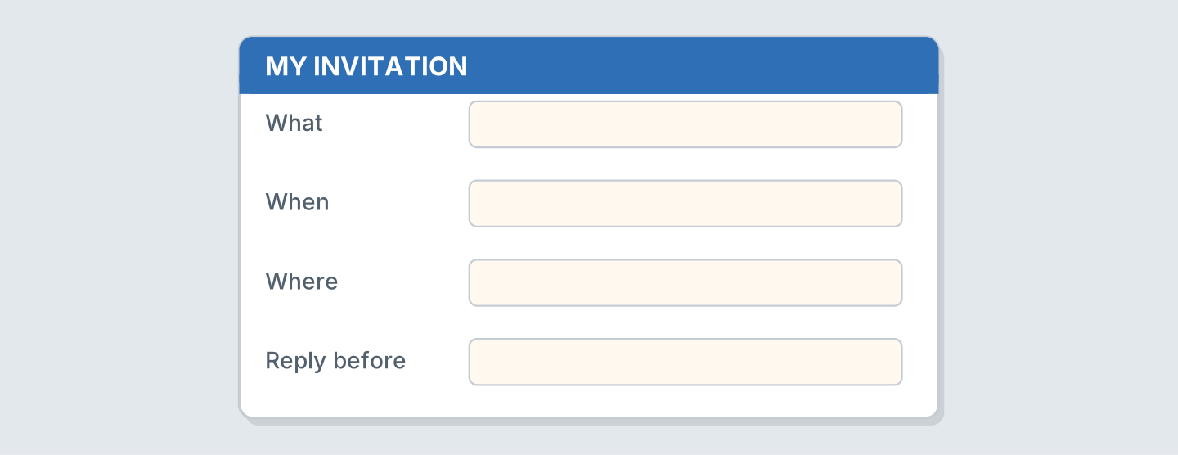
Figure 7.28 · A form for an invitation.
- What: a birthday (example)
- What: ______________
- When: ______________
- Reply before: ______________
6B Look at Figure 7.29. Write four lines about next week.
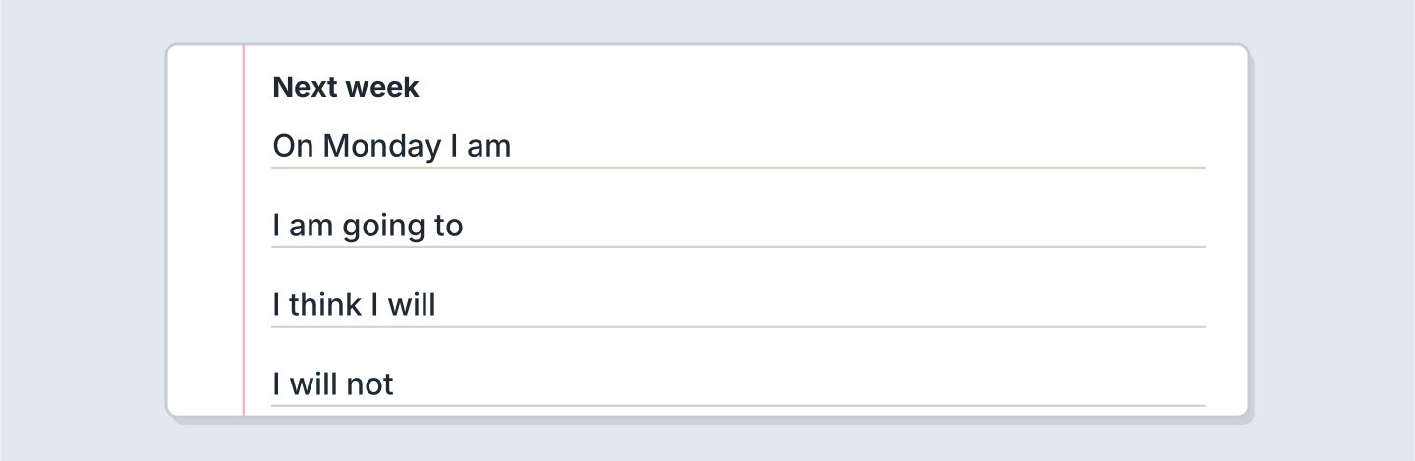
Figure 7.29 · Four lines about next week.
- On Monday I am seeing the dentist. (example)
- On Monday I am ______________.
- I am going to ______________.
- I think I will save ______________ and spend the rest.
6C Look at Figure 7.30. Write a reply of four lines.
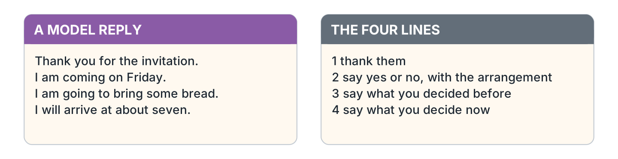
Figure 7.30 · A model reply.
- Thank you for the invitation. I am coming on Friday. (example)
- Thank them, and say how you heard about it.
- Say yes or no, and say what you have arranged already.
- Say what you decided before, and what you will bring.
- Say what you decide now, when you will arrive, and the amount you will bring.
Part 7 · Real-World File
7A Look at Figure 7.31. Answer the questions.
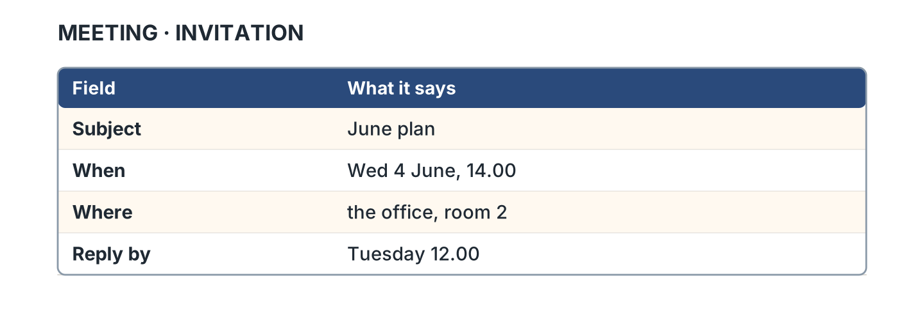
Figure 7.31 · A calendar invitation.
- What is the subject? — June plan (example)
- When is the meeting? — ______________
- Where is it? — ______________
- When do you have to reply? — ______________
7B Look at Figure 7.32. Answer the questions.
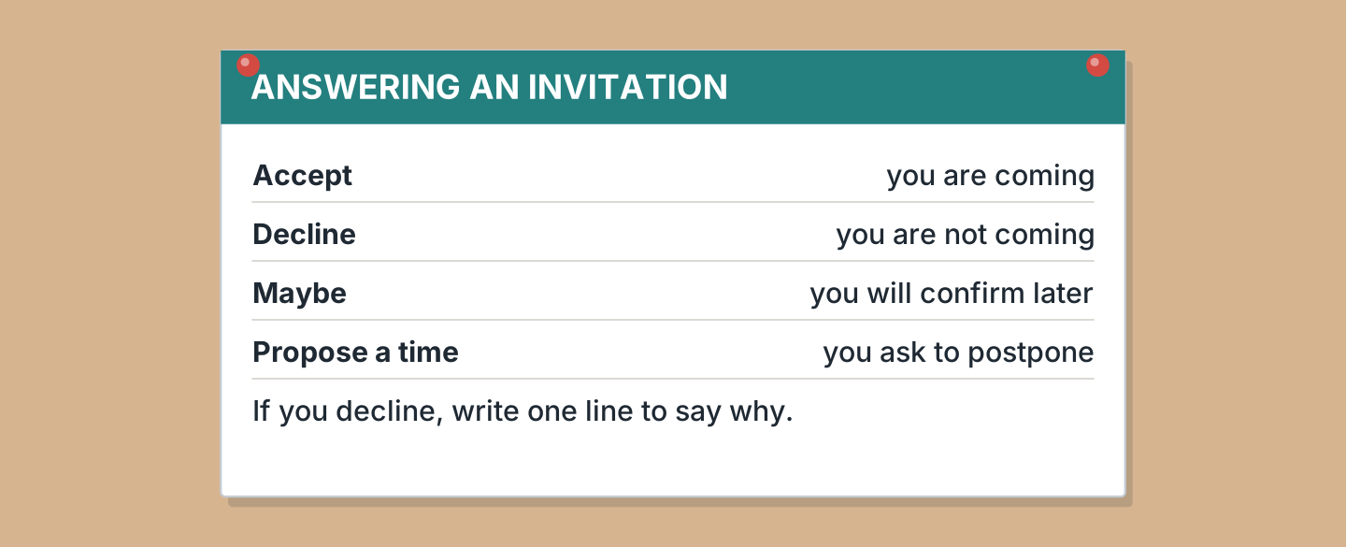
Figure 7.32 · What the buttons mean.
- What does Accept mean? — you are coming (example)
- What does Decline mean? — ______________
- What does Maybe mean? — ______________
- What do you write if you decline? — ______________
7C Look at Figure 7.33. Write about a meeting you arranged.

Figure 7.33 · Three places to meet.
- We are meeting at the cafe on Tuesday at six. (example)
- Where and when, and which direction I travel: ______________
- Who I am meeting, the deadline, and who will pay the bill: ______________
- What I will bring, what it costs, and whether I can afford it: ______________
Part 8 · Review & Can-Do
8A Look at Figure 7.34. Write the word.
Figure 7.34 · Six things from this unit.
Words: cake · camera · clock · cup · envelope · guitar
- 1 — cake (example)
- 2 — ______________
- 3 — ______________
- 4 — ______________
- 5 — ______________
8B Look at Figure 7.35. Complete the sentences.
Figure 7.35 · The three futures in blocks.
Words: am · going · meeting · will
- I am ______ him at six. (meeting) (example)
- I am ______ to cook.
- I ______ help you.
- I ______ meeting him at six.
8C Look at Figure 7.36. Write the short form.
Figure 7.36 · Four short forms with will.
- we will — we’ll (example)
- they will — ______________
- will not — ______________
- he will — ______________
8D Look at Figure 7.37. Match the person and the plan.
Figure 7.37 · Four people, four plans.
Person | Their plan
1 Nadia | a I am having a party at the cafe on Friday.
2 Sam | b I am driving the late bus that evening.
3 Lili | c I am going to bring a cake and some bread.
4 Marek | d I will come after work, at about eight.
 | e I am flying to Madrid on Monday.
One option is not needed.
- 1 — a (example)
- 2 — ______
- 3 — ______
- 4 — ______
8E Look at Figure 7.38. Tick what you can do.
Figure 7.38 · What I can do.
- I can talk about an arrangement I made. — ✓ (example)
- I can use going to and will. — ______
- I can accept or decline an invitation. — ______
- I can ask somebody to postpone a meeting. — ______

Unit 8: At Work
In this unit you say what you must do at work, and what you should do.
Warm Up
W1 Look at Figure 8.1. Answer the questions.
Figure 8.1 · The first day at the office.
- Who is asking the question? — Lili (example)
- What must she do first? — ______________
- Who gives her the answer? — ______________
- Which room are they working in? — ______________
W2 Look at Figure 8.2. Answer the questions.
Figure 8.2 · A job advert.
- How many hours a week? — 20 (example)
- How much is the pay? — ______________
- When does the job start? — ______________
- How old must you be? — ______________
W3 Look at Figure 8.3. Write the word.
Figure 8.3 · Six things in an office.
Words: badge · board · clock · desk · notebook · phone
- 1 — desk (example)
- 2 — ______________
- 3 — ______________
- 4 — ______________
- 5 — ______________
Part 1 · Words & Sounds
1A Look at Figure 8.4. Write must, must not or should.
Figure 8.4 · Must, must not and should.
- You ______ wear a badge. — must (example)
- You ______ smoke here.
- You ______ arrive five minutes early.
- You ______ carry your card at all times.
1B Look at Figure 8.5. Write the same thing another way.
Figure 8.5 · Must and have to.
- You must wear a badge. — You have to wear a badge. (example)
- You must not be late. — ______________
- You have to wash your hands. — ______________
- You cannot use a phone here. — ______________
1C Look at Figure 8.6. Write the job.
Figure 8.6 · Four jobs on Hill Road.
- Fatima — nurse (example)
- Sam — ______________
- Nadia — ______________
- Marek — ______________
1D Say it. Look at Figure 8.7. Say the short forms.
Figure 8.7 · Where the stress falls.
- must not — mustn’t (example)
- should not
- cannot
- do not have to
- will not
1E Look at Figure 8.8. Answer the questions.
Figure 8.8 · What the job needs.
- Must you be over eighteen? — yes (example)
- Do you need experience? — ______________
- Why do you need English? — ______________
- Do you need a car? — ______________
1F Look at Figure 8.9. Write the word for the meaning.
Figure 8.9 · Five words about a job.
- the work you did before — experience (example)
- a letter about you — ______________
- what you studied for — ______________
- you always come — ______________
- a better job, same place — ______________
Part 2 · Grammar
2A Look at Figure 8.10. Write the answer.
Figure 8.10 · Asking about the rules at work.
- Must I wear the shirt? ✓ — Yes, every day. (example)
- Can I eat at my desk? ✗ — ______________
- Should I arrive early? ✓ — ______________
- Must I bring a reference? ✓ — ______________
2B Look at Figure 8.11. Write yes or no.
Figure 8.11 · What each job asks for.
- A nurse must wear a badge. — yes (example)
- A cook must wear a badge. — ______
- A driver must have a licence. — ______
- A nurse must have a licence. — ______
2C Look at Figure 8.12. Write not allowed or your choice.
Figure 8.12 · Not allowed, or your choice.
- You must not use your phone here. — not allowed (example)
- You do not have to work on Sunday. — ______________
- You must not smoke inside. — ______________
- You do not have to wear a tie. — ______________
2D Look at Figure 8.13. Answer the questions.
Figure 8.13 · Three jobs and their pay.
- How much does an assistant earn? — 12 an hour (example)
- How much does a driver earn? — ______________
- Which job pays the most? — ______________
- How much more is a nurse than an assistant? — ______________
2E Look at Figure 8.14. Write should or should not.
Figure 8.14 · Should and should not.
- You ______ ask your supervisor. — should (example)
- You ______ decide alone.
- You ______ write it down.
- You ______ forget the deadline.
2F Look at Figure 8.15. Find the mistake and write it correctly.
Figure 8.15 · Mistakes with must and should.
- You must to wear it. — You must wear (example)
- He musts arrive early. — ______________
- You should to ask him. — ______________
- She must not to smoke. — ______________
Part 3 · Listening
3A Listen. Look at Figure 8.16. Write the number.
Figure 8.16 · Four people about their work.
- Ben — 1 (example)
- Rosa — ______
- Lili — ______
- Omar — ______
3B Listen. Look at Figure 8.17. Write the answer you hear.
Figure 8.17 · The interview times.
- Who is at 09.30? — A. Silva (example)
- Which job is L. Chen here for? — ______________
- Which job is J. Kowalski applying for? — ______________
- Which room is the driver interview in? — ______________
3C Listen. Look at Figure 8.18. Write the answer you hear.
Figure 8.18 · The rules on the board.
- What must everyone wear? — a badge (example)
- What must nobody do inside? — ______________
- What should the kitchen staff tie back? — ______________
- What should a driver check? — ______________
3D Listen. Look at Figure 8.19. Write the number of the thing you hear.
Figure 8.19 · Four more things to hear.
- paper — 1 (example)
- a card — ______
- a key — ______
- a shirt — ______
Part 4 · Speaking
4A Look at Figure 8.20. Ask a colleague for advice.
Figure 8.20 · Asking a new colleague.
- A: Should I send the email today? B: Yes, before the deadline. (example)
- Ask whether you should confirm the meeting, and suggest a day.
- Ask what you must do before the guest arrives, and by what deadline.
- Say one rule at your work, and whether you can postpone it.
4B Look at Figure 8.21. Ask and answer.
Figure 8.21 · Four questions on the first day.
- A: What time must I start? B: Eight, with the early shift. (example)
- A: Where should I put my coat? B: ______________
- A: Must I wear a uniform? B: ______________
- A: Who should I ask? B: ______________
4C Look at Figure 8.22. Say what happens in each picture.
Figure 8.22 · A first day in four moments.
- First Lili arrives ten minutes early. (example)
- Say what she reads, and what she should put in her diary.
- Say what she asks, and who she should ask.
- Say what she does at the end, and whether she is available on Friday.
4D Look at Figure 8.23. Ask two of these people about their rules.
Figure 8.23 · Three people to ask about work.
- A: What must you carry? B: A licence, every time I drive. (example)
- Ask Fatima what she must wear, and what is not allowed.
- Ask Sam what he must check before the journey, and about delays.
- Say what you do not have to do in your own work.
Part 5 · Reading
5A Look at Figure 8.24. Answer the questions.
Figure 8.24 · Two job adverts.
- How many hours is the cafe job? — twenty (example)
- How much does the driver job pay? — ______________
- Which job needs a licence? — ______________
- Which job needs no experience? — ______________
5B Look at Figure 8.25. Answer the questions.
Figure 8.25 · Messages about an interview.
- When is the interview? — Friday at 10.15 (example)
- What should she bring? — ______________
- How will she confirm? — ______________
- Who writes first? — ______________
5C Look at Figure 8.26. Choose the correct answer.
Figure 8.26 · The safety rules.
- When must you wash your hands? (a) after work (b) before you start (c) never — b (example)
- What is not allowed in the kitchen? (a) phones (b) badges (c) water
- Who do you tell about a cut? (a) a customer (b) the supervisor (c) nobody
- When must you report an accident? (a) the same day (b) next week (c) never
5D Look at Figure 8.27. Read and correct. Write the correct word.
Figure 8.27 · A letter about a job.
- The letter is from the clinic. — cafe (example)
- The job starts in August. — ______________
- She should reply before Monday. — ______________
- She should bring a reference. — ______________
Part 6 · Writing
6A Look at Figure 8.28. Complete the form about you.
Figure 8.28 · An application form.
- Experience: a year in a hotel (example)
- Experience: ______________
- Why you want the job, and whether the hours are available: ______________
- When I can start, and the arrangement I must confirm: ______________
6B Look at Figure 8.29. Write four lines about your work or study.
Figure 8.29 · Four lines about a job.
- In my job I must wear a uniform. (example)
- In my job I must ______________.
- I must not ______________.
- I should remind my supervisor to ______________.
6C Look at Figure 8.30. Write four lines to apply for a job.
Figure 8.30 · A model application.
- I worked in a hotel for a year and I served customers. (example)
- Say what you did before, and for how long.
- Say what the work was, and how direct the journey was.
- Say why you want this job, and what you intend to learn.
- Say when you can start, and the route and fare to get there.
Part 7 · Real-World File
7A Look at Figure 8.31. Answer the questions.
Figure 8.31 · A real job advert.
- How many hours a week? — 30 (example)
- How much is the pay? — ______________
- What must you have? — ______________
- When is the closing date? — ______________
7B Look at Figure 8.32. Answer the questions.
Figure 8.32 · How to apply.
- What do you send? — the form and one reference (example)
- How can you send it? — ______________
- When are the interviews? — ______________
- What happens if you are late? — ______________
7C Look at Figure 8.33. Write about a job you would like.
Figure 8.33 · Three places that are hiring.
- I would like to work at the clinic. I must get a qualification first. (example)
- The job, the hours, and whether the seat is comfortable: ______________
- What I must have, what I should learn, and the salary: ______________
- The journey: the platform, the fare, and how long it takes: ______________
Part 8 · Review & Can-Do
8A Look at Figure 8.34. Write the word.
Figure 8.34 · Six things from this unit.
Words: badge · card · clock · desk · notebook · shirt
- 1 — badge (example)
- 2 — ______________
- 3 — ______________
- 4 — ______________
- 5 — ______________
8B Look at Figure 8.35. Complete the sentences.
Figure 8.35 · Must and should in blocks.
Words: arrive · must · should · You
- You ______ wear a badge. (must) (example)
- ______ must wear a badge.
- You ______ arrive early.
- You should ______ early.
8C Look at Figure 8.36. Answer the questions.
Figure 8.36 · Three jobs, three weeks.
- How many hours is the assistant job? — 20 (example)
- How many hours is the driver job? — ______________
- Which job has the fewest hours? — ______________
- How many more hours is reception than assistant? — ______________
8D Look at Figure 8.37. Match the worker and the rule.
Figure 8.37 · Four workers, four rules.
Worker | Their rule
1 Fatima | a I must wash my hands before every patient.
2 Sam | b I must carry my licence when I drive.
3 Nadia | c I must tie my hair back in the kitchen.
4 Marek | d I must check the stairs every morning.
 | e I must wear a helmet on the bike.
One option is not needed.
- 1 — a (example)
- 2 — ______
- 3 — ______
- 4 — ______
8E Look at Figure 8.38. Tick what you can do.
Figure 8.38 · What I can do.
- I can say what I must and must not do at work. — ✓ (example)
- I can give advice with should. — ______
- I can read a job advert. — ______
- I can fill in an application form. — ______

Unit 9: Feeling Better
In this unit you say how you feel and give advice with should.
Warm Up
W1 Look at Figure 9.1. Answer the questions.
Figure 9.1 · Omar at the clinic.
- Who is the patient here? — Omar (example)
- What two things hurt him? — ______________
- Who asks him the question? — ______________
- What does the nurse want to know? — ______________
W2 Look at Figure 9.2. Answer the questions.
Figure 9.2 · A note from the clinic.
- What is his temperature? — 38.4 (example)
- What are his two symptoms? — ______________
- How many tablets a day? — ______________
- When should he come back? — ______________
W3 Look at Figure 9.3. Write the word.
Figure 9.3 · Four things in the medicine box.
Words: bottle · box · prescription · tablet
- 1 — a tablet (example)
- 2 — ______________
- 3 — ______________
- 4 — ______________
Part 1 · Words & Sounds
1A Look at Figure 9.4. Write the word for the meaning.
Figure 9.4 · Six words for how you feel.
- the room seems to move — dizzy (example)
- you want to scratch it — ______________
- it hurts when you use it — ______________
- it is bigger than before — ______________
- you have no energy at all — ______________
1B Look at Figure 9.5. Answer the questions.
Figure 9.5 · Inside the body.
- Where is the heart? — in the chest (example)
- Which part is above the chest? — ______________
- Which two parts are inside the chest? — ______________
- Which part moves your leg? — ______________
1C Look at Figure 9.6. Write should or should not.
Figure 9.6 · Good for you, bad for you.
- You ______ drink more water. — should (example)
- You ______ drink coffee all day.
- You ______ carry anything heavy.
- You ______ ask the nurse about the itchy rash.
1D Say it. Look at Figure 9.7. Say the red words with stress.
Figure 9.7 · Where the stress falls in advice.
- You should REST for two DAYS. (example)
- She should SEE the DOCtor.
- He should not LIFT that BOX.
- You should RING the pharmacy at NINE.
- They should STAY at HOME today.
1E Look at Figure 9.8. Answer the questions.
Figure 9.8 · Who you see at the clinic.
- Who do you see for a cough? — the nurse (example)
- Do you need an appointment for a rash? — ______________
- Where do you go with a broken bone? — ______________
- Which one must you book first? — ______________
1F Look at Figure 9.9. Write the word for the meaning.
Figure 9.9 · Five words at the pharmacy.
- what the doctor writes — a prescription (example)
- where you buy medicine — ______________
- you swallow it with water — ______________
- it stops a disease — ______________
- the nurse uses a needle — ______________
Part 2 · Grammar
2A Look at Figure 9.10. Write the advice.
Figure 9.10 · Advice for three problems.
- I have a headache. — You should drink water and rest. (example)
- My ankle is swollen after training. — ______________
- I feel dizzy every morning. — ______________
- I cut my hand at work. — ______________
2B Look at Figure 9.11. Write should, should not or must.
Figure 9.11 · Should, should not and must.
- You ______ rest for two days. — should (example)
- You ______ go to work today.
- You ______ take the tablet with food.
- You ______ forget the second tablet.
2C Look at Figure 9.12. Write yes or no.
Figure 9.12 · What three patients must do.
- Omar should rest. — yes (example)
- Lili should rest. — ______
- Rosa should see the doctor. — ______
- Omar should see the doctor. — ______
2D Look at Figure 9.13. Answer the questions.
Figure 9.13 · Days at home.
- How many days is Omar at home? — 3 (example)
- How many days is Rosa at home? — ______________
- Who is at home for the fewest days? — ______________
- How many more days is Rosa than Omar? — ______________
2E Look at Figure 9.14. Write the answer to the question.
Figure 9.14 · The question and the advice.
- Should I take a tablet now? ✓ — Yes, one with food. (example)
- Should he go to work today? ✗ — ______________
- Should she ring the clinic first? ✓ — ______________
- Should they walk to the pharmacy? ✗ — ______________
2F Look at Figure 9.15. Find the mistake and write it correctly.
Figure 9.15 · Mistakes with should.
- You should to rest. — You should rest (example)
- He shoulds drink water. — ______________
- She should to see the nurse. — ______________
- They should not to carry it. — ______________
Part 3 · Listening
3A Listen. Look at Figure 9.16. Write the number.
Figure 9.16 · Four people at the clinic.
- Omar — 1 (example)
- Rosa — ______
- Marek — ______
- Lili — ______
3B Listen. Look at Figure 9.17. Write the answer you hear.
Figure 9.17 · The clinic list on Thursday.
- O. Hassan — a sore throat and a cough (example)
- R. Alvarez — ______________
- M. Nowak — ______________
- Who comes last, and to which room? — ______________
3C Listen. Look at Figure 9.18. Complete the card for Rosa.
Figure 9.18 · The card the nurse fills in.
- Name: R. Alvarez (example)
- Symptom: ______________
- Temperature: ______________
- Advice: ______________
3D Listen. Look at Figure 9.19. Write the number of the thing you hear.
Figure 9.19 · Four things in the pharmacy.
- the letter from the clinic — 1 (example)
- a vitamin tablet — ______
- a bottle of water — ______
- a cup of tea — ______
Part 4 · Speaking
4A Look at Figure 9.20. Ask the nurse for advice.
Figure 9.20 · Asking the nurse for advice.
- A: My back is sore after the fall. B: You should rest. (example)
- Say what hurts, and ask reception to arrange another visit.
- Ask what you should take, and whether the nurse must check it.
- Say one thing you must not do this week, and explain why.
4B Look at Figure 9.21. Ask and answer.
Figure 9.21 · Four questions about feeling sick.
- A: Should I take a tablet? B: Yes, one with food. (example)
- A: Should I stay at home? B: ______________
- A: What should I eat? B: ______________
- A: Who should I ring? B: ______________
4C Look at Figure 9.22. Say what happens on each day.
Figure 9.22 · Getting better in four days.
- On Monday Omar is weak and his chest hurts. (example)
- Say what the nurse finds, and the first idea she gives him.
- Say what he takes at home, and the rule on the label.
- Say what he can already do on Friday, and whether he can manage the stairs.
4D Look at Figure 9.23. Ask two of these people for advice.
Figure 9.23 · Three people who can help you.
- A: What should I take for a cough? B: These tablets, three a day. (example)
- Ask Fatima about a swollen ankle, and when she should check it.
- Ask Ben what the fee is, and whether you can afford it.
- Say who you ring when somebody is injured, and whether to take a taxi instead.
Part 5 · Reading
5A Look at Figure 9.24. Answer the questions.
Figure 9.24 · Two notes about a cough.
- How often should you drink water? — every hour (example)
- How many days should you rest? — ______________
- When should you take the tablet? — ______________
- What should you not carry? — ______________
5B Look at Figure 9.25. Answer the questions.
Figure 9.25 · Messages about an appointment.
- When is the appointment? — Thursday at 09.10 (example)
- What should she bring with the old prescription? — ______________
- How will she confirm the appointment? — ______________
- Who writes the first message? — ______________
5C Look at Figure 9.26. Choose the correct answer.
Figure 9.26 · Before your vaccine.
- When should you eat? (a) after it (b) an hour before (c) never — b (example)
- What must you bring? (a) your card and the letter (b) a bottle (c) nothing
- What should you tell them? (a) your age (b) your address (c) an allergy
- How long should you sit after? (a) five minutes (b) fifteen minutes (c) a day
5D Look at Figure 9.27. Read and correct. Write the correct word.
Figure 9.27 · A letter about a test.
- The letter is for O. Hassan. — R. Alvarez (example)
- The blood test was on 14 March. — ______________
- The result shows an infection. — ______________
- The advice is more sleep. — ______________
Part 6 · Writing
6A Look at Figure 9.28. Complete the form about you.
Figure 9.28 · A form at the clinic.
- Allergy: an itchy rash on my skin from one tablet (example)
- Allergy, and what happens if you take it: ______________
- The tablets you take now, and how many a day: ______________
- Why you came today, and whether your employer knows: ______________
6B Look at Figure 9.29. Write four lines of advice for a sick friend.
Figure 9.29 · Four lines of advice.
- You should drink a lot of water today. (example)
- You should ______________.
- You should not ______________.
- You must ______________, and I will remind you.
6C Look at Figure 9.30. Write four lines to a friend who is sick.
Figure 9.30 · A model note to a friend.
- I heard that you are sick, and I am sorry. (example)
- Say that you heard the news, and who gave it to you.
- Say one thing your friend should do, and for how long.
- Say one thing they should not do, and give the reason.
- Offer help, say when you are available, and suggest a day.
Part 7 · Real-World File
7A Look at Figure 9.31. Answer the questions.
Figure 9.31 · A real pharmacy label.
- Who is the medicine for? — O. Hassan (example)
- What is the medicine for? — ______________
- How many tablets a day? — ______________
- When must he finish them? — ______________
7B Look at Figure 9.32. Answer the questions.
Figure 9.32 · How to take the tablets.
- What should you take them with? — food and water (example)
- What must you never do? — ______________
- Where should you keep them? — ______________
- When should you stop taking them? — ______________
7C Look at Figure 9.33. Write about a time you were sick.
Figure 9.33 · Three places to get help.
- I had a fever, so I went to the pharmacy for tablets. (example)
- The symptom, how long it lasted, and who you asked: ______________
- Where you went, how you got there, and the delay: ______________
- The advice you got, and whether you still take it: ______________
Part 8 · Review & Can-Do
8A Look at Figure 9.34. Write the word.
Figure 9.34 · Six things for a sick day.
Words: bed · bottle · box · cup · prescription · tablet
- 1 — a tablet (example)
- 2 — ______________
- 3 — ______________
- 4 — ______________
- 5 — ______________
8B Look at Figure 9.35. Complete the sentences.
Figure 9.35 · Should in blocks.
Words: lift · rest · should · should not
- You ______ rest today. (should) (example)
- You ______ lift the box.
- You should ______ today.
- You should not ______ the box.
8C Look at Figure 9.36. Answer the questions.
Figure 9.36 · How many tablets a day.
- How many tablets a day does Omar take? — 3 (example)
- How many does Lili take? — ______________
- Who takes the fewest tablets? — ______________
- How many more does Omar take than Rosa? — ______________
8D Look at Figure 9.37. Match the person and the problem.
Figure 9.37 · Four people, four problems.
Person | Their problem
1 Omar | a My throat is sore and I cough all night.
2 Rosa | b My back hurts after I fell on the stairs.
3 Marek | c I cut my hand on a glass at work.
4 Lili | d I feel dizzy and weak in the morning.
 | e My tooth hurts when I drink cold water.
One option is not needed.
- 1 — a (example)
- 2 — ______
- 3 — ______
- 4 — ______
8E Look at Figure 9.38. Tick what you can do.
Figure 9.38 · What I can do.
- I can say how I feel and name the symptom. — ✓ (example)
- I can give advice with should and should not. — ______
- I can read a pharmacy label. — ______
- I can fill in a form at a clinic. — ______

Unit 10: The Way I Am
In this unit you describe a person and say how they do things.
Warm Up
W1 Look at Figure 10.1. Answer the questions.
Figure 10.1 · Talking about a new flatmate.
- Who has a new flatmate? — Lili (example)
- How does the new flatmate work? — ______________
- What does Nadia want to know? — ______________
- Who are they comparing her with? — ______________
W2 Look at Figure 10.2. Answer the questions.
Figure 10.2 · Who the club needs.
- Which day is the reading job? — Monday (example)
- Which job needs somebody cheerful? — ______________
- What must the money person never be? — ______________
- Which job wants a person who speaks slowly? — ______________
W3 Look at Figure 10.3. Write the word for the meaning.
Figure 10.3 · Four words for a person.
- always smiling — cheerful (example)
- quiet with new people — ______________
- gives a lot away — ______________
- does not want to work — ______________
Part 1 · Words & Sounds
1A Look at Figure 10.4. Write the word for the meaning.
Figure 10.4 · Six words for a character.
- sure of what he can do — confident (example)
- asks about everything — ______________
- wants what you have — ______________
- says unkind things — ______________
- thinks of other people — ______________
1B Look at Figure 10.5. Write the opposite.
Figure 10.5 · The opposite with un- and dis-.
- fair — unfair (example)
- friendly — ______________
- kind — ______________
- honest — ______________
1C Look at Figure 10.6. Write the adverb.
Figure 10.6 · From adjective to adverb.
- quiet — quietly (example)
- careful — ______________
- slow — ______________
- good — ______________
1D Say it. Look at Figure 10.7. Say the strong part more strongly.
Figure 10.7 · The weak sound in an adverb.
- CAREfully (example)
- QUIETly
- GENerously
- SENsibly
- HAPpily
1E Look at Figure 10.8. Answer the questions.
Figure 10.8 · A flatmate wanted.
- What is the room like? — bright and comfortable (example)
- What are the two students like in the week? — ______________
- What kind of person do they want? — ______________
- Who is the room not for? — ______________
1F Look at Figure 10.9. Write the word for the meaning.
Figure 10.9 · Five more words for a person.
- thinks before he acts — sensible (example)
- feels things strongly — ______________
- thinks only of himself — ______________
- talks and talks — ______________
- never gets excited — ______________
Part 2 · Grammar
2A Look at Figure 10.10. Write the adverb in the gap.
Figure 10.10 · The verb and the adverb.
- He drives ______ . — carefully (example)
- She speaks ______ , so I hardly hear her.
- They work ______ , but they never forget a thing.
- He answers ______ , because he is a careful person.
2B Look at Figure 10.11. Write always, sometimes or never.
Figure 10.11 · How often they are late.
- Omar is ______ late. — always (example)
- Rosa is ______ late.
- Marek is ______ late.
- Marek is ______ the first one here.
2C Look at Figure 10.12. Write the same idea with not as … as.
Figure 10.12 · Not as … as.
- Rosa is calmer than Ben. — Ben is not as calm as Rosa. (example)
- Marek is tidier than me. — ______________
- Nadia is more talkative than Omar. — ______________
- My old flat was quieter than this one. — ______________
2D Look at Figure 10.13. Answer the questions.
Figure 10.13 · Late this month.
- How often was Omar late? — six times (example)
- How often was Marek late? — ______________
- Who was late the fewest times? — ______________
- How many more times was Omar late than Rosa? — ______________
2E Look at Figure 10.14. Write the answer.
Figure 10.14 · How often questions.
- How often is Omar late? — He is always late. (example)
- Does Rosa ever shout? — ______________
- Is Marek as talkative as Ben? — ______________
- Do you ever forget a name? — ______________
2F Look at Figure 10.15. Find the mistake and write it correctly.
Figure 10.15 · Mistakes with adverbs.
- He drives careful. — He drives carefully (example)
- She speaks very good. — ______________
- They work slow and careless. — ______________
- He is never not late. — ______________
Part 3 · Listening
3A Listen. Look at Figure 10.16. Write the number.
Figure 10.16 · Four people describe a friend.
- Nadia — 1 (example)
- Ben — ______
- Omar — ______
- Marek — ______
3B Listen. Look at Figure 10.17. Write one word about each person.
Figure 10.17 · The club list on Saturday.
- L. Chen — shy (example)
- O. Hassan — ______________
- M. Nowak — ______________
- Who never forgets the money? — ______________
3C Listen. Look at Figure 10.18. Complete the note about the new tenant.
Figure 10.18 · The note the landlord writes.
- Name: L. Chen (example)
- Character: ______________
- How often she is out: ______________
- One thing to know: ______________
3D Listen. Look at Figure 10.19. Write the number of the thing you hear.
Figure 10.19 · Four things in her room.
- she reads every evening — 1 (example)
- she plays at parties — ______
- she trains on Saturday — ______
- she waters it every day — ______
Part 4 · Speaking
4A Look at Figure 10.20. Ask a colleague about a person.
Figure 10.20 · Two colleagues at the desk.
- A: Is the new supervisor strict? B: Not as strict as the last one. (example)
- Ask what the new person is like, and whether she is reliable.
- Ask how she works, and whether she is as quick as the last one.
- Say one habit you keep at work, and one thing you must never forget.
4B Look at Figure 10.21. Ask and answer.
Figure 10.21 · Four questions about a person.
- A: What is she like? B: Calm, and very generous. (example)
- A: How does she work? B: ______________
- A: How often does she chat? B: ______________
- A: Is she as shy as Omar? B: ______________
4C Look at Figure 10.22. Say what happens in each picture.
Figure 10.22 · A day with a new flatmate.
- First she arrives quietly and asks about her room. (example)
- Say what she cooks, whether the food is healthy, and her diet.
- Say what she chats about, and whether you are pleased.
- Say what she tidies, and how comfortable the flat is now.
4D Look at Figure 10.23. Describe two of these people.
Figure 10.23 · Three people to describe.
- A: What is Rosa like? B: Gentle, and she greets everybody. (example)
- Say what Sam is like, and how carefully he drives the bus.
- Say what Nadia is like, and how she stays strong on a long shift.
- Say what a good neighbour is like, and what you suggest they do instead.
Part 5 · Reading
5A Look at Figure 10.24. Answer the questions.
Figure 10.24 · Two people in the club.
- Who is never late? — Marek (example)
- How does Marek work? — ______________
- How often is Nadia late? — ______________
- Who is more talkative? — ______________
5B Look at Figure 10.25. Answer the questions.
Figure 10.25 · Messages about a flatmate.
- What is the new flatmate like? — calm and tidy (example)
- What does she do for everybody? — ______________
- Who do they compare her with? — ______________
- What is she like at first? — ______________
5C Look at Figure 10.26. Choose the correct answer.
Figure 10.26 · The rules of the club.
- What do you always do? (a) shout (b) greet a new person (c) leave — b (example)
- What must nobody do? (a) shout (b) agree (c) tidy up
- When do they usually finish? (a) at seven (b) at ten (c) at nine
- The club is (a) stricter than the old one (b) not as strict (c) the same
5D Look at Figure 10.27. Read and correct. Write the correct word.
Figure 10.27 · A letter about a flatmate.
- The letter is from the club. — the landlord (example)
- The tenant is loud and messy. — ______________
- She plays the guitar on Monday. — ______________
- She is noisier than the last tenant. — ______________
Part 6 · Writing
6A Look at Figure 10.28. Complete the form about you.
Figure 10.28 · A form about you.
- Three words about me: calm, curious, quite talkative (example)
- Three words about me, and which one a friend would choose: ______________
- How I work, and whether I organise my day as well as my flatmate: ______________
- One thing I never do, and one routine I keep every day: ______________
6B Look at Figure 10.29. Write four lines about a friend.
Figure 10.29 · Four lines about a friend.
- My friend Rosa is gentle and very generous. (example)
- My friend is ______________.
- She always ______________.
- She is not as ______________ as I am at an interview, and I am glad.
6C Look at Figure 10.30. Write a short paragraph about a person you know.
Figure 10.30 · A model paragraph.
- My friend Omar is quiet and very kind. (example)
- Give two words about the person, and say how you met.
- Say one thing they always do, and where they find the energy.
- Say one thing they never do, even when they are frightened.
- Finish with a not as … as, and say why that is important.
Part 7 · Real-World File
7A Look at Figure 10.31. Answer the questions.
Figure 10.31 · A real personality quiz.
- How many questions are there? — four (example)
- What is answer A at a party? — ______________
- What does a new job make the B person? — ______________
- How does the B person work? — ______________
7B Look at Figure 10.32. Answer the questions.
Figure 10.32 · What your answers mean.
- What is a mostly A person like? — confident and talkative (example)
- What is a mostly B person like? — ______________
- What is a two and two person like? — ______________
- Is one answer better than another? — ______________
7C Look at Figure 10.33. Sort the six answers, then write about you.
Figure 10.33 · Which answer is A or B.
- Rings at once is A, because an A person is quick. (example)
- Sort the other five, and say which is most like you when you are sick: ______________
- Your own quiz answer, and whether a friend would agree: ______________
- What the quiz says about how you spend money, and whether it is worth it: ______________
Part 8 · Review & Can-Do
8A Look at Figure 10.34. Write the word for the meaning.
Figure 10.34 · Six words for a mood.
- nothing is interesting — bored (example)
- you cannot sit still — ______________
- before a test or a talk — ______________
- you did something well — ______________
- you think about a problem — ______________
8B Look at Figure 10.35. Complete the sentences.
Figure 10.35 · The adverb in blocks.
Words: always · Marek · slowly · smiles
- Marek works ______ . (slowly) (example)
- ______ works slowly.
- Nadia ______ smiles.
- Nadia always ______ .
8C Look at Figure 10.36. Answer the questions.
Figure 10.36 · Friends at the club.
- How many friends has Nadia at the club? — 14 (example)
- How many friends has Omar? — ______________
- Who has the fewest friends there? — ______________
- How many more has Nadia than Marek? — ______________
8D Look at Figure 10.37. Match the person and the sentence.
Figure 10.37 · Four people, four characters.
Person | What they say
1 Nadia | a I talk to everybody, and I am rarely quiet.
2 Ben | b I ask a lot of questions, because I am curious.
3 Omar | c I am shy, so I listen more than I speak.
4 Marek | d I work slowly, and I check everything twice.
 | e I take a lot of exercise, and I am never still.
One option is not needed.
- 1 — a (example)
- 2 — ______
- 3 — ______
- 4 — ______
8E Look at Figure 10.38. Tick what you can do.
Figure 10.38 · What I can do.
- I can describe a person with four or five words. — ✓ (example)
- I can say how somebody does something. — ______
- I can say how often I do a thing. — ______
- I can read and answer a personality quiz. — ______

