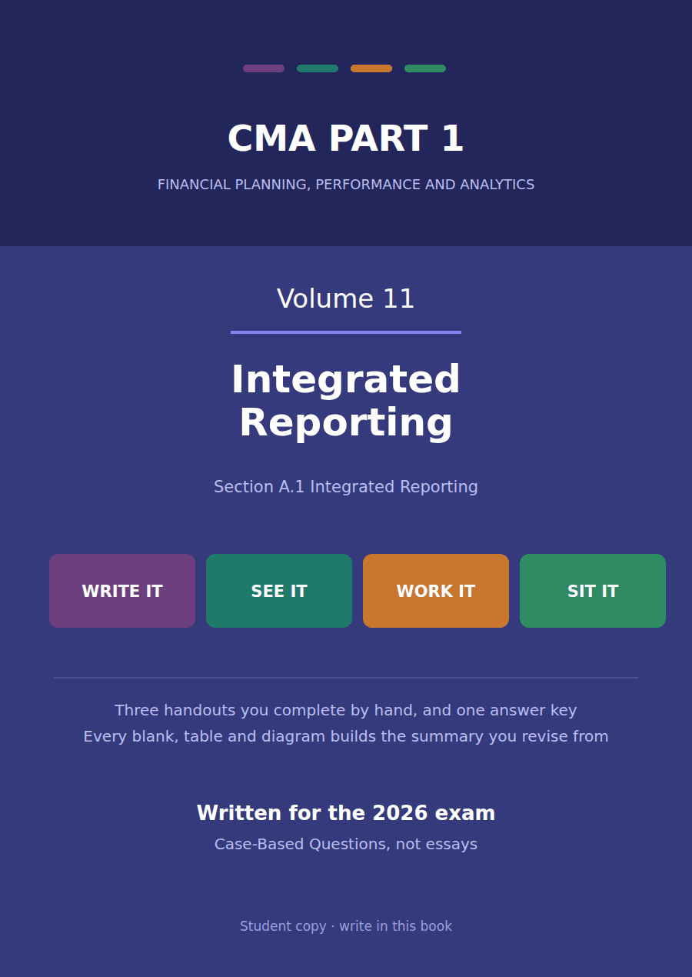

CMA Part 1 · Volume 11
Integrated Reporting
Three handouts, one answer key. A report that explains how a company creates value, and the six capitals it creates it from.
These handouts are not notes to read. You write them. The words you supply are the summary, so a finished handout is a page you can revise from, in your own handwriting.
Work in pen. Do not look at the key until the whole handout is done — the key is written to explain the mistake, and you only get that benefit if you have made it first.
The three handouts
# | Handout | What it gives you
1 | Integrated Reporting and Integrated Thinking | Northwind’s statements explain the $510,000 it earned. They say nothing about how it will earn anything in 20X9, and that gap is what this volume is about.
2 | The Six Capitals and the Value Creation Process | Northwind’s balance sheet measures one of the six stores of value it runs on. The other five are why the $510,000 is possible at all.
3 | The Eight Elements, and What Adoption Costs | Eight questions a report must answer, and one honest account of why most companies have not adopted the framework.

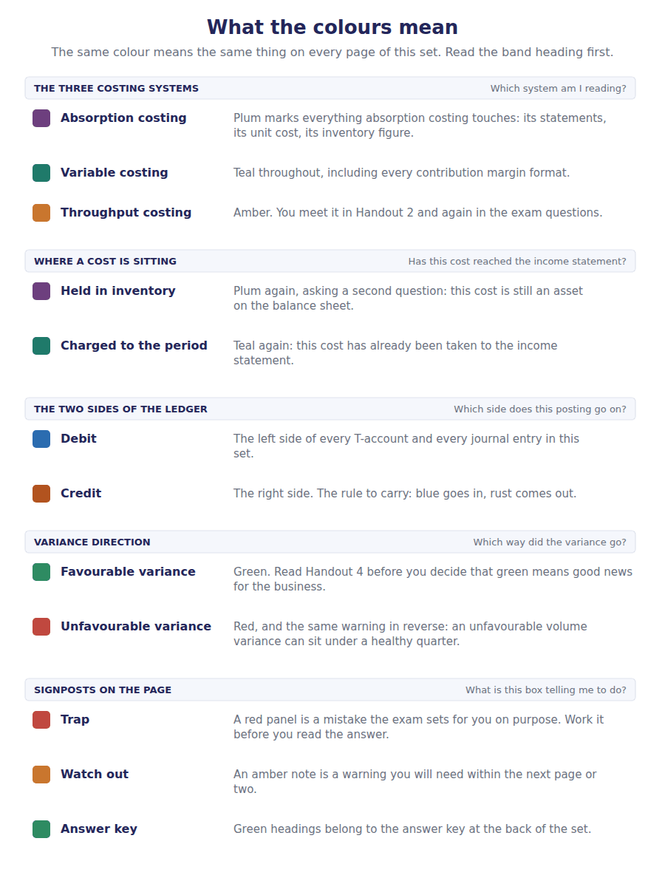
How to read the markers
Marker | Meaning
R1 | Teaching English. Short sentences. This is where a new idea arrives.
R2 | Textbook English. Longer sentences and passive verbs, as a textbook writes them.
R3 | Exam English. Exactly how the CMA exam phrases it, traps included.
Numbered rule | A space you fill in. The number matches the answer key.
Red table | A trap. Read it twice.

Handout 1 · Integrated Reporting and Integrated Thinking
Northwind’s statements explain the $510,000 it earned. They say nothing about how it will earn anything in 20X9, and that gap is what this volume is about.
Volume 11 · Integrated Reporting · R1 moving to R2
LANGUAGE FOCUS
Register you are working in | R1 while the purpose is being established, R2 once the principles are being applied.
Say it exactly like this | create value over time · report on value creation · connect financial and non-financial information · determine what is material · embed integrated thinking in a business · address the providers of financial capital
Words that are not the same | integrated report / financial statements · integrated thinking / integrated reporting · financial capital / the other capitals · short term / over time
Remember | An integrated report is not a sustainability report. Its subject is value creation for the business, not its environmental record for its own sake. Integrated reporting is not an accounting standard. There is no required format and no general audit requirement.

What you will be able to do when this handout is finished
- Say what an integrated report is and what it reports on.
- Name its primary intended audience.
- Distinguish integrated thinking from integrated reporting.
- State the seven guiding principles.
- Say how an integrated report differs from the financial statements.

What the statements do not say
Volume 1 built Northwind’s statements. They report $4,800,000 of sales, $510,000 of profit and $4,990,000 of total assets, all of it measured, audited and comparable.
A reader deciding whether to invest for ten years needs more than that. Are the engineers staying? Is the brand holding? What happens to the components business if its main customer redesigns?
None of those are assets and none of them can be put in the balance sheet. Yet every one of them bears on whether there will be a profit in 20X9.
An integrated report is an attempt to answer them, in one concise document, alongside the figures.

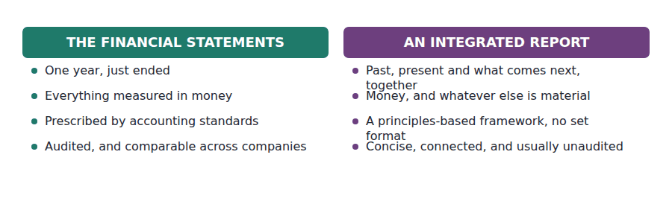
Part 1 · What it is and who it is for one document, one audience
Exercise 1A Read and complete. Write one word in each space.
OBJECTIVE | Say what an integrated report reports on and who its primary reader is.
YOU WILL NEED | Volume 1 Handout 1, on the purpose of financial reporting.
HOW TO START | • The subject of the report is a process rather than a period. Think about what the reader is trying to predict.  • The framework names one audience first, and it is the same audience the financial statements serve: a provider of financial capital, which means an investor or a lender.  • The last blank is the quality the framework puts into the definition itself, and most first attempts fail it.

WORD BANK
audited · capital · concise · destroyed · detailed · profit · value
Not every word is used.

R1 An integrated report explains how a company’s strategy, governance, performance and prospects lead it to create ¹ over time. Its subject is that process, not a period.
Value is not only financial and not only the company’s own. A business uses and affects resources of several kinds, and the report has to show what it does to each. Value can also be ² , and the framework requires that to be reported too.
The report is addressed first to the providers of financial ³ : the investors and lenders who commit money and want to know whether the business will still be creating value in ten years.
Other stakeholders benefit from reading it, and it is not written for them first. And it must be ⁴ , which is part of the definition rather than a presentational preference.
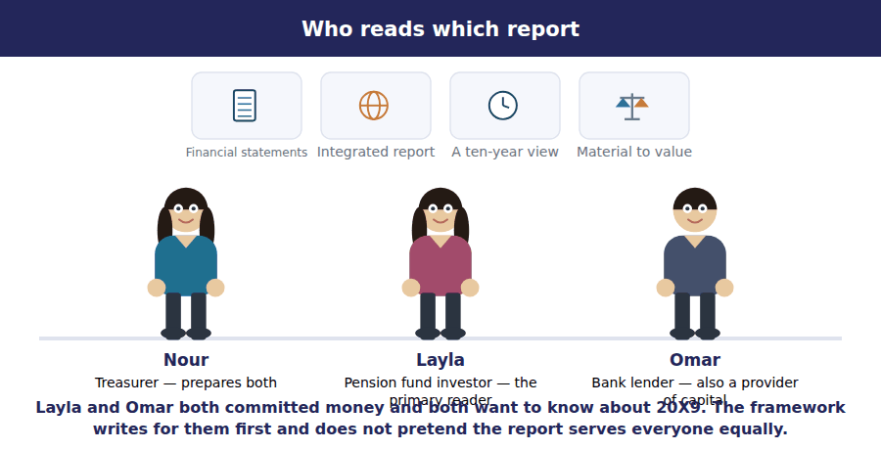
Part 2 · Thinking before reporting the practice and its output
R2 Integrated thinking is what happens inside a business: managers actively considering the relationships between the units they run and the resources they use and affect. The report is its output. A company that has not done the thinking can only produce a document.
Exercise 1B Sort each item into the column it belongs in.
OBJECTIVE | Distinguish integrated thinking from integrated reporting.
YOU WILL NEED | The paragraph above.
HOW TO START | • Ask where each activity happens: inside the management of the business, or in the document that comes out of it.  • Breaking down the barriers between functions is a management change and not a disclosure.  • Two of the items are about the document, and one of those two is about its length.

Activity | INTEGRATED THINKING | INTEGRATED REPORTING
1. Capital budgeting that weighs the effect on staff retention
2. Publishing one concise document in place of several
3. Breaking down the barriers between finance and operations
4. Deciding which matters are material to value creation
5. Managers held accountable for resources that are not on the balance sheet
6. Connecting the strategy section to the performance figures on the page

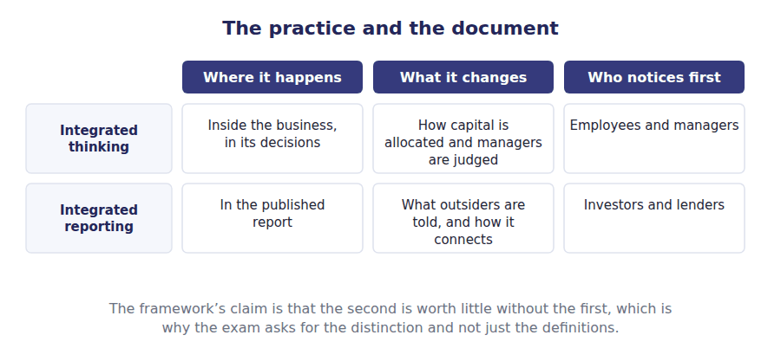
Part 3 · The seven guiding principles how the report is prepared
Exercise 1C Complete the right-hand column. One short phrase in each cell.
OBJECTIVE | State each guiding principle and say what it requires.
YOU WILL NEED | Exercises 1A and 1B.
HOW TO START | • Two of the seven are about what goes in: one is a threshold and one is a limit on length.  • One is about showing the links between things rather than listing them separately, and it is the principle most reports fail.  • Two are paired qualities, and both of those pairs appear as single principles.

Guiding principle | What it requires
Strategic focus and future orientation
Connectivity of information
Stakeholder relationships
Materiality
Conciseness
Reliability and completeness
Consistency and comparability

1 | 2 | 3 | 4 | 5 | 6
7

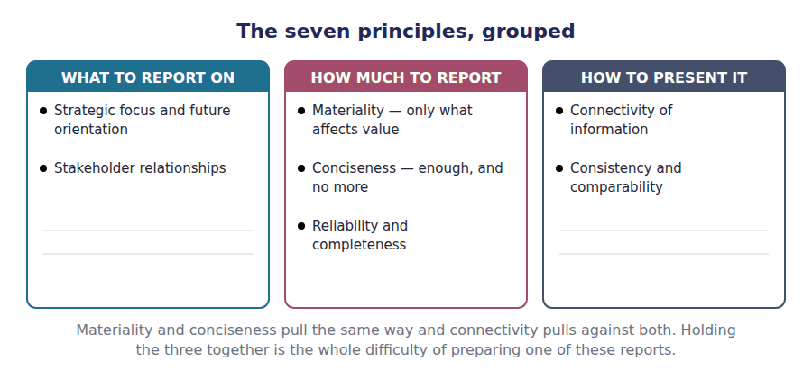
Part 4 · The principle that does the work connectivity
Exercise 1D Read and complete. Write one word in each space.
OBJECTIVE | Say what connectivity of information requires and why it is hard.
YOU WILL NEED | Exercise 1C.
HOW TO START | • A report with a strategy section, a performance section and a risk section may still fail this principle. Ask what is missing.  • Northwind’s $510,000 of profit depends on things no section of the statements mentions.  • The last blank is what a reader should be able to do once the links are shown.

WORD BANK
everything · future · leave · links · nothing · past · sections
Not every word is used.

R2 Connectivity requires the report to show the ⁵ between the factors that affect value, rather than reporting each of them in a section of its own.
A report that describes a strategy on one page, the year’s results on another and the principal risks on a third has told the reader three things and connected ⁶ .
Done properly, Northwind’s report would show how retaining its engineers feeds the product development that produced this year’s $4,800,000 of sales, and what happens to that if the engineers ⁷ .
The test is whether a reader can follow a chain from a resource the company depends on to a number in the statements, and so form a view about the ⁸ .
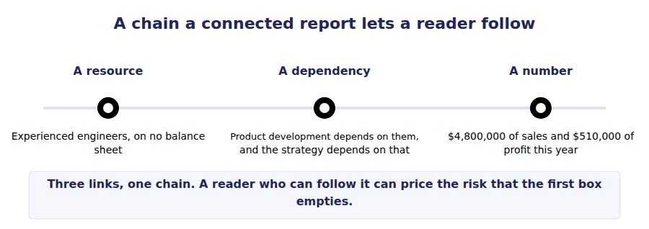
Part 5 · Against the financial statements five differences
Exercise 1E Complete both right-hand columns where they are blank.
OBJECTIVE | Compare an integrated report with the financial statements on five points.
YOU WILL NEED | Exercises 1A and 1C, and Volume 1 Handout 1.
HOW TO START | • One of the five is a difference of period, and the integrated report covers more than one.  • On one row the two reports agree, and that row is the audience.  • The last row is the one most students get wrong, and the answer for the integrated report is that there is no general requirement.

 | The financial statements | An integrated report
Period covered | The year just ended
Measured in | Money
Prepared for
Governed by | Accounting standards
Assured by | A statutory audit

1 | 2 | 3 | 4 | 5 | 6
7

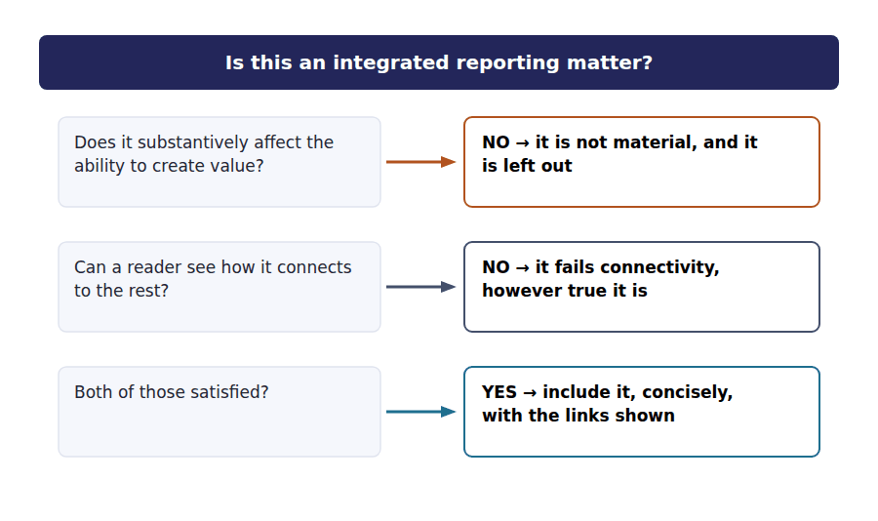
Watch out! Integrated reporting is a framework and not a standard. There is no prescribed format, no line items, and no general requirement for assurance. A question that offers a required statement or a mandatory audit is offering a distractor.
Part 6 · Exam pitch the questions as the CMA sets them
1. [Level A] An integrated report is best described as a communication about:
(A) A company’s environmental and social performance
(B) How a company’s strategy, governance, performance and prospects lead to value creation over time
(C) The results of the year just ended
(D) A company’s compliance with accounting standards
2. [Level A] The primary intended audience of an integrated report is:
(A) Employees
(B) Providers of financial capital
(C) Regulators
(D) All stakeholders equally
3. [Level B] Integrated thinking differs from integrated reporting in that it:
(A) Is required by the framework
(B) Happens inside the business, in how decisions are made
(C) Covers a longer period
(D) Is audited
4. [Level B] Which guiding principle requires an integrated report to show the relationships between the factors affecting value?
(A) Materiality
(B) Connectivity of information
(C) Conciseness
(D) Reliability and completeness
5. [Level B] Under the integrated reporting framework, a matter is material if it:
(A) Exceeds a quantitative threshold
(B) Substantively affects the company’s ability to create value
(C) Would change an auditor’s opinion
(D) Is required by an accounting standard
6. [Level C] An integrated report that runs to 300 pages and discloses every available metric:
(A) Complies with the framework, because completeness is a principle
(B) Fails the framework, because conciseness and materiality are also principles
(C) Complies, provided it is audited
(D) Fails, because the framework sets a page limit
7. [Level C] Assurance on an integrated report is:
(A) Required annually, by the statutory auditor
(B) Not generally required by the framework
(C) Required only for listed companies
(D) Required for the non-financial sections only
ADAPTIVE TIP Two words answer most questions on this topic: value and over time. If an option is about a past period, about compliance, or about one stakeholder group other than the providers of capital, it is almost certainly the distractor.

Handout 2 · The Six Capitals and the Value Creation Process
Northwind’s balance sheet measures one of the six stores of value it runs on. The other five are why the $510,000 is possible at all.
Volume 11 · Integrated Reporting · R2
LANGUAGE FOCUS
Register you are working in | R2 throughout, with one R3 classification because the exam asks which capital an item belongs to.
Say it exactly like this | draw on a capital · deplete a stock of capital · transform inputs into outputs · report an outcome rather than an output · trade one capital off against another · describe a business model
Words that are not the same | input / output · output / outcome · financial capital / the other five · increase / deplete
Remember | The six capitals are not six new asset categories. Most of them are not assets of the company at all and are reported on because the company affects them. An output is not an outcome. The component is the output; what making it did to each capital is the outcome.

What you will be able to do when this handout is finished
- Name the six capitals and say what each one is.
- Classify a resource into the right capital.
- Describe the value creation process in its four stages.
- Distinguish an output from an outcome.
- Explain a trade-off between two capitals.

Six stores of value, one on the balance sheet
Northwind’s balance sheet measures $4,990,000 of total assets and $2,670,000 of equity. That is financial capital, and the accounts measure it well.
It also runs on five other things. A plant, a set of component designs, an engineering team, twenty years of dealing with its main customer, and the metal and energy its machines consume.
Only the first of those five is on the balance sheet, as $3,200,000 of property, plant and equipment. The team and the relationship are not assets in accounting at all.
The framework calls all six capitals and asks a company to report what it does to each.

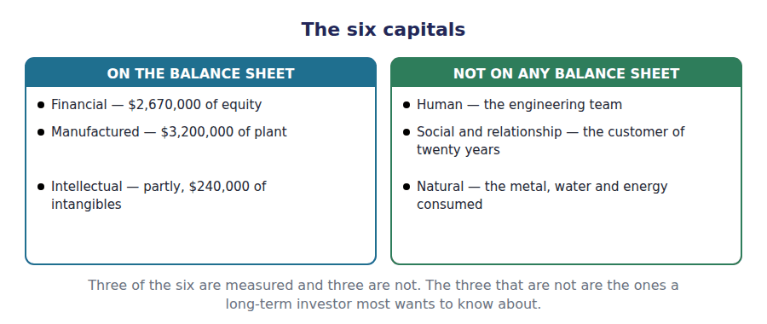
Part 1 · The six, named and what each one covers
Exercise 2A Complete the middle column. One short phrase in each cell.
OBJECTIVE | Name each of the six capitals and say what it covers.
YOU WILL NEED | Handout 1 Exercise 1A, on what value creation means.
HOW TO START | • Two of the six cover physical things, and they are distinguished by whether the company sells them or uses them.  • One of the six covers things that cannot be touched at all, and it is wider than the intangible assets of Volume 5.  • The last two are reported because the company affects them rather than because it owns them.

Capital | What it is | Northwind’s example
Financial |  | $2,670,000 of equity and $1,350,000 of debt
Manufactured |  | $3,200,000 of property, plant and equipment
Intellectual |  | Component designs, and the $240,000 of intangibles
Human |  | The engineering team, on no balance sheet
Social and relationship |  | Twenty years of dealing with its main customer
Natural |  | The metal, water and energy the plant consumes

1 | 2 | 3 | 4 | 5 | 6

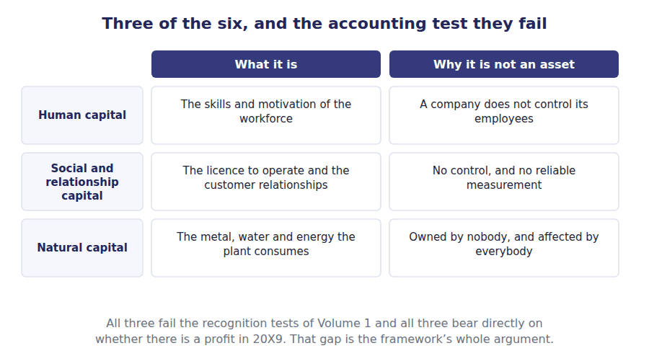
Part 2 · Sorting a resource into a capital the classification the exam asks for
R2 The hard cases turn on one distinction each. Physical things a company sells are outputs rather than manufactured capital. Knowledge inside people is human capital, while knowledge written down and owned by the company is intellectual capital.
Exercise 2B Sort each item into the column it belongs in.
OBJECTIVE | Classify each resource into the capital it belongs to.
YOU WILL NEED | Exercise 2A, and the paragraph above.
HOW TO START | • Ask first whether the item is physical, and if it is, whether the company sells it or uses it.  • A patent is written down and owned; a technician’s experience is not. They are different capitals.  • Two of the items are relationships rather than things, and one of those is with a regulator.

Resource | MANUFACTURED | INTELLECTUAL | HUMAN | SOCIAL
1. The machining centre on the factory floor
2. A patent on a component design
3. A technician’s twenty years of experience
4. The licence to operate granted by the regulator
5. The quality management system the company wrote
6. The trust of the main customer
7. The warehouse and its racking
8. The training the engineers have been given

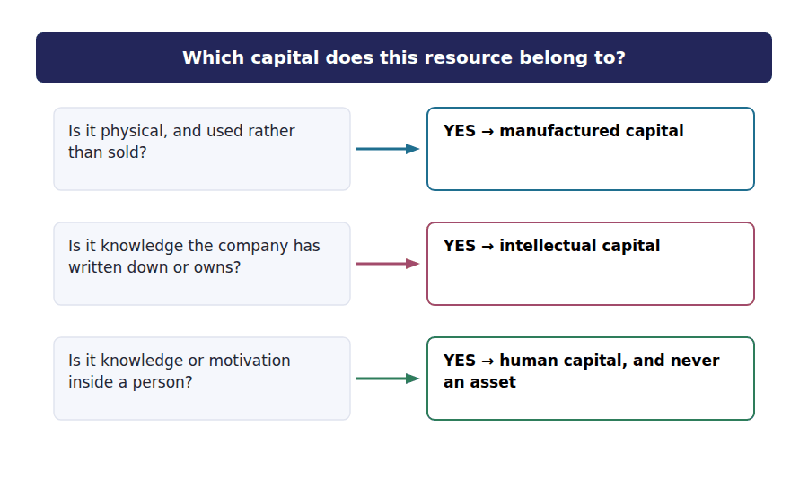
Part 3 · The value creation process four stages, in order
Exercise 2C Complete both right-hand columns.
OBJECTIVE | Describe the four stages of the value creation process.
YOU WILL NEED | Exercise 2A.
HOW TO START | • The first stage is the capitals going in, and Northwind draws on all six of them.  • The third stage is what comes out of the factory, and it includes what nobody wanted as well as what was sold.  • The fourth stage is the one students collapse into the third. It is the effect on each capital, not the thing produced.

Stage | What it means | Northwind
Inputs
Business activities
Outputs
Outcomes

1 | 2 | 3 | 4 | 5 | 6
7 | 8

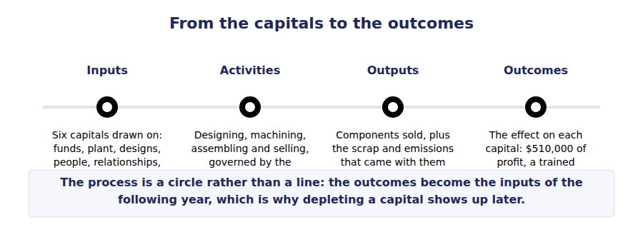
Part 4 · Output against outcome the distinction that is tested
Exercise 2D Read and complete. Write one word in each space.
OBJECTIVE | Distinguish an output from an outcome and give one of each.
YOU WILL NEED | Exercise 2C, and the process figure above.
HOW TO START | • Northwind’s factory produces components. Ask what else it produces that nobody ordered.  • The outcome is not the thing. It is what making the thing did to each of the six capitals.  • The last blank is the kind of outcome students leave out, and the framework requires it.

WORD BANK
effect · financial · natural · negative · outcome · output · profit
Not every word is used.

R2 An output is what comes out of the business activities: Northwind’s components, and also the scrap and emissions that came with them. A by-product is still an ¹ .
An outcome is different. It is the ² of those activities and outputs on the capitals, inside the company and outside it.
So the component is an output; the $510,000 of profit it helped produce is a financial outcome, the skills the engineers gained in designing it are a human outcome, and the metal consumed in making it is a ³ outcome.
Note the direction of that last one. An outcome can be ⁴ , and a framework that only let a company report the capitals it had increased would be worth nothing.
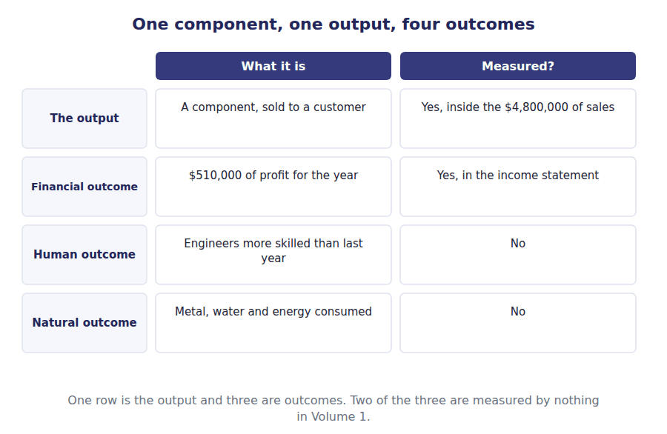
Part 5 · Trading one capital for another where the framework earns its keep
Exercise 2E Read and complete. Write one word in each space.
OBJECTIVE | Explain a trade-off between two capitals and say why it matters.
YOU WILL NEED | Exercise 2D.
HOW TO START | • Suppose Northwind cuts its training budget and reports a higher profit this year.  • Ask which capital rose and which fell, and whether the statements would show both.  • The last blank is what the framework asks a company to disclose about such a decision.

WORD BANK
balance · decline · improve · later · profit · sooner · trade-off
Not every word is used.

R2 Suppose Northwind halves its training budget. Profit rises this year, so financial capital increases, and the skills of its engineers ⁵ , so human capital is depleted.
The income statement reports the first effect and is silent about the second. A reader seeing only the statements would record an improvement where the framework would record a ⁶ .
That is where the six capitals earn their keep. A company genuinely practising integrated thinking has to ask what a decision does to each capital rather than to ⁷ alone.
And because the outcomes of one year are the inputs of the next, a capital run down now reduces what is available ⁸ , which is exactly what a ten-year investor is trying to find out.
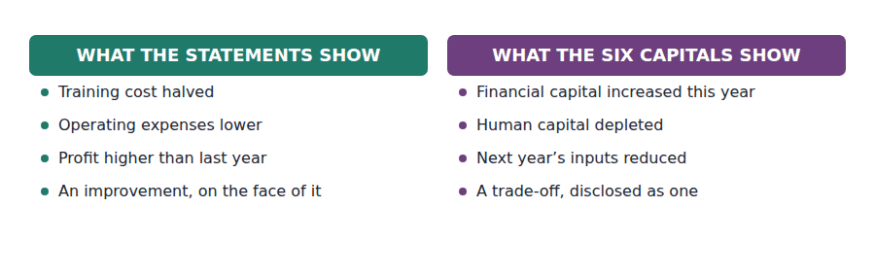
Watch out! A company need not use the six capitals as the structure of its report, and it must consider all of them. The framework asks which capitals matter to this business and what it does to them, not for six headed sections.
Part 6 · Exam pitch the questions as the CMA sets them
1. [Level A] Which of the following is not one of the six capitals in the integrated reporting framework?
(A) Intellectual capital
(B) Regulatory capital
(C) Natural capital
(D) Social and relationship capital
2. [Level A] A company’s factory buildings and machinery are an example of:
(A) Financial capital
(B) Manufactured capital
(C) Intellectual capital
(D) Natural capital
3. [Level B] The experience and motivation of a company’s workforce is:
(A) An intangible asset, amortised over its useful life
(B) Human capital, reported in an integrated report but not on the balance sheet
(C) Intellectual capital
(D) Not reported anywhere
4. [Level B] In the value creation process, scrap metal produced alongside a company’s products is:
(A) An outcome
(B) An output
(C) An input
(D) Not reported
5. [Level B] An outcome in the integrated reporting framework is:
(A) The product a company sells
(B) The effect of the company’s activities and outputs on the capitals
(C) The revenue earned in the period
(D) A forecast of next year’s results
6. [Level C] A company reduces its training spend, raising this year’s profit. Under the framework this is:
(A) An increase in value creation
(B) A trade-off, with financial capital increased and human capital depleted
(C) Outside the scope of an integrated report
(D) A reduction in manufactured capital
7. [Level C] Must an integrated report be structured around the six capitals?
(A) Yes, with a section for each
(B) No, but all six must be considered
(C) Yes, for listed companies only
(D) No, and only financial capital need be considered
ADAPTIVE TIP For any item, ask two questions: is it going in, coming out, or an effect? And if it is going in, is it physical, written down, inside a person, a relationship, or from the environment? Those two questions place every item this topic can offer you.

Handout 3 · The Eight Elements, and What Adoption Costs
Eight questions a report must answer, and one honest account of why most companies have not adopted the framework.
Volume 11 · Integrated Reporting · R2 moving to R3
LANGUAGE FOCUS
Register you are working in | R2 for the elements, R3 for the benefits and limitations, which the exam asks as an evaluation question.
Say it exactly like this | address a content element · explain the basis of preparation · disclose a forward-looking statement · obtain assurance over a disclosure · compare one report with another · fall back on boilerplate
Words that are not the same | element / principle · performance / outlook · benefit / limitation · disclosure / assurance
Remember | The eight elements are not a table of contents. They are questions to be answered, in whatever structure suits the business. The limitations are not an argument against the framework. They are what the exam expects a candidate to be able to state.

What you will be able to do when this handout is finished
- Name the eight content elements.
- Say which question each element answers.
- Distinguish the elements from the guiding principles.
- State the benefits of preparing an integrated report.
- State its limitations, and say which is the most serious.

Eight questions
Handout 1 gave the seven principles, which govern how a report is prepared. This handout gives the eight content elements, which govern what it has to address.
Each element is a question rather than a heading. The framework prescribes no structure at all, and a company may answer the eight in whatever order its own business makes sensible.
Then the honest part. Very few companies prepare one of these, and the reasons are good ones.
The exam asks for both halves: the benefits, and the limitations.

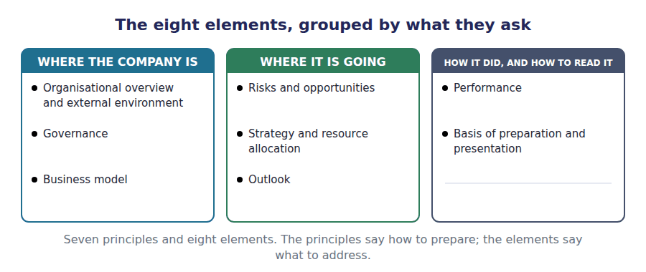
Part 1 · The eight elements each one a question
Exercise 3A Complete the right-hand column. One question in each cell.
OBJECTIVE | Say which question each content element answers.
YOU WILL NEED | Handout 1 Exercise 1C, on the seven principles. · Handout 2 Exercise 2C, on the business model.
HOW TO START | • Two of the eight are forward-looking, and only one of those two is about the company’s own intentions.  • One asks how the company creates value at all, and Handout 2 named it.  • The last one is the only element about the report itself rather than about the business.

Content element | The question it answers
Organisational overview and external environment
Governance
Business model
Risks and opportunities
Strategy and resource allocation
Performance
Outlook
Basis of preparation and presentation

1 | 2 | 3 | 4 | 5 | 6
7 | 8

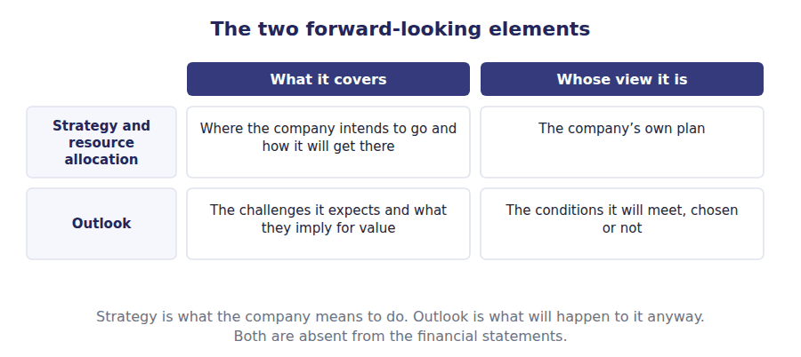
Part 2 · Elements against principles what to address, how to prepare
Exercise 3B Sort each item into the column it belongs in.
OBJECTIVE | Distinguish the content elements from the guiding principles.
YOU WILL NEED | Exercise 3A, and Handout 1 Exercise 1C.
HOW TO START | • A principle is a quality the whole report must have. An element is a matter the report must address.  • Conciseness is a quality of the document, not a subject of it.  • Three of the six items are elements, and one of those three is about how the report itself was put together.

Item | CONTENT ELEMENT | GUIDING PRINCIPLE
1. Governance
2. Connectivity of information
3. Outlook
4. Conciseness
5. Basis of preparation and presentation
6. Stakeholder relationships

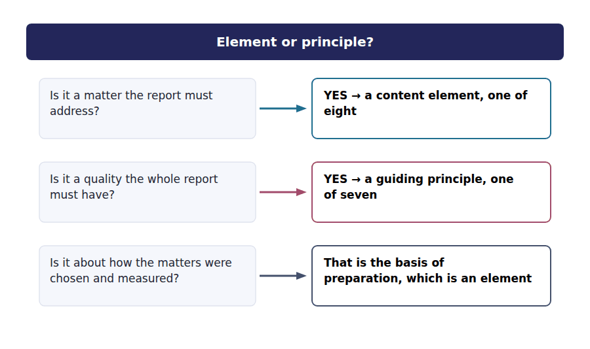
Part 3 · What adoption gives the case for it
Exercise 3C Read and complete. Write one word in each space.
OBJECTIVE | State the benefits of preparing an integrated report.
YOU WILL NEED | Handout 1 Exercise 1B, on integrated thinking.
HOW TO START | • The largest benefit is not to the reader at all. Ask what a company has to do inside itself before it can write one.  • Northwind’s statements explain the $510,000 and say nothing about the engineers. Ask what a reader gains from having both.  • The last blank is what a company discovers about a decision before it takes it.

WORD BANK
decision · figures · know · links · reporting · saving · thinking
Not every word is used.

R2 The largest benefit falls inside the business. A company cannot write about its six capitals without first considering them when it decides things, so preparing the report forces integrated ¹ .
For a reader, the gain is connection. Northwind’s $510,000 of profit and the engineering team that made it possible appear in the same document, with the ² between them shown.
And a reader gets an outlook. The financial statements stop at the year end; the report says what the company expects to meet next, which is what a long-term provider of capital actually wants to ³ .
Inside the business, trade-offs become visible before they are made. Halving a training budget stops looking like a saving and starts looking like a ⁴ .
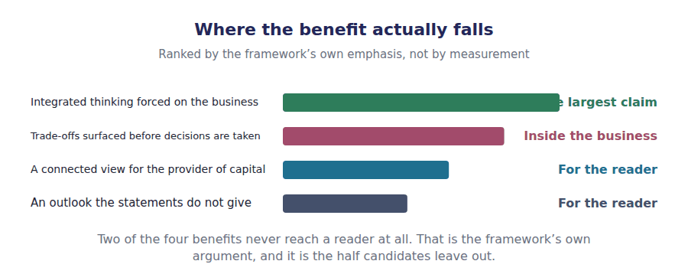
Part 4 · What it costs the case against, stated fairly
Exercise 3D Read and complete. Write one word in each space.
OBJECTIVE | State the limitations of integrated reporting.
YOU WILL NEED | Exercise 3C, and Handout 1 Exercise 1E on assurance.
HOW TO START | • Volume 1’s statements can be compared with any other company’s. Ask whether two integrated reports can.  • A statutory audit covers the financial statements. Ask what covers the claim about the engineers.  • The last blank is what a report becomes when the thinking behind it has been skipped.

WORD BANK
audited · boilerplate · comparability · concise · connectivity · measures · reliability
Not every word is used.

R3 The framework prescribes no format and no measures, so two integrated reports are hard to set beside each other. The loss of ⁵ is the first limitation, and it is the price of a principles-based approach.
The second is assurance. There is no general requirement for an integrated report to be ⁶ , so a claim about a company’s workforce carries nothing like the authority of a figure in the statements.
The third is measurement. Several of the capitals have no accepted unit at all, so a company reporting on its human capital is choosing its own ⁷ and its own basis for them.
The fourth is the most serious. A company can address all eight elements in language true of any company in its industry, and a report of that kind is ⁸ : compliant, concise, connected-looking and worthless.
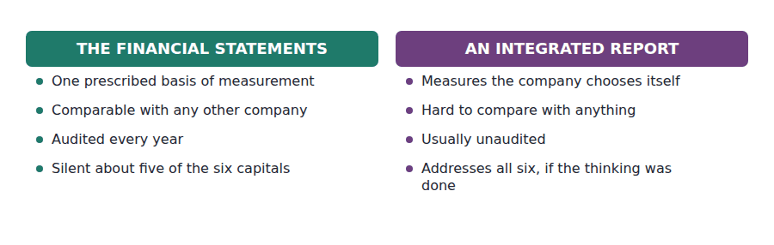
Part 5 · Both sides at once the evaluation the exam asks for
Exercise 3E Complete both columns. Each row is one benefit and one cost.
OBJECTIVE | Set the benefits and the limitations against each other.
YOU WILL NEED | Exercises 3C and 3D.
HOW TO START | • Each row is a pair: the same feature of the framework seen from two sides.  • The reader gains an outlook and loses assurance, and both of those come from the same absence of a standard.  • The last row is about time, and the cost on that row is the one Exercise 3D called most serious.

 | What adoption gives | What it costs or risks
For the reader
For the preparer
For the figures
Over time

1 | 2 | 3 | 4 | 5 | 6
7 | 8

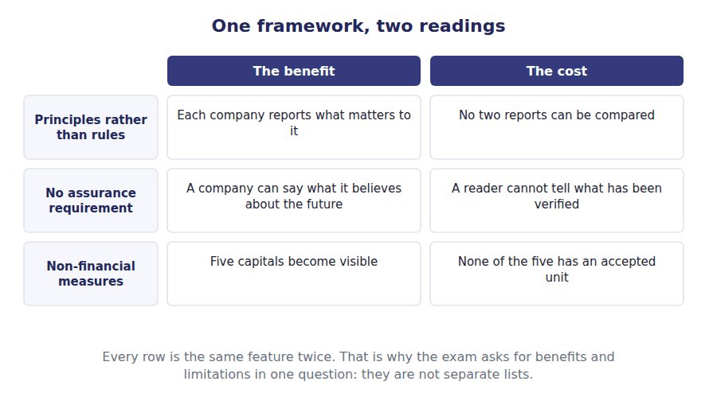
Watch out! The exam wants both halves. A question asking you to evaluate integrated reporting is not satisfied by the benefits, and an answer that only lists the limitations has missed that the framework’s main claim is about decisions rather than disclosure.
Part 6 · Exam pitch the questions as the CMA sets them
1. [Level A] How many content elements does the integrated reporting framework specify?
(A) Six
(B) Eight
(C) Seven
(D) Three
2. [Level A] Which of the following is a content element rather than a guiding principle?
(A) Conciseness
(B) Outlook
(C) Materiality
(D) Connectivity of information
3. [Level B] The content element that explains how the matters to include were chosen and measured is:
(A) Governance
(B) Basis of preparation and presentation
(C) Performance
(D) Business model
4. [Level B] The most frequently cited benefit of preparing an integrated report is:
(A) A lower cost of capital
(B) That it forces integrated thinking inside the business
(C) A reduction in audit fees
(D) Compliance with accounting standards
5. [Level B] A principal limitation of integrated reporting is that:
(A) It is too short to be useful
(B) Reports are difficult to compare, because no format or measures are prescribed
(C) It excludes financial information
(D) It is required only of listed companies
6. [Level C] A company publishes a report addressing all eight content elements in language that would be true of any competitor. The report:
(A) Complies with the framework in substance
(B) Addresses the elements and fails the framework’s purpose
(C) Fails because it is too concise
(D) Cannot be published without assurance
7. [Level C] Compared with the financial statements, the absence of an assurance requirement over an integrated report:
(A) Makes it more reliable, because management speaks directly
(B) Is a limitation, because a reader cannot tell what has been verified
(C) Has no practical effect
(D) Applies only to the outlook element
ADAPTIVE TIP Learn the three counts cold: six capitals, seven principles, eight elements. Then learn one pair from each list in detail, because the questions that are not about counting are almost always about telling a principle from an element.

Answer Key
Volume 11 · Handouts 1 to 3
Every answer carries the reason for it and the mistake it defeats.

Handout 1 · Integrated Reporting and Integrated Thinking answers
Completed text and exercises
# | Answer | Why | The trap it defeats
1 | value | Over time, which is why what comes next is in it.
2 | destroyed | Good news and bad, both material.
3 | capital | Investors and lenders, named explicitly. | Students answer that an integrated report is for all stakeholders. The framework names one audience first, and the exam tests that it is named.
4 | concise | In the definition, not an afterthought.
Grid 1 | 1 INTEGRATED THINKING 2 INTEGRATED REPORTING 3 INTEGRATED THINKING 4 INTEGRATED REPORTING 5 INTEGRATED THINKING 6 INTEGRATED REPORTING | The left column changes how decisions are made. The right column changes what is published. Only the left one can make the right one true.
5 | links | Relationships, not sections.
6 | nothing | Three disclosures are not one report. | Students read connectivity as putting the sections in the same document. It means showing how each one bears on the others.
7 | leave | The risk and the resource, reported together.
8 | future | Which is what the primary reader came for.

Exam-pitch questions
# | Answer | Why | The trap it defeats
1 | (B) How a company’s strategy, governance, performance and prospects lead to value creation over time | Value creation over time is the subject. (A) describes a sustainability report, which is the commonest confusion on this topic and a different document with a different purpose. | Level A
2 | (B) Providers of financial capital | The framework names investors and lenders first. (D) is the generous answer the word integrated invites, and the framework explicitly does not say it. | Level A
3 | (B) Happens inside the business, in how decisions are made | Thinking is the management practice and the report is its output. (A) inverts the relationship: the framework asks for the report, and the thinking is what makes the report mean anything. | Level B
4 | (B) Connectivity of information | Connectivity is about relationships rather than content. (A) and (C) both limit what goes in, and a report can satisfy them both while connecting nothing. | Level B
5 | (B) Substantively affects the company’s ability to create value | The test is effect on value creation, not effect on a reported figure. (A) is the accounting instinct, and the framework sets no threshold at all. | Level B
6 | (B) Fails the framework, because conciseness and materiality are also principles | Completeness is balanced against conciseness and materiality, and the definition itself says concise. (D) is the wrong reason for the right answer: there is no page limit, just principles that pull against each other. | Level C
7 | (B) Not generally required by the framework | The framework imposes no general assurance requirement, which is one of the sharpest differences from the financial statements. (A) assumes the audit rules carry across, and they do not. | Level C

Exercise 1C · the seven principles
Guiding principle | What it requires
Strategic focus and future orientation | Insight into the strategy and how it affects value over time
Connectivity of information | The links between the factors affecting value, shown together
Stakeholder relationships | The quality of relationships with key stakeholders
Materiality | Only matters that substantively affect value creation
Conciseness | Enough to understand, and no more
Reliability and completeness | All material matters, good and bad, without material error
Consistency and comparability | The same basis over time, and comparably with others

Exercise 1E · the two reports compared
 | The financial statements | An integrated report
Period covered | The year just ended | The past, the present and what is expected next
Measured in | Money | Money, and whatever else is material
Prepared for | Investors and lenders, primarily | Providers of financial capital, primarily
Governed by | Accounting standards | A principles-based framework
Assured by | A statutory audit | No general requirement

R2 The audience row is the one to remember, because it is the row where the two reports agree. Both are written first for the people who have committed money, which is why an integrated report is not a sustainability report with the accounts attached.
R2 The assurance row is the one most often got wrong. A statutory audit covers the financial statements; the framework asks for no general assurance on the integrated report at all, and Handout 3 returns to what that costs a reader.

Handout 2 · The Six Capitals and the Value Creation Process answers
Completed text and exercises
# | Answer | Why | The trap it defeats
Grid 1 | 1 MANUFACTURED 2 INTELLECTUAL 3 HUMAN 4 SOCIAL 5 INTELLECTUAL 6 SOCIAL 7 MANUFACTURED 8 HUMAN | The written-down system is intellectual and the training inside people is human. Same knowledge, two capitals, and the test is where it lives.
1 | output | Wanted or not, it came out.
2 | effect | Not the thing, but what the thing did. | Students answer that the outcome is the product. The product is the output; the outcome is what making it did to each capital.
3 | natural | Metal, water and energy.
4 | negative | Value can be destroyed, and must be reported.
5 | decline | Less training, fewer skills.
6 | trade-off | One capital up, another down.
7 | profit | One of six, and the only measured one. | Students read the six capitals as a disclosure exercise. Their purpose is to make the trade-offs visible before the decision is taken.
8 | later | This year’s outcomes are next year’s inputs.

Exam-pitch questions
# | Answer | Why | The trap it defeats
1 | (B) Regulatory capital | The six are financial, manufactured, intellectual, human, social and relationship, and natural. Regulatory capital is a banking term, offered here because it sounds like it belongs. | Level A
2 | (B) Manufactured capital | Physical objects used in production rather than sold. (D) is the distractor the raw materials inside the building invite: the metal is natural capital and the machine that shapes it is not. | Level A
3 | (B) Human capital, reported in an integrated report but not on the balance sheet | A company does not control its employees, so there is no asset, and the framework reports the capital anyway. (C) is the near miss: knowledge written down is intellectual, knowledge inside a person is human. | Level B
4 | (B) An output | Outputs include by-products, wanted or not. (A) is the confusion the whole distinction exists to prevent: the scrap is a thing produced, and the depletion of natural capital is the outcome. | Level B
5 | (B) The effect of the company’s activities and outputs on the capitals | An effect on the capitals, internal or external, positive or negative. (A) is the output, and distinguishing the two is the single most tested point in A.1(n). | Level B
6 | (B) A trade-off, with financial capital increased and human capital depleted | Two capitals moved in opposite directions and the report has to show both. (A) is what the income statement alone would suggest, and it is the reading the six capitals exist to correct. | Level C
7 | (B) No, but all six must be considered | Consideration is required and the structure is not. (A) is the compliance instinct, and a report with six headed sections and no connections between them would fail the connectivity principle of Handout 1. | Level C

Exercise 2A · the six capitals
Capital | What it is | Northwind’s example
Financial | Funds available for use in the business | $2,670,000 of equity and $1,350,000 of debt
Manufactured | Physical objects the company uses, not sells | $3,200,000 of property, plant and equipment
Intellectual | Knowledge-based intangibles, owned or organisational | Component designs, and the $240,000 of intangibles
Human | People’s skills, experience and motivation | The engineering team, on no balance sheet
Social and relationship | Relationships with communities and stakeholders | Twenty years of dealing with its main customer
Natural | Environmental resources the company uses or affects | The metal, water and energy the plant consumes

Exercise 2C · the value creation process
Stage | What it means | Northwind
Inputs | The capitals the business draws on | Metal, engineers, designs, the plant, the funds
Business activities | What the company does to those inputs | Designing, machining, assembling, selling
Outputs | The products and by-products that result | Components, and the scrap and emissions with them
Outcomes | The effects on each capital, inside and outside the company | $510,000 of profit, a trained workforce, metal consumed

R2 Three of the six appear in Volume 1 and three do not. Financial capital is the $2,670,000 of equity and $1,350,000 of debt; manufactured capital is the $3,200,000 of property, plant and equipment; intellectual capital is partly the $240,000 of intangibles and mostly not recognised at all.
R2 The outputs row and the outcomes row are the two most often confused. The component is an output and so is the scrap; the $510,000 of profit, the skills gained and the metal consumed are all outcomes, and only the first of those three is measured anywhere in this course.

Handout 3 · The Eight Elements, and What Adoption Costs answers
Completed text and exercises
# | Answer | Why | The trap it defeats
Grid 1 | 1 CONTENT ELEMENT 2 GUIDING PRINCIPLE 3 CONTENT ELEMENT 4 GUIDING PRINCIPLE 5 CONTENT ELEMENT 6 GUIDING PRINCIPLE | Stakeholder relationships is a principle and not an element, which is the pairing the exam uses to see whether the two lists have been learned separately.
1 | thinking | The practice, not the document.
2 | links | Connectivity, from Handout 1.
3 | know | The outlook element.
4 | decision | With two capitals moving in opposite directions. | Students list only disclosure benefits. The framework’s own strongest claim is about how decisions get made.
5 | comparability | No format, no comparison.
6 | audited | No general requirement at all.
7 | measures | Its own units, and its own basis.
8 | boilerplate | Compliant and empty. | Students treat the limitations as a list to recite. This one is why so few companies produce reports worth reading, and the exam asks which limitation matters most.

Exam-pitch questions
# | Answer | Why | The trap it defeats
1 | (B) Eight | Eight content elements, against seven guiding principles and six capitals. (C) is the number of principles, and the three counts are the easiest marks on this topic to lose. | Level A
2 | (B) Outlook | Outlook is a matter the report must address. The other three are qualities the whole report must have, which is exactly the distinction being tested. | Level A
3 | (B) Basis of preparation and presentation | It is the only element about the report itself rather than the business, and without it a reader cannot interpret any non-financial measure in the document. | Level B
4 | (B) That it forces integrated thinking inside the business | The framework’s own strongest claim is about how decisions get made, not about disclosure. (D) is impossible: the framework is not an accounting standard and compliance with it satisfies nothing statutory. | Level B
5 | (B) Reports are difficult to compare, because no format or measures are prescribed | A principles-based framework buys relevance at the cost of comparability. (C) is false: the financial statements sit inside the picture an integrated report draws. | Level B
6 | (B) Addresses the elements and fails the framework’s purpose | Boilerplate is the characteristic failure of this framework: the elements can be addressed while the connectivity and materiality principles are not met at all. (A) mistakes coverage for communication. | Level C
7 | (B) Is a limitation, because a reader cannot tell what has been verified | Unverified claims about unmeasured capitals are exactly where a sceptical reader needs assurance most. (A) is the argument a company might make and is not the one the exam rewards. | Level C

Exercise 3A · the eight content elements
Content element | The question it answers
Organisational overview and external environment | What does the company do, and in what circumstances?
Governance | How does governance support value creation?
Business model | What is the company’s system for creating value?
Risks and opportunities | What could affect value creation, and how is it managed?
Strategy and resource allocation | Where does the company want to go, and how will it get there?
Performance | What has it achieved against its objectives?
Outlook | What challenges will it meet, and with what effect?
Basis of preparation and presentation | How were the matters to include chosen and measured?

Exercise 3E · benefits and limitations, paired
 | What adoption gives | What it costs or risks
For the reader | A connected view, with an outlook | No assurance, and little comparability
For the preparer | Integrated thinking forced on the business | Real cost, and competitive disclosure
For the figures | Non-financial drivers made visible | Measures that are unmeasured and unverified
Over time | Trade-offs surfaced before decisions | Boilerplate, if the thinking is skipped

R2 Each row of the second table is one feature of the framework read twice. Principles instead of rules let every company report what matters to it and make no two reports comparable; the absence of assurance lets a company state what it believes and leaves a reader unable to tell what has been checked.
R2 The last row is the one to carry into the exam. The benefit is that trade-offs surface before decisions are taken; the cost is that a company that skips the thinking can still publish a document, and most of what has been published is of that kind.

Glossary
Every term in Volume 11, with the Arabic equivalent and the places it misleads
The third column is for recognition only. In the exam room you work in English.

Term | What it means in CMA English | بالعربية | Careful
basis of preparation | The content element explaining how the matters to include were chosen and how they were measured. | أساس الإعداد | The element that makes the rest readable, because without it a reader cannot tell what a non-financial measure means.
boilerplate | Disclosure that is generic enough to be true of any company and so tells a reader nothing. | صياغة نمطية جاهزة | The characteristic failure of this framework. A report can address all eight elements in boilerplate and satisfy none of them.
business model | A company’s system for turning inputs into outputs and outcomes through its business activities. | نموذج العمل | The framework’s own term for the middle of the value creation process, and one of the eight content elements of Handout 3.
content element | One of the eight matters an integrated report is required to address, each framed as a question. | عنصر المحتوى | A question, not a section heading. The framework is explicit that no structure is prescribed.
financial capital | The pool of funds available to a company, from investors, lenders or its own operations. | رأس المال المالي | The only one of the framework’s six capitals that the balance sheet measures. Handout 2 takes the other five.
human capital | The competences, capabilities, experience and motivation of a company’s people. | رأس المال البشري | Never an asset in accounting, because a company does not control its employees. The framework reports it anyway.
integrated report | A concise communication about how a company’s strategy, governance, performance and prospects lead to value creation over time. | التقرير المتكامل | Concise is in the definition. Length is a failure of the framework, not compliance with it.
integrated thinking | Active consideration of the relationships between a company’s business units and the resources it uses, when making decisions. | التفكير المتكامل | The practice inside the business. The report is only its output, which is why a report without the thinking is worthless.
intellectual capital | Knowledge-based intangibles: patents, designs, systems and organisational know-how. | رأس المال الفكري | Wider than the intangible assets on a balance sheet, because most know-how fails the recognition tests of Volume 5.
manufactured capital | Physical objects a company uses in production rather than sells, including buildings, equipment and infrastructure. | رأس المال المصنوع | Called manufactured, not manufacturing. Inventory is an output and not part of this capital.
materiality | The test that a matter be included only if it substantively affects the company’s ability to create value. | الأهمية النسبية | A different test from the accounting one. Here the question is effect on value creation, not effect on a reported figure.
natural capital | Environmental resources a company uses or affects, renewable and otherwise. | رأس المال الطبيعي | Reported because the company affects it, not because it owns it. That is true of most of the six.
outcome | The internal and external effect of a company’s activities and outputs on the capitals. | النتيجة | An outcome can be negative. Depleting a capital is an outcome the framework requires to be reported.
outlook | The content element covering the challenges the company expects and their implications for value creation. | التوقعات المستقبلية | Distinct from performance, which is backward-looking. This is where the framework differs most from the financial statements.
provider of financial capital | An investor or lender who commits money to a business, and the primary intended reader of an integrated report. | مقدّم رأس المال المالي | The framework names this audience explicitly. Other stakeholders benefit, and the report is not addressed to them first.
risks and opportunities | The content element covering what could affect value creation and how the company manages it. | المخاطر والفرص | Opportunities as well as risks, which is the half candidates leave out of the name.
social and relationship capital | The relationships a company has with its communities, customers, suppliers and other stakeholders. | رأس المال الاجتماعي والعلاقات | Includes a company’s licence to operate and its reputation. Both can be destroyed in a week.
value creation | The process by which a company increases, decreases or transforms the resources it uses and affects. | خلق القيمة | Value can be destroyed as well as created, and the framework requires both to be reported.

