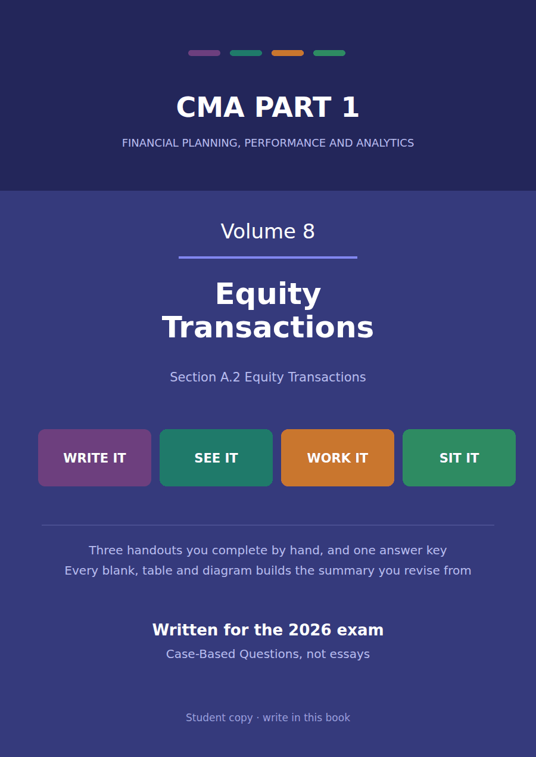

CMA Part 1 · Volume 8
Equity Transactions
Three handouts, one answer key. What moves paid-in capital, what moves retained earnings, and why a stock dividend is neither.
These handouts are not notes to read. You write them. The words you supply are the summary, so a finished handout is a page you can revise from, in your own handwriting.
Work in pen. Do not look at the key until the whole handout is done — the key is written to explain the mistake, and you only get that benefit if you have made it first.
The three handouts
# | Handout | What it gives you
1 | Paid-In Capital or Retained Earnings? | Northwind’s equity of $2,670,000 came from two sources that are never mixed: $1,320,000 put in by shareholders and $1,274,000 earned by the company.
2 | Buying Your Own Shares Back | Northwind buys 10,000 of its own shares for $90,000 and sells 7,000 of them again, one lot at a profit and one at a loss. Neither reaches the income statement.
3 | Small Dividends, Large Dividends and Splits | A 10% stock dividend costs retained earnings $270,000. A 30% one costs $90,000. A split costs nothing at all, and all three leave total equity exactly where it was.

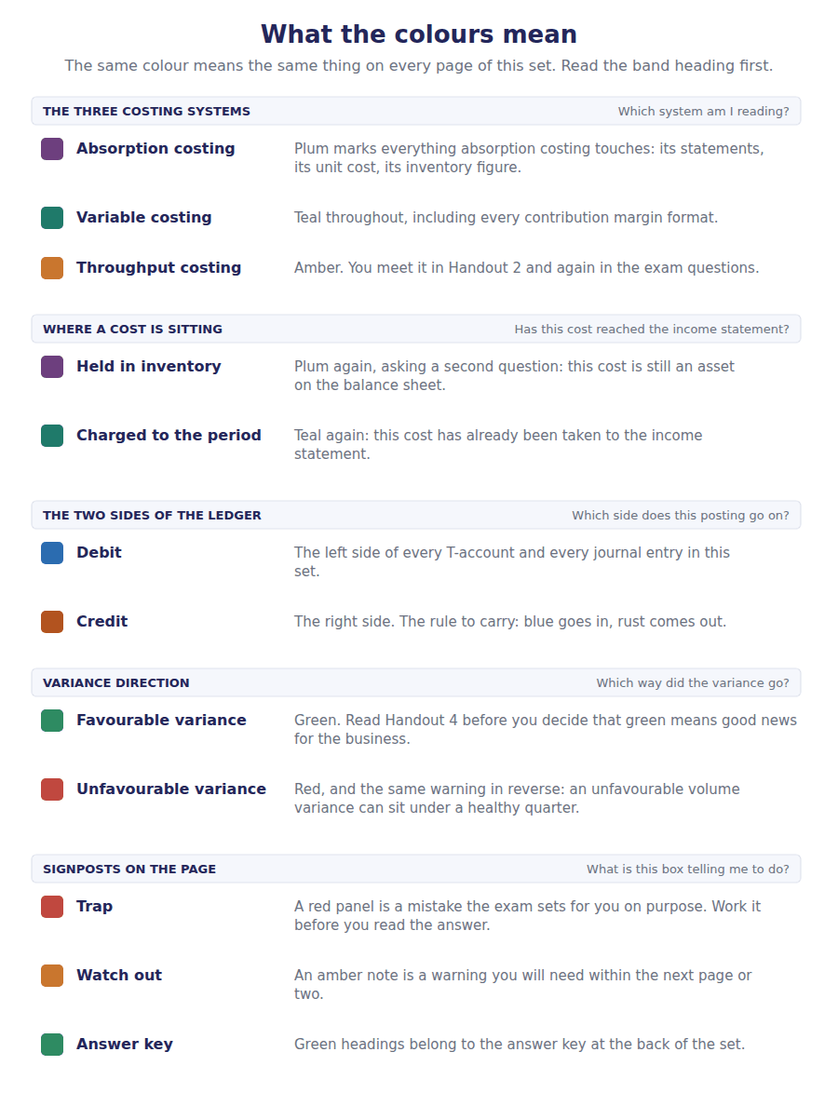
How to read the markers
Marker | Meaning
R1 | Teaching English. Short sentences. This is where a new idea arrives.
R2 | Textbook English. Longer sentences and passive verbs, as a textbook writes them.
R3 | Exam English. Exactly how the CMA exam phrases it, traps included.
Numbered rule | A space you fill in. The number matches the answer key.
Red table | A trap. Read it twice.

Handout 1 · Paid-In Capital or Retained Earnings?
Northwind’s equity of $2,670,000 came from two sources that are never mixed: $1,320,000 put in by shareholders and $1,274,000 earned by the company.
Volume 8 · Equity Transactions · R1 moving to R2
LANGUAGE FOCUS
Register you are working in | R1 while the two sources are separated, R2 once the transactions are being classified.
Say it exactly like this | issue shares at a premium · credit additional paid-in capital · charge an amount to retained earnings · declare a dividend · state a par value · reduce legal capital
Words that are not the same | paid-in capital / retained earnings · contributed / earned · par value / issue price · declared / paid
Remember | Additional paid-in capital is not profit. No part of it was ever earned by the company. Retained earnings is not cash. It is a measure of profits not distributed, and the cash may be anywhere.

What you will be able to do when this handout is finished
- Name the two sources of shareholders’ equity and keep them apart.
- Say what par value is and what it is for.
- Record an issue of shares above par.
- Decide, for a given transaction, which equity account it moves.
- Read a statement of changes in equity and reconcile it.

Two sources, never mixed
Northwind’s shareholders’ equity stands at $2,670,000. Every dollar of it arrived in one of two ways.
Shareholders paid in $1,320,000 for their shares. The company earned $1,274,000 and has not distributed it.
The two are reported separately and are never added together into one figure, because they answer different questions. One says what the owners put in; the other says what the business has made.
This handout sorts the year’s transactions into the right one.

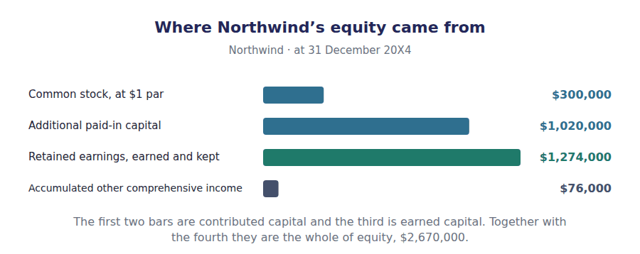
Part 1 · Par value and what it is for a floor, not a price
Exercise 1A Read and complete. Write one word in each space.
OBJECTIVE | Say what par value is and why a share sells for more than it.
YOU WILL NEED | Volume 1 Handout 4, for the equity section of the balance sheet.
HOW TO START | • Northwind’s shares have a par value of $1 and were issued at $7.  • Par was invented to protect somebody. Ask who is harmed if a company gives its shares away.  • The last blank is the account that takes the excess over par, and it is not an income account.

WORD BANK
capital · ceiling · earnings · floor · legal · market · par
Not every word is used.

R1 Northwind’s charter fixes a par value of $1 a share. That figure is not what a share is worth and never was. It is a ¹ , set so that shares cannot be handed out for nothing.
The protection is for creditors rather than shareholders. Par multiplied by the shares issued is the company’s ² capital, and that amount may not be paid back out as a dividend.
Northwind issued 20,000 shares during 20X4 at $7 each. Of the $7, $1 is par and the other $6 is a premium the buyers were willing to pay for a share worth more than its ³ value.
The premium is still money shareholders put in, so it belongs with contributed capital. It is credited to additional paid-in ⁴ and never to income.
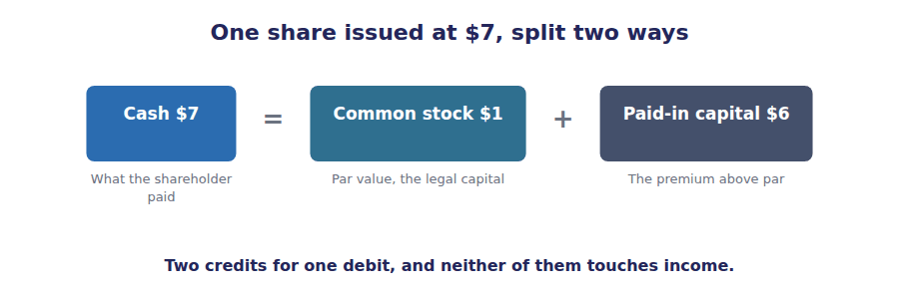
Part 2 · Reading the equity section four lines, two sources
Exercise 1B Complete the right-hand column. One short phrase in each cell.
OBJECTIVE | Say where each line of the equity section came from.
YOU WILL NEED | Exercise 1A, and Volume 1 Handout 6 on comprehensive income.
HOW TO START | • Two of the four lines are contributed and two are not.  • The $76,000 of accumulated other comprehensive income is the one Volume 1 and Volume 6 both traced.  • The amounts are given. Only the source is being asked for.

Equity at 31 December 20X4 | Amount | Where it came from
Common stock, $1 par | $300,000
Additional paid-in capital | $1,020,000
Retained earnings | $1,274,000
Accumulated other comprehensive income | $76,000
Total shareholders’ equity | $2,670,000

1 | 2 | 3 | 4

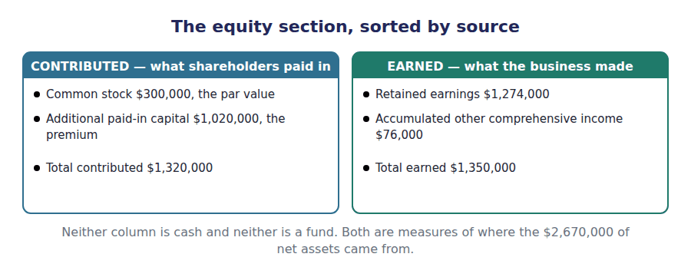
Part 3 · Which account does a transaction move? the classification, item by item
R2 A transaction with shareholders moves contributed capital. A transaction that reports or distributes the company’s own performance moves retained earnings. A transaction with an outsider that is neither moves nothing in equity at all.
Exercise 1C Sort each transaction into the column it belongs in.
OBJECTIVE | Decide which equity account each transaction moves.
YOU WILL NEED | The paragraph above, and Exercise 1B.
HOW TO START | • Ask who the other party is. A shareholder acting as a shareholder means contributed capital.  • Profit, loss and dividends are all about the company’s own performance and its distribution.  • Two of the items move no equity account at all, and borrowing is one of them.

Transaction | PAID-IN | RETAINED | NEITHER
1. Shares issued above par for cash
2. Net income reported for the year
3. A cash dividend declared
4. A long-term loan drawn down
5. Shares issued in exchange for a building
6. An item of inventory written down to market
7. A prior period error corrected
8. Interest paid on a bond

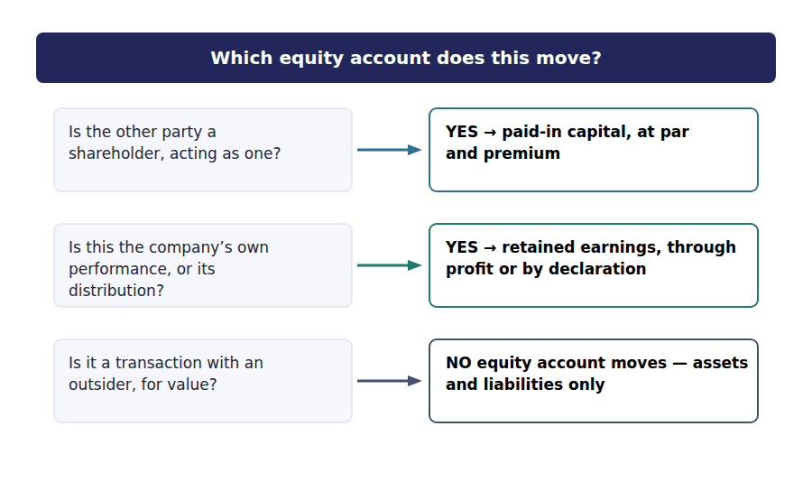
Part 4 · The statement of changes in equity the year, reconciled
Exercise 1D Complete the grid. Write a dash where an account is not affected.
OBJECTIVE | Reconcile each equity account from its opening to its closing balance.
YOU WILL NEED | Exercises 1A and 1C, and Volume 1 Handout 5 for the net income.
HOW TO START | • Three transactions, three accounts, and most cells are dashes.  • The share issue splits between two columns: $1 of par and $6 of premium a share.  • Retained earnings takes the $510,000 of profit and gives up the $170,000 of dividends, and must close at $1,274,000.

Movement during 20X4 | Common stock | Additional paid-in capital | Retained earnings
Balance at 1 January 20X4 | $280,000 | $900,000 | $934,000
20,000 shares issued at $7
Net income for the year
Dividends declared
Balance at 31 December 20X4

1 | 2 | 3 | 4 | 5 | 6
7 | 8 | 9 | 10 | 11 | 12

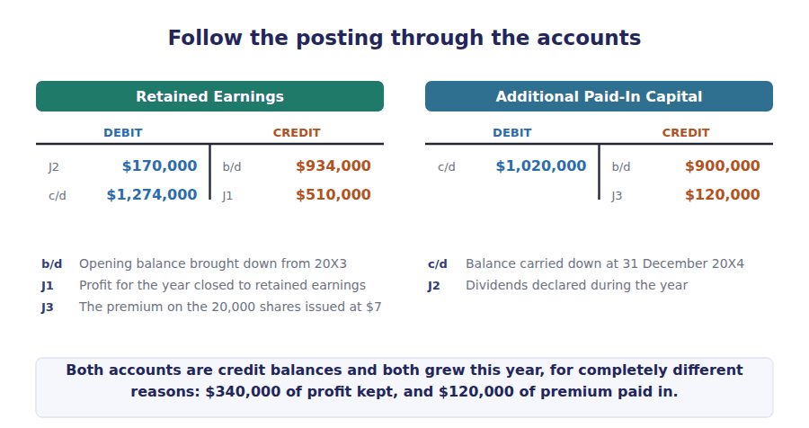
Watch out! Retained earnings is not a pot of money. Northwind has $1,274,000 of retained earnings and $420,000 of cash. A company can be unable to pay a dividend with large retained earnings, and a question that asks whether a dividend can be paid is asking about cash and about legal capital, not about the balance.
Part 5 · Declaring a dividend three dates, one entry
Exercise 1E Read and complete. Write one word in each space.
OBJECTIVE | Say which of the three dividend dates produces an accounting entry.
YOU WILL NEED | Exercise 1D, where the $170,000 of dividends reduced retained earnings.
HOW TO START | • A dividend has a declaration date, a record date and a payment date, and they are not all accounting events.  • Ask on which date the company first has an obligation it cannot avoid.  • The last blank is what the record date does, and it is a matter of identifying shareholders rather than of measuring anything.

WORD BANK
arose · declaration · expense · payable · payment · receivable · record
Not every word is used.

R2 A dividend passes three dates. On the date of ⁵ the board resolves to pay, and from that moment the company owes the money and cannot withdraw the decision.
That is the date the entry is made. Retained earnings is reduced by the $170,000 declared and a dividends ⁶ liability is recognised for the same amount.
On the date of payment the liability is settled in cash. Equity is untouched, because it was reduced when the obligation ⁷ rather than when the cheques went out.
Between the two sits the date of ⁸ , which fixes who the shareholders are and so who gets paid. No entry is made on it at all.
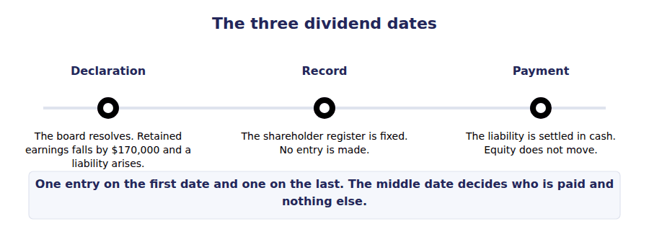
Part 6 · Exam pitch the questions as the CMA sets them
1. [Level A] A company issues 5,000 shares of $2 par common stock for $15 a share. Additional paid-in capital increases by:
(A) $75,000
(B) $65,000
(C) $10,000
(D) Nil, because the excess is income
2. [Level A] Par value represents:
(A) The market value of a share at issue
(B) A nominal amount that fixes the company’s legal capital
(C) The book value of a share
(D) The minimum dividend per share
3. [Level B] Which of the following increases paid-in capital?
(A) Net income for the year
(B) Shares issued in exchange for land
(C) A cash dividend declared
(D) A revaluation of available-for-sale securities
4. [Level B] Retained earnings is reduced by:
(A) Issuing shares below par
(B) A dividend declared but not yet paid
(C) Drawing down a bank loan
(D) Purchasing inventory on credit
5. [Level C] Northwind’s equity is $2,670,000, of which $1,274,000 is retained earnings. Its cash balance is $420,000. The largest cash dividend it could physically pay is:
(A) $1,274,000
(B) $420,000
(C) $2,670,000
(D) $1,350,000
6. [Level C] A company with no-par shares assigns a stated value of $5. Shares are issued at $20. The accounting is:
(A) The whole $20 is credited to common stock
(B) $5 to common stock and $15 to additional paid-in capital
(C) The whole $20 is credited to additional paid-in capital
(D) $5 to common stock and $15 to retained earnings
7. [Level B] A prior period error is corrected in the current year. The correction is reported:
(A) In current year profit
(B) As an adjustment to the opening balance of retained earnings
(C) In other comprehensive income
(D) As a reduction of paid-in capital
ADAPTIVE TIP Before you touch an equity question, ask who the other party is. A shareholder acting as a shareholder can never generate income or a loss for the company, however large the amounts are, and that single rule disposes of most of the distractors on this topic.

Handout 2 · Buying Your Own Shares Back
Northwind buys 10,000 of its own shares for $90,000 and sells 7,000 of them again, one lot at a profit and one at a loss. Neither reaches the income statement.
Volume 8 · Equity Transactions · R2
LANGUAGE FOCUS
Register you are working in | R2 throughout, with the share-count vocabulary drilled at R2 because the exam uses it without explanation.
Say it exactly like this | repurchase shares on the market · hold shares in treasury · reissue treasury shares · charge a deficiency to retained earnings · reduce the shares outstanding · retire shares permanently
Words that are not the same | issued / outstanding · authorised / issued · treasury stock / retired stock · above cost / below cost
Remember | Treasury stock is not an asset. A company cannot own part of itself, so the cost is deducted from equity. A reissue above cost is not a gain. No transaction with a shareholder can produce income.

What you will be able to do when this handout is finished
- Say why treasury stock is deducted from equity rather than held as an asset.
- Record a repurchase under the cost method.
- Record a reissue above cost and a reissue below cost.
- Distinguish authorised, issued, outstanding and treasury shares.
- Say what a buy-back does and does not do to total equity.

A company buys its own shares
In 20X4 Northwind bought 10,000 of its own shares on the market at $9 each, paying $90,000.
Later in the year it sold 4,000 of them at $12 and another 3,000 at $7.
One lot went out above what the company paid and one below. Neither difference is a gain or a loss, and neither appears in profit.
This handout records all three transactions and tracks what each one does to the share counts.

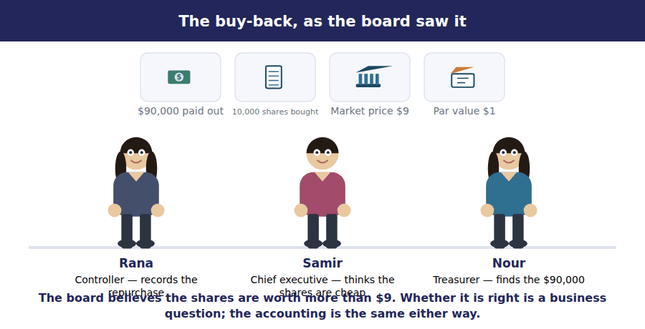
Part 1 · Why it is not an asset a company cannot own itself
Exercise 2A Read and complete. Write one word in each space.
OBJECTIVE | Say why treasury stock is deducted from equity and not held as an asset.
YOU WILL NEED | Volume 1 Handout 2, for the definition of an asset. · Handout 1, for the two sources of equity.
HOW TO START | • Ask what future benefit the company gets from holding its own shares.  • A share entitles its holder to a share of the company. Think about what that means when the holder is the company.  • The last blank is the direction the cost moves total equity.

WORD BANK
asset · deducted · dividend · expense · itself · others · revenue
Not every word is used.

R2 A share is a claim on the company. If the company holds the share, the claim is against ¹ , and a claim a company holds against itself is worth nothing to it.
So the $90,000 paid is not an asset. What has actually happened is that the company has returned $90,000 of capital to the shareholders who sold, exactly as a ² returns capital, and the shares are simply no longer in outside hands.
The cost is therefore recorded in a treasury stock account and ³ from total equity. It is shown as the last line of the equity section, after retained earnings.
Total equity falls by the full $90,000 paid, and nothing is charged to any ⁴ account, because a transaction with shareholders cannot produce a cost of doing business.
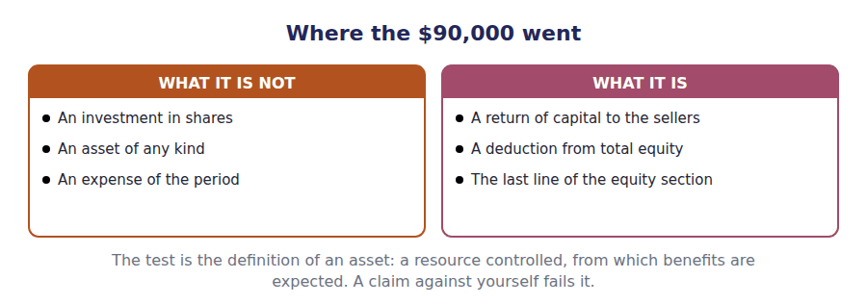
Part 2 · Recording the three transactions the cost method
R2 Under the cost method the treasury account carries what was paid. A reissue above cost credits a paid-in capital account for the excess; a reissue below cost charges the deficiency against that same account, and against retained earnings only when it runs out.
Exercise 2B Read and complete, then record the three entries underneath.
OBJECTIVE | Record the repurchase and both reissues under the cost method.
YOU WILL NEED | Exercise 2A, and the paragraph above.
HOW TO START | • The treasury account is debited with the $90,000 paid and credited with the cost of the shares that go back out, at $9 each.  • The first reissue brings in $12 for shares that cost $9, so there is $12,000 to account for.  • The second brings in $7 for shares that cost $9, which leaves $6,000 short. There is $12,000 of paid-in capital from the first reissue to absorb it.

WORD BANK
cost · earnings · gain · income · loss · market · paid-in
Not every word is used.

R2 The 10,000 shares bought at $9 are carried at their ⁵ of $90,000. The treasury account is a single figure, and the market price after the purchase never changes it.
The first reissue sells 4,000 shares at $12. The company receives $48,000 and removes $36,000 of cost from the treasury account. The $12,000 difference is credited to paid-in capital from treasury stock, because it is not a ⁶ .
The second reissue sells 3,000 shares at $7, which is $2 below cost. The $6,000 shortfall is charged first against the ⁷ capital the first reissue created.
Here $12,000 was available and only $6,000 is needed, so $6,000 remains and nothing touches retained earnings. Had the account been empty, the rest would have been charged to retained ⁸ .
J1 10,000 shares repurchased on the market at $9 each. A deduction from equity, not an investment.
Account | Debit | Credit
Treasury Stock
Cash
J2 4,000 treasury shares reissued at $12, against a cost of $9. Three lines, and the third is not a gain.
Account | Debit | Credit
Cash
Treasury Stock
Paid-In Capital from Treasury Stock
J3 3,000 treasury shares reissued at $7, below the $9 cost. The shortfall goes against paid-in capital, not against profit.
Account | Debit | Credit
Cash
Paid-In Capital from Treasury Stock
Treasury Stock

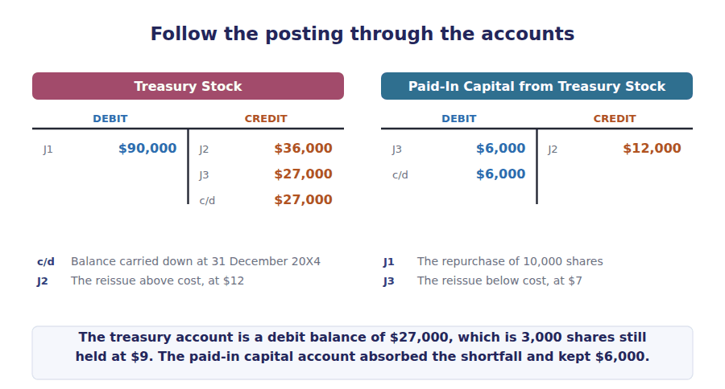
Part 3 · Four share counts and which one matters
Exercise 2C Complete the grid. Two rows never change.
OBJECTIVE | Track the four share counts through the buy-back and the reissues.
YOU WILL NEED | Exercise 2B, and Handout 1 Exercise 1D for the shares issued.
HOW TO START | • The authorised shares and the issued shares are both unaffected by a buy-back: the shares exist and were issued, whoever holds them now.  • Treasury rises by 10,000 and then falls by the 7,000 reissued.  • The outstanding shares are the issued shares less the treasury shares, and that is the only one of the four counts a per-share figure uses.

Share count | Before the buy-back | After the buy-back | After both reissues
Authorised | 500,000
Issued | 300,000
Held in treasury | Nil
Outstanding | 300,000

1 | 2 | 3 | 4 | 5 | 6

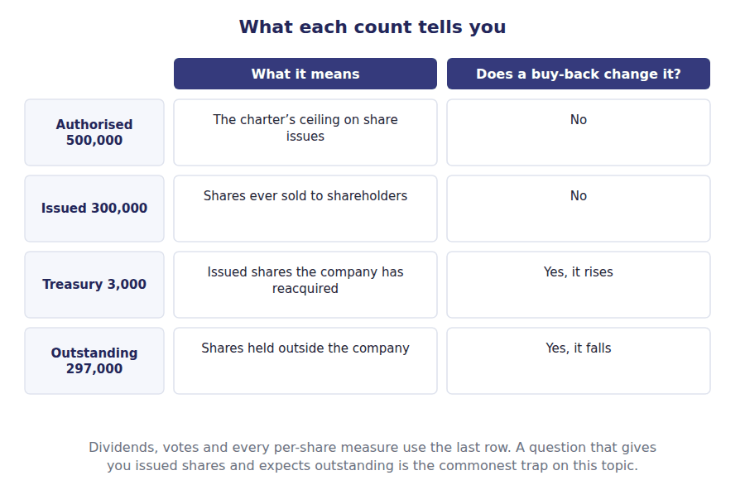
Part 4 · What it does to the totals equity, and the figures built on it
Exercise 2D Complete the grid. The amounts are cumulative.
OBJECTIVE | Say what each step does to total shareholders’ equity.
YOU WILL NEED | Exercise 2B, and Handout 1 Exercise 1B for the opening equity.
HOW TO START | • Equity before any of this is the $2,670,000 Volume 1 reported.  • A buy-back takes cash out, so equity falls by exactly what was paid.  • A reissue brings cash in, so equity rises by exactly what was received, whatever the shares originally cost.

Equity after each step | Amount | What changed
Total equity before the buy-back | $2,670,000
Less 10,000 shares bought back at $9
Plus 4,000 reissued at $12
Plus 3,000 reissued at $7

1 | 2 | 3 | 4 | 5 | 6

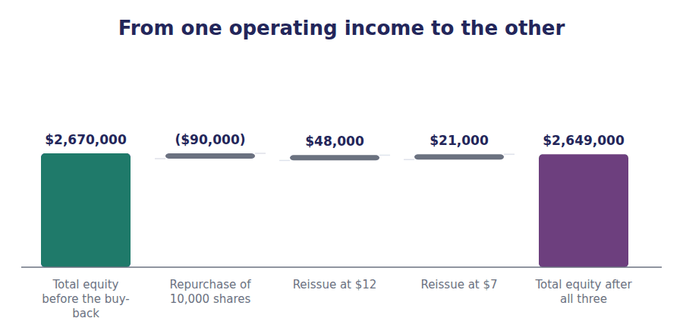
Watch out! A buy-back reduces equity and reduces the shares outstanding, so it raises earnings per share and raises return on equity without the company having earned anything more. A question that asks what a buy-back does to a ratio is asking you to notice that the denominator moved.
Part 5 · Exam pitch the questions as the CMA sets them
1. [Level A] Treasury stock is reported in the financial statements as:
(A) An investment, at fair value
(B) A deduction from total shareholders’ equity, at cost
(C) An intangible asset
(D) A reduction of common stock at par
2. [Level A] A company reacquires 10,000 of its own shares at $9. The effect on total shareholders’ equity is:
(A) No effect, because one equity account replaces another
(B) A decrease of $90,000
(C) A decrease of $10,000, the par value
(D) An increase of $90,000
3. [Level B] Treasury shares costing $9 each are reissued at $12. The $3 a share difference is:
(A) A gain in the income statement
(B) A credit to paid-in capital from treasury stock
(C) A credit to retained earnings
(D) Other comprehensive income
4. [Level B] Treasury shares costing $9 each are reissued at $7 when the paid-in capital from treasury stock account is nil. The $2 a share shortfall is charged to:
(A) The income statement as a loss
(B) Retained earnings
(C) Common stock
(D) Additional paid-in capital from the original share issue
5. [Level B] A company has 300,000 shares issued and holds 3,000 in treasury. The number of shares used to compute earnings per share is:
(A) 300,000
(B) 297,000
(C) 500,000
(D) 10,000
6. [Level C] Northwind buys back 10,000 shares for $90,000 and immediately reissues 4,000 of them at $12. The net effect on total equity of the two transactions together is:
(A) A decrease of $90,000
(B) A decrease of $42,000
(C) An increase of $12,000
(D) No net effect
7. [Level C] A company retires reacquired shares rather than holding them in treasury. Compared with holding them, retiring them:
(A) Has a larger effect on total equity
(B) Reduces the shares issued as well as the shares outstanding
(C) Produces a gain or loss in profit
(D) Has no effect on any share count
ADAPTIVE TIP Write the cost per share at the top of any treasury question and compare every later price with it. The difference is never income: above cost it is a credit to paid-in capital, below cost it is a charge against that same account and then against retained earnings.

Handout 3 · Small Dividends, Large Dividends and Splits
A 10% stock dividend costs retained earnings $270,000. A 30% one costs $90,000. A split costs nothing at all, and all three leave total equity exactly where it was.
Volume 8 · Equity Transactions · R2 moving to R3
LANGUAGE FOCUS
Register you are working in | R2 for the mechanics, R3 for the comparison, which the exam puts as a question about effects on accounts.
Say it exactly like this | declare a stock dividend · capitalise retained earnings · issue shares pro rata · split the shares two for one · adjust the par value · restate shares retrospectively
Words that are not the same | stock dividend / cash dividend · small / large · market value / par value · stock dividend / stock split
Remember | A stock dividend is not income to the shareholder. Each holder owns the same fraction of the same company afterwards. A stock split is not a transaction. Nothing is recorded, and only the share count and the par value change.

What you will be able to do when this handout is finished
- Say what a shareholder receives from a stock dividend.
- Record a small stock dividend at market value.
- Record a large stock dividend at par value.
- Say what a stock split changes and what it records.
- Compare the effect of all three on each equity account.

Three ways to hand out more shares
Northwind has 300,000 shares of $1 par in issue, trading at $9.
The board considers three proposals: a 10% stock dividend, a 30% stock dividend, and a 2 for 1 split.
Every shareholder ends up with more shares and the same fraction of the same company. No cash moves and total equity does not change under any of the three.
Yet the accounting differs in every case, and that is what this handout is for.

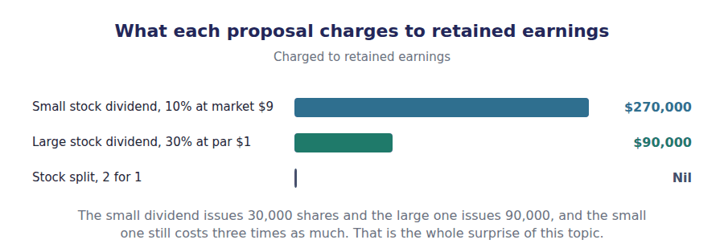
Part 1 · What a shareholder actually gets nothing, measured carefully
Exercise 3A Read and complete. Write one word in each space.
OBJECTIVE | Say what a shareholder receives from a stock dividend.
YOU WILL NEED | Handout 1 Exercise 1E, on how a cash dividend works.
HOW TO START | • Follow a shareholder who holds 30,000 shares out of 300,000 and work out their fraction before and after.  • Nothing leaves the company, so ask what the shareholder is richer by.  • The last blank is why a company does it at all, and it is about the price of one share.

WORD BANK
cash · dividend · falls · half · income · rises · tenth
Not every word is used.

R2 A shareholder holding 30,000 of Northwind’s 300,000 shares owns one tenth of the company. After a 10% stock dividend they hold 33,000 of 330,000, which is still one ¹ .
No asset has left the company and no shareholder has given anything up, so nobody is better off. A stock dividend is not ² to the shareholder and is not taxed as a receipt.
What has changed is that the same equity is divided among more shares, so the price of a single share ³ in proportion. Three shares at $8.18 are worth what two were.
Boards do it to bring the share price into a range more buyers are comfortable with, and to signal confidence without spending any ⁴ .
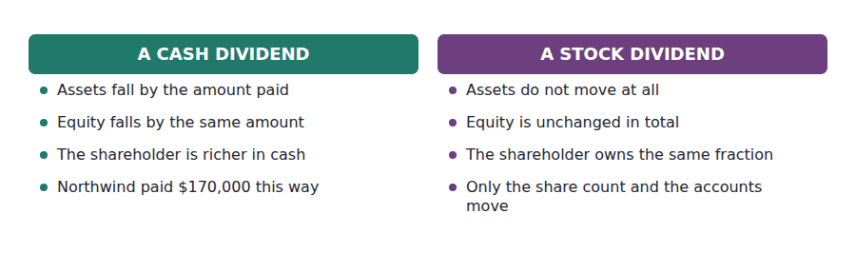
Part 2 · The small stock dividend capitalised at market value
R2 A distribution of less than about a quarter of the shares in issue is treated as a small stock dividend. The market has absorbed so small an increase without much moving the price, so the shares given away are measured at what they are worth: market value.
Exercise 3B Read and complete, then record the entry underneath.
OBJECTIVE | Record a small stock dividend and say which accounts move.
YOU WILL NEED | Exercise 3A, and the paragraph above.
HOW TO START | • 10% of 300,000 shares is 30,000 new shares.  • They are measured at the market price of $9, not at the $1 par.  • The credit splits in two, exactly as an issue of shares for cash does: par to one account and the rest to the other.

WORD BANK
$240,000 · capital · earnings · market · par · reduced · unchanged
Not every word is used.

R2 A 10% dividend on 300,000 shares issues 30,000 new shares. Because the distribution is small, they are capitalised at their ⁵ value of $9 each, or $270,000 in total.
That $270,000 is charged to retained ⁶ , which is why the transaction is called a dividend at all: it uses up profits that could otherwise have been distributed in cash.
The credit side splits. Common stock takes the par value of $30,000 and additional paid-in capital takes the remaining ⁷ .
Total equity is ⁸ , because $270,000 has moved out of one equity account and into two others. Only the composition of equity is different.
J1 A 10% stock dividend declared and issued: 30,000 shares at the market price of $9. One debit inside equity, two credits inside equity, and no cash.
Account | Debit | Credit
Retained Earnings
Common Stock
Additional Paid-In Capital

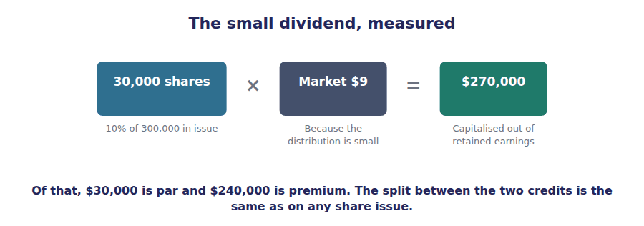
Part 3 · The large stock dividend capitalised at par
Exercise 3C Read and complete. Write one word or figure in each space.
OBJECTIVE | Record a large stock dividend and say why the measurement changes.
YOU WILL NEED | Exercise 3B.
HOW TO START | • 30% of 300,000 shares is 90,000 new shares, which is enough to move the market price materially.  • If the price will fall because of the distribution, the price before it is not a sensible measure of what is being given away.  • The last blank is the comparison the exam is really testing: which of the two dividends costs retained earnings more.

WORD BANK
$90,000 · half · larger · market · par · quarter · smaller
Not every word is used.

R2 A 30% dividend issues 90,000 new shares, which is a large enough increase that the market price will fall roughly in proportion. Measuring the distribution at the old price would overstate it, so a large dividend is capitalised at ⁹ .
The charge to retained earnings is therefore 90,000 shares at $1, or ¹⁰ , and the whole of it is credited to common stock. Additional paid-in capital is not involved at all.
The threshold between the two is conventionally about a ¹¹ of the shares in issue, and a distribution of that size or more is treated as large.
So the 10% dividend costs retained earnings $270,000 and the 30% dividend costs only $90,000. The ¹² distribution is the more expensive one, because it is measured at a much higher price per share.
J2 A 30% stock dividend declared and issued: 90,000 shares at the $1 par value. Two lines only, because there is no premium to record.
Account | Debit | Credit
Retained Earnings
Common Stock

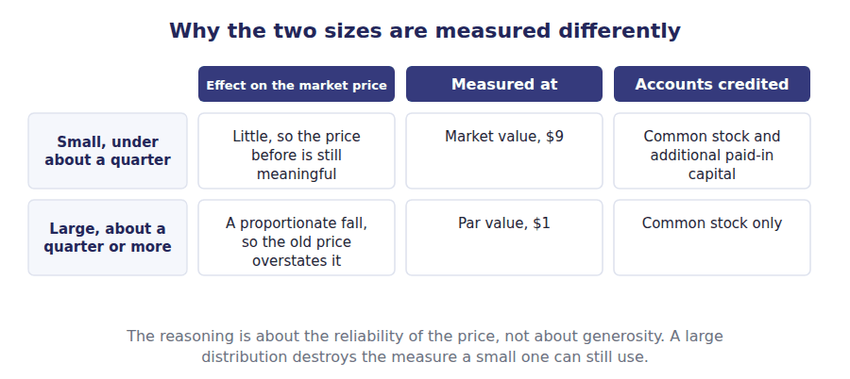
Part 4 · The stock split nothing to record
Exercise 3D Complete the right-hand column. Four of the six rows do not change.
OBJECTIVE | Say what a stock split changes in the accounts.
YOU WILL NEED | Exercises 3B and 3C.
HOW TO START | • A 2 for 1 split doubles the share count, so ask what has to happen to the par value for the common stock account to stay put.  • 300,000 shares at $1 par is $300,000. Check that 600,000 shares at the new par is the same figure.  • If no account changes, no entry is made. The whole record is a note of the new count and the new par.

Account | Before the split | After the 2 for 1 split
Shares issued | 300,000
Par value per share | $1
Common stock | $300,000
Additional paid-in capital | $1,020,000
Retained earnings | $1,274,000
Total equity | $2,670,000

1 | 2 | 3 | 4 | 5 | 6

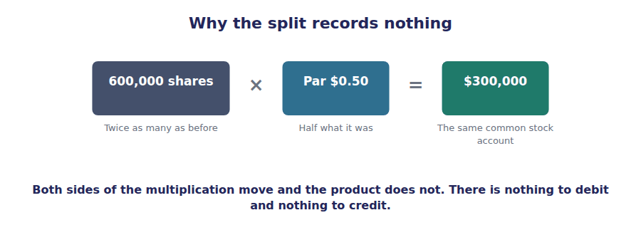
Part 5 · All three compared the question as the exam asks it
Exercise 3E Complete the grid. Every column ends with the same answer.
OBJECTIVE | Compare the effect of the three proposals on each equity account.
YOU WILL NEED | Exercises 3B, 3C and 3D.
HOW TO START | • Rows 2 to 4 are the computations you have already done.  • Row 5 asks about par value per share, and only one of the three columns moves it.  • Row 6 is the same in all three columns, and it is the answer the exam wants most often.

 | Small stock dividend | Large stock dividend | Stock split
Shares issued | 10% | 30% | 2 for 1
New shares
Capitalised at
Charged to retained earnings
Par value per share after
Total equity after

1 | 2 | 3 | 4 | 5 | 6
7 | 8 | 9 | 10 | 11 | 12
13 | 14 | 15

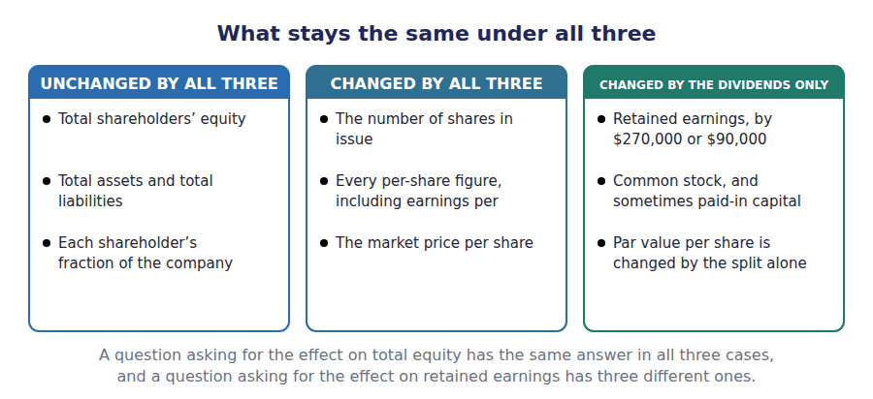
Watch out! A property dividend is the odd one out of the family. Something real does leave the company, so the asset is first remeasured to fair value, the gain or loss on it goes through profit, and retained earnings is then charged with that fair value. It is the only distribution in this handout that touches the income statement at all.
Watch out! Earnings per share is restated for a stock dividend or a split as though the new shares had always existed, including for every prior year shown. Weighting them from the date of issue, the way a cash share issue is weighted, is the error the exam is looking for.
Part 6 · Exam pitch the questions as the CMA sets them
1. [Level A] A stock dividend has what effect on total shareholders’ equity?
(A) It decreases it by the market value of the shares issued
(B) No effect
(C) It decreases it by the par value of the shares issued
(D) It increases it by the market value of the shares issued
2. [Level B] A company with 300,000 shares of $1 par, trading at $9, declares a 10% stock dividend. Retained earnings is reduced by:
(A) $30,000
(B) $270,000
(C) $240,000
(D) Nil
3. [Level B] The same company instead declares a 30% stock dividend. Retained earnings is reduced by:
(A) $810,000
(B) $90,000
(C) $270,000
(D) Nil
4. [Level A] A 2 for 1 stock split is recorded by:
(A) A debit to retained earnings and a credit to common stock
(B) No entry, with a memorandum of the new share count and par value
(C) A credit to additional paid-in capital
(D) A debit to common stock and a credit to retained earnings
5. [Level B] After a 2 for 1 split of 300,000 shares with a $1 par value, the common stock account is:
(A) $600,000
(B) $300,000
(C) $150,000
(D) $1,020,000
6. [Level C] Which of the following reduces retained earnings by the largest amount, for a company with 300,000 shares of $1 par trading at $9?
(A) A 30% stock dividend
(B) A 10% stock dividend
(C) A 2 for 1 stock split
(D) All three are equal
7. [Level C] A company declares a dividend that exceeds its retained earnings. The excess is:
(A) Carried forward as a deficit
(B) Charged to paid-in capital and disclosed as a liquidating dividend
(C) Recognised as an expense
(D) Not permitted in any circumstances
ADAPTIVE TIP For any stock dividend, ask the size first. Under about a quarter means market value and a credit split between two accounts; a quarter or more means par value and one credit. And whatever the answer, total equity has not moved.

Answer Key
Volume 8 · Handouts 1 to 3
Every answer carries the reason for it and the mistake it defeats.

Handout 1 · Paid-In Capital or Retained Earnings? answers
Completed text and exercises
# | Answer | Why | The trap it defeats
1 | floor | The lowest price at which shares may be issued.
2 | legal | The part of equity that cannot be distributed.
3 | par | The charter’s nominal figure.
4 | capital | Contributed, not earned. | Students put the premium in income. Nothing a shareholder pays for a share is ever revenue.
Grid 1 | 1 PAID-IN 2 RETAINED 3 RETAINED 4 NEITHER 5 PAID-IN 6 RETAINED 7 RETAINED 8 RETAINED | A write-down, interest and a loss all reach retained earnings through profit. Only the loan itself touches no equity account.
5 | declaration | The board resolves, and the obligation exists.
6 | payable | A current liability like any other.
7 | arose | Declaration, not payment. | Students reduce equity when the cash leaves. By then the reduction has already happened.
8 | record | It identifies shareholders; it measures nothing.

Exam-pitch questions
# | Answer | Why | The trap it defeats
1 | (B) $65,000 | 5,000 shares at $13 above par is $65,000, with $10,000 going to the par account. (A) credits the whole proceeds to the premium account and leaves legal capital unrecorded. | Level A
2 | (B) A nominal amount that fixes the company’s legal capital | Par fixes legal capital, which may not be distributed. (A) and (C) both attach an economic meaning to a figure set arbitrarily in the charter, which is the misreading the exam tests. | Level A
3 | (B) Shares issued in exchange for land | Shares issued are a transaction with shareholders, whatever is received for them. (A) and (C) move retained earnings, and (D) goes to accumulated other comprehensive income. | Level B
4 | (B) A dividend declared but not yet paid | Declaration is the event that reduces retained earnings and creates the liability; payment only settles it. (A) is a paid-in capital question and in most jurisdictions is not permitted at all. | Level B
5 | (B) $420,000 | Retained earnings measures what may be distributed, not what is available to distribute: the company cannot pay out more cash than the $420,000 it holds. (A) is the standard confusion of a measure with a fund. | Level C
6 | (B) $5 to common stock and $15 to additional paid-in capital | Stated value does the work par would do, so the split is the same. (D) is the trap: nothing a shareholder pays can ever reach retained earnings, because retained earnings records only what the company has earned. | Level C
7 | (B) As an adjustment to the opening balance of retained earnings | An error belongs to the year it was made, so the opening balance is restated rather than this year’s profit. (A) would let a past mistake distort a current result, which is exactly what the treatment exists to prevent. | Level B

Exercise 1B · where each line came from
Equity at 31 December 20X4 | Amount | Where it came from
Common stock, $1 par | $300,000 | Par value of the 300 shares issued,000
Additional paid-in capital | $1,020,000 | Everything shareholders paid above par
Retained earnings | $1,274,000 | Profits earned and not yet distributed
Accumulated other comprehensive income | $76,000 | Gains required to bypass profit
Total shareholders’ equity | $2,670,000

Exercise 1D · the completed reconciliation
Movement during 20X4 | Common stock | Additional paid-in capital | Retained earnings
Balance at 1 January 20X4 | $280,000 | $900,000 | $934,000
20,000 shares issued at $7 | $20,000 | $120,000 | —
Net income for the year | — | — | $510,000
Dividends declared | — | — | ($170,000)
Balance at 31 December 20X4 | $300,000 | $1,020,000 | $1,274,000

R2 Each column closes on the figure Volume 1 reported: common stock at $300,000, additional paid-in capital at $1,020,000 and retained earnings at $1,274,000. The share issue is the only transaction that appears in two columns at once.
R2 Accumulated other comprehensive income is not in the grid because nothing in these three transactions touches it. Its $24,000 movement for the year was traced in Volume 6.

Handout 2 · Buying Your Own Shares Back answers
Completed text and exercises
# | Answer | Why | The trap it defeats
1 | itself | A claim against yourself is not a resource.
2 | dividend | Cash out to shareholders, in both cases.
3 | deducted | A negative item inside equity. | Students put treasury stock among the investments. It is a contra-equity account and never an asset.
4 | expense | No shareholder transaction reaches profit.
5 | cost | What was paid, and it does not move afterwards.
6 | gain | Never, on the company’s own shares. | Students report $3 a share of profit on the first reissue. There is no such thing.
7 | paid-in | The account the first reissue filled.
8 | earnings | The last resort, and only when the other is exhausted.

Exam-pitch questions
# | Answer | Why | The trap it defeats
1 | (B) A deduction from total shareholders’ equity, at cost | At cost, deducted from equity. (A) is the classification students reach for by analogy with other shareholdings, and it fails because the company cannot hold a claim against itself. | Level A
2 | (B) A decrease of $90,000 | Cash of $90,000 leaves the company, so equity falls by $90,000. (A) confuses a transfer inside equity with a return of capital out of it. | Level A
3 | (B) A credit to paid-in capital from treasury stock | No transaction in a company’s own shares produces income, so the excess goes to paid-in capital. (A) is the error the whole topic exists to prevent. | Level B
4 | (B) Retained earnings | With no treasury paid-in capital to absorb it, the shortfall reduces retained earnings. (A) is wrong for the same reason a reissue above cost is not a gain, and (C) would reduce legal capital. | Level B
5 | (B) 297,000 | Per-share figures use shares outstanding, which is issued less treasury: 297,000. (A) is the trap, and it overstates the denominator by every share the company has bought back. | Level B
6 | (B) A decrease of $42,000 | $90,000 out and $48,000 back in is a net reduction of $42,000. (C) reports the paid-in capital credit as though it were the whole effect, which ignores the cash that left in the first place. | Level C
7 | (B) Reduces the shares issued as well as the shares outstanding | Retirement cancels the shares, so the issued count falls too and they can never be reissued. (A) is wrong: the cash paid is the same, so the effect on total equity is identical. | Level C

Exercise 2C · the completed share counts
Share count | Before the buy-back | After the buy-back | After both reissues
Authorised | 500,000 | 500,000 | 500,000
Issued | 300,000 | 300,000 | 300,000
Held in treasury | Nil | 10,000 | 3,000
Outstanding | 300,000 | 290,000 | 297,000

Exercise 2D · the effect on total equity
Equity after each step | Amount | What changed
Total equity before the buy-back | $2,670,000 | The $2,670,000 Volume 1 reported
Less 10,000 shares bought back at $9 | $2,580,000 | Equity falls by the $90,000 paid
Plus 4,000 reissued at $12 | $2,628,000 | Equity rises by the $48,000 received
Plus 3,000 reissued at $7 | $2,649,000 | Equity rises by the $21,000 received

Exercise 2B · the three entries, completed
J1 10,000 shares repurchased at $9.
Account | Debit | Credit
Treasury Stock | $90,000
Cash |  | $90,000
J2 4,000 reissued at $12, above the $9 cost.
Account | Debit | Credit
Cash | $48,000
Treasury Stock |  | $36,000
Paid-In Capital from Treasury Stock |  | $12,000
J3 3,000 reissued at $7, below the $9 cost.
Account | Debit | Credit
Cash | $21,000
Paid-In Capital from Treasury Stock | $6,000
Treasury Stock |  | $27,000

R2 After all three entries Northwind still holds 3,000 shares in treasury at a cost of $27,000, and $6,000 remains in paid-in capital from treasury stock. Retained earnings was never touched, because the $6,000 shortfall on the second reissue was smaller than the $12,000 the first reissue had created.

Handout 3 · Small Dividends, Large Dividends and Splits answers
Completed text and exercises
# | Answer | Why | The trap it defeats
1 | tenth | Same fraction, more shares.
2 | income | Nothing was received that was not already owned. | Students treat the new shares as a gain. The shareholder’s claim is unchanged; only its denominator moved.
3 | falls | More shares over the same equity.
4 | cash | Nothing leaves the company at all.
5 | market | What the shares given away are worth.
6 | earnings | Profits capitalised and no longer distributable.
7 | $240,000 | $270,000 less the $30,000 of par.
8 | unchanged | One account down, two up, by the same total. | Students reduce total equity. Nothing left the company, so the total cannot have moved.
9 | par | The nominal figure, because the market figure is about to move.
10 | $90,000 | 90,000 shares at $1.
11 | quarter | Between twenty and twenty-five per cent in practice.
12 | smaller | $270,000 against $90,000, and the small one is three times the cost. | Students assume a bigger distribution must cost more. The measurement basis changes, and it dominates the share count.

Exam-pitch questions
# | Answer | Why | The trap it defeats
1 | (B) No effect | Amounts move between equity accounts and the total is untouched, because no asset leaves the company. (A) is the answer that confuses a stock dividend with a cash one. | Level A
2 | (B) $270,000 | A small dividend is capitalised at market: 30,000 shares at $9 is $270,000. (A) applies the par measurement that belongs to a large dividend. | Level B
3 | (B) $90,000 | A large dividend is capitalised at par: 90,000 shares at $1 is $90,000. (A) is the market-value computation, which would charge $810,000 for a distribution that moves the price down in proportion. | Level B
4 | (B) No entry, with a memorandum of the new share count and par value | The share count doubles and the par value halves, so every balance is unchanged and there is nothing to record. (A) is the stock dividend entry applied to a split. | Level A
5 | (B) $300,000 | 600,000 shares at $0.50 par is still $300,000. (A) doubles the count without halving the par, which is the mistake that makes a split look like a share issue. | Level B
6 | (B) A 10% stock dividend | The 10% dividend is capitalised at market and costs $270,000; the 30% one is capitalised at par and costs $90,000. The smaller distribution is the larger charge, which is exactly the inversion the question tests. | Level C
7 | (B) Charged to paid-in capital and disclosed as a liquidating dividend | Beyond retained earnings a distribution is returning contributed capital, which must be charged there and disclosed as such. (A) would leave a negative retained earnings balance created by a distribution rather than by losses. | Level C

Exercise 3D · the split, account by account
Account | Before the split | After the 2 for 1 split
Shares issued | 300,000 | 600,000
Par value per share | $1 | $0.50
Common stock | $300,000 | $300,000
Additional paid-in capital | $1,020,000 | $1,020,000
Retained earnings | $1,274,000 | $1,274,000
Total equity | $2,670,000 | $2,670,000

Exercise 3E · all three compared
 | Small stock dividend | Large stock dividend | Stock split
Shares issued | 10% | 30% | 2 for 1
New shares | 30,000 | 90,000 | 300,000
Capitalised at | Market, $9 | Par, $1 | Nothing
Charged to retained earnings | $270,000 | $90,000 | Nil
Par value per share after | $1 | $1 | $0.50
Total equity after | Unchanged | Unchanged | Unchanged

Exercises 3B and 3C · the two entries, completed
J1 The 10% stock dividend, at the $9 market price.
Account | Debit | Credit
Retained Earnings | $270,000
Common Stock |  | $30,000
Additional Paid-In Capital |  | $240,000
J2 The 30% stock dividend, at the $1 par value.
Account | Debit | Credit
Retained Earnings | $90,000
Common Stock |  | $90,000

R2 The two entries are alternatives, not a sequence: the board declares one dividend or the other. Either way total equity is the $2,670,000 Volume 1 reported, before and after.
R2 The 10% dividend issues 30,000 shares and charges $270,000. The 30% dividend issues 90,000 shares and charges $90,000. Three times as many shares for a third of the charge, because the measurement basis changed from $9 to $1.

Glossary
Every term in Volume 8, with the Arabic equivalent and the places it misleads
The third column is for recognition only. In the exam room you work in English.

Term | What it means in CMA English | بالعربية | Careful
authorised shares | The maximum number of shares the charter permits the company to issue. | الأسهم المصرح بها | A ceiling, and usually far above the shares actually issued. It is disclosed and never accounted for.
capitalise | To move an amount out of retained earnings into permanent contributed capital. | رسملة | The whole point of a stock dividend: the amount capitalised can never be paid out as a cash dividend again.
cost method | Recording treasury stock at what was paid for it, as a single deduction from total equity. | طريقة التكلفة | The method the exam assumes unless it says otherwise. The par value method exists and is rarely tested.
legal capital | The portion of equity that may not be distributed to shareholders, normally the par value of the shares issued. | رأس المال القانوني | The reason par exists at all: it fixes a floor that protects creditors.
liquidating dividend | A distribution that exceeds retained earnings and so returns contributed capital to shareholders. | توزيع تصفوي | Charged to paid-in capital rather than to retained earnings, and it must be disclosed as a return of capital.
outstanding shares | Issued shares that are held by shareholders outside the company. | الأسهم القائمة | The count that matters for dividends, voting and every per-share measure. Treasury shares are excluded from it.
paid-in capital | The total amount shareholders have paid the company for its shares. | رأس المال المدفوع | Called contributed capital in some texts. It covers the par account and the premium account together.
par value | A nominal amount per share fixed in the company’s charter, below which shares may not normally be issued. | القيمة الاسمية | Arbitrary and usually tiny. It has nothing to do with what a share is worth, and the exam uses that gap deliberately.
property dividend | A distribution of a non-cash asset to shareholders, measured at the asset’s fair value. | توزيع عيني | Unlike a stock dividend, something really does leave the company, and a gain or loss on the asset is recognised first.
retained earnings | Cumulative profits of the company less cumulative distributions to shareholders. | الأرباح المحتجزة | A cumulative balance, not a result for the year. The year’s profit is only the latest addition to it.
retire | To cancel reacquired shares, so that they cease to be issued at all. | إلغاء الأسهم | Different from holding shares in treasury: retired shares cannot be reissued, and the issued count falls.
stated value | An amount a board assigns to no-par shares, which then serves the purpose par would have served. | القيمة المقررة | Used where a jurisdiction allows shares without par. The accounting is identical, with stated value in place of par.
stock dividend | A distribution of a company’s own additional shares to its existing shareholders, in proportion to their holdings. | توزيع أسهم مجانية | No asset leaves the company. It is a transfer inside equity and nothing more.
stock split | An increase in the number of shares with a proportionate reduction in par value, leaving every balance unchanged. | تجزئة الأسهم | Not recorded by any entry. A memorandum note of the new count and the new par is the whole of the accounting.
treasury stock | A company’s own issued shares that it has reacquired and not cancelled. | أسهم الخزينة | Still issued, no longer outstanding. That distinction decides every per-share figure.

