Handout 7.1
Which goods belong in inventory?
section 7.1 of the book
Before you start
Three summaries of this handout, in the book’s own words. Read all three first: together they are the whole session. Then fill the gaps, guessing where you have to.

What this handout settles, cycle by cycle
In this handout | What you will read | How you check it
Which goods belong in inventory? | a figure to read · Memo item | Which of these did this cycle settle?
The words this section uses precisely | The English the exam uses, and what it translates | What is the safest way to settle a disagreement about an answer on this sheet?

Words this handout uses precisely
Words this handout uses precisely | tick it if you could already use it in a sentence
inventory
weighted-average cost
goods in transit
consignee
normal capacity
specific identification

1. Where the section starts — Fill every gap. The list holds more words than there are gaps, so one or two of them are not used.
choose from: consignor · consignee · periodic inventory system · FOB destination · weighted-average cost · consignment · FOB shipping point
Under , control passes to the buyer when the goods leave the seller, so the buyer includes them. Under , the seller keeps control until the goods arrive, so the seller includes them. In a , the (the owner) gives goods to a , who sells them for a commission.
2. What it settles in the middle — Fill every gap. The list holds more words than there are gaps, so one or two of them are not used.
choose from: weighted-average cost · inventory · periodic inventory system · FOB shipping point · FOB destination · goods in transit
In a bill-and-hold sale, the seller keeps the goods in its unless strict conditions show that the buyer already controls them. : the BUYER includes . : the SELLER includes them.
3. Where it ends — Fill every gap. The list holds more words than there are gaps, so one or two of them are not used.
choose from: consignment · periodic inventory system · weighted-average cost · goods in transit · FOB destination · FOB shipping point · consignee
In U.S. exam questions, and are simple shipping terms that decide who controls , by truck, rail or sea. Do not bring Incoterm rules into these questions. Arabic: البضاعة بالأمانة is ; the owner is the consignor (المُرسِل) and the seller in the shop is the (المُرسَل إليه).

CYCLE A | Which goods belong in inventory?

ORIENT One claim. Decide now; you will check it in a moment.

4. The book gives the category of M4 (at a Doha consignee) as “Add to the count”. TRUE / FALSE
MODEL Read it before you answer anything below it.

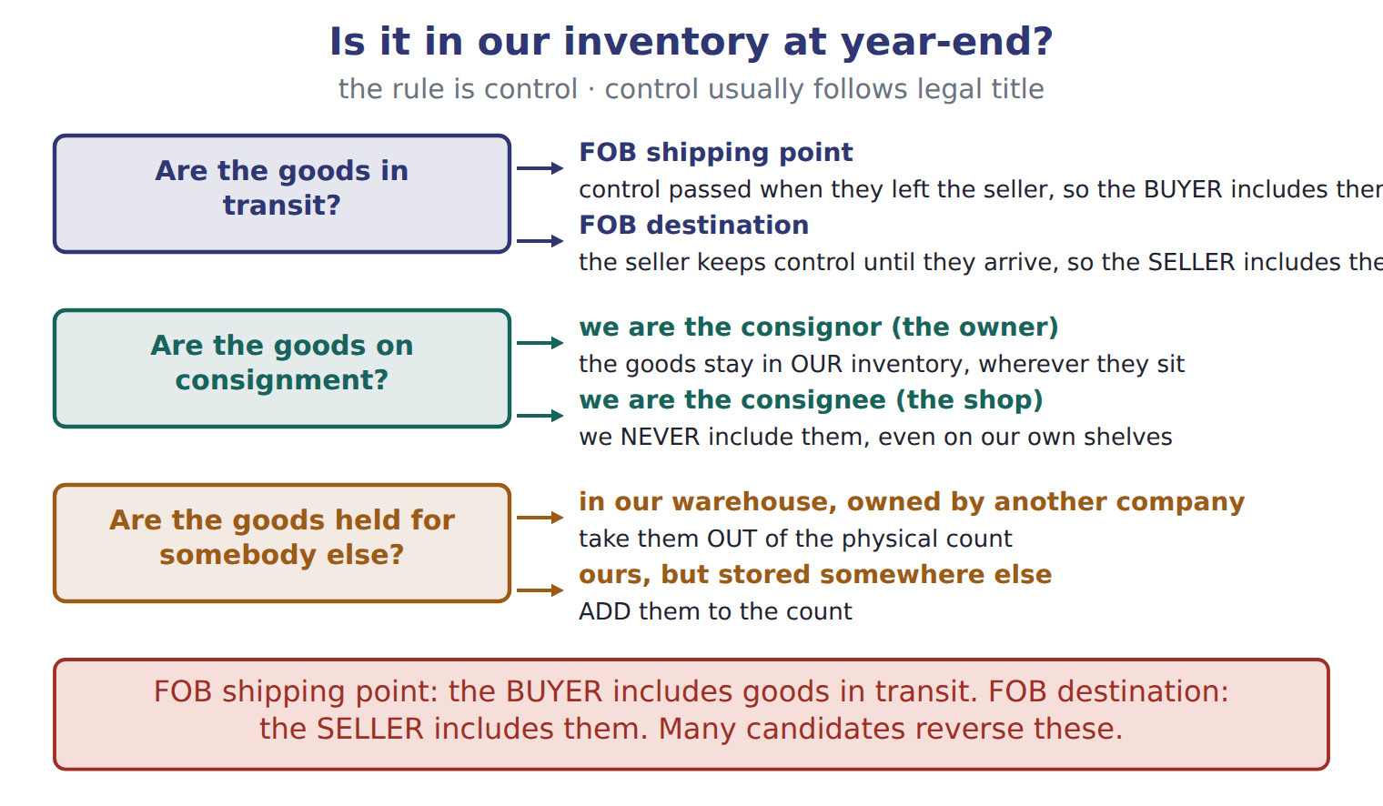
Memo item — the book’s own table
Memo item | Category
M1 (FOB shipping point, bought) | Add to the count
M2 (FOB destination, sold) | Add to the count
M3 (held for a Beirut producer) | Subtract from the count
M4 (at a Doha consignee) | Add to the count

READ THE MODEL Every answer is printed above. Find it, do not recall it.

5. Which memo item does the book pair with “Subtract from the count”?
A. M4 (at a Doha consignee) | C. M2 (FOB destination, sold)
B. M1 (FOB shipping point, bought) | D. M3 (held for a Beirut producer)
SORT THEM | Write each one under its category. Every item belongs to exactly one group.
the items: M1 (FOB shipping point, bought) · M2 (FOB destination, sold) · M3 (held for a Beirut producer) · M4 (at a Doha consignee)
Add to the count | Subtract from the count

APPLY No help on this move.

8. A seller ships goods on December 30, FOB destination. The goods arrive on January 2. At December 31, the goods should be:
A. included in the buyer's inventory.
B. included in the seller's inventory, with no sale recorded yet.
C. removed from the seller's inventory, with a sale recorded.
D. excluded from both companies' inventories.
9. A strike cut production far below normal capacity. How should the fixed production overhead that was not allocated to units be treated?
A. As an expense of the period
B. Added to the cost of the units produced
C. Deferred as an asset to next year
D. Charged directly to retained earnings
10. Which statement about periodic and perpetual systems is TRUE?
A. LIFO gives the same cost of goods sold under both systems.
B. The moving average always equals the periodic weighted average.
C. FIFO gives the same cost of goods sold under both systems.
D. A perpetual system requires specific identification.
11. Specific identification is MOST appropriate for:
A. unique, high-value items such as cars.
B. large volumes of identical glass bottles.
C. any items when prices are rising.
D. perishable food products.
WORK IN PAIRS | Compare every answer on this page with your partner before you read any key.
If you disagree: go back to the model and find the row that settles it. The row decides, not the louder voice.
CHECKPOINT 12. Which of these did this cycle settle?
A. the rule and where it comes from
B. nothing in particular
C. only the vocabulary
D. only the arithmetic
If you got it wrong: redo the READ THE MODEL questions of cycle A.

CYCLE B | The words this section uses precisely

ORIENT

13. A term in the exam means exactly what the book defines it to mean, whatever it means in ordinary English. TRUE / FALSE

MODEL

The English the exam uses, and what it translates
English (exam term) | the Arabic it translates
inventory | المخزون
weighted-average cost | المتوسط المرجح للتكلفة
goods in transit | بضاعة في الطريق
consignee | المُرسَل إليه (الوكيل بالعمولة)
normal capacity | الطاقة العادية
specific identification | التحديد العيني (التمييز المحدد)

READ THE MODEL

Write the letter of the Arabic term beside each English term. Every term is used once.
A المتوسط المرجح للتكلفة | D بضاعة في الطريق
B المُرسَل إليه (الوكيل بالعمولة) | E المخزون
C الطاقة العادية | F التحديد العيني (التمييز المحدد)

14. specific identification
15. goods in transit
16. inventory
17. weighted-average cost
18. normal capacity
19. consignee

APPLY

20. Prices are falling. Which method gives the highest gross profit?
A. FIFO
B. Weighted average
C. LIFO
D. All methods give the same gross profit.
21. Prices are rising, and a LIFO company sells more units than it buys, so old layers are liquidated. What is the effect in that year?
A. Gross profit decreases.
B. Gross profit increases.
C. There is no effect, because costs are historical.
D. A loss arises that must be deferred.
22. The tax rate is 25%. Ending inventory was overstated by 40. By how much is net income overstated in that year?
A. 10 | C. 40
B. 30 | D. 50
23. Ending inventory for 2026 is understated by 15. Inventory for 2025 was correct. What is the effect on 2026 cost of goods sold?
A. Understated by 15 | C. Overstated by 15
B. No effect | D. Overstated by 30

CHECKPOINT 24. What is the safest way to settle a disagreement about an answer on this sheet?
A. find the row of the model that decides it
B. take the answer of whoever is more confident
C. leave it until the lecturer says
D. choose the longer option
If you got it wrong: redo the READ THE MODEL questions of cycle B.

FROM MEMORY | Close the earlier pages first.
25. Rebuild the figure from this handout. Label every part and fill in every box.
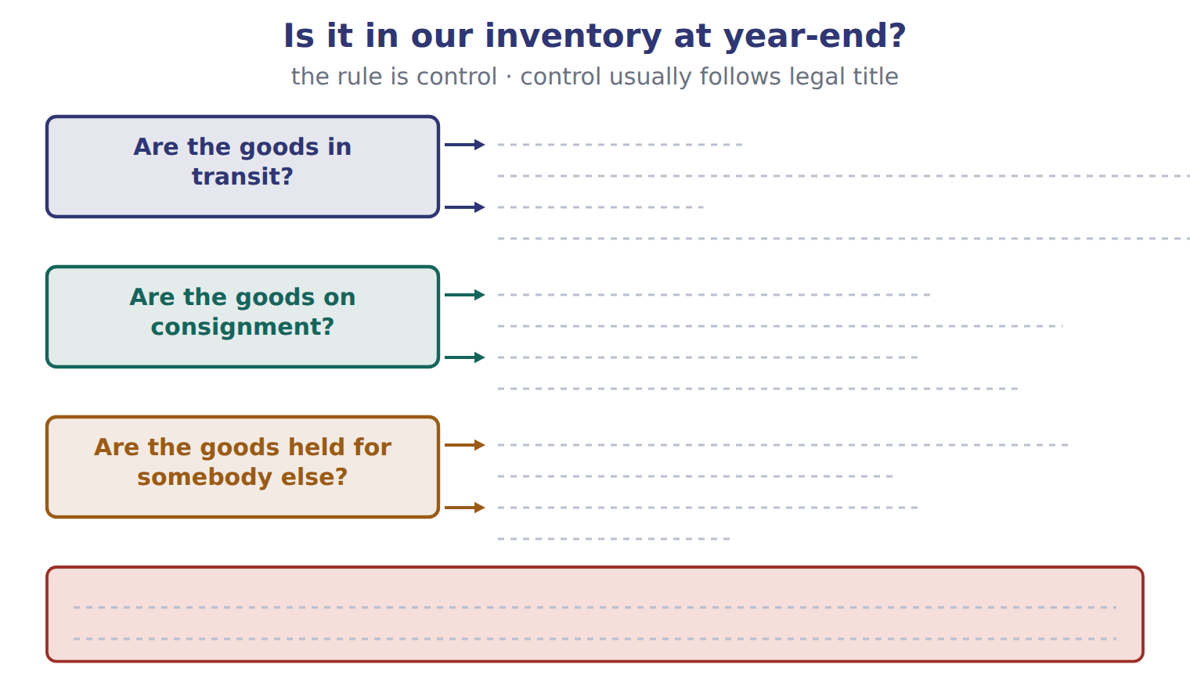
TEACH IT BACK | Write it for a classmate who missed this session — not for the marker.
26. In three or four sentences, write what this section settles and the one rule a reader has to take away.
every one of these words must appear: inventory · weighted-average cost · goods in transit · consignee

Handout 7.2
Which costs belong in inventory?
section 7.2 of the book
Before you start
Three summaries of this handout, in the book’s own words. Read all three first: together they are the whole session. Then fill the gaps, guessing where you have to.

What this handout settles, cycle by cycle
In this handout | What you will read | How you check it
Which costs belong in inventory? | a figure to read · Item · the book’s own rule, gapped | Which of these did this cycle settle?
The words this section uses precisely | The English the exam uses, and what it translates | What is the safest way to settle a disagreement about an answer on this sheet?

Words this handout uses precisely
Words this handout uses precisely | tick it if you could already use it in a sentence
cost of goods sold
periodic inventory system
FOB shipping point
physical count
abnormal waste
moving average

1. Where the section starts — Fill every gap. The list holds more words than there are gaps, so one or two of them are not used.
choose from: abnormal waste · FOB shipping point · purchase discount · freight-in
For goods that are bought, cost includes the purchase price, , import duties, non-refundable taxes and handling, less trade discounts and any taken for early payment. For goods that are made, cost also includes direct labor and production overhead.
2. What it settles in the middle — Fill every gap. The list holds more words than there are gaps, so one or two of them are not used.
choose from: FOB shipping point · Period cost · inventory · freight-out · normal capacity · abnormal waste
In the same way, (unusual spoilage, idle time or extra freight) is an expense, not cost. s include to customers, sales commissions, advertising, general and administrative costs, and the storage of finished goods. Interest on inventory that is produced routinely is also a period cost.
3. Where it ends — Fill every gap. The list holds more words than there are gaps, so one or two of them are not used.
choose from: FOB shipping point · abnormal waste · location · condition · expenses
Other costs are shown below (whole dollars). The two costs at the bottom of the table happen after the goods are ready for use. They do not bring the bottles to their present and , so they are .

CYCLE A | Which costs belong in inventory?

ORIENT One claim. Decide now; you will check it in a moment.

4. The book gives the amount of Cost of the bottles in inventory as “22,000”. TRUE / FALSE
MODEL Read it before you answer anything below it.

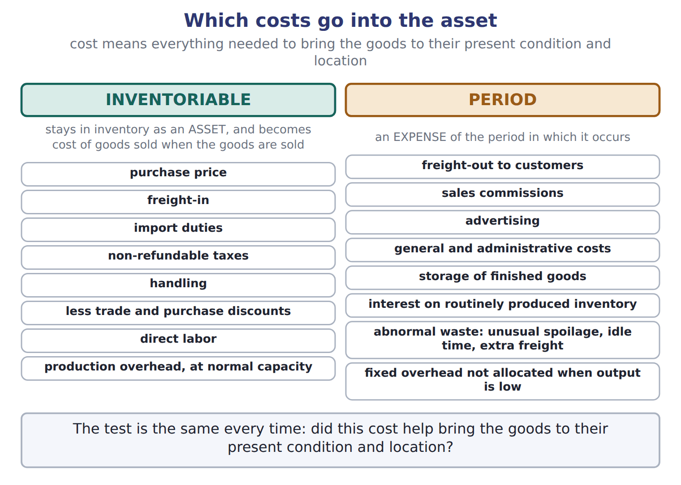

Item — the book’s own table
Item | Amount | Inventory cost?
Invoice price | 20,000 | Yes
Purchase discount taken | (400) | Yes (reduces cost)
Freight-in from the port to Amman | 1,200 | Yes
Import duty (not refundable) | 900 | Yes
Insurance while the bottles are in transit | 300 | Yes
Freight-out when filled bottles go to customers | 700 | No: selling expense
Storage of finished olive oil | 250 | No: period cost
Cost of the bottles in inventory | 22,000

READ THE MODEL Every answer is printed above. Find it, do not recall it.

5. Which amount does the book give for Invoice price?
A. 22,000 | C. 20,000
B. 1,200 | D. (400)
6. The book gives the inventory cost? of Purchase discount taken as “Yes (reduces cost)”. TRUE / FALSE
INVENT THE RULE

7. Complete the book’s own sentence. The list holds more words than there are gaps.
use every one of these words: inventory · inventoriable cost · cost of goods sold · LIFO reserve
These are inventoriable costs: they stay in as an asset, and they become when the goods are sold.

Two of the book’s own cases, side by side
Invoice price | Purchase discount taken
Amount: 20,000 | Amount: (400)
Only the facts above differ. What is the inventory cost? of Invoice price?
8. Choose one:
A. Yes | C. Yes (reduces cost)
B. No: selling expense | D. No: period cost

APPLY No help on this move.

9. Which item is a period cost for Orontes?
A. Import duties on sesame seeds
B. Freight-in on glass bottles
C. Wages of bottling-line workers
D. Advertising for a new tahini brand
10. The tax rate is 25%. Ending inventory was overstated by 40. By how much is net income overstated in that year?
A. 10 | C. 40
B. 30 | D. 50
11. Ending inventory for 2026 is understated by 15. Inventory for 2025 was correct. What is the effect on 2026 cost of goods sold?
A. Understated by 15 | C. Overstated by 15
B. No effect | D. Overstated by 30
WORK IN PAIRS | Compare every answer on this page with your partner before you read any key.
If you disagree: go back to the model and find the row that settles it. The row decides, not the louder voice.
CHECKPOINT 12. Which of these did this cycle settle?
A. the rule and where it comes from
B. nothing in particular
C. only the vocabulary
D. only the arithmetic
If you got it wrong: redo the READ THE MODEL questions of cycle A.

CYCLE B | The words this section uses precisely

ORIENT

13. A term in the exam means exactly what the book defines it to mean, whatever it means in ordinary English. TRUE / FALSE

MODEL

The English the exam uses, and what it translates
English (exam term) | the Arabic it translates
cost of goods sold | تكلفة البضاعة المباعة
periodic inventory system | نظام الجرد الدوري
FOB shipping point | التسليم عند نقطة الشحن
physical count | الجرد الفعلي
abnormal waste | التلف غير العادي
moving average | المتوسط المتحرك

READ THE MODEL

Write the letter of the Arabic term beside each English term. Every term is used once.
A نظام الجرد الدوري | D التلف غير العادي
B التسليم عند نقطة الشحن | E المتوسط المتحرك
C تكلفة البضاعة المباعة | F الجرد الفعلي

14. cost of goods sold
15. abnormal waste
16. moving average
17. physical count
18. FOB shipping point
19. periodic inventory system

APPLY

20. Which amount does the book give for Cost of the bottles in inventory?
A. (400) | C. 1,200
B. 20,000 | D. 22,000
CHECKPOINT 21. What is the safest way to settle a disagreement about an answer on this sheet?
A. find the row of the model that decides it
B. take the answer of whoever is more confident
C. leave it until the lecturer says
D. choose the longer option
If you got it wrong: redo the READ THE MODEL questions of cycle B.

FROM MEMORY | Close the earlier pages first.
22. Rebuild the figure from this handout. Label every part and fill in every box.
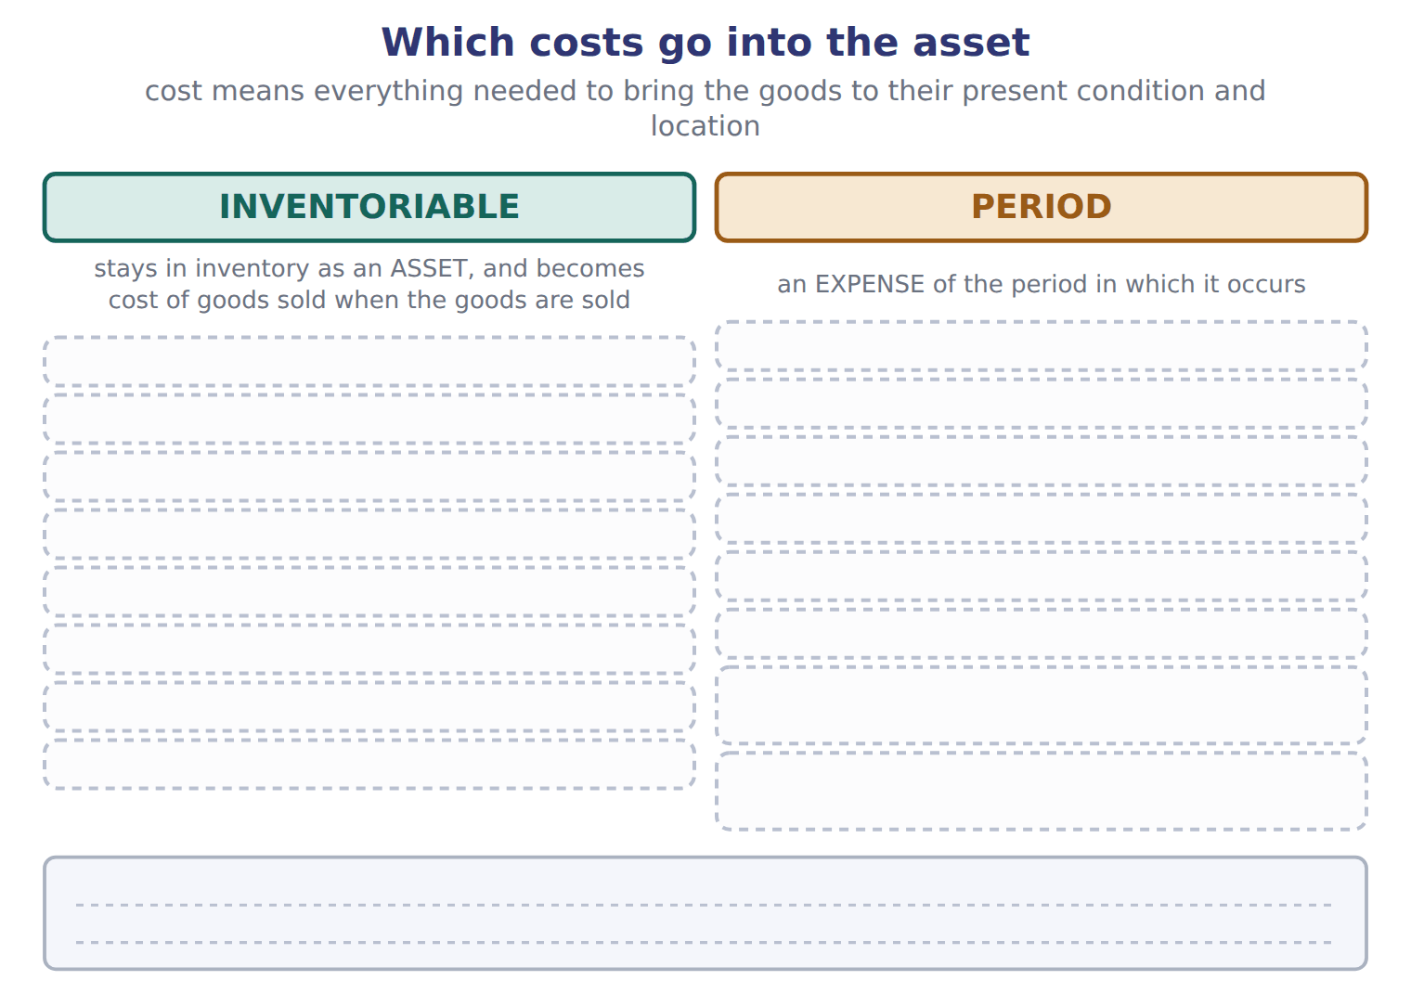
TEACH IT BACK | Write it for a classmate who missed this session — not for the marker.
23. In three or four sentences, write what this section settles and the one rule a reader has to take away.
every one of these words must appear: cost of goods sold · periodic inventory system · FOB shipping point · physical count

Handout 7.3
Cost flow assumptions
section 7.3 of the book
Before you start
Three summaries of this handout, in the book’s own words. Read all three first: together they are the whole session. Then fill the gaps, guessing where you have to.

What this handout settles, cycle by cycle
In this handout | What you will read | How you check it
Cost flow assumptions | a figure to read · Method · the book’s own rule, gapped | Which of these did this cycle settle?
The words this section uses precisely | a figure to read · Method · The English the exam uses, and what it translates | What is the safest way to settle a disagreement about an answer on this sheet?

Words this handout uses precisely
Words this handout uses precisely | tick it if you could already use it in a sentence
goods available for sale
perpetual inventory system
FOB destination
freight-in
inventoriable cost
LIFO liquidation

1. Where the section starts — Fill every gap. The list holds more words than there are gaps, so one or two of them are not used.
choose from: cost of goods sold · moving average · Specific identification · cost flow assumption · consignee · inventory
When a company sells some units and keeps others, it must decide which costs go to and which stay in ending . This decision is a . It does not need to match the physical flow of the goods. tracks the actual cost of each item.
2. What it settles in the middle — Fill every gap. The list holds more words than there are gaps, so one or two of them are not used.
choose from: cost of goods sold · consignee · periodic inventory system · perpetual inventory system · moving average
In a , the company counts the goods at year-end and calculates for the whole period. In a , it updates inventory and cost of goods sold after every purchase and every sale.
3. Where it ends — Fill every gap. The list holds more words than there are gaps, so one or two of them are not used.
choose from: moving average · compare · therefore · consignee · frameworks
Cedar Retail, our IFRS company, uses FIFO. You will the two again in Chapter 17. Under LIFO, the company adds a layer when it buys more than it sells. A company can use LIFO even if it ships its oldest bottles first.

CYCLE A | Cost flow assumptions

ORIENT One claim. Decide now; you will check it in a moment.

4. Every number in a financial statement belongs to an element the framework defines. TRUE / FALSE
MODEL Read it before you answer anything below it.

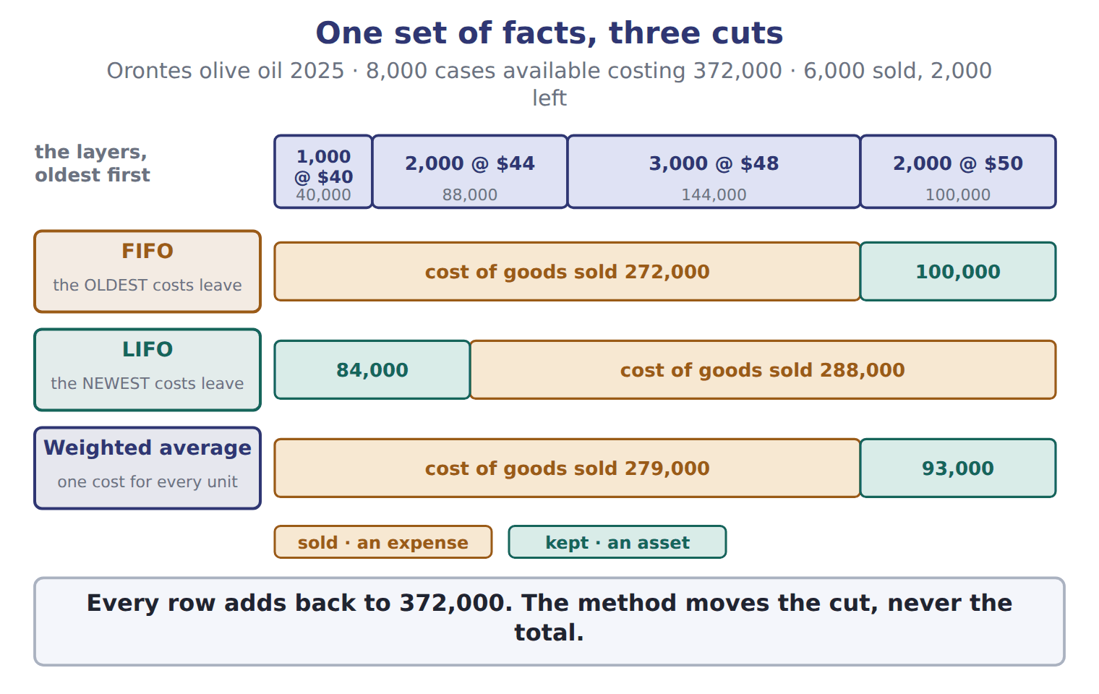

Method — the book’s own table
Method | Periodic: ending inventory | Periodic: COGS | Perpetual: ending inventory | Perpetual: COGS
FIFO | 100,000 | 272,000 | 100,000 | 272,000
LIFO | 84,000 | 288,000 | 93,000 | 279,000
Average (weighted / moving) | 93,000 | 279,000 | 97,633 | 274,367

READ THE MODEL Every answer is printed above. Find it, do not recall it.

5. Which method does the book pair with “100,000”?
A. Average (weighted / moving) | C. LIFO
B. FIFO
Complete every empty cell. The first full row shows the pattern.
Method | Periodic: ending inventory | Periodic: COGS | Perpetual: ending inventory | Perpetual: COGS
FIFO | 100,000 | 272,000 | 100,000 | 272,000
LIFO
Average (weighted / moving)

INVENT THE RULE

8. Complete the book’s own sentence. The list holds more words than there are gaps.
use every one of these words: consignee · periodic inventory system · cost of goods sold · freight-in
In a , the company counts the goods at year-end and calculates for the whole period.

Two of the book’s own cases, side by side
FIFO | LIFO
Periodic: ending inventory: 100,000 | Periodic: ending inventory: 84,000
Periodic: COGS: 272,000 | Periodic: COGS: 288,000
Perpetual: ending inventory: 100,000 | Perpetual: ending inventory: 93,000
Only the facts above differ. What is the perpetual: cogs of FIFO?
9. Choose one:
A. 274,367 | C. 272,000
B. 279,000
APPLY No help on this move.

10. In the Orontes olive-oil example, what is FIFO cost of goods sold (whole USD)?
A. 100,000 | C. 279,000
B. 272,000 | D. 288,000
WORK IN PAIRS | Compare every answer on this page with your partner before you read any key.
If you disagree: go back to the model and find the row that settles it. The row decides, not the louder voice.

CHECKPOINT 11. Which of these did this cycle settle?
A. the rule and where it comes from
B. nothing in particular
C. only the vocabulary
D. only the arithmetic
If you got it wrong: redo the READ THE MODEL questions of cycle A.

CYCLE B | The words this section uses precisely

ORIENT

12. A term in the exam means exactly what the book defines it to mean, whatever it means in ordinary English. TRUE / FALSE
MODEL

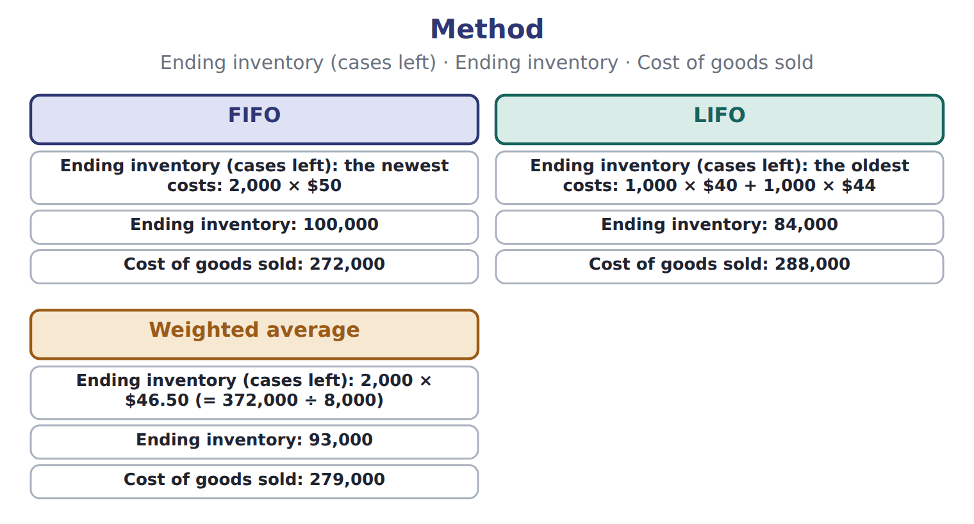
Method — the book’s own table
Method | Ending inventory (cases left) | Ending inventory | Cost of goods sold
FIFO | the newest costs: 2,000 × $50 | 100,000 | 272,000
LIFO | the oldest costs: 1,000 × $40 + 1,000 × $44 | 84,000 | 288,000
Weighted average | 2,000 × $46.50 (= 372,000 ÷ 8,000) | 93,000 | 279,000

The English the exam uses, and what it translates
English (exam term) | the Arabic it translates
goods available for sale | البضاعة المتاحة للبيع
perpetual inventory system | نظام الجرد المستمر
FOB destination | التسليم عند نقطة الوصول
freight-in | مصاريف نقل المشتريات
inventoriable cost | تكلفة قابلة للتحميل على المخزون
LIFO liquidation | تصفية طبقات LIFO

READ THE MODEL

Write the letter of the Arabic term beside each English term. Every term is used once.
A مصاريف نقل المشتريات | D نظام الجرد المستمر
B التسليم عند نقطة الوصول | E البضاعة المتاحة للبيع
C تكلفة قابلة للتحميل على المخزون | F تصفية طبقات LIFO

13. perpetual inventory system
14. goods available for sale
15. FOB destination
16. inventoriable cost
17. LIFO liquidation
18. freight-in

19. Which method does the book pair with “the newest costs: 2,000 × $50”?
A. Weighted average | C. FIFO
B. LIFO
APPLY

20. Which English term does the exam use for “البضاعة المتاحة للبيع”?
A. LIFO liquidation | C. goods available for sale
B. perpetual inventory system | D. inventoriable cost
CHECKPOINT 21. What is the safest way to settle a disagreement about an answer on this sheet?
A. find the row of the model that decides it
B. take the answer of whoever is more confident
C. leave it until the lecturer says
D. choose the longer option
If you got it wrong: redo the READ THE MODEL questions of cycle B.

FROM MEMORY | Close the earlier pages first.
22. Rebuild the figure from this handout. Label every part and fill in every box.
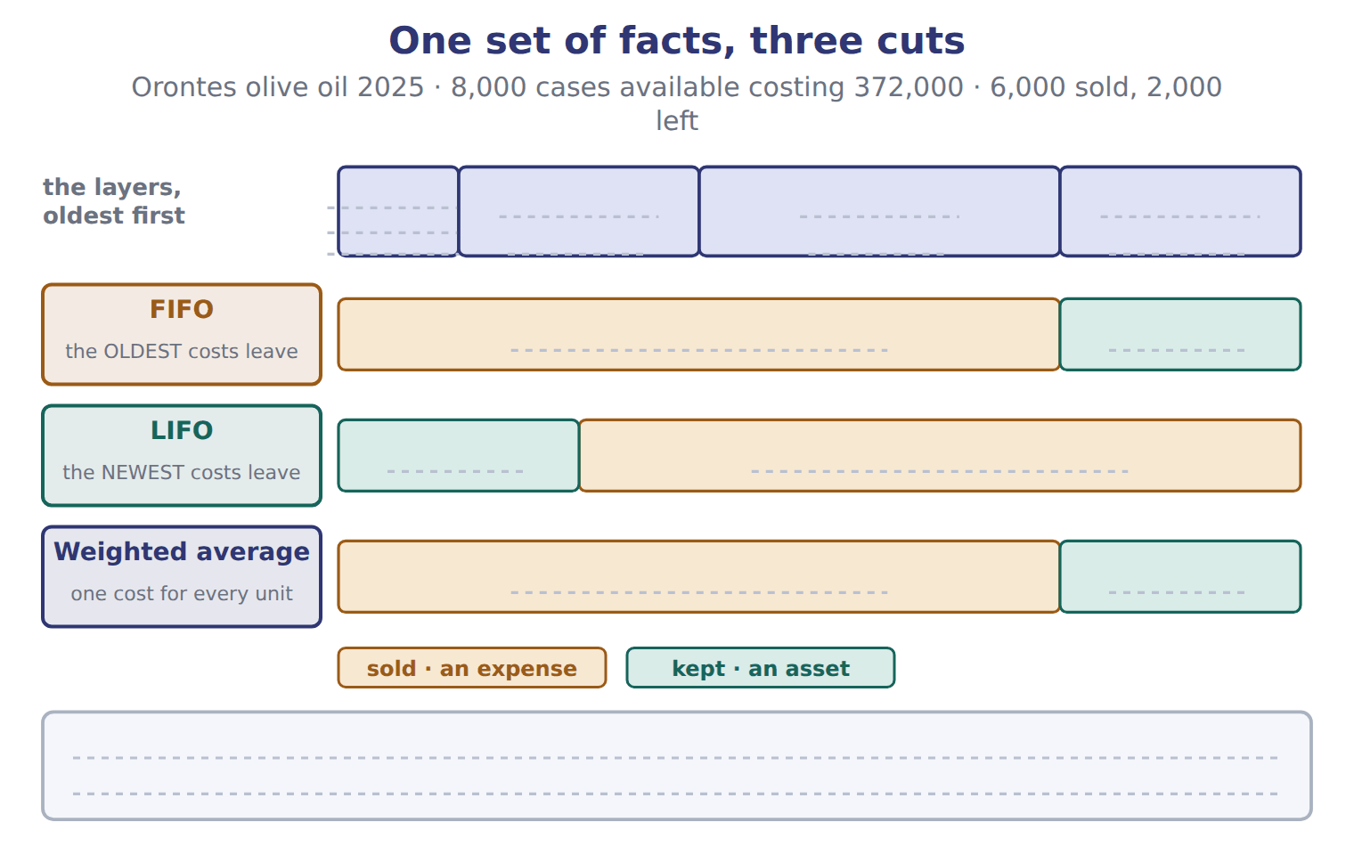
TEACH IT BACK | Write it for a classmate who missed this session — not for the marker.
23. In three or four sentences, write what this section settles and the one rule a reader has to take away.
every one of these words must appear: goods available for sale · perpetual inventory system · FOB destination · freight-in

Handout 7.4
Effects on income, taxes and assets
section 7.4 of the book
Before you start
Three summaries of this handout, in the book’s own words. Read all three first: together they are the whole session. Then fill the gaps, guessing where you have to.

What this handout settles, cycle by cycle
In this handout | What you will read | How you check it
Effects on income, taxes and assets | a figure to read | Which of these did this cycle settle?
The words this section uses precisely | The English the exam uses, and what it translates | What is the safest way to settle a disagreement about an answer on this sheet?

Words this handout uses precisely
Words this handout uses precisely | tick it if you could already use it in a sentence
FIFO (first-in, first-out)
LIFO reserve
consignment
freight-out
period cost
LIFO conformity rule

1. Where the section starts — Fill every gap. The list holds more words than there are gaps, so one or two of them are not used.
choose from: freight-in · cost of goods sold · physical count · gross profit · inventory
When prices are rising, the methods give very different results. FIFO puts the old, cheaper costs into . So FIFO gives the lowest cost of goods sold, the highest , the highest income tax and the highest ending .
2. What it settles in the middle — Fill every gap. The list holds more words than there are gaps, so one or two of them are not used.
choose from: physical count · cost of goods sold · LIFO reserve · freight-in · inventory
An analyst can convert LIFO results to FIFO with two relationships. FIFO equals LIFO inventory plus the . FIFO equals LIFO cost of goods sold minus the increase in the LIFO reserve during the year.
3. Where it ends — Fill every gap. The list holds more words than there are gaps, so one or two of them are not used.
choose from: LIFO liquidation · freight-in · cost of goods sold · LIFO reserve · physical count
To get FIFO , SUBTRACT the increase in the from LIFO cost of goods sold. In rising prices, LIFO gives LOWER income and LOWER taxes, not higher. A raises income once. Do not treat it as a better business.

CYCLE A | Effects on income, taxes and assets

ORIENT One claim. Decide now; you will check it in a moment.

4. Every number in a financial statement belongs to an element the framework defines. TRUE / FALSE
MODEL Read it before you answer anything below it.

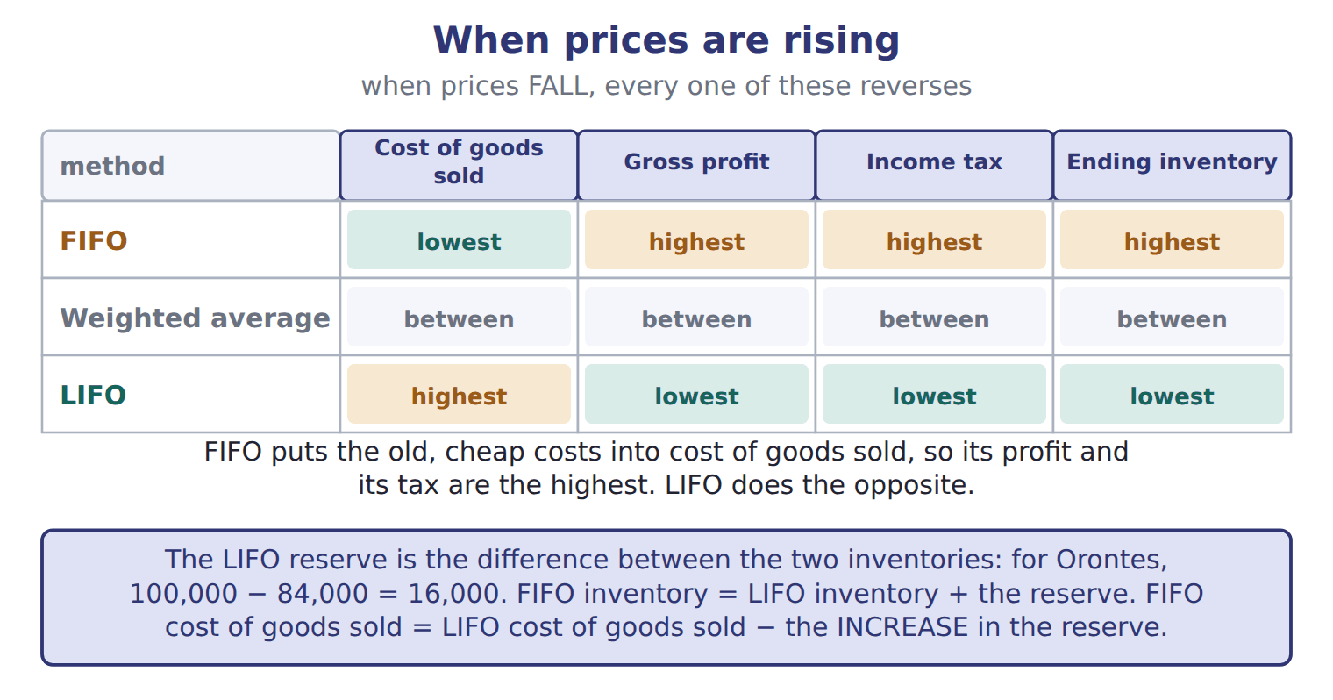
READ THE MODEL Every answer is printed above. Find it, do not recall it.

5. Which part of this chapter is section 7.1?
A. Cost flow assumptions
B. Which goods belong in inventory?
C. Effects on income, taxes and assets
D. Which costs belong in inventory?
APPLY No help on this move.

6. Beginning inventory was 100 units at $10. The company bought 200 units at $12 and then 100 units at $15. It sold 250 units. Using periodic LIFO, what is ending inventory?
A. 1,600 | C. 2,100
B. 1,838 | D. 3,300
WORK IN PAIRS | Compare every answer on this page with your partner before you read any key.
If you disagree: go back to the model and find the row that settles it. The row decides, not the louder voice.
CHECKPOINT 7. Which of these did this cycle settle?
A. the rule and where it comes from
B. nothing in particular
C. only the vocabulary
D. only the arithmetic
If you got it wrong: redo the READ THE MODEL questions of cycle A.

CYCLE B | The words this section uses precisely

ORIENT

8. A term in the exam means exactly what the book defines it to mean, whatever it means in ordinary English. TRUE / FALSE
MODEL

The English the exam uses, and what it translates
English (exam term) | the Arabic it translates
FIFO (first-in, first-out) | الوارد أولاً يُصرف أولاً
LIFO reserve | احتياطي LIFO (فرق تقويم LIFO)
consignment | البضاعة بالأمانة
freight-out | مصاريف نقل المبيعات
period cost | تكلفة الفترة
LIFO conformity rule | قاعدة التوافق الضريبي لطريقة LIFO

READ THE MODEL

Write the letter of the Arabic term beside each English term. Every term is used once.
A احتياطي LIFO (فرق تقويم LIFO) | D قاعدة التوافق الضريبي لطريقة LIFO
B الوارد أولاً يُصرف أولاً | E تكلفة الفترة
C البضاعة بالأمانة | F مصاريف نقل المبيعات

9. FIFO (first-in, first-out)
10. freight-out
11. LIFO reserve
12. period cost
13. LIFO conformity rule
14. consignment

APPLY

15. Which English term does the exam use for “الوارد أولاً يُصرف أولاً”?
A. FIFO (first-in, first-out) | C. LIFO reserve
B. consignment | D. LIFO conformity rule
CHECKPOINT 16. What is the safest way to settle a disagreement about an answer on this sheet?
A. find the row of the model that decides it
B. take the answer of whoever is more confident
C. leave it until the lecturer says
D. choose the longer option
If you got it wrong: redo the READ THE MODEL questions of cycle B.

FROM MEMORY | Close the earlier pages first.
17. Rebuild the figure from this handout. Label every part and fill in every box.
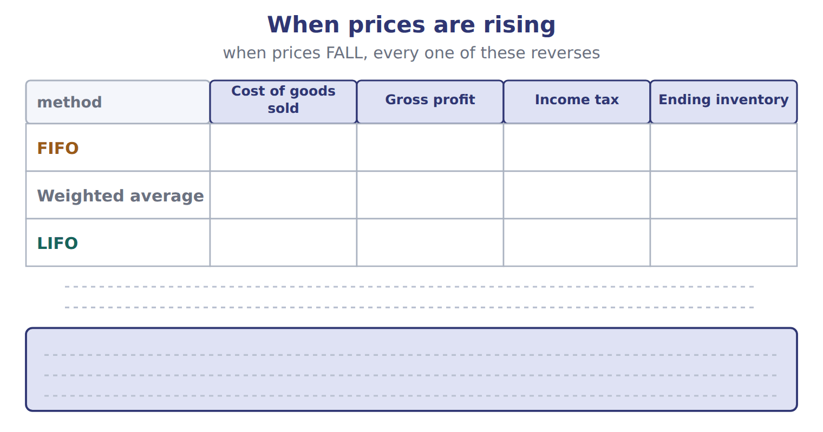
TEACH IT BACK | Write it for a classmate who missed this session — not for the marker.
18. In three or four sentences, write what this section settles and the one rule a reader has to take away.
every one of these words must appear: FIFO (first-in, first-out) · LIFO reserve · consignment · freight-out

Handout 7.5
Inventory errors
section 7.5 of the book
Before you start
Three summaries of this handout, in the book’s own words. Read all three first: together they are the whole session. Then fill the gaps, guessing where you have to.

What this handout settles, cycle by cycle
In this handout | What you will read | How you check it
Inventory errors | a figure to read · Item | Which of these did this cycle settle?
The words this section uses precisely | a figure to read · Memo item · The English the exam uses, and what it translates | What is the safest way to settle a disagreement about an answer on this sheet?

Words this handout uses precisely
Words this handout uses precisely | tick it if you could already use it in a sentence
LIFO (last-in, first-out)
counterbalancing error
consignor
purchase discount
cost flow assumption
gross profit

1. Where the section starts — Fill every gap. The list holds more words than there are gaps, so one or two of them are not used.
choose from: cost of goods sold · purchase discount · inventory · gross profit
If ending is wrong, is wrong in the same year. And because this year's ending inventory is next year's beginning inventory, the error moves into the next year too. At the end of 2025, Orontes counted some goods twice, so ending inventory was overstated by 40 (USD 000).
2. What it settles in the middle — Fill every gap. The list holds more words than there are gaps, so one or two of them are not used.
choose from: purchase discount · inventory · gross profit · cost of goods sold
Errors in purchases work in a similar way. Row 3 is a classic exam item: when a purchase is left out of both purchases and the count, and income are still correct, but and accounts payable are both understated.
3. Where it ends — Fill every gap. The list holds more words than there are gaps, so one or two of them are not used.
choose from: inventory · purchase discount · overstated · gross profit · direction
The prefix tells you the . Net income is by 40 (the size of the error), not overstated to 940. In a question, find the direction for the first year, then reverse it for the second year. A. Net income is overstated; is correct.

CYCLE A | Inventory errors

ORIENT One claim. Decide now; you will check it in a moment.

4. Every number in a financial statement belongs to an element the framework defines. TRUE / FALSE
MODEL Read it before you answer anything below it.

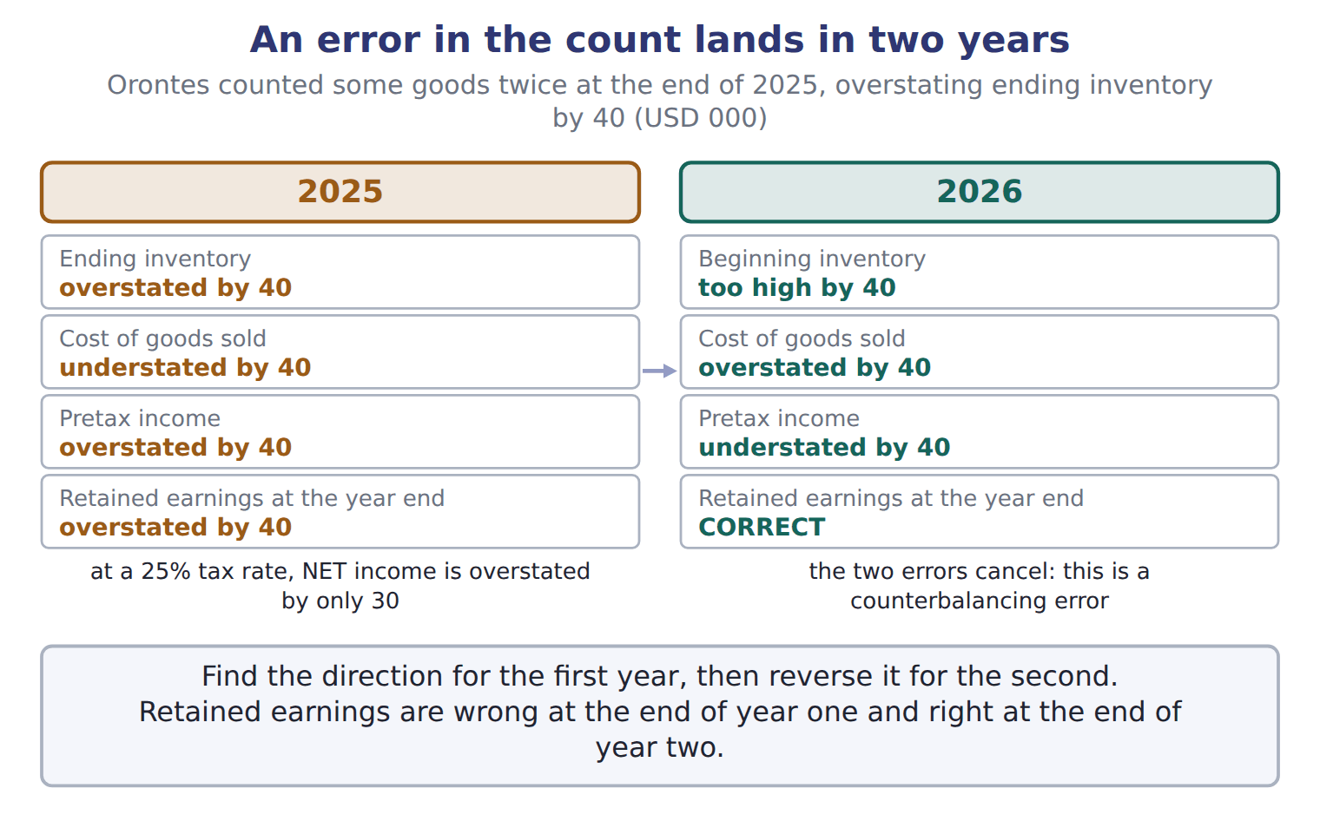
Item — the book’s own table
Item | Answer
COGS, line 2: 1,200 × $22 | $26,400
Ending inventory, line 1: 300 × $22 | $6,600
Ending inventory, line 2: 500 × $20 | $10,000
Total COGS | $25,000 + $26,400 = $51,400
Total ending inventory | $6,600 + $10,000 = $16,600
Check | $51,400 + $16,600 = $68,000, the cost of goods available.

READ THE MODEL Every answer is printed above. Find it, do not recall it.

5. Which part of this chapter is section 7.1?
A. Cost flow assumptions
B. Which goods belong in inventory?
C. Effects on income, taxes and assets
D. Which costs belong in inventory?
APPLY No help on this move.

6. What is the Orontes LIFO reserve for olive oil at the end of 2025 (whole USD)?
A. 4,000 | C. 9,000
B. 7,000 | D. 16,000

WORK IN PAIRS | Compare every answer on this page with your partner before you read any key.
If you disagree: go back to the model and find the row that settles it. The row decides, not the louder voice.
CHECKPOINT 7. Which of these did this cycle settle?
A. the rule and where it comes from
B. nothing in particular
C. only the vocabulary
D. only the arithmetic
If you got it wrong: redo the READ THE MODEL questions of cycle A.

CYCLE B | The words this section uses precisely

ORIENT

8. A term in the exam means exactly what the book defines it to mean, whatever it means in ordinary English. TRUE / FALSE
MODEL

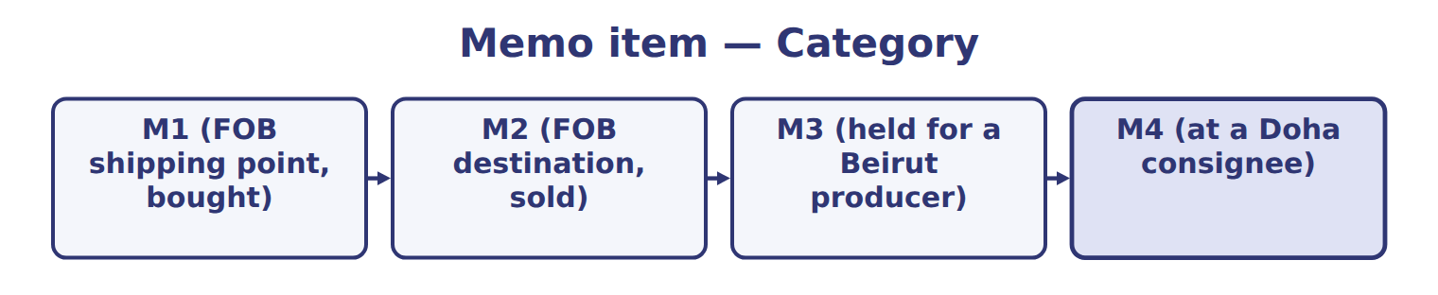
Memo item — the book’s own table
Memo item | Category
M1 (FOB shipping point, bought)
M2 (FOB destination, sold)
M3 (held for a Beirut producer)
M4 (at a Doha consignee)

The English the exam uses, and what it translates
English (exam term) | the Arabic it translates
LIFO (last-in, first-out) | الوارد أخيراً يُصرف أولاً
counterbalancing error | خطأ ذاتي التصحيح (خطأ معاكس)
consignor | المُرسِل (مالك البضاعة بالأمانة)
purchase discount | خصم المشتريات (خصم نقدي)
cost flow assumption | افتراض تدفق التكلفة
gross profit | مجمل الربح

READ THE MODEL

Write the letter of the Arabic term beside each English term. Every term is used once.
A خصم المشتريات (خصم نقدي) | D خطأ ذاتي التصحيح (خطأ معاكس)
B مجمل الربح | E الوارد أخيراً يُصرف أولاً
C افتراض تدفق التكلفة | F المُرسِل (مالك البضاعة بالأمانة)

9. consignor
10. cost flow assumption
11. LIFO (last-in, first-out)
12. purchase discount
13. gross profit
14. counterbalancing error

APPLY

Write the letter of the matching answer beside each item. Every one is used once.
A $51,400 + $16,600 = $68,000, the cost of goods available.
B $25,000 + $26,400 = $51,400
C $6,600
D $6,600 + $10,000 = $16,600
E $26,400
F $10,000

15. COGS, line 2: 1,200 × $22
16. Ending inventory, line 1: 300 × $22
17. Ending inventory, line 2: 500 × $20
18. Total COGS
19. Total ending inventory
20. Check

CHECKPOINT 21. What is the safest way to settle a disagreement about an answer on this sheet?
A. find the row of the model that decides it
B. take the answer of whoever is more confident
C. leave it until the lecturer says
D. choose the longer option
If you got it wrong: redo the READ THE MODEL questions of cycle B.

FROM MEMORY | Close the earlier pages first.
22. Rebuild the figure from this handout. Label every part and fill in every box.
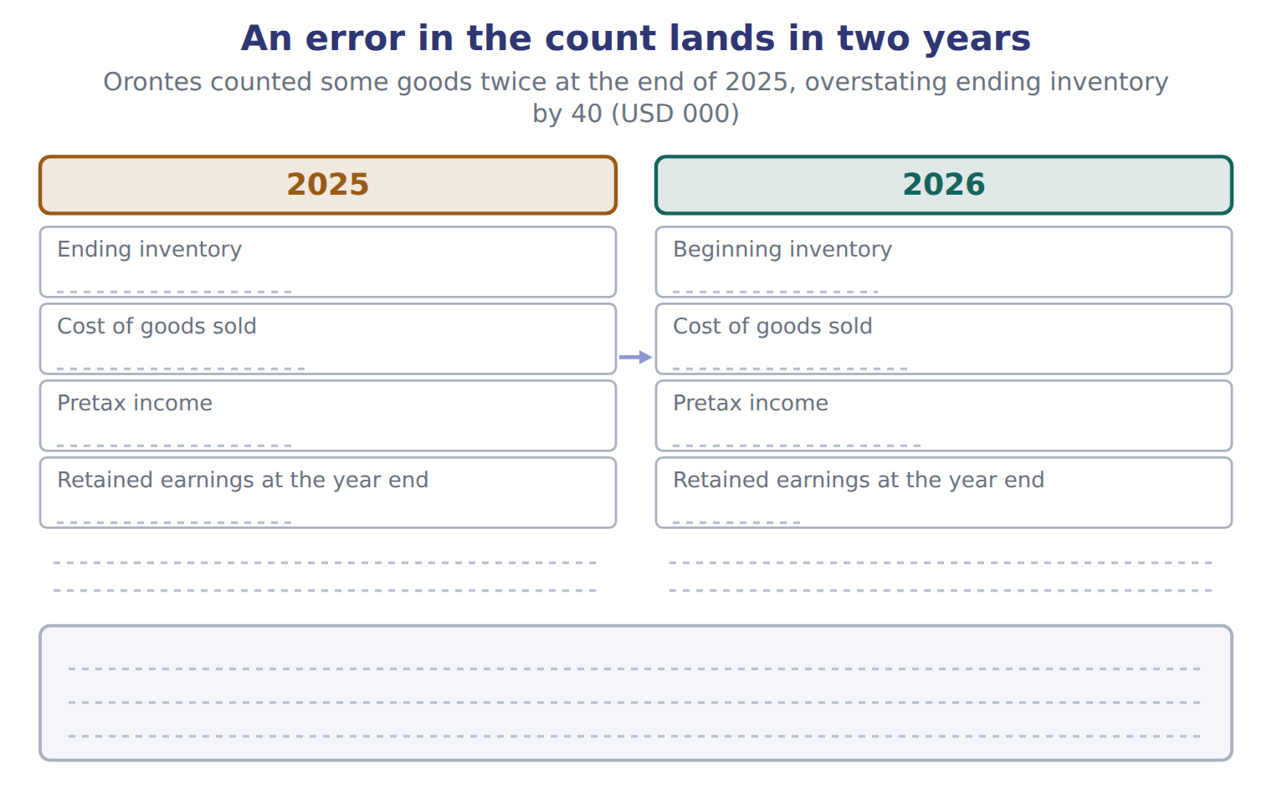
TEACH IT BACK | Write it for a classmate who missed this session — not for the marker.
23. In three or four sentences, write what this section settles and the one rule a reader has to take away.
every one of these words must appear: LIFO (last-in, first-out) · counterbalancing error · consignor · purchase discount

Handout 7.6
The whole chapter
every section, shuffled, and the chapter’s own case set
Before you start
Three summaries of this chapter, in the book’s own words, with words taken out. Read all three first: together they are the whole chapter. Then fill the gaps.

What this handout settles, cycle by cycle
In this handout | What you will read | How you check it
The whole chapter, in order | a figure to read | The LIFO conformity rule requires that:
The chapter’s case set | The chapter’s case set, item by item | What has to be settled before any figure in a case set is worked out?
The words it uses precisely | inventory · cost of goods sold · goods available for sale · FIFO (first-in, first-out) · LIFO (last-in, first-out) · weighted-average cost | matching, at the end of cycle B

1. Where the chapter starts — Fill every gap. The list holds more words than there are gaps, so one or two of them are not used.
choose from: FOB destination · inventory · consignee · consignment · inventoriable cost · consignor · goods available for sale
Under , the seller keeps control until the goods arrive, so the seller includes them. In a , the (the owner) gives goods to a , who sells them for a commission. The goods stay in the consignor's .
2. What it settles in the middle — Fill every gap. The list holds more words than there are gaps, so one or two of them are not used.
choose from: inventoriable cost · cost of goods sold · goods available for sale · perpetual inventory system · periodic inventory system
In a , the company counts the goods at year-end and calculates for the whole period. In a , it updates inventory and cost of goods sold after every purchase and every sale.
3. Where it ends — Fill every gap. The list holds more words than there are gaps, so one or two of them are not used.
choose from: goods available for sale · LIFO liquidation · LIFO reserve · inventoriable cost · cost of goods sold
To get FIFO , SUBTRACT the increase in the from LIFO cost of goods sold. In rising prices, LIFO gives LOWER income and LOWER taxes, not higher. A raises income once. Do not treat it as a better business.

CYCLE A | The whole chapter, in order

ORIENT

4. The sections of a chapter have to be taken in order, because each one uses what the one before it settled. TRUE / FALSE
MODEL

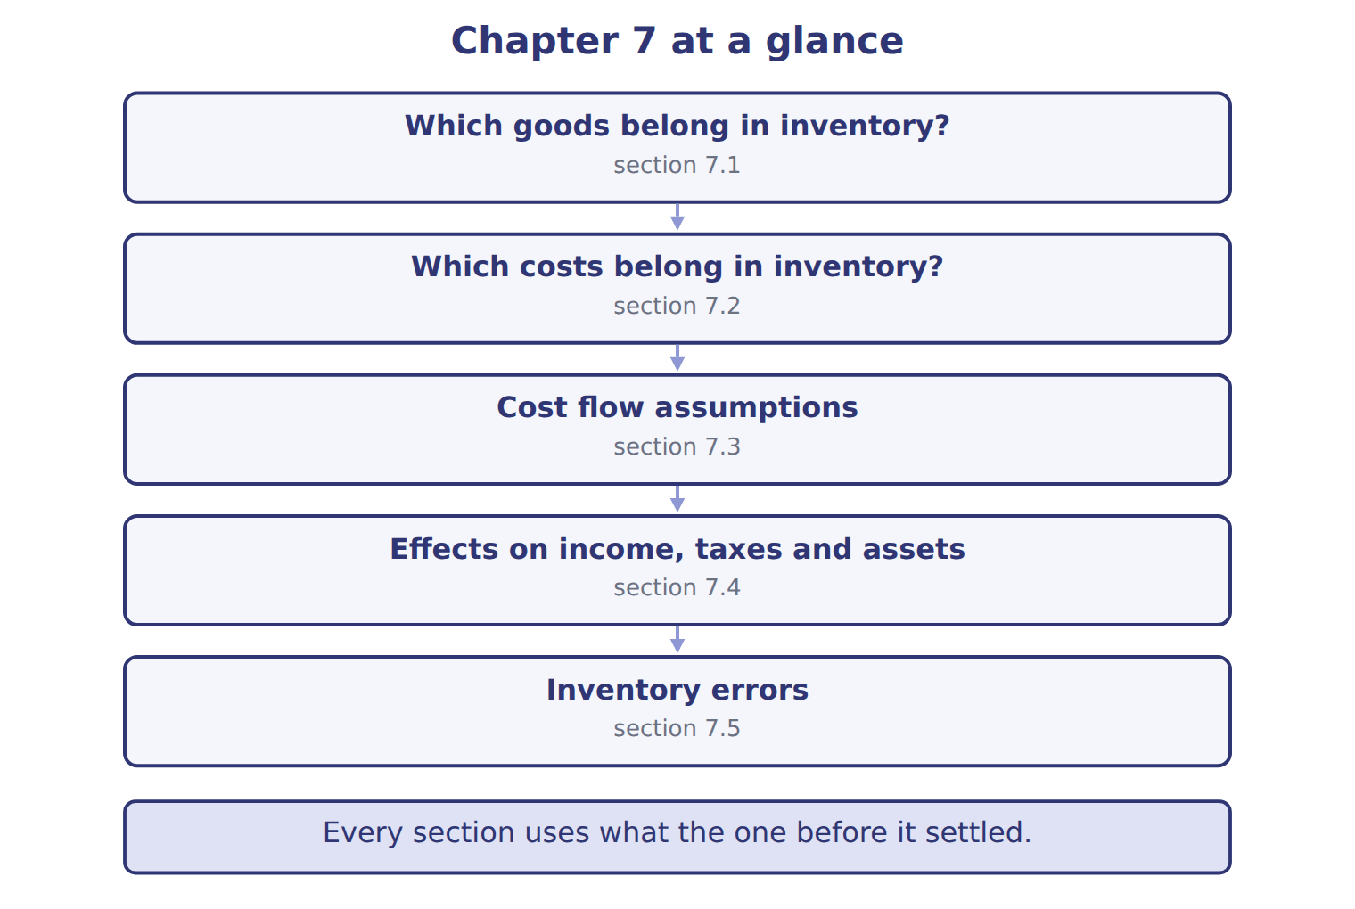

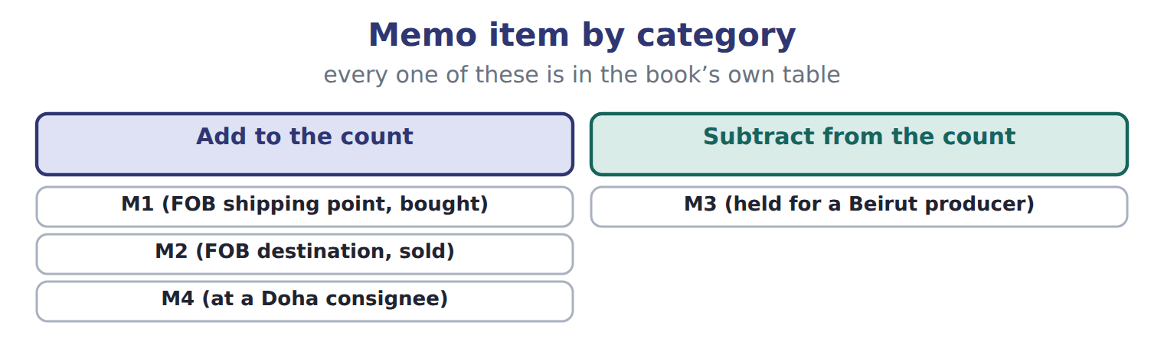
READ THE MODEL

5. Which part of this chapter is section 7.1?
A. Effects on income, taxes and assets
B. Which costs belong in inventory?
C. Cost flow assumptions
D. Which goods belong in inventory?
Write the letter of the section number beside each section title. Every number is used once.
A 7.1 | D 7.4
B 7.2 | E 7.5
C 7.3

6. Which goods belong in inventory?
7. Which costs belong in inventory?
8. Cost flow assumptions
9. Effects on income, taxes and assets
10. Inventory errors

APPLY

11. Cedar Retail S.A.L. reports under IFRS. Which method may it NOT use?
A. FIFO
B. Weighted average
C. LIFO
D. Specific identification for unique items
12. On December 28, a supplier in Türkiye ships glass bottles to Orontes, FOB shipping point. They arrive on January 4. Who includes the bottles in inventory at December 31?
A. The supplier, the seller
B. Neither company until the bottles arrive
C. Both companies, half each
D. Orontes, the buyer
13. Barada Wholesale holds cartons of Orontes tahini on consignment and sells them for a commission. Which statement is correct at year-end?
A. Orontes includes the cartons in inventory; Barada does not.
B. Barada includes the cartons because they are in its warehouse.
C. Both companies include the cartons.
D. Neither company includes the cartons until they are sold.
14. Which cost is included in the cost of inventory?
A. Freight-out to customers | C. Freight-in on purchased goods
B. Sales commissions | D. Storage of finished goods

15. Use the glass-bottle example in Section 7.2. What is the cost of the bottles in inventory (whole USD)?
A. 20,800 | C. 22,400
B. 22,000 | D. 22,950
16. Under LIFO, ending inventory consists of:
A. the newest costs.
B. an average of all costs.
C. the actual cost of each unit still on hand.
D. the oldest costs.
WORK IN PAIRS | Compare every answer with your partner first.
If you disagree: name the section each question belongs to. Most disagreements turn out to be about the section, not the answer.
CHECKPOINT 17. The LIFO conformity rule requires that:
A. a company using LIFO for its U.S. tax return also uses LIFO in its financial statements.
B. companies reporting under IFRS use LIFO.
C. a company using LIFO applies it to every inventory in every country.
D. a company using LIFO for its financial statements uses FIFO for tax.
If you got it wrong: go back to the MODEL move of cycle A and find the section this question belongs to.

CYCLE B | The chapter’s case set

ORIENT

18. In a case question, the exhibit has to be read and adjusted before any figure is worked out. TRUE / FALSE

MODEL

The chapter’s case set, item by item
Item | What it asks
C7-1 | For each memo item, decide how Orontes should adjust the physical count. (On the exam screen you would drag each item in
C7-2 | Enter the correct number of cartons in ending inventory.
C7-3 | Enter FIFO ending inventory in USD.
C7-4 | Enter weighted-average cost of goods sold in USD.
C7-5 | If Orontes had used the unadjusted count, its FIFO cost of goods sold would have been: [select]
C7-6 | If Orontes used periodic LIFO for tahini, what would the LIFO reserve be at December 31 (USD)? The beginning layer is th

READ THE MODEL

The tasks of a case set have to be worked in one order, because each one uses the result of the one before it. Write the letter of its place beside each task.
A first | C third
B second | D fourth

19. Enter the correct number of cartons in ending inventory.
20. Enter FIFO ending inventory in USD.
21. If Orontes had used the unadjusted count, its FIFO cost of goods sold would have been: [select]
22. Enter weighted-average cost of goods sold in USD.

APPLY

23. What is the weighted-average cost per case of olive oil in the Orontes example?
A. $40.00 | C. $46.50
B. $45.50 | D. $50.00
24. Prices are rising. Which method gives the highest net income?
A. FIFO
B. LIFO
C. Weighted average
D. All methods give the same net income.
25. A company reports LIFO cost of goods sold of 500,000. Its LIFO reserve increased from 30,000 to 45,000 during the year. What would cost of goods sold be under FIFO?
A. 455,000 | C. 515,000
B. 485,000 | D. 545,000
26. Ending inventory for 2025 was understated. What are the effects on net income?
A. 2025 overstated; 2026 understated
B. 2025 understated; 2026 no effect
C. No effect in either year
D. 2025 understated; 2026 overstated

CHECKPOINT 27. What has to be settled before any figure in a case set is worked out?
A. the exhibit, adjusted for every note that goes with it
B. the method the company uses
C. the tax rate
D. the order of the items
If you got it wrong: reread the case panel in the MODEL move of cycle B.

FROM MEMORY | Close the earlier pages first.
28. Rebuild the chapter map. Write every section in order and what each one settles.
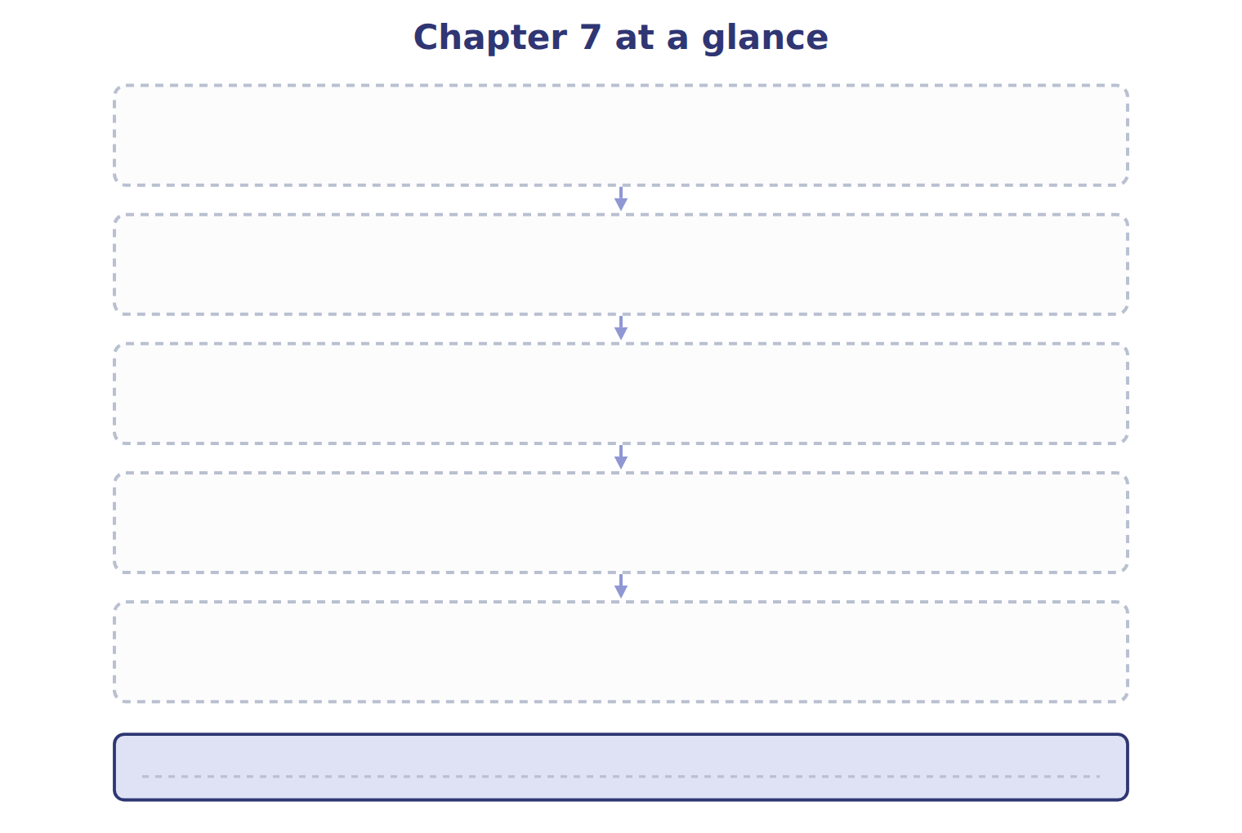
TEACH IT BACK | Write it for a student starting this chapter tomorrow — not for the marker.
29. In four or five sentences, write what the whole chapter settles, section by section.
every one of these words must appear: inventory · cost of goods sold · goods available for sale · FIFO (first-in, first-out)

