Handout 8.1
Which test applies?
section 8.1 of the book
Before you start
Three summaries of this handout, in the book’s own words. Read all three first: together they are the whole session. Then fill the gaps, guessing where you have to.

What this handout settles, cycle by cycle
In this handout | What you will read | How you check it
Which test applies? | a figure to read · Orontes olive oil, December 31, 2025 | Which of these did this cycle settle?
The words this section uses precisely | The English the exam uses, and what it translates | What is the safest way to settle a disagreement about an answer on this sheet?

Words this handout uses precisely
Words this handout uses precisely | tick it if you could already use it in a sentence
net realizable value (NRV)
retail inventory method
floor
markdown

1. Where the section starts — Fill every gap. The list holds more words than there are gaps, so one or two of them are not used.
choose from: floor · retail inventory method · realizable · identification · shrinkage
Inventory measured by FIFO, average cost or specific uses the lower of cost and net value (LCNRV). Inventory measured by LIFO or the uses the lower of cost or market (LCM) (Section 8.2).
2. What it settles in the middle — Fill every gap. The list holds more words than there are gaps, so one or two of them are not used.
choose from: write-down · shrinkage · competitor · floor
In late December, a large cut prices. Orontes now expects to sell each case for $54, with $6 of selling and delivery costs. The of $4,000 is a loss of 2025. The new amount, $48 a case, is now the cost basis of these cases.
3. Where it ends — Fill every gap. The list holds more words than there are gaps, so one or two of them are not used.
choose from: transport · write-down · shrinkage · reversal · floor
Under U.S. GAAP the is zero. NRV = selling price − costs to complete, sell and . Do NOT deduct a normal profit; that only defines the LCM . Check the method first: FIFO or average → LCNRV; LIFO or retail → LCM.

CYCLE A | Which test applies?

ORIENT One claim. Decide now; you will check it in a moment.

4. Every number in a financial statement belongs to an element the framework defines. TRUE / FALSE
MODEL Read it before you answer anything below it.

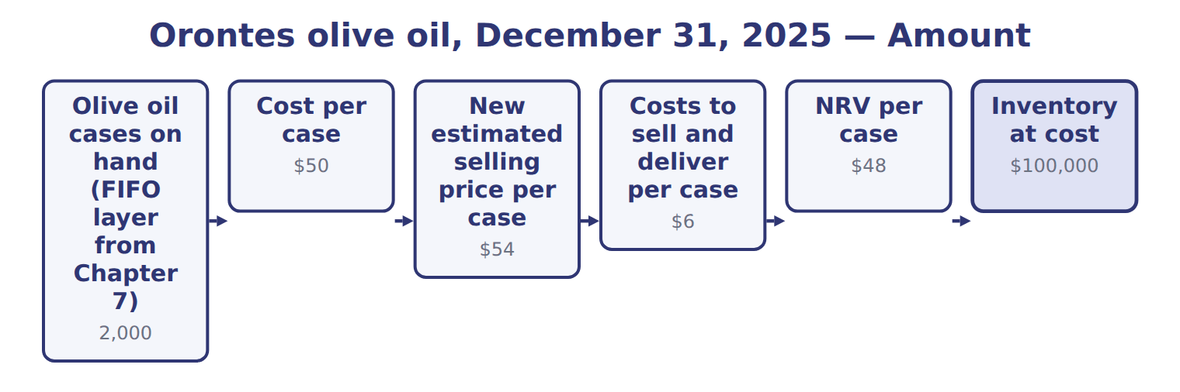
Orontes olive oil, December 31, 2025 — the book’s own table
Orontes olive oil, December 31, 2025 | Amount
Olive oil cases on hand (FIFO layer from Chapter 7) | 2,000
Cost per case | $50
New estimated selling price per case | $54
Costs to sell and deliver per case | $6
NRV per case | $48
Inventory at cost | $100,000
Inventory at LCNRV | $96,000
Write-down (loss in income) | $4,000

READ THE MODEL Every answer is printed above. Find it, do not recall it.

5. Which amount does the book give for Olive oil cases on hand (FIFO layer from Chapter 7)?
A. $4,000 | C. 2,000
B. $50 | D. $54

APPLY No help on this move.

6. A company uses the weighted-average method. At year-end, NRV is below cost. The company should:
A. write the inventory down to replacement cost.
B. disclose the decline in the notes only.
C. record the decline in other comprehensive income.
D. write the inventory down to NRV and recognize a loss in income.
7. Date syrup is measured under LIFO. Cost is $50, replacement cost $48, selling price $55, costs to sell $10 and normal profit $6 per case. At what amount per case is it reported?
A. $39 | C. $48
B. $45 | D. $50
8. In the retail inventory method, freight-in is:
A. added to both the cost and retail columns.
B. added to the cost column only.
C. added to the retail column only.
D. ignored.
9. The gross profit method is acceptable for:
A. interim reports and estimating casualty losses.
B. annual financial statements under U.S. GAAP.
C. replacing the year-end physical count.
D. tax returns only.
WORK IN PAIRS | Compare every answer on this page with your partner before you read any key.
If you disagree: go back to the model and find the row that settles it. The row decides, not the louder voice.
CHECKPOINT 10. Which of these did this cycle settle?
A. the rule and where it comes from
B. nothing in particular
C. only the vocabulary
D. only the arithmetic
If you got it wrong: redo the READ THE MODEL questions of cycle A.

CYCLE B | The words this section uses precisely

ORIENT

11. A term in the exam means exactly what the book defines it to mean, whatever it means in ordinary English. TRUE / FALSE

MODEL

The English the exam uses, and what it translates
English (exam term) | the Arabic it translates
net realizable value (NRV) | صافي القيمة القابلة للتحقق
retail inventory method | طريقة سعر التجزئة
floor | الحد الأدنى
markdown | تخفيض سعر البيع

READ THE MODEL

Write the letter of the Arabic term beside each English term. Every term is used once.
A صافي القيمة القابلة للتحقق | C طريقة سعر التجزئة
B تخفيض سعر البيع | D الحد الأدنى

12. floor
13. net realizable value (NRV)
14. markdown
15. retail inventory method

APPLY

16. When prices are rising, which statement about FIFO is TRUE?
A. Taxes are lower than under LIFO.
B. Current costs are matched with current revenues.
C. Ending inventory is close to current cost.
D. It is not allowed under IFRS.
17. Which is a disadvantage of LIFO?
A. Income includes large holding gains when prices rise.
B. Taxes are higher when prices rise.
C. It cannot be used for U.S. tax returns.
D. The balance sheet can show inventory at very old costs.
18. Spiral review (Chapter 7). A FIFO company moves from a periodic to a perpetual system. What happens to cost of goods sold?
A. It increases.
B. It decreases.
C. It does not change.
D. It depends on the timing of sales.
19. Spiral review (Chapter 7). Ending inventory for 2025 is overstated. What is the effect on 2025 cost of goods sold?
A. Understated | C. Overstated
B. No effect
20. Which amount does the book give for Write-down (loss in income)?
A. $96,000 | C. $4,000
B. $100,000 | D. 2,000
CHECKPOINT 21. What is the safest way to settle a disagreement about an answer on this sheet?
A. find the row of the model that decides it
B. take the answer of whoever is more confident
C. leave it until the lecturer says
D. choose the longer option
If you got it wrong: redo the READ THE MODEL questions of cycle B.

FROM MEMORY | Close the earlier pages first.
22. Rebuild the figure from this handout. Label every part and fill in every box.
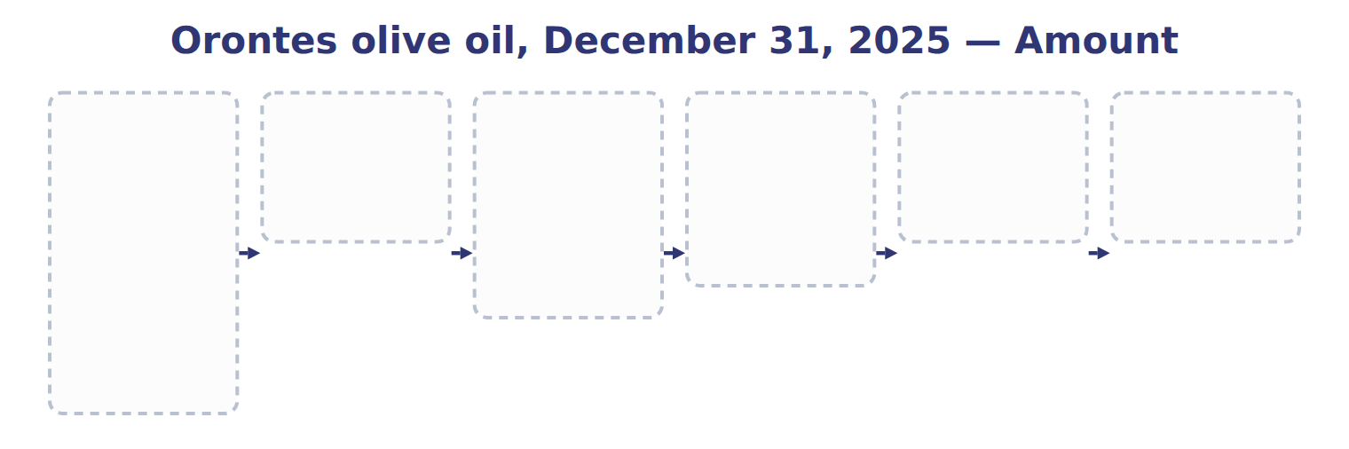
TEACH IT BACK | Write it for a classmate who missed this session — not for the marker.
23. In three or four sentences, write what this section settles and the one rule a reader has to take away.
every one of these words must appear: net realizable value (NRV) · retail inventory method · floor · markdown

Handout 8.2
Lower of cost or market
section 8.2 of the book
Before you start
Three summaries of this handout, in the book’s own words. Read all three first: together they are the whole session. Then fill the gaps, guessing where you have to.

What this handout settles, cycle by cycle
In this handout | What you will read | How you check it
Lower of cost or market | a figure to read · Item | Which of these did this cycle settle?
The words this section uses precisely | The English the exam uses, and what it translates | What is the safest way to settle a disagreement about an answer on this sheet?

Words this handout uses precisely
Words this handout uses precisely | tick it if you could already use it in a sentence
lower of cost and net realizable value (LCNRV)
cost-to-retail ratio
normal profit margin
shrinkage

1. Where the section starts — Fill every gap. The list holds more words than there are gaps, so one or two of them are not used.
choose from: ceiling · markup · normal profit margin · floor · write-down · replacement cost
Under LCM, market starts with : the current cost to buy or make the item again. It cannot be higher than a equal to NRV, and it cannot be lower than a equal to NRV minus a .
2. What it settles in the middle — Fill every gap. The list holds more words than there are gaps, so one or two of them are not used.
choose from: item-by-item basis · purchase commitment · write-down · replacement cost · markup
The is the most conservative. One more rule: if a company has a firm, non-cancellable at a price above the current market, it records the expected loss now, in the current period. Do not compare directly with cost.
3. Where it ends — Fill every gap. The list holds more words than there are gaps, so one or two of them are not used.
choose from: ceiling · floor · shrinkage · write-down · markup · replacement cost
When is below the , market is the floor. When it is above the , market is the ceiling. Read the basis in the question: item by item, by category or total. In French, dépréciation des stocks is an inventory , not depreciation (amortissement).
How every cycle on this sheet works
How a cycle works | what you do
MODEL | read the figure or the table before you answer anything
READ THE MODEL | every answer is printed on the same page
INVENT THE RULE | write the rule yourself, then compare with the book
APPLY | no help on this move
CHECKPOINT | mark it yourself; if you miss it, the sheet says what to redo

CYCLE A | Lower of cost or market

ORIENT One claim. Decide now; you will check it in a moment.

4. Every number in a financial statement belongs to an element the framework defines. TRUE / FALSE
MODEL Read it before you answer anything below it.

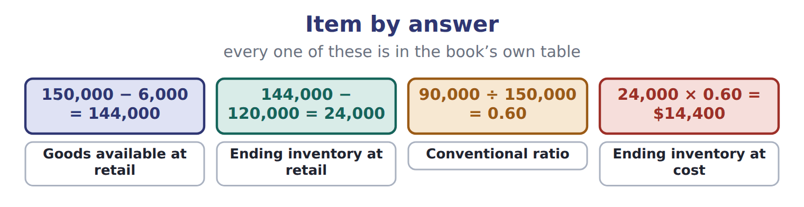
Item — the book’s own table
Item | Answer
Goods available at retail | 150,000 − 6,000 = 144,000
Ending inventory at retail | 144,000 − 120,000 = 24,000
Conventional ratio | 90,000 ÷ 150,000 = 0.60
Ending inventory at cost | 24,000 × 0.60 = $14,400

READ THE MODEL Every answer is printed above. Find it, do not recall it.

SORT THEM | Write each one under its answer. Every item belongs to exactly one group.
the items: Goods available at retail · Ending inventory at retail · Conventional ratio · Ending inventory at cost
144,000 − 120,000 = 24,000 | 150,000 − 6,000 = 144,000 | 24,000 × 0.60 = $14,400 | 90,000 ÷ 150,000 = 0.60

APPLY No help on this move.

9. Under U.S. GAAP, a company wrote inventory down at the end of 2025. In 2026, the selling price recovers. What should the company do?
A. Nothing; the write-down is not reversed.
B. Reverse the write-down, up to the original amount.
C. Reverse the write-down through OCI.
D. Reverse the write-down only if the recovery happens within one year.
10. Spiral review (Chapter 7). A FIFO company moves from a periodic to a perpetual system. What happens to cost of goods sold?
A. It increases.
B. It decreases.
C. It does not change.
D. It depends on the timing of sales.
11. Spiral review (Chapter 7). Ending inventory for 2025 is overstated. What is the effect on 2025 cost of goods sold?
A. Understated | C. Overstated
B. No effect
12. Which statement about IAS 2 is TRUE?
A. LIFO inventory uses the lower of cost or market.
B. A write-down is reversed when NRV recovers, up to the original write-down.
C. The retail method must use LCM.
D. Write-downs are recorded in other comprehensive income.
WORK IN PAIRS | Compare every answer on this page with your partner before you read any key.
If you disagree: go back to the model and find the row that settles it. The row decides, not the louder voice.
CHECKPOINT 13. Which of these did this cycle settle?
A. the rule and where it comes from
B. nothing in particular
C. only the vocabulary
D. only the arithmetic
If you got it wrong: redo the READ THE MODEL questions of cycle A.

CYCLE B | The words this section uses precisely

ORIENT

14. A term in the exam means exactly what the book defines it to mean, whatever it means in ordinary English. TRUE / FALSE

MODEL

The English the exam uses, and what it translates
English (exam term) | the Arabic it translates
lower of cost and net realizable value (LCNRV) | التكلفة أو صافي القيمة القابلة للتحقق، أيهما أقل
cost-to-retail ratio | نسبة التكلفة إلى سعر التجزئة
normal profit margin | هامش الربح العادي
shrinkage | العجز في المخزون (الفاقد)

READ THE MODEL

Write the letter of the Arabic term beside each English term. Every term is used once.
A التكلفة أو صافي القيمة القابلة للتحقق، أيهما أقل
B العجز في المخزون (الفاقد)
C هامش الربح العادي
D نسبة التكلفة إلى سعر التجزئة

15. lower of cost and net realizable value (LCNRV)
16. normal profit margin
17. shrinkage
18. cost-to-retail ratio

APPLY

Write the letter of the matching answer beside each item. Every one is used once.
A 90,000 ÷ 150,000 = 0.60 | C 144,000 − 120,000 = 24,000
B 150,000 − 6,000 = 144,000 | D 24,000 × 0.60 = $14,400

19. Goods available at retail
20. Ending inventory at retail
21. Conventional ratio
22. Ending inventory at cost

CHECKPOINT 23. What is the safest way to settle a disagreement about an answer on this sheet?
A. find the row of the model that decides it
B. take the answer of whoever is more confident
C. leave it until the lecturer says
D. choose the longer option
If you got it wrong: redo the READ THE MODEL questions of cycle B.

FROM MEMORY | Close the earlier pages first.
24. Rebuild the figure from this handout. Label every part and fill in every box.

TEACH IT BACK | Write it for a classmate who missed this session — not for the marker.
25. In three or four sentences, write what this section settles and the one rule a reader has to take away.
every one of these words must appear: lower of cost and net realizable value (LCNRV) · cost-to-retail ratio · normal profit margin · shrinkage

Handout 8.3
The retail inventory method and the gross profit method
section 8.3 of the book
Before you start
Three summaries of this handout, in the book’s own words. Read all three first: together they are the whole session. Then fill the gaps, guessing where you have to.

What this handout settles, cycle by cycle
In this handout | What you will read | How you check it
The retail inventory method and the gross profit method | a figure to read · Item | Which of these did this cycle settle?
The words this section uses precisely | The English the exam uses, and what it translates | What is the safest way to settle a disagreement about an answer on this sheet?

Words this handout uses precisely
Words this handout uses precisely | tick it if you could already use it in a sentence
lower of cost or market (LCM)
conventional retail method
item-by-item basis

1. Where the section starts — Fill every gap. The list holds more words than there are gaps, so one or two of them are not used.
choose from: ceiling · cost-to-retail ratio · markup · conventional retail method · replacement cost · retail inventory method
The estimates ending inventory at cost from retail prices. It uses a : goods available at cost divided by goods available at retail. Retail prices change during the year. A raises the selling price above the original retail price. The includes net markups in the ratio but leaves out net markdowns.
2. What it settles in the middle — Fill every gap. The list holds more words than there are gaps, so one or two of them are not used.
choose from: ceiling · statements · replacement cost · gross profit method · acceptable
The estimates ending inventory from the usual gross profit rate. It is used for interim reports, to check a physical count, and to estimate inventory lost in a fire or a theft. It is not for annual financial .
3. Where it ends — Fill every gap. The list holds more words than there are gaps, so one or two of them are not used.
choose from: replacement cost · cost-to-retail ratio · ceiling · shrinkage · markup
For example, a of one half on cost is a gross profit rate of one third on sales. Conventional retail: markups IN the ratio, markdowns OUT. Freight-in goes in the cost column only; normal is deducted from retail after the ratio. A. included in the .

CYCLE A | The retail inventory method and the gross profit method

ORIENT One claim. Decide now; you will check it in a moment.

4. Every number in a financial statement belongs to an element the framework defines. TRUE / FALSE
MODEL Read it before you answer anything below it.

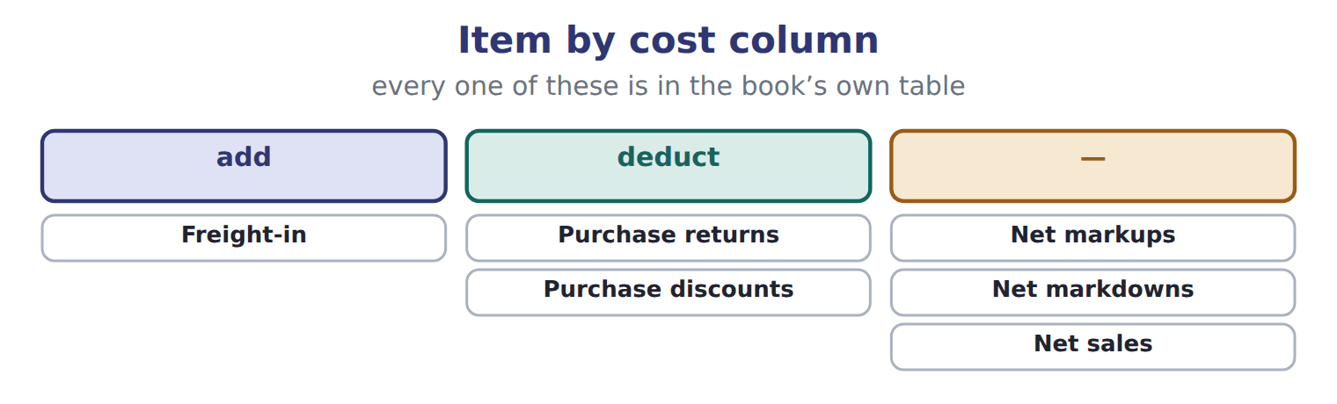

Item — the book’s own table
Item | Cost column | Retail column
Freight-in | add | —
Purchase returns | deduct | deduct
Purchase discounts | deduct | —
Net markups | — | add (before the ratio)
Net markdowns | — | deduct (after the conventional ratio)
Net sales | — | deduct
Normal shrinkage and employee discounts | — | deduct (after the ratio)

READ THE MODEL Every answer is printed above. Find it, do not recall it.

5. Which retail column does the book give for Purchase returns?
A. deduct (after the ratio) | C. —
B. deduct | D. add (before the ratio)
SORT THEM | Write each one under its cost column. Every item belongs to exactly one group.
the items: Freight-in · Purchase returns · Purchase discounts · Net markups · Net markdowns · Net sales · Normal shrinkage and employee discounts
add | deduct | —

Complete every empty cell. The first full row shows the pattern.
Item | Cost column | Retail column
Freight-in | add | —
Purchase returns
Purchase discounts
Net markups
Net markdowns
Net sales
Normal shrinkage and employee discounts

APPLY No help on this move.

15. A company recognized an inventory write-down in the first quarter. The market price recovers in the third quarter of the same fiscal year. What is the treatment?
A. The loss can never be recovered.
B. Inventory is written up to the new market price, even above cost.
C. The loss may be recovered in the third quarter, up to the amount written down.
D. The recovery is recorded in OCI.
WORK IN PAIRS | Compare every answer on this page with your partner before you read any key.
If you disagree: go back to the model and find the row that settles it. The row decides, not the louder voice.

CHECKPOINT 16. Which of these did this cycle settle?
A. the rule and where it comes from
B. nothing in particular
C. only the vocabulary
D. only the arithmetic
If you got it wrong: redo the READ THE MODEL questions of cycle A.

CYCLE B | The words this section uses precisely

ORIENT

17. A term in the exam means exactly what the book defines it to mean, whatever it means in ordinary English. TRUE / FALSE
MODEL

The English the exam uses, and what it translates
English (exam term) | the Arabic it translates
lower of cost or market (LCM) | التكلفة أو السوق، أيهما أقل
conventional retail method | طريقة التجزئة التقليدية
item-by-item basis | أساس كل صنف على حدة

READ THE MODEL

18. A glossary term and its translation are a pair the book itself gives. TRUE / FALSE
APPLY

19. Which retail column does the book give for Normal shrinkage and employee discounts?
A. deduct
B. add (before the ratio)
C. deduct (after the ratio)
D. deduct (after the conventional ratio)
CHECKPOINT 20. What is the safest way to settle a disagreement about an answer on this sheet?
A. find the row of the model that decides it
B. take the answer of whoever is more confident
C. leave it until the lecturer says
D. choose the longer option
If you got it wrong: redo the READ THE MODEL questions of cycle B.

FROM MEMORY | Close the earlier pages first.
21. Rebuild the figure from this handout. Label every part and fill in every box.
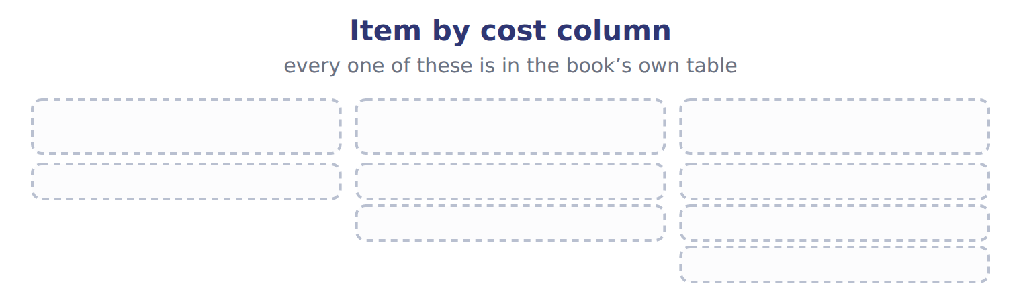
TEACH IT BACK | Write it for a classmate who missed this session — not for the marker.
22. In three or four sentences, write what this section settles and the one rule a reader has to take away.
every one of these words must appear: lower of cost or market (LCM) · conventional retail method · item-by-item basis

Handout 8.4
Advantages and disadvantages of the methods
section 8.4 of the book
Before you start
Three summaries of this handout, in the book’s own words. Read all three first: together they are the whole session. Then fill the gaps, guessing where you have to.

What this handout settles, cycle by cycle
In this handout | What you will read | How you check it
Advantages and disadvantages of the methods | a figure to read · Criterion | Which of these did this cycle settle?
The words this section uses precisely | The English the exam uses, and what it translates | What is the safest way to settle a disagreement about an answer on this sheet?

Words this handout uses precisely
Words this handout uses precisely | tick it if you could already use it in a sentence
replacement cost
gross profit method
purchase commitment

1. Where the section starts — Fill every gap. The list holds more words than there are gaps, so one or two of them are not used.
choose from: strengths · identification · floor · manipulate · shrinkage
The weighted average and specific have their own . The weighted average is simple, smooths price changes and is hard to , but its results are neither fully current on the balance sheet nor on the income statement.
2. What it settles in the middle — Fill every gap. The list holds more words than there are gaps, so one or two of them are not used.
choose from: out-of-date · trade-off · shrinkage · statements · floor
The main is between the two . LIFO gives a more realistic income statement when prices change, but an balance sheet. FIFO gives a realistic balance sheet, but its income includes holding gains. The weighted average sits between them.
3. Where it ends — Fill every gap. The list holds more words than there are gaps, so one or two of them are not used.
choose from: shrinkage · management · floor · overstates · physical
D. It needs the fewest records. A. it is not allowed under U.S. GAAP. B. it always income. C. it ignores the flow of goods. D. can choose which units to sell and so change income.
How every cycle on this sheet works
How a cycle works | what you do
MODEL | read the figure or the table before you answer anything
READ THE MODEL | every answer is printed on the same page
INVENT THE RULE | write the rule yourself, then compare with the book
APPLY | no help on this move
CHECKPOINT | mark it yourself; if you miss it, the sheet says what to redo

CYCLE A | Advantages and disadvantages of the methods

ORIENT One claim. Decide now; you will check it in a moment.

4. Every number in a financial statement belongs to an element the framework defines. TRUE / FALSE
MODEL Read it before you answer anything below it.

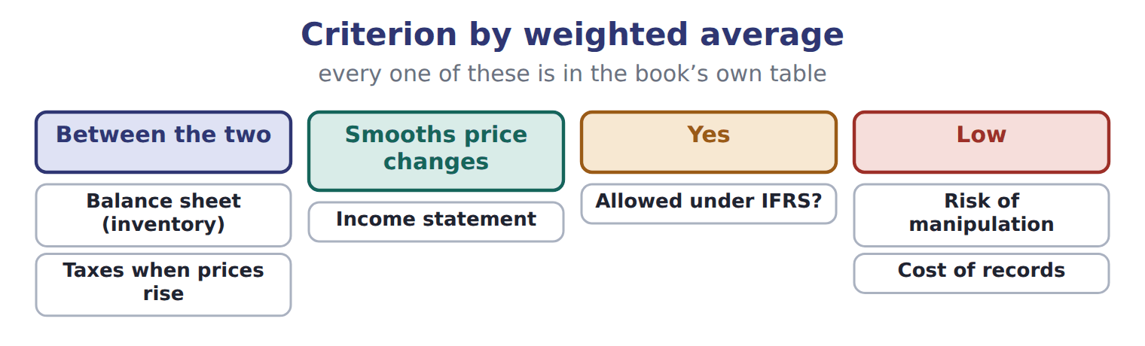

Criterion — the book’s own table
Criterion | FIFO | LIFO | Weighted average | Specific identification
Balance sheet (inventory) | Close to current cost | Old costs; can be far out of date | Between the two | Actual cost of each item
Income statement | Includes holding gains when prices rise | Matches current costs with revenues | Smooths price changes | Exact matching
Taxes when prices rise | Highest | Lowest (tax deferral) | Between the two | Depends on items sold
Allowed under IFRS? | Yes | No | Yes | Yes (required for unique items)
Risk of manipulation | Low | Year-end purchases; liquidations | Low | High for identical items
Cost of records | Moderate | Higher (layers, conformity) | Low | High

READ THE MODEL Every answer is printed above. Find it, do not recall it.

5. Which criterion does the book pair with “Close to current cost”?
A. Income statement | C. Balance sheet (inventory)
B. Allowed under IFRS? | D. Risk of manipulation
SORT THEM | Write each one under its weighted average. Every item belongs to exactly one group.
the items: Balance sheet (inventory) · Income statement · Taxes when prices rise · Allowed under IFRS? · Risk of manipulation · Cost of records
Between the two | Low | Smooths price changes | Yes

Complete every empty cell. The first full row shows the pattern.
Criterion | FIFO | LIFO | Weighted average | Specific identification
Balance sheet (inventory) | Close to current cost | Old costs; can be far out of date | Between the two | Actual cost of each item
Income statement
Taxes when prices rise
Allowed under IFRS?
Risk of manipulation
Cost of records

APPLY No help on this move.

15. A retailer's markup is 25% on cost. What gross profit rate on sales should it use in the gross profit method?
A. 25% | C. 75%
B. 33.3% | D. 20%

WORK IN PAIRS | Compare every answer on this page with your partner before you read any key.
If you disagree: go back to the model and find the row that settles it. The row decides, not the louder voice.
CHECKPOINT 16. Which of these did this cycle settle?
A. the rule and where it comes from
B. nothing in particular
C. only the vocabulary
D. only the arithmetic
If you got it wrong: redo the READ THE MODEL questions of cycle A.

CYCLE B | The words this section uses precisely

ORIENT

17. A term in the exam means exactly what the book defines it to mean, whatever it means in ordinary English. TRUE / FALSE
MODEL

The English the exam uses, and what it translates
English (exam term) | the Arabic it translates
replacement cost | تكلفة الإحلال
gross profit method | طريقة مجمل الربح
purchase commitment | التزام شراء

READ THE MODEL

18. A glossary term and its translation are a pair the book itself gives. TRUE / FALSE
APPLY

19. A term on this page means what the book defines it to mean. What settles a disagreement about one?
A. the glossary printed on this page
B. what the word means in ordinary English
C. the translation that sounds closest
D. whichever reading makes the item easier
CHECKPOINT 20. What is the safest way to settle a disagreement about an answer on this sheet?
A. find the row of the model that decides it
B. take the answer of whoever is more confident
C. leave it until the lecturer says
D. choose the longer option
If you got it wrong: redo the READ THE MODEL questions of cycle B.

FROM MEMORY | Close the earlier pages first.
21. Rebuild the figure from this handout. Label every part and fill in every box.
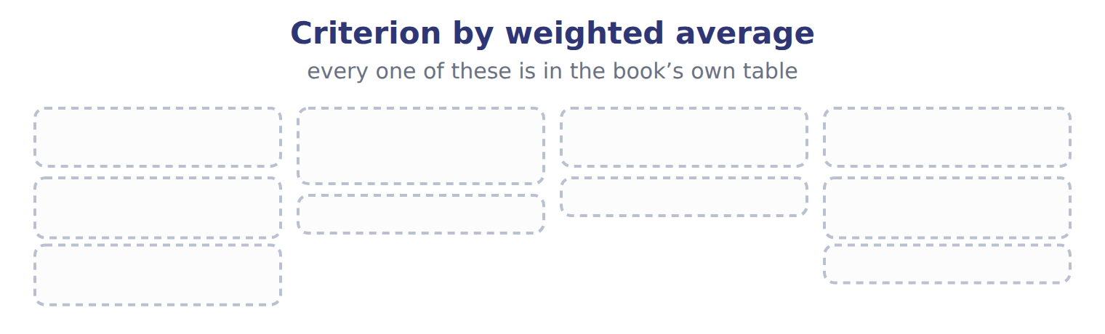
TEACH IT BACK | Write it for a classmate who missed this session — not for the marker.
22. In three or four sentences, write what this section settles and the one rule a reader has to take away.
every one of these words must appear: replacement cost · gross profit method · purchase commitment

Handout 8.5
Recommending a method
section 8.5 of the book
Before you start
Three summaries of this handout, in the book’s own words. Read all three first: together they are the whole session. Then fill the gaps, guessing where you have to.

What this handout settles, cycle by cycle
In this handout | What you will read | How you check it
Recommending a method | a figure to read · Product line | Which of these did this cycle settle?
The words this section uses precisely | a figure to read · Product line · The English the exam uses, and what it translates | What is the safest way to settle a disagreement about an answer on this sheet?

Words this handout uses precisely
Words this handout uses precisely | tick it if you could already use it in a sentence
write-down
ceiling
markup

1. Where the section starts — Fill every gap. The list holds more words than there are gaps, so one or two of them are not used.
choose from: identification · liquidating · manipulation · ceiling · markup
If items are identical and sold in large volumes, specific is costly and open to . If the company wants the U.S. tax benefit of LIFO, it must also report LIFO profits to investors, and it must avoid old layers.
2. What it settles in the middle — Fill every gap. The list holds more words than there are gaps, so one or two of them are not used.
choose from: ceiling · conformity · inventory · markup · reported
LIFO would lower taxes while prices rise, but would lower profits too, and the balance sheet would show old costs. FIFO matches the physical flow and gives lenders a current amount, but taxes are higher.
3. Where it ends — Fill every gap. The list holds more words than there are gaps, so one or two of them are not used.
choose from: ceiling · reported · markup · management · physical
Check IFRS, taxes, price trends, the flow and the cost of records before you choose. Prices are rising, and it wants lower taxes. Prices are rising, and accepts lower profits in exchange for the lowest income taxes.
How every cycle on this sheet works
How a cycle works | what you do
MODEL | read the figure or the table before you answer anything
READ THE MODEL | every answer is printed on the same page
INVENT THE RULE | write the rule yourself, then compare with the book
APPLY | no help on this move
CHECKPOINT | mark it yourself; if you miss it, the sheet says what to redo

CYCLE A | Recommending a method

ORIENT One claim. Decide now; you will check it in a moment.

4. Every number in a financial statement belongs to an element the framework defines. TRUE / FALSE
MODEL Read it before you answer anything below it.

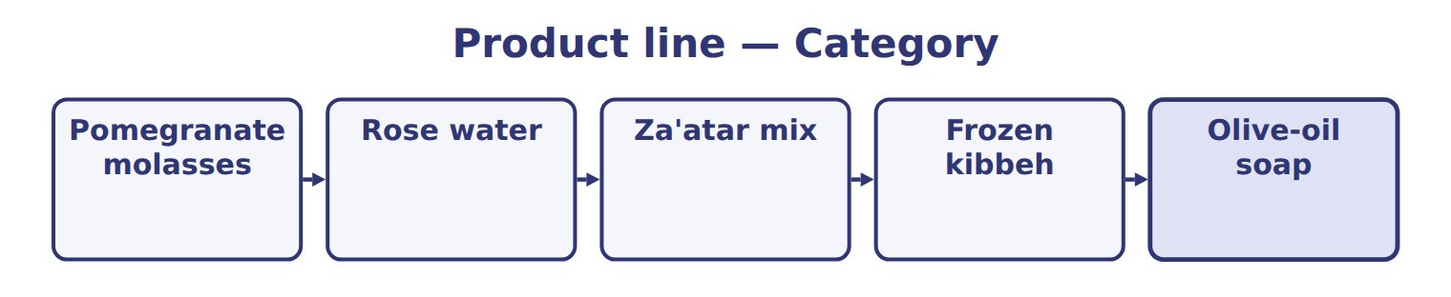
Product line — the book’s own table
Product line | Category
Pomegranate molasses
Rose water
Za'atar mix
Frozen kibbeh
Olive-oil soap

READ THE MODEL Every answer is printed above. Find it, do not recall it.

5. Which part of this chapter is section 8.1?
A. Recommending a method
B. Which test applies?
C. Advantages and disadvantages of the methods
D. Lower of cost or market
APPLY No help on this move.

6. Orontes signed a firm, non-cancellable contract to buy sesame seeds next year at a fixed price. At year-end, the market price is well below the contract price. What should Orontes do?
A. Recognize the loss when the seeds arrive.
B. Disclose the contract only.
C. Recognize the expected loss now.
D. Record the difference as an asset.
WORK IN PAIRS | Compare every answer on this page with your partner before you read any key.
If you disagree: go back to the model and find the row that settles it. The row decides, not the louder voice.
CHECKPOINT 7. Which of these did this cycle settle?
A. the rule and where it comes from
B. nothing in particular
C. only the vocabulary
D. only the arithmetic
If you got it wrong: redo the READ THE MODEL questions of cycle A.

CYCLE B | The words this section uses precisely

ORIENT

8. A term in the exam means exactly what the book defines it to mean, whatever it means in ordinary English. TRUE / FALSE
MODEL

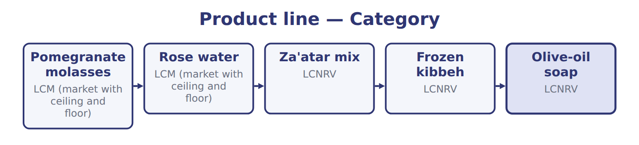
Product line — the book’s own table
Product line | Category
Pomegranate molasses | LCM (market with ceiling and floor)
Rose water | LCM (market with ceiling and floor)
Za'atar mix | LCNRV
Frozen kibbeh | LCNRV
Olive-oil soap | LCNRV

The English the exam uses, and what it translates
English (exam term) | the Arabic it translates
write-down | تخفيض القيمة
ceiling | الحد الأعلى
markup | زيادة سعر البيع

READ THE MODEL

9. Which product line does the book pair with “LCM (market with ceiling and floor)”?
A. Pomegranate molasses | C. Frozen kibbeh
B. Olive-oil soap | D. Za'atar mix
APPLY

10. A term on this page means what the book defines it to mean. What settles a disagreement about one?
A. the glossary printed on this page
B. what the word means in ordinary English
C. the translation that sounds closest
D. whichever reading makes the item easier
CHECKPOINT 11. What is the safest way to settle a disagreement about an answer on this sheet?
A. find the row of the model that decides it
B. take the answer of whoever is more confident
C. leave it until the lecturer says
D. choose the longer option
If you got it wrong: redo the READ THE MODEL questions of cycle B.

FROM MEMORY | Close the earlier pages first.
12. Rebuild the figure from this handout. Label every part and fill in every box.
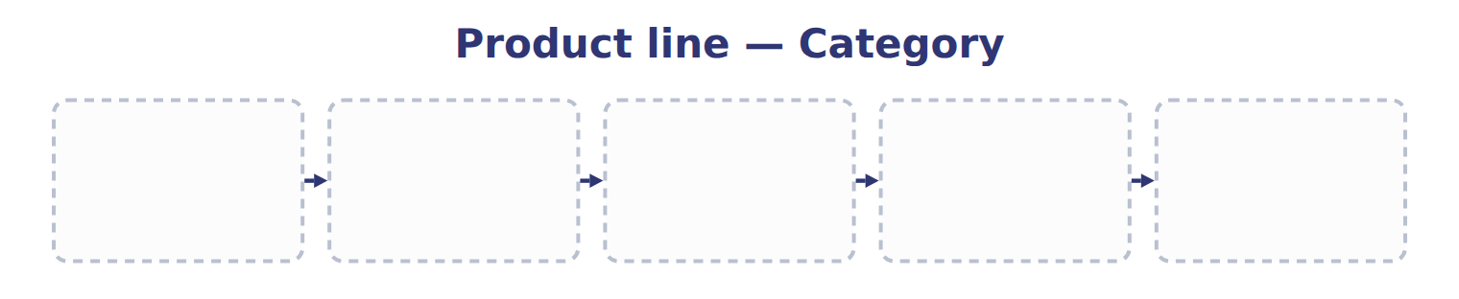
TEACH IT BACK | Write it for a classmate who missed this session — not for the marker.
13. In three or four sentences, write what this section settles and the one rule a reader has to take away.
every one of these words must appear: write-down · ceiling · markup

Handout 8.6
The whole chapter
every section, shuffled, and the chapter’s own case set
Before you start
Three summaries of this chapter, in the book’s own words, with words taken out. Read all three first: together they are the whole chapter. Then fill the gaps.

What this handout settles, cycle by cycle
In this handout | What you will read | How you check it
The whole chapter, in order | a figure to read | A company sells custom-built industrial ovens, each with a different cost. Which method should it recommend?
The chapter’s case set | The chapter’s case set, item by item | What has to be settled before any figure in a case set is worked out?
The words it uses precisely | net realizable value (NRV) · lower of cost and net realizable value (LCNRV) · lower of cost or market (LCM) · replacement cost · write-down · retail inventory method | matching, at the end of cycle B

1. Where the chapter starts — Fill every gap. The list holds more words than there are gaps, so one or two of them are not used.
choose from: gross profit method · markdown · normal profit margin · floor · ceiling · replacement cost · write-down
U.S. GAAP never reverses an annual . Under LCM, market starts with : the current cost to buy or make the item again. It cannot be higher than a equal to NRV, and it cannot be lower than a equal to NRV minus a .
2. What it settles in the middle — Fill every gap. The list holds more words than there are gaps, so one or two of them are not used.
choose from: floor · gross profit method · write-down · ceiling · markdown · replacement cost
When is below the , market is the floor. When it is above the , market is the ceiling. Read the basis in the question: item by item, by category or total. In French, dépréciation des stocks is an inventory , not depreciation (amortissement).
3. Where it ends — Fill every gap. The list holds more words than there are gaps, so one or two of them are not used.
choose from: identification · manipulation · gross profit method · liquidating · floor
If items are identical and sold in large volumes, specific is costly and open to . If the company wants the U.S. tax benefit of LIFO, it must also report LIFO profits to investors, and it must avoid old layers.

CYCLE A | The whole chapter, in order

ORIENT

4. The sections of a chapter have to be taken in order, because each one uses what the one before it settled. TRUE / FALSE
MODEL

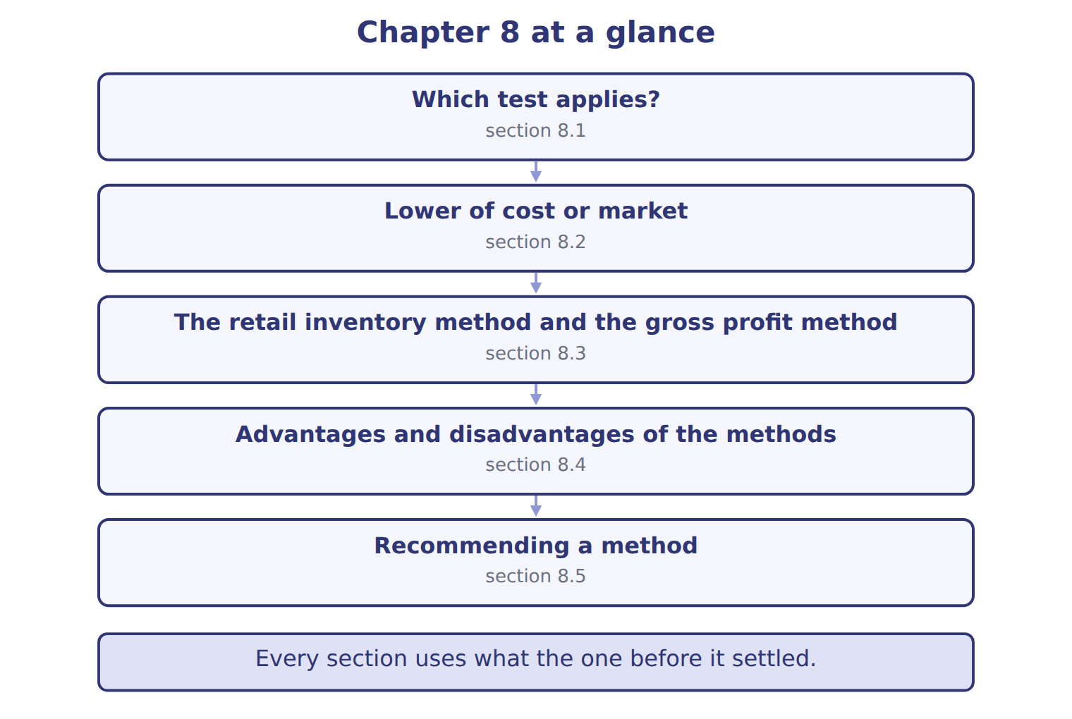

READ THE MODEL

5. Which part of this chapter is section 8.1?
A. Recommending a method
B. Advantages and disadvantages of the methods
C. Lower of cost or market
D. Which test applies?
Write the letter of the section number beside each section title. Every number is used once.
A 8.1 | D 8.4
B 8.2 | E 8.5
C 8.3

6. Which test applies?
7. Lower of cost or market
8. The retail inventory method and the gross profit method
9. Advantages and disadvantages of the methods
10. Recommending a method

APPLY

11. Which basis gives the largest LCM write-down?
A. Item by item
B. Total inventory
C. By category
D. All bases give the same write-down.
12. In the conventional retail method, net markdowns are:
A. included in the cost-to-retail ratio.
B. left out of the cost-to-retail ratio.
C. deducted from the cost column.
D. ignored completely.
13. Use the Jebel Ali fire example. What is the estimated inventory at the date of the fire (whole USD)?
A. 72,308 | C. 100,000
B. 88,000 | D. 260,000
14. When prices are rising, which is an advantage of LIFO?
A. It matches current costs with current revenues.
B. It shows inventory close to current cost.
C. It is allowed under IFRS.
D. It needs the fewest records.

15. For large volumes of identical items, the main disadvantage of specific identification is that:
A. it is not allowed under U.S. GAAP.
B. it always overstates income.
C. it ignores the physical flow of goods.
D. management can choose which units to sell and so change income.
16. Cedar Retail S.A.L. reports under IFRS. Prices are rising, and it wants lower taxes. Which recommendation is appropriate?
A. LIFO, because it lowers taxes when prices rise
B. FIFO or weighted average, because LIFO is not allowed
C. Specific identification for all of its items
D. The LIFO retail method
WORK IN PAIRS | Compare every answer with your partner first.
If you disagree: name the section each question belongs to. Most disagreements turn out to be about the section, not the answer.
CHECKPOINT 17. A company sells custom-built industrial ovens, each with a different cost. Which method should it recommend?
A. LIFO
B. Specific identification
C. Weighted average
D. The retail inventory method
If you got it wrong: go back to the MODEL move of cycle A and find the section this question belongs to.

CYCLE B | The chapter’s case set

ORIENT

18. In a case question, the exhibit has to be read and adjusted before any figure is worked out. TRUE / FALSE

MODEL

The chapter’s case set, item by item
Item | What it asks
C8-1 | Match each product line to the test that applies. (On the exam screen you would drag each line into a box.)
C8-2 | Enter the write-down for pomegranate molasses (USD).
C8-3 | Enter the total write-down for all five lines (USD).
C8-4 | Enter the total carrying amount of the five lines after the write-downs (USD).
C8-5 | In 2026, the NRV of za'atar mix rises to $13 a unit. Under U.S. GAAP, the 2025 write-down: [select]
C8-6 | If Orontes reported under IFRS, how much of the za'atar write-down would it reverse in 2026 (USD)?

READ THE MODEL

The tasks of a case set have to be worked in one order, because each one uses the result of the one before it. Write the letter of its place beside each task.
A first | D fourth
B second | E fifth
C third | F sixth

19. Match each product line to the test that applies. (On the exam screen you would drag each line into a box.)
20. Enter the write-down for pomegranate molasses (USD).
21. Enter the total carrying amount of the five lines after the write-downs (USD).
22. Enter the total write-down for all five lines (USD).
23. In 2026, the NRV of za'atar mix rises to $13 a unit. Under U.S. GAAP, the 2025 write-down: [select]
24. If Orontes reported under IFRS, how much of the za'atar write-down would it reverse in 2026 (USD)?

APPLY

25. A U.S. subsidiary reports under U.S. GAAP, but its parent prepares IFRS group statements. The parent wants one method for group reporting. Which recommendation fits best?
A. FIFO or weighted average, so the same records work for the IFRS group statements
B. LIFO, because the subsidiary reports under U.S. GAAP
C. LIFO for the subsidiary and the retail method for the group
D. Specific identification, to avoid the IFRS rules
CHECKPOINT 26. What has to be settled before any figure in a case set is worked out?
A. the exhibit, adjusted for every note that goes with it
B. the method the company uses
C. the tax rate
D. the order of the items
If you got it wrong: reread the case panel in the MODEL move of cycle B.

FROM MEMORY | Close the earlier pages first.
27. Rebuild the chapter map. Write every section in order and what each one settles.
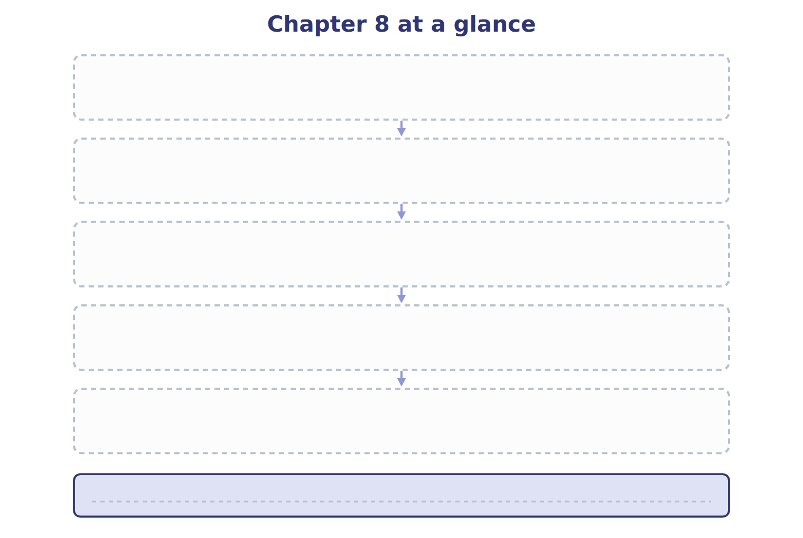
TEACH IT BACK | Write it for a student starting this chapter tomorrow — not for the marker.
28. In four or five sentences, write what the whole chapter settles, section by section.
every one of these words must appear: net realizable value (NRV) · lower of cost and net realizable value (LCNRV) · lower of cost or market (LCM) · replacement cost

