Handout 9.1
Three categories of debt securities
section 9.1 of the book
Before you start
Three summaries of this handout, in the book’s own words. Read all three first: together they are the whole session. Then fill the gaps, guessing where you have to.

What this handout settles, cycle by cycle
In this handout | What you will read | How you check it
Three categories of debt securities | a figure to read · Item | Which of these did this cycle settle?
The words this section uses precisely | a figure to read · Year · The English the exam uses, and what it translates | What is the safest way to settle a disagreement about an answer on this sheet?

Words this handout uses precisely
Words this handout uses precisely | tick it if you could already use it in a sentence
debt security
held-to-maturity (HTM) securities
effective-interest method
bond premium
measurement alternative

1. Where the section starts — Fill every gap. The list holds more words than there are gaps, so one or two of them are not used.
choose from: classification · significant influence · debt security · management's · basis difference
Section 9.4 covers equity securities. When a company buys a , it classifies it into one of three categories, and it reassesses the at each reporting date. The category depends on intent and ability, not on the type of bond.
2. What it settles in the middle — Fill every gap. The list holds more words than there are gaps, so one or two of them are not used.
choose from: significant influence · portfolio · transfers · securities · basis difference
If the company would sell the bond when interest rates change or when it needs cash, it does not have the intent to hold it. And if it sells or HTM for other reasons, it taints the whole HTM , which raises doubt about its intent for all its other HTM securities.
3. Where it ends — Fill every gap. The list holds more words than there are gaps, so one or two of them are not used.
choose from: irrevocable · basis difference · significant influence · fair value · election
The is , and all changes in then go to net income. The same bond can be trading, AFS or HTM. Read the facts about intent and ability. A company that might sell when rates change cannot use HTM.

CYCLE A | Three categories of debt securities

ORIENT One claim. Decide now; you will check it in a moment.

4. Every number in a financial statement belongs to an element the framework defines. TRUE / FALSE
MODEL Read it before you answer anything below it.

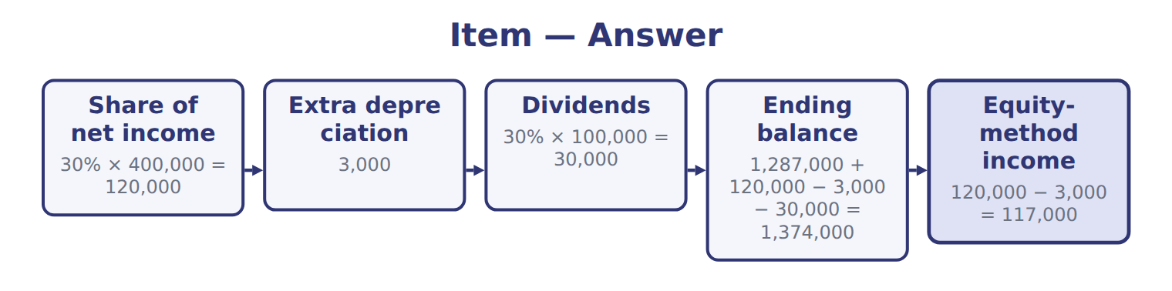
Item — the book’s own table
Item | Answer
Share of net income | 30% × 400,000 = 120,000
Extra depreciation | 3,000
Dividends | 30% × 100,000 = 30,000
Ending balance | 1,287,000 + 120,000 − 3,000 − 30,000 = 1,374,000
Equity-method income | 120,000 − 3,000 = 117,000

READ THE MODEL Every answer is printed above. Find it, do not recall it.

5. Which part of this chapter is section 9.1?
A. Equity securities and the equity method
B. Three categories of debt securities
C. Measuring debt securities
D. Credit losses on debt securities

APPLY No help on this move.

6. A debt security should be classified as held-to-maturity only if the company has:
A. the positive intent and the ability to hold it until maturity.
B. no plan to sell it within the next year.
C. bought it at a discount.
D. the fair value option.
7. How is a held-to-maturity bond reported on the balance sheet?
A. At fair value
B. At face value
C. At cost, with no amortization
D. At amortized cost, net of any allowance for credit losses
8. Which statement about credit losses on debt securities is correct?
A. AFS allowances are limited to amortized cost minus fair value; HTM allowances have no such limit.
B. Both HTM and AFS use the same CECL allowance with no limit.
C. Neither category records credit losses until a default.
D. AFS credit losses go to OCI.
9. Which option exists under IFRS 9 but NOT under U.S. GAAP?
A. Measuring trading debt at fair value through profit or loss
B. An irrevocable election to put fair value changes on shares in OCI
C. The equity method for associates
D. Amortized cost for debt held to collect cash flows
WORK IN PAIRS | Compare every answer on this page with your partner before you read any key.
If you disagree: go back to the model and find the row that settles it. The row decides, not the louder voice.
CHECKPOINT 10. Which of these did this cycle settle?
A. the rule and where it comes from
B. nothing in particular
C. only the vocabulary
D. only the arithmetic
If you got it wrong: redo the READ THE MODEL questions of cycle A.

CYCLE B | The words this section uses precisely

ORIENT

11. A term in the exam means exactly what the book defines it to mean, whatever it means in ordinary English. TRUE / FALSE

MODEL

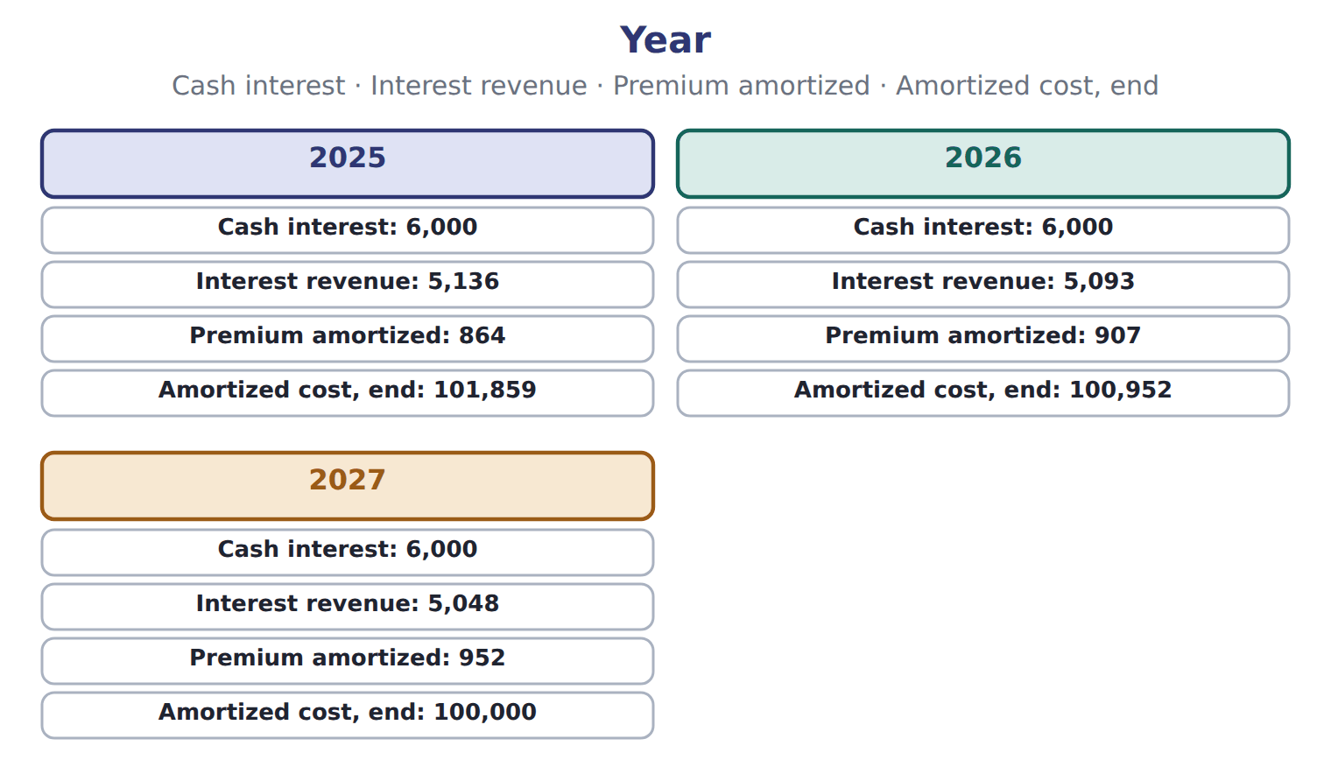
Year — the book’s own table
Year | Cash interest | Interest revenue | Premium amortized | Amortized cost, end
2025 | 6,000 | 5,136 | 864 | 101,859
2026 | 6,000 | 5,093 | 907 | 100,952
2027 | 6,000 | 5,048 | 952 | 100,000

The English the exam uses, and what it translates
English (exam term) | the Arabic it translates
debt security | أداة دين (سند)
held-to-maturity (HTM) securities | أوراق مالية محتفظ بها حتى تاريخ الاستحقاق
effective-interest method | طريقة الفائدة الفعلية
bond premium | علاوة إصدار السند
measurement alternative | بديل القياس

READ THE MODEL

Write the letter of the Arabic term beside each English term. Every term is used once.
A أداة دين (سند)
B طريقة الفائدة الفعلية
C علاوة إصدار السند
D أوراق مالية محتفظ بها حتى تاريخ الاستحقاق
E بديل القياس

12. debt security
13. held-to-maturity (HTM) securities
14. measurement alternative
15. effective-interest method
16. bond premium

APPLY

17. Spiral review (Chapter 1). Interest revenue on a bond is recognized each year even when the premium makes the cash received higher than the revenue. Which basis does this follow?
A. The cash basis | C. The accrual basis
B. The direct write-off method | D. Immediate recognition
18. Spiral review (Chapter 6). Which debt investments follow the same CECL model as trade receivables?
A. Held-to-maturity securities | C. Available-for-sale securities
B. Trading securities | D. Shares measured at fair value
Write the letter of the matching answer beside each item. Every one is used once.
A 30% × 400,000 = 120,000
B 1,287,000 + 120,000 − 3,000 − 30,000 = 1,374,000
C 120,000 − 3,000 = 117,000
D 30% × 100,000 = 30,000
E 3,000

19. Share of net income
20. Extra depreciation
21. Dividends
22. Ending balance
23. Equity-method income

24. Which interest revenue does the book give for 2027?
A. 5,136 | C. 5,093
B. 5,048
Complete every empty cell. The first full row shows the pattern.
Year | Cash interest | Interest revenue | Premium amortized | Amortized cost, end
2025 | 6,000 | 5,136 | 864 | 101,859
2026
2027

CHECKPOINT 27. What is the safest way to settle a disagreement about an answer on this sheet?
A. find the row of the model that decides it
B. take the answer of whoever is more confident
C. leave it until the lecturer says
D. choose the longer option
If you got it wrong: redo the READ THE MODEL questions of cycle B.

FROM MEMORY | Close the earlier pages first.
28. Rebuild the figure from this handout. Label every part and fill in every box.
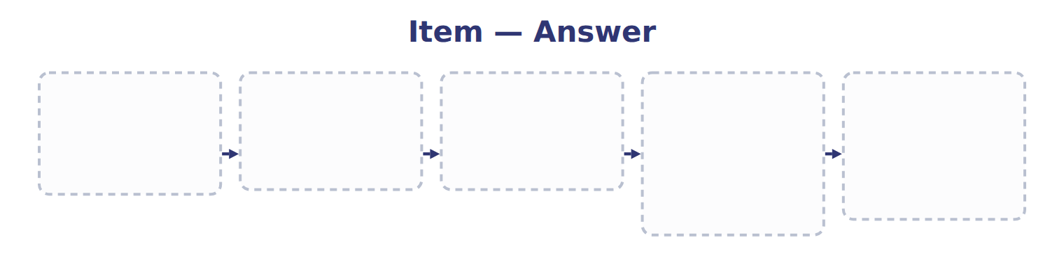
TEACH IT BACK | Write it for a classmate who missed this session — not for the marker.
29. In three or four sentences, write what this section settles and the one rule a reader has to take away.
every one of these words must appear: debt security · held-to-maturity (HTM) securities · effective-interest method · bond premium

Handout 9.2
Measuring debt securities
section 9.2 of the book
Before you start
Three summaries of this handout, in the book’s own words. Read all three first: together they are the whole session. Then fill the gaps, guessing where you have to.

What this handout settles, cycle by cycle
In this handout | What you will read | How you check it
Measuring debt securities | a figure to read · Category · the book’s own rule, gapped | Which of these did this cycle settle?
The words this section uses precisely | a figure to read · 2025, whole USD · The English the exam uses, and what it translates | What is the safest way to settle a disagreement about an answer on this sheet?

Words this handout uses precisely
Words this handout uses precisely | tick it if you could already use it in a sentence
equity security
fair value
equity method
bond discount
basis difference

1. Where the section starts — Fill every gap. The list holds more words than there are gaps, so one or two of them are not used.
choose from: bond discount · effective-interest method · equity method · investee · bond premium
A bond is bought at a when its stated interest rate is higher than the market rate, and at a when it is lower. Under the , interest revenue for each year is the carrying amount at the start of the year multiplied by the market rate at purchase.
2. What it settles in the middle — Fill every gap. The list holds more words than there are gaps, so one or two of them are not used.
choose from: equity method · accumulated · investee · reclassification adjustment
While Orontes holds an AFS bond, its unrealized gains and losses build up in OCI, part of equity. When Orontes sells the bond, the realized gain or loss moves to net income through a , sometimes called recycling.
3. Where it ends — Fill every gap. The list holds more words than there are gaps, so one or two of them are not used.
choose from: accumulated · equity method · unrealized · investee · immediately
When a security moves into trading, any gain or loss not yet in net income goes to net income . When an AFS security moves to HTM, the unrealized amount stays in OCI and is amortized over the remaining life.

CYCLE A | Measuring debt securities

ORIENT One claim. Decide now; you will check it in a moment.

4. The book gives the balance sheet amount of Equity method as “Cost + share of income − dividends”. TRUE / FALSE
MODEL Read it before you answer anything below it.

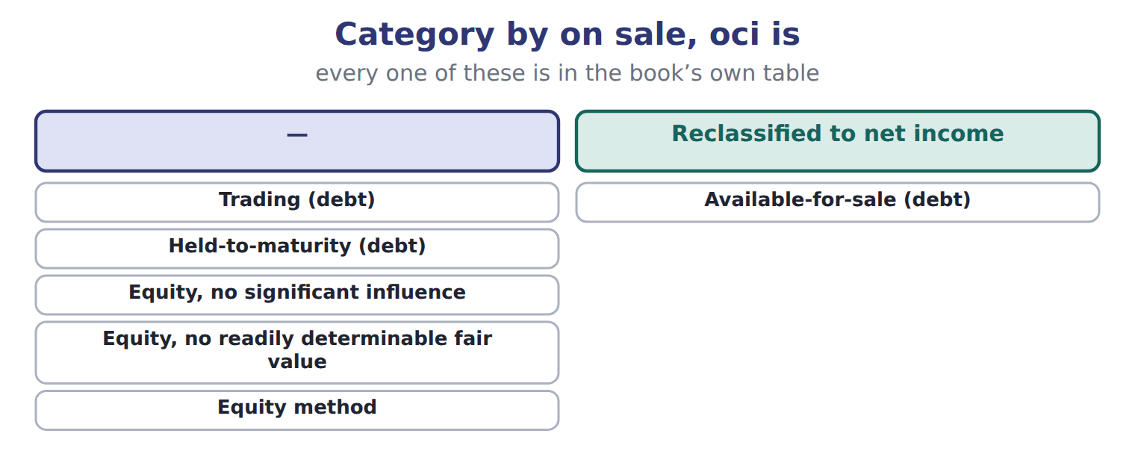

Category — the book’s own table
Category | Balance sheet amount | Unrealized gains and losses go to | On sale, OCI is
Trading (debt) | Fair value | Net income | —
Available-for-sale (debt) | Fair value | OCI (credit losses: net income) | Reclassified to net income
Held-to-maturity (debt) | Amortized cost − allowance | Not recognized | —
Equity, no significant influence | Fair value | Net income | —
Equity, no readily determinable fair value | Measurement alternative | Net income (price changes, impairment) | —
Equity method | Cost + share of income − dividends | Not recognized | —

READ THE MODEL Every answer is printed above. Find it, do not recall it.

5. Which balance sheet amount does the book give for Trading (debt)?
A. Cost + share of income − dividends
B. Fair value
C. Measurement alternative
D. Amortized cost − allowance
SORT THEM | Write each one under the heading it belongs to. Every item belongs to exactly one group.
the items: Trading (debt) · Available-for-sale (debt) · Held-to-maturity (debt) · Equity, no significant influence · Equity, no readily determinable fair value · Equity method
Reclassified to net income | —

Complete every empty cell. The first full row shows the pattern.
Category | Balance sheet amount | Unrealized gains and losses go to | On sale, OCI is
Trading (debt) | Fair value | Net income | —
Available-for-sale (debt)
Held-to-maturity (debt)
Equity, no significant influence
Equity, no readily determinable fair value
Equity method

INVENT THE RULE

13. Complete the book’s own sentence. The list holds more words than there are gaps.
use every one of these words: bond discount · bond premium · trading securities · measurement alternative
A bond is bought at a when its stated interest rate is higher than the market rate, and at a when it is lower.

Two of the book’s own cases, side by side
Trading (debt) | Available-for-sale (debt)
Balance sheet amount: Fair value | Balance sheet amount: Fair value
Unrealized gains and losses go to: Net income | Unrealized gains and losses go to: OCI (credit losses: net income)
Only the facts above differ. What is the on sale, oci is of Trading (debt)?
14. Choose one:
A. — | C. both of them
B. Reclassified to net income | D. neither of them
APPLY No help on this move.

15. A company sells a large part of its held-to-maturity portfolio because it needs cash. What is the MOST likely consequence?
A. Nothing, because the sale was for a business reason.
B. The gain on the sale goes to OCI.
C. Its remaining HTM securities are tainted and should be reclassified.
D. The securities are reclassified as trading at cost.
WORK IN PAIRS | Compare every answer on this page with your partner before you read any key.
If you disagree: go back to the model and find the row that settles it. The row decides, not the louder voice.
CHECKPOINT 16. Which of these did this cycle settle?
A. the rule and where it comes from
B. nothing in particular
C. only the vocabulary
D. only the arithmetic
If you got it wrong: redo the READ THE MODEL questions of cycle A.

CYCLE B | The words this section uses precisely

ORIENT

17. A term in the exam means exactly what the book defines it to mean, whatever it means in ordinary English. TRUE / FALSE

MODEL

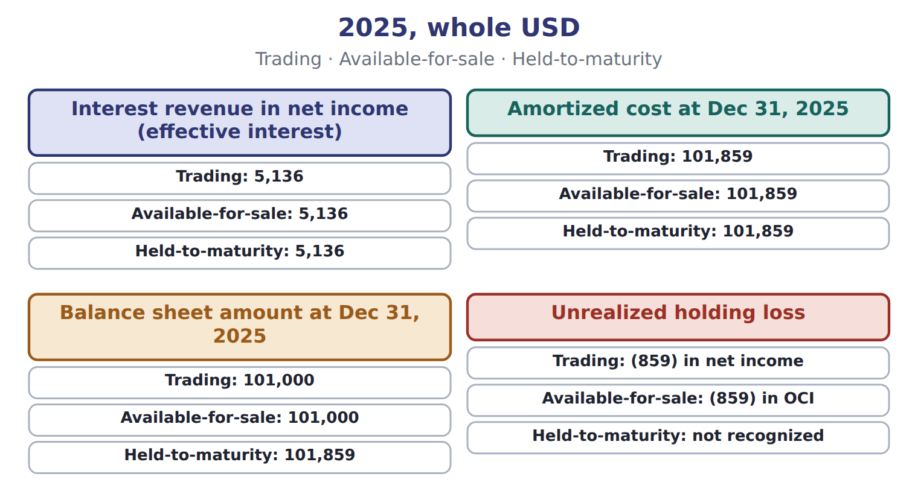
2025, whole USD — the book’s own table
2025, whole USD | Trading | Available-for-sale | Held-to-maturity
Interest revenue in net income (effective interest) | 5,136 | 5,136 | 5,136
Amortized cost at Dec 31, 2025 | 101,859 | 101,859 | 101,859
Balance sheet amount at Dec 31, 2025 | 101,000 | 101,000 | 101,859
Unrealized holding loss | (859) in net income | (859) in OCI | not recognized

The English the exam uses, and what it translates
English (exam term) | the Arabic it translates
equity security | أداة حقوق ملكية (أسهم)
fair value | القيمة العادلة
equity method | طريقة حقوق الملكية
bond discount | خصم إصدار السند
basis difference | فرق الأساس

READ THE MODEL

Write the letter of the Arabic term beside each English term. Every term is used once.
A خصم إصدار السند | D طريقة حقوق الملكية
B القيمة العادلة | E أداة حقوق ملكية (أسهم)
C فرق الأساس

18. equity security
19. equity method
20. fair value
21. basis difference
22. bond discount

APPLY

23. Which balance sheet amount does the book give for Equity method?
A. Amortized cost − allowance
B. Cost + share of income − dividends
C. Measurement alternative
D. Fair value
CHECKPOINT 24. What is the safest way to settle a disagreement about an answer on this sheet?
A. find the row of the model that decides it
B. take the answer of whoever is more confident
C. leave it until the lecturer says
D. choose the longer option
If you got it wrong: redo the READ THE MODEL questions of cycle B.

FROM MEMORY | Close the earlier pages first.
25. Rebuild the figure from this handout. Label every part and fill in every box.
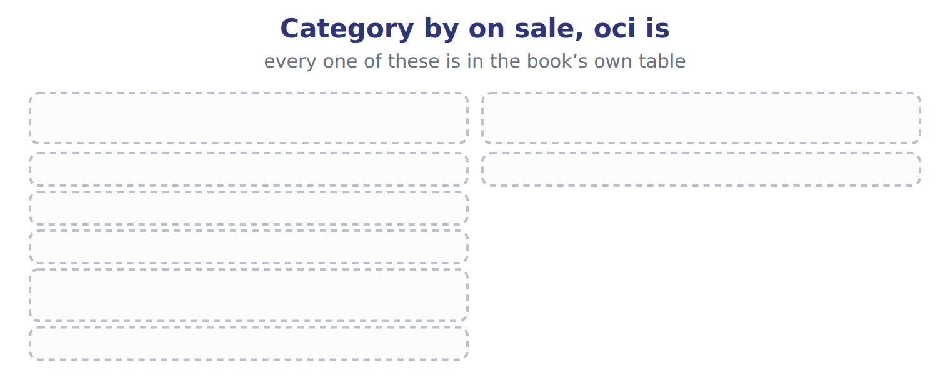
TEACH IT BACK | Write it for a classmate who missed this session — not for the marker.
26. In three or four sentences, write what this section settles and the one rule a reader has to take away.
every one of these words must appear: equity security · fair value · equity method · bond discount

Handout 9.3
Credit losses on debt securities
section 9.3 of the book
Before you start
Three summaries of this handout, in the book’s own words. Read all three first: together they are the whole session. Then fill the gaps, guessing where you have to.

What this handout settles, cycle by cycle
In this handout | What you will read | How you check it
Credit losses on debt securities | a figure to read · Investment | Which of these did this cycle settle?
The words this section uses precisely | The English the exam uses, and what it translates | What is the safest way to settle a disagreement about an answer on this sheet?

Words this handout uses precisely
Words this handout uses precisely | tick it if you could already use it in a sentence
trading securities
other comprehensive income (OCI)
fair value option
significant influence

1. Where the section starts — Fill every gap. The list holds more words than there are gaps, so one or two of them are not used.
choose from: securities · bond premium · fair value option · receivables · amortized
HTM are measured at cost, so they follow CECL, like the in Chapter 6: the company records an allowance for lifetime expected credit losses from day one. For very safe bonds, such as U.S. Treasury bonds, the expected loss can be zero.
2. What it settles in the middle — Fill every gap. The list holds more words than there are gaps, so one or two of them are not used.
choose from: amortized · fair value option · bond premium · allowance · fair value
The credit part is recorded in an through net income. The rest of the decline goes to OCI. An AFS bond has an cost of $50,000 and a of $44,000. The allowance can never be larger than amortized cost minus fair value: $6,000.
3. Where it ends — Fill every gap. The list holds more words than there are gaps, so one or two of them are not used.
choose from: fair value · allowance · amortized · fair value option · bond premium
AFS ≤ cost − . If the company intends to sell, there is no allowance: write the bond down to fair value. A. Record an allowance for the credit part only. B. Write the bond down to fair value through net income.
How every cycle on this sheet works
How a cycle works | what you do
MODEL | read the figure or the table before you answer anything
READ THE MODEL | every answer is printed on the same page
INVENT THE RULE | write the rule yourself, then compare with the book
APPLY | no help on this move
CHECKPOINT | mark it yourself; if you miss it, the sheet says what to redo

CYCLE A | Credit losses on debt securities

ORIENT One claim. Decide now; you will check it in a moment.

4. The book gives the category of E as “Equity method”. TRUE / FALSE
MODEL Read it before you answer anything below it.

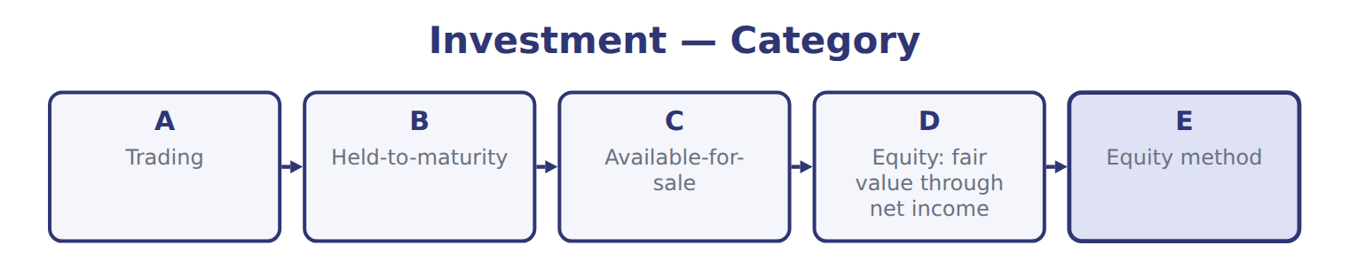
Investment — the book’s own table
Investment | Category
A | Trading
B | Held-to-maturity
C | Available-for-sale
D | Equity: fair value through net income
E | Equity method

READ THE MODEL Every answer is printed above. Find it, do not recall it.

5. Which category does the book give for A?
A. Available-for-sale | C. Trading
B. Held-to-maturity | D. Equity method
APPLY No help on this move.

6. Use the Orontes bond. What is the amortized cost at December 31, 2025 (whole USD)?
A. 100,000 | C. 101,859
B. 101,000 | D. 102,723
WORK IN PAIRS | Compare every answer on this page with your partner before you read any key.
If you disagree: go back to the model and find the row that settles it. The row decides, not the louder voice.
CHECKPOINT 7. Which of these did this cycle settle?
A. the rule and where it comes from
B. nothing in particular
C. only the vocabulary
D. only the arithmetic
If you got it wrong: redo the READ THE MODEL questions of cycle A.

CYCLE B | The words this section uses precisely

ORIENT

8. A term in the exam means exactly what the book defines it to mean, whatever it means in ordinary English. TRUE / FALSE

MODEL

The English the exam uses, and what it translates
English (exam term) | the Arabic it translates
trading securities | أوراق مالية بغرض المتاجرة
other comprehensive income (OCI) | الدخل الشامل الآخر
fair value option | خيار القيمة العادلة
significant influence | التأثير الجوهري

READ THE MODEL

Write the letter of the Arabic term beside each English term. Every term is used once.
A التأثير الجوهري | C خيار القيمة العادلة
B الدخل الشامل الآخر | D أوراق مالية بغرض المتاجرة

9. fair value option
10. trading securities
11. significant influence
12. other comprehensive income (OCI)

APPLY

Write the letter of the matching category beside each investment. Every one is used once.
A Equity method
B Available-for-sale
C Trading
D Held-to-maturity
E Equity: fair value through net income

13. A
14. B
15. C
16. D
17. E

CHECKPOINT 18. What is the safest way to settle a disagreement about an answer on this sheet?
A. find the row of the model that decides it
B. take the answer of whoever is more confident
C. leave it until the lecturer says
D. choose the longer option
If you got it wrong: redo the READ THE MODEL questions of cycle B.

FROM MEMORY | Close the earlier pages first.
19. Rebuild the figure from this handout. Label every part and fill in every box.
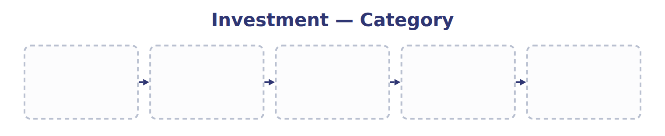
TEACH IT BACK | Write it for a classmate who missed this session — not for the marker.
20. In three or four sentences, write what this section settles and the one rule a reader has to take away.
every one of these words must appear: trading securities · other comprehensive income (OCI) · fair value option · significant influence

Handout 9.4
Equity securities and the equity method
section 9.4 of the book
Before you start
Three summaries of this handout, in the book’s own words. Read all three first: together they are the whole session. Then fill the gaps, guessing where you have to.

What this handout settles, cycle by cycle
In this handout | What you will read | How you check it
Equity securities and the equity method | a figure to read · Item · the book’s own rule, gapped | Which of these did this cycle settle?
The words this section uses precisely | a figure to read · Investment · The English the exam uses, and what it translates | What is the safest way to settle a disagreement about an answer on this sheet?

Words this handout uses precisely
Words this handout uses precisely | tick it if you could already use it in a sentence
available-for-sale (AFS) securities
reclassification adjustment
unrealized holding gain or loss
investee

1. Where the section starts — Fill every gap. The list holds more words than there are gaps, so one or two of them are not used.
choose from: measurement alternative · equity method · fair value option · investee · significant influence
With , the investor uses the . Under the equity method, the investment starts at cost. It increases by the investor's share of the 's net income and decreases by the dividends the investor receives.
2. What it settles in the middle — Fill every gap. The list holds more words than there are gaps, so one or two of them are not used.
choose from: dividends · supplier · measurement alternative · investment · fair value option
The are not income, because they only return part of the . Orontes and Jordan Glass Co. On January 1, 2025, Orontes buys 30% of Jordan Glass Co., its bottle , for $1,200,000.
3. Where it ends — Fill every gap. The list holds more words than there are gaps, so one or two of them are not used.
choose from: equity security · measurement alternative · equity method · significant influence · fair value option
Profits on sales between the two companies are eliminated until the goods are sold to outsiders. And when an investor first gains , it starts the from that date; it does not restate prior years. An investor may also elect the for an equity-method investment.

CYCLE A | Equity securities and the equity method

ORIENT One claim. Decide now; you will check it in a moment.

4. The book gives the investment of E as “Shares of Amman Cold Storage Co. (25%)”. TRUE / FALSE
MODEL Read it before you answer anything below it.

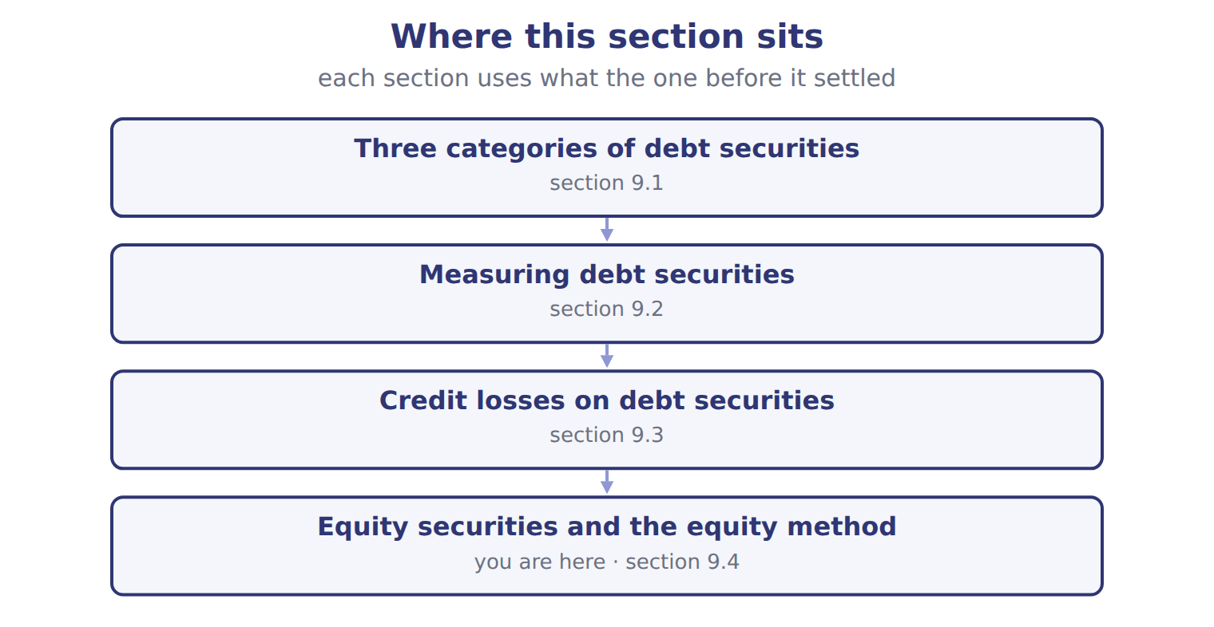
Item — the book’s own table
Item | Investment | Facts | Amounts, Dec 31, 2025
A | Corporate bond | Bought to sell in the near term; the treasury team trades it actively. | cost 40,000; fair value 42,000
B | Government bond | Orontes intends and is able to hold it until it matures in 2029. | cost 60,000; fair value 57,000
C | Corporate bond | No plan to trade it or to hold it to maturity; no credit loss expected. | cost 30,000; fair value 28,500
D | Listed shares (5% of the company) | No significant influence. Dividend received during 2025: 800. | cost 25,000; fair value 27,000
E | Shares of Amman Cold Storage Co. (25%) | Orontes has a seat on the board. Carrying amount on Jan 1, 2025: 500,000. Investee net income: 120,000; dividends paid: 40,000.

READ THE MODEL Every answer is printed above. Find it, do not recall it.

5. Which investment does the book give for A?
A. Shares of Amman Cold Storage Co. (25%)
B. Listed shares (5% of the company)
C. Government bond
D. Corporate bond

INVENT THE RULE

6. Complete the book’s own sentence. The list holds more words than there are gaps.
use every one of these words: significant influence · investee · equity method · measurement alternative
And when an investor first gains , it starts the from that date; it does not restate prior years.

Two of the book’s own cases, side by side
A | B
Investment: Corporate bond | Investment: Government bond
Facts: Bought to sell in the near term; the treasury team trades it actively. | Facts: Orontes intends and is able to hold it until it matures in 2029.
Only the facts above differ. What is the amounts, dec 31, 2025 of A?
7. Choose one:
A. cost 25,000; fair value 27,000 | C. cost 40,000; fair value 42,000
B. cost 60,000; fair value 57,000 | D. cost 30,000; fair value 28,500
APPLY No help on this move.

8. Orontes classifies the bond as trading. What amount is reported in 2025 net income for the change in fair value (whole USD)?
A. A loss of 2,723 | C. No amount; it goes to OCI
B. A loss of 859 | D. A gain of 859
WORK IN PAIRS | Compare every answer on this page with your partner before you read any key.
If you disagree: go back to the model and find the row that settles it. The row decides, not the louder voice.
CHECKPOINT 9. Which of these did this cycle settle?
A. the rule and where it comes from
B. nothing in particular
C. only the vocabulary
D. only the arithmetic
If you got it wrong: redo the READ THE MODEL questions of cycle A.

CYCLE B | The words this section uses precisely

ORIENT

10. A term in the exam means exactly what the book defines it to mean, whatever it means in ordinary English. TRUE / FALSE
MODEL

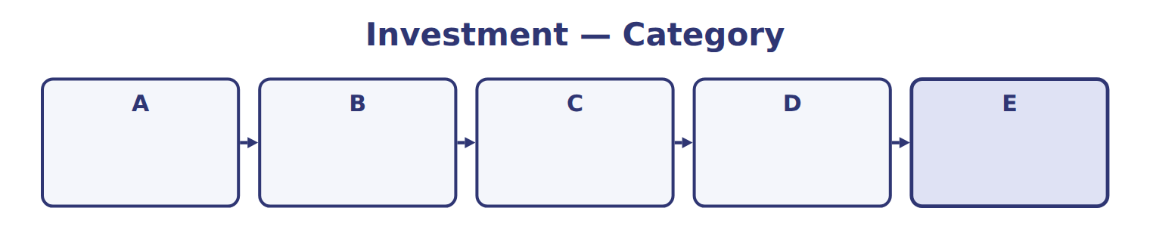

Investment — the book’s own table
Investment | Category
A
B
C
D
E

The English the exam uses, and what it translates
English (exam term) | the Arabic it translates
available-for-sale (AFS) securities | أوراق مالية متاحة للبيع
reclassification adjustment | تعديل إعادة التصنيف
unrealized holding gain or loss | مكسب أو خسارة حيازة غير محققة
investee | المنشأة المستثمر فيها

READ THE MODEL

Write the letter of the Arabic term beside each English term. Every term is used once.
A أوراق مالية متاحة للبيع | C مكسب أو خسارة حيازة غير محققة
B تعديل إعادة التصنيف | D المنشأة المستثمر فيها

11. investee
12. reclassification adjustment
13. available-for-sale (AFS) securities
14. unrealized holding gain or loss

APPLY

15. Which English term does the exam use for “أوراق مالية متاحة للبيع”?
A. investee
B. unrealized holding gain or loss
C. reclassification adjustment
D. available-for-sale (AFS) securities
CHECKPOINT 16. What is the safest way to settle a disagreement about an answer on this sheet?
A. find the row of the model that decides it
B. take the answer of whoever is more confident
C. leave it until the lecturer says
D. choose the longer option
If you got it wrong: redo the READ THE MODEL questions of cycle B.

FROM MEMORY | Close the earlier pages first.
17. Rebuild the figure from this handout. Label every part and fill in every box.
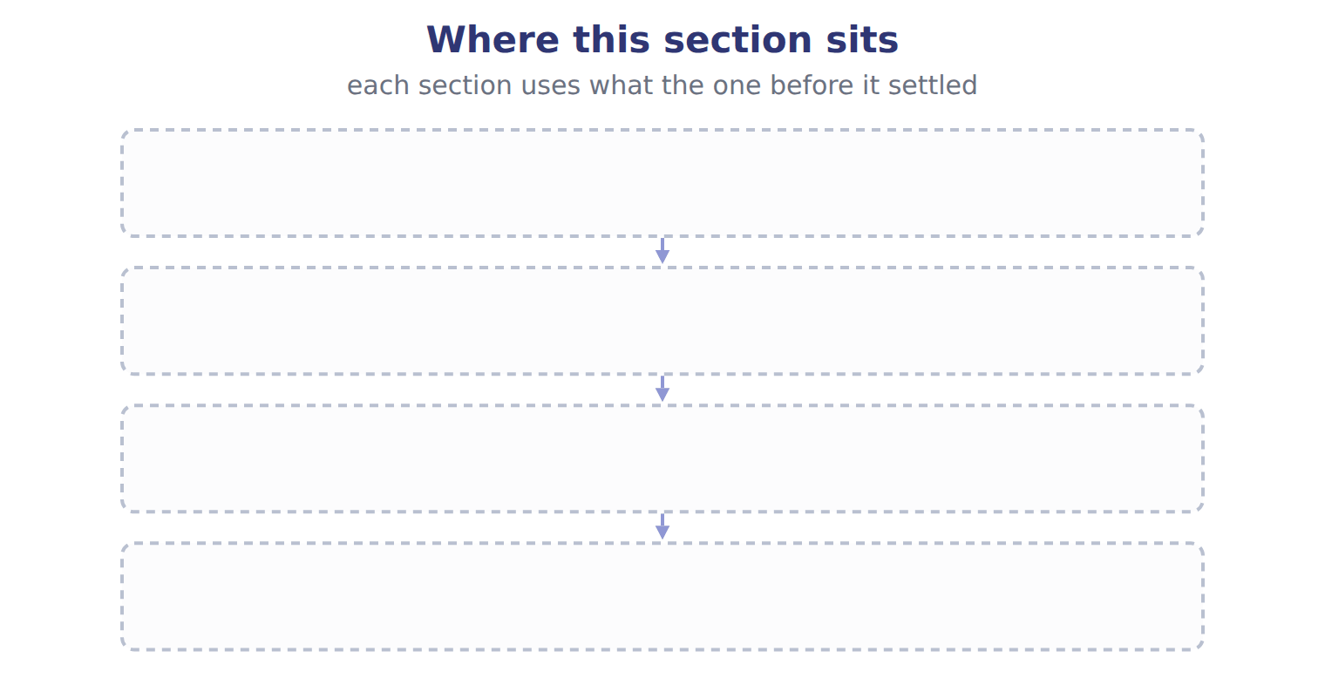
TEACH IT BACK | Write it for a classmate who missed this session — not for the marker.
18. In three or four sentences, write what this section settles and the one rule a reader has to take away.
every one of these words must appear: available-for-sale (AFS) securities · reclassification adjustment · unrealized holding gain or loss · investee

Handout 9.5
The whole chapter
every section, shuffled, and the chapter’s own case set
Before you start
Three summaries of this chapter, in the book’s own words, with words taken out. Read all three first: together they are the whole chapter. Then fill the gaps.

What this handout settles, cycle by cycle
In this handout | What you will read | How you check it
The whole chapter, in order | a figure to read | Orontes sells its AFS bond at the end of 2026. Which amount goes to net income as a realized gain (whole USD)?
The chapter’s case set | The chapter’s case set, item by item | What has to be settled before any figure in a case set is worked out?
The words it uses precisely | debt security · equity security · trading securities · available-for-sale (AFS) securities · held-to-maturity (HTM) securities · fair value | matching, at the end of cycle B

1. Where the chapter starts — Fill every gap. The list holds more words than there are gaps, so one or two of them are not used.
choose from: investee · effective-interest method · bond premium · bond discount · trading securities
A bond is bought at a when its stated interest rate is higher than the market rate, and at a when it is lower. Under the , interest revenue for each year is the carrying amount at the start of the year multiplied by the market rate at purchase.
2. What it settles in the middle — Fill every gap. The list holds more words than there are gaps, so one or two of them are not used.
choose from: amortized · fair value · investee · trading securities · allowance
The credit part is recorded in an through net income. The rest of the decline goes to OCI. An AFS bond has an cost of $50,000 and a of $44,000. The allowance can never be larger than amortized cost minus fair value: $6,000.
3. Where it ends — Fill every gap. The list holds more words than there are gaps, so one or two of them are not used.
choose from: fair value option · equity method · investee · effective-interest method · trading securities · significant influence
Losses reduce the investment only to zero, unless the investor has guaranteed the 's debts. Profits on sales between the two companies are eliminated until the goods are sold to outsiders. And when an investor first gains , it starts the from that date; it does not restate prior years. An investor may also elect the for an equity-method investment.

CYCLE A | The whole chapter, in order

ORIENT

4. The sections of a chapter have to be taken in order, because each one uses what the one before it settled. TRUE / FALSE
MODEL

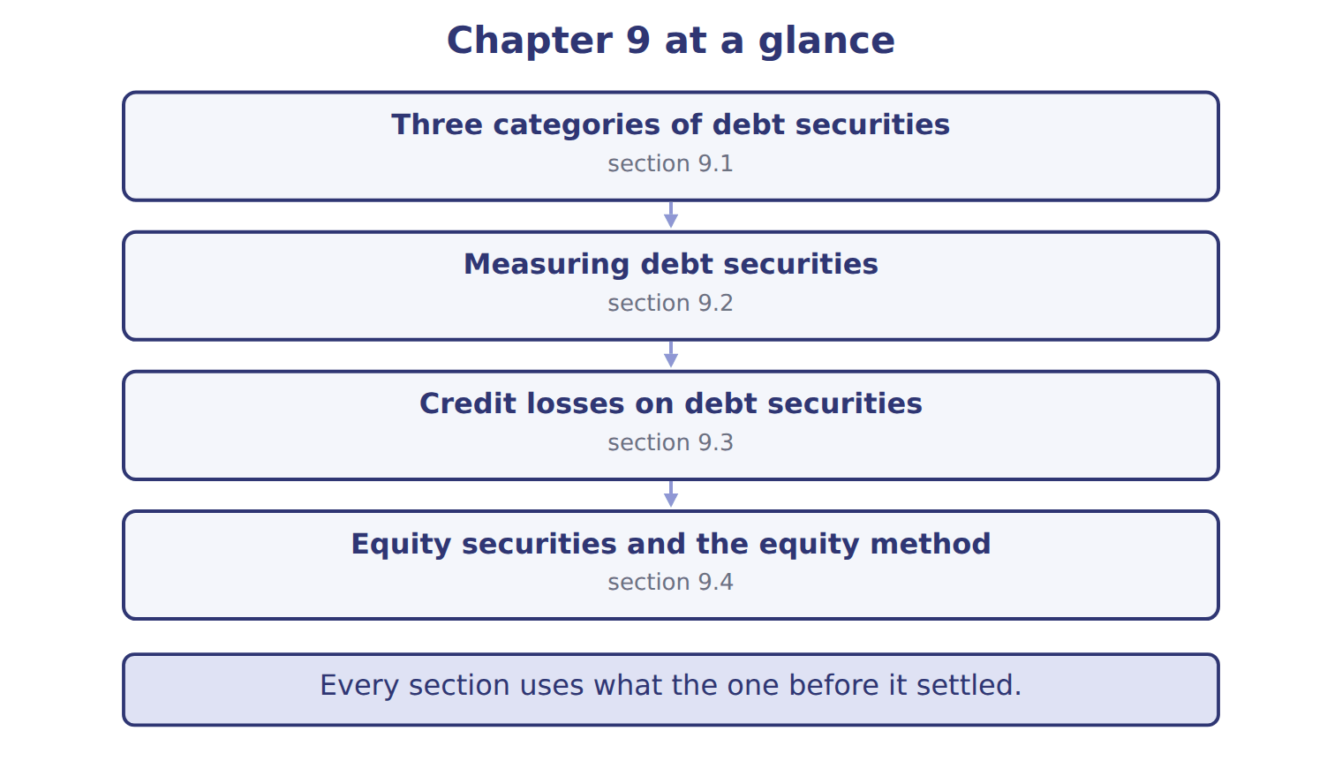

READ THE MODEL

5. Which part of this chapter is section 9.1?
A. Equity securities and the equity method
B. Measuring debt securities
C. Credit losses on debt securities
D. Three categories of debt securities
Write the letter of the section number beside each section title. Every number is used once.
A 9.1 | C 9.3
B 9.2 | D 9.4

6. Three categories of debt securities
7. Measuring debt securities
8. Credit losses on debt securities
9. Equity securities and the equity method

APPLY

10. Use the Jordan Glass example. What is the investment balance at December 31, 2025 (whole USD)?
A. 1,287,000 | C. 1,347,000
B. 1,290,000 | D. 1,637,000
11. Under the equity method, the part of the basis difference assigned to goodwill is:
A. amortized over ten years.
B. expensed immediately.
C. added to the investor's own goodwill account.
D. not amortized.
12. An investor first gains significant influence by buying more shares. How does it apply the equity method?
A. Retroactively, restating all prior years
B. Only from the next fiscal year
C. It keeps fair value through net income
D. From the date it gains influence, with no restatement of prior years
13. Orontes buys a bond and plans to sell it if interest rates fall or if it needs cash. How should it classify the bond?
A. Held-to-maturity | C. Available-for-sale
B. Trading | D. Equity method
14. Which securities can be classified as held-to-maturity?
A. Debt securities only
B. Equity securities only
C. Both debt and equity securities
D. Any security with a fixed maturity date or a dividend

15. Use the Orontes bond. What is interest revenue for 2025 (whole USD)?
A. 864 | C. 5,136
B. 5,000 | D. 6,000
WORK IN PAIRS | Compare every answer with your partner first.
If you disagree: name the section each question belongs to. Most disagreements turn out to be about the section, not the answer.
CHECKPOINT 16. Orontes sells its AFS bond at the end of 2026. Which amount goes to net income as a realized gain (whole USD)?
A. 0
B. 548
C. 859
D. 1,407
If you got it wrong: go back to the MODEL move of cycle A and find the section this question belongs to.

CYCLE B | The chapter’s case set

ORIENT

17. In a case question, the exhibit has to be read and adjusted before any figure is worked out. TRUE / FALSE

MODEL

The chapter’s case set, item by item
Item | What it asks
C9-1 | Match each investment to its category. (On the exam screen you would drag each one into a box.)
C9-2 | Enter the total unrealized holding gain (or loss) reported in 2025 NET INCOME for investments A to D.
C9-3 | Enter the amount reported in 2025 OTHER COMPREHENSIVE INCOME (show a loss in parentheses).
C9-4 | Enter the carrying amount of investment E at December 31, 2025.
C9-5 | Enter the equity-method income from investment E for 2025.
C9-6 | In 2026 Orontes sells bond C at its December 31, 2025 fair value. The loss in accumulated OCI: [select]

READ THE MODEL

The tasks of a case set have to be worked in one order, because each one uses the result of the one before it. Write the letter of its place beside each task.
A first | D fourth
B second | E fifth
C third | F sixth

18. Enter the equity-method income from investment E for 2025.
19. In 2026 Orontes sells bond C at its December 31, 2025 fair value. The loss in accumulated OCI: [select]
20. Enter the total unrealized holding gain (or loss) reported in 2025 NET INCOME for investments A to D.
21. Enter the carrying amount of investment E at December 31, 2025.
22. Match each investment to its category. (On the exam screen you would drag each one into a box.)
23. Enter the amount reported in 2025 OTHER COMPREHENSIVE INCOME (show a loss in parentheses).

APPLY

24. At year-end, the fair value of an available-for-sale bond is below its amortized cost. There is no credit loss. Where is the decline reported?
A. In net income
B. Nowhere; AFS stays at amortized cost
C. Directly in retained earnings
D. In other comprehensive income
25. Use Case B of the fair-value floor example. What allowance for credit losses is recorded (whole USD)?
A. 0 | C. 6,000
B. 3,000 | D. 8,000
26. An AFS bond is below amortized cost, and the company intends to sell it before it recovers. What is the treatment?
A. Record an allowance for the credit part only.
B. Write the bond down to fair value through net income.
C. Record the whole decline in OCI.
D. Do nothing until the sale.

27. Orontes holds 3% of a listed company's shares. How are changes in their fair value reported?
A. In net income
B. In other comprehensive income
C. Not at all; the shares stay at cost
D. Under the equity method
CHECKPOINT 28. What has to be settled before any figure in a case set is worked out?
A. the exhibit, adjusted for every note that goes with it
B. the method the company uses
C. the tax rate
D. the order of the items
If you got it wrong: reread the case panel in the MODEL move of cycle B.

FROM MEMORY | Close the earlier pages first.
29. Rebuild the chapter map. Write every section in order and what each one settles.
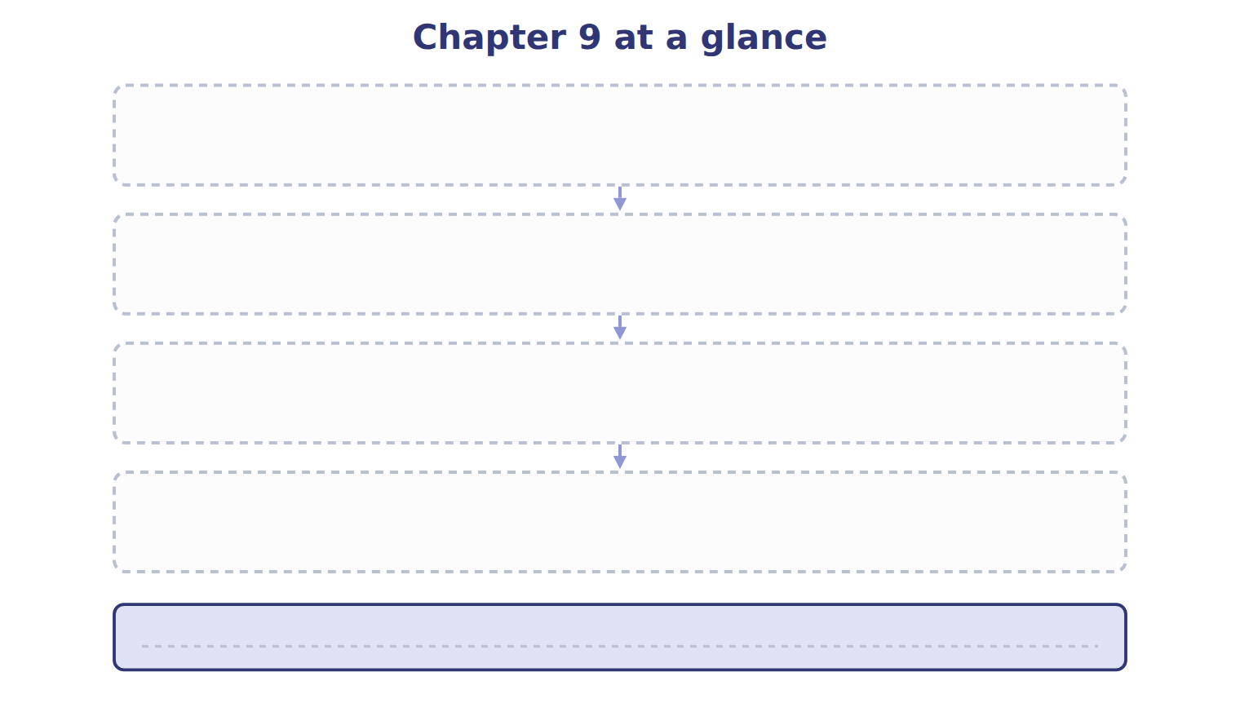
TEACH IT BACK | Write it for a student starting this chapter tomorrow — not for the marker.
30. In four or five sentences, write what the whole chapter settles, section by section.
every one of these words must appear: debt security · equity security · trading securities · available-for-sale (AFS) securities

