Handout 12.1
What makes a liability current
section 12.1 of the book
Before you start
Three summaries of this handout, in the book’s own words. Read all three first: together they are the whole session. Then fill the gaps, guessing where you have to.

What this handout settles, cycle by cycle
In this handout | What you will read | How you check it
What makes a liability current | a figure to read · Orontes, December 31, 2025 (Chapter 2) · Suppose: Barada, one month in 2027 | Which of these did this cycle settle?
The words this section uses precisely | a figure to read · Item · The English the exam uses, and what it translates | What is the safest way to settle a disagreement about an answer on this sheet?

Words this handout uses precisely
Words this handout uses precisely | tick it if you could already use it in a sentence
current liabilities
warranty liability
commercial paper

1. Where the section starts — Fill every gap. The list holds more words than there are gaps, so one or two of them are not used.
choose from: short-term obligation · compensated absences · liabilities · discounted · Customer
Because the time is short, they are not to present value. deposits are contract , as Chapter 11 showed: they become revenue when Orontes delivers.
2. What it settles in the middle — Fill every gap. The list holds more words than there are gaps, so one or two of them are not used.
choose from: distributable · declaration · short-term obligation · liabilities · compensated absences
Customer deposits are contract , as Chapter 11 showed: they become revenue when Orontes delivers. Cash dividends become a liability on the date. A stock dividend is not a liability, because no assets will be paid.
3. Where it ends — Fill every gap from the list. The list holds more words than there are gaps.
choose from: Principal due within one year · Customer payments received before delivery · Cash dividends declared, not yet paid · Amounts owed to suppliers for goods and services · Current tax not yet paid
The book’s own table “Orontes, December 31, 2025 (Chapter 2)” settles these: for Accounts payable it is , for Income taxes payable it is , for Contract liabilities it is and for Dividends payable it is .
How every cycle on this sheet works
How a cycle works | what you do
MODEL | read the figure or the table before you answer anything
READ THE MODEL | every answer is printed on the same page
INVENT THE RULE | write the rule yourself, then compare with the book
APPLY | no help on this move
CHECKPOINT | mark it yourself; if you miss it, the sheet says what to redo

CYCLE A | What makes a liability current

ORIENT One claim. Decide now; you will check it in a moment.

4. Every number in a financial statement belongs to an element the framework defines. TRUE / FALSE
MODEL Read it before you answer anything below it.

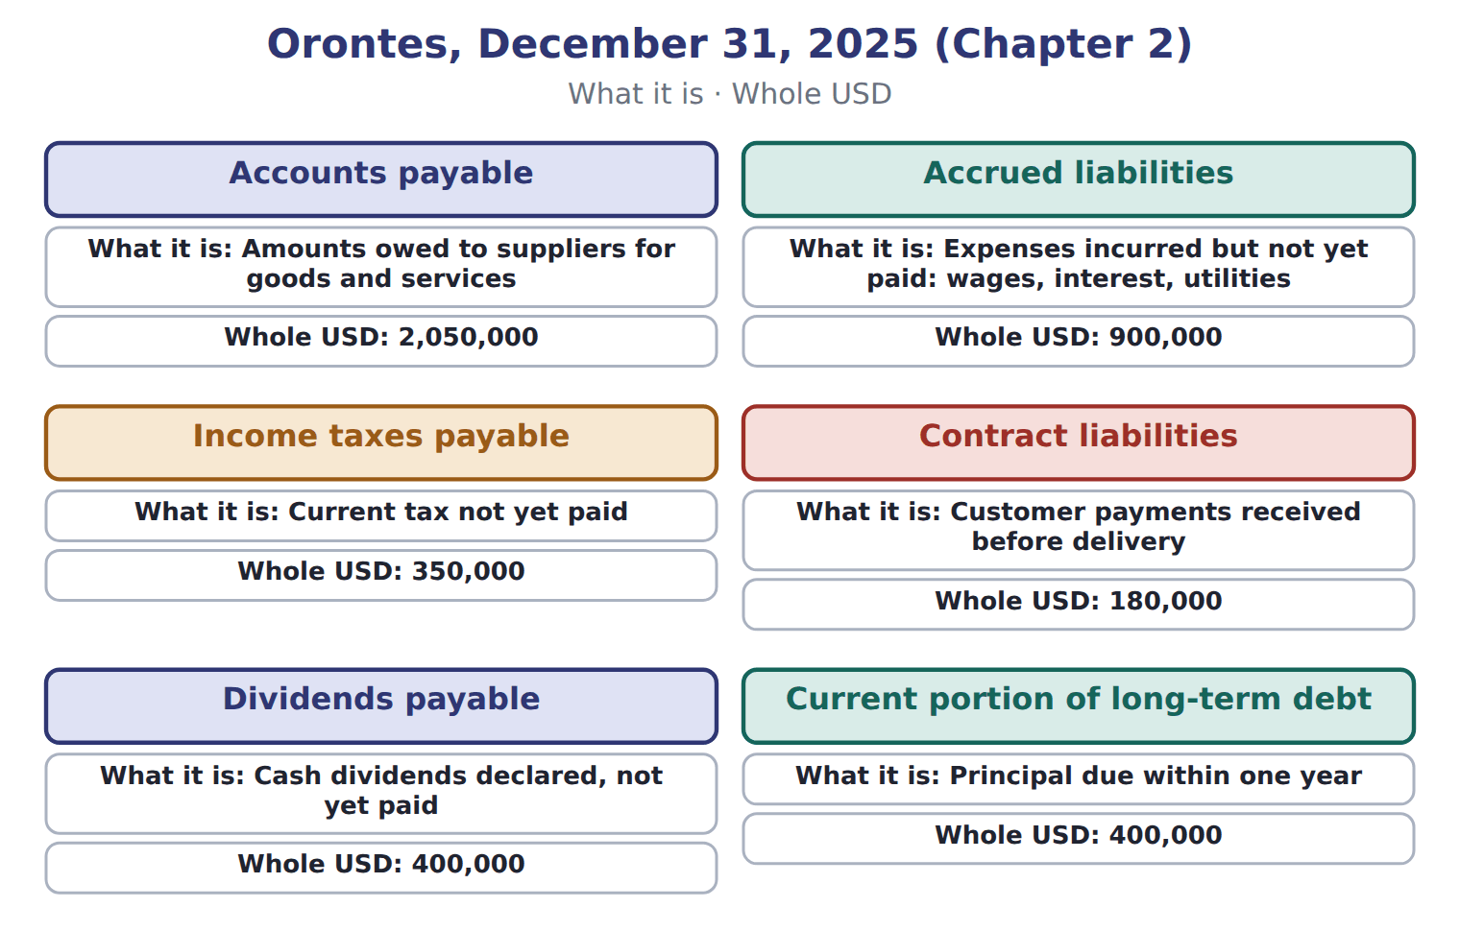
Orontes, December 31, 2025 (Chapter 2) — the book’s own table
Orontes, December 31, 2025 (Chapter 2) | What it is | Whole USD
Accounts payable | Amounts owed to suppliers for goods and services | 2,050,000
Accrued liabilities | Expenses incurred but not yet paid: wages, interest, utilities | 900,000
Income taxes payable | Current tax not yet paid | 350,000
Contract liabilities | Customer payments received before delivery | 180,000
Dividends payable | Cash dividends declared, not yet paid | 400,000
Current portion of long-term debt | Principal due within one year | 400,000
Total current liabilities |  | 4,280,000

READ THE MODEL Every answer is printed above. Find it, do not recall it.

5. Which part of this chapter is section 12.1?
A. What makes a liability current
B. IFRS and covenants
C. Payroll, taxes collected and compensated absences
D. Short-term debt expected to be refinanced

APPLY No help on this move.

6. Which item is NOT a current liability?
A. A cash dividend payable
B. A stock dividend distributable
C. Sales tax payable
D. Customer deposits for next month's orders
7. A shop's cash register shows total receipts of $10,500, including 5% sales tax. What are sales revenue and sales tax payable?
A. $10,500 and $525 | C. $10,000 and $500
B. $9,975 and $525 | D. $10,500 and $0
8. Income tax withheld from employees' wages is recorded by the employer as:
A. an expense of the employer
B. a current liability until paid to the government
C. a reduction of the employer's income tax expense
D. revenue
Suppose: Barada, one month in 2027 — the extract for the question that follows
Suppose: Barada, one month in 2027 | Whole USD
Gross wages for the month | 40,000
Income tax withheld from employees | 4,000
Employees' social security withheld (7%) | 2,800
Net pay to employees | 33,200
Employer's social security (payroll tax expense, 7%) | ________
Total owed to the tax authorities | ________
Cash register total, including 5% sales tax: 21,000. Sales revenue | ________
Sales tax payable | ________

9. The extract for this question is printed with it. What is Barada's total payroll cost for the month (whole USD)?
A. 9,600 | C. 40,000
B. 33,200 | D. 42,800
WORK IN PAIRS | Compare every answer on this page with your partner before you read any key.
If you disagree: go back to the model and find the row that settles it. The row decides, not the louder voice.
CHECKPOINT 10. Which of these did this cycle settle?
A. the rule and where it comes from
B. nothing in particular
C. only the vocabulary
D. only the arithmetic
If you got it wrong: redo the READ THE MODEL questions of cycle A with the model in front of you.

CYCLE B | The words this section uses precisely

ORIENT

11. A term in the exam means exactly what the book defines it to mean, whatever it means in ordinary English. TRUE / FALSE

MODEL

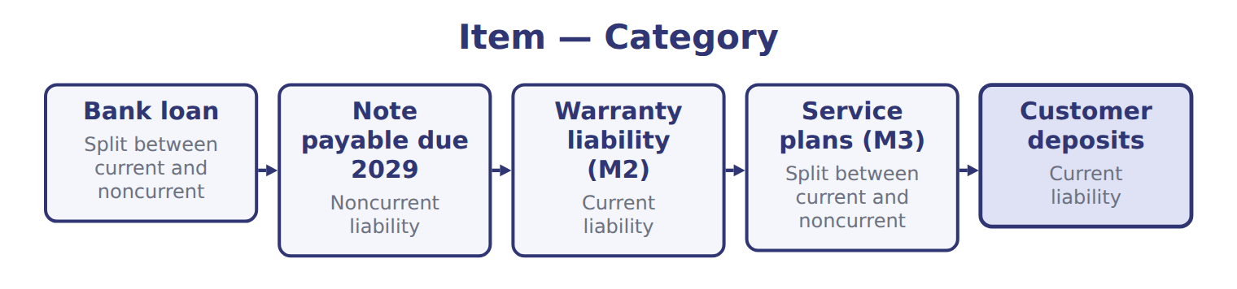
Item — the book’s own table
Item | Category
Bank loan | Split between current and noncurrent
Note payable due 2029 | Noncurrent liability
Warranty liability (M2) | Current liability
Service plans (M3) | Split between current and noncurrent
Customer deposits | Current liability

The English the exam uses, and what it translates
English (exam term) | the Arabic it translates
current liabilities | الالتزامات المتداولة
warranty liability | التزام الضمان
commercial paper | الأوراق التجارية

READ THE MODEL

APPLY

12. Which liability can never be reclassified as noncurrent under the refinancing rule?
A. A short-term bank loan
B. Commercial paper
C. Trade accounts payable
D. A current maturity of long-term debt
13. Which factor suggests that a warranty that cannot be bought separately is service-type?
A. The law requires it
B. It covers the product for much longer than defects normally appear
C. It only repairs defects present at delivery
D. It lasts 90 days
14. In which year is the expense for an assurance-type warranty recognized?
A. The year of the sale
B. The year repairs are paid
C. The year the warranty ends
D. Spread evenly over the warranty period

Suppose: Orontes, commercial paper of 3,000,000 — the extract for the question that follows
Suppose: Orontes, commercial paper of 3,000,000 | Noncurrent (U.S. GAAP) | Current (U.S. GAAP)
A. Issues 5-year bonds on February 10 and uses the cash to repay the paper at maturity | 3,000,000 | 0
B. Repays the paper with cash on January 15, then issues bonds on February 10 | 0 | 3,000,000
C. Issues shares on February 10 for 2,400,000 to repay the paper | 2,400,000 | 600,000
D. Signs a qualifying agreement on February 1 to borrow 80% of inventory; inventory will not fall below 3,125,000 | 2,500,000 | 500,000
E. Same as D, but the lender may cancel if it sees a 'material adverse change' | 0 | 3,000,000

15. Use the extract, scenario D. How much of the commercial paper is noncurrent (whole USD)?
A. 2,500,000 | C. 3,000,000
B. 3,125,000
16. The extract for this question is printed with it. What is Barada's total payroll cost for the month (whole USD)?
A. 9,600 | C. 40,000
B. 33,200 | D. 42,800
CHECKPOINT 17. What is the safest way to settle a disagreement about an answer on this sheet?
A. find the row of the model that decides it
B. take the answer of whoever is more confident
C. leave it until the lecturer says
D. choose the longer option
If you got it wrong: redo the READ THE MODEL questions of cycle B.

FROM MEMORY | Close the earlier pages first.
18. Rebuild the figure from this handout. Label every part and fill in every box.
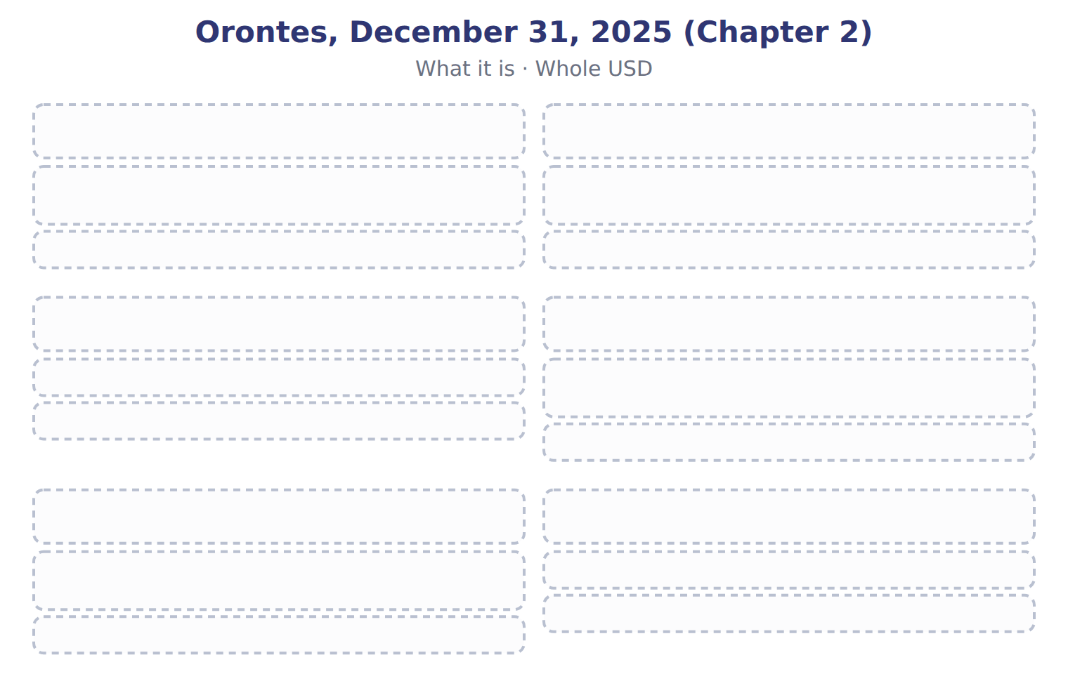
TEACH IT BACK | Write it for a classmate who missed this session — not for the marker.
19. In three or four sentences, write what this section settles and the one rule a reader has to take away.
every one of these words must appear: current liabilities · warranty liability · commercial paper

Handout 12.2
Payroll, taxes collected and compensated absences
section 12.2 of the book
Before you start
Three summaries of this handout, in the book’s own words. Read all three first: together they are the whole session. Then fill the gaps, guessing where you have to.

What this handout settles, cycle by cycle
In this handout | What you will read | How you check it
Payroll, taxes collected and compensated absences | a figure to read · Suppose: Barada, one month in 2027 · Suppose: Orontes, commercial paper of 3,000,000 | The extract for this question is printed with it. Which of Orontes's current liabilities comes from a financing activity?
The words this section uses precisely | a figure to read · Item · The English the exam uses, and what it translates | What is the safest way to settle a disagreement about an answer on this sheet?

Words this handout uses precisely
Words this handout uses precisely | tick it if you could already use it in a sentence
short-term obligation
withholding

1. Where the section starts — Fill every gap. The list holds more words than there are gaps, so one or two of them are not used.
choose from: liabilities · short-term obligation · service-type warranty · withholding
Payroll creates several . The employer deducts , such as income tax and the employees' share of social security, from gross wages.
2. What it settles in the middle — Fill every gap. The list holds more words than there are gaps, so one or two of them are not used.
choose from: service-type warranty · short-term obligation · payroll taxes · withholding
The employer deducts , such as income tax and the employees' share of social security, from gross wages. These amounts belong to the government, so they are liabilities, not expenses. The employer's own , such as its share of social security, are an additional expense.
3. Where it ends — Fill every gap. The list holds more words than there are gaps, so one or two of them are not used.
choose from: government · short-term obligation · collected · customers · service-type warranty
Barada's total payroll cost is the gross wages plus its own social security. Sales tax and VAT from are also owed to the .
How every cycle on this sheet works
How a cycle works | what you do
MODEL | read the figure or the table before you answer anything
READ THE MODEL | every answer is printed on the same page
INVENT THE RULE | write the rule yourself, then compare with the book
APPLY | no help on this move
CHECKPOINT | mark it yourself; if you miss it, the sheet says what to redo

CYCLE A | Payroll, taxes collected and compensated absences

ORIENT One claim. Decide now; you will check it in a moment.

4. Every number in a financial statement belongs to an element the framework defines. TRUE / FALSE
MODEL Read it before you answer anything below it.

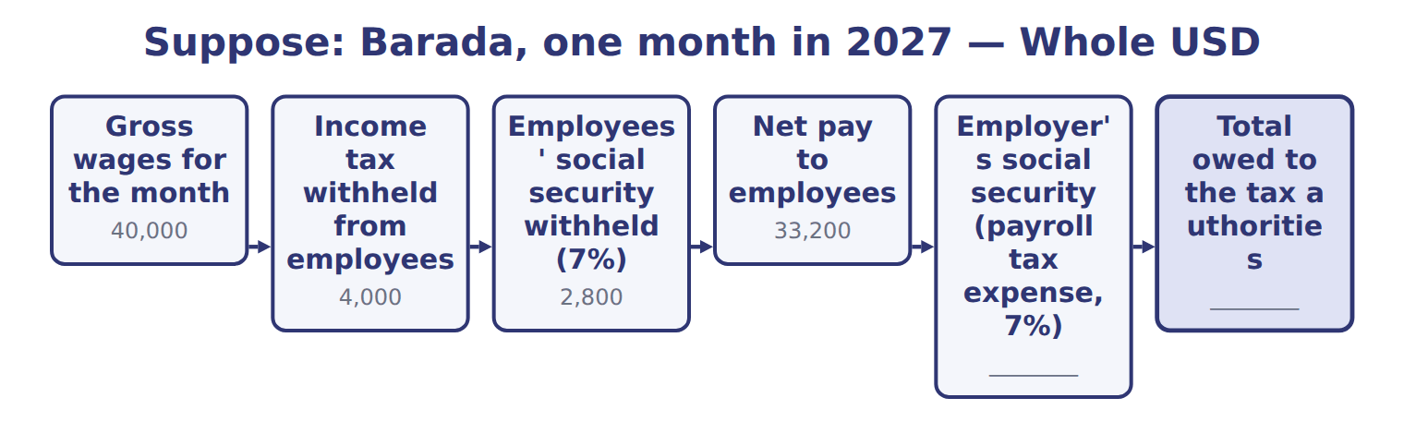
Suppose: Barada, one month in 2027 — the book’s own table
Suppose: Barada, one month in 2027 | Whole USD
Gross wages for the month | 40,000
Income tax withheld from employees | 4,000
Employees' social security withheld (7%) | 2,800
Net pay to employees | 33,200
Employer's social security (payroll tax expense, 7%) | ________
Total owed to the tax authorities | ________
Cash register total, including 5% sales tax: 21,000. Sales revenue | ________
Sales tax payable | ________

READ THE MODEL Every answer is printed above. Find it, do not recall it.

5. Which part of this chapter is section 12.1?
A. What makes a liability current
B. IFRS and covenants
C. Payroll, taxes collected and compensated absences
D. Short-term debt expected to be refinanced

APPLY No help on this move.

6. Use Section 12.2. What is Barada's employer payroll tax expense for the month (whole USD)?
A. 0 | C. 4,000
B. 2,800 | D. 9,600
7. A company pays a sick day only if the employee is actually sick; unused days are lost. At year-end, the company:
A. need not accrue the unused sick days
B. must accrue all unused sick days
C. discloses a contingent liability
D. records a reserve in equity
8. Which factor suggests that a warranty that cannot be bought separately is service-type?
A. The law requires it
B. It covers the product for much longer than defects normally appear
C. It only repairs defects present at delivery
D. It lasts 90 days
9. In which year is the expense for an assurance-type warranty recognized?
A. The year of the sale
B. The year repairs are paid
C. The year the warranty ends
D. Spread evenly over the warranty period
10. Under IAS 37, when does an IFRS company recognize a warranty provision?
A. Only when the outflow is virtually certain
B. When an outflow is more likely than not and can be estimated reliably
C. Only when repairs are made
D. Never; warranties are disclosed only
Suppose: Orontes, commercial paper of 3,000,000 — the extract for the question that follows
Suppose: Orontes, commercial paper of 3,000,000 | Noncurrent (U.S. GAAP) | Current (U.S. GAAP)
A. Issues 5-year bonds on February 10 and uses the cash to repay the paper at maturity | 3,000,000 | 0
B. Repays the paper with cash on January 15, then issues bonds on February 10 | 0 | 3,000,000
C. Issues shares on February 10 for 2,400,000 to repay the paper | 2,400,000 | 600,000
D. Signs a qualifying agreement on February 1 to borrow 80% of inventory; inventory will not fall below 3,125,000 | 2,500,000 | 500,000
E. Same as D, but the lender may cancel if it sees a 'material adverse change' | 0 | 3,000,000

11. Use the extract, scenario B. Why is the whole commercial paper current?
A. Bonds cannot be used to refinance commercial paper
B. The bonds were issued after the balance sheet date
C. It was repaid with current assets before the long-term financing was obtained
D. The paper was due within one year
WORK IN PAIRS | Compare every answer on this page with your partner before you read any key.
If you disagree: go back to the model and find the row that settles it. The row decides, not the louder voice.

Orontes, December 31, 2025 (Chapter 2) — the extract for the question that follows
Orontes, December 31, 2025 (Chapter 2) | What it is | Whole USD
Accounts payable | Amounts owed to suppliers for goods and services | 2,050,000
Accrued liabilities | Expenses incurred but not yet paid: wages, interest, utilities | 900,000
Income taxes payable | Current tax not yet paid | 350,000
Contract liabilities | Customer payments received before delivery | 180,000
Dividends payable | Cash dividends declared, not yet paid | 400,000
Current portion of long-term debt | Principal due within one year | 400,000
Total current liabilities |  | 4,280,000

CHECKPOINT 12. The extract for this question is printed with it. Which of Orontes's current liabilities comes from a financing activity?
A. Accounts payable
B. Current portion of long-term debt
C. Contract liabilities
D. Accrued liabilities
If you got it wrong: redo the READ THE MODEL questions of cycle A with the model in front of you.

CYCLE B | The words this section uses precisely

ORIENT

13. A term in the exam means exactly what the book defines it to mean, whatever it means in ordinary English. TRUE / FALSE
MODEL

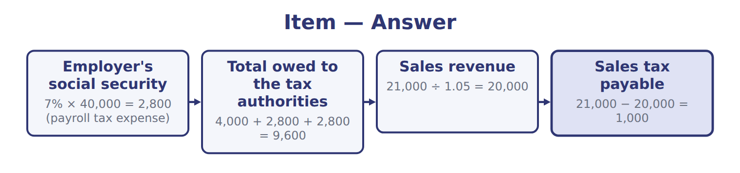
Item — the book’s own table
Item | Answer
Employer's social security | 7% × 40,000 = 2,800 (payroll tax expense)
Total owed to the tax authorities | 4,000 + 2,800 + 2,800 = 9,600
Sales revenue | 21,000 ÷ 1.05 = 20,000
Sales tax payable | 21,000 − 20,000 = 1,000

The English the exam uses, and what it translates
English (exam term) | the Arabic it translates
short-term obligation | التزام قصير الأجل
withholding | الاستقطاع

READ THE MODEL

14. A glossary term and its translation are a pair the book itself gives. TRUE / FALSE
APPLY

15. Why are accounts payable due in 30 days not discounted to present value?
A. The time to payment is short, so the difference is not significant
B. Liabilities are never discounted
C. They are measured at fair value
D. They are shown net of cash
16. A one-year warranty that a product will work as agreed is:
A. a service-type warranty; revenue is deferred
B. an assurance-type warranty; the cost is accrued at the sale
C. a loss contingency that is only disclosed
D. recorded only when repairs are made
17. The extract for this question is printed with it. Which of Orontes's current liabilities comes from a financing activity?
A. Accounts payable
B. Current portion of long-term debt
C. Contract liabilities
D. Accrued liabilities
18. Use the extract, scenario B. Why is the whole commercial paper current?
A. Bonds cannot be used to refinance commercial paper
B. The bonds were issued after the balance sheet date
C. It was repaid with current assets before the long-term financing was obtained
D. The paper was due within one year
19. Use the extract, scenario C. How much of the commercial paper is shown as noncurrent (whole USD)?
A. 0 | C. 2,400,000
B. 600,000 | D. 3,000,000
CHECKPOINT 20. What is the safest way to settle a disagreement about an answer on this sheet?
A. find the row of the model that decides it
B. take the answer of whoever is more confident
C. leave it until the lecturer says
D. choose the longer option
If you got it wrong: redo the READ THE MODEL questions of cycle B.

FROM MEMORY | Close the earlier pages first.
21. Rebuild the figure from this handout. Label every part and fill in every box.
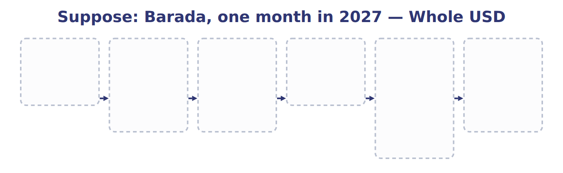
TEACH IT BACK | Write it for a classmate who missed this session — not for the marker.
22. In three or four sentences, write what this section settles and the one rule a reader has to take away.
every one of these words must appear: short-term obligation · withholding

Handout 12.3
Short-term debt expected to be refinanced
section 12.3 of the book
Before you start
Three summaries of this handout, in the book’s own words. Read all three first: together they are the whole session. Then fill the gaps, guessing where you have to.

What this handout settles, cycle by cycle
In this handout | What you will read | How you check it
Short-term debt expected to be refinanced | a figure to read · Suppose: Orontes, commercial paper of 3,000,000 | Which of these did this cycle settle?
The words this section uses precisely | The English the exam uses, and what it translates | What is the safest way to settle a disagreement about an answer on this sheet?

Words this handout uses precisely
Words this handout uses precisely | tick it if you could already use it in a sentence
qualifying financing agreement
compensated absences

1. Where the section starts — Fill every gap. The list holds more words than there are gaps, so one or two of them are not used.
choose from: statements · current liabilities · sales tax payable · qualifying financing agreement · short-term
The company shows its ability in one of two ways, before the are issued. It can actually refinance: issue long-term debt or shares after the balance sheet date and use the cash for the debt. Or it can sign a .
2. What it settles in the middle — Fill every gap. The list holds more words than there are gaps, so one or two of them are not used.
choose from: liabilities · noncurrent · refinanced · current liabilities · sales tax payable
The amount cannot exceed the amount or available. Debt repaid with current assets before the new financing is obtained stays current. Refinanced debt moves to noncurrent , never to equity, even when shares are issued.
3. Where it ends — Fill every gap. The list holds more words than there are gaps, so one or two of them are not used.
choose from: noncurrent · refinanced · current liabilities · sales tax payable
Repaid first, later: still current. Refinanced with shares: liability up to the proceeds, not equity. A 'material adverse change' clause makes the agreement fail.
How every cycle on this sheet works
How a cycle works | what you do
MODEL | read the figure or the table before you answer anything
READ THE MODEL | every answer is printed on the same page
INVENT THE RULE | write the rule yourself, then compare with the book
APPLY | no help on this move
CHECKPOINT | mark it yourself; if you miss it, the sheet says what to redo

CYCLE A | Short-term debt expected to be refinanced

ORIENT One claim. Decide now; you will check it in a moment.

4. Every number in a financial statement belongs to an element the framework defines. TRUE / FALSE
MODEL Read it before you answer anything below it.

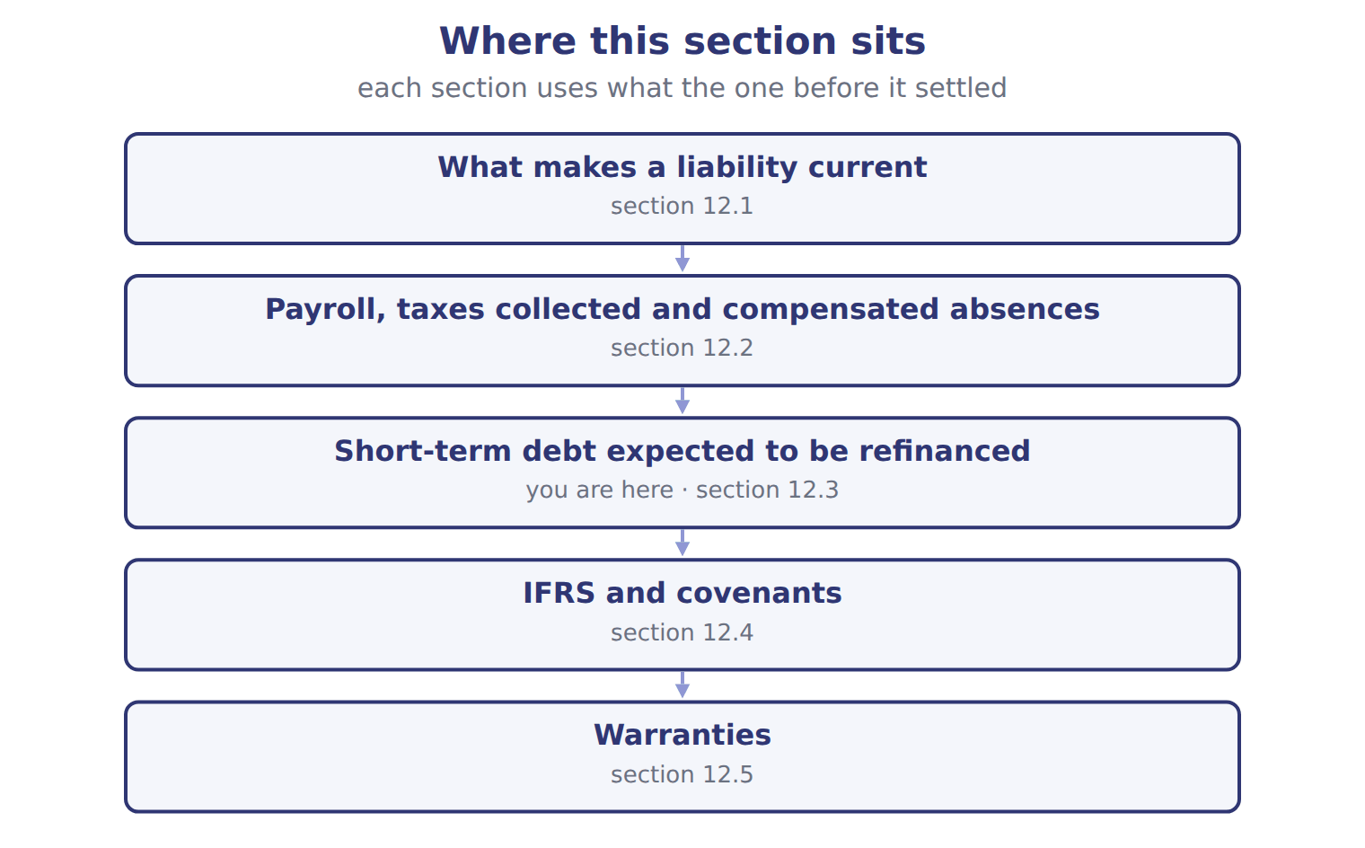
Suppose: Orontes, commercial paper of 3,000,000 — the book’s own table
Suppose: Orontes, commercial paper of 3,000,000 | Noncurrent (U.S. GAAP) | Current (U.S. GAAP)
A. Issues 5-year bonds on February 10 and uses the cash to repay the paper at maturity | 3,000,000 | 0
B. Repays the paper with cash on January 15, then issues bonds on February 10 | 0 | 3,000,000
C. Issues shares on February 10 for 2,400,000 to repay the paper | 2,400,000 | 600,000
D. Signs a qualifying agreement on February 1 to borrow 80% of inventory; inventory will not fall below 3,125,000 | 2,500,000 | 500,000
E. Same as D, but the lender may cancel if it sees a 'material adverse change' | 0 | 3,000,000

READ THE MODEL Every answer is printed above. Find it, do not recall it.

5. Which part of this chapter is section 12.1?
A. What makes a liability current
B. IFRS and covenants
C. Payroll, taxes collected and compensated absences
D. Short-term debt expected to be refinanced

APPLY No help on this move.

6. A state's unclaimed-property law requires a retailer to hand over the value of gift cards that are never used. For these cards, the retailer:
A. recognizes breakage revenue as cards expire
B. recognizes revenue when the cards are sold
C. records a reserve in equity
D. keeps a liability until it pays the state; it does not recognize breakage revenue
WORK IN PAIRS | Compare every answer on this page with your partner before you read any key.
If you disagree: go back to the model and find the row that settles it. The row decides, not the louder voice.
CHECKPOINT 7. Which of these did this cycle settle?
A. the rule and where it comes from
B. nothing in particular
C. only the vocabulary
D. only the arithmetic
If you got it wrong: redo the READ THE MODEL questions of cycle A.

CYCLE B | The words this section uses precisely

ORIENT

8. A term in the exam means exactly what the book defines it to mean, whatever it means in ordinary English. TRUE / FALSE
MODEL

The English the exam uses, and what it translates
English (exam term) | the Arabic it translates
qualifying financing agreement | اتفاقية تمويل مؤهلة
compensated absences | الإجازات المدفوعة المستحقة

READ THE MODEL

9. A glossary term and its translation are a pair the book itself gives. TRUE / FALSE
APPLY

10. A term on this page means what the book defines it to mean. What settles a disagreement about one?
A. the glossary printed on this page
B. what the word means in ordinary English
C. the translation that sounds closest
D. whichever reading makes the item easier
CHECKPOINT 11. What is the safest way to settle a disagreement about an answer on this sheet?
A. find the row of the model that decides it
B. take the answer of whoever is more confident
C. leave it until the lecturer says
D. choose the longer option
If you got it wrong: redo the READ THE MODEL questions of cycle B.

FROM MEMORY | Close the earlier pages first.
12. Rebuild the figure from this handout. Label every part and fill in every box.
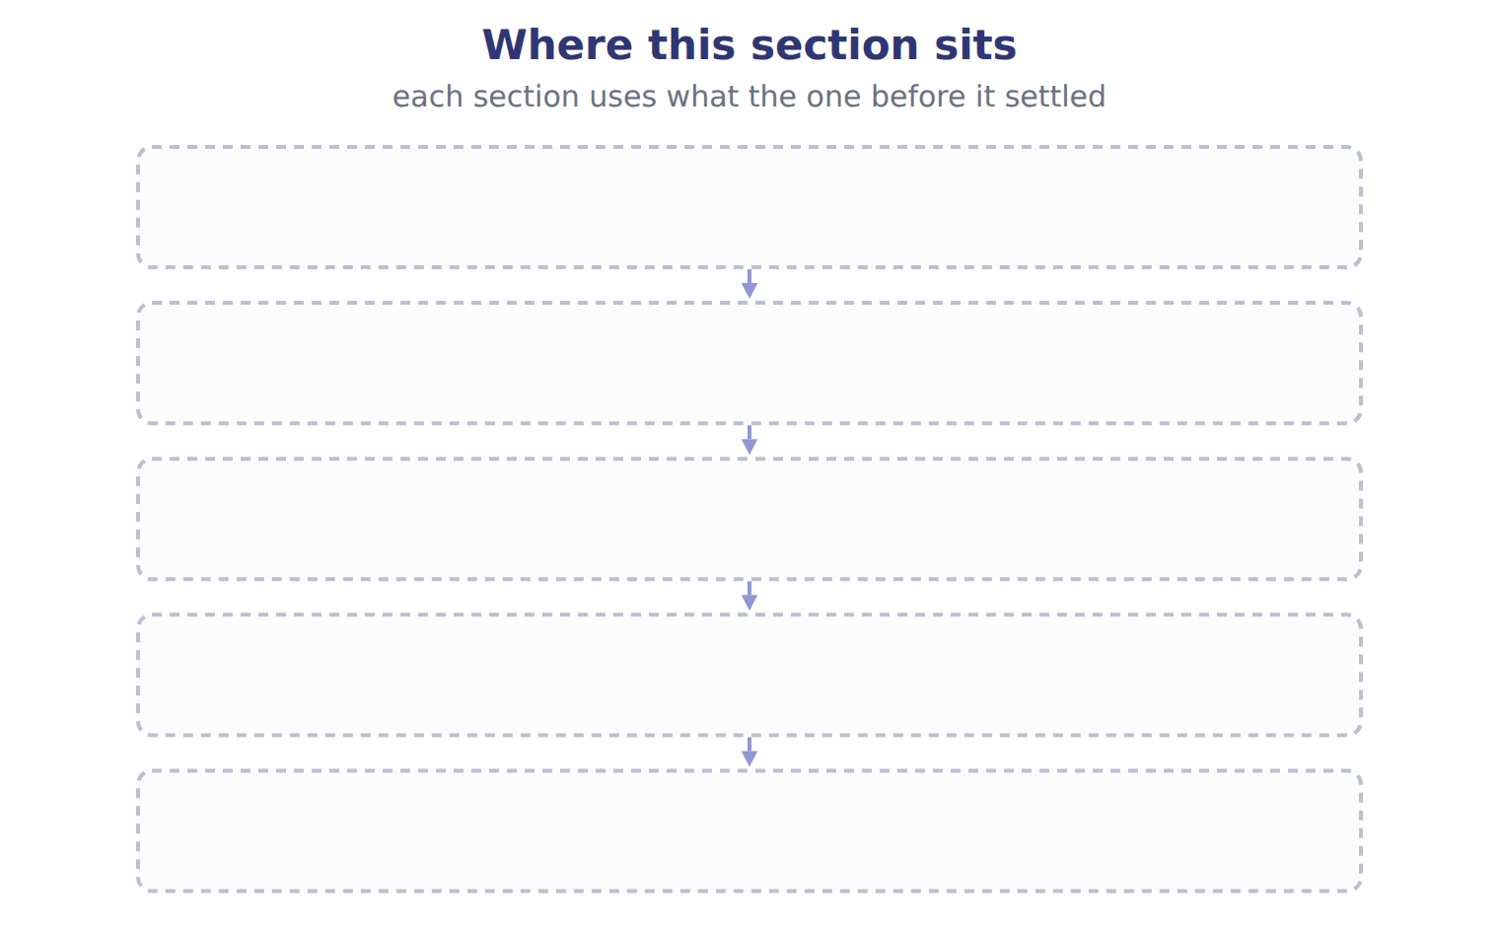
TEACH IT BACK | Write it for a classmate who missed this session — not for the marker.
13. In three or four sentences, write what this section settles and the one rule a reader has to take away.
every one of these words must appear: qualifying financing agreement · compensated absences

Handout 12.4
IFRS and covenants
section 12.4 of the book
Before you start
Three summaries of this handout, in the book’s own words. Read all three first: together they are the whole session. Then fill the gaps, guessing where you have to.

What this handout settles, cycle by cycle
In this handout | What you will read | How you check it
IFRS and covenants | a figure to read · Situation | Which of these did this cycle settle?
The words this section uses precisely | The English the exam uses, and what it translates | What is the safest way to settle a disagreement about an answer on this sheet?

Words this handout uses precisely
Words this handout uses precisely | tick it if you could already use it in a sentence
assurance-type warranty
payroll taxes

1. Where the section starts — Fill every gap. The list holds more words than there are gaps, so one or two of them are not used.
choose from: short-term obligation · scenarios · commercial paper · assurance-type warranty
In A, C and D above, an IFRS company would show the whole as current. Covenants follow the same logic.
2. What it settles in the middle — Fill every gap. The list holds more words than there are gaps, so one or two of them are not used.
choose from: assurance-type warranty · classification · covenants · short-term obligation · amendments
Under IFRS, only that must be met on or before the reporting date affect ; future covenants are disclosed. The IAS 1 on classification and covenants apply from January 1, 2024, and are testable now as IFRS contrasts.
3. Where it ends — Fill every gap from the list. The list holds more words than there are gaps.
choose from: Accrue if probable (likely) and estimable · Consider only violations at the balance sheet date · Noncurrent if the waiver lasts more than one year · Can make the debt noncurrent
The book’s own table “Situation” settles these: for Refinancing agreed after the reporting date, before issuance it is , for Waiver of a covenant breach received after the reporting date it is and for Covenants tested after the reporting date it is .
How every cycle on this sheet works
How a cycle works | what you do
MODEL | read the figure or the table before you answer anything
READ THE MODEL | every answer is printed on the same page
INVENT THE RULE | write the rule yourself, then compare with the book
APPLY | no help on this move
CHECKPOINT | mark it yourself; if you miss it, the sheet says what to redo

CYCLE A | IFRS and covenants

ORIENT One claim. Decide now; you will check it in a moment.

4. Every number in a financial statement belongs to an element the framework defines. TRUE / FALSE
MODEL Read it before you answer anything below it.

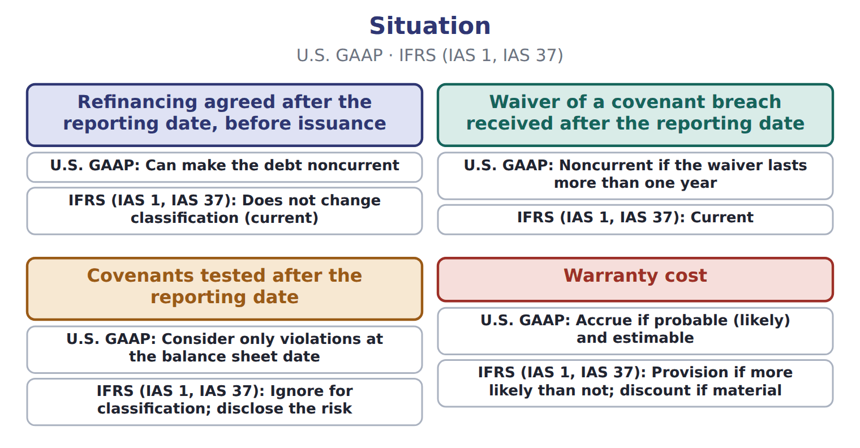
Situation — the book’s own table
Situation | U.S. GAAP | IFRS (IAS 1, IAS 37)
Refinancing agreed after the reporting date, before issuance | Can make the debt noncurrent | Does not change classification (current)
Waiver of a covenant breach received after the reporting date | Noncurrent if the waiver lasts more than one year | Current
Covenants tested after the reporting date | Consider only violations at the balance sheet date | Ignore for classification; disclose the risk
Warranty cost | Accrue if probable (likely) and estimable | Provision if more likely than not; discount if material

READ THE MODEL Every answer is printed above. Find it, do not recall it.

5. Which situation does the book pair with “Can make the debt noncurrent”?
A. Covenants tested after the reporting date
B. Warranty cost
C. Refinancing agreed after the reporting date, before issuance
APPLY No help on this move.

6. To show short-term debt as noncurrent under U.S. GAAP, a company needs:
A. only intent to refinance
B. a verbal promise from its bank
C. a history of always refinancing
D. intent to refinance long-term and demonstrated ability before the statements are issued

WORK IN PAIRS | Compare every answer on this page with your partner before you read any key.
If you disagree: go back to the model and find the row that settles it. The row decides, not the louder voice.
CHECKPOINT 7. Which of these did this cycle settle?
A. the rule and where it comes from
B. nothing in particular
C. only the vocabulary
D. only the arithmetic
If you got it wrong: redo the READ THE MODEL questions of cycle A.

CYCLE B | The words this section uses precisely

ORIENT

8. A term in the exam means exactly what the book defines it to mean, whatever it means in ordinary English. TRUE / FALSE
MODEL

The English the exam uses, and what it translates
English (exam term) | the Arabic it translates
assurance-type warranty | ضمان من نوع التأكيد
payroll taxes | ضرائب الرواتب

READ THE MODEL

9. A glossary term and its translation are a pair the book itself gives. TRUE / FALSE
APPLY

Write the letter of the matching entry beside each situation. Every one is used once.
A Accrue if probable (likely) and estimable
B Consider only violations at the balance sheet date
C Can make the debt noncurrent
D Noncurrent if the waiver lasts more than one year

10. Refinancing agreed after the reporting date, before issuance
11. Waiver of a covenant breach received after the reporting date
12. Covenants tested after the reporting date
13. Warranty cost

CHECKPOINT 14. What is the safest way to settle a disagreement about an answer on this sheet?
A. find the row of the model that decides it
B. take the answer of whoever is more confident
C. leave it until the lecturer says
D. choose the longer option
If you got it wrong: redo the READ THE MODEL questions of cycle B.

FROM MEMORY | Close the earlier pages first.
15. Rebuild the figure from this handout. Label every part and fill in every box.
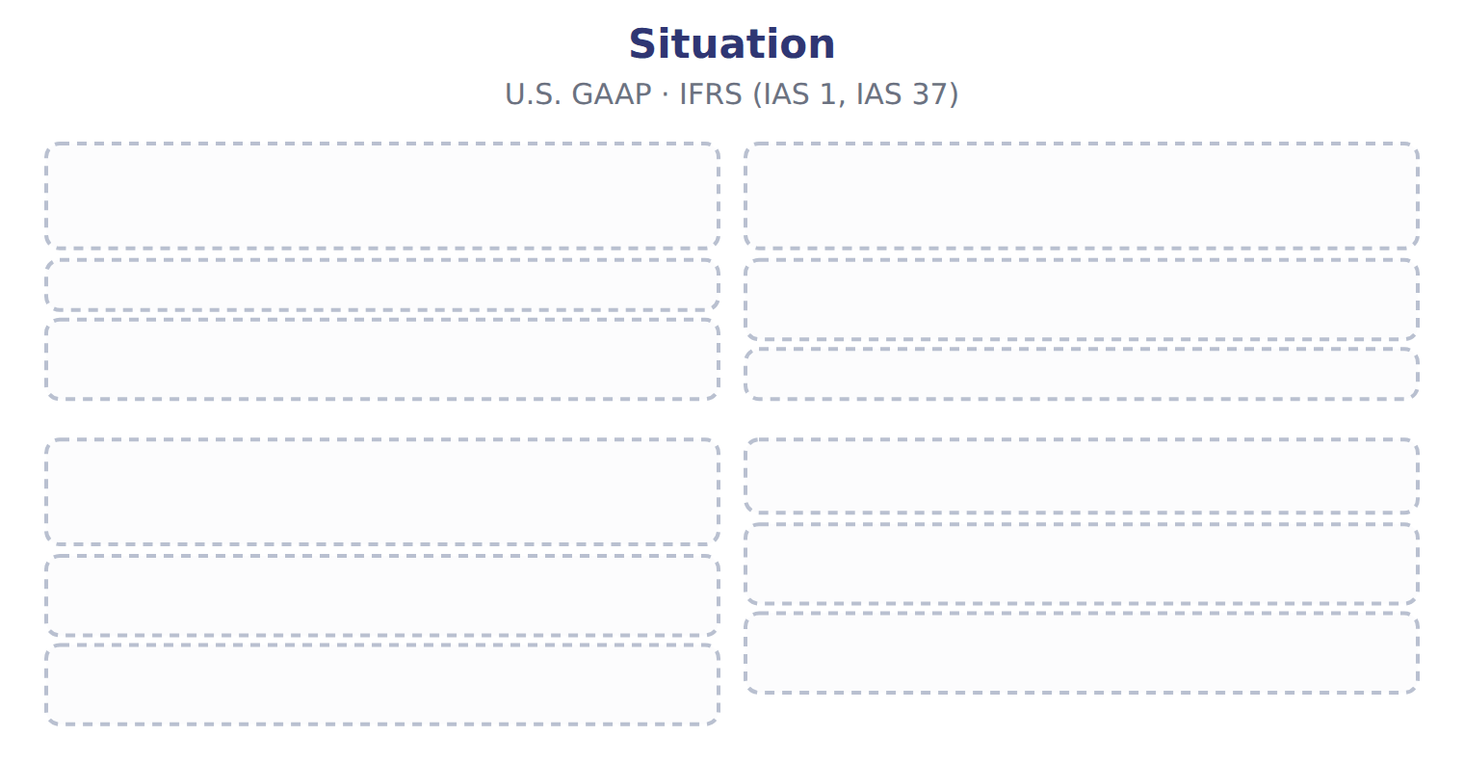
TEACH IT BACK | Write it for a classmate who missed this session — not for the marker.
16. In three or four sentences, write what this section settles and the one rule a reader has to take away.
every one of these words must appear: assurance-type warranty · payroll taxes

Handout 12.5
Warranties
section 12.5 of the book
Before you start
Three summaries of this handout, in the book’s own words. Read all three first: together they are the whole session. Then fill the gaps, guessing where you have to.

What this handout settles, cycle by cycle
In this handout | What you will read | How you check it
Warranties | a figure to read · Barada Wholesale, selected liabilities, December | Which of these did this cycle settle?
The words this section uses precisely | a figure to read · Item · The English the exam uses, and what it translates | What is the safest way to settle a disagreement about an answer on this sheet?

Words this handout uses precisely
Words this handout uses precisely | tick it if you could already use it in a sentence
service-type warranty
sales tax payable

1. Where the section starts — Fill every gap. The list holds more words than there are gaps, so one or two of them are not used.
choose from: warranty liability · service-type warranty · current liabilities · commercial paper
The company estimates the repair cost at the time of sale, records warranty expense and a , and reduces the liability as repairs are made. A gives the customer an extra service, such as extended cover.
2. What it settles in the middle — Fill every gap. The list holds more words than there are gaps, so one or two of them are not used.
choose from: service-type · current liabilities · dispensers · separately · commercial paper
A warranty that customers can buy is always . Suppose Orontes sells 2,000 beverage in 2026 for $3,000,000, with a one-year assurance warranty. It expects repairs to cost 2% of sales.
3. Where it ends — Fill every gap. The list holds more words than there are gaps, so one or two of them are not used.
choose from: separately · current liabilities · commercial paper · allowance · warranty liability
Extended plan sold : defer revenue; do not accrue a cost. Expense warranty costs in the year of the sale, not when repairs are paid. Arabic مخصص can mean a U.S. , a liability or an IFRS provision; use here.
How every cycle on this sheet works
How a cycle works | what you do
MODEL | read the figure or the table before you answer anything
READ THE MODEL | every answer is printed on the same page
INVENT THE RULE | write the rule yourself, then compare with the book
APPLY | no help on this move
CHECKPOINT | mark it yourself; if you miss it, the sheet says what to redo

CYCLE A | Warranties

ORIENT One claim. Decide now; you will check it in a moment.

4. Every number in a financial statement belongs to an element the framework defines. TRUE / FALSE
MODEL Read it before you answer anything below it.

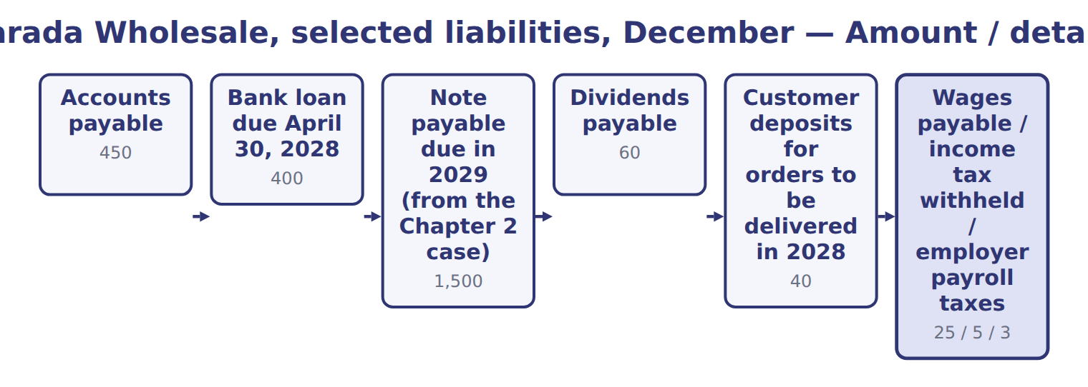
Barada Wholesale, selected liabilities, December — the book’s own table
Barada Wholesale, selected liabilities, December | Amount / details
Accounts payable | 450
Bank loan due April 30, 2028 | 400
Note payable due in 2029 (from the Chapter 2 case) | 1,500
Dividends payable | 60
Customer deposits for orders to be delivered in 2028 | 40
Wages payable / income tax withheld / employer payroll taxes | 25 / 5 / 3
M1 | On February 15, 2028, before the statements were issued on March 1, 2028, Barada signed a non-cancelable three-year agreement. The bank will
M2 | In 2027 Barada began selling kitchen equipment with a one-year warranty that the product works as agreed. Sales were 1000; expected repairs
M3 | Barada also sold separately priced three-year service plans for 36, all starting on January 1, 2027.
M4 | Deferred tax balances are not shown here; Chapter 13 covers them.

READ THE MODEL Every answer is printed above. Find it, do not recall it.

5. Which part of this chapter is section 12.1?
A. What makes a liability current
B. IFRS and covenants
C. Payroll, taxes collected and compensated absences
D. Short-term debt expected to be refinanced

APPLY No help on this move.

6. Which financing agreement does NOT qualify to support noncurrent classification?
A. A five-year non-cancelable line of credit with no violations
B. One the lender may cancel if it sees a 'material adverse change' in the borrower
C. An agreement cancelable only for a missed interest payment
D. An agreement with a financially strong bank
WORK IN PAIRS | Compare every answer on this page with your partner before you read any key.
If you disagree: go back to the model and find the row that settles it. The row decides, not the louder voice.
CHECKPOINT 7. Which of these did this cycle settle?
A. the rule and where it comes from
B. nothing in particular
C. only the vocabulary
D. only the arithmetic
If you got it wrong: redo the READ THE MODEL questions of cycle A.

CYCLE B | The words this section uses precisely

ORIENT

8. A term in the exam means exactly what the book defines it to mean, whatever it means in ordinary English. TRUE / FALSE
MODEL

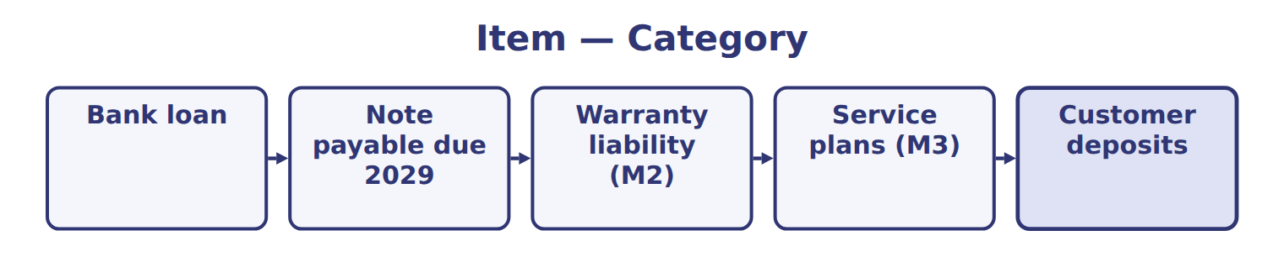
Item — the book’s own table
Item | Category
Bank loan
Note payable due 2029
Warranty liability (M2)
Service plans (M3)
Customer deposits

The English the exam uses, and what it translates
English (exam term) | the Arabic it translates
service-type warranty | ضمان من نوع الخدمة
sales tax payable | ضريبة المبيعات المستحقة

READ THE MODEL

9. A glossary term and its translation are a pair the book itself gives. TRUE / FALSE

APPLY

10. A term on this page means what the book defines it to mean. What settles a disagreement about one?
A. the glossary printed on this page
B. what the word means in ordinary English
C. the translation that sounds closest
D. whichever reading makes the item easier
CHECKPOINT 11. What is the safest way to settle a disagreement about an answer on this sheet?
A. find the row of the model that decides it
B. take the answer of whoever is more confident
C. leave it until the lecturer says
D. choose the longer option
If you got it wrong: redo the READ THE MODEL questions of cycle B.

FROM MEMORY | Close the earlier pages first.
12. Rebuild the figure from this handout. Label every part and fill in every box.
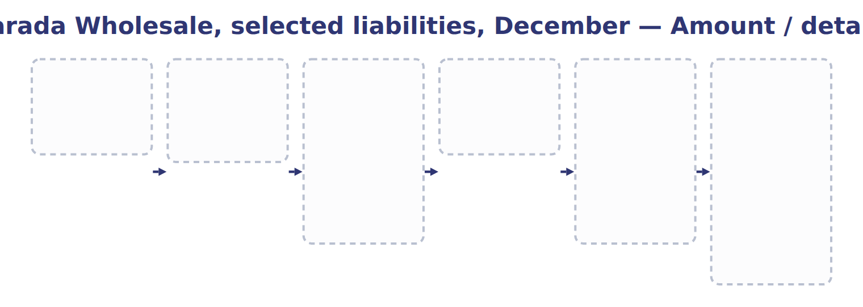
TEACH IT BACK | Write it for a classmate who missed this session — not for the marker.
13. In three or four sentences, write what this section settles and the one rule a reader has to take away.
every one of these words must appear: service-type warranty · sales tax payable

Handout 12.6
The whole chapter
every section, shuffled, and the chapter’s own case set
Before you start
Three summaries of this chapter, in the book’s own words, with words taken out. Read all three first: together they are the whole chapter. Then fill the gaps.

What this handout settles, cycle by cycle
In this handout | What you will read | How you check it
The whole chapter, in order | a figure to read · Suppose: Orontes, commercial paper of 3,000,000 | A company's year ends on December 31 and its statements are issued on March 5. It issues long-term bonds on March 20 to repay a note due in June. How is the note classified at December 31?
The chapter’s case set | The chapter’s case set, item by item | What has to be settled before any figure in a case set is worked out?
The words it uses precisely | current liabilities · short-term obligation · qualifying financing agreement · assurance-type warranty · service-type warranty · warranty liability | matching, at the end of cycle B

1. Where the chapter starts — Fill every gap. The list holds more words than there are gaps, so one or two of them are not used.
choose from: declaration · sales tax payable · commercial paper · liabilities · distributable
Customer deposits are contract , as Chapter 11 showed: they become revenue when Orontes delivers. Cash dividends become a liability on the date. A stock dividend is not a liability, because no assets will be paid.
2. What it settles in the middle — Fill every gap. The list holds more words than there are gaps, so one or two of them are not used.
choose from: sales tax payable · refinanced · commercial paper · liabilities · noncurrent
The amount cannot exceed the amount or available. Debt repaid with current assets before the new financing is obtained stays current. Refinanced debt moves to noncurrent , never to equity, even when shares are issued.
3. Where it ends — Fill every gap. The list holds more words than there are gaps, so one or two of them are not used.
choose from: amendments · commercial paper · covenants · classification · sales tax payable
Under IFRS, only that must be met on or before the reporting date affect ; future covenants are disclosed. The IAS 1 on classification and covenants apply from January 1, 2024, and are testable now as IFRS contrasts.

CYCLE A | The whole chapter, in order

ORIENT

4. The sections of a chapter have to be taken in order, because each one uses what the one before it settled. TRUE / FALSE
MODEL

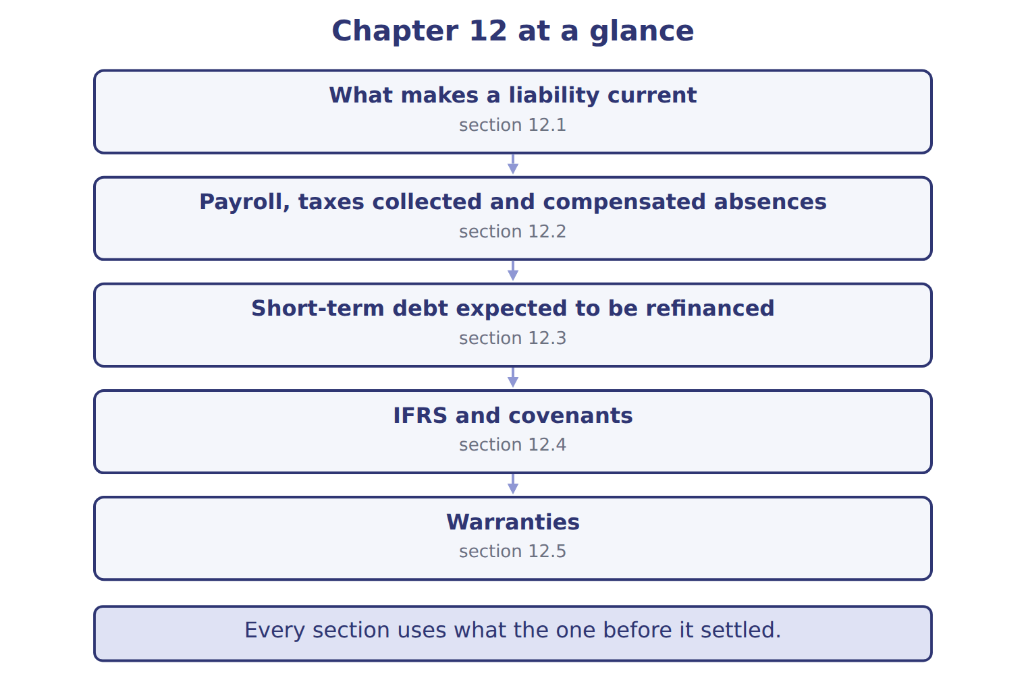

READ THE MODEL

5. Which part of this chapter is section 12.1?
A. Short-term debt expected to be refinanced
B. IFRS and covenants
C. What makes a liability current
D. Payroll, taxes collected and compensated absences
Write the letter of the section number beside each section title. Every number is used once.
A 12.1 | D 12.4
B 12.2 | E 12.5
C 12.3

6. What makes a liability current
7. Payroll, taxes collected and compensated absences
8. Short-term debt expected to be refinanced
9. IFRS and covenants
10. Warranties

APPLY

11. A company sells a separately priced two-year extended warranty. It records the cash received as:
A. revenue at the sale
B. a reduction of warranty expense
C. a contract liability, recognized as revenue over two years
D. a warranty liability for expected repairs
12. A company sold products for $800,000 with a one-year assurance warranty. It expects repairs of 3% of sales and spent $9,000 on repairs this year. What is the year-end warranty liability?
A. $0 | C. $15,000
B. $9,000 | D. $24,000

13. A warranty has an assurance element and a service element, but they cannot reasonably be accounted for separately. The company:
A. treats the whole warranty as one performance obligation
B. accrues the whole warranty as a cost
C. ignores the service element
D. discloses the warranty only
Suppose: Orontes, commercial paper of 3,000,000 — the extract for the question that follows
Suppose: Orontes, commercial paper of 3,000,000 | Noncurrent (U.S. GAAP) | Current (U.S. GAAP)
A. Issues 5-year bonds on February 10 and uses the cash to repay the paper at maturity | 3,000,000 | 0
B. Repays the paper with cash on January 15, then issues bonds on February 10 | 0 | 3,000,000
C. Issues shares on February 10 for 2,400,000 to repay the paper | 2,400,000 | 600,000
D. Signs a qualifying agreement on February 1 to borrow 80% of inventory; inventory will not fall below 3,125,000 | 2,500,000 | 500,000
E. Same as D, but the lender may cancel if it sees a 'material adverse change' | 0 | 3,000,000

14. Use the extract, scenario C. How much of the commercial paper is shown as noncurrent (whole USD)?
A. 0 | C. 2,400,000
B. 600,000 | D. 3,000,000
Suppose: Orontes, commercial paper of 3,000,000 — the extract for the question that follows
Suppose: Orontes, commercial paper of 3,000,000 | Noncurrent (U.S. GAAP) | Current (U.S. GAAP)
A. Issues 5-year bonds on February 10 and uses the cash to repay the paper at maturity | 3,000,000 | 0
B. Repays the paper with cash on January 15, then issues bonds on February 10 | 0 | 3,000,000
C. Issues shares on February 10 for 2,400,000 to repay the paper | 2,400,000 | 600,000
D. Signs a qualifying agreement on February 1 to borrow 80% of inventory; inventory will not fall below 3,125,000 | 2,500,000 | 500,000
E. Same as D, but the lender may cancel if it sees a 'material adverse change' | 0 | 3,000,000

15. A one-year warranty that a product will work as agreed is:
A. a service-type warranty; revenue is deferred
B. an assurance-type warranty; the cost is accrued at the sale
C. a loss contingency that is only disclosed
D. recorded only when repairs are made
WORK IN PAIRS | Compare every answer with your partner first.
If you disagree: name the section each question belongs to. Most disagreements turn out to be about the section, not the answer.

CHECKPOINT 16. A company's year ends on December 31 and its statements are issued on March 5. It issues long-term bonds on March 20 to repay a note due in June. How is the note classified at December 31?
A. Equity
B. Current
C. Split in proportion
If you got it wrong: go back to the MODEL move of cycle A and find the section this question belongs to.

CYCLE B | The chapter’s case set

ORIENT

17. In a case question, the exhibit has to be read and adjusted before any figure is worked out. TRUE / FALSE
MODEL

The chapter’s case set, item by item
Item | What it asks
C12-1 | Classify each item at December 31, 2027. (On the exam screen you would drag each item into a box.)
C12-2 | Enter the noncurrent part of the bank loan.
C12-3 | Enter the warranty liability at December 31, 2027.
C12-4 | Enter the 2027 revenue from the service plans.
C12-5 | Enter Barada's total current liabilities at December 31, 2027.
C12-6 | If the agreement in M1 allowed the bank to cancel after any 'material adverse change', the bank loan would be: [select]

READ THE MODEL

The tasks of a case set have to be worked in one order, because each one uses the result of the one before it. Write the letter of its place beside each task.
A first | D fourth
B second | E fifth
C third | F sixth

18. Enter the noncurrent part of the bank loan.
19. If the agreement in M1 allowed the bank to cancel after any 'material adverse change', the bank loan would be: [select]
20. Enter Barada's total current liabilities at December 31, 2027.
21. Enter the 2027 revenue from the service plans.
22. Classify each item at December 31, 2027. (On the exam screen you would drag each item into a box.)
23. Enter the warranty liability at December 31, 2027.

APPLY

24. When short-term debt is excluded from current liabilities because of refinancing, the company must disclose:
A. a description of the financing agreement and the terms of the new obligation
B. nothing, because the debt is noncurrent
C. only the interest rate
D. the bank's credit rating

CHECKPOINT 25. What has to be settled before any figure in a case set is worked out?
A. the exhibit, adjusted for every note that goes with it
B. the method the company uses
C. the tax rate
D. the order of the items
If you got it wrong: reread the case panel in the MODEL move of cycle B.

FROM MEMORY | Close the earlier pages first.
26. Rebuild the chapter map. Write every section in order and what each one settles.
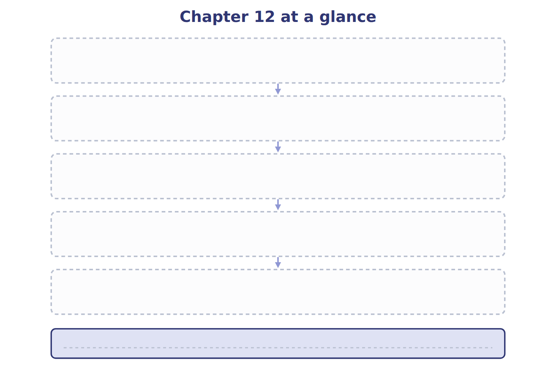
TEACH IT BACK | Write it for a student starting this chapter tomorrow — not for the marker.
27. In four or five sentences, write what the whole chapter settles, section by section.
every one of these words must appear: current liabilities · short-term obligation · qualifying financing agreement · assurance-type warranty

