Handout 14.1
What is a lease?
section 14.1 of the book
Before you start
Three summaries of this handout, in the book’s own words. Read all three first: together they are the whole session. Then fill the gaps, guessing where you have to.

What this handout settles, cycle by cycle
In this handout | What you will read | How you check it
What is a lease? | a figure to read · Lease | Which of these did this cycle settle?
The words this section uses precisely | Item · The English the exam uses, and what it translates | What is the safest way to settle a disagreement about an answer on this sheet?

Words this handout uses precisely
Words this handout uses precisely | tick it if you could already use it in a sentence
lease
incremental borrowing rate

1. Where the section starts — Fill every gap. The list holds more words than there are gaps, so one or two of them are not used.
choose from: lease term · lease liability · lessee · lease · lessor
A is a contract that gives the right to control the use of an identified asset for a period of time in exchange for payment. The uses the asset; the provides it.
2. What it settles in the middle — Fill every gap. The list holds more words than there are gaps, so one or two of them are not used.
choose from: residual value guarantee · lease term · lessor · lessee · lease liability
The uses the asset; the provides it. The asset must be identified, and the supplier must not have a real right to swap it for another. The lessee controls the asset if it gets almost all of its economic benefits and decides how it is used. The is the period the lessee cannot cancel, plus any renewal periods it is reasonably certain to use.
3. Where it ends — Fill every gap. The list holds more words than there are gaps, so one or two of them are not used.
choose from: residual value guarantee · lessee · short-term lease · incremental borrowing rate · lease
The discount rate is the rate implicit in the if the can find it; otherwise it is the lessee's .
How every cycle on this sheet works
How a cycle works | what you do
MODEL | read the figure or the table before you answer anything
READ THE MODEL | every answer is printed on the same page
INVENT THE RULE | write the rule yourself, then compare with the book
APPLY | no help on this move
CHECKPOINT | mark it yourself; if you miss it, the sheet says what to redo

CYCLE A | What is a lease?

ORIENT One claim. Decide now; you will check it in a moment.

4. Every number in a financial statement belongs to an element the framework defines. TRUE / FALSE
MODEL Read it before you answer anything below it.

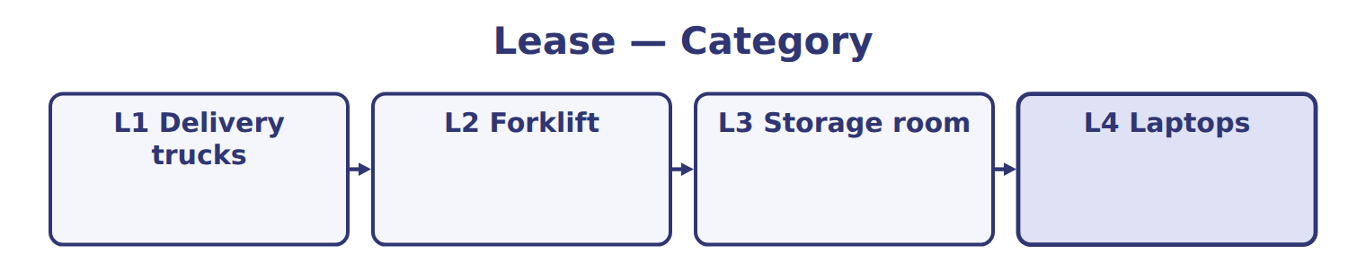
Lease — the book’s own table
Lease | Category
L1 Delivery trucks
L2 Forklift
L3 Storage room
L4 Laptops

READ THE MODEL Every answer is printed above. Find it, do not recall it.

5. Which part of this chapter is section 14.1?
A. What is a lease?
B. Initial measurement
C. Presentation
D. Finance or operating? The five criteria
APPLY No help on this move.

6. A supplier promises to provide 'a delivery truck' each day and may send any truck from its large fleet at no cost. Does Orontes have a lease?
A. No, because the supplier has a substantive right to substitute the truck
B. Yes, because Orontes uses a truck every day
C. Yes, because the contract is for more than 12 months
D. No, because trucks cannot be leased
7. A 7-year lease of a machine with a 9-year economic life, no transfer, no option, a standard asset, and payments worth 70% of fair value. Using common policies, the lease is:
A. an operating lease, because the PV is below 90%
B. an operating lease, because there is no purchase option
C. a short-term lease
D. a finance lease, because 7 of 9 years is a major part of the life
8. Compared with an operating lease on the same terms, a finance lease gives:
A. the same expense every year
B. higher total expense in early years and lower in later years
C. higher total expense over the lease term
D. no expense until the lease ends
9. Which IFRS 16 feature does NOT exist in ASC 842?
A. An exemption for short-term leases
B. An exemption for leases of low-value assets
C. A right-of-use asset
D. Discounting the lease payments

WORK IN PAIRS | Compare every answer on this page with your partner before you read any key.
If you disagree: go back to the model and find the row that settles it. The row decides, not the louder voice.
CHECKPOINT 10. Which of these did this cycle settle?
A. the rule and where it comes from
B. nothing in particular
C. only the vocabulary
D. only the arithmetic
If you got it wrong: redo the READ THE MODEL questions of cycle A.

CYCLE B | The words this section uses precisely

ORIENT

11. A term in the exam means exactly what the book defines it to mean, whatever it means in ordinary English. TRUE / FALSE
MODEL

Item — the book’s own table
Item | Answer
2028 | Opening 267,301; interest 16,038; closing 183,339; ROU amortization 83,962; lease cost 100,000
2029 | Opening 183,339; interest 11,000; closing 94,339; ROU amortization 89,000; lease cost 100,000
2030 | Opening 94,339; interest 5,661; closing 0; ROU amortization 94,339; lease cost 100,000

The English the exam uses, and what it translates
English (exam term) | the Arabic it translates
lease | عقد الإيجار
incremental borrowing rate | معدل الاقتراض الإضافي

READ THE MODEL

12. A glossary term and its translation are a pair the book itself gives. TRUE / FALSE
APPLY

13. An IFRS company pays interest on a lease liability. Under current IAS 7 it may classify the interest as:
A. operating or financing, as a policy choice
B. investing only
C. operating only, as under U.S. GAAP
D. not a cash flow
CHECKPOINT 14. What is the safest way to settle a disagreement about an answer on this sheet?
A. find the row of the model that decides it
B. take the answer of whoever is more confident
C. leave it until the lecturer says
D. choose the longer option
If you got it wrong: redo the READ THE MODEL questions of cycle B.

FROM MEMORY | Close the earlier pages first.
15. Rebuild the figure from this handout. Label every part and fill in every box.
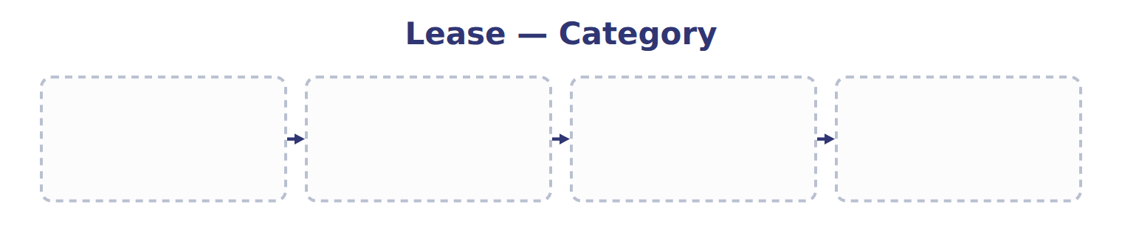
TEACH IT BACK | Write it for a classmate who missed this session — not for the marker.
16. In three or four sentences, write what this section settles and the one rule a reader has to take away.
every one of these words must appear: lease · incremental borrowing rate

Handout 14.2
Finance or operating? The five criteria
section 14.2 of the book
Before you start
Three summaries of this handout, in the book’s own words. Read all three first: together they are the whole session. Then fill the gaps, guessing where you have to.

What this handout settles, cycle by cycle
In this handout | What you will read | How you check it
Finance or operating? The five criteria | a figure to read · Criterion · the book’s own rule, gapped | Which of these did this cycle settle?
The words this section uses precisely | The English the exam uses, and what it translates | What is the safest way to settle a disagreement about an answer on this sheet?

Words this handout uses precisely
Words this handout uses precisely | tick it if you could already use it in a sentence
right-of-use asset
lease term

1. Where the section starts — Fill every gap. The list holds more words than there are gaps, so one or two of them are not used.
choose from: lease term · operating lease · lease · right-of-use asset · finance lease · lessee
A classifies each at the start. It is a if it meets any one of five criteria; otherwise it is an .
2. What it settles in the middle — Fill every gap. The list holds more words than there are gaps, so one or two of them are not used.
choose from: lease · economic · right-of-use asset · substantially · dit-bail
Many companies use about 75% or more of life as a major part, and about 90% or more of fair value as all. French cré and Arabic عقد تأجير تمويلي are legal forms of contract.
3. Where it ends — Fill every gap from the list. The list holds more words than there are gaps.
choose from: No: 5 of 30 years (17%) · Operating lease · No: any company could use it · No: 421,236 of 1,500,000 (28%)
The book’s own table “Criterion” settles these: for 3. Major part of economic life it is , for 4. PV ≥ substantially all of fair value it is and for 5. Specialized asset it is .
How every cycle on this sheet works
How a cycle works | what you do
MODEL | read the figure or the table before you answer anything
READ THE MODEL | every answer is printed on the same page
INVENT THE RULE | write the rule yourself, then compare with the book
APPLY | no help on this move
CHECKPOINT | mark it yourself; if you miss it, the sheet says what to redo

CYCLE A | Finance or operating? The five criteria

ORIENT One claim. Decide now; you will check it in a moment.

4. Every number in a financial statement belongs to an element the framework defines. TRUE / FALSE
MODEL Read it before you answer anything below it.

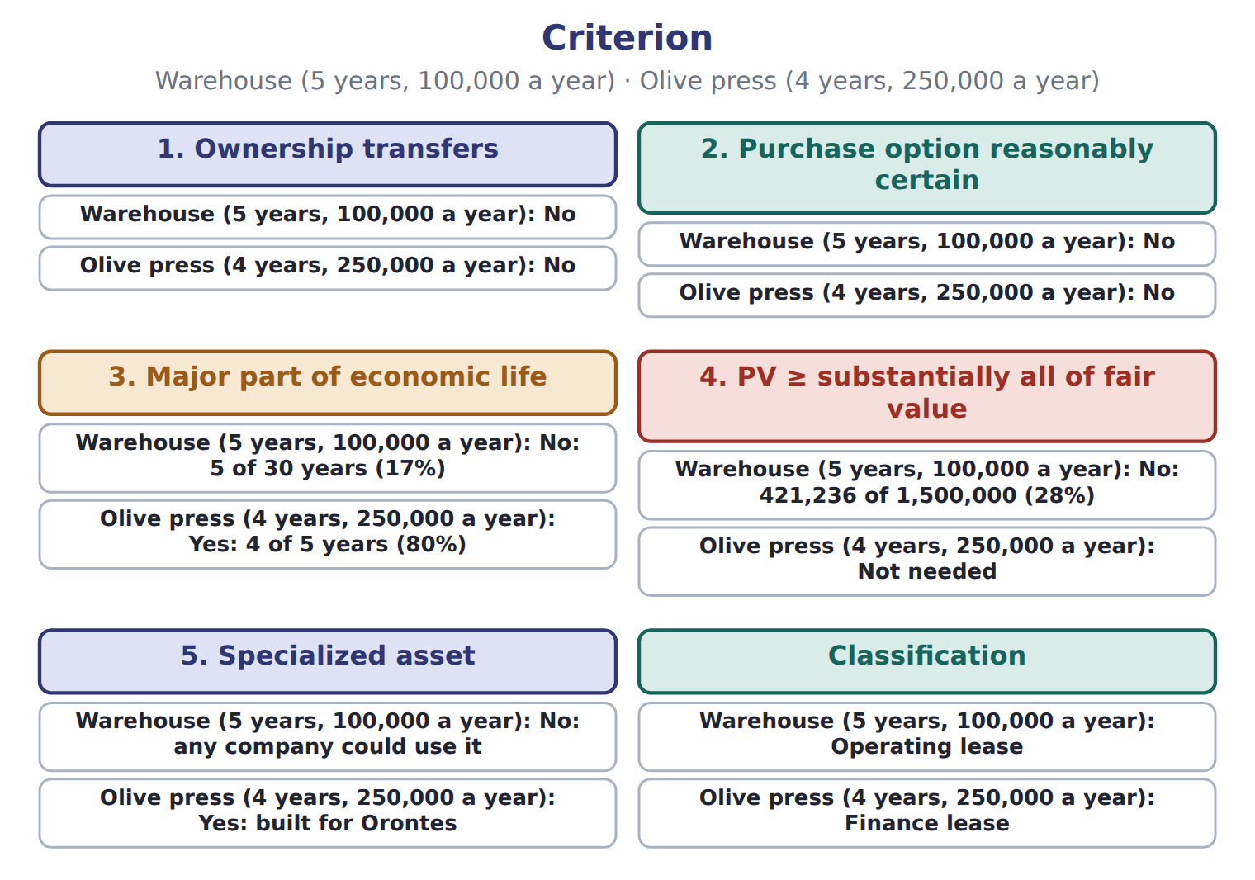

Criterion — the book’s own table
Criterion | Warehouse (5 years, 100,000 a year) | Olive press (4 years, 250,000 a year)
1. Ownership transfers | No | No
2. Purchase option reasonably certain | No | No
3. Major part of economic life | No: 5 of 30 years (17%) | Yes: 4 of 5 years (80%)
4. PV ≥ substantially all of fair value | No: 421,236 of 1,500,000 (28%) | Not needed
5. Specialized asset | No: any company could use it | Yes: built for Orontes
Classification | Operating lease | Finance lease

READ THE MODEL Every answer is printed above. Find it, do not recall it.

5. Which criterion does the book pair with “No: 5 of 30 years (17%)”?
A. 5. Specialized asset
B. 2. Purchase option reasonably certain
C. 1. Ownership transfers
D. 3. Major part of economic life
Complete every empty cell. The first full row shows the pattern.
Criterion | Warehouse (5 years, 100,000 a year) | Olive press (4 years, 250,000 a year)
1. Ownership transfers | No | No
2. Purchase option reasonably certain
3. Major part of economic life
4. PV ≥ substantially all of fair value
5. Specialized asset
Classification

INVENT THE RULE

11. Complete the book’s own sentence. The list holds more words than there are gaps.
use every one of these words: right-of-use asset · operating lease · lessor · finance lease
A crédit-bail contract can be an , and an ordinary rental can be a .

Two of the book’s own cases, side by side
1. Ownership transfers | 3. Major part of economic life
Warehouse (5 years, 100,000 a year): No | Warehouse (5 years, 100,000 a year): No: 5 of 30 years (17%)
Only the facts above differ. What is the olive press (4 years, 250,000 a year) of 1. Ownership transfers?
12. Choose one:
A. Not needed | C. Yes: 4 of 5 years (80%)
B. No | D. Yes: built for Orontes
APPLY No help on this move.

13. A lease includes an option to buy the asset for $1 at the end. The lessee is reasonably certain to use it. The lease is:
A. an operating lease | C. a finance lease
B. a sale | D. a service contract

WORK IN PAIRS | Compare every answer on this page with your partner before you read any key.
If you disagree: go back to the model and find the row that settles it. The row decides, not the louder voice.
CHECKPOINT 14. Which of these did this cycle settle?
A. the rule and where it comes from
B. nothing in particular
C. only the vocabulary
D. only the arithmetic
If you got it wrong: redo the READ THE MODEL questions of cycle A.

CYCLE B | The words this section uses precisely

ORIENT

15. A term in the exam means exactly what the book defines it to mean, whatever it means in ordinary English. TRUE / FALSE
MODEL

The English the exam uses, and what it translates
English (exam term) | the Arabic it translates
right-of-use asset | أصل حق الاستخدام
lease term | مدة عقد الإيجار

READ THE MODEL

16. A glossary term and its translation are a pair the book itself gives. TRUE / FALSE
APPLY

17. A term on this page means what the book defines it to mean. What settles a disagreement about one?
A. the glossary printed on this page
B. what the word means in ordinary English
C. the translation that sounds closest
D. whichever reading makes the item easier
CHECKPOINT 18. What is the safest way to settle a disagreement about an answer on this sheet?
A. find the row of the model that decides it
B. take the answer of whoever is more confident
C. leave it until the lecturer says
D. choose the longer option
If you got it wrong: redo the READ THE MODEL questions of cycle B.

FROM MEMORY | Close the earlier pages first.
19. Rebuild the figure from this handout. Label every part and fill in every box.
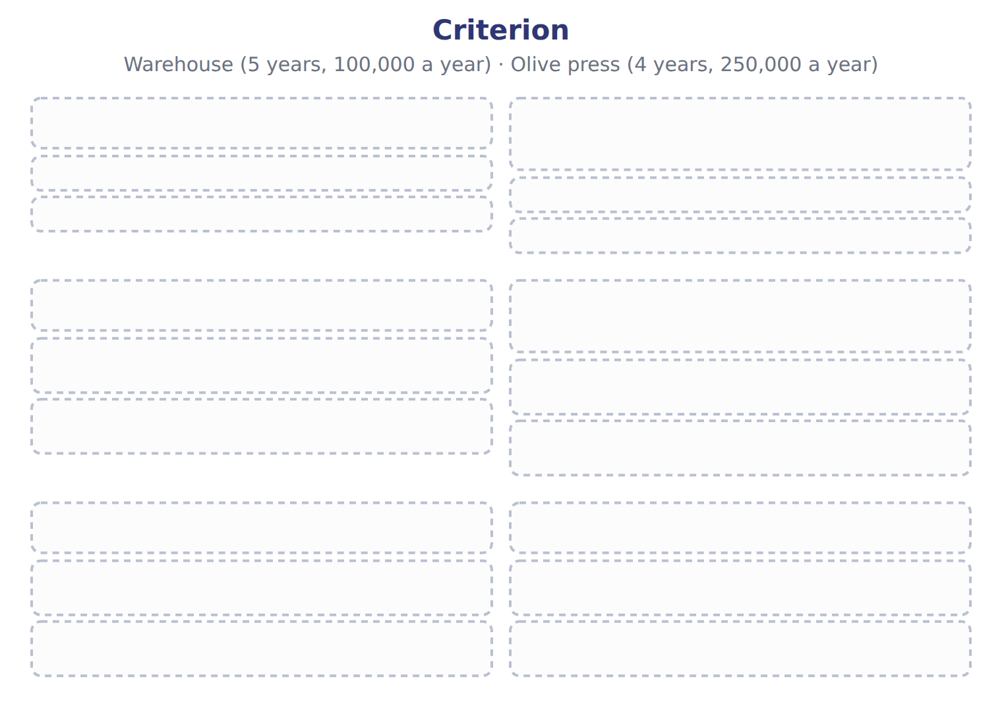
TEACH IT BACK | Write it for a classmate who missed this session — not for the marker.
20. In three or four sentences, write what this section settles and the one rule a reader has to take away.
every one of these words must appear: right-of-use asset · lease term

Handout 14.3
Initial measurement
section 14.3 of the book
Before you start
Three summaries of this handout, in the book’s own words. Read all three first: together they are the whole session. Then fill the gaps, guessing where you have to.

What this handout settles, cycle by cycle
In this handout | What you will read | How you check it
Initial measurement | a figure to read · Suppose: January 1, 2026 (whole USD) · the book’s own rule, gapped | Which of these did this cycle settle?
The words this section uses precisely | The English the exam uses, and what it translates | What is the safest way to settle a disagreement about an answer on this sheet?

Words this handout uses precisely
Words this handout uses precisely | tick it if you could already use it in a sentence
lease liability
lessee

1. Where the section starts — Fill every gap. The list holds more words than there are gaps, so one or two of them are not used.
choose from: lessee · right-of-use asset · operating lease · sale and leaseback · lease liability
For both types, the records a and a at the start. The liability is the present value of the lease payments not yet paid.
2. What it settles in the middle — Fill every gap. The list holds more words than there are gaps, so one or two of them are not used.
choose from: right-of-use asset · lessee · incremental borrowing rate · lease · lease liability · residual value guarantee
The discount rate is the rate implicit in the if the can find it; otherwise it is the lessee's . Lease payments include fixed payments, payments that depend on an index such as CPI, a purchase price the lessee is reasonably certain to pay, and amounts it expects to pay under a .
3. Where it ends — Fill every gap. The list holds more words than there are gaps, so one or two of them are not used.
choose from: lessee · undiscounted · lease liability · right-of-use asset
The starts at the liability, plus any prepaid payments and initial direct costs, minus incentives received. Orontes uses 6%, the rate on its bank note from Chapter 1. The payments are higher, because part of each payment is interest.
How every cycle on this sheet works
How a cycle works | what you do
MODEL | read the figure or the table before you answer anything
READ THE MODEL | every answer is printed on the same page
INVENT THE RULE | write the rule yourself, then compare with the book
APPLY | no help on this move
CHECKPOINT | mark it yourself; if you miss it, the sheet says what to redo

CYCLE A | Initial measurement

ORIENT One claim. Decide now; you will check it in a moment.

4. Every number in a financial statement belongs to an element the framework defines. TRUE / FALSE
MODEL Read it before you answer anything below it.

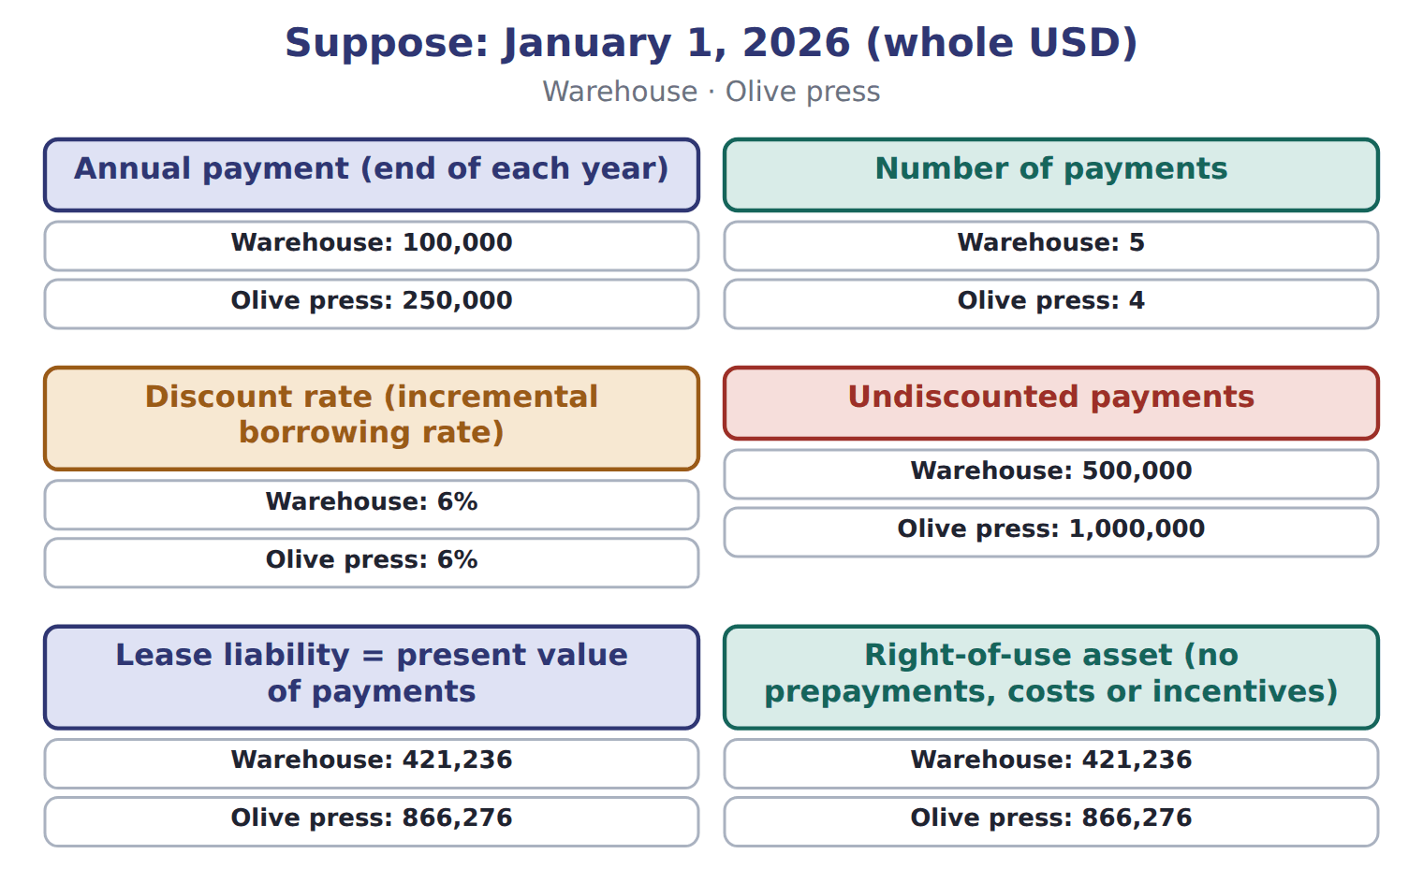
Suppose: January 1, 2026 (whole USD) — the book’s own table
Suppose: January 1, 2026 (whole USD) | Warehouse | Olive press
Annual payment (end of each year) | 100,000 | 250,000
Number of payments | 5 | 4
Discount rate (incremental borrowing rate) | 6% | 6%
Undiscounted payments | 500,000 | 1,000,000
Lease liability = present value of payments | 421,236 | 866,276
Right-of-use asset (no prepayments, costs or incentives) | 421,236 | 866,276

READ THE MODEL Every answer is printed above. Find it, do not recall it.

5. Which warehouse does the book give for Annual payment (end of each year)?
A. 6% | C. 100,000
B. 421,236 | D. 500,000
6. Which olive press does the book give for Undiscounted payments?
A. 250,000 | C. 1,000,000
B. 6% | D. 866,276

INVENT THE RULE

7. Complete the book’s own sentence. The list holds more words than there are gaps.
use every one of these words: sale and leaseback · lease liability · lease · incremental borrowing rate · lessee
The discount rate is the rate implicit in the if the can find it; otherwise it is the lessee's .

Two of the book’s own cases, side by side
Annual payment (end of each year) | Number of payments
Warehouse: 100,000 | Warehouse: 5
Only the facts above differ. What is the olive press of Annual payment (end of each year)?
8. Choose one:
A. 6% | C. 4
B. 250,000 | D. 1,000,000
APPLY No help on this move.

9. A French company signs a crédit-bail contract for a truck. Under ASC 842, the lease is classified by:
A. its legal form: always a finance lease
B. the five criteria, not the legal form
C. the tax treatment
D. the lessor's choice
WORK IN PAIRS | Compare every answer on this page with your partner before you read any key.
If you disagree: go back to the model and find the row that settles it. The row decides, not the louder voice.
CHECKPOINT 10. Which of these did this cycle settle?
A. the rule and where it comes from
B. nothing in particular
C. only the vocabulary
D. only the arithmetic
If you got it wrong: redo the READ THE MODEL questions of cycle A.

CYCLE B | The words this section uses precisely

ORIENT

11. A term in the exam means exactly what the book defines it to mean, whatever it means in ordinary English. TRUE / FALSE
MODEL

The English the exam uses, and what it translates
English (exam term) | the Arabic it translates
lease liability | التزام عقد الإيجار
lessee | المستأجر

READ THE MODEL

12. A glossary term and its translation are a pair the book itself gives. TRUE / FALSE

APPLY

13. Which warehouse does the book give for Right-of-use asset (no prepayments, costs or incentives)?
A. 500,000 | C. 100,000
B. 6% | D. 421,236
CHECKPOINT 14. What is the safest way to settle a disagreement about an answer on this sheet?
A. find the row of the model that decides it
B. take the answer of whoever is more confident
C. leave it until the lecturer says
D. choose the longer option
If you got it wrong: redo the READ THE MODEL questions of cycle B.

FROM MEMORY | Close the earlier pages first.
15. Rebuild the figure from this handout. Label every part and fill in every box.
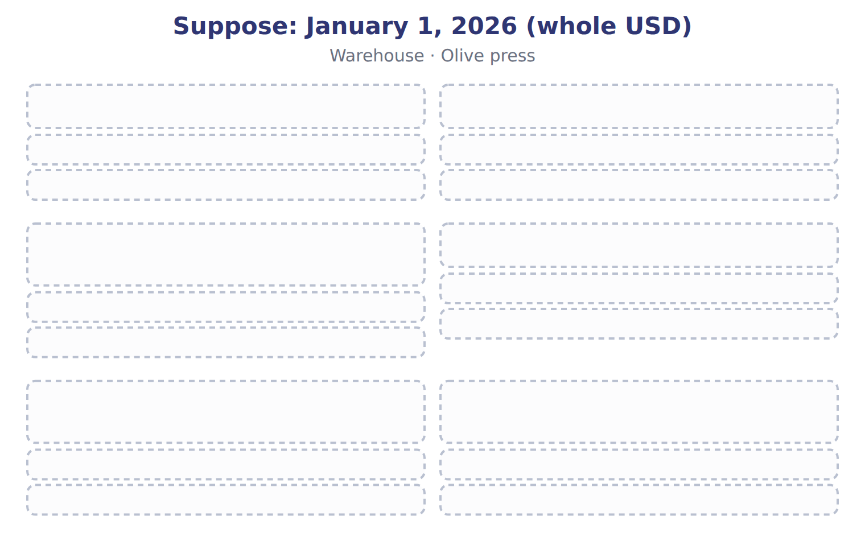
TEACH IT BACK | Write it for a classmate who missed this session — not for the marker.
16. In three or four sentences, write what this section settles and the one rule a reader has to take away.
every one of these words must appear: lease liability · lessee

Handout 14.4
Subsequent measurement: two expense patterns
section 14.4 of the book
Before you start
Three summaries of this handout, in the book’s own words. Read all three first: together they are the whole session. Then fill the gaps, guessing where you have to.

What this handout settles, cycle by cycle
In this handout | What you will read | How you check it
Subsequent measurement: two expense patterns | a figure to read · Lease · Criterion | Which contract contains a lease?
The words this section uses precisely | The English the exam uses, and what it translates · Suppose: January 1, 2026 (whole USD) | What is the safest way to settle a disagreement about an answer on this sheet?

Words this handout uses precisely
Words this handout uses precisely | tick it if you could already use it in a sentence
finance lease
lessor

1. Where the section starts — Fill every gap. The list holds more words than there are gaps, so one or two of them are not used.
choose from: finance lease · right-of-use asset · sale and leaseback · lessee · residual value guarantee
For a , the records interest on the liability and, separately, amortization of the , usually straight-line. Interest is highest at the start, when the liability is largest, so total expense falls each year.
2. What it settles in the middle — Fill every gap. The list holds more words than there are gaps, so one or two of them are not used.
choose from: lessee · operating lease · finance lease · residual value guarantee
For an , the records one lease cost, normally the same each year. The liability still grows by interest and falls by payments.
3. Where it ends — Fill every gap. The list holds more words than there are gaps, so one or two of them are not used.
choose from: lease · finance lease · right-of-use asset · residual value guarantee
The amortization of the is simply the difference between the cost and the interest, so the asset and the liability stay equal when there are no prepayments or incentives. The liability is a present value, not the total of the payments.
How every cycle on this sheet works
How a cycle works | what you do
MODEL | read the figure or the table before you answer anything
READ THE MODEL | every answer is printed on the same page
INVENT THE RULE | write the rule yourself, then compare with the book
APPLY | no help on this move
CHECKPOINT | mark it yourself; if you miss it, the sheet says what to redo

CYCLE A | Subsequent measurement: two expense patterns

ORIENT One claim. Decide now; you will check it in a moment.

4. The book gives the category of L4 Laptops as “Operating lease”. TRUE / FALSE
MODEL Read it before you answer anything below it.

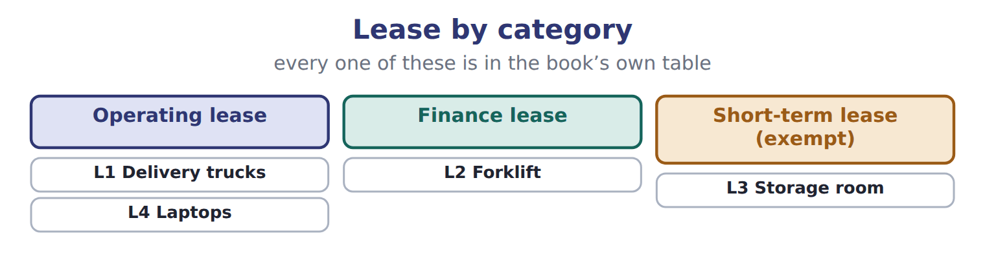
Lease — the book’s own table
Lease | Category
L1 Delivery trucks | Operating lease
L2 Forklift | Finance lease
L3 Storage room | Short-term lease (exempt)
L4 Laptops | Operating lease

READ THE MODEL Every answer is printed above. Find it, do not recall it.

5. Which category does the book give for L1 Delivery trucks?
A. Finance lease | C. Short-term lease (exempt)
B. Operating lease
SORT THEM | Write each one under its category. Every item belongs to exactly one group.
the items: L1 Delivery trucks · L2 Forklift · L3 Storage room · L4 Laptops
Finance lease | Operating lease | Short-term lease (exempt)

APPLY No help on this move.

9. A lessee rents a storage room for 10 months, with no purchase option, and elects the short-term exemption. It:
A. records an ROU asset and a lease liability
B. expenses the payments straight-line and records no ROU asset or liability
C. records a finance lease
D. discloses the lease only in a note, with no expense
10. A lease has no transfer or purchase option, covers 40% of the asset's life, and the PV of payments is 60% of fair value. The asset is standard. The lease is:
A. a finance lease | C. not a lease
B. a short-term lease | D. an operating lease

Criterion — the extract for the question that follows
Criterion | Warehouse (5 years, 100,000 a year) | Olive press (4 years, 250,000 a year)
1. Ownership transfers | No | No
2. Purchase option reasonably certain | No | No
3. Major part of economic life | No: 5 of 30 years (17%) | Yes: 4 of 5 years (80%)
4. PV ≥ substantially all of fair value | No: 421,236 of 1,500,000 (28%) | Not needed
5. Specialized asset | No: any company could use it | Yes: built for Orontes
Classification | Operating lease | Finance lease

11. The extract for this question is printed with it. Why is the olive-press lease a finance lease?
A. The asset is specialized and the term is a major part of its economic life
B. The payments are larger than the warehouse payments
C. Orontes will buy the press at the end
D. All equipment leases are finance leases
WORK IN PAIRS | Compare every answer on this page with your partner before you read any key.
If you disagree: go back to the model and find the row that settles it. The row decides, not the louder voice.
CHECKPOINT 12. Which contract contains a lease?
A. A cleaning company provides staff to clean Orontes's offices
B. A supplier delivers olive oil every month from any of its tanks
C. Orontes rents a specific warehouse for five years and decides how it is used
D. Orontes buys a delivery van
If you got it wrong: redo the READ THE MODEL questions of cycle A with the model in front of you.

CYCLE B | The words this section uses precisely

ORIENT

13. A term in the exam means exactly what the book defines it to mean, whatever it means in ordinary English. TRUE / FALSE
MODEL

The English the exam uses, and what it translates
English (exam term) | the Arabic it translates
finance lease | عقد إيجار تمويلي
lessor | المؤجر

READ THE MODEL

14. A glossary term and its translation are a pair the book itself gives. TRUE / FALSE

APPLY

15. A lease is noncancelable for four years, with a two-year renewal option that the lessee is reasonably certain to use. The lease term is:
A. four years | C. two years
B. six years | D. the asset's economic life
16. Which contract contains a lease?
A. A cleaning company provides staff to clean Orontes's offices
B. A supplier delivers olive oil every month from any of its tanks
C. Orontes rents a specific warehouse for five years and decides how it is used
D. Orontes buys a delivery van
17. A lessee cannot determine the rate implicit in the lease. Which rate does a public company use to measure the lease liability?
A. The risk-free rate | C. Zero
B. Its incremental borrowing rate | D. The lessor's cost of capital
18. Where does Orontes report the principal part of its 2026 olive-press payment in the statement of cash flows?
A. Operating activities | C. It is not a cash flow
B. Investing activities | D. Financing activities
19. The extract for this question is printed with it. Why is the olive-press lease a finance lease?
A. The asset is specialized and the term is a major part of its economic life
B. The payments are larger than the warehouse payments
C. Orontes will buy the press at the end
D. All equipment leases are finance leases
Suppose: January 1, 2026 (whole USD) — the extract for the question that follows
Suppose: January 1, 2026 (whole USD) | Warehouse | Olive press
Annual payment (end of each year) | 100,000 | 250,000
Number of payments | 5 | 4
Discount rate (incremental borrowing rate) | 6% | 6%
Undiscounted payments | 500,000 | 1,000,000
Lease liability = present value of payments | 421,236 | 866,276
Right-of-use asset (no prepayments, costs or incentives) | 421,236 | 866,276

20. The extract for this question is printed with it. At what amount does Orontes first record the warehouse lease liability (whole USD)?
A. 500,000 | C. 100,000
B. 421,236
CHECKPOINT 21. What is the safest way to settle a disagreement about an answer on this sheet?
A. find the row of the model that decides it
B. take the answer of whoever is more confident
C. leave it until the lecturer says
D. choose the longer option
If you got it wrong: redo the READ THE MODEL questions of cycle B.

FROM MEMORY | Close the earlier pages first.
22. Rebuild the figure from this handout. Label every part and fill in every box.
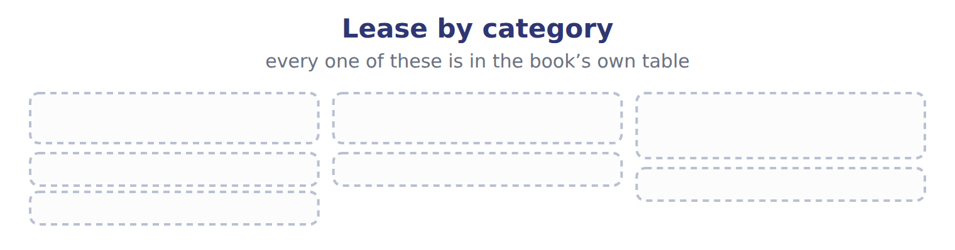
TEACH IT BACK | Write it for a classmate who missed this session — not for the marker.
23. In three or four sentences, write what this section settles and the one rule a reader has to take away.
every one of these words must appear: finance lease · lessor

Handout 14.5
Presentation
section 14.5 of the book
Before you start
Three summaries of this handout, in the book’s own words. Read all three first: together they are the whole session. Then fill the gaps, guessing where you have to.

What this handout settles, cycle by cycle
In this handout | What you will read | How you check it
Presentation | a figure to read · Item · the book’s own rule, gapped | Which of these did this cycle settle?
The words this section uses precisely | The English the exam uses, and what it translates | What is the safest way to settle a disagreement about an answer on this sheet?

Words this handout uses precisely
Words this handout uses precisely | tick it if you could already use it in a sentence
operating lease
residual value guarantee

1. Where the section starts — Fill every gap. The list holds more words than there are gaps, so one or two of them are not used.
choose from: liabilities · right-of-use · residual value guarantee · sale and leaseback · lease
On the balance sheet, the assets and of finance leases are shown separately from those of operating leases, or disclosed with the line items that contain them. Each liability is split into a current part, the principal due within a year, and a noncurrent part.
2. What it settles in the middle — Fill every gap. The list holds more words than there are gaps, so one or two of them are not used.
choose from: residual value guarantee · sale and leaseback · finance lease · operating lease
On the income statement, a shows interest expense and amortization separately; an shows one lease cost in operating expenses. In the statement of cash flows, finance-lease principal is financing; its interest and all operating-lease payments are operating.
3. Where it ends — Fill every gap. The list holds more words than there are gaps, so one or two of them are not used.
choose from: lease · Finance-lease · residual value guarantee · sale and leaseback · Operating-lease
New s are a noncash investing and financing activity, disclosed separately. payments are operating cash flows, even though a liability is on the balance sheet. interest is operating under U.S. GAAP, not financing.
How every cycle on this sheet works
How a cycle works | what you do
MODEL | read the figure or the table before you answer anything
READ THE MODEL | every answer is printed on the same page
INVENT THE RULE | write the rule yourself, then compare with the book
APPLY | no help on this move
CHECKPOINT | mark it yourself; if you miss it, the sheet says what to redo

CYCLE A | Presentation

ORIENT One claim. Decide now; you will check it in a moment.

4. Every number in a financial statement belongs to an element the framework defines. TRUE / FALSE
MODEL Read it before you answer anything below it.

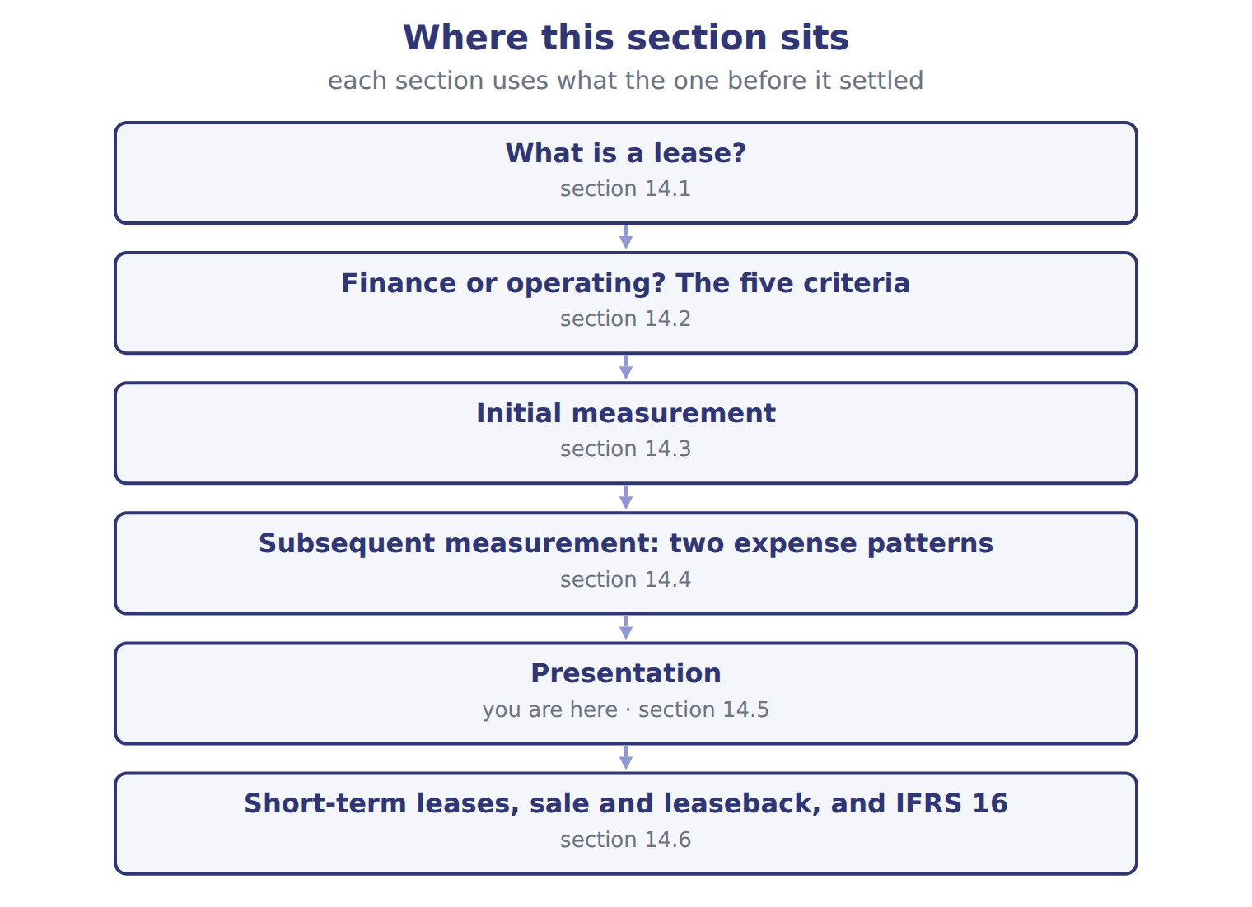
Item — the book’s own table
Item | Finance lease (olive press) | Operating lease (warehouse)
Balance sheet | ROU asset and lease liability, shown separately from operating leases (or disclosed) | ROU asset and lease liability, shown separately from finance leases (or disclosed)
Income statement | Interest expense and amortization, shown separately | One lease cost in operating expenses
Cash flow: principal | Financing | Operating
Cash flow: interest | Operating | Operating (part of the single payment)
Orontes at December 31, 2026 | Liability 668,253: current 209,905, noncurrent 458,348; ROU asset 649,707 | Liability 346,510; ROU asset 346,510

READ THE MODEL Every answer is printed above. Find it, do not recall it.

5. Which part of this chapter is section 14.1?
A. What is a lease?
B. Initial measurement
C. Presentation
D. Finance or operating? The five criteria

INVENT THE RULE

6. Complete the book’s own sentence. The list holds more words than there are gaps.
use every one of these words: operating lease · short-term lease · finance lease · residual value guarantee
On the income statement, a shows interest expense and amortization separately; an shows one lease cost in operating expenses.

Two of the book’s own cases, side by side
Income statement | Cash flow: principal
Finance lease (olive press): Interest expense and amortization, shown separately | Finance lease (olive press): Financing
Only the facts above differ. What is the operating lease (warehouse) of Income statement?
7. Choose one:
A. One lease cost in operating expenses
B. Liability 346,510; ROU asset 346,510
C. Operating (part of the single payment)
D. Operating
APPLY No help on this move.

8. A company sells its head office to a bank and leases it back under a finance lease. Under ASC 842, the transaction is:
A. a sale with the full gain recognized
B. a sale with the gain deferred
C. a failed sale: the company keeps the building and records the cash as a loan
D. an operating lease with no asset
WORK IN PAIRS | Compare every answer on this page with your partner before you read any key.
If you disagree: go back to the model and find the row that settles it. The row decides, not the louder voice.
CHECKPOINT 9. Which of these did this cycle settle?
A. the rule and where it comes from
B. nothing in particular
C. only the vocabulary
D. only the arithmetic
If you got it wrong: redo the READ THE MODEL questions of cycle A.

CYCLE B | The words this section uses precisely

ORIENT

10. A term in the exam means exactly what the book defines it to mean, whatever it means in ordinary English. TRUE / FALSE
MODEL

The English the exam uses, and what it translates
English (exam term) | the Arabic it translates
operating lease | عقد إيجار تشغيلي
residual value guarantee | ضمان القيمة المتبقية

READ THE MODEL

11. A glossary term and its translation are a pair the book itself gives. TRUE / FALSE

APPLY

12. A term on this page means what the book defines it to mean. What settles a disagreement about one?
A. the glossary printed on this page
B. what the word means in ordinary English
C. the translation that sounds closest
D. whichever reading makes the item easier
CHECKPOINT 13. What is the safest way to settle a disagreement about an answer on this sheet?
A. find the row of the model that decides it
B. take the answer of whoever is more confident
C. leave it until the lecturer says
D. choose the longer option
If you got it wrong: redo the READ THE MODEL questions of cycle B.

FROM MEMORY | Close the earlier pages first.
14. Rebuild the figure from this handout. Label every part and fill in every box.
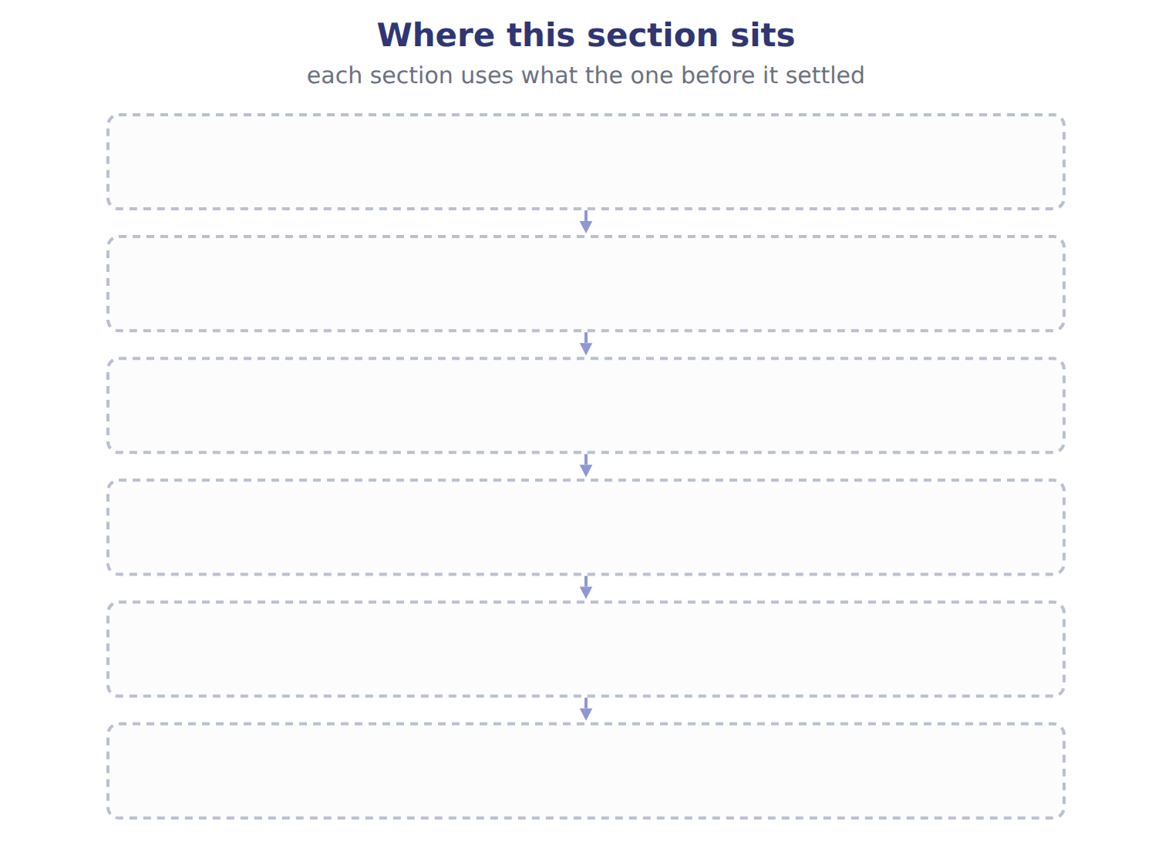
TEACH IT BACK | Write it for a classmate who missed this session — not for the marker.
15. In three or four sentences, write what this section settles and the one rule a reader has to take away.
every one of these words must appear: operating lease · residual value guarantee

Handout 14.6
Short-term leases, sale and leaseback, and IFRS 16
section 14.6 of the book
Before you start
Three summaries of this handout, in the book’s own words. Read all three first: together they are the whole session. Then fill the gaps, guessing where you have to.

What this handout settles, cycle by cycle
In this handout | What you will read | How you check it
Short-term leases, sale and leaseback, and IFRS 16 | a figure to read · Topic · the book’s own rule, gapped | Which of these did this cycle settle?
The words this section uses precisely | Barada Wholesale, leases signed in 2028 (whole U · The English the exam uses, and what it translates | What is the safest way to settle a disagreement about an answer on this sheet?

Words this handout uses precisely
Words this handout uses precisely | tick it if you could already use it in a sentence
short-term lease
sale and leaseback

1. Where the section starts — Fill every gap. The list holds more words than there are gaps, so one or two of them are not used.
choose from: residual value guarantee · lease term · lessee · short-term lease
A lasts 12 months or less and has no purchase option that the is reasonably certain to use. A lessee may choose, by class of asset, to keep such leases off the balance sheet and expense the payments straight-line.
2. What it settles in the middle — Fill every gap. The list holds more words than there are gaps, so one or two of them are not used.
choose from: residual value guarantee · lease term · finance lease · sale and leaseback
In a , a company sells an asset and leases it back. It is a sale only if control passes to the buyer under the revenue rules. If the leaseback is a , or the seller can buy the asset back, there is no sale: the cash received is a loan.
3. Where it ends — Fill every gap. The list holds more words than there are gaps, so one or two of them are not used.
choose from: lease · finance lease · residual value guarantee · lease term · lessee
IFRS 16 has one model: every is accounted for like a , with depreciation and interest. It allows an exemption for low-value assets and remeasures the liability when an index such as CPI changes.
How every cycle on this sheet works
How a cycle works | what you do
MODEL | read the figure or the table before you answer anything
READ THE MODEL | every answer is printed on the same page
INVENT THE RULE | write the rule yourself, then compare with the book
APPLY | no help on this move
CHECKPOINT | mark it yourself; if you miss it, the sheet says what to redo

CYCLE A | Short-term leases, sale and leaseback, and IFRS 16

ORIENT One claim. Decide now; you will check it in a moment.

4. Every number in a financial statement belongs to an element the framework defines. TRUE / FALSE
MODEL Read it before you answer anything below it.

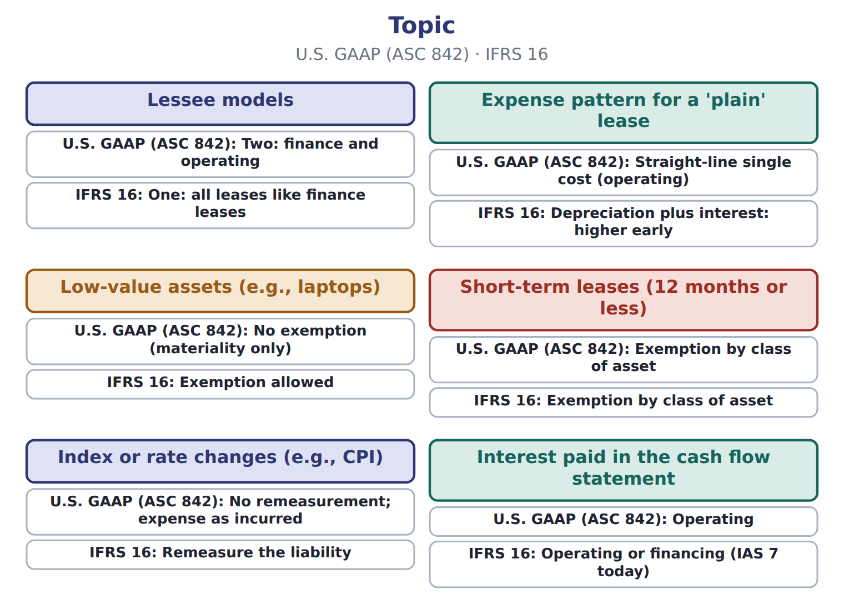

Topic — the book’s own table
Topic | U.S. GAAP (ASC 842) | IFRS 16
Lessee models | Two: finance and operating | One: all leases like finance leases
Expense pattern for a 'plain' lease | Straight-line single cost (operating) | Depreciation plus interest: higher early
Low-value assets (e.g., laptops) | No exemption (materiality only) | Exemption allowed
Short-term leases (12 months or less) | Exemption by class of asset | Exemption by class of asset
Index or rate changes (e.g., CPI) | No remeasurement; expense as incurred | Remeasure the liability
Interest paid in the cash flow statement | Operating | Operating or financing (IAS 7 today)

READ THE MODEL Every answer is printed above. Find it, do not recall it.

5. Which topic does the book pair with “Two: finance and operating”?
A. Interest paid in the cash flow statement
B. Low-value assets (e.g., laptops)
C. Short-term leases (12 months or less)
D. Lessee models
Complete every empty cell. The first full row shows the pattern.
Topic | U.S. GAAP (ASC 842) | IFRS 16
Lessee models | Two: finance and operating | One: all leases like finance leases
Expense pattern for a 'plain' lease
Low-value assets (e.g., laptops)
Short-term leases (12 months or less)
Index or rate changes (e.g., CPI)
Interest paid in the cash flow statement

INVENT THE RULE

11. Complete the book’s own sentence. The list holds more words than there are gaps.
use every one of these words: lessee · finance lease · lease · short-term lease
A lasts 12 months or less and has no purchase option that the is reasonably certain to use.

Two of the book’s own cases, side by side
Lessee models | Expense pattern for a 'plain' lease
U.S. GAAP (ASC 842): Two: finance and operating | U.S. GAAP (ASC 842): Straight-line single cost (operating)
Only the facts above differ. What is the ifrs 16 of Lessee models?
12. Choose one:
A. Depreciation plus interest: higher early
B. One: all leases like finance leases
C. Exemption allowed
D. Exemption by class of asset
APPLY No help on this move.

13. A lessee pays $5,000 of initial direct costs and receives a $3,000 lease incentive. The lease liability is $80,000. What is the ROU asset?
A. $78,000 | C. $82,000
B. $80,000 | D. $88,000

WORK IN PAIRS | Compare every answer on this page with your partner before you read any key.
If you disagree: go back to the model and find the row that settles it. The row decides, not the louder voice.
CHECKPOINT 14. Which of these did this cycle settle?
A. the rule and where it comes from
B. nothing in particular
C. only the vocabulary
D. only the arithmetic
If you got it wrong: redo the READ THE MODEL questions of cycle A.

CYCLE B | The words this section uses precisely

ORIENT

15. A term in the exam means exactly what the book defines it to mean, whatever it means in ordinary English. TRUE / FALSE
MODEL

Barada Wholesale, leases signed in 2028 (whole U — the book’s own table
Barada Wholesale, leases signed in 2028 (whole U | Details
L1 Delivery trucks | 3-year lease from January 1, 2028; 30,000 at the end of each year; economic life 8 years; fair value 150,000; no ownership transfer, no purc
L2 Forklift | 5-year lease with an option to buy the forklift for $1 at the end; Barada is reasonably certain to use it.
L3 Storage room | 10-month lease; no purchase option. Barada applies the short-term exemption.
L4 Laptops | 3-year lease of office laptops; standard terms; no transfer or option.
M1 | Barada's incremental borrowing rate is 8%. The rate implicit in the leases is not known. Barada is not a public business entity but does not
M2 | Present value of an annuity of $1 for 3 years at 8%: 2.5771.

The English the exam uses, and what it translates
English (exam term) | the Arabic it translates
short-term lease | عقد إيجار قصير الأجل
sale and leaseback | البيع وإعادة الاستئجار

READ THE MODEL

16. A glossary term and its translation are a pair the book itself gives. TRUE / FALSE

APPLY

Write the letter of the matching entry beside each topic. Every one is used once.
A Two: finance and operating
B Exemption by class of asset
C Operating
D Straight-line single cost (operating)
E No remeasurement; expense as incurred
F No exemption (materiality only)

17. Lessee models
18. Expense pattern for a 'plain' lease
19. Low-value assets (e.g., laptops)
20. Short-term leases (12 months or less)
21. Index or rate changes (e.g., CPI)
22. Interest paid in the cash flow statement

CHECKPOINT 23. What is the safest way to settle a disagreement about an answer on this sheet?
A. find the row of the model that decides it
B. take the answer of whoever is more confident
C. leave it until the lecturer says
D. choose the longer option
If you got it wrong: redo the READ THE MODEL questions of cycle B.

FROM MEMORY | Close the earlier pages first.
24. Rebuild the figure from this handout. Label every part and fill in every box.
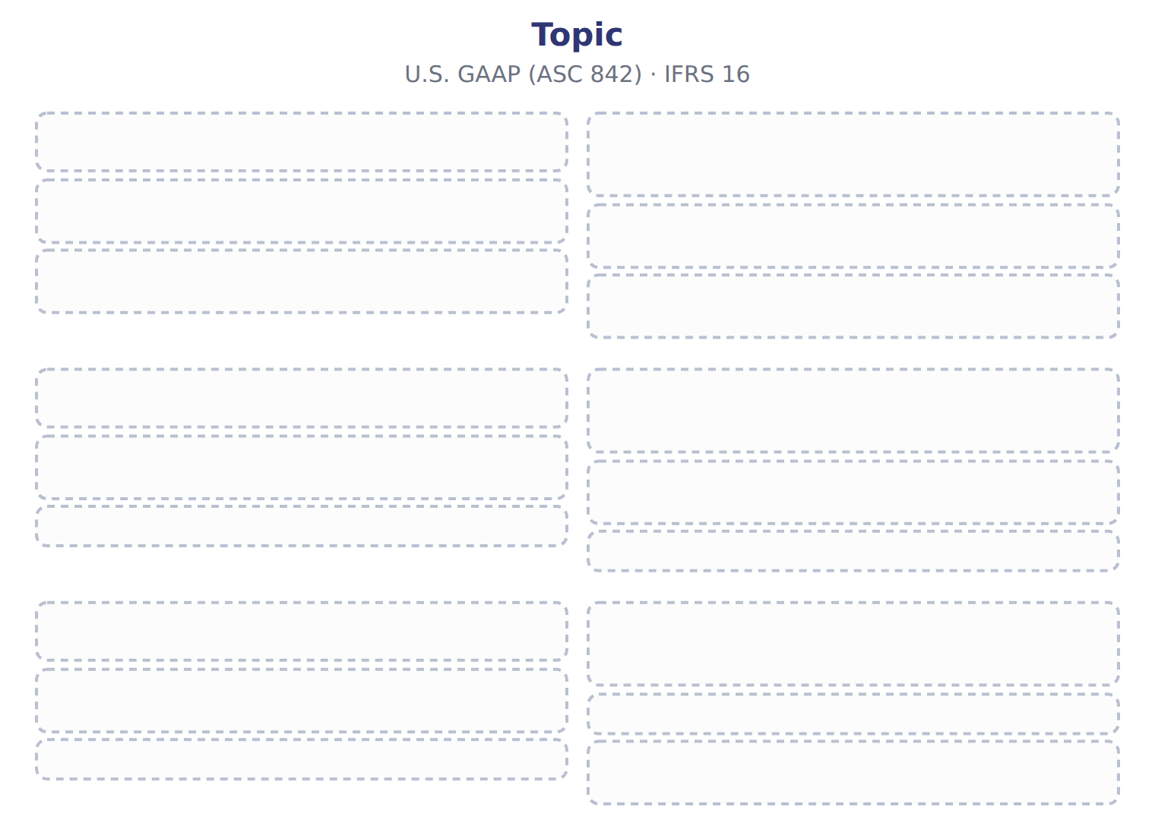
TEACH IT BACK | Write it for a classmate who missed this session — not for the marker.
25. In three or four sentences, write what this section settles and the one rule a reader has to take away.
every one of these words must appear: short-term lease · sale and leaseback

Handout 14.7
The whole chapter
every section, shuffled, and the chapter’s own case set
Before you start
Three summaries of this chapter, in the book’s own words, with words taken out. Read all three first: together they are the whole chapter. Then fill the gaps.

What this handout settles, cycle by cycle
In this handout | What you will read | How you check it
The whole chapter, in order | a figure to read · Suppose: January 1, 2026 (whole USD) | Which payment is included in the lease liability at the start?
The chapter’s case set | The chapter’s case set, item by item | What has to be settled before any figure in a case set is worked out?
The words it uses precisely | lease · right-of-use asset · lease liability · finance lease · operating lease · short-term lease | matching, at the end of cycle B

1. Where the chapter starts — Fill every gap. The list holds more words than there are gaps, so one or two of them are not used.
choose from: residual value guarantee · lease term · lessor · lessee · finance lease · operating lease
The is the period the cannot cancel, plus any renewal periods it is reasonably certain to use. A lessee classifies each lease at the start. It is a if it meets any one of five criteria; otherwise it is an .
2. What it settles in the middle — Fill every gap. The list holds more words than there are gaps, so one or two of them are not used.
choose from: lessor · residual value guarantee · lessee · right-of-use asset · finance lease
For a , the records interest on the liability and, separately, amortization of the , usually straight-line. Interest is highest at the start, when the liability is largest, so total expense falls each year.
3. Where it ends — Fill every gap. The list holds more words than there are gaps, so one or two of them are not used.
choose from: operating lease · lessee · finance lease · residual value guarantee
Each liability is split into a current part, the principal due within a year, and a noncurrent part. On the income statement, a shows interest expense and amortization separately; an shows one lease cost in operating expenses.

CYCLE A | The whole chapter, in order

ORIENT

4. The sections of a chapter have to be taken in order, because each one uses what the one before it settled. TRUE / FALSE
MODEL

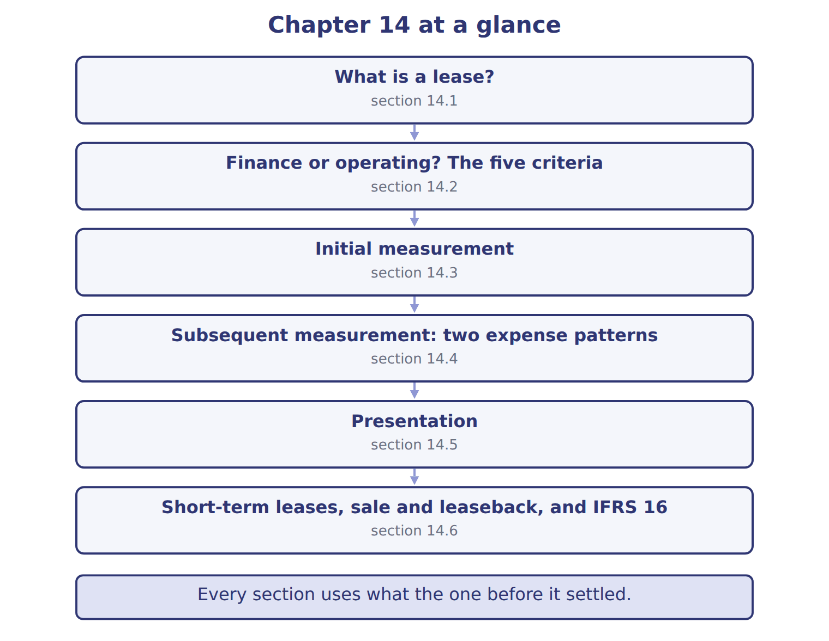

READ THE MODEL

5. Which part of this chapter is section 14.1?
A. Initial measurement
B. Presentation
C. What is a lease?
D. Finance or operating? The five criteria
Write the letter of the section number beside each section title. Every number is used once.
A 14.1 | D 14.4
B 14.2 | E 14.5
C 14.3 | F 14.6

6. What is a lease?
7. Finance or operating? The five criteria
8. Initial measurement
9. Subsequent measurement: two expense patterns
10. Presentation
11. Short-term leases, sale and leaseback, and IFRS 16

APPLY

12. On its income statement, a lessee shows interest expense for:
A. finance leases only | C. both lease types
B. operating leases only | D. neither lease type
13. Where does a lessee disclose a new ROU asset obtained in exchange for a lease liability?
A. As an investing outflow
B. As a financing inflow
C. As a supplemental noncash investing and financing activity
D. It is not disclosed
14. Which party records the right-of-use asset?
A. The lessor | C. The lessee
B. Both | D. Neither

Suppose: January 1, 2026 (whole USD) — the extract for the question that follows
Suppose: January 1, 2026 (whole USD) | Warehouse | Olive press
Annual payment (end of each year) | 100,000 | 250,000
Number of payments | 5 | 4
Discount rate (incremental borrowing rate) | 6% | 6%
Undiscounted payments | 500,000 | 1,000,000
Lease liability = present value of payments | 421,236 | 866,276
Right-of-use asset (no prepayments, costs or incentives) | 421,236 | 866,276

15. The extract for this question is printed with it. At what amount does Orontes first record the warehouse lease liability (whole USD)?
A. 500,000 | C. 100,000
B. 421,236
16. A lessee cannot determine the rate implicit in the lease. Which rate does a public company use to measure the lease liability?
A. The risk-free rate | C. Zero
B. Its incremental borrowing rate | D. The lessor's cost of capital
17. Where does Orontes report the principal part of its 2026 olive-press payment in the statement of cash flows?
A. Operating activities | C. It is not a cash flow
B. Investing activities | D. Financing activities
WORK IN PAIRS | Compare every answer with your partner first.
If you disagree: name the section each question belongs to. Most disagreements turn out to be about the section, not the answer.
CHECKPOINT 18. Which payment is included in the lease liability at the start?
A. Future payments based on the lessee's sales
B. Payments for cleaning services in the same contract
C. Payments after a renewal the lessee does not expect to use
D. A payment that rises each year with the CPI, measured at today's index
If you got it wrong: go back to the MODEL move of cycle A and find the section this question belongs to.

CYCLE B | The chapter’s case set

ORIENT

19. In a case question, the exhibit has to be read and adjusted before any figure is worked out. TRUE / FALSE

MODEL

The chapter’s case set, item by item
Item | What it asks
C14-1 | Classify each lease. (On the exam screen you would drag each lease into a box.)
C14-2 | Enter the lease liability for the trucks (L1) on January 1, 2028.
C14-3 | Enter the 2028 lease cost for the trucks (L1).
C14-4 | Enter the truck lease liability at December 31, 2028.
C14-5 | Enter the truck right-of-use asset at December 31, 2028.
C14-6 | Where does Barada report the 2028 truck payment in its statement of cash flows? [select]

READ THE MODEL

The tasks of a case set have to be worked in one order, because each one uses the result of the one before it. Write the letter of its place beside each task.
A first | D fourth
B second | E fifth
C third | F sixth

20. Classify each lease. (On the exam screen you would drag each lease into a box.)
21. Enter the truck right-of-use asset at December 31, 2028.
22. Enter the lease liability for the trucks (L1) on January 1, 2028.
23. Enter the truck lease liability at December 31, 2028.
24. Enter the 2028 lease cost for the trucks (L1).
25. Where does Barada report the 2028 truck payment in its statement of cash flows? [select]

APPLY

26. How are the payments on an operating lease classified in the statement of cash flows?
A. Operating activities
B. Financing activities
C. Investing activities
D. Split between operating and financing
27. Orontes leases office laptops for three years. Under U.S. GAAP, the lease:
A. can be expensed as a low-value lease
B. is always a finance lease
C. is recognized on the balance sheet; there is no low-value exemption
D. is a short-term lease
CHECKPOINT 28. What has to be settled before any figure in a case set is worked out?
A. the exhibit, adjusted for every note that goes with it
B. the method the company uses
C. the tax rate
D. the order of the items
If you got it wrong: reread the case panel in the MODEL move of cycle B.

FROM MEMORY | Close the earlier pages first.
29. Rebuild the chapter map. Write every section in order and what each one settles.
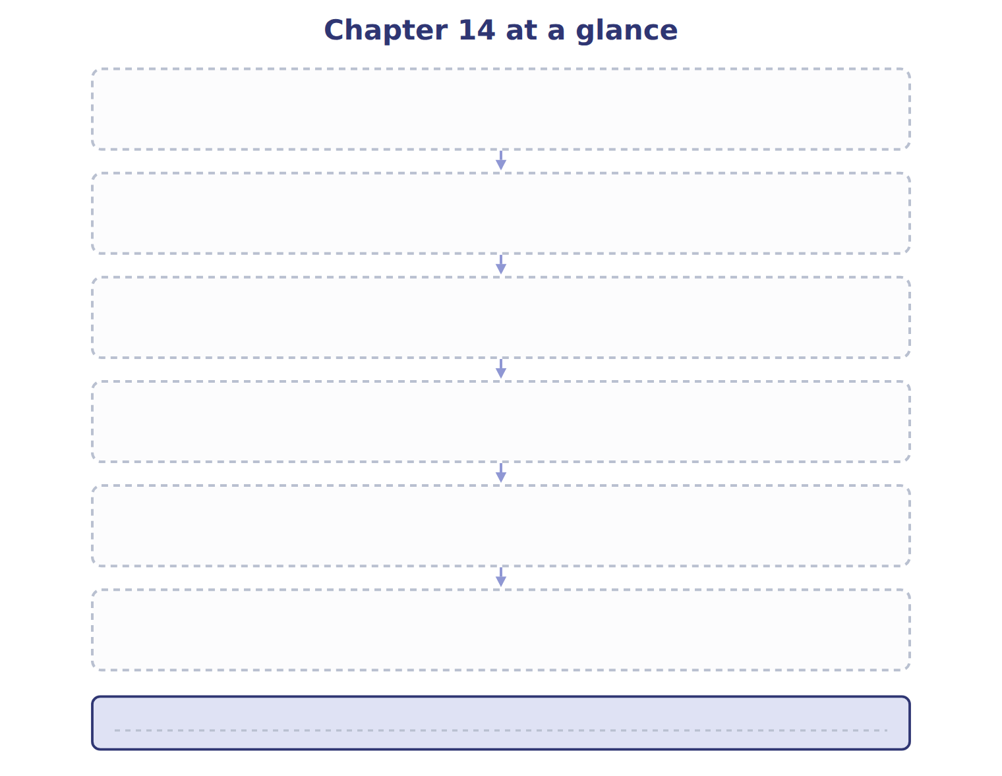
TEACH IT BACK | Write it for a student starting this chapter tomorrow — not for the marker.
30. In four or five sentences, write what the whole chapter settles, section by section.
every one of these words must appear: lease · right-of-use asset · lease liability · finance lease

