Handout 17.1
(i) Share-based payments and employee benefits
section 17.1 of the book
Before you start
Three summaries of this handout, in the book’s own words. Read all three first: together they are the whole session. Then fill the gaps, guessing where you have to.

What this handout settles, cycle by cycle
In this handout | What you will read | How you check it
(i) Share-based payments and employee benefits | a figure to read · Topic · the book’s own rule, gapped | Which of these did this cycle settle?
The words this section uses precisely | a figure to read · Item · The English the exam uses, and what it translates | What is the safest way to settle a disagreement about an answer on this sheet?

Words this handout uses precisely
Words this handout uses precisely | tick it if you could already use it in a sentence
revaluation model
prior service cost
lower of cost and net realizable value (LCNRV)

1. Where the section starts — Fill every gap. The list holds more words than there are gaps, so one or two of them are not used.
choose from: conditions · graded vesting · prior service cost · component depreciation · straight-line
For share awards that vest in parts, or , U.S. GAAP lets a company recognize the cost over the whole period or tranche by tranche, when the awards have only service . IFRS 2 requires tranche by tranche, which puts more expense in the early years.
2. What it settles in the middle — Fill every gap. The list holds more words than there are gaps, so one or two of them are not used.
choose from: recognized · forfeitures · obligation · prior service cost · component depreciation
U.S. GAAP also allows a policy choice to record as they occur; IFRS 2 requires an estimate. Employer payroll taxes on share awards are when the tax arises under U.S. GAAP, but accrued over the vesting period under IFRS.
3. Where it ends — Fill every gap. The list holds more words than there are gaps, so one or two of them are not used.
choose from: component depreciation · remeasurements · defined benefit plan · prior service cost · graded vesting
For a , both frameworks put in OCI. U.S. GAAP later amortizes them into net income; IAS 19 never reclassifies them. Orontes amends its plan and creates of $50,000: U.S. GAAP amortizes $5,000 a year from OCI, while IAS 19 expenses the whole amount at once.

CYCLE A | (i) Share-based payments and employee benefits

ORIENT One claim. Decide now; you will check it in a moment.

4. Every number in a financial statement belongs to an element the framework defines. TRUE / FALSE
MODEL Read it before you answer anything below it.

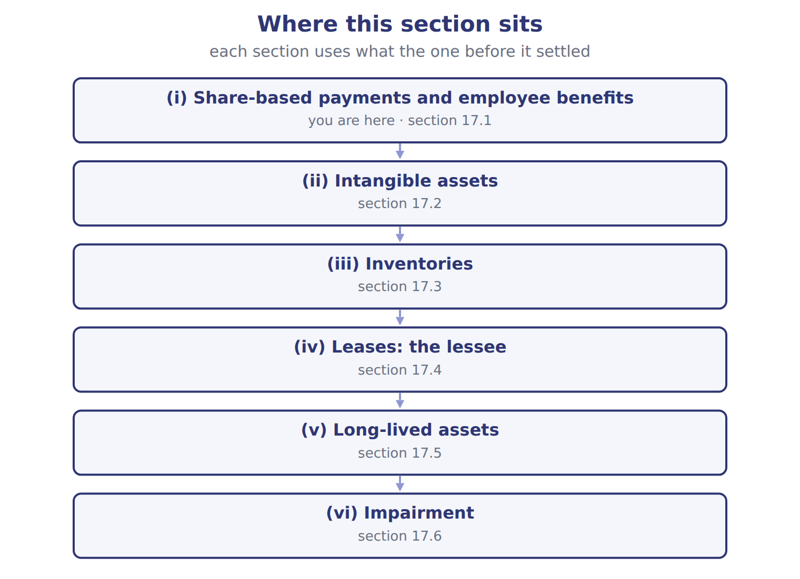

Topic — the book’s own table
Topic | U.S. GAAP (ASC 718, 715) | IFRS (IFRS 2, IAS 19)
Graded vesting (service condition) | Choice: straight-line over the whole period or tranche by tranche | Tranche by tranche
Forfeitures | Policy choice: estimate or record as they occur | Estimate
Employer payroll taxes on awards | When the tax obligation arises (exercise or vesting) | Accrued over the vesting period
Pension remeasurements (actuarial gains and losses) | OCI, then amortized into net income (corridor) | OCI, never reclassified to profit
Return on plan assets | Expected return | Net interest at the discount rate
Prior service cost: Orontes amendment of 50,000 | OCI, amortized over 10 years: 5,000 a year | Expensed at once: 50,000

READ THE MODEL Every answer is printed above. Find it, do not recall it.

5. Which topic does the book pair with “Choice: straight-line over the whole period or tranche by tranche”?
A. Employer payroll taxes on awards
B. Prior service cost: Orontes amendment of 50,000
C. Return on plan assets
D. Graded vesting (service condition)
INVENT THE RULE

6. Complete the book’s own sentence. The list holds more words than there are gaps.
use every one of these words: remeasurements · revaluation model · revaluation surplus · defined benefit plan
For a , both frameworks put in OCI.

Two of the book’s own cases, side by side
Graded vesting (service condition) | Forfeitures
U.S. GAAP (ASC 718, 715): Choice: straight-line over the whole period or tranche by tranche | U.S. GAAP (ASC 718, 715): Policy choice: estimate or record as they occur
Only the facts above differ. What is the ifrs (ifrs 2, ias 19) of Graded vesting (service condition)?
7. Choose one:
A. Estimate
B. Accrued over the vesting period
C. OCI, never reclassified to profit
D. Tranche by tranche

APPLY No help on this move.

8. Orontes, an SEC registrant, wants to amortize its goodwill over 10 years. It:
A. may, using the private-company alternative
B. must amortize over 40 years
C. may, if IFRS allows it
D. may not; only private companies can elect goodwill amortization
9. Under IAS 19, what happens to actuarial losses recognized in OCI?
A. They are amortized into profit over future service
B. They are recognized in profit when the plan is settled
C. They are never reclassified to profit or loss
D. They are reversed the next year
10. Under U.S. GAAP, which return on plan assets reduces pension cost?
A. Interest at the discount rate on plan assets
B. The actual return
C. No return is used
D. The expected return on plan assets
11. Employer payroll taxes on stock options: when does a U.S. company recognize the liability?
A. Evenly over the vesting period
B. When the tax obligation arises, usually at exercise or vesting
C. At grant date
D. Never; it is an employee cost
WORK IN PAIRS | Compare every answer on this page with your partner before you read any key.
If you disagree: go back to the model and find the row that settles it. The row decides, not the louder voice.
CHECKPOINT 12. Which of these did this cycle settle?
A. the rule and where it comes from
B. nothing in particular
C. only the vocabulary
D. only the arithmetic
If you got it wrong: redo the READ THE MODEL questions of cycle A.

CYCLE B | The words this section uses precisely

ORIENT

13. A term in the exam means exactly what the book defines it to mean, whatever it means in ordinary English. TRUE / FALSE
MODEL

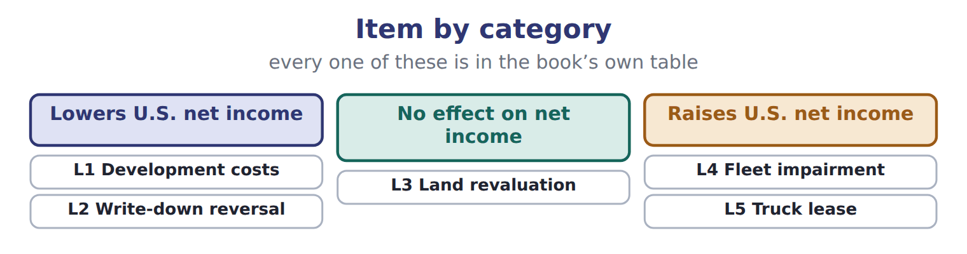

Item — the book’s own table
Item | Category
L1 Development costs | Lowers U.S. net income
L2 Write-down reversal | Lowers U.S. net income
L3 Land revaluation | No effect on net income
L4 Fleet impairment | Raises U.S. net income
L5 Truck lease | Raises U.S. net income

The English the exam uses, and what it translates
English (exam term) | the Arabic it translates
revaluation model | نموذج إعادة التقييم
prior service cost | تكلفة الخدمة السابقة
lower of cost and net realizable value (LCNRV) | التكلفة أو صافي القيمة القابلة للتحقق، أيهما أقل

READ THE MODEL

14. Which category does the book give for L1 Development costs?
A. Raises U.S. net income | C. No effect on net income
B. Lowers U.S. net income
15. Which category does the book give for L2 Write-down reversal?
A. Raises U.S. net income | C. No effect on net income
B. Lowers U.S. net income
16. Which category does the book give for L3 Land revaluation?
A. No effect on net income | C. Raises U.S. net income
B. Lowers U.S. net income
APPLY

17. Which intangible is recognized under BOTH frameworks?
A. A patent bought from another company
B. An internally generated brand
C. Development costs of a new recipe under U.S. GAAP
D. An internally built customer list
18. Inventory with a cost of $80,000 was written down to $70,000. NRV then rises to $85,000. What is the carrying amount under IFRS?
A. $70,000 | C. $80,000
B. $75,000 | D. $85,000
CHECKPOINT 19. What is the safest way to settle a disagreement about an answer on this sheet?
A. find the row of the model that decides it
B. take the answer of whoever is more confident
C. leave it until the lecturer says
D. choose the longer option
If you got it wrong: redo the READ THE MODEL questions of cycle B.

FROM MEMORY | Close the earlier pages first.
20. Rebuild the figure from this handout. Label every part and fill in every box.
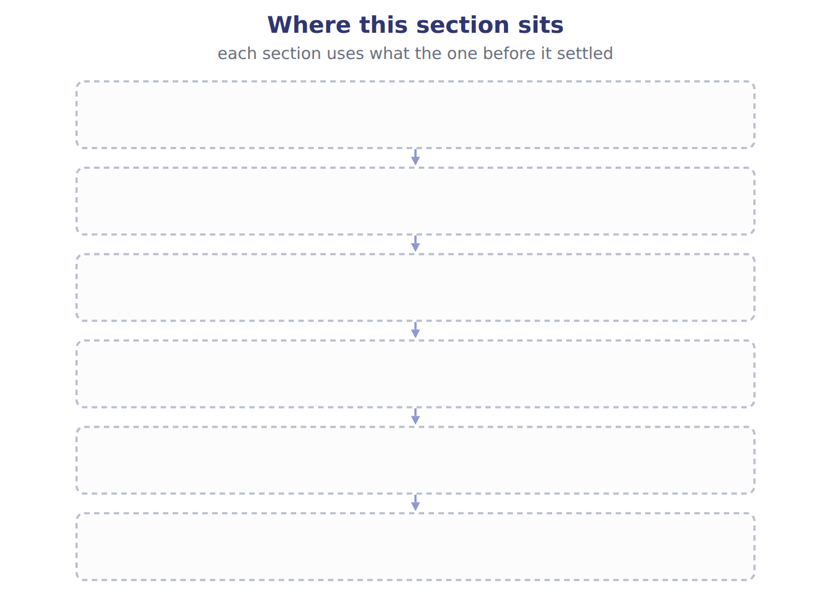
TEACH IT BACK | Write it for a classmate who missed this session — not for the marker.
21. In three or four sentences, write what this section settles and the one rule a reader has to take away.
every one of these words must appear: revaluation model · prior service cost · lower of cost and net realizable value (LCNRV)

Handout 17.2
(ii) Intangible assets
section 17.2 of the book
Before you start
Three summaries of this handout, in the book’s own words. Read all three first: together they are the whole session. Then fill the gaps, guessing where you have to.

What this handout settles, cycle by cycle
In this handout | What you will read | How you check it
(ii) Intangible assets | a figure to read · Topic | Which of these did this cycle settle?
The words this section uses precisely | a figure to read · Item · The English the exam uses, and what it translates | What is the safest way to settle a disagreement about an answer on this sheet?

Words this handout uses precisely
Words this handout uses precisely | tick it if you could already use it in a sentence
revaluation surplus
remeasurements
component depreciation

1. Where the section starts — Fill every gap. The list holds more words than there are gaps, so one or two of them are not used.
choose from: remeasurements · capitalizes · development · component depreciation · feasibility
U.S. GAAP expenses research and as incurred, with narrow exceptions for software. IAS 38 expenses research but development once six criteria are met, such as technical , intention and ability to complete, and a way to generate future benefits.
2. What it settles in the middle — Fill every gap. The list holds more words than there are gaps, so one or two of them are not used.
choose from: intangibles · remeasurements · component depreciation · revaluation model
Under U.S. GAAP the whole amount is an expense; under IFRS it is an intangible asset, amortized once the product is ready. IAS 38 also allows the for , but only where an active market exists, which is rare.
3. Where it ends — Fill every gap. The list holds more words than there are gaps, so one or two of them are not used.
choose from: intangibles · environmental · remeasurements · component depreciation · internal-use
U.S. GAAP never revalues upward. Both frameworks refuse to recognize internally generated brands. ASU 2025-06 simplifies when software costs are capitalized, and ASU 2026-02 creates new rules for credits.
How every cycle on this sheet works
How a cycle works | what you do
MODEL | read the figure or the table before you answer anything
READ THE MODEL | every answer is printed on the same page
INVENT THE RULE | write the rule yourself, then compare with the book
APPLY | no help on this move
CHECKPOINT | mark it yourself; if you miss it, the sheet says what to redo

CYCLE A | (ii) Intangible assets

ORIENT One claim. Decide now; you will check it in a moment.

4. Every number in a financial statement belongs to an element the framework defines. TRUE / FALSE
MODEL Read it before you answer anything below it.

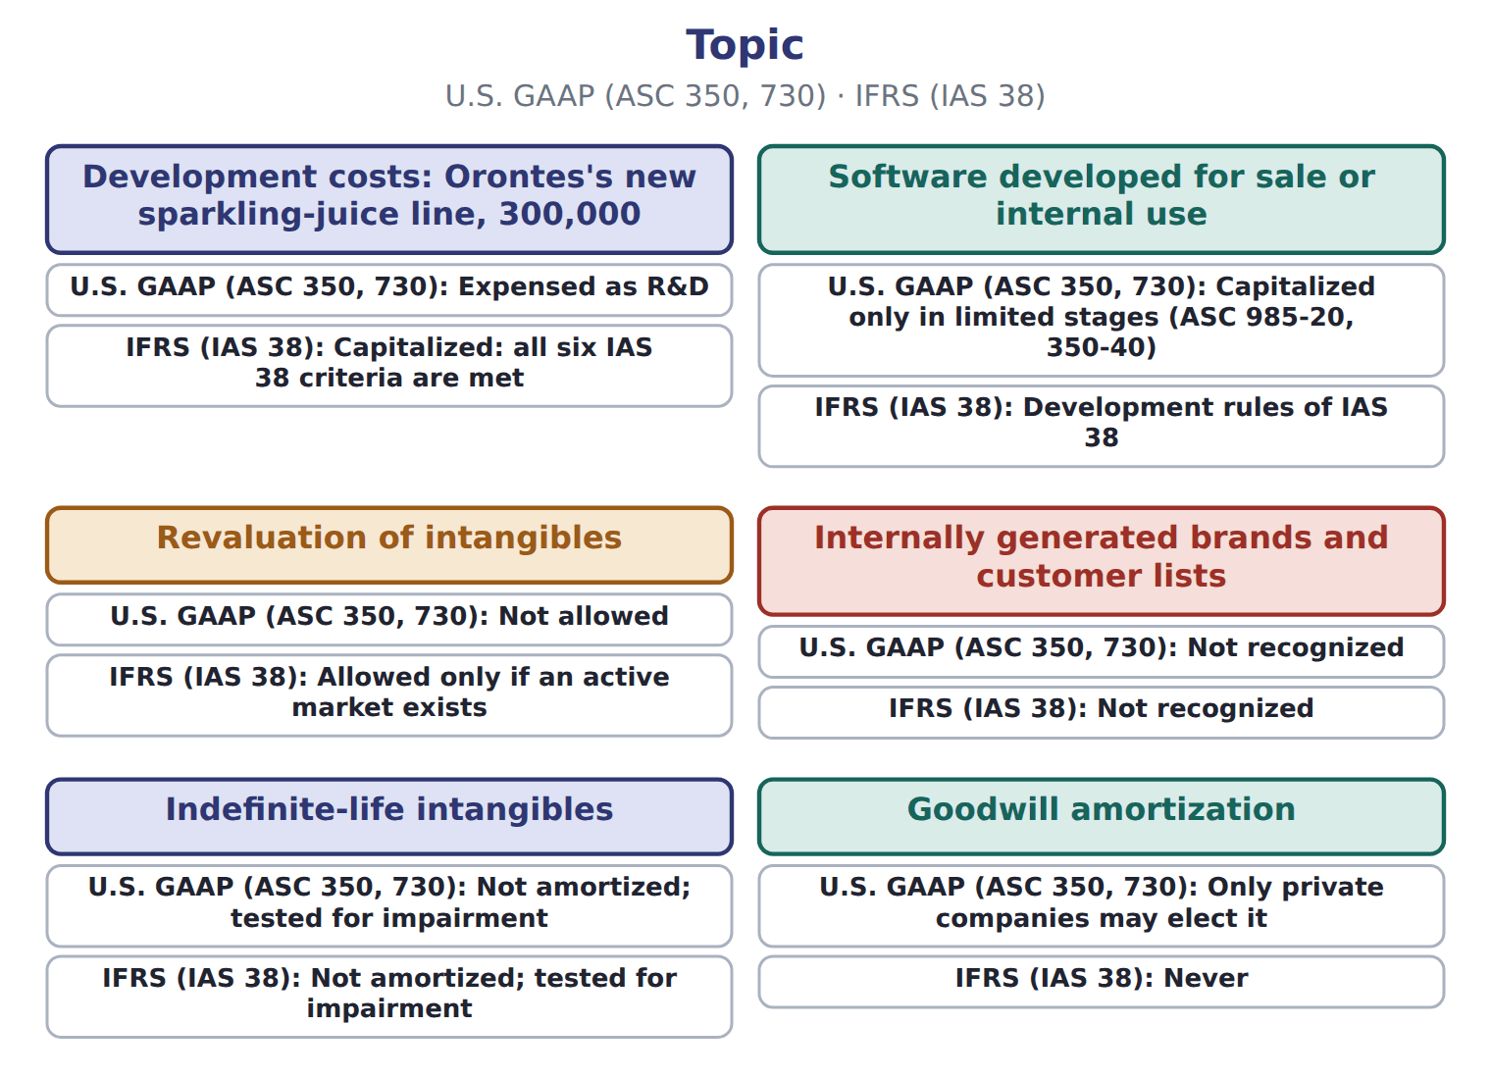

Topic — the book’s own table
Topic | U.S. GAAP (ASC 350, 730) | IFRS (IAS 38)
Development costs: Orontes's new sparkling-juice line, 300,000 | Expensed as R&D | Capitalized: all six IAS 38 criteria are met
Software developed for sale or internal use | Capitalized only in limited stages (ASC 985-20, 350-40) | Development rules of IAS 38
Revaluation of intangibles | Not allowed | Allowed only if an active market exists
Internally generated brands and customer lists | Not recognized | Not recognized
Indefinite-life intangibles | Not amortized; tested for impairment | Not amortized; tested for impairment
Goodwill amortization | Only private companies may elect it | Never

READ THE MODEL Every answer is printed above. Find it, do not recall it.

5. Which topic does the book pair with “Capitalized only in limited stages (ASC 985-20, 350-40)”?
A. Internally generated brands and customer lists
B. Indefinite-life intangibles
C. Software developed for sale or internal use
D. Goodwill amortization
APPLY No help on this move.

6. A U.S. company uses LIFO. Which valuation rule applies at year-end?
A. Lower of cost or market
B. Lower of cost and net realizable value
C. Fair value
D. Replacement cost always
7. Over the whole life of a lease, compared with IFRS 16, a U.S. operating lease gives:
A. a lower total expense
B. the same total expense, spread evenly instead of front-loaded
C. a higher total expense
D. no expense until the lease ends
8. An IFRS company holds an office building to earn rent. It may measure the building:
A. only at cost
B. only at fair value through OCI
C. at replacement cost
D. at fair value through profit or loss, or at cost (IAS 40)
9. Under U.S. GAAP, which measure is compared with the carrying amount in the first step of an impairment test for a held-and-used asset group?
A. Undiscounted future cash flows | C. Recoverable amount
B. Value in use | D. Fair value
WORK IN PAIRS | Compare every answer on this page with your partner before you read any key.
If you disagree: go back to the model and find the row that settles it. The row decides, not the louder voice.
CHECKPOINT 10. Which of these did this cycle settle?
A. the rule and where it comes from
B. nothing in particular
C. only the vocabulary
D. only the arithmetic
If you got it wrong: redo the READ THE MODEL questions of cycle A.

CYCLE B | The words this section uses precisely

ORIENT

11. A term in the exam means exactly what the book defines it to mean, whatever it means in ordinary English. TRUE / FALSE
MODEL

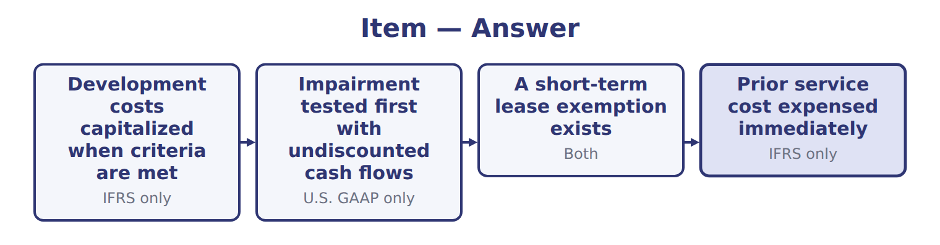
Item — the book’s own table
Item | Answer
Development costs capitalized when criteria are met | IFRS only
Impairment tested first with undiscounted cash flows | U.S. GAAP only
A short-term lease exemption exists | Both
Prior service cost expensed immediately | IFRS only

The English the exam uses, and what it translates
English (exam term) | the Arabic it translates
revaluation surplus | فائض إعادة التقييم
remeasurements | إعادة القياس
component depreciation | الإهلاك حسب المكونات

READ THE MODEL

12. A glossary term and its translation are a pair the book itself gives. TRUE / FALSE
APPLY

13. An asset has a carrying amount of $500,000, fair value less costs of disposal of $420,000 and value in use of $460,000. What is the IFRS impairment loss?
A. $0 | C. $60,000
B. $40,000 | D. $80,000
14. Goodwill was impaired last year. This year the cash-generating unit recovers. Under IFRS, the goodwill impairment is:
A. reversed in full | C. reversed through OCI
B. reversed up to original cost | D. never reversed
15. Which pair shows a correct difference?
A. U.S.: research and development expensed; IFRS: development capitalized when criteria are met
B. U.S.: development capitalized; IFRS: expensed
C. Both capitalize research
D. Both expense all software costs

CHECKPOINT 16. What is the safest way to settle a disagreement about an answer on this sheet?
A. find the row of the model that decides it
B. take the answer of whoever is more confident
C. leave it until the lecturer says
D. choose the longer option
If you got it wrong: redo the READ THE MODEL questions of cycle B.

FROM MEMORY | Close the earlier pages first.
17. Rebuild the figure from this handout. Label every part and fill in every box.
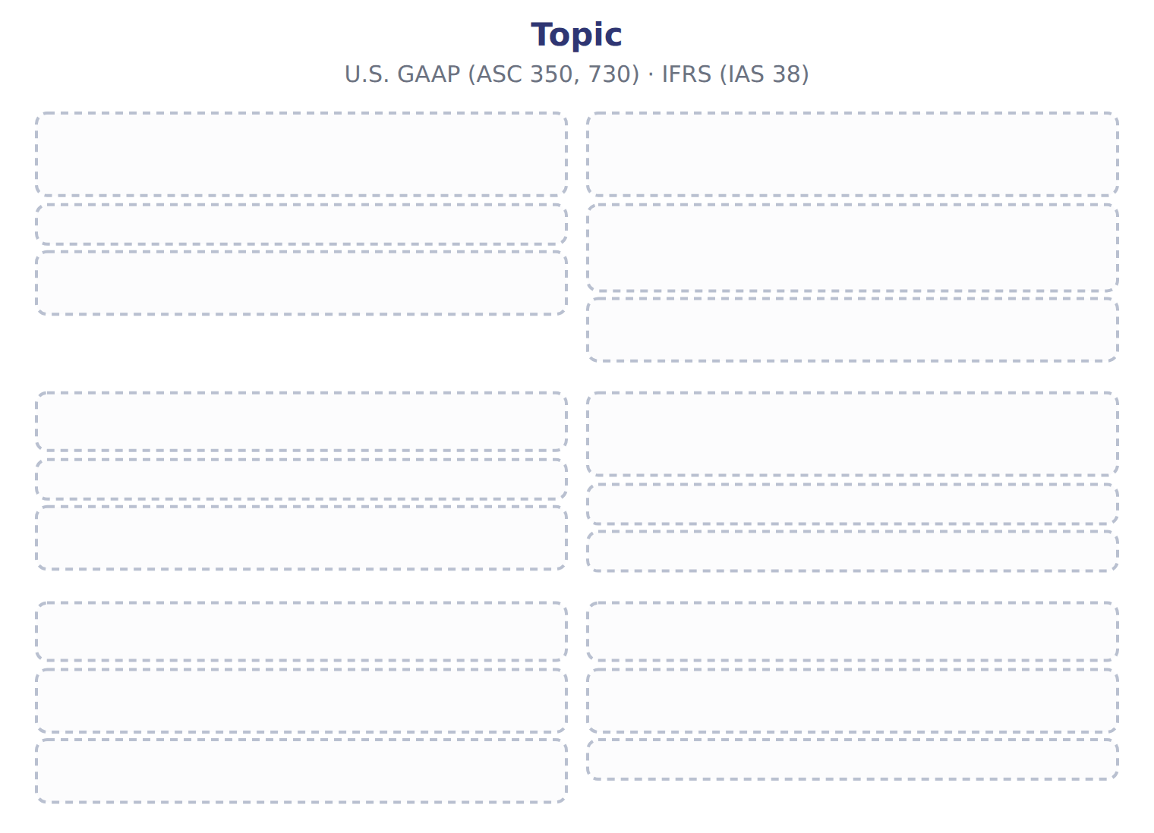
TEACH IT BACK | Write it for a classmate who missed this session — not for the marker.
18. In three or four sentences, write what this section settles and the one rule a reader has to take away.
every one of these words must appear: revaluation surplus · remeasurements · component depreciation

Handout 17.3
(iii) Inventories
section 17.3 of the book
Before you start
Three summaries of this handout, in the book’s own words. Read all three first: together they are the whole session. Then fill the gaps, guessing where you have to.

What this handout settles, cycle by cycle
In this handout | What you will read | How you check it
(iii) Inventories | a figure to read · Item | Which of these did this cycle settle?
The words this section uses precisely | The English the exam uses, and what it translates | What is the safest way to settle a disagreement about an answer on this sheet?

Words this handout uses precisely
Words this handout uses precisely | tick it if you could already use it in a sentence
development costs
graded vesting
fair value less costs of disposal

1. Where the section starts — Fill every gap. The list holds more words than there are gaps, so one or two of them are not used.
choose from: frameworks · statements · recoverability test · financial · value in use
U.S. GAAP allows it, and companies that use LIFO for tax must also use it in their . Chapter 7 showed how LIFO changes cost of goods sold when prices rise. Both write inventory down when its value falls below cost.
2. What it settles in the middle — Fill every gap. The list holds more words than there are gaps, so one or two of them are not used.
choose from: inventory · recoverability test · recovers · value in use · difference
IAS 2 uses the lower of cost and NRV for all . U.S. GAAP uses lower of cost and NRV for FIFO and average cost, but lower of cost or market for LIFO and the retail method. The key comes when value .
3. Where it ends — Fill every gap. The list holds more words than there are gaps, so one or two of them are not used.
choose from: recoverability test · value in use · write-down · depreciation · inventory
IFRS reverses the , but never above the original cost. French stocks means , not shares. French dépréciation des stocks is a write-down, not . In U.S. terms, a write-down reduces the inventory itself; do not call it a provision or a reserve.
How every cycle on this sheet works
How a cycle works | what you do
MODEL | read the figure or the table before you answer anything
READ THE MODEL | every answer is printed on the same page
INVENT THE RULE | write the rule yourself, then compare with the book
APPLY | no help on this move
CHECKPOINT | mark it yourself; if you miss it, the sheet says what to redo

CYCLE A | (iii) Inventories

ORIENT One claim. Decide now; you will check it in a moment.

4. Every number in a financial statement belongs to an element the framework defines. TRUE / FALSE
MODEL Read it before you answer anything below it.

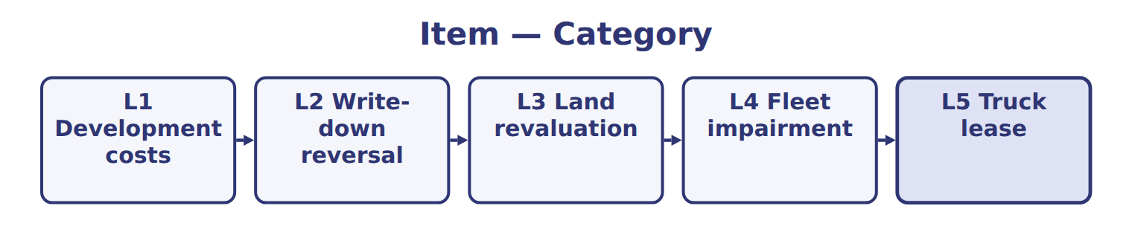
Item — the book’s own table
Item | Category
L1 Development costs
L2 Write-down reversal
L3 Land revaluation
L4 Fleet impairment
L5 Truck lease

READ THE MODEL Every answer is printed above. Find it, do not recall it.

5. Which part of this chapter is section 17.2?
A. (ii) Intangible assets | C. (iii) Inventories
B. (v) Long-lived assets | D. (iv) Leases: the lessee
APPLY No help on this move.

6. A lessee's payments rise each year with the CPI. After a CPI increase, under IFRS 16 the lessee:
A. expenses the increase with no remeasurement
B. remeasures the lease liability
C. reclassifies the lease
D. records a gain
7. Which pair shows a correct difference?
A. U.S.: research and development expensed; IFRS: development capitalized when criteria are met
B. U.S.: development capitalized; IFRS: expensed
C. Both capitalize research
D. Both expense all software costs
WORK IN PAIRS | Compare every answer on this page with your partner before you read any key.
If you disagree: go back to the model and find the row that settles it. The row decides, not the louder voice.
CHECKPOINT 8. Which of these did this cycle settle?
A. the rule and where it comes from
B. nothing in particular
C. only the vocabulary
D. only the arithmetic
If you got it wrong: redo the READ THE MODEL questions of cycle A.

CYCLE B | The words this section uses precisely

ORIENT

9. A term in the exam means exactly what the book defines it to mean, whatever it means in ordinary English. TRUE / FALSE
MODEL

The English the exam uses, and what it translates
English (exam term) | the Arabic it translates
development costs | تكاليف التطوير
graded vesting | الاستحقاق المتدرج
fair value less costs of disposal | القيمة العادلة ناقصاً تكاليف الاستبعاد

READ THE MODEL

10. A glossary term and its translation are a pair the book itself gives. TRUE / FALSE
APPLY

11. A term on this page means what the book defines it to mean. What settles a disagreement about one?
A. the glossary printed on this page
B. what the word means in ordinary English
C. the translation that sounds closest
D. whichever reading makes the item easier
CHECKPOINT 12. What is the safest way to settle a disagreement about an answer on this sheet?
A. find the row of the model that decides it
B. take the answer of whoever is more confident
C. leave it until the lecturer says
D. choose the longer option
If you got it wrong: redo the READ THE MODEL questions of cycle B.

FROM MEMORY | Close the earlier pages first.
13. Rebuild the figure from this handout. Label every part and fill in every box.

TEACH IT BACK | Write it for a classmate who missed this session — not for the marker.
14. In three or four sentences, write what this section settles and the one rule a reader has to take away.
every one of these words must appear: development costs · graded vesting · fair value less costs of disposal

Handout 17.4
(iv) Leases: the lessee
section 17.4 of the book
Before you start
Three summaries of this handout, in the book’s own words. Read all three first: together they are the whole session. Then fill the gaps, guessing where you have to.

What this handout settles, cycle by cycle
In this handout | What you will read | How you check it
(iv) Leases: the lessee | a figure to read · Topic | Which of these did this cycle settle?
The words this section uses precisely | The English the exam uses, and what it translates | What is the safest way to settle a disagreement about an answer on this sheet?

Words this handout uses precisely
Words this handout uses precisely | tick it if you could already use it in a sentence
value in use
defined benefit plan
recoverability test

1. Where the section starts — Fill every gap. The list holds more words than there are gaps, so one or two of them are not used.
choose from: depreciation · right-of-use · straight-line · recoverable amount · recoverability test
IFRS 16 has one lessee model: every lease is treated like a finance lease, with of the asset plus interest. U.S. GAAP keeps two models, and an operating lease has one cost.
2. What it settles in the middle — Fill every gap. The list holds more words than there are gaps, so one or two of them are not used.
choose from: remeasures · recoverable amount · recoverability test · classifies · exemption
Over the whole lease, total expense is the same. IFRS 16 also allows an for low-value assets, the liability when an index such as CPI changes, and lease principal as financing.
3. Where it ends — Fill every gap from the list. The list holds more words than there are gaps.
choose from: No exemption · Operating · One straight-line lease cost: 100,000 · Full gain if a sale · Not remeasured · Two: finance and operating
The book’s own table “Topic” settles these: for Lessee models it is , for Warehouse lease, 2026 expense (Chapter 14) it is , for Low-value assets it is and for Index-linked payments (CPI) it is .
How every cycle on this sheet works
How a cycle works | what you do
MODEL | read the figure or the table before you answer anything
READ THE MODEL | every answer is printed on the same page
INVENT THE RULE | write the rule yourself, then compare with the book
APPLY | no help on this move
CHECKPOINT | mark it yourself; if you miss it, the sheet says what to redo

CYCLE A | (iv) Leases: the lessee

ORIENT One claim. Decide now; you will check it in a moment.

4. Every number in a financial statement belongs to an element the framework defines. TRUE / FALSE
MODEL Read it before you answer anything below it.

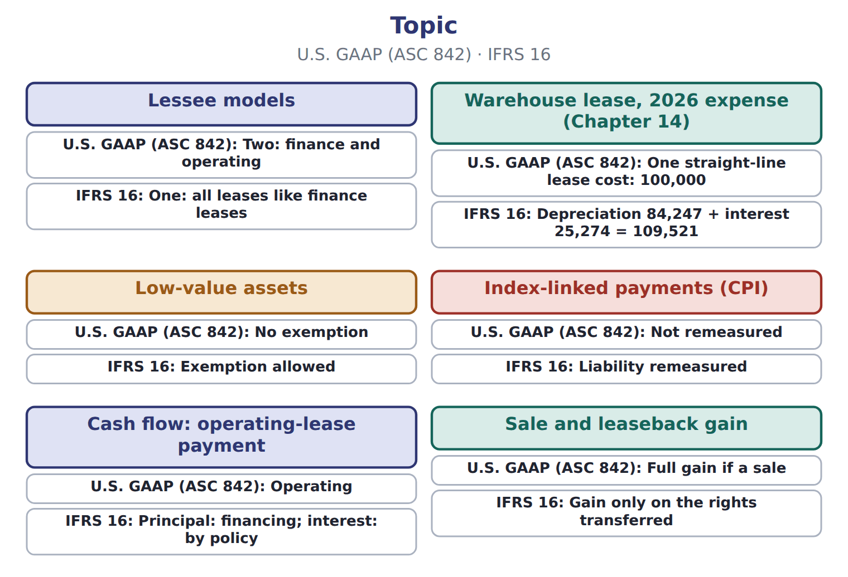
Topic — the book’s own table
Topic | U.S. GAAP (ASC 842) | IFRS 16
Lessee models | Two: finance and operating | One: all leases like finance leases
Warehouse lease, 2026 expense (Chapter 14) | One straight-line lease cost: 100,000 | Depreciation 84,247 + interest 25,274 = 109,521
Low-value assets | No exemption | Exemption allowed
Index-linked payments (CPI) | Not remeasured | Liability remeasured
Cash flow: operating-lease payment | Operating | Principal: financing; interest: by policy
Sale and leaseback gain | Full gain if a sale | Gain only on the rights transferred

READ THE MODEL Every answer is printed above. Find it, do not recall it.

5. Which topic does the book pair with “Two: finance and operating”?
A. Warehouse lease, 2026 expense (Chapter 14)
B. Lessee models
C. Sale and leaseback gain
D. Low-value assets

APPLY No help on this move.

6. Under IFRS, a company borrows specifically to build a plant and earns interest on unspent funds. The capitalized borrowing cost is:
A. interest incurred, with no deduction
B. zero
C. interest incurred minus the investment income earned on the borrowed funds
D. investment income only
WORK IN PAIRS | Compare every answer on this page with your partner before you read any key.
If you disagree: go back to the model and find the row that settles it. The row decides, not the louder voice.
CHECKPOINT 7. Which of these did this cycle settle?
A. the rule and where it comes from
B. nothing in particular
C. only the vocabulary
D. only the arithmetic
If you got it wrong: redo the READ THE MODEL questions of cycle A.

CYCLE B | The words this section uses precisely

ORIENT

8. A term in the exam means exactly what the book defines it to mean, whatever it means in ordinary English. TRUE / FALSE
MODEL

The English the exam uses, and what it translates
English (exam term) | the Arabic it translates
value in use | القيمة من الاستخدام
defined benefit plan | خطة المنافع المحددة
recoverability test | اختبار قابلية الاسترداد

READ THE MODEL

9. A glossary term and its translation are a pair the book itself gives. TRUE / FALSE
APPLY

Write the letter of the matching entry beside each topic. Every one is used once.
A Two: finance and operating
B Not remeasured
C Operating
D No exemption
E Full gain if a sale
F One straight-line lease cost: 100,000

10. Lessee models
11. Warehouse lease, 2026 expense (Chapter 14)
12. Low-value assets
13. Index-linked payments (CPI)
14. Cash flow: operating-lease payment
15. Sale and leaseback gain

CHECKPOINT 16. What is the safest way to settle a disagreement about an answer on this sheet?
A. find the row of the model that decides it
B. take the answer of whoever is more confident
C. leave it until the lecturer says
D. choose the longer option
If you got it wrong: redo the READ THE MODEL questions of cycle B.

FROM MEMORY | Close the earlier pages first.
17. Rebuild the figure from this handout. Label every part and fill in every box.
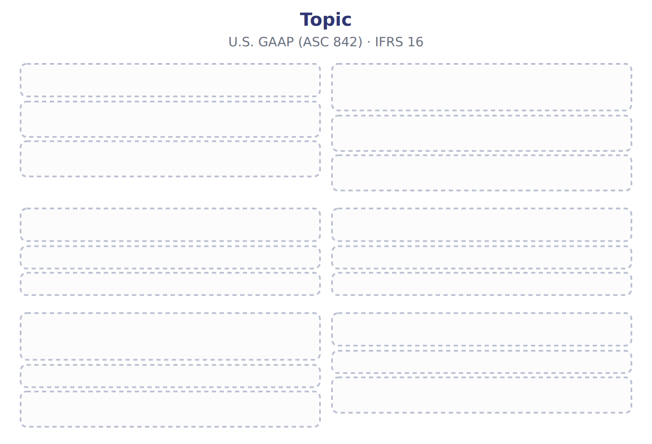
TEACH IT BACK | Write it for a classmate who missed this session — not for the marker.
18. In three or four sentences, write what this section settles and the one rule a reader has to take away.
every one of these words must appear: value in use · defined benefit plan · recoverability test

Handout 17.5
(v) Long-lived assets
section 17.5 of the book
Before you start
Three summaries of this handout, in the book’s own words. Read all three first: together they are the whole session. Then fill the gaps, guessing where you have to.

What this handout settles, cycle by cycle
In this handout | What you will read | How you check it
(v) Long-lived assets | a figure to read · Topic · the book’s own rule, gapped | Which of these did this cycle settle?
The words this section uses precisely | The English the exam uses, and what it translates | What is the safest way to settle a disagreement about an answer on this sheet?

Words this handout uses precisely
Words this handout uses precisely | tick it if you could already use it in a sentence
recoverable amount
research and development (R&D)

1. Where the section starts — Fill every gap. The list holds more words than there are gaps, so one or two of them are not used.
choose from: defined benefit plan · development costs · revaluation model · revaluation surplus
U.S. GAAP carries property, plant and equipment at cost less depreciation. IAS 16 also allows the for a whole class of assets: the assets are carried at fair value, and increases go to a in OCI.
2. What it settles in the middle — Fill every gap. The list holds more words than there are gaps, so one or two of them are not used.
choose from: Orontes · revaluation model · development costs · defined benefit plan
Under U.S. GAAP it stays at cost. Under IFRS, if chose the , it would show the land at fair value and a surplus of $600,000 in OCI.
3. Where it ends — Fill every gap. The list holds more words than there are gaps, so one or two of them are not used.
choose from: defined benefit plan · component depreciation · construction · development costs
IFRS requires for significant parts with different lives; U.S. GAAP allows but does not require it. Both frameworks capitalize borrowing costs on assets under , but IFRS deducts income earned on specific borrowings.
How every cycle on this sheet works
How a cycle works | what you do
MODEL | read the figure or the table before you answer anything
READ THE MODEL | every answer is printed on the same page
INVENT THE RULE | write the rule yourself, then compare with the book
APPLY | no help on this move
CHECKPOINT | mark it yourself; if you miss it, the sheet says what to redo

CYCLE A | (v) Long-lived assets

ORIENT One claim. Decide now; you will check it in a moment.

4. Every number in a financial statement belongs to an element the framework defines. TRUE / FALSE
MODEL Read it before you answer anything below it.

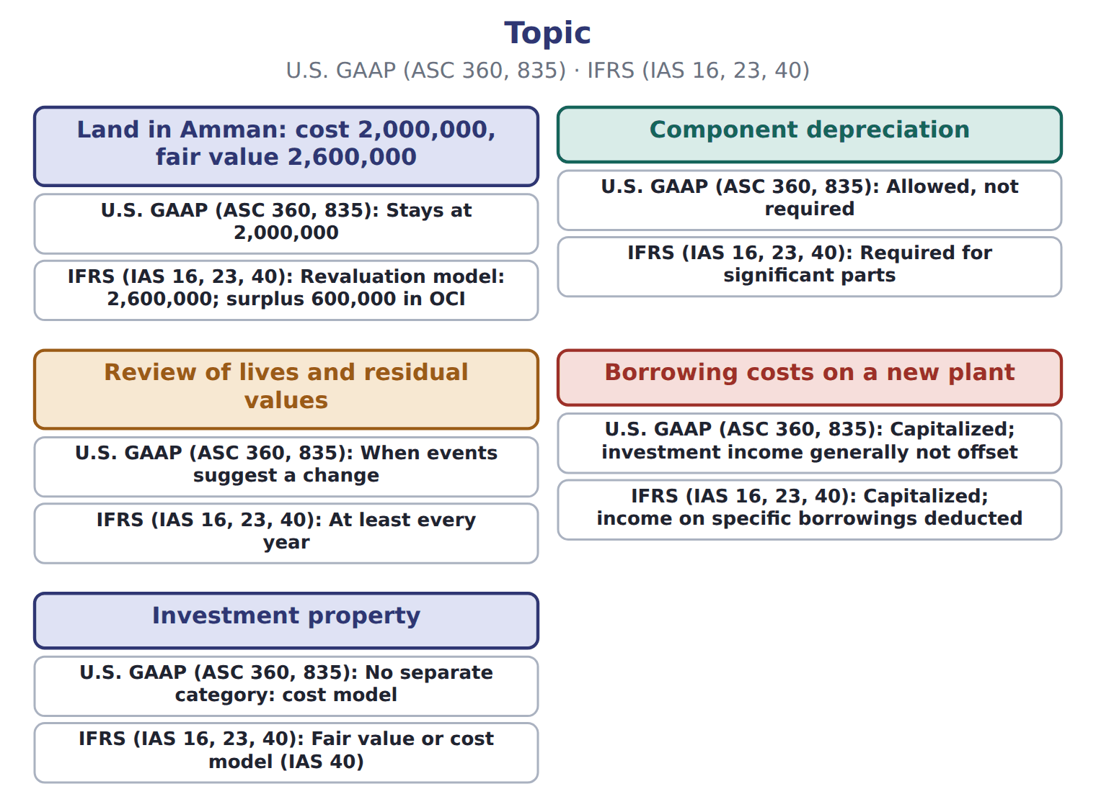
Topic — the book’s own table
Topic | U.S. GAAP (ASC 360, 835) | IFRS (IAS 16, 23, 40)
Land in Amman: cost 2,000,000, fair value 2,600,000 | Stays at 2,000,000 | Revaluation model: 2,600,000; surplus 600,000 in OCI
Component depreciation | Allowed, not required | Required for significant parts
Review of lives and residual values | When events suggest a change | At least every year
Borrowing costs on a new plant | Capitalized; investment income generally not offset | Capitalized; income on specific borrowings deducted
Investment property | No separate category: cost model | Fair value or cost model (IAS 40)

READ THE MODEL Every answer is printed above. Find it, do not recall it.

5. Which topic does the book pair with “Stays at 2,000,000”?
A. Component depreciation
B. Investment property
C. Land in Amman: cost 2,000,000, fair value 2,600,000
D. Review of lives and residual values

INVENT THE RULE

6. Complete the book’s own sentence. The list holds more words than there are gaps.
use every one of these words: revaluation model · revaluation surplus · value in use · recoverable amount
IAS 16 also allows the for a whole class of assets: the assets are carried at fair value, and increases go to a in OCI.

Two of the book’s own cases, side by side
Component depreciation | Review of lives and residual values
U.S. GAAP (ASC 360, 835): Allowed, not required | U.S. GAAP (ASC 360, 835): When events suggest a change
Only the facts above differ. What is the ifrs (ias 16, 23, 40) of Component depreciation?
7. Choose one:
A. Fair value or cost model (IAS 40)
B. At least every year
C. Required for significant parts
APPLY No help on this move.

8. What is the IFRS equivalent of a U.S. 'asset group' in impairment testing?
A. A reporting unit | C. A disposal group
B. A cash-generating unit | D. A component of an entity
WORK IN PAIRS | Compare every answer on this page with your partner before you read any key.
If you disagree: go back to the model and find the row that settles it. The row decides, not the louder voice.
CHECKPOINT 9. Which of these did this cycle settle?
A. the rule and where it comes from
B. nothing in particular
C. only the vocabulary
D. only the arithmetic
If you got it wrong: redo the READ THE MODEL questions of cycle A.

CYCLE B | The words this section uses precisely

ORIENT

10. A term in the exam means exactly what the book defines it to mean, whatever it means in ordinary English. TRUE / FALSE
MODEL

The English the exam uses, and what it translates
English (exam term) | the Arabic it translates
recoverable amount | المبلغ القابل للاسترداد
research and development (R&D) | البحث والتطوير

READ THE MODEL

11. A glossary term and its translation are a pair the book itself gives. TRUE / FALSE

APPLY

Write the letter of the matching entry beside each topic. Every one is used once.
A Stays at 2,000,000
B Capitalized; investment income generally not offset
C No separate category: cost model
D Allowed, not required
E When events suggest a change

12. Land in Amman: cost 2,000,000, fair value 2,600,000
13. Component depreciation
14. Review of lives and residual values
15. Borrowing costs on a new plant
16. Investment property

CHECKPOINT 17. What is the safest way to settle a disagreement about an answer on this sheet?
A. find the row of the model that decides it
B. take the answer of whoever is more confident
C. leave it until the lecturer says
D. choose the longer option
If you got it wrong: redo the READ THE MODEL questions of cycle B.

FROM MEMORY | Close the earlier pages first.
18. Rebuild the figure from this handout. Label every part and fill in every box.
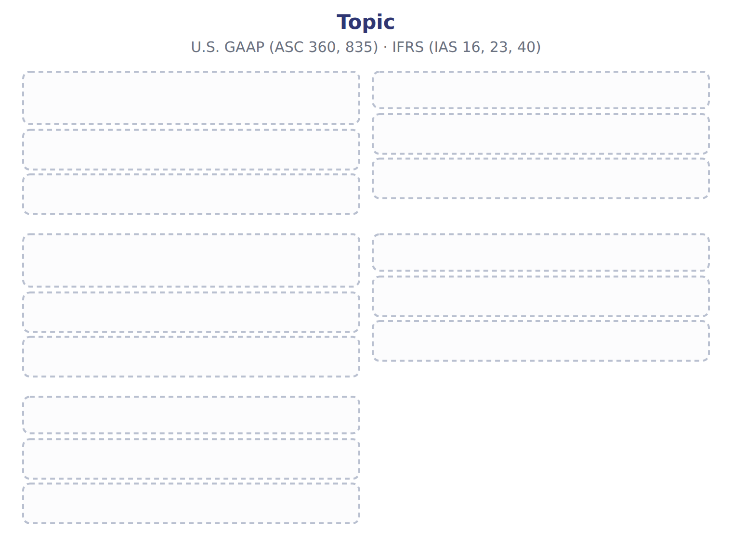
TEACH IT BACK | Write it for a classmate who missed this session — not for the marker.
19. In three or four sentences, write what this section settles and the one rule a reader has to take away.
every one of these words must appear: recoverable amount · research and development (R&D)

Handout 17.6
(vi) Impairment
section 17.6 of the book
Before you start
Three summaries of this handout, in the book’s own words. Read all three first: together they are the whole session. Then fill the gaps, guessing where you have to.

What this handout settles, cycle by cycle
In this handout | What you will read | How you check it
(vi) Impairment | a figure to read · Suppose: Levant Distribution LLC, 2027 (USD 000) | Which of these did this cycle settle?
The words this section uses precisely | a figure to read · Statement · The English the exam uses, and what it translates | What is the safest way to settle a disagreement about an answer on this sheet?

Words this handout uses precisely
Words this handout uses precisely | tick it if you could already use it in a sentence
cash-generating unit
net realizable value (NRV)

1. Where the section starts — Fill every gap. The list holds more words than there are gaps, so one or two of them are not used.
choose from: graded vesting · undiscounted · compares · held-and-used · cash-generating unit
U.S. GAAP tests a asset group in two steps. First, it the carrying amount with future cash flows.
2. What it settles in the middle — Fill every gap. The list holds more words than there are gaps, so one or two of them are not used.
choose from: cash-generating unit · value in use · graded vesting · fair value less costs of disposal · revaluation model · recoverable amount
Only if the carrying amount is higher does it measure a loss, equal to the carrying amount minus fair value. It compares the carrying amount of an asset or with its : the higher of and , a discounted cash-flow measure.
3. Where it ends — Fill every gap. The list holds more words than there are gaps, so one or two of them are not used.
choose from: held-and-used · graded vesting · cash-generating unit · recoverable amount
The frameworks also differ after the loss. IFRS reverses an impairment when the rises, but not for goodwill and not above the carrying amount without the loss. U.S. GAAP never reverses an impairment of a asset or of goodwill.
How every cycle on this sheet works
How a cycle works | what you do
MODEL | read the figure or the table before you answer anything
READ THE MODEL | every answer is printed on the same page
INVENT THE RULE | write the rule yourself, then compare with the book
APPLY | no help on this move
CHECKPOINT | mark it yourself; if you miss it, the sheet says what to redo

CYCLE A | (vi) Impairment

ORIENT One claim. Decide now; you will check it in a moment.

4. Every number in a financial statement belongs to an element the framework defines. TRUE / FALSE
MODEL Read it before you answer anything below it.

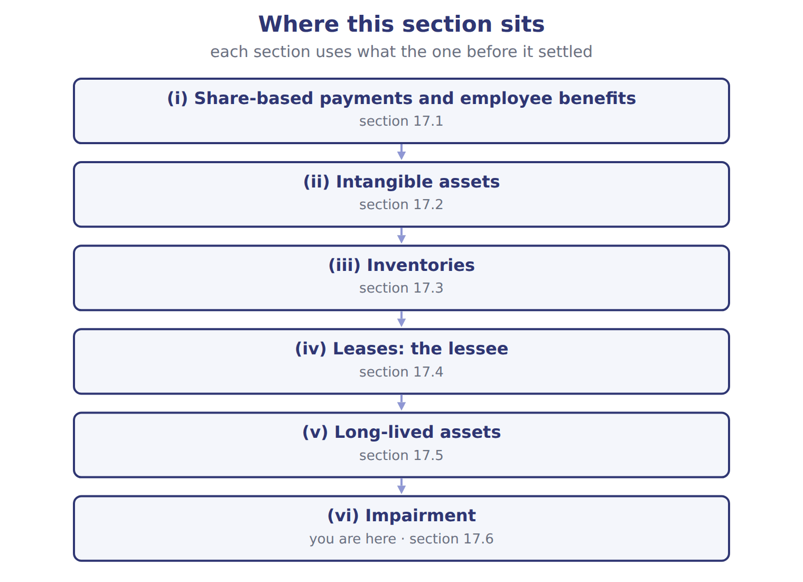

Suppose: Levant Distribution LLC, 2027 (USD 000) — the book’s own table
Suppose: Levant Distribution LLC, 2027 (USD 000) | Amount / details
Levant's 2027 net income under IFRS (local books) | 1,114
L1 | Development costs of a new ordering app capitalized in 2027 under IAS 38: 240. None is amortized yet.
L2 | A 2026 inventory write-down was reversed in 2027 under IAS 2: gain of 30.
L3 | Warehouse land revalued upward by 400; the surplus is in OCI.
L4 | Delivery fleet: IAS 36 impairment loss of 50; carrying amount now 450. Undiscounted cash flows are higher than the carrying amount before th
L5 | Truck lease: IFRS 16 expense 78; as a U.S. operating lease, the straight-line cost would be 72.
M1 | Orontes must convert Levant's figures to U.S. GAAP before consolidation (Chapter 16). Ignore tax effects.

READ THE MODEL Every answer is printed above. Find it, do not recall it.

5. Which part of this chapter is section 17.2?
A. (ii) Intangible assets | C. (iii) Inventories
B. (v) Long-lived assets | D. (iv) Leases: the lessee
APPLY No help on this move.

6. You have just written the rule this cycle settles. What decides whether your wording is right?
A. the model printed earlier in this cycle
B. how confident you felt writing it
C. the length of the sentence you wrote
D. whichever wording your partner used
WORK IN PAIRS | Compare every answer on this page with your partner before you read any key.
If you disagree: go back to the model and find the row that settles it. The row decides, not the louder voice.
CHECKPOINT 7. Which of these did this cycle settle?
A. the rule and where it comes from
B. nothing in particular
C. only the vocabulary
D. only the arithmetic
If you got it wrong: redo the READ THE MODEL questions of cycle A.

CYCLE B | The words this section uses precisely

ORIENT

8. A term in the exam means exactly what the book defines it to mean, whatever it means in ordinary English. TRUE / FALSE

MODEL

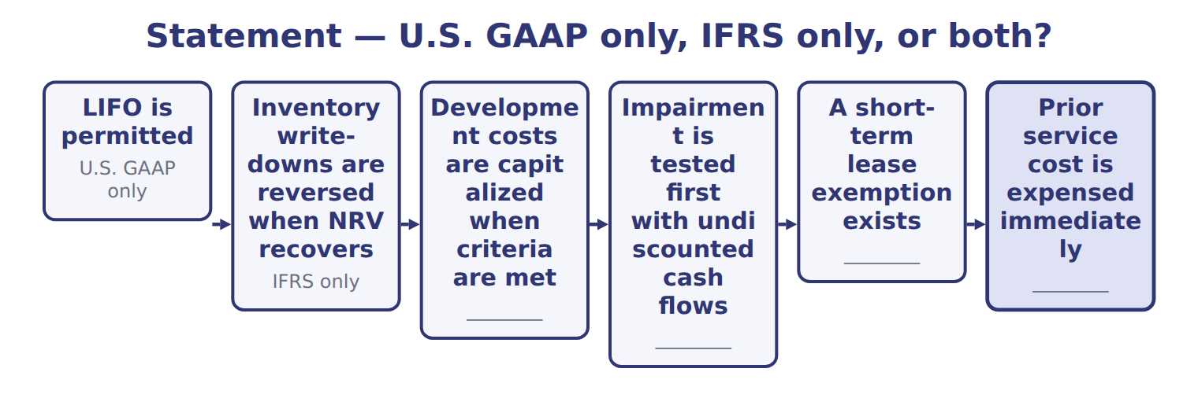
Statement — the book’s own table
Statement | U.S. GAAP only, IFRS only, or both?
LIFO is permitted | U.S. GAAP only
Inventory write-downs are reversed when NRV recovers | IFRS only
Development costs are capitalized when criteria are met | ________
Impairment is tested first with undiscounted cash flows | ________
A short-term lease exemption exists | ________
Prior service cost is expensed immediately | ________

The English the exam uses, and what it translates
English (exam term) | the Arabic it translates
cash-generating unit | وحدة توليد النقد
net realizable value (NRV) | صافي القيمة القابلة للتحقق

READ THE MODEL

9. Which statement does the book pair with “U.S. GAAP only”?
A. Impairment is tested first with undiscounted cash flows
B. Inventory write-downs are reversed when NRV recovers
C. A short-term lease exemption exists
D. LIFO is permitted
APPLY

SORT THEM | Write each one under the heading it belongs to. Every item belongs to exactly one group.
the items: LIFO is permitted · Inventory write-downs are reversed when NRV recovers · Development costs are capitalized when criteria are met · Impairment is tested first with undiscounted cash flows · A short-term lease exemption exists · Prior service cost is expensed immediately
IFRS only | U.S. GAAP only | ________

CHECKPOINT 13. What is the safest way to settle a disagreement about an answer on this sheet?
A. find the row of the model that decides it
B. take the answer of whoever is more confident
C. leave it until the lecturer says
D. choose the longer option
If you got it wrong: redo the READ THE MODEL questions of cycle B.

FROM MEMORY | Close the earlier pages first.
14. Rebuild the figure from this handout. Label every part and fill in every box.
TEACH IT BACK | Write it for a classmate who missed this session — not for the marker.
15. In three or four sentences, write what this section settles and the one rule a reader has to take away.
every one of these words must appear: cash-generating unit · net realizable value (NRV)

Handout 17.7
The whole chapter
every section, shuffled, and the chapter’s own case set
Before you start
Three summaries of this chapter, in the book’s own words, with words taken out. Read all three first: together they are the whole chapter. Then fill the gaps.

What this handout settles, cycle by cycle
In this handout | What you will read | How you check it
The whole chapter, in order | a figure to read · Topic | The extract for this question is printed with it. How much of Orontes's prior service cost is recognized in 2027 net income under IAS 19 and under U.S. GAAP (whole USD)?
The chapter’s case set | The chapter’s case set, item by item · Topic | What has to be settled before any figure in a case set is worked out?
The words it uses precisely | revaluation model · revaluation surplus · development costs · value in use · recoverable amount · cash-generating unit | matching, at the end of cycle B

1. Where the chapter starts — Fill every gap. The list holds more words than there are gaps, so one or two of them are not used.
choose from: cash-generating unit · defined benefit plan · prior service cost · remeasurements · development costs · component depreciation
For a , both frameworks put in OCI. U.S. GAAP later amortizes them into net income; IAS 19 never reclassifies them. Orontes amends its plan and creates of $50,000: U.S. GAAP amortizes $5,000 a year from OCI, while IAS 19 expenses the whole amount at once. The largest intangibles difference is .
2. What it settles in the middle — Fill every gap. The list holds more words than there are gaps, so one or two of them are not used.
choose from: cash-generating unit · statements · financial · component depreciation · frameworks
U.S. GAAP allows it, and companies that use LIFO for tax must also use it in their . Chapter 7 showed how LIFO changes cost of goods sold when prices rise. Both write inventory down when its value falls below cost.
3. Where it ends — Fill every gap. The list holds more words than there are gaps, so one or two of them are not used.
choose from: component depreciation · fair value less costs of disposal · value in use · revaluation model · recoverable amount · cash-generating unit
Only if the carrying amount is higher does it measure a loss, equal to the carrying amount minus fair value. It compares the carrying amount of an asset or with its : the higher of and , a discounted cash-flow measure.

CYCLE A | The whole chapter, in order

ORIENT

4. The sections of a chapter have to be taken in order, because each one uses what the one before it settled. TRUE / FALSE
MODEL

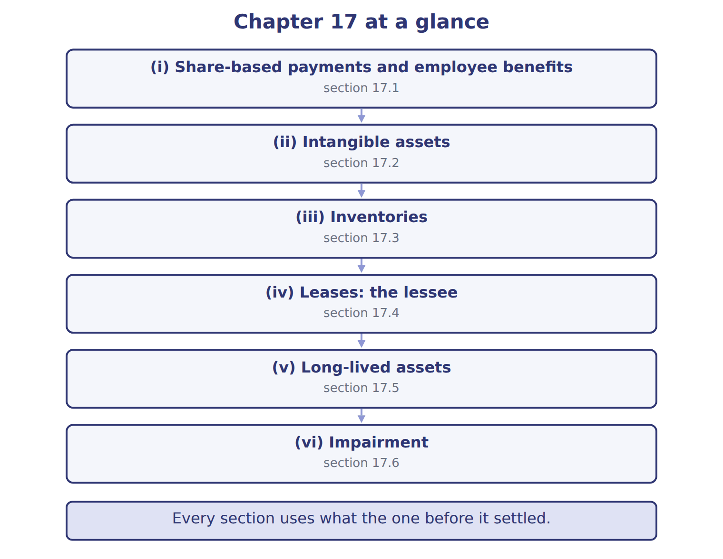
READ THE MODEL

Write the letter of the section number beside each section title. Every number is used once.
A 17.1 | D 17.4
B 17.2 | E 17.5
C 17.3 | F 17.6

5. (i) Share-based payments and employee benefits
6. (ii) Intangible assets
7. (iii) Inventories
8. (iv) Leases: the lessee
9. (v) Long-lived assets
10. (vi) Impairment

APPLY

11. A French subsidiary using IFRS wants to adopt LIFO to lower its taxable profit. Under IFRS, it:
A. cannot use LIFO
B. may use LIFO if it also uses it for tax
C. may use LIFO for part of its inventory
D. must use LIFO when prices rise
Topic — the extract for the question that follows
Topic | U.S. GAAP (ASC 842) | IFRS 16
Lessee models | Two: finance and operating | One: all leases like finance leases
Warehouse lease, 2026 expense (Chapter 14) | One straight-line lease cost: 100,000 | Depreciation 84,247 + interest 25,274 = 109,521
Low-value assets | No exemption | Exemption allowed
Index-linked payments (CPI) | Not remeasured | Liability remeasured
Cash flow: operating-lease payment | Operating | Principal: financing; interest: by policy
Sale and leaseback gain | Full gain if a sale | Gain only on the rights transferred

12. The extract for this question is printed with it. What is the warehouse lease expense for 2026 under IFRS 16 (whole USD)?
A. 25,274 | C. 100,000
B. 84,247 | D. 109,521
13. Which lessee rule exists under IFRS 16 but NOT under ASC 842?
A. An exemption for leases of 12 months or less
B. A right-of-use asset for most leases
C. An exemption for leases of low-value assets
D. Discounting the lease payments
Topic — the extract for the question that follows
Topic | U.S. GAAP (ASC 360, 835) | IFRS (IAS 16, 23, 40)
Land in Amman: cost 2,000,000, fair value 2,600,000 | Stays at 2,000,000 | Revaluation model: 2,600,000; surplus 600,000 in OCI
Component depreciation | Allowed, not required | Required for significant parts
Review of lives and residual values | When events suggest a change | At least every year
Borrowing costs on a new plant | Capitalized; investment income generally not offset | Capitalized; income on specific borrowings deducted
Investment property | No separate category: cost model | Fair value or cost model (IAS 40)

14. The extract for this question is printed with it. Under IFRS with the revaluation model, where does the $600,000 increase in the land's value go?
A. To net income as a gain | C. To retained earnings directly
B. Nowhere; land stays at cost | D. To OCI, as a revaluation surplus
15. An aircraft has an engine that lasts 5 years and a body that lasts 25 years. Which statement is correct?
A. IFRS requires the parts to be depreciated separately; U.S. GAAP allows but does not require it
B. U.S. GAAP requires component depreciation; IFRS does not
C. Both prohibit component depreciation
D. Only the body is depreciated
WORK IN PAIRS | Compare every answer with your partner first.
If you disagree: name the section each question belongs to. Most disagreements turn out to be about the section, not the answer.

Topic — the extract for the question that follows
Topic | U.S. GAAP (ASC 718, 715) | IFRS (IFRS 2, IAS 19)
Graded vesting (service condition) | Choice: straight-line over the whole period or tranche by tranche | Tranche by tranche
Forfeitures | Policy choice: estimate or record as they occur | Estimate
Employer payroll taxes on awards | When the tax obligation arises (exercise or vesting) | Accrued over the vesting period
Pension remeasurements (actuarial gains and losses) | OCI, then amortized into net income (corridor) | OCI, never reclassified to profit
Return on plan assets | Expected return | Net interest at the discount rate
Prior service cost: Orontes amendment of 50,000 | OCI, amortized over 10 years: 5,000 a year | Expensed at once: 50,000

CHECKPOINT 16. The extract for this question is printed with it. How much of Orontes's prior service cost is recognized in 2027 net income under IAS 19 and under U.S. GAAP (whole USD)?
A. IFRS 5,000; U.S. 50,000
B. Both 50,000
C. Both 5,000
D. IFRS 50,000; U.S. 5,000
If you got it wrong: go back to the MODEL move of cycle A and find the section this question belongs to.

CYCLE B | The chapter’s case set

ORIENT

17. In a case question, the exhibit has to be read and adjusted before any figure is worked out. TRUE / FALSE

MODEL

The chapter’s case set, item by item
Item | What it asks
C17-1 | How does each item change Levant's net income when it is converted to U.S. GAAP? (On the exam screen you would drag each
C17-2 | Enter the net decrease in Levant's 2027 net income on conversion to U.S. GAAP.
C17-3 | Enter Levant's 2027 net income under U.S. GAAP.
C17-4 | Enter the carrying amount of the delivery fleet under U.S. GAAP.
C17-5 | By how much is Levant's equity lower under U.S. GAAP than under IFRS?
C17-6 | Under U.S. GAAP, Levant's 2027 inventory write-down reversal is: [select]

READ THE MODEL

The tasks of a case set have to be worked in one order, because each one uses the result of the one before it. Write the letter of its place beside each task.
A first | D fourth
B second | E fifth
C third

18. Under U.S. GAAP, Levant's 2027 inventory write-down reversal is: [select]
19. By how much is Levant's equity lower under U.S. GAAP than under IFRS?
20. Enter Levant's 2027 net income under U.S. GAAP.
21. Enter the carrying amount of the delivery fleet under U.S. GAAP.
22. Enter the net decrease in Levant's 2027 net income on conversion to U.S. GAAP.

APPLY

Topic — the extract for the question that follows
Topic | U.S. GAAP (ASC 718, 715) | IFRS (IFRS 2, IAS 19)
Graded vesting (service condition) | Choice: straight-line over the whole period or tranche by tranche | Tranche by tranche
Forfeitures | Policy choice: estimate or record as they occur | Estimate
Employer payroll taxes on awards | When the tax obligation arises (exercise or vesting) | Accrued over the vesting period
Pension remeasurements (actuarial gains and losses) | OCI, then amortized into net income (corridor) | OCI, never reclassified to profit
Return on plan assets | Expected return | Net interest at the discount rate
Prior service cost: Orontes amendment of 50,000 | OCI, amortized over 10 years: 5,000 a year | Expensed at once: 50,000

23. A company grants share options that vest one third each year for three years (service condition only). Which statement is correct?
A. Both frameworks require straight-line recognition
B. U.S. GAAP allows straight-line or tranche-by-tranche recognition; IFRS 2 requires tranche by tranche
C. U.S. GAAP requires tranche by tranche; IFRS allows a choice
D. Neither framework recognizes expense until vesting

CHECKPOINT 24. What has to be settled before any figure in a case set is worked out?
A. the exhibit, adjusted for every note that goes with it
B. the method the company uses
C. the tax rate
D. the order of the items
If you got it wrong: reread the case panel in the MODEL move of cycle B.

FROM MEMORY | Close the earlier pages first.
25. Rebuild the chapter map. Write every section in order and what each one settles.
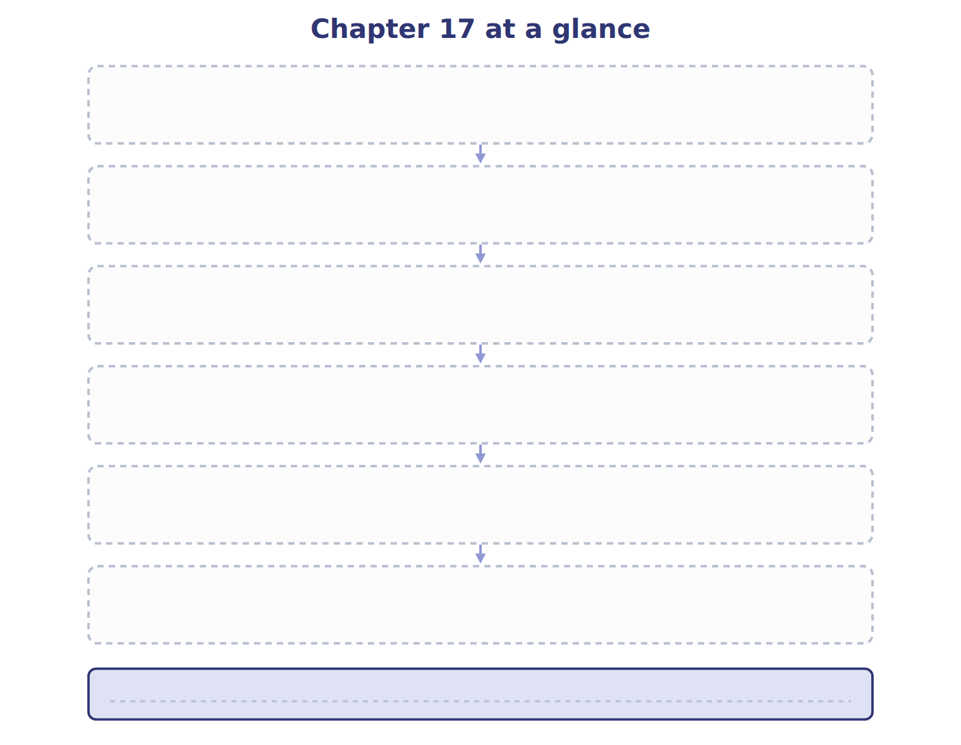
TEACH IT BACK | Write it for a student starting this chapter tomorrow — not for the marker.
26. In four or five sentences, write what the whole chapter settles, section by section.
every one of these words must appear: revaluation model · revaluation surplus · development costs · value in use

