Table of Contents

B1.2 · Unit 1 · What the Canteen Buys
English Animated · Weighing It Up · Hospital Regional, Valdivia Student's Book pages 6–27 · 22 pp · ~11 hours

Part 0 · The Big Picture ◆ A · THE WORLD
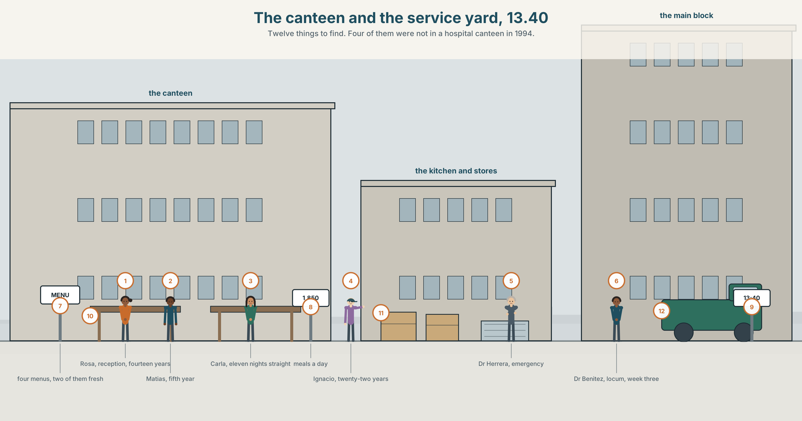{width=6.6in}
The canteen and the service yard, 13.40 — Twelve things to find. Four of them were not in a hospital canteen in 1994.

What did we used to eat?
By the end of this unit you can describe how eating changed in one family or one region across two generations. One hundred and fifty words.
◆ A · THE WORLD | What a hospital feeds four hundred people a day, and who decides
◆ B · THE SYSTEM | used to · would · be used to · get used to · 23 words for diet and change · 22 words for habit · used to against use to
◆ C · THE PERFORMANCE | A hundred and fifty words on two generations of one kitchen

0A · Find it
Find twelve things in this picture. Four of them were not in a hospital canteen in 1994.
a steam counter · a vending machine · a tray rail · a till · a salad bar · a tinned-fruit shelf · a staff notice · a menu board · a wall clock · a recycling point · a water dispenser · a cold cabinet

0B · Guess it
Two things on the menu board cost the hospital almost nothing and two cost it a great deal. Which, and does the price on the board tell you which is which?

0C · Say it ⏺
Record forty-five seconds. What did your grandparents eat that you do not? Name three things, and say what replaced each one. You will record it again at the end of this unit.

Part 1 · Vocabulary Lab 1 ◆ B · THE SYSTEM
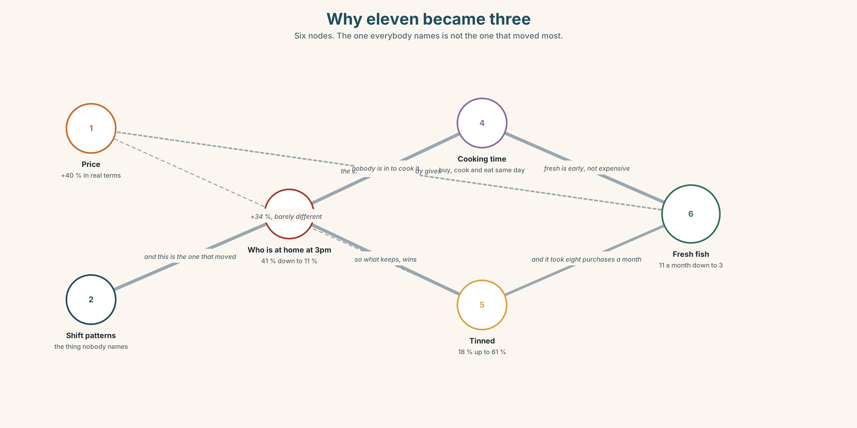{width=6.6in}
Why eleven became three — Six nodes. The one everybody names is not the one that moved most.

1A · Meet — what is on the plate
Match each word to one place on the map.
diet · portion · staple · seasonal · processed · fresh · tinned · recipe · household · budget

1B · Sort — the food, the money, or the habit?
Three columns.
portion · staple · budget · recipe · processed · canteen · generation · seasonal · household
One of them changes column the moment there is less money. Which, and why?

1C · Meet — the words that sound neutral and are not
processed · convenience food · home cooking
All three describe how something was made. Which two carry a judgement, and who is being judged?

1D · Collocation Lab
Complete each one with one word.
- The ward meeting has agreed to cut ______ on salt across all four menus.
- Rosa says nobody in her family ever ______ out until she was nineteen.
- Potatoes are a ______ of this region and always have been.
- Carla grew ______ on tinned fruit and does not think badly of it.
- He lives ______ whatever is left at the end of a night shift.
- They ______ up on flour in March because the road closes.

1E · The fixed expressions
f We never had that. f Nobody cooked like that.
Two sentences from the same conversation, and only one of them is a complaint.
Which? Write the three lines that come before each one.

1F · Own it
Think of one food that your family ate and does not now. Tell a partner four sentences: what it was, who made it, when it stopped, and what you feel about that.

Part 2 · Listening ◆ A · THE WORLD
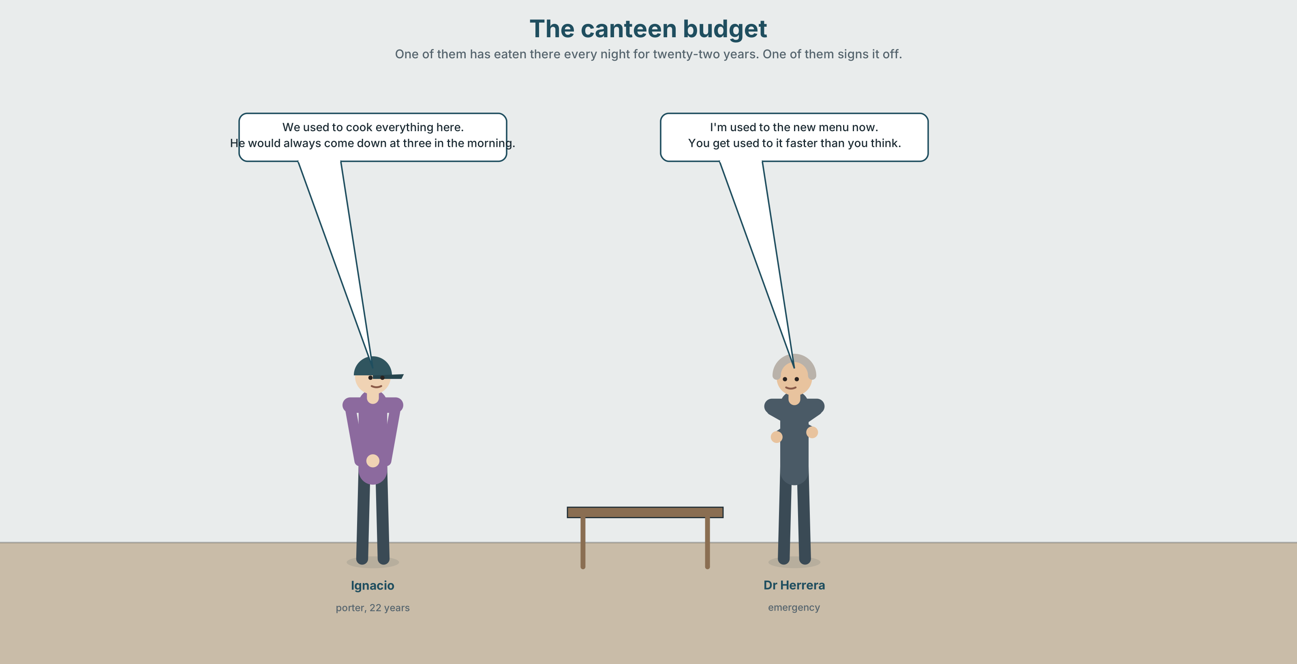{width=6.6in}
The canteen budget — One of them has eaten there every night for twenty-two years. One of them signs it off.

2A · The canteen budget 🔊 Track 1.1
Before you listen. The canteen budget has to cover four hundred meals a day, and the staff eat there too. Guess: who argues for the cheaper food, and on what grounds?
Listen once. One question. By how much has the budget fallen in real terms?
Listen again. Complete the table.
 | What they want | Their reason | What they are not saying
Rosa
Dr Herrera
Ignacio
Listen again. Choose the best answer.
- The canteen serves 200 / 400 / 650 meals a day.
- Staff meals are free / subsidised / full price.
- The cheaper menu would save about 4 / 11 / 19 per cent.
- Ignacio's objection is about taste / dignity / cost.
Noticing. Four sentences from the recording.
- We used to cook everything here.
- He would always come down at three in the morning.
- I'm used to the new menu now.
- You get used to it faster than you think.
All four contain used or would. Only two of them are about a habit that has stopped. Which two, and what are the other two doing?

2B · Decoding clinic 🔊 Track 1.2
Thirty seconds of Ignacio. Four jobs.
- How many times does he say used to?
- In used to, is there a d sound anywhere?
- Catch the two years he names.
- He switches from we to they halfway through. Where, and what changes?
Transcripts, page 150.

Part 3 · Grammar Lab 1 ◆ B · THE SYSTEM

Four ways of talking about what is normal

3A · Notice
Look at the four sentences in Part 2.
- Sentence 1 and sentence 2 are both about the past. Which one could describe a state?
- In sentence 3, used to is followed by a noun. What has changed about the meaning?
- Sentence 4 describes a process. What is the difference between be used to and get used to?
- Try "He would always be a porter." Why does that fail?
- Try "I used to the new menu." What is missing?

3B · See
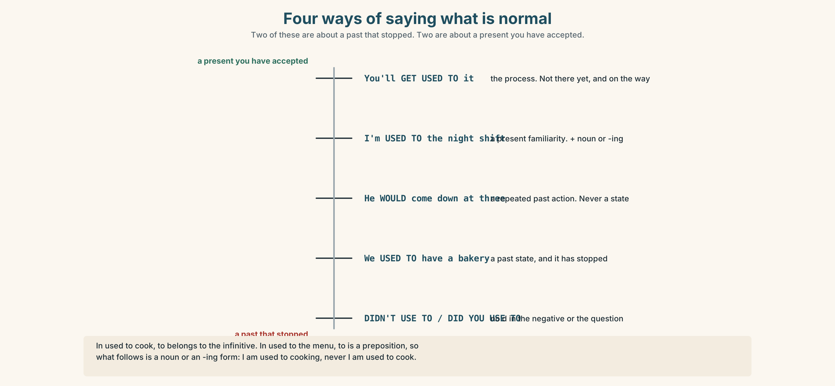{width=6.6in}
Four ways of saying what is normal — Two of these are about a past that stopped. Two are about a present you have accepted.

3C · Know
 | Shape | Use it for
used to + verb | She used to cook here. | a past habit or state that has stopped
would + verb | He would come down at three. | a past habit only — never a state
be used to + noun / -ing | I*'m used to** the new menu.* | a present familiarity
get used to + noun / -ing | You*'ll get used to** it.* | the process of becoming familiar
The would trap. would cannot carry a state. ✓ We used to have a bakery. ✗ We would have a bakery. ✓ He would bake on Saturdays. ✓ He used to bake on Saturdays.
The to trap. In used to cook, to belongs to the infinitive. In used to the menu, to is a preposition, so what follows is a noun or an -ing form. ✓ I'm used to cooking. ✗ I'm used to cook.
The spelling trap. The negative and the question drop the d: didn't use to · Did you use to…?
Why it matters. Three of these four can describe the same year and tell you different things about the speaker: what stopped, what was repeated, and what they have accepted.

3D · Use — controlled
The canteen (1) __________ (cook) everything on site until 2011. On night shifts Ignacio (2) __________ (come) down at three and the cook (3) __________ (leave) a plate for him. There (4) __________ (be) a bakery in the basement, which closed in 1998. Rosa says she (5) __________ (be / not / used to) the tinned fruit at first and that everybody (6) __________ (get / used to) it within a month, which she thinks is the part worth noticing.

3E · Use — guided
Rewrite each one with used to, would, be used to or get used to. Two of them have only one possible answer.
- There was a bakery in the basement. (there isn't now)
- Every Saturday he baked bread. (he doesn't now)
- The night shift does not bother me anymore.
- At first it was strange. Now it isn't.
- The hospital had its own garden. (it doesn't now)

3F · Use — open
Interview a partner about their first week in any job, school or city. Use all four forms. Then report two of their answers using a different form from the one they used.

3G · Error autopsy
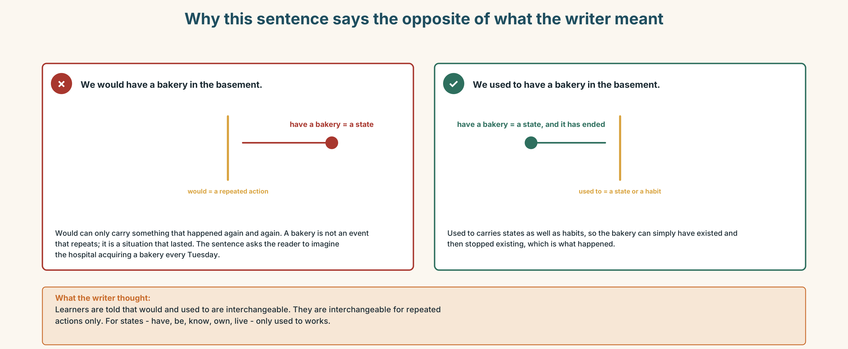{width=6.6in}
Why this sentence says the opposite of what the writer meant — Why this sentence says the opposite of what the writer meant
Read the two versions. Then explain, in one sentence, what the first one actually says.

3H · Check — eight items
- There ______ (be) a bakery here. (not now)
- He ______ come down at three every night. (habit only)
- I'm ______ ______ the new menu now.
- You'll ______ ______ ______ it.
- ______ you ______ to work nights? (question form)
- I didn't ______ to like it.
- She's used to ______ (work) twelve-hour shifts.
- We ______ (have) a garden until 2006.
0–4 → Workbook pp. 4–7. 5–6 → Part 6. 7–8 → page 19.

Part 4 · Speaking ◆ C · THE PERFORMANCE

4A · Fluency starter — two generations
In pairs. One of you is sixty. One of you is twenty. Ninety seconds each on what a normal Tuesday dinner was. Then swap ages and do it again.

4B · The functional core — describing a change in habit
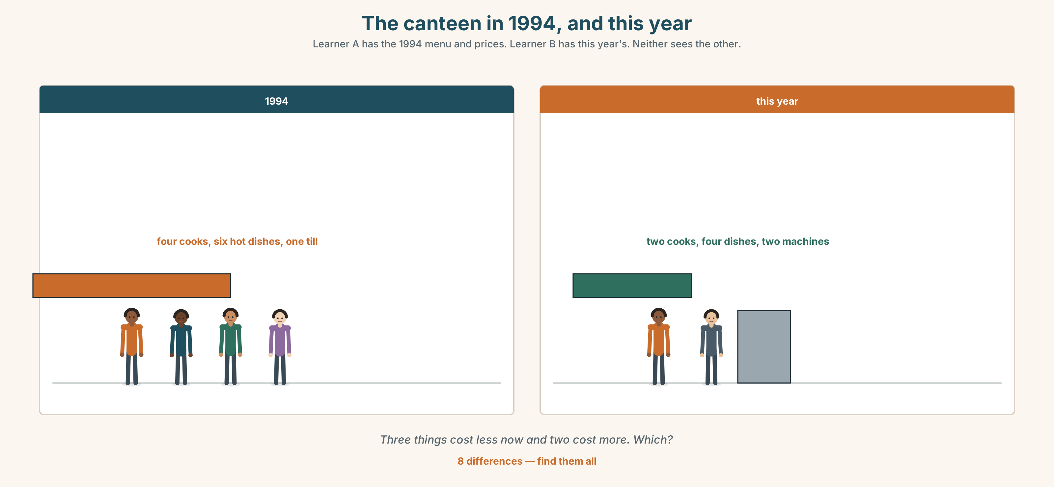{width=6.6in}
The canteen in 1994, and this year — Learner A has the 1994 menu and prices. Learner B has this year's. Neither sees the other.
Language Bank
what stopped | We used to… · There used to be… · Nobody does that now.
what was repeated | He would always… · Every Saturday she'd…
what you have accepted | I'm used to it. · You get used to it.
the honest qualification | I'm not sure it was better. · That's nostalgia talking.
Information gap. Learner A has the 1994 canteen menu and prices. Learner B has this year's. Neither sees the other. Find three things that cost less now and two that cost more.

4C · The performance — two minutes ⏺
Describe how eating changed in one family or one place across two generations. Two minutes. You must include:
one thing that stopped · one habit that repeated · one thing somebody got used to · one sentence that refuses to be nostalgic
Record it.

4D · Observer
One person listens for one thing: did the speaker claim the past was better without saying so out loud?

4E · Three criteria
☐ Did I use all four forms correctly? ☐ Is there a date or a decade in it? ☐ Did I resist the nostalgia at least once?

Part 5 · Reading ◆ A · THE WORLD

5A · Predict
An explainer about regional diet change. The title is "Nobody chose this, and everybody did." What do you expect the argument to be? Two sentences.

5B · Read — two minutes

Nobody chose this, and everybody did
In 1990 the average household in this region bought fresh fish eleven times a month. The figure now is three. Over the same period the number of households buying tinned fish at least weekly rose from eighteen per cent to sixty-one.
The obvious explanation is price, and the obvious explanation is wrong, or at least incomplete. Fresh fish here has risen by about forty per cent in real terms. Tinned fish has risen by thirty-four. The gap between them has widened, but not nearly enough to account for a fall of eight purchases a month.
What has changed more than the price is the shape of the day. In 1990, forty-one per cent of households in the region had somebody at home between two and four in the afternoon. That figure is now eleven per cent. Fresh fish is not expensive; it is early. It has to be bought in the morning, cooked the same day, and eaten by people who are in the house.
Ask anybody over sixty and they will tell you it is because young people cannot cook. Ask anybody under thirty and they will tell you it is because fish is expensive. Both answers are a way of describing a schedule without mentioning it.
This matters for the hospital canteen, which buys for four hundred people whose shifts are the reason the region's afternoons are empty. Whatever the canteen serves, it is serving the thing that made the change in the first place.

5C · Comprehension — eight questions
- What were the 1990 and current figures for fresh fish purchases?
- What happened to tinned fish over the same period?
- Why does the writer say the price explanation is incomplete? Give the numbers.
- What has changed about the shape of the day?
- What does the writer mean by "fresh fish is not expensive; it is early"?
- What explanation do people over sixty give, and what do people under thirty give?
- What does the writer say both explanations are really describing?
- Why does the last paragraph say the canteen is a special case?

5D · Vocabulary in context
Guess from the text. Then check.
in real terms · account for · the shape of the day · a way of describing · whatever it serves

5E · The counter-text
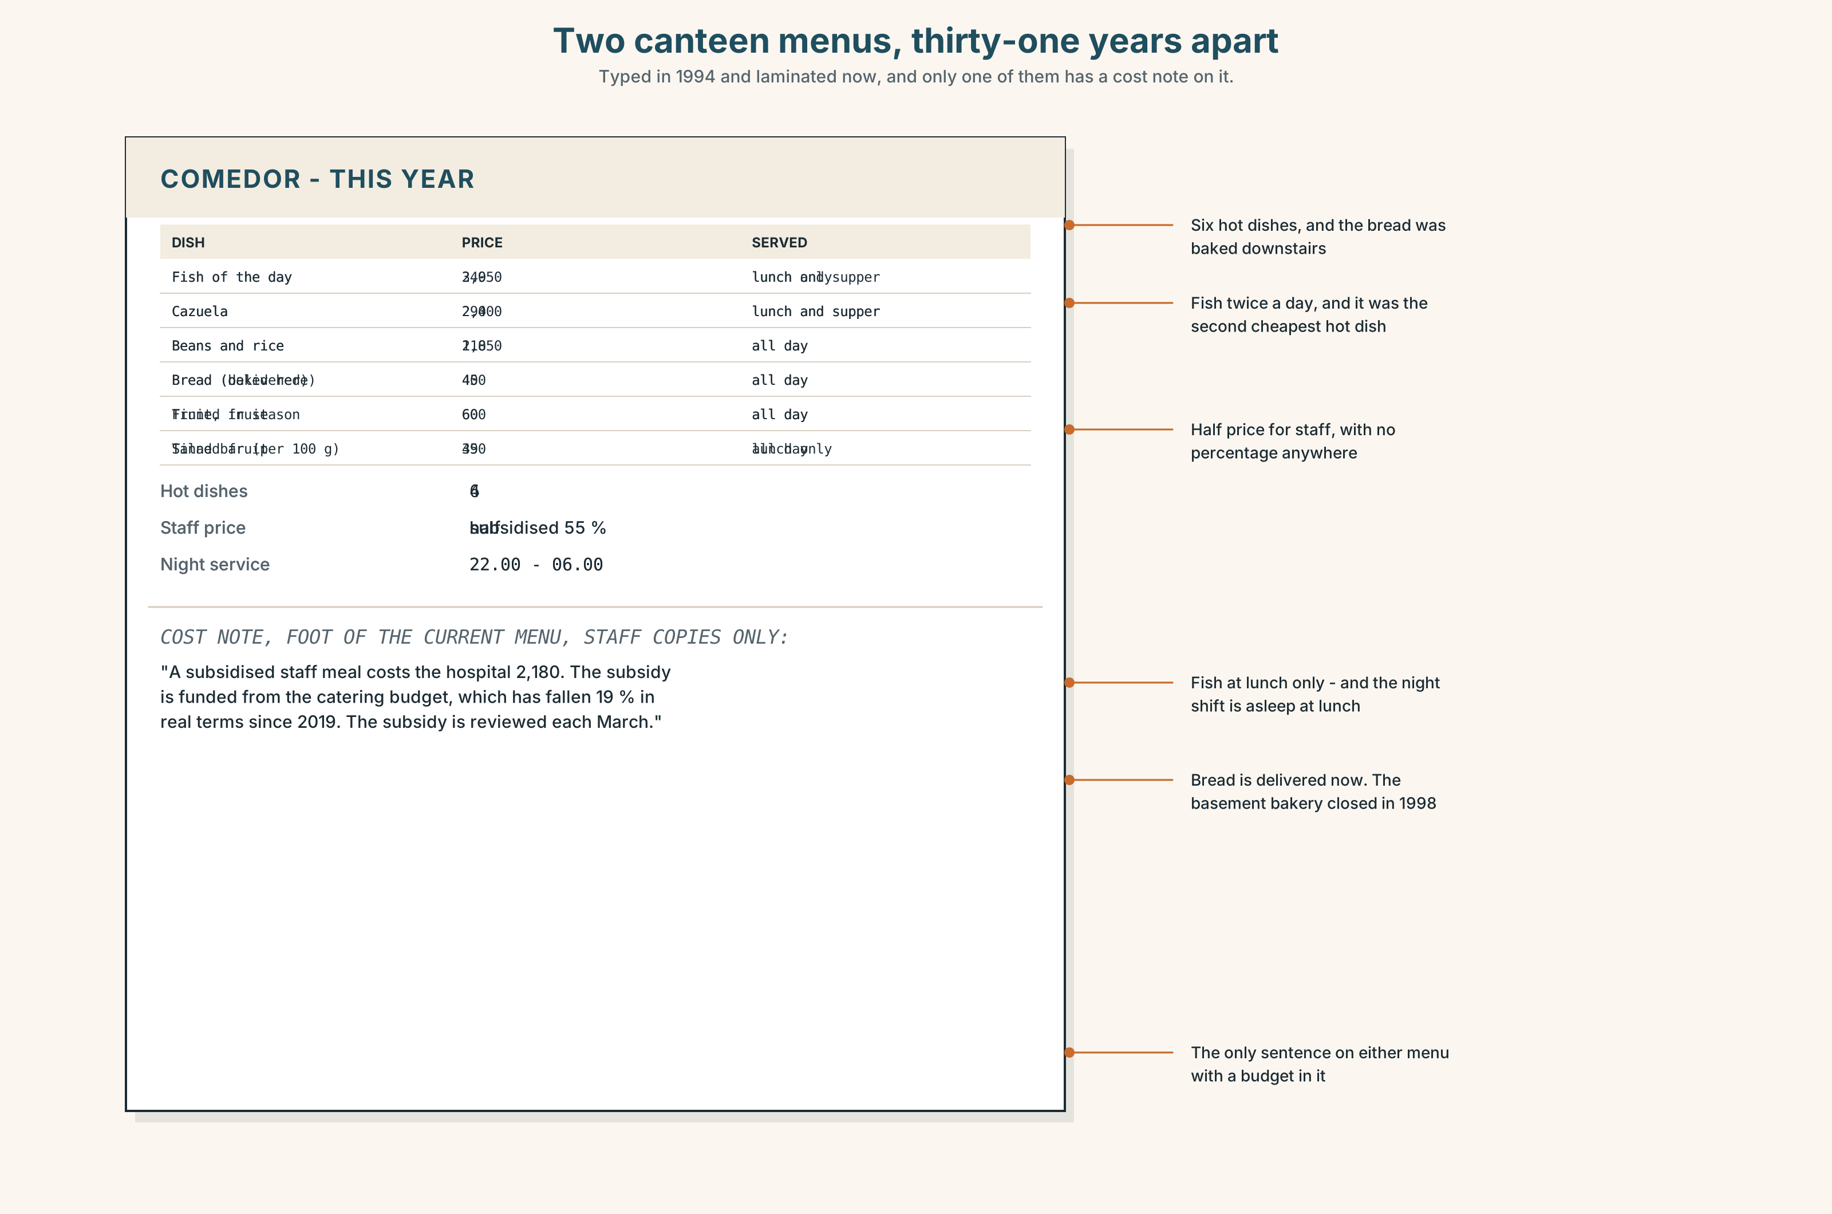{width=6.6in}
Two canteen menus, thirty-one years apart — Typed in 1994 and laminated now, and only one of them has a cost note on it.
Read the two canteen menus — 1994 and this year — and answer.
- How many hot dishes were there in 1994, and how many now?
- What has happened to the price of the staff meal, in money and in real terms?
- Which three items appear on both menus with the same name?
- What is on the current menu that did not exist as a category in 1994?
- One line of the current menu is a cost note for staff only. What does it say?

5F · Two texts
The explainer says fresh fish purchases fell because of the shape of the day. The current menu shows fish served only at lunch.
Put those two facts together. Who in this hospital eats fish? Three sentences.

Part 6 · Vocabulary Lab 2 ◆ B · THE SYSTEM

Words for how often, and how it changed

6A · Sort — a habit, a change, or a speed?
Three columns.
routine · gradually · custom · increasingly · tradition · steadily · constantly · overnight · typically · practice

6B · Chunk completion
- Over ______ , the fish disappeared from the Tuesday menu.
- As a ______ , the kitchen buys nothing that cannot be delivered twice a week.
- More and ______ of the staff eat on the ward.
- She took ______ cooking at night because the day kitchen was always busy.
- He fell ______ the habit of eating at four and has not got out of it.
- In those ______ the bakery delivered twice a day.

6C · Three adverbs that are not interchangeable
gradually · steadily · overnight
Gradually allows for stops and starts. Steadily does not. Overnight is almost always an exaggeration.
Which fits each sentence, and what would the other two imply?
- The number of fresh purchases fell ______ between 1990 and 2010.
- The canteen changed its supplier ______ , in March, with no notice.
- People ______ stopped going home in the afternoon.

6D · The fixed expression
f You'd never see that now.
Say it three times: as regret, as relief, and as a simple observation. Which is hardest?

6E · Contrast Clinic
Eight items. used to, would, be used to or get used to.
- There ______ be a garden here.
- Every night he ______ come down at three.
- I ______ the smell now. I didn't at first.
- You'll ______ the hours.
- She ______ work in paediatrics.
- ______ you ______ to work weekends?
- He isn't ______ being told what to do.
- We ______ have four cooks. Now there are two.

Part 7 · Pronunciation & Fluency Lab ◆ B · THE SYSTEM

Four phrases, one sound
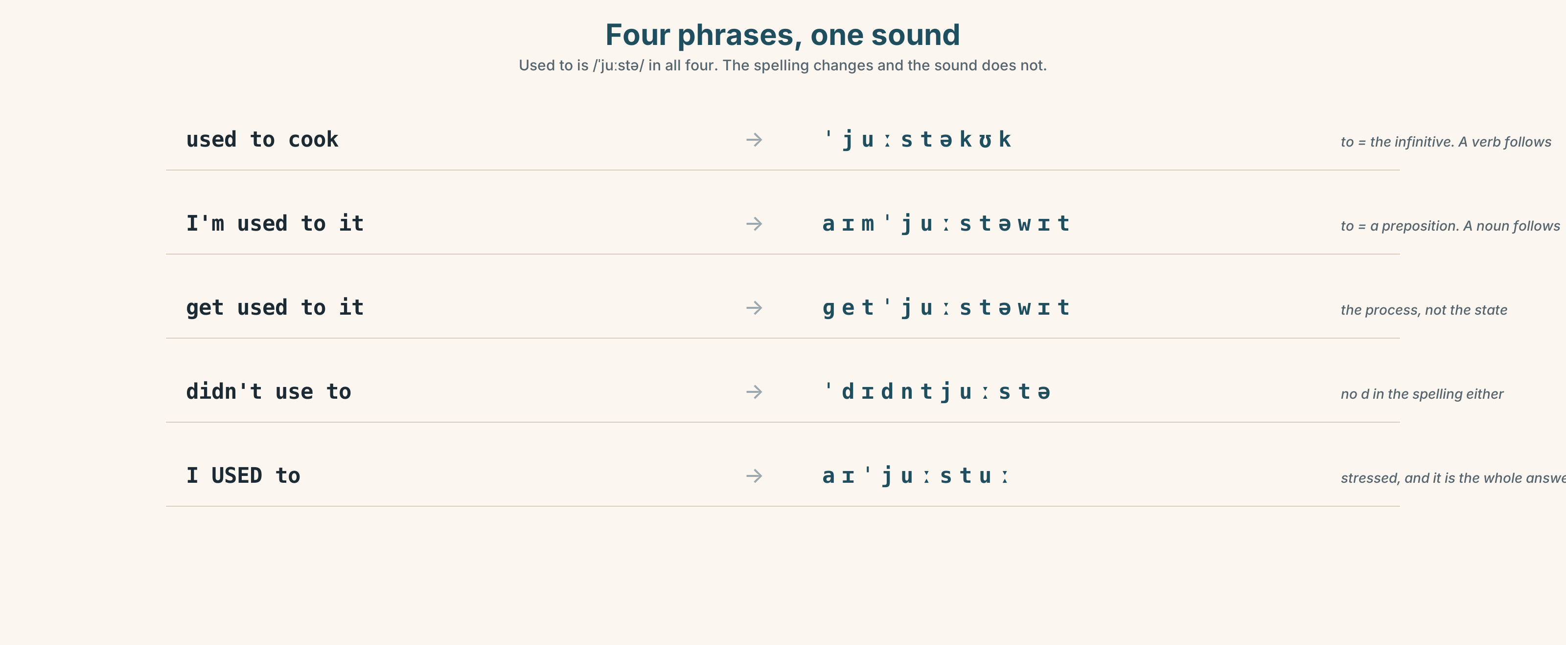{width=6.6in}
Four phrases, one sound — Used to is /ˈjuːstə/ in all four. The spelling changes and the sound does not.

7A · Hear 🔊 Track 1.3
used to cook → /ˈjuːstəkʊk/ I'm used to it → /aɪmˈjuːstəwɪt/ get used to it → /ɡetˈjuːstəwɪt/ didn't use to → /ˈdɪdntjuːstə/
In all four, used to is /ˈjuːstə/. The spelling changes; the sound does not.

7B · Say
Say each one. Then say the whole sentence three times, faster:
I used to hate it and now I'm used to it, and you get used to it faster than you think.

7C · Make it mean something
Say these two:
I USED to. (and I do not now — this is the whole answer) I'm used TO it. (and you are asking me whether it still bothers me)
Which of the two would you say in reply to "Does the night shift bother you?"

7D · Fluency 30 ⏺
Thirty seconds: three things you used to do, two you would always do, and one you have got used to. Three times, faster.

Part 8 · Writing ◆ C · THE PERFORMANCE

Two generations of a kitchen · 150 words
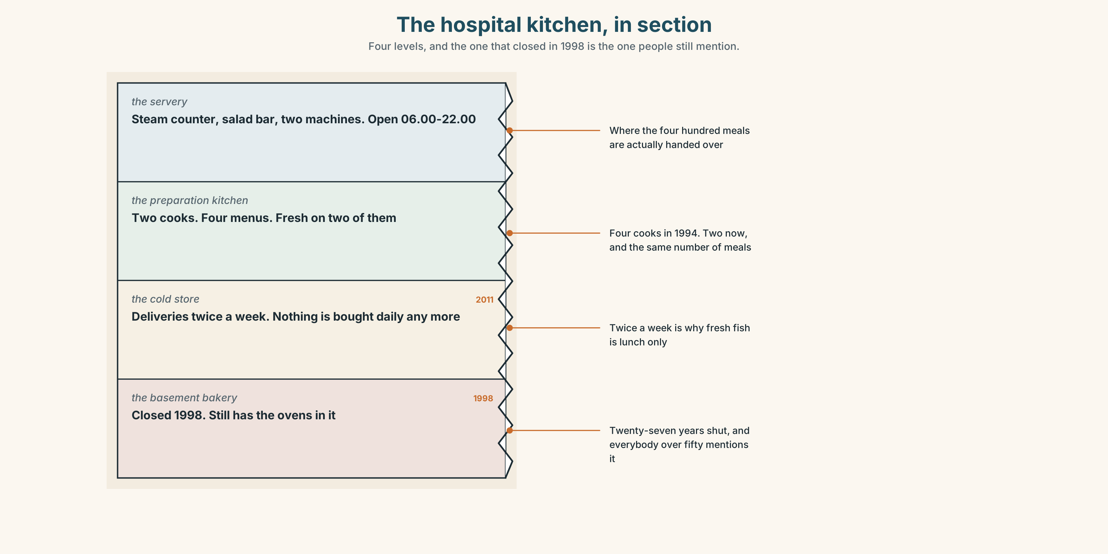{width=6.6in}
The hospital kitchen, in section — Four levels, and the one that closed in 1998 is the one people still mention.

8A · Read the model
My grandmother bought fish eleven times a month and I have the receipts, because she kept them in a tin and nobody threw the tin out. [the claim is a number, and the source of the number is an object]
She would go at seven, before the market filled, and she used to say that anything still there at nine had been there on Monday. I do not know whether that was true. [one habit with *would*, one saying with *used to*, and a refusal to vouch for it]
I buy fish about twice a month and I buy it on a Saturday, which is the only morning I am in the house. That is the whole of the change. It is not about cooking and it is not really about money; it is about who is at home at nine in the morning. [the explanation, and it contradicts both of the usual ones]
I am used to it. I would like to say I mind, and I am not sure I do. [*be used to*, and then an admission that undercuts the nostalgia the reader was expecting]
Questions about the writer's choices:
- The first paragraph produces a tin of receipts. What does that do for everything after it?
- The last line refuses to feel what the reader expects. Is that honest, or is it a pose?
- The piece never uses the word tradition. Would it be better or worse with it?

8B · The anti-model
Food was much better in my grandparents' time. Everything was fresh and local and people knew how to cook. Nowadays everyone eats processed food and nobody has time for a proper meal. It is a great shame and something has been lost.
Correct English, and there is nothing in it that could be checked. Name three claims that would need evidence, and one word that is doing all the emotional work.

8C · Plan
a number, with its source → one habit, with would → the explanation that is not the usual one → what you have got used to, honestly

8D · Write — 150 words

8E · Peer review — three criteria
☐ Is there one checkable number? ☐ Is there one habit described with would? ☐ Does the piece avoid saying the past was better?

8F · Write it again · 8G · Publish
On the wall, with the two menus from Part 5E beside it.

Part 9 · The File ◆ A · THE WORLD + C · THE PERFORMANCE

WORK FILE · The Review
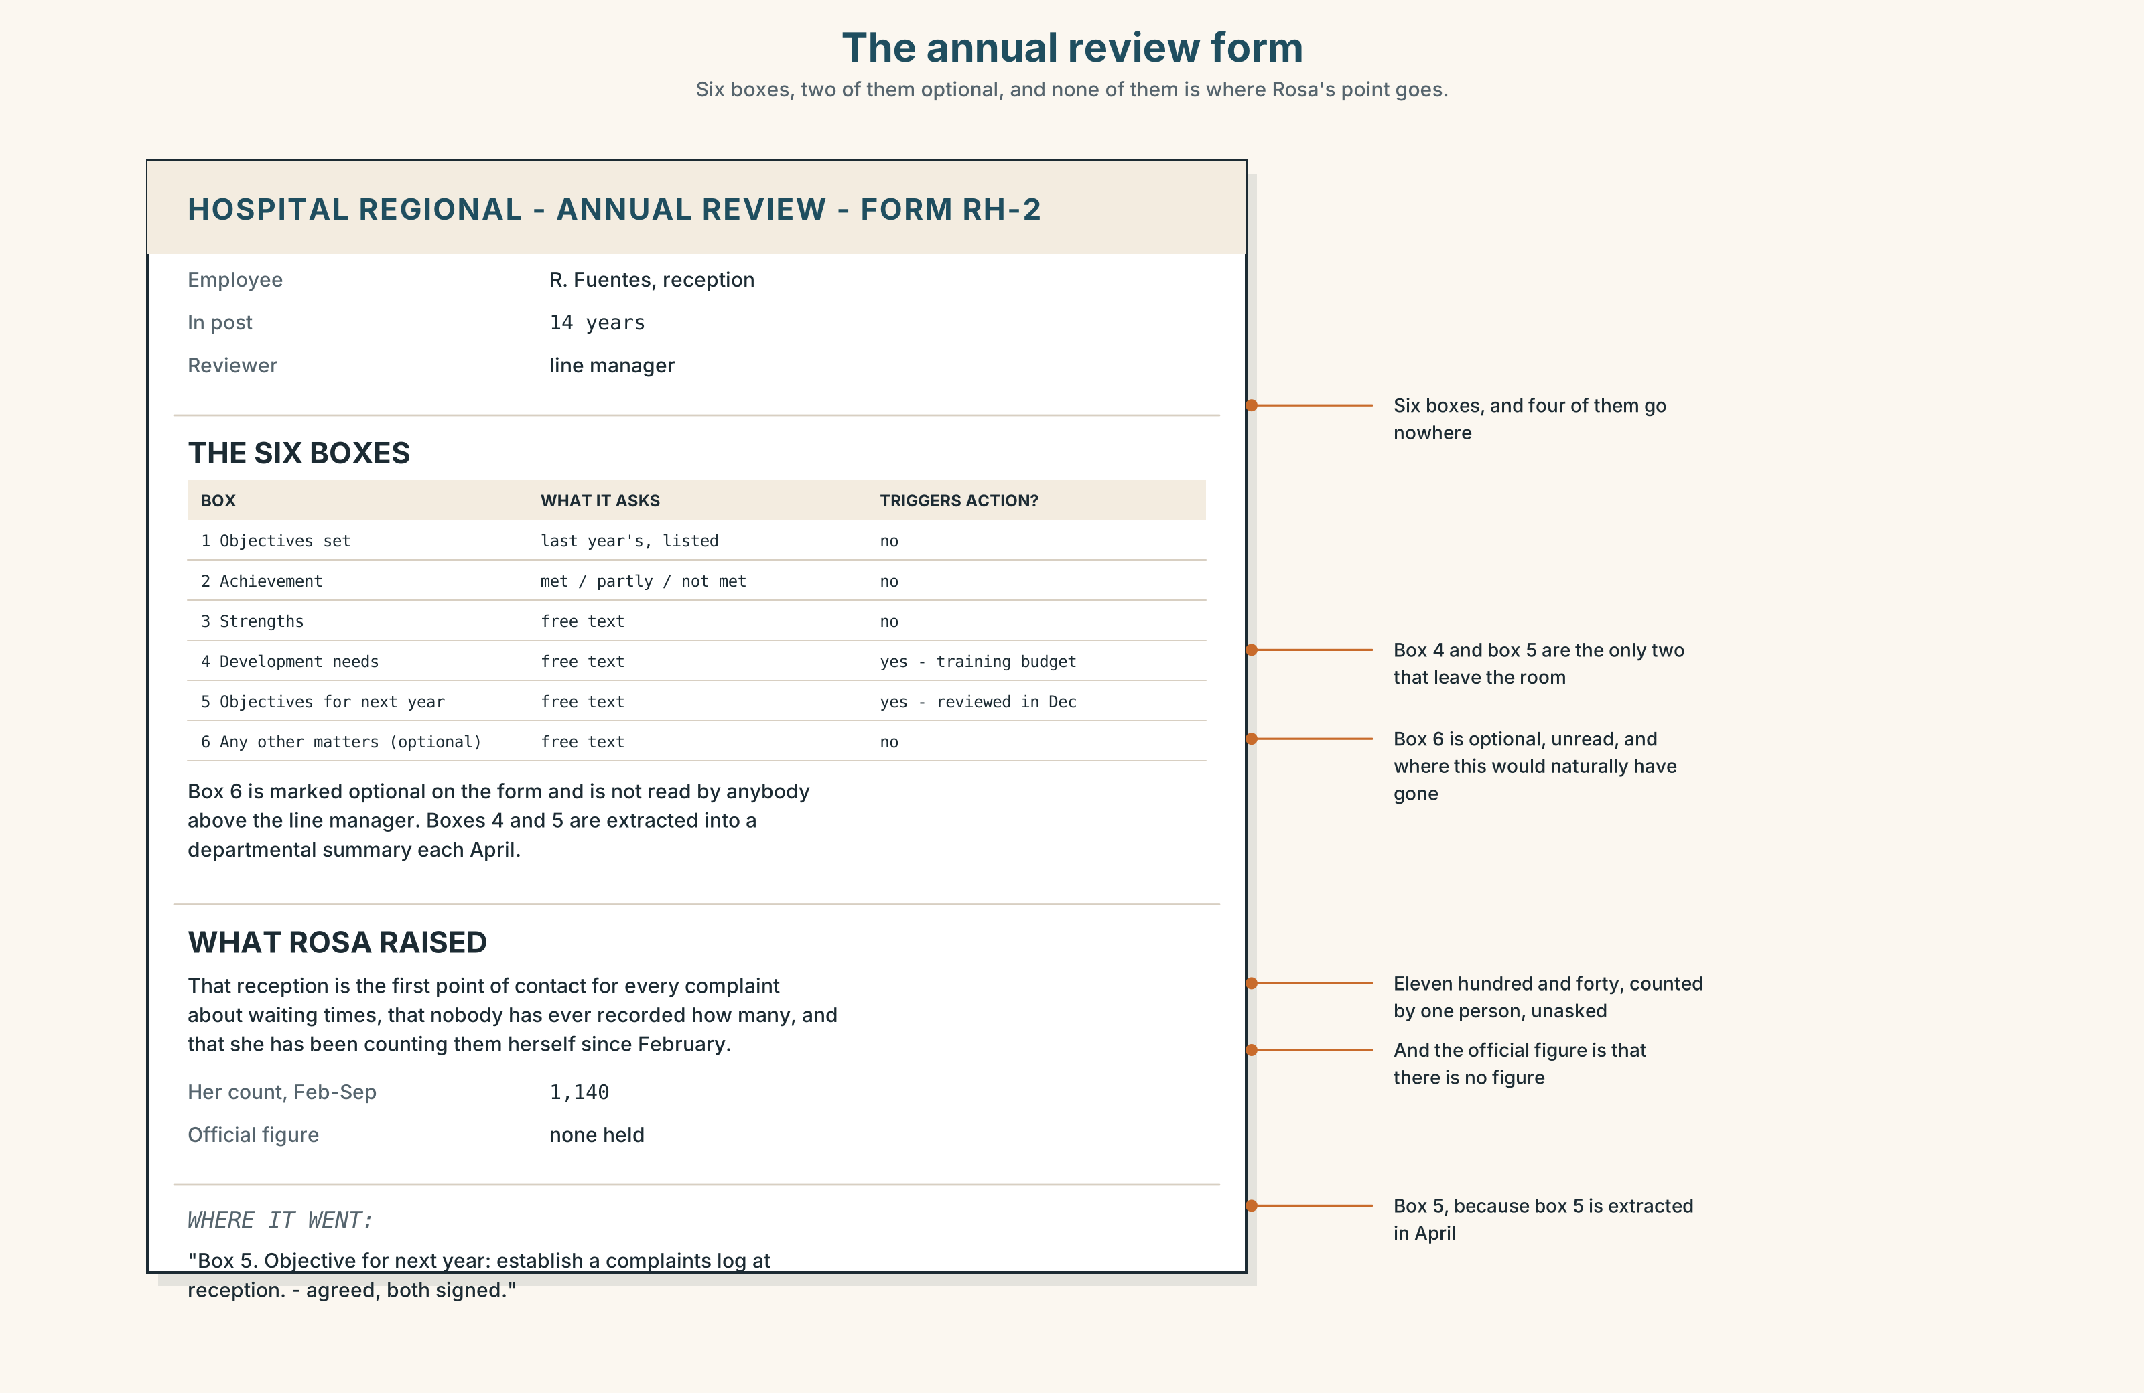{width=6.6in}
The annual review form — Six boxes, two of them optional, and none of them is where Rosa's point goes.

9A · The annual review 🔊 Track 1.4
Rosa has worked on reception for fourteen years. Her review is twenty minutes. Listen to all of it.
- How does her manager open, and what is the first real question?
- What does Rosa raise that is not on the form?
- What is agreed, and who writes it down?

9B · The form, and the conversation
Read the review form in the figure. It has six boxes.
Which of the six does the conversation actually fill? And which box is where Rosa's point would have to go, if anywhere?

9C · Raising something that is not on the agenda
"Can I add something that isn't on here?" · "While we're talking about it…" · "This may not be the right place, but…" · "I'd like this recorded."
Match each to its effect. One of the four changes what has to happen afterwards. Which?

9D · Your turn
In pairs. Twelve minutes. One reviews, one is reviewed, using the real form. The person being reviewed must raise one thing that is not on it, and must get it written down. Then swap.

9E · Transfer
Write the one sentence you would want in your own review this year. Keep it. You will look at it again at the end of this book.

Part 10 · Mediation & Interaction ◆ C · THE PERFORMANCE
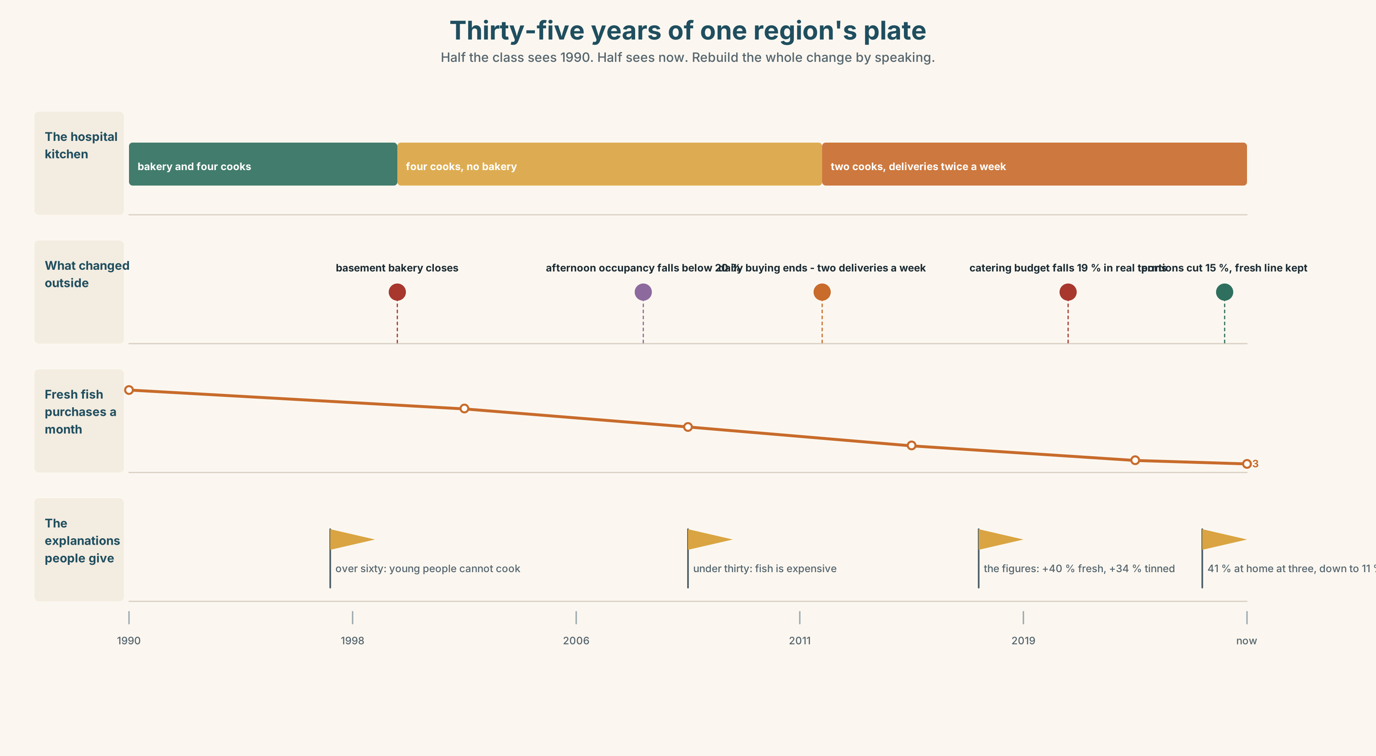{width=6.6in}
Thirty-five years of one region's plate — Half the class sees 1990. Half sees now. Rebuild the whole change by speaking.

10A · Relay
Half the class sees the 1994 menu and the 1990 purchasing figures. Half sees this year's. Rebuild thirty years of one region's diet by speaking. Twelve minutes.

10B · Simplify
Explain the canteen's cost note from Part 5E to a new member of staff on their first day. Five sentences only.
Plan: what a staff meal costs → what it costs the hospital → what the subsidy depends on → what changes next year → what to do if you cannot afford it

10C · Compress
The explainer in Part 5 into forty words, for the canteen noticeboard.

10D · Online
Write one message to the catering committee: you have read the figures, you accept the budget cannot stretch, and you are proposing one specific change that costs nothing.

10E · Your language
How does your language distinguish a stopped habit from a present familiarity? Does it have one form or two? Say I used to work nights and I'm used to working nights in both languages, and tell a partner which was harder.

Part 11 · The Decision ◆ C · THE PERFORMANCE

Cheaper, or better
The canteen budget has fallen nineteen per cent in real terms in six years. It feeds four hundred people a day, and about a hundred and forty of them are staff on shift, for whom it is the only hot food available between ten at night and six in the morning.
- Cheaper. Move to the processed line. Saves eleven per cent. Nobody goes hungry and nothing is nutritionally illegal.
- Better. Keep fresh preparation on two of the four menus and cut portion sizes elsewhere. Costs nothing extra and reduces what everybody gets.
- Smaller. Close the night service. Saves twenty-two per cent. The hundred and forty people on nights bring their own or do not eat.

11A · The evidence
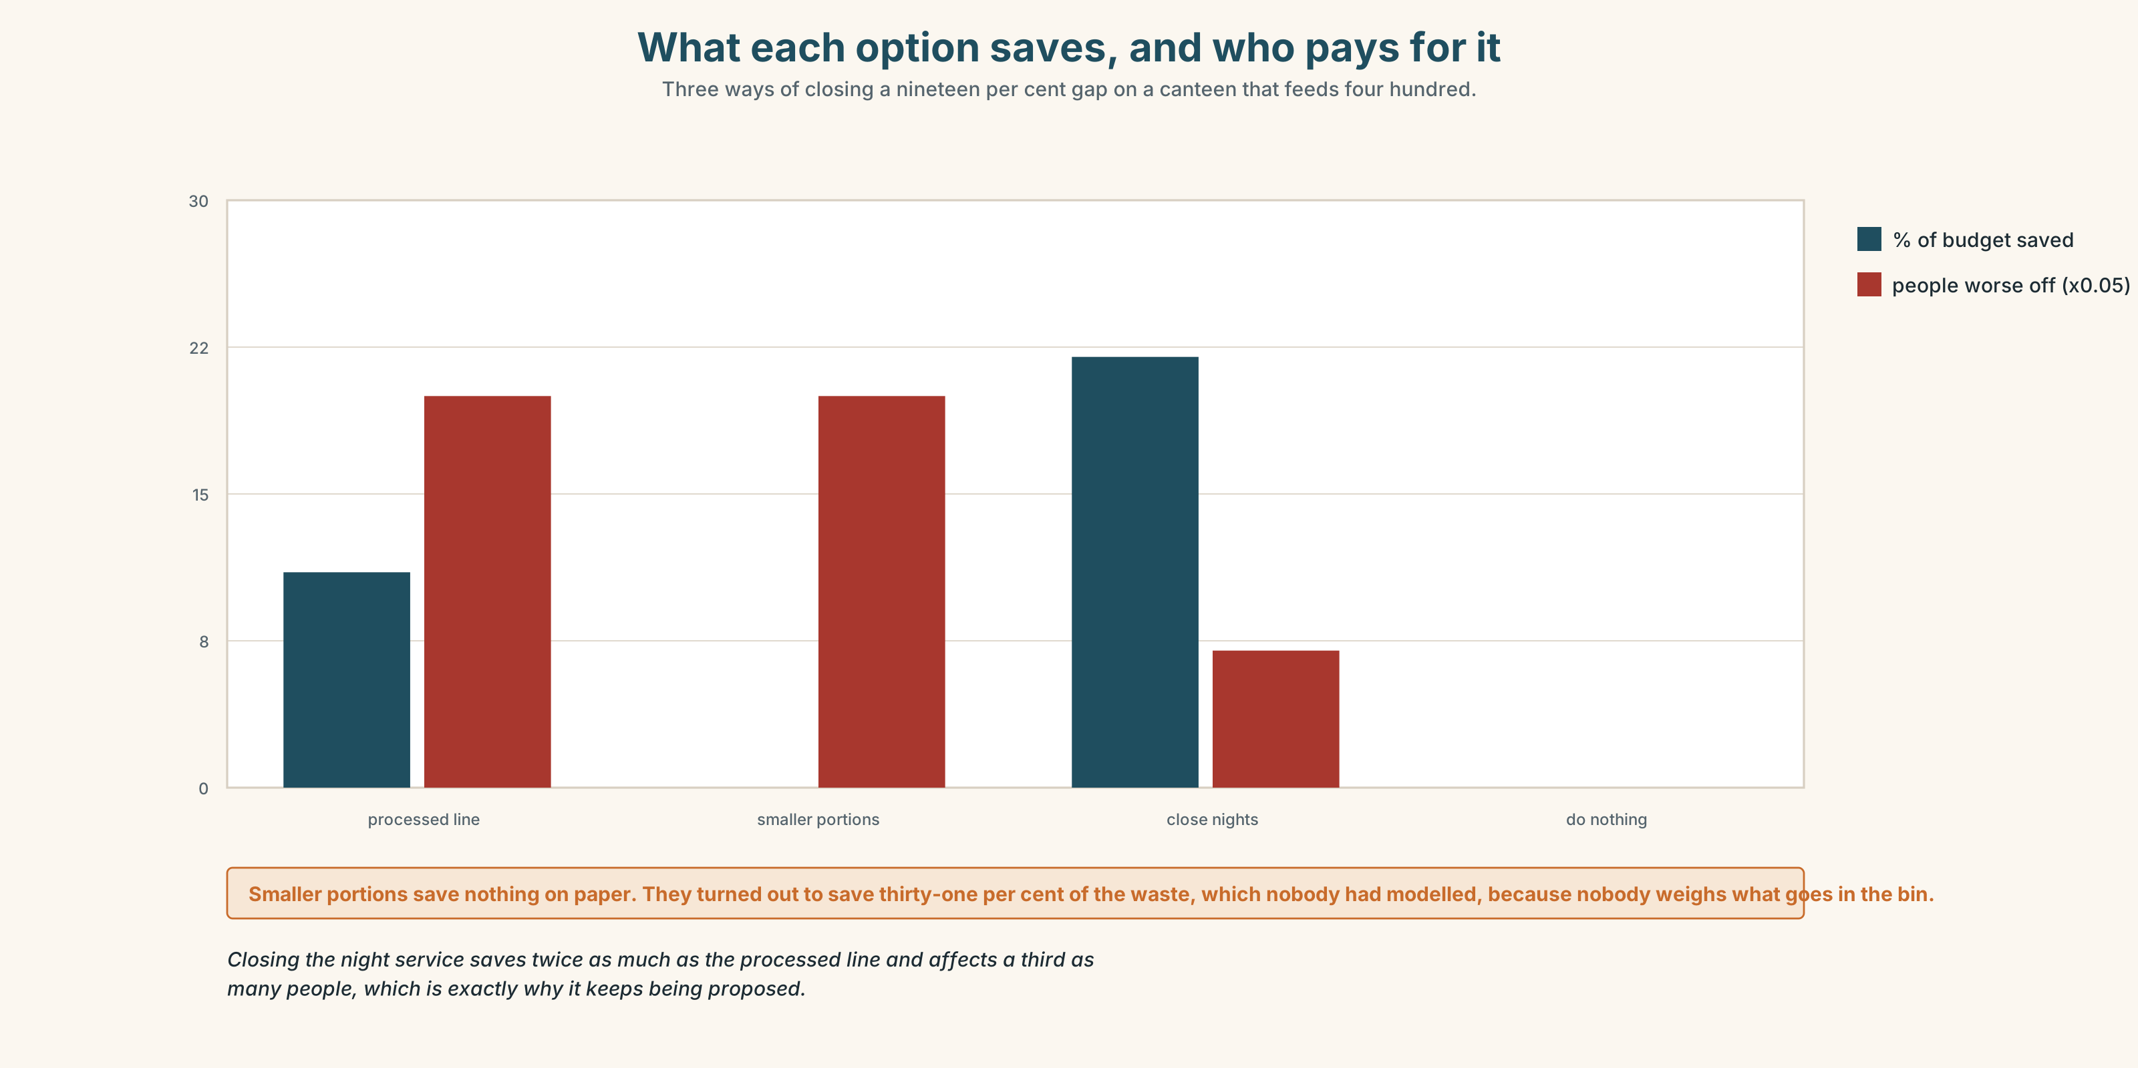{width=6.6in}
What each option saves, and who pays for it — Three ways of closing a nineteen per cent gap on a canteen that feeds four hundred.
- The two menus from Part 5E — and the cost note at the bottom of the current one.
- The chart — what each option costs, what it saves, and who it affects.
- The voice. Ignacio, thirty seconds: "I have been here twenty-two years and I have eaten there every night of them. It is not about the food. If you close it at night, the only people who lose anything are the ones who are here at four in the morning, and we are already the ones who lose things."

11B · Talk about it
In fours. Everybody speaks twice. Use the frame.
If they ______ , then ______ . So I think ______ .
Words you can use: budget · portion · processed · fresh · staple · cut down on · a balanced diet · convenience food

11C · Decide
Write three sentences. Choose, say why, and name what it costs.
I think the canteen should ______________________ , because ______________________ . What this costs is ______________________ .

11D · Model decision
They should cut portion sizes and keep fresh preparation, and they should publish the portion change rather than letting people discover it. Every version of this costs somebody something, and the two options that look painless — processed food, closing at night — both put the whole cost on the hundred and forty people with the least choice about when they eat. A smaller plate for four hundred is the only version where the cost is shared, and it is also the only one anybody will complain about, which is probably the test.

11E · The Reveal
What happened. Portions came down by about fifteen per cent across all four menus and the fresh line stayed. The change was announced on a notice that nobody read.
Complaints ran at about four a week for two months and then stopped. In month five the canteen manager found that total food waste had fallen by thirty-one per cent, which more than covered the eleven per cent the processed line would have saved. Nobody had modelled that and nobody had thought to.
The night service stayed open. Ignacio still eats there at three. He says the plate is smaller and that he had not noticed until somebody told him, which he thinks is either the best or the worst thing about the whole business and he has not decided which.
Smaller plates saved more than cheaper food would have, because people had been throwing a third of it away.
Was it the right decision? Say why — and say what should have been measured first.

Part 12 · Landing ◆ all three lines

12A · Recycle — twelve items
- There ______ (be) a bakery here. (not now)
- He ______ come down at three every night. (habit only)
- I'm ______ ______ the new menu now.
- You'll ______ ______ ______ the hours.
- They've agreed to cut ______ on salt.
- Potatoes are a ______ of this region.
- She grew ______ on tinned fruit.
- Over ______ , the fish disappeared from the menu.
- (A2.2 U2) We ______ (wait) for that delivery since June.
- (A2.2 U8) The hall, ______ was built in 1884, is the oldest.
- (A2.1 U3) I ______ (use) to live on that street.
- (A2.1 U6) I can't afford ______ (replace) it.

12B · Consolidate
One hundred and fifty words. How eating changed in one family or one place. All four forms from Part 3, one checkable number, and one sentence that refuses to say the past was better.

12C · Can-do, with evidence
I can… | My evidence | Sure?
distinguish a stopped habit, a repeated action and a present familiarity | Part 3H score | ◯ ◑ ●
describe thirty years of change in two minutes | Part 4C recording | ◯ ◑ ●
write 150 words with a checkable number in them | Part 8 draft 2 | ◯ ◑ ●
raise something in a review that is not on the form | Part 9D role play | ◯ ◑ ●

12D · Replay ⏺
Find your forty-five seconds from Part 0C. Listen. Record it again. Two sentences: what is different, and what you would still not be able to say.

12E · Glossary — forty-five items, as a map
ON THE PLATE · diet · portion · staple · a staple of · seasonal · fresh · tinned · processed · recipe WHERE IT COMES FROM · canteen · household · budget · home cooking · convenience food · a balanced diet WHAT PEOPLE DO · generation · cut down on · eat out · grow up on · live off · give up · stock up AND DO NOT · we never had that · nobody cooked like that · you'd never see that now HABIT · practice · routine · custom · tradition · be used to · get used to · would always · take to · fall into · as a rule HOW IT CHANGED · gradually · constantly · rarely · typically · increasingly · steadily · overnight · in those days · over time · more and more

12F · Next
Unit 2 · What if it had gone differently?

