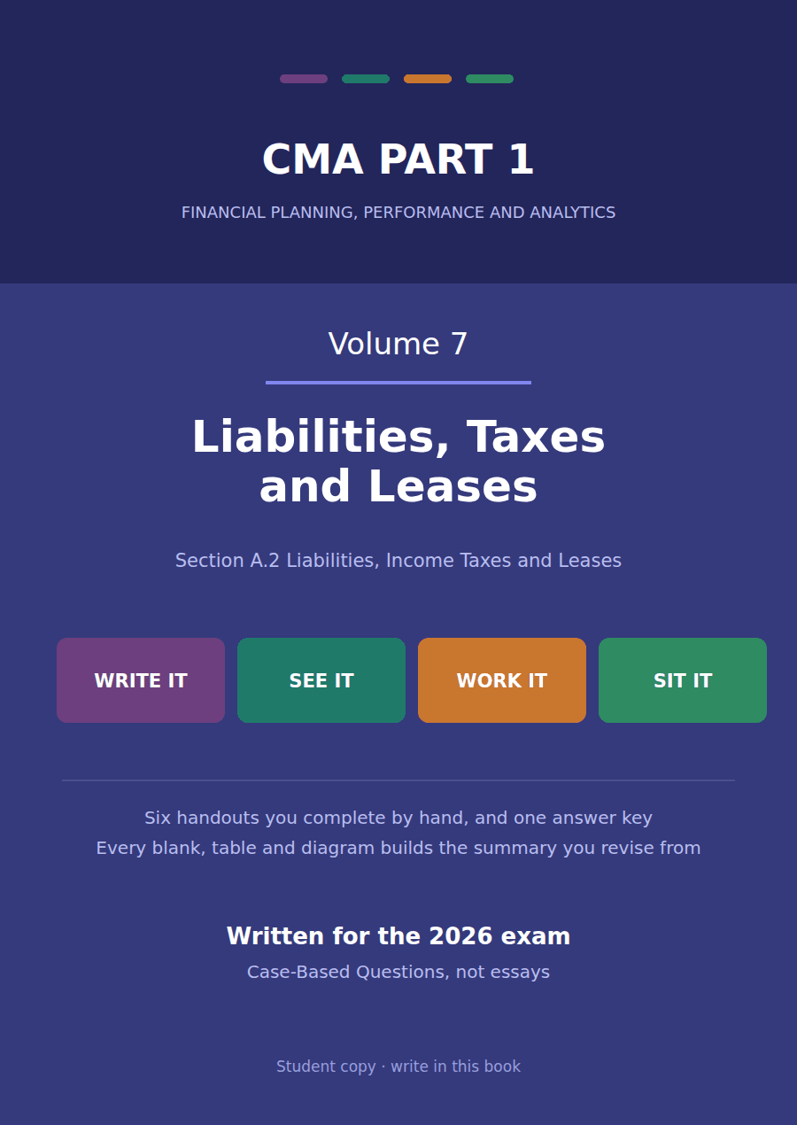

CMA Part 1 · Volume 7
Liabilities, Taxes and Leases
Six handouts, one answer key. Two liability questions, the whole of deferred tax, and the two kinds of lease.
These handouts are not notes to read. You write them. The words you supply are the summary, so a finished handout is a page you can revise from, in your own handwriting.
Work in pen. Do not look at the key until the whole handout is done — the key is written to explain the mistake, and you only get that benefit if you have made it first.
The six handouts
# | Handout | What it gives you
1 | Two Liability Questions: Refinancing and Warranties | The whole of Section A’s liability measurement is two questions. One is about a date, and the other is about whether a promise was sold.
2 | Why Tax Expense Is Not the Tax Bill | Northwind reports $170,000 of tax and sends the government $146,000. The gap is not an error, and explaining it is the whole of deferred tax.
3 | Temporary and Permanent Differences | Handout 2 found a $24,000 gap between the charge and the bill. Only some differences create it, and knowing which is the whole skill.
4 | Deferred Tax Assets and Liabilities | Northwind’s balance sheet shows one deferred tax line of $160,000. Five differences sit behind it, and two of them are assets.
5 | Operating and Finance Leases: the Distinction | Northwind signed two leases in the same week. Both go on the balance sheet, and only one of them is a purchase in disguise.
6 | Where Each Lease Lands on the Statements | The machine lease costs $67,078 in year one and $52,355 in year five. The warehouse floor costs $40,000 every year. The payments never change.

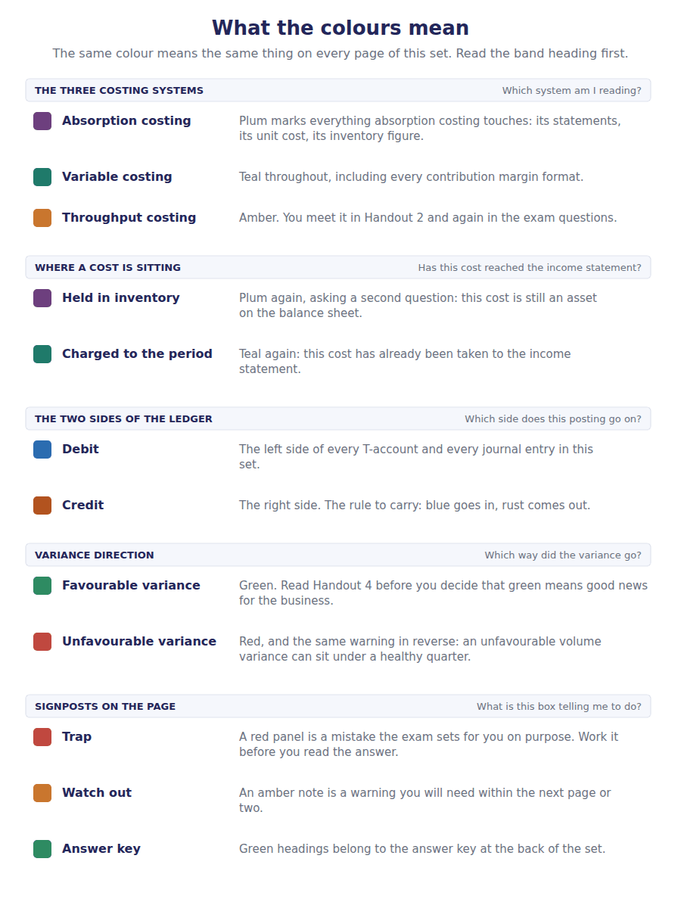
How to read the markers
Marker | Meaning
R1 | Teaching English. Short sentences. This is where a new idea arrives.
R2 | Textbook English. Longer sentences and passive verbs, as a textbook writes them.
R3 | Exam English. Exactly how the CMA exam phrases it, traps included.
Numbered rule | A space you fill in. The number matches the answer key.
Red table | A trap. Read it twice.

Handout 1 · Two Liability Questions: Refinancing and Warranties
The whole of Section A’s liability measurement is two questions. One is about a date, and the other is about whether a promise was sold.
Volume 7 · Liabilities, Taxes and Leases · R1 moving to R2
LANGUAGE FOCUS
Register you are working in | R1 while each question is set up, R2 once the conditions are applied.
Say it exactly like this | classify a liability as current · refinance a short-term obligation · recognise a provision for warranty claims · settle a claim against the provision · allocate part of the transaction price · defer revenue over the service period
Words that are not the same | current / non-current · intent / ability · assurance / service · provision / deferred revenue
Remember | Intending to refinance is not enough. The ability has to be demonstrated, and the standards say how. A warranty is not always a liability. One kind of warranty is a performance obligation and produces revenue instead.

What you will be able to do when this handout is finished
- Say when short-term debt expected to be refinanced may be classified as non-current.
- Classify a note under four different refinancing situations.
- Distinguish an assurance warranty from a service warranty.
- Record and roll forward a warranty provision.
- Say what happens to the transaction price when a warranty is a separate promise.

Two liability questions, and no others
Section A asks remarkably little about liability measurement. There is no bond amortisation, no pension arithmetic and no provisions beyond warranties.
What it asks is two questions. The first is about a date: when may a debt that falls due next year be reported as non-current? The second is about a promise: when is a warranty a liability, and when is it revenue the company has not yet earned?
Northwind faces both. It has a $400,000 note falling due in March 20X5, and it gives a warranty on every component it sells.

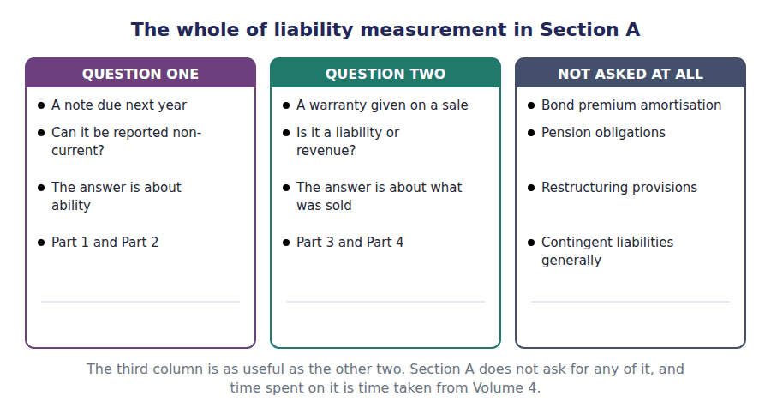
Part 1 · The refinancing question intention is not the test
Exercise 1A Read and complete. Write one word in each space.
OBJECTIVE | Say when a short-term debt may be classified as non-current.
YOU WILL NEED | Volume 1 Handout 2, for the current and non-current test.
HOW TO START | • The ordinary rule comes first. The exception comes second, and it has conditions.  • Blank 2 is the thing that is not enough on its own.  • The last blank is the moment by which the agreement has to be in place.

WORD BANK
ability · audited · current · issued · non-current · willingness
Not every word is used.

R1 The ordinary rule is the one from Volume 1. A debt due within a year of the balance sheet date is a ¹ liability, and Northwind’s $400,000 note falls due in March.
There is one exception, and it exists because a company that will simply replace the debt with a longer one is not really facing a payment next year at all.
To use it the company must intend to refinance on a long-term basis and must demonstrate the ² to do so. Intention alone is never enough: every company with a cash problem intends to refinance.
Ability is demonstrated in one of two ways. Either the debt is actually refinanced after the balance sheet date but before the statements are ³ , or a binding refinancing agreement is in place by then. Either way the evidence must exist before the reader sees the statements.
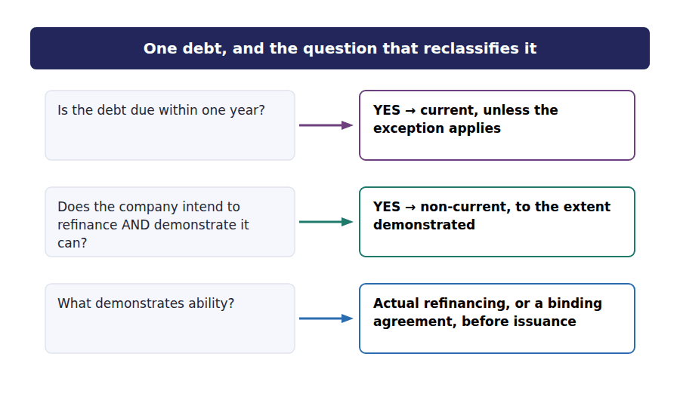
Exercise 1B Complete the table. Split the note between the two columns where it has to be split.
OBJECTIVE | Classify the note under four refinancing situations.
YOU WILL NEED | Exercise 1A
HOW TO START | • Each row is the same $400,000 note under different facts.  • The third row is the one that splits. Only what is covered may move.  • The fourth row turns on a date, and it is the date of issuance rather than the balance sheet date.

The situation at 31 December 20X4 | Current | Non-current
No refinancing agreement in place
Agreement signed before the statements are issued, for the full $400,000
Agreement covers only $250,000 of the note
Agreement signed after the statements are issued

1 | 2 | 3 | 4 | 5 | 6
7 | 8

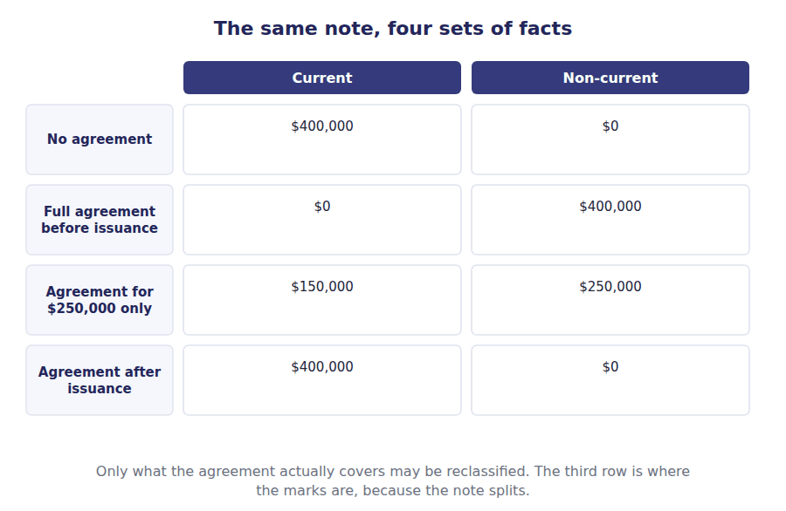
Part 2 · The warranty question liability, or revenue not yet earned?
R2 Every component Northwind sells carries a warranty, and the accounting depends entirely on what that warranty promises. Two kinds exist and they are treated in completely different places in the statements.
R2 An assurance warranty promises only that the product will work as it was specified to. The customer did not buy it separately and could not have declined it. It is therefore not a promise the company sold, and the expected cost of honouring it is a provision.
Exercise 1C Sort each warranty into the column it belongs in.
OBJECTIVE | Distinguish the two kinds of warranty and say where each is reported.
YOU WILL NEED | Exercise 1B, and the two paragraphs above.
HOW TO START | • Ask one question: could the customer have bought this separately, or declined it?  • A warranty that merely promises the product works is not a separate promise, however long it runs.  • The last one is the trap. Length is not the test.

The warranty given | ASSURANCE — a provision | SERVICE — a performance obligation
1. A one-year promise that the component works as specified
2. A three-year extended plan the customer paid extra for
3. A plan covering accidental damage, sold separately
4. A two-year promise that the component works as specified
5. Free annual servicing included in the price but also sold separately
6. A legal requirement that the product conform to specification

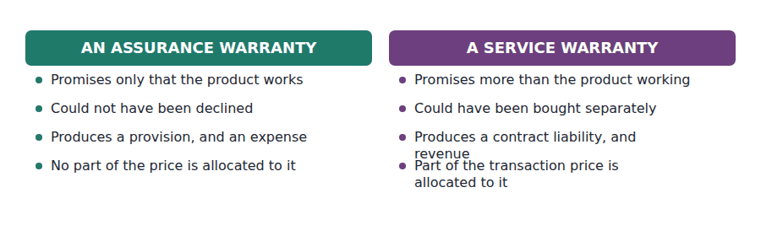
Part 3 · The provision recording it and rolling it forward
Exercise 1D Complete the schedule, then the journal entries underneath.
OBJECTIVE | Record the warranty charge and roll the provision forward.
YOU WILL NEED | Exercise 1C
HOW TO START | • The charge is 2% of the year’s sales of $4,800,000.  • Claims settled reduce the provision. They are not an expense when they are paid — the expense was charged when the provision was raised.  • The closing figure is whatever the three lines above it produce.

Movement in the warranty provision during 20X4 | Amount
Provision at 1 January 20X4 | $40,000
Charge for the year, 2% of sales of $4,800,000
Less claims settled during the year
Provision at 31 December 20X4

1 | 2 | 3

J1 The warranty charge for the year, 2% of sales. The expense is recognised now, on sales already made.
Account | Debit | Credit
Warranty Expense
Warranty Provision
J2 Claims of $76,000 settled in cash during the year. No expense. The provision absorbs it, exactly as an allowance absorbs a write-off.
Account | Debit | Credit
Warranty Provision
Cash

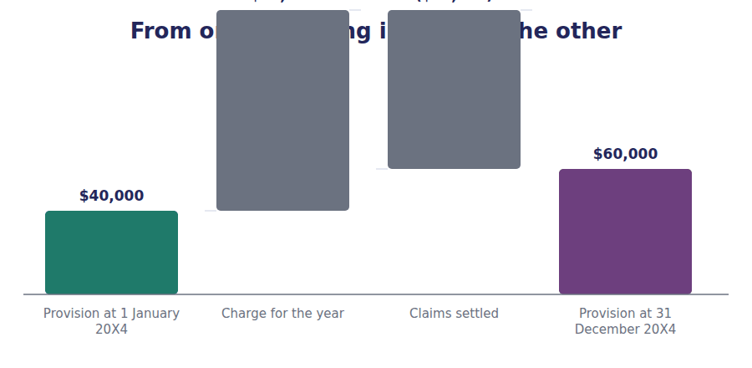
Part 4 · When the warranty is revenue instead the service approach
Exercise 1E Read and complete.
OBJECTIVE | Say what happens to the transaction price when a warranty is a separate promise.
YOU WILL NEED | Exercise 1D · Volume 2 Handout 3, for allocation.
HOW TO START | • A service warranty is a performance obligation, so Volume 2’s five steps apply to it.  • Blank 2 is the step that gives it a share of the price.  • The last blank is the balance sheet line the unearned part sits in until the service period runs.

WORD BANK
allocated · asset · estimate · expense · immediately · liability · over · provision
Not every word is used.

R2 A service warranty is a separate performance obligation, so it is not accounted for as a ⁴ at all. Nothing is estimated and no expense is charged on the day of sale.
Instead it goes through the five steps from Volume 2. Part of the transaction price is ⁵ to it on a relative standalone selling price basis, exactly as the support contract in that volume was.
The allocated amount is then recognised as revenue ⁶ the warranty period, because the customer receives and consumes the benefit of the cover as time passes.
Until it is earned, the unrecognised part sits on the balance sheet as a contract ⁷ . The company has been paid for cover it has not yet provided, which is the same position as Meridian’s support contract in Volume 2.
One consequence is worth stating. The same warranty period produces an ⁸ on day one under the assurance approach and revenue spread across the period under the service approach, so the two treatments move reported profit in opposite directions in the year of sale.
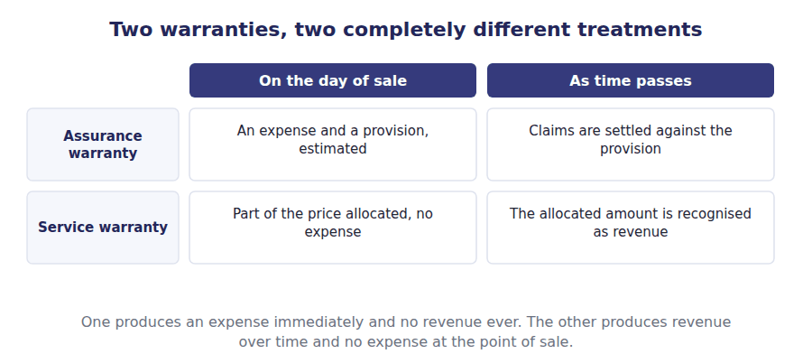
Watch out! A warranty provision behaves exactly like the allowance for credit losses in Volume 3. The expense is charged when the provision is raised, and settling a claim reduces the provision without touching income. If a question asks the effect of paying a claim, the answer is none.
Part 5 · Exam pitch the questions as the CMA sets them
1. [Level B] A note of $400,000 falls due in March. A binding refinancing agreement for the full amount is signed before the financial statements are issued. The note should be classified as:
(A) Current, because it falls due within one year
(B) Non-current, because the ability to refinance has been demonstrated
(C) Half current and half non-current
(D) Non-current, provided management intends to refinance
2. [Level C] A note of $400,000 falls due within one year. A refinancing agreement covers only $250,000 of it. The amount reported as a current liability is:
(A) $0
(B) $150,000
(C) $400,000
(D) $250,000
3. [Level A] A warranty that promises only that the product will function as specified is accounted for as:
(A) A separate performance obligation, with revenue allocated to it
(B) A provision, with the expected cost charged as an expense
(C) A contingent liability disclosed in the notes
(D) A reduction of revenue
4. [Level B] A company sells a machine with a three-year extended service plan that customers may buy separately. The plan should be:
(A) Charged as a warranty provision
(B) Treated as a separate performance obligation, with part of the transaction price allocated to it
(C) Ignored until a claim is made
(D) Recognised as revenue in full on the day of sale
5. [Level B] A warranty provision stands at $40,000. Claims of $76,000 are settled in cash during the year. The effect on net income of settling those claims is:
(A) A decrease of $76,000
(B) An increase of $76,000
(C) No effect
(D) A decrease of $96,000
6. [Level A] A warranty provision opened at $40,000. The charge for the year was $96,000 and claims of $76,000 were settled. The closing provision is:
(A) $60,000
(B) $96,000
(C) $40,000
(D) $136,000
7. [Level C] Which of the following determines whether a warranty is an assurance warranty or a service warranty?
(A) The length of the warranty period
(B) Whether the customer could have purchased it separately
(C) Whether any claims have been made
(D) The size of the expected cost
ADAPTIVE TIP Both questions in this handout are about evidence rather than intention. A refinancing needs demonstrated ability, and a service warranty needs a price the customer could have paid separately. Look for the evidence in the stem before you classify anything.

Handout 2 · Why Tax Expense Is Not the Tax Bill
Northwind reports $170,000 of tax and sends the government $146,000. The gap is not an error, and explaining it is the whole of deferred tax.
Volume 7 · Liabilities, Taxes and Leases · R1 moving to R2
LANGUAGE FOCUS
Register you are working in | R1 while the two figures are separated, R2 once the allocation is explained.
Say it exactly like this | compute taxable income · allocate tax between periods · charge deferred tax to income · reverse a timing difference · apply the enacted rate · reconcile the effective rate
Words that are not the same | tax expense / tax payable · accounting profit / taxable income · current tax / deferred tax · statutory rate / effective rate
Remember | The tax return is not the income statement. They measure different things and are not meant to agree. Deferred tax is not a payment the company has avoided. It is a payment moved to a later year.

What you will be able to do when this handout is finished
- Say why accounting profit and taxable income differ.
- Split income tax expense into its current and deferred parts.
- Compute taxable income from accounting profit and a timing difference.
- Say what interperiod tax allocation is and what it is for.
- Reconcile the reported tax charge to the statutory rate.

Two figures that should agree and do not
Northwind’s income statement reports income tax expense of $170,000. The company’s tax return for the same year asks for $146,000.
The difference of $24,000 is not a mistake, not a dispute with the tax authority and not tax the company has escaped.
It exists because the accounts and the tax return measure the same year by different rules, and the accounts are required to report a charge that matches the profit they themselves measured.
This handout explains the gap. Handouts 3 and 4 take it apart.

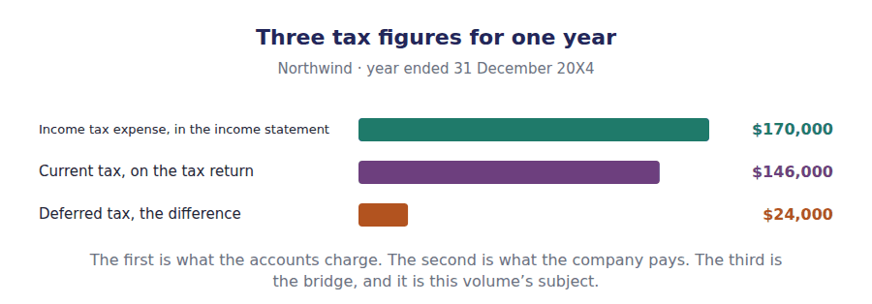
Part 1 · Two measurements of one year why they differ at all
Exercise 2A Read and complete. Write one word in each space.
OBJECTIVE | Say why accounting profit and taxable income differ.
YOU WILL NEED | Volume 1 Handout 3, for how accounting profit is measured.
HOW TO START | • The two sets of rules exist for different purposes. Name each purpose.  • Blank 3 is the figure the tax return produces, and it is not profit before tax.  • The last blank is what the differences do over time, and it is the reason deferred tax is a timing question.

WORD BANK
audit · error · permanent · profit · revenue · reverses · taxable
Not every word is used.

R1 The accounts exist to tell a reader how the company performed. The tax rules exist to raise ¹ for the government, and they are written with that in mind rather than with a reader in mind.
So the two measure the same year differently. The tax rules may allow a faster write-off of equipment to encourage investment, refuse a deduction for a fine, or ignore interest on a government bond altogether. None of those is an ² in either measurement.
The figure the tax rules produce is called ³ income, and the tax actually payable is computed on it. Northwind’s accounting profit before tax is $680,000, and its taxable income for the same year is different.
Most of these differences are temporary. A faster write-off now means a smaller write-off later, so the difference ⁴ in a future period and the two measurements eventually agree.
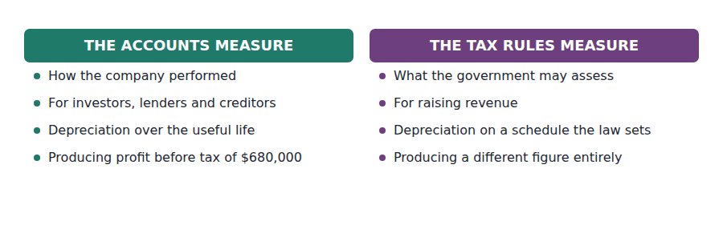
Part 2 · Computing taxable income one difference, worked
Exercise 2B Complete the table. Both columns start from the same figure.
OBJECTIVE | Compute taxable income from accounting profit and one timing difference.
YOU WILL NEED | Exercise 2A
HOW TO START | • The first row is identical in both columns. Only the depreciation line differs.  • Northwind charged $250,000 of depreciation in its accounts and claimed $346,000 on its return.  • The last row applies 25% to each column, and the two answers are the two figures from the opening scene.

 | In the accounts | In the tax return
Profit before depreciation and tax | $930,000 | $930,000
Depreciation deducted | ($250,000) | ($346,000)
Profit before tax, as measured
At 25%

1 | 2 | 3 | 4

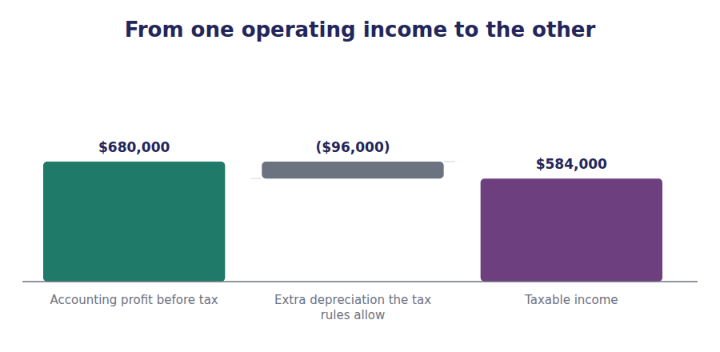
Part 3 · What the accounts are required to report interperiod allocation
R2 If the income statement simply reported the tax on the return, the charge would follow the tax rules rather than the profit the statement itself measured. A year of heavy capital spending would show a low tax charge against an unchanged profit, and the margin would be meaningless.
R2 So the accounts report a charge matched to their own profit. The current part is what the return asks for; the deferred part is the tax on the difference, charged now because the profit it relates to was reported now.
Exercise 2C Complete the schedule, then record the entry underneath.
OBJECTIVE | Split the reported charge into its current and deferred parts.
YOU WILL NEED | Exercise 2B, and the two paragraphs above.
HOW TO START | • The current part is the figure you computed in the right-hand column of Exercise 2B.  • The deferred part is the tax on the timing difference: $96,000 at 25%.  • The two must add to the charge reported in Volume 1, which is $170,000.

Income tax expense for 20X4 | Amount
Current tax — what the return actually asks for
Deferred tax — the timing difference, charged now
Income tax expense reported in the income statement

1 | 2 | 3

J1 The tax charge for 20X4, split between the part payable now and the part deferred. One expense, two credits, and only one of them is a bill.
Account | Debit | Credit
Income Tax Expense
Income Taxes Payable
Deferred Tax Liability

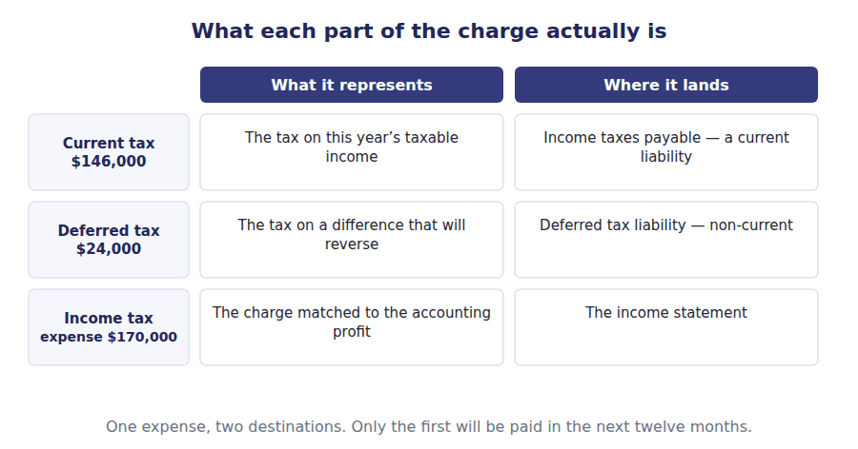
Part 4 · Checking the charge the effective rate reconciliation
Exercise 2D Read and complete.
OBJECTIVE | Reconcile the reported charge to the statutory rate.
YOU WILL NEED | Exercise 2C
HOW TO START | • Start from profit before tax at the statutory rate. The timing difference does not appear in this reconciliation at all — think about why.  • Blank 2 is the kind of difference that does appear, because it never reverses.  • Northwind has one of each, and they happen to be the same size.

WORD BANK
$146,000 · $170,000 · deferred · effective · reverses · statutory · temporary
Not every word is used.

R2 Profit before tax is $680,000, and at the statutory rate of 25% the charge would be ⁵ .
The depreciation difference does not appear in this reconciliation, because it reverses: the accounts have already charged tax on the whole of their own profit, with part of it ⁶ . A difference that ⁷ changes when tax is charged and never how much.
What does appear is a difference that never reverses. Northwind paid a $20,000 fine that the tax rules do not allow as a deduction, which adds $5,000 to the charge, and received $20,000 of municipal bond interest that is not taxable at all, which takes $5,000 away.
Here the two happen to be equal and cancel, so the reported charge is exactly $170,000 and the effective rate is the same as the ⁸ rate. That is a coincidence of this company’s figures, not a rule.
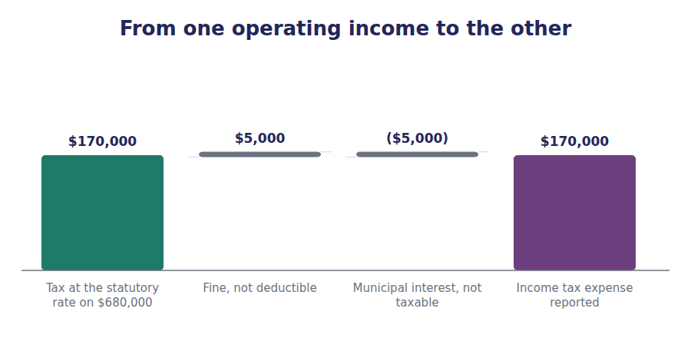
Part 5 · Which rate enacted, not expected
Exercise 2E Sort each statement into the column that says whether it is true.
OBJECTIVE | Say which tax rate is applied to a difference that will reverse later.
YOU WILL NEED | Exercise 2D
HOW TO START | • The rate used is the one that will apply when the difference reverses, and it has to be law already.  • A rate a government has announced but not enacted is not used.  • When a rate changes, the existing balance has to be remeasured, and that affects the current year.

Statement about the rate used for deferred tax | TRUE | FALSE
1. The rate is the one enacted for the period in which the difference reverses
2. A rate announced by a government but not yet passed into law is used
3. Existing deferred tax balances are remeasured when a new rate is enacted
4. The remeasurement is spread over the remaining reversal period
5. The effect of a rate change is recognised in the period of enactment
6. The current year’s rate is always used, whatever happens later

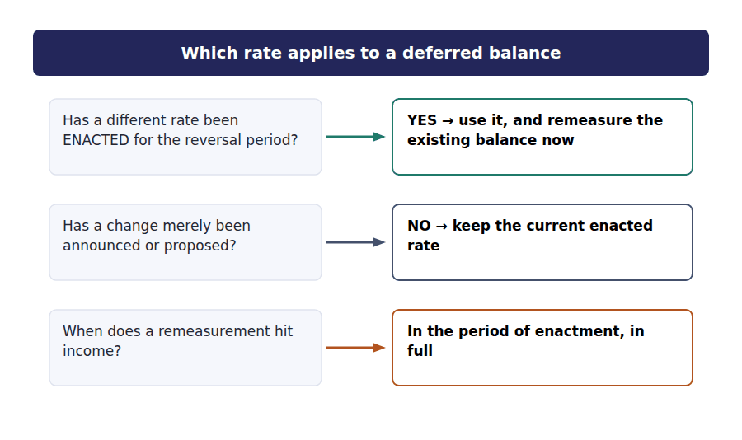
Watch out! Deferred tax never changes the total tax a company pays. It changes which year the charge appears in. If a question asks about the tax paid over the life of an asset, the answer is the same under every depreciation schedule.
Part 6 · Exam pitch the questions as the CMA sets them
1. [Level A] A company reports income tax expense of $170,000 and income taxes payable of $146,000 for the year. The difference of $24,000 is:
(A) An error in the tax return
(B) Deferred tax, arising from a difference that will reverse
(C) Tax the company has permanently avoided
(D) A penalty assessed by the tax authority
2. [Level B] Accounting profit before tax is $680,000. Tax depreciation exceeds book depreciation by $96,000. Taxable income is:
(A) $776,000
(B) $584,000
(C) $680,000
(D) $170,000
3. [Level B] Interperiod tax allocation exists so that:
(A) The company pays less tax overall
(B) The tax charge in the income statement matches the accounting profit that gave rise to it
(C) The tax return and the financial statements agree
(D) Deferred tax balances are eliminated
4. [Level C] Which of the following would cause the effective tax rate to differ from the statutory rate?
(A) Tax depreciation exceeding book depreciation
(B) A fine that is not deductible for tax purposes
(C) A difference that will reverse in three years
(D) A change in the timing of a tax payment
5. [Level C] A government enacts a lower tax rate that will take effect in two years. An existing deferred tax liability should be:
(A) Left unchanged until the rate takes effect
(B) Remeasured at the new rate, with the effect recognised in the period of enactment
(C) Remeasured at the new rate, with the effect spread over two years
(D) Written off entirely
6. [Level B] Which rate is used to measure a deferred tax balance?
(A) The current year’s rate, always
(B) The rate enacted for the period in which the difference is expected to reverse
(C) The rate the government has announced it intends to introduce
(D) The average rate over the reversal period
7. [Level C] Over the entire life of an asset, the total tax a company pays is affected by the depreciation method used for tax purposes:
(A) Yes, an accelerated schedule reduces total tax
(B) No, only the timing of the payments changes
(C) Yes, provided the rate stays constant
(D) Only if the asset is sold before the end of its life
ADAPTIVE TIP Write three figures at the top of any deferred tax question: accounting profit, taxable income, and the rate. Everything else in the question is built from those three, and the one the stem withholds is usually the answer.

Handout 3 · Temporary and Permanent Differences
Handout 2 found a $24,000 gap between the charge and the bill. Only some differences create it, and knowing which is the whole skill.
Volume 7 · Liabilities, Taxes and Leases · R2
LANGUAGE FOCUS
Register you are working in | R2 throughout, with one R3 classification so the student meets the exam’s own wording for the two categories.
Say it exactly like this | originate a temporary difference · reverse in a future period · give rise to a deferred tax liability · disallow a deduction · exclude an item from taxable income · affect the effective tax rate
Words that are not the same | temporary difference / permanent difference · originate / reverse · taxable temporary difference / deductible temporary difference · deferred tax liability / deferred tax asset
Remember | A temporary difference is not a small difference and a permanent difference is not a large one. The test is whether it reverses. A permanent difference is not ignored. It changes the tax charge in the year it arises and is simply never recognised as deferred tax.

What you will be able to do when this handout is finished
- Define a temporary difference and a permanent difference.
- Decide, for a given item, which of the two it is.
- Say which of the two gives rise to deferred tax, and why.
- Distinguish a taxable from a deductible temporary difference.
- Say which kind of difference moves the effective tax rate.

Not every difference is deferred
Handout 2 reconciled a tax charge of $170,000 to a tax bill of $146,000. Four separate differences were in play that year.
Only one of them produced the $24,000 of deferred tax. The other two changed the charge directly and left no balance behind at all.
The difference between the two kinds is not a matter of size or importance. It is a single question: will the two measurements eventually agree?
This handout asks that question of five items from Northwind’s year and sorts them.

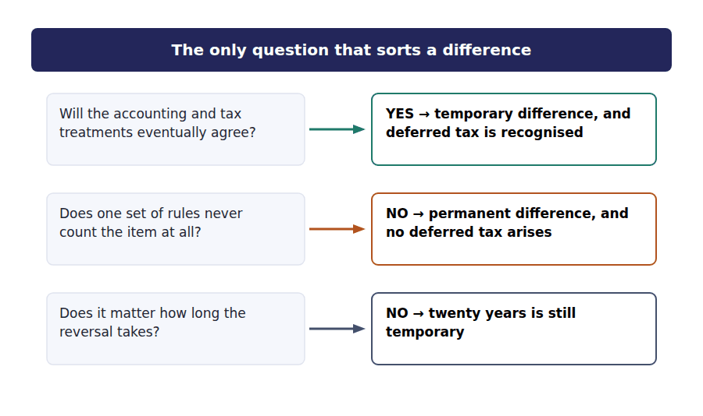
Part 1 · The temporary kind it originates, then it reverses
Exercise 3A Read and complete. Write one word in each space.
OBJECTIVE | Define a temporary difference and say what makes it temporary.
YOU WILL NEED | Handout 2, Exercises 2B and 2C.
HOW TO START | • Blanks 1 and 2 are the verb pair the exam uses for the two ends of the difference’s life.  • Northwind claimed $346,000 of depreciation on its return and charged $250,000 in its accounts. Over the asset’s life, both figures come to the same total.  • The last blank is what a temporary difference leaves behind on the balance sheet.

WORD BANK
asset · expire · liability · originate · permanent · reverses · timing
Not every word is used.

R2 Northwind deducted $346,000 of depreciation on its return and charged $250,000 in its accounts. The gap of $96,000 did not appear out of nothing and will not stay. It is said to ¹ in this period.
An asset has one cost, and both sets of rules write off that cost in full. A faster deduction now therefore means a smaller one later. In those later periods the difference ² , and the two measurements agree in total.
Because the whole of the gap is recovered, nothing is gained or lost in the end. What changes is the ³ of the payments, and the company has the use of the money in the meantime.
The accounts are required to report the tax on their own profit, so the tax on the unreversed part is charged now and carried on the balance sheet as a deferred tax ⁴ until it reverses.
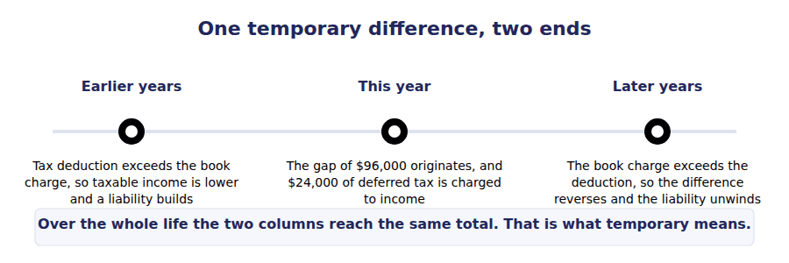
Part 2 · The two directions taxable and deductible
R2 A temporary difference can run either way. Where the tax rules allow the deduction first, taxable income is below accounting profit now and will be above it later. Where the accounts charge the expense first, the reverse holds.
Exercise 3B Sort each item into the column that names the kind of difference it creates.
OBJECTIVE | Distinguish a taxable from a deductible temporary difference.
YOU WILL NEED | Exercise 3A, and the paragraph above.
HOW TO START | • Ask what the item does to taxable income when it reverses, not what it does this year.  • If taxable income will be higher on reversal, more tax will be owed, so the balance is a liability.  • Northwind’s warranty and bad debt accruals are both charged in the accounts before the tax rules allow them.

Item | TAXABLE | DEDUCTIBLE
1. Tax depreciation claimed ahead of the book charge
2. Warranty expense accrued before the repairs are paid for
3. Bad debt expense accrued before the account is written off
4. Revenue recognised in the accounts before it is taxed
5. Rent collected in advance, taxed on receipt but earned later
6. Development costs deducted on the return before amortisation

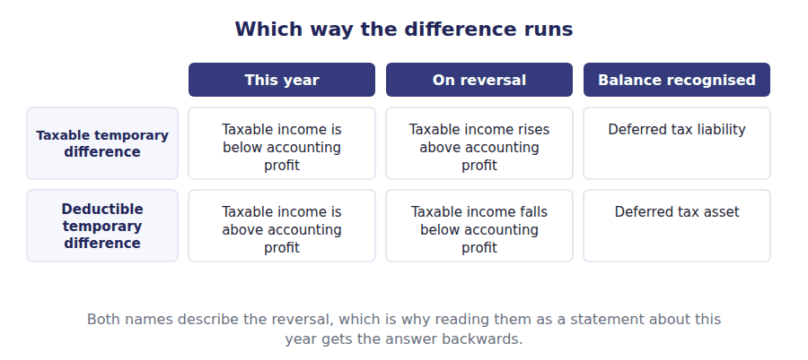
Part 3 · The permanent kind counted once, or not at all
Exercise 3C Read and complete. Write one word in each space.
OBJECTIVE | Define a permanent difference and say why no deferred tax arises.
YOU WILL NEED | Exercise 3A, and Handout 2 Exercise 2D.
HOW TO START | • Northwind had two permanent differences, and Handout 2 put both of them through the rate reconciliation.  • Blank 2 is what the tax rules do to the fine, and blank 3 is what they do to the municipal interest.  • The last blank is the rate that a permanent difference moves and a temporary one does not.

WORD BANK
defer · disallow · effective · enacted · exclude · reverses · statutory
Not every word is used.

R2 Some items are counted by one set of rules and by the other in no period at all. There is nothing to come back, so the difference never ⁵ and is called permanent.
Northwind paid a $20,000 fine. It is an expense in the accounts, and the tax rules ⁶ it as a deduction in this year and in every year. The company is simply taxed on $20,000 more than it earned.
The same company received $20,000 of municipal bond interest. It is income in the accounts, and the tax rules ⁷ it altogether. Neither item will ever be settled by a later period.
So no balance is recognised. A permanent difference changes the tax charge in the year it arises and therefore moves the ⁸ rate away from the statutory one.
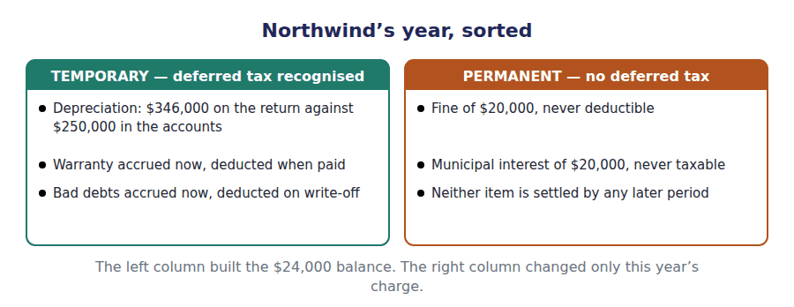
Part 4 · Sorting them under exam conditions the two questions, asked together
Exercise 3D Complete both right-hand columns. Write Yes or No in each cell.
OBJECTIVE | Decide for each item whether it reverses and whether deferred tax arises.
YOU WILL NEED | Exercises 3A, 3B and 3C.
HOW TO START | • The two columns always agree. That is the point of the exercise.  • Work the first column first: ask whether the two treatments ever come together.  • Five items, ten cells, and no cell where the answers differ.

Item from Northwind’s year | Reverses? | Deferred tax?
Tax depreciation of $346,000 against book depreciation of $250,000
A $20,000 fine the tax rules disallow
$20,000 of municipal bond interest that is never taxed
Warranty expense accrued now, deducted when paid
Bad debt expense of $35,000 accrued now, deducted on write-off

1 | 2 | 3 | 4 | 5 | 6
7 | 8 | 9 | 10

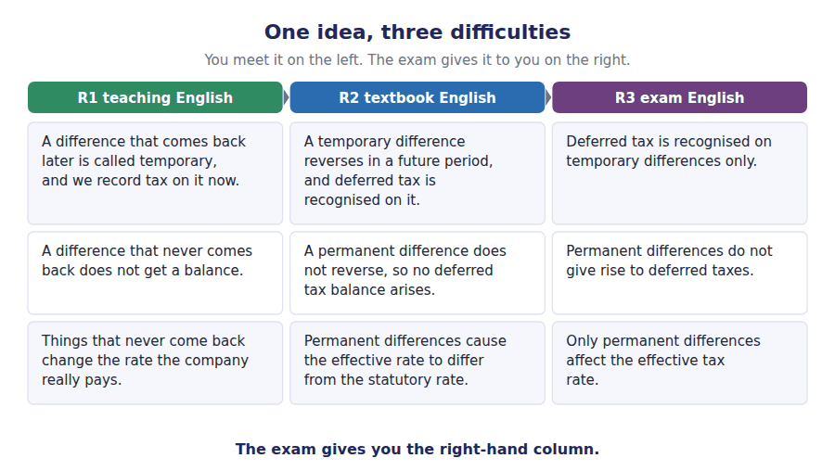
Watch out! A question that lists five items and asks how many give rise to deferred tax is asking one thing five times: does it reverse? Fines, penalties, municipal interest, life insurance proceeds on an officer and the dividends received deduction are the permanent differences the exam reuses.
Part 5 · Exam pitch the questions as the CMA sets them
1. [Level A] A temporary difference is one that:
(A) Is small in relation to pre-tax income
(B) Will reverse in one or more future periods
(C) Arises only from depreciation
(D) Affects the effective tax rate
2. [Level A] Which of the following is a permanent difference?
(A) Tax depreciation claimed ahead of the book charge
(B) A fine that the tax rules never allow as a deduction
(C) Warranty costs accrued before they are paid
(D) Rent collected in advance and taxed on receipt
3. [Level B] A company accrues warranty expense of $60,000 that will be deductible only when the repairs are paid for. This creates:
(A) A taxable temporary difference and a deferred tax liability
(B) A deductible temporary difference and a deferred tax asset
(C) A permanent difference
(D) No difference, because the total expense is the same
4. [Level B] A taxable temporary difference is so named because:
(A) It is taxable in the current period
(B) It will increase taxable income when it reverses
(C) It arises from taxable income rather than accounting profit
(D) It is the only kind on which tax is assessed
5. [Level B] Which of the following would cause a company’s effective tax rate to fall below the statutory rate?
(A) Tax depreciation in excess of book depreciation
(B) Interest received on municipal bonds that is not taxable
(C) A warranty accrual not yet deductible
(D) A deferred tax liability arising in the period
6. [Level C] Northwind reports pre-tax profit of $680,000, has a $20,000 fine that is not deductible and $20,000 of non-taxable municipal interest, and its statutory rate is 25%. Its effective tax rate is:
(A) Above 25%
(B) Exactly 25%
(C) Below 25%
(D) Not determinable without the deferred tax balance
7. [Level C] A company has one temporary difference that will reverse over the next four years. Over those four years, in total, the deferred tax recognised on it will:
(A) Grow, because the balance accretes
(B) Unwind to zero
(C) Remain constant until the final year
(D) Be reclassified as a permanent difference
ADAPTIVE TIP Read the item, not the label. Ask only whether the accounts and the return will ever agree on it. If they will, it is temporary and carries deferred tax; if they will not, it is permanent and carries none, and it is the one that moves the effective rate.

Handout 4 · Deferred Tax Assets and Liabilities
Northwind’s balance sheet shows one deferred tax line of $160,000. Five differences sit behind it, and two of them are assets.
Volume 7 · Liabilities, Taxes and Leases · R2 moving to R3
LANGUAGE FOCUS
Register you are working in | R2 for the recognition and measurement, R3 for the realisation test, which the exam states in its own fixed phrase.
Say it exactly like this | recognise a deferred tax asset · measure a balance at the enacted rate · assess the realisability of an asset · record a valuation allowance · carry a loss forward · present a balance as non-current
Words that are not the same | deferred tax asset / deferred tax liability · gross balance / net presentation · recognition / realisation · valuation allowance / write-off
Remember | A valuation allowance is not a write-off. The asset stays on the books and the allowance can be released. Netting the balances is not optional presentation. Within one tax jurisdiction a single net figure is required.

What you will be able to do when this handout is finished
- Say when a deferred tax asset arises rather than a liability.
- Measure each deferred tax component from its difference and the rate.
- State the test for whether a deferred tax asset is realisable.
- Record and interpret a valuation allowance.
- Present the balances the way the balance sheet requires.

One line, five differences
Volume 1’s balance sheet carries a single non-current line: deferred tax liability, $160,000.
Handout 3 found five temporary differences in Northwind’s year. Three of them run one way and two run the other.
The $160,000 is not the sum of the five. It is the net of a gross liability and two gross assets, and the netting is required rather than chosen.
This handout measures each component, nets them, decides whether the assets are worth anything, and rolls the balance forward.

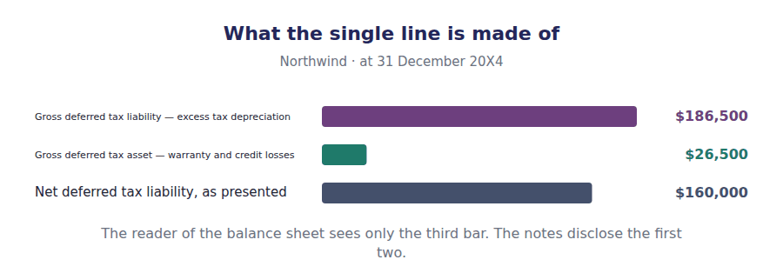
Part 1 · When the balance is an asset the deduction is coming, not gone
Exercise 4A Read and complete. Write one word in each space.
OBJECTIVE | Say when a deferred tax asset arises rather than a liability.
YOU WILL NEED | Handout 3, Exercise 3B.
HOW TO START | • Northwind charged a warranty provision in its accounts that the tax rules will not allow until the repairs are paid for.  • If the expense is in the accounts first, this year’s taxable income is the higher of the two figures.  • Blank 4 is what the asset needs in future years before it is worth anything at all.

WORD BANK
asset · deductible · higher · income · liability · lower · taxable
Not every word is used.

R2 Northwind’s warranty provision stands at $60,000, and none of it has been deducted on a tax return. The expense is in the accounts now and the deduction comes later, so this year’s taxable income is ¹ than accounting profit.
The company has therefore paid tax on profit it has not reported. When the repairs are paid for, the deduction arrives and taxable income falls below accounting profit. The difference is ² .
A future deduction already charged against accounting profit is an economic benefit, so it is carried as a deferred tax ³ . At 25% the warranty provision alone gives $15,000.
The benefit is conditional. A deduction reduces a tax bill only if there is a bill to reduce, so the asset is worth something only if there will be future taxable ⁴ to set it against.
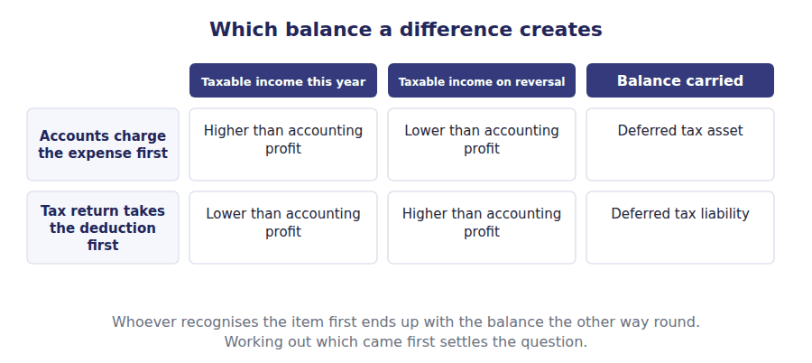
Part 2 · Measuring the components each difference at the enacted rate
R2 Each component is measured on its own: the cumulative difference multiplied by the rate enacted for the period in which it will reverse. The balances are then netted within a tax jurisdiction and the net figure is presented as non-current, whatever the timing of the reversals.
Exercise 4B Complete the right-hand column, then net the three figures.
OBJECTIVE | Measure each deferred tax component and net them to one balance.
YOU WILL NEED | Exercise 4A, and Handout 3 Exercise 3D.
HOW TO START | • Multiply each cumulative difference by 25%. The differences are given.  • The two deductible components are shown as negative amounts because they reduce the liability.  • The last row is the figure Volume 1 reported, so you can check your own work against it.

Component at 31 December 20X4 | Difference | At 25%
Cumulative excess tax depreciation — taxable | $746,000
Warranty provision not yet deductible — deductible | $60,000
Allowance for credit losses not yet deductible — deductible | $46,000
Net deferred tax liability, as presented

1 | 2 | 3 | 4

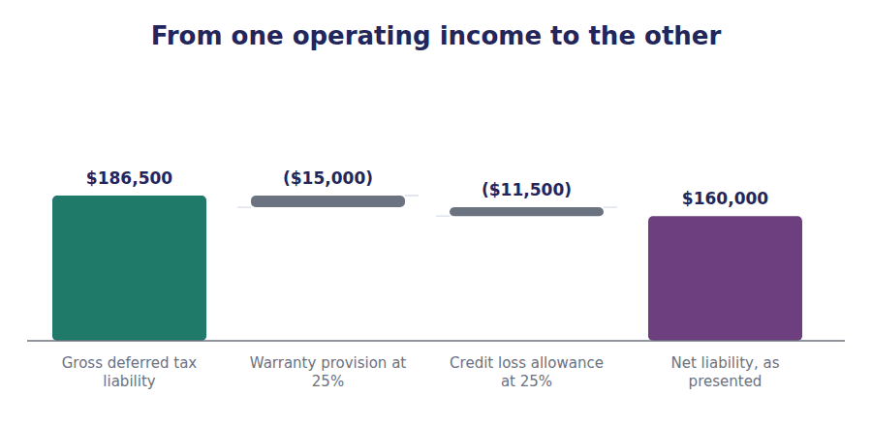
Part 3 · Whether the asset is worth anything the realisation test
Exercise 4C Read and complete. Write one word in each space.
OBJECTIVE | State the test for realising a deferred tax asset and apply it.
YOU WILL NEED | Exercise 4A.
HOW TO START | • The threshold is a probability, and the exam states it in four words.  • A net operating loss carryforward is the asset most often written down, because the losses that created it are themselves the evidence against realisation.  • Blank 2 is the account that reduces the asset without removing it from the books.  • A company with a long record of losses has the hardest time meeting the test, because the evidence runs against it.

WORD BANK
allowance · carryforwards · certain · impairment · not · released · reversed
Not every word is used.

R3 A deferred tax asset is recognised in full. It is then reduced by a valuation allowance if, on the weight of available evidence, it is more likely than ⁵ that some part of it will not be realised.
The reduction is recorded in a valuation ⁶ rather than against the asset itself, so the gross asset and the doubt about it are both visible to a reader.
The evidence is weighed, not counted. A history of recent losses, expiring ⁷ and no reliable forecast of profit all point one way; existing taxable temporary differences that will reverse into income point the other.
The allowance is not permanent. If the outlook improves it is ⁸ , and the release increases income in the period the judgement changes.
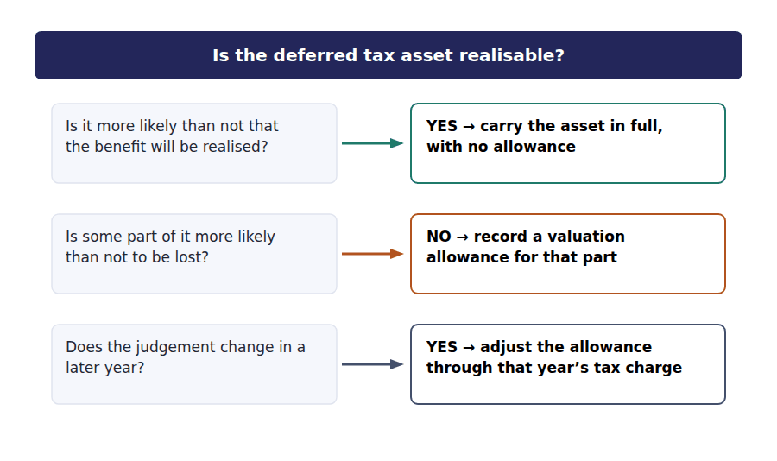
J1 A valuation allowance of $30,000 recorded against a deferred tax asset whose realisation has become doubtful. The asset is untouched. Only the allowance moves.
Account | Debit | Credit
Income Tax Expense
Valuation Allowance — Deferred Tax Asset
J2 The same allowance released two years later, when profitable forecasts make realisation likely again. The release lands in income, in the year the view changed.
Account | Debit | Credit
Valuation Allowance — Deferred Tax Asset
Income Tax Expense

Part 4 · The balance over a year where the movement went
Exercise 4D Complete the schedule. Two charges make up the movement.
OBJECTIVE | Roll the deferred tax liability forward and split the movement.
YOU WILL NEED | Exercise 4B, and Volume 1 Handout 6 on comprehensive income.
HOW TO START | • The opening balance is $128,000 and the closing balance is $160,000, so the movement is $32,000.  • Handout 2 found $24,000 of deferred tax inside income tax expense. That is the first charge.  • The rest sits in other comprehensive income, because the gain it relates to was reported there and not in profit.

Deferred tax liability | Amount
Balance at 1 January 20X4 | $128,000
Charged to income tax expense
Charged to other comprehensive income
Balance at 31 December 20X4

1 | 2 | 3

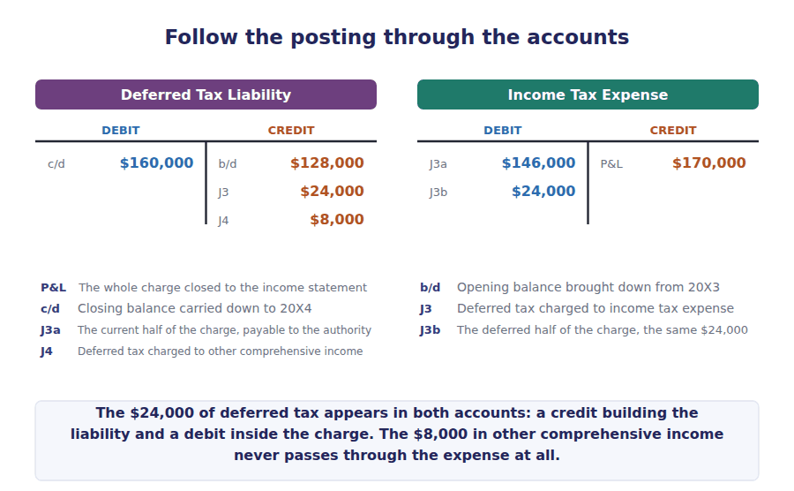
Watch out! Tax follows its item. Deferred tax on a gain reported in other comprehensive income is charged to other comprehensive income, not to income tax expense. A question that gives you the whole movement in the balance and asks for the expense is testing exactly that split.
Part 5 · Exam pitch the questions as the CMA sets them
1. [Level A] A deferred tax asset arises when:
(A) Tax depreciation exceeds book depreciation
(B) An expense is charged in the accounts before it is deductible
(C) A fine is disallowed for tax purposes
(D) The enacted rate is reduced
2. [Level A] A company has a deductible temporary difference of $400,000 and an enacted rate of 30%%. The deferred tax asset is:
(A) $400,000
(B) $120,000
(C) $280,000
(D) Nil until the difference reverses
3. [Level B] A valuation allowance is recorded when:
(A) A deferred tax liability is unlikely to be settled
(B) It is more likely than not that part of a deferred tax asset will not be realised
(C) The enacted tax rate changes
(D) A permanent difference arises
4. [Level B] The threshold for realising a deferred tax asset is that realisation is:
(A) Reasonably possible
(B) More likely than not
(C) Probable and estimable
(D) Virtually certain
5. [Level B] On a classified balance sheet, deferred tax balances are presented as:
(A) Current or non-current, according to when the difference reverses
(B) A single net non-current amount for each tax jurisdiction
(C) Always a current asset and a non-current liability
(D) An offset against the related asset or liability
6. [Level C] A deferred tax liability of $128,000 at the start of the year becomes $160,000 at the end. Income tax expense includes $24,000 of deferred tax. The remainder was:
(A) An error in the opening balance
(B) Charged to other comprehensive income
(C) Paid to the tax authority
(D) Released as a valuation allowance
7. [Level C] A company with large loss carryforwards releases part of its valuation allowance because forecasts have improved. The effect on the current year is:
(A) No effect, because the asset was already recognised
(B) A reduction in income tax expense, increasing net income
(C) An increase in other comprehensive income
(D) A restatement of the prior year
ADAPTIVE TIP In any deferred tax question, write the gross liability and the gross asset separately before you net them. Stems are built to punish netting too early: the valuation allowance, the rate change and the jurisdiction test all apply to a component, not to the net figure.

Handout 5 · Operating and Finance Leases: the Distinction
Northwind signed two leases in the same week. Both go on the balance sheet, and only one of them is a purchase in disguise.
Volume 7 · Liabilities, Taxes and Leases · R2
LANGUAGE FOCUS
Register you are working in | R2 for the recognition, R3 for the classification tests, which the exam states in its own wording.
Say it exactly like this | obtain the right to use an asset · recognise a right-of-use asset · measure the lease liability · discount the payments at the borrowing rate · classify a lease at commencement · exercise a purchase option
Words that are not the same | finance lease / operating lease · lessee / lessor · right-of-use asset / leased asset · lease term / economic life
Remember | An operating lease is not off the balance sheet. Since the standard changed, both kinds are recognised. A finance lease is not a lease the company has broken. It is a lease whose economics are those of a purchase.

What you will be able to do when this handout is finished
- Say what a lessee recognises at the start of any lease.
- Measure the lease liability and the right-of-use asset.
- State the five tests that classify a lease.
- Apply the tests to a lease and classify it.
- Say which leases need not be recognised at all.

Two leases, one week
In January 20X4 Northwind signed two leases. The first is a production machine for 5 years, with payments of $60,000 a year.
The second is one floor of a distribution warehouse for 3 years, at $40,000 a year.
The machine has 6 years of economic life left and the building has 40. Neither contract transfers legal ownership of anything.
Both leases go on the balance sheet. This handout decides which kind each one is, and Handout 6 reports them.

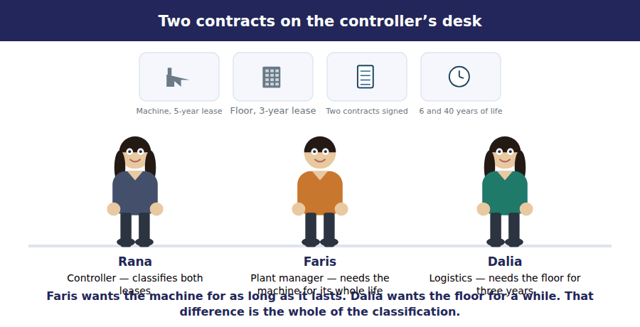
Part 1 · What every lease puts on the balance sheet the asset and the liability
Exercise 5A Read and complete. Write one word in each space.
OBJECTIVE | Say what a lessee recognises at the start of a lease, and at what amount.
YOU WILL NEED | Volume 1 Handout 2, on what makes something an asset.
HOW TO START | • A lessee does not own the machine, so ask what it does control.  • The liability is measured on the same basis as any other borrowing, and $60,000 of payments over 5 years is not $300,000.  • The last blank is the rate used when the contract does not state one.

WORD BANK
asset · borrowing · future · interest · liability · market · present
Not every word is used.

R2 Northwind does not own the machine and never will. What it does hold is the right to use the machine for 5 years, and it can stop anyone else from using it. That right is controlled, so it is an ¹ .
The payments are an unavoidable commitment, so a liability is recognised at the same time. Both are measured at the ² value of the 5 payments of $60,000, which is $239,563 and not the $300,000 the company will hand over in total.
The gap of $60,437 between the two figures is ³ , and it is recognised across the term rather than at the start.
Discounting needs a rate. The rate the lessor charged is used when the lessee can determine it; otherwise the lessee uses its own incremental ⁴ rate, which here is 8.0.%.
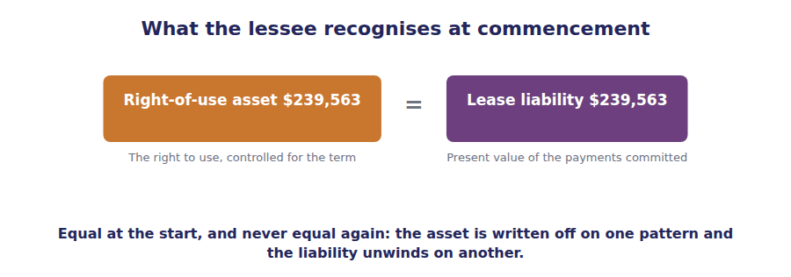
Part 2 · The five tests risks and rewards, in order
R2 A lease is classified once, at commencement, and the question is whether substantially all the risks and rewards of owning the asset have passed to the lessee. Five tests stand for that question. Meeting any one of them makes the lease a finance lease.
Exercise 5B Match each test to what it is testing. Write one letter in each space.
OBJECTIVE | State the five classification tests and say what each one looks for.
YOU WILL NEED | The paragraph above.
HOW TO START | • Two of the five are about ownership passing, by transfer or by option.  • Two are about whether the lessee is taking the asset for substantially its whole value or its whole life.  • The fifth asks whether the asset is of any use to anybody else.

 | Item | Answer |  | Option
1 | Ownership transfers at the end of the term |  | A | Ownership passes by the contract itself
2 | A purchase option reasonably certain to be exercised |  | B | Ownership will pass because the lessee will choose it
3 | The term is a major part of the remaining economic life |  | C | The lessee is taking almost the whole of the asset’s use
4 | The present value is substantially all of the fair value |  | D | The lessee is paying almost the whole of the asset’s value
5 | The asset is specialised, with no alternative use |  | E | Nobody else could use the asset, so the lessor bears no risk

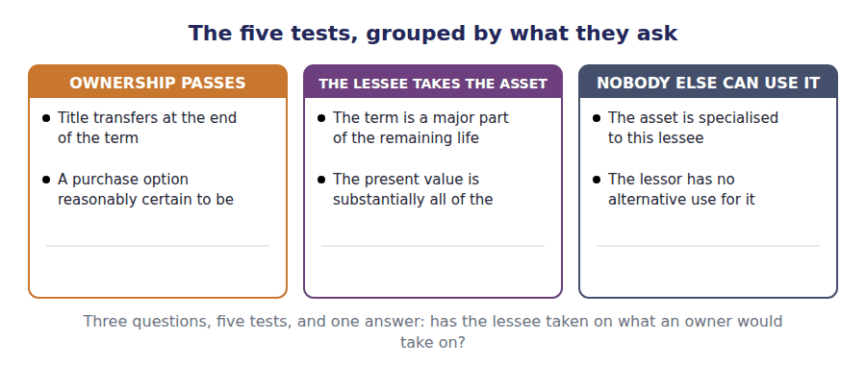
Part 3 · Northwind’s two leases the tests applied
Exercise 5C Complete the grid. Write Yes or No, with the figure that decides it where one is given.
OBJECTIVE | Apply the five tests to each lease and classify it.
YOU WILL NEED | Exercise 5B, and the opening scene for the terms and lives.
HOW TO START | • The machine runs 5 years against 6 years of life. Work out the share before you answer row 3.  • The warehouse floor runs 3 years against 40, and its present value of $103,000 is set against a fair value of $900,000.  • Once one test is met you may stop. The last row asks for the classification, not for a count of the tests.

Test | The machine lease | The warehouse floor
Ownership transfers at the end of the term
There is a purchase option reasonably certain to be exercised
The term is a major part of the remaining economic life
The present value is substantially all of the fair value
The asset is specialised, with no alternative use
Classification

1 | 2 | 3 | 4 | 5 | 6
7 | 8 | 9 | 10 | 11 | 12

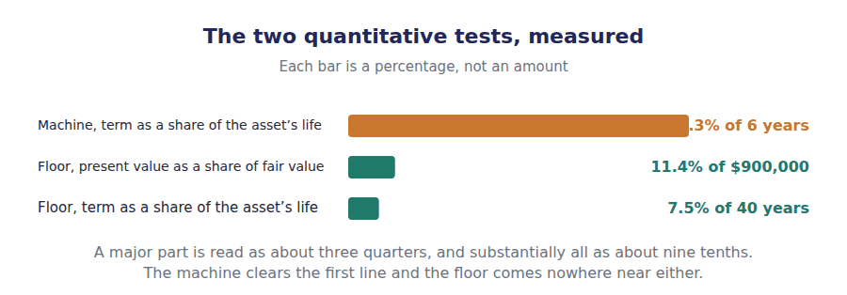
Part 4 · The leases that stay off the short-term election
Exercise 5D Read and complete. Write one word in each space.
OBJECTIVE | Say which leases a lessee need not recognise, and on what condition.
YOU WILL NEED | Exercise 5A.
HOW TO START | • The exemption is set by the length of the term, and the threshold is a round number of months.  • A lease with an option to buy cannot use the exemption, however short it is.  • The last blank is what a company that takes the exemption reports instead.

WORD BANK
capitalised · eighteen · expense · option · recognised · renewal · twelve
Not every word is used.

R2 Recognising a right-of-use asset for a photocopier on a nine-month contract costs more than it tells anyone. A lessee may therefore elect not to recognise a lease of ⁵ months or less.
The election is made by class of underlying asset rather than contract by contract, and a lease that contains a purchase ⁶ is excluded from it whatever its length.
A company that takes the election reports the payments as an ⁷ on a straight-line basis over the term, and discloses that it has done so.
Northwind’s two leases run 5 and 3 years, so neither qualifies. Both are ⁸ , and the only question left is how each one is reported.
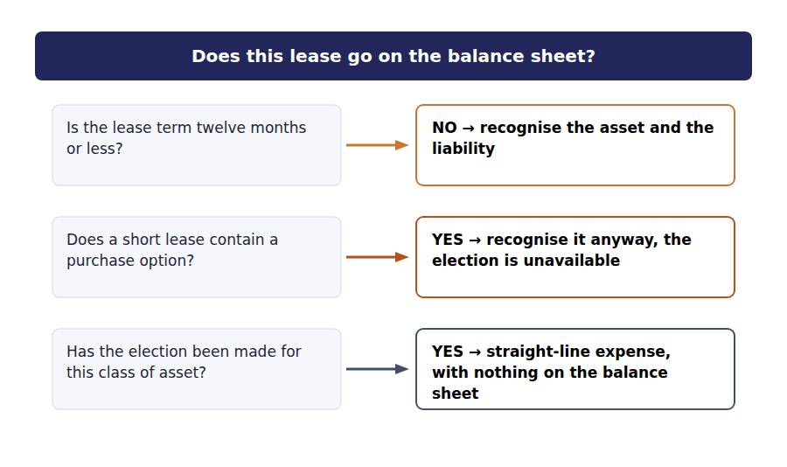
Watch out! Classification happens once, at commencement, and is not revisited because the asset’s remaining life shortens or because rates move. It is reassessed only when the contract itself is modified.
Part 6 · Exam pitch the questions as the CMA sets them
1. [Level A] At the commencement of a lease, a lessee recognises:
(A) Nothing, until the first payment is made
(B) A right-of-use asset and a lease liability at the present value of the payments
(C) The leased asset at its fair value and a liability at the total payments
(D) A liability only, because the asset is not owned
2. [Level A] Which of the following, on its own, makes a lease a finance lease?
(A) The lease term is three years
(B) The present value of the payments is substantially all of the asset’s fair value
(C) The lessee pays the insurance and the maintenance
(D) The lease cannot be cancelled
3. [Level B] A 5-year lease is signed on an asset with 6 years of remaining economic life. On the term test alone the lease is:
(A) An operating lease, because ownership does not transfer
(B) A finance lease, because the term is a major part of the remaining life
(C) An operating lease, because the term is under ten years
(D) Not classifiable without the fair value
4. [Level B] A lease liability is measured at the present value of the payments. The discount rate used is:
(A) The risk-free rate
(B) The rate implicit in the lease, or the lessee’s incremental borrowing rate if that is not determinable
(C) The lessee’s weighted average cost of capital
(D) The rate stated in the lease, always
5. [Level B] A lessee elects not to recognise a nine-month lease. It reports:
(A) Nothing at all
(B) The payments as an expense on a straight-line basis over the term
(C) A right-of-use asset only
(D) The payments as interest expense
6. [Level C] A three-year lease of a floor of a building with 40 years of remaining life, whose payments have a present value of $103,000 against a fair value of $900,000, is:
(A) A finance lease, because the asset is real property
(B) An operating lease, because no test is met
(C) A finance lease, because the term cannot be cancelled
(D) Exempt from recognition, because only part of a building is leased
7. [Level C] Two years into a finance lease, the asset’s remaining economic life has shortened so that the remaining term is now its whole life. The classification should be:
(A) Reassessed, and the lease remains a finance lease
(B) Left as it was, because classification is not revisited without a modification
(C) Reassessed, and the lease becomes an operating lease
(D) Reassessed at each reporting date as a matter of course
ADAPTIVE TIP Work the five tests in order and stop at the first Yes. A stem that gives you a term, a life, a present value and a fair value is giving you two tests and three distractors, and the test that is met first is usually the only one that needs computing.

Handout 6 · Where Each Lease Lands on the Statements
The machine lease costs $67,078 in year one and $52,355 in year five. The warehouse floor costs $40,000 every year. The payments never change.
Volume 7 · Liabilities, Taxes and Leases · R2 moving to R3
LANGUAGE FOCUS
Register you are working in | R2 for the mechanics, R3 for the statement presentation, which the exam asks about in its own terms.
Say it exactly like this | amortise the right-of-use asset · unwind the lease liability · apply the effective interest method · report a single lease cost · classify a payment as financing · front-load the expense
Words that are not the same | interest expense / amortisation expense · single lease cost / two separate charges · operating cash flow / financing cash flow · front-loaded / straight-line
Remember | A finance lease is not more expensive. Over the term both leases cost exactly what was paid. The single lease cost of an operating lease is not rent paid. It is the total payments spread evenly, whatever the payment pattern is.

What you will be able to do when this handout is finished
- Build a lease liability amortisation schedule.
- Record the two charges a finance lease produces each year.
- Record the single cost an operating lease produces each year.
- Say where each lease payment appears in the cash flow statement.
- Explain why one lease front-loads its cost and the other does not.

Two leases, two patterns
Handout 5 classified Northwind’s machine lease as a finance lease and its warehouse floor as an operating lease.
Both are on the balance sheet. The machine at $239,563 and the floor at $103,000.
From here the two part company. The finance lease produces two charges each year and the operating lease produces one, and the patterns are not the same shape at all.
This handout reports both, year by year, on all three statements.

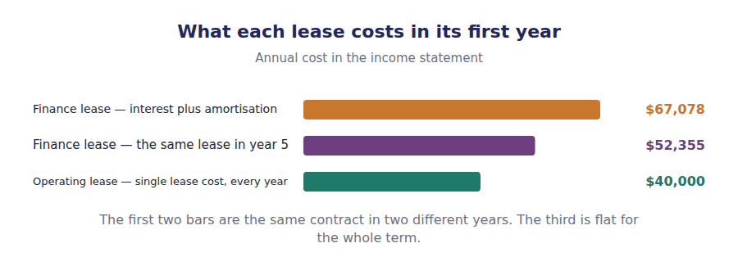
Part 1 · The finance lease liability a schedule like any other borrowing
Exercise 6A Complete the table. Each closing balance is the next opening balance.
OBJECTIVE | Build the lease liability amortisation schedule.
YOU WILL NEED | Handout 5 Exercise 5A, for the $239,563 present value. · Volume 7 Handout 1, on how a liability unwinds.
HOW TO START | • Interest is 8% of the opening balance, not of the original $239,563.  • The payment of $60,000 is the same every year, so as the interest falls more of each payment reduces the balance.  • The last closing balance must be nil. If it is not, check the interest you computed in year one.

Year | Opening liability | Interest at 8% | Payment | Closing liability
1 | $239,563 | $19,165 | $60,000 | $198,728
2 |  |  | $60,000
3 |  |  | $60,000
4 |  |  | $60,000
5 |  |  | $60,000

1 | 2 | 3 | 4 | 5 | 6
7 | 8 | 9 | 10 | 11 | 12

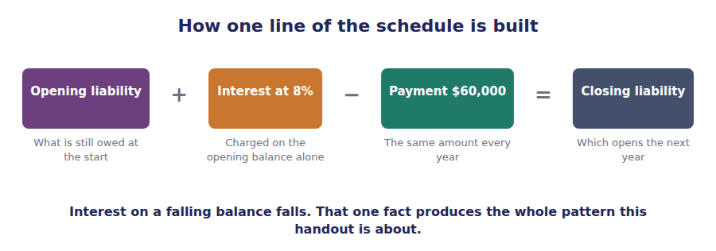
Part 2 · The finance lease in the accounts two charges, not one
R2 A finance lease is reported as what it is: an asset bought with borrowed money. The right-of-use asset is amortised on a straight-line basis over the term, and the liability carries interest on the effective interest method.
Exercise 6B Read and complete, then record the entries underneath.
OBJECTIVE | Record the first year of the finance lease and name both charges.
YOU WILL NEED | Exercise 6A.
HOW TO START | • Two charges reach the income statement, and they are not the same kind of expense.  • The amortisation is $239,563 divided by 5 years, and it is the same every year.  • The last blank is the shape the two charges make together as the years pass.

WORD BANK
$47,913 · $60,000 · falls · front-loaded · rises · separately · straight-line
Not every word is used.

R2 The right-of-use asset of $239,563 is written off over the 5-year term on a straight-line basis, giving ¹ of amortisation in every year of the lease.
The liability carries interest instead. In year one it is 8% of $239,563, or $19,165; in year two the balance is lower, so the charge ² to $15,898.
Two charges therefore reach the income statement each year, and they are reported ³ : amortisation among the operating expenses and interest among the finance costs.
Because one charge is flat and the other declines, the total cost of the lease is ⁴ . It is $67,078 in year one and $52,355 in year 5.
J1 The machine lease recognised at commencement, at the present value of the five payments. An asset and a liability, equal on day one and never again.
Account | Debit | Credit
Right-of-Use Asset — Machine
Lease Liability
J2 Year one amortisation of the right-of-use asset, $239,563 over 5 years. An operating expense, flat for the whole term.
Account | Debit | Credit
Amortisation Expense — Right-of-Use Asset
Accumulated Amortisation — Right-of-Use Asset
J3 The year one payment of $60,000, of which $19,165 is interest. One cheque, split between a finance cost and a repayment.
Account | Debit | Credit
Interest Expense
Lease Liability
Cash

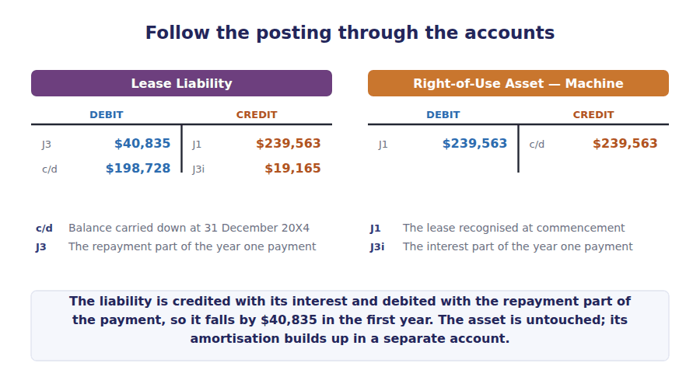
Part 3 · The operating lease in the accounts one cost, spread evenly
Exercise 6C Read and complete. Write one word or figure in each space.
OBJECTIVE | Record the first year of the operating lease and say what the charge is.
YOU WILL NEED | Handout 5 Exercise 5C, which classified this lease.
HOW TO START | • The total committed is 3 payments of $40,000. Divide it by the term.  • The charge is one line. It is not split between interest and amortisation, even though the liability does carry interest internally.  • The last blank is the basis on which the cost is spread.

WORD BANK
$120,000 · $40,000 · declining · finance · single · statement · straight-line
Not every word is used.

R2 The warehouse floor is on the balance sheet at $103,000, exactly as the machine is. The difference is what reaches the income ⁵ .
Northwind has committed to 3 payments of $40,000, or ⁶ in total. Spread over the 3-year term, the charge is $40,000 in each year.
That is reported as one line, called a ⁷ lease cost, among the operating expenses. No interest line appears, although the liability does unwind with interest inside the computation.
The cost is the same in every year of the term, so it is said to be recognised on a ⁸ basis. Even a lease with rising payments produces a flat charge.
J4 The warehouse floor lease recognised at commencement, at the present value of the three payments. An operating lease is on the balance sheet too.
Account | Debit | Credit
Right-of-Use Asset — Warehouse Floor
Lease Liability
J5 Year one of the operating lease: one cost of $40,000 and one payment of $40,000. One expense line, whatever is happening underneath.
Account | Debit | Credit
Lease Cost
Cash

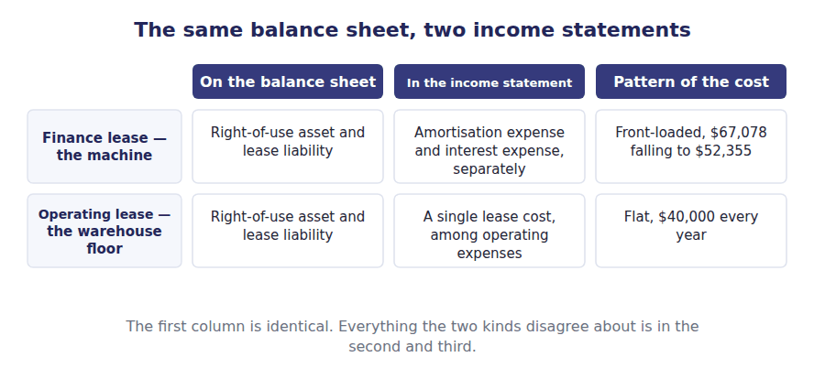
Part 4 · The two patterns side by side and why the totals still agree
Exercise 6D Complete the finance lease column, then total both.
OBJECTIVE | Compare the annual cost of the two leases and total each column.
YOU WILL NEED | Exercises 6A, 6B and 6C.
HOW TO START | • Each finance lease figure is that year’s interest from Exercise 6A plus $47,913 of amortisation.  • The operating lease column is given, and it stops after 3 years because the term is shorter.  • The finance lease total must equal 5 payments of $60,000. If it does not, one of the interest figures is wrong.

Year | Finance lease cost | Operating lease cost
1 |  | $40,000
2 |  | $40,000
3 |  | $40,000
4 |  | —
5 |  | —
Total |  | $120,000

1 | 2 | 3 | 4 | 5 | 6

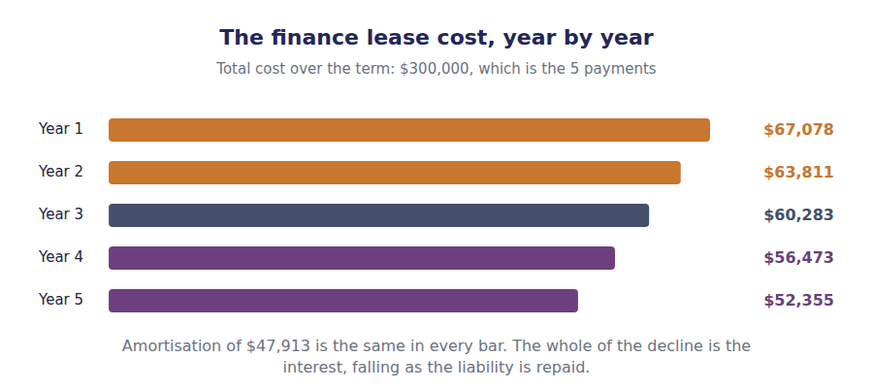
Part 5 · The cash flow statement where each payment is classified
R3 The payments are identical in form and classified differently. A finance lease payment is split: the interest part is an operating outflow and the principal part is a financing outflow. An operating lease payment is an operating outflow in full.
Exercise 6E Sort each item into the section it belongs in.
OBJECTIVE | Classify each lease cash flow in the statement of cash flows.
YOU WILL NEED | The paragraph above, and Volume 1 Handout 8 on the three sections.
HOW TO START | • Split the finance lease payment before you classify it: $19,165 of interest and $40,835 of principal in year one.  • Recognising a lease at commencement moves no cash at all, so it appears in neither section.  • Short-term lease payments under the recognition exemption are ordinary operating payments.

Lease cash flow | OPERATING | FINANCING
1. The interest part of a finance lease payment
2. The principal part of a finance lease payment
3. An operating lease payment in full
4. A payment on a short-term lease under the exemption
5. Variable lease payments not included in the liability

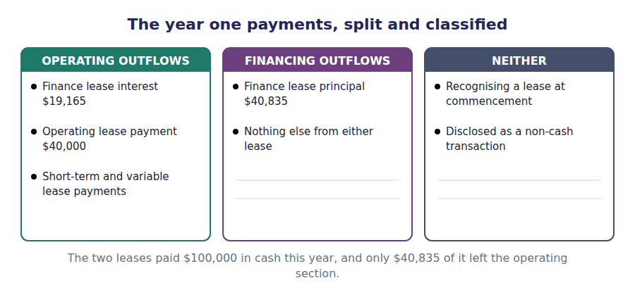
Watch out! Over the whole term both leases cost exactly what was paid: $300,000 for the machine and $120,000 for the floor. A finance lease is not a more expensive lease. It is the same cash in a different order, which is why a question asking for total expense over the term needs no schedule at all.
Part 6 · Exam pitch the questions as the CMA sets them
1. [Level A] A lessee reports a finance lease in the income statement as:
(A) A single lease cost on a straight-line basis
(B) Amortisation expense and interest expense, reported separately
(C) Rent expense equal to the cash paid
(D) Interest expense only
2. [Level A] A 3-year operating lease requires 3 payments of $40,000. The lease cost in year one is:
(A) $120,000
(B) $40,000
(C) $103,000
(D) $34,333
3. [Level B] A lease liability of $239,563 carries interest at 8%. The annual payment is $60,000. Interest expense in year two is:
(A) $19,165
(B) $15,898
(C) $38,330
(D) $4,800
4. [Level B] In the statement of cash flows, the principal portion of a finance lease payment is reported as:
(A) An operating outflow
(B) A financing outflow
(C) An investing outflow
(D) A non-cash transaction
5. [Level B] Compared with an operating lease of the same asset for the same payments, a finance lease reports, in the first year:
(A) A lower total expense
(B) A higher total expense
(C) The same total expense
(D) No expense at all
6. [Level C] Over the entire lease term, total expense under a finance lease compared with an operating lease on the same payments is:
(A) Higher, because interest is charged
(B) The same, because both equal the payments made
(C) Lower, because the asset is amortised
(D) Not comparable
7. [Level C] A company recognises a right-of-use asset and a lease liability of $239,563 at commencement. In the statement of cash flows for that year, the recognition is reported as:
(A) An investing outflow of $239,563
(B) Nothing, with disclosure as a non-cash transaction
(C) A financing inflow and an investing outflow of $239,563
(D) An operating outflow of $239,563
ADAPTIVE TIP Three figures settle almost any lease question: the opening liability, the rate and the payment. From those you can build any row of the schedule, and the amortisation is the present value divided by the term whatever the schedule says.

Answer Key
Volume 7 · Handouts 1 to 6
Every answer carries the reason for it and the mistake it defeats.

Handout 1 · Two Liability Questions: Refinancing and Warranties answers
Completed text and exercises
# | Answer | Why | The trap it defeats
1 | current | Due within a year, so current by the ordinary rule.
2 | ability | Demonstrated, not asserted. | Students accept management’s stated intention. The standard asks for evidence of ability.
3 | issued | Before issuance, not before the year end.
Grid 1 | 1 ASSURANCE — a provision 2 SERVICE — a performance obligation 3 SERVICE — a performance obligation 4 ASSURANCE — a provision 5 SERVICE — a performance obligation 6 ASSURANCE — a provision | The fourth item runs for two years and is still assurance. Length is not the test; what is promised is.
4 | provision | Not a provision — a performance obligation.
5 | allocated | Step 4, on a relative standalone basis.
6 | over | Over the period, as the cover is provided. | Students recognise the whole service warranty on the day of sale, which pulls years of revenue into one period.
7 | liability | Paid for, not yet provided.
8 | expense | One charges on day one; the other earns over time.

Exam-pitch questions
# | Answer | Why | The trap it defeats
1 | (B) Non-current, because the ability to refinance has been demonstrated | The agreement demonstrates ability before issuance, so the exception applies. (D) is the trap: intention alone is never sufficient, and the word provided in that option is doing work the standard does not permit. | Level B
2 | (B) $150,000 | Only what the agreement covers may be reclassified: $400,000 − $250,000 = $150,000 stays current. (C) ignores the agreement entirely and (A) applies it to the whole note. | Level C
3 | (B) A provision, with the expected cost charged as an expense | An assurance warranty is not a promise the customer bought, so it produces a provision rather than revenue. (A) describes a service warranty. (C) understates it — the obligation exists and only its amount is estimated. | Level A
4 | (B) Treated as a separate performance obligation, with part of the transaction price allocated to it | It is a service warranty and therefore a performance obligation, allocated under Volume 2’s step 4 and recognised over the period. (D) is the common error and pulls three years of revenue into one. | Level B
5 | (C) No effect | The expense was charged when the provision was raised; settling a claim reduces the provision and cash together. (A) is the intuitive answer and the wrong one — the same structure as a write-off against the allowance for credit losses in Volume 3. | Level B
6 | (A) $60,000 | $40,000 + $96,000 − $76,000 = $60,000. (D) omits the claims, which is the only movement that reduces the provision. | Level A
7 | (B) Whether the customer could have purchased it separately | Separability is the test: a warranty the customer could have bought or declined is a promise the company sold. (A) is the commonest wrong answer — a two-year promise that the product works is still assurance. | Level C

Exercise 1B · the completed classification
The situation at 31 December 20X4 | Current | Non-current
No refinancing agreement in place | $400,000 | $0
Agreement signed before the statements are issued, for the full $400,000 | $0 | $400,000
Agreement covers only $250,000 of the note | $150,000 | $250,000
Agreement signed after the statements are issued | $400,000 | $0

Exercise 1D · the completed provision
Movement in the warranty provision during 20X4 | Amount
Provision at 1 January 20X4 | $40,000
Charge for the year, 2% of sales of $4,800,000 | $96,000
Less claims settled during the year | ($76,000)
Provision at 31 December 20X4 | $60,000

J1 The warranty charge for the year.
Account | Debit | Credit
Warranty Expense | $96,000
Warranty Provision |  | $96,000
J2 Claims settled in cash.
Account | Debit | Credit
Warranty Provision | $76,000
Cash |  | $76,000

Handout 2 · Why Tax Expense Is Not the Tax Bill answers
Completed text and exercises
# | Answer | Why | The trap it defeats
1 | revenue | A different purpose, so different rules.
2 | error | Neither measurement is wrong. | Students treat the gap as a mistake to be reconciled away. It is two valid measurements of one year.
3 | taxable | The tax rules’ own figure.
4 | reverses | What goes one way now comes back later.
5 | $170,000 | $680,000 at 25%.
6 | deferred | Charged now, paid in a later year.
7 | reverses | Timing differences never change the total.
8 | statutory | Equal only because the two permanents cancel. | Students expect the effective rate to equal the statutory rate. It usually does not, and only permanent differences move it.
Grid 1 | 1 TRUE 2 FALSE 3 TRUE 4 FALSE 5 TRUE 6 FALSE | Enacted, not announced; and a rate change hits the year it is enacted, not the years the difference reverses in.

Exam-pitch questions
# | Answer | Why | The trap it defeats
1 | (B) Deferred tax, arising from a difference that will reverse | The gap between the charge and the bill is the deferred part. (C) is the common misreading: the tax is postponed rather than escaped, and the total over time is unaffected. | Level A
2 | (B) $584,000 | A larger deduction on the return reduces taxable income: $680,000 − $96,000 = $584,000. (A) adds the difference, which is the error to guard against when the direction is not spelled out. | Level B
3 | (B) The tax charge in the income statement matches the accounting profit that gave rise to it | Without allocation the charge would follow the return, and a year of heavy capital spending would show a low charge against an unchanged profit. (C) is impossible by design: the two measure the same year by different rules. | Level B
4 | (B) A fine that is not deductible for tax purposes | Only permanent differences move the effective rate; timing differences change when the charge falls and not how large it is. (A) and (C) both describe timing differences, which is exactly the distinction the question is testing. | Level C
5 | (B) Remeasured at the new rate, with the effect recognised in the period of enactment | The balance is remeasured at the enacted rate and the whole effect hits the period of enactment. (A) and (C) both delay an effect the standards require to be recognised at once. | Level C
6 | (B) The rate enacted for the period in which the difference is expected to reverse | Enacted, and for the reversal period. (C) is the trap: an announcement is not law, and measuring on an intention would let a government statement move reported profit. | Level B
7 | (B) No, only the timing of the payments changes | The same deductions are taken in total, so the total tax is unchanged and only its distribution moves. (A) is the intuition the whole topic exists to correct — the benefit is the time value of the deferral, not a reduction. | Level C

Exercise 2B · the two measurements
 | In the accounts | In the tax return
Profit before depreciation and tax | $930,000 | $930,000
Depreciation deducted | ($250,000) | ($346,000)
Profit before tax, as measured | $680,000 | $584,000
At 25% | $170,000 | $146,000

Exercise 2C · the completed split
Income tax expense for 20X4 | Amount
Current tax — what the return actually asks for | $146,000
Deferred tax — the timing difference, charged now | $24,000
Income tax expense reported in the income statement | $170,000

J1 The tax charge for 20X4.
Account | Debit | Credit
Income Tax Expense | $170,000
Income Taxes Payable |  | $146,000
Deferred Tax Liability |  | $24,000

Handout 3 · Temporary and Permanent Differences answers
Completed text and exercises
# | Answer | Why | The trap it defeats
1 | originate | The exam’s own word for a difference arising.
2 | reverses | A smaller deduction later undoes the larger one now.
3 | timing | Not the amount. The amount is the same either way. | Students read the deferral as a saving. The total is unchanged; only its distribution across years moves.
4 | liability | An amount that will be paid, later.
Grid 1 | 1 TAXABLE 2 DEDUCTIBLE 3 DEDUCTIBLE 4 TAXABLE 5 DEDUCTIBLE 6 TAXABLE | Taxable means taxable later. Each item in the first column has had its tax relief early and will pay for it.
5 | reverses | Nothing to come back means nothing to defer.
6 | disallow | The deduction is refused outright.
7 | exclude | The income is left out of the computation.
8 | effective | The rate actually borne, charge over pre-tax profit. | Students look for the effective rate to move on a timing difference. Only permanents move it.

Exam-pitch questions
# | Answer | Why | The trap it defeats
1 | (B) Will reverse in one or more future periods | Reversal is the whole test. (A) is the trap built into the word temporary, which describes the difference’s life and not its size, and (D) describes a permanent difference instead. | Level A
2 | (B) A fine that the tax rules never allow as a deduction | A disallowed fine is deducted in no period at all, so nothing reverses. (A), (C) and (D) are all timing: each item is eventually counted by both sets of rules. | Level A
3 | (B) A deductible temporary difference and a deferred tax asset | The accounts charge the expense first, so taxable income is higher now and lower on reversal: a deductible difference and an asset. (A) reverses the direction, which is the most common error, and (D) confuses an equal total with an equal pattern. | Level B
4 | (B) It will increase taxable income when it reverses | The name describes the reversal. Reading it as a statement about the current year, as (A) does, inverts the classification and so inverts the asset and liability as well. | Level B
5 | (B) Interest received on municipal bonds that is not taxable | Non-taxable income is never counted by the tax rules, so it lowers the charge permanently. (A), (C) and (D) are all temporary: they move the charge between years without changing its total. | Level B
6 | (B) Exactly 25% | The two permanent differences are equal and opposite, so they cancel and the effective rate equals the statutory rate. (D) is the trap: the deferred balance is irrelevant to the effective rate, because temporary differences never move it. | Level C
7 | (B) Unwind to zero | A temporary difference reverses in full, so the balance it created unwinds to nothing. (D) is impossible: the two categories are defined by whether reversal happens, so an item cannot move between them. | Level C

Exercise 3D · the completed catalogue
Item from Northwind’s year | Reverses? | Deferred tax?
Tax depreciation of $346,000 against book depreciation of $250,000 | Yes | Yes
A $20,000 fine the tax rules disallow | No | No
$20,000 of municipal bond interest that is never taxed | No | No
Warranty expense accrued now, deducted when paid | Yes | Yes
Bad debt expense of $35,000 accrued now, deducted on write-off | Yes | Yes

R2 Every row answers Yes twice or No twice. The second column is not a separate judgement: deferred tax is recognised on temporary differences and on nothing else, so the first answer decides the second.
R2 The two temporary rows that are not depreciation — the warranty and the bad debt accrual — both run the other way, and Handout 4 shows why that makes them assets rather than liabilities.

Handout 4 · Deferred Tax Assets and Liabilities answers
Completed text and exercises
# | Answer | Why | The trap it defeats
1 | higher | The expense has not reached the return yet.
2 | deductible | Named for what it does on reversal.
3 | asset | A benefit the company will collect later.
4 | income | Nothing to deduct from, nothing to deduct. | Students recognise the asset and stop. The exam almost always goes on to ask whether it will be realised.
5 | not | More than fifty per cent, in the exam’s own phrase.
6 | allowance | A contra account, so nothing is hidden. | Students write the asset down directly. The standard requires a separate allowance, exactly as receivables do.
7 | carryforwards | Losses have an expiry date; after it they are worth nothing.
8 | released | The judgement changed, so the balance changes.

Exam-pitch questions
# | Answer | Why | The trap it defeats
1 | (B) An expense is charged in the accounts before it is deductible | The accounts charge first, so tax is paid now and the deduction comes later: an asset. (A) is the mirror case and gives a liability, and (C) is permanent, so it gives no balance at all. | Level A
2 | (B) $120,000 | $400,000 at 30%% is $120,000. (A) is the difference itself rather than the tax on it, which is the error to guard against when a stem gives the difference and not the tax. | Level A
3 | (B) It is more likely than not that part of a deferred tax asset will not be realised | The allowance belongs to the asset and to the realisation question alone. (A) is impossible: settling a liability needs no future income, so no equivalent allowance exists. | Level B
4 | (B) More likely than not | More likely than not means a probability above fifty per cent. (A) and (D) sit either side of it and are the wordings the exam borrows from contingencies and from tax positions to make the choice look plausible. | Level B
5 | (B) A single net non-current amount for each tax jurisdiction | One net non-current figure per jurisdiction, whatever the reversal dates. (A) is the rule that was withdrawn and remains the commonest wrong answer on this topic. | Level B
6 | (B) Charged to other comprehensive income | The movement is $32,000 and the expense carries $24,000, leaving $8,000 charged where the related gain was reported: other comprehensive income. (C) confuses the deferred balance with the current tax actually paid. | Level C
7 | (B) A reduction in income tax expense, increasing net income | Releasing the allowance credits income tax expense in the year the judgement changed. (D) is the trap: a change in estimate is never taken back to a prior period. | Level C

Exercise 4B · the completed components
Component at 31 December 20X4 | Difference | At 25%
Cumulative excess tax depreciation — taxable | $746,000 | $186,500
Warranty provision not yet deductible — deductible | $60,000 | ($15,000)
Allowance for credit losses not yet deductible — deductible | $46,000 | ($11,500)
Net deferred tax liability, as presented |  | $160,000

Exercise 4D · the completed roll-forward
Deferred tax liability | Amount
Balance at 1 January 20X4 | $128,000
Charged to income tax expense | $24,000
Charged to other comprehensive income | $8,000
Balance at 31 December 20X4 | $160,000

J1 A valuation allowance of $30,000 recorded.
Account | Debit | Credit
Income Tax Expense | $30,000
Valuation Allowance — Deferred Tax Asset |  | $30,000
J2 The same allowance released.
Account | Debit | Credit
Valuation Allowance — Deferred Tax Asset | $30,000
Income Tax Expense |  | $30,000

R2 The cumulative taxable difference of $746,000 is the whole of the excess depreciation claimed since the assets were bought, not this year’s $96,000. Only the movement in the balance passes through this year’s tax charge, which is why the $24,000 in Handout 2 is so much smaller than the $186,500 balance.

Handout 5 · Operating and Finance Leases: the Distinction answers
Completed text and exercises
# | Answer | Why | The trap it defeats
1 | asset | Control of a resource, not ownership of it. | Students look for a title deed. The framework asks for control of a benefit, and a lease gives exactly that.
2 | present | A commitment to pay later is worth less than its total.
3 | interest | The price of paying over five years.
4 | borrowing | What it would cost this company to borrow the same amount.
Match 1 | 1-A 2-B 3-C 4-D 5-E | Any one test is enough. They are not weighed against each other and there is no majority to reach.
5 | twelve | One year, stated in months.
6 | option | An option to buy points the other way entirely.
7 | expense | No asset, no liability, just a cost.
8 | recognised | Both kinds go on the balance sheet. | Students still read operating leases as off balance sheet. That rule is gone, and the exam tests its replacement.

Exam-pitch questions
# | Answer | Why | The trap it defeats
1 | (B) A right-of-use asset and a lease liability at the present value of the payments | Both sides are recognised at present value. (C) is the error to guard against: measuring the liability at the undiscounted total would capitalise the interest as well as the principal. | Level A
2 | (B) The present value of the payments is substantially all of the asset’s fair value | That is one of the five tests, and meeting any one is sufficient. (C) and (D) are features of almost every lease of either kind and so distinguish nothing. | Level A
3 | (B) A finance lease, because the term is a major part of the remaining life | 5 of 6 years is 83.3% of the remaining life, comfortably a major part of it. (A) is the common error: ownership transfer is only the first of five tests, and failing it settles nothing. | Level B
4 | (B) The rate implicit in the lease, or the lessee’s incremental borrowing rate if that is not determinable | The implicit rate first, the incremental borrowing rate as the fallback. (D) fails because many contracts state no rate at all, which is precisely why the fallback exists. | Level B
5 | (B) The payments as an expense on a straight-line basis over the term | The exemption removes the balance sheet entries, not the cost. (A) is the trap: an election about recognition never removes an expense the company has incurred. | Level B
6 | (B) An operating lease, because no test is met | $103,000 is a small fraction of $900,000 and three years a small fraction of 40, so no test is met. (D) is the trap: part of a building is an identified asset like any other and is recognised in the ordinary way. | Level C
7 | (B) Left as it was, because classification is not revisited without a modification | Classification is made once at commencement and reconsidered only on modification. (D) describes a continuous reassessment the standard deliberately avoids, because it would move leases between categories every year. | Level C

Exercise 5C · the completed classification grid
Test | The machine lease | The warehouse floor
Ownership transfers at the end of the term | No | No
There is a purchase option reasonably certain to be exercised | No | No
The term is a major part of the remaining economic life | Yes — 5 of 6 years | No — 3 of 40 years
The present value is substantially all of the fair value | Not tested — already met | No — $103,000 of $900,000
The asset is specialised, with no alternative use | No | No
Classification | Finance lease | Operating lease

R2 The machine lease meets the term test at 83.3% of the remaining life, so it is a finance lease and the remaining tests need not be worked. The warehouse floor meets none: 3 of 40 years and $103,000 of $900,000.
R2 Both leases are on the balance sheet at $239,563 and $103,000 respectively. What separates them from here is the pattern of the cost, and Handout 6 works both.

Handout 6 · Where Each Lease Lands on the Statements answers
Completed text and exercises
# | Answer | Why | The trap it defeats
1 | $47,913 | $239,563 over 5 years.
2 | falls | A constant rate on a smaller balance.
3 | separately | Two lines, in two different parts of the statement. | Students report one combined lease expense. That is the operating lease treatment, and using it here loses the interest line the exam asks about.
4 | front-loaded | Heavier early, lighter later.
5 | statement | The balance sheets match; this is where they part.
6 | $120,000 | 3 payments of $40,000.
7 | single | One line, and the standard’s own word for it.
8 | straight-line | Equal amounts in equal periods. | Students charge the cash paid. With uneven payments that is wrong in every year but the average one.
Grid 1 | 1 OPERATING 2 FINANCING 3 OPERATING 4 OPERATING 5 OPERATING | Only one of the five is financing, and it is the part of the payment that reduces the recognised liability.

Exam-pitch questions
# | Answer | Why | The trap it defeats
1 | (B) Amortisation expense and interest expense, reported separately | Two charges, in two places: amortisation among operating expenses and interest among finance costs. (A) is the operating lease treatment, which is the distinction the question exists to test. | Level A
2 | (B) $40,000 | $120,000 over 3 years is $40,000 a year. (A) charges the whole commitment in the first year, and (D) spreads the present value rather than the payments, which is the finance lease computation applied to the wrong kind of lease. | Level A
3 | (B) $15,898 | Year two interest is 8% of the year two opening balance of $198,728, or $15,898. (A) is year one interest, charged again on a balance that has already fallen by $40,835. | Level B
4 | (B) A financing outflow | Repaying a recognised liability is financing, exactly as repaying a loan is. (A) is the trap, because the interest portion of the same cheque does sit in operating. | Level B
5 | (B) A higher total expense | Front-loading makes the first year heavier: $67,078 against $40,000 on Northwind’s figures. (C) is true over the whole term and false in every single year of it, which is why the stem names a year. | Level B
6 | (B) The same, because both equal the payments made | Both come to the cash paid: $300,000 over 5 years here. (A) double-counts, because the interest is part of the payments and not additional to them. | Level C
7 | (B) Nothing, with disclosure as a non-cash transaction | No cash moves at commencement, so nothing enters any section and the transaction is disclosed instead. (C) is the gross-up that would be right for an asset bought with a new loan and wrong here, because there was never a loan drawn in cash. | Level C

Exercise 6A · the completed amortisation schedule
Year | Opening liability | Interest at 8% | Payment | Closing liability
1 | $239,563 | $19,165 | $60,000 | $198,728
2 | $198,728 | $15,898 | $60,000 | $154,626
3 | $154,626 | $12,370 | $60,000 | $106,996
4 | $106,996 | $8,560 | $60,000 | $55,556
5 | $55,556 | $4,444 | $60,000 | $0

R2 The last closing balance is nil, which is the check on the whole schedule. Interest falls every year because it is charged on the opening balance, and the opening balance falls every year.
Exercise 6D · the two cost patterns
Year | Finance lease cost | Operating lease cost
1 | $67,078 | $40,000
2 | $63,811 | $40,000
3 | $60,283 | $40,000
4 | $56,473 | —
5 | $52,355 | —
Total | $300,000 | $120,000

R2 The finance lease column totals $300,000, which is 5 payments of $60,000. Amortisation of $47,913 is in every year and the rest is the falling interest. The last year carries $47,911 of amortisation rather than $47,913, because the five charges have to add to the $239,563 the asset was recognised at.
The finance lease entries, completed
J1 The machine lease recognised at commencement.
Account | Debit | Credit
Right-of-Use Asset — Machine | $239,563
Lease Liability |  | $239,563
J2 Year one amortisation of the right-of-use asset.
Account | Debit | Credit
Amortisation Expense — Right-of-Use Asset | $47,913
Accumulated Amortisation — Right-of-Use Asset |  | $47,913
J3 The year one payment, split.
Account | Debit | Credit
Interest Expense | $19,165
Lease Liability | $40,835
Cash |  | $60,000

The operating lease entries, completed
J4 The warehouse floor lease recognised at commencement.
Account | Debit | Credit
Right-of-Use Asset — Warehouse Floor | $103,000
Lease Liability |  | $103,000
J5 Year one of the operating lease.
Account | Debit | Credit
Lease Cost | $40,000
Cash |  | $40,000

R2 J5 balances only because the payment and the straight-line cost are equal here. Where the payments rise or fall across the term, the difference is taken to the right-of-use asset and the liability, and the single lease cost stays flat.

Glossary
Every term in Volume 7, with the Arabic equivalent and the places it misleads
The third column is for recognition only. In the exam room you work in English.

Term | What it means in CMA English | بالعربية | Careful
assurance warranty | A promise that the product will work as specified. | ضمان التأكيد | Not a separate promise. The customer did not buy it; it came with the product, so it produces a provision rather than revenue.
current tax | The tax payable on this year’s taxable income. | الضريبة الجارية | The figure on the return, and the amount the company will actually pay.
deductible temporary difference | A difference that will reduce taxable income when it reverses, and so creates a deferred tax asset. | الفرق المؤقت القابل للخصم | The mirror image. It raises tax now and lowers it later.
deferred tax | The tax effect of differences that will reverse in later periods. | الضريبة المؤجلة | Charged now and paid later, or the reverse. It never changes the total tax a company pays over time.
deferred tax asset | The balance sheet amount for a future deduction that has already been charged against accounting profit. | أصل الضريبة المؤجلة | Worth something only if there will be taxable income to deduct it from, which is why it alone can be written down.
deferred tax liability | The balance sheet amount for tax that has been charged to income but is payable in a later period. | التزام الضريبة المؤجلة | A real obligation, but not one the tax authority has billed yet. It is always presented as non-current.
effective interest method | Charging interest at a constant rate on a falling balance, so the charge declines as the liability is repaid. | طريقة الفائدة الفعلية | The same method the exam applies to bonds and to notes. The falling balance is what makes the charge fall.
enacted rate | The tax rate that has been passed into law for the period in which a difference will reverse. | المعدل المُشرَّع | Not a forecast and not the current rate if a change has already been enacted. The exam tests exactly that distinction.
finance lease | A lease that transfers substantially all the risks and rewards of ownership to the lessee. | عقد إيجار تمويلي | Called a capital lease in older material and in some exam questions. The two names mean the same thing.
front-loaded | Describing a cost that is higher in the early periods of an arrangement than in the later ones. | مُحمَّل على البداية | A pattern, not a total. Front-loading never changes how much is paid in the end.
interperiod tax allocation | Matching the tax charge to the accounting profit that gave rise to it, rather than to the year the cash is paid. | توزيع الضريبة بين الفترات | The reason deferred tax exists at all. Without it the tax charge would follow the tax return rather than the accounts.
lease liability | The present value of the payments the lessee has committed to make over the lease term. | التزام الإيجار | Measured at present value, never at the sum of the payments. The difference is the interest.
lessee | The party that obtains the right to use an asset under a lease. | المستأجر | Part 1 is written from the lessee’s side throughout. The lessor accounts for the same contract as a receivable.
more likely than not | The recognition threshold for a deferred tax asset: a probability of more than fifty per cent. | الأرجح من عدمه | More than half, not substantially certain and not merely possible. The exam tests the exact threshold.
net operating loss carryforward | A tax loss of one year carried into later years to reduce the taxable income of those years. | الخسارة التشغيلية المدورة | The commonest source of a large deferred tax asset, and the commonest reason a valuation allowance is needed.
non-cash transaction | A transaction that changes assets and liabilities without any cash moving, disclosed rather than classified. | معاملة غير نقدية | Recognising a lease is the commonest one in this volume. It belongs in no section of the cash flow statement at all.
operating lease | A lease that is not a finance lease, under which the lessee reports a single straight-line cost. | عقد إيجار تشغيلي | Still recognised on the balance sheet. Only the pattern of the cost differs from a finance lease.
originate | To arise for the first time, said of a temporary difference in the period that creates it. | ينشأ | The exam pairs originate with reverse. A difference originates in one year and reverses in another.
permanent difference | A difference that never reverses, because the item is taxed or deducted in no period at all. | الفرق الدائم | The item does not move between years. One set of rules counts it and the other never does.
provision | A liability of uncertain timing or amount. | مخصص | A warranty provision is a real liability: the obligation exists, and only its size and timing are estimated.
realisable | Capable of being turned into an actual tax saving, said of a deferred tax asset. | قابل للتحقق | Recognition and realisation are separate questions. The asset is recognised in full first, then reduced if it is not realisable.
refinance | To replace a short-term obligation with a longer-term one. | إعادة التمويل | The test is not whether the company wants to. It is whether it has demonstrated that it can.
refinancing agreement | A binding arrangement to replace short-term debt with long-term financing. | اتفاقية إعادة التمويل | It must be in place before the statements are issued, and it is evidence of ability rather than of intention.
right-of-use asset | The asset a lessee recognises for its right to use the leased item over the lease term. | أصل حق الاستخدام | Not the item itself. The lessee controls the use for a period, which is what is capitalised.
service warranty | A promise of a service beyond the product working as specified. | ضمان الخدمة | A separate performance obligation. Part of the transaction price is allocated to it and recognised over the service period.
single lease cost | The one expense an operating lease produces each period, equal to the total payments divided by the lease term. | تكلفة الإيجار الواحدة | It is not interest and it is not amortisation. It is one line, and the standard calls it a lease cost.
straight-line basis | Recognising an equal amount in each period of an arrangement. | على أساس القسط الثابت | The same phrase as in depreciation, and it means the same thing: the periods get equal shares, whatever the cash does.
tax jurisdiction | A single taxing authority whose balances are netted against one another. | النطاق الضريبي | Balances in different jurisdictions are not netted, which is why a group can report a deferred tax asset and a liability at once.
taxable income | Profit as measured by the tax rules, on which tax is actually assessed. | الدخل الخاضع للضريبة | A different measurement of the same year, not a different year and not an error.
taxable temporary difference | A difference that will increase taxable income when it reverses, and so creates a deferred tax liability. | الفرق المؤقت الخاضع للضريبة | Named for what happens on reversal, not for this year. It lowers tax now and raises it later.
temporary difference | A difference between the accounting and tax treatment of an item that will reverse in a later period. | الفرق المؤقت | Temporary says nothing about size. A difference that takes twenty years to reverse is still temporary.
valuation allowance | A reduction of a deferred tax asset to the amount expected to be realised. | مخصص تقييم | Only the asset can carry one. There is no equivalent for a deferred tax liability, because a liability needs no future income to be settled.

