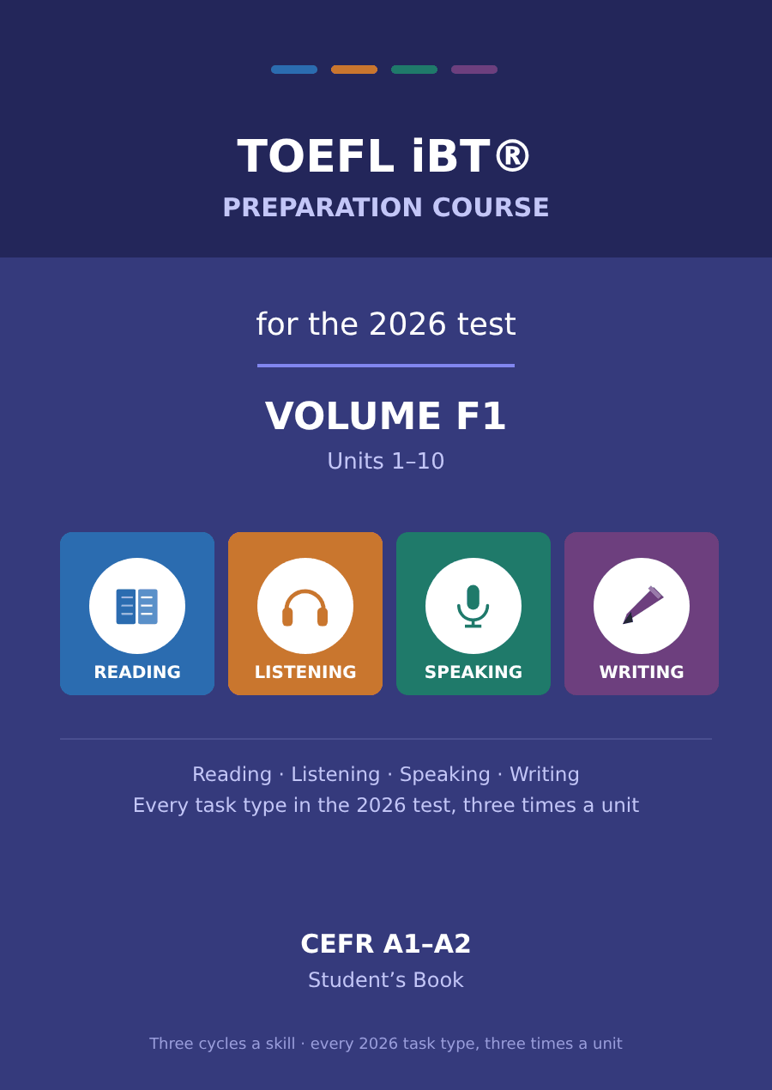

TOEFL iBT® Preparation Course 2026
Volume F1 · Units 1–10 · CEFR A1–A2
Student’s Book with Progress Test F

This course prepares A1–A2 learners for the TOEFL iBT® test as it has been since 21 January 2026. Every task name, item count and timing in this book follows the official ETS practice test for that form.
This is Foundation 1, and it comes before Volume 1. It exists because the rest of the course starts at B1, and a great many people who need the TOEFL are not there yet. Being told to "do a general English course first and come back" is not an answer, because a general course does not know where you are going.
So this book goes where you are going, from much further back. It has the same ten units as every other volume, the same task names in the same order, and exactly the same number of exercises. Nothing has been taken out. What is different is that every text is shorter, every sentence is simpler, and every word is one of the two thousand most common words of English or a word this book teaches you first.
There are five cycles a skill in every unit, not three. Three take an everyday sub-topic. The other two take one academic field — living things, trade, the weather, history, rocks, stories — because that is what Volume 1 is made of, and a student should not meet an academic passage for the first time there. Four more pages in every unit are not about the test at all.

Series TOEFL iBT® Preparation Course 2026
Level CEFR A1–A2 (A1 in, a solid A2 out)
Components Student’s Book · Audio · Interview video
This volume Units 1–10, Progress Test F, answer key, audio scripts, glossary

TOEFL and TOEFL iBT are registered trademarks of ETS. This publication is not endorsed by or affiliated with ETS. Format details are taken from ETS’s own published practice material for the January 2026 form.

Map of the book Volume F1
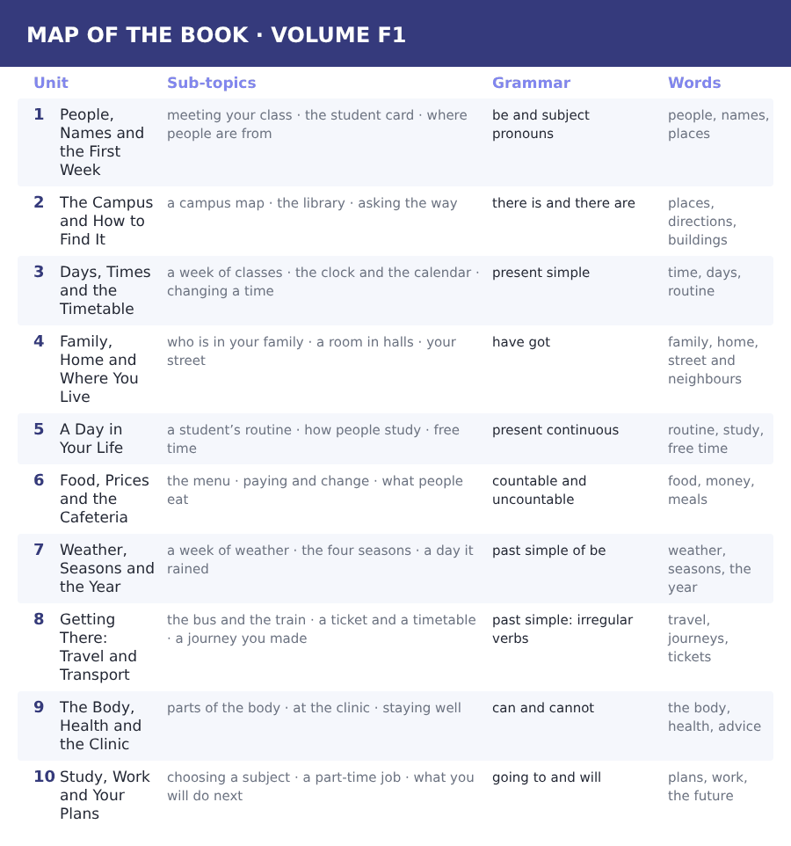

How to use this book Three cycles, four skills
Every unit is twenty pages and every unit is built the same way, so once you have worked through Unit 1 you know where everything is.
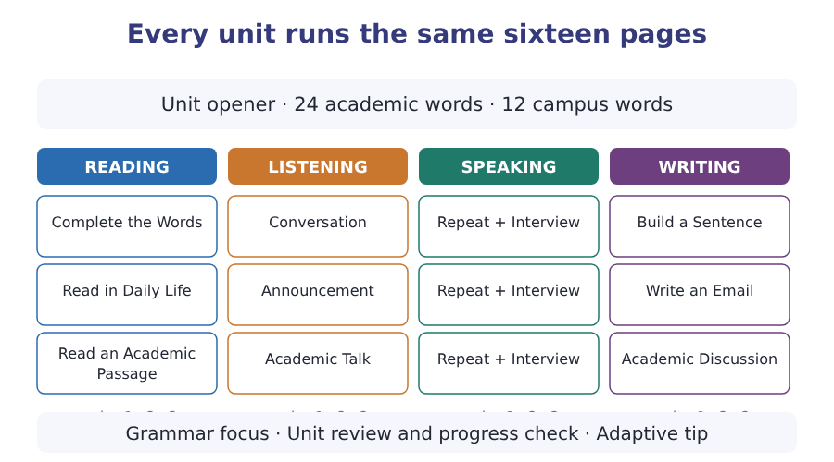
What a cycle is
A cycle is one sub-topic taken through one skill. Cycle 1 of Reading, Listening, Speaking and Writing all deal with sub-topic A; cycle 2 with sub-topic B; cycle 3 with sub-topic C. That is why the email you write in Writing cycle 2 answers the announcement you heard in Listening cycle 2.
Teach, guide, test
Inside every cycle the order is the same. A skill box tells you what to do. A guided exercise does it with help. An exam exercise does it the way the test will.

The 2026 test at a glance What you are preparing for
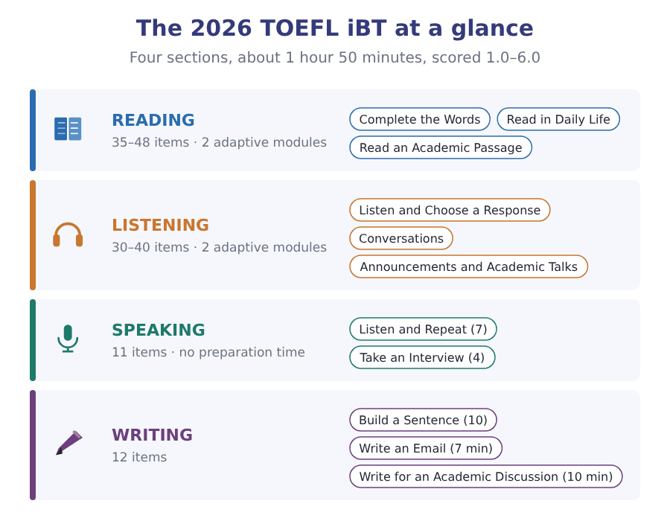
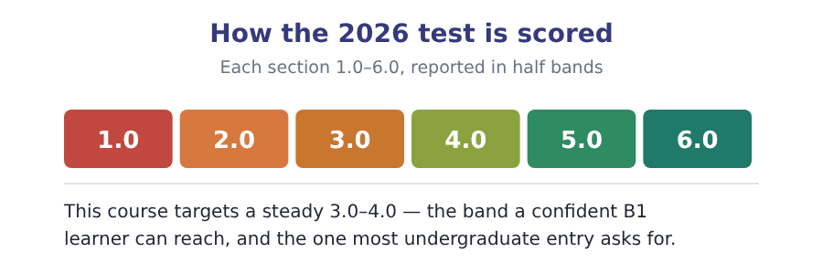

What an adaptive test does to you Modules, and why you cannot go back
Read this page now and do not worry about it. The Progress Test at the end of this book is one module per section, so that you finish it. The real two-module shape below is waiting for you in Volume 1.
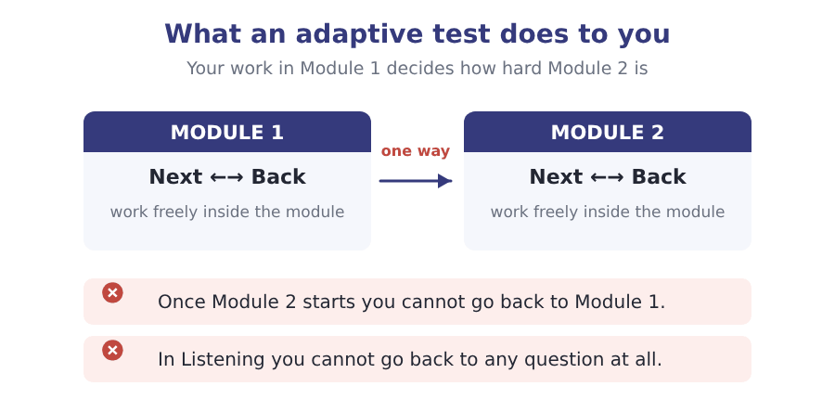
Reading and Listening are adaptive. Each is split into two modules, and how you do in Module 1 decides how hard Module 2 is. Two rules follow, and they are not the same rule.
- In Reading you can move Next and Back freely inside a module. Only the jump to Module 2 is one-way.
- In Listening you cannot go back to a previous question at all. The audio plays once.
- The early questions in a module carry the most weight, because they place you. Never rush them to buy time later.
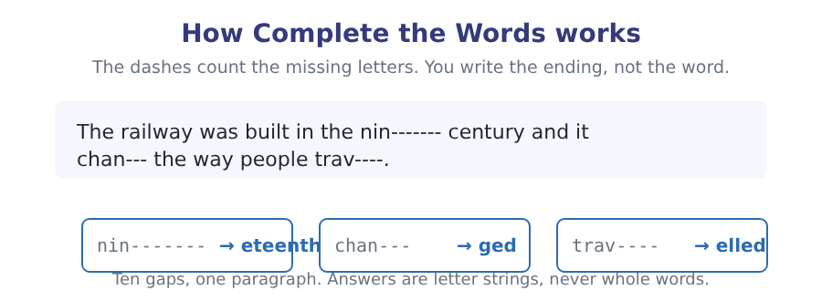

Study planner Twelve weeks, two units a week
When | What | Focus
Week 1 | Unit 1 · People, Names and the First Week | Vocabulary, Reading, Listening
Week 2 | Unit 2 · The Campus and How to Find It | Speaking, Writing, grammar, review
Week 3 | Unit 3 · Days, Times and the Timetable | Vocabulary, Reading, Listening
Week 4 | Unit 4 · Family, Home and Where You Live | Speaking, Writing, grammar, review
Week 5 | Unit 5 · A Day in Your Life | Vocabulary, Reading, Listening
Week 6 | Unit 6 · Food, Prices and the Cafeteria | Speaking, Writing, grammar, review
Week 7 | Unit 7 · Weather, Seasons and the Year | Vocabulary, Reading, Listening
Week 8 | Unit 8 · Getting There: Travel and Transport | Speaking, Writing, grammar, review
Week 9 | Unit 9 · The Body, Health and the Clinic | Vocabulary, Reading, Listening
Week 10 | Unit 10 · Study, Work and Your Plans | Speaking, Writing, grammar, review
Week 11 | Review units 1–10 | Glossary and grammar reference
Week 12 | Progress Test F | Sit it in one sitting, then mark it

Unit 1 · People, Names and the First Week
TOEFL iBT® Preparation Course 2026 · Volume F1
CEFR A2 · Grammar: be and subject pronouns · a and an · plural -s · Word field: people, names, places
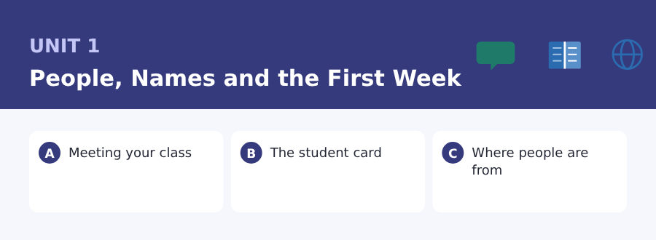
By the end of this unit I can…
- say and spell my name, my country and my student number
- find one fact in a short notice or an email
- understand a short text about people and where they are from
- follow a short conversation between two students who have just met
- ask and answer simple questions with am, is and are
- write a short email to a college office and a short post about myself

Three sub-topics, three cycles in every skill. Everything in this unit comes back in the review at the end, and again in Unit 2.

Vocabulary 1 · The words you need most 24 words from the two thousand most common words of English
These are not academic words. They are the words that carry ordinary English, and until you own them the academic words of Volume 1 have nothing to stand on. Cover the right-hand column and test yourself.
name what people call you | classmate a person in the same class as you
age how old you are | meet to see and talk to somebody for the first time
old a person of many years, or a thing from long ago | welcome a word you say to a person who arrives
young a person of few years | introduce to tell people who somebody is
country a land with its own government, like Peru | spell to say the letters of a word one by one
city a very big town | letter A, B and C are letters
town a place with houses and shops, smaller than a city | number one, two and three are numbers
village a very small town in the countryside | address where your house is: the street and the town
live to have your home in a place | email a message you send from a computer or a phone
speak to say words to somebody | phone the thing you call people with
language English, Arabic and Spanish are languages | married with a husband or a wife
friend a person you like and see often | single one only, or with no husband or wife

Exercise A Work in pairs. Ask and answer.
1. What is your full name, and how do you spell your family name?
2. Which city or town are you from, and is it big or small?
3. How many languages are there in your family?
4. Who is the first person you meet on a normal day?
Vocabulary 2 · Campus and everyday 12 words for student life
Every Listening conversation in the real test happens on a campus. These twelve words come back in this unit and again in Volume 1.
student card the small card that shows you are a student here | tutorial a small class with only a few students
campus all the buildings of a college in one place | classroom the room where a class happens
department one part of a college, for one subject | corridor the long space between the rooms of a building
course the subject you study for a year or more | noticeboard the board on a wall with papers on it
registration the day you put your name on the college list | student number the number the college gives you
lecture a teacher speaks and many students listen | induction the first talk that tells new students what to do

Words you will meet again: name | country | spell | student card | campus | department | meet | language

Sound and Spelling The letters of the alphabet
People spell names at you from the first minute of the first day, and they spell them fast. The letters are not hard, but they come in groups that sound the same, and that is where names are lost.
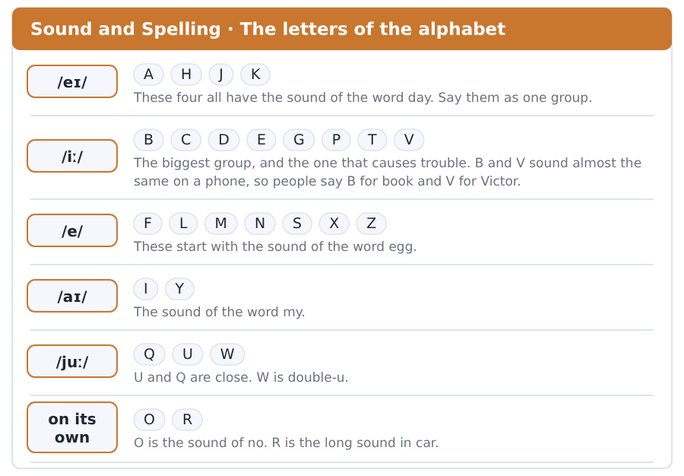
Exercise A Listen. Which word do you hear?
1. Do you hear B or V?
2. Do you hear G or J?
3. Do you hear M or N?
4. Do you hear E or I?
5. Do you hear S or F?
6. Do you hear A or E?
Exercise B Say these out loud. Record yourself if you can.
1. Spell your family name, letter by letter, three times.
2. Spell the name of your town.
3. Spell these: RIVERSIDE, DEMIR, CHEN, RUIZ.
4. Say your student number one number at a time.


SKILL · Count the dashes
- Each dash is one missing letter. Count them before you write.
- Look at the word in front. Twelve student- must be more than one, so it is s.
- Most of the missing letters in this unit are -s, -es or -ies.
- Never write a whole word. You finish one; you do not replace it.

Exercise A Guided practice. Five words are not complete. Write the missing letters.
My name is Ana Ruiz. I am a student at Riverside College. In my class there are twelve student-. We are from eight different countr---. Two student- in my class are from Brazil. My teach-- is Mr Dale. He speak- Spanish and English.

The first one is done for you: 1 student- → s (students)
Exercise B Exam practice. One paragraph, ten gaps — the real task.
Welcome to Riverside College. On your first day you meet the other student- in your group. There are fifteen student- in Group B and they are from nine countr---. Your teach-- gives you a student card with your name and your student number on it. The card open- the door of the computer room- and the classroom. Keep it with you. The office in Block C open- at nine o’clock every day and it close- at five. The staff there speak- several language-.

Check your answers in the key at the back of the book.


SKILL · The answer is on the page
- Read the question first. Then look for the same word on the page.
- Numbers, times and days are easy to find. Find them first.
- If two answers look right, one of them is not on the page at all.
- Do not use what you know about your own college. Use this page.

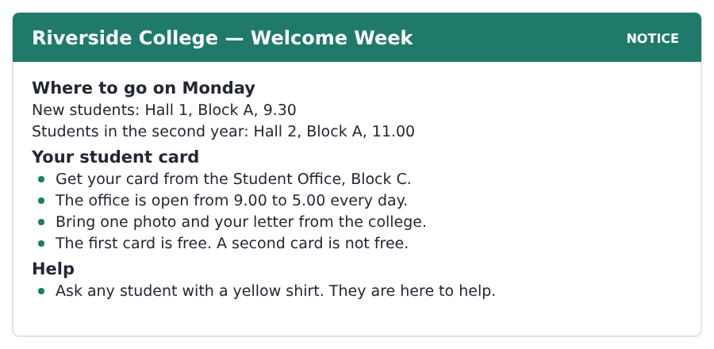
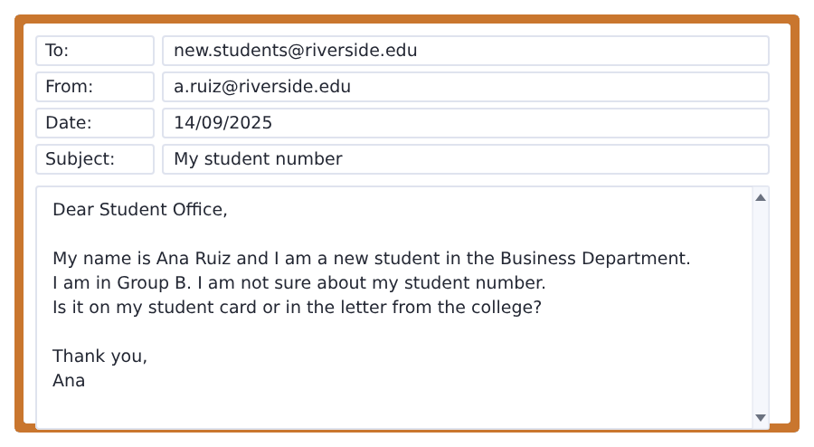
Exercise A Guided practice. The answer is on the page — find it.
1. Where do new students go on Monday?
(A) Hall 2
(B) Block C
(C) the office
(D) Hall 1
2. When does the Student Office close?
(A) 9.00
(B) 11.00
(C) 5.00
(D) 10.00
3. Which card is free?
(A) the first card
(B) every card
(C) the second card
(D) no card
4. What is Ana’s department?
(A) English
(B) Business
(C) Science
(D) Art
Exercise B Exam practice.
5. What do students in the second year do at 11.00?
(A) get a card
(B) go to Hall 2
(C) go to Block C
(D) meet Ana
6. What do you bring to the Student Office?
(A) a photo and a letter
(B) a photo only
(C) 10 dollars
(D) a yellow shirt
7. Who are the students in yellow shirts?
(A) new students
(B) teachers
(C) students here to help
(D) students in year two
8. Which group is Ana in?
(A) Group A
(B) Group C
(C) Hall 1
(D) Group B
9. What is Ana not sure about?
(A) her group
(B) her department
(C) her photo
(D) her student number
10. Where is the Student Office?
(A) Block A
(B) Block B
(C) Block C
(D) Hall 1


SKILL · Find the number, then the word
- Short texts like this one carry the answers in the numbers.
- Underline every number as you read. There are only a few.
- The last paragraph is the writer’s opinion, not a fact from the first two.
- If a question asks about every student, look for the word every.

One Class, Nine Countries
Group B is a class of fifteen students at Riverside College. The students are from nine different countries. Four of them are from this city. The others are from Brazil, Turkey, Poland, Kenya, Peru and three other countries.
In the class there are twenty-one languages. Many students speak two or three. Yusuf Demir speaks Turkish, Arabic and English. Mei Chen speaks three languages too. Every student in the room speaks English. It is the only language of the whole class.
This is normal in a college now. A class is not one country. It is a small map of the world, and English is the road between the parts of it.
[111 words]

Exercise A Guided practice.
1. How many students are in Group B?
(A) nine
(B) fifteen
(C) four
(D) twenty-one
2. How many countries are the students from?
(A) nine
(B) four
(C) three
(D) fifteen
3. How many students are from this city?
(A) nine
(B) three
(C) four
(D) two
4. How many languages speaks Yusuf Demir? (Yusuf speaks how many?)
(A) one
(B) three
(C) two
(D) four
Exercise B Exam practice.
5. Which language does every student speak?
(A) Turkish
(B) Arabic
(C) Spanish
(D) English
6. How many languages are there in the class?
(A) twenty-one
(B) nine
(C) fifteen
(D) three
7. Mei Chen speaks
(A) three languages
(B) one language
(C) two languages
(D) nine languages
8. In the last paragraph a class today is
(A) one country
(B) always difficult
(C) very quiet
(D) a small map of the world
9. Which country is NOT in the passage?
(A) Peru
(B) Japan
(C) Kenya
(D) Poland
10. Many students in the class speak
(A) only English
(B) no English
(C) two or three languages
(D) nine languages
11. Which sentence says the big idea?
(A) A class is difficult.
(B) There are nine countries.
(C) Four students are from this city.
(D) English is the road.

The field: People and Their Ways Two more cycles in every skill, on one subject
Everything up to here was about your own life, because that is where a language starts. From this page the same unit turns to a subject, and the subject is one Volume 1 will take up properly: how people live, and why the same thing is done differently in different places.
custom a thing people in a place always do | member one person in a group
tradition a custom that is very old | community the people who live in one place
culture the customs and ideas of a group of people | relative a member of your family: an aunt, a cousin
nation all the people of one country | ancestor a member of your family from long ago
generation all the people born at about the same time | marriage two people become husband and wife
population the number of people in a place | household the people who live in one house


SKILL · Three places, one point
- A short academic text often gives three examples of one idea.
- The idea is usually in the first or the last sentence.
- The examples are there to prove the idea, not to be learned.
- A question about all countries wants the idea, not an example.

One Person, Three Names
In English a person has a first name and a family name. The first name comes first. This is not a rule of the world. It is the custom of one part of it.
In China and in Hungary the family name comes first. In Iceland the second name is not a family name. It is the name of a mother or a father, and a word for child.
In Spain a person has two family names. One comes from the mother and one from the father. The custom is different in every nation. In every nation it feels normal.
[100 words]

Exercise A Guided practice.
1. In English, which name comes first?
(A) the family name
(B) the father’s name
(C) the first name
(D) the mother’s name
2. In China the family name is
(A) second
(B) first
(C) not used
(D) the same as the first name
3. In Iceland the second name is
(A) the name of a mother or father and a word for child
(B) a family name
(C) the name of a town
(D) not a name
Exercise B Exam practice.
4. In Spain a person has
(A) one family name
(B) no family name
(C) two family names
(D) three first names
5. The two Spanish family names come from
(A) the two oldest people
(B) the mother and the father
(C) the father only
(D) the town
6. The order of names in English is
(A) a rule of the world
(B) the oldest custom
(C) a new idea
(D) a custom of one part of the world
7. What is the big idea of the passage?
(A) The custom is different everywhere and feels normal everywhere.
(B) English names are correct.
(C) Iceland is not common.
(D) Two family names are better.


SKILL · Both sides of one fact
- When a text gives two ways of doing something, it usually says both work.
- Look for the good thing about each one. There is normally one each.
- The last paragraph often says what is changing and why.
- A question with why wants the reason, not the change.

How Many People Are a Family?
A household is the people in one house. In some nations a household is two parents and their children. In others it is three generations in one building, with a grandmother at home all day.
Both work. The small household is easy to move for a job. The large one is cheap. A member of the family is always at home with the children.
In most nations the household of today is small. The household of a hundred years ago is not. The reason is work in the cities. It is also a city flat with two rooms in it.
[100 words]

Exercise A Guided practice.
1. What is a household?
(A) a family name
(B) a town
(C) the people in one house
(D) a generation
2. In some nations a household is
(A) one person
(B) two parents and their children
(C) only older people in the family
(D) a whole village
3. What is good about a small household?
(A) it is easy to move for a job
(B) it is cheap
(C) somebody is always at home
(D) it is an old custom
Exercise B Exam practice.
4. What is good about a large household?
(A) it is easy to move
(B) it is a new custom
(C) it is small
(D) it is cheap and somebody is at home
5. The household of today is
(A) small
(B) large
(C) the same as before
(D) only in cities
6. Why is that?
(A) people have no children
(B) grandmothers work
(C) houses are expensive to build
(D) work in the cities and small flats
7. What does the writer think about the two kinds of household?
(A) the small one is better
(B) both work
(C) the large one is better
(D) neither works now

Sentence Builder A sentence needs a person and a verb
In English you cannot leave the verb out. In many languages *I a student* is a good sentence. In English it is not a sentence at all, and in the Writing section it scores nothing. Put am, is or are in.
Not a sentence | A sentence
I a student. | I am a student.
She from Turkey. | She is from Turkey.
My name Ana. | My name is Ana.
in Block C | The office is in Block C.
Fifteen students in my class. | There are fifteen students in my class.

Watch out! A capital letter at the start and a full stop at the end. Both of them are part of the sentence, not decoration.
Exercise A Is it a sentence? Write yes or no. If no, put it right.
1. I from Peru.
2. He a teacher.
3. They in the corridor.
4. my student number is 4071
5. She is in Group B.
6. Welcome to the college.


Exercise A Listen and choose a response. You hear one line. Choose the best reply.
1. Hello. Are you a new student?
(A) In Block C.
(B) It is nine o’clock.
(C) Yes, I am.
(D) Two languages.
2. What is your name?
(A) Ana Ruiz.
(B) From Peru.
(C) It is a tutorial.
(D) Yes, please.
3. How do you spell that?
(A) In the corridor.
(B) I am fine.
(C) Fifteen.
(D) R-U-I-Z.
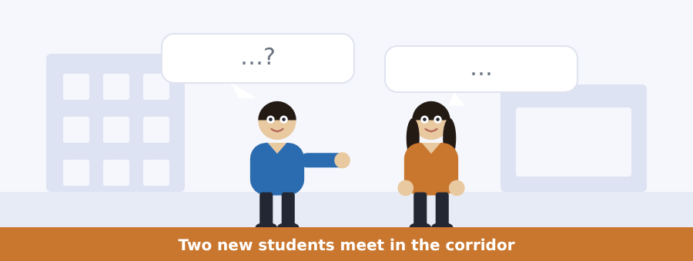
SKILL · Listen for the name and the country
- The first thing people say is a name. Write it down at once.
- People spell names on the phone and in a first meeting. Learn the letters.
- Where are you from? is the second question in almost every first meeting.
- If you miss the name, you can ask: Sorry, how do you spell that?

Exercise B Listen and answer. The audio plays once.
4. Which group are the two students in?
(A) Group A
(B) Group B
(C) Group C
(D) room 12
5. How does Ana spell her name?
(A) A-N-N-A
(B) A-N-E
(C) A-N-A
(D) A-M-A
6. Where is Ana from?
(A) Turkey
(B) Peru
(C) Brazil
(D) this city
7. Where is Yusuf from?
(A) Turkey
(B) Peru
(C) Poland
(D) Kenya
8. Which room is the class in?
(A) room 2
(B) room 20
(C) Block C
(D) room 12
9. Where is the classroom?
(A) in Block C
(B) next to the office
(C) at the end of the corridor
(D) on the noticeboard
Audio script: see the back of the book. Do not read it before you listen.


Exercise A Listen and choose a response. You hear one line. Choose the best reply.
1. Good morning, everyone.
(A) In Block C.
(B) Good morning.
(C) Six students.
(D) Yes, it is free.
2. Is the office open on Saturday?
(A) No, it is not.
(B) At nine.
(C) In Hall 1.
(D) My student number.
3. Where is the Student Office?
(A) At five.
(B) It is free.
(C) Two photos.
(D) In Block C.
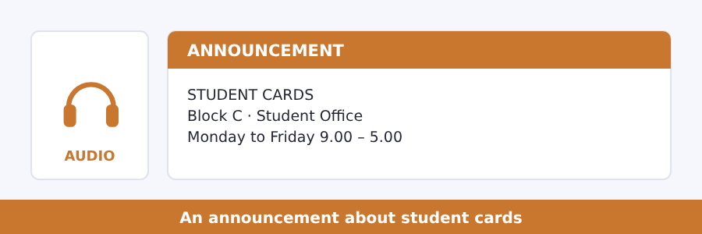
SKILL · Listen for where and when
- An announcement is one person speaking to many. It is slower than a talk.
- The important words are a place and a time. Wait for them.
- Numbers often come twice: 9.00 ... from nine in the morning.
- The last line of an announcement is usually what you must do.

Exercise B Listen and answer. The audio plays once.
4. Where is the Student Office?
(A) Block A
(B) Block B
(C) Block C
(D) Hall 1
5. When does the office open?
(A) at five
(B) at the weekend
(C) on Saturday
(D) at nine
6. Is the office open on Saturday?
(A) no
(B) yes, all day
(C) yes, in the morning
(D) only for new students
7. What do students bring?
(A) two photos
(B) one photo and a letter
(C) ten dollars
(D) a student card
8. What is the first card?
(A) not free
(B) in Block A
(C) free
(D) for teachers
Audio script: see the back of the book. Do not read it before you listen.


Exercise A Listen and choose a response. You hear one line. Choose the best reply.
1. Welcome to the course.
(A) Thank you.
(B) In nine countries.
(C) It is a tutorial.
(D) Two photos.
2. Are you ready?
(A) In Block C.
(B) My family name.
(C) At nine.
(D) Yes, I am.
3. What is a family name?
(A) At five o’clock.
(B) Nine.
(C) It is the name of your family.
(D) In the corridor.
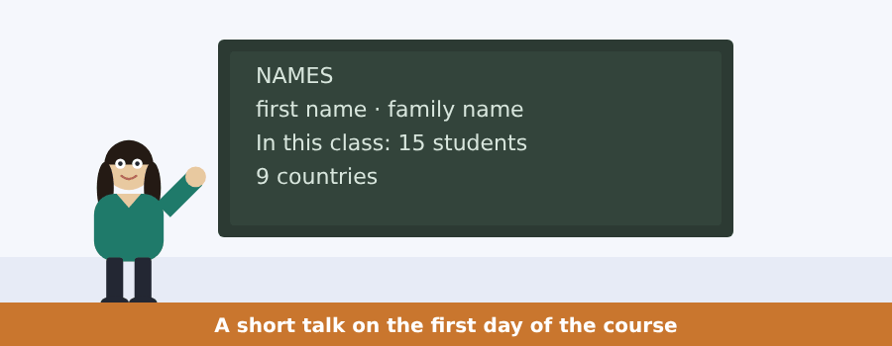
SKILL · A talk has one big idea
- The first sentence of a talk usually says what the talk is about.
- The board shows you the words you will hear. Read it before you listen.
- A talk gives examples. The example is not the big idea.
- The last sentence often says the big idea again in other words.

Exercise B Listen and answer. The audio plays once.
4. Who is the speaker?
(A) a student
(B) a teacher
(C) an office worker
(D) a new student
5. What is the talk about?
(A) the course
(B) student cards
(C) countries
(D) names
6. In English, which name comes first?
(A) the family name
(B) both
(C) the first name
(D) neither
7. What is the teacher’s first name?
(A) Robert
(B) Dale
(C) Mr
(D) Riverside
8. How many students are in the room?
(A) nine
(B) fifteen
(C) twelve
(D) twenty-one
9. What does the teacher ask the students to do?
(A) spell their names
(B) write their country
(C) say which name to use
(D) bring a photo
Audio script: see the back of the book. Do not read it before you listen.


Exercise A Listen and choose a response.
1. Is the family name always second?
(A) In Iceland.
(B) Two names.
(C) Yes, I am.
(D) No, it is not.
2. How do you say your name?
(A) In China.
(B) It is A-N-A.
(C) Yes, I do.
(D) Three generations.
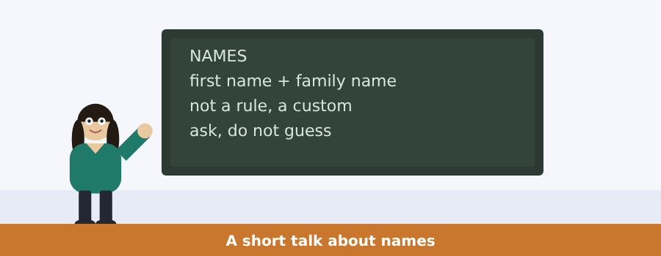
SKILL · The talk says the idea twice
- A short academic talk gives its idea, then examples, then the idea again.
- If you miss it at the start, wait. It comes back at the end.
- Examples are usually marked by in, for example or like.
- Write the idea in your own words as soon as you hear it.

Exercise B Listen and answer. The audio plays once.
3. What is a name, for this speaker?
(A) a piece of a culture
(B) only a word
(C) a family rule
(D) a difficult thing
4. Which country does the speaker say is different?
(A) England
(B) China
(C) Spain
(D) France
5. In Iceland the second name is
(A) the name of a mother or a father
(B) a family name
(C) a town
(D) not used
6. What does the speaker ask the class to do?
(A) learn the names
(B) write the names down
(C) ask people how they say their own name
(D) use first names only
Audio script: see the back of the book.


Exercise A Listen and choose a response.
1. Is your household small?
(A) In the city.
(B) Four people.
(C) Yes, I do.
(D) Yes, it is.
2. How many people are in your household?
(A) In a flat.
(B) Five.
(C) Yes, there are.
(D) My grandmother.
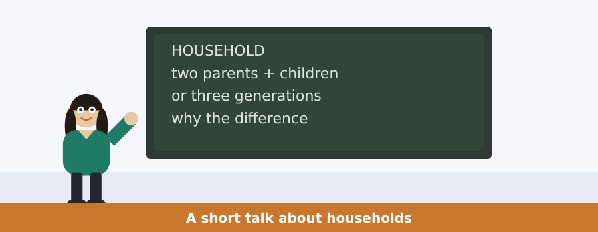
SKILL · Numbers carry the argument
- In a talk about nation the numbers are the evidence.
- Write every number down, even if you do not yet know why.
- Here and there mark a difference, and the difference is the point.
- The reason for a difference comes after because.

Exercise B Listen and answer. The audio plays once.
3. How many people are in a household in this country?
(A) about two
(B) about three
(C) about five
(D) about ten
4. How many are there in some other nations?
(A) about two
(B) about four
(C) about ten
(D) six or seven
5. How many reasons does the speaker give?
(A) one
(B) two
(C) three
(D) four
6. In many other nations the household is
(A) three generations
(B) one person
(C) two people
(D) getting smaller
Audio script: see the back of the book.


Part 1 · Listen and Repeat
You hear a sentence and repeat it once. There is no preparation time, and the sentences get longer. Focus: the sounds of the letters A, E and I
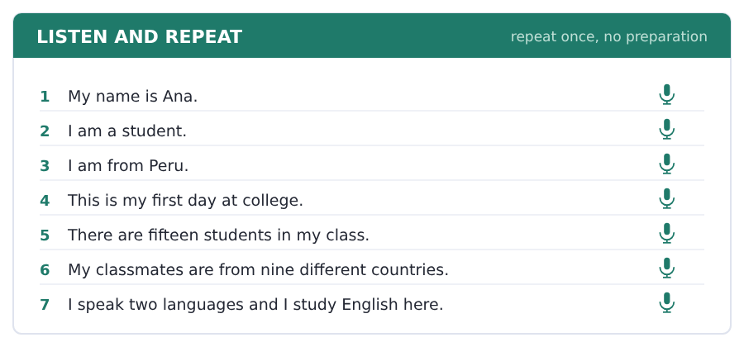
SKILL · Say the whole sentence
- You hear one sentence and you say it once. There is no time to prepare.
- Start as the beep ends. A long silence scores nothing.
- Short and complete beats long and half-finished.
- If you make a mistake, keep going. Do not start again.

Part 2 · Take an Interview
An interviewer asks you four questions on one theme: you and where you are from. Answer each one fully. There is no preparation time.
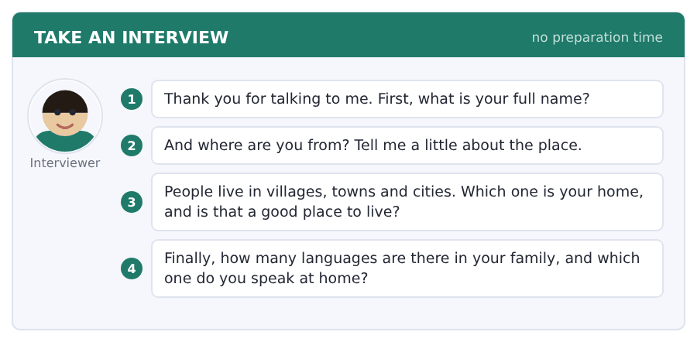
Say it like this
- My full name is ... . My family name is ... .
- I am from ... . It is a ... in the north of ... .
- My home is a ... . It is a good place to live because ... .
- In my family we speak ... . At home I speak ... .
A good answer sounds like this
Question 1 — My full name is Ana Ruiz. Ana is my first name and Ruiz is my family name.
Question 2 — I am from Peru. My home is a small town near the sea. It is quiet and the people there are friendly.
Question 3 — My home is a town. It is a good place to live because it is small, so I know many people, but it is not far from a city.
Question 4 — In my family we speak two languages. At home I speak Spanish with my parents, and I speak English at college.
I can… | Not yet | Yes
I started speaking straight away | □ | □
I finished every sentence I began | □ | □
I gave a reason after my opinion | □ | □


Part 1 · Listen and Repeat
You hear a sentence and repeat it once. There is no preparation time, and the sentences get longer. Focus: saying letters and numbers clearly
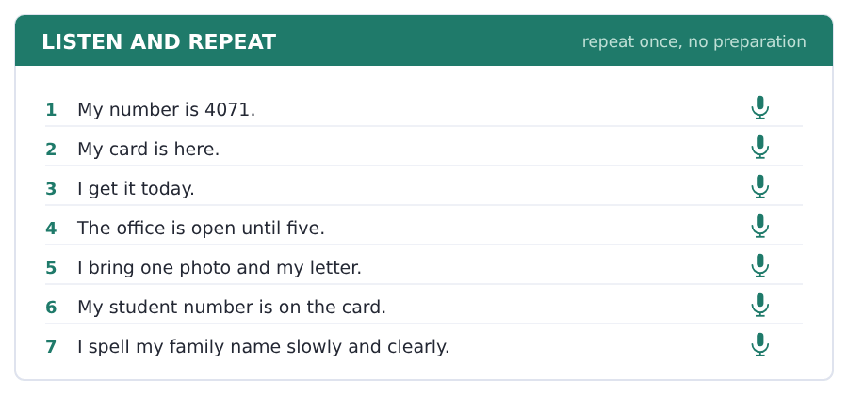
SKILL · Letters and numbers
- Say numbers one by one: 2-0-4-1, not two thousand and forty-one.
- Group the letters in threes when you spell: R-U-I, Z.
- Say the letter twice if it is not clear: B, B for book.
- Slow down for a number. Nobody speaks fast and clearly at the same time.

Part 2 · Take an Interview
An interviewer asks you four questions on one theme: cards, numbers and papers. Answer each one fully. There is no preparation time.
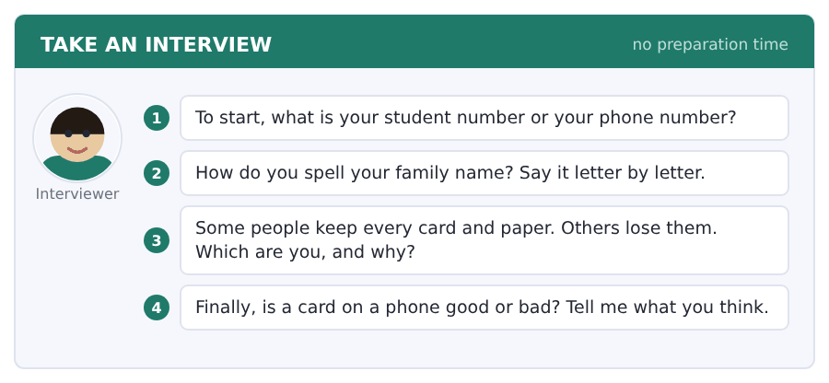
Say it like this
- My number is ... . I say it one number at a time.
- My family name is ... . That is ..., ..., ... .
- I always ... , because ... .
- I think a card on a phone is ... , because ... .
A good answer sounds like this
Question 1 — My student number is 4-0-7-1. I say it one number at a time because people do not hear it the first time.
Question 2 — My family name is Ruiz. That is R, U, I, Z. The Z is at the end.
Question 3 — I keep every paper. I put my card in the same pocket every day, because then I never look for it.
Question 4 — I think a card on a phone is good, because my phone is always in my hand. But a card in my pocket is safe when the phone is off.
I can… | Not yet | Yes
I said every number one at a time | □ | □
I spelled my name slowly and clearly | □ | □
I answered the question, not a different one | □ | □


Part 1 · Listen and Repeat
You hear a sentence and repeat it once. There is no preparation time, and the sentences get longer. Focus: word stress in country and language names
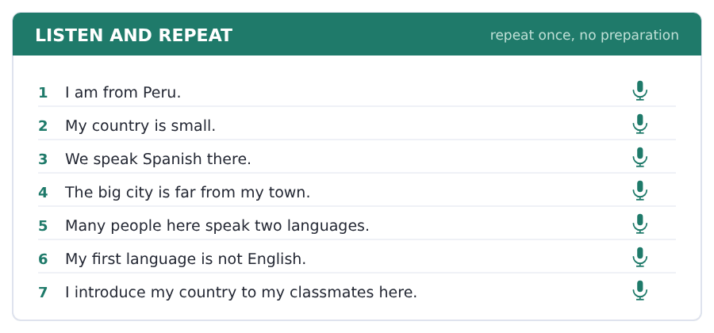
SKILL · One strong part in every word
- Every long word has one strong part: TUR-key, bra-ZIL.
- Put the strong part a little louder and a little longer.
- A wrong strong part is harder to understand than a wrong sound.
- Say the country and the language together: Turkey, Turkish.

Part 2 · Take an Interview
An interviewer asks you four questions on one theme: countries and languages. Answer each one fully. There is no preparation time.
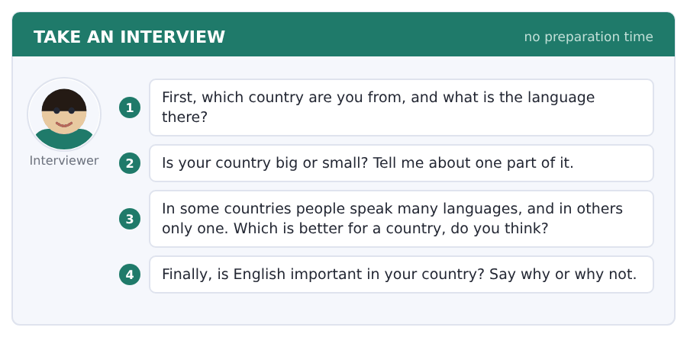
Say it like this
- I am from ... and the language there is ... .
- My country is ... . In the north there is ... .
- I think ... is better for a country, because ... .
- English is ... important in my country, because ... .
A good answer sounds like this
Question 1 — I am from Peru and the language there is Spanish. Many people also speak Quechua.
Question 2 — My country is not very big, but it is not small. In the east there is a big green forest and in the west there is the sea.
Question 3 — I think many languages is better for a country, because every language is a different way to see things. But it is not easy for the schools.
Question 4 — English is very important in my country, because the work in the cities is with people from other countries.
I can… | Not yet | Yes
I made one part of each long word strong | □ | □
I said the country and the language, not only one | □ | □
I gave an example, not only an opinion | □ | □


Part 1 · Listen and Repeat
You hear a sentence and repeat it once. There is no preparation time, and the sentences get longer. Focus: saying a foreign name carefully
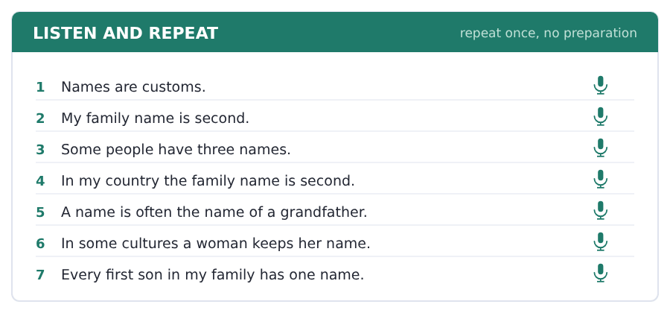
SKILL · A name is worth slowing down for
- Say a name you do not know slowly, and ask if you have it right.
- Sorry, how do you say that? is a polite question, not a rude one.
- Most people are pleased that you asked. Nobody is pleased that you guessed.
- In the Speaking test, a clear slow answer scores above a fast unclear one.

Part 2 · Take an Interview
An interviewer asks you four questions on one theme: names and where they come from. Answer each one fully. There is no preparation time.
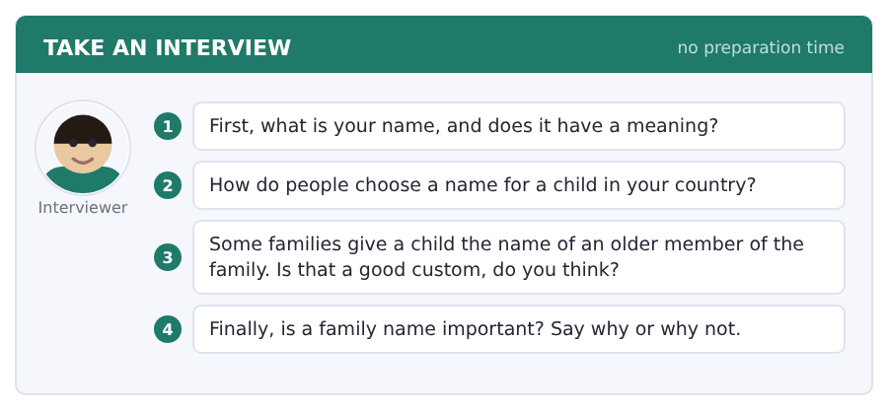
Say it like this
- My name is ... . It means ... .
- In my country people usually ... .
- I think it is ... , because ... .
- A good custom is ... , because ... .
A good answer sounds like this
Question 1 — My name is Ana. It is a very old name and it is short in every language, and that helps.
Question 2 — In my country the parents usually choose, but a grandmother often has an opinion about it.
Question 3 — I think it is a good custom, because the name is a line back through the family. But a child is not a copy of a an older member of the family.
Question 4 — A family name is important, because it tells people where you are from. In my country it tells them the part of the country as well.
I can… | Not yet | Yes
I said names slowly and clearly | □ | □
I used a field word from this unit | □ | □
I gave a reason after my opinion | □ | □


Part 1 · Listen and Repeat
You hear a sentence and repeat it once. There is no preparation time, and the sentences get longer. Focus: the sounds in culture, custom and community
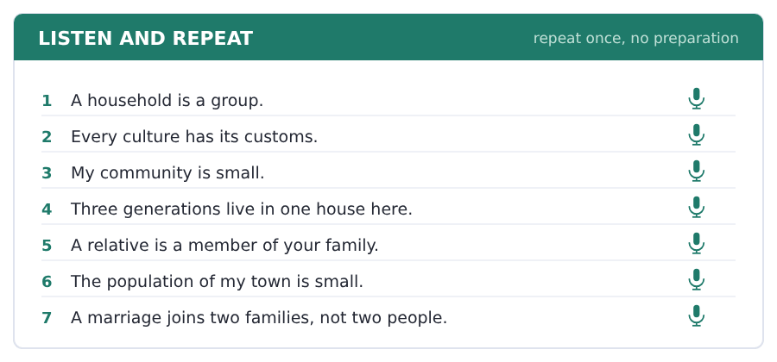
SKILL · Three long words, one strong part each
- CULture, CUStom, comMUnity, popuLAtion.
- The -tion ending always takes the strong part before it.
- Say the word three times before you use it in a sentence.
- A field word said well is worth two said badly.

Part 2 · Take an Interview
An interviewer asks you four questions on one theme: homes and the people in them. Answer each one fully. There is no preparation time.
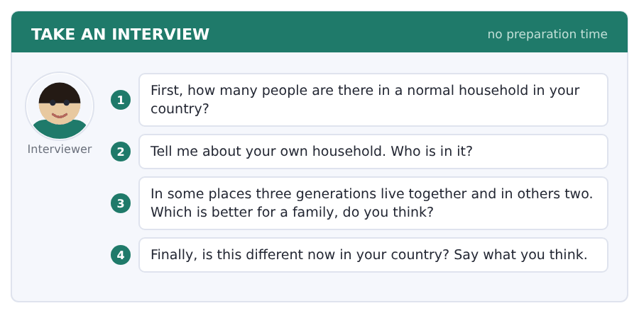
Say it like this
- In my country a household is usually ... .
- My own household is ... .
- I think ... , because ... .
- This is different now, because ... .
A good answer sounds like this
Question 1 — In my country a normal household is four or five people, and often a grandmother as well.
Question 2 — My own household is my parents, my brother and me. My grandmother is in the next street.
Question 3 — I think three generations is better for small children, because somebody is always at home. It is harder for the middle generation.
Question 4 — This is different now, because young people move to the city for work and a city flat is small.
I can… | Not yet | Yes
I put the strong part in the right place in long words | □ | □
I used three or more field words | □ | □
I answered all four questions | □ | □


You see a sentence, then a set of words in boxes. Put the words in order to make one grammatical sentence. Almost every item in the real test makes a question or a question inside another sentence.
SKILL · Questions put be in front
- A statement is: You are a student. A question is: Are you a student?
- With am, is and are, the verb jumps in front of the person.
- What, where and how come first of all: Where are you from?
- Put the question mark at the end. It is part of the answer.

Exercise A Guided practice. The first three are worked through.
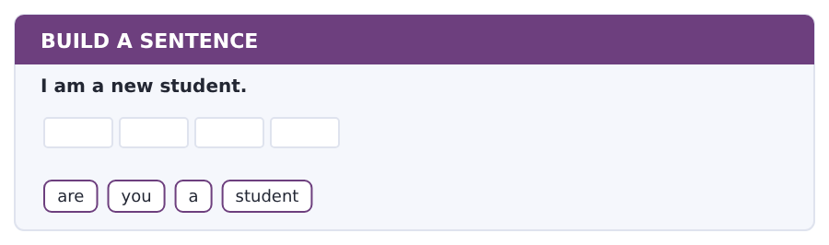
1. Are you a student?
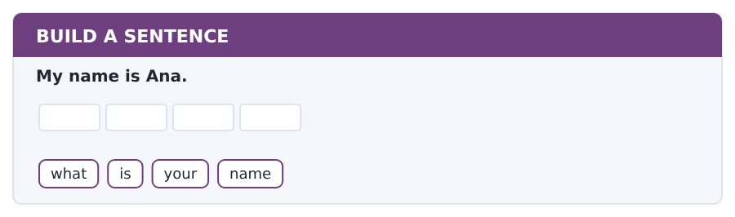
2. What is your name?
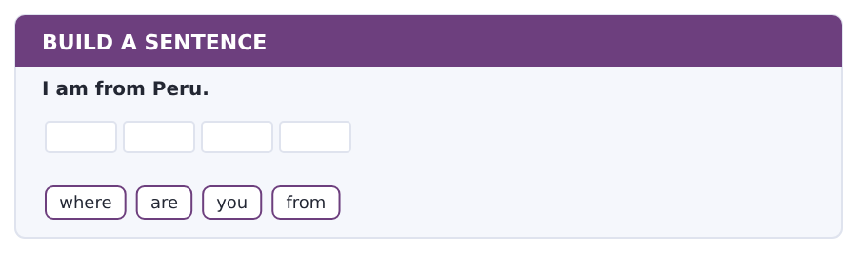
3. Where are you from?
Exercise B Exam practice. Write the sentence.
4. There are fifteen students.
how / many / students / are / there
__________________________________________________________
5. The office is in Block C.
where / is / the / office
__________________________________________________________
6. My classmates are friendly.
are / your / classmates / friendly
__________________________________________________________
7. I am in Group B.
which / group / are / you / in
__________________________________________________________
8. The card is free.
is / the / card / free
__________________________________________________________
9. She is from Turkey.
is / she / from / Turkey
__________________________________________________________
10. My teacher is Mr Dale.
who / is / your / teacher
__________________________________________________________


You read a short situation and write an email. You have 7 minutes. The three bullet points are the mark scheme: answer all three.
In the real test you write as much as you can in seven minutes. In this unit, aim for about 36 words. That number goes up in every unit of this book, and in Volume 1 it stops being a number at all.
You are a new student at Riverside College. You are in Group B.
You do not have your student card. Write to the Student Office.
- say who you are and which group you are in
- say that you do not have your card
- ask when the office is open
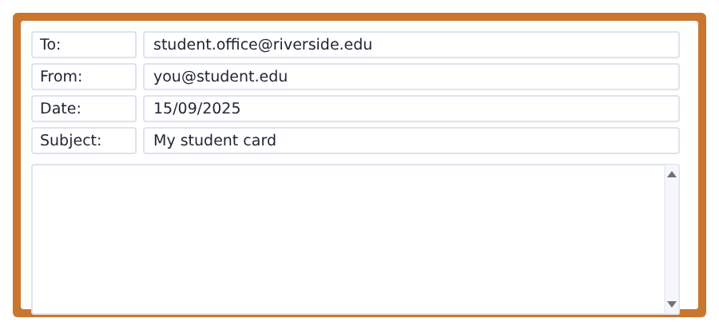
SKILL · Three bullets, three sentences
- Every bullet point is one mark. Answer all three.
- One sentence for each bullet is enough at this level.
- Start with Dear and finish with your name.
- Ask your question with a question mark at the end.

Model email
Dear Student Office,

My name is Ana Ruiz and I am a new student in Group B.
I am not sure about my student card, because I do not have it.
When is your office open?

Thank you,
Ana Ruiz
Why it works
- It answers all three bullet points, in the same order.
- Every sentence is short and complete. Nothing is half-finished.
- The question is a real question, with the right word order and a question mark.
- It has a greeting at the top and a name at the bottom.
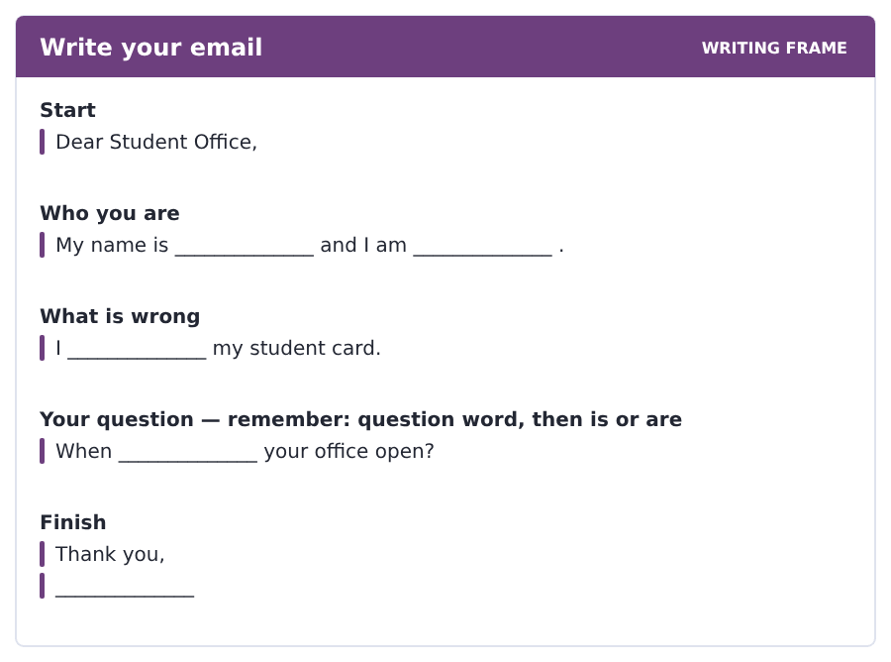
Now write your own. 7 minutes.
__________________________________________________________
__________________________________________________________
__________________________________________________________
__________________________________________________________
__________________________________________________________
__________________________________________________________
__________________________________________________________
__________________________________________________________


A professor asks a question and two students answer. You add your own post. You have 10 minutes and an effective answer is at least 100 words.
One hundred words is what the real test wants, and you will get there. For this unit, write about 40. Every unit of this book asks for a few more.
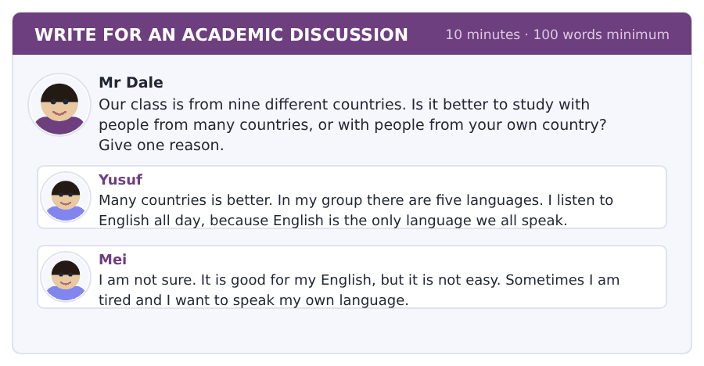
SKILL · Say what you think, then why
- Sentence one: your opinion. Sentence two: your reason.
- Use because. It is the most useful word on this page.
- Say one thing about another student’s post. Agree or do not agree.
- Short sentences are fine. Half sentences are not.

Sentence starters
- I agree with Yusuf, because ...
- I am not sure, because ...
- In my country ...
- For me, the best thing is ...
Model post
I agree with Yusuf. Many countries is better for me, because I speak English every hour of the day.
In my own country I speak English only in the classroom.
Mei is right that it is hard work, but it is good hard work.
[44 words]
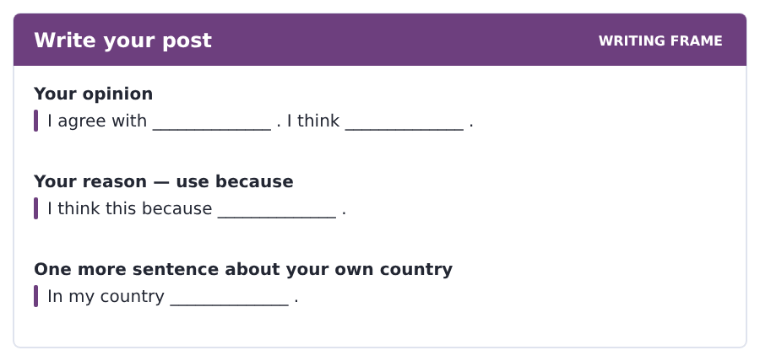
Now write your own. 10 minutes, at least 40 words.
__________________________________________________________
__________________________________________________________
__________________________________________________________
__________________________________________________________
__________________________________________________________
__________________________________________________________
__________________________________________________________
__________________________________________________________
__________________________________________________________
__________________________________________________________


The same task again, on the subject of this unit. The sentences are about people and their ways now, and the word order has not changed at all.
SKILL · The same question order, a new subject
- Nothing changes because the sentence is about a nation.
- The question word first, then is or are, then the thing.
- A long subject is still one thing: the family name in China is ...
- Read the sentence back. If it sounds like a question, it is one.

Exercise A Guided practice.
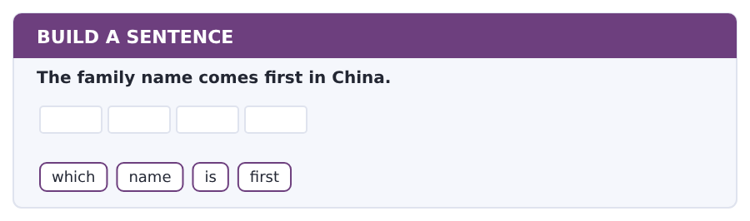
1. Which name is first?
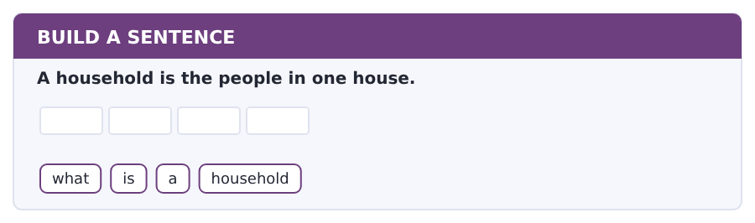
2. What is a household?
Exercise B Exam practice. Write the sentence.
3. There are two family names in Spain.
how many / family names / are / there
__________________________________________________________
4. A custom is normal to its own nation.
is / this / custom / normal / here
__________________________________________________________
5. A household today is small.
is / your / household / small
__________________________________________________________
6. The population of the town is forty thousand.
what / is / the population / exactly
__________________________________________________________


A second discussion, and this one is about the subject rather than about your own week. In the real test both kinds come up, and the second kind is the harder one.
For this unit, write about 40 words. The real test wants a hundred.
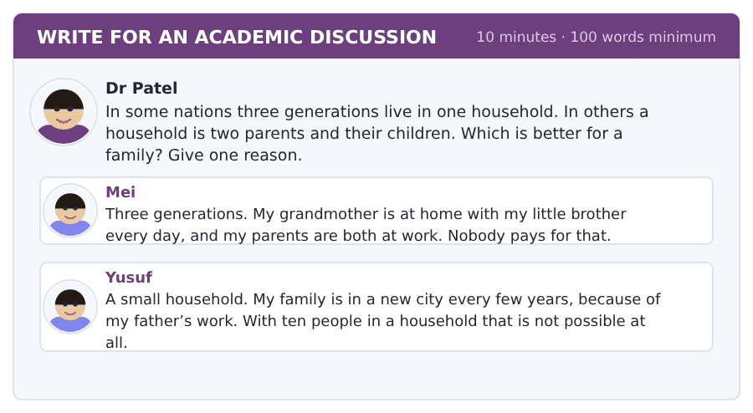
SKILL · A subject question is still about you
- A question about nation still wants your own example.
- Say which one you agree with, then why, then your own case.
- Use the field words. That is what they are for.
- Forty words is about four short sentences.

Sentence starters
- I agree with Mei, because ...
- In my own nation ...
- A large household is ...
- The custom is changing, because ...
Model post
I agree with Mei. A large household is better for small children, because a member of the family is always at home.
In my own nation this is the normal custom.
But Yusuf is right about work. A small household moves and a large one cannot.
[46 words]
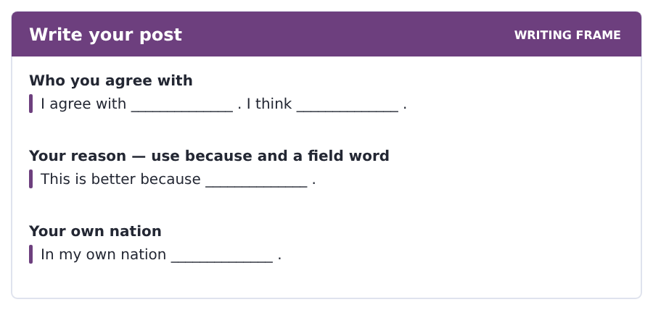
Now write your own. 10 minutes, at least 40 words.
__________________________________________________________
__________________________________________________________
__________________________________________________________
__________________________________________________________
__________________________________________________________
__________________________________________________________
__________________________________________________________
__________________________________________________________
__________________________________________________________
__________________________________________________________

Grammar focus be and subject pronouns · a and an · plural -s
Form | Example
I + am | I am a student.
he / she / it + is | She is from Peru.
you / we / they + are | They are in Group B.
negative | He is not in my class.
question | Are you a new student?
a / an | a student, a college, an office, an email
plural -s | one student, two students; one class, two classes

There are only three forms of be in the present: am, is and are. Learn which person takes which one and half of the grammar of this unit is done.
A question is made by putting am, is or are in front of the person. Nothing else moves: You are from Peru becomes Are you from Peru?
Use an, not a, in front of a, e, i, o and u: an office, an email, an hour. It is about the sound at the start of the word.
Watch out! Never say *I are* or *He am*. And never leave be out: *I student* is not a sentence in English, even though it is a sentence in many other languages.
Exercise 1 Write am, is or are.
1. I __________ a new student.
2. She __________ from Brazil.
3. They __________ in the corridor.
4. You __________ in Group B.
5. __________ he your teacher?
6. We __________ not in Hall 1.
Exercise 2 Write a or an.
1. __________ student
2. __________ office
3. __________ email
4. __________ classroom
5. __________ hour
6. __________ department
Exercise 3 Make a question.
1. You are from Kenya.
2. She is a teacher.
3. They are in my class.
4. It is free.
How this is tested in Build a Sentence
In the real test, at least seven of the ten Build a Sentence items make a question. In this unit every question you make is a be question, so the rule is always the same: am, is or are goes in front of the person, and the question word goes in front of that.

Typing and the Screen The home row
The real test is typed. Nobody gives you paper. If you are still looking for the keys, you lose the Writing section before your English does.
Put your left hand on A S D F and your right hand on J K L. Your fingers start here and they come back here after every word. Do not look down.
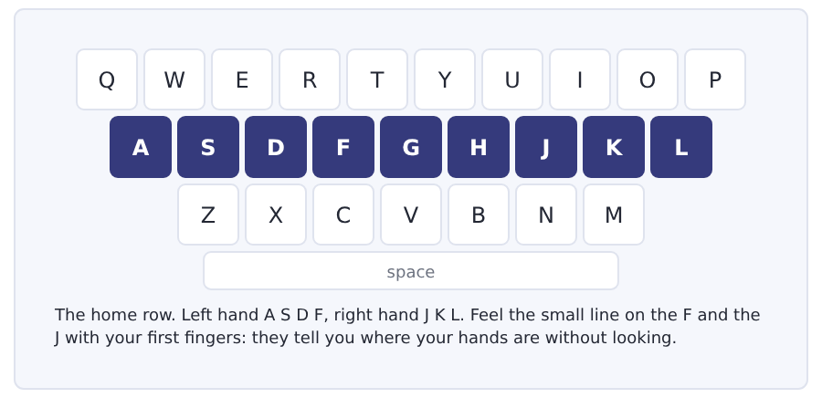
Exercise Type this. Time yourself, then write your speed in the box.
asdf jkl asdf jkl asdf jkl
a sad lad; a glad lass; all fall
ask dad; add half; a flask
My time _______ seconds
Words a minute _______ (the target for Unit 1 is 8)

Learning to Learn A vocabulary notebook that works
A list of words with your own language next to them does not work for long. You read it, you know it, you close the book, it is gone. Three columns work much better than two.
- Column 1: the word. Column 2: a short meaning in English, not in your language. Column 3: one sentence with the word in it, from this book.
- Write the sentence from this book, not a sentence you make up. The book sentence is correct.
- Cover column 1 and read column 2. Say the word. Then do it the other way.
- Six words a day is better than thirty words on Sunday.
- Come back to a page after one day, then after one week, then after one month.
ADAPTIVE TIP Put the date at the top of every page of your notebook. In three months you will see how far you have come, and on a bad day that is worth more than any rule.

Unit review and progress check Unit 1
Exercise A Vocabulary. Write the word.
1. what people call you
2. a very big town
3. a very small town
4. to say the letters one by one
5. a person in your class
6. the small card that shows you study here
7. all the buildings of a college
8. one part of a college, for one subject
9. a teacher speaks and many students listen
10. a small class with a few students
11. the long space between the rooms of a building
12. English and Spanish are these
Exercise B Grammar. Complete the sentence.
1. I __________ a student.
2. She __________ from Brazil.
3. They __________ in Group B.
4. __________ you in my class?
5. He is __________ office worker.
6. There are twelve __________ (student).
7. __________ is your teacher?
8. We __________ not in Hall 2.
Exercise C One timed mini-section. 6 minutes.
1. The Student Office is in
(A) Hall 1
(B) Block A
(C) room 12
(D) Block C
2. Ana is from
(A) Turkey
(B) Peru
(C) Brazil
(D) Kenya
3. In English the first name comes
(A) after the family name
(B) at the end
(C) before the family name
(D) in the middle
4. Which sentence is correct?
(A) I am a student.
(B) I a student.
(C) I am student.
(D) I student am.
5. Which question is correct?
(A) Where you are from?
(B) From where you are?
(C) You are from where?
(D) Where are you from?
6. Group B has students from
(A) two countries
(B) fifteen countries
(C) nine countries
(D) twenty-one countries
Can you do these now?
I can… | Not yet | Yes
say and spell my name, my country and my student number | □ | □
find one fact in a short notice or an email | □ | □
understand a short text about people and where they are from | □ | □
follow a short conversation between two students who have just met | □ | □
ask and answer simple questions with am, is and are | □ | □
write a short email to a college office and a short post about myself | □ | □

ADAPTIVE TIP On the first day, write three things on one card and keep it in your pocket: your student number, the name of your department, and the name of your tutor. You will be asked for all three, often, and by people who are in a hurry.

Unit 2 · The Campus and How to Find It
TOEFL iBT® Preparation Course 2026 · Volume F1
CEFR A2 · Grammar: there is and there are · prepositions of place · this, that, these, those · Word field: places, directions, buildings
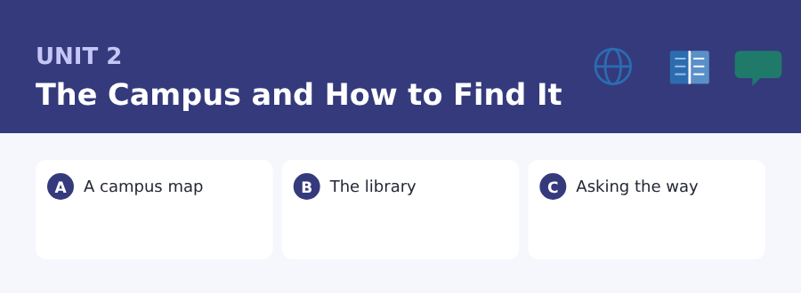
By the end of this unit I can…
- say where a place is with there is and there are
- find a room from a notice or a map
- understand a short text about how a college is organised
- follow a conversation in which somebody asks the way
- ask where something is and give simple directions
- write an email asking about opening times

Three sub-topics, three cycles in every skill. Unit 1 gave you the people. This unit gives you the place they are in.

Vocabulary 1 · The words you need most 24 words from the two thousand most common words of English
These are not academic words. They are the words that carry ordinary English, and until you own them the academic words of Volume 1 have nothing to stand on. Cover the right-hand column and test yourself.
building a thing with walls and a roof: a house, a school, a shop | far a long way
floor the part you walk on, or one level of a building | between with one thing on each side
room one space inside a building | behind at the back of
door you open it to go in | opposite on the other side, looking at it
stairs steps that take you up to the next floor | corner where two walls or two streets meet
lift a small room that takes you up and down | map a picture of a place from above
entrance the door you come in by | sign words on a wall or a board that tell you something
exit the door you go out by | find to see where something is
left this side when you look at a clock at nine | turn to go left or right
right the other side | walk to go on your feet
straight not left and not right: the same way | upstairs on or to a higher floor
near not far | downstairs on or to a lower floor

Exercise A Work in pairs. Ask and answer.
1. Where is the library in your college, and is it near or far?
2. Which room in a college is the most important, do you think?
3. Do you use a map on paper or a map on your phone?
4. What is between your home and your college?
Vocabulary 2 · Campus and everyday 12 words for student life
Every Listening conversation in the real test happens on a campus. These twelve words come back in this unit and again in Volume 1.
library the building with the books in it | study room a quiet room for students to work in
lecture hall a big room with many seats for a lecture | locker a small box with a key, for your things
laboratory the room for science work | car park the place where cars stay
canteen the place in a college where you eat | bookshop the shop that sells books
reception the desk at the entrance where people ask questions | sports centre the building for games and exercise
help desk the desk where you go with a problem | hall of residence the building where students live

Words you will meet again: building | floor | library | canteen | map | entrance | between | reception

Sound and Spelling Numbers, and the trouble with teen and ty
Numbers are the most common thing you hear wrong in a listening test. The problem is almost always the same two families: thirteen and thirty, fourteen and forty, and the rest of that pair.
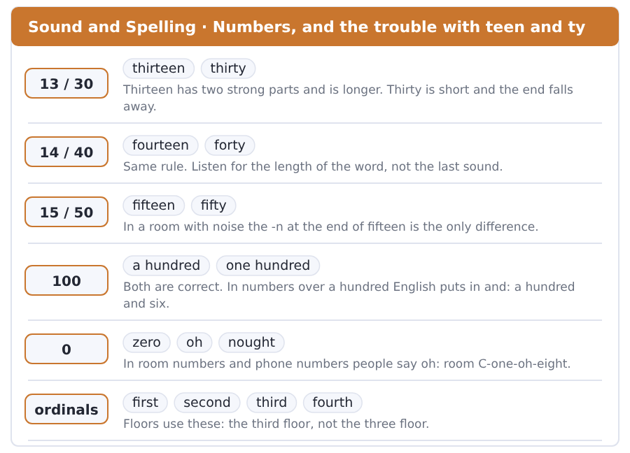
Exercise A Listen. Which word do you hear?
1. Do you hear 13 or 30?
2. Do you hear 14 or 40?
3. Do you hear 15 or 50?
4. Do you hear 16 or 60?
5. Do you hear 18 or 80?
6. Do you hear 19 or 90?
Exercise B Say these out loud. Record yourself if you can.
1. Count from thirteen to twenty.
2. Say these room numbers: A104, B208, C316.
3. Say your phone number one number at a time.
4. Say the floors: first, second, third, fourth, fifth.


SKILL · Plurals and the -s on the verb
- Two different -s live in English: one on nouns, one on verbs.
- Six building- is more than one, so it takes s.
- A sign show- you the way: here the sign is one thing, so the verb takes s.
- A word that ends in -y usually changes to -ies: laboratory, laboratories.

Exercise A Guided practice. Five words are not complete. Write the missing letters.
Riverside campus is not very big. There are six building-. The library is in Block B. In Block A there are ten classroom- and two laborator---. There are also two lift- in Block A. The sports centre is behind Block C. A sign at the entrance show- you the way.

The first one is done for you: 1 building- → s (buildings)
Exercise B Exam practice. One paragraph, ten gaps — the real task.
Welcome to the campus. There are six building- here and they all have a letter on the door. Block A is the big building near the main entrance. Inside there are twenty classroom-, two laborator--- and a study room on the top floor. The teach--- have an office on the second floor. There are locker- near the stairs. The canteen is in Block B, next to the library. There are two entrance- to the library. The back door open- at eight and close- at six. If you cannot find a room, ask at the help desk. The staff there know all the short way- across the campus, and they also have free map- of the building.

Check your answers in the key at the back of the book.


SKILL · Read the question, then scan
- Scan means move your eyes fast and look for one thing only.
- Opening times, floors and room numbers are the easiest things to scan for.
- A web page is not a story. You do not read it from the top.
- When you find the words of the question on the page, slow down and read.

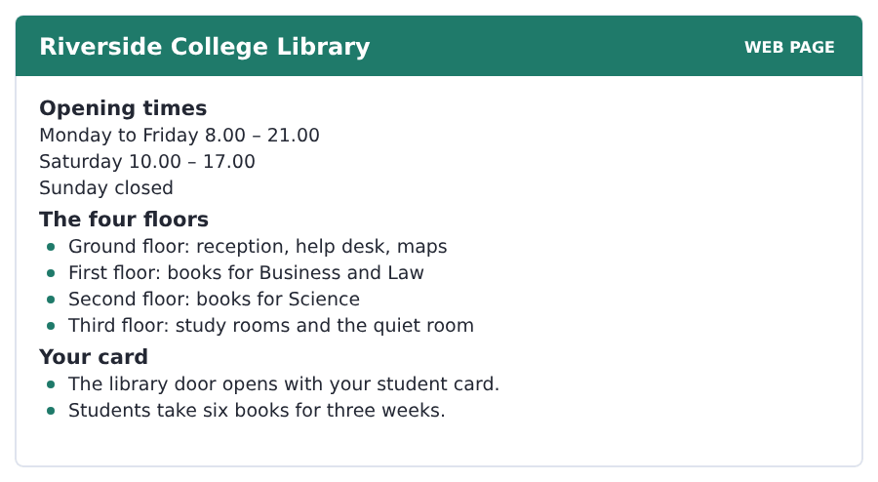
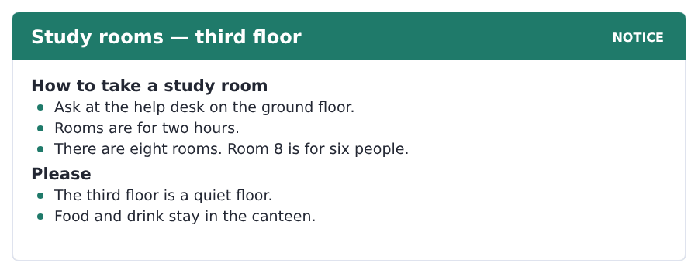
Exercise A Guided practice. The answer is on the page — find it.
1. When is the library closed?
(A) Monday
(B) Saturday
(C) Friday
(D) Sunday
2. Where are the Science books?
(A) ground floor
(B) second floor
(C) first floor
(D) third floor
3. How many books does a student take?
(A) three
(B) eight
(C) six
(D) twenty-one
4. Where do you ask for a study room?
(A) the help desk
(B) the third floor
(C) the canteen
(D) the car park
Exercise B Exam practice.
5. What time does the library open on Saturday?
(A) 8.00
(B) 17.00
(C) 10.00
(D) 21.00
6. What opens the library door?
(A) a key
(B) the help desk
(C) a locker
(D) a student card
7. Where is the quiet room?
(A) third floor
(B) ground floor
(C) first floor
(D) second floor
8. How long is a study room for?
(A) one hour
(B) two hours
(C) three hours
(D) all day
9. Which room is for six people?
(A) Room 2
(B) Room 8
(C) Room 3
(D) Room 6
10. Where do students eat?
(A) the study rooms
(B) the third floor
(C) the library
(D) the canteen


SKILL · Letters and numbers carry meaning
- In a short text about a place, the letters and numbers are the facts.
- Room B204: read it as three parts — the block, the floor, the door.
- The last paragraph of a short text is often the writer’s opinion.
- A question with every or all needs a word like every or all in the text.

A Campus Is a Small Town
Riverside campus is a small town. There are six buildings, a canteen, a sports centre and a shop. About two thousand people come here every day.
Every building has a letter. Block A is for Business, Block B is for Science and Block C is for the offices. The letters are on every door and on every map. New students find a room by the letter first and the number second. Room B204 is in Block B, on the second floor, and it is the fourth door.
Not every college does this. Some colleges use names, not letters. A name is easy to remember. A letter is easy to find on a map. A campus with letters is cold at first, but nobody needs a map for long.
[128 words]

Exercise A Guided practice.
1. How many buildings are there on the campus?
(A) four
(B) ten
(C) six
(D) two thousand
2. Which block is for Science?
(A) Block B
(B) Block A
(C) Block C
(D) Block D
3. Where is room B204?
(A) Block A, floor 2
(B) Block B, floor 4
(C) Block B, floor 2
(D) Block C, floor 2
4. What does every building have?
(A) a canteen
(B) a letter
(C) a shop
(D) a map
Exercise B Exam practice.
5. How many people come to the campus every day?
(A) two thousand
(B) six
(C) two hundred
(D) four hundred
6. Where are the offices?
(A) Block A
(B) Block B
(C) the sports centre
(D) Block C
7. In room B204, what is the 4?
(A) the block
(B) the door
(C) the floor
(D) the year
8. Some colleges use
(A) numbers only
(B) no maps
(C) names
(D) one building
9. The writer thinks a name is
(A) easy to remember
(B) easy to find on a map
(C) cold
(D) not easy
10. A campus with letters is
(A) warm at first
(B) always difficult
(C) never easy
(D) cold at first
11. What is the big idea of the passage?
(A) Riverside is very big.
(B) Letters help people find rooms.
(C) Science is in Block B.
(D) Students are often lost.

The field: Making and Building Two more cycles in every skill, on one subject
Everything up to here was about your own life, because that is where a language starts. From this page the same unit turns to a subject, and the subject is one Volume 1 will take up properly: how a building or a bridge is designed, and why it is the shape it is.
design to plan the shape of a thing before you make it | concrete the hard material of most modern buildings
shape round, square or long: what a thing looks like | steel very strong metal
weight how heavy a thing is | roof the top of a building
curve a line that is not straight | column a tall round post that holds a weight
arch a curve over a door or a bridge | architect the person who designs a building
material wood, stone and steel are materials | balance the right middle between two things that pull apart


SKILL · A passage that explains a shape
- A passage about design gives a problem and then the shape that solves it.
- Draw the shape on your paper as you read. It takes four seconds.
- Words like under, over, across and down are doing real work here.
- A question about why wants the problem, not the shape.

The Strongest Shape There Is
Look at an old stone bridge. The top of it is a curve, not a straight line. This is not for beauty. It is the answer to a problem.
Stone is very strong under weight and very weak across it. A straight stone over a river breaks in the middle. An arch is a curve. The weight of the bridge runs down the curve and into the ground at each end.
There is no steel in a Roman bridge and there is no concrete. There is only stone and shape. Some of those bridges are two thousand years old and cars drive over them today.
[105 words]

Exercise A Guided practice.
1. What is the top of an old stone bridge?
(A) a straight line
(B) a column
(C) a roof
(D) a curve
2. Why is it a curve?
(A) for beauty
(B) it is cheap
(C) it is the answer to a problem
(D) it is quick
3. Stone is very strong
(A) under weight
(B) across weight
(C) in water
(D) in the air
Exercise B Exam practice.
4. What happens to a straight stone over a river?
(A) it breaks in the middle
(B) it is strong
(C) it gets longer
(D) it is cheap
5. In an arch, where does the weight go?
(A) into the river
(B) up to the roof
(C) into the middle
(D) down the curve and into the ground
6. What is in a Roman bridge?
(A) steel and concrete
(B) wood
(C) stone and shape
(D) concrete only
7. How old are some of those bridges?
(A) two hundred years
(B) two thousand years
(C) five hundred years
(D) a thousand years


SKILL · Easy to describe, hard to make
- An academic passage often says that a simple thing is not simple.
- The list of jobs a thing must do is the centre of this kind of text.
- Count the jobs as you read. There are usually three or four.
- A question about the design wants the jobs, not the material.

Why a Chair Is Difficult
A chair is four legs and a flat part. It is the first thing a student of design makes, and it is one of the hardest.
A chair carries the weight of a person. It is light enough for one hand. It is comfortable for an hour. It is cheap to make a thousand times. It is also a thing in a room, so it has a shape people like.
Every one of these is easy on its own. Together they fight. A strong chair is heavy. A light chair is weak. There is no best answer. The designer looks for the right balance.
[104 words]

Exercise A Guided practice.
1. What is a chair?
(A) three legs and a back
(B) four legs and a flat part
(C) a curve
(D) a column
2. When does a student of design make a chair?
(A) first
(B) last
(C) never
(D) after a building
3. How many jobs does the passage give a chair?
(A) two
(B) three
(C) five
(D) four
Exercise B Exam practice.
4. A strong chair is
(A) light
(B) cheap
(C) comfortable
(D) heavy
5. A light chair is
(A) strong
(B) cheap
(C) expensive
(D) weak
6. What does the designer look for?
(A) the right balance
(B) the best answer
(C) the cheapest material
(D) the newest shape
7. Why is a chair hard to design?
(A) the material is expensive
(B) nobody buys chairs
(C) the jobs fight each other
(D) it has four legs

Sentence Builder Capital letters and full stops
A sentence starts with a capital letter and ends with a full stop. In the Writing section this is not a small thing: a page with no capital letters and no full stops is hard to read, and a marker who has to work hard gives you a lower band.
Not a sentence | A sentence
the library is in block b | The library is in Block B.
there are six blocks | There are six blocks.
where is the canteen | Where is the canteen?
my name is ana i am from peru | My name is Ana. I am from Peru.
turn left at the corner then walk straight on | Turn left at the corner. Then walk straight on.

Watch out! Names of people, places, days and months take a capital letter in the middle of a sentence too: on Monday, in Block C, with Ana.
Exercise A Is it a sentence? Write yes or no. If no, put it right.
1. there is a map at the entrance
2. is there a lift in this building
3. the canteen is open on saturday
4. i study in the library every monday
5. There are eight study rooms.
6. walk past the shop the library is on your left


Exercise A Listen and choose a response. You hear one line. Choose the best reply.
1. Excuse me, is there a canteen near here?
(A) At four o’clock.
(B) Yes, in Block B.
(C) Two books.
(D) He is a teacher.
2. Where is the library?
(A) It is free.
(B) On Monday.
(C) Yes, it is.
(D) Opposite the canteen.
3. Thank you very much.
(A) Turn left.
(B) In Block A.
(C) You are welcome.
(D) Six books.
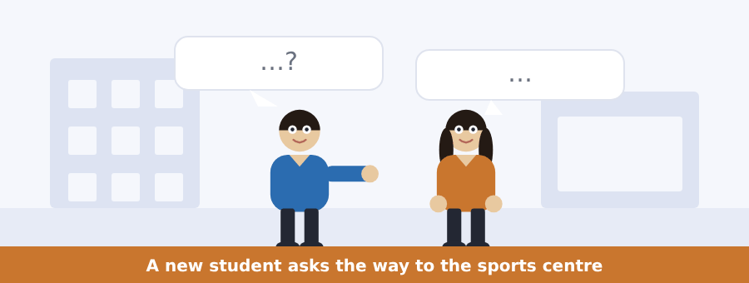
SKILL · Follow the directions in order
- Directions come in order. Draw the way with your finger as you listen.
- Left, right and straight are the three words that matter most.
- Past, behind, opposite and next to tell you where to stop.
- If you miss one step, listen for the last one. People repeat the end.

Exercise B Listen and answer. The audio plays once.
4. What is the man looking for?
(A) the library
(B) the sports centre
(C) Block C
(D) the car park
5. Where is the sports centre?
(A) behind Block C
(B) in Block C
(C) opposite Block C
(D) in the library
6. Where is Block C?
(A) behind the library
(B) opposite the library
(C) in the library
(D) next to the canteen
7. Which way does he turn at the corner?
(A) left
(B) straight on
(C) right
(D) back
8. The sports centre is behind
(A) the library
(B) the canteen
(C) Block A
(D) the car park
9. What is at the entrance?
(A) a sign
(B) a help desk
(C) a locker
(D) a lift
Audio script: see the back of the book. Do not read it before you listen.


Exercise A Listen and choose a response. You hear one line. Choose the best reply.
1. Is the library open on Wednesday?
(A) On the second floor.
(B) Yes, it is.
(C) Six books.
(D) Turn right.
2. Where are the Science books today?
(A) On the ground floor.
(B) At nine.
(C) Yes, they are.
(D) For two hours.
3. Sorry about the trouble.
(A) In Block C.
(B) Three weeks.
(C) That is fine.
(D) It is closed.
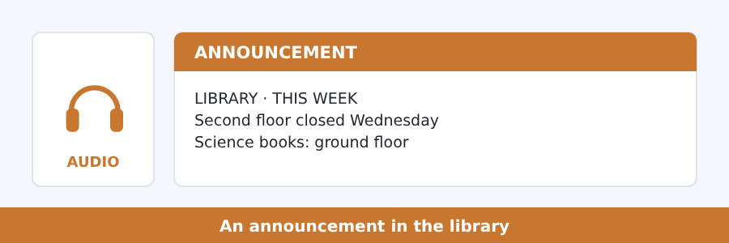
SKILL · One change, one reason
- Most short announcements say one thing is different this week.
- Listen for the day, the place and the reason, in that order.
- The reason often comes last, after because or so.
- Write the change in three words. That is usually all you need.

Exercise B Listen and answer. The audio plays once.
4. Which floor is closed?
(A) the ground floor
(B) the first floor
(C) the third floor
(D) the second floor
5. Which day is it closed?
(A) Monday
(B) Friday
(C) Sunday
(D) Wednesday
6. Why is it closed?
(A) no staff
(B) a free day
(C) work on the lift
(D) new books
7. Where are the Science books on that day?
(A) the ground floor
(B) the first floor
(C) the third floor
(D) the canteen
8. What about the study rooms?
(A) they are closed
(B) they are open as normal
(C) they move
(D) they are on the second floor
Audio script: see the back of the book. Do not read it before you listen.


Exercise A Listen and choose a response. You hear one line. Choose the best reply.
1. Is there a map at the entrance?
(A) At nine.
(B) Six books.
(C) Yes, there is.
(D) He is new.
2. Are there any study rooms?
(A) It is closed.
(B) Yes, there are eight.
(C) On Wednesday.
(D) Turn left.
3. How do I find room B204?
(A) It is free.
(B) At the weekend.
(C) Yes, you do.
(D) Block B, second floor.
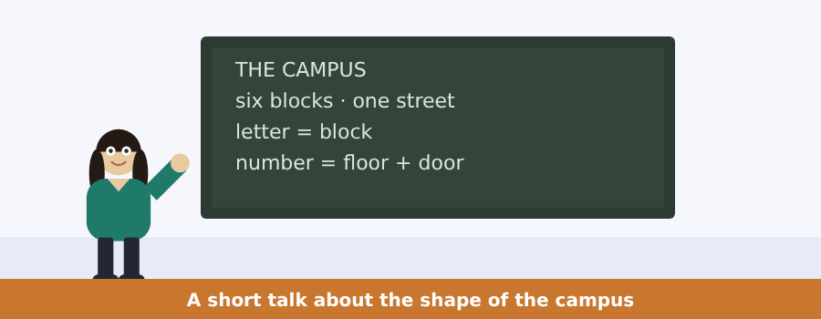
SKILL · Listen for the plan behind the place
- A talk about a place usually explains the plan, not the walk.
- The speaker gives a rule, then an example of the rule.
- Hear the rule first. The example is there to make the rule clear.
- A question about why usually points at the rule, not the example.

Exercise B Listen and answer. The audio plays once.
4. How many blocks are there?
(A) six
(B) one
(C) three
(D) eight
5. Where are the blocks?
(A) on both sides of the street
(B) at the end of the street
(C) behind the library
(D) in the car park
6. In room C108, what is the 1?
(A) the block
(B) the door
(C) the street
(D) the floor
7. In room C108, what is the 08?
(A) the block
(B) the door
(C) the floor
(D) the year
8. How many numbers does a room have?
(A) one
(B) two
(C) three
(D) four
9. Why does the speaker explain the rule?
(A) because the campus is big
(B) because the map is wrong
(C) so students do not need a map
(D) so students go to Block C
Audio script: see the back of the book. Do not read it before you listen.


Exercise A Listen and choose a response.
1. Is a straight stone strong across a river?
(A) In the middle.
(B) Two thousand years.
(C) Yes, I am.
(D) No, it is not.
2. What shape is the top of the bridge?
(A) At the end.
(B) A curve.
(C) Yes, it is.
(D) Stone.
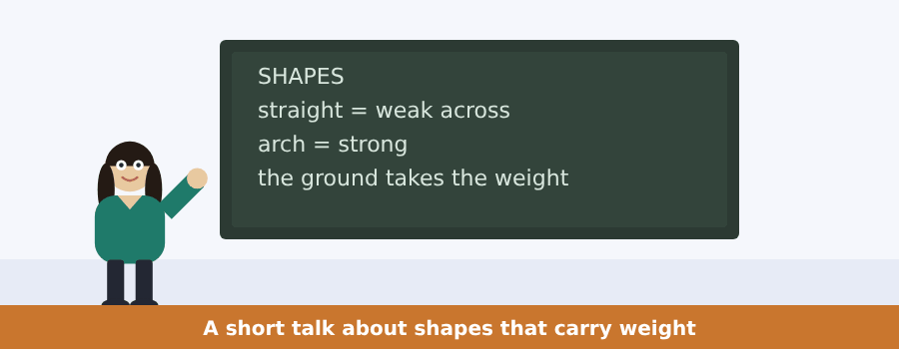
SKILL · Follow the weight
- In a talk about building, follow where the weight goes.
- Down, into and across are the words that tell you.
- The speaker usually names the material and then the shape.
- The shape is the point. The material is the example.

Exercise B Listen and answer. The audio plays once.
3. What is the question behind every building?
(A) where does the weight go
(B) the material of it
(C) the price of it
(D) the architect of it
4. A flat stone over a river
(A) is strong
(B) gets longer
(C) sends the weight down
(D) breaks in the middle
5. An arch sends the weight
(A) up
(B) into the river
(C) into the ground at both ends
(D) to the middle
6. What is very good at weight?
(A) stone
(B) the ground
(C) steel
(D) the curve
Audio script: see the back of the book.


Exercise A Listen and choose a response.
1. Is a strong chair heavy?
(A) Yes, it is.
(B) In a room.
(C) Four legs.
(D) Yes, I do.
2. What does a designer look for?
(A) At the end.
(B) The right balance.
(C) Yes, they do.
(D) A chair.
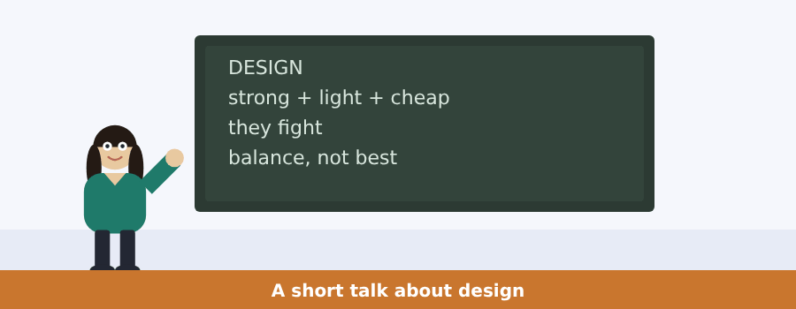
SKILL · Lists in a talk
- When a speaker lists things, hold up a finger for each one.
- The point usually comes after the list, not before it.
- But and however say the list is about to turn.
- A question about the point wants the sentence after the list.

Exercise B Listen and answer. The audio plays once.
3. How many things must a chair be?
(A) two
(B) three
(C) five
(D) four
4. Each one on its own is
(A) difficult
(B) expensive
(C) easy
(D) impossible
5. What is the problem?
(A) they fight
(B) the material
(C) the price
(D) the shape
6. A designer looks for
(A) the best chair
(B) the cheapest chair
(C) a balance
(D) a new material
Audio script: see the back of the book.


Part 1 · Listen and Repeat
You hear a sentence and repeat it once. There is no preparation time, and the sentences get longer. Focus: the sounds /θ/ in third and /ð/ in there
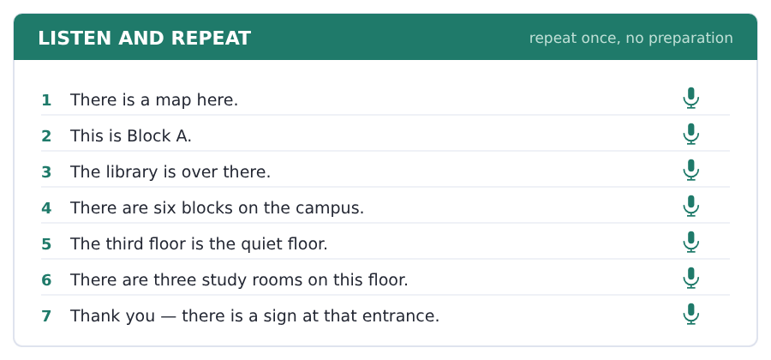
SKILL · Two th sounds
- There, this and that use the soft /ð/, with the voice on.
- Third, three and thank use the hard /θ/, with no voice.
- Put your tongue between your teeth for both. That is the whole trick.
- Never say *zere* or *dere*. The tongue must come out.

Part 2 · Take an Interview
An interviewer asks you four questions on one theme: the place where you study. Answer each one fully. There is no preparation time.
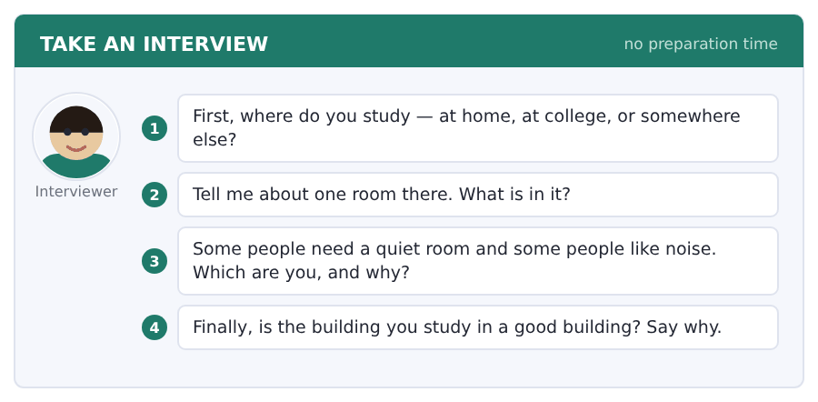
Say it like this
- I study ... . It is ... .
- There is a ... and there are two ... .
- I need ... , because ... .
- The building is ... , because ... .
A good answer sounds like this
Question 1 — I study at the college library, because at home there is always somebody in the room.
Question 2 — There is one long table and there are twelve chairs. There is a window behind the table.
Question 3 — I need a quiet room. I think about one thing at a time, so noise takes the thing away.
Question 4 — The building is good, because the study rooms are at the top and the canteen is on the ground floor.
I can… | Not yet | Yes
I put my tongue between my teeth for th | □ | □
I used there is and there are correctly | □ | □
I gave a reason after my opinion | □ | □


Part 1 · Listen and Repeat
You hear a sentence and repeat it once. There is no preparation time, and the sentences get longer. Focus: numbers: thirteen and thirty, fourteen and forty
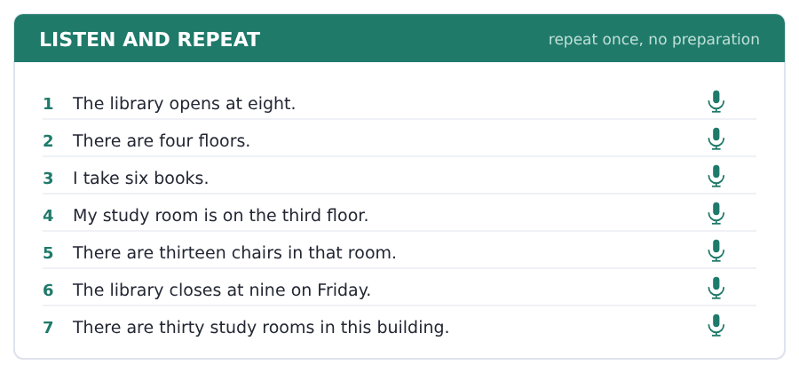
SKILL · The teen and the ty
- Thirteen is THIR-TEEN, with two strong parts. Thirty is THIR-ty.
- The -teen number is longer. Make it longer when you say it.
- If somebody looks unsure, say one-three or three-zero.
- Times are the same: at fifteen past, at fifty past.

Part 2 · Take an Interview
An interviewer asks you four questions on one theme: books and reading. Answer each one fully. There is no preparation time.
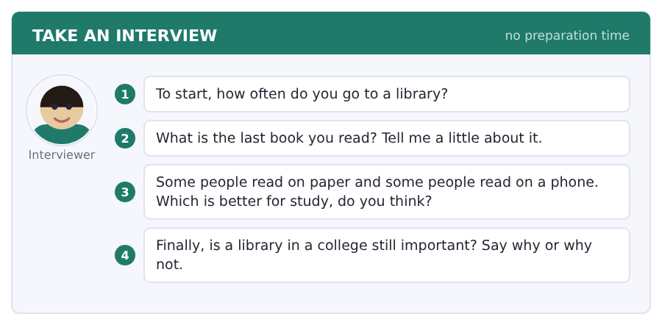
Say it like this
- I go to a library ... .
- The book is about ... . It is ... .
- I think ... is better for study, because ... .
- A library is ... important, because ... .
A good answer sounds like this
Question 1 — I go to a library two or three times a week, usually in the afternoon.
Question 2 — The book is about a family in a small town. It is not long and the English in it is not difficult.
Question 3 — I think paper is better for study, because on a phone my eyes are tired after an hour.
Question 4 — A library is still important, because it is a quiet room for students with no quiet room at home.
I can… | Not yet | Yes
I made the -teen numbers longer than the -ty numbers | □ | □
I answered with a full sentence | □ | □
I gave an example | □ | □


Part 1 · Listen and Repeat
You hear a sentence and repeat it once. There is no preparation time, and the sentences get longer. Focus: the stress in long place words
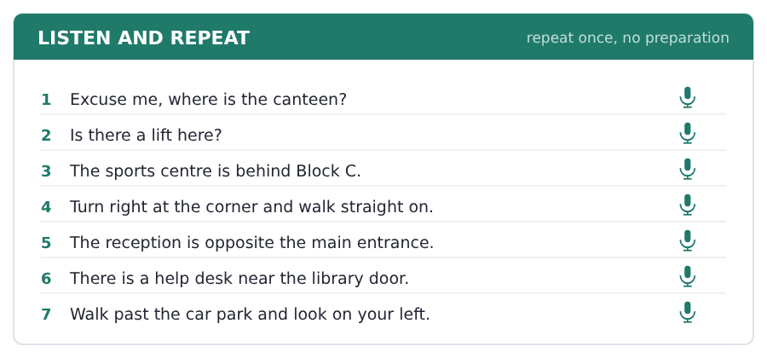
SKILL · Say the question, then stop
- Ask one question and stop. Do not add three more.
- Excuse me at the start makes every question polite.
- Repeat the last words of the answer. It shows you understand.
- If you do not understand, say Sorry, again please. That is enough.

Part 2 · Take an Interview
An interviewer asks you four questions on one theme: finding your way. Answer each one fully. There is no preparation time.
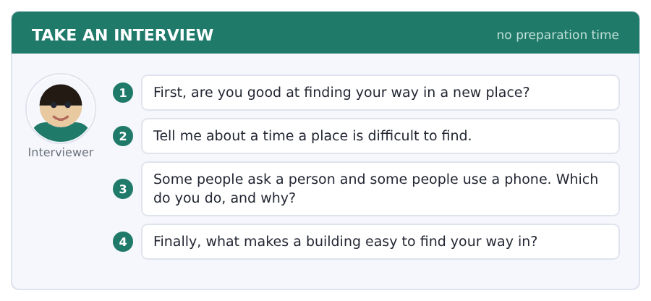
Say it like this
- I am ... at finding my way.
- The ... in my town is difficult to find, because ... .
- I usually ... , because ... .
- A building is easy when ... .
A good answer sounds like this
Question 1 — I am not very good at finding my way. In a new place I always walk the wrong way first.
Question 2 — The station in my town is difficult to find, because there are four entrances and only one of them is open.
Question 3 — I usually ask a person, because a person knows the short way and a phone does not.
Question 4 — A building is easy when there is a sign at every corner and a map at the entrance.
I can… | Not yet | Yes
I asked one question and stopped | □ | □
I used a preposition of place in every answer | □ | □
I said more than one sentence | □ | □


Part 1 · Listen and Repeat
You hear a sentence and repeat it once. There is no preparation time, and the sentences get longer. Focus: the sounds in shape words: /ʃ/ and /tʃ/
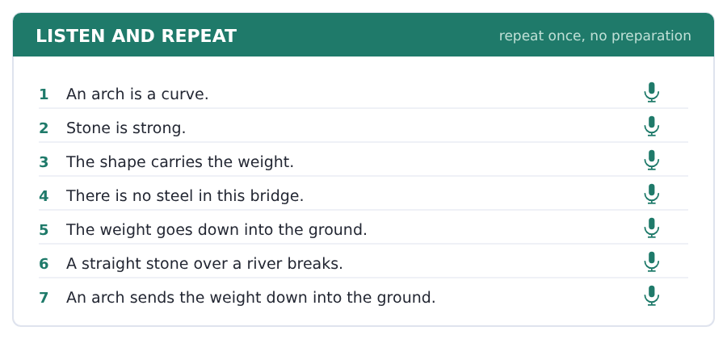
SKILL · Shape and chair
- Shape, she and wash use /ʃ/, with no t at the front.
- Chair, cheap and watch use /tʃ/, with a t at the front.
- Say the pair: shop / chop, share / chair, wash / watch.
- These two sounds carry a lot of the vocabulary of this field.

Part 2 · Take an Interview
An interviewer asks you four questions on one theme: buildings and bridges. Answer each one fully. There is no preparation time.
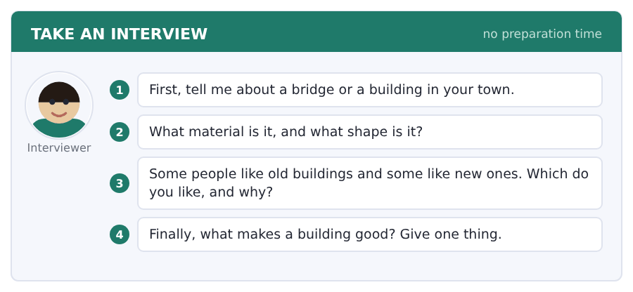
Say it like this
- There is a ... in my town. It is ... .
- It is made of ... .
- I think ... , because ... .
- A good building is ... , because ... .
A good answer sounds like this
Question 1 — There is an old stone bridge in my town. It is the oldest thing we have and it is still the way into the centre.
Question 2 — It is made of stone, and the top of it is a curve. There are four arches under it.
Question 3 — I like old buildings, because the material is real stone and the shape is there for a reason.
Question 4 — A good building is quiet inside. That is one thing nobody puts in a picture and everybody feels.
I can… | Not yet | Yes
I said /ʃ/ and /tʃ/ correctly | □ | □
I used three field words | □ | □
I gave a reason after my opinion | □ | □


Part 1 · Listen and Repeat
You hear a sentence and repeat it once. There is no preparation time, and the sentences get longer. Focus: the stress in design words
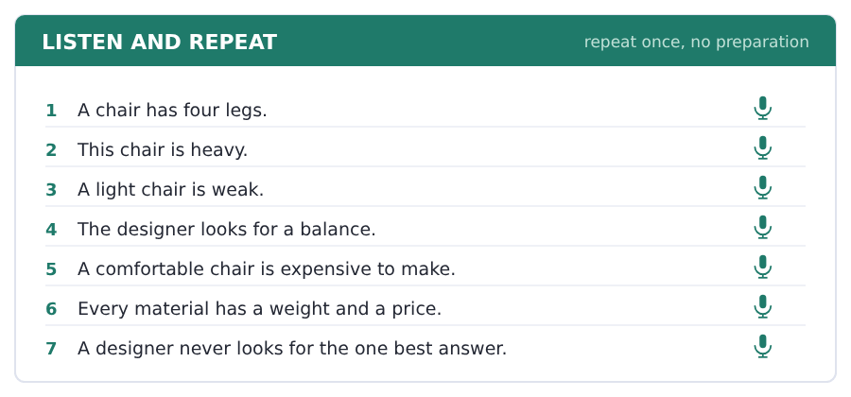
SKILL · deSIGN, maTErial, STRUCture
- deSIGN has the strong part second. The g is silent.
- maTErial and arCHItect both take the strong part in the middle.
- STRUCture and COLumn take it first.
- Say each word three times before you use it in a sentence.

Part 2 · Take an Interview
An interviewer asks you four questions on one theme: design in everyday things. Answer each one fully. There is no preparation time.
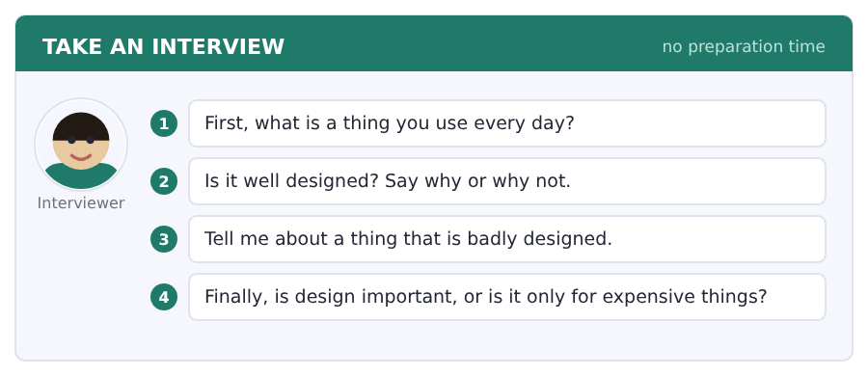
Say it like this
- The thing I use most is ... .
- It is good because ... .
- A badly designed thing is ... .
- I think design is ... , because ... .
A good answer sounds like this
Question 1 — The thing I use every day is my bag. It is four years old and it is still good.
Question 2 — It is well designed, because there is one big space and two small ones, and I never look for my keys.
Question 3 — The door of my building is badly designed. You pull it and it opens the other way, and everybody is wrong every time.
Question 4 — Design is important in cheap things most of all, because a cheap thing is a thing a lot of people use.
I can… | Not yet | Yes
I put the strong part in the right place | □ | □
I gave an example, not only an opinion | □ | □
I answered all four questions | □ | □


You see a sentence, then a set of words in boxes. Put the words in order to make one grammatical sentence. Almost every item in the real test makes a question or a question inside another sentence.
SKILL · Is there and Are there
- One thing: Is there a lift? More than one: Are there any lifts?
- The question starts with is or are, then there.
- Where goes in front of everything: Where is the lift?
- Keep the question short. Four or five words is a normal question.

Exercise A Guided practice. The first three are worked through.
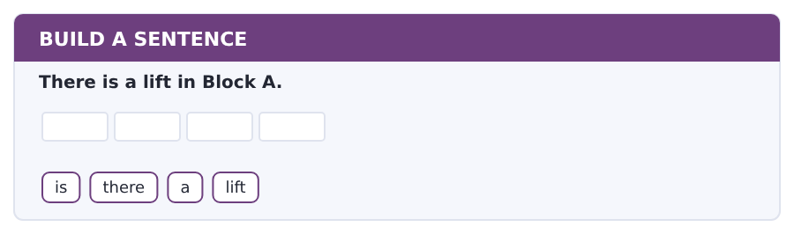
1. Is there a lift?
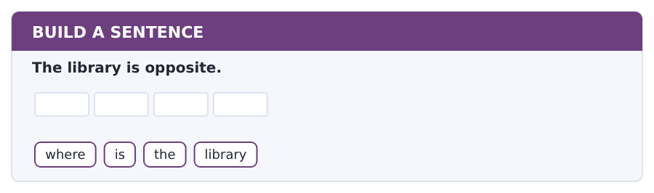
2. Where is the library?
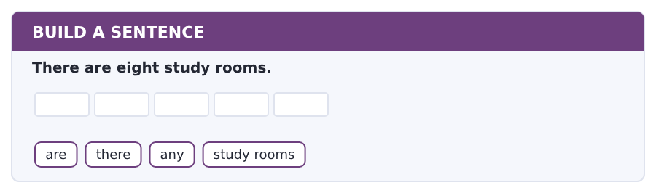
3. Are there any study rooms?
Exercise B Exam practice. Write the sentence.
4. The canteen is in Block B.
where / is / the / canteen
__________________________________________________________
5. There is a map at the entrance.
is / there / a / map
__________________________________________________________
6. There are six blocks.
how / many / blocks / are / there
__________________________________________________________
7. The help desk is on the ground floor.
which / floor / is / the help desk / on
__________________________________________________________
8. There is a car park behind Block C.
is / there / a / car park
__________________________________________________________
9. The library is on your left.
walk / past / the library / now
__________________________________________________________
10. The sports centre is behind the car park.
what / is / behind / the car park
__________________________________________________________


You read a short situation and write an email. You have 7 minutes. The three bullet points are the mark scheme: answer all three.
In the real test you write as much as you can in seven minutes. In this unit, aim for about 40 words. That number goes up in every unit of this book, and in Volume 1 it stops being a number at all.
You want a study room in the library on Saturday.
You do not know if the library is open. Write to the library.
- say who you are
- ask about Saturday opening times
- ask how to take a study room
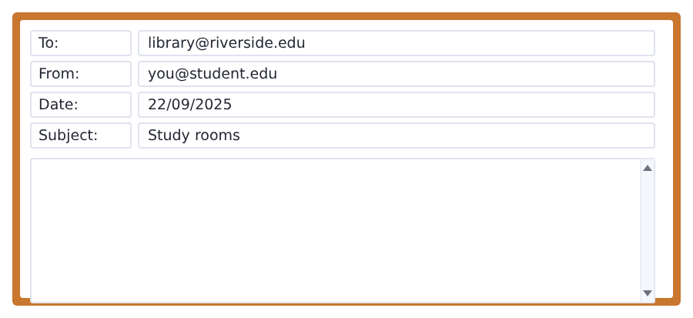
SKILL · A question needs a question mark
- Every bullet point that starts with ask needs a question mark.
- Put the question word first: When ...? How ...? Where ...?
- One sentence for each bullet point is enough.
- Do not ask four questions when the task asks for two.

Model email
Dear Library,

My name is Ana Ruiz and I am a student in Group B.
When is the library open on Saturday?
How do I take a study room on the third floor?

Thank you,
Ana Ruiz
Why it works
- The three bullet points are answered in the order of the task.
- Both questions have a question word at the front and a question mark at the end.
- The sentences are short. Short and correct is better here.
- There is a greeting at the top and a name at the bottom.
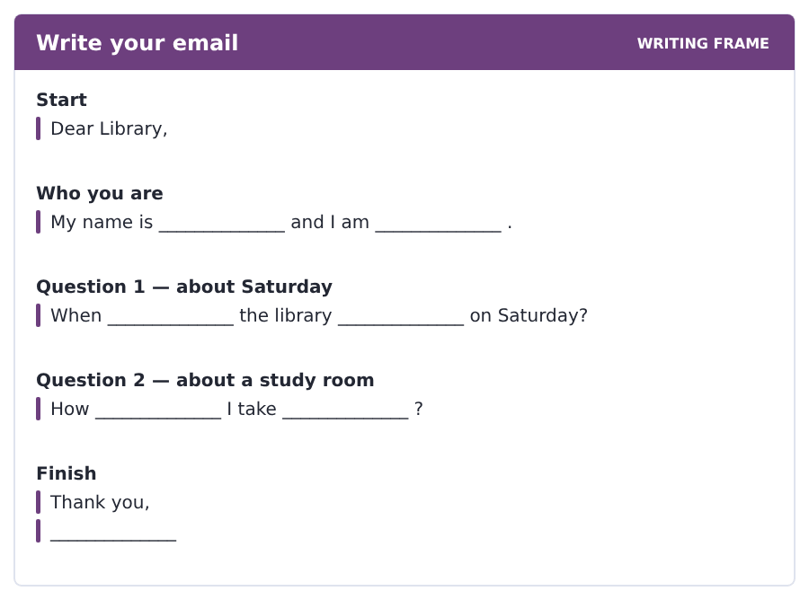
Now write your own. 7 minutes.
__________________________________________________________
__________________________________________________________
__________________________________________________________
__________________________________________________________
__________________________________________________________
__________________________________________________________
__________________________________________________________
__________________________________________________________


A professor asks a question and two students answer. You add your own post. You have 10 minutes and an effective answer is at least 100 words.
One hundred words is what the real test wants, and you will get there. For this unit, write about 45. Every unit of this book asks for a few more.
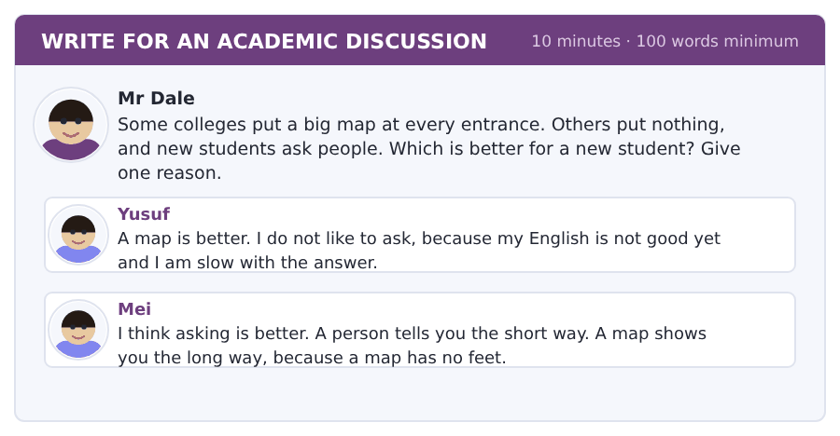
SKILL · Answer the question on the page
- The professor asks which is better. Say which, in your first sentence.
- Then say why, with because.
- Say one thing about Yusuf or Mei. Agree or do not agree.
- Three short sentences are enough for a full post at this level.

Sentence starters
- I agree with Mei, because ...
- For a new student, a map is ...
- In my first week ...
- The best thing is ...
Model post
I agree with Mei. Asking a person is better for a new student, because a person answers the real question.
A map shows every building, and a new student does not want every building.
But a map at the entrance is also good on the first day, when there is nobody to ask.
[53 words]
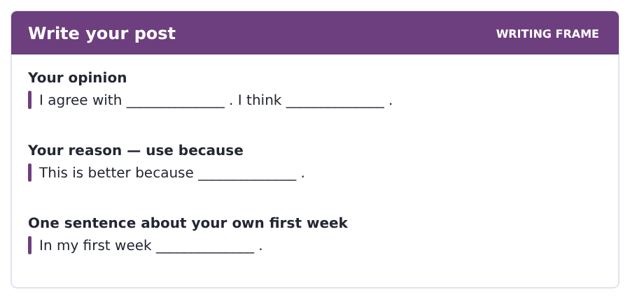
Now write your own. 10 minutes, at least 45 words.
__________________________________________________________
__________________________________________________________
__________________________________________________________
__________________________________________________________
__________________________________________________________
__________________________________________________________
__________________________________________________________
__________________________________________________________
__________________________________________________________
__________________________________________________________


The same task again, on the subject of this unit. The sentences are about making and building now, and the word order has not changed at all.
SKILL · There is and there are, about things
- The same question order, now about a bridge and not a canteen.
- Is there or Are there goes to the front and nothing else moves.
- What and where come first of all.
- Keep the question short. Four or five words is normal.

Exercise A Guided practice.
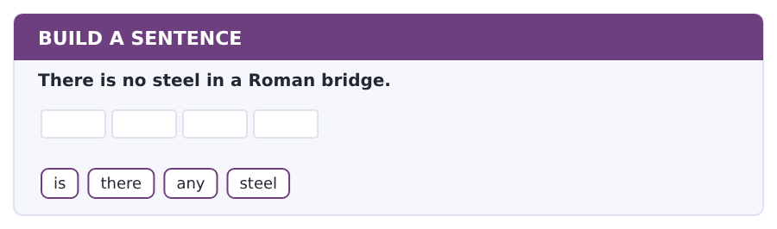
1. Is there any steel?
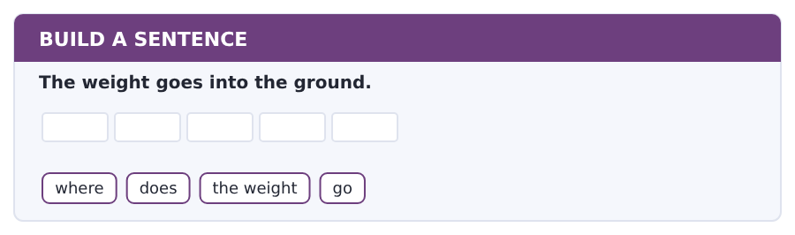
2. Where does the weight go?
Exercise B Exam practice. Write the sentence.
3. An arch is a curve.
what / shape / is / an arch
__________________________________________________________
4. There is a column under the roof.
is / there / a / column
__________________________________________________________
5. Concrete is a modern material.
is / concrete / a / modern material
__________________________________________________________
6. The architect designs the building.
who / designs / the / building
__________________________________________________________


A second discussion, and this one is about the subject rather than about your own week. In the real test both kinds come up, and the second kind is the harder one.
For this unit, write about 45 words. The real test wants a hundred.
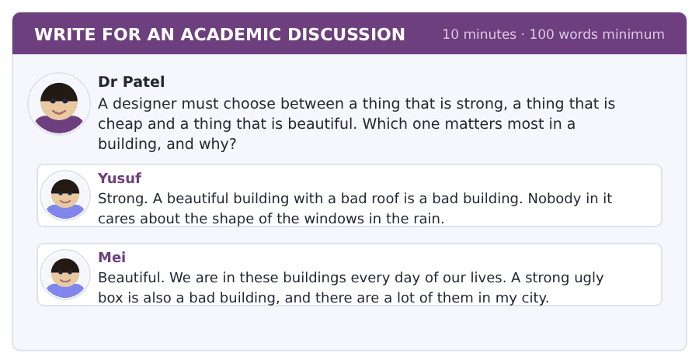
SKILL · A design question has no right answer
- The professor asks which matters most. Say which, in sentence one.
- Then give one reason, with because.
- Say one thing about the other post. The best posts do this.
- Use a field word. That is what the vocabulary page was for.

Sentence starters
- I agree with Yusuf, because ...
- A building must first ...
- In my city ...
- The right balance is ...
Model post
I agree with Yusuf. A building must first be strong, because a roof that with a hole in it is not a design at all.
But Mei is right about the box. In my city there are strong square buildings and nobody likes them.
The right balance is strong first, and then beautiful.
[53 words]
Now write your own. 10 minutes, at least 45 words.
__________________________________________________________
__________________________________________________________
__________________________________________________________
__________________________________________________________
__________________________________________________________
__________________________________________________________
__________________________________________________________
__________________________________________________________
__________________________________________________________
__________________________________________________________

Grammar focus there is and there are · prepositions of place · this, that, these, those
Form | Example
there is + one thing | There is a lift in Block A.
there are + more things | There are six blocks.
negative | There is not a canteen in Block C.
question | Is there a map? / Are there any study rooms?
place words | in, on, at, near, behind, between, opposite, next to
this / that | this room (here) · that room (over there)
these / those | these books (here) · those books (over there)

There is and there are say that something exists. They do not say who owns it. There is a lift means a lift exists in this place.
Use any in questions and in negatives with plural words: Are there any lockers? There are not any lockers here.
This and these are for things near you. That and those are for things away from you. This is the only difference, and it is the same in the plural.
Watch out! Never say *It has a lift in Block A* or *Have a lift*. Many languages build this sentence with have. English builds it with there is.
Exercise 1 Write there is or there are.
1. __________ a help desk near the door.
2. __________ eight study rooms on the third floor.
3. __________ not a lift in this building.
4. __________ two entrances to the library.
5. __________ a sign at the corner.
6. __________ six blocks on the campus.
Exercise 2 Write in, on, behind, between, opposite or near.
1. The canteen is __________ Block B.
2. The books are __________ the second floor.
3. The sports centre is __________ Block C.
4. The library is __________ the canteen and the shop.
5. My room is __________ the help desk, so I see it from my door.
6. The car park is __________ the entrance, only two minutes away.
Exercise 3 Write this, that, these or those.
1. __________ book here is mine.
2. __________ buildings over there are the halls of residence.
3. __________ rooms here are the study rooms.
4. __________ man at the other end of the corridor is my teacher.
How this is tested in Build a Sentence
In Build a Sentence the test loves there is and there are, because the word order changes when the sentence becomes a question: There is a lift becomes Is there a lift? Only two words move, and they move together.

Typing and the Screen The top row
The real test is typed. Nobody gives you paper. If you are still looking for the keys, you lose the Writing section before your English does.
Your fingers stay on the home row and reach up. The left hand takes Q W E R T and the right hand takes Y U I O P. Reach up, type, come back down.
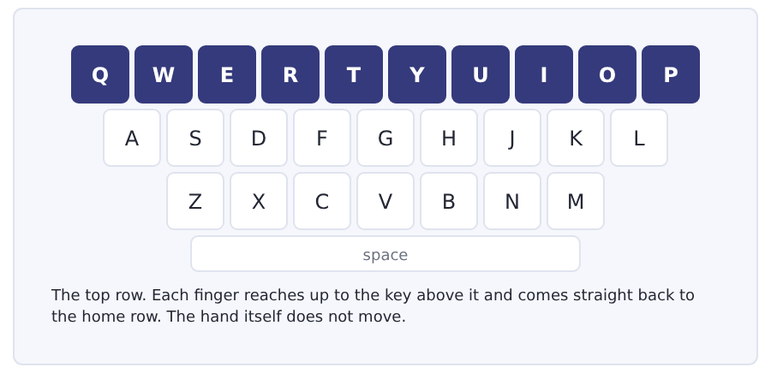
Exercise Type this. Time yourself, then write your speed in the box.
qwer tyui op qwer tyui op
we type to the top row; we were there
they are quiet; the quiet type were right
My time _______ seconds
Words a minute _______ (the target for Unit 2 is 9)

Learning to Learn Using a dictionary for learners
A dictionary that gives you one word in your own language is quick and it teaches you almost nothing. A dictionary for learners gives you a meaning in easy English, a sentence, and the part of speech. That is three times the work and ten times the result.
- Look for a dictionary with the word learner in the name. It is written in the two thousand words you are learning here.
- Read the whole entry, not the first line. The second meaning is often the one you want.
- Look at the little word after the word: n for noun, v for verb, adj for adjective. It tells you where the word goes in a sentence.
- Copy the example sentence, not the meaning. A sentence shows you how to use the word; a meaning only tells you what it is.
- Look up a word twice. The first time you read it. The second time you learn it.
ADAPTIVE TIP Do not look up every word. Read the whole sentence first and guess. Then look it up and see if you are right. Guessing and checking builds a skill that looking up does not.

Unit review and progress check Unit 2
Exercise A Vocabulary. Write the word.
1. the building with the books
2. the place where you eat in a college
3. the room for science work
4. the desk at the entrance
5. a small box with a key, for your things
6. the door you come in by
7. steps up to the next floor
8. on the other side, looking at it
9. a picture of a place from above
10. where two streets meet
11. not far
12. a small room that takes you up
Exercise B Grammar. Complete the sentence.
1. __________ a lift in Block A.
2. __________ six blocks on the campus.
3. The canteen is __________ Block B.
4. The library is __________ the canteen and the shop.
5. __________ there any study rooms?
6. __________ book here is mine.
7. The books are __________ the second floor.
8. __________ buildings over there are new.
Exercise C One timed mini-section. 6 minutes.
1. The library is closed on
(A) Monday
(B) Wednesday
(C) Saturday
(D) Sunday
2. The sports centre is
(A) behind Block C
(B) in Block C
(C) opposite the canteen
(D) in the car park
3. In room C108, the 1 is
(A) the block
(B) the floor
(C) the door
(D) the year
4. Which sentence is correct?
(A) There is a lift here.
(B) It has a lift here.
(C) Have a lift here.
(D) Is a lift here.
5. Which question is correct?
(A) There is a map?
(B) Is a map there?
(C) A map is there?
(D) Is there a map?
6. Every building on the campus has
(A) a number
(B) a letter
(C) a lift
(D) a canteen
Can you do these now?
I can… | Not yet | Yes
say where a place is with there is and there are | □ | □
find a room from a notice or a map | □ | □
understand a short text about how a college is organised | □ | □
follow a conversation in which somebody asks the way | □ | □
ask where something is and give simple directions | □ | □
write an email asking about opening times | □ | □

ADAPTIVE TIP In the Listening section, numbers are where marks are lost, not grammar. When you hear a number, write the figure down at once — 13, not thirteen. Figures are faster, and you can still hear the next sentence while you write them.

Unit 3 · Days, Times and the Timetable
TOEFL iBT® Preparation Course 2026 · Volume F1
CEFR A2 · Grammar: present simple · third-person -s · adverbs of frequency · Word field: time, days, routine
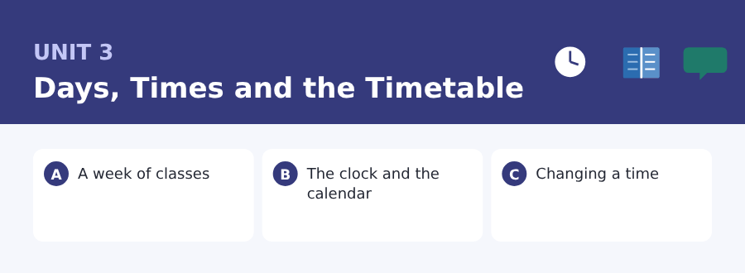
By the end of this unit I can…
- say and write the time in two ways
- read a timetable and find one class in it
- understand a short text about how a college week is built
- follow a conversation in which two people change a time
- say how often I do something
- write an email asking to change a time

Three sub-topics, three cycles in every skill. Almost every Listening question in the real test turns on a time or a day. This unit is that.

Vocabulary 1 · The words you need most 24 words from the two thousand most common words of English
These are not academic words. They are the words that carry ordinary English, and until you own them the academic words of Volume 1 have nothing to stand on. Cover the right-hand column and test yourself.
day Monday is a day | minute sixty seconds
week seven days | quarter one of four equal parts; fifteen minutes
month January is a month | past after the hour: ten past three
year twelve months | before earlier than
morning the first part of the day | after later than
afternoon after twelve and before the evening | start to begin
evening the end of the day, before night | finish to end
night when it is dark | always every time
early before the usual time | usually most times
late after the usual time | sometimes some times, not many
clock the thing on the wall that shows the time | never no times at all
hour sixty minutes | often many times

Exercise A Work in pairs. Ask and answer.
1. What time does your first class start on Monday?
2. Are you an early person or a night person?
3. How often do you look at your timetable?
4. Which day of the week is the best one, and why?
Vocabulary 2 · Campus and everyday 12 words for student life
Every Listening conversation in the real test happens on a campus. These twelve words come back in this unit and again in Volume 1.
timetable the paper that shows your classes and their times | seminar a class where students talk, not only the teacher
lesson one class, usually one hour | workshop a class where you do something with your hands
break a short time with no class | attendance how often you come to class
term one of the parts of the college year | register the list of names the teacher calls
semester half of a college year | schedule a plan of times, like a timetable
deadline the last day you can give work in | tutor your own teacher: this person looks after your work

Words you will meet again: timetable | term | deadline | tutor | always | usually | quarter | break

Sound and Spelling The three sounds of -s, and the times of the day
The -s ending is on half the words in this unit, and it has three different sounds. Nobody hears the difference at first, and nobody needs a rule — but you do need to notice that the third one is a whole extra syllable.
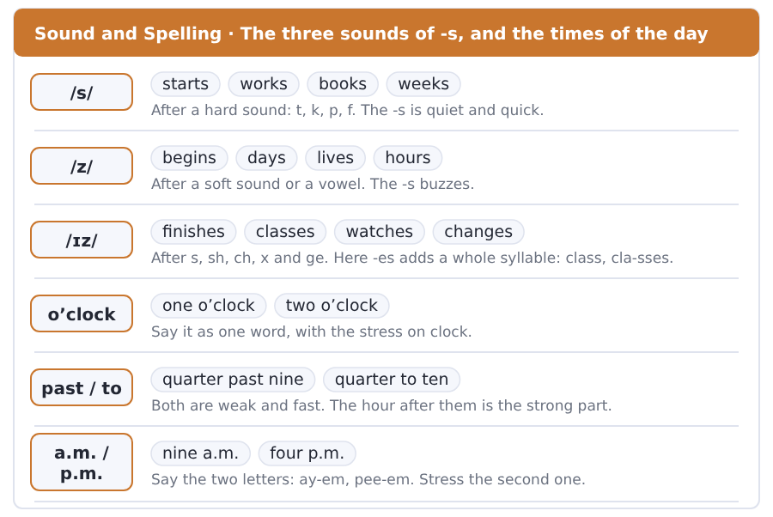
Exercise A Listen. Which word do you hear?
1. Is the ending /s/ or /z/? — starts
2. Is the ending /s/ or /z/? — begins
3. Is the ending one syllable or two? — finishes
4. Do you hear past or to?
5. Do you hear 9.15 or 9.50?
6. Do you hear a.m. or p.m.?
Exercise B Say these out loud. Record yourself if you can.
1. Say these: starts, works, begins, lives, finishes, watches.
2. Say these times: 7.30, 9.15, 10.45, 14.00, 16.20.
3. Say today’s date in two ways.
4. Say your timetable for Monday out loud, with the times.


SKILL · The -s on the verb
- He, she and it take -s on the verb: the class start-s at nine.
- I, you, we and they take no -s: the classes start at nine.
- A word ending in -ch, -sh, -ss or -o takes -es: finish-es, go-es.
- Count the dashes. One dash is s; two dashes are es or er.

Exercise A Guided practice. Five words are not complete. Write the missing letters.
My week start- on Monday. My first class begin- at nine and finish-- at eleven. On Tuesday I have two seminar-. My tutor usually see- me on Friday afternoon.

The first one is done for you: 1 start- → s (starts)
Exercise B Exam practice. One paragraph, ten gaps — the real task.
The college week at Riverside start- on Monday morning. Most lesson- begin at nine and the last one finish-- at five. There is a break of one hour at one o’clock, and the canteen open- at half past twelve. Every student ha- four lesson- a day. A seminar last- fifty minute- and a workshop last- two hours. The tutor call- the register at the start of every class.

Check your answers in the key at the back of the book.


SKILL · Read the row, then the column
- A timetable has a day across the top and a time down the side.
- Put one finger on the day and one on the time, then move them together.
- Read the question twice: it usually names a day and a time.
- Watch for the words every and only. They change the answer.

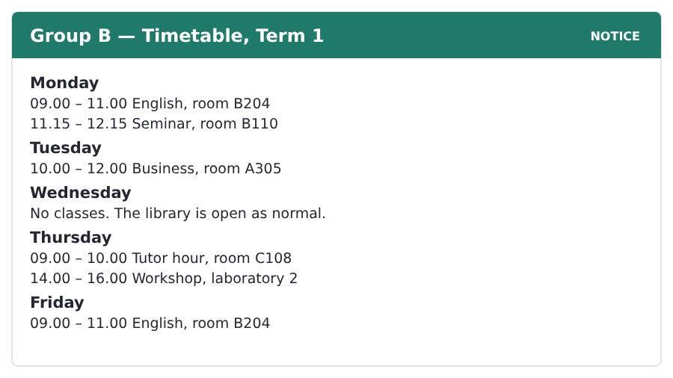
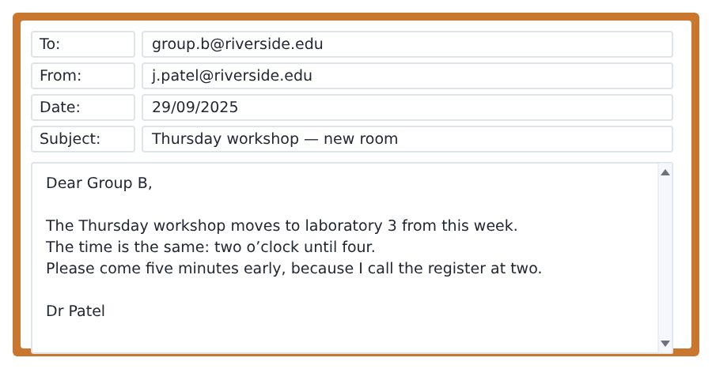
Exercise A Guided practice. The answer is on the page — find it.
1. What time does the Monday seminar start?
(A) 11.15
(B) 09.00
(C) 11.00
(D) 12.15
2. Which day has no classes?
(A) Monday
(B) Wednesday
(C) Tuesday
(D) Friday
3. Where is the Business class?
(A) B204
(B) B110
(C) A305
(D) C108
4. Which room does the workshop move to?
(A) laboratory 2
(B) B204
(C) C108
(D) laboratory 3
Exercise B Exam practice.
5. How long is the English class on Monday?
(A) one hour
(B) two hours
(C) three hours
(D) half an hour
6. On which days is there an English class?
(A) Monday and Friday
(B) Monday and Tuesday
(C) Tuesday and Thursday
(D) Thursday and Friday
7. When is the tutor hour?
(A) Monday 09.00
(B) Tuesday 10.00
(C) Thursday 09.00
(D) Friday 09.00
8. Does the workshop change its time?
(A) yes, it starts later
(B) yes, it starts earlier
(C) no, there is no workshop
(D) no, the time is the same
9. Why does Dr Patel ask students to come early?
(A) the room is small
(B) the laboratory is far
(C) the register is at two
(D) the class is long
10. How many classes does Group B have on Thursday?
(A) two
(B) one
(C) three
(D) four


SKILL · Find the reason, not only the fact
- A short text often gives a fact and then a reason for it.
- The reason usually starts with because, for or so.
- A question with why wants the reason, not the fact in front of it.
- The last sentence is often the idea the whole text is about.

Why a College Week Looks Like This
A college week is not the same on every day. Monday and Tuesday are heavy. Wednesday is often free. Thursday and Friday are heavy again.
There is a reason for the free day. Students need one day in the week for reading, and teachers need one day for their own work. A free Wednesday also gives the college a day for games and for clubs.
The shape of the week is not the same in every country. In some places the week runs from Sunday to Thursday. In others the free day is Friday. But the idea behind it is always the same: a week needs a hole in the middle. A student with five heavy days does the work of four.
[122 words]

Exercise A Guided practice.
1. Which day is often free?
(A) Monday
(B) Wednesday
(C) Tuesday
(D) Friday
2. Why do students need a free day?
(A) for games only
(B) for the canteen
(C) for the register
(D) for reading
3. Who else needs the free day?
(A) the office
(B) the library
(C) the tutors and teachers
(D) new students
4. In some countries the week runs from
(A) Monday to Friday
(B) Sunday to Thursday
(C) Tuesday to Saturday
(D) Wednesday to Sunday
Exercise B Exam practice.
5. A college week is
(A) the same on every day
(B) always five days
(C) always four days
(D) not the same on every day
6. Which days are heavy?
(A) Monday, Tuesday, Thursday and Friday
(B) Monday and Wednesday
(C) Wednesday and Thursday
(D) only Friday
7. What else does the free day give the college?
(A) a day for lectures
(B) a day for the canteen
(C) a day for games and clubs
(D) a day for the register
8. In some countries the free day is
(A) Monday
(B) Wednesday
(C) Sunday
(D) Friday
9. The idea behind every week is
(A) five heavy days
(B) a hole in the middle
(C) no free day
(D) four lessons
10. A student with five heavy days
(A) does the work of four
(B) does the work of six
(C) does the work of five
(D) does no work
11. What is the writer’s opinion?
(A) Free days waste time.
(B) Wednesday is the best day.
(C) A week needs a free day.
(D) Teachers work too much.

The field: Space and the Sky Two more cycles in every skill, on one subject
Everything up to here was about your own life, because that is where a language starts. From this page the same unit turns to a subject, and the subject is one Volume 1 will take up properly: the day, the month and the year, and the things in the sky that make them.
planet a very large round thing that goes round a star | calendar the paper or the system that counts the days of a year
star a ball of fire very far away in the sky | detail a small part of a picture or a thing
moon it goes round the Earth and it is bright at night | shadow the dark shape a thing makes in the light
orbit the path of one thing around another | bright with a lot of light
telescope you look through it and far things look near | measure to find how long, how heavy or how far a thing is
distance how far one thing is from another | million a thousand thousand


SKILL · A passage that explains a word
- Some passages explain where an ordinary word comes from.
- The old meaning is usually in the first or the second sentence.
- Numbers in this kind of passage are the evidence. Note them.
- A question about why usually wants the number.

Where a Month Comes From
The word month and the word moon are the same old word. This is not an accident of English. It is a fact about the sky.
The moon goes round the Earth. One orbit takes about twenty-nine and a half days. For most of history that orbit is the only clock a farmer has. It is a very good one, because anybody can see it from a door.
A year of twelve of these months is about three hundred and fifty-four days. The year of the sun is three hundred and sixty-five. The difference is eleven days. Every calendar in the world is an answer to those days.
[108 words]

Exercise A Guided practice.
1. The word month and the word moon are
(A) different words
(B) the same old word
(C) new words
(D) Greek words
2. How long is one orbit of the moon?
(A) about seven days
(B) about fourteen days
(C) about three hundred days
(D) about twenty-nine and a half days
3. For most of history the moon is
(A) the only clock a farmer has
(B) a planet
(C) a star
(D) a shadow
Exercise B Exam practice.
4. Why is it a good clock?
(A) it is bright
(B) it is far away
(C) it is round
(D) anybody can see it from a door
5. A year of twelve moon months is about
(A) three hundred days
(B) three hundred and sixty-five days
(C) three hundred and fifty-four days
(D) four hundred days
6. The year of the sun is
(A) three hundred and sixty-five days
(B) three hundred and fifty-four days
(C) three hundred and sixty days
(D) four hundred days
7. What is every calendar in the world an answer to?
(A) the moon
(B) eleven days
(C) the sun
(D) twelve months


SKILL · A passage that corrects an idea
- Some passages begin with what people think and then correct it.
- The correction is the point, and it usually comes early.
- Watch for in fact, really and the word not.
- A question about what it really does wants the correction.

A Telescope Does Not Make Things Bigger
People say that a telescope makes a far thing bigger. In fact it does something else. It takes in light.
The eye is small, so it takes in very little light. A telescope has a big glass at the front. That glass takes in a thousand times the light of an eye. The picture is not only bigger. It is brighter, and a bright picture carries more detail.
This is why a big telescope beats a small one. It is also why the big ones stand on mountains. Air moves all the time. Above most of the air the picture is still. A still picture of a weak star is the hardest thing in the field.
[116 words]

Exercise A Guided practice.
1. What do people say a telescope does?
(A) takes in light
(B) measures distance
(C) makes a far thing bigger
(D) makes a shadow
2. What does it really do?
(A) takes in light
(B) makes things smaller
(C) measures the orbit
(D) makes a picture dark
3. Why does the eye take in little light?
(A) it is weak
(B) it is round
(C) it moves
(D) it is small
Exercise B Exam practice.
4. How much light does the glass take in?
(A) ten times an eye
(B) a thousand times an eye
(C) a hundred times an eye
(D) a million times an eye
5. A bright picture carries
(A) a dark room
(B) more air
(C) more detail
(D) a small picture
6. Why are the big telescopes on mountains?
(A) they are safe there
(B) the air is warm
(C) people live there
(D) above most of the air the picture is still
7. What is the hardest thing in the field?
(A) a still picture of a weak star
(B) a bright star
(C) a big glass
(D) a mountain

Sentence Builder One idea, one sentence
At this level the most common mistake in writing is not a wrong word. It is two sentences joined by a comma. English does not allow that. Use a full stop, or use and, but, because or so.
Not a sentence | A sentence
I get up at seven, I take the bus at eight. | I get up at seven and I take the bus at eight.
The class is at nine, I am always early. | The class is at nine, so I am always early.
I do not come on Thursday, I work. | I do not come on Thursday because I work.
My tutor is free on Friday, she is busy on Monday. | My tutor is free on Friday but she is busy on Monday.
It is late, I go home. | It is late. I go home.

Watch out! And, but, so and because are not the same. And adds. But turns. So gives the result. Because gives the reason. Choosing the wrong one changes your meaning even when the grammar is right.
Exercise A Is it a sentence? Write yes or no. If no, put it right.
1. The library closes at nine, I study at home.
2. I like Monday, I do not like Tuesday.
3. She is late, the bus is late.
4. We have a seminar, we have a workshop.
5. I am never late. I always take the early bus.
6. My deadline is Monday, I start today.


Exercise A Listen and choose a response. You hear one line. Choose the best reply.
1. What time does the seminar start?
(A) In room B110.
(B) At quarter past eleven.
(C) On Wednesday.
(D) Yes, it does.
2. Do you have a class on Wednesday?
(A) At nine.
(B) In the library.
(C) No, I do not.
(D) It is free.
3. Is four o’clock all right for you?
(A) In the canteen.
(B) Two hours.
(C) On Monday.
(D) Yes, that is fine.
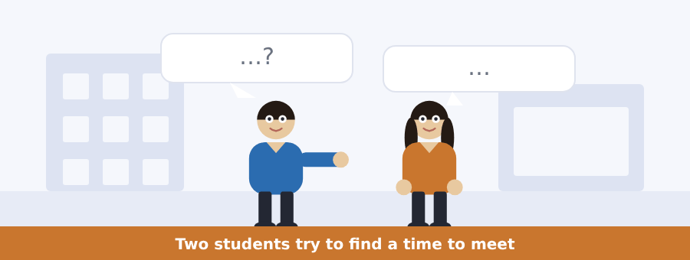
SKILL · Hold two times in your head
- When people change a time, you hear the old time and the new one.
- Write both down. The question usually asks for the new one.
- Listen for but, sorry and what about. The time changes after those words.
- The last time in the conversation is usually the answer.

Exercise B Listen and answer. The audio plays once.
4. When does the man have his tutor hour?
(A) Thursday at ten
(B) Thursday at nine
(C) Thursday at one
(D) Thursday at two
5. How long is the tutor hour?
(A) one hour
(B) half an hour
(C) two hours
(D) three hours
6. Why is ten not good for the woman?
(A) she works in a shop
(B) she has a class
(C) she is in the library
(D) she is late
7. What time do they meet?
(A) nine
(B) ten
(C) one
(D) two
8. Where do they meet?
(A) the library
(B) the canteen
(C) the workshop
(D) room B110
9. What does the woman do at the end?
(A) she calls her tutor
(B) she goes to work
(C) she looks at her timetable
(D) she writes it on her phone
Audio script: see the back of the book. Do not read it before you listen.


Exercise A Listen and choose a response. You hear one line. Choose the best reply.
1. When is the last day of term?
(A) In room B204.
(B) Yes, it is.
(C) On Friday the twelfth.
(D) Two weeks.
2. Do we have classes next week?
(A) At four.
(B) In December.
(C) It is a deadline.
(D) No, we do not.
3. Is the deadline on Monday?
(A) In the canteen.
(B) Yes, it is.
(C) Four lessons.
(D) On the timetable.
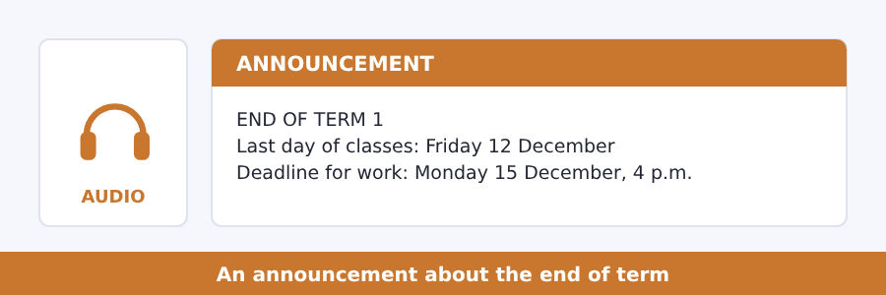
SKILL · Dates are two pieces of news
- A date has a day and a month. Catch both.
- A deadline usually comes with a time as well as a date.
- The word by means before and including: by Monday.
- If you only hear one date, it is usually the deadline, not the holiday.

Exercise B Listen and answer. The audio plays once.
4. When is the last day of classes?
(A) 12 December
(B) 5 December
(C) 15 December
(D) 5 January
5. What happens in the week after that?
(A) the college is closed
(B) classes go on as normal
(C) the college is open with no lessons
(D) Term 2 starts
6. When is the deadline for term work?
(A) 15 December at four
(B) 12 December
(C) 15 December at nine
(D) 5 January
7. When does Term 2 start?
(A) 15 December
(B) 5 January
(C) 1 January
(D) 12 January
8. Where are the dates?
(A) on the timetable
(B) in the library
(C) in an email
(D) on the noticeboard outside the office
Audio script: see the back of the book. Do not read it before you listen.


Exercise A Listen and choose a response. You hear one line. Choose the best reply.
1. What is the time?
(A) On Monday.
(B) Quarter past nine.
(C) In room B204.
(D) Yes, it is.
2. Does a timetable use the twenty-four hour clock?
(A) At nine.
(B) In December.
(C) Two hours.
(D) Yes, it does.
3. Sorry, what time?
(A) Half past three.
(B) In the canteen.
(C) On Friday.
(D) Yes, please.
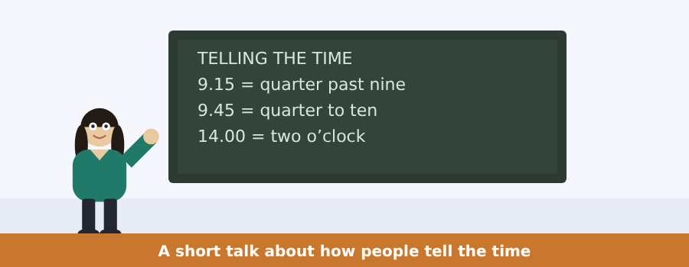
SKILL · Two systems, one clock
- English tells the time in two ways: nine fifteen, and quarter past nine.
- In the first half of the hour you say past. In the second half you say to.
- A timetable uses the twenty-four hour clock; a person usually does not.
- When you hear fourteen hundred, think two in the afternoon.

Exercise B Listen and answer. The audio plays once.
4. Why does the speaker talk about the clock?
(A) it is interesting
(B) the timetable is new
(C) it costs students marks
(D) students are late
5. How many systems does English use for the time?
(A) one
(B) two
(C) three
(D) four
6. Before the half hour you say
(A) past
(B) to
(C) o’clock
(D) hundred
7. After the half hour you say
(A) the same hour
(B) no hour
(C) the hour before
(D) the next hour
8. What is quarter to ten?
(A) 9.15
(B) 9.30
(C) 9.45
(D) 10.15
9. Fourteen hundred is
(A) two in the afternoon
(B) four in the afternoon
(C) fourteen minutes
(D) two in the morning
Audio script: see the back of the book. Do not read it before you listen.


Exercise A Listen and choose a response.
1. How long is a moon month?
(A) In the sky.
(B) About twenty-nine days.
(C) Yes, it is.
(D) Twelve.
2. Is the moon a planet?
(A) At night.
(B) Twelve months.
(C) Yes, I do.
(D) No, it is not.
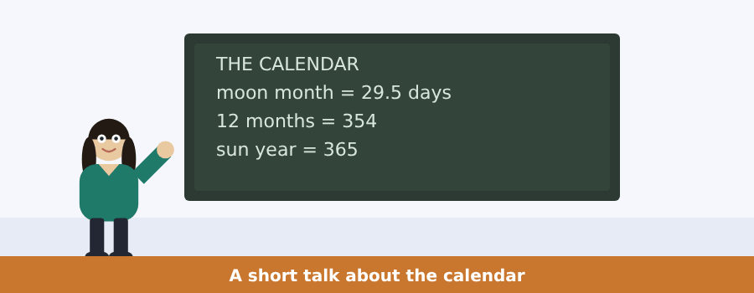
SKILL · Numbers are the argument
- In a talk about time the numbers carry everything.
- Write the figures, not the words. There is no time for words.
- The difference between two numbers is often the point.
- A question about why usually points at that difference.

Exercise B Listen and answer. The audio plays once.
3. What kind of problem is it?
(A) a problem of language
(B) a problem of weather
(C) a problem of numbers
(D) a problem of distance
4. Twelve moon months make
(A) three hundred and fifty-four days
(B) three hundred days
(C) three hundred and sixty-five days
(D) four hundred days
5. How many days are missing?
(A) one
(B) twelve
(C) twenty-nine
(D) eleven
6. What do some calendars do?
(A) take a month away
(B) add a month every three years
(C) use no months
(D) follow the stars
Audio script: see the back of the book.


Exercise A Listen and choose a response.
1. Does a telescope make things bigger?
(A) On a mountain.
(B) Yes, I do.
(C) It takes in light.
(D) A thousand.
2. Why are telescopes on mountains?
(A) At night.
(B) The air is still there.
(C) Yes, they are.
(D) Very big.
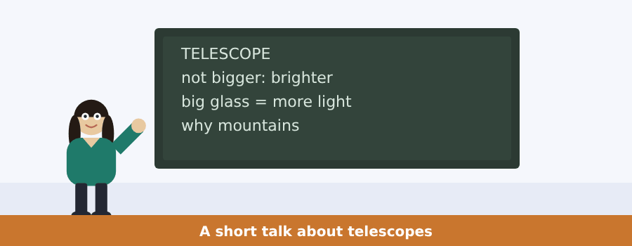
SKILL · A talk that corrects you
- A talk often starts with the common idea and then says no.
- The word but or in fact marks the turn. Listen for it.
- What comes after the turn is what you need.
- The examples after it are there to make it clear.

Exercise B Listen and answer. The audio plays once.
3. What do most people think a telescope does?
(A) takes in light
(B) measures distance
(C) moves the air
(D) makes a far star bigger
4. What does the speaker call a telescope?
(A) a window for light
(B) a clock
(C) a mountain
(D) a shadow
5. How big is the glass?
(A) as big as an eye
(B) as big as a hand
(C) as big as a door
(D) as big as a house
6. What happens to the picture?
(A) it is brighter
(B) it is darker
(C) it is smaller
(D) it moves
Audio script: see the back of the book.


Part 1 · Listen and Repeat
You hear a sentence and repeat it once. There is no preparation time, and the sentences get longer. Focus: the three sounds of the -s ending
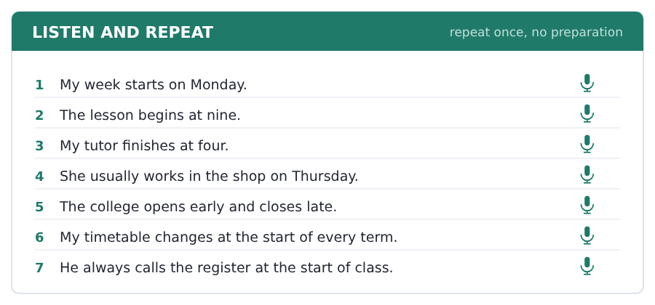
SKILL · /s/, /z/ and /ɪz/
- After a hard sound the -s is /s/: starts, finishes early.
- After a soft sound the -s is /z/: begins, lives, days.
- After s, sh, ch, x and ge the ending is a whole syllable: finishes.
- Nobody learns these from a rule. Say the words until they feel right.

Part 2 · Take an Interview
An interviewer asks you four questions on one theme: your week. Answer each one fully. There is no preparation time.
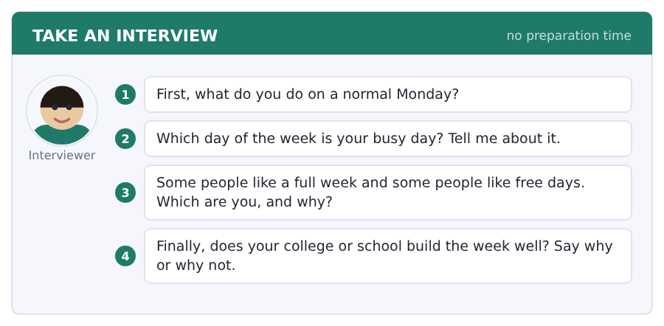
Say it like this
- On Monday I ... . Then I ... .
- My busy day is ... . I have ... .
- I like ... , because ... .
- I think my college builds the week ... , because ... .
A good answer sounds like this
Question 1 — On Monday I get up at seven and I take the bus at eight. My first class starts at nine.
Question 2 — My busy day is Thursday. I have a tutor hour in the morning and a workshop in the afternoon.
Question 3 — I like a full week, because then I work. On a free day I always say I start in one hour, and the day goes.
Question 4 — I think my college builds the week well, because the free day is in the middle and not at the end.
I can… | Not yet | Yes
I used the -s ending on he, she and it | □ | □
I said a time in every answer | □ | □
I gave a reason after my opinion | □ | □


Part 1 · Listen and Repeat
You hear a sentence and repeat it once. There is no preparation time, and the sentences get longer. Focus: saying times and dates out loud
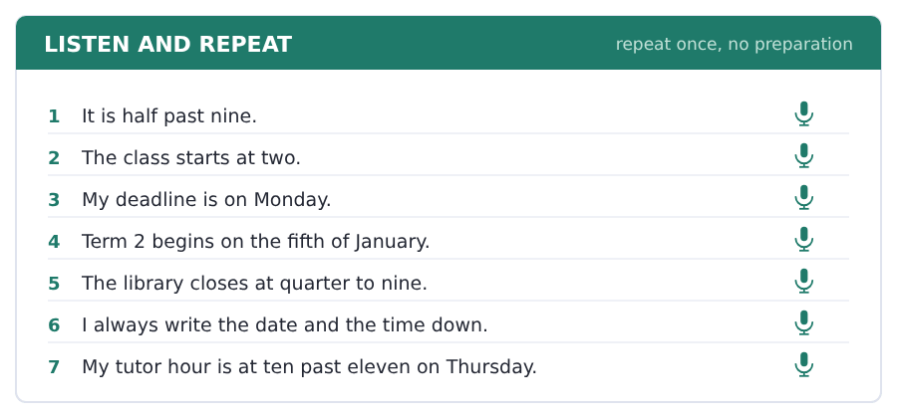
SKILL · Say the time the way people say it
- For 9.15 you can say nine fifteen or quarter past nine. Both are right.
- For 9.45 say quarter to ten, not quarter to nine.
- Dates: the fifth of January, or January the fifth.
- Say the day first when it matters: Monday the fifth.

Part 2 · Take an Interview
An interviewer asks you four questions on one theme: time in your life. Answer each one fully. There is no preparation time.
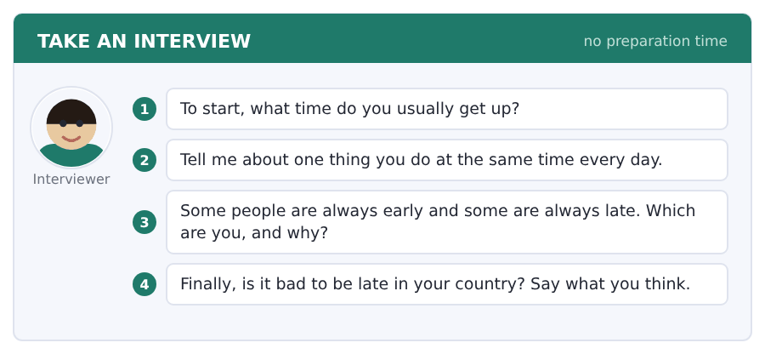
Say it like this
- I usually get up at ... .
- Every day at ... I ... .
- I am usually ... , because ... .
- In my country ... , because ... .
A good answer sounds like this
Question 1 — I usually get up at half past six, and at the weekend at eight.
Question 2 — Every day at one o’clock I eat with the same three people in the canteen.
Question 3 — I am usually early, because I hate the feeling of a run to the door.
Question 4 — In my country ten minutes late is normal for friends. For a class or for work it is not normal at all.
I can… | Not yet | Yes
I said the time in a full sentence | □ | □
I used past and to correctly | □ | □
I answered all four questions | □ | □


Part 1 · Listen and Repeat
You hear a sentence and repeat it once. There is no preparation time, and the sentences get longer. Focus: polite question forms with do and does
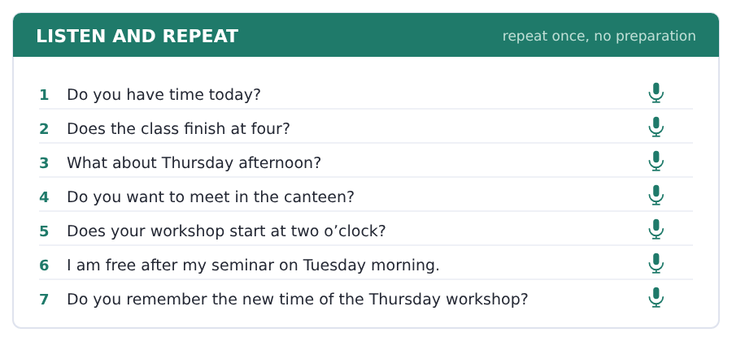
SKILL · Ask, do not tell
- Do you have time on Thursday? is a question. You have time is not.
- Do and does carry the question. The main verb stays plain.
- Never say *Does he works?* The -s is on does already.
- What about ...? is the easiest way to offer a new time.

Part 2 · Take an Interview
An interviewer asks you four questions on one theme: meeting people and changing plans. Answer each one fully. There is no preparation time.
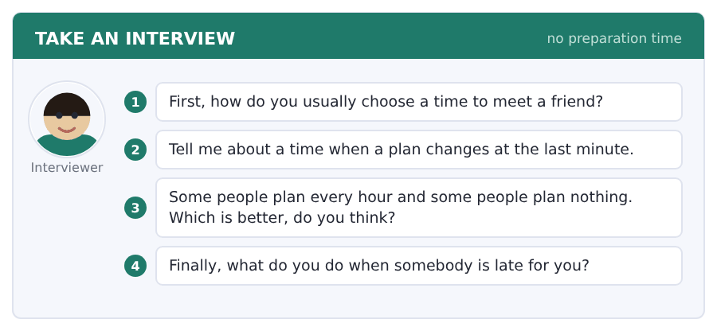
Say it like this
- I usually ... , because it is ... .
- Sometimes my ... changes, and then I ... .
- I think ... is better, because ... .
- When somebody is late I ... .
A good answer sounds like this
Question 1 — I usually send a message, because then the time is in writing and nobody forgets it.
Question 2 — Sometimes my workshop changes to another room, and then I run across the campus with my bag.
Question 3 — I think a plan for the big things is better. If I plan every hour, one late bus breaks the whole day.
Question 4 — When somebody is late I read on my phone for ten minutes. After that I send one message and I go.
I can… | Not yet | Yes
I used do and does correctly in my questions | □ | □
I did not put -s on the verb after does | □ | □
I gave an example, not only an opinion | □ | □


Part 1 · Listen and Repeat
You hear a sentence and repeat it once. There is no preparation time, and the sentences get longer. Focus: saying large numbers
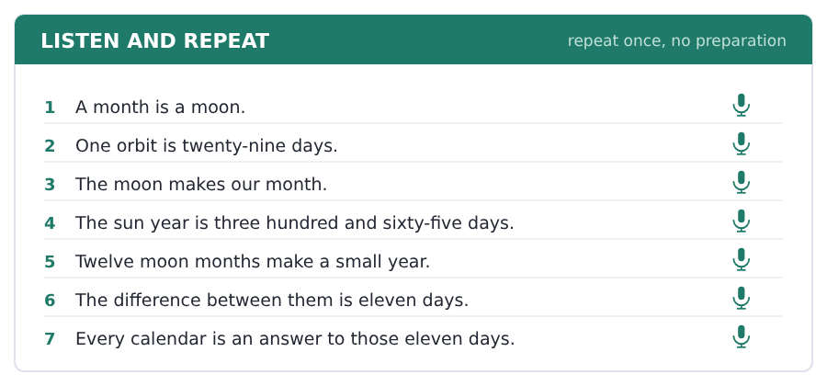
SKILL · Large numbers in English
- Say three hundred and sixty-five, with the and before the last part.
- A thousand thousand is a million. Say the parts, not the figures.
- Slow down for a number and speed up again after it.
- If the number is the answer, say it twice.

Part 2 · Take an Interview
An interviewer asks you four questions on one theme: the sky and time. Answer each one fully. There is no preparation time.
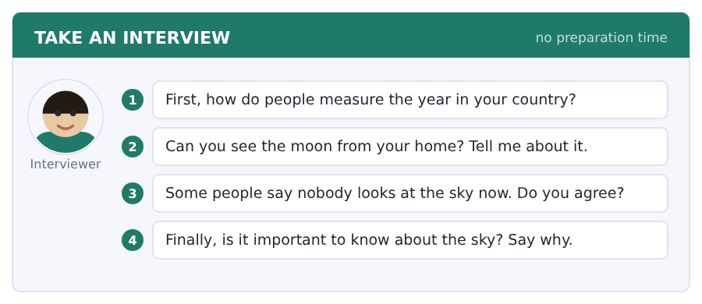
Say it like this
- In my country the calendar is ... .
- We measure the year by ... .
- I ... see the moon, because ... .
- I think the sky is ... , because ... .
A good answer sounds like this
Question 1 — In my country we use the sun year of three hundred and sixty-five days, but the old days of rest still follow the moon.
Question 2 — I can see the moon from my window, but there are a lot of lights in my street and the stars are not clear.
Question 3 — I agree. In a city you look down at a phone, and the sky is the one thing nobody sells you.
Question 4 — I think it is important, because the calendar on my wall is a piece of counting about the moon and almost nobody knows it.
I can… | Not yet | Yes
I said the large numbers clearly | □ | □
I used three field words | □ | □
I gave a reason after my opinion | □ | □


Part 1 · Listen and Repeat
You hear a sentence and repeat it once. There is no preparation time, and the sentences get longer. Focus: the sounds in science words
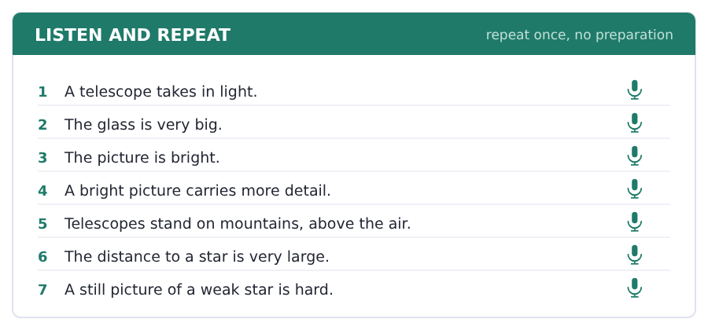
SKILL · TELescope, disTANCE, SURface
- TELescope takes the strong part first, like TELephone.
- disTANCE and surFACE are easy to put the stress on wrongly.
- The -sc- in telescope is /sk/, not /sh/.
- Say each word three times before the interview.

Part 2 · Take an Interview
An interviewer asks you four questions on one theme: looking at things far away. Answer each one fully. There is no preparation time.
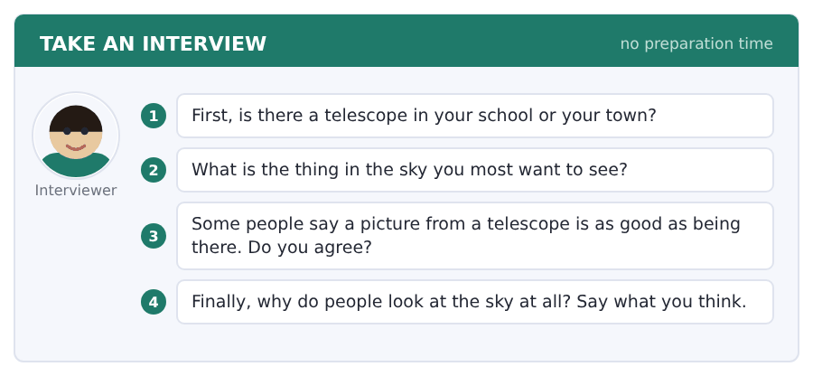
Say it like this
- I ... look at the sky, because ... .
- The thing I want to see is ... .
- I think ... , because ... .
- A telescope is ... , because ... .
A good answer sounds like this
Question 1 — There is one in my school. We use it twice a year, usually in the winter.
Question 2 — The thing I want to see is the face of the moon, with the shadows on one side of it.
Question 3 — I do not agree. A picture is flat and a telescope is your own eye at the end of a long distance.
Question 4 — People look at the sky because it is the one place that is the same for everybody, in every country.
I can… | Not yet | Yes
I put the strong part in the right place | □ | □
I used a field word in every answer | □ | □
I answered all four questions | □ | □


You see a sentence, then a set of words in boxes. Put the words in order to make one grammatical sentence. Almost every item in the real test makes a question or a question inside another sentence.
SKILL · do and does make the question
- I, you, we, they take do. He, she, it take does.
- The main verb has no -s in the question: Does the class start?
- The question word comes first: When does the class start?
- How often is one of the most common question openings in the test.

Exercise A Guided practice. The first three are worked through.
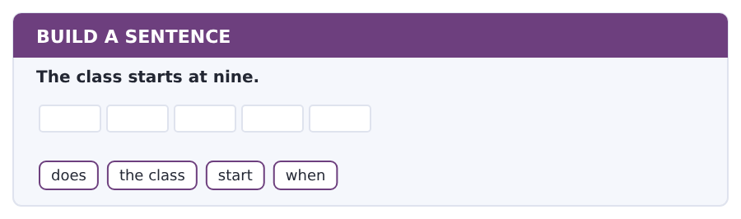
1. When does the class start?
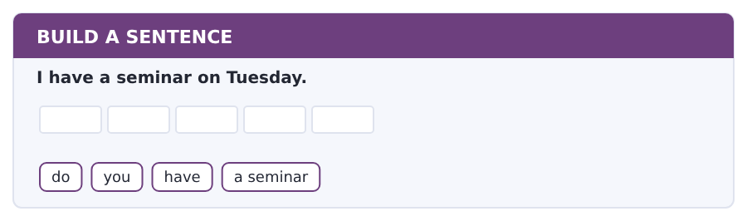
2. Do you have a seminar?
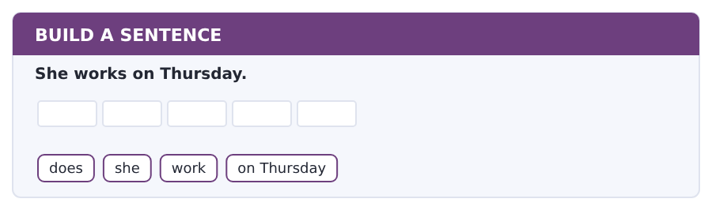
3. Does she work on Thursday?
Exercise B Exam practice. Write the sentence.
4. The library closes at nine.
does / the library / close / when
__________________________________________________________
5. I always eat in the canteen.
do / you / eat / where
__________________________________________________________
6. He finishes at four.
does / he / finish / what time
__________________________________________________________
7. They have four lessons a day.
do / they / have / how many lessons
__________________________________________________________
8. The term starts in January.
does / the term / start / when
__________________________________________________________
9. I look at my timetable every day.
do / you / look / how often
__________________________________________________________
10. My tutor sees me on Friday.
your tutor / sees / you / on Friday
__________________________________________________________


You read a short situation and write an email. You have 7 minutes. The three bullet points are the mark scheme: answer all three.
In the real test you write as much as you can in seven minutes. In this unit, aim for about 46 words. That number goes up in every unit of this book, and in Volume 1 it stops being a number at all.
You cannot come to the Thursday workshop at two o’clock.
You work in a shop on Thursday afternoon. Write to Dr Patel.
- say who you are and which workshop you mean
- say why you cannot come at two
- ask if there is another workshop on a different day
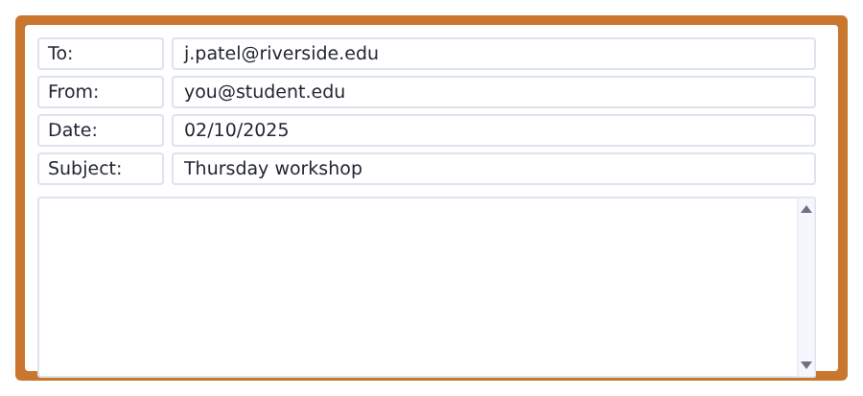
SKILL · Say the problem in one sentence
- Do not write three sentences about the problem. One is enough.
- Give the reason with because. A reason makes a request polite.
- The question is the point of the email. Put it near the end.
- Keep the same subject line. It tells the reader what this is about.

Model email
Dear Dr Patel,

My name is Ana Ruiz and I am in Group B.
I cannot come to the Thursday workshop at two o’clock, because I work in a shop on Thursday afternoon.
Is there another workshop on a different day?

Thank you,
Ana Ruiz
Why it works
- All three bullet points are there, in order.
- The reason comes after because, in the same sentence as the problem.
- The question is a real question with a question mark.
- It is short. A short, clear email gets a fast answer.
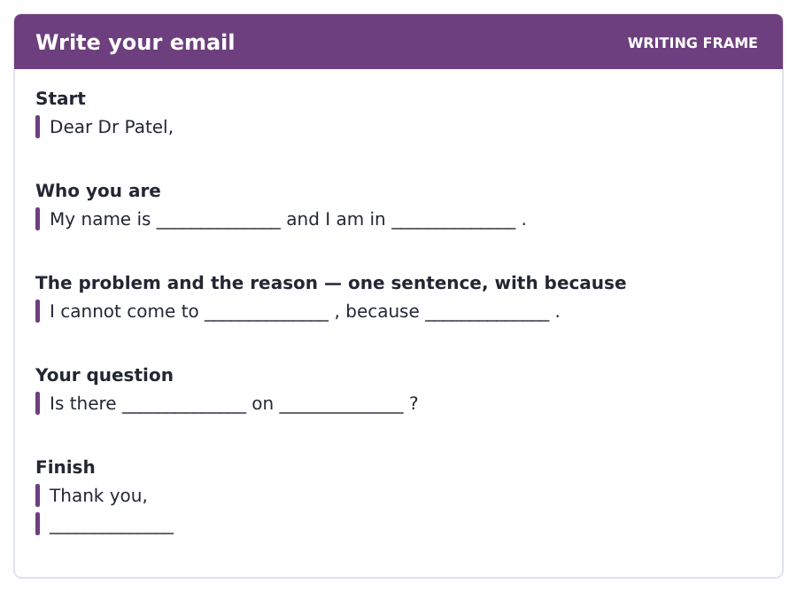
Now write your own. 7 minutes.
__________________________________________________________
__________________________________________________________
__________________________________________________________
__________________________________________________________
__________________________________________________________
__________________________________________________________
__________________________________________________________
__________________________________________________________


A professor asks a question and two students answer. You add your own post. You have 10 minutes and an effective answer is at least 100 words.
One hundred words is what the real test wants, and you will get there. For this unit, write about 50. Every unit of this book asks for a few more.
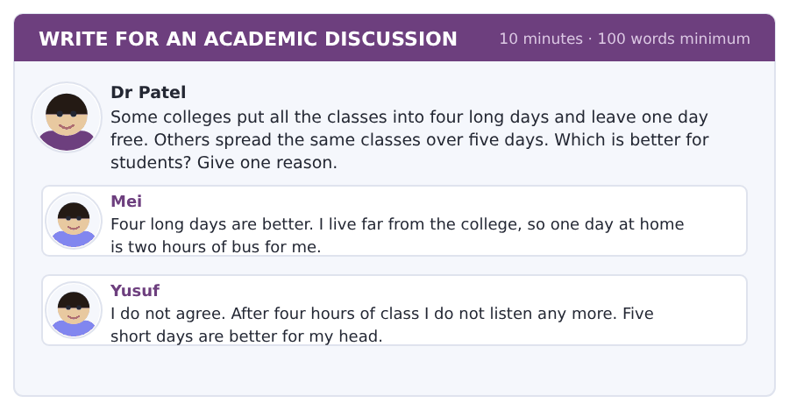
SKILL · Agree with one person by name
- Say which post you agree with. It shows you read them.
- Then say why, with because.
- Add one new idea the other two do not say.
- Fifty words is about four short sentences. Count them once, then stop counting.

Sentence starters
- I agree with Mei, because ...
- I do not agree with Yusuf, because ...
- In my case ...
- The problem with four long days is ...
Model post
I agree with Mei. Four long days are better for me, because the bus to the college takes an hour.
Yusuf is right about the last hour of a long day. Nobody listens at four o’clock.
But a free day is a day for the library, and the library is where I do my real work.
[56 words]
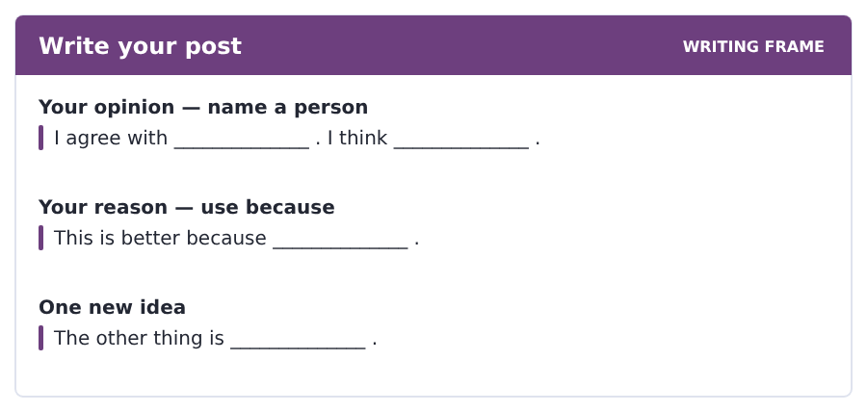
Now write your own. 10 minutes, at least 50 words.
__________________________________________________________
__________________________________________________________
__________________________________________________________
__________________________________________________________
__________________________________________________________
__________________________________________________________
__________________________________________________________
__________________________________________________________
__________________________________________________________
__________________________________________________________


The same task again, on the subject of this unit. The sentences are about space and the sky now, and the word order has not changed at all.
SKILL · do and does with a subject that is a thing
- The moon, a telescope and a year all take does, like he and she.
- The verb after does stays plain: How long does it take?
- How long, how many and how far all go to the front.
- Nothing changes because the subject is a planet and not a person.

Exercise A Guided practice.
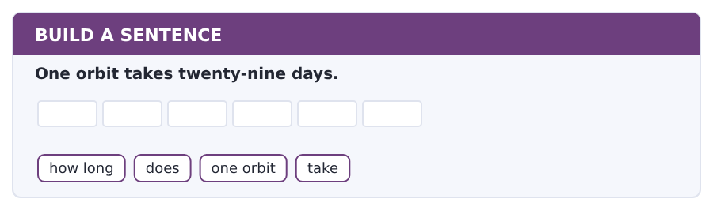
1. How long does one orbit take?
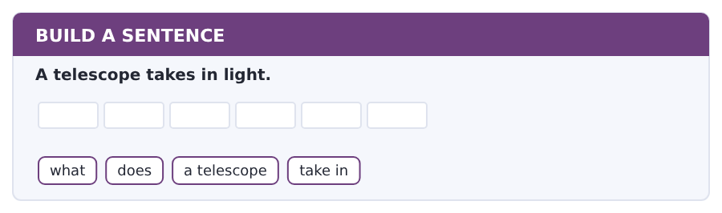
2. What does a telescope take in?
Exercise B Exam practice. Write the sentence.
3. The moon goes round the Earth.
what / does / the moon / go round
__________________________________________________________
4. Twelve months make 354 days.
how many / days / do / twelve months / make
__________________________________________________________
5. The big telescopes are on mountains.
where / are / the big telescopes / exactly
__________________________________________________________
6. A bright picture carries more detail.
what / does / a bright picture / carry
__________________________________________________________


A second discussion, and this one is about the subject rather than about your own week. In the real test both kinds come up, and the second kind is the harder one.
For this unit, write about 50 words. The real test wants a hundred.
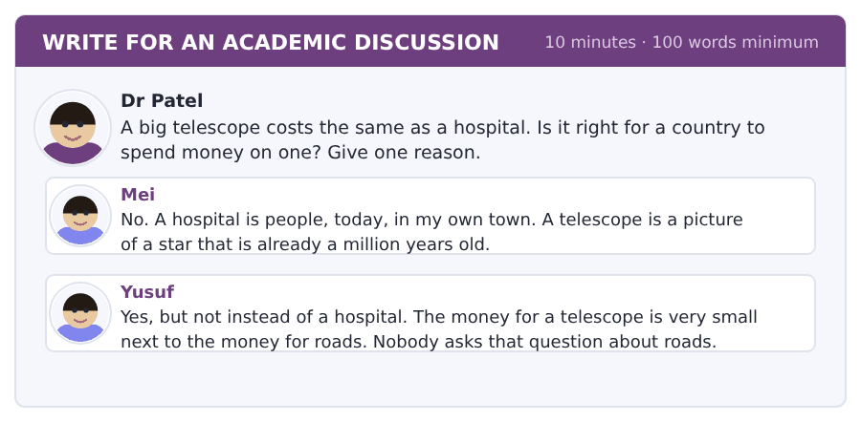
SKILL · A money question needs a number
- A question about cost is easier to answer with one real number in it.
- Say yes or no in the first sentence, then the reason.
- Say one thing about the other post.
- Fifty words is four or five short sentences.

Sentence starters
- I agree with Yusuf, because ...
- Mei is right that ...
- In my country ...
- The real question is ...
Model post
I agree with Yusuf. A country is right to spend some money on a telescope, because the money is very small.
Mei is right that a hospital is people today. Nobody can answer that.
But the real question is not a telescope or a hospital. It is a telescope or a road, and we build roads without any question at all.
[61 words]
Now write your own. 10 minutes, at least 50 words.
__________________________________________________________
__________________________________________________________
__________________________________________________________
__________________________________________________________
__________________________________________________________
__________________________________________________________
__________________________________________________________
__________________________________________________________
__________________________________________________________
__________________________________________________________

Grammar focus present simple · third-person -s · adverbs of frequency
Form | Example
I / you / we / they | I start at nine. They start at nine.
he / she / it + -s | He starts at nine. The class starts at nine.
-es after ch, sh, ss, x, o | She finishes. He goes. It washes.
negative | I do not work on Friday. He does not work on Friday.
question | Do you work? Does he work?
how often | always, usually, often, sometimes, never
where the adverb goes | I always work. I am always late.

The present simple is the tense of timetables, habits and facts. It is the tense almost all of this book is written in.
The -s appears once in a sentence and only once. He works, but Does he work? and He does not work — the -s has moved to does.
Adverbs of frequency go before the main verb but after the verb be: I always arrive early, but I am always early.
Watch out! Never say *He don’t* or *Does she works?* These two are the most common mistakes at this level, and both of them are about the same -s.
Exercise 1 Write the verb with or without -s.
1. My week __________ (start) on Monday.
2. The lessons __________ (begin) at nine.
3. She __________ (finish) at four.
4. My tutor __________ (see) me on Friday.
5. We __________ (have) four lessons a day.
6. He __________ (go) to the library every evening.
Exercise 2 Write do or does.
1. __________ you have a class on Wednesday?
2. __________ the library close at nine?
3. He __________ not work on Thursday.
4. __________ they call the register?
5. She __________ not come on Friday.
6. __________ your term start in January?
Exercise 3 Put the adverb in the right place.
1. I am late. (never)
2. She works on Thursday. (usually)
3. We have a seminar on Tuesday. (always)
4. He is in the canteen at one. (often)
How this is tested in Build a Sentence
Build a Sentence gives you do or does and a plain verb, and the only way to use them is the question order: question word, then do or does, then the person, then the verb with nothing on the end.

Typing and the Screen The bottom row and the full stop
The real test is typed. Nobody gives you paper. If you are still looking for the keys, you lose the Writing section before your English does.
The bottom row is Z X C V B N M, and then the comma, the full stop and the question mark. These three are the keys you use most in writing, and they all live down here.
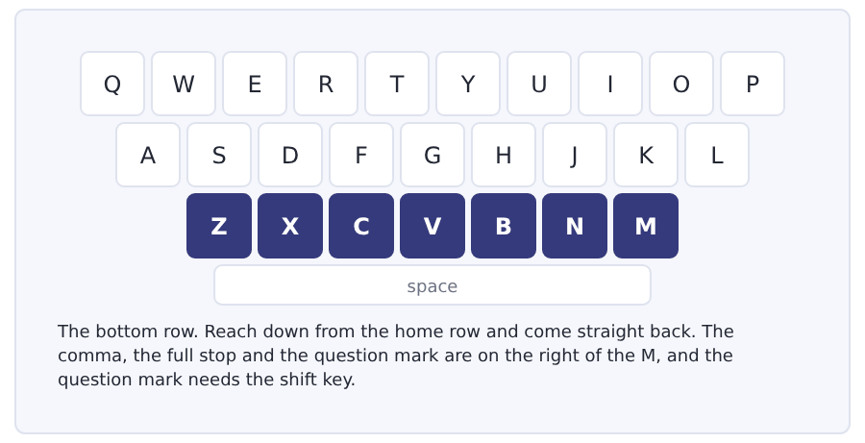
Exercise Type this. Time yourself, then write your speed in the box.
zxcv bnm zxcv bnm
can we move, or can we not move?
my class, my bus, my week; be brave, come back.
My time _______ seconds
Words a minute _______ (the target for Unit 3 is 10)

Learning to Learn Review that is spaced, not frantic
Most students review by reading everything the night before a test. That feels like work and it is almost useless. Your memory keeps what it meets again after it has started to forget it, not what it meets twice in one evening.
- After a lesson, read your notes once the same evening. Five minutes.
- Read them again the next day. Three minutes.
- Read them again one week later. Three minutes.
- Read them again one month later. Two minutes.
- Thirteen minutes in a month beats two hours the night before, and it is not close.
ADAPTIVE TIP Put the four dates at the top of every page of notes when you write it: today, tomorrow, next week, next month. Then review is not a decision you have to make every evening. It is a line you cross off.

Unit review and progress check Unit 3
Exercise A Vocabulary. Write the word.
1. the paper that shows your classes
2. the last day you can give work in
3. one of the parts of the college year
4. your own teacher, for your work
5. the list of names the teacher calls
6. a class where students talk
7. a short time with no class
8. fifteen minutes
9. sixty minutes
10. every time
11. no times at all
12. after the usual time
Exercise B Grammar. Complete the sentence.
1. My week __________ (start) on Monday.
2. The lessons __________ (begin) at nine.
3. She __________ (finish) at four.
4. __________ you have a class today?
5. __________ the library close at nine?
6. He __________ not work on Thursday.
7. I am __________ late. (never)
8. She __________ works on Thursday. (usually)
Exercise C One timed mini-section. 6 minutes.
1. The Monday seminar starts at
(A) 09.00
(B) 11.00
(C) 11.15
(D) 12.15
2. The deadline for term work is
(A) 12 December
(B) 15 December
(C) 5 January
(D) 1 January
3. Quarter to ten is
(A) 9.15
(B) 9.30
(C) 10.15
(D) 9.45
4. Which sentence is correct?
(A) She does not work on Friday.
(B) He do not work on Friday.
(C) Does she works on Friday?
(D) She not work on Friday.
5. Which sentence is correct?
(A) I always am late.
(B) Always I am late.
(C) I am late always.
(D) I am always late.
6. A college week often has a free day because
(A) teachers are tired
(B) the canteen is closed
(C) students need a day for reading
(D) the library is full
Can you do these now?
I can… | Not yet | Yes
say and write the time in two ways | □ | □
read a timetable and find one class in it | □ | □
understand a short text about how a college week is built | □ | □
follow a conversation in which two people change a time | □ | □
say how often I do something | □ | □
write an email asking to change a time | □ | □

ADAPTIVE TIP Every time you hear a time in the Listening section, write the figures, not the words: 9.45, not quarter to ten. Figures take one second and words take four, and the audio does not wait for you.

Unit 4 · Family, Home and Where You Live
TOEFL iBT® Preparation Course 2026 · Volume F1
CEFR A2 · Grammar: have got · possessive ’s · my, your, his, her · Word field: family, home, street and neighbours
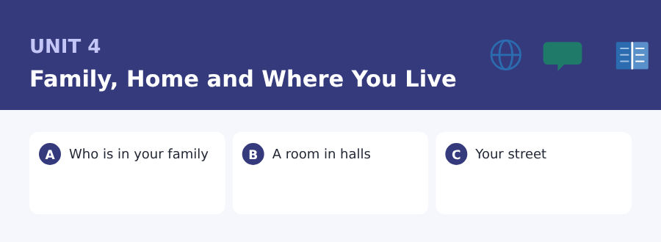
By the end of this unit I can…
- say who is in my family with have got
- read a short notice about a room and find the cost
- understand a short text about how students live
- follow a conversation about a problem in a shared flat
- ask and answer questions about family and home
- write an email to a landlord about a problem

Three sub-topics, three cycles in every skill. The test asks about your own life in Speaking, and this is the part of it everybody has.

Vocabulary 1 · The words you need most 24 words from the two thousand most common words of English
These are not academic words. They are the words that carry ordinary English, and until you own them the academic words of Volume 1 have nothing to stand on. Cover the right-hand column and test yourself.
family your mother, father, brothers and sisters | uncle the brother of your mother or father
mother your female parent | aunt the sister of your mother or father
father your male parent | cousin the child of your uncle or aunt
parent your mother or your father | husband the man a woman is married to
brother a boy or man with the same parents as you | wife the woman a man is married to
sister a girl or woman with the same parents as you | house a building for one family
son the male child of a parent | flat a home on one floor inside a bigger building
daughter the female child of a parent | kitchen the room where you cook
child a young person | bedroom the room where you sleep
baby a very young child | garden the green space outside a house
grandmother the mother of your mother or father | neighbour the person next door to you
grandfather the father of your mother or father | street a road in a town with houses on it

Exercise A Work in pairs. Ask and answer.
1. How many people are there in your family?
2. Have you got a brother or a sister?
3. What is your favourite room in your home, and why?
4. Who lives next to you, and do you know them well?
Vocabulary 2 · Campus and everyday 12 words for student life
Every Listening conversation in the real test happens on a campus. These twelve words come back in this unit and again in Volume 1.
landlord the owner of the flat you pay for | contract the paper you sign with the landlord
rent the money you pay every month for a flat | common room the shared room in a hall where students sit together
deposit money you pay at the start and get back at the end | accommodation a place to live
roommate your partner in a shared room or flat | cleaner the worker who cleans the building
laundry the room or shop where clothes are washed | rubbish the things you throw away
bills the paper that says how much you pay for water and light | washing machine the machine that washes clothes

Words you will meet again: family | flat | rent | landlord | neighbour | contract | accommodation | street

Sound and Spelling Word stress: where the strong part goes
Every English word of two parts or more has one strong part. Get the sounds a little wrong and people still understand you. Get the strong part wrong and they often do not.
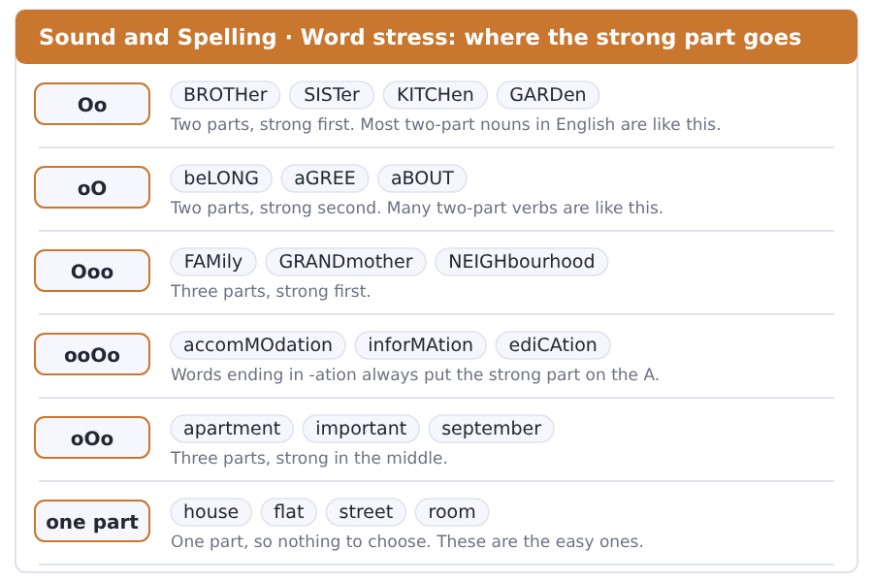
Exercise A Listen. Which word do you hear?
1. Is it BROTHer or broTHER?
2. Is it FAMily or faMILy?
3. Is it accomMOdation or aCCOMmodation?
4. Is it SEPtember or sepTEMber?
5. Is it NEIGHbour or neighBOUR?
6. Is it imPORtant or IMportant?
Exercise B Say these out loud. Record yourself if you can.
1. Say these with the strong part loud: family, brother, grandmother, neighbour.
2. Say these: accommodation, information, education.
3. Say the names of five people in your family.
4. Say your address out loud, slowly, twice.


SKILL · The apostrophe s
- My brother’s flat means the flat of my brother. One person, ’s.
- More than one person already ending in s takes only the apostrophe.
- Do not confuse it with the plural -s. Brothers is two boys; brother’s is one boy and his thing.
- Count the dashes and remember the apostrophe is not a letter.

Exercise A Guided practice. Five words are not complete. Write the missing letters.
My family is not big. I have got one brother and two sister-. My brother live- in the city and my sister- live with my parent-. My mother work- in a school.

The first one is done for you: 1 sister- → s (sisters)
Exercise B Exam practice. One paragraph, ten gaps — the real task.
Most student- at Riverside live with their parent- or in a flat. A flat near the college cost- a lot, so three or four student- usually share one. Every flat ha- a kitchen and a common room, and some of them have garden-. The landlord clean- the stairs, but the student- clean the kitchen. One of my roommate- cook- for everybody on Sunday, and the rest of us wash the plates.

Check your answers in the key at the back of the book.


SKILL · Find the money first
- In any notice about a room, find the price before anything else.
- Look for the word a month, a week or each. The number changes with it.
- A deposit is not the rent. Two numbers, two different things.
- In the rent and not in the rent are the words that cost students money.

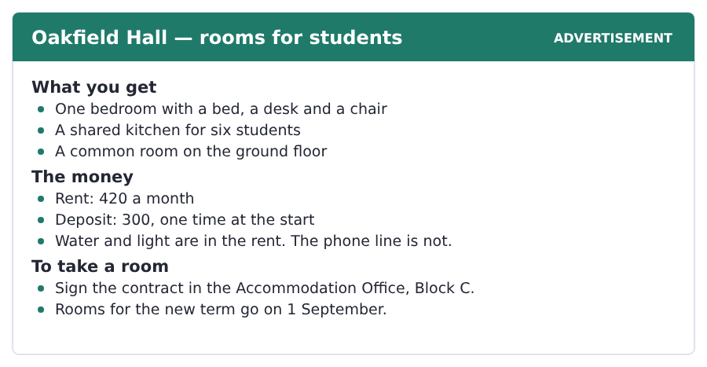
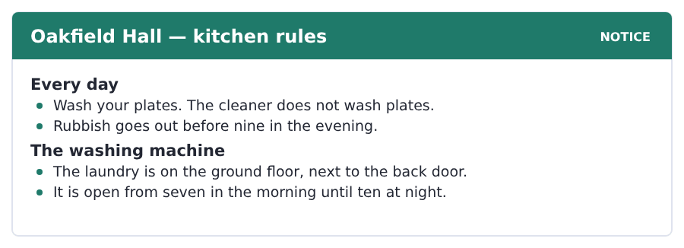
Exercise A Guided practice. The answer is on the page — find it.
1. How much is the rent?
(A) 300 a month
(B) 420 a month
(C) 420 a week
(D) 300 a week
2. How many students share the kitchen?
(A) three
(B) four
(C) nine
(D) six
3. What is not in the rent?
(A) water
(B) light
(C) the phone line
(D) the common room
4. Where do you sign the contract?
(A) the Accommodation Office
(B) Oakfield Hall
(C) the common room
(D) the laundry
Exercise B Exam practice.
5. How much is the deposit?
(A) 420
(B) 720
(C) 120
(D) 300
6. When do rooms for the new term go?
(A) 1 August
(B) 1 October
(C) 1 September
(D) 1 January
7. Who washes the plates?
(A) the students
(B) the cleaner
(C) the landlord
(D) nobody
8. When does the rubbish go out?
(A) before seven in the morning
(B) before nine in the evening
(C) before ten at night
(D) any time
9. Where is the laundry?
(A) the top floor
(B) the common room
(C) the ground floor
(D) Block C
10. What is in the bedroom?
(A) a bed and a washing machine
(B) a bed, a desk and a chair
(C) a kitchen
(D) a common room


SKILL · Three things, three paragraphs
- When a text says three kinds, expect three of everything.
- Each paragraph usually takes one idea and finishes it.
- The word but marks the other side of the same thing. Watch for it.
- A question with not or does not wants you to find the negative sentence.

Where Students Live, and Why
Students live in three kinds of place. Some live at home with their parents. Some live in a hall with other students. Some share a flat on a street near the college.
Money decides most of it. A hall costs a lot, but the rent pays for water, light and a cleaner. A shared flat is cheap, but the bills come every month and somebody has to pay them. A room at home is free, and the journey to the college is not.
There is one thing the money does not show. A student in a hall meets forty people in the first week. A student at home meets the same people as always. For a student in a new country, that first week is worth a lot of rent.
[130 words]

Exercise A Guided practice.
1. How many kinds of place does the passage give?
(A) two
(B) four
(C) five
(D) three
2. What decides most of it?
(A) money
(B) the college
(C) parents
(D) the journey
3. What does the hall rent pay for?
(A) food
(B) water, light and a cleaner
(C) internet
(D) a journey
4. A room at home is
(A) cheap
(B) expensive
(C) free
(D) shared
Exercise B Exam practice.
5. A shared flat is cheap, but
(A) it has no kitchen
(B) it is far
(C) it has no cleaner
(D) the bills come every month
6. What is not free for a student at home?
(A) the journey to college
(B) the room
(C) the bills
(D) the cleaner
7. How many people does a student in a hall meet in the first week?
(A) four
(B) fourteen
(C) forty
(D) four hundred
8. A student at home meets
(A) forty new people
(B) nobody
(C) new neighbours
(D) the same people as always
9. The thing the money does not show is
(A) the people you meet
(B) the bills
(C) the cleaner
(D) the rent
10. For a student in a new country, the first week is
(A) cheap
(B) worth a lot of rent
(C) free
(D) difficult to pay
11. What is the writer’s advice?
(A) A hall is worth the money for a new student.
(B) Always live at home.
(C) Never share a flat.
(D) Bills are the main problem.

The field: Living Things Two more cycles in every skill, on one subject
Everything up to here was about your own life, because that is where a language starts. From this page the same unit turns to a subject, and the subject is one Volume 1 will take up properly: what makes a thing alive, and why a child looks like its parents.
cell the smallest living part of a plant or an animal | oxygen the gas in the air that living things need
plant a tree, a flower or grass | energy what a thing needs to work or to move
grow to get bigger | living alive, not dead
leaf the flat green part of a plant | nature all the plants and animals of the world
root the part of a plant under the ground | feed to give food to, or to take food in
seed a small hard thing that a new plant comes from | copy a thing that is the same as another thing


SKILL · A list that is also the answer
- A passage like this one is a list, and the list is the whole answer.
- Count the things on the list with your finger.
- The last sentence usually tests the list against a hard example.
- A question with every or all wants the whole list.

Four Things, and Nothing Else
A plant and a dog have got very little in common. One has got leaves and roots. The other has got legs and teeth.
But every living thing does the same four things. It takes in food or light for energy. It grows. It makes more of itself. And it answers the world around it: a root goes down, a leaf turns to the light.
Here is the hard example. A seed in a dry room does none of these for twenty years. Is it alive? It has got everything it needs inside it and it waits for water. Most people in the field say yes.
[106 words]

Exercise A Guided practice.
1. What has a plant got?
(A) legs and teeth
(B) cells only
(C) leaves and roots
(D) nothing
2. How many things does every living thing do?
(A) two
(B) three
(C) five
(D) four
3. What does a living thing take in?
(A) water only
(B) food or light for energy
(C) air only
(D) seeds
Exercise B Exam practice.
4. What does a root do?
(A) it turns to the light
(B) it grows leaves
(C) it goes down
(D) it makes seeds
5. What does a leaf do?
(A) it goes down
(B) it turns to the light
(C) it feeds the dog
(D) it waits
6. How long does the seed in the dry room do nothing?
(A) twenty years
(B) two years
(C) ten years
(D) a hundred years
7. What do most people in the field say about the seed?
(A) it is not alive
(B) it is a plant
(C) it is a cell
(D) it is alive


SKILL · An idea you cannot see
- A passage about something very small needs a picture in your head.
- The writer usually gives one, and it is often an everyday thing.
- Hold the picture and the hard word goes with it.
- A question about how many wants a number, not the picture.

The Copy Inside Every Cell
A child has got the eyes of one parent and the hands of the other. Everybody sees this and almost nobody asks how it happens.
The answer is in the cells. A human body has got about thirty million million cells. Nearly every one of them has got its own copy of the same very long book. Think of a very long book, and then think of a copy of it in every cell.
A child gets half of the book from one parent and half from the other. That is why a child is like both of them and the same as neither. Two children of the same parents get a different half.
[114 words]

Exercise A Guided practice.
1. What does a child have got?
(A) nothing from the parents
(B) only the mother’s eyes
(C) the eyes of one parent and the hands of the other
(D) a different body
2. Where is the answer?
(A) in the cells
(B) in the eyes
(C) in the hands
(D) in the book
3. What does the writer ask you to think of?
(A) a cell
(B) a very long book
(C) a plant
(D) a seed
Exercise B Exam practice.
4. How many cells has a human body got?
(A) thirty thousand
(B) thirty million
(C) a hundred
(D) thirty million million
5. What has nearly every cell got inside it?
(A) a different book
(B) no copy
(C) half a book
(D) its own copy of the same book
6. How much of the book does a child get from one parent?
(A) all of it
(B) none of it
(C) half of it
(D) two copies
7. Why is a child the same as neither parent?
(A) the book is new
(B) it gets half from each
(C) the cells are different
(D) it has got more cells

Sentence Builder The word order of a simple sentence
English is a language of word order. Who does it comes first, the verb comes second, and the thing comes third. You cannot move them around the way many languages can, and when you do, the meaning changes or disappears.
Not a sentence | A sentence
Has got my brother a flat. | My brother has got a flat.
In the kitchen is a washing machine. | There is a washing machine in the kitchen.
Lives my family in a small town. | My family lives in a small town.
The rent pays my father. | My father pays the rent.
Every evening cooks her brother. | Her brother cooks every evening.

Watch out! Time and place go at the end, or at the front with a comma. They do not go between the verb and the thing: I clean the kitchen on Sunday, not *I clean on Sunday the kitchen*.
Exercise A Is it a sentence? Write yes or no. If no, put it right.
1. has got a garden my neighbour
2. on the ground floor is the laundry
3. pays the bills every month my roommate
4. wash I on Sunday my clothes
5. My sister lives in the city.
6. three students share the flat


Exercise A Listen and choose a response. You hear one line. Choose the best reply.
1. Have you got a minute?
(A) Yes, of course.
(B) In the kitchen.
(C) Four hundred.
(D) On Monday.
2. Whose plates are these?
(A) They are Mei’s.
(B) In the laundry.
(C) At nine.
(D) Yes, they are.
3. Is the washing machine free?
(A) On the ground floor.
(B) Six students.
(C) Every month.
(D) No, it is not.
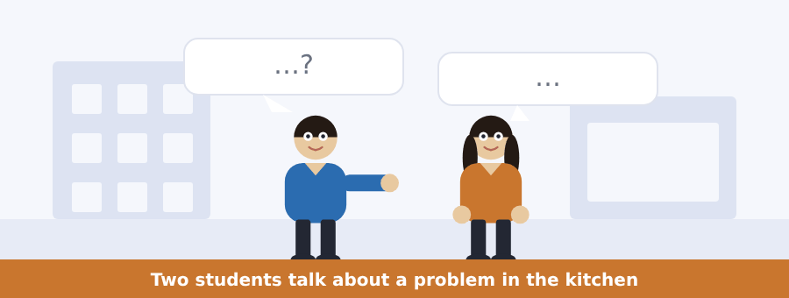
SKILL · Who has the problem?
- In a conversation about a problem, one person has it and one does not.
- Listen for I and you. They tell you who is who.
- The solution usually comes in the last three lines.
- A question about what they decide means the end, not the middle.

Exercise B Listen and answer. The audio plays once.
4. What is the problem?
(A) the washing machine
(B) the rent
(C) plates in the kitchen
(D) the stairs
5. How many plates are in the kitchen?
(A) six
(B) nine
(C) seven
(D) ten
6. Why are the plates not the man’s?
(A) he is away
(B) he eats in the canteen
(C) he has no kitchen
(D) he washes them
7. Whose plates does the woman think they are?
(A) the landlord’s
(B) the cleaner’s
(C) Yusuf’s
(D) Lena’s and her brother’s
8. Who do they decide to talk to?
(A) Lena
(B) the landlord
(C) the cleaner
(D) Lena’s brother
9. Where does the man see Lena?
(A) the kitchen
(B) the canteen
(C) the common room
(D) the laundry
Audio script: see the back of the book. Do not read it before you listen.


Exercise A Listen and choose a response. You hear one line. Choose the best reply.
1. Is there any water on Tuesday morning?
(A) No, there is not.
(B) On the ground floor.
(C) Six students.
(D) At the weekend.
2. Where is the laundry?
(A) On Tuesday.
(B) Yes, it is.
(C) On the ground floor.
(D) Three hours.
3. Have we got a common room?
(A) At nine.
(B) Yes, we have.
(C) In September.
(D) Four hundred.
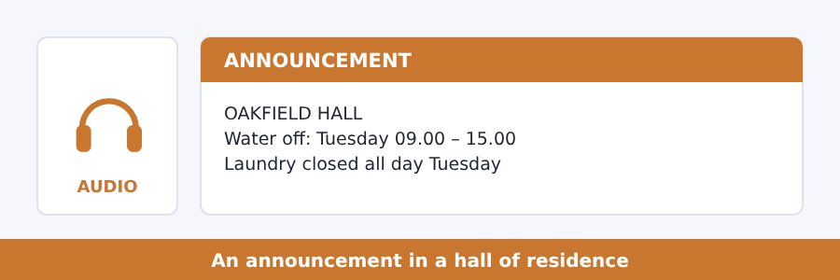
SKILL · A problem and a time
- An announcement about a building gives a problem and a window of time.
- The window has two ends. Catch both numbers.
- Listen for what still works. It is usually at the end.
- A question about Tuesday needs the Tuesday sentence, not the Monday one.

Exercise B Listen and answer. The audio plays once.
4. When is there no water?
(A) Monday morning
(B) Tuesday all day
(C) Wednesday afternoon
(D) Tuesday 9.00 to 15.00
5. Why is there no water?
(A) no cleaner
(B) a free day
(C) work in the building
(D) the laundry is full
6. What about the laundry?
(A) open as normal
(B) closed all day
(C) open in the morning
(D) closed in the afternoon
7. What does the speaker ask students to do?
(A) wash the plates
(B) stay in the common room
(C) pay the bills
(D) take a bottle
8. Where is there drinking water?
(A) the common room
(B) the kitchen
(C) the laundry
(D) the office
Audio script: see the back of the book. Do not read it before you listen.


Exercise A Listen and choose a response. You hear one line. Choose the best reply.
1. Have students got a lot of money?
(A) In a flat.
(B) On Tuesday.
(C) Yes, it is.
(D) No, they have not.
2. Whose street is this?
(A) It is a student street.
(B) At nine.
(C) Three hundred.
(D) Yes, it is.
3. Do you know your neighbours?
(A) On the ground floor.
(B) Every month.
(C) Yes, I do.
(D) It is cheap.
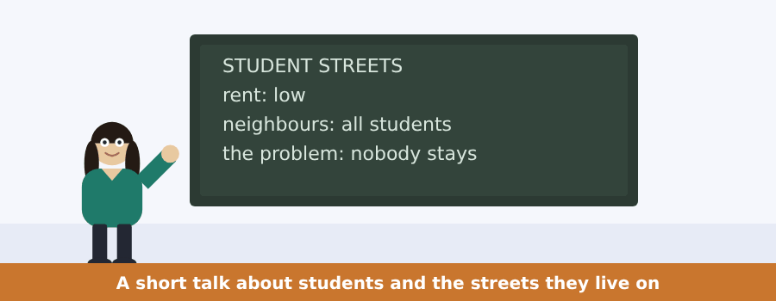
SKILL · A good thing and a bad thing
- A talk often gives one side and then turns with but or however.
- Write a plus and a minus on your paper and fill them in as you listen.
- The speaker’s own opinion usually comes after the turn.
- A question about the problem means the second half of the talk.

Exercise B Listen and answer. The audio plays once.
4. What is special about these streets?
(A) they are quiet
(B) almost everybody is a student
(C) the rent is high
(D) there are no shops
5. What is the rent like?
(A) low
(B) high
(C) the same as a hall
(D) free
6. When do the shops close?
(A) early
(B) at nine
(C) late
(D) at six
7. What is the problem?
(A) the rent goes up
(B) the shops close
(C) there is noise
(D) nobody stays
8. What happens every September?
(A) the rent goes up
(B) the whole street changes
(C) the shops open
(D) the students leave college
9. What does the speaker mean at the end?
(A) students are bad neighbours
(B) the rent is too low
(C) streets need more shops
(D) old people make a street work
Audio script: see the back of the book. Do not read it before you listen.


Exercise A Listen and choose a response.
1. Is a seed alive?
(A) In a dry room.
(B) Most people say yes.
(C) Four things.
(D) Yes, I am.
2. What does a leaf do?
(A) Under the ground.
(B) Yes, it is.
(C) It turns to the light.
(D) Twenty years.
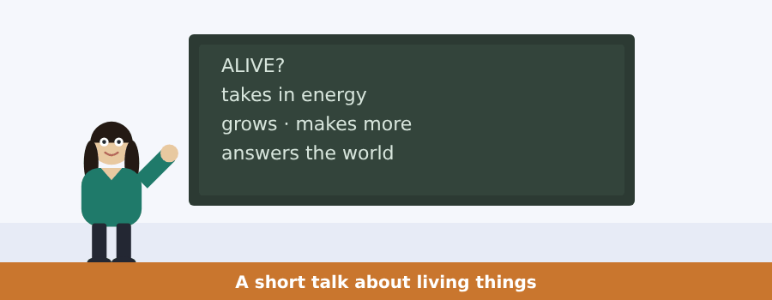
SKILL · A list in a talk
- A talk like this one gives a list and then one hard case.
- The hard case is where the definition is tested.
- The speaker often asks a question and then answers it.
- Write the list first and keep the hard case at the side.

Exercise B Listen and answer. The audio plays once.
3. What do you get if you ask a class?
(A) a list of animals
(B) an answer
(C) a list of plants
(D) a question
4. How many things does a living thing do?
(A) two
(B) four
(C) three
(D) five
5. How many of them does a fire do?
(A) one
(B) two
(C) four
(D) three
6. Which one does a fire not do?
(A) take in energy
(B) grow
(C) answer the world
(D) make more fires
Audio script: see the back of the book.


Exercise A Listen and choose a response.
1. Has every cell got its own copy?
(A) Yes, nearly every one.
(B) In the eyes.
(C) Thirty.
(D) Yes, I have.
2. How much does a child get from one parent?
(A) In the cells.
(B) Yes, it does.
(C) A book.
(D) Half.
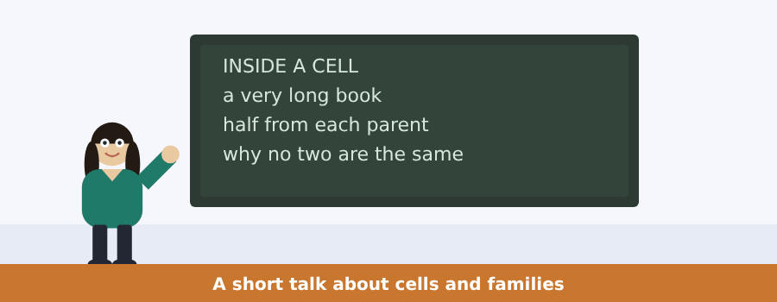
SKILL · A picture in a talk
- When a speaker says think of, a picture is coming. Keep it.
- The picture carries the hard idea for the rest of the talk.
- Numbers after the picture are the evidence.
- A question about why usually comes back to the picture.

Exercise B Listen and answer. The audio plays once.
3. How many letters are in the book?
(A) three thousand
(B) three thousand million
(C) three million
(D) thirty million
4. Where is the book?
(A) in every cell
(B) in the eyes
(C) in the hands
(D) in one cell only
5. How much comes from the mother?
(A) all of it
(B) none of it
(C) half of it
(D) a third of it
6. Why are no two people in a family the same?
(A) they have different books
(B) each one gets a different half
(C) the book changes
(D) cells are different
Audio script: see the back of the book.


Part 1 · Listen and Repeat
You hear a sentence and repeat it once. There is no preparation time, and the sentences get longer. Focus: the weak form of have and got
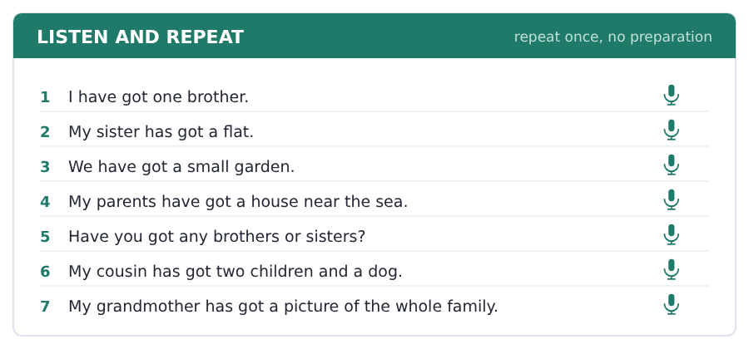
SKILL · Have got runs together
- In speech have got is one sound: I’ve got, she’s got.
- The strong word is the thing you have, not have or got.
- In a question the have comes first and stays weak: Have you got ...?
- Listen for the thing at the end. That is where the answer is.

Part 2 · Take an Interview
An interviewer asks you four questions on one theme: your family. Answer each one fully. There is no preparation time.
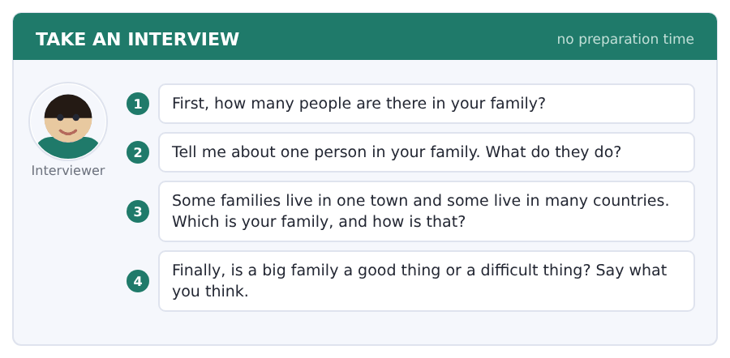
Say it like this
- In my family there are ... . I have got ... .
- My ... is a ... . He or she ... .
- My family lives ... . It is ... .
- I think a ... family is ... , because ... .
A good answer sounds like this
Question 1 — In my family there are five people. I have got one brother and one sister, and my grandmother lives with us.
Question 2 — My father is a driver. He works for a company in the city and he is out of the house from six in the morning.
Question 3 — My family lives in two countries. My aunt and my cousins are in another country, so we see them once a year.
Question 4 — I think a big family is a good thing, because there is always somebody at home. But a small family is quiet, and quiet is good for study.
I can… | Not yet | Yes
I used have got and has got correctly | □ | □
I said a number in my first answer | □ | □
I gave a reason after my opinion | □ | □


Part 1 · Listen and Repeat
You hear a sentence and repeat it once. There is no preparation time, and the sentences get longer. Focus: the possessive ’s in speech
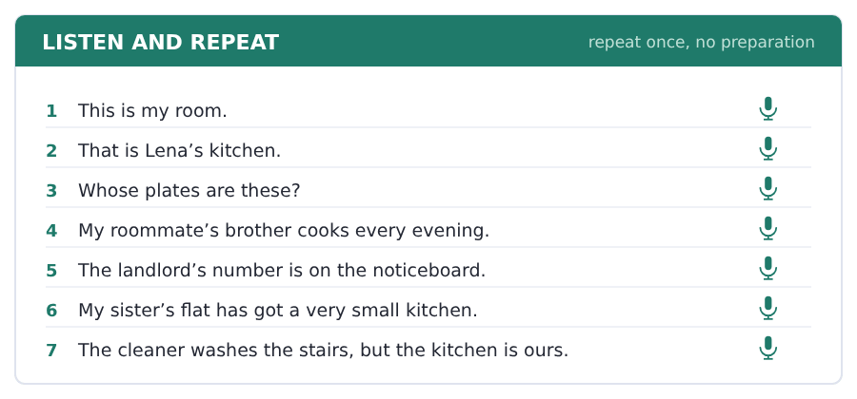
SKILL · My brother’s room
- The ’s sounds the same as a plural -s. Only the meaning is different.
- Say the owner first: Lena’s brother, not the brother of Lena.
- For two owners, the ’s goes on the last one: Lena and Mei’s kitchen.
- In a question, whose carries the meaning: Whose plates are these?

Part 2 · Take an Interview
An interviewer asks you four questions on one theme: your home and your room. Answer each one fully. There is no preparation time.
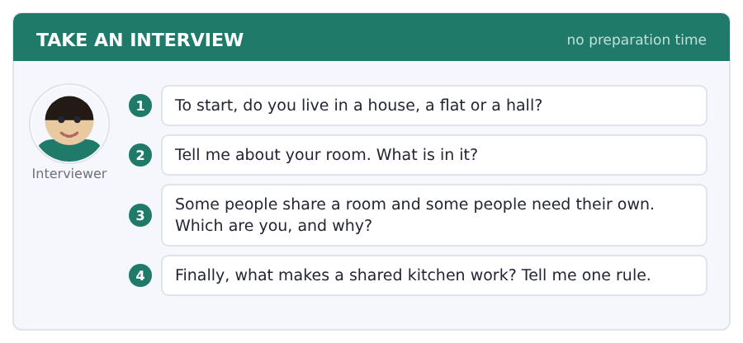
Say it like this
- I live in ... . It has got ... .
- In my room there is ... and there are ... .
- I ... share a room, because ... .
- The rule is ... , because ... .
A good answer sounds like this
Question 1 — I live in a flat with three other students. It has got four bedrooms and one kitchen.
Question 2 — In my room there is a bed and a desk, and there are a lot of books on the floor by the window.
Question 3 — I cannot share a room, because I study late at night and my light keeps other people awake.
Question 4 — The rule is simple: wash your own plate before you leave the kitchen. One plate is nothing. Nine plates are a war.
I can… | Not yet | Yes
I used ’s for the owner | □ | □
I described my room with there is and there are | □ | □
I answered all four questions | □ | □


Part 1 · Listen and Repeat
You hear a sentence and repeat it once. There is no preparation time, and the sentences get longer. Focus: word stress in family words
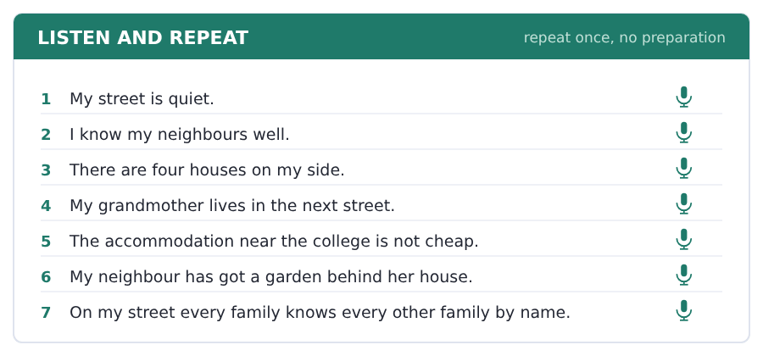
SKILL · The strong part of a long word
- GRANDmother, NEIGHbour, acCOMModation — one part is strong.
- In accommodation the strong part is the fourth one: a-cco-mmo-DA-tion.
- A wrong strong part makes a word hard to hear, even with good sounds.
- Say the word three times with the strong part before you use it.

Part 2 · Take an Interview
An interviewer asks you four questions on one theme: your street and your neighbours. Answer each one fully. There is no preparation time.
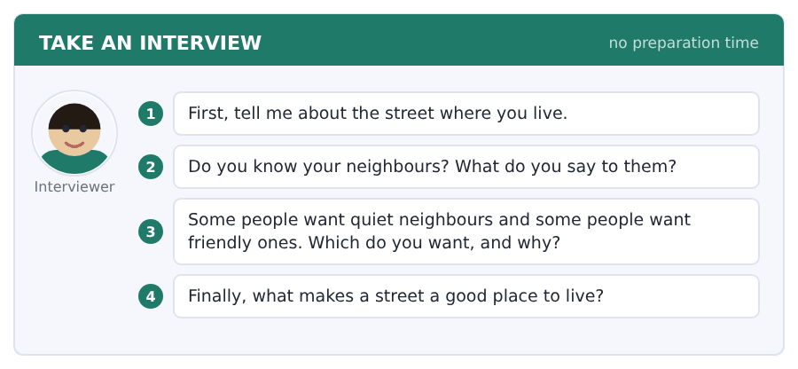
Say it like this
- My street is ... . There are ... .
- I know ... . I usually say ... .
- I want ... neighbours, because ... .
- A street is good when ... .
A good answer sounds like this
Question 1 — My street is short and quiet. There are about twenty houses and a small shop at the corner.
Question 2 — I know the family next door well. I usually say good morning and ask about their daughter.
Question 3 — I want friendly neighbours, because a quiet street with nobody in it is not safe at night.
Question 4 — A street is good when people stay for years. Then everybody knows the children and the old people.
I can… | Not yet | Yes
I put the stress on the right part of long words | □ | □
I used a family word in every answer | □ | □
I gave an example, not only an opinion | □ | □


Part 1 · Listen and Repeat
You hear a sentence and repeat it once. There is no preparation time, and the sentences get longer. Focus: the sound /ɪŋ/ in living and growing words
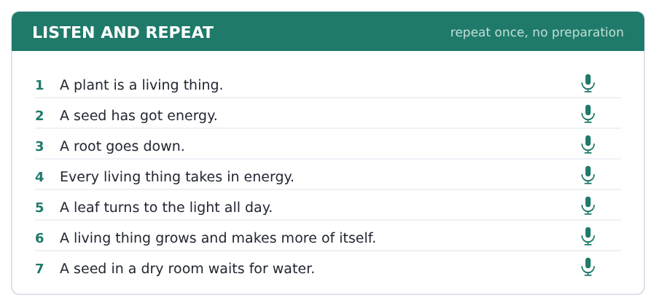
SKILL · Living, growing, feeding
- The -ing here is the same sound you learned in Unit 5 of this book.
- Living has a short /ɪ/; leaving has a long /iː/.
- Say the pair: living / leaving, filling / feeling.
- A wrong vowel here changes the word completely.

Part 2 · Take an Interview
An interviewer asks you four questions on one theme: plants and living things. Answer each one fully. There is no preparation time.
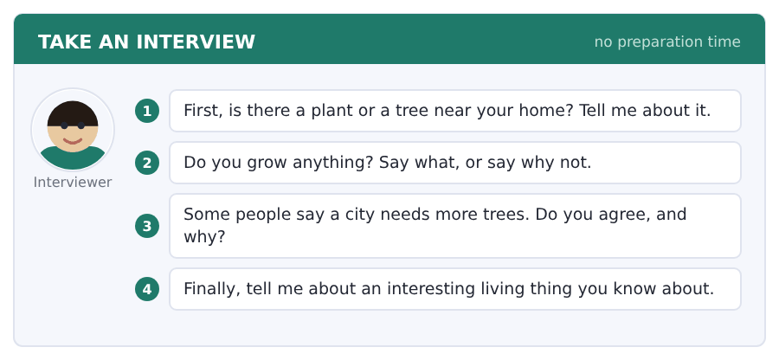
Say it like this
- There is a ... near my home.
- It has got ... .
- I think ... , because ... .
- Nature is ... in my country, because ... .
A good answer sounds like this
Question 1 — There is a very old tree in the street behind my house. It has got a wall round it, because the roots break the road.
Question 2 — I grow nothing. I live on the fourth floor and there is no window on the side with the sun.
Question 3 — I agree. A street with trees is cooler in summer, and in my city that is four months of the year.
Question 4 — An interesting living thing I know about is a seed. It does nothing for twenty years and then it is a tree.
I can… | Not yet | Yes
I said living and leaving differently | □ | □
I used three field words | □ | □
I gave a reason after my opinion | □ | □


Part 1 · Listen and Repeat
You hear a sentence and repeat it once. There is no preparation time, and the sentences get longer. Focus: saying very large numbers
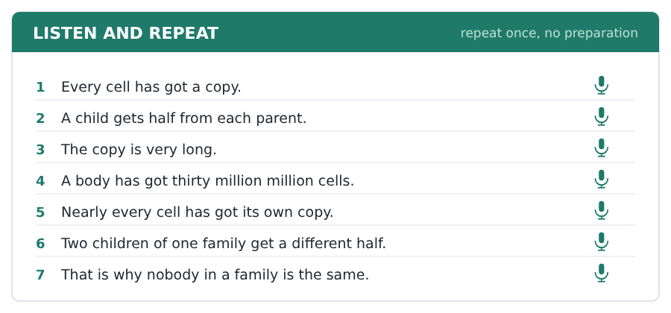
SKILL · Million and thousand million
- Say the parts: thirty million million, three thousand million.
- English puts and before the last small part: a hundred and six.
- Say a large number slowly. Nobody hears a fast one.
- If it is the answer to a question, say it twice.

Part 2 · Take an Interview
An interviewer asks you four questions on one theme: families and what they share. Answer each one fully. There is no preparation time.
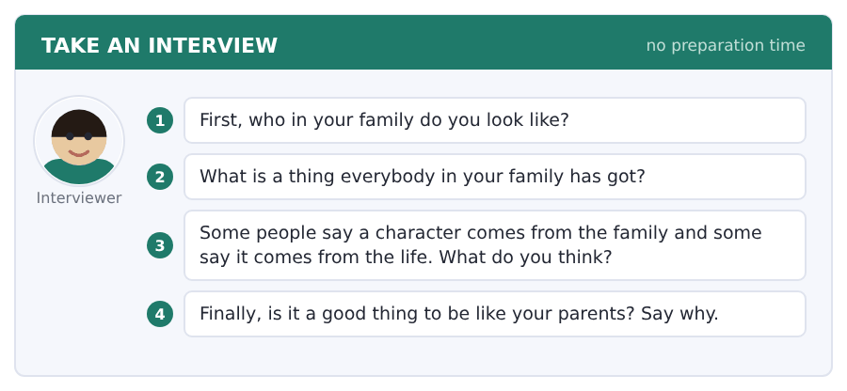
Say it like this
- In my family we all have got ... .
- I am like my ... , because ... .
- I think ... is from the family, because ... .
- The thing nobody in my family has got is ... .
A good answer sounds like this
Question 1 — I look like my mother. We have got the same eyes and the same very straight hair.
Question 2 — A thing everybody in my family has got is a bad memory for names. All four of us.
Question 3 — I think it is both. The cells give you a start and then your life does the rest.
Question 4 — It is a good thing and a difficult thing. People in my town see my father before they see me.
I can… | Not yet | Yes
I said the large numbers slowly and clearly | □ | □
I used have got correctly | □ | □
I answered all four questions | □ | □


You see a sentence, then a set of words in boxes. Put the words in order to make one grammatical sentence. Almost every item in the real test makes a question or a question inside another sentence.
SKILL · Have got in a question
- Have you got ...? and Has he got ...? The have moves to the front.
- Whose asks about the owner: Whose room is this?
- How many goes in front of everything: How many brothers have you got?
- Never put do with got. *Do you have got* is wrong.

Exercise A Guided practice. The first three are worked through.
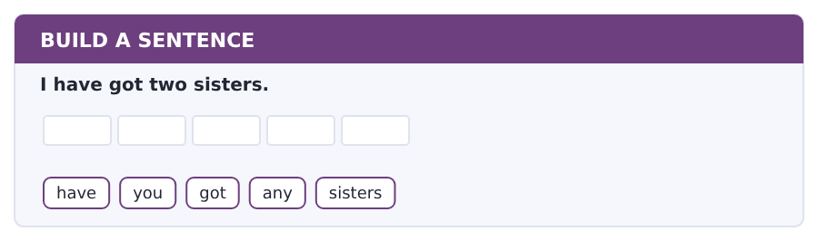
1. Have you got any sisters?
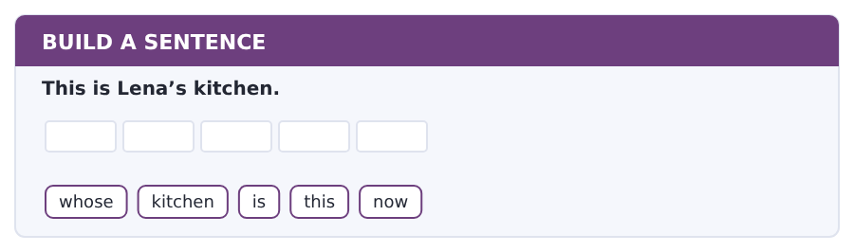
2. Whose kitchen is this now?
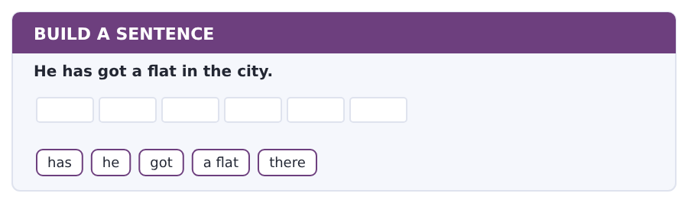
3. Has he got a flat there?
Exercise B Exam practice. Write the sentence.
4. My parents have got a garden.
have / your parents / got / a garden / too
__________________________________________________________
5. She has got three cousins.
how many / cousins / has / she / got
__________________________________________________________
6. These plates are Lena’s.
whose / plates / are / these / exactly
__________________________________________________________
7. The rent is 420 a month.
how much / is / the rent / here / a month
__________________________________________________________
8. I live in a flat with my brother.
who / do / you / live / with
__________________________________________________________
9. My uncle has got two children.
has / your uncle / got / any children / now
__________________________________________________________
10. The laundry is on the ground floor.
where / is / the laundry / in / this hall
__________________________________________________________


You read a short situation and write an email. You have 7 minutes. The three bullet points are the mark scheme: answer all three.
In the real test you write as much as you can in seven minutes. In this unit, aim for about 52 words. That number goes up in every unit of this book, and in Volume 1 it stops being a number at all.
You live in Oakfield Hall, room 14.
The washing machine in the laundry does not work. Write to the office.
- say who you are and where your room is
- say what the problem is
- ask when somebody can come
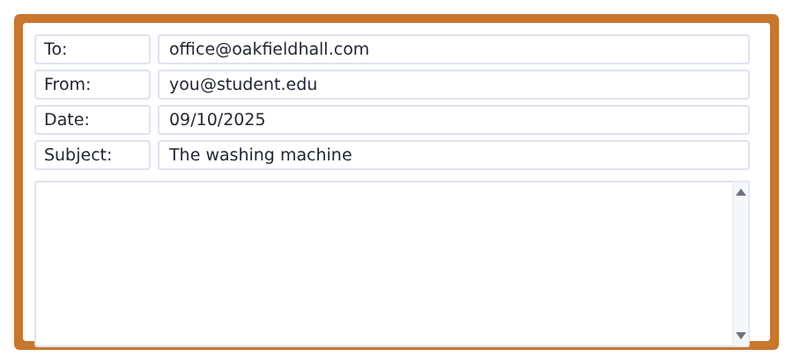
SKILL · A problem email has a shape
- Who you are, what is wrong, what you want. Always in that order.
- Give the room number. Nobody can help you without it.
- Say what is wrong in plain words. Do not say it twice.
- End with a question, not with a complaint.

Model email
Dear Office,

My name is Ana Ruiz and I am in room 14 in Oakfield Hall.
The washing machine in the laundry does not work. It is full of water and the door does not open.
When can somebody come and look at it?

Thank you,
Ana Ruiz
Why it works
- The room number is in the first sentence, where the reader needs it.
- The problem is two short facts, not a long story.
- The question is polite and it asks for a time, so the answer is useful.
- Nobody is blamed. An email that blames people gets a slow answer.
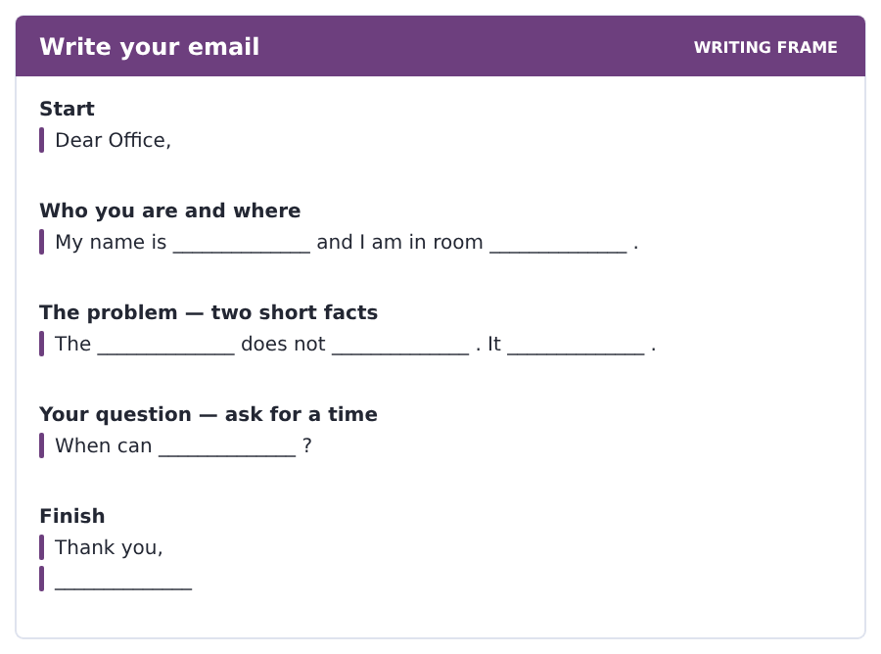
Now write your own. 7 minutes.
__________________________________________________________
__________________________________________________________
__________________________________________________________
__________________________________________________________
__________________________________________________________
__________________________________________________________
__________________________________________________________
__________________________________________________________


A professor asks a question and two students answer. You add your own post. You have 10 minutes and an effective answer is at least 100 words.
One hundred words is what the real test wants, and you will get there. For this unit, write about 55. Every unit of this book asks for a few more.
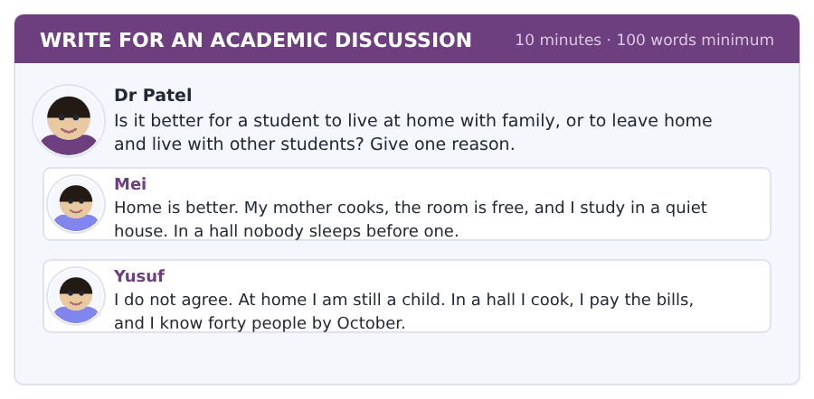
SKILL · Use the other posts
- Name the person you agree with. Then name the one you do not.
- Give one reason of your own, not a reason already on the page.
- Fifty-five words is five short sentences. Write them, then stop.
- A post with no reason is not an answer, however long it is.

Sentence starters
- I agree with Yusuf, because ...
- Mei is right about ...
- In my own case ...
- The thing nobody says is ...
Model post
I agree with Yusuf. A student learns more outside the family house, because nobody does the small things for you.
Mei is right about the quiet, and quiet is important in the exam term.
In my own case the journey decides it. My family house is two hours away, so home is not really free.
[55 words]
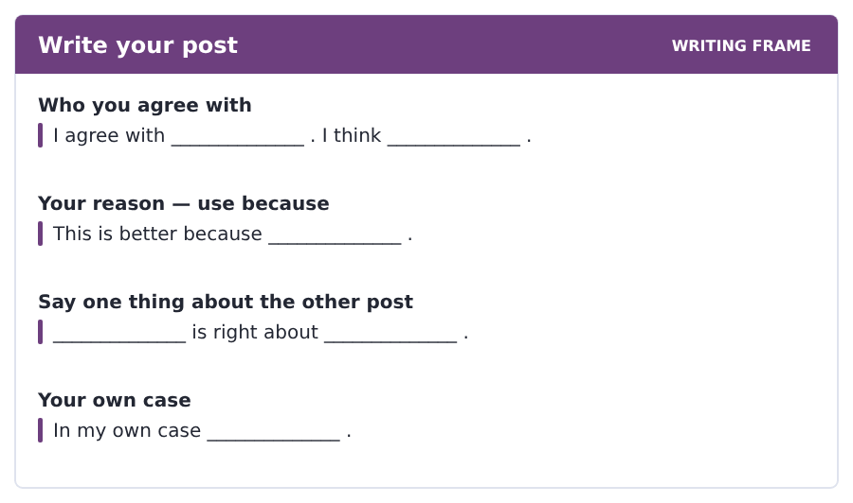
Now write your own. 10 minutes, at least 55 words.
__________________________________________________________
__________________________________________________________
__________________________________________________________
__________________________________________________________
__________________________________________________________
__________________________________________________________
__________________________________________________________
__________________________________________________________
__________________________________________________________
__________________________________________________________


The same task again, on the subject of this unit. The sentences are about living things now, and the word order has not changed at all.
SKILL · have got, about a cell
- Has it got ...? works for a thing as well as for a person.
- How many goes in front of everything.
- The verb after has got never changes.
- Keep the question short even when the subject is long.

Exercise A Guided practice.
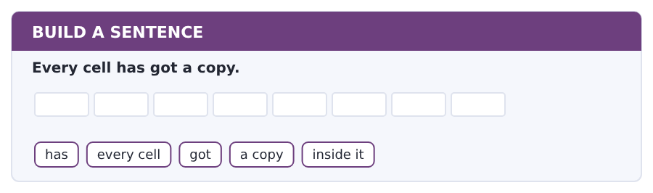
1. Has every cell got a copy inside it?
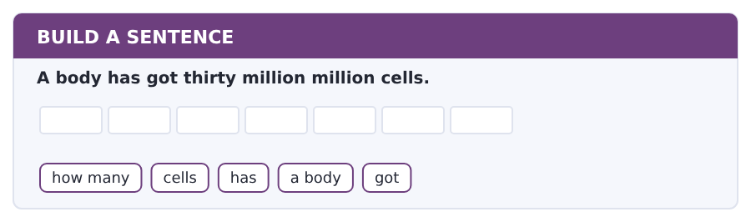
2. How many cells has a body got?
Exercise B Exam practice. Write the sentence.
3. A plant has got roots.
has / a plant / got / any / roots
__________________________________________________________
4. A child gets half from each parent.
how much / does / a child / get / from one parent
__________________________________________________________
5. A seed has got everything inside it.
what / has / a seed / got / inside it
__________________________________________________________
6. A leaf turns to the light.
what / does / a leaf / turn / to
__________________________________________________________


A second discussion, and this one is about the subject rather than about your own week. In the real test both kinds come up, and the second kind is the harder one.
For this unit, write about 55 words. The real test wants a hundred.
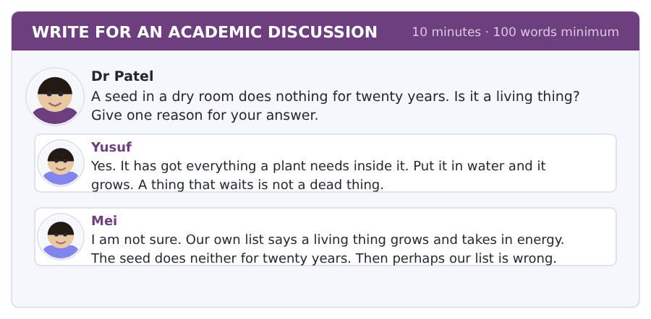
SKILL · Test the list, not the seed
- This question is really about the list, not about the seed.
- Say yes or no first, then say which part of the list decides it.
- Mei does something clever: she asks if the list is wrong. Say what you think about that.
- Fifty-five words is five short sentences.

Sentence starters
- I agree with Yusuf, because ...
- Mei is right that ...
- Our list says ...
- Perhaps the answer is ...
Model post
I agree with Yusuf. A seed is a living thing, because everything it needs is already inside it.
Mei is right that our list does not fit. The seed does not grow and it takes in nothing.
Perhaps the answer is that the list is about what a thing can do, and not about what it does today.
[58 words]
Now write your own. 10 minutes, at least 55 words.
__________________________________________________________
__________________________________________________________
__________________________________________________________
__________________________________________________________
__________________________________________________________
__________________________________________________________
__________________________________________________________
__________________________________________________________
__________________________________________________________
__________________________________________________________

Grammar focus have got · possessive ’s · my, your, his, her
Form | Example
I / you / we / they have got | I have got two sisters.
he / she / it has got | She has got a flat.
negative | I have not got a garden. He has not got a car.
question | Have you got a brother? Has she got a room?
’s = one owner | my brother’s flat, Lena’s kitchen
s’ = more than one owner | the students’ kitchen
my, your, his, her, our, their | This is her room, not their room.

Have got and have mean the same thing here. Have got is more common in speech; have is more common in writing. The test uses both.
The ’s goes on the owner, not on the thing: my sister’s room, never *my sister room’s*.
His and her follow the owner, not the thing. Mei and her brother: her, because Mei is a woman, even though brother is a man.
Watch out! Never say *Do you have got?* or *She have got*. Have got makes its own question with have, and the he/she form is has.
Exercise 1 Write have got or has got.
1. I __________ one brother.
2. She __________ a small flat.
3. My parents __________ a garden.
4. The hall __________ a common room.
5. We __________ a washing machine on the ground floor.
6. He __________ two children.
Exercise 2 Put the apostrophe in the right place.
1. my brothers flat (one brother)
2. the students kitchen (many students)
3. Lenas room (one person)
4. my parents house (two people)
5. the landlords number (one person)
6. my sisters children (one sister)
Exercise 3 Write my, your, his, her, our or their.
1. Mei lives with __________ brother.
2. Yusuf cooks in __________ kitchen.
3. We clean __________ own flat.
4. The students pay __________ own bills.
How this is tested in Build a Sentence
Build a Sentence likes have got because the question moves two words and nothing else: You have got a room becomes Have you got a room? Whose is the other favourite, and whose always comes first in the sentence.

Typing and the Screen Capital letters and the shift key
The real test is typed. Nobody gives you paper. If you are still looking for the keys, you lose the Writing section before your English does.
A capital letter is two keys at once: shift and the letter. The shift key on the left is for letters your right hand types, and the shift key on the right is for letters your left hand types. Never use one hand for both.
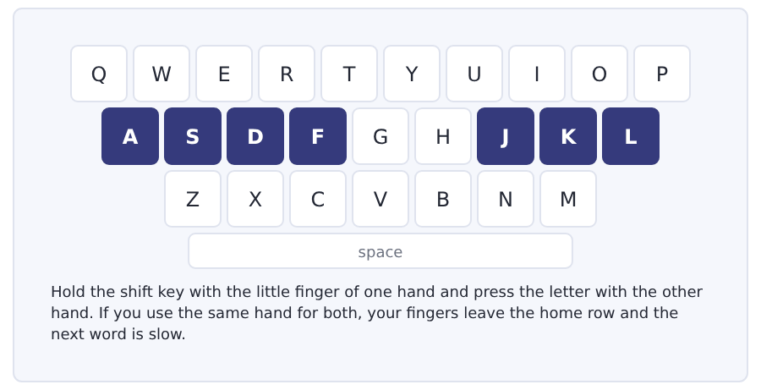
Exercise Type this. Time yourself, then write your speed in the box.
Ana Mei Yusuf Lena Oakfield Hall
My name is Ana. I live in Oakfield Hall.
Dear Office, The washing machine does not work. Thank you, Ana
My time _______ seconds
Words a minute _______ (the target for Unit 4 is 11)

Learning to Learn Word families: one word is really five
Every time you learn a word, you can usually get three or four more for nothing. They look the same and they share a meaning. Learning them together costs almost no extra time and it doubles what you can say.
- Write the word in the middle of a page and the other forms around it.
- Example: clean (verb), clean (adjective), cleaner (person), cleaning (the work).
- Example: live (verb), alive (adjective), living room (the place).
- Mark which one is the noun, which is the verb and which is the adjective. That is what decides where it goes in the sentence.
- In the real test, Build a Sentence and Complete the Words both turn on these endings. This is not extra work; it is the work.
ADAPTIVE TIP The endings tell you the job of the word. Words ending in -tion, -ment and -ness are nouns. Words ending in -ful, -less and -able are adjectives. Words ending in -ly are usually adverbs. Four endings, and you can guess the job of thousands of words.

Unit review and progress check Unit 4
Exercise A Vocabulary. Write the word.
1. the owner of the flat you pay for
2. the money you pay every month
3. money you pay at the start and get back
4. your partner in a shared flat
5. the paper you sign with the landlord
6. the shared room in a hall
7. the things you throw away
8. a place to live
9. the person next door to you
10. the child of your uncle or aunt
11. the room where you cook
12. a home on one floor of a building
Exercise B Grammar. Complete the sentence.
1. I __________ one brother. (have got)
2. She __________ a small flat. (have got)
3. __________ you got any sisters?
4. This is my __________ flat. (brother, one)
5. That is the __________ kitchen. (students, many)
6. Mei lives with __________ brother.
7. We clean __________ own flat.
8. __________ plates are these?
Exercise C One timed mini-section. 6 minutes.
1. The rent at Oakfield Hall is
(A) 300 a month
(B) 420 a week
(C) 720 a month
(D) 420 a month
2. The students decide to talk to
(A) Lena
(B) the landlord
(C) the cleaner
(D) the office
3. The problem with student streets is
(A) the rent
(B) the shops
(C) nobody stays
(D) the noise
4. Which sentence is correct?
(A) Have you got a brother?
(B) Do you have got a brother?
(C) You have got a brother?
(D) Has you got a brother?
5. Which is correct?
(A) my sister room’s
(B) my sister’s room
(C) my sisters room
(D) my sister rooms
6. A student in a hall meets forty people in
(A) the first day
(B) the first term
(C) the first year
(D) the first week
Can you do these now?
I can… | Not yet | Yes
say who is in my family with have got | □ | □
read a short notice about a room and find the cost | □ | □
understand a short text about how students live | □ | □
follow a conversation about a problem in a shared flat | □ | □
ask and answer questions about family and home | □ | □
write an email to a landlord about a problem | □ | □

ADAPTIVE TIP In Speaking, the family questions are the easy marks and everybody wastes them. Have three sentences ready about one person in your family — what they do, where they live, one small detail. You will use them in half the interviews you ever sit.

Unit 5 · A Day in Your Life
TOEFL iBT® Preparation Course 2026 · Volume F1
CEFR A2 · Grammar: present continuous · present continuous and present simple · Word field: routine, study, free time
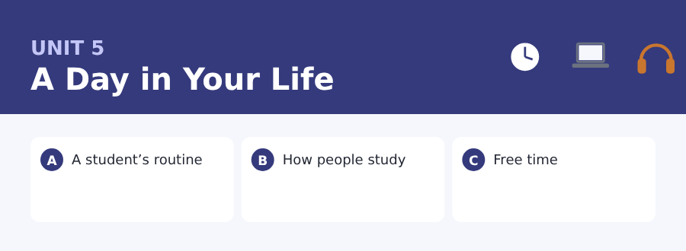
By the end of this unit I can…
- say what I am doing now and what I do every day
- read a short notice about a computer room and find a rule
- understand a short text about how students really study
- follow a conversation about a day that is going wrong
- talk about my routine and my free time
- write an email about a problem with a deadline

Three sub-topics, three cycles in every skill. Now you can say what you do every day and what you are doing at this moment — two different things, two different tenses.

Vocabulary 1 · The words you need most 24 words from the two thousand most common words of English
These are not academic words. They are the words that carry ordinary English, and until you own them the academic words of Volume 1 have nothing to stand on. Cover the right-hand column and test yourself.
breakfast the first food of the day | watch to look at something for a time
lunch the food you eat in the middle of the day | play to do a game or music
dinner the main food of the evening | sleep to close your eyes at night and rest
wash to clean with water | bed the thing you sleep in
shower you stand under water to wash | tired needing sleep or rest
dress to put your clothes on | busy with a lot to do
leave to go away from a place | hobby something you do because you like it
arrive to come to a place | music what you hear when somebody sings or plays
study to learn something with books | exercise moving your body to stay well
read to look at words and understand them | cook to make food hot and ready
write to put words on paper | homework the work a teacher gives you for home
listen to use your ears on purpose | together with other people, not alone

Exercise A Work in pairs. Ask and answer.
1. What do you usually eat for breakfast?
2. What are you doing this evening?
3. How many hours do you sleep on a normal night?
4. What is your hobby, and when do you do it?
Vocabulary 2 · Campus and everyday 12 words for student life
Every Listening conversation in the real test happens on a campus. These twelve words come back in this unit and again in Volume 1.
borrow to take a thing for a time and give it back | notes the short words you write in a class
return to give a thing back | revision reading your notes again before a test
print to put your work on paper with a machine | assignment a piece of work with a deadline
password the secret word that opens your account | group work work that three or four students do together
folder where you keep papers or files together | computer room the room in a college with computers in it
photocopy a copy of a paper made by a machine | log in to put your name and password into a computer

Words you will meet again: routine | notes | revision | assignment | borrow | password | tired | together

Sound and Spelling The -ing ending, and words that run together
Two things make fast English hard to hear, and both of them are in this unit. The first is the -ing ending, which is one sound and not two. The second is linking: the end of one word joins the start of the next, and the word you know disappears into the word beside it.
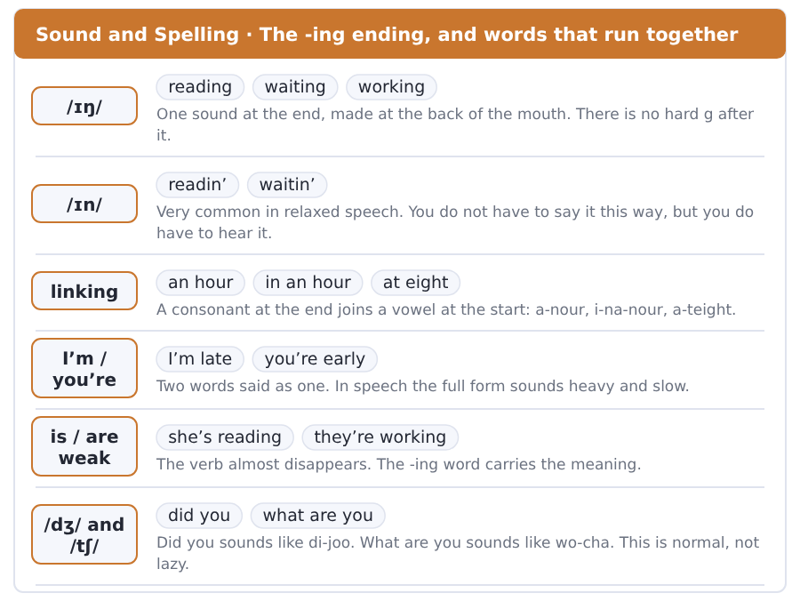
Exercise A Listen. Which word do you hear?
1. Do you hear reading or readin’?
2. Do you hear an hour or a flower?
3. Do you hear I am or I’m?
4. Do you hear she is or she’s?
5. Do you hear working or walking?
6. Do you hear at eight or a tape?
Exercise B Say these out loud. Record yourself if you can.
1. Say these joined: in an hour, at eight, on a Monday, for an exam.
2. Say I’m, you’re, he’s, she’s, we’re, they’re.
3. Say five -ing words slowly, then fast: reading, waiting, writing, sitting, studying.
4. Say what you are doing right now, in one sentence.


SKILL · The -ing ending
- Add -ing to the plain verb: read, read-ing.
- A verb ending in -e loses the e: write, writ-ing; make, mak-ing.
- A short verb with one vowel doubles the last letter: sit, sitt-ing.
- Count the dashes. Three dashes is almost always -ing.

Exercise A Guided practice. Five words are not complete. Write the missing letters.
It is nine o’clock and the library is full. Mei is read--- at the window. Two students are writ--- their notes together. Nobody is talk---. The printer is work--- again, and two students are wait--- for it.

The first one is done for you: 1 read--- → ing (reading)
Exercise B Exam practice. One paragraph, ten gaps — the real task.
Every morning Ana get- up at seven and ha- breakfast with her roommate. She leave- the flat at eight and arrive- at the college before nine. Today is different. It is half past nine and she is still sitt--- on the bus, because the traffic is bad. Her phone is ring--- and she is not answer--- it. Her first class start- in ten minutes and the teacher alway- call- the register at the start.

Check your answers in the key at the back of the book.


SKILL · Rules come in two kinds
- A notice about a room gives you what you must do and what you must not do.
- Look for please, do not, only and always. The rule follows them.
- Times and numbers inside a rule change the rule. Read them.
- If two rules look the same, one of them has an exception in it.

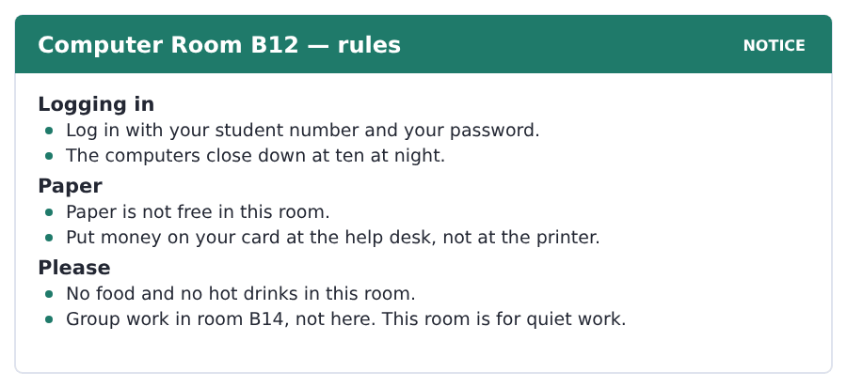
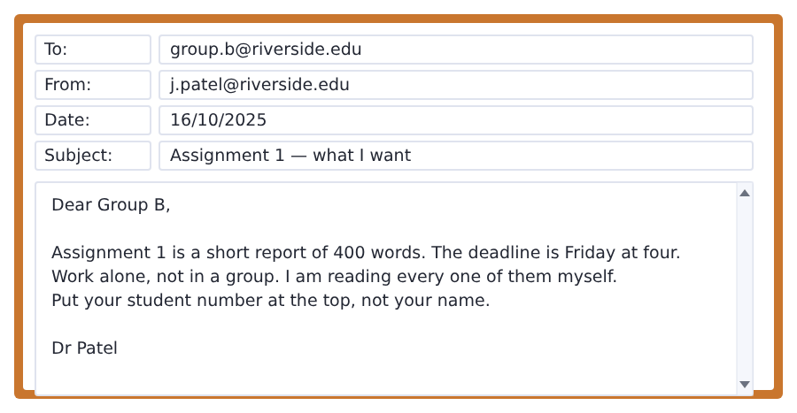
Exercise A Guided practice. The answer is on the page — find it.
1. What do you need to log in?
(A) your student number and password
(B) your name and card
(C) money
(D) a folder
2. Is paper free in room B12?
(A) yes, always
(B) no, it is not free
(C) only for Group B
(D) only after ten
3. Where do you put money on your card?
(A) at the printer
(B) in room B14
(C) at the help desk
(D) online
4. How long is Assignment 1?
(A) 40 words
(B) 4 pages
(C) 4 hours
(D) 400 words
Exercise B Exam practice.
5. When do the computers close down?
(A) at four
(B) at nine
(C) at ten at night
(D) at midnight
6. Where is group work?
(A) room B12
(B) room B14
(C) the library
(D) the help desk
7. What is not allowed in room B12?
(A) quiet work
(B) paper
(C) logging in
(D) food and hot drinks
8. When is the deadline for Assignment 1?
(A) Friday at four
(B) Thursday at four
(C) Friday at ten
(D) Monday at nine
9. Does Dr Patel want group work for this assignment?
(A) no
(B) yes
(C) only for Group B
(D) only in room B14
10. What goes at the top of the report?
(A) your name
(B) the date
(C) the word count
(D) your student number


SKILL · A text can argue with itself
- Some texts give an idea and then take it apart.
- Watch for but, however and the real number. They mark the turn.
- A phrase in italics or quotes, like real study, is usually the key idea.
- The last sentence often states the key idea in the shortest words of all.

What Students Say, and What They Do
Ask a student how long they study. The answer is usually four or five hours a day. Then watch the same student for a day. The real number is much smaller. Nobody is counting, and an hour at a desk feels like real work.
The difference is not a lie. A student sits at a desk for four hours. He calls it four hours of study. But in those four hours the phone rings twice. A friend comes in. The same page stays open for forty minutes, and nothing goes into the head.
Teachers have a name for the real number. They call it real study. Two hours of real study beats six hours at a desk. Try it for two weeks. The first week is hard. The second week is easy. The desk is not the work. The attention is the work.
[143 words]

Exercise A Guided practice.
1. How long do students say they study?
(A) one hour
(B) four or five hours
(C) two hours
(D) six hours
2. What is the real number?
(A) the same
(B) much bigger
(C) much smaller
(D) six hours
3. What do teachers call it?
(A) time at a desk
(B) real study
(C) revision
(D) group work
4. How long is the same page open for?
(A) four minutes
(B) fourteen minutes
(C) forty minutes
(D) four hours
Exercise B Exam practice.
5. The writer says the difference is
(A) not a lie
(B) a lie
(C) a mistake in the question
(D) a joke
6. What happens twice in the four hours?
(A) a friend comes in
(B) the page turns
(C) the student eats
(D) the phone rings
7. Two hours of real study
(A) is not enough
(B) is the same as six hours
(C) is only for teachers
(D) beats six hours at a desk
8. What is the first week like?
(A) easy
(B) easy
(C) hard
(D) the same
9. What is the second week?
(A) hard
(B) easy
(C) the same
(D) four hours
10. The last sentence says the work is
(A) the attention
(B) the desk
(C) the hours
(D) the page
11. What is the big idea of the passage?
(A) Students do not work.
(B) Hours at a desk are not the same as study.
(C) Teachers do not understand.
(D) Phones are bad.

The field: People and the Mind Two more cycles in every skill, on one subject
Everything up to here was about your own life, because that is where a language starts. From this page the same unit turns to a subject, and the subject is one Volume 1 will take up properly: why you forget what you learn, and why a habit is so hard to stop.
memory what your mind keeps | brain the part of the body you think with
forget to not keep a thing in your mind | behaviour what a person does
attention the work your mind does on one thing | react to do something because of something else
habit a thing you do again and again without thinking | pattern a thing that happens again and again in the same way
notice to see or hear a thing | experiment a careful test
mind the part of you that thinks | choice what you take when there are two things


SKILL · Numbers that make an argument
- A passage with numbers in it is usually making one point.
- Find the point first, then put the numbers under it.
- Watch for so or the answer is: the writer is turning to advice.
- A question with how many or how much wants a number, nothing else.

The First Day Is the Problem
You read a page of new words today. Tomorrow you know half of them. In a week you know very few of them.
This is normal and it happens to everybody. An experiment on memory shows the shape of the problem. Most of what you forget goes in the first day. After that first day the line is almost level.
So the answer is not a long hour of work on the first day. The answer is a short look again after one day, after one week and after one month. A student with this habit keeps eight words in ten, and the work is short every time.
[108 words]

Exercise A Guided practice.
1. How many of the words do you know tomorrow?
(A) all of them
(B) very few
(C) half of them
(D) none
2. What does the experiment show?
(A) the shape of the problem
(B) the answer
(C) a new word
(D) a student
3. When does most of the forgetting happen?
(A) in the first hour
(B) in the first week
(C) in the first month
(D) in the first day
Exercise B Exam practice.
4. What is the line like after the first day?
(A) it is almost level
(B) it goes down fast
(C) it goes up
(D) it stops
5. What is not the answer?
(A) a short look again
(B) a look after a week
(C) a long hour on the first day
(D) a look after a month
6. How many times does the writer say to look again?
(A) once
(B) twice
(C) four times
(D) three times
7. How many words in ten does such a student keep?
(A) five
(B) eight
(C) six
(D) ten


SKILL · Two things the writer keeps apart
- Some passages are built on one difference. Find the two words.
- Here they are habit and choice. Everything else hangs on them.
- Mark the sentence where the writer says they are not the same.
- A question about why usually asks you to use that difference.

A Habit Is Not a Choice
Look at a person with a habit. Perhaps she is looking at her phone right now, and she does not notice it at all. Ask her and she stops.
A habit is not a choice. A choice happens in one part of the brain and a habit happens in another. The second part is old and fast. It works with no attention at all, and that is why it is good.
So people in the field do not say, stop the habit. They say, keep the same pattern and change the middle of it. Your hand goes to the phone; your hand takes a book. The habit stays and the behaviour changes.
[112 words]

Exercise A Guided practice.
1. What is the person doing?
(A) changing a habit
(B) looking at her phone
(C) taking a book
(D) reading a page
2. Does she notice it?
(A) yes, all the time
(B) only in the morning
(C) no, not at all
(D) only with a book
3. What happens if you ask her?
(A) she stops
(B) she goes on
(C) she takes a book
(D) she forgets
Exercise B Exam practice.
4. Where does a choice happen?
(A) in the hand
(B) in the phone
(C) in the pattern
(D) in one part of the brain
5. What is the second part of the brain like?
(A) new and slow
(B) old and fast
(C) old and slow
(D) new and fast
6. Why is a habit good for you?
(A) it needs no attention
(B) it is a choice
(C) it is new
(D) it takes a book
7. What do people in the field say?
(A) stop the habit
(B) change the hand
(C) take a phone
(D) change the middle of the pattern

Sentence Builder Finishing the sentence you started
Half a sentence scores nothing, and at this level most half sentences have the same cause: the writer starts with a long opening phrase and forgets to put a verb after it. Read your sentence back and find the verb. If there is no verb, there is no sentence.
Not a sentence | A sentence
Because the traffic is bad this morning. | I am late because the traffic is bad this morning.
Students who study every evening. | Students study every evening.
In the computer room on the ground floor. | The printer is in the computer room on the ground floor.
I am waiting and. | I am waiting and she is coming.
For example my brother. | For example, my brother studies at night.

Watch out! A sentence that starts with because, when, if or although needs a second half. On its own it is a piece of a sentence, however long it is.
Exercise A Is it a sentence? Write yes or no. If no, put it right.
1. Because I am ill this week.
2. Working in the library every evening.
3. When the printer is not working.
4. My roommate, who cooks on Sunday.
5. I am reading a long book about a family.
6. At half past nine on the bus.


Exercise A Listen and choose a response. You hear one line. Choose the best reply.
1. Where are you?
(A) At eight o’clock.
(B) Yes, I am.
(C) I am on the bus.
(D) Every morning.
2. What are you doing?
(A) At nine.
(B) I am waiting for the printer.
(C) Yes, I do.
(D) In the flat.
3. Are you coming to the class?
(A) Yes, I am.
(B) Every Monday.
(C) In room B12.
(D) Four hours.
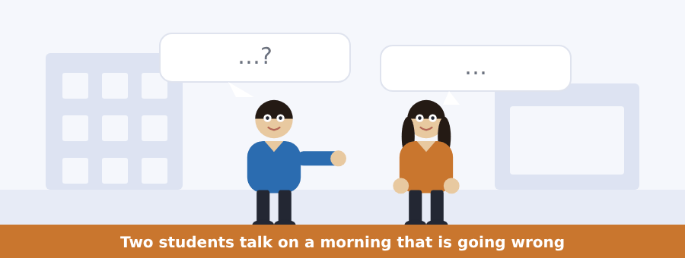
SKILL · Now or every day?
- Listen for am, is and are in front of an -ing word. That is happening now.
- Usually, always and every day mark the routine, not this moment.
- A problem conversation often holds both: I always catch the eight bus, but today I am sitting here.
- The question usually asks about today, not about the routine.

Exercise B Listen and answer. The audio plays once.
4. Where is the woman?
(A) in the class
(B) in room B14
(C) on the bus
(D) at home
5. Why is she late?
(A) she is at home
(B) the bus is early
(C) she is in the library
(D) the traffic is terrible
6. Which bus does she usually catch?
(A) seven o’clock
(B) eight o’clock
(C) nine o’clock
(D) ten o’clock
7. What is Dr Patel doing?
(A) reading the assignment
(B) printing
(C) calling the register
(D) waiting at the door
8. Is the assignment group work?
(A) no
(B) yes
(C) only for Group B
(D) only in B14
9. Why is the man going to room B14?
(A) for group work
(B) it is quiet
(C) to see Dr Patel
(D) the printer here is not working
Audio script: see the back of the book. Do not read it before you listen.


Exercise A Listen and choose a response. You hear one line. Choose the best reply.
1. Is the printer working?
(A) In room B14.
(B) Five pages.
(C) At ten.
(D) No, it is not.
2. What is happening at two o’clock?
(A) The printers are going down.
(B) In the library.
(C) Yes, it is.
(D) Four hundred words.
3. Where can I use a printer?
(A) At four.
(B) In room B14.
(C) Yes, you can.
(D) On your card.
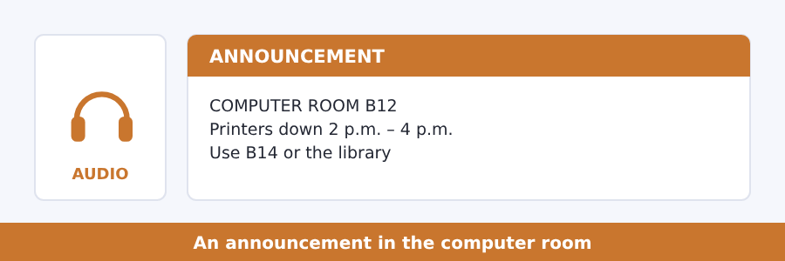
SKILL · What is happening and what to do
- An announcement about a machine says what is wrong and where to go.
- The where to go part is the one students miss.
- Listen for instead and or. The other place comes after them.
- A time window has two ends. Write both.

Exercise B Listen and answer. The audio plays once.
4. Which printers are going down?
(A) the library printers
(B) the printers in B14
(C) the printers in B12
(D) all the printers
5. When are they going down?
(A) between one and three
(B) between two and four
(C) between four and six
(D) all day
6. Why are they going down?
(A) they are broken
(B) there is no paper
(C) a new machine is arriving
(D) the room is closed
7. Where can students go for paper?
(A) room B14 or the library
(B) nowhere
(C) only the library
(D) only room B14
8. What about the computers?
(A) they are going down too
(B) they are closed
(C) they are moving to B14
(D) they are working as normal
Audio script: see the back of the book. Do not read it before you listen.


Exercise A Listen and choose a response. You hear one line. Choose the best reply.
1. Are you doing anything this evening?
(A) In the library.
(B) At eight.
(C) Yes, I am playing football.
(D) Four hours.
2. What do you do in your free time?
(A) I play the piano.
(B) I am reading now.
(C) Yes, I do.
(D) In the computer room.
3. Why is an empty evening a problem?
(A) At seven.
(B) Because nothing fills it.
(C) Yes, it is.
(D) In the hall.
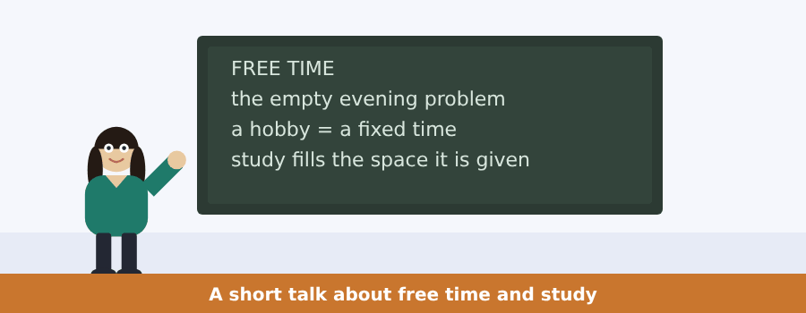
SKILL · A talk that gives advice
- A talk with advice starts with a problem, not with the advice.
- The advice usually comes after so, and then an example follows it.
- Count the pieces of advice. There are rarely more than two.
- The question why usually points back to the problem at the start.

Exercise B Listen and answer. The audio plays once.
4. What is the talk about?
(A) football
(B) the library
(C) deadlines
(D) free time and study
5. A student with an empty evening
(A) studies more
(B) studies all night
(C) plays football
(D) does not study more
6. What does study do?
(A) always takes four hours
(B) happens in the morning
(C) fills the space it is given
(D) needs a desk
7. Why does the student with football study well?
(A) football is easy
(B) the clock is real
(C) the evening is empty
(D) the library closes
8. What is the advice?
(A) put one fixed thing in your week
(B) study more hours
(C) stop playing football
(D) work in the evening
9. What happens to the study around it?
(A) it gets worse
(B) it gets better
(C) it stops
(D) it moves to the morning
Audio script: see the back of the book. Do not read it before you listen.


Exercise A Listen and choose a response.
1. Have you got a bad memory?
(A) In the first day.
(B) Eight in ten.
(C) Almost nobody has.
(D) A plan.
2. What is forgetting?
(A) A bad memory.
(B) Yes, it is.
(C) Every day.
(D) It is the work the brain is doing.
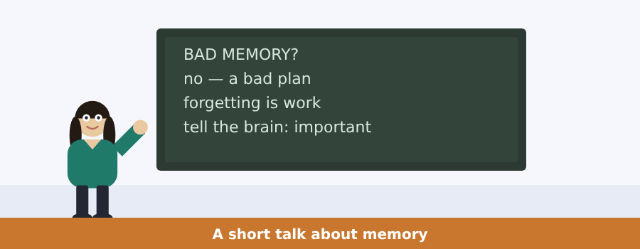
SKILL · A speaker who says you are wrong
- Some talks open with a thing everybody says, and then take it apart.
- The second sentence is usually the turn. Listen for almost nobody.
- What follows the turn is the speaker’s real point.
- Do not write the first sentence down as the answer.

Exercise B Listen and answer. The audio plays once.
3. What does everybody say?
(A) I have a bad memory
(B) I have a bad plan
(C) I forget faces
(D) I have a good brain
4. What do people really have?
(A) a bad memory
(B) a bad brain
(C) a bad plan
(D) a good memory
5. What is forgetting, for this speaker?
(A) a fault in the brain
(B) a bad plan
(C) a habit
(D) the work the brain is doing
6. What is the speaker’s question?
(A) how do I stop forgetting
(B) how do I tell my brain this one is important
(C) how do I keep every face
(D) how do I get a good brain
Audio script: see the back of the book.


Exercise A Listen and choose a response.
1. Why is your hand doing it?
(A) It is a habit.
(B) In my pocket.
(C) Yes, it is.
(D) A message.
2. Is there a message?
(A) My hand.
(B) No, there is not.
(C) A habit.
(D) Yes, I am.
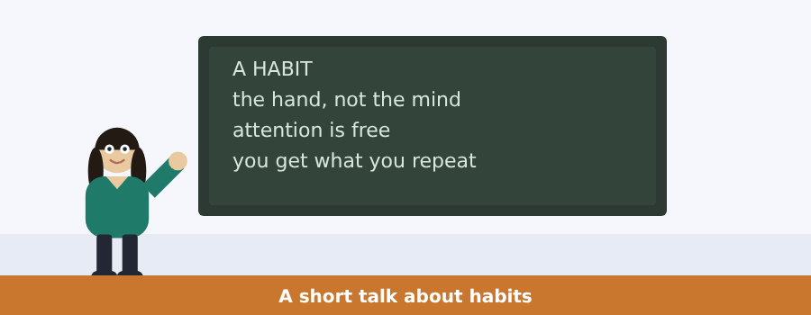
SKILL · A speaker who shows you something
- When a speaker says watch me, a small show is coming.
- The show is the evidence. Say what happens in it.
- The point comes after the show, often as this is ... .
- The last sentence is usually the warning. Keep it.

Exercise B Listen and answer. The audio plays once.
3. What is the speaker doing first?
(A) taking the phone out of his pocket
(B) looking at the phone
(C) putting it back
(D) reading a message
4. Is there a message?
(A) yes
(B) there are two
(C) he does not say
(D) no
5. Where is his mind?
(A) on the phone
(B) in his pocket
(C) somewhere else
(D) on the work
6. What does the brain give you?
(A) the habits you want
(B) a new mind
(C) free attention only
(D) the habits you repeat
Audio script: see the back of the book.


Part 1 · Listen and Repeat
You hear a sentence and repeat it once. There is no preparation time, and the sentences get longer. Focus: the weak /ə/ in am, are and the -ing ending
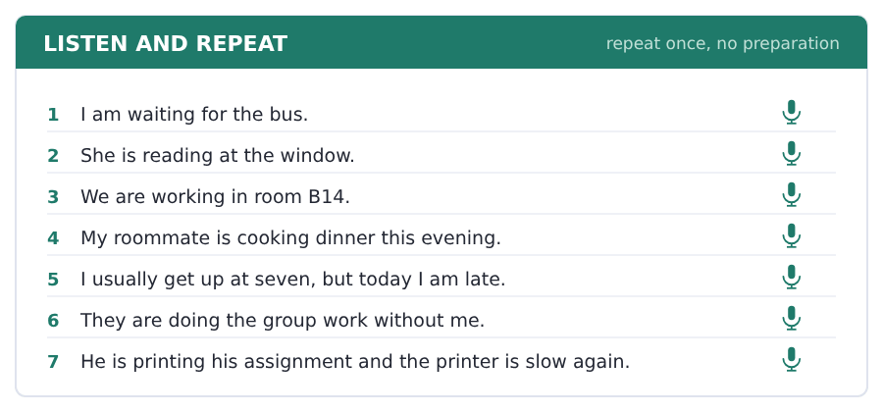
SKILL · Two words, one sound
- I am becomes I’m and you are becomes you’re. Say them joined.
- The -ing ending is /ɪŋ/, not /iːn/. The g is not a hard g.
- The strong word is the verb: I’m WAITing, not I AM waiting.
- If you say every word strongly, you sound like a robot and you run out of time.

Part 2 · Take an Interview
An interviewer asks you four questions on one theme: your normal day. Answer each one fully. There is no preparation time.
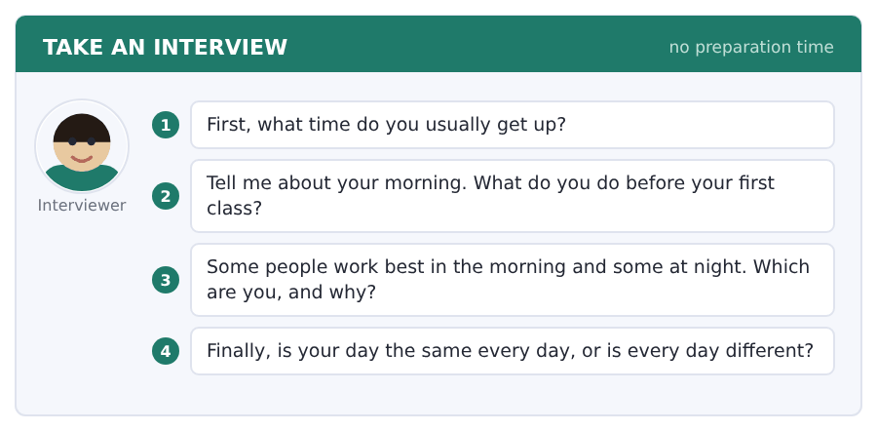
Say it like this
- I usually get up at ... .
- First I ... , then I ... .
- I work best in the ... , because ... .
- My day is ... , because ... .
A good answer sounds like this
Question 1 — I usually get up at half past six, and on Saturday at nine.
Question 2 — First I have a shower, then I make coffee and read my messages. I leave the flat at eight.
Question 3 — I work best at night, because the flat is quiet and nobody writes to me after eleven.
Question 4 — My day is the same from Monday to Thursday, and then Friday is different, because I work in a shop.
I can… | Not yet | Yes
I used is or are with every -ing verb | □ | □
I used the present simple for my routine | □ | □
I gave a reason after my opinion | □ | □


Part 1 · Listen and Repeat
You hear a sentence and repeat it once. There is no preparation time, and the sentences get longer. Focus: linking a word that ends in a consonant to a word that starts with a vowel
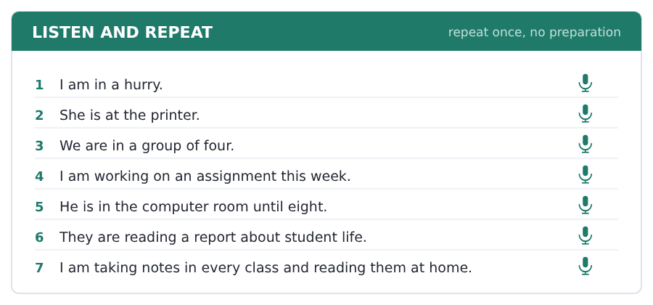
SKILL · Words run together
- Native speakers join the end of one word to the start of the next.
- An hour sounds like a-nour. In a minute sounds like i-na-minute.
- This is why you cannot find the word you know in the sound you hear.
- Practise joining on purpose. It helps your listening as much as your speaking.

Part 2 · Take an Interview
An interviewer asks you four questions on one theme: how you study. Answer each one fully. There is no preparation time.
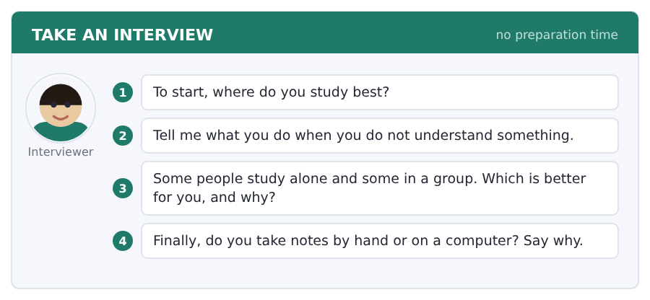
Say it like this
- I study best ... , because ... .
- When I do not understand, I ... .
- I study ... , because ... .
- I take notes ... , because ... .
A good answer sounds like this
Question 1 — I study best in the library, because at home my bed is in the same room as my desk.
Question 2 — When I do not understand, I read the paragraph again out loud. If that does not work I write a question in my notes and ask the tutor.
Question 3 — I study alone, because in a group we talk for twenty minutes and work for ten.
Question 4 — I take notes by hand, because my hand is slow and that makes me choose the important words.
I can… | Not yet | Yes
I joined my words instead of saying them one by one | □ | □
I answered with a reason every time | □ | □
I used a study word from this unit | □ | □


Part 1 · Listen and Repeat
You hear a sentence and repeat it once. There is no preparation time, and the sentences get longer. Focus: sounding interested: the voice goes up and down
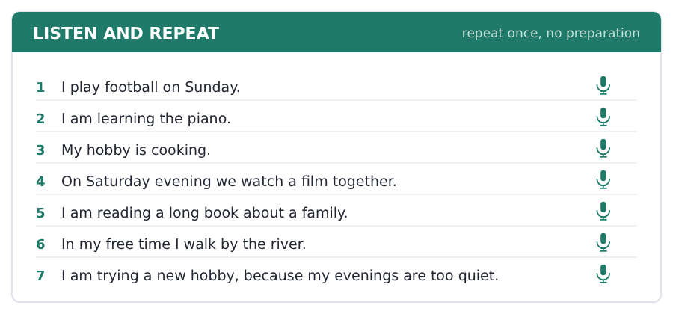
SKILL · Flat is worse than wrong
- A flat voice sounds bored, and a bored answer scores lower.
- Let your voice go up on the important word and down at the end.
- Free-time questions are the easiest place to sound interested.
- A smile changes the sound of your voice, even on a recording.

Part 2 · Take an Interview
An interviewer asks you four questions on one theme: your free time. Answer each one fully. There is no preparation time.
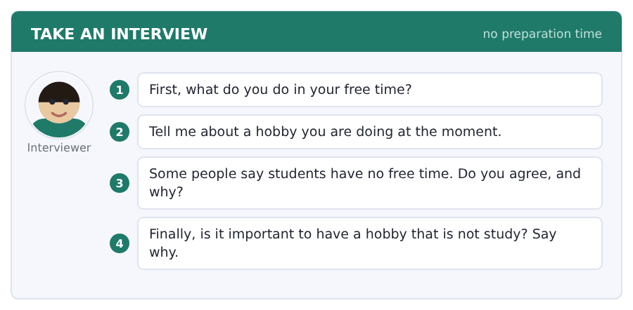
Say it like this
- In my free time I ... .
- At the moment I am ... .
- I ... agree, because ... .
- A hobby is ... , because ... .
A good answer sounds like this
Question 1 — In my free time I play football on Sunday morning and I cook for my roommates in the evening.
Question 2 — At the moment I am learning to play the piano. I am not good yet, but I am playing every day for twenty minutes.
Question 3 — I do not agree. Students have free time, but it is in small pieces and the pieces are easy to lose.
Question 4 — A hobby is important, because it puts a real clock in the week. Everything else moves around it.
I can… | Not yet | Yes
My voice went up and down, not flat | □ | □
I used the present continuous for now | □ | □
I gave an example in every answer | □ | □


Part 1 · Listen and Repeat
You hear a sentence and repeat it once. There is no preparation time, and the sentences get longer. Focus: where the stress falls in a long word
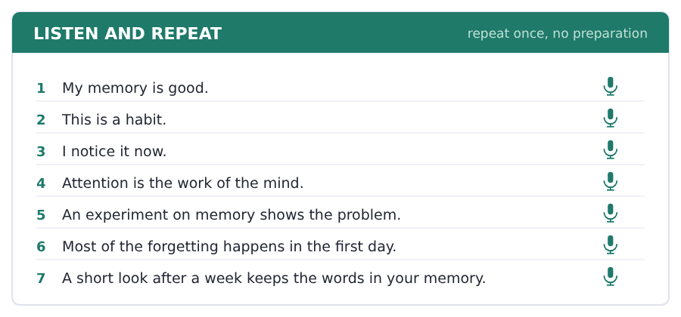
SKILL · MEM-ory, at-TEN-tion
- Every long English word has got one loud part. Find it first.
- MEM-ory and BE-haviour are loud at the front.
- At-TEN-tion and ex-PER-iment are loud in the middle.
- The loud part is where the listener hears the word.

Part 2 · Take an Interview
An interviewer asks you four questions on one theme: how you learn and remember. Answer each one fully. There is no preparation time.
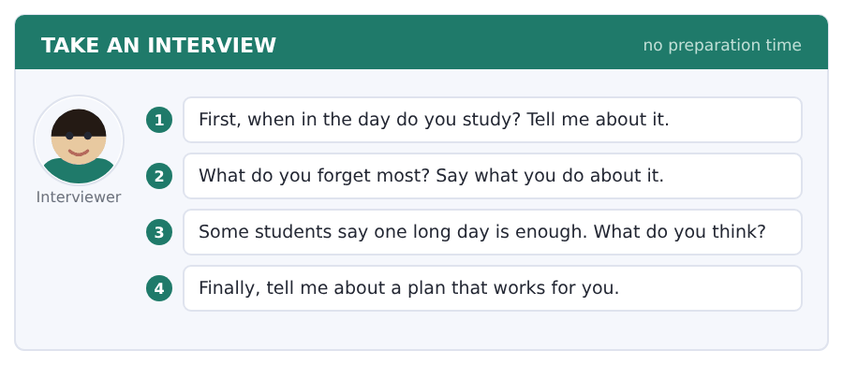
Say it like this
- I study ... , because ... .
- I forget ... , and I think ... .
- My plan is ... .
- For me the best time is ... .
A good answer sounds like this
Question 1 — I study in the morning before work. The house is quiet and my attention is good for about forty minutes.
Question 2 — I forget names. I write a new name down in my phone on the same day and I look at it again on the next day.
Question 3 — I do not think one long day is enough. The passage says most of it goes in the first day, so you need a second day.
Question 4 — My plan is twenty minutes a day with no phone in the room. It is a small habit and I keep it.
I can… | Not yet | Yes
I said the loud part of each long word clearly | □ | □
I used three field words | □ | □
I gave a reason after my opinion | □ | □


Part 1 · Listen and Repeat
You hear a sentence and repeat it once. There is no preparation time, and the sentences get longer. Focus: the quiet /ə/ in the parts nobody stresses
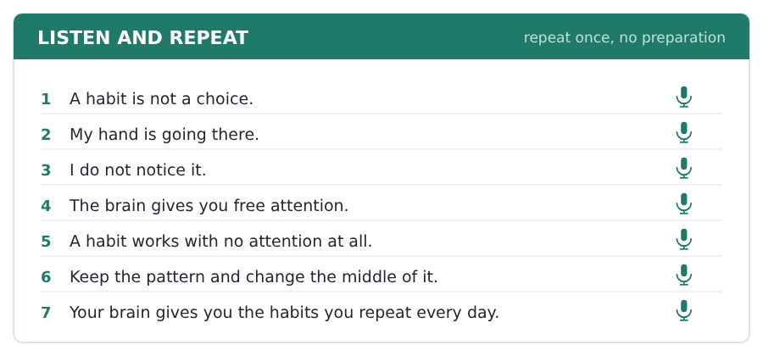
SKILL · The quiet vowel
- The quiet parts of a long word all take the same small sound.
- Say attention: the first part is almost nothing at all.
- This sound is the most common one in English. Do not make it big.
- A big quiet part sounds slow and hard to follow.

Part 2 · Take an Interview
An interviewer asks you four questions on one theme: your own habits. Answer each one fully. There is no preparation time.
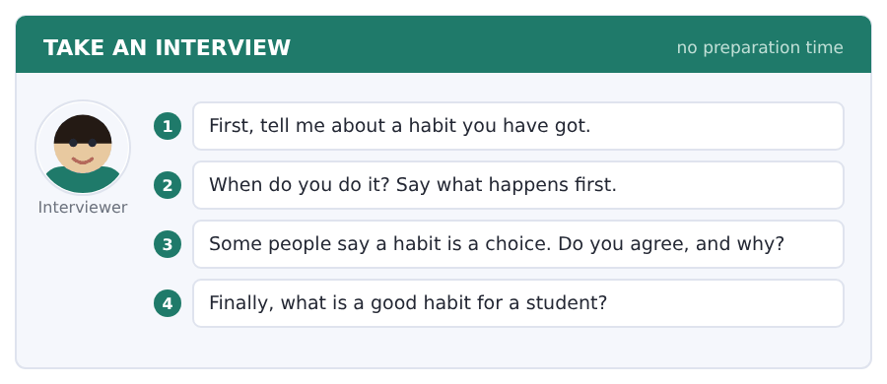
Say it like this
- I have got a habit of ... .
- I do it when ... .
- I want to change ... , because ... .
- A good habit for a student is ... .
A good answer sounds like this
Question 1 — I have got a habit of looking at my phone in bed. I am doing it before I notice it.
Question 2 — I do it when I am tired. My hand goes to the table and then the phone is in my hand.
Question 3 — I do not agree. A choice needs attention, and a habit needs none at all. That is the whole problem with it.
Question 4 — A good habit for a student is a short look again on the next day. It takes ten minutes and it changes everything.
I can… | Not yet | Yes
I kept the quiet parts small and quick | □ | □
I used the present continuous for now | □ | □
I answered all four questions | □ | □


You see a sentence, then a set of words in boxes. Put the words in order to make one grammatical sentence. Almost every item in the real test makes a question or a question inside another sentence.
SKILL · Questions in the present continuous
- Am, is or are goes in front of the person: Are you working?
- The main verb keeps -ing and never changes.
- What are you doing? is the most common question of this kind in the test.
- Do not mix the two: *Are you work?* and *Do you working?* are both wrong.

Exercise A Guided practice. The first three are worked through.
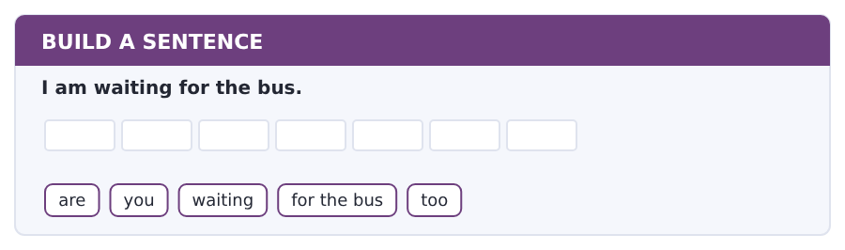
1. Are you waiting for the bus too?
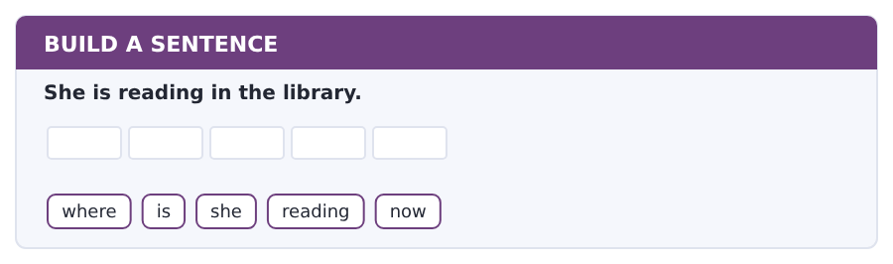
2. Where is she reading now?
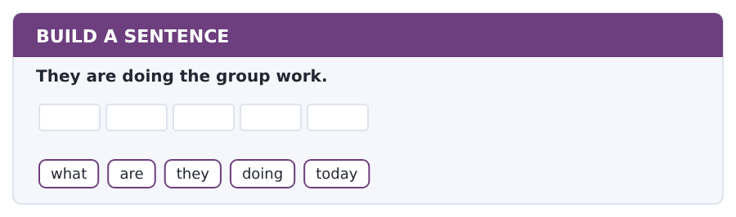
3. What are they doing today?
Exercise B Exam practice. Write the sentence.
4. He is printing his assignment.
what / is / he / printing / now
__________________________________________________________
5. The traffic is bad this morning.
why / are / you / late / today
__________________________________________________________
6. I usually get up at seven.
what time / do / you / get up / on Monday
__________________________________________________________
7. We are working in room B14.
where / are / you / working / today
__________________________________________________________
8. Dr Patel is calling the register.
is / he / calling / the register / now
__________________________________________________________
9. She studies every evening.
does / she / study / here / every evening
__________________________________________________________
10. I am borrowing your notes.
are / you / borrowing / my notes / again
__________________________________________________________


You read a short situation and write an email. You have 7 minutes. The three bullet points are the mark scheme: answer all three.
In the real test you write as much as you can in seven minutes. In this unit, aim for about 58 words. That number goes up in every unit of this book, and in Volume 1 it stops being a number at all.
You are writing Assignment 1 for Dr Patel. The deadline is Friday.
You are ill this week and your work is not ready. Write to Dr Patel.
- say which assignment you mean
- say what the problem is now
- ask for two more days
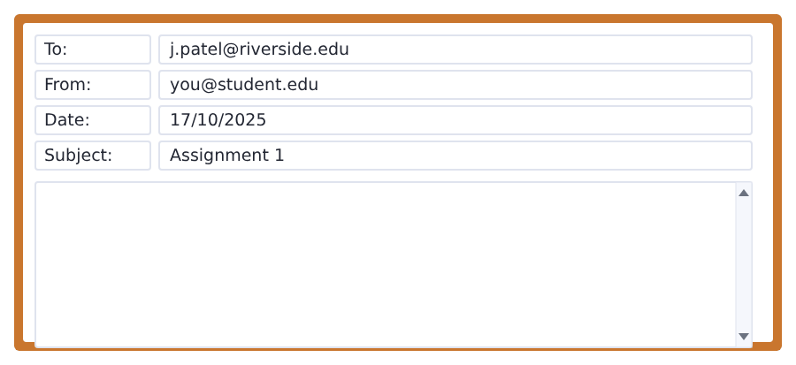
SKILL · Ask for one thing, clearly
- An email that asks for something must say exactly what it asks for.
- Two more days is clear. Some more time is not.
- Give the reason once, in the same sentence as the problem.
- Do not apologise three times. Once is polite; three times is noise.

Model email
Dear Dr Patel,

My name is Ana Ruiz and I am in Group B. I am writing about Assignment 1.
I am ill this week, so my report is not ready for Friday.
Is it possible to give it to you on Sunday, two days late?

Thank you,
Ana Ruiz
Why it works
- The assignment is named in the first short paragraph.
- The problem and the reason are one sentence, joined with so.
- The request is exact: Sunday, two days late. The reader can say yes or no.
- It is short, and short is polite when you are asking for a favour.
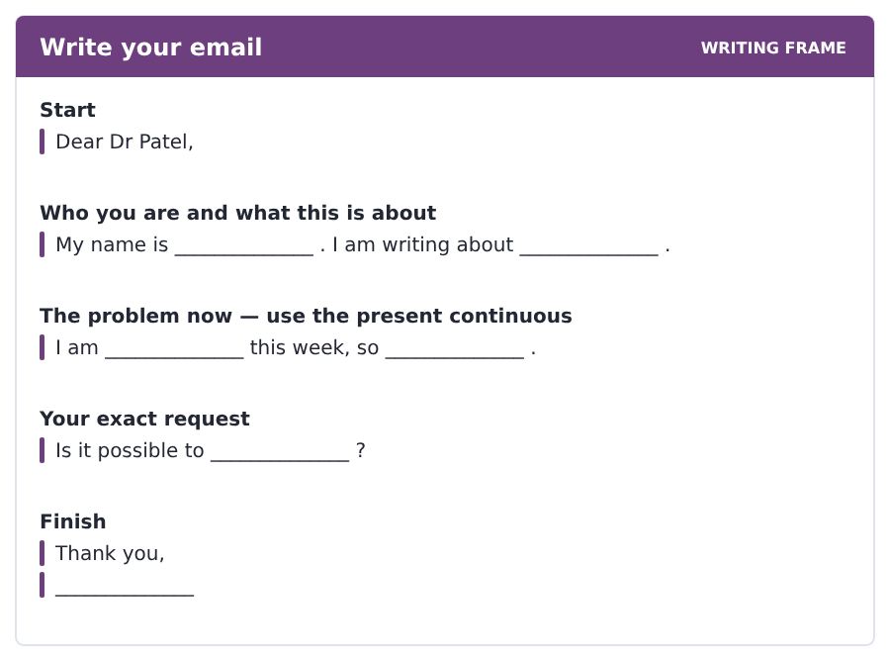
Now write your own. 7 minutes.
__________________________________________________________
__________________________________________________________
__________________________________________________________
__________________________________________________________
__________________________________________________________
__________________________________________________________
__________________________________________________________
__________________________________________________________


A professor asks a question and two students answer. You add your own post. You have 10 minutes and an effective answer is at least 100 words.
One hundred words is what the real test wants, and you will get there. For this unit, write about 60. Every unit of this book asks for a few more.
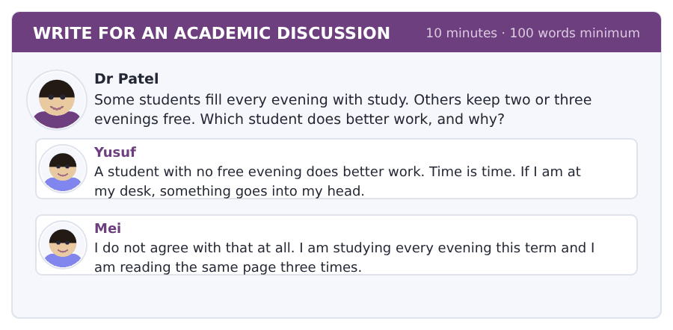
SKILL · Use your own experience
- A post with one real example from your own life is worth three opinions.
- Say what you are doing this term. That is the present continuous.
- Then say what you usually do. That is the present simple.
- Sixty words is five or six short sentences.

Sentence starters
- I agree with Mei, because ...
- This term I am ...
- In my experience ...
- The real problem is ...
Model post
I agree with Mei. A student with no free evening does worse work.
This term I am keeping Wednesday and Sunday free. My notes from the other evenings are clear now, and I am not reading the same page twice.
Yusuf is right that time at a desk matters. But a tired head at a desk is not study. It is sitting, and it feels like work.
[67 words]
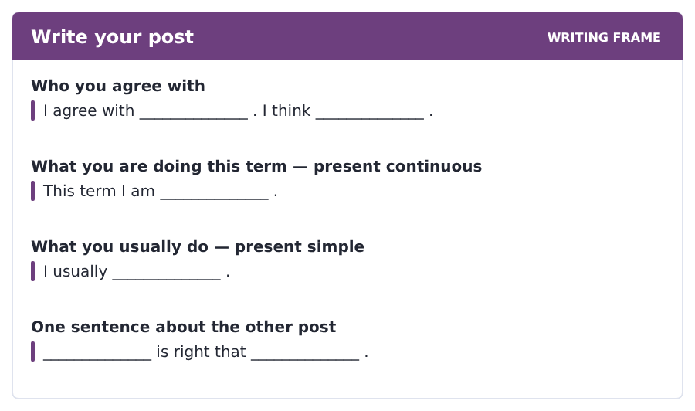
Now write your own. 10 minutes, at least 60 words.
__________________________________________________________
__________________________________________________________
__________________________________________________________
__________________________________________________________
__________________________________________________________
__________________________________________________________
__________________________________________________________
__________________________________________________________
__________________________________________________________
__________________________________________________________


The same task again, on the subject of this unit. The sentences are about people and the mind now, and the word order has not changed at all.
SKILL · Questions in the present continuous
- Put is or are in front of the person, and -ing stays where it is.
- A question word goes first: What is she doing?
- Now, right now and this week all go at the end.
- Never use do with -ing. Is she looking? not Does she looking?

Exercise A Guided practice.
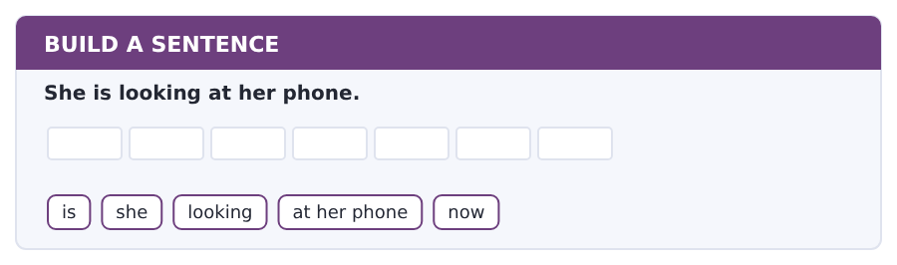
1. Is she looking at her phone now?
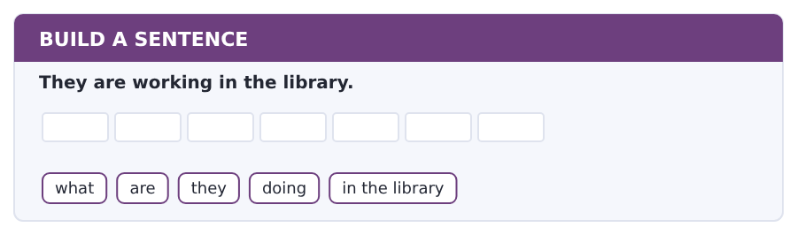
2. What are they doing in the library?
Exercise B Exam practice. Write the sentence.
3. I am changing a habit this week.
are / you / changing / a habit / this week
__________________________________________________________
4. She is forgetting the new words.
why / is / she / forgetting / the new words
__________________________________________________________
5. My hand is going to the phone.
where / is / your hand / going / now
__________________________________________________________
6. The students are reading the page again.
what / are / the students / reading / again
__________________________________________________________


A second discussion, and this one is about the subject rather than about your own week. In the real test both kinds come up, and the second kind is the harder one.
For this unit, write about 60 words. The real test wants a hundred.
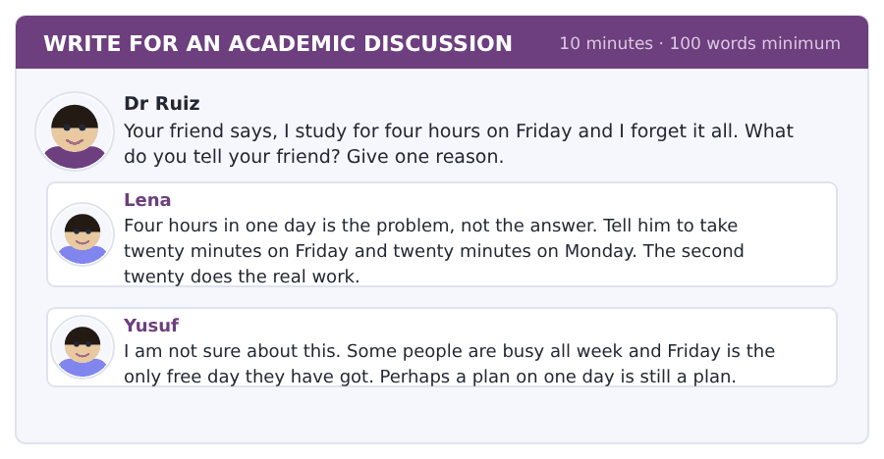
SKILL · Advice with a reason behind it
- Say the advice in one sentence. Then say why it works.
- The why comes from the passage: the first day is where you lose it.
- Yusuf makes a fair point about busy people. Answer it.
- Sixty words is about six short sentences.

Sentence starters
- I agree with Lena, because ...
- Yusuf is right that ...
- The passage says ...
- So I tell my friend to ...
Model post
I agree with Lena. The passage says most of the forgetting happens in the first day.
So four hours on Friday is four hours in the wrong place. Twenty minutes on Monday does more for the memory.
Yusuf is right that some people are busy. But a free day is not the only thing you need. You need two days, and they can be short.
[65 words]
Now write your own. 10 minutes, at least 60 words.
__________________________________________________________
__________________________________________________________
__________________________________________________________
__________________________________________________________
__________________________________________________________
__________________________________________________________
__________________________________________________________
__________________________________________________________
__________________________________________________________
__________________________________________________________

Grammar focus present continuous · present continuous and present simple
Form | Example
am / is / are + -ing | I am waiting. She is reading. They are working.
negative | I am not waiting. He is not working.
question | Are you waiting? What is she reading?
now, at the moment, today | I am reading a long book at the moment.
present simple = routine | I read for an hour every evening.
always, usually, every day | She usually arrives before nine.
spelling | write → writing, sit → sitting, study → studying

The present continuous is for now and for around now. I am learning the guitar is true this month, even if you are not holding it at this second.
The present simple is for the routine and for facts. The two tenses answer two different questions: What are you doing? and What do you do?
A few verbs almost never take -ing: know, want, like, need, understand. You say I know, not *I am knowing*.
Watch out! Never put do or does with an -ing verb, and never leave am, is or are out. *Do you working?* and *You working?* are the two commonest mistakes here, and both of them come from the same missing word.
Exercise 1 Write the present continuous.
1. I __________ (wait) for the bus.
2. She __________ (read) at the window.
3. They __________ (do) the group work.
4. He __________ (not answer) his phone.
5. We __________ (work) in room B14.
6. The printer __________ (not work) again.
Exercise 2 Present simple or present continuous?
1. I __________ (get) up at seven every day.
2. Today she __________ (sit) on the bus at half past nine.
3. My roommate __________ (cook) dinner every Sunday.
4. Listen — somebody __________ (knock) at the door.
5. He __________ (study) in the library at the moment.
6. The college __________ (open) at eight on weekdays.
Exercise 3 Write the -ing form.
1. write
2. sit
3. study
4. come
How this is tested in Build a Sentence
Build a Sentence often gives you is or are and an -ing word. The moment you see both, the question order is fixed: question word, then is or are, then the person, then the -ing word.

Typing and the Screen Typing a whole sentence without looking
The real test is typed. Nobody gives you paper. If you are still looking for the keys, you lose the Writing section before your English does.
You know the three rows now. This week you put them together. The test is not a typing test, but every minute you spend looking for a key is a minute you do not spend thinking.
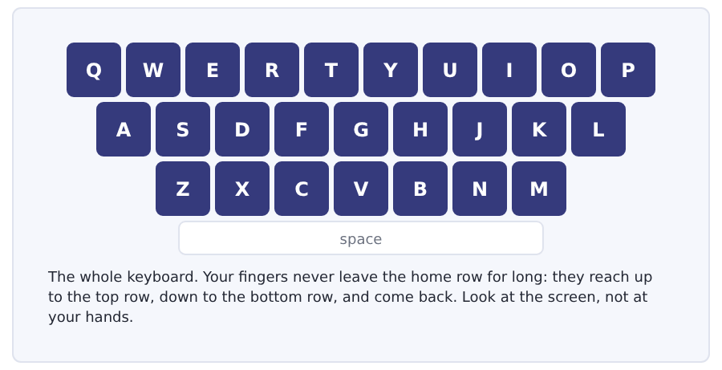
Exercise Type this. Time yourself, then write your speed in the box.
I am waiting for the bus and the traffic is bad.
She is reading at the window in the library.
The printer is not working, so I am going to room B14.
My time _______ seconds
Words a minute _______ (the target for Unit 5 is 12)

Learning to Learn Notes you can actually use
Most students write notes they never read again, and the reason is that the notes are a copy of the lesson. A copy is useless, because you already have the lesson. Useful notes are shorter than the lesson and they have your own questions in them.
- Draw a line down the page one third from the left before the class starts.
- Write the notes on the right. Keep them short: words, not sentences.
- After the class, write your own questions in the narrow left column.
- To review, cover the right side and answer your own questions from the left.
- This takes ten minutes after a class and it turns notes into a test you can sit again and again.
ADAPTIVE TIP Leave a gap when you miss something. Do not stop and do not try to catch up: you will lose the next two minutes as well. Mark the gap and fill it after the class from somebody else’s notes.

Unit review and progress check Unit 5
Exercise A Vocabulary. Write the word.
1. the first food of the day
2. to take a thing and give it back later
3. the secret word that opens your account
4. a piece of work with a deadline
5. reading your notes again before a test
6. to put your work on paper with a machine
7. the short words you write in a class
8. work three or four students do together
9. something you do because you like it
10. needing sleep or rest
11. to come to a place
12. moving your body to stay well
Exercise B Grammar. Complete the sentence.
1. I __________ (wait) for the bus now.
2. She __________ (read) at the window.
3. I __________ (get) up at seven every day.
4. Today she __________ (sit) on the bus.
5. __________ you working in room B14?
6. He __________ not answering his phone.
7. My roommate __________ (cook) every Sunday.
8. What __________ you doing?
Exercise C One timed mini-section. 6 minutes.
1. In room B12 the paper is
(A) not free
(B) free
(C) only for groups
(D) in the library
2. The woman is late because
(A) she is at home
(B) the traffic is terrible
(C) the printer is broken
(D) the class is early
3. Teachers call real study
(A) revision
(B) group work
(C) real study
(D) homework
4. Which sentence is correct?
(A) Are you working now?
(B) Do you working now?
(C) You working now?
(D) Are you work now?
5. Which sentence is correct?
(A) I am knowing the answer.
(B) I am know the answer.
(C) I knowing the answer.
(D) I know the answer.
6. The advice in the talk is
(A) study every evening
(B) put one fixed thing in your week
(C) study in the morning
(D) stop your hobby
Can you do these now?
I can… | Not yet | Yes
say what I am doing now and what I do every day | □ | □
read a short notice about a computer room and find a rule | □ | □
understand a short text about how students really study | □ | □
follow a conversation about a day that is going wrong | □ | □
talk about my routine and my free time | □ | □
write an email about a problem with a deadline | □ | □

ADAPTIVE TIP In Speaking, listen for the tense in the question and answer in the same one. What do you do? wants your routine. What are you doing? wants this week. Answering the wrong one is the fastest way to sound like you did not understand.

Unit 6 · Food, Prices and the Cafeteria
TOEFL iBT® Preparation Course 2026 · Volume F1
CEFR A2 · Grammar: countable and uncountable · some and any · much, many and a lot of · Word field: food, money, meals
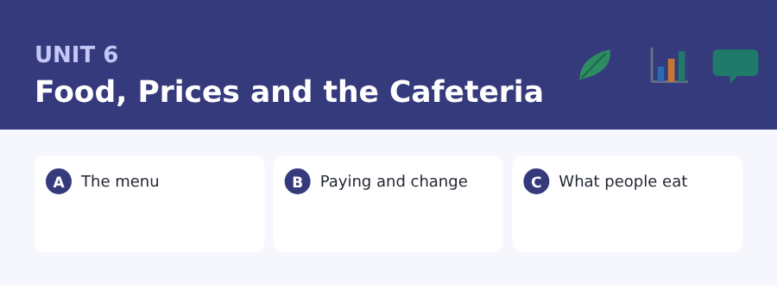
By the end of this unit I can…
- say how much and how many of something there is
- read a menu and work out what a meal costs
- understand a short text about why student food is what it is
- follow a conversation about paying for something
- order food and ask about the price
- write an email about a mistake on a bill

Three sub-topics, three cycles in every skill. Money and food are in every Listening conversation the test has ever written, and both of them turn on one grammar point: can you count it?

Vocabulary 1 · The words you need most 24 words from the two thousand most common words of English
These are not academic words. They are the words that carry ordinary English, and until you own them the academic words of Volume 1 have nothing to stand on. Cover the right-hand column and test yourself.
food what people eat | egg a hen gives you one of these every day
sandwich two pieces of bread with food between them | sugar the white thing that makes food sweet
water the drink with no colour and no taste | salt the white thing that makes food salty
coffee a hot brown drink that keeps you awake | salad cold vegetables eaten together
tea a hot drink made from leaves | dish one kind of cooked food; also the plate it is on
milk the white drink that comes from a cow | fresh new today, not old
bread the food made from flour and baked | price how much money a thing costs
rice small white grains you cook in water | cost to need an amount of money
meat food from an animal | money what you pay with
fish an animal from the water, and the food from it | pay to give money for a thing
fruit apples, bananas and oranges are fruit | change the money you get back when you pay too much
vegetable a plant you cook and eat with the main dish | hungry needing food

Exercise A Work in pairs. Ask and answer.
1. How much fruit do you eat in a normal week?
2. How many cups of coffee or tea do you drink a day?
3. Do you usually pay with cash or with a card?
4. What is a cheap meal in your country?
Vocabulary 2 · Campus and everyday 12 words for student life
Every Listening conversation in the real test happens on a campus. These twelve words come back in this unit and again in Volume 1.
cafeteria a big self-service place to eat | self-service you take the food yourself; nobody brings it
menu the list of food and prices | vending machine a machine that sells drinks and snacks
tray the flat thing you carry your plates on | snack a small amount of food between meals
queue a line of people waiting | portion the amount of food on one plate
till the machine where you pay | cash money as notes and paper, not a card
receipt the small paper that shows what you pay | card reader the machine you put your card on to pay

Words you will meet again: menu | queue | till | receipt | price | cash | portion | vending machine

Sound and Spelling Long and short vowels, and the l at the end
Two sounds decide whether a food word is understood. The first is the length of the vowel: eat and it are different words. The second is the l at the end of a word, which many learners drop without hearing it.
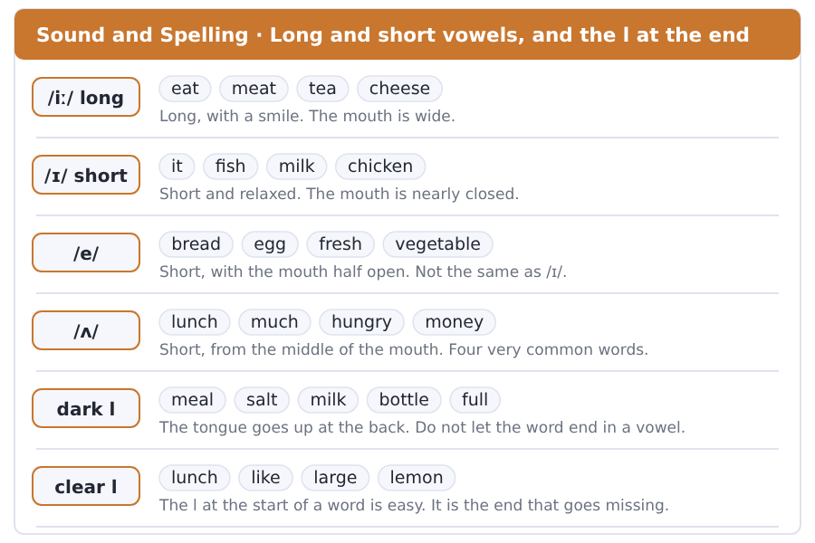
Exercise A Listen. Which word do you hear?
1. Do you hear eat or it?
2. Do you hear meat or mitt?
3. Do you hear bread or bird?
4. Do you hear much or march?
5. Do you hear meal or me?
6. Do you hear full or foo?
Exercise B Say these out loud. Record yourself if you can.
1. Say the pairs: eat/it, meat/mitt, bean/bin, sheep/ship.
2. Say with a strong end: meal, salt, milk, bottle, full, small.
3. Say these prices: 1.10, 2.20, 3.50, 0.90.
4. Order a meal out loud: a hot dish, a bottle of water, and a fruit.


SKILL · Plurals you can count
- Countable words take a plural -s: two egg-, three snack-.
- Uncountable words never do: rice, bread, water, money.
- If the word in front is a number, the word needs its -s.
- Words ending in -y take -ies: one portion of berr---.

Exercise A Guided practice. Five words are not complete. Write the missing letters.
The cafeteria sell- four kind- of sandwich today. There are also two soup- and three salad-. Most student- take a tray and queue at the till.

The first one is done for you: 1 sell- → s (sells)
Exercise B Exam practice. One paragraph, ten gaps — the real task.
The Riverside cafeteria open- at eight and close- at six. In the morning it sell- coffee, tea and egg- with bread. At lunch there are three hot dish-- and a long table of salad-. A small portion cost- two pounds and a large one cost- three. Students with a cash card pay- less, because the college give- ten per cent back every month.

Check your answers in the key at the back of the book.


SKILL · Add the numbers yourself
- A menu question often asks for a total, not a price.
- Write the numbers down the side of the page and add them once.
- Watch for with and without. They change the price.
- An offer for students is always in the small print. Read it.

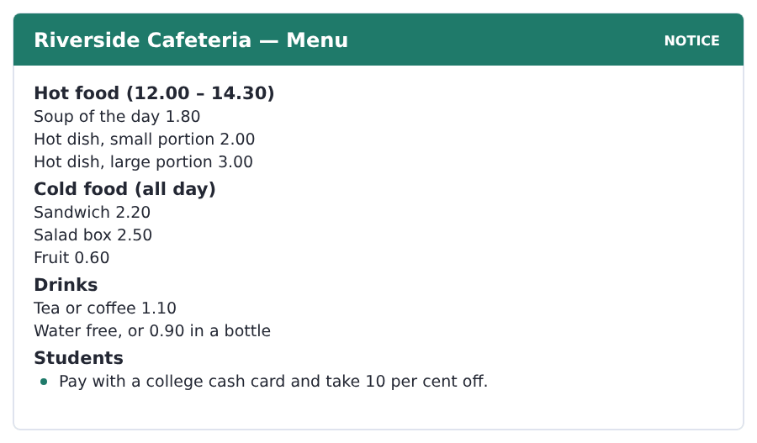
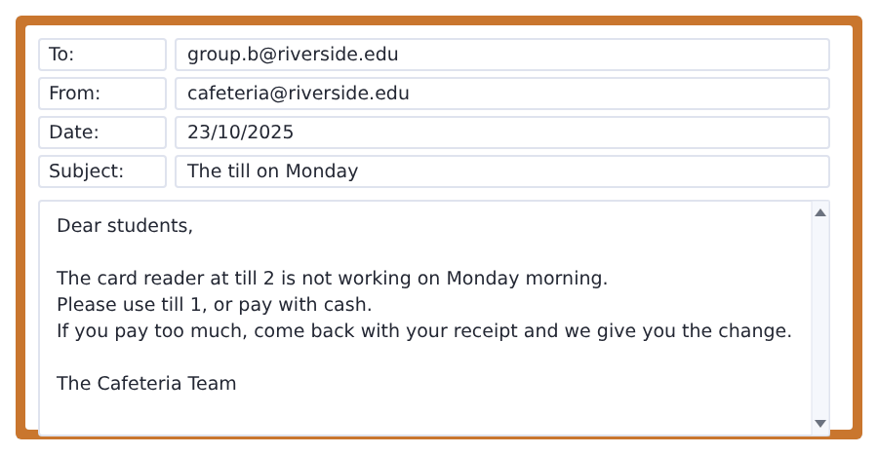
Exercise A Guided practice. The answer is on the page — find it.
1. How much is a sandwich?
(A) 1.80
(B) 2.00
(C) 2.50
(D) 2.20
2. When can you buy hot food?
(A) all day
(B) 8.00 – 18.00
(C) 12.00 – 14.30
(D) only in the morning
3. How much is free water?
(A) free
(B) 0.60
(C) 0.90
(D) 1.10
4. Which till is not working on Monday?
(A) till 1
(B) till 2
(C) both tills
(D) the vending machine
Exercise B Exam practice.
5. A soup and a coffee cost
(A) 2.20
(B) 3.10
(C) 2.90
(D) 3.30
6. A large hot dish and a fruit cost
(A) 3.00
(B) 3.60
(C) 3.80
(D) 4.10
7. What do students with a cash card get?
(A) free water
(B) a free fruit
(C) a large portion
(D) 10 per cent off
8. What is the difference between a small and a large hot dish?
(A) 1.00
(B) 0.50
(C) 1.20
(D) 2.00
9. What do students do on Monday morning?
(A) use till 1 or pay with cash
(B) wait
(C) go to the vending machine
(D) eat outside
10. What do you need if you pay too much?
(A) your card
(B) your student number
(C) a tray
(D) your receipt


SKILL · Facts, then the reason, then the turn
- A three-paragraph text often runs: what happens, why it happens, what people get wrong about it.
- The word but near the end marks the turn.
- Numbers in the last paragraph are usually the writer’s evidence.
- A question about the writer’s opinion belongs to the last paragraph.

Why Student Food Is What It Is
Walk into any student cafeteria and you find the same four things. There is rice or there is bread. There is one hot dish with meat and one without. There is a table of salad. There is a machine with cold drinks in it.
The reason is money, and the reason is also time. A cafeteria has forty minutes to feed six hundred people. Rice and bread are cheap, they keep, and they fill a person up. A salad table needs no cook at all.
Students say bad things about this food, and they are right about the taste. But they are often wrong about the price. A hot dish in the cafeteria costs two pounds. The same food from a shop near the college costs four. The shop also gives you less food, in a box you throw away. A cafeteria is many things, and one of them is cheap.
[151 words]

Exercise A Guided practice.
1. How many things are in every student cafeteria?
(A) two
(B) four
(C) three
(D) six
2. What are the two reasons?
(A) taste and health
(B) money and taste
(C) money and time
(D) time and space
3. How long does a cafeteria have?
(A) forty minutes
(B) fourteen minutes
(C) four hours
(D) six hours
4. How many people does it feed?
(A) sixty
(B) forty
(C) six hundred
(D) four hundred
Exercise B Exam practice.
5. Why are rice and bread on every menu?
(A) students like them
(B) they are fresh
(C) they need a cook
(D) they are cheap and they fill a person up
6. What needs no cook?
(A) the hot dish
(B) the salad table
(C) the bread
(D) the machine
7. Students are right about
(A) the price
(B) the taste
(C) the portion
(D) the time
8. Students are often wrong about
(A) the taste
(B) the cook
(C) the price
(D) the salad
9. A hot dish in a shop near the college costs
(A) four pounds
(B) two pounds
(C) three pounds
(D) six pounds
10. What else does the shop give you?
(A) more food
(B) a free drink
(C) a receipt
(D) less food, in a box
11. What is the writer’s point in the last paragraph?
(A) The food tastes bad.
(B) Shops are better.
(C) The cafeteria is cheap for what it is.
(D) Students should cook.

The field: Work, Trade and Money Two more cycles in every skill, on one subject
Everything up to here was about your own life, because that is where a language starts. From this page the same unit turns to a subject, and the subject is one Volume 1 will take up properly: why people use money at all, and what a price is really telling you.
trade to give a thing and take another thing | market a place where people buy and sell
exchange one trade: you give and you take | business the work of buying and selling
demand how much of a thing people want | tax money a government takes from pay or from goods
supply how much of a thing there is to buy | customer the person buying a thing
worker a person with a job | value what a thing is good for
goods things people buy and sell | profit the money a business keeps at the end


SKILL · A problem, then the answer to it
- Many passages in this field show you a problem first.
- The problem is usually a small story with two or three people in it.
- The answer comes in the last part. Find the word that names it.
- A question with why often wants the problem, not the answer.

Three People and No Trade
You make bread and I make shoes. You want shoes and I want bread. So we trade, and we are both happy. This is the easy case, and it does not happen often.
Usually it is not like this. You make bread and you want a window for your shop. The man with the windows wants no bread at all. He wants a chair. Now there are three people and nobody can trade.
Money is the answer, and it is a very old answer. The man with the windows takes money for a window, because he knows the man with the chairs takes money too. Money is not the thing people want. It is the middle step between two things they want. An exchange with money in the middle is easy.
[131 words]

Exercise A Guided practice.
1. What do you make in the first part?
(A) shoes
(B) windows
(C) chairs
(D) bread
2. Why are you both happy?
(A) each one wants what the other makes
(B) there is no money
(C) the bread is free
(D) there are three people
3. How often does the easy case happen?
(A) every day
(B) not often
(C) in every market
(D) never
Exercise B Exam practice.
4. What does the man with the windows want?
(A) a chair
(B) bread
(C) shoes
(D) money only
5. How many people are in the problem?
(A) one
(B) two
(C) four
(D) three
6. Why does the window man take money?
(A) he wants money
(B) he wants bread
(C) he knows the chair man takes money too
(D) he has got no windows
7. What is money, for this writer?
(A) a thing people want
(B) the middle step between two things
(C) a kind of goods
(D) a price


SKILL · One idea, three examples
- When a writer says a thing is really something else, keep both words.
- Here a price is really a message. Everything after that is evidence.
- Count the examples. A question may ask you for one of them.
- The last part usually says why the idea matters.

The Number That Knows Things
A price looks like a number on a thing. It is really a message, and it is a message about the whole world.
Think about coffee. If the rain does not come in Brazil, the supply of coffee in the market is very small. But the demand is the same: people still want their cup in the morning. So the price goes up. A customer in another country sees the new price and buys tea this week. Nobody tells her about the rain. The price tells her.
That is why people in the field say a price carries news. A business with no prices has no idea what people want. The price is the only message that gets from a customer to a worker on the other side of the world.
[131 words]

Exercise A Guided practice.
1. What does a price look like?
(A) a message
(B) a market
(C) a number on a thing
(D) a customer
2. What is a price really?
(A) a number
(B) a cost
(C) a profit
(D) a message about the whole world
3. What happens if the rain does not come in Brazil?
(A) the supply goes up
(B) the supply of coffee is very small
(C) the price goes down
(D) nobody buys tea
Exercise B Exam practice.
4. What does the customer buy this week?
(A) tea
(B) coffee
(C) rain
(D) nothing
5. Who tells her about the rain?
(A) a worker
(B) a business
(C) the market
(D) nobody
6. What is true about a business with no prices?
(A) it has no idea what people want
(B) it makes a good profit
(C) it has many customers
(D) it sends the news
7. What does the price get from a customer to a worker?
(A) money
(B) a message
(C) goods
(D) coffee

Sentence Builder A and the, and when a word needs neither
Three choices face you in front of almost every noun in English: a, the, or nothing. Use a for one of many, the first time. Use the when both people know which one. Use nothing for uncountable things and for plurals in general.
Not a sentence | A sentence
I want a rice. | I want some rice.
The students like a cheap food. | Students like cheap food.
I buy bread at shop. | I buy bread at the shop.
Can I have water, please? | Can I have some water, please?
She eats a fruit every day. | She eats fruit every day.

Watch out! Talking about things in general needs no article at all: Students like cheap food. Putting the in front of it narrows it to one particular group, and that is a different sentence.
Exercise A Is it a sentence? Write yes or no. If no, put it right.
1. I want a bread.
2. He drinks a coffee every morning.
3. Money is important for student.
4. Can I have a water?
5. The cafeteria opens at eight.
6. I eat sandwich at one.


Exercise A Listen and choose a response. You hear one line. Choose the best reply.
1. How much is that, all together?
(A) At the till.
(B) Yes, it is.
(C) Four pounds twenty.
(D) Two trays.
2. Can I pay with a card?
(A) In the queue.
(B) Yes, of course.
(C) Three salads.
(D) At one o’clock.
3. Have you got any change?
(A) Yes, here you are.
(B) In the cafeteria.
(C) It is hot.
(D) At the till.
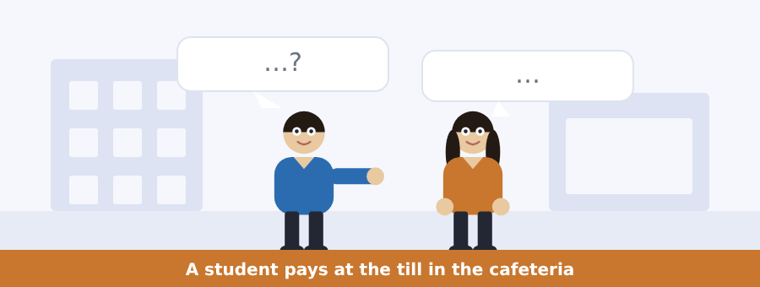
SKILL · Hold the running total
- In a shop conversation the numbers come one at a time and then all together.
- Write each one down. The last number is almost always the total.
- Listen for all together, that comes to and that is.
- The change is the money back, not the money paid. Two different numbers.

Exercise B Listen and answer. The audio plays once.
4. What does the man buy?
(A) a sandwich and tea
(B) a salad and fruit
(C) a large hot dish and water
(D) a small hot dish and coffee
5. How much is it before the ten per cent?
(A) 3.00
(B) 3.50
(C) 4.00
(D) 3.90
6. How much is the water?
(A) free
(B) 0.60
(C) 1.10
(D) 0.90
7. How much does he pay with the card?
(A) 3.00
(B) 3.50
(C) 3.90
(D) 4.00
8. Why does he want a receipt?
(A) to pay with a card
(B) the food is cold
(C) the till sometimes takes too much
(D) he wants a card
9. What does the woman need to give money back?
(A) the paper
(B) the card
(C) the tray
(D) the student number
Audio script: see the back of the book. Do not read it before you listen.


Exercise A Listen and choose a response. You hear one line. Choose the best reply.
1. Is there any hot food today?
(A) At the till.
(B) Two pounds.
(C) Yes, I am.
(D) No, there is not.
2. How many sandwiches are there?
(A) At two o’clock.
(B) Yes, there are.
(C) About forty.
(D) In the queue.
3. Sorry for the trouble.
(A) In the cafeteria.
(B) That is all right.
(C) Three pounds.
(D) At the till.
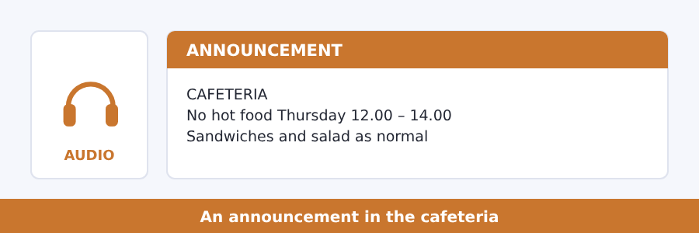
SKILL · What is off and what is still on
- An announcement about food usually takes one thing away and leaves the rest.
- The things that stay are as important as the thing that goes.
- Listen for as normal, still and instead.
- An apology at the end is not information. Ignore it.

Exercise B Listen and answer. The audio plays once.
4. What is not there on Thursday?
(A) hot food between twelve and two
(B) sandwiches
(C) drinks
(D) fruit
5. Why not?
(A) no cook
(B) there is no food
(C) the cafeteria is closed
(D) the big cooker is not working
6. What is there as normal?
(A) hot dishes
(B) soup
(C) sandwiches, salad and fruit
(D) nothing
7. What does the speaker say about the queue?
(A) it is long
(B) there is no queue for the cold food
(C) it is at till 2
(D) it starts at twelve
8. What does the speaker call Thursday?
(A) the fastest day of the week
(B) the worst day
(C) a free day
(D) the busiest day
Audio script: see the back of the book. Do not read it before you listen.


Exercise A Listen and choose a response. You hear one line. Choose the best reply.
1. How many meals do you eat a day?
(A) At the cafeteria.
(B) Yes, I do.
(C) Three.
(D) With rice.
2. Is there much rice in your food at home?
(A) At seven.
(B) Two plates.
(C) In the shop.
(D) Yes, a lot.
3. Do you eat any meat?
(A) No, I do not.
(B) In the evening.
(C) Three pounds.
(D) At the till.
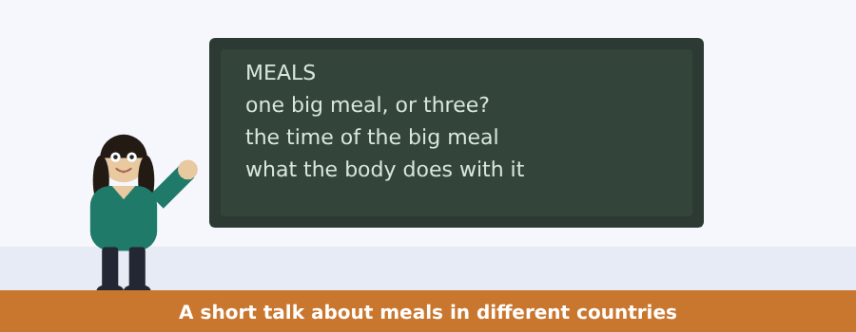
SKILL · Compare without the word compare
- A talk about countries moves from one to another with in, here and there.
- Each example usually gets one or two sentences only.
- The speaker’s point comes after all the examples, not before.
- A question about all countries wants the point, not an example.

Exercise B Listen and answer. The audio plays once.
4. What is the talk about?
(A) prices
(B) the time of the big meal
(C) cooking
(D) cafeterias
5. In Spain the big meal is
(A) in the morning
(B) in the evening
(C) in the middle of the day
(D) at night
6. In Britain it is
(A) the same as Spain
(B) the other way round
(C) in the middle of the day
(D) with rice
7. In many countries in Asia there is rice
(A) at every meal
(B) only at dinner
(C) never at breakfast
(D) only on Sunday
8. What does the speaker say about right and wrong?
(A) one way is right
(B) rice is best
(C) Spain is right
(D) none of it is right or wrong
9. Why does it matter for a student in a new country?
(A) food costs money
(B) the body keeps the old clock for about a month
(C) the cafeteria is closed
(D) rice is cheap
Audio script: see the back of the book. Do not read it before you listen.


Exercise A Listen and choose a response.
1. Why do we use money?
(A) Because trade without it is hard work.
(B) In the market.
(C) Yes, we do.
(D) Three steps.
2. How many steps does money cut it to?
(A) In the market.
(B) Yes, it does.
(C) A chair.
(D) One.
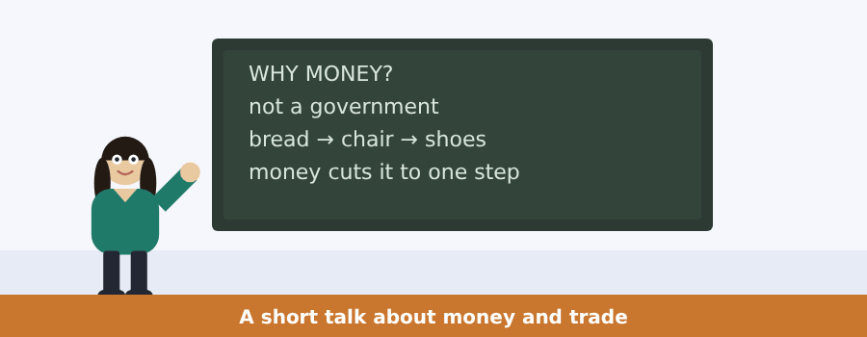
SKILL · A question the speaker answers himself
- A talk that opens with why often answers in the next sentence.
- Listen for not because ... . The speaker is clearing the wrong answer.
- The right answer comes straight after it.
- The small story in the middle is there to prove the answer.

Exercise B Listen and answer. The audio plays once.
3. What is the wrong answer to the question?
(A) trade is hard work
(B) money cuts steps
(C) a government makes money
(D) there are millions of prices
4. What does the bread man want?
(A) bread
(B) shoes
(C) money
(D) a chair
5. How far are you from your bread?
(A) one step
(B) three steps
(C) two steps
(D) four steps
6. What is every price in the market?
(A) a government
(B) a kind of bread
(C) one of those small steps
(D) hard work
Audio script: see the back of the book.


Exercise A Listen and choose a response.
1. How much is a cup of coffee?
(A) It is two pounds fifty.
(B) In the canteen.
(C) Yes, it is.
(D) A number.
2. Who writes it all down?
(A) In Brazil.
(B) A number.
(C) Yes, they do.
(D) Nobody does.
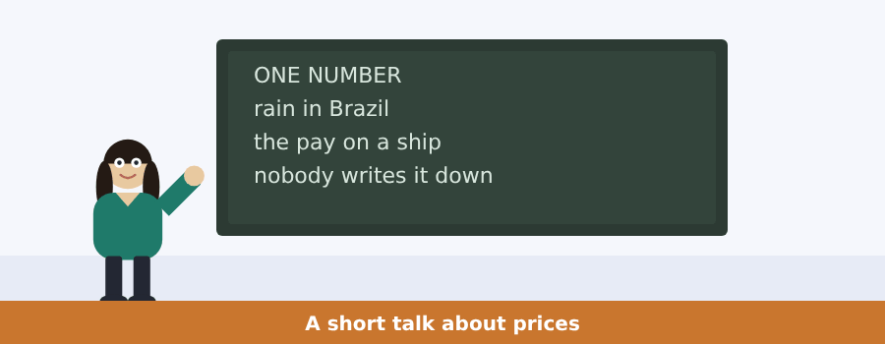
SKILL · A speaker who points at one thing
- When a speaker says look at one number, that number is the whole talk.
- What follows is a list of the things the number knows.
- Write the list. Three or four short notes are enough.
- The last sentence is the point. Do not miss it.

Exercise B Listen and answer. The audio plays once.
3. What number does the speaker point at?
(A) the pay on a ship
(B) the price of a cup of coffee
(C) the rain in Brazil
(D) the number of students
4. What does the number know about Brazil?
(A) how much rain falls there
(B) how many people live there
(C) what the pay is there
(D) how much coffee costs there
5. What does a worker on a ship get?
(A) coffee
(B) a cup
(C) pay for an hour
(D) a price
6. What does nobody do?
(A) write all of that down
(B) drink the coffee
(C) pay the price
(D) work on a ship
Audio script: see the back of the book.


Part 1 · Listen and Repeat
You hear a sentence and repeat it once. There is no preparation time, and the sentences get longer. Focus: the sounds in food words: /iː/, /ɪ/ and /e/
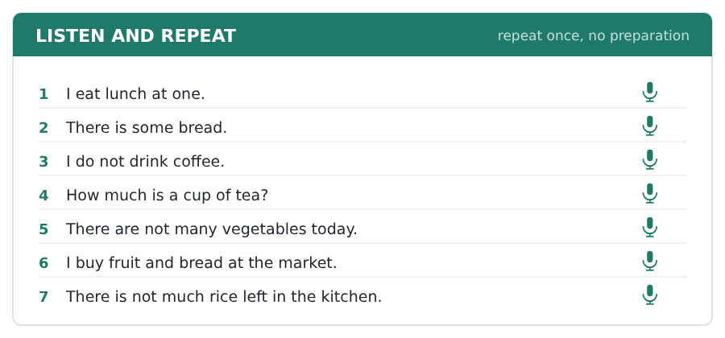
SKILL · Three short sounds
- Eat and it are not the same vowel. Eat is long, it is short.
- Bread and bed hold the short /e/. Beard does not.
- A wrong vowel in a food word is the fastest way to be misunderstood.
- Say the pair: eat / it, meat / mitt, bean / bin.

Part 2 · Take an Interview
An interviewer asks you four questions on one theme: food and meals. Answer each one fully. There is no preparation time.
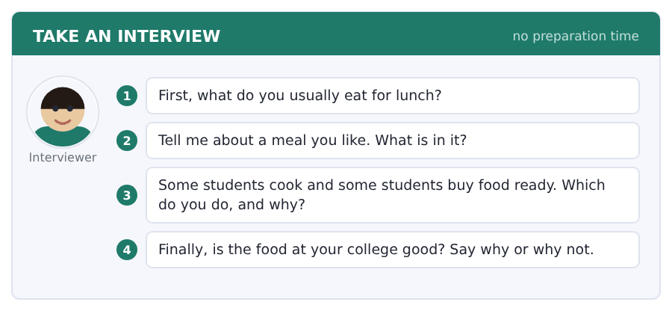
Say it like this
- For lunch I usually eat ... .
- I like ... . There is ... in it and some ... .
- I ... , because ... .
- The food at my college is ... , because ... .
A good answer sounds like this
Question 1 — For lunch I usually eat a sandwich and some fruit. On a cold day I take the soup.
Question 2 — I like the rice dish my mother cooks. There is chicken in it and some vegetables, and a lot of salt.
Question 3 — I cook, because it is cheap and because I know what is in the food.
Question 4 — The food at my college is not bad, because the portions are big. But there is not much fresh fruit.
I can… | Not yet | Yes
I used much with uncountable words and many with countable ones | □ | □
I said a long vowel in eat, meat and tea | □ | □
I gave a reason after my opinion | □ | □


Part 1 · Listen and Repeat
You hear a sentence and repeat it once. There is no preparation time, and the sentences get longer. Focus: saying prices out loud
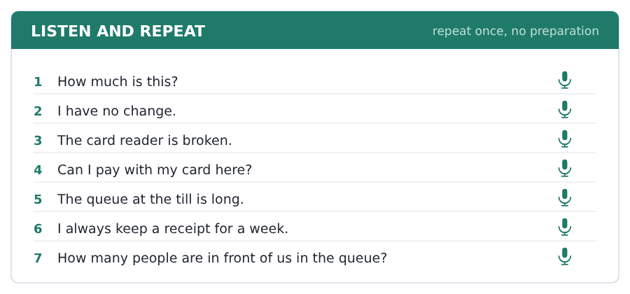
SKILL · Prices have their own rhythm
- Three pounds fifty is normally said three fifty.
- The pence part is a number, not a word: ninety, not ninety pence.
- When you are not sure, repeat the number back: three fifty, yes?
- Say the big part strongly and the small part fast.

Part 2 · Take an Interview
An interviewer asks you four questions on one theme: money and paying. Answer each one fully. There is no preparation time.
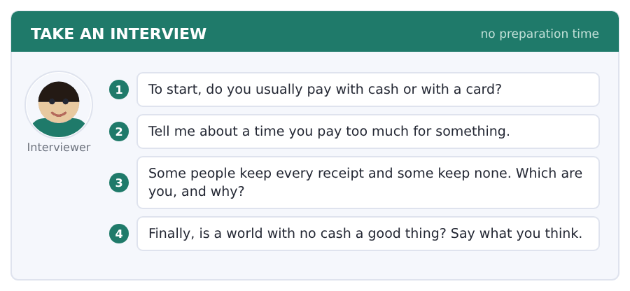
Say it like this
- I usually pay with ... , because ... .
- Once I pay ... for ... . It is ... .
- I keep ... , because ... .
- A world with no cash is ... , because ... .
A good answer sounds like this
Question 1 — I usually pay with a card, because in the cafeteria a card is ten per cent cheap for students.
Question 2 — Once I pay four pounds for a bottle of water at a station. There is free water in the next room.
Question 3 — I keep every receipt for a month, because the till is wrong about twice a year and then the paper is the only thing that helps.
Question 4 — A world with no cash is not a good thing for everybody, because some old people have no card and no phone.
I can… | Not yet | Yes
I said the prices clearly, big part first | □ | □
I used a money word from this unit in every answer | □ | □
I answered all four questions | □ | □


Part 1 · Listen and Repeat
You hear a sentence and repeat it once. There is no preparation time, and the sentences get longer. Focus: the /l/ at the end of a word
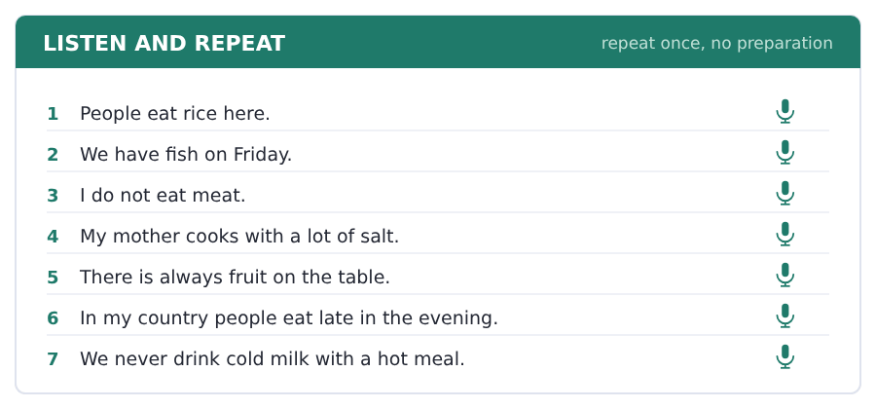
SKILL · Dark and clear l
- The l in like is at the front of the mouth. The l in meal is at the back.
- Many learners drop the end l: meaw, salad bow. Keep the tongue up.
- Words that matter here: meal, salt, milk, bottle, full, small.
- Say the word, then the word plus a vowel: meal, a meal-at-one.

Part 2 · Take an Interview
An interviewer asks you four questions on one theme: food in your country. Answer each one fully. There is no preparation time.
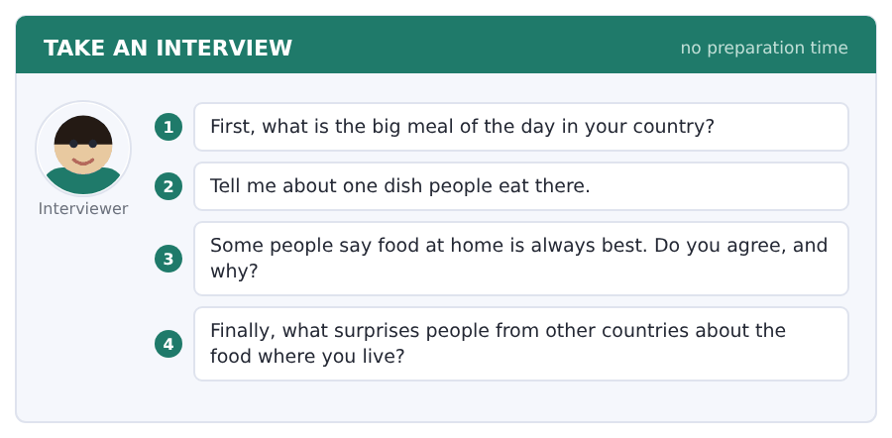
Say it like this
- In my country the big meal is ... .
- One dish is ... . There is ... in it.
- I ... agree, because ... .
- People are surprised that ... .
A good answer sounds like this
Question 1 — In my country the big meal is in the middle of the day, and the evening meal is small and late.
Question 2 — One dish is a soup with fish and rice. There is a lot of salt in it, and people eat it with bread.
Question 3 — I agree, but not because of the cooking. Food at home is best because of the people at the table.
Question 4 — People are surprised that we eat at ten in the evening. For them that is the middle of the night.
I can… | Not yet | Yes
I kept the l sound at the end of meal, salt and milk | □ | □
I used some and any correctly | □ | □
I gave an example, not only an opinion | □ | □


Part 1 · Listen and Repeat
You hear a sentence and repeat it once. There is no preparation time, and the sentences get longer. Focus: the three sounds of the plural -s
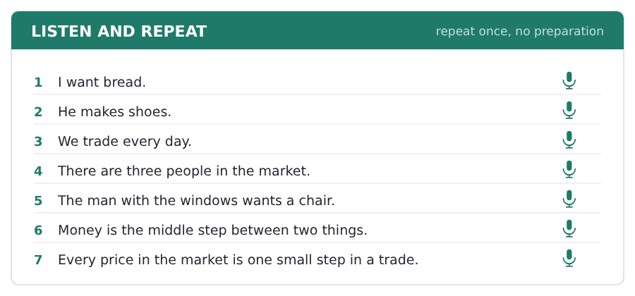
SKILL · Markets, wages, businesses
- After a quiet sound the -s is /s/: markets, shops, prices.
- After a loud sound the -s is /z/: wages, chairs, goods.
- After s, sh or ch the -s is a whole part: businesses, prices.
- A missing -s makes a listener count wrong.

Part 2 · Take an Interview
An interviewer asks you four questions on one theme: work and money in your country. Answer each one fully. There is no preparation time.
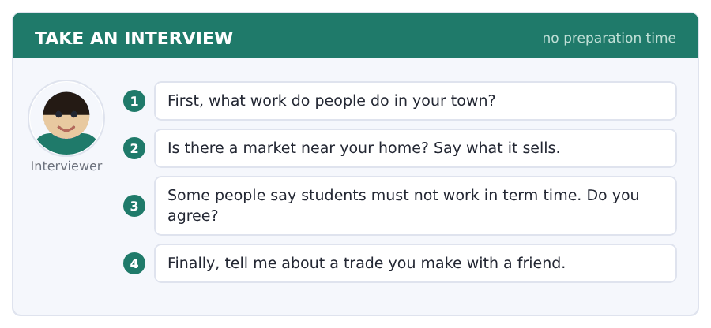
Say it like this
- In my town people work in ... .
- A good pay for an hour is about ... .
- I think ... , because ... .
- The market near my home sells ... .
A good answer sounds like this
Question 1 — In my town people work in two big factories and in the shops in the middle of it.
Question 2 — There is a market on Friday. It sells food, fish and cheap clothes, and the prices are very good.
Question 3 — I do not agree. Many students need the money, and they pay no tax on eight hours a week.
Question 4 — I make a trade with my friend every week. I help him with English and he drives me to the college.
I can… | Not yet | Yes
I said every plural -s | □ | □
I used three field words | □ | □
I gave a reason after my opinion | □ | □


Part 1 · Listen and Repeat
You hear a sentence and repeat it once. There is no preparation time, and the sentences get longer. Focus: saying a price out loud
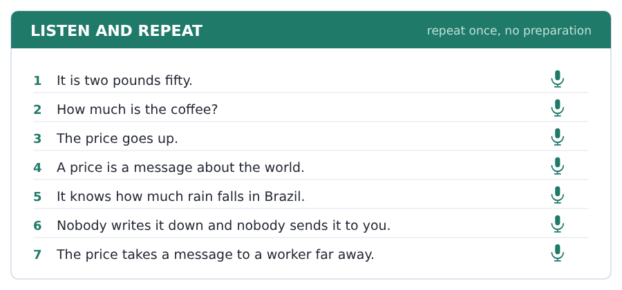
SKILL · Two pounds fifty
- English says the big part, then the small part: four pounds twenty.
- The loud part is the number, not the money word.
- For a round price people say pounds and stop: twelve pounds.
- Say it slowly. A price is the one thing nobody wants to hear twice.

Part 2 · Take an Interview
An interviewer asks you four questions on one theme: prices and what you buy. Answer each one fully. There is no preparation time.
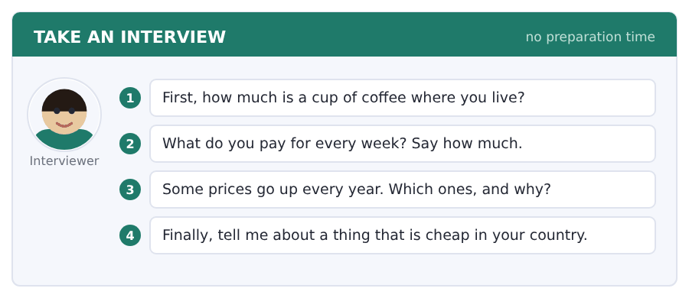
Say it like this
- A cup of coffee costs about ... .
- I pay ... for ... every week.
- The price of ... is ... in my country.
- I think ... is cheap, because ... .
A good answer sounds like this
Question 1 — A cup of coffee is about two pounds twenty in my town, and it is three pounds in the city.
Question 2 — I pay nine pounds a week for the bus and about thirty pounds for food.
Question 3 — The price of a room goes up every year, because there are many students and not many rooms.
Question 4 — Food is very cheap in my country. Two people eat very well for ten pounds.
I can… | Not yet | Yes
I said the prices clearly and slowly | □ | □
I used how much correctly | □ | □
I answered all four questions | □ | □


You see a sentence, then a set of words in boxes. Put the words in order to make one grammatical sentence. Almost every item in the real test makes a question or a question inside another sentence.
SKILL · How much and how many
- How much goes with things you cannot count: money, rice, water.
- How many goes with things you can count: eggs, people, pounds.
- Both come at the very front of the question.
- Is there any ...? and Are there any ...? follow the same rule.

Exercise A Guided practice. The first three are worked through.
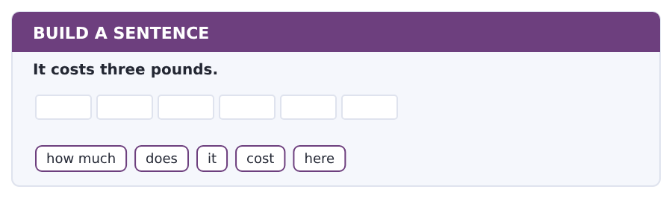
1. How much does it cost here?
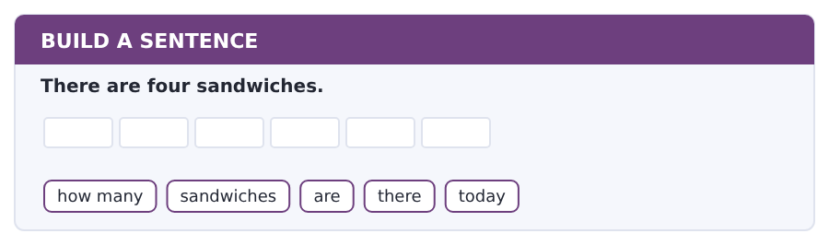
2. How many sandwiches are there today?
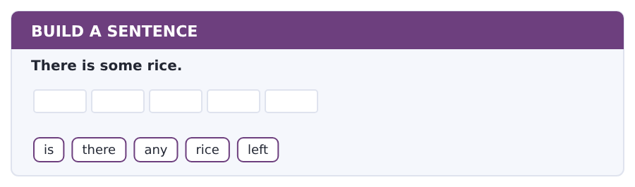
3. Is there any rice left?
Exercise B Exam practice. Write the sentence.
4. A coffee is one pound ten.
how much / is / a coffee / in / here
__________________________________________________________
5. There are six people in the queue.
how many / people / are / in / the queue
__________________________________________________________
6. I have no change.
have / you / got / any / change
__________________________________________________________
7. The hot dish costs two pounds.
how much / does / the hot dish / cost / today
__________________________________________________________
8. There is not much milk.
is / there / much / milk / left
__________________________________________________________
9. Students take ten per cent off.
how much / do / students / take / off
__________________________________________________________
10. She wants a receipt.
does / she / want / a receipt / too
__________________________________________________________


You read a short situation and write an email. You have 7 minutes. The three bullet points are the mark scheme: answer all three.
In the real test you write as much as you can in seven minutes. In this unit, aim for about 60 words. That number goes up in every unit of this book, and in Volume 1 it stops being a number at all.
On Monday you pay at till 2 in the cafeteria.
The till takes four pounds, but your food is three pounds fifty.
- say when and where you pay
- say what the problem is, with both numbers
- ask what you should do now
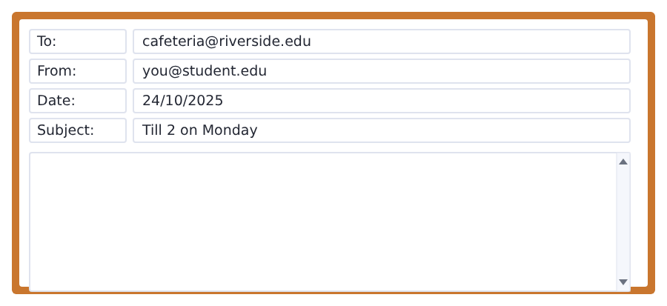
SKILL · Numbers make a complaint easy to answer
- Give both numbers: what you pay and what it should be.
- Give the day, the time and the till. Nobody can check without them.
- Say you have the receipt. That is the fact that settles it.
- Ask one clear question at the end.

Model email
Dear Cafeteria Team,

My name is Ana Ruiz and I am in Group B.
On Monday at about one o’clock I pay at till 2. My food is three pounds fifty, but the till takes four pounds.
I have the receipt with me.
What should I do now?

Thank you,
Ana Ruiz
Why it works
- Both numbers are in one sentence, so the reader sees the gap at once.
- The day, the time and the till number are all there.
- The receipt is mentioned, because it is the proof.
- The question is short and it asks for an action, not for an apology.
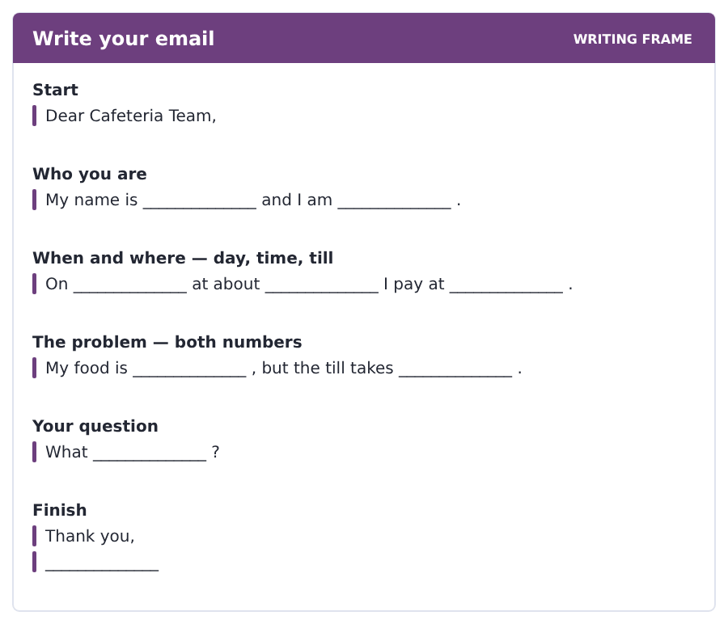
Now write your own. 7 minutes.
__________________________________________________________
__________________________________________________________
__________________________________________________________
__________________________________________________________
__________________________________________________________
__________________________________________________________
__________________________________________________________
__________________________________________________________


A professor asks a question and two students answer. You add your own post. You have 10 minutes and an effective answer is at least 100 words.
One hundred words is what the real test wants, and you will get there. For this unit, write about 65. Every unit of this book asks for a few more.
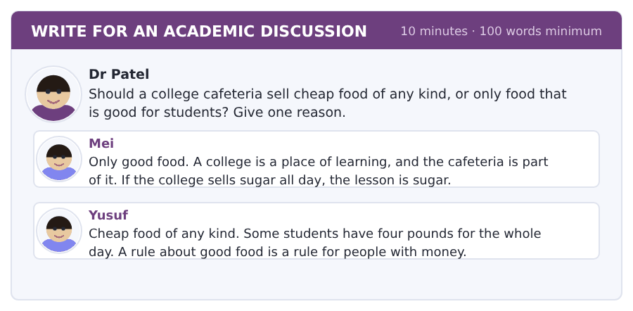
SKILL · Hold two true things at once
- Both posts here are right about something. Say which part of each one is right.
- Then say what you think, with because.
- Sixty-five words is about six short sentences.
- A post that only repeats the question is not an answer.

Sentence starters
- I agree with Yusuf, because ...
- Mei is right that ...
- In my cafeteria ...
- The answer is probably ...
Model post
I agree with Yusuf. A cafeteria should sell cheap food of any kind, because a hungry student learns nothing at all.
Mei is right that a college teaches with everything it does, and the cafeteria is part of that.
In my cafeteria the cheapest meal is also the best one: rice, fish and a vegetable for two pounds. The answer is probably to make the good food the cheap food.
[70 words]
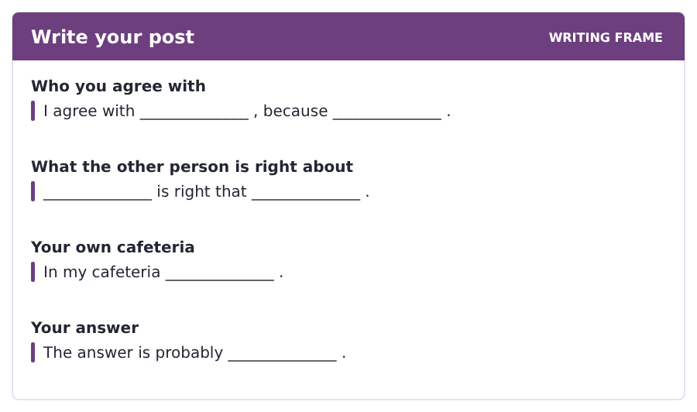
Now write your own. 10 minutes, at least 65 words.
__________________________________________________________
__________________________________________________________
__________________________________________________________
__________________________________________________________
__________________________________________________________
__________________________________________________________
__________________________________________________________
__________________________________________________________
__________________________________________________________
__________________________________________________________


The same task again, on the subject of this unit. The sentences are about work, trade and money now, and the word order has not changed at all.
SKILL · How much and how many
- How much goes with money, rain, coffee, work: things you cannot count.
- How many goes with customers, prices, workers: things you can count.
- How much is it? is the normal question for a price.
- The verb comes after the question words, not before them.

Exercise A Guided practice.
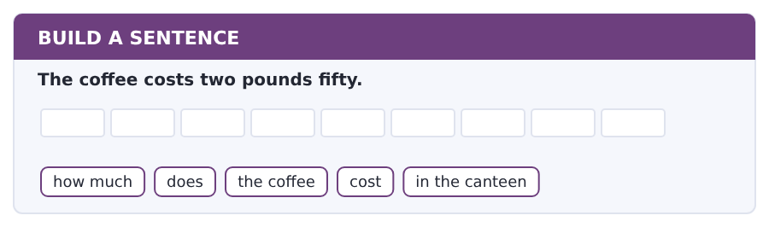
1. How much does the coffee cost in the canteen?
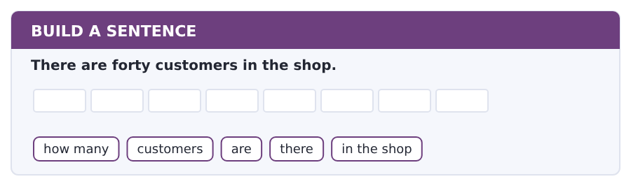
2. How many customers are there in the shop?
Exercise B Exam practice. Write the sentence.
3. The worker gets eight pounds an hour.
how much / does / the worker / get / an hour
__________________________________________________________
4. There is very little coffee in the market.
how much / coffee / is / there / in the market
__________________________________________________________
5. The business has got three workers.
how many / workers / has / the business / got
__________________________________________________________
6. The price tells the customer about the rain.
what / does / the price / tell / the customer
__________________________________________________________


A second discussion, and this one is about the subject rather than about your own week. In the real test both kinds come up, and the second kind is the harder one.
For this unit, write about 65 words. The real test wants a hundred.
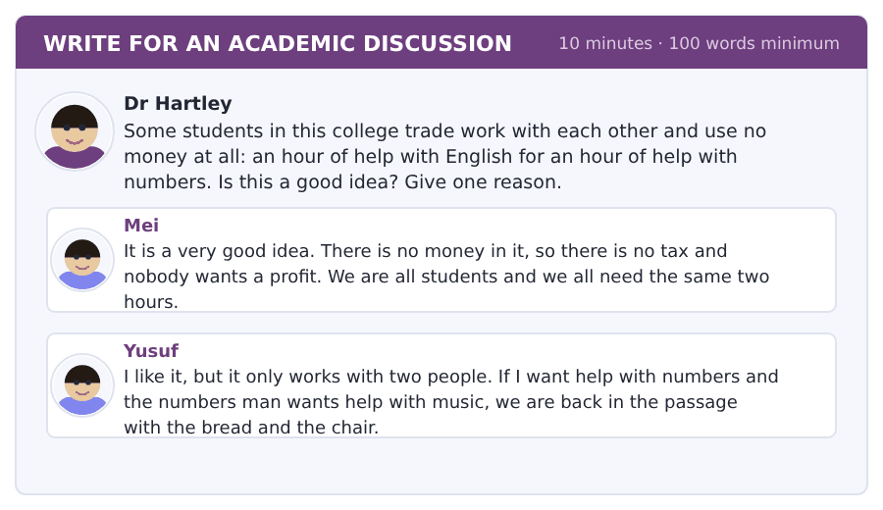
SKILL · Use the passage to answer a real question
- This is the passage’s problem in your own college. Say so.
- Yusuf sees it: two people is easy, three is hard. Use that.
- Say yes or no first, then give the reason from the passage.
- Sixty-five words is about six sentences.

Sentence starters
- I think it is a good idea, because ...
- Yusuf is right that ...
- The passage says ...
- So the answer is ...
Model post
I think it is a good idea for two people. An hour for an hour is a fair trade and it costs nothing.
But Yusuf is right about three people. The passage says trade is hard work when nobody wants what you have got.
So the answer is both. Keep it for two students in the same week, and use money for everything else. For a group of three it is no good at all.
[75 words]
Now write your own. 10 minutes, at least 65 words.
__________________________________________________________
__________________________________________________________
__________________________________________________________
__________________________________________________________
__________________________________________________________
__________________________________________________________
__________________________________________________________
__________________________________________________________
__________________________________________________________
__________________________________________________________

Grammar focus countable and uncountable · some and any · much, many and a lot of
Form | Example
countable | one egg, two eggs; a sandwich, four sandwiches
uncountable | rice, bread, water, money, food (never *a rice*)
some in a statement | There is some rice. There are some eggs.
any in a question or negative | Is there any rice? There are not any eggs.
much + uncountable | There is not much milk. How much money?
many + countable | There are not many eggs. How many people?
a lot of + both | a lot of rice, a lot of eggs

The question is not what the thing is but how English treats it. Money is uncountable in English even though you can count coins.
Much and many are most common in questions and negatives. In a positive sentence English usually says a lot of: There is a lot of rice.
To count an uncountable thing, put a container in front of it: a bottle of water, two cups of tea, a piece of bread.
Watch out! Never say *a bread*, *two rices* or *many money*. If you need the number, use a container: two pieces of bread, two bowls of rice, a lot of money.
Exercise 1 Write some or any.
1. There is __________ bread on the table.
2. Is there __________ milk in the kitchen?
3. There are not __________ eggs left.
4. Can I have __________ water, please?
5. Have you got __________ change?
6. We need __________ fruit for the week.
Exercise 2 Write much or many.
1. How __________ money have you got?
2. How __________ people are in the queue?
3. There is not __________ rice left.
4. There are not __________ sandwiches today.
5. How __________ does a coffee cost?
6. How __________ cups of tea do you drink?
Exercise 3 Countable or uncountable? Write C or U.
1. water
2. egg
3. money
4. sandwich
How this is tested in Build a Sentence
How much and how many open more Build a Sentence items than any other pair of words in this book. The order never changes: how much or how many, then the thing, then is or are or does.

Typing and the Screen Numbers and the money keys
The real test is typed. Nobody gives you paper. If you are still looking for the keys, you lose the Writing section before your English does.
Prices, dates and times are typed with the number row, and the number row is the one place where touch typing really breaks down. The fingers reach up two rows, and most people look.
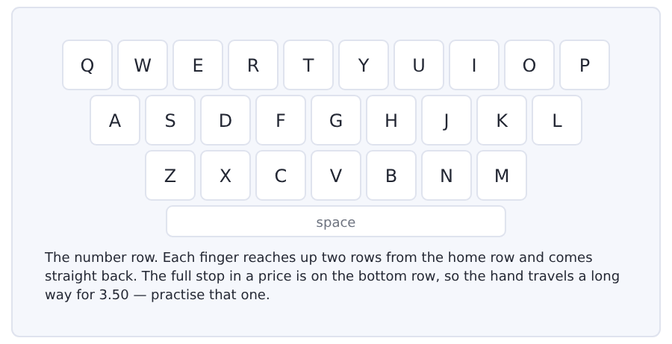
Exercise Type this. Time yourself, then write your speed in the box.
1234 5678 90 1234 5678 90
1.80 2.00 2.20 2.50 0.60 1.10 3.00
A soup is 1.80 and a coffee is 1.10, so that is 2.90.
My time _______ seconds
Words a minute _______ (the target for Unit 6 is 13)

Learning to Learn Guessing a word from the words around it
In the real test you will meet words you do not know, and you cannot look them up. This is not a problem if you can guess well, and guessing is a skill with steps, not a feeling.
- Decide what job the word does. Is it a thing, an action or a description? The words around it tell you.
- Look for a word you know inside it: unhappy, cheaply, cooker.
- Decide if the meaning is good or bad from the sentence: the soup was inedible, so we left it.
- Put a simple word in its place and read the sentence again. If it still makes sense, your guess is good enough.
- Only then look it up, and only if the word comes up again.
ADAPTIVE TIP A good guess does not need the exact meaning. In a reading test you need just enough meaning to answer the question, and the question almost never turns on the hard word itself.

Unit review and progress check Unit 6
Exercise A Vocabulary. Write the word.
1. a big self-service place to eat
2. the list of food and prices
3. the flat thing you carry plates on
4. a line of people waiting
5. the machine where you pay
6. the small paper that shows what you pay
7. a machine that sells drinks and snacks
8. the amount of food on one plate
9. money as notes, not a card
10. the money you get back
11. needing food
12. new today, not old
Exercise B Grammar. Complete the sentence.
1. There is __________ bread on the table.
2. Is there __________ milk in the kitchen?
3. How __________ money have you got?
4. How __________ people are in the queue?
5. There is not __________ rice left.
6. There are not __________ sandwiches today.
7. I want __________ water, please.
8. There is a __________ of fruit on the table.
Exercise C One timed mini-section. 6 minutes.
1. A soup and a coffee cost
(A) 2.20
(B) 3.10
(C) 3.30
(D) 2.90
2. The man pays with his college card and it costs
(A) 3.00
(B) 3.50
(C) 3.90
(D) 4.00
3. In many countries in Asia there is rice
(A) only at dinner
(B) never at breakfast
(C) at every meal
(D) only on Sunday
4. Which sentence is correct?
(A) I want some rice.
(B) I want a rice.
(C) I want many rice.
(D) I want a lot rice.
5. Which question is correct?
(A) How many money have you got?
(B) How much people are there?
(C) How many money is there?
(D) How much money have you got?
6. The cafeteria has forty minutes to feed
(A) sixty people
(B) four hundred people
(C) six hundred people
(D) forty people
Can you do these now?
I can… | Not yet | Yes
say how much and how many of something there is | □ | □
read a menu and work out what a meal costs | □ | □
understand a short text about why student food is what it is | □ | □
follow a conversation about paying for something | □ | □
order food and ask about the price | □ | □
write an email about a mistake on a bill | □ | □

ADAPTIVE TIP Prices in the Listening section are said once and fast. Write the figures the moment you hear them, even if you do not yet know which question they belong to. A number on your paper is worth a mark; a number in your head is gone by the next sentence.

Unit 7 · Weather, Seasons and the Year
TOEFL iBT® Preparation Course 2026 · Volume F1
CEFR A2 · Grammar: past simple of be · regular -ed · ago, last and in 1990 · Word field: weather, seasons, the year
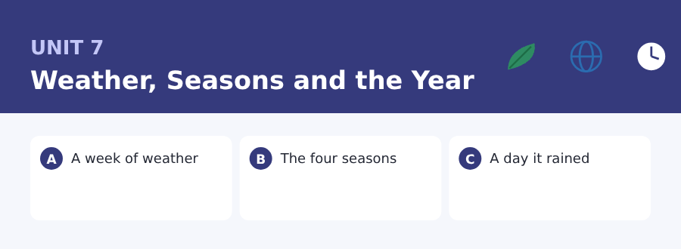
By the end of this unit I can…
- say where something or somebody was with was and were
- read a weather page and find one day in it
- understand a short text about why the seasons matter
- follow a conversation about a trip that went wrong
- tell a very short story about yesterday
- write an email about a day you missed

Three sub-topics, three cycles in every skill. From this unit on you can talk about the past, and half of the English language opens up.

Vocabulary 1 · The words you need most 24 words from the two thousand most common words of English
These are not academic words. They are the words that carry ordinary English, and until you own them the academic words of Volume 1 have nothing to stand on. Cover the right-hand column and test yourself.
weather rain, sun, wind and snow together | spring the season after winter
rain water that falls from the sky | summer the hot season
snow soft white ice that falls in winter | autumn the season when the leaves fall
wind air that moves fast | winter the cold season
sun the light and heat in the sky by day | temperature how hot or cold a thing is
cloud the white or dark thing in the sky that holds rain | degree the unit of temperature: twenty degrees
sky the space above you | forecast what somebody says about the weather of tomorrow
dry with no water | umbrella you hold it over your head in the rain
wet with water on it | coat the long warm thing you wear outside
warm a little hot, and pleasant | storm very bad weather with wind and rain
cool a little cold, and pleasant | ice water that is hard and cold
season spring, summer, autumn and winter | sunny with a lot of sun

Exercise A Work in pairs. Ask and answer.
1. What was the weather like yesterday?
2. Which season do you like, and why?
3. Were you outside at the weekend?
4. What do you do on a very wet day?
Vocabulary 2 · Campus and everyday 12 words for student life
Every Listening conversation in the real test happens on a campus. These twelve words come back in this unit and again in Volume 1.
sports field the big green space for games | club a group of students with the same interest
gym the room with machines for exercise | society a club for a subject or an idea
swimming pool the big water for swimming | membership being a member of a club
changing room the room where you put on your sports clothes | cancelled stopped before it happens
match a game between two teams | postponed moved to a later day
team the group of players on one side | kit the clothes and things you need for a game

Words you will meet again: weather | season | forecast | match | cancelled | postponed | degree | storm

Sound and Spelling The three sounds of -ed
Every regular past verb in English ends in the same four letters and comes out of the mouth in one of three ways. Two of them add nothing to the length of the word. The third adds a whole beat, and that is the one that changes what you hear.
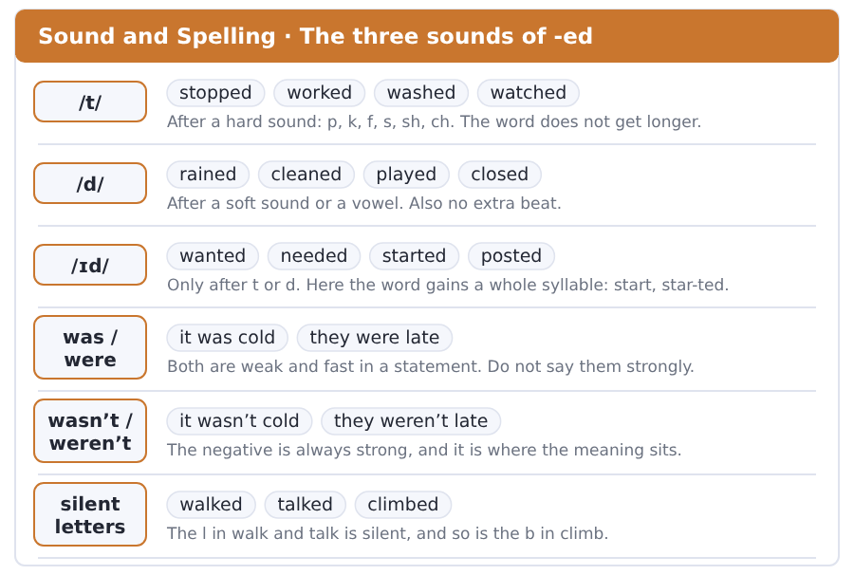
Exercise A Listen. Which word do you hear?
1. Is the ending /t/ or /d/? — stopped
2. Is the ending /t/ or /d/? — rained
3. How many syllables? — started
4. How many syllables? — watched
5. Do you hear was or wasn’t?
6. Do you hear were or weren’t?
Exercise B Say these out loud. Record yourself if you can.
1. Say these with no extra beat: stopped, worked, washed, watched, played.
2. Say these with an extra beat: wanted, needed, started, posted.
3. Say: it was cold / it wasn’t cold. Make the second one strong.
4. Tell the story of yesterday in five sentences, all in the past.


SKILL · The -ed ending
- A regular past verb ends in -ed: walk, walk-ed.
- A verb ending in -e takes only -d: close, close-d.
- A short verb with one vowel doubles the letter: stop, stopp-ed.
- A verb ending in a consonant and -y takes -ied: try, tr-ied.

Exercise A Guided practice. Five words are not complete. Write the missing letters.
Last week the weather chang-- every day. On Monday it rain-- all morning. On Tuesday the wind stopp-- and the sun was warm. On Wednesday the sky clear-- at four. On Thursday we all carr--- an umbrella and it stayed dry all day.

The first one is done for you: 1 chang-- → ed (changed)
Exercise B Exam practice. One paragraph, ten gaps — the real task.
The storm last October was the worst one for years. The wind start-- on Friday night and it continu-- until Sunday. Two old trees fall on the sports field and the college clos-- the gym for a week. Nobody was hurt, but the match on Saturday was cancell-- and the swimming pool fill-- with water from the roof. On Monday the staff clean-- the field, check-- the roof and open-- the gym again. The college post-- a notice and everybody check-- it every hour.

Check your answers in the key at the back of the book.


SKILL · A table of numbers is a text
- A weather page is a table. Read the row and the column, like a timetable.
- The two numbers for a day are usually the high and the low.
- A symbol is a word: sun, cloud, rain. Learn the six common ones.
- A question about the coldest day wants the smallest low number.

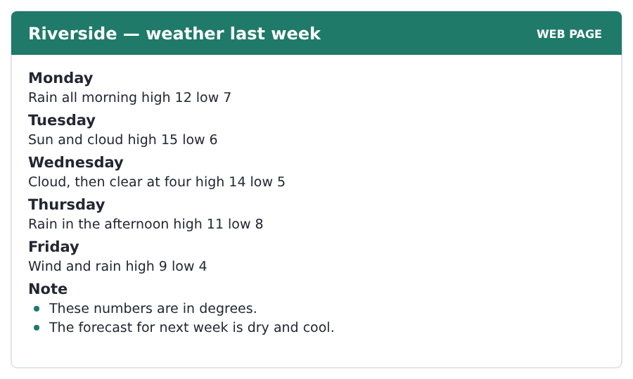
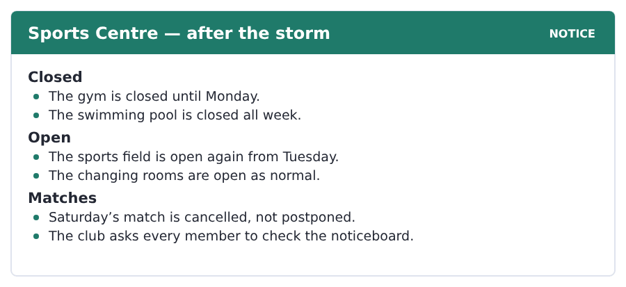
Exercise A Guided practice. The answer is on the page — find it.
1. Which day was the coldest?
(A) Monday
(B) Wednesday
(C) Thursday
(D) Friday
2. Which day was the warmest?
(A) Monday
(B) Wednesday
(C) Tuesday
(D) Friday
3. What time was the sky clear on Wednesday?
(A) at two
(B) at four
(C) at six
(D) in the morning
4. What is the forecast for next week?
(A) dry and cool
(B) wet and warm
(C) snow
(D) storms
Exercise B Exam practice.
5. On which days was there rain?
(A) Monday and Tuesday
(B) Tuesday and Wednesday
(C) Monday, Thursday and Friday
(D) only Friday
6. What was the high on Thursday?
(A) 8
(B) 11
(C) 9
(D) 14
7. When does the gym open again?
(A) Monday
(B) Tuesday
(C) Saturday
(D) next week
8. What about the swimming pool?
(A) open on Tuesday
(B) open on Monday
(C) open as normal
(D) closed all week
9. Is Saturday’s match on a different day?
(A) no, it is cancelled
(B) yes, next week
(C) yes, on Sunday
(D) no, it is on Tuesday
10. What does the club ask members to do?
(A) come to the gym
(B) check the noticeboard
(C) pay the membership
(D) bring a kit


SKILL · A fact, then the exception, then you
- A text that starts with most people often turns on the second sentence.
- The exception is usually the real subject of the text.
- The last paragraph moves from the world to the reader.
- A question about why it matters points at the last paragraph.

Four Seasons, and the Places That Have Two
Most people learn four seasons at school. They are spring, summer, autumn and winter. For a large part of the world that list is wrong.
Near the middle of the Earth the temperature changes very little. What changes is the rain. Those countries have two seasons. One is wet and one is dry. The year turns on the first big storm. In parts of Asia the wet season arrives in the same month every year. The whole farming year waits for it, and so do the schools.
This matters for a student in a new country. It is not only a fact about the world. A student from a two-season country is not ready for a dark afternoon at four in November. The cold is easy to plan for. You buy a coat. The dark is not easy at all, because nobody remembers to warn you about it. You can buy a coat in an afternoon. You cannot buy an extra hour of light.
[164 words]

Exercise A Guided practice.
1. How many seasons do most people learn at school?
(A) two
(B) three
(C) five
(D) four
2. Near the middle of the Earth, what changes very little?
(A) the rain
(B) the wind
(C) the temperature
(D) the dark
3. What changes there instead?
(A) the rain
(B) the temperature
(C) the sun
(D) the month
4. How many seasons do those countries have?
(A) three
(B) two
(C) four
(D) none
Exercise B Exam practice.
5. What does the year turn on there?
(A) the first cold day
(B) the first dry month
(C) the first big storm
(D) the shortest day
6. In parts of Asia the wet season arrives
(A) at a different time every year
(B) only in winter
(C) twice a year
(D) in the same month every year
7. What waits for it?
(A) the schools
(B) the storms
(C) the students
(D) the whole farming year
8. Who is not ready for a dark November afternoon?
(A) a student from a two-season country
(B) a cook
(C) a teacher
(D) a student from a cold country
9. What is easy to plan for?
(A) the dark
(B) the rain
(C) the cold
(D) the storm
10. What is not easy to plan for?
(A) the cold
(B) the dark
(C) the wind
(D) the wet season
11. What is the writer’s point?
(A) Four seasons is the normal year.
(B) Asia has better weather.
(C) The dark is the real problem, not the cold.
(D) Students should stay at home.

The field: Water, Air and Weather Two more cycles in every skill, on one subject
Everything up to here was about your own life, because that is where a language starts. From this page the same unit turns to a subject, and the subject is one Volume 1 will take up properly: where rain comes from, and why air that feels like nothing makes wind.
cycle a thing that goes round and comes back to the start | surface the top of a thing
vapour water in the air as a gas | pressure the push of the air or the water on a thing
ocean a very big sea | gas a thing like air: not hard and not water
river water that runs across the land to the sea | liquid a thing like water: it runs and it has no shape
flow to run like water | steam the hot white vapour over boiling water
rise to go up | solid hard, with its own shape, like ice or rock


SKILL · Follow one thing round a circle
- A passage about a cycle takes one thing all the way round.
- Follow the water with your finger and stop at every change.
- There are four or five stops. A question may ask for one of them.
- The last sentence often says the circle has no start and no end.

The Water in Your Glass Is Old
Rain falls on a field in your country. Where was that water last week? Perhaps it was in the sea, four hundred miles away.
The sun warms the surface of the ocean. Some of the water leaves the surface as vapour: a gas you cannot see. The vapour rises with the warm air. High up the air is cold, and the vapour becomes very small drops of liquid water. Millions of those drops together are a cloud.
The cloud moves over the land and the drops join each other. When a drop is heavy, it falls. It goes into a river, the river flows to the sea, and the sun warms it again. This is the water cycle, and it has no start and no end.
[126 words]

Exercise A Guided practice.
1. Where was the water last week?
(A) perhaps in the sea
(B) in a field
(C) in a cloud only
(D) in a glass
2. What warms the surface of the ocean?
(A) the wind
(B) the rain
(C) the land
(D) the sun
3. What leaves the surface as vapour?
(A) the air
(B) some of the water
(C) the cloud
(D) the drops
Exercise B Exam practice.
4. What is the air like high up?
(A) warm
(B) heavy
(C) cold
(D) dry
5. What is a cloud?
(A) a gas you cannot see
(B) millions of small drops together
(C) warm air
(D) a kind of rain
6. When does a drop fall?
(A) when it is heavy
(B) when it is cold
(C) when it is small
(D) when the sun comes
7. What does the writer say about the water cycle?
(A) it is very slow
(B) it happens once
(C) it needs a river
(D) it has no start and no end


SKILL · From a small fact to a big one
- Some passages start with a thing you can do with your hand.
- They end with a thing as big as the weather. Follow the steps.
- The word that carries the whole passage is usually in the middle.
- Here it is pressure. Every later sentence uses it.

Air That Feels Like Nothing
Air feels like nothing at all. Put your hand out of a window and it is empty. But the air over your hand is twenty miles deep, and all of it is heavy.
You do not feel this pressure, because the air inside your body pushes out with the same pressure. Take the air out of a can and you see it at once. The air outside closes the can like a hand.
Pressure is not the same everywhere, and that is where weather comes from. Warm air is light and it rises, so the pressure under it goes down. Cold air is heavy and it falls. Air flows from the high pressure to the low pressure, and that flow of air is the wind.
[125 words]

Exercise A Guided practice.
1. What does air feel like?
(A) heavy
(B) cold
(C) wet
(D) nothing at all
2. How deep is the air over your hand?
(A) two miles
(B) two hundred miles
(C) twenty miles
(D) four miles
3. Why do you not feel the pressure?
(A) the air is light
(B) the air inside you pushes out the same
(C) your hand is empty
(D) the window is open
Exercise B Exam practice.
4. What happens to a can with the air taken out?
(A) the air outside closes it
(B) it rises
(C) it gets warm
(D) nothing happens
5. What is warm air like?
(A) heavy, and it falls
(B) cold and wet
(C) light, and it rises
(D) the same everywhere
6. What happens to the pressure under warm air?
(A) it goes down
(B) it goes up
(C) it stays the same
(D) it stops
7. What is the wind?
(A) cold air only
(B) the weather
(C) warm air falling
(D) air flowing from high pressure to low pressure

Sentence Builder Keeping one tense through a paragraph
A paragraph about the past stays in the past from the first word to the last. The commonest writing mistake at this level is a story that starts in the past and slides into the present halfway through, usually at the exciting part.
Not a sentence | A sentence
Last Saturday it rained and the match is cancelled. | Last Saturday it rained and the match was cancelled.
I waited an hour. Then I go home. | I waited an hour. Then I went home.
The wind was strong and trees fall on the field. | The wind was strong and trees fell on the field.
There was a notice but nobody sees it. | There was a notice but nobody saw it.
It was cold, so I am wearing my coat. | It was cold, so I wore my coat.

Watch out! Check the verbs at the end of a paragraph, not at the start. The slide into the present almost always happens in the last two sentences, when you are writing fastest.
Exercise A Is it a sentence? Write yes or no. If no, put it right.
1. Last winter was long and it is very dark.
2. I waited at the field and then I walk home.
3. The storm started on Friday and continues all weekend.
4. There were two trees down and the field is closed.
5. It rained all day and we stayed at home.
6. The match was cancelled but nobody posts a notice.


Exercise A Listen and choose a response. You hear one line. Choose the best reply.
1. Were you at the match on Saturday?
(A) At four.
(B) No, I was not.
(C) In the gym.
(D) Yes, I do.
2. Was the weather bad?
(A) In November.
(B) Two teams.
(C) At the pool.
(D) Yes, it was terrible.
3. Where were you yesterday?
(A) At home all day.
(B) Yes, I was.
(C) It was cold.
(D) Every week.
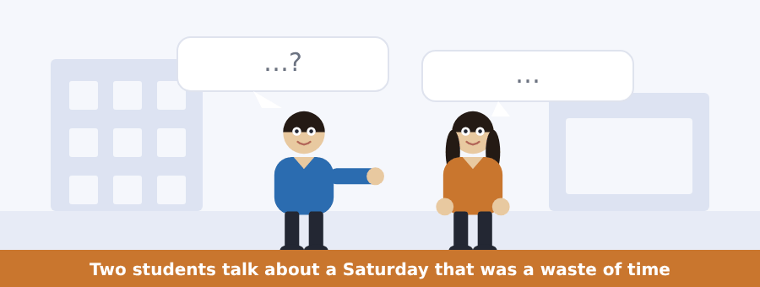
SKILL · Was and were carry the story
- A story about the past is held together by was and were.
- Listen for was not and were not. They often carry the point.
- The time words tell you the order: first, then, after that.
- A question about how somebody felt wants an adjective, not an event.

Exercise B Listen and answer. The audio plays once.
4. Where was the woman on Saturday?
(A) at home
(B) in the gym
(C) at the sports field
(D) at the pool
5. When was the notice posted?
(A) at ten
(B) at eleven
(C) on Friday
(D) on Sunday
6. What time were the students there?
(A) at nine
(B) at ten
(C) at eleven
(D) at twelve
7. Why was the match cancelled?
(A) the rain
(B) no players
(C) the wind
(D) the field was wet
8. What was at the far end of the field?
(A) water
(B) a notice
(C) the changing rooms
(D) two trees down
9. Where was the notice?
(A) on the club page
(B) on the board
(C) in the gym
(D) in an email
Audio script: see the back of the book. Do not read it before you listen.


Exercise A Listen and choose a response. You hear one line. Choose the best reply.
1. Was there a storm last night?
(A) In the gym.
(B) Two matches.
(C) At the pool.
(D) Yes, there was.
2. Were the roads bad this morning?
(A) At eight.
(B) They were terrible.
(C) In October.
(D) Yes, I do.
3. Is the gym open today?
(A) Last night.
(B) Two degrees.
(C) No, it is not.
(D) Yes, it was.
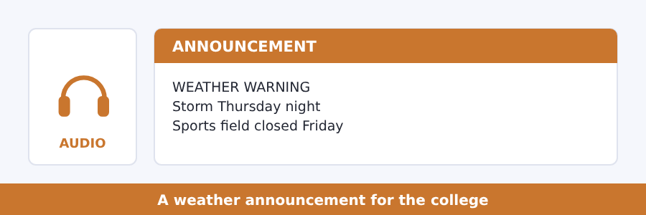
SKILL · A warning has an action in it
- A weather warning says what is coming and what people must do.
- The action is often the last sentence.
- Listen for the day and the part of the day: Thursday night.
- A question about what is open wants the list, not the warning.

Exercise B Listen and answer. The audio plays once.
4. When does the storm arrive?
(A) Thursday night
(B) Wednesday night
(C) Friday night
(D) Saturday morning
5. What is closed on Friday?
(A) the gym
(B) the library
(C) all buildings
(D) the sports field and the car park
6. What is open as normal?
(A) the sports field
(B) the car park
(C) the gym and the library
(D) nothing
7. What does the speaker ask students to do?
(A) use the car park
(B) come early by bus
(C) check the gym
(D) stay at home
8. When does the college post any change?
(A) by seven in the morning
(B) by nine
(C) at two
(D) on Thursday night
Audio script: see the back of the book. Do not read it before you listen.


Exercise A Listen and choose a response. You hear one line. Choose the best reply.
1. Was the summer hot last year?
(A) In two seasons.
(B) At the pool.
(C) Yes, I do.
(D) It was very hot.
2. Were you here last winter?
(A) No, I was not.
(B) In the gym.
(C) Four degrees.
(D) Yes, it is.
3. How many seasons are there in your country?
(A) At four.
(B) Yes, there are.
(C) Two.
(D) Last October.
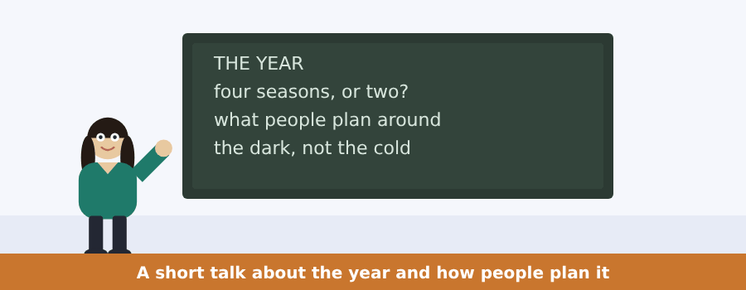
SKILL · Follow the argument, not the examples
- A talk with two or three examples is usually making one point.
- Write the point in your own words after the first example.
- If the next example fits your point, you have it right.
- The question about the talk as a whole wants the point.

Exercise B Listen and answer. The audio plays once.
4. What was the speaker’s question to the class?
(A) about the weather
(B) how many seasons there are
(C) about November
(D) about the dark
5. What was the answer of almost everybody?
(A) four
(B) two
(C) three
(D) five
6. How many of the class are from a two-season place?
(A) nobody
(B) about half
(C) everybody
(D) about a third
7. What do people plan their year around?
(A) the temperature
(B) the thing that stops them working
(C) the school year
(D) the seasons
8. In a cold country that is
(A) rain
(B) the dark
(C) snow and ice
(D) wind
9. What surprises people every year in December?
(A) the dark at four
(B) the cold
(C) the snow
(D) the rain
Audio script: see the back of the book. Do not read it before you listen.


Exercise A Listen and choose a response.
1. How old is the water in your glass?
(A) In the ocean.
(B) Yes, it is.
(C) Very new.
(D) A hundred million years old.
2. Was it in a cloud last month?
(A) In a river.
(B) A hundred years.
(C) Yes, it was.
(D) Yes, it is.
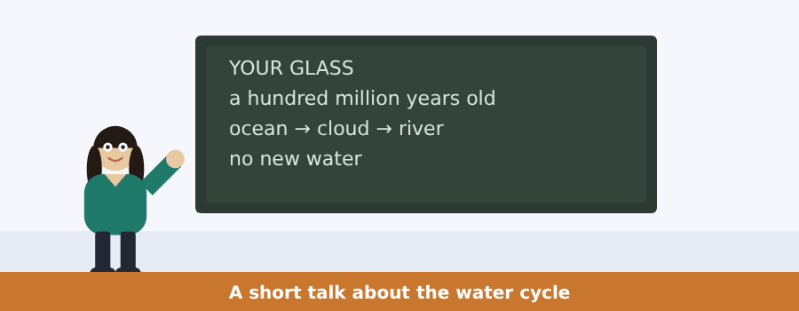
SKILL · A speaker who starts with a small thing
- A talk can open with a glass of water and end with the planet.
- The first claim is usually the surprise. Write it down.
- Then comes the circle. Keep the order of the stops.
- The last sentence often brings it back to you.

Exercise B Listen and answer. The audio plays once.
3. What is strange about the water in your glass?
(A) it is very clean
(B) it is very old
(C) it is new
(D) it is cold
4. How much new water is there on the planet?
(A) a little
(B) none
(C) half of it
(D) a hundred million
5. What carries the water after the sun lifts it?
(A) the wind
(B) the river
(C) the field
(D) the tree
6. Where was the water last month?
(A) in a tree
(B) in a river
(C) in the ocean
(D) in a cloud
Audio script: see the back of the book.


Exercise A Listen and choose a response.
1. What is wind?
(A) On the weather page.
(B) Yes, it is.
(C) Air going from high pressure to low pressure.
(D) Very cold.
2. Was the pressure high yesterday?
(A) Very low.
(B) Yes, it was.
(C) On Saturday.
(D) Yes, it is.
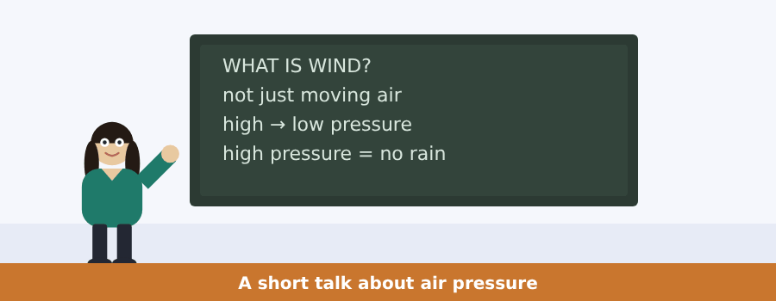
SKILL · A speaker who says the usual answer is not enough
- Listen for that is true, but. The speaker is not saying no.
- The real answer comes in the next sentence, and it is longer.
- Then the speaker shows you where you meet the idea in real life.
- That last part is often the item you get wrong. Keep it.

Exercise B Listen and answer. The audio plays once.
3. What do most people say wind is?
(A) high pressure
(B) low pressure
(C) cold air
(D) moving air
4. What does the speaker think of that answer?
(A) it is true but not an answer
(B) it is wrong
(C) it is the whole answer
(D) it is a question
5. Where do you hear about high pressure?
(A) in the ocean
(B) in a cloud
(C) on the weather page
(D) in a river
6. What does high pressure mean for your Saturday?
(A) rain all day
(B) no cloud and no rain
(C) a cold wind
(D) a big storm
Audio script: see the back of the book.


Part 1 · Listen and Repeat
You hear a sentence and repeat it once. There is no preparation time, and the sentences get longer. Focus: the three sounds of the -ed ending
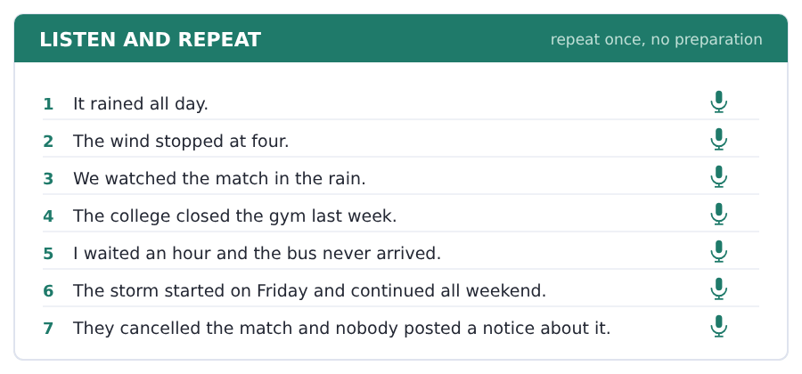
SKILL · /t/, /d/ and /ɪd/
- After a hard sound the -ed is /t/: stopped, worked, washed.
- After a soft sound or a vowel it is /d/: rained, cleaned, played.
- After t or d it is a whole syllable /ɪd/: wanted, needed, started.
- Only the third one adds a beat to the word. The other two do not.

Part 2 · Take an Interview
An interviewer asks you four questions on one theme: the weather. Answer each one fully. There is no preparation time.
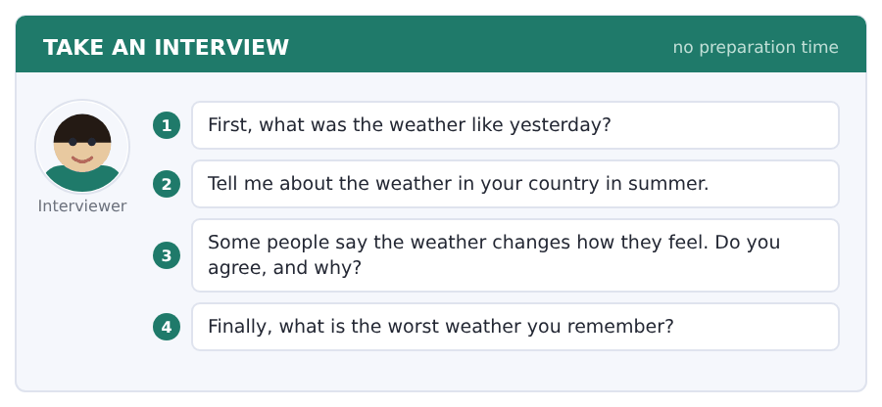
Say it like this
- Yesterday it was ... .
- In summer it is ... . The temperature is about ... .
- I ... agree, because ... .
- The worst weather was ... . It was ... .
A good answer sounds like this
Question 1 — Yesterday it was cold and wet all morning, and then the sun was out out at about three.
Question 2 — In summer it is very hot and dry in my country. The temperature is about thirty-five degrees in August.
Question 3 — I agree. On a dark wet morning I work slowly, and on a bright one I finish the same work in half the time.
Question 4 — The worst weather was a storm two years ago. The wind was so strong that it moved a car in our street.
I can… | Not yet | Yes
I used the right -ed sound for each verb | □ | □
I used was and were for the past | □ | □
I gave a reason after my opinion | □ | □


Part 1 · Listen and Repeat
You hear a sentence and repeat it once. There is no preparation time, and the sentences get longer. Focus: was and were, strong and weak
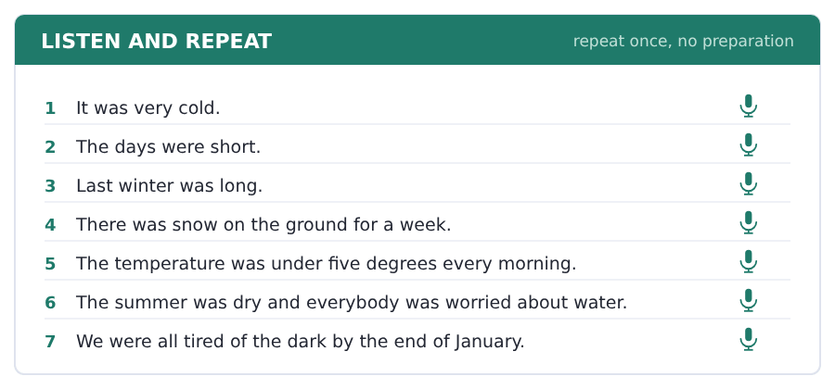
SKILL · Weak was, strong was not
- In a statement was is weak and fast: it was cold.
- In a short answer it is strong: Yes, it WAS.
- Was not and were not are always strong. That is where the meaning is.
- Listen for the strong one. It usually carries the point of the sentence.

Part 2 · Take an Interview
An interviewer asks you four questions on one theme: seasons and the year. Answer each one fully. There is no preparation time.
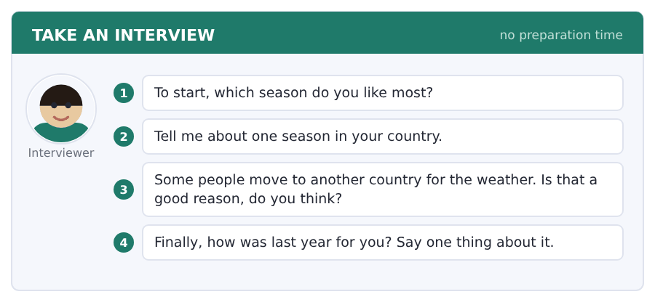
Say it like this
- I like ... , because ... .
- In ... the weather is ... and people ... .
- I think it is ... , because ... .
- Last year was ... for me, because ... .
A good answer sounds like this
Question 1 — I like autumn, because it is cool enough to walk and the light in the afternoon is beautiful.
Question 2 — In winter the weather in my country is wet, not cold. People carry an umbrella from November until March.
Question 3 — I think it is a good reason for some people. A long dark winter is hard, and nobody should pretend it is not.
Question 4 — Last year was a busy year for me, because I started this course and I moved to a new city in the same month.
I can… | Not yet | Yes
I used was and were in every answer | □ | □
I made was not and were not strong | □ | □
I answered all four questions | □ | □


Part 1 · Listen and Repeat
You hear a sentence and repeat it once. There is no preparation time, and the sentences get longer. Focus: telling a very short story
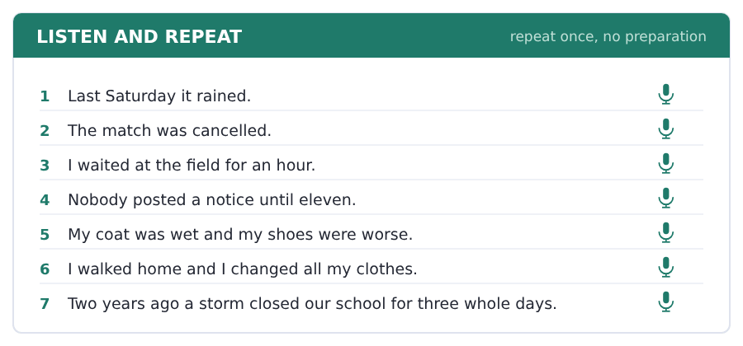
SKILL · Three sentences make a story
- What happened, what you did, how it ended. That is enough.
- Put the time first: Last Saturday, Two years ago.
- Use and then to move forward. It is simple and it works.
- Finish the story. An unfinished story sounds like a mistake.

Part 2 · Take an Interview
An interviewer asks you four questions on one theme: a day you remember. Answer each one fully. There is no preparation time.
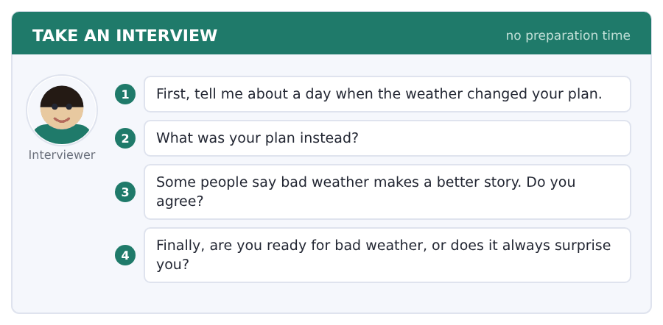
Say it like this
- Last ... it ... . My plan was ... .
- Instead I ... .
- I ... agree, because ... .
- I am ... ready, because ... .
A good answer sounds like this
Question 1 — Last summer it rained for a whole weekend. My plan was a trip to the sea with two friends.
Question 2 — Instead we stayed in the flat, cooked a big meal and watched three films. It was not the plan, but it was a good day.
Question 3 — I agree. Nobody tells a story about a day when everything worked.
Question 4 — I am never ready. I own an umbrella and it lives at home, in the box by the door, every single time.
I can… | Not yet | Yes
I told the story in order, with a time at the front | □ | □
I finished every sentence and the story | □ | □
I used at least three -ed verbs | □ | □


Part 1 · Listen and Repeat
You hear a sentence and repeat it once. There is no preparation time, and the sentences get longer. Focus: the /w/ at the start of water, wind and weather
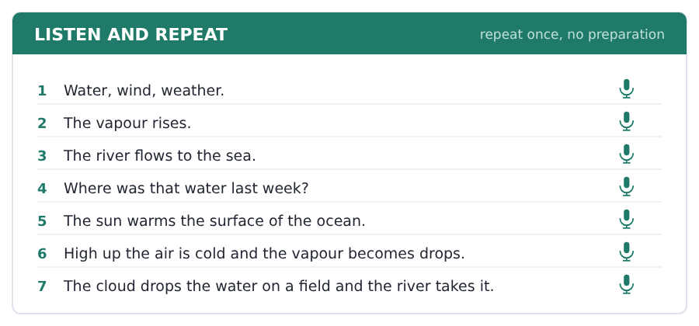
SKILL · Water, not vater
- For /w/ the lips go small and round, and they do not touch the teeth.
- For /v/ the top teeth touch the bottom lip. Feel the difference.
- Say the pair: wine / vine, west / vest, wet / vet.
- This field is full of /w/ words, so it is worth ten minutes.

Part 2 · Take an Interview
An interviewer asks you four questions on one theme: water and weather where you live. Answer each one fully. There is no preparation time.
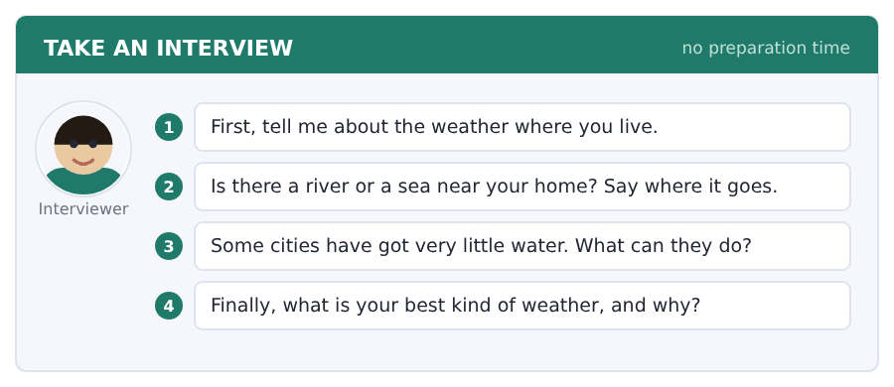
Say it like this
- The weather in ... is ... in winter.
- There is a river near ... .
- I think ... , because ... .
- In my country the rain comes in ... .
A good answer sounds like this
Question 1 — The weather in my town is hot and dry in summer and cold at night in winter.
Question 2 — There is a river twenty minutes from my home. It flows north and it goes into a very big lake.
Question 3 — They can keep the rain water in winter and use it in summer. My grandmother does this with two big cans.
Question 4 — My best kind of weather is a cold morning with no wind. The air is clear and you see the hills.
I can… | Not yet | Yes
I kept my teeth off my lip for every /w/ | □ | □
I used three field words | □ | □
I gave a reason after my opinion | □ | □


Part 1 · Listen and Repeat
You hear a sentence and repeat it once. There is no preparation time, and the sentences get longer. Focus: saying a long noun phrase in one piece
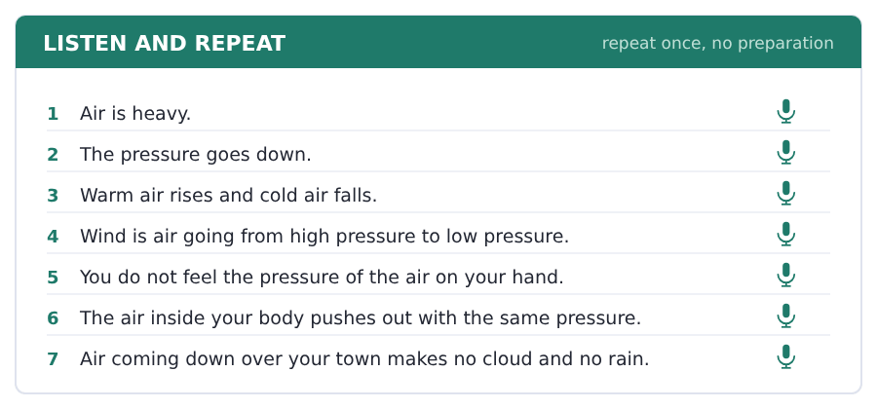
SKILL · A-place-with-high-pressure
- Academic English puts four or five words into one idea.
- Say a place with high pressure as one word, with no stop in it.
- The loud part is the important word: high PRESSure.
- A stop in the middle makes the listener wait for a new idea.

Part 2 · Take an Interview
An interviewer asks you four questions on one theme: the weather page and what it tells you. Answer each one fully. There is no preparation time.
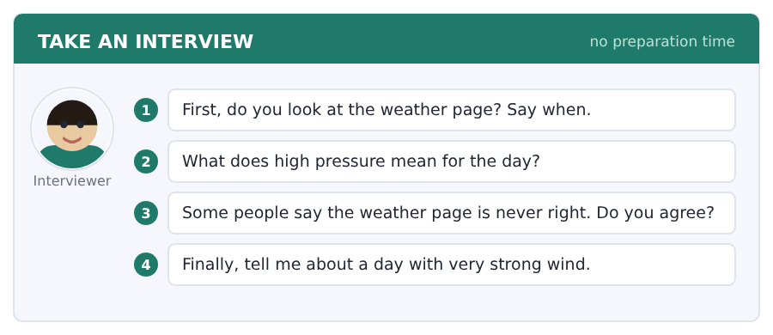
Say it like this
- I look at the weather page when ... .
- High pressure means ... .
- I think ... , because ... .
- The hardest weather for me is ... .
A good answer sounds like this
Question 1 — I look at the weather page on Thursday, because I walk in the hills at the weekend.
Question 2 — High pressure means the air over you is coming down, so there is no cloud and no rain.
Question 3 — I do not agree. It is right about tomorrow and wrong about next week, and that is a fair answer.
Question 4 — There was a day last winter with a very strong wind. The trees in our street were all over the road.
I can… | Not yet | Yes
I said each long phrase in one piece | □ | □
I used was and were correctly | □ | □
I answered all four questions | □ | □


You see a sentence, then a set of words in boxes. Put the words in order to make one grammatical sentence. Almost every item in the real test makes a question or a question inside another sentence.
SKILL · Was and were in a question
- Was or were goes in front of the person: Were you there?
- The question word goes first: Where were you?
- There was and there were move the same way: Was there a notice?
- Never put did with was. *Did you were* is wrong.

Exercise A Guided practice. The first three are worked through.
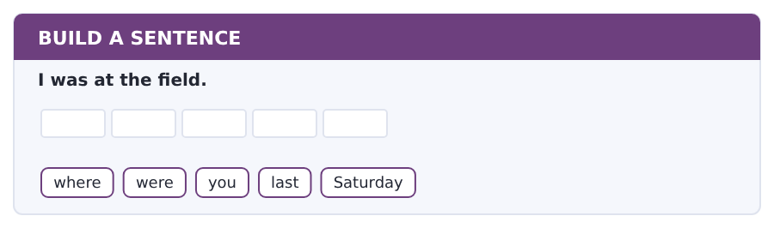
1. Where were you last Saturday?
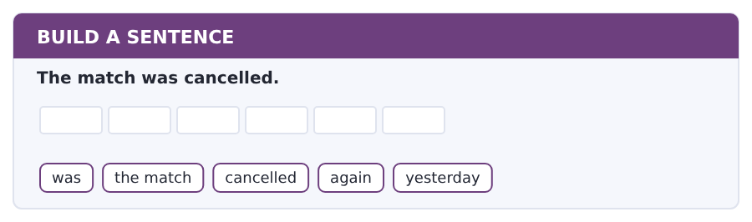
2. Was the match cancelled again yesterday?
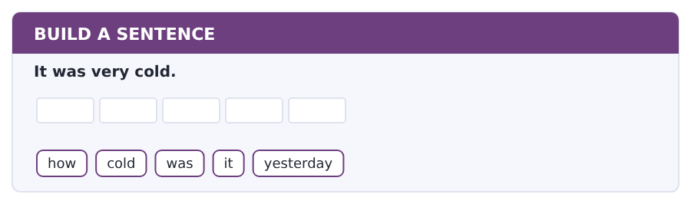
3. How cold was it yesterday?
Exercise B Exam practice. Write the sentence.
4. There was a storm on Friday.
was / there / a storm / here / on Friday
__________________________________________________________
5. The students were at the field at ten.
what time / were / the students / there / exactly
__________________________________________________________
6. The notice was on the club page.
where / was / the notice / posted / exactly
__________________________________________________________
7. Two trees were down.
how many / trees / were / down / exactly
__________________________________________________________
8. It rained all morning.
was / there / rain / here / all morning
__________________________________________________________
9. The gym was closed.
was / the gym / closed / again / last week
__________________________________________________________
10. I was at home.
were / you / at home / here / all day
__________________________________________________________


You read a short situation and write an email. You have 7 minutes. The three bullet points are the mark scheme: answer all three.
In the real test you write as much as you can in seven minutes. In this unit, aim for about 62 words. That number goes up in every unit of this book, and in Volume 1 it stops being a number at all.
You were at the sports field on Saturday at ten. The match was cancelled.
Nobody posted a notice until eleven. Write to the Sports Centre.
- say where you were and when
- say what the problem with the notice was
- ask them to send a message next time
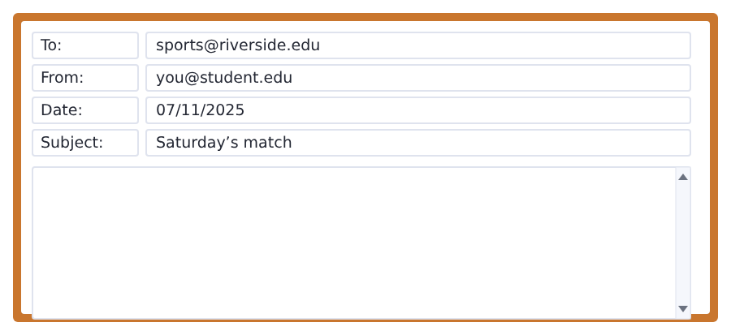
SKILL · Complain about the system, not the person
- Say what happened, with times. Times make a complaint real.
- Do not say somebody was lazy. Say the notice was late.
- Ask for one change, and make it easy to do.
- A short, calm email about a system gets the system changed.

Model email
Dear Sports Centre,

My name is Ana Ruiz and I am a member of the football club.
I was at the sports field at ten on Saturday with about twenty other students. The match was cancelled, but the notice was not on the club page until eleven.
Is it possible to send a message to members next time?

Thank you,
Ana Ruiz
Why it works
- Both times are there: ten and eleven. The gap is the whole complaint.
- Twenty other students shows this was not only one person’s problem.
- Nobody is blamed. The notice was late, not a person.
- The request is one easy change, so it can be said yes to.
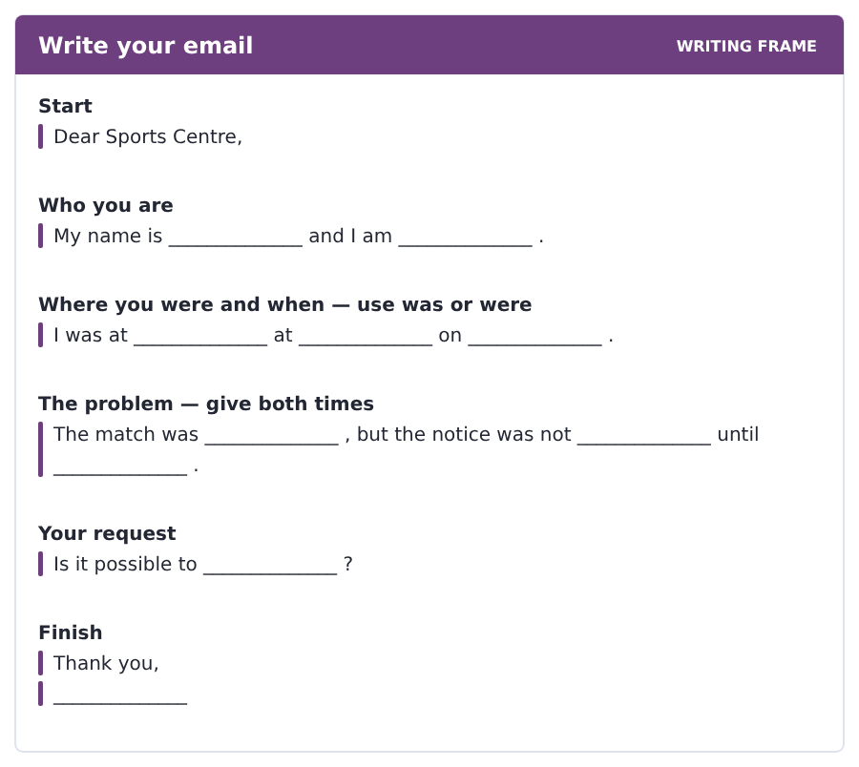
Now write your own. 7 minutes.
__________________________________________________________
__________________________________________________________
__________________________________________________________
__________________________________________________________
__________________________________________________________
__________________________________________________________
__________________________________________________________
__________________________________________________________


A professor asks a question and two students answer. You add your own post. You have 10 minutes and an effective answer is at least 100 words.
One hundred words is what the real test wants, and you will get there. For this unit, write about 70. Every unit of this book asks for a few more.
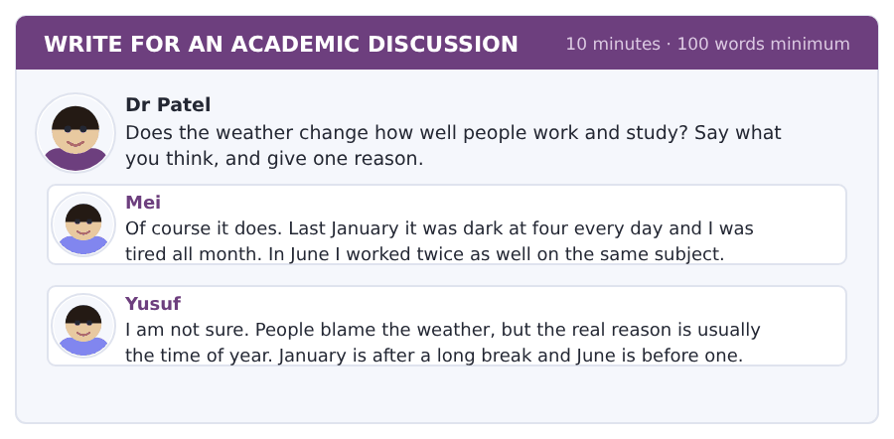
SKILL · Two reasons can both be true
- Mei names the weather. Yusuf names the time of year. Both can be right.
- Say which one you think is stronger, and why.
- Use the past: last winter, in June, two years ago.
- Seventy words is six or seven short sentences.

Sentence starters
- I agree with Mei, because ...
- Yusuf is right that ...
- Last winter I ...
- In my opinion the real reason is ...
Model post
I agree with Mei, but Yusuf is right about the time of year as well.
Last winter I was slow in January and I was slow again in February, and there was no long break in February at all.
In my opinion the real reason is the dark, not the cold and not the time of year. A dark afternoon moves my evening two hours, and then my work moves with it.
[72 words]
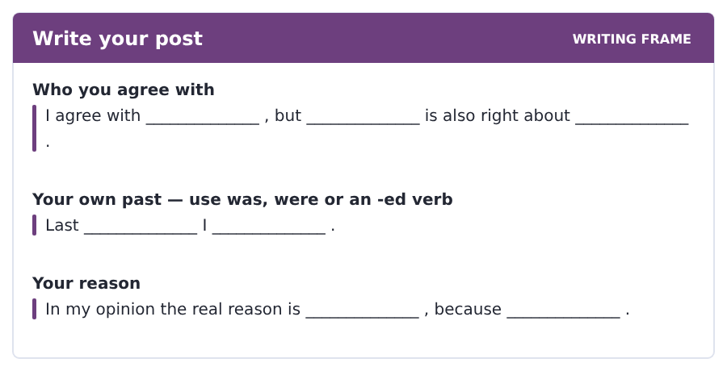
Now write your own. 10 minutes, at least 70 words.
__________________________________________________________
__________________________________________________________
__________________________________________________________
__________________________________________________________
__________________________________________________________
__________________________________________________________
__________________________________________________________
__________________________________________________________
__________________________________________________________
__________________________________________________________


The same task again, on the subject of this unit. The sentences are about water, air and weather now, and the word order has not changed at all.
SKILL · Questions with was and were
- Was goes with it, he, she and one thing. Were goes with they and you.
- In a question was and were come in front of the person or thing.
- A question word goes first: Where was the water?
- Last week, yesterday and in summer go at the end.

Exercise A Guided practice.
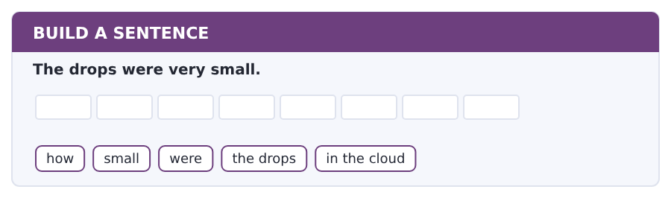
1. How small were the drops in the cloud?
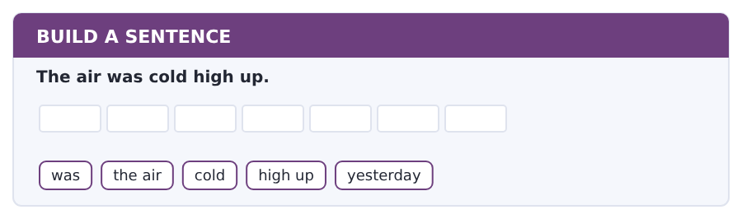
2. Was the air cold high up yesterday?
Exercise B Exam practice. Write the sentence.
3. The river was very low in summer.
why / was / the river / so low / in summer
__________________________________________________________
4. There were three clouds over the field.
how many / clouds / were / there / over the field
__________________________________________________________
5. The water was in a tree.
where / was / the water / before / the river
__________________________________________________________
6. The students were in the laboratory.
were / the students / in the laboratory / at nine / this morning
__________________________________________________________


A second discussion, and this one is about the subject rather than about your own week. In the real test both kinds come up, and the second kind is the harder one.
For this unit, write about 70 words. The real test wants a hundred.
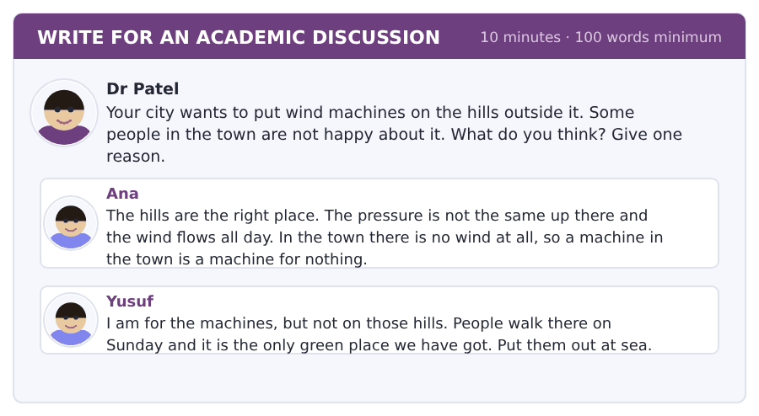
SKILL · Two people who agree and still argue
- Ana and Yusuf both want the machines. They argue about the place.
- So do not write for or against. Write where, and why there.
- Use the passage: wind needs a difference in pressure.
- Seventy words is about seven short sentences.

Sentence starters
- I agree with Ana about the hills, because ...
- Yusuf is right that ...
- The passage says the wind ...
- So the best place is ...
Model post
I agree with Ana about the hills. The passage says air flows from high pressure to low pressure, and on a hill that difference is big.
Yusuf is right that people walk there on Sunday. But a wind machine takes very little land and the hill under it is still open.
So the best place is the hills, and the town can keep the paths open. The sea is a good second answer, but it costs a lot of money.
[80 words]
Now write your own. 10 minutes, at least 70 words.
__________________________________________________________
__________________________________________________________
__________________________________________________________
__________________________________________________________
__________________________________________________________
__________________________________________________________
__________________________________________________________
__________________________________________________________
__________________________________________________________
__________________________________________________________

Grammar focus past simple of be · regular -ed · ago, last and in 1990
Form | Example
I / he / she / it was | I was at home. It was cold.
you / we / they were | We were at the field. They were late.
negative | I was not there. They were not ready.
question | Was it cold? Were you there?
there was / there were | There was a storm. There were two trees down.
regular past | rain → rained, stop → stopped, carry → carried
time phrases | yesterday, last week, two years ago, in 1990

Be is the one verb with two past forms. Everything else has one form for every person: I walked, she walked, they walked.
Ago counts back from now and goes after the amount: two years ago. Last goes in front: last year. In goes with a year or a month: in 1990.
The -ed ending is written the same way every time but said three ways. The spelling is the rule; the sound is a habit.
Watch out! Never say *I was go* or *I did was*. Was and were are complete verbs on their own, and they never take did.
Exercise 1 Write was or were.
1. I __________ at home all day.
2. The students __________ at the field at ten.
3. It __________ very cold on Friday.
4. There __________ two trees down.
5. __________ you at the match?
6. The gym __________ not open.
Exercise 2 Write the past of the verb.
1. It __________ (rain) all morning.
2. The wind __________ (stop) at four.
3. We __________ (carry) an umbrella.
4. The college __________ (close) the gym.
5. Nobody __________ (post) a notice.
6. I __________ (wait) for an hour.
Exercise 3 Write ago, last or in.
1. two years __________
2. __________ winter
3. __________ 1990
4. three days __________
How this is tested in Build a Sentence
From this unit Build a Sentence can ask you for a past question, and the order is the one you already know: question word, then was or were, then the person. Nothing else moves.

Typing and the Screen Typing without looking, and fixing as you go
The real test is typed. Nobody gives you paper. If you are still looking for the keys, you lose the Writing section before your English does.
By now you can reach every key. This week the work is not speed but the habit of not looking down, and of fixing a mistake with one key instead of with the mouse.
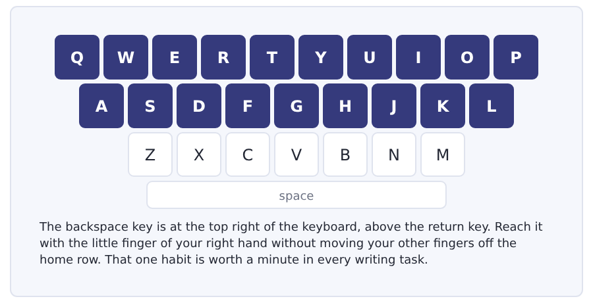
Exercise Type this. Time yourself, then write your speed in the box.
Last Saturday it rained and the match was cancelled.
The storm started on Friday night and continued until Sunday.
I waited at the sports field for an hour and nobody came.
My time _______ seconds
Words a minute _______ (the target for Unit 7 is 14)

Learning to Learn Learning the irregular verbs before you need them
Next week every verb goes irregular, and the list looks frightening. It is not. About fifty verbs cover almost everything you will ever read in this book, and the fifty fall into small groups that rhyme.
- Learn them in sound groups, not in alphabetical order: think–thought, bring–brought, buy–bought, teach–taught.
- Another group: speak–spoke, break–broke, write–wrote, drive–drove.
- Another: come–came, become–became, run–ran, swim–swam.
- Five a day for ten days is the whole list, and the groups mean you are really learning twelve things, not fifty.
- Use the table at the back of this book. The third column is for Volume 1; ignore it for now.
ADAPTIVE TIP Say the two forms together, always, and never the first one alone: go–went, see–saw, take–took. A verb learned as a pair comes back as a pair, and the past is the half you need under pressure.

Unit review and progress check Unit 7
Exercise A Vocabulary. Write the word.
1. what somebody says about the weather of tomorrow
2. very bad weather with wind and rain
3. the season when the leaves fall
4. you hold it over your head in the rain
5. how hot or cold a thing is
6. a game between two teams
7. stopped before it happens
8. moved to a later day
9. the room with machines for exercise
10. the clothes you need for a game
11. water that is hard and cold
12. with a lot of sun
Exercise B Grammar. Complete the sentence.
1. I __________ at home all day.
2. The students __________ at the field.
3. __________ you at the match?
4. It __________ (rain) all morning.
5. The wind __________ (stop) at four.
6. We __________ (carry) an umbrella.
7. I __________ (wait) for an hour.
8. two years __________
Exercise C One timed mini-section. 6 minutes.
1. The coldest day last week was
(A) Monday
(B) Wednesday
(C) Thursday
(D) Friday
2. The match was cancelled because of
(A) the rain
(B) no players
(C) the wind
(D) the pool
3. Near the middle of the Earth the thing that changes is
(A) the rain
(B) the temperature
(C) the dark
(D) the wind
4. Which sentence is correct?
(A) I was at home.
(B) I was go home.
(C) I am was at home.
(D) I were at home.
5. Which is the past of carry?
(A) carryed
(B) carried
(C) carryd
(D) carrying
6. In the talk, what surprises people in December is
(A) the cold
(B) the snow
(C) the rain
(D) the dark
Can you do these now?
I can… | Not yet | Yes
say where something or somebody was with was and were | □ | □
read a weather page and find one day in it | □ | □
understand a short text about why the seasons matter | □ | □
follow a conversation about a trip that went wrong | □ | □
tell a very short story about yesterday | □ | □
write an email about a day you missed | □ | □

ADAPTIVE TIP In Speaking, a past question needs a past answer, and the marker is listening for it. Have one small true story ready about last year — a journey, a day, a change — and practise it until the verbs are automatic. One rehearsed story carries you through a dozen different questions.

Unit 8 · Getting There: Travel and Transport
TOEFL iBT® Preparation Course 2026 · Volume F1
CEFR A2 · Grammar: past simple: irregular verbs · questions with did · Word field: travel, journeys, tickets
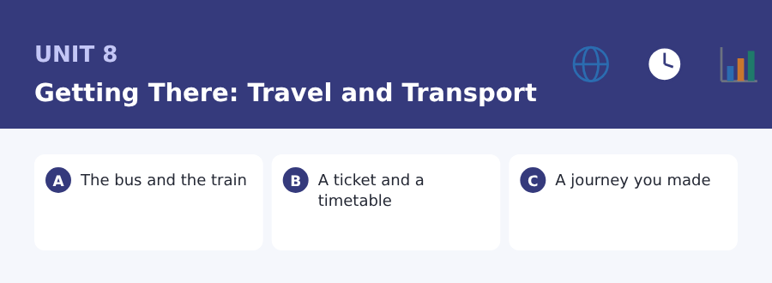
By the end of this unit I can…
- tell a short story about a journey in the past
- read a timetable and a ticket and find the facts
- understand a short text about how students travel
- follow a conversation about a journey that went wrong
- ask questions about the past with did
- write an email asking for money back after a delay

Three sub-topics, three cycles in every skill. This unit carries the fifty irregular verbs that English uses most, and after it the past is yours.

Vocabulary 1 · The words you need most 24 words from the two thousand most common words of English
These are not academic words. They are the words that carry ordinary English, and until you own them the academic words of Volume 1 have nothing to stand on. Cover the right-hand column and test yourself.
travel to go from one place to another | platform the part of a station where you wait for the train
journey the act of going from one place to another | driver the person who drives
transport buses, trains and other ways of travelling | passenger somebody travelling in a bus, train or car
bus a big road machine that carries many people | luggage the bags you take on a journey
train it runs on rails between stations | delay a wait that should not happen
car a small road machine for four or five people | crowded with too many people in it
bicycle you ride it and it has two wheels | direct with no change on the way
taxi a car you pay to take you somewhere | miss to arrive too late for something
station the place where trains and buses stop | catch to arrive in time for a bus or train
airport the place where planes land | traffic all the vehicles on the road
ticket the paper or card that lets you travel | road the hard way that cars drive on
seat the place where you sit | wheel the round part that turns

Exercise A Work in pairs. Ask and answer.
1. How did you come to college today?
2. Did you ever miss a bus or a train? What happened?
3. How long is your journey to college?
4. Which kind of transport do you like, and why?
Vocabulary 2 · Campus and everyday 12 words for student life
Every Listening conversation in the real test happens on a campus. These twelve words come back in this unit and again in Volume 1.
travel card the card you load with money for buses and trains | zone one part of a city for the price of a ticket
student discount a lower price because you are a student | fare the price of a journey
bus pass a card for many bus journeys | barrier the gate you put your ticket in at a station
cycle rack the metal frame where you leave a bicycle | lost property the office that keeps the things people leave
shuttle bus a small bus between two places on one route | return ticket a ticket there and back
route the way a bus or train goes | single ticket a ticket one way only

Words you will meet again: journey | delay | platform | fare | route | shuttle bus | return ticket | crowded

Sound and Spelling The vowels inside the irregular pasts
Most irregular past forms change the vowel in the middle and nothing else. Once you hear the vowel groups, fifty separate words become about six patterns, and the list stops being frightening.
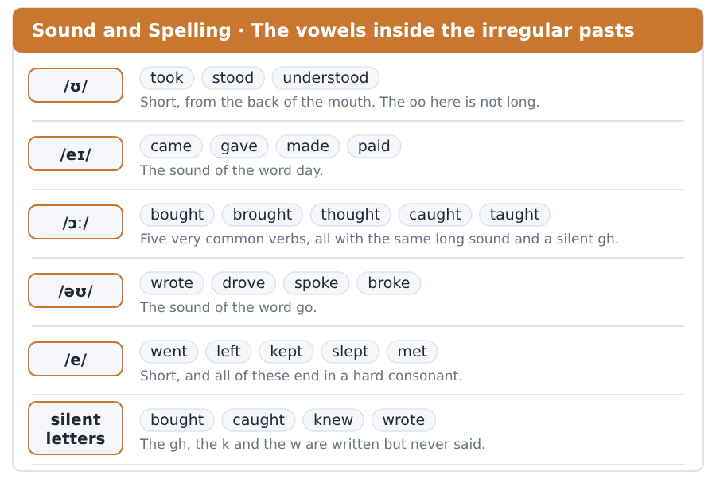
Exercise A Listen. Which word do you hear?
1. Do you hear took or take?
2. Do you hear came or come?
3. Do you hear bought or brought?
4. Do you hear wrote or rode?
5. Do you hear went or want?
6. Do you hear left or lift?
Exercise B Say these out loud. Record yourself if you can.
1. Say the pairs: go–went, take–took, come–came, see–saw.
2. Say the /ɔː/ group: bought, brought, thought, caught, taught.
3. Say five sentences about yesterday, all with irregular verbs.
4. Say a train time, a platform number and a price in one breath.


SKILL · Irregular verbs have no rule
- Regular verbs add -ed. Irregular verbs change inside: take, took.
- There is no rule and there is no short cut. There is only the list.
- Count the dashes. Each dash is one letter of the missing part.
- Learn them in pairs and say both halves out loud.

Exercise A Guided practice. Five words are not complete. Write the missing letters.
Yesterday I t--- the early bus. I l--- the flat at seven and I g-- to the station at half past. The train c--- on time and I f---- a seat by the window.

The first one is done for you: 1 t--- → ook (took)
Exercise B Exam practice. One paragraph, ten gaps — the real task.
Last Monday the shuttle bus br--- down near the station. The driver t--- everybody to get off and we st--- on the road in the rain. Nobody kn-- how long the wait was. I w--- to the station and c----- the train instead, but the barrier d-- not read my travel card. A member of staff c--- over and op---- the gate for me. I g-- to the college at half past ten and the lecture was already over. I sat down in the canteen and waited for the next one.

Check your answers in the key at the back of the book.


SKILL · Two documents, one answer
- A question sometimes needs the ticket and the timetable together.
- Check the date and the zone on a ticket before anything else.
- A timetable column is one journey from top to bottom.
- The words before and after a time decide everything on a ticket.

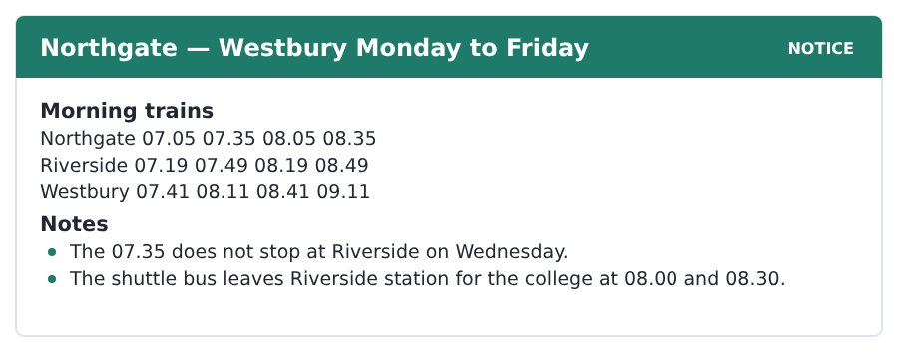
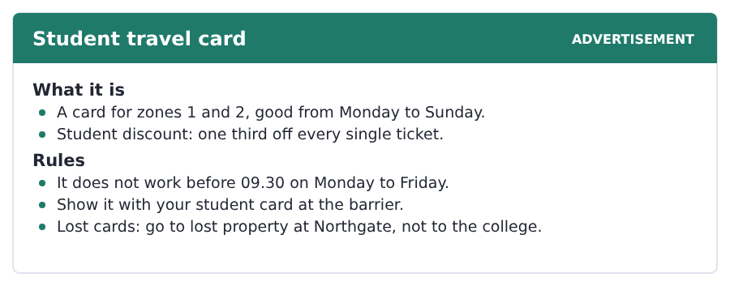
Exercise A Guided practice. The answer is on the page — find it.
1. What time does the 07.05 from Northgate reach Westbury?
(A) 07.19
(B) 07.41
(C) 08.11
(D) 08.41
2. Which train does not stop at Riverside on Wednesday?
(A) 07.05
(B) 08.05
(C) 07.35
(D) 08.35
3. How much is the student discount?
(A) one half off
(B) one quarter off
(C) nothing
(D) one third off
4. When is the travel card does not work?
(A) before 09.30 on Monday to Friday
(B) after 09.30
(C) at the weekend
(D) in zone 2
Exercise B Exam practice.
5. A student takes the 08.05 from Northgate. When does it reach Riverside?
(A) 08.11
(B) 08.41
(C) 08.19
(D) 08.49
6. Which shuttle bus can that student catch?
(A) 08.30
(B) 08.00
(C) both
(D) neither
7. Can a student use the travel card on the 08.05 train?
(A) yes
(B) only on Wednesday
(C) only in zone 1
(D) no
8. What do you show at the barrier?
(A) only the travel card
(B) the travel card and the student card
(C) only the student card
(D) the ticket and the timetable
9. Where do you go if you lose the card?
(A) the college office
(B) lost property at Northgate
(C) the shuttle bus
(D) the station at Westbury
10. How many zones does the card cover?
(A) one
(B) three
(C) all of them
(D) two


SKILL · The number is the argument
- When a text gives you a number twice, that number is the point.
- Ten hours a week is a fact. A large part of a week is the writer’s view.
- Watch for but and so. They mark the turns in a short argument.
- The last sentence often names what the whole text is really about.

The Hour Nobody Counts
Ask a student how long their course is. They tell you the hours of teaching. Nobody counts the journey. But a student an hour away spends ten hours a week on a bus.
Ten hours is a large part of a week. The college knows this and the timetable does not. Classes start at nine. The cheap travel card does not work before half past nine. So the students with the least money pay the full fare, every single day of the term.
Some of those ten hours are not lost. A bus is a reading room with bad lights. Many students do their reading there and nowhere else, because on a bus nobody can ask them to do anything. But a journey of two hours each way is a different thing. That student came for a course. They got a course and a job, and nobody told them about the second one. Ten hours is not free time. It is the price on the other ticket.
[167 words]

Exercise A Guided practice.
1. What do students tell you about their course?
(A) the price
(B) the journey
(C) the hours of teaching
(D) the timetable
2. How many hours a week does a student an hour away spend on a bus?
(A) ten
(B) two
(C) five
(D) twenty
3. When do classes start?
(A) eight
(B) nine
(C) half past eight
(D) half past nine
4. When does the cheap travel card start to work?
(A) eight
(B) nine
(C) half past nine
(D) ten
Exercise B Exam practice.
5. Who takes the dearest ticket?
(A) rich students
(B) teachers
(C) everybody
(D) students with the least money
6. What does the writer call a bus?
(A) a reading room with bad lights
(B) a waste of time
(C) a second home
(D) a classroom
7. Why do some students read there and nowhere else?
(A) the lights are good
(B) it is quiet
(C) the journey is short
(D) nobody can ask them to do anything
8. What is a different thing?
(A) a journey of two hours each way
(B) a one-hour journey
(C) a shuttle bus
(D) a travel card
9. What did that student get?
(A) a course only
(B) a cheap ticket
(C) a course plus a job
(D) a free bus
10. What does the writer say about the second one?
(A) it is easy
(B) nobody told them about it
(C) it pays well
(D) the college chose it
11. What is the passage really about?
(A) bad buses
(B) the hidden cost of a long journey
(C) cheap tickets
(D) reading on a bus

The field: History and Change Two more cycles in every skill, on one subject
Everything up to here was about your own life, because that is where a language starts. From this page the same unit turns to a subject, and the subject is one Volume 1 will take up properly: why the first cities grew where they grew, and how anybody knows.
century a hundred years | stone hard rock, cut for building
ancient very old, from a long time back | wall the side of a building, or a long one round a city
empire many countries under one king | writing words on paper, stone or clay
king the man over a country in the old world | record writing that keeps a fact for later
war fighting between two countries | ruins the old walls and floors still in the ground
farming growing food in a field | evidence the things that show you something is true


SKILL · A passage that answers one why
- A history passage often opens with the world before the change.
- Then it names the change. Here it is one word: farming.
- Everything after that is what the change made possible.
- A question with why wants the change, not the list after it.

A City Is What Extra Food Looks Like
Ten thousand years ago there were no cities anywhere on Earth. Everybody walked, and everybody looked for food every day. A person with no farm looks for food all day and has no time for anything else.
Then people started farming. A family with a field grew food for ten families. So nine families did something else. One built a house, one cut stone, one kept the records, and one was a king. That is what a city is: a place full of people and very few farms.
The first cities grew in the places with good land and easy water. Food came in from the land, and stone and shoes went out from the city. A wall went round the whole thing, because a city with food in it is a city somebody wants. Some of those ancient walls are still there.
[143 words]

Exercise A Guided practice.
1. How many cities were there ten thousand years ago?
(A) ten
(B) a few
(C) none
(D) nine
2. What did everybody do every day?
(A) looked for food
(B) walked to a city
(C) built a house
(D) kept records
3. How much food did a family with a field grow?
(A) food for one family
(B) no food
(C) food for a king
(D) food for ten families
Exercise B Exam practice.
4. How many families did something else?
(A) one
(B) two
(C) nine
(D) ten
5. What is a city, for this writer?
(A) a place full of people and very few farms
(B) a place with many walls
(C) a place with a king
(D) a place with good water
6. Where did the first cities grow?
(A) on high land
(B) near a wall
(C) far from water
(D) in the places with good land and easy water
7. Why did a wall go round the city?
(A) to keep the people out
(B) because a city with food in it is a city somebody wants
(C) to carry the stone
(D) because the king lived there


SKILL · A numbered answer
- When a writer says there are three kinds, the passage has three parts.
- Find first, second and third and mark them.
- Each part gets one example. The example is what the questions use.
- A question with how many wants the number, not the parts.

Three Kinds of Evidence
Nobody wrote the story of the first cities down. There was no writing yet. So how does anybody know any of this? The answer is a good one.
There are three kinds of evidence. The first is the ruins. The walls and the floors are still in the ground, and a wall tells you how big the city was. The second is the things people threw away. A cup with old food in it tells you what the people ate. And the third kind is writing.
Writing came late and it changed everything. The first records were not stories. They were lists: so much food, so many animals, and a name at the end. A city needs writing, because nobody remembers four thousand animals.
[124 words]

Exercise A Guided practice.
1. Who wrote the story of the first cities down?
(A) a king
(B) the farms
(C) the city
(D) nobody
2. How many kinds of evidence are there?
(A) three
(B) two
(C) four
(D) ten
3. What is the first kind?
(A) writing
(B) the ruins
(C) the things people threw away
(D) the animals
Exercise B Exam practice.
4. What does a wall tell you?
(A) what the people ate
(B) who the king was
(C) how big the city was
(D) how many animals there were
5. What does a cup with old food in it tell you?
(A) how big the city was
(B) the name of the king
(C) what the people ate
(D) when writing came
6. What were the first records?
(A) lists
(B) stories
(C) walls
(D) cups
7. Why does a city need writing?
(A) to keep the walls up
(B) to grow food
(C) because the king asked for it
(D) because nobody remembers four thousand animals

Sentence Builder Telling a story in order
A story is easy to read when it goes forward in time and hard to read when it jumps. Put the time word at the front of the sentence, keep the order of events, and use then, after that and in the end to move the reader along.
Not a sentence | A sentence
I took the train. The bus broke down before that. | The bus broke down, so I took the train.
I missed the class. I left at seven. | I left at seven, but I still missed the class.
The barrier did not open. I had money on my card. | I had money on my card, but the barrier did not open.
At half past ten I arrived. The lecture finished at ten. | The lecture finished at ten and I arrived at half past.
I waited. Nobody came. I walked. | I waited, and when nobody came, I walked.

Watch out! One short story needs one tense. If the whole thing happened yesterday, every verb in it is a past verb, including the ones in the last sentence.
Exercise A Is it a sentence? Write yes or no. If no, put it right.
1. The train was late. I left home early.
2. I went to lost property. My bag was on the train.
3. A man opened the gate. My card did not work.
4. I arrive at ten. The class started at nine.
5. I waited for an hour and then I walked.
6. The driver said forty minutes. I did not wait.


Exercise A Listen and choose a response. You hear one line. Choose the best reply.
1. Did you catch the early train?
(A) At the barrier.
(B) No, I missed it.
(C) Two zones.
(D) Yes, I am.
2. How did you get here?
(A) At nine.
(B) I took the bus.
(C) Yes, I did.
(D) In zone 2.
3. Where did you leave your bicycle?
(A) Yesterday.
(B) Yes, I did.
(C) At the cycle rack.
(D) Two wheels.
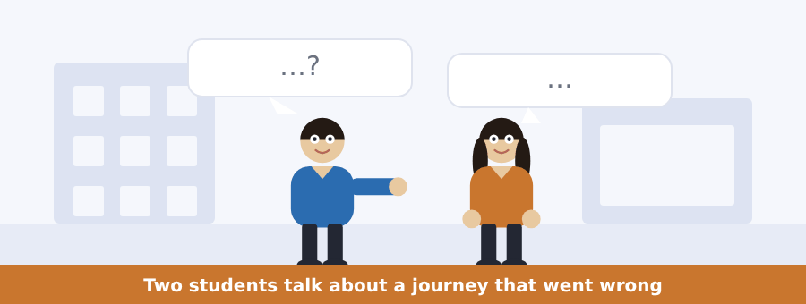
SKILL · Past questions begin with did
- Did at the front of a question tells you the whole thing is in the past.
- The verb after did goes back to its plain form: Did you take the bus?
- In the answer the verb is irregular again: Yes, I took the early one.
- Listen for the plain verb after did. It is not a mistake.

Exercise B Listen and answer. The audio plays once.
4. What happened to the shuttle bus?
(A) it was late
(B) it was full
(C) it did not come
(D) it broke down
5. How long was the wait for another bus?
(A) forty minutes
(B) fourteen minutes
(C) four minutes
(D) an hour
6. What did the man do instead?
(A) he waited
(B) he took a taxi
(C) he went home
(D) he walked to the station and took the train
7. Why did the barrier not open?
(A) the card was for the wrong zone
(B) no money on the card
(C) the card was lost
(D) the barrier was broken
8. Who helped him?
(A) the driver
(B) a member of staff
(C) another student
(D) nobody
9. What time did he arrive?
(A) ten
(B) eleven
(C) half past ten
(D) half past nine
Audio script: see the back of the book. Do not read it before you listen.


Exercise A Listen and choose a response. You hear one line. Choose the best reply.
1. Did the train leave on time?
(A) From platform 2.
(B) Two zones.
(C) No, it did not.
(D) Yes, it is.
2. Which platform is it?
(A) At ten past.
(B) Yes, it is.
(C) A single ticket.
(D) Platform 2.
3. How late is it?
(A) Twenty minutes.
(B) At the barrier.
(C) Yes, it is.
(D) Zone 3.
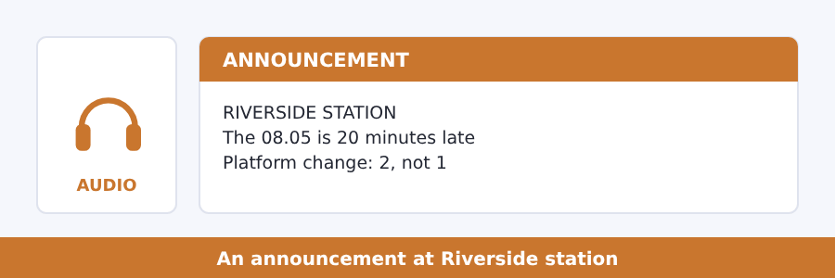
SKILL · Two changes in one announcement
- A station announcement often changes a time and a platform at once.
- The platform number is said twice: the new one and the old one.
- Listen for instead of and not. They mark the change.
- Apologies at the end carry no information.

Exercise B Listen and answer. The audio plays once.
4. How late is the 08.05?
(A) ten minutes
(B) twenty minutes
(C) thirty minutes
(D) an hour
5. Why is it late?
(A) bad weather
(B) no driver
(C) a delay earlier this morning
(D) work on the line
6. Which platform does it leave from today?
(A) platform 1
(B) platform 3
(C) the same as always
(D) platform 2
7. What can passengers with a single ticket do?
(A) get their money back
(B) use the 08.35 at no extra cost
(C) take the bus
(D) go to lost property
8. What does the shuttle bus do?
(A) waits for this train
(B) leaves on time
(C) does not run
(D) goes to Westbury
Audio script: see the back of the book. Do not read it before you listen.


Exercise A Listen and choose a response. You hear one line. Choose the best reply.
1. Did many students come by bus last year?
(A) Yes, they did.
(B) At the station.
(C) Two zones.
(D) Yes, they are.
2. How much did the ticket cost?
(A) At nine.
(B) Three pounds.
(C) Yes, it did.
(D) From platform 2.
3. What can a college change?
(A) Yesterday.
(B) Yes, it can.
(C) Two hours.
(D) The time of the first class.
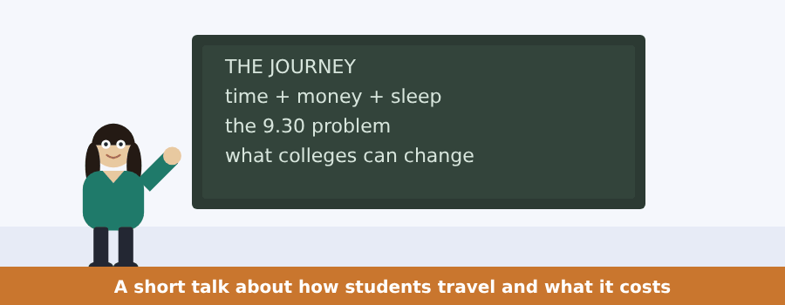
SKILL · A talk with a problem and a fix
- A talk about a problem usually ends with something somebody could do.
- Write down the problem in one line before the fix arrives.
- Numbers in this kind of talk are evidence, not detail.
- The question about the fix is usually the last one.

Exercise B Listen and answer. The audio plays once.
4. How many students did they ask?
(A) forty
(B) fifty
(C) four hundred
(D) four thousand
5. What was the middle answer?
(A) fifteen minutes
(B) fifty minutes each way
(C) two hours
(D) eight hours
6. For about a quarter of the students the journey went over
(A) one hour a day
(B) three hours a day
(C) eight hours a week
(D) two hours a day
7. What did they find about money?
(A) the cheap card does not work before half past nine
(B) students pay nothing
(C) the fare went down
(D) the college pays the fare
8. Who pays the full fare every morning?
(A) the teachers
(B) everybody
(C) the poorest students
(D) nobody
9. What does the speaker say a college can choose?
(A) the start time of a first class
(B) the price of the ticket
(C) the bus route
(D) the travel card
Audio script: see the back of the book. Do not read it before you listen.


Exercise A Listen and choose a response.
1. Why did the first cities grow?
(A) Ten thousand years.
(B) Yes, they did.
(C) Because of food.
(D) In a field.
2. Did people live together before farming?
(A) In a city.
(B) Yes, they did.
(C) Food for ten.
(D) Yes, they do.
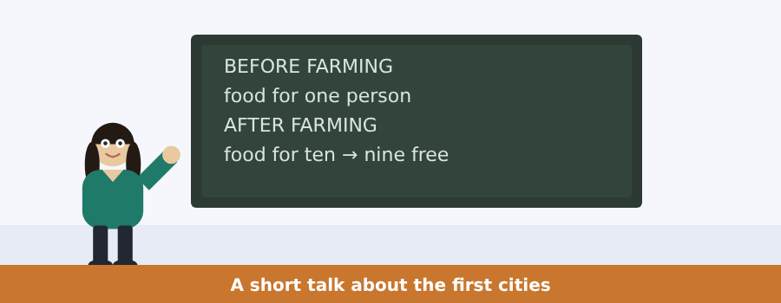
SKILL · A speaker who corrects an answer
- A talk can open with a student’s wrong answer. It is not the point.
- Listen for that is not the reason. The real reason comes next.
- Here the real reason is one word, and the speaker repeats it.
- The last two sentences are usually the whole talk in short.

Exercise B Listen and answer. The audio plays once.
3. What did somebody in the class say?
(A) because of food
(B) because of the king
(C) because of farming
(D) because people wanted to live together
4. What is the real reason?
(A) the king
(B) the walls
(C) food
(D) the cups
5. How much food did one person find before farming?
(A) food for ten
(B) no food
(C) food for nine
(D) food for one person
6. What is a city, for this speaker?
(A) a lot of houses
(B) what extra food looks like
(C) a wall and a king
(D) a field
Audio script: see the back of the book.


Exercise A Listen and choose a response.
1. How do we know about the first cities?
(A) From three things.
(B) Six thousand years.
(C) Yes, we do.
(D) A list of animals.
2. Did anybody write it down at the time?
(A) A cup.
(B) Three things.
(C) No, nobody did.
(D) Yes, they do.
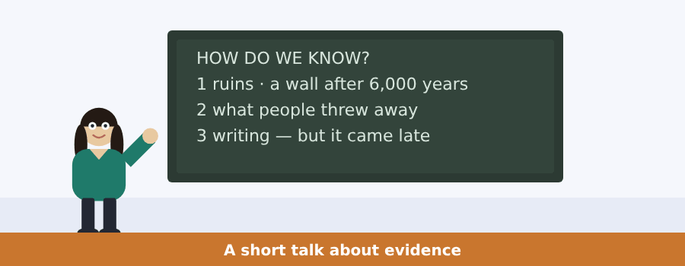
SKILL · A list you must keep in order
- First, second and third are a gift: they tell you how many notes.
- Write the number and two or three words. Nothing else.
- The speaker gives one example for each. Keep the examples apart.
- The last sentence is often the surprise, not the summary.

Exercise B Listen and answer. The audio plays once.
3. Why is it a fair question?
(A) the ruins are gone
(B) the cups are broken
(C) writing came early
(D) nobody wrote any of it down at the time
4. How long is a wall still a wall?
(A) six hundred years
(B) six thousand years
(C) a century
(D) ten years
5. What does a cup of old food tell you?
(A) what a whole street ate for dinner
(B) how old the city was
(C) who the king was
(D) how many animals there were
6. What was the first writing in the world?
(A) a story
(B) a record of a war
(C) a wall
(D) a list of animals
Audio script: see the back of the book.


Part 1 · Listen and Repeat
You hear a sentence and repeat it once. There is no preparation time, and the sentences get longer. Focus: irregular past forms said out loud
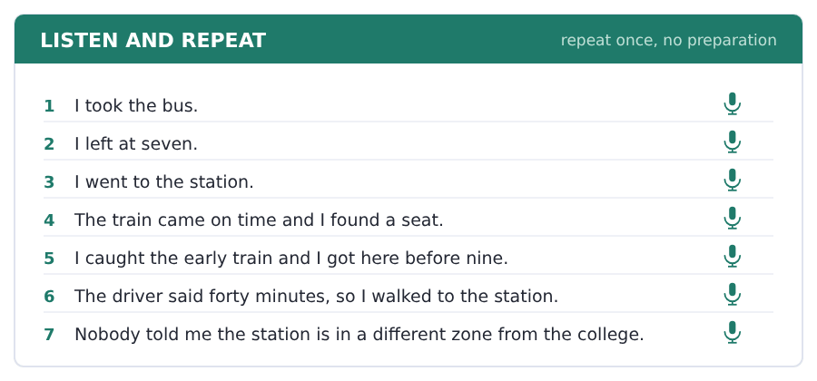
SKILL · Say the pair, not the word
- Learn go–went, take–took, come–came as single items.
- Under pressure the pair comes back together and the single word does not.
- Many irregular pasts have a long vowel: came, took, wrote, drove.
- Say the past with the time phrase: I went yesterday, not just I went.

Part 2 · Take an Interview
An interviewer asks you four questions on one theme: how you travel. Answer each one fully. There is no preparation time.
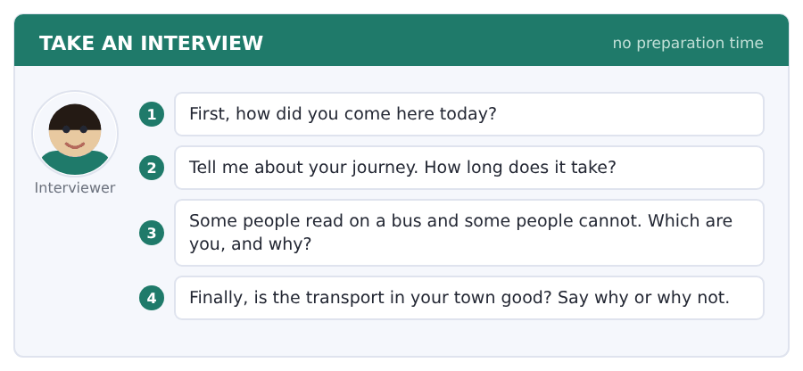
Say it like this
- Today I came ... . It took ... .
- My journey is ... . First I ... , then I ... .
- I ... read on a bus, because ... .
- The transport in my town is ... , because ... .
A good answer sounds like this
Question 1 — Today I came by bus. It took about forty minutes, because the traffic was bad near the bridge.
Question 2 — My journey is two buses. First I take the 14 to the station, then I take the shuttle bus to the college.
Question 3 — I cannot read on a bus, because the road makes me feel ill after ten minutes. I listen to something instead.
Question 4 — The transport in my town is not good, because everything goes to the middle. To go two streets across you go all the way in and out again.
I can… | Not yet | Yes
I used the past form of every irregular verb | □ | □
I put a time phrase with my past verbs | □ | □
I gave a reason after my opinion | □ | □


Part 1 · Listen and Repeat
You hear a sentence and repeat it once. There is no preparation time, and the sentences get longer. Focus: saying times, platforms and prices clearly
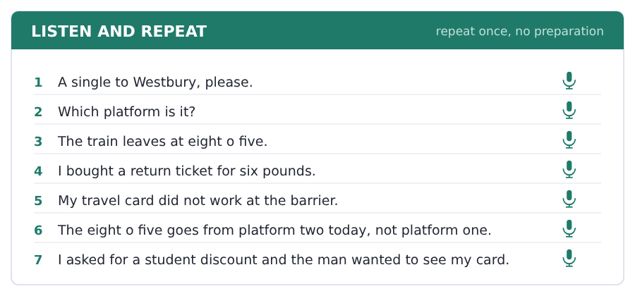
SKILL · Numbers under pressure
- Say a train time in two parts: oh eight oh five.
- Say a platform number on its own, then repeat it: platform two, two.
- When you ask for a ticket, say the place first, then single or return.
- Slow down for the number and speed up again after it.

Part 2 · Take an Interview
An interviewer asks you four questions on one theme: tickets and journeys. Answer each one fully. There is no preparation time.
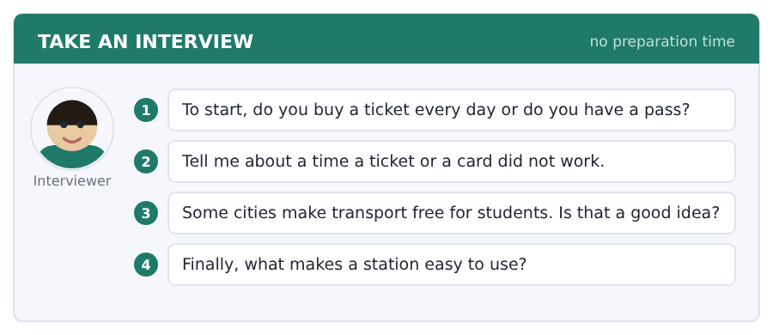
Say it like this
- I usually ... , because ... .
- Once my ... did not work. I ... .
- I think it is ... , because ... .
- A station is easy when ... .
A good answer sounds like this
Question 1 — I have a bus pass, because I take four buses a day and a ticket for each one costs too much.
Question 2 — Once my travel card did not work at the barrier. A member of staff opened the gate, but I missed the train.
Question 3 — I think it is a good idea. A student with no money for the fare stays at home, and then the free place at the college is worth nothing.
Question 4 — A station is easy when the platform numbers are big and the next train is on a board at the entrance.
I can… | Not yet | Yes
I said the times and numbers slowly and clearly | □ | □
I used the past in my story | □ | □
I answered all four questions | □ | □


Part 1 · Listen and Repeat
You hear a sentence and repeat it once. There is no preparation time, and the sentences get longer. Focus: telling a story with a problem in it
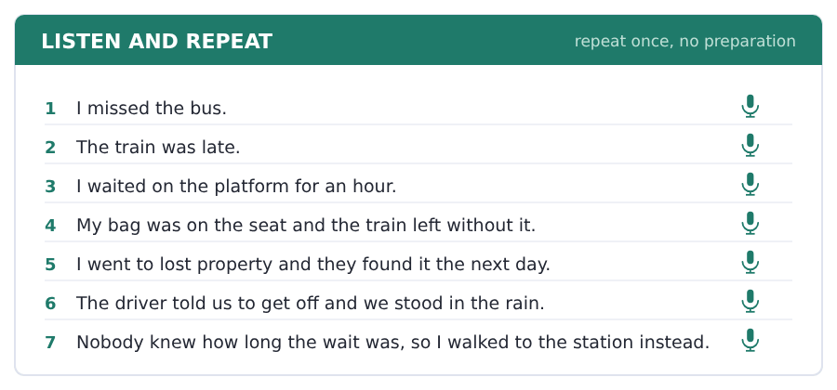
SKILL · A story needs a turn
- Start with the plan, then the problem, then what you did.
- The problem is where the listener starts to listen.
- Use but and so to mark the turns. They are enough.
- End with what happened in the end, even if it was nothing.

Part 2 · Take an Interview
An interviewer asks you four questions on one theme: a journey you remember. Answer each one fully. There is no preparation time.
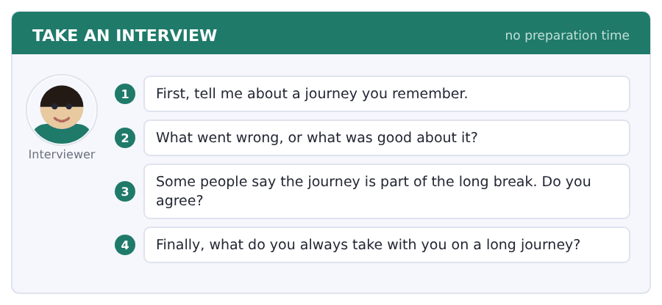
Say it like this
- Last ... I went to ... .
- The problem was ... . So I ... .
- I ... agree, because ... .
- I always take ... , because ... .
A good answer sounds like this
Question 1 — Last summer I went to the north of the country by train. It was nine hours and I did it in one day.
Question 2 — The problem was the seat. I booked one by the window and a family sat in it, so I stood for two hours.
Question 3 — I agree, but only on a good day. Nobody says that at midnight in a station with no information.
Question 4 — I always take water and something to read, because a delay with nothing to do is the longest hour there is.
I can… | Not yet | Yes
I told the story in order with a problem in the middle | □ | □
I used at least five past verbs | □ | □
I finished the story | □ | □


Part 1 · Listen and Repeat
You hear a sentence and repeat it once. There is no preparation time, and the sentences get longer. Focus: the three sounds of the past -ed
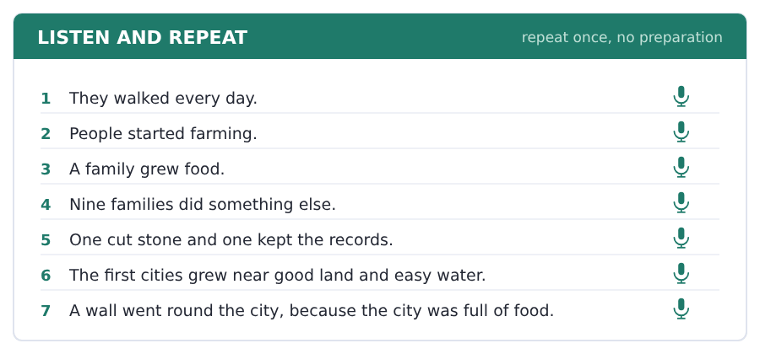
SKILL · Walked, lived, started
- After a quiet sound the -ed is /t/: walked, looked, asked.
- After a loud sound the -ed is /d/: lived, carried, grew old.
- After t or d the -ed is a whole part: started, wanted, ended.
- Say started with two parts and walked with one.

Part 2 · Take an Interview
An interviewer asks you four questions on one theme: the history of your own town. Answer each one fully. There is no preparation time.
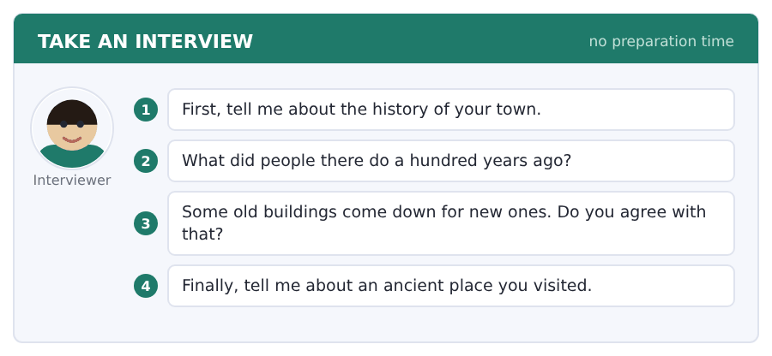
Say it like this
- My town started about ... .
- People there worked in ... .
- I think ... , because ... .
- The oldest building in my town is ... .
A good answer sounds like this
Question 1 — My town started about four hundred years ago as a very small village near a river.
Question 2 — A hundred years ago people there worked on the land and in one factory by the water.
Question 3 — I do not agree with all of it. Keep the ones with good stone, and take the rest down.
Question 4 — I visited an ancient wall in the south of my country last summer. It was Roman and it was still very high.
I can… | Not yet | Yes
I said walked with one part and started with two | □ | □
I used three field words | □ | □
I gave a reason after my opinion | □ | □


Part 1 · Listen and Repeat
You hear a sentence and repeat it once. There is no preparation time, and the sentences get longer. Focus: the quiet did in a past question
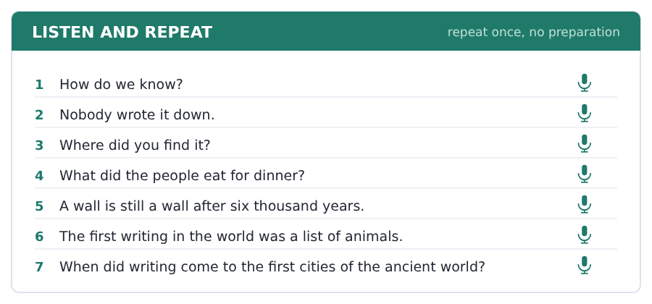
SKILL · Where-did-you, in one piece
- In a real question did is small and quick, not loud.
- Where did you go? sounds like three words, not four.
- The loud words are the question word and the verb.
- A loud did sounds like a police question, not a seminar.

Part 2 · Take an Interview
An interviewer asks you four questions on one theme: how we know about the past. Answer each one fully. There is no preparation time.
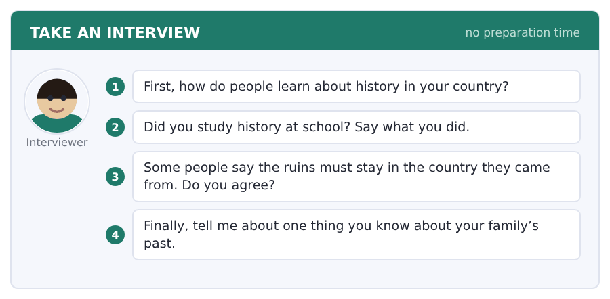
Say it like this
- We know about ... from ... .
- I read about ... in ... .
- I think ... , because ... .
- For me the interesting evidence is ... .
A good answer sounds like this
Question 1 — People learn about history at school and from the television. There is a very good old city in the north.
Question 2 — I studied history for four years. We did the ancient world in the first year and I liked it very much.
Question 3 — I agree. The evidence came out of that ground, and the people there must see it.
Question 4 — My grandfather came to this country in nineteen sixty. He worked on the road for thirty years.
I can… | Not yet | Yes
I kept did small and quick | □ | □
I used the past simple correctly | □ | □
I answered all four questions | □ | □


You see a sentence, then a set of words in boxes. Put the words in order to make one grammatical sentence. Almost every item in the real test makes a question or a question inside another sentence.
SKILL · did takes the past away from the verb
- Did you take the bus? The did carries the past; take stays plain.
- The same in the negative: I did not take the bus.
- Never say *Did you took* or *I did not took*. One past is enough.
- Question word first: Where did you go? What time did you leave?

Exercise A Guided practice. The first three are worked through.
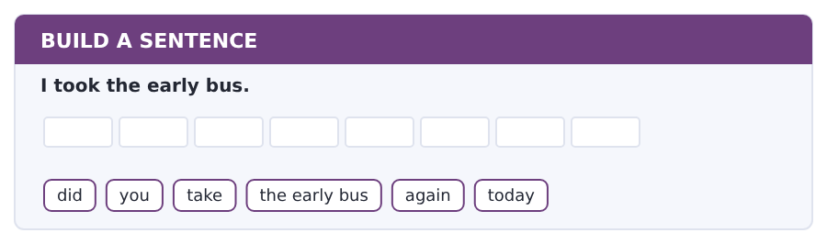
1. Did you take the early bus again today?
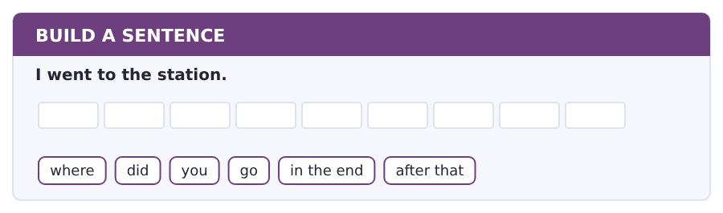
2. Where did you go in the end after that?
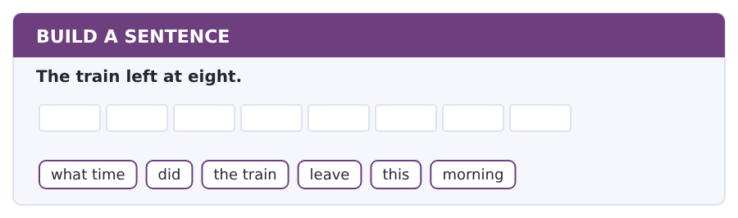
3. What time did the train leave this morning?
Exercise B Exam practice. Write the sentence.
4. The bus broke down near the station.
where / did / the bus / break / down / exactly
__________________________________________________________
5. I waited for forty minutes.
how long / did / you / wait / for it / exactly
__________________________________________________________
6. A member of staff opened the gate.
who / did / open / the gate / for you / in the end
__________________________________________________________
7. I got there at half past ten.
what time / did / you / get / there / in the end
__________________________________________________________
8. My card did not work.
did / your card / work / at the barrier / again / yesterday
__________________________________________________________
9. I came by train.
how / did / you / come / to college / today
__________________________________________________________
10. She bought a return ticket.
what / did / she / buy / at the station / this morning
__________________________________________________________


You read a short situation and write an email. You have 7 minutes. The three bullet points are the mark scheme: answer all three.
In the real test you write as much as you can in seven minutes. In this unit, aim for about 66 words. That number goes up in every unit of this book, and in Volume 1 it stops being a number at all.
On Monday 10 November you took the 08.05 train from Northgate.
It was forty minutes late and you missed a class. Write to the company.
- say which train you took and when
- say what happened and what it cost you
- ask for the money back
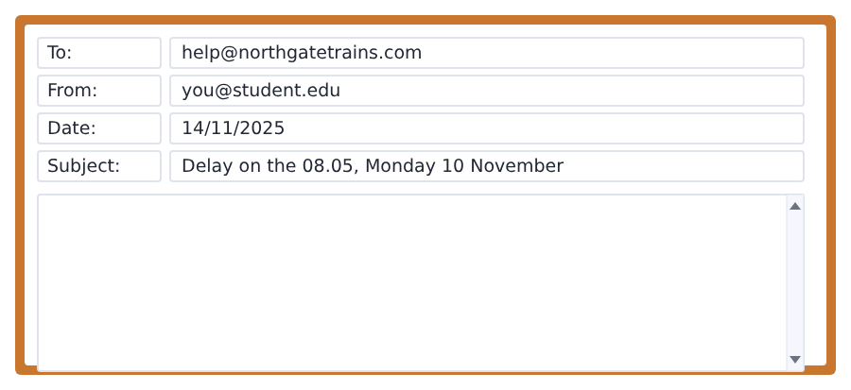
SKILL · A past complaint needs past verbs
- The whole email is in the past, except the request at the end.
- Name the train by its time and the day by its date. Both.
- Say the result for you: I missed a class. That is the cost.
- Ask for one thing: the money back, or a free ticket.

Model email
Dear Northgate Trains,

My name is Ana Ruiz and I am a student at Riverside College.
On Monday 10 November I took the 08.05 from Northgate to Riverside. The train left forty minutes late and I missed my first class.
I bought a single ticket and I still have it.
Is it possible to have the money back?

Thank you,
Ana Ruiz
Why it works
- The train and the date are both in the first sentence of the complaint.
- Every verb in the story is a past verb: took, left, missed, bought.
- The cost to the writer is named: a missed class.
- The request is one clear thing and it is the last line before the ending.
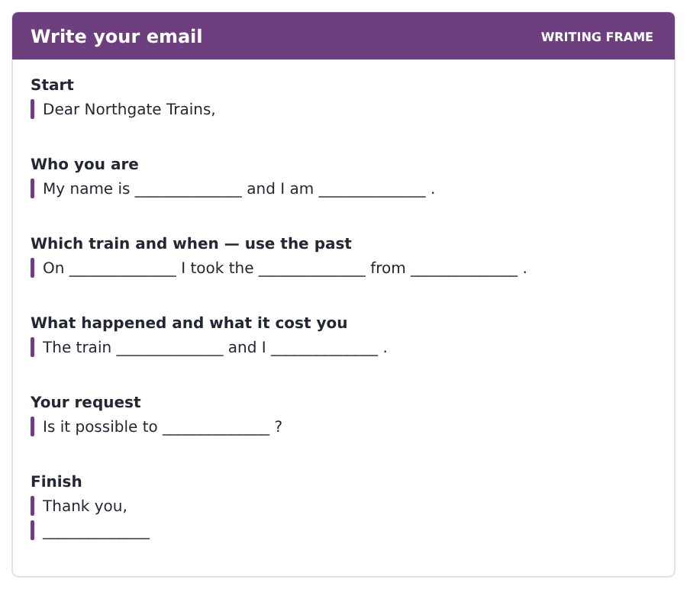
Now write your own. 7 minutes.
__________________________________________________________
__________________________________________________________
__________________________________________________________
__________________________________________________________
__________________________________________________________
__________________________________________________________
__________________________________________________________
__________________________________________________________


A professor asks a question and two students answer. You add your own post. You have 10 minutes and an effective answer is at least 100 words.
One hundred words is what the real test wants, and you will get there. For this unit, write about 75. Every unit of this book asks for a few more.
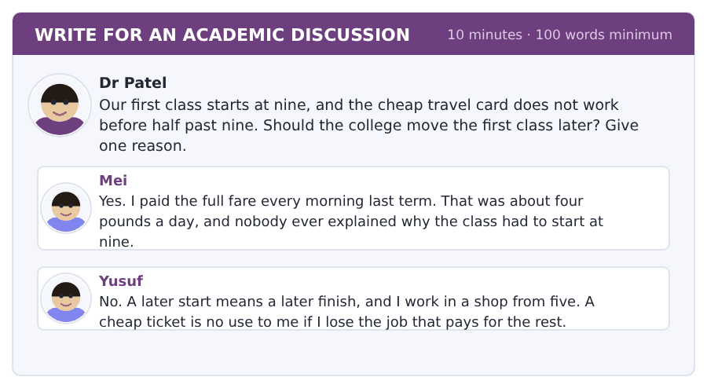
SKILL · Two costs, not one
- Mei counts money. Yusuf counts time. Say which cost is bigger for you.
- Use the past to give evidence: last term I paid, last year I missed.
- Then answer the question directly: yes or no.
- Seventy-five words is about seven short sentences.

Sentence starters
- I agree with Mei, because ...
- Yusuf is right that ...
- Last term I ...
- The college could ...
Model post
I agree with Mei. The college should move the first class to half past nine.
Last term I paid the full fare four days a week, and that came to as much money as my books.
Yusuf is right that a later finish is a real problem for students with a job in the evening.
The college could move only the first class of the day and keep the rest where they are. Then both of us get what we need.
[81 words]
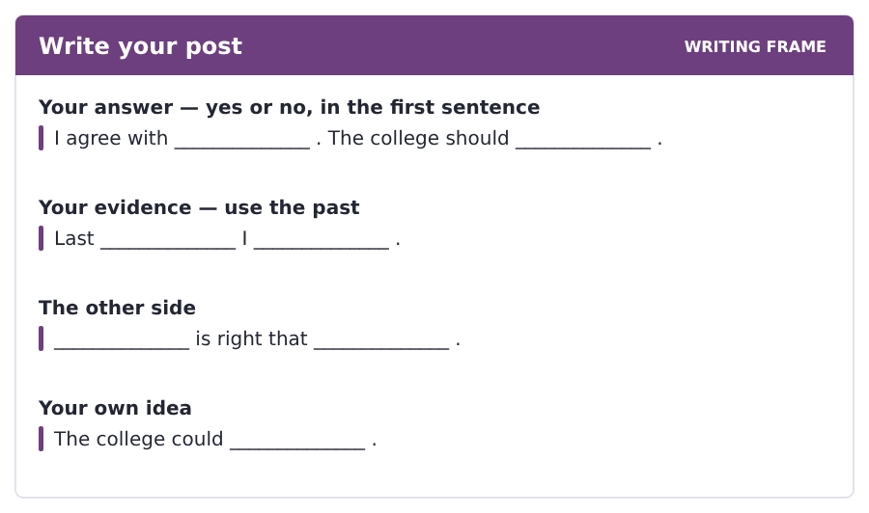
Now write your own. 10 minutes, at least 75 words.
__________________________________________________________
__________________________________________________________
__________________________________________________________
__________________________________________________________
__________________________________________________________
__________________________________________________________
__________________________________________________________
__________________________________________________________
__________________________________________________________
__________________________________________________________


The same task again, on the subject of this unit. The sentences are about history and change now, and the word order has not changed at all.
SKILL · Questions in the past simple
- Did goes in front of the person, and the verb goes back to its plain form.
- When did people start? not When did people started?
- A question word goes first: Where did the cities grow?
- With who as the subject there is no did: Who wrote it down?

Exercise A Guided practice.
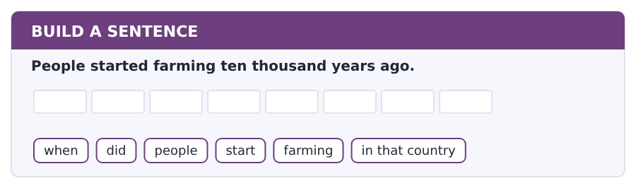
1. When did people start farming in that country?
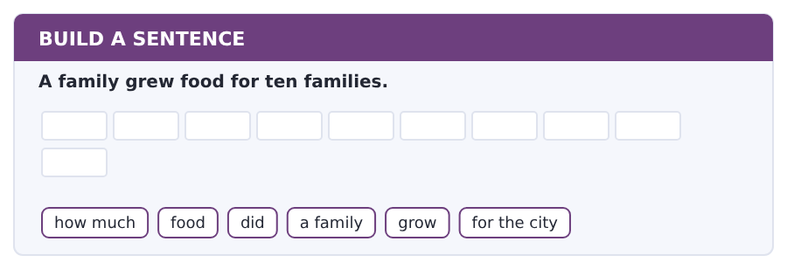
2. How much food did a family grow for the city?
Exercise B Exam practice. Write the sentence.
3. The first cities grew near good land.
where / did / the first cities / grow / in that / country
__________________________________________________________
4. Nobody wrote the story down.
who / wrote / the story / of the first / cities / down
__________________________________________________________
5. The people threw the cups away.
what / did / the people / throw / away / in the city
__________________________________________________________
6. Writing came late.
when / did / writing / come / to the first / cities
__________________________________________________________


A second discussion, and this one is about the subject rather than about your own week. In the real test both kinds come up, and the second kind is the harder one.
For this unit, write about 75 words. The real test wants a hundred.
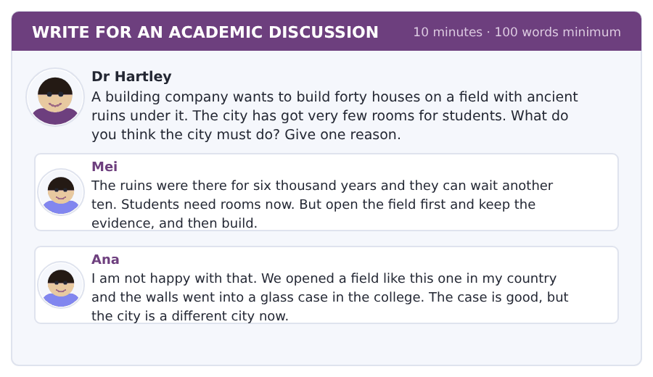
SKILL · Two good answers and one choice
- Mei and Ana both care about the ruins. They want different ends.
- Say which one you take, and say what you give up.
- Use the passage: ruins are evidence, and evidence goes once.
- Seventy-five words is about seven sentences.

Sentence starters
- I agree with Mei, because ...
- Ana is right that ...
- The passage says the ruins ...
- So the city must ...
Model post
I agree with Mei. Students need rooms now, and the city cannot keep every old field for ever.
But Ana is right that you only dig a field once. The passage says the ruins are evidence, and evidence does not come back.
So the city must open the whole field first and pay for it. Then it can build the forty houses. That costs a year, and a year is not a high price for six thousand of them.
[79 words]
Now write your own. 10 minutes, at least 75 words.
__________________________________________________________
__________________________________________________________
__________________________________________________________
__________________________________________________________
__________________________________________________________
__________________________________________________________
__________________________________________________________
__________________________________________________________
__________________________________________________________
__________________________________________________________

Grammar focus past simple: irregular verbs · questions and negatives with did
Form | Example
irregular past | go → went, take → took, come → came
same for every person | I went. She went. They went.
question | Did you go? Where did she go?
negative | I did not go. He did not take it.
the verb after did | plain form only: did you take, not *did you took*
short answer | Yes, I did. No, I did not.
was and were are different | Was it late? (never *Did it was late?*)

An irregular past has one form and it never changes for the person. That is the good news: fifty words and the whole past tense is yours.
Did carries the past in a question or a negative, so the main verb goes back to its plain form. The past is marked once, never twice.
Be is the exception again. Was and were make their own questions and negatives and never take did.
Watch out! The two mistakes to watch are *Did you went?* and *I didn’t went*. Both put the past in twice. Once did appears, the other verb relaxes.
Exercise 1 Write the past of the verb.
1. I __________ (take) the early bus.
2. She __________ (leave) at seven.
3. We __________ (go) to the station.
4. The train __________ (come) on time.
5. He __________ (find) a seat by the window.
6. They __________ (tell) us to get off.
Exercise 2 Make a question with did.
1. You took the bus.
2. She left at seven.
3. They went by train.
4. He found a seat.
5. You missed the class.
6. It broke down.
Exercise 3 Correct the mistake.
1. Did you went to the station?
2. I didn’t took the bus.
3. Did it was late?
4. She did not came.
How this is tested in Build a Sentence
Build a Sentence will give you did and a plain verb in the same set of tiles. That pair tells you two things at once: the sentence is a past question, and the verb does not change.

Typing and the Screen Typing a short story, and the apostrophe
The real test is typed. Nobody gives you paper. If you are still looking for the keys, you lose the Writing section before your English does.
Past-tense writing needs one key you have not used much: the apostrophe, for didn’t, wasn’t and couldn’t. It sits next to the return key, under the right little finger.
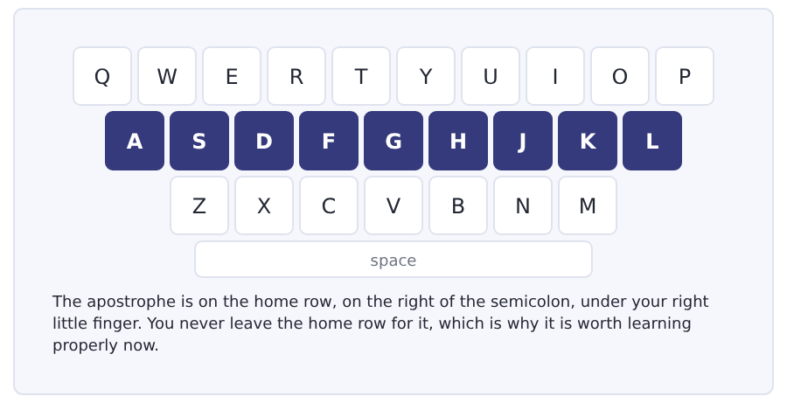
Exercise Type this. Time yourself, then write your speed in the box.
didn’t wasn’t couldn’t wouldn’t shouldn’t
The bus broke down and I didn’t wait for another one.
I took the train, but my card wasn’t valid for that zone.
My time _______ seconds
Words a minute _______ (the target for Unit 8 is 15)

Learning to Learn Reading on a journey
If your journey to college is an hour, you have ten hours a week that you are not using. That is more time than any class you take. A bus is not a good desk, but it is a very good reading room, for one reason: nobody there can ask you to do anything else.
- Choose reading, not writing. A bus is bad for a pen and fine for a page.
- Take one thing only, and decide what it is before you leave the house.
- Read with a pencil and mark the words you do not know. Look them up at the other end, not on the bus.
- If you feel ill when you read on a bus, listen instead. An audio book or a recording of a lecture does the same job.
- Count it as study. It is study, and a week that includes it is two hours longer than a week that does not.
ADAPTIVE TIP Put the thing you will read in your bag the night before. The decision is the hard part, and the night before is the only time you have the energy to make it.

Unit review and progress check Unit 8
Exercise A Vocabulary. Write the word.
1. the act of going from one place to another
2. the part of a station where you wait
3. a wait that should not happen
4. the price of a journey
5. the way a bus or train goes
6. a ticket there and back
7. the gate you put your ticket in
8. the office that keeps things people leave
9. somebody travelling in a bus or a train
10. the bags you take on a journey
11. with too many people in it
12. a lower price because you are a student
Exercise B Grammar. Complete the sentence.
1. I __________ (take) the early bus.
2. She __________ (leave) at seven.
3. We __________ (go) to the station.
4. The train __________ (come) on time.
5. __________ you take the bus?
6. I did not __________ (take) the train.
7. __________ it late? (be)
8. Where __________ you go?
Exercise C One timed mini-section. 6 minutes.
1. The 07.05 from Northgate reaches Westbury at
(A) 07.19
(B) 07.41
(C) 08.11
(D) 08.41
2. The barrier did not open because
(A) there was no money
(B) it was broken
(C) the card was for the wrong zone
(D) the card was lost
3. In the talk, the middle journey was
(A) fifty minutes each way
(B) fifteen minutes
(C) two hours
(D) eight hours
4. Which sentence is correct?
(A) Did you go to the station?
(B) Did you went to the station?
(C) Did you going to the station?
(D) You went to the station?
5. Which sentence is correct?
(A) Did it was late?
(B) Did it late?
(C) It was late?
(D) Was it late?
6. The writer calls a bus
(A) a waste of time
(B) a second home
(C) a reading room with bad lights
(D) a classroom
Can you do these now?
I can… | Not yet | Yes
tell a short story about a journey in the past | □ | □
read a timetable and a ticket and find the facts | □ | □
understand a short text about how students travel | □ | □
follow a conversation about a journey that went wrong | □ | □
ask questions about the past with did | □ | □
write an email asking for money back after a delay | □ | □

ADAPTIVE TIP In the Listening section a journey is a string of numbers: a time, a platform, a price, a delay. Write each one down as a figure the moment you hear it. You will not remember which number the question wants until the question arrives, and by then the audio has gone.

Unit 9 · The Body, Health and the Clinic
TOEFL iBT® Preparation Course 2026 · Volume F1
CEFR A2 · Grammar: can and cannot · should · orders · how-words ending in -ly · Word field: the body, health, advice
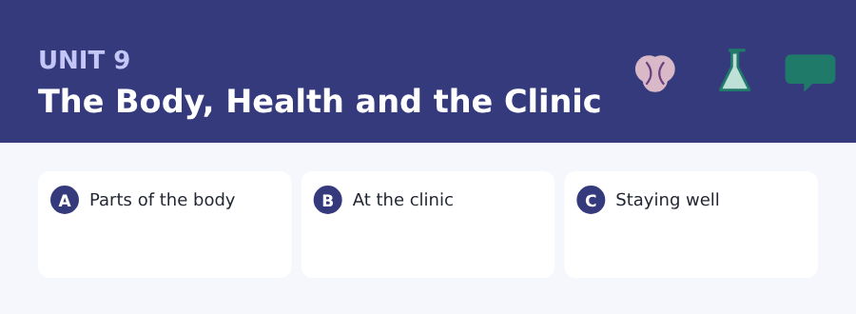
By the end of this unit I can…
- say what I can and cannot do
- read a clinic notice and find what to do
- understand a short text about health and students
- follow a conversation at a health centre
- give simple advice with should
- write an email asking for an appointment

Three sub-topics, three cycles in every skill. This unit gives you the language of advice, and the first eight words of the Academic Word List that Volume 1 is built on.

Vocabulary 1 · The words you need most 24 words from the two thousand most common words of English
These are not academic words. They are the words that carry ordinary English, and until you own them the academic words of Volume 1 have nothing to stand on. Cover the right-hand column and test yourself.
body all of a person from head to foot | heart it moves the blood around your body
head the part with your eyes and mouth in it | blood the red liquid inside you
eye you see with it | ill not well
ear you hear with it | pain the bad feeling when a part of you hurts
nose you smell with it | hurt to give pain, or to feel pain
mouth you eat and speak with it | medicine what you take to get well
tooth one of the hard white things in your mouth | rest to stop and do nothing for a time
arm the long part between your shoulder and your hand | healthy well, and likely to stay well
hand the part with five fingers | breathe to take air in and let it out
leg you walk on two of these | careful thinking about danger before you act
foot the part at the end of your leg | dangerous able to hurt you
skin the soft cover of the whole body | cough the sharp noise you make when your throat is bad

Exercise A Work in pairs. Ask and answer.
1. Can you touch your foot without bending your legs?
2. What should a student do to stay healthy?
3. Are you registered with a doctor here?
4. Which part of the body do people hurt most often in a game?
Vocabulary 2 · Campus and everyday 12 words for student life
Every Listening conversation in the real test happens on a campus. These twelve words come back in this unit and again in Volume 1.
clinic a small place for medical help | sick note the paper that says you were too ill to come
appointment a time the doctor keeps for you | health centre the building with doctors and nurses in it
doctor the person who finds out what is wrong | waiting room the room where you sit before the doctor calls you
nurse the person who looks after you in a clinic | symptom a sign that something is wrong with you
prescription the paper the doctor writes for your medicine | treatment what the doctor does to make you well
pharmacy the shop that gives you the medicine | register with to put your name on a doctor’s list

Vocabulary 3 · First academic words The bridge into Volume 1
Volume 1 teaches four hundred and eighty words from the Academic Word List. These are the first of them, and they are here so that the list is not new when you meet it.
area one part of a place or a subject | method a way of doing something
benefit a good thing that comes from something | process a set of steps, one after another
create to make something new | require to need
factor one of the things that make something happen | role the job a person or thing does

Words you will meet again: clinic | appointment | symptom | treatment | healthy | rest | benefit | factor

Sound and Spelling Weak forms, and the words that disappear
English squeezes its small words almost out of existence, and that is the single biggest reason a listening test sounds faster than real life. The small words are not important for meaning, so the language does not spend time on them.
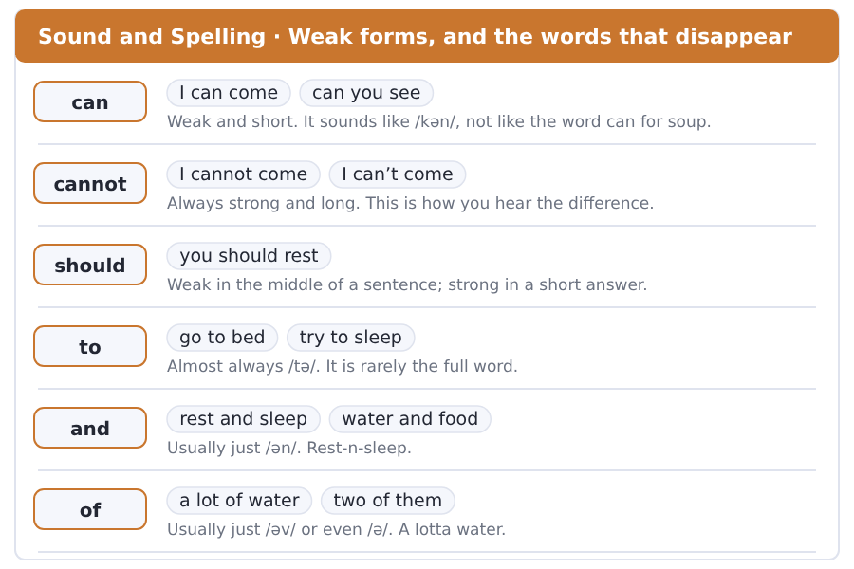
Exercise A Listen. Which word do you hear?
1. Do you hear can or cannot?
2. Do you hear can or cannot?
3. Do you hear should or shouldn’t?
4. Do you hear to or two?
5. Do you hear and or an?
6. Do you hear a lot of or a lotta?
Exercise B Say these out loud. Record yourself if you can.
1. Say both and feel the difference: I can come / I cannot come.
2. Say with weak forms: a lot of water, go to bed, rest and sleep.
3. Say five pieces of advice with should, each with a reason.
4. Say the parts of the body from head to foot, out loud.


SKILL · Adverbs from adjectives
- Most of these words add -ly to the adjective: careful, careful-ly.
- An adjective ending in -y changes to -ily: easy, eas-ily.
- The -ly word tells you how. The adjective tells you what kind.
- Count the dashes: two is usually -ly, four is usually -ily.

Exercise A Guided practice. Five words are not complete. Write the missing letters.
Walk slow-- up the stairs for a week. Breathe deep-- and rest when you need to. If you feel bad, stop immediate--. The nurse speaks very quick-- on the phone, so listen careful--.

The first one is done for you: 1 slow-- → ly (slowly)
Exercise B Exam practice. One paragraph, ten gaps — the real task.
A cold is not dangerous, but it can make a week very long. Sleep proper--, drink water regular-- and eat normal--. Do not take medicine at once. Most cold- finish quick-- on their own. If you cannot breathe easi--, or if the pain is strong, go to the clinic immediate--. The nurse there listens careful-- and the doctor explains the treatment clear--. Students often wait too long, and then they get well slow-- and miss a whole week. Act early, not bravely.

Check your answers in the key at the back of the book.


SKILL · Find the step you are on
- A clinic notice is a set of steps. Find your step first.
- If, when and before mark the step you need.
- A phone number and a time belong to one step, not to all of them.
- Can wait and cannot wait send you to two places. Read that line twice.

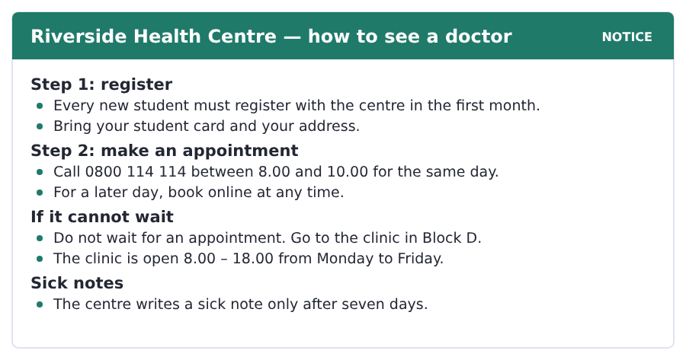
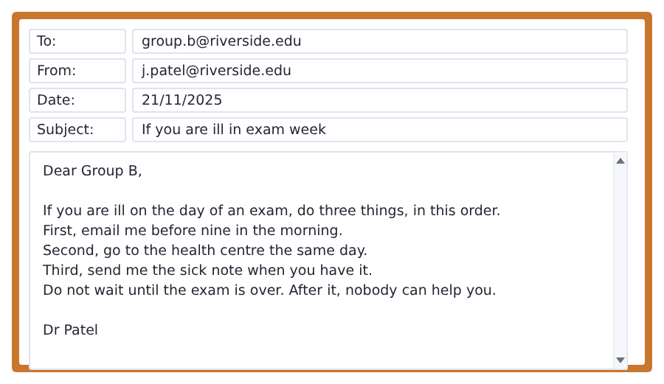
Exercise A Guided practice. The answer is on the page — find it.
1. When must a new student register?
(A) in the first month
(B) in the first week
(C) in the first term
(D) before the exam
2. What do you bring to register?
(A) a sick note
(B) your student card and your address
(C) a prescription
(D) nothing
3. When can you call for a same-day appointment?
(A) 8.00 – 18.00
(B) any time
(C) after 18.00
(D) 8.00 – 10.00
4. Where do you go if it cannot wait?
(A) the health centre
(B) the pharmacy
(C) the clinic in Block D
(D) online
Exercise B Exam practice.
5. How do you book an appointment for a later day?
(A) call at eight
(B) go to Block D
(C) book online
(D) ask your tutor
6. When is the clinic in Block D open?
(A) 8.00 – 18.00 from Monday to Friday
(B) 8.00 – 10.00 every day
(C) all night
(D) only in exam week
7. Who does not get a sick note?
(A) a student ill for ten days
(B) a new student
(C) a student in Block D
(D) a student ill for three days
8. What is the first thing to do if you are ill on an exam day?
(A) go to the health centre
(B) email Dr Patel before nine
(C) send the sick note
(D) wait until the exam is over
9. When should you go to the health centre?
(A) the next day
(B) after the exam
(C) in the first month
(D) the same day
10. What does Dr Patel say about waiting?
(A) it is fine
(B) after the exam nobody can help you
(C) wait for the sick note
(D) wait for an appointment


SKILL · A pattern, a cause, and advice
- A text that starts with a pattern usually explains it and then uses it.
- Each of these and together are the words that join small causes into one.
- The advice is almost always at the end, after but.
- A question with how many wants a number from the middle paragraph.

The Three Weeks Nobody Tells You About
Every health centre in every college town knows the same thing. In the third week of the first term the waiting room fills up. The same thing happens in the third week after the winter break.
The reason is not bad luck. A new student meets a lot of new people in one month. They sleep badly in a new bed. They eat at different times. Each of these is a small factor on its own. Together they create a body with no strength. Then one cold goes round a hall of two hundred rooms in a week, and the waiting room fills up.
Nothing here requires a doctor. Sleep, water and food do the work, and the process is slow and boring. But two things help, and both are free. Register with a doctor in your first week, when you are well and the waiting room is empty. And in week three, go to bed early for four nights. That is the whole method, and most students learn it in the second year.
[174 words]

Exercise A Guided practice.
1. When does the waiting room fill up?
(A) the third week
(B) the first week
(C) the second week
(D) the last week
2. When does it happen again?
(A) in the summer
(B) in week one
(C) in the third week after the winter break
(D) in the exam week
3. Is the reason bad luck?
(A) yes
(B) sometimes
(C) only in winter
(D) no
4. Where does a cold go round?
(A) a classroom
(B) a hall of two hundred rooms
(C) the health centre
(D) the library
Exercise B Exam practice.
5. In a month a new student meets
(A) a lot of new people
(B) nobody
(C) two people
(D) only their class
6. What does the passage say about sleep?
(A) students sleep well
(B) they sleep too much
(C) they sleep badly in a new bed
(D) sleep does not matter
7. What do the small factors do together?
(A) create a body with no strength
(B) nothing
(C) make students strong
(D) fill the pharmacy
8. Does any of this require a doctor?
(A) yes, always
(B) only in week three
(C) no
(D) only for a cold
9. What does the work?
(A) medicine
(B) sleep, water and food
(C) the clinic
(D) the pharmacy
10. When should you register with a doctor?
(A) in week three
(B) when you are ill
(C) in the second year
(D) in your first week
11. What is the advice for week three?
(A) go to bed early for four nights
(B) take medicine
(C) stay in your room
(D) go to the clinic

The field: Rocks, Land and Time Two more cycles in every skill, on one subject
Everything up to here was about your own life, because that is where a language starts. From this page the same unit turns to a subject, and the subject is one Volume 1 will take up properly: how a hill keeps a record of time, and why volcanoes sit in lines.
rock the hard stuff the ground is made of | volcano a mountain with hot rock coming out of it
layer one flat piece of rock or soil over another | melt to go from solid to liquid with heat
fossil an animal or plant from long ago, still in the rock | valley the low land between two hills
soil the soft brown ground a plant grows in | coal black rock from old plants, for burning
sand the very small bits of rock on a beach | deep a long way down
mountain a very high hill | plate one of the very big pieces of rock the ground is made of


SKILL · One rule, then what it lets you do
- Some passages give you a rule and then use it three times.
- The rule is usually short and the writer says it is simple.
- Write the rule down first. Everything else follows from it.
- A question with why usually wants the rule, not the example.

A Hill With Forty Pages
The side of a hill by the sea looks like one wall of rock. Look again and you can see lines across it. Each line is the top of a layer, and every layer is a piece of time.
The rule is simple and nobody can break it. Sand and soil go down on the ground, year after year, and the new sand always goes on top. So the layer at the bottom went down first and the layer at the top went down last. A hill with forty layers in it is a book with forty pages.
And there are things inside the layers. A fossil is an animal or a plant from the time of that layer, still in the rock. You can find a fish in a layer four hundred miles from any sea. The fish did not walk there. The sea was there, and then it went away.
[152 words]

Exercise A Guided practice.
1. What can you see on the side of the hill?
(A) one wall of rock only
(B) a fish
(C) lines across it
(D) forty books
2. What is each line?
(A) a piece of sand
(B) the top of a layer
(C) a fossil
(D) a page
3. Where does the new sand go?
(A) at the bottom
(B) in the sea
(C) in the middle
(D) on top
Exercise B Exam practice.
4. Which layer went down first?
(A) the one at the top
(B) the one in the middle
(C) the one at the bottom
(D) all of them together
5. What is a hill with forty layers like?
(A) a wall
(B) a book with forty pages
(C) a sea
(D) a fossil
6. What is a fossil?
(A) a kind of sand
(B) a line across a hill
(C) a piece of coal
(D) an animal or plant from the time of that layer
7. Why can you find a fish far from any sea?
(A) the sea was there and then it went away
(B) the fish walked there
(C) somebody put it there
(D) the layer moved


SKILL · A pattern first, an answer after
- A passage can open with a pattern on a map and no reason for it.
- The reason always comes later. Read to the end before you answer.
- The middle part is the machine: three or four steps in order.
- Keep the steps in order. A question often asks for one of them.

The Lines Round the Oceans
Put the volcanoes of the world on a map and you see something strange. They are not everywhere. They sit in long lines, and the lines go round the oceans.
The ground under your feet is not one piece. It is a set of very big plates, and they move about as fast as your hair grows. Where two plates meet, one of them goes under the other, down into the hot rock. Deep down it is very hot and some of that rock melts.
The melted rock is light and it comes up where it can. It comes up at the line where the two plates meet, and that line is where you find the volcano. So a volcano is not a hole in the ground. It is the top of a very long road from deep under the sea.
[141 words]

Exercise A Guided practice.
1. Where do the volcanoes sit?
(A) everywhere
(B) in long lines round the oceans
(C) in the middle of the land
(D) in one country
2. Is the ground under your feet one piece?
(A) yes
(B) yes, in the oceans only
(C) no, it is a set of big plates
(D) nobody knows
3. How fast do the plates move?
(A) very fast
(B) they do not move
(C) four hundred miles a year
(D) about as fast as your hair grows
Exercise B Exam practice.
4. What happens where two plates meet?
(A) one goes under the other
(B) they stop
(C) they melt together
(D) a sea comes
5. What happens to the rock deep down?
(A) it gets cold
(B) some of it melts
(C) it goes up at once
(D) it becomes sand
6. Where does the melted rock come up?
(A) in the middle of a plate
(B) in a valley
(C) at the line where two plates meet
(D) under the soil
7. What is a volcano, for this writer?
(A) the top of a very long road from deep under the sea
(B) a hole in the ground
(C) a kind of mountain with no rock
(D) a line on a map

Sentence Builder Writing a list that works in a sentence
Three things in a list take commas between them and and before the last one: rest, water and sleep. The items in the list must all be the same kind of word — three nouns, or three verbs, but never a mix.
Not a sentence | A sentence
Rest, drinking water and you should sleep. | Rest, drink water and sleep.
sleep, water, food | Sleep, water and food do the work.
You should rest and water. | You should rest and drink water.
He listened carefully, clear and slow. | He listened carefully, clearly and slowly.
Bring your card, address and to register. | Bring your card and your address, and register.

Watch out! Keep the list in one shape. If the first item is a verb, every item is a verb. This is the commonest reason a long sentence stops making sense halfway through.
Exercise A Is it a sentence? Write yes or no. If no, put it right.
1. You should rest, water and sleeping.
2. She spoke quickly, clear and careful.
3. Bring your card, your address and registering.
4. Email me, go to the centre and the sick note.
5. Sleep, water and food do the work.
6. Do not wait, do not study late and resting.


Exercise A Listen and choose a response. You hear one line. Choose the best reply.
1. Can you come in at four?
(A) In Block D.
(B) Two days.
(C) It hurts.
(D) Yes, I can.
2. What should I do?
(A) At four o’clock.
(B) Yes, you should.
(C) Rest and drink water.
(D) In the waiting room.
3. Where does it hurt?
(A) Since Monday.
(B) In my back.
(C) Yes, it does.
(D) At the clinic.
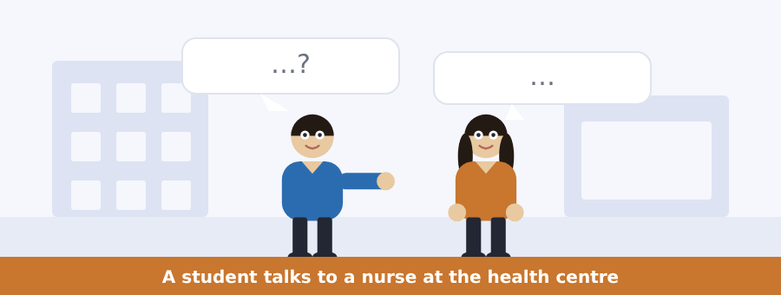
SKILL · Advice sounds like a question
- Advice often comes as a question: Can you come at four?
- Should and could are the polite words. They are not weak.
- The instruction is usually the shortest sentence in the conversation.
- If you are asked to do three things, count them on your fingers.

Exercise B Listen and answer. The audio plays once.
4. What is the man’s problem?
(A) a cough and a bad head
(B) a pain in his leg
(C) a temperature
(D) he cannot breathe
5. Since when has he had the problem?
(A) Thursday
(B) Monday
(C) Wednesday
(D) Saturday
6. Can he breathe normally?
(A) no
(B) yes
(C) only at night
(D) the nurse does not ask
7. What does the nurse tell him to do?
(A) take medicine
(B) see a doctor today
(C) go to the pharmacy
(D) rest, drink water and sleep
8. What should he do if he still feels bad on Wednesday?
(A) wait
(B) go to Block D
(C) call before ten
(D) email his tutor
9. Can he have a sick note?
(A) no, not for a cough
(B) yes, today
(C) yes, after the exam
(D) yes, on Wednesday
Audio script: see the back of the book. Do not read it before you listen.


Exercise A Listen and choose a response. You hear one line. Choose the best reply.
1. Should I register now?
(A) Yes, you should.
(B) In Block D.
(C) Two weeks.
(D) Yes, I can.
2. Can I register online?
(A) At the pharmacy.
(B) Since Monday.
(C) Yes, you can.
(D) In my back.
3. How long does it take?
(A) In Block D.
(B) Yes, it does.
(C) From Monday to Friday.
(D) About ten minutes.
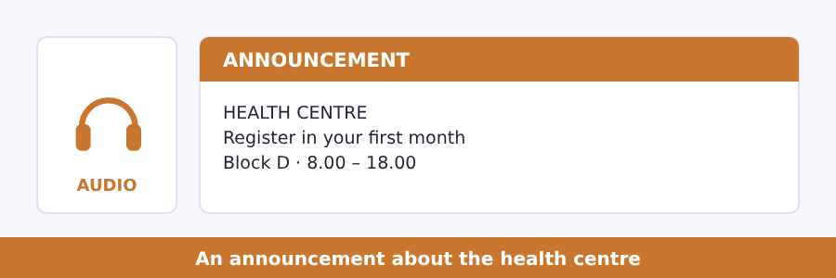
SKILL · An announcement that tells you to act
- Some announcements are not news. They are an instruction.
- The instruction is usually in the first and the last sentence.
- A number in the middle is a deadline or a phone number.
- Listen for must and please. They mark the thing you have to do.

Exercise B Listen and answer. The audio plays once.
4. Who must register?
(A) every student
(B) every new student
(C) only ill students
(D) only students in Block D
5. How many have not registered yet?
(A) about half
(B) a quarter
(C) almost all
(D) nobody
6. How long does registering take?
(A) about five minutes
(B) about ten minutes
(C) about an hour
(D) a whole day
7. What do you bring?
(A) a sick note
(B) a prescription
(C) nothing
(D) your student card and your address
8. Why should you do it while you are well?
(A) it is cheaper
(B) the centre closes
(C) in week three the waiting room is full
(D) the nurse is away
Audio script: see the back of the book. Do not read it before you listen.


Exercise A Listen and choose a response. You hear one line. Choose the best reply.
1. Can a cold go round a whole hall?
(A) Yes, it can.
(B) In week three.
(C) Two hundred.
(D) Yes, I do.
2. What should a new student do first?
(A) At eight.
(B) Yes, they should.
(C) Register with a doctor.
(D) In Block D.
3. Does it require a doctor?
(A) In week three.
(B) No, it does not.
(C) Yes, it can.
(D) From Monday to Friday.
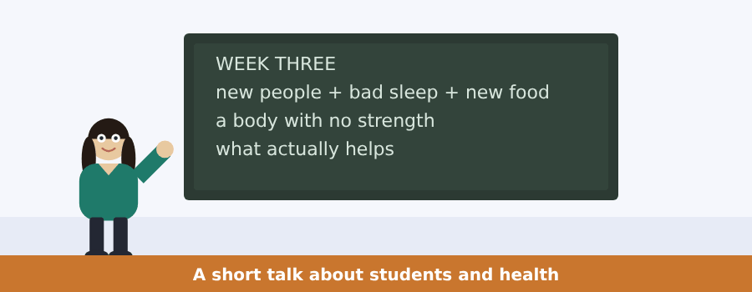
SKILL · Several causes, one result
- A talk about causes lists them and then adds them up.
- The result comes after together, so or and then.
- Advice at the end is usually two things, not five.
- A question about what helps wants the advice, not the causes.

Exercise B Listen and answer. The audio plays once.
4. What runs out three weeks into every first term?
(A) medicine
(B) appointments
(C) sick notes
(D) chairs in the health centre
5. When does it happen again?
(A) in March
(B) in January
(C) in June
(D) in the exam week
6. Does it have anything to do with the weather?
(A) yes
(B) only in January
(C) only in winter
(D) no
7. How many factors does the speaker name?
(A) three
(B) two
(C) four
(D) five
8. What is the first piece of advice?
(A) take medicine
(B) eat more
(C) register in your first week
(D) stay in
9. What is the second?
(A) drink more water
(B) do more exercise
(C) see a doctor
(D) go to bed early for four nights
Audio script: see the back of the book. Do not read it before you listen.


Exercise A Listen and choose a response.
1. Can you read a hill?
(A) In a layer.
(B) Yes, you can.
(C) Forty pages.
(D) Yes, I do.
2. Which layer is the old one?
(A) In the sea.
(B) Yes, it is.
(C) The one at the bottom.
(D) A fossil.
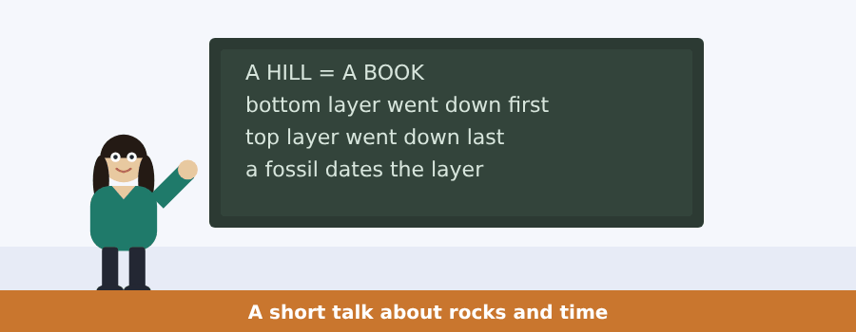
SKILL · A speaker with one tool
- A talk can hang on one small rule the speaker uses again and again.
- Write the rule in five words and keep it at the top of your notes.
- Then note what the rule tells you in each example.
- If you lose the thread, go back to the rule. It still works.

Exercise B Listen and answer. The audio plays once.
3. What is the speaker’s work?
(A) reading hills
(B) making maps
(C) finding fish
(D) writing books
4. What is the whole rule?
(A) old rock goes on top
(B) new rock goes on top of old rock
(C) every hill has forty layers
(D) a fossil has a date
5. How does she read a hill with forty layers?
(A) from the top down
(B) from the middle
(C) from the bottom up
(D) she cannot
6. What does a fossil give her?
(A) the age of that layer
(B) a rule
(C) a new layer
(D) a map
Audio script: see the back of the book.


Exercise A Listen and choose a response.
1. Can a volcano come up in the middle of a plate?
(A) In a line.
(B) Very hot.
(C) Yes, I can.
(D) Not usually, no.
2. Where do the lines go?
(A) Under the soil.
(B) Round the oceans.
(C) Yes, they do.
(D) Very slowly.
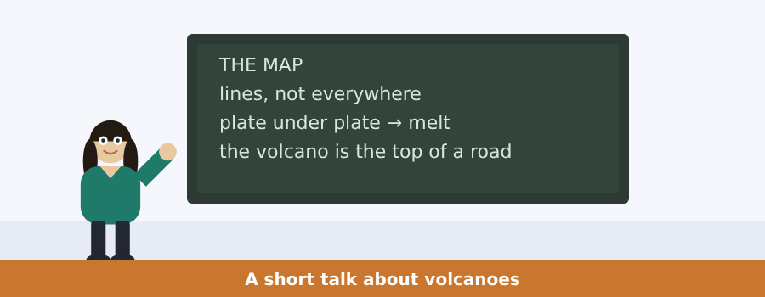
SKILL · A speaker who starts with a map
- A talk can open with a thing you can see and no reason for it.
- That is the question of the talk. Write it as a question.
- The answer is a short machine. Note the steps with arrows.
- The last line often turns the idea round. Keep it word for word.

Exercise B Listen and answer. The audio plays once.
3. What does the speaker do in his first class?
(A) he puts a map on the wall
(B) he asks a question
(C) he reads a hill
(D) he draws a plate
4. What do the students always see?
(A) the plates
(B) the hot rock
(C) the door
(D) that the volcanoes are in lines
5. What do the plates do?
(A) they stay still
(B) they melt
(C) they push against each other
(D) they go round the oceans
6. What is the volcano, for this speaker?
(A) the thing itself
(B) a plate
(C) a line on a map
(D) the door
Audio script: see the back of the book.


Part 1 · Listen and Repeat
You hear a sentence and repeat it once. There is no preparation time, and the sentences get longer. Focus: the /ʌ/ and /ɑː/ sounds in body words
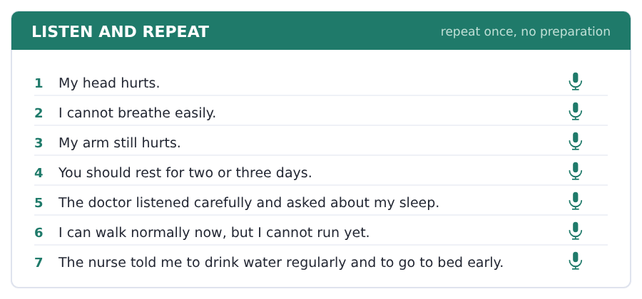
SKILL · Two sounds that change a word
- Blood, tooth and cut are short. Arm, heart and start are long.
- The short /ʌ/ is made in the middle of the mouth with no effort.
- The long /ɑː/ opens the mouth and holds.
- Pairs to practise: cut / cart, hut / heart, bun / barn.

Part 2 · Take an Interview
An interviewer asks you four questions on one theme: health and the body. Answer each one fully. There is no preparation time.
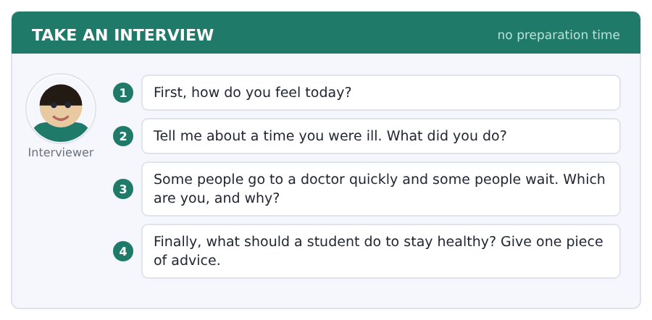
Say it like this
- Today I feel ... .
- Last ... I was ill. I ... .
- I usually ... , because ... .
- A student should ... , because ... .
A good answer sounds like this
Question 1 — Today I feel fine, thank you. I was tired last week, but I slept well at the weekend.
Question 2 — Last winter I was ill for a week. I stayed in my room, took a lot of water and slept about ten hours a night.
Question 3 — I usually wait too long, because an appointment takes a morning and I always have a class.
Question 4 — A student should go to bed at the same time every night, because sleep is the one thing nobody can do for you later.
I can… | Not yet | Yes
I used can and cannot correctly | □ | □
I used a word like carefully or slowly | □ | □
I gave a reason after my advice | □ | □


Part 1 · Listen and Repeat
You hear a sentence and repeat it once. There is no preparation time, and the sentences get longer. Focus: the weak form of can and the strong form of cannot
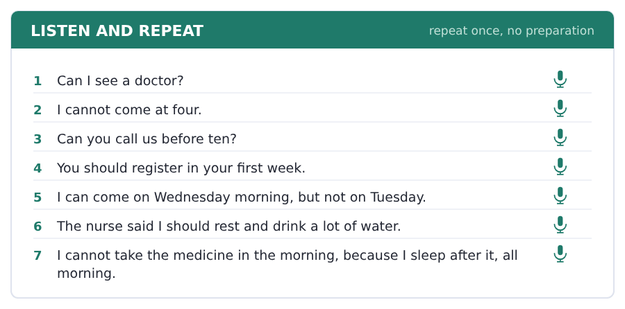
SKILL · Can is weak, cannot is strong
- In I can come the can is short and almost disappears.
- In I cannot come the word is strong and slow. That is the difference.
- If you cannot hear the difference, listen for the length, not the sound.
- In a short answer can is strong again: Yes, I CAN.

Part 2 · Take an Interview
An interviewer asks you four questions on one theme: doctors and appointments. Answer each one fully. There is no preparation time.
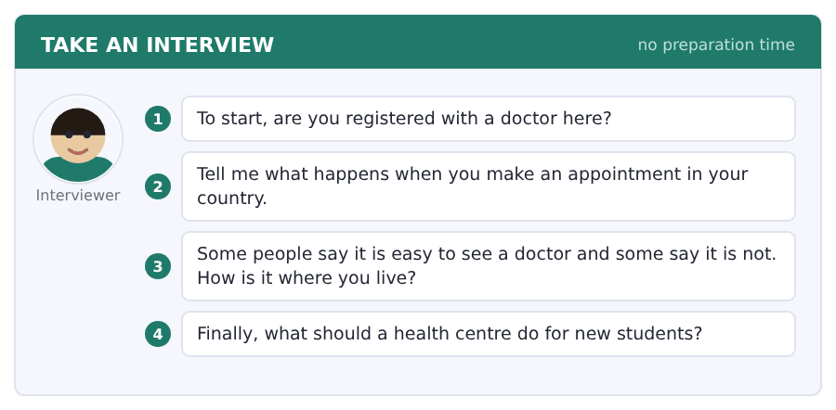
Say it like this
- I am ... registered, because ... .
- In my country you ... . Then ... .
- Where I live it is ... , because ... .
- A health centre should ... .
A good answer sounds like this
Question 1 — I am registered. I did it in my first week, because the college sent an email about it twice.
Question 2 — In my country you call in the morning and they give you a time the same day. Then you wait about an hour in the waiting room.
Question 3 — Where I live it is not easy, because there are two doctors for a whole area and everybody calls at eight.
Question 4 — A health centre should come to the halls in the first week. If you wait for students to come to you, half of them never do.
I can… | Not yet | Yes
I made cannot strong and can weak | □ | □
I used should for advice | □ | □
I answered all four questions | □ | □


Part 1 · Listen and Repeat
You hear a sentence and repeat it once. There is no preparation time, and the sentences get longer. Focus: giving advice without sounding rude
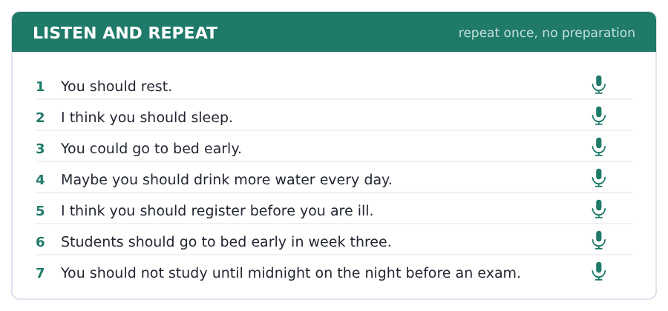
SKILL · Should, not must
- You should go to bed early is advice. You must go to bed early is an order.
- In the Speaking test, advice questions want should or could.
- Soften it with I think or Maybe: I think you should rest.
- Give the reason straight after the advice. Advice with no reason is noise.

Part 2 · Take an Interview
An interviewer asks you four questions on one theme: advice for a new student. Answer each one fully. There is no preparation time.
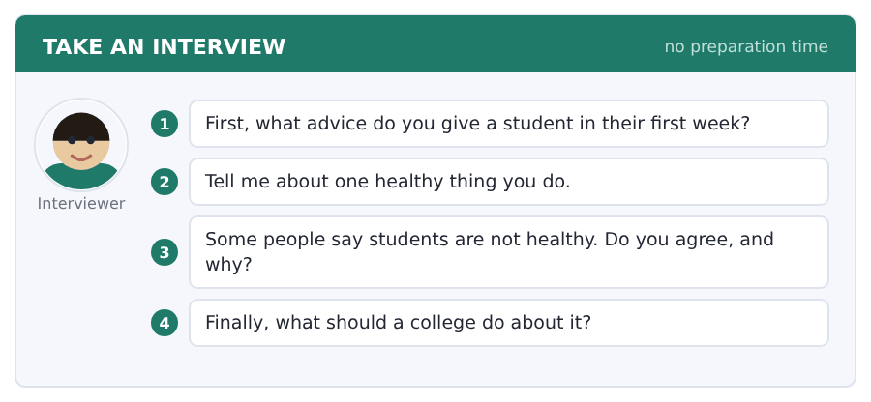
Say it like this
- I think a new student should ... .
- One thing I do is ... .
- I ... agree, because ... .
- A college should ... , because ... .
A good answer sounds like this
Question 1 — I think a new student should register with a doctor in the first week, because in week three nobody can see you.
Question 2 — One thing I do is a long walk every Sunday morning. It is not exercise exactly, but it gets me out of the room.
Question 3 — I agree, but it is not because they are not trying. Students are poor, they sleep badly and they eat at strange times.
Question 4 — A college should make the first class later. Everything else is advice, and advice is free because it costs nothing to give.
I can… | Not yet | Yes
I used should and could for advice | □ | □
I gave a reason after every piece of advice | □ | □
I did not sound like I was giving an order | □ | □


Part 1 · Listen and Repeat
You hear a sentence and repeat it once. There is no preparation time, and the sentences get longer. Focus: the two o sounds: rock and road
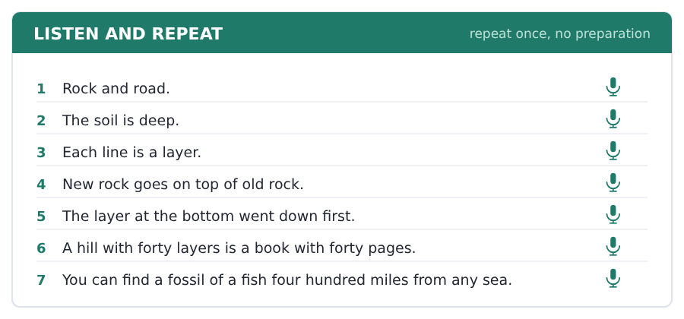
SKILL · Rock, not roak
- In rock, hot and top the o is short and open: /ɒ/.
- In road, cold and old the o is long and it moves: /əʊ/.
- Say the pair: rock / road, not / note, cost / coast.
- This field is full of both, so the pair is worth the work.

Part 2 · Take an Interview
An interviewer asks you four questions on one theme: the land where you live. Answer each one fully. There is no preparation time.
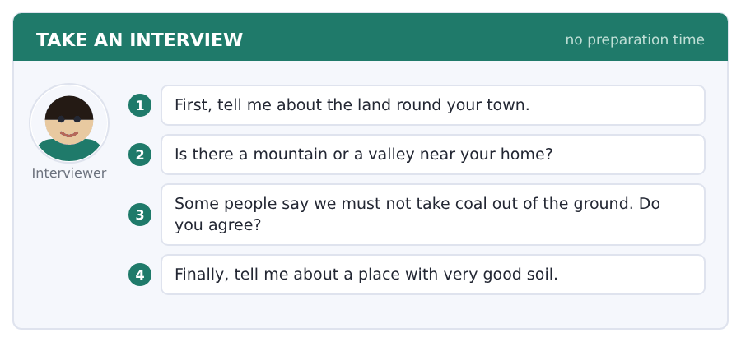
Say it like this
- The land round my town is ... .
- There is a mountain / a valley near ... .
- I think ... , because ... .
- The soil in my country is good for ... .
A good answer sounds like this
Question 1 — The land round my town is very flat and the soil is dark and deep. It is all fields.
Question 2 — There is a long valley about an hour to the west, with a river at the bottom of it.
Question 3 — I agree with that now. We can get the same work from the sun and the wind, and the coal is not clean.
Question 4 — The land by the river has very good soil, because the water brings the soil down every winter.
I can… | Not yet | Yes
I said rock and road differently every time | □ | □
I used three field words | □ | □
I gave a reason after my opinion | □ | □


Part 1 · Listen and Repeat
You hear a sentence and repeat it once. There is no preparation time, and the sentences get longer. Focus: the loud can and the quiet can
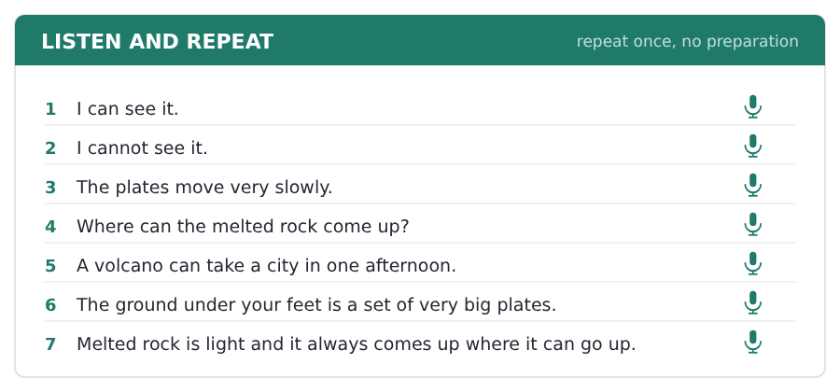
SKILL · I can go, I CAN’T go
- In a normal sentence can is small and quick: I can see it.
- Cannot is always loud and long: I CAN’T see it.
- So the loud word tells the listener yes or no, not the word can.
- A quiet cannot is the most common mistake at this level.

Part 2 · Take an Interview
An interviewer asks you four questions on one theme: danger and where people live. Answer each one fully. There is no preparation time.
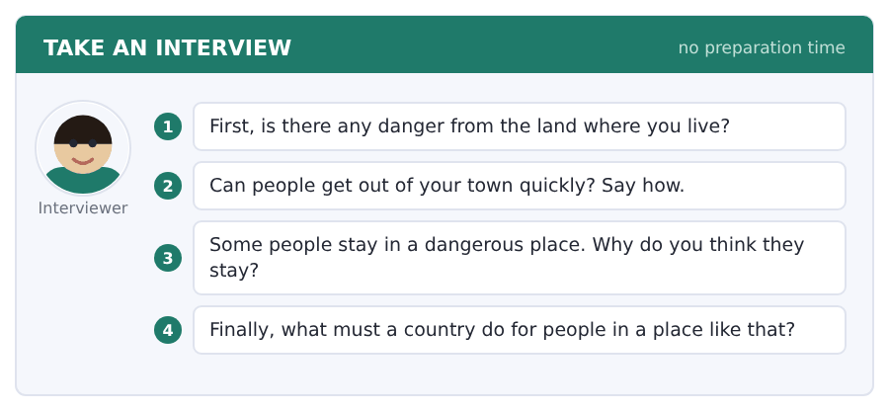
Say it like this
- People in my country live near ... .
- I can / cannot ... , because ... .
- I think the country must ... .
- The danger there is ... .
A good answer sounds like this
Question 1 — There is no volcano near me, but the river comes over the road about once in ten years.
Question 2 — People can get out on two roads and the train. In the summer it is very slow.
Question 3 — They stay because the work is there and the family is there. A danger once in forty years is far away in your head.
Question 4 — A country must build the road out first and tell people early. After that it is their own choice.
I can… | Not yet | Yes
I made cannot loud and can quiet | □ | □
I used can and cannot correctly | □ | □
I answered all four questions | □ | □


You see a sentence, then a set of words in boxes. Put the words in order to make one grammatical sentence. Almost every item in the real test makes a question or a question inside another sentence.
SKILL · can and should in a question
- Can and should go straight in front of the person: Can I come?
- The verb after them is always plain: should I take, never *should I to take*.
- The question word comes first: What should I do?
- Never add do or does to a can or should question.

Exercise A Guided practice. The first three are worked through.
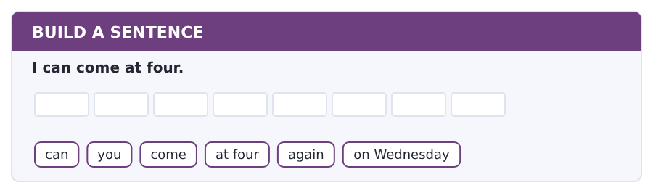
1. Can you come at four again on Wednesday?
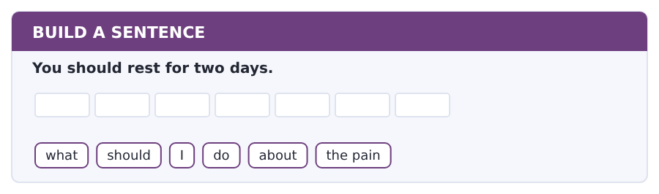
2. What should I do about the pain?
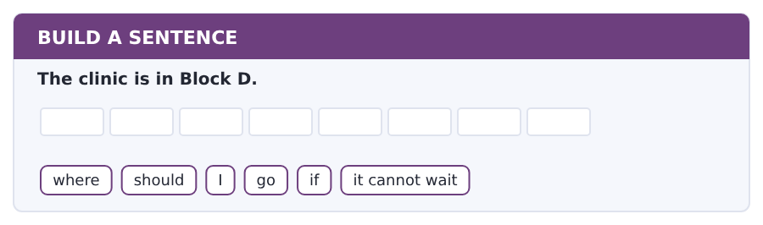
3. Where should I go if it cannot wait?
Exercise B Exam practice. Write the sentence.
4. I cannot breathe easily.
can / you / breathe / easily / at night / now
__________________________________________________________
5. You should call before ten.
when / should / I / call / the clinic / tomorrow
__________________________________________________________
6. A new student must register.
who / should / register / with / the health centre / first
__________________________________________________________
7. You can book online.
can / I / book / online / for / next week
__________________________________________________________
8. The nurse writes a sick note after seven days.
how long / should / I / wait / for / a sick note
__________________________________________________________
9. I can see you on Wednesday.
which day / can / you / see / me / this week
__________________________________________________________
10. Students should sleep more in week three.
what / should / students / do / in / week three
__________________________________________________________


You read a short situation and write an email. You have 7 minutes. The three bullet points are the mark scheme: answer all three.
In the real test you write as much as you can in seven minutes. In this unit, aim for about 68 words. That number goes up in every unit of this book, and in Volume 1 it stops being a number at all.
You have a bad cough and a pain in your chest since Saturday.
You have an exam on Thursday. Write to the health centre.
- say who you are and that you are registered
- say what the symptoms are and since when
- ask for an appointment before Thursday
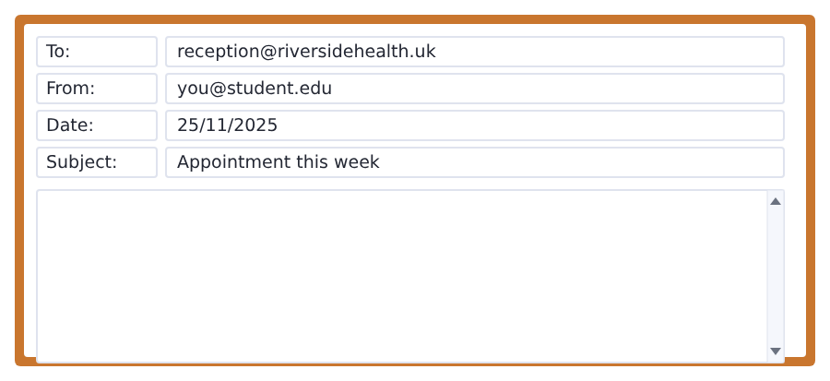
SKILL · Symptoms are facts, not a story
- List the symptoms in one sentence. Two is already too many.
- Say since when. A doctor needs the day, not the feeling.
- Say why the time matters: an exam, a deadline, a journey.
- Ask for an appointment before a named day, not as soon as possible.

Model email
Dear Reception,

My name is Ana Ruiz and I am registered with the health centre. My student number is 4071.
I have a bad cough and a pain in my chest. It started on Saturday and it is not better.
I have an exam on Thursday morning.
Can I have an appointment before Thursday?

Thank you,
Ana Ruiz
Why it works
- The student number is there, because reception cannot find you without it.
- The symptoms are two facts and a date. No story.
- The exam explains why the day matters, in one short sentence.
- The request names a day, so the answer can be yes or no.
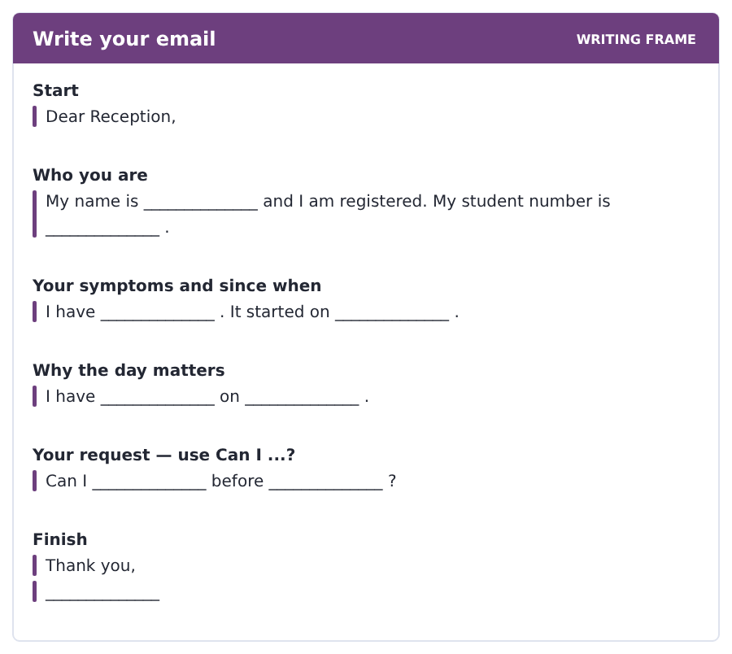
Now write your own. 7 minutes.
__________________________________________________________
__________________________________________________________
__________________________________________________________
__________________________________________________________
__________________________________________________________
__________________________________________________________
__________________________________________________________
__________________________________________________________


A professor asks a question and two students answer. You add your own post. You have 10 minutes and an effective answer is at least 100 words.
One hundred words is what the real test wants, and you will get there. For this unit, write about 80. Every unit of this book asks for a few more.
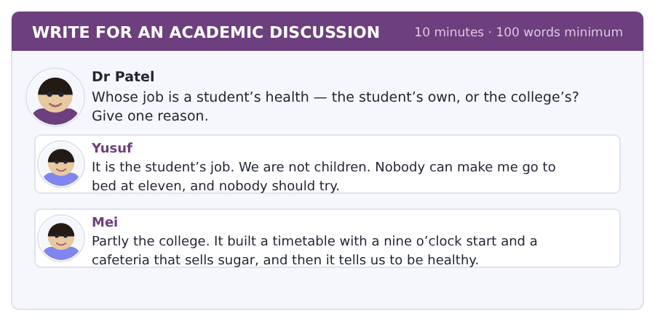
SKILL · Answer a whose question directly
- The question asks whose. Say whose in your first sentence.
- Both can be partly true. Say which part belongs to whom.
- Use should for what each one ought to do.
- Eighty words is seven or eight short sentences.

Sentence starters
- I agree with Mei, because ...
- Yusuf is right that ...
- The college should ...
- The student should ...
Model post
I agree with Mei, but only partly. Health is the student’s job and the conditions are the college’s.
Yusuf is right that nobody can make a grown student go to bed early. That part belongs to the student.
But the college builds the timetable and chooses what the cafeteria sells, and those two things create the week we live in. Nobody chooses a nine o’clock start on their own.
The college should fix the things only it can fix. Then the advice it gives us is worth listening to.
[89 words]
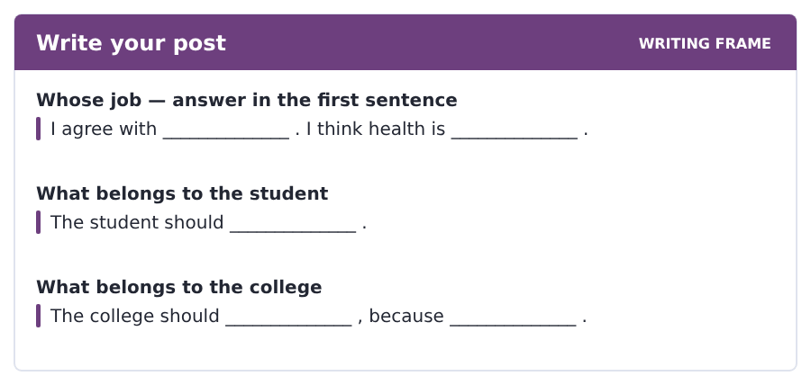
Now write your own. 10 minutes, at least 80 words.
__________________________________________________________
__________________________________________________________
__________________________________________________________
__________________________________________________________
__________________________________________________________
__________________________________________________________
__________________________________________________________
__________________________________________________________
__________________________________________________________
__________________________________________________________


The same task again, on the subject of this unit. The sentences are about rocks, land and time now, and the word order has not changed at all.
SKILL · Questions with can and cannot
- Can comes in front of the person or thing: Can you see it?
- The verb after can never changes: can see, not can sees.
- A question word goes first: Where can you find a fossil?
- Cannot is one word in writing and can’t when you say it.

Exercise A Guided practice.
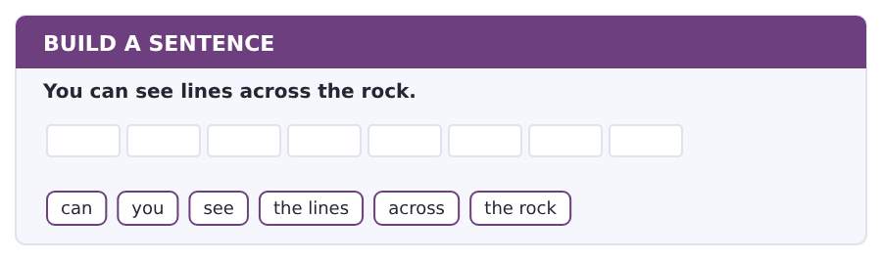
1. Can you see the lines across the rock?
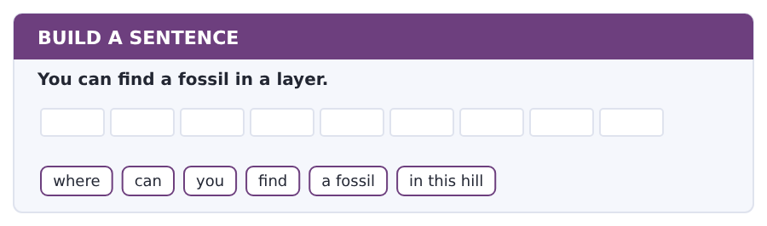
2. Where can you find a fossil in this hill?
Exercise B Exam practice. Write the sentence.
3. Nobody can break the rule.
can / anybody / break / the rule / about the / layers
__________________________________________________________
4. She can read a hill from the bottom up.
how / can / she / read / a hill / with forty layers
__________________________________________________________
5. The rock melts deep down.
why / does / the rock / melt / deep down / under a plate
__________________________________________________________
6. A fossil gives her the age of the layer.
what / does / a fossil / give / her / in that layer
__________________________________________________________


A second discussion, and this one is about the subject rather than about your own week. In the real test both kinds come up, and the second kind is the harder one.
For this unit, write about 80 words. The real test wants a hundred.
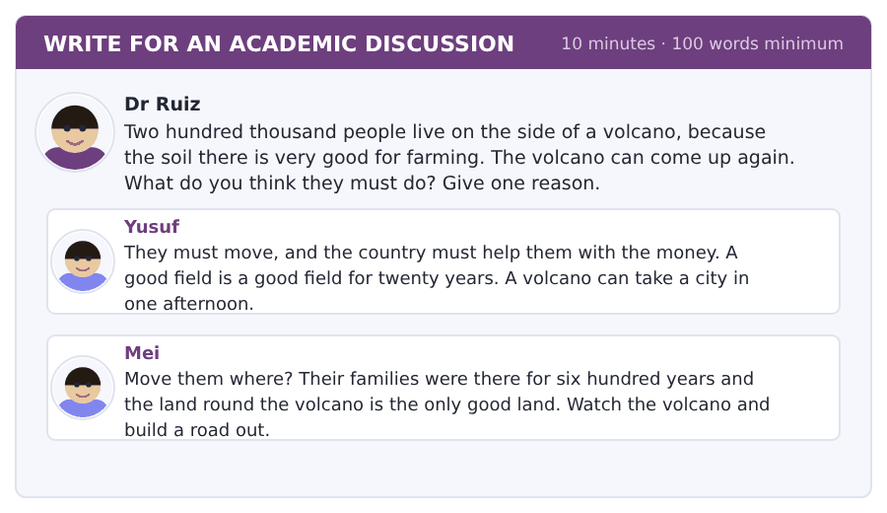
SKILL · A question with no clean answer
- Nobody wins this one. Say which cost you take and why.
- Yusuf takes the safe answer. Mei takes the real one. Both are fair.
- Use the passage: the plates move, so the volcano is not finished.
- Eighty words is about eight short sentences.

Sentence starters
- I agree with Mei, because ...
- Yusuf is right that ...
- The passage says the plates ...
- So the answer is ...
Model post
I agree with Mei. Two hundred thousand people cannot move to land that is not there.
But Yusuf is right that the danger is real. The passage says the plates are still moving, so the volcano is not finished with that mountain.
So the answer is a road and a plan. Build two good roads down the valley, watch the rock every day, and give every family one place to go. That is money the country can find, and it is money for a road the farms want in any case.
[91 words]
Now write your own. 10 minutes, at least 80 words.
__________________________________________________________
__________________________________________________________
__________________________________________________________
__________________________________________________________
__________________________________________________________
__________________________________________________________
__________________________________________________________
__________________________________________________________
__________________________________________________________
__________________________________________________________

Grammar focus can and cannot · should · orders · how-words ending in -ly
Form | Example
can / cannot | I can come at four. I cannot breathe easily.
should / should not | You should rest. You should not study until midnight.
question | Can I book online? What should I do?
short answer | Yes, I can. No, you should not.
order form | Rest. Drink water. Do not wait.
how-words in -ly | He listened carefully. She speaks quickly.
the odd ones | good → well, fast → fast, hard → hard

Can, cannot and should never change their form, and the verb after them is always plain. That makes them the easiest structures in the book and the most useful in the Speaking test.
An order form has no subject at all: Rest. Drink water. It is the normal form for an instruction, and in English it is not rude.
A how-word usually goes after the verb or after the object: she read the notice carefully, not *she read carefully the notice*.
Watch out! Never say *I can to come* or *Do you can come?* Can makes its own question and takes a plain verb. The same is true of should.
Exercise 1 Write can, cannot or should.
1. I __________ breathe easily, so I do not need a doctor.
2. You __________ rest for two days.
3. __________ I book an appointment online?
4. She __________ come on Tuesday, because she has a class.
5. Students __________ register in the first month.
6. What __________ I do about the pain?
Exercise 2 Write the -ly word.
1. He listened __________ (careful).
2. She speaks very __________ (quick).
3. Breathe __________ (slow).
4. I sleep __________ (bad) in a new bed.
5. The doctor explained it __________ (clear).
6. He plays football __________ (good).
Exercise 3 Write the order form of the verb.
1. You should rest.
2. You should drink water.
3. You should not wait.
4. You should call before ten.
How this is tested in Build a Sentence
Can and should are gifts in Build a Sentence. The moment one of them is in the tiles you know the shape of the whole sentence: question word, then can or should, then the person, then a plain verb.

Typing and the Screen Typing under a clock
The real test is typed. Nobody gives you paper. If you are still looking for the keys, you lose the Writing section before your English does.
In the real test you type an email in seven minutes and a discussion post in ten. This week you stop practising keys and start practising the clock.
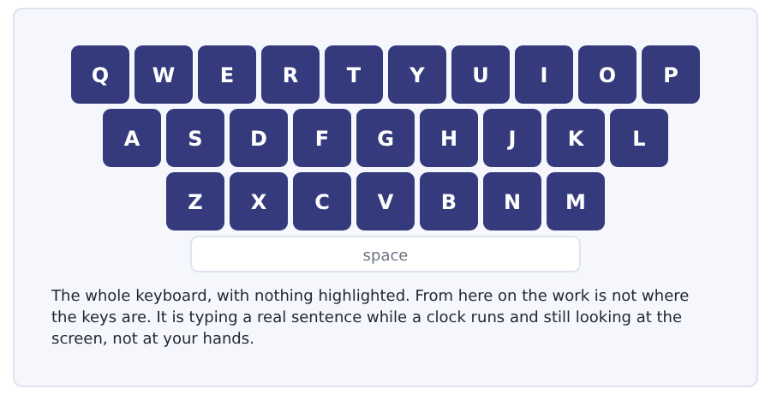
Exercise Type this. Time yourself, then write your speed in the box.
I have a bad cough and a pain in my chest. It started on Saturday.
Can I have an appointment before Thursday? I have an exam that morning.
You should rest, drink water and go to bed early for four nights.
My time _______ seconds
Words a minute _______ (the target for Unit 9 is 16)

Learning to Learn What to do when you do not understand
Everybody meets a page they cannot follow. The difference between students is not whether it happens but what they do in the next five minutes. Most read the same paragraph again, slower, four times. That almost never works.
- Read the whole thing to the end first, even the parts you do not follow. The end often explains the middle.
- Say the paragraph out loud in one sentence. If you cannot, you have found the exact place where it stopped making sense.
- Go back one paragraph, not one line. The problem is usually earlier than it feels.
- Write your question down as a question, not as a feeling. Not this is hard, but why does the writer say the reason is not bad luck?
- Take that written question to the tutor hour. A specific question gets a specific answer in two minutes.
ADAPTIVE TIP Reading the same line four times feels like work and is almost always wasted. The second reading is useful. The third and fourth are a way of avoiding the moment when you have to admit you need help.

Unit review and progress check Unit 9
Exercise A Vocabulary. Write the word.
1. a time the doctor keeps for you
2. the paper the doctor writes for medicine
3. the shop that gives you the medicine
4. a sign that something is wrong with you
5. what the doctor does to make you well
6. the room where you sit before the doctor
7. the paper that says you were too ill
8. able to hurt you
9. thinking about danger before you act
10. a good thing that comes from something
11. one of the things that make something happen
12. a way of doing something
Exercise B Grammar. Complete the sentence.
1. I __________ breathe easily. (be able)
2. You __________ rest for two days. (advice)
3. __________ I book an appointment online?
4. He listened __________ (careful).
5. She speaks very __________ (quick).
6. I sleep __________ (bad) in a new bed.
7. He plays football __________ (good).
8. __________ water. (order form of drink)
Exercise C One timed mini-section. 6 minutes.
1. For an appointment on the same day you call between
(A) 8.00 and 10.00
(B) 8.00 and 18.00
(C) 10.00 and 12.00
(D) any time
2. The nurse does not give the man a sick note because
(A) he is not registered
(B) the exam is on Thursday
(C) it is only a cough
(D) he came too late
3. The waiting room fills up in
(A) week one
(B) week three
(C) week two
(D) week ten
4. Which sentence is correct?
(A) I can come at four.
(B) I can to come at four.
(C) Do you can come at four?
(D) I can coming at four.
5. Which is the -ly word from good?
(A) goodly
(B) well
(C) better
(D) goodly done
6. The two pieces of advice in the talk are
(A) medicine and rest
(B) eat more and drink water
(C) see a doctor and take medicine
(D) register early and sleep in week three
Can you do these now?
I can… | Not yet | Yes
say what I can and cannot do | □ | □
read a clinic notice and find what to do | □ | □
understand a short text about health and students | □ | □
follow a conversation at a health centre | □ | □
give simple advice with should | □ | □
write an email asking for an appointment | □ | □

ADAPTIVE TIP In the Speaking section the advice questions are the ones to prepare. Every interview has one, and the shape of a good answer never changes: should, then the advice, then because and a reason. Practise that shape until it arrives without thinking.

Unit 10 · Study, Work and Your Plans
TOEFL iBT® Preparation Course 2026 · Volume F1
CEFR A2 · Grammar: going to and will · comparatives · and, but, because, so · Word field: plans, work, the future
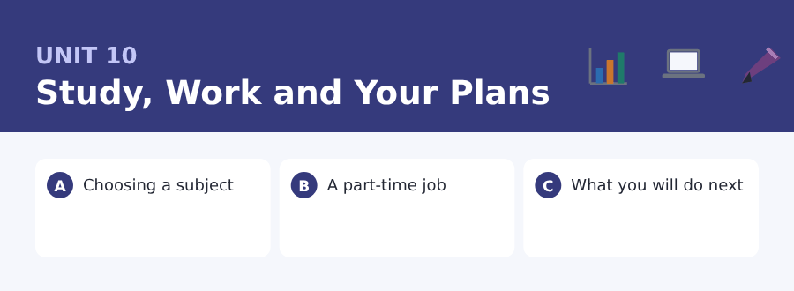
By the end of this unit I can…
- talk about my plans with going to and will
- read a job advertisement and find the hours and the pay
- understand a short text about choosing a subject
- follow a conversation about a part-time job
- compare two things with -er and more
- write an email applying for a job on campus

Three sub-topics, three cycles in every skill. The last unit of this book is about what comes next, and so is the last page of it.

Vocabulary 1 · The words you need most 24 words from the two thousand most common words of English
These are not academic words. They are the words that carry ordinary English, and until you own them the academic words of Volume 1 have nothing to stand on. Cover the right-hand column and test yourself.
plan what you decide to do before you do it | part-time for only some of the hours of a week
future the time after now | full-time for all the normal hours of a week
hope to want something to happen | important with a big effect; worth your time
decide to choose after thinking | difficult not easy
choose to take one thing and not another | succeed to do what you set out to do
career the work a person does for many years | fail not to succeed
job the work you are paid for | try to make an effort
interview a meeting where somebody asks you questions about a job | improve to get better
apply to ask for a job or a place, in writing | goal the thing you are working towards
experience the knowledge a job or a life gives you | shift the hours of one piece of work: the evening shift
skill something you can do well because you learned it | wage money paid for each hour of work
salary the money a job pays you | employer the person or company you work for

Exercise A Work in pairs. Ask and answer.
1. What are you going to do after this course?
2. Do you have a part-time job, or would you like one?
3. Which subject is better for a job, and why?
4. What is the hardest thing about choosing a career?
Vocabulary 2 · Campus and everyday 12 words for student life
Every Listening conversation in the real test happens on a campus. These twelve words come back in this unit and again in Volume 1.
university degree what you get at the end of a university course | certificate the paper that proves you passed
subject the thing you study: history, chemistry, law | application form the paper you fill in when you apply
module one part of a course, with its own exam | reference a letter about you from a teacher or an employer
exam the test at the end of a module or a year | careers service the office that helps students find work
grade the mark you get for a piece of work | internship a short time working in a company to learn
result what you get at the end of an exam | CV the paper that lists your study and your work

Vocabulary 3 · First academic words The bridge into Volume 1
Volume 1 teaches four hundred and eighty words from the Academic Word List. These are the first of them, and they are here so that the list is not new when you meet it.
available there to be used or taken | individual one single person
data facts and numbers you can work with | issue a subject people argue about
environment everything around a person or a thing | major large and important
establish to start something that will last | percent in each hundred
finance money, and the management of money | research careful study to find out something new
identify to say exactly which one it is | similar almost the same
income the money that comes in | source the place a thing comes from
indicate to show or point to | structure the way the parts of a thing are put together

Words you will meet again: plan | career | degree | experience | reference | research | available | similar

Sound and Spelling Everything this book has taught you about sound, in one page
This is the last Sound and Spelling page. It puts the nine before it in one place, because every one of them comes up in every minute of the Listening section, and because you will want one page to come back to.
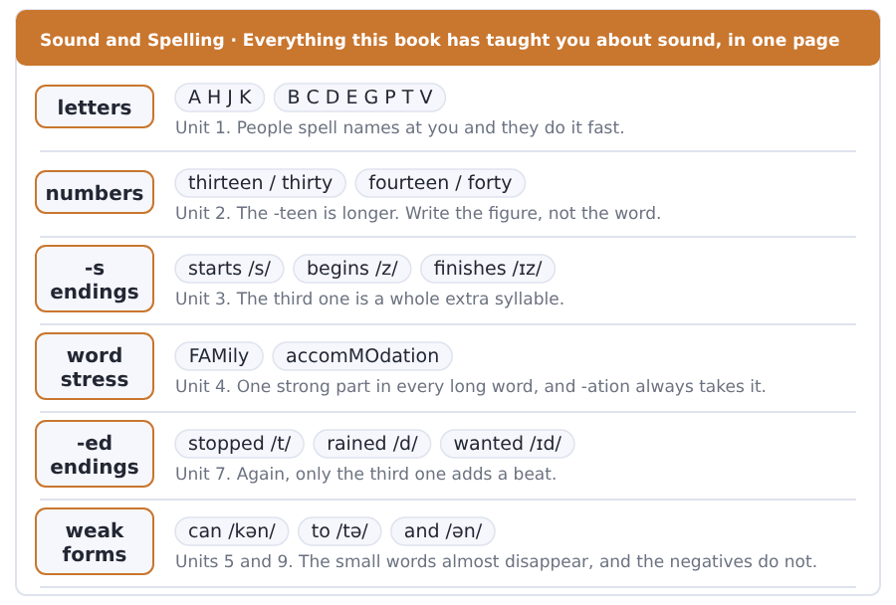
Exercise A Listen. Which word do you hear?
1. Do you hear thirteen or thirty?
2. Is the ending /s/, /z/ or /ɪz/? — finishes
3. Is the ending /t/, /d/ or /ɪd/? — wanted
4. Do you hear can or cannot?
5. Do you hear will or won’t?
6. Do you hear going to or gonna?
Exercise B Say these out loud. Record yourself if you can.
1. Spell your full name and your address out loud.
2. Say the numbers 13 to 19, then 30 to 90.
3. Say five past verbs with each of the three -ed sounds.
4. Say your plan for next year in three sentences with going to.


SKILL · Comparative endings
- A short adjective adds -er: cheap, cheap-er.
- An adjective ending in -y changes to -ier: easy, eas-ier.
- A short adjective with one vowel doubles the letter: big, bigg-er.
- A long adjective takes more in front and no ending at all.

Exercise A Guided practice. Five words are not complete. Write the missing letters.
A degree in law is long-- than a degree in business. The work is hard-- and the reading is heav---. But the first salary is usually high--, and the number of jobs is bigg--.

The first one is done for you: 1 long-- → er (longer)
Exercise B Exam practice. One paragraph, ten gaps — the real task.
Students choose a subject for three reasons, and money is only one of them. A course with a high-- salary at the end is not always the bett-- choice. A student on the wrong course works slow--, finds the reading hard-- and leaves with a low-- grade. A student on the right course works quick--, reads a lot and finishes strong--. The careers service says the same thing every year: the easi--- question is what pays well, and the hard--- question is what you will still read about in ten years. The bett-- answer is almost never the first one.

Check your answers in the key at the back of the book.


SKILL · Hours and money together
- A job advertisement has three numbers: the hours, the wage and the shift.
- Work out the week before you compare two jobs.
- Watch for per hour and per week. They are not the same number.
- The last line of an advertisement usually says how to apply.

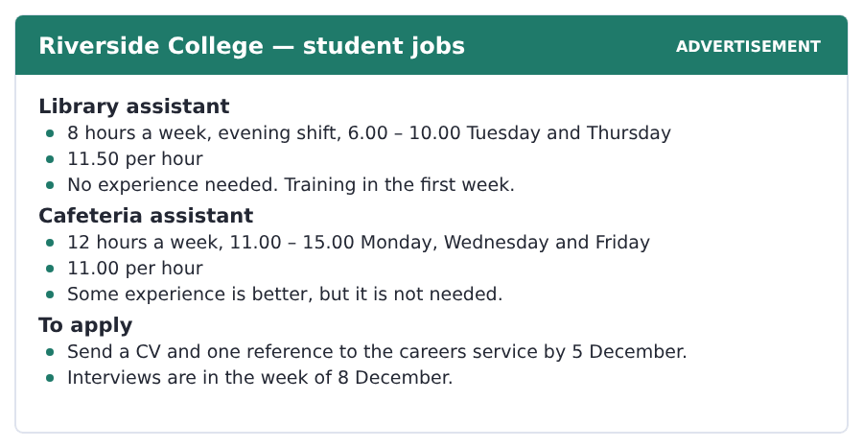
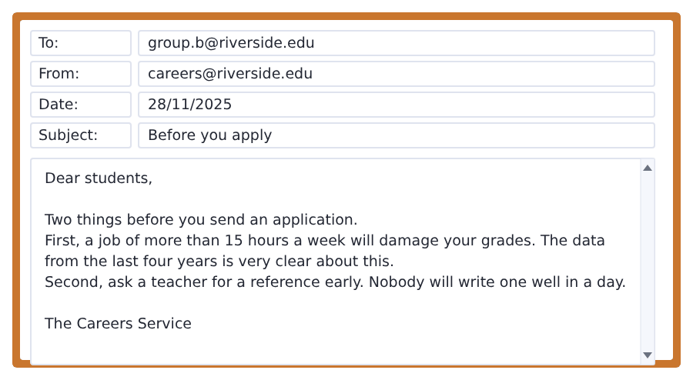
Exercise A Guided practice. The answer is on the page — find it.
1. How many hours a week is the library job?
(A) 6
(B) 10
(C) 12
(D) 8
2. How much does the cafeteria job pay per hour?
(A) 11.00
(B) 11.50
(C) 12.00
(D) 15.00
3. Which job needs no experience?
(A) the cafeteria job
(B) both
(C) the library job
(D) neither
4. What do you send to apply?
(A) a CV only
(B) a CV and one reference
(C) a certificate
(D) an interview
Exercise B Exam practice.
5. Which job pays more in a week?
(A) the library job
(B) they are the same
(C) it does not say
(D) the cafeteria job
6. Which job pays more per hour?
(A) the cafeteria job
(B) they are the same
(C) the library job
(D) it does not say
7. When is the deadline for an application?
(A) 5 December
(B) 1 December
(C) 8 December
(D) 15 December
8. When are the interviews?
(A) the week of 1 December
(B) the week of 8 December
(C) the week of 5 December
(D) in January
9. How many hours a week will damage your grades?
(A) more than 8
(B) more than 15
(C) more than 12
(D) more than 20
10. What does the careers service say about a reference?
(A) ask a teacher early
(B) ask for it on the day
(C) you do not need one
(D) the service writes it


SKILL · The question behind the question
- A text that says students ask the wrong question will give you the right one.
- The right question is usually in the last paragraph.
- Watch for but, so and the better question. They mark the turn.
- A question about what a service cannot do points at the last two lines.

The Question Nobody Can Answer For You
Every careers service in the world gets the same question, and it is always the wrong one. Students ask which subject will get them a job. Nobody can answer that, because the jobs of the next ten years are not all here yet.
The research indicates something more important. Across every subject, the student still interested in the third year finishes strongly. That is a smaller thing than a career plan and a much better source of energy. Interest keeps a person reading at eleven at night. A salary in six years does not.
So the better question is simpler. Which of these subjects will you still want to read about when nobody is making you? The answer is individual and nobody else can give it to you. A careers service can show you the data, the income and the shape of a kind of work. It cannot tell you what will still interest you. That is the one factor it all turns on. It is also the one thing you already know about yourself.
[175 words]

Exercise A Guided practice.
1. What question do students ask?
(A) how much will I earn
(B) how long is the course
(C) where should I study
(D) which subject will get me a job
2. Why can nobody answer it?
(A) the service is busy
(B) students do not listen
(C) the jobs of the next ten years are not all here yet
(D) the data is wrong
3. Who finishes strongly?
(A) students with a plan
(B) the students with a job
(C) the students with the best grades
(D) students still interested in the third year
4. What keeps a person reading at eleven at night?
(A) interest
(B) a salary
(C) a deadline
(D) a careers service
Exercise B Exam practice.
5. A career plan is
(A) a smaller thing than interest
(B) a bigger thing than interest
(C) the same as interest
(D) not mentioned
6. What is a better source of energy?
(A) a salary
(B) a plan
(C) interest
(D) a degree
7. What is the better question?
(A) which subject will you still want to read about
(B) which subject pays most
(C) which subject is easiest
(D) which subject is shortest
8. The answer to that question is
(A) in the data
(B) the same for everybody
(C) individual
(D) at the careers service
9. What can a careers service show you?
(A) which subject will hold you
(B) the data, the income and the structure
(C) your grades
(D) your future
10. What can it not tell you?
(A) the income
(B) the structure
(C) the data
(D) which subject will still hold you
11. What is the one factor the whole thing turns on?
(A) money
(B) the course
(C) interest
(D) the careers service

The field: Stories and Writing Two more cycles in every skill, on one subject
Everything up to here was about your own life, because that is where a language starts. From this page the same unit turns to a subject, and the subject is one Volume 1 will take up properly: what turns a list of true things into a story, and why a short story starts late.
character a person in a story | title the name of a book or a story
plot the things that happen in a story, in order | describe to say what a thing or a person is like
scene one part of a story, in one place at one time | imagine to see a thing in your head
novel a long story in a book | ending the last part of a story
poem a short piece of writing in lines | voice the way one writer sounds on the page
reader the person reading the book | chapter one numbered part of a long book


SKILL · A list, then the thing the list is missing
- A passage can start with something that is almost right.
- Then it changes one thing and asks you to look again.
- The change is the answer. Put your finger on it.
- The last part usually names the machine in three or four steps.

True Is Not Enough
Here is a list. A man got up. He went to work. He came home. He went to bed. Nothing in that list is a story, and you will not read it twice. But every sentence in it is true, and that is the point: true is not enough.
Now change one thing. A man got up, and he knew his brother was outside the door. Now every sentence in the list is interesting. Nobody has to tell you that. Why? Because the man wants something and something is in the way of it.
That is the whole machine, and it is very old. A character wants something. Something stops him. He does something about it. And at the end he is not the same man. A story is more interesting than a list, because nothing in a list wants anything.
[141 words]

Exercise A Guided practice.
1. How many sentences are in the first list?
(A) two
(B) three
(C) five
(D) four
2. Is anything in the list true?
(A) yes, every sentence
(B) no, none of it
(C) only the first one
(D) the writer does not say
3. What is the one thing the writer changes?
(A) the man gets up later
(B) the brother is outside the door
(C) the man goes to bed first
(D) the list gets longer
Exercise B Exam practice.
4. Why is every sentence interesting now?
(A) the list is longer
(B) the sentences are not true
(C) the brother is a character
(D) the man wants something and something is in the way
5. How many steps are in the machine?
(A) two
(B) four
(C) three
(D) six
6. What is the character like at the end?
(A) not the same man
(B) the same man
(C) in the same place
(D) asleep
7. Why is a story more interesting than a list?
(A) it is longer
(B) it is true
(C) nothing in a list wants anything
(D) it has a title


SKILL · Two things set side by side
- When a passage puts two forms together, it will keep them apart.
- Here they are the novel and the short story. Mark both words.
- Every later sentence belongs to one of them. Put it there.
- A question may give you one and ask about the other.

It Starts Late and It Ends Early
A novel has got four hundred pages and a short story has got twelve. So a short story is not a small novel. It is a different machine, and it does a different job.
A novel can start with a child and finish with an old man. A short story has no room for that, so it starts late. It begins on the day the problem starts, and often in the middle of the day. The writer tells you nothing about the years before it.
And it ends early. A novel will tell you what happened to everybody. A short story stops at the moment the character sees something, and it leaves the rest to you. That is why the ending of a short story often feels like a door closing in another room. The reader does the last piece of the work.
[143 words]

Exercise A Guided practice.
1. How many pages has a short story got?
(A) twelve
(B) four hundred
(C) a hundred
(D) two
2. Is a short story a small novel?
(A) yes
(B) no, it is a different machine
(C) yes, with fewer characters
(D) the writer does not say
3. Where does a short story begin?
(A) with a child
(B) at the ending
(C) in another room
(D) on the day the problem starts
Exercise B Exam practice.
4. What does a novel do that a short story cannot?
(A) start late
(B) end early
(C) start with a child and finish with an old man
(D) leave the rest to you
5. What does the writer of a short story tell you about the years before?
(A) everything
(B) nothing
(C) one chapter
(D) the ending
6. Where does a short story stop?
(A) at the moment the character sees something
(B) at the end of everybody’s life
(C) in the middle of the day
(D) after four hundred pages
7. Who does the last piece of the work?
(A) the writer
(B) the character
(C) the reader
(D) the novel

Sentence Builder Joining two sentences into one
Four words do almost all the joining in English: and adds, but turns, because gives the reason, so gives the result. A paragraph of five short sentences with no joining words reads like a list. A paragraph where every sentence is joined reads like one long breath. Mix them.
Not a sentence | A sentence
The job pays well. It is twelve hours. | The job pays well, but it is twelve hours.
I chose the library job. It is quieter. | I chose the library job because it is quieter.
I need a reference. I will email my tutor. | I need a reference, so I will email my tutor.
I sent my CV. I sent a reference. | I sent my CV and a reference.
Because the deadline is the fifth. | I will send it today because the deadline is the fifth.

Watch out! Because gives a reason and so gives a result, and they point in opposite directions. I was late because the bus broke down. The bus broke down, so I was late. Same two facts, two different sentences.
Exercise A Is it a sentence? Write yes or no. If no, put it right.
1. I applied for the job. It is quiet.
2. The deadline is Friday. I will write it tonight.
3. The job pays well. The hours are long.
4. I sent a CV. I sent a reference.
5. I chose this subject because I am interested in it.
6. My tutor is away. I will ask her on Monday.


Exercise A Listen and choose a response. You hear one line. Choose the best reply.
1. What are you going to do after the course?
(A) At four.
(B) Yes, I am.
(C) In the library.
(D) I am going to work for a year.
2. Will you send the application today?
(A) Yes, I will.
(B) In December.
(C) Twelve hours.
(D) Yes, I am.
3. Which job is better?
(A) At eleven.
(B) The cafeteria one.
(C) Yes, it is.
(D) On Tuesday.
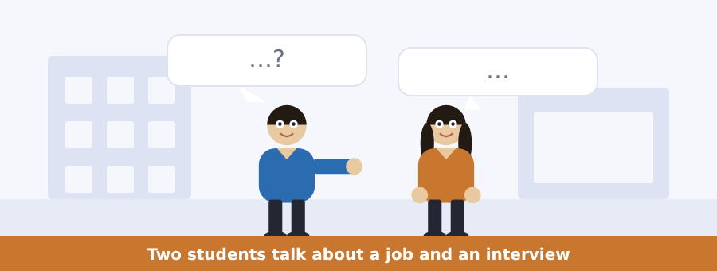
SKILL · Plans and promises
- Going to is for a plan you have already made.
- Will is for a decision in the moment, or a promise.
- Listen for the difference: I am going to apply, I will send it tonight.
- A question about a plan wants the going to sentence.

Exercise B Listen and answer. The audio plays once.
4. Which job is the man going to apply for?
(A) the cafeteria job
(B) both
(C) neither
(D) the library job
5. Why not the cafeteria job?
(A) it pays less per hour
(B) it is too far
(C) it is twelve hours and he has exams
(D) it has no training
6. What else does he say about the library job?
(A) it pays more
(B) it is longer
(C) it needs experience
(D) it is quieter and he can read
7. Why has the woman not applied yet?
(A) she is not interested
(B) she needs a reference
(C) the deadline is over
(D) she has a job
8. What will the woman do tonight?
(A) email Dr Patel
(B) send the application
(C) go to the careers service
(D) nothing
9. Why is the man not very nervous?
(A) he knows the interviewer
(B) the job is easy
(C) he worked in a shop for two years
(D) he has a reference
Audio script: see the back of the book. Do not read it before you listen.


Exercise A Listen and choose a response. You hear one line. Choose the best reply.
1. When does module choice open?
(A) In the library.
(B) Yes, it does.
(C) Four modules.
(D) On the first of December.
2. Will the system close on the twelfth?
(A) Yes, it will.
(B) In Block C.
(C) Three modules.
(D) Yes, it is.
3. What should I do first?
(A) At four.
(B) Yes, you should.
(C) Talk to your tutor.
(D) In January.
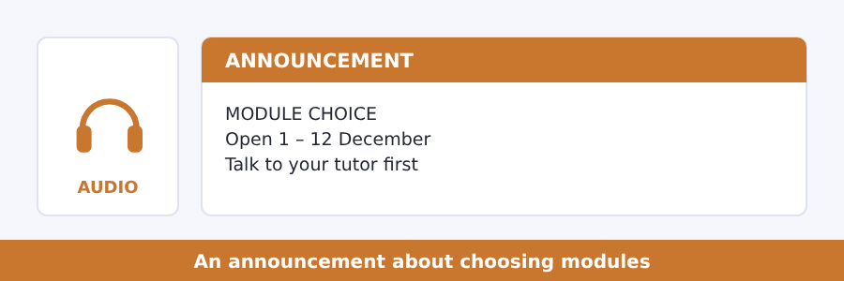
SKILL · A deadline and a warning
- An announcement about a choice gives a window and a consequence.
- The consequence is what happens if you do nothing. Listen for it.
- Advice in an announcement usually comes as should, not must.
- A question about what happens if you are late wants the last part.

Exercise B Listen and answer. The audio plays once.
4. When is the system open?
(A) 1 – 12 January
(B) 1 – 12 December
(C) 12 – 31 December
(D) all year
5. How many modules do you choose?
(A) two
(B) four
(C) three
(D) five
6. When can you change them?
(A) never
(B) twice
(C) any time
(D) once before the end of January
7. Why should you talk to your tutor?
(A) some modules require a module from this year
(B) the tutor chooses
(C) the system is closed
(D) the office is busy
8. What happens if you choose nothing?
(A) nothing
(B) you repeat the year
(C) the office will choose for you
(D) you lose your place
Audio script: see the back of the book. Do not read it before you listen.


Exercise A Listen and choose a response. You hear one line. Choose the best reply.
1. Will the next book be harder?
(A) In January.
(B) Yes, it will.
(C) Four modules.
(D) Yes, it is.
2. Are you going to take the test this year?
(A) In the library.
(B) Yes, I do.
(C) Two hours.
(D) No, I am not.
3. What comes after this book?
(A) Volume 1.
(B) At four.
(C) Yes, it does.
(D) In December.
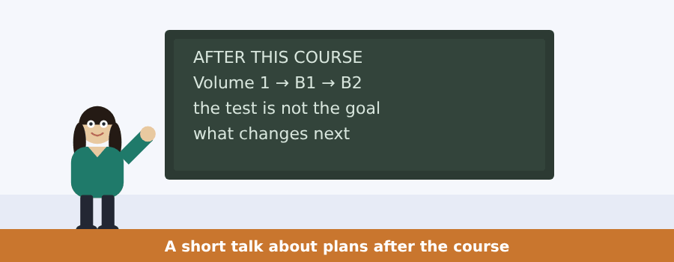
SKILL · A talk that looks forward
- A talk about the future uses will and going to and a lot of numbers.
- The numbers here are levels and months, not money.
- The last part of a talk like this is usually advice for tomorrow.
- A question about what changes wants the list in the middle.

Exercise B Listen and answer. The audio plays once.
4. What does the speaker say about the test?
(A) you are ready
(B) you should book it
(C) you are not ready to sit it
(D) it is easy
5. What are you ready for?
(A) Volume 1
(B) the test
(C) Volume 3
(D) a job
6. Volumes 1 and 2 take you to
(A) A2
(B) B1
(C) B2
(D) C1
7. How long will the reading passages be?
(A) about 110 words
(B) about 175 words
(C) about 265 words
(D) about 400 words
8. Where will the vocabulary come from?
(A) the general list
(B) the glossary
(C) the careers service
(D) the Academic Word List
9. What will not change?
(A) the shape of every unit
(B) the passages
(C) the vocabulary
(D) the word bank
Audio script: see the back of the book. Do not read it before you listen.


Exercise A Listen and choose a response.
1. Is a list of true things a story?
(A) In the morning.
(B) No, it is not.
(C) Four sentences.
(D) Yes, I am.
2. What will the character be like at the end?
(A) In the same room.
(B) Yes, he will.
(C) A long novel.
(D) Not the same person.
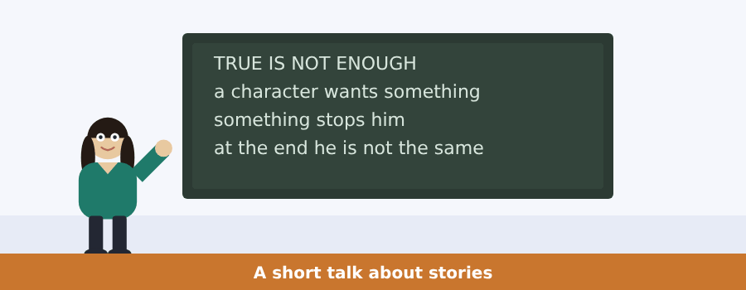
SKILL · A speaker who tests you with an example
- A talk can give you something and ask if it is the thing.
- Your answer will be no. Listen for what is missing.
- The speaker then names the parts. Write them as a short list.
- The last line often tells you what to do with the idea.

Exercise B Listen and answer. The audio plays once.
3. How many sentences does the speaker give?
(A) two
(B) three
(C) four
(D) six
4. What do most of the students say?
(A) no
(B) yes
(C) nothing
(D) they ask a question
5. What has the list got no room for?
(A) a character
(B) a want
(C) a hospital
(D) a bus
6. What does the speaker tell the class to find first?
(A) the plot
(B) the ending
(C) the title
(D) the want
Audio script: see the back of the book.


Exercise A Listen and choose a response.
1. Will the writer tell you about the years before?
(A) Four hundred pages.
(B) Yes, I will.
(C) No, nothing at all.
(D) In the morning.
2. Which form is longer?
(A) In twelve pages.
(B) The novel.
(C) Yes, it is.
(D) The reader.
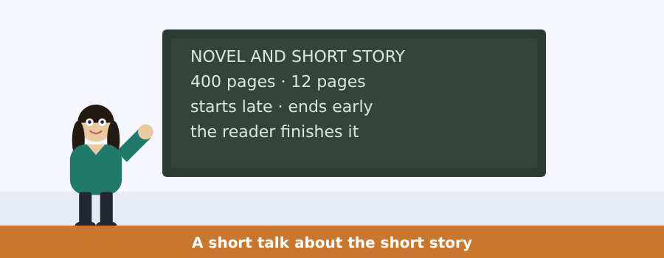
SKILL · Two forms, one talk
- A talk that sets two forms side by side will go back and forth.
- Two columns in your notes are faster than one long list.
- Put every fact under the form it belongs to, as you hear it.
- A question will often give you one form and ask about the other.

Exercise B Listen and answer. The audio plays once.
3. What do students say to the speaker?
(A) they are going to write a novel
(B) they will not write anything
(C) they want a chapter
(D) they are going to write a short story
4. What do they write instead?
(A) a poem
(B) twelve pages
(C) the first chapter of a novel
(D) nothing
5. When does a short story start?
(A) on the worst day of somebody’s life
(B) when the character is a child
(C) at the ending
(D) after twelve pages
6. What does the short story do with the doors?
(A) it opens one and walks out
(B) it closes every door
(C) it leaves them all shut
(D) it has no doors
Audio script: see the back of the book.


Part 1 · Listen and Repeat
You hear a sentence and repeat it once. There is no preparation time, and the sentences get longer. Focus: the weak form of going to, and will
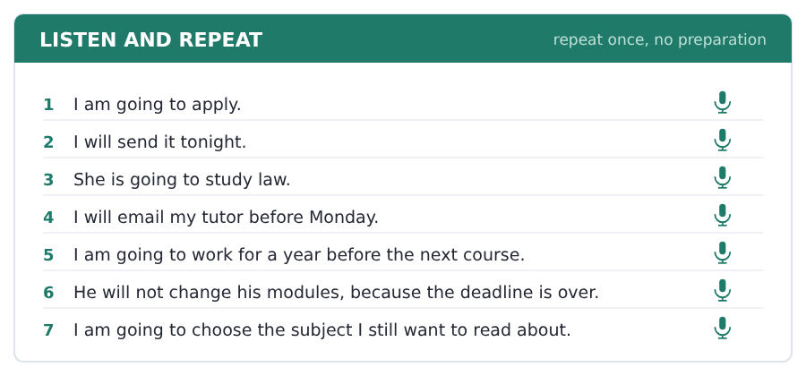
SKILL · Gonna and I’ll
- Going to is almost always said as one squeezed word in speech.
- Will is usually just ’ll: I’ll send it, she’ll be there.
- The strong word is the verb after them, not the will itself.
- Won’t is always strong, like cannot. That is how you hear it.

Part 2 · Take an Interview
An interviewer asks you four questions on one theme: your plans. Answer each one fully. There is no preparation time.
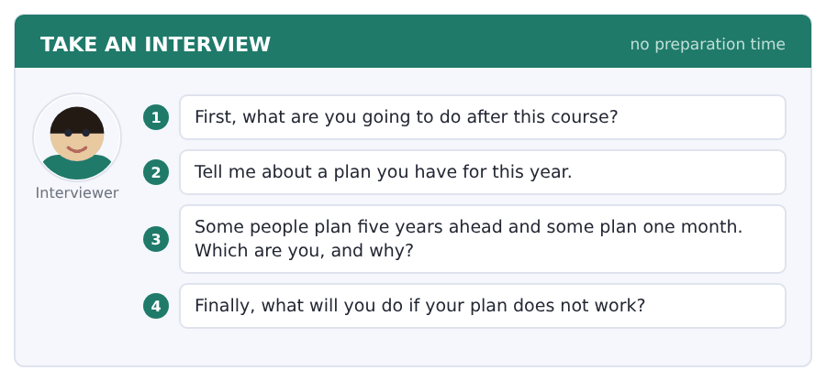
Say it like this
- After this course I am going to ... .
- This year I am going to ... , because ... .
- I plan about ... ahead, because ... .
- If my plan does not work, I will ... .
A good answer sounds like this
Question 1 — After this course I am going to start Volume 1 and take the test in about two years.
Question 2 — This year I am going to find a part-time job, because I want the experience and I need the money.
Question 3 — I plan about one year ahead, because five years ago I planned five years and almost none of it happened.
Question 4 — If my plan does not work, I will take a year, work, and start again. A year is not a long time at my age.
I can… | Not yet | Yes
I used going to for plans and will for decisions | □ | □
I said going to quickly, not word by word | □ | □
I gave a reason after my opinion | □ | □


Part 1 · Listen and Repeat
You hear a sentence and repeat it once. There is no preparation time, and the sentences get longer. Focus: comparing two things out loud
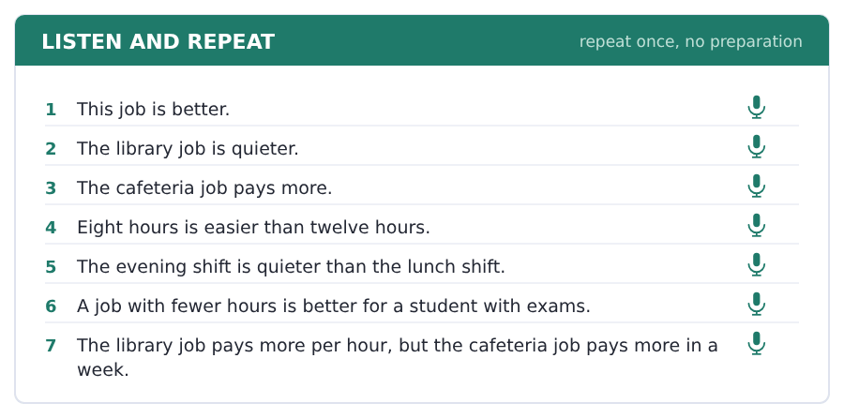
SKILL · Make the comparison clear
- Say both things: the cafeteria job is longer than the library job.
- Do not drop the than. It is the word the listener waits for.
- For long adjectives use more: more interesting, more difficult.
- Never say *more longer*. One comparison per adjective.

Part 2 · Take an Interview
An interviewer asks you four questions on one theme: work and study together. Answer each one fully. There is no preparation time.
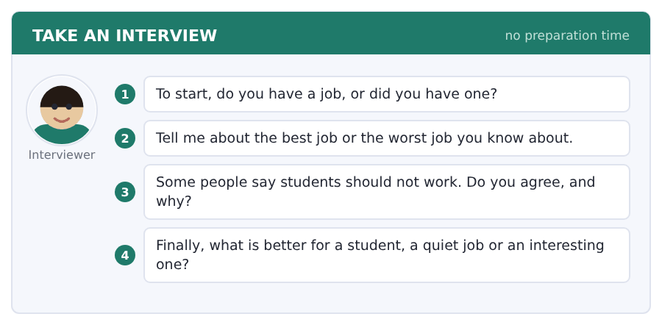
Say it like this
- I ... a job. It is ... .
- The best job I know is ... , because ... .
- I ... agree, because ... .
- I think a ... job is better, because ... .
A good answer sounds like this
Question 1 — I have a job in a shop on Saturday. It is eight hours and the wage is not good, but the people are.
Question 2 — The best job I know is my cousin’s. He works in a library and he reads for two of his six hours.
Question 3 — I do not agree. Students need the money, and a job teaches you things a course cannot.
Question 4 — I think a quiet job is better for a student, because an interesting job takes your head as well as your hours.
I can… | Not yet | Yes
I used than in every comparison | □ | □
I used -er for short words and more for long ones | □ | □
I answered all four questions | □ | □


Part 1 · Listen and Repeat
You hear a sentence and repeat it once. There is no preparation time, and the sentences get longer. Focus: sounding sure about the future
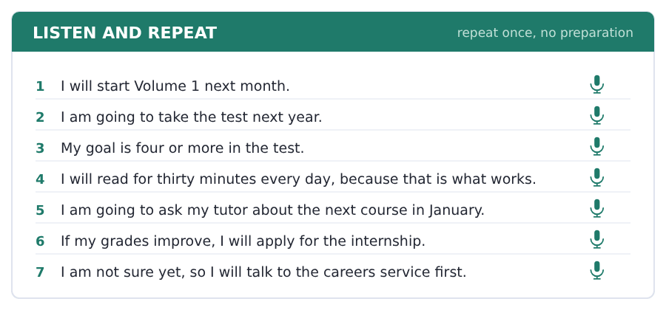
SKILL · Say the plan, then the reason
- A plan with a reason sounds like a plan. Without one it sounds like a wish.
- Use because, so and but to join the pieces.
- If you do not know, say so and then say what you will do to find out.
- Finish on the plan, not on the doubt.

Part 2 · Take an Interview
An interviewer asks you four questions on one theme: the next two years. Answer each one fully. There is no preparation time.
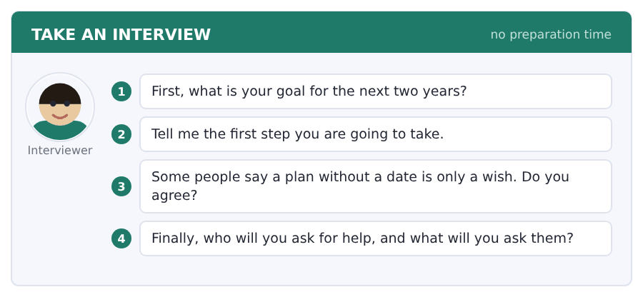
Say it like this
- My goal is ... , because ... .
- The first step is ... . I am going to ... .
- I ... agree, because ... .
- I will ask ... , and I will ask them about ... .
A good answer sounds like this
Question 1 — My goal is to finish Volume 2 and sit the test, because I need a score for a university application.
Question 2 — The first step is Volume 1. I am going to start it next Monday and do two units a month.
Question 3 — I agree. Every plan I kept had a date on it, and every plan I did not keep was a nice idea.
Question 4 — I will ask my tutor, and I will ask her the universities that take my score, and about what else they want.
I can… | Not yet | Yes
I gave a date or a number in my plan | □ | □
I gave a reason after every plan | □ | □
I finished on the plan, not on the doubt | □ | □


Part 1 · Listen and Repeat
You hear a sentence and repeat it once. There is no preparation time, and the sentences get longer. Focus: the quiet to in going to
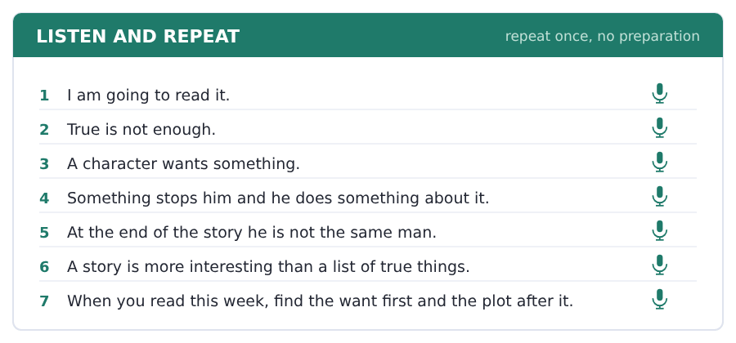
SKILL · Gonna, in real speech
- In going to the to is very small: it sounds like gunna.
- Say I am going to read it with no stop in the middle.
- A loud to sounds like a reading test, not a sentence.
- In writing it is always going to. Only the sound changes.

Part 2 · Take an Interview
An interviewer asks you four questions on one theme: reading and the stories you like. Answer each one fully. There is no preparation time.
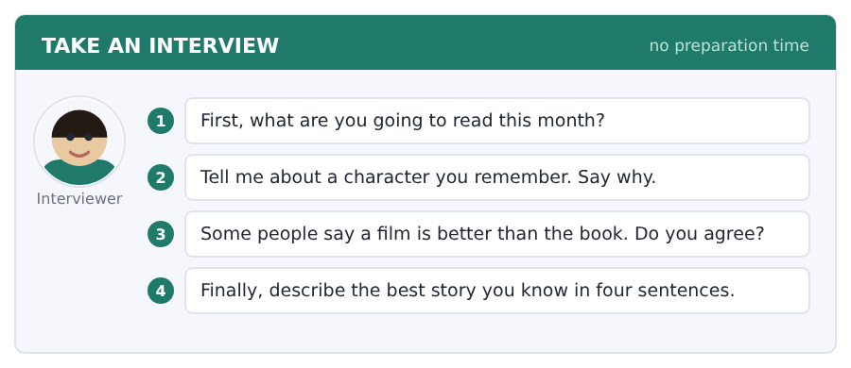
Say it like this
- I am going to read ... .
- My favourite character is ... , because ... .
- I think ... is better than ... , because ... .
- The last book I finished was ... .
A good answer sounds like this
Question 1 — I am going to read a book of short stories my sister gave me. There are eleven in it.
Question 2 — I remember a woman in a story. She waited twenty years for a letter. She wanted one small thing and she never got it.
Question 3 — I do not agree. A film will show you the face, but the book is the only place you get the want.
Question 4 — A man comes home after a war. Nobody in the town knows him. He says nothing for a year. Then he walks out again.
I can… | Not yet | Yes
I said going to as one quick piece | □ | □
I used three field words | □ | □
I gave a reason after my opinion | □ | □


Part 1 · Listen and Repeat
You hear a sentence and repeat it once. There is no preparation time, and the sentences get longer. Focus: reading a sentence out loud
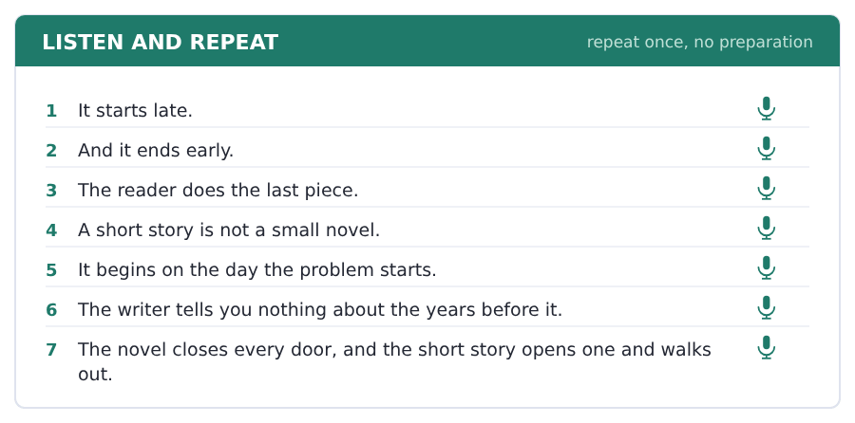
SKILL · Where the voice goes down
- At a full stop the voice goes down and stops. Let it.
- At a comma it stays up: the sentence is not finished.
- A long sentence has two or three pieces. Breathe between them.
- This is the one skill that makes a reader sound like a reader.

Part 2 · Take an Interview
An interviewer asks you four questions on one theme: books, writing and your own reading. Answer each one fully. There is no preparation time.
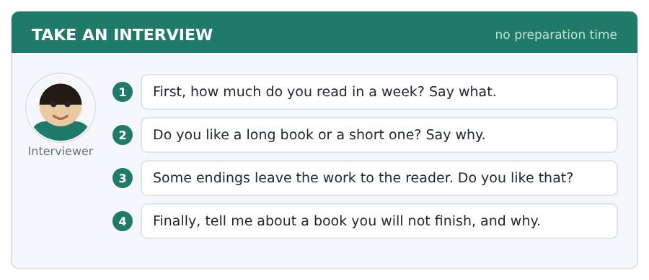
Say it like this
- I read ... pages a week.
- I like the voice of ... , because ... .
- A good ending is ... .
- I will read more ... next year, because ... .
A good answer sounds like this
Question 1 — I read about sixty pages a week, and most of it is on my phone on the bus.
Question 2 — I like a short one. I can hold a whole short story in my head and I can see the shape of it.
Question 3 — I like it very much. The best ending I know gives you two answers and will not say which one it is.
Question 4 — I will not finish a long novel about a family. There are nine characters and after a hundred pages nobody wants anything.
I can… | Not yet | Yes
I let my voice go down at every full stop | □ | □
I kept it up at the commas | □ | □
I answered all four questions | □ | □


You see a sentence, then a set of words in boxes. Put the words in order to make one grammatical sentence. Almost every item in the real test makes a question or a question inside another sentence.
SKILL · Questions about the future
- Are you going to ...? uses the be question you learned in Unit 1.
- Will you ...? puts will in front of the person and nothing else moves.
- Question word first: What are you going to study? When will you apply?
- Never put do or does with will or going to.

Exercise A Guided practice. The first three are worked through.
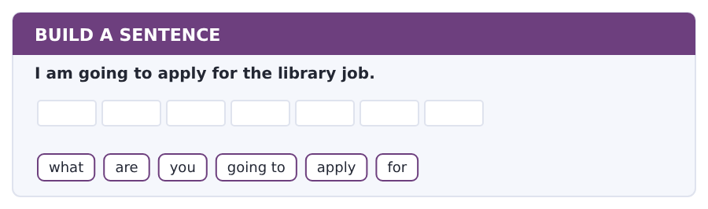
1. What are you going to apply for?
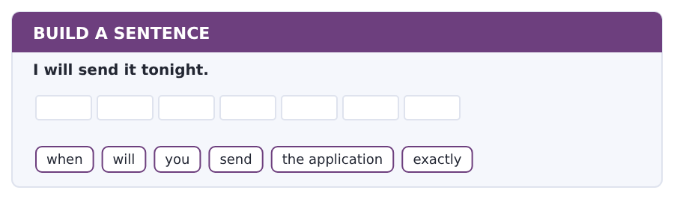
2. When will you send the application exactly?
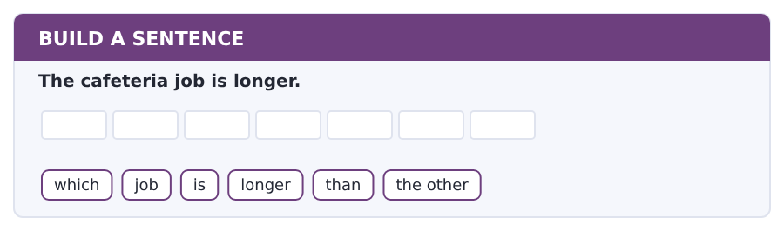
3. Which job is longer than the other?
Exercise B Exam practice. Write the sentence.
4. She is going to study law.
what / is / she / going to / study / next year
__________________________________________________________
5. I will email my tutor on Monday.
who / will / you / email / on / Monday
__________________________________________________________
6. The deadline is the fifth of December.
when / is / the deadline / for / the library / application
__________________________________________________________
7. The library job is quieter.
which / job / is / quieter / in / your opinion
__________________________________________________________
8. I am going to work for a year.
are / you / going to / work / for / a year
__________________________________________________________
9. He will not change his modules.
will / he / change / his modules / before / January
__________________________________________________________
10. Volume 1 is harder than this book.
how much / harder / is / Volume 1 / than / this book
__________________________________________________________


You read a short situation and write an email. You have 7 minutes. The three bullet points are the mark scheme: answer all three.
In the real test you write as much as you can in seven minutes. In this unit, aim for about 72 words. That number goes up in every unit of this book, and in Volume 1 it stops being a number at all.
You want the library assistant job: 8 hours a week, evening shift.
You worked in a shop for two years. Write to the careers service.
- say which job you are applying for
- say what experience you have
- say when you are available and ask about the interview
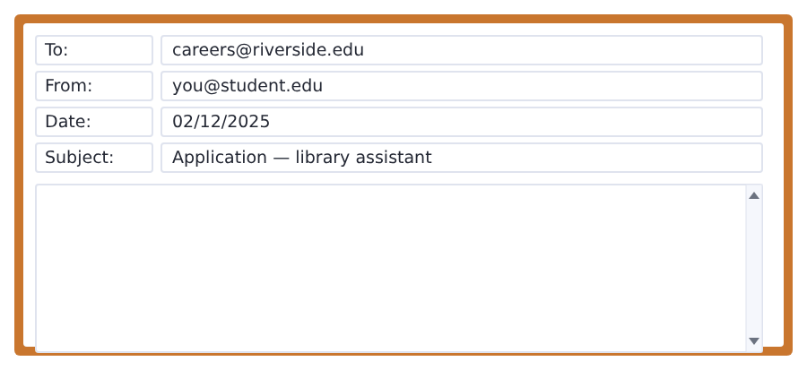
SKILL · An application is not a life story
- Name the job in the first line. They have four jobs and a hundred emails.
- Give one piece of experience and say how long it was.
- Say when you are free. A good application saves the reader a question.
- End with one question, about the next step.

Model email
Dear Careers Service,

My name is Ana Ruiz and I am in Group B. I would like to apply for the library assistant job.
I worked in a shop for two years at home, so I have experience with people and with a till.
I am available on Tuesday and Thursday evenings, and I am going to send my CV and a reference from Dr Patel this week.
When will the interviews be?

Thank you,
Ana Ruiz
Why it works
- The job is named in the first three lines, where the reader looks.
- The experience is one job, with a length and a reason it is relevant.
- The days match the shift in the advertisement exactly.
- The question is about the next step, so the reply moves things forward.
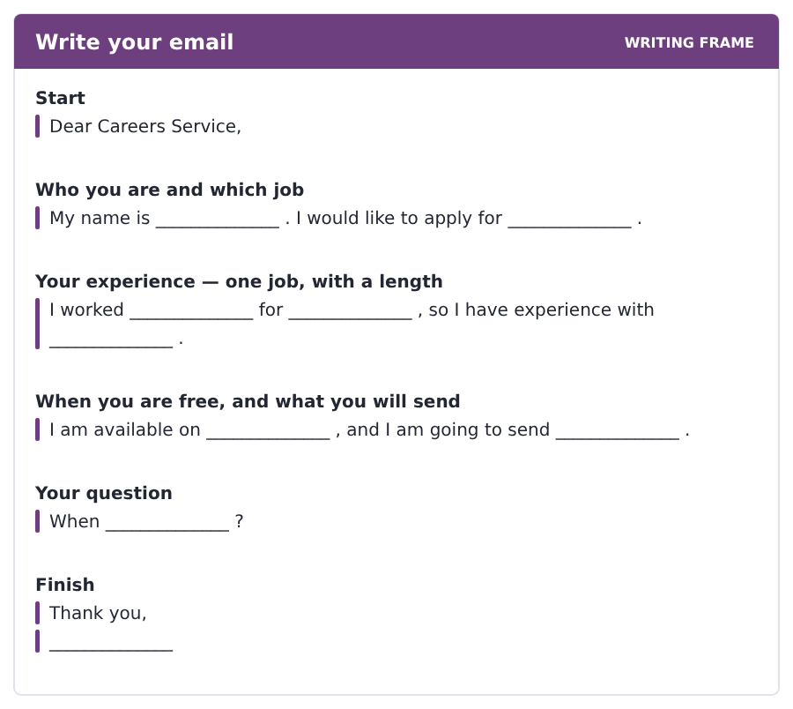
Now write your own. 7 minutes.
__________________________________________________________
__________________________________________________________
__________________________________________________________
__________________________________________________________
__________________________________________________________
__________________________________________________________
__________________________________________________________
__________________________________________________________


A professor asks a question and two students answer. You add your own post. You have 10 minutes and an effective answer is at least 100 words.
One hundred words is what the real test wants, and you will get there. For this unit, write about 85. Every unit of this book asks for a few more.
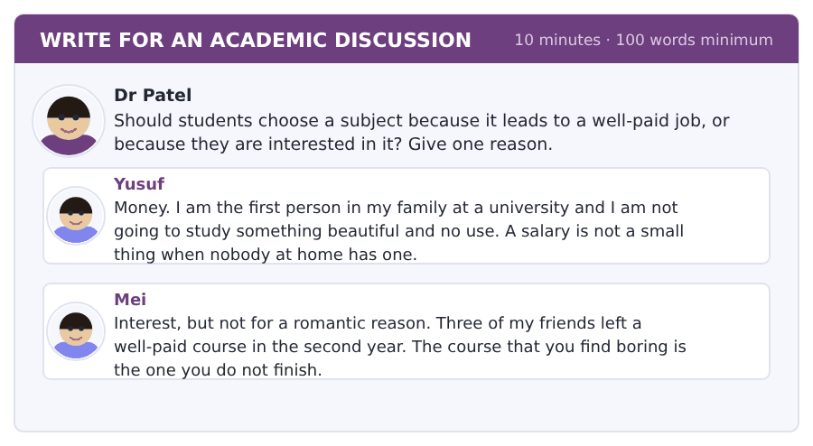
SKILL · A question with two good answers
- Both posts here are serious. Do not choose one and ignore the other.
- Say what each one gets right, then say where you stand.
- Use will and going to for what you yourself plan to do.
- Eighty-five words is about eight short sentences.

Sentence starters
- I agree with Mei, because ...
- Yusuf is right that ...
- In my own case I am going to ...
- The real answer is probably ...
Model post
Yusuf is right that a salary matters. People say it does not matter, and they always have one.
But Mei is right about the thing that decides it. A course you do not finish pays nothing at all.
In my own case I am going to choose the subject I still read about when nobody is making me, and then look for the best-paid work inside it.
The real answer is probably that the two questions are one question, and the order you ask them in is what changes.
[89 words]
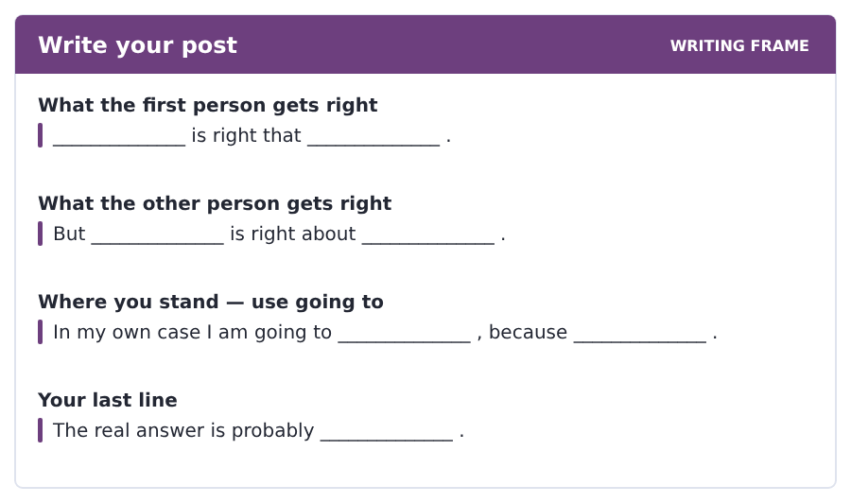
Now write your own. 10 minutes, at least 85 words.
__________________________________________________________
__________________________________________________________
__________________________________________________________
__________________________________________________________
__________________________________________________________
__________________________________________________________
__________________________________________________________
__________________________________________________________
__________________________________________________________
__________________________________________________________


The same task again, on the subject of this unit. The sentences are about stories and writing now, and the word order has not changed at all.
SKILL · Questions about what comes next
- Will goes in front of the person: Will you read it?
- Going to needs am, is or are: Is she going to write a novel?
- A question word goes first: What will the reader do?
- The verb after will and after to never changes.

Exercise A Guided practice.
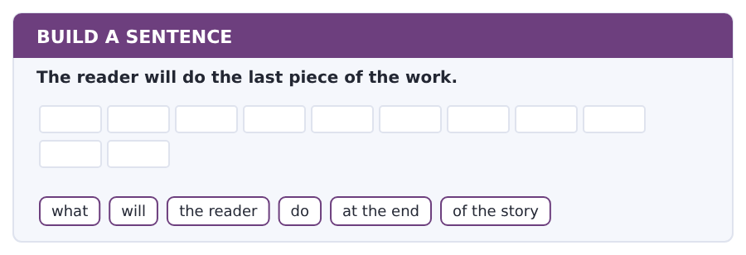
1. What will the reader do at the end of the story?
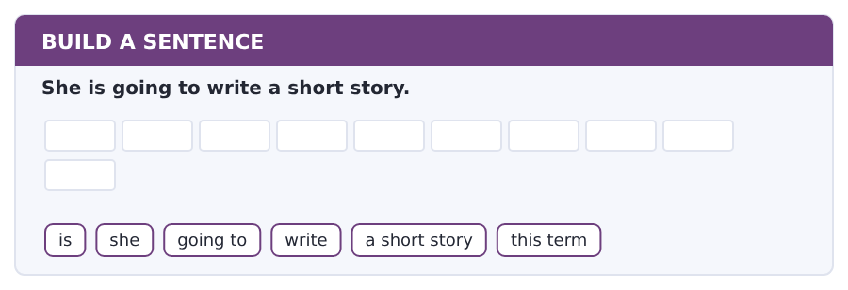
2. Is she going to write a short story this term?
Exercise B Exam practice. Write the sentence.
3. The writer will tell you nothing about the years before.
will / the writer / tell / us / about the years / before
__________________________________________________________
4. The story is going to stop early.
when / is / the story / going to / stop / in this chapter
__________________________________________________________
5. A short story is more interesting than a list.
why / is / a short story / more interesting / than / a list
__________________________________________________________
6. They are going to read the novel in two weeks.
how long / are / they / going to / take / over the novel
__________________________________________________________


A second discussion, and this one is about the subject rather than about your own week. In the real test both kinds come up, and the second kind is the harder one.
For this unit, write about 85 words. The real test wants a hundred.
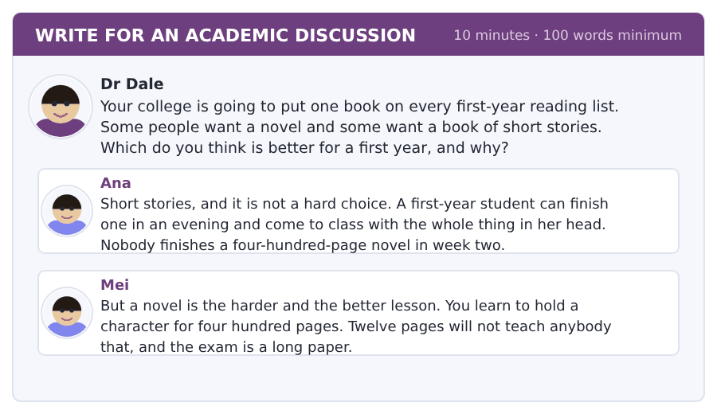
SKILL · A choice with a reason on each side
- Both answers are good, so your reason is the whole mark.
- Say which one, then say what the other one does better.
- Use the passage: the two forms are different machines.
- Eighty-five words is about eight sentences.

Sentence starters
- I agree with Ana, because ...
- Mei is right that ...
- The passage says the two forms ...
- So the college must ...
Model post
I agree with Ana for a first year. A student with no finished book learns nothing, and twelve pages get read.
Mei is right that a novel teaches something a short story cannot. The passage says they are different machines, so they are different lessons.
But the first year is the year to build the habit. Start with short stories in the first term and put the novel in the second. By then the students will read four hundred pages and not be afraid of them.
[86 words]
Now write your own. 10 minutes, at least 85 words.
__________________________________________________________
__________________________________________________________
__________________________________________________________
__________________________________________________________
__________________________________________________________
__________________________________________________________
__________________________________________________________
__________________________________________________________
__________________________________________________________
__________________________________________________________

Grammar focus going to and will · comparatives · and, but, because, so
Form | Example
going to = a plan | I am going to apply for the library job.
will = a decision now | I will email her tonight.
question | Are you going to apply? Will you send it today?
negative | I am not going to work. He will not change.
short adjective + -er | cheap → cheaper, easy → easier
long adjective + more | more difficult, more interesting
joining words | and, but, because, so

Going to looks back at a decision you already made. Will looks at this moment. Both talk about the future, and that is why they feel the same at first.
A comparison needs than. Without it the sentence is only half said: this job is longer than that one, not *this job is longer*.
Good and bad are irregular: good → better, bad → worse. These two come up constantly, so learn them on their own.
Watch out! Never say *more longer* or *more easier*. Use -er or more, never both. And never put do or does with will: *Do you will come?* is not English.
Exercise 1 Write going to or will.
1. I __________ apply for the library job. (I decided last week)
2. That is a good idea. I __________ do the same. (deciding now)
3. She __________ study law next year. (her plan)
4. The phone is ringing. I __________ answer it. (deciding now)
5. We __________ move to a new flat in July. (our plan)
6. I promise I __________ send it tonight.
Exercise 2 Write the comparative.
1. This job is __________ (long) than that one.
2. The library is __________ (quiet) than the canteen.
3. This module is __________ (difficult) than the last one.
4. Her grade is __________ (good) than mine.
5. The cafeteria job is __________ (easy) to get.
6. The weather today is __________ (bad) than yesterday.
Exercise 3 Write and, but, because or so.
1. I applied for the library job __________ it is quieter.
2. The job pays well, __________ it is twelve hours.
3. I need a reference, __________ I will email my tutor tonight.
4. I sent my CV __________ a reference.
How this is tested in Build a Sentence
Build a Sentence in the real test is full of future questions, because they move two or three words at once: What are you going to do? and When will you send it? Both of them follow the same rule you learned in Unit 1.

Typing and the Screen Typing an email in seven minutes
The real test is typed. Nobody gives you paper. If you are still looking for the keys, you lose the Writing section before your English does.
This is the last typing page, and it is a test, not a lesson. In the real exam you have seven minutes for the email and ten for the discussion post, and nobody gives you more.
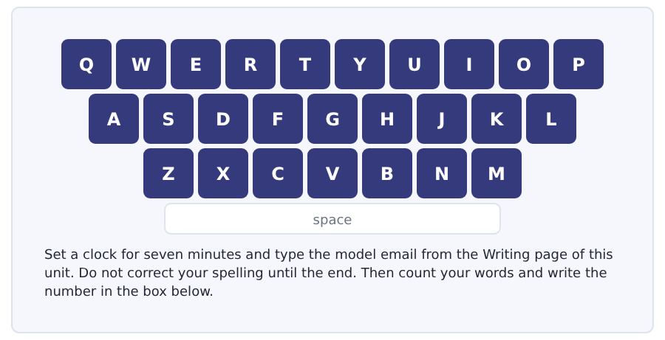
Exercise Type this. Time yourself, then write your speed in the box.
Dear Careers Service, I would like to apply for the library assistant job.
I worked in a shop for two years, so I have experience with people.
I am available on Tuesday and Thursday evenings. When will the interviews be?
My time _______ seconds
Words a minute _______ (the target for Unit 10 is 18)

Learning to Learn How to use Volume 1
You have finished this book, so here is the only study advice that matters now: the next book is built exactly like this one, and that is the whole point. You are not starting again. You are carrying on.
- Do one unit a week. Sixteen pages is about five hours, and five hours a week is a real course.
- Read the academic passage twice before you look at a single question. In this book you could answer from memory. In Volume 1 you cannot.
- Keep the vocabulary notebook from Unit 1. The Academic Word List goes in the same three columns.
- Use the glossary of this book when a general word stops you. That is what it is for, and it is not cheating.
- When a unit is hard, do the Reading and the Listening and leave Speaking and Writing for the next day. Half a unit done well beats a whole unit done at midnight.
ADAPTIVE TIP Read the first academic passage of Volume 1 Unit 1 now and count the words you do not know. Expect about twenty. Most of them will be words from the subject itself — ports, valleys, railroads — and not grammar. That is the gap this book does not close, and it is exactly what Foundation 2 is for.

Unit review and progress check Unit 10
Exercise A Vocabulary. Write the word.
1. one part of a course, with its own exam
2. a letter about you from a teacher
3. the paper that lists your study and work
4. a short time working in a company to learn
5. the office that helps students find work
6. the money a job pays you
7. the knowledge a job or a life gives you
8. there to be used or taken
9. facts and numbers you can work with
10. almost the same
11. one single person
12. careful study to find out something new
Exercise B Grammar. Complete the sentence.
1. I __________ apply tomorrow. (my plan)
2. That is a good idea. I __________ do the same. (now)
3. This job is __________ (long) than that one.
4. This module is __________ (difficult) than the last one.
5. Her grade is __________ (good) than mine.
6. I applied __________ it is quieter.
7. The job pays well, __________ the hours are long.
8. I need a reference, __________ I will email my tutor.
Exercise C One timed mini-section. 6 minutes.
1. The library job is
(A) 12 hours a week
(B) 8 hours a week
(C) 15 hours a week
(D) 6 hours a week
2. The cafeteria job pays more because
(A) the wage is higher
(B) it has training
(C) it needs experience
(D) the week is longer
3. The passage says the better question is
(A) which subject pays most
(B) which subject is easiest
(C) which subject will you still want to read about
(D) which subject is shortest
4. Which sentence is correct?
(A) This job is longer than that one.
(B) This job is more longer.
(C) This job is more long.
(D) This job is longer that one.
5. Which sentence is correct?
(A) Do you will come?
(B) You will come?
(C) Are you will come?
(D) Will you come?
6. After this book you are ready for
(A) the TOEFL test
(B) Volume 3
(C) Volume 1
(D) a job
Can you do these now?
I can… | Not yet | Yes
talk about my plans with going to and will | □ | □
read a job advertisement and find the hours and the pay | □ | □
understand a short text about choosing a subject | □ | □
follow a conversation about a part-time job | □ | □
compare two things with -er and more | □ | □
write an email applying for a job on campus | □ | □

ADAPTIVE TIP This is the last tip in this book, so it is the one about the book. Do not put it away. The glossary, the irregular verbs and the Sound and Spelling pages are the three things you will come back to all the way through Volume 1, and a book you have already read is the fastest reference you will ever own.

Progress Test F
The real order and the real task names · one module in each section
Reading 20 · Listening 16 · Writing 12 · Speaking 11 — 59 items
Sit this in one sitting. Do not look anything up. Mark it with the key at the back, then read the explanations — they matter more than the score.
Two numbers here are not reduced, and that is deliberate. Build a Sentence is ten items because the real task is ten. Speaking is seven repeats and four interview questions because that is the task; shortening it would leave you practising something else.

Reading Section In an actual test the clock shows you how long you have
You can use Next and Back to move between questions inside this module.
Fill in the missing letters in the paragraph. (Questions 1–10)
Riverside College is a small campus with six building-. The library open- at eight every morning and close- at nine. In the canteen a hot dish cost- two pounds and a sandwich cost- two twenty. Last term the college clos-- the gym for a week, because a storm damag-- the roof. The staff clean-- the sports field and open-- it again on the Tuesday. Most student- walk to the college.

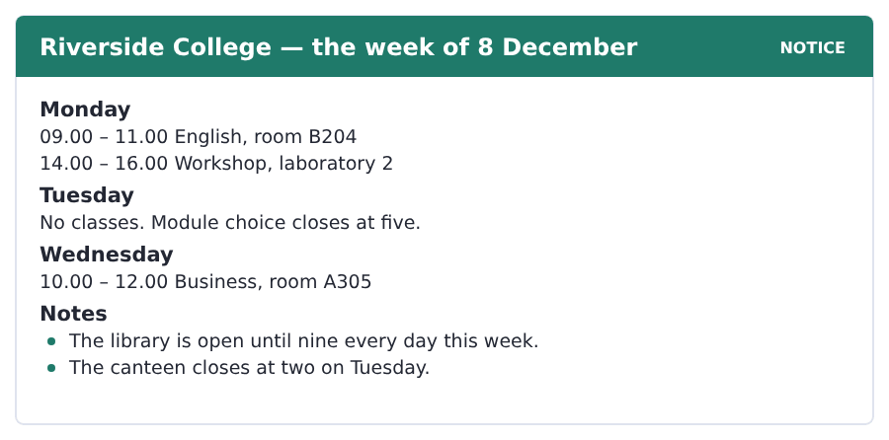
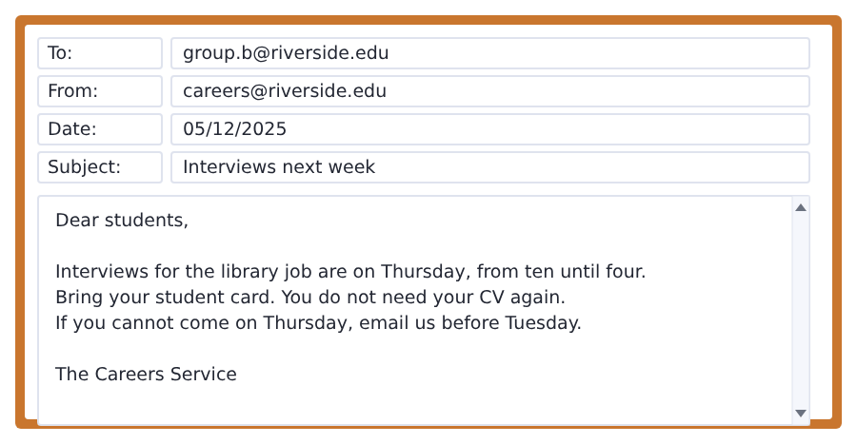
11. Where is the English class on Monday?
(A) A305
(B) laboratory 2
(C) the library
(D) B204
12. What time does module choice close?
(A) two
(B) five
(C) four
(D) nine
13. When does the canteen close on Tuesday?
(A) at four
(B) at five
(C) at two
(D) at nine
14. When are the interviews?
(A) Thursday
(B) Tuesday
(C) Wednesday
(D) Friday
15. What do students bring to the interview?
(A) a student card
(B) a CV
(C) a reference
(D) nothing
Why a College Week Has a Hole in It
A college week is not the same on every day. Monday and Tuesday are heavy. Wednesday is often free. Thursday and Friday are heavy again.
There is a reason for the free day. Students need one day for reading. Teachers need one day for their own work. A free Wednesday also gives the college a day for games and for clubs.
The shape is not the same in every country. In some places the week runs from Sunday to Thursday. But the idea is always the same. A week needs a hole in the middle, and a student with five heavy days does the work of four.
[117 words]

16. Which day is often free?
(A) Monday
(B) Tuesday
(C) Friday
(D) Wednesday
17. Why do students need the free day?
(A) for games
(B) for reading
(C) for the canteen
(D) for clubs
18. What else does the free day give the college?
(A) a day for exams
(B) a day for the library
(C) a day for games and clubs
(D) a day for work
19. In some places the week runs from
(A) Sunday to Thursday
(B) Monday to Friday
(C) Tuesday to Saturday
(D) Wednesday to Sunday
20. A student with five heavy days does the work of
(A) six
(B) four
(C) five
(D) three

Listening Section You will not be able to return to previous questions
Choose the best response.
1. Excuse me, is there a canteen in this building?
(A) At four o’clock.
(B) Two pounds.
(C) He is a teacher.
(D) Yes, on the ground floor.
2. Did you take the early bus?
(A) At the barrier.
(B) Two zones.
(C) No, I missed it.
(D) Yes, I am.
3. What are you going to do after this course?
(A) I am going to work for a year.
(B) At nine.
(C) Yes, I do.
(D) In the library.
Listen to a conversation.

4. Where is the woman at the start of the conversation?
(A) in the class
(B) in the library
(C) on the bus
(D) at home
5. Why is she late?
(A) she is ill
(B) the traffic is bad
(C) the bus is early
(D) she is in the canteen
6. Which bus does she usually take?
(A) seven o’clock
(B) nine o’clock
(C) ten o’clock
(D) eight o’clock
7. What is the man doing now?
(A) waiting at the door
(B) calling the register
(C) eating lunch
(D) printing his work
8. What do they decide?
(A) to meet at one in the canteen
(B) to meet at ten
(C) to go home
(D) to call the tutor
Listen to an announcement.
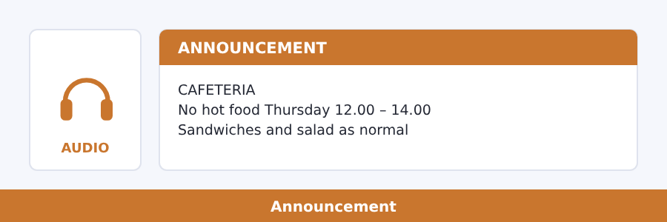
9. What is not there on Thursday?
(A) sandwiches
(B) drinks
(C) hot food between twelve and two
(D) fruit
10. Why not?
(A) no cook
(B) the big cooker is not working
(C) the cafeteria is closed
(D) there is no food
11. What is there as normal?
(A) sandwiches, salad and fruit
(B) hot dishes
(C) soup
(D) nothing
12. What does the speaker say about the queue?
(A) it is long
(B) it starts at twelve
(C) there is no queue for the cold food
(D) it is at till 2
Listen to a talk.
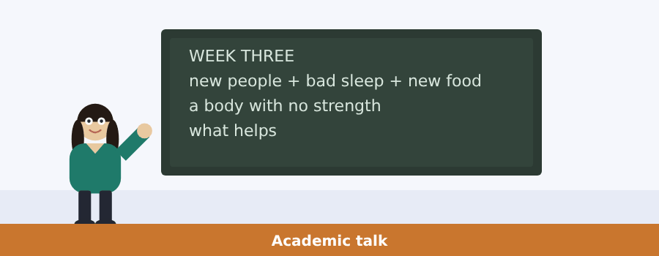
13. What fills up in week three?
(A) the library
(B) the waiting room at the health centre
(C) the canteen
(D) the gym
14. Is the reason bad luck?
(A) yes
(B) sometimes
(C) only in winter
(D) no
15. What is the first piece of advice?
(A) register with a doctor in your first week
(B) take medicine
(C) eat more
(D) stay in your room
16. What is the second?
(A) drink more water
(B) do more exercise
(C) see a doctor
(D) go to bed early for four nights

Writing Section 12 questions, three types of task
Build a Sentence. Move the words to make grammatical sentences.
1. I am a new student.
are / you / a / student / here
__________________________________________________________
2. The office is in Block C.
where / is / the office / exactly
__________________________________________________________
3. There are six blocks.
how many / blocks / are / there
__________________________________________________________
4. The class starts at nine.
when / does / the class / start
__________________________________________________________
5. I have got one brother.
have / you / got / any / brothers
__________________________________________________________
6. She is reading in the library.
what / is / she / reading / now
__________________________________________________________
7. A coffee is one pound ten.
how much / is / a coffee / in here
__________________________________________________________
8. There was a storm on Friday.
was / there / a storm / on Friday
__________________________________________________________
9. I took the early bus.
did / you / take / the early bus / today
__________________________________________________________
10. I am going to apply for the job.
what / are / you / going to / apply / for
__________________________________________________________
Write an Email. You have 7 minutes.
You want a study room in the library on Saturday morning.
You do not know if the library is open. Write to the library.
- say who you are and which group you are in
- ask about Saturday opening times
- ask how to take a study room
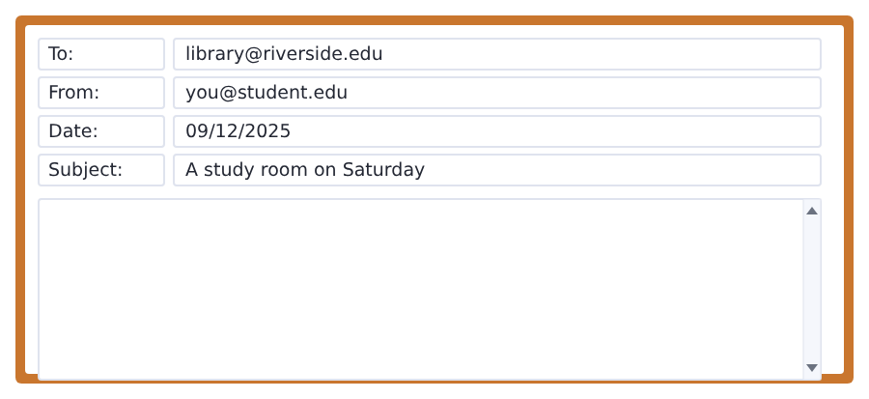
__________________________________________________________
__________________________________________________________
__________________________________________________________
__________________________________________________________
__________________________________________________________
__________________________________________________________
__________________________________________________________
__________________________________________________________
Write for an Academic Discussion. You have 10 minutes.
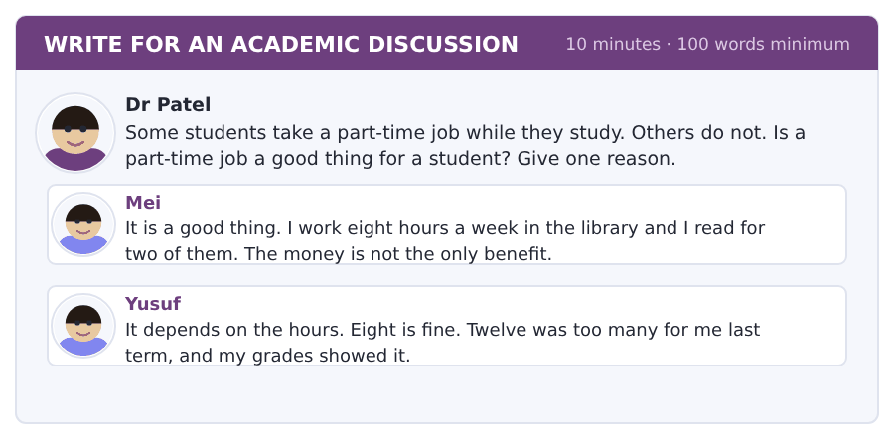
An effective response will contain at least 100 words.
__________________________________________________________
__________________________________________________________
__________________________________________________________
__________________________________________________________
__________________________________________________________
__________________________________________________________
__________________________________________________________
__________________________________________________________
__________________________________________________________
__________________________________________________________

Speaking Section 11 questions, two types of task · no preparation time
Listen and Repeat. Repeat only once.
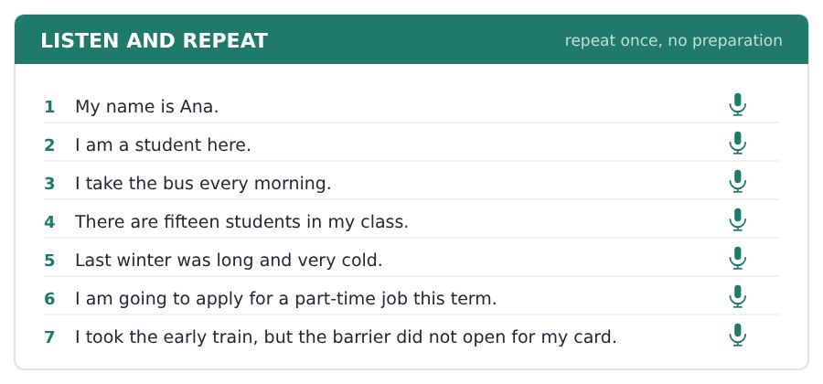
Take an Interview. Answer the questions and say as much as you can.
your life as a student
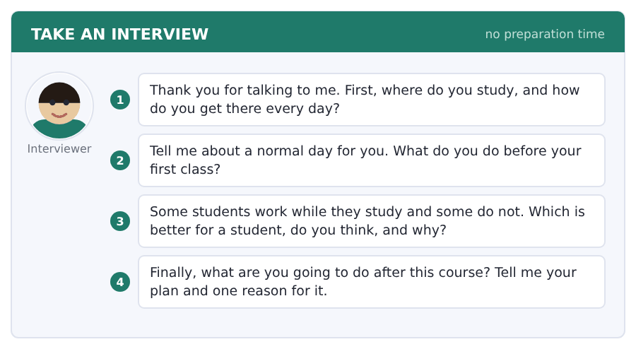

First sight of the real thing
One page from Volume 1 · do not mark this, and do not worry about it
This is the Academic Passage from Volume 1, Unit 1. Nothing has been changed.
Everything else in this book was written for you. This page was not. It is the real passage from the next book, at the real length and the real level, and it is here for one reason: so that you know exactly what you are walking towards.
Before you read
- It is about two hundred and sixty-five words. The longest passage in this book is a hundred and seventy-five.
- There will be words you do not know. Fifteen is normal at this point. Twenty-five means do the glossary of this book once more first.
- Do not look anything up. Read it once, at speed, and see how much comes through.
- Then read it again slowly. The second reading is where the difference is.
Why Cities Grew Where They Did
Look at a map of the United States in 1800 and almost every large town sits on water. New York, Boston, Philadelphia and Charleston were ports. Further inland, St Louis and Cincinnati stood on great rivers. This was not an accident. Before the railroad, moving a ton of goods thirty miles over land cost about as much as shipping it across the Atlantic. A town without water transport could feed itself, but it could not trade, and a town that could not trade did not grow.
The railroad broke that rule. After 1840 a line could be laid almost anywhere, and towns began to appear in places with no river at all. Chicago is the clearest example. It had a small harbour and a great deal of swamp, and in 1840 fewer than five thousand people lived there. Thirty years later it was the meeting point of eleven railroad companies and the fourth largest city in the country. What had changed was not the land but the cost of crossing it.
Geography still mattered, though. Railroads were cheapest to build on flat ground, so lines followed valleys and plains, and towns followed the lines. Where a line crossed a river, or where two companies met, a city grew. Historians call these places break-in-bulk points: somewhere goods have to be moved from one kind of transport to another. Wherever goods stop, people stay. The pattern is very old. Only the reason for stopping had changed.
[265 words]

Now count
Count the words you did not know on the first reading and write the number here. Then come back to this page when you have finished Volume 1 Unit 1 and count again.
Words I did not know today _______
Date _______
What you already have
You can read the first sentence of every paragraph and say what the paragraph is about. You know how the questions after it will be laid out, because they are laid out that way in this book, on the same page of every unit. That is not nothing. That is most of what a reader needs, and the rest is vocabulary, which is a matter of time rather than of talent.

Answer key
Volume F1 · Units 1–10 and Progress Test F
Every wrong option is explained, because a letter on its own teaches nothing.

Unit 1 · People, Names and the First Week
Reading 1 · Complete the Words
1 s | 3 ies | 5 s | 7 s | 9 s
2 s | 4 er | 6 s | 8 s | 10 s

Reading 2 · Read in Daily Life
1 (D) The notice says New students: Hall 1. Hall 2 is for the second year.
2 (C) Open from 9.00 to 5.00. The 9.00 is when it opens.
3 (A) The first card is free. A second card is not free.
4 (B) Her email says a new student in the Business Department.
5 (B) Students in the second year: Hall 2, Block A, 11.00.
6 (A) Bring one photo and your letter from the college.
7 (C) Ask any student with a yellow shirt. They are here to help.
8 (D) I am in Group B, in the second line of her email.
9 (D) I am not sure about my student number.
10 (C) Collect your card from the Student Office, Block C.
Reading 3 · Short Text
1 (B) A class of fifteen students. Nine is the number of countries.
2 (A) The students are from nine different countries.
3 (C) Four of them are from this city.
4 (B) Turkish, Arabic and English is three languages.
5 (D) Every student in the room speaks English.
6 (A) In the class there are twenty-one languages.
7 (A) Mei Chen speaks three languages too. Too means the same as Yusuf.
8 (D) It is a small map of the world, in the last paragraph.
9 (B) Brazil, Turkey, Poland, Kenya and Peru are there. Japan is not.
10 (C) Many students speak two or three.
11 (D) The last line says English is the road between the parts of it.
Reading 4 · Academic Passage
1 (C) In English a person has a first name and a family name. The first name comes first.
2 (B) In China and in Hungary the family name comes first.
3 (A) It is the name of the father or the mother and a word for child.
4 (C) In Spain and in much of Latin America a person has two family names.
5 (B) Two family names, one from the mother and one from the father.
6 (D) This is not a rule of the world. It is a custom of one part of it.
7 (A) The last sentence says it in the fewest words.
Reading 5 · Academic Passage
1 (C) A household is the people in one house.
2 (B) In some nations a household is two parents and their children.
3 (A) The small household is easy to move for a job.
4 (D) The large one is cheap. A member of the family is always at home.
5 (A) The household of today is small. The household of a hundred years ago is not small at all.
6 (D) The reason is work in the cities, and a city flat with two rooms in it.
7 (B) Both work, at the start of the second paragraph.
Listening 1 · Conversation
1 (C) Are you ...? takes Yes, I am. The other three answer other questions.
2 (A) The question asks for a name, so the answer is a name.
3 (D) Spell means say the letters, so the answer is letters.
4 (B) The woman asks Are you in Group B? and the man says Yes, I am.
5 (C) She says No, one n. A-N-A.
6 (B) From Peru is her answer to Where are you from?
7 (A) I am from Turkey.
8 (D) It is room 12, at the end of the conversation.
9 (C) It is at the end of this corridor.
Listening 2 · Announcement
1 (B) A greeting takes a greeting back.
2 (A) Is it ...? takes Yes, it is or No, it is not.
3 (D) Where asks for a place, so the answer is a place.
4 (C) The Student Office is in Block C.
5 (D) Open from nine in the morning until five.
6 (A) It is not open at the weekend.
7 (B) Bring one photo and the letter from the college.
8 (C) Your first card is free.
Listening 3 · Short Talk
1 (A) Welcome takes Thank you.
2 (D) Are you ...? takes Yes, I am.
3 (C) The question asks what a family name is.
4 (B) He says I am Mr Dale and this is your first tutorial.
5 (D) We start with names, because a name is the first word you give a person.
6 (C) A first name comes before a family name.
7 (A) My first name is Robert and my family name is Dale.
8 (B) There are fifteen students from nine countries.
9 (C) Please tell me which of your two names you want me to use.
Listening 4 · Academic Talk
1 (D) Is it ...? takes Yes, it is or No, it is not.
2 (B) The question asks for the name itself.
3 (A) It is also a piece of a culture.
4 (B) In English the first name is first. In China it is not.
5 (A) In Iceland the second name is the name of a mother or a father.
6 (C) So in this class, ask people how they say their own name.
Listening 5 · Academic Talk
1 (D) Is it ...? takes Yes, it is.
2 (B) How many asks for a number.
3 (A) In this country a household today is about two people.
4 (D) In some other nations it is six or seven.
5 (C) Cities for work, small flats, and fewer children.
6 (A) In many other nations the household is still three generations.
Writing 1 · Build a Sentence
1 Are you a student?
2 What is your name?
3 Where are you from?
4 How many students are there?
5 Where is the office?
6 Are your classmates friendly?
7 Which group are you in?
8 Is the card free?
9 Is she from Turkey?
10 Who is your teacher?
Writing 4 · Build a Sentence
1 Which name is first?
2 What is a household?
3 How many family names are there?
4 Is this custom normal here?
5 Is your household small?
6 What is the population exactly?
Grammar focus
Exercise 1 am · is · are · are · Is · are
Exercise 2 a · an · an · a · an · a
Exercise 3 Are you from Kenya? · Is she a teacher? · Are they in my class? · Is it free?
Unit review
A Vocabulary 1 name · 2 city · 3 village · 4 spell · 5 classmate · 6 student card · 7 campus · 8 department · 9 lecture · 10 tutorial · 11 corridor · 12 languages
B Grammar 1 am · 2 is · 3 are · 4 Are · 5 an · 6 students · 7 Who · 8 are
C Mini-section 1 D · 2 B · 3 C · 4 A · 5 D · 6 C

Unit 2 · The Campus and How to Find It
Reading 1 · Complete the Words
1 s | 3 ies | 5 s | 7 s | 9 s
2 s | 4 ers | 6 s | 8 s | 10 s

Reading 2 · Read in Daily Life
1 (D) Sunday closed, in the opening times.
2 (B) Second floor: books for Science.
3 (C) Students take six books for three weeks. Three is the number of weeks.
4 (A) Ask at the help desk on the ground floor.
5 (C) Saturday 10.00 – 17.00. The 17.00 is when it closes.
6 (D) The library door opens with your student card.
7 (A) Third floor: study rooms and the quiet room.
8 (B) Rooms are for two hours.
9 (B) Room 8 is for six people. Six is the number of people, not the room.
10 (D) Food and drink stay in the canteen.
Reading 3 · Short Text
1 (C) There are six buildings. Two thousand is the number of people.
2 (A) Block B is for Science.
3 (C) B is the block and the 2 is the floor.
4 (B) Every building has a letter.
5 (A) About two thousand people come here every day.
6 (D) Block C is for the offices.
7 (B) It is the fourth door, in the second paragraph.
8 (C) Some colleges use names, not letters.
9 (A) A name is easy to remember. The map one is the letter.
10 (D) A campus with letters is cold at first.
11 (B) Every paragraph is about how the letters and numbers help you find a room.
Reading 4 · Academic Passage
1 (D) The top of it is a curve, not a straight line.
2 (C) This is not for beauty. It is the answer to a problem.
3 (A) Stone is very strong under weight and very weak across it.
4 (A) A straight stone over a river breaks in the middle.
5 (D) The weight of the bridge runs down the curve and into the ground at each end.
6 (C) There is only stone and shape.
7 (B) Some of those bridges are two thousand years old.
Reading 5 · Academic Passage
1 (B) A chair is four legs and a flat part.
2 (A) It is the first thing a student of design makes.
3 (C) Weight, light, comfortable, cheap and a shape people like: five.
4 (D) A strong chair is heavy.
5 (D) A light chair is weak.
6 (A) The designer looks for the right balance.
7 (C) Every one of these is easy on its own. Together they fight.
Listening 1 · Conversation
1 (B) Is there ...? takes Yes, there is, or the place itself.
2 (D) Where asks for a place.
3 (C) Thank you takes You are welcome.
4 (B) His first question is Where is the sports centre?
5 (A) It is behind Block C.
6 (B) It is the building opposite the library.
7 (C) Turn right at the corner.
8 (D) On your left, behind the car park.
9 (A) There is a sign at the entrance.
Listening 2 · Announcement
1 (B) Is it ...? takes Yes, it is or No, it is not.
2 (A) Where asks for a place.
3 (C) An apology takes That is fine.
4 (D) On Wednesday the second floor is closed all day.
5 (D) On Wednesday, in the first sentence of the announcement.
6 (C) Because of work on the lift.
7 (A) On the ground floor on that day only, next to the help desk.
8 (B) The study rooms on the third floor are open as normal.
Listening 3 · Short Talk
1 (C) Is there ...? takes Yes, there is.
2 (B) Are there ...? takes Yes, there are.
3 (D) How do I find ...? asks for the place.
4 (A) There is one street and six blocks.
5 (A) The blocks are on both sides of the street.
6 (D) The first number is the floor.
7 (B) The two numbers after it are the door.
8 (C) Every room has that letter and three numbers.
9 (C) Learn this rule once and you never need a map again.
Listening 4 · Academic Talk
1 (D) Is it ...? takes Yes, it is or No, it is not.
2 (B) What shape asks for a shape.
3 (A) There is one question behind every building: where does the weight go?
4 (D) It has nowhere to send it, so it breaks in the middle.
5 (C) An arch sends the weight down the curve and into the ground at both ends.
6 (B) The ground is very good at weight.
Listening 5 · Academic Talk
1 (A) Is it ...? takes Yes, it is.
2 (B) The question asks what the designer looks for.
3 (D) Carry a person, light, cheap, and look right: four.
4 (C) Each one of those is easy.
5 (A) The problem is that they fight.
6 (C) A designer looks for a balance.
Writing 1 · Build a Sentence
1 Is there a lift?
2 Where is the library?
3 Are there any study rooms?
4 Where is the canteen?
5 Is there a map?
6 How many blocks are there?
7 Which floor is the help desk on?
8 Is there a car park?
9 Walk past the library now.
10 What is behind the car park?
Writing 4 · Build a Sentence
1 Is there any steel?
2 Where does the weight go?
3 What shape is an arch?
4 Is there a column?
5 Is concrete a modern material?
6 Who designs the building?
Grammar focus
Exercise 1 There is · There are · There is · There are · There is · There are
Exercise 2 in · on · behind · between · opposite · near
Exercise 3 This · Those · These · That
Unit review
A Vocabulary 1 library · 2 canteen · 3 laboratory · 4 reception · 5 locker · 6 entrance · 7 stairs · 8 opposite · 9 map · 10 corner · 11 near · 12 lift
B Grammar 1 There is · 2 There are · 3 in · 4 between · 5 Are · 6 This · 7 on · 8 Those
C Mini-section 1 D · 2 A · 3 B · 4 A · 5 D · 6 B

Unit 3 · Days, Times and the Timetable
Reading 1 · Complete the Words
1 s | 3 es | 5 s | 7 s | 9 s
2 s | 4 s | 6 s | 8 s | 10 s

Reading 2 · Read in Daily Life
1 (A) 11.15 – 12.15 Seminar. The 12.15 is the end.
2 (B) Wednesday: No classes.
3 (C) 10.00 – 12.00 Business, room A305.
4 (D) The Thursday workshop moves to laboratory 3.
5 (B) 09.00 – 11.00 is two hours.
6 (A) English, room B204 appears on Monday and on Friday.
7 (C) Thursday 09.00 – 10.00 Tutor hour.
8 (D) The time is the same: two o’clock until four.
9 (C) Because I call the register at two.
10 (A) Tutor hour and the workshop: two.
Reading 3 · Short Text
1 (B) Wednesday is often free, in the first paragraph.
2 (D) Students need one day in the week for reading.
3 (C) Teachers need one day for their own work.
4 (B) In some places the week runs from Sunday to Thursday.
5 (D) The first sentence says it is not the same on every day.
6 (A) Monday and Tuesday are heavy ... Thursday and Friday are heavy again.
7 (C) A free Wednesday also gives the college a day for games and for clubs.
8 (D) In others the free day is Friday.
9 (B) A week needs a hole in the middle.
10 (A) A student with five heavy days does the work of four.
11 (C) Every paragraph builds to a week needs a hole in the middle.
Reading 4 · Academic Passage
1 (B) The word month and the word moon are the same old word.
2 (D) One orbit takes about twenty-nine and a half days.
3 (A) That orbit is the only clock a farmer has.
4 (D) Anybody can see it from a door.
5 (C) A year of twelve of these months is about three hundred and fifty-four days.
6 (A) The year of the sun is three hundred and sixty-five.
7 (B) Every calendar in the world is an answer to those eleven days.
Reading 5 · Academic Passage
1 (C) People say that a telescope makes a far thing bigger.
2 (A) In fact it does something else. It takes in light.
3 (D) The eye is small, so it takes in very little light.
4 (B) That glass takes in a thousand times the light of an eye.
5 (C) It is brighter, and a bright picture carries more detail.
6 (D) Above most of the air the picture is still.
7 (A) A still picture of a very faint star is the hardest thing in the field.
Listening 1 · Conversation
1 (B) What time asks for a time.
2 (C) Do you ...? takes Yes, I do or No, I do not.
3 (D) A question about a time takes yes or no, then the time.
4 (B) I have the tutor hour at nine, on Thursday morning.
5 (A) How long does it last? One hour.
6 (A) I always work in the shop on Thursday morning.
7 (C) Then we meet at one.
8 (B) One o’clock in the canteen.
9 (D) I write it on my phone now.
Listening 2 · Announcement
1 (C) When asks for a day or a date.
2 (D) Do we ...? takes Yes, we do or No, we do not.
3 (B) Is it ...? takes Yes, it is.
4 (A) Friday the twelfth of December.
5 (C) The college is open in the week after that, but there are no lessons.
6 (A) Monday the fifteenth of December at four in the afternoon.
7 (B) Term 2 starts on Monday the fifth of January.
8 (D) Check the dates on the noticeboard outside the office.
Listening 3 · Short Talk
1 (B) What is the time? asks for the time.
2 (D) Does it ...? takes Yes, it does.
3 (A) The speaker asks for the time again.
4 (C) Because it costs students marks in the listening test.
5 (B) English has two systems and it uses both.
6 (A) Before the half hour you say past.
7 (D) After the half hour you say to, and you say the next hour.
8 (C) Quarter to ten is 9.45, on the board.
9 (A) A timetable shows fourteen hundred. A person says two o’clock.
Listening 4 · Academic Talk
1 (B) How long asks for an amount of time.
2 (D) Is it ...? takes Yes, it is or No, it is not.
3 (C) It is a problem of numbers.
4 (A) Twelve of those make three hundred and fifty-four days.
5 (D) Eleven days are missing.
6 (B) Some calendars add a month every three years.
Listening 5 · Academic Talk
1 (C) The answer corrects the idea in the question.
2 (B) Why asks for a reason.
3 (D) Most people think a telescope is a thing that makes a far star bigger.
4 (A) A telescope is a window for light.
5 (C) A telescope has a glass as big as a door.
6 (A) So the picture is brighter.
Writing 1 · Build a Sentence
1 When does the class start?
2 Do you have a seminar?
3 Does she work on Thursday?
4 When does the library close?
5 Where do you eat?
6 What time does he finish?
7 How many lessons do they have?
8 When does the term start?
9 How often do you look?
10 Your tutor sees you on Friday.
Writing 4 · Build a Sentence
1 How long does one orbit take?
2 What does a telescope take in?
3 What does the moon go round?
4 How many days do twelve months make?
5 Where are the big telescopes exactly?
6 What does a bright picture carry?
Grammar focus
Exercise 1 starts · begin · finishes · sees · have · goes
Exercise 2 Do · Does · does · Do · does · Does
Exercise 3 I am never late. · She usually works on Thursday. · We always have a seminar on Tuesday. · He is often in the canteen at one.
Unit review
A Vocabulary 1 timetable · 2 deadline · 3 term · 4 tutor · 5 register · 6 seminar · 7 break · 8 quarter · 9 hour · 10 always · 11 never · 12 late
B Grammar 1 starts · 2 begin · 3 finishes · 4 Do · 5 Does · 6 does · 7 never · 8 usually
C Mini-section 1 C · 2 B · 3 D · 4 A · 5 D · 6 C

Unit 4 · Family, Home and Where You Live
Reading 1 · Complete the Words
1 s | 3 s | 5 s | 7 s | 9 s
2 s | 4 s | 6 s | 8 s | 10 s

Reading 2 · Read in Daily Life
1 (B) Rent: 420 a month. The 300 is the deposit.
2 (D) A shared kitchen for six students.
3 (C) Water and light are in the rent. The phone line is not.
4 (A) Sign the contract in the Accommodation Office, Block C.
5 (D) Deposit: 300, one time at the start.
6 (C) Rooms for the new term go on 1 September.
7 (A) Wash your plates. The cleaner does not wash plates.
8 (B) Rubbish goes out before nine in the evening.
9 (C) The laundry is on the ground floor, next to the back door.
10 (B) One bedroom with a bed, a desk and a cupboard.
Reading 3 · Short Text
1 (D) Students live in three kinds of place.
2 (A) Money decides most of it.
3 (B) The rent pays for water, light and a cleaner.
4 (C) A room at home is free.
5 (D) A shared flat is cheap, but the bills come every month.
6 (A) A room at home is free, and the journey to the college is not.
7 (C) A student in a hall meets forty people in the first week.
8 (D) A student at home meets the same people as always.
9 (A) The last paragraph is about the people, not the money.
10 (B) That first week is worth a lot of rent.
11 (A) The last paragraph says the first week in a hall is worth a lot of rent.
Reading 4 · Academic Passage
1 (C) One has got leaves and roots.
2 (D) But every living thing does the same four things.
3 (B) It takes in food or light for energy.
4 (C) A root goes down, a leaf turns to the light.
5 (B) A leaf turns to the light.
6 (A) A seed in a dry room does none of these for twenty years.
7 (D) Most people in the field say yes.
Reading 5 · Academic Passage
1 (C) A child has got the eyes of one parent and the hands of the other.
2 (A) The answer is in the cells.
3 (B) Think of a very long book.
4 (D) A human body has got about thirty million million cells.
5 (D) Nearly every one of them has got its own copy of the same very long book.
6 (C) A child gets half of the book from one parent.
7 (B) A child gets half from one parent and half from the other.
Listening 1 · Conversation
1 (A) Have you got ...? takes Yes or No, not a place.
2 (A) Whose asks who the owner is.
3 (D) Is it ...? takes Yes, it is or No, it is not.
4 (C) It is about the kitchen ... There are nine of them in the kitchen.
5 (B) There are nine of them in the kitchen.
6 (B) They are not mine. I eat in the canteen.
7 (D) I think they are Lena’s and her brother’s.
8 (A) So we talk to Lena, not to the landlord.
9 (C) I see her in the common room at six.
Listening 2 · Announcement
1 (A) Is there ...? takes Yes, there is or No, there is not.
2 (C) Where asks for a place.
3 (B) Have we got ...? takes Yes, we have.
4 (D) From nine in the morning until three in the afternoon.
5 (C) Because of work in the building.
6 (B) The laundry on the ground floor is closed all day.
7 (D) Please take a bottle with you in the morning.
8 (A) The common room is open as normal, and there is drinking water there.
Listening 3 · Short Talk
1 (D) Have they got ...? takes Yes, they have or No, they have not.
2 (A) Whose asks about the owner or the kind.
3 (C) Do you ...? takes Yes, I do.
4 (B) Streets where almost everybody is a student.
5 (A) The rent on those streets is low.
6 (C) The shops are open late.
7 (D) But there is a problem ... Nobody stays.
8 (B) Every September the whole street changes.
9 (D) A street with no old people in it is a street with no memory.
Listening 4 · Academic Talk
1 (B) The question asks about the seed, so the answer is about it.
2 (C) What does ...? asks for an action.
3 (A) You get a list of animals.
4 (B) It takes in energy, it grows, it makes more of itself, and it answers the world.
5 (D) A fire does three of them.
6 (C) A fire never answers anything at all.
Listening 5 · Academic Talk
1 (A) Has it got ...? takes a yes or no answer.
2 (D) How much asks for an amount.
3 (B) Think of a book of three thousand million letters.
4 (A) That same book inside every cell of your body.
5 (C) Half of your book comes from your mother.
6 (B) Your brother gets a different half of the same two books.
Writing 1 · Build a Sentence
1 Have you got any sisters?
2 Whose kitchen is this now?
3 Has he got a flat there?
4 Have your parents got a garden too?
5 How many cousins has she got?
6 Whose plates are these exactly?
7 How much is the rent here a month?
8 Who do you live with?
9 Has your uncle got any children now?
10 Where is the laundry in this hall?
Writing 4 · Build a Sentence
1 Has every cell got a copy inside it?
2 How many cells has a body got?
3 Has a plant got any roots?
4 How much does a child get from one parent?
5 What has a seed got inside it?
6 What does a leaf turn to?
Grammar focus
Exercise 1 have got · has got · have got · has got · have got · has got
Exercise 2 my brother’s flat · the students’ kitchen · Lena’s room · my parents’ house · the landlord’s number · my sister’s children
Exercise 3 her · his · our · their
Unit review
A Vocabulary 1 landlord · 2 rent · 3 deposit · 4 roommate · 5 contract · 6 common room · 7 rubbish · 8 accommodation · 9 neighbour · 10 cousin · 11 kitchen · 12 flat
B Grammar 1 have got · 2 has got · 3 Have · 4 brother’s · 5 students’ · 6 her · 7 our · 8 Whose
C Mini-section 1 D · 2 A · 3 C · 4 A · 5 B · 6 D

Unit 5 · A Day in Your Life
Reading 1 · Complete the Words
1 s | 3 s | 5 ing | 7 ing | 9 s
2 s | 4 s | 6 ing | 8 s | 10 s

Reading 2 · Read in Daily Life
1 (A) Log in with your student number and your password.
2 (B) Paper is not free in this room.
3 (C) Put money on your card at the help desk, not at the printer.
4 (D) A short report of 400 words.
5 (C) The computers close down at ten at night.
6 (B) Group work in room B14, not here.
7 (D) No food and no hot drinks in this room.
8 (A) The deadline is Friday at four.
9 (A) Work alone, not in a group.
10 (D) Put your student number at the top, not your name.
Reading 3 · Short Text
1 (B) The answer is usually four or five hours a day.
2 (C) The real number is much smaller.
3 (B) They call it real study.
4 (C) The same page is open for forty minutes.
5 (A) The difference is not a lie.
6 (D) The phone rings twice.
7 (D) Two hours of real study beats six hours at a desk.
8 (C) The first week is hard.
9 (B) The second week is easy.
10 (A) The desk is not the work. The attention is the work.
11 (B) Every paragraph is about the gap between hours and real study.
Reading 4 · Academic Passage
1 (C) Tomorrow you know half of them.
2 (A) An experiment on memory shows the shape of the problem.
3 (D) Most of what you forget goes in the first day.
4 (A) After that first day the line is almost level.
5 (C) So the answer is not a long hour of work on the first day.
6 (D) After one day, after one week and after one month.
7 (B) A student with this habit keeps eight words in ten.
Reading 5 · Academic Passage
1 (B) Perhaps she is looking at her phone right now.
2 (C) She does not notice it at all.
3 (A) Ask her and she stops.
4 (D) A choice happens in one part of the brain.
5 (B) The second part is old and fast.
6 (A) It works with no attention at all, and that is why it is good.
7 (D) Keep the same pattern and change the middle of it.
Listening 1 · Conversation
1 (C) Where asks for a place and the answer is happening now.
2 (B) What are you doing? asks about this moment, so the answer is are + -ing.
3 (A) Are you ...? takes Yes, I am.
4 (C) I am still on the bus.
5 (D) The traffic is terrible this morning.
6 (B) I always catch the eight o’clock bus.
7 (C) Dr Patel is calling the register now.
8 (A) No, this assignment is alone.
9 (D) The printer here is not working.
Listening 2 · Announcement
1 (D) Is it ...? takes Yes, it is or No, it is not.
2 (A) What is happening? asks about an event, so the answer is is + -ing.
3 (B) Where asks for a place.
4 (C) The printers in this room, and the announcement is for room B12.
5 (B) Between two and four this afternoon.
6 (C) Because a new machine is arriving.
7 (A) You can use room B14 or the library.
8 (D) The computers themselves are working as normal.
Listening 3 · Short Talk
1 (C) Are you doing ...? asks about a plan, and the answer is am + -ing.
2 (A) What do you do ...? asks about the routine, so the answer is present simple.
3 (B) Why asks for a reason.
4 (D) I want to talk about free time ... in a study skills talk.
5 (D) A student with an empty evening does not study more.
6 (C) Study fills the space it is given.
7 (B) Because the clock is real.
8 (A) Put one fixed thing in your week that is not study.
9 (B) Then the study around it gets better, not worse.
Listening 4 · Academic Talk
1 (C) The speaker answers the question, not the words in it.
2 (D) What is ...? asks for a definition, so the answer is a sentence.
3 (A) Everybody says, I have a bad memory.
4 (C) What people have is a bad plan.
5 (D) It is the work the brain is doing.
6 (B) The question is how do I tell my brain, this one is important.
Listening 5 · Academic Talk
1 (A) Why asks for a reason.
2 (B) Is there ...? takes there is or there is not.
3 (A) I am taking my phone out of my pocket.
4 (D) There is no message and there is no call.
5 (C) My hand is doing it and my mind is somewhere else.
6 (D) Your brain gives you the habits you repeat, and not the habits you want.
Writing 1 · Build a Sentence
1 Are you waiting for the bus too?
2 Where is she reading now?
3 What are they doing today?
4 What is he printing now?
5 Why are you late today?
6 What time do you get up on Monday?
7 Where are you working today?
8 Is he calling the register now?
9 Does she study here every evening?
10 Are you borrowing my notes again?
Writing 4 · Build a Sentence
1 Is she looking at her phone now?
2 What are they doing in the library?
3 Are you changing a habit this week?
4 Why is she forgetting the new words?
5 Where is your hand going now?
6 What are the students reading again?
Grammar focus
Exercise 1 am waiting · is reading · are doing · is not answering · are working · is not working
Exercise 2 get · is sitting · cooks · is knocking · is studying · opens
Exercise 3 writing · sitting · studying · coming
Unit review
A Vocabulary 1 breakfast · 2 borrow · 3 password · 4 assignment · 5 revision · 6 print · 7 notes · 8 group work · 9 hobby · 10 tired · 11 arrive · 12 exercise
B Grammar 1 am waiting · 2 is reading · 3 get · 4 is sitting · 5 Are · 6 is · 7 cooks · 8 are
C Mini-section 1 A · 2 B · 3 C · 4 A · 5 D · 6 B

Unit 6 · Food, Prices and the Cafeteria
Reading 1 · Complete the Words
1 s | 3 s | 5 es | 7 s | 9 s
2 s | 4 s | 6 s | 8 s | 10 s

Reading 2 · Read in Daily Life
1 (D) Sandwich 2.20, in the cold food part.
2 (C) Hot food (12.00 – 14.30).
3 (A) Water free, or 0.90 in a bottle.
4 (B) The card reader at till 2 is not working on Monday morning.
5 (C) 1.80 and 1.10 make 2.90.
6 (B) 3.00 and 0.60 make 3.60.
7 (D) Pay with a college cash card and take 10 per cent off.
8 (A) 2.00 and 3.00, so the difference is 1.00.
9 (A) Please use till 1, or pay with cash.
10 (D) Come back with your receipt and we give you the change.
Reading 3 · Short Text
1 (B) You find the same four things.
2 (C) The reason is money, and the reason is also time.
3 (A) A cafeteria has forty minutes to feed six hundred people.
4 (C) Forty minutes to feed six hundred people.
5 (D) Rice and bread are cheap, they keep, and they fill a person up.
6 (B) A salad table needs no cook at all.
7 (B) They are right about the taste.
8 (C) But they are often wrong about the price.
9 (A) The same food from a shop near the college costs four.
10 (D) The shop also gives you less food, in a box you throw away.
11 (C) The numbers at the end are there to show the cafeteria is cheap.
Reading 4 · Academic Passage
1 (D) You make bread and I make shoes.
2 (A) You want shoes and I want bread. So we trade.
3 (B) This is the easy case, and it does not happen often.
4 (A) He wants a chair.
5 (D) Now there are three people and nobody can trade.
6 (C) Because he knows the man with the chairs takes money too.
7 (B) It is the middle step between two things they want.
Reading 5 · Academic Passage
1 (C) A price looks like a number on a thing.
2 (D) It is really a message, and it is a message about the whole world.
3 (B) The supply of coffee in the market is very small.
4 (A) A customer in another country sees the new price and buys tea this week.
5 (D) Nobody tells her about the rain. The price tells her.
6 (A) A business with no prices has no idea what people want.
7 (B) The price is the only message that gets from a customer to a worker.
Listening 1 · Conversation
1 (C) How much ...? asks for an amount of money.
2 (B) Can I ...? takes Yes, of course or No, sorry.
3 (A) Have you got ...? takes Yes or No.
4 (C) A large hot dish and a bottle of water.
5 (D) Three pounds ninety.
6 (D) The water is ninety.
7 (B) Ten per cent off. Three pounds fifty.
8 (C) This till takes too much money sometimes.
9 (A) We give the money back, but we need the paper.
Listening 2 · Announcement
1 (D) Is there any ...? takes Yes, there is or No, there is not.
2 (C) How many ...? asks for a number.
3 (B) An apology takes That is all right.
4 (A) There is no hot food between twelve and two.
5 (D) Because the big cooker is not working.
6 (C) Sandwiches, salad boxes and fruit are all there as normal.
7 (B) There is no queue for the cold food.
8 (A) Thursday is in fact the fastest day of the week.
Listening 3 · Short Talk
1 (C) How many ...? asks for a number.
2 (D) Is there much ...? asks about an amount you cannot count.
3 (A) Do you ...? takes Yes, I do or No, I do not.
4 (B) The time of the big meal is where countries are not the same.
5 (C) In Spain the big meal is in the middle of the day.
6 (B) In Britain it is the other way round.
7 (A) There is rice at every meal, including breakfast.
8 (D) None of this is right or wrong.
9 (B) The body keeps the old clock for about a month.
Listening 4 · Academic Talk
1 (A) Why asks for a reason, so the answer starts with because.
2 (D) How many asks for a number.
3 (C) Not because a government makes it.
4 (D) You want bread and the bread man wants a chair.
5 (B) You are now three steps from your bread.
6 (C) Every price in the market is one of those small steps.
Listening 5 · Academic Talk
1 (A) How much asks for a price.
2 (D) Who asks for a person, and here the answer is nobody.
3 (B) The price of a cup of coffee in this canteen.
4 (A) It knows how much rain falls in Brazil.
5 (C) It knows what a worker on a ship gets for an hour.
6 (A) Nobody writes all of that down and nobody sends it to you.
Writing 1 · Build a Sentence
1 How much does it cost here?
2 How many sandwiches are there today?
3 Is there any rice left?
4 How much is a coffee in here?
5 How many people are in the queue?
6 Have you got any change?
7 How much does the hot dish cost today?
8 Is there much milk left?
9 How much do students take off?
10 Does she want a receipt too?
Writing 4 · Build a Sentence
1 How much does the coffee cost in the canteen?
2 How many customers are there in the shop?
3 How much does the worker get an hour?
4 How much coffee is there in the market?
5 How many workers has the business got?
6 What does the price tell the customer?
Grammar focus
Exercise 1 some · any · any · some · any · some
Exercise 2 much · many · much · many · much · many
Exercise 3 U · C · U · C
Unit review
A Vocabulary 1 cafeteria · 2 menu · 3 tray · 4 queue · 5 till · 6 receipt · 7 vending machine · 8 portion · 9 cash · 10 change · 11 hungry · 12 fresh
B Grammar 1 some · 2 any · 3 much · 4 many · 5 much · 6 many · 7 some · 8 lot
C Mini-section 1 D · 2 B · 3 C · 4 A · 5 D · 6 C

Unit 7 · Weather, Seasons and the Year
Reading 1 · Complete the Words
1 ed | 3 ed | 5 ed | 7 ed | 9 ed
2 ed | 4 ed | 6 ed | 8 ed | 10 ed

Reading 2 · Read in Daily Life
1 (D) Friday has the lowest low: 4 degrees.
2 (C) Tuesday has the highest high: 15 degrees.
3 (B) Cloud, then clear at four.
4 (A) The forecast for next week is dry and cool.
5 (C) Rain all morning, rain in the afternoon, wind and rain.
6 (B) Rain in the afternoon high 11 low 8.
7 (A) The gym is closed until Monday.
8 (D) The swimming pool is closed all week.
9 (A) Saturday’s match is cancelled, not postponed.
10 (B) The club asks every member to check the noticeboard.
Reading 3 · Short Text
1 (D) Spring, summer, autumn and winter.
2 (C) The temperature changes very little across the year.
3 (A) What changes is the rain.
4 (B) Those countries have two seasons, a wet one and a dry one.
5 (C) The year turns on the first big storm.
6 (D) The wet season arrives in the same month every year.
7 (D) The whole farming year waits for it.
8 (A) A student from a two-season country is not ready for it.
9 (C) The cold is easy to plan for.
10 (B) The dark is not, because nobody remembers to warn you about it.
11 (C) The last paragraph is about the dark, not the cold.
Reading 4 · Academic Passage
1 (A) Perhaps it was in the sea, four hundred miles away.
2 (D) The sun warms the surface of the ocean.
3 (B) Some of the water leaves the surface as vapour.
4 (C) High up the air is cold.
5 (B) Millions of those drops together are a cloud.
6 (A) When a drop is heavy, it falls.
7 (D) This is the water cycle, and it has no start and no end.
Reading 5 · Academic Passage
1 (D) Air feels like nothing at all.
2 (C) The air over your hand is twenty miles deep.
3 (B) The air inside your body pushes out with the same pressure.
4 (A) The air outside closes the can like a hand.
5 (C) Warm air is light and it rises.
6 (A) Warm air is light and it rises, so the pressure under it goes down.
7 (D) Air flows from the high pressure to the low pressure, and that flow of air is the wind.
Listening 1 · Conversation
1 (B) Were you ...? takes Yes, I was or No, I was not.
2 (D) Was it ...? takes Yes, it was.
3 (A) Where asks for a place, and the answer is in the past.
4 (C) Were you at the sports field on Saturday? I was.
5 (B) Nobody posted it until eleven.
6 (B) We were all there at ten.
7 (C) It was the wind, not the rain.
8 (D) Two trees were down at the far end.
9 (A) The notice was on the club page, not on the board.
Listening 2 · Announcement
1 (D) Was there ...? takes Yes, there was.
2 (B) Were they ...? takes a past answer.
3 (C) Is it ...? is a present question, so the answer is present.
4 (A) A storm arrives on Thursday night.
5 (D) The sports field and the car park behind Block C are closed all day.
6 (C) The gym, the library and all teaching buildings are open as normal.
7 (B) If you come by bus, please start early on Friday.
8 (A) The college posts any change on the main page by seven in the morning.
Listening 3 · Short Talk
1 (D) Was it ...? takes a past answer.
2 (A) Were you ...? takes Yes, I was or No, I was not.
3 (C) How many asks for a number.
4 (B) How many seasons are there?
5 (A) Almost everybody answered four.
6 (D) About a third of this room is from a place with two.
7 (B) They plan it around the thing that stops them working.
8 (C) In a cold country that is snow and ice.
9 (A) It is the dark at four in the afternoon.
Listening 4 · Academic Talk
1 (D) How old asks for an age.
2 (C) Was it ...? takes was or was not.
3 (B) It is old. Not a hundred years old: a hundred million years old.
4 (B) There is no new water on this planet.
5 (A) The sun lifts it off the ocean and the wind carries it.
6 (D) Your glass of water was in a cloud last month.
Listening 5 · Academic Talk
1 (C) What is ...? wants the whole answer, not two words.
2 (B) Was ...? takes was or was not.
3 (D) Most people say moving air.
4 (A) That is true, but it is not an answer.
5 (C) So when you hear high pressure on the weather page.
6 (B) High pressure means the air over you is coming down, and air coming down makes no cloud and no rain.
Writing 1 · Build a Sentence
1 Where were you last Saturday?
2 Was the match cancelled again yesterday?
3 How cold was it yesterday?
4 Was there a storm here on Friday?
5 What time were the students there exactly?
6 Where was the notice posted exactly?
7 How many trees were down exactly?
8 Was there rain here all morning?
9 Was the gym closed again last week?
10 Were you at home here all day?
Writing 4 · Build a Sentence
1 How small were the drops in the cloud?
2 Was the air cold high up yesterday?
3 Why was the river so low in summer?
4 How many clouds were there over the field?
5 Where was the water before the river?
6 Were the students in the laboratory at nine this morning?
Grammar focus
Exercise 1 was · were · was · were · Were · was
Exercise 2 rained · stopped · carried · closed · posted · waited
Exercise 3 ago · last · in · ago
Unit review
A Vocabulary 1 forecast · 2 storm · 3 autumn · 4 umbrella · 5 temperature · 6 match · 7 cancelled · 8 postponed · 9 gym · 10 kit · 11 ice · 12 sunny
B Grammar 1 was · 2 were · 3 Were · 4 rained · 5 stopped · 6 carried · 7 waited · 8 ago
C Mini-section 1 D · 2 C · 3 A · 4 A · 5 B · 6 D

Unit 8 · Getting There: Travel and Transport
Reading 1 · Complete the Words
1 oke | 3 ood | 5 ent | 7 id | 9 ened
2 old | 4 ew | 6 aught | 8 ame | 10 ot

Reading 2 · Read in Daily Life
1 (B) The 07.05 column: Northgate 07.05, Riverside 07.19, Westbury 07.41.
2 (C) The 07.35 does not stop at Riverside on Wednesday.
3 (D) Student discount: one third off every single ticket.
4 (A) It does not work before 09.30 on Monday to Friday.
5 (C) The 08.05 column gives Riverside 08.19.
6 (A) The train reaches Riverside at 08.19, so the 08.30 bus.
7 (D) It does not work before 09.30 on Monday to Friday.
8 (B) Show it with your student card at the barrier.
9 (B) Lost cards: go to lost property at Northgate, not to the college.
10 (D) A card for zones 1 and 2.
Reading 3 · Short Text
1 (C) They tell you the hours of teaching.
2 (A) Spends ten hours a week on a bus.
3 (B) Classes start at nine.
4 (C) The cheap travel card does not work before half past nine.
5 (D) The students with the least money take the dearest ticket.
6 (A) A bus is a reading room with bad lights.
7 (D) Because on a bus nobody can ask them to do anything.
8 (A) But a journey of two hours each way is a different thing.
9 (C) Got a course plus a job.
10 (B) Nobody told them about the second one.
11 (B) Every paragraph is about the time and money the journey takes.
Reading 4 · Academic Passage
1 (C) Ten thousand years ago there were no cities anywhere on Earth.
2 (A) Everybody walked, and everybody looked for food every day.
3 (D) A family with a field grew food for ten families.
4 (C) So nine families did something else.
5 (A) That is what a city is: a place full of people and very few farms.
6 (D) The first cities grew in the places with good land and easy water.
7 (B) Because a city with food in it is a city somebody wants.
Reading 5 · Academic Passage
1 (D) Nobody wrote the story of the first cities down.
2 (A) There are three kinds of evidence.
3 (B) The first is the ruins.
4 (C) A wall tells you how big the city was.
5 (C) A cup with old food in it tells you what the people ate.
6 (A) The first records were not stories. They were lists.
7 (D) A city needs writing, because nobody remembers four thousand animals.
Listening 1 · Conversation
1 (B) Did you ...? takes a past answer: Yes, I did, or what happened.
2 (B) How did you ...? asks for the way, in the past.
3 (C) Where did you ...? asks for a place, in the past.
4 (D) The shuttle bus broke down outside the station.
5 (A) The driver said forty minutes.
6 (D) I walked to the station and took the train.
7 (A) The card is for zones 1 and 2 and the barrier wanted zone 3.
8 (B) A member of staff came over and opened the gate.
9 (C) I got there at half past ten.
Listening 2 · Announcement
1 (C) Did it ...? takes Yes, it did or No, it did not.
2 (D) Which platform asks for a number.
3 (A) How late asks for an amount of time.
4 (B) The 08.05 service is twenty minutes late.
5 (C) Because of a delay earlier this morning.
6 (D) It leaves from platform 2 today, not from platform 1.
7 (B) Can use the 08.35 instead, at no extra cost.
8 (A) The shuttle bus to the college waits for this train.
Listening 3 · Short Talk
1 (A) Did they ...? takes Yes, they did.
2 (B) How much did ...? asks for a price in the past.
3 (D) What can ...? asks about something possible.
4 (C) We asked four hundred students one question.
5 (B) The middle answer was fifty minutes each way.
6 (D) For about a quarter of the students it went over two hours a day.
7 (A) The cheap travel card does not work before half past nine.
8 (C) A timetable that charges our poorest students the full fare every morning.
9 (A) The start time of a first class is a thing a college chooses.
Listening 4 · Academic Talk
1 (C) Why asks for a reason.
2 (B) Did ...? takes did or did not.
3 (D) Somebody said, because people wanted to live together.
4 (C) That is not the reason. The reason is food.
5 (D) One person looked for food all day and found food for one person.
6 (B) A city is not a lot of houses. A city is what extra food looks like.
Listening 5 · Academic Talk
1 (A) How do we know asks for the source, not a number of years.
2 (C) Did ...? takes did or did not.
3 (D) Nobody wrote any of this down at the time.
4 (B) A wall is still a wall after six thousand years.
5 (A) A cup of old food tells you what a whole street ate for dinner.
6 (D) The first writing in the world was not a story. It was a list of animals.
Writing 1 · Build a Sentence
1 Did you take the early bus again today?
2 Where did you go in the end after that?
3 What time did the train leave this morning?
4 Where did the bus break down exactly?
5 How long did you wait for it exactly?
6 Who did open the gate for you in the end?
7 What time did you get there in the end?
8 Did your card work at the barrier again yesterday?
9 How did you come to college today?
10 What did she buy at the station this morning?
Writing 4 · Build a Sentence
1 When did people start farming in that country?
2 How much food did a family grow for the city?
3 Where did the first cities grow in that country?
4 Who wrote the story of the first cities down?
5 What did the people throw away in the city?
6 When did writing come to the first cities?
Grammar focus
Exercise 1 took · left · went · came · found · told
Exercise 2 Did you take the bus? · Did she leave at seven? · Did they go by train? · Did he find a seat? · Did you miss the class? · Did it break down?
Exercise 3 Did you go to the station? · I did not take the bus. · Was it late? · She did not come.
Unit review
A Vocabulary 1 journey · 2 platform · 3 delay · 4 fare · 5 route · 6 return ticket · 7 barrier · 8 lost property · 9 passenger · 10 luggage · 11 crowded · 12 student discount
B Grammar 1 took · 2 left · 3 went · 4 came · 5 Did · 6 take · 7 Was · 8 did
C Mini-section 1 B · 2 C · 3 A · 4 A · 5 D · 6 C

Unit 9 · The Body, Health and the Clinic
Reading 1 · Complete the Words
1 ly | 3 ly | 5 ly | 7 ly | 9 ly
2 ly | 4 s | 6 ly | 8 ly | 10 ly

Reading 2 · Read in Daily Life
1 (A) Every new student must register with the centre in the first month.
2 (B) Bring your student card and your address.
3 (D) Call 0800 114 114 between 8.00 and 10.00 for the same day.
4 (C) Do not wait for an appointment. Go to the clinic in Block D.
5 (C) For a later day, book online at any time.
6 (A) The clinic is open 8.00 – 18.00 from Monday to Friday.
7 (D) The centre writes a sick note only after seven days.
8 (B) First, email me before nine in the morning.
9 (D) Second, go to the health centre the same day.
10 (B) Do not wait until the exam is over. After it, nobody can help you.
Reading 3 · Short Text
1 (A) In the third week of the first term the waiting room fills up.
2 (C) The same thing happens in the third week after the winter break.
3 (D) The reason is not bad luck.
4 (B) One cold goes round a hall of two hundred rooms in a week.
5 (A) A new student meets a lot of new people in a month.
6 (C) They sleep badly in a new bed.
7 (A) Together they create a body with no strength.
8 (C) Nothing here requires a doctor.
9 (B) Sleep, water and food do the work.
10 (D) Register with a doctor in your first week, when you are well.
11 (A) In week three, go to bed early for four nights.
Reading 4 · Academic Passage
1 (C) Look again and you can see lines across it.
2 (B) Each line is the top of a layer.
3 (D) The new sand always goes on top.
4 (C) The layer at the bottom went down first.
5 (B) A hill with forty layers in it is a book with forty pages.
6 (D) A fossil is an animal or a plant from the time of that layer.
7 (A) The fish did not walk there. The sea was there, and then it went away.
Reading 5 · Academic Passage
1 (B) They sit in long lines, and the lines go round the oceans.
2 (C) The ground under your feet is not one piece.
3 (D) They move about as fast as your hair grows.
4 (A) Where two plates meet, one of them goes under the other.
5 (B) Deep down it is very hot and some of that rock melts.
6 (C) It comes up at the line where the two plates meet.
7 (A) It is the top of a very long road from deep under the sea.
Listening 1 · Conversation
1 (D) Can you ...? takes Yes, I can or No, I cannot.
2 (C) What should I do? asks for advice, so the answer is an instruction.
3 (B) Where does it hurt? asks for a part of the body.
4 (A) I have a bad cough and my head hurts.
5 (D) He answers Since Saturday when the nurse asks Since when?
6 (B) Can you breathe normally? Yes, I can.
7 (D) Rest, drink water and sleep.
8 (C) Call us before ten and we can see you the same day.
9 (A) Not for a cough. We only write one after seven days.
Listening 2 · Announcement
1 (A) Should I ...? takes Yes, you should.
2 (C) Can I ...? takes Yes, you can.
3 (D) How long asks for an amount of time.
4 (B) Every new student must register with us in the first month.
5 (A) About half of you have not done it yet.
6 (B) Registering takes about ten minutes.
7 (D) Bring your student card and your address.
8 (C) In week three the waiting room is full.
Listening 3 · Short Talk
1 (A) Can it ...? takes Yes, it can.
2 (C) What should ...? asks for advice.
3 (B) Does it ...? takes Yes, it does or No, it does not.
4 (D) This health centre runs out of chairs.
5 (B) It is the same in January, three weeks after the winter break.
6 (D) It has nothing to do with the weather.
7 (A) New people, bad sleep, new food and times: three changes.
8 (C) Register with us in your first week, while the waiting room is empty.
9 (D) Then in week three, go to bed early for four nights.
Listening 4 · Academic Talk
1 (B) Can ...? takes can or cannot.
2 (C) Which asks you to choose one of them.
3 (A) My work is reading hills.
4 (B) New rock goes on top of old rock. That is the whole rule.
5 (C) I can read it from the bottom up, like a book.
6 (A) When I find a fish I know about, I know the age of that layer.
Listening 5 · Academic Talk
1 (D) Can ...? takes can or cannot.
2 (B) Where asks for a place.
3 (A) I put a map of the volcanoes of the world on the wall.
4 (D) Students always see it. They are in lines.
5 (C) The ground is a set of plates and they push against each other.
6 (D) The volcano is not the thing. The volcano is the door.
Writing 1 · Build a Sentence
1 Can you come at four again on Wednesday?
2 What should I do about the pain?
3 Where should I go if it cannot wait?
4 Can you breathe easily at night now?
5 When should I call the clinic tomorrow?
6 Who should register with the health centre first?
7 Can I book online for next week?
8 How long should I wait for a sick note?
9 Which day can you see me this week?
10 What should students do in week three?
Writing 4 · Build a Sentence
1 Can you see the lines across the rock?
2 Where can you find a fossil in this hill?
3 Can anybody break the rule about the layers?
4 How can she read a hill with forty layers?
5 Why does the rock melt deep down under a plate?
6 What does a fossil give her in that layer?
Grammar focus
Exercise 1 can · should · Can · cannot · should · should
Exercise 2 carefully · quickly · slowly · badly · clearly · well
Exercise 3 Rest. · Drink water. · Do not wait. · Call before ten.
Unit review
A Vocabulary 1 appointment · 2 prescription · 3 pharmacy · 4 symptom · 5 treatment · 6 waiting room · 7 sick note · 8 dangerous · 9 careful · 10 benefit · 11 factor · 12 method
B Grammar 1 can · 2 should · 3 Can · 4 carefully · 5 quickly · 6 badly · 7 well · 8 Drink
C Mini-section 1 A · 2 C · 3 B · 4 A · 5 B · 6 D

Unit 10 · Study, Work and Your Plans
Reading 1 · Complete the Words
1 er | 3 ly | 5 er | 7 er | 9 est
2 er | 4 er | 6 ly | 8 est | 10 er

Reading 2 · Read in Daily Life
1 (D) 8 hours a week, evening shift.
2 (A) Cafeteria assistant ... 11.00 per hour.
3 (C) Library assistant ... No experience needed.
4 (B) Send a CV and one reference to the careers service.
5 (D) 8 x 11.50 is 92. 12 x 11.00 is 132. The cafeteria job pays more.
6 (C) 11.50 is more than 11.00 per hour, even though the week is smaller.
7 (A) Send a CV and one reference ... by 5 December.
8 (B) Interviews are in the week of 8 December.
9 (B) A job of more than 15 hours a week will damage your grades.
10 (A) Ask a teacher for a reference early.
Reading 3 · Short Text
1 (D) Students ask which subject will get them a job.
2 (C) Because the jobs of the next ten years are not all here yet.
3 (D) A student still interested in the third year finishes strongly.
4 (A) Interest keeps a person reading at eleven at night.
5 (B) Interest is a smaller thing than a career plan, so the plan is bigger.
6 (C) A much better source of energy.
7 (A) Which of these subjects will you still want to read about?
8 (C) The answer is individual and nobody else can give it to you.
9 (B) A careers service can show you the data, the income and the structure.
10 (D) It cannot tell you which subject will still hold you in ten years.
11 (C) That is the one factor the whole thing turns on, about interest.
Reading 4 · Academic Passage
1 (D) A man got up. He went to work. He came home. He went to bed.
2 (A) But every sentence in it is true.
3 (B) A man got up, and he knew his brother was outside the door.
4 (D) Because the man wants something and something is in the way of it.
5 (B) A character wants something. Something stops him. He does something about it. And at the end he is not the same man.
6 (A) And at the end he is not the same man.
7 (C) A story is more interesting than a list, because nothing in a list wants anything.
Reading 5 · Academic Passage
1 (A) A novel has got four hundred pages and a short story has got twelve.
2 (B) So a short story is not a small novel. It is a different machine.
3 (D) It begins on the day the problem starts.
4 (C) A novel can start with a child and finish with an old man.
5 (B) The writer tells you nothing about the years before it.
6 (A) A short story stops at the moment the character sees something.
7 (C) The reader does the last piece of the work.
Listening 1 · Conversation
1 (D) What are you going to ...? asks about a plan.
2 (A) Will you ...? takes Yes, I will or No, I will not.
3 (B) Which ...? asks you to compare and choose one.
4 (D) I am going to apply for the library one.
5 (C) It is twelve hours and three of my modules have exams in January.
6 (D) The library one is quieter as well. And I can read there.
7 (B) I need a reference and Dr Patel is away until Monday.
8 (A) I will email her tonight.
9 (C) They are going to ask about my experience, and I worked in a shop for two years.
Listening 2 · Announcement
1 (D) When asks for a date.
2 (A) Will it ...? takes Yes, it will.
3 (C) What should I do? asks for advice.
4 (B) The system is open from the first until the twelfth of December.
5 (B) You choose four modules.
6 (D) You can change them once before the end of January.
7 (A) Some modules require a module from this year and the system will not tell you that.
8 (C) The office will choose for you.
Listening 3 · Short Talk
1 (B) Will it ...? takes Yes, it will.
2 (D) Are you going to ...? takes Yes, I am or No, I am not.
3 (A) What comes after ...? asks for the next thing.
4 (C) You are not ready to sit the TOEFL test.
5 (A) What you are ready for is Volume 1.
6 (B) Volumes 1 and 2 will take you to B1.
7 (C) At about two hundred and sixty-five words.
8 (D) The words will come from the Academic Word List.
9 (A) The shape of every unit will not change at all.
Listening 4 · Academic Talk
1 (B) Is it ...? takes it is or it is not.
2 (D) What will ...? asks about the end of the story.
3 (C) I will give you four sentences.
4 (A) Most of you say no, and you are right.
5 (B) What it has got no room for is a want.
6 (D) So when you read this week, find the want first.
Listening 5 · Academic Talk
1 (C) Will ...? takes will or will not.
2 (B) Which asks you to choose one of the two.
3 (D) Students come to me and say, I am going to write a short story.
4 (C) Then they write the first chapter of a novel.
5 (A) A short story starts on the worst day of somebody’s life.
6 (A) The novel closes every door. The short story opens one and walks out of the room.
Writing 1 · Build a Sentence
1 What are you going to apply for?
2 When will you send the application exactly?
3 Which job is longer than the other?
4 What is she going to study next year?
5 Who will you email on Monday?
6 When is the deadline for the library application?
7 Which job is quieter in your opinion?
8 Are you going to work for a year?
9 Will he change his modules before January?
10 How much harder is Volume 1 than this book?
Writing 4 · Build a Sentence
1 What will the reader do at the end of the story?
2 Is she going to write a short story this term?
3 Will the writer tell us about the years before?
4 When is the story going to stop in this chapter?
5 Why is a short story more interesting than a list?
6 How long are they going to take over the novel?
Grammar focus
Exercise 1 am going to · will · is going to · will · are going to · will
Exercise 2 longer · quieter · more difficult · better · easier · worse
Exercise 3 because · but · so · and
Unit review
A Vocabulary 1 module · 2 reference · 3 CV · 4 internship · 5 careers service · 6 salary · 7 experience · 8 available · 9 data · 10 similar · 11 individual · 12 research
B Grammar 1 am going to · 2 will · 3 longer · 4 more difficult · 5 better · 6 because · 7 but · 8 so
C Mini-section 1 B · 2 D · 3 C · 4 A · 5 D · 6 C

Progress Test F
Reading
1 s | 5 s | 9 ed | 13 C | 17 B
2 s | 6 ed | 10 s | 14 A | 18 C
3 s | 7 ed | 11 D | 15 A | 19 A
4 s | 8 ed | 12 B | 16 D | 20 B

11 (D) 09.00 – 11.00 English, room B204.
12 (B) Module choice closes at five, on Tuesday.
13 (C) The canteen closes at two on Tuesday.
14 (A) Interviews for the library job are on Thursday.
15 (A) Bring your student card. You do not need your CV again.
16 (D) Wednesday is often free.
17 (B) Students need one day for reading.
18 (C) A free Wednesday also gives the college a day for games and for clubs.
19 (A) In some places the week runs from Sunday to Thursday.
20 (B) A student with five heavy days does the work of four.
Listening
1 D | 5 B | 9 C | 13 B
2 C | 6 D | 10 B | 14 D
3 A | 7 D | 11 A | 15 A
4 C | 8 A | 12 C | 16 D

1 (D) Is there ...? takes Yes, there is, or the place itself.
2 (C) Did you ...? takes a past answer.
3 (A) What are you going to ...? asks about a plan.
4 (C) She says I am still on the bus.
5 (B) The traffic is bad this morning.
6 (D) I always take the eight o’clock bus.
7 (D) I am printing my work in room B14.
8 (A) Then we meet at one in the canteen.
9 (C) There is no hot food between twelve and two.
10 (B) Because the big cooker is not working.
11 (A) Sandwiches, salad boxes and fruit are all there as normal.
12 (C) There is no queue for the cold food.
13 (B) In the third week the waiting room fills up.
14 (D) The reason is not bad luck.
15 (A) Register with a doctor in your first week.
16 (D) In week three, go to bed early for four nights.
Writing · Build a Sentence
1 Are you a student here?
2 Where is the office exactly?
3 How many blocks are there?
4 When does the class start?
5 Have you got any brothers?
6 What is she reading now?
7 How much is a coffee in here?
8 Was there a storm on Friday?
9 Did you take the early bus today?
10 What are you going to apply for?
The email, the discussion post and the whole Speaking section are rated, not marked. Use the band descriptors on the next page.

Audio scripts
Volume F1
Read these only after you have listened. At B1 a script is a reading text too, and teachers may use it as one.

Unit 1 · People, Names and the First Week
Listening 1 · Conversation
Woman: Hello. Are you in Group B?
Man: Yes, I am. I am Yusuf.
Woman: Nice to meet you, Yusuf. I am Ana.
Man: Sorry, Anna with two n?
Woman: No, one n. A-N-A.
Man: Thank you. Where are you from, Ana?
Woman: From Peru. And you?
Man: I am from Turkey. The classroom is this way, I think.
Woman: It is room 12, so it is at the end of this corridor.
Listen and choose a response, items 1–3:
1. Hello. Are you a new student?
2. What is your name?
3. How do you spell that?
Listening 2 · Announcement
Woman: Good morning, everyone, and welcome to Riverside College. This is a short announcement about your student card. The Student Office is in Block C. It is open from nine in the morning until five, Monday to Friday. It is not open at the weekend. Bring one photo and the letter from the college. Your first card is free.
Listen and choose a response, items 1–3:
1. Good morning, everyone.
2. Is the office open on Saturday?
3. Where is the Student Office?
Listening 3 · Short Talk
Man: Good morning. I am Mr Dale and this is your first tutorial. Before we start the course, we start with names, because a name is the first word you give a person. In English a first name comes before a family name. My first name is Robert and my family name is Dale, so I am Robert Dale. In this room there are fifteen students from nine countries. Not every country puts the names in this order. So please tell me which of your two names you want me to use.
Listen and choose a response, items 1–3:
1. Welcome to the course.
2. Are you ready?
3. What is a family name?
Listening 4 · Academic Talk
Woman: A name is the first word you give a person, and it is also a piece of a culture. In English the first name is first. In China it is not. In Iceland the second name is the name of a mother or a father. None of these is more correct. They are customs, and a custom is normal to its own nation. So in this class, ask people how they say their own name.
Listen and choose a response, items 1–2:
1. Is the family name always second?
2. How do you say your name?
Listening 5 · Academic Talk
Man: In this country a household today is about two people. In some other nations it is six or seven. That is a very large difference, and the reason is not one thing. In a city people move for work, city flats are small, and families have fewer children. In many other nations the household is three generations, and in those places a grandmother is at home with the children all day.
Listen and choose a response, items 1–2:
1. Is your household small?
2. How many people are in your household?
Speaking · Listen and Repeat
Cycle 1: My name is Ana. | I am a student. | I am from Peru. | This is my first day at college. | There are fifteen students in my class. | My classmates are from nine different countries. | I speak two languages and I study English here.
Cycle 2: My number is 4071. | My card is here. | I get it today. | The office is open until five. | I bring one photo and my letter. | My student number is on the card. | I spell my family name slowly and clearly.
Cycle 3: I am from Peru. | My country is small. | We speak Spanish there. | The big city is far from my town. | Many people here speak two languages. | My first language is not English. | I introduce my country to my classmates here.
Cycle 4: Names are customs. | My family name is second. | Some people have three names. | In my country the family name is second. | A name is often the name of a grandfather. | In some cultures a woman keeps her name. | Every first son in my family has one name.
Cycle 5: A household is a group. | Every culture has its customs. | My community is small. | Three generations live in one house here. | A relative is a member of your family. | The population of my town is small. | A marriage joins two families, not two people.
Speaking · Take an Interview
Cycle 1 · you and where you are from
Interviewer 1: Thank you for talking to me. First, what is your full name?
Interviewer 2: And where are you from? Tell me a little about the place.
Interviewer 3: People live in villages, towns and cities. Which one is your home, and is that a good place to live?
Interviewer 4: Finally, how many languages are there in your family, and which one do you speak at home?
Cycle 2 · cards, numbers and papers
Interviewer 1: To start, what is your student number or your phone number?
Interviewer 2: How do you spell your family name? Say it letter by letter.
Interviewer 3: Some people keep every card and paper. Others lose them. Which are you, and why?
Interviewer 4: Finally, is a card on a phone good or bad? Tell me what you think.
Cycle 3 · countries and languages
Interviewer 1: First, which country are you from, and what is the language there?
Interviewer 2: Is your country big or small? Tell me about one part of it.
Interviewer 3: In some countries people speak many languages, and in others only one. Which is better for a country, do you think?
Interviewer 4: Finally, is English important in your country? Say why or why not.
Cycle 4 · names and where they come from
Interviewer 1: First, what is your name, and does it have a meaning?
Interviewer 2: How do people choose a name for a child in your country?
Interviewer 3: Some families give a child the name of an older member of the family. Is that a good custom, do you think?
Interviewer 4: Finally, is a family name important? Say why or why not.
Cycle 5 · homes and the people in them
Interviewer 1: First, how many people are there in a normal household in your country?
Interviewer 2: Tell me about your own household. Who is in it?
Interviewer 3: In some places three generations live together and in others two. Which is better for a family, do you think?
Interviewer 4: Finally, is this different now in your country? Say what you think.

Unit 2 · The Campus and How to Find It
Listening 1 · Conversation
Man: Excuse me. I am new here. Where is the sports centre?
Woman: It is behind Block C. Do you know Block C?
Man: No, I do not.
Woman: It is the building opposite the library.
Man: Ah, the library I know. So I walk past the library.
Woman: Yes. Walk past the library and turn right at the corner.
Man: Right at the corner.
Woman: Then straight on for two minutes. The sports centre is on your left, behind the car park.
Man: Behind the car park. Thank you.
Woman: There is a sign at the entrance. You cannot miss it.
Listen and choose a response, items 1–3:
1. Excuse me, is there a canteen near here?
2. Where is the library?
3. Thank you very much.
Listening 2 · Announcement
Woman: Good afternoon. This is a short announcement about the library. On Wednesday the second floor is closed all day, because of work on the lift. The Science books are on the ground floor on that day only, next to the help desk. The study rooms on the third floor are open as normal. We are sorry for the trouble.
Listen and choose a response, items 1–3:
1. Is the library open on Wednesday?
2. Where are the Science books today?
3. Sorry about the trouble.
Listening 3 · Short Talk
Man: Before your first class, here is the plan of this campus. There is one street and six blocks. The blocks are on both sides of the street. Every block has a letter and every room has that letter and three numbers. The first number is the floor. The two numbers after it are the door. So room C108 is in Block C, on the first floor, and it is the eighth door. It is the same rule in every block on this campus. Learn this rule once and you never need a map again.
Listen and choose a response, items 1–3:
1. Is there a map at the entrance?
2. Are there any study rooms?
3. How do I find room B204?
Listening 4 · Academic Talk
Woman: There is one question behind every building: where does the weight go? A flat stone over a river has nowhere to send it, so it breaks in the middle. An arch sends the weight down the curve and into the ground at both ends. The ground is very good at weight. That is the whole idea, and it is two thousand years old.
Listen and choose a response, items 1–2:
1. Is a straight stone strong across a river?
2. What shape is the top of the bridge?
Listening 5 · Academic Talk
Man: A chair must carry a person, and it must be light, and it must be cheap, and it must look like something you want in your room. Each one of those is easy. The problem is that they fight. Strong means heavy. Light means weak. So a designer is never look for the best chair. There is no best chair. A designer looks for a balance between four things that pull in different directions.
Listen and choose a response, items 1–2:
1. Is a strong chair heavy?
2. What does a designer look for?
Speaking · Listen and Repeat
Cycle 1: There is a map here. | This is Block A. | The library is over there. | There are six blocks on the campus. | The third floor is the quiet floor. | There are three study rooms on this floor. | Thank you — there is a sign at that entrance.
Cycle 2: The library opens at eight. | There are four floors. | I take six books. | My study room is on the third floor. | There are thirteen chairs in that room. | The library closes at nine on Friday. | There are thirty study rooms in this building.
Cycle 3: Excuse me, where is the canteen? | Is there a lift here? | The sports centre is behind Block C. | Turn right at the corner and walk straight on. | The reception is opposite the main entrance. | There is a help desk near the library door. | Walk past the car park and look on your left.
Cycle 4: An arch is a curve. | Stone is strong. | The shape carries the weight. | There is no steel in this bridge. | The weight goes down into the ground. | A straight stone over a river breaks. | An arch sends the weight down into the ground.
Cycle 5: A chair has four legs. | This chair is heavy. | A light chair is weak. | The designer looks for a balance. | A comfortable chair is expensive to make. | Every material has a weight and a price. | A designer never looks for the one best answer.
Speaking · Take an Interview
Cycle 1 · the place where you study
Interviewer 1: First, where do you study — at home, at college, or somewhere else?
Interviewer 2: Tell me about one room there. What is in it?
Interviewer 3: Some people need a quiet room and some people like noise. Which are you, and why?
Interviewer 4: Finally, is the building you study in a good building? Say why.
Cycle 2 · books and reading
Interviewer 1: To start, how often do you go to a library?
Interviewer 2: What is the last book you read? Tell me a little about it.
Interviewer 3: Some people read on paper and some people read on a phone. Which is better for study, do you think?
Interviewer 4: Finally, is a library in a college still important? Say why or why not.
Cycle 3 · finding your way
Interviewer 1: First, are you good at finding your way in a new place?
Interviewer 2: Tell me about a time a place is difficult to find.
Interviewer 3: Some people ask a person and some people use a phone. Which do you do, and why?
Interviewer 4: Finally, what makes a building easy to find your way in?
Cycle 4 · buildings and bridges
Interviewer 1: First, tell me about a bridge or a building in your town.
Interviewer 2: What material is it, and what shape is it?
Interviewer 3: Some people like old buildings and some like new ones. Which do you like, and why?
Interviewer 4: Finally, what makes a building good? Give one thing.
Cycle 5 · design in everyday things
Interviewer 1: First, what is a thing you use every day?
Interviewer 2: Is it well designed? Say why or why not.
Interviewer 3: Tell me about a thing that is badly designed.
Interviewer 4: Finally, is design important, or is it only for expensive things?

Unit 3 · Days, Times and the Timetable
Listening 1 · Conversation
Woman: Yusuf, do you have time on Thursday morning?
Man: Thursday morning? I have the tutor hour at nine.
Woman: How long does it last?
Man: One hour. So I am free at ten.
Woman: Ten is not good for me. I always work in the shop on Thursday morning.
Man: What about the afternoon? My workshop starts at two.
Woman: Then we meet at one. We have the whole lunch break.
Man: One o’clock in the canteen. That is fine.
Woman: Good. I never remember these things, so I write it on my phone now.
Listen and choose a response, items 1–3:
1. What time does the seminar start?
2. Do you have a class on Wednesday?
3. Is four o’clock all right for you?
Listening 2 · Announcement
Man: Good morning. This is an announcement about the end of Term 1. The last day of classes is Friday the twelfth of December. The college is open in the week after that, but there are no lessons. The deadline for your term work is Monday the fifteenth of December at four in the afternoon. Term 2 starts on Monday the fifth of January. Please check the dates on the noticeboard.
Listen and choose a response, items 1–3:
1. When is the last day of term?
2. Do we have classes next week?
3. Is the deadline on Monday?
Listening 3 · Short Talk
Woman: This morning I want to say something about the clock, because it costs students marks in the listening test. English has two systems and it uses both. The first one is easy: nine fifteen, nine thirty, nine forty-five. The second one cuts the hour in half. Before the half hour you say past: quarter past nine. After the half hour you say to, and you say the next hour: quarter to ten. A timetable shows fourteen hundred. A person says two o’clock. Both of them mean the same moment, and the test uses both.
Listen and choose a response, items 1–3:
1. What is the time?
2. Does a timetable use the twenty-four hour clock?
3. Sorry, what time?
Listening 4 · Academic Talk
Woman: Every calendar in the world has the same problem, and it is a problem of numbers. The moon gives you a month of about twenty-nine and a half days. Twelve of those make three hundred and fifty-four days. But the sun gives you a year of three hundred and sixty-five. Eleven days are missing. Some calendars add a month every three years. Others leave the moon and follow only the sun.
Listen and choose a response, items 1–2:
1. How long is a moon month?
2. Is the moon a planet?
Listening 5 · Academic Talk
Man: Most people think a telescope is a thing that makes a far star bigger. That is not really what it does. A telescope is a window for light. Your eye is a very small window. A telescope has a glass as big as a door, and it takes in a thousand times the light of an eye. So the picture is brighter, and detail you cannot see at all comes out of the dark.
Listen and choose a response, items 1–2:
1. Does a telescope make things bigger?
2. Why are telescopes on mountains?
Speaking · Listen and Repeat
Cycle 1: My week starts on Monday. | The lesson begins at nine. | My tutor finishes at four. | She usually works in the shop on Thursday. | The college opens early and closes late. | My timetable changes at the start of every term. | He always calls the register at the start of class.
Cycle 2: It is half past nine. | The class starts at two. | My deadline is on Monday. | Term 2 begins on the fifth of January. | The library closes at quarter to nine. | I always write the date and the time down. | My tutor hour is at ten past eleven on Thursday.
Cycle 3: Do you have time today? | Does the class finish at four? | What about Thursday afternoon? | Do you want to meet in the canteen? | Does your workshop start at two o’clock? | I am free after my seminar on Tuesday morning. | Do you remember the new time of the Thursday workshop?
Cycle 4: A month is a moon. | One orbit is twenty-nine days. | The moon makes our month. | The sun year is three hundred and sixty-five days. | Twelve moon months make a small year. | The difference between them is eleven days. | Every calendar is an answer to those eleven days.
Cycle 5: A telescope takes in light. | The glass is very big. | The picture is bright. | A bright picture carries more detail. | Telescopes stand on mountains, above the air. | The distance to a star is very large. | A still picture of a weak star is hard.
Speaking · Take an Interview
Cycle 1 · your week
Interviewer 1: First, what do you do on a normal Monday?
Interviewer 2: Which day of the week is your busy day? Tell me about it.
Interviewer 3: Some people like a full week and some people like free days. Which are you, and why?
Interviewer 4: Finally, does your college or school build the week well? Say why or why not.
Cycle 2 · time in your life
Interviewer 1: To start, what time do you usually get up?
Interviewer 2: Tell me about one thing you do at the same time every day.
Interviewer 3: Some people are always early and some are always late. Which are you, and why?
Interviewer 4: Finally, is it bad to be late in your country? Say what you think.
Cycle 3 · meeting people and changing plans
Interviewer 1: First, how do you usually choose a time to meet a friend?
Interviewer 2: Tell me about a time when a plan changes at the last minute.
Interviewer 3: Some people plan every hour and some people plan nothing. Which is better, do you think?
Interviewer 4: Finally, what do you do when somebody is late for you?
Cycle 4 · the sky and time
Interviewer 1: First, how do people measure the year in your country?
Interviewer 2: Can you see the moon from your home? Tell me about it.
Interviewer 3: Some people say nobody looks at the sky now. Do you agree?
Interviewer 4: Finally, is it important to know about the sky? Say why.
Cycle 5 · looking at things far away
Interviewer 1: First, is there a telescope in your school or your town?
Interviewer 2: What is the thing in the sky you most want to see?
Interviewer 3: Some people say a picture from a telescope is as good as being there. Do you agree?
Interviewer 4: Finally, why do people look at the sky at all? Say what you think.

Unit 4 · Family, Home and Where You Live
Listening 1 · Conversation
Woman: Yusuf, have you got a minute? It is about the kitchen.
Man: The plates again?
Woman: The plates again. There are nine of them in the kitchen.
Man: They are not mine. I eat in the canteen.
Woman: I know. I think they are Lena’s and her brother’s.
Man: Her brother? He does not live here.
Woman: He comes every evening and he cooks.
Man: Right. So we talk to Lena, not to the landlord.
Woman: Yes. The landlord only cleans the stairs, not the kitchen.
Man: I see her in the common room at six. I say something then.
Listen and choose a response, items 1–3:
1. Have you got a minute?
2. Whose plates are these?
3. Is the washing machine free?
Listening 2 · Announcement
Man: Good evening, everybody in Oakfield Hall. This is an announcement about Tuesday. There is no water in the building from nine in the morning until three in the afternoon, because of work in the building. The laundry on the ground floor is closed all day. The kitchens have no water either, so please take a bottle with you in the morning. The common room is open as normal, and there is drinking water there.
Listen and choose a response, items 1–3:
1. Is there any water on Tuesday morning?
2. Where is the laundry?
3. Have we got a common room?
Listening 3 · Short Talk
Woman: In every college town there are two or three streets where almost everybody is a student. The rent on those streets is low, the shops are open late, and nobody says anything about noise at eleven at night. For a new student that sounds perfect, and for one year it is. But there is a problem, and it is the same problem every year. Nobody stays. Every September the whole street changes, so nobody knows the neighbours and nobody looks after the street. A street with no old people in it is a street with no memory.
Listen and choose a response, items 1–3:
1. Have students got a lot of money?
2. Whose street is this?
3. Do you know your neighbours?
Listening 4 · Academic Talk
Woman: Ask a class what a living thing is and you get a list of animals. That is not an answer. A living thing takes in energy, it grows, it makes more of itself, and it answers the world around it. A plant does all four. A fire does three of them, and that is why the fourth one matters. A fire takes in energy, it grows and it makes more fires. But a fire never answers anything at all.
Listen and choose a response, items 1–2:
1. Is a seed alive?
2. What does a leaf do?
Listening 5 · Academic Talk
Man: Think of a book of three thousand million letters. Now think of that same book inside every cell of your body, and there are about thirty million million cells. Half of your book comes from your mother and half from your father. Your brother gets a different half of the same two books. That is why a family looks like a family, and why no two people in it are the same.
Listen and choose a response, items 1–2:
1. Has every cell got its own copy?
2. How much does a child get from one parent?
Speaking · Listen and Repeat
Cycle 1: I have got one brother. | My sister has got a flat. | We have got a small garden. | My parents have got a house near the sea. | Have you got any brothers or sisters? | My cousin has got two children and a dog. | My grandmother has got a picture of the whole family.
Cycle 2: This is my room. | That is Lena’s kitchen. | Whose plates are these? | My roommate’s brother cooks every evening. | The landlord’s number is on the noticeboard. | My sister’s flat has got a very small kitchen. | The cleaner washes the stairs, but the kitchen is ours.
Cycle 3: My street is quiet. | I know my neighbours well. | There are four houses on my side. | My grandmother lives in the next street. | The accommodation near the college is not cheap. | My neighbour has got a garden behind her house. | On my street every family knows every other family by name.
Cycle 4: A plant is a living thing. | A seed has got energy. | A root goes down. | Every living thing takes in energy. | A leaf turns to the light all day. | A living thing grows and makes more of itself. | A seed in a dry room waits for water.
Cycle 5: Every cell has got a copy. | A child gets half from each parent. | The copy is very long. | A body has got thirty million million cells. | Nearly every cell has got its own copy. | Two children of one family get a different half. | That is why nobody in a family is the same.
Speaking · Take an Interview
Cycle 1 · your family
Interviewer 1: First, how many people are there in your family?
Interviewer 2: Tell me about one person in your family. What do they do?
Interviewer 3: Some families live in one town and some live in many countries. Which is your family, and how is that?
Interviewer 4: Finally, is a big family a good thing or a difficult thing? Say what you think.
Cycle 2 · your home and your room
Interviewer 1: To start, do you live in a house, a flat or a hall?
Interviewer 2: Tell me about your room. What is in it?
Interviewer 3: Some people share a room and some people need their own. Which are you, and why?
Interviewer 4: Finally, what makes a shared kitchen work? Tell me one rule.
Cycle 3 · your street and your neighbours
Interviewer 1: First, tell me about the street where you live.
Interviewer 2: Do you know your neighbours? What do you say to them?
Interviewer 3: Some people want quiet neighbours and some people want friendly ones. Which do you want, and why?
Interviewer 4: Finally, what makes a street a good place to live?
Cycle 4 · plants and living things
Interviewer 1: First, is there a plant or a tree near your home? Tell me about it.
Interviewer 2: Do you grow anything? Say what, or say why not.
Interviewer 3: Some people say a city needs more trees. Do you agree, and why?
Interviewer 4: Finally, tell me about an interesting living thing you know about.
Cycle 5 · families and what they share
Interviewer 1: First, who in your family do you look like?
Interviewer 2: What is a thing everybody in your family has got?
Interviewer 3: Some people say a character comes from the family and some say it comes from the life. What do you think?
Interviewer 4: Finally, is it a good thing to be like your parents? Say why.

Unit 5 · A Day in Your Life
Listening 1 · Conversation
Man: Ana, where are you? The class is starting.
Woman: I am still on the bus. The traffic is terrible this morning.
Man: You usually arrive before nine.
Woman: I know. I always catch the eight o’clock bus, but today it is not moving.
Man: Dr Patel is calling the register now.
Woman: Say that I am coming. I am ten minutes away.
Man: All right. Are you doing the group work after?
Woman: No, this assignment is alone. He is reading every one himself.
Man: Right. I am going to room B14 anyway, because the printer here is not working.
Woman: Again? Wait for me. I am borrowing your notes.
Listen and choose a response, items 1–3:
1. Where are you?
2. What are you doing?
3. Are you coming to the class?
Listening 2 · Announcement
Woman: Good afternoon. This is an announcement for everybody working in computer room B12. The printers in this room are going down between two and four this afternoon, because a new machine is arriving. You can use room B14 or the library, and the cost there is the same. The computers themselves are working as normal, so you can keep working. We are sorry for the trouble.
Listen and choose a response, items 1–3:
1. Is the printer working?
2. What is happening at two o’clock?
3. Where can I use a printer?
Listening 3 · Short Talk
Man: I want to talk about free time, and I know that sounds strange in a study skills talk. Here is the problem. A student with an empty evening does not study more. Study fills the space it is given, so an evening with nothing in it becomes an evening of very slow work and a phone. A student with football at seven studies hard from four until half past six, because the clock is real. So my advice is strange but it is true: put one fixed thing in your week that is not study. Then the study around it gets better, not worse.
Listen and choose a response, items 1–3:
1. Are you doing anything this evening?
2. What do you do in your free time?
3. Why is an empty evening a problem?
Listening 4 · Academic Talk
Woman: Everybody says, I have a bad memory. Almost nobody has a bad memory. What people have is a bad plan. And here is the thing nobody tells you. Forgetting is not a fault in the brain. It is the work the brain is doing. A brain with no forgetting keeps every face from every day. Then nothing in your life is important any more. So the question is not how do I stop forgetting. The question is how do I tell my brain, this one is important.
Listen and choose a response, items 1–2:
1. Have you got a bad memory?
2. What is forgetting?
Listening 5 · Academic Talk
Man: Watch me for a moment. I am taking my phone out of my pocket. I am looking at it. I am putting it back. Why? There is no message and there is no call. My hand is doing it and my mind is somewhere else. This is a habit. A habit is a thing your brain gives you, so that your attention is free for other work. And the problem is only this. Your brain gives you the habits you repeat, and not the habits you want.
Listen and choose a response, items 1–2:
1. Why is your hand doing it?
2. Is there a message?
Speaking · Listen and Repeat
Cycle 1: I am waiting for the bus. | She is reading at the window. | We are working in room B14. | My roommate is cooking dinner this evening. | I usually get up at seven, but today I am late. | They are doing the group work without me. | He is printing his assignment and the printer is slow again.
Cycle 2: I am in a hurry. | She is at the printer. | We are in a group of four. | I am working on an assignment this week. | He is in the computer room until eight. | They are reading a report about student life. | I am taking notes in every class and reading them at home.
Cycle 3: I play football on Sunday. | I am learning the piano. | My hobby is cooking. | On Saturday evening we watch a film together. | I am reading a long book about a family. | In my free time I walk by the river. | I am trying a new hobby, because my evenings are too quiet.
Cycle 4: My memory is good. | This is a habit. | I notice it now. | Attention is the work of the mind. | An experiment on memory shows the problem. | Most of the forgetting happens in the first day. | A short look after a week keeps the words in your memory.
Cycle 5: A habit is not a choice. | My hand is going there. | I do not notice it. | The brain gives you free attention. | A habit works with no attention at all. | Keep the pattern and change the middle of it. | Your brain gives you the habits you repeat every day.
Speaking · Take an Interview
Cycle 1 · your normal day
Interviewer 1: First, what time do you usually get up?
Interviewer 2: Tell me about your morning. What do you do before your first class?
Interviewer 3: Some people work best in the morning and some at night. Which are you, and why?
Interviewer 4: Finally, is your day the same every day, or is every day different?
Cycle 2 · how you study
Interviewer 1: To start, where do you study best?
Interviewer 2: Tell me what you do when you do not understand something.
Interviewer 3: Some people study alone and some in a group. Which is better for you, and why?
Interviewer 4: Finally, do you take notes by hand or on a computer? Say why.
Cycle 3 · your free time
Interviewer 1: First, what do you do in your free time?
Interviewer 2: Tell me about a hobby you are doing at the moment.
Interviewer 3: Some people say students have no free time. Do you agree, and why?
Interviewer 4: Finally, is it important to have a hobby that is not study? Say why.
Cycle 4 · how you learn and remember
Interviewer 1: First, when in the day do you study? Tell me about it.
Interviewer 2: What do you forget most? Say what you do about it.
Interviewer 3: Some students say one long day is enough. What do you think?
Interviewer 4: Finally, tell me about a plan that works for you.
Cycle 5 · your own habits
Interviewer 1: First, tell me about a habit you have got.
Interviewer 2: When do you do it? Say what happens first.
Interviewer 3: Some people say a habit is a choice. Do you agree, and why?
Interviewer 4: Finally, what is a good habit for a student?

Unit 6 · Food, Prices and the Cafeteria
Listening 1 · Conversation
Woman: Next, please. Is that everything?
Man: Yes. A large hot dish and a bottle of water.
Woman: Three pounds ninety, please.
Man: Sorry, how much?
Woman: Three ninety. The dish is three and the water is ninety.
Man: Right. Can I pay with my college card?
Woman: You can, and then it is ten per cent off. Three pounds fifty.
Man: That is a good reason to carry it. Here you are.
Woman: Thank you. Do you want a receipt?
Man: Yes, please. This till takes too much money sometimes.
Woman: Then always take the receipt. We give the money back, but we need the paper.
Listen and choose a response, items 1–3:
1. How much is that, all together?
2. Can I pay with a card?
3. Have you got any change?
Listening 2 · Announcement
Man: Good morning from the cafeteria. We have a short announcement about Thursday. There is no hot food between twelve and two, because the big cooker is not working and a new one is on the way. Sandwiches, salad boxes and fruit are all there as normal, and the drinks machine is working. There is no queue for the cold food, so Thursday is in fact the fastest day of the week. We are sorry for the trouble.
Listen and choose a response, items 1–3:
1. Is there any hot food today?
2. How many sandwiches are there?
3. Sorry for the trouble.
Listening 3 · Short Talk
Woman: People eat the same things in very different ways, and the time of the big meal is where countries are not the same. In Spain the big meal is in the middle of the day and the evening meal is small. In Britain it is the other way round. In many countries in Asia there is rice at every meal, including breakfast, and a breakfast with no rice in it does not feel like food. None of this is right or wrong. But it matters for a student in a new country, because the body keeps the old clock for about a month and the new cafeteria keeps the new one.
Listen and choose a response, items 1–3:
1. How many meals do you eat a day?
2. Is there much rice in your food at home?
3. Do you eat any meat?
Listening 4 · Academic Talk
Man: Here is a question with a very old answer. Why do we use money? Not because a government makes it. We use money because trade without it is hard work. You want bread and the bread man wants a chair. So you look for a chair, and the chair man wants shoes, and you are now three steps from your bread. Money cuts all of that to one step, and every exchange is a short one. Every price in the market is one of those small steps, and there are millions of them every day.
Listen and choose a response, items 1–2:
1. Why do we use money?
2. How many steps does money cut it to?
Listening 5 · Academic Talk
Woman: I want you to look at one number. The price of a cup of coffee in this canteen. That number knows things you do not know. It knows how much rain falls in Brazil. It knows what a worker on a ship gets for an hour. It knows how many people in this college want coffee at nine in the morning. Nobody writes all of that down and nobody sends it to you. The price does the work, and it does it in one number.
Listen and choose a response, items 1–2:
1. How much is a cup of coffee?
2. Who writes it all down?
Speaking · Listen and Repeat
Cycle 1: I eat lunch at one. | There is some bread. | I do not drink coffee. | How much is a cup of tea? | There are not many vegetables today. | I buy fruit and bread at the market. | There is not much rice left in the kitchen.
Cycle 2: How much is this? | I have no change. | The card reader is broken. | Can I pay with my card here? | The queue at the till is long. | I always keep a receipt for a week. | How many people are in front of us in the queue?
Cycle 3: People eat rice here. | We have fish on Friday. | I do not eat meat. | My mother cooks with a lot of salt. | There is always fruit on the table. | In my country people eat late in the evening. | We never drink cold milk with a hot meal.
Cycle 4: I want bread. | He makes shoes. | We trade every day. | There are three people in the market. | The man with the windows wants a chair. | Money is the middle step between two things. | Every price in the market is one small step in a trade.
Cycle 5: It is two pounds fifty. | How much is the coffee? | The price goes up. | A price is a message about the world. | It knows how much rain falls in Brazil. | Nobody writes it down and nobody sends it to you. | The price takes a message to a worker far away.
Speaking · Take an Interview
Cycle 1 · food and meals
Interviewer 1: First, what do you usually eat for lunch?
Interviewer 2: Tell me about a meal you like. What is in it?
Interviewer 3: Some students cook and some students buy food ready. Which do you do, and why?
Interviewer 4: Finally, is the food at your college good? Say why or why not.
Cycle 2 · money and paying
Interviewer 1: To start, do you usually pay with cash or with a card?
Interviewer 2: Tell me about a time you pay too much for something.
Interviewer 3: Some people keep every receipt and some keep none. Which are you, and why?
Interviewer 4: Finally, is a world with no cash a good thing? Say what you think.
Cycle 3 · food in your country
Interviewer 1: First, what is the big meal of the day in your country?
Interviewer 2: Tell me about one dish people eat there.
Interviewer 3: Some people say food at home is always best. Do you agree, and why?
Interviewer 4: Finally, what surprises people from other countries about the food where you live?
Cycle 4 · work and money in your country
Interviewer 1: First, what work do people do in your town?
Interviewer 2: Is there a market near your home? Say what it sells.
Interviewer 3: Some people say students must not work in term time. Do you agree?
Interviewer 4: Finally, tell me about a trade you make with a friend.
Cycle 5 · prices and what you buy
Interviewer 1: First, how much is a cup of coffee where you live?
Interviewer 2: What do you pay for every week? Say how much.
Interviewer 3: Some prices go up every year. Which ones, and why?
Interviewer 4: Finally, tell me about a thing that is cheap in your country.

Unit 7 · Weather, Seasons and the Year
Listening 1 · Conversation
Man: Were you at the sports field on Saturday?
Woman: I was, and it was a mistake.
Man: The match was cancelled, was it not?
Woman: Yes, but nobody posted it until eleven. We were all there at ten.
Man: In that rain?
Woman: In that rain. My coat was wet after five minutes and my shoes were worse.
Man: Why was it cancelled? The field was all right on Friday.
Woman: It was the wind, not the rain. Two trees were down at the far end.
Man: And the notice?
Woman: The notice was on the club page, not on the board. Nobody looked there.
Man: So the weather was bad and the club was worse.
Listen and choose a response, items 1–3:
1. Were you at the match on Saturday?
2. Was the weather bad?
3. Where were you yesterday?
Listening 2 · Announcement
Woman: Good afternoon. This is a weather announcement for everybody on the Riverside campus. A storm arrives on Thursday night, with strong wind and heavy rain until Friday morning. The sports field and the car park behind Block C are closed all day on Friday. The gym, the library and all teaching buildings are open as normal. If you come by bus, please start early on Friday. The college posts any change on the main page by seven in the morning.
Listen and choose a response, items 1–3:
1. Was there a storm last night?
2. Were the roads bad this morning?
3. Is the gym open today?
Listening 3 · Short Talk
Man: Last week I asked this class a simple question: how many seasons are there? Almost everybody answered four, and about a third of this room is from a place with two. That is what school does to a fact. Now, the important part. People do not plan their year around the temperature. They plan it around the thing that stops them working. In a cold country that is snow and ice. In a wet country it is the rain. And in a cold country in December it is not the cold at all. It is the dark at four in the afternoon, and that one surprises people every single year. So when you plan your term, look at the clock and the dark, not only at the temperature outside.
Listen and choose a response, items 1–3:
1. Was the summer hot last year?
2. Were you here last winter?
3. How many seasons are there in your country?
Listening 4 · Academic Talk
Man: Here is something strange about the water in your glass. It is old. Not a hundred years old: a hundred million years old. There is no new water on this planet and there is no old water either. It is the same water, and it goes round and round. The sun lifts it off the ocean and the wind carries it. The cloud drops it on a field and the river takes it back. Your glass of water was in a cloud last month and in a river last year, and some of it was in a tree.
Listen and choose a response, items 1–2:
1. How old is the water in your glass?
2. Was it in a cloud last month?
Listening 5 · Academic Talk
Woman: Here is a question nobody answers right. What is wind? Most people say moving air, and that is true, but it is not an answer. Wind is air going from a place with high pressure to a place with low pressure. That is all it is. So when you hear high pressure on the weather page, you now know what it means for your Saturday. High pressure means the air over you is coming down, and air coming down makes no cloud and no rain. That is good news for a Saturday.
Listen and choose a response, items 1–2:
1. What is wind?
2. Was the pressure high yesterday?
Speaking · Listen and Repeat
Cycle 1: It rained all day. | The wind stopped at four. | We watched the match in the rain. | The college closed the gym last week. | I waited an hour and the bus never arrived. | The storm started on Friday and continued all weekend. | They cancelled the match and nobody posted a notice about it.
Cycle 2: It was very cold. | The days were short. | Last winter was long. | There was snow on the ground for a week. | The temperature was under five degrees every morning. | The summer was dry and everybody was worried about water. | We were all tired of the dark by the end of January.
Cycle 3: Last Saturday it rained. | The match was cancelled. | I waited at the field for an hour. | Nobody posted a notice until eleven. | My coat was wet and my shoes were worse. | I walked home and I changed all my clothes. | Two years ago a storm closed our school for three whole days.
Cycle 4: Water, wind, weather. | The vapour rises. | The river flows to the sea. | Where was that water last week? | The sun warms the surface of the ocean. | High up the air is cold and the vapour becomes drops. | The cloud drops the water on a field and the river takes it.
Cycle 5: Air is heavy. | The pressure goes down. | Warm air rises and cold air falls. | Wind is air going from high pressure to low pressure. | You do not feel the pressure of the air on your hand. | The air inside your body pushes out with the same pressure. | Air coming down over your town makes no cloud and no rain.
Speaking · Take an Interview
Cycle 1 · the weather
Interviewer 1: First, what was the weather like yesterday?
Interviewer 2: Tell me about the weather in your country in summer.
Interviewer 3: Some people say the weather changes how they feel. Do you agree, and why?
Interviewer 4: Finally, what is the worst weather you remember?
Cycle 2 · seasons and the year
Interviewer 1: To start, which season do you like most?
Interviewer 2: Tell me about one season in your country.
Interviewer 3: Some people move to another country for the weather. Is that a good reason, do you think?
Interviewer 4: Finally, how was last year for you? Say one thing about it.
Cycle 3 · a day you remember
Interviewer 1: First, tell me about a day when the weather changed your plan.
Interviewer 2: What was your plan instead?
Interviewer 3: Some people say bad weather makes a better story. Do you agree?
Interviewer 4: Finally, are you ready for bad weather, or does it always surprise you?
Cycle 4 · water and weather where you live
Interviewer 1: First, tell me about the weather where you live.
Interviewer 2: Is there a river or a sea near your home? Say where it goes.
Interviewer 3: Some cities have got very little water. What can they do?
Interviewer 4: Finally, what is your best kind of weather, and why?
Cycle 5 · the weather page and what it tells you
Interviewer 1: First, do you look at the weather page? Say when.
Interviewer 2: What does high pressure mean for the day?
Interviewer 3: Some people say the weather page is never right. Do you agree?
Interviewer 4: Finally, tell me about a day with very strong wind.

Unit 8 · Getting There: Travel and Transport
Listening 1 · Conversation
Woman: You came in late yesterday. What happened?
Man: The shuttle bus broke down outside the station.
Woman: Did you wait for another one?
Man: No. The driver said forty minutes, so I walked to the station and took the train.
Woman: That was the right choice.
Man: It was, until the barrier. My travel card did not open it.
Woman: Was there any money on it?
Man: There was. The card is for zones 1 and 2 and the barrier wanted zone 3. Nobody told me the station is in zone 3.
Woman: So what did you do?
Man: A member of staff came over and opened the gate. He was very good about it.
Woman: And the lecture?
Man: I got there at half past ten. It finished at ten.
Listen and choose a response, items 1–3:
1. Did you catch the early train?
2. How did you get here?
3. Where did you leave your bicycle?
Listening 2 · Announcement
Man: This is an announcement for passengers for Westbury. The 08.05 service is twenty minutes late, because of a delay earlier this morning. It leaves from platform 2 today, not from platform 1. Passengers with a single ticket for the 08.05 can use the 08.35 instead, at no extra cost. The shuttle bus to the college waits for this train, so nobody misses the first class. The next service after that one is the 09.05 from platform 1, and it runs as normal today. We are sorry for the delay.
Listen and choose a response, items 1–3:
1. Did the train leave on time?
2. Which platform is it?
3. How late is it?
Listening 3 · Short Talk
Woman: Last year we asked four hundred students one question: how long is your journey to this college? The middle answer was fifty minutes each way. That is over eight hours a week, and for about a quarter of the students it went over two hours a day. Then we asked about money, and we found something nobody expected. The cheap travel card does not work before half past nine, and our first class starts at nine. So we built a timetable that charges our poorest students the full fare every morning. We did not do that on purpose. But we did it, and we can change it, because the start time of a first class is a thing a college chooses. We are looking at it now, and we plan to tell you what we decide before the next term starts.
Listen and choose a response, items 1–3:
1. Did many students come by bus last year?
2. How much did the ticket cost?
3. What can a college change?
Listening 4 · Academic Talk
Woman: I asked my class last year why the first cities grew where they grew. Somebody said, because people wanted to live together. But people always wanted that. That is not the reason. The reason is food. Before farming, one person looked for food all day and found food for one person. After farming, one person worked a field and grew food for ten. So nine people out of ten were free. One made a cup, one cut a stone, one kept a record, and one was a king. A city is not a lot of houses. A city is what extra food looks like.
Listen and choose a response, items 1–2:
1. Why did the first cities grow?
2. Did people live together before farming?
Listening 5 · Academic Talk
Man: Students ask me how we know. It is a fair question, because nobody wrote any of this down at the time. We know from three things. First, the ruins: a wall is still a wall after six thousand years. Second, the things people threw away. That is the part of the work I like. A cup of old food tells you what a whole street ate for dinner. And third, writing. But writing came late. The first writing in the world was not a story. It was a list of animals. Nothing else at all.
Listen and choose a response, items 1–2:
1. How do we know about the first cities?
2. Did anybody write it down at the time?
Speaking · Listen and Repeat
Cycle 1: I took the bus. | I left at seven. | I went to the station. | The train came on time and I found a seat. | I caught the early train and I got here before nine. | The driver said forty minutes, so I walked to the station. | Nobody told me the station is in a different zone from the college.
Cycle 2: A single to Westbury, please. | Which platform is it? | The train leaves at eight o five. | I bought a return ticket for six pounds. | My travel card did not work at the barrier. | The eight o five goes from platform two today, not platform one. | I asked for a student discount and the man wanted to see my card.
Cycle 3: I missed the bus. | The train was late. | I waited on the platform for an hour. | My bag was on the seat and the train left without it. | I went to lost property and they found it the next day. | The driver told us to get off and we stood in the rain. | Nobody knew how long the wait was, so I walked to the station instead.
Cycle 4: They walked every day. | People started farming. | A family grew food. | Nine families did something else. | One cut stone and one kept the records. | The first cities grew near good land and easy water. | A wall went round the city, because the city was full of food.
Cycle 5: How do we know? | Nobody wrote it down. | Where did you find it? | What did the people eat for dinner? | A wall is still a wall after six thousand years. | The first writing in the world was a list of animals. | When did writing come to the first cities of the ancient world?
Speaking · Take an Interview
Cycle 1 · how you travel
Interviewer 1: First, how did you come here today?
Interviewer 2: Tell me about your journey. How long does it take?
Interviewer 3: Some people read on a bus and some people cannot. Which are you, and why?
Interviewer 4: Finally, is the transport in your town good? Say why or why not.
Cycle 2 · tickets and journeys
Interviewer 1: To start, do you buy a ticket every day or do you have a pass?
Interviewer 2: Tell me about a time a ticket or a card did not work.
Interviewer 3: Some cities make transport free for students. Is that a good idea?
Interviewer 4: Finally, what makes a station easy to use?
Cycle 3 · a journey you remember
Interviewer 1: First, tell me about a journey you remember.
Interviewer 2: What went wrong, or what was good about it?
Interviewer 3: Some people say the journey is part of the long break. Do you agree?
Interviewer 4: Finally, what do you always take with you on a long journey?
Cycle 4 · the history of your own town
Interviewer 1: First, tell me about the history of your town.
Interviewer 2: What did people there do a hundred years ago?
Interviewer 3: Some old buildings come down for new ones. Do you agree with that?
Interviewer 4: Finally, tell me about an ancient place you visited.
Cycle 5 · how we know about the past
Interviewer 1: First, how do people learn about history in your country?
Interviewer 2: Did you study history at school? Say what you did.
Interviewer 3: Some people say the ruins must stay in the country they came from. Do you agree?
Interviewer 4: Finally, tell me about one thing you know about your family’s past.

Unit 9 · The Body, Health and the Clinic
Listening 1 · Conversation
Woman: Come in. What is the problem?
Man: I have a bad cough and my head hurts.
Woman: Since when?
Man: Since Saturday. It was not bad at first.
Woman: Can you breathe normally?
Man: Yes, I can. It is only the cough.
Woman: Then you do not need a doctor today. Rest, drink water and sleep.
Man: I have an exam on Thursday.
Woman: Then be careful. Do not study until midnight. If you still feel bad on Wednesday, call us before ten and we can see you the same day.
Man: And a sick note?
Woman: Not for a cough, I am afraid. We only write one after seven days.
Man: All right. Thank you.
Listen and choose a response, items 1–3:
1. Can you come in at four?
2. What should I do?
3. Where does it hurt?
Listening 2 · Announcement
Woman: This is a short announcement from the Riverside Health Centre. Every new student must register with us in the first month, and about half of you have not done it yet. Registering takes about ten minutes. Bring your student card and your address to Block D between eight and six from Monday to Friday, or do it online in the student area. Please do this while you are well. In week three the waiting room is full, and we cannot see a student with no name on our list that day.
Listen and choose a response, items 1–3:
1. Should I register now?
2. Can I register online?
3. How long does it take?
Listening 3 · Short Talk
Man: Three weeks into every first term, this health centre runs out of chairs. It is the same in January, three weeks after the winter break, and it has nothing to do with the weather. Think about what changes for a new student. They meet a lot of new people in one month. They sleep in a new bed and they sleep badly. They eat at new times, and often they eat less. Each factor on its own is small. Put the three together and you create a body with no strength, in a building with two hundred rooms in it. Now the important part. Register with us in your first week, while the waiting room is empty. Then in week three, go to bed early for four nights. That is it. Those two things beat anything in our pharmacy.
Listen and choose a response, items 1–3:
1. Can a cold go round a whole hall?
2. What should a new student do first?
3. Does it require a doctor?
Listening 4 · Academic Talk
Woman: My work is reading hills, and I can do it because of one rule. New rock goes on top of old rock. That is the whole rule. So when I stand at a hill with forty layers in it, I can read it from the bottom up, like a book. The bottom layer went down first. Now, a layer does not come with a date on it. But a fossil does. When I find a fish I know about, I know the age of that layer, and then I know the age of every layer under it as well. Forty layers, and I can date all of them.
Listen and choose a response, items 1–2:
1. Can you read a hill?
2. Which layer is the old one?
Listening 5 · Academic Talk
Man: I put a map of the volcanoes of the world on the wall in my first class, every year, and I say nothing for a minute. Students always see it. They are in lines. Now why? The answer is under your feet. The ground is a set of plates and they push against each other. Where two of them meet, one goes down under the other. It gets hot down there and it melts, and melted rock always comes up where it can. So the lines on my map are the lines where the plates meet. The volcano is not the thing. The volcano is the door.
Listen and choose a response, items 1–2:
1. Can a volcano come up in the middle of a plate?
2. Where do the lines go?
Speaking · Listen and Repeat
Cycle 1: My head hurts. | I cannot breathe easily. | My arm still hurts. | You should rest for two or three days. | The doctor listened carefully and asked about my sleep. | I can walk normally now, but I cannot run yet. | The nurse told me to drink water regularly and to go to bed early.
Cycle 2: Can I see a doctor? | I cannot come at four. | Can you call us before ten? | You should register in your first week. | I can come on Wednesday morning, but not on Tuesday. | The nurse said I should rest and drink a lot of water. | I cannot take the medicine in the morning, because I sleep after it, all morning.
Cycle 3: You should rest. | I think you should sleep. | You could go to bed early. | Maybe you should drink more water every day. | I think you should register before you are ill. | Students should go to bed early in week three. | You should not study until midnight on the night before an exam.
Cycle 4: Rock and road. | The soil is deep. | Each line is a layer. | New rock goes on top of old rock. | The layer at the bottom went down first. | A hill with forty layers is a book with forty pages. | You can find a fossil of a fish four hundred miles from any sea.
Cycle 5: I can see it. | I cannot see it. | The plates move very slowly. | Where can the melted rock come up? | A volcano can take a city in one afternoon. | The ground under your feet is a set of very big plates. | Melted rock is light and it always comes up where it can go up.
Speaking · Take an Interview
Cycle 1 · health and the body
Interviewer 1: First, how do you feel today?
Interviewer 2: Tell me about a time you were ill. What did you do?
Interviewer 3: Some people go to a doctor quickly and some people wait. Which are you, and why?
Interviewer 4: Finally, what should a student do to stay healthy? Give one piece of advice.
Cycle 2 · doctors and appointments
Interviewer 1: To start, are you registered with a doctor here?
Interviewer 2: Tell me what happens when you make an appointment in your country.
Interviewer 3: Some people say it is easy to see a doctor and some say it is not. How is it where you live?
Interviewer 4: Finally, what should a health centre do for new students?
Cycle 3 · advice for a new student
Interviewer 1: First, what advice do you give a student in their first week?
Interviewer 2: Tell me about one healthy thing you do.
Interviewer 3: Some people say students are not healthy. Do you agree, and why?
Interviewer 4: Finally, what should a college do about it?
Cycle 4 · the land where you live
Interviewer 1: First, tell me about the land round your town.
Interviewer 2: Is there a mountain or a valley near your home?
Interviewer 3: Some people say we must not take coal out of the ground. Do you agree?
Interviewer 4: Finally, tell me about a place with very good soil.
Cycle 5 · danger and where people live
Interviewer 1: First, is there any danger from the land where you live?
Interviewer 2: Can people get out of your town quickly? Say how.
Interviewer 3: Some people stay in a dangerous place. Why do you think they stay?
Interviewer 4: Finally, what must a country do for people in a place like that?

Unit 10 · Study, Work and Your Plans
Listening 1 · Conversation
Woman: Are you going to apply for one of the college jobs?
Man: I am going to apply for the library one. Eight hours is enough.
Woman: The cafeteria job pays more in a week.
Man: It does, but it is twelve hours and three of my modules have exams in January.
Woman: That is fair. The library one is quieter as well.
Man: And I can read there. Have you sent your application yet?
Woman: Not yet. I need a reference and Dr Patel is away until Monday.
Man: The deadline is the fifth.
Woman: I know. I will email her tonight and ask for it on Monday morning.
Man: Good. The interviews are the week after, so there is time.
Woman: Are you nervous about the interview?
Man: A little. But they are going to ask about my experience, and I worked in a shop for two years. I will be all right.
Listen and choose a response, items 1–3:
1. What are you going to do after the course?
2. Will you send the application today?
3. Which job is better?
Listening 2 · Announcement
Woman: This is an announcement about module choice for next year. The system is open from the first until the twelfth of December. You choose four modules and you can change them once before the end of January. Talk to your tutor before you choose, because some modules require a module from this year and the system will not tell you that. If you choose nothing by the twelfth, the office will choose for you, and the modules that are still available in the middle of December are not the ones you want.
Listen and choose a response, items 1–3:
1. When does module choice open?
2. Will the system close on the twelfth?
3. What should I do first?
Listening 3 · Short Talk
Man: You are at the end of this book, so let us be honest about where you are. You are not ready to sit the TOEFL test, and you were never going to be after ten units. What you are ready for is Volume 1, and that is a real thing. From here the road is clear. Volumes 1 and 2 will take you to B1, and that is the level most people sit the test at. Volumes 3 and 4 will take you to B2, and at B2 a good score becomes normal. Three things will change in Volume 1. The reading passages will be longer, at about two hundred and sixty-five words. The vocabulary will come from the Academic Word List, not from the general one. And nobody will give you a word bank. The shape of every unit will not change at all, and that is the part you already own.
Listen and choose a response, items 1–3:
1. Will the next book be harder?
2. Are you going to take the test this year?
3. What comes after this book?
Listening 4 · Academic Talk
Woman: I will give you four sentences and you will tell me if it is a story. A woman left the house. She took the bus. She got off at the hospital. She went in. Well? Most of you say no, and you are right, but ask yourselves why. Every word of it is true. What it has got no room for is a want. Add six words — she did not know if her father was still alive — and the same four sentences are a story. Nothing else changed at all. So when you read this week, find the want first. The plot is only what gets in its way.
Listen and choose a response, items 1–2:
1. Is a list of true things a story?
2. What will the character be like at the end?
Listening 5 · Academic Talk
Man: Students come to me and say, I am going to write a short story, and then they write the first chapter of a novel. The two forms are not the same size of the same thing. A novel has got room to grow a character from a child. Twelve pages have got no room at all, so a short story starts on the worst day of somebody’s life and it starts in the middle of that day. And it will stop before you want it to. The novel closes every door. The short story opens one and walks out of the room, and you are the one still standing there.
Listen and choose a response, items 1–2:
1. Will the writer tell you about the years before?
2. Which form is longer?
Speaking · Listen and Repeat
Cycle 1: I am going to apply. | I will send it tonight. | She is going to study law. | I will email my tutor before Monday. | I am going to work for a year before the next course. | He will not change his modules, because the deadline is over. | I am going to choose the subject I still want to read about.
Cycle 2: This job is better. | The library job is quieter. | The cafeteria job pays more. | Eight hours is easier than twelve hours. | The evening shift is quieter than the lunch shift. | A job with fewer hours is better for a student with exams. | The library job pays more per hour, but the cafeteria job pays more in a week.
Cycle 3: I will start Volume 1 next month. | I am going to take the test next year. | My goal is four or more in the test. | I will read for thirty minutes every day, because that is what works. | I am going to ask my tutor about the next course in January. | If my grades improve, I will apply for the internship. | I am not sure yet, so I will talk to the careers service first.
Cycle 4: I am going to read it. | True is not enough. | A character wants something. | Something stops him and he does something about it. | At the end of the story he is not the same man. | A story is more interesting than a list of true things. | When you read this week, find the want first and the plot after it.
Cycle 5: It starts late. | And it ends early. | The reader does the last piece. | A short story is not a small novel. | It begins on the day the problem starts. | The writer tells you nothing about the years before it. | The novel closes every door, and the short story opens one and walks out.
Speaking · Take an Interview
Cycle 1 · your plans
Interviewer 1: First, what are you going to do after this course?
Interviewer 2: Tell me about a plan you have for this year.
Interviewer 3: Some people plan five years ahead and some plan one month. Which are you, and why?
Interviewer 4: Finally, what will you do if your plan does not work?
Cycle 2 · work and study together
Interviewer 1: To start, do you have a job, or did you have one?
Interviewer 2: Tell me about the best job or the worst job you know about.
Interviewer 3: Some people say students should not work. Do you agree, and why?
Interviewer 4: Finally, what is better for a student, a quiet job or an interesting one?
Cycle 3 · the next two years
Interviewer 1: First, what is your goal for the next two years?
Interviewer 2: Tell me the first step you are going to take.
Interviewer 3: Some people say a plan without a date is only a wish. Do you agree?
Interviewer 4: Finally, who will you ask for help, and what will you ask them?
Cycle 4 · reading and the stories you like
Interviewer 1: First, what are you going to read this month?
Interviewer 2: Tell me about a character you remember. Say why.
Interviewer 3: Some people say a film is better than the book. Do you agree?
Interviewer 4: Finally, describe the best story you know in four sentences.
Cycle 5 · books, writing and your own reading
Interviewer 1: First, how much do you read in a week? Say what.
Interviewer 2: Do you like a long book or a short one? Say why.
Interviewer 3: Some endings leave the work to the reader. Do you like that?
Interviewer 4: Finally, tell me about a book you will not finish, and why.

Progress Test F
Listening, Module 1
1. Excuse me, is there a canteen in this building?
2. Did you take the early bus?
3. What are you going to do after this course?
Conversation
Man: Ana, where are you? The class starts in five minutes.
Woman: I am still on the bus. The traffic is bad this morning.
Man: You usually arrive before nine.
Woman: I know. I always take the eight o’clock bus, but today it is not moving.
Man: Dr Patel is calling the register now.
Woman: Say that I am coming. What are you doing?
Man: I am printing my work in room B14. The printer here is slow.
Woman: Are you free at lunch?
Man: I am. Then we meet at one in the canteen.
Woman: Good. See you there.
Announcement
Man: Good morning from the cafeteria. We have a short announcement about Thursday. There is no hot food between twelve and two, because the big cooker is not working. Sandwiches, salad boxes and fruit are all there as normal, and the drinks machine is working. There is no queue for the cold food, so Thursday is in fact the fastest day of the week.
Academic talk
Woman: Three weeks into every first term, this health centre runs out of chairs. The same thing happens in January, three weeks after the winter break. The reason is not bad luck. A new student meets a lot of new people in one month. They sleep badly in a new bed, and they eat at new times. Each one is a small thing. Put them together and you create a body with no strength. Now the important part. Register with a doctor in your first week, while the waiting room is empty. Then in week three, go to bed early for four nights. Those two things beat anything in our pharmacy.
Speaking
Listen and Repeat: My name is Ana. | I am a student here. | I take the bus every morning. | There are fifteen students in my class. | Last winter was long and very cold. | I am going to apply for a part-time job this term. | I took the early train, but the barrier did not open for my card.
Interviewer 1: Thank you for talking to me. First, where do you study, and how do you get there every day?
Interviewer 2: Tell me about a normal day for you. What do you do before your first class?
Interviewer 3: Some students work while they study and some do not. Which is better for a student, do you think, and why?
Interviewer 4: Finally, what are you going to do after this course? Tell me your plan and one reason for it.

Glossary
Volume F1 · 384 entries with A2 definitions
The number after each word is the unit where it is first taught.

A
accommodation a place to live (4) | appointment a time the doctor keeps for you (9)
address where your house is: the street and the town (1) | area one part of a place or a subject (9)
after later than (3) | arm the long part between your shoulder and your hand (9)
afternoon after twelve and before the evening (3) | arrive to come to a place (5)
age how old you are (1) | assignment a piece of work with a deadline (5)
airport the place where planes land (8) | attendance how often you come to class (3)
always every time (3) | aunt the sister of your mother or father (4)
application form the paper you fill in when you apply (10) | autumn the season when the leaves fall (7)
apply to ask for a job or a place, in writing (10) | available there to be used or taken (10)

B
baby a very young child (4) | bookshop the shop that sells books (2)
barrier the gate you put your ticket in at a station (8) | borrow to take a thing for a time and give it back (5)
bed the thing you sleep in (5) | bread the food made from flour and baked (6)
bedroom the room where you sleep (4) | break a short time with no class (3)
before earlier than (3) | breakfast the first food of the day (5)
behind at the back of (2) | breathe to take air in and let it out (9)
benefit a good thing that comes from something (9) | brother a boy or man with the same parents as you (4)
between with one thing on each side (2) | building a thing with walls and a roof: a house, a school, a shop (2)
bicycle you ride it and it has two wheels (8) | bus a big road machine that carries many people (8)
bills the paper that says how much you pay for water and light (4) | bus pass a card for many bus journeys (8)
blood the red liquid inside you (9) | busy with a lot to do (5)
body all of a person from head to foot (9)

C
cafeteria a big self-service place to eat (6) | clock the thing on the wall that shows the time (3)
campus all the buildings of a college in one place (1) | cloud the white or dark thing in the sky that holds rain (7)
cancelled stopped before it happens (7) | club a group of students with the same interest (7)
canteen the place in a college where you eat (2) | coat the long warm thing you wear outside (7)
car a small road machine for four or five people (8) | coffee a hot brown drink that keeps you awake (6)
car park the place where cars stay (2) | common room the shared room in a hall where students sit together (4)
card reader the machine you put your card on to pay (6) | computer room the room in a college with computers in it (5)
career the work a person does for many years (10) | contract the paper you sign with the landlord (4)
careers service the office that helps students find work (10) | cook to make food hot and ready (5)
careful thinking about danger before you act (9) | cool a little cold, and pleasant (7)
cash money as notes and paper, not a card (6) | corner where two walls or two streets meet (2)
catch to arrive in time for a bus or train (8) | corridor the long space between the rooms of a building (1)
certificate the paper that proves you passed (10) | cost to need an amount of money (6)
change the money you get back when you pay too much (6) | cough the sharp noise you make when your throat is bad (9)
changing room the room where you put on your sports clothes (7) | country a land with its own government, like Peru (1)
child a young person (4) | course the subject you study for a year or more (1)
choose to take one thing and not another (10) | cousin the child of your uncle or aunt (4)
city a very big town (1) | create to make something new (9)
classmate a person in the same class as you (1) | crowded with too many people in it (8)
classroom the room where a class happens (1) | CV the paper that lists your study and your work (10)
cleaner the worker who cleans the building (4) | cycle rack the metal frame where you leave a bicycle (8)
clinic a small place for medical help (9)

D
dangerous able to hurt you (9) | difficult not easy (10)
data facts and numbers you can work with (10) | dinner the main food of the evening (5)
daughter the female child of a parent (4) | direct with no change on the way (8)
day Monday is a day (3) | dish one kind of cooked food; also the plate it is on (6)
deadline the last day you can give work in (3) | doctor the person who finds out what is wrong (9)
decide to choose after thinking (10) | door you open it to go in (2)
degree the unit of temperature: twenty degrees (7) | downstairs on or to a lower floor (2)
delay a wait that should not happen (8) | dress to put your clothes on (5)
department one part of a college, for one subject (1) | driver the person who drives (8)
deposit money you pay at the start and get back at the end (4) | dry with no water (7)

E
ear you hear with it (9) | establish to start something that will last (10)
early before the usual time (3) | evening the end of the day, before night (3)
egg a hen gives you one of these every day (6) | exam the test at the end of a module or a year (10)
email a message you send from a computer or a phone (1) | exercise moving your body to stay well (5)
employer the person or company you work for (10) | exit the door you go out by (2)
entrance the door you come in by (2) | experience the knowledge a job or a life gives you (10)
environment everything around a person or a thing (10) | eye you see with it (9)

F
factor one of the things that make something happen (9) | floor the part you walk on, or one level of a building (2)
fail not to succeed (10) | folder where you keep papers or files together (5)
family your mother, father, brothers and sisters (4) | food what people eat (6)
far a long way (2) | foot the part at the end of your leg (9)
fare the price of a journey (8) | forecast what somebody says about the weather of tomorrow (7)
father your male parent (4) | fresh new today, not old (6)
finance money, and the management of money (10) | friend a person you like and see often (1)
find to see where something is (2) | fruit apples, bananas and oranges are fruit (6)
finish to end (3) | full-time for all the normal hours of a week (10)
fish an animal from the water, and the food from it (6) | future the time after now (10)
flat a home on one floor inside a bigger building (4)

G
garden the green space outside a house (4) | grandmother the mother of your mother or father (4)
goal the thing you are working towards (10) | group work work that three or four students do together (5)
grade the mark you get for a piece of work (10) | gym the room with machines for exercise (7)
grandfather the father of your mother or father (4)

H
hall of residence the building where students live (2) | homework the work a teacher gives you for home (5)
hand the part with five fingers (9) | hope to want something to happen (10)
head the part with your eyes and mouth in it (9) | hour sixty minutes (3)
health centre the building with doctors and nurses in it (9) | house a building for one family (4)
healthy well, and likely to stay well (9) | hungry needing food (6)
heart it moves the blood around your body (9) | hurt to give pain, or to feel pain (9)
help desk the desk where you go with a problem (2) | husband the man a woman is married to (4)
hobby something you do because you like it (5)

I
ice water that is hard and cold (7) | individual one single person (10)
identify to say exactly which one it is (10) | induction the first talk that tells new students what to do (1)
ill not well (9) | internship a short time working in a company to learn (10)
important with a big effect; worth your time (10) | interview a meeting where somebody asks you questions about a job (10)
improve to get better (10) | introduce to tell people who somebody is (1)
income the money that comes in (10) | issue a subject people argue about (10)
indicate to show or point to (10)

J
job the work you are paid for (10) | journey the act of going from one place to another (8)

K
kit the clothes and things you need for a game (7) | kitchen the room where you cook (4)

L
laboratory the room for science work (2) | letter A, B and C are letters (1)
landlord the owner of the flat you pay for (4) | library the building with the books in it (2)
language English, Arabic and Spanish are languages (1) | lift a small room that takes you up and down (2)
late after the usual time (3) | listen to use your ears on purpose (5)
laundry the room or shop where clothes are washed (4) | live to have your home in a place (1)
leave to go away from a place (5) | locker a small box with a key, for your things (2)
lecture a teacher speaks and many students listen (1) | log in to put your name and password into a computer (5)
lecture hall a big room with many seats for a lecture (2) | lost property the office that keeps the things people leave (8)
left this side when you look at a clock at nine (2) | luggage the bags you take on a journey (8)
leg you walk on two of these (9) | lunch the food you eat in the middle of the day (5)
lesson one class, usually one hour (3)

M
major large and important (10) | milk the white drink that comes from a cow (6)
map a picture of a place from above (2) | minute sixty seconds (3)
married with a husband or a wife (1) | miss to arrive too late for something (8)
match a game between two teams (7) | module one part of a course, with its own exam (10)
meat food from an animal (6) | money what you pay with (6)
medicine what you take to get well (9) | month January is a month (3)
meet to see and talk to somebody for the first time (1) | morning the first part of the day (3)
membership being a member of a club (7) | mother your female parent (4)
menu the list of food and prices (6) | mouth you eat and speak with it (9)
method a way of doing something (9) | music what you hear when somebody sings or plays (5)

N
name what people call you (1) | nose you smell with it (9)
near not far (2) | notes the short words you write in a class (5)
neighbour the person next door to you (4) | noticeboard the board on a wall with papers on it (1)
never no times at all (3) | number one, two and three are numbers (1)
night when it is dark (3) | nurse the person who looks after you in a clinic (9)

O
often many times (3) | opposite on the other side, looking at it (2)
old a person of many years, or a thing from long ago (1)

P
pain the bad feeling when a part of you hurts (9) | photocopy a copy of a paper made by a machine (5)
parent your mother or your father (4) | plan what you decide to do before you do it (10)
part-time for only some of the hours of a week (10) | platform the part of a station where you wait for the train (8)
passenger somebody travelling in a bus, train or car (8) | play to do a game or music (5)
password the secret word that opens your account (5) | portion the amount of food on one plate (6)
past after the hour: ten past three (3) | postponed moved to a later day (7)
pay to give money for a thing (6) | prescription the paper the doctor writes for your medicine (9)
percent in each hundred (10) | price how much money a thing costs (6)
pharmacy the shop that gives you the medicine (9) | print to put your work on paper with a machine (5)
phone the thing you call people with (1) | process a set of steps, one after another (9)

Q
quarter one of four equal parts; fifteen minutes (3) | queue a line of people waiting (6)

R
rain water that falls from the sky (7) | result what you get at the end of an exam (10)
read to look at words and understand them (5) | return to give a thing back (5)
receipt the small paper that shows what you pay (6) | return ticket a ticket there and back (8)
reception the desk at the entrance where people ask questions (2) | revision reading your notes again before a test (5)
reference a letter about you from a teacher or an employer (10) | rice small white grains you cook in water (6)
register the list of names the teacher calls (3) | right the other side (2)
register with to put your name on a doctor’s list (9) | road the hard way that cars drive on (8)
registration the day you put your name on the college list (1) | role the job a person or thing does (9)
rent the money you pay every month for a flat (4) | room one space inside a building (2)
require to need (9) | roommate your partner in a shared room or flat (4)
research careful study to find out something new (10) | route the way a bus or train goes (8)
rest to stop and do nothing for a time (9) | rubbish the things you throw away (4)

S
salad cold vegetables eaten together (6) | son the male child of a parent (4)
salary the money a job pays you (10) | source the place a thing comes from (10)
salt the white thing that makes food salty (6) | speak to say words to somebody (1)
sandwich two pieces of bread with food between them (6) | spell to say the letters of a word one by one (1)
schedule a plan of times, like a timetable (3) | sports centre the building for games and exercise (2)
season spring, summer, autumn and winter (7) | sports field the big green space for games (7)
seat the place where you sit (8) | spring the season after winter (7)
self-service you take the food yourself; nobody brings it (6) | stairs steps that take you up to the next floor (2)
semester half of a college year (3) | start to begin (3)
seminar a class where students talk, not only the teacher (3) | station the place where trains and buses stop (8)
shift the hours of one piece of work: the evening shift (10) | storm very bad weather with wind and rain (7)
shower you stand under water to wash (5) | straight not left and not right: the same way (2)
shuttle bus a small bus between two places on one route (8) | street a road in a town with houses on it (4)
sick note the paper that says you were too ill to come (9) | structure the way the parts of a thing are put together (10)
sign words on a wall or a board that tell you something (2) | student card the small card that shows you are a student here (1)
similar almost the same (10) | student discount a lower price because you are a student (8)
single one only, or with no husband or wife (1) | student number the number the college gives you (1)
single ticket a ticket one way only (8) | study to learn something with books (5)
sister a girl or woman with the same parents as you (4) | study room a quiet room for students to work in (2)
skill something you can do well because you learned it (10) | subject the thing you study: history, chemistry, law (10)
skin the soft cover of the whole body (9) | succeed to do what you set out to do (10)
sky the space above you (7) | sugar the white thing that makes food sweet (6)
sleep to close your eyes at night and rest (5) | summer the hot season (7)
snack a small amount of food between meals (6) | sun the light and heat in the sky by day (7)
snow soft white ice that falls in winter (7) | sunny with a lot of sun (7)
society a club for a subject or an idea (7) | swimming pool the big water for swimming (7)
sometimes some times, not many (3) | symptom a sign that something is wrong with you (9)

T
taxi a car you pay to take you somewhere (8) | traffic all the vehicles on the road (8)
tea a hot drink made from leaves (6) | train it runs on rails between stations (8)
team the group of players on one side (7) | transport buses, trains and other ways of travelling (8)
temperature how hot or cold a thing is (7) | travel to go from one place to another (8)
term one of the parts of the college year (3) | travel card the card you load with money for buses and trains (8)
ticket the paper or card that lets you travel (8) | tray the flat thing you carry your plates on (6)
till the machine where you pay (6) | treatment what the doctor does to make you well (9)
timetable the paper that shows your classes and their times (3) | try to make an effort (10)
tired needing sleep or rest (5) | turn to go left or right (2)
together with other people, not alone (5) | tutor your own teacher: this person looks after your work (3)
tooth one of the hard white things in your mouth (9) | tutorial a small class with only a few students (1)
town a place with houses and shops, smaller than a city (1)

U
umbrella you hold it over your head in the rain (7) | upstairs on or to a higher floor (2)
uncle the brother of your mother or father (4) | usually most times (3)
university degree what you get at the end of a university course (10)

V
vegetable a plant you cook and eat with the main dish (6) | village a very small town in the countryside (1)
vending machine a machine that sells drinks and snacks (6)

W
wage money paid for each hour of work (10) | week seven days (3)
waiting room the room where you sit before the doctor calls you (9) | welcome a word you say to a person who arrives (1)
walk to go on your feet (2) | wet with water on it (7)
warm a little hot, and pleasant (7) | wheel the round part that turns (8)
wash to clean with water (5) | wife the woman a man is married to (4)
washing machine the machine that washes clothes (4) | wind air that moves fast (7)
watch to look at something for a time (5) | winter the cold season (7)
water the drink with no colour and no taste (6) | workshop a class where you do something with your hands (3)
weather rain, sun, wind and snow together (7) | write to put words on paper (5)

Y
year twelve months (3) | young a person of few years (1)

Z
zone one part of a city for the price of a ticket (8)

Grammar reference
Volume F1 · the ten points of this volume, on two pages
Unit 1 · be and subject pronouns · a and an · plural -s
Form | Example
I + am | I am a student.
he / she / it + is | She is from Peru.
you / we / they + are | They are in Group B.
negative | He is not in my class.
question | Are you a new student?
a / an | a student, a college, an office, an email
plural -s | one student, two students; one class, two classes

In the real test, at least seven of the ten Build a Sentence items make a question. In this unit every question you make is a be question, so the rule is always the same: am, is or are goes in front of the person, and the question word goes in front of that.
Unit 2 · there is and there are · prepositions of place · this, that, these, those
Form | Example
there is + one thing | There is a lift in Block A.
there are + more things | There are six blocks.
negative | There is not a canteen in Block C.
question | Is there a map? / Are there any study rooms?
place words | in, on, at, near, behind, between, opposite, next to
this / that | this room (here) · that room (over there)
these / those | these books (here) · those books (over there)

In Build a Sentence the test loves there is and there are, because the word order changes when the sentence becomes a question: There is a lift becomes Is there a lift? Only two words move, and they move together.
Unit 3 · present simple · third-person -s · adverbs of frequency
Form | Example
I / you / we / they | I start at nine. They start at nine.
he / she / it + -s | He starts at nine. The class starts at nine.
-es after ch, sh, ss, x, o | She finishes. He goes. It washes.
negative | I do not work on Friday. He does not work on Friday.
question | Do you work? Does he work?
how often | always, usually, often, sometimes, never
where the adverb goes | I always work. I am always late.

Build a Sentence gives you do or does and a plain verb, and the only way to use them is the question order: question word, then do or does, then the person, then the verb with nothing on the end.
Unit 4 · have got · possessive ’s · my, your, his, her
Form | Example
I / you / we / they have got | I have got two sisters.
he / she / it has got | She has got a flat.
negative | I have not got a garden. He has not got a car.
question | Have you got a brother? Has she got a room?
’s = one owner | my brother’s flat, Lena’s kitchen
s’ = more than one owner | the students’ kitchen
my, your, his, her, our, their | This is her room, not their room.

Build a Sentence likes have got because the question moves two words and nothing else: You have got a room becomes Have you got a room? Whose is the other favourite, and whose always comes first in the sentence.
Unit 5 · present continuous · present continuous and present simple
Form | Example
am / is / are + -ing | I am waiting. She is reading. They are working.
negative | I am not waiting. He is not working.
question | Are you waiting? What is she reading?
now, at the moment, today | I am reading a long book at the moment.
present simple = routine | I read for an hour every evening.
always, usually, every day | She usually arrives before nine.
spelling | write → writing, sit → sitting, study → studying

Build a Sentence often gives you is or are and an -ing word. The moment you see both, the question order is fixed: question word, then is or are, then the person, then the -ing word.
Unit 6 · countable and uncountable · some and any · much, many and a lot of
Form | Example
countable | one egg, two eggs; a sandwich, four sandwiches
uncountable | rice, bread, water, money, food (never *a rice*)
some in a statement | There is some rice. There are some eggs.
any in a question or negative | Is there any rice? There are not any eggs.
much + uncountable | There is not much milk. How much money?
many + countable | There are not many eggs. How many people?
a lot of + both | a lot of rice, a lot of eggs

How much and how many open more Build a Sentence items than any other pair of words in this book. The order never changes: how much or how many, then the thing, then is or are or does.
Unit 7 · past simple of be · regular -ed · ago, last and in 1990
Form | Example
I / he / she / it was | I was at home. It was cold.
you / we / they were | We were at the field. They were late.
negative | I was not there. They were not ready.
question | Was it cold? Were you there?
there was / there were | There was a storm. There were two trees down.
regular past | rain → rained, stop → stopped, carry → carried
time phrases | yesterday, last week, two years ago, in 1990

From this unit Build a Sentence can ask you for a past question, and the order is the one you already know: question word, then was or were, then the person. Nothing else moves.
Unit 8 · past simple: irregular verbs · questions and negatives with did
Form | Example
irregular past | go → went, take → took, come → came
same for every person | I went. She went. They went.
question | Did you go? Where did she go?
negative | I did not go. He did not take it.
the verb after did | plain form only: did you take, not *did you took*
short answer | Yes, I did. No, I did not.
was and were are different | Was it late? (never *Did it was late?*)

Build a Sentence will give you did and a plain verb in the same set of tiles. That pair tells you two things at once: the sentence is a past question, and the verb does not change.
Unit 9 · can and cannot · should · orders · how-words ending in -ly
Form | Example
can / cannot | I can come at four. I cannot breathe easily.
should / should not | You should rest. You should not study until midnight.
question | Can I book online? What should I do?
short answer | Yes, I can. No, you should not.
order form | Rest. Drink water. Do not wait.
how-words in -ly | He listened carefully. She speaks quickly.
the odd ones | good → well, fast → fast, hard → hard

Can and should are gifts in Build a Sentence. The moment one of them is in the tiles you know the shape of the whole sentence: question word, then can or should, then the person, then a plain verb.
Unit 10 · going to and will · comparatives · and, but, because, so
Form | Example
going to = a plan | I am going to apply for the library job.
will = a decision now | I will email her tonight.
question | Are you going to apply? Will you send it today?
negative | I am not going to work. He will not change.
short adjective + -er | cheap → cheaper, easy → easier
long adjective + more | more difficult, more interesting
joining words | and, but, because, so

Build a Sentence in the real test is full of future questions, because they move two or three words at once: What are you going to do? and When will you send it? Both of them follow the same rule you learned in Unit 1.

Can-do record
Tick a statement when you can do it without help
Unit 1 · People, Names and the First Week
I can… | Not yet | Yes
say and spell my name, my country and my student number | □ | □
find one fact in a short notice or an email | □ | □
understand a short text about people and where they are from | □ | □
follow a short conversation between two students who have just met | □ | □
ask and answer simple questions with am, is and are | □ | □
write a short email to a college office and a short post about myself | □ | □

Unit 2 · The Campus and How to Find It
I can… | Not yet | Yes
say where a place is with there is and there are | □ | □
find a room from a notice or a map | □ | □
understand a short text about how a college is organised | □ | □
follow a conversation in which somebody asks the way | □ | □
ask where something is and give simple directions | □ | □
write an email asking about opening times | □ | □

Unit 3 · Days, Times and the Timetable
I can… | Not yet | Yes
say and write the time in two ways | □ | □
read a timetable and find one class in it | □ | □
understand a short text about how a college week is built | □ | □
follow a conversation in which two people change a time | □ | □
say how often I do something | □ | □
write an email asking to change a time | □ | □

Unit 4 · Family, Home and Where You Live
I can… | Not yet | Yes
say who is in my family with have got | □ | □
read a short notice about a room and find the cost | □ | □
understand a short text about how students live | □ | □
follow a conversation about a problem in a shared flat | □ | □
ask and answer questions about family and home | □ | □
write an email to a landlord about a problem | □ | □

Unit 5 · A Day in Your Life
I can… | Not yet | Yes
say what I am doing now and what I do every day | □ | □
read a short notice about a computer room and find a rule | □ | □
understand a short text about how students really study | □ | □
follow a conversation about a day that is going wrong | □ | □
talk about my routine and my free time | □ | □
write an email about a problem with a deadline | □ | □

Unit 6 · Food, Prices and the Cafeteria
I can… | Not yet | Yes
say how much and how many of something there is | □ | □
read a menu and work out what a meal costs | □ | □
understand a short text about why student food is what it is | □ | □
follow a conversation about paying for something | □ | □
order food and ask about the price | □ | □
write an email about a mistake on a bill | □ | □

Unit 7 · Weather, Seasons and the Year
I can… | Not yet | Yes
say where something or somebody was with was and were | □ | □
read a weather page and find one day in it | □ | □
understand a short text about why the seasons matter | □ | □
follow a conversation about a trip that went wrong | □ | □
tell a very short story about yesterday | □ | □
write an email about a day you missed | □ | □

Unit 8 · Getting There: Travel and Transport
I can… | Not yet | Yes
tell a short story about a journey in the past | □ | □
read a timetable and a ticket and find the facts | □ | □
understand a short text about how students travel | □ | □
follow a conversation about a journey that went wrong | □ | □
ask questions about the past with did | □ | □
write an email asking for money back after a delay | □ | □

Unit 9 · The Body, Health and the Clinic
I can… | Not yet | Yes
say what I can and cannot do | □ | □
read a clinic notice and find what to do | □ | □
understand a short text about health and students | □ | □
follow a conversation at a health centre | □ | □
give simple advice with should | □ | □
write an email asking for an appointment | □ | □

Unit 10 · Study, Work and Your Plans
I can… | Not yet | Yes
talk about my plans with going to and will | □ | □
read a job advertisement and find the hours and the pay | □ | □
understand a short text about choosing a subject | □ | □
follow a conversation about a part-time job | □ | □
compare two things with -er and more | □ | □
write an email applying for a job on campus | □ | □

The irregular verbs you actually need
Fifty-five verbs · learn them in the middle column first
English has about two hundred irregular verbs. These are the ones that come up again and again, and Unit 8 of this book teaches them. The third column is the past participle. You do not need it yet — it is what Volume 1 Unit 1 uses to build the present perfect, and it is printed here so that it is already familiar when you get there.
Verb | Past | Participle
be | was / were | been
become | became | become
begin | began | begun
break | broke | broken
bring | brought | brought
build | built | built
buy | bought | bought
catch | caught | caught
choose | chose | chosen
come | came | come
cost | cost | cost
cut | cut | cut
do | did | done
drink | drank | drunk
drive | drove | driven
eat | ate | eaten
fall | fell | fallen
feel | felt | felt
find | found | found
fly | flew | flown
forget | forgot | forgotten
get | got | got
give | gave | given
go | went | gone
grow | grew | grown
have | had | had
hear | heard | heard
hold | held | held

Verb | Past | Participle
keep | kept | kept
know | knew | known
leave | left | left
lose | lost | lost
make | made | made
meet | met | met
pay | paid | paid
put | put | put
read | read | read
run | ran | run
say | said | said
see | saw | seen
sell | sold | sold
send | sent | sent
sit | sat | sat
sleep | slept | slept
speak | spoke | spoken
spend | spent | spent
stand | stood | stood
take | took | taken
teach | taught | taught
tell | told | told
think | thought | thought
understand | understood | understood
wear | wore | worn
win | won | won
write | wrote | written

What Volume 1 will ask of you
Where this book stops and the next one starts
You have finished ten units. Here is exactly what changes when you open Volume 1, so that none of it is a surprise.
 | This book | Volume 1
Academic passage | 110 words in Unit 1, 175 by Unit 10 | 265 words
Academic talk | 85 words in Unit 1, 150 by Unit 10 | about 190 words
Discussion post | 40 words, rising to 80 | at least 100 words
Vocabulary | 384 general-service words | 480 Academic Word List words
Subject matter | student life | history, astronomy, genetics, geology …
Grammar | ends at past simple and will | starts at present perfect
The test | one module in each section | two modules, adaptive

The one thing that does not change
The architecture. Three sub-topics, three cycles, the same twelve task names in the same order, the same number of exercises on the same pages. You already know how to use Volume 1. You have been using it for ten units.
What to do in the week between the two books
- Read the glossary of this book once, all of it, out loud.
- Do the Progress Test again and give yourself no help at all.
- Type one of your own email answers from memory and time it.
- Read the first academic passage of Volume 1 Unit 1 and count what you do not know. Expect about twenty, and expect most of them to be words from the subject — ports, valleys, historians — rather than words of grammar.



