Table of Contents

B1.3 · Unit 5 · The Essay Nobody Heard
English Animated · Making the Case · a university campus, Melbourne Student's Book pages 94–115 · 22 pp · ~11 hours

Part 0 · The Big Picture ◆ A · THE WORLD
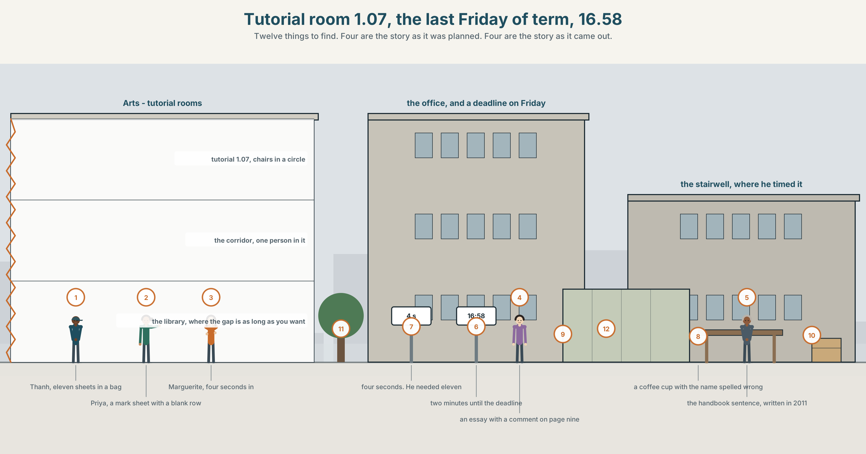{width=6.6in}
Tutorial room 1.07, the last Friday of term, 16.58 — Twelve things to find. Four are the story as it was planned. Four are the story as it came out.

What is the point exactly?
By the end of this unit you can tell a story with a deliberate reveal, and land it.
◆ A · THE WORLD | A tutorial where the best writing in the group has never been said aloud
◆ B · THE SYSTEM | cleft sentences: It was… · What I… · 24 words for storytelling and emphasis · 21 focus forms · nuclear stress placement
◆ C · THE PERFORMANCE | A two-minute story that arrives somewhere the listener did not expect

0A · Find it
Find twelve things in this picture. Four of them are the story as it was planned. Four are the story as it came out.
a mark sheet with one blank row · an essay with a comment in the margin · a tutorial room with the chairs in a circle · a laptop open at page nine of eleven · a clock at 16.58 · a window with the blind half down · a printed essay with a corner folded · a corridor with one person in it · a noticeboard with a deadline on it · a coffee cup with a name spelled wrong · a bag with a book in it, unopened · a door with a nameplate and a timetable taped under it

0B · Guess it
Two of the twelve are the same thing at two different moments. Which, and what changed between them?

0C · Say it ⏺
Record forty-five seconds. Tell something that happened to you, and keep one fact back until the last sentence. You will record it again at the end of this unit.

Part 1 · Vocabulary Lab 1 ◆ B · THE SYSTEM
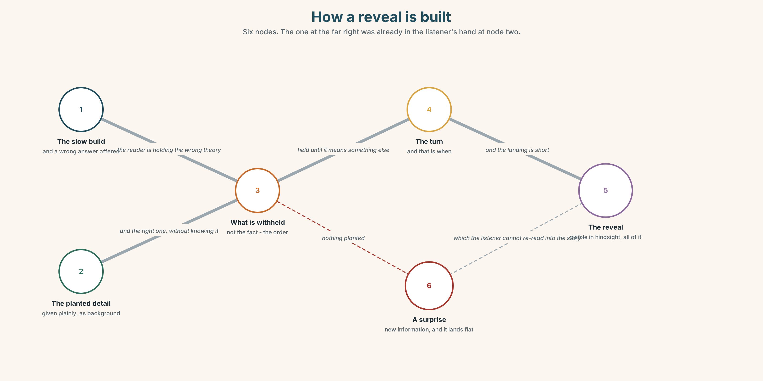{width=6.6in}
How a reveal is built — Six nodes. The one at the far right was already in the listener's hand at node two.

1A · Meet — the words of a told story
anecdote · pacing · detail · climax · reveal · twist · punchline · payoff
- Which two of these are the end, and what is the difference between them?
- A twist and a reveal: which one changes what you already heard?
- Pacing is a quantity of what?
- Why does a story with too much detail have no detail at all?
A reveal is not new information. It is information the listener already had, arriving in the one order that makes it mean something else.

1B · Sort — before, during, or after the reveal?
foreshadow · withhold · a slow build · the thing nobody saw · it turns out · save it for · and that is when · emphasis · focus
Three columns. Two of them belong in more than one. Say which and why.

1C · Meet — the phrase that does most of the work
c the thing nobody saw
Not the thing nobody knew. The thing that was in front of everybody for the whole story.
- Why is the second kind harder to write and better to hear?
- Think of a story you know where the reveal was visible from the first minute.

1D · Collocation Lab
the point | the point is · miss ~ · get to ~
what matters | what matters is · ~ here · ~ most
save | ~ it for the end · ~ it for later
a slow build | ~ to the reveal · too slow ~
Which two of these can be said about somebody else's story while they are telling it?

1E · The fixed expressions
f And that is when. — the three words that mark the turn, and they work because the sentence after them is short. f I will come back to that. — a promise. If you do not keep it, the listener remembers.
Which one is a storyteller's tool and which is a speaker's debt?

1F · Own it
The four phrasal verbs of a reveal.
give away · hold off · lead up to · land it
- Which two are about timing, and which about effect?
- What exactly do you give away — the ending, or the fact that there is one?
- Hold off and withhold: which is a decision and which is a technique?
- Write one sentence in which somebody fails to land it despite everything else being right.

Part 2 · Listening ◆ A · THE WORLD
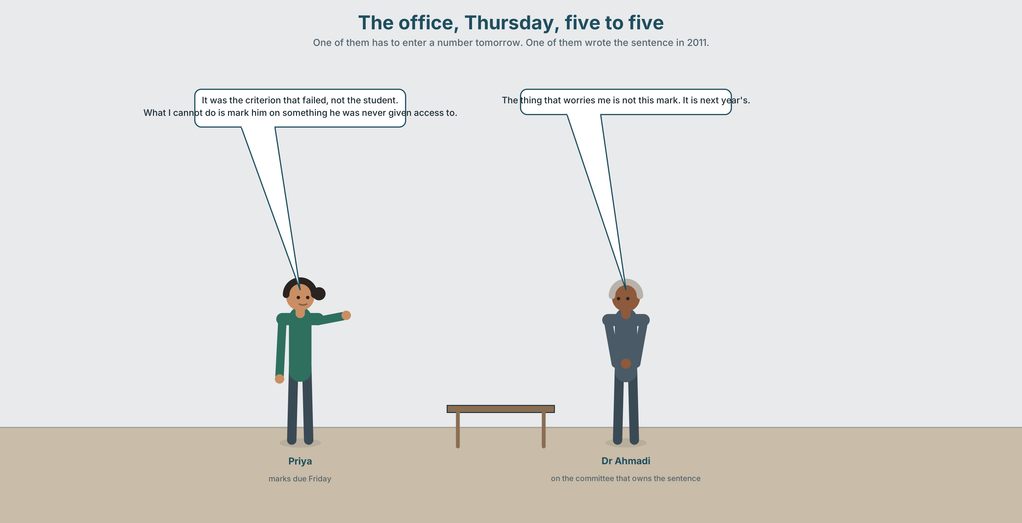{width=6.6in}
The office, Thursday, five to five — One of them has to enter a number tomorrow. One of them wrote the sentence in 2011.

2A · The mark that is due on Friday 🔊 Track 5.1
Before you listen. Priya has to submit participation marks. One student has spoken twice in eleven weeks and written the best essays in the group. Guess: what does she do?
Listen once. One question. What is the published criterion, and who wrote it?
Listen again. Complete the table.
 | Thanh | Group median
times spoken
essay mark
participation mark as the rule gives it
Listen again. Choose the best answer.
- Priya thinks the criterion is right / wrong / unenforceable.
- Dr Ahmadi says the mark is hers / the department's / nobody's.
- Thanh has asked about it / has not asked / asked in week two.
- The deadline is Friday / Monday / already past.
Noticing. Four sentences from the recording.
- It was the criterion that failed, not the student.
- What I cannot do is mark him on something he was never given access to.
- All I did was read eleven essays and put them in order.
- The thing that worries me is not this mark. It is next year's.
All four put one part of the sentence in a spotlight. Which part, in each?

2B · Decoding clinic 🔊 Track 5.2
Thirty seconds of Priya. Four jobs.
- How many cleft sentences can you count?
- In it was the criterion that failed, which word is loudest?
- Catch the two marks out of fifteen.
- She repeats one word three times. Which, and why?
Transcripts, page 154.

Part 3 · Grammar Lab 1 ◆ B · THE SYSTEM

Putting one part of a sentence in a spotlight

3A · Notice
Look at the four sentences in Part 2.
- In sentence 1, what is being emphasised, and what is it being contrasted with?
- In sentence 2, which half of the sentence is the new information?
- Rewrite sentence 3 as an ordinary sentence. What is lost?
- Sentence 4 splits one idea across two sentences. Why not one?
- Try "It was failed the criterion." What is missing?

3B · See
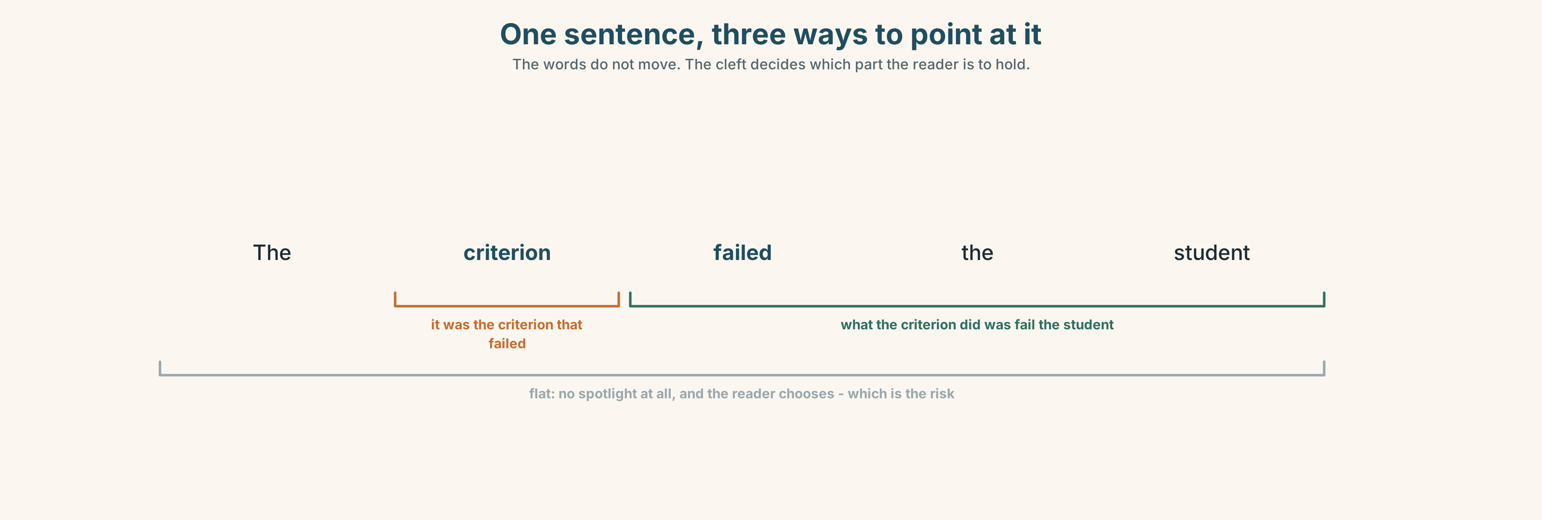{width=6.6in}
One sentence, three ways to point at it — The words do not move. The cleft decides which part the reader is to hold.

3C · Know
 | Shape | Spotlights
it-cleft | it was X who / that… | a noun — a person, a thing, a time
wh-cleft | What I did was read them. | an action, or a whole clause
the one / the thing | The thing that worries me is… | a noun, more conversationally
the reason | The reason why he said nothing is… | a cause
all-cleft | All I did was read eleven essays. | and it means only that, nothing more
A cleft takes one sentence and makes it two clauses, so that one part can be made prominent. He failed the criterion becomes It was the criterion that he failed — and now the sentence is about the criterion.
The all-cleft always carries a defence or a minimisation. All I did was ask means and look what happened. Native speakers hear the implication even when it was not meant.
The cleft needs both halves. ✗ It was failed the criterion. ✓ It was the criterion that failed.
Why it matters. Word order in English is fixed; emphasis in speech is carried by stress. In writing, a cleft is how you make somebody read the stress you meant.

3D · Use — controlled
(1) __________ was not the essay that was the problem. (2) __________ worried Priya was the sentence in the handbook, which had been written in 2011 and had never been read by anybody who had to use it. (3) __________ thing that made it unusable was not its wording but its verb: contributes. (4) __________ reason why she could not simply ignore it is that marks are audited. (5) __________ I did was put eleven essays in order, she said, and then look at the mark the rule gave the person at the top. (6) __________ not until then that she saw how far apart the two numbers were. (7) __________ one thing she was certain of was that she was not going to be the only tutor in this position on Friday.

3E · Use — guided
Rewrite each one as a cleft, using the structure in brackets.
- The criterion failed, not the student. (it-cleft)
- She read eleven essays. That is all. (all-cleft)
- She wants the rule changed, not the mark. (wh-cleft)
- He said nothing because the moment had always gone. (the reason)
- The audit worries her most. (the thing)

3F · Use — open
In pairs. Describe a decision somebody else made badly, in six sentences, three of which must be clefts. Your partner's job is to say what each cleft is contrasting with.

3G · Error autopsy
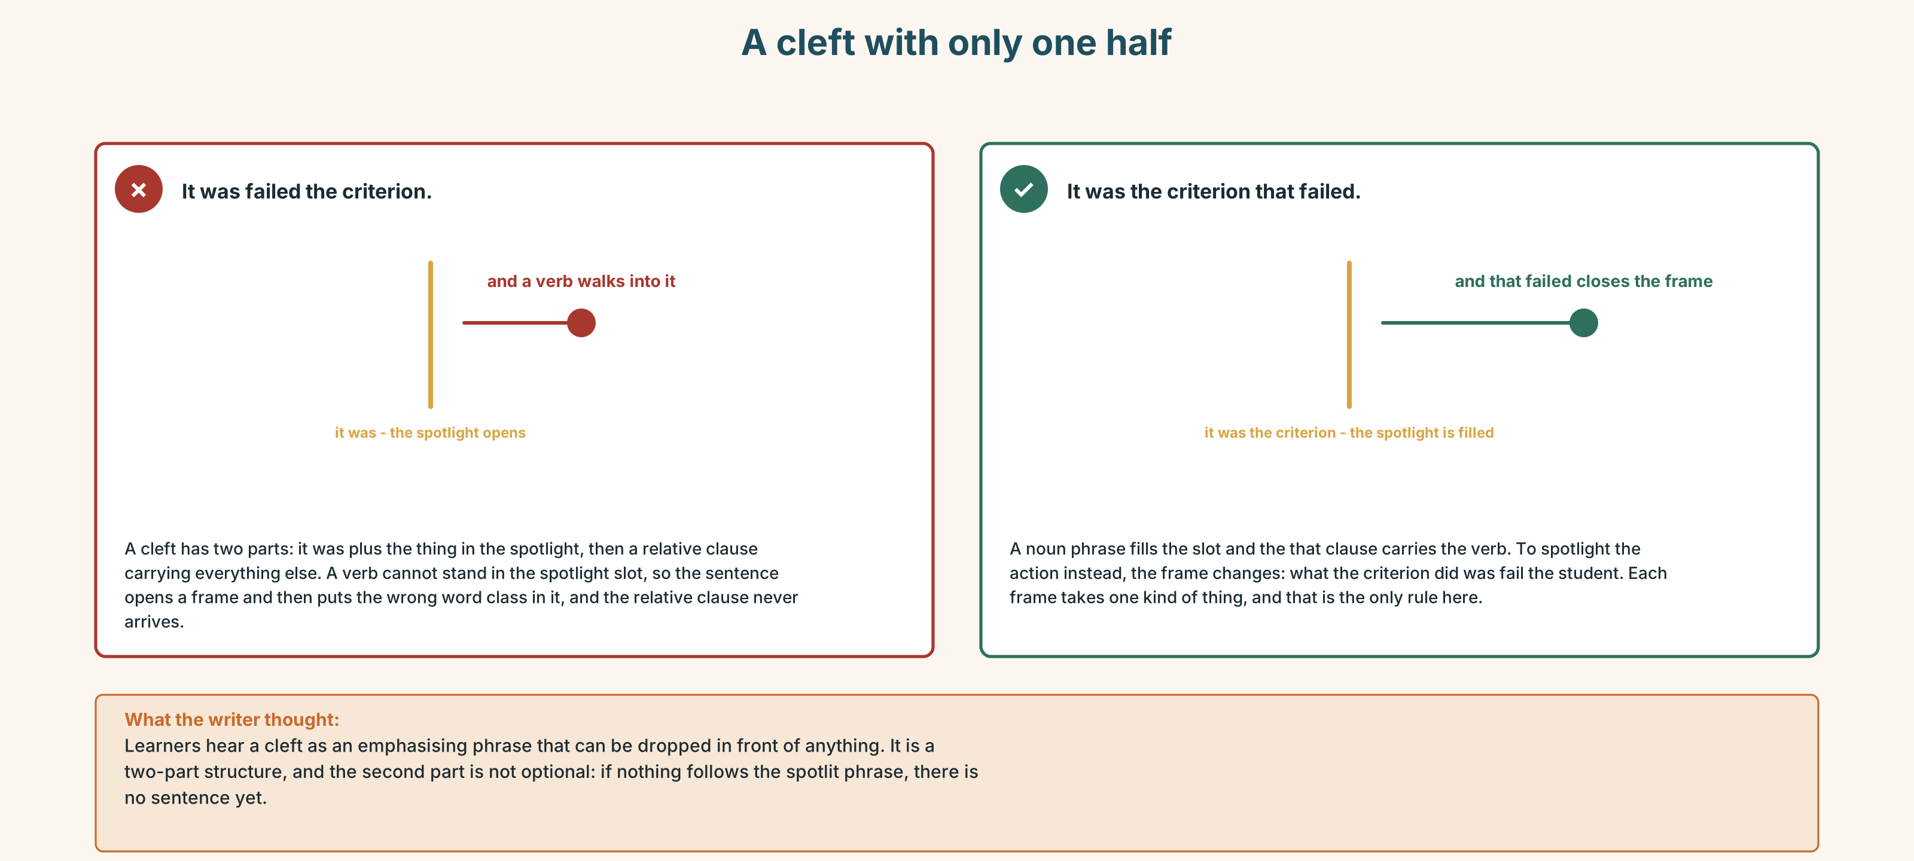{width=6.6in}
A cleft with only one half — A cleft with only one half
Read both versions. Then say what the first one accidentally emphasises.

3H · Check — eight items
- ______ was the criterion that failed. (it-cleft)
- ______ worries me is the audit. (wh-cleft)
- ______ I did was read them in order. (all-cleft)
- The ______ why he said nothing is simple. (cause)
- The ______ that worries me is next year. (noun)
- ✗ It was failed the criterion. → correct it.
- It was ______ then that she saw it. (not + time)
- The ______ thing he asked for was a deadline. (single)
0–4 → Workbook pp. 22–25. 5–6 → Part 6. 7–8 → page 107.

Part 4 · Speaking ◆ C · THE PERFORMANCE

4A · Fluency starter — move the spotlight
One learner gives a flat sentence. The next says it as a cleft. The next moves the spotlight to a different part. The chain breaks when there is nothing left to emphasise.

4B · The functional core — telling it so it lands
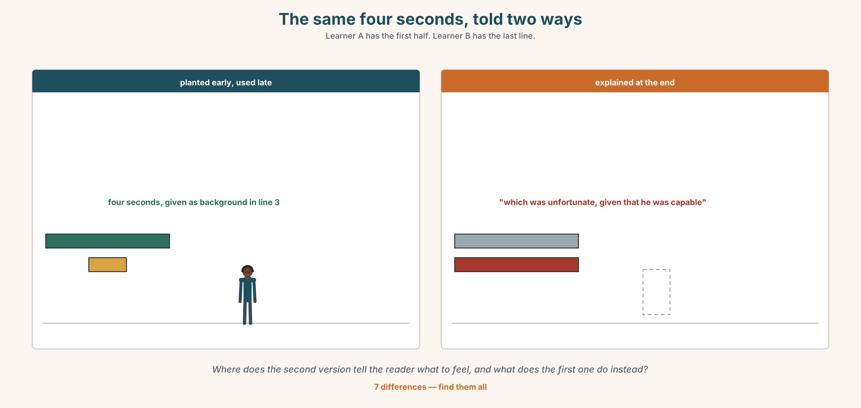{width=6.6in}
The same four seconds, told two ways — Learner A has the first half. Learner B has the last line.
Language Bank
the slow build | This was the third week. · Nothing had happened yet.
the detail you keep | I will come back to that. · There was one other thing.
the turn | And that is when… · It turns out… · Not until then did I…
the landing | The point is… · What matters is… · one short sentence, and stop
Information gap. Learner A has the first half of a story. Learner B has the last line. Build the middle so that the last line is a reveal and not a surprise.

4C · The performance — two minutes ⏺
Tell a true story with a deliberate reveal. Two minutes. You must include:
a slow build · one detail planted early and used late · a turn, marked · a landing of one short sentence
Record it.

4D · Observer
One person listens for one thing: was the reveal visible in hindsight, or did it come from nowhere?

4E · Three criteria
☐ Was the planted detail there before it mattered? ☐ Did I mark the turn, out loud? ☐ Was the last sentence shorter than the one before it?

Part 5 · Reading ◆ A · THE WORLD

5A · Predict
A fiction extract, titled "The Quiet Room." What do you expect the last line to do to the first paragraph? Two sentences.

5B · Read — two minutes and a quarter

THE QUIET ROOM from a collection of short fiction
For eleven weeks Vinh sat in the same chair, third from the window, and did not speak. He had a reason, and the reason was not nerves.
He had worked out in the second week that the gap between a question and an answer in that room was about four seconds. He had timed it, once, with the stopwatch on his phone, under the table. Four seconds, and then Marguerite would be speaking. He needed eleven. He had measured that too, writing his answer down and then reading it aloud at the speed people talked, in a stairwell, twice.
So he wrote. He wrote the answers to every question that was asked and most of the ones that were not, and at the end of each session he put the sheet in his bag and went to the library, where the gap between a question and an answer was as long as he wanted it to be.
In week nine the tutor asked a question nobody answered. The silence went on. Vinh counted it: six seconds, seven, nine. At eleven he opened his mouth, and at eleven and a half Marguerite, who had been looking at her phone, said something that was almost but not quite what he had been going to say.
He wrote that down too.
At the end of term the tutor returned the essays. His had a comment on the last page that said: This is the best piece of writing I have had from this group in four years. Why have I never heard any of this?
He read it twice. Then he took out the eleven sheets of paper from eleven weeks, squared the edges, and put them on her desk on his way out, without saying anything, which was, he realised on the stairs, exactly the problem she had just asked him about.

5C · Comprehension — eight questions
- Where does Vinh sit, and for how long?
- What is the four seconds, and how does he know?
- Why does he need eleven, and how did he measure that?
- What does he do with the written answers?
- What happens in week nine, second by second?
- What does Marguerite say, and why is "almost but not quite" the point?
- What does the tutor's comment say, and what does it ask?
- What does Vinh do with the eleven sheets, and what does he realise on the stairs?

5D · Vocabulary in context
Guess from the text. Then check.
under the table · at the speed people talked · squared the edges · on his way out · which was, he realised

5E · The counter-text
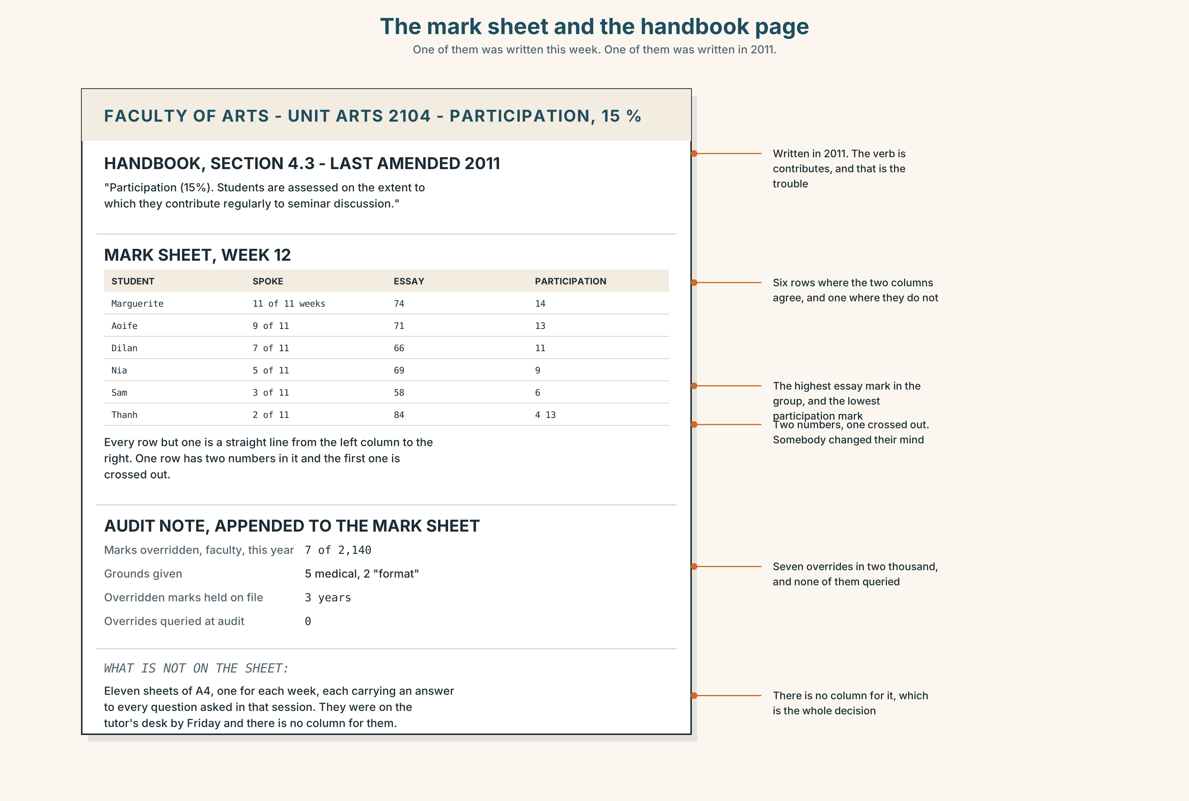{width=6.6in}
The mark sheet and the handbook page — One of them was written this week. One of them was written in 2011.
Read the mark sheet and the handbook page, and answer.
- What exactly does the published criterion say, and when was it written?
- What mark does the criterion give Thanh, and what mark does the essay give him?
- How many tutors have overridden the criterion this year, and on what grounds?
- What does the audit note say happens to an overridden mark?
- One row of the sheet has two marks in it, one crossed out. Which, and what does that tell you?

5F · Two texts
The story says the gap was four seconds and Vinh needed eleven. The handbook says participation means contributing regularly to seminar discussion.
Does the criterion measure a capacity or a speed? Three sentences.

Part 6 · Vocabulary Lab 2 ◆ B · THE SYSTEM

The words that point

6A · Sort — what does each one spotlight?
Three columns: a person or thing · an action · a degree.
it · what · all · the thing · the reason · the one · merely · precisely · exactly · specifically · particularly

6B · Chunk completion
- It was Marguerite ______ answered, four seconds in.
- What I ______ is that he had timed it.
- All I ______ was read eleven essays.
- The ______ that worries me is the audit.
- The reason ______ he said nothing is on the sheet.
- The ______ thing he wanted was eleven seconds.

6C · Four adverbs that narrow
precisely · exactly · specifically · particularly
Three of them narrow to a point. One of them narrows to a degree. Which, and what happens if you swap them?
Write four sentences about the story, one with each.

6D · Two verbs that point at something
p point up · p zero in on
The comment points up the problem with the criterion. She zeroed in on the one sentence that mattered.
Point up makes something visible. Zero in on means everything else stops mattering.
Rewrite two sentences from Part 5B using one of them.

6E · The fixed expressions
f What happened was this. — a frame. Everything after it is the story, and the listener knows to stop interrupting. c not until then — It was not until then that she saw it. The delay is the point.
Use one of them to open a story and the other to turn it.

6F · Contrast Clinic
Eight items. Four are wrong. Correct them and say what the rule is.
- It was failed the criterion.
- It was the criterion that failed.
- What I did was read them in order.
- What I did was reading them in order.
- All I did was asked a question.
- All I did was ask a question.
- The reason why he said nothing is simple.
- It was not until then she saw it.

Part 7 · Pronunciation & Fluency Lab ◆ B · THE SYSTEM

Where the loudest word goes
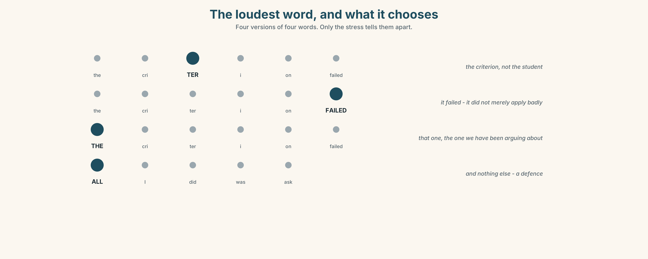{width=6.6in}
The loudest word, and what it chooses — Four versions of four words. Only the stress tells them apart.

7A · Hear 🔊 Track 5.3
It was the CRITERION that failed. The cleft has already chosen the word. The stress just confirms it.
Now listen to the flat version, three times:
The CRITERION failed. · The criterion FAILED . · THE criterion failed. Three meanings, one word order, and only the stress tells them apart.

7B · Say
Say all four. Then say this one three times, faster:
It was not until then that she saw how far apart the two numbers were.

7C · Make it mean something
Say these two:
All I did was ASK . (and look what happened) ALL I did was ask. (and nothing else — I am defending myself)
One sentence, two defences. Which is which?

7D · Fluency 30 ⏺
Thirty seconds: four clefts, each with the stress on the spotlit word. Three times, faster, keeping the stress.

Part 8 · Writing ◆ C · THE PERFORMANCE

A story with a reveal · 180 words
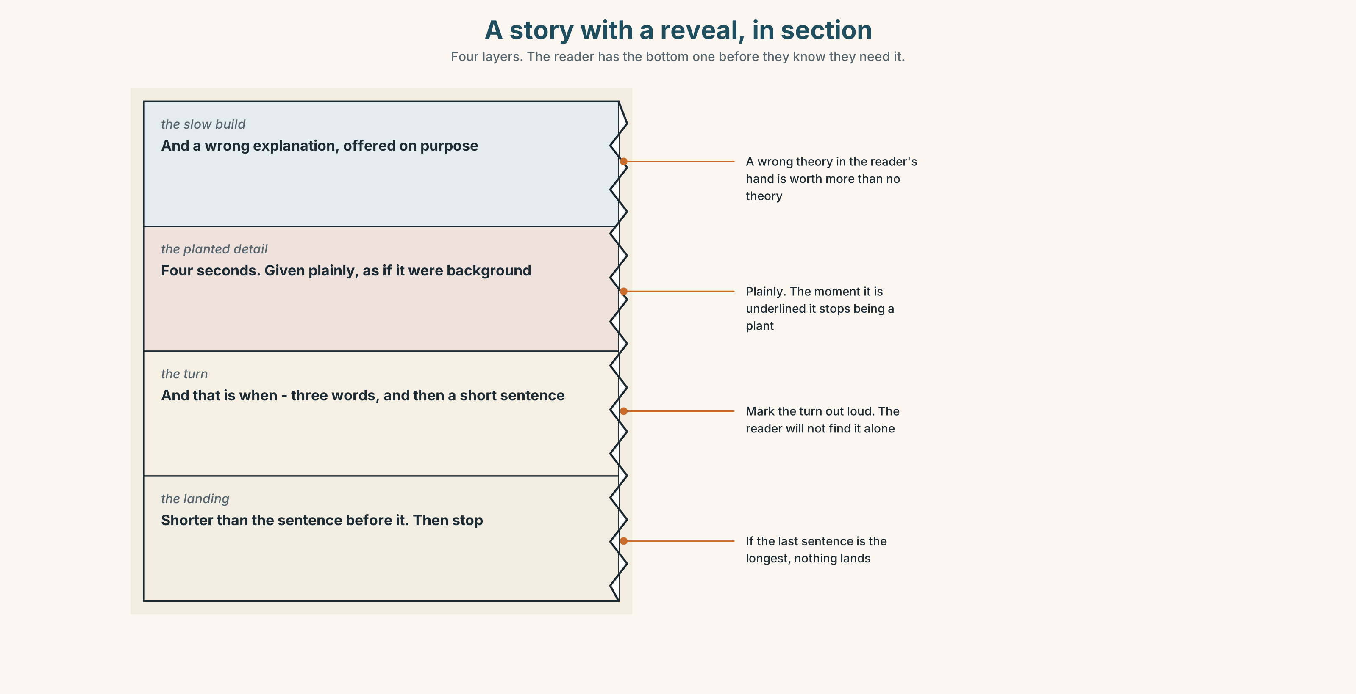{width=6.6in}
A story with a reveal, in section — Four layers. The reader has the bottom one before they know they need it.

8A · Read the model
For eleven weeks he sat in the same chair and said nothing, and everyone in the room had a theory about why. [the slow build, and it gives the reader a wrong answer to hold]
It was not shyness. He had timed the gap between a question and an answer in that room, with a stopwatch, and it was four seconds. [the planted detail, given plainly, as if it were background]
He needed eleven. [three words, and the reader now has everything — the reveal is already theirs]
And that is when the tutor's comment on his essay stopped being a compliment and became a question he could not answer out loud, which was the whole problem, and was on the page in front of her. [the turn, and the landing is the shape of the story itself]
Questions about the writer's choices:
- The first paragraph offers a wrong explanation. What does that buy?
- The third paragraph is three words. Why is it a paragraph?
- The reveal is a number the reader already had. Why is it still a reveal?

8B · The anti-model
He was a quiet student who struggled to contribute in class, which was unfortunate given that he was clearly very capable. In the end his tutor realised that he had a lot to offer and that the seminar format was not working for him, which was a shame for everyone involved.
Correct English, and nothing in it lands. Name the three things it explains that it should have shown, and say what in the end is doing.

8C · Plan
the slow build, with a wrong answer offered → the detail, planted plainly → the turn, marked → the landing, shorter than the sentence before it

8D · Write — 180 words

8E · Peer review — three criteria
☐ Was the reveal visible in hindsight? ☐ Is the planted detail given before it matters, and given plainly? ☐ Is the last sentence the shortest?

8F · Write it again · 8G · Publish
Read aloud, not handed round. Watch the faces for where it lands.

Part 9 · The File ◆ A · THE WORLD + C · THE PERFORMANCE

STUDY FILE · Reading at Speed
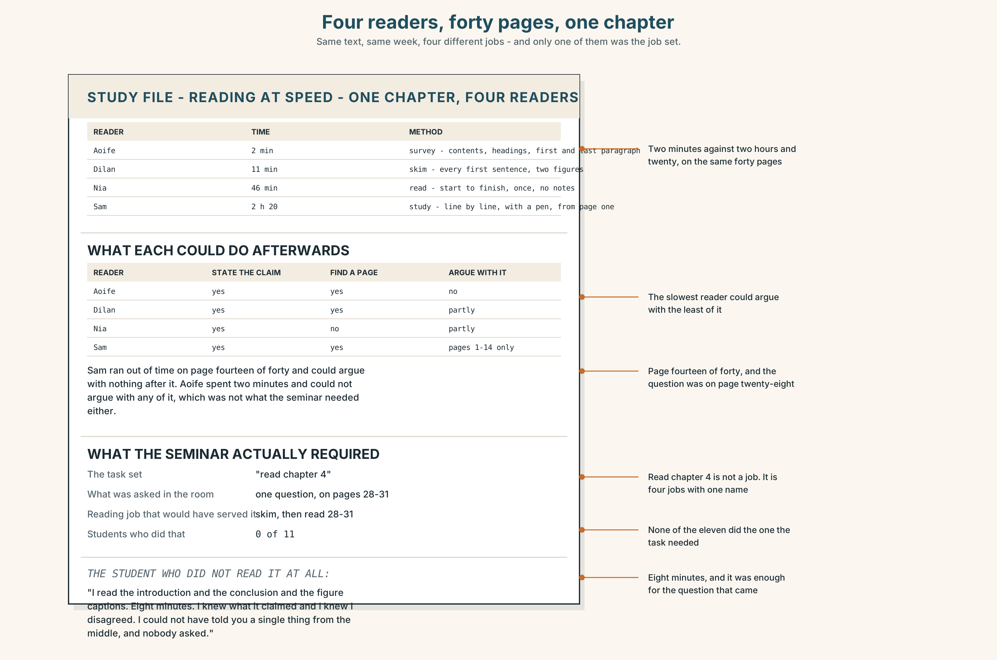{width=6.6in}
Four readers, forty pages, one chapter — Same text, same week, four different jobs - and only one of them was the job set.

9A · Four readers, one chapter 🔊 Track 5.4
Four students describe reading the same forty pages. Listen.
- Which one read it fastest, and what do they remember?
- Which one read it slowest, and did they understand more?
- One of them did not read it at all and could still discuss it. How?

9B · Four speeds, four jobs
survey — what is this, and do I need it? — two minutes for forty pages skim — what does it claim? — ten minutes read — what is the argument, exactly? — forty minutes study — could I reconstruct this? — two hours, with a pen
Which of the four are you doing by default, and is it the one the task needs?

9C · The thing nobody teaches
Most reading failures are not speed failures. They are not knowing which of the four you are supposed to be doing, and doing the slowest one on everything until the time runs out.
Look at this week's reading list. Mark each item with one of the four.

9D · Your turn
In fours. Twelve minutes. Everybody surveys the same chapter for two minutes, then writes three sentences on what it claims. Compare. How much of it did two minutes get?

9E · Transfer
Time yourself on the next thing you read for a class. Which of the four were you doing, and which did the task actually need?

Part 10 · Mediation & Interaction ◆ C · THE PERFORMANCE
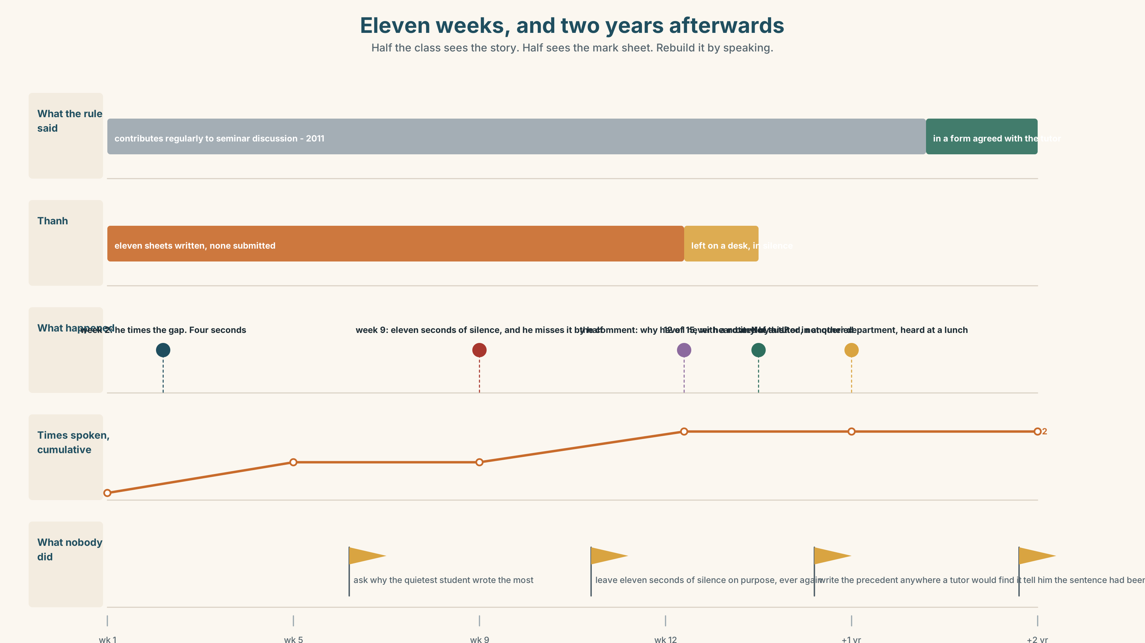{width=6.6in}
Eleven weeks, and two years afterwards — Half the class sees the story. Half sees the mark sheet. Rebuild it by speaking.

10A · Relay
Half the class sees the story. Half sees the mark sheet. Rebuild the term by speaking. Twelve minutes.

10B · Simplify
Explain the participation criterion to a student who has just received a mark they do not understand. Five sentences only.
Plan: what the rule says → what it measures → what it does not → what their mark is → what they can ask for, and by when

10C · Compress
The story in Part 5B into forty words, keeping the reveal.

10D · Online
Write one message from Thanh to Priya: you have read the comment, you want to answer the question in it, and you are proposing one specific thing for next semester.

10E · Your language
Does your language have clefts? Say it was the criterion that failed in both languages. Which uses word order, and which uses a particle or a case ending?

Part 11 · The Decision ◆ C · THE PERFORMANCE

A mark that is due on Friday
Participation is fifteen per cent. The criterion says contributes regularly to seminar discussion. Thanh has spoken twice in eleven weeks and has the highest essay mark in the group.
- Apply the rule. 4 out of 15. It is defensible at audit, it is what the handbook says, and it drops his unit mark by seven points.
- Override it. 13 out of 15, with a written justification. The mark stands unless the audit pulls it, and an overridden mark is flagged for three years.
- Mark the eleven sheets. He wrote an answer to every question asked and never submitted them. Nothing in the criterion says contribution has to be spoken. Nothing says it can be written either.

11A · The evidence
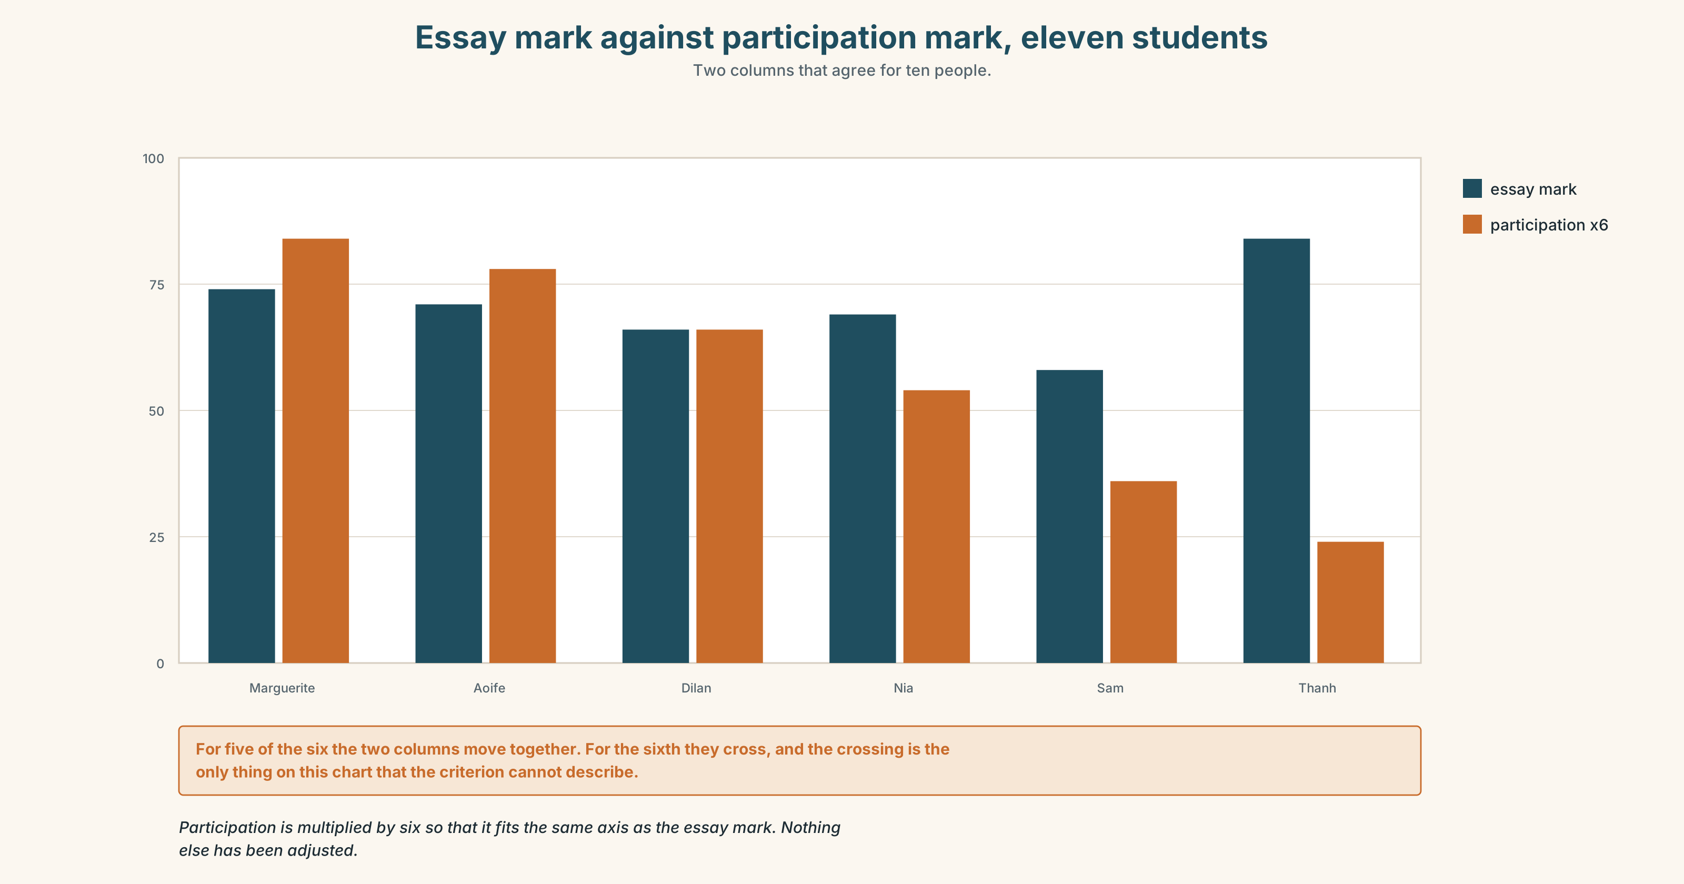{width=6.6in}
Essay mark against participation mark, eleven students — Two columns that agree for ten people.
- The mark sheet and the handbook page from Part 5E — and the row with two marks in it.
- The chart — essay mark against participation mark, for every student in the group.
- The voice. Thanh, thirty seconds: "I am not asking her to change the rule. I know she cannot. What I want is for somebody to write down that the rule and the thing it is supposed to measure came apart, because if nobody writes it down, next year there is another one of me and she starts from nothing."

11B · Talk about it
In fours. Everybody speaks twice. Use the frame.
It was ______ that ______ . What ______ is ______ .
Words you can use: reveal · emphasis · focus · detail · withhold · pacing · payoff · the point is · what matters is · it turns out

11C · Decide
Write three sentences. Choose, say why, and name what it costs.
I think Priya should ______________________ , because ______________________ . What this costs is ______________________ .

11D · Model decision
Mark the sheets, and write down why. The third option is the only one that does not require pretending: it does not pretend the rule is right and it does not pretend she has the power to rewrite it on a Friday. It also produces a document. An overridden mark disappears into an audit file; a marked set of eleven written contributions is a precedent with a date on it, and the next tutor in this position has something to point at.

11E · The Reveal
What happened. Priya marked the eleven sheets and gave 12 out of 15, with a note that the contributions were written because the format made spoken ones impossible for this student at this speed. The mark was not audited. Nobody queried it.
In March the following year a different tutor, in a different department, cited it. She had heard about it from Priya at a teaching lunch, which is the only route by which anything in a university travels in under four years.
The handbook sentence was finally changed two years later. The new version says contributes to seminar discussion in a form agreed with the tutor, and the person who drafted it has never met Thanh and does not know the sentence exists because of him.
One mark, one note, and a sentence in a handbook that two thousand students will read and nobody will trace back. It turns out the thing nobody saw was the eleven sheets of paper in his bag, every week, for a whole semester.
Was it the right decision? Say why — and say what Priya should have done in week three.

Part 12 · Landing ◆ all three lines

12A · Recycle — twelve items
- ______ was the criterion that failed.
- ______ worries me is the audit.
- ______ I did was read them in order.
- The ______ why he said nothing is simple.
- The ______ that worries me is next year.
- It was not ______ then that she saw it.
- The ______ thing he asked for was time.
- She ______ in on the one sentence that mattered.
- The comment ______ up the problem.
- He did not ______ away the ending.
- She ______ off until the last line.
- He could not ______ it, and the room stayed quiet.

12B · Consolidate
Three columns, from memory: it-clefts · wh-clefts · the noun clefts (the thing, the reason, the one).

12C · Can-do, with evidence
☐ I can tell a two-minute story with a reveal that is visible in hindsight. Evidence: 4C, 8D ☐ I can build it-clefts and wh-clefts correctly. Evidence: 3H, 6F ☐ I can put the nuclear stress on the word the cleft chose. Evidence: 7D ☐ I can plant a detail early and use it late. Evidence: 8D

12D · Replay ⏺
Record 0C again. Listen to both. What have you got that you did not have in week one?

12E · Glossary — forty-five items, as a map
THE STORY · anecdote · pacing · detail · climax · reveal · twist · punchline · payoff THE CRAFT · foreshadow · withhold · emphasis · focus · a slow build · save it for · lead up to · hold off · give away · land it THE MOMENT · it turns out · the thing nobody saw · the point is · what matters is WHAT PEOPLE SAY · and that is when · I will come back to that · what happened was this THE SPOTLIGHT · it · what · all · the thing · the reason · the one · it was X who · what I mean is · all I did was · the thing that · the reason why · the one thing · not until then NARROWING · merely · precisely · exactly · specifically · particularly · point up · zero in on

12F · Next
Unit 6 · What are they really claiming?

