Table of Contents

B1.3 · Unit 6 · The Clause on Page Nine
English Animated · Making the Case · a university campus, Melbourne Student's Book pages 116–137 · 22 pp · ~11 hours

Part 0 · The Big Picture ◆ A · THE WORLD
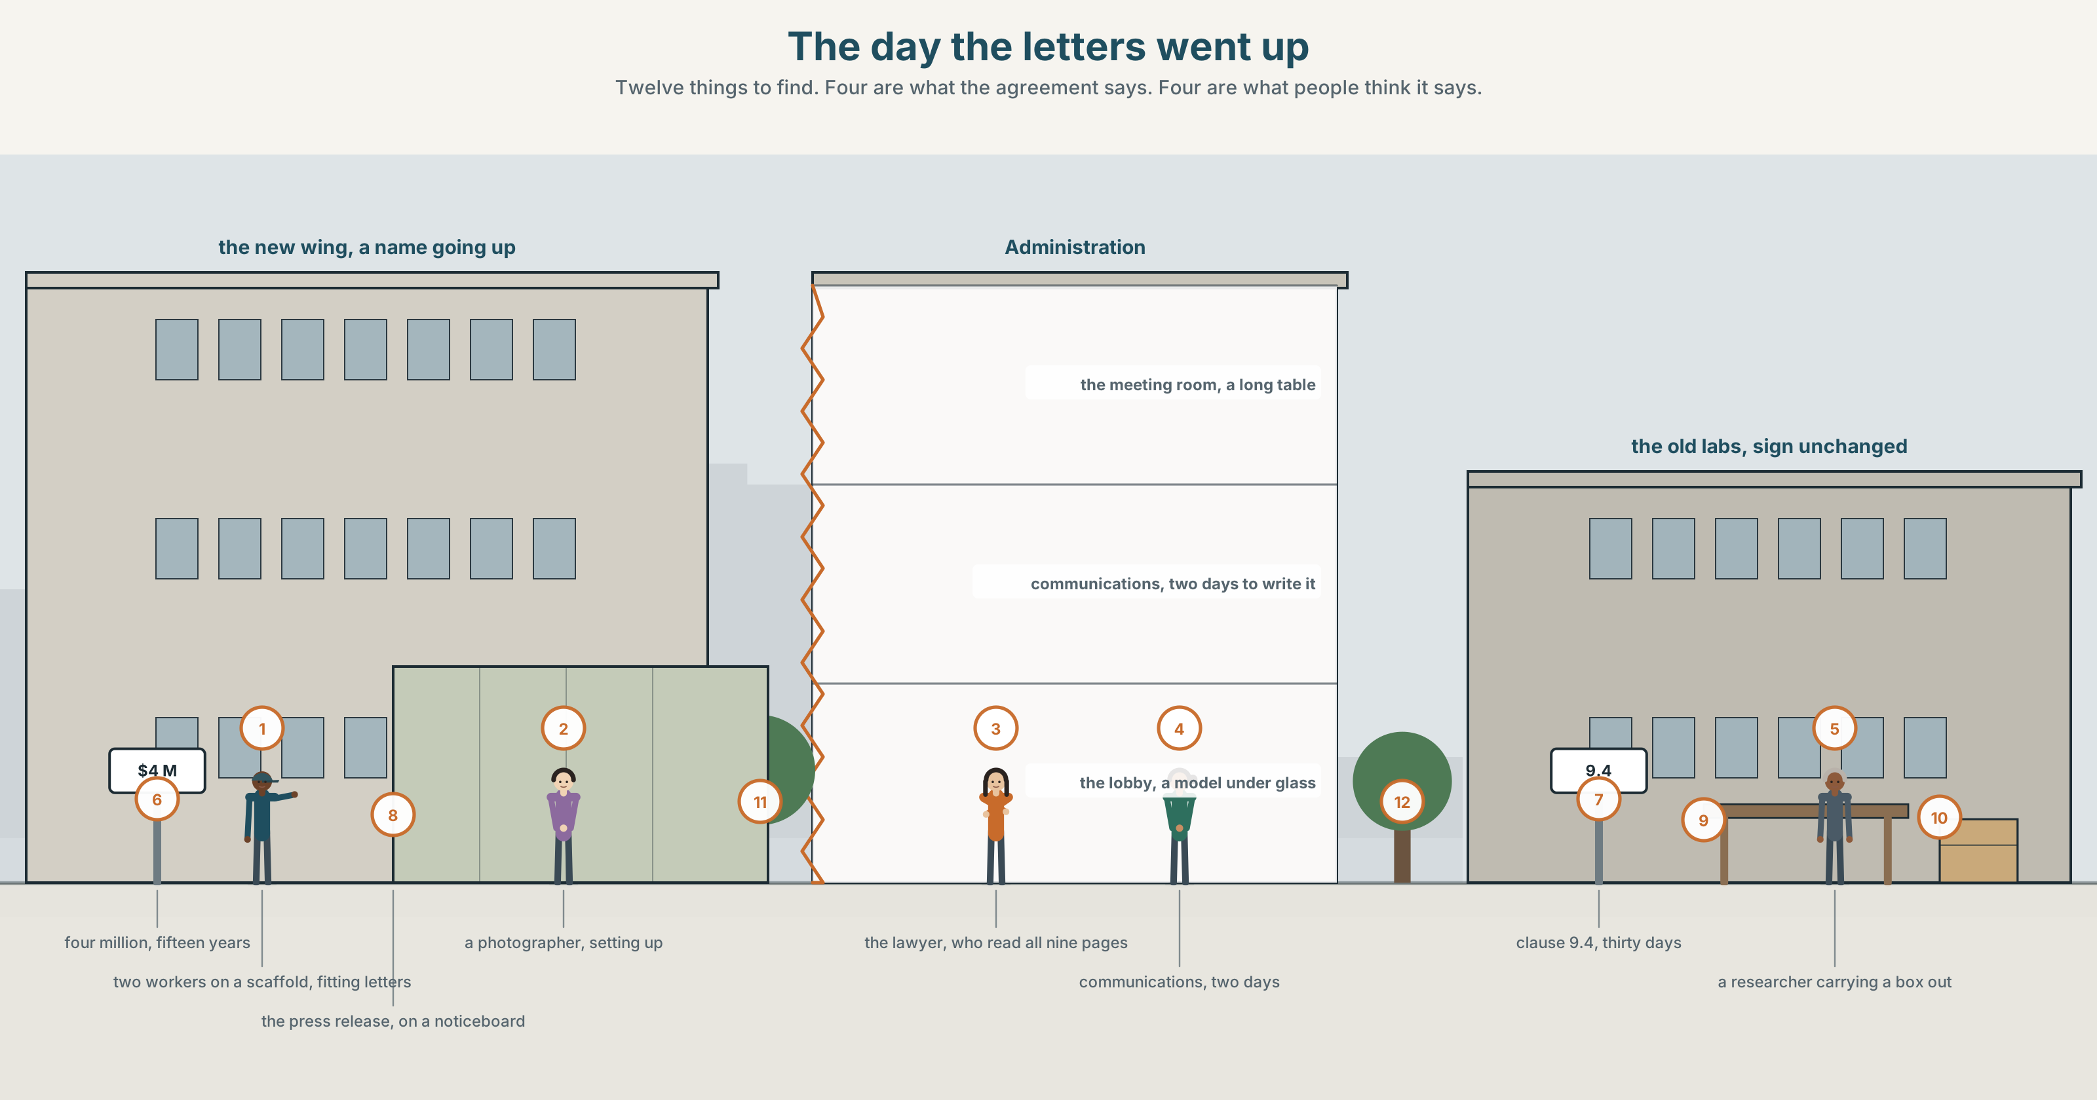{width=6.6in}
The day the letters went up — Twelve things to find. Four are what the agreement says. Four are what people think it says.

What are they really claiming?
By the end of this unit you can report a negotiation accurately, attributing every claim to whoever made it.
◆ A · THE WORLD | Four million dollars, a name on a building, and a paragraph about publishing
◆ B · THE SYSTEM | reporting verbs and their patterns: accuse of · persuade to · insist on · 24 words for claims, PR and negotiation · 21 verb patterns · stress on the reporting verb
◆ C · THE PERFORMANCE | A report of a meeting in which every claim has a name on it

0A · Find it
Find twelve things in this picture. Four of them are what the agreement says. Four are what people think it says.
a building with a name going up in letters · a scaffold with two workers on it · a press release on a noticeboard · a meeting room with a long table · a nine-page document with a corner turned down · a model of a new wing under glass · a photographer setting up · a researcher carrying a box out of a lab · a cheque the size of a door · a lanyard with a sponsor's logo · a lecture theatre with a new name on the door · a sign that still says the old name

0B · Guess it
Two of the twelve contradict each other. Which, and which one is older?

0C · Say it ⏺
Record forty-five seconds. Describe an agreement you have made where one part turned out to matter much more than it looked. You will record it again at the end of this unit.

Part 1 · Vocabulary Lab 1 ◆ B · THE SYSTEM
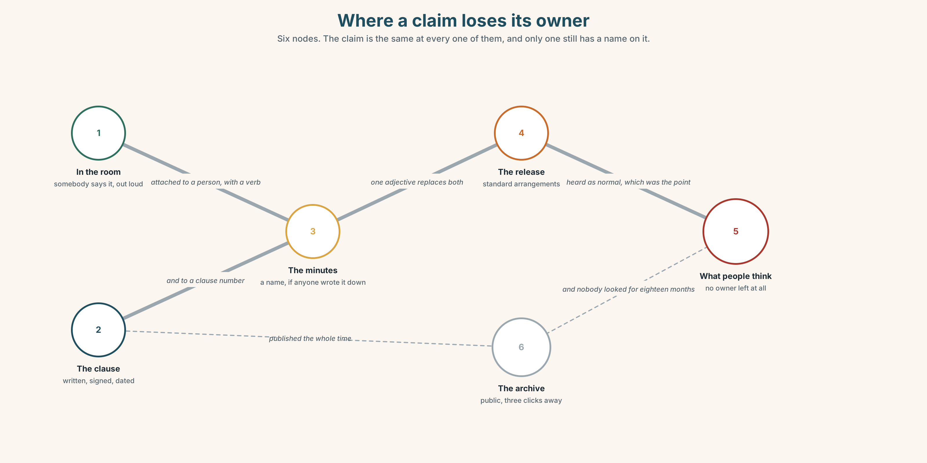{width=6.6in}
Where a claim loses its owner — Six nodes. The claim is the same at every one of them, and only one still has a name on it.

1A · Meet — the words of a negotiation
claim · sponsor · clause · negotiation · concession · leverage · undertaking · stakeholder
- Which two of these are things you give, and which two are things you have?
- What is the difference between a clause and an undertaking?
- Leverage: where does it come from, and can both sides have it at once?
- Why is stakeholder a word that usually arrives when somebody is about to be ignored?
A claim in this unit is not a lie. It is a statement somebody is responsible for, and the whole job of a report is to keep the statement attached to the person.

1B · Sort — the money, the document, or the story?
naming rights · spin · briefing · retraction · the small print · strings attached · on the record · in exchange for · a sticking point
Three columns. Two of them belong in more than one. Say which and why.

1C · Meet — the phrase that does most of the work
c a sticking point
The one item on which an agreement is currently not happening. There is usually exactly one, and it is usually not the one being discussed.
- Why does naming the sticking point out loud speed a negotiation up?
- In a flat-share argument about washing up, what is the sticking point likely to be?

1D · Collocation Lab
on the record | say something ~ · put it ~ · off ~
in exchange for | given ~ · agreed ~
the small print | read ~ · hidden in ~
strings attached | with ~ · no ~
Which two of these are almost always said by the side with less power?

1E · The fixed expressions
f That is not what was agreed. — the sentence that needs a document behind it, or it is just a louder opinion. f We are not going to say that. — a refusal that gives no reason, and in a negotiation it is often the most informative thing anybody says.
Which one needs evidence, and which one is the evidence?

1F · Own it
The four phrasal verbs of a deal.
water down · push back · sign up to · hold out
- Which two describe resistance, and how do they differ?
- What exactly gets watered down — the words, or the obligation?
- Sign up to and sign: what does the particle add?
- Write one sentence in which somebody holds out and gets less than if they had not.

Part 2 · Listening ◆ A · THE WORLD
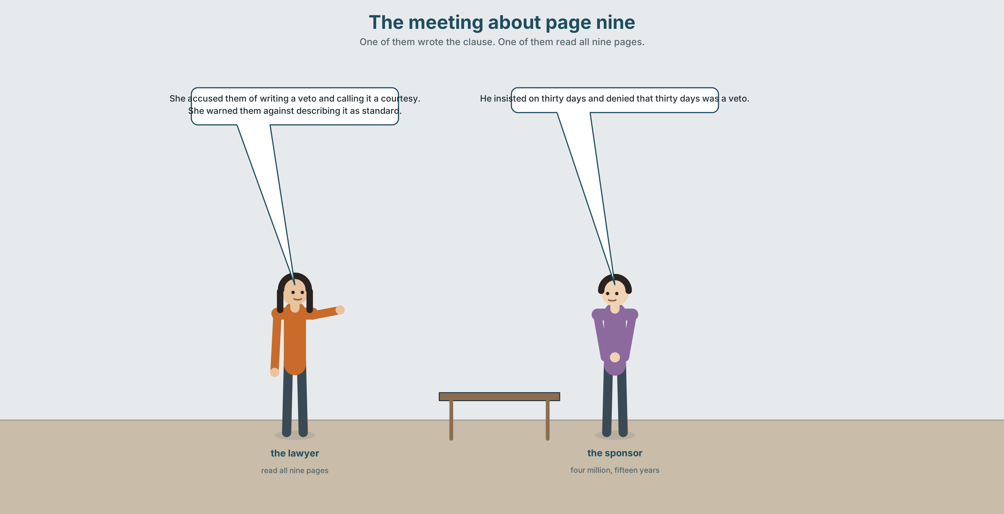{width=6.6in}
The meeting about page nine — One of them wrote the clause. One of them read all nine pages.

2A · The meeting about page nine 🔊 Track 6.1
Before you listen. A company has offered four million dollars for a new research wing. The agreement runs to nine pages. Guess: which page is the problem?
Listen once. One question. What does the sponsor want, and what does the university want?
Listen again. Complete the table.
 | The sponsor | The university
on the name
on publication
on the deadline
Listen again. Choose the best answer.
- The sticking point is the name / clause 9.4 / the money.
- The sponsor says the clause is standard / new / negotiable.
- The Dean has signed / refused / asked for time.
- Somebody uses the word stakeholder once / twice / four times.
Noticing. Four sentences from the recording.
- She accused them of writing a veto and calling it a courtesy.
- They persuaded the Dean to take it to the committee rather than decide alone.
- He insisted on thirty days and denied that thirty days was a veto.
- She warned them against describing it as standard, because it is not.
All four report a claim and attach it to somebody. Which one reports two claims at once?

2B · Decoding clinic 🔊 Track 6.2
Thirty seconds of the negotiation. Four jobs.
- How many reporting verbs can you count?
- In accused them of writing, which word is stressed?
- Catch the two numbers.
- One speaker says we are not going to say that. What were they asked to say?
Transcripts, page 155.

Part 3 · Grammar Lab 1 ◆ B · THE SYSTEM

Reporting verbs, and the patterns they insist on

3A · Notice
Look at the four sentences in Part 2.
- In sentence 1, what follows accused them?
- In sentence 2, what follows persuaded the Dean? Is it the same shape?
- Rewrite sentence 3 without insisted on. What changes?
- Sentence 4 uses warn against. What would warn to mean, and is it English?
- Try "They accused them to write a veto." What is wrong with it?

3B · See
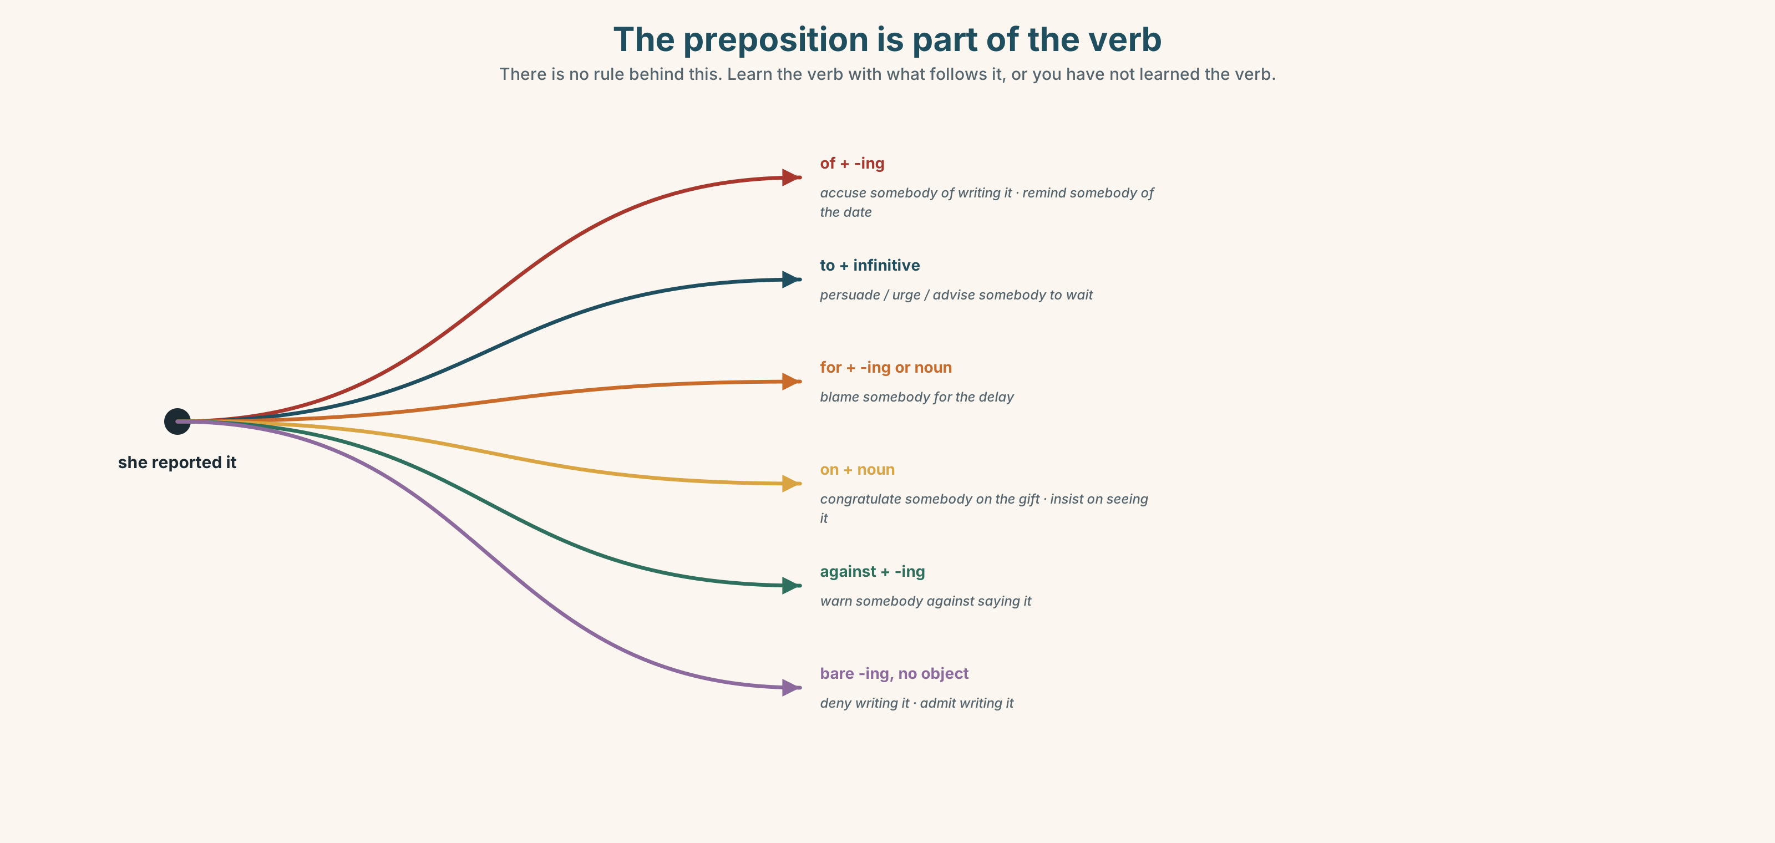{width=6.6in}
The preposition is part of the verb — There is no rule behind this. Learn the verb with what follows it, or you have not learned the verb.

3C · Know
Pattern | Verbs | Example
verb + sb + of + -ing | accuse · remind | She accused them of writing a veto.
verb + sb + to + infinitive | persuade · urge · advise · warn · remind | They persuaded the Dean to wait.
verb + sb + for + -ing | blame · congratulate | He blamed them for the delay.
verb + sb + on + noun | congratulate | She congratulated them on the gift.
verb + sb + against + -ing | warn · advise | She warned them against saying it.
verb + on + -ing | insist | He insisted on seeing the draft.
verb + -ing | deny · admit | He denied writing it.
verb + that + clause | insist · deny · admit · warn · remind | He insisted that thirty days was normal.
The pattern is part of the word. Accuse takes of; blame takes for; congratulate takes on. There is no rule behind this and no shortcut: learn the verb with its preposition or you have not learned the verb.
Four of them take two patterns, and the meaning does not change: insist on / insist that, deny doing / deny that, warn against / warn that, remind to / remind that.
A preview of Unit 7. He is said to have written it reports a claim without saying whose it is. That is the whole of next unit, and it is what this unit's grammar exists to make unnecessary.
Why it matters. A report that loses the pattern loses the person, and a claim with no person attached is the most dangerous sentence in any document.

3D · Use — controlled
The university's lawyer (1) __________ the company __________ writing a veto and calling it a courtesy. The company's representative (2) __________ that it was a veto, and (3) __________ on the word review. He then (4) __________ the Dean __________ take it to the committee rather than decide alone, which was good advice and was also a delay. The Dean (5) __________ him __________ the November deadline, and he (6) __________ her __________ assuming it was movable. Nobody (7) __________ anybody __________ anything, which in a negotiation of this size is itself worth noting.

3E · Use — guided
Report each one with the verb in brackets.
- "You have written a veto and called it a courtesy." (accuse)
- "Take it to the committee." (persuade)
- "Thirty days is standard, whatever you say." (insist)
- "I did not write that paragraph." (deny)
- "Do not call it standard in the press release." (warn)

3F · Use — open
In pairs. Report a disagreement you have both seen, in six sentences, four of which must use a different reporting verb with its pattern. Your partner's job is to catch any claim that has lost its owner.

3G · Error autopsy
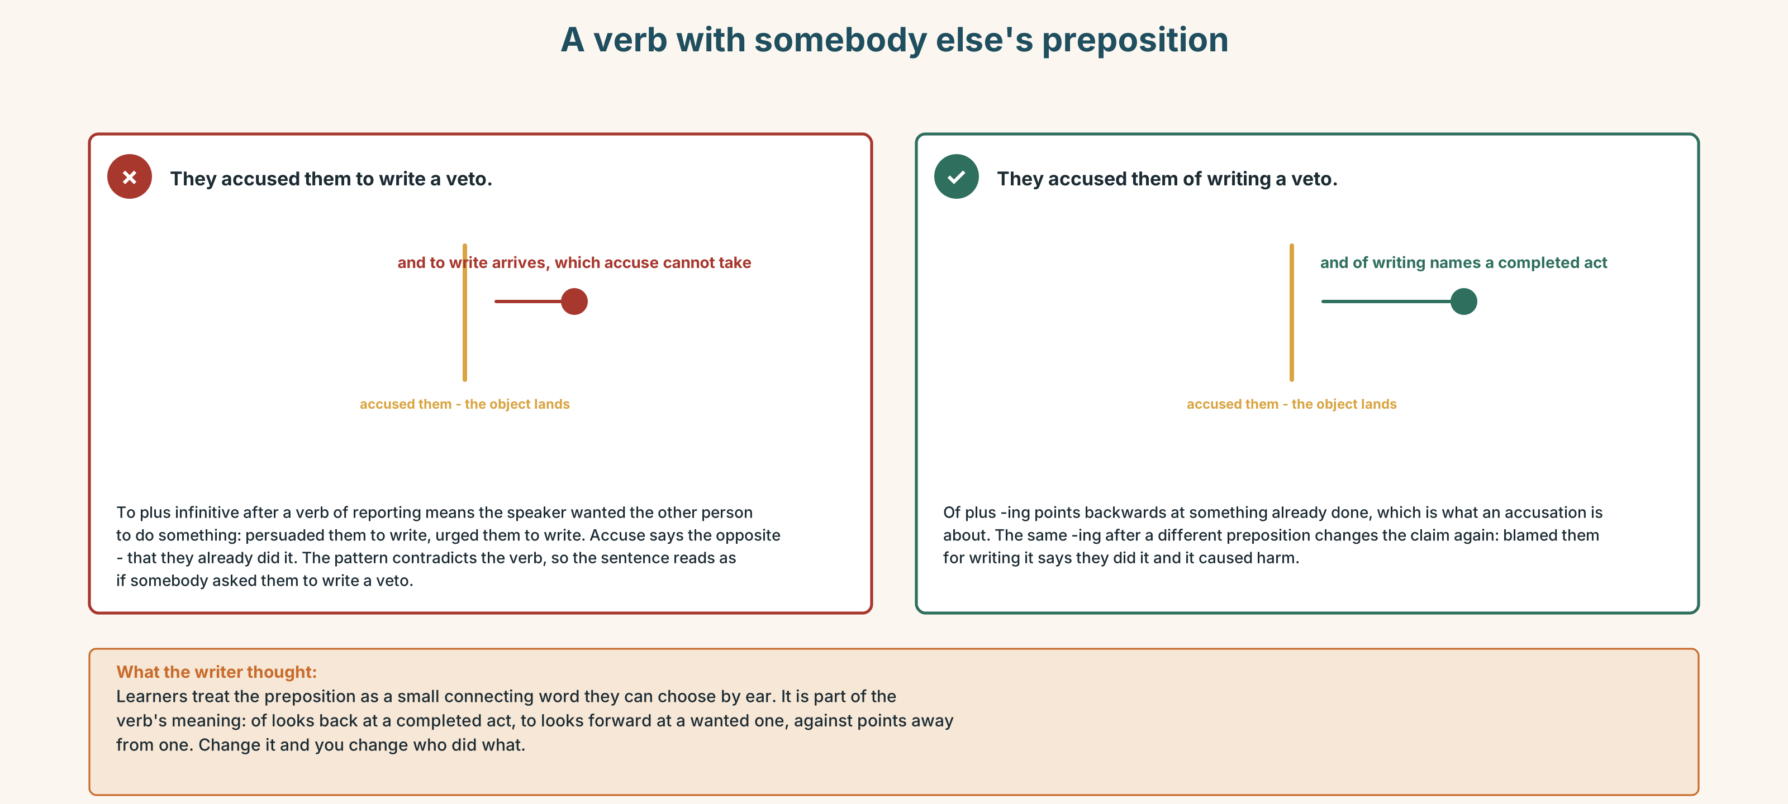{width=6.6in}
A verb with somebody else's preposition — A verb with somebody else's preposition
Read both versions. Then say who, in the first one, is responsible for the claim.

3H · Check — eight items
- She accused them ______ writing a veto.
- They persuaded the Dean ______ wait.
- He blamed them ______ the delay.
- She congratulated them ______ the gift.
- She warned them ______ saying it.
- He insisted ______ seeing the draft.
- He denied ______ (write) it.
- ✗ They accused them to write a veto. → correct it.
0–4 → Workbook pp. 26–29. 5–6 → Part 6. 7–8 → page 129.

Part 4 · Speaking ◆ C · THE PERFORMANCE

4A · Fluency starter — attach it
One learner gives a claim with no owner. The next attaches it to somebody with a reporting verb. The chain breaks on a wrong preposition.

4B · The functional core — reporting a negotiation
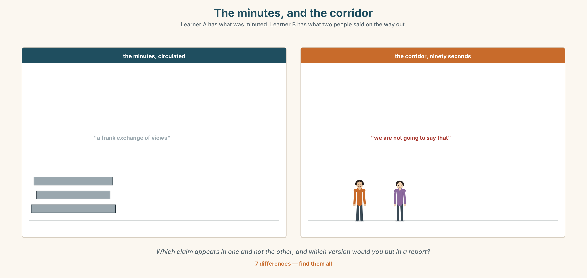{width=6.6in}
The minutes, and the corridor — Learner A has what was minuted. Learner B has what two people said on the way out.
Language Bank
what was said | X insisted on… · Y denied… · Z admitted…
what was offered | …in exchange for… · The concession was…
the sticking point | The one thing they would not move on was…
what was not said | Nobody mentioned… · It was not put on the record.
Information gap. Learner A has the minutes. Learner B has what two people said in the corridor afterwards. Find the claim that appears in one and not the other.

4C · The performance — three minutes ⏺
Report a negotiation, real or from the unit. Three minutes. You must include:
every claim attached to a named person · what each side gave up · the sticking point · one thing nobody said out loud
Record it.

4D · Observer
One person listens for one thing: did any claim arrive without an owner?

4E · Three criteria
☐ Does every claim have a name on it? ☐ Did I use four different reporting verbs with the right pattern? ☐ Did I separate what was agreed from what was assumed?

Part 5 · Reading ◆ A · THE WORLD

5A · Predict
A personal essay, titled "I wrote the press release." What do you expect the writer to admit? Two sentences.

5B · Read — two minutes and a quarter

I WROTE THE PRESS RELEASE a personal essay
I have worked in university communications for eleven years and I have written somewhere around nine hundred press releases. I am going to describe one paragraph of one of them, because it is the only thing I have written that I still think about.
The gift was four million dollars for a research wing. The agreement had nine pages. Clause 9.4 said that the sponsor would be given thirty days' sight of any publication arising from work done in the wing, and could request amendments. Not require. Request.
I was given the agreement on a Tuesday and asked for a release by Thursday. I read all nine pages, which I want on the record, because the thing people assume about my job is that we do not read them.
I wrote: The partnership includes standard arrangements for the review of research outputs prior to publication.
Every word in that sentence is true. Standard is doing the most work. The arrangement is not standard — I checked four comparable agreements and three had no review clause at all — but the sentence does not say it is common. It says it is standard, which is a word that means of a known type and is heard as normal. I knew that when I wrote it. That is the craft, and I am not going to pretend it was an accident.
What I did not do was lie, and what I also did not do was put the clause in the release, which would have taken eleven words.
A researcher found it eighteen months later, in the agreement, which had been public the whole time on a page three clicks from the homepage. She accused the university of hiding it. She was wrong about hiding and right about everything else, and the thing I have not been able to get past is that if she had been wrong about everything, I would have been fine.

5C · Comprehension — eight questions
- How long has the writer worked in communications, and how many releases?
- What exactly does clause 9.4 allow the sponsor to do? Give both verbs.
- What does the writer want on the record, and why?
- Which word in the written sentence is "doing the most work", and how?
- What did the writer check, and what did they find?
- What two things does the writer say they did not do?
- How was the clause found, and how long had it been public?
- What is the writer "not able to get past"?

5D · Vocabulary in context
Guess from the text. Then check.
arising from · doing the most work · of a known type · three clicks from the homepage · right about everything else

5E · The counter-text
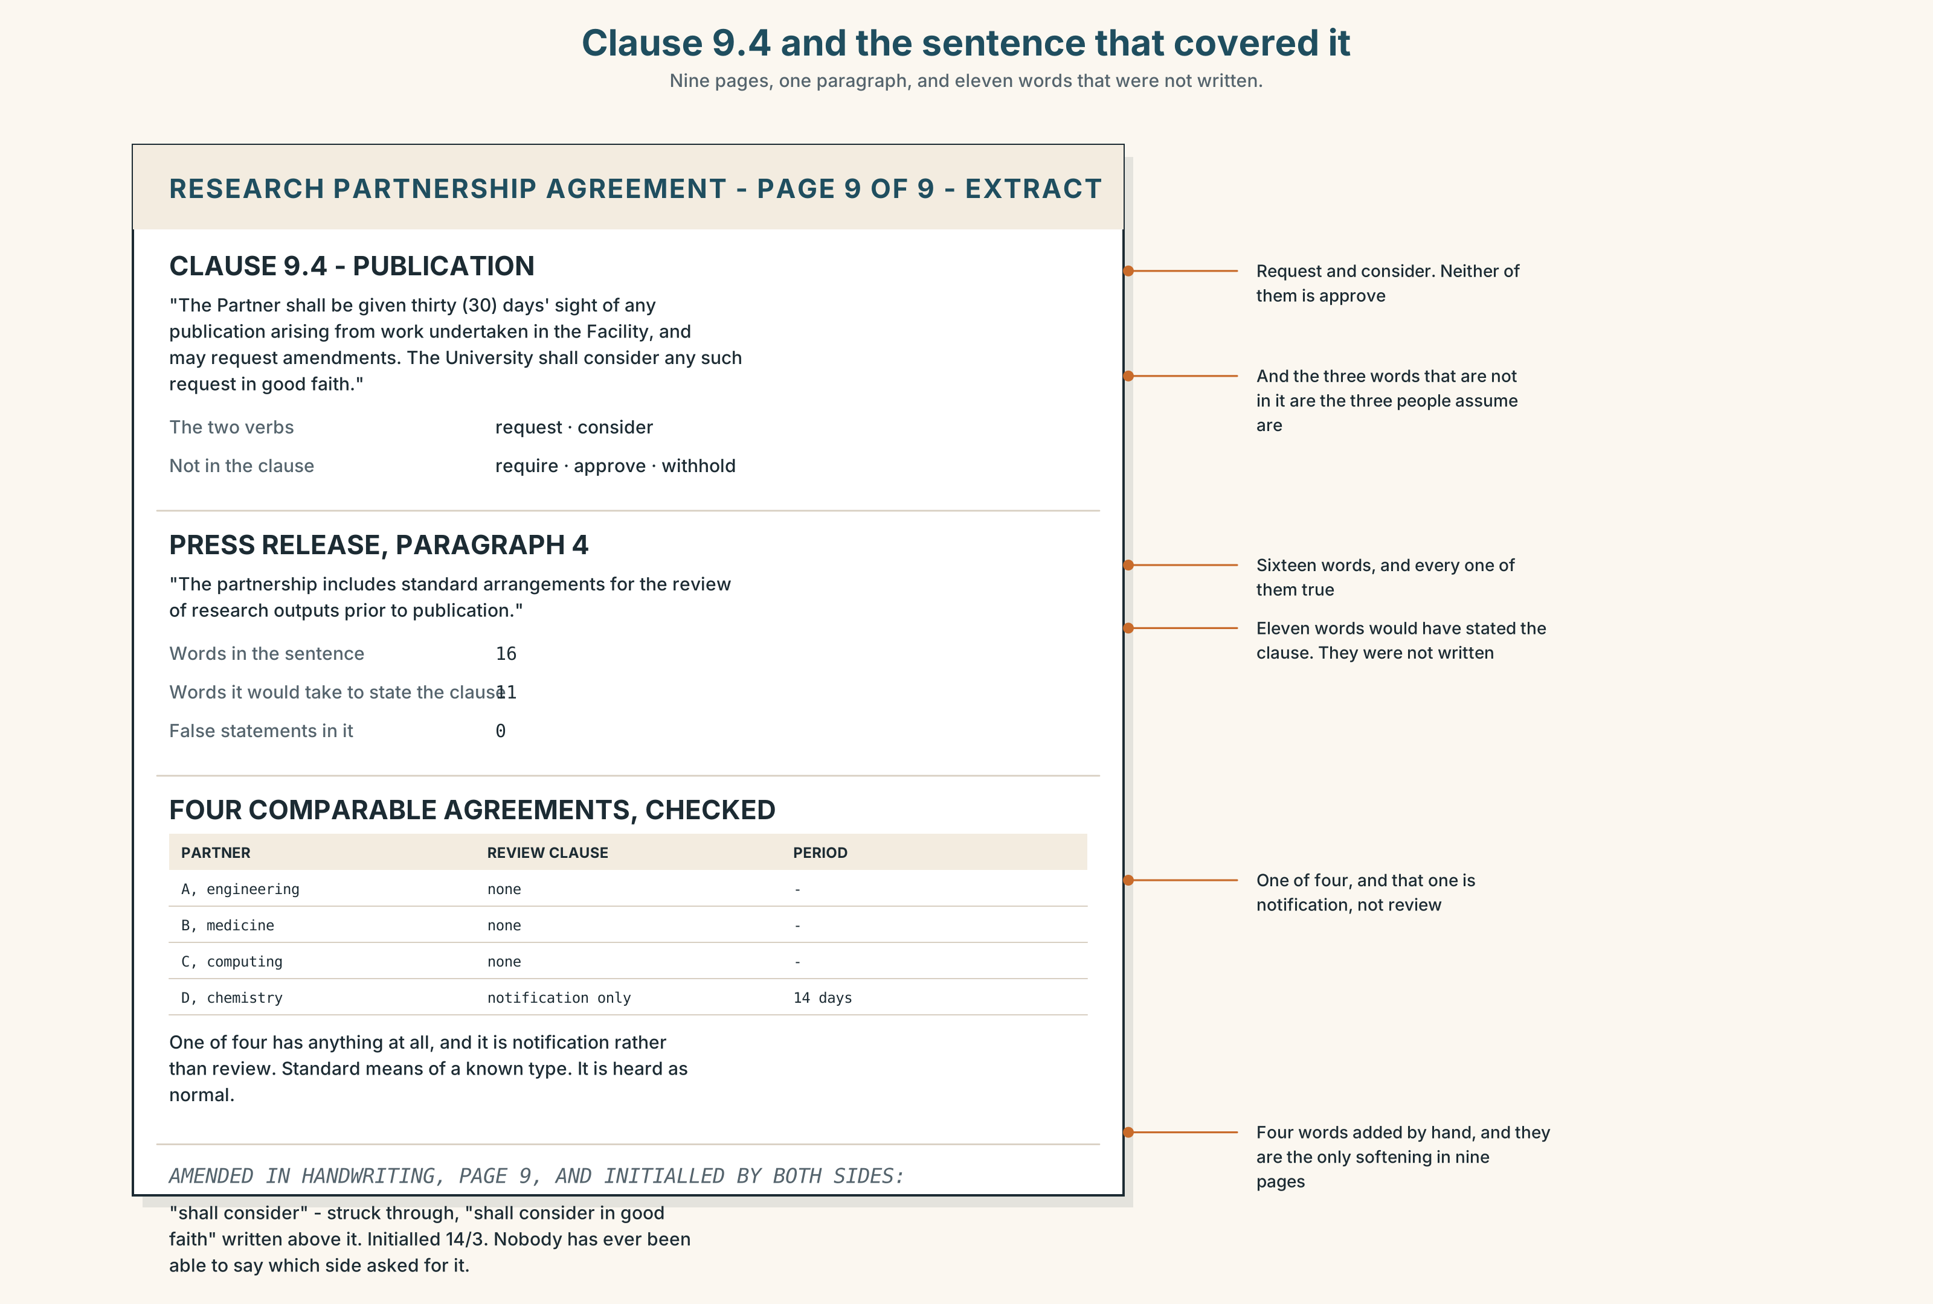{width=6.6in}
Clause 9.4 and the sentence that covered it — Nine pages, one paragraph, and eleven words that were not written.
Read clause 9.4 and the press release, and answer.
- What exactly does 9.4 say? Quote the two verbs.
- Which sentence of the release covers 9.4, and what does it leave out?
- How many comparable agreements were checked, and what did they contain?
- What does the sponsor's internal briefing note say the clause is for?
- One line of the agreement has been amended in handwriting and initialled. Which?

5F · Two texts
The release says the arrangements are standard. Three of four comparable agreements have no review clause at all.
Is the release false? Three sentences.

Part 6 · Vocabulary Lab 2 ◆ B · THE SYSTEM

Learning the preposition with the verb

6A · Sort — which preposition?
Four columns: of · for · on · against.
accuse somebody · blame somebody · congratulate somebody · warn somebody · insist · remind somebody · advise somebody

6B · Chunk completion
- accuse somebody ______ writing it
- persuade somebody ______ take it to committee
- blame somebody ______ the delay
- congratulate somebody ______ the gift
- warn somebody ______ saying it
- insist ______ seeing the draft

6C · Two that change meaning with the pattern
remind · warn
He reminded her to read it. — she was going to forget. He reminded her that she had read it. — she had forgotten that she already knew. She warned them against saying it. — do not. She warned them that it was not standard. — information, not instruction.
Write four sentences about the essay in Part 5, one of each.

6D · The two that persuade
p talk into · p talk out of
They talked her into signing. · He talked them out of using the word.
Both take -ing, both imply the other person did not want to, and both are warmer and less formal than persuade.
Rewrite two sentences from Part 2 using them.

6E · Deny, admit, and the one that has no object
deny doing · admit doing · and insist which takes no object at all.
He denied doing it. He admitted writing the first draft. He insisted on both.
Write three sentences about the writer of the essay.

6F · Contrast Clinic
Eight items. Four are wrong. Correct them and say what the rule is.
- They accused them to write a veto.
- They accused them of writing a veto.
- He insisted to see the draft.
- He insisted on seeing the draft.
- She congratulated them for the gift.
- She warned them against saying it.
- He denied to write it.
- He reminded her to read it.

Part 7 · Pronunciation & Fluency Lab ◆ B · THE SYSTEM

The reporting verb carries the weight
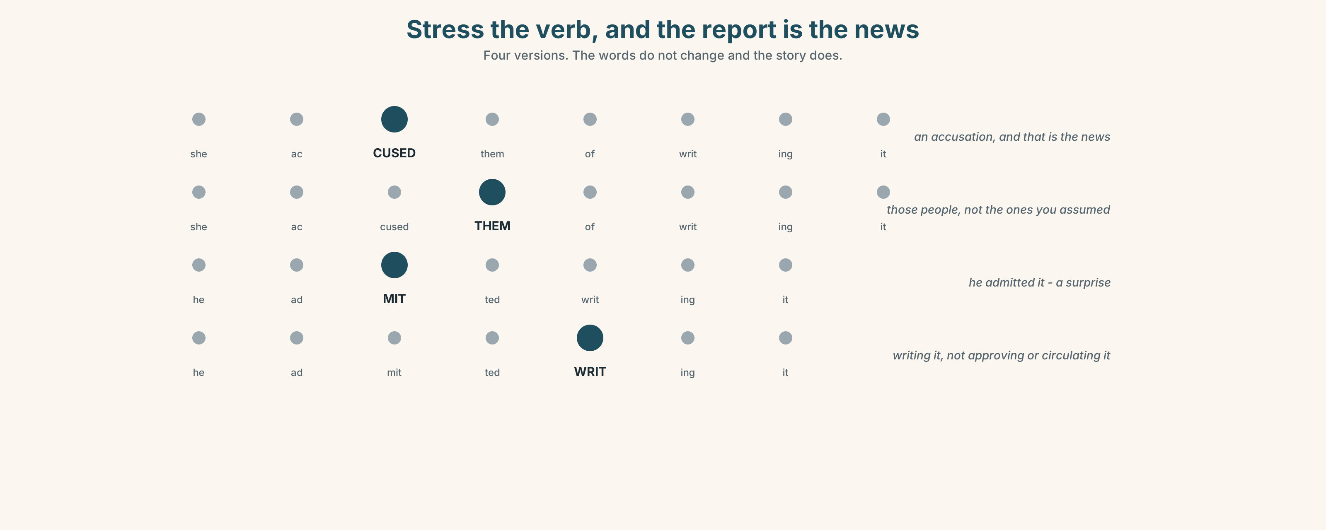{width=6.6in}
Stress the verb, and the report is the news — Four versions. The words do not change and the story does.

7A · Hear 🔊 Track 6.3
She ACCUSED them of writing a veto. The verb is the news. Everything after it is the content of the accusation.
Now with the stress moved:
She accused THEM of writing a veto. Now the news is who, and the accusation is old information.

7B · Say
Say both. Then say this one three times, faster:
He insisted on thirty days and denied that thirty days was a veto.

7C · Make it mean something
Say these two:
He ADMITTED writing it. (and that is a surprise) He admitted WRITING it. (as opposed to approving it, or circulating it)
One sentence, two stories. Which is which?

7D · Fluency 30 ⏺
Thirty seconds: four reports, four different verbs, the stress on the verb each time. Three times, faster.

Part 8 · Writing ◆ C · THE PERFORMANCE

A report of a meeting · 190 words
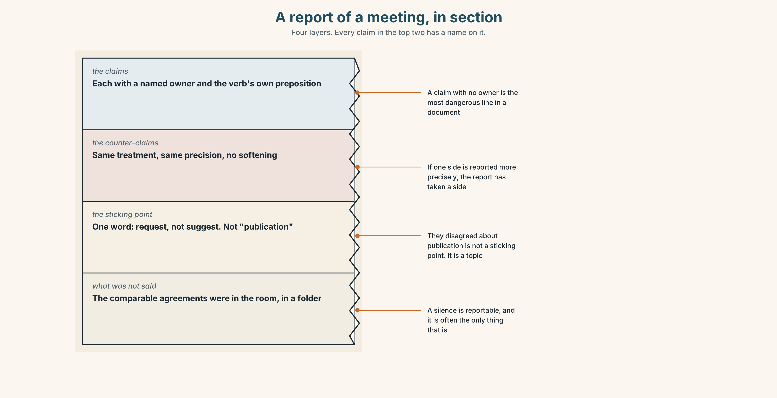{width=6.6in}
A report of a meeting, in section — Four layers. Every claim in the top two has a name on it.

8A · Read the model
The sponsor's representative insisted on retaining clause 9.4 and denied that a thirty-day review amounted to a veto. [two claims, one sentence, both attached to the same named person]
The university's lawyer accused the company of writing a veto and calling it a courtesy. She warned them against describing the clause as standard in any public document. [the opposing claims, with their patterns intact]
The sticking point was not the money or the name. It was the word request, which the sponsor would not change to suggest and the university would not accept as it stood. [the sticking point, named, and it is a single word]
Nobody raised the comparable agreements. They were in the room, in a folder, and they were not mentioned. [what was not said, which a report should carry]
Questions about the writer's choices:
- Every claim has a name. What would the report be worth without them?
- The sticking point is one word. Why is that more useful than "they disagreed about publication"?
- The last paragraph reports a silence. Can a report do that fairly?

8B · The anti-model
There was a frank exchange of views regarding the publication provisions. Both parties expressed their positions and it was felt that further discussion would be beneficial. A number of concerns were raised and will be taken forward.
Correct English, and nobody in it did anything. Find the three passives that have deleted a person, and say who it was felt belongs to.

8C · Plan
the claims, each with its owner → the opposing claims, same treatment → the sticking point, named as precisely as you can → what was not said

8D · Write — 190 words

8E · Peer review — three criteria
☐ Does every claim have a named owner? ☐ Is the sticking point as precise as the evidence allows? ☐ Have I reported what was not said as well as what was?

8F · Write it again · 8G · Publish
Circulate to the people you reported. That is the test.

Part 9 · The File ◆ A · THE WORLD + C · THE PERFORMANCE

CULTURE FILE · Silence, Interruption and Turn-taking
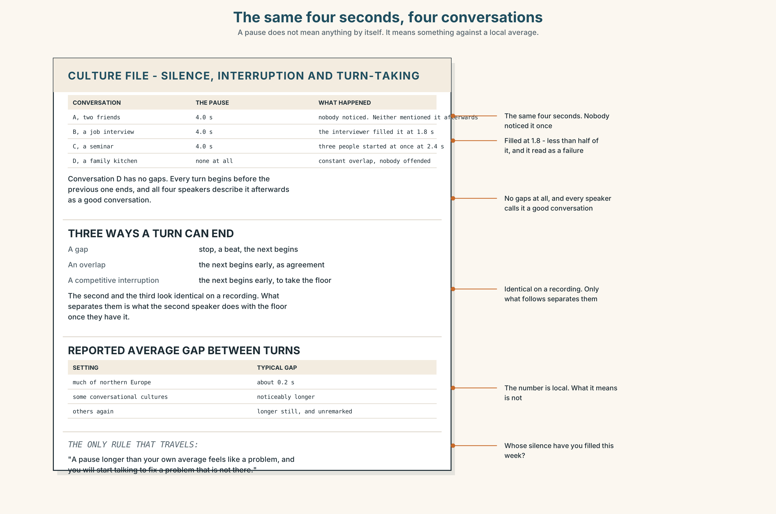{width=6.6in}
The same four seconds, four conversations — A pause does not mean anything by itself. It means something against a local average.

9A · Four seconds of nothing 🔊 Track 6.4
The same pause, in four conversations. Listen.
- In which one is the pause comfortable?
- In which one does somebody fill it, and what does filling it do?
- One of the four has no pauses at all, and nobody is being rude. How does that work?

9B · Three ways a turn can end
a gap — one speaker stops, a beat, the next begins an overlap — the next begins slightly early, as agreement a competitive interruption — the next begins early, to take the floor
Which two are easily mistaken for each other, and by whom?

9C · The length of a comfortable silence
Reported averages: around 0.2 seconds between turns in much of northern Europe; longer in some conversational cultures, and noticeably longer in others again. The number matters less than this: whatever yours is, a pause longer than it feels like a problem, and you will start talking to fix a problem that is not there.
Whose silence have you filled this week?

9D · Your turn
In fours. Twelve minutes. Discuss anything, with one rule: three seconds of silence after every turn, timed. Then: who found it hardest, and what got said that would not have?

9E · Transfer
Count the interruptions in your next meeting, and sort them into the three kinds. Bring the three numbers.

Part 10 · Mediation & Interaction ◆ C · THE PERFORMANCE
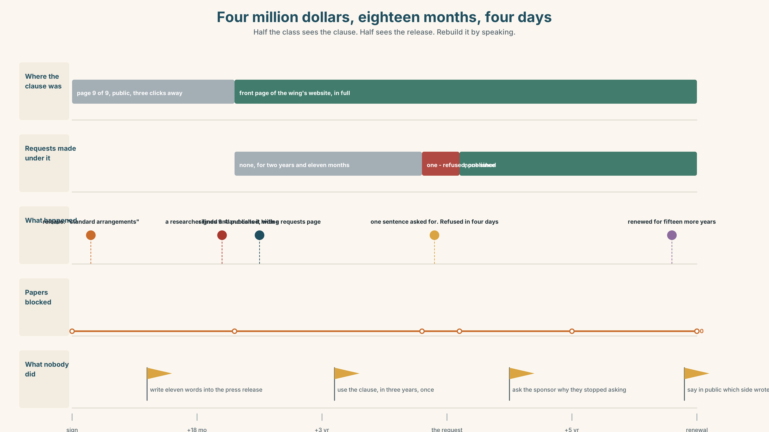{width=6.6in}
Four million dollars, eighteen months, four days — Half the class sees the clause. Half sees the release. Rebuild it by speaking.

10A · Relay
Half the class sees clause 9.4. Half sees the press release. Rebuild the agreement by speaking. Twelve minutes.

10B · Simplify
Explain clause 9.4 to a PhD student about to start work in the new wing. Five sentences only.
Plan: what it says → what it does not say → what it would feel like → what they can do before signing → who to ask

10C · Compress
The essay in Part 5B into forty words, keeping the admission.

10D · Online
Write one message to the communications office: you are not accusing anybody of lying, you have one specific question about one word, and you want an answer in writing.

10E · Your language
Does your language attach claims to people the way English does? Say she accused them of writing it in both languages. Which marks the accusation on the verb, and which on a particle?

Part 11 · The Decision ◆ C · THE PERFORMANCE

Four million dollars, and a paragraph about publishing
The gift funds a research wing for fifteen years. Clause 9.4 gives the sponsor thirty days' sight of any publication and the right to request amendments. The sponsor will not remove it. The Dean has until November.
- Sign it. Four million, a wing, forty researchers. The clause says request, not require, and no comparable agreement has ever been used to block anything.
- Refuse the clause. The sponsor has said it is not negotiable. They have said that about two other things already and moved on both.
- Sign it and publish it. Take the clause, and put it, in full, on the front page of the wing's website, alongside every request ever made under it.

11A · The evidence
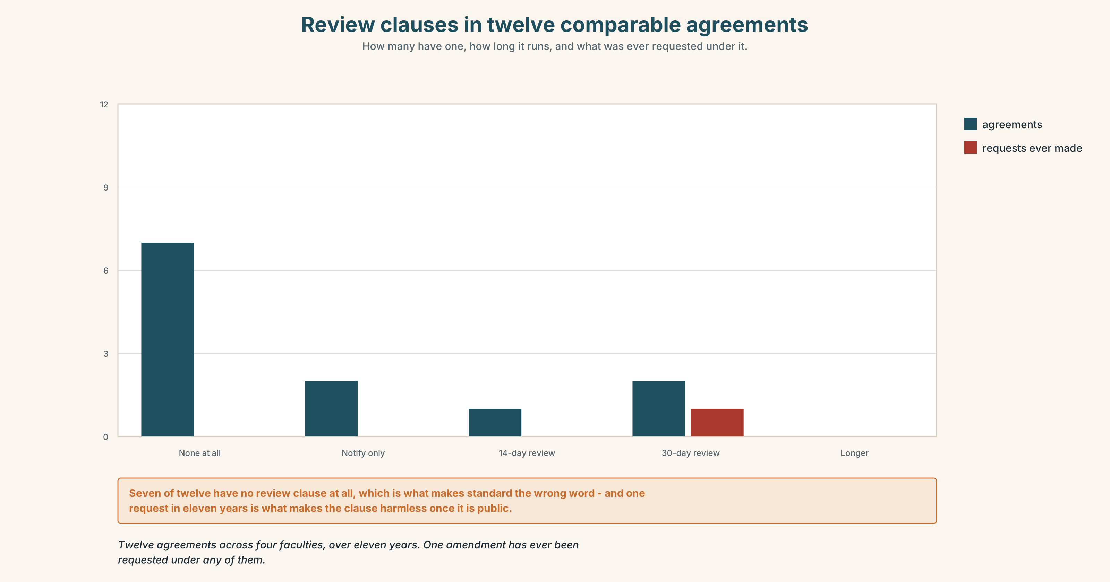{width=6.6in}
Review clauses in twelve comparable agreements — How many have one, how long it runs, and what was ever requested under it.
- Clause 9.4 and the press release from Part 5E — and the handwritten amendment.
- The chart — review clauses in twelve comparable agreements, and what was requested under each.
- The voice. A postdoctoral researcher, thirty seconds: "Nobody will ever block a paper. They will not need to. I will know on the day I start what the thirty days are for, and in four years nobody will be able to point at a single thing I did not write, including me."

11B · Talk about it
In fours. Everybody speaks twice. Use the frame.
They ______ us of ______ . We ______ on ______ . The sticking point is ______ .
Words you can use: claim · clause · leverage · concession · undertaking · stakeholder · spin · retraction · the small print · strings attached

11C · Decide
Write three sentences. Choose, say why, and name what it costs.
I think the university should ______________________ , because ______________________ . What this costs is ______________________ .

11D · Model decision
Sign it and publish it. The clause is not the danger; the clause plus silence is. A review right that everybody can see is a review right nobody can use quietly, and publishing every request made under it turns the sponsor's leverage into a public record of how little they use it — or into evidence, if they use it a lot. The cost is that the sponsor will read this decision as hostile, and they will be partly right.

11E · The Reveal
What happened. The university signed and published. The clause went on the wing's website in week one, with a page beside it headed Requests made under clause 9.4, which stayed empty for two years and eleven months.
Then one request was made, on a paper about a competitor's product. It asked for the removal of one sentence. The university refused, published the request and the refusal on the same page, and the paper went out unchanged four days later.
The sponsor renewed for a second fifteen years. Their head of partnerships said in a conference talk, without mentioning the university by name, that the published-requests page was the single most useful thing any partner had ever done for them, because it meant nobody internally ever asked them to make a request again.
The clause was never the problem. Writing it down where everybody could see it was what made it harmless, and it took four days and one refusal to prove it.
Was it the right decision? Say why — and say what the researcher in 11A would say now.

Part 12 · Landing ◆ all three lines

12A · Recycle — twelve items
- She accused them ______ writing it.
- They persuaded the Dean ______ wait.
- He blamed them ______ the delay.
- She congratulated them ______ the gift.
- She warned them ______ saying it.
- He insisted ______ seeing the draft.
- He denied ______ (write) it.
- They ______ her into signing.
- He ______ them out of using the word.
- The clause was ______ down to one sentence.
- They ______ back on the deadline.
- Nobody would ______ up to it in writing.

12B · Consolidate
Four columns, from memory: verbs taking of · taking for · taking on · taking to + infinitive.

12C · Can-do, with evidence
☐ I can report a negotiation with every claim attached to a person. Evidence: 4C, 8D ☐ I can use reporting verbs with the correct pattern. Evidence: 3H, 6F ☐ I can stress a reporting verb to make the report, not the content, the news. Evidence: 7D ☐ I can report what was not said. Evidence: 8D

12D · Replay ⏺
Record 0C again. Listen to both. What have you got that you did not have in week one?

12E · Glossary — forty-five items, as a map
THE DEAL · claim · sponsor · clause · naming rights · negotiation · concession · leverage · undertaking · stakeholder THE STORY · spin · briefing · retraction · on the record THE MOVES · in exchange for · a sticking point · walk away · the small print · strings attached · water down · push back · sign up to · hold out WHAT PEOPLE SAY · that is not what was agreed · we are not going to say that · he is said to have REPORTING VERBS · accuse · persuade · blame · congratulate · warn · remind · insist · deny · admit · urge · advise THE PATTERNS · accuse somebody of · persuade somebody to · blame somebody for · congratulate somebody on · warn somebody against · insist on · deny doing · talk into · talk out of

12F · Next
Unit 7 · Who says so?

