Table of Contents

B2.1 · Unit 1 · Forty Minutes Behind
English Animated · Reading Between Lines · a newsroom, Toronto Student's Book pages 6–27 · 22 pp · ~11 hours

Part 0 · The Big Picture ◆ A · THE WORLD
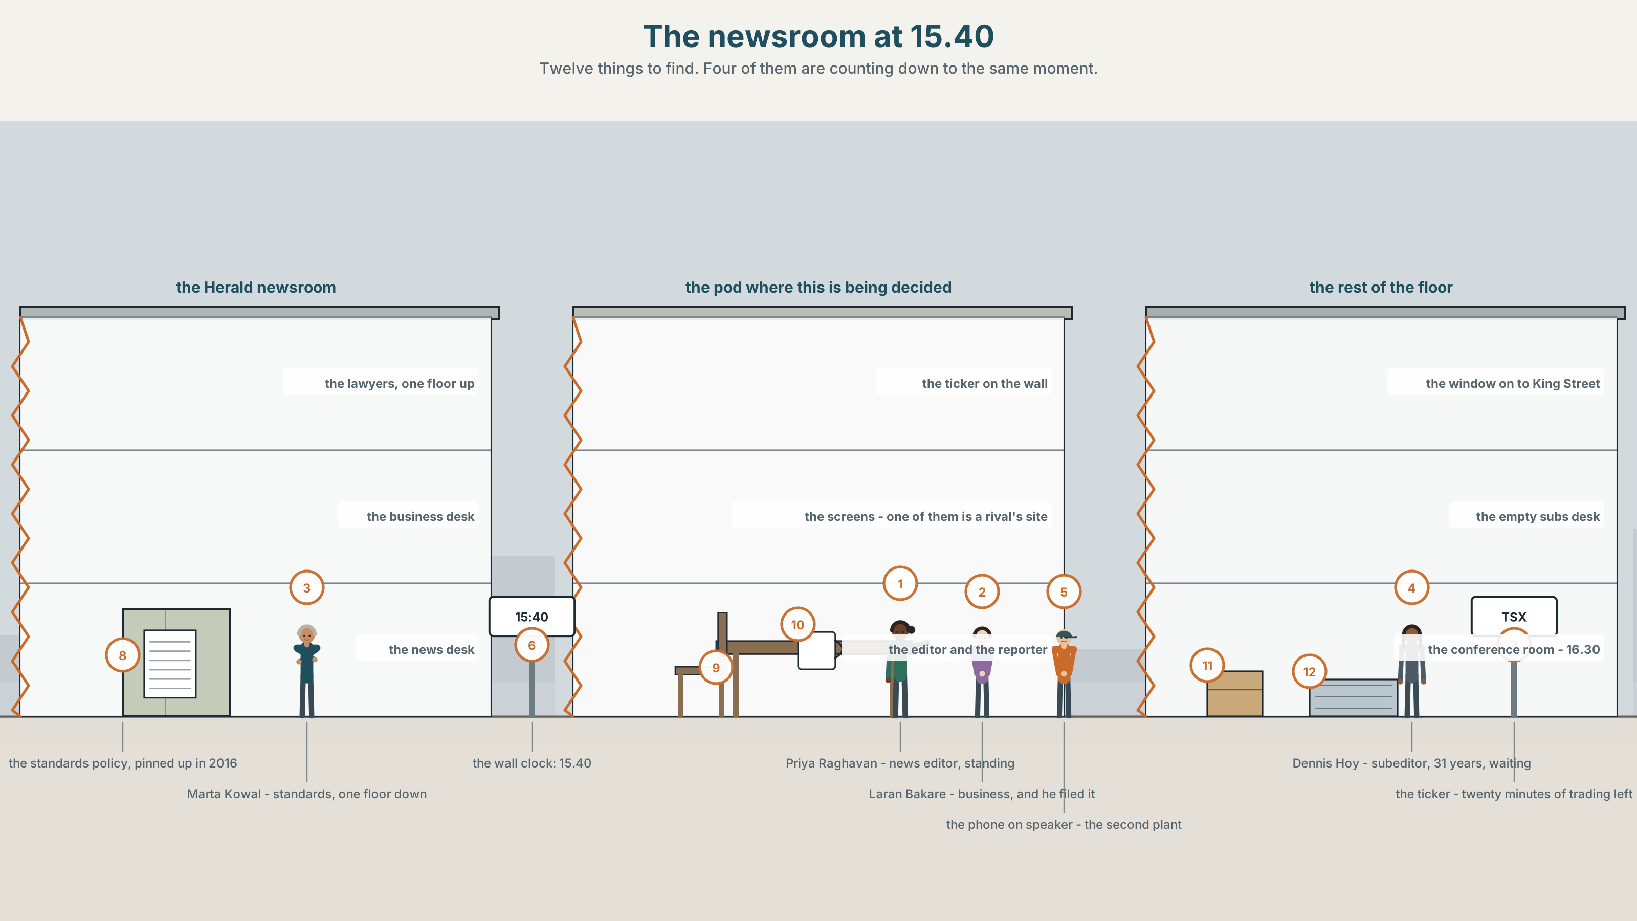{width=6.6in}
The newsroom at 15.40 — Twelve things to find. Four of them are counting down to the same moment.

What is a fact worth?
By the end of this unit you can choose between the simple and the continuous deliberately, and say what each one claims. Two hundred words.
◆ A · THE WORLD | A newsroom at 15.40, forty minutes before a market closes, holding a story it cannot stand up
◆ B · THE SYSTEM | aspect as meaning, across every tense · 28 words for verification and evidence · 22 words that carry aspect in their own right · prominence on the new information
◆ C · THE PERFORMANCE | Two hundred words in which every tense choice is defensible

0A · Find it
Find twelve things in this picture. Four of them are counting down to the same moment.
a wall clock at 15.40 · a market ticker · a screen with a draft headline · a telephone on speaker · a printed email · a desk with nobody at it · a second screen showing a rival's site · a whiteboard with two names on it · a lawyer's number on a note · a cup of cold coffee · a standing editor · a sitting reporter

0B · Guess it
Two of the twelve exist only because of one of the others. Which, and what is the causal chain?

0C · Say it ⏺
Record sixty seconds. Describe something you believe is true and cannot prove. What would it take to prove it, and who would have to do the work? You will record it again at the end of this unit.

Part 1 · Vocabulary Lab 1 ◆ B · THE SYSTEM
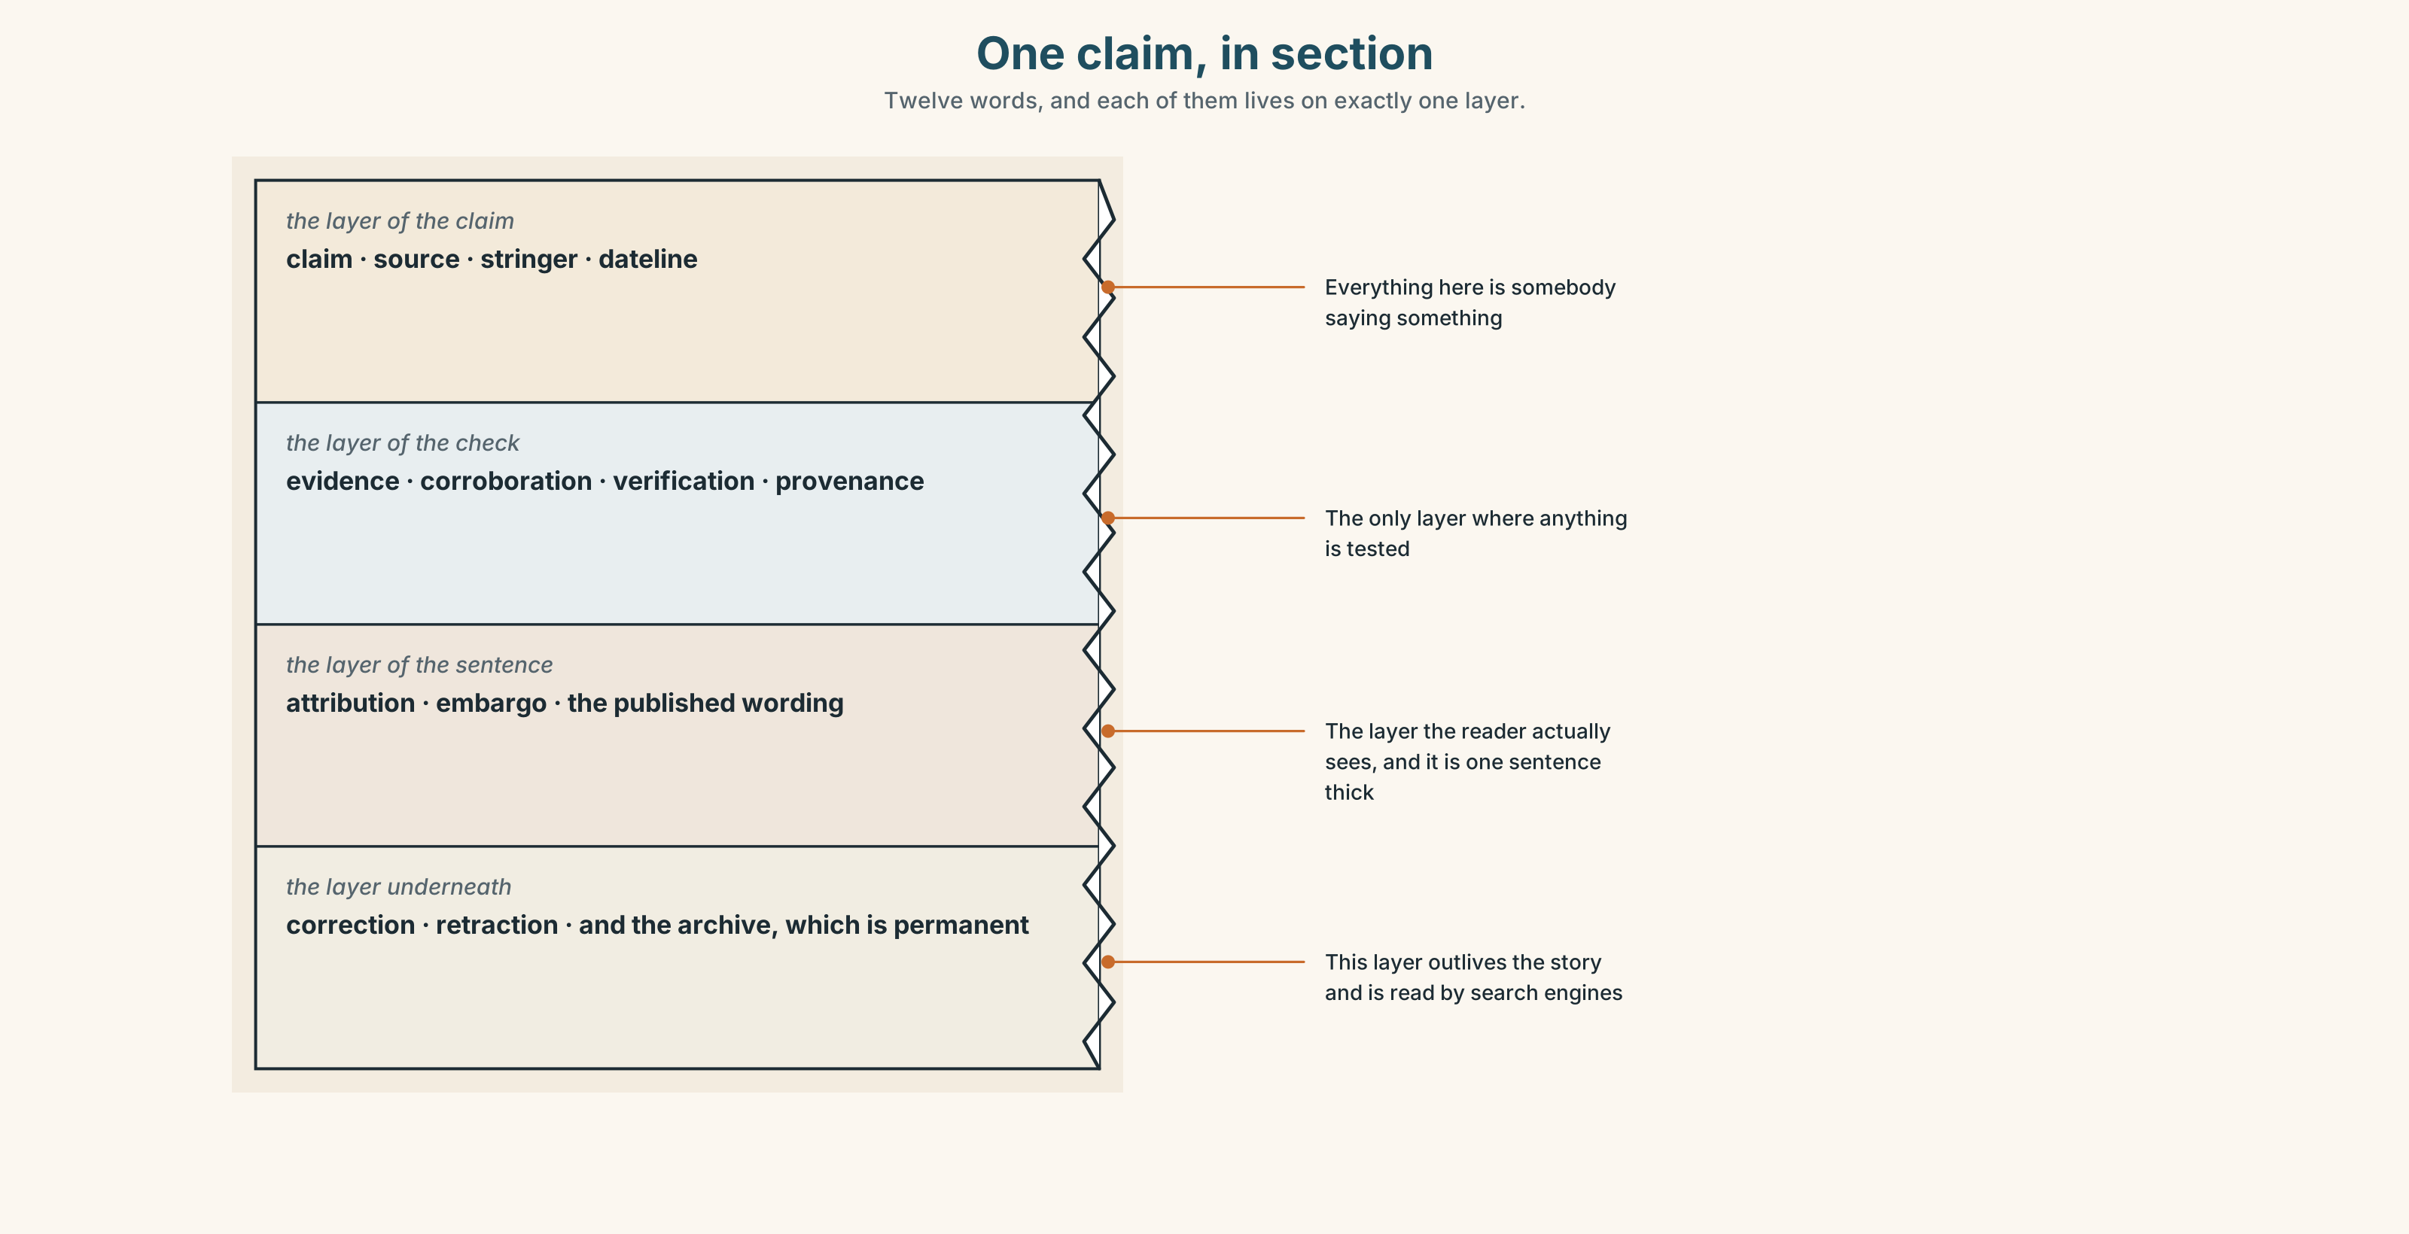{width=6.6in}
One claim, in section — Twelve words, and each of them lives on exactly one layer.

1A · Meet — the words of a claim
Match each word to one layer of the cutaway.
claim · source · evidence · corroboration · verification · attribution · provenance · correction · retraction · embargo · stringer · dateline

1B · Sort — before publication, after publication, or both?
Three columns.
verification · correction · corroboration · retraction · embargo · attribution · provenance · claim · evidence · source

1C · Meet — the words that describe a story's state
a single source | One person says it. Nobody else has said it.
a verified account | More than one independent route to the same fact.
a working assumption | Believed, acted on, and not yet evidence.
a story with legs | It will still be a story on Thursday.
the cost of being first | Measured in corrections, and paid later.

1D · Collocation Lab
Complete each one with a word from the box, and say which of the five is the only one that is not about publishing.
stand a story up · run a correction · hold the line · on the record · off the record
- We cannot ______ ______ ______ ______ with one caller and a screenshot.
- If we are wrong on Friday we ______ ______ ______ on Monday, on page two.
- She would say it ______ ______ ______ and not with her name on it.
- He said the same thing ______ ______ ______ , twenty minutes later, after we asked twice.
- Everybody else has gone. We ______ ______ ______ .

1E · The phrasal verbs, and the three fixed expressions
stand up · back up · hold off
f we can't stand it up · f it checks out · f who else has it?
One of the three fixed expressions is a question that is never really a question. Which, and what is it actually doing?

1F · Own it
Write one sentence about something you know that you could not currently stand up, and one about something you could.

Part 2 · Listening ◆ A · THE WORLD
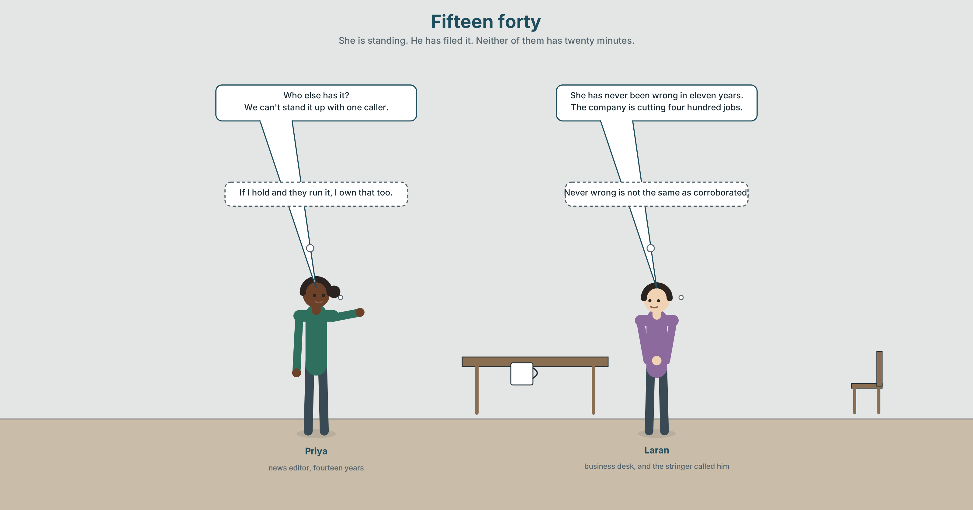{width=6.6in}
Fifteen forty — She is standing. He has filed it. Neither of them has twenty minutes.

2A · Fifteen forty 🔊 Track 1.1
Before you listen. The market closes at 16.00. The paper has one source and a claim that would move a share price.
Listen once. What exactly does the source claim, and what exactly can the paper prove?
Listen again. Complete the table.
 | What is claimed | What is corroborated | What is assumed
the job cuts
the timing
the board meeting
Listen again. True or false?
- The reporter has two independent sources. ☐ T ☐ F
- The claim was made on the record. ☐ T ☐ F
- A rival outlet has the same story. ☐ T ☐ F
- The editor decides to publish before the close. ☐ T ☐ F
Noticing. Four sentences from the recording.
- The company is cutting four hundred jobs.
- The company cuts four hundred jobs.
- The company has been cutting jobs since March.
- The company had been going to announce it on Thursday.
All four are about the same event. Which of the four makes the strongest factual claim, and which commits the paper to the least?

2B · Decoding clinic 🔊 Track 1.2
Thirty seconds at speed. Three jobs.
- In we can't stand it up, which syllable carries the main prominence, and why that one?
- The editor repeats a phrase three times with the prominence in a different place each time. Write the three versions.
- One sentence ends on a word that is not new information. What effect does that have?

Part 3 · Grammar Lab 1 ◆ B · THE SYSTEM

Aspect is not about time

3A · Notice
Look at the four sentences in Part 2 again.
- Which of the four presents the event as a whole, closed and countable?
- Which presents it as in progress, and therefore incomplete and possibly reversible?
- What does the perfect in sentence 3 add that sentence 1 does not have?
- What does sentence 4 claim about something that did not happen?

3B · See
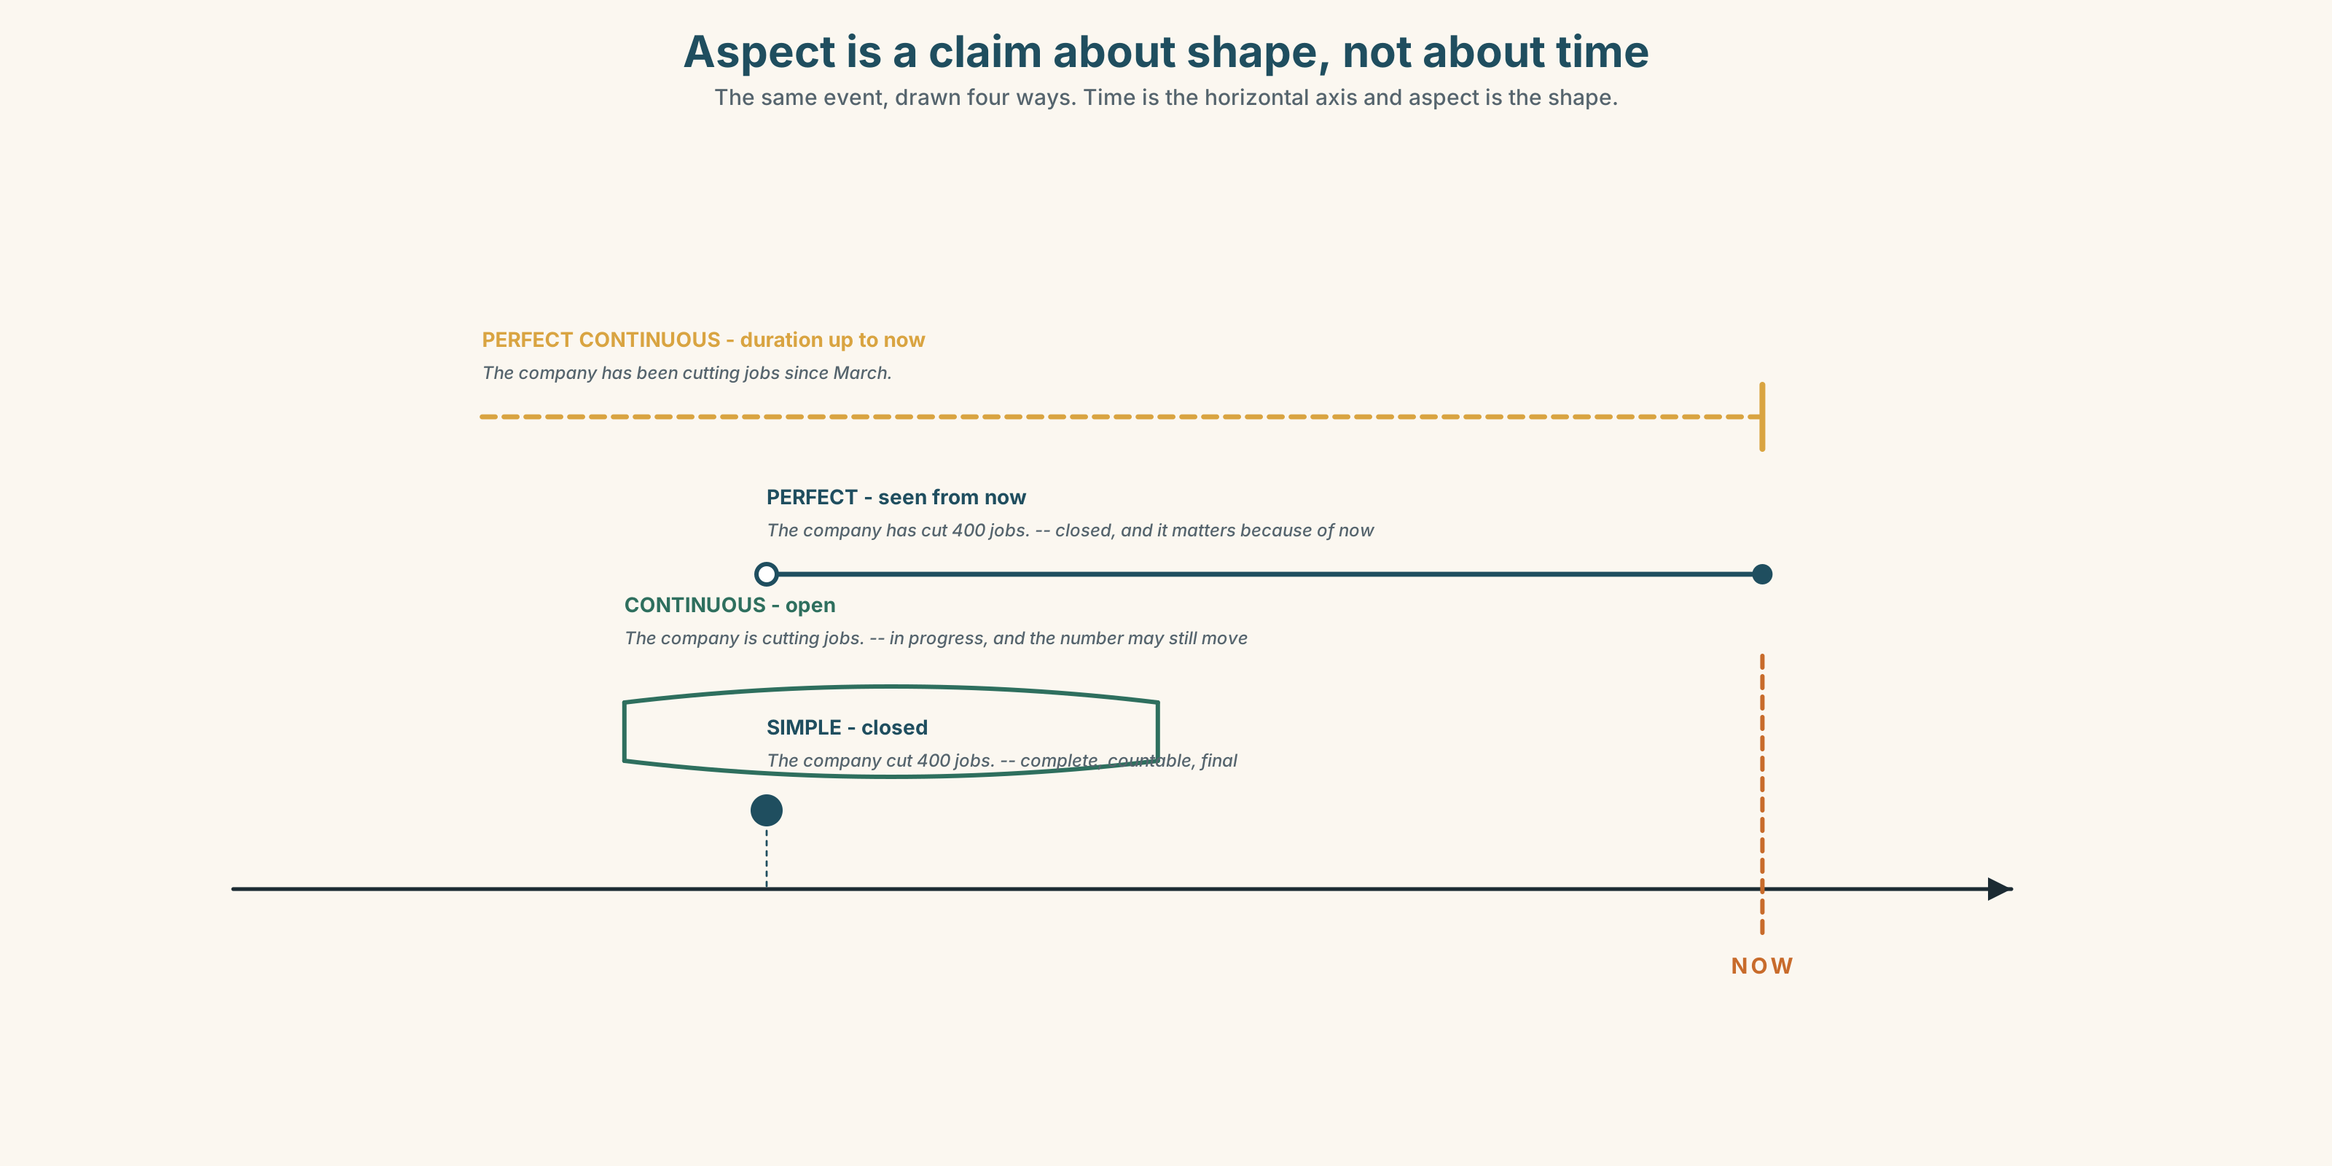{width=6.6in}
Aspect is a claim about shape, not about time — The same event, drawn four ways. Time is the horizontal axis and aspect is the shape.

3C · Know
simple | the event as a complete unit | The company cut four hundred jobs.
continuous | the event as in progress, unfinished | The company is cutting four hundred jobs.
perfect | the event seen from a later point | The company has cut four hundred jobs.
perfect continuous | duration up to a later point | The company has been cutting jobs since March.
The choice is a claim, not a decoration. Is cutting says the process is live and the number may change. Cut says it is done and the number is final. A newspaper that writes cuts when it means is cutting has published a fact it does not have.
Four tenses, one distinction. Aspect is independent of time: was cutting, is cutting, will be cutting make the same claim about completeness at three different times.
state verbs resist the continuous | owns, contains, consists of — and when they take it, the meaning shifts
the continuous softens | I'm hoping you can help is less committed than I hope
the perfect links | the event is being presented because of its consequence now
the future in the past | was going to, had been going to — a plan that did not survive
Why it matters. Every sentence in a news report is a claim about how finished something is, and that is the claim most likely to be wrong.

3D · Use — controlled
Complete with the most defensible aspect.
The company (1) ______ (cut) four hundred jobs — the board minutes exist and we have seen them. According to one person, the company (2) ______ (consider) cuts, and the number (3) ______ (move) all week. It (4) ______ (lose) money since the third quarter, which nobody disputes. On Tuesday the board (5) ______ (go to announce) it on Thursday, and then it did not.

3E · Use — guided
Rewrite each one so that it commits the paper to less, changing only the aspect.
- The company closes the Thunder Bay plant.
- The regulator rejected the application.
- The minister has resigned.
- Three directors sold shares in the week before the announcement.
- The union accepts the offer.

3F · Use — open
In pairs. One of you has a claim and a single source. The other is the standards editor. Negotiate a sentence that can be published. The aspect is the negotiation.

3G · Error autopsy
✗ The company is owning four hundred patents. ✗ By Friday the number was changing six times. ✗ She is knowing the figure since March.
For each one, say what the writer was trying to claim and what the sentence actually claims.

3H · Check — eight items
- The company ______ (cut) 400 jobs. (confirmed, complete)
- The company ______ (cut) jobs since March. (duration up to now)
- The number ______ (change) all week. (in progress, unfinished)
- The board ______ (go to announce) it on Thursday. (a plan that failed)
- ✗ The report is containing three errors. → correct it.
- ✗ We are knowing this since Tuesday. → correct it.
- ✗ The company was cutting 400 jobs and the figure is final. → why do these contradict?
- Rewrite The minister resigns so that it claims less.

Part 4 · Speaking ◆ C · THE PERFORMANCE

4A · Fluency starter — the aspect swap
One person makes a statement in the simple. The next repeats it in the continuous and says what has changed about the claim. Round the room. Nobody may say nothing.

4B · The functional core — saying what you can prove
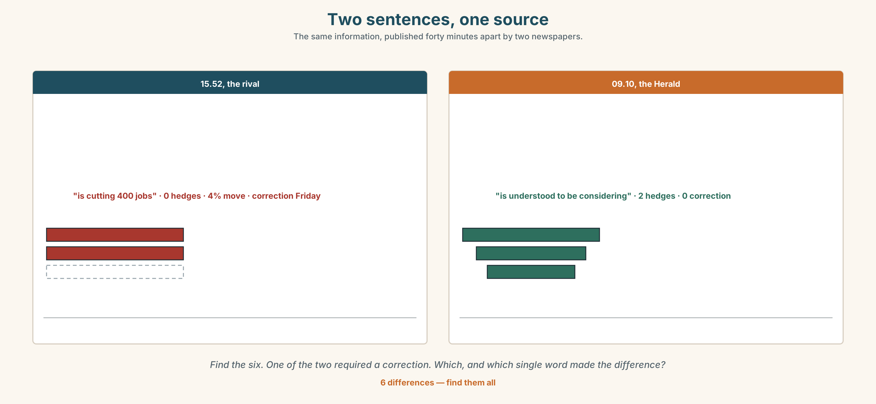{width=6.6in}
Two sentences, one source — The same information, published forty minutes apart by two newspapers.
Language Bank
the claim | We understand that… · It is thought to have… · One source says…
the hedge | as it stands · at the time of writing · is being treated as
the commitment | it checks out · a verified account · on the record
the refusal | we can't stand it up · who else has it?
Information gap. Learner A has what the source said. Learner B has what the documents show. Draft one sentence that both of you would sign.

4C · The performance — three minutes ⏺
You are the reporter. Your partner is the standards editor and will stop you the moment you claim more than you can prove. Three minutes. You must:
state the claim · say what is corroborated and what is a working assumption · propose a publishable sentence · say what would change it
Record it.

4D · Observer
One person tracks every tense choice and marks the ones that claimed more than the evidence.

4E · Three criteria
☐ Was every aspect choice defensible against the evidence? ☐ Did I separate corroborated from assumed out loud, in those words? ☐ Did I say what would change the sentence?

Part 5 · Reading ◆ A · THE WORLD

5A · Predict
The title is "Forty minutes behind." What do you think the paper lost, and what do you think it gained?

5B · Read — two minutes

Forty minutes behind
At 15.40 on a Tuesday the Herald had a single source, a screenshot and a claim that four hundred jobs were going at a plant in Thunder Bay. The market closed at 16.00. Everybody in the room knew what the story was worth before the close and what it was worth after it.
The stringer who filed it has lived in Thunder Bay for eleven years and has never been wrong. That is not the same as corroboration and everybody in the room knew that too.
At 15.52 a rival outlet published. The share price moved four per cent in the last eight minutes of trading. The Herald was still asking a second plant for a second account, and did not publish until 09.10 the next morning.
On Thursday the company confirmed three hundred and ten jobs, not four hundred, and said no decision had been taken on the timing. The rival ran a correction on Friday, two column centimetres, on page eleven.
Nobody in the Herald newsroom believes the paper made money on Tuesday. The argument in the room since has been about a different question: whether being right on Wednesday is a product anybody is buying.

5C · Comprehension — eight questions
- What did the paper have at 15.40?
- What time did the market close?
- How long had the stringer lived in Thunder Bay?
- When did the rival publish?
- How much did the share price move?
- What figure did the company confirm, and how does it differ from the published one?
- Why does the writer say the stringer's record "is not the same as corroboration"?
- The last paragraph changes the question. What is the new question, and why can nobody in the newsroom answer it?

5D · Vocabulary in context
Infer from the text, then check.
going at a plant · filed it · a second account · no decision had been taken · two column centimetres

5E · The counter-text
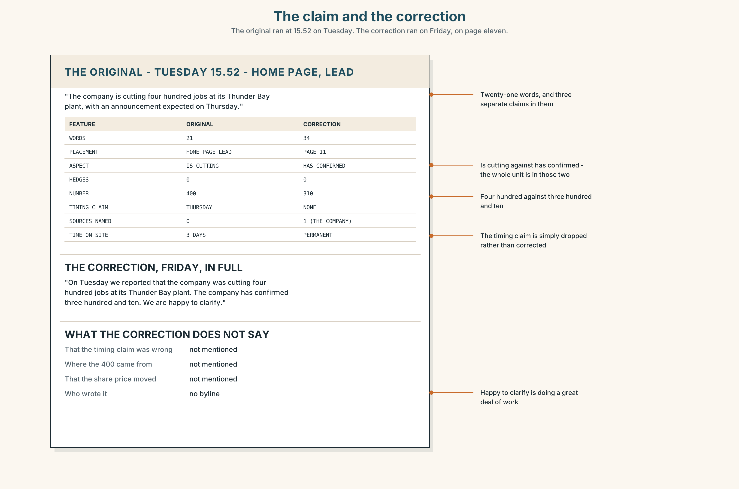{width=6.6in}
The claim and the correction — The original ran at 15.52 on Tuesday. The correction ran on Friday, on page eleven.
Read the rival's correction and the Herald's story, and answer.
- What does the correction say, and where is it placed?
- The original claim and the correction use different aspects. Identify both and say what each one claims.
- How many words are in the original claim and how many in the correction?
- What does the correction not say?

5F · Two texts
The Herald's story at 09.10 uses is understood to be considering. The rival's story at 15.52 used is cutting.
Both turned out to be wrong about the number. Were they wrong in the same way? Write two sentences.

Part 6 · Vocabulary Lab 2 ◆ B · THE SYSTEM

Words that carry aspect without a verb

6A · Sort — finished, in progress, or not yet started?
Three columns.
ongoing · settled · provisional · unfolding · emergent · habitual · momentary · iterative

6B · Chunk completion
- as it ______ — what is true at this moment and may not be later
- at the time of ______ — the writer dates the claim to the act of writing
- is being ______ as — somebody else has classified it, and the writer has not
- is ______ to — a claim with the source removed
- had been ______ — a plan that was overtaken
- is ______ to have — a past event, attributed to nobody

6C · Three that are not interchangeable
is understood to · is thought to have · is being treated as
Say which one attributes to an unnamed source, which attributes to nobody at all, and which attributes to an institution's procedure.

6D · The phrasal verbs and the fixed expressions
play out · bear out · pan out
f the situation is developing · f we understand that · f it now appears that
Two of these three fixed expressions can be written before anything is known. Which two, and what does the third require?

6E · Contrast Clinic
Eight items. For each, write the sentence with the aspect that matches the evidence given.
- Board minutes seen. 400 confirmed. (cut)
- One caller, no documents. (cut)
- Losses in every quarter since March. (lose)
- A number that changed three times on Monday. (change)
- A plan for Thursday that was abandoned on Tuesday. (announce)
- A regulator's decision published this morning. (reject)
- A process that began in 2019 and has not finished. (restructure)
- A single event last March, closed. (close)

Part 7 · Pronunciation & Fluency Lab ◆ B · THE SYSTEM
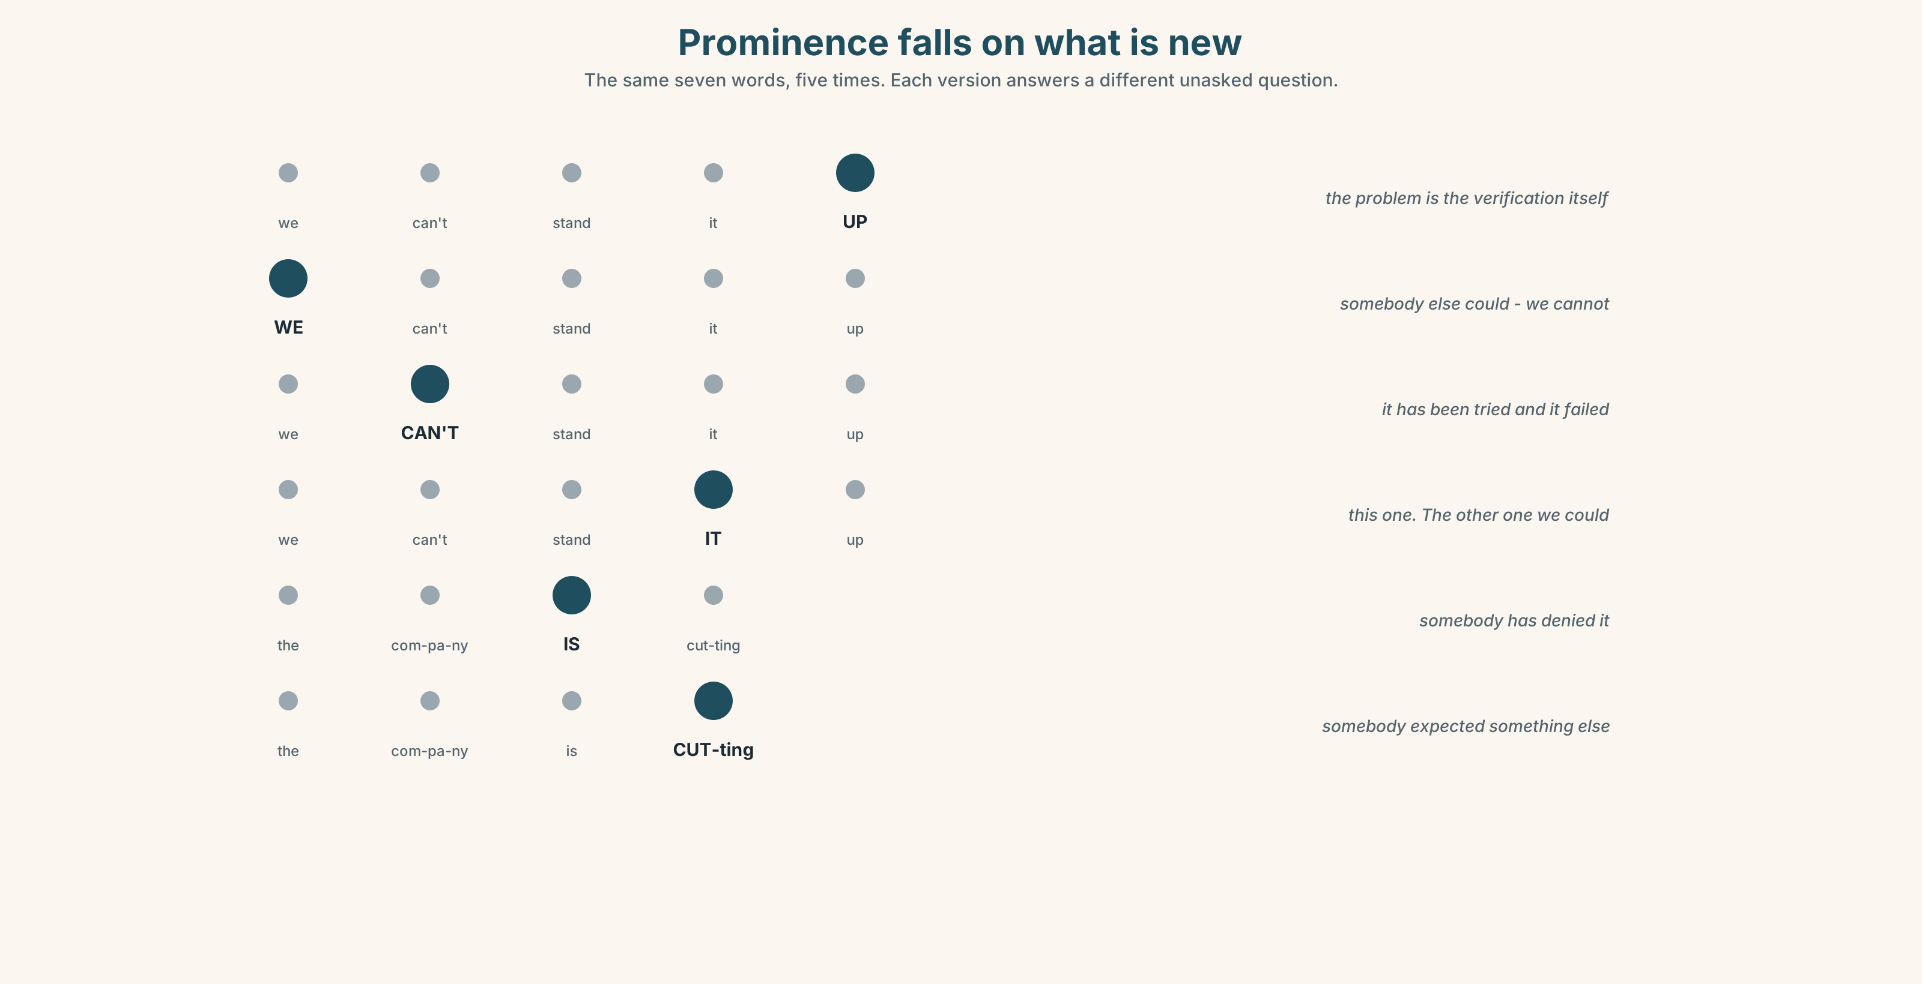{width=6.6in}
Prominence falls on what is new — The same seven words, five times. Each version answers a different unasked question.

Prominence falls on what is new

7A · Hear 🔊 Track 1.3
We can't stand it UP. — the problem is the verification WE can't stand it up. (somebody else can) — the problem is us We can't stand IT up. (we can stand the other one up) — the problem is this story

7B · Say
Say each one three times. Then say this:
The company is cutting jobs. It isn't cutting FOUR HUNDRED jobs. — the second prominence is the whole correction.

7C · Make it mean something
Say these two:
The company IS cutting jobs. — somebody has denied it The company is CUTTING jobs. — somebody expected something else
English puts the main prominence on the information the listener does not already have. Moving it is not emphasis for its own sake; it is a claim about what the listener knows.

7D · Fluency 30 ⏺
Thirty seconds: one claim, stated four times with four different aspects, each followed by the evidence it would require. Three times, faster.

Part 8 · Writing ◆ C · THE PERFORMANCE

A story you can defend · 200 words

8A · Read the model
Thunder Bay plant: 400 jobs under review [the headline hedges with two words]
The Herald understands that the company is considering cuts of up to four hundred jobs at its Thunder Bay plant. [*understands* and *is considering* — a claim with a source removed and a process presented as unfinished]
A single source, who was not authorised to speak, described a board paper circulated on Monday. The Herald has not seen the paper. [what is not known, said in the second paragraph, not the ninth]
The company has been losing money at the plant since the third quarter of last year, which is a matter of public record. [the perfect continuous, on the one fact that needs no source]
The company declined to comment. No decision is understood to have been taken on timing. [the second hedge, and the thing the rival did not write]
Questions about the writer's choices:
- is considering rather than is cutting. What exactly does the change in verb and aspect buy?
- The Herald has not seen the paper. Why in paragraph two?
- The only perfect continuous in the piece is on the public-record fact. Why there?

8B · The anti-model
The company is cutting 400 jobs at its Thunder Bay plant, the Herald can reveal. The cuts will be announced on Thursday. Workers were told nothing. The company refused to comment.
Four sentences, four unhedged claims, and three of them turned out to be wrong. Rewrite it so that every claim is defensible against the evidence described in 5B.

8C · Plan
the hedged headline → the claim with its hedge → what is not known → the one fact that needs no source → the refusal

8D · Write — 200 words

8E · Peer review — three criteria
☐ Is every aspect choice defensible against stated evidence? ☐ Is what is not known in the first half? ☐ Is there at least one fact that requires no source, and is it marked as such?

8F · Write it again · 8G · Publish
Rewrite after review. Publish the two versions side by side with the evidence list between them.

Part 9 · The File ◆ A · THE WORLD + C · THE PERFORMANCE
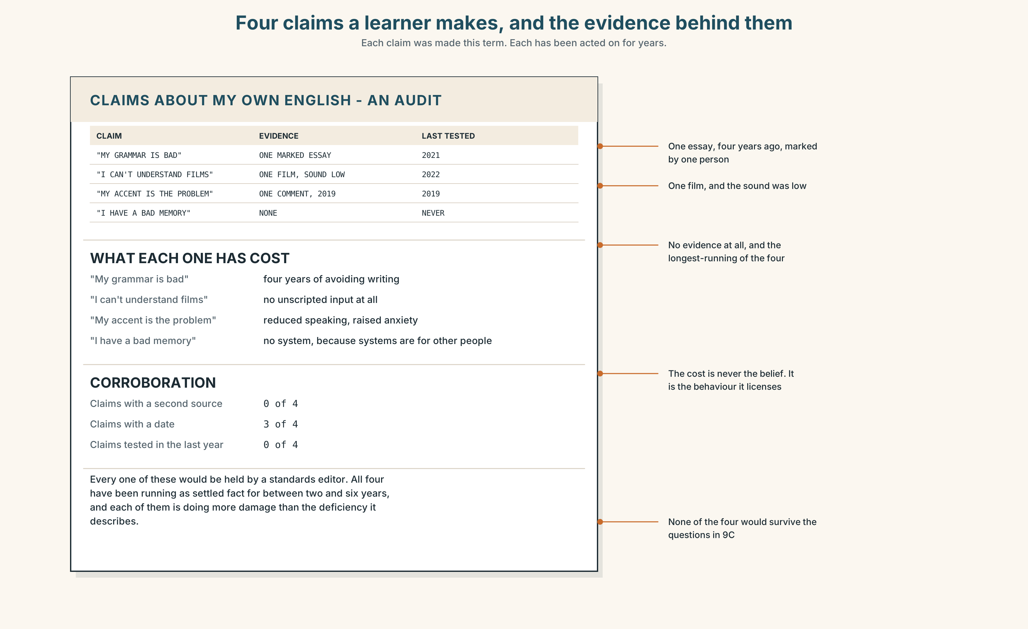{width=6.6in}
Four claims a learner makes, and the evidence behind them — Each claim was made this term. Each has been acted on for years.

STUDY FILE · What you can stand up about your own English

9A · A claim nobody has corroborated 🔊 Track 1.4
Learners make claims about their own English constantly — my grammar is bad, I can't understand films, my pronunciation is the problem — and almost none of them has ever been checked against evidence.
the claim | I can't understand native speakers.
the evidence | one film, in 2022, with the sound low
the corroboration | none
what it costs | three years of avoiding the thing

9B · Stand one up
Take one claim you make about your own English. Write the evidence you actually have for it, with dates. Most learners find the evidence is a single occasion.

9C · Role play — the standards editor
In pairs. One of you states three claims about your own English. The other is the standards editor and may ask only: What is your evidence? Who else has said it? When was it last tested?

9D · The working assumption
Some claims cannot be tested cheaply and still have to be acted on. Mark yours as working assumptions, in writing. A working assumption you have labelled is a different thing from a belief you have forgotten you adopted.

9E · Transfer — before next week
Test one claim. Watch twenty minutes of something unscripted, with no subtitles, and write down the percentage you followed. Bring the number.

Part 10 · Mediation & Interaction ◆ C · THE PERFORMANCE
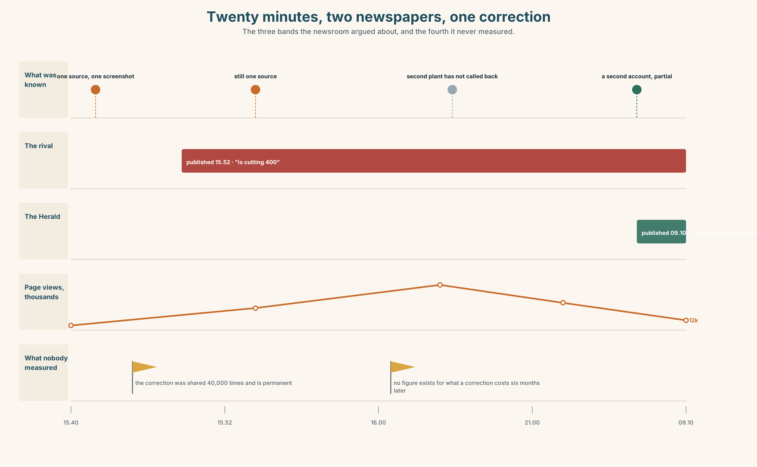{width=6.6in}
Twenty minutes, two newspapers, one correction — The three bands the newsroom argued about, and the fourth it never measured.

10A · Relay
Half the class has the source's account. Half has the documents. Produce one agreed sentence by speaking only. Ten minutes.

10B · Simplify — for one reader
A reader emails: Why did you publish a day late? Answer in four sentences without blaming the rival and without claiming virtue.

10C · Online
Write one message to a colleague explaining why a sentence in their draft claims more than the evidence. Three sentences. Name the aspect.

10D · Your language
Does your language mark the difference between cuts and is cutting grammatically? Translate all four sentences from 2A. Which distinctions survive?

Part 11 · The Decision ◆ C · THE PERFORMANCE

Forty minutes
It is 15.40. One source, a screenshot, a claim that moves a share price, and twenty minutes of trading left.
Option one: publish now with hedges. Is understood to be considering. Defensible, fast, and a hedge in a headline is read by nobody.
Option two: hold until a second account. Costs the exclusive and about forty thousand page views, and is what the paper's own standards policy requires.
Option three: publish the fact that you are holding it — a line saying the Herald has heard the claim and has not been able to corroborate it.

11A · The evidence
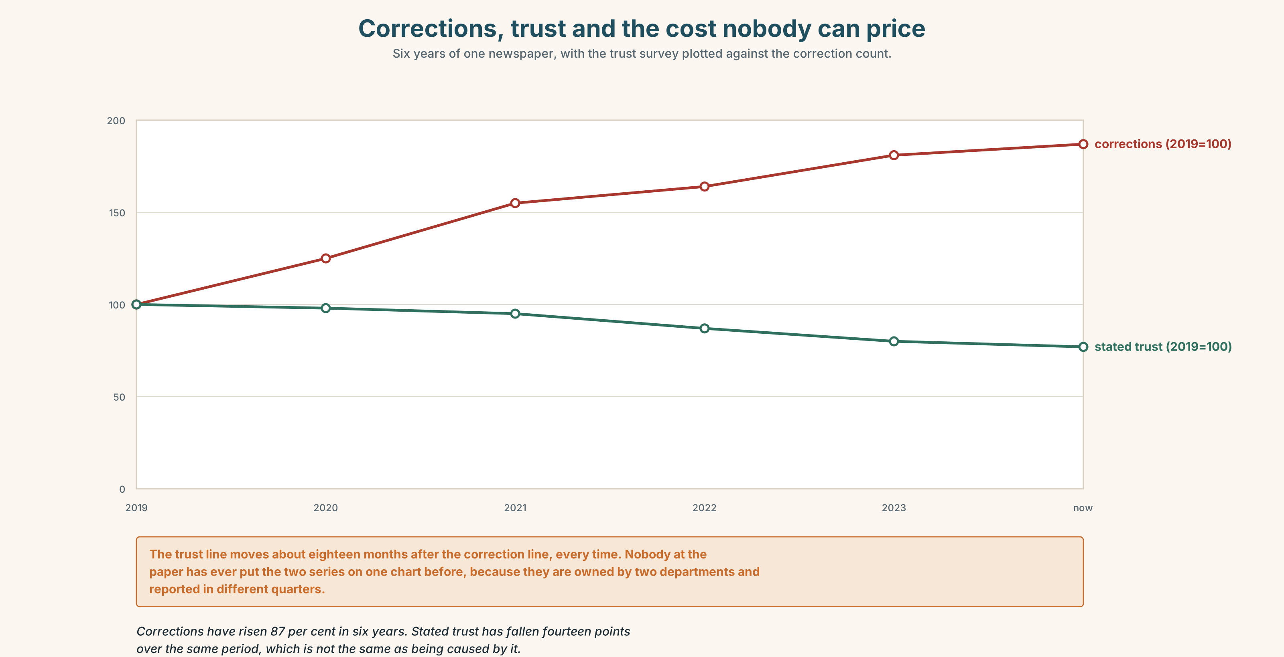{width=6.6in}
Corrections, trust and the cost nobody can price — Six years of one newspaper, with the trust survey plotted against the correction count.
🔊 Track 1.6. The standards editor, 30 seconds: "We ran four hundred corrections last year. Nobody can tell me what one costs, because the cost is not on the day you correct it. It is six months later, in a different story, when somebody decides on balance not to believe us."

11B · Talk about it
In threes. Use the frame. Everybody takes one position and must state the evidence it rests on.
I would ______ , because ______ , and I would be wrong if ______ .

11C · Decide
Write three sentences: the decision, the evidence, and the condition under which you would reverse it.

11D · Model decision
Option three. The first two are a choice between being wrong and being late, and both of those have been priced. Nobody has ever priced the third, which is the only one that tells the reader what the paper actually knows at 15.40 — and what a reader buys from a newspaper, if they buy anything, is the difference between those two states.

11E · The Reveal
What happened. The Herald held. It published at 09.10 with is understood to be considering, and it has never published a line saying what it is holding.
Then something nobody in the room predicted: the rival's correction, two column centimetres on page eleven, was screenshotted and shared about forty thousand times. The correction travelled further than the story it corrected, and it is still the first result for the company's name.
One question. You do not have to answer it out loud.
The newsroom argued for two days about whether being right on Wednesday is a product. What did the forty thousand screenshots suggest about who was buying it?

Part 12 · Landing ◆ all three lines

12A · Recycle — fifteen items
- The company ______ (cut) 400 jobs. (confirmed, complete)
- The company ______ (cut) jobs since March. (duration up to now)
- The number ______ (change) all week. (in progress)
- The board ______ (go to announce) it on Thursday. (a plan that failed)
- ______ it ______ , we have one source. (two words — what is true at this moment)
- The claim ______ ______ ______ as unverified. (three words — somebody else classified it)
- It ______ ______ ______ have begun in March. (three words — attributed to nobody)
- We cannot ______ ______ ______ ______ . (four words — the refusal)
- It ______ ______ . (two words — the opposite of 8)
- We will have to ______ ______ ______ on Monday. (three words — page two)
- The documents ______ ______ what she told us. (two words)
- Let us see how it ______ ______ before we publish. (two words)
- (Unit 0) Everybody else has gone. We ______ ______ ______ . (three words)
- She said it ______ ______ ______ , without her name. (three words)
- The Herald ______ that a board paper exists. (the verb that removes the source)

12B · Consolidate — one task, everything in it
Write a 150-word account of something you witnessed. Every verb must be defensible: mark in the margin, for each one, whether you are claiming it is complete, in progress, or inferred.

12C · Can-do, with evidence
☐ I can choose aspect to match evidence. Evidence: 3H, 8D ☐ I can hedge a claim without weakening the sentence. Evidence: 4C, 6C ☐ I can hear and place prominence on new information. Evidence: 7C ☐ I can say what would change my sentence. Evidence: 11C

12D · Replay ⏺
Record 0C again. Compare the two. How many of your original claims had evidence attached?

12E · Glossary — fifty items, as a map
THE CLAIM · claim · source · stringer · dateline · attribution · provenance THE CHECK · verification · evidence · corroboration · embargo AFTERWARDS · correction · retraction THE STATES OF A STORY · a single source · a verified account · a working assumption · a story with legs · the cost of being first ON OR OFF · on the record · off the record WHAT YOU DO · stand a story up · run a correction · hold the line · stand up · back up · hold off IN THE ROOM · we can't stand it up · it checks out · who else has it? ASPECT, IN A WORD · ongoing · momentary · habitual · iterative · provisional · settled · unfolding · emergent ASPECT, IN A PHRASE · as it stands · at the time of writing · has been developing · is being treated as · was being described as · is understood to · had been expecting · is thought to have WHAT HAPPENS NEXT · play out · bear out · pan out WHAT YOU WRITE · the situation is developing · we understand that · it now appears that

12F · Next
Unit 2 · Who is "we"?

