Table of Contents

B2.1 · Unit 3 · A Doubling of Risk
English Animated · Reading Between Lines · a newsroom, Toronto Student's Book pages 50–71 · 22 pp · ~11 hours

Part 0 · The Big Picture ◆ A · THE WORLD
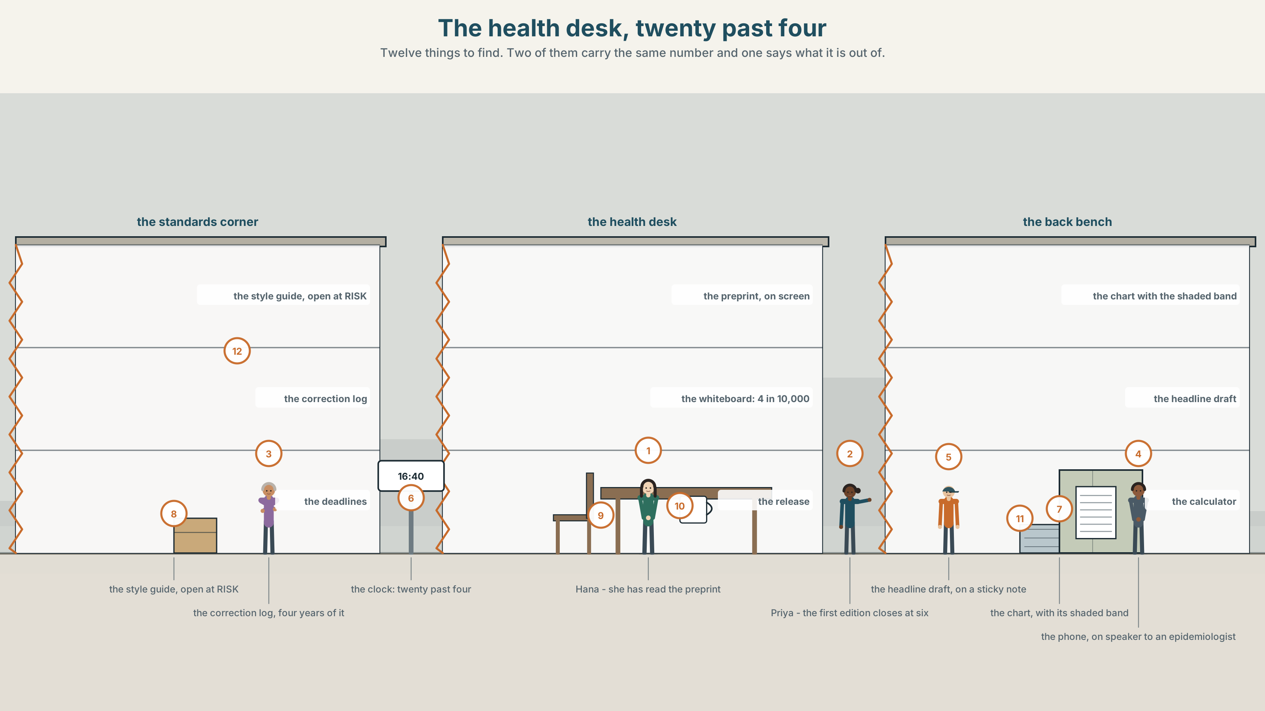{width=6.6in}
The health desk, twenty past four — Twelve things to find. Two of them carry the same number and one says what it is out of.

How sure are you?
By the end of this unit you can set your certainty exactly where the evidence puts it, and defend the setting. Two hundred words.
◆ A · THE WORLD | A press release that says doubles, a preprint that says four in ten thousand, and a headline due at six
◆ B · THE SYSTEM | the full epistemic range of modals · 28 words for risk and evidence · 22 words and phrases for calibrating certainty · stress on a modal
◆ C · THE PERFORMANCE | Two hundred words in which every claim is pitched at its evidence

0A · Find it
Find twelve things in this picture. Two of them contain the same number and only one of them says what it is out of.
the printed press release · the preprint on the screen · the whiteboard with the base rate on it · the phone on speaker to an epidemiologist · the headline draft on a sticky note · the health desk's correction log · a calculator · a chart with a shaded band on it · the style guide open at RISK · the clock showing 16:40 · the first edition deadline on the wall · a mug with a university logo

0B · Guess it
One object in this picture would change the headline if anybody read it. Which one, and why has nobody opened it?

0C · Say it ⏺
Record sixty seconds. Describe something about your own future that you are sure of, and something you are only fairly sure of. Make the difference audible. You will record it again at the end of this unit.

Part 1 · Vocabulary Lab 1 ◆ B · THE SYSTEM
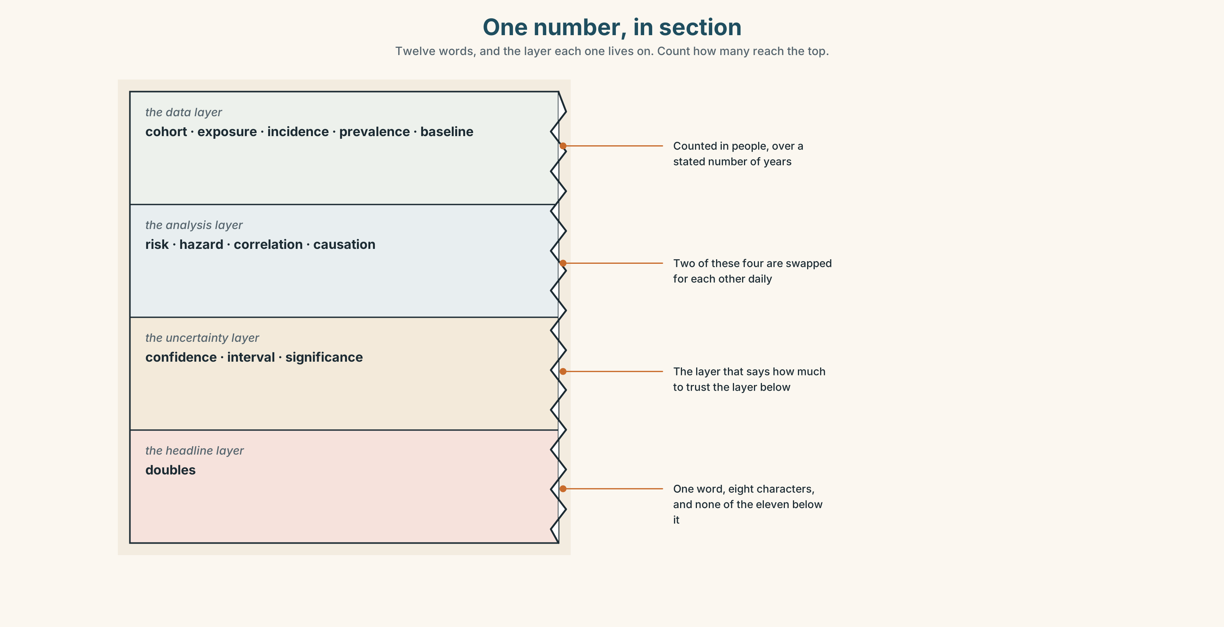{width=6.6in}
One number, in section — Twelve words, and the layer each one lives on. Count how many reach the top.

1A · Meet — the words under a number
Match each word to one layer of the cutaway.
risk · hazard · exposure · incidence · prevalence · baseline · confidence · interval · significance · correlation · causation · cohort

1B · Sort — counted in people, a relation between numbers, or a measure of doubt?
Three columns. Two of the twelve are swapped for one another in print almost daily, and that swap is the subject of this unit.
cohort · incidence · risk · confidence · prevalence · correlation · interval · exposure · hazard · baseline · causation · significance

1C · Meet — the five phrases a risk story turns on
absolute risk | How many people out of how many. The only figure a reader can act on.
relative risk | One risk divided by another. Large, dramatic, and meaningless alone.
a doubling of risk | Two in a million, or four in ten. The phrase does not distinguish them.
the base rate | What the risk was before anything happened. Almost never printed.
statistically significant | Unlikely to be chance. Not a synonym for large, important or true.

1D · Collocation Lab
Complete each one, and say which of the five has been checked by somebody with no stake in it.
a causal link · the margin of error · peer reviewed · a preprint · a press release
- The university's communications office sent ______ ______ ______ at nine this morning.
- The study itself is ______ ______ , posted online and not yet assessed by anybody.
- Nothing in it has been ______ ______ , which the release mentions in the last line.
- The authors are careful never to claim ______ ______ ______ ; the release is not.
- The estimate carries ______ ______ ______ ______ wide enough to include almost no effect at all.

1E · The phrasal verbs, and the three fixed expressions
scale up · rule out · bear in mind
f the evidence does not support that · f it may well be · f we cannot rule it out
Two of these fixed expressions leave a door open and one closes it. Which closes it, and which of the two open doors is doing the more honest work?

1F · Own it
Write one sentence about your own health, work or study that contains a number, and then write underneath it what that number is out of.

Part 2 · Listening ◆ A · THE WORLD
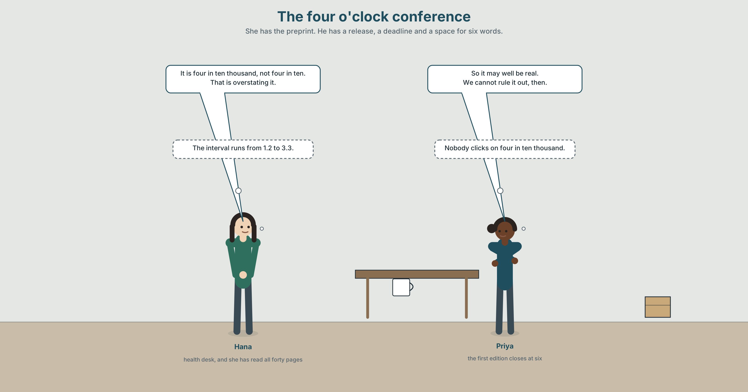{width=6.6in}
The four o'clock conference — She has the preprint. He has a release, a deadline and a space for six words.

2A · The four o'clock conference 🔊 Track 3.1
Before you listen. A press release says night shifts double the risk of a rare heart-rhythm condition. The health reporter has read the preprint. The news editor has forty minutes.
Listen once. What does the study show, and what does the release say it shows?
Listen again. Complete the table.
 | The number | What it is out of | How sure the authors are
the release
the preprint
the epidemiologist
Listen again. True or false?
- The reporter has spoken to one of the authors. ☐ T ☐ F
- The release gives the base rate. ☐ T ☐ F
- The confidence interval runs from 1.2 to 3.3. ☐ T ☐ F
- The editor wants the word doubles kept. ☐ T ☐ F
Noticing. Five sentences from the recording.
- It must be a real effect.
- It is likely to be a real effect.
- It may well be a real effect.
- It could hardly have been chance, at that interval.
- We cannot rule it out.
Five settings on one scale, about one finding. Which of the five could the paper defend in court, and which could it defend only in the bar afterwards?

2B · Decoding clinic 🔊 Track 3.2
Thirty seconds at speed. Three jobs.
- The epidemiologist says must have four times. Write what you hear, not what is written.
- One modal is stressed. Which, and what is the speaker contrasting it with?
- The reporter says that is overstating it once. What exactly is she rejecting?

Part 3 · Grammar Lab 1 ◆ B · THE SYSTEM

A modal is a promise about how sure you are

3A · Notice
Look at the five sentences in Part 2 again.
- Which one commits the speaker most, and what evidence would it need?
- Which one commits the speaker least while still asserting something?
- Sentence 4 is about the past. How does the form show it?
- Sentence 5 says nothing about how probable the effect is. What does it say instead?

3B · See
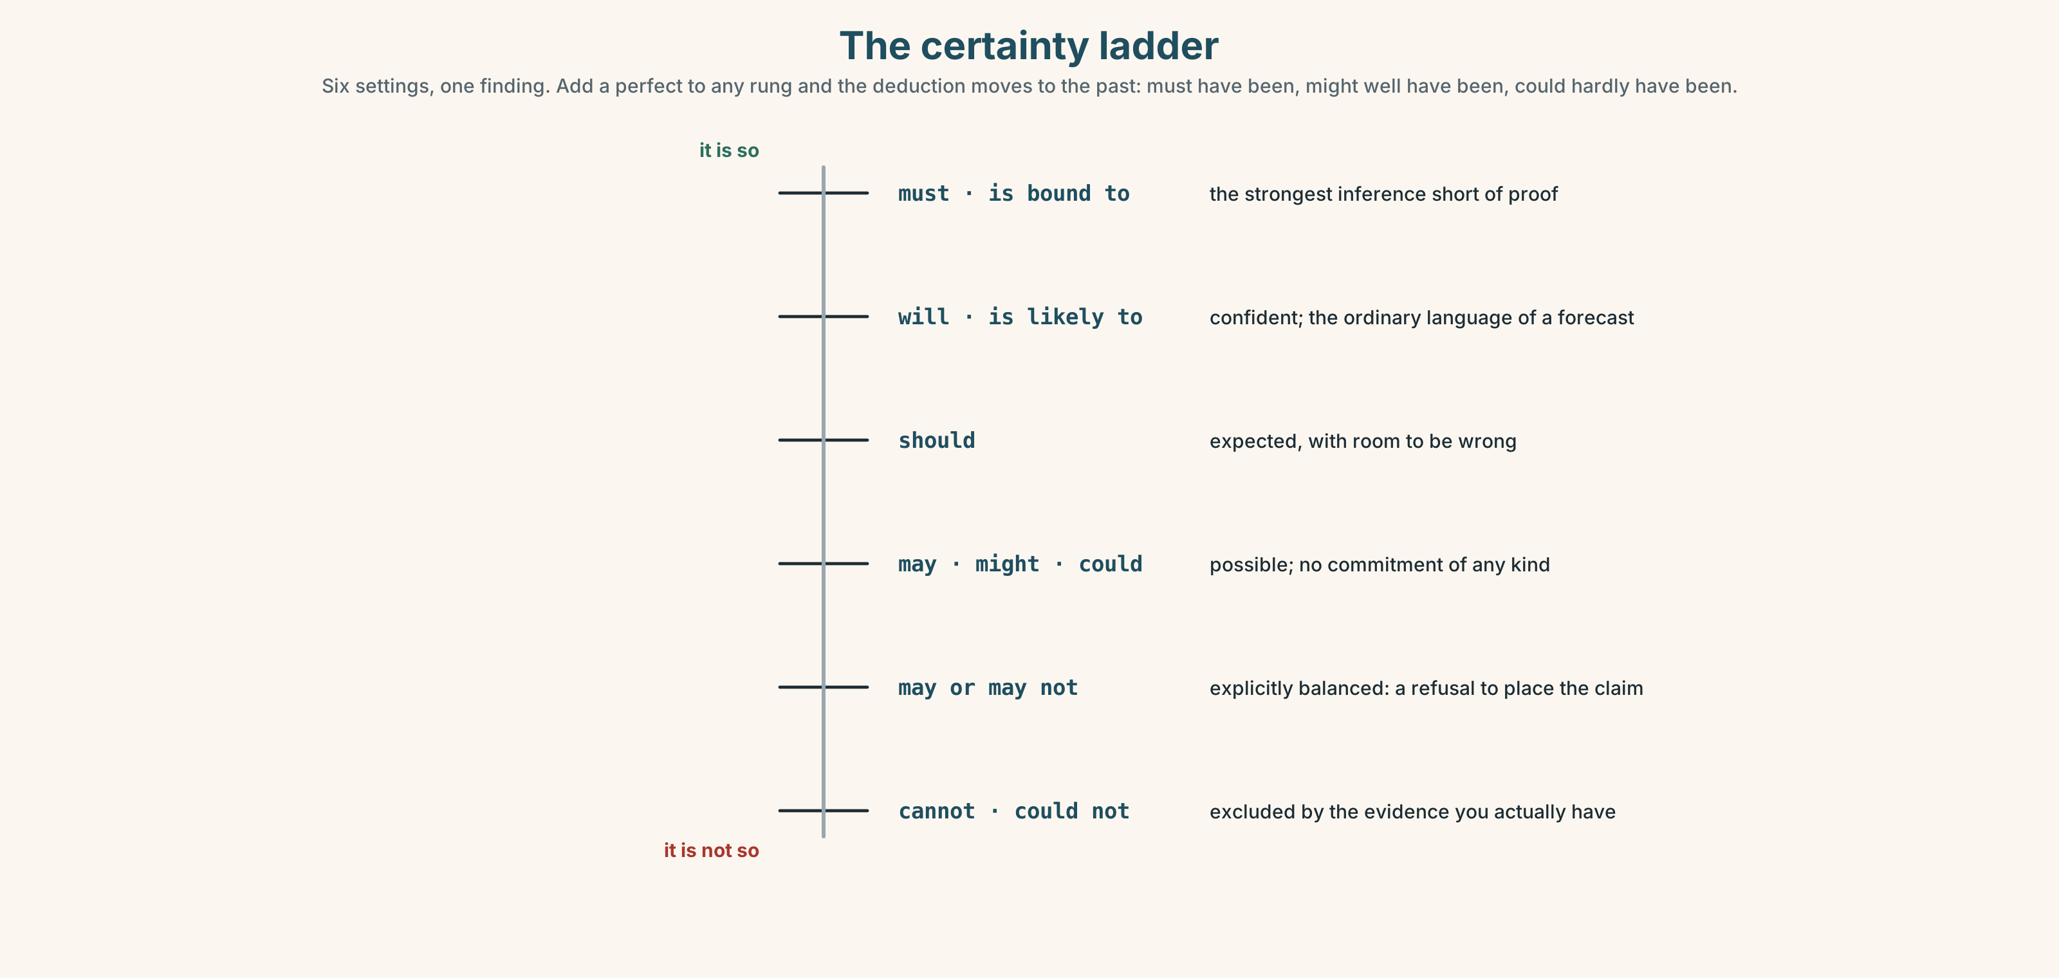{width=6.6in}
The certainty ladder — Six settings, one finding. Add a perfect to any rung and the deduction moves to the past: must have been, might well have been, could hardly have been.

3C · Know
must · is bound to | the strongest inference short of proof | It must be a real effect.
will · is likely to | confident, and routine in forecasting | That is likely to be the explanation.
should | expected, with room to be wrong | The replication should settle it.
may · might · could | possible; no commitment at all | It may well be chance.
can't · could hardly have | excluded by the evidence | It could hardly have been chance.
The epistemic modals are a scale, and the scale is public. A reader who sees must and later learns the interval ran from 1.2 to 3.3 has caught the writer overclaiming, and will not forget it.
Deduction about the past takes the perfect. must have been, might well have been, could hardly have been. The modal sets the certainty; the perfect sets the time. The two choices are independent, which is why every combination exists.
adverbs run the same scale | conceivably · arguably · presumably · demonstrably · unequivocally
and some of them do not | ostensibly · allegedly · reportedly — these report somebody else's certainty, not yours
the passive reporting frame | is said to · is reported to · has yet to be confirmed
the balanced statement | may or may not — which is a refusal to place the claim at all
Why it matters. Every sentence about the future, about a cause, or about somebody else's data is a bet, and the modal is the size of the bet. Writers who always bet large are read once.

3D · Use — controlled
Complete with the modal that the evidence in brackets will support.
The finding (1) ______ be chance, given the interval. (it cannot be excluded) At that cohort size the effect (2) ______ be real. (as sure as the data allows) The authors (3) ______ have seen the release before it went out. (the evidence suggests not) A replication (4) ______ settle it within two years. (expected, with room) Whether it applies to day workers (5) ______ or ______ ______ be the same question. (explicitly balanced)

3E · Use — guided
Rewrite each one so that the certainty matches the evidence in brackets.
- Night shifts cause the condition. (one cohort, not peer reviewed)
- The release was written by somebody who had not read the paper. (a guess, past)
- The effect is chance. (excluded by the interval)
- The paper will replicate. (a hope, not a forecast)
- The authors disagree with the release. (you have not asked them)

3F · Use — open
In pairs. One of you states a claim at the top of the scale. The other asks what would you need to have seen? Keep going until the claim comes down to where the evidence actually is.

3G · Error autopsy
✗ It must to be a real effect. ✗ It might be chance last year, we cannot say. ✗ The evidence doesn't support that it is demonstrably possible.
For each, name the rule and say what the writer was reaching for.

3H · Check — eight items
- It ______ be chance; the interval includes 1.2. (possible, uncommitted)
- At that cohort size it ______ be real. (strongest inference)
- They ______ ______ seen the release first. (past, strong inference, negative evidence)
- It ______ ______ ______ been chance at that interval. (past, all but excluded)
- It ______ ______ ______ be the same in day workers. (explicitly balanced, five words)
- ✗ It must to be a real effect. → correct it.
- Rewrite Night shifts cause it so that it survives peer review.
- Rewrite We cannot rule it out so that a reader can tell how likely it is.

Part 4 · Speaking ◆ C · THE PERFORMANCE

4A · Fluency starter — move one notch
One person makes a claim. The next person repeats it one notch weaker, the next one notch weaker again, until nothing is left. Then climb back up. No notch may be skipped.

4B · The functional core — calibrating certainty
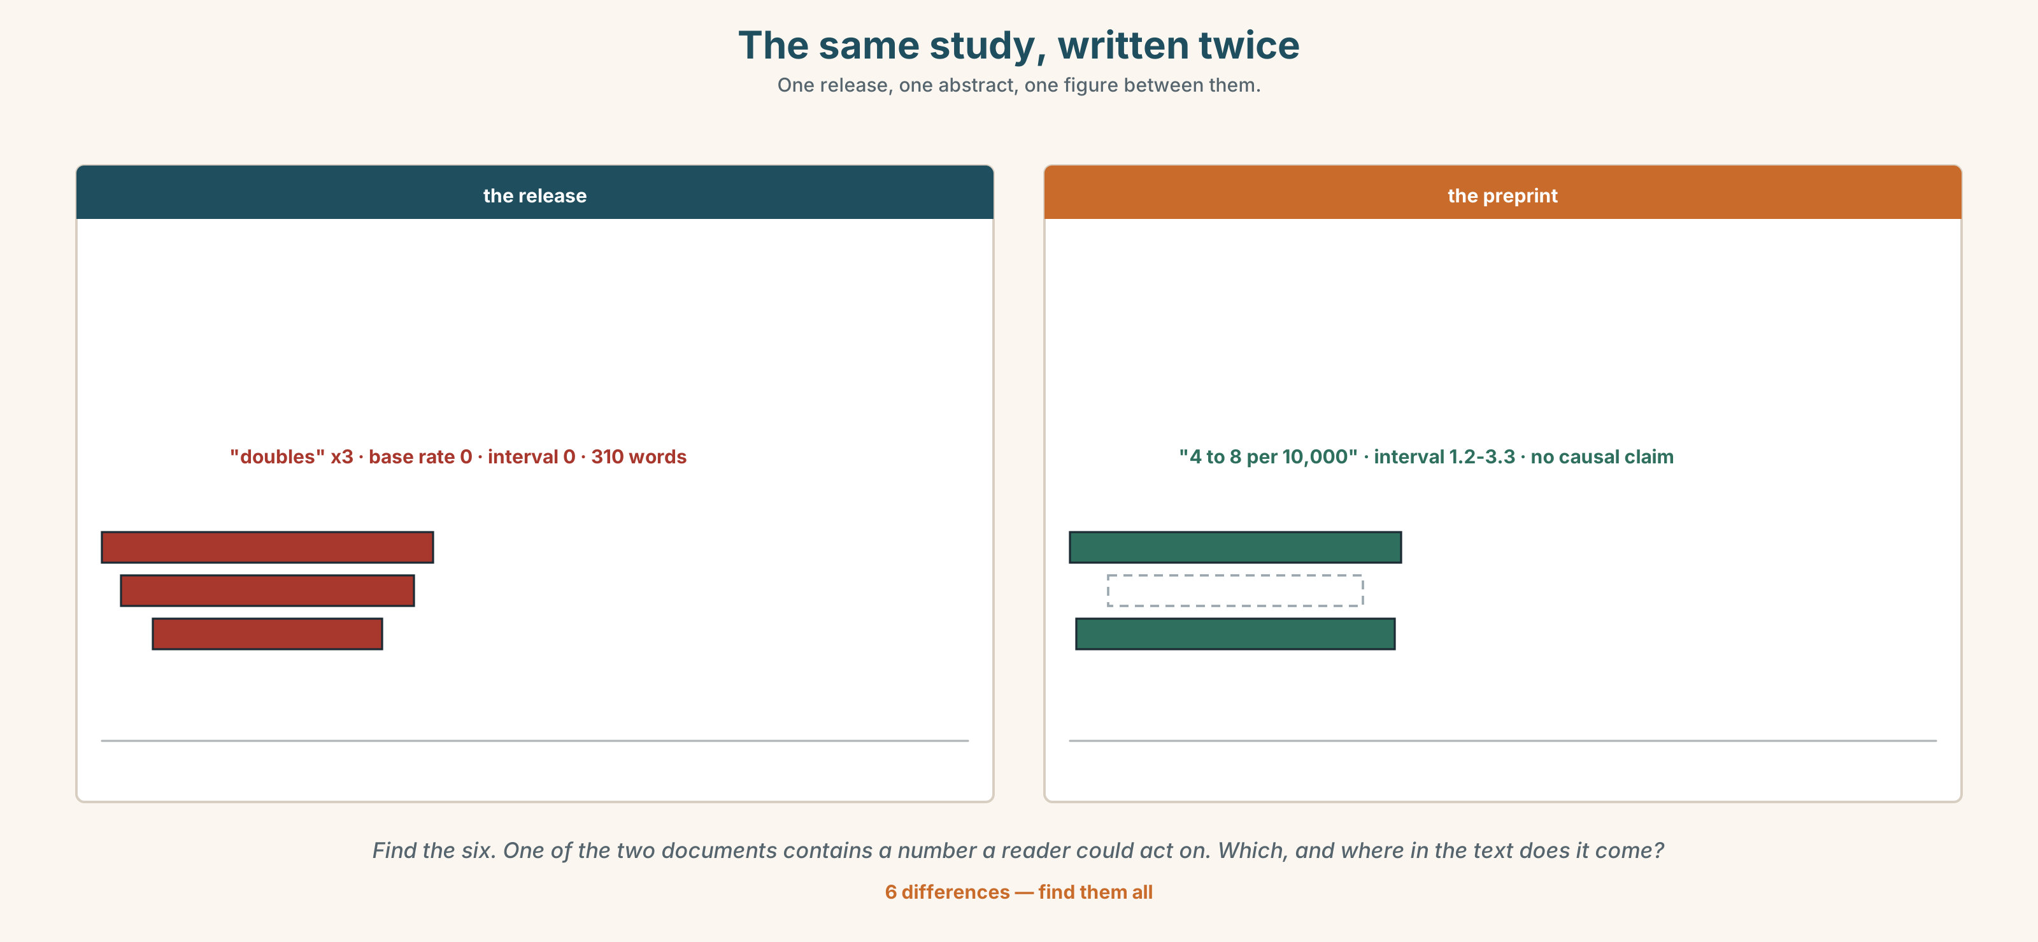{width=6.6in}
The same study, written twice — One release, one abstract, one figure between them.
Language Bank
committing | demonstrably · unequivocally · is bound to · must surely be
hedging | conceivably · arguably · presumably · may or may not
sourcing it elsewhere | ostensibly · allegedly · reportedly · is said to · has yet to be
refusing the frame | that is overstating it · the evidence does not support that
Information gap. Learner A has the press release. Learner B has the preprint's own abstract. Agree on one sentence that both documents can support.

4C · The performance — three minutes ⏺
Present the finding to a room, in three minutes, stating your certainty three times at three different settings: once at the top of the scale about something you can prove, once in the middle, and once at the bottom. Your partner writes down the evidence each setting would need.
Record it.

4D · Observer
One person marks every modal and every adverb of certainty, and writes beside each one the evidence it is claiming.

4E · Three criteria
☐ Was every claim pitched where its evidence actually is? ☐ Did I use at least one past-deduction form, with a perfect? ☐ Could my partner tell, by ear, which claims I would defend?

Part 5 · Reading ◆ A · THE WORLD

5A · Predict
The title is "Four in ten thousand." What do you expect the headline on this story to have said instead, and why?

5B · Read — two minutes

Four in ten thousand
The release arrived at nine. Night work, it said, doubles the risk of a rare heart-rhythm condition, in a cohort of sixty-one thousand Danish adults followed for nine years.
The preprint says something narrower. In the group that worked no night shifts, the incidence was four cases per ten thousand people per year. In the group working four or more nights a week it was eight. That is a doubling of risk, and it is also four extra people in ten thousand.
The confidence interval runs from 1.2 to 3.3, which means the study is consistent with an effect of almost nothing and with an effect three times larger than the one reported. The result is statistically significant, just. The authors say, twice, that they cannot establish a causal link and that the cohort was not designed to.
The release says doubles three times. It does not give the base rate anywhere in three hundred and ten words.
By four o'clock the health reporter had the epidemiologist on the phone. "It may well be real," she said. "We cannot rule it out, and we cannot scale it up to the whole workforce either. Bear in mind what it is out of."
The first edition closes at six. The desk has two numbers, both true, and room for one of them in a headline.

5C · Comprehension — eight questions
- How many people were in the cohort, and for how long?
- What was the incidence in the group that worked no night shifts?
- What does the confidence interval run from and to?
- How many times does the release use the word doubles?
- What do the authors say twice?
- Why does the writer give the length of the release in words?
- "Both true" — what is the difference between the two numbers, if neither is wrong?
- The last sentence says room for one of them. What is the real constraint being described?

5D · Vocabulary in context
Infer from the text, then check.
consistent with an effect of almost nothing · just · designed to · what it is out of · room for one of them

5E · The counter-text
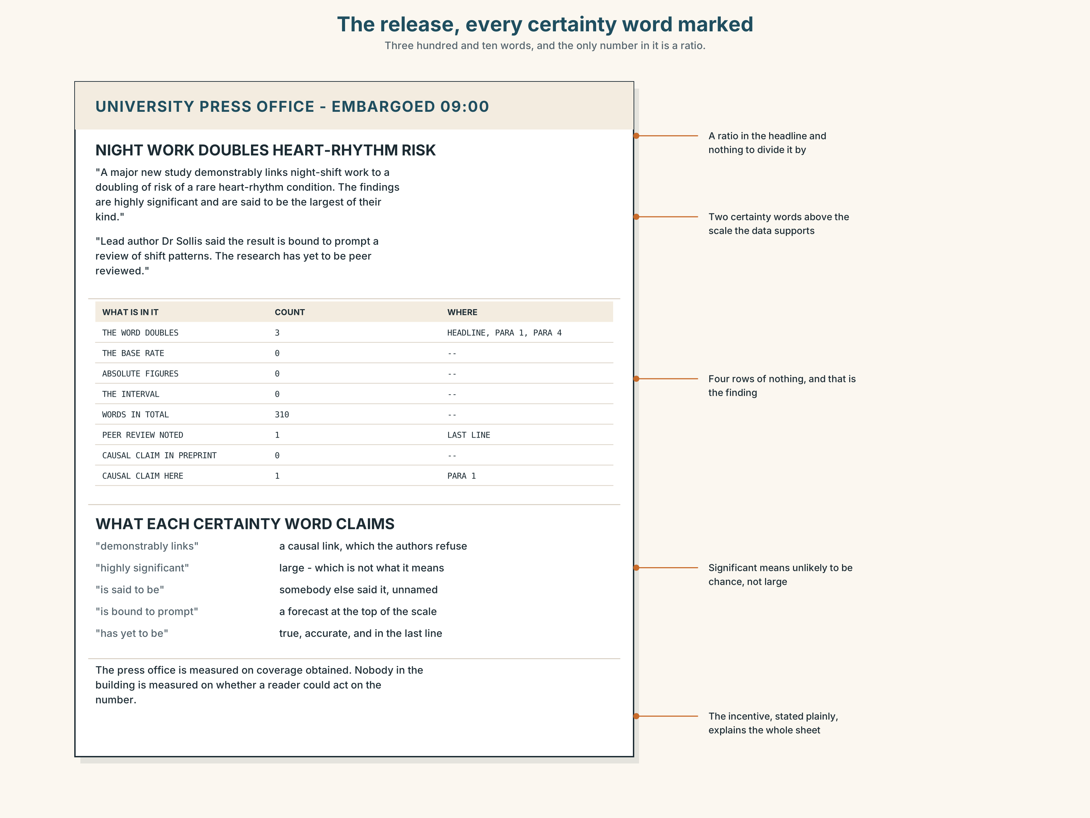{width=6.6in}
The release, every certainty word marked — Three hundred and ten words, and the only number in it is a ratio.
Read the press release and answer.
- Where in the release does the base rate appear?
- Find every word in it that sets a level of certainty, and say what evidence each one claims.
- The release and the preprint use the same figure. What does each one leave out?
- Who wrote the release, and what were they measured on?

5F · Two texts
The release says doubles the risk. The preprint says an increase from four to eight cases per ten thousand person-years.
Is the release false? Write two sentences, and use the phrase the base rate in one of them.

Part 6 · Vocabulary Lab 2 ◆ B · THE SYSTEM

Saying how sure you are, in one word

6A · Sort — the writer is unsure, somebody else said it, or the writer is committed?
Three columns.
presumably · allegedly · demonstrably · conceivably · reportedly · unequivocally · arguably · ostensibly

6B · Chunk completion
- The replication ______ ______ ______ take two years. (three words — expected, confident)
- At that sample size the result ______ ______ ______ hold. (three words — as sure as you can be)
- They ______ ______ ______ read the preprint before writing the release. (three words — past, strong)
- It ______ ______ ______ been chance at that interval. (four words — past, all but excluded)
- There ______ ______ ______ some effect, on these numbers. (three words — strong inference)
- Day workers ______ ______ ______ ______ show the same pattern. (five words — balanced)
- The release ______ ______ ______ have been approved by the authors. (three words — reported, unverified)
- The finding ______ ______ ______ ______ replicated. (four words — not yet, and that matters)

6C · Three that are not interchangeable
is said to · is likely to · has yet to be
Say which one gives a probability, which one gives a source, and which one gives a date that has not arrived.

6D · The phrasal verbs and the fixed expressions
hedge about · come down on · hold back
f on the balance of probability · f to the best of our knowledge · f that is overstating it
One of these three fixed expressions is a legal standard, one is an institutional limit and one is a correction. Match them, and say which one a scientist would use about their own work.

6E · Contrast Clinic
Eight items. Rewrite each sentence so that the certainty moves to the level in brackets.
- Night shifts cause the condition. (one cohort, no causal claim possible)
- The effect is chance. (all but excluded, past form)
- Perhaps the release was written by the press office. (strong inference about the past)
- The study is wrong. (you have read the abstract only)
- It will be replicated next year. (a hope with no evidence)
- Everybody knows night work is dangerous. (what you can actually demonstrate)
- The authors approved the release. (you have been told, by one person)
- There is no effect. (the interval includes both almost nothing and a large effect)

Part 7 · Pronunciation & Fluency Lab ◆ B · THE SYSTEM
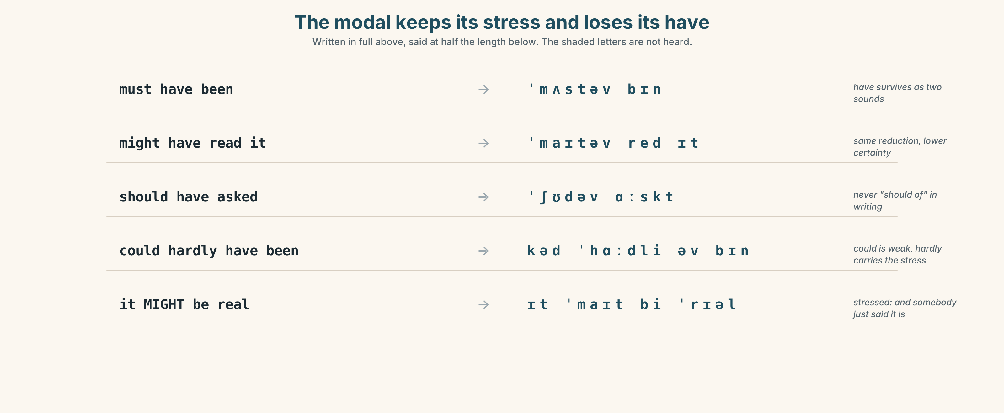{width=6.6in}
The modal keeps its stress and loses its have — Written in full above, said at half the length below. The shaded letters are not heard.

A modal you stress is a modal you are defending

7A · Hear 🔊 Track 3.3
It must have been chance. → /ɪt ˈmʌstəv bɪn ˈtʃɑːns/ — have has gone entirely They might have read it. → /ðeɪ ˈmaɪtəv ˈred ɪt/ It could hardly have been real. → /ɪt kəd ˈhɑːdli əv bɪn ˈrɪəl/

7B · Say
Say each one three times, fast. Then say this:
They might have read it, they should have read it, and they could have asked. — three perfect modals in one breath, and not one full have among them.

7C · Make it mean something
Say these two:
It might be real. — unstressed modal: the ordinary, uncommitted statement It MIGHT be real. — stressed: and somebody in the room has just said it definitely is
An unstressed modal reports your certainty. A stressed one disputes somebody else's, which is why a stressed modal in a meeting is never neutral.

7D · Fluency 30 ⏺
Thirty seconds: one finding, described at four settings on the scale, from excluded to certain, with the modal reduced every time it carries a perfect. Three times, faster.

Part 8 · Writing ◆ C · THE PERFORMANCE

A risk story, with every claim at its evidence · 200 words

8A · Read the model
A Danish cohort of sixty-one thousand adults, followed for nine years, reports four extra cases of a rare heart-rhythm condition per ten thousand night workers per year. [the absolute figure first, with what it is out of]
That is a doubling of the baseline, which was four in ten thousand. [the relative figure second, and it is now interpretable]
The result is statistically significant, but the confidence interval runs from 1.2 to 3.3, so the effect may well be very small. [the modal is set at the interval, not at the headline]
The authors could hardly have been clearer that they cannot show a causal link; the university's press release, which has yet to be corrected, says doubles three times and gives no base rate. [past deduction with a perfect, then a reporting frame that places the blame precisely]
Questions about the writer's choices:
- The absolute figure comes first. What would the reader have done with the relative one alone?
- May well be appears once. Why not is?
- The last sentence does not accuse anybody of lying. What does it do instead, and how?

8B · The anti-model
Night work doubles your risk of a serious heart condition, a major new study has found. Experts say the findings are highly significant and could have implications for millions of workers. The research, which has yet to be published, is said to be the largest of its kind.
Three sentences, one real number hidden inside a ratio, and significant used in the wrong sense. Rewrite it so that a reader could decide what to do on Monday.

8C · Plan
the absolute figure, with its base rate → the ratio, now interpretable → the uncertainty, with the modal set at it → who said what, and what has yet to be done

8D · Write — 200 words

8E · Peer review — three criteria
☐ Does every number say what it is out of? ☐ Is each modal set where the interval puts it, not where the story would like it? ☐ Is every claim you did not verify attributed to whoever made it?

8F · Write it again · 8G · Publish
Rewrite after review. Publish both, and underline every modal in each.

Part 9 · The File ◆ A · THE WORLD + C · THE PERFORMANCE
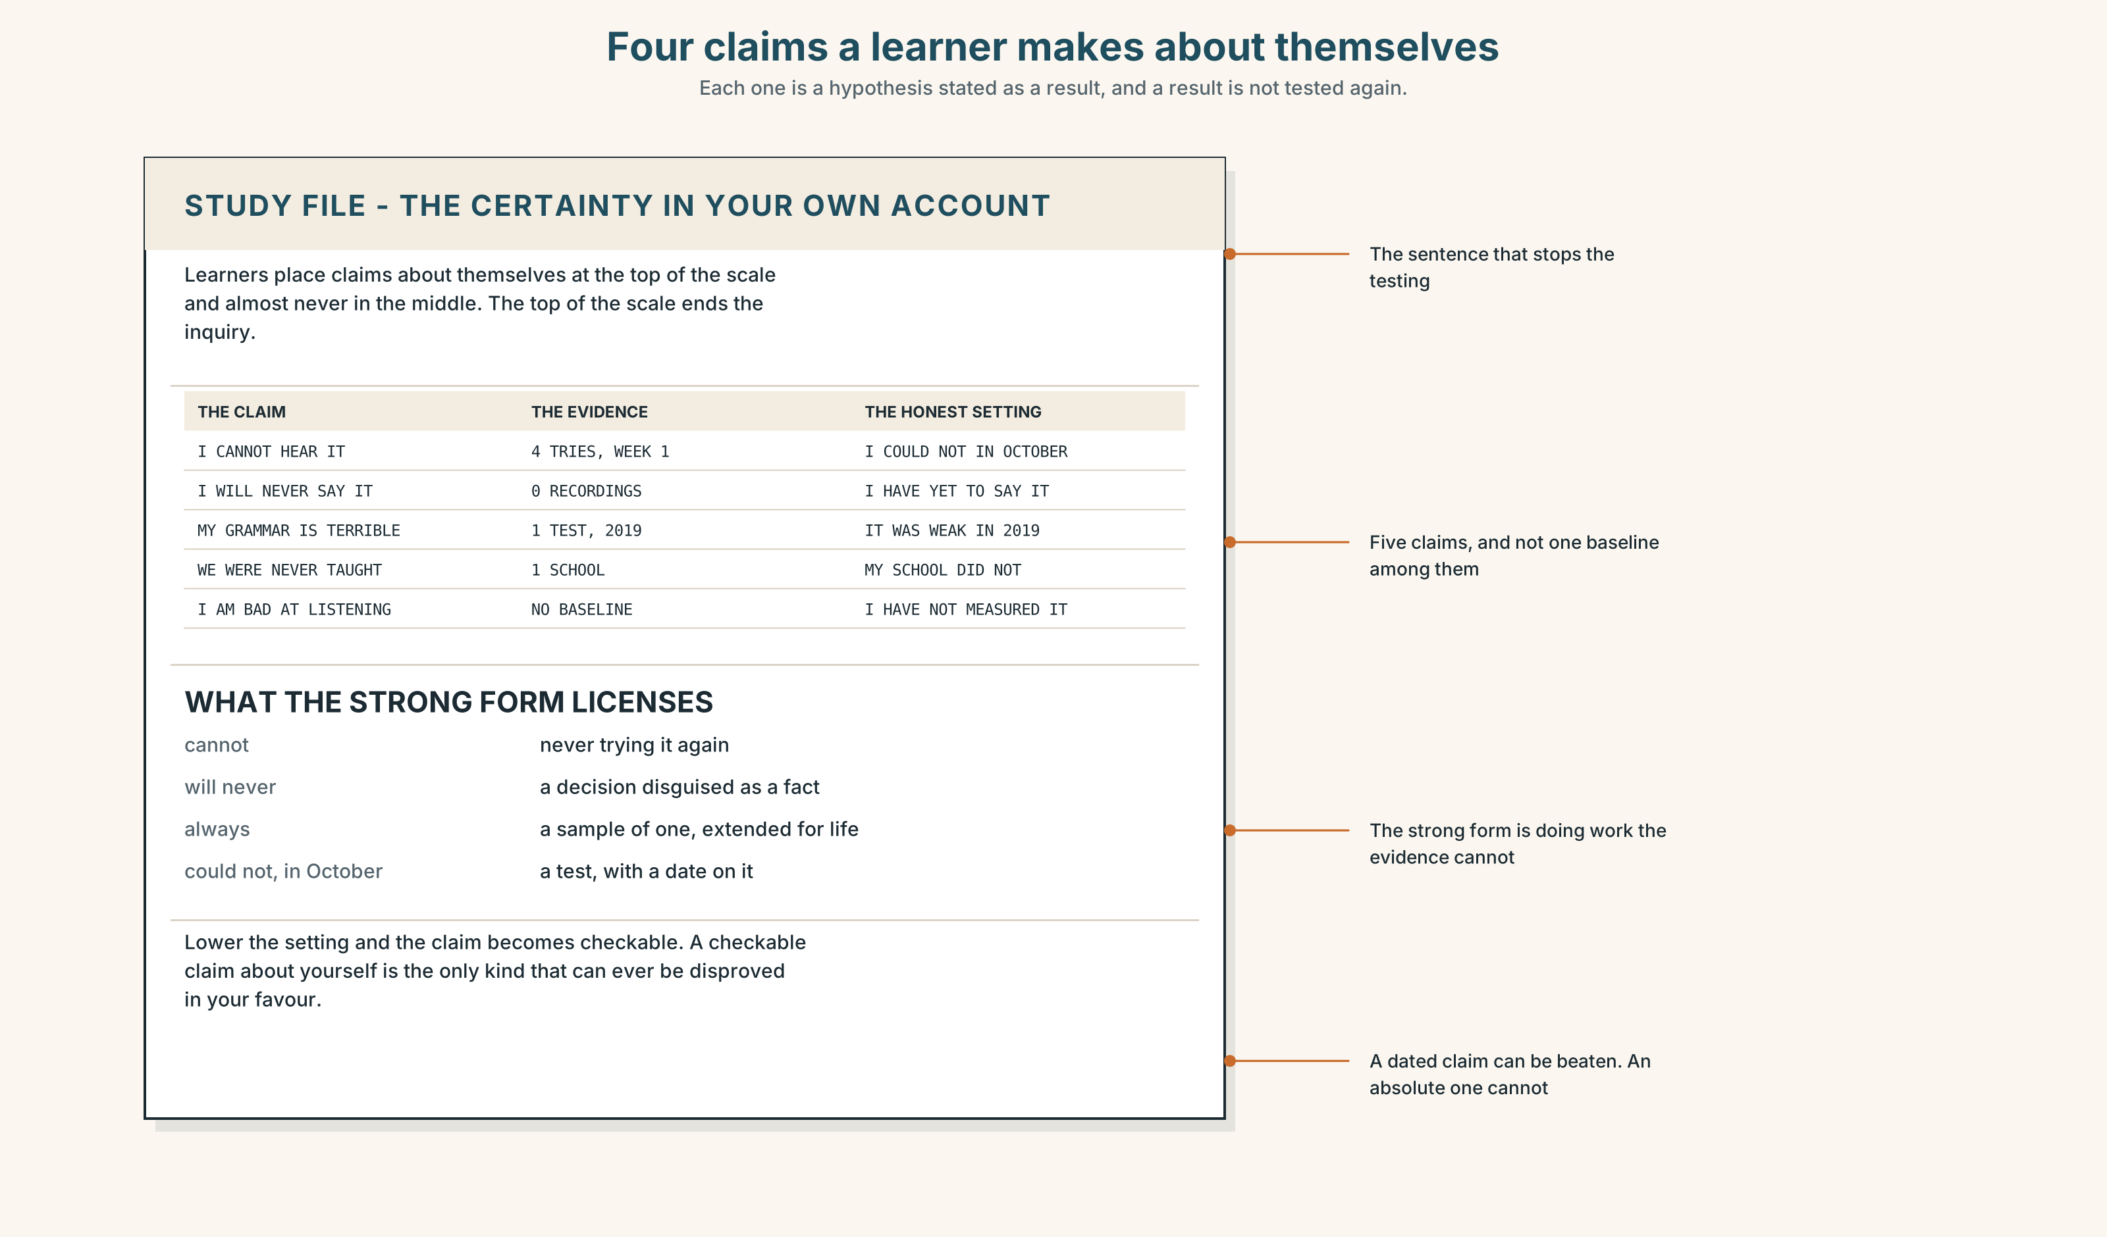{width=6.6in}
Four claims a learner makes about themselves — Each one is a hypothesis stated as a result, and a result is not tested again.

STUDY FILE · The certainty in your own account

9A · Claims you make about yourself 🔊 Track 3.4
Learners describe their own ability at the very top of the certainty scale and almost never at the middle: I can't hear the difference, I will never pronounce this, my grammar is terrible. Each one is a hypothesis stated as a result, and a hypothesis stated as a result stops being tested.
the claim | I can't hear the difference
the evidence | four attempts, all in week one, none recorded
the honest setting | I could not hear it in October
what the strong form licenses | never trying again

9B · Lower the setting
Take three sentences you have said about your English at the top of the scale. Rewrite each at the setting its evidence supports, with a date.

9C · Role play — what would you need to have seen?
In pairs. One of you states a claim about your own English. The other may only ask what would you need to have seen to be that sure? Four rounds each.

9D · The thing you are genuinely sure of
Everybody has one thing about their English they can demonstrate. Name yours and name the evidence. Then say it at the top of the scale, out loud, once.

9E · Transfer — before next week
Take one claim you made at the top of the scale and test it properly. Three attempts, recorded, one week apart. Bring the recordings and the original sentence.

Part 10 · Mediation & Interaction ◆ C · THE PERFORMANCE
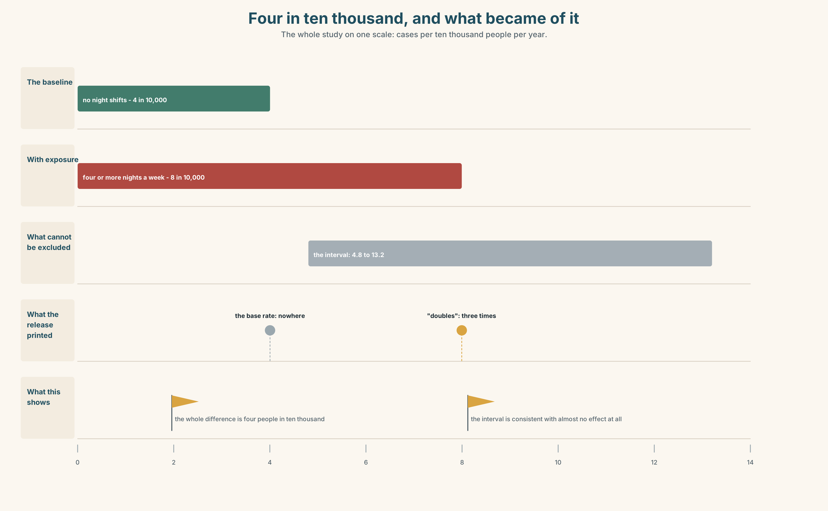{width=6.6in}
Four in ten thousand, and what became of it — The whole study on one scale: cases per ten thousand people per year.

10A · Relay
Half the class has the release. Half has the preprint. Produce one headline both documents support, by speaking only. Ten minutes.

10B · Simplify — for one reader
A reader writes: I work nights. Should I stop? Reply in four sentences. Give the absolute figures and set your modals honestly.

10C · Online
Write one message to the press office about the missing base rate. Three sentences. Do not accuse; describe what a reader cannot do without it.

10D · Your language
How does your language mark the difference between it must be and it may be? Translate all five sentences from Part 2. Which distinctions survive, and which collapse?

Part 11 · The Decision ◆ C · THE PERFORMANCE

The headline at six o'clock
Two numbers, both true, and room for one.
Option one: Night work doubles heart risk, study finds. True, accurate to the release, and the number readers will remember.
Option two: Night work linked to four extra cases in ten thousand. True, accurate to the preprint, and nobody will click on it.
Option three: run option one, and adopt a standing rule that no risk figure appears anywhere in the paper without its base rate in the same sentence.

11A · The evidence
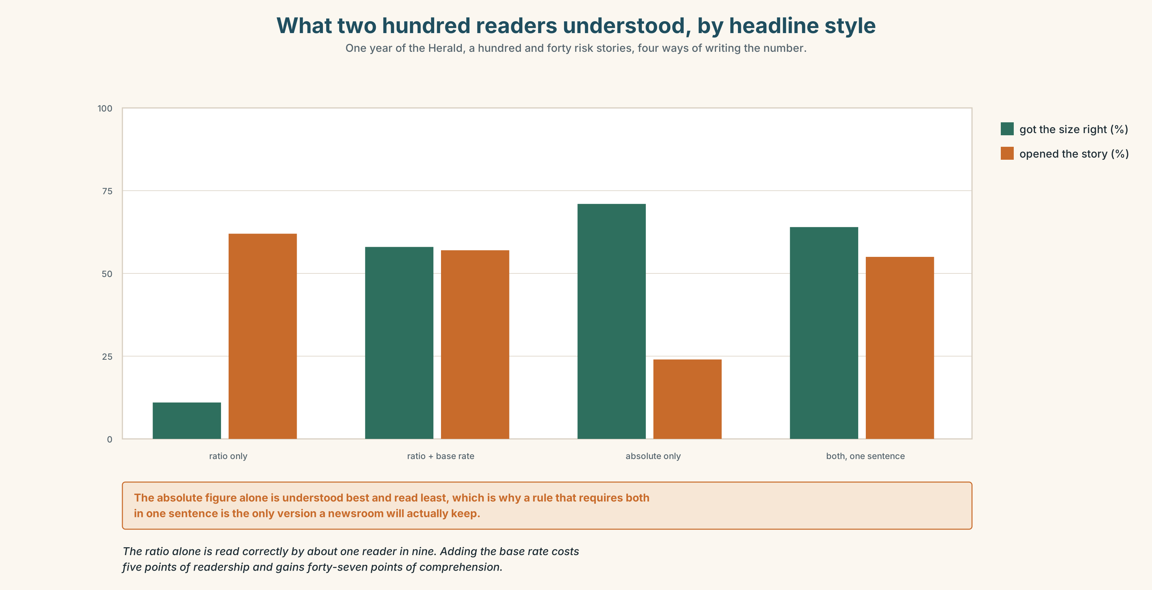{width=6.6in}
What two hundred readers understood, by headline style — One year of the Herald, a hundred and forty risk stories, four ways of writing the number.
🔊 Track 3.6. The standards editor, 30 seconds: "We have run a hundred and forty risk stories in a year. I asked two hundred readers what a doubling meant, and the median answer was fifty per cent. Not fifty per cent more — fifty per cent of people. We are not informing anybody. We are producing a number that happens to be correct and a belief that is wildly wrong, and then defending the number."

11B · Talk about it
In threes. Use the frame, and state your certainty setting every time you use it.
I would ______ , because ______ , and the evidence for that is ______ .

11C · Decide
Write three sentences: the decision, the evidence, and the thing you would accept as proof you were wrong.

11D · Model decision
Option three. Option two is honest and unread, which helps nobody, and option one on its own produces the fifty-per-cent belief the standards editor measured. The base-rate rule costs nine words a story and is the only version where the figure the reader remembers is a figure they can use. It also has a cost worth naming: some stories will not survive their own base rate, and those are the stories the rule exists for.

11E · The Reveal
What happened. The Herald ran the first headline and adopted the rule. Nine months later the preprint failed peer review on the exposure definition and was withdrawn.
Then something nobody predicted: the health reporter began returning press releases that gave no base rate, with a one-line note. Within a year, three university press offices in the city were putting the base rate in the first paragraph — not because anybody asked them to, but because the alternative was not being covered.
One question. You do not have to answer it out loud.
The rule was about the Herald's own sentences. Why did it change what other people wrote?

Part 12 · Landing ◆ all three lines

12A · Recycle — fifteen items
- It ______ be chance; the interval includes 1.2. (possible, uncommitted)
- At that size the effect ______ be real. (strongest inference)
- It ______ ______ ______ been chance at that interval. (past, all but excluded)
- Day workers ______ ______ ______ ______ show the pattern. (five words, balanced)
- The finding ______ ______ ______ ______ replicated. (four words, not yet)
- ______ , the release was written by somebody who had not read the paper. (one word — a guess)
- The effect is not ______ large, only unlikely to be chance. (one word)
- ______ ______ ______ was four cases in ten thousand. (three words)
- The study is ______ ______ , posted online and not yet assessed. (two words)
- ______ ______ ______ ______ ______ ______ , night work is the likelier explanation. (six words — the legal standard)
- ______ ______ ______ ______ ______ ______ , no replication exists. (six words — the institutional limit)
- ______ ______ ______ ______ ______ . (five words — the correction you make to an overclaim)
- You cannot ______ ______ one cohort to a whole workforce. (two words)
- Somebody has to ______ ______ ______ one side or the other by six. (three words)
- He tends to ______ ______ when the numbers are thin. (two words)

12B · Consolidate — one task, everything in it
Write 150 words about a claim in the news this week, placing every assertion at the setting its evidence supports. Mark three settings in the margin: one top, one middle, one bottom.

12C · Can-do, with evidence
☐ I can use the full range of epistemic modals, including past deduction. Evidence: 3H, 8D ☐ I can calibrate a claim to the evidence behind it. Evidence: 4C, 6E ☐ I can read a risk figure and say what it is out of. Evidence: 5C, 10B ☐ I can reduce and stress a modal for effect. Evidence: 7C

12D · Replay ⏺
Record 0C again. Compare. How many settings did you use the first time, and how many now?

12E · Glossary — fifty items, as a map
THE MEASUREMENTS · incidence · prevalence · cohort · baseline · exposure THE RELATIONS · risk · hazard · correlation · causation THE DOUBT · confidence · interval · significance THE FIVE PHRASES · absolute risk · relative risk · a doubling of risk · the base rate · statistically significant THE PAPER TRAIL · a causal link · the margin of error · peer reviewed · a preprint · a press release WHAT PEOPLE DO WITH EVIDENCE · scale up · rule out · bear in mind · hedge about · come down on · hold back IN THE ROOM · the evidence does not support that · it may well be · we cannot rule it out THE ADVERBS · conceivably · arguably · presumably · ostensibly · allegedly · reportedly · demonstrably · unequivocally THE FRAMES · is likely to · is bound to · might well have · could hardly have · must surely be · may or may not · is said to · has yet to be THE STANDARDS · on the balance of probability · to the best of our knowledge · that is overstating it

12F · Next
Unit 4 · What was going to happen?

