Table of Contents

B2.1 · Unit 4 · It Was Going to Open in 2019
English Animated · Reading Between Lines · a newsroom, Toronto Student's Book pages 72–93 · 22 pp · ~11 hours

Part 0 · The Big Picture ◆ A · THE WORLD
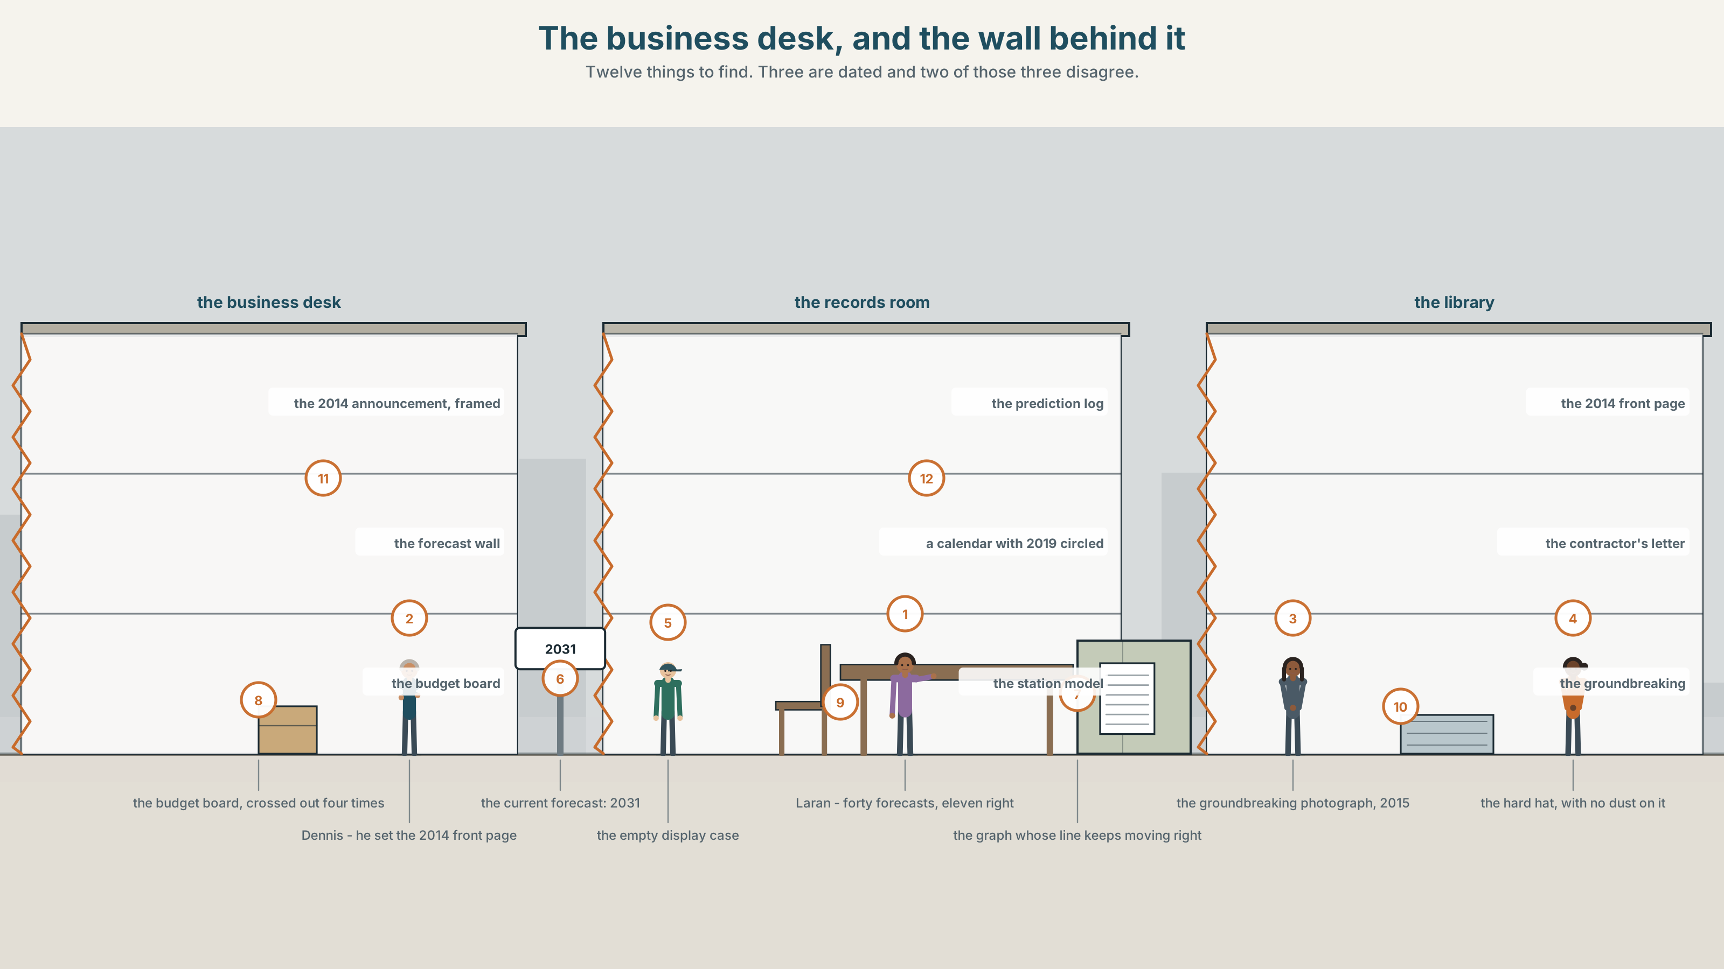{width=6.6in}
The business desk, and the wall behind it — Twelve things to find. Three are dated and two of those three disagree.

What was going to happen?
By the end of this unit you can narrate a plan that did not happen, from the vantage point of the people who made it. Two hundred words.
◆ A · THE WORLD | A transit line announced in 2014, due in 2019, and a wall of the paper's own forecasts
◆ B · THE SYSTEM | future in the past · 28 words for forecasting and failure · 22 words and frames for looking backwards and forwards · was gonna
◆ C · THE PERFORMANCE | Two hundred words about something that was supposed to happen

0A · Find it
Find twelve things in this picture. Three of them are dated and two of those three contradict each other.
the 2014 announcement, framed · the forecast wall · the budget board, crossed out four times · a model of the station that was never built · the business desk's prediction log · a hard hat with no dust on it · the first-edition page from 2014 · a calendar with 2019 circled · the contractor's letter · a graph with a line that keeps moving right · a photograph of the groundbreaking · an empty display case

0B · Guess it
Two objects in this picture were made on the same day and now disagree. Which two, and which of them has been quietly replaced since?

0C · Say it ⏺
Record sixty seconds. Describe something you were going to do last year and did not do. Say what you thought at the time, not what you think now. You will record it again at the end of this unit.

Part 1 · Vocabulary Lab 1 ◆ B · THE SYSTEM
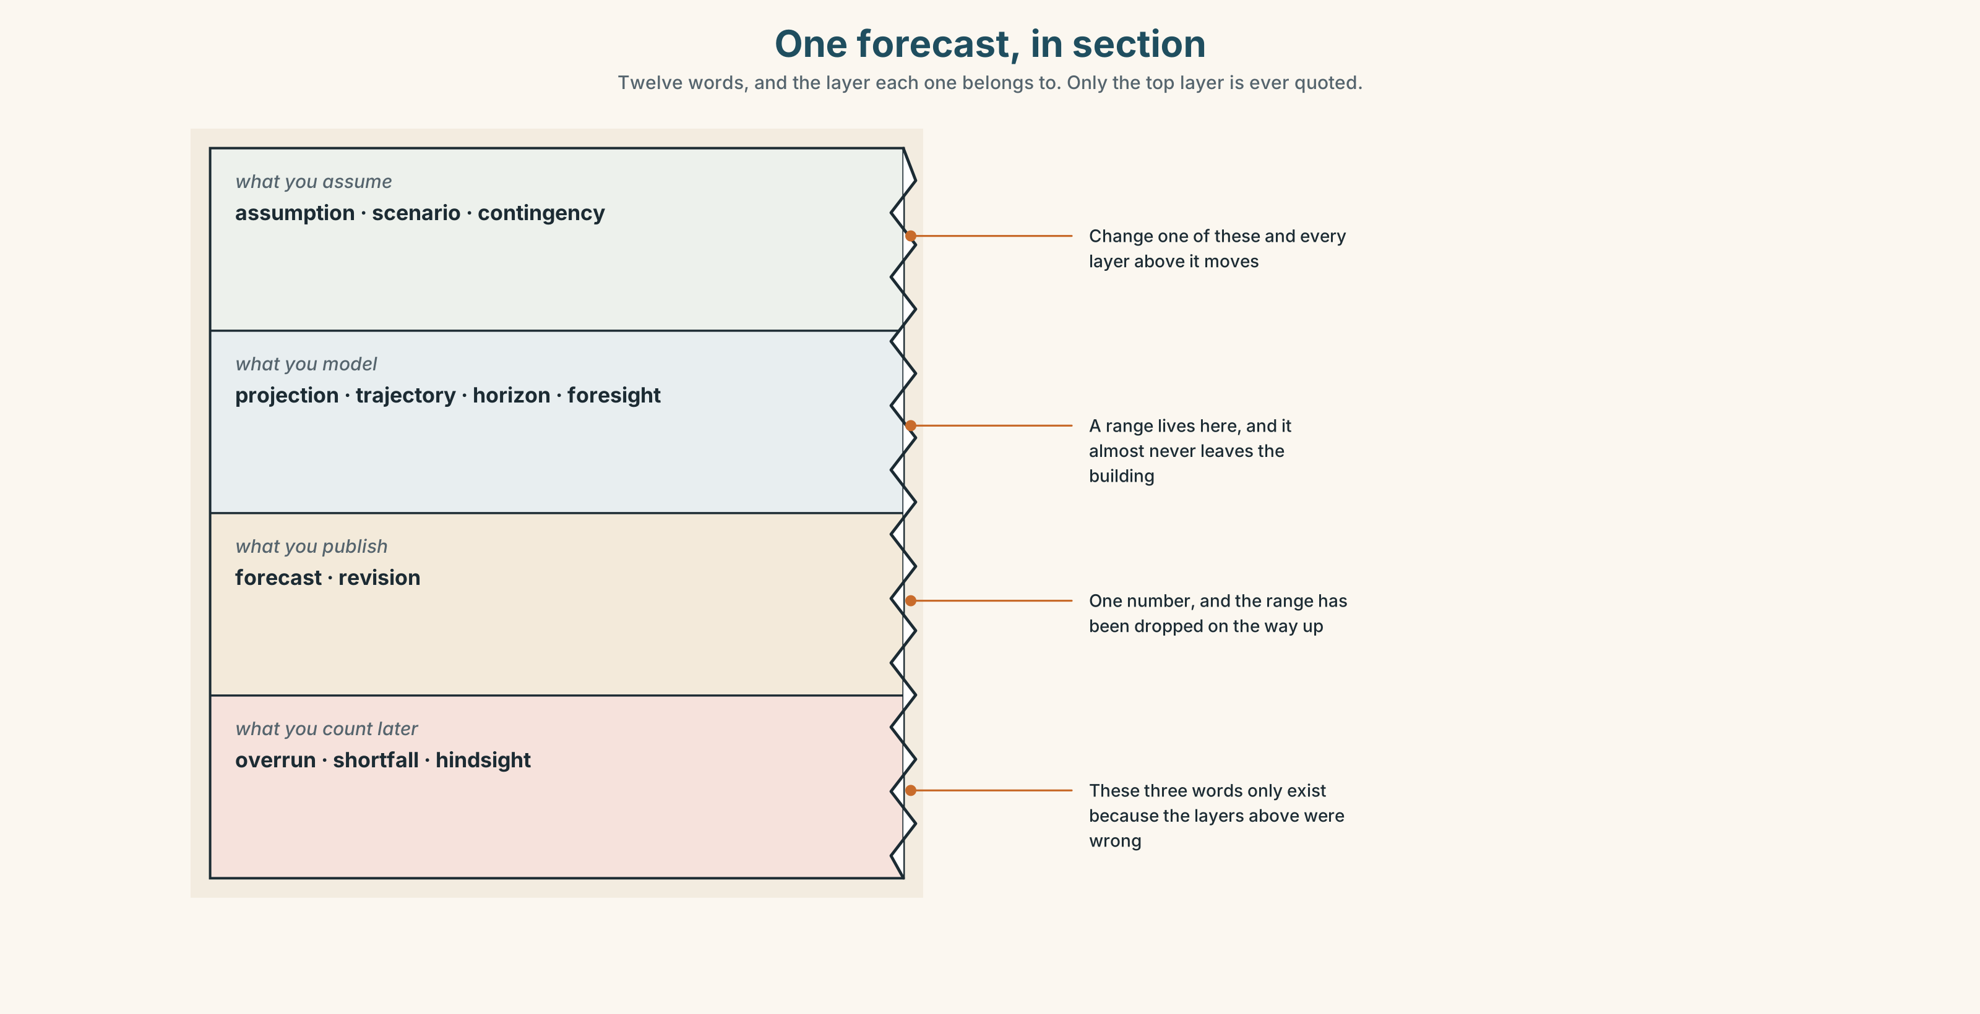{width=6.6in}
One forecast, in section — Twelve words, and the layer each one belongs to. Only the top layer is ever quoted.

1A · Meet — the words of a prediction
Match each word to one layer of the cutaway.
forecast · projection · scenario · trajectory · revision · hindsight · foresight · contingency · overrun · shortfall · horizon · assumption

1B · Sort — made beforehand, the shape of the thing, or counted afterwards?
Three columns. Two of the twelve are the same word looking in opposite directions.
forecast · trajectory · revision · projection · horizon · hindsight · scenario · overrun · assumption · foresight · shortfall · contingency

1C · Meet — the five phrases that carry a forecast
on current trends | A sentence that presents a straight line as a fact about the future.
a worst case | The number nobody plans for and everybody later says they published.
the central estimate | The middle of a range, reported as though the range were not there.
revised downwards | The passive that removes whoever did the revising.
an optimistic forecast | A phrase only ever used afterwards, and never by its author.

1D · Collocation Lab
Complete each one, and say which of the five could have been written in 2014.
with hindsight · as things turned out · the plan was to · a missed deadline · the gap between
- ______ ______ ______ ______ open the line in the spring of 2019.
- ______ ______ ______ ______ , the tunnelling took four years longer than the contract allowed.
- ______ ______ , the 2014 schedule assumed nothing would be found under the harbour.
- ______ ______ ______ the announcement and the first train is now seventeen years.
- ______ ______ ______ is not news until there have been four of them.

1E · The phrasal verbs, and the three fixed expressions
fall through · come off · hold up
f it was supposed to be · f that never happened · f nobody saw it coming
One of these fixed expressions is almost always false when it is said. Which, and what is it usually doing for the speaker?

1F · Own it
Write one sentence beginning The plan was to… about your own year, and underneath it write the month in which you stopped believing it.

Part 2 · Listening ◆ A · THE WORLD
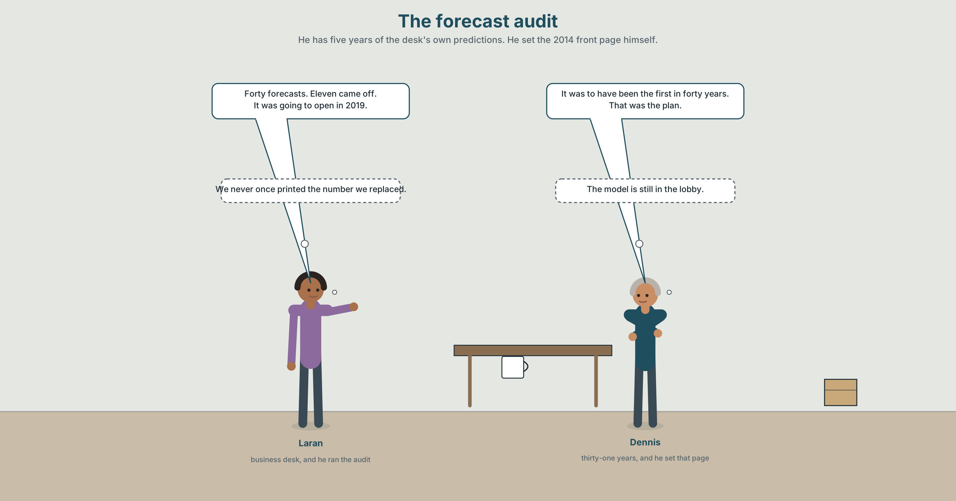{width=6.6in}
The forecast audit — He has five years of the desk's own predictions. He set the 2014 front page himself.

2A · The forecast audit 🔊 Track 4.1
Before you listen. The business desk has gone back through five years of its own predictions. The subeditor has been at the paper since 1995 and remembers the announcement.
Listen once. What were the paper's own forecasts, and how many of them came off?
Listen again. Complete the table.
 | What was going to happen | When | What actually happened
the line
the budget
the paper's forecast
Listen again. True or false?
- The line was originally due to open in 2019. ☐ T ☐ F
- The paper predicted the first delay. ☐ T ☐ F
- The budget has been revised four times. ☐ T ☐ F
- The subeditor wrote the 2014 front page. ☐ T ☐ F
Noticing. Five sentences from the recording.
- It was going to open in 2019.
- It was due to open in 2019.
- It would have opened in 2019, but for the harbour.
- It was to have opened in 2019.
- It would later open in 2031, if it opens.
All five look back at a future that never arrived. Which one blames something, which one is the most formal, and which one is a plain report?

2B · Decoding clinic 🔊 Track 4.2
Thirty seconds at speed. Three jobs.
- The subeditor says was going to five times. Write what you hear, not what is written.
- One speaker says would have twice, in two different ways. Transcribe both.
- Somebody says that was the plan. What is the tone, and how do you know?

Part 3 · Grammar Lab 1 ◆ B · THE SYSTEM

Standing in 2014 and looking forward

3A · Notice
Look at the five sentences in Part 2 again.
- Where is the speaker standing in each one — in 2014, or now?
- Which sentence contains an obstacle, and which word puts it there?
- Sentence 4 is the most formal of the five. What register does was to have belong to?
- Sentence 5 uses would about something still ahead. How is that possible?

3B · See
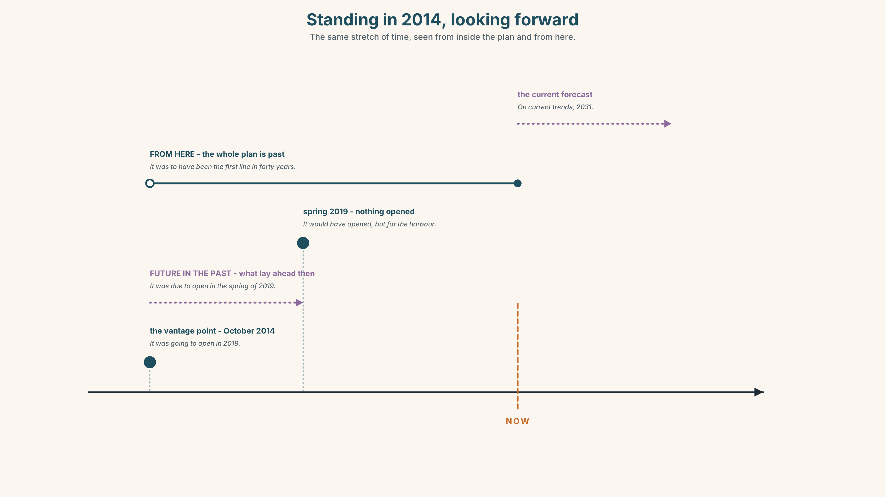{width=6.6in}
Standing in 2014, looking forward — The same stretch of time, seen from inside the plan and from here.

3C · Know
was going to | the plan or expectation, neutral | It was going to open in 2019.
was due to | a scheduled commitment, often contractual | It was due to open in 2019.
was about to | on the point of happening, interrupted | They were about to sign.
would have | and something prevented it | It would have opened, but for the harbour.
was to have been | formal, written, and faintly reproachful | It was to have been the first line in forty years.
would later | the narrator, who knows how it ends | It would later be revised four times.
Future in the past is a vantage point, not a tense. You stand at a moment in the past and look forward from it, and the reader knows you also know what happened. That double knowledge is the whole effect.
The narrator's would is the most useful form in this unit. It would later overrun by nine years is only available to somebody telling the story afterwards, and it tells the reader there is more coming.
standing at the start | originally · formerly · the plan was to · was due to
moving through | subsequently · latterly · would later · as it would turn out
arriving at the end | eventually · ultimately · in the event · as things turned out
choosing a direction | prospectively · retrospectively · with hindsight
Why it matters. Every institution has a record of things that were going to happen. The grammar that narrates those honestly is the grammar that stops a newsroom repeating them.

3D · Use — controlled
Complete so that each sentence looks forward from 2014.
The line (1) ______ ______ ______ open in 2019. (a schedule, contractual) It (2) ______ ______ ______ be the first new line in forty years. (formal, written) The contractor (3) ______ ______ ______ sign when the survey came back. (on the point of) It (4) ______ ______ opened on time, but for the harbour. (and something prevented it) The budget (5) ______ ______ be revised four times. (the narrator, who knows)

3E · Use — guided
Rewrite each one from the vantage point of 2014, looking forward.
- The line did not open in 2019.
- They nearly signed in March.
- The budget was eventually six point one billion.
- The paper got one forecast in four right.
- The station model is still in its case.

3F · Use — open
In pairs. One of you describes a plan from inside it, in 2014. The other may only reply with a sentence containing would later. Six turns each, and the second speaker must not reveal the ending until the last one.

3G · Error autopsy
✗ It was going to opened in 2019. ✗ It would have open on time if the harbour was not there. ✗ Eventually, the line was about to open in 2031.
For each, name the rule and say what the writer was reaching for.

3H · Check — eight items
- The line ______ ______ ______ open in 2019. (a contractual schedule)
- It ______ ______ ______ ______ the first new line in forty years. (formal and written)
- They ______ ______ ______ sign when the survey came back. (on the point of)
- It ______ ______ opened on time, but for the harbour. (prevented)
- The budget ______ ______ be revised four times. (the narrator)
- ✗ It was going to opened in 2019. → correct it.
- Rewrite They did not sign so that the reader can feel how close it came.
- Rewrite The line opened in 2031 so that a reader standing in 2014 could have said it.

Part 4 · Speaking ◆ C · THE PERFORMANCE

4A · Fluency starter — the plan and the ending
One person states a plan in the past. The next adds a sentence with would later. The next adds another. The fifth person has to supply the ending, and it must follow from all four.

4B · The functional core — narrating a thwarted plan
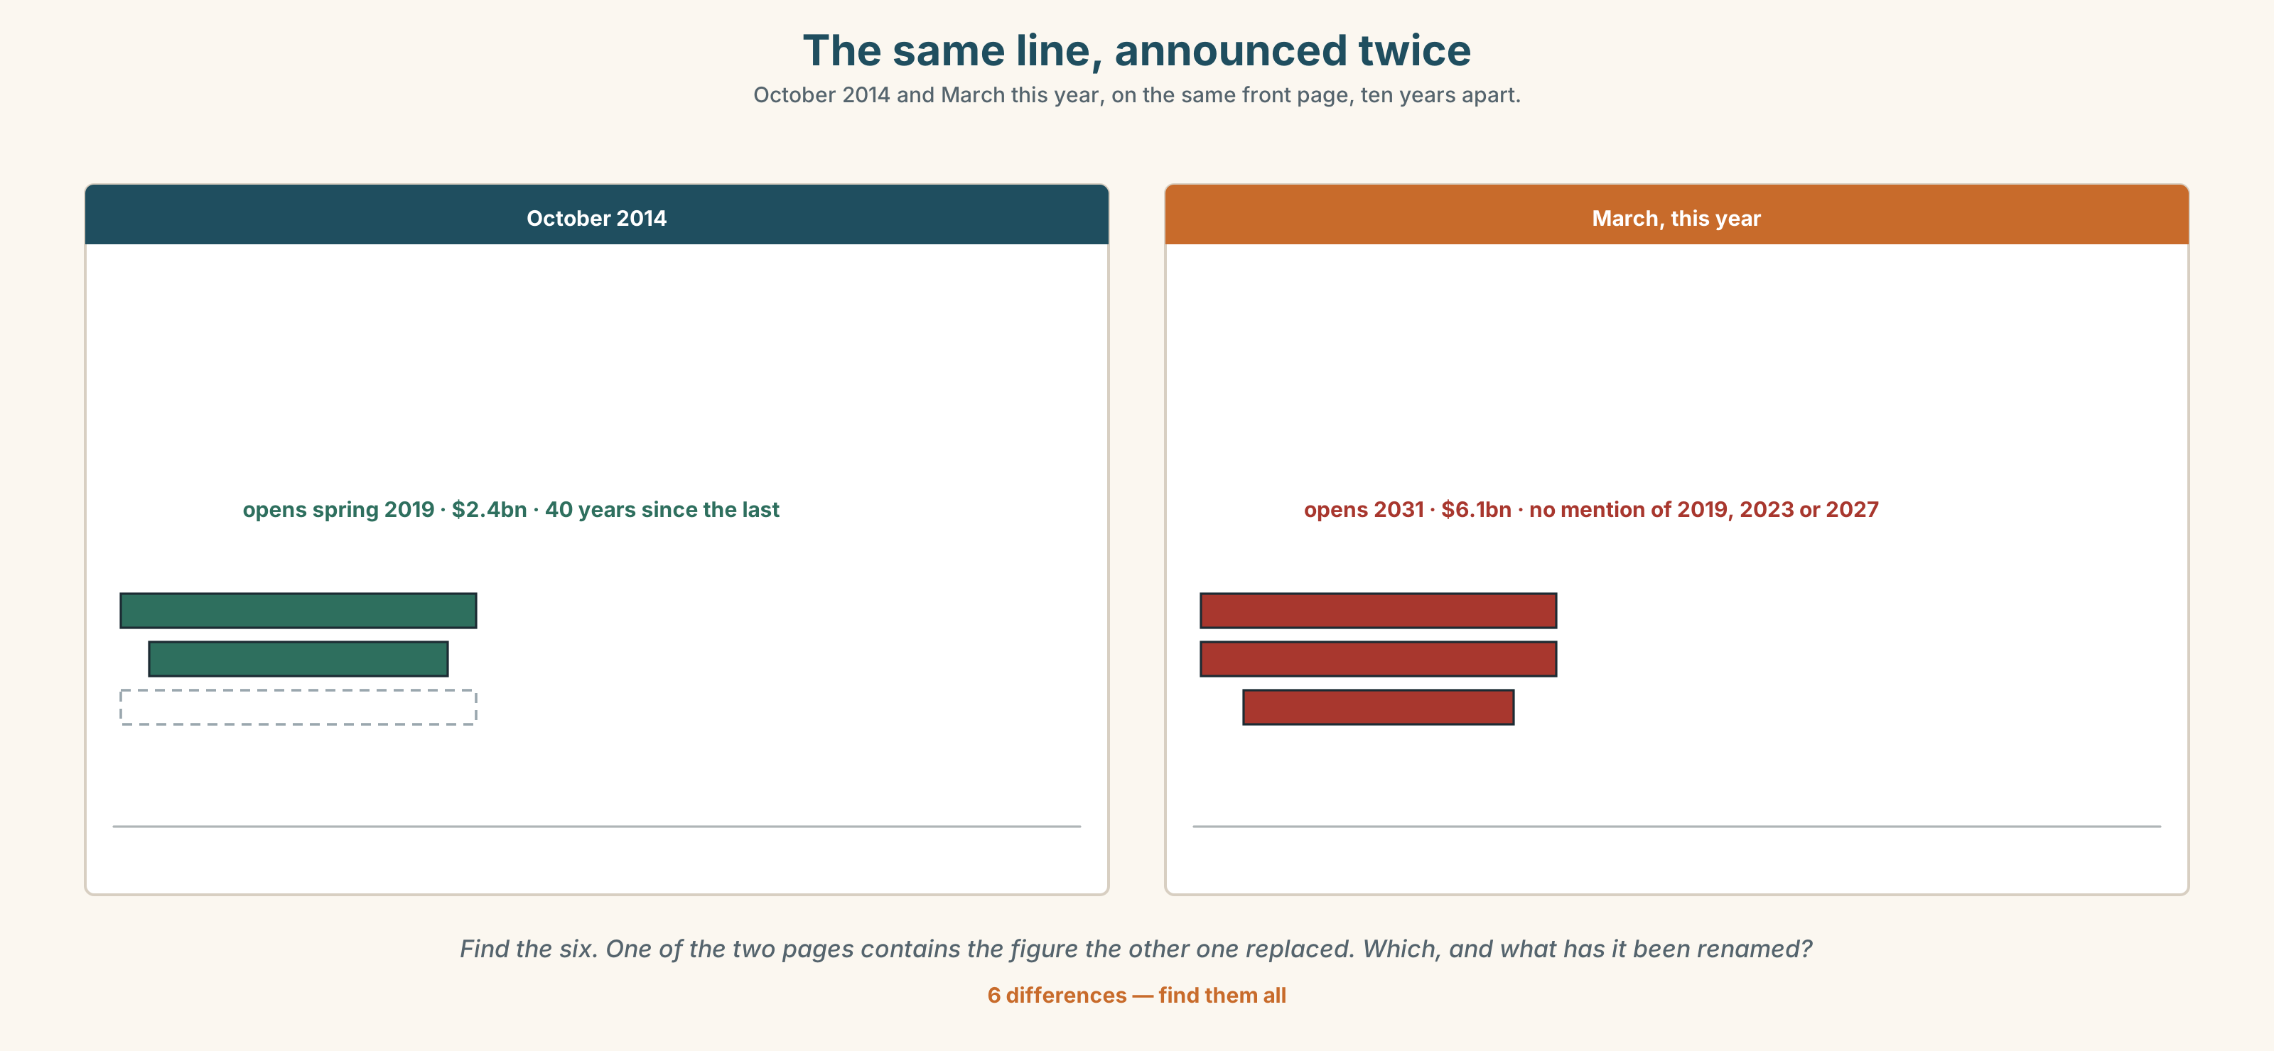{width=6.6in}
The same line, announced twice — October 2014 and March this year, on the same front page, ten years apart.
Language Bank
standing in the plan | was going to · was due to · had intended to · that was the plan
the near miss | was about to · would have been · it would be years before
the narrator | would later · as it would turn out · subsequently · latterly
the ending | eventually · ultimately · in the event · as things turned out
Information gap. Learner A has the 2014 announcement. Learner B has this year's schedule. Agree on a four-sentence account that neither document contradicts.

4C · The performance — three minutes ⏺
Tell the story of something that did not happen, in three minutes, spending the first minute entirely inside the plan. Your partner must not be able to tell how it ends until you say so.
Record it.

4D · Observer
One person marks every point at which the speaker leaves the plan and speaks as the narrator.

4E · Three criteria
☐ Did the first minute stay inside the plan, with no hindsight leaking in? ☐ Did I use at least three different future-in-the-past forms? ☐ Could my partner say, afterwards, what the people at the time believed?

Part 5 · Reading ◆ A · THE WORLD

5A · Predict
The title is "The line that was going to open in 2019." How many times do you think a seventeen-year project is re-announced, and by whom?

5B · Read — two minutes

The line that was going to open in 2019
In October 2014 the city announced a new transit line to the east end. It was to have been the first new line in forty years. It was due to open in the spring of 2019, at a cost of two point four billion dollars.
The Herald's front page that morning carried a projection of journey times and a photograph of a model of the station. The model is still in the lobby of the planning office. The station is not built.
The opening date has since been revised to 2023, to 2027 and, in March, to 2031. The budget has been revised downwards once, in 2016, and upwards three times. The central estimate is now six point one billion.
The paper has published two hundred and forty pieces about the line. Thirty-one of them contain a forecast date. None of the thirty-one mentions the forecast it replaced.
Nobody saw it coming, the city's transport chair said in 2023, of the second delay. The 2016 contingency documents, released under access law in 2024, model the harbour problem on page eleven and put a worst case at 2029.

5C · Comprehension — eight questions
- When was the line announced, and when was it due to open?
- What was the original cost, and what is the central estimate now?
- How many of the paper's pieces contain a forecast date?
- How many of those mention the forecast they replaced?
- What is on page eleven of the 2016 documents?
- Why does the writer mention the model in the lobby twice as often as the station?
- The last paragraph sets a quotation against a document. What is the writer doing, and why not say it outright?
- "Revised downwards once and upwards three times" — what would be lost by writing "revised four times"?

5D · Vocabulary in context
Infer from the text, then check.
it was to have been · has since been revised · released under access law · of the second delay · model the harbour problem

5E · The counter-text
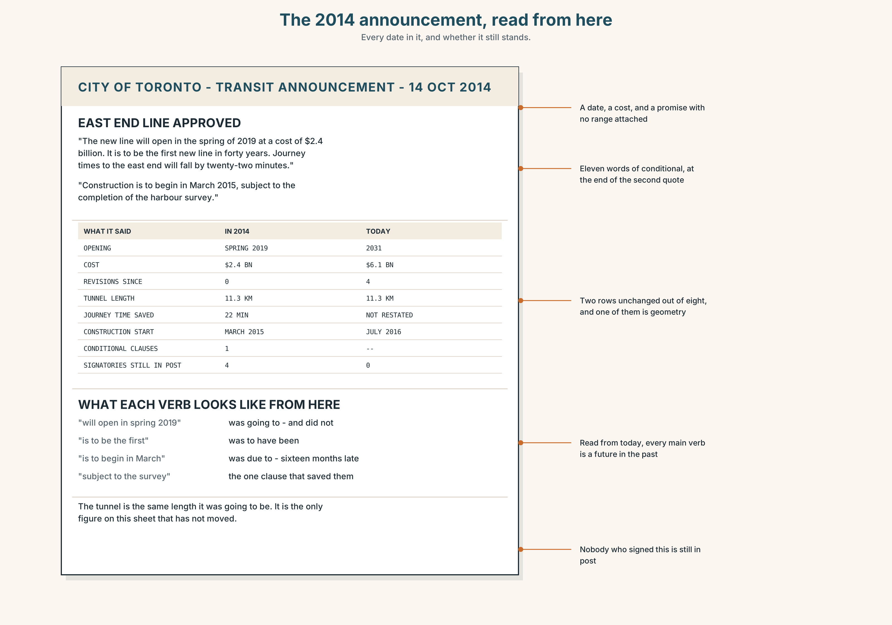{width=6.6in}
The 2014 announcement, read from here — Every date in it, and whether it still stands.
Read the 2014 announcement and answer.
- Which verbs in it are future in the past, read from today?
- Find every date in it, and say which of them still stands.
- The announcement contains one conditional. What was it protecting?
- Who signed it, and where are they now?

5F · Two texts
The 2014 notice says the line will open in spring 2019. The 2024 documents say a worst case of 2029 was modelled in 2016.
Is "nobody saw it coming" a lie? Write two sentences, and use with hindsight in one of them.

Part 6 · Vocabulary Lab 2 ◆ B · THE SYSTEM

Where you are standing when you say it

6A · Sort — at the start, somewhere along the way, or looking from one end?
Three columns.
subsequently · originally · retrospectively · eventually · formerly · prospectively · latterly · ultimately

6B · Chunk completion
- The line ______ ______ ______ open in 2019. (three words — the plan)
- It ______ ______ ______ open in 2019. (three words — the schedule)
- They ______ ______ ______ sign when the survey came back. (three words — on the point of)
- It ______ ______ ______ the first new line in forty years. (four words — and it was not)
- The city ______ ______ ______ build it in two phases. (three words — a stated intention)
- It ______ ______ ______ ______ ______ opened by now. (five words — formal, reproachful)
- The budget ______ ______ be revised four times. (two words — the narrator)
- ______ ______ ______ ______ ______ , the harbour was the least of it. (five words — the narrator again)

6C · Three that are not interchangeable
was going to · was due to · was to have been
Say which one reports a plan, which one reports a commitment, and which one carries a complaint.

6D · The phrasal verbs and the fixed expressions
back out · pull out · call off
f it would be years before · f that was the plan · f in the event
Two of these three phrasal verbs describe leaving an agreement and one describes ending an event. Which is which, and what is the difference between the other two?

6E · Contrast Clinic
Eight items. Rewrite each sentence so that the vantage point moves to the place in brackets.
- The line did not open in 2019. (standing in 2014)
- They did not sign. (a near miss)
- The budget rose to six point one billion. (the narrator, with more to come)
- The harbour caused a delay. (formal, written, reproachful)
- It opened in 2031. (as a prediction made in 2014)
- Nobody expected the second delay. (and the documents did)
- The paper got one forecast in four right. (looking back deliberately)
- The contractor left the project. (a stated intention that changed)

Part 7 · Pronunciation & Fluency Lab ◆ B · THE SYSTEM
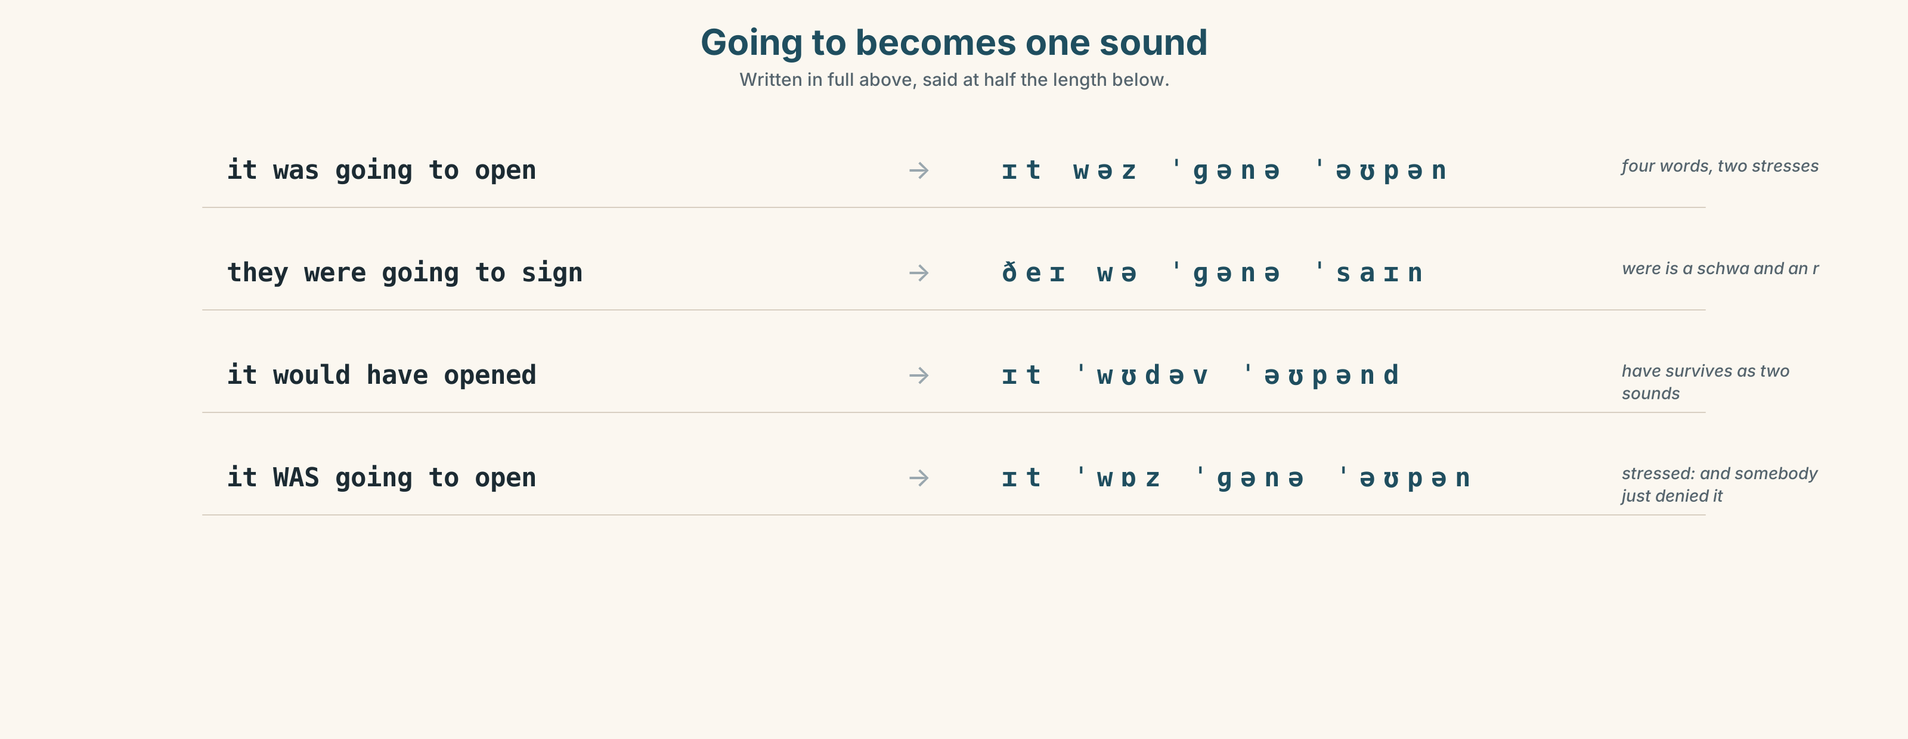{width=6.6in}
Going to becomes one sound — Written in full above, said at half the length below.

Going to becomes one sound and takes the stress with it

7A · Hear 🔊 Track 4.3
It was going to open. → /ɪt wəz ˈɡənə ˈəʊpən/ They were going to sign. → /ðeɪ wə ˈɡənə ˈsaɪn/ It would have opened. → /ɪt ˈwʊdəv ˈəʊpənd/

7B · Say
Say each one three times, fast. Then say this:
It was going to open, they were going to sign, and it would have been finished. — three reduced forms in one breath, and one stress in each.

7C · Make it mean something
Say these two:
It was going to open in 2019. — the plain report, the stress on the date It WAS going to open in 2019. — stressed: and somebody has just denied that it ever was
A stressed auxiliary is almost always an argument, which is why the archive matters: you can only stress was if you can produce the document.

7D · Fluency 30 ⏺
Thirty seconds: one plan, told from inside it, with four reduced forms and one stressed auxiliary. Three times, faster.

Part 8 · Writing ◆ C · THE PERFORMANCE

A plan that did not happen · 200 words

8A · Read the model
In October 2014 the line was due to open in the spring of 2019, at two point four billion dollars. [the schedule and the number, as they stood, with no hindsight in the sentence]
It was to have been the first new line in forty years, and the model of the station was photographed for the front page. [the formal form carries the reproach without the writer stating one]
The 2016 contingency documents would later put a worst case at 2029, which the city did not publish. [would later: the narrator steps in, and the reader now knows there is more]
As things turned out, the opening has been revised three times since, and the model is still in the lobby. With hindsight, the only figure in the 2014 announcement that has held is the length of the tunnel. [the ending, and one concrete detail doing the work of an adjective]
Questions about the writer's choices:
- The first paragraph has no hindsight in it at all. What does that buy, and what does it cost?
- Would later appears once. What would happen if it appeared four times?
- The last sentence names the one forecast that held. Why end on the thing that worked?

8B · The anti-model
The disastrous transit project has been a catalogue of failures from the start. Experts warned the timeline was unrealistic, but the city pressed ahead anyway. Now, years late and billions over budget, it stands as a monument to incompetence. Nobody saw it coming.
Four sentences, three unnamed sources, no dates, and a final sentence that contradicts the second. Rewrite it from inside 2014, with a date in every sentence.

8C · Plan
the schedule as it stood → the formal expectation → the narrator, once → the ending, with one concrete survival

8D · Write — 200 words

8E · Peer review — three criteria
☐ Does the opening stay inside the plan, with no hindsight leaking backwards? ☐ Is every date the date somebody actually wrote down? ☐ Does the narrator step in deliberately, and not more than twice?

8F · Write it again · 8G · Publish
Rewrite after review. Publish both, and mark the moment the narrator first appears in each.

Part 9 · The File ◆ A · THE WORLD + C · THE PERFORMANCE
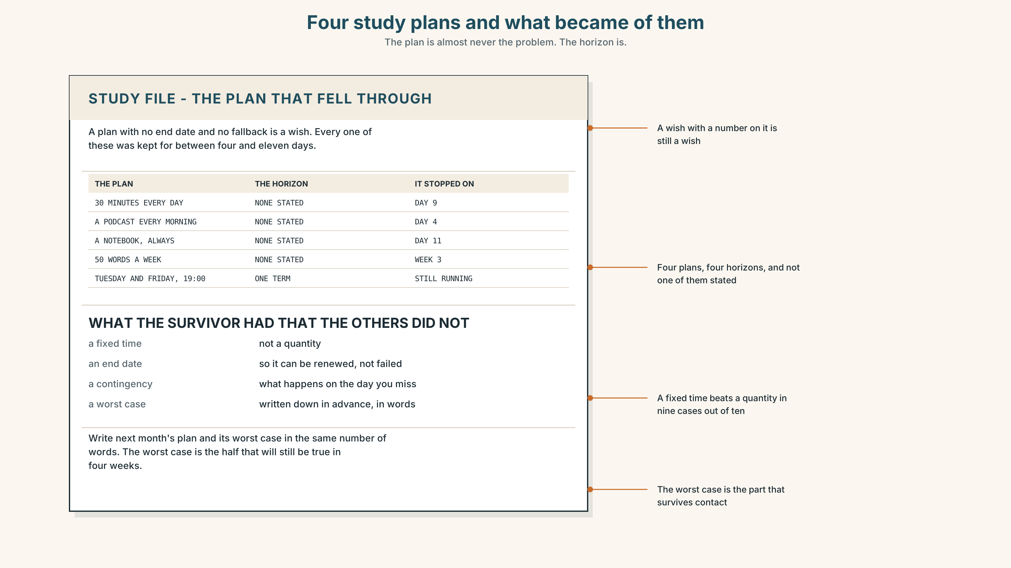{width=6.6in}
Four study plans and what became of them — The plan is almost never the problem. The horizon is.

STUDY FILE · The study plan that fell through

9A · What you were going to do 🔊 Track 4.4
Every learner has a plan that did not come off: thirty minutes a day, a podcast every morning, a notebook. The plan is almost never the problem. The horizon is.
the plan | I was going to study thirty minutes every day
the horizon | indefinite
the contingency | none
what actually held | the two days a week with a fixed time

9B · Rebuild it
Take one plan of yours that fell through. Write what it was, what the first missed day was, and what you would need to have had in place.

9C · Role play — the 2014 version of you
In pairs. One of you describes a learning plan as you believed it at the time, with no hindsight. The other may only ask and what was the contingency? Four rounds each.

9D · The one that held
Everybody has one habit that survived. Name yours and say what was different about it. Nine times in ten the answer is a fixed time, not a quantity.

9E · Transfer — before next week
Write next month's plan with a worst case beside it, in the same number of words. Bring both. The worst case is the only part that will still be true in four weeks.

Part 10 · Mediation & Interaction ◆ C · THE PERFORMANCE
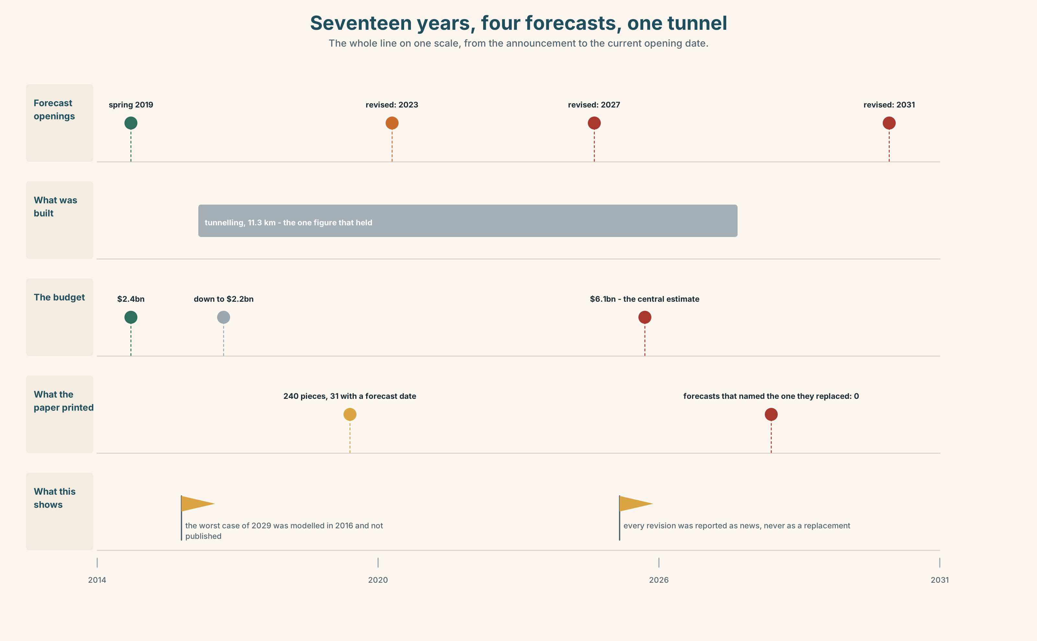{width=6.6in}
Seventeen years, four forecasts, one tunnel — The whole line on one scale, from the announcement to the current opening date.

10A · Relay
Half the class has the 2014 announcement. Half has the 2024 documents. Produce one paragraph both sides accept, by speaking only. Ten minutes.

10B · Simplify — for one reader
A reader writes: I bought a flat near the station in 2015. What should I have been told? Reply in four sentences, from inside 2015, and then once from now.

10C · Online
Write one message to a colleague whose article says nobody saw it coming. Three sentences. Cite the page number and leave the judgement to them.

10D · Your language
How does your language look forward from a point in the past? Translate all five sentences from Part 2. Which of the five distinctions does your language keep, and which does it collapse into one form?

Part 11 · The Decision ◆ C · THE PERFORMANCE

The forecast audit
The business desk has proposed that the paper publish, once a year, every forecast it made twelve months earlier and what became of each one.
Option one: do not. A newspaper's job is to report what people say, and a public scoreboard of its own wrong guesses will be quoted against it for years.
Option two: publish it in full, including the names of the writers.
Option three: publish it in full, without names, and require that every new forecast in the paper carry the date and value of the forecast it replaces.

11A · The evidence
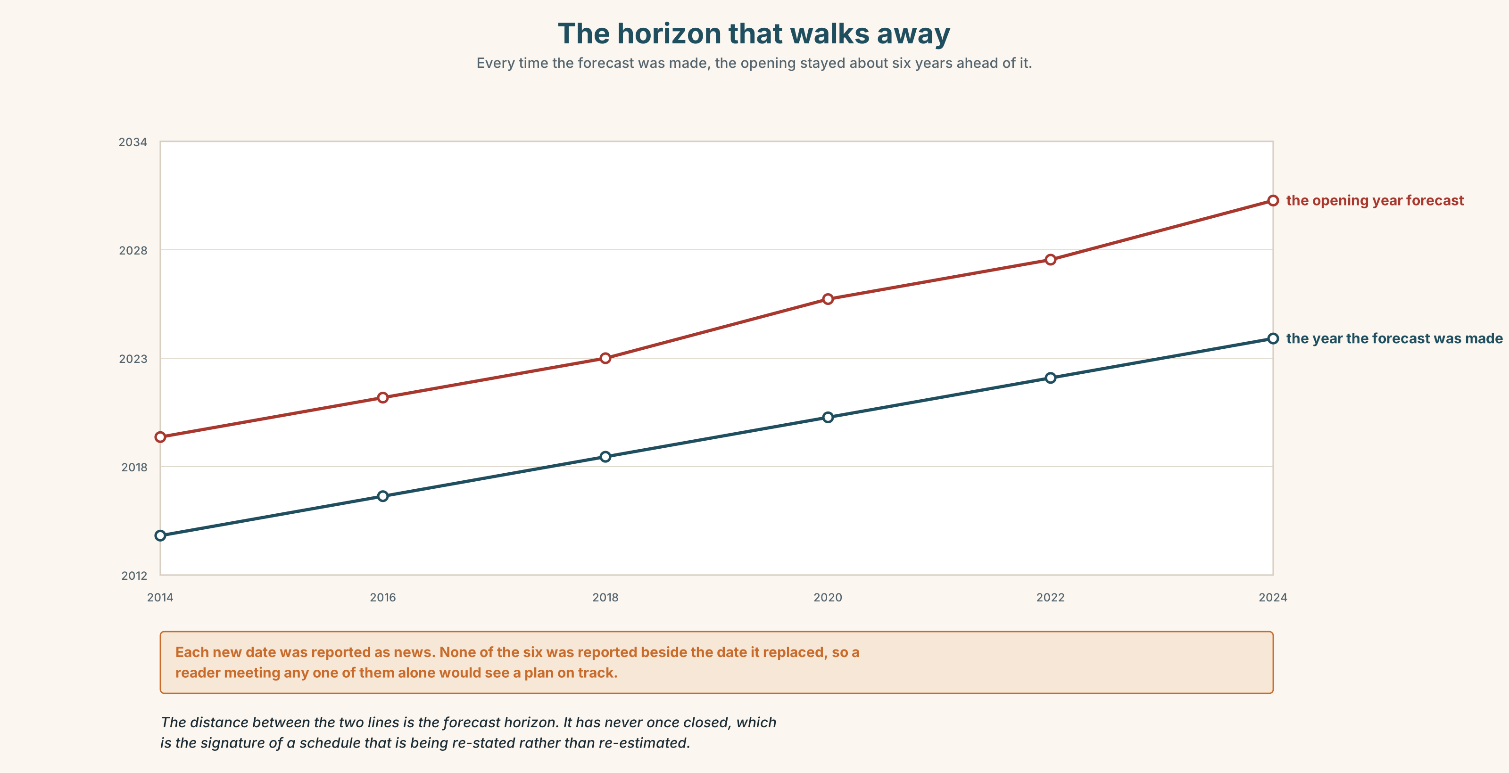{width=6.6in}
The horizon that walks away — Every time the forecast was made, the opening stayed about six years ahead of it.
🔊 Track 4.6. Laran Bakare, business desk, 30 seconds: "We ran forty forecasts in five years and eleven came off. That is worse than a coin, and I am not embarrassed by it, because the ones we got wrong were the ones everybody got wrong and the chart shows exactly why. What I am embarrassed by is that we never once printed the number we were replacing."

11B · Talk about it
In threes. Use the frame, and state which vantage point you are speaking from each time.
I would ______ , because ______ , and in five years it would ______ .

11C · Decide
Write three sentences: the decision, the evidence, and what you would expect to see in the first audit if you were right.

11D · Model decision
Option three. Names turn an audit into a disciplinary record and the desk will quietly stop forecasting, which is the one outcome that helps nobody. The replacement rule is the part that does the work: a forecast printed beside the forecast it supersedes cannot be re-announced as news, and it is the re-announcement, not the error, that has cost this paper its credibility on the line.

11E · The Reveal
What happened. The Herald published the audit without names and adopted the replacement rule. Eleven of forty was the headline figure, and it was quoted against the paper for a fortnight.
Then something nobody predicted: the city's own press office began including the superseded date in its announcements, because the Herald printed it anyway and the office preferred to be the one who said it. The number of re-announcements fell by half in a year.
One question. You do not have to answer it out loud.
The rule applied only to the Herald's own pages. Why did it change what the city published?

Part 12 · Landing ◆ all three lines

12A · Recycle — fifteen items
- The line ______ ______ ______ open in 2019. (three words — the schedule)
- It ______ ______ ______ ______ the first in forty years. (four words — formal)
- They ______ ______ ______ sign when the survey came back. (three words)
- It ______ ______ opened on time, but for the harbour. (two words)
- The budget ______ ______ be revised four times. (two words — the narrator)
- ______ , the plan was two phases, not three. (one word — at the start)
- ______ , it opened in 2031. (one word — at the end)
- ______ , the 2016 documents say it all. (one word — looking back deliberately)
- ______ ______ ______ ______ , the harbour was the least of it. (five words)
- ______ ______ ______ ______ ______ ______ a train ran on it. (six words — the long wait)
- ______ ______ ______ ______ . (four words — the resigned confirmation)
- ______ ______ ______ , only one of the four forecasts held. (three words — the outcome)
- The contractor ______ ______ in March, three weeks before signing. (two words)
- The opening event was ______ ______ for the second time. (two words)
- The whole financing ______ ______ when the bank withdrew. (two words)

12B · Consolidate — one task, everything in it
Write 150 words about a public project in your own city that was going to happen. Spend the first half inside the plan and mark in the margin the sentence where you become the narrator.

12C · Can-do, with evidence
☐ I can narrate a plan from inside it, in the past. Evidence: 3H, 8D ☐ I can use would later and as it would turn out to manage what the reader knows. Evidence: 4C ☐ I can distinguish a plan, a schedule and a reproach. Evidence: 6C, 6E ☐ I can reduce going to and stress an auxiliary for argument. Evidence: 7C

12D · Replay ⏺
Record 0C again. Compare. Did you stay inside the plan this time, and for how long?

12E · Glossary — fifty items, as a map
WHAT YOU MAKE BEFOREHAND · forecast · projection · scenario · assumption · contingency THE SHAPE AND THE DISTANCE · trajectory · horizon · foresight WHAT YOU COUNT AFTERWARDS · revision · hindsight · overrun · shortfall THE FIVE FORECAST PHRASES · on current trends · a worst case · the central estimate · revised downwards · an optimistic forecast LOOKING BACK AT IT · with hindsight · as things turned out · the plan was to · a missed deadline · the gap between WHAT HAPPENS TO PLANS · fall through · come off · hold up · back out · pull out · call off IN THE ROOM · it was supposed to be · that never happened · nobody saw it coming THE ADVERBS · eventually · ultimately · subsequently · originally · formerly · latterly · prospectively · retrospectively THE FRAMES · was going to · was due to · was about to · would have been · had intended to · was to have been · would later · as it would turn out THE ENDINGS · it would be years before · that was the plan · in the event

12F · Next
Unit 5 · On what condition?

