Table of Contents

B2.1 · Unit 5 · Clause Seven
English Animated · Reading Between Lines · a newsroom, Toronto Student's Book pages 94–115 · 22 pp · ~11 hours

Part 0 · The Big Picture ◆ A · THE WORLD
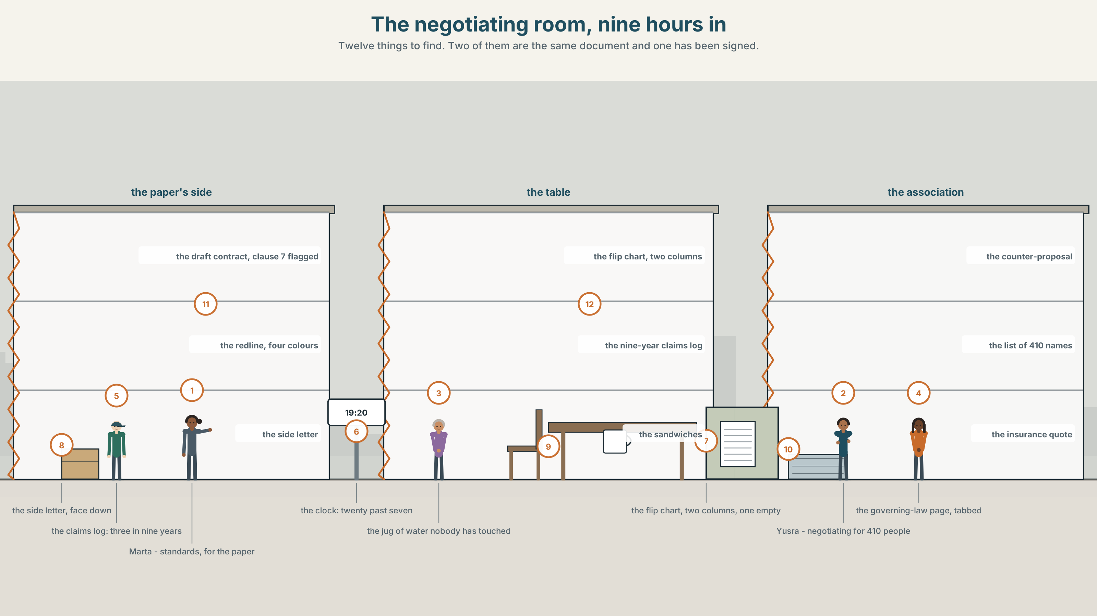{width=6.6in}
The negotiating room, nine hours in — Twelve things to find. Two of them are the same document and one has been signed.

On what condition?
By the end of this unit you can set a condition precisely, and hear the difference between a condition and a threat. Two hundred words.
◆ A · THE WORLD | A new contributor contract, four hundred and ten freelancers, and one clause nobody will sign
◆ B · THE SYSTEM | the full conditional system, including provided, but for and supposing · 28 words for terms and negotiation · 22 connectors and frames · the tune over a long conditional
◆ C · THE PERFORMANCE | Two hundred words that make an offer and name its conditions

0A · Find it
Find twelve things in this picture. Two of them are the same document and only one of them has been signed.
the draft contract, clause 7 flagged · the side letter, face down · a redline with four colours · the association's counter-proposal · a list of four hundred and ten names · the insurance quotation · the nine-year claims log · a flip chart with two columns · a jug of water nobody has touched · the governing-law page, tabbed · a clock showing 19:20 · a plate of sandwiches, untouched

0B · Guess it
One document in this picture explains why the negotiation has lasted nine hours. Which, and why is it face down?

0C · Say it ⏺
Record sixty seconds. Describe something you would agree to do, and state two conditions. Make one of them a condition you would actually enforce. You will record it again at the end of this unit.

Part 1 · Vocabulary Lab 1 ◆ B · THE SYSTEM
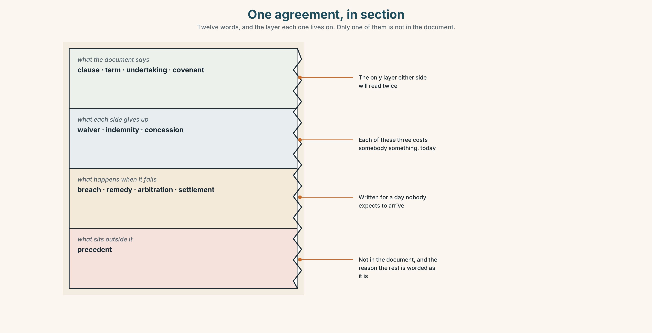{width=6.6in}
One agreement, in section — Twelve words, and the layer each one lives on. Only one of them is not in the document.

1A · Meet — the words of an agreement
Match each word to one layer of the cutaway.
clause · term · undertaking · waiver · indemnity · precedent · covenant · breach · remedy · settlement · arbitration · concession

1B · Sort — part of the document, something one side gives up, or what happens when it goes wrong?
Three columns. One of the twelve is not in the document at all, and is the reason the other eleven are written the way they are.
clause · breach · waiver · remedy · term · indemnity · arbitration · undertaking · concession · covenant · settlement · precedent

1C · Meet — the five phrases that keep a negotiation alive
subject to contract | Nothing said before signature binds anybody. The sentence that allows talking.
on the understanding that | A condition stated in words, not in the document. Dangerous, and everywhere.
without prejudice | An offer that cannot be quoted against you if it is refused.
in good faith | Unenforceable, and the only reason most contracts work.
the governing law | Which country's courts, which nobody reads until they need it.

1D · Collocation Lab
Complete each one, and say which of the five is the only one a court would look at first.
a material breach · a break clause · terms and conditions · a side letter · to the extent that
- Eleven named contributors were offered ______ ______ ______ , face down, at eight o'clock.
- Nobody reads ______ ______ ______ ______ ; everybody is bound by them.
- Either side may leave after twelve months under ______ ______ ______ .
- Only ______ ______ ______ ends the contract; everything smaller is a remedy question.
- The indemnity applies ______ ______ ______ ______ the contributor knew and did not say.

1E · The phrasal verbs, and the three fixed expressions
hammer out · draw up · water down
f that is not what we agreed · f we can live with that · f it depends what you mean by
One of these fixed expressions ends a negotiation and one restarts it. Which is which, and what does the third one buy?

1F · Own it
Write one condition you would put on something you do for other people, and then write what would happen if somebody broke it.

Part 2 · Listening ◆ A · THE WORLD
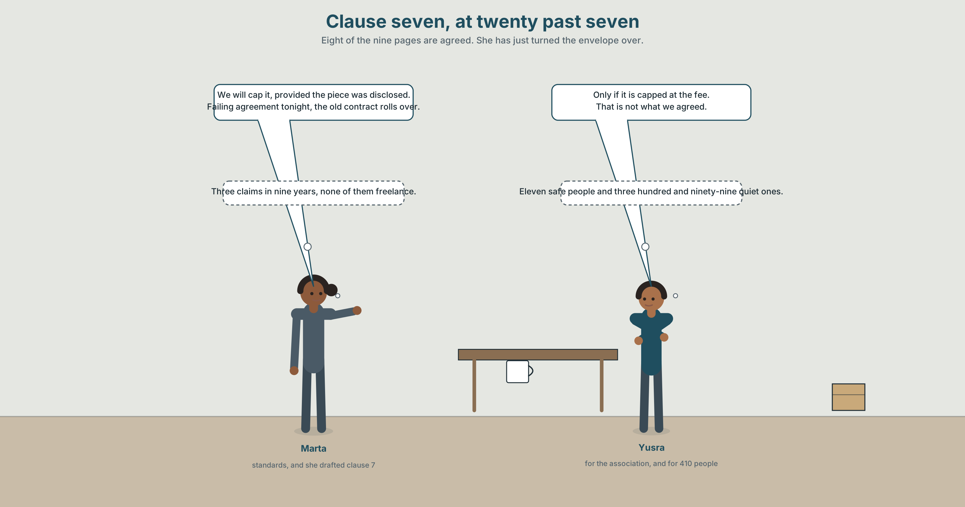{width=6.6in}
Clause seven, at twenty past seven — Eight of the nine pages are agreed. She has just turned the envelope over.

2A · Clause seven, at seven twenty 🔊 Track 5.1
Before you listen. The paper's standards editor and the freelancers' negotiator have been in the room since ten. Clause 7 makes contributors liable, without limit, for any claim arising from their work.
Listen once. What does each side want, and what is the first thing either of them offers?
Listen again. Complete the table.
 | The condition offered | What it costs them | What they want in return
the paper
the association
the side letter
Listen again. True or false?
- The paper has had three claims in nine years. ☐ T ☐ F
- All three were about freelance work. ☐ T ☐ F
- Insurance costs a freelancer about nineteen hundred dollars. ☐ T ☐ F
- The association knows about the side letter. ☐ T ☐ F
Noticing. Six sentences from the recording.
- We will cap it, provided the piece was fully disclosed.
- We will cap it, as long as the piece was fully disclosed.
- We will cap it only if the piece was fully disclosed.
- But for the disclosure rule, we would not cap it at all.
- Supposing nothing was disclosed — what then?
- Failing agreement tonight, the old contract rolls over.
Six conditionals, six different jobs. Which one is a threat, which one is a hypothesis, and which two are almost the same?

2B · Decoding clinic 🔊 Track 5.2
Thirty seconds at speed. Three jobs.
- One speaker runs a twenty-two-word conditional. Mark where the voice does not fall.
- Which word tells you the main clause is still coming?
- Somebody says it depends what you mean by. What word are they querying, and why then?

Part 3 · Grammar Lab 1 ◆ B · THE SYSTEM

A condition is a door, and you choose how wide

3A · Notice
Look at the six sentences in Part 2 again.
- Which two could swap places with no change of meaning at all?
- Which one narrows the door to a single crack, and which word does it?
- Sentence 4 describes a world that did not happen. What is it actually telling the other side?
- Sentence 6 has no if in it. What is doing the work?

3B · See
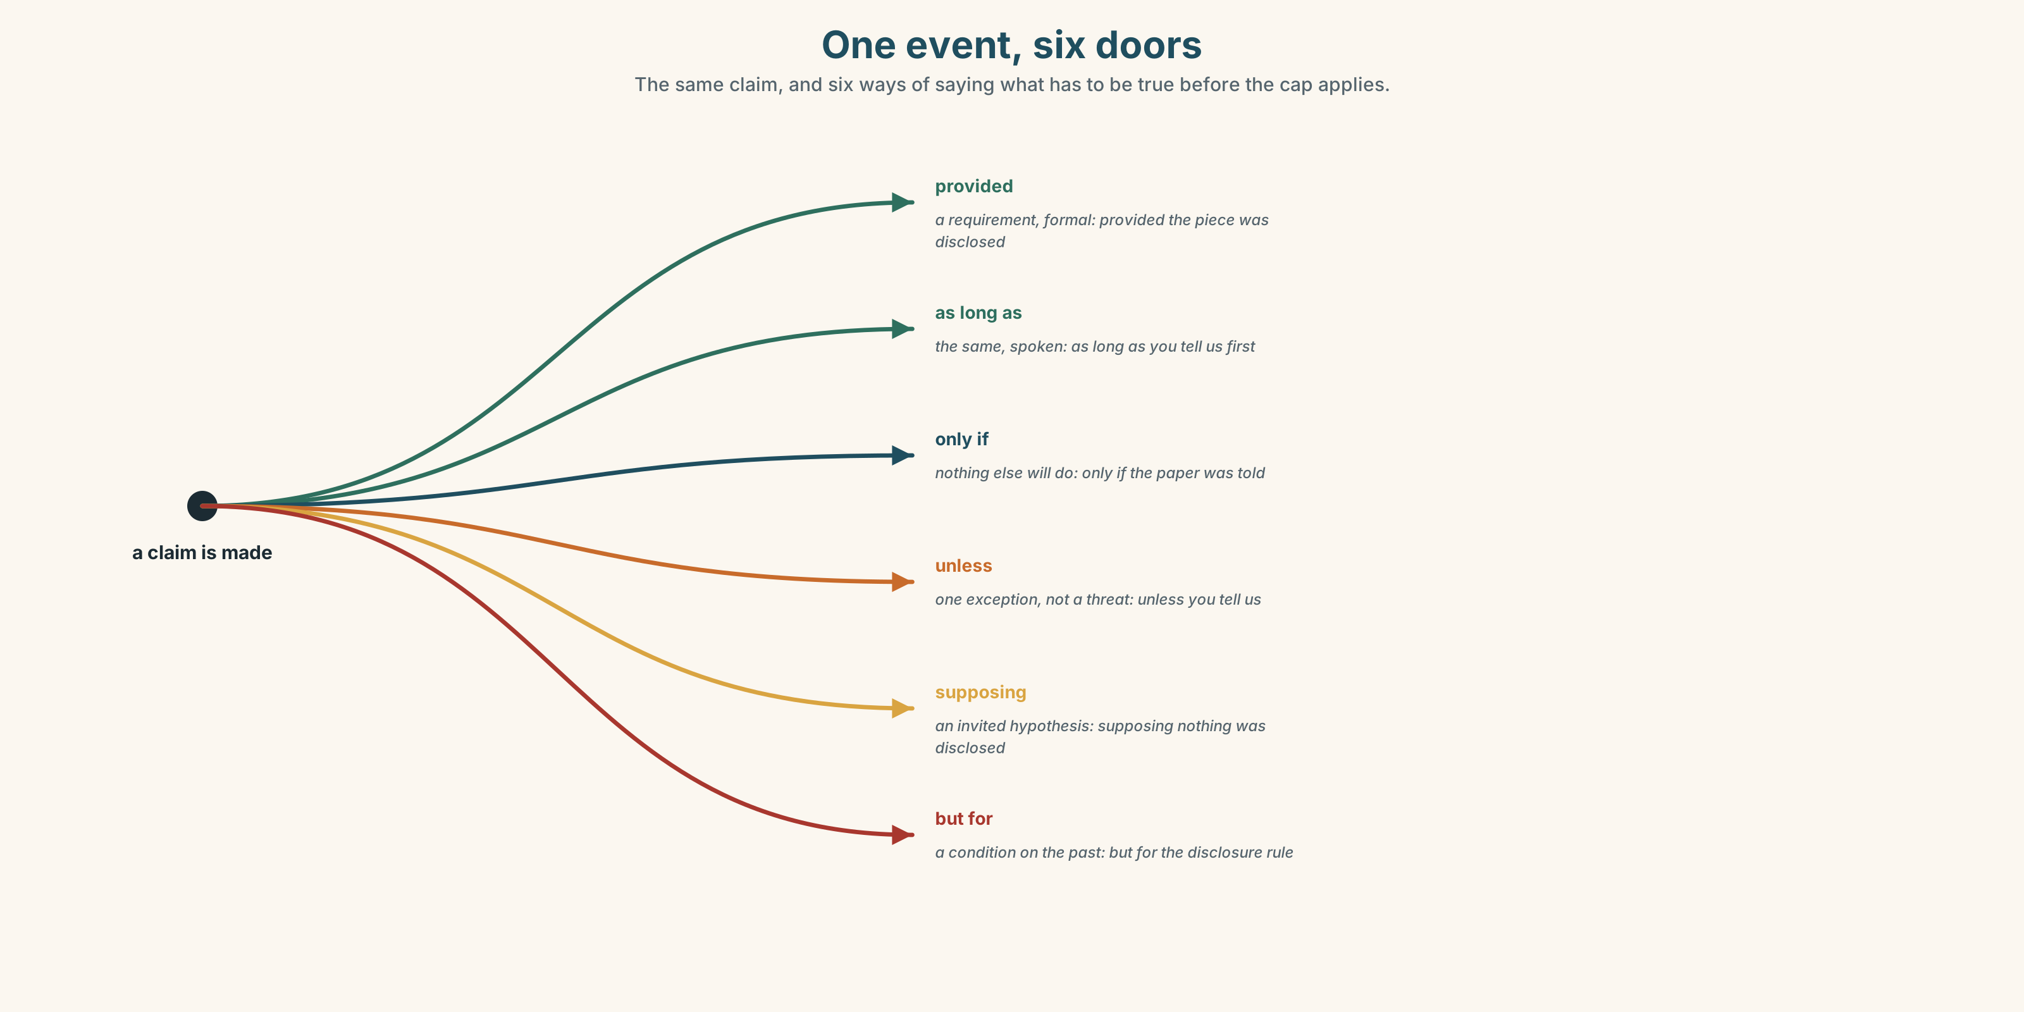{width=6.6in}
One event, six doors — The same claim, and six ways of saying what has to be true before the cap applies.

3C · Know
provided · provided that | formal, and the condition is a requirement | provided the piece was disclosed
as long as | the same meaning, spoken register | as long as you tell us first
on condition that | explicit, and usually written into a document | on condition that the cap applies
only if | exclusive — nothing else will do | only if the paper was told
unless | the negative condition, and it is not if not | unless the paper was told
in the event that | formal, about something that may happen | in the event that a claim is made
supposing · assuming that | a hypothesis, invited rather than imposed | supposing nothing was disclosed
but for · were it not for | a condition on something that already happened | but for the disclosure rule
failing · absent | formal, in the sense if there is no | failing agreement tonight
otherwise | the consequence of the condition not being met | disclose it; otherwise the cap goes
The difference between provided and only if is the size of the opening. Provided says: this is what I need. Only if says: this and nothing else, and I am telling you that on purpose.
Unless is not the same as if not. Unless you tell us, the cap goes has one exception. If you don't tell us, the cap goes is a straight consequence. The first is an invitation; the second is a threat, and a negotiator who confuses them loses the room.
the formal connectors | notwithstanding · insofar as · to the extent that · given that
the hypothetical frame | supposing · assuming that · were it not for · all other things being equal
what you do under pressure | fall back on · hold out for · give in
Why it matters. A condition stated loosely is a condition you will not be able to enforce, and one stated too tightly is a condition nobody will accept. The grammar is the negotiation.

3D · Use — controlled
Complete with the connector the context requires.
We will cap the indemnity (1) ______ the piece was fully disclosed. (a requirement) (2) ______ agreement tonight, the old contract rolls over. (formal, "if there is no") (3) ______ the disclosure rule, we would not have offered a cap at all. (a condition on the past) (4) ______ nothing was disclosed — what happens then? (an invited hypothesis) Disclose it before publication; (5) ______ , the cap does not apply. (the consequence of not)

3E · Use — guided
Rewrite each one with the connector in brackets, keeping the meaning as close as you can.
- If you tell us first, we will cap it. (provided)
- If you don't tell us, the cap goes. (unless)
- We will cap it, but only in cases where you told us. (only if)
- If there is no agreement tonight, the old contract continues. (failing)
- We offered a cap because the disclosure rule exists. (but for)

3F · Use — open
In pairs. One of you makes an offer with a condition. The other must restate the condition more narrowly, then more widely. Four rounds, and nobody may use if at any point.

3G · Error autopsy
✗ We will cap it unless you tell us first. ✗ Provided that you would tell us, we would have capped it. ✗ But for you disclose it, there is no cap.
For each, name the rule and say what the writer was reaching for.

3H · Check — eight items
- We will cap it ______ the piece was disclosed. (a requirement, formal)
- ______ agreement tonight, the old contract rolls over. (one word, formal)
- ______ ______ the disclosure rule, there would be no cap. (two words, about the past)
- ______ nothing was disclosed — what then? (one word, an invited hypothesis)
- Disclose it; ______ , the cap does not apply. (one word)
- ✗ We will cap it unless you tell us first. → correct it.
- Rewrite If you don't tell us, the cap goes so that it sounds like an invitation.
- Rewrite We'll cap it if you tell us so that nothing else will satisfy the condition.

Part 4 · Speaking ◆ C · THE PERFORMANCE

4A · Fluency starter — widen the door
One person states a condition. The next states it one degree more generously. Five people, five degrees, and the fifth one has to be something the first person could still live with.

4B · The functional core — setting conditions
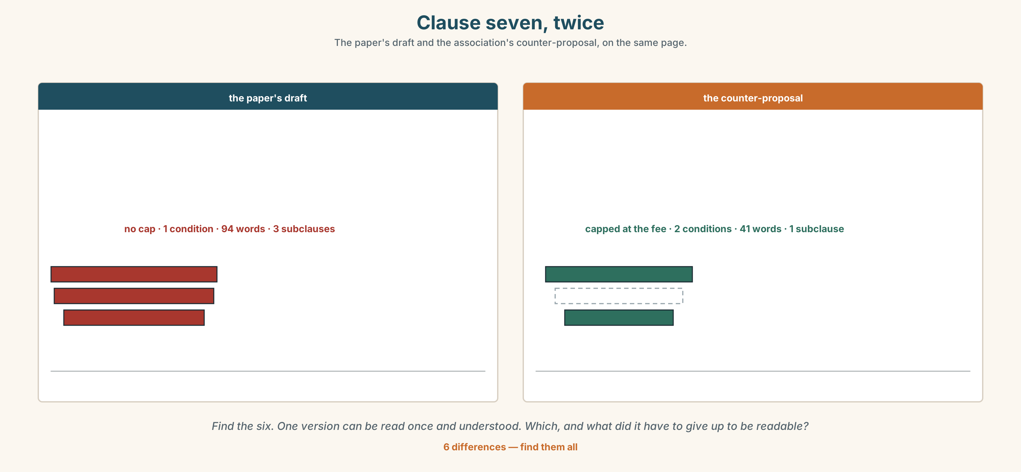{width=6.6in}
Clause seven, twice — The paper's draft and the association's counter-proposal, on the same page.
Language Bank
opening | subject to contract · without prejudice · assuming that
conditioning | provided · as long as · on condition that · in the event that
narrowing | only if · unless · to the extent that · that is conditional on
closing | we can live with that · but for that · all other things being equal
Information gap. Learner A has the paper's draft of clause 7. Learner B has the association's counter-proposal. Agree on one wording, and write down what each side gave up.

4C · The performance — three minutes ⏺
Negotiate one clause in three minutes. You must make three offers, each one conditional, and each condition narrower than the last. Your partner says, at the end, which one they would have accepted.
Record it.

4D · Observer
One person writes down every condition offered and marks whether it was a requirement, an exclusion or a hypothesis.

4E · Three criteria
☐ Was every offer conditional, and was the condition audible? ☐ Did I distinguish unless from if not in the way I meant it? ☐ Could my partner state, afterwards, exactly what I would accept?

Part 5 · Reading ◆ A · THE WORLD

5A · Predict
The title is "Four hundred and ten signatures and one envelope." What do you think is in the envelope, and who was not shown it?

5B · Read — two minutes

Four hundred and ten signatures and one envelope
Four hundred and ten people write for the Herald without working for it. The new contributor contract runs to nine pages, and eight of them were agreed by lunchtime.
Clause 7 says that a contributor will indemnify the paper, without limit, against any claim arising from their work. The association's position is that the clause is unenforceable in practice and corrosive in principle: nobody with four thousand three hundred dollars of annual freelance income can meet a claim, so the clause does not transfer risk, it transfers fear.
The paper's position is that the clause is standard, that it has never been invoked, and that the alternative is to stop commissioning anything difficult.
In nine years there have been three claims. All three arose from work by staff reporters. None arose from a freelance piece.
At eight o'clock a side letter was placed face down on the table. It had been offered, three months earlier, to eleven named contributors, capping their liability at five thousand dollars. The association had not been told. Nobody in the room disputed that the eleven are the eleven who file the hardest stories.
The negotiator read it twice and said one sentence: That is not what we agreed.

5C · Comprehension — eight questions
- How many contributors are there, and how long is the contract?
- What does clause 7 require?
- How many claims have there been, and from whose work?
- How much does the side letter cap liability at?
- How many contributors were offered it?
- The association says the clause transfers fear, not risk. What is the argument?
- Why does the writer say "nobody in the room disputed" rather than stating it directly?
- The piece ends on four words of quotation. What would a paragraph of explanation have cost?

5D · Vocabulary in context
Infer from the text, then check.
without working for it · corrosive in principle · has never been invoked · placed face down on the table · the hardest stories

5E · The counter-text
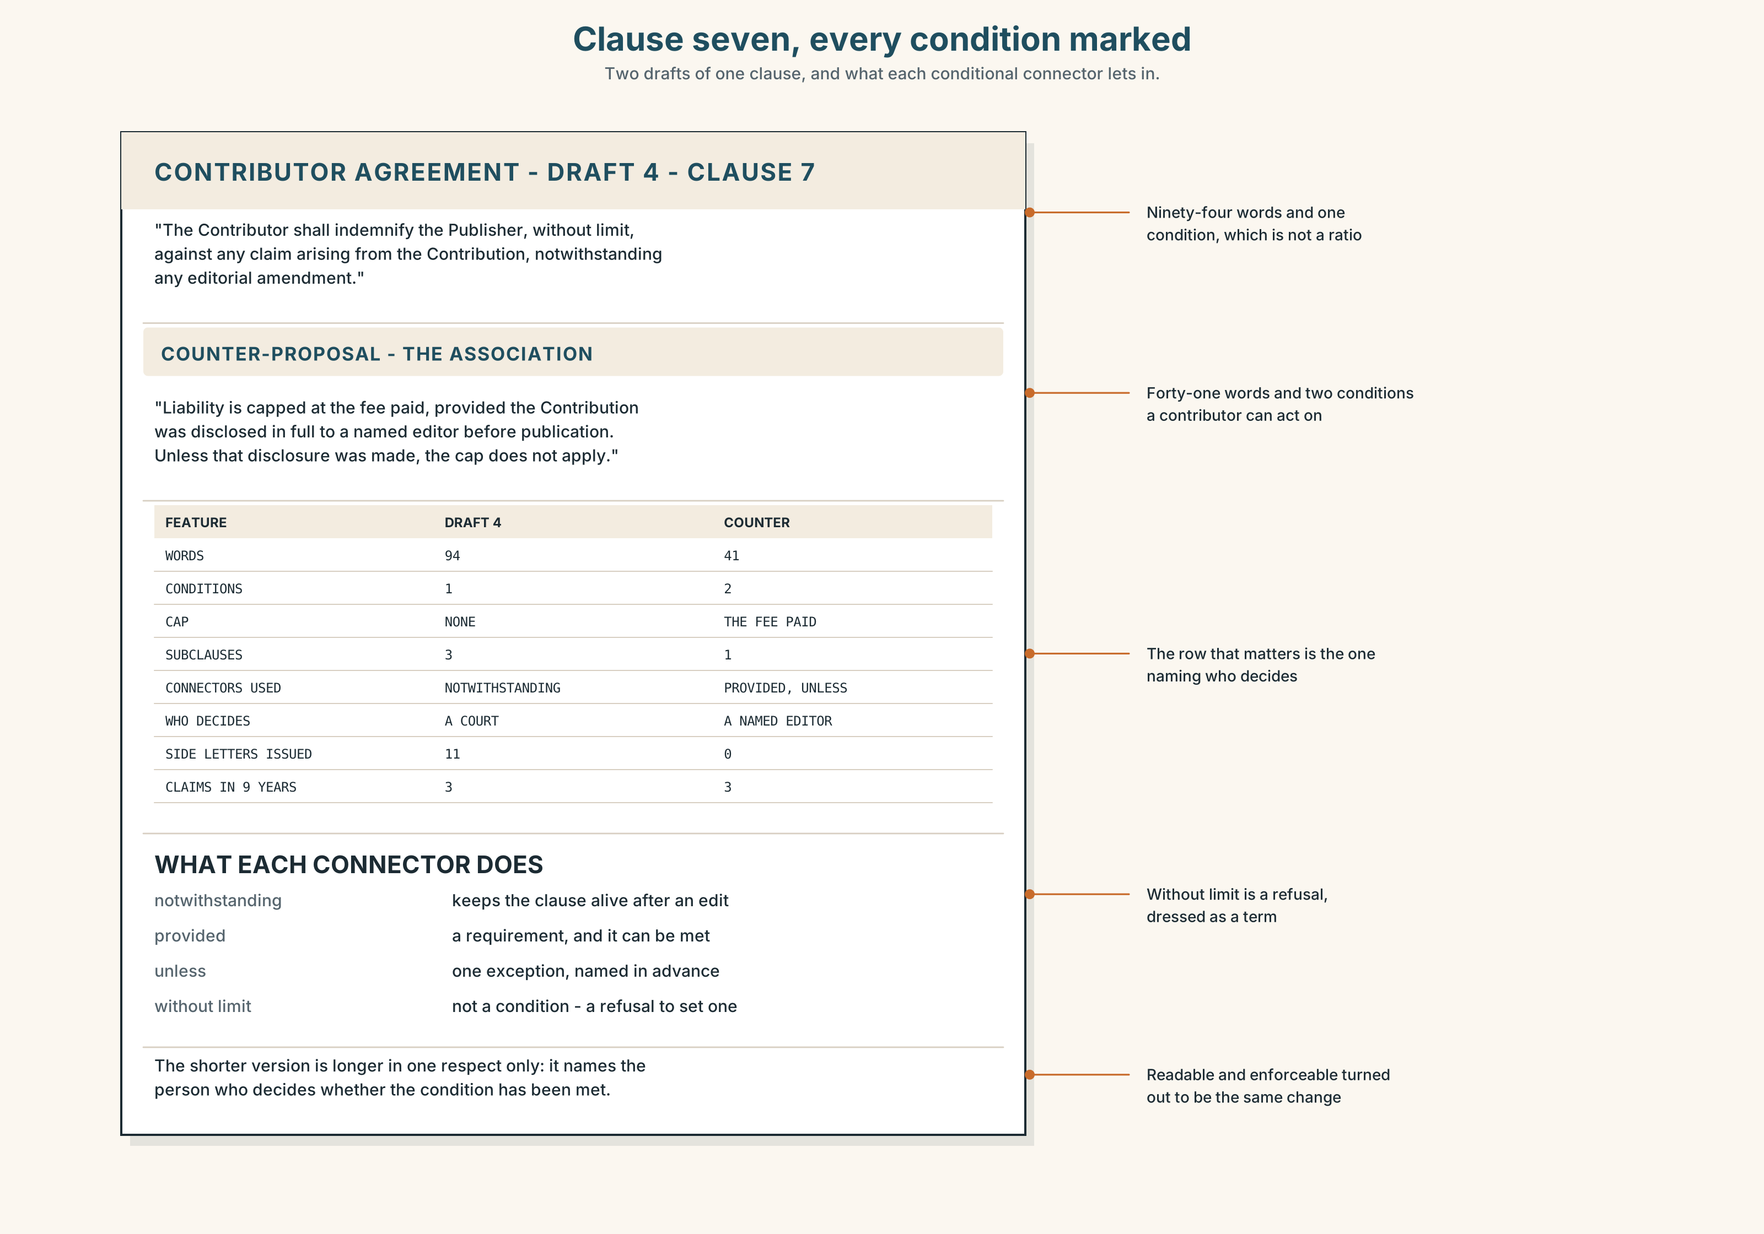{width=6.6in}
Clause seven, every condition marked — Two drafts of one clause, and what each conditional connector lets in.
Read clause 7 and the counter-proposal, and answer.
- How many conditions does each version contain?
- Find every conditional connector in both and say what each one lets in or keeps out.
- The counter-proposal has a cap. What is the cap conditional on?
- Which of the two versions could a contributor read once and understand?

5F · Two texts
The paper says the clause is standard. The association says it is unenforceable in practice.
Can both be true? Write two sentences, and use to the extent that in one of them.

Part 6 · Vocabulary Lab 2 ◆ B · THE SYSTEM

Connectors that do the work of if

6A · Sort — a requirement, an exception, or a formal qualifier?
Three columns.
provided · unless · notwithstanding · supposing · failing · insofar · absent · otherwise

6B · Chunk completion
- We will cap it ______ ______ ______ you tell us first. (three words, spoken register)
- The cap applies ______ ______ ______ the piece was disclosed. (three words, written)
- ______ ______ ______ ______ a claim is made, the cap is the ceiling. (four words, formal)
- ______ ______ the disclosure rule, there would be no cap. (two words)
- ______ ______ ______ ______ ______ the rule, the clause would stand as drafted. (five words)
- ______ ______ the claims log says three, the clause has never been invoked. (two words)
- ______ ______ nothing was disclosed, what is the paper's position? (two words, a hypothesis)
- The cap applies ______ ______ , and not in any other case. (two words, exclusive)

6C · Three that are not interchangeable
unless · only if · provided
Say which one states an exception, which one excludes everything else, and which one states a requirement you expect to be met.

6D · The phrasal verbs and the fixed expressions
fall back on · hold out for · give in
f but for that · f all other things being equal · f that is conditional on
One of these three fixed expressions is almost never true when it is said. Which, and what is it protecting the speaker from?

6E · Contrast Clinic
Eight items. Rewrite each sentence so that the condition changes in the way the bracket says.
- If you tell us, we will cap it. (nothing else will do)
- If you don't tell us, the cap goes. (an exception, not a threat)
- We capped it because the rule exists. (a condition on the past)
- If there is no agreement, the old contract continues. (one formal word)
- The cap applies to disclosed pieces. (make the condition explicit and written)
- Perhaps nothing was disclosed. (invite the other side to think it through)
- The clause stands, although the log says three claims. (a formal concessive qualifier)
- Tell us first, or there is no cap. (state the consequence with one adverb)

Part 7 · Pronunciation & Fluency Lab ◆ B · THE SYSTEM
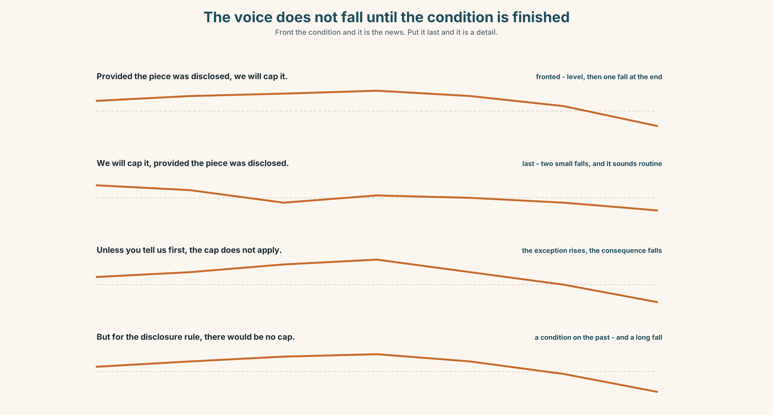{width=6.6in}
The voice does not fall until the condition is finished — Front the condition and it is the news. Put it last and it is a detail.

A long conditional does not fall until the end

7A · Hear 🔊 Track 5.3
Provided the piece was fully disclosed before publication, ↗ we will cap it. ↘ We will cap it, ↘ provided the piece was fully disclosed. ↘ Unless you tell us first, ↗ the cap does not apply. ↘

7B · Say
Say each one three times. Then say this twenty-two-word sentence without letting your voice fall until the last three words:
Provided the piece was fully disclosed to a named editor before publication, and nothing was withheld, the cap applies.

7C · Make it mean something
Say these two:
We will cap it, provided you tell us. — the condition is an afterthought, and sounds routine Provided you tell us, we will cap it. — the condition is the news, and the room hears it
Front the condition and it becomes the point; put it last and it becomes a detail. Negotiators front conditions they intend to enforce.

7D · Fluency 30 ⏺
Thirty seconds: one offer, three conditions, each fronted, and the voice level until the end of each. Three times, faster.

Part 8 · Writing ◆ C · THE PERFORMANCE

An offer with its conditions · 200 words

8A · Read the model
The paper will cap a contributor's liability at the fee paid for the piece, provided the piece was disclosed in full to a named editor before publication. [the offer, then the condition, fronted inside the sentence so it cannot be skimmed]
Unless that disclosure was made, the cap does not apply. [unless, with one exception — not a threat, and the difference is deliberate]
In the event that a claim is made, the paper will conduct the defence and the contributor will cooperate. [the formal frame for something that may happen, and both obligations in one sentence]
But for the disclosure rule, this cap would not be on the table; all other things being equal, the association would have preferred the clause deleted, and has said so. [a condition on the past, and the other side's position stated by us before they state it]
Questions about the writer's choices:
- The condition is fronted in sentence one. What would moving it to the end have done?
- Sentence two uses unless. What would if you don't have sounded like?
- The last sentence states the other side's preference. Why give that away?

8B · The anti-model
We are pleased to offer a cap on liability. We would of course expect contributors to act responsibly and to keep us informed. Obviously if something goes wrong we will need to look at the circumstances. We hope this is acceptable.
Four sentences, three conditions, and not one of them stated in a form anybody could enforce. Rewrite it with every condition explicit and the consequence of each one named.

8C · Plan
the offer with its condition fronted → the exception → the formal frame for a future event → the condition on the past, and the other side's position

8D · Write — 200 words

8E · Peer review — three criteria
☐ Is every condition stated in a form somebody could check? ☐ Does each connector do the job you meant — requirement, exception or hypothesis? ☐ Is the consequence of each unmet condition stated, not implied?

8F · Write it again · 8G · Publish
Rewrite after review. Publish both, and underline every conditional connector.

Part 9 · The File ◆ A · THE WORLD + C · THE PERFORMANCE
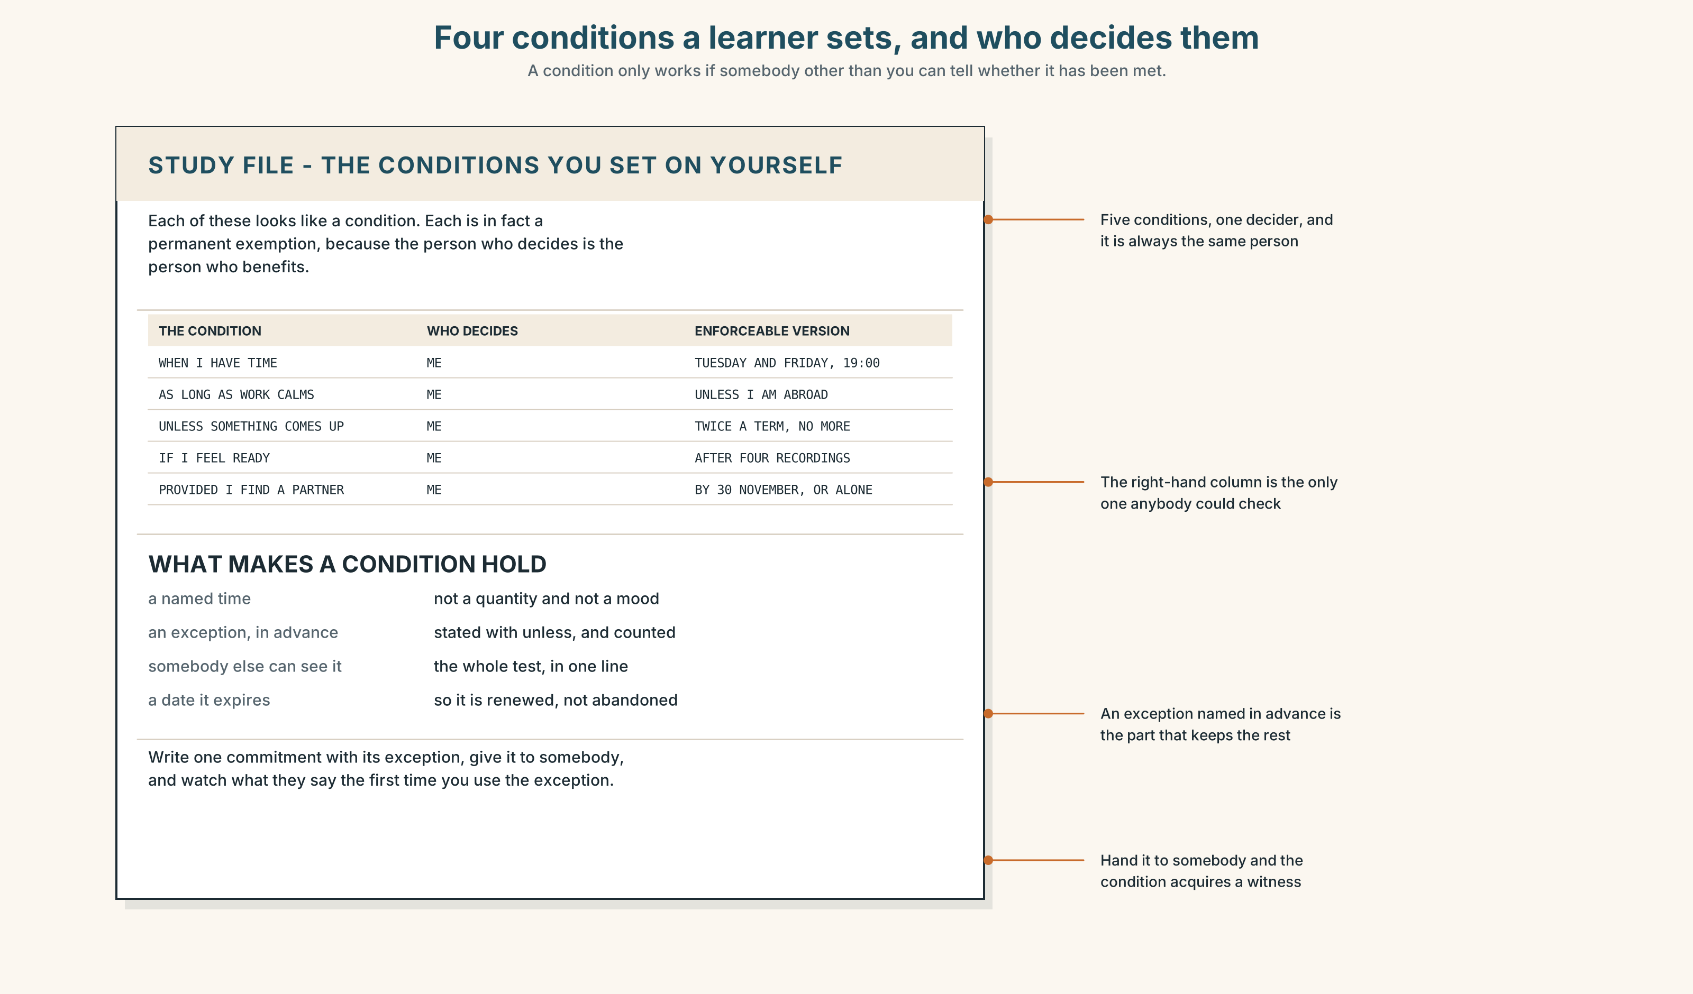{width=6.6in}
Four conditions a learner sets, and who decides them — A condition only works if somebody other than you can tell whether it has been met.

STUDY FILE · The conditions you set on yourself

9A · The unenforceable condition 🔊 Track 5.4
Learners set conditions on their own study constantly, and almost never in a form that can be checked: I'll do it when I have time, as long as work calms down, unless something comes up. Each one looks like a condition and is in fact a permanent exemption.
the condition | as long as work calms down
who decides it is met | the person who benefits from it not being met
the enforceable version | on Tuesdays and Fridays at seven, unless I am abroad
the difference | the second one names the exception in advance

9B · Make one enforceable
Take three conditions you have set on your own study. Rewrite each so that somebody else could tell, by looking, whether it had been met.

9C · Role play — the negotiator
In pairs. One of you proposes a study plan with a condition. The other may only ask and who decides whether that has happened? Four rounds each.

9D · The exception you will actually use
Everybody needs one exception or the plan breaks the first week. Name yours in advance, in writing, and put a number on how often it may be used.

9E · Transfer — before next week
Write one study commitment with its exception stated using unless, and give it to somebody. Bring back what they said when you tried to use the exception.

Part 10 · Mediation & Interaction ◆ C · THE PERFORMANCE
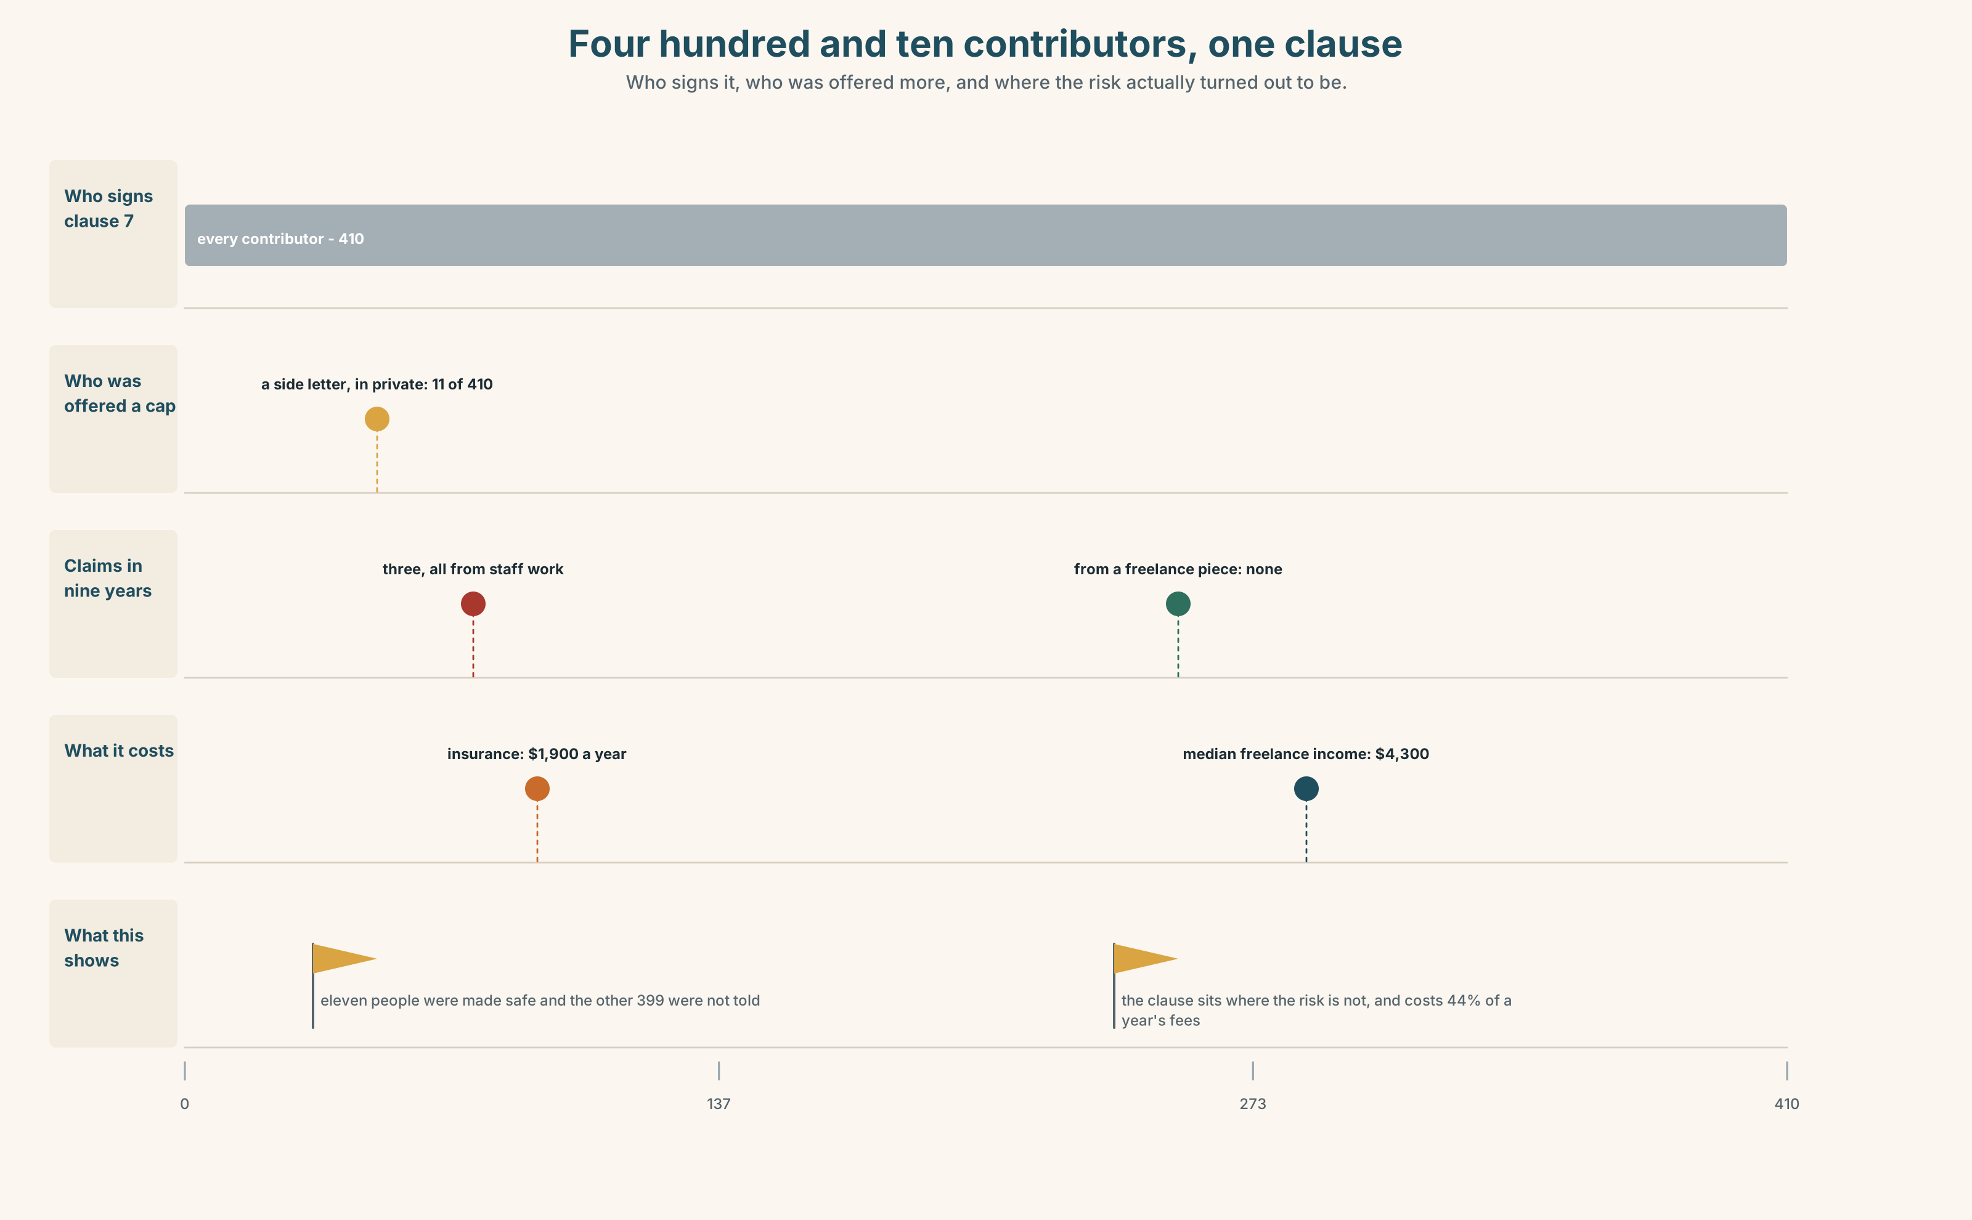{width=6.6in}
Four hundred and ten contributors, one clause — Who signs it, who was offered more, and where the risk actually turned out to be.

10A · Relay
Half the class has clause 7. Half has the counter-proposal. Produce one clause both sides will sign, by speaking only. Ten minutes.

10B · Simplify — for one reader
A contributor writes: What am I actually agreeing to? Reply in four sentences, with every condition and its consequence named, and no legal words.

10C · Online
Write one message to the eleven contributors who were offered the side letter. Three sentences. Say what happened and what happens now.

10D · Your language
How does your language distinguish unless from if not? Translate all six sentences from Part 2. Which of the six collapse into one form?

Part 11 · The Decision ◆ C · THE PERFORMANCE

Clause seven
It is twenty past seven and eight of the nine pages are agreed.
Option one: keep clause 7 as drafted. It is standard across the industry, it has never been invoked, and removing it will be read as an admission.
Option two: delete it. The paper commissions the work, the paper carries the risk, and the claims log says the risk is not where the clause puts it.
Option three: cap liability at the fee paid for the piece, conditional on full disclosure to a named editor before publication — and withdraw every side letter, publishing the fact that they existed.

11A · The evidence
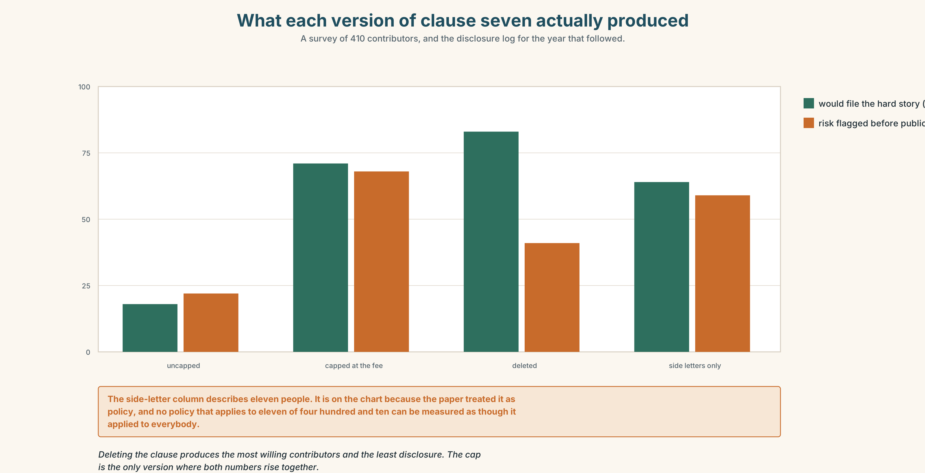{width=6.6in}
What each version of clause seven actually produced — A survey of 410 contributors, and the disclosure log for the year that followed.
🔊 Track 5.6. The association's negotiator, 30 seconds: "I have been asked all evening what we would accept. Here is what we will not accept: a clause that makes eleven people safe and three hundred and ninety-nine people quiet. Cap it, delete it, I can argue either at a meeting. The side letter I cannot argue at all, because it is not a term, it is a favour, and a favour can be withdrawn by the person who gave it."

11B · Talk about it
In threes. Use the frame, and front every condition you state.
I would ______ , provided ______ , and unless ______ , I would ______ .

11C · Decide
Write three sentences: the decision, the condition it rests on, and what would make you abandon it.

11D · Model decision
Option three. Deletion is cleaner and I would sign it, but it removes the one thing the clause could usefully do, which is make a contributor tell an editor what they know before publication rather than after. A cap at the fee is small enough to be survivable and large enough to be felt, and it is conditional on the behaviour the paper actually wants. The side letters go in any case: whatever they bought, they cost more.

11E · The Reveal
What happened. The Herald capped liability at the fee, conditional on disclosure, and withdrew the eleven side letters. Two of the eleven resigned from the panel in protest at losing them. Nobody else did.
Then something nobody predicted: pre-publication disclosure by freelancers rose from under a third to four fifths within a year — not because the cap was generous, but because a condition somebody can meet is a condition they think about, and an unlimited liability is one they can only try not to think about at all.
One question. You do not have to answer it out loud.
The uncapped clause asked for more and got less. Why?

Part 12 · Landing ◆ all three lines

12A · Recycle — fifteen items
- We will cap it ______ the piece was disclosed. (one word, a formal requirement)
- ______ you tell us first, the cap does not apply. (one word, an exception)
- ______ ______ the disclosure rule, there would be no cap. (two words)
- ______ agreement tonight, the old contract rolls over. (one word)
- ______ nothing was disclosed, what then? (one word, a hypothesis)
- Tell us first; ______ , the cap goes. (one word)
- The clause stands ______ the claims log. (one word, formal and concessive)
- The cap applies ______ ______ ______ ______ the contributor knew. (four words)
- The talks are ______ ______ until both boards sign. (two words)
- The offer was made ______ ______ , so it cannot be quoted. (two words)
- Everything in this room is being done ______ ______ ______ . (three words)
- ______ ______ ______ ______ ______ ______ . (six words — the sentence that ended the evening)
- It took nine hours to ______ ______ one clause. (two words)
- The lawyers will ______ ______ the final text tomorrow. (two words)
- The association refused to let them ______ ______ the disclosure rule. (two words)

12B · Consolidate — one task, everything in it
Write 150 words offering something with three conditions, one fronted, one as an exception and one about the past. Mark the three in the margin.

12C · Can-do, with evidence
☐ I can use the full conditional system, including but for and failing. Evidence: 3H, 8D ☐ I can distinguish a requirement, an exception and an exclusion. Evidence: 6C, 6E ☐ I can set a condition somebody else could check. Evidence: 9B, 10B ☐ I can hold the tune across a long conditional. Evidence: 7B

12D · Replay ⏺
Record 0C again. Compare. Is the condition you set the first time one you could enforce?

12E · Glossary — fifty items, as a map
PARTS OF THE DOCUMENT · clause · term · undertaking · covenant WHAT ONE SIDE GIVES UP · waiver · indemnity · concession WHEN IT GOES WRONG · breach · remedy · arbitration · settlement · precedent THE FIVE PHRASES · subject to contract · on the understanding that · without prejudice · in good faith · the governing law WHAT IS IN THE PAPERWORK · a material breach · a break clause · terms and conditions · a side letter · to the extent that WHAT NEGOTIATORS DO · hammer out · draw up · water down · fall back on · hold out for · give in IN THE ROOM · that is not what we agreed · we can live with that · it depends what you mean by THE CONNECTORS · provided · supposing · unless · otherwise · failing · absent · notwithstanding · insofar THE FRAMES · as long as · on condition that · in the event that · but for · were it not for · given that · assuming that · only if CLOSING IT · but for that · all other things being equal · that is conditional on

12F · Next
Unit 6 · Why put it there?

