2.1 Purpose and structure of the balance sheet
Chapter 2 · section 2.1

Fill every gap. Each word list holds one word more than there are gaps.
Chapter 2, section by section
Each stage leads to the next.
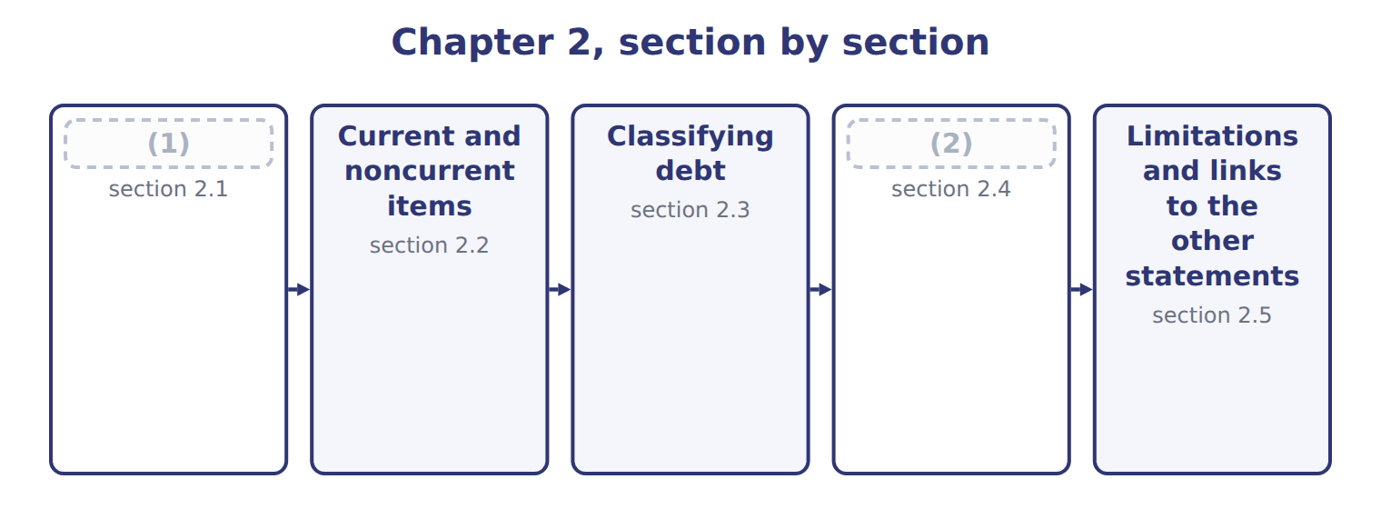
word list
Purpose and structure of the balance sheet · right of setoff · Other presentation matters

Summary 1 gaps 3–14
The balance sheet reports a (3) assets, liabilities and (4) at one point in time. It answers three (5) for investors and (6) . Can the company pay its bills in the (7) months? This is liquidity. Can it pay all its debts over time? This is (8) . Can it raise cash or change its plans if something (9) happens? This is financial (10) . U.S. companies that file with the SEC present a (11) balance sheet. It (12) current from noncurrent assets and current from noncurrent liabilities, so users can see the (13) position at once. Some companies, such as banks, list items in order of liquidity instead, without a current (14) . All the amounts come from the same records as the earlier chapters on receivables, inventory, investments and long-lived assets. For example, the equity-method investments include Jordan Glass Co. from, and goodwill fell after the impairments.
word list
unexpected · questions · company's · solvency · lenders · equity · current · classified · subtotal · separates · coming · flexibility · short-term

Orontes Foods Inc. — classified balance sheets at December 31, 2025 and 2024
Orontes Foods Inc. (whole USD) | Dec 31, 2025 | Dec 31, 2024
ASSETS
Current assets
Cash | 7,302,100 | 2,100,000
Trading securities | 42,000 | 40,000
Accounts (15) , net of allowance (2025: 156,000; 2024: 140,000) | 4,144,000 | 3,760,000
Inventory | 2,450,000 | 2,300,000
(16) | 204,000 | 180,000
Assets held for sale | 46,000 | —
Total current assets | 14,188,100 | 8,380,000
Noncurrent assets
Debt securities (held-to-maturity and available-for-sale) | 88,500 | 90,000
Equity securities | 27,000 | 25,000
Equity-method investments | 1,807,000 | 500,000
Property, plant and equipment, net of accumulated (17) (2025: 11,988,000; 2024: 8,000,000) | 14,802,000 | 16,000,000
(18) | 260,000 | 300,000
Goodwill | 300,000 | 950,000
Other noncurrent assets | 200,000 | 200,000
TOTAL ASSETS | 31,672,600 | 26,445,000
LIABILITIES AND STOCKHOLDERS' EQUITY
Current liabilities
(19) | 2,050,000 | 1,900,000
Accrued liabilities | 900,000 | 850,000
Income taxes payable | 350,000 | 300,000
Contract liabilities | 180,000 | 120,000
Dividends payable | 400,000 | —
(20) | 400,000 | 400,000
Total current liabilities | 4,280,000 | 3,570,000
(21) | 6,000,000 | 5,600,000
Deferred tax liability | 999,625 | 900,000
Total liabilities | 11,279,625 | 10,070,000
(22)
Stockholders' equity
Common stock, $1 par; shares issued and (23) : 2025 8,100,000, 2024 8,000,000 | 8,100,000 | 8,000,000
(24) | 5,400,000 | 4,000,000
Retained earnings | 6,894,100 | 4,375,000
Accumulated other comprehensive income (loss) | (1,125) | —
Total stockholders' equity | 20,392,975 | 16,375,000
TOTAL LIABILITIES AND STOCKHOLDERS' EQUITY | 31,672,600 | 26,445,000

word list
Prepaid expenses · Current portion of long-term debt · Equity-method investments · Brand (indefinite-lived) · Long-term debt, less current portion · outstanding · Additional paid-in capital · depreciation · receivable · Accounts payable · Commitments and contingencies (Note 12)

Summary 2 gaps 25–30
Read the figure from the top. (25) assets come first, from cash down to assets held for sale. Then come the noncurrent assets: (26) , property, plant and equipment, and (27) assets. (28) follow the same order, and equity comes last. Contra accounts, such as the allowance for credit losses and accumulated (29) , are shown with the asset they reduce. The line Commitments and (30) has no amount; it tells the reader to look at a note.
word list
liquidity · intangible · depreciation · Liabilities · Current · investments · contingencies

The English this section uses, and its Arabic
Each term sits against what it means.
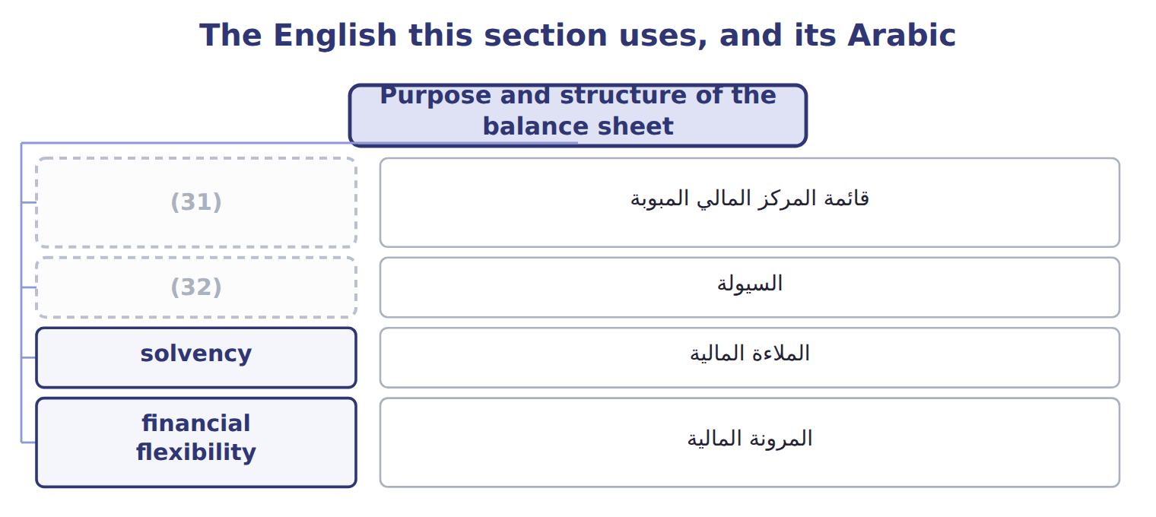
word list
السيولة · liquidity · classified balance sheet

The English this sheet uses, and its Arabic
English (exam term) | Arabic
classified balance sheet | قائمة المركز المالي المبوبة
liquidity | السيولة
solvency | الملاءة المالية
financial flexibility | المرونة المالية

Answer key · 2.1 Purpose and structure of the balance sheet

1 Purpose and structure of the balance sheet | 17 depreciation
2 Other presentation matters | 18 Brand (indefinite-lived)
3 company's | 19 Accounts payable
4 equity | 20 Current portion of long-term debt
5 questions | 21 Long-term debt, less current portion
6 lenders | 22 Commitments and contingencies (Note 12)
7 coming | 23 outstanding
8 solvency | 24 Additional paid-in capital
9 unexpected | 25 Current
10 flexibility | 26 investments
11 classified | 27 intangible
12 separates | 28 Liabilities
13 short-term | 29 depreciation
14 subtotal | 30 contingencies
15 receivable | 31 classified balance sheet
16 Prepaid expenses | 32 liquidity

the summaries in full
Summary 1 The balance sheet reports a company's assets, liabilities and equity at one point in time. It answers three questions for investors and lenders. Can the company pay its bills in the coming months? This is liquidity. Can it pay all its debts over time? This is solvency. Can it raise cash or change its plans if something unexpected happens? This is financial flexibility. U.S. companies that file with the SEC present a classified balance sheet. It separates current from noncurrent assets and current from noncurrent liabilities, so users can see the short-term position at once. Some companies, such as banks, list items in order of liquidity instead, without a current subtotal. All the amounts come from the same records as the earlier chapters on receivables, inventory, investments and long-lived assets. For example, the equity-method investments include Jordan Glass Co. from, and goodwill fell after the impairments.
Summary 2 Read the figure from the top. Current assets come first, from cash down to assets held for sale. Then come the noncurrent assets: investments, property, plant and equipment, and intangible assets. Liabilities follow the same order, and equity comes last. Contra accounts, such as the allowance for credit losses and accumulated depreciation, are shown with the asset they reduce. The line Commitments and contingencies has no amount; it tells the reader to look at a note.

2.2 Current and noncurrent items
Chapter 2 · section 2.2

Fill every gap. Each word list holds one word more than there are gaps.
Summary 1 gaps 1–12
Current assets are cash and other assets that the company expects to turn into cash, sell or use up within one year or within its operating cycle, (1) is longer. The operating cycle is the (2) time from buying materials to (3) cash from customers. Current liabilities are (4) the company expects to settle by using current assets or by (5) other current liabilities. It takes about 32 days to sell its (6) and 34 days to collect from customers: 66 days in total. (7) the cycle is shorter than a year, Orontes uses one year to (8) its items. Some assets that look current are not. (9) cash set aside to repay long-term debt or to build a plant is (10) . So are long-term (11) , receivables that will not be collected within the period, the cash surrender value of life insurance, and long-term (12) .
word list
average · noncurrent · investments · classify · obligations · collecting · creating · Working · whichever · Restricted · prepayments · inventory · Because

Summary 2 gaps 13–19
On the (13) side, current portion of (14) debt is current, because that part of the principal is due within a year. Two (15) come directly from these totals. Working capital is current assets minus current liabilities. The current ratio is current assets (16) by current liabilities. For (17) at the end of 2025, working capital is $14,188,100 − $4,280,000 = $9,908,100, and the current ratio is 3.31. A year (18) the ratio was 2.35. Part 2 of the CMA exam (19) these ratios in depth.
word list
Orontes · long-term · analyzes · liability · solvency · divided · measures · earlier

Working capital or the ratio?

Summary 3 gaps 20–23
Paying a (20) in cash reduces current assets and current (21) by the same amount: working capital does not change, but the current ratio changes. (22) debt from current to (23) increases working capital and the current ratio. Use the operating cycle only when it is longer than one year.
word list
noncurrent · liabilities · measures · Reclassifying · supplier

Worked example: classifying three Orontes items

Summary 4 gaps 24–29
Next year's (24) on long-term debt, $400,000. It is due within one year, so it is a current (25) ; the rest of the debt stays noncurrent. The (26) van held for sale, $46,000. Orontes (27) to sell it within the year, so it is a current asset, outside PP&E. The (28) investments, $1,807,000. Orontes plans to hold them for the long term, so they are noncurrent (29) .
word list
delivery · assets · liability · operating · installment · expects · equity-method

Current or noncurrent?

The first two are done. Classify the other four and give a reason.
Classify each item: current or noncurrent? (complete the blanks)
Item | Classification | Reason
Cash set aside in a sinking fund to repay bonds in 2029 | (30) | Restricted for a noncurrent purpose
Date vinegar that Orontes ages for 18 months before sale | Current asset | The (31) is longer than one year, so the cycle applies
Cash surrender value of an executive life insurance policy | ________ | ________
Bank loan due on demand; the bank has never asked for repayment | ________ | ________
Deferred tax asset from warranty costs expected to reverse next year | ________ | ________
Customer deposits for orders to be delivered next month | ________ | ________

word list
Noncurrent asset · operating cycle · current assets

The words this section uses
Each term sits against what it means.
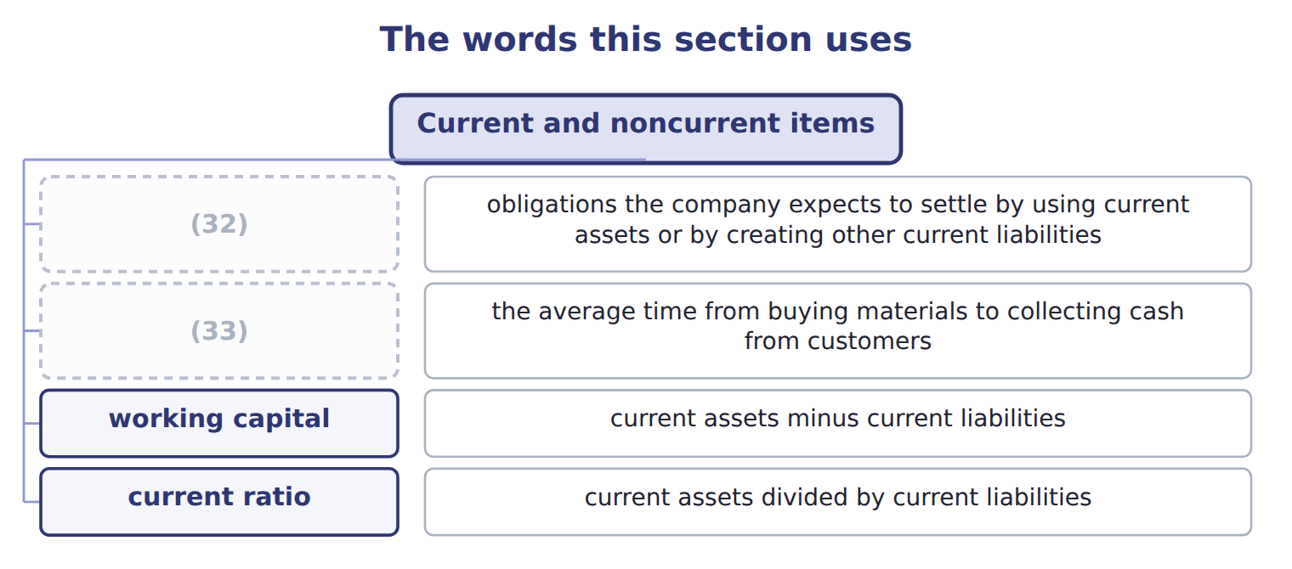
word list
callable debt · operating cycle · current liabilities

The English this sheet uses, and its Arabic
English (exam term) | Arabic
current assets | الأصول المتداولة
current liabilities | الالتزامات المتداولة
operating cycle | دورة التشغيل
working capital | رأس المال العامل
current ratio | نسبة التداول
restricted cash | النقد المقيد

Answer key · 2.2 Current and noncurrent items

1 whichever | 18 earlier
2 average | 19 analyzes
3 collecting | 20 supplier
4 obligations | 21 liabilities
5 creating | 22 Reclassifying
6 inventory | 23 noncurrent
7 Because | 24 installment
8 classify | 25 liability
9 Restricted | 26 delivery
10 noncurrent | 27 expects
11 investments | 28 equity-method
12 prepayments | 29 assets
13 liability | 30 Noncurrent asset
14 long-term | 31 operating cycle
15 measures | 32 current liabilities
16 divided | 33 operating cycle
17 Orontes

the summaries in full
Summary 1 Current assets are cash and other assets that the company expects to turn into cash, sell or use up within one year or within its operating cycle, whichever is longer. The operating cycle is the average time from buying materials to collecting cash from customers. Current liabilities are obligations the company expects to settle by using current assets or by creating other current liabilities. It takes about 32 days to sell its inventory and 34 days to collect from customers: 66 days in total. Because the cycle is shorter than a year, Orontes uses one year to classify its items. Some assets that look current are not. Restricted cash set aside to repay long-term debt or to build a plant is noncurrent. So are long-term investments, receivables that will not be collected within the period, the cash surrender value of life insurance, and long-term prepayments.
Summary 2 On the liability side, current portion of long-term debt is current, because that part of the principal is due within a year. Two measures come directly from these totals. Working capital is current assets minus current liabilities. The current ratio is current assets divided by current liabilities. For Orontes at the end of 2025, working capital is $14,188,100 − $4,280,000 = $9,908,100, and the current ratio is 3.31. A year earlier the ratio was 2.35. Part 2 of the CMA exam analyzes these ratios in depth.
Summary 3 Paying a supplier in cash reduces current assets and current liabilities by the same amount: working capital does not change, but the current ratio changes. Reclassifying debt from current to noncurrent increases working capital and the current ratio. Use the operating cycle only when it is longer than one year.
Summary 4 Next year's installment on long-term debt, $400,000. It is due within one year, so it is a current liability; the rest of the debt stays noncurrent. The delivery van held for sale, $46,000. Orontes expects to sell it within the year, so it is a current asset, outside PP&E. The equity-method investments, $1,807,000. Orontes plans to hold them for the long term, so they are noncurrent assets.

2.3 Classifying debt
Chapter 2 · section 2.3

Fill every gap. Each word list holds one word more than there are gaps.
Summary 1 gaps 1–12
Debt is where (1) gets difficult, and where the exam likes to test. Long-term debt that is due in (2) is split: the current (3) of long-term debt is current and the rest is noncurrent. (4) shows $400,000 as current and $6,000,000 as long-term. Loan (5) contain conditions called covenants, for example a maximum (6) ratio. If a company breaks a (7) , the lender may be able to demand (8) at once. Such (9) debt is current, even if the company does not (10) the lender to act. It stays noncurrent only if, before the (11) are issued, the lender gives a (12) for more than one year, or a grace period exists and the company will probably cure the violation within it. A subjective acceleration clause, such as a right to demand payment after a 'material adverse change', makes debt current only if acceleration is probable.
word list
portion · covenant · debt-to-equity · signing · Orontes · classification · statements · expect · installments · agreements · callable · repayment · waiver

Summary 2 gaps 13–22
Debt that is due on demand is always (13) . (14) debt can be shown as noncurrent (15) refinancing, but only if the company intends to (16) it on a long-term basis and shows that it can. It shows this by (17) long-term debt or shares after the (18) sheet date but before the statements are issued, or by signing a (19) financing agreement. IAS 1 asks one question: at the reporting date, does the company have a right to defer (20) for at least twelve months? A (21) or refinancing obtained after the reporting date does not count. U.S. GAAP (22) events up to the date the statements are issued.
word list
counts · Short-term · refinance · current · through · waiver · issuing · balance · intends · settlement · qualifying

Debt classification: U.S. GAAP versus IFRS
Situation at the reporting date | U.S. GAAP (ASC 470-10) | IFRS (IAS 1)
Short-term debt refinanced long-term after year-end, before issuance | Noncurrent (intent and (23) ability) | Current (no right to defer at the reporting date)
Covenant broken at year-end; waiver for more than 12 months obtained after year-end | Noncurrent | Current
Covenant broken at year-end; waiver obtained on or before year-end | Noncurrent | Noncurrent
Covenant tested only after year-end (future compliance doubtful) | Noncurrent; disclose | Noncurrent; disclose the risk
Subjective acceleration clause | Current only if acceleration is probable | Ignored unless it removes the right to defer
Deferred tax assets and liabilities | All noncurrent | (24)

word list
demonstrated · All non-current · working capital

Summary 3 gaps 25–26
The FASB proposed a simpler (25) rule in 2017 and again in 2019, but removed the project from its agenda in April 2021. Do not use the old (26) on the exam.
word list
agreements · debt-classification · proposal

Debt traps

Summary 4 gaps 27–28
Refinanced after (27) but before issuance: noncurrent under U.S. GAAP, current under IFRS. Due on (28) : always current. A waiver obtained before issuance, for more than a year: noncurrent under U.S. GAAP.
word list
reporting · demand · year-end

The English this section uses, and its Arabic
Each term sits against what it means.
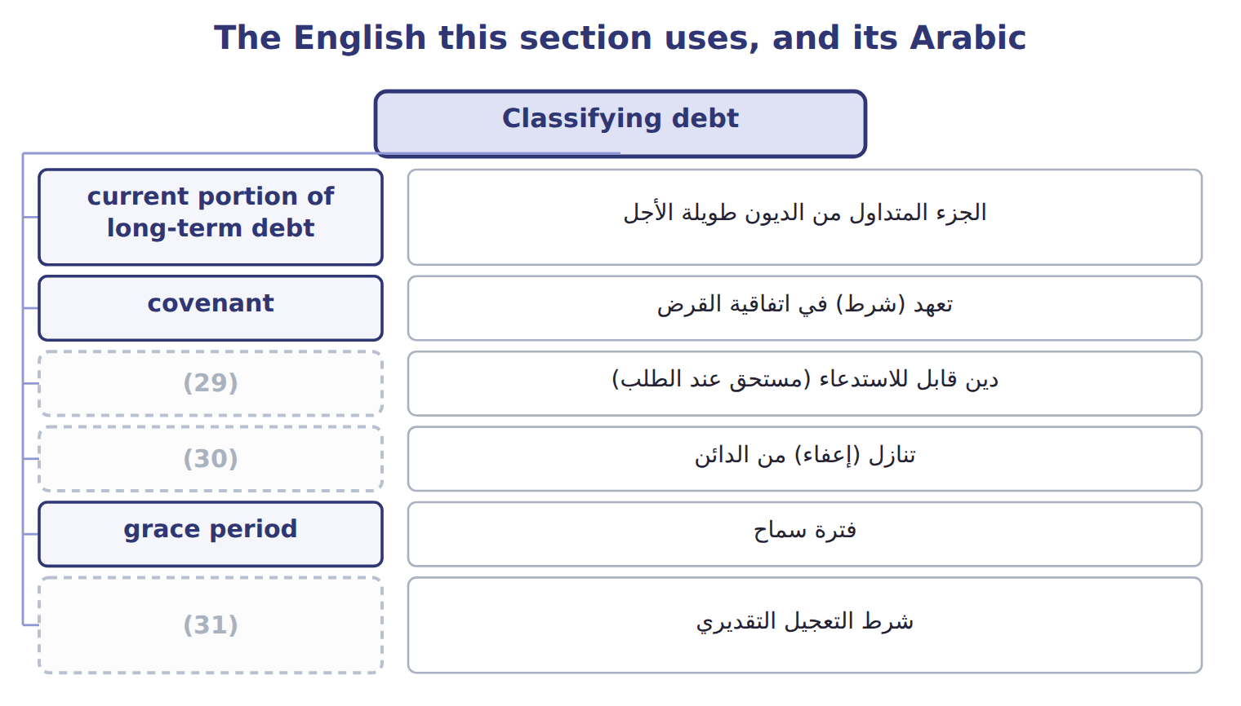
word list
financial flexibility · waiver · callable debt · subjective acceleration clause

The English this sheet uses, and its Arabic
English (exam term) | Arabic
current portion of long-term debt | الجزء المتداول من الديون طويلة الأجل
covenant | تعهد (شرط) في اتفاقية القرض
callable debt | دين قابل للاستدعاء (مستحق عند الطلب)
waiver | تنازل (إعفاء) من الدائن
grace period | فترة سماح
subjective acceleration clause | شرط التعجيل التقديري
refinancing | إعادة التمويل

Answer key · 2.3 Classifying debt

1 classification | 17 issuing
2 installments | 18 balance
3 portion | 19 qualifying
4 Orontes | 20 settlement
5 agreements | 21 waiver
6 debt-to-equity | 22 counts
7 covenant | 23 demonstrated
8 repayment | 24 All non-current
9 callable | 25 debt-classification
10 expect | 26 proposal
11 statements | 27 year-end
12 waiver | 28 demand
13 current | 29 callable debt
14 Short-term | 30 waiver
15 through | 31 subjective acceleration clause
16 refinance

the summaries in full
Summary 1 Debt is where classification gets difficult, and where the exam likes to test. Long-term debt that is due in installments is split: the current portion of long-term debt is current and the rest is noncurrent. Orontes shows $400,000 as current and $6,000,000 as long-term. Loan agreements contain conditions called covenants, for example a maximum debt-to-equity ratio. If a company breaks a covenant, the lender may be able to demand repayment at once. Such callable debt is current, even if the company does not expect the lender to act. It stays noncurrent only if, before the statements are issued, the lender gives a waiver for more than one year, or a grace period exists and the company will probably cure the violation within it. A subjective acceleration clause, such as a right to demand payment after a 'material adverse change', makes debt current only if acceleration is probable.
Summary 2 Debt that is due on demand is always current. Short-term debt can be shown as noncurrent through refinancing, but only if the company intends to refinance it on a long-term basis and shows that it can. It shows this by issuing long-term debt or shares after the balance sheet date but before the statements are issued, or by signing a qualifying financing agreement. IAS 1 asks one question: at the reporting date, does the company have a right to defer settlement for at least twelve months? A waiver or refinancing obtained after the reporting date does not count. U.S. GAAP counts events up to the date the statements are issued.
Summary 3 The FASB proposed a simpler debt-classification rule in 2017 and again in 2019, but removed the project from its agenda in April 2021. Do not use the old proposal on the exam.
Summary 4 Refinanced after year-end but before issuance: noncurrent under U.S. GAAP, current under IFRS. Due on demand: always current. A waiver obtained before issuance, for more than a year: noncurrent under U.S. GAAP.

2.4 Other presentation matters
Chapter 2 · section 2.4

Fill every gap. Each word list holds one word more than there are gaps.
Summary 1 gaps 1–8
A few more rules decide what (1) on the balance sheet and how. All deferred tax assets and liabilities are (2) . Orontes shows its deferred tax (3) of $999,625 below (4) debt. Assets and liabilities may be offset only when a right of setoff exists: the two parties owe each other (5) amounts, the company has the legal right and the intent to set them off, and the right is (6) . A loss (7) is an existing (8) that may cause a loss, such as a lawsuit. Gain contingencies are never recorded before they are realized.
word list
liability · determinable · contingency · enforceable · appears · liquidity · noncurrent · situation · long-term

Loss contingencies: recognition and disclosure
Likelihood of the loss | Recognition (if reasonably estimable) | Disclosure
Probable | Accrue a (9) and a loss (best estimate; if no best estimate, the minimum of the range) | Accrue and disclose
Reasonably possible | No accrual | Disclose the nature and an estimate (or say it cannot be (10) )
Remote | No accrual | (11)
Gain contingency | Never recognized before it is realized | (12)

word list
loss contingency · liability · estimated · No disclosure (except guarantees) · Disclose carefully, without misleading

Each fact, and what it settles
The rows are a set, not a sequence.
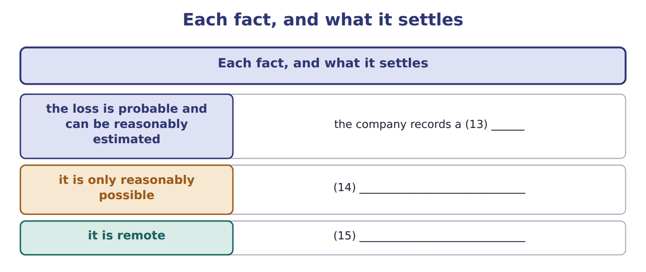
word list
the company discloses it in a note · the company does nothing · it is only reasonably possible · liability

Summary 2 gaps 16–25
Subsequent (16) happen after the (17) sheet date but before the statements are issued. If an event gives more (18) about a condition that (19) existed at year-end, the company adjusts the statements. If the condition arose after year-end, the company only (20) it. Finally, the notes begin with a summary of (21) accounting policies, such as the inventory method and (22) methods. The notes are part of the statements, not an extra. IFRS records a (23) when a loss is more likely than not, a lower (24) than the U.S. 'probable'. When the estimate is a range, IFRS usually uses the (25) ; U.S. GAAP uses the best estimate or, if none, the minimum.
word list
threshold · reasonably · depreciation · already · midpoint · events · information · balance · provision · discloses · significant

Reserve, provision, allowance

Summary 3 gaps 26–27
In U.S. GAAP answers, use allowance for (26) , accrued liability or loss (27) for liabilities, and never call either a reserve.
word list
contingency · contra-assets · reserve

The English this section uses, and its Arabic
Each term sits against what it means.
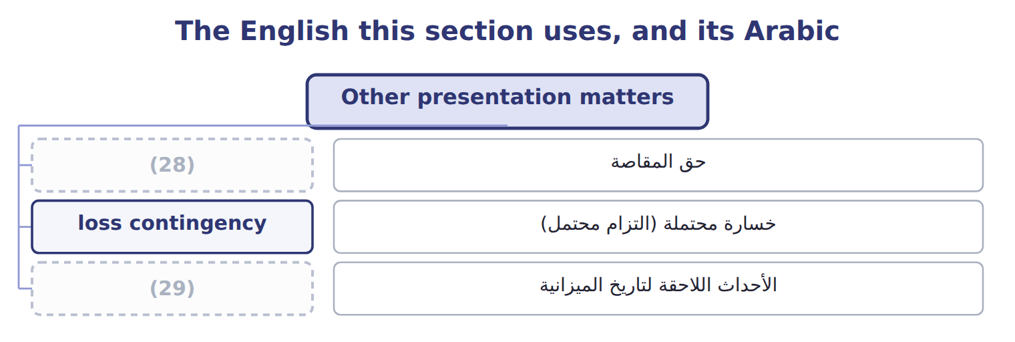
word list
operating cycle · subsequent events · right of setoff

The English this sheet uses, and its Arabic
English (exam term) | Arabic
right of setoff | حق المقاصة
loss contingency | خسارة محتملة (التزام محتمل)
subsequent events | الأحداث اللاحقة لتاريخ الميزانية

Answer key · 2.4 Other presentation matters

1 appears | 16 events
2 noncurrent | 17 balance
3 liability | 18 information
4 long-term | 19 already
5 determinable | 20 discloses
6 enforceable | 21 significant
7 contingency | 22 depreciation
8 situation | 23 provision
9 liability | 24 threshold
10 estimated | 25 midpoint
11 No disclosure (except guarantees) | 26 contra-assets
12 Disclose carefully, without misleading | 27 contingency
13 liability | 28 right of setoff
14 the company discloses it in a note | 29 subsequent events
15 the company does nothing

the summaries in full
Summary 1 A few more rules decide what appears on the balance sheet and how. All deferred tax assets and liabilities are noncurrent. Orontes shows its deferred tax liability of $999,625 below long-term debt. Assets and liabilities may be offset only when a right of setoff exists: the two parties owe each other determinable amounts, the company has the legal right and the intent to set them off, and the right is enforceable. A loss contingency is an existing situation that may cause a loss, such as a lawsuit. Gain contingencies are never recorded before they are realized.
Summary 2 Subsequent events happen after the balance sheet date but before the statements are issued. If an event gives more information about a condition that already existed at year-end, the company adjusts the statements. If the condition arose after year-end, the company only discloses it. Finally, the notes begin with a summary of significant accounting policies, such as the inventory method and depreciation methods. The notes are part of the statements, not an extra. IFRS records a provision when a loss is more likely than not, a lower threshold than the U.S. 'probable'. When the estimate is a range, IFRS usually uses the midpoint; U.S. GAAP uses the best estimate or, if none, the minimum.
Summary 3 In U.S. GAAP answers, use allowance for contra-assets, accrued liability or loss contingency for liabilities, and never call either a reserve.

2.5 Limitations and links to the other statements
Chapter 2 · section 2.5

Fill every gap. Each word list holds one word more than there are gaps.
Summary 1 gaps 1–12
The balance sheet is useful, but it is not a (1) of the company. Most assets are at (2) cost, not current value: (3) land and buildings are shown at what they cost years ago. Many amounts depend on (4) , such as the (5) for credit losses and useful lives. (6) resources are (7) . (8) developed brands, customer loyalty and a skilled (9) are not recorded, so the balance sheet usually shows much less than the market value of the company. Some (10) are only in the notes. (11) , the balance sheet shows one day. A company can improve its year-end picture, for example by delaying payments to (12) for a few days. Readers therefore compare several dates and read the other statements too. The four statements are connected. Net income from the income statement increases retained earnings in the statement of changes in equity, and the closing retained earnings appear on the balance sheet.
word list
suppliers · historical · missing · Finally · Orontes's · obligations · allowance · workforce · Important · Internally · improve · estimates · valuation

Summary 2 gaps 13–16
The net change in cash in the (13) of cash flows explains the change in the (14) cash. Other comprehensive income works the same way. (15) OCI of $(1,125) does not go into retained earnings. It goes into (16) other comprehensive income, which is $(1,125) on the balance sheet.
word list
accumulated · missing · Orontes's · balance-sheet · statement

Book value is not market value

Summary 3 gaps 17–18
Total (17) ' equity is a book amount. It is not what the company is worth, and it is not the (18) value of the shares.
word list
stockholders · market · compare

Book value is not market value
Every item belongs to exactly one group.
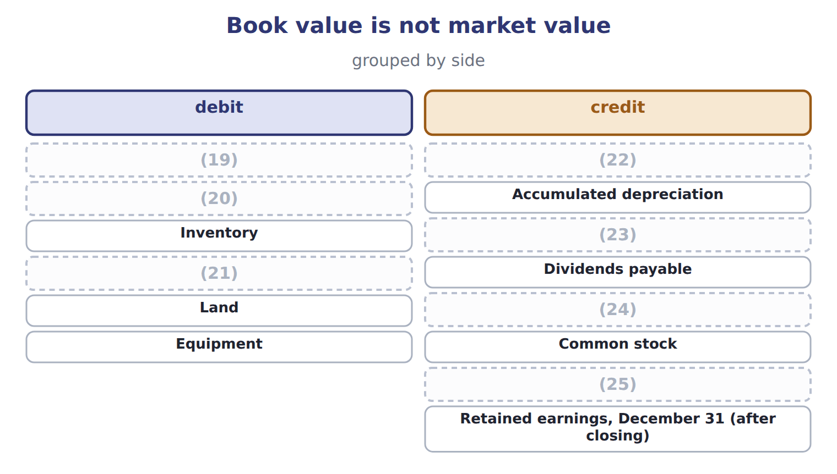
word list
Prepaid rent · Allowance for credit losses · Accounts payable · Additional paid-in capital · Accounts receivable · Notes payable (long-term) · Cash · Inventory

Item — Answer
Item | Answer
Cash surrender value | (26) : it is not expected to be turned into cash in the operating cycle.
Loan due on demand | (27) : debt due on demand is current, whatever the bank's expected behaviour.
Deferred tax asset | Noncurrent asset: all deferred taxes are noncurrent.
Customer deposits | Current liability (contract liability): it will be settled by delivering goods within a year.

word list
Current liability · callable debt · Noncurrent asset

Account — Category
Account | Category
Prepaid rent | Current asset
Land | Noncurrent asset
Allowance for credit losses | (28)
Dividends payable | (29)
Additional paid-in capital | (30)

word list
Current liability · Current asset · M1 · Equity

Answer key · 2.5 Limitations and links to the other statements

1 valuation | 16 accumulated
2 historical | 17 stockholders
3 Orontes's | 18 market
4 estimates | 19 Cash
5 allowance | 20 Accounts receivable
6 Important | 21 Prepaid rent
7 missing | 22 Allowance for credit losses
8 Internally | 23 Accounts payable
9 workforce | 24 Notes payable (long-term)
10 obligations | 25 Additional paid-in capital
11 Finally | 26 Noncurrent asset
12 suppliers | 27 Current liability
13 statement | 28 Current asset
14 balance-sheet | 29 Current liability
15 Orontes's | 30 Equity

the summaries in full
Summary 1 The balance sheet is useful, but it is not a valuation of the company. Most assets are at historical cost, not current value: Orontes's land and buildings are shown at what they cost years ago. Many amounts depend on estimates, such as the allowance for credit losses and useful lives. Important resources are missing. Internally developed brands, customer loyalty and a skilled workforce are not recorded, so the balance sheet usually shows much less than the market value of the company. Some obligations are only in the notes. Finally, the balance sheet shows one day. A company can improve its year-end picture, for example by delaying payments to suppliers for a few days. Readers therefore compare several dates and read the other statements too. The four statements are connected. Net income from the income statement increases retained earnings in the statement of changes in equity, and the closing retained earnings appear on the balance sheet.
Summary 2 The net change in cash in the statement of cash flows explains the change in the balance-sheet cash. Other comprehensive income works the same way. Orontes's OCI of $(1,125) does not go into retained earnings. It goes into accumulated other comprehensive income, which is $(1,125) on the balance sheet.
Summary 3 Total stockholders' equity is a book amount. It is not what the company is worth, and it is not the market value of the shares.

