16.1 What consolidated statements are
Chapter 16 · section 16.1

Fill every gap. Each word list holds one word more than there are gaps.
Chapter 16, section by section
Each stage leads to the next.
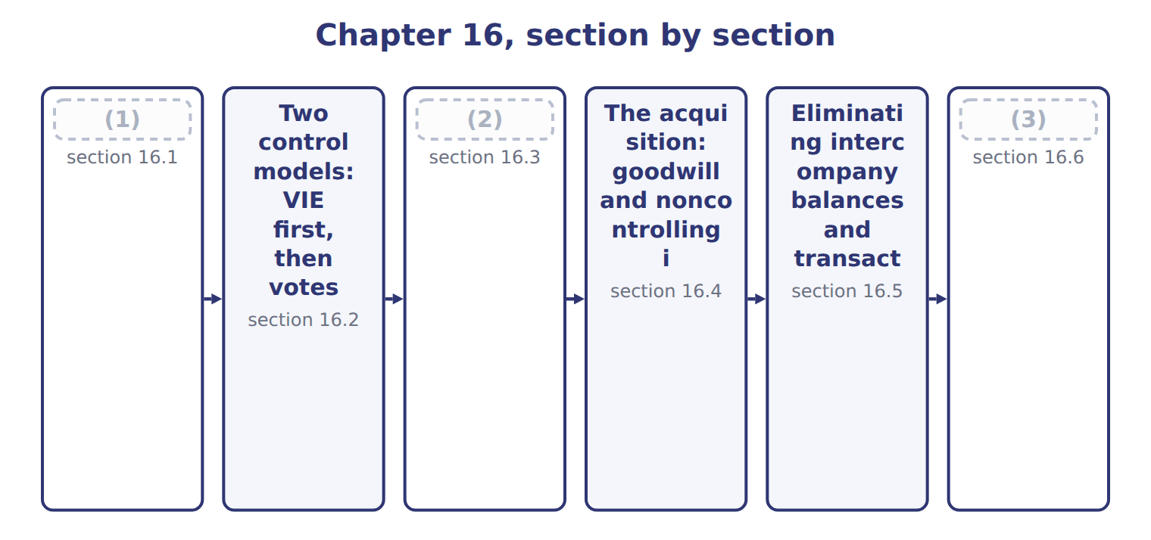
word list
Full consolidation, proportionate consolidatio · IFRS differences and what is changing · What consolidated statements are · Eliminating intercompany balances and transact

Summary 1 gaps 4–15
Consolidated financial statements present a parent and its (4) as a single (5) entity. They are prepared mainly for the parent's (6) and creditors, who need to see all the resources the group controls and all its (7) . A company (8) another entity when it has a (9) financial interest in it. (10) adds all of the subsidiary's assets, (11) , revenues and expenses to the parent's, line by line, even when the parent owns less than all of its shares. The part of a subsidiary's equity that the parent does not own is the noncontrolling interest (NCI). It is shown (12) consolidated equity, (13) from the parent's equity. Net income and (14) income are split (15) the parent and NCI on the face of the statements. The exam uses noncontrolling interest. It is equity, never a liability.
word list
subsidiaries · separately · controlling · Consolidation · between · consolidates · comprehensive · obligations · controls · shareholders · economic · liabilities · within

The English this section uses, and its Arabic
Each term sits against what it means.
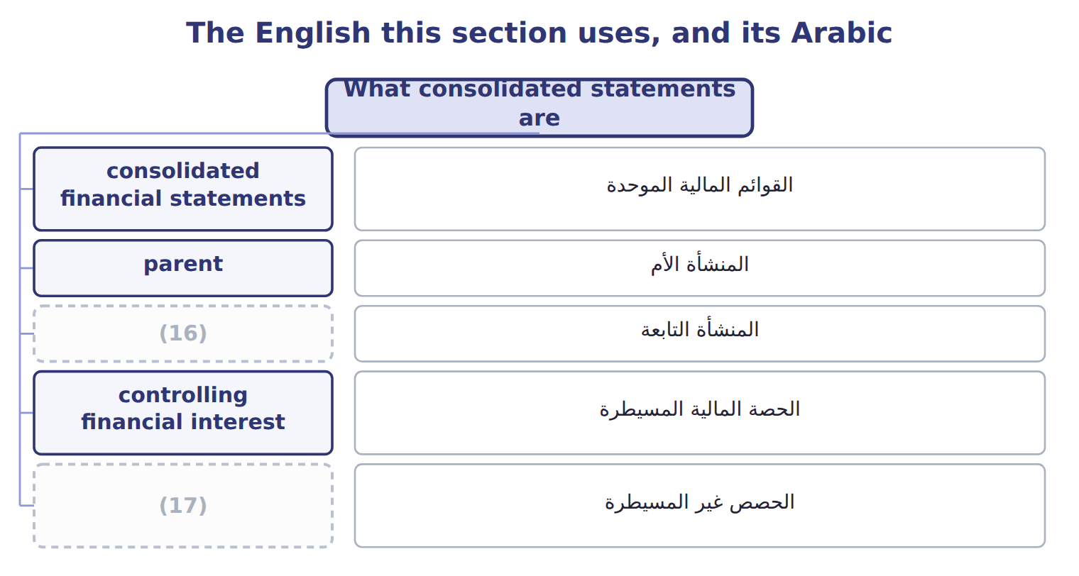
word list
primary beneficiary · subsidiary · noncontrolling interest

The English this sheet uses, and its Arabic
English (exam term) | Arabic
consolidated financial statements | القوائم المالية الموحدة
parent | المنشأة الأم
subsidiary | المنشأة التابعة
controlling financial interest | الحصة المالية المسيطرة
noncontrolling interest | الحصص غير المسيطرة

Answer key · 16.1 What consolidated statements are

1 What consolidated statements are | 10 Consolidation
2 Full consolidation, proportionate consolidatio | 11 liabilities
3 IFRS differences and what is changing | 12 within
4 subsidiaries | 13 separately
5 economic | 14 comprehensive
6 shareholders | 15 between
7 obligations | 16 subsidiary
8 consolidates | 17 noncontrolling interest
9 controlling

the summaries in full
Summary 1 Consolidated financial statements present a parent and its subsidiaries as a single economic entity. They are prepared mainly for the parent's shareholders and creditors, who need to see all the resources the group controls and all its obligations. A company consolidates another entity when it has a controlling financial interest in it. Consolidation adds all of the subsidiary's assets, liabilities, revenues and expenses to the parent's, line by line, even when the parent owns less than all of its shares. The part of a subsidiary's equity that the parent does not own is the noncontrolling interest (NCI). It is shown within consolidated equity, separately from the parent's equity. Net income and comprehensive income are split between the parent and NCI on the face of the statements. The exam uses noncontrolling interest. It is equity, never a liability.

16.2 Two control models: VIE first, then votes
Chapter 16 · section 16.2

Fill every gap. Each word list holds one word more than there are gaps.
Summary 1 gaps 1–12
U.S. GAAP has two ways to (1) control, and they are (2) in order. First, the company asks (3) the other entity is a (4) interest entity (VIE). An entity is a VIE if its equity at risk is too small to (5) its activities, or if its equity (6) do not have the power to direct it or do not bear its losses and returns. A VIE is (7) by its primary (8) : the party that has both the power to direct the activities that most affect the VIE's performance and the obligation to absorb losses, or the right to receive benefits, that could be significant. Both (9) are required. If the entity is not a VIE, the (10) interest model (11) . A company that holds more than 50% of the votes generally controls the entity, unless other owners have substantive (12) rights, such as the right to approve budgets.
word list
whether · holders · variable · applies · consolidated · conditions · applied · beneficiary · participating · primary · voting · finance · identify

Worked example: Orontes's cold-chain entity

Summary 2 gaps 13–18
Suppose a logistics entrepreneur owns all the shares of Orontes (13) Logistics SPV. The shares cost $100,000. Banks lend $9,900,000, (14) by Orontes. Equity is only 1% of the funding, and Orontes decides routes and (15) : the SPV is a VIE. Orontes has the power and bears the losses through its guarantee, so it is the primary (16) . Orontes (17) the SPV although it owns no shares. The (18) $100,000 is NCI.
word list
Cold-Chain · activities · entrepreneur's · beneficiary · guaranteed · consolidates · customers

Suppose: is the cold-chain SPV a VIE, and who consolidates it?
Suppose: Orontes Cold-Chain Logistics SPV, 2027 | Facts (whole USD) | Conclusion
Is equity at risk enough to finance the activities? | No: third-party equity is 100,000, only 1% of total funding | (19)
Do the equity holders direct the key activities? | (20) | VIE
Who absorbs losses? | Orontes guarantees the 9,900,000 of debt | Orontes
Primary beneficiary? | Orontes has both power and exposure to (21) losses | Orontes consolidates
NCI in consolidation | The third party's equity of 100,000 | (22)

word list
controlling financial interest · Shown as NCI · No: Orontes decides routes and customers · Suggests a VIE · significant

Control traps

Summary 3 gaps 23–25
Test the VIE model before (23) votes. The primary (24) needs power AND significant economics, not one of them. Under U.S. GAAP, less than half of the votes is not (25) , even if the other owners are widely spread.
word list
Suppose · beneficiary · control · counting

The English this sheet uses, and its Arabic
English (exam term) | Arabic
variable interest entity | منشأة ذات حصص متغيرة
primary beneficiary | المستفيد الرئيسي

Answer key · 16.2 Two control models: VIE first, then votes

1 identify | 14 guaranteed
2 applied | 15 customers
3 whether | 16 beneficiary
4 variable | 17 consolidates
5 finance | 18 entrepreneur's
6 holders | 19 Suggests a VIE
7 consolidated | 20 No: Orontes decides routes and customers
8 beneficiary | 21 significant
9 conditions | 22 Shown as NCI
10 voting | 23 counting
11 applies | 24 beneficiary
12 participating | 25 control
13 Cold-Chain

the summaries in full
Summary 1 U.S. GAAP has two ways to identify control, and they are applied in order. First, the company asks whether the other entity is a variable interest entity (VIE). An entity is a VIE if its equity at risk is too small to finance its activities, or if its equity holders do not have the power to direct it or do not bear its losses and returns. A VIE is consolidated by its primary beneficiary: the party that has both the power to direct the activities that most affect the VIE's performance and the obligation to absorb losses, or the right to receive benefits, that could be significant. Both conditions are required. If the entity is not a VIE, the voting interest model applies. A company that holds more than 50% of the votes generally controls the entity, unless other owners have substantive participating rights, such as the right to approve budgets.
Summary 2 Suppose a logistics entrepreneur owns all the shares of Orontes Cold-Chain Logistics SPV. The shares cost $100,000. Banks lend $9,900,000, guaranteed by Orontes. Equity is only 1% of the funding, and Orontes decides routes and customers: the SPV is a VIE. Orontes has the power and bears the losses through its guarantee, so it is the primary beneficiary. Orontes consolidates the SPV although it owns no shares. The entrepreneur's $100,000 is NCI.
Summary 3 Test the VIE model before counting votes. The primary beneficiary needs power AND significant economics, not one of them. Under U.S. GAAP, less than half of the votes is not control, even if the other owners are widely spread.

16.3 Full consolidation, proportionate consolidation and the equity method
Chapter 16 · section 16.3

Fill every gap. Each word list holds one word more than there are gaps.
Summary 1 gaps 1–10
Full consolidation is used for every (1) the company (2) . The (3) items are added in full, and NCI shows the part the (4) does not own. The equity method, which the LOS call 'equity consolidation', is used when the investor has (5) influence, usually 20% to 50% of the votes, and for most joint (6) . The (7) is one line on the balance sheet, and the investor's share of income is one line on the income (8) , as for Jordan Glass. (9) consolidation adds only the investor's share of each asset, (10) , revenue and expense. U.S. GAAP generally does not allow it; it survives only for some construction and oil and gas interests.
word list
liability · bottles · investment · subsidiary's · Proportionate · controls · statement · ventures · significant · entity · parent

Full consolidation, equity method and proportionate consolidation
Method | When used (U.S. GAAP) | What appears | Intercompany profit removed | Orontes
Full consolidation | (11) | 100% of each asset, (12) , revenue and expense; NCI shown | 100% of intercompany items | Levant (80%)
Equity method | (13) | One line: investment and share of income | (14) | Jordan Glass (30%)
Proportionate consolidation | Rare in U.S. GAAP: some construction and oil and gas interests | (15) | Investor's share | Not used by Orontes

word list
Control (subsidiary or VIE) · controlling financial interest · Investor's share of each line · liability · Significant influence (20%–50%); joint ventures · Only the investor's share: 30% × 40,000 = 12,000

Summary 2 gaps 16–18
The methods also remove intercompany profit (16) . When Jordan Glass sells bottles to Orontes, the equity method removes only Orontes's 30% share of the (17) profit: $12,000. A controlled (18) intercompany profit is removed in full.
word list
differently · investment · unrealized · subsidiary's

'Equity consolidation' is the equity method

Summary 3 gaps 19–20
The LOS (19) 'equity consolidation' means the equity method: one line, no NCI. It is not full consolidation. Also, joint ventures use the equity method, not (20) consolidation.
word list
proportionate · phrase · differently

The English this section uses, and its Arabic
Each term sits against what it means.
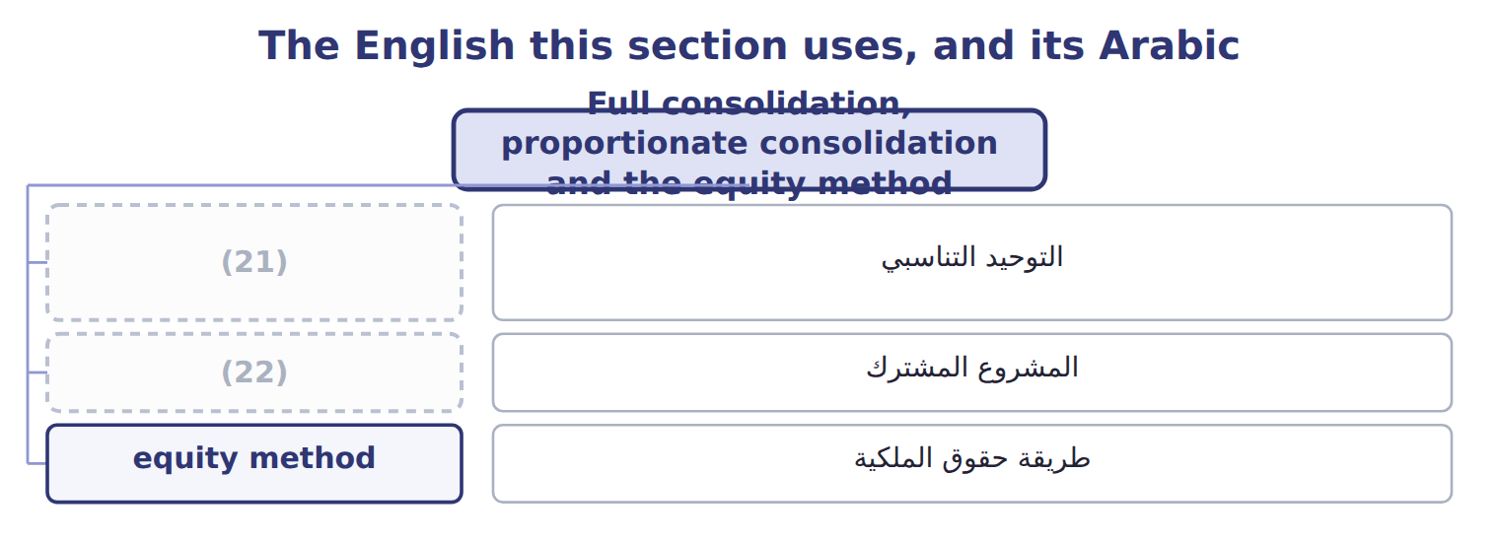
word list
proportionate consolidation · equity method · joint venture

The English this sheet uses, and its Arabic
English (exam term) | Arabic
proportionate consolidation | التوحيد التناسبي
joint venture | المشروع المشترك
equity method | طريقة حقوق الملكية

Answer key · 16.3 Full consolidation, proportionate consolidation and the equity method

1 entity | 12 liability
2 controls | 13 Significant influence (20%–50%); joint ventures
3 subsidiary's | 14 Only the investor's share: 30% × 40,000 = 12,000
4 parent | 15 Investor's share of each line
5 significant | 16 differently
6 ventures | 17 unrealized
7 investment | 18 subsidiary's
8 statement | 19 phrase
9 Proportionate | 20 proportionate
10 liability | 21 proportionate consolidation
11 Control (subsidiary or VIE) | 22 joint venture

the summaries in full
Summary 1 Full consolidation is used for every entity the company controls. The subsidiary's items are added in full, and NCI shows the part the parent does not own. The equity method, which the LOS call 'equity consolidation', is used when the investor has significant influence, usually 20% to 50% of the votes, and for most joint ventures. The investment is one line on the balance sheet, and the investor's share of income is one line on the income statement, as for Jordan Glass. Proportionate consolidation adds only the investor's share of each asset, liability, revenue and expense. U.S. GAAP generally does not allow it; it survives only for some construction and oil and gas interests.
Summary 2 The methods also remove intercompany profit differently. When Jordan Glass sells bottles to Orontes, the equity method removes only Orontes's 30% share of the unrealized profit: $12,000. A controlled subsidiary's intercompany profit is removed in full.
Summary 3 The LOS phrase 'equity consolidation' means the equity method: one line, no NCI. It is not full consolidation. Also, joint ventures use the equity method, not proportionate consolidation.

16.4 The acquisition: goodwill and noncontrolling interest
Chapter 16 · section 16.4

Fill every gap. Each word list holds one word more than there are gaps.
Summary 1 gaps 1–8
When a company gains control of a (1) , it uses the (2) method. It measures the (3) identifiable assets and (4) at fair value, and it measures NCI at fair value too. (5) is the price paid plus the fair value of NCI, minus the fair value of the net assets. (6) pays $8,000,000 for 80% of Levant, and the other 20% is worth $1,900,000. (7) net assets are $7,300,000 on its books, but its (8) is worth $1,200,000 more, so the net assets at fair value are $8,500,000.
word list
subsidiary's · liabilities · acquisition · Goodwill · Levant's · business · equipment · transaction · Orontes

Worked example: the acquisition-date elimination

Summary 2 gaps 9–16
Remove (9) equity of $7,300,000: it is not owned by (10) to the group, except through NCI. Add the (11) step-up of $1,200,000 and (12) of $1,400,000. Remove Orontes's (13) of $8,000,000 and (14) NCI of $1,900,000 in equity. Debits and (15) both equal $9,900,000. After the (16) , if Orontes buys or sells some Levant shares but keeps control, the change is an equity transaction: no gain or loss is recognized. If Orontes loses control, it removes Levant from the consolidation and remeasures any interest it keeps at fair value.
word list
equipment · Levant's · acquisition · credits · investment · record · business · outsiders · goodwill

Suppose: elimination entry at the acquisition of Levant
Consolidation worksheet, January 1, 2027 (whole | Debit | Credit
(17) | 7,300,000
(18) | 1,200,000
Goodwill | 1,400,000
Investment in Levant (Orontes's books) |  | 8,000,000
Noncontrolling interest (equity) |  | 1,900,000
(19) | 9,900,000 | 9,900,000

word list
Property, plant and equipment (fair value step-up) · subsidiary · Levant's equity (book value) · Totals

The English this section uses, and its Arabic
Each term sits against what it means.
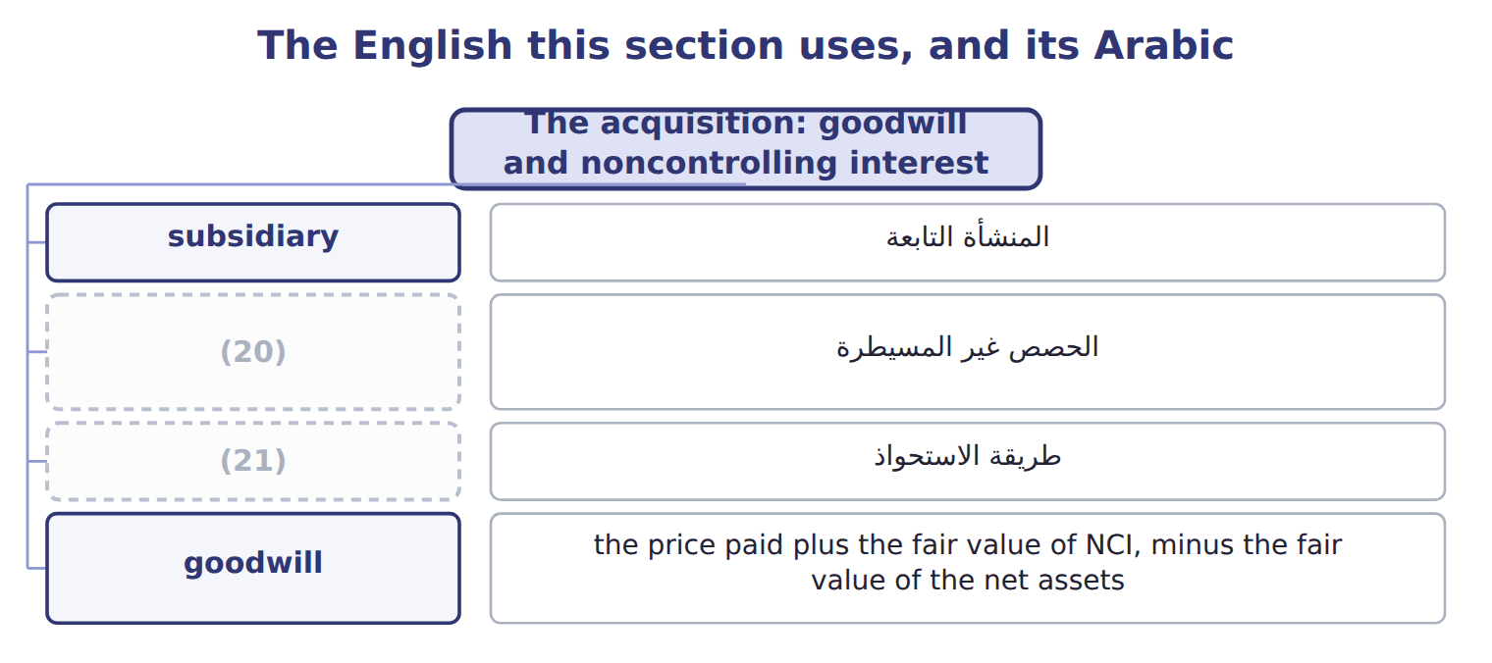
word list
acquisition method · طريقة الاستحواذ · noncontrolling interest

The English this sheet uses, and its Arabic
English (exam term) | Arabic
acquisition method | طريقة الاستحواذ
goodwill | الشهرة

Answer key · 16.4 The acquisition: goodwill and noncontrolling interest

1 business | 12 goodwill
2 acquisition | 13 investment
3 subsidiary's | 14 record
4 liabilities | 15 credits
5 Goodwill | 16 acquisition
6 Orontes | 17 Levant's equity (book value)
7 Levant's | 18 Property, plant and equipment (fair value step-up)
8 equipment | 19 Totals
9 Levant's | 20 noncontrolling interest
10 outsiders | 21 acquisition method
11 equipment

the summaries in full
Summary 1 When a company gains control of a business, it uses the acquisition method. It measures the subsidiary's identifiable assets and liabilities at fair value, and it measures NCI at fair value too. Goodwill is the price paid plus the fair value of NCI, minus the fair value of the net assets. Orontes pays $8,000,000 for 80% of Levant, and the other 20% is worth $1,900,000. Levant's net assets are $7,300,000 on its books, but its equipment is worth $1,200,000 more, so the net assets at fair value are $8,500,000.
Summary 2 Remove Levant's equity of $7,300,000: it is not owned by outsiders to the group, except through NCI. Add the equipment step-up of $1,200,000 and goodwill of $1,400,000. Remove Orontes's investment of $8,000,000 and record NCI of $1,900,000 in equity. Debits and credits both equal $9,900,000. After the acquisition, if Orontes buys or sells some Levant shares but keeps control, the change is an equity transaction: no gain or loss is recognized. If Orontes loses control, it removes Levant from the consolidation and remeasures any interest it keeps at fair value.

16.5 Eliminating intercompany balances and transactions
Chapter 16 · section 16.5

Fill every gap. Each word list holds one word more than there are gaps.
Summary 1 gaps 1–11
A group (1) sell to itself, owe money to itself or earn income from itself. Every (2) transaction is therefore eliminated in full, whatever the percentage owned: sales and cost of sales, (3) and payables, loans and interest, and dividends. (4) profit on goods still held inside the group is also removed from (5) and income until the goods are sold to outsiders. In a (6) sale the parent earned the profit, so the whole (7) reduces the parent's share. In an upstream sale the (8) earned it, so NCI bears its share. When one group company sells (9) to another, the gain is eliminated and the asset returns to its (10) cost basis. The buyer's extra (11) on the gain is reversed each year.
word list
inventory · original · downstream · reduces · elimination · cannot · depreciation · Unrealized · receivables · intercompany · subsidiary · equipment

Suppose: Orontes's 2027 intercompany eliminations for Levant
Every item belongs to exactly one group.
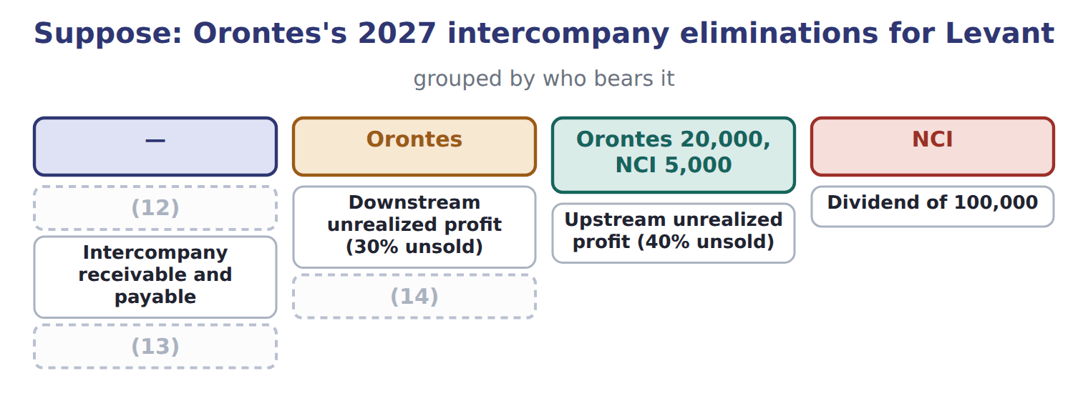
word list
Truck sold for 90,000 (carrying 60,000) · Loan of 1,000,000 at 6% · Downstream unrealized profit (30% unsold) · Intercompany sales and cost of sales

NCI at the end of 2027

Complete the five blanks.

Suppose: NCI roll-forward for Levant, 2027 (complete the blanks)
Suppose: NCI in Levant, 2027 (whole USD) | Amount
(15) | 1,900,000
(16) | 900,000
Less: (17) on the PP&E step-up (1,200,000 ÷ 10 years) | (120,000)
(18) | ________
Adjusted net income of Levant | ________
NCI share (20%) | ________
Less: dividends paid to NCI | ________
NCI at December 31, 2027 | ________

word list
NCI at January 1, 2027 (fair value) · Less: upstream unrealized profit · depreciation · Levant's 2027 net income · Truck sold for 90,000 (carrying 60,000)

Elimination traps

Summary 2 gaps 19–21
Eliminate (19) items in full, not only the parent's share. (20) profit reduces only the parent's share; upstream profit is shared with NCI. For an (21) investee, remove only the investor's share of the profit.
word list
equity-method · intercompany · eliminated · Downstream

The English this section uses, and its Arabic
Each term sits against what it means.
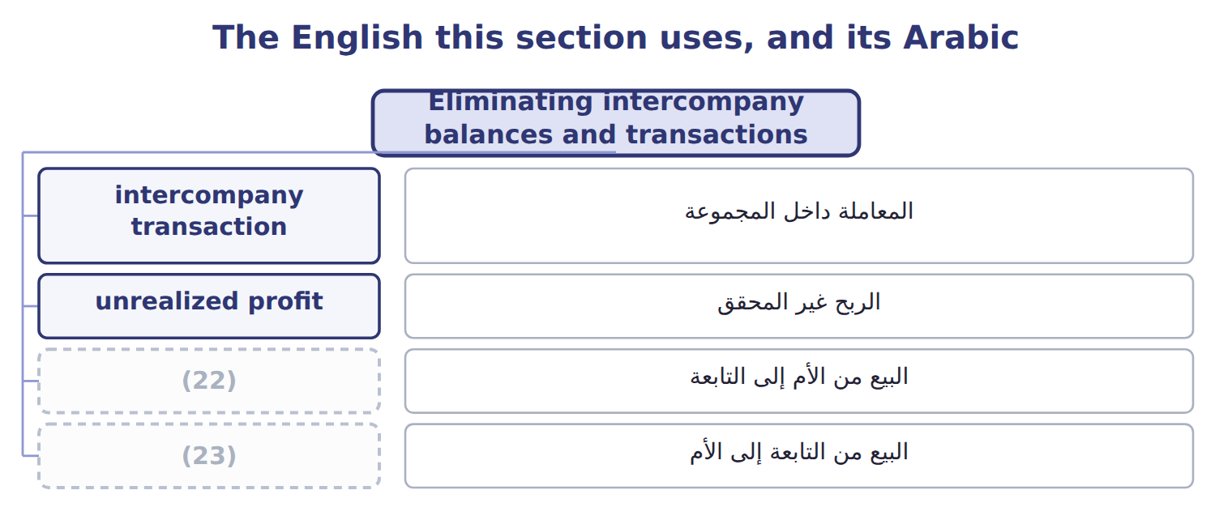
word list
downstream sale · unrealized profit · upstream sale

The English this sheet uses, and its Arabic
English (exam term) | Arabic
intercompany transaction | المعاملة داخل المجموعة
unrealized profit | الربح غير المحقق
downstream sale | البيع من الأم إلى التابعة
upstream sale | البيع من التابعة إلى الأم

Answer key · 16.5 Eliminating intercompany balances and transactions

1 cannot | 13 Loan of 1,000,000 at 6%
2 intercompany | 14 Truck sold for 90,000 (carrying 60,000)
3 receivables | 15 NCI at January 1, 2027 (fair value)
4 Unrealized | 16 Levant's 2027 net income
5 inventory | 17 depreciation
6 downstream | 18 Less: upstream unrealized profit
7 elimination | 19 intercompany
8 subsidiary | 20 Downstream
9 equipment | 21 equity-method
10 original | 22 downstream sale
11 depreciation | 23 upstream sale
12 Intercompany sales and cost of sales

the summaries in full
Summary 1 A group cannot sell to itself, owe money to itself or earn income from itself. Every intercompany transaction is therefore eliminated in full, whatever the percentage owned: sales and cost of sales, receivables and payables, loans and interest, and dividends. Unrealized profit on goods still held inside the group is also removed from inventory and income until the goods are sold to outsiders. In a downstream sale the parent earned the profit, so the whole elimination reduces the parent's share. In an upstream sale the subsidiary earned it, so NCI bears its share. When one group company sells equipment to another, the gain is eliminated and the asset returns to its original cost basis. The buyer's extra depreciation on the gain is reversed each year.
Summary 2 Eliminate intercompany items in full, not only the parent's share. Downstream profit reduces only the parent's share; upstream profit is shared with NCI. For an equity-method investee, remove only the investor's share of the profit.

16.6 IFRS differences and what is changing
Chapter 16 · section 16.6

Fill every gap. Each word list holds one word more than there are gaps.
Summary 1 gaps 1–9
IFRS 10 uses one control model: an investor (1) an entity if it has power over it, (2) to variable returns, and the (3) to use its power to affect those returns. There is no (4) VIE model, and an investor can have de facto control with less than half of the votes. IFRS 3 lets a company (5) NCI either at fair value or at its share of net assets, which gives partial (6) : for Levant, $1,200,000 (7) of $1,400,000. Under IFRS 11, joint ventures use the equity method and joint (8) recognize their own share of assets and (9) .
word list
controls · measure · exposure · operations · goodwill · liabilities · recognize · instead · separate · ability

Consolidation: U.S. GAAP and IFRS
Topic | U.S. GAAP (ASC 810, 805) | IFRS (IFRS 10, 3, 11)
Control model | (10) | One: power, variable returns and the link between them
Control below 50% of votes | (11) | Possible: de facto control
Measuring NCI | (12) | Fair value or share of net assets (partial goodwill), deal by deal
Joint arrangements | Joint ventures: equity method | Joint ventures: equity method; joint operations: own share of assets and liabilities
Group accounting policies | (13) | Uniform policies required
Investment-entity subsidiaries in a parent's statements | Parent keeps their fair value accounting | (14)

word list
Fair value (full goodwill) · Supplier (30%, significant influence) · Not through voting alone (unless a VIE) · Two: VIE model first, then voting interest · A non-investment-entity parent consolidates them · No general uniformity rule

Summary 2 gaps 15–19
ASU 2025-03 changes how to (15) the acquirer when the (16) company is a VIE; it is not testable before about January 2028. In January 2026 the FASB began (17) on bringing the VIE and voting models closer (18) . That is a (19) only. ASU 2023-05, on joint venture formations, affects only the joint venture's own statements.
word list
proposal · ventures · together · acquired · identify · research

Suppose: Barada Wholesale and Tadmor Retail, 202 — Amount
Suppose: Barada Wholesale and Tadmor Retail, 202 | Amount
Price paid for 75% of Tadmor Retail LLC, January 1, 2028 | 600
(20) | 190
(21) | 700
Barada sold goods to Tadmor: sales 200, margin 30%, 25% still held by Tadmor
(22) : sales 160, margin 25%, 50% still held by Barada
Tadmor owes Barada at December 31, 2028 | 40
Tadmor's 2028 net income (before any (23) adjustment) | 120
(24) | 40
M1 | Tadmor's assets are at fair value on its books, so there is no step-up to depreciate.
M2 | Barada also holds 30% of a supplier (significant influence) and 8% of a listed food company.

word list
Tadmor sold goods to Barada · consolidation · Fair value of Tadmor's identifiable net assets · Dividends paid by Tadmor in 2028 · Fair value of the 25% noncontrolling interest · Listed food company (8%)

Item — Answer
Item | Answer
Less: upstream unrealized profit | (25,000)
Adjusted net income of Levant | (25)
NCI share | (26)
Less: dividends paid to NCI | (20,000)
NCI at December 31, 2027 | 1,900,000 + 151,000 − 20,000 = 2,031,000

word list
900,000 − 120,000 − 25,000 = 755,000 · Fair value of the 25% noncontrolling interest · 20% × 755,000 = 151,000

Investment — Category
Investment | Category
Tadmor Retail (75%) | (27)
Supplier (30%, significant influence) | (28)
Listed food company (8%) | Fair value through net income
Cold-storage SPV that Barada directs and guarantees (VIE) | Full consolidation

word list
Full consolidation · primary beneficiary · Equity method

The English this section uses, and its Arabic
Each term sits against what it means.
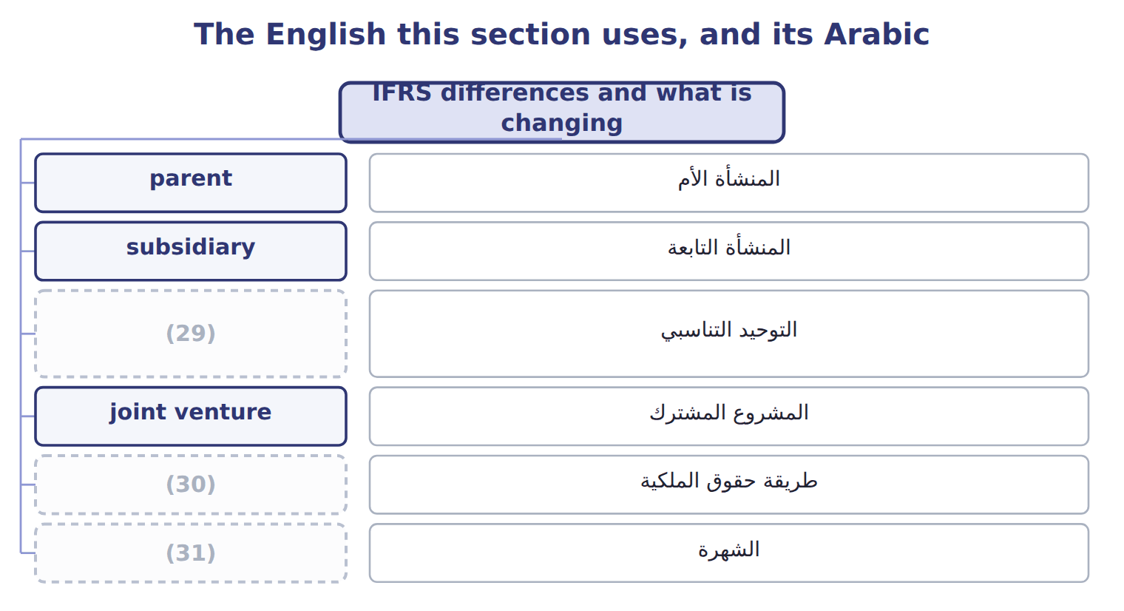
word list
equity method · proportionate consolidation · upstream sale · goodwill

Answer key · 16.6 IFRS differences and what is changing

1 controls | 17 research
2 exposure | 18 together
3 ability | 19 proposal
4 separate | 20 Fair value of the 25% noncontrolling interest
5 measure | 21 Fair value of Tadmor's identifiable net assets
6 goodwill | 22 Tadmor sold goods to Barada
7 instead | 23 consolidation
8 operations | 24 Dividends paid by Tadmor in 2028
9 liabilities | 25 900,000 − 120,000 − 25,000 = 755,000
10 Two: VIE model first, then voting interest | 26 20% × 755,000 = 151,000
11 Not through voting alone (unless a VIE) | 27 Full consolidation
12 Fair value (full goodwill) | 28 Equity method
13 No general uniformity rule | 29 proportionate consolidation
14 A non-investment-entity parent consolidates them | 30 equity method
15 identify | 31 goodwill
16 acquired

the summaries in full
Summary 1 IFRS 10 uses one control model: an investor controls an entity if it has power over it, exposure to variable returns, and the ability to use its power to affect those returns. There is no separate VIE model, and an investor can have de facto control with less than half of the votes. IFRS 3 lets a company measure NCI either at fair value or at its share of net assets, which gives partial goodwill: for Levant, $1,200,000 instead of $1,400,000. Under IFRS 11, joint ventures use the equity method and joint operations recognize their own share of assets and liabilities.
Summary 2 ASU 2025-03 changes how to identify the acquirer when the acquired company is a VIE; it is not testable before about January 2028. In January 2026 the FASB began research on bringing the VIE and voting models closer together. That is a proposal only. ASU 2023-05, on joint venture formations, affects only the joint venture's own statements.

